Lab-Project 8: Breaking a BIOS Password

What You Need for This Project
- VMware Workstation or VMware Player.
- Warning: About half the students that try cannot do this project because the VMs close instantly and they cannot capture the images. I have not been able to find any pattern--some machines do that and others do not. If it happens to you, you can either try using a different machine or capture a video of the action. You can then either turn in the video, or capture stills from the video.
- Student should update to VMware 16 and Windows 10.

Assigning a BIOS Password
- Open a virtual machine (VM), but don't start it. It doesn't matter what OS is installed on the VM. If you don't have a VM handy, just create a new one.
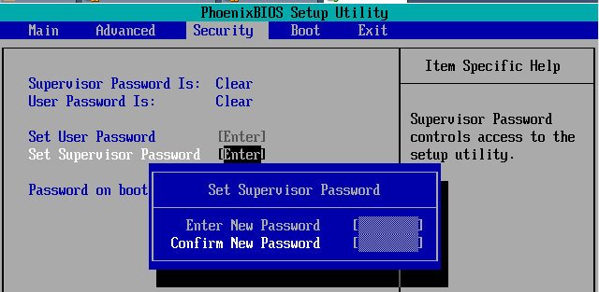
- From the VMware Workstation menu bar, click VM, Power, "Power ON to BIOS". If that menu item is not there, you may have an old version of VMware, or VMware Player. You can probably still do the project by starting the machine, clicking quickly in it, and pressing F2 to open the BIOS. If the machine boots up too quickly for you to get into the BIOS, power the virtual machine down, find its .vmx file, and add this line to the end of it:
bios.bootdelay = 5000
Complete instructions for the process are here:
http://www.howtogeek.com/howto/16876/how-to-increase-the-vmware-boot-screen-delay/
- When the "PhoenixBIOS Setup Utility" screen appears, click in the VM to capture the keyboard. Then use the keyboard arrow keys to select the Security menu. Press Enter to "Set Supervisor Password".
- Enter a BIOS password of 12345678 in both boxes, as shown to the right on this page. Use the Enter key to move from one box to the other.
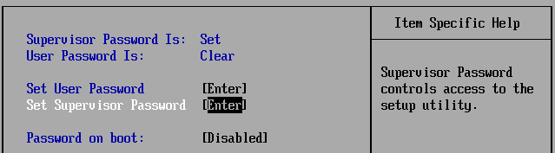
- After entering the password in both fields, press Enter. A "Setup Notice" box appears saying "Changes have been saved.". Press Enter again.
- Your BIOS screen should now show that the "Supervisor Password" is "Set", as shown to the right on this page.
- Press F10 and then Enter to save changes.
- When the VM restarts, from the VMware Workstation menu bar, click VM, Power, "Power Off"

Entering the Wrong Password Three Times
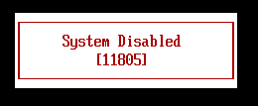

- From the VMware Workstation menu bar, click VM, Power, "Power ON to BIOS".
- A blue box asks you to "Enter Password". Enter something wrong, like X, and press Enter. Repeat the process three times.
- A "System Disabled" box appears, as shown to the right on this page, with a code number visible.

Saving a Screen Image
- Make sure your screen shows the "System Disabled" box, with the code number visible.
- Save it as Lab-Proj 8a from YOUR NAME.
- 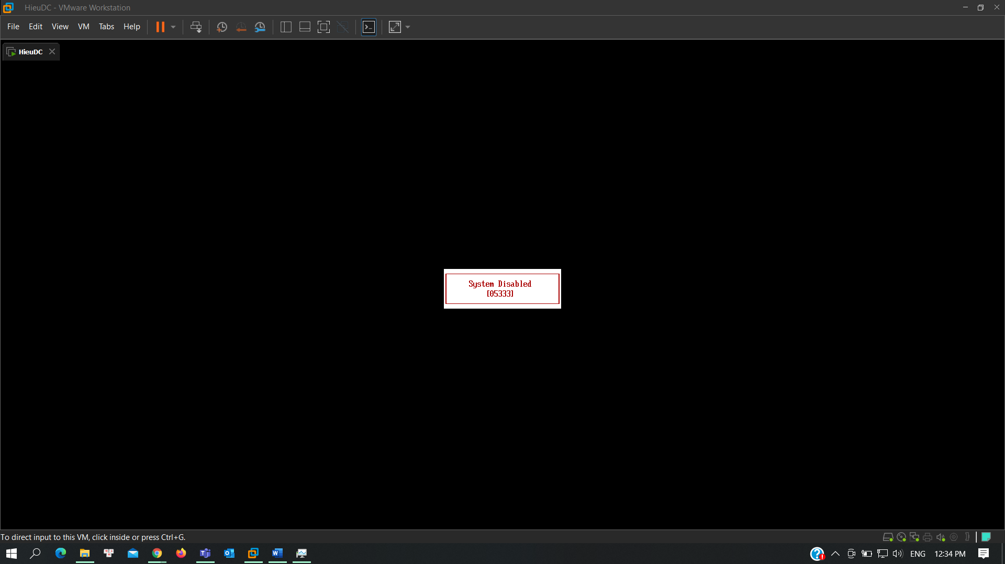

Downloading the BIOS Keygen
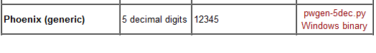
- Open a Web browser and go to link
- In the "Phoenix (generic) line, download the "Windows binary" link.
- On your desktop, unzip the file pwgen-5dec.zip.

Using the Keygen
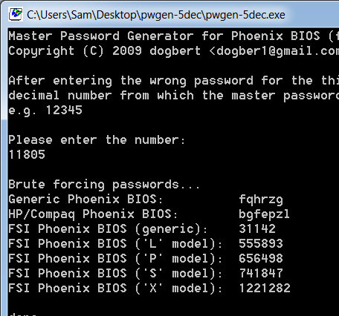
- A box pops up showing a pwgen-5dec.exe file. Double-click that file. If a warning box pops up, click Run.
- A command prompt window opens. Click in that box and enter the number from your "System Disabled" message.
- It finds a series of passwords. Notice that the passwords you get are not the same ones I got, and don't include the password is not the one you entered--but it will probably still work.

Saving a Screen Image
- Make sure your screen shows the "Generic Phoenix BIOS" line, with a generated password visible that is different from the example above.
- Save it as Lab-Proj 8b from YOUR NAME.
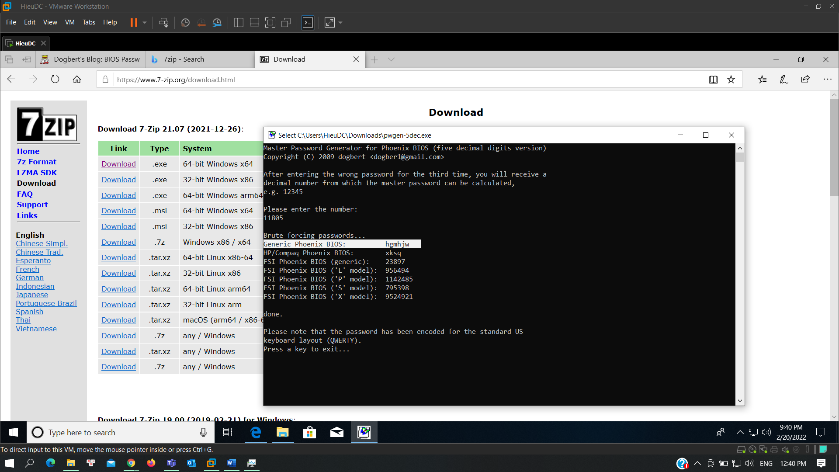

Testing the Generated Password
- Press Ctrl+Alt to release the keyboard from the VM.
- From the VMware Workstation menu bar, click VM, Power, "Power Off". Click "Power off".
- From the VMware Workstation menu bar, click VM, Power, "Power On to BIOS".
- A blue box asks you to "Enter Password". Enter the password from the "Generic Phoenix BIOS" line in the keygen--when I did it, it was fqhrzg
- If the password works, you will see the BIOS open. If it fails, run the keygen again. Every time you run it, it finds different passwords, and they don't all work. But it worked for me two out of three times.

Setting a Boot Password
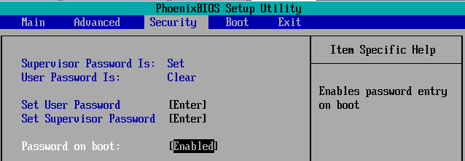
- In the Security menu, press the down-arrow to select the "Password on boot" item. Press Enter to select it. A blue box pops up. Press the down-arrow key to highlight Enabled and press Enter.
- Your BIOS screen should now show that the "Password on boot" is "Enabled", as shown to the right on this page.
- Press F10 and then Enter to save changes.

Entering the Wrong Password Three Times
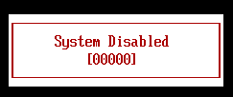
- A blue box asks you to "Enter Password". Enter something wrong, like X, and press Enter. Repeat the process three times.
- A "System Disabled" box appears, as shown to the right on this page, but this time the code number is 00000.

Saving a Screen Image
- Make sure your screen shows the "System Disabled" box, with a number of 00000.
- Save it as Lab-Proj 8c from YOUR NAME.
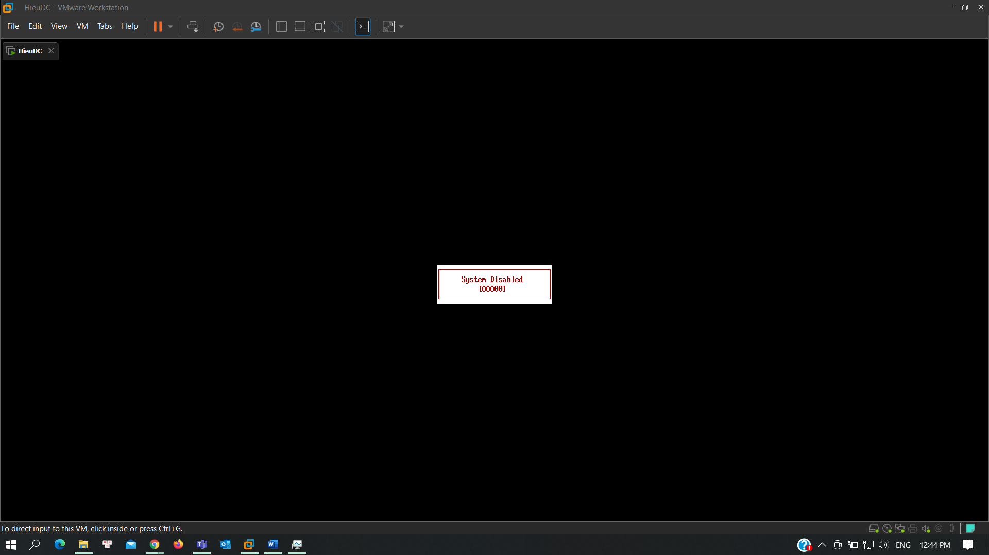

Using the Keygen
- Run the keygen and enter the code of 00000. It generates a password.

Testing the Generated Password
- Press Ctrl+Alt to release the keyboard from the VM.
- From the VMware Workstation menu bar, click VM, Power, "Power Off". Click "Power off".
- From the VMware Workstation menu bar, click VM, Power, "Power On ".
- A blue box asks you to "Enter Password". Enter the password from the "Generic Phoenix BIOS" line in the keygen. It won't work--obviously 00000 is not the real code. This keygen works for BIOS passwords, but not for boot passwords.

Clearing the Passwords
- Press Ctrl+Alt to release the keyboard from the VM.
- From the VMware Workstation menu bar, click VM, Power, "Power Off". Click "Power off".
- From the VMware Workstation menu bar, click VM, Power, "Power On to BIOS".
- A blue box asks you to "Enter Password". Enter the password you chose originally: 12345678
- Use the arrow keys to get to the Security page. Highlight "Password on Boot" and press Enter. Use the arrow keys to highlight Disabled and press Enter.
- In the Security menu, set the "Password on boot" to Disabled.
- Use the arrow keys to highlight "Set Supervisor Password" and press Enter.
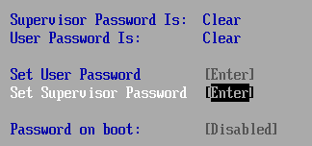
- In the blue "Set Supervisor Password" box, enter 12345678 in the first line. Press Enter four times.
- Your BIOS screen should now show that both passwords are Clear, as shown to the right on this page.
- Press F10 and then Enter to save changes.

Turning in your Project
- Submit the images from Steps “Saving a Screen Image” to: cms with a subject line of Lab-Proj 8 From Your Name, replacing Your Name with your real name.

