Lab-Project A1: Photorec
What You Need for This Project
- A Windows machine, real or virtual
- Student should update to VMware 16 and Windows 10.
Downloading the Image File
Right-click the link below and save the file on your desktop. This is a forensic image from a digital camera which contains deleted images. It was originally posted on digitalcorpora.org, but it vanished from there, so a copy here (or from Instructor)
Preparing the Data Directories
Create a new folder on the root of C: with your name on it: C:\YOURNAME
Copy the nps-2009-canon2-gen6.dd file into the C:\YOURNAME folder.
Create another new folder on the root of C: with your real name on it followed by a 2: C:\YOURNAME2
Downloading PhotoRec
On your Windows machine, in a Web browser, go to link.
Click the green "TestDisk 7.0 Free Download" button.
Click Start, Computer. Navigate to the folder you downloaded that file into, which is probably the Downloads folder.
Unzip the downloaded file.
Drag the testdisk-7.0-WIP folder and drop it on the root of C:, as shown below.
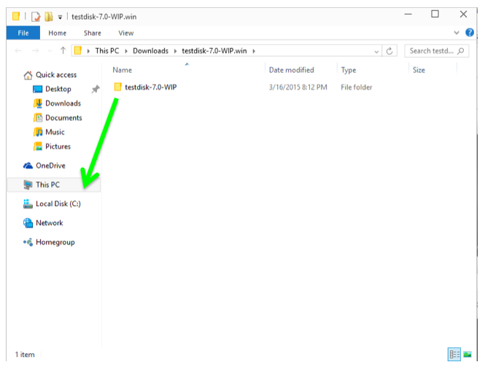
Click Start, type CMD, and press Shift+Ctrl+Enter to open an Administrator Command Prompt.
Execute these commands, changing the folder name in the second command to the name you assigned to your folder:
cd \testdisk-7.0-WIP
photorec_win C:\YOURNAME\nps-2009-canon2-gen6.dd
A Command Prompt window opens with a text-only Photorec interface, as shown below:
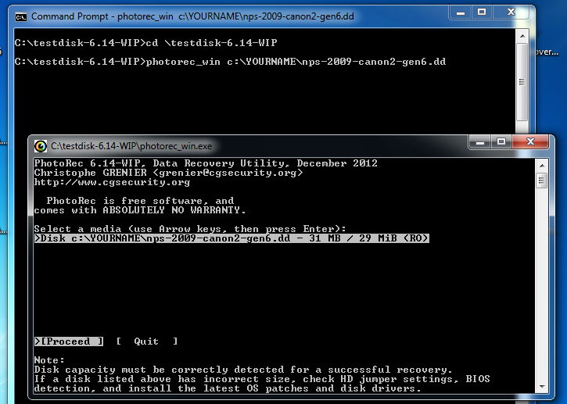
Click in the Photorec window, and press Enter to accept the default selection of the nps-2009-canon2-gen6.dd file.
The next screen asks you which partition to search, as shown below. Press Enter again to accept the default selection.
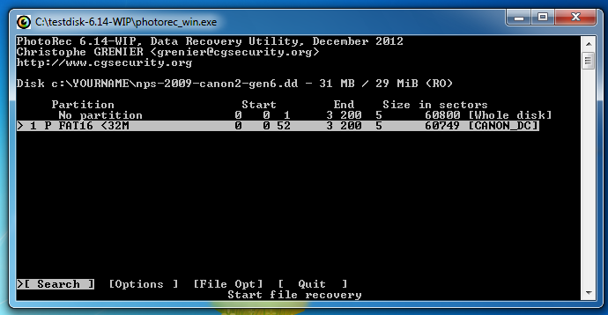
The next window asks what the file system is. It's usually FAT for Canon SD cards, so press Enter to accept the default choice.
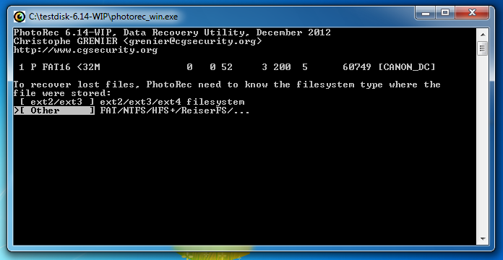
In the next window, press Enter to search unallocated space only. We don't need to recover the images that are still intact.
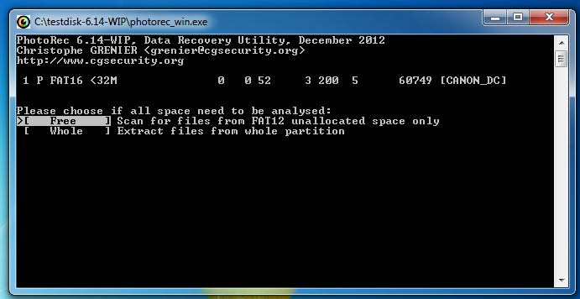
The next window asks where to store the recovered files. This is a really clumsy interface--press the left-arrow key once on the keyboard to move to C: and press the down-arrow key till the C:\YOURNAME2 folder is highlighted, as shown below. Then press Enter.
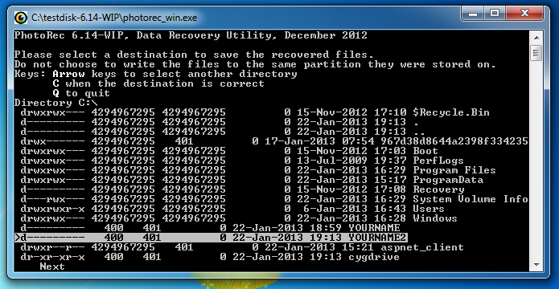
In the next window, press C.
The files are recovered, and listed as shown below:
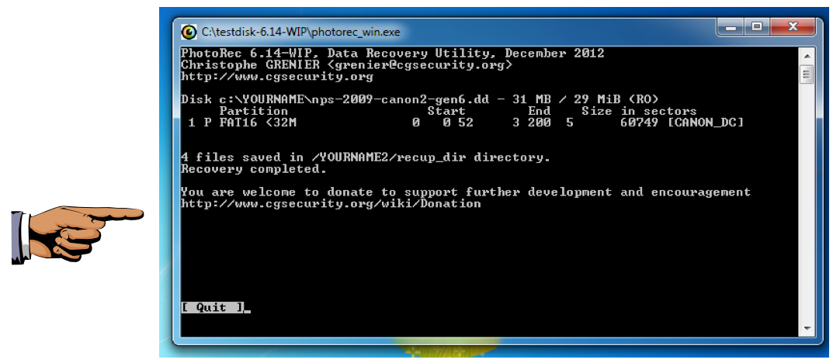
Saving a Screen Image
Make sure your screen shows "4 files saved" and YOURNAME is visible.
Save the image with the filename Lab-ProjA1a-YOURNAME.png, using your real name.
Viewing the Recovered Files
Click Start, Computer.
Open the C:\YOURNAME2\recup_dir.1 folder.
You see four recovered images, a report, and four thumbnail versions, as shown below.
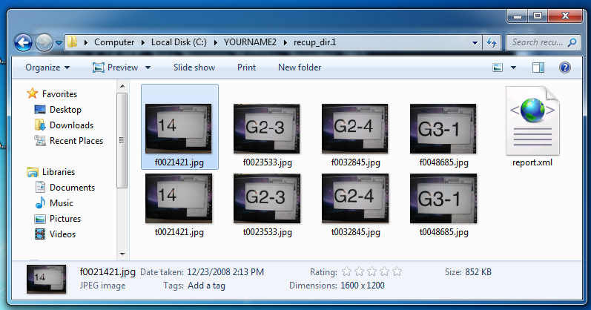
Saving a Screen Image
Make sure your screen shows the folder as above and YOURNAME is visible.
Save the image with the filename Lab-ProjA1b-YOURNAME.png, using your real name.
Turning in your Project
Submit the images to: cms with a subject line of "Lab-ProjA1 From Your Name", replacing "Your Name" with your real name.

