ĐỀ THI CUỐI KỲ 1 NH 2018-2019

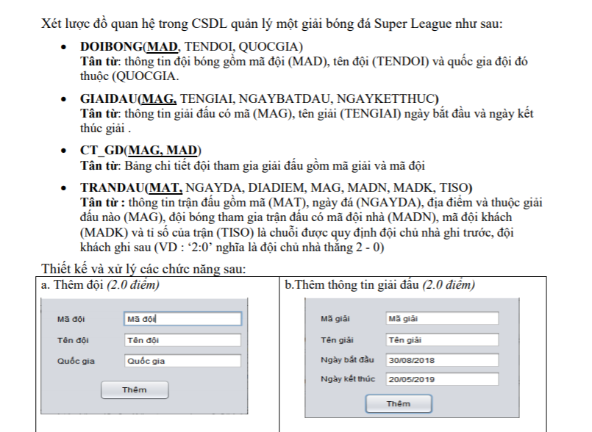

Câu a:

jTextField txtMaDoi= new jTextField(“ Mã đội”);

jTextField txtTenDoi= new jTextField(“Tên Đôi”);

jTexField txtQuocGia = new jTextField(“quốc Gia”);

jButton btnThem = new jButton (“ Thêm”);

btnThem.addActionlistener( (e)->{

string sql= “insert doibong into values ( txtMaDoi.getText(), txtTenDoi.getText(), txtQuocGia.getText()”;

statement stmt= con.createStatement();

stmt.excute(sql);

});

Câu b:

jTextField txtMaGiai = new jTextField(“Mã giải”);

jTextField txtTenGiai = new jTextField(“Tên Giải”);

jTextField txtNgayBatDau = new jTextField(“Ngày Bắt Đầu”);

jTextField txtNgayKetThuc = new jTextField(“Ngày Kết Thúc”);

jButton btnThem = n ew jButton(“Thêm”);

btnthem.addActionListener( (e )->{

String sql= “insert giaidau into values (txtMagiai.getText(), txtTenGiai.getText(), txtNgayBatDau.getText(), txtNgayKetThucs.getText()”;

statement stmt = con.createStatement();

stmt.excute(sql);

});

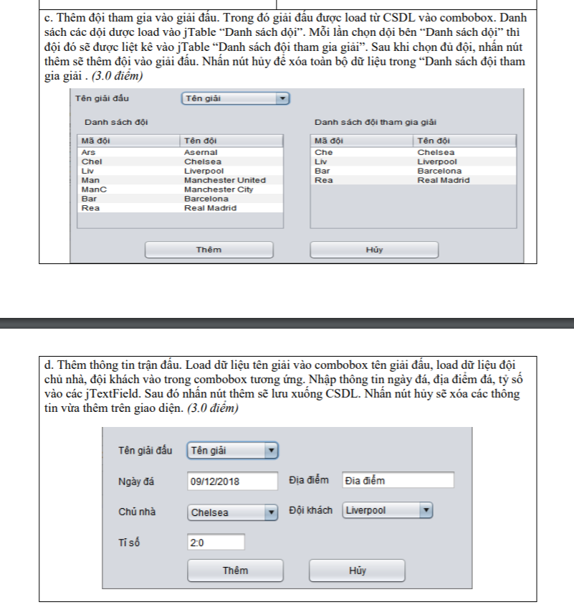

Câu c:

jCombobox cbbTenGiai = new jCombobox (new String[]{“Tên Giải”});

jTable tblDanhSachDoi = new jTable();

defaultTableModel modelDoi = (defaultTableModel) tblDanhSachDoi.getModel();

modelDoi.setColumndentifiers( new String[]{“ Mã Đội ” ,” Tên Đội ”});

jTable tblDanhSachThamGia = new jTable();

defautTableModel modelThamGia= (defautTableModel) tbtDnahSachThamGia.getModel();

modelThamGia.setColumndentifiers( new String[]{“ Mã Đội ”,” Tên Đội ”});

class GiaiDau{ String MAG, TenGiai, NgayBatDau, NgayKetThuc ; }

ArrayList<GiaiDau> ListGiaiDau= new ArrayList<GiaiDau>();

String sql= “ select MaG, TenGiai from GiaiDau “;

statement stmt= con.createStatement();

ResultSet rs= (ResultSet) stmt.excuteQuery(sql);

while (rs.next()) {

GiaiDau gd = new GiaiDau();

gd.MaG=rs.getString(“MAG”);

gd.TenGiai=rs.getString(“TenGiai”);

ListGiaiDau.add(gd);

}

for( var x : ListGiaiDau) cbbTenGiai.addItem(x.TenGiai);

class DoiBong{ String MaDoi, String TenDoi, String QuocGia; }

ArrayList<DoiBong> ListDoiBong = new ArrayList<DoiBong>();

String sql= “ select MaD, TenDoi from DoiBong “;

statement stmt = con.createStatement();

ResultSet rs= (ResultSet) stmt.excuteQuery(sql);

while (rs.next()) {

DoiBong db = new DoiBong();

db.MaDoi= rd.getString(“Mad”);

db.TenDoi= rd.getString(“TenDoi”);

ListDoiBong.add(db);

}

For( x in ListDoiBong) ModelDoi.addRow( new Object[]{ x.getMaDoi(), x.getTenDoi() } );

ArrayList<doibong> ListDoiBongThamGia= new ArrayList<doibong>();

tblDanhSachDoi.addMouseListener(new MouseAdapter() {

@Override

public void mouseClicked(MouseEvent e){

int vitri= tblDanhSachDoi.getSelectedRow();

if( vitri>-1) {

int check=0;

for( var x : ListDoiBongThamGia){

if( x.getMaDoi() == ListDoiBong.get(vitri).getMaDoi() ) check =1;

}

if( check ==0) ListDoiBongThamGia.add(ListDoiBong.get(vitri);

}

tblDanhSachThamGia.setRowCount(0);

for( var x in ListDoiBongThamGia) modelThamGia.addRow( new Object[]{x.getMaDoi(), x.getTenDoi() };

}});

btnThem.addActionListener( (e)->{

for( int i=0; i< ListGiaiDoi.size(); i++)

{

String sql= “insert CT_GD into values (MAG= ListGiaiDoi.get(cbbTenGiai.getSelectedIndex()).getMaG() , MAD= ListDoiBongThamGia.get( ).getMAD(i)”;

Statement stmt = con.createStatement();

Stmt.excute(sql);

}

});

btnHuy.addActionListener( (e)->{

ListDoiBongThamGia.clear();

tblDanhSachThamGia.setRowCount(0);

});

Câu d:

cbbTenGiai đã làm trên

jTextField txtNgayDa =new jTextField(“ Ngày Đá”);

jTextField txtDiaDiem = new jTextField(“Đia ĐIểm”);

jCombobox vbbChuNha = new jCombobox();

jCombobox cbbDoiKhach = new jCombobox();

jTextField txtTiSo = new jTextField(“2:0”);

jButton btnThem = new jbutton(“Thêm”);

jButton btn Huy = new jButton(‘hủy”);

ArrayList<String> Key= new ArrayList<String>();

string sql= “ select MaD, TenDoi from doiBong ”;

statement stmt = con.createStatement();

ResultSet rs= (ResultSet) stmt.excuteQuery(sql);

while(rs.next()){

Key.add( rs.getString(‘MaD”);

cbbDoiNhan.add(rs.getString(“TenDoi”);

cbbDoiKhach.add(rs.getString(“TenDoi”);

}

btnThem.addActionListener( (e)->{

String sql= “ insert TranDau into values ( NgayDa=txtNgayDa.getText(), DiaDiem= txtDiaDiem.getText(), MAG= ListGiaiDau.get(cbbGiaiDau.getSelectedIndex()).getMaG() , MADG = Key.get(cbbDoiNhan.getSelectedIndex()), MADK.get(cbbDoiKhach.getSelectedIndex()), TISO= txtTiSo.getText() )”;

Statement stmt = con.createStatement();

Stmt.excute();

});

btnHuy.addActionListener( (e )->{

this.txtNgayDa.setText(“”);

this.txtDiaDiem.setText(“”);

this.txtTiSo.setText(“”);

} );

ĐỀ THI CUỐI KỲ 2 NH 2018-2019

Câu 1:

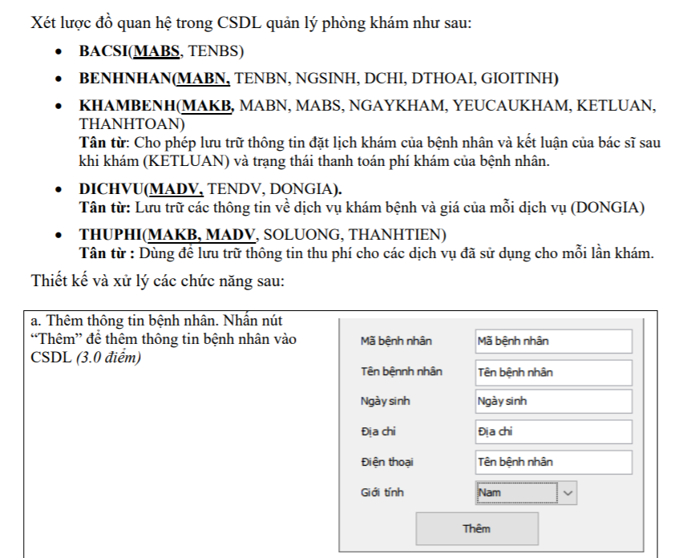

jTextField txtMaBenhNhan = new jTextField(“Mã Bệnh Nhân”);

jTextField txtTenBenhNhan= new =jTextFIeld(“ Tên Bệnh Nhân”);

jTextFIeld txtNgaySinh = new jTextField(“ Ngày Sinh”);

jTextField txtSoDIenThoai= new jTextField(‘Số Điện Thoại”);

jCombobox cbbGioiTinh = new Jcombobox( new String[]{“ Nam”, “Nữ”};

jButton btnThem= new jButton(“ Thêm ”);

btnthem.addActionListener( (e)->{

String sql= “ insert into BenhNhan (mabn,tenbn, ngsinh, diachi, dthoai, gioitinh) values

txtMaBenhNhan.getText(), txtTenBenhNhan.getText(), txtNgaySinh.getText(),txtDiaChi.getText(),cbbGioiTinh.getSelectedItem()”;

Statement stmt = con.createStatement();

Stmt.execute(sql);

Con.close();

});

Câu 2:

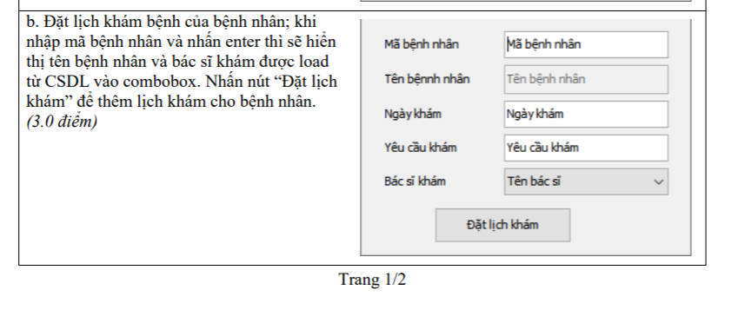

jTextField txtMaBenhNhan = new jTextField(“Mã Bệnh Nhân”);

jTextField txtTenBenhNhan= new =jTextFIeld(“ Tên Bệnh Nhân”);

txtTenBenhNhan.setEnabled(false);

jTextField txtNgayKham = new jTextField(“Ngày Khám”);

jTextField txtYeuCauKham= new =jTextFIeld(“ Yêu Cầu Khám”);

jCombobox cbbBacSiKham = new jComBoBox(new String[]{”Tên Bác Sĩ”}):

jButton btnDatLichKham = new jButton(“ Đặt Lịch Khám”);

txtMaBenhNhan.addKeyListener(new KeyAdapter() {

@Override

public void keyPressed(KeyEvent e) {

if (e.getKeyCode() == KeyEvent.VK_ENTER) {

String sql_BenhNhan = "select* from BenhNhan where mabn= txtMaBenhNhan.getText() '";

Statement stmt = con.createStatement();

ResultSet rs= (ResultSet) stmt.excuteQuery(sql_BenhNhan);

while (rs.next()) txtTenBenhNhan.setText(rs.getString("tenbn"));

con.close();

});

String sql= “select * from BacSi”;

Statement stmt = con.createStatement();

ResultSet rs= (ResultSet) stmt.excuteQuery(sql);

ArrayList<String> Key= new ArrayList<String>();

While(rs.next(){

Key.add( rs.getString(“ mabs”) );

cbbBacSiKham.addItem(rs.getString(“TenBs”);

}

con.close();

btnDatLichKham.addActionListener((e) -> {

String sql= "insert into KhamBenh (mabn,mabs,ngaykham,yeucaukham, ketLuan,thanhtoan) values ( txtMaKhamBenh.getText(), Key.get( cbbBacSiKham.getSelectedIndex() ), txtNgayKham.getText(), txtYeuCauKham.getText() )”;

Statement stmt = con.createStatement();

Stmt.execute(sql);

});

Câu 3:

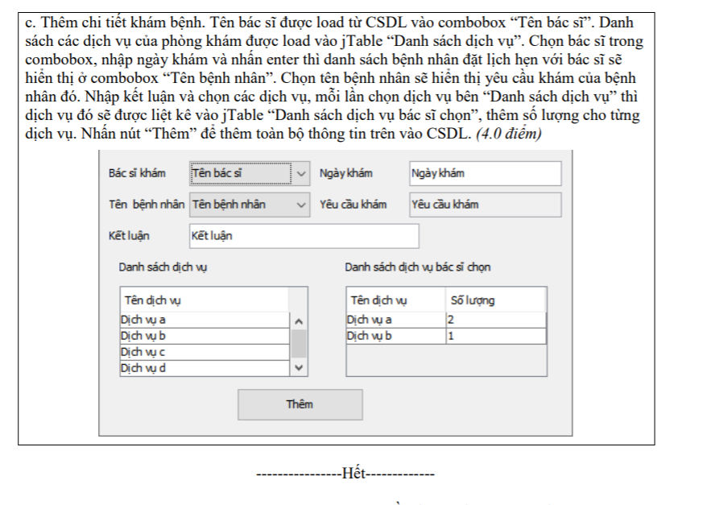

jCombobox BacSiKham = new jCombobox( new String[]{“Tên Bác Sĩ”})// đã Làm câu 2

jTextField txtNgayKham = new jTextField(“Ngày khám”):

jTextField txtYeuCauKham = new jTextField(“Yêu Cầu Khám “);

txtYeuCauKham.setEnabled(false);

jTextField txtketLuan = new jTextField(“ Kết Luận”);

jTable tbDanhSachDichVu = new jTable();

DefaultTableModel modelDichVu = (DefaultTableModel) tbDanhSachDichVu.getModel();

modelDichVu.setColumnIdentifiers( new String []{ “ Tên Dịch Vụ” });

jTable tblBacSiChon = new jTable();

DefaultTableModel modelBacSiChon = (DefaultTableModel) tbBacSiChon.getModel();

modelDichVu.setColumnIdentifiers( new String []{ “ Tên Dịch Vụ” , “Số Lượng”});

ArrayList<String> KeyKB= new ArrayList<String>();

ArrayList<String> KeyBN= new ArrayList<String>();

this.txtNgayKham.addKeyListener( new KeyAdapter() {

@Override

public void keyPressed(KeyEvent e) {

if (e.getKeyCode() == KeyEvent.VK_ENTER) {

String sql= “ Select bn.Mabn, bn.TenBn

From KhamBenh kb join BenhNhan bn on kb.mabn = bn . mabn

Where kb.mabs = Key.get( cbbBacSiKham.getSelectedIndex() ) and

Kb.mabn= KeyBN.get(cbbTenBenhNhan.getSelectedIndex() ) and

kb.ngaykham =txtNgayKham.getText()”;

Statement stmt = con.createStatement();

ResultSet rs= (ResultSet) stmt.excuteQuery(sql);

While(rs.next(){

KeyKB.add( rs.getString("Makb") );

KeyBN.add( rs.getString("Mabn") );

cbbTenBenhNhan.addItem(rs.getString("TenBn"));

}

});

cbbTenBenhNhan.addActionListener((e) -> {

String SQL= "select yeucaukham

from khambenh where mabn=KeyBN.get( cbbTenBenhNhan.getSelectedIndex() ) and Mabs= KeyBS.get(cbbBacSiKhamM.getSelectedIndex() ) and ngaykham= txtNgayKhamM.getText() ";

Statement stmt = con.createStatement();

ResultSet rs= (ResultSet) stmt.excuteQuery(sql);

while (rs.next()) txtYeuCauKham.setText(rs.getString("yeucaukham"));

});

String dv= "select * from DichVu";

ArrayList<String>KeyDV= new ArrayList<String>();

ArrayList<String>ValueDV = new ArrayList<String>();

Statement stmt = con.createStatement();

ResultSet rs= (ResultSet) stmt.excuteQuery(sql);

while (rs.next()) {

KeyDV.add ( rs.getString("Madv") );

ValueDV.add( rs.getString("TenDV"));

}

for( var x : ValueDV) modelDichVu.addRow( new Object[]{ x });

DefaultTableModel modelDV= (DefaultTableModel) tblDanhSachBSChon.getModel();

ArrayList<String> ListTP= new ArrayList<String>();

tblDanhSachDichVu.addMouseListener(new MouseAdapter() {

@Override

public void mouseClicked(MouseEvent e)

{

int Index= tblDanhSachDichVu.getSelectedRow();

if(Index>-1)

{

ListTP.add(KeyDV.get(Index));

modelDV.addRow(new Object[]{ValueDV.get(Index),"0" });

}

}

});

btnThem.addActionListener((e) -> {

String sql_KhamBenh="update KhamBenh set ketluan=txtKetLuat.getText()

where Mabn=KeyBN[cbbTenBenhNhan.getSelectedIndex()] and mabs=Key[cbbBacSiKham.getSelectedIndex()] and ngaykham= txtNgayKham.getText()";

Statement stmt = con.createStatement();

Stmt.execute(sql);

for(int i=0; i<listTP.size() ; i++){

String Sql_ThuPhi= "insert into thuPhi values( makb= KeyKB.get( cbbTenBenhNhan.getSelectedIndex() ), madv= ListTP.get(i), soluong= modelDV.getValueAt(i, 0) , thanhtien=modelDV.getValueAt(i, 1) * dv.getDonGia () ";

Statement stmt = con.createStatement();

Stmt.execute(sql_thuPhi);

}

});

ĐỒ ÁN QUẢN LÝ QUÁN CÀ PHÊ

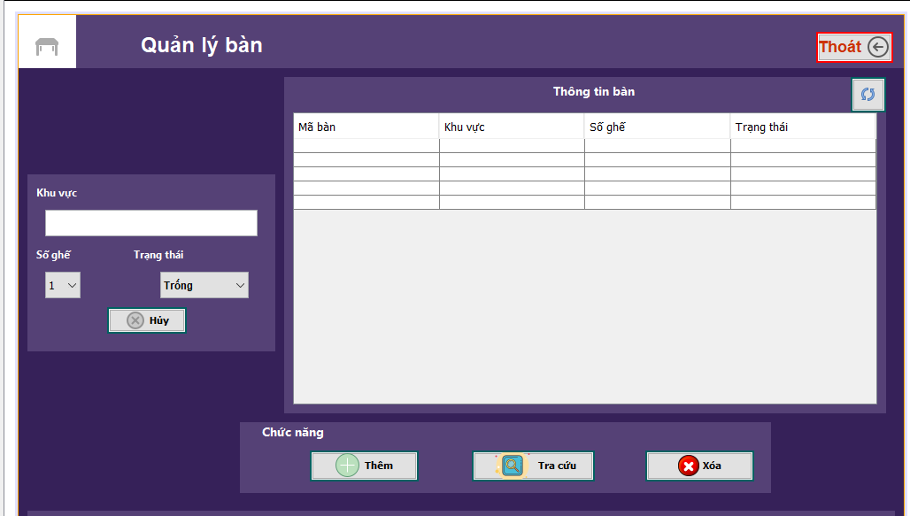

BanDTO

package DTO;

public class BanDTO {

int MaBan;

String KhuVuc;

int SoGhe;

String TrangThai;

public BanDTO(int MaBan, String KhuVuc, int SoGhe, String TrangThai) {

this.MaBan = MaBan;

this.KhuVuc = KhuVuc;

this.SoGhe = SoGhe;

this.TrangThai = TrangThai;

}

public BanDTO( String KhuVuc, int SoGhe, String TrangThai) {

this.KhuVuc = KhuVuc;

this.SoGhe = SoGhe;

this.TrangThai = TrangThai;

}

public BanDTO(){

}

public int getMaBan() {

return MaBan;

}

public void setMaBan(int MaBan) {

this.MaBan = MaBan;

}

public String getKhuVuc() {

return KhuVuc;

}

public void setKhuVuc(String KhuVuc) {

this.KhuVuc = KhuVuc;

}

public int getSoGhe() {

return SoGhe;

}

public void setSoGhe(int SoGhe) {

this.SoGhe = SoGhe;

}

public String getTrangThai() {

return TrangThai;

}

public void setTrangThai(String TrangThai) {

this.TrangThai = TrangThai;

}

}

BANDAL

package DAL;

import static DAL.Database.conectionJDBC;

import DTO.BanDTO;

import java.sql.ResultSet;

import java.sql.SQLException;

import java.sql.Statement;

import java.util.ArrayList;

import java.util.logging.Level;

import java.util.logging.Logger;

/**

*

* @author Acer

*/

public class BanDAL {

private Database db;

public BanDAL(){

db = new Database();

}

public ArrayList<BanDTO> getAllBan(){

ArrayList<BanDTO> listTable = new ArrayList<BanDTO>();

String sql = "select * from BAN";

ResultSet rs = Database.getData(conectionJDBC (),sql);

try {

while (rs.next()){

BanDTO table_DTO = new BanDTO();

table_DTO.setMaBan(rs.getInt("MABAN"));

table_DTO.setKhuVuc(rs.getString("KHUVUC"));

table_DTO.setSoGhe(rs.getInt("SOGHE"));

table_DTO.setTrangThai(rs.getString("TRANGTHAI"));

listTable.add(table_DTO);

}

} catch (SQLException ex) {

Logger.getLogger(BanDAL.class.getName()).log(Level.SEVERE, null, ex);

}

return listTable;

}

//Add Menu

public boolean addMenu( String KHUVUC, int SOGHE, String TRANGTHAI){

String sql = "insert into BAN values (MABAN_SEQ.nextval,'"+KHUVUC+"','"+SOGHE+"','"+TRANGTHAI+"')";

try {

Statement statement = conectionJDBC().createStatement();

statement.executeUpdate(sql);

return true;

} catch (Exception ex) {

ex.printStackTrace();

}

return false;

}

public ArrayList<String> loadDataToCombobox__SoGhe(){

ArrayList<String> list = new ArrayList<String>();

String sql = "Select SOGHE from BAN";

ResultSet rs = Database.getData(conectionJDBC(), sql);

try {

while (rs.next()){

list.add(rs.getString("SOGHE"));

}

} catch (SQLException ex) {

Logger.getLogger(BanDAL.class.getName()).log(Level.SEVERE, null, ex);

}

return list;

}

public ArrayList<String> loadDataToCombobox_TrangThai(){

ArrayList<String> list = new ArrayList<String>();

String sql = "Select TRANGTHAI from BAN";

ResultSet rs = Database.getData(conectionJDBC(), sql);

try {

while (rs.next()){

list.add(rs.getString("TRANGTHAI"));

}

} catch (SQLException ex) {

Logger.getLogger(BanDAL.class.getName()).log(Level.SEVERE, null, ex);

}

return list;

}

public boolean addMenu(String text) {

throw new UnsupportedOperationException("Not supported yet."); //To change body of generated methods, choose Tools | Templates.

}

//Xóa bàn

public boolean removeBan(String MaBan){

String sql = "delete from BAN where MABAN = '"+MaBan+"'";

Statement statement;

try {

statement = conectionJDBC().createStatement();

statement.executeUpdate(sql);

return true;

} catch (SQLException ex) {

Logger.getLogger(BanDAL.class.getName()).log(Level.SEVERE, null, ex);

}

return false;

}

// Look up

public BanDTO getBan(int MaBan){

String sql = "select * from BAN where MABAN = '"+MaBan+"'";

ResultSet rs = Database.getData(conectionJDBC (),sql);

BanDTO table_DTO = new BanDTO();

try {

while (rs.next()){

table_DTO.setMaBan(rs.getInt("MAMON"));

table_DTO.setKhuVuc(rs.getString("KHUVUC"));

table_DTO.setSoGhe(rs.getInt("SOGHE"));

table_DTO.setTrangThai(rs.getString("TrangThai"));

//listMenu.add(menu_DTO);

}

} catch (SQLException ex) {

Logger.getLogger(BanDAL.class.getName()).log(Level.SEVERE, null, ex);

}

return table_DTO;

}

}

BanBLL

package BLL;

import DAL.BanDAL;

import DTO.BanDTO;

import java.util.ArrayList;

public class BanBLL {

BanDAL tableDAL = new BanDAL();

public ArrayList<BanDTO> getAllBan()

{

return tableDAL.getAllBan();

}

public boolean addmenu(String KHUVUC, int SOGHE, String TRANGTHAI){

return tableDAL.addMenu(KHUVUC,SOGHE,TRANGTHAI);

}

public boolean removeBan(String MaBan){

return removeBan(MaBan);

}

public BanDTO getBan(int MaBan){

return tableDAL.getBan(MaBan);

}

}

BAN_GUI

public class Ban_GUI extends javax.swing.JFrame {

DefaultTableModel tableModel;

public JTable getTblMenu() {

return jTable__Bang;

}

public void setTblMenu(JTable tblMenu) {

this.jTable__Bang = tblMenu;

}

/**

* Creates new form Ban_GUI

*/

public Ban_GUI() {

initComponents();

tableModel = (DefaultTableModel) jTable__Bang.getModel();

showTable();

// loadCombobox();

// loadCombobox1();

}

private void loadCombobox(){

BanDAL dal = new BanDAL();

ArrayList<String> list = dal.loadDataToCombobox__SoGhe();

for (String item : list){

jComboBox__SoGhe.addItem(item.toString());

}

}

private void loadCombobox1(){

BanDAL dal = new BanDAL();

ArrayList<String> list = dal.loadDataToCombobox_TrangThai();

for (String item : list){

jComboBox_TrangThai.addItem(item.toString());

}

}

public void showTable(){

BanDAL dal= new BanDAL();

ArrayList<BanDTO> listNL = dal.getAllBan();

tableModel.setRowCount(0);

for(BanDTO s : listNL){

tableModel.addRow(new Object[]{s.getMaBan(), s.getKhuVuc(), s.getSoGhe(),s.getTrangThai(), });

}

}

private void button_thoatActionPerformed(java.awt.event.ActionEvent evt) {

// TODO add your handling code here:

new Chu_Quan().setVisible(true);

this.dispose();

}

private void jButton_huyActionPerformed(java.awt.event.ActionEvent evt) {

// TODO add your handling code here:

jKhuVuc.setText("");

jComboBox__SoGhe.setSelectedItem("1");

jComboBox_TrangThai.setSelectedItem("Trống");

}

private void jButton_xoaActionPerformed(java.awt.event.ActionEvent evt) {

// TODO add your handling code here:

// REMOVE

int xoa = jTable__Bang.getSelectedRow();

String MaBan = jTable__Bang.getValueAt(xoa, 0).toString();

BanDAL dal = new BanDAL();

if(dal.removeBan(MaBan)){

JOptionPane.showMessageDialog(rootPane, "success");

new Ban_GUI().setVisible(true);

}

else{

JOptionPane.showMessageDialog(rootPane, "eror");

}

}

private void jButton_tracuuActionPerformed(java.awt.event.ActionEvent evt) {

// TODO add your handling code here:

// LOOK UP

bienTam.a = 1;

A lookup = new A();

lookup.setLocationRelativeTo(null);

lookup.setVisible(true);

this.setVisible(false);

}

public void show1mon(int MaBan){

int rowCount = jTable__Bang.getRowCount();

int temp = 0;

for (int i = 0;i< rowCount;i++){

if (String.valueOf(MaBan).equals(jTable__Bang.getValueAt(i, 0).toString())){

BanBLL tdBLL = new BanBLL();

BanDTO td = tdBLL.getBan(MaBan);

tableModel.setRowCount(0);

tableModel.addRow(new Object[]{td.getMaBan(), td.getKhuVuc(),td.getSoGhe(), td.getTrangThai()});

temp++;

break;

}

}

if (temp == 1){

JOptionPane.showMessageDialog(rootPane, "TÌM THÀNH CÔNG");

}

else {

JOptionPane.showMessageDialog(rootPane, "Khong co mã bàn vua tim");

}

}

private void jButton_themActionPerformed(java.awt.event.ActionEvent evt) {

// TODO add your handling code here:

BanDAL menuDAL = new BanDAL();

String value = jComboBox__SoGhe.getSelectedItem().toString();

String value1 = jComboBox_TrangThai.getSelectedItem().toString();

if( menuDAL.addMenu(jKhuVuc.getText(),Integer.parseInt(value), value1.toString() ))

{

JOptionPane.showMessageDialog(rootPane, "success");

}

else{

JOptionPane.showMessageDialog(rootPane, "error");

}

}

public static void main(String args[]) {

public void run() {

new Ban_GUI().setVisible(true);

}

}