NEXTAG PRODUCT

# NEXTAG is a company specializing in selling all kinds of purse and wallets.They have many products of different brands such as Lous Vuitton,Gucci, Dior, Prada, Coach, Love Moschino, Burberry. The company is always updated with the latest market trends, collections of many famous brands.

**1.Information product**

**a. Introduce**

A wallet is a small, flat case that can be used to carry such small personal items as paper currency, credit cards, and identification documents (driver's license, identification card, club card, etc.), photographs, transit pass, business cards and other paper or laminated cards.

A purse is designed to hold your wallet and many other items, including your home keys, smartphone, makeup, a bottle of water, and anything else you might need throughout the day.

In addition to their practical function, wallet and purse may be used as a fashion accessory, or to demonstrate the style, wealth, or status of the owner.

**b. Types**

* Bi-fold wallet: a type of wallet in which the banknotes are folded over once. Credit cards and identification cards may be stored horizontally or vertically.

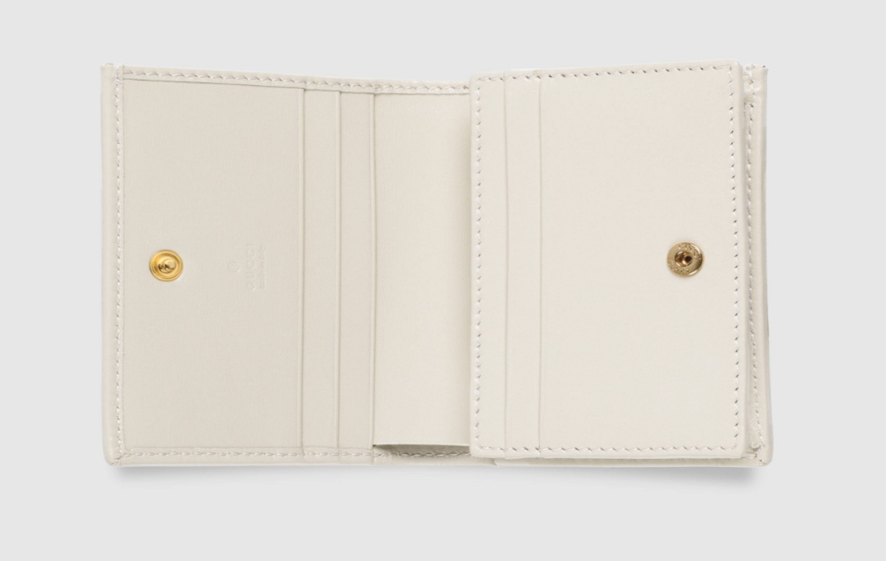

* Tri-fold wallet: a wallet with two folds, in which credit cards are generally stored vertically.

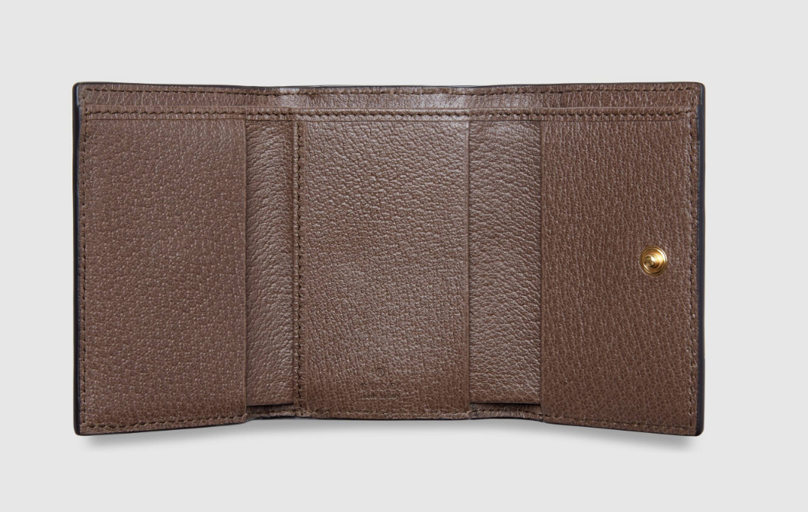

* Front pocket wallet: a case with no currency compartment and very few pockets for cards. Usually banknotes are folded and held in a wallet compartment.

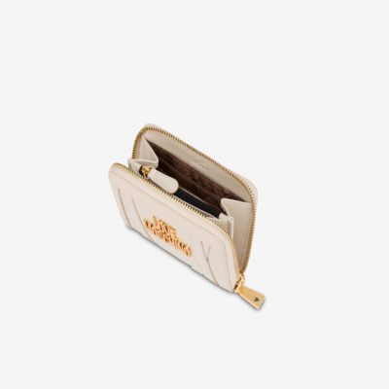

* Long wallet: a larger wallet usually worn with jeans, fastened by a chain, strap, or leather rein. Bills are held flat, and long wallets typically have a coin purse.

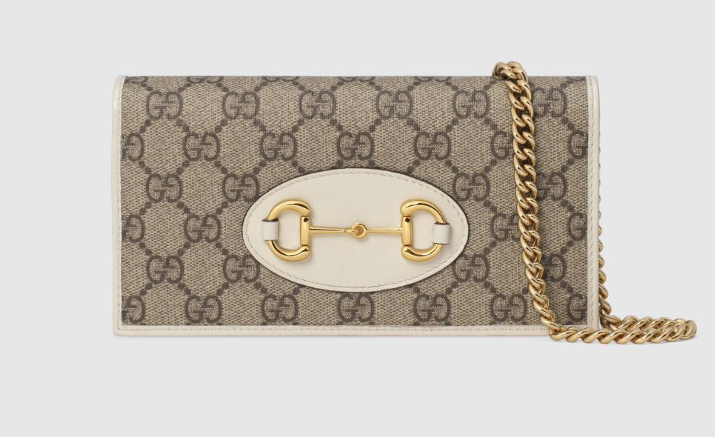

* Side by side wallet: divides the contents into two stacks instead of one, so it is half as thick.

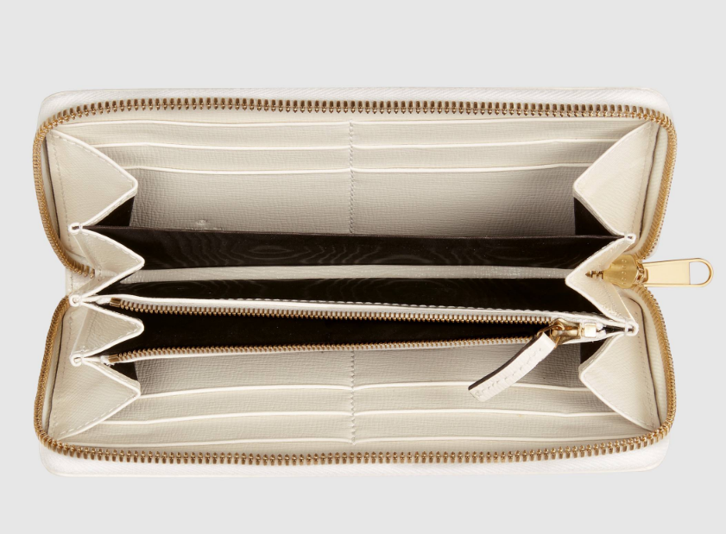

* The baguette purse: has with one or two short straps which makes it a great to wear with dressier clothing

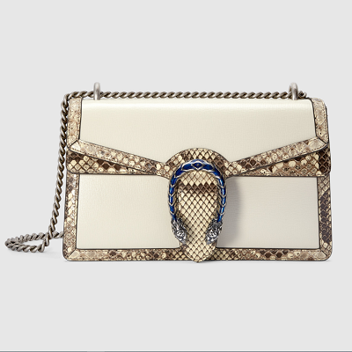

* Coin purse: is a small money bag or pouch, made for carrying [coins](https://en.wikipedia.org/wiki/Coin)

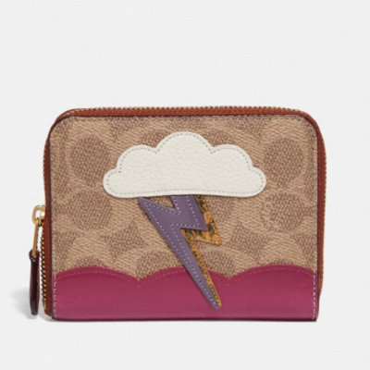

**c. Material**

* Leather: Calf leather, Goat leather, Lamb leather.

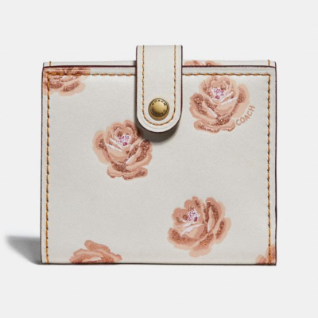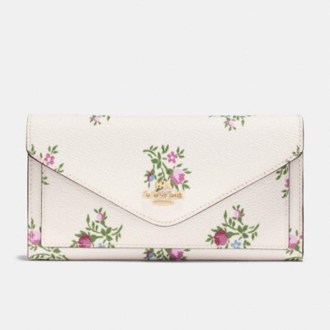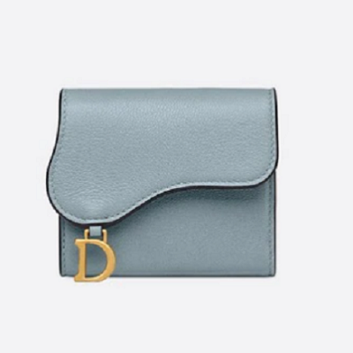

* Fabric :

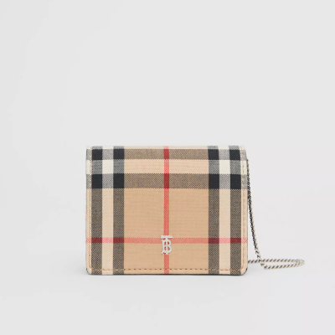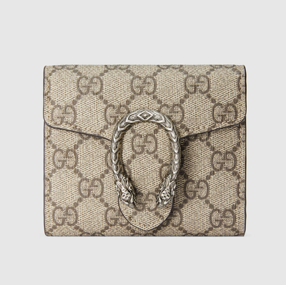

**2 .Product care**

* To keep your product beautiful as the years pass, we recommend following these guidelines for its care :
* Beware not to scratch or rub your product against abrasive surfaces, especially the leather trim.
* Keep your product away from damp or humid environments and avoid direct exposure to sunlight, keep your product away from any direct source of heat (radiators, car interiors overheated by the sun, etc ).
* - Avoid contact with greasy substances, cosmetics, perfume, and hydroalcoholic solutions, as well as any material (magazines, other leathers, etc.) that may transfer their coloured pigments onto the product.
* Keep your product away from water. Should it get wet or dirty on the surface, dry with a lint free, light-coloured, absorbent cloth. Never use soap or solvent.
* If your lining gets dirty or in case of superficial stains, we recommend that you wipe it with a soft and light-coloured cloth.
* In order to protect your product when you are not using it, store it in the felt protective pouch provided

Taking proper care of your NEXTAG product will allow you to fully appreciate its beauty for many years.

For any enquiries about your product, please do not hesitate to contact us.