|  |  |
| --- | --- |
|  | **FPT ACADEMY INTERNATIONAL**  **FPT – APTECH COMPUTER EDUCATION** |

**Centre Name: ACE-HCMC-2-FPT.**

**Address: 590 Cach Mang Thang 8, District 3, Ho Chi Minh City, Viet Nam.**

MEDICARE

**Design Document**

|  |  |  |
| --- | --- | --- |
| **Supervisor:** | Mr. TRAN PHUOC SINH | |
| **Semester:** | 4 | |
| **Batch No:** | T1.2008.A0 | |
| **Group No:** | 3 | |
| **Order:** | **Full name** | **Roll No.** |
| 1. | PHAN PHUC THINH | Student1275061 |
| 2. | NGUYEN THI MINH THU | Student1273010 |
| 3. | TRAN HOANG QUOC TAI | Student1273014 |
| 4. | VO THI KIM DUNG | Student1275249 |

**Month**: December **Year**: 2020

**This is to certify that**

**Mr.**PHAN PHUC THINH

**Mrs.** NGUYEN THI MINH THU

**Mr.** TRAN HOANG QUOC TAI

**Mrs.** VO THI KIM DUNG

**have successfully designed & developed:**

e-Project: MEDICARE

**Submitted by:**

Mr. TRAN PHUOC SINH

**Date of issue:** May 26nd 2022

**Authorized Signature:**

Table of Contents

REVIEW 1 95

I. ACKNOWLEDGEMENT 5

II. Problem definition 6

**1.** **Introduction:** 6

**2.** **Existing System :** 6

III. Requirement Specification 6

**1.** **Customer’s Requirement Specifications:** 6

**1.1** **Online Auction :** 6

**1.2** **Admin** 7

**1.3** **Users** 7

**1.3.1** **Buyers role:** 7

**1.3.2** **Seller role :** 7

1.4 Payment module of online auction art system: 7

**1.5** **About us** 8

**1.6** **Contact us** 8

**2.** **Functional Requirement Specifications :** 8

**2.1** **Function of Admin :** 8

**2.2** **Function of Users:** 8

**3.** **Non-Functional Requirement Specifications:** 9

**4.** **System Requirement Specifications:** 10

**4.1. Server requirements:** 10

4.2 Client requirements: 10

**5.** **Development Software** 10

**6.** **Technology** 10

Task Sheet REVIEW 1 11

REVIEW 2 12

I. ARCHITECTURE AND DESIGN OF THE PROJECT: 13

II. ALGORITHM AND DATA FLOWCHART 13

**1.** **Symbol generates:** 13

**2.** **Main data flowchart for admin and users.** 14

**3.** **Login process (For both admins and users).** 15

**4.** **Logout process (For both admin and users).** 15

**5.** **Insert user (For admin).** 15

**6.** **Update user (For admin).** 16

**7.** **Delete user (For admin).** 16

**8.** **Insert , update ,delete Product(For users and admin).** 17

**9.** **Insert , update ,delete Auction(For users and admin).** 18

**9.** **Insert , update ,delete Category for admin.** 19

**10.** **Crreate Rating (For users).** 19

**11.** **Bid AMOUNT (For buyers)** 20

III. Use Case Diagram 20

**1.** **Admin Use Case** **Diagram** 21

**2.** **Seller Use Case Diagram:** 22

**3.** **Buyer Use Case** **Diagram** 23

**IV. Entities & Attributes** 24

**1.** **Category** 24

**2.** **Products** 25

**3.** **User** 25

**4.** **Auction** 25

**3.** **AuctionBid** 26

**4.** **Rating** 26

**5.** **Message** 27

**6.** **Commnent** 27

**7.** **News** 28

V. Entity Relationship Diagram (ERD Concept) 29

Task Sheet REVIEW 2 30

REVIEW 3 31

I. Table Structure (ERD Physical) 32

II. Database Design 33

III. Site Map 37

**1.** **User Sitemap** 37

**2.** **Admin Sitemap** 38

Task Sheet REVIEW 3 98

# REVIEW 1

# ACKNOWLEDGEMENT

* First and foremost, we would like to express the deepest appreciation to our admirable instructor – Mr. TRAN PHUOC SINH. During the time of the project, he continually and convincingly conveyed a spirit of adventure in regard to research and scholarship, and an excitement in regard to teaching. Without his guidance and persistent help this dissertation would not have been possible. Therefore, once again, we truly value your dedication and guidance, Mr. SINH.
* Next, it would have been impossible to carry out and complete this project without the collaboration among our team members. Although we have gone through many obstacles during the project implementation, eventually we gained what we aimed at by our hard work, our strong commitment and of course, our brotherhood.
* Finally, thanks to Aptech’s e-Project team, we had a golden opportunity to apply what we have learnt into reality and gain hands-on experience which is essential for our future career.

# Problem definition

- **MediCare is both a companion and a personal doctor of your own family, every health problem that you calmly listen to has a dedicated answer by a doctor. As long as you have a phone with an internet or wifi connection, you can see a doctor wherever you are.**

**- ADMIN:** The administrator will log in and update the website's data. Admin can add or remove

templates, images. In addition, the administrator can view the responses received from users. Admin

can see a list of all transactions made. Users can manage their profile, purchase products and make

payments. Payment details must be checked by Admin.

**- FAVORABLE:**

* **Patients do not have to go to the clinic, do not have to wait in line for the examination.**
* **Doctors can easily detect abnormal symptoms early and monitor the progression of the disease as well as the effectiveness of treatment methods or drugs. Finally give the best adjustments, advice.**
* **Especially during the Covid-19 epidemic, limiting contact brings safety for both patients and medical staff.**
* Doctors using telehealth consultation services bring more sources of income, besides the main source of income from the hospital.

**- WEAKNESS:**

* Human resources for doctors are still small and cannot meet the requirements
* Regulations on coordination and appropriate information exchange between family doctor's clinics and the medical examination and treatment system have not been developed in the process of patient management.
* Fees for home health care services are still spontaneous and have not been paid for by health insurance.

# Requirement Specification

1. **Customer’s Requirement Specifications:**
   1. **MediCare :**

- The website allows users to view auction products offered by OA.

- The website contains all kinds of products by categories such as sale products, new products.

- The homepage should be well designed and formatted with all proper navigation links, site headers and footers, Links to login to the site.

- It must contain links such as Home; discount products, new products, Payment methods, About us, Contact, Login (admin and user).

* 1. **Admin**
* Admin give the access to the users who want to become the member of the Online Auction.
* Admin will set up the Categories of the items. A category is a logical subdivision of products (eg: Furniture, Electronic Accessories, Books) Admin should be able to Create Categories, Merge Category etc..
* Whenever the buyers want to purchase products from the Online Auction they can bid by providing a bid amount (which should be greater than the previous bid).
  1. **Users**

Users is classified by 2 categories : artist role who want to display and sell the art works on the website and the buyers (art lovers) role who want to buy the art works.

* + 1. **Buyers role:**
* Once a buyer has login information, they can create their profile to be able to access new products and check the information to be able to bid on that product.
* Buyers can also upload their data related to their personal information like name, address, phone... etc.
* Buyers can review and rate the products.
  + 1. **Auctioneer role :**

### Auctioneers can register as members and pay a small portion of the price of each product to the site to finance the site's operations.

### Auctioneers can hold auctions and sell products at the maximum bid price.

1.4 **Payment Module of OA System:**

* This modules helps the buyers to make the financial transactions easily.
* The buyers can make a deposit or make the payment with different payment methods such as :debit card, credit card or through net banking(ex: PayPal).
* The buyers will get the notification to complete the payment prior two to three days so that buyers don’t get any late charges.
  1. **About us**
* The admin can change or update easily the design and the content of the About us page .
  1. **Contact us**
* The admin can change or update easily the design and the content of the Contact us page .

1. **Functional Requirement Specifications :**
   1. **Function of Admin :**

* REQ-01: Login, Logout.
* REQ-02: Change Password.
* REQ-03: Manage user.
* REQ-04 : Manage category products.
* REQ-05: Manage history of auctions
* REQ-05: Manage the information of the products.
  1. **Function of Users:**

2.2.1. Function of buyers:

* REQ-06 : Register.
* REQ-07 : Login, Logout.
* REQ-08 : Receive the notification and verification by email.
* REQ-09 : Search the product by categories and title.
* REQ-10: View the information about the products
* REQ-11 : Participate the auction by submitting their bids.
* REQ-12 : For each product sold, the seller will rate the buyer.
* REQ-13 : Contact the admin.

2.2.2. Function of auctioneer:

* REQ-14: Register.
* REQ-15: Login, Logout.
* REQ-16 : Create new product and edit information product.
* REQ-17 : Create the auction or delete the auction if unsatisfied.
* REQ-18: Pay a fraction of the price of each product to the Website.
* REQ-23 : Contact the admin.

1. **Non-Functional Requirement Specifications:**

* Login by Facebook, Gmail.
* Report.
* Realtime of auction.

1. **System Requirement Specifications:**

**4.1. Server requirements:**

* **Hardware**

|  |  |
| --- | --- |
| Component | Requirement |
| CPU | Processor type:  Pentium IV-compatible processor or faster  Processor speed:  Recommended: 2.0 GHz or faster |
| OS | Microsoft Windows XP or higher with IIS |
| Memory (RAM) | RAM:  Minimum: 512 MB  Recommended: 2 GB or more |
| Hard Drive | Free space:  Minimum: 200 MB  Recommended: 50 GB or more  Maximum: Operating system maximum |

* **Software :**

|  |  |
| --- | --- |
| Component | Requirement |
| ASP.NET Core | Version .NET Core 5.0 |
| RDBMS | Microsoft SQL Server |

### 4.2 Client requirements:

* **Hardware**

|  |  |
| --- | --- |
| Component | Requirement |
| CPU | Processor type:  Pentium III-compatible processor or faster  Processor speed:  Recommended: 1.0 GHz or faster |
| OS | All OS (Window, Linux, Android, Mac OS …) |
| Memory (RAM) | RAM:  Minimum: 512 MB  Recommended: 1 GB or more  Maximum: Operating system maximum |
| Hard Drive | Free space:  Minimum: 10 MB |

* **Software**

|  |  |
| --- | --- |
| Component | Requirement |
| Web Browser | IE 4.0 , Firefox 3.0,Chrome or Higher….. |

1. **Development Software**

* Microsoft SQL Server
* Microsoft Visual Studio 2019

1. **Technology**

* ASP.NET Core 5.0
* Entity Framework Core 5.0.12

# TASK SHEET REVIEW 1

|  |  |  |  |  |  |  |  |
| --- | --- | --- | --- | --- | --- | --- | --- |
| **Project Ref. No.:**  **e-P/Advertisement** **Portal Management** **System/01** | | **Project Title:** | **Activity Plan** **Prepared** **By:** | **Date of Preparation of Activity Plan:** | | | |
| **No.** | **Task** | **Actual Start** **Date** | **Actual** **Days** | **Team** **Mate** **Names** | **Status** |
| 1 | Acknowledgement | Online Auction | PHAN PHUC THINH | 20/12/2021 | 1 | All member | Completed |
| 2 | Problem Definition | 20/12/2021 | 1 | All member | Completed |
| 3 | Requirement Specification | 20/12/2021 | 1 | All member | Completed |
| 4 | Task sheet review | 20/12/2021 | 1 | All member | Completed |

|  |  |
| --- | --- |
| **Date: 20/12/2021** | |
| Signature of Instructor:  **Mr. TRAN PHUOC SINH** | Signature of Team Leader:  **PHAN PHUC THINH** |

|  |
| --- |
|  |

# REVIEW 2

# ARCHITECTURE AND DESIGN OF THE PROJECT:

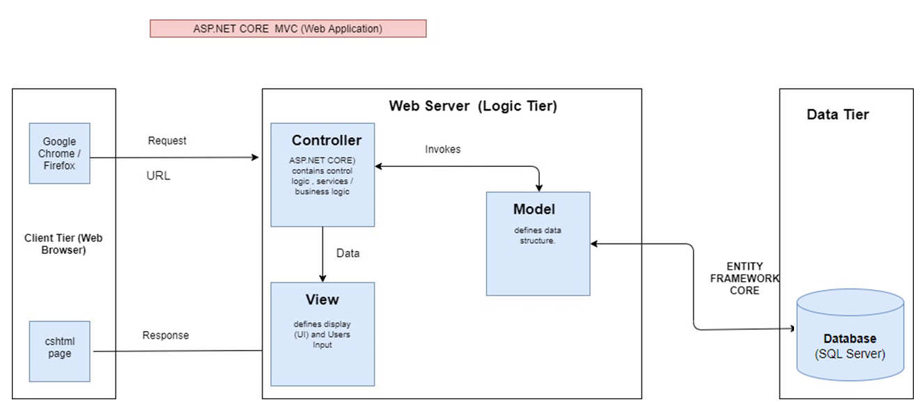

Figure 1: Architecture and Design of the Project

1. **ALGORITHM AND DATA FLOWCHART**
2. **Symbol generates:**

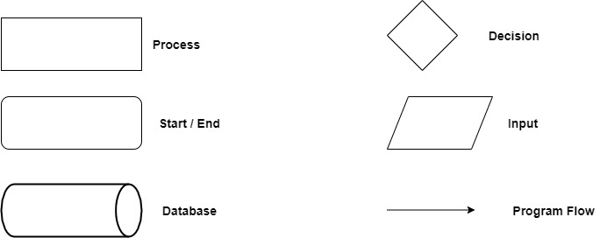

Figure 2: Symbol used in flowchart.

1. **Main data flowchart for admin and users.**

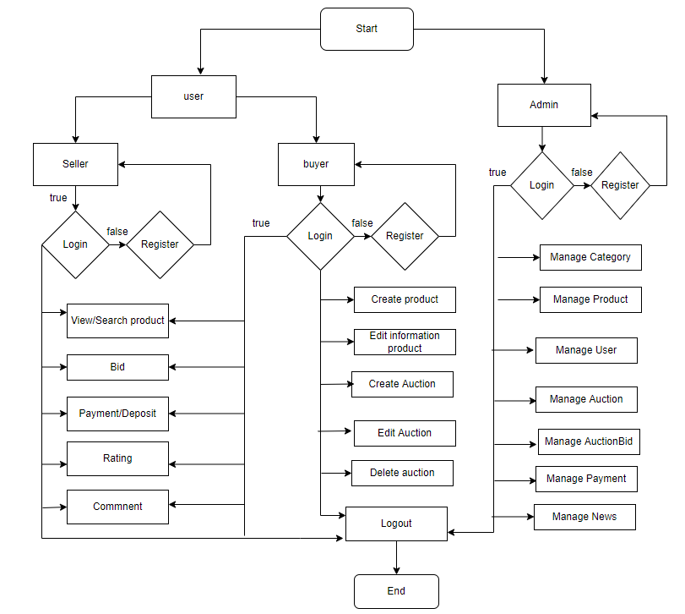

Figure 3: Main flowchart (For both admin and users).

1. **Login process (For both admins and users).**

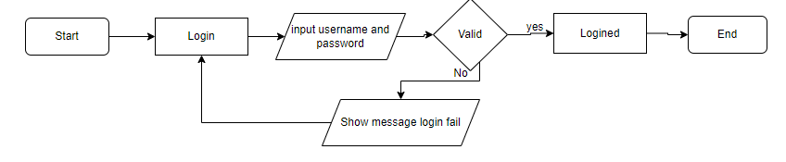

Figure 4: Login process.

1. **Logout process (For both admin and users).**

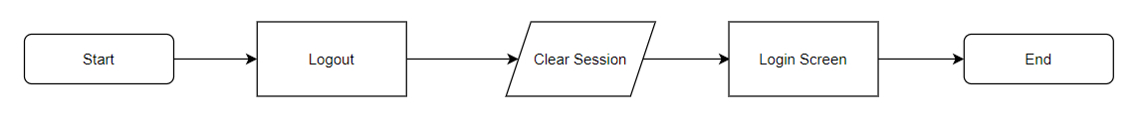

Figure 5: Logout process

1. **Insert user (For admin).**

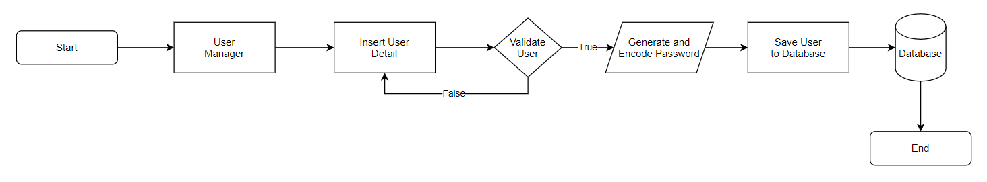

Figure 6: Insert user.

1. **Update user (For admin).**

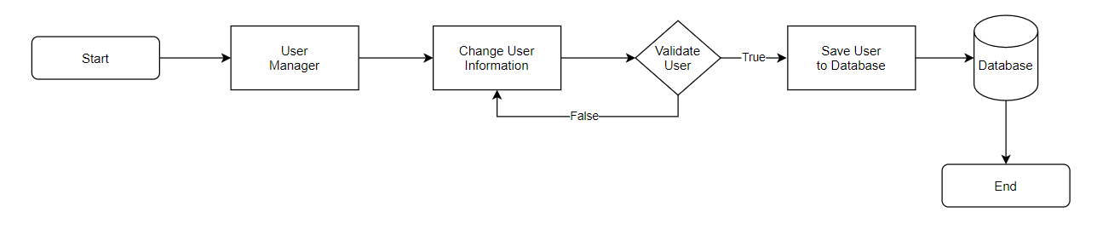

Figure 7: Update user

1. **Delete user (For admin).**

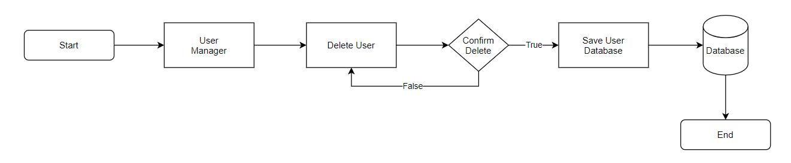

Figure 8: Delete user.

### Update user’s information (For User only)

Figure 9: Update user.

1. **Create, Edit and Delete Product (For admin and users).**

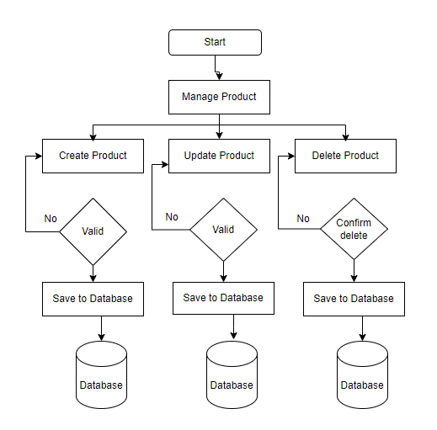

Figure 10: Manage Product.

### Insert, Update, Delete Auction (For admin and users).

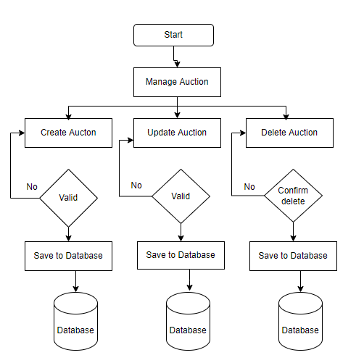

Figure 11: Manage Auction

### Insert, Update, Delete Category (For admin only)

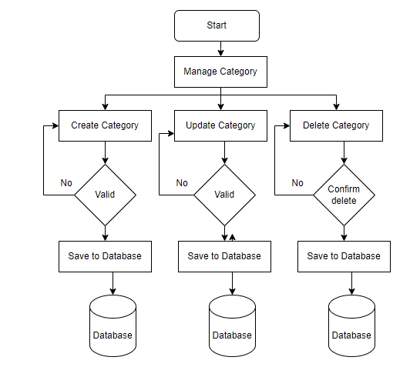

Figure 12: Manage Category

1. **Create Rating (For both admin and users).**

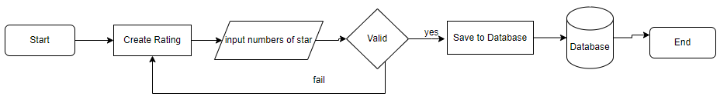

Figure 13: Create Rating.

1. **Bit price online (For buyers)**

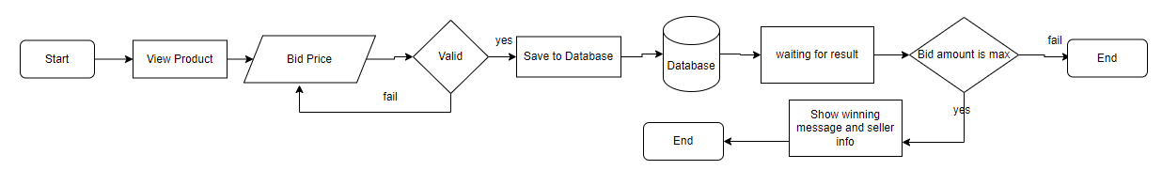

Figure 14: Bit price online.

## Use Case Diagram

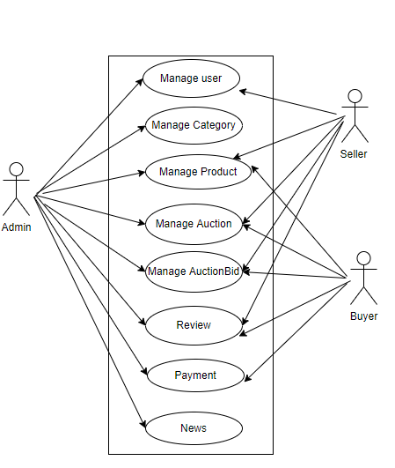

1. **Admin Use Case**

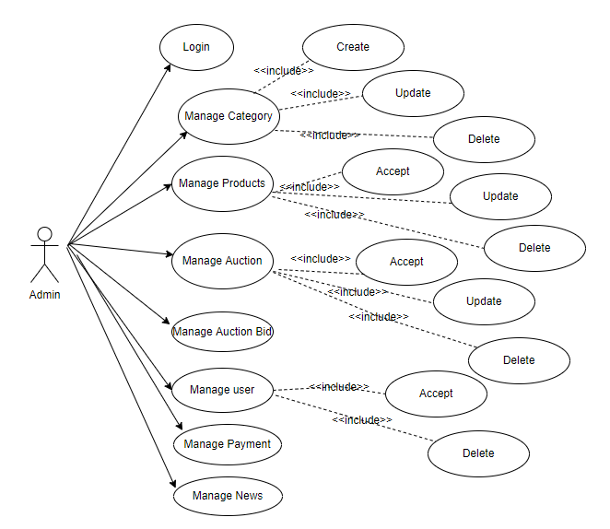

### Seller Use Case

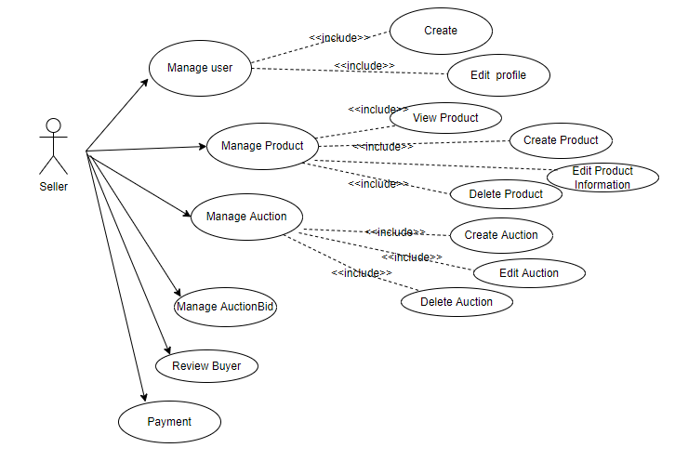

### Buyer Use Case (Subcribed)

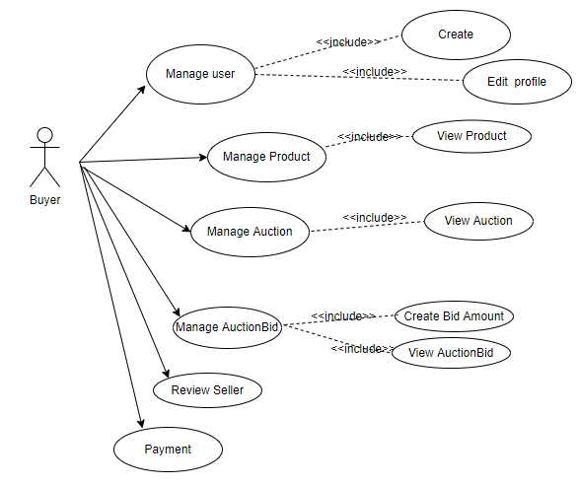

1. **Entities & Attributes**
2. **Category**

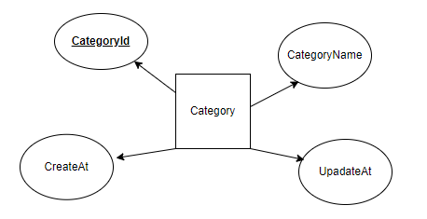

1. **Products**

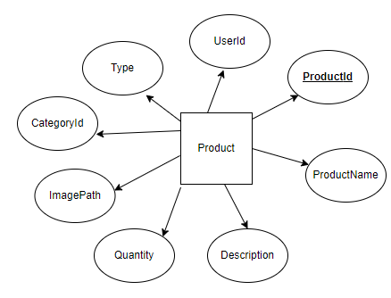

1. **User**

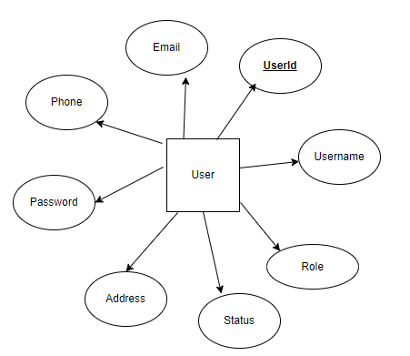

1. **Auction**

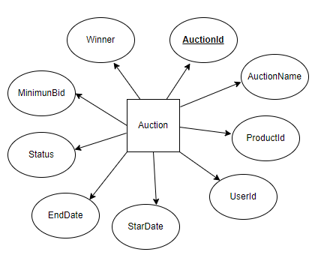

1. **AuctionBid**

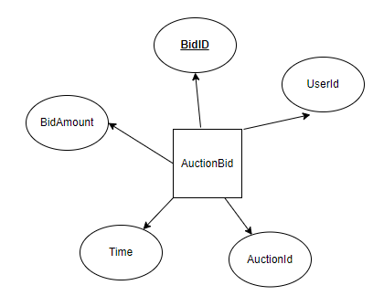

1. **Rating**

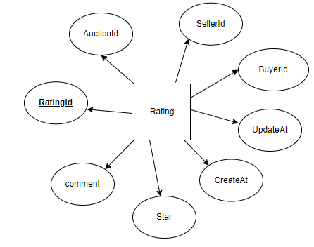

1. **Message**

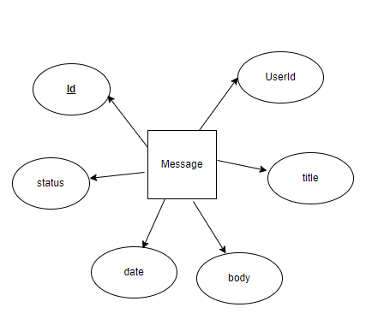

1. **News**

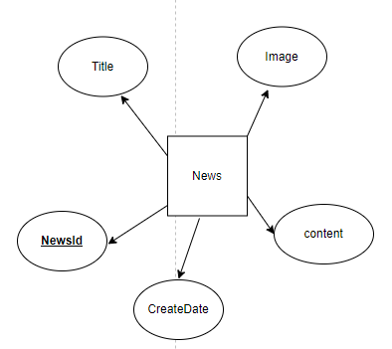

1. **Entity Relationship Diagram (ERD Concept)**

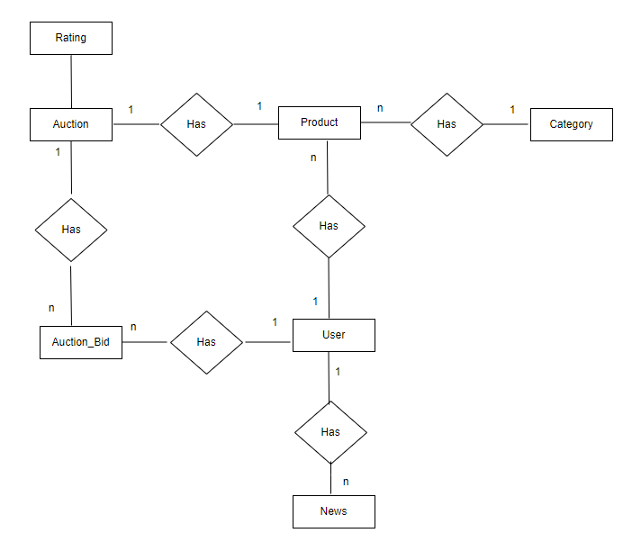

# Task Sheet REVIEW 2

|  |  |  |  |  |  |  |  |
| --- | --- | --- | --- | --- | --- | --- | --- |
| **Project Ref. No.:**  **eP/Advertisement** **Portal Management** **System/01** | | **Project Title:** | **Activity Plan** **Prepared** **By:** | **Date of Preparation of Activity Plan:** | | | |
| **Sr.No.** | **Task** | **Actual Start** **Date** | **Actual** **Days** | **Team** **Mate** **Names** | **Status** |
| 1 | Architecture & Design of Project | Online Auction | Thinh | 24/12/2021 | 2 | All Member | Completed |
| 2 | Algorithms – Data Flowchart | 24/12/2021 | 2 | All Member | Completed |
| 3 | Use Case Diagram | 24/12/2021 | 3 | All Member | Completed |
| 4 | Entity and Properties | 24/12/2021 | 2 | All Member | Completed |
| 5 | ERD Concept | 24/12/2021 | 3 | All Member | Completed |
| 6 | Task sheet review | 24/12/2021 | 1 | Thinh | Completed |

|  |  |
| --- | --- |
| **Date: 27/12/2021** | |
| Signature of Instructor:  **Mr. Tran Phuoc Sinh** | Signature of Team Leader:  **Phan Phúc Thịnh** |
|  |  |

|  |  |
| --- | --- |
|  | |
|  |  |
|  |  |

# 

# REVIEW 3

\

1. **Table Structure (ERD Physical)**

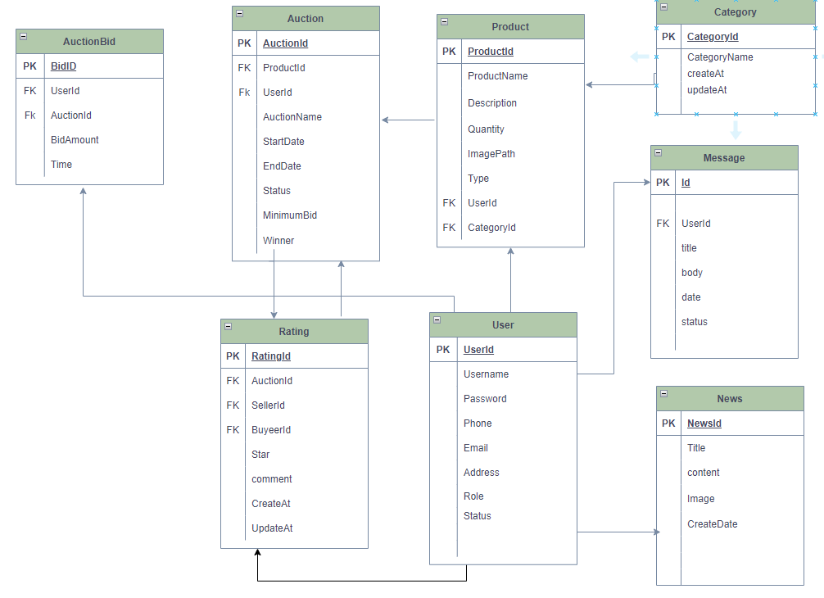

1. **Database Design**

|  |  |  |  |  |  |  |  |  |
| --- | --- | --- | --- | --- | --- | --- | --- | --- |
| **Category** | |  |  |  |  |  |  |  |
| **Sr.No** | **Field Name** | **Data Type** | **Size** | **Null** | **DefaultValue** | **Key** | **Table-Field-Ref** | **Description** |
| 1 | CategoryId | int | 11 | Not Allow | Identity(1,1) | Primary |  |  |
| 2 | CategoryName | varchar | 50 | Not Allow |  |  |  |  |
| 3 | CreateAt | datetime |  |  |  |  |  |  |
| 4 | UpdateAt | datetime |  |  |  |  |  |  |

|  |  |  |  |  |  |  |  |  |
| --- | --- | --- | --- | --- | --- | --- | --- | --- |
| **Product** | |  |  |  |  |  |  |  |
| **Sr.No** | **Field Name** | **Data Type** | **Size** | **Null** | **DefaultValue** | **Key** | **Table-Field-Ref** | **Description** |
| 1 | ProductId | int | 11 | Not Allow | Identity(1,1) | Primary |  |  |
| 2 | ProductName | varchar | 150 | Not Allow |  |  |  |  |
| 3 | Description | text |  | Not Allow |  |  |  |  |
| 4 | ImagePath | varchar | 100 |  |  |  |  |  |
| 5 | UserId | int | 11 | Not Allow |  | Foreign | User |  |
| 6 | CategoryId | int | 11 | Not Allow |  | Foreign | Category |  |
| 7 | Status | bit |  |  |  |  |  |  |
| 8 | Type | Varchar | 50 | Not Allow |  |  |  |  |

|  |  |  |  |  |  |  |  |  |
| --- | --- | --- | --- | --- | --- | --- | --- | --- |
| **Auction** | |  |  |  |  |  |  |  |
| **Sr.No** | **Field Name** | **Data Type** | **Size** | **Null** | **DefaultValue** | **Key** | **Table-Field-Ref** | **Description** |
| 1 | AuctionId | int | 11 | Not Allow | Identity(1,1) | Primary |  |  |
| 2 | ProductName | varchar | 255 |  |  |  |  |  |
| 3 | ProductId | int | 11 | Not Allow |  | Foreign | Product |  |
| 4 | UserId | int | 11 | Not Allow |  | Foreign | User |  |
| 5 | StartDate | datetime | 100 |  |  |  |  |  |
| 6 | EndDate | datetime | 11 | Not Allow |  |  |  |  |
| 7 | MinimumBid | int | 11 | Not Allow |  |  |  |  |
| 8 | Winner | int | 11 |  |  | Foreign | User |  |
| 8 | Status | bit |  |  |  |  |  |  |

|  |  |  |  |  |  |  |  |  |  |  |  |  |  |  |  |  |  |  |  |  |  |  |  |  |  |  |  |  |  |  |  |  |  |  |  |  |  |  |  |  |  |  |  |  |  |  |  |  |  |  |  |  |  |  |  |  |  |  |  |  |  |  |  |  |  |  |  |  |  |  |  |  |  |  |  |  |  |  |  |  |  |  |  |  |  |  |  |  |
| --- | --- | --- | --- | --- | --- | --- | --- | --- | --- | --- | --- | --- | --- | --- | --- | --- | --- | --- | --- | --- | --- | --- | --- | --- | --- | --- | --- | --- | --- | --- | --- | --- | --- | --- | --- | --- | --- | --- | --- | --- | --- | --- | --- | --- | --- | --- | --- | --- | --- | --- | --- | --- | --- | --- | --- | --- | --- | --- | --- | --- | --- | --- | --- | --- | --- | --- | --- | --- | --- | --- | --- | --- | --- | --- | --- | --- | --- | --- | --- | --- | --- | --- | --- | --- | --- | --- | --- | --- |
| |  |  |  |  |  |  |  |  |  |  | | --- | --- | --- | --- | --- | --- | --- | --- | --- | --- | | **AuctionBid** | |  |  |  |  |  |  |  |  | | **Sr.No** | **Field Name** | **Data Type** | **Size** | **Null** | **DefaultValue** | **Key** | **Table-Field-Ref** | **Description** | | 1 | BidId | int | 11 | Not Allow | Identity(1,1) | Primary |  |  | | 2 | UserId | int | 11 | Not Allow |  | Foreign | User |  | | 3 | AuctionId | int | 11 | Not Allow |  | Foreign | Auction |  | | 4 | BidAmount | int |  | Not Allow |  |  |  |  | | 5 | Time | datetime |  |  |  |  |  |  | | | | | | | | | | | | | | | | | |  | |  |  |  |  |  |  |
| **User** | | |  | | |  |  | |  | |  | |  | |  | | |
| **Sr.No** | **Field Name** | **Data Type** | | **Size** | **Null** | | | **DefaultValue** | | **Key** | | **Table-Field-Ref** | | **Description** | |
| 1 | UserId | int | | 11 | Not Allow | | | Identity(1,1) | | Primary | |  | |  | |
| 2 | Username | varchar | | 100 | Not Allow | | |  | |  | |  | |  | |
| 4 | Password | varchar | | 50 | Not Allow | | |  | |  | |  | |  | |
| 5 | Address | varchar | | 255 | Not Allow | | |  | |  | |  | |  | |
| 6 | Phone | varchar | | 11 | Not Allow | | |  | |  | |  | |  | |
| 7 | Email | varchar | | 255 | Not Allow | | |  | |  | |  | |  | |
| 8 | Type | int | | 11 | Not Allow | | |  | |  | |  | |  | |
| 9 | Status | bit | |  | Not Allow | | |  | |  | |  | |  | |

|  |  |  |  |  |  |  |  |  |
| --- | --- | --- | --- | --- | --- | --- | --- | --- |
| **Rating** | |  |  |  |  |  |  |  |
| **Sr.No** | **Field Name** | **Data Type** | **Size** | **Null** | **DefaultValue** | **Key** | **Table-Field-Ref** | **Description** |
| 1 | RatingId | int | 11 | Not Allow | Identity(1,1) | primary |  |  |
| 2 | AuctionId | int | 11 | Not Allow |  | foreign | Auction |  |
| 3 | SellerId | int | 11 | Not Allow |  | foreign | User |  |
| 4 | BuyerId | int | 11 | Not Allow |  | foreign | User |  |
| 5 | Star | int | 11 |  |  |  |  |  |
| 6 | comment | text |  |  |  |  |  |  |
| 7 | CreateAt | Datetime |  |  |  |  |  |  |
| 8 | UpdateAt | Datetime |  |  |  |  |  |  |

|  |  |  |  |  |  |  |  |  |
| --- | --- | --- | --- | --- | --- | --- | --- | --- |
| **Message** | |  |  |  |  |  |  |  |
| **Sr.No** | **Field Name** | **Data Type** | **Size** | **Null** | **DefaultValue** | **Key** | **Table-Field-Ref** | **Description** |
| 1 | MessageId | int | 11 | Not Allow |  | Primary |  |  |
| 2 | UserId | int | 11 | Not Allow |  | Foreign | User |  |
| 3 | Title | varchar | 255 | Not Allow |  |  |  |  |
| 4 | Body | longtext |  | Not Allow |  |  |  |  |
| 5 | date | datetime |  |  |  |  |  |  |
| 6 | status | bit |  |  |  |  |  |  |

|  |  |  |  |  |  |  |  |  |  |  |  |  |  |
| --- | --- | --- | --- | --- | --- | --- | --- | --- | --- | --- | --- | --- | --- |
| **News** | |  | |  | |  | |  |  |  | |  | |
| **Sr.No** | **Field Name** | | **Data Type** | | **Size** | | **Null** | **DefaultValue** | **Key** | **Table-Field-Ref** | **Description** | |
| 1 | NewsId | | int | | 11 | | Not Allow |  | primary |  |  | |
| 2 | Title | | varchar | | 255 | | Not Allow |  |  |  |  | |
| 3 | content | | longtext | |  | | Not Allow |  |  |  |  | |
| 4 | Image | | varchar | | 255 | | Not Allow |  |  |  |  | |
| 6 | CreateDate | | Datetime | |  | |  |  |  |  |  | |

1. **Site Map**

### Customer’s Site Map

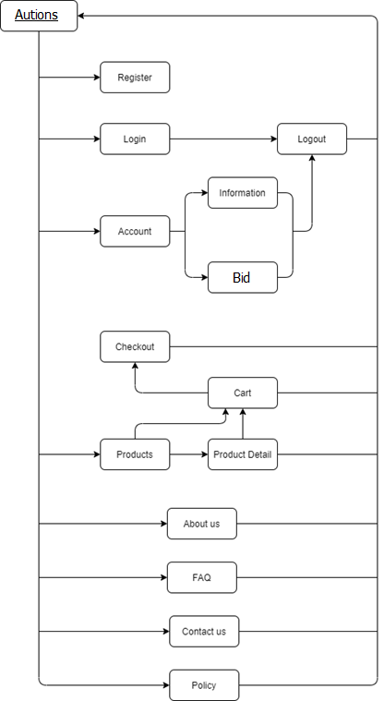

### Admin’s Site Map

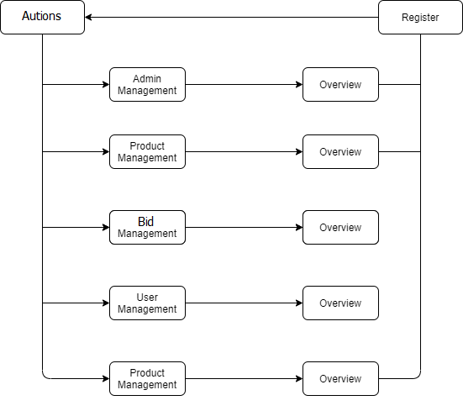

## autions DESIGN template

### Homepage

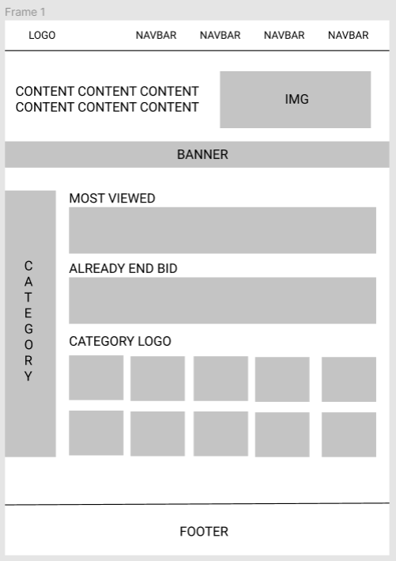

|  |  |  |  |  |  |
| --- | --- | --- | --- | --- | --- |
| **No** | **Name** | **Type** | **Validation** | **Event** | **Description** |
|  | MOST VIEWED | Link |  | Click | Go to MOST VIEWED of page. |
|  | ALREADY END BID | Link |  | Click | View product already end bid time. |
|  | Logo | Link |  | Click | Go to homepage. |
|  | Navigation bar (LOGIN) | Link |  | Click | Go to LOGIN page. |
|  | Navigation bar (HELP) | Link |  | Click | Go to HELP page. |
|  | Category   * Accessories * Cars * Fashion * Toys | Link |  | Click | Show category of auctions. |
|  | Category Logo | Link |  | Click | Allow user to view the product. |
|  | Footer (information) | Link |  | Click | Go to information for Auctions company. |
|  | Footer(News) | Link |  | Click | Show news of Auction. |

### PRODUCT LIST

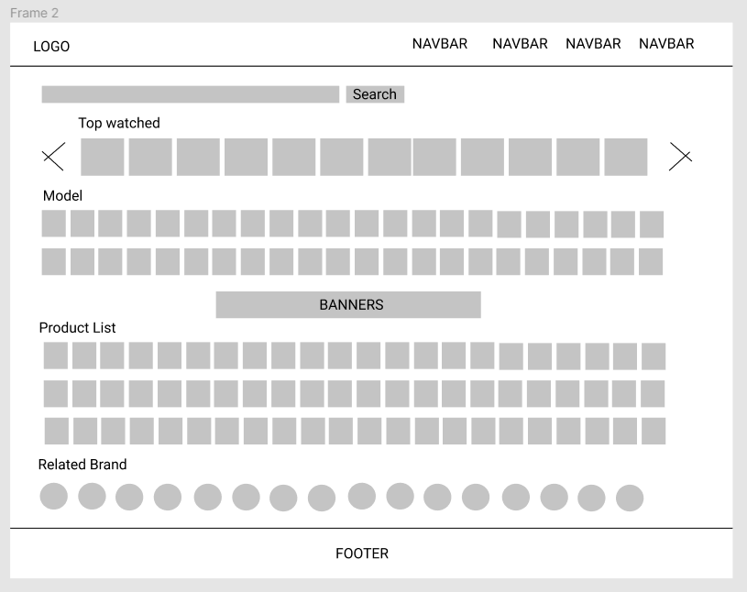

|  |  |  |  |  |  |
| --- | --- | --- | --- | --- | --- |
| **No** | **Name** | **Type** | **Validation** | **Event** | **Description** |
| 1 | Search Input | Text |  |  | Search product. |
| 2 | Top watched | Carousel |  |  | Show top watched products. |
| 3 | Model | Link |  | Click | Show list model of product |
| 4 | Banner | Link |  | Click | Advertisement Banner |
| 5 | Product List | List |  |  | Show list of bid product. |
| 6 | Related Brand | List |  |  | Show Related brand of product. |

### Product detail

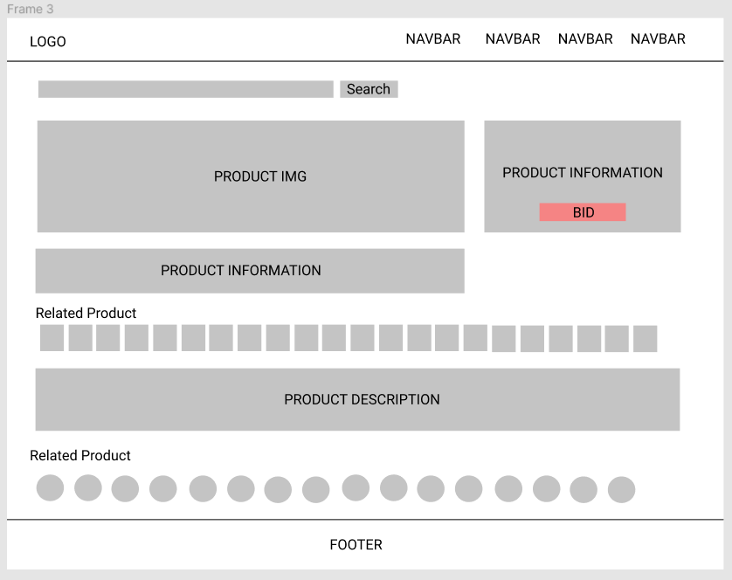

|  |  |  |  |  |  |
| --- | --- | --- | --- | --- | --- |
| **No** | **Name** | **Type** | **Validation** | **Event** | **Description** |
| 1 | Product Information | Text |  |  | Show information of product. |
| 2 | Image | Text |  |  | Show image product. |
| 3 | Product Information | Text |  |  | View more information such as quantity, quality (new, used) |
| 4 | Product Description | Text |  |  | Show description of product. |
| 5 | Related product | Image |  |  | Show relative product. |

### BID PROCESS

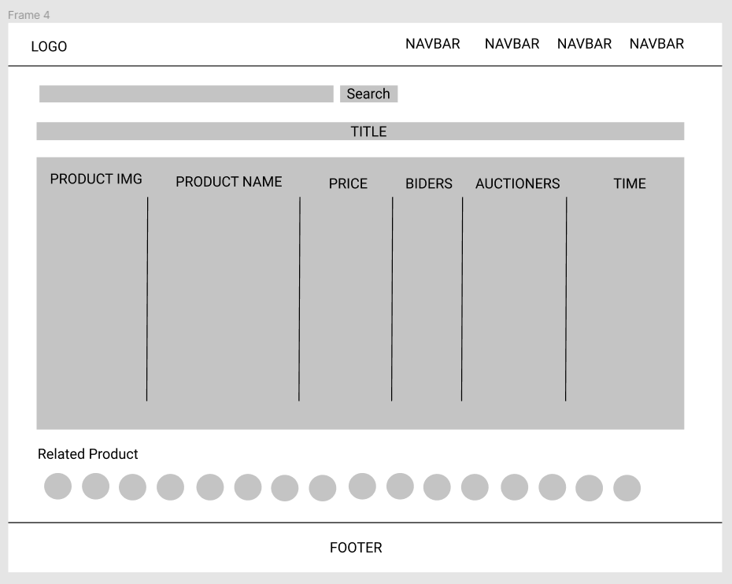

|  |  |  |  |  |  |
| --- | --- | --- | --- | --- | --- |
| **No** | **Name** | **Type** | **Validation** | **Event** | **Description** |
| 1 | Bid process | Table |  |  | Show process of bidding |
| 2 | Table (IMG) | Image |  |  | Show img of bidding products. |
| 3 | Table (Product Name) | Text |  |  | Show quantity of selected products. |
| 4 | Table (Price) | Number |  |  | Show price of bidding products. |
| 5 | Table (Bidders) | Number |  |  | Show how many bidder is bidding. |
| 6 | Table (Auctioner) | Text |  |  | Show auctioner of product. |
| 7 | Table (Time) | Datetime |  |  | Show end time of bid. |

### received the goods?

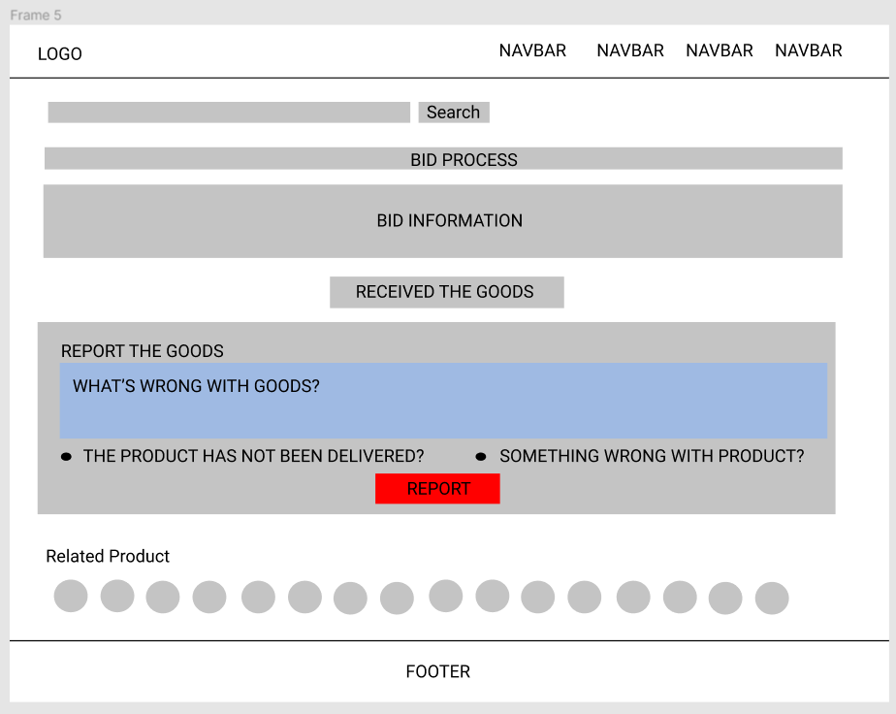

|  |  |  |  |  |  |
| --- | --- | --- | --- | --- | --- |
| **No** | **Name** | **Type** | **Validation** | **Event** | **Description** |
| 1 | Bid Information | Text |  |  | Show bid of information. |
| 2 | Received the goods? | Button |  | Click | Confirm the goods has been received. |
| 3 | Report the goods | Form |  |  | Report the goods if some problems with product. |
| 4 | Related Product | List |  |  | Show list of related product. |

### Customer

#### Customer Login & Register

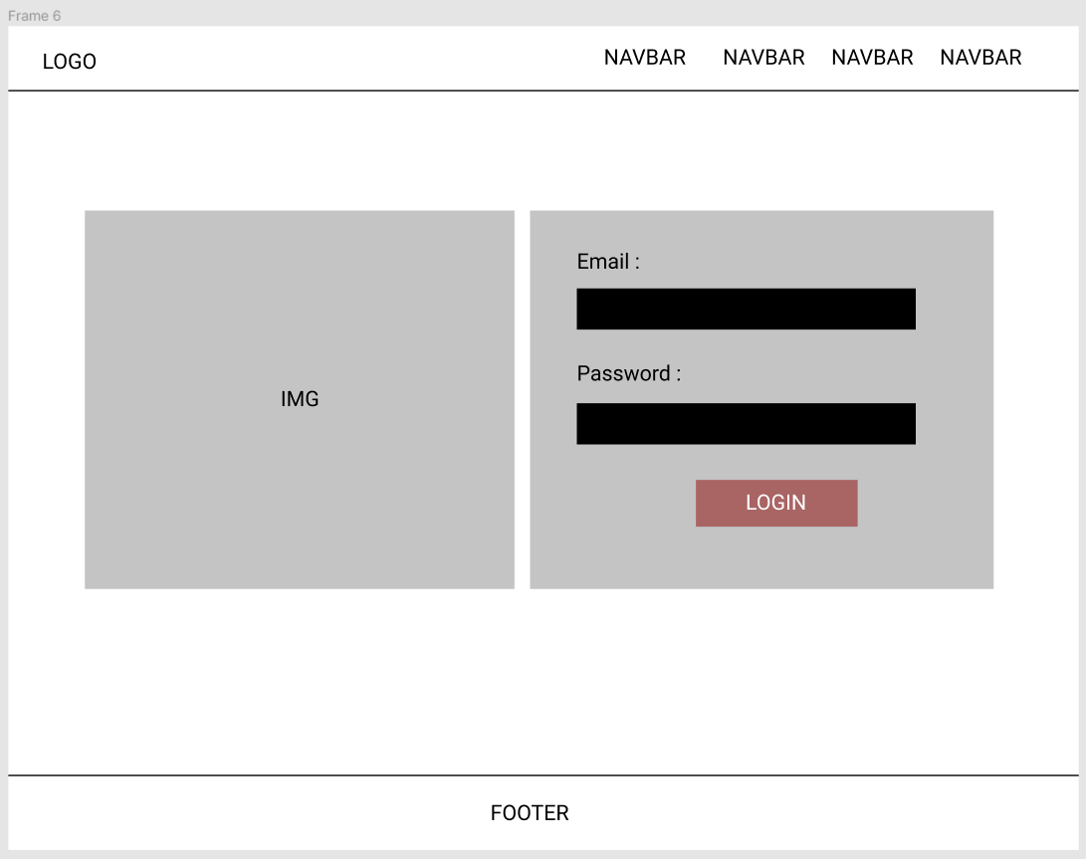

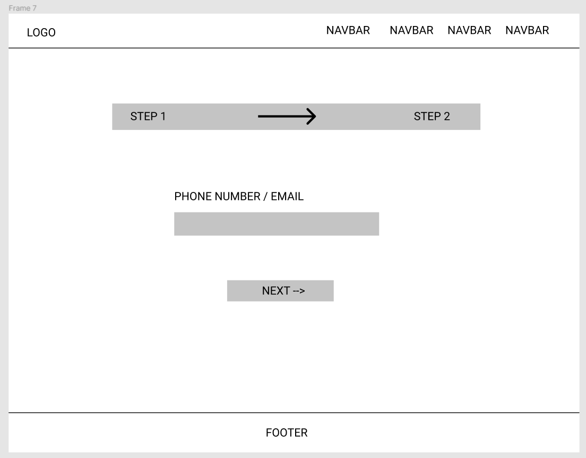

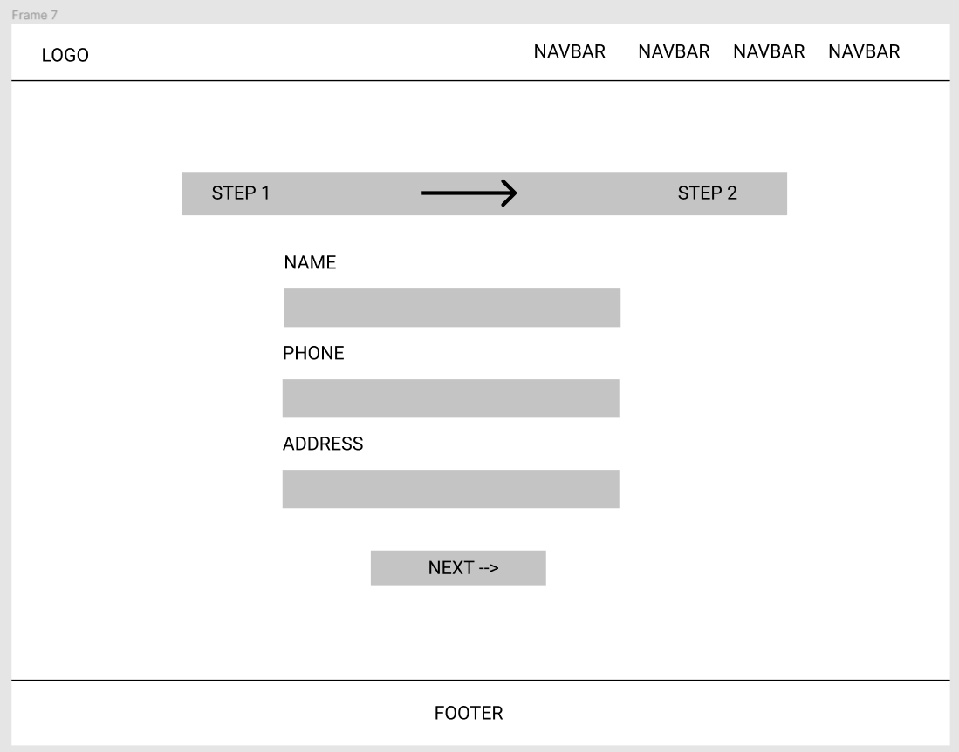

|  |  |  |  |  |  |
| --- | --- | --- | --- | --- | --- |
| **No.** | **Name** | **Type** | **Validation** | **Event** | **Description** |
| 1 | Name | Text | Not null, not number |  | Customer/Admin’s name |
| 3 | Address | Null | Not null, must be address |  | Customer/Admin’s address |
| 3 | Phone Number | Null | Not null, must be phone number |  | Customer’s phone |
|  | | | | | |

#### Contact auctioners

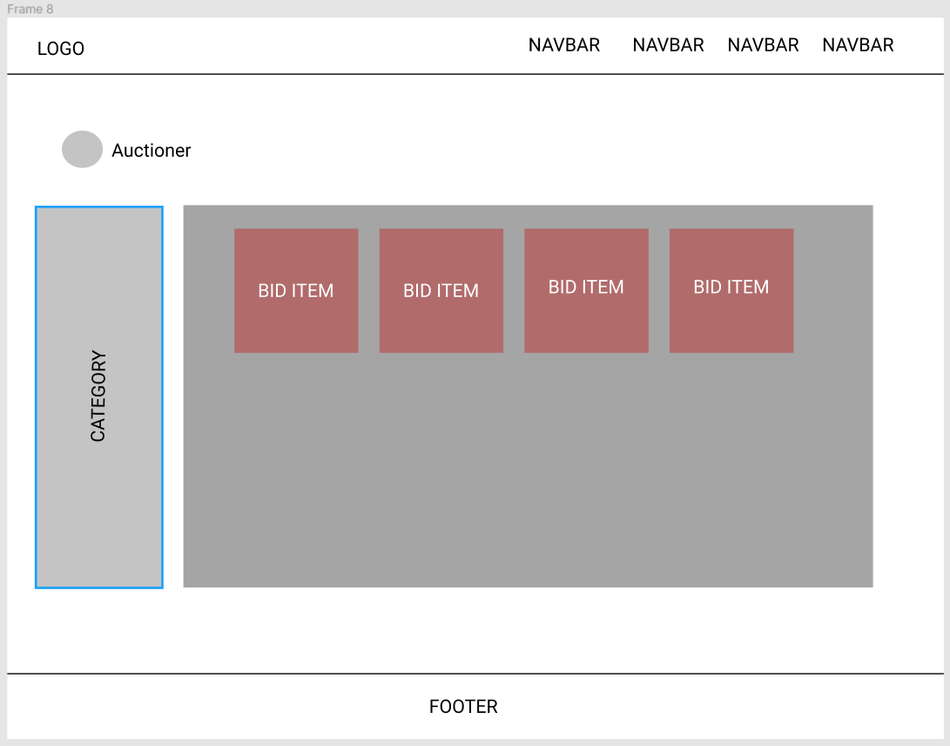

|  |  |  |  |  |  |
| --- | --- | --- | --- | --- | --- |
| **No.** | **Name** | **Type** | **Validation** | **Event** | **Description** |
| 1 | Auctioner | Object |  |  | Auctioner’s name |
| 2 | Category |  |  |  | Category product of auctioner |
| 3 | Bid Item | Image |  |  | Auctioner bid item |
|  | | | | | |

#### BLOGS

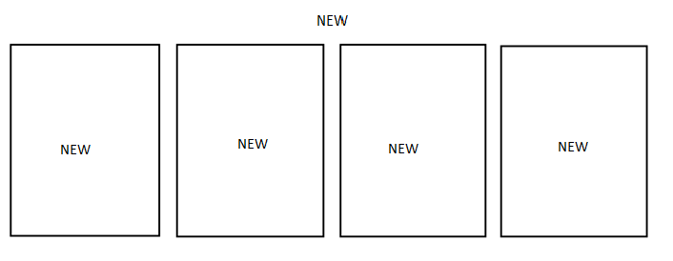

#### Purchase history

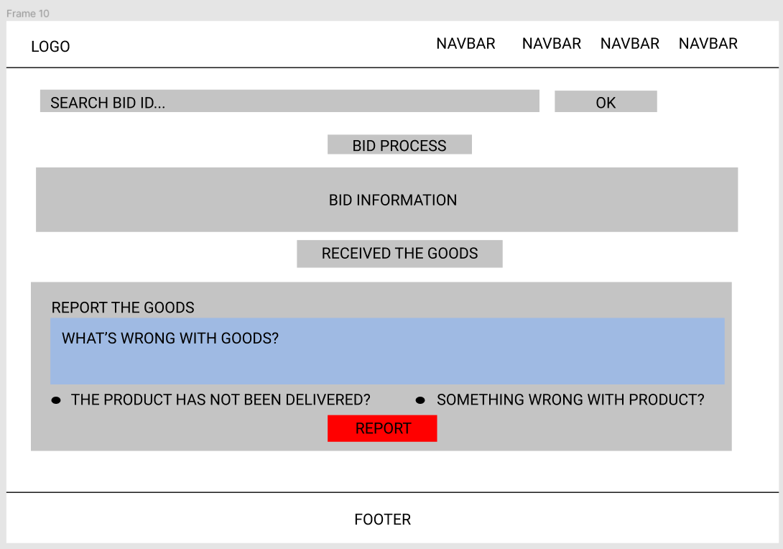

|  |  |  |  |  |  |
| --- | --- | --- | --- | --- | --- |
| **No.** | **Name** | **Type** | **Validation** | **Event** | **Description** |
| 1 | Search Bid | NULL | Not null must be code order. |  | Search bid information by code. |
| 2 | Bid Process |  |  |  | Show process of bidding |
| 3 | Report the goods |  |  |  | Complaint about the goods, condition, have been shipped or not? |
|  | | | | | |

#### Store rules

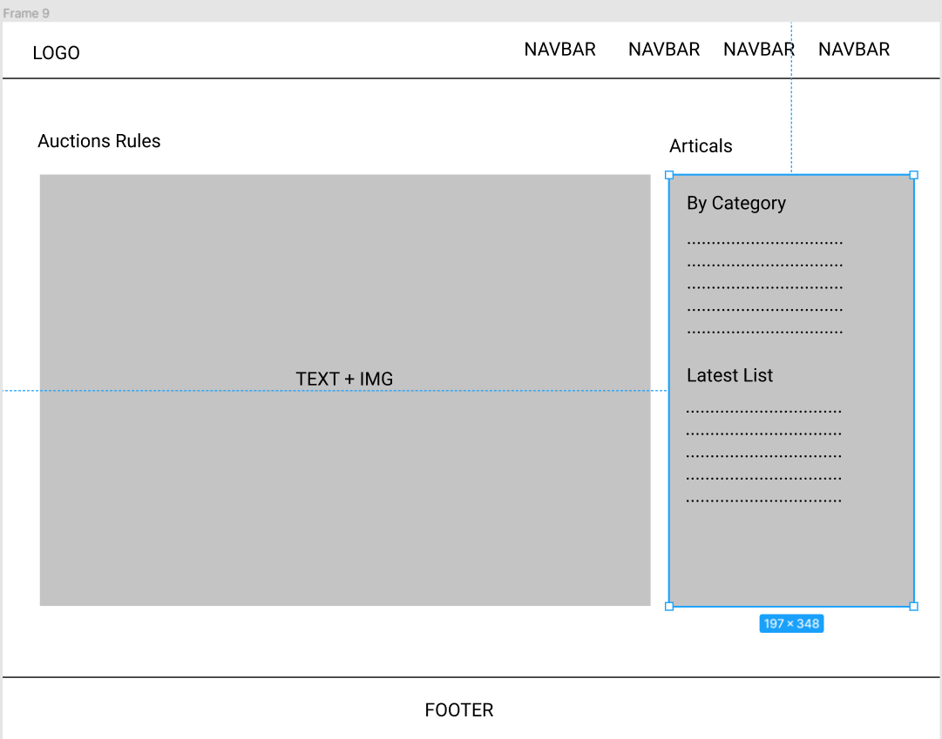

#### Admin manager

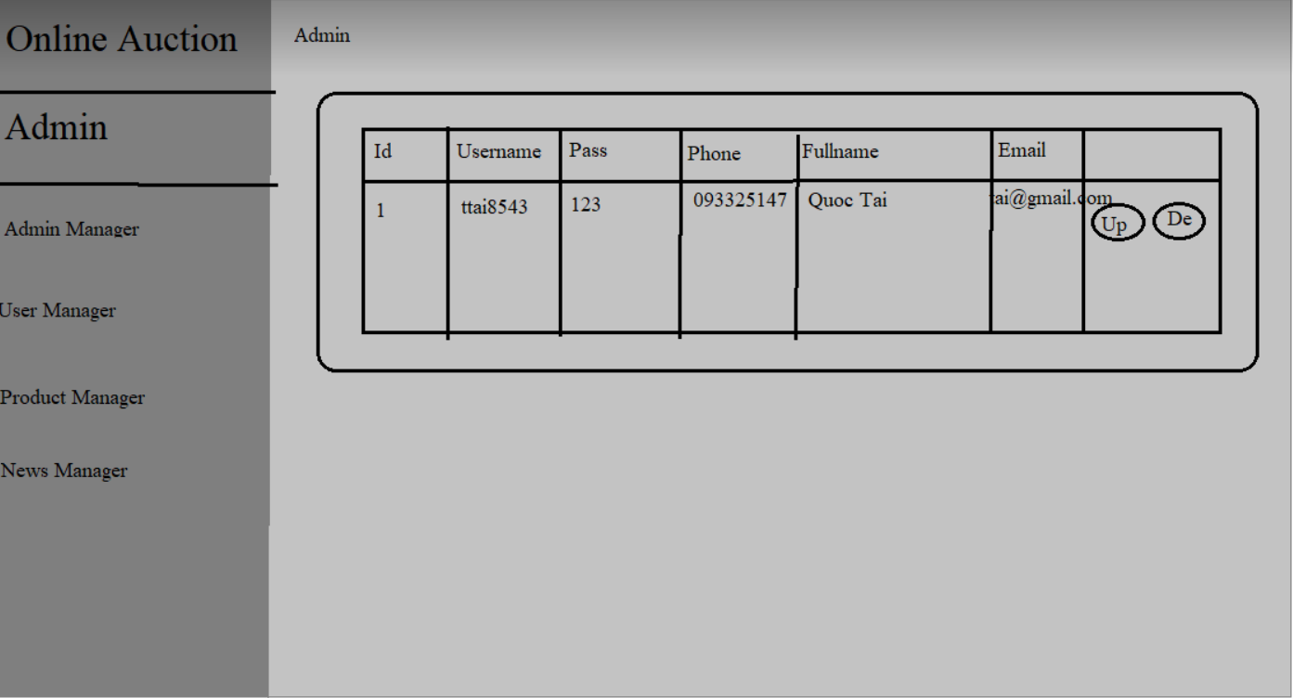

|  |  |  |  |  |
| --- | --- | --- | --- | --- |
| **No** | **Name** | **Validation** | **Event** | **Description** |
| 1 | id | Not null, must be number. |  | Admin’s id. |
| 2 | username | Not null, force matches in the database. |  | Admin’s account name. |
| 3 | password | Not null, force matches in the database. |  | Admin’s password. |
| 4 | fullname | Not null, not number. |  | Admin’s name. |
| 5 | phone | Not null, must be phone number. |  | Admin’s phone. |
| 6 | email | Not null, must be email (have .com and @). |  | Admin’s email. |
| 7 | update |  | Click | Link to update admin form. |
| 8 | delete |  | Click | Link to delete admin form. |

#### User manager

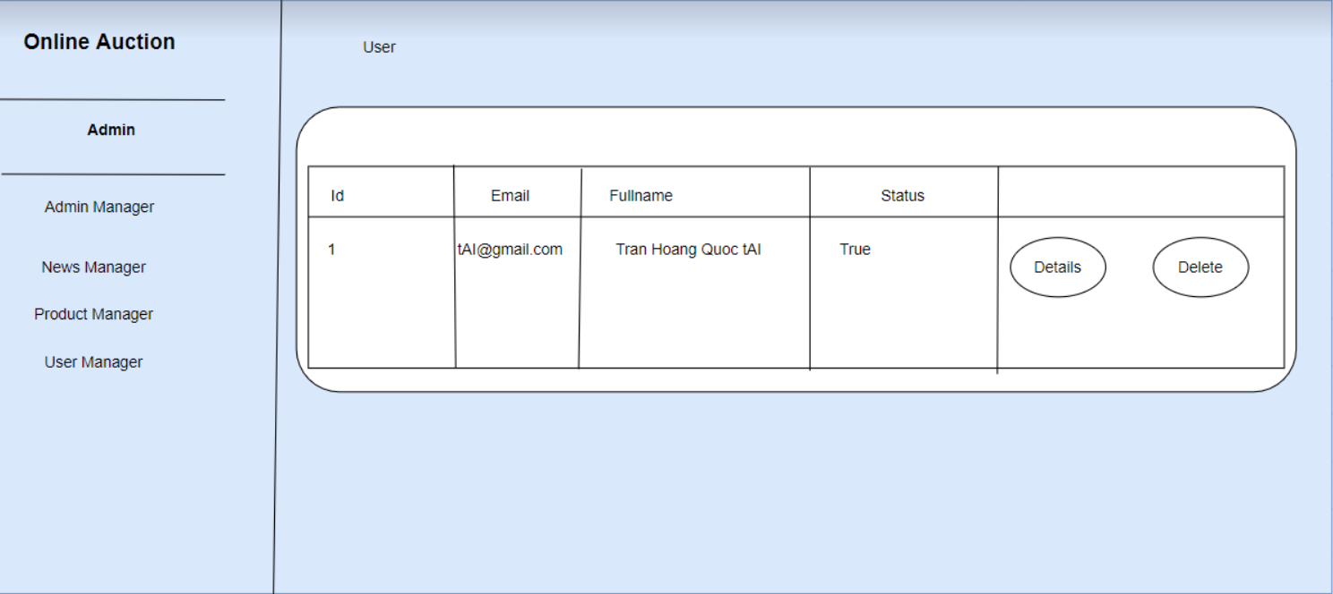

|  |  |  |  |  |
| --- | --- | --- | --- | --- |
| **No** | **Name** | **Validation** | **Event** | **Description** |
| 1 | id | Not null, must be number. |  | Customer’s id. |
| 2 | fullname | Not null, not number. |  | Customer’s name. |
| 3 | username | Not null, force matches in the database. |  | Customer’s account name. |
| 4 | Status | Not null, force matches in the database. |  | Customer’s status. |
| 5 | Detail |  | Click | Link to detail customer form. |
| 6 | Delete |  | Click | Link to delete customer form. |

* 1. **Product Manager**

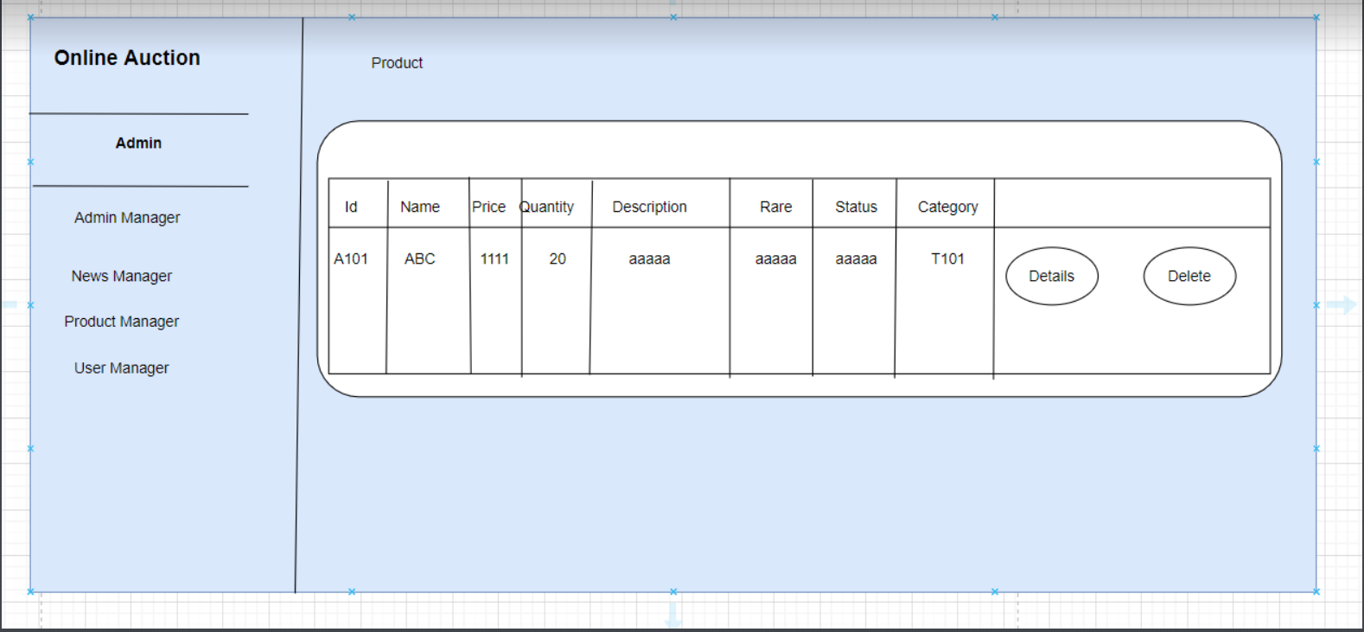

|  |  |  |  |  |
| --- | --- | --- | --- | --- |
| **No** | **Name** | **Validation** | **Event** | **Description** |
| 1 | id | Not null, must be number. |  | Product’s id. |
| 2 | category | Not null, force matches in the database. |  | Product’s category. |
| 3 | name | Not null, force matches in the database. |  | Product’s name. |
| 4 | price | Not null, must be number. |  | Product’s price. |
| 5 | status | Not null, force matches in the database. |  | Product’s status. |
| 6 | rare | Not null, force matches in the database. |  | Product’s rare. |
| 7 | quantity | Not null, must be number., force matches in the database. |  | Product’s quantity. |
| 8 | Description | Not null, force matches in the database. |  | Product’s description. |
| 9 | Detail |  | Click | Link to detail product form. |
| 10 | Delete |  | Click | Link to delete product form. |

* 1. **News**

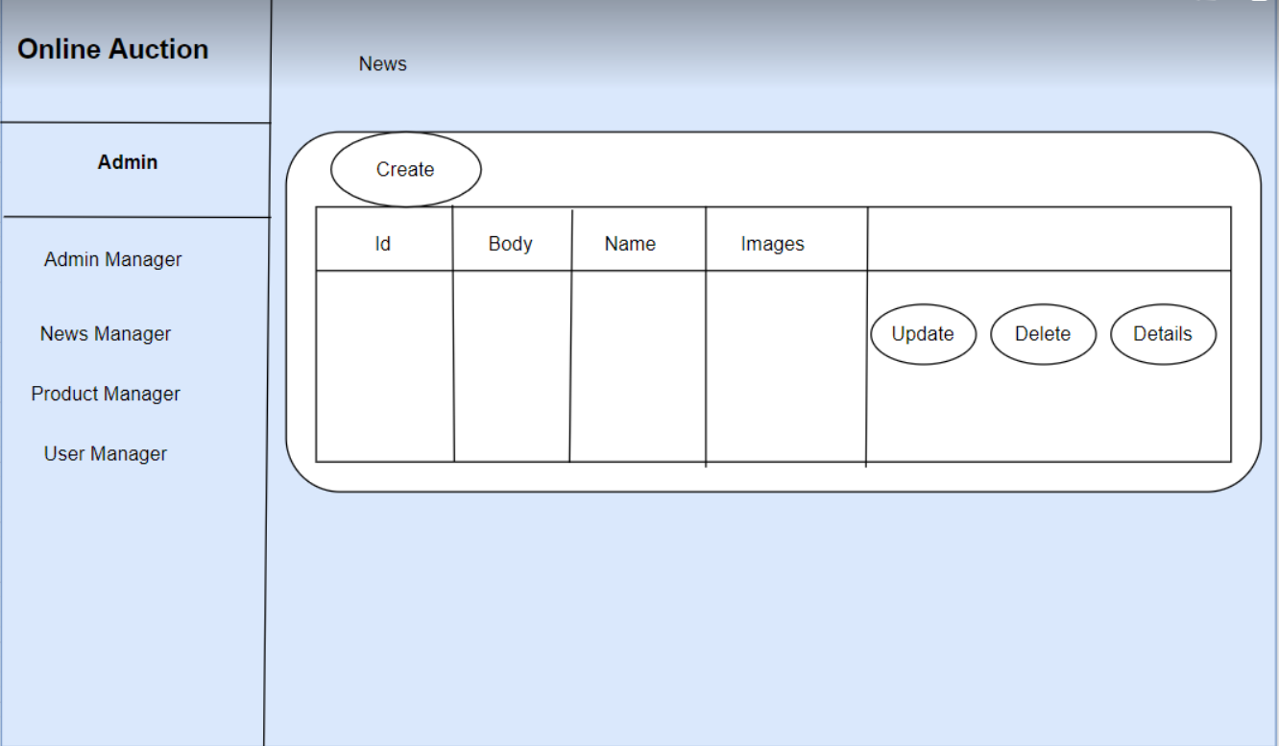

|  |  |  |  |  |
| --- | --- | --- | --- | --- |
| **No** | **Name** | **Validation** | **Event** | **Description** |
| 1 | id | Not null, must be number. |  | News’s id. |
| 2 | body | Not null, force matches in the database. |  | News’s title. |
| 3 | name | Not null, force matches in the database. |  | News’s status. |
| 8 | images | Not null, force matches in the database. |  | News’s images. |
| 4 | Create |  | Click | Link to create news form. |
| 5 | Detail |  | Click | Link to detail news form. |
| 6 | Update |  | Click | Link to update news form. |
| 7 | Delete |  | Click | Link to delete news form. |

# Task Sheet REVIEW 3

|  |  |  |  |  |  |  |  |
| --- | --- | --- | --- | --- | --- | --- | --- |
| **Project Ref. No.:**  **eP/Advertisement** **Portal Management** **System/01** | | **Project Title:** | **Activity Plan** **Prepared** **By:** | **Date of Preparation of Activity Plan:** | | | |
| **Sr.No.** | **Task** | **Actual Start** **Date** | **Actual** **Days** | **Team** **Mate** **Names** | **Status** |
| 1 | Table Structure (ERD Physical) | Online Auction | Thinh | 26/01/2021 | 4 | All Member | Completed |
| 2 | Database Design | 26/01/2021 | 4 | All Member | Completed |
| 3 | Site Map | 26/01/2021 | 1 | All Member | Completed |
| 4 | GUI Design | 26/01/2021 | 1 | All Member | Completed |
|  | **Admin Interface** |  |  |  |  |
| 5 | Login, Logout for Admin Interface | 26/01/2021 | 21 | All Member |  |
| 6 | Manage Profile Admin | 26/01/2021 | 21 | All Member |  |
| 7 | Manage User | 26/01/2021 | 21 | All Member |  |
| 8 | Manage News | 26/01/2021 | 21 | All Member |  |
| 9 | Manage Product | 26/01/2021 | 21 | All Member |  |
| 10 | Mange About Us Page,Contact Us | 26/01/2021 | 21 | All Member |  |
| 11 | Manage History Bid | 26/01/2021 | 21 | All Member |  |
| 12 | Manage Bank Account of Admin | 26/01/2021 | 21 | All Member |  |
| 36 | Task sheet review |  | 1 |  | Completed |

|  |  |
| --- | --- |
| **Date: 11/05/2020** | |
| Signature of Instructor:  **Mr. Tran Phuoc Sinh** | Signature of Team Leader:  **To Dao Viet Hoang** |