Vo Hoang Minh Triet 2331200121
1.exercises
1.3
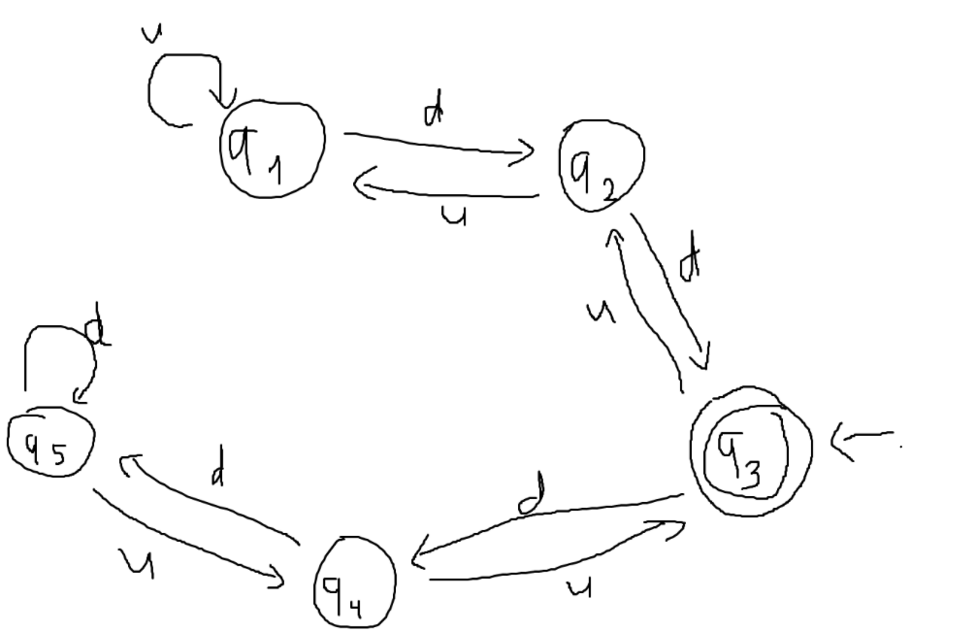
1.4a. {w| w has at least three a’s and at least two b’s}
$M_{1} = (Q_{1}, Σ, δ_{1}, q_{1}, F_{1})$ is the machine that recognizes $\{w| w has at least 3 a’s\}$:
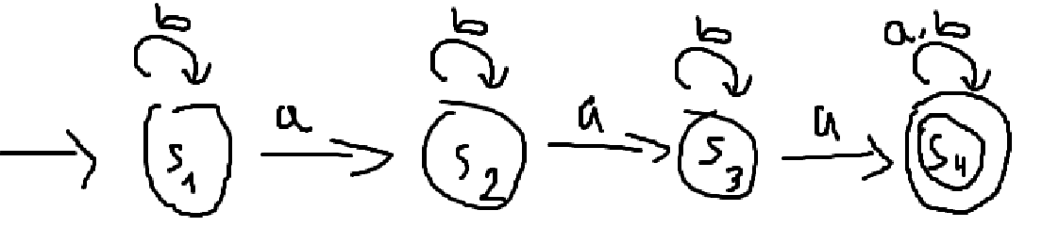
$M_{2} = (Q_{2}, Σ, δ_{2}, q_{2}, F_{2})$ recognizes $\{w| w has at least two b’s\}$:
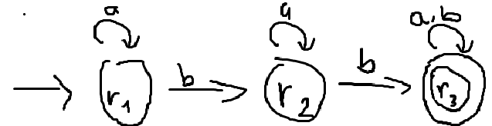
The machine that accepts the intersection of 2 languages is $M=(Q, Σ, δ, q, F)$
With $Q=\left\{\left(q_{1},q_{2}\right)\right|q_{1}∈Q_{1}, q_{2}∈Q_{2}\}$
Let $δ\left(\left(q_{1}, q_{2}\right),c\right)=\left(δ_{1}\left(q_{1},c\right),δ_{2}\left(q_{2},c\right)\right)$ foreach $(q_{1},q_{2})∈Q$ and $c∈Σ$, we get the following table:
$$δ$$ | a | b
$$s_{1},r_{1}$$ | $$s_{2},r_{1}$$ | $$s_{1},r_{2}$$
$$s_{1},r_{2}$$ | $$s_{2},r_{2}$$ | $$s_{1},r_{3}$$
$$s_{1},r_{3}$$ | $$s_{2},r_{3}$$ | $$s_{1},r_{3}$$
$$s_{2},r_{1}$$ | $$s_{3},r_{1}$$ | $$s_{2},r_{2}$$
$$s_{2},r_{2}$$ | $$s_{3},r_{2}$$ | $$s_{2},r_{3}$$
$$s_{2},r_{3}$$ | $$s_{3},r_{3}$$ | $$s_{2},r_{3}$$
$$s_{3},r_{1}$$ | $$s_{4},r_{1}$$ | $$s_{3},r_{2}$$
$$s_{3},r_{2}$$ | $$s_{4},r_{2}$$ | $$s_{3},r_{3}$$
$$s_{3},r_{3}$$ | $$s_{4},r_{3}$$ | $$s_{3},r_{3}$$
$$s_{4},r_{1}$$ | $$s_{4},r_{1}$$ | $$s_{4},r_{2}$$
$$s_{4},r_{2}$$ | $$s_{4},r_{2}$$ | $$s_{4},r_{3}$$
$$s_{4},r_{3}$$ | $$s_{4},r_{3}$$ | $$s_{4},r_{3}$$

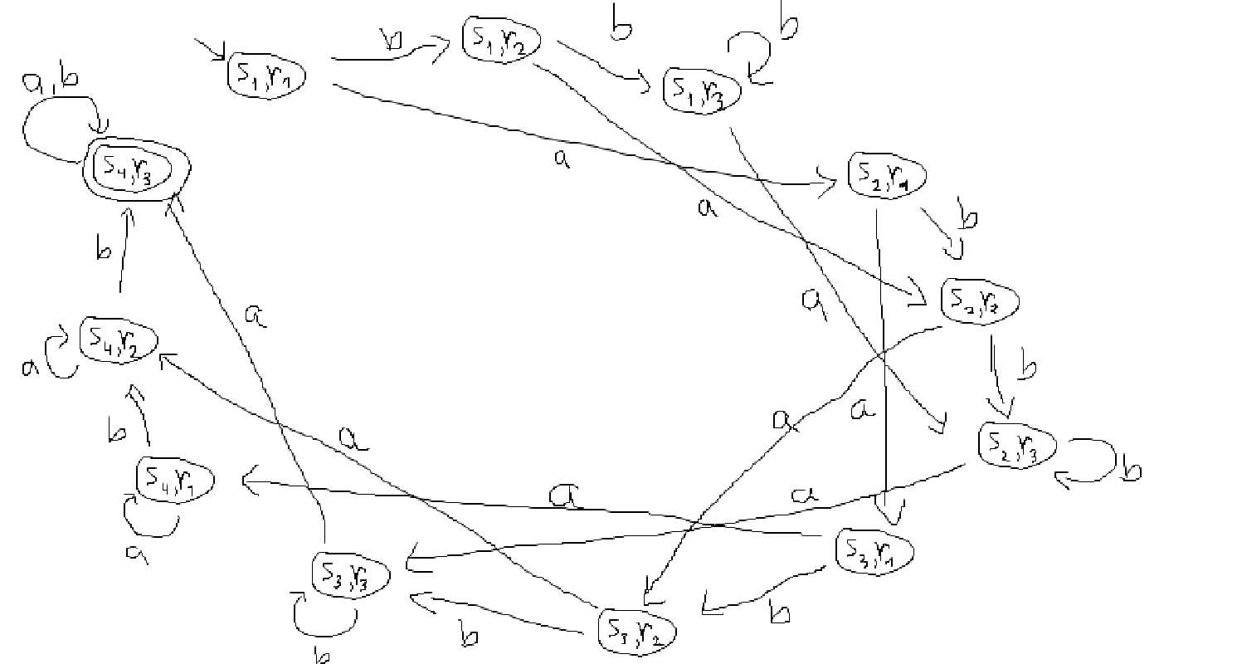
1.4c. {w| w has an even number of a’s and one or two b’s}. But is 0 an even number?
$M_{1} = (Q_{1}, Σ, δ_{1}, q_{1}, F_{1})$ is the machine that recognizes $\left\{w\right|w has an even number of a’s\}$:
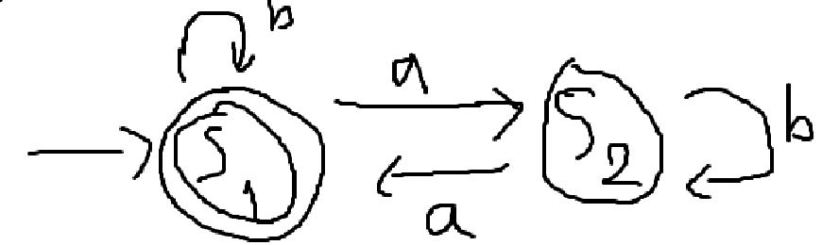
$M_{2} = (Q_{2}, Σ, δ_{2}, q_{2}, F_{2})$ recognizes $\left\{w\right|w has one or two b’s\}$:
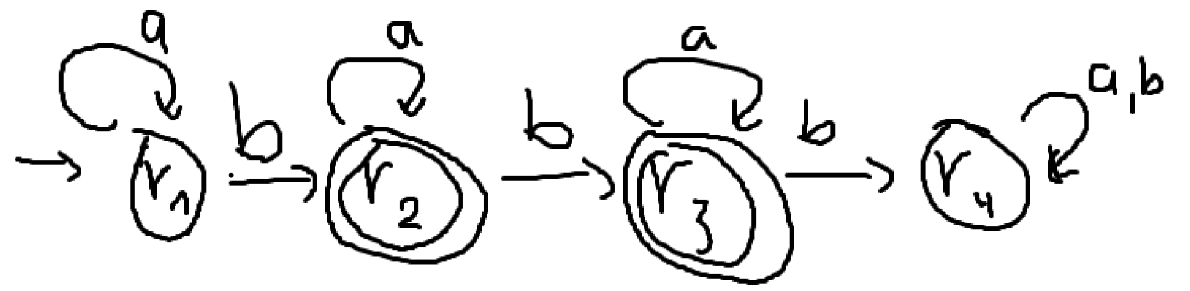
Let $δ\left(\left(q_{1}, q_{2}\right),c\right)=\left(δ_{1}\left(q_{1},c\right),δ_{2}\left(q_{2},c\right)\right)$ for each $\left(q_{1},q_{2}\right)∈Q$ and $c∈Σ$, the state diagram of $M=M_{1}∩M_{2}$ is:
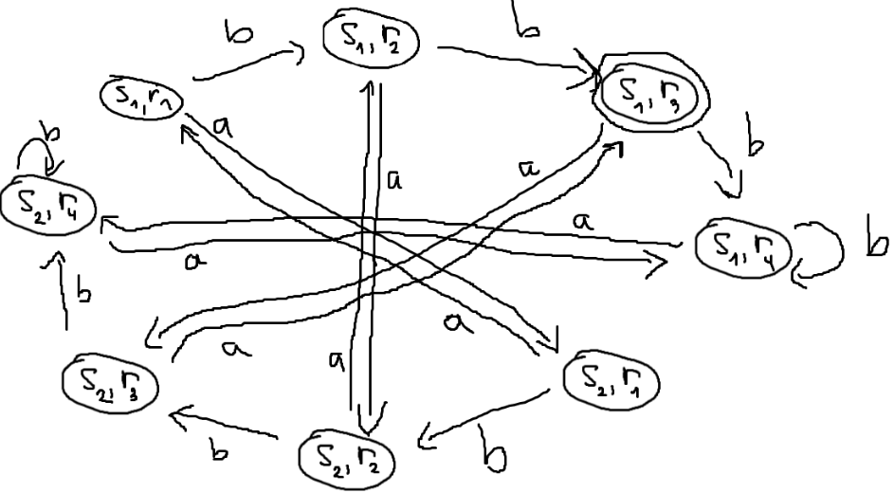
1.4e. {w| w starts with an a and has at most one b}
Let $M_{1}$ be the machine that accepts {w | w starts with an a}
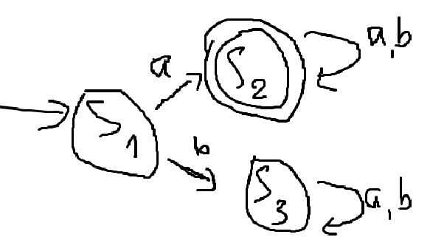
And $M_{2}$ be the machine that accepts {w | w has at most one b}
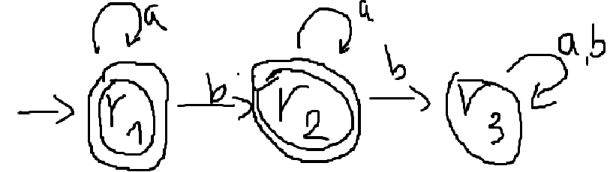
Let $δ\left(\left(q_{1}, q_{2}\right),c\right)=\left(δ_{1}\left(q_{1},c\right),δ_{2}\left(q_{2},c\right)\right)$ for each $(q_{1},q_{2})∈Q$ and $c∈Σ$, the state diagram of $M=M_{1}∩M_{2}$ is:

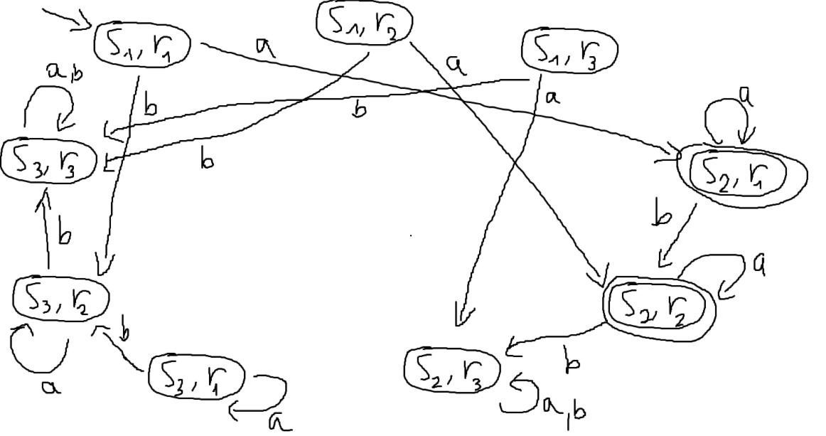
Or:
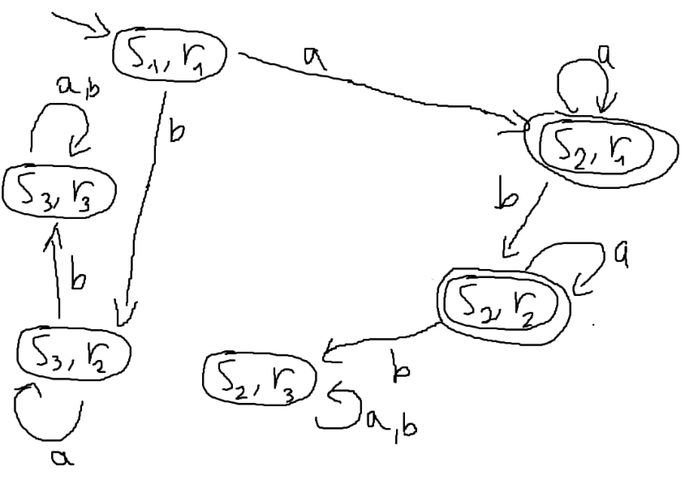
1.4f. {w | w has an odd number of a’s and ends with a b}
Let $M_{1}$ be the machine that accepts {w | w has an odd number of a}
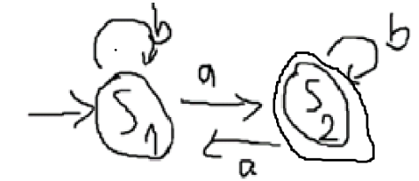
And $M_{2}$ be the machine that accepts {w | w ends with a b}
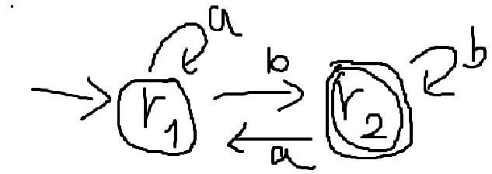
Let $δ\left(\left(q_{1}, q_{2}\right),c\right)=\left(δ_{1}\left(q_{1},c\right),δ_{2}\left(q_{2},c\right)\right)$ for each $\left(q_{1},q_{2}\right)∈Q$ and $c∈Σ$, the state diagram of $M=M_{1}∩M_{2}$ is:
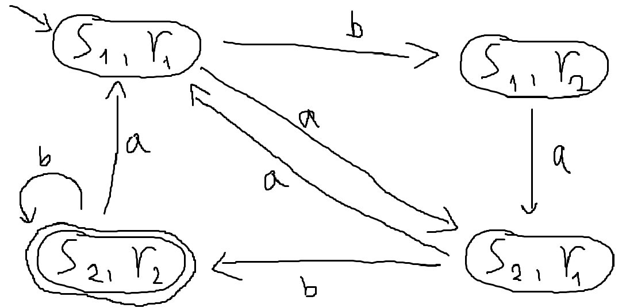
1.4g. {w| w has even length and an odd number of a’s}
Let $M_{1}$ be the machine that accepts {w | w has even length}
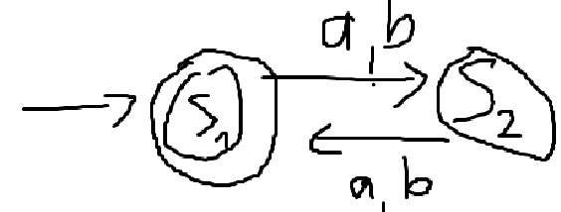
And $M_{2}$ be the machine that accepts {w | w has an odd number of a}
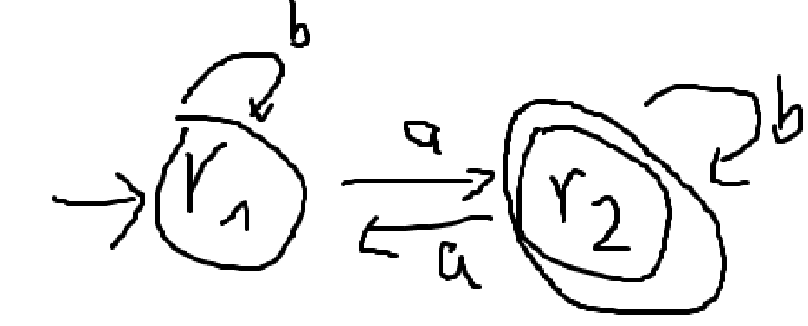
Let $δ\left(\left(q_{1}, q_{2}\right),c\right)=\left(δ_{1}\left(q_{1},c\right),δ_{2}\left(q_{2},c\right)\right)$ for each $\left(q_{1},q_{2}\right)∈Q$ and $c∈Σ$, the state diagram of $M=M_{1}∩M_{2}$ is:
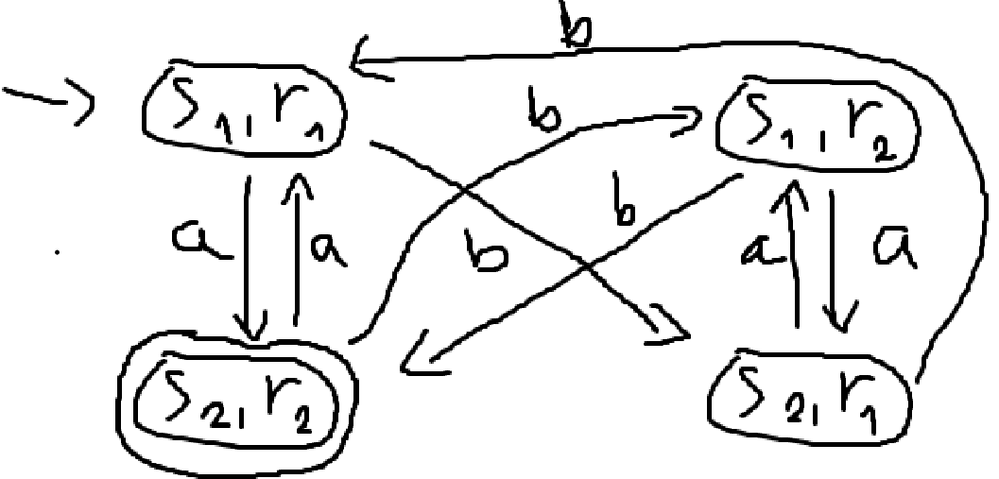

1.6a.
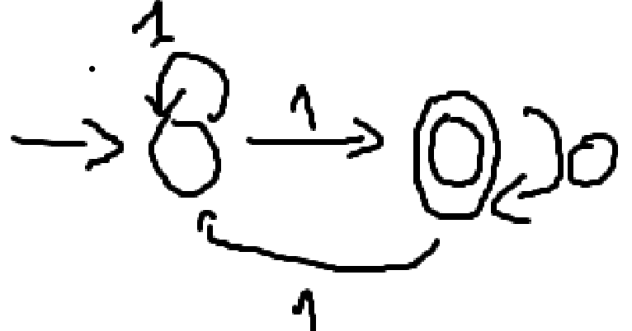
1.6b.
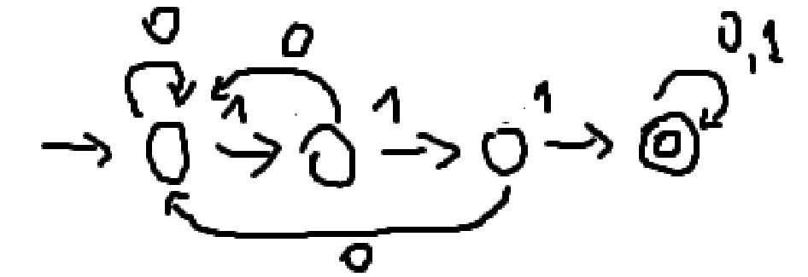
1.6c.
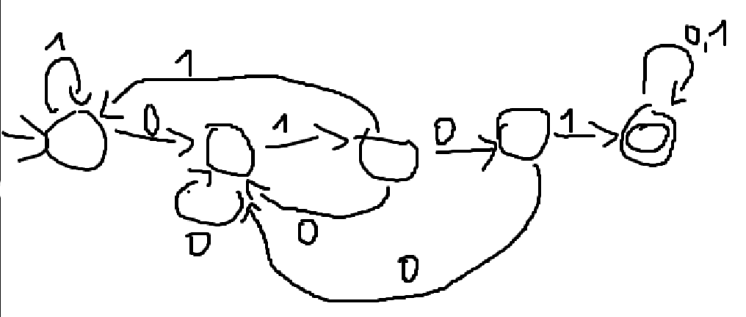
1.6d.
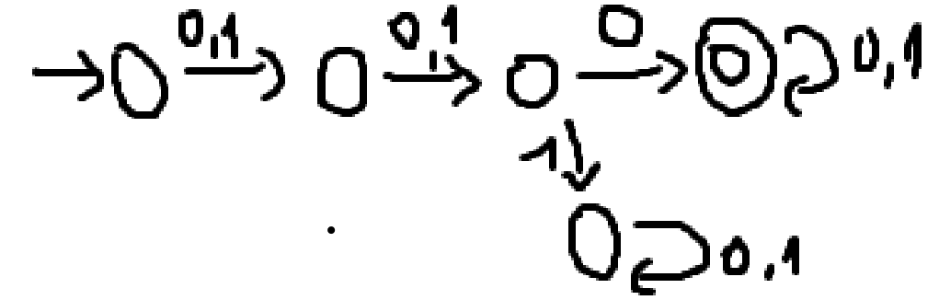
1.6e.
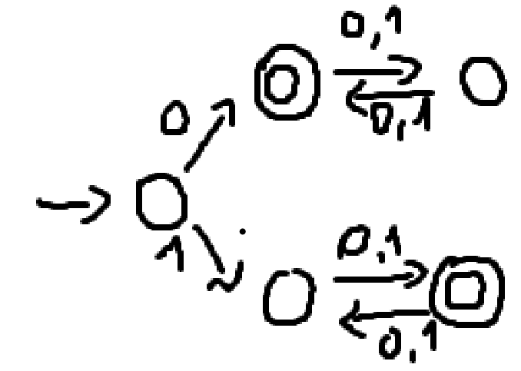
1.6f.
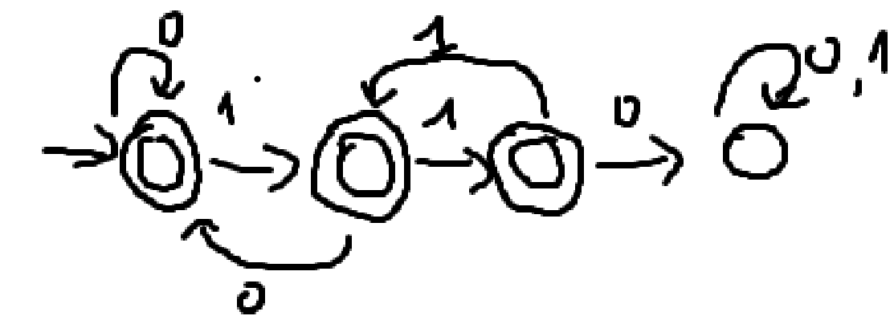
1.6g.
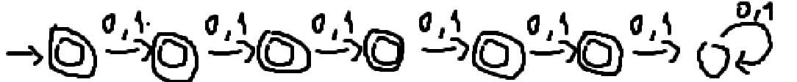

1.6h.
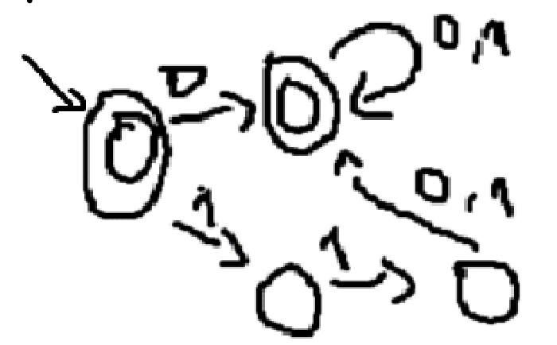
1.6i.
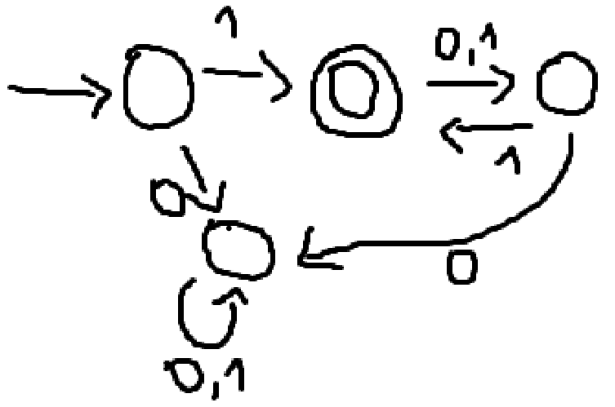
1.6j.
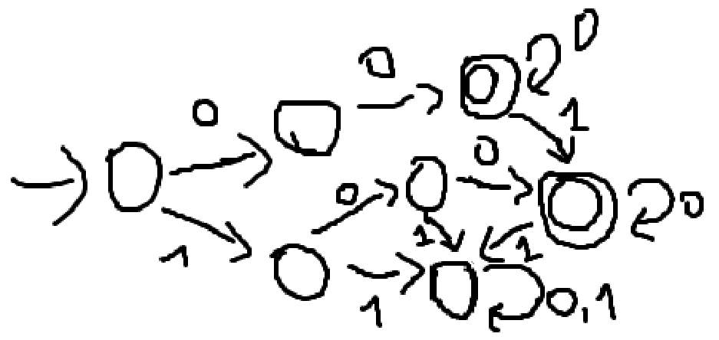
1.6k.
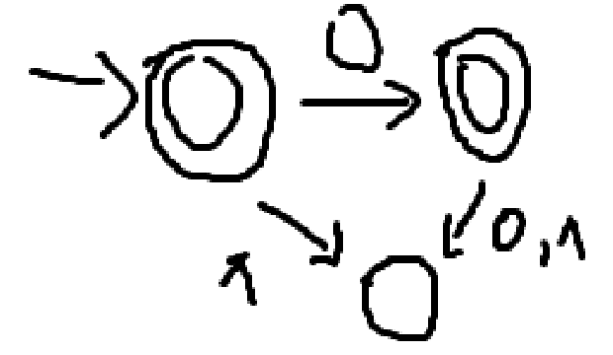

1.6l.
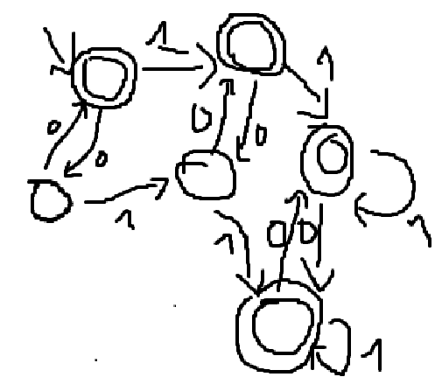
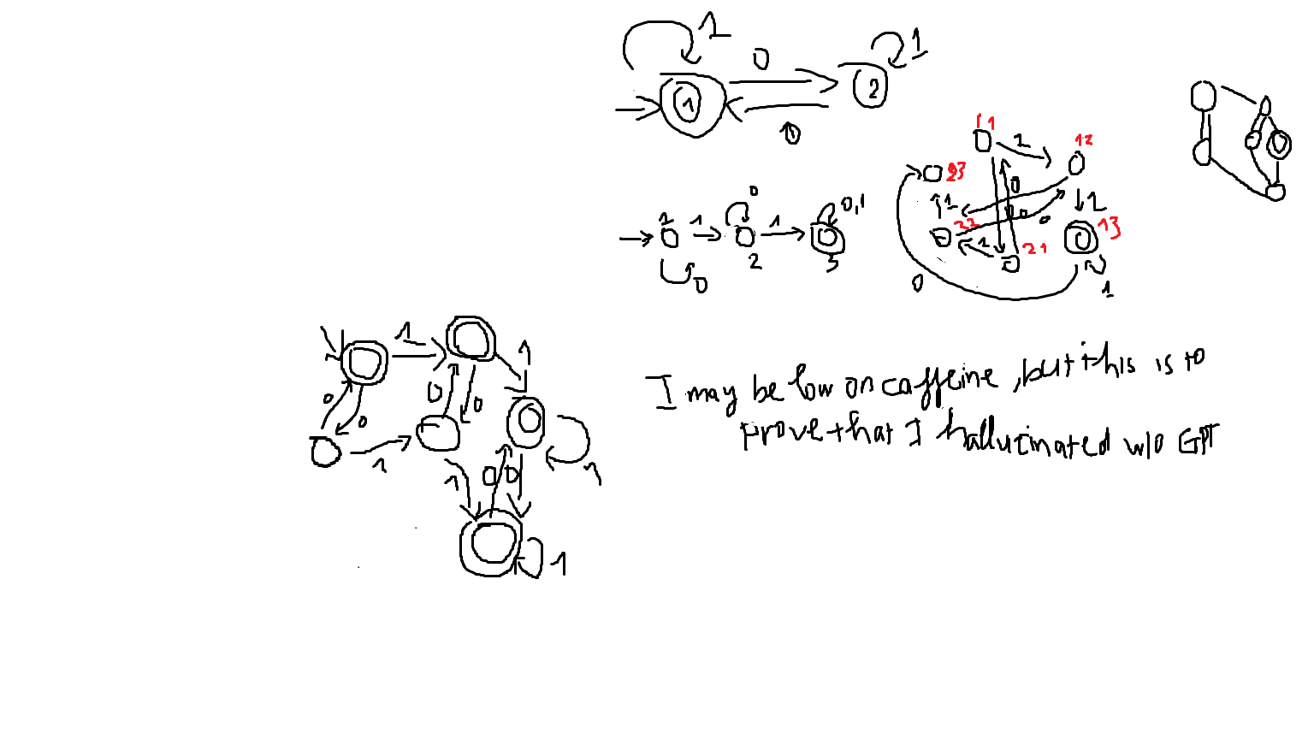
1.6m.
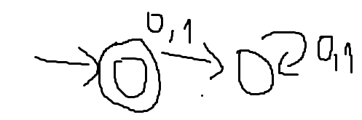
1.6n.
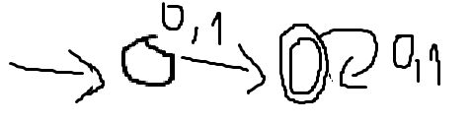

1.7b.

1.7c.

1.7d. how am I supposed to draw it with 2 states?
1.7e.
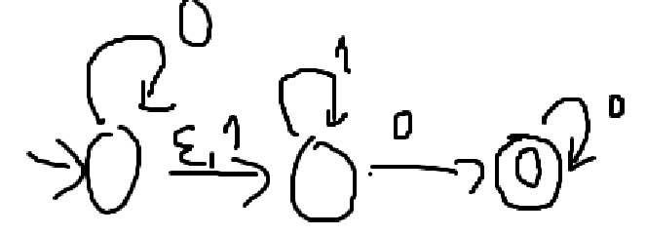
1.7g
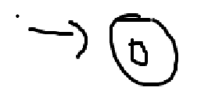
1.7h
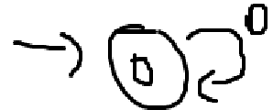

1.16a.
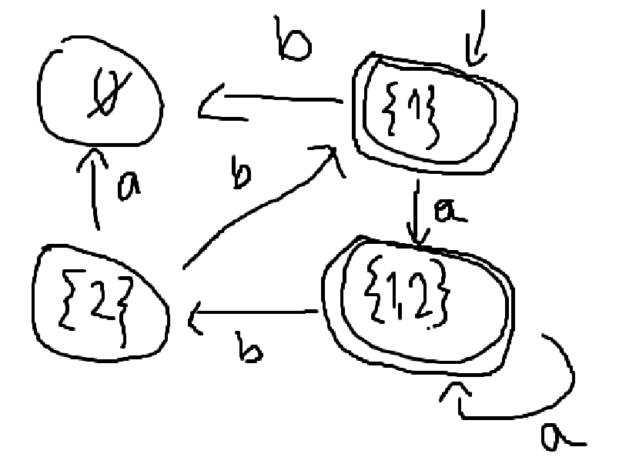
1.16b.
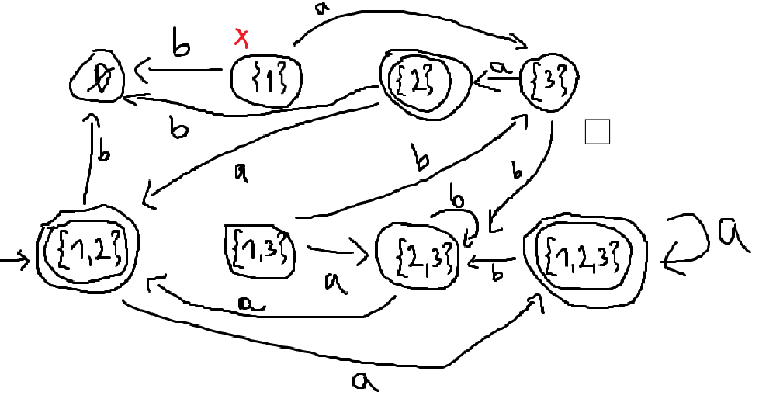
Or:
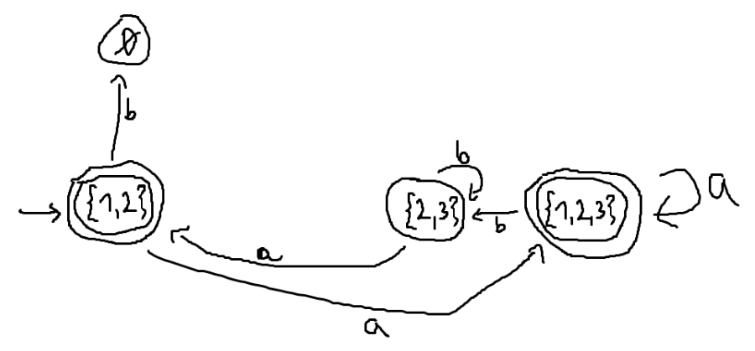

1.18:
a. $1Σ^{*}0$
b. $Σ^{*}1Σ^{*}1Σ^{*}1Σ^{*}$
c. $Σ^{*}0101Σ^{*}$
d. $ΣΣ0Σ^{*}$
e. $0{\left(ΣΣ\right)}^{*}∪1Σ{\left(ΣΣ\right)}^{*}$
f.
g. $ϵ∪Σ∪ΣΣ∪ΣΣΣ∪ΣΣΣΣ∪ΣΣΣΣΣ$
h.
i. ${\left(1Σ\right)}^{*}1^{*}$
j.
k. $ϵ∪0$
l.
m. $ϵ$
n. $Σ^{+}$

1.21:
a. $a^{*}b{\left(a∪ba^{*}b\right)}^{*}$
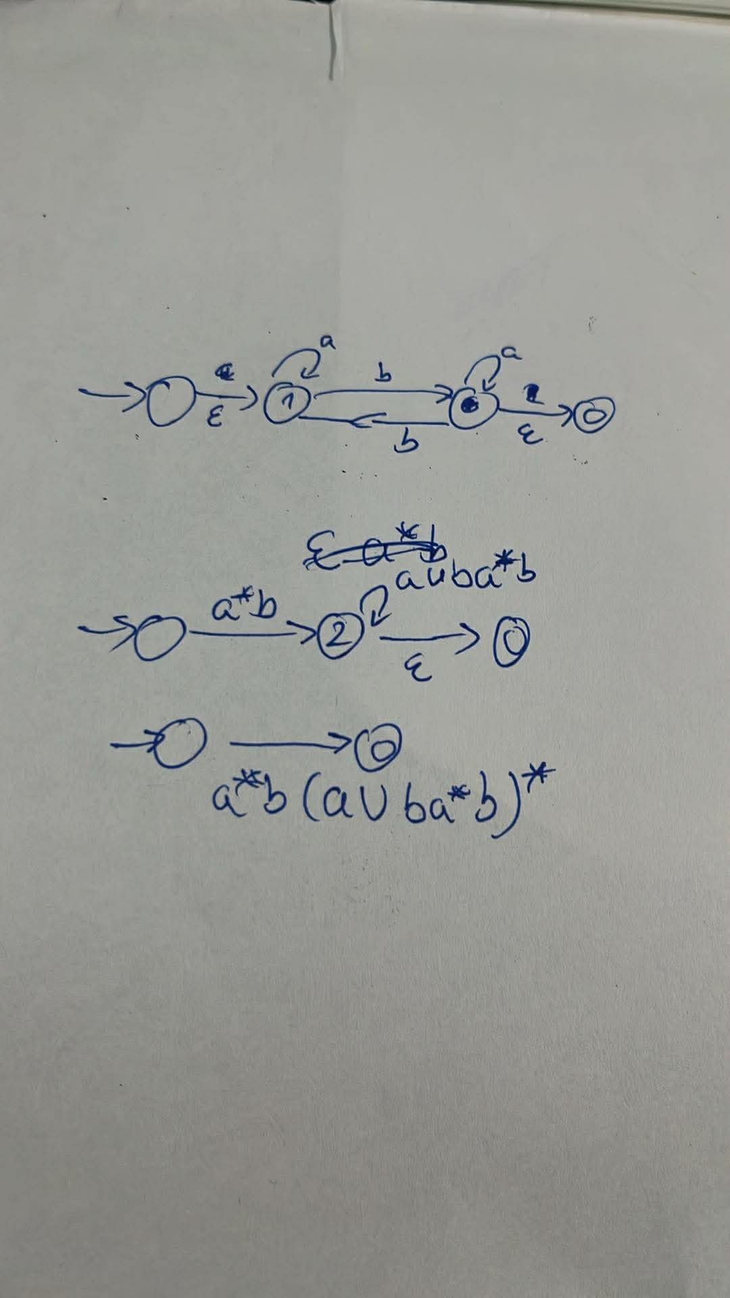
b. $\left(a∪b\right)a^{*}b{\left((b∪a\left(a∪b\right))a^{*}b\right)}^{*}∪ϵ$
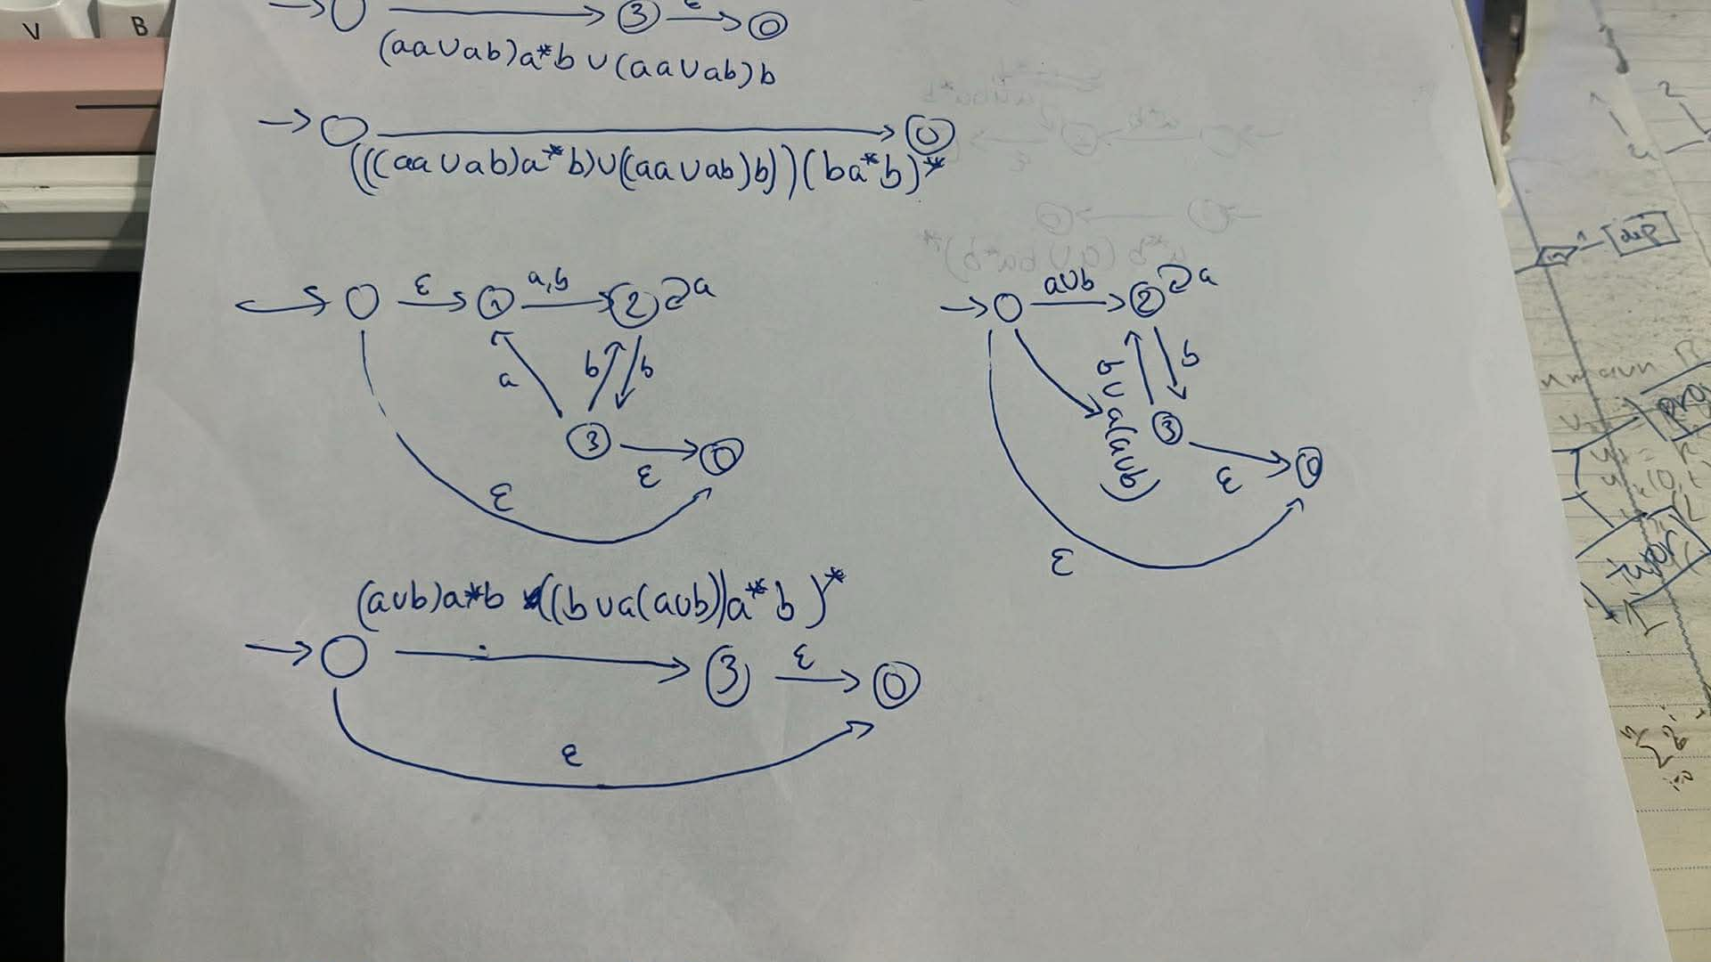

1.22:$/\#{\left(a∪b∪/ \right)}^{*}\#{\left(\#∪\left(a∪b\right)\#\right)}^{*} /$
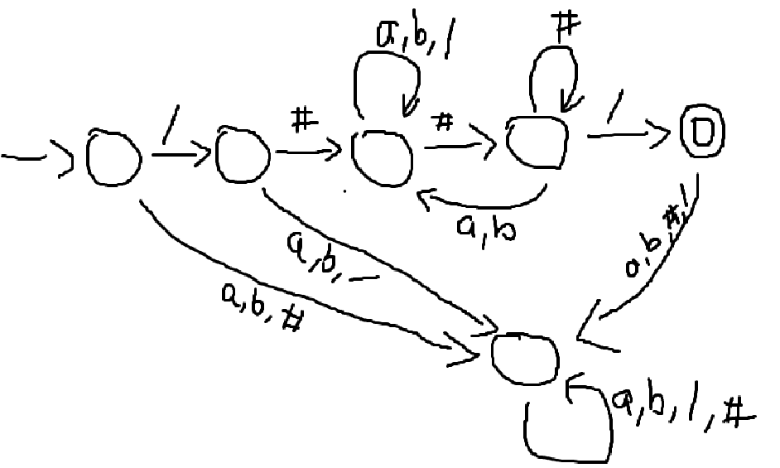
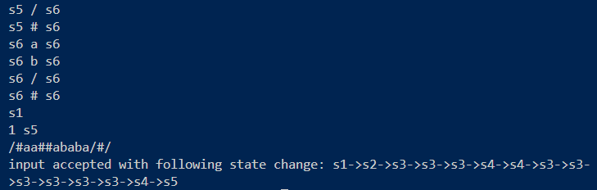
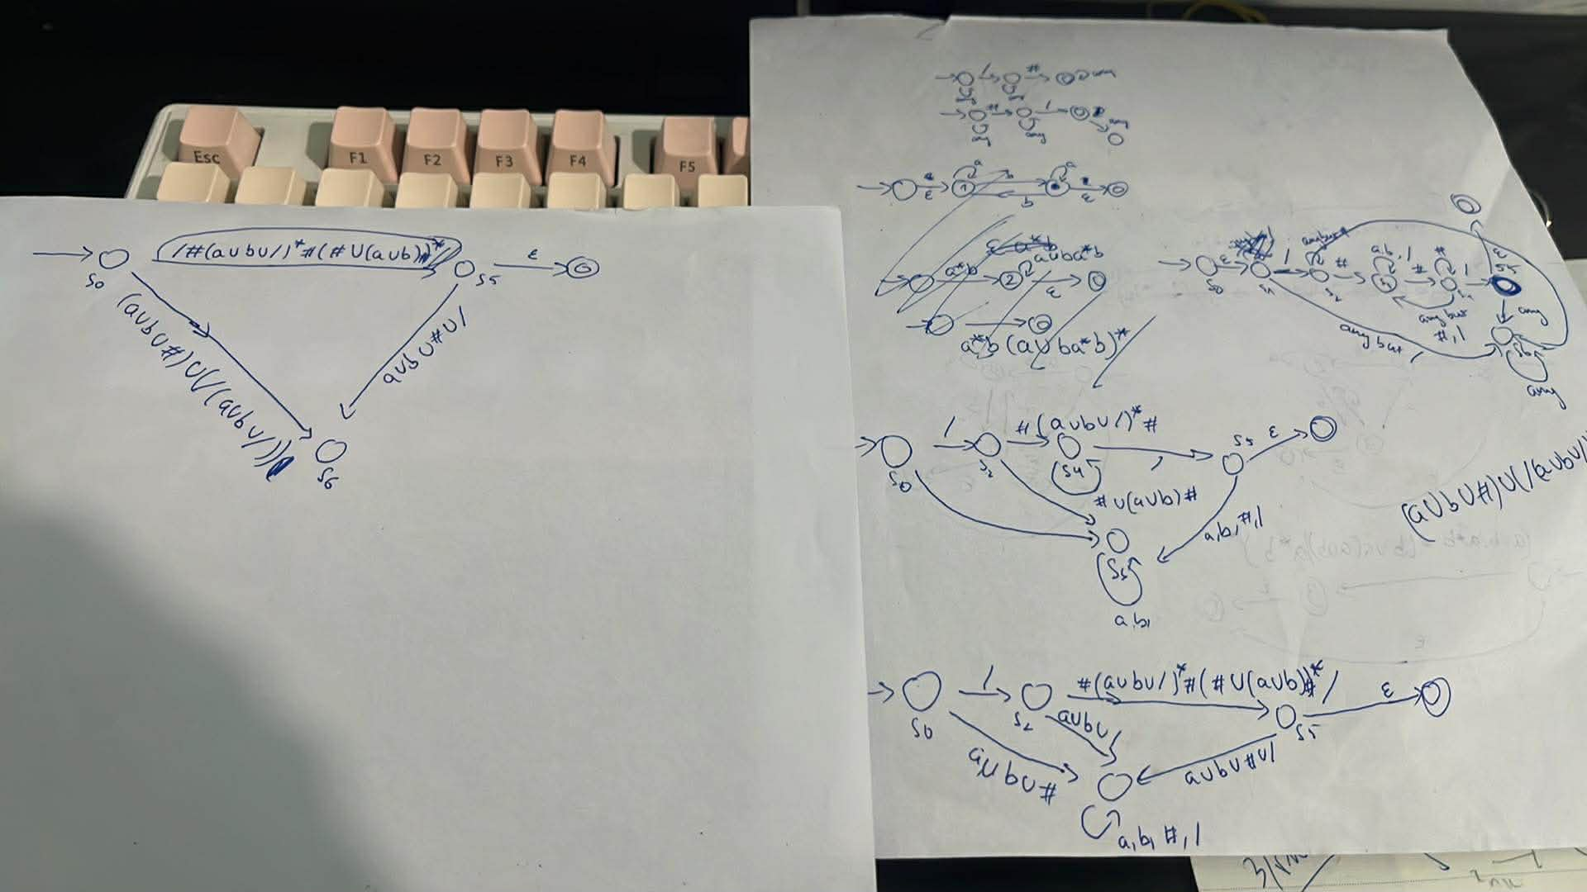

1.28
a.
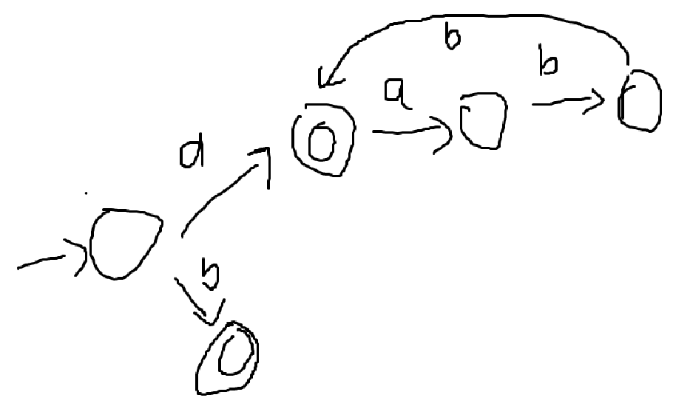
b.
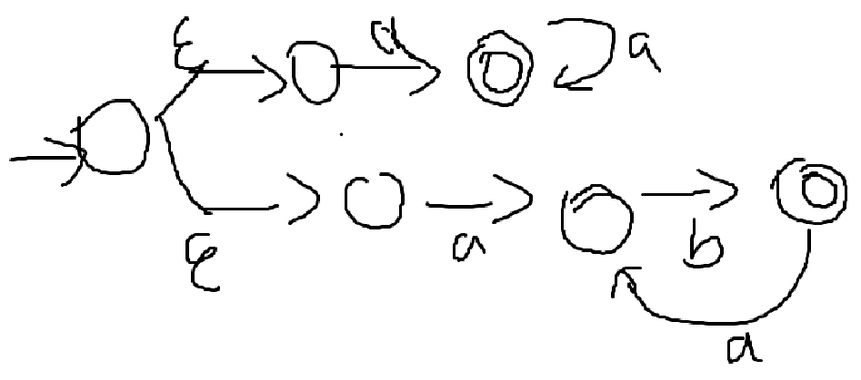
c.
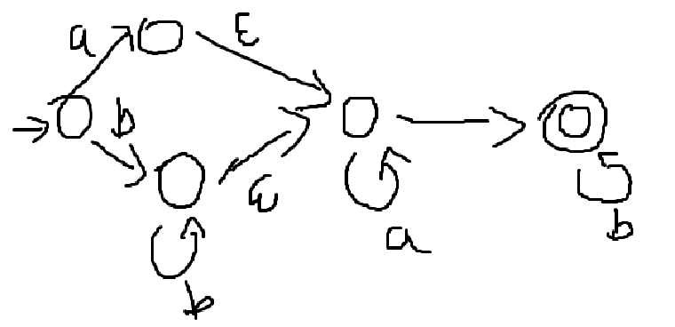
1.29: $A_{2} = \{www | w∈{\left\{a, b\right\}}^{*}\}$

