1b.
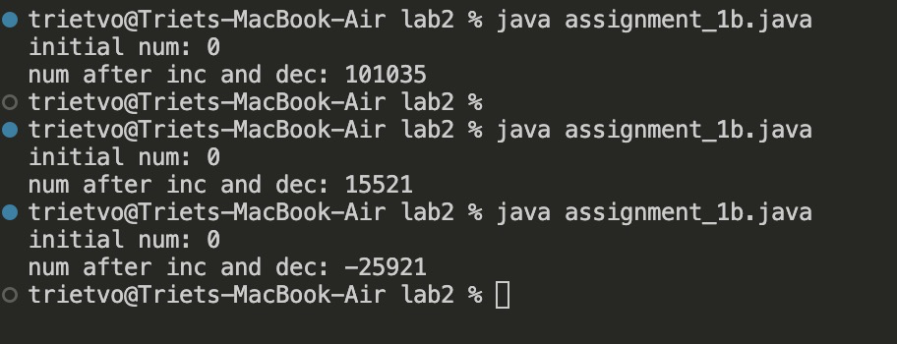
Race condition. Both threads try to write/change a shared variable at the same time. At which point, the value of such variable depends on the order of execution on machine code, not the written code itself.

