Project 3: Homographies

# Sample Pictures: Atrium

## Mosaic Pieces After Warping

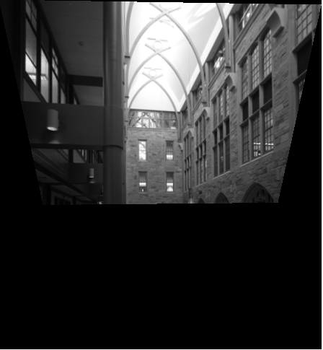 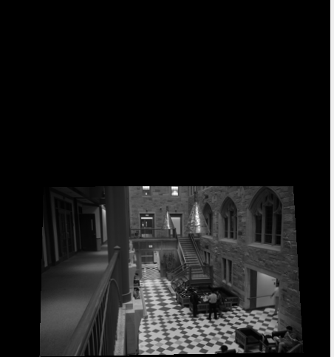

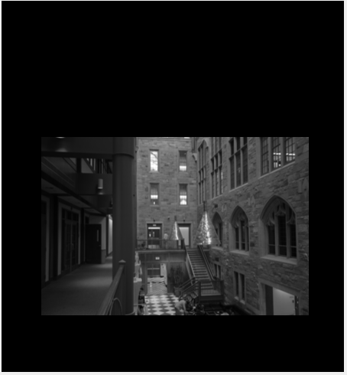

## Mosaic Before Blending

## 

This looks great!

The images may look a little blurrier than usual because I down sampled to 10% of the original image. My poor mac book air can’t take all of this.

## Blended Assembly

### Pieces

### 

I have no idea why the overlapping regions are darker. I normalized them, but I guess I shouldn’t add the same pixels to each other over and over again?

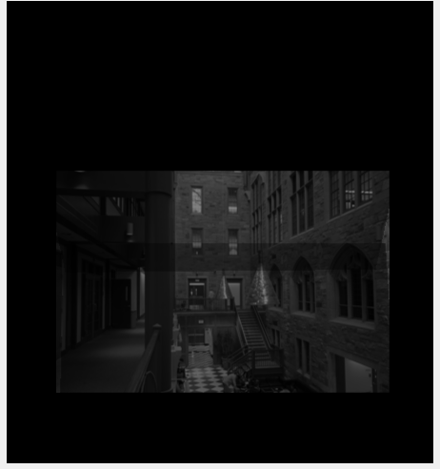

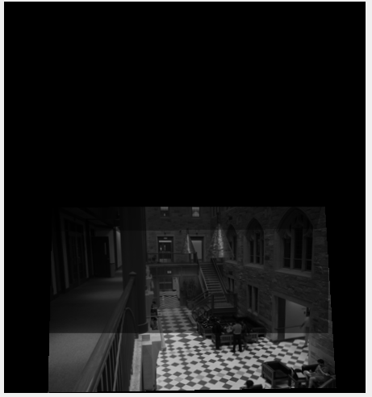

### Final Blended Mosaic

## 

I don’t think the blending does much for me.

## Two Band Blending

### Low Frequency Pieces

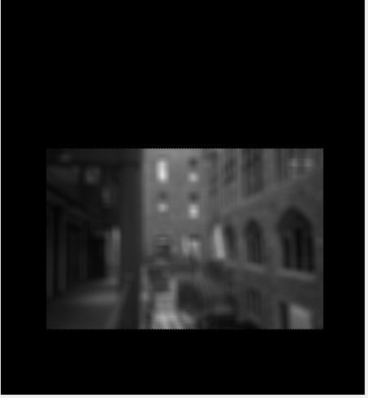

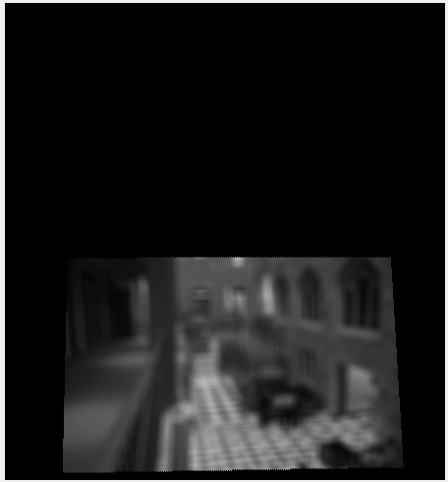

### Low Frequency Mosaic

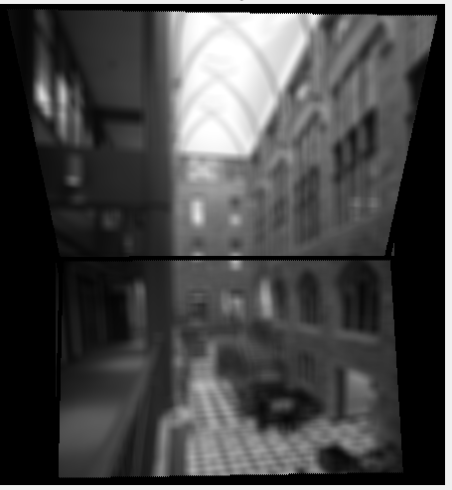

For some reason, there are black borders where the images overlap.

### High Frequency Pieces

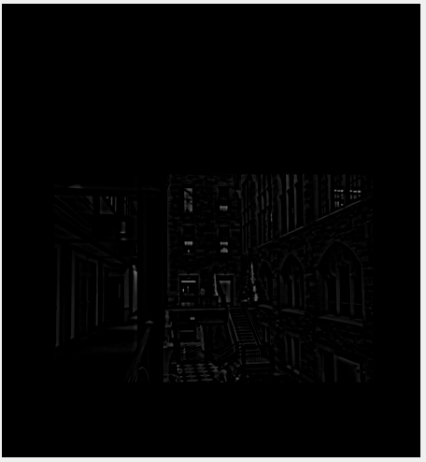

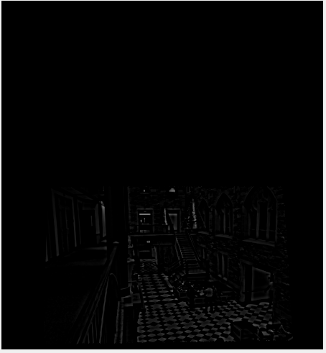

### High Frequency Mosaic

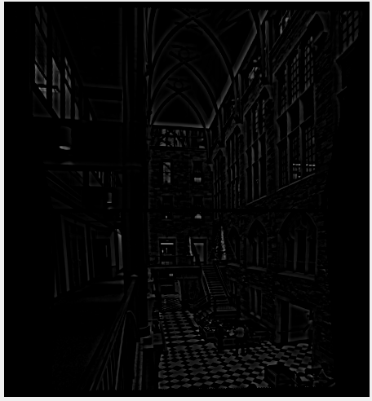

This looks great, I love it.

## Low and High Frequency Mosaics Added Together

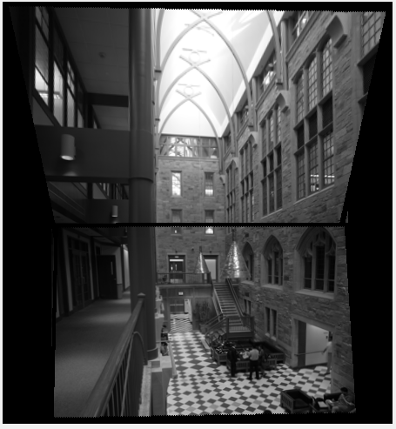

Wow, simply adding the two low and high frequencies together can help blend, why go through all that messy homography stuff.

# My Pictures: Drinkward Dorm at Harvey Mudd College

## Mosaic Pieces After Warping

I am not creative and took pictures of buildings because they have a lot of corners.

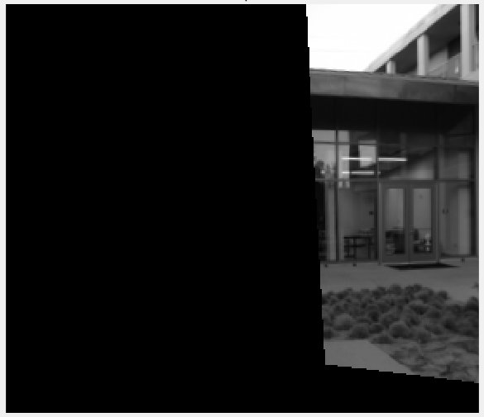

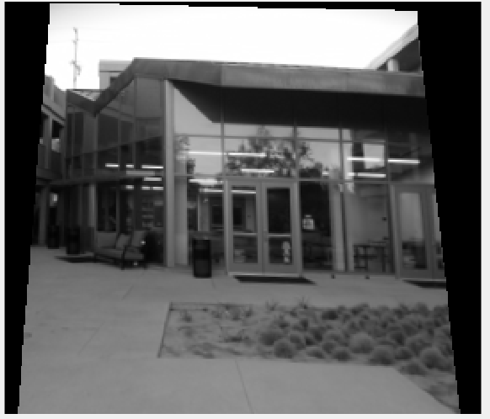

## Mosaic Before Blending

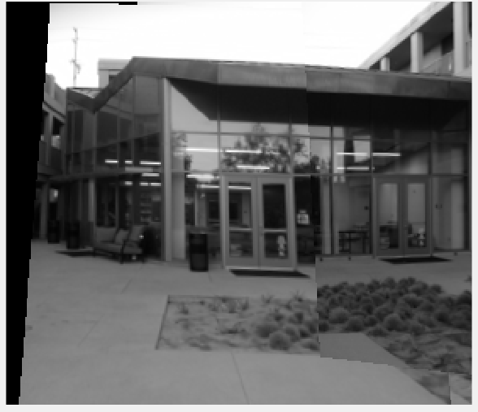

## Blended Assembly: Pieces

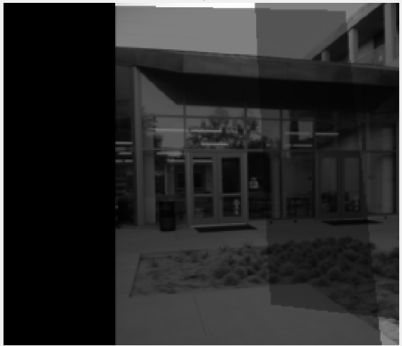

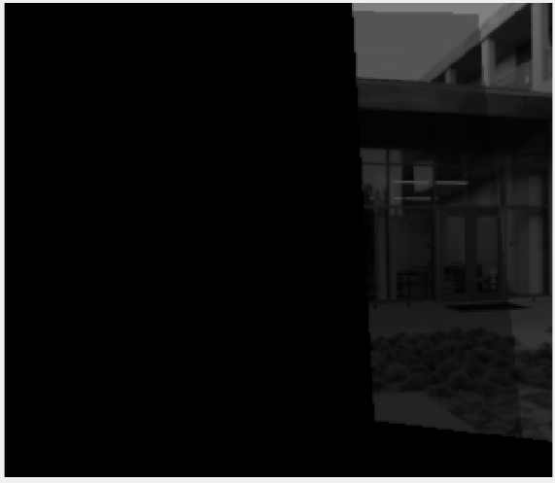

## Blended Assembly Mosaic

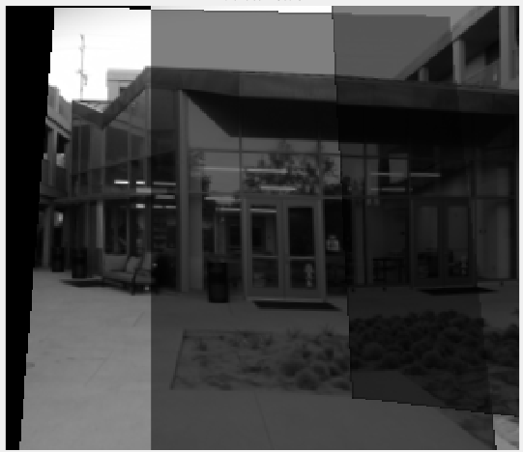

## Two Band Blending: Low Frequency Pieces

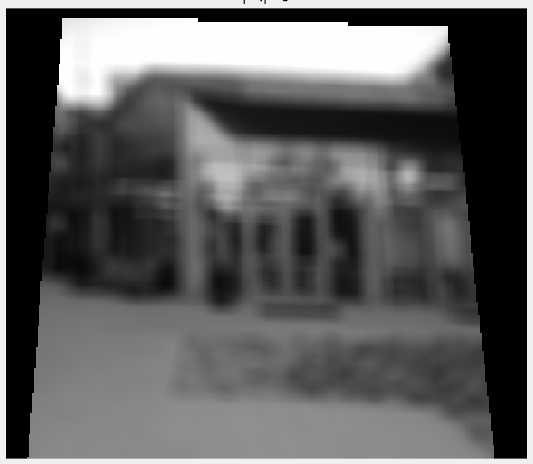

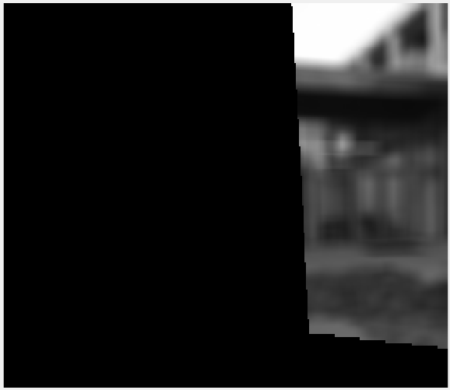

## Two Band Blending: Low Frequency Mosaic

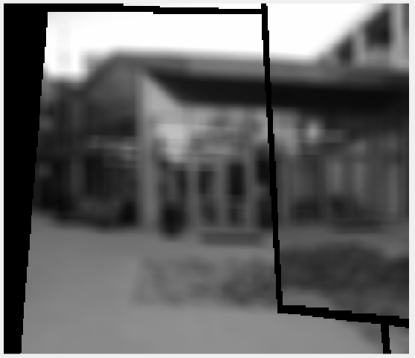

## Two Band Blending: High Frequency Pieces

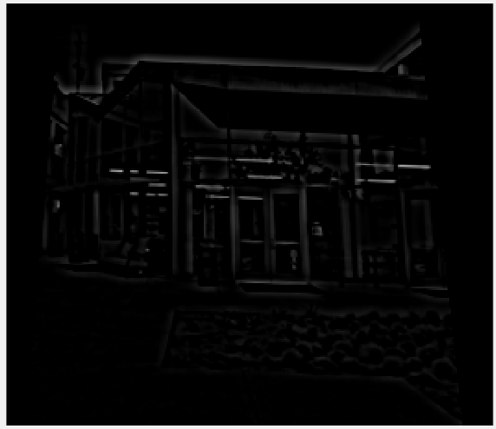

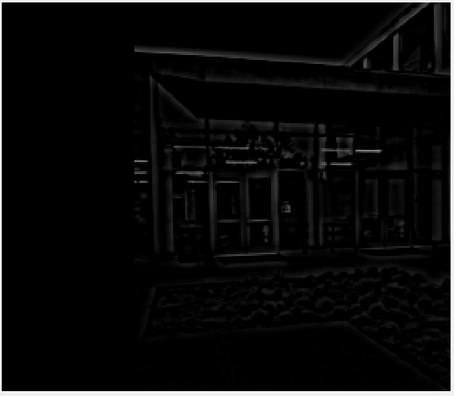

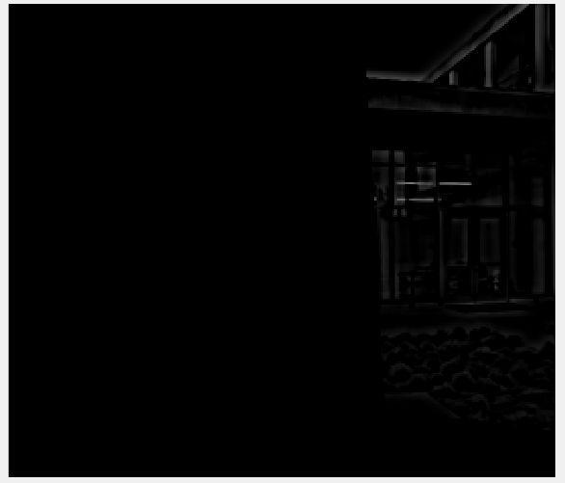

## Two Band Blending: High Frequency Mosaic

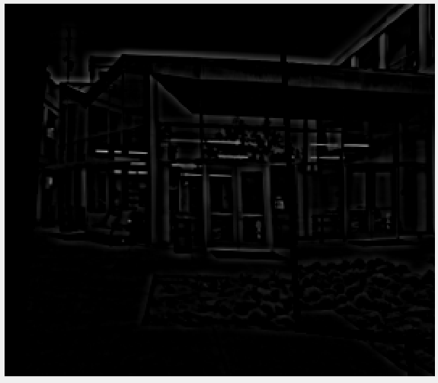

## Two Band Blending: Low and High Frequency Added Together

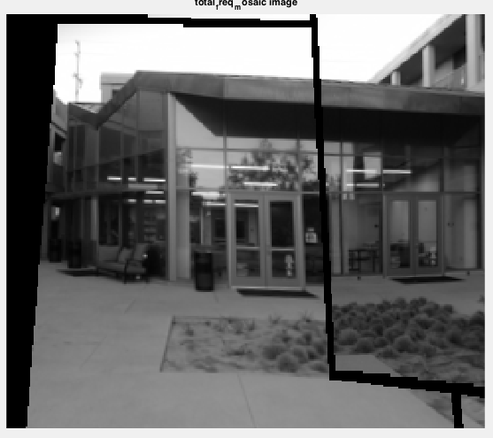

# My Pictures: Shanahan Building at HMC

## Mosaic Pieces Before Blending

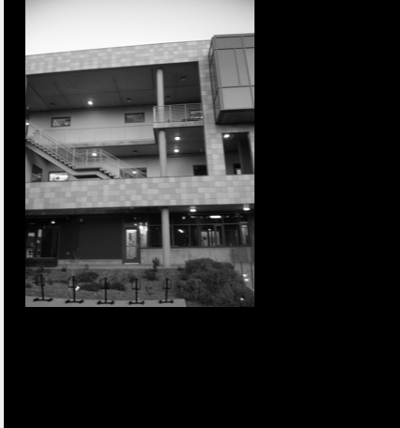

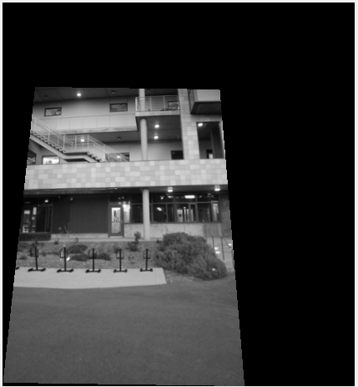

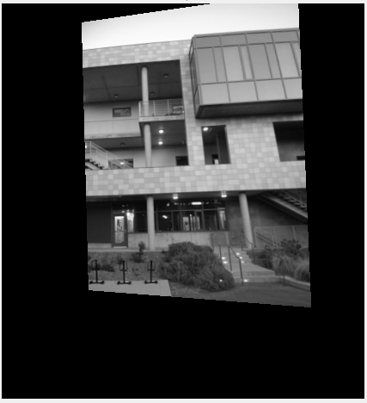

## Mosaic Without Blending

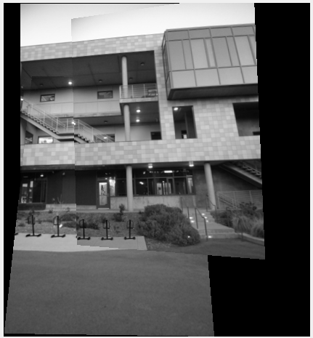

## Blended Assembly: Pieces

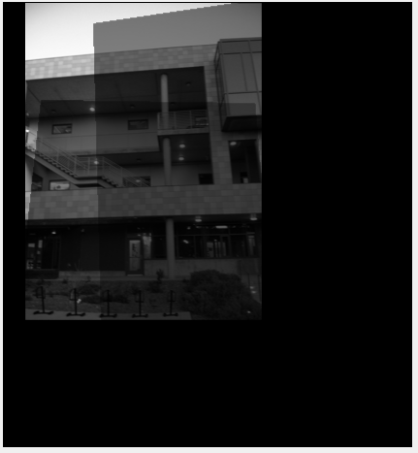

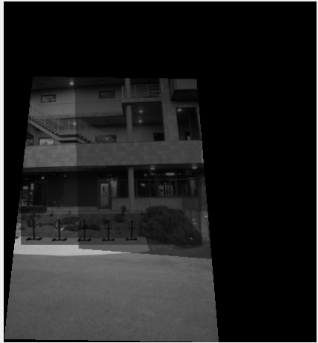

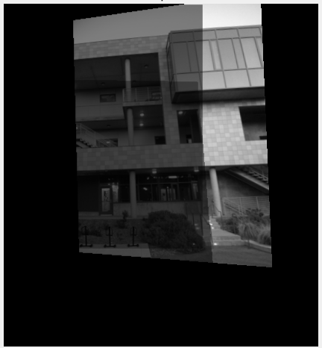

## Blended Mosaic

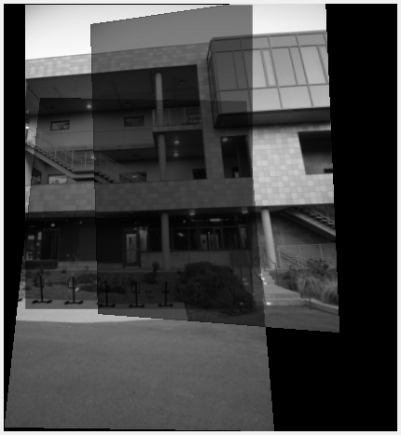

## Two Band Blending: Low Frequency Mosaic Pieces

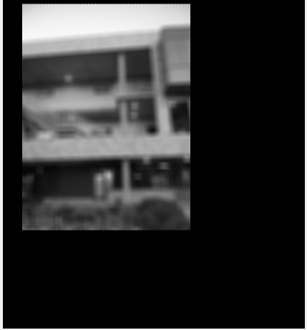

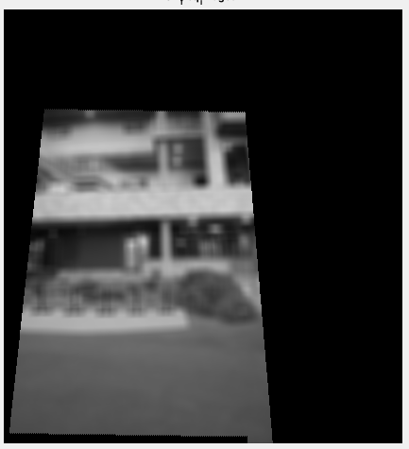

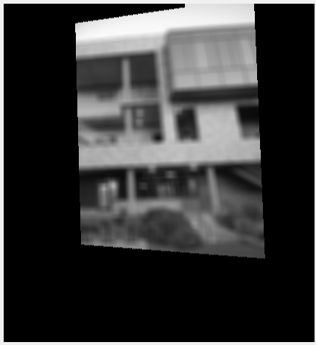

## Two Band Blending: Low Frequency Mosaic

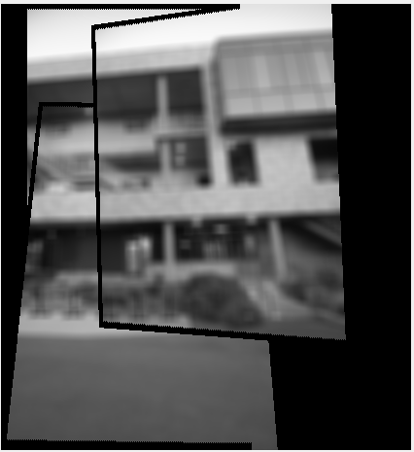

## Two Band Blending: High Frequency Pieces

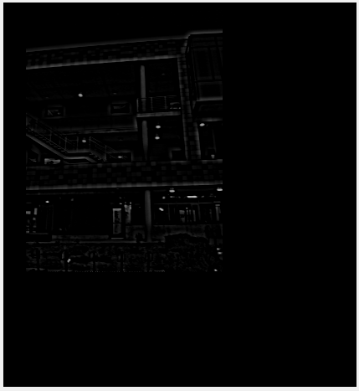

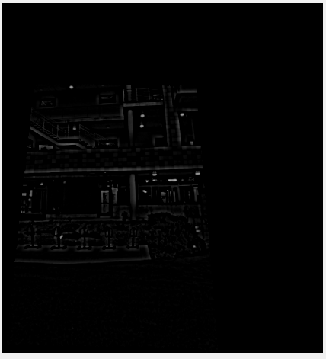

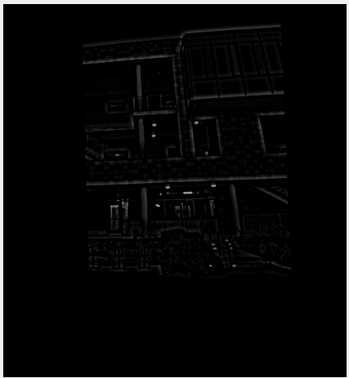

## Two Band Blending: High Frequency Mosaic

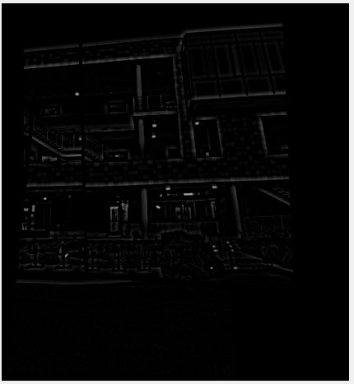

## Two Band Blending: Low + High Frequency

