SAKAI E-LEARNING SYSTEM

# Users

1. Students
2. Teachers

# Features

## Students

1. Login
2. View announcements (List + detail)/ Download attachment (optional)
3. View resources/Download attachment (optional)
4. View discussions/comments (Discussion list/ discussion detail or list of comments)
5. Create discussions/comments
6. View gradebook
7. View assignment (List + detail)/ Download attachment (optional)
8. Submit assignment/ Upload attachment(optional)

## Teacher

1. Login
2. Add teachers to class (optional)
3. Add students to class (optional)
4. View/Edit announcements/ Upload file (optional)
5. View/Edit/Delete resources/Upload file (optional)
6. View discussions/comments
7. Create discussions/comments
8. Create/Edit assignments/ Upload file (optional)
9. Create/Update/Delete gradebook/ Export grade book (optional)

# UI/UX

## Login

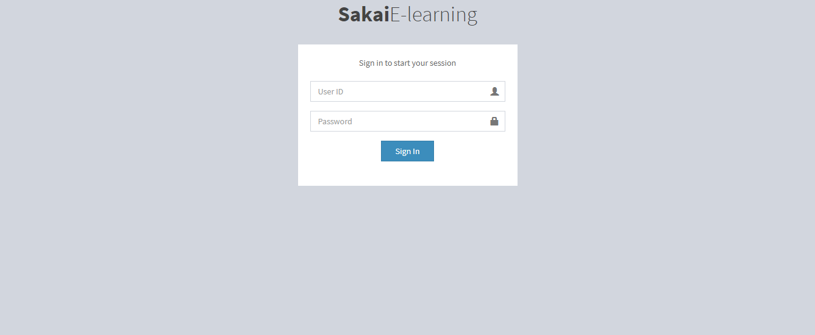

## Homepage

1. Students

* After logging in, students are redirected to homepage. Homepage will display all the recent notifications of all classes

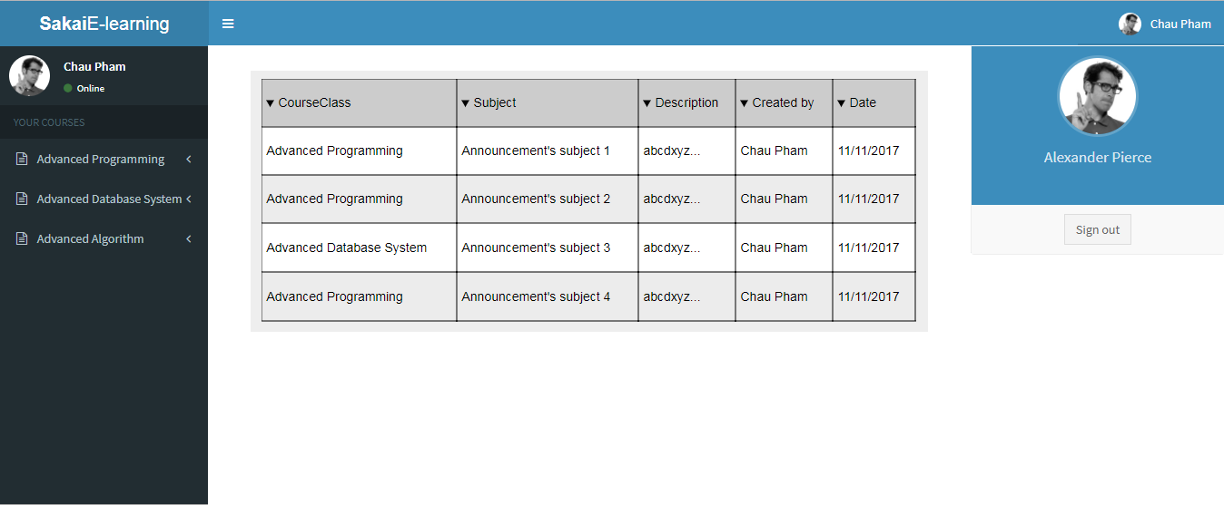

## Annoucement

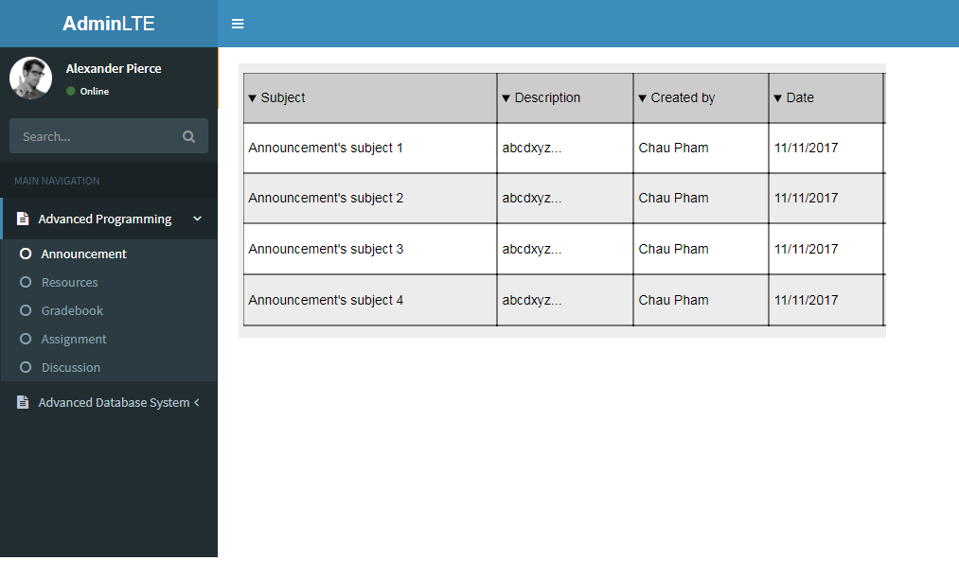

## Announcement list