**HO CHI MINH CITY UNIVERSITY OF TECHNOLOGY**

**FACULTY OF COMPUTER SCIENCE AND ENGINEERING**



**LSI LOGIC DESIGN**

**LAB 2 - SYNTHESIS**

Giảng viên hướng dẫn: Huỳnh Phúc Nghị

Sinh viên: Trần Minh Trí - 1910637

Nguyễn Lê Gia Hinh - 2011213

Mai Lê Cường - 2012764

Lê Thanh Dương - 2012883

Lê Thanh Tiến - 1912196

*- 03/2023 -*

**☞NETLIST:**

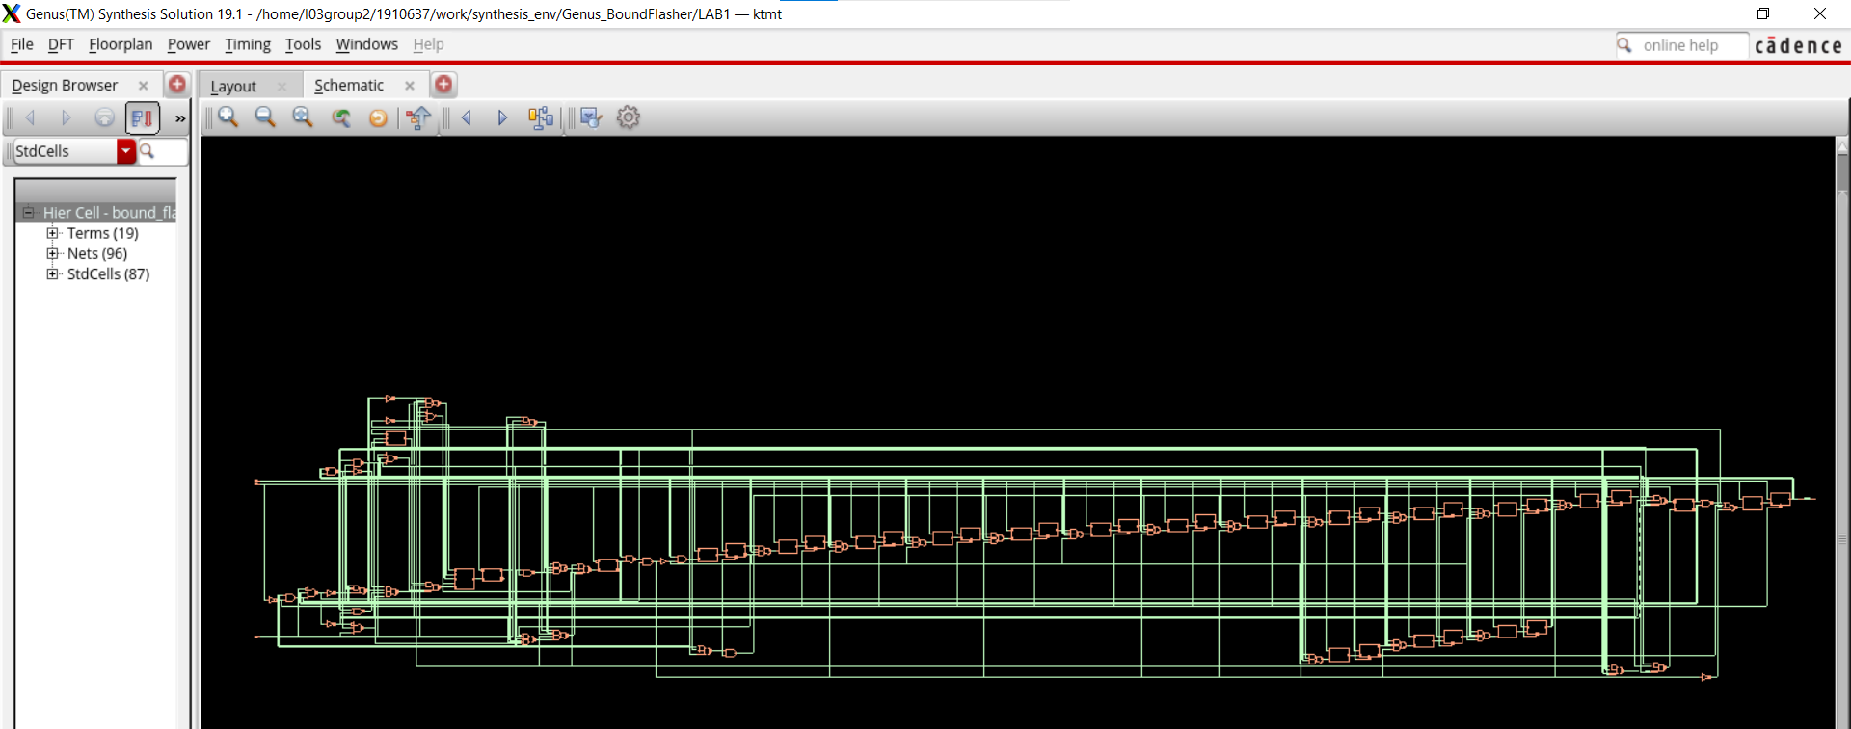

**☞MAXIMUM DESIGN FREQUENCY:**

- We know that in order to find maximum design frequency -> we need to find mim period.

- Therefore, we modify the period in the file **bound_flasher_gate.sdc** in folder **constraints:**

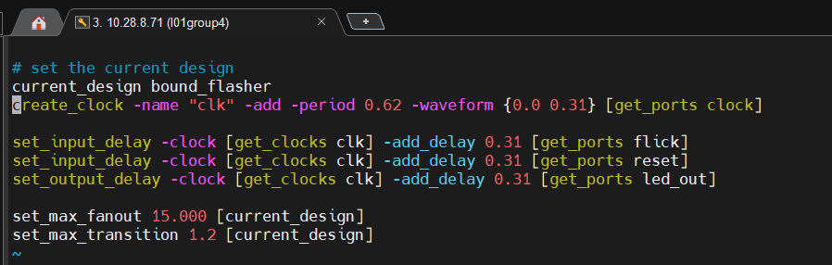

**=>** We finally found the min period -> max design frequency.

**This result can be found in file final_qor.rpt.**

