https://spl.robocup.org/
https://www.robocup.org/leagues/5

CHAPTER 2: SYSTEM PRINCIPLE AND COMPONENTS SELECTION

2.1 Mechanical principles selection
The number of wheels using in most type of mobile robot and soccer robot play an important role in analyzing the dynamic and motion control of the robot.
Based on the purposes and characteristics of the robot, the number of using wheel can be modified, the mechanism should be compact and easy to install. However, soccer robots from all over the world currently have 5 popular types of mechanism.
Table 2.1 Comparison of some suitable principle
Principle | Advantages | Disadvantages
 | Small size and easy to install. It allows the robot to spin around a pivot point, which is more flexible than the others | Lack of passive wheel. Self-balance algorithm should be implemented or accept the friction force created by 1 edge of the robot base and the surface.
 | Easy to rotate, flexible in moving | Complex transmission drive, need 3 independent motors. Robot can be overturned when it rotates suddenly
 | Small size and easy to install. It allows the robot to spin around a pivot point. | Passive wheel can lead to undesired movement.
 | Easy to install, can rotate with high speed, high aesthetic | Difficult to synchronize the speed of 4 motors while on straight line. Need a lot of space to install.
 | Can move multi-direction with rotating. High flexibility | Complex transmission drive, need 4 independent motors.

Conclusion
The purpose of this thesis is to fabricate a small size soccer robot (100 x 100 x 100 mm) and light weight. Therefore, the robot platform consist of 2 driving wheels at the rear and one ball wheel in the front is selected. The ball wheel is suitable with our flat plane platform as it provides 1 contact point, which produce less friction compared to other type of wheel, reducing the occurrence of slipping that produce noise for the control algorithm.
Fig 2.1 The chosen soccer robot mechanism
The mechanism is no need to implement self-balanced algorithm. However, the passive wheel might cause undesired movement, increasing the complexity of kinematic and dynamic analysis.
Fig 2.2 Schematic diagram of soccer robot
2.2 Wheel selection
There are 3 popular types of wheels using in mobile robot industry: standard/fixed wheel, castor wheel and Omni wheel. However, the chosen mechanism is coaxial shaft system, so they must be driving wheels. Hence, castor wheel option is eliminated.
Table 2.2 Comparison of wheels
 | Fixed wheel | Omni wheel
Advantages | - Small size  - Better traction  - Affordable | - High flexibility  - 3 degree of freedom  - Small friction
Disadvantages | - Poor flexibility  - 2 degree of freedom | - Slip phenomenon is easy to occur  - Big size  - Expensive
According to the scope, Omni wheel is not necessary because flexibility movement is no need to be created. Furthermore, fixed wheel allows the robot to move faster because of the ability of traction.
2.3 Motor selection
DC encoder motor is used in this project due to the small size, suitable for the design requirement.
Motors used to in this project need to be compact, lightweight and can create moderate torque and number of revolutions per minute. Besides, they should ensure the high precision demand and easy to be controlled.

Table 2.3. Comparing and selecting motor
Approach | Illustration | Advantages | Disadvantages
Servo motor | 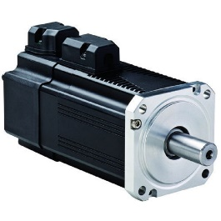 | - High torque to inertia ratio  - Encoder determines accuracy and resolution  - Compact | - Need tuning to stabilize the feedback loop  - Expensive
DC motor  With encoder | 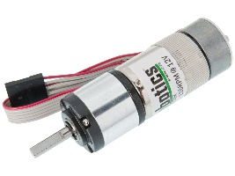 | - Meet the demand of the size and power  - Long service life and easy for installation  - Affordable  - Encoder determines accuracy and resolution | - Small torque  - Need tuning to stabilize the feedback loop
Stepper motor | 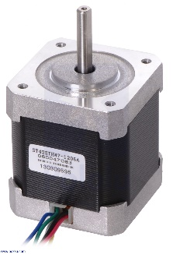 | - Cost less money than motor with encoder  - Flexibility  - Excellent low speed torque and repeatability  - Compact | - Low efficiency and accuracy  - No feedback used in motor indicates to missed steps  - Extremely noisy
Conclusion: Choose DC motor with encoder. Due to their compact size, it is easy to be installed. Furthermore, they are affordable and can ensure the high accuracy demand in speed control.

2.4 Battery selection
The battery source should not only be small, carriable and lightweight, but also supply enough energy for electrical components.

Table 2.4. Compare battery sources available for sale
Approach | Illustration | Advantages | Disadvantages
Lithium – Ion batteries | 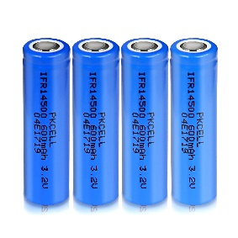 | - Affordable  - Charging cycle up to 400 times or more  - Rarely worn-out battery | - Heavier comparing to the same power Li-po cells  - Pin would be damaged if the voltage is extremely low or higher than 4.2 V/cell.
Lithium – Poly batteries | 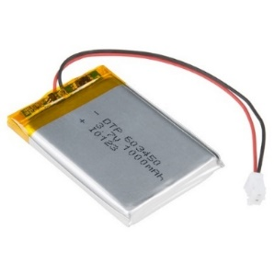 | - High compact resistance  - Good discharging ability.  - Flexible in size, suitable for a large range of products. | - More expensive.  - Poor capacity.  - Lifespan would be decreased after charging cycles (after around 300 charging cycles, the capacity would be decrease by 20% ).
Conclusion: Choose Lithium – Ion batteries due to their reliability and discharging ability. Moreover, they are cheap, easy to be installed.
2.5 Controller selection
The purpose is to collect, transmit and receive data:
- Control motor
- Send data back to PC
- The controller should be small, lightweight

Table 2.5 Comparison of controller
Option | Illustration | Advantages | Disadvantages
Microcontroller | 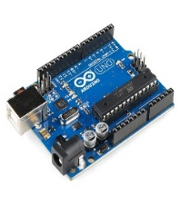  Arduino UNO development kit | - High performance.  - Easy to communicate without the presence of other expensive devices | - Poor technology can lead to anti-interference.
PLC | 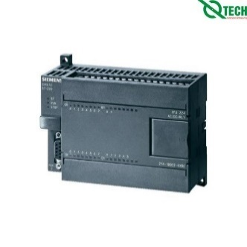  PLC Siemens S7-200 | - Designed to be implemented in industrial environment easily  - Built-in communication for I/O remote inputs and outputs, instrumentation  - Easily controlled by logical adjustments via software, no adjustments are required to the wire connections. | - Expensive  - Complex wiring  - Difficult to alternate  - Difficult to find out error
Conclusion: Choose microcontroller option because:
- High performance.
- Communicate UART easily.
- Small size.
- Affordable.
- Many available modules in market can be chosen based on requirement.

Table 2.6 Compare and select microcontroller
Option | Illustration | Characteristics
STM32 | 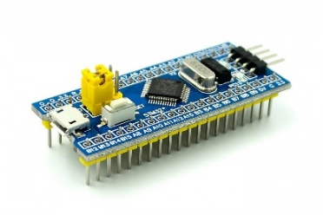 | - Full of communication protocol, interrupt, timers, …  - Design software easier because of IDE, productivity can be also optimized.  - Low investment
PIC | 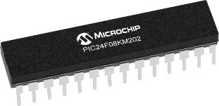 | - Many available communication protocols, interrupt, timers, …  - Expensive
Arduino | 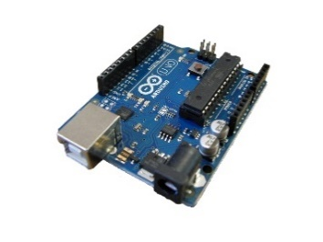 | - Full of communication protocols, interrupt, timers, …  - Design software easier because of IDE, productivity can be also optimized.  - Low investment
Raspberry Pi | 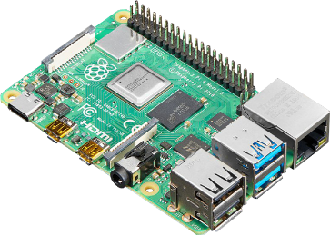 | - Low cost  - Huge processing power in a compact board  - Many interfaces (HDMI, multiple USB, Ethernet, onboard Wi-Fi and Bluetooth, many GPIOS …)  - Support Linux, Python
ESP32 NodeMCU | 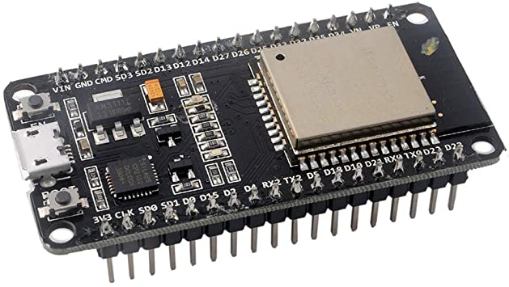 | - Full of communication protocols, interrupt, timers, …  - Design software easier because of IDE, productivity can be also optimized.  - Low investment  - Specially, Wi-Fi communication protocol is available.
Conclusion: Choose ESP32 NodeMCU, because it not only satisfies design requirements, but also has IDE and support libraries which makes designing software easier. Moreover, Wi-Fi communication protocol is available, makes it convenient in using process.
2.6 Transmission environment
The control system has 2 main tasks: receive data from PC and control speed of 2 motor. In order to complete these tasks, wired or wireless communication can be implemented. Because the robot should move constantly, so wireless communication is preferable.

Table 2.7 Wireless communication is widely used in mobile industry
Option | Characteristics
Bluetooth  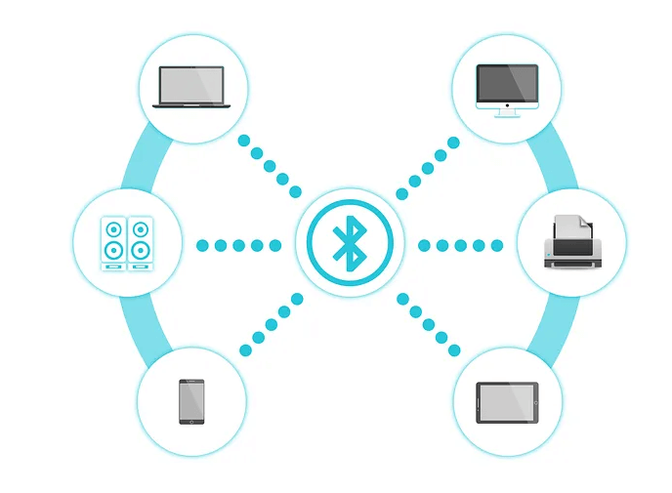 | - Low bandwidth.  -Suitable for communication among a small number of devices.  - Narrow range.
Wi-Fi  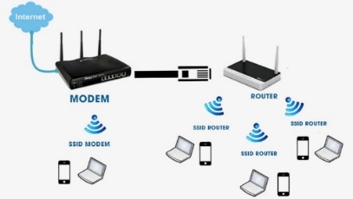 | - High bandwidth.  - Support for a huge number of users.  - Large range.  - Utilized by lots of industrial environment
Based on technical requirements, Wi-Fi communication is chosen
2.7 Communication protocol
The protocol should be easy to be designed, available in Wi-Fi environment and enable to ensure the real time problems. In the world of Internet protocol traffic, TCP or UDP setup can be considered.
Transmission Control Protocol (TCP) is connection-oriented, meaning once a connection has been established, data can be transmitted in two directions.
User Datagram Protocol (UDP) is a simpler, connectionless Internet protocol wherein error-checking and recovery services are not required.

Table 2.8 Difference between TCP and UDP protocol
Feature | TCP | UDP
Connection status | Requires an established connection to transmit data (connection should be closed once transmission is complete) | Connectionless protocol with no requirements for opening, maintaining, or terminating a connection
Data sequencing | Able to sequence | Unable to sequence
Guaranteed delivery | Can guarantee delivery of data to the destination router | Cannot guarantee delivery of data to the destination
Retransmission of data | Retransmission of lost packets is possible | No retransmission of lost packets
Error checking | Extensive error checking and acknowledgment of data | Basic error checking mechanism using checksums
Method of transfer | Data is read as a byte stream; messages are transmitted to segment boundaries | UDP packets with defined boundaries; sent individually and checked for integrity on arrival
Optimal use | Used by HTTPS, HTTP, SMTP, POP, FPT | Video conferencing, streaming, DNS, VoIP

Conclusion: Choose TCP. Because TCP has built-in systems to check for errors and to guarantee data will be delivered in the order it was sent, making it the perfect protocol for transferring information data files. Besides, MicroPython library of ESP strongly support TCP socket.
2.8 Control mechanism
Requirement:
The interfaces should be as simple as possible, to make it easy to modify, observe and install. Because of executing multiple tasks simultaneously, the memory overflow phenomenon should not occur.
The soccer robot includes several control modules, such as power module, motor control module, microcontroller module and communication module.
There are two popular methods used to connect these modules: centralized control and distributed control.
Fig 2.3 Centralized control structure
Fig 2.4 Distributed control structure
Table 2.9 Differences of Centralized control and Distributed control
 | Centralized control | Distributed control
Principle | The central microcontroller unit receives and analyzes data from sensor modules, then sends signal to control motors | Each microcontroller units take responsible for completing specific functions such as analyses data from sensor module or sends signal to control motors. These motors communicate to a central microcontroller unit.
Advantages | - Simple, easy to install, communicate and manage the source code.  - Compact structure.  - Enough I/O pins. | - As many controllers, the central MCU does not need high performance to complete all tasks.  - Easy to work in a group, fix bugs and update source code.
Disadvantages | - MCU requires high performance because of heavy calculation volume, leads to real time operating problems.  - Difficult to debug and update program | - Complex hardware and need a lot of space  - Difficult in solving communication problems. The signals are likely to be disturbed.

Conclusion:
Although the distributed control system has several benefits, it does not meet the demand of space because of the size of the robot. Moreover, communication among many MCU problems is difficult issue. Hence, centralized control method is selected, due to its simplicity.
2.9 Evaluation
Table 2.10 The summary expenditure for components
Quantity | Components | Price in unit (vnd)
2 | Wheel | 150.000
2 | Gear transmission | 200.000
2 | Shaft | 100.000
4 | Bearing | 20.000
2 | Shaft housing | 80.000
1 | Esp32 DevKit V1 | 174.000
1 | TB6612FNG Module Driver | 70.000
2 | Motor GA25 | 225.000
2 | LM2596 Module
1 | PCB | 550.000
1 | Passive wheel | 10.000
16 | Copper bar | 5.000
4 | Lithium cell
1 | Cell case
Total

The calculated tangential stress:
$σ_{H}=\frac{Z_{M}Z_{H}Z_{ε}}{d_{1}}\sqrt{\frac{2T_{1}K_{H}\left(u+1\right)}{b_{w }u}}$ (6.58 p.115[1])
$$=\frac{190×1.76×0.79}{34}\sqrt{\frac{2×460×1.23×\left(0.5+1\right)}{7×0.5}}=209.7 MPa$$
where:
$Z_{H}$: coefficient of contact area $Z_{H}=\sqrt{\frac{2\cos{β}}{\sin{2}α_{tw}}}=\sqrt{\frac{2cos0}{\sin\left(2×16.56°\right)}}≈1.76$
$Z_{ε}$: contact length coefficient, when $ε_{b}$ < 1 use the following equation:
$Z_{ε}=\sqrt{\frac{1}{ε_{α}}}=\sqrt{\frac{1}{2.14}}=0.79$ (6.36c p.105[1])
where:$ε_{α} = \frac{\sqrt{d_{a1}^{2}-d_{b1}^{2}}+\sqrt{d_{a2}^{2}-d_{b2}^{2}}-2α_{w}sinα_{tw}}{\frac{2πmcos\left(α_{t}\right)}{\cos\left(β\right)}}$ (6.47 p.105[1])
$$=\frac{\sqrt{{36}^{2}-{31.5}^{2}}+\sqrt{{19}^{2}-{16}^{2}}-2×25×\sin\left(16.56°\right)}{2π×1×\frac{\cos\left(16.56°\right)}{\cos\left(0°\right)}}=2.14$$
(6.48 p.105[1])
$$ε_{b}=\frac{b_{w}sinβ}{mπ}=0<1$$
$Z_{M}=190MPa^{\frac{1}{3}}$: material mechanical property coefficient, chosen based on table 6.5 p.96[1], given that the gears are made by steel
$K_{H}$: coefficient of load
$$K_{H}=K_{Hβ}K_{Hv}K_{Hα}=1×1.16×1.038≈1.22$$
where:
$K_{Hβ}= 1$ is coefficient of undistributed load on gear width
$K_{Hα}= 1.13$is undistributed load coefficient
$K_{Hv}=1+\frac{v_{H}b_{w}d_{w1}}{2T_{1}K_{Hβ}K_{Hα}}=1+\frac{0.371×7×34}{2×460×1×1.13} ≈1.088$
with:$v_{H}=δ_{H}g_{0}v\sqrt{\frac{a_{w}}{u}}=0.002×73×0.36×\sqrt{\frac{25}{0.5}} =0.371$
$δ_{H}=0.002$ is coefficient of contacting errors, chosen based on table 6.15 p.107[1] given that gear with inclined teeth and ${HB}_{2}≤350HB$
${ g}_{0}$ = 73 is coefficient of teeth module error, chosen based on table 6.16 p.107[1] given that the degree of accuracy is 9, module $≤$ 3.55.
Precisely calculating the allowable contacting stress:
$\left[σ_{H}\right]=\left[σ_{H}\right]Z_{R}Z_{V}K_{xH}=340×1×0.77×1=260.6 MPa$ (6.1a p.93[1])
where: $\left[σ_{H}\right]$ on the right side of the equation is calculated in part II.5 above,
$$\left[σ_{H}\right]=340 MPa$$
Checking the value of tangential stress:
$$σ_{H}\sqrt{K_{lv}}=209.7×\sqrt{1}=209.7 MPa<\left[σ_{Hmax}\right]= 952 MPa$$
$→$This satisfies the strength condition
Determine the bending stress for driving gear:
$σ_{F1}=\frac{2T_{1}K_{F}Y_{ε}Y_{β}Y_{F1}}{b_{w}d_{w1}m}$ (6. p.108[1])
$$=2×460×1.68×0.47×1×\frac{4.26}{\left(7×34×1\right)}=12.5MPa$$
where: $K_{F}=K_{Fβ}K_{Fα}K_{Fv}=1.01×1.37×1.22=1.62$is coefficient of load affected bending (the other parameters are chosen and calculated above)
$Y_{ε}=\frac{1}{ε_{α}}= 1/2.14 = 0.47$ is the coefficient of meshing
$Y_{β}= 1- \frac{β}{140} = 1-0/140 = 1$ is the coefficient of teeth incline
$Y_{F1}=4.26$ is the coefficient of teeth type, chosen based on table 6.18 p.109[1] given the displacement coefficient x = 0 and the corresponding teeth of driving gear as calculated below:
$$z_{v1}=\frac{z_{1}}{\cos^{3}β}=34$$
$K_{Fv}=1+\frac{v_{F}b_{w}d_{w1}}{2T_{1}K_{Fβ}K_{Fα}}$ (6.46 p.109[1])
$$=1+\frac{4.07×7×34}{2×460×1.01×1.37} ≈1.22$$
where: the parameters are notated in the previous part
$$v_{F}=δ_{F}g_{o}v\sqrt{\frac{a_{w}}{u}}=1.11$$
Determine the bending stress for driven gear:
$σ_{F2}=\frac{σ_{F1}Y_{F2}}{Y_{F1}}=12.5×3.72/4.26 = 10.9 MPa$ (6.44 p.108[1])
where: $Y_{F2}=3.72$ is the coefficient of teeth type, chosen based on table 6.18 p.109[1], given the displacement coefficient x = 0 and the corresponding teeth of driven gear as calculated below
$$z_{v2}=\frac{z_{2}}{\cos^{3}β}=17$$
Calculating precisely the allowable bending stress for both gears:
$\left[σ_{F1}\right]=\left[σ_{F1}\right]Y_{R}Y_{s}K_{xF} = 190.3×1×1.08×1 ≈ 205.5 MPa$ (6.2a p.93[1])
$\left[σ_{F2}\right]=\left[σ_{F2}\right]Y_{R}Y_{s}K_{xF}= 174.9 ×1×1.08×1 ≈ 188.8 MPa$ (6.2a p.93[1])
where: $\left[σ_{F1}\right],\left[σ_{F2}\right]$on the right side of the equation is calculated,
$$\left[σ_{F1}\right]=190.3 MPa;\left[σ_{F2}\right]=174.9 MPa$$
$Y_{R}=1$ is coefficient of surface roughness (use gears had been through grinding process)
$Y_{s}=1.08- 0.0695\text{ln}\left(m\right)=1.08-0.0695\text{ln}\left(1\right)=1.08$ is coefficient of sensitivity to load
$K_{xF}=1$ is coefficient of gear size affected to bending stress (when $d_{a}≤400$)
Checking the bending stress:
$σ_{F1}K_{lv}= 235.2×1=235.2 Mpa<\left[σ_{F1max}\right]=304MPa$ (6.49 p.110[1])
$σ_{F2}K_{lv}= 232×1=232 Mpa<\left[σ_{F2max}\right]=272 MPa$ (6.49 p.110[1])
- Both gears satisfy the bending stress condition

Based on Lewis strength check standard:
$$σ=\frac{F_{t}×P}{b×Y}=\frac{4.12×1/1}{7×0.302}=1.94<\frac{σ_{b}}{3}=200 Mpa$$
Lewis factor can be check in table 12.1 of reference []
Hence, the driven gear strength satisfies the requirement.
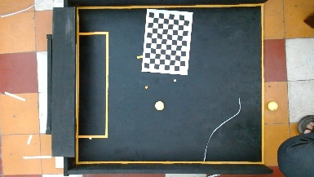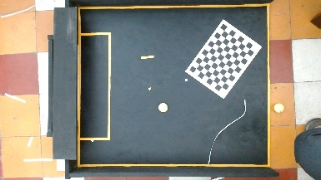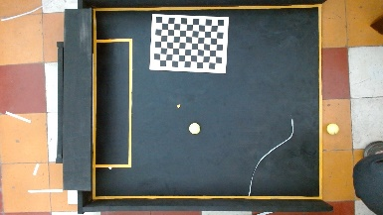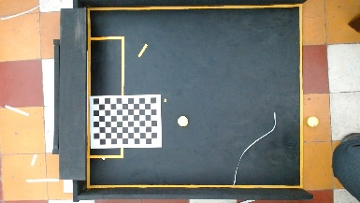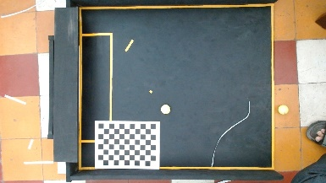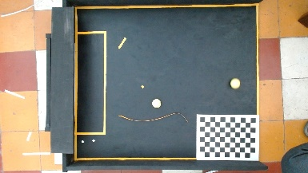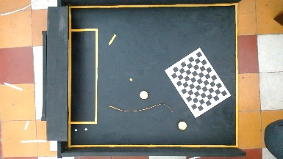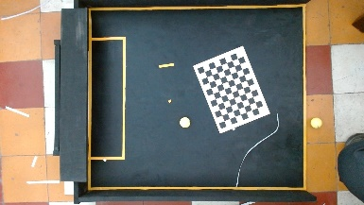
Fig 5.16 Calibration album

CHAPTER 6: MATHEMATIC MODEL
6.1 Mathematic model
Because the robot run on an even ground, constant load, no external force during operation process, so only kinematic analysis should be considered.
The position and orientation of the robot can be displayed by 3 main parameters $\left(x,y,φ\right)$. In which, $\left(x,y\right)$ is coordinate of the robot and $φ$ is the angle formed by a vector which is fixed to the robot and a fixed vector in the fixed coordinate system.
Fig 6.1 Kinematic model
Assume $v$ and $ω$ are velocity and angular velocity respectively at centroid C.
Kinematic equation of the system:
$\left[\begin{matrix}\dot{x} \\ \dot{y} \\ \dot{φ}\end{matrix}\right]=\left[\begin{matrix}\cos{φ} \\ \sin{φ} \\ 0\end{matrix}\begin{matrix}0 \\ 0 \\ 1\end{matrix}\right]\left[\begin{matrix}v \\ ω\end{matrix}\right]$ (4.1)
Angular velocity of the wheel:
$\left[\begin{matrix}ω_{r} \\ ω_{l}\end{matrix}\right]=\left[\begin{matrix}\frac{1}{r} & \frac{b}{r} \\ \frac{1}{r} & -\frac{b}{r}\end{matrix}\right]\left[\begin{matrix}v \\ ω\end{matrix}\right]$ (4.2)
In which,
$ω_{r}$ : right wheel’s angular velocity
$ω_{l}$ : left wheel’s angular velocity
$r$ : wheel radius
$b$ : distance between wheels
Tracking point coordinate:
$\left\{\begin{aligned}x_{r}=x_{c}+d\cos{∅} \\ y_{r}=y_{c}+ds\end{aligned}\right.$
In which,
$d$ : distance from centroid to tracking point
To control the robot to follow the virtual line path $R\left(x_{r},y_{r},φ_{r}\right)$, the centroid must be controlled to follow the desire line path and the direction of the robot is tangent to the line.
Robot followed to the line satisfies:
$\left\{\begin{aligned}x_{r}=v_{r}\cos{φ_{r}} \\ y_{r}=v_{r}\sin{φ_{r}} \\ φ_{r}=ω_{r}\end{aligned}\right.$ (4.3)
Fig 6.2 Error model
To meet the demand, 3 characteristic error parameters are required to demonstrate the error of distance from centroid to R line, $e={\left[\begin{matrix}e_{1} & e_{2} & e_{3}\end{matrix}\right]}^{T}$
The errors are determined by geometry relation:
$\left[\begin{matrix}e_{1} \\ e_{2} \\ e_{3}\end{matrix}\right]=\left[\begin{matrix}\cos{φ} & \sin{φ} & 0 \\ -\sin{φ} & \cos{φ} & 0 \\ 0 & 0 & 1\end{matrix}\right]\left[\begin{matrix}x_{r}-x \\ y_{r}-y \\ φ_{r}-φ\end{matrix}\right]$ (4.4)
Differentiate the equation 4.3,
$\left[\begin{matrix}\dot{e_{1}} \\ {\dot{e}}_{2} \\ {\dot{e}}_{3}\end{matrix}\right]=\left[\begin{matrix}v_{r}\cos{e_{3}} \\ v_{r}\sin{e_{3}} \\ ω_{r}\end{matrix}\right]+\left[\begin{matrix}-1 & e_{2} \\ 0 & -e_{1} \\ 0 & -1\end{matrix}\right]\left[\begin{matrix}v \\ ω\end{matrix}\right]$ (4.5)
6.2 Transfer function of motor – driver
The transfer function of a system is defined as the ratio of Laplace transform of output to the Laplace transform of input where all the initial conditions is zero.
In DC motor case, choose the revolution per minute is the output and the %PWM is the input signal.
Hence, to find the motor transfer function, the power is supplied for the motor with the known signal and then calculate the rotation speed of the motor.
Firstly, the relationship between the input and output signal must be determined as linear or non-linear. To define the relationship, several PWM values are used as the input. Finally, plot the response of the motor in settling statement corresponding to the PWM input value.
1 second of sampling time is enough for the motor to be stable.
Choose 22 samples to find the relationship between motor and driver.
6.2.1 Left motor
- Determine the relationship of %PWM - Speed
Table of sample:
Table 4.1 Revolution per minute correspond to %PWM
Number | PWM (%) | Speed (rpm)
1 | 17.65 | 49
2 | 21.57 | 67
3 | 25.49 | 79
4 | 29.41 | 91
5 | 33.33 | 103
6 | 37.25 | 116
7 | 41.18 | 128
8 | 45.1 | 141
9 | 49.02 | 154
10 | 52.94 | 166
11 | 56.86 | 179
12 | 60.79 | 192
13 | 64.71 | 205
14 | 68.63 | 217
15 | 72.55 | 231
16 | 76.47 | 244
17 | 80.39 | 256
18 | 84.31 | 268
19 | 88.24 | 280
20 | 92.16 | 292
21 | 96.08 | 302
22 | 100 | 311

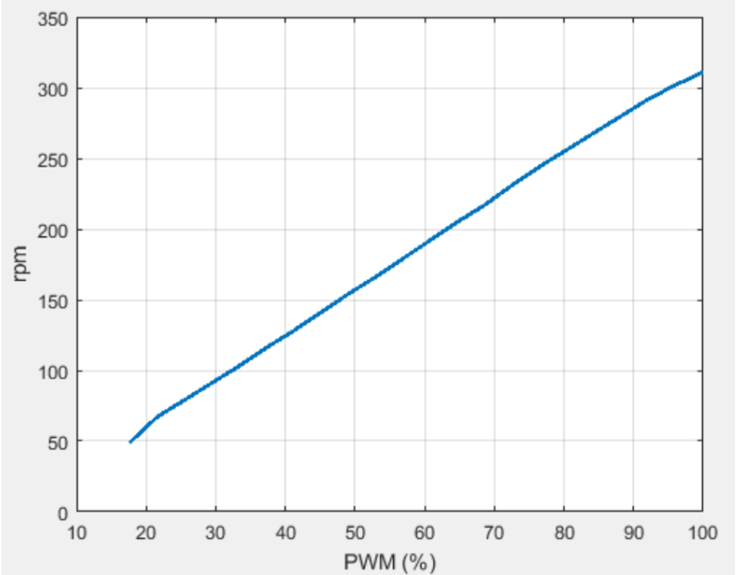
Fig 6.3 Relationship of %PWM-Speed graph
From figure 4.1, the relationship of %PWM and motor speed can be considered as linear.
- Determine the transfer function
The maximum speed of the motor when the load is zero is $ω_{max}=328 rpm$
Encoder pulse: $n=274$ pulses per revolution
$→$ The maximum frequency to read encoder: $f_{max}=\frac{2×ω_{max}×n}{60}=4090$ Hz
$→$ The minimum sampling cycle is $T_{min}=\frac{1}{f_{max}}=244.5μs$
Choose PWM signal value followed by the function
$PWM\left(\%\right)=\left\{\begin{aligned}20\%, 0≤T≤0.4s \\ 40\%, 0.4≤t≤0.8s \\ 60\%,0.8≤t≤1.2s \\ 80\%,1.2≤t≤1.6s \\ 100\%,1.6≤t≤2s\end{aligned}\right.$ T = 2s
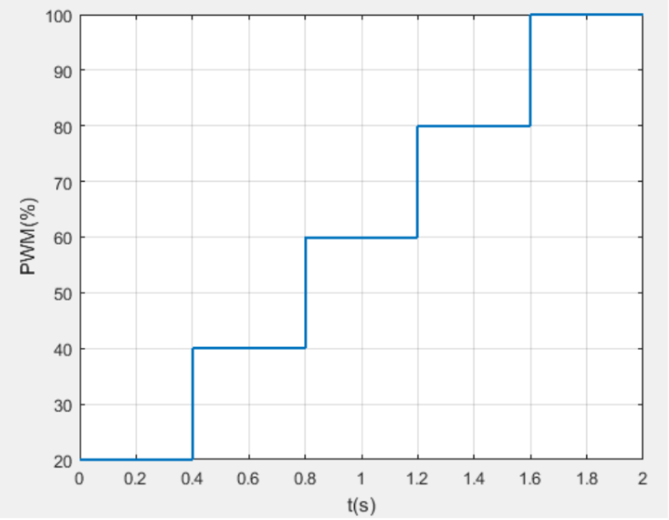
Fig 6.4 PWM signal graph
The frequency $f=\frac{1}{T}=0.5$ Hz
Analyzing signals as Fourier series with frequency of each component $f_{k}=kf=0.5k$
The maximum cut-off frequency is $f_{c}=25Hz$
To restore the signal, the sampling frequency should be determined: $f_{s}≥2f_{c}=50$ Hz
Choose $f_{s}=50$ Hz $→T_{s}=0.2$s
Required number of samples: $nδT=mT→n=\frac{2m}{0.02}=100m$
Choose m = 1 $→$ n = 100 samples
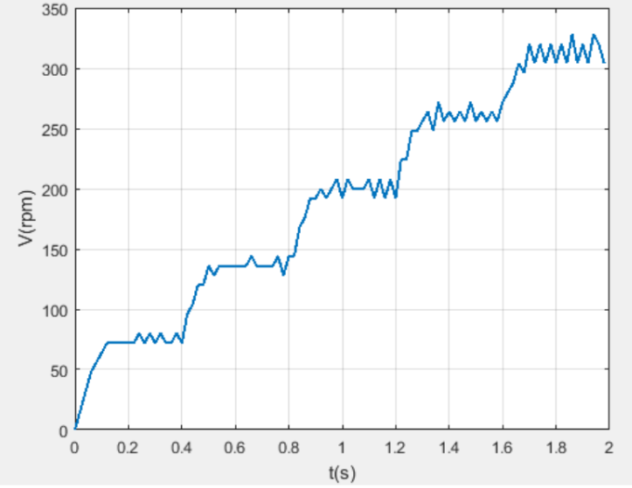
Fig 6.5 Left motor response
The transfer function of left motor – driver has form: $H\left(s\right)=\frac{K}{s+a}$
Utilizing System Identification of Matlab to find the transfer function
$→$ The transfer function: $H\left(s\right)=\frac{76.47}{s+23.6}$
6.2.2 Right motor
- Determine the relationship of %PWM - Speed
Table of sample:
Table 4.1 Revolution per minute correspond to %PWM
Number | PWM (%) | Speed (rpm)
1 | 17.65 | 52
2 | 21.57 | 69
3 | 25.49 | 80
4 | 29.41 | 92
5 | 33.33 | 104
6 | 37.25 | 116
7 | 41.18 | 129
8 | 45.1 | 143
9 | 49.02 | 154
10 | 52.94 | 166
11 | 56.86 | 179
12 | 60.79 | 191
13 | 64.71 | 205
14 | 68.63 | 217
15 | 72.55 | 230
16 | 76.47 | 242
17 | 80.39 | 255
18 | 84.31 | 267
19 | 88.24 | 279
20 | 92.16 | 288
21 | 96.08 | 299
22 | 100 | 308

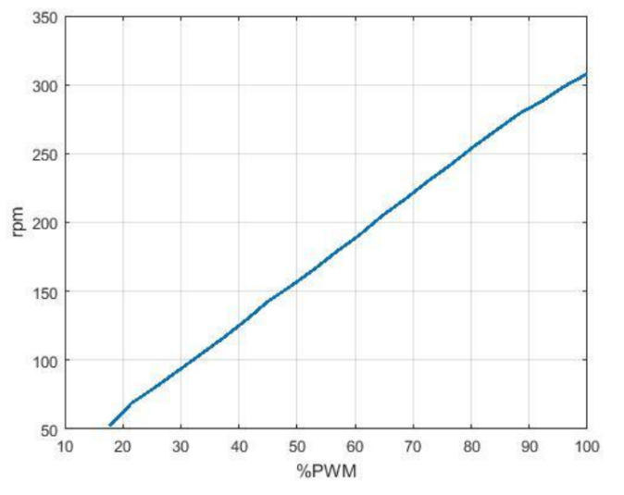
Fig 6.6 Relationship of %PWM-Speed graph
From figure 4.1, the relationship of %PWM and motor speed can be considered as linear.
- Determine the transfer function
Similar to the left motor, the right motor response is demonstrated by the below figure
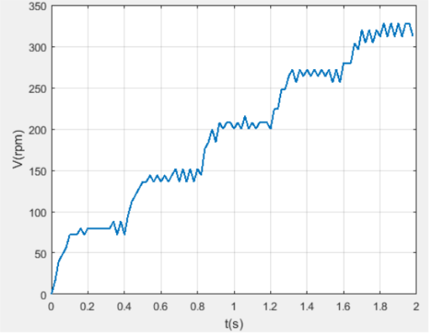
Fig 6.7 Right motor response
The transfer function of left motor – driver has form: $H\left(s\right)=\frac{K}{s+a}$
Utilizing System Identification of Matlab to find the transfer function
$→$ The transfer function: $H\left(s\right)=\frac{74.58}{s+22.57}$
6.3 PID controller
Technical requirement:
- Settling time: $T_{s}$ =
- Steady state error: ess =
- Overshoot: M =
By using PID tuner of Matlab, the parameters are received: $K_{p}$ = , $K_{i}$ = , $K_{d}$ =
Based on the above PID parameters, combined with modification in real life, the final parameters are:
- Left motor: $K_{p}$ = , $K_{i}$ = , $K_{d}$ =
- Right motor: $K_{p}$ = , $K_{i}$ = , $K_{d}$ =
Evaluation:
- Settling time: $T_{s}$ =
- Steady state error: ess =
- Overshoot: M =
Fig 6.8 Response of rotational speed with PID controller in real life
5.3 Camera calibration
5.3.1 Definition
After choosing the camera, the camera calibration process is very important. Camera calibration is the process of estimating the parameters of a pinhole camera model approximating the camera that produced a given photograph or video. Usually, the pinhole camera parameters are represented in a 3 × 4 matrix called the camera matrix. The pinhole camera model assumed that the aperture is an infinitesimal hole, all the light rays passing through it to reach the image plane. It is a projection mapping from the 3D Euclidean coordinate of the real world to the 2D Euclidean in the image world.
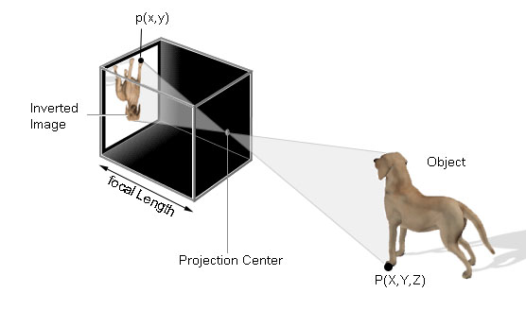
Fig 5.3 Pinhole camera model
Some pinhole cameras introduce significant distortion to images. Two major kinds of distortion are radial distortion and tangential distortion.
Radial distortion, which causes straight lines to appear curved, usually occur due to unequal bending of light. The rays bend more near the edges the lens than the rays near the center of the lens. Due to radial distortion, straight lines in real world appeared to be curved in the image. Radial distortion can be represented as follows:
$$x_{distorted}=x\left(1+k_{1}r^{2}+k_{2}r^{4}+k_{3}r^{6}\right)$$
$$y_{distorted}=y\left(1+k_{1}r^{2}+k_{2}r^{4}+k_{3}r^{6}\right)$$
Tangential distortion occurs because the image-taking lens is not aligned perfectly parallel to the imaging plane. So, some areas in the image may look nearer than expected. The amount of tangential distortion can be represented as below:
$$x_{distorted}=x+\left[2p_{1}xy+p_{2}\left(r^{2}+2x^{2}\right)\right]$$
$$y_{distorted}=y+\left[2p_{2}xy+p_{1}\left(r^{2}+2y^{2}\right)\right]$$
Hence, there are distortion coefficients need to be determined: $\left(k_{1}{ k}_{2} k_{3} p_{1} p_{2}\right)$
5.3.2 Calibration process
The camera calibration process is shown as below:
Fig 5.4 Camera calibration flowchart

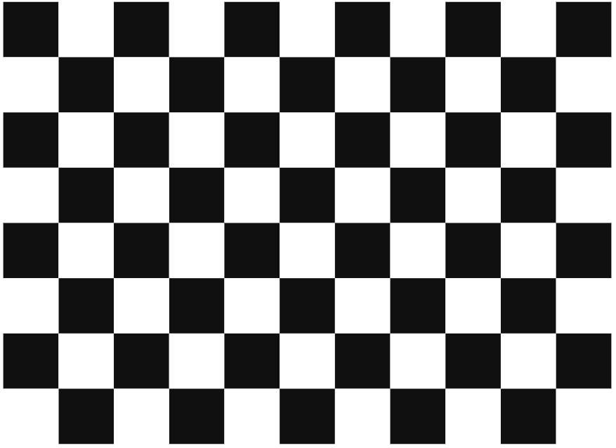
Fig 5.5 10x7 vertices chessboard
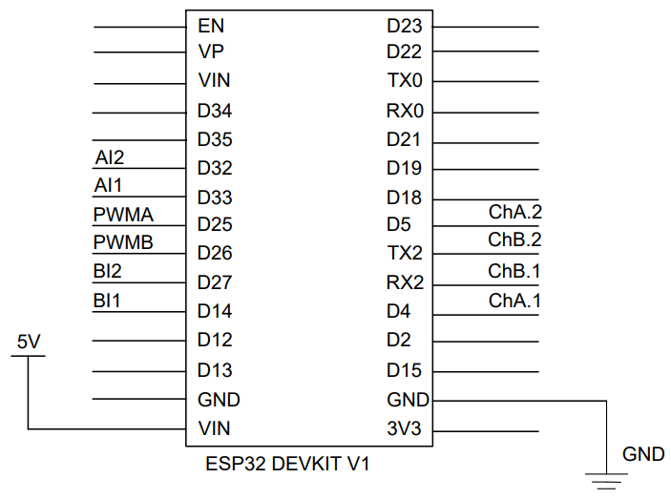

6.1 Final result
The final robot model is finally completed. Figure 6.1 describes the final model.
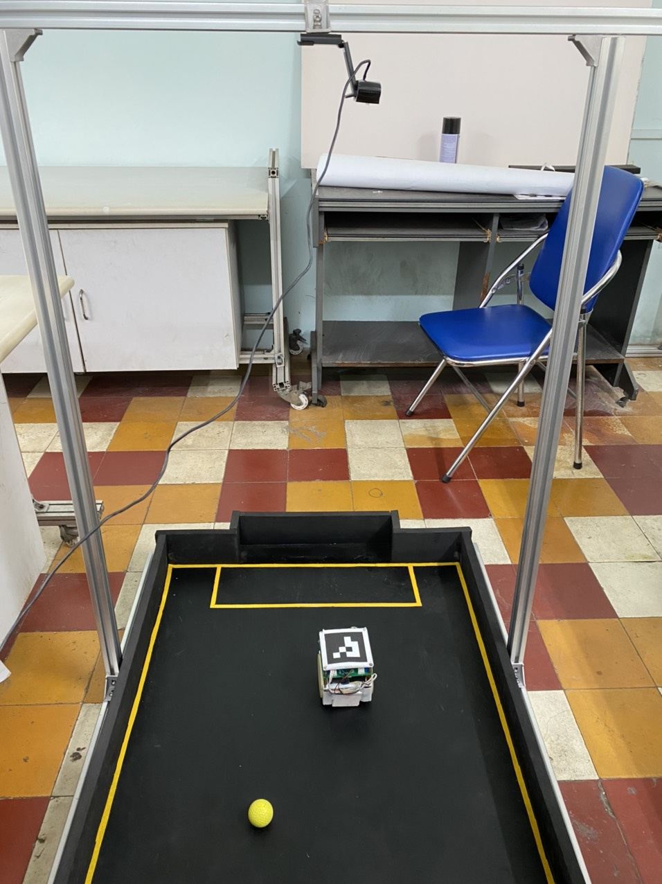
Fig 6.1 Final model
6.2 Evaluate the model
3.8.2 PID controller
After finishing the installation of hardware, the controller is tested, followed by 2 cases: moving forward and rotation. In case moving forward, the robot is controlled to move forward with 10cm of distance. In case rotation, the robot is controlled to rotate ${360}^{o}$. The measuring process can be summarized as follow:
- Firstly, manually rotate the wheels to push the robot to move 10 centimeters. The purpose of this step is to calculate exactly how many pulses per centimeter. In this step, a counting pulse function is required. Figure 3.18 illustrates the process of step 1. Table 3.10 records the results of each attempt
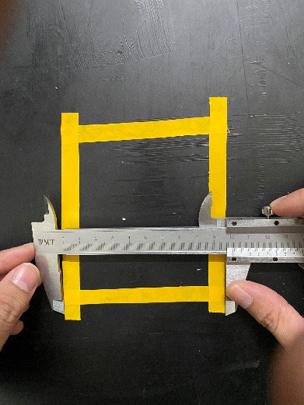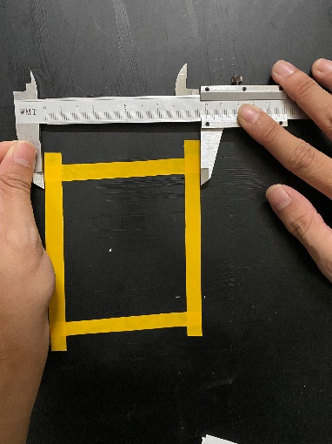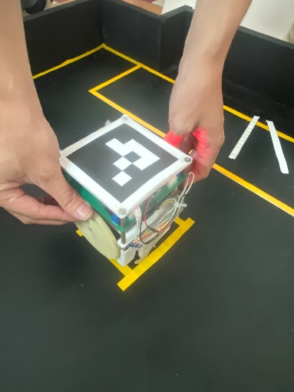
a) b) c)
Figure 3.18 Counting pulses process
a), b) Recheck the distance c) Push the wheels to move 10 centimeters
Table 3.10 Counting pulses record
Attempt | Number of pulses
1 | 82
2 | 78
3 | 79
4 | 83
5 | 80
Average | 80.4
- Secondly, input the rounding average number of pulses from table 3.10 to recheck whether the robot move forward a distance of 10 centimeters. Caliper ruler is used to check the length of distance the robot has moved, which is demonstrated in figure 3.19. Table 3.11 records the result of step 2.
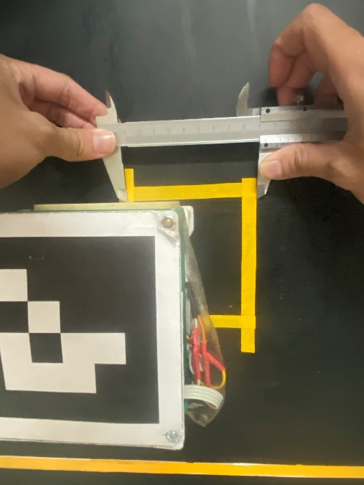
Figure 3.19 Recheck the distance
Table 3.11 Recheck the distance result

The accuracy of the controller is determined by testing 10 times for each case and the recorded data is described in table 3.10
Table 3.10 PID result
Case | Moving forward d (cm) | Rotation $θ$ (deg)
1 | 8.4 | 350
2 | 8.3 | 352
3 | 8.6 | 360
4 | 8.5 | 345
5 | 8.6 | 341
6 | 8 | 360
7 | 9 | 351
8 | 8.5 | 359
9 | 8 | 354
10 | 8.3 | 357
Average | $$\overline{d}=8.42$$ | $$\overline{θ}=352.9$$
From data in table 3.10, the standard deviation can be determined
$$σ_{d}=\sqrt{\frac{1}{9}\sum_{i=1}^{10}{{\left(d_{i}-\overline{d}\right)}^{2}}}≈0.645\left(cm\right)$$
$$σ_{ θ }=\sqrt{\frac{1}{9}\sum_{i=1}^{10}{{\left({ θ }_{i}-\overline{ θ }\right)}^{2}}}≈9.365\left(deg\right)$$
Then the standard error can be calculated:
$$σ_{\overline{d}}=\frac{σ_{d}}{\sqrt{10}}≈0.2\left(cm\right)$$
$$σ_{\overline{θ}}=\frac{σ_{ θ }}{\sqrt{10}}≈2.962\left(deg\right)$$
Based on $3σ$ standard with 97% of reliability, the errors are quite large. The sources of errors might come from:
- The surface of the field is not ideal.
- The errors from gear transmission.
- The PWM signal sent to motor might be noised.

[1] A Brief History of Robocup, robocup.org, https://www.robocup.org/a_brief_history_of_robocup
[2] Nao soccer robots will meet human rivals in 2050, FayerWayer, 2019
[3] Sven Behnke, Playing Soccer with Humanoid Robots, Ki – Zeitschrift Kunstliche Intelligenz, 03/2006, p.51-56
[4] RoboCup 2019, Sydney, Australia, https://nimbro.net/Humanoid/
[5] RoboCup Standard Platform League, robocup.org, https://spl.robocup.org/
[6] RoboCup Technical Committee, RoboCup Standard Platform League (NAO) Rule Book, robocup.org, 2022-05-16
[7] Robin Soetens, Bernardo Cunha, Tutorial: Requirements for RoboCup MSL, April 2016
[8] RoboCup Junior Soccer Technical Committee, RoboCup Junior Soccer - Rules 2018, RoboCup.org, 2018
[9] Carlos Henryque Caloete Pena, An Analysis of Reinforcement Learning applied to Coach task in IEEE very Small Size Soccer, ResearchGate, November 2020
[10] The FIRA MiroSot Robot Soccer Playground, FIRA
[11] Tieu Binh Tran, Study and Implementation of a Robot Soccer System based on the CDIO approach, Faculty of Mechanical Engineering Ho Chi Minh City University of Technology, 2021
[12] Trinh Chat, Le Van Uyen, Tinh toan thiet ke he dan dong co khi, Nha xuat ban giao duc, sixth edition
[13] ArtisTech, Driving Small Motors with TB6612FNG, Autodesk Instructables, 2020
[14] Zerynth, DOIT Esp32 DevKit v1, https://olddocs.zerynth.com/r2.6.2/official/board.zerynth.doit_esp32/docs/index.html
[15] Hshop, LM2596 Buck Converter, https://hshop.vn/products/mach-giamop-dc-lm2596-3a
[16] Amit’s Thoughts on Pathfinding, Introduction to A*, Red Blob Games, Jun 2020
[17] Vibhakar Mohta, A* search algorithm, Geeks for geek, 30 May 2022

TABLE OF TABLES
Table 2.1 Desired parameter 14
Table 2.2 Motor parameter 15
Table 2.3 Gear drive parameters 19
Table 3.1 TB6612FNG driver datasheet 28
Table 3.2 Esp32 datasheet [22] 29
Table 3.3 LM2596 buck module parameter 30
Table 3.5 Total power of the electrical system 31
Table 3.6 Lithium Li-on battery parameters 32
Table 3.7 Revolution per minute correspond to %PWM (Right motor) 36
Table 3.8 Revolution per minute correspond to %PWM (Left motor) 37
Table 3.9 Set of PID parameters 39
Table 3.10 Counting pulses record 41
Table 3.11 Recheck the distance result 42
Table 4.1 Technical Specification C922 Pro HD stream webcam 44
Table 4.2 Ball recognition error result (first method) 51
Table 4.3 Robot recognition error result (first method) 52
Table 4.4 Ball recognition error result (second method) 53
Table 5.1 Difference between TCP and UDP protocol [19] 64
Table 5.2 Probability of goal 73
Table 5.3 The table of the performance of the robot over 20 test cases 73

