**Yearly Airline Performance Report – 2019**

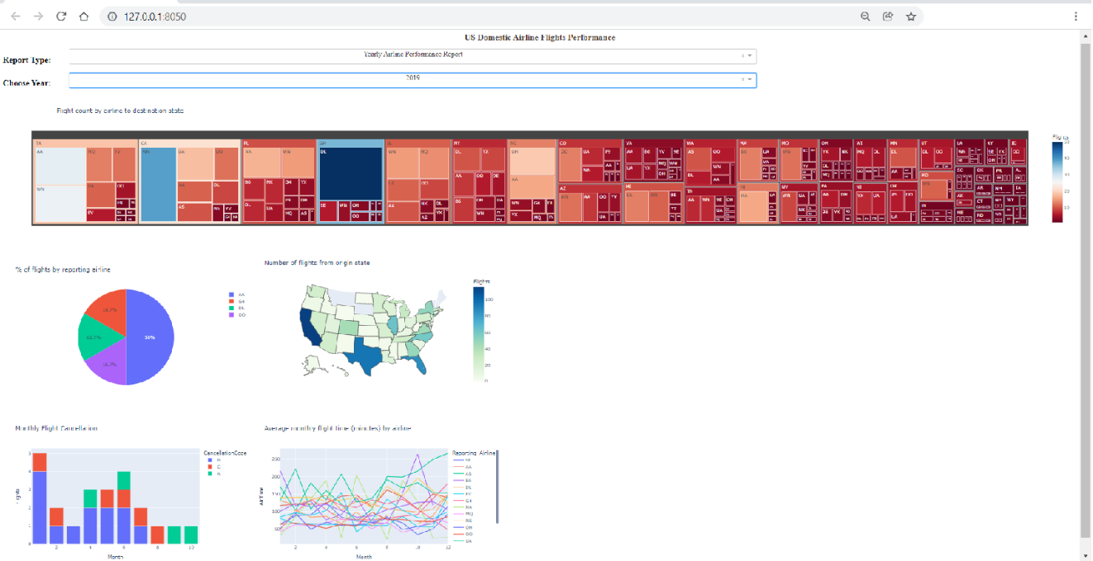

**Yearly Airline Performance Report – 2015**

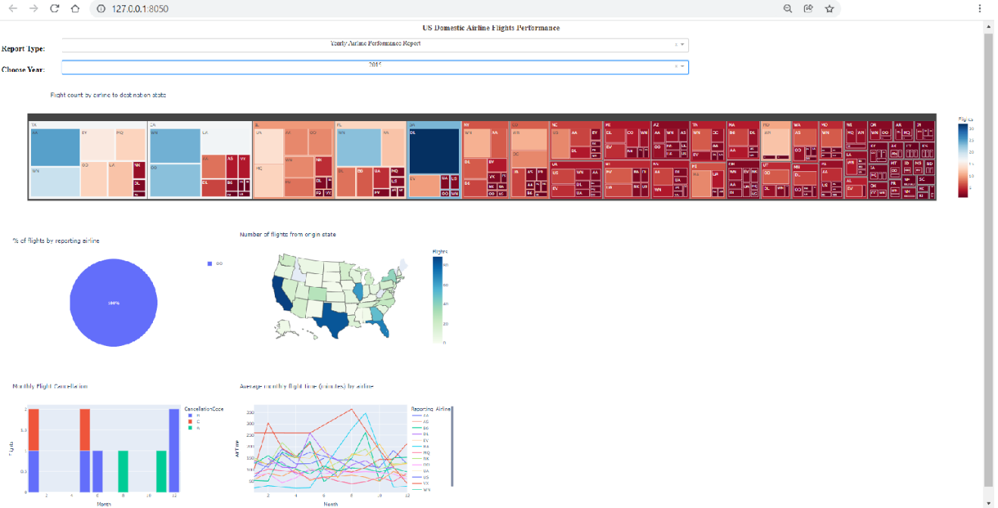

**Yearly Airline Delay Report – 2019**

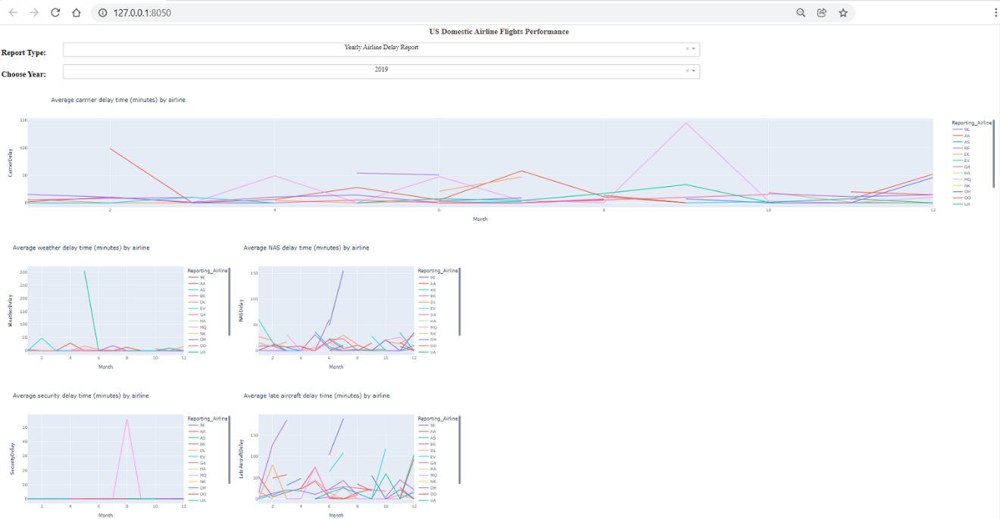

**Yearly Airline Delay Report – 2008**

