Library management system – Group 11

**Team members:**

Vũ Bình Minh – 20226058 – ICT 01 K67 – [minh.vb226058@sis.hust.edu.vn](mailto:minh.vb226058@sis.hust.edu.vn)

Ngô Anh Tú – 20226005 – ICT 01 K67 – [tu.na226005@sis.hust.edu.vn](mailto:tu.na226005@sis.hust.edu.vn)

Đặng Trọng Văn – 20226072 – ICT 02 K67 – [van.dt226072@sis.hust.edu.vn](mailto:van.dt226072@sis.hust.edu.vn)

# 1. Library management description

Library Management System is designed to streamline and automate the workflows and activities of libraries, helping them manage resources efficiently while providing a better user experience for borrowers.

**1.1. Business context**

The business operates in the library, where the primary goal is to manage and facilitate the lending of books and other resources to borrowers. The system automates tasks like managing books, authors, publishers, borrowers, and library staff operations. It tracks book loans, returns, updates book information, and handles any compensations for late returns or damaged books.

**1.2. Users**

* **Borrowers**: People who borrow books from the library. They interact with the system to check out, return, and, if necessary, compensate for lost or damaged books.
* **Staff**: Responsible for updating the book inventory, managing loans, and overseeing the overall operations of book lending and returns

**1.3. Business processes:**

**- Book updating process:** When a book is acquired, the staff member responsible for entering the book’s details into the system. A book can be assigned to one or many authors, but it must be assigned to one publisher. The genre of the book is classified and entered the system. The book’s data (book_id, title, language, publish year, price, book_count) is updated and categorized according to the system.

- **Book borrowing proces**s: A borrower logs into the system or approaches a staff member to request the book. The availability of the book is checked through the book count attribute. If available, the loan entity is created to track the borrowing transaction, including details like the borrow date and return date. The staff member manages the borrowing transaction, ensuring the book is issued to the borrower. After that, the system updates the book count to reflect the current availability. If the book count is equal to 0, the book is now unavailable. Otherwise, if the book count is greater than 0, the book is now available.

- **Book return and compensate process**: When a borrower returns a book, the staff member processed the return, updating the return date in the loan entity. The system checks if the book is returned late, damaged or lost. If there is late return, damage or loss, the borrower will have to pay a fine with details like the fee and paid status, the fee will be calculated in the deposit. Once compensation is processed, the staff member updates the system to reflect the compensation payment.

- **Borrower management proces**s: When a borrower wants to use the library, the staff registers the borrower’s details, including name, phone, date of birth, address, deposit and email. Borrower information can be updated by staff, ensuring that personal details like contact information are current. Before borrowing books, the borrower must pay a deposit of 100,000 VND. The deposit fee will serve as a fee that allows you to continue borrowing books here. 3 months after the borrowing date, if the borrower doesn’t return the books, a compensation fee of 100,000 VND will be calculated in the deposit. After 10 days from the expected return date, if the borrower does not return the book, they will be placed on the blacklist. Also, if the borrower damages or losts the book without compensating for it, they will also be placed on blacklist.

- **Staff management process**: The library’s staff are managed within the system with details such as name, phone, date of birth and staff_id. Staff members are responsible for managing various library operations such as updating books, borrower registration, loan management and compensations.

**1.4. Features**

The system stores and manages several important features:

* **Book**: Information about each book, including book_id, title, publish_year, book_count, price and language
* **Borrower**: Information about each borrower, including borrower_id, name, phone, date of birth, address, email, deposit and black_list status
* **Staff**: Details about the staff members managing the system, including staff_id, name, phone, date of birth
* **Loan**: Information about the loan_id, return_date, borrow_date, the damaged status of books, the paid status and the fee
* **Author**: Details about author_id and author’s name
* **Publisher**: Details about publisher_id and publisher’s name
* **Genre**: Details about genre_id and genre’s name

**1.5. Business rules**

* When the borrower borrows the books, the loan period for borrowing books is 3 months.
* The number of books borrowing must be less than or equal to 3 books.
* When creating accounts, users will have to pay a deposit of 100,000 VND.
* If the borrower returns the book past the due date, the compensation fee will be calculated in the deposit and the value will be 100,000 VND.
* 10 days after the expected return date, if the borrower doesn’t return the books, the borrower will be blacklisted and will no longer be allowed to borrow books.
* If the borrower damages or losts the book, they will have to compensate an amount equivalent to the price of the book.
* Borrowers must maintain a deposit of 100,000 VND to be able to read books. In cases where the deposit balance is 0, they must deduct 100,000 VND if they wish to continue reading.
* If readers no longer wish to continue reading, the deposit amount will be refunded.

# 2. Application Description

## 1. Borrowers

Borrowers are individuals who interact with the system to access and manage library resources. They can perform the following functions:

1. Search and View Books: Check the availability of books by title, genre, author, or publisher.
2. Borrow Books:
   * Request to borrow up to 3 books at a time. They will also need to provide their deposit and borrowing status that meets the requirements.
   * Allowed to access information on loan periods and due dates for borrowed books.
3. Return Books:
   * Return borrowed books and confirm their status as undamaged.
   * Pay fines for late returns, damages, or lost books, calculated automatically by the system.
4. View Profile:
   * Check personal details, borrowing history, and penalties (if any).

3. Entity relationship diagram

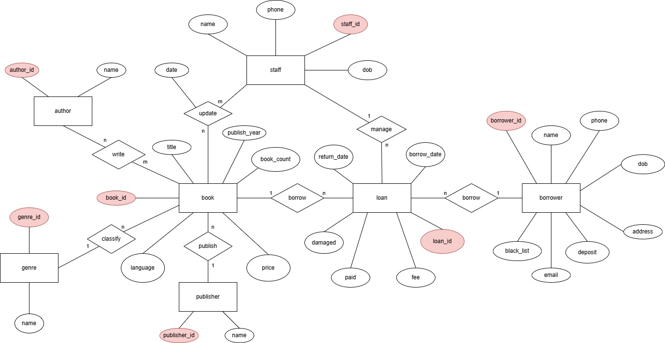

# 4. Relational schema

