Name: TRAM Sex: Female Age: 27 Patient ID: 2586

LMCA 50 mm + LACA 70 mm - LPCA 67 mm +

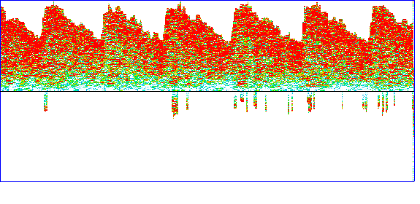 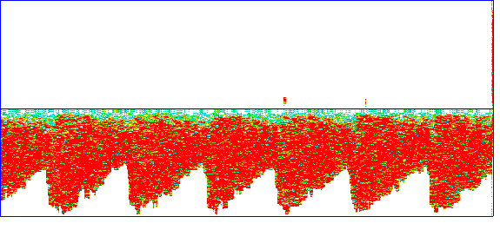 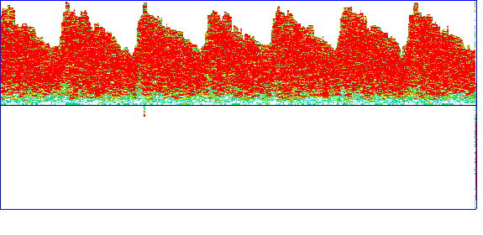

Mean: 67.7 Peak: 97.6 SBI: 0.31 Mean: -67.2 Peak: -95.9 SBI: 0.30 Mean: 63.9 Peak: 96.5 SBI: 0.34

PI: 0.66 Dias: 52.8 STI: 0.28 PI: 0.64 Dias: -52.8 STI: 0.27 PI: 0.76 Dias: 47.7 STI: 0.30

RI: 0.46 S/D: 1.85 RI: 0.45 S/D: 1.82 RI: 0.51 S/D: 2.02

RMCA 50 mm + RACA 70 mm - RPCA 64 mm +

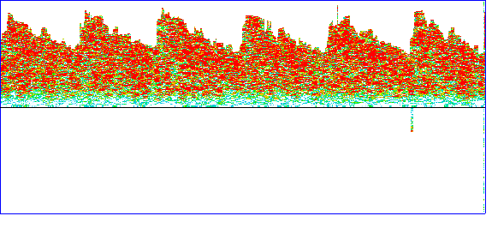 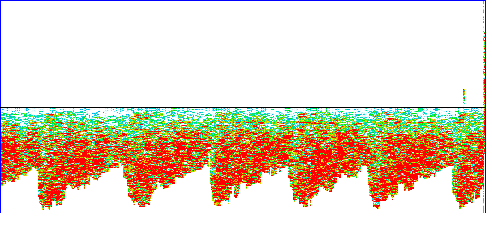 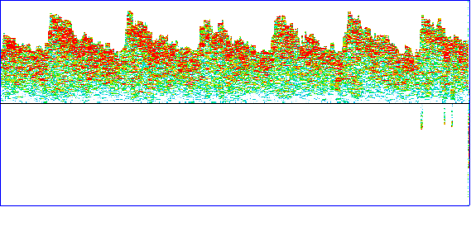

Mean: 65.5 Peak: 93.0 SBI: 0.30 Mean: -66.4 Peak: -93.6 SBI: 0.29 Mean: 63.7 Peak: 89.0 SBI: 0.28

PI: 0.63 Dias: 51.7 STI: 0.27 PI: 0.61 Dias: -52.8 STI: 0.26 PI: 0.59 Dias: 51.1 STI: 0.26

RI: 0.44 S/D: 1.80 RI: 0.44 S/D: 1.77 RI: 0.43 S/D: 1.74

**Record and Analysis:**

**Conclusion:**

Signature:

2023-07-18