Name______Cosette King___________ Mark _____________________/50

[**Instructions**: Remove everything that is not a heading below and fill in with your own diagrams, etc.]

## Brief introduction __/3

I oversee textures and model placement. For textures, the most important task will be to design the meteors and how they interact with the environment and music as well as any other textures the game will have in its environment. Another element that will be in the game is rings that the player will try to fly through to get points. I will oversee the ring design and placement as well.

## Use case diagram with scenario __14

[Use the lecture notes in class. Ensure you have at least one exception case]

### Use Case Diagrams

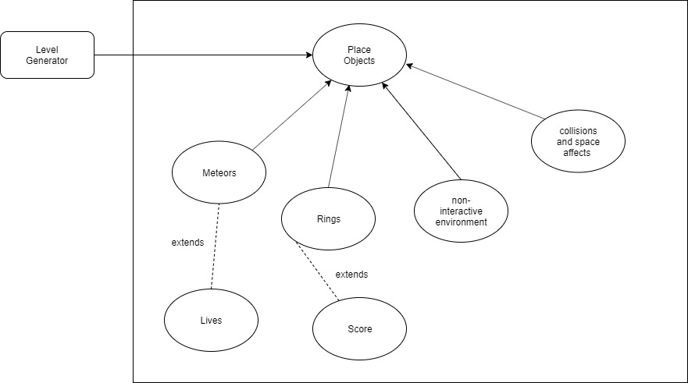

### Scenarios

**[You will need a scenario for each use case]**

**Name:** Place Meteors

**Summary:** uses the machine to place meteors

**Actors:** player

**Preconditions:** game has started

**Basic sequence:**

**Step 1:** get number of meteors to be placed found in the data

**Step 2:** spawn the number of meteors

**Step 3:** have the meteors move according to its programming

**Step 4:** Calculate and show result.

**Exceptions:**

**Step 1:** the meter should not spawn near or on the player

**Step 2:** A button other than [calculate] or a number input is pressed: ignore input.

**Post conditions:** meteors placed in the environment and can be interacted with

**Priority:** 1*

**ID:** Cosette_1

*The priorities are 1 = must have, 2 = essential, 3 = nice to have.

**Name:** Place rings

**Summary:** uses the machine to place rings

**Actors:** player

**Preconditions:** game has started

**Basic sequence:**

**Step 1:** get number of rings to be placed found in the data

**Step 2:** spawn the number of rings

**Step 3:** rings should be stationary

**Exceptions:**

**Step 1:** rings should not be placed to close to a meteor or on the player.

**Post conditions:** rings placed in the environment and can be interacted with

**Priority:** 1*

**ID:** Cosette_2

*The priorities are 1 = must have, 2 = essential, 3 = nice to have.

**Name:** non interactive environment

**Summary:** places the surrounding environment to make the game more in depth

**Actors:** player

**Preconditions:** game has started

**Basic sequence:**

**Step 1:** get level information from the system

**Step 2:** place the desired environment in the system

**Step 3:** have the environment react with the music

**Exceptions:**

**Step 1:** such objects such as stars should be stationary

**Post conditions:** background environment

**Priority:** 3*

**ID:** Cosette_3

*The priorities are 1 = must have, 2 = essential, 3 = nice to have.

**Name:** collision and space affects

**Summary:** uses the machine to determine when the player collides with a meteor or a ring and calls the appropriate collision affect

**Actors:** player

**Preconditions:** player collides with object

**Basic sequence:**

**Step 1:** determine if the player has collided with an object

**Step 2:** determine what object that is

**Step 3:** call the appropriate collision affect

**Step 4:** change score as necessary

**Exceptions:**

**Step 1:** if the collision was with a meteor then the player should lose lives or end the game

**Post conditions:** lives or score is changed

**Priority:** 1*

**ID:** Cosette_4

*The priorities are 1 = must have, 2 = essential, 3 = nice to have.

## Data Flow diagram(s) from Level 0 to process description for your feature _______14

[Get the Level 0 from your team. Highlight the path to your feature]

### Data Flow Diagrams

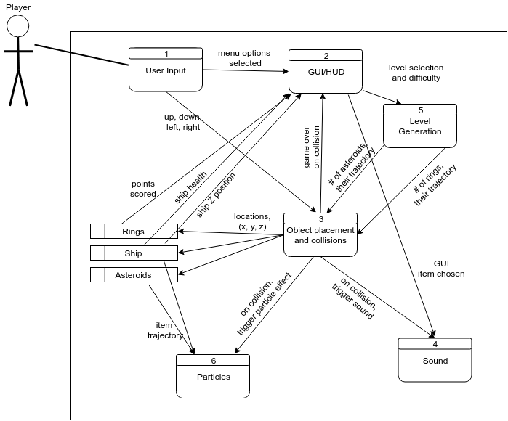

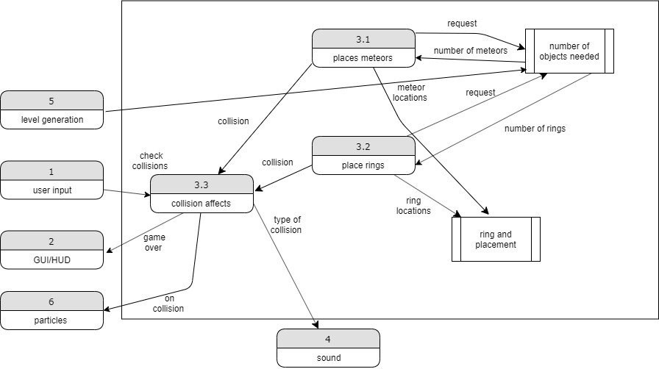

### Process Descriptions

3.1: places meteors

Given a set number of meteors, the process will set meteors in a set location in the environment at a reasonable dispersion. Making sure that there are not too many meteors at a given point or near the rings

3.2: places rings

Given a set number of rings, the rings will be placed in a position on the map that will be reasonable for the player to reach without having too much difficulty or having it be impossible. At no point should a ring collide with a meteor

3.3: collision effects

When the player collides with a ring or a meteor, the collision effects should be implemented as well as a call to increase the score if the collision was with a ring, or decrease the lives or end the game if the collision was with a meteor

## Acceptance Tests ________9

[Describe the inputs and outputs of the tests you will run. Ensure you cover all the boundary cases.]

Generate the number of meteors and rings in the environment

Outcome:

* Meteors are evenly dispersed
* Rings are possible to get to
* There are no meteors colliding with rings

Collision testing:

Inputs: collide with rings and meteors multiple times to ensure that the process is working

Outcome:

* Collision with rings increase score
* The correct sound and effect are played when the ship hits the ring
* Collision with meteor decreases lives or ends game when life limit is reached
* The correct sound and effect are played when the ship hits the meteor

## Timeline _________/10

[Figure out the tasks required to complete your feature]

### Work items

|  |  |  |
| --- | --- | --- |
| **Task** | **Duration (hours)** | **Predecessor Task(s)** |
| 1. Design models and textures | 7 | - |
| 2. Place models in environment | 3 | 1 |
| 3. Integrate models with code | 5 | 1 |
| 4. Model interactions | 10 | 2,3 |
| 5. Model reactions | 6 | 4 |
| 6. Add space affects | 5 | 5 |
| 7. Testing | 10 | 6 |

### Pert diagram

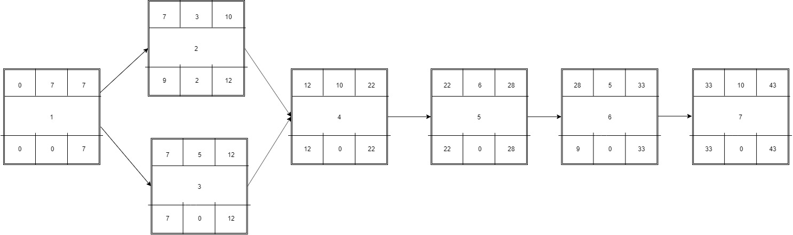

### Gantt timeline

|  |  |  |  |  |  |  |  |  |  |  |  |  |  |  |  |  |  |  |  |  |  |  |  |  |  |  |  |  |  |  |  |  |  |  |  |  |  |  |  |  |  |  |  |
| --- | --- | --- | --- | --- | --- | --- | --- | --- | --- | --- | --- | --- | --- | --- | --- | --- | --- | --- | --- | --- | --- | --- | --- | --- | --- | --- | --- | --- | --- | --- | --- | --- | --- | --- | --- | --- | --- | --- | --- | --- | --- | --- | --- |
| 1 |  |  |  |  |  |  | 7 |  |  |  |  |  |  |  |  |  |  |  |  |  |  |  |  |  |  |  |  |  |  |  |  |  |  |  |  |  |  |  |  |  |  |  |  |
| 2 |  |  |  |  |  |  |  |  |  | 10 |  |  |  |  |  |  |  |  |  |  |  |  |  |  |  |  |  |  |  |  |  |  |  |  |  |  |  |  |  |  |  |  |  |
| 3 |  |  |  |  |  |  |  |  |  |  |  | 12 |  |  |  |  |  |  |  |  |  |  |  |  |  |  |  |  |  |  |  |  |  |  |  |  |  |  |  |  |  |  |  |
| 4 |  |  |  |  |  |  |  |  |  |  |  |  |  |  |  |  |  |  |  |  |  |  |  |  |  |  |  |  |  |  |  |  |  |  |  |  |  |  |  |  |  |  |  |
| 5 |  |  |  |  |  |  |  |  |  |  |  |  |  |  |  |  |  |  |  |  |  |  |  |  |  |  |  |  |  |  |  |  |  |  |  |  |  |  |  |  |  |  |  |
| 6 |  |  |  |  |  |  |  |  |  |  |  |  |  |  |  |  |  |  |  |  |  |  |  |  |  |  |  |  |  |  |  |  |  |  |  |  |  |  |  |  |  |  |  |
| 7 |  |  |  |  |  |  |  |  |  |  |  |  |  |  |  |  |  |  |  |  |  |  |  |  |  |  |  |  |  |  |  |  |  |  |  |  |  |  |  |  |  |  |  |
|  | 1 | 2 | 3 | 4 | 5 | 6 | 7 | 8 | 9 | 10 | 11 | 12 | 13 | 14 | 15 | 16 | 17 | 18 | 19 | 20 |  | 22 |  | 24 |  | 26 |  | 28 |  | 30 |  | 32 |  | 34 |  | 36 |  | 38 |  | 40 |  | 42 | 43 |