座號：19 姓名：柯昱廷

作業-Responsive Web Design

**請利用Bootstrap套件實作RWD，並達成下列要求：**

1. 利用Visual Studio NuGet安裝Bootstrap4.6套件。
2. 將Bootstrap所需相關函式庫Include進網頁。
3. 請建立一個具響應式功能的網頁(檔名:**RWD_Homework.html**)，並達到以下要求：
4. 請使用bootstrap所提供之Jumbotron、NavBar、Media Object、Modal、Carousel互相配合，製作一單頁面網頁，主題及內容不限。
5. 需提供至少適合兩種解析度的瀏覽效果，含一般電腦與行動裝置。
6. 網站中必須有自訂的CSS檔來更改原bootstrap所提供之樣式，並將此檔命名為**MyStyle.css**，且須Include至頁面中。

**繳交作業時，請以FTP上傳程式原始檔與本文件檔各一份，原始程式碼請另放置在一個「完成結果檔」資料夾內。**

※以上各項均須完全達成始得通過※

畫面截圖(畫面太長或太大可分段截圖)：

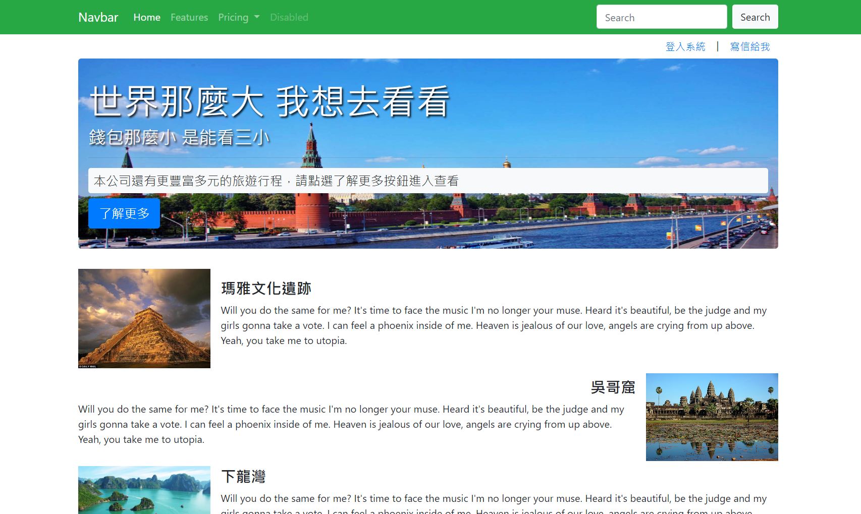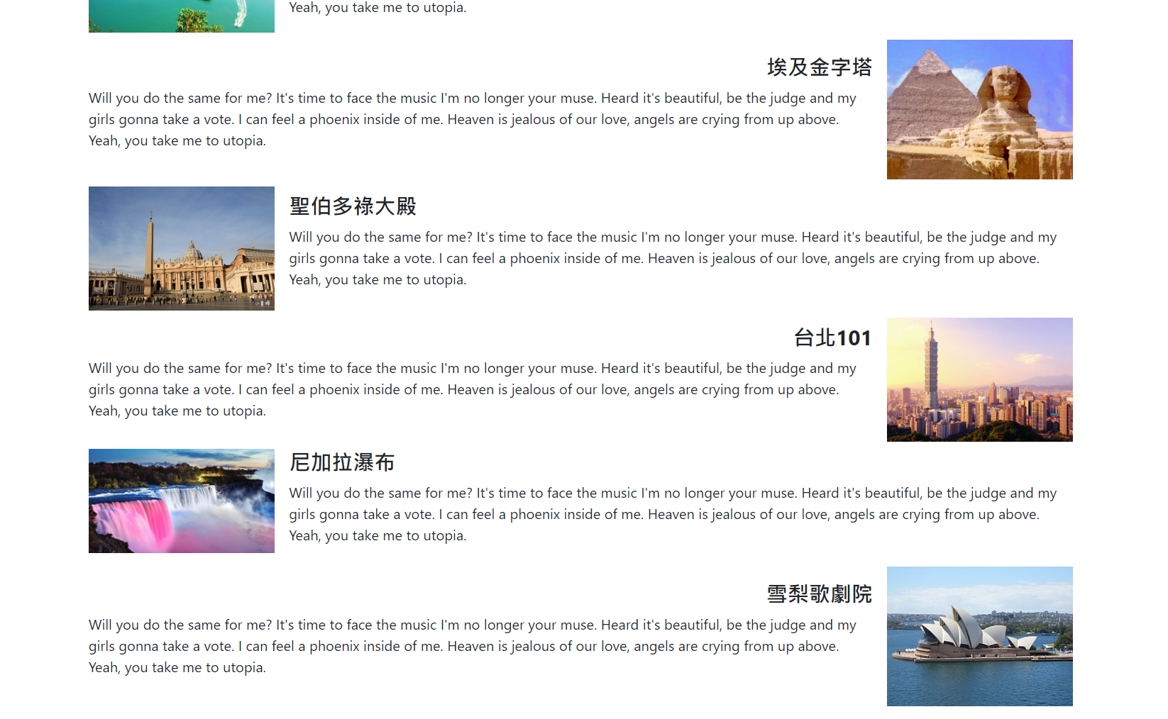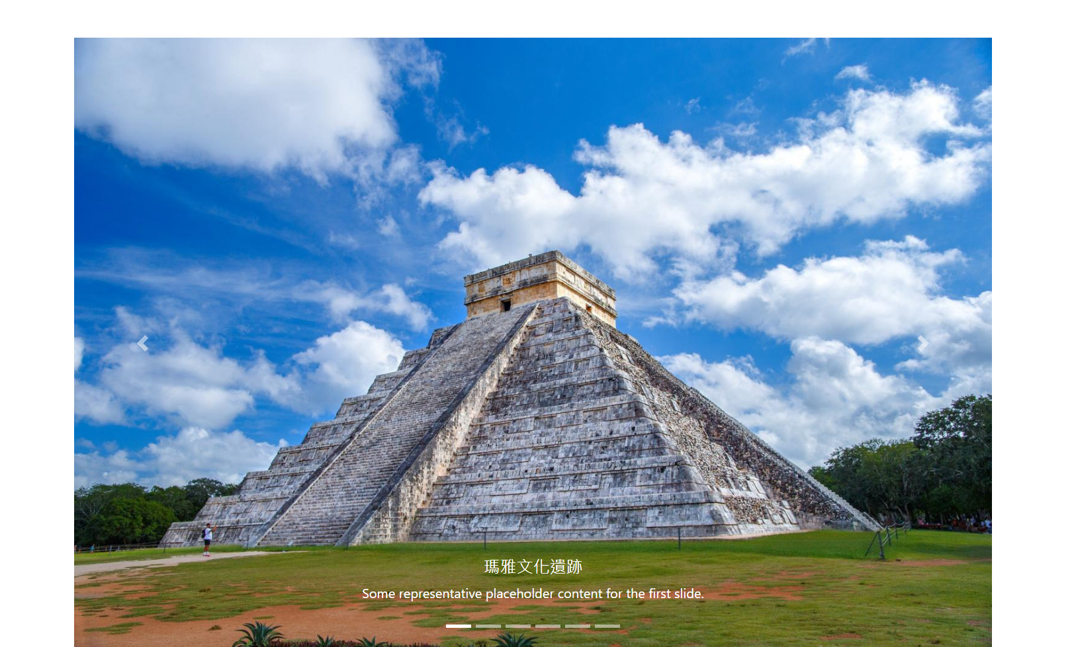

程式碼(所有的程式碼均須貼上)：

HTML檔：

<!DOCTYPE html>

<html>

<head>

<meta charset="utf-8" />

<title></title>

<meta name="viewport" content="width=device-width" />

<link href="Content/bootstrap.min.css" rel="stylesheet" />

<link href="Content/MyStyle.css" rel="stylesheet" />

</head>

<body>

<nav class="navbar navbar-expand-lg navbar-dark bg-success">

<div class="container">

<a class="navbar-brand" href="#">Navbar</a>

<button class="navbar-toggler" type="button" data-toggle="collapse" data-target="#navbarSupportedContent" aria-controls="navbarSupportedContent" aria-expanded="false" aria-label="Toggle navigation">

<span class="navbar-toggler-icon"></span>

</button>

<div class="collapse navbar-collapse text-light" id="navbarSupportedContent">

<ul class="navbar-nav mr-auto">

<li class="nav-item active">

<a class="nav-link" href="#">Home <span class="sr-only">(current)</span></a>

</li>

<li class="nav-item">

<a class="nav-link" href="#">Features</a>

</li>

<li class="nav-item dropdown">

<a class="nav-link dropdown-toggle" href="#" role="button" data-toggle="dropdown" aria-expanded="false">

Pricing

</a>

<div class="dropdown-menu">

<a class="dropdown-item" href="#">Action</a>

<a class="dropdown-item" href="#">Another action</a>

<div class="dropdown-divider"></div>

<a class="dropdown-item" href="#">Something else here</a>

</div>

</li>

<li class="nav-item">

<a class="nav-link disabled">Disabled</a>

</li>

</ul>

<form class="form-inline my-2 my-lg-0">

<input class="form-control mr-sm-2" type="search" placeholder="Search" aria-label="Search">

<button class="btn my-2 my-sm-0 bg-light" type="submit">Search</button>

</form>

</div>

</div>

</nav>

<div class="container">

<!-- Button trigger modal -->

<div class="text-right">

<button type="button" class="btn btn-link" data-toggle="modal" data-target="#exampleModal">

登入系統

</button>

|

<button type="button" class="btn btn-link">

寫信給我

</button>

</div>

<!-- Modal -->

<div class="modal fade" id="exampleModal" tabindex="-1" aria-labelledby="exampleModalLabel" aria-hidden="true">

<div class="modal-dialog">

<div class="modal-content">

<div class="modal-header">

<h5 class="modal-title" id="exampleModalLabel">登入系統</h5>

<button type="button" class="close" data-dismiss="modal" aria-label="Close">

<span aria-hidden="true">&times;</span>

</button>

</div>

<div class="modal-body">

<div class="form-group">

<label for="email">E-mail</label>

<input type="text" id="email" class="form-control" placeholder="Enter Your E-mail..." />

</div>

<div class="form-group">

<label for="password">Password</label>

<input type="text" id="password" class="form-control" />

</div>

</div>

<div class="modal-footer">

<button type="button" class="btn btn-secondary" data-dismiss="modal">Cancel</button>

<button type="button" class="btn btn-primary">Login</button>

</div>

</div>

</div>

</div>

<!--jumbotron-->

<div class="jumbotron text-white p-7">

<h1 class="display-4 text-shadow"><strong>世界那麼大 我想去看看</strong></h1>

<h3 class="text-shadow">錢包那麼小 是能看三小</h3>

<hr>

<h5 class="bg-light text-dark p-2 rounded">本公司還有更豐富多元的旅遊行程，請點選了解更多按鈕進入查看</h5>

<a class="btn btn-primary btn-lg" href="#">了解更多</a>

</div>

<!--media-->

<div class="media mt-4">

<img src="/Photo/01.jpg" class="mr-3" width="210">

<div class="media-body m-auto">

<h4 class="mt-0"><strong>瑪雅文化遺跡</strong></h4>

<p>Will you do the same for me? It's time to face the music I'm no longer your muse. Heard it's beautiful, be the judge and my girls gonna take a vote. I can feel a phoenix inside of me. Heaven is jealous of our love, angels are crying from up above. Yeah, you take me to utopia.</p>

</div>

</div>

<div class="media mt-2">

<div class="media-body m-auto">

<h4 class="mt-0 text-right"><strong>吳哥窟</strong></h4>

<p>Will you do the same for me? It's time to face the music I'm no longer your muse. Heard it's beautiful, be the judge and my girls gonna take a vote. I can feel a phoenix inside of me. Heaven is jealous of our love, angels are crying from up above. Yeah, you take me to utopia.</p>

</div>

<img src="/Photo/02.jpg" class="ml-3" width="210">

</div>

<div class="media mt-2">

<img src="/Photo/03.jpg" class="mr-3" width="210">

<div class="media-body m-auto">

<h4 class="mt-0"><strong>下龍灣</strong></h4>

<p>Will you do the same for me? It's time to face the music I'm no longer your muse. Heard it's beautiful, be the judge and my girls gonna take a vote. I can feel a phoenix inside of me. Heaven is jealous of our love, angels are crying from up above. Yeah, you take me to utopia.</p>

</div>

</div>

<div class="media mt-2">

<div class="media-body m-auto">

<h4 class="mt-0 text-right"><strong>埃及金字塔</strong></h4>

<p>Will you do the same for me? It's time to face the music I'm no longer your muse. Heard it's beautiful, be the judge and my girls gonna take a vote. I can feel a phoenix inside of me. Heaven is jealous of our love, angels are crying from up above. Yeah, you take me to utopia.</p>

</div>

<img src="/Photo/04.jpg" class="ml-3" width="210">

</div>

<div class="media mt-2">

<img src="/Photo/05.jpg" class="mr-3" width="210">

<div class="media-body m-auto">

<h4 class="mt-0"><strong>聖伯多祿大殿</strong></h4>

<p>Will you do the same for me? It's time to face the music I'm no longer your muse. Heard it's beautiful, be the judge and my girls gonna take a vote. I can feel a phoenix inside of me. Heaven is jealous of our love, angels are crying from up above. Yeah, you take me to utopia.</p>

</div>

</div>

<div class="media mt-2">

<div class="media-body m-auto">

<h4 class="mt-0 text-right"><strong>台北101</strong></h4>

<p>Will you do the same for me? It's time to face the music I'm no longer your muse. Heard it's beautiful, be the judge and my girls gonna take a vote. I can feel a phoenix inside of me. Heaven is jealous of our love, angels are crying from up above. Yeah, you take me to utopia.</p>

</div>

<img src="/Photo/06.jpg" class="ml-3" width="210">

</div>

<div class="media mt-2">

<img src="/Photo/07.jpg" class="mr-3" width="210">

<div class="media-body m-auto">

<h4 class="mt-0"><strong>尼加拉瀑布</strong></h4>

<p>Will you do the same for me? It's time to face the music I'm no longer your muse. Heard it's beautiful, be the judge and my girls gonna take a vote. I can feel a phoenix inside of me. Heaven is jealous of our love, angels are crying from up above. Yeah, you take me to utopia.</p>

</div>

</div>

<div class="media mt-2">

<div class="media-body m-auto">

<h4 class="mt-0 text-right"><strong>雪梨歌劇院</strong></h4>

<p>Will you do the same for me? It's time to face the music I'm no longer your muse. Heard it's beautiful, be the judge and my girls gonna take a vote. I can feel a phoenix inside of me. Heaven is jealous of our love, angels are crying from up above. Yeah, you take me to utopia.</p>

</div>

<img src="/Photo/08.jpg" class="ml-3" width="210">

</div>

<!--Carousel-->

<div id="carouselExampleCaptions" class="carousel slide mt-5" data-ride="carousel">

<ol class="carousel-indicators">

<li data-target="#carouselExampleCaptions" data-slide-to="0" class="active"></li>

<li data-target="#carouselExampleCaptions" data-slide-to="1"></li>

<li data-target="#carouselExampleCaptions" data-slide-to="2"></li>

<li data-target="#carouselExampleCaptions" data-slide-to="3"></li>

<li data-target="#carouselExampleCaptions" data-slide-to="4"></li>

<li data-target="#carouselExampleCaptions" data-slide-to="5"></li>

</ol>

<div class="carousel-inner">

<div class="carousel-item active">

<img src="/Photo/11.jpg" class="d-block w-100" alt="...">

<div class="carousel-caption d-none d-md-block">

<h5>瑪雅文化遺跡</h5>

<p>Some representative placeholder content for the first slide.</p>

</div>

</div>

<div class="carousel-item">

<img src="/Photo/12.jpg" class="d-block w-100" alt="...">

<div class="carousel-caption d-none d-md-block">

<h5>吳哥窟</h5>

<p>Some representative placeholder content for the second slide.</p>

</div>

</div>

<div class="carousel-item">

<img src="/Photo/13.jpg" class="d-block w-100" alt="...">

<div class="carousel-caption d-none d-md-block">

<h5>下龍灣</h5>

<p>Some representative placeholder content for the third slide.</p>

</div>

</div>

<div class="carousel-item">

<img src="/Photo/14.jpg" class="d-block w-100" alt="...">

<div class="carousel-caption d-none d-md-block">

<h5>埃及金字塔</h5>

<p>Some representative placeholder content for the third slide.</p>

</div>

</div>

<div class="carousel-item">

<img src="/Photo/15.jpg" class="d-block w-100" alt="...">

<div class="carousel-caption d-none d-md-block">

<h5>聖伯多祿大殿</h5>

<p>Some representative placeholder content for the third slide.</p>

</div>

</div>

<div class="carousel-item">

<img src="/Photo/16.jpg" class="d-block w-100" alt="...">

<div class="carousel-caption d-none d-md-block">

<h5>台北101</h5>

<p>Some representative placeholder content for the third slide.</p>

</div>

</div>

</div>

<button class="carousel-control-prev" type="button" data-target="#carouselExampleCaptions" data-slide="prev">

<span class="carousel-control-prev-icon" aria-hidden="true"></span>

<span class="sr-only">Previous</span>

</button>

<button class="carousel-control-next" type="button" data-target="#carouselExampleCaptions" data-slide="next">

<span class="carousel-control-next-icon" aria-hidden="true"></span>

<span class="sr-only">Next</span>

</button>

</div>

</div>

<script src="Scripts/jquery-3.0.0.min.js"></script>

<script src="Scripts/bootstrap.bundle.min.js"></script>

</body>

</html>

CSS檔：

body {

}

caption {

padding-top: 0.75rem;

padding-bottom: 0.75rem;

color: #6c757d;

text-align: left;

caption-side: top;

}

.MyTable {

overflow:auto;

}

.breadcrumb-item + .breadcrumb-item::before {

color: #ff0000;

content: ">";

}

.jumbotron {

padding: 2rem 1rem;

margin-bottom: 2rem;

background-image: url('../photo/00.jpg');

background-repeat:round; /*預設為repeat*/

border-radius: 0.3rem;

}

.text-shadow {

text-shadow: 2px 2px 3px black;

}

.modal-content {

background-image: url(../photo/03.jpg);

background-repeat: round;

}