座號：　　　姓名：

階段性作業八

預存程序(Stored Procedure)撰寫練習

**請在利用Northwind資料庫，建立一個名為「Sum_for_Products_Salse_Pivot」的預存程序，需完成如下的要求：**

1. **顯示以月份欄、以產品名稱為列的樞鈕分析表。**
2. **顯示的值為每月份產品的銷售額。**(售價＊銷售數量-折扣)
3. **須建立參數查詢，可對預存程序傳入年度，樞鈕分析表即顯示當年度的銷售樞鈕分析結果。**
4. **銷售額的顯示不得為null，若有null值須顯示0。**
5. **產品須按代碼順序排列，月份需按小到大排列。**

**顯示結果可參考下圖：**

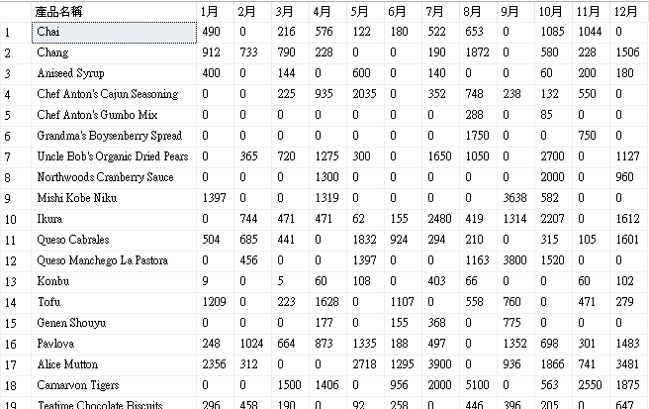

**程式碼：**

--建立預存程序

create procedure Sum_for_Products_Salse_Pivot

@yy int

as

begin

select pvt.ProductName as 產品名稱 , ISNULL([1],0) as '1月', ISNULL([2],0) as '2月'

, ISNULL([3],0) as '3月', ISNULL([4],0) as '4月', ISNULL([5],0) as '5月', ISNULL([6],0) as '6月'

, ISNULL([7],0) as '7月', ISNULL([8],0) as '8月', ISNULL([9],0) as '9月', ISNULL([10],0) as '10月'

, ISNULL([11],0) as '11月', ISNULL([12],0) as '12月'

from

(select p.ProductID , p.ProductName , year(o.OrderDate)as[Year] , month(o.OrderDate)as[month] , round(sum(od.UnitPrice*od.Quantity*(1-od.Discount)),0)as Total from [Order Details] as od

inner join Orders as o on od.OrderID=o.OrderID

inner join Products as p on p.ProductID=od.ProductID

where year(o.OrderDate)=@yy

Group by p.ProductID , p.ProductName , year(o.OrderDate) , month(o.OrderDate)) as x

pivot

(

--pivot裡面放統計值

sum(x.Total)

for x.Month in

([1],[2],[3],[4],[5],[6],[7],[8],[9],[10],[11],[12])

)as pvt

order by pvt.ProductID

end

go

--呼叫

exec Sum_for_Products_Salse_Pivot 1997

**請將答案繕打後列印繳交，並親簽座號與姓名**

**（本項作業須達80分方可通過）**