Scribble to Digital

Team ID : 69b79e08a79186fe858a92ad

Team Size : 5

Team Leader : Muralidharan k

Team member : Manikandan S

Team member : kalaiarasan M
Team member : Kishore P
Team member : Svanesan V

Introduction
Converting handwritten notes into digital format is a common challenge faced by students and professionals. Poor lighting, unclear handwriting, and mixed content (notes + tasks) reduce productivity and require manual rewriting.
Scribble to Digital is an AI-powered system that converts messy handwritten notes into clean, structured digital text. The system enhances uploaded images, extracts text using OCR, and applies Generative AI to correct grammar and automatically extract To-Do tasks.
The application is developed using Streamlit as the frontend framework and Python as the backend processing engine.

Use Case Scenarios

Scenario 1: Handwritten Note Digitization with Image Enhancement
Users upload a photo of messy handwritten notes through the Streamlit interface. The system internally enhances the image using OpenCV by converting it to grayscale, increasing brightness and contrast, reducing noise, and applying thresholding techniques.
After enhancement, the improved image is passed to the OCR engine for accurate text extraction. This process ensures better readability and higher text recognition accuracy even for low-quality or unclear handwriting.
The output includes:
- Raw OCR extracted text
- Improved clarity for further AI processing

Scenario 2: Intelligent Text Correction and Contextual Reconstruction
After OCR extraction, the raw text may contain spelling mistakes, missing letters, and broken words due to handwriting variations.
The Generative AI model analyzes the extracted text and:
- Corrects spelling errors
- Improves grammar and sentence structure
- Reconstructs incomplete or unclear words using contextual understanding
- Formats the text into readable paragraphs
This ensures that messy handwritten content is converted into professional and well-structured digital text.

Scenario 3: Automatic To-Do Extraction and Task Identification
Handwritten notes often contain a mixture of general information and actionable tasks. Identifying tasks manually can be time-consuming.
The AI system analyses sentence intent and:
- Detects task-oriented statements
- Extracts actionable items
- Organizes them into a structured bullet-point To-Do list
This allows users to quickly identify important tasks separately from general notes, improving productivity and task management.

Architecture Overview
Scribble to Digital is an intelligent AI-powered web application designed to convert handwritten notes into clean, structured digital text. The platform is built using the Streamlit framework, enabling rapid development of an interactive user interface. The system integrates:
- Streamlit for frontend and application logic
- OpenCV for image preprocessing and enhancement
- OCR Engine (Tesseract/EasyOCR) for text extraction
- Google Gemini 2.5 Flash (Generative AI) for contextual correction, formatting, and task extraction
The platform processes handwritten images, enhances clarity, extracts text, corrects errors using AI, and optionally generates structured outputs such as formatted notes and to-do lists.

Core Technologies
- Streamlit: Interactive web application framework for UI, file uploads, and result display
- Google Gemini 2.5 Flash: AI model for contextual understanding, grammar correction, and smart task extraction
- OpenCV: Image preprocessing (grayscale conversion, noise removal, thresholding)
- OCR (Tesseract/EasyOCR): Converts enhanced handwritten images into raw digital text
- Python: Core programming language
- ReportLab / Python-DOCX: Optional export to PDF and Word formats

Component-Wise Architecture

Component Description
Provides a simple web interface for users to upload handwritten images. Streamlit Frontend UI Displays enhanced images, extracted text, corrected content, and to-do lists dynamically.
Enhances uploaded images by converting to grayscale, adjusting
Image Processing brightness/contrast, reducing noise, and applying thresholding to improve
Layer (OpenCV)
OCR accuracy.
Extracts raw text from the processed image. Handles handwriting recognition
OCR Layer and converts image content into machine-readable text.
Processes extracted text to: • Correct spelling and grammar • Reconstruct
Generative AI Layer incomplete words • Format into structured paragraphs • Extract actionable
(Gemini 2.5 Flash) to-do items
Converts AI-processed content into downloadable formats such as PDF or Export Module Word documents.

Pre-requisites
- Google AI Studio Account Setup – To generate Gemini API Key
- Python 3.8+ Installed
- Streamlit Framework Installed
- Required Python Libraries ○ opencv-python
○ pytesseract / easyocr
○ google-generativeai
○ pillow
○ reportlab (for PDF export)
○ python-docx (for Word export)
- Tesseract OCR Installed (if using pytesseract)

Project Workflow

1. Gemini AI Setup & Initialization

Activity 1.1: Set up Google AI Studio with Gemini API
- Create or sign in to Google AI Studio account
- Generate API key for Gemini model access
- Enable Gemini 2.5 Flash model
- Test API integration using a sample prompt

Activity 1.2: Configure API Keys and Environment o Store GEMINI_API_KEY securely in .env file ● Load environment variables using python-dotenv ● Configure model parameters: o Temperature o Max output tokens o Response format
- Validate API connectivity inside Streamlit app

Activity 1.3: Design AI Prompts for Note Processing ● Create prompt template for: o Grammar correction
- Sentence reconstruction o Formatting messy text into structured paragraphs ● Design separate prompt for:
- To-do task extraction o Task prioritization (if needed)
● Test prompt effectiveness with sample handwritten text

2. Core Functionality Development

Activity 2.1: Design Streamlit App Structure ● Create modular project structure:

Configure Streamlit layout:
- Title & description
- File uploader
- Processing buttons
- Output display sections

Activity 2.2: Implement Image Processing Module
- Accept image upload (JPG/PNG) ● Apply preprocessing using OpenCV: o Convert to grayscale o Adjust brightness & contrast o Remove noise
o Apply thresholding
- Display enhanced image preview in Streamlit

Activity 2.3: Implement OCR Extraction
- Integrate Tesseract or EasyOCR
- Extract raw handwritten text
- Clean unnecessary symbols
- Display raw OCR output for comparison

Activity 2.4: AI-Based Contextual Processing
● Send OCR text to Gemini API ● Perform: o Grammar correction o Sentence completion o Context-based word guessing
o Formatting into structured notes ● Extract action items separately ● Return: o Clean digital text o Structured to-do list

3. Streamlit UI Implementation

Activity 3.1: Build Interactive UI Components
- st.file_uploader() for image upload
- st.image() for displaying uploaded & enhanced image
- st.button() for processing steps
- st.spinner() for loading indication
- st.text_area() for displaying extracted text

Activity 3.2: Display Structured Results
- Section 1: Enhanced Image o Section 2: Raw OCR Text o Section 3: AI-Corrected Digital Notes o Section 4: Extracted To-Do Tasks (bullet format) Optional:
- Checkbox to show/hide raw OCR o Download buttons for final output

• Activity 3.3: Add Export Functionality
• Generate downloadable:
- PDF(usingReport
Lab) o Word file (using pythondocx)
- Use st.download_button() o Allow preview before download

4. Testing & Optimization

Activity 4.1: Functional Testing ● Test with:
o Clear handwriting o Messy handwriting o Mixed text + tasks o Bullet points
- Validate OCR accuracy
- Validate AI corrections

Activity 4.2: Evaluate AI Response Quality ● Check:
  - Grammar correction accuracy
  - Logical sentence flow o Proper formatting o
Correct task extraction
- Ensure no hallucinated content

Activity 4.3: Performance Optimization
- Optimize image preprocessing steps ● Reduce API token usage ● Add error handling for: o Empty image
o API failure o OCR failure
- Improve prompt clarity

Activity 4.4: Ensure Export Quality
- Validate PDF formatting
- Check Word document structure ● Ensure file compatibility
- Test downloads across browsers

MILESTONE 1: Generative AI Initialization

Project: Scribble to Digital (Streamlit Framework)
In this foundational stage, the objective is to establish and configure the AI infrastructure required to power the Scribble to Digital application.
The platform uses Gemini 2.5 Flash, Google’s fast and efficient multimodal model, to:
- Correct messy handwritten OCR text
- Improve grammar and sentence flow
- Reconstruct incomplete words
- Extract structured to-do tasks
- Convert handwritten notes into clean digital format
Activity 1.1: Set up Google AI Studio and Enable Gemini API

1. Sign in to Google AI Studio
- Visit: https://makersuite.google.com/app/apikey
- Sign in with your Google account
- Accept terms and conditions

2. Create API Key
- Click "Create API Key"
- Copy the generated API key

3. Select Model
Choose: Gemini 2.5 Flash
Model Features:
- Fast response time
- Efficient token usage
- Suitable for text correction & formatting
- Free tier supports multiple requests per minute
Best for:
- OCR text cleaning
- Contextual rewriting
- Structured note generation

Activity 1.2: Configure Environment and Test Connection (Streamlit Setup)

Step 1: Create. env File Inside your project folder:
Step 2: Install Required Dependencies

Libraries Used:
- streamlit → UI framework
- google-generativeai → Gemini API integration
- python-dotenv → Load environment variables
- opencv-python → Image preprocessing
- pytesseract → OCR text extraction
- pillow → Image handling
Step 3: Test Gemini API Connection in Streamlit Create a simple test inside
Activity 1.3: Validate Connectivity and Response Quality Test Case 1: Grammar Correction Input:

Expected Output:

Test Case 2: Structured Note Formatting Input:

Expected Output:
- Formatted paragraph
- Bullet list tasks extracted

MILESTONE 2: Core Functionalities Development (Streamlit)
This milestone focuses on building the complete working application using Streamlit + Gemini 2.5 Flash.
The goal is to:
- Upload handwritten note images
- Extract text using OCR
- Clean & correct text using Gemini
- Extract tasks automatically
- Display structured digital output
- Enable download options

File Explorer Structure

Activity 2.1: Streamlit Initialization and Import Libraries Import Required Libraries In app.py: Configure Gemini Model

Activity 2.2: OCR Processing Module
Create utils/ocr_processor.py
Purpose:
- Convert image to grayscale
- Improve brightness
- Remove noise
- Extract raw OCR text

Activity 2.3: Gemini AI Processing Module
Create utils/ai_processor.py

AI Responsibilities:
- Grammar correction
- Sentence restructuring
- Context guessing
- To-Do extraction
Activity 2.4: Streamlit Main UI Logic
Inside app.py

Activity 2.5: Export Functionality Create utils/file_export.py
Save as TXT

In app.py:

MILESTONE 3: Backend – Flask Integration (app.py)
This milestone focuses on implementing the complete Flask backend for the Scribble to Digital application, including OCR processing, GenAI integration, task extraction, error handling, and export functionality.
Activity 3.1: Complete Route Definitions All routes are properly defined with:

1. Input Validation
- Validates uploaded image file type (.jpg, .png, .jpeg)
- Checks for empty file upload
- Validates file size limit
- Ensures image can be processed

2. Error Handling
- Handles OCR processing errors
- Handles Gemini API failures
- Returns proper JSON error responses
- Prevents server crash on invalid input

3. Logging
- Logs image upload events
- Logs OCR extracted text
- Logs GenAI responses
- Logs export operations
- Debug logs for development mode
4. Response Formatting
● Structured JSON response:

Activity 3.2: Modular Architecture
Main Application Structure

Separation of Concerns
- app.py → Controls routes & server startup

Flask Server Initialization (app.py)

Activity3.3:Export Implementation Complete implementation of:

1. PDF Generation
- Clean formatted digital notes
- Structured to-do list section
- Professional layout
- Downloadable file

2. Word Document Export (.docx)
- Heading styles
- Bullet points for tasks
- Editable format

3. CSV Export (Task List)
- Task column
- Status column (Pending/Done)
- Compatible with Excel

4. File Cleanup & Management
- Temporary file storage
- Auto-delete after download
- Secure file handling

MILESTONE 4: UI Development
This milestone focuses on building a modern, responsive, and interactive frontend interface using Streamlit for the Scribble to Digital application.
The UI allows users to:
- Upload handwritten notes
- Process them using OCR + Generative AI
- View structured digital output
- Download formatted results

Activity 4.1: Landing Page Development
Home Page: Transform Your Notes into Digital Intelligence
🔹 Hero Section
Title:
✍️ Transform Your Handwritten Notes into Smart Digital Content
Subtitle:
Convert messy notes into clean text and structured to-do lists using OCR and AI.
🔹 Feature Cards Section
Using Streamlit columns layout:

1. Upload Notes
- Accept handwritten image
- Supports JPG, PNG, JPEG
- Instant preview

2. Smart Correction
- Fixes spelling mistakes
- Uses contextual AI logic
- Improves readability

3. To-Do Extraction
- Identifies action items
- Converts tasks into list format
- Separates notes from tasks

Activity 4.2: Processing Page (Main Generator Page)
Handwritten Notes Processing Page
Input Fields:
- Image Upload Section
- Convert Button ● Reset Button
UI Layout (Streamlit Flow)

Activity 4.3: UI Components Implementation (Streamlit Code Structure) Sidebar
Navigation (Multi-page Design)
Home Page Layout
Processing Page Layout Activity 4.4: Export Interface Export Options:
- Download Clean Text (.txt)
- Download Task List (.csv)
- Future enhancement: PDF export

Activity 4.5: UI Design Principles Applied
- Clean card-style sections
- Proper spacing
- Clear section separation
- User feedback (spinner, success message)
- Mobile responsive (Streamlit auto-adjusts)
- Logical workflow design

Complete User Interaction Flow
- User opens application.
- Views landing page with features.
- Navigates to processing page.
- Uploads handwritten image.
- Clicks convert.
- Views:
o Clean text o Extracted tasks ● Downloads results.

MILESTONE 5: Testing & Optimization
Scribble to Digital – Handwritten Notes Digitizer
This milestone focuses on comprehensive testing, quality validation, and performance optimization of the Scribble to Digital application to ensure accuracy, reliability, and smooth user experience. Activity 5.1: Comprehensive Testing
Test Scenarios

Test Scenario 1: Clear Handwriting
- High-resolution image
- Proper lighting
- Neatly written text
Expected Result:
- Accurate OCR text extraction
- Proper grammar correction using AI
- Correct identification of tasks
Outcome:
The system successfully extracted clean text and correctly separated action items into a todo list.

Test Scenario 2: Medium Quality Handwriting
- Slight shadows
- Minor spelling distortions
- Mixed notes and tasks
Expected Result:
- OCR extracts readable text
- AI corrects spelling using contextual logic
- Tasks are properly separated
Outcome:
The AI improved sentence clarity and successfully identified most tasks.

Test Scenario 3: Poor Quality Image
- Blurry text
- Low brightness
- Irregular handwriting
Expected Result:
- Partial text extraction
- Context-based correction
- Limited but usable output
Outcome:
Image enhancement improved visibility, and the AI generated partially corrected readable text.

Test Scenario 4: Notes Without Tasks
- Informational notes only
- No action keywords
Expected Result:
- Clean digital text
- No tasks detected
Outcome:
System correctly displayed cleaned notes and returned “No tasks detected”.

Test Scenario 5: Bullet Point Notes
- Notes containing dashes or numbers
- Clearly defined tasks
Expected Result:
- Structured to-do list
- Proper formatting
Outcome:
Tasks were correctly identified and formatted as a digital list.

Activity 5.2: Quality Evaluation
The following aspects were evaluated:
- OCR Accuracy
The percentage of correctly recognized words from handwritten input.
- Contextual Correction
Improvement in grammar, clarity, and sentence meaning after AI processing.
- To-Do Extraction Accuracy
Correct identification of action items without duplication or irrelevant content.
- Format Consistency
Proper separation of clean text and to-do list sections.
- Export Quality
Verification that downloaded files (TXT, CSV, PDF if enabled) are correctly formatted and usable.

Activity 5.3: Performance Optimization
Several improvements were implemented to enhance system performance:
- Optimized image preprocessing to reduce processing time.
- Improved prompt structure to reduce unnecessary API response length.
- Added input validation for file type and size.
- Implemented loading spinner to improve user experience.
- Prevented automatic reprocessing on page refresh in Streamlit.
- Handled API and OCR errors gracefully with user-friendly messages.

Stress Testing
Multiple images were uploaded sequentially to verify stability.
Large image files were tested to ensure the system does not crash.
System remained stable under continuous usage.

Edge Case Handling
- Blank image upload
- Non-text image upload
- OCR failure
- Gemini API failure
- Internet connectivity issues
- All cases were handled with appropriate error messages.

Sample code

app.py import google.generativeai as genai import os from dotenv import load_dotenv load_dotenv() genai.configure(api_key=os.getenv("GEMINI_API_KEY")) model = genai.GenerativeModel("gemini-2.5-flash") def process_notes(text):
prompt = f"""
You are an AI that fixes messy OCR text from handwritten notes.

The OCR text may contain:
- spelling mistakes
- missing letters
- broken words
- random symbols

Your tasks:

- Correct spelling mistakes
- Reconstruct incomplete words
- Fix grammar
- Convert into clear readable paragraphs
- Extract To-Do tasks separately

Return output in this format:

CLEAN NOTES:
<corrected notes>

TODO TASKS:
- task 1
- task 2

OCR TEXT:
{text}
""" response = model.generate_content(prompt)

return response.text

app.py

genai.configure(api_key=os.getenv("GEMINI_API_KEY"))

model = genai.GenerativeModel("gemini-2.5-flash")

def process_notes(text):
prompt = f"""
You are an AI that fixes messy OCR text from handwritten notes.

The OCR text may contain:
- spelling mistakes
- missing letters
- broken words
- random symbols

Your tasks:

- Correct spelling mistakes
- Reconstruct incomplete words
- Fix grammar
- Convert into clear readable paragraphs
- Extract To-Do tasks separately

Return output in this format:

CLEAN NOTES:
<corrected notes>

TODO TASKS:
- task 1
- task 2

OCR TEXT:
{text}
""" response = model.generate_content(prompt) return response.text

utils.py

def preprocess_image(image):

img = np.array(image)

# Convert to grayscale gray = cv2.cvtColor(img, cv2.COLOR_BGR2GRAY)

# Increase contrast gray = cv2.convertScaleAbs(gray, alpha=2, beta=20)

# Remove noise blur = cv2.GaussianBlur(gray, (5,5), 0)

# Thresholding thresh = cv2.adaptiveThreshold( blur,
255,
cv2.ADAPTIVE_THRESH_GAUSSIAN_C, cv2.THRESH_BINARY,
11,
2
)

return thresh

def extract_text(image):

processed = preprocess_image(image)

config = "--oem 3 --psm 6"

text = pytesseract.image_to_string(processed, config=config)

return text, processed

app.py

st.title("✍️ Scribble to Digital") st.write("Convert handwritten notes into clean digital text using OCR and AI")

uploaded_file = st.file_uploader("Upload handwritten image", type=["png","jpg","jpeg"])

if uploaded_file:

image = Image.open(uploaded_file)

st.subheader("Uploaded Image") st.image(image)

if st.button("Process Notes"):

with st.spinner("Processing..."):

raw_text, enhanced = extract_text(image)

st.subheader("Enhanced Image") st.image(enhanced)

st.subheader("Raw OCR Text") st.text_area("", raw_text, height=150)

ai_result = process_notes(raw_text)

st.subheader("AI Corrected Notes & Tasks") st.text_area("", ai_result, height=300) txt_file = export_txt(ai_result) pdf_file = export_pdf(ai_result) docx_file = export_docx(ai_result)

)

Output

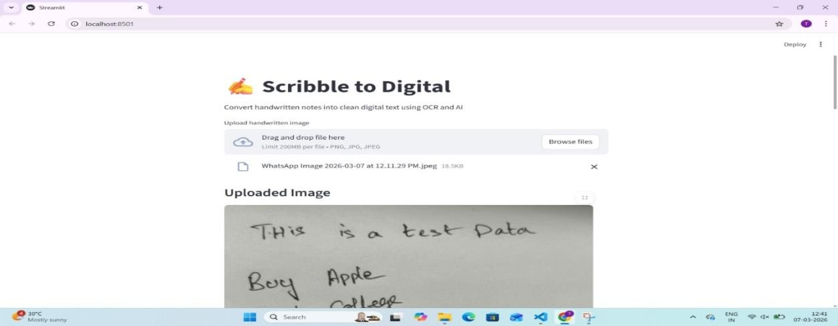

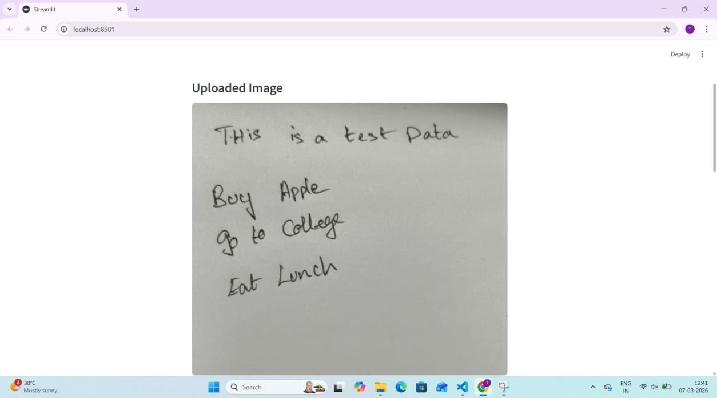

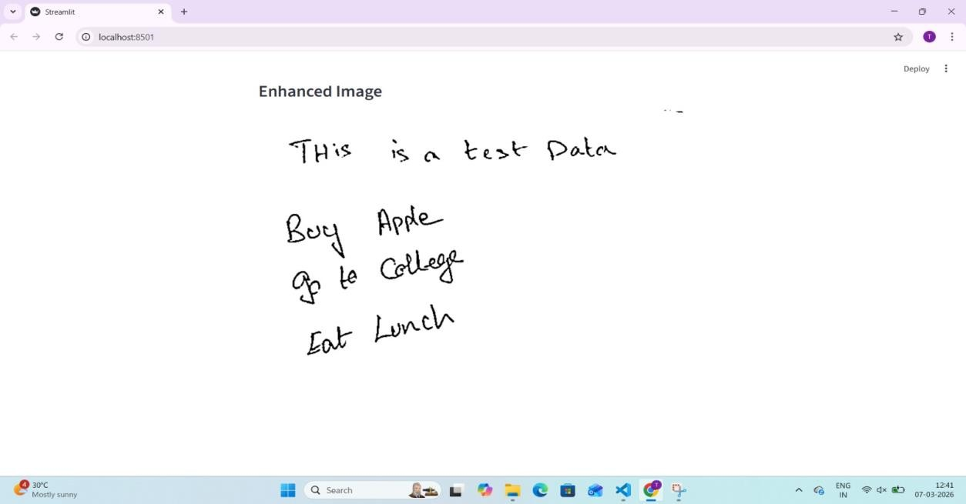
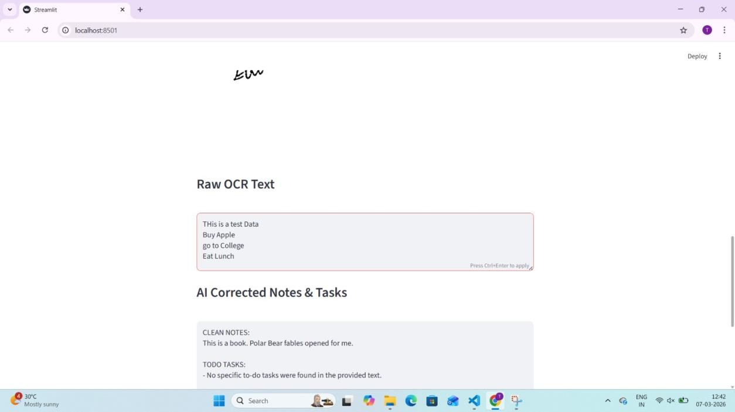

Conclusion
Scribble to Digital transforms traditional handwritten note-taking into an intelligent, AI-powered digital workflow. By combining OCR technology with advanced generative AI, the system accurately extracts handwritten content, enhances readability through contextual correction, and intelligently identifies actionable tasks. The integration of image preprocessing, structured AI prompts, and a responsive Streamlit frontend ensures a seamless and user-friendly experience.
From image enhancement and text recognition to contextual understanding and to-do extraction, every component of Scribble to Digital is designed with a focus on accuracy, efficiency, and reliability. The system not only digitizes messy notes but also adds value by organizing content into clean text and structured task lists, saving users time and effort.
With modular architecture, effective error handling, and optimized performance, Scribble to Digital demonstrates how AI can bridge the gap between handwritten creativity and digital productivity. Whether used by students, professionals, or teams, the application serves as a smart assistant that enhances organization, improves clarity, and streamlines everyday workflows.

