
SIK Worksheets v.1.0 Name:
Circuit 9, How the Circuits Work Date:

Circuit 9

Explanation:  This circuit is actually two different circuits. One circuit for the photoresistor and another for the LED. See How the Circuits Work, Circuit 1 for an explanation of the LED circuit. The photoresistor circuit gets electricity from the 5V on the Arduino. The electricity passes through the photoresistor and sends a signal to Analog Pin # 0 on the Arduino. The value of this signal changes depending on the amount of sunlight. This analog reading is then used in the code you load onto the Arduino and effects the power signal in the LED circuit. The resistor below the Analog Pin connection creates the voltage divider necessary to measure the resistance of the photoresistor. Finally the electricity reaches ground, closing the circuit and allowing electricity to flow from power source to ground. |  | Schematic:  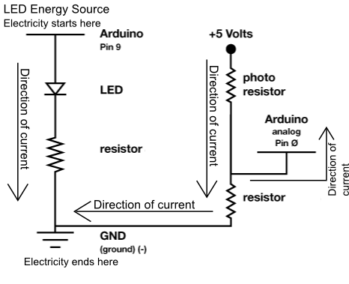
Components:  Arduino Digital Pin # 13: Power source, PWM (if code uses analogWrite) or digital (if code uses digitalWrite) output from Arduino board.  Arduino Analog Pin # 0: Analog input to Arduino board.  330 Ohm Resistor: A resistor resists the current flowing through the circuit. In the LED circuit it reduces the current so the LED in the circuit does not burn out. In the photoresistor circuit the resistor completes the voltage divider.  LED: As in other diodes, current flows easily from the + side, or anode (longer wire), to the - side, or cathode (shorter wire), but not in the reverse direction.  Photoresistor: A resistor with a resistance value that changes depending on the amount of light hitting the sensor.  +5V: Five Volt power source.  Gnd: Ground |  | Code:
This circuit is another example of Analog input. It is also a perfect example of a voltage divider. Don't worry about the “map” and “constrain” functions they are explained in the glossary. Unsure about the voltage divider? See the voltage divider page towards the back of this section.

