
SIK Worksheets v.1.0 Name:
Circuit 10, How the Circuits Work Date:

Circuit 10

Explanation:  This circuit takes electricity from the 5V on the Arduino. The temp sensor sends an analog value to Arduino Analog Pin # 0. Then the electricity reaches ground, closing the circuit and allowing electricity to flow from power source through the sensor to ground. Finally Arduino uses it's Serial monitor to display the temperature reading. |  | Schematic:  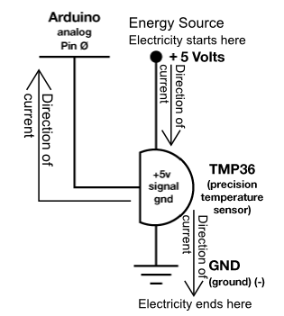
Components:  Arduino Analog Pin # 0: Analog input to Arduino board.  Temperature Sensor: Provides a voltage value depending on the temperature. Some math is then required to convert this value to Celsius or Fahrenheit.  +5V: Five Volt power source.  Gnd: Ground |  | Code:
There is a lot of math involved in the code section of this circuit and it all has a reason. But how would you know you need to offset the temperature reading by .5 unless you had read the Datasheet? Also, pay attention to the code lines that enable Serial communication.

