
SIK Worksheets v.1.0 Name:
Circuit 7, How the Circuits Work Date:

Circuit 7

Explanation:  This circuit is actually two different circuits. One circuit for the buttons and another for the LED. See How the Circuits Work, Circuit 1 for an explanation of the LED circuit. The button circuit gets electricity from the 5V on the Arduino. The electricity passes through a pull up resistor, causing the input on Arduino Pins # 2 and # 3 to read HIGH when the buttons are not being pushed. When a button is pushed it allows the current to flow to ground, causing a LOW reading on the input pin connected to it. This LOW reading is then used in the code you load onto the Arduino and effects the power signal in the LED circuit. |  | Schematic:  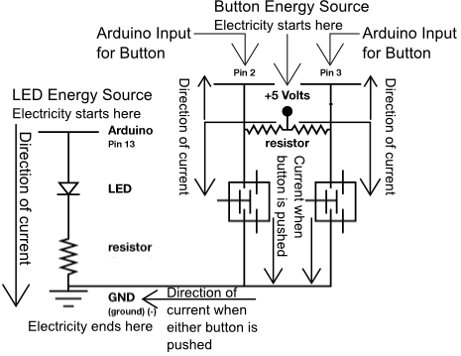
Components:  Arduino Digital Pin # 13: Power source, PWM (if code uses analogWrite) or digital (if code uses digitalWrite) output from Arduino board.  Arduino Digital Pin # 2 and # 3: Digital input to Arduino board.  330 & 10K Ohm Resistors: Resistors resist the current flowing through the circuit. In the LED circuit the 330 ohm resistor reduces the current so the LED in the circuit does not burn out. In the button circuits the 10K's ensure that the buttons will read HIGH when they are not pressed.  LED: As in other diodes, current flows easily from the + side, or anode (longer wire), to the - side, or cathode (shorter wire), but not in the reverse direction.  Button: A press button which is open (or disconnected) when not in use and closed (or connected) when pressed. This allows you to complete a circuit when you press a button.  +5V: Five Volt power source.  Gnd: Ground |  | Code:
This circuit is the first circuit to use the input capabilities of the Arduino. Notice the difference in setup(). You are still using a Digital Pin but you are using it as input rather than output. Buttons are sweet by the way, let the kids press these buttons instead of yours

