
SIK Worksheets v.1.0 Name:
Circuit 8, How the Circuits Work Date:

Circuit 8

Explanation:  This circuit is actually two different circuits. One circuit for the potentiometer and another for the LED. See How the Circuits Work, Circuit 1 for an explanation of the LED circuit. The potentiometer circuit gets electricity from the 5V on the Arduino. The electricity passes through the potentiometer and sends a signal to Analog Pin # 0 on the Arduino. The value of this signal changes depending on the setting of the dial on the potentiometer. This analog reading is then used in the code you load onto the Arduino and effects the power signal in the LED circuit. Finally the electricity reaches ground, closing the circuit and allowing electricity to flow from power source to ground. |  | Schematic:  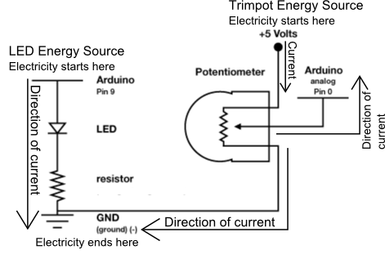
Components:

Arduino Digital Pin # 13: Power source, PWM (if code uses analogWrite) or digital (if code uses the IOPin block) output from Arduino board.

Arduino Analog Pin # 0: Analog input to Arduino board.

330 Ohm Resistor: A resistor resists the current flowing through the circuit. In the LED circuit it reduces the current so the LED in the circuit does not burn out.

LED: As in other diodes, current flows easily from the + side, or anode (longer wire), to the - side, or cathode (shorter wire), but not in the reverse direction.

Potentiometer: A voltage divider which outputs an analog value.

+5V: Five Volt power source.

Gnd: Ground

Code:

This is another example of input, only this time it is Analog. Circuits 7 and 8 in the S.I.K. introduces you to the two kinds of input your board can receive: Digital and Analog. Not sure what a voltage divider is? Check out Voltage Divider page towards the back of this section.

