
SIK Worksheets v.1.0 Name:
Circuit 1, How the Circuits Work Date:

Circuit 1

Explanation:  This circuit takes electricity from digital Pin # 9 on the Arduino. Pin # 9 on the Arduino has Pulse Width Modulation capability allowing the user to change the brightness of the LED when using the AnalogWrite block. The LED is connected to the circuit so electricity enters through the anode (+, or longer wire) and exits through the cathode (-, or shorter wire). The resistor dissipates current so the LED does not draw current above the maximum rating and burn out. Finally the electricity reaches ground, closing the circuit and allowing electricity to flow from power source to ground. |  | Schematic:  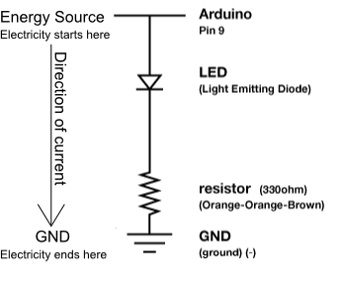
Components:  Arduino Digital Pin # 9: Power source, PWM (if code uses the AnalogWrite block) or digital (if code uses the IOPin.Write block) output from Arduino board.  LED: As in other diodes, current flows easily from the + side, or anode (longer wire), to the - side, or cathode (shorter wire), but not in the reverse direction.  330 Ohm Resistor: A resistor resists the current flowing through the circuit. In this circuit the resistor reduces the current so the LED does not burn out.  Gnd: Ground |  | Code:  or for PWM output loop could read :
This first circuit is the simplest form of output in the kit. You can use the LED to teach both analog and digital output before moving on to more exciting outputs. There is an LED built into your Arduino board which corresponds to Digital Pin # 13.

