
SIK Worksheets v.1.0 Name:
Circuit 6, How the Circuits Work Date:

Circuit 6

Explanation:  This circuit gets electricity from Arduino Pin # 12. The Piezo element plays different musical notes depending on the speed and duration of the electrical signal sent from Pin # 12. Finally the electricity reaches ground, closing the circuit and allowing electricity to flow from power source to ground. |  | Schematic:  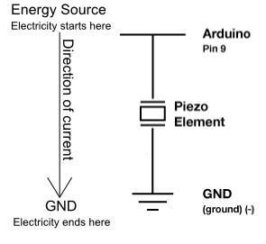
Components:

Arduino Digital Pin # 12: Power source, digital output from Arduino board. (If changed to PWM output this creates distortion of note, not a change in volume.)

Piezo element: A tiny speaker with a magnetic coil that responds to electrical current by moving more or less depending on the current. The coil is attached to a diaphragm which moves air and causes the noise we hear.

Gnd: Ground

Code:

This code is fairly complicated. Don't worry if you don't understand some aspects of it. If you do understand it, congratulations! You are already ahead of this packet in regards to Arduino code. Just remember, this is another way to use digital pins to create analog output.

