00A-095, Probe Board, 2CH, BNC

|  |  |
| --- | --- |
| **PART NUMBER** | 00A-095 |
| **GROUP NAME** | Probing and Prototyping (00A) |
| **CIRCUIT NAME** | BNC HOOKUP WIRE BOARD |
| **VARIANT DESCRIPTION** | HOOKUP WIRE, 24 AWG, PTFE |
| **BOARD DESIGN** | PCB50 |
| **PRODUCT DESCRIPTION** | Panel of 00A-095 miniPCBs, v-scored (1 Panel = 4 Pieces) |

# Circuit Description

This board contains two (2) BNC connectors with hookup wire points for each signal and signal return pin. This board enables reliable signal paths between developmental test setups and lab equipment.

# Panel Board

|  |  |
| --- | --- |
|  |  |
| TOP VIEW | BOTTOM VIEW |

# Single Board

|  |  |
| --- | --- |
|  |  |
| TOP VIEW | BOTTOM VIEW |

# Part Locations

|  |  |
| --- | --- |
|  |  |
| TOP VIEW | BOTTOM VIEW |

# Schematic

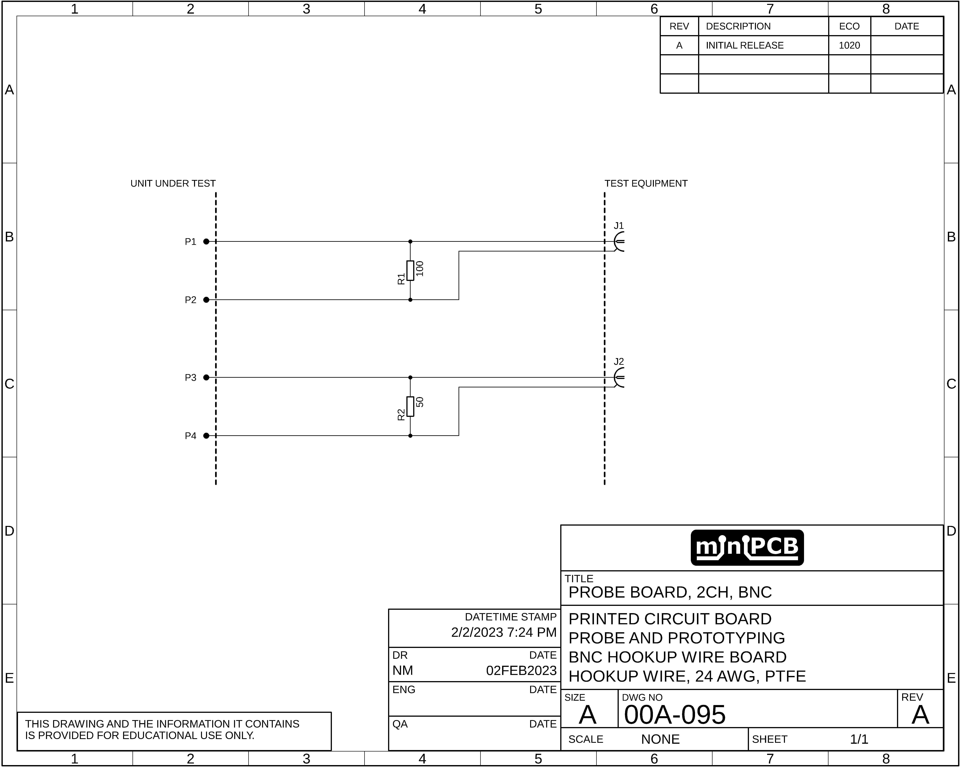

# Parts List Form

|  |  |  |  |  |
| --- | --- | --- | --- | --- |
| **REF DES** | **PART TYPE** | **MFG PART NUMBER** | **PART DESCRIPTION** | **FIND** |
| J1 | BNC RA | 5227161-1 | CONN BNC JACK R/A 50 OHM PCB | 1 |
| J2 | BNC RA | 5227161-1 | CONN BNC JACK R/A 50 OHM PCB | 2 |
| P1 | HOOKUP POINT |  |  | 3 |
| P2 | HOOKUP POINT |  |  | 4 |
| P3 | HOOKUP POINT |  |  | 5 |
| P4 | HOOKUP POINT |  |  | 6 |
| R1 | RESISTOR, 0805 |  |  | 7 |
| R2 | RESISTOR, 0805 |  |  | 8 |

# Gerber Files

This section contains images of the layers included in each Gerber file.

## TOP COPPER (GLTX)

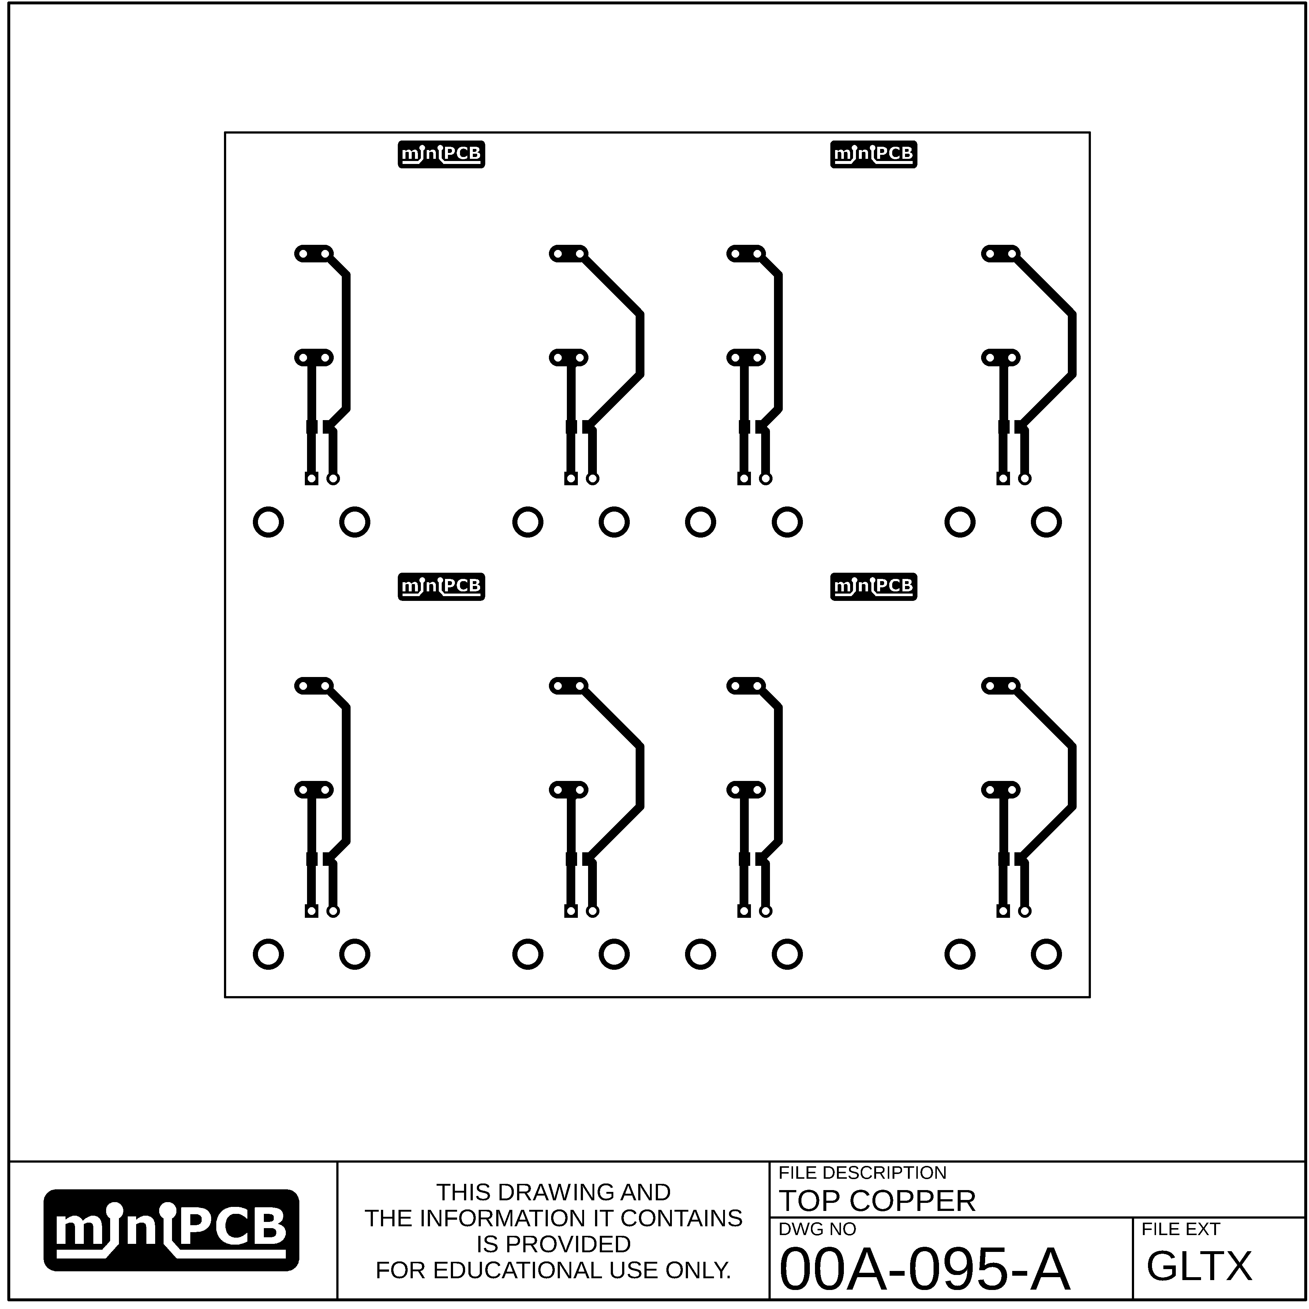

## TOP CREAM (GCTX)

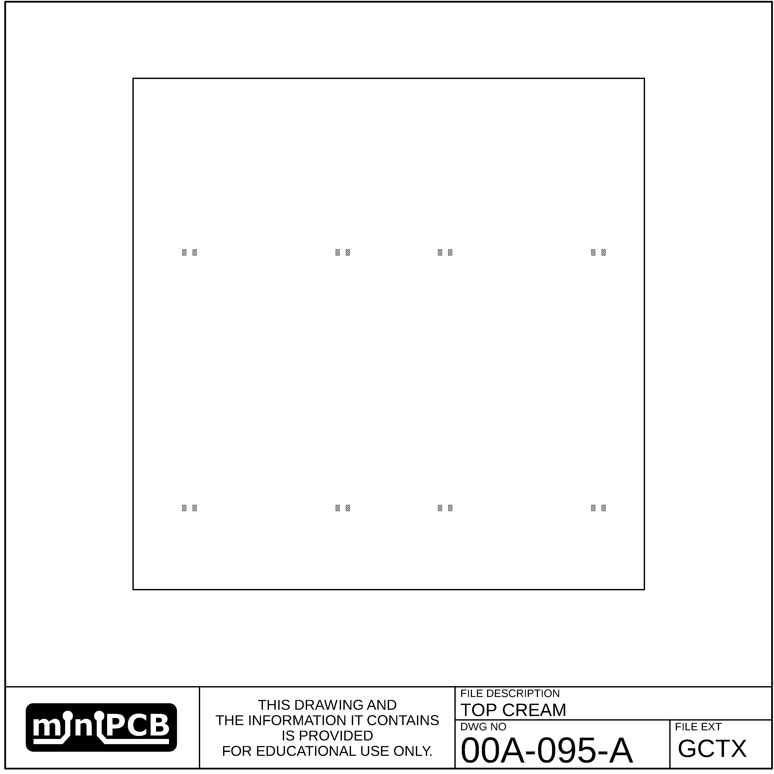

## BOTTOM CREAM (GCBX)

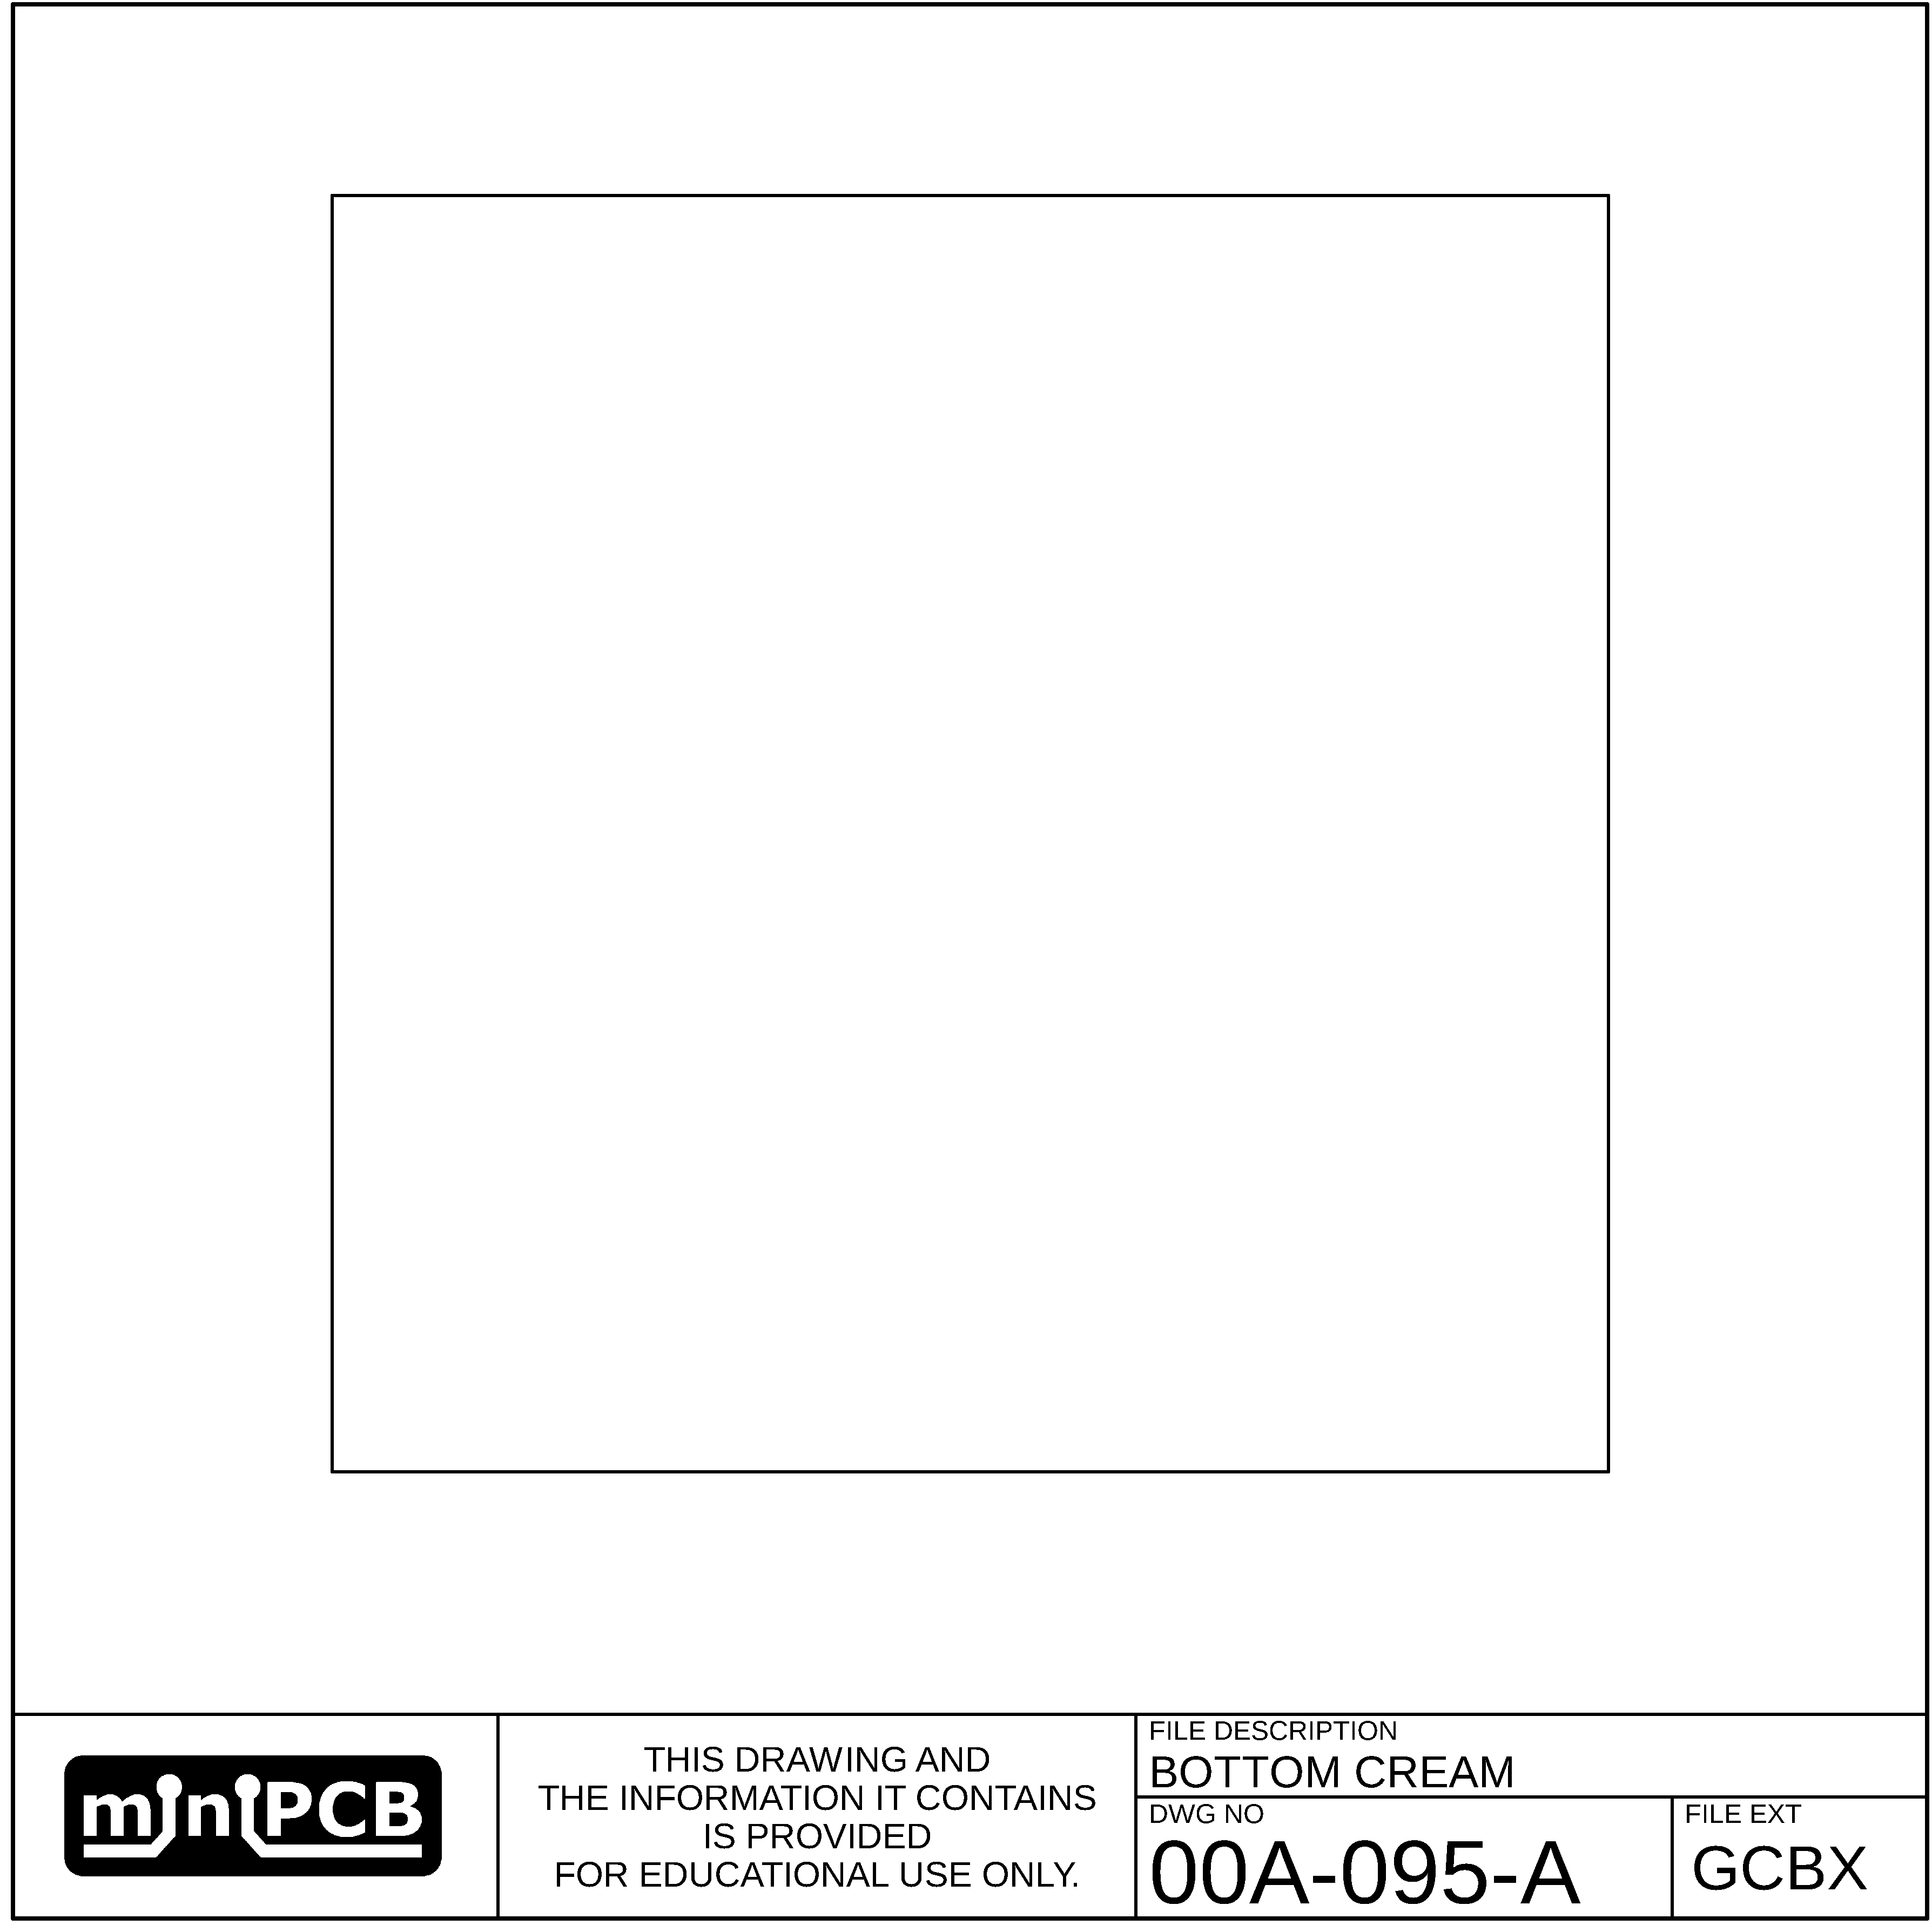

## BOTTOM COPPER (GLBX)

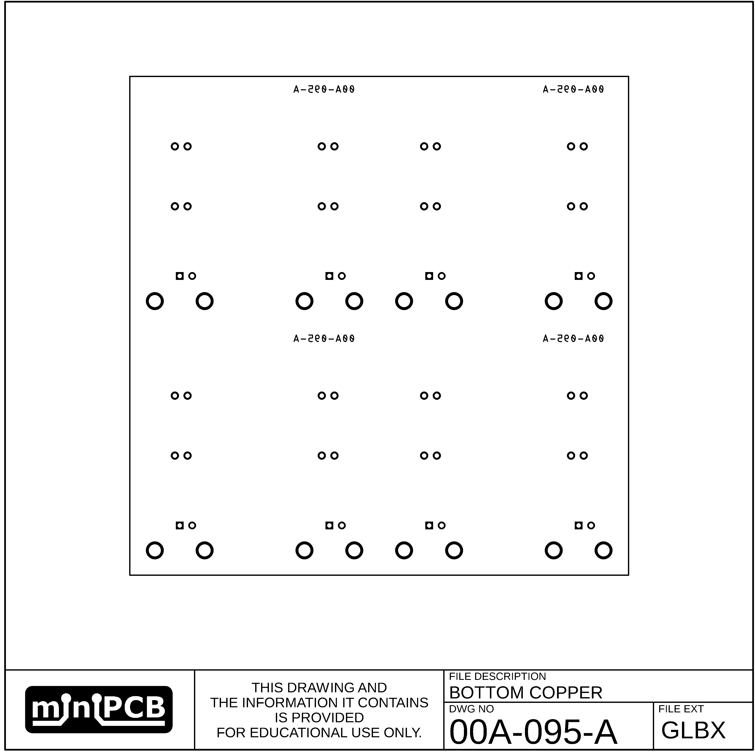

## TOP SILKSCREEN (GOTX)

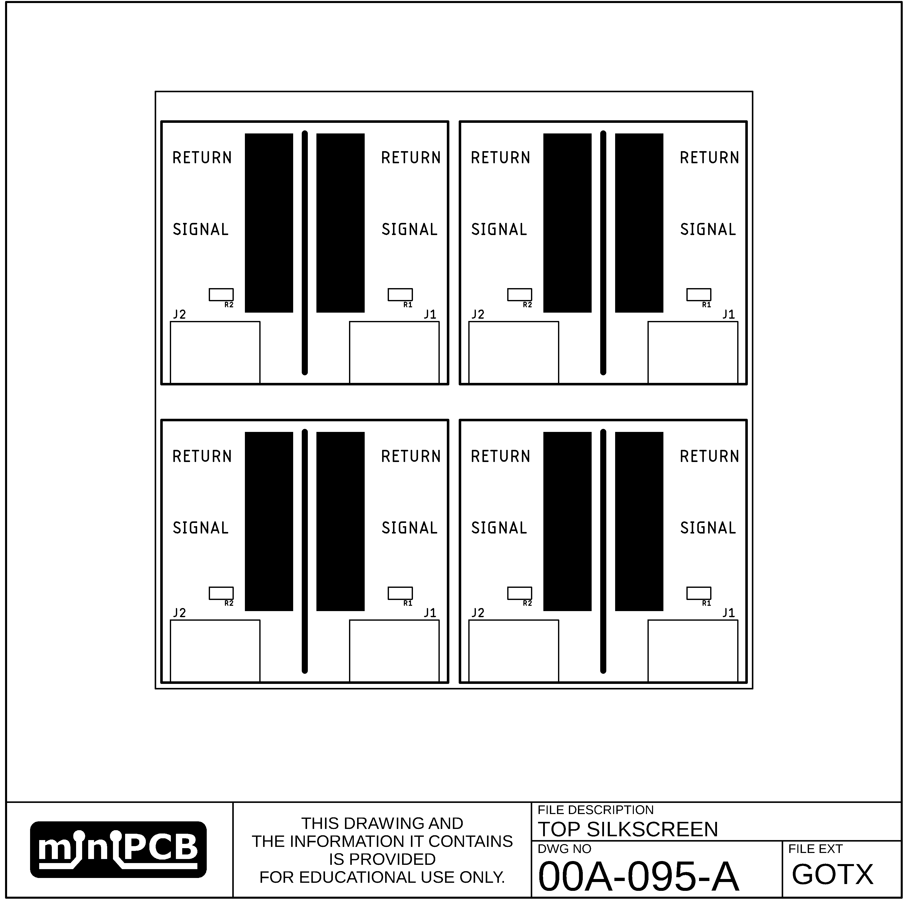

## BOTTOM SILKSCREEN (GOBX)

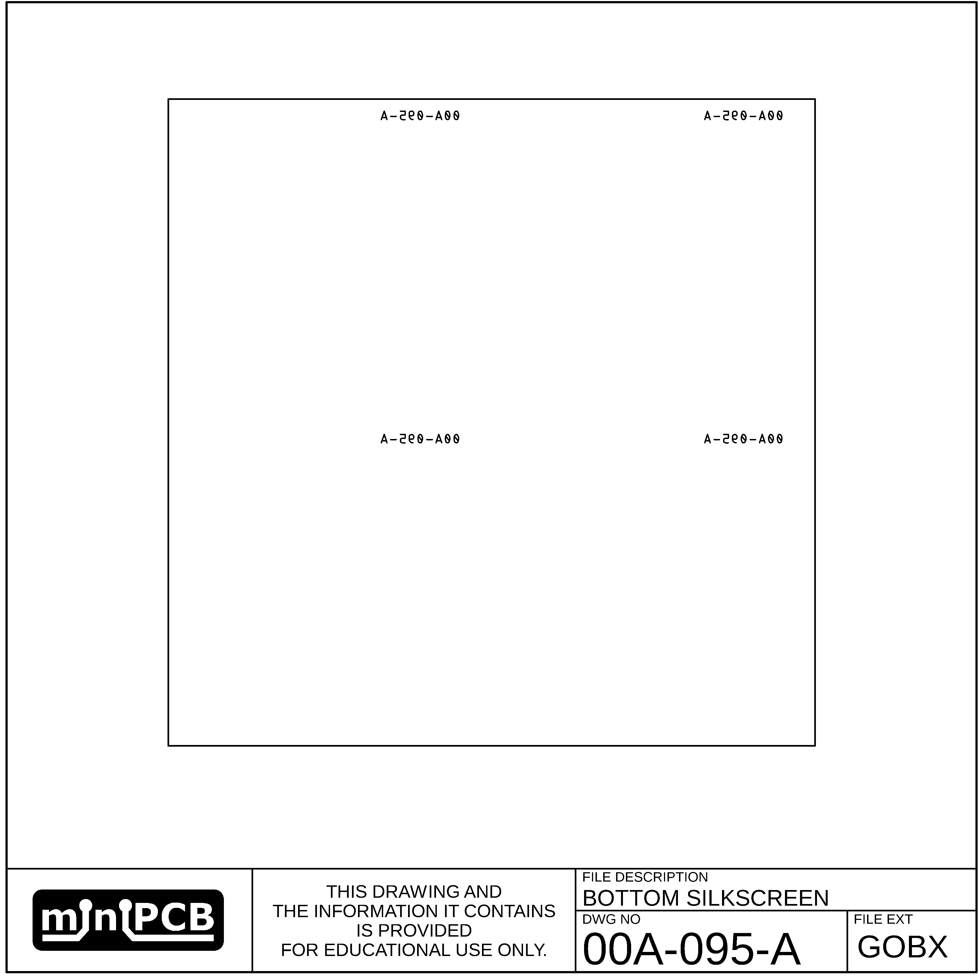

## TOP SOLDERMASK (GSTX)

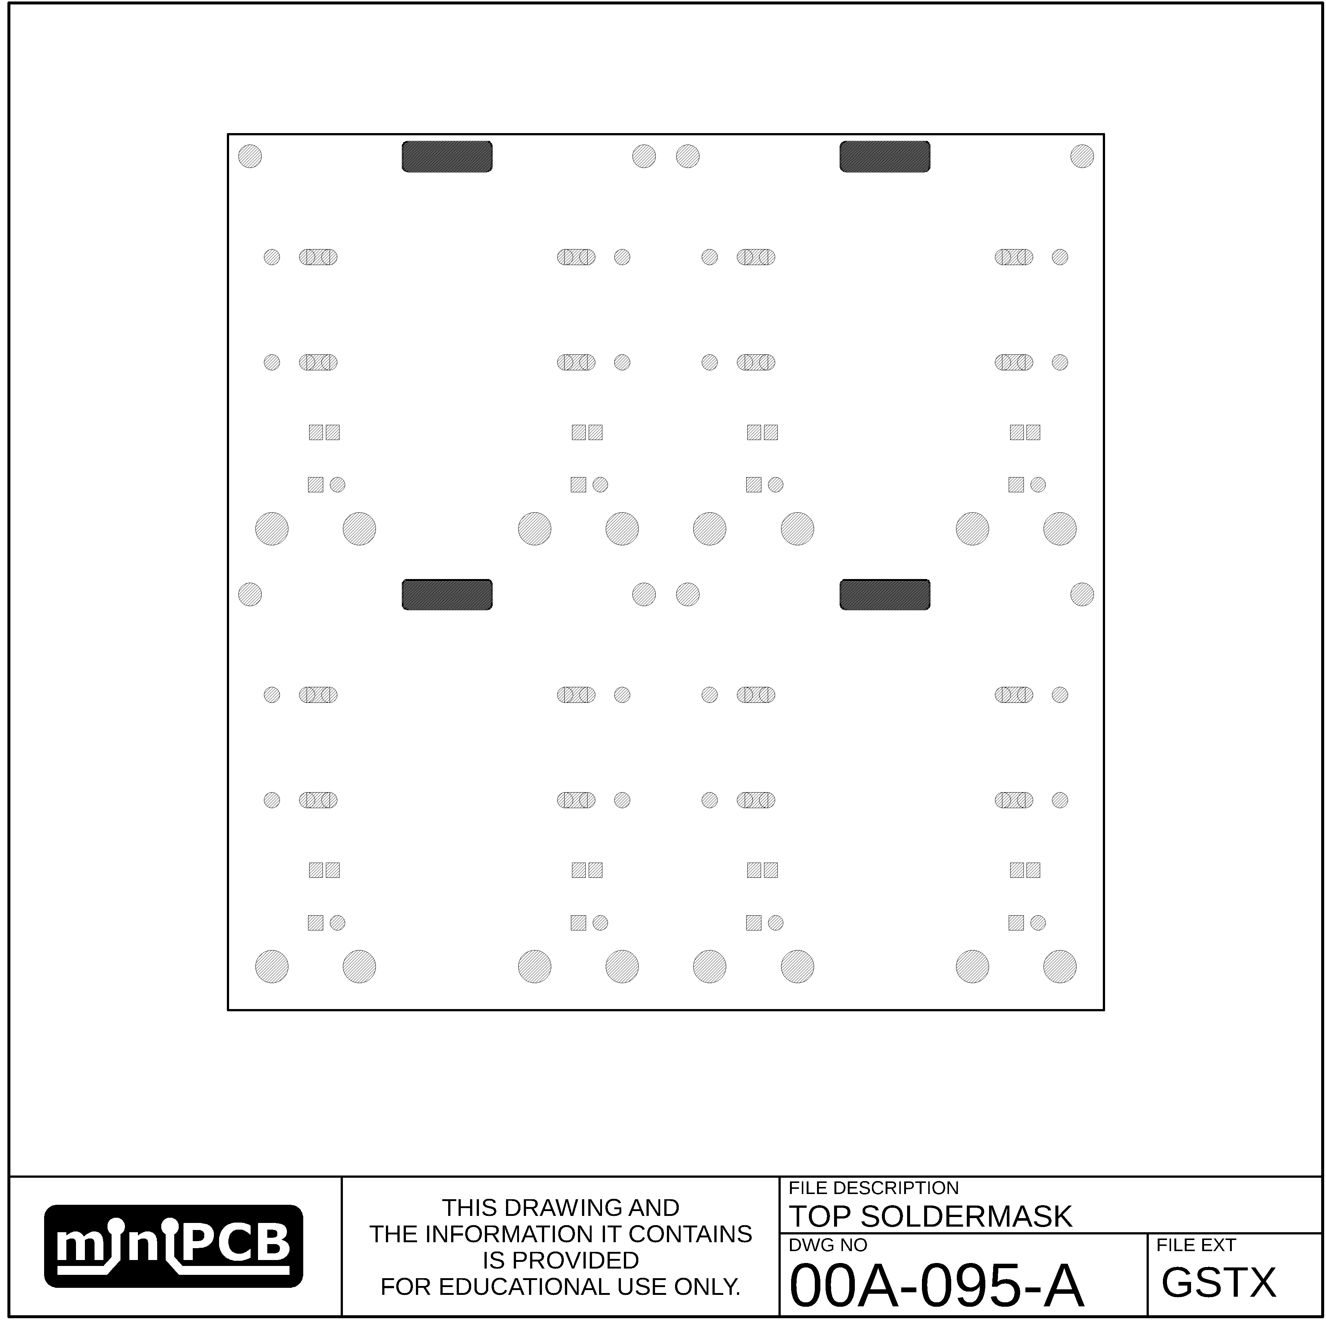

## BOTTOM SOLDER MASK (GSBX)

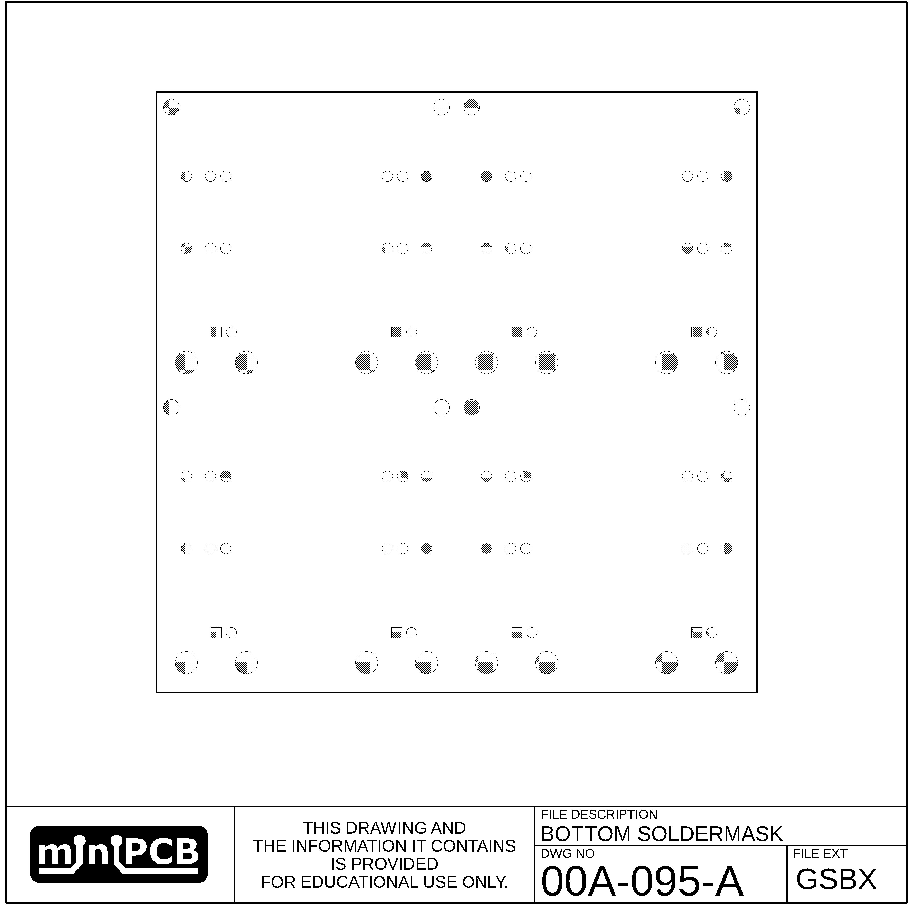

## EDGE (GM1)

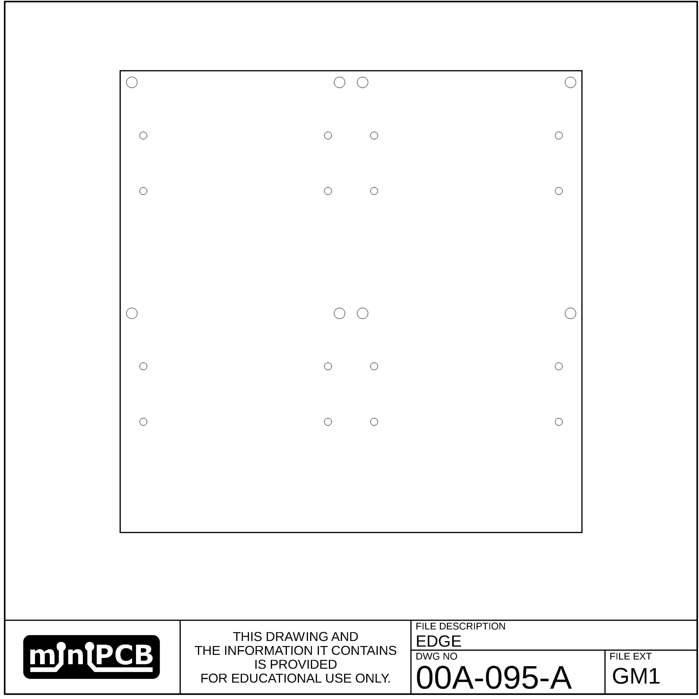

## VSCORE (GM2)

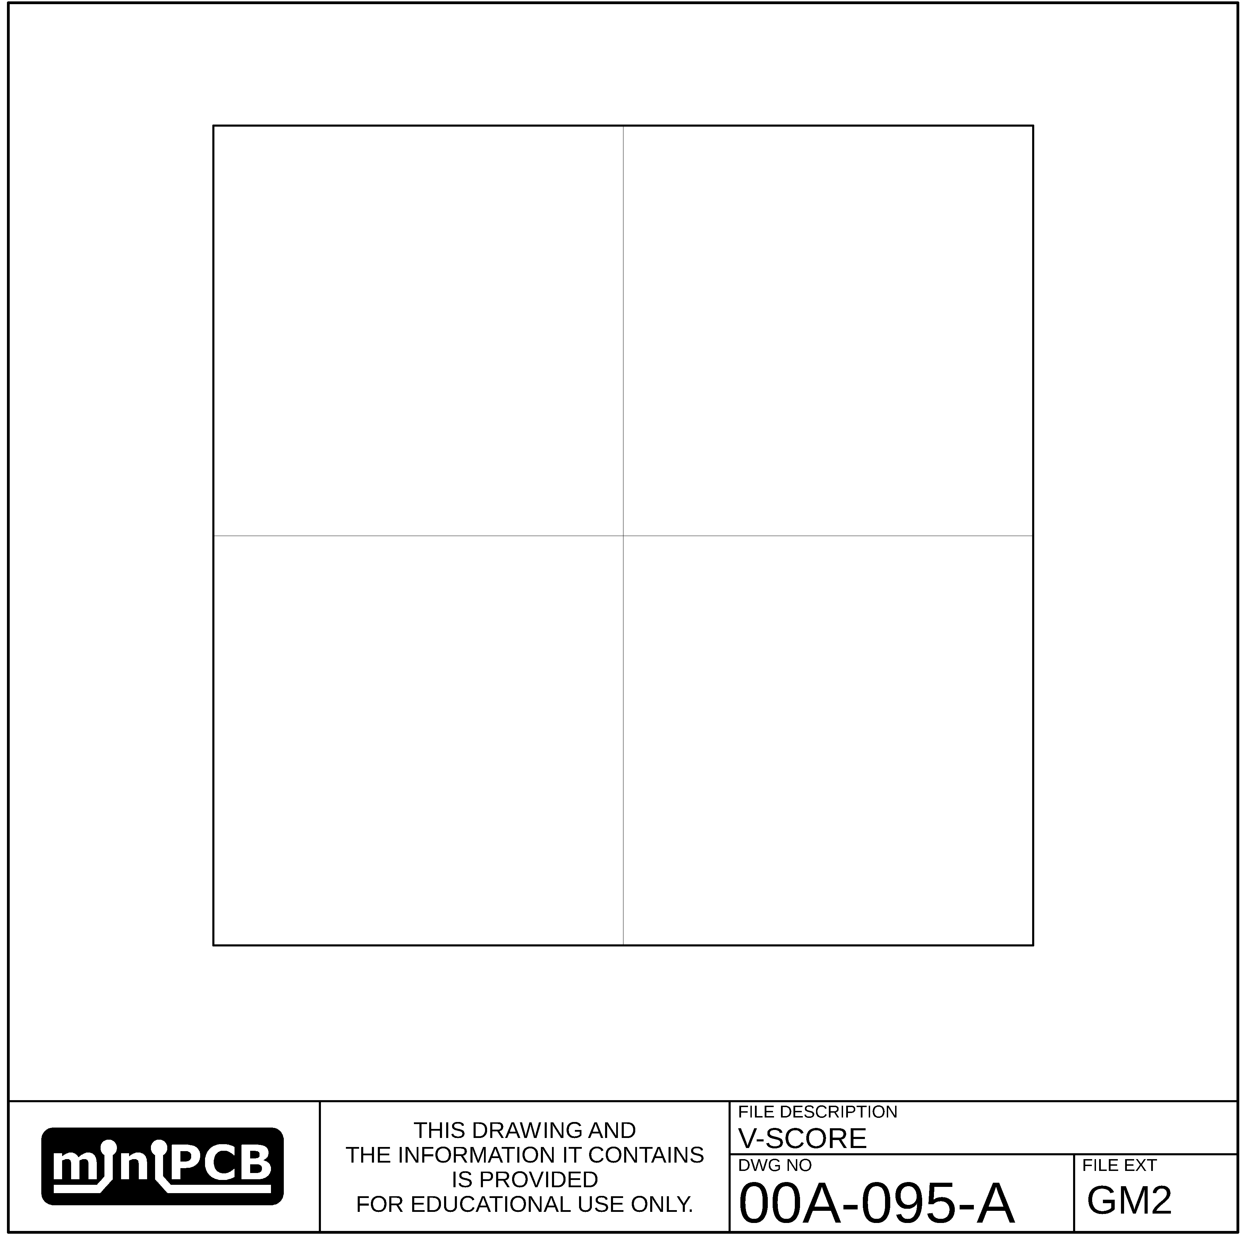

## MILLING (GM3)

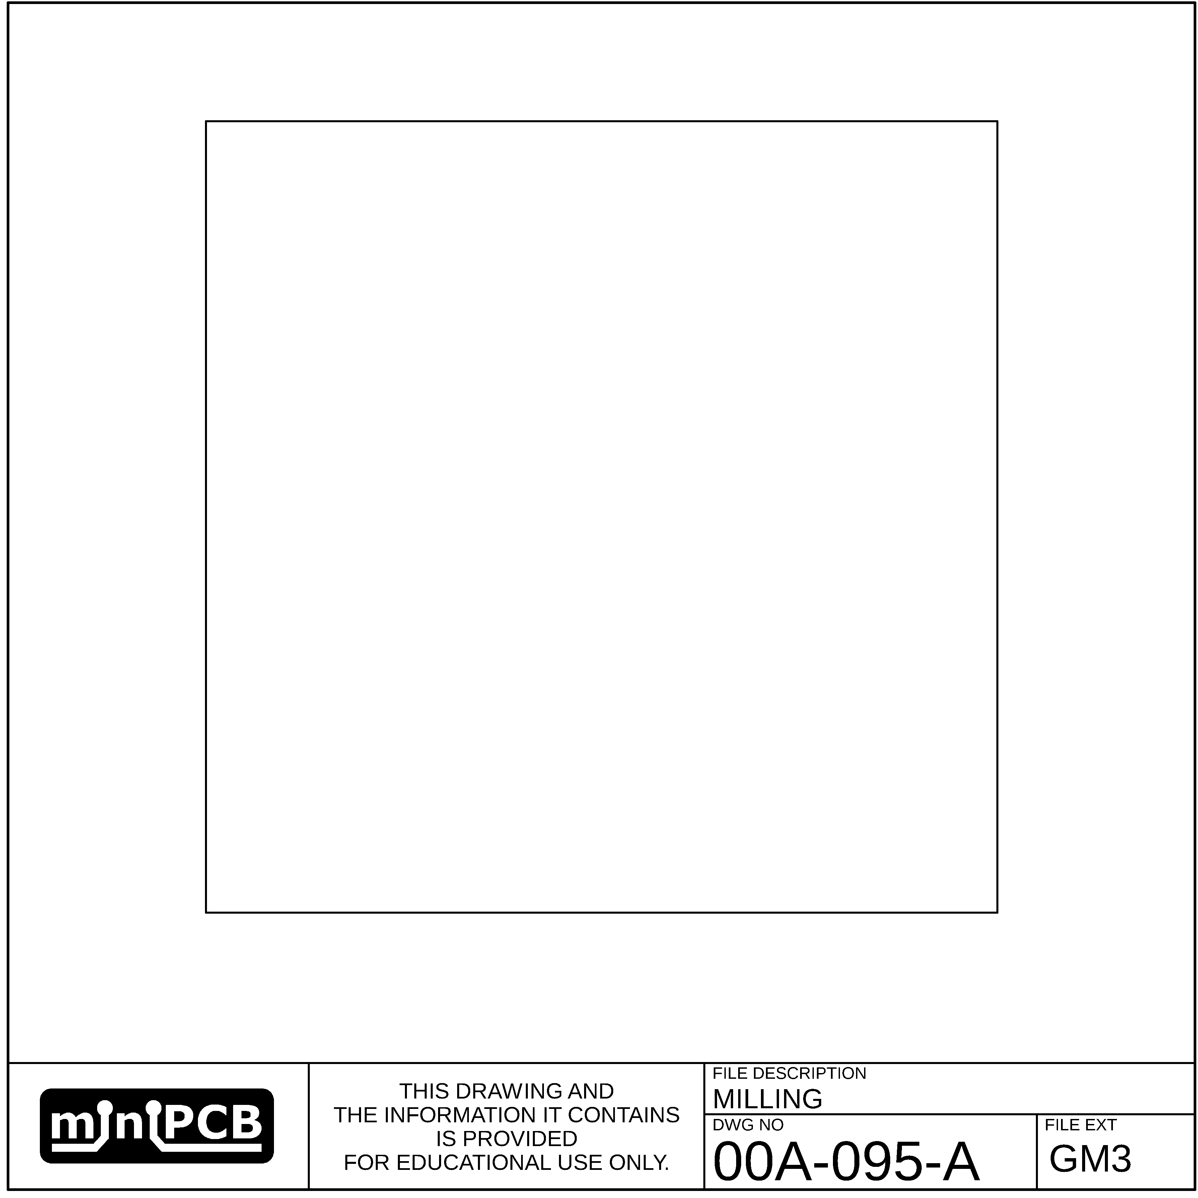

# Change and Liability Notice

This document is subject to change without notice. While effort has been made to ensure the accuracy of the material contained within this document, Nolan Manteufel shall under no circumstances be liable for incidental or consequential damages or related expenses resulting from the use of this document.

# Trademark Notice

miniPCB is a trademark of Nolan Manteufel.

This datasheet does not constitute permission to use the miniPCB trademark.

|  |  |  |
| --- | --- | --- |
| WORDMARK | FIGUREMARK | FIGUREMARK |
| miniPCB™ | A picture containing drawing  Description automatically generated™ | Icon  Description automatically generated™ |

# Revision History

|  |  |  |  |
| --- | --- | --- | --- |
| REV | DESCRIPTION | ECO | DATE |
| A | Initial Release |  |  |
|  |  |  |  |