00A-110, Power Limiter, Switched

|  |  |
| --- | --- |
| **PART NUMBER** | 00A-110 |
| **GROUP NAME** | Probing and Prototyping (00A) |
| **CIRCUIT NAME** | Short-Circuit Protection Device |
| **VARIANT DESCRIPTION** | Static Load, Manual Control |
| **BOARD DESIGN** | PCB50 |
| **PRODUCT DESCRIPTION** | Panel of #00A-110 miniPCBs, v-scored (1 Panel = 4 Pieces) |

# Circuit Description

This board contains two (2) power resistors, four (4) banana jack posts, four (4) multimeter probe receptacles, and a rotary switch. This board enables Unit Under Test (UUT) boards to be powered up safely during developmental testing.

# Panel Board

|  |  |
| --- | --- |
|  |  |
| TOP VIEW | BOTTOM VIEW |

# Single Board

|  |  |
| --- | --- |
|  |  |
| TOP VIEW | BOTTOM VIEW |

# Part Locations

|  |  |
| --- | --- |
|  |  |
| TOP VIEW | BOTTOM VIEW |

# Schematic

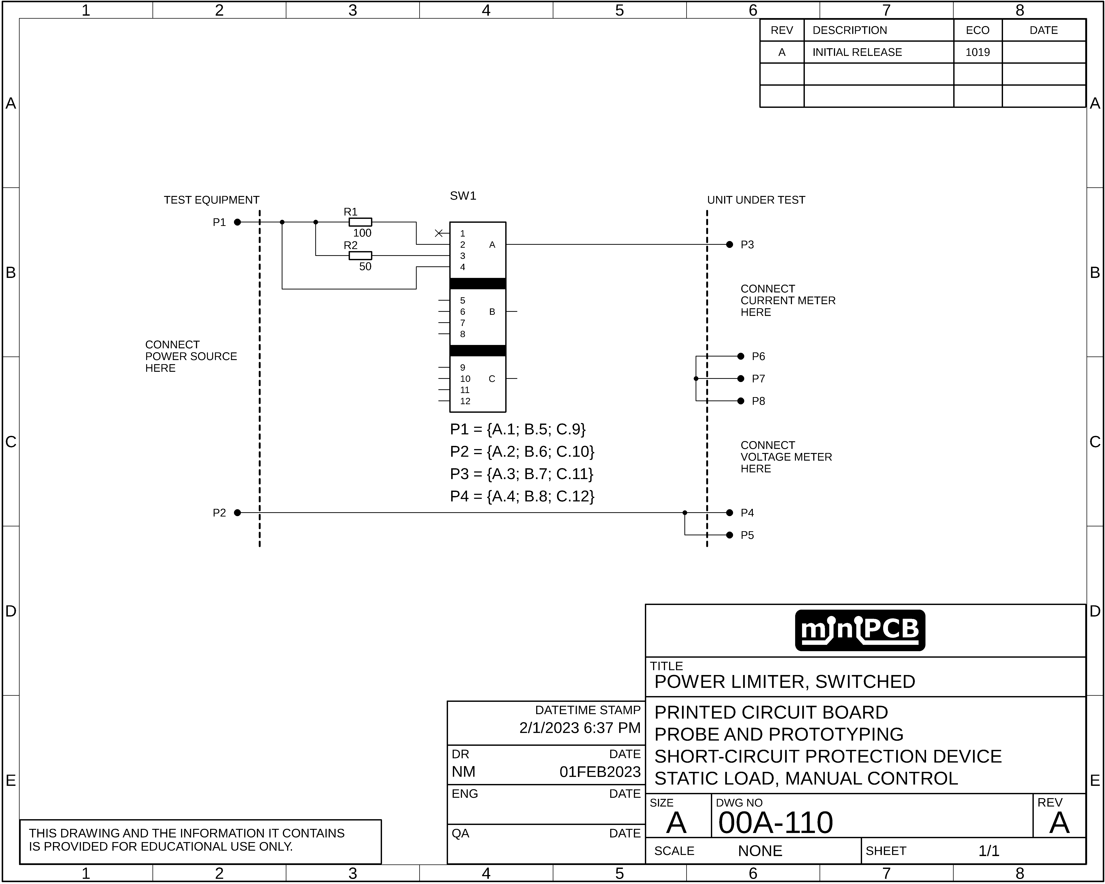

# Gerber Files

This section contains images of the layers included in each Gerber file.

## TOP COPPER (GLTX)

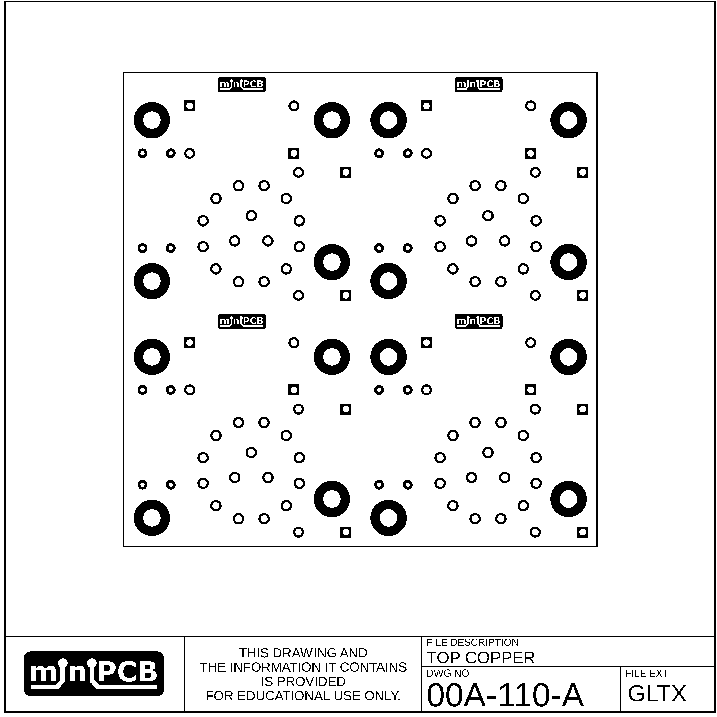

## TOP CREAM (GCTX)

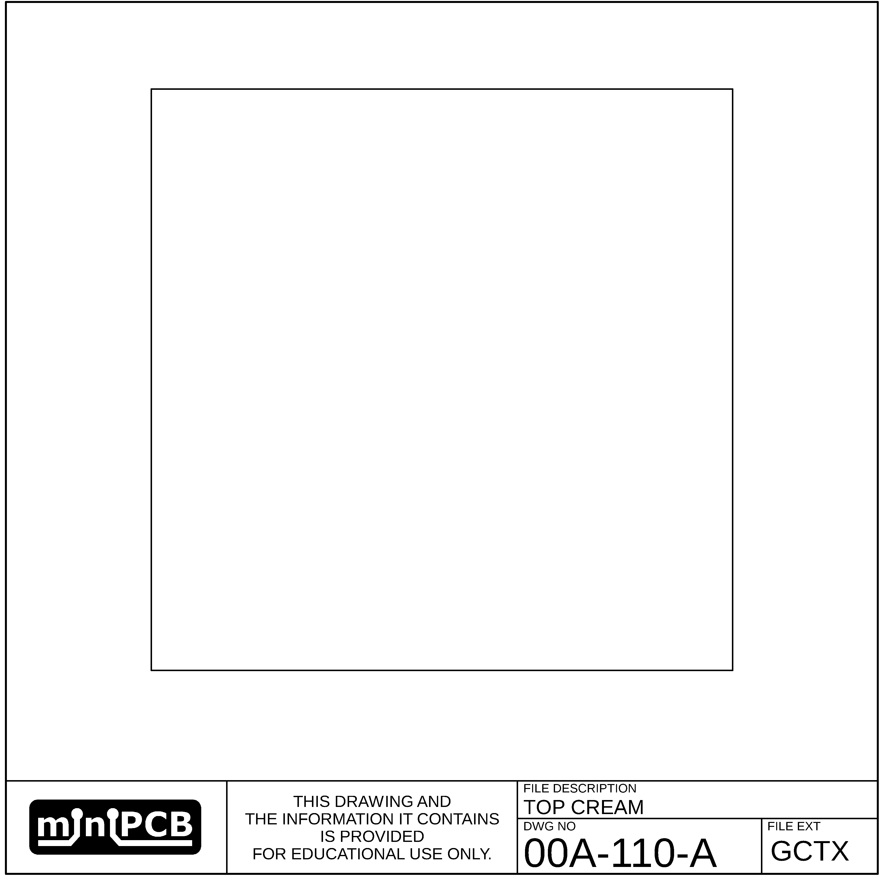

## BOTTOM CREAM (GCBX)

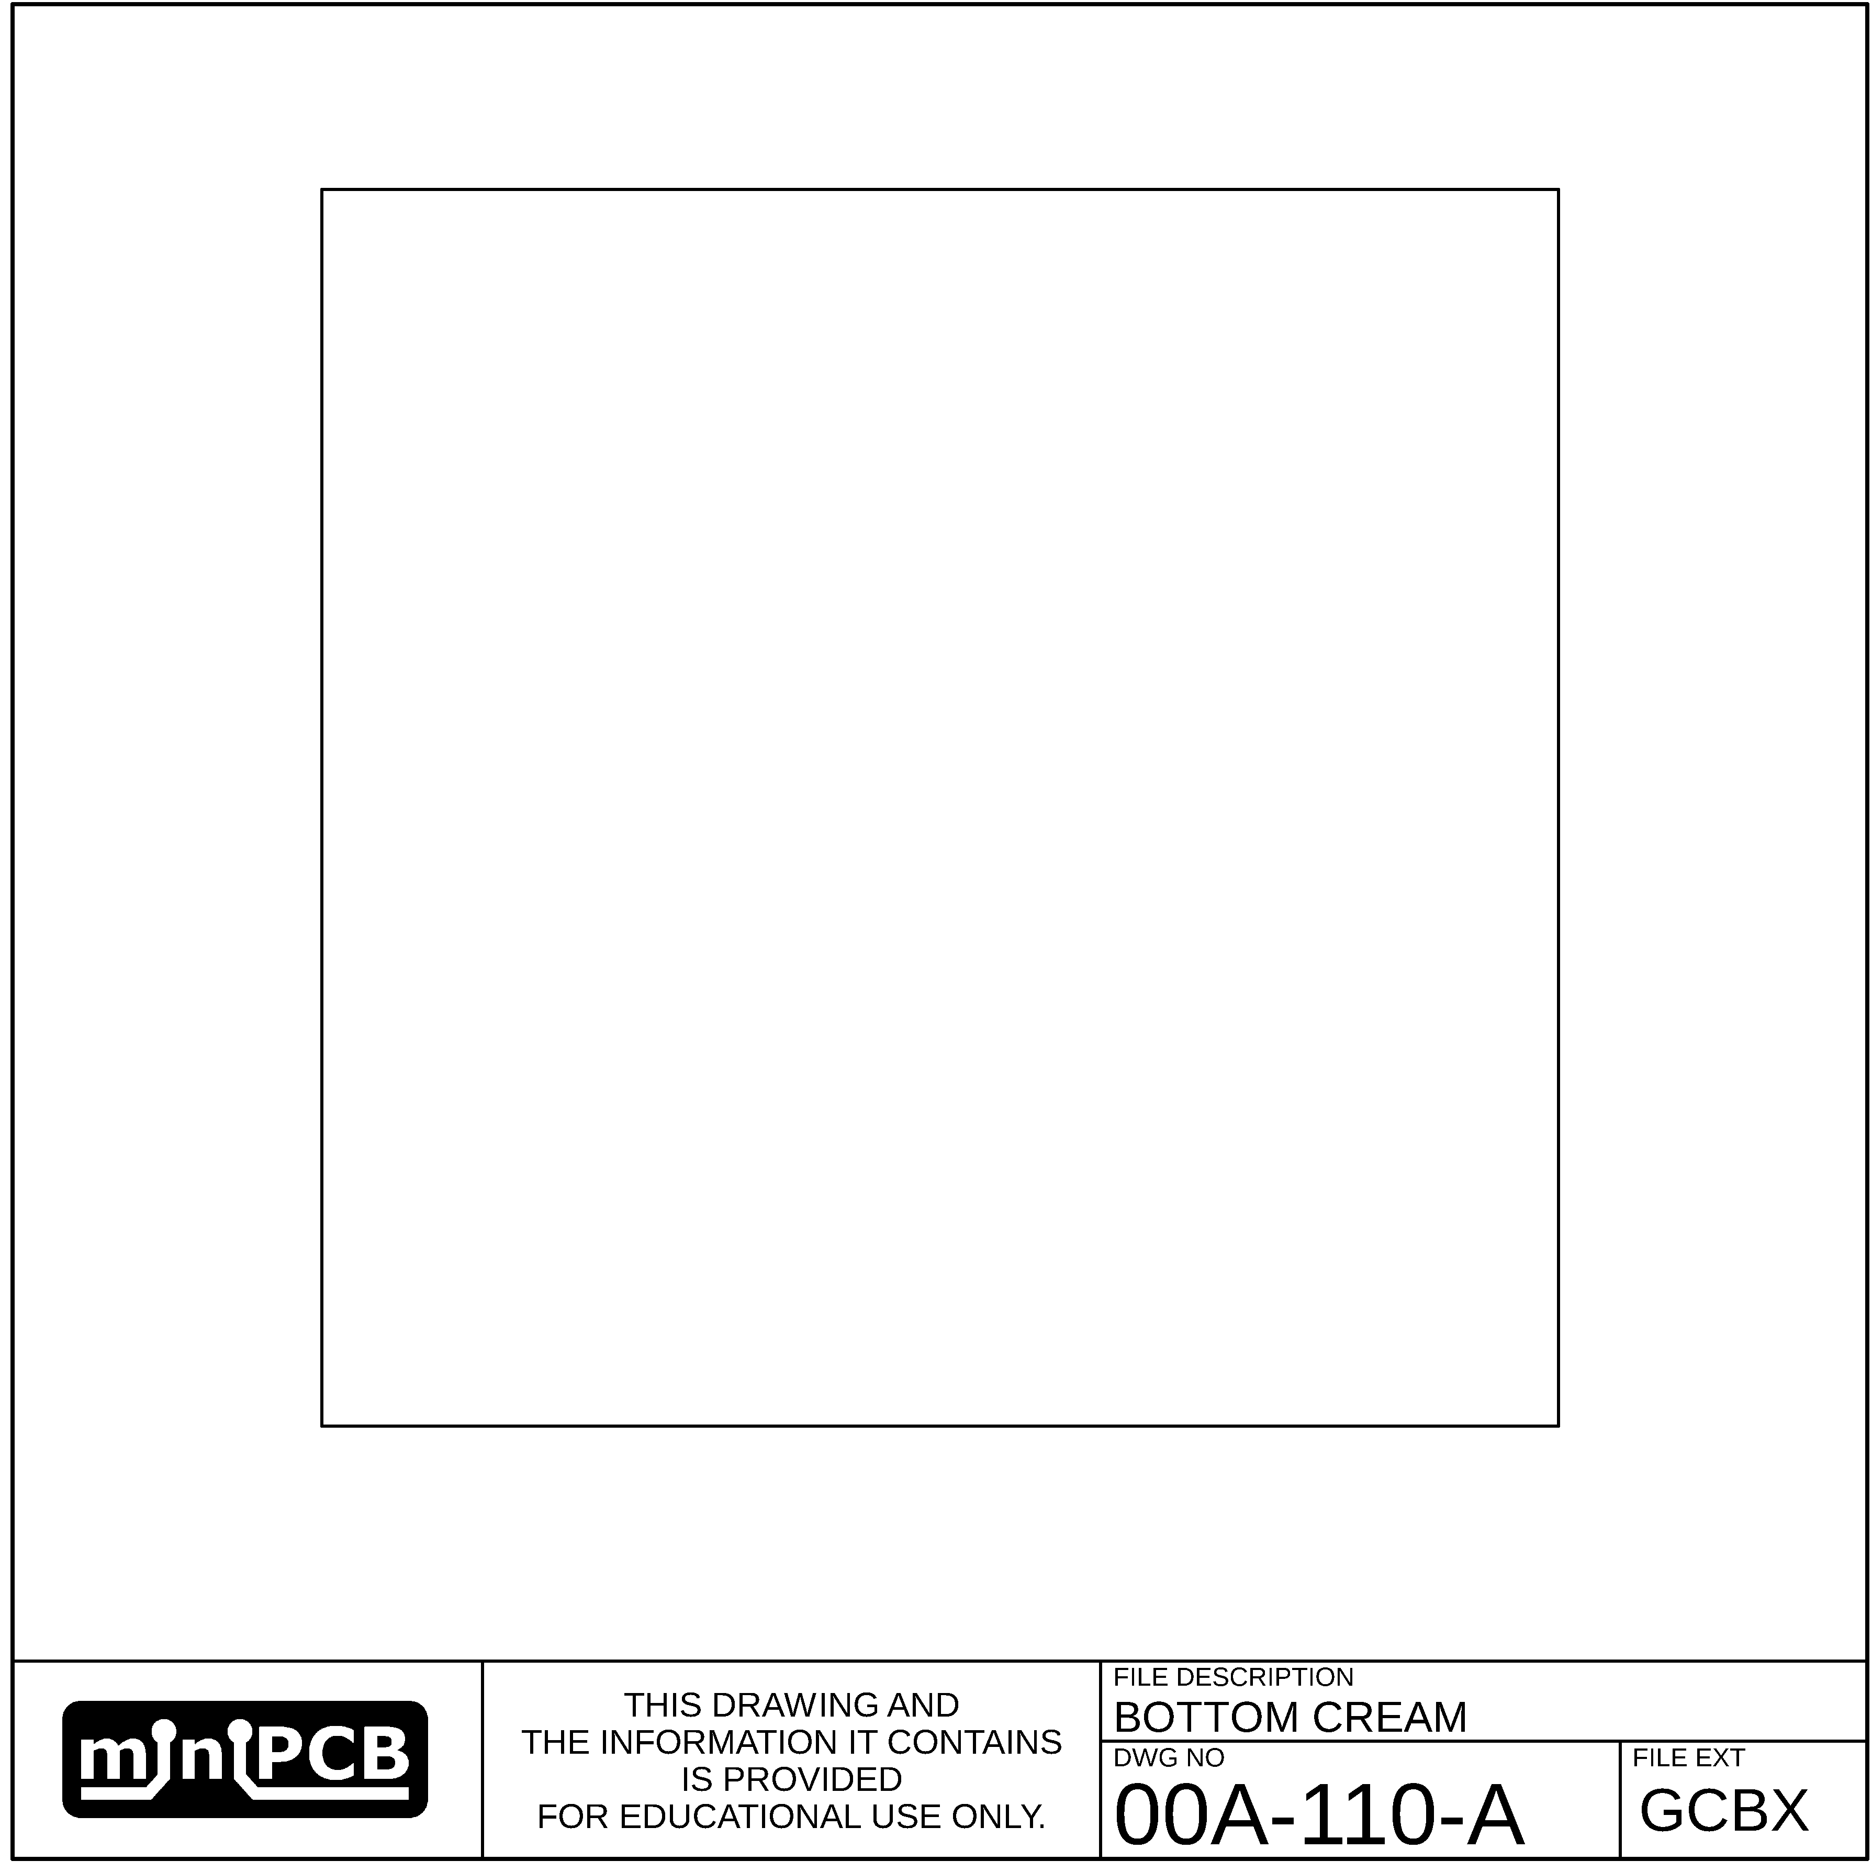

## BOTTOM COPPER (GLBX)

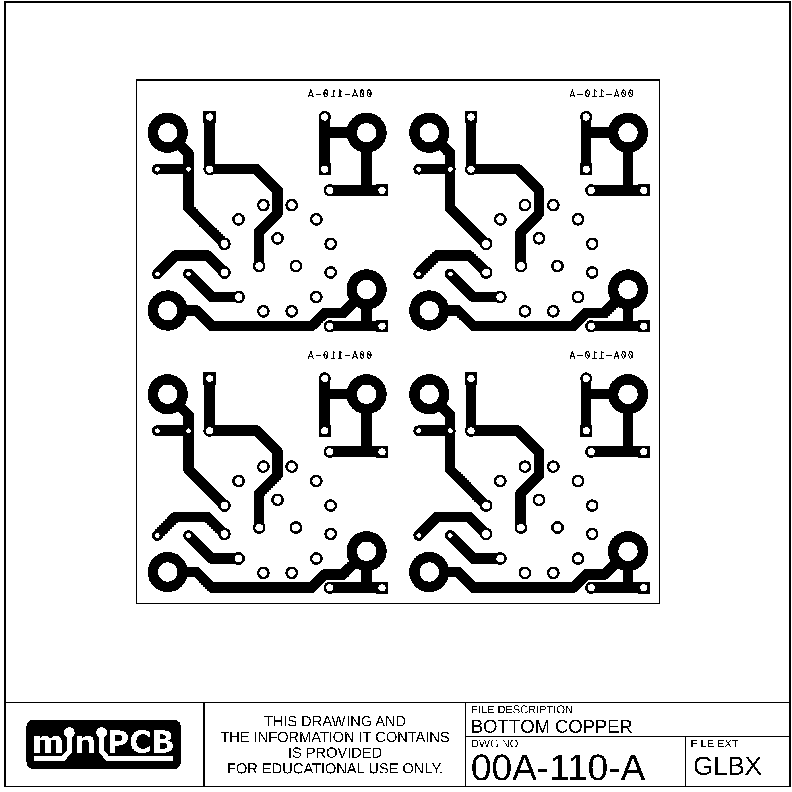

## TOP SILKSCREEN (GOTX)

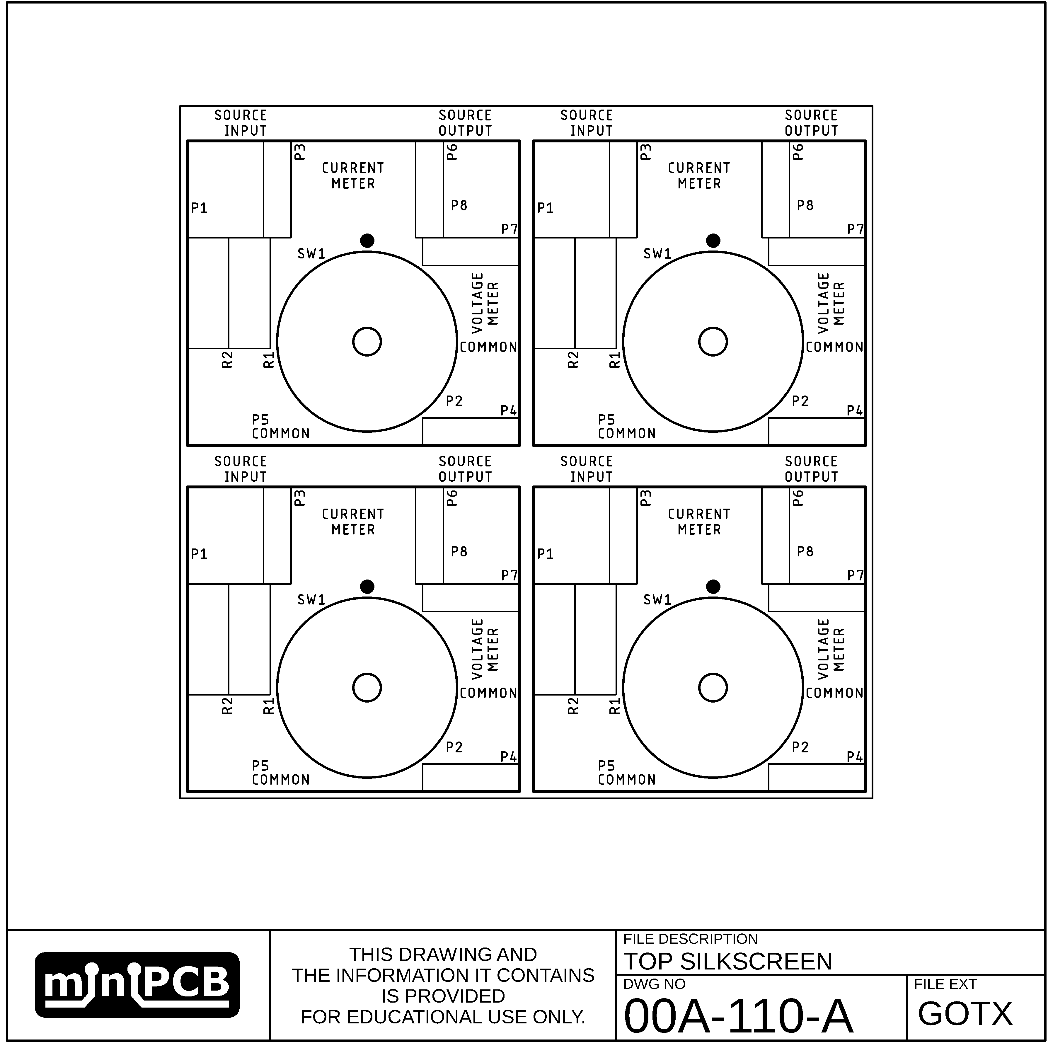

## BOTTOM SILKSCREEN (GOBX)

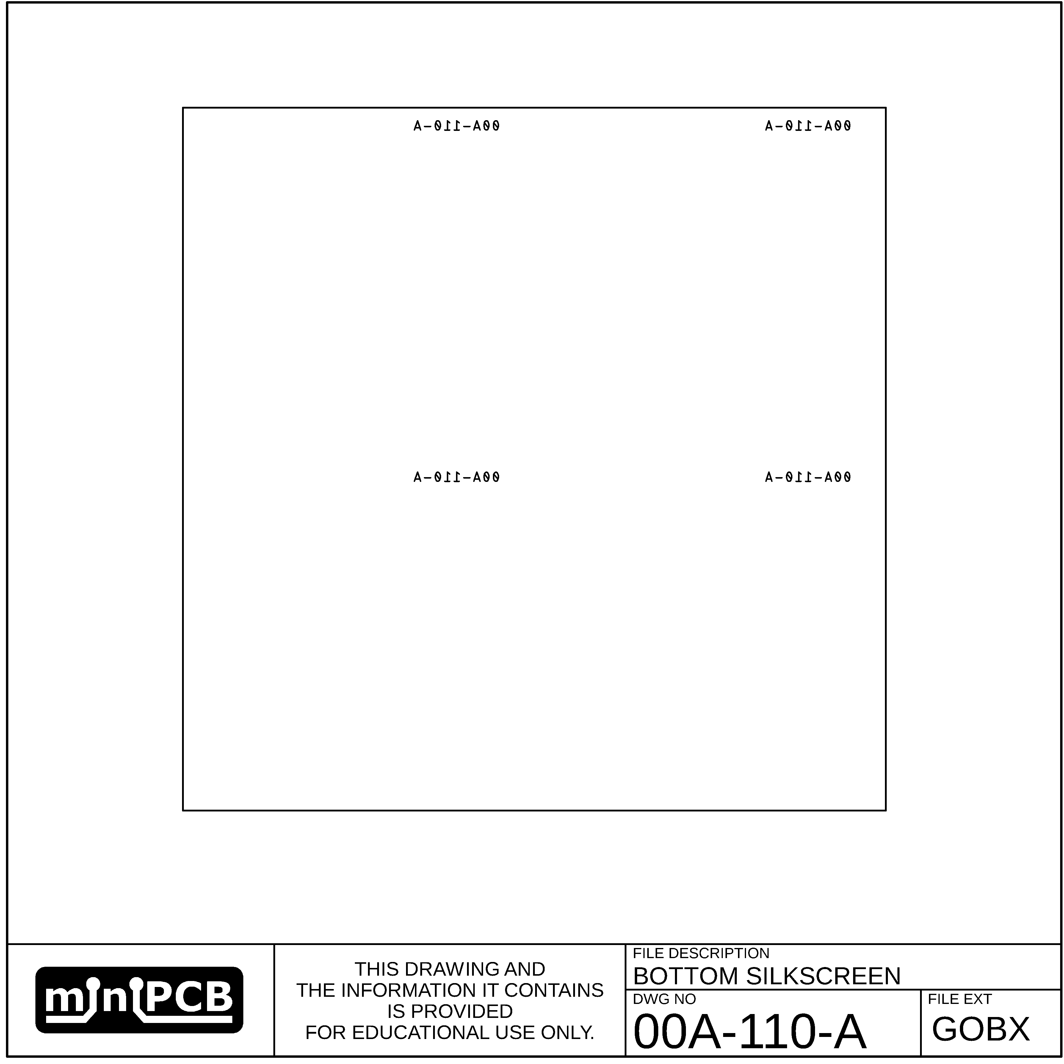

## TOP SOLDERMASK (GSTX)

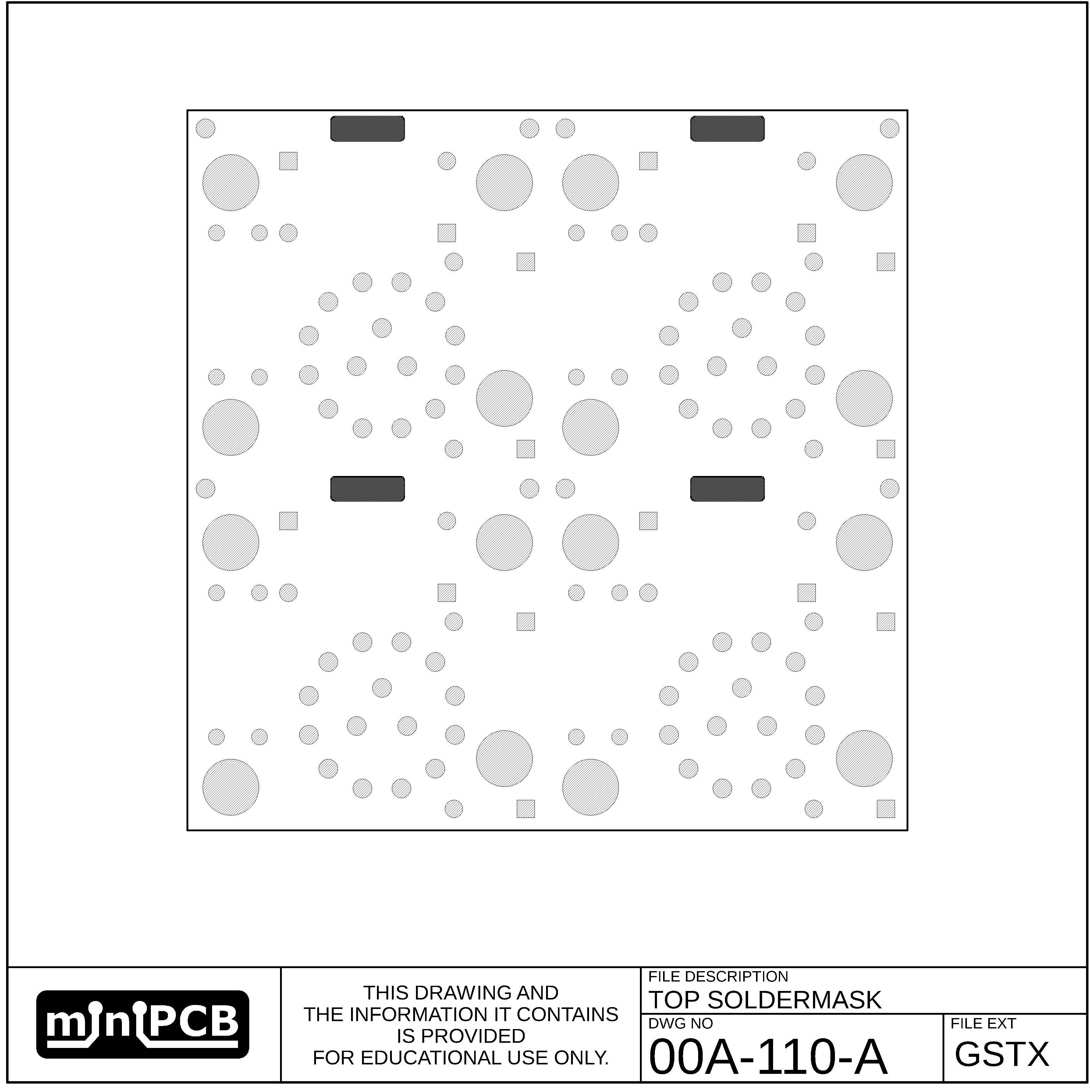

## BOTTOM SOLDER MASK (GSBX)

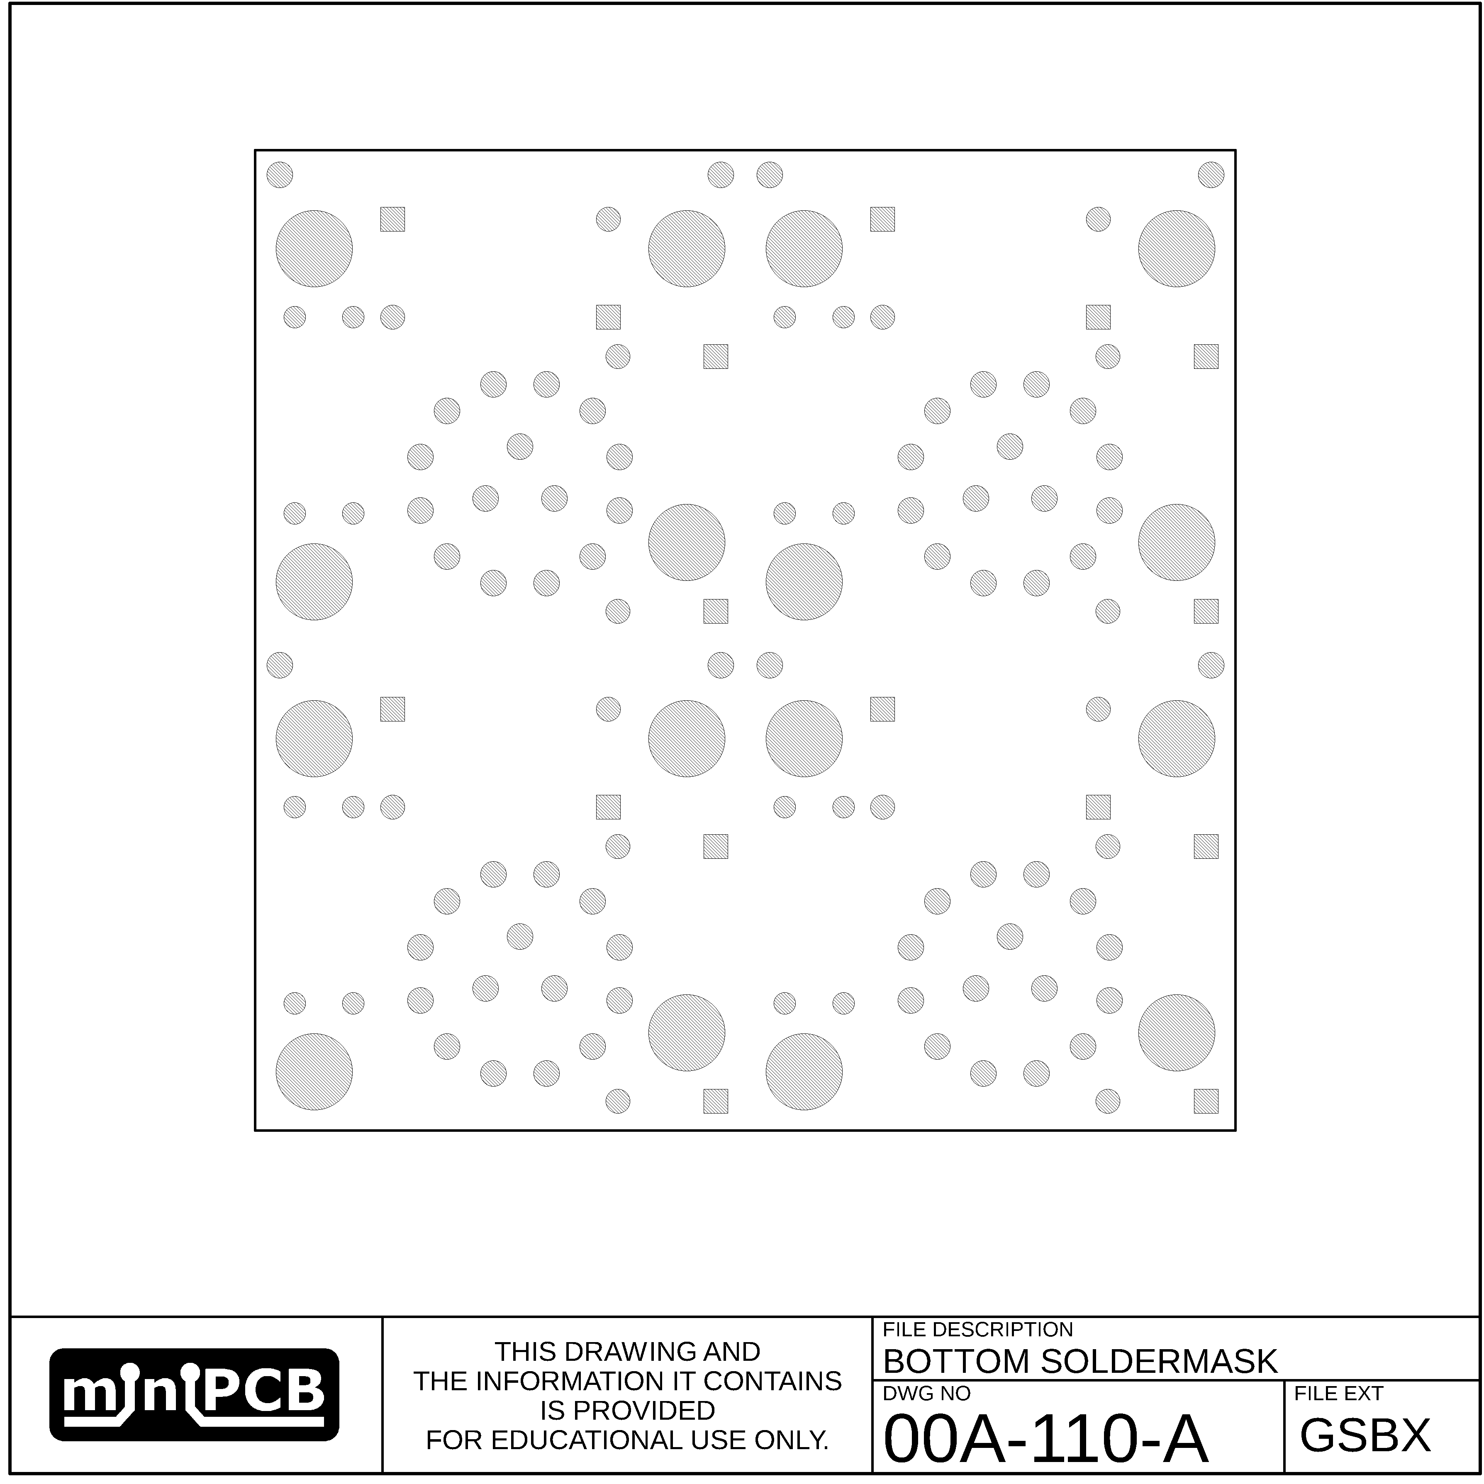

## EDGE (GM1)

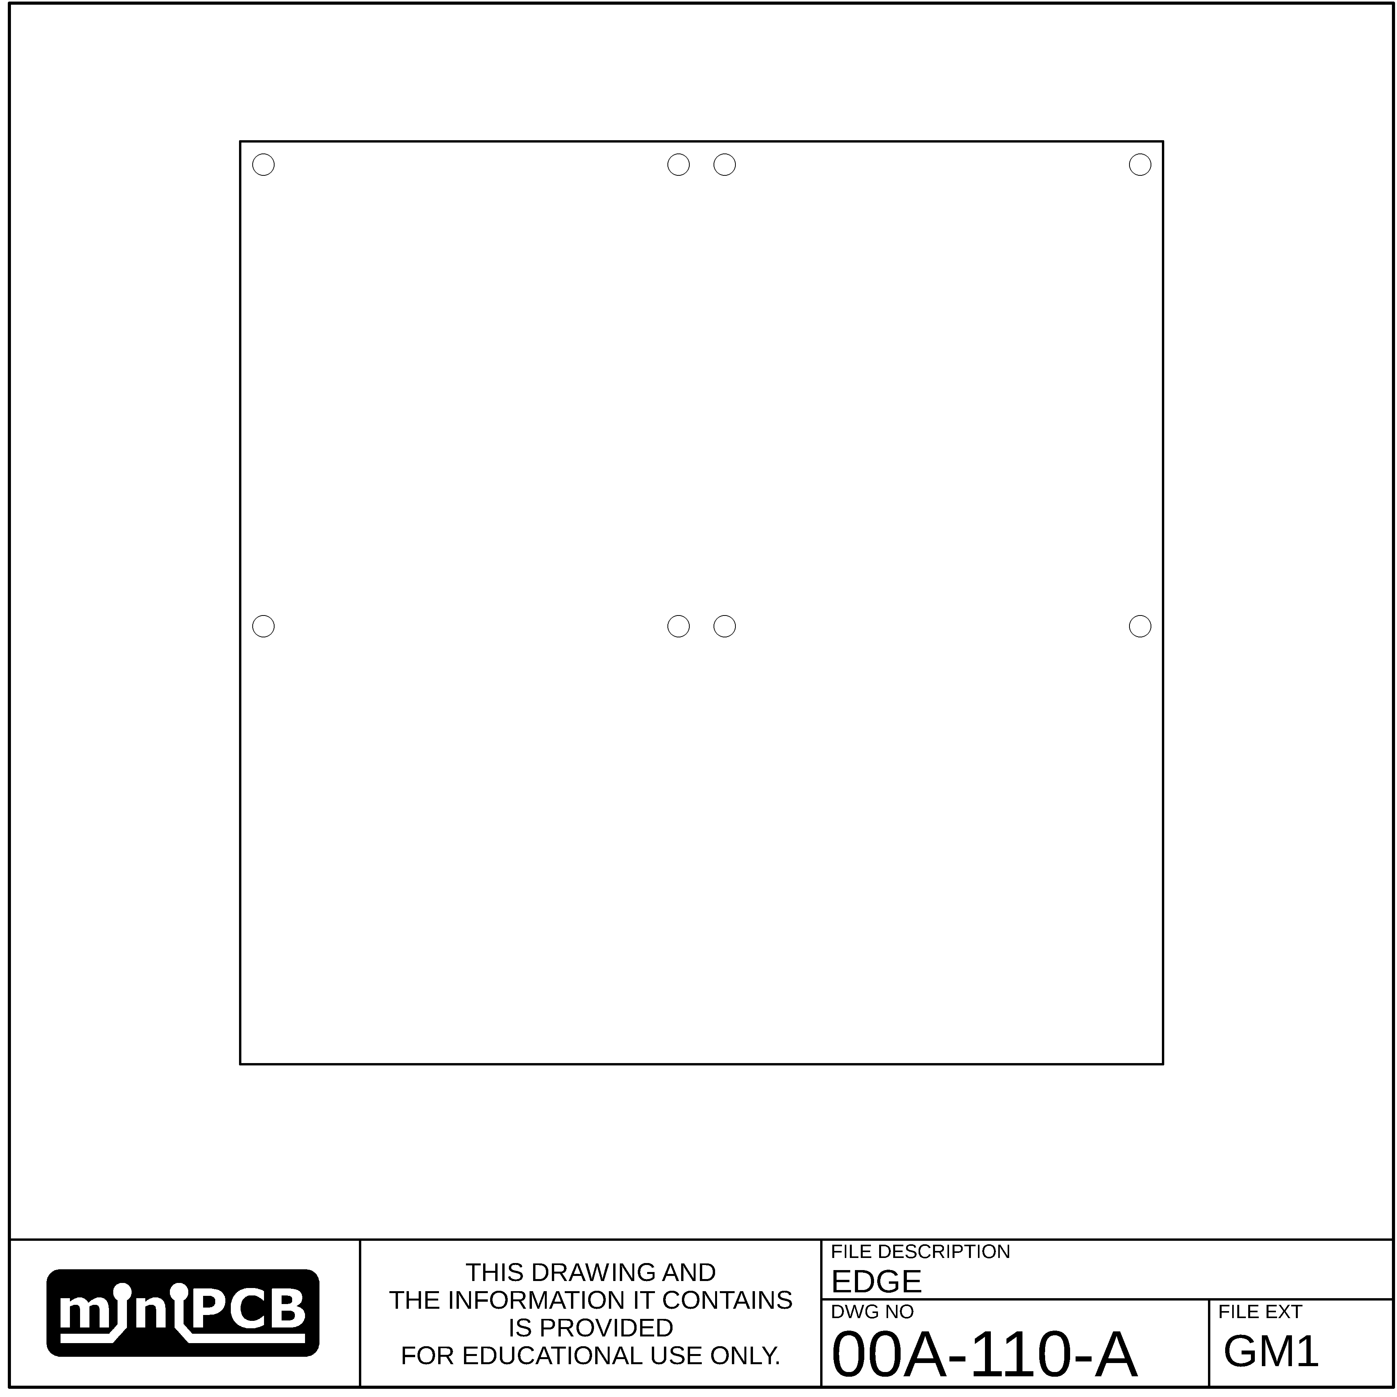

## VSCORE (GM2)

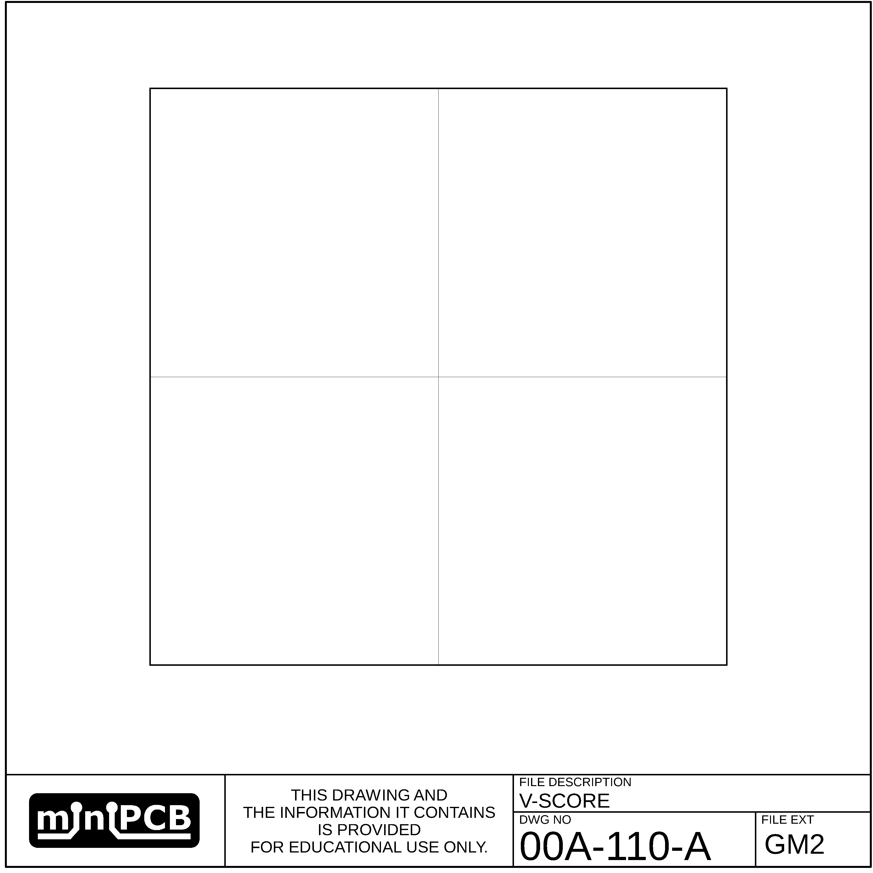

## MILLING (GM3)

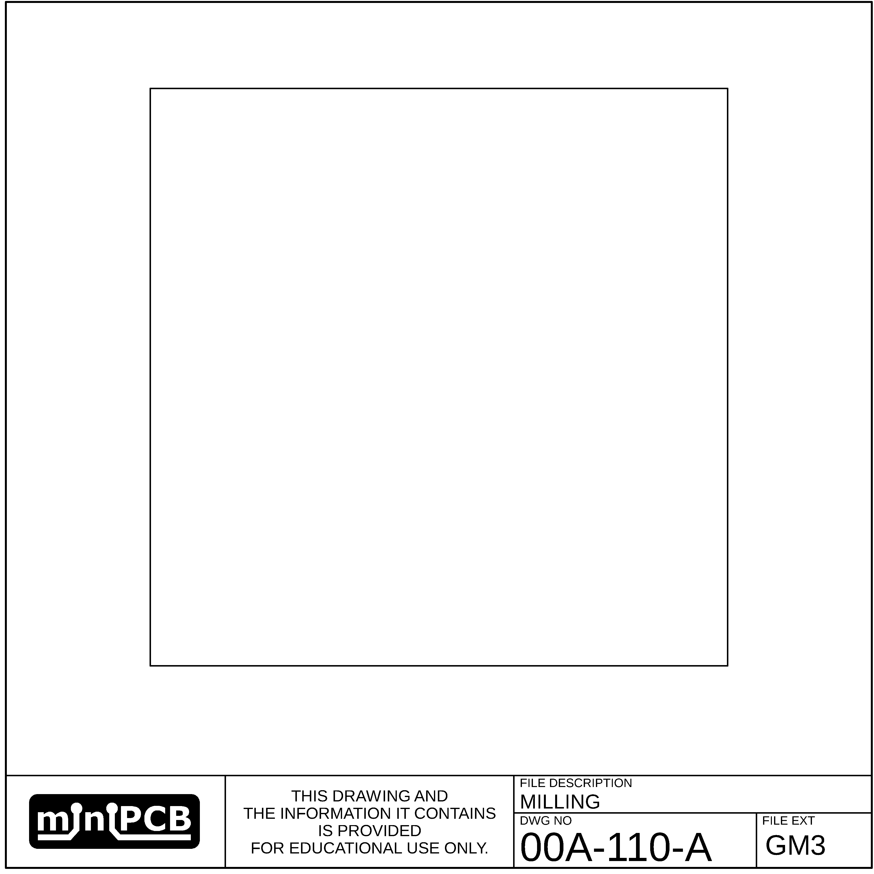

# Parts List

|  |  |  |  |  |
| --- | --- | --- | --- | --- |
| **REF DES** | **PART TYPE** | **MFG PART NUMBER** | **PART DESCRIPTION** | **FIND** |
| P1 | RECEPTACLE |  | BANANA JACK | 1 |
| P2 | RECEPTACLE |  | BANANA JACK | 2 |
| P8 | RECEPTACLE |  | BANANA JACK | 3 |
| P5 | RECEPTACLE |  | BANANA JACK | 4 |
| P3 | RECEPTACLE | KE6060 | MULTIMETER PROBE | 5 |
| P6 | RECEPTACLE | KE6060 | MULTIMETER PROBE | 6 |
| P7 | RECEPTACLE | KE6060 | MULTIMETER PROBE | 7 |
| P4 | RECEPTACLE | KE6060 | MULTIMETER PROBE | 8 |
| R1 | RESISTOR |  | THD, 100 Ω, 15mm PITCH | 9 |
| R2 | RESISTOR |  | THD, 50 Ω, 15mm PITCH | 10 |
| SW1 | SWITCH | i036708 | SWITCH, ROTARY, 3P4T | 11 |

# Change and Liability Notice

This document is subject to change without notice. While effort has been made to ensure the accuracy of the material contained within this document, Nolan Manteufel shall under no circumstances be liable for incidental or consequential damages or related expenses resulting from the use of this document.

# Trademark Notice

miniPCB is a trademark of Nolan Manteufel.

This datasheet does not constitute permission to use the miniPCB trademark.

|  |  |  |
| --- | --- | --- |
| WORDMARK | FIGUREMARK | FIGUREMARK |
| miniPCB™ | A picture containing drawing  Description automatically generated™ | Icon  Description automatically generated™ |

# Revision History

|  |  |  |  |
| --- | --- | --- | --- |
| REV | DESCRIPTION | ECO | DATE |
| A | Initial Release | 1019 |  |
|  |  |  |  |