Curve-Tracer Oscilloscope Accessory

# Background

The idea is to create a box that has facility power input, a component under test interface, and two (2) BNC output channels with voltage signals that represent voltage across the component under test and current through the component under test.

# Introduction

There are two reasons to make an opensource curve-tracer oscilloscope accessory. First, even used/obsolete curve tracers are too expensive for the typical student. But the ability to visualize current-per-voltage behavior is very important to learning analog electronic circuits. Second, components used on exemplar miniPCBs can be characterized and documented. This will remove the ambiguity and uncertainty created by using components with unknown origin.

# Block Diagram

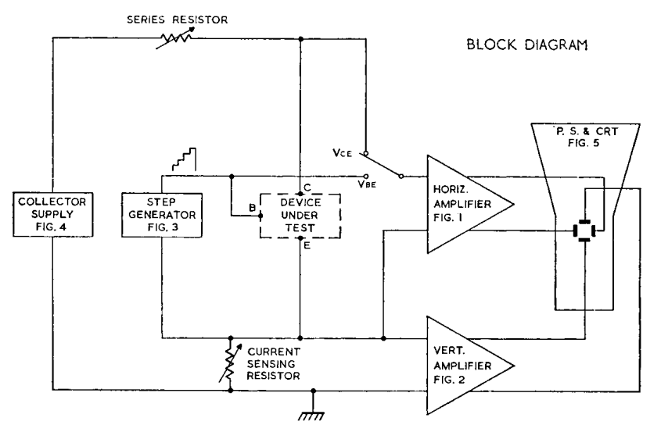

Figure – Source: https://w140.com/tekwiki/images/8/83/070-1075-00.pdf

# Theory Of Operation

Current through per voltage across. … big, big, big topic. If the student never learns to think in terms of current-per-voltage graphs, they’ll never be able to design novel analog electronic circuits.

# Schematic Idea

See the user manual for TELEQUIPMENT (TEKTRONIX UK) CT71 Curve Tracer for more schematics and information.

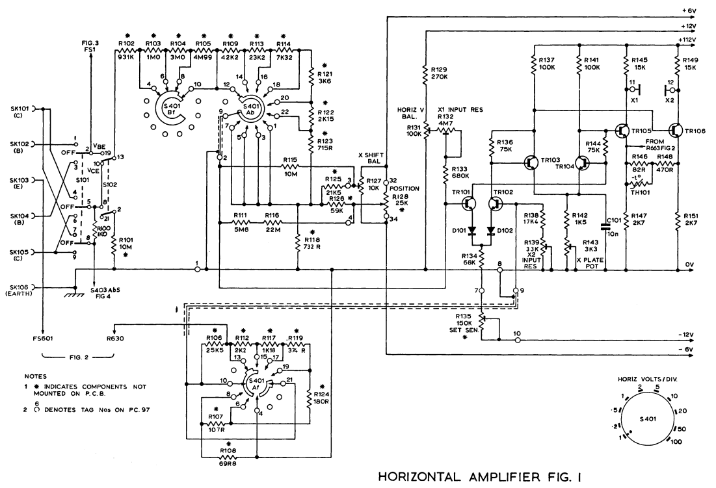

Figure – Source: https://w140.com/tekwiki/images/8/83/070-1075-00.pdf

# Change and Liability Notice

This document is subject to change without notice. While effort has been made to ensure the accuracy of the material contained within this document, Nolan Manteufel shall under no circumstances be liable for incidental or consequential damages or related expenses resulting from the use of this document.

# Trademark Notice

miniPCB is a trademark of Nolan Manteufel.

This specification does not constitute permission to use the miniPCB trademark.

|  |  |  |
| --- | --- | --- |
| WORDMARK | FIGUREMARK | FIGUREMARK |
| miniPCB™ | A picture containing drawing  Description automatically generated™ | Icon  Description automatically generated™ |

# Revision History

|  |  |  |  |
| --- | --- | --- | --- |
| REV | DESCRIPTION | ECO | DATE |
| A | Initial Release | N/A | 08DEC2022 |
|  |  |  |  |