Opamp Inverting Amplifier

|  |  |
| --- | --- |
| **PART NUMBER** | 04A-005 |
| **GROUP NAME** | Opamp Amplifiers (04A) |
| **CIRCUIT NAME** | Inverting Amplifier |
| **VARIANT DESCRIPTION** | Single supply, DC Bias Trimmer |
| **BOARD DESIGN** | PCB50-A-05 |
| **PRODUCT DESCRIPTION** | Panel of #04A-005 miniPCBs, v-scored (1 Panel = 4 Pieces) |

# Basic Circuit Diagram

|  |
| --- |
| Inverting Operational Amplifier |
| Figure – Source: https://www.electronics-tutorials.ws/opamp/opamp_2.html |

# Theory of Operation

This circuit amplifies a small voltage signal. Since there is no DC blocking capacitor on the signal input pin P1-4, the difference between the DC component of the input signal and the reference voltage set by the potentiometer R2 will be amplified.

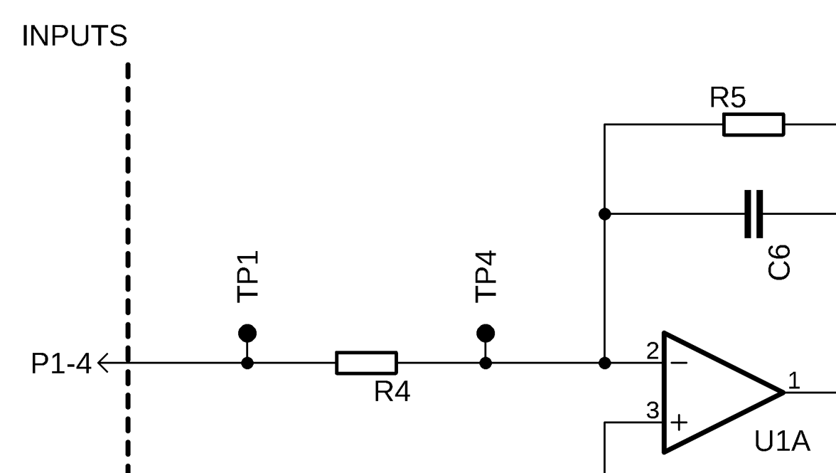

The feedback capacitor C6 allows larger feedback resistor values to be used without decreasing the amplifier’s gain bandwidth.

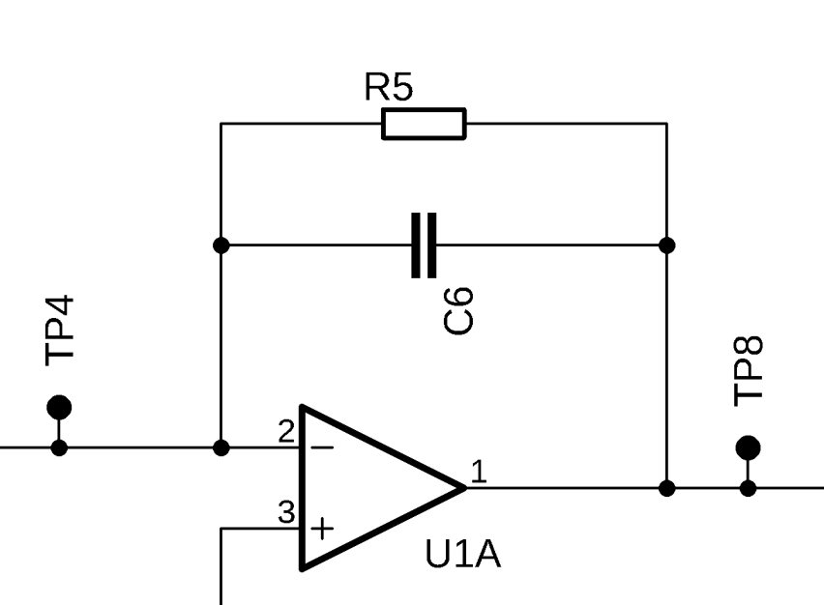

A low-pass Butterworth filter is formed by resistor R6 and capacitor C3 to minimize noise on the non-inverting opamp input.

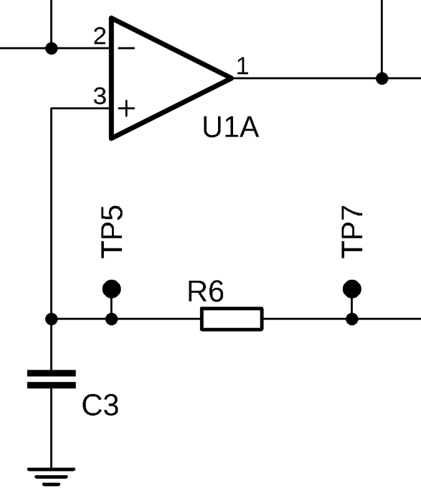

The input impedance is largely determined by resistor R4. The output impedance is largely determined by the opamp U1.

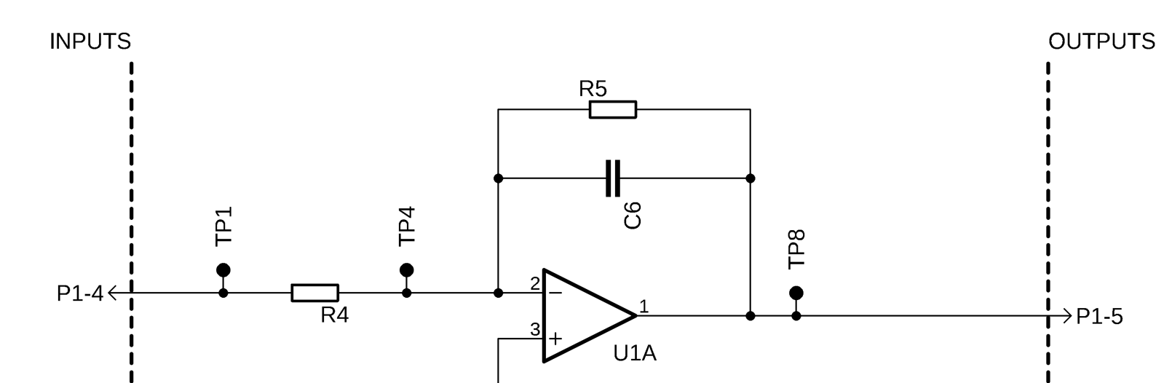

The minimum and maximum supply voltage is largely determined by the opamp U1. Only the V+ power source is needed to operate this circuit.

Capacitors C2 and C5 filter the V+ power rail. Using capacitors with different values, generally between 10X and 1000X different, will provide better performance than two capacitors with similar values. The smaller capacitor should be used for C2 since C2 is closer to the opamp pin than C5.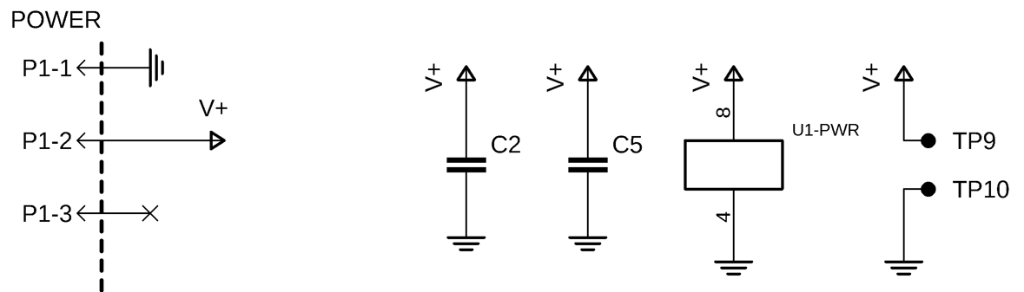

# Panel Board

|  |  |
| --- | --- |
|  |  |
| TOP VIEW | BOTTOM VIEW |

# Single Board

|  |  |
| --- | --- |
|  |  |
| TOP VIEW | BOTTOM VIEW |

|  |  |
| --- | --- |
|  |  |
| TOP VIEW | BOTTOM VIEW |

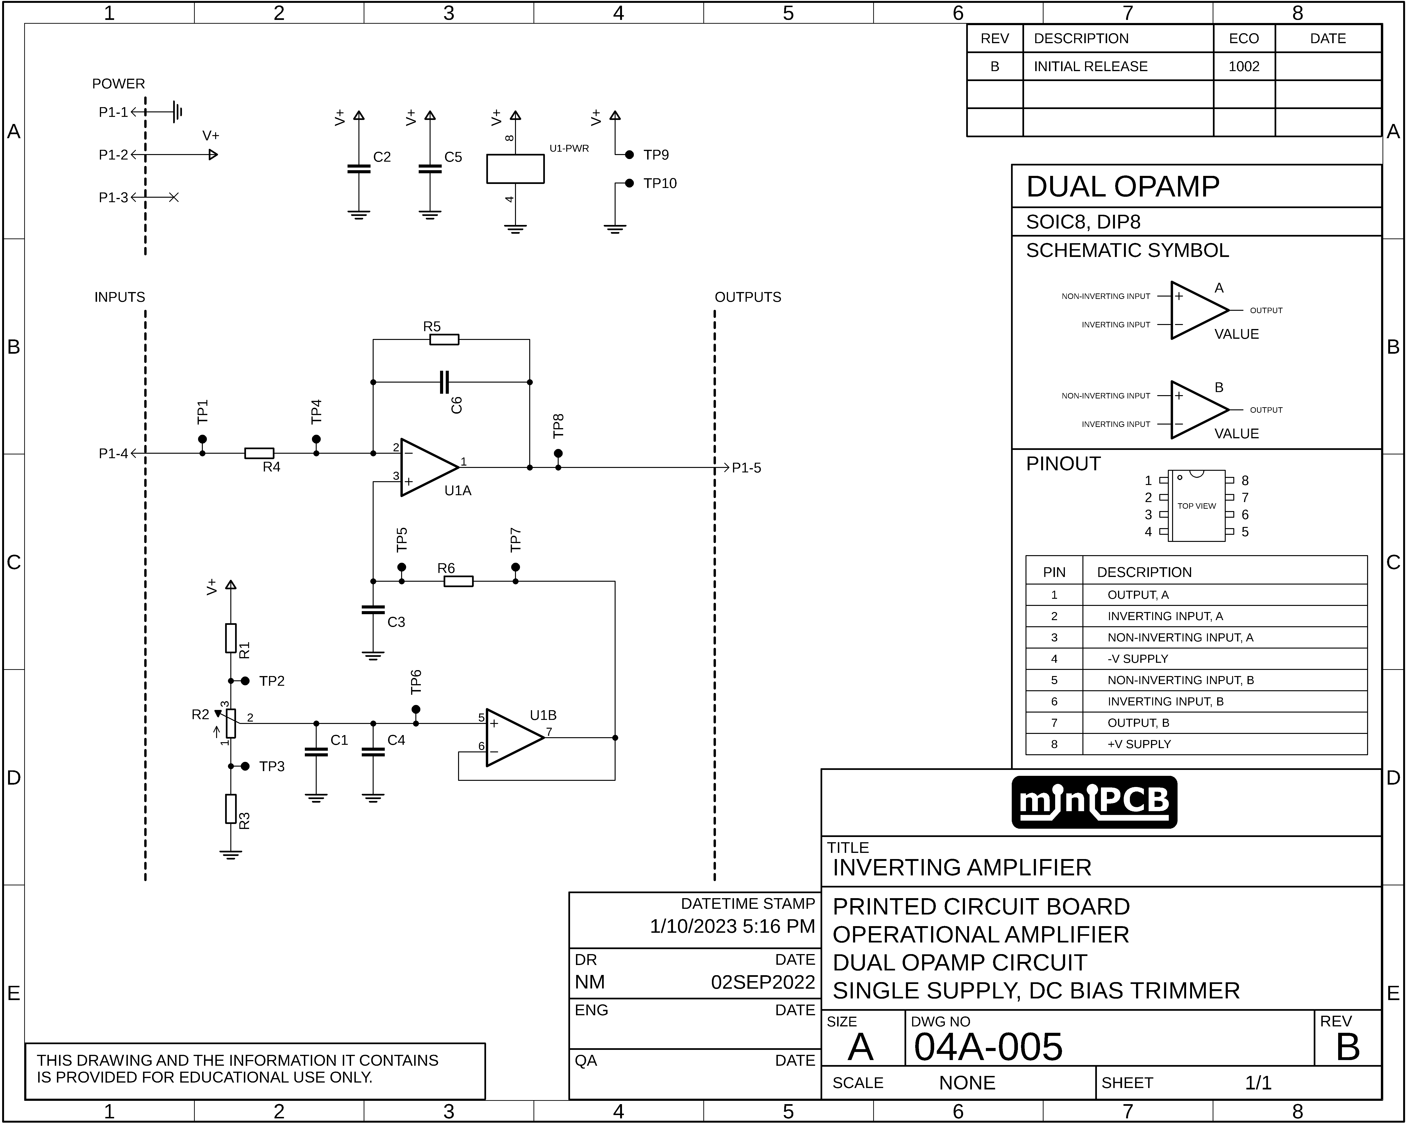

# Gerber Files

This section contains images of the layers included in each Gerber file.

## TOP COPPER (GLTX)

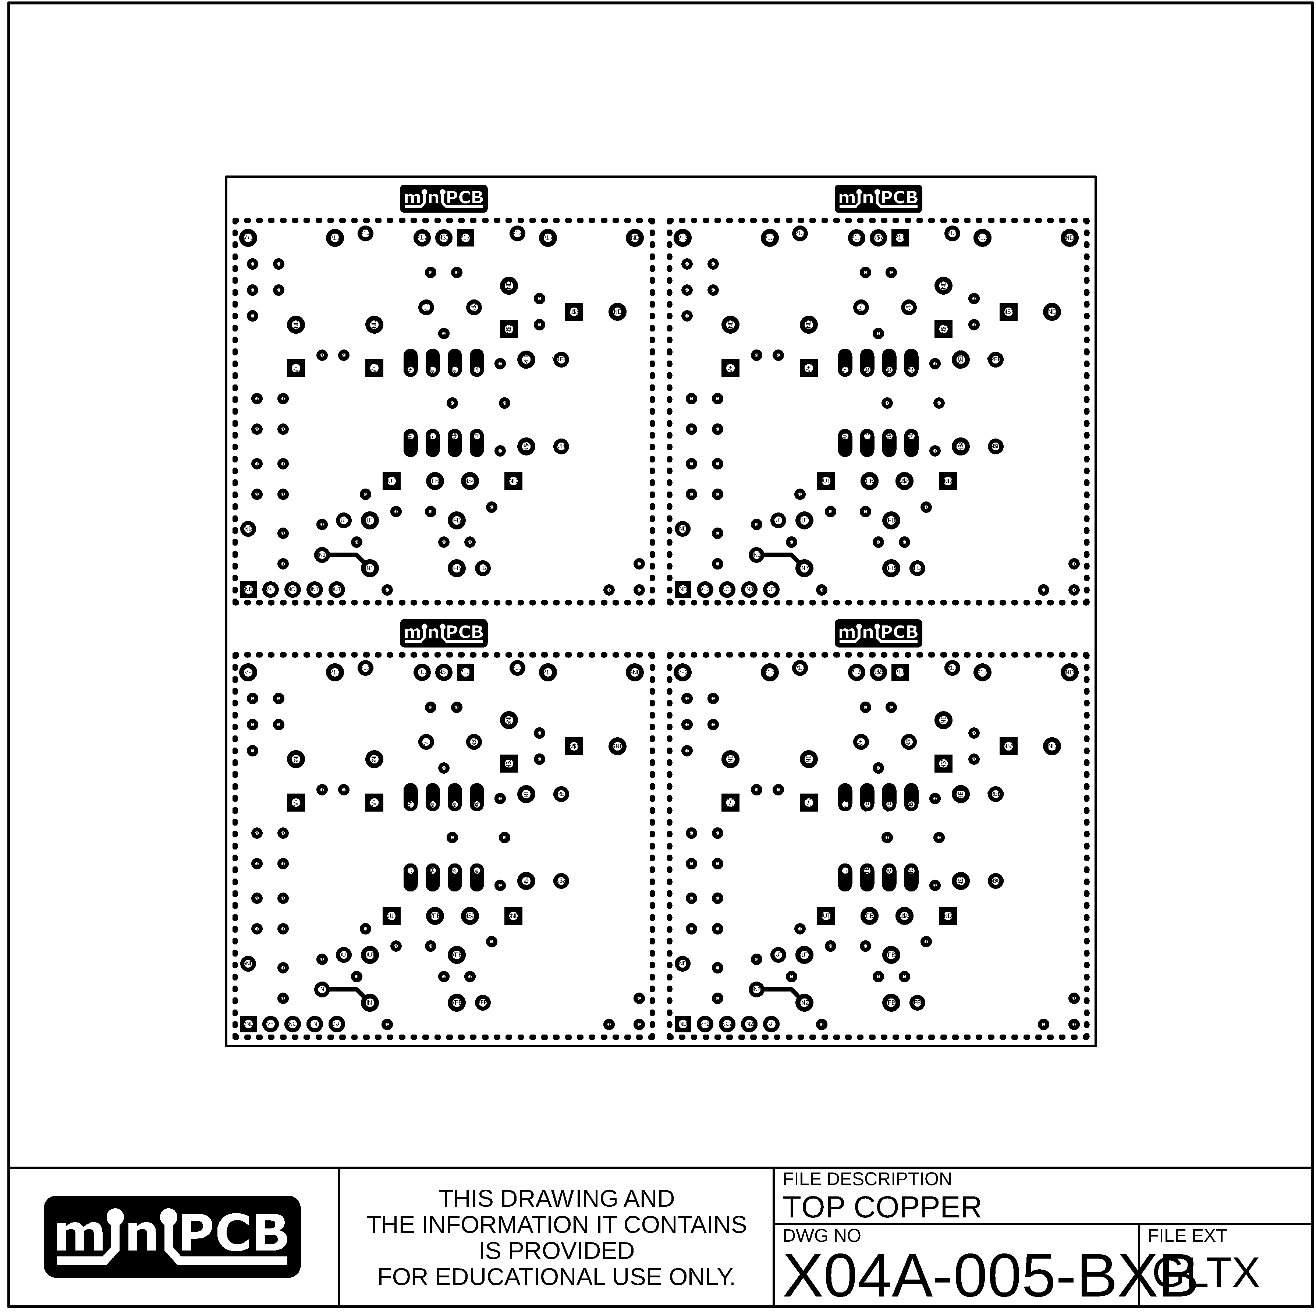

## TOP CREAM (GCTX)

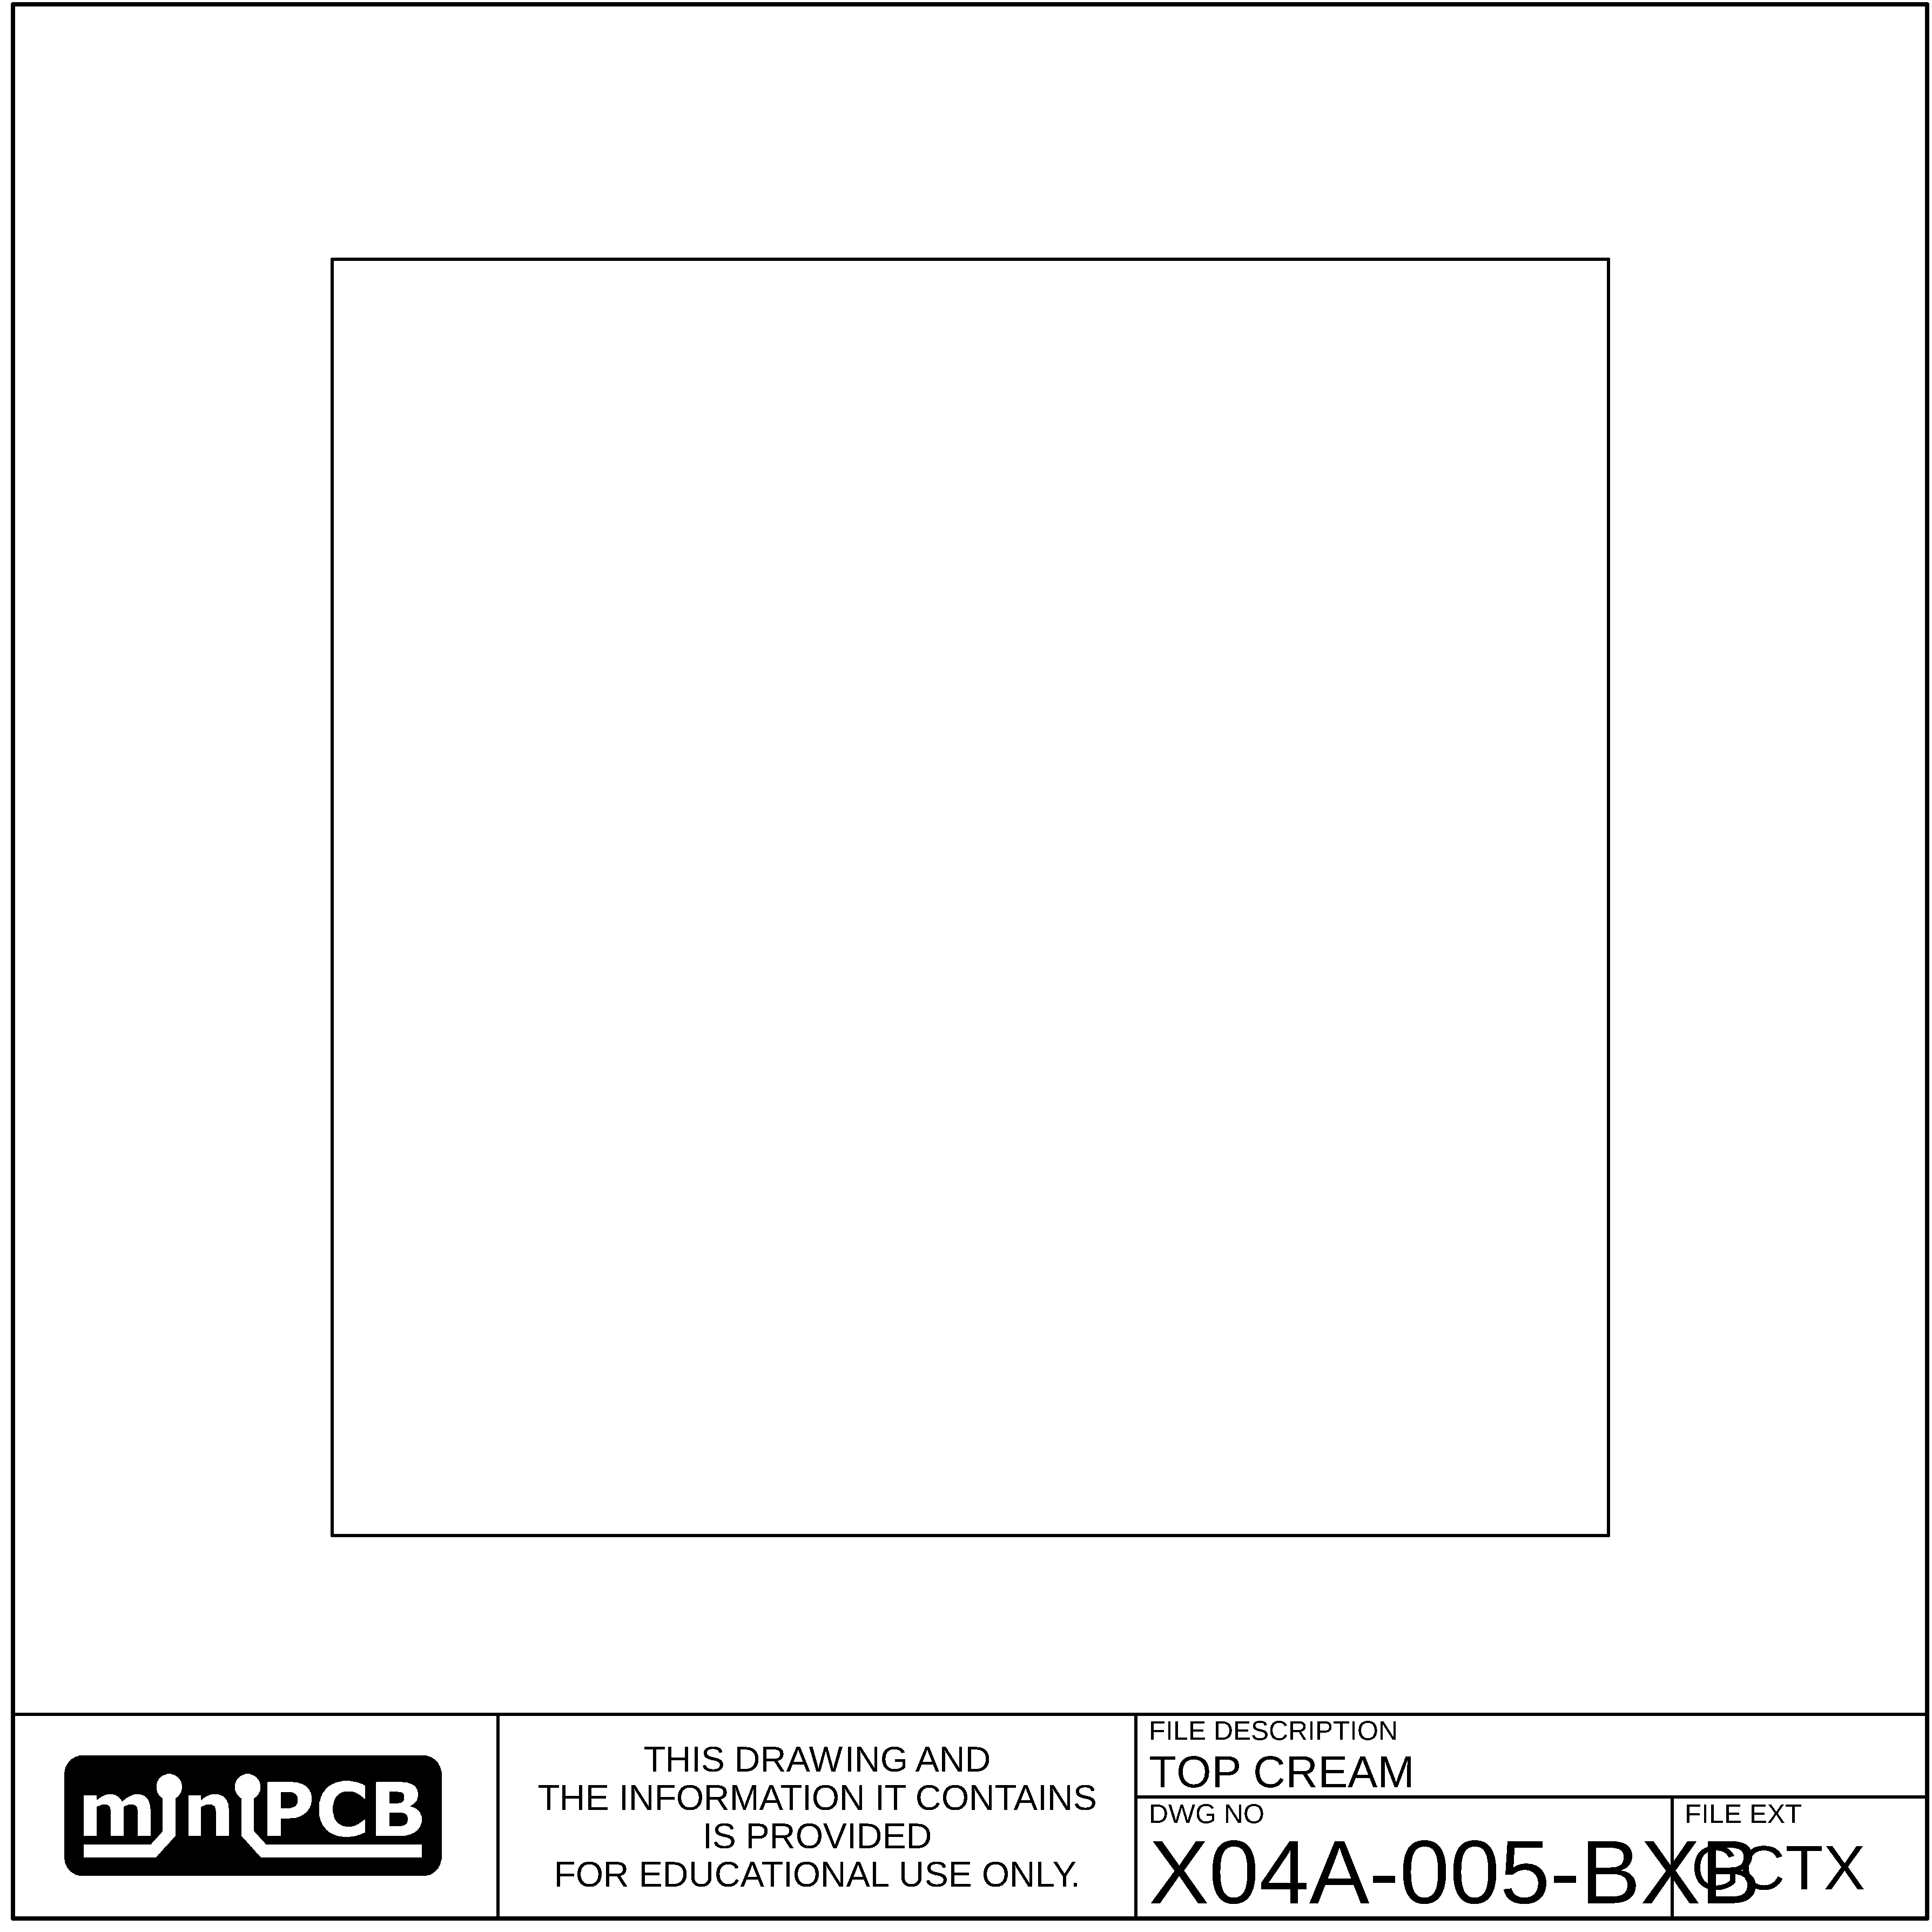

## BOTTOM CREAM (GCBX)

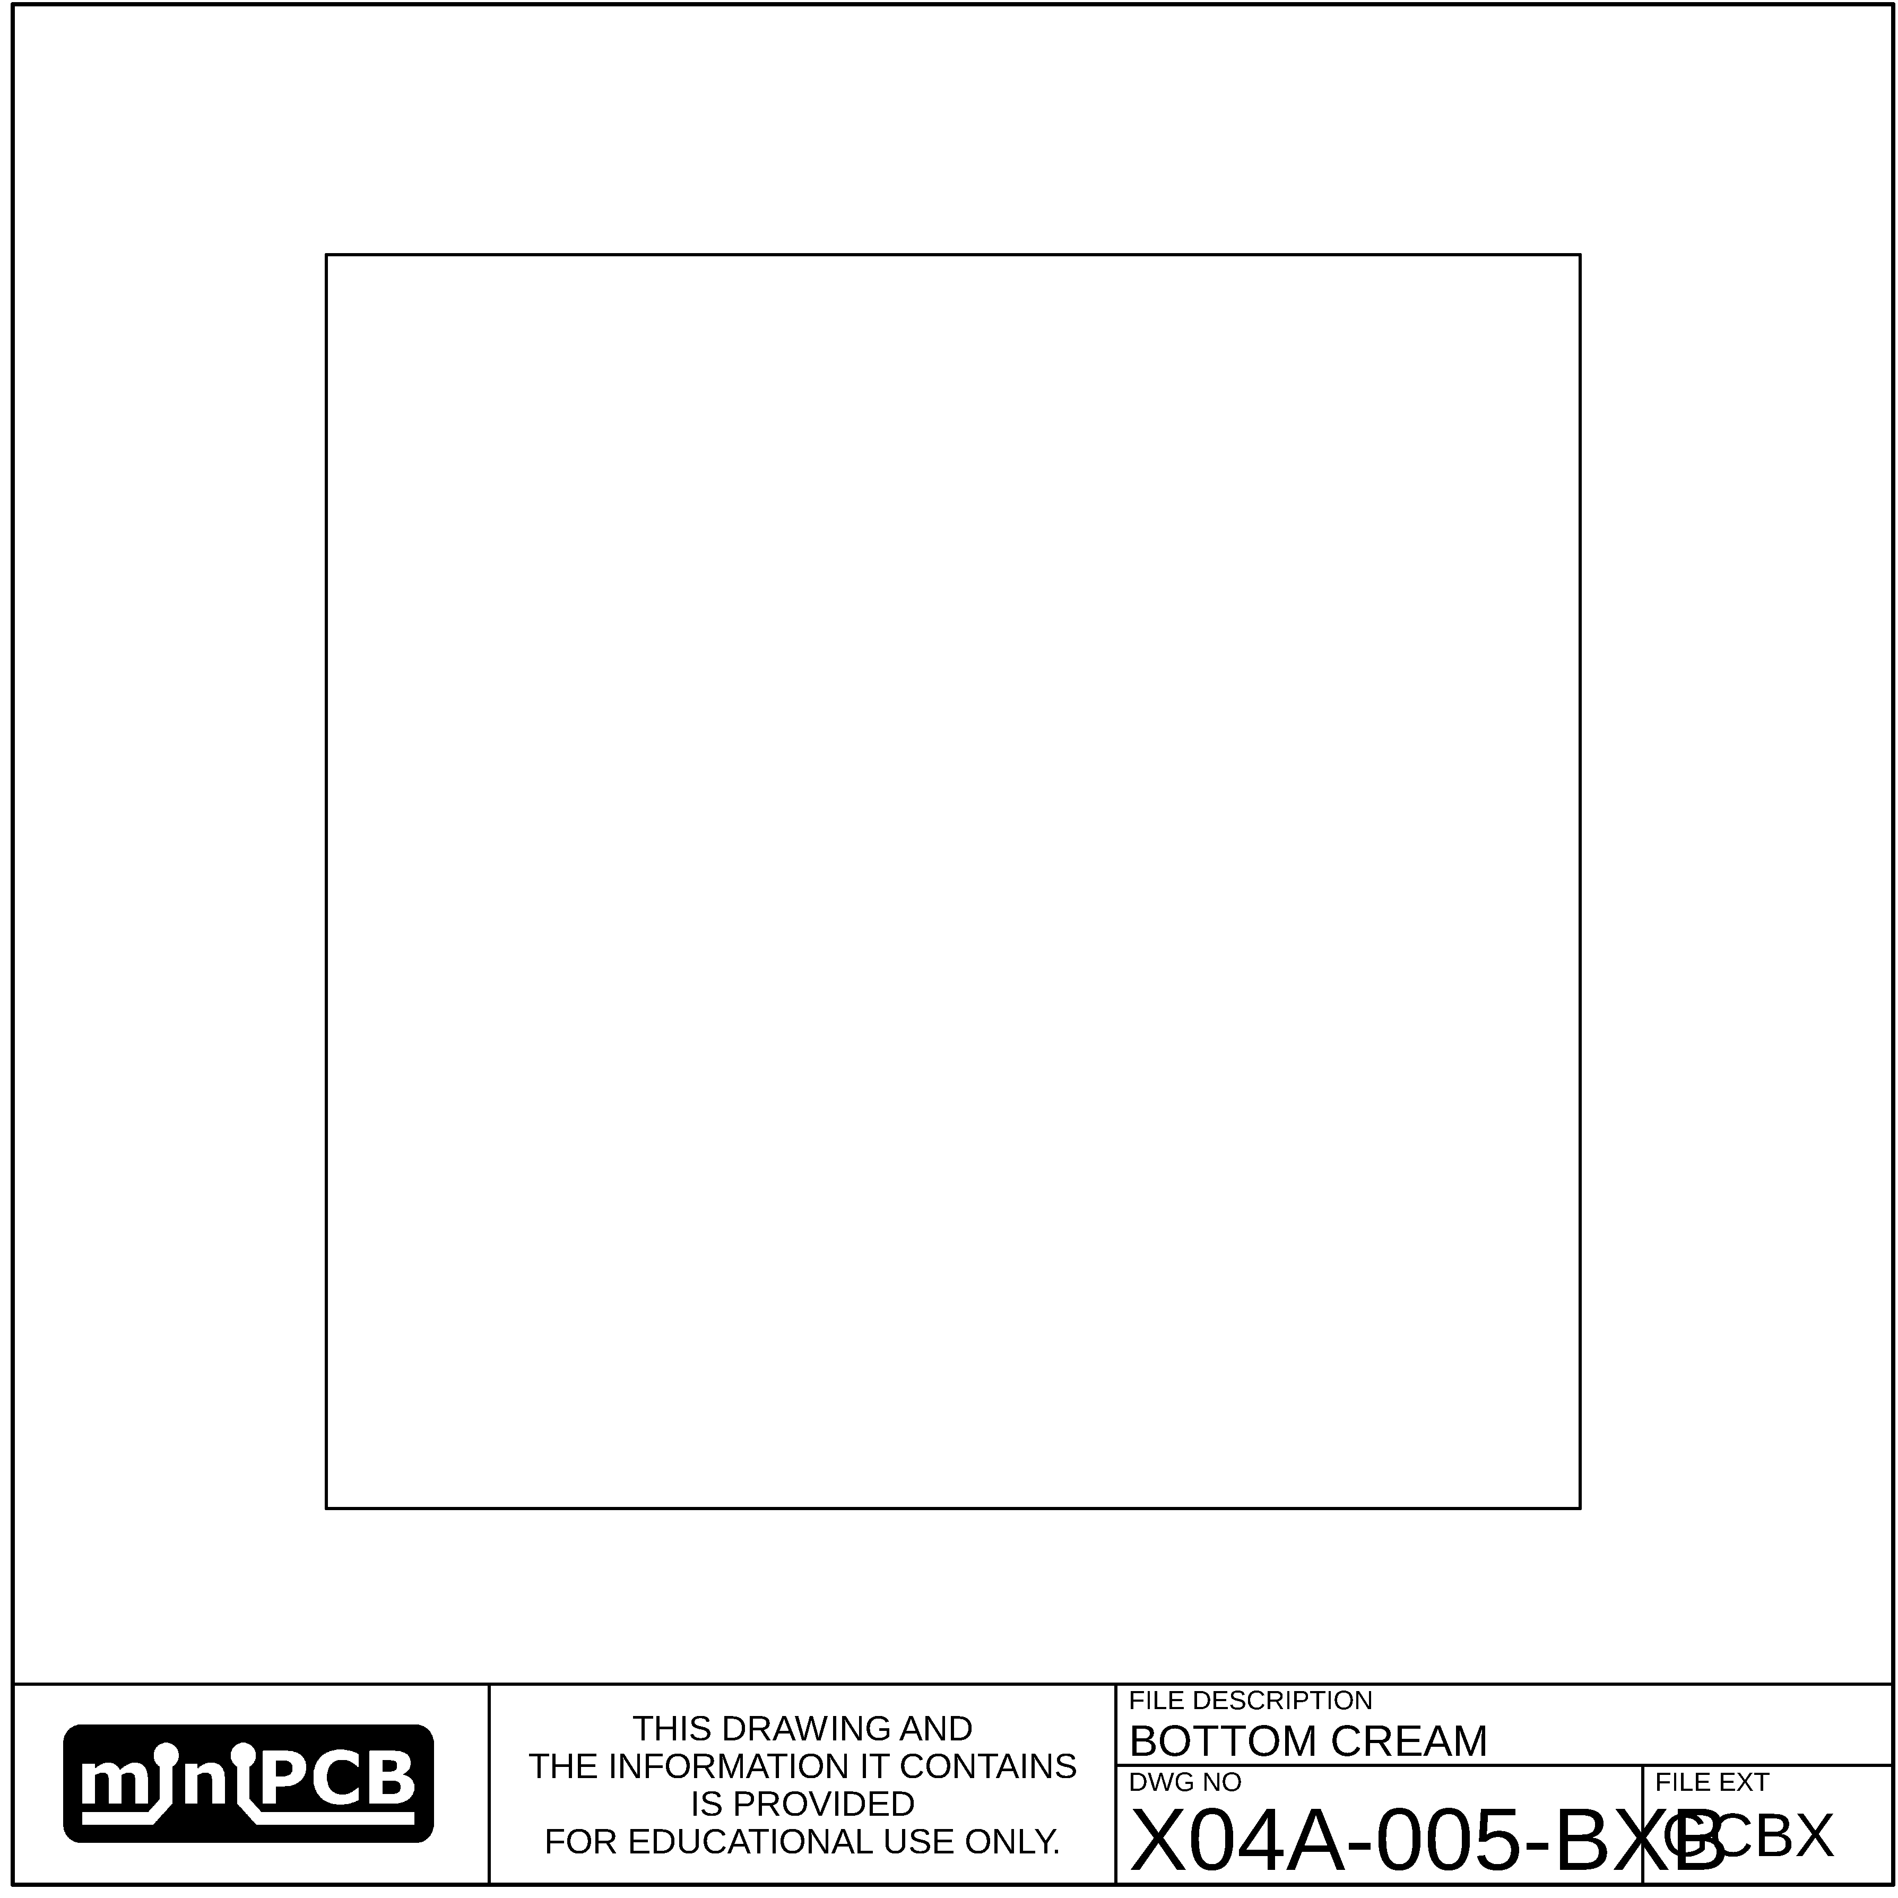

## BOTTOM COPPER (GLBX)

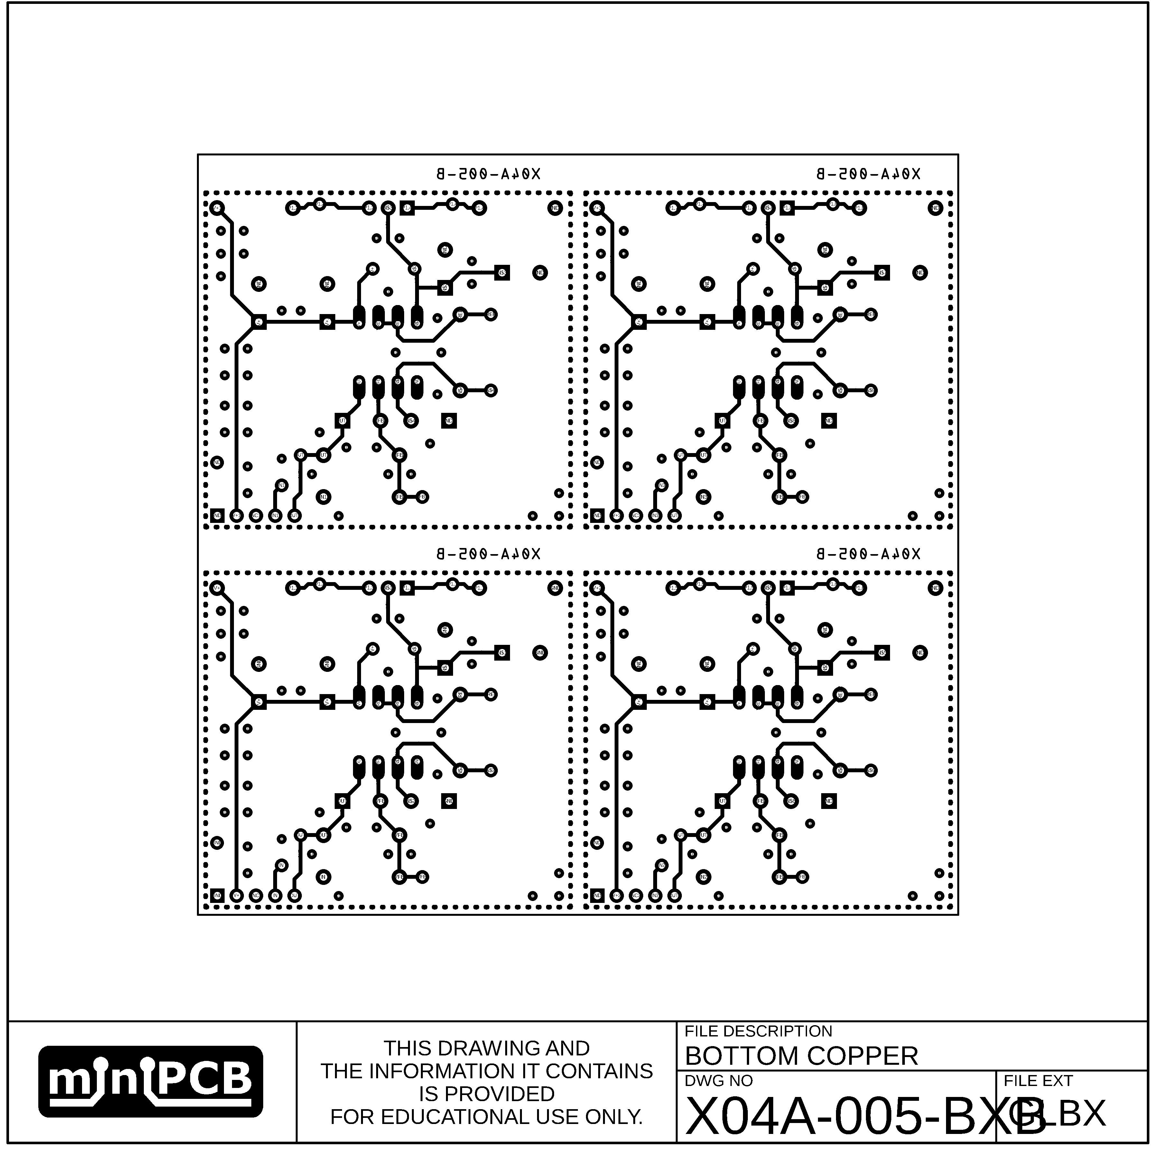

## TOP SILKSCREEN (GOTX)

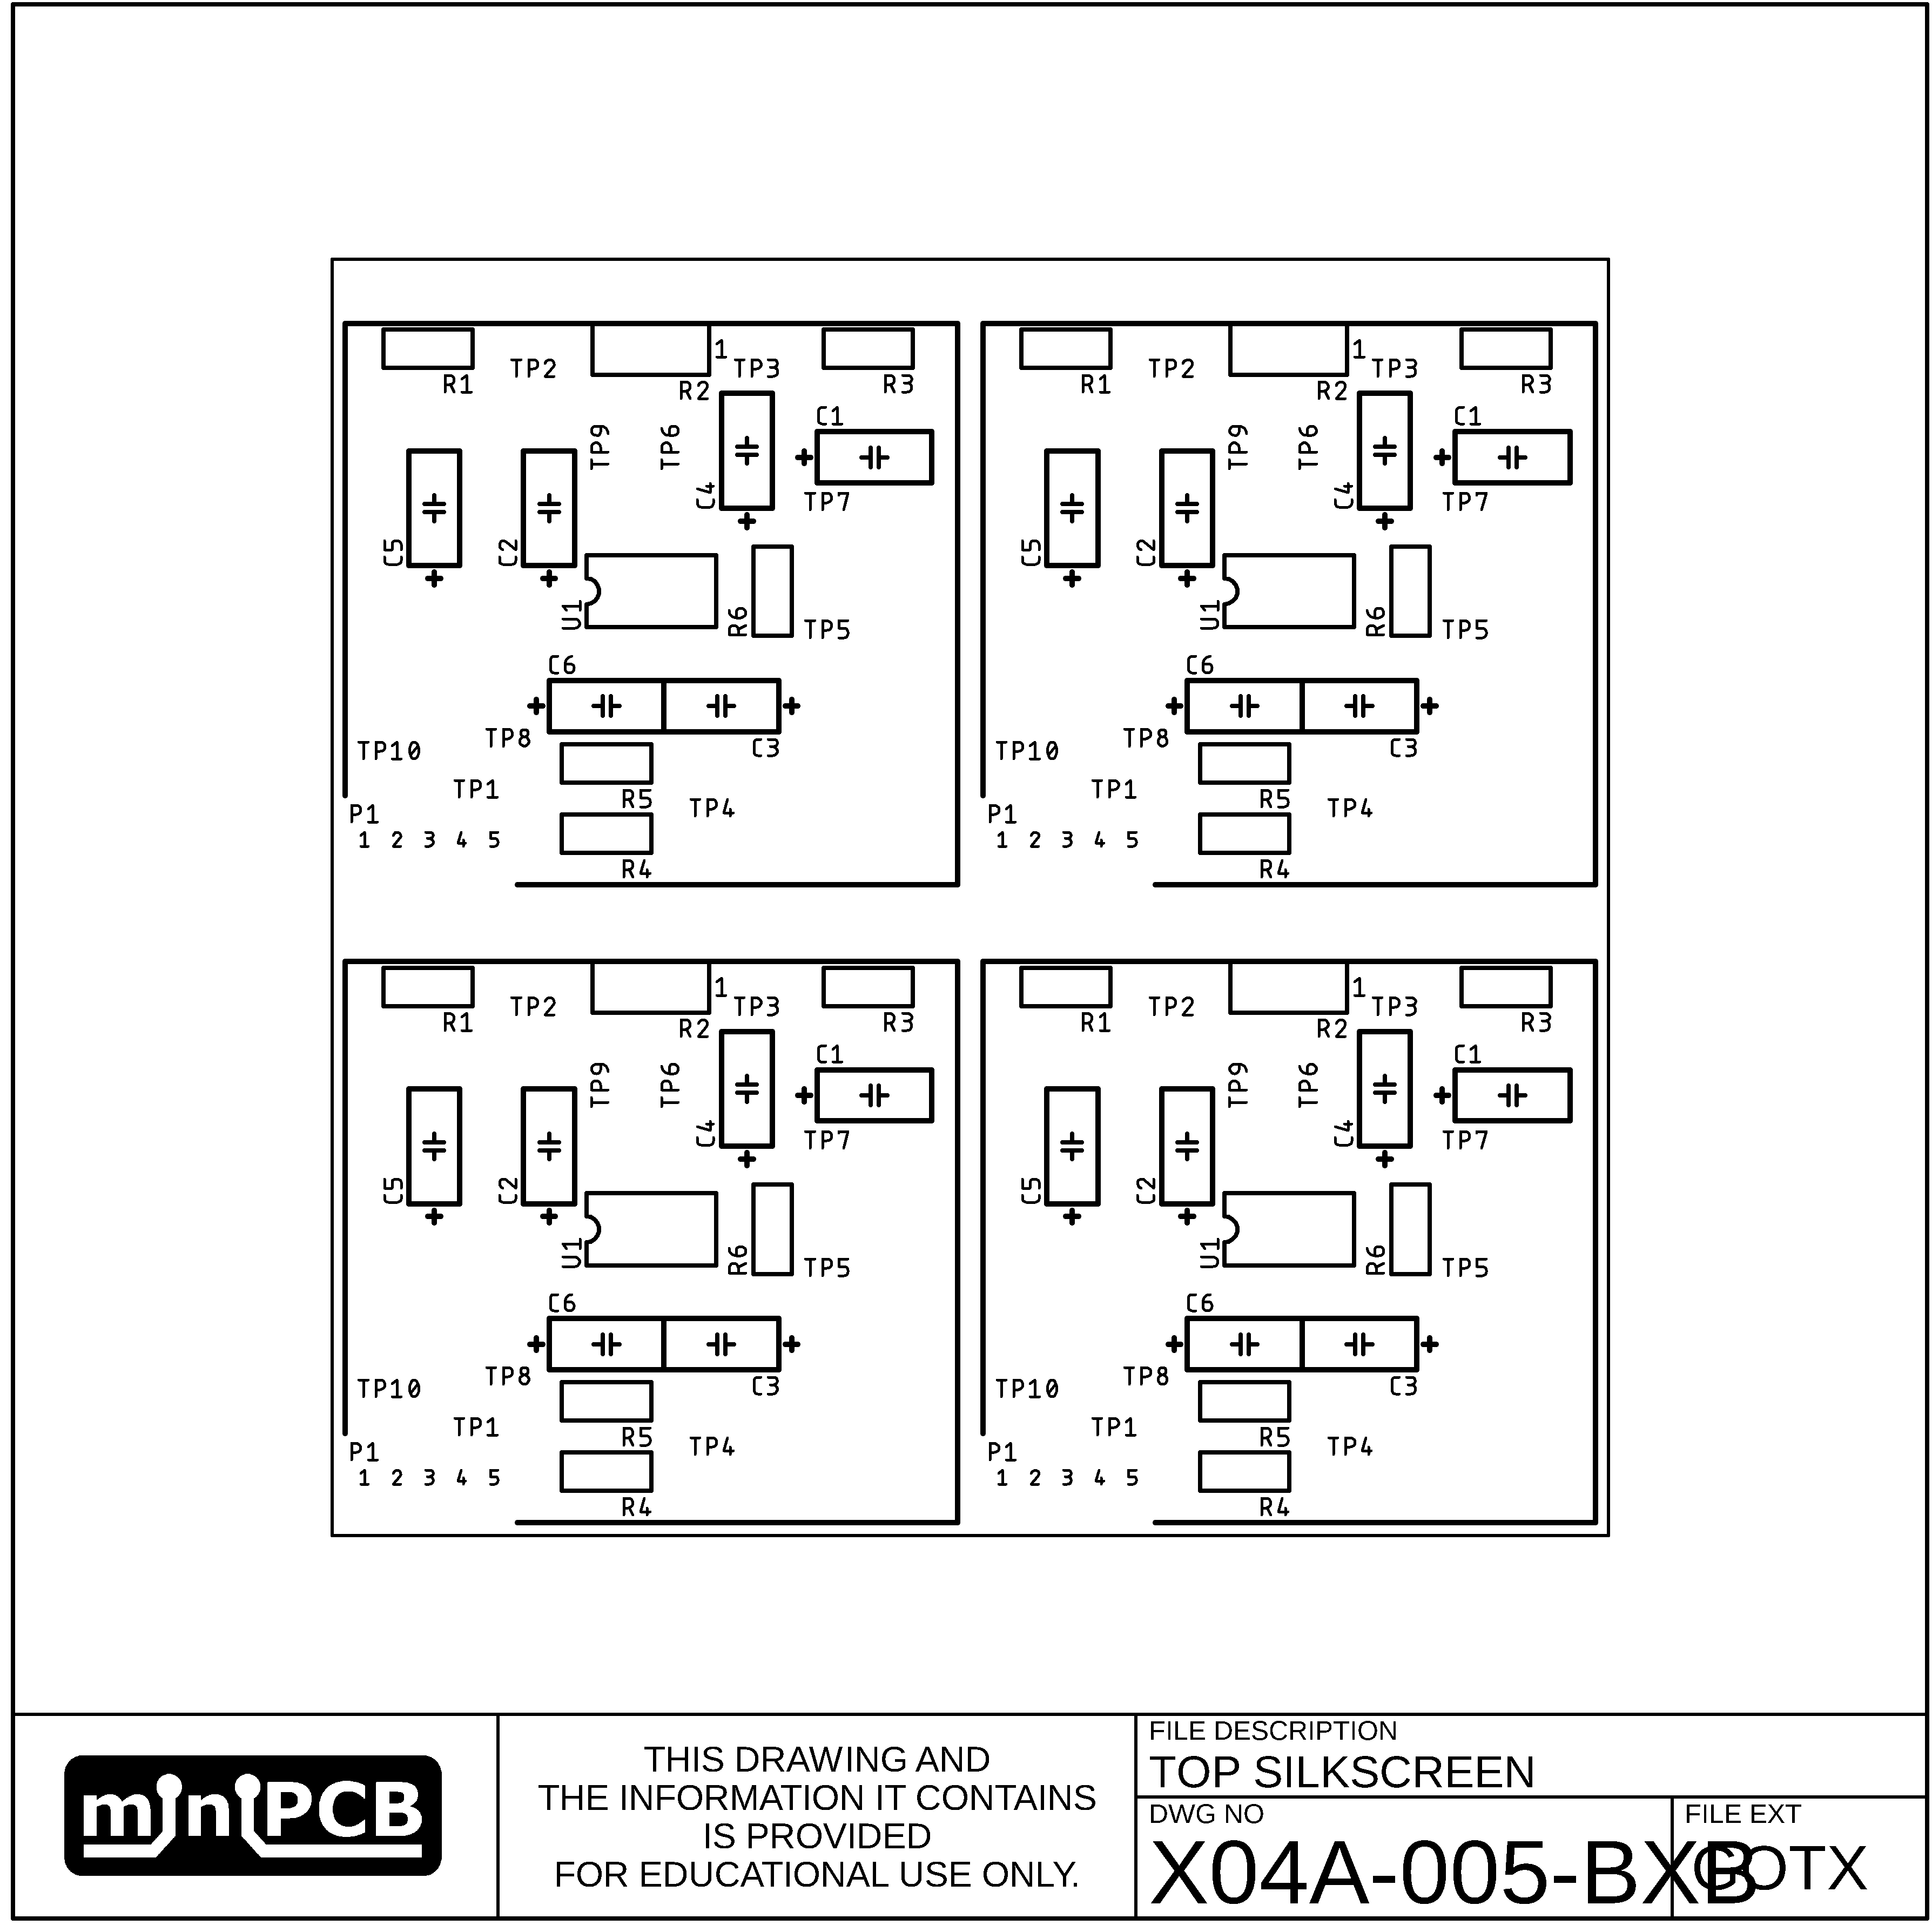

## BOTTOM SILKSCREEN (GOBX)

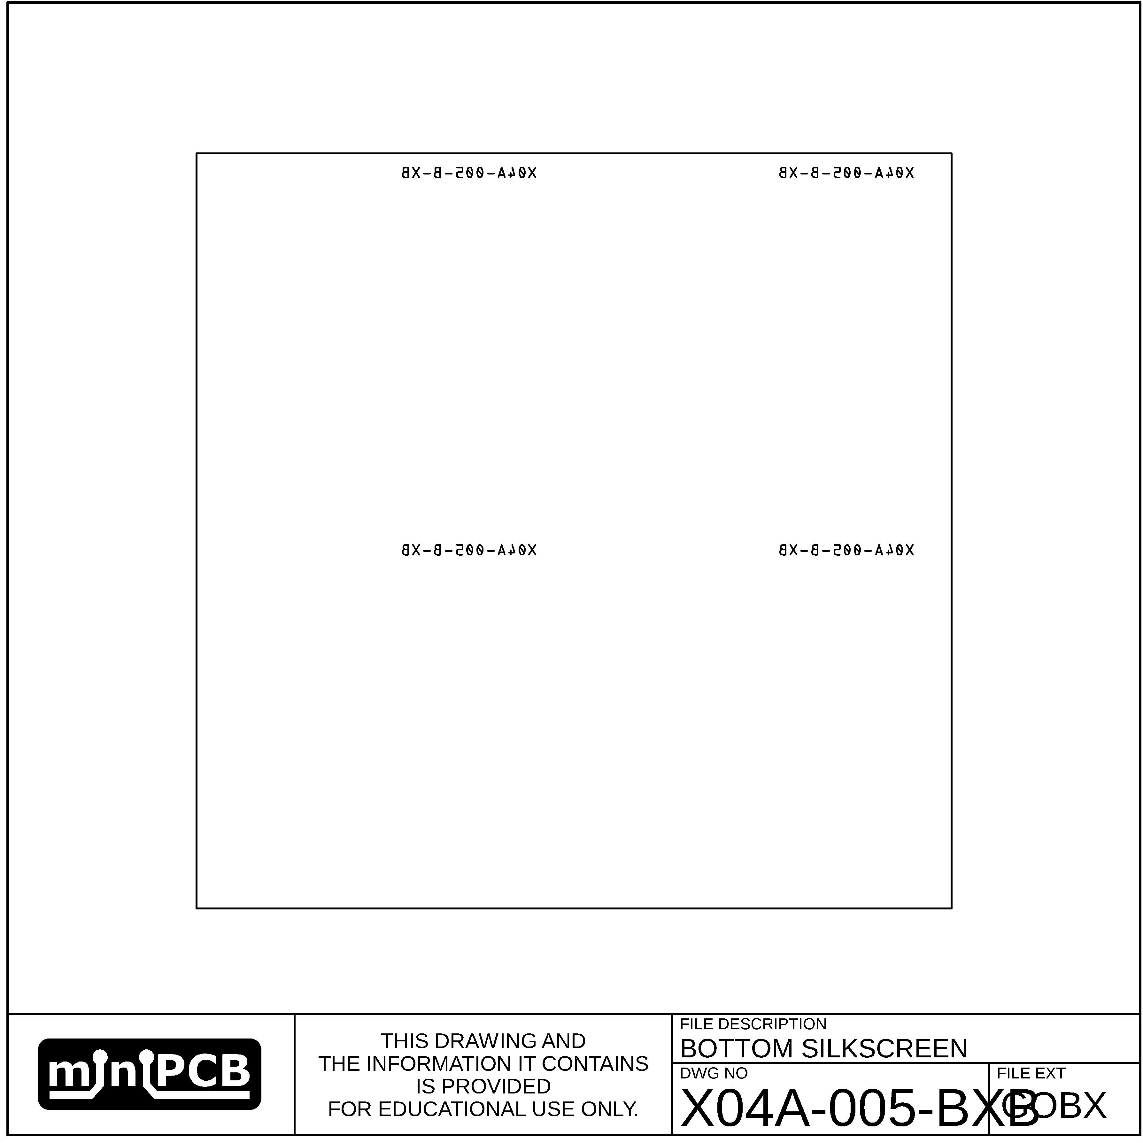

## TOP SOLDERMASK (GSTX)

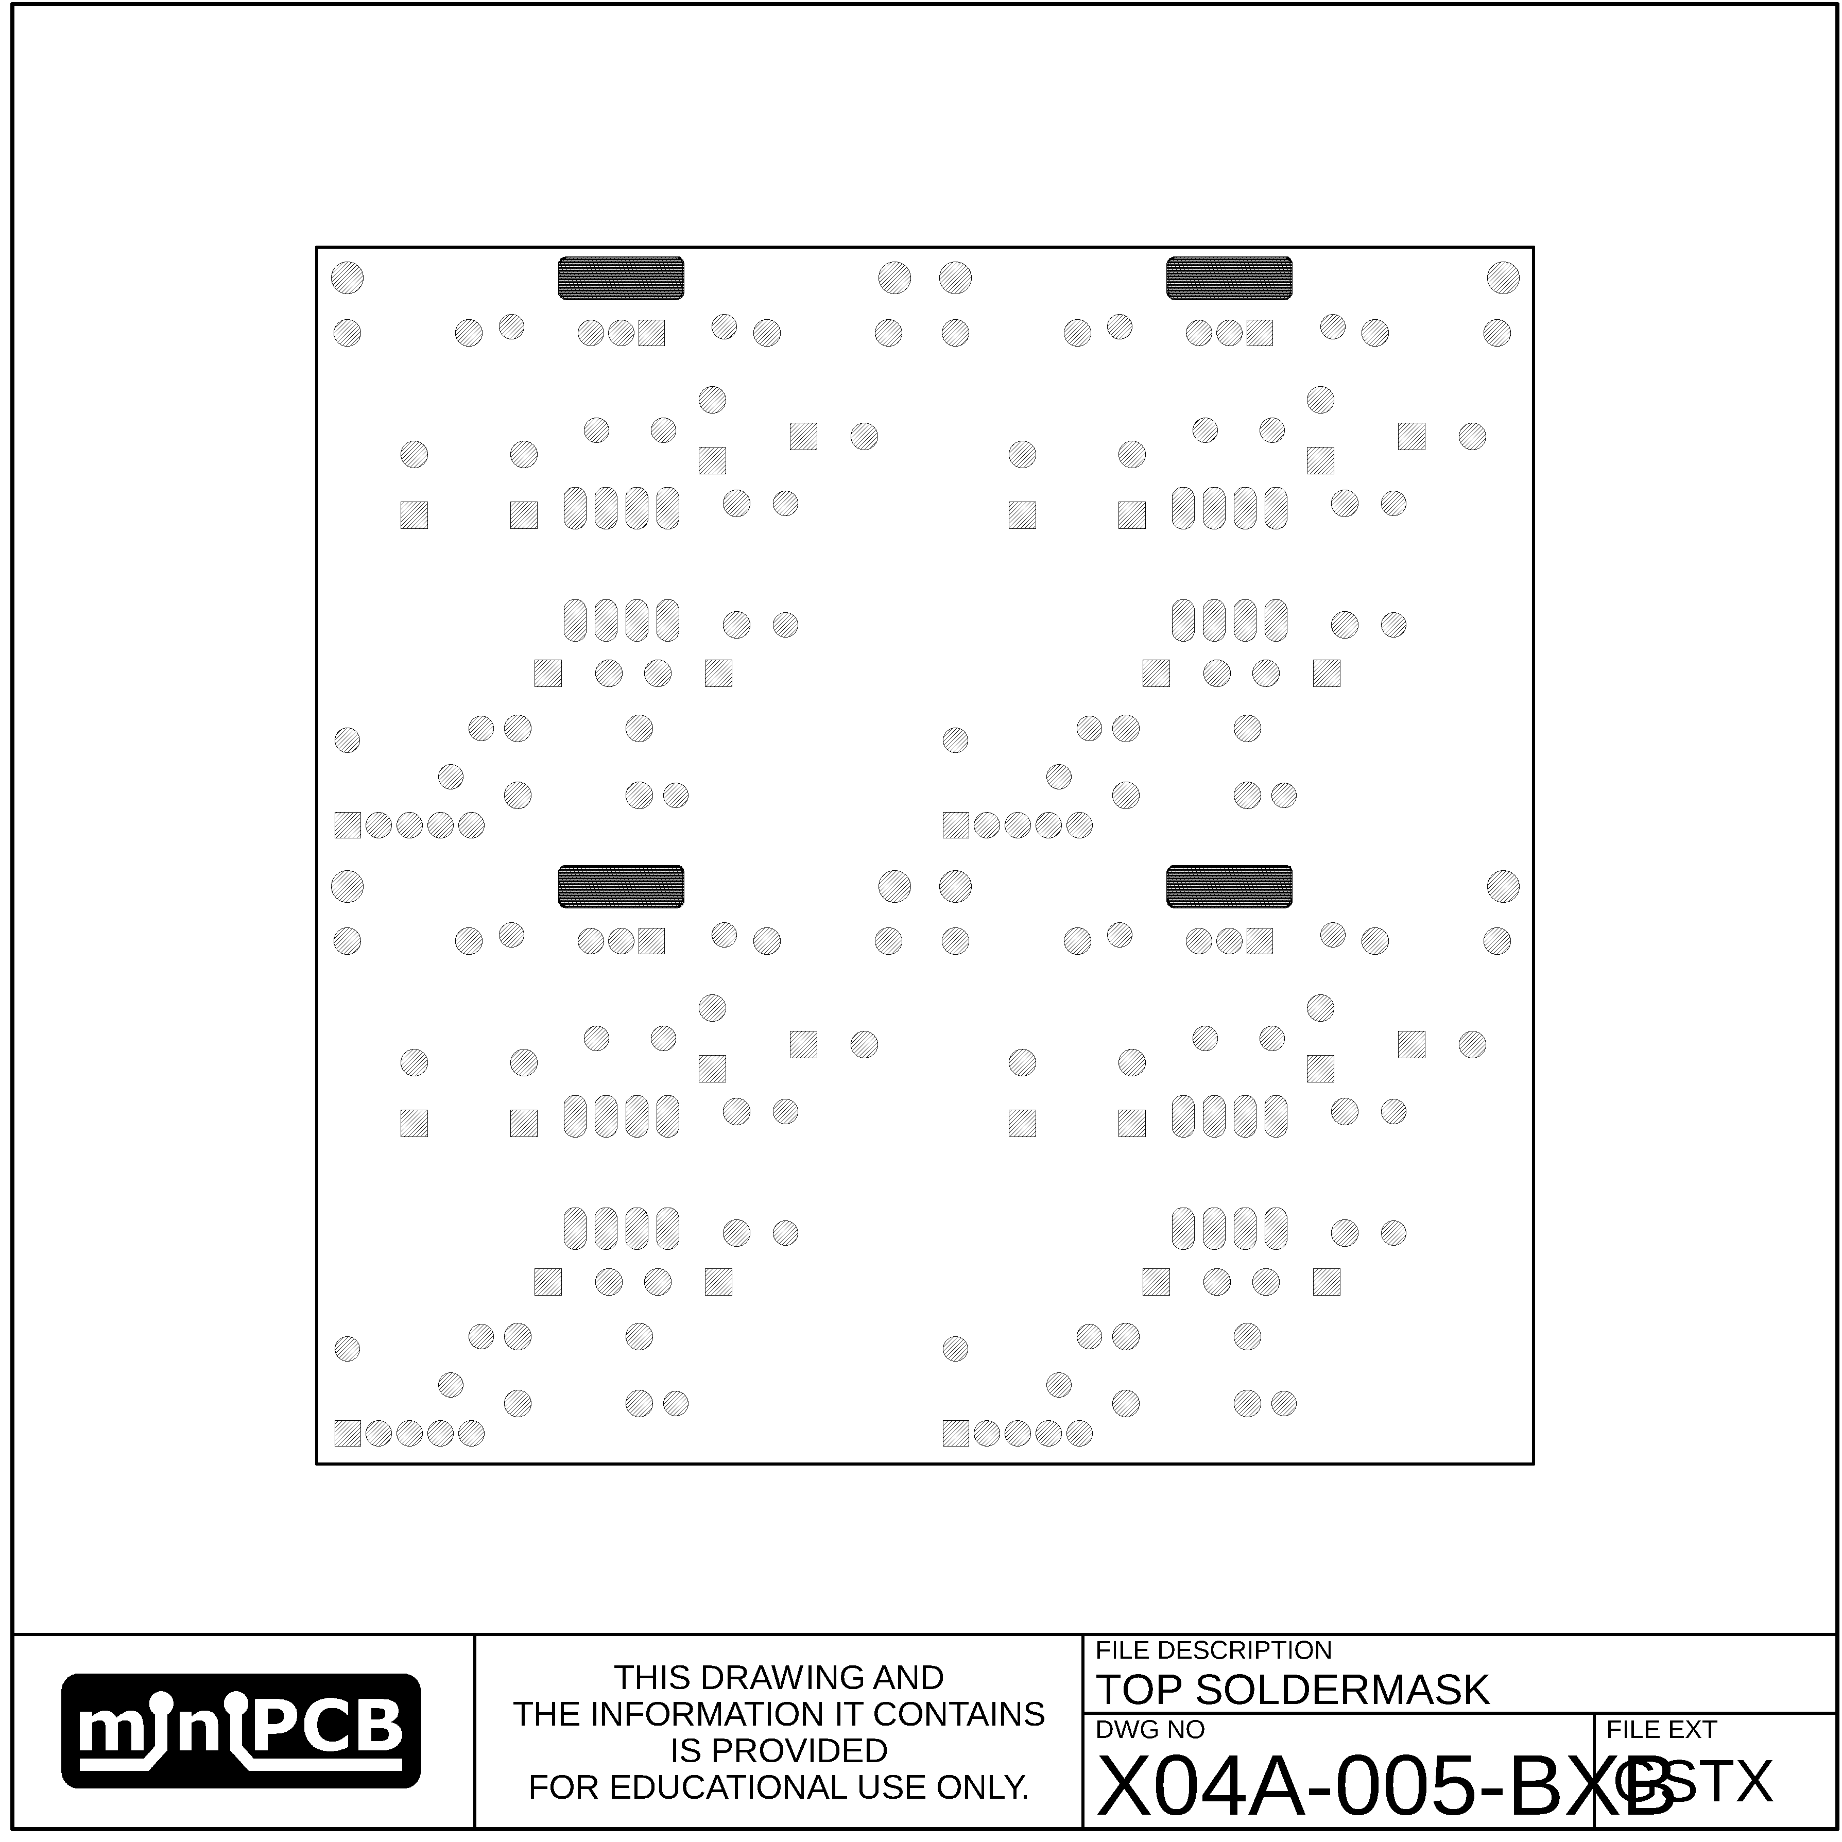

## BOTTOM SOLDER MASK (GSBX)

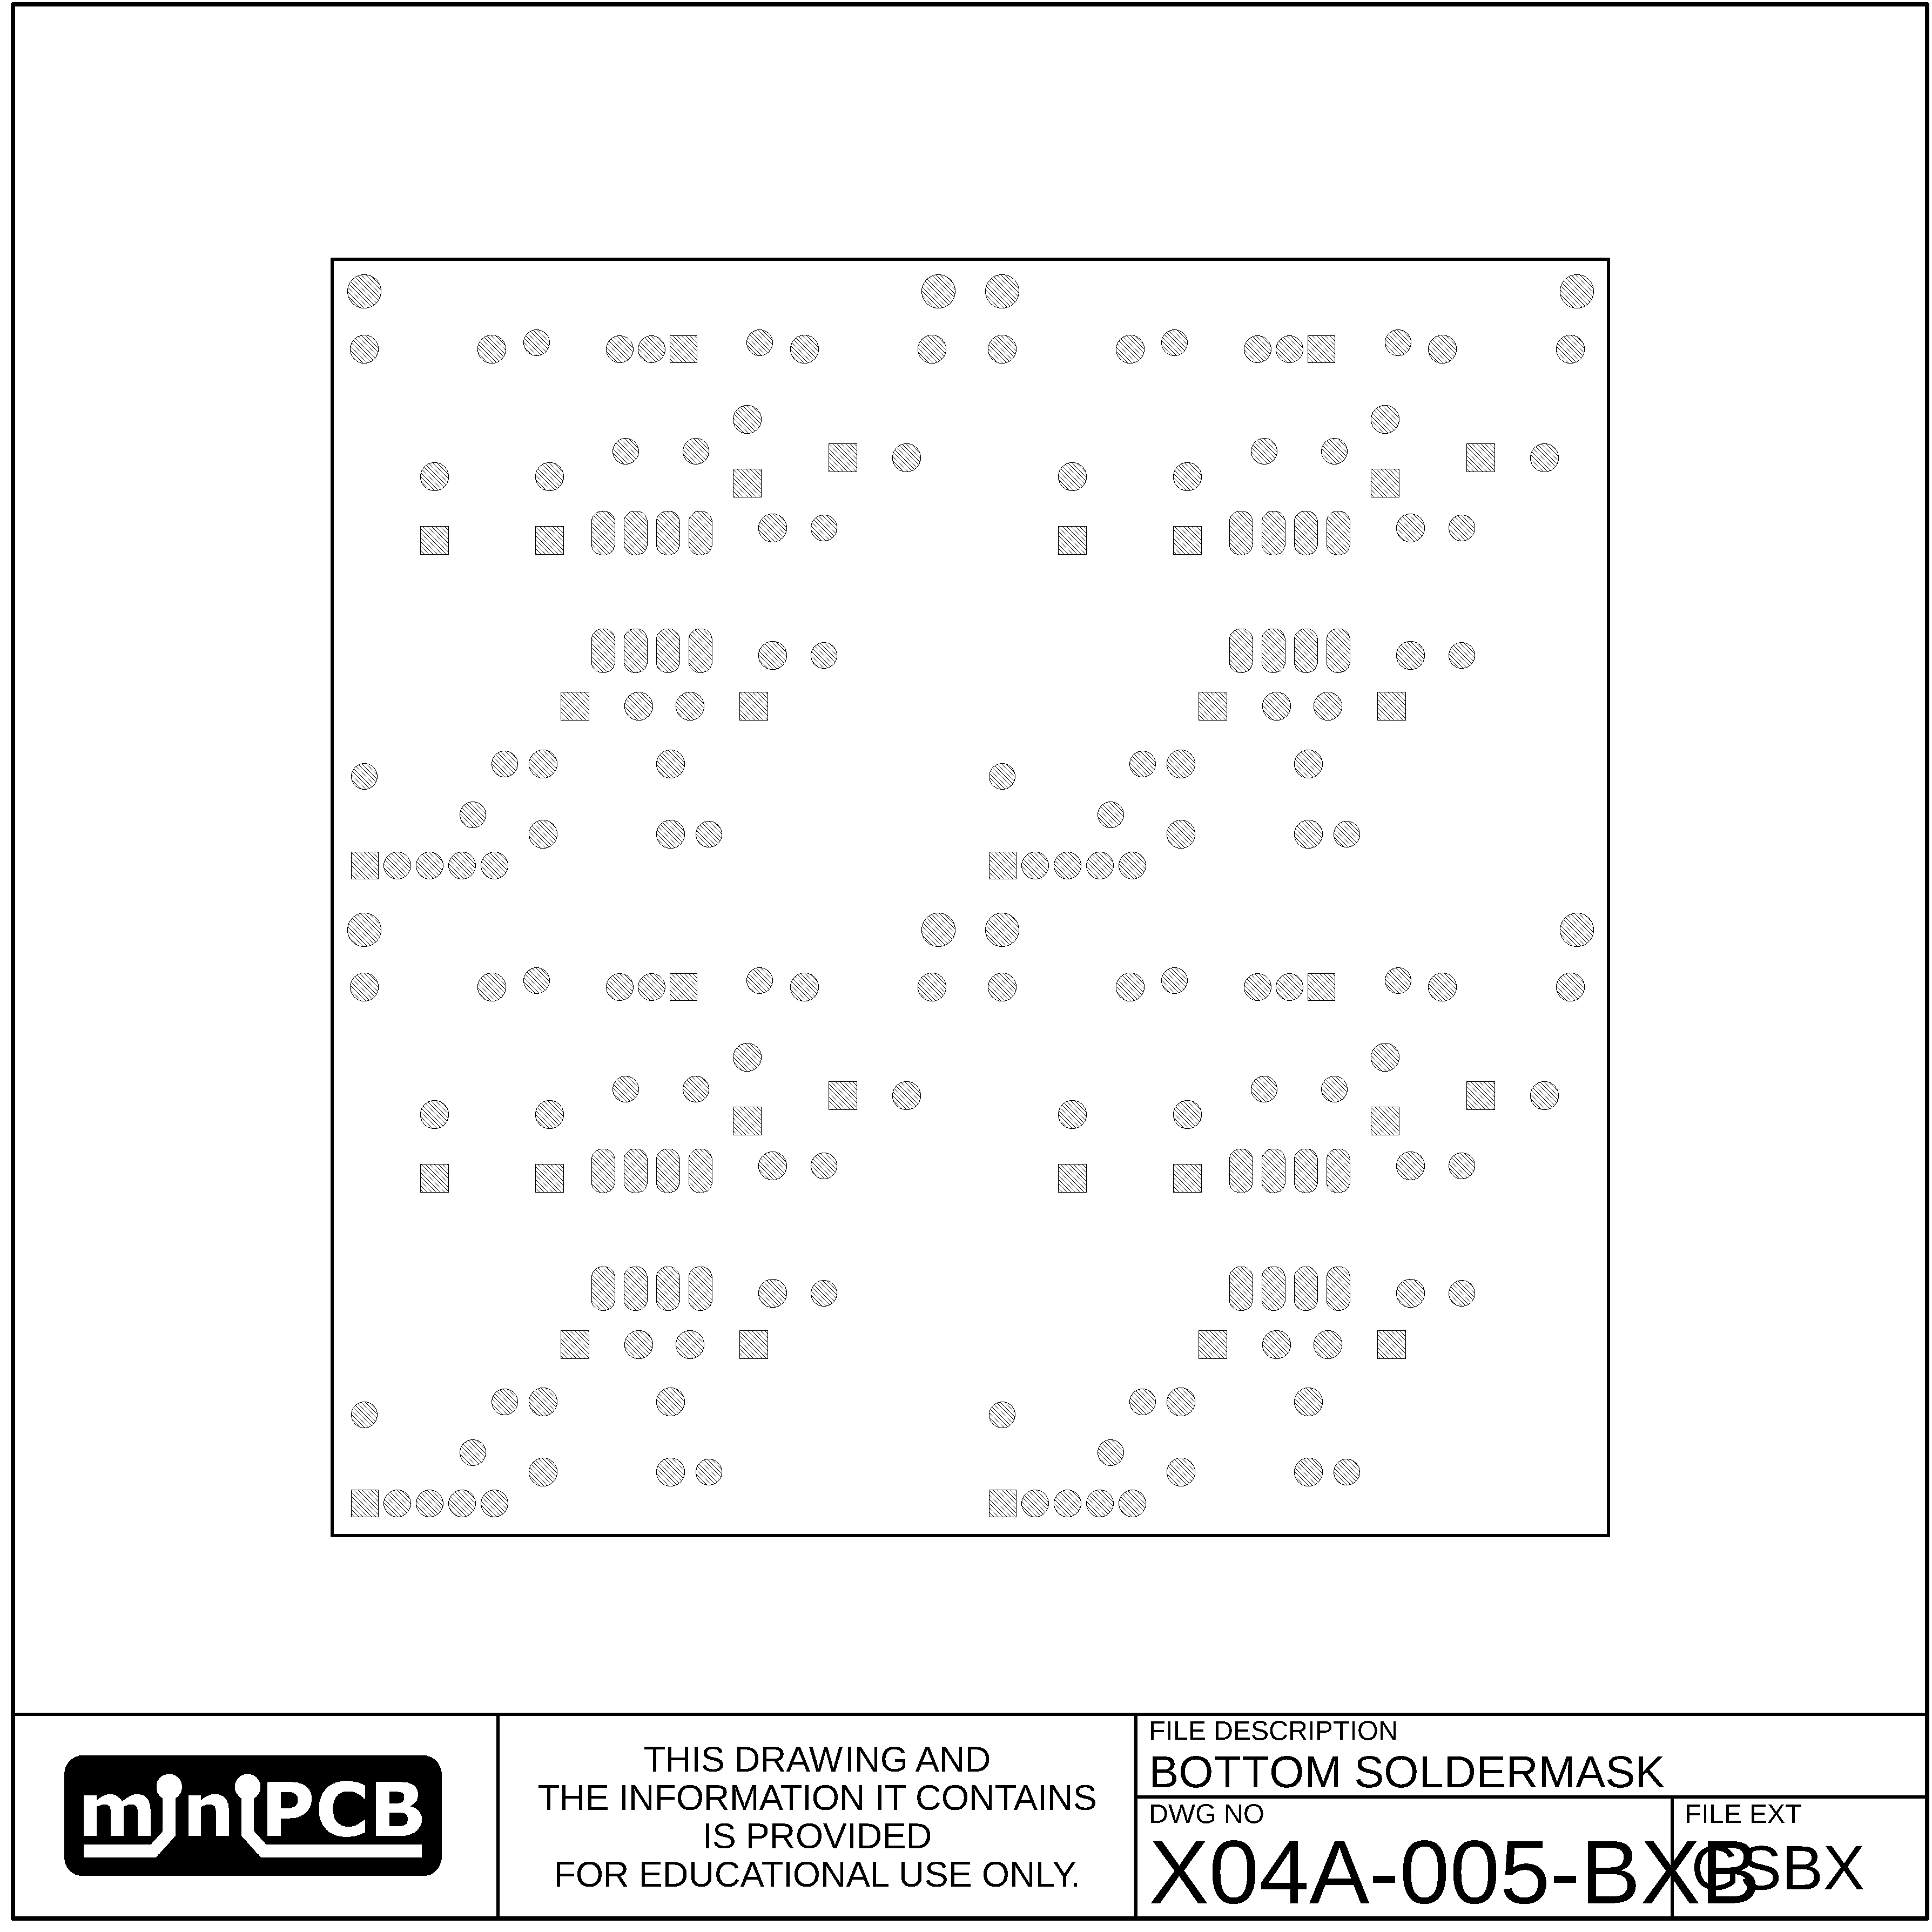

## EDGE (GM1)

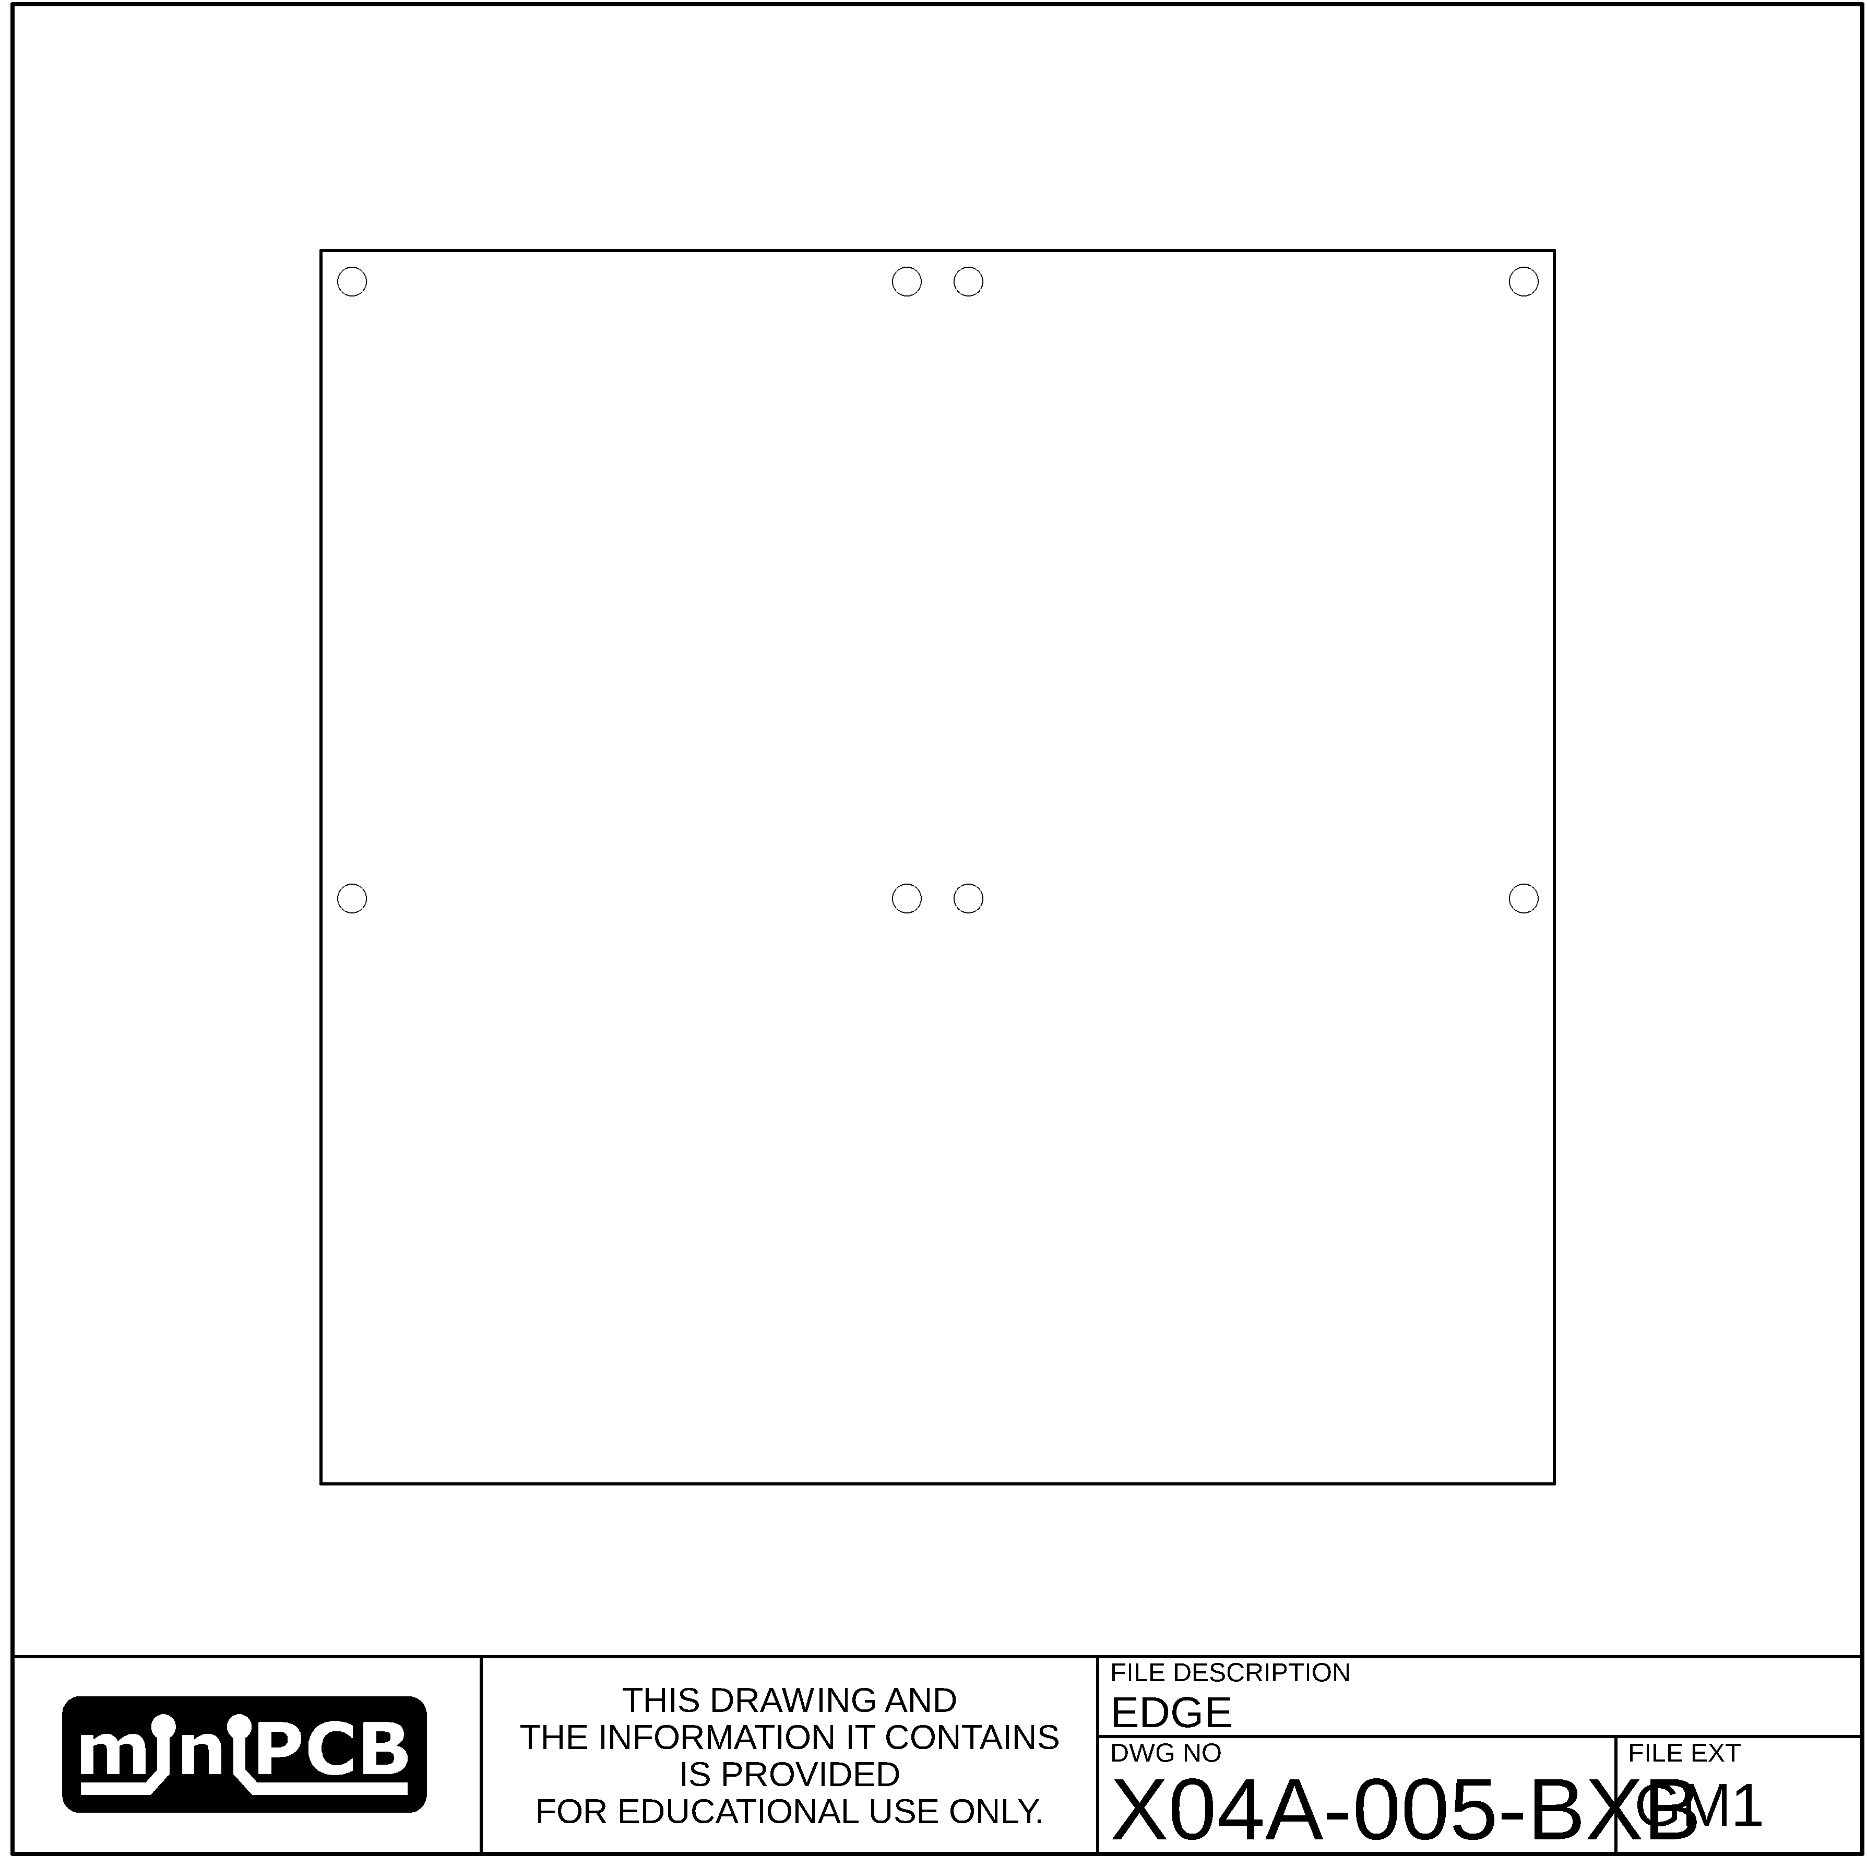

## VSCORE (GM2)

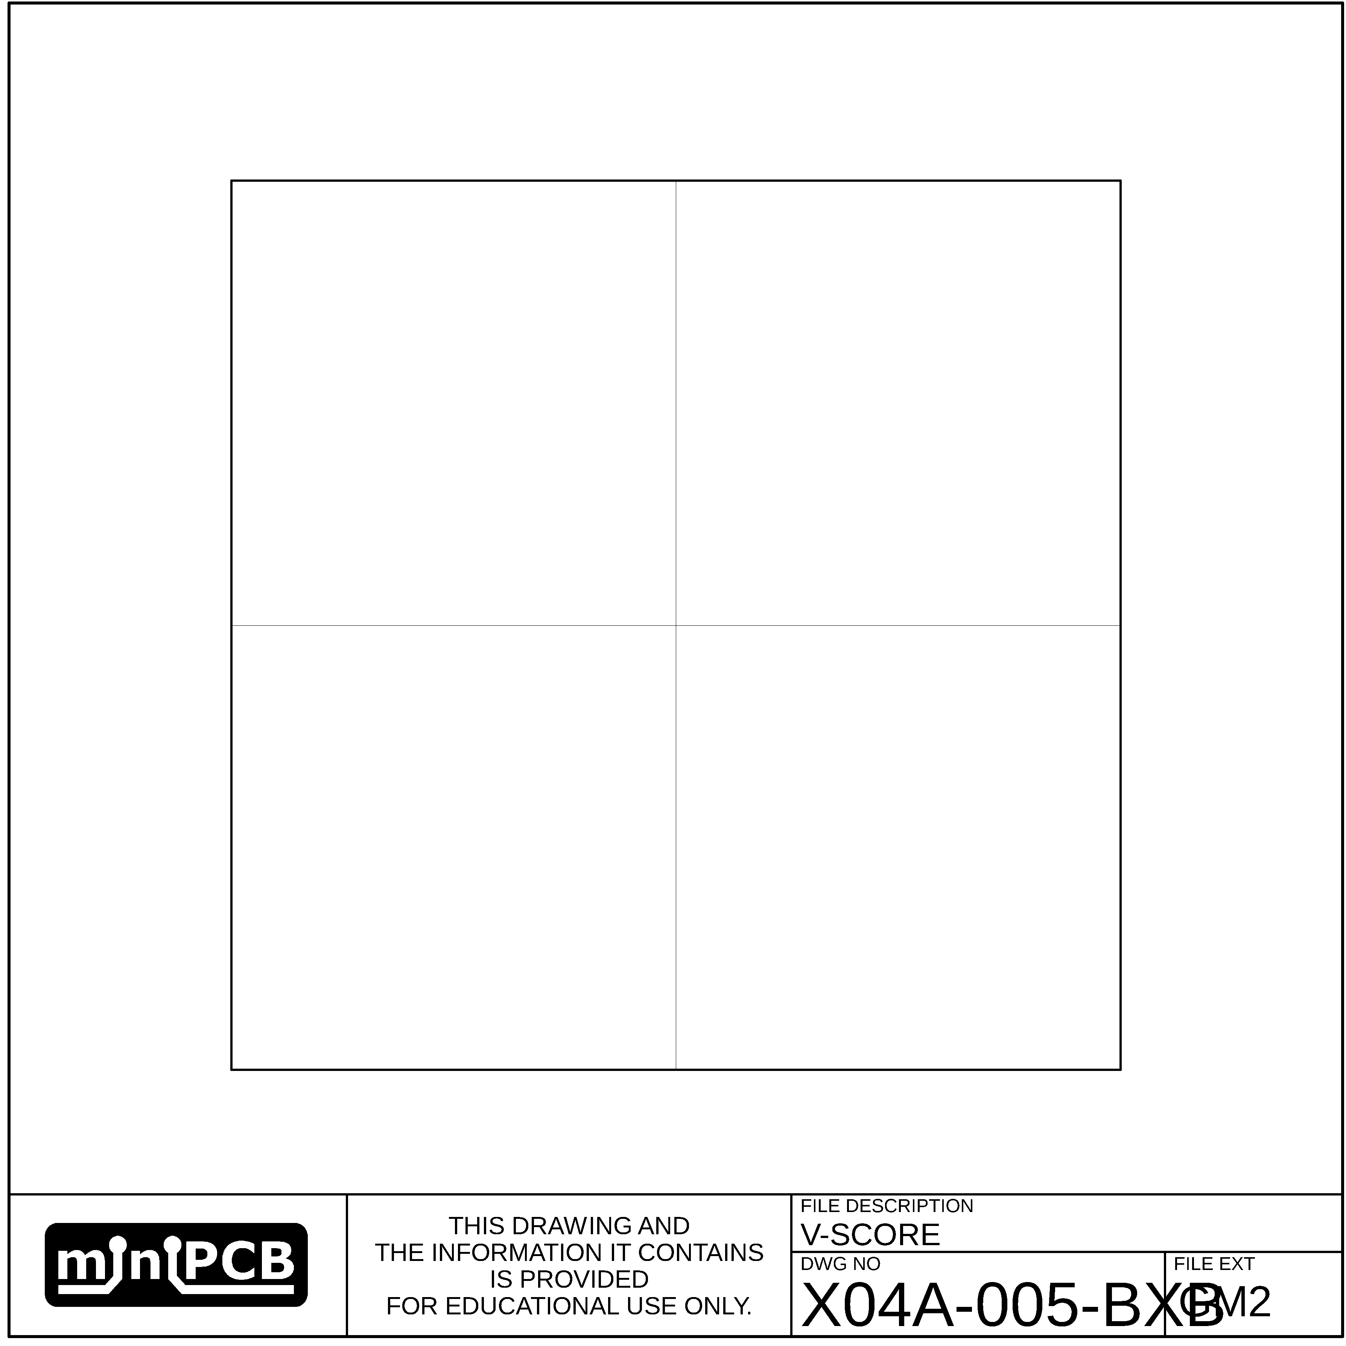

## MILLING (GM3)

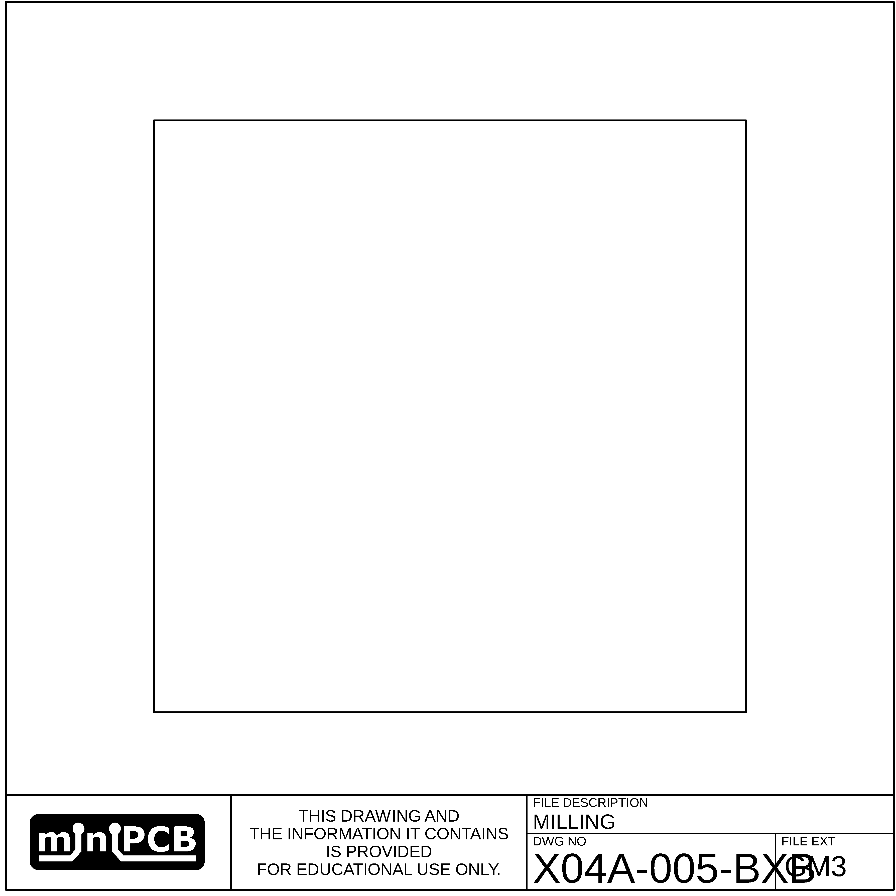

# Design Example

## Design Specifications

|  |  |  |  |  |  |  |
| --- | --- | --- | --- | --- | --- | --- |
| **POWER REQUIREMENTS** | | | | | | |
| **PARAMETER NAME** | **SYMBOL** | | **UNITS** | **LOWER LIMIT** | **TARGET VALUE** | **UPPER LIMIT** |
| Postive DC Supply | +V | | V | 3.1 | 3.3 | 3.5 |
| Negative DC Supply | -V | | V | N/A | N/A | N/A |
| **STIMULI REQUIREMENTS** | | | | | | |
| **PARAMETER NAME** | **SYMBOL** | | **UNITS** | **LOWER LIMIT** | **TARGET VALUE** | **UPPER LIMIT** |
| Maximum Voltage Gain |  | |  |  |  |  |
| Bandwidth |  | | Hz |  |  |  |
| Common-Mode Offset |  | |  |  |  |  |
| Common-Mode Gain |  | |  |  |  |  |
| Maximum Input Bias Current |  | | A |  |  |  |
| Maximum Phase Shift |  | |  |  |  |  |
| Source Impedance |  | | Ω |  |  |  |
| **PERFORMANCE CHARACTERISTICS** | | | | | | |
| **PARAMETER NAME** | **SYMBOL** | **UNITS** | | **LOWER LIMIT** | **TARGET VALUE** | **UPPER LIMIT** |
| Quiescient Current | $$I_{q}$$ | A | |  |  |  |
| Voltage Gain | $$A_{v}$$ | $$\frac{V}{V}$$ | |  |  |  |
| Input Impedance | $$R_{i}$$ | Ω | |  |  |  |
| Output Impedance | $$R_{i}$$ | Ω | |  |  |  |

## Parts List

|  |  |  |  |  |
| --- | --- | --- | --- | --- |
| **QTY REQ** | **REFERENCE DESIGNATORS** | **PART NUMBER** | **PART DESCRIPTION** | **FIND** |
| 1 | - | 04A-005 | PRINTED CIRCUIT BOARD, miniPCB™ | 1 |
| 1 | C1 | 47 uF | CAPACITOR, ELECTROLYTIC | 2 |
| 1 | C2 | 330 nF | CAPACITOR, ELECTROLYTIC | 3 |
| 1 | C3 | 6.8 uF | CAPACITOR, ELECTROLYTIC | 4 |
| 1 | C4 | 4.7 nF | CAPACITOR, CERAMIC | 5 |
| 1 | C5 | 3.3 uF | CAPACITOR, ELECTROLYTIC | 6 |
| 1 | C6 | 100 pF | CAPACITOR, CERAMIC | 7 |
| 1 | P1 | - | HEADER PINS, 5P | 8 |
| 1 | R1 | 10 KΩ | RESISTOR | 9 |
| 1 | R2 | 100 KΩ | POTENTIOMETER, MULTITURN | 10 |
| 1 | R3 | 10 KΩ | RESISTOR | 11 |
| 1 | R4 | 10 KΩ | RESISTOR | 12 |
| 1 | R5 | 100 KΩ | RESISTOR | 13 |
| 1 | R6 | 10 Ω | RESISTOR | 14 |
| 1 | U1 | MCP6022-I/P | OPAMP, 2 CHANNEL, DIP8 | 15 |
| 10 | TP1, TP2, TP3, TP4, TP5, TP6, TP7, TP8, TP9, TP10 | 5000 | TEST POINTS, KEYSTONE ELECTRONICS | 16 |

## Test List

| **TEST #** | **TEST NAME** | **TEST DESCRIPTION** |
| --- | --- | --- |
| 1 |  |  |
| 2 |  |  |
| 3 |  |  |
| 4 |  |  |
| 5 |  |  |
| 6 |  |  |
| 7 |  |  |
| 8 |  |  |
| 9 |  |  |
| 10 |  |  |
| 11 |  |  |

## Test Results

## Test Conclusions

# FORM: Test Results

# FORM: Design Specifications

|  |  |  |  |  |  |  |
| --- | --- | --- | --- | --- | --- | --- |
| **POWER REQUIREMENTS** | | | | | | |
| **PARAMETER NAME** | **SYMBOL** | | **UNITS** | **LOWER LIMIT** | **TARGET VALUE** | **UPPER LIMIT** |
| Postive DC Supply | +V | | V | 3.1 | 3.3 | 3.5 |
| Negative DC Supply | -V | | V | N/A | N/A | N/A |
| **STIMULI REQUIREMENTS** | | | | | | |
| **PARAMETER NAME** | **SYMBOL** | | **UNITS** | **LOWER LIMIT** | **TARGET VALUE** | **UPPER LIMIT** |
| Maximum Voltage Gain |  | |  |  |  |  |
| Bandwidth |  | | Hz |  |  |  |
| Common-Mode Offset |  | |  |  |  |  |
| Common-Mode Gain |  | |  |  |  |  |
| Maximum Input Bias Current |  | | A |  |  |  |
| Maximum Phase Shift |  | |  |  |  |  |
| Source Impedance |  | | Ω |  |  |  |
| **PERFORMANCE CHARACTERISTICS** | | | | | | |
| **PARAMETER NAME** | **SYMBOL** | **UNITS** | | **LOWER LIMIT** | **TARGET VALUE** | **UPPER LIMIT** |
| Quiescient Current | $$I_{q}$$ | A | |  |  |  |
| Voltage Gain | $$A_{v}$$ | $$\frac{V}{V}$$ | |  |  |  |
| Input Impedance | $$R_{i}$$ | Ω | |  |  |  |
| Output Impedance | $$R_{i}$$ | Ω | |  |  |  |

# FORM: Parts List

|  |  |  |  |  |
| --- | --- | --- | --- | --- |
| **QTY REQ** | **REFERENCE DESIGNATORS** | **PART NUMBER** | **PART DESCRIPTION** | **FIND** |
| 1 | - | 04A-005 | PRINTED CIRCUIT BOARD, miniPCB™ | 1 |
| 1 | C1 |  | CAPACITOR | 2 |
| 1 | C2 |  | CAPACITOR | 3 |
| 1 | C3 |  | CAPACITOR | 4 |
| 1 | C4 |  | CAPACITOR | 5 |
| 1 | C5 |  | CAPACITOR | 6 |
| 1 | C6 |  | CAPACITOR | 7 |
| 1 | P1 |  | HEADER PINS, 5P | 8 |
| 1 | R1 |  | RESISTOR | 9 |
| 1 | R2 |  | POTENTIOMETER, MULTITURN | 10 |
| 1 | R3 |  | RESISTOR | 11 |
| 1 | R4 |  | RESISTOR | 12 |
| 1 | R5 |  | RESISTOR | 13 |
| 1 | R6 |  | RESISTOR | 14 |
| 1 | U1 |  | OPAMP, 2 CHANNEL, DIP8 | 15 |
| 10 | TP1, TP2, TP3, TP4, TP5, TP6, TP7, TP8, TP9, TP10 | 5000 | TEST POINTS, KEYSTONE ELECTRONICS | 16 |

# Change and Liability Notice

This document is subject to change without notice. While effort has been made to ensure the accuracy of the material contained within this document, Nolan Manteufel shall under no circumstances be liable for incidental or consequential damages or related expenses resulting from the use of this document.

# Trademark Notice

miniPCB is a trademark of Nolan Manteufel.

This datasheet does not constitute permission to use the miniPCB trademark.

|  |  |  |
| --- | --- | --- |
| WORDMARK | FIGUREMARK | FIGUREMARK |
| miniPCB™ | A picture containing drawing  Description automatically generated™ | Icon  Description automatically generated™ |

# Revision History

|  |  |  |  |
| --- | --- | --- | --- |
| REV | DESCRIPTION | ECO | DATE |
| A | Initial Release | 1002 |  |
|  |  |  |  |