Window Comparator

|  |  |
| --- | --- |
| **PART NUMBER** | 08A-005 |
| **GROUP NAME** | Signal Converter (08A) |
| **CIRCUIT NAME** | Window Comparator |
| **VARIANT DESCRIPTION** | Single Supply, THD, Window Threshold Trimmers |
| **BOARD DESIGN** | PCB50-A-07 |
| **PRODUCT DESCRIPTION** | Panel of #08A-005 miniPCBs, v-scored (1 Panel = 4 Pieces) |

# Circuit Description

This circuit amplifies a small voltage signal.

# Panel Board

|  |  |
| --- | --- |
|  |  |
| TOP VIEW | BOTTOM VIEW |

# Single Board

|  |  |
| --- | --- |
|  |  |
| TOP VIEW | BOTTOM VIEW |

# Part Locations

|  |  |
| --- | --- |
|  |  |
| TOP VIEW | BOTTOM VIEW |

# Schematic

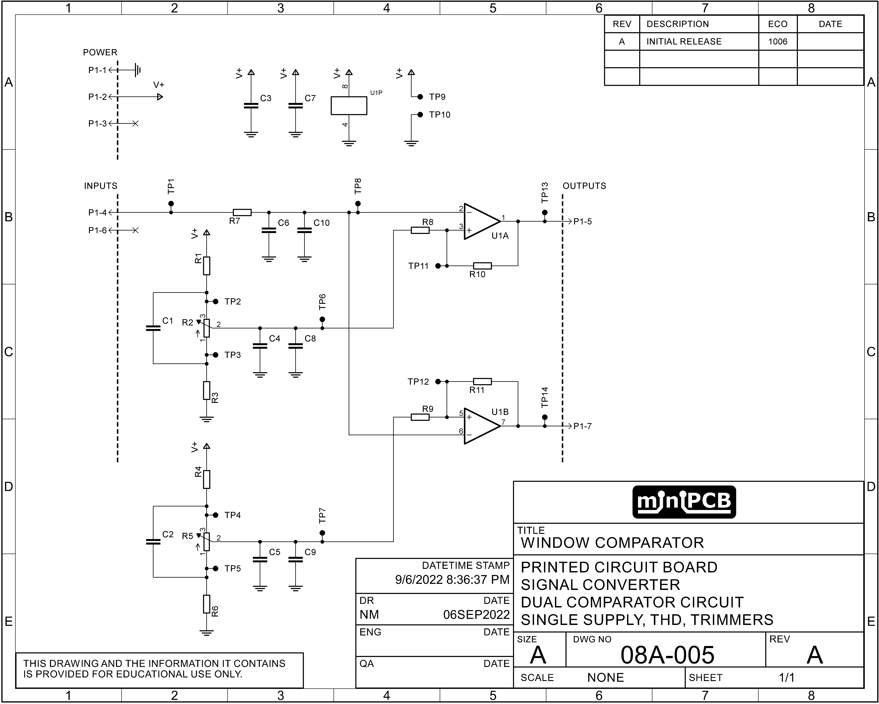

# Gerber Files

This section contains images of the layers included in each Gerber file.

## TOP COPPER (GLTX)

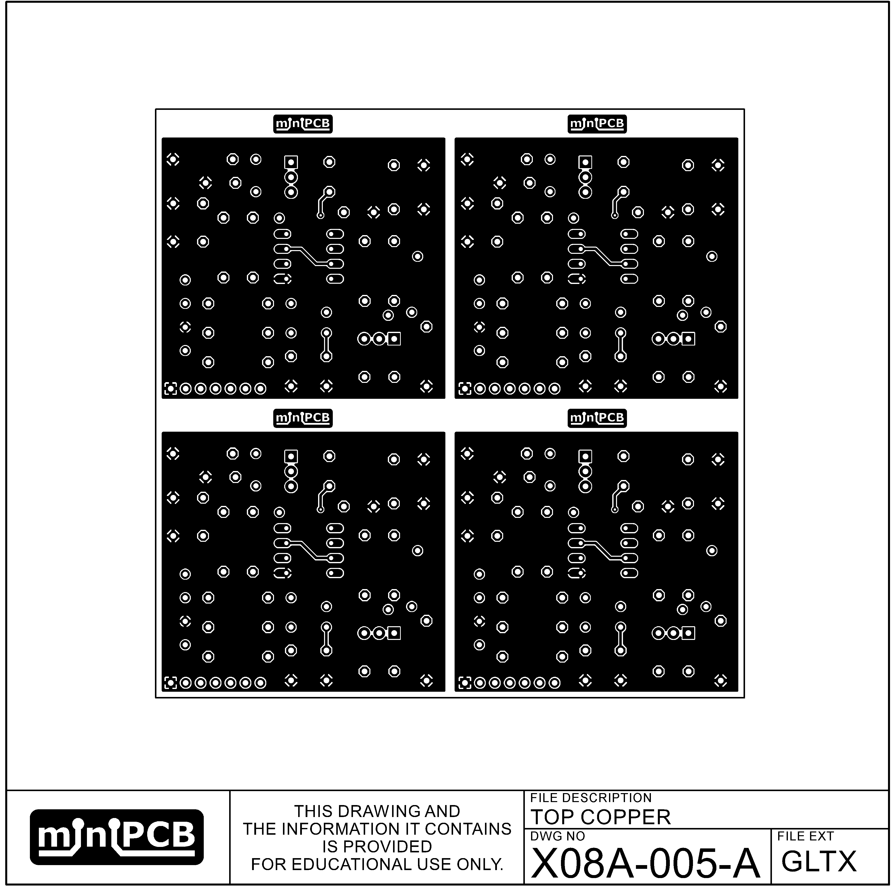

## TOP CREAM (GCTX)

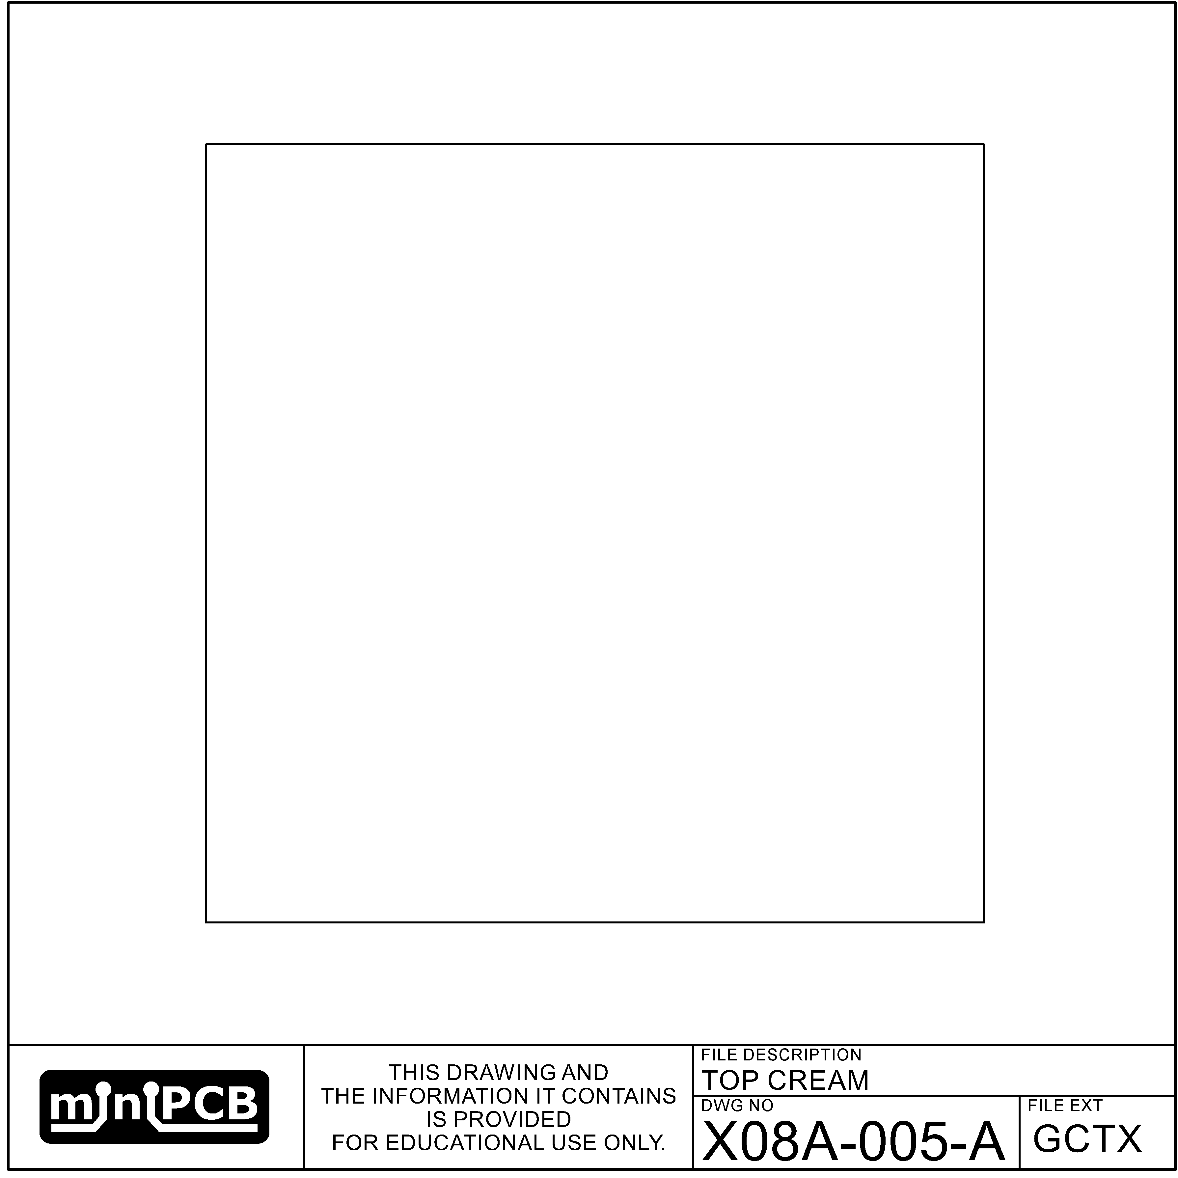

## BOTTOM CREAM (GCBX)

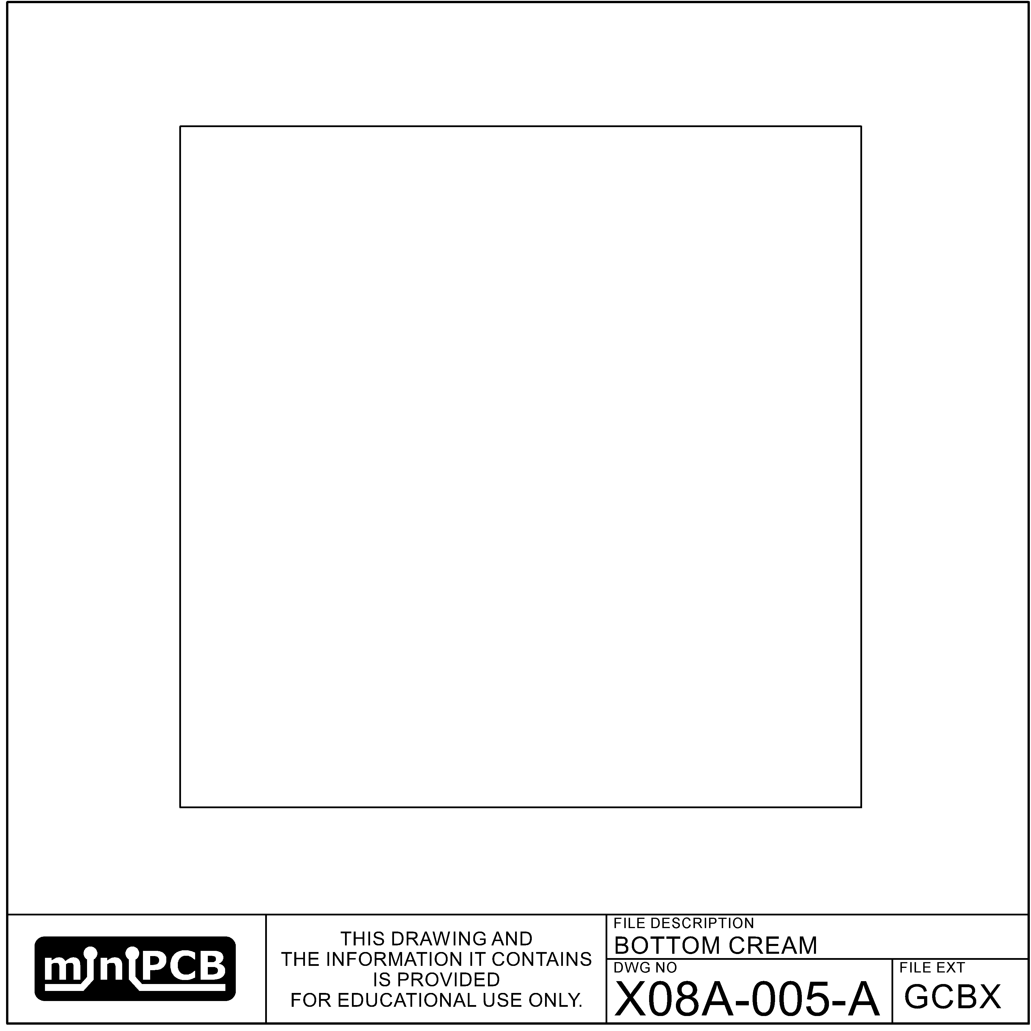

## BOTTOM COPPER (GLBX)

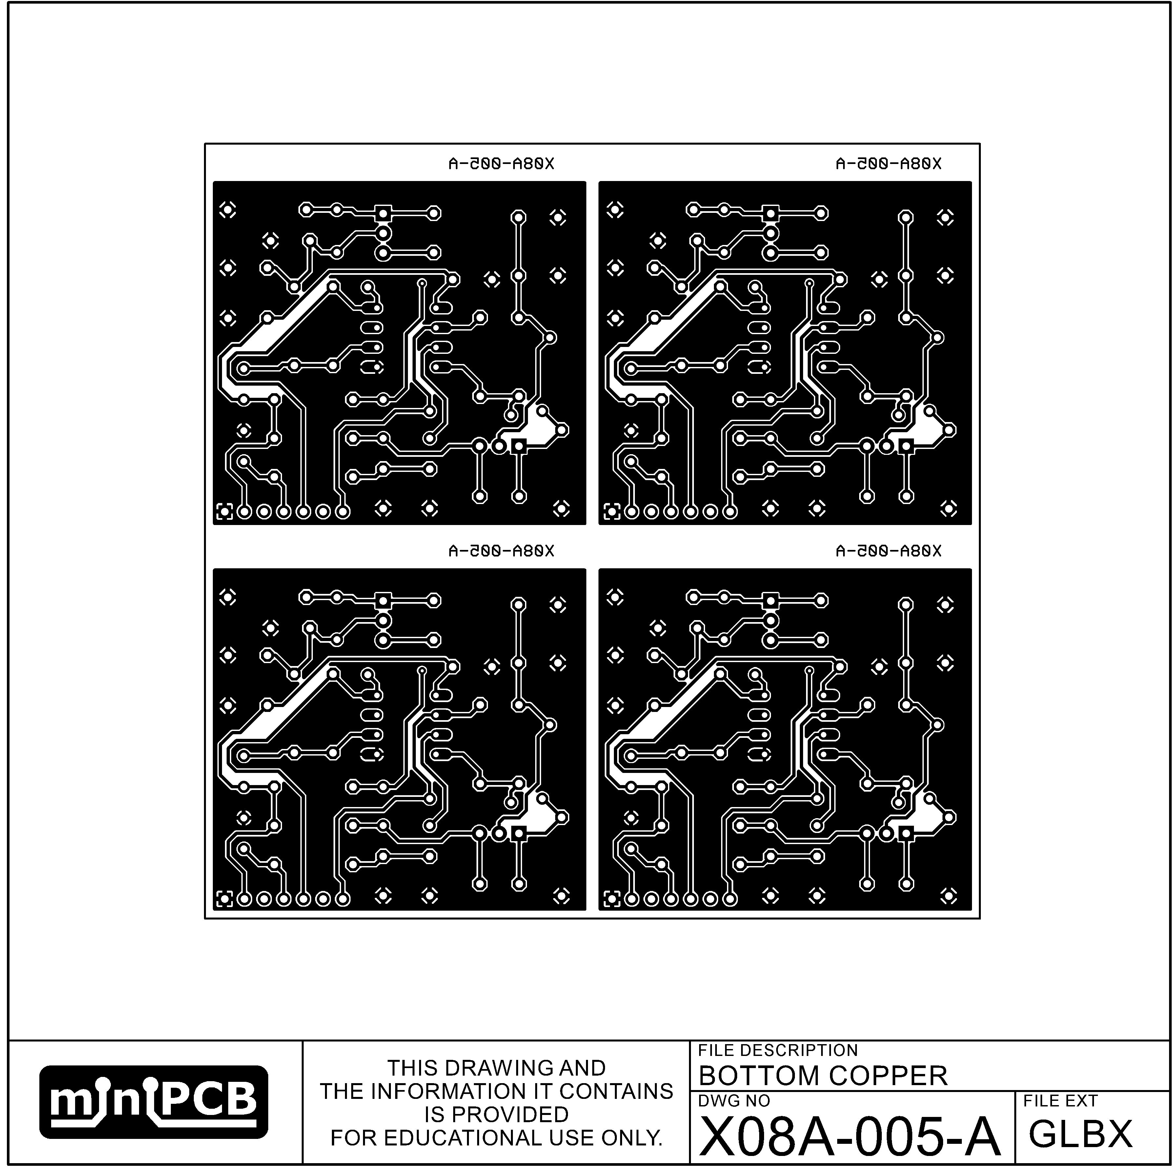

## TOP SILKSCREEN (GOTX)

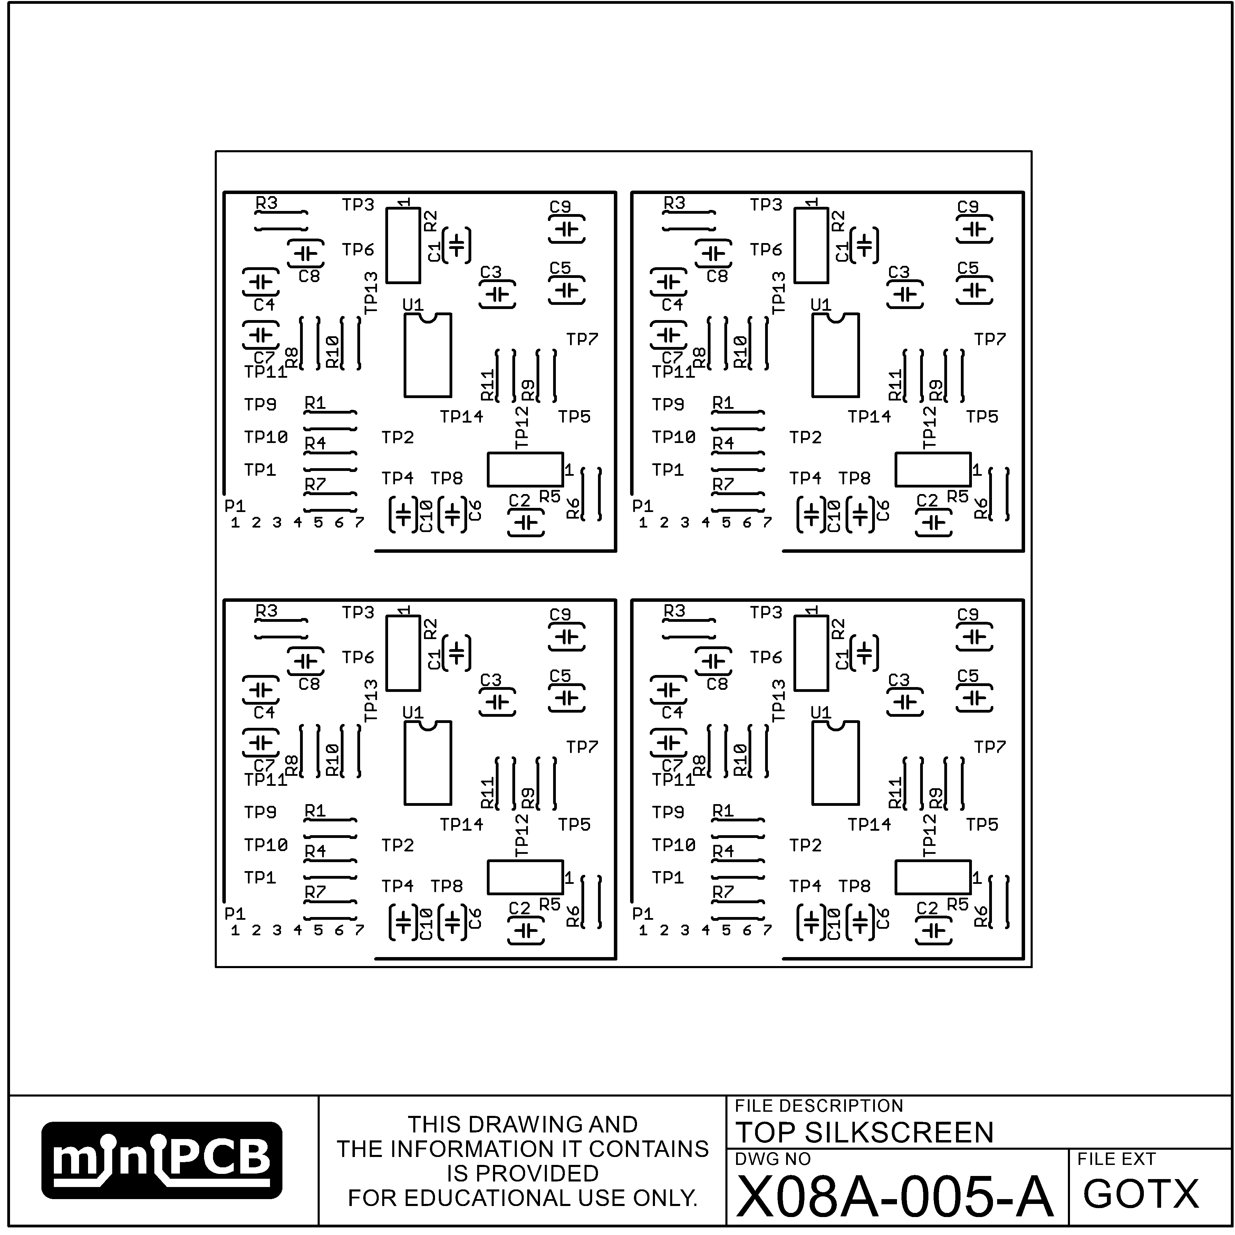

## BOTTOM SILKSCREEN (GOBX)

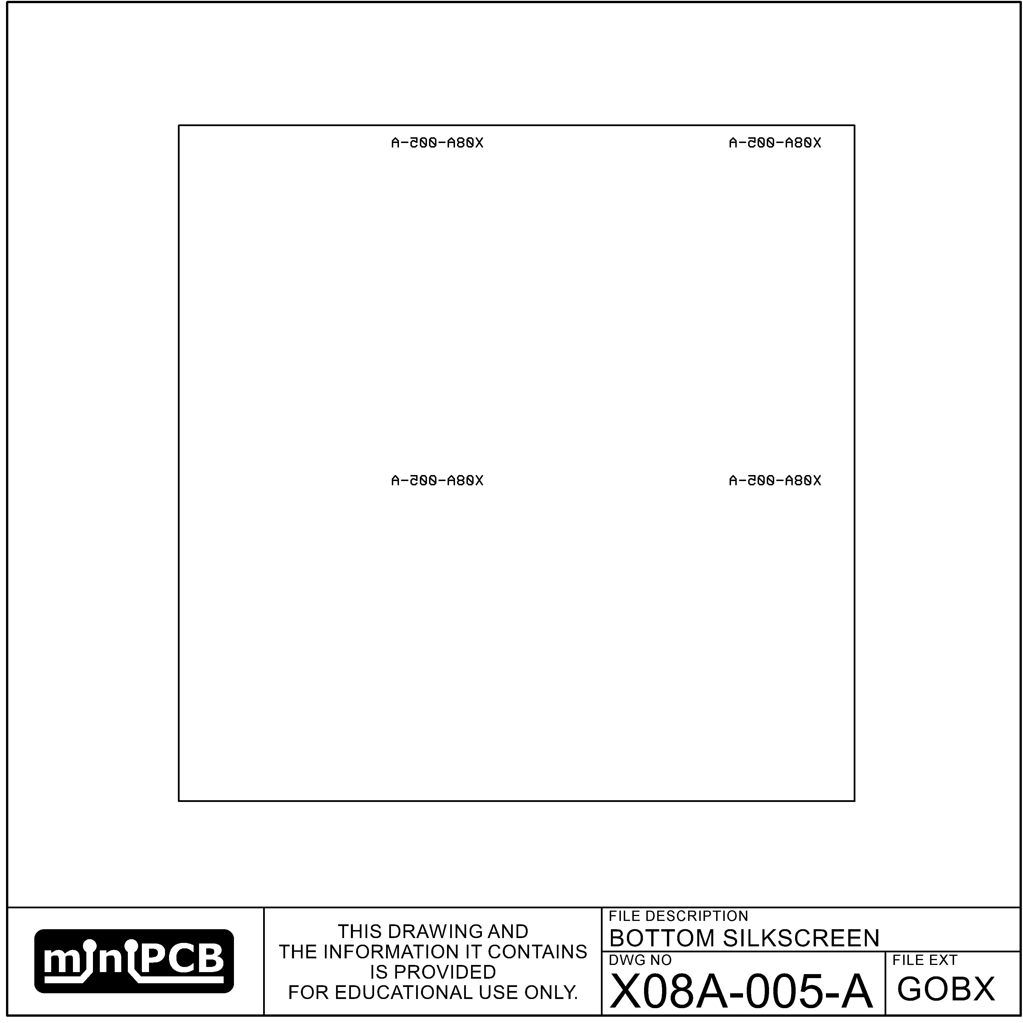

## TOP SOLDERMASK (GSTX)

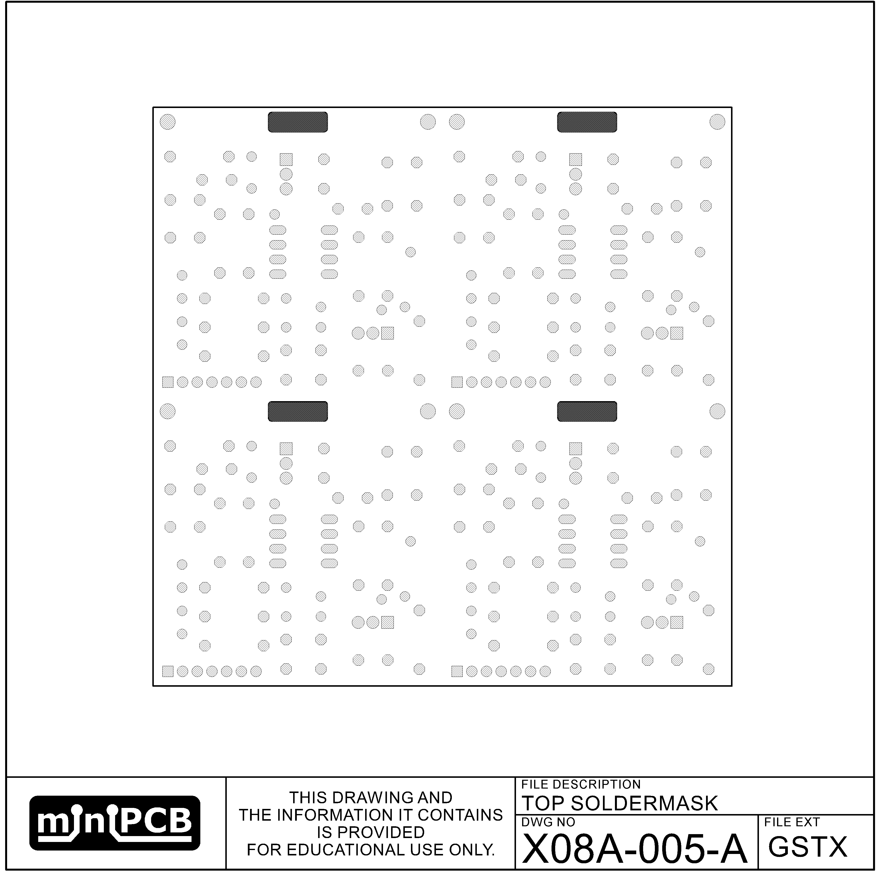

## BOTTOM SOLDER MASK (GSBX)

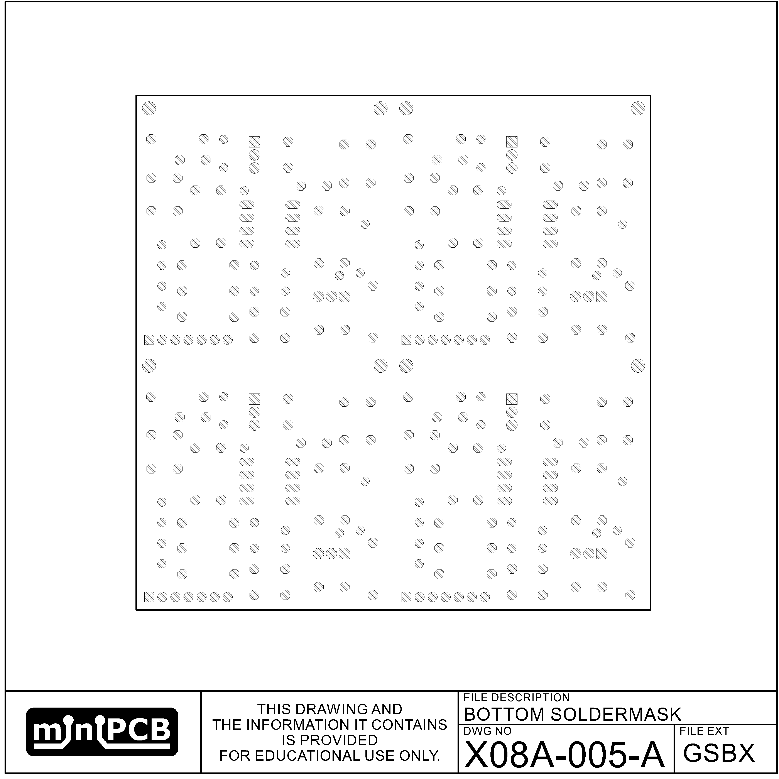

## EDGE (GM1)

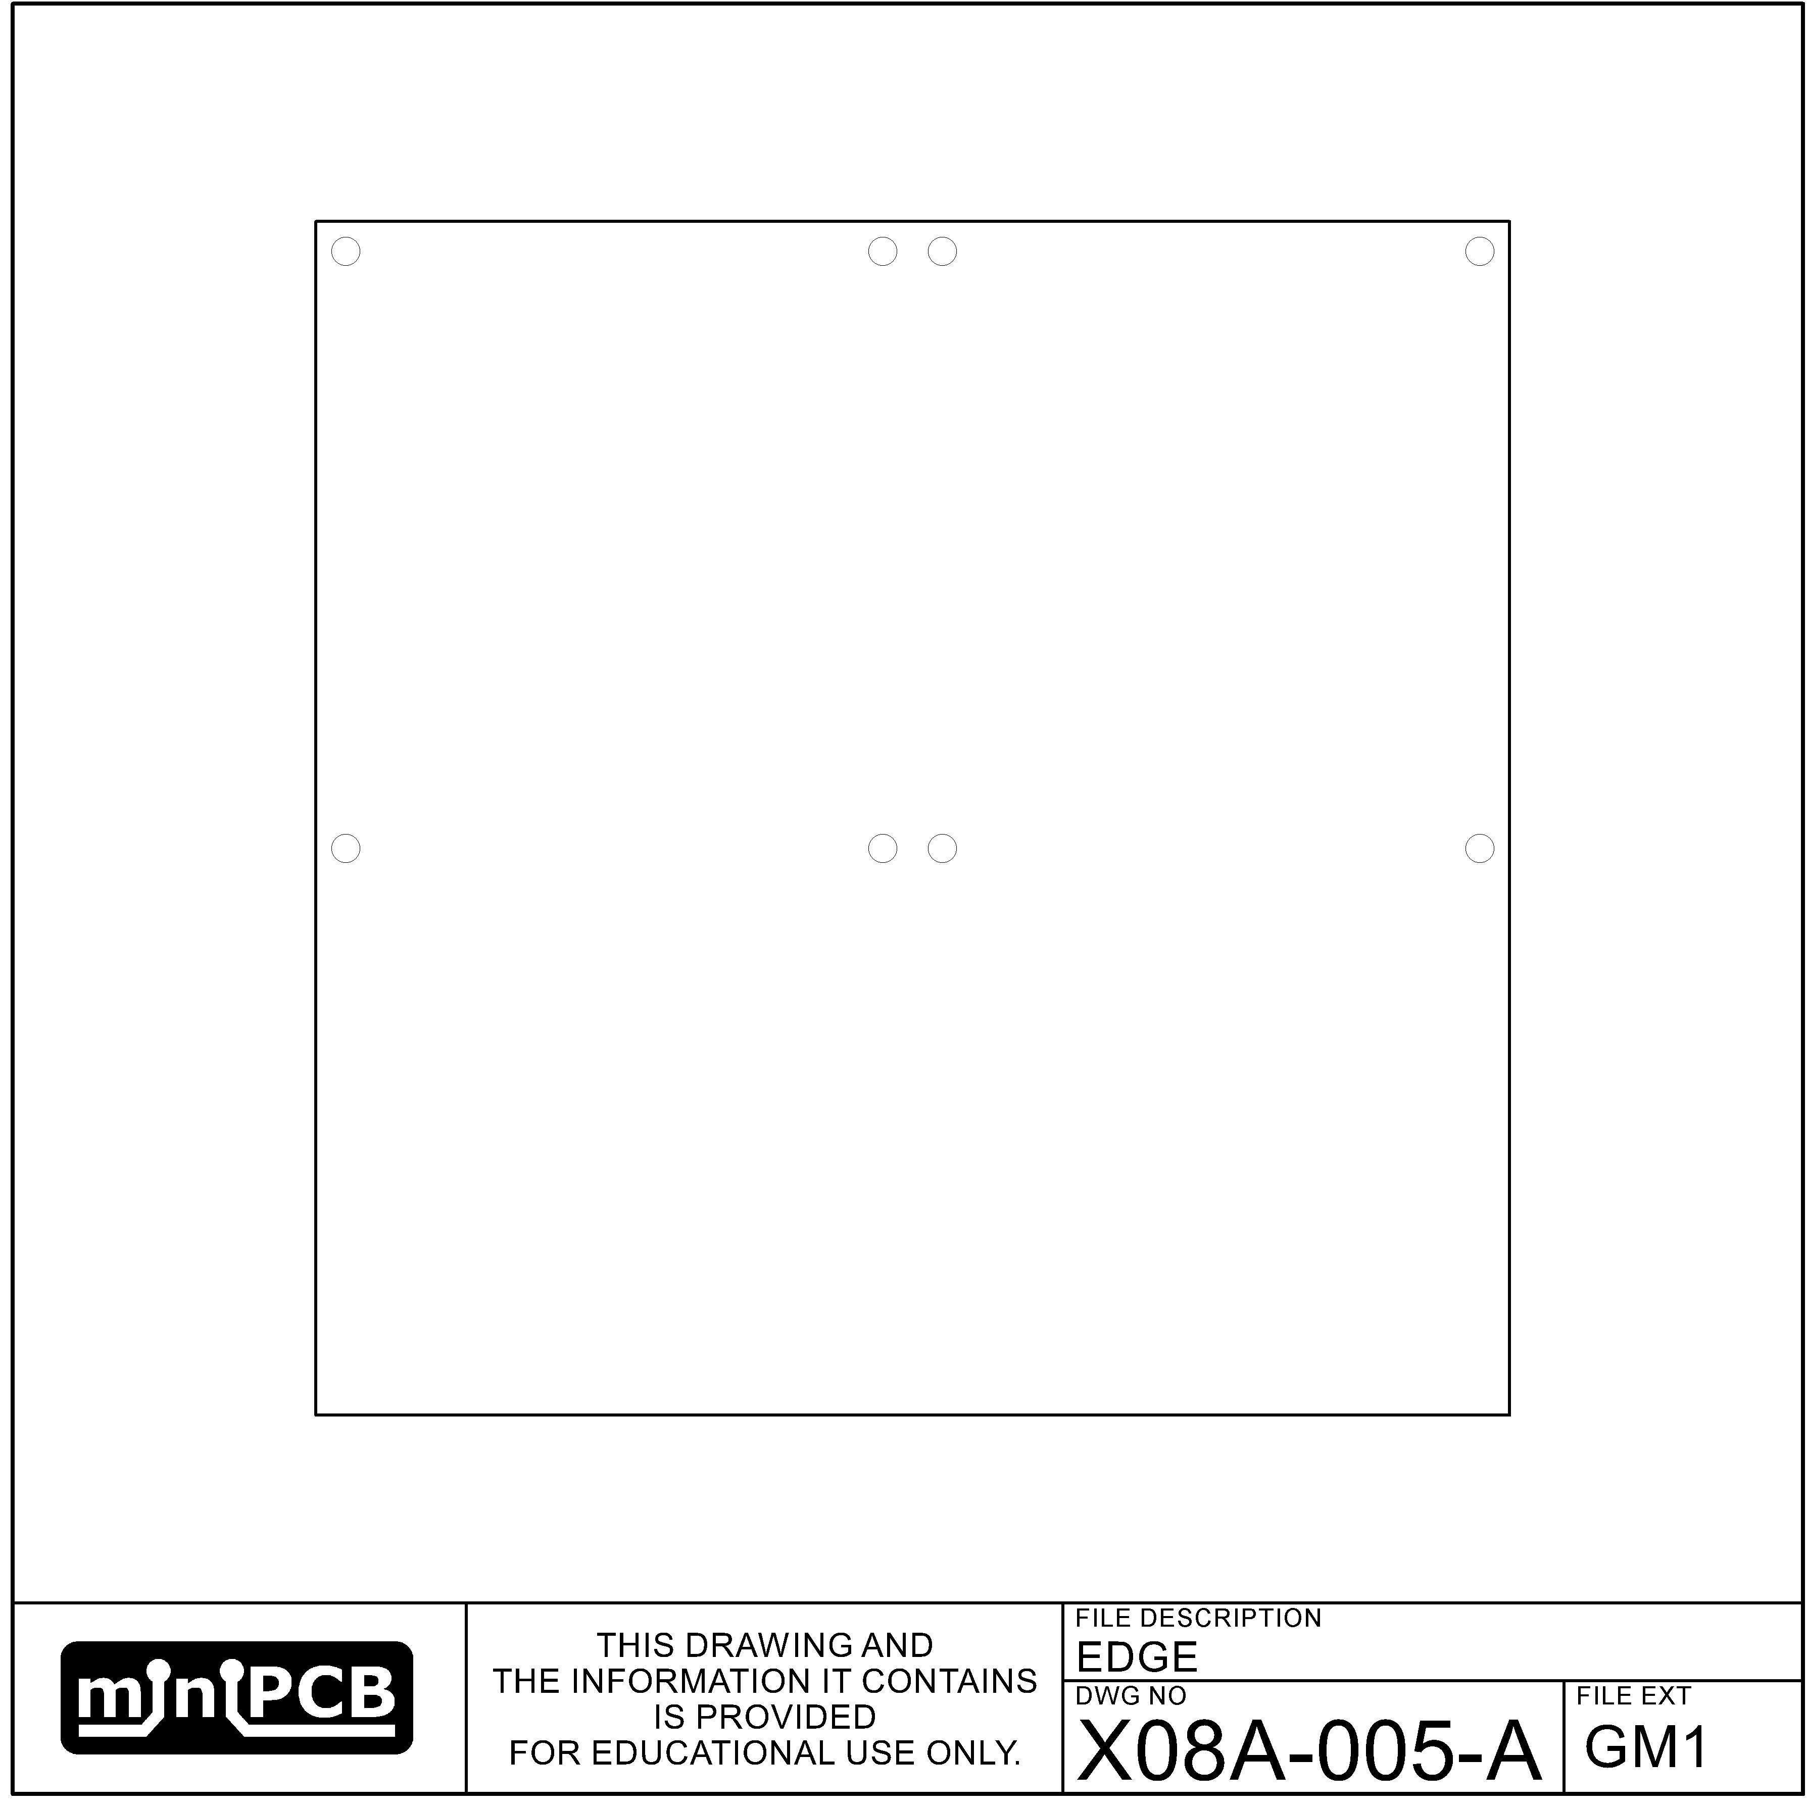

## VSCORE (GM2)

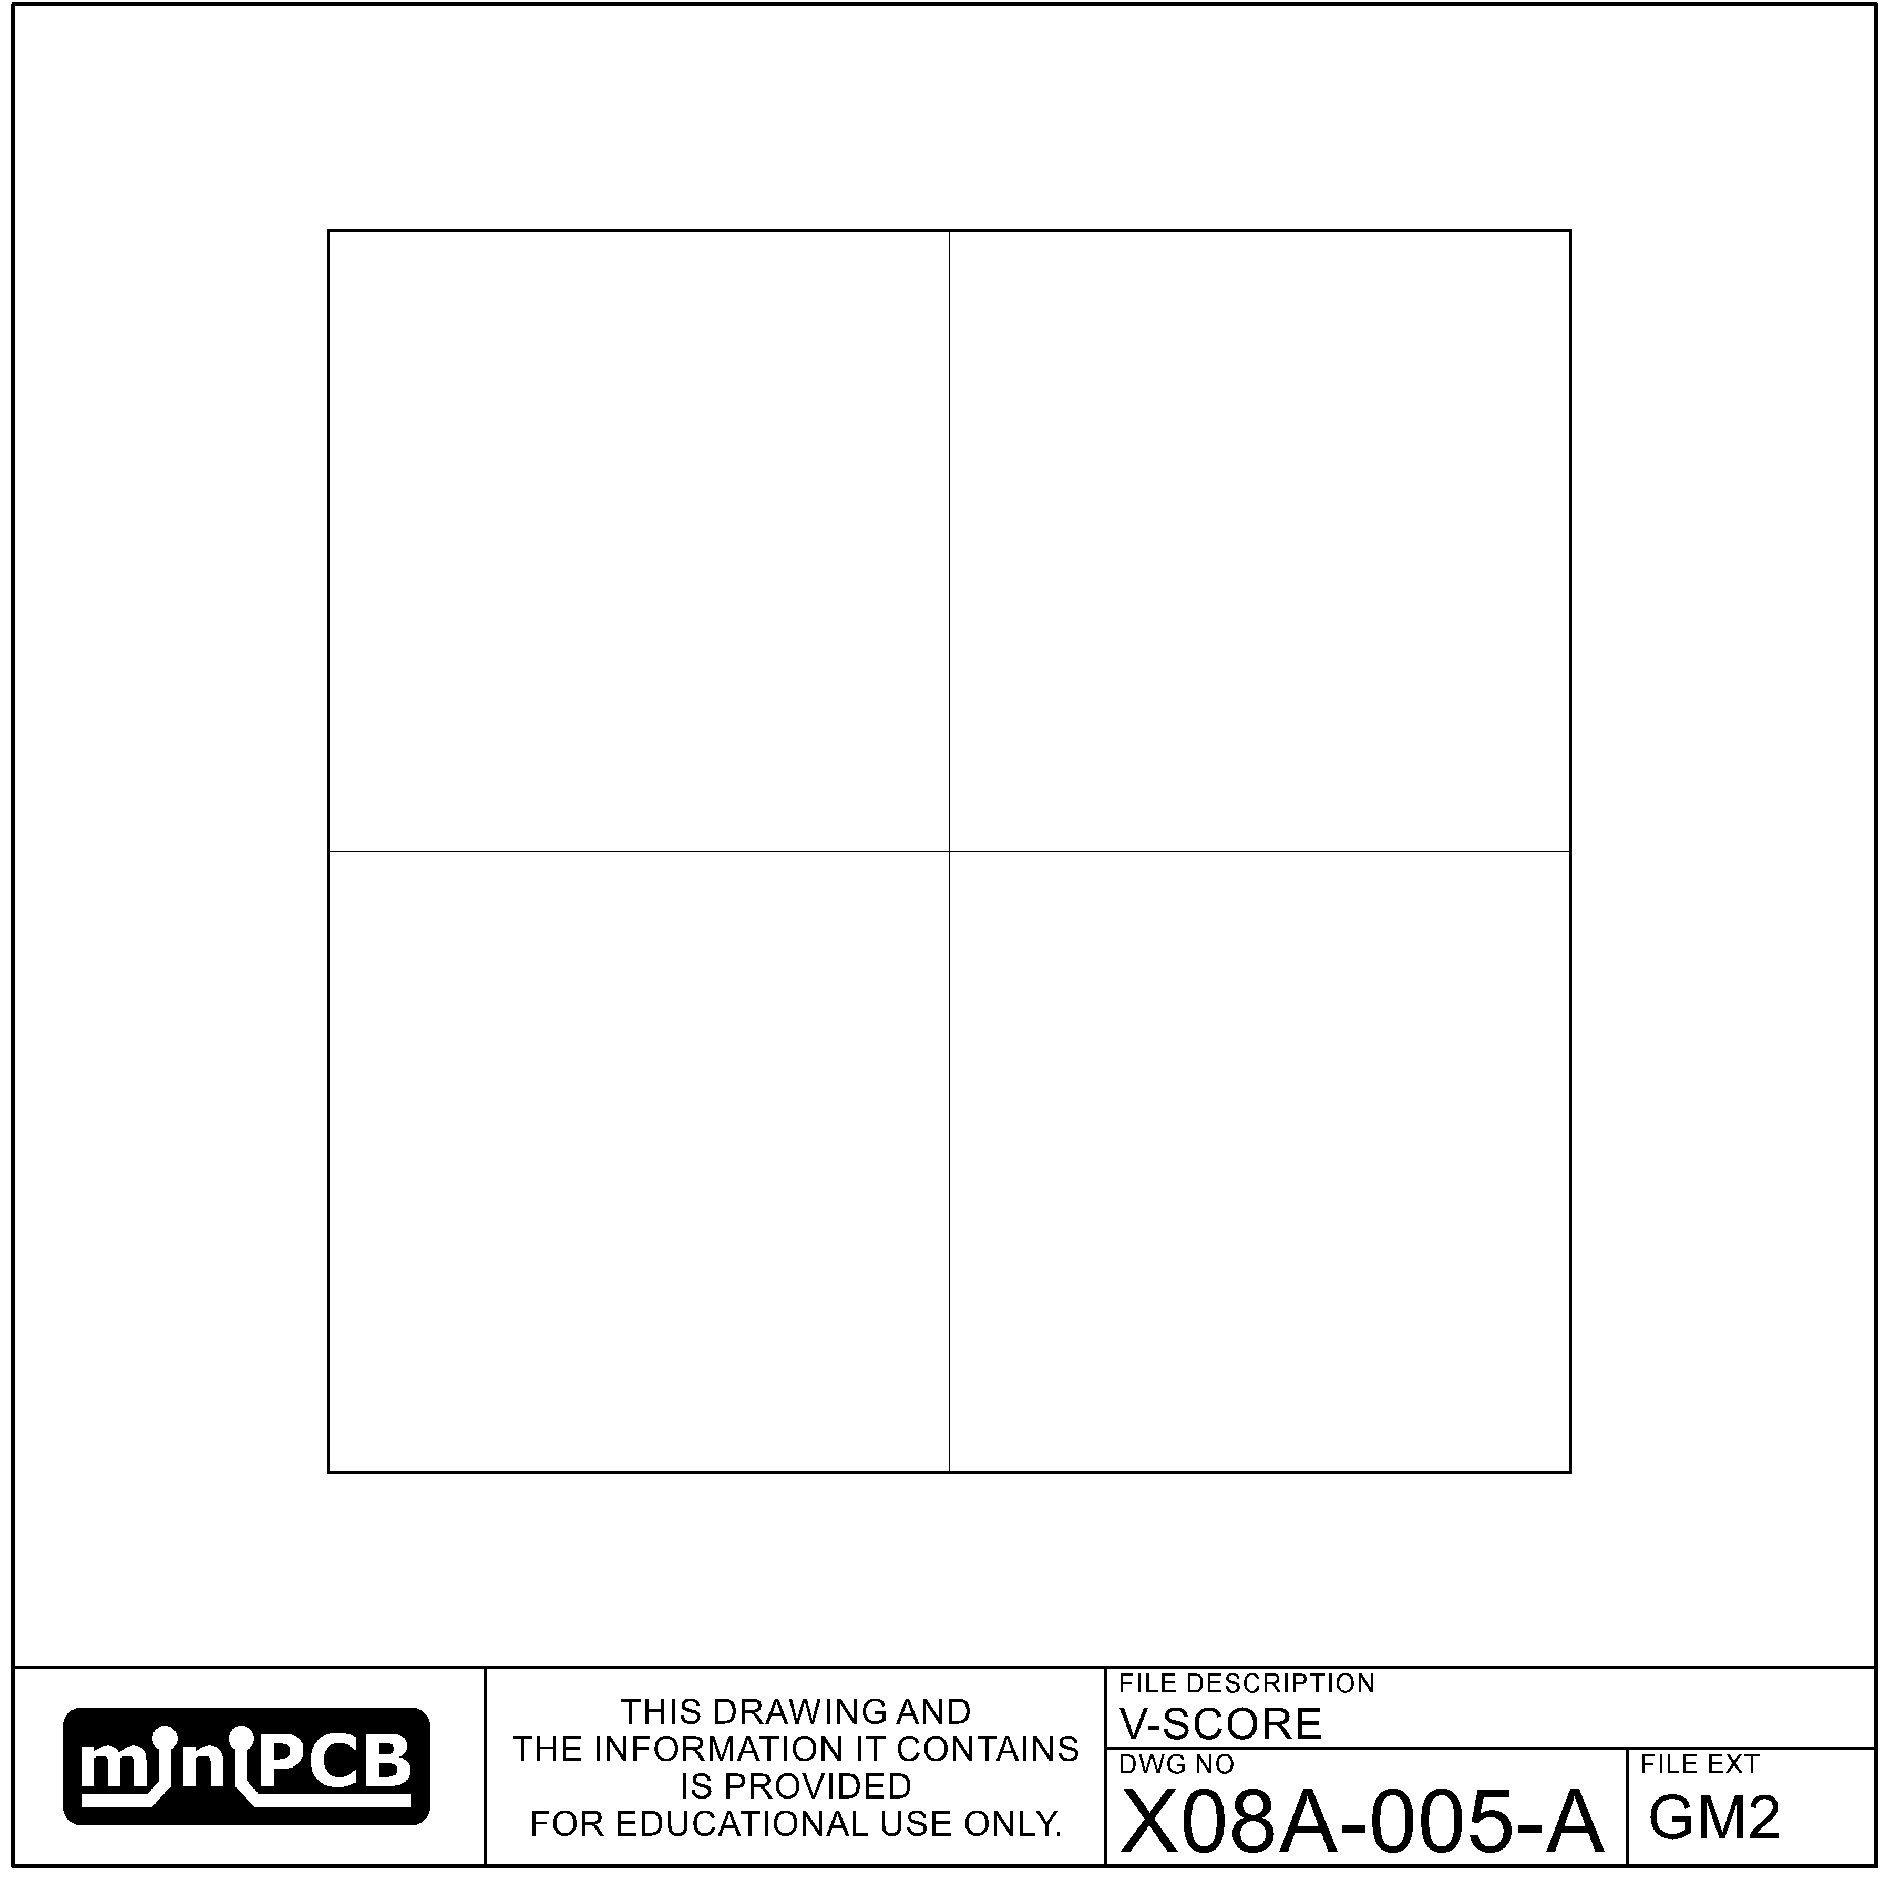

## MILLING (GM3)

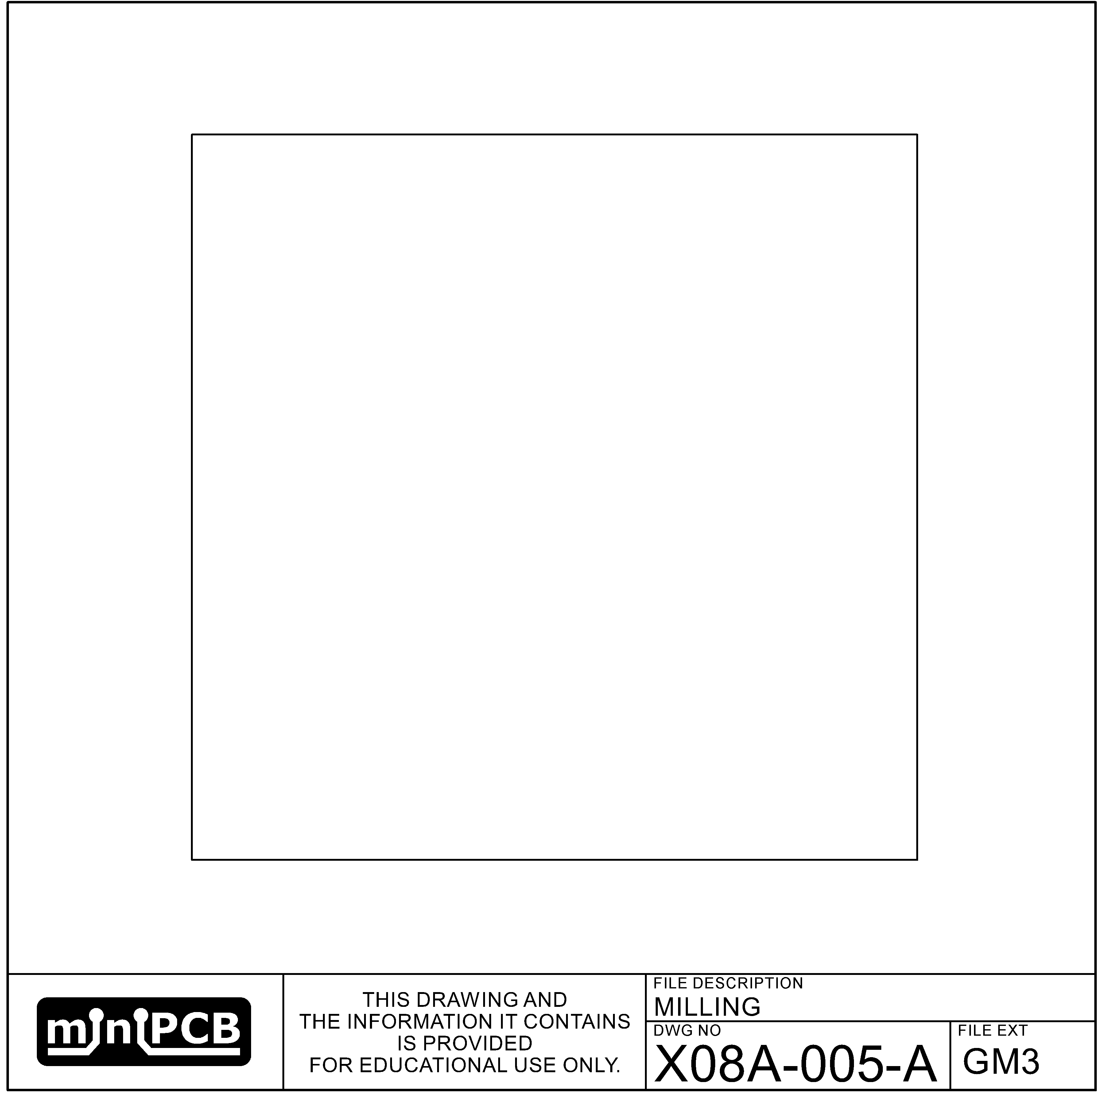

# Theory of Operation

The purpose of this circuit is to…

This circuit is supplied with a positive DC voltage…

The input stimuli is DC coupled…

The output signal is DC coupled…

# Design Inputs

## Design Requirements Form

|  |  |  |  |  |  |  |
| --- | --- | --- | --- | --- | --- | --- |
| **POWER REQUIREMENTS** | | | | | | |
| **PARAMETER NAME** | **SYMBOL** | | **UNITS** | **LOWER LIMIT** | **TARGET VALUE** | **UPPER LIMIT** |
| Postive DC Supply | +V | | V |  |  |  |
| Negative DC Supply | -V | | V |  |  |  |
| **STIMULI REQUIREMENTS** | | | | | | |
| **PARAMETER NAME** | **SYMBOL** | | **UNITS** | **LOWER LIMIT** | **TARGET VALUE** | **UPPER LIMIT** |
| Signal Voltage, Peak to Peak | $$V_{s}$$ | | V |  |  |  |
| Signal Frequency | $$f_{s}$$ | | Hz |  |  |  |
| Common Mode | $$V_{cm}$$ | | V |  |  |  |
| Source Impedance | $$R_{s}$$ | | Ω |  |  |  |
| **PERFORMANCE CHARACTERISTICS** | | | | | | |
| **PARAMETER NAME** | **SYMBOL** | **UNITS** | | **LOWER LIMIT** | **TARGET VALUE** | **UPPER LIMIT** |
| Quiescient Current | $$I_{q}$$ | A | |  |  |  |
| Voltage Gain | $$A_{v}$$ | V/V | |  |  |  |
| Current Gain | $$A_{i}$$ | A/A | |  |  |  |
| Power Gain | $$A_{p}$$ | P/P | |  |  |  |
| Input Impedance | $$R_{i}$$ | Ω | |  |  |  |
| Output Impedance | $$R_{i}$$ | Ω | |  |  |  |

# Design Outputs

## Parts List Form

|  |  |  |  |  |
| --- | --- | --- | --- | --- |
| **REF DES** | **PART TYPE** | **MFG PART NUMBER** | **PART DESCRIPTION** | **FIND** |
|  |  |  |  | 1 |
|  |  |  |  | 2 |
|  |  |  |  | 3 |
|  |  |  |  | 4 |
|  |  |  |  | 5 |
|  |  |  |  | 6 |
|  |  |  |  | 7 |
|  |  |  |  | 8 |
|  |  |  |  | 9 |
|  |  |  |  | 10 |
|  |  |  |  | 11 |

# Testing Plans

## Developmental Testing

1. Plan each calibration and service test.
2. Predict expected values for each test measurement.
3. Determine if expected values satisfy design requirements.
4. Assemble a prototype that is representative of what might be the final design.
5. Perform the calibration and service testing plans.
6. Determine if the design outputs satisfy design requirements.

## Calibration and Service Testing

1. With power off, measure resistances between each pin.
2. If measured resistances are not as expected, end testing fail, components need to be replaced.
3. With power on, measure voltages at each pin.
4. If measured voltages are not as expected, end testing fail, components need to be replaced.
5. With power on, adjust potentiometer PX such that the voltage at test point TPX is ##.
6. If measured voltages cannot be adjusted to an expected value, end testing fail, components need to be replaced.
7. With power on, apply stimuli and measure outputs.
8. If measured output signals are not as expected, end testing fail, components need to be replaced.
9. If measured output signals are as expected, end testing pass.-

# Design Example

## Design Inputs

|  |  |  |  |  |  |  |
| --- | --- | --- | --- | --- | --- | --- |
| **POWER REQUIREMENTS** | | | | | | |
| **PARAMETER NAME** | **SYMBOL** | | **UNITS** | **LOWER LIMIT** | **TARGET VALUE** | **UPPER LIMIT** |
| Postive DC Supply | +V | | V | 4.9 | 5 | 5.1 |
| Negative DC Supply | -V | | V |  |  |  |
| **STIMULI REQUIREMENTS** | | | | | | |
| **PARAMETER NAME** | **SYMBOL** | | **UNITS** | **LOWER LIMIT** | **TARGET VALUE** | **UPPER LIMIT** |
| Signal Voltage, Peak to Peak | $$V_{s}$$ | | V | 0.015 | 0.02 | 0.025 |
| Signal Frequency | $$f_{s}$$ | | Hz |  |  |  |
| Common Mode | $$V_{cm}$$ | | V |  |  |  |
| Source Impedance | $$R_{s}$$ | | Ω |  |  |  |
| **PERFORMANCE CHARACTERISTICS** | | | | | | |
| **PARAMETER NAME** | **SYMBOL** | **UNITS** | | **LOWER LIMIT** | **TARGET VALUE** | **UPPER LIMIT** |
| Quiescient Current | $$I_{q}$$ | A | |  |  |  |
| Voltage Gain | $$A_{v}$$ | V/V | |  |  |  |
| Current Gain | $$A_{i}$$ | A/A | |  |  |  |
| Power Gain | $$A_{p}$$ | P/P | |  |  |  |
| Input Impedance | $$R_{i}$$ | Ω | |  |  |  |
| Output Impedance | $$R_{i}$$ | Ω | |  |  |  |

## Design Outputs

|  |  |  |  |  |
| --- | --- | --- | --- | --- |
| **PARTS LIST** | | | | |
| **QTY REQ** | **REFERENCE DESIGNATORS** | **MFG PART NUMBER** | **PART DESCRIPTION** | **FIND** |
| 3 | R1, R2, R5 |  | RESISTOR, 1.5K, 1/4W, 1% | 1 |
| 2 | R3, R4 |  | 100 | 2 |
| 1 | Q1 |  | 2N2222 | 3 |
| 1 | C1 |  | 10u | 4 |
| 1 | C2 |  | 1u | 5 |
| 1 | C3 |  | 0.1u | 6 |
|  |  |  |  |  |

# Developmental Tests per Example

# Test Report per Example

# Change and Liability Notice

This document is subject to change without notice. While effort has been made to ensure the accuracy of the material contained within this document, Nolan Manteufel shall under no circumstances be liable for incidental or consequential damages or related expenses resulting from the use of this document.

# Trademark Notice

miniPCB is a trademark of Nolan Manteufel.

This datasheet does not constitute permission to use the miniPCB trademark.

|  |  |  |
| --- | --- | --- |
| WORDMARK | FIGUREMARK | FIGUREMARK |
| miniPCB™ | A picture containing drawing  Description automatically generated™ | Icon  Description automatically generated™ |

# Revision History

|  |  |  |  |
| --- | --- | --- | --- |
| REV | DESCRIPTION | ECO | DATE |
| A | Initial Release |  |  |
|  |  |  |  |