Submission Screenshots:

* Create an Account Empty Page: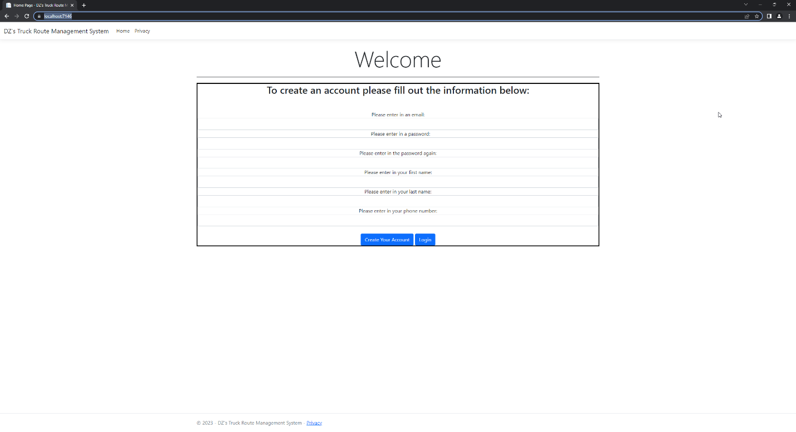
* Create an Account with all Required:

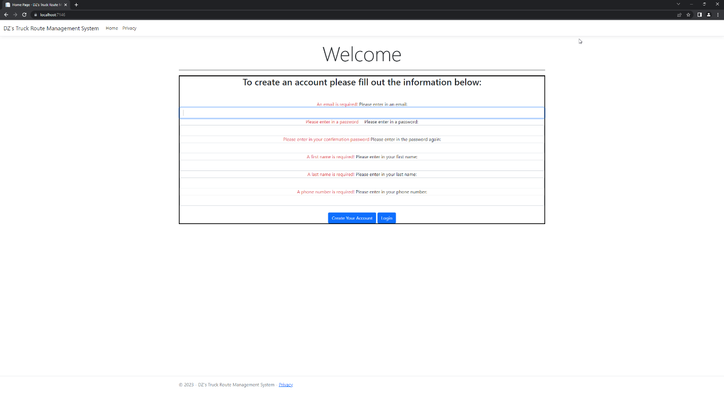

* Create an Account with same Email Error:

* Create an Account with Phone number needing Correct format:Graphical user interface

  Description automatically generated

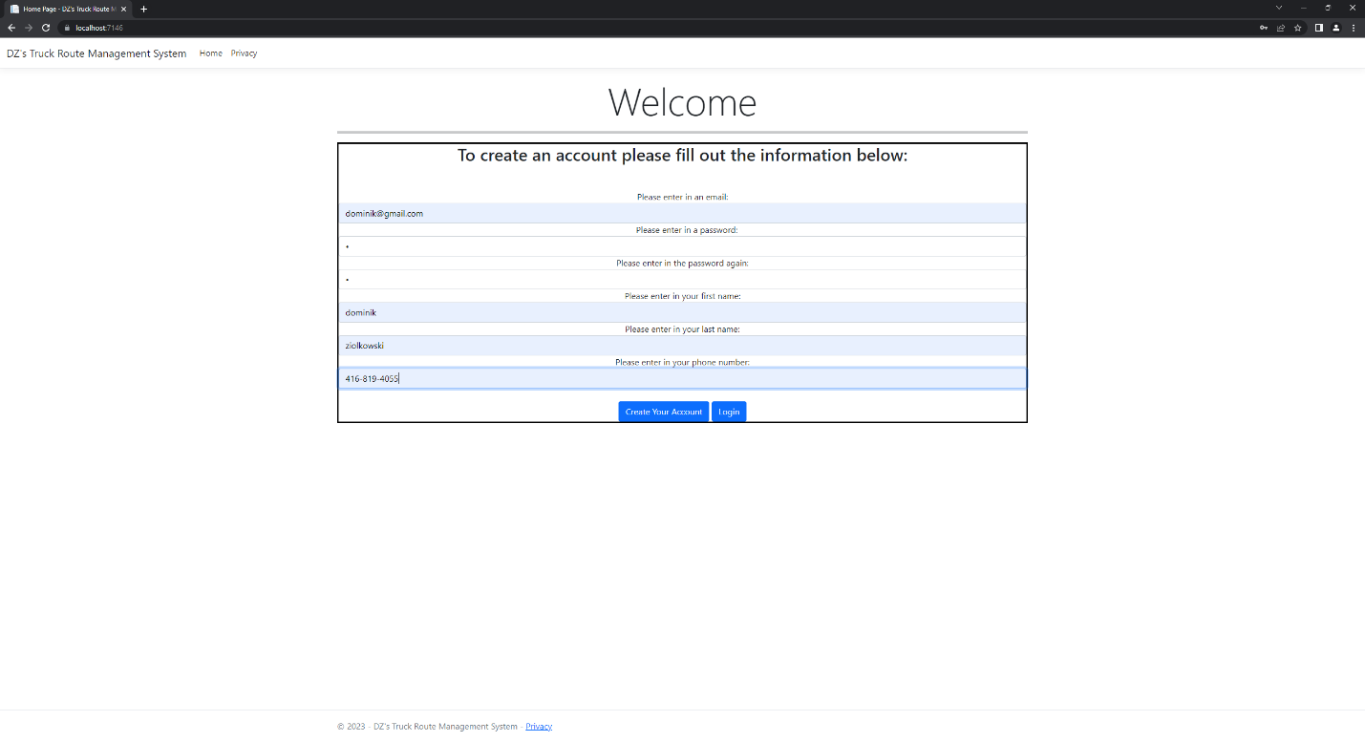

* Login Page:

* Login Page Error – Email or Password:

* Dashboard Empty: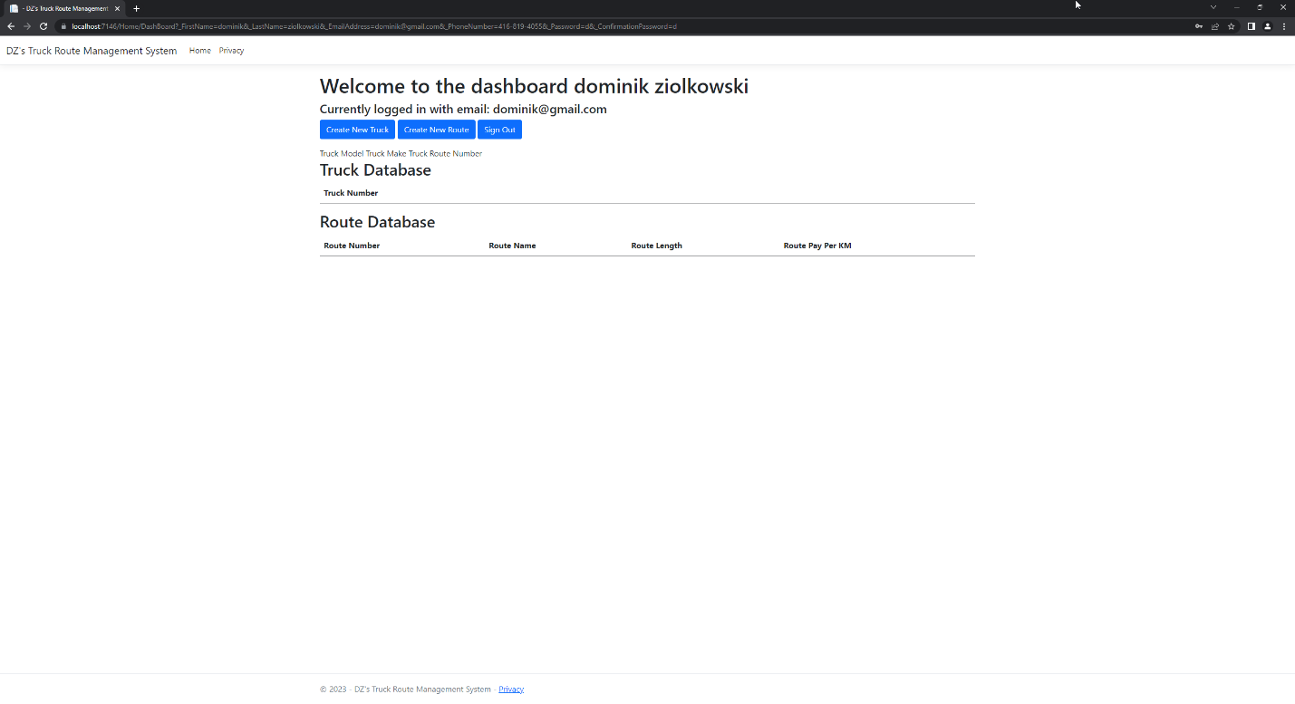
* Accessing Dashboard non logged in – returns to login:

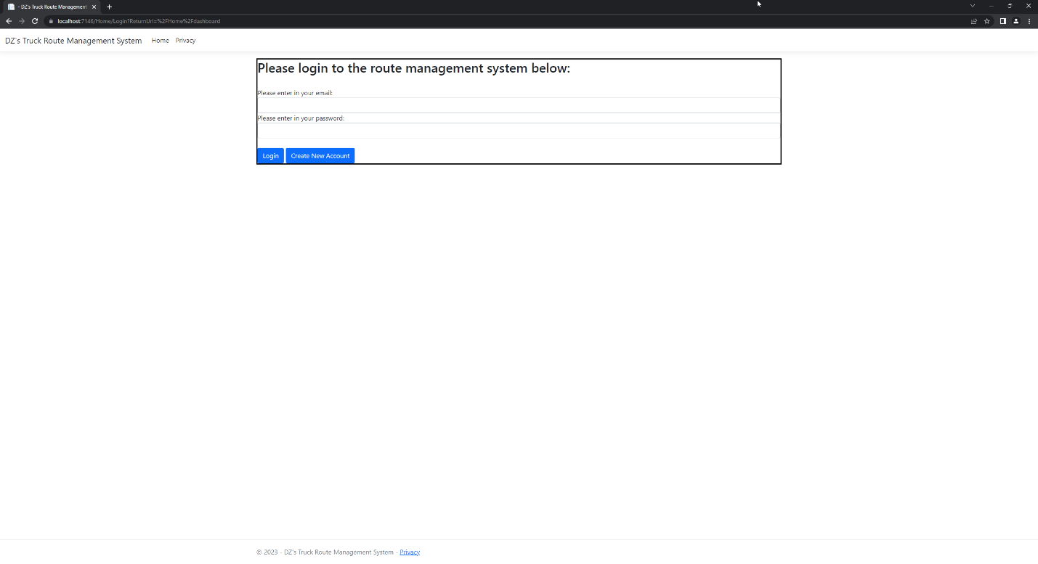

* Add a Truck page: Graphical user interface, text, application, email

  Description automatically generated
* Add a route page:

* Dashboard After Added Stuff: Graphical user interface, application, table

  Description automatically generated