Submission Screenshots:

* Commands For Database:

* HomeController Functionalities:

* Data Annotations on the model classes:

* API Controller Truck:

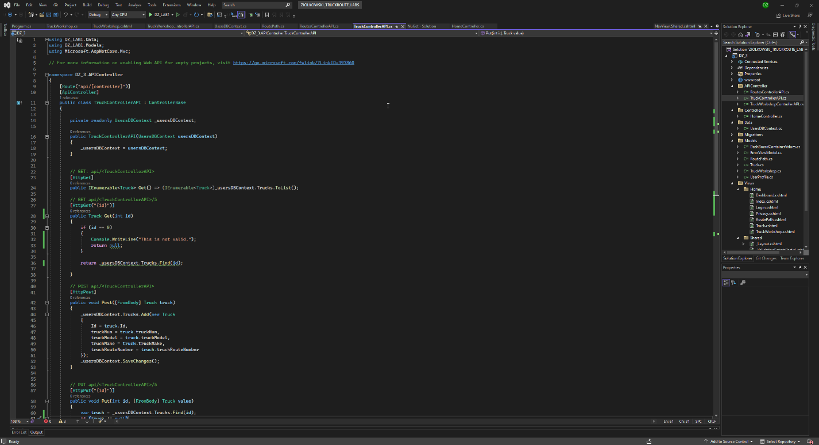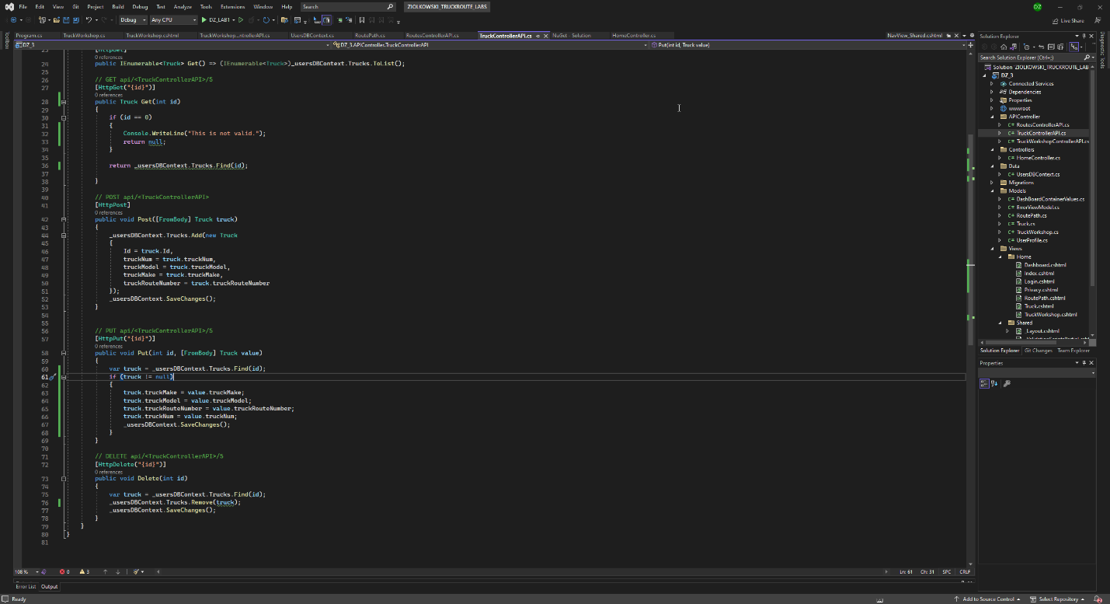

* API Controller Route:

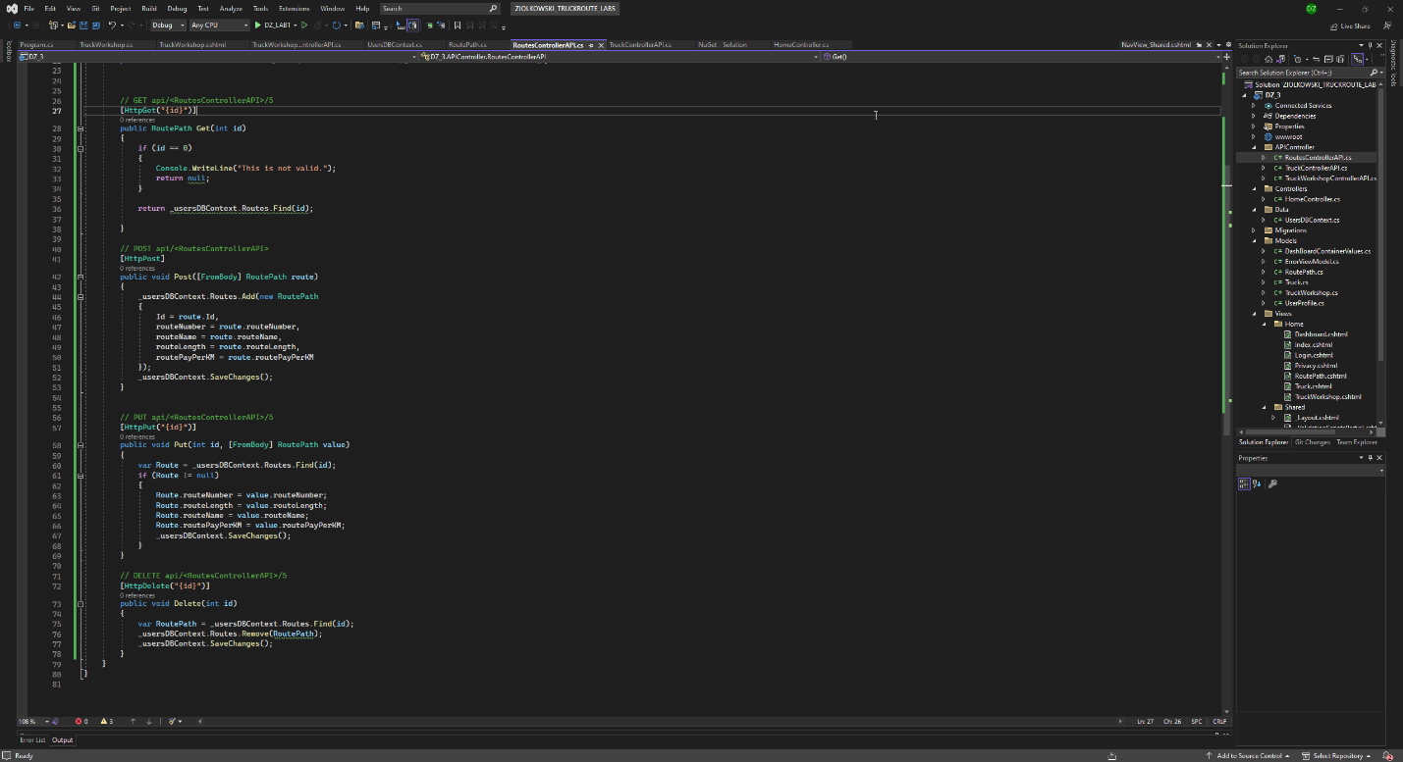

* API Controller Truck Workshop: 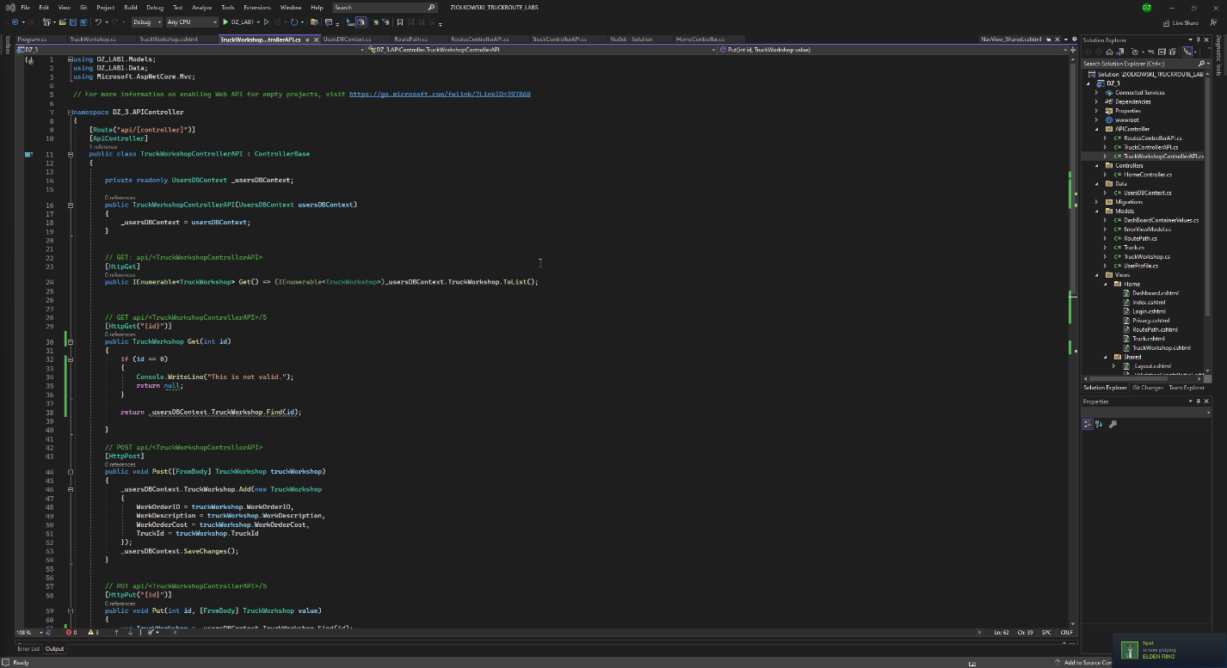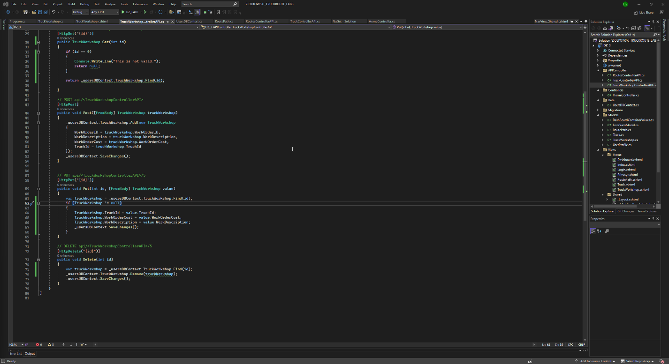
* API Documentation:

* PostMan For Trucks
  + PostGraphical user interface

    Description automatically generated
  + GetGraphical user interface, text, application

    Description automatically generated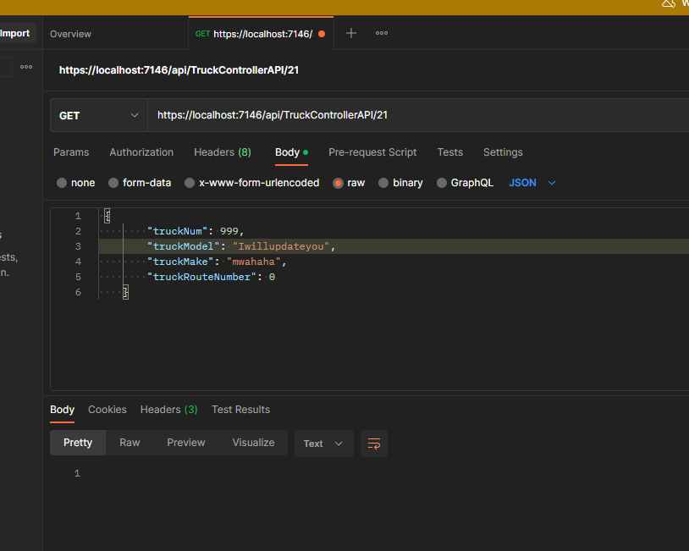
  + Get/idA screenshot of a computer

    Description automatically generated
  + Put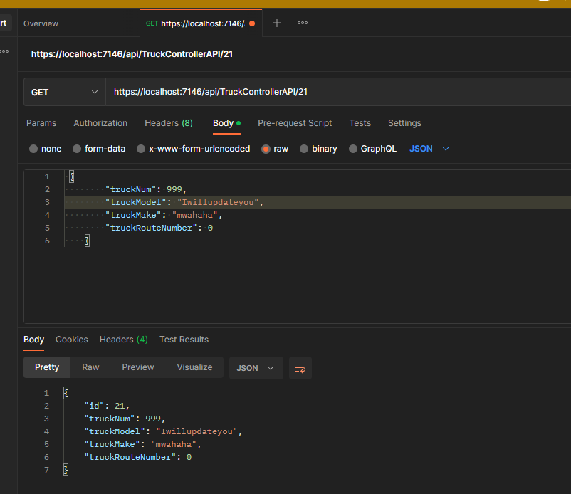
  + Delete

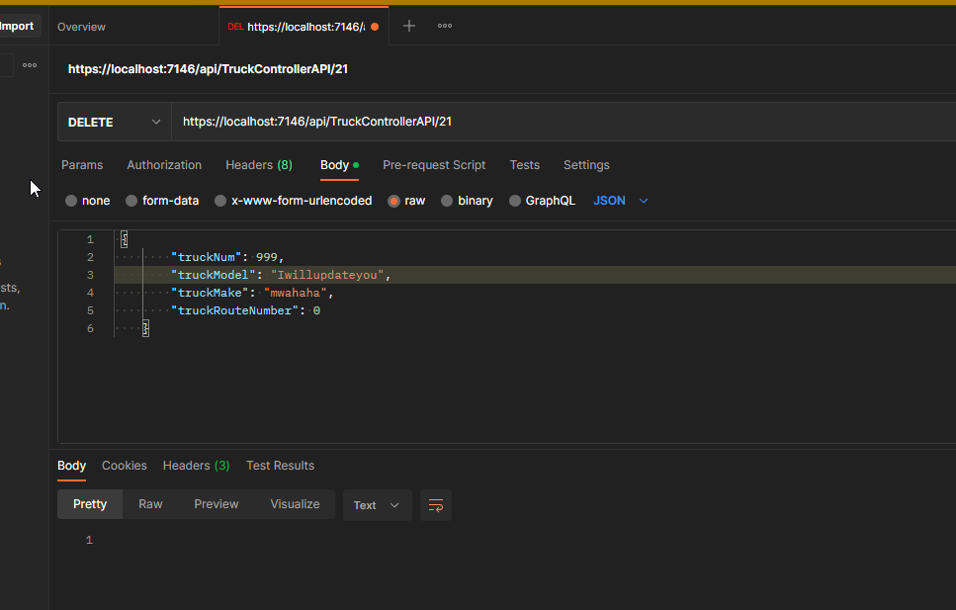

* PostMan For Truck WorkShop
  + PostA screenshot of a computer

    Description automatically generated
  + Get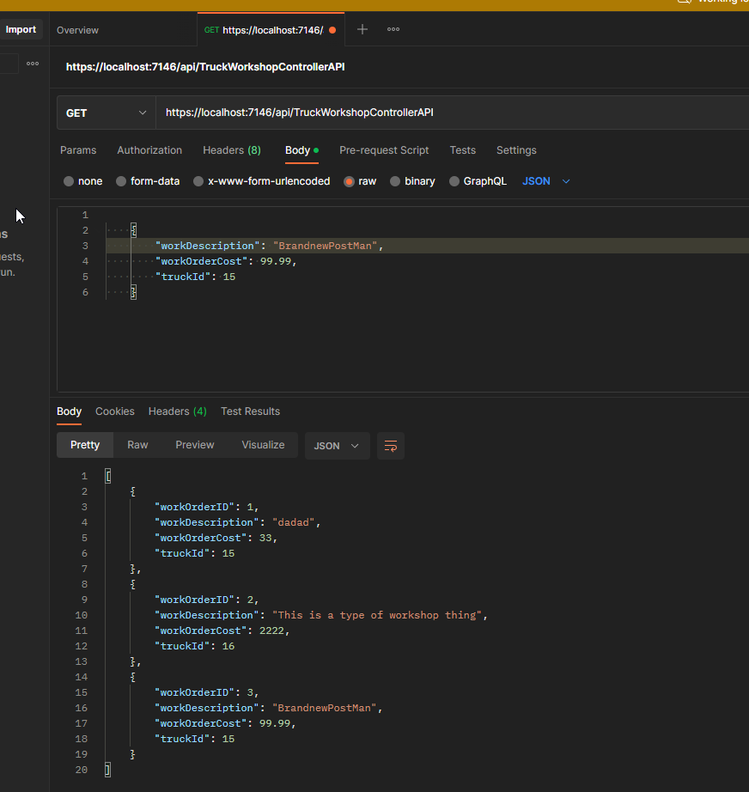
  + Get/id

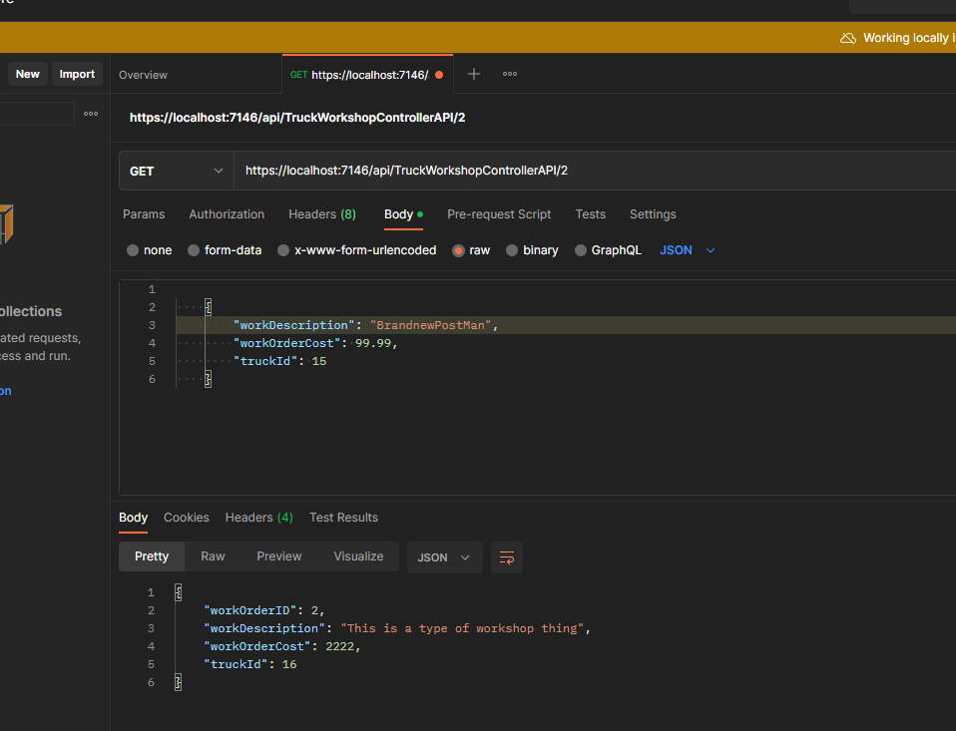

* + PutA screenshot of a computer

    Description automatically generated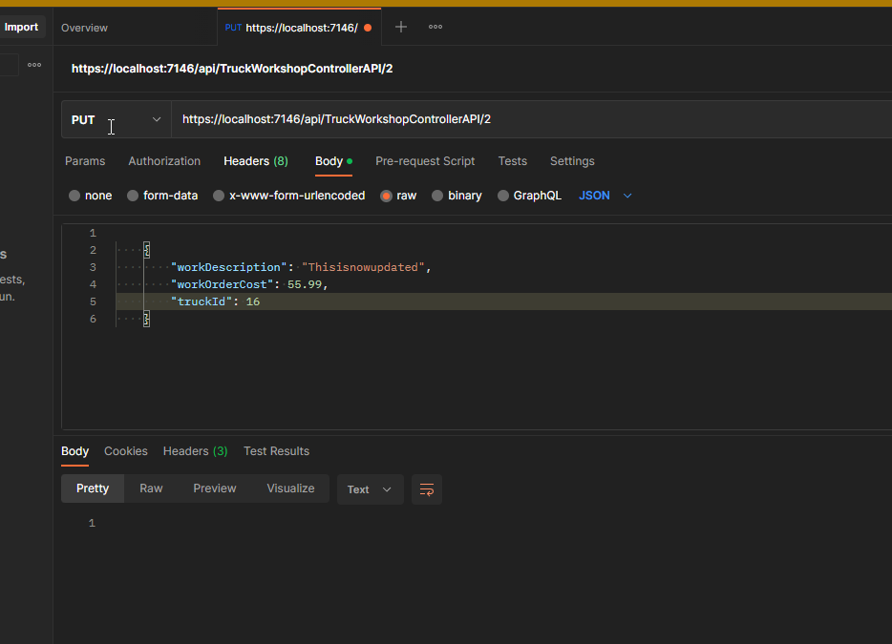
  + Delete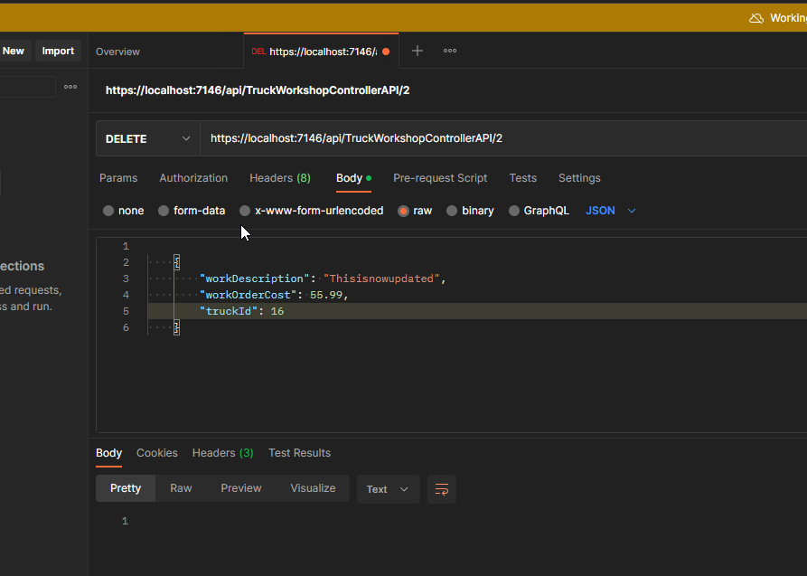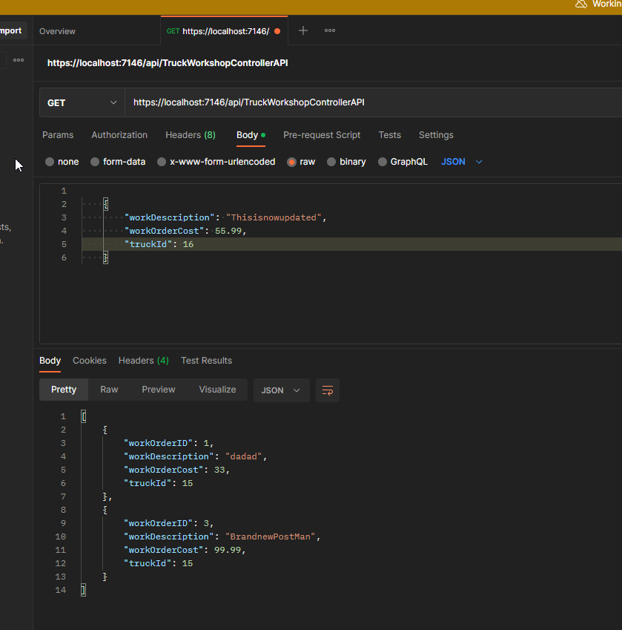
* PostMan For Routes
  + PostA screenshot of a computer

    Description automatically generated
  + Get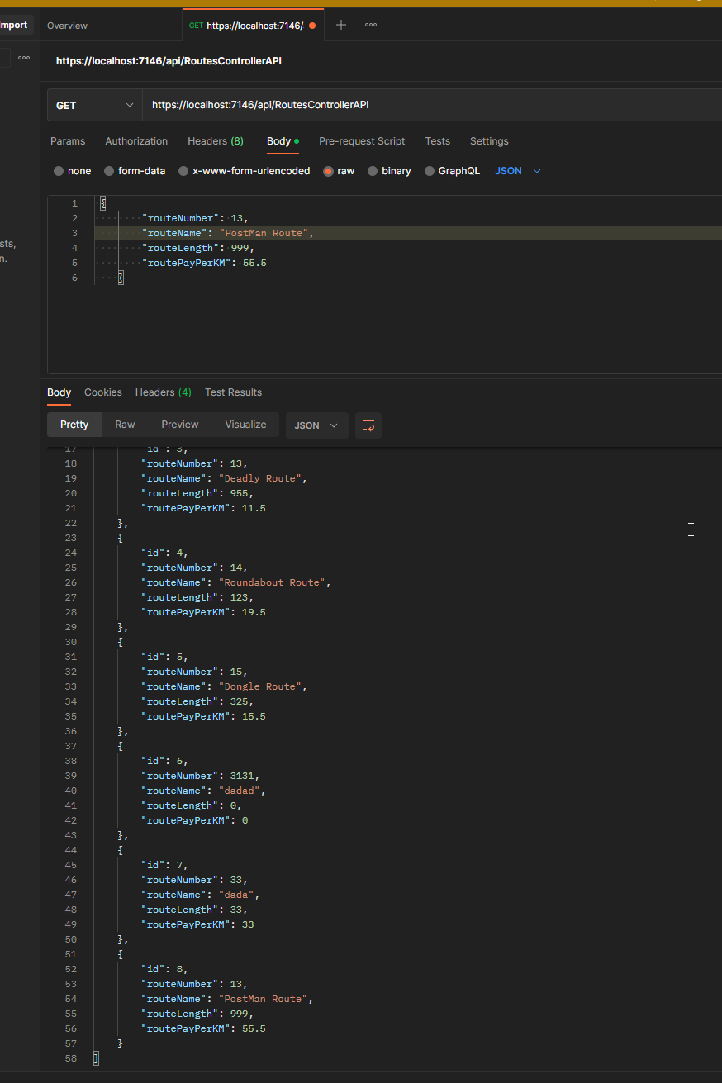
  + Get/id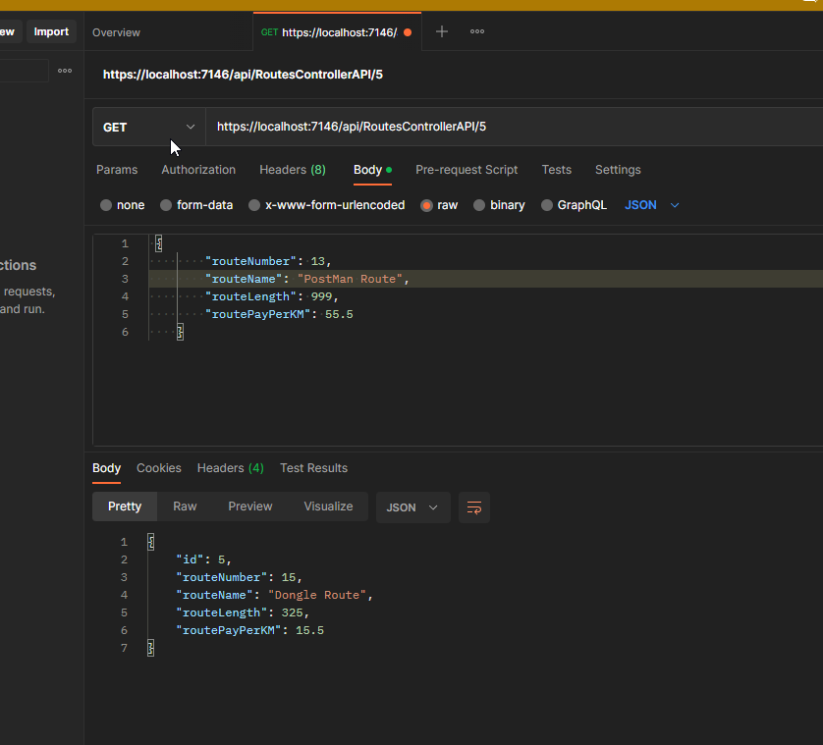
  + Put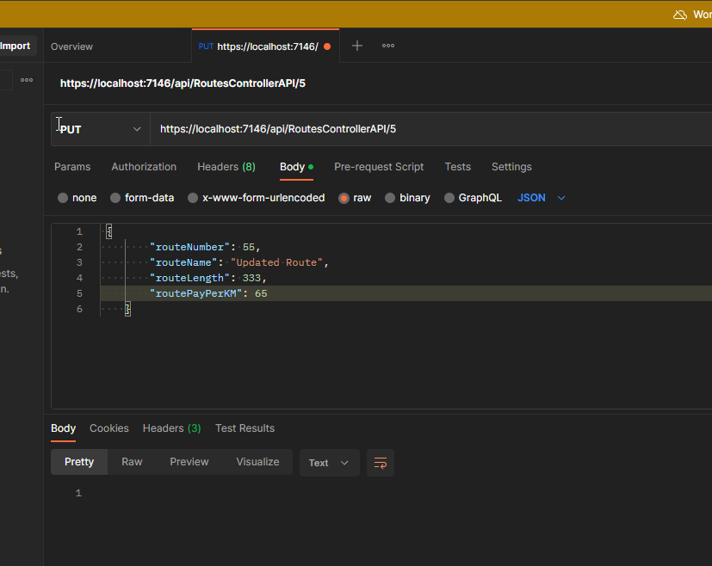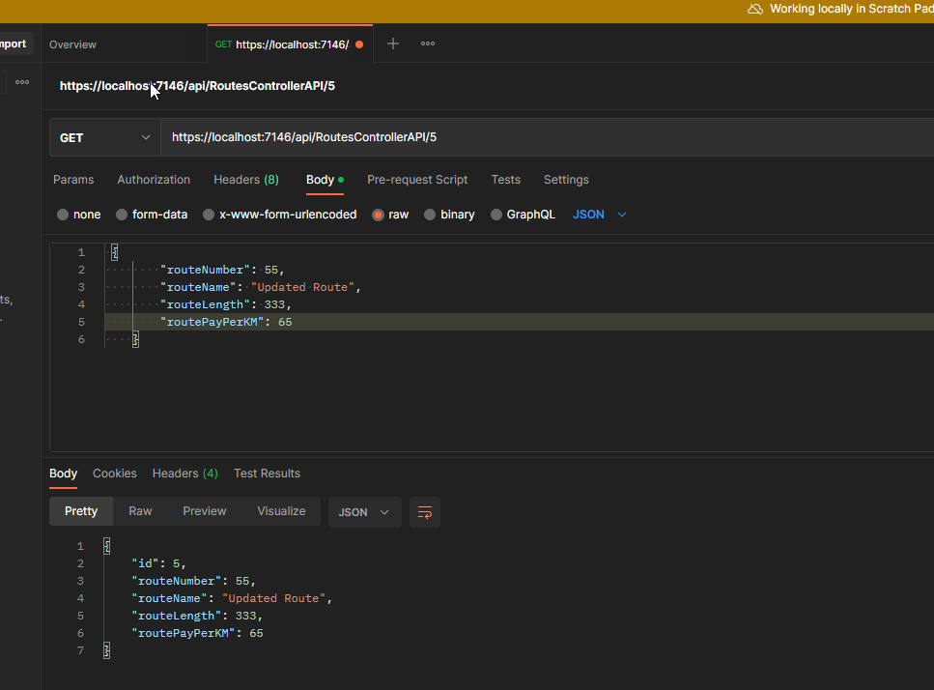
  + Delete