React Native Mobile App Development in VS Code
Beginner Setup, Coding, Preview, Troubleshooting, and Android APK Build Guide
Purpose of this guide
A practical Windows-focused walkthrough for creating an Expo/React Native app in Visual Studio Code, previewing it on a phone or emulator, editing the user interface, resolving common setup errors, and producing an Android installer (.apk).

Recommended beginner path
Step | Action | Result
1 | Install tools | VS Code + Node.js LTS
2 | Create project | Expo / create-expo-app
3 | Run project | npx expo start
4 | Code the UI | src/app/index.tsx or the project entry screen
5 | Preview | Expo Go on a phone; browser or emulator as alternatives
6 | Build installer | EAS Build -> Android .apk

Guide date: August 2026

Contents
1. What you are installing
2. Install VS Code and Node.js
3. Fix the PowerShell npm.ps1 error
4. Create your first Expo / React Native project
5. Understand the project folders
6. Start and preview the app
7. Add textboxes, buttons, labels, and other components
8. Android SDK / adb error and emulator setup
9. Expo Go incompatibility on iPhone
10. Convert the app to an Android installer (.apk)
11. Troubleshooting reference
12. Quick command reference
13. Official reference links

1. What you are installing
React Native lets you build mobile applications using JavaScript or TypeScript and React. For a beginner, Expo provides the simplest way to create, run, and test a React Native project without configuring all native Android/iOS tools on day one.
Important distinction
VS Code is where you write and edit the code. The visual preview runs on a real phone, a web browser, or an Android emulator. VS Code itself is not a drag-and-drop Android designer.

Core tools you will use:
- Visual Studio Code - code editor.
- Node.js LTS - provides node and npm.
- Expo - creates and runs the React Native project.
- Expo Go - convenient preview app on supported physical phones.
- Android Studio - optional at first; needed for the Android emulator and local Android SDK tools.
- EAS CLI - used later to create installable Android builds in the cloud.

2. Install VS Code and Node.js
1. Install Visual Studio Code
Download and install VS Code, then open it.
VS Code download page
2. Install Node.js LTS
Install the current Long-Term Support (LTS) release of Node.js.
Node.js download page
3. Restart VS Code
After Node.js installation, fully close and reopen VS Code so the terminal sees the new PATH entries.
4. Verify Node.js and npm
node --version
npm --version

Expected result
Both commands should print version numbers. If node works but npm gives a PowerShell security error, use the next section.

3. Fix the PowerShell npm.ps1 error
On Windows PowerShell, you may see an error similar to: “npm.ps1 cannot be loaded because running scripts is disabled on this system.” This is a PowerShell execution-policy issue, not a broken Node.js installation.
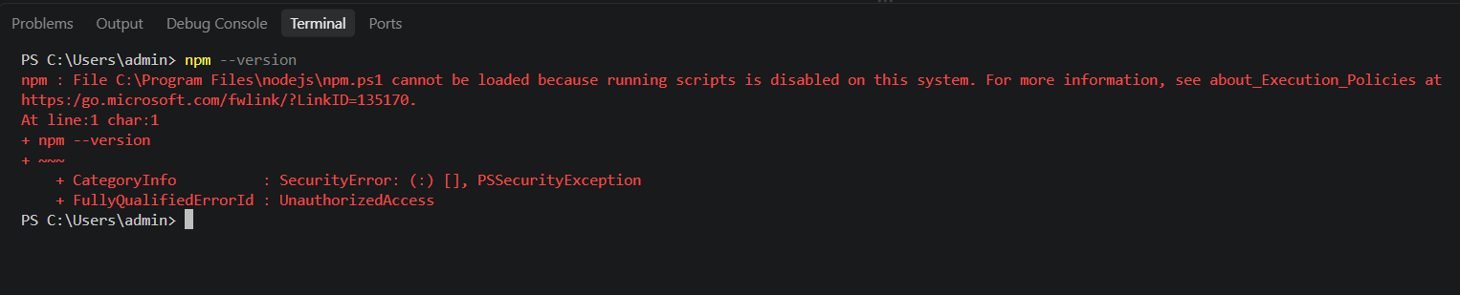
Example: PowerShell blocks npm.ps1 because script execution is disabled.
1. Allow locally created scripts for your Windows user
Set-ExecutionPolicy -Scope CurrentUser -ExecutionPolicy RemoteSigned

When PowerShell asks for confirmation, enter Y and press Enter.
2. Close and reopen the VS Code terminal
3. Test npm again
npm --version

Alternative if you prefer not to change the execution policy
Use Command Prompt instead of PowerShell in VS Code: Terminal -> New Terminal -> use the terminal profile dropdown -> Command Prompt. npm normally runs there without the PowerShell script-policy restriction.

4. Create your first Expo / React Native project
In a VS Code terminal, move to the folder where you want to keep your projects, then create the app.
npx create-expo-app@latest MyFirstApp
cd MyFirstApp

If the VS Code command-line launcher is available, you can open the project folder with:
code .

If code . is not recognized
Use File -> Open Folder in VS Code and select the MyFirstApp folder. The code command is convenient but not required.

Before running the app, a useful check is:
dir

This lists the project files and folders. Depending on the Expo template, the exact folder structure can differ.

5. Understand the project folders
A common source of confusion is expecting every project to contain App.tsx. Newer Expo templates can use Expo Router and place screens under a src/app folder instead.
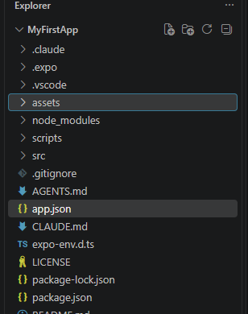
Example project Explorer: this project has a src folder and no App.tsx at the root.
Typical locations to check, in this order:
- src/app/index.tsx
- app/index.tsx
- App.tsx
- App.js
Folder names are not terminal commands
Typing app/ by itself in PowerShell tries to execute a command named app. To enter a folder, use cd app. To open a file, click it in the VS Code Explorer.

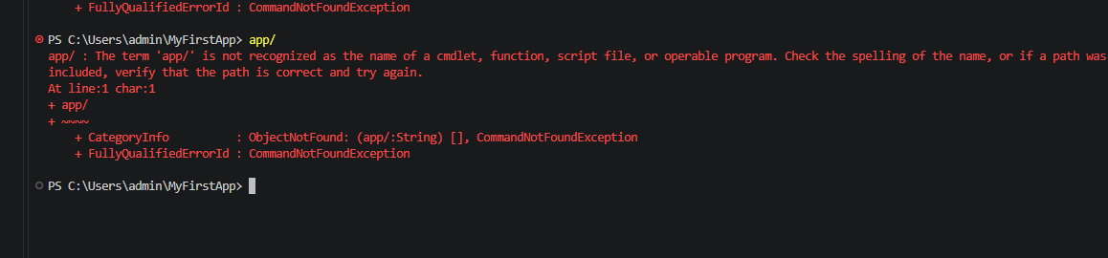
Example: PowerShell reports app/ as an unrecognized command.
dir
cd src
dir
cd app
dir

You do not need to enter the app folder to start Expo. Normally you run Expo from the project root, for example C:\Users\admin\MyFirstApp.

6. Start and preview the app
1. Return to the project root
cd C:\Users\admin\MyFirstApp

2. Start Expo
npx expo start

Option A - Preview on a real phone (recommended for beginners)
Install Expo Go on the phone when the project SDK is supported by the current Expo Go release. Keep the computer and phone on the same network, then scan the QR code shown by Expo.
If the QR code does not connect
Try tunnel mode:

npx expo start --tunnel

Option B - Preview in a web browser
With Expo running, press W in the terminal. This is useful for quick layout checks, but web rendering can differ from a real Android device.

Option C - Preview in an Android emulator
Install Android Studio, create an Android Virtual Device, and configure the Android SDK. With Expo running, press A to open the app on the emulator.

7. Add textboxes, buttons, labels, and other components
React Native user interfaces are normally written as components in .tsx or .js files. There is no requirement to drag controls onto a visual form. You add components in code and see the result update in your preview.
Common React Native UI components:
Component | Purpose
View | Container used for layout.
Text | Labels and text content.
TextInput | Textbox / editable input field.
Button | Simple button.
Pressable | Custom clickable / touchable area.
Image | Displays images.
ScrollView | Scrollable content area.
FlatList | Efficient list of repeated items.

Example screen for src/app/index.tsx (or your project's main screen file):
import { useState } from "react";
import { View, Text, TextInput, Button, StyleSheet } from "react-native";
export default function HomeScreen() {
const [name, setName] = useState("");
return (
<View style={styles.container}>
<Text style={styles.title}>My First Android App</Text>
<TextInput
value={name}
onChangeText={setName}
placeholder="Enter your name"
style={styles.input}
/>
<Button
title="Submit"
onPress={() => alert(`Hello ${name || "there"}!`)}
/>
</View>
);
}
const styles = StyleSheet.create({
container: {
flex: 1,
justifyContent: "center",
padding: 24,
},
title: {
fontSize: 26,
fontWeight: "bold",
marginBottom: 20,
},
input: {
borderWidth: 1,
borderColor: "#999",
borderRadius: 8,
padding: 12,
marginBottom: 16,
},
});

Development loop
Edit the screen in VS Code -> save the file -> Expo reloads/refreshes -> inspect the change on your phone, browser, or emulator.

8. Android SDK / adb error and emulator setup
If Expo reports that the Android SDK path cannot be found and adb is not recognized, Expo is trying to use Android native tools that are not installed or not on PATH.
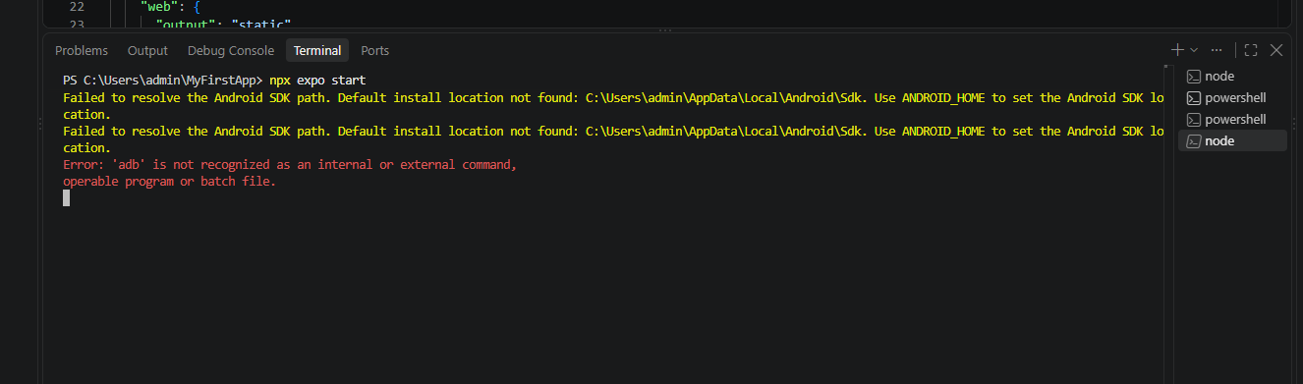
Example: missing Android SDK path and adb command.

Fast workaround - use a real phone
If you only want to code and preview, use Expo Go on a supported physical phone and do not press A in the Expo terminal. This avoids Android Studio setup initially.

Full solution - install Android Studio and configure SDK tools
- Install Android Studio.
- Use Android Studio SDK Manager to install an Android SDK platform, Android SDK Platform-Tools, and Android Emulator.
- Create an Android Virtual Device (AVD) in Device Manager.
- Confirm the SDK location. A common Windows location is C:\Users\<your-user>\AppData\Local\Android\Sdk.
- Set ANDROID_HOME to the SDK path.
- Add the platform-tools folder to the Windows PATH so adb can be found.
- Restart VS Code after changing environment variables.
Example environment values:
ANDROID_HOME=C:\Users\admin\AppData\Local\Android\Sdk
PATH entry: C:\Users\admin\AppData\Local\Android\Sdk\platform-tools

Test ADB:
adb --version

If adb is still not recognized
Verify that the platform-tools folder actually contains adb.exe, confirm the PATH entry has no typo, then close all VS Code windows and reopen VS Code.

9. Expo Go incompatibility on iPhone
On a physical iPhone, the App Store generally provides the current Expo Go version. If the project uses an unsupported Expo SDK, the phone may report that the project and Expo Go are incompatible even when no newer App Store update is visible.
Start with these checks from the project root:
npx expo-doctor
npm list expo

Then repair package versions that do not match the installed Expo SDK:
npx expo install --fix

Restart Expo with a clean cache:
npx expo start -c

iPhone-specific limitation
A physical iPhone does not normally allow installing an older Expo Go version to match an old project SDK. The usual fix is to move the project to a supported SDK version, or use an appropriate development-build workflow.

If starting a new project specifically for Expo Go on a physical device, check Expo's current “Create a project” page for the SDK version currently supported by Expo Go, because compatibility changes over time.

10. Convert the app to an Android installer (.apk)
For direct installation on an Android phone, build an APK. Expo EAS Build can create the binary in the cloud, so you do not need a fully configured local Android SDK just to produce the installer.
1. Install the EAS command-line tool
npm install -g eas-cli

2. Sign in to your Expo account
eas login

3. Configure EAS Build
eas build:configure

This creates or updates an eas.json file.
4. Configure a preview APK profile
{
"build": {
"preview": {
"distribution": "internal",
"android": {
"buildType": "apk"
}
},
"production": {}
}
}

5. Build the Android APK
eas build --platform android --profile preview

On the first build, EAS may ask to generate or manage Android signing credentials. For a beginner setup, allowing EAS to manage the keystore is usually the simplest choice.
6. Install the APK on the Android phone
When the build finishes, open the build link on the Android device, download the .apk, and install it. Android may ask permission to install apps from that browser or file manager.
APK vs AAB
APK (.apk) is suitable for direct installation and testing. AAB (.aab) is the standard production artifact for Google Play. The default production EAS profile normally creates an AAB unless you explicitly configure an APK.

Production / Google Play build command:
eas build --platform android --profile production

11. Troubleshooting reference
Use this table as a quick diagnosis guide. Start with the most likely cause and apply the listed fix.
Problem / message | Likely cause | Solution
npm.ps1 cannot be loaded | PowerShell script execution policy blocks npm.ps1 | Run Set-ExecutionPolicy -Scope CurrentUser -ExecutionPolicy RemoteSigned, or use Command Prompt.
npm is not recognized | Node.js/npm is missing or VS Code has not refreshed PATH | Install Node.js LTS, restart VS Code, then run node --version and npm --version.
app/ is not recognized | A folder name was typed as if it were a command | Use cd app to enter the folder, or click the folder in Explorer.
No App.tsx | The template uses Expo Router / a newer project structure | Look for src/app/index.tsx or app/index.tsx and edit the screen file there.
Android SDK path not found | Android Studio SDK is not installed/configured | Use a real phone for now, or install Android Studio and set ANDROID_HOME.
'adb' is not recognized | Android platform-tools are missing from PATH | Install SDK Platform-Tools and add <SDK>\platform-tools to PATH. Restart VS Code.
Expo Go says project is incompatible | Project SDK is not supported by the installed Expo Go | Run npx expo-doctor, npm list expo, npx expo install --fix, then npx expo start -c. Follow Expo's current SDK upgrade guidance if needed.
QR code will not connect | Phone/computer networking issue | Use the same network; try npx expo start --tunnel; temporarily check firewall/network restrictions.
Changes do not appear | Metro cache or app refresh issue | Save the file; reload the app; restart with npx expo start -c if necessary.
Cannot find node_modules | Dependencies were not installed or were removed | Run npm install from the project root.
EAS command not found | EAS CLI not installed or terminal has old PATH | Run npm install -g eas-cli, reopen the terminal, then eas --version.
APK installs are blocked | Android blocks unknown installation sources | Allow installation from the browser/file manager used to open the APK, then install the trusted build.

12. Quick command reference
Task | Command
Check Node.js | node --version
Check npm | npm --version
Create Expo project | npx create-expo-app@latest MyFirstApp
Enter project folder | cd MyFirstApp
List files | dir
Start Expo | npx expo start
Start Expo with tunnel | npx expo start --tunnel
Clear Expo cache | npx expo start -c
Check Expo project health | npx expo-doctor
Show installed Expo version | npm list expo
Repair Expo package versions | npx expo install --fix
Check ADB | adb --version
Install EAS CLI | npm install -g eas-cli
Log in to EAS | eas login
Configure EAS build | eas build:configure
Build Android APK | eas build --platform android --profile preview
Build Android Play Store bundle | eas build --platform android --profile production

13. Official reference links
- Expo - Create a project
- Expo - Create your first app
- Expo - Development tools / Expo Go compatibility
- Expo - Build APKs for Android devices and emulators
- Expo - EAS Build introduction
- Expo - Submit Android apps
- React Native - Set up your environment
Final recommendation
For the simplest learning experience: write code in VS Code, preview on a real phone, and use EAS Build when you need an Android APK. Add Android Studio only when you specifically need an emulator, ADB, native Android tooling, or local builds.

