Designing Android at Scale
Volume 3 — Lifecycle, Background & Media
Prakash Sharma
First Edition · 2026

Table of Contents
- Copyright
- Preface
- How to Read This Book
- The Series at a Glance
- Part VI — Lifecycle, Background & Platform
  - Chapter 44 — Application Lifecycle Management
  - Chapter 45 — App Startup Optimization
  - Chapter 46 — Foreground Services
  - Chapter 47 — Doze, App Standby & Background Execution Limits
  - Chapter 48 — Alarms & Exact Scheduling
  - Chapter 49 — Push Notifications (FCM) Architecture
  - Chapter 50 — Notification Center / Inbox
  - Chapter 51 — Runtime Permissions Management
  - Chapter 52 — Deep Links & App Links Routing
  - Chapter 53 — Navigation Architecture (Multi-Module)
  - Chapter 54 — App Update & Forced-Upgrade Flow
  - Chapter 55 — Widgets & App Shortcuts
- Part VII — Media & Files
  - Chapter 56 — Image Loading & Caching (Coil)
  - Chapter 57 — Thumbnail Generation & Caching
  - Chapter 58 — Media Playback State (Media3/ExoPlayer)
  - Chapter 59 — Offline Media Downloads (OTT)
  - Chapter 60 — Camera Capture Pipeline (CameraX)
  - Chapter 61 — Large File & Streaming Handling
  - Chapter 62 — File Sharing & Content Providers (Storage Access Framework)
- Glossary & Index of Key Terms
- Acknowledgements
- About the Author
- Also in This Series

Copyright
Designing Android at Scale Volume 3 — Lifecycle, Background & Media
Copyright © 2026 Prakash Sharma. All rights reserved.
No part of this publication may be reproduced, stored in a retrieval system, or transmitted in any form or by any means — electronic, mechanical, photocopying, recording, or otherwise — without the prior written permission of the author, except for brief quotations in reviews.
This book is an independent work. All product names, trademarks, and registered trademarks — including Android, Kotlin, and any third-party libraries, services, or platforms referenced — are the property of their respective owners and are used for identification and educational purposes only. Their use does not imply any affiliation with or endorsement by the trademark holders, nor by the author’s employer.
The code, patterns, and architectures in this book are provided for educational purposes “as is,” without warranty of any kind. The author assumes no responsibility for errors or omissions, or for damages resulting from the use of the information herein. Always validate designs against your own requirements, security review, and the current official platform documentation.
StreamCart is a fictional application used throughout this series as a running example. Any resemblance to real products or companies is coincidental.
First Edition · 2026

Preface
Most Android books teach you APIs. This series teaches you to design systems.
There is a large gap between knowing what OkHttp, Room, or WorkManager are and knowing how to compose them into an application that works offline, survives process death, syncs reliably, stays secure, performs on a budget phone, and can be maintained by a large team for years. Closing that gap — moving from API user to system designer — is the goal of Designing Android at Scale.
The complete work spans 100 chapters across eleven parts, published as a five-volume series. Every chapter follows the same rigorous 18-section structure — from problem definition and requirements, through architecture, a complete Kotlin implementation, concurrency and failure analysis, scaling, security, performance, testing, and observability, to a full set of system-design interview questions and exercises. Every chapter is anchored to one running reference application — StreamCart, a fictional e-commerce and streaming app — so the patterns compose into a coherent system rather than floating as isolated recipes.
This is Volume 3 — Lifecycle, Background & Media. It covers Part VI and Part VII:
- Part VI — Lifecycle, Background & Platform (Chapters 44–55): the lifecycle and startup, foreground services, Doze and background limits, alarms, FCM and the notification inbox, runtime permissions, deep links, navigation, app updates, and widgets.
- Part VII — Media & Files (Chapters 56–62): image loading and thumbnails with Coil, Media3/ExoPlayer playback, offline OTT with DRM, the CameraX capture pipeline, large-file streaming, and the Storage Access Framework.
You do not need to read the volumes strictly in order, but each builds on the vocabulary, the layering, and the StreamCart reference application established across the series — most of all on Volume 1 — Foundations, which introduces them.

Who this book is for
This series is written for intermediate-to-senior Android engineers who are comfortable with Kotlin and Jetpack and want to level up to architecture and system design — and for anyone preparing for a senior Android system-design interview, where exactly this skill (composing subsystems with explicit trade-offs under real requirements) is what’s assessed. Chapter 100, the capstone, models that interview end to end.
Let’s design.

How to Read This Book
The 18-section chapter structure. Every chapter is deliberately uniform, so you always know where to find things: Problem Definition → Requirements → System Design Fundamentals → High-Level Architecture → Detailed Component Design → End-to-End Data Flow → Complete Kotlin Implementation → Concurrency & Race Conditions → Failure Scenarios → Scaling → Alternatives & Trade-offs → Security → Performance → Testing → Observability → Interview Preparation → Exercises → Summary & Reference Sheet. Read a chapter top-to-bottom the first time; afterwards, the Summary & Reference Sheet at the end is your quick refresher, and the Interview Preparation section is your drill.
Code. Implementations are in Kotlin, using current Jetpack libraries and idioms (Compose, Coroutines/Flow, Hilt, Room). Snippets are focused on the design point rather than being copy-paste-complete apps; package names and some glue are elided for clarity. Treat the code as a precise description of the design, not a finished module.
Diagrams. Architecture, data-flow, and failure diagrams appear throughout. They are the fast path to the mental model — study them before the prose.
The StreamCart reference app. Every pattern is applied to StreamCart, a fictional e-commerce + streaming application (catalog, cart, checkout, payments, order tracking, streaming, real-time updates, across phone/TV/watch). Reusing one app lets the patterns compose.
Cross-references between volumes. Because the complete work is one 100-chapter book split across five volumes, chapters reference each other by number (for example, “Ch 29” or “Ch 75”). References outside this volume’s chapter range point to other volumes of the series — see The Series at a Glance, next. Each reference is a pointer to where a topic is treated in depth, not a prerequisite you must read first.
Conventions. monospace denotes code, types, APIs, and file paths. Bold marks key terms on first use. Chapter numbers in parentheses — “(Ch 5)” — are cross-references.

The Series at a Glance
Designing Android at Scale is published in five volumes. Each is self-contained, but together they form one continuous 100-chapter system-design curriculum built on the StreamCart reference application.
- Volume 1 — Foundations: Networking & Local Data · Parts I–II · Chapters 1–18 — the networking core, persistence and the single source of truth, threading, dependency injection, and the networking patterns layered on top — search, pagination, caching, and reliability.
- Volume 2 — Security, Offline-First & State · Parts III–V · Chapters 19–43 — authentication and token management, cryptography and the Keystore, secure storage and PII handling, offline-first architecture, the outbox pattern, delta sync and conflict resolution, and shared/global state.
- Volume 3 — Lifecycle, Background & Media · Parts VI–VII · Chapters 44–62 (this volume) — the Android lifecycle and startup, foreground and background work, WorkManager, Doze and background limits, notifications, deep links and navigation, plus media playback with Media3/ExoPlayer, DRM, the camera, and file handling.
- Volume 4 — Real-Time & Feature Architectures · Parts VIII–IX · Chapters 63–81 — WebSocket and SSE, presence and typing, live location, BLE and nearby connections, and the commerce feature stack — feeds, recommendations, cart, checkout, payments, order tracking, reviews, and onboarding.
- Volume 5 — Performance, Scale & Platform Breadth · Parts X–XI · Chapters 82–100 — analytics, crash reporting, distributed tracing, performance and memory, rendering and jank, battery, baseline profiles, modularization, localization, accessibility, theming, Android TV and Wear OS, and the end-to-end StreamCart capstone.
Turn the page to begin.

Part VI — Lifecycle, Background & Platform
Living inside the Android platform: the lifecycle, startup, foreground and background work, Doze and app standby, alarms, WorkManager, notifications, permissions, deep links, navigation, app updates, and widgets.

Chapter 44 — Application Lifecycle Management
Part VI — Lifecycle, Background & Platform · Complexity: Standard (≥25 interview questions)
Prerequisites: Ch 6 (UI state/ViewModel), Ch 8 (process death), Ch 5 (Hilt/ Application), Ch 14/41 (background batching, flush on background). Foundational for Ch 45 (startup), Ch 46/47 (services/Doze), Ch 49 (push).
Reference surface in StreamCart: knowing when the app is foreground vs background, initializing/tearing down app-wide resources at the right time, and doing lifecycle-correct work (flush analytics on background, refresh on foreground).

44.1 Problem Definition and Real-World Context
Android apps don’t have a simple “running/stopped” model — there’s a process, an Application, Activities/Fragments (or Compose destinations), and the whole app moving between foreground and background, each with its own lifecycle. Code that ignores these boundaries leaks, wastes battery, crashes, or misbehaves:
- Work tied to the wrong lifecycle. A network poll or location request started in an Activity keeps running after the user leaves (battery/leak), or a coroutine tied to a destroyed scope crashes.
- No foreground/background awareness. The app can’t tell when it’s backgrounded to flush analytics (Ch 14), pause expensive work, or refresh on return — so it polls while hidden or shows stale data on resume.
- Initializing in the wrong place. Heavy work in Application.onCreate slows every launch (Ch 45); per-Activity re-init duplicates work.
- Leaks from lifecycle misuse. Observing without lifecycle awareness, holding Activity references, or not unregistering callbacks leaks the Activity/memory.
- Process-lifetime assumptions. Treating the Application as permanent misses that the OS kills the process (Ch 8) and that Application.onCreate runs on every cold start.
The architecture: understand the lifecycle hierarchy (process → Application → Activity/Fragment/Compose), use lifecycle-aware components (LifecycleOwner, repeatOnLifecycle, viewModelScope, Ch 6) so work is scoped to the right lifetime, detect app-wide foreground/background via ProcessLifecycleOwner, and place initialization/teardown correctly. This chapter is about doing the right work at the right lifecycle boundary without leaks or waste.

Three practical use cases
- Foreground/background work (StreamCart). Flush batched analytics (Ch 14) and pause real-time connections (Ch 63) when the app backgrounds; refresh/reconnect on foreground.
- Lifecycle-scoped work (all). A screen’s data collection stops when it’s not visible (repeatOnLifecycle, Ch 6); a long task survives navigation via the ViewModel/WorkManager (Ch 30).
- App-wide init (all). Initialize crash reporting/DI/logging once in Application (lightly, Ch 45), and app-wide observers via ProcessLifecycleOwner.

Why this is architectural
Lifecycle management defines what runs when (process/app/screen scopes), how work is bounded and cancelled (no leaks/waste), and how the app reacts to foreground/background — cross-cutting properties that determine correctness, battery, and memory across every feature.

44.2 Requirements Engineering

Functional requirements
ID | Requirement
F1 | Scope work to the correct lifecycle (process/app/screen); cancel when the scope ends.
F2 | Detect app-wide foreground/background transitions.
F3 | Do lifecycle-correct reactions (flush/pause on background; refresh/reconnect on foreground).
F4 | Initialize app-wide resources once, in the right place (lightly).
F5 | Avoid leaks (lifecycle-aware observation; no retained Activity refs).
F6 | Survive config change (ViewModel) and process death (Ch 8).

Non-functional requirements
Attribute | Policy
Correctness | Work bounded to its lifecycle; no crashes on destroyed scopes.
Battery | No background work while hidden (unless intended).
Memory | No lifecycle leaks (LeakCanary, Ch 89).
Performance | Light Application.onCreate (Ch 45).
Maintainability | Lifecycle-aware components, not manual callbacks.

Scope
- In scope: lifecycle hierarchy (process/Application/Activity/Fragment/Compose), LifecycleOwner/repeatOnLifecycle/viewModelScope, ProcessLifecycleOwner (app foreground/background), app-wide init/teardown, leak avoidance, lifecycle in Compose.
- Out of scope: startup optimization (Ch 45), services/Doze (Ch 46/47), process death/SavedState (Ch 8), UI state (Ch 6).

Assumptions & constraints
- Jetpack Lifecycle (androidx.lifecycle), Compose + lifecycle-runtime-compose, Hilt. minSdk 24. Process is ephemeral (Ch 8); Application recreated on each cold start.

44.3 System Design Fundamentals
- The lifecycle hierarchy (nested lifetimes):
  - Process: the OS process. Created on cold start, killed anytime in background (Ch 8). Application.onCreate runs once per process.
  - Application: the app-global object (@HiltAndroidApp), lives as long as the process. Place app-wide, cheap, one-time init here (DI, crash reporting, logging).
  - Activity / Fragment / Compose destination: UI lifecycles (onCreate/onStart/ onResume/onPause/onStop/onDestroy), recreated on config change. Screen-scoped work lives here (but state lives in the ViewModel, Ch 6).
  - App foreground/background: the whole app moving between visible and hidden — observed via ProcessLifecycleOwner.
- Lifecycle-aware components (the modern model). Instead of manual onStart/onStop plumbing, use LifecycleOwner + LifecycleObserver / repeatOnLifecycle(STARTED) / lifecycleScope / viewModelScope (Ch 6) so work automatically starts/stops/cancels with the lifecycle. This is what prevents leaks and wasted work — e.g., repeatOnLifecycle(STARTED) collects a Flow only while the screen is visible.
- ProcessLifecycleOwner (app-wide foreground/background). A single LifecycleOwner for the whole app: ON_START when the app comes to the foreground, ON_STOP when it goes to the background (after the last Activity stops). Use it for app-level reactions: flush analytics (Ch 14), pause/resume WebSockets (Ch 63), pause expensive polling. Don’t infer background from a single Activity’s onStop (config changes / multi-Activity flows mislead).
- Scope selection = correctness + battery. Match work to the lifetime it should have: UI-only work → screen scope (stops when invisible); work that must survive navigation/config → ViewModel (Ch 6); work that must survive the UI/process → WorkManager (Ch 30). Starting long work in a screen scope is the classic bug.
- Init placement. App-wide, cheap, needed-early init → Application.onCreate (keep it light, Ch 45) or App Startup (Ch 45). Per-feature init → lazily when the feature is used (DI, Ch 5). Avoid heavy work in Application.onCreate — it runs on every cold start.
- Compose lifecycle. Composables observe the lifecycle via collectAsStateWithLifecycle and LocalLifecycleOwner; DisposableEffect/ LaunchedEffect tie work to composition + lifecycle (Ch 6/7).
Core insight: scope every piece of work to the correct lifecycle using lifecycle- aware components so it starts/stops/cancels automatically; detect app-wide foreground/ background with ProcessLifecycleOwner for app-level reactions; and place initialization by how early and how broadly it’s needed — correctness and battery follow from right-scoping.

44.4 High-Level Architecture
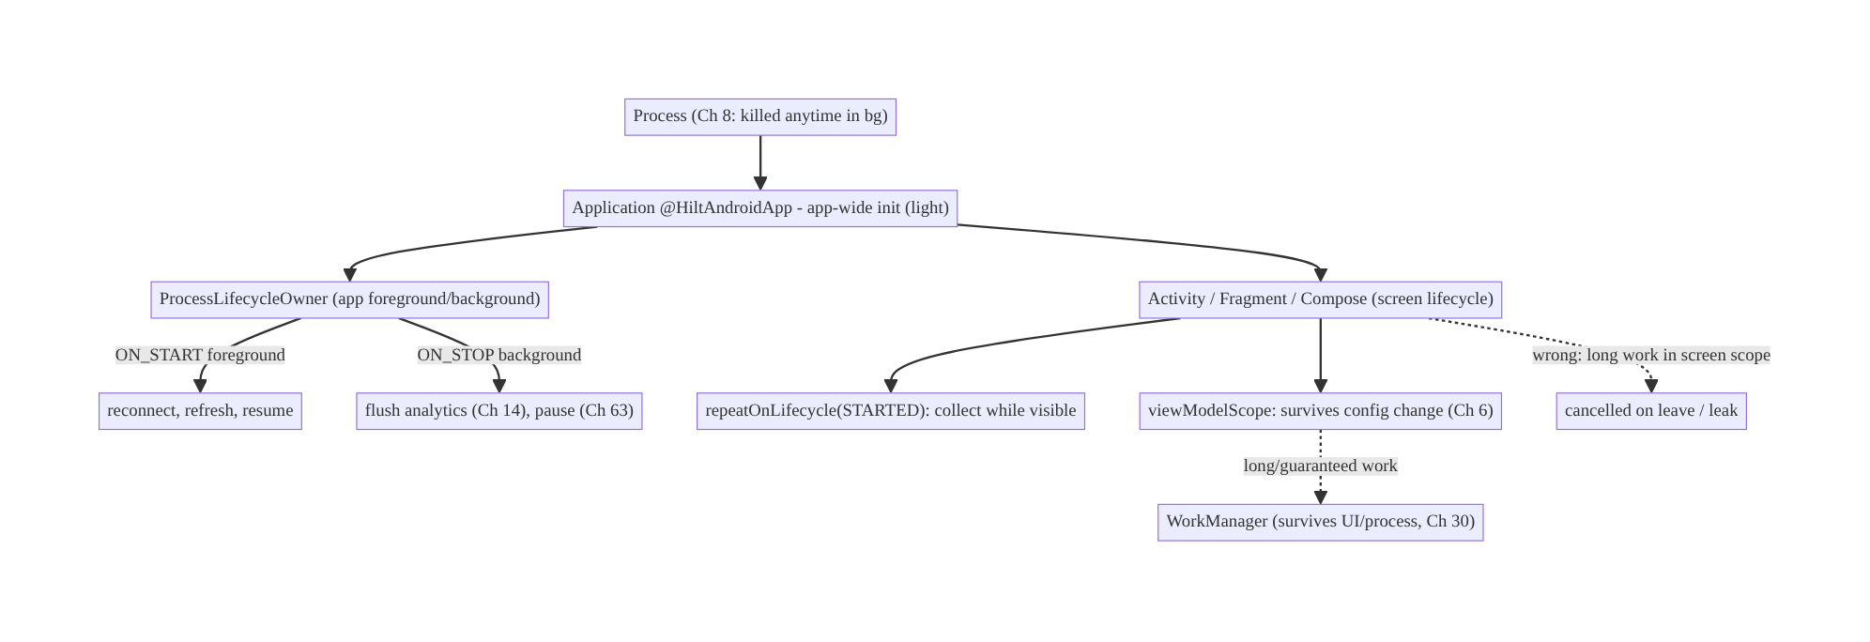
44.4 High-Level Architecture
Components & ownership
- Application does light app-wide init; owns app-scoped singletons (Ch 5).
- ProcessLifecycleOwner signals app foreground/background for app-level reactions.
- Screen lifecycle scopes visible-only work (repeatOnLifecycle); ViewModel scopes config-surviving work; WorkManager for beyond-UI work.
Direction: process → Application → (app lifecycle via ProcessLifecycleOwner) + (screen lifecycles); work scoped to the matching lifetime.

44.5 Detailed Component Design
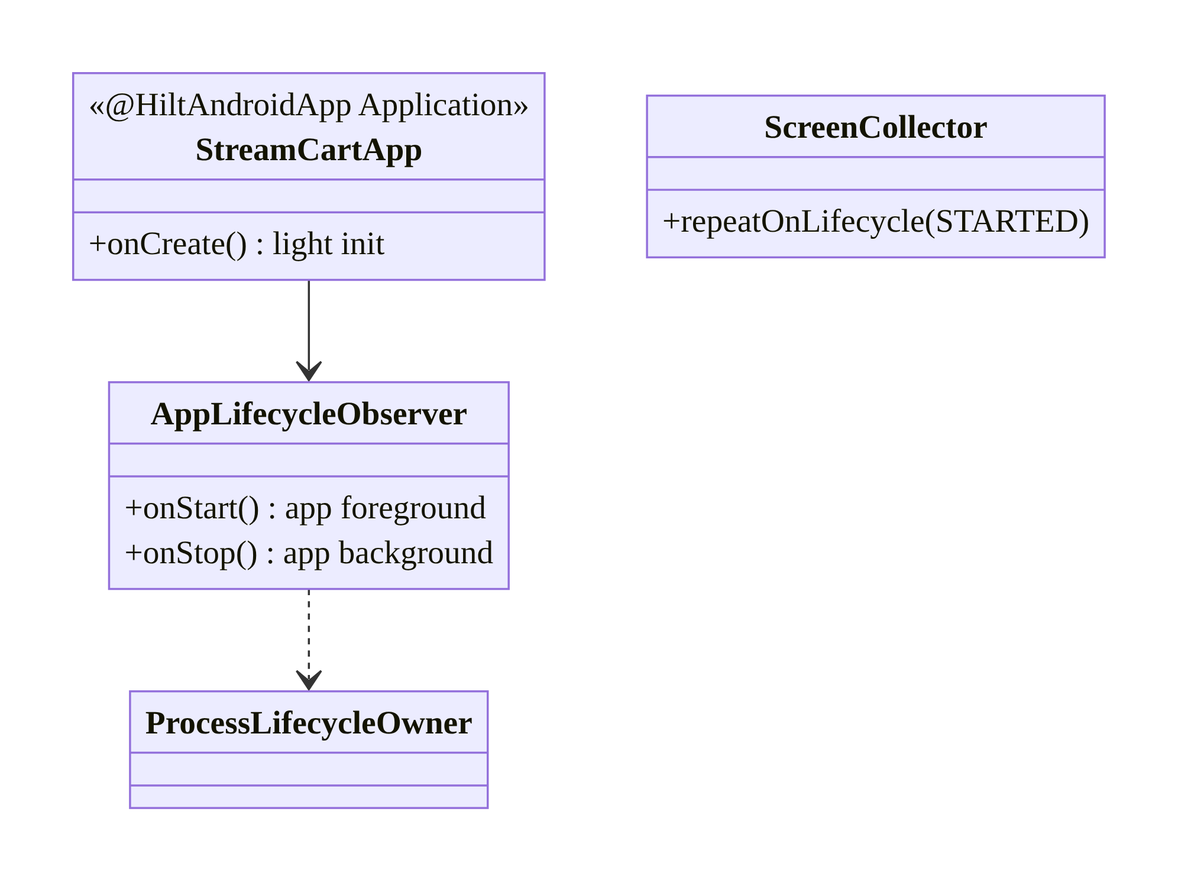
44.5 Detailed Component Design
Scope | Lifetime | Mechanism | Use for
Process | process | Application | app-wide singletons (Ch 5)
App fg/bg | app visible | ProcessLifecycleOwner | flush/pause/resume app-wide
Screen | visible | repeatOnLifecycle(STARTED)/lifecycleScope | UI-only collection
ViewModel | config-change | viewModelScope (Ch 6) | survives rotation/nav
Beyond UI | kill/reboot | WorkManager (Ch 30) | guaranteed background

44.6 End-to-End Data Flow

App foreground/background reactions
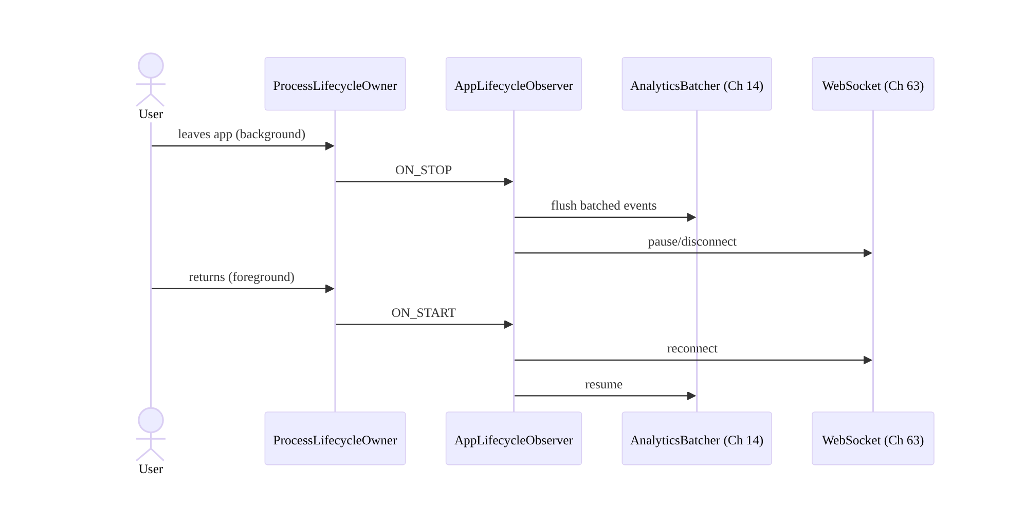
App foreground/background reactions

Screen-scoped collection
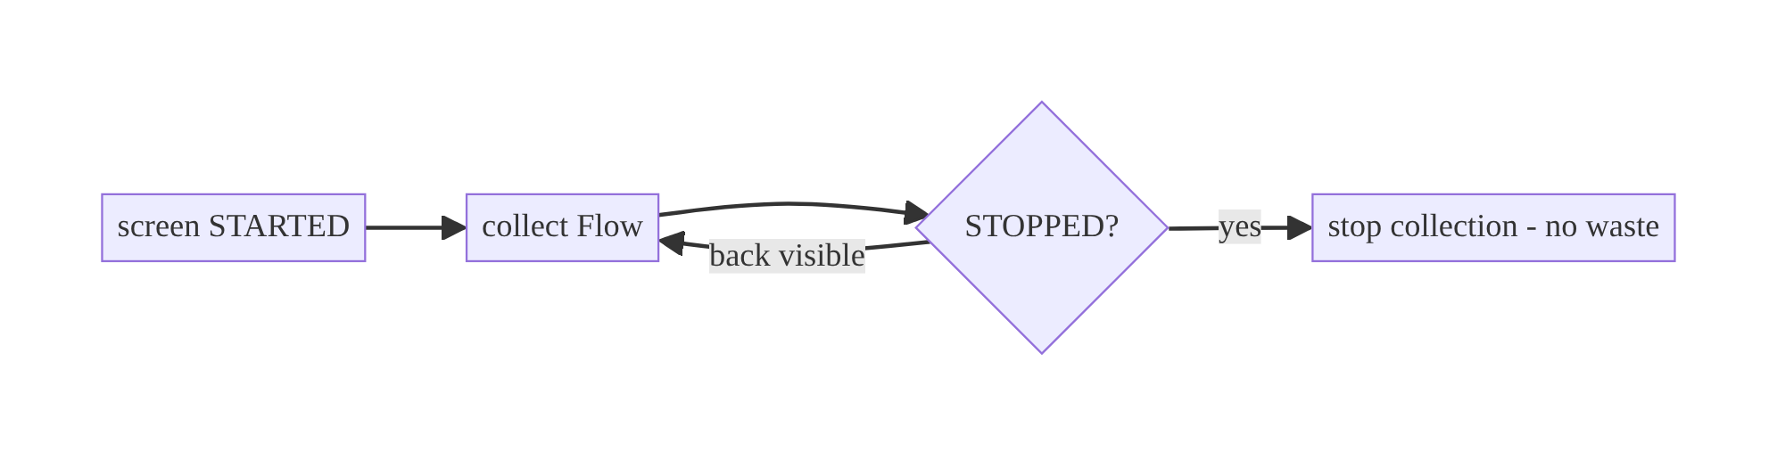
Screen-scoped collection

44.7 Complete Kotlin Implementation
Package: com.streamcart.app.

44.7.1 Application: light app-wide init (Ch 45)
@HiltAndroidApp
class StreamCartApp : Application(), Configuration.Provider { // Config.Provider for WorkManager (Ch 30)
@Inject lateinit var workerFactory: HiltWorkerFactory
@Inject lateinit var appLifecycleObserver: AppLifecycleObserver
override fun onCreate() {
super.onCreate()
// Keep this LIGHT (runs on every cold start, Ch 45). Heavy init -> lazy / App Startup.
Timber.plant(/* redacting tree, Ch 28 */)
ProcessLifecycleOwner.get().lifecycle.addObserver(appLifecycleObserver) // app fg/bg
}
override val workManagerConfiguration get() = Configuration.Builder().setWorkerFactory(workerFactory).build()
}

44.7.2 App-wide foreground/background observer
@Singleton
class AppLifecycleObserver @Inject constructor(
private val analytics: AnalyticsBatcher, // Ch 14
private val realtime: RealtimeConnection, // Ch 63
private val sync: SyncScheduler, // Ch 30
) : DefaultLifecycleObserver {
override fun onStart(owner: LifecycleOwner) { // app -> foreground
realtime.resume()
sync.requestSync() // refresh on return
}
override fun onStop(owner: LifecycleOwner) { // app -> background
analytics.flush() // batch flush (Ch 14)
realtime.pause() // stop expensive work while hidden
}
}

44.7.3 Screen-scoped collection (lifecycle-aware, no leak)
// Compose: collect only while visible (Ch 6).
@Composable
fun FeedScreen(viewModel: FeedViewModel = hiltViewModel()) {
val state by viewModel.uiState.collectAsStateWithLifecycle() // stops in STOPPED
// one-time events (Ch 7) with lifecycle-aware collection:
val lifecycleOwner = LocalLifecycleOwner.current
LaunchedEffect(viewModel, lifecycleOwner) {
lifecycleOwner.repeatOnLifecycle(Lifecycle.State.STARTED) { // visible-only
viewModel.effects.collect { /* handle */ }
}
}
}
// Views: equivalent.
// lifecycleScope.launch { repeatOnLifecycle(Lifecycle.State.STARTED) { vm.state.collect { render(it) } } }

44.7.4 Right-scoping work (the decision)
// UI-only (stop when invisible) -> screen scope.
// Survives config change / navigation -> viewModelScope (Ch 6).
class FeedViewModel @Inject constructor(...) : ViewModel() {
init { viewModelScope.launch { /* work that should survive rotation */ } }
}
// Must survive UI/process (upload, sync) -> WorkManager (Ch 30), NOT a screen/VM scope.

44.7.5 Module structure
:app StreamCartApp (@HiltAndroidApp), AppLifecycleObserver
# Screen lifecycle: per feature; WorkManager: :sync (Ch 30); App Startup: Ch 45.

44.8 Concurrency and Race Conditions
Scenario | Risk | Handling
Collect without lifecycle | leak/waste while hidden | repeatOnLifecycle(STARTED) / collectAsStateWithLifecycle
Long work in screen scope | cancelled on leave | move to viewModelScope / WorkManager
Config change restarts work | duplicate | viewModelScope survives config change (Ch 6)
Infer bg from one Activity’s onStop | false background on rotation/multi-activity | use ProcessLifecycleOwner
Callback not unregistered | leak | lifecycle-aware observer auto-removes
Heavy Application.onCreate | slow every start | keep light; lazy/App Startup (Ch 45)
- ProcessLifecycleOwner is the correct app-foreground/background signal — a single Activity’s onStop fires on rotation and when moving between the app’s own Activities, so using it as “backgrounded” is wrong; ProcessLifecycleOwner debounces that.
- Lifecycle-aware components auto-cancel/unregister, which is the whole leak- prevention story — don’t hand-roll onStart/onStop registration.

44.9 Failure Scenarios and Recovery
Failure | Detection | Response | Outcome
Work runs while backgrounded | battery/network stats | pause on ON_STOP; scope correctly | battery saved
Crash collecting after destroy | crash | lifecycle-aware collection | no crash
Leak (Activity retained) | LeakCanary (Ch 89) | remove refs; lifecycle-aware | no leak
Long task dies on navigation | incomplete | WorkManager/ViewModel (Ch 30/6) | survives
False background (rotation) | wrong flush/pause | ProcessLifecycleOwner not Activity | correct
Process death | state lost | SavedState/SSOT (Ch 8/3) | restored
Stale data on resume | user report | refresh on ON_START | fresh
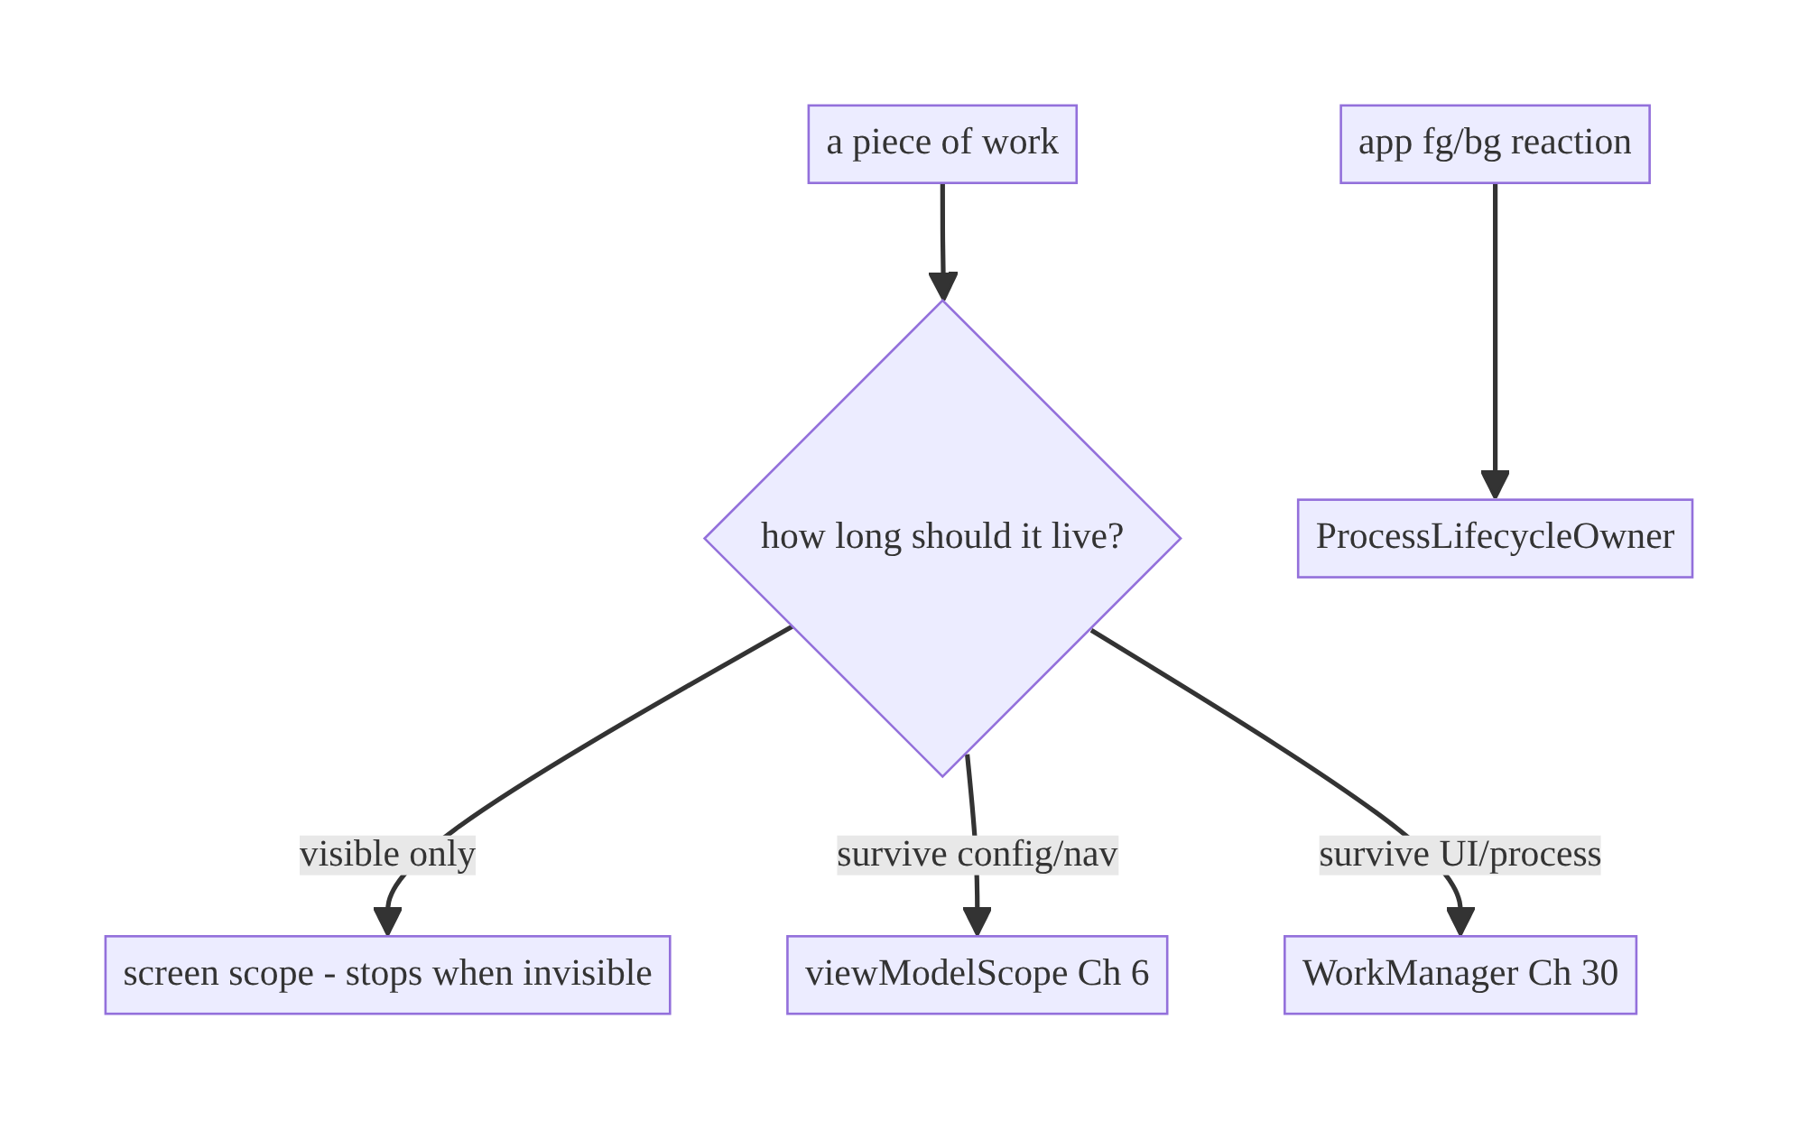
44.9 Failure Scenarios and Recovery
Scope is the decision that prevents most lifecycle bugs: visible-only → screen; survive-config → ViewModel; survive-process → WorkManager. Choosing wrong causes leaks (too broad), cancelled work (too narrow), or battery drain (unscoped).

44.10 Scaling the Implementation
- Level 1. viewModelScope + collectAsStateWithLifecycle for screens (Ch 6).
- Level 2. ProcessLifecycleOwner observer for app-wide fg/bg reactions (flush/ pause/resume).
- Level 3 — production. Correct scope per work type; light Application.onCreate; App Startup for init ordering (Ch 45); leak checks (Ch 89).
- Level 4 — large. Modular lifecycle observers; per-feature init on demand (DI, Ch 5); background pausing of expensive subsystems (real-time, Ch 63; location, Ch 67).
- Level 5 — enterprise. Lifecycle-driven resource governance, observability of fg/bg time + background work, consistent lifecycle conventions across teams.
Avoid overengineering: most lifecycle needs are met by viewModelScope + lifecycle-aware collection + a single ProcessLifecycleOwner observer. Don’t build a custom lifecycle framework.

44.11 Alternative Approaches and Trade-offs
Dimension | Option A | Option B | When
Observe lifecycle | Lifecycle-aware (repeatOnLifecycle) | manual onStart/onStop | Lifecycle-aware always (auto cancel/unregister); manual is leak-prone
App fg/bg | ProcessLifecycleOwner | track Activity count | ProcessLifecycleOwner (handles config/multi-activity); manual counting is error-prone
Work scope | Screen / ViewModel / WorkManager | one scope for all | Match scope to needed lifetime
Init | Application.onCreate (light) / App Startup | lazy per-feature | App-wide early → Application/App Startup; feature → lazy (Ch 45/5)
Flow collection | collectAsStateWithLifecycle | collectAsState | Lifecycle-aware default; plain only if always-visible
Lifecycle-aware vs manual callbacks: lifecycle-aware components (repeatOnLifecycle, lifecycleScope, observers) start/stop/cancel with the lifecycle automatically — no leaked collectors, no work while hidden. Manual onStart/onStop registration is verbose and the #1 source of leaks (forgetting to unregister) and crashes (acting on a destroyed view). Always prefer lifecycle-aware.
ProcessLifecycleOwner vs Activity-count tracking: both can detect app foreground/background, but ProcessLifecycleOwner correctly handles configuration changes and transitions between the app’s own Activities (debouncing), whereas manual counting easily miscounts. Use ProcessLifecycleOwner.

44.12 Security Considerations
- Hide sensitive content when backgrounded: on ON_STOP / for sensitive screens, set FLAG_SECURE or show a privacy screen so the recents/app-switcher thumbnail and screenshots don’t leak content (banking/health).
- Pause sensitive work in background: stop location (Ch 67), camera, or real-time streams when the app is hidden unless explicitly a foreground service (Ch 46).
- Clear sensitive in-memory state on background/process death where appropriate (e.g., re-auth on return for sensitive apps, Ch 21).
- Don’t log lifecycle with PII (Ch 28).
- Client vs backend: lifecycle reactions are client resource management; the backend is unaffected but benefits (fewer background requests, cleaner sessions).

44.13 Performance and Resource Optimization
- Stop work while hidden: pause polling/real-time/animation on ON_STOP — the main battery lever from lifecycle awareness.
- Light Application.onCreate: it’s on the cold-start critical path (Ch 45); defer heavy init (App Startup / lazy).
- Visible-only collection (repeatOnLifecycle) avoids recomposition/computation for off-screen UI.
- Release resources on the right teardown (onStop/onDestroy/DisposableEffect).
- Batch and flush on background (analytics, Ch 14) rather than continuously.
- Profiling: background CPU/network/wakelocks (Battery Historian), foreground/ background time, LeakCanary (Ch 89), startup trace (Ch 45).

44.14 Testing Strategy
Lifecycle is testable with TestLifecycleOwner/Lifecycle.State; ViewModels in isolation (Ch 6).
class AppLifecycleObserverTest {
@Test fun `flushes analytics and pauses on background`() {
val analytics = FakeAnalytics(); val realtime = FakeRealtime()
val obs = AppLifecycleObserver(analytics, realtime, FakeSync())
obs.onStop(TestLifecycleOwner())
assertTrue(analytics.flushed && realtime.paused)
}
@Test fun `reconnects and refreshes on foreground`() {
val realtime = FakeRealtime(); val sync = FakeSync()
AppLifecycleObserver(FakeAnalytics(), realtime, sync).onStart(TestLifecycleOwner())
assertTrue(realtime.resumed && sync.requested)
}
}
// repeatOnLifecycle behavior: use TestLifecycleOwner + moveToState; assert collection
// starts in STARTED and stops in CREATED.
class ScreenCollectionTest {
@Test fun `collects only while started`() = runTest {
val owner = TestLifecycleOwner(initialState = Lifecycle.State.CREATED)
// launch repeatOnLifecycle(STARTED); move to STARTED -> collects; move to CREATED -> stops
}
}
What to test: fg/bg observer reactions, lifecycle-scoped collection start/stop (fake lifecycle owner), work-scope correctness (survives config in VM; cancelled in screen), and a leak check (LeakCanary) in instrumentation.

44.15 Production Observability
- Metrics: foreground/background time, background CPU/network/wakelocks, cold-start frequency (Ch 45), leak reports (Ch 89), analytics-flush-on-background success.
- Logs: app_lifecycle{event=foreground/background}, scope{work, lifecycle} (no PII, Ch 28).
- Debugging: battery drain → work not paused in background / wrong scope; crashes after navigation → non-lifecycle-aware collection; leaks → retained Activity/ callback; stale on resume → no foreground refresh; slow launch → heavy Application.onCreate (Ch 45).
- Alerting: background-work/wakelock spike → lifecycle regression.
- Privacy: sensitive content in recents → FLAG_SECURE/privacy screen.

44.16 System Design Interview Preparation
≥25 questions.
Fundamentals
- Lifecycle hierarchy? Process → Application → Activity/Fragment/Compose, plus app-wide foreground/background.
- What runs once per process? Application.onCreate (every cold start).
- What survives config change? ViewModel (Ch 6); not the Activity.
- What survives process death? Only persisted state (SavedState/SSOT, Ch 8/3).
- Lifecycle-aware components? LifecycleOwner/observer, repeatOnLifecycle, lifecycleScope, viewModelScope — auto start/stop/cancel.
App fg/bg
- Detect app foreground/background? ProcessLifecycleOwner (ON_START/ON_STOP).
- Why not a single Activity’s onStop? Fires on rotation/multi-activity → false background.
- What to do on background? Flush analytics (Ch 14), pause real-time (Ch 63), stop expensive work.
- On foreground? Reconnect/refresh.
Scoping
- Visible-only work? Screen scope (repeatOnLifecycle(STARTED)).
- Survive config/nav? viewModelScope.
- Survive UI/process? WorkManager (Ch 30).
- Classic scoping bug? Long work in a screen scope (cancelled on leave).
Leaks
- How avoid leaks? Lifecycle-aware observation; no Activity refs; auto-unregister.
- collectAsState vs collectAsStateWithLifecycle? The latter stops in STOPPED.
- Compose lifecycle? LocalLifecycleOwner, DisposableEffect/LaunchedEffect.
Init
- Where app-wide init? Application.onCreate (light) or App Startup (Ch 45).
- Why keep onCreate light? Cold-start critical path.
- Per-feature init? Lazy via DI (Ch 5).
Security
- Sensitive content in recents? FLAG_SECURE/privacy screen on background.
- Pause sensitive work? Location/camera/streams when hidden.
Testing
- How test fg/bg? Fake observer + onStart/onStop; assert reactions.
- How test lifecycle collection? TestLifecycleOwner + move states.
Production debugging
- Battery drain? Work not paused/wrong scope.
- Crash after leaving screen? Non-lifecycle-aware collection.
- Stale on resume? No foreground refresh.

Design-change challenges
- Flush analytics when the app backgrounds. ProcessLifecycleOwner onStop.
- Stop a WebSocket while hidden. Pause on background, reconnect on foreground.
- A long task dies on navigation. Move to WorkManager/ViewModel.
- Battery drain from background polling. Pause on background; scope correctly.
- Sensitive content shows in recents. FLAG_SECURE/privacy screen.

Mock walkthrough (abridged)
Clarify (what work, how long should it live, app-wide reactions?) → lifecycle hierarchy → scope work (screen/VM/WorkManager) with lifecycle-aware components → ProcessLifecycleOwner for app fg/bg → light init placement (Ch 45) → leak avoidance → security (FLAG_SECURE) → testing.

44.17 Practical Exercises
- Beginner. Add a ProcessLifecycleOwner observer that flushes analytics on background and refreshes on foreground. Eval: correct reactions.
- Intermediate. Make a screen collect its Flow only while visible (repeatOnLifecycle/collectAsStateWithLifecycle). Eval: stops when hidden; no leak.
- Advanced. Right-scope three work items (visible-only, survive-config, survive-process) to screen/VM/WorkManager. Eval: each has correct lifetime.
- Production debugging. Fix battery drain (background polling not paused) and a crash (collecting after destroy). Eval: paused; lifecycle-aware.
- System design challenge. Add FLAG_SECURE/privacy screen on background for a sensitive screen and re-auth on foreground (Ch 21). Eval: no recents leak; gated return.
(Solutions withheld unless requested.)

44.18 Chapter Summary & Reference Sheet
Key decisions: understand the lifecycle hierarchy (process → Application → screen, plus app foreground/background); scope every piece of work to the lifetime it needs — visible-only → screen scope (repeatOnLifecycle/ collectAsStateWithLifecycle), survive-config/nav → viewModelScope (Ch 6), survive-UI/process → WorkManager (Ch 30) — using lifecycle-aware components so it auto-cancels (no leaks/waste); detect app foreground/background with ProcessLifecycleOwner (not a single Activity’s onStop) for app-level reactions (flush analytics Ch 14, pause real-time Ch 63, refresh on return); keep Application.onCreate light (Ch 45); and protect sensitive content on background (FLAG_SECURE).
Concepts: lifecycle hierarchy, lifecycle-aware components, ProcessLifecycleOwner, scope selection (screen/ViewModel/WorkManager), app fg/bg reactions, init placement, leak avoidance, Compose lifecycle.
Common mistakes: long work in a screen scope (cancelled); unscoped background work (battery); non-lifecycle-aware collection (leak/crash); inferring background from one Activity’s onStop; heavy Application.onCreate; retained Activity refs; sensitive content in recents.
Checklist:
- ☐ scope work correctly (screen/VM/WorkManager)
- ☐ lifecycle-aware collection
- ☐ ProcessLifecycleOwner for app fg/bg
- ☐ flush/pause on background + refresh on foreground
- ☐ light Application.onCreate
- ☐ no retained Activity refs
- ☐ FLAG_SECURE/privacy on background (sensitive)
- ☐ release resources on teardown.
Key APIs: Application/@HiltAndroidApp, ProcessLifecycleOwner, DefaultLifecycleObserver, Lifecycle.State/repeatOnLifecycle, lifecycleScope/ viewModelScope, collectAsStateWithLifecycle, LocalLifecycleOwner, DisposableEffect/LaunchedEffect, FLAG_SECURE, TestLifecycleOwner.
References:
- Lifecycle-aware components: https://developer.android.com/topic/libraries/architecture/lifecycle
- Process & app lifecycle: https://developer.android.com/guide/components/activities/process-lifecycle
- ProcessLifecycleOwner: https://developer.android.com/reference/androidx/lifecycle/ProcessLifecycleOwner
- Safer flow collection: https://developer.android.com/topic/libraries/architecture/coroutines#restart
- (composes) Ch 6 UI State, Ch 8 Process Death, Ch 30 WorkManager, Ch 45 Startup

Chapter 45 — App Startup Optimization
Part VI — Lifecycle, Background & Platform · Complexity: Standard (≥25 interview questions)
Prerequisites: Ch 44 (lifecycle, Application.onCreate), Ch 5 (Hilt/init), Ch 6 (UI state), Ch 12/13 (cache/paging for first screen). Pairs with Ch 46/47 (background), Ch 86/89 (perf/profiling).
Reference surface in StreamCart: getting from tap to usable content fast — cold-start time, time-to-first-frame, and time-to-first-meaningful-content on the home feed.

45.1 Problem Definition and Real-World Context
Startup is the user’s first impression on every launch and a ranked Play Store / Android vitals metric. A slow cold start (blank screen, spinner, jank) causes drop-off, bad reviews, and (past Google’s thresholds) reduced store visibility. The problem is that everything competes to run at startup — DI graph creation, library initialization, first network calls, database opens, first-screen layout — and if that work lands on the critical path to first frame, the app feels slow.
Concretely, teams hit:
- Heavy Application.onCreate. Every SDK (analytics, crash, ads, image loader, feature flags) wants to initialize there; serialized on the main thread, this delays the first frame directly (Ch 44).
- Three start types, one experience. Cold (new process), warm (process alive, Activity recreated), and hot (Activity in memory) start cost very differently; optimizing only cold, or measuring the wrong one, misleads.
- Blocking the first frame on data. Waiting for a network call before showing anything → long blank screen. Should show cached/skeleton first (Ch 12/34).
- Uncoordinated initialization. Each library registers its own ContentProvider to auto-init (each one costs main-thread time); order and laziness are unmanaged.
- No measurement. Without startup traces / Android vitals, teams can’t tell cold from warm, or find the slow initializer.
The architecture: understand the three start types and the phases (process fork → Application → first Activity → first frame → first meaningful content); move work off the critical path (lazy init, background init, defer non-essential SDKs); coordinate initialization with Jetpack App Startup instead of per-library ContentProviders; show content fast (cached data + skeletons, not a blank wait on the network); and measure with startup traces, reportFullyDrawn(), Macrobenchmark, and Android vitals. This chapter is about minimizing time-to-usable and keeping it from regressing.

Three practical use cases
- StreamCart cold start. Trim Application.onCreate, defer non-essential SDKs, show a cached/skeleton home feed immediately, and stream fresh data (Ch 29/34).
- Baseline Profiles. Ship a Baseline Profile so hot code paths are AOT-compiled on first run → faster startup and smoother first scroll.
- Regression gate. Macrobenchmark cold-start test in CI to catch startup regressions before release.

Why this is architectural
Startup optimization is about what runs on the critical path and what the user sees first — cross-cutting decisions touching DI, every SDK, the first screen’s data strategy, and the build (Baseline Profiles, R8). It’s measured, gated, and defended over time, not a one-off tweak.

45.2 Requirements Engineering

Functional requirements
ID | Requirement
F1 | Show a first frame quickly (fast time-to-initial-display).
F2 | Show meaningful content quickly (cached/skeleton, not a blank network wait).
F3 | Keep Application.onCreate minimal; defer non-essential init.
F4 | Coordinate initialization (App Startup) with correct ordering/laziness.
F5 | Measure cold/warm/hot startup; report fully-drawn.
F6 | Gate regressions (Macrobenchmark in CI; Android vitals).

Non-functional requirements
Attribute | Target/Policy
Cold start (TTID) | Fast (target e.g. <1s initial display on mid device; team-specific).
TTFMC | Meaningful content quickly (cached first).
Regression | CI gate on cold-start benchmark.
Correctness | Deferred init must not break first-use (lazy, not broken).
Battery | Don’t do unnecessary eager work at startup.

Scope
- In scope: start types (cold/warm/hot), startup phases, Application.onCreate trimming, lazy/background init, Jetpack App Startup, first-screen data strategy (cache + skeleton), Baseline Profiles/R8 relation, measurement (traces, reportFullyDrawn, Macrobenchmark, vitals), regression gating.
- Out of scope: general lifecycle (Ch 44), background work (Ch 46/47), deep perf profiling methodology (Ch 86), Compose perf (Ch 60).

Assumptions & constraints
- Hilt, Compose, Jetpack App Startup, Macrobenchmark, R8/Baseline Profiles. minSdk 24. Cold start is unavoidable (process was killed, Ch 8); optimize its cost, not its existence.

45.3 System Design Fundamentals
- Three start types (measure the right one):
  - Cold start: no process exists. OS forks the process, creates Application, then the first Activity, then the first frame. The expensive case; Application. onCreate is on its critical path.
  - Warm start: process alive but the Activity was destroyed (e.g., returned after the OS reclaimed the Activity). Skips Application creation; recreates the Activity.
  - Hot start: Activity still in memory; cheapest (just bring to foreground).
- Startup phases and the “critical path”: fork → Application.onCreate → first Activity onCreate/layout → first frame drawn (TTID, time to initial display) → first meaningful content (TTFMC, reportFullyDrawn). Any main-thread work in these phases pushes the first frame later. The goal is to shrink the critical path: do only what’s needed for the first frame now; defer the rest.
- Move work off the critical path (the main lever):
  - Lazy init: create expensive singletons when first used, not at startup (DI makes this natural, Ch 5).
  - Background init: initialize things that aren’t needed for the first frame on a background dispatcher.
  - Defer non-essential SDKs: analytics/ads/feature-flags that aren’t needed to render → init after first frame (e.g., post-reportFullyDrawn, or App Startup dependency ordering).
- Jetpack App Startup (coordinated init): replaces each library’s own auto-initializing ContentProvider (each a main-thread cost) with a single InitializationProvider and Initializer<T> components with declared dependencies — so init order is explicit and you can make initializers lazy. Fewer providers, ordered init.
- Show content fast, not a blank network wait: render cached data (Ch 12/34) or a skeleton (Ch 6) on the first frame; fetch fresh in the background and update (offline-first, Ch 29). Blocking the first frame on a network call is the classic “slow launch” that’s really a data-strategy problem.
- Build-time help:
  - Baseline Profiles: ship a profile of hot startup/first-scroll code so ART AOT-compiles it on install → faster startup and smoother first frames (big, nearly free win).
  - R8 (Ch 27): smaller/faster code; startup-aware optimizations.
  - Startup theme/splash: a proper SplashScreen (windowBackground) avoids a blank white/black flash and gives perceived speed.
- Measurement: startup traces (Perfetto/System Trace), reportFullyDrawn() (marks TTFMC), Macrobenchmark (StartupTimingMetric, cold/warm/hot, in CI), and Android vitals (field cold-start distribution). Optimize what you measure.
Core insight: cold start is the expensive case; shrink its critical path by doing only first-frame-essential work on the main thread (lazy/background/deferred init, coordinated via App Startup), show cached/skeleton content immediately instead of blocking on the network, lean on Baseline Profiles, and measure/gate with traces, reportFullyDrawn, Macrobenchmark and Android vitals so startup is fast and stays fast.

45.4 High-Level Architecture
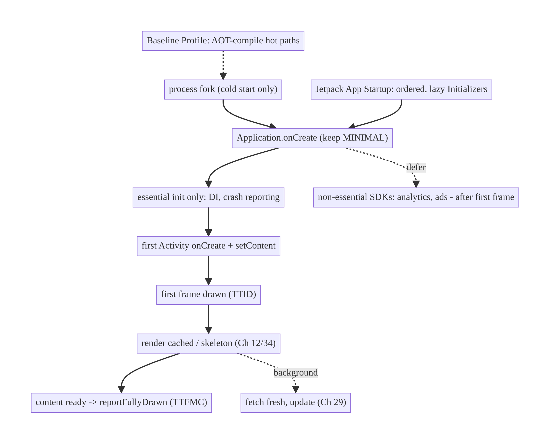
45.4 High-Level Architecture
Components & ownership
- Application does only essential init; non-essential SDKs deferred.
- Jetpack App Startup coordinates/ordered initializers (one provider).
- First Activity renders cached/skeleton immediately; fetches fresh in background; calls reportFullyDrawn().
- Baseline Profile / R8 speed the code at build/install time.
- Macrobenchmark / vitals measure and gate.
Direction: minimal critical path → fast first frame → cached content now, fresh later → measured and gated.

45.5 Detailed Component Design
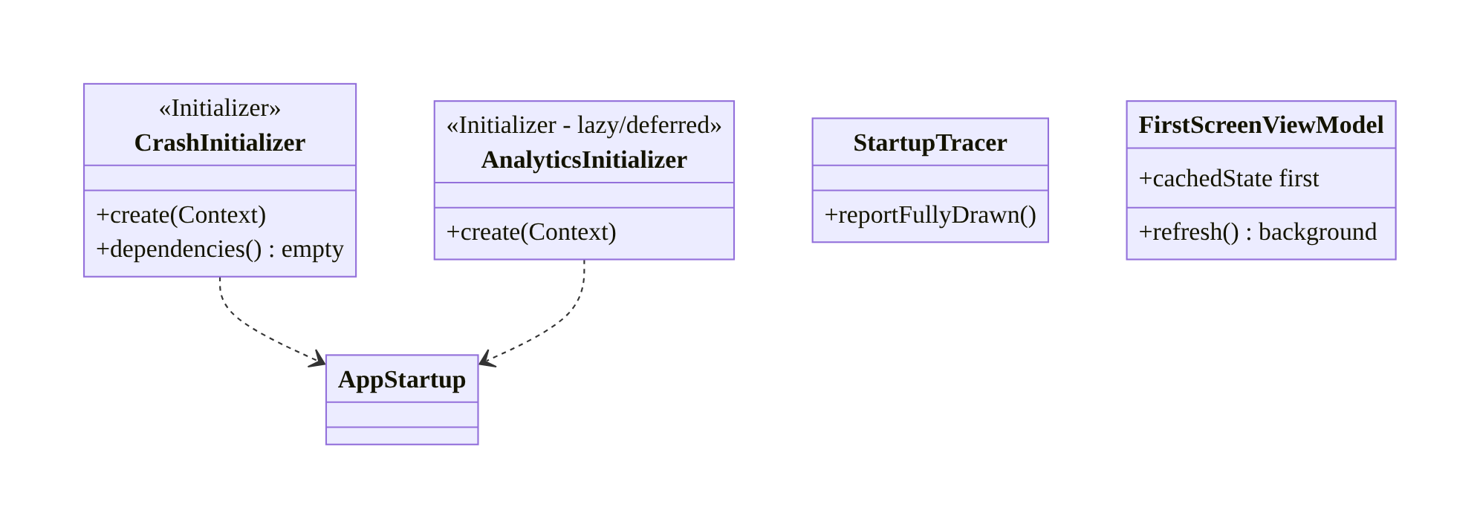
45.5 Detailed Component Design
Technique | What it does | Cost of ignoring
Minimal onCreate | less main-thread work | slow every cold start
Lazy/background init | off critical path | slow first frame
App Startup | ordered, single provider | many providers, unordered
Cache + skeleton | content now | blank network wait
Baseline Profile | AOT hot paths | slower startup/jank
reportFullyDrawn + Macrobenchmark | measure/gate | silent regressions

45.6 End-to-End Data Flow

Cold start (optimized)
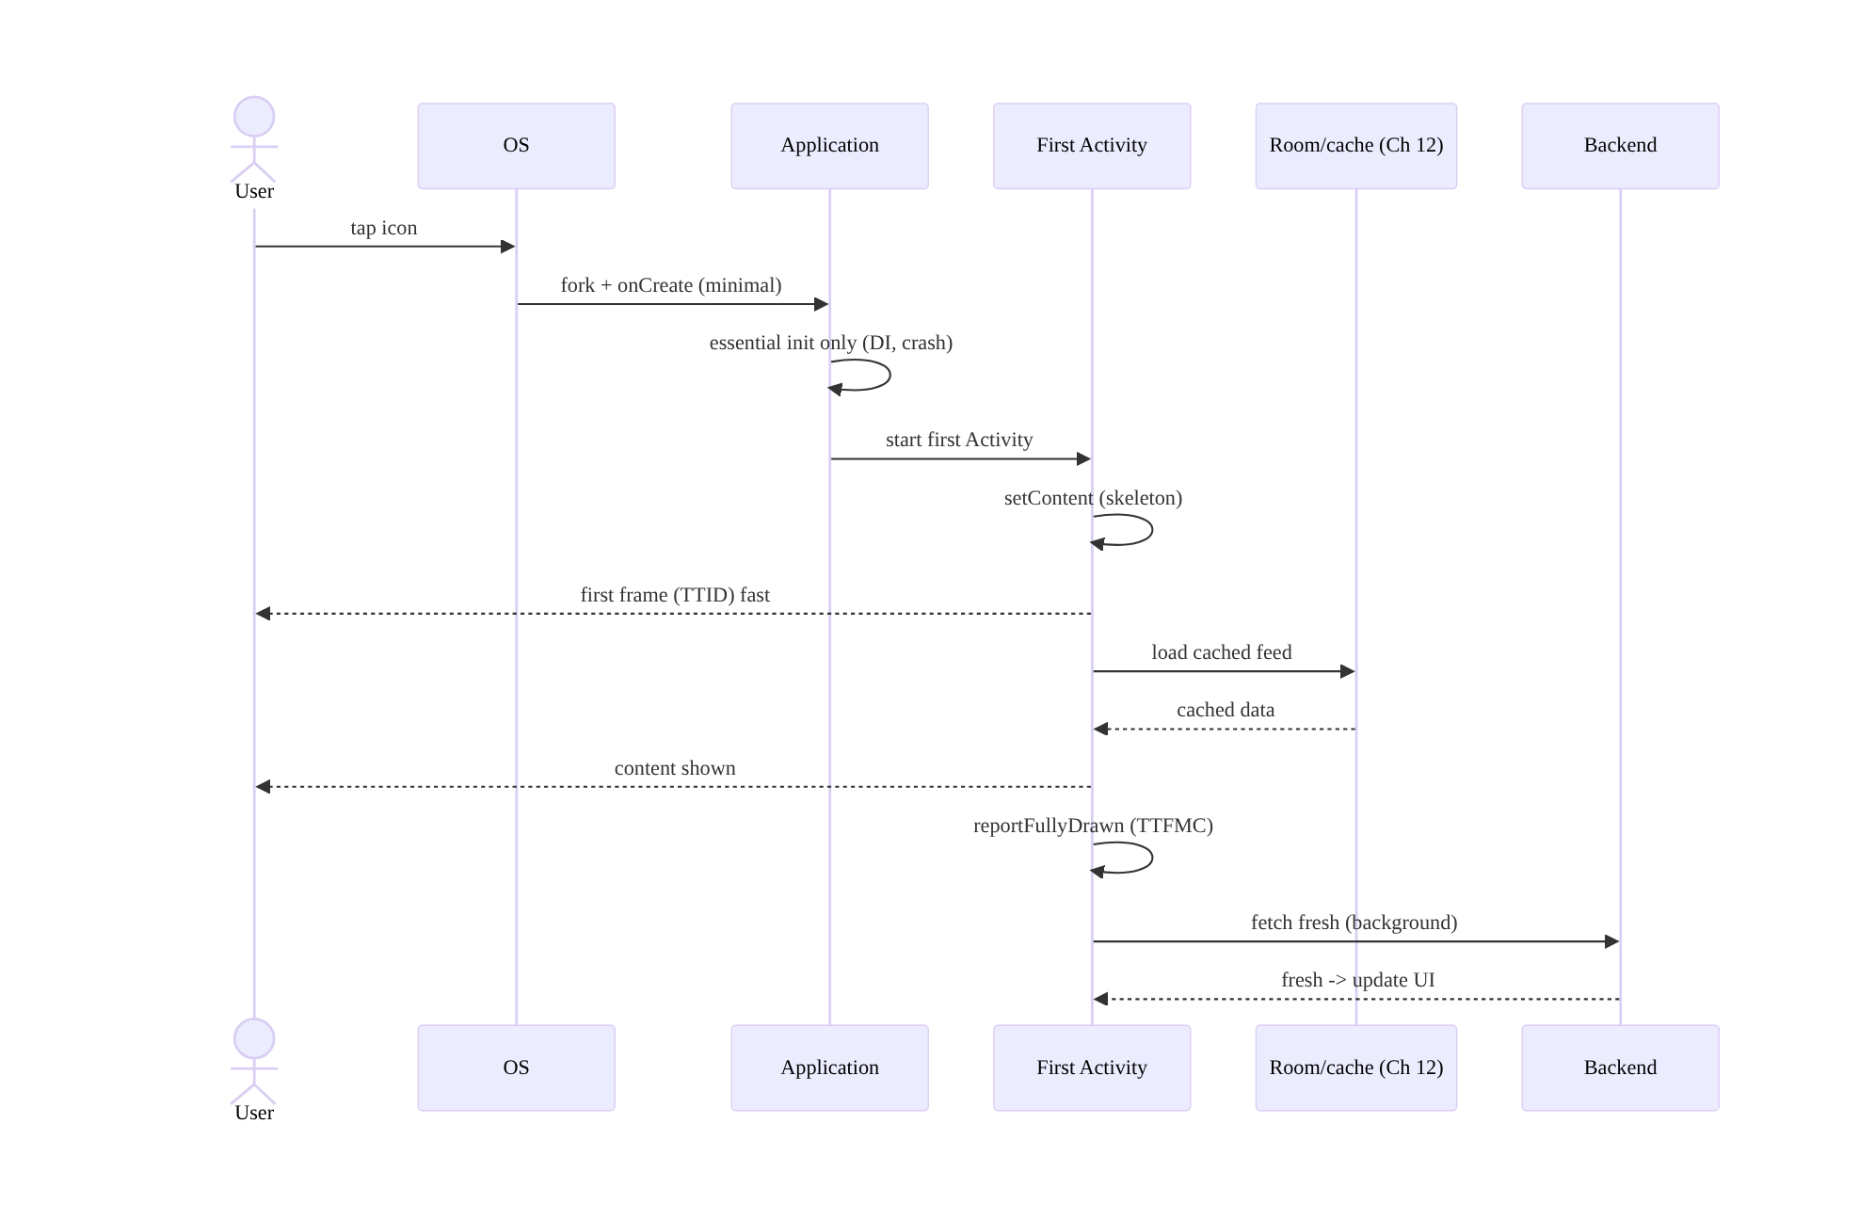
Cold start (optimized)

Init placement decision
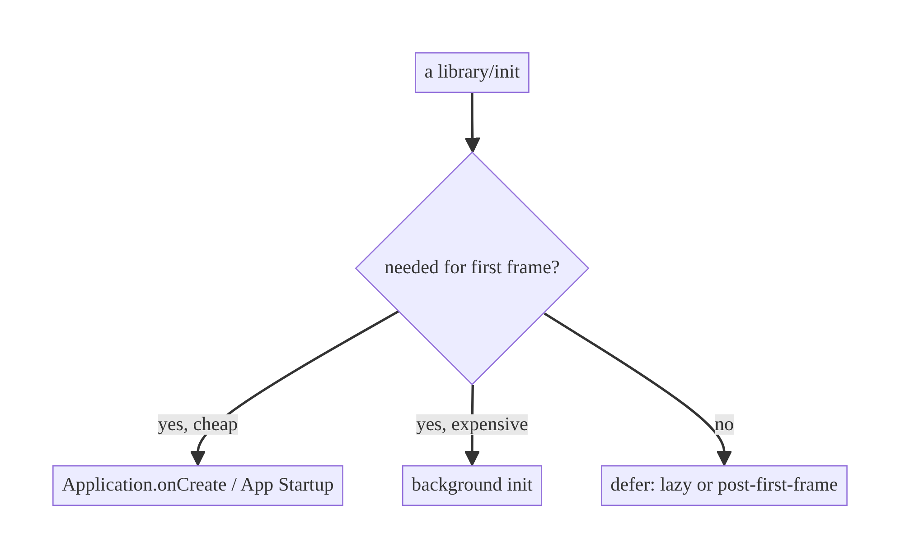
Init placement decision

45.7 Complete Kotlin Implementation
Package: com.streamcart.startup.

45.7.1 Minimal Application, deferred non-essential init
@HiltAndroidApp
class StreamCartApp : Application() {
@Inject lateinit var appScope: CoroutineScope // @ApplicationScope (Ch 5)
@Inject lateinit var analytics: Lazy<AnalyticsSdk> // Lazy -> not created at startup
override fun onCreate() {
super.onCreate()
// ESSENTIAL, cheap, main-thread only:
Timber.plant(/* redacting tree */) // crash/log context (Ch 28)
// NON-ESSENTIAL -> background, off critical path:
appScope.launch(Dispatchers.Default) {
analytics.get().initialize() // deferred, not needed for first frame
}
}
}

45.7.2 Jetpack App Startup: ordered, lazy initializers
// Essential, must run before first frame -> App Startup with explicit order.
class CrashReportingInitializer : Initializer<CrashReporter> {
override fun create(context: Context): CrashReporter =
CrashReporter.init(context) // cheap, essential
override fun dependencies(): List<Class<out Initializer<*>>> = emptyList()
}
// Non-essential -> remove its auto-init (manifest) and init lazily/deferred instead.
// <provider android:name="androidx.startup.InitializationProvider" ...>
// <meta-data android:name="...AnalyticsInitializer" tools:node="remove" />
// </provider>

45.7.3 First screen: cached/skeleton now, fresh later + reportFullyDrawn
class FirstScreenViewModel @Inject constructor(
private val repo: FeedRepository, // offline-first (Ch 29)
) : ViewModel() {
val uiState: StateFlow<FeedUiState> = repo.observeFeed() // emits cached immediately (Ch 3)
.map { FeedUiState.Content(it) }
.stateIn(viewModelScope, SharingStarted.Eagerly, FeedUiState.Skeleton) // skeleton first
init { viewModelScope.launch { repo.refresh() } } // fresh in background
}
@Composable
fun FirstScreen(vm: FirstScreenViewModel = hiltViewModel()) {
val state by vm.uiState.collectAsStateWithLifecycle()
val activity = LocalContext.current as? ComponentActivity
when (state) {
is FeedUiState.Skeleton -> SkeletonFeed() // first frame content (perceived speed)
is FeedUiState.Content -> {
FeedList((state as FeedUiState.Content).items)
LaunchedEffect(Unit) { activity?.reportFullyDrawn() } // mark TTFMC
}
}
}

45.7.4 Macrobenchmark cold-start gate (CI)
@RunWith(AndroidJUnit4::class)
class StartupBenchmark {
@get:Rule val rule = MacrobenchmarkRule()
@Test fun coldStartup() = rule.measureRepeated(
packageName = "com.streamcart",
metrics = listOf(StartupTimingMetric()), // timeToInitialDisplay + fullDisplay
iterations = 10,
startupMode = StartupMode.COLD,
) {
pressHome(); startActivityAndWait() // measures cold start to reportFullyDrawn
}
// CI asserts the median stays under the budget -> regression gate.
}

45.7.5 Module structure
:app minimal Application, App Startup initializers, SplashScreen
:feature:* first-screen VM (cache-first + reportFullyDrawn)
:benchmark Macrobenchmark (StartupTimingMetric) + Baseline Profile generation
# Baseline Profile shipped in :app; R8 full mode (Ch 27).

45.8 Concurrency and Race Conditions
Scenario | Risk | Handling
Background init not ready on first use | NPE/crash | Lazy/await; init essential synchronously
Deferred SDK used before init | missing event | essential path synchronous; others lazy-safe
First frame blocked on IO | slow TTID | load cache off main thread; skeleton first
App Startup dependency cycle | crash | acyclic dependencies()
reportFullyDrawn called repeatedly | wrong metric | once, when content first shown
Parallel init races | corrupted singletons | each init idempotent / @Singleton (Ch 5)
- Essential vs deferred must be correct: anything the first frame truly needs must be ready synchronously (cheaply) or awaited; only genuinely-not-needed work is deferred/background. Deferring something the first screen uses causes a crash or missing data — the subtle bug of aggressive startup trimming.
- First-frame work must be off the main thread for IO: loading cache should be on a background dispatcher (Room suspending, Ch 3); the main thread draws the skeleton immediately.

45.9 Failure Scenarios and Recovery
Failure | Detection | Response | Outcome
Slow cold start | vitals / Macrobenchmark | trim onCreate; defer SDKs; Baseline Profile | fast
Blank screen on launch | user report / trace | skeleton + cache first | content now
Deferred init crash on use | crash | make essential-for-first-use synchronous | no crash
Regression shipped | vitals spike | CI Macrobenchmark gate | caught pre-release
White flash before UI | visual | SplashScreen (windowBackground) | smooth
Jank on first scroll | frame metrics | Baseline Profile | smooth
Measuring wrong start type | misleading data | distinguish cold/warm/hot | correct focus
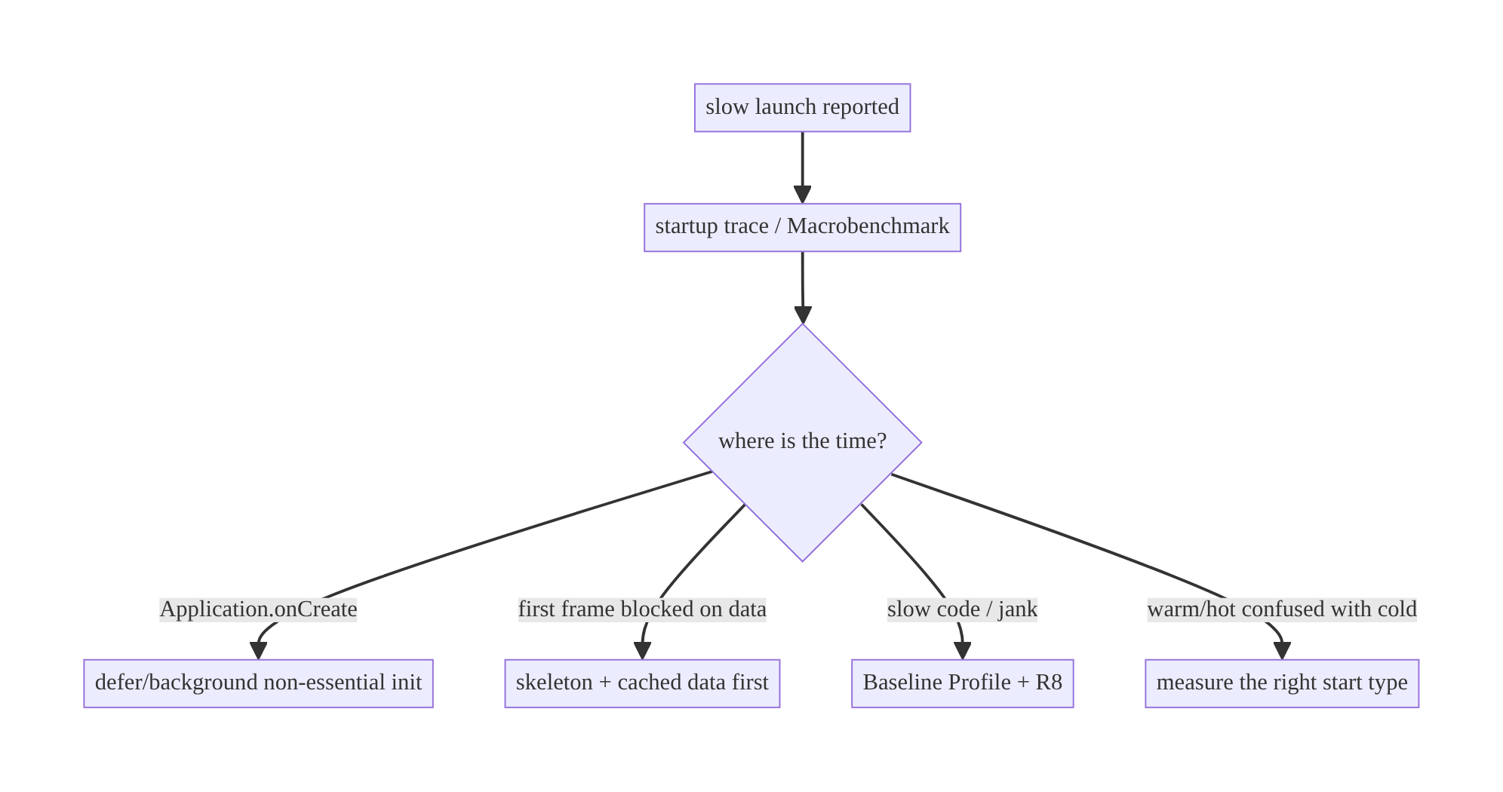
45.9 Failure Scenarios and Recovery
“Slow launch” is almost always one of four things: heavy Application.onCreate, a first frame blocked on the network, un-AOT’d hot code, or measuring the wrong start type. A startup trace tells you which — don’t optimize blind.

45.10 Scaling the Implementation
- Level 1. Minimal Application.onCreate; skeleton + cached first screen.
- Level 2. Jetpack App Startup for ordered init; defer non-essential SDKs; ship a Baseline Profile.
- Level 3 — production. reportFullyDrawn; Macrobenchmark cold-start in CI; Android vitals monitoring; SplashScreen API.
- Level 4 — large. Per-module init budgets; lazy feature initialization (Ch 5/96); R8 full mode; profile-guided optimization; startup-cost reviews per SDK added.
- Level 5 — enterprise. Startup SLOs with vitals alerting; automated regression gates per PR; per-device-class budgets (low-end vs flagship); dashboards of TTID/ TTFMC distributions.
Avoid overengineering: for most apps, a minimal onCreate + cache-first first screen + Baseline Profile + one Macrobenchmark gets 90% of the win. Don’t micro-defer cheap init or build elaborate startup frameworks prematurely.

45.11 Alternative Approaches and Trade-offs
Dimension | Option A | Option B | When
Init coordination | Jetpack App Startup | per-library ContentProvider | App Startup (one provider, ordered); auto-providers cost main-thread time
Non-essential SDK | Defer/lazy | eager in onCreate | Defer unless needed for first frame
First screen | Cache + skeleton | block on network | Cache-first always (offline-first, Ch 29)
Compile | Baseline Profile + R8 | none | Always ship a Baseline Profile
Measurement | Macrobenchmark + vitals | manual timing | Macrobenchmark (reproducible, CI) + vitals (field)
Splash | SplashScreen API | custom splash Activity | SplashScreen API (no extra Activity/latency)
App Startup vs per-library auto-init: many libraries auto-initialize via their own ContentProvider, each adding fixed main-thread cost at process start and giving you no control over order or laziness. Jetpack App Startup consolidates these into one InitializationProvider with explicit Initializer dependencies, so you pay for one provider, control ordering, and can defer/remove initializers. Prefer it; remove auto-init providers you don’t need.
Cache-first vs network-blocking first screen: blocking the first frame on a network response produces a long blank/spinner launch that users perceive as “slow app,” even when onCreate is fast. Rendering cached data (or a skeleton) immediately and streaming fresh data in makes launch feel instant and is the offline-first default (Ch 29). The only cost is briefly showing slightly-stale data, which is almost always the right trade.

45.12 Security Considerations
- Don’t do security-sensitive heavy work on the hot startup path in a way that leaks timing, but do gate sensitive screens (re-auth, Ch 21) before showing content — perceived speed must not bypass auth.
- SplashScreen must not show protected content; keep it a brand/skeleton.
- Deferred analytics/attribution SDKs still must honor consent (Ch 28/87) — defer initialization timing, not consent.
- Baseline Profiles / R8 don’t weaken security; R8 also obfuscates (Ch 27).
- Client vs backend: startup is a client-perceived-performance concern; backend is unaffected except that cache-first reduces cold-start request spikes.

45.13 Performance and Resource Optimization
This chapter is a performance chapter; key levers recap:
- Trim the critical path: minimal onCreate; defer/background non-essential init.
- Baseline Profiles: AOT hot startup + first-scroll paths (largest low-effort win).
- Cache-first first screen: content now, not a network wait.
- R8 full mode (Ch 27): smaller, faster code.
- Avoid main-thread IO at startup (cache load off-main; lazy DB open).
- SplashScreen API for perceived speed without an extra Activity.
- Measure: startup traces (find the slow initializer), Macrobenchmark (StartupTimingMetric cold/warm/hot), reportFullyDrawn (TTFMC), Android vitals (field distribution), per-device-class budgets.

45.14 Testing Strategy
Startup is validated by Macrobenchmark (timing) and field vitals; correctness of deferred init by unit/integration tests.
// Macrobenchmark: cold/warm/hot timing (see 45.7.4). Assert medians under budget in CI.
// Baseline Profile generation (run on CI/device):
@Test fun generateBaselineProfile() = baselineProfileRule.collect(packageName = "com.streamcart") {
pressHome(); startActivityAndWait()
// scroll the first screen so the profile captures first-scroll hot paths
}
// Correctness: deferred SDK is initialized before first use path; essential init is synchronous.
class StartupInitTest {
@Test fun `essential init completes before first screen uses it`() { /* ... */ }
@Test fun `deferred analytics initializes off critical path`() { /* ... */ }
}
What to test: cold/warm/hot timing (Macrobenchmark, CI-gated), Baseline Profile generation + presence, first screen renders skeleton then cached content, deferred init doesn’t break first-use, reportFullyDrawn called exactly once.

45.15 Production Observability
- Metrics: Android vitals cold-start distribution (p50/p90/p95), TTID/TTFMC, excessive-startup rate, per-device-class startup, Baseline Profile coverage, first- frame jank.
- Logs/traces: startup Perfetto traces (per-phase), reportFullyDrawn timing, per-initializer timing (App Startup).
- Debugging: regression → Macrobenchmark + trace to find the new slow init; field- only slowness → low-end device class; blank launch → first-frame data blocking; jank → missing/stale Baseline Profile.
- Alerting: vitals cold-start p90 over budget → alert; CI benchmark regression → block merge.
- Dashboards: startup time by device class and app version over releases.

45.16 System Design Interview Preparation
≥25 questions.
Fundamentals
- Cold vs warm vs hot? New process / process-alive-Activity-recreated / Activity-in- memory — decreasing cost.
- Startup phases? fork → Application → first Activity → first frame (TTID) → first meaningful content (TTFMC).
- What’s the critical path? Main-thread work before the first frame.
- Biggest onCreate risk? Heavy serialized SDK init.
- TTID vs TTFMC? First frame drawn vs content actually meaningful (reportFullyDrawn).
Optimizing
- Main lever? Move non-essential work off the critical path (lazy/background/defer).
- What to defer? SDKs not needed for the first frame (analytics, ads).
- Jetpack App Startup? One InitializationProvider + ordered Initializers vs per-library providers.
- Why remove auto-init providers? Each costs main-thread time at process start.
- First screen strategy? Cached/skeleton now, fresh in background.
- Baseline Profiles? AOT-compile hot startup/scroll paths → faster + smoother.
- R8’s role? Smaller/faster code (Ch 27).
- SplashScreen API? Perceived speed, no extra Activity.
Measurement
- How measure startup? Startup traces, Macrobenchmark StartupTimingMetric, reportFullyDrawn, Android vitals.
- Macrobenchmark vs manual? Reproducible, CI-gateable, cold/warm/hot modes.
- Field vs lab? Vitals (field distribution) vs Macrobenchmark (lab).
- Mark TTFMC? reportFullyDrawn() when content is shown.
Pitfalls
- Deferring too much? Deferred-but-needed init crashes first use.
- Measuring wrong type? Confusing warm/hot with cold misleads.
- Blank launch cause? First frame blocked on network.
- Jank on first scroll? Missing Baseline Profile.
Security
- Speed vs auth? Still gate sensitive screens (re-auth); splash shows no protected content.
- Deferred analytics + consent? Defer timing, not consent.
Production
- Regression gate? CI Macrobenchmark budget + vitals alert.
- Field-only slowness? Low-end device class — set per-class budgets.
- Find the slow initializer? Startup Perfetto trace.

Design-change challenges
- Cold start is 3s. Trace → trim onCreate/defer SDKs, cache-first screen, Baseline Profile.
- Launch shows a blank screen for 2s. Skeleton + cached content first; fetch in background.
- An SDK must init but not block startup. Background/deferred init; essential path synchronous.
- Startup regressed after a release. CI Macrobenchmark gate; trace the new init.
- First scroll janks. Ship/refresh Baseline Profile; R8 full mode.

Mock walkthrough (abridged)
Clarify (which start type, target, device classes?) → phases & critical path → trim onCreate/App Startup/defer SDKs → cache-first first screen + reportFullyDrawn → Baseline Profile + R8 → measure (Macrobenchmark + vitals) → regression gate → security (auth still enforced).

45.17 Practical Exercises
- Beginner. Move a non-essential SDK init out of Application.onCreate to a deferred/background init. Eval: first frame unaffected; SDK still works.
- Intermediate. Make the first screen render a skeleton, then cached data, then fresh; call reportFullyDrawn. Eval: no blank wait; TTFMC marked.
- Advanced. Add a Macrobenchmark cold-start test and a Baseline Profile; gate in
  - Eval: benchmark runs; profile ships; CI fails on regression.
- Production debugging. A trace shows onCreate dominated by one initializer — convert it to App Startup lazy/background. Eval: critical path shortened.
- System design challenge. Define per-device-class startup budgets and vitals alerting; investigate a field-only regression. Eval: budgets + alert; low-end diagnosed.
(Solutions withheld unless requested.)

45.18 Chapter Summary & Reference Sheet
Key decisions: treat cold start as the expensive case and shrink its critical path — keep Application.onCreate minimal, make init lazy/background/deferred unless it’s needed for the first frame, and coordinate it with Jetpack App Startup (one provider, ordered initializers) instead of per-library auto-init providers; show content immediately (skeleton + cached data, fresh in the background — offline-first, Ch 29) rather than blocking the first frame on the network; ship a Baseline Profile (+ R8) so hot paths are AOT-compiled; use the SplashScreen API for perceived speed; and measure and gate with startup traces, reportFullyDrawn(), Macrobenchmark (cold/warm/hot in CI) and Android vitals (field) so startup is fast and stays fast.
Concepts: start types (cold/warm/hot), startup phases, critical path, TTID/TTFMC, lazy/background/deferred init, App Startup, cache-first first screen, Baseline Profiles, R8, SplashScreen API, Macrobenchmark, Android vitals, regression gating.
Common mistakes: heavy Application.onCreate; eager non-essential SDK init; blocking the first frame on the network; per-library auto-init providers; no Baseline Profile (jank); deferring something the first screen needs (crash); measuring the wrong start type; no CI regression gate.
Checklist:
- ☐ minimal onCreate
- ☐ defer/background non-essential init
- ☐ App Startup for ordering
- ☐ skeleton + cached first screen
- ☐ reportFullyDrawn()
- ☐ Baseline Profile + R8
- ☐ SplashScreen API
- ☐ Macrobenchmark cold-start in CI
- ☐ Android vitals monitoring
- ☐ per-device-class budgets.
Key APIs: Application/@HiltAndroidApp, androidx.startup.Initializer/ InitializationProvider, Lazy<T> (Hilt), ComponentActivity.reportFullyDrawn(), core-splashscreen SplashScreen, Macrobenchmark StartupTimingMetric/StartupMode, Baseline Profile (baselineProfileRule), R8/proguard-rules.
References:
- App startup time: https://developer.android.com/topic/performance/vitals/launch-time
- Jetpack App Startup: https://developer.android.com/topic/libraries/app-startup
- Baseline Profiles: https://developer.android.com/topic/performance/baselineprofiles/overview
- Macrobenchmark: https://developer.android.com/topic/performance/benchmarking/macrobenchmark-overview
- SplashScreen: https://developer.android.com/develop/ui/views/launch/splash-screen
- (composes) Ch 5 DI/lazy, Ch 29 Offline-First, Ch 27 R8, Ch 86 Profiling

Chapter 46 — Foreground Services
Part VI — Lifecycle, Background & Platform · Complexity: Standard (≥25 interview questions)
Prerequisites: Ch 44 (lifecycle), Ch 30 (WorkManager), Ch 18 (download manager), Ch 50 (notifications). Pairs with Ch 47 (Doze/background limits), Ch 63 (real-time), Ch 67 (location).
Reference surface in StreamCart: user-visible ongoing work that must keep running while the app is backgrounded — media playback, an active download, live order tracking, a navigation/location session.

46.1 Problem Definition and Real-World Context
Android aggressively restricts background execution to protect battery (Ch 47), so a plain background thread or service is killed soon after the app leaves the foreground. But some work is ongoing, user-initiated, and must continue while backgrounded with the user’s knowledge — playing music, downloading a large file, tracking a run, navigating. The mechanism for that is a foreground service (FGS): a service that shows a persistent notification and is treated by the OS as “the user is aware this is running,” so it’s far less likely to be killed and is exempt from many background limits while it runs.
The problem is that FGS is powerful and therefore heavily governed, and misuse is a top cause of crashes and Play policy rejections:
- Wrong tool. Using an FGS for deferrable or short work that should be WorkManager (Ch 30) — wasting battery and triggering policy issues — or using WorkManager for truly ongoing user-visible work it can’t guarantee.
- FGS type requirements (modern Android). From Android 10+ (and much stricter on Android 14+), every FGS must declare a type (mediaPlayback, location, dataSync, connectedDevice, etc.), hold the matching permission, and only be started in allowed circumstances — or it crashes/ForegroundServiceStartNotAllowed.
- Background-start restrictions. Android 12+ forbids starting an FGS from the background except for specific exemptions; starting one from a backgrounded app throws.
- Notification requirements. FGS must post a notification promptly (else ANR/crash), and on Android 13+ needs notification permission (Ch 51) for it to be visible.
- Lifecycle correctness. Not stopping the service when work is done (battery, “stuck” notification), or not handling process death/restart (START_STICKY semantics, Ch 8).
The architecture: choose FGS only for ongoing, user-visible, must-run-now work; declare the correct service type + permissions; start it legally (from the foreground or an allowed exemption; or promote from WorkManager via setForeground); post a compliant notification promptly; manage its lifecycle (stop when done, handle restart); and reserve WorkManager (Ch 30) for everything deferrable. This chapter is about keeping legitimate ongoing work alive within the platform’s rules.

Three practical use cases
- StreamCart media playback. mediaPlayback FGS + MediaSession; keeps audio/ video playing and controllable from the notification while backgrounded.
- Active large download. A dataSync FGS (or WorkManager long-running worker via setForeground, Ch 18/30) with a progress notification; survives backgrounding.
- Live order tracking / navigation. A location FGS for an active trip; stops when the trip ends (Ch 67).

Why this is architectural
The FGS-vs-WorkManager decision, service-type declaration, start-legality, and lifecycle management are platform-contract choices that determine whether ongoing work survives, whether the app passes Play review, and how much battery it costs — decisions that shape any feature doing continuous background work.

46.2 Requirements Engineering

Functional requirements
ID | Requirement
F1 | Keep ongoing, user-visible work running while backgrounded.
F2 | Declare the correct FGS type + permissions; start only when allowed.
F3 | Post a compliant notification promptly; reflect progress/controls.
F4 | Stop the service when work completes (no stuck notification).
F5 | Handle process death/restart correctly.
F6 | Use WorkManager for deferrable work, not FGS.

Non-functional requirements
Attribute | Policy
Compliance | Correct FGS type; legal start; Play policy adherence.
Battery | FGS only while truly needed; stop promptly.
Reliability | Survives backgrounding; restart semantics defined.
UX | Clear, actionable notification; controls where relevant.
Correctness | No ForegroundServiceStartNotAllowed/ANR.

Scope
- In scope: FGS concept and when to use it vs WorkManager; service types + permissions; start legality (Android 12+/14+); notification requirements (+ Android 13 permission); lifecycle (startForeground, stopSelf, restart/START_STICKY); WorkManager setForeground; media/download/location examples.
- Out of scope: Doze/background limits detail (Ch 47), WorkManager internals (Ch 30), notifications design (Ch 50), location specifics (Ch 67), media session detail (media chapter).

Assumptions & constraints
- minSdk 24, targetSdk current (so Android 12+ background-start and 14+ type enforcement apply). Hilt, WorkManager, MediaSessionService/MediaSession for media. FGS is governed by OS version + Play policy; rules tighten over versions.

46.3 System Design Fundamentals
- What an FGS is. A Service that calls startForeground(id, notification, type) within a few seconds of starting, showing a persistent notification. The OS treats it as user-aware ongoing work: far lower kill priority, and exempt from most background- execution limits (Ch 47) while running. It is not for deferrable or invisible work.
- FGS vs WorkManager (the core decision):
  - WorkManager (Ch 30): deferrable, guaranteed-eventually background work (sync, upload, cleanup). The OS schedules it respecting Doze/battery. Use for almost all background work.
  - Foreground service: immediate, ongoing, user-visible, must-run-now work the user started (playback, active download, live tracking). The user sees a notification and could stop it.
  - Bridge: a WorkManager worker can become a long-running foreground worker via setForeground() (Ch 30) — WorkManager-managed but FGS-backed for user-visible long tasks (e.g., a big upload/download, Ch 18). Prefer this for “long task that’s deferrable-ish but must show progress.”
- Service types (Android 10+, enforced on 14+). Each FGS declares a type in the manifest (android:foregroundServiceType) and passes it to startForeground: mediaPlayback, location, dataSync, connectedDevice, camera, microphone, phoneCall, health, remoteMessaging, shortService, specialUse, systemExempted. Each type requires specific permissions and allowed use cases; on Android 14+ starting a type you can’t justify throws. dataSync and shortService are time-limited.
- Start legality (Android 12+). You generally cannot start an FGS while the app is in the background; doing so throws ForegroundServiceStartNotAllowed. Start it from the foreground, or rely on a defined exemption (e.g., responding to a high-priority FCM, from an exact alarm, from a visible notification action, Bluetooth/ companion-device cases, Ch 47/48/49). For background-triggered ongoing work, the clean path is often WorkManager/setForeground or an exemption.
- Notification requirements. The FGS notification must appear promptly (missing it → crash/ANR). On Android 13+ a service’s notification is only shown if the app holds POST_NOTIFICATIONS (Ch 51) — the service still runs, but silently, which hurts the “user is aware” contract. Design the notification with meaningful content and actions (play/pause, cancel).
- Lifecycle & restart. Start with startForegroundService()/ContextCompat. startForegroundService() (then startForeground within the window), stop with stopSelf()/stopForeground() when work is done (critical — else a stuck notification + battery). onStartCommand return (START_STICKY/START_NOT_STICKY/ START_REDELIVER_INTENT) defines restart behavior after process death (Ch 8); choose per semantics (sticky for playback that should resume state, not-sticky for one-shot).
- Modern media = MediaSessionService. For playback, use Media3’s MediaSessionService (handles the FGS, notification, and system controls) rather than hand-rolling — the recommended, compliant path.
Core insight: use a foreground service only for ongoing, user-visible, must-run-now work the user initiated; declare the correct type and permissions; start it legally (foreground or a defined exemption, or via WorkManager’s setForeground); post a compliant notification promptly; and stop it the moment work is done — while routing all deferrable work to WorkManager so the app stays within the platform’s tightening background rules.

46.4 High-Level Architecture
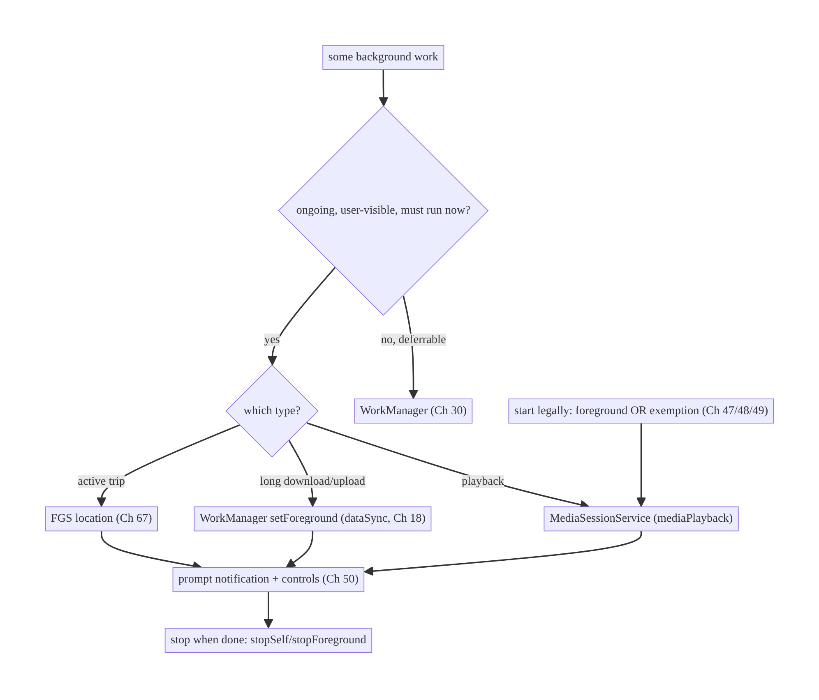
46.4 High-Level Architecture
Components & ownership
- Decision gate: deferrable → WorkManager; ongoing user-visible → FGS.
- FGS (or MediaSessionService / WorkManager setForeground) runs the ongoing work, posts the notification, and stops when done.
- Start path must be legal (foreground or exemption).
Direction: classify work → choose FGS type/mechanism → start legally → notify → stop promptly.

46.5 Detailed Component Design
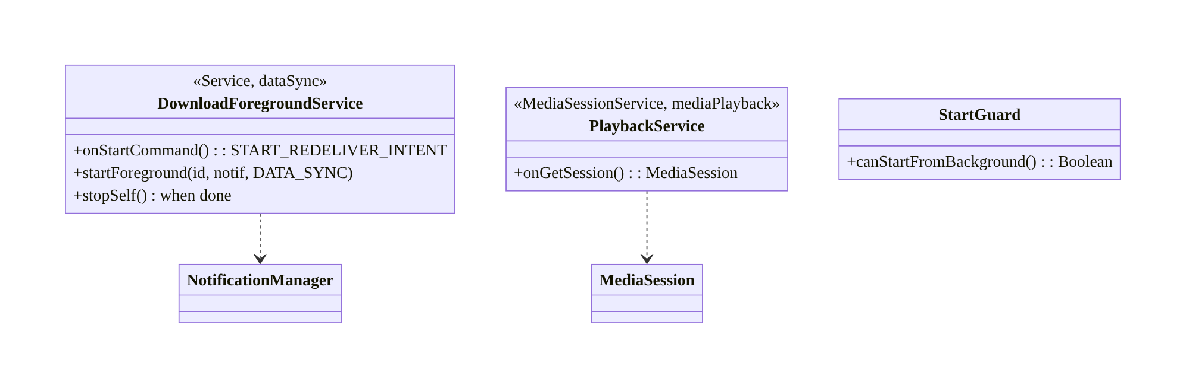
46.5 Detailed Component Design
Mechanism | Type | Use for | Notes
MediaSessionService | mediaPlayback | audio/video | Media3 handles FGS + controls
FGS (dataSync) / WM setForeground | dataSync | active download/upload | time-limited; prefer WM for deferrable-long
FGS location | location | active trip/navigation | needs location perms (Ch 67)
WorkManager | — | deferrable sync/upload | default for background work

46.6 End-to-End Data Flow

Starting & stopping an FGS (download)
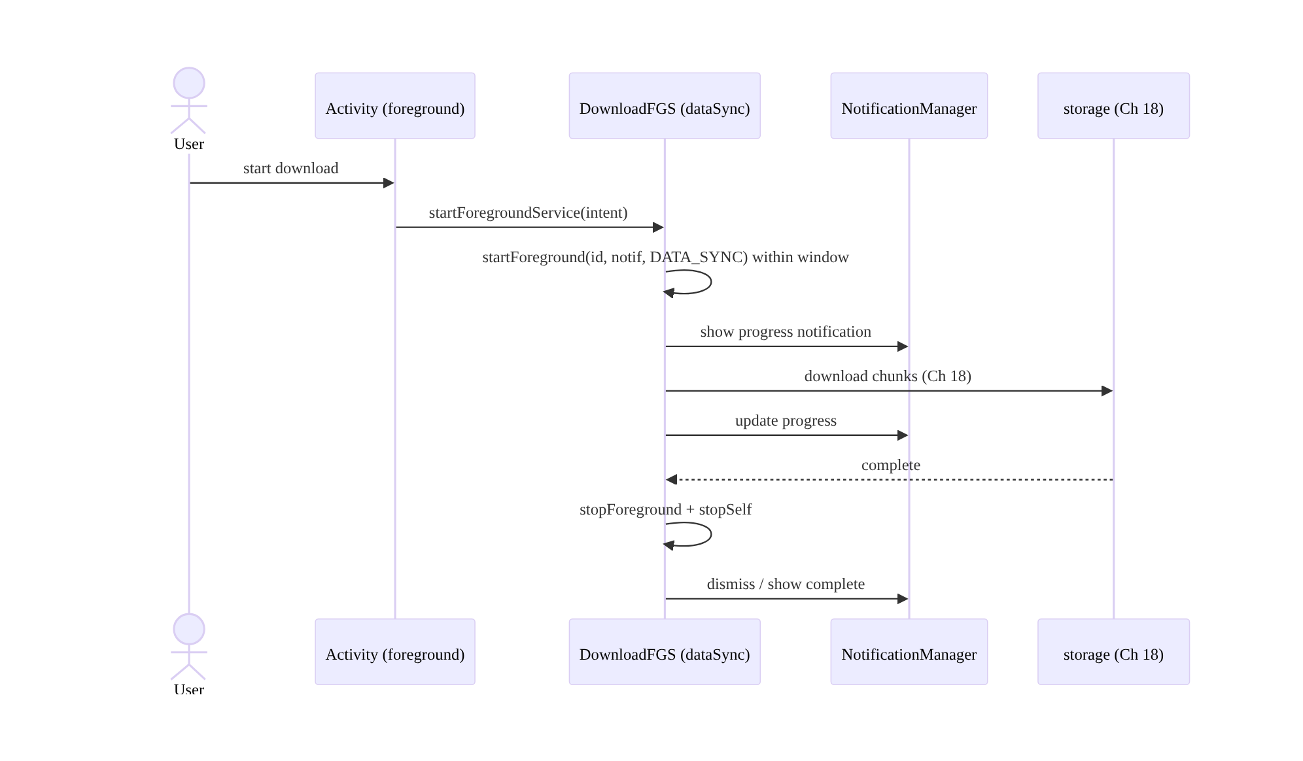
Starting & stopping an FGS (download)

Decision: FGS vs WorkManager
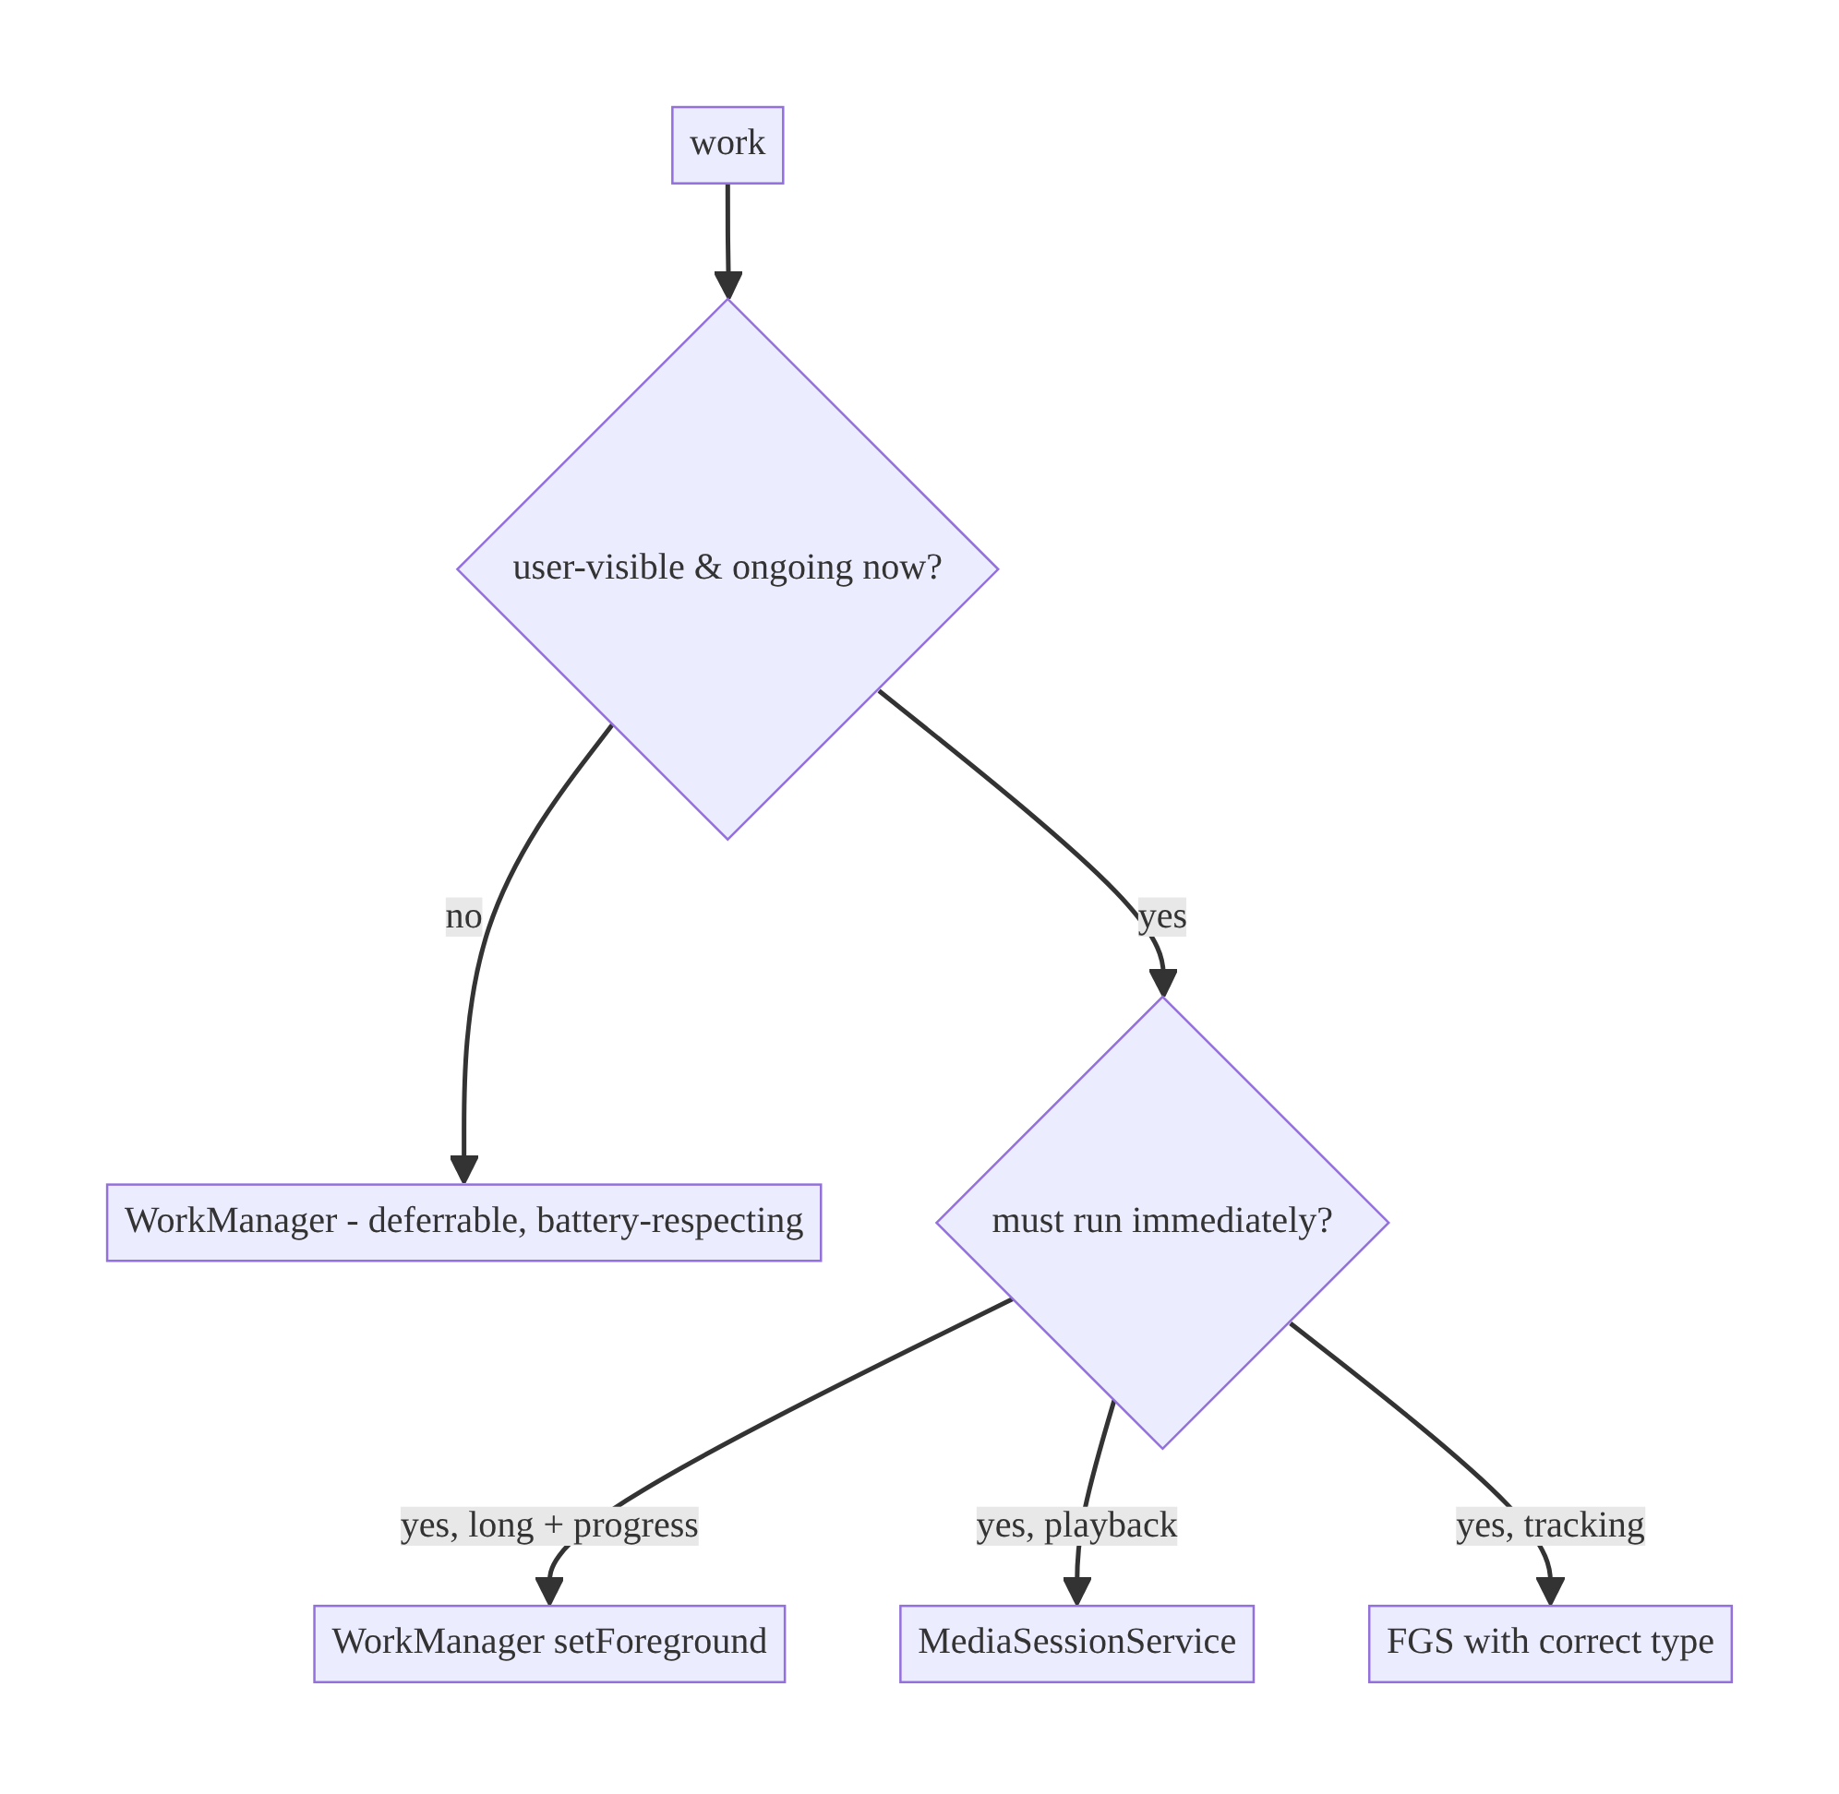
Decision: FGS vs WorkManager

46.7 Complete Kotlin Implementation
Package: com.streamcart.fgs.

46.7.1 Manifest: type + permissions (Android 14+)
<uses-permission android:name="android.permission.FOREGROUND_SERVICE" />
<uses-permission android:name="android.permission.FOREGROUND_SERVICE_DATA_SYNC" />
<uses-permission android:name="android.permission.POST_NOTIFICATIONS" /> <!-- Android 13+ (Ch 51) -->
<service
android:name=".fgs.DownloadForegroundService"
android:exported="false"
android:foregroundServiceType="dataSync" />

46.7.2 A compliant foreground service (download)
@AndroidEntryPoint
class DownloadForegroundService : Service() {
@Inject lateinit var downloader: FileDownloader // Ch 18
private val scope = CoroutineScope(SupervisorJob() + Dispatchers.IO)
override fun onStartCommand(intent: Intent?, flags: Int, startId: Int): Int {
val url = intent?.getStringExtra(EXTRA_URL) ?: run { stopSelf(); return START_NOT_STICKY }
// MUST call startForeground promptly with a notification + the declared type:
startForeground(NOTIF_ID, buildNotification(progress = 0),
ServiceInfo.FOREGROUND_SERVICE_TYPE_DATA_SYNC)
scope.launch {
downloader.download(url) { pct -> updateNotification(pct) } // progress
withContext(Dispatchers.Main) { stopSelf(startId) } // STOP when done
}
return START_REDELIVER_INTENT // re-deliver intent if killed mid-work (Ch 8)
}
override fun onDestroy() { scope.cancel(); super.onDestroy() }
override fun onBind(intent: Intent?): IBinder? = null
private fun buildNotification(progress: Int): Notification =
NotificationCompat.Builder(this, CHANNEL_DOWNLOADS)
.setContentTitle("Downloading")
.setSmallIcon(R.drawable.ic_download)
.setProgress(100, progress, false)
.setOngoing(true)
.addAction(cancelAction()) // user can stop (Ch 50)
.build()
}

46.7.3 Starting legally (from the foreground only)
class DownloadStarter @Inject constructor(@ApplicationContext private val context: Context) {
fun start(url: String) {
// Call this ONLY from the foreground (Android 12+). From background -> use WorkManager
// or a defined exemption (high-priority FCM, exact alarm, notification action).
val intent = Intent(context, DownloadForegroundService::class.java).putExtra(EXTRA_URL, url)
ContextCompat.startForegroundService(context, intent)
}
}

46.7.4 Preferred for long deferrable work: WorkManager setForeground (Ch 30)
@HiltWorker
class LongDownloadWorker @AssistedInject constructor(
@Assisted ctx: Context, @Assisted params: WorkerParameters, private val downloader: FileDownloader,
) : CoroutineWorker(ctx, params) {
override suspend fun getForegroundInfo() =
ForegroundInfo(NOTIF_ID, buildNotification(0), ServiceInfo.FOREGROUND_SERVICE_TYPE_DATA_SYNC)
override suspend fun doWork(): Result {
setForeground(getForegroundInfo()) // promote to FGS-backed
return runCatching { downloader.download(inputData.getString("url")!!) { setProgressAsync(workDataOf("p" to it)) } }
.fold({ Result.success() }, { Result.retry() }) // WorkManager handles retry/constraints (Ch 30)
}
}

46.7.5 Media playback = MediaSessionService (don’t hand-roll)
@AndroidEntryPoint
class PlaybackService : MediaSessionService() { // foregroundServiceType="mediaPlayback"
@Inject lateinit var player: ExoPlayer
private lateinit var session: MediaSession
override fun onCreate() { super.onCreate(); session = MediaSession.Builder(this, player).build() }
override fun onGetSession(controllerInfo: MediaSession.ControllerInfo) = session
override fun onDestroy() { session.release(); player.release(); super.onDestroy() }
}

46.7.6 Module structure
:core:fgs DownloadForegroundService, DownloadStarter, StartGuard
:feature:media PlaybackService (MediaSessionService), MediaSession
:core:work LongDownloadWorker (setForeground), WorkManager setup (Ch 30)

46.8 Concurrency and Race Conditions
Scenario | Risk | Handling
startForeground not called in time | crash/ANR | call it synchronously in onStartCommand
Start FGS from background (Android 12+) | ForegroundServiceStartNotAllowed | start from foreground / exemption / WorkManager
Service not stopped | stuck notification + battery | stopSelf/stopForeground on completion
Process death mid-work | lost work | START_REDELIVER_INTENT/START_STICKY (Ch 8); WorkManager for guarantees
Multiple starts | duplicate work | startId handling / single service instance
No POST_NOTIFICATIONS (Android 13+) | silent FGS (user unaware) | request permission (Ch 51)
- startForeground must happen fast — the OS gives a few seconds after startForegroundService; missing it crashes. Build the notification cheaply and call it first thing.
- Background start is the common crash: on Android 12+ you cannot start an FGS from the background without an exemption; route background-triggered ongoing work through WorkManager/setForeground or an allowed exemption (high-priority FCM for a call/alarm, Ch 48/49).

46.9 Failure Scenarios and Recovery
Failure | Detection | Response | Outcome
FGS killed in background | work incomplete | WorkManager/setForeground; restart semantics | survives/resumes
ForegroundServiceStartNotAllowed | crash | start legally; exemption; WorkManager | compliant
Missing startForeground | ANR/crash | call promptly | stable
Stuck notification | user report | stop service on completion | dismissed
Silent FGS (no notif) | user unaware | request POST_NOTIFICATIONS | visible
Play policy rejection | review | correct type + justified use | approved
Wrong tool (FGS for deferrable) | battery/policy | move to WorkManager | compliant, efficient
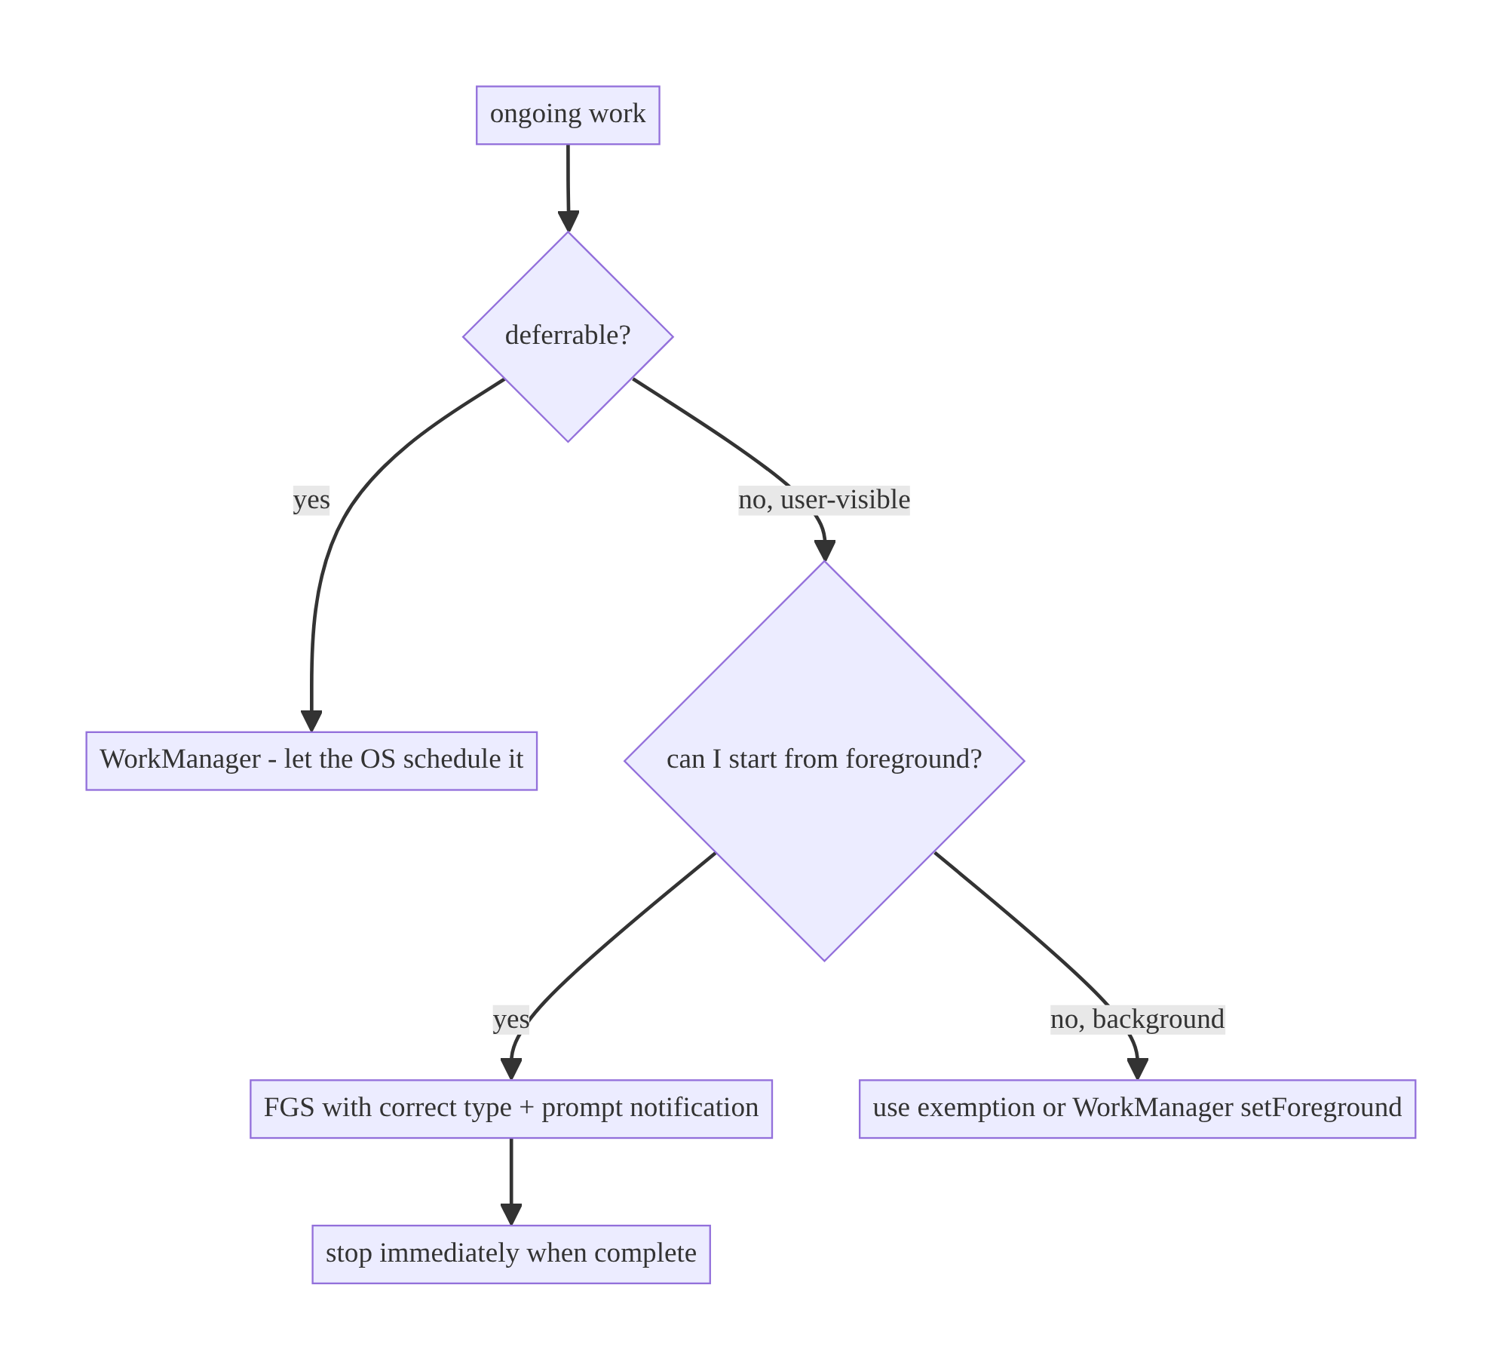
46.9 Failure Scenarios and Recovery
Most FGS failures are policy/lifecycle, not logic: wrong tool (deferrable work in an FGS), illegal background start, missing/late startForeground, or not stopping. Classify the work first — if it’s deferrable, it’s WorkManager, full stop.

46.10 Scaling the Implementation
- Level 1. Media playback via MediaSessionService; WorkManager for all deferrable work.
- Level 2. dataSync FGS (or WM setForeground) for active downloads/uploads with progress notifications; correct types + permissions.
- Level 3 — production. Legal start paths (foreground/exemption); POST_ NOTIFICATIONS handling (Ch 51); restart semantics; stop-on-complete discipline.
- Level 4 — large. Multiple FGS types (media + location trip + sync) coordinated; consistent notification/controls; policy review per type; battery budgets.
- Level 5 — enterprise. FGS usage governance (which teams may use which types), Play-policy compliance checks in CI (manifest lint for types/permissions), observability of FGS runtime + kills, migration of misused FGS to WorkManager.
Avoid overengineering: most apps need exactly one or two FGS types (media, maybe download/location) and WorkManager for everything else. Don’t build custom background frameworks around FGS; prefer MediaSessionService and WorkManager setForeground.

46.11 Alternative Approaches and Trade-offs
Dimension | Option A | Option B | When
Ongoing vs deferrable | Foreground service | WorkManager | FGS only for ongoing user-visible; WorkManager otherwise
Long download | WM setForeground | raw FGS | Prefer WM (retry/constraints + FGS-backed)
Playback | MediaSessionService | hand-rolled FGS | Always MediaSessionService (compliant, controls)
Background-triggered ongoing | Exemption (FCM/alarm) | start FGS directly | Exemption/WorkManager; direct start throws (Android 12+)
Restart | START_REDELIVER_INTENT/STICKY | START_NOT_STICKY | Per semantics (resume vs one-shot)
FGS vs WorkManager: the single most important decision. WorkManager is for deferrable, guaranteed-eventually work and respects Doze/battery — it’s the default. A foreground service is for ongoing, user-visible, must-run-now work and costs a persistent notification and battery. Using an FGS for deferrable work drains battery and risks Play rejection; using WorkManager for genuine ongoing playback fails because it can’t guarantee immediate continuous execution. For long user-visible tasks that are “deferrable-ish but must show progress,” WorkManager’s setForeground gives you both.
MediaSessionService vs hand-rolled playback FGS: Media3’s MediaSessionService manages the foreground service, the media notification, system/Bluetooth/Auto controls, and audio focus for you, and stays compliant with changing FGS rules. Hand-rolling all of that is error-prone and a frequent source of policy and lifecycle bugs. Always use MediaSessionService.

46.12 Security Considerations
- android:exported="false" for internal services — don’t let other apps start your FGS.
- Validate start intents (the EXTRA_URL/params) — an exported or PendingIntent-triggered service must treat inputs as untrusted (Ch 23/52).
- Least-privilege types/permissions: declare only the FGS types you use; location/ camera/microphone types require the matching runtime permissions and should run only during an active, user-understood session (privacy).
- Notification must not leak sensitive content on the lock screen (Ch 50) — use public/private versions.
- Don’t abuse specialUse/systemExempted — Play scrutinizes these; justify or you’ll be rejected.
- Client vs backend: FGS is client execution; the backend only sees the resulting requests (download/sync), which follow normal auth (Ch 19).

46.13 Performance and Resource Optimization
- Stop the service the instant work is done — the #1 battery lever (a lingering FGS holds wakelocks/CPU).
- Prefer WorkManager for deferrable work so the OS batches it in maintenance windows (Ch 47) instead of running an FGS continuously.
- Throttle notification updates (e.g., progress at most a few times/sec) — frequent notify() calls are costly.
- Release resources (ExoPlayer, sockets, GPS) in onDestroy/on stop.
- shortService/dataSync time limits: design long work to checkpoint and resume via WorkManager rather than hold an FGS indefinitely.
- Profiling: FGS runtime duration, wakelocks, battery (Battery Historian), kill/ restart counts.

46.14 Testing Strategy
FGS is tested with Robolectric/instrumentation (service lifecycle) and WorkManager test APIs for setForeground workers.
@RunWith(AndroidJUnit4::class)
class DownloadForegroundServiceTest {
@Test fun `calls startForeground promptly and stops when done`() {
val controller = Robolectric.buildService(DownloadForegroundService::class.java,
Intent().putExtra(EXTRA_URL, "https://x/file")).create().startCommand(0, 0)
val svc = controller.get()
// assert a foreground notification was posted (shadow), and stopSelf on completion
}
}
// WorkManager setForeground worker (Ch 30 TestListenableWorkerBuilder):
class LongDownloadWorkerTest {
@Test fun `promotes to foreground and succeeds`() = runTest {
val worker = TestListenableWorkerBuilder<LongDownloadWorker>(context, inputData = workDataOf("url" to "...")).build()
assertEquals(Result.success(), worker.doWork())
}
}
What to test: startForeground called with correct type/notification promptly; stopSelf on completion; restart return value; setForeground worker promotion; manifest lint (declared types match startForeground types); notification content/ actions. Instrumentation on real devices for Android-13/14 start-legality behavior.

46.15 Production Observability
- Metrics: FGS start success vs ForegroundServiceStartNotAllowed, FGS runtime duration distribution, kill/restart counts, stuck-notification reports, FGS-related crashes/ANRs, battery attribution, Play policy flags.
- Logs: fgs{type, start_reason, duration, stop_reason} (no PII, Ch 28).
- Debugging: ForegroundServiceStartNotAllowed → background start / wrong exemption; stuck notification → service not stopped; silent FGS → missing POST_NOTIFICATIONS; frequent kills → wrong tool (should be WorkManager) or missing restart semantics.
- Alerting: spike in FGS-start failures or FGS crashes after an OS/targetSdk update (tightened rules).
- Compliance: monitor Play Console policy notices for FGS types.

46.16 System Design Interview Preparation
≥25 questions.
Fundamentals
- What is an FGS? A service with a persistent notification, treated as user-aware ongoing work; low kill priority; exempt from most background limits while running.
- FGS vs WorkManager? Ongoing user-visible must-run-now vs deferrable guaranteed- eventually.
- Default for background work? WorkManager.
- When is FGS the only option? Continuous user-initiated work (playback, active download/tracking).
- FGS service types? mediaPlayback, location, dataSync, connectedDevice, etc.; declared + permissioned (Android 14+ enforced).
Rules
- Android 12+ background start? Forbidden without exemption → ForegroundServiceStartNotAllowed.
- Exemptions? High-priority FCM, exact alarm, notification action, companion device, etc.
- startForeground timing? Must call within a few seconds → else crash/ANR.
- Android 13+ notification? Needs POST_NOTIFICATIONS to be visible (Ch 51).
- Time-limited types? dataSync/shortService.
Lifecycle
- How start? startForegroundService (then startForeground).
- How stop? stopSelf/stopForeground when done (critical).
- Restart semantics? START_STICKY/NOT_STICKY/REDELIVER_INTENT per need (Ch 8).
- Stuck notification cause? Service not stopped.
Mechanisms
- Long download best practice? WorkManager setForeground.
- Playback best practice? MediaSessionService (Media3).
- Why not hand-roll playback FGS? Media3 handles FGS/notification/controls/ compliance.
Security
- Exported? false for internal services.
- Least privilege? Declare only used types; location/camera need runtime perms.
- Lock-screen leak? Public/private notification versions.
Testing
- How test an FGS? Robolectric service controller; assert startForeground/ stopSelf.
- How test setForeground worker? TestListenableWorkerBuilder (Ch 30).
Production
- ForegroundServiceStartNotAllowed? Background start — use foreground/exemption/ WorkManager.
- Silent FGS? Missing notification permission.
- Frequent kills? Wrong tool or missing restart semantics.
- Play rejection? Wrong/unjustified FGS type.

Design-change challenges
- Music must keep playing in background. MediaSessionService (mediaPlayback) + controls.
- A large download must survive backgrounding. WorkManager setForeground (dataSync) + progress notification.
- Start ongoing work from a push while backgrounded. High-priority FCM exemption or WorkManager (Ch 49).
- FGS notification is stuck after completion. Stop the service on completion.
- App crashes starting an FGS from the background. Move to legal start/exemption/ WorkManager.

Mock walkthrough (abridged)
Clarify (is the work ongoing/user-visible/immediate, what type, what start trigger?) → classify FGS vs WorkManager → pick mechanism (MediaSessionService/setForeground/FGS) → declare type + permissions → legal start → prompt notification + controls → stop on completion → restart semantics → security (exported, least privilege) → testing.

46.17 Practical Exercises
- Beginner. Add background music playback via MediaSessionService (mediaPlayback). Eval: plays while backgrounded; notification controls work.
- Intermediate. Make a large download survive backgrounding with WorkManager setForeground (dataSync) + progress. Eval: continues; stops/clears on done.
- Advanced. Add a location FGS for an active trip that stops when the trip ends; request POST_NOTIFICATIONS. Eval: correct type/perms; visible; stops.
- Production debugging. Fix a ForegroundServiceStartNotAllowed crash (background start) and a stuck notification (no stop). Eval: legal start; stops.
- System design challenge. Audit all services; migrate deferrable work from FGS to WorkManager and justify remaining FGS types for Play. Eval: minimal FGS; compliant.
(Solutions withheld unless requested.)

46.18 Chapter Summary & Reference Sheet
Key decisions: use a foreground service only for ongoing, user-visible, must-run-now work the user started (playback, active download/upload, live tracking) — route everything deferrable to WorkManager (Ch 30), and for long user-visible tasks prefer WorkManager setForeground; for media always use MediaSessionService; declare the correct FGS type + permissions (enforced on Android 14+); start legally (from the foreground, or a defined exemption like high-priority FCM/exact alarm — background start throws on Android 12+); call startForeground promptly with a compliant notification (and hold POST_NOTIFICATIONS on Android 13+, Ch 51); define restart semantics (START_*, Ch 8); and stop the service the moment work is done. Keep services exported=false and types least-privilege.
Concepts: foreground service, FGS types, start legality (Android 12+/14+), startForeground/stopSelf, restart semantics, WorkManager setForeground, MediaSessionService, notification requirements + POST_NOTIFICATIONS.
Common mistakes: FGS for deferrable work (battery/policy); background start (ForegroundServiceStartNotAllowed); missing/late startForeground (ANR); not stopping (stuck notification/battery); wrong/undeclared type (Android 14+ crash/rejection); silent FGS (no notification permission); hand-rolling playback.
Checklist:
- ☐ classify FGS vs WorkManager
- ☐ correct type + permissions
- ☐ legal start (foreground/exemption)
- ☐ startForeground promptly
- ☐ compliant notification + POST_NOTIFICATIONS
- ☐ stop on completion
- ☐ restart semantics
- ☐ MediaSessionService for media
- ☐ setForeground for long downloads
- ☐ exported=false + least privilege.
Key APIs: Service/startForeground/stopSelf/stopForeground, ContextCompat.startForegroundService, ServiceInfo.FOREGROUND_SERVICE_TYPE_*, android:foregroundServiceType, CoroutineWorker.setForeground/ForegroundInfo (Ch 30), MediaSessionService/MediaSession (Media3), NotificationCompat (Ch 50), POST_NOTIFICATIONS (Ch 51).
References:
- Foreground services: https://developer.android.com/develop/background-work/services/foreground-services
- FGS types (Android 14): https://developer.android.com/about/versions/14/changes/fgs-types-required
- Background start restrictions: https://developer.android.com/guide/components/foreground-services#background-start-restrictions
- Long-running workers: https://developer.android.com/develop/background-work/background-tasks/persistent/how-to/long-running
- Media3 MediaSessionService: https://developer.android.com/media/media3/session/background-playback
- (composes) Ch 30 WorkManager, Ch 18 Downloads, Ch 47 Doze, Ch 50 Notifications, Ch 51 Permissions

Chapter 47 — Doze, App Standby & Background Execution Limits
Part VI — Lifecycle, Background & Platform · Complexity: Complex (≥40 interview questions)
Prerequisites: Ch 30 (WorkManager), Ch 46 (foreground services), Ch 44 (lifecycle), Ch 48 (alarms), Ch 49 (FCM). Foundational for every background feature (sync Ch 29/32, outbox Ch 31, uploads Ch 17).
Reference surface in StreamCart: making background sync, uploads, and notifications reliable and battery-friendly across Doze, App Standby Buckets, and OEM battery managers — so work completes without draining the battery or getting the app killed.

47.1 Problem Definition and Real-World Context
Android’s single biggest source of user complaints historically was battery drain from apps working in the background. Over many releases Google built an escalating set of background execution restrictions — Doze, App Standby Buckets, background service limits, background location limits, battery optimization, and (on top of AOSP) aggressive OEM battery managers (Xiaomi, Huawei, Samsung, OnePlus, etc.). The result: you cannot assume your background code runs when you want it to. Alarms are deferred, network is blocked, services are killed, and jobs are delayed — sometimes for hours — unless you cooperate with the system.
This is the central reliability tension of Android background work:
- Deferred/blocked work. In Doze, the device batches background activity into periodic maintenance windows; outside them, network access and wakelocks are suspended and alarms/jobs are deferred. A naive AlarmManager alarm or raw thread simply won’t fire/run on time.
- App Standby Buckets. The OS classifies each app into active / working-set / frequent / rare / restricted based on usage, and throttles its jobs, alarms, FCM quota, and network accordingly. A rarely-used app’s background work is heavily limited.
- Background service limits (Android 8+). You can’t freely start background services; startService from the background throws unless it becomes a foreground service (Ch 46) — pushing most background work to WorkManager/JobScheduler.
- OEM killers. Many OEMs kill or “optimize” backgrounded apps far more aggressively than AOSP, breaking even correct WorkManager usage unless the user exempts the app.
- Doing it wrong both ways. Fighting the system (wakelocks, exact alarms, foreground-service abuse) drains battery and gets you flagged/killed; ignoring it means work never completes. The craft is cooperating with the restrictions.
The architecture: understand each restriction (Doze, Buckets, service/location limits, battery optimization, OEM behavior); use the OS-blessed mechanisms — WorkManager for deferrable work (it respects and schedules around all of this), foreground services (Ch 46) for ongoing user-visible work, exact alarms (Ch 48) only for genuine user-facing time precision, high-priority FCM (Ch 49) for time-sensitive wake-ups; set correct constraints (network, charging, idle) so work runs in the right window; request exemptions sparingly and legitimately (battery- optimization/exact-alarm exemptions) with clear justification; and degrade gracefully when work is throttled. This chapter is about reliable background work that respects battery — the hardest, most device-fragmented area of Android.

Three practical use cases
- StreamCart periodic sync. A periodic WorkManager job with network constraints that runs in Doze maintenance windows / per the app’s bucket, batching efficiently (Ch 29/32) — not an exact alarm.
- Time-sensitive notification. A price-drop/order-update that must wake the app promptly → high-priority FCM (Ch 49), which is allowed limited Doze wake-ups, rather than a background poll.
- OEM-killed sync. Detecting an aggressive OEM, guiding the user to disable battery optimization for the app, and using a foreground service for the critical path.

Why this is architectural
Background execution limits are a platform contract that shapes every background feature: which mechanism to use, what constraints to set, how to handle deferral and device fragmentation, and when (and how legitimately) to seek exemptions. Getting it wrong fails sync reliability or battery life — both are user-visible and ranked by the Play Store.

47.2 Requirements Engineering

Functional requirements
ID | Requirement
F1 | Deferrable background work completes reliably (eventually), respecting battery.
F2 | Time-sensitive work wakes the app promptly via allowed mechanisms.
F3 | Set correct constraints so work runs in the right conditions (network/charging/idle).
F4 | Detect and handle restriction (bucket demotion, battery optimization, OEM killing).
F5 | Request exemptions only when legitimate, with user consent.
F6 | Degrade gracefully under throttling (backoff, catch-up on next window).

Non-functional requirements
Attribute | Target/Policy
Battery | Cooperate with Doze/Buckets; no wakelock/exact-alarm abuse.
Reliability | Work completes within acceptable latency per its urgency.
Compatibility | Works across OS versions + major OEMs.
Compliance | Exemptions justified (Play scrutinizes); correct mechanism per use.
Observability | Measure completion latency, deferral, kills by device/bucket.

Scope
- In scope: Doze (deep + light), App Standby Buckets, background service/location limits, battery optimization/allowlist, OEM battery managers, choosing mechanisms (WorkManager/FGS/exact alarm/high-priority FCM), constraints, exemptions (REQUEST_IGNORE_BATTERY_OPTIMIZATIONS, exact-alarm permission), graceful degradation, measurement.
- Out of scope: WorkManager internals (Ch 30), FGS detail (Ch 46), alarms detail (Ch 48), FCM detail (Ch 49), sync algorithms (Ch 32).

Assumptions & constraints
- minSdk 24 (Doze since 23, Buckets since 28, service limits since 26). WorkManager as the primary scheduler. Device fragmentation is a hard reality; OEM behavior is not fully controllable — design for it, don’t assume AOSP.

47.3 System Design Fundamentals
- Doze (device idle): when the device is unplugged, screen-off, and stationary for a while, it enters deep Doze: periodic maintenance windows (increasingly far apart) are the only times background apps run; outside them network access and wakelocks are suspended, standard alarms and jobs are deferred to the next window, and AlarmManager is batched. Light Doze (screen-off but moving / recently used) is a lighter version with more frequent windows. What survives Doze: high-priority FCM (limited), foreground services, exact alarms (setExactAndAllowWhileIdle/ setAlarmClock, Ch 48), and WorkManager jobs (run in windows).
- App Standby Buckets (Android 9+): the OS buckets each app by usage — active (in use / just used), working set (regular use), frequent, rare, restricted (rarely used or misbehaving) — and throttles jobs, alarms, FCM quota, and network progressively per bucket. The worse the bucket, the more your background work is delayed and the smaller your high-priority-FCM budget. Keeping the app useful (so users open it) keeps it in a good bucket; the restricted bucket is near-total background suspension.
- Background service limits (Android 8+): apps can’t start background services at will; startService from background throws BackgroundServiceStartNotAllowed. The OS pushes you to WorkManager/JobScheduler for deferrable work and foreground services (Ch 46) for ongoing visible work.
- Battery optimization / allowlist: by default apps are “optimized” (subject to Doze/ Standby). An app can be allowlisted (exempt from some Doze restrictions) — either by the user via settings or by prompting with ACTION_REQUEST_IGNORE_BATTERY_OPTIMIZATIONS. Use this sparingly and legitimately — Play restricts which app categories may request it, and abuse causes rejection.
- OEM battery managers (the fragmentation reality): many OEMs add aggressive background killing on top of AOSP (killing WorkManager jobs, ignoring standard guarantees) unless the user manually exempts the app (varies per OEM; see dontkillmyapp.com-style guidance). You cannot fully control this in code — detect likely-aggressive OEMs and guide the user to the right settings; use a foreground service for truly critical paths.
- Mechanism selection (the decision):
Need | Mechanism | Why
Deferrable background work (sync, upload) | WorkManager (Ch 30) | Respects Doze/Buckets; reschedules; constraints
Ongoing user-visible work (playback, active download) | Foreground service (Ch 46) | Exempt while running
Prompt wake for time-sensitive data | High-priority FCM (Ch 49) | Allowed limited Doze wake-ups
Genuine user-facing exact time (alarm clock, calendar) | Exact alarm (Ch 48) | setAlarmClock/setExactAndAllowWhileIdle
Precise periodic polling | ❌ (don’t) | Fights the system; use FCM/WorkManager
- Constraints (make work run in the right window): WorkManager constraints (NetworkType, requiresCharging, requiresDeviceIdle, requiresBatteryNotLow) tell the OS when to run — e.g., heavy sync only on unmetered + charging runs during Doze maintenance windows at low cost. Correct constraints = reliable and battery-friendly.
- Graceful degradation: assume work may be deferred; design for catch-up (delta/incremental sync on next window, Ch 32), backoff (Ch 2/30), and idempotency (Ch 15) so deferral/retry is safe. Don’t assume exact timing.
Core insight: you cannot run arbitrary background code on your own schedule — Doze, App Standby Buckets, service limits, battery optimization, and OEM killers all throttle it. Cooperate: use WorkManager for deferrable work (with correct constraints so it runs in the right Doze window), foreground services for ongoing visible work, high-priority FCM for prompt wake-ups, and exact alarms only for genuine user-facing time; request battery-optimization/OEM exemptions only when legitimate and user-consented; and design work to be deferrable, idempotent, and catch-up-capable so throttling degrades it gracefully instead of breaking it.

47.4 High-Level Architecture
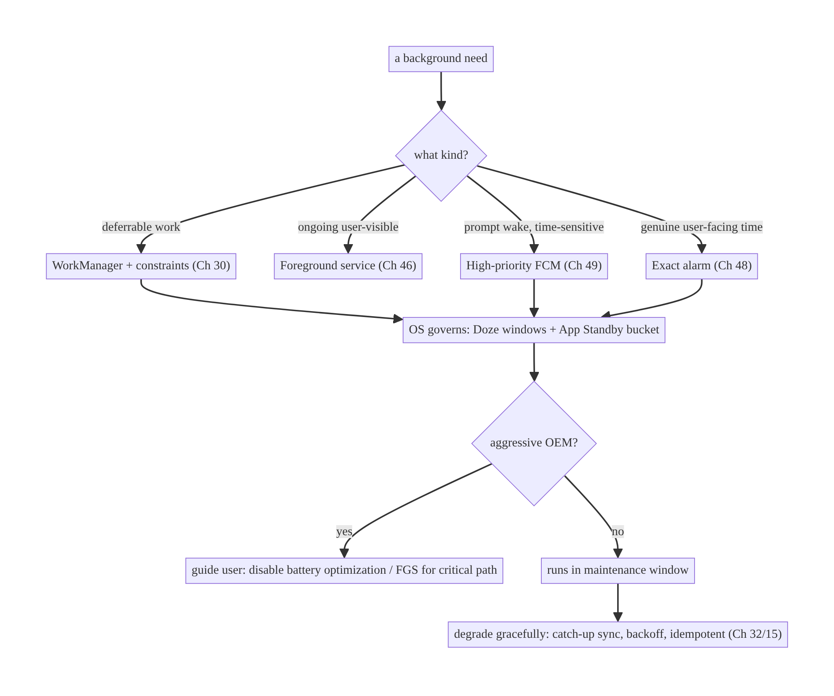
47.4 High-Level Architecture
Components & ownership
- Classifier/decision maps each need to the OS-blessed mechanism.
- WorkManager carries deferrable work with constraints; the OS governs when (Doze/bucket).
- OEM handling detects aggressive devices and guides the user; FGS for critical paths.
- Degradation (catch-up/backoff/idempotency) makes deferral safe.
Direction: classify → OS-blessed mechanism + constraints → OS schedules in window → handle OEM/exemptions → degrade gracefully.

47.5 Detailed Component Design
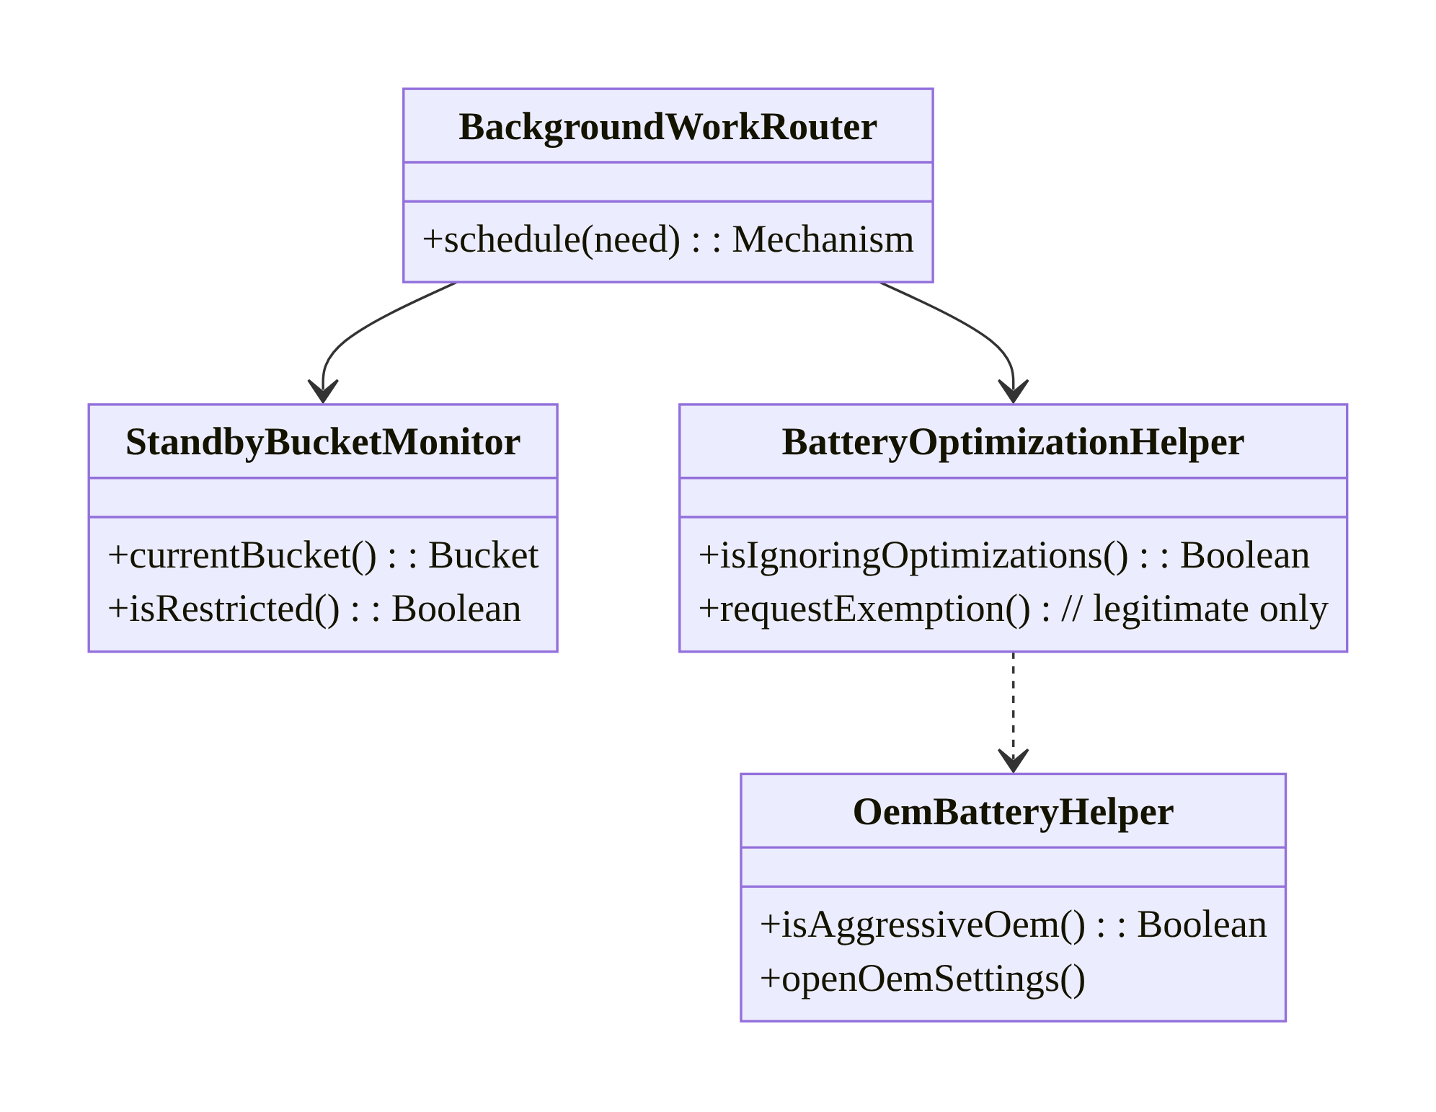
47.5 Detailed Component Design
Component | Responsibility
BackgroundWorkRouter | pick mechanism per need (WM/FGS/FCM/alarm)
StandbyBucketMonitor | read UsageStatsManager.appStandbyBucket → adapt expectations
BatteryOptimizationHelper | check/request allowlist (legitimate cases only)
OemBatteryHelper | detect aggressive OEMs; guide user

47.6 End-to-End Data Flow

Deferrable sync under Doze
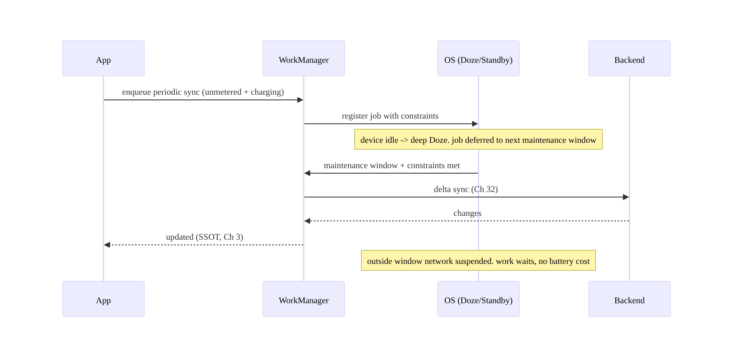
Deferrable sync under Doze

Time-sensitive wake via high-priority FCM
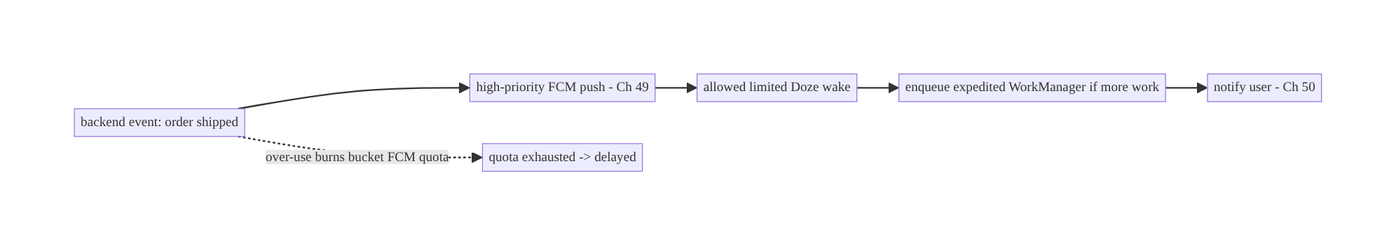
Time-sensitive wake via high-priority FCM

47.7 Complete Kotlin Implementation
Package: com.streamcart.background.

47.7.1 Deferrable periodic sync with correct constraints (not an alarm)
@Singleton
class SyncScheduler @Inject constructor(private val workManager: WorkManager) {
fun schedulePeriodicSync() {
val constraints = Constraints.Builder()
.setRequiredNetworkType(NetworkType.UNMETERED) // run on wifi
.setRequiresBatteryNotLow(true)
.build() // OS runs it in a Doze window when met
val request = PeriodicWorkRequestBuilder<SyncWorker>(6, TimeUnit.HOURS)
.setConstraints(constraints)
.setBackoffCriteria(BackoffPolicy.EXPONENTIAL, 30, TimeUnit.SECONDS) // graceful retry (Ch 2)
.build()
workManager.enqueueUniquePeriodicWork("sync", ExistingPeriodicWorkPolicy.KEEP, request)
}
// Time-sensitive one-off that should run ASAP within OS allowance:
fun expedite() = workManager.enqueue(
OneTimeWorkRequestBuilder<SyncWorker>()
.setExpedited(OutOfQuotaPolicy.RUN_AS_NON_EXPEDITED_WORK_REQUEST) // expedited where allowed
.build())
}

47.7.2 Standby bucket awareness (adapt expectations, log)
@Singleton
class StandbyBucketMonitor @Inject constructor(@ApplicationContext private val ctx: Context) {
private val usageStats = ctx.getSystemService(Context.USAGE_STATS_SERVICE) as UsageStatsManager
fun currentBucket(): Int = usageStats.appStandbyBucket // ACTIVE/WORKING_SET/FREQUENT/RARE/RESTRICTED
fun isRestricted(): Boolean =
currentBucket() >= UsageStatsManager.STANDBY_BUCKET_RESTRICTED
// Use to: log/measure, widen sync intervals in bad buckets, and warn if RESTRICTED.
}

47.7.3 Battery-optimization exemption (legitimate cases only, user-consented)
@Singleton
class BatteryOptimizationHelper @Inject constructor(@ApplicationContext private val ctx: Context) {
private val pm = ctx.getSystemService(Context.POWER_SERVICE) as PowerManager
fun isIgnoringOptimizations(): Boolean = pm.isIgnoringBatteryOptimizations(ctx.packageName)
/** Only for app categories Play allows (e.g., alarm/health). Show rationale FIRST (Ch 51 pattern). */
@SuppressLint("BatteryLife")
fun exemptionIntent(): Intent = Intent(Settings.ACTION_REQUEST_IGNORE_BATTERY_OPTIMIZATIONS)
.setData(Uri.parse("package:${ctx.packageName}"))
// Prefer linking to Settings.ACTION_IGNORE_BATTERY_OPTIMIZATION_SETTINGS for general apps.
}

47.7.4 OEM detection + guidance (can’t fix in code; guide the user)
object OemBatteryHelper {
private val aggressive = setOf("xiaomi", "huawei", "honor", "oppo", "vivo", "oneplus", "samsung", "meizu")
fun isAggressiveOem(): Boolean = Build.MANUFACTURER.lowercase() in aggressive
/** Best-effort deep link to the OEM's auto-start/battery settings; fall back to app settings. */
fun oemSettingsIntents(): List<Intent> = listOf(
Intent().setComponent(ComponentName("com.miui.securitycenter",
"com.miui.permcenter.autostart.AutoStartManagementActivity")),
// ... other OEM components (wrapped in try/catch when launching) ...
Intent(Settings.ACTION_APPLICATION_DETAILS_SETTINGS, Uri.parse("package:$PKG")), // fallback
)
}

47.7.5 Graceful degradation: idempotent catch-up sync
// SyncWorker is idempotent (Ch 15) and does delta/catch-up sync (Ch 32), so deferral/retry is safe.
@HiltWorker
class SyncWorker @AssistedInject constructor(
@Assisted ctx: Context, @Assisted p: WorkerParameters, private val repo: SyncRepository,
) : CoroutineWorker(ctx, p) {
override suspend fun doWork(): Result = runCatching {
repo.deltaSyncSince(repo.lastSyncCursor()) // catch up whatever was missed while deferred
}.fold({ Result.success() }, { if (runAttemptCount < 5) Result.retry() else Result.failure() })
}

47.7.6 Module structure
:core:background SyncScheduler, StandbyBucketMonitor, BatteryOptimizationHelper, OemBatteryHelper, BackgroundWorkRouter
:core:work SyncWorker (idempotent, delta/catch-up) [Ch 30/32]
# FGS -> :core:fgs (Ch 46); FCM -> :feature:push (Ch 49); alarms -> :core:alarm (Ch 48).

47.8 Concurrency and Race Conditions
Scenario | Risk | Handling
Work deferred to a later window | stale data | idempotent delta/catch-up sync (Ch 32/15)
Retry after throttle | duplicates | idempotency keys (Ch 15)
Multiple windows run overlapping work | races | enqueueUniqueWork/single-flight (Ch 11/30)
Bucket demotion mid-session | unexpected delay | adapt intervals; measure bucket
FCM quota exhausted | push dropped/delayed | don’t over-send high-priority; fall back to WorkManager
Exact alarm fires in Doze | battery/abuse flag | use only for genuine user-facing time (Ch 48)
- Design for deferral, not timing. Because the OS decides when work runs, two “scheduled” runs can collapse into one window or be far apart — make work idempotent (Ch 15) and catch-up-based (sync since a cursor, Ch 32) so order/timing don’t matter.
- Unique work prevents overlapping jobs when windows and triggers coincide (enqueueUniquePeriodicWork/enqueueUniqueWork, Ch 30).

47.9 Failure Scenarios and Recovery
Failure | Detection | Response | Outcome
Sync never runs (OEM kill) | completion telemetry by OEM | guide user to exempt; FGS for critical path | runs
Work delayed hours (RESTRICTED bucket) | bucket telemetry | encourage engagement; widen intervals; high-priority FCM for urgent | acceptable
Exact alarm abuse → flagged | Play/battery stats | switch to WorkManager/FCM | compliant
High-priority FCM dropped | delivery telemetry (Ch 49) | reduce volume; expedited WorkManager fallback | delivered within quota
Battery drain complaint | Android vitals (wakelocks) | remove wakelock/exact-alarm abuse; constraints | battery ok
Background start crash | crash | WorkManager/FGS, not startService | compliant
Stale data after long idle | user report | catch-up delta sync on next window | fresh
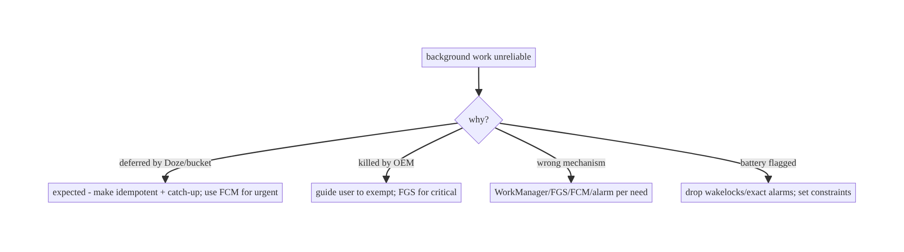
47.9 Failure Scenarios and Recovery
The system is not broken when it defers your work — it is working as designed. Reliability comes from choosing the OS-blessed mechanism, setting constraints, and making work idempotent/catch-up — not from fighting Doze. Fighting it (wakelocks, exact alarms, FGS abuse) gets you battery-flagged and OEM-killed.

47.10 Scaling the Implementation
- Level 1. All deferrable work on WorkManager with sensible constraints; FGS for ongoing visible work (Ch 46).
- Level 2. High-priority FCM for time-sensitive wake-ups (Ch 49); expedited work where allowed; idempotent catch-up sync (Ch 32/15).
- Level 3 — production. Standby-bucket awareness; battery-optimization exemption for legitimate categories (consented); OEM detection + user guidance; completion telemetry by bucket/OEM/OS.
- Level 4 — large. Per-feature background budgets; adaptive sync intervals by bucket/ battery; FCM-quota-aware prioritization (Ch 14); FGS reserved for truly critical paths; Android-vitals battery monitoring.
- Level 5 — enterprise. Background-work governance (which mechanisms teams may use), device-fragmentation dashboards (completion by OEM/OS/bucket), automated battery- regression gates, documented degradation SLOs per feature urgency tier.
Avoid overengineering: for most apps, WorkManager with correct constraints + high-priority FCM for urgent + idempotent catch-up sync is the whole story. Don’t add exemption prompts, OEM deep-links, or bucket logic unless telemetry shows you need them — each adds friction and Play risk.

47.11 Alternative Approaches and Trade-offs
Dimension | Option A | Option B | When
Deferrable work | WorkManager | exact alarm + raw service | WorkManager always (respects limits); alarms fight the system
Prompt wake | High-priority FCM | background polling | FCM (allowed Doze wake); polling is blocked/battery-flagged
Ongoing visible | Foreground service | wakelock + background service | FGS (Ch 46); wakelock abuse is killed/flagged
Reliability on OEMs | User-guided exemption + FGS critical path | assume AOSP guarantees | Guide/FGS; AOSP assumption breaks on OEMs
Exemption | Request only for legitimate categories | request for everyone | Legitimate-only (Play rejects abuse)
Degradation | Idempotent catch-up + backoff | assume exact timing | Catch-up (deferral-safe); exact-timing breaks
WorkManager vs exact alarms for periodic work: exact alarms (setExactAndAllowWhileIdle) can fire in Doze, which tempts developers to use them for “reliable” periodic sync — but this fights the battery model, is heavily rate-limited, flags your app for battery drain, and on Android 12+ requires the SCHEDULE_EXACT_ALARM/ USE_EXACT_ALARM permission reserved for genuine user-facing timing (alarm clocks, calendars, Ch 48). WorkManager with constraints is the correct tool for deferrable periodic work: it runs in maintenance windows at low battery cost and reschedules automatically.
High-priority FCM vs background polling: to react to a server event promptly, polling from the background is blocked/deferred by Doze and burns battery for nothing most of the time. High-priority FCM is the OS-blessed way to wake the app for time-sensitive data (limited Doze wake-ups, bucket-dependent quota). Use FCM to push the trigger, then do the work with WorkManager/expedited work (Ch 49).
Battery-optimization exemption vs cooperating: an exemption makes your background work more reliable but costs battery, annoys users, and is Play-restricted to certain app categories. Most apps should cooperate (WorkManager + FCM) rather than request exemptions; reserve exemptions for apps whose core function genuinely requires it (alarms, health monitoring, sync-heavy enterprise), always with a clear rationale and user consent.

47.12 Security & Privacy Considerations
- Background location is doubly restricted (Doze + background-location permission, Ch 67): only access it during an active, user-understood foreground session or FGS — never silently in the background.
- Exemption prompts are a social-engineering surface: be honest about why you need the exemption; don’t trick users into allowlisting for battery-draining purposes (Play policy + user trust).
- High-priority FCM payloads reach the app in Doze — treat them as untrusted (Ch 49), validate, and don’t include sensitive data in the push itself (Ch 28).
- OEM deep-links must fall back gracefully and never assume a component exists (wrap in try/catch) — a crash here is a trust/UX hit.
- Don’t abuse systemExempted/specialUse FGS types (Ch 46) to dodge limits — Play scrutinizes this.
- Client vs backend: the backend should send time-sensitive events as pushes rather than expecting the client to poll, and should tolerate catch-up sync patterns (delta since cursor, Ch 32) since client timing is non-deterministic.

47.13 Performance and Resource Optimization
- Correct constraints are the main battery lever: heavy work on unmetered + charging + battery-not-low runs in Doze windows essentially for free.
- Batch background work (one periodic sync, not many timers) so the OS coalesces it into fewer windows (Ch 14).
- Don’t hold wakelocks; let WorkManager manage execution. Wakelocks are a top battery offender and OEM-kill trigger.
- Adapt to bucket/battery: widen sync intervals in worse buckets / low battery; skip non-essential work.
- Minimize high-priority FCM (quota- and battery-costly); use normal-priority for non-urgent, and coalesce server events.
- Profiling: Battery Historian (Doze state, wakelocks, alarms, jobs), Android vitals (excessive wakeups/wakelocks), completion-latency telemetry by bucket/OEM.

47.14 Testing Strategy
Background limits are tested with adb Doze/Standby simulation, WorkManager test APIs, and device-matrix (OEM) testing.
# Simulate deep Doze (force the device idle) and verify work defers/catches up:
adb shell dumpsys deviceidle force-idle
adb shell dumpsys deviceidle unforce
# Set a standby bucket to verify throttled behavior:
adb shell am set-standby-bucket com.streamcart restricted
# Inspect scheduled jobs/alarms:
adb shell dumpsys jobscheduler | grep streamcart
adb shell dumpsys alarm | grep streamcart
// WorkManager constraints + catch-up (Ch 30 TestDriver):
@Test fun `periodic sync runs when constraints met and catches up`() = runTest {
val wm = WorkManagerTestInitHelper.getTestDriver(context)!!
// enqueue; setAllConstraintsMet(id); setPeriodDelayMet(id); assert delta/catch-up sync ran
}
@Test fun `sync worker is idempotent under retry`() = runTest { /* run twice, assert no duplicates (Ch 15) */ }
What to test: Doze deferral + catch-up (adb force-idle), restricted-bucket behavior (set-standby-bucket), constraint gating (WM TestDriver), idempotent retry, FCM→expedited path (Ch 49), exemption-state read, OEM deep-link fallback (no crash). Device-matrix testing on major OEMs is essential — emulator behavior under-represents OEM killing.

47.15 Production Observability
- Metrics: background-work completion latency and success rate by standby bucket / OEM / OS version; deferral counts; WorkManager job attempts/failures; FGS kill counts (Ch 46); high-priority FCM delivery + quota (Ch 49); Android vitals excessive-wakeup/wakelock rates; battery-optimization-exemption acceptance.
- Logs: bg_work{mechanism, bucket, oem, os, latency, result} (no PII, Ch 28).
- Debugging: sync unreliable on one OEM → OEM killing (guide user / FGS); work always delayed → RESTRICTED bucket (engagement) or wrong mechanism; battery flagged → wakelock/ exact-alarm abuse; FCM delayed → quota exhausted (reduce volume).
- Alerting: completion-rate drop on a specific OEM/OS after an update; battery-vitals regression.
- Dashboards: completion by OEM × OS × bucket (the fragmentation matrix) — the key artifact for this domain.

47.16 System Design Interview Preparation
≥40 questions.
Doze
- What is Doze? Device-idle mode batching background activity into maintenance windows; network/wakelocks suspended, alarms/jobs deferred outside them.
- Deep vs light Doze? Stationary+unplugged+screen-off (windows far apart) vs screen-off/recently-used (more frequent).
- What survives Doze? High-priority FCM (limited), FGS, exact alarms (setExactAndAllowWhileIdle/setAlarmClock), WorkManager jobs (in windows).
- Maintenance window? Periodic interval when deferred background work runs.
- Why Doze exists? Battery life; top historical complaint.
App Standby Buckets
- What are buckets? Active/working-set/frequent/rare/restricted usage tiers that throttle jobs/alarms/FCM/network.
- How assigned? By usage/recency (and misbehavior → restricted).
- Restricted bucket? Near-total background suspension.
- How to stay in a good bucket? Keep the app useful so users open it.
- Read the bucket? UsageStatsManager.appStandbyBucket.
Service/background limits
- Android 8 background service limit? Can’t start background services freely; startService from background throws.
- What replaced free background services? WorkManager/JobScheduler + FGS.
- Background location limits? Throttled; needs background-location permission (Ch 67).
Battery optimization / OEM
- Battery optimization? Default state subjecting apps to Doze/Standby; allowlist exempts.
- How request exemption? ACTION_REQUEST_IGNORE_BATTERY_OPTIMIZATIONS (legitimate categories only).
- Risk of exemption? Battery cost, user annoyance, Play restriction.
- OEM battery managers? Aggressive killing beyond AOSP; need user to exempt; not code-fixable.
- Handling OEMs? Detect + guide user; FGS for critical path.
Mechanism selection
- Deferrable work? WorkManager.
- Ongoing visible? Foreground service (Ch 46).
- Prompt time-sensitive wake? High-priority FCM (Ch 49).
- Genuine user-facing exact time? Exact alarm (Ch 48).
- Why not exact alarms for sync? Fights battery model; rate-limited; permission- restricted; flagged.
- Why not background polling? Blocked/deferred/battery-flagged — use FCM.
Constraints & degradation
- WorkManager constraints? Network/charging/idle/battery — run in the right window.
- Heavy sync constraint? Unmetered + charging → runs in Doze windows cheaply.
- Expedited work? setExpedited for time-sensitive one-offs within quota.
- Graceful degradation? Idempotent catch-up delta sync + backoff.
- Why idempotent? Deferral/retry can duplicate (Ch 15).
- Catch-up sync? Sync since a cursor (Ch 32) regardless of timing.
Security/privacy
- Background location? Only during active/foreground/FGS session; permission-gated.
- Exemption honesty? Don’t trick users; Play policy + trust.
- FCM payload in Doze? Untrusted; no sensitive data in push.
- OEM deep-link safety? try/catch + fallback (component may not exist).
Testing
- Simulate Doze? adb dumpsys deviceidle force-idle.
- Set a bucket? adb am set-standby-bucket ... restricted.
- Why device-matrix? OEM killing varies; emulator under-represents.
- Test constraints? WorkManager TestDriver.
Production
- Sync unreliable on one OEM? OEM killing — guide user / FGS.
- Always-delayed work? Restricted bucket or wrong mechanism.
- Battery flagged in vitals? Wakelock/exact-alarm abuse — cooperate.
- FCM delayed? Quota exhausted — reduce volume; expedited fallback.
- Key dashboard? Completion by OEM × OS × bucket.

Design-change challenges
- Sync works on Pixel but not Xiaomi. OEM killing — detect + guide to disable battery optimization; FGS for critical path.
- React to a server event within seconds while backgrounded. High-priority FCM → expedited WorkManager (not polling).
- Battery team flags the app for wakeups. Remove wakelocks/exact alarms; move to WorkManager + constraints.
- Periodic sync is deferred for hours. Expected under Doze/restricted bucket — idempotent catch-up; FCM for urgent; improve engagement.
- An “alarm” feature needs exact timing. Exact alarm with proper permission (Ch 48) — the legitimate exemption case.

Mock walkthrough (abridged)
Clarify (urgency, frequency, user-visible?, target OEMs/OS?) → explain Doze/Buckets/ limits → classify mechanism (WorkManager/FGS/FCM/alarm) → set constraints → design for deferral (idempotent catch-up + backoff) → OEM/exemption handling (legitimate only) → measure completion by OEM/bucket → security (background location, exemption honesty).

47.17 Practical Exercises
- Beginner. Convert a periodic sync from an AlarmManager alarm to a WorkManager periodic job with unmetered + batteryNotLow constraints. Eval: runs in Doze windows; no battery flag.
- Intermediate. Add high-priority FCM → expedited WorkManager for a time-sensitive update; verify it wakes under adb force-idle. Eval: wakes promptly; no polling.
- Advanced. Make sync idempotent + catch-up (delta since cursor) so deferral/retry is safe; test under forced Doze and restricted bucket. Eval: no duplicates; catches up.
- Production debugging. Diagnose OEM-killed sync: detect aggressive OEM, guide the user to exempt, use an FGS for the critical path. Eval: reliable on the OEM; graceful fallback.
- System design challenge. Build a completion-by-OEM×OS×bucket dashboard and a policy for when (and how legitimately) to request battery-optimization exemptions. Eval: fragmentation visible; exemption policy sound.
(Solutions withheld unless requested.)

47.18 Chapter Summary & Reference Sheet
Key decisions: accept that you cannot run arbitrary background code on your own schedule — Doze (maintenance windows), App Standby Buckets, background service/location limits, battery optimization, and aggressive OEM managers all throttle it — and cooperate instead of fighting: use WorkManager for deferrable work with correct constraints (network/charging/idle) so it runs in Doze windows cheaply, foreground services (Ch 46) for ongoing user-visible work, high-priority FCM (Ch 49) for prompt time-sensitive wake-ups (then expedited WorkManager), and exact alarms (Ch 48) only for genuine user-facing time; design work to be idempotent and catch-up-based (delta since cursor, Ch 32/15) so deferral/retry degrades gracefully; detect aggressive OEMs and guide users to exempt the app (and use an FGS for truly critical paths); and request battery-optimization exemptions only for legitimate app categories, with consent. Measure completion by OEM × OS × bucket — the fragmentation matrix is the key artifact.
Concepts: Doze (deep/light, maintenance windows), App Standby Buckets, background service/location limits, battery optimization/allowlist, OEM battery managers, mechanism selection (WorkManager/FGS/FCM/alarm), WorkManager constraints, expedited work, graceful degradation (idempotent catch-up), exemptions.
Common mistakes: exact alarms / background polling for periodic sync (battery-flagged, throttled); assuming AOSP guarantees on OEM devices; holding wakelocks; requesting battery exemptions for all apps (Play rejection); assuming exact background timing (not idempotent/ catch-up); no completion telemetry by OEM/bucket; silent background location.
Checklist:
- ☐ deferrable work → WorkManager + constraints
- ☐ ongoing visible → FGS
- ☐ prompt wake → high-priority FCM → expedited work
- ☐ exact time → exact alarm (legit only)
- ☐ idempotent catch-up sync + backoff
- ☐ standby-bucket awareness
- ☐ OEM detection + user guidance
- ☐ exemptions legitimate + consented
- ☐ no wakelock/exact-alarm abuse
- ☐ completion telemetry by OEM × OS × bucket.
Key APIs: WorkManager Constraints/setExpedited/enqueueUniquePeriodicWork (Ch 30), UsageStatsManager.appStandbyBucket, PowerManager.isIgnoringBatteryOptimizations/ ACTION_REQUEST_IGNORE_BATTERY_OPTIMIZATIONS, Build.MANUFACTURER, AlarmManager.setExactAndAllowWhileIdle/setAlarmClock (Ch 48), high-priority FCM (Ch 49), adb dumpsys deviceidle / am set-standby-bucket.
References:
- Doze and App Standby: https://developer.android.com/training/monitoring-device-state/doze-standby
- App Standby Buckets: https://developer.android.com/topic/performance/appstandby
- Background execution limits: https://developer.android.com/about/versions/oreo/background
- Optimize for Doze (testing): https://developer.android.com/training/monitoring-device-state/doze-standby#testing_doze
- (composes) Ch 30 WorkManager, Ch 46 FGS, Ch 48 Alarms, Ch 49 FCM, Ch 32 Delta Sync, Ch 15 Idempotency

Chapter 48 — Alarms & Exact Scheduling
Part VI — Lifecycle, Background & Platform · Complexity: Standard (≥25 interview questions)
Prerequisites: Ch 47 (Doze/background limits), Ch 30 (WorkManager), Ch 46 (FGS), Ch 49 (FCM), Ch 8 (process death/reboot). Pairs with Ch 50 (notifications).
Reference surface in StreamCart: time-triggered features — a flash-sale reminder at an exact moment, a “watch party starts at 8pm” alert, a daily digest — scheduled correctly so they fire on time and respect battery and the platform’s exact-alarm rules.

48.1 Problem Definition and Real-World Context
Some features must happen at a specific time: an alarm clock at 7:00, a medication reminder, a calendar event alert, a scheduled flash sale. Android’s AlarmManager is the API for time-based triggers, but it sits squarely inside the background-restriction world (Ch 47): inexact alarms are batched and deferred (good for battery, bad for precision), and exact alarms are a privileged, permission-gated, Play-restricted capability because they wake the device and cost battery. Choosing the wrong alarm type means either the feature fires late (missed reminder) or the app is battery-flagged and rejected from Play.
Concretely, teams hit:
- Using exact alarms for everything. Developers reach for setExact to be “safe,” but on Android 12+ exact alarms require SCHEDULE_EXACT_ALARM/USE_EXACT_ALARM, are reserved for genuine user-facing timing, and drain battery — most “reminders” should be inexact or WorkManager.
- Alarms lost on reboot. Alarms don’t survive a device reboot; without a BOOT_COMPLETED receiver to reschedule, every alarm vanishes after a restart (Ch 8).
- Alarms deferred by Doze. A plain setExact is still deferred in Doze; only setExactAndAllowWhileIdle / setAlarmClock fire during Doze (and sparingly).
- Wrong tool entirely. Using alarms for deferrable periodic work (sync) that should be WorkManager, or for server-driven events that should be FCM (Ch 47/49).
- Android 14+ tightening. SCHEDULE_EXACT_ALARM is no longer granted by default to most apps on Android 13+/14+; only specific categories get USE_EXACT_ALARM automatically — the rest must request and justify it, or design around it.
The architecture: classify the trigger — is it genuinely user-facing exact time, or deferrable, or server-driven?; use WorkManager for deferrable periodic/one-off work (Ch 30), FCM for server events (Ch 49), and AlarmManager only for user-facing time-of-day triggers; within alarms, pick the right method (setAlarmClock for true alarm-clock UX, setExactAndAllowWhileIdle for exact-must-fire-in-Doze, setWindow/setInexactRepeating for battery-friendly approximate); reschedule on reboot (BOOT_COMPLETED) and time/timezone changes; and request the exact-alarm permission only when justified, degrading to inexact otherwise. This chapter is about firing time-based work on time without abusing the platform.

Three practical use cases
- Flash-sale reminder (StreamCart). “Sale starts at 8:00 PM” — a user-set exact reminder via setExactAndAllowWhileIdle (or setAlarmClock if it’s alarm-clock-like), rescheduled on reboot.
- Daily digest at ~9am. Not time-critical to the minute → inexact window / WorkManager periodic — battery-friendly.
- Server-driven “your order ships now.” Not a client timer at all → FCM (Ch 49).

Why this is architectural
Alarm selection (exact vs inexact vs WorkManager vs FCM), permission handling, Doze behavior, and reboot/timezone rescheduling are platform-contract decisions that determine whether time-based features fire correctly and whether the app passes Play review and battery vitals — recurring choices across any time-triggered feature.

48.2 Requirements Engineering

Functional requirements
ID | Requirement
F1 | Fire user-facing time triggers at (or near) the intended time.
F2 | Choose the correct mechanism (exact alarm / inexact / WorkManager / FCM).
F3 | Survive reboot and time/timezone changes (reschedule).
F4 | Request exact-alarm permission only when justified; degrade to inexact otherwise.
F5 | Deliver the alarm’s effect correctly (notification/work) even in Doze.
F6 | Cancel/update alarms when the underlying need changes.

Non-functional requirements
Attribute | Policy
Battery | Inexact/WorkManager by default; exact only when necessary.
Compliance | Exact-alarm permission justified (Play-restricted).
Reliability | Survives reboot/time change; fires in Doze when exact.
Correctness | Right time; idempotent effect; no duplicates.
UX | Late/missed reminders avoided for genuinely time-critical cases.

Scope
- In scope: AlarmManager methods (set, setWindow, setExact, setExactAndAllowWhileIdle, setAlarmClock, setInexactRepeating), exact-alarm permission (Android 12+/13+/14+), Doze behavior, BOOT_COMPLETED/time-change rescheduling, PendingIntent + BroadcastReceiver, alarm→WorkManager/notification handoff, mechanism selection vs WorkManager/FCM, cancellation/update.
- Out of scope: Doze mechanics in depth (Ch 47), WorkManager internals (Ch 30), FCM (Ch 49), notification design (Ch 50), process death detail (Ch 8).

Assumptions & constraints
- minSdk 24, targetSdk current (Android 12+ exact-alarm permission, 14+ tightening). Hilt, WorkManager. Alarms don’t survive reboot; exact alarms are privileged; Doze defers non-exact alarms.

48.3 System Design Fundamentals
- AlarmManager fires a PendingIntent at a time — typically to a BroadcastReceiver that then posts a notification (Ch 50) or enqueues WorkManager (Ch 30) for anything beyond a few seconds of work (a receiver must return fast).
- Exact vs inexact (the core axis):
  - Inexact (set, setWindow, setInexactRepeating): the OS batches them to coalesce wake-ups → battery-friendly, but fires approximately (could be minutes off, more in Doze). Use for anything not needing to-the-minute precision (daily digest, periodic refresh — or better, WorkManager).
  - Exact (setExact, setExactAndAllowWhileIdle, setAlarmClock): fires at the precise time. Privileged and battery-costly. Use only for genuine user-facing timing.
- Doze interaction (Ch 47): in Doze, inexact alarms and plain setExact are deferred to maintenance windows. Only setExactAndAllowWhileIdle (rate-limited — roughly once per ~9 minutes per app) and setAlarmClock fire during Doze. So “must fire exactly, even in Doze” = setExactAndAllowWhileIdle or setAlarmClock.
- setAlarmClock is special: it represents a user-visible alarm clock, shows the next-alarm in the status bar, and is the most reliable (least restricted) — but is meant for actual alarm-clock-style UX, not arbitrary reminders.
- Exact-alarm permission (Android 12+):
  - SCHEDULE_EXACT_ALARM — requestable; on Android 13+ not granted by default for most apps; the user grants it in settings (you can deep-link via ACTION_REQUEST_SCHEDULE_EXACT_ALARM). Check AlarmManager.canScheduleExactAlarms().
  - USE_EXACT_ALARM — auto-granted but only for apps whose core function is alarms/clocks/calendars (Play-enforced); using it without qualifying → rejection.
  - If you can’t/shouldn’t hold the permission, degrade to inexact / WorkManager and accept approximate timing.
- Reboot & time changes: alarms are cleared on reboot. Register a BOOT_COMPLETED receiver (with RECEIVE_BOOT_COMPLETED) to reschedule all alarms from persisted state (Ch 3/8). Also handle ACTION_TIMEZONE_CHANGED/ ACTION_TIME_CHANGED to recompute absolute trigger times. Alarm definitions live in a DB/DataStore (SSOT), not just in AlarmManager.
- Mechanism selection (don’t default to alarms):
Trigger | Mechanism
User-facing exact time, must fire in Doze (alarm clock, med reminder) | setAlarmClock / setExactAndAllowWhileIdle (+ permission)
Approximate time-of-day (daily digest) | inexact alarm or WorkManager periodic
Deferrable periodic work (sync) | WorkManager (Ch 30) — not an alarm
Server-driven event (order shipped) | FCM (Ch 49) — not an alarm
- PendingIntent correctness: use FLAG_IMMUTABLE (required Android 12+) plus FLAG_UPDATE_CURRENT/distinct request codes to update/cancel the right alarm; cancel via a matching PendingIntent + AlarmManager.cancel.
Core insight: use AlarmManager only for genuine user-facing time-of-day triggers, not for deferrable work (WorkManager) or server events (FCM); within alarms, pick inexact (battery-friendly, approximate) by default and exact (setExactAndAllowWhileIdle/ setAlarmClock, permission-gated, fires in Doze) only when precision truly matters; persist alarm definitions as the source of truth and reschedule on reboot and time changes; and request the exact-alarm permission only when justified, degrading to inexact otherwise.

48.4 High-Level Architecture
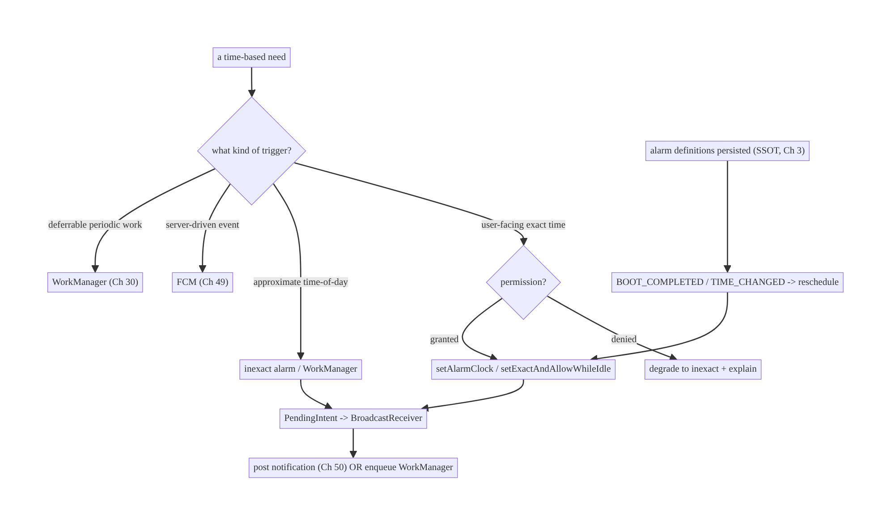
48.4 High-Level Architecture
Components & ownership
- Classifier routes to WorkManager/FCM/alarm (alarms only for user-facing time).
- AlarmScheduler sets/cancels alarms via PendingIntent; picks exact vs inexact per need + permission.
- AlarmReceiver fires fast → notification/WorkManager.
- SSOT + reboot/time receivers persist alarm definitions and reschedule.
Direction: classify → schedule (right method) → receiver → effect; persisted definitions reschedule on reboot/time change.

48.5 Detailed Component Design
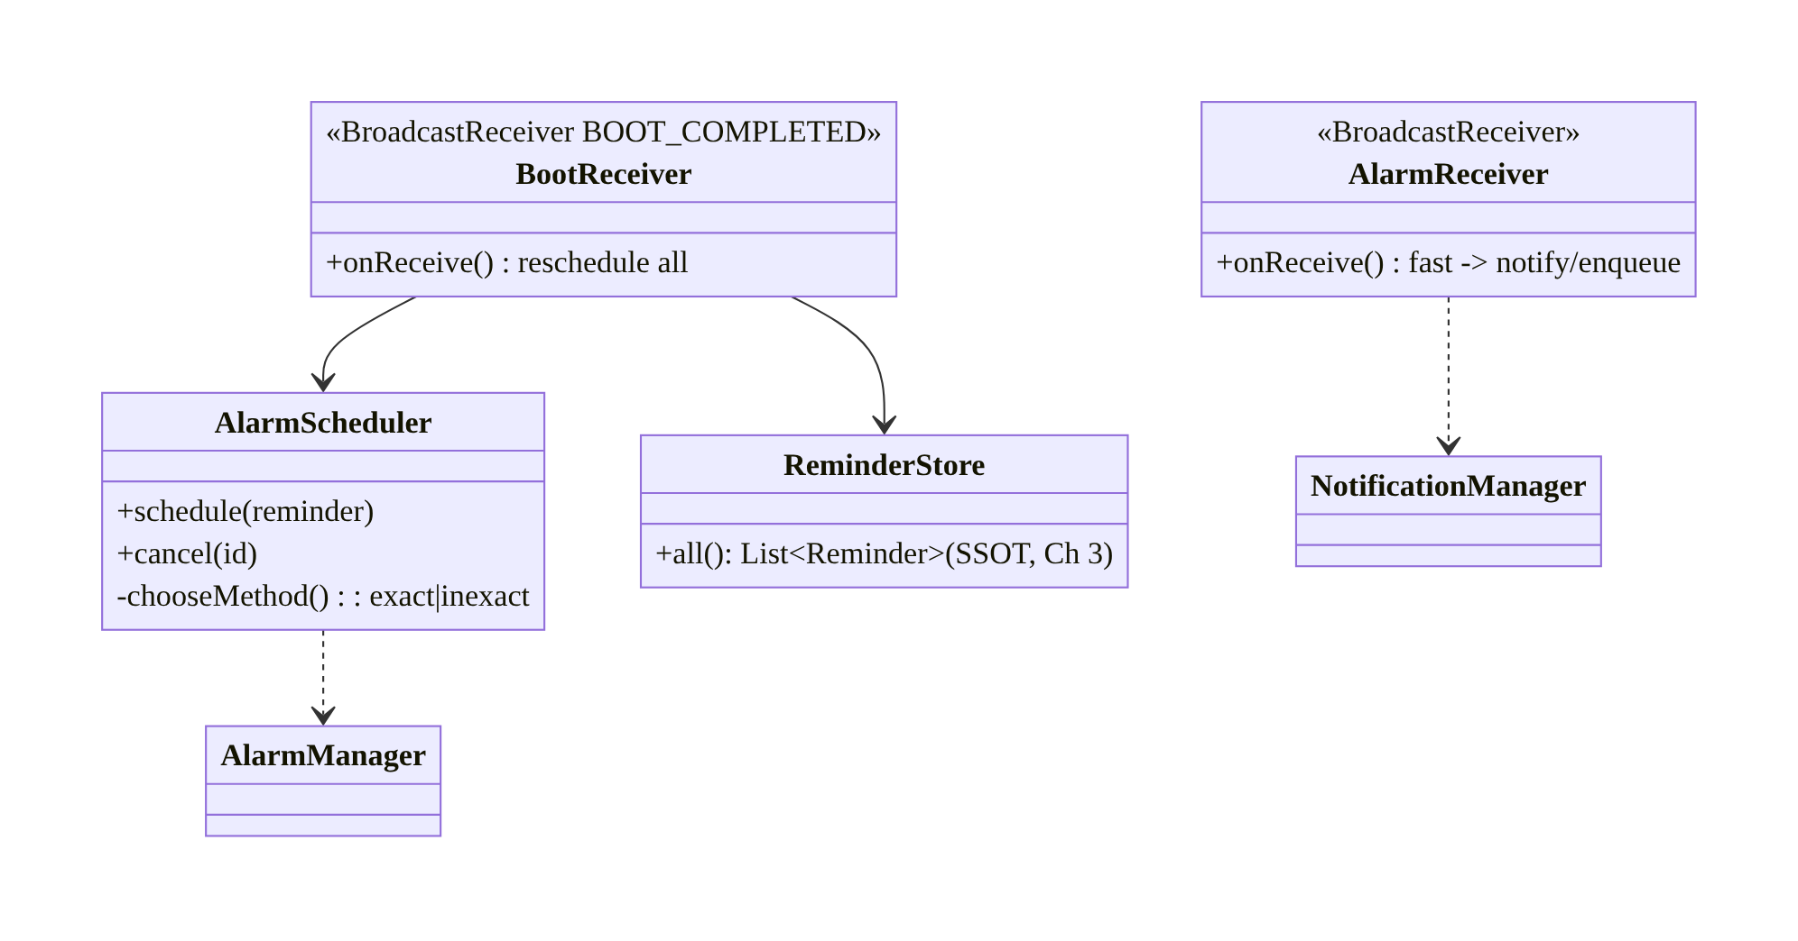
48.5 Detailed Component Design
Method | Precision | Doze | Permission | Use for
setInexactRepeating/setWindow | approx | deferred | none | battery-friendly periodic/time-of-day
setExact | exact | deferred in Doze | exact-alarm | exact but Doze-tolerant (rare)
setExactAndAllowWhileIdle | exact | fires (rate-limited) | exact-alarm | exact reminder in Doze
setAlarmClock | exact | fires | exact-alarm | true alarm-clock UX (most reliable)

48.6 End-to-End Data Flow

Scheduling & firing an exact reminder
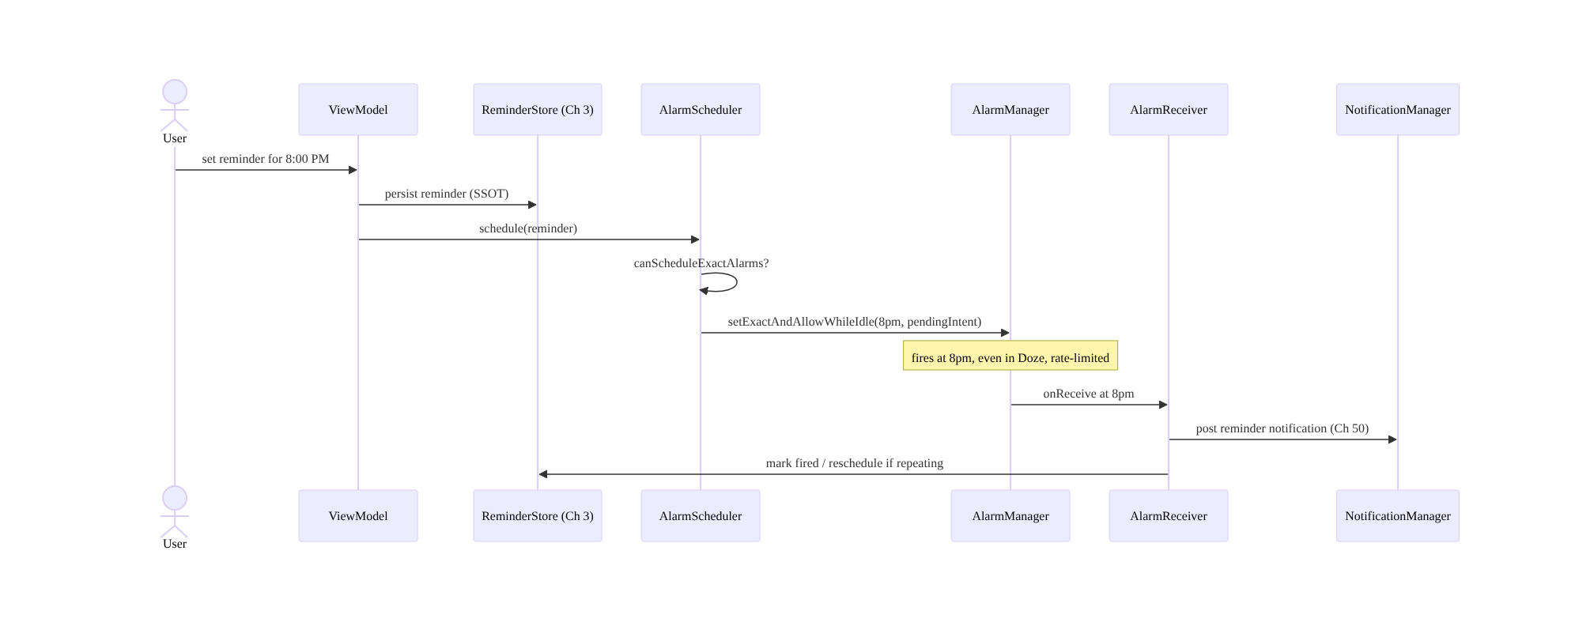
Scheduling & firing an exact reminder

Reboot rescheduling
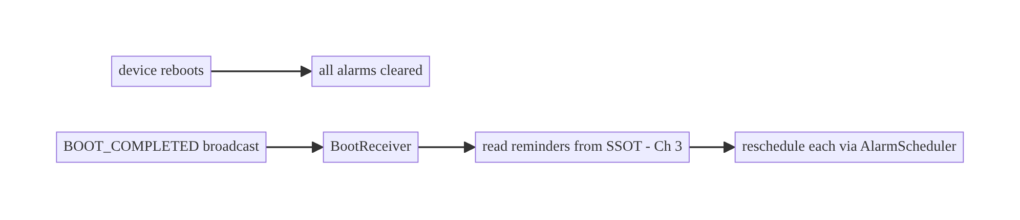
Reboot rescheduling

48.7 Complete Kotlin Implementation
Package: com.streamcart.alarm.

48.7.1 Manifest: permissions + receivers
<!-- Android 12+: requestable; NOT default-granted on 13+. USE_EXACT_ALARM only if app qualifies. -->
<uses-permission android:name="android.permission.SCHEDULE_EXACT_ALARM" />
<uses-permission android:name="android.permission.RECEIVE_BOOT_COMPLETED" />
<uses-permission android:name="android.permission.POST_NOTIFICATIONS" /> <!-- Ch 51 -->
<receiver android:name=".alarm.AlarmReceiver" android:exported="false" />
<receiver android:name=".alarm.BootReceiver" android:exported="true">
<intent-filter>
<action android:name="android.intent.action.BOOT_COMPLETED" />
<action android:name="android.intent.action.TIMEZONE_CHANGED" />
</intent-filter>
</receiver>

48.7.2 AlarmScheduler: choose method, handle permission, degrade
@Singleton
class AlarmScheduler @Inject constructor(@ApplicationContext private val ctx: Context) {
private val am = ctx.getSystemService(Context.ALARM_SERVICE) as AlarmManager
fun schedule(reminder: Reminder) {
val pi = pendingIntent(reminder)
val canExact = Build.VERSION.SDK_INT < 31 || am.canScheduleExactAlarms()
when {
reminder.isAlarmClockLike && canExact -> // most reliable, fires in Doze
am.setAlarmClock(AlarmManager.AlarmClockInfo(reminder.triggerAtMillis, null), pi)
reminder.needsExact && canExact -> // exact, fires in Doze (rate-limited)
am.setExactAndAllowWhileIdle(AlarmManager.RTC_WAKEUP, reminder.triggerAtMillis, pi)
else -> // degrade: battery-friendly, approximate
am.setWindow(AlarmManager.RTC_WAKEUP, reminder.triggerAtMillis, WINDOW_MS, pi)
}
}
fun cancel(reminder: Reminder) = am.cancel(pendingIntent(reminder))
private fun pendingIntent(r: Reminder): PendingIntent {
val intent = Intent(ctx, AlarmReceiver::class.java).putExtra(EXTRA_ID, r.id)
return PendingIntent.getBroadcast(ctx, r.id.hashCode(), intent,
PendingIntent.FLAG_UPDATE_CURRENT or PendingIntent.FLAG_IMMUTABLE) // IMMUTABLE required 12+
}
/** Deep-link to grant exact-alarm permission (only prompt if feature truly needs it). */
fun requestExactPermissionIntent() = Intent(Settings.ACTION_REQUEST_SCHEDULE_EXACT_ALARM,
Uri.parse("package:${ctx.packageName}"))
}

48.7.3 AlarmReceiver: fire fast → notification / WorkManager
@AndroidEntryPoint
class AlarmReceiver : BroadcastReceiver() {
@Inject lateinit var notifier: ReminderNotifier // Ch 50
@Inject lateinit var store: ReminderStore // Ch 3
@Inject lateinit var scheduler: AlarmScheduler
override fun onReceive(context: Context, intent: Intent) {
val id = intent.getStringExtra(EXTRA_ID) ?: return
// Receivers must return quickly. Light work inline; heavy work -> WorkManager (goAsync for short IO).
val pending = goAsync()
CoroutineScope(Dispatchers.Default).launch {
try {
val reminder = store.get(id) ?: return@launch
notifier.notifyReminder(reminder) // post notification (idempotent, Ch 50)
if (reminder.repeating) scheduler.schedule(reminder.nextOccurrence()) // reschedule
} finally { pending.finish() }
}
}
}

48.7.4 BootReceiver: reschedule from SSOT
@AndroidEntryPoint
class BootReceiver : BroadcastReceiver() {
@Inject lateinit var store: ReminderStore
@Inject lateinit var scheduler: AlarmScheduler
override fun onReceive(context: Context, intent: Intent) {
if (intent.action !in setOf(Intent.ACTION_BOOT_COMPLETED, Intent.ACTION_TIMEZONE_CHANGED)) return
val pending = goAsync()
CoroutineScope(Dispatchers.Default).launch {
try { store.all().filter { it.isFuture() }.forEach { scheduler.schedule(it) } } // reschedule all
finally { pending.finish() }
}
}
}

48.7.5 Module structure
:core:alarm AlarmScheduler, AlarmReceiver, BootReceiver, ExactAlarmPermission
:core:data ReminderStore (Room/DataStore SSOT, Ch 3/4)
# Effect: notification -> :core:notifications (Ch 50); heavy work -> :core:work (Ch 30).

48.8 Concurrency and Race Conditions
Scenario | Risk | Handling
Receiver does slow work | ANR | goAsync() for short IO; WorkManager for heavy
Alarm fires twice | duplicate notification | idempotent effect (dedupe by id, Ch 15)
Reboot before reschedule | lost alarms | BOOT_COMPLETED rescheduling from SSOT
Timezone/DST change | wrong fire time | recompute on TIMEZONE_CHANGED; store local time + zone
Update vs cancel race | stale alarm fires | FLAG_UPDATE_CURRENT + matching request code
Exact permission revoked at runtime | SecurityException | canScheduleExactAlarms() check + degrade
- Receivers must be fast: onReceive runs on the main thread with a short budget; use goAsync() only for brief IO and hand anything substantial to WorkManager (Ch 30).
- Idempotent effect: an alarm can fire more than once (reschedule races, duplicate pending intents); dedupe the notification/work by reminder id (Ch 15).
- Store local time + zone, compute absolute at schedule time: so DST/timezone changes recompute correctly on TIMEZONE_CHANGED (don’t just persist an absolute epoch for a “9am local” reminder).

48.9 Failure Scenarios and Recovery
Failure | Detection | Response | Outcome
Alarm lost after reboot | fire telemetry | BOOT_COMPLETED reschedule from SSOT | survives
Reminder late | user report | use exact (setExactAndAllowWhileIdle/setAlarmClock) if truly time-critical | on time
Battery-flagged (exact abuse) | vitals | move non-critical to inexact/WorkManager | battery ok
Play rejection (USE_EXACT_ALARM) | review | use SCHEDULE_EXACT_ALARM (requested) or degrade | approved
SecurityException on exact | crash | canScheduleExactAlarms() + degrade | no crash
Wrong time after DST | user report | recompute on time/zone change | correct
Deferrable work via alarm | battery/policy | WorkManager (Ch 30) | compliant
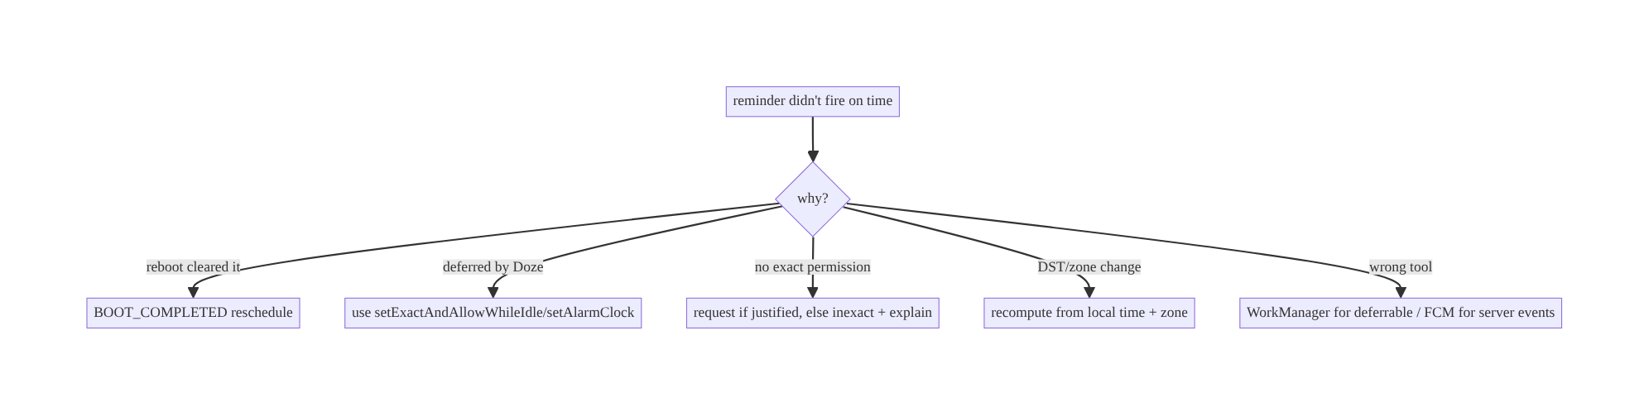
48.9 Failure Scenarios and Recovery
Two failure families dominate: alarms vanishing (reboot/time change → reschedule from SSOT) and alarms firing late (Doze/inexact/permission → use the right exact method if truly time-critical, else accept approximate). And the meta-failure: using alarms for work that should be WorkManager or FCM.

48.10 Scaling the Implementation
- Level 1. Inexact alarms / WorkManager for approximate time-of-day; notification effect.
- Level 2. Exact alarms (setExactAndAllowWhileIdle/setAlarmClock) for genuine time-critical reminders with permission handling + degradation; BOOT_COMPLETED reschedule.
- Level 3 — production. SSOT alarm definitions; timezone/DST handling; idempotent effects; WorkManager handoff for heavy work; exact-alarm permission UX (rationale + deep-link).
- Level 4 — large. Many reminder types routed correctly (alarm vs WorkManager vs FCM, Ch 47); alarm budget/consolidation; per-feature precision requirements; server-synced reminders (Ch 32).
- Level 5 — enterprise. Reminder reliability SLOs; fire-latency telemetry; exact- alarm-permission governance (which features qualify); cross-device reminder sync.
Avoid overengineering: most reminders are not to-the-minute critical — use inexact/WorkManager and avoid the exact-alarm permission entirely. Reserve exact alarms for the few genuinely user-facing timing features.

48.11 Alternative Approaches and Trade-offs
Dimension | Option A | Option B | When
Precision | Exact alarm | inexact/WorkManager | Exact only for user-facing time-critical; inexact by default
Deferrable periodic | WorkManager | setInexactRepeating | WorkManager (constraints, reliability, Ch 30)
Server event | FCM | client alarm polling | FCM (Ch 49) — no client timer
Exact in Doze | setExactAndAllowWhileIdle/setAlarmClock | setExact | AllowWhileIdle/AlarmClock (setExact is deferred in Doze)
Permission | SCHEDULE_EXACT_ALARM (request) | USE_EXACT_ALARM (auto) | USE_EXACT only if app’s core is alarms/clock; else request SCHEDULE
Reschedule | SSOT + BOOT_COMPLETED | re-set at app launch only | SSOT + boot receiver (alarms cleared on reboot)
Exact alarm vs inexact/WorkManager: exact alarms fire precisely but are privileged, battery-costly, permission-gated (Android 12+), and Play-restricted — abusing them for non-critical reminders drains battery and risks rejection. Inexact alarms and WorkManager are battery-friendly and reliable for anything that doesn’t need to-the-minute precision. Default to inexact/WorkManager; escalate to exact only for genuine user-facing timing.
Alarm vs WorkManager vs FCM: AlarmManager is for time-of-day client triggers; WorkManager is for deferrable periodic/one-off work (sync/upload) and respects Doze/constraints (Ch 30/47); FCM is for server-driven events (Ch 49). Using an alarm for deferrable work fights the battery model; using one to poll for server events is wasteful and blocked — route each to its proper mechanism.

48.12 Security Considerations
- PendingIntent must be FLAG_IMMUTABLE (required Android 12+) so other components can’t tamper with the intent; use explicit intents (your own receiver class).
- BootReceiver is exported=true (the system sends BOOT_COMPLETED) — validate the action and do minimal work; don’t trust extras.
- AlarmReceiver exported=false so other apps can’t trigger it.
- Validate reminder data read in the receiver (it’s from your own store, but treat intent extras as just an id, then load from SSOT).
- Don’t leak sensitive content in the fired notification on the lock screen (Ch 50).
- Exact-alarm permission is Play-scrutinized — only declare USE_EXACT_ALARM if the app genuinely qualifies; misuse is a policy violation.
- Client vs backend: alarms are client timers; server-synced reminders should round-trip through normal auth/sync (Ch 19/32), and server-driven alerts belong in FCM (Ch 49).

48.13 Performance and Resource Optimization
- Prefer inexact/WorkManager — the OS coalesces inexact alarms, saving wake-ups (Ch 47); exact alarms wake the device and cost battery.
- Rate-limit exact-while-idle: setExactAndAllowWhileIdle is throttled (~1 per 9 min) — don’t schedule many; consolidate.
- Keep receivers trivial: fire fast; hand heavy work to WorkManager to avoid ANR and wake-time.
- Cancel stale alarms so you don’t wake for nothing.
- Batch time-of-day work into a single alarm/window rather than many.
- Profiling: adb shell dumpsys alarm (scheduled alarms, wake-up counts), Battery Historian (alarm-driven wake-ups), fire-latency telemetry.

48.14 Testing Strategy
Alarms are tested with Robolectric (ShadowAlarmManager), adb for exact/Doze behavior, and receiver unit tests.
@RunWith(AndroidJUnit4::class)
class AlarmSchedulerTest {
@Test fun `schedules exact-while-idle when permitted and needed`() {
val scheduler = AlarmScheduler(context)
scheduler.schedule(Reminder(id = "1", triggerAtMillis = future, needsExact = true))
val shadow = shadowOf(context.getSystemService(AlarmManager::class.java))
assertEquals(future, shadow.nextScheduledAlarm.triggerAtTime)
}
@Test fun `degrades to window when exact not permitted`() { /* deny canScheduleExactAlarms -> setWindow */ }
}
class BootReceiverTest {
@Test fun `reschedules all future reminders on boot`() { /* fake store with 3 future -> 3 scheduled */ }
}
# Verify alarm fires in Doze (exact-while-idle) and survives idle:
adb shell dumpsys deviceidle force-idle
adb shell dumpsys alarm | grep streamcart
# Reboot persistence (manual/instrumented): set alarm, reboot, assert rescheduled.
What to test: method selection (exact when permitted+needed, degrade otherwise), PendingIntent immutability/update, receiver fires fast + idempotent effect, boot/ timezone rescheduling from SSOT, Doze firing (setExactAndAllowWhileIdle), permission revoked → degrade (no crash). Device testing for real reboot/Doze behavior.

48.15 Production Observability
- Metrics: reminder fire latency (scheduled vs actual), missed-fire rate, reboot-reschedule success, exact-alarm-permission grant rate, battery-attribution of alarms, duplicate-fire rate.
- Logs: alarm{id, method, scheduled_at, fired_at, latency} (no PII, Ch 28).
- Debugging: late reminders → inexact/Doze/no-permission; missing after reboot → boot receiver not firing (OEM auto-start, Ch 47) / reschedule failed; battery flag → exact-alarm overuse; duplicates → non-idempotent effect.
- Alerting: missed-fire or latency spike after an OS/targetSdk change (exact-alarm tightening).
- Device matrix: OEM boot-receiver reliability varies (Ch 47) — track reschedule success by OEM.

48.16 System Design Interview Preparation
≥25 questions.
Fundamentals
- What does AlarmManager do? Fires a PendingIntent at a time (→ receiver → notification/WorkManager).
- Exact vs inexact? Precise (privileged, battery-costly) vs batched/approximate (battery-friendly).
- Default choice? Inexact / WorkManager; exact only for user-facing time-critical.
- Why not exact for everything? Battery, permission, Play restriction.
- What runs in the receiver? Fast work only; heavy → WorkManager (goAsync for brief IO).
Doze & methods
- Doze effect on alarms? Inexact and setExact deferred to windows.
- What fires in Doze? setExactAndAllowWhileIdle (rate-limited) and setAlarmClock.
- setAlarmClock? User-visible alarm clock; most reliable; for alarm-clock UX.
- Rate limit on exact-while-idle? ~1 per 9 minutes per app.
Permission
- Android 12+ exact-alarm permission? SCHEDULE_EXACT_ALARM (request) / USE_EXACT_ALARM (auto for qualifying apps).
- Android 13+ change? SCHEDULE_EXACT_ALARM not default-granted for most apps.
- Check before scheduling? canScheduleExactAlarms().
- No permission? Degrade to inexact / WorkManager.
- USE_EXACT_ALARM misuse? Play rejection (only alarm/clock/calendar apps qualify).
Reboot/time
- Alarms after reboot? Cleared — reschedule via BOOT_COMPLETED from SSOT.
- Why SSOT for alarms? AlarmManager isn’t persistent storage.
- Timezone/DST? Recompute on TIMEZONE_CHANGED; store local time + zone.
PendingIntent
- FLAG_IMMUTABLE? Required Android 12+; prevents tampering.
- Update/cancel the right alarm? FLAG_UPDATE_CURRENT + matching request code.
Mechanism selection
- Deferrable periodic work? WorkManager, not an alarm.
- Server event? FCM, not an alarm.
- When is an alarm right? User-facing time-of-day trigger.
Security
- Receiver exported? AlarmReceiver false; BootReceiver true (validate action).
- Lock-screen leak? Public/private notification (Ch 50).
Testing/production
- Test alarms? Robolectric ShadowAlarmManager; adb dumpsys alarm/deviceidle.
- Late reminders? Inexact/Doze/no-permission.
- Missing after reboot? Boot receiver / OEM auto-start (Ch 47).

Design-change challenges
- A medication reminder must fire exactly, even in Doze. setExactAndAllowWhileIdle/ setAlarmClock + permission; reschedule on reboot.
- Reminders vanish after reboot. BOOT_COMPLETED receiver rescheduling from SSOT.
- App battery-flagged for alarm wake-ups. Move non-critical reminders to inexact/ WorkManager; consolidate.
- Daily digest doesn’t need exact time. Inexact window / WorkManager periodic — avoid the exact-alarm permission.
- “Order shipped” alert. FCM (server-driven), not a client alarm.

Mock walkthrough (abridged)
Clarify (precision needed? user-facing? deferrable? server-driven?) → classify (alarm vs WorkManager vs FCM) → pick alarm method (inexact default, exact if critical) → permission handling + degradation → PendingIntent (immutable) → receiver fires fast → effect (notification/WorkManager, idempotent) → reboot/timezone reschedule from SSOT → security/ testing.

48.17 Practical Exercises
- Beginner. Schedule an approximate daily-digest trigger with setWindow/WorkManager (no exact-alarm permission). Eval: fires roughly on time; battery-friendly.
- Intermediate. Add an exact reminder with setExactAndAllowWhileIdle, permission check, and degradation to inexact when denied. Eval: exact when permitted; no crash when not.
- Advanced. Persist reminders (SSOT) and reschedule all on BOOT_COMPLETED and TIMEZONE_CHANGED. Eval: survives reboot; correct after DST.
- Production debugging. Fix duplicate reminder notifications (non-idempotent) and a slow receiver (ANR). Eval: dedup by id; goAsync/WorkManager.
- System design challenge. Route a mixed set of triggers (sync, digest, med reminder, order alert) to WorkManager/inexact/exact/FCM correctly and justify the exact-alarm permission. Eval: each on the right mechanism; permission justified.
(Solutions withheld unless requested.)

48.18 Chapter Summary & Reference Sheet
Key decisions: use AlarmManager only for genuine user-facing time-of-day triggers — route deferrable periodic/one-off work to WorkManager (Ch 30) and server-driven events to FCM (Ch 49); within alarms, default to inexact (setWindow/setInexactRepeating, battery-friendly, approximate) and escalate to exact only when precision truly matters (setExactAndAllowWhileIdle or setAlarmClock, which fire in Doze, permission-gated on Android 12+); persist alarm definitions as the SSOT (Ch 3) and reschedule on BOOT_COMPLETED and timezone/DST changes (alarms are cleared on reboot); keep receivers fast and idempotent (hand heavy work to WorkManager); use FLAG_IMMUTABLE PendingIntents; and request the exact-alarm permission only when justified (SCHEDULE_EXACT_ALARM for most, USE_EXACT_ALARM only for true alarm/clock apps), degrading to inexact otherwise.
Concepts: AlarmManager methods, exact vs inexact, Doze behavior (setExactAndAllowWhileIdle/setAlarmClock), exact-alarm permission (12+/13+/14+), PendingIntent immutability, BroadcastReceiver, reboot/timezone rescheduling, SSOT, alarm→notification/WorkManager handoff, mechanism selection.
Common mistakes: exact alarms for non-critical reminders (battery/Play); alarms lost on reboot (no boot receiver); setExact expecting it to fire in Doze; alarms for deferrable work (should be WorkManager) or server events (should be FCM); slow receiver (ANR); non-idempotent effect (duplicates); mutable PendingIntent; USE_EXACT_ALARM without qualifying.
Checklist:
- ☐ classify alarm vs WorkManager vs FCM
- ☐ inexact by default, exact only if critical
- ☐ setExactAndAllowWhileIdle/setAlarmClock for Doze-exact
- ☐ exact-alarm permission check + degrade
- ☐ FLAG_IMMUTABLE PendingIntent
- ☐ receiver fast + idempotent
- ☐ heavy work → WorkManager
- ☐ SSOT alarm definitions
- ☐ reschedule on reboot + timezone change
- ☐ receivers exported correctly.
Key APIs: AlarmManager.set/setWindow/setInexactRepeating/setExact/ setExactAndAllowWhileIdle/setAlarmClock/cancel/canScheduleExactAlarms, AlarmManager.AlarmClockInfo, PendingIntent.getBroadcast/FLAG_IMMUTABLE/ FLAG_UPDATE_CURRENT, BroadcastReceiver/goAsync, BOOT_COMPLETED/TIMEZONE_CHANGED, SCHEDULE_EXACT_ALARM/USE_EXACT_ALARM/ACTION_REQUEST_SCHEDULE_EXACT_ALARM.
References:
- Schedule alarms: https://developer.android.com/develop/background-work/services/alarms/schedule
- Exact alarm permission: https://developer.android.com/about/versions/14/changes/schedule-exact-alarms
- Alarms and Doze: https://developer.android.com/training/monitoring-device-state/doze-standby
- (composes) Ch 47 Doze/Limits, Ch 30 WorkManager, Ch 49 FCM, Ch 50 Notifications, Ch 8 Process Death

Chapter 49 — Push Notifications (FCM) Architecture
Part VI — Lifecycle, Background & Platform · Complexity: Complex (≥40 interview questions)
Prerequisites: Ch 47 (Doze/background limits), Ch 30 (WorkManager), Ch 46 (FGS), Ch 19 (auth), Ch 51 (notification permission), Ch 50 (notification inbox). Pairs with Ch 48 (alarms), Ch 32 (sync).
Reference surface in StreamCart: server-driven real-time signals — order shipped, price drop, chat message, live-stream starting — delivered to the device promptly and reliably, turned into notifications or silent data syncs, across app states and the platform’s background limits.

49.1 Problem Definition and Real-World Context
Apps constantly need the server to reach the client when something happens: your order shipped, a message arrived, a watched item dropped in price, a live stream is starting. The client can’t poll for this — polling is blocked/deferred by Doze (Ch 47), wastes battery, and scales terribly. The platform answer is push notifications via Firebase Cloud Messaging (FCM): a single OS-level, battery-efficient channel from your server through Google’s infrastructure to the device, even when the app is backgrounded or killed.
FCM looks simple (“send a notification”) but is a distributed delivery system with real engineering depth:
- Delivery is best-effort, not guaranteed. FCM may drop, delay, or collapse messages (especially in Doze / bad App Standby buckets, Ch 47). You cannot assume a push arrived — critical state must be reconciled via sync (Ch 32), with push as a trigger, not the source of truth.
- Notification vs data messages, × app state. A “notification message” is auto-displayed by the system when backgrounded but delivered to your code when foregrounded; a “data message” always goes to your code. Behavior differs across foreground / background / killed, and getting this matrix wrong means missed or duplicated notifications.
- Token lifecycle. Each app install has an FCM registration token that can rotate at any time (onNewToken); the server must store it per user/device, and stale tokens must be pruned or sends fail. Logout/account-switch (Ch 22/42) must invalidate tokens.
- Priority & quotas. High-priority messages can wake the app in Doze (limited, bucket-dependent quota, Ch 47); normal-priority may be delayed. Over-using high priority burns quota and gets throttled.
- Security. Payloads traverse Google’s servers — never put secrets/PII in the payload; treat received payloads as untrusted input; authenticate the effect (fetch over authed API, Ch 19). Topic subscriptions and misrouting can leak data across users/accounts.
- Fan-out & targeting. Sending to millions (topics, device groups, per-user tokens) is a backend scaling problem; the client must subscribe/unsubscribe correctly and handle multi-device.
The architecture: integrate FCM for the transport; model notification vs data messages and handle each across app states; manage the token lifecycle (register, onNewToken, server upsert, logout invalidation, multi-device); choose priority deliberately (high only for time-sensitive, Ch 47); treat push as a trigger, reconcile truth via sync (Ch 32) so dropped messages self-heal; do heavy work in WorkManager/expedited (Ch 30), not in the receiver; render notifications via a central Notifier (channels, grouping, Ch 50) gated by notification permission (Ch 51); and secure payloads (no secrets, untrusted input, authed effects, per-account isolation). This chapter is the client-side architecture of a reliable, secure push system — one of the most-asked Android system-design topics.

Three practical use cases
- StreamCart order update. High-priority data message “order X shipped” → wake → (optionally) expedited WorkManager fetches details over authed API (Ch 19) → notification (Ch 50); truth reconciled by order sync (Ch 32) if the push was dropped.
- Chat message. Data message with a lightweight signal → fetch the message, show a grouped conversation notification; mark read syncs back.
- Marketing / topic broadcast. Normal-priority topic message (e.g., “flash-sale-subscribers”) → notification; respects user notification preferences and consent (Ch 28/51).

Why this is architectural
Push touches the server↔client contract, background execution limits, auth/ security, sync/consistency, permissions, and notification UX at once. The decisions — message type, priority, token management, trigger-vs-truth, payload security, fan-out — determine whether real-time features are reliable, battery-friendly, secure, and correct across every app state and device.

49.2 Requirements Engineering

Functional requirements
ID | Requirement
F1 | Receive server-driven messages across foreground/background/killed states.
F2 | Manage FCM token lifecycle (register, rotate, server upsert, invalidate on logout).
F3 | Turn messages into notifications (Ch 50) or silent data syncs, correctly per state.
F4 | Use push as a trigger; reconcile authoritative state via sync (Ch 32).
F5 | Choose priority deliberately; do heavy work off the receiver (WorkManager).
F6 | Respect notification permission/consent (Ch 51) and per-account isolation (Ch 42).

Non-functional requirements
Attribute | Target/Policy
Reliability | Dropped/delayed push self-heals via sync; no missing critical state.
Latency | Time-sensitive via high-priority (prompt Doze wake); others normal.
Battery/Quota | High priority only when justified; receiver does minimal work.
Security | No secrets/PII in payload; untrusted input; authed effects; per-account routing.
Correctness | No duplicate/missed notifications across states; idempotent.
Scale | Token storage + fan-out handle millions (backend); client multi-device.

Scope
- In scope: FCM integration, notification vs data messages, app-state matrix, token lifecycle (onNewToken, server upsert, logout/account invalidation, multi-device), priority/quota (Ch 47), trigger-vs-truth reconciliation (Ch 32), receiver→WorkManager handoff, topics/targeting (client side), notification rendering handoff (Ch 50), permission gating (Ch 51), payload security + per-account isolation.
- Out of scope: notification UI/inbox detail (Ch 50), permission UX detail (Ch 51), Doze mechanics (Ch 47), sync algorithm (Ch 32), backend fan-out internals (described, not built), WorkManager internals (Ch 30).

Assumptions & constraints
- Firebase/FCM (HTTP v1 API server-side), minSdk 24, targetSdk current (Android 13+ notification permission). Hilt, WorkManager, Retrofit/OkHttp (Ch 1). Delivery is best-effort; tokens rotate; payload ≤ ~4KB; high-priority quota is bucket-dependent.

49.3 System Design Fundamentals
- FCM transport model. Your backend sends a message to the FCM HTTP v1 API (authed via a service account), targeting a registration token, a topic, or a device group. Google’s infrastructure holds a persistent, battery-efficient connection to the device and delivers the message to the OS, which routes it to your app (even if killed, subject to limits). It’s a best-effort channel.
- Message types (critical distinction):
  - Notification message: payload has a notification block. When the app is backgrounded/killed, the system displays it automatically (you don’t run code); the data arrives in the launch intent if tapped. When foregrounded, it’s delivered to onMessageReceived and you display it.
  - Data message: payload has only a data block. Always delivered to onMessageReceived (your code), in all states (subject to limits) — you control display. Recommended for apps that want consistent control.
  - Mixed (both blocks): system shows the notification when backgrounded; data is in the intent. Avoid relying on onMessageReceived for mixed messages when backgrounded.
- App-state × type matrix (the thing to get right):
State | Notification message | Data message
Foreground | onMessageReceived (you show) | onMessageReceived
Background | system shows; data in tap intent | onMessageReceived (limited by Doze/bucket)
Killed | system shows; data in tap intent | onMessageReceived if delivered (more likely dropped/delayed)
- For full control + background sync, use data messages with high priority for time-sensitive ones — and still reconcile via sync.
- Token lifecycle. On first run (and on rotation) FCM issues a registration token (FirebaseMessaging.getToken() / onNewToken). The client must upsert it to the backend keyed by user + device (Ch 42 per-account). Tokens rotate unpredictably; always honor onNewToken. On logout/account switch, delete/ invalidate the token server-side and locally (Ch 22/42) so the next user doesn’t get the previous user’s pushes. The server must prune stale tokens (FCM returns UNREGISTERED/NOT_FOUND on send → remove).
- Priority & Doze (Ch 47). high priority can wake the app in Doze for prompt delivery (limited, App Standby bucket-dependent quota); normal may be batched/ delayed. Use high only for genuinely time-sensitive, user-impacting messages (chat, order status); over-use exhausts quota and gets you throttled. High-priority data message → optionally expedited WorkManager (Ch 30) for the follow-up work.
- Push is a trigger, not the source of truth. Because delivery is best-effort, never treat a push as authoritative state. A push says “something may have changed” → the client does a delta sync (Ch 32) over the authed API to get the real state, into the SSOT (Ch 3). This way a dropped push self-heals at the next sync/app-open, and a duplicate push is idempotent (Ch 15). Critical flows (payments, orders) must not depend solely on push.
- Receiver discipline. onMessageReceived runs on a background thread with a short budget (~seconds, and heavily limited in Doze). Do minimal work: parse, maybe show a notification, and enqueue WorkManager (expedited for urgent) for any fetch/sync — don’t do network/DB heavy lifting inline.
- Targeting: per-user tokens (most control, multi-device via multiple tokens), topics (pub/sub broadcast — client subscribeToTopic, good for broad segments, but coarse and public-ish so no sensitive targeting), device groups (legacy). The client subscribes/unsubscribes to topics per preference and unsubscribes on logout.
- Security: payloads pass through Google → no secrets/PII in them (Ch 28); treat payload fields as untrusted (validate, don’t eval/deep-link blindly, Ch 52); authenticate the effect (fetch over authed API, Ch 19); ensure per-account isolation (a push for account A must not render under account B, Ch 42) by checking the active account against the payload’s target.
Core insight: FCM is a best-effort, battery-efficient server→client transport; model notification-vs-data messages across foreground/background/killed states (prefer data messages for control), manage the rotating per-user/device token lifecycle (upsert, onNewToken, invalidate on logout), choose high priority only for time-sensitive messages within quota, keep the receiver minimal (hand work to WorkManager), and — above all — treat push as a trigger and reconcile authoritative state via sync so dropped/duplicate messages self-heal; secure payloads (no secrets, untrusted input, authed effects, per-account isolation) and gate display on notification permission.

49.4 High-Level Architecture
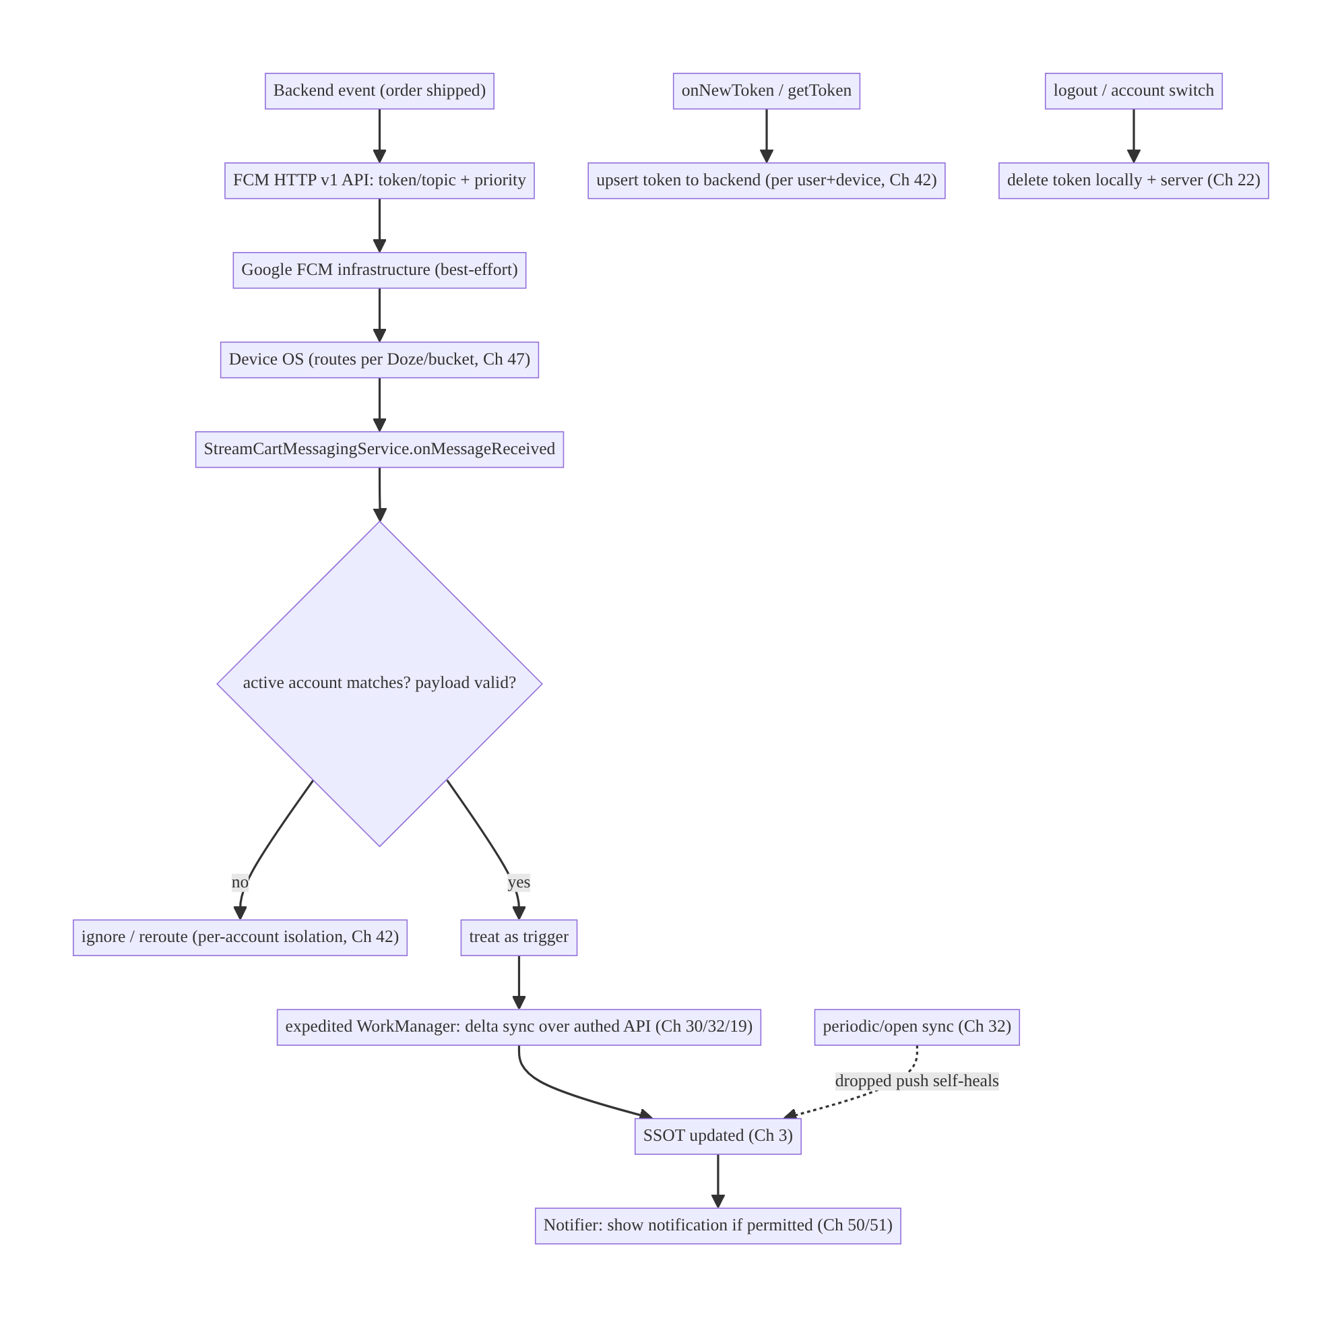
49.4 High-Level Architecture
Components & ownership
- Backend emits events → FCM API (targeting + priority).
- FirebaseMessagingService receives messages, validates/per-account-checks, and hands off to WorkManager + Notifier.
- Token manager upserts/invalidates tokens.
- Sync (Ch 32) is the safety net that makes dropped push self-heal (truth lives in the SSOT, not the push).
Direction: event → FCM → OS → service (validate) → WorkManager sync → SSOT → notification; token lifecycle + sync keep it reliable and secure.

49.5 Detailed Component Design
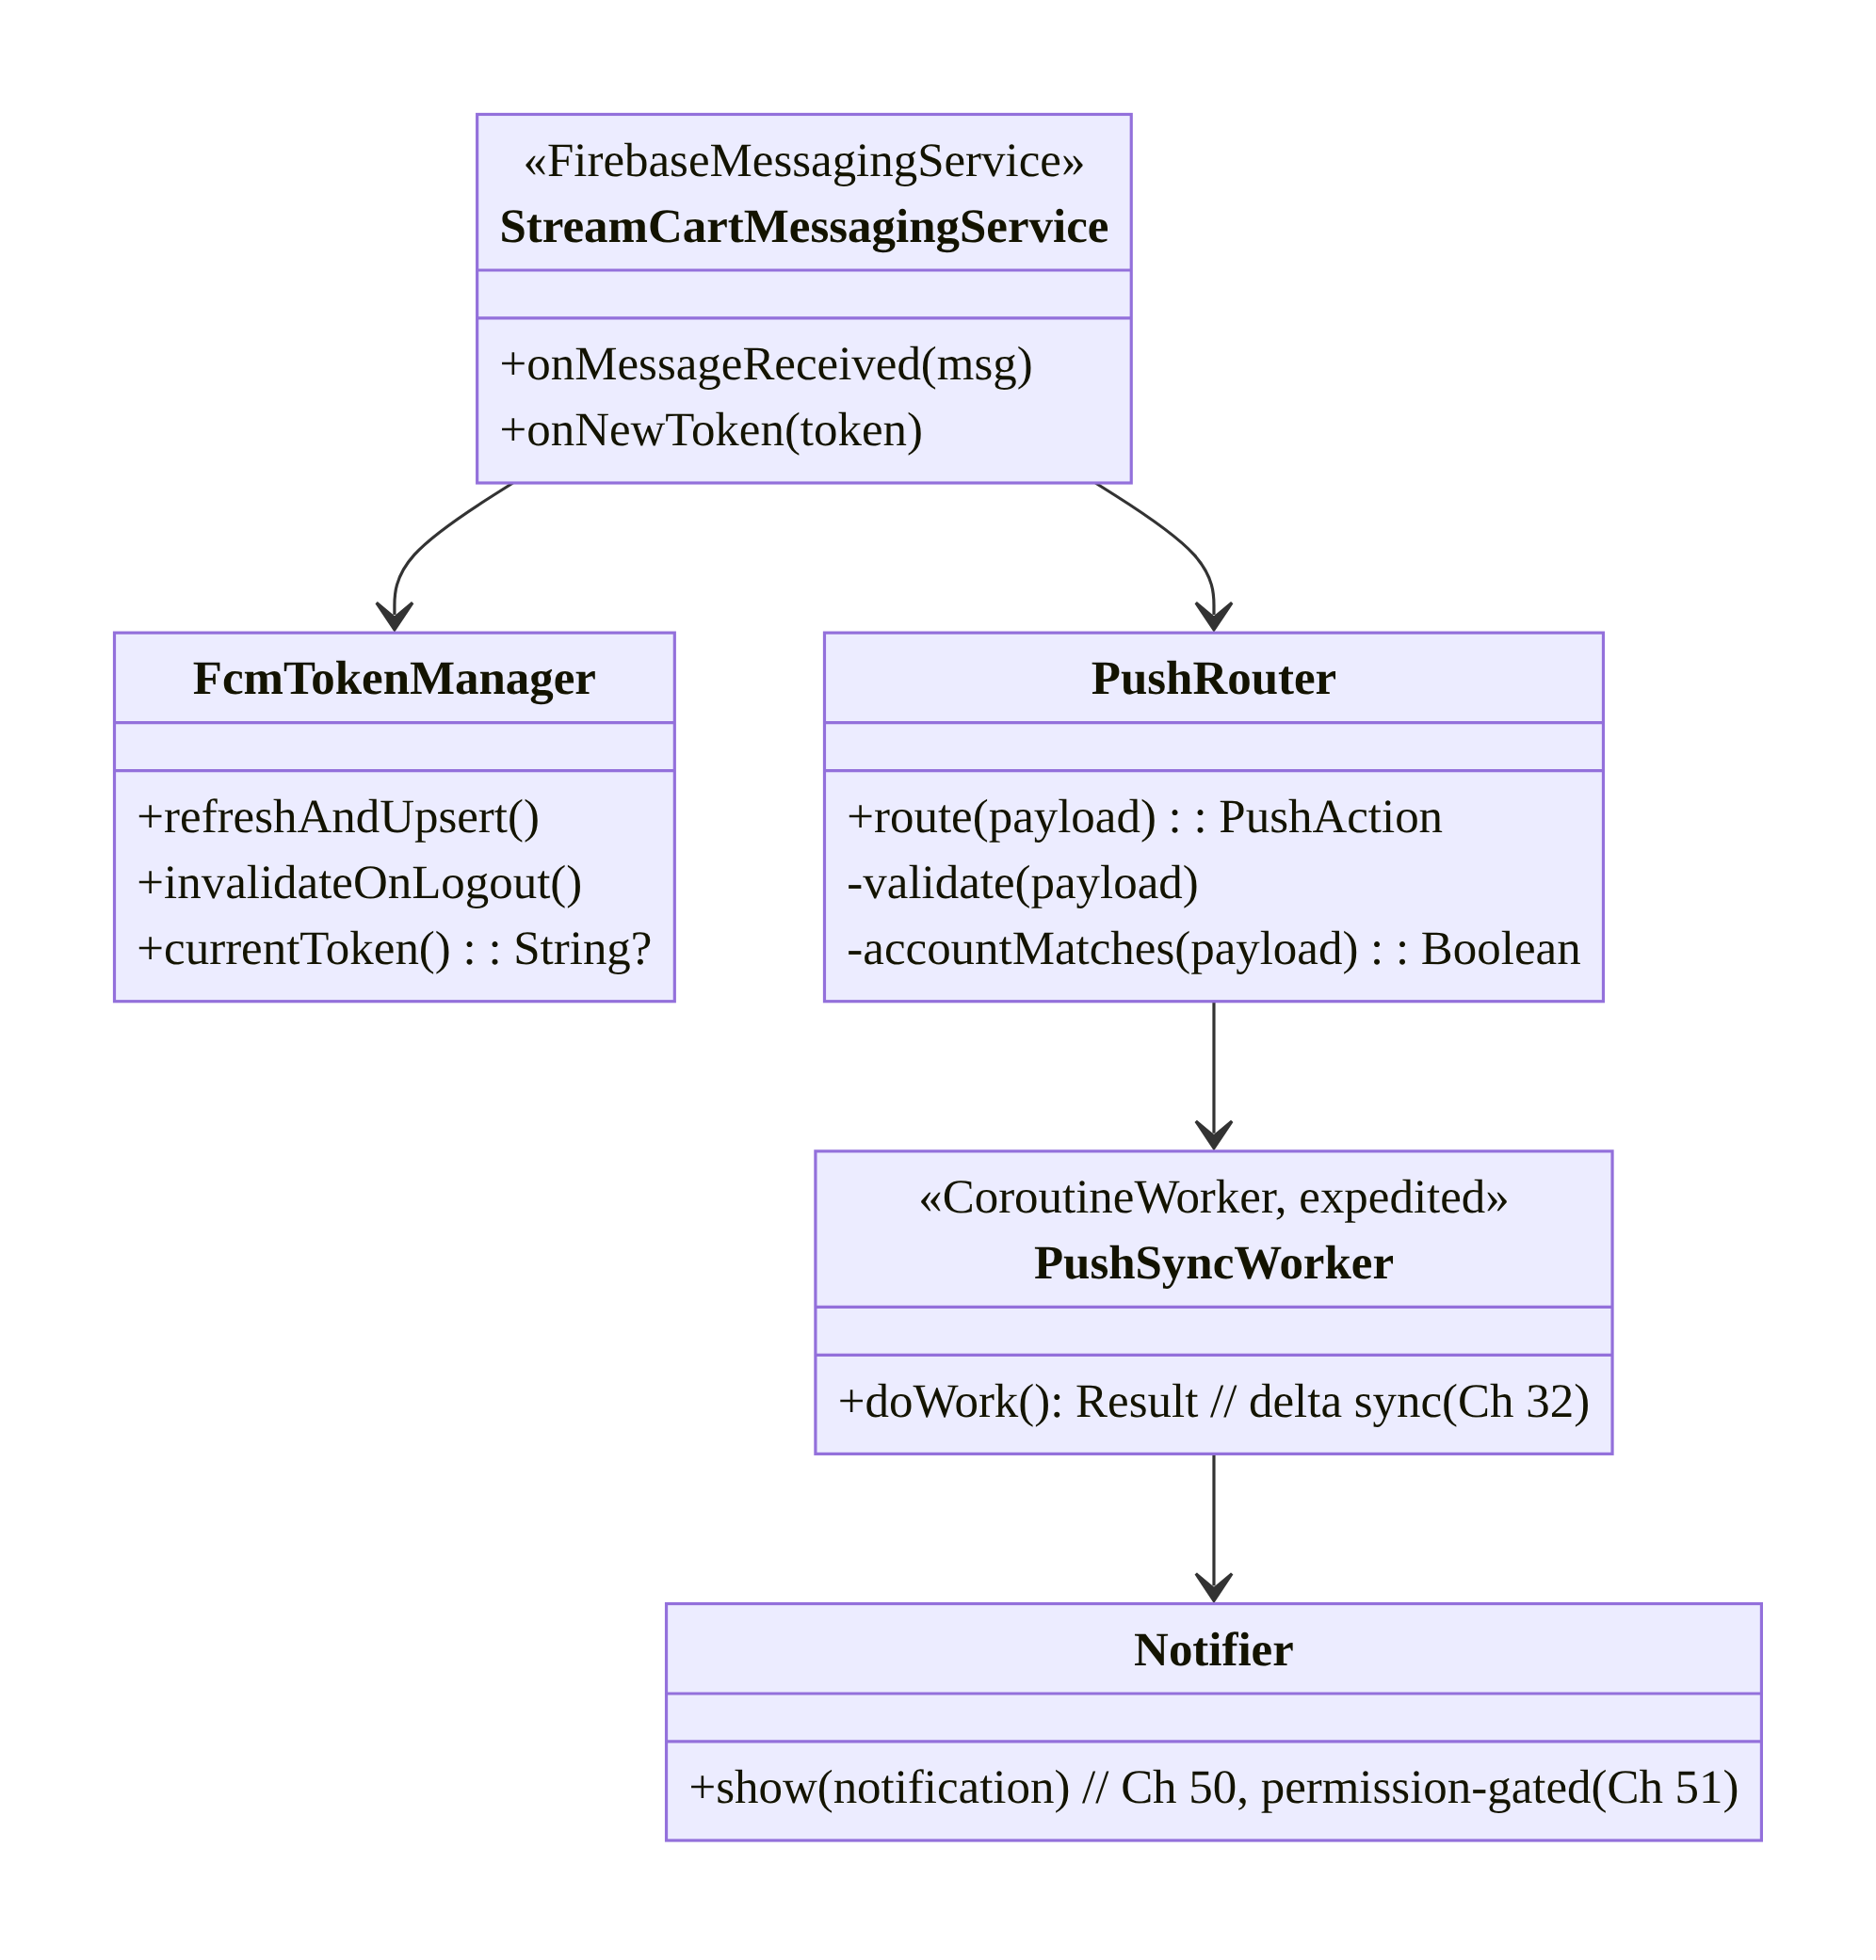
49.5 Detailed Component Design
Component | Responsibility
StreamCartMessagingService | receive messages + token; minimal work; hand off
FcmTokenManager | token upsert/rotation/invalidation (per account, Ch 42)
PushRouter | validate payload (untrusted), per-account check, classify action
PushSyncWorker | expedited delta sync over authed API → SSOT (Ch 30/32/19)
Notifier | render notification (channels/grouping, Ch 50), permission-gated (Ch 51)

49.6 End-to-End Data Flow

High-priority data message → sync → notification
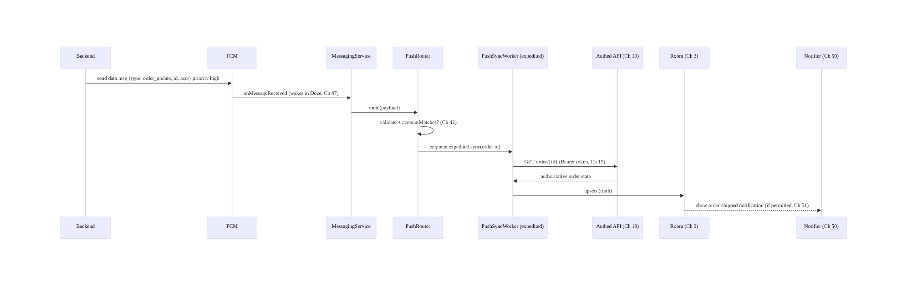
High-priority data message → sync → notification

Dropped push self-heals via sync
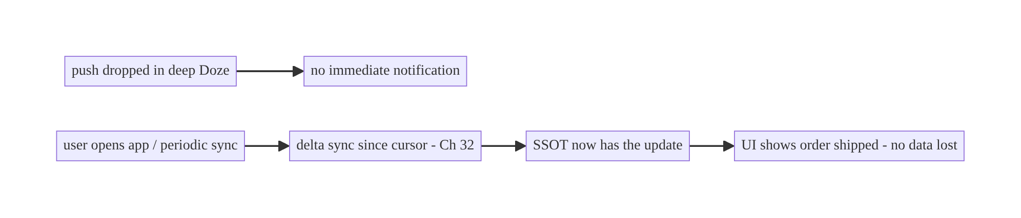
Dropped push self-heals via sync

Token rotation
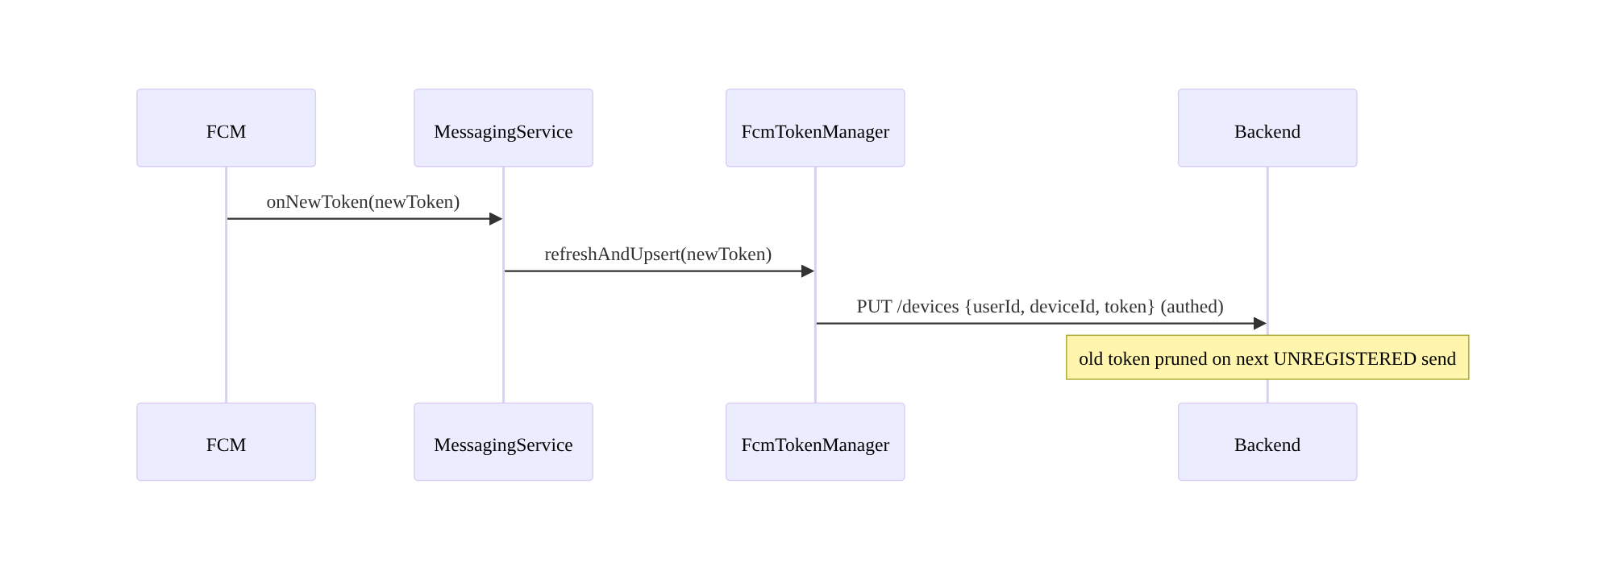
Token rotation

49.7 Complete Kotlin Implementation
Package: com.streamcart.push.

49.7.1 Manifest + service registration
<uses-permission android:name="android.permission.POST_NOTIFICATIONS" /> <!-- Android 13+ (Ch 51) -->
<service
android:name=".push.StreamCartMessagingService"
android:exported="false">
<intent-filter><action android:name="com.google.firebase.MESSAGING_EVENT" /></intent-filter>
</service>

49.7.2 FirebaseMessagingService: minimal, hand off
@AndroidEntryPoint
class StreamCartMessagingService : FirebaseMessagingService() {
@Inject lateinit var router: PushRouter
@Inject lateinit var tokenManager: FcmTokenManager
override fun onMessageReceived(message: RemoteMessage) {
// Runs on a background thread with a short budget. Do MINIMAL work; hand off to WorkManager.
router.route(message.data, message.notification?.let { NotificationPart(it.title, it.body) })
}
override fun onNewToken(token: String) {
// Token rotated -> upsert to backend (fire-and-forget via WorkManager so it survives process death).
tokenManager.enqueueUpsert(token)
}
}

49.7.3 PushRouter: validate (untrusted), per-account check, enqueue sync
@Singleton
class PushRouter @Inject constructor(
@ApplicationContext private val ctx: Context,
private val activeAccount: ActiveAccountProvider, // Ch 42
private val workManager: WorkManager,
private val notifier: Notifier, // Ch 50
) {
fun route(data: Map<String, String>, notif: NotificationPart?) {
// 1) Treat payload as UNTRUSTED input.
val type = data["type"]?.takeIf { it in KNOWN_TYPES } ?: return // allowlist, no eval
val targetAccount = data["acct"]
// 2) Per-account isolation (Ch 42): drop/stash if not the active account.
if (targetAccount != null && targetAccount != activeAccount.current()?.id) return
// 3) Push is a TRIGGER: enqueue expedited sync to fetch authoritative state over authed API.
val id = data["id"]
workManager.enqueue(
OneTimeWorkRequestBuilder<PushSyncWorker>()
.setInputData(workDataOf("type" to type, "id" to id))
.setExpedited(OutOfQuotaPolicy.RUN_AS_NON_EXPEDITED_WORK_REQUEST) // prompt (Ch 30/47)
.build())
// 4) Optionally show an immediate lightweight notification (content confirmed after sync).
}
companion object { val KNOWN_TYPES = setOf("order_update", "chat_message", "price_drop") }
}

49.7.4 PushSyncWorker: fetch truth over authed API → SSOT → notify
@HiltWorker
class PushSyncWorker @AssistedInject constructor(
@Assisted ctx: Context, @Assisted p: WorkerParameters,
private val syncRepo: SyncRepository, // Ch 32, authed (Ch 19)
private val notifier: Notifier, // Ch 50
) : CoroutineWorker(ctx, p) {
override suspend fun getForegroundInfo() = ForegroundInfo(/* for expedited on older OS */ ...)
override suspend fun doWork(): Result = runCatching {
val type = inputData.getString("type") ?: return Result.failure()
val id = inputData.getString("id")
val update = syncRepo.fetchAuthoritative(type, id) // GET over Bearer token; idempotent (Ch 15)
notifier.notifyFor(update) // render (permission-gated, Ch 50/51)
}.fold({ Result.success() }, { if (runAttemptCount < 3) Result.retry() else Result.failure() })
}

49.7.5 FcmTokenManager: register, upsert, invalidate on logout
@Singleton
class FcmTokenManager @Inject constructor(
private val firebaseMessaging: FirebaseMessaging,
private val api: DeviceApi, // authed (Ch 19)
private val workManager: WorkManager,
private val session: SessionManager, // Ch 22
) {
/** Call after login / on app start (while logged in). */
suspend fun refreshAndUpsert() {
val token = firebaseMessaging.token.await()
api.upsertDevice(DeviceDto(deviceId = session.deviceId, token = token)) // keyed by user+device (Ch 42)
}
fun enqueueUpsert(token: String) = workManager.enqueue(
OneTimeWorkRequestBuilder<TokenUpsertWorker>().setInputData(workDataOf("t" to token))
.setConstraints(Constraints.Builder().setRequiredNetworkType(NetworkType.CONNECTED).build())
.build()) // survives process death; retried until delivered
/** On logout / account switch (Ch 22/42): stop pushes for this user. */
suspend fun invalidateOnLogout() {
runCatching { api.deleteDevice(session.deviceId) } // server stops sending
firebaseMessaging.deleteToken().await() // rotate token locally
// unsubscribe from all topics tied to the account:
// topics.forEach { firebaseMessaging.unsubscribeFromTopic(it).await() }
}
}

49.7.6 Topic subscription (per preference; unsubscribe on logout)
suspend fun setMarketingOptIn(enabled: Boolean, fm: FirebaseMessaging) {
if (enabled) fm.subscribeToTopic("flash_sale").await()
else fm.unsubscribeFromTopic("flash_sale").await()
// Never use topics for sensitive/targeted content (coarse, not per-user-secure).
}

49.7.7 Module structure
:feature:push StreamCartMessagingService, PushRouter, PushSyncWorker, FcmTokenManager, TokenUpsertWorker
:core:notifications Notifier (Ch 50), permission (Ch 51)
:core:sync SyncRepository (Ch 32), authed API (Ch 19)
:core:session SessionManager, ActiveAccountProvider (Ch 22/42)

49.8 Concurrency and Race Conditions
Scenario | Risk | Handling
Duplicate push (FCM re-delivery) | duplicate notification/work | idempotent sync + notification dedupe by id (Ch 15)
Token rotates mid-session | sends fail / wrong device | onNewToken → upsert via WorkManager (survives death)
Logout then stale push arrives | wrong user sees data | per-account check (Ch 42) + token invalidation
Receiver does heavy work | dropped/ANR under Doze | hand to WorkManager (expedited)
Multiple pushes trigger overlapping sync | races | enqueueUniqueWork / single-flight (Ch 11/30)
Notification shown before truth fetched | wrong content | show after sync, or update notification post-sync
Topic subscribe race on login/logout | cross-account leakage | subscribe on login, unsubscribe on logout (await)
- Idempotency is mandatory: FCM can deliver a message more than once and your sync + notification must dedupe by a stable id (Ch 15) so re-delivery doesn’t double-notify or double-apply.
- Token upsert must survive process death: do it via WorkManager (retried), not an inline network call in onNewToken (the process may die before it completes).
- Per-account check guards cross-user leakage: always compare the payload’s target account to the active account before rendering/applying (Ch 42); invalidate tokens on logout so the server stops sending.

49.9 Failure Scenarios and Recovery
Failure | Detection | Response | Outcome
Push dropped (Doze/bucket) | missing notification | delta sync on open/periodic (Ch 32) | self-heals
Delivered but delayed | late notification | high priority for time-sensitive; sync backstop | acceptable
Stale token (send fails) | FCM UNREGISTERED | server prunes; client re-registers (onNewToken) | restored
Duplicate delivery | double notification | idempotent dedupe by id (Ch 15) | single
Cross-account push | wrong user content | per-account check + logout invalidation (Ch 42) | isolated
Payload tampered/malformed | crash/exploit | validate as untrusted; allowlist types (Ch 52) | safe
No notification permission | silent (Android 13+) | request permission (Ch 51); still sync | data correct
High-priority quota exhausted | throttled/delayed | reduce high-priority volume; normal + sync | within quota
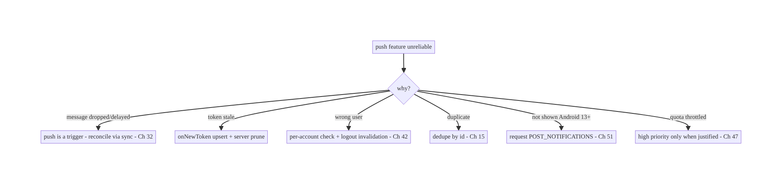
49.9 Failure Scenarios and Recovery
The golden rule: push is a trigger, never the source of truth. Because FCM is best-effort, correctness comes from reconciling via sync (Ch 32) — then dropped, delayed, and duplicate messages all self-heal. Every other failure (token, account, permission, quota) has a specific fix, but this one principle is what makes push reliable at all.

49.10 Scaling the Implementation
- Level 1. FCM integration; data messages → notification; token upsert on login + onNewToken.
- Level 2. Push-as-trigger + delta sync reconciliation (Ch 32); receiver → expedited WorkManager; notification permission gating (Ch 51).
- Level 3 — production. Per-account isolation + logout token invalidation (Ch 42/22); idempotent dedupe; priority discipline; payload validation; topics per preference; notification channels/grouping (Ch 50).
- Level 4 — large. Multi-device token management; quota-aware priority (Ch 14/47); push analytics (delivery/open rates); server-side token pruning + fan-out via topics/ device groups; A/B of notification content; consent/preference center (Ch 28).
- Level 5 — enterprise. Push reliability SLOs (delivery/latency by bucket/OS/OEM); dead-letter/retry on the backend; multi-region FCM; per-notification-type priority policy; privacy/consent governance; observability of trigger→sync→notify funnel.
Avoid overengineering: for most apps, data messages + token upsert + push-as- trigger-with-sync + permission gating is the core. Don’t build custom delivery guarantees on top of FCM (sync is your guarantee); don’t high-priority everything.

49.11 Alternative Approaches and Trade-offs
Dimension | Option A | Option B | When
Message type | Data message | notification message | Data for control/consistency; notification for simple system-shown broadcasts
Source of truth | Sync (push = trigger) | trust the payload | Always sync-reconcile (push best-effort); never trust payload as truth
Priority | High (time-sensitive) | normal (default) | High only for chat/order-status; normal otherwise (quota, Ch 47)
Follow-up work | Expedited WorkManager | inline in receiver | WorkManager (receiver budget tiny, Doze-limited)
Targeting | Per-user token | topic | Token for personal/secure; topic for broad non-sensitive segments
Real-time transport | FCM push | WebSocket (Ch 63) | FCM for background/killed wake; WebSocket for live foreground session
Token upsert | WorkManager (durable) | inline network | WorkManager (survives process death)
Data vs notification messages: notification messages are simplest (system shows them when backgrounded, no code), but you lose control when backgrounded/killed and can’t customize or reconcile reliably. Data messages always reach your code, giving consistent control to validate, per-account-check, sync, and render — at the cost of handling display yourself and running under tighter Doze limits. For a real app that needs correctness and per-account isolation, prefer data messages (high priority for time-sensitive) and always reconcile via sync.
Push vs WebSocket for real-time (Ch 63): FCM is the right transport when the app may be backgrounded or killed (it wakes the app battery-efficiently via the OS). A WebSocket (Ch 63) is right for a live foreground session (chat open, live stream) where you need low-latency bidirectional streaming — but it dies when backgrounded. Real apps use both: WebSocket while foregrounded/active, FCM to wake for background events, with sync (Ch 32) as the reconciliation layer behind both.
Push as truth vs push as trigger: trusting the payload as authoritative state is the classic mistake — a dropped push then means permanently missed state, and a duplicate means double-applied changes. Treating push as a trigger that prompts an authed, idempotent sync (Ch 32/15/19) makes the system self-healing and secure (the payload can even be minimal, avoiding PII). This is the single most important design decision in the chapter.

49.12 Security & Privacy Considerations
- No secrets or PII in the payload. Payloads traverse Google’s servers and may be logged/cached; send a minimal signal (type + id), fetch details over the authed API (Ch 19). Never put tokens, full messages, prices tied to identity, etc., in the push (Ch 28).
- Treat payloads as untrusted input. Validate/allowlist type; never blindly deep-link from a payload (open-redirect/intent-injection risk, Ch 52); never eval or trust URLs/ids without server verification.
- Authenticate the effect. The notification’s data is fetched with the user’s auth (Bearer, Ch 19); the push itself grants no access.
- Per-account isolation (Ch 42). Check the payload’s target account against the active account before rendering/applying; invalidate the token on logout/switch so the previous user’s pushes stop. A chat push for account A must never render under account B.
- Topics are coarse/semi-public. Never use topics for sensitive or per-user targeting (anyone who reverse-engineers the app can subscribe); use per-user tokens for anything personal.
- Notification content on lock screen must respect sensitivity (public/private versions, Ch 50) and consent (Ch 51/28).
- Token theft/misuse: tokens are not secrets that grant access, but a leaked token lets someone send to that device via your authed backend only — protect the send API, rotate on logout, and prune stale tokens.
- Client vs backend: the backend owns token storage (per user/device), fan-out, pruning stale tokens, priority policy, and never embedding PII; the client owns validation, per-account routing, sync reconciliation, and permission gating.

49.13 Performance and Resource Optimization
- Minimal receiver work → hand to WorkManager; avoids ANR and Doze drops.
- High priority sparingly (quota + battery, Ch 47); batch/coalesce server events so you send fewer, more meaningful pushes (Ch 14).
- Collapsible messages (collapseKey): let FCM collapse superseded messages (e.g., “3 new messages” replaces older) to save battery/bandwidth.
- Small payloads (≤4KB; keep well under) — signal, not content.
- Coalesce sync triggers: multiple pushes → unique/debounced sync work (Ch 11/30) rather than N fetches.
- Notification throttling/grouping (Ch 50) to avoid spamming + battery from many notify() calls.
- Profiling: delivery/open funnel, wake-ups and battery attributed to push (Battery Historian), high-priority quota usage, sync-after-push cost.

49.14 Testing Strategy
Push is tested with faked RemoteMessage, WorkManager test APIs, and the FCM console/ adb for end-to-end.
class PushRouterTest {
@Test fun `drops push for non-active account`() {
val router = PushRouter(ctx, FakeActiveAccount("A"), fakeWm, fakeNotifier)
router.route(mapOf("type" to "chat_message", "id" to "1", "acct" to "B"), null)
assertTrue(fakeWm.enqueued.isEmpty()) // per-account isolation (Ch 42)
}
@Test fun `ignores unknown message type`() {
PushRouter(ctx, FakeActiveAccount("A"), fakeWm, fakeNotifier).route(mapOf("type" to "evil"), null)
assertTrue(fakeWm.enqueued.isEmpty()) // allowlist validation
}
@Test fun `enqueues expedited sync for known type`() { /* assert WorkManager enqueue */ }
}
class PushSyncWorkerTest {
@Test fun `sync is idempotent across duplicate pushes`() = runTest {
val worker = TestListenableWorkerBuilder<PushSyncWorker>(ctx, workDataOf("type" to "order_update","id" to "1")).build()
worker.doWork(); worker.doWork() // twice
assertEquals(1, fakeNotifier.shown.count { it.id == "1" }) // deduped (Ch 15)
}
}
class FcmTokenManagerTest {
@Test fun `invalidateOnLogout deletes device and rotates token`() = runTest { /* assert deleteDevice + deleteToken */ }
}
# End-to-end with adb (send a data message to the app):
adb shell am broadcast -a com.google.android.c2dm.intent.RECEIVE ... # or FCM test console
adb shell dumpsys deviceidle force-idle # verify high-priority wakes it (Ch 47)
What to test: router validation + per-account drop + unknown-type drop; expedited enqueue; idempotent sync (duplicate pushes → one notification); token upsert via WorkManager; logout invalidation; permission-gated rendering (Ch 51); app-state behavior (foreground vs background) on device; Doze high-priority wake.

49.15 Production Observability
- Metrics: delivery → open funnel (sent / delivered / displayed / tapped); delivery latency and drop rate by App Standby bucket / OS / OEM (Ch 47); token upsert success + stale-token prune rate; high-priority quota usage; duplicate- delivery rate; per-account mis-route count (should be 0); notification-permission grant rate (Ch 51); sync-after-push success.
- Logs: push{type, priority, delivered_at, synced, notified, account_ok} — no PII/ payload content (Ch 28).
- Debugging: missing notifications → drop (Doze/bucket) → rely on sync; late → priority/quota; wrong user → per-account/token invalidation bug; duplicates → non-idempotent; not shown on 13+ → permission; sends failing → stale tokens not pruned.
- Alerting: delivery-rate drop on an OS/OEM after update; high-priority quota exhaustion; any cross-account mis-route (security alert).
- Dashboards: delivery funnel and drop-by-bucket/OEM; trigger→sync→notify success rate (the reliability KPI).

49.16 System Design Interview Preparation
≥40 questions.
Fundamentals
- Why not poll? Doze blocks/defers it, battery/scale — use push (Ch 47).
- What is FCM? Battery-efficient OS-level server→client transport via Google infra; best-effort.
- Notification vs data message? System-shown when backgrounded vs always delivered to your code.
- Which to prefer? Data messages (control/consistency); notification for simple broadcasts.
- App-state matrix? Foreground → your code; background/killed → system shows notification messages, data messages may be dropped/delayed.
Reliability
- Is delivery guaranteed? No — best-effort; may drop/delay/collapse.
- Golden rule? Push is a trigger, not the source of truth.
- How dropped push self-heals? Delta sync on open/periodic (Ch 32).
- Duplicate delivery? Idempotent sync + dedupe by id (Ch 15).
- Critical flows (payment) on push alone? Never — reconcile via sync.
Tokens
- Registration token? Per-install id to target; can rotate.
- onNewToken? Rotation callback — upsert to backend.
- Store token keyed by? User + device (multi-device, per-account, Ch 42).
- Logout? Delete/invalidate token + unsubscribe topics.
- Stale tokens? Server prunes on UNREGISTERED/NOT_FOUND.
- Upsert durably? WorkManager (survives process death).
Priority/Doze
- High vs normal priority? High can wake in Doze (limited quota); normal may be delayed (Ch 47).
- When high? Time-sensitive (chat, order status) only.
- Quota? Bucket-dependent; over-use throttled.
- Follow-up work? Expedited WorkManager, not inline.
Receiver
- onMessageReceived constraints? Short budget, background thread, Doze-limited.
- What to do inline? Validate, per-account check, enqueue WorkManager, maybe lightweight notify.
Targeting
- Per-user token vs topic vs device group? Control/secure vs broad pub/sub vs legacy.
- Topics for sensitive content? No — coarse/semi-public.
- Subscribe/unsubscribe lifecycle? On preference change; unsubscribe on logout.
Security
- Secrets/PII in payload? Never (traverses Google).
- Payload trust? Untrusted — validate/allowlist; no blind deep-link (Ch 52).
- Authenticate the effect? Fetch over authed API (Ch 19).
- Per-account isolation? Check active account vs payload; invalidate on logout (Ch 42).
- Token a secret? No, but protect the send API; rotate/prune.
Push vs WebSocket
- When WebSocket? Live foreground session (Ch 63).
- When FCM? Background/killed wake.
- Use both? Yes — WS foreground, FCM background, sync reconciles.
Permissions/UX
- Android 13+ display? Needs POST_NOTIFICATIONS (Ch 51).
- No permission? Data still syncs; just not shown.
- Notification rendering? Central Notifier, channels/grouping (Ch 50).
Testing/Production
- Test the router? Fake RemoteMessage; assert validation/per-account/enqueue.
- Test idempotency? Run sync twice → one notification.
- Missing notifications in prod? Drops (Doze/bucket) → rely on sync.
- Wrong user sees push? Per-account/token invalidation bug.
- Sends failing? Stale tokens not pruned.
- Key reliability KPI? Trigger→sync→notify success + delivery-by-bucket.

Design-change challenges
- Design push for chat. Data message (high priority) → fetch message → grouped notification; WebSocket when foregrounded; sync reconciles; per-account isolation.
- Order-status push must never be missed. Push as trigger + authoritative order sync (Ch 32); don’t depend on delivery.
- Users report pushes for the wrong account after switching. Per-account check + token invalidation on switch (Ch 42).
- Battery/quota complaints from too many high-priority pushes. Downgrade non-urgent to normal; coalesce/collapse; sync backstop (Ch 47).
- Notifications not showing on Android 13+. Request POST_NOTIFICATIONS; data still syncs (Ch 51).

Mock walkthrough (abridged)
Clarify (what events, how time-sensitive, multi-account/device, foreground live too?) → FCM transport + message type (data) → token lifecycle (upsert/rotate/invalidate) → priority policy (Ch 47) → push-as-trigger + sync reconciliation (Ch 32) → receiver → expedited WorkManager → per-account isolation + payload security (Ch 42/28/52) → notification rendering + permission (Ch 50/51) → push vs WebSocket (Ch 63) → observability (delivery funnel, drop-by-bucket).

49.17 Practical Exercises
- Beginner. Integrate FCM: receive a data message, show a notification, upsert the token on login and in onNewToken. Eval: message received across states; token stored.
- Intermediate. Make push a trigger: on receipt, enqueue an expedited WorkManager delta sync over the authed API; show the notification after truth is fetched. Eval: dropped push self-heals on next sync.
- Advanced. Add per-account isolation + logout token invalidation + idempotent dedupe. Eval: no cross-account rendering; duplicates → one notification; logout stops pushes.
- Production debugging. Diagnose “notifications missing in prod”: confirm drops by bucket, verify sync backstop, and fix a stale-token pruning gap. Eval: reliability restored; stale tokens pruned.
- System design challenge. Design chat real-time using FCM (background) + WebSocket (foreground) + sync (reconcile), with priority policy and a delivery funnel dashboard. Eval: correct across states; self-healing; observable.
(Solutions withheld unless requested.)

49.18 Chapter Summary & Reference Sheet
Key decisions: use FCM as a best-effort, battery-efficient server→client transport; prefer data messages (consistent code control across app states) with high priority only for time-sensitive events (bucket-limited quota, Ch 47); manage the token lifecycle rigorously (register, onNewToken, durable WorkManager upsert keyed by user+device, invalidate on logout/account switch, server prunes stale tokens); keep onMessageReceived minimal and hand follow-up work to expedited WorkManager (Ch 30); and above all treat push as a trigger, reconciling authoritative state via sync (Ch 32) so dropped, delayed, and duplicate messages self-heal (idempotent, Ch 15) — never trust the payload as truth; secure it (no secrets/PII, untrusted input, authed effects via Ch 19, per-account isolation via Ch 42, topics only for coarse non-sensitive segments); gate display on POST_NOTIFICATIONS (Ch 51) and render via a central Notifier (Ch 50); and combine FCM (background) with a WebSocket (foreground live, Ch 63) when real-time matters.
Concepts: FCM transport, notification vs data messages, app-state matrix, token lifecycle/rotation/invalidation, priority & Doze quota, push-as-trigger + sync reconciliation, receiver→WorkManager handoff, topics/targeting, per-account isolation, payload security, permission gating, FCM vs WebSocket.
Common mistakes: treating push as the source of truth (dropped = lost); heavy work in the receiver; not handling onNewToken/not pruning stale tokens; high-priority everything (quota throttle); PII in payload; trusting payload (blind deep-link); no per-account check / no logout invalidation (cross-account leak); topics for sensitive targeting; no POST_NOTIFICATIONS handling; non-idempotent (duplicates).
Checklist:
- ☐ data messages + deliberate priority
- ☐ token upsert (user+device, durable) + onNewToken
- ☐ invalidate token + unsubscribe topics on logout
- ☐ receiver minimal → expedited WorkManager
- ☐ push = trigger; reconcile via sync
- ☐ idempotent dedupe by id
- ☐ validate payload (allowlist, no blind deep-link)
- ☐ authed effect (Ch 19)
- ☐ per-account isolation (Ch 42)
- ☐ no secrets/PII in payload
- ☐ POST_NOTIFICATIONS gating
- ☐ delivery funnel + drop-by-bucket telemetry.
Key APIs: FirebaseMessagingService/onMessageReceived/onNewToken, FirebaseMessaging.getToken/deleteToken/subscribeToTopic/unsubscribeFromTopic, RemoteMessage (data/notification), FCM HTTP v1 API (server), priority: high|normal, collapseKey, CoroutineWorker.setExpedited/OutOfQuotaPolicy (Ch 30), POST_NOTIFICATIONS (Ch 51), NotificationCompat (Ch 50).
References:
- FCM overview: https://firebase.google.com/docs/cloud-messaging
- Message types: https://firebase.google.com/docs/cloud-messaging/concept-options
- Receive messages on Android: https://firebase.google.com/docs/cloud-messaging/android/receive
- Manage tokens: https://firebase.google.com/docs/cloud-messaging/manage-tokens
- Notifications & Doze/priority: https://firebase.google.com/docs/cloud-messaging/concept-options#setting-the-priority-of-a-message
- (composes) Ch 47 Doze/Limits, Ch 30 WorkManager, Ch 32 Delta Sync, Ch 19 Auth, Ch 42 Multi-Account, Ch 50 Notifications, Ch 51 Permissions, Ch 63 WebSockets

Chapter 50 — Notification Center / Inbox
Part VI — Lifecycle, Background & Platform · Complexity: Standard (≥25 interview questions)
Prerequisites: Ch 49 (FCM/push), Ch 51 (notification permission), Ch 3 (SSOT/ Room), Ch 32 (sync), Ch 52 (deep links). Pairs with Ch 46 (FGS notifications), Ch 6 (UI state).
Reference surface in StreamCart: both halves of “notifications” — the system notifications (channels, grouping, styles, actions, lock-screen) shown in the status bar, and the in-app notification inbox (a persistent, synced list of messages the user can read, mark read, and act on).

50.1 Problem Definition and Real-World Context
“Notifications” means two related systems that teams often conflate:
- System notifications — the OS status-bar/drawer notifications, governed by channels (Android 8+), importance, grouping, styles (BigText, Inbox, Messaging), actions, and lock-screen visibility. These are ephemeral (dismissed = gone) and fully user-controllable (per-channel settings).
- In-app notification inbox — a persistent, synced list inside the app (bell icon → list of order updates, messages, promos) that survives dismissal, shows read/unread, and is the source of truth for “what did I get.” This is a normal offline-first data feature (SSOT + sync, Ch 3/32), not a system-notification concern.
The problems arise when these aren’t designed together:
- Treating the system notification as the record. Once dismissed, it’s gone — if there’s no inbox, the user permanently loses the message. The inbox (persisted, synced) is the record; the system notification is a transient alert.
- Channel mismanagement. No channels (required Android 8+), one giant channel (user can’t tune), or wrong importance → users disable all notifications. Channels created late or renamed badly confuse settings.
- Notification spam & no grouping. Posting many individual notifications instead of grouping (summary + children) floods the drawer and gets the app muted.
- Inconsistent rendering. Scattered NotificationCompat calls across the codebase → inconsistent styling, missing actions, duplicate ids, lock-screen leaks. A central Notifier is needed.
- Read-state divergence. Tapping a system notification doesn’t mark the inbox item read; reading in-app doesn’t dismiss the system notification; read state doesn’t sync across devices (Ch 32).
- Permission (Android 13+). Without POST_NOTIFICATIONS (Ch 51), system notifications are silently suppressed — but the inbox should still work.
The architecture: build a central Notifier that owns channels (created at startup, correct importance), consistent styles/actions/grouping, lock-screen visibility, and ids; model the inbox as an offline-first feature (Room SSOT + sync, Ch 3/32) with read/unread and actions; link the two (tapping a system notification deep-links into the app and marks the inbox item read, Ch 52; in-app read optionally cancels the system notification; read state syncs, Ch 32); and gate system display on notification permission (Ch 51) while keeping the inbox functional regardless. This chapter is about a coherent notification experience across the status bar and an in-app inbox.

Three practical use cases
- StreamCart order update. Push (Ch 49) → inbox row persisted (SSOT) + system notification posted (right channel, deep-link action, Ch 52); tapping marks read and navigates; read syncs across devices.
- Grouped chat messages. Multiple messages → grouped notification (summary + per- message children, Messaging style); inbox shows the conversation; reading in-app cancels the system group.
- Promotions channel. A separate low-importance “Promotions” channel the user can mute independently without losing transactional notifications.

Why this is architectural
The notification experience spans push (Ch 49), persistence/sync (Ch 3/32), deep links (Ch 52), permissions (Ch 51), and UI (Ch 6) — and the key insight (system notification = transient alert; inbox = durable record; keep them in sync) is a design decision that affects reliability, UX, and user trust (spam → muting).

50.2 Requirements Engineering

Functional requirements
ID | Requirement
F1 | Post consistent system notifications (channels, styles, actions, grouping, lock-screen).
F2 | Maintain a persistent, synced in-app inbox (read/unread, actions).
F3 | Link the two: tap → deep-link + mark read; in-app read → optionally cancel system notif; read syncs.
F4 | Group related notifications; avoid spam.
F5 | Gate system display on permission (Ch 51); inbox works regardless.
F6 | Respect per-channel user settings and consent/preferences.

Non-functional requirements
Attribute | Policy
Durability | Inbox persists (SSOT); system notifications are transient alerts.
Consistency | Central Notifier; one style/id scheme; read state in sync.
UX / trust | Grouping, correct importance; no spam → avoid muting.
Privacy | Lock-screen sensitivity (public/private); no PII leak (Ch 28).
Resilience | Works without notification permission (inbox); offline-first inbox.

Scope
- In scope: notification channels/groups/importance, styles (BigText/Inbox/ Messaging/BigPicture), actions + PendingIntent, grouping (summary + children), lock-screen visibility, central Notifier, in-app inbox (Room SSOT + sync, read/unread), linking system↔inbox (deep link + read sync), permission gating, channel settings deep-link.
- Out of scope: push transport (Ch 49), permission request UX (Ch 51), deep-link routing detail (Ch 52), sync algorithm (Ch 32), SSOT internals (Ch 3), FGS notifications (Ch 46).

Assumptions & constraints
- minSdk 24; channels required Android 8+ (targetSdk enforces); Android 13+ notification permission. NotificationCompat, Room, WorkManager/sync, Compose. Inbox is an offline-first feature; system notifications are ephemeral and user-controllable.

50.3 System Design Fundamentals
- System notification = transient alert; inbox = durable record. This is the core mental model. The status-bar notification alerts the user now and can be dismissed; the inbox (persisted in Room, synced, Ch 3/32) is the authoritative list of what the user received and its read state. Design both and keep them consistent.
- Channels (Android 8+, mandatory). Every notification belongs to a channel with a user-controllable importance (HIGH/DEFAULT/LOW/MIN), sound, vibration, and lock-screen behavior. Create channels at app startup (idempotent), one per category (Transactional, Chat, Promotions, …) so users can tune/mute each independently. You cannot change a channel’s importance after creation (the user owns it) — so choose categories thoughtfully and don’t over-split.
- Channel groups organize many channels in settings (e.g., “Account A” vs “Account B” for multi-account, Ch 42).
- Styles & content. NotificationCompat with BigTextStyle (long text), InboxStyle (list), MessagingStyle (chat — the correct style for conversations, shows avatars/sender), BigPictureStyle (image). Set a small icon, content title/ text, timestamp, and a content PendingIntent (deep link, Ch 52) + action buttons (PendingIntents: Reply/Mark read/Archive).
- Grouping (avoid spam). Related notifications share a group key; post a summary notification plus children. The system collapses them into one group in the drawer. Essential for chat/updates — posting N separate notifications floods the drawer and gets the app muted.
- Lock-screen visibility & privacy. setVisibility(PUBLIC/PRIVATE/SECRET) and a public version (setPublicVersion) control what shows on the lock screen; keep sensitive content off it (Ch 28). Respect the channel’s lock-screen setting too.
- PendingIntent correctness (Ch 49/52). Content/action intents use FLAG_IMMUTABLE (Android 12+), explicit intents (your own component / a deep-link Uri), and distinct request codes per notification; tapping routes via deep links (Ch 52) into the right screen and marks the inbox item read.
- Inbox as offline-first (Ch 3/29/32). The inbox is a Room table (InboxItem{id, type, title, body, deepLink, isRead, createdAt, account}), written when a push arrives (Ch 49) and reconciled by sync (Ch 32) so it’s consistent across devices and survives reinstalls (server-backed). The UI (Ch 6) observes it; read state is a synced field (mark read locally → sync up → other devices reflect it).
- Linking the two systems:
  - Push (Ch 49) → write inbox item (SSOT) and post system notification (same id/deep link).
  - Tap system notification → deep-link (Ch 52) → screen + mark inbox item read → cancel the system notification.
  - Read in-app → optionally cancel the corresponding system notification (NotificationManager.cancel(id)); sync read state (Ch 32).
- Permission gating (Ch 51). On Android 13+, no POST_NOTIFICATIONS → system notifications are suppressed, but the inbox still receives and shows items (push data still arrives, Ch 49). So the inbox is the resilient channel; design it to work regardless of permission.
Core insight: treat the system notification as a transient alert and the in-app inbox (Room SSOT + sync) as the durable record; render all system notifications through one central Notifier that owns channels (by category, created at startup), consistent styles/ actions/grouping, and lock-screen privacy; link the two so a tap deep-links and marks read and in-app reads cancel/sync, with read state synced across devices; and keep the inbox functional even without notification permission — so the user never loses a message and never gets spammed into muting the app.

50.4 High-Level Architecture
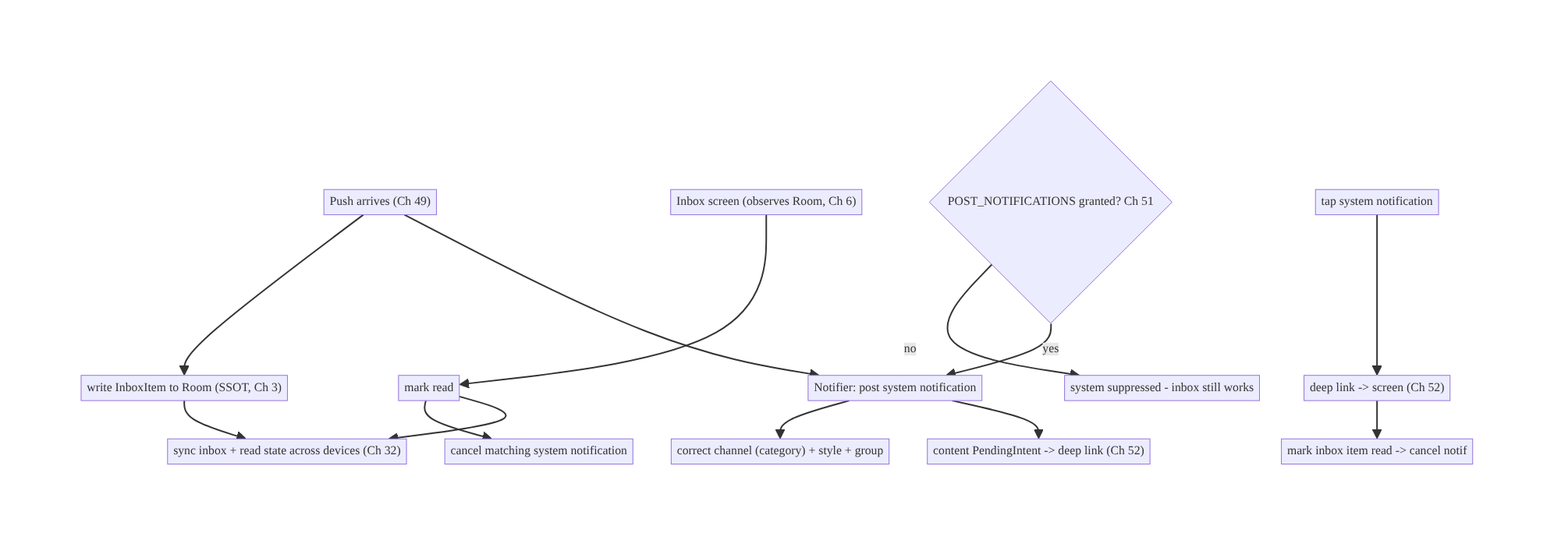
50.4 High-Level Architecture
Components & ownership
- Notifier centralizes system-notification rendering (channels/styles/grouping/ privacy/ids).
- Inbox (Room SSOT + sync) is the durable record with read state.
- Linking (deep link, mark-read, cancel, read-sync) keeps the two consistent.
- Permission gates system display only; the inbox is resilient.
Direction: push → inbox (durable) + system alert (transient) → tap/read links them → read state syncs.

50.5 Detailed Component Design
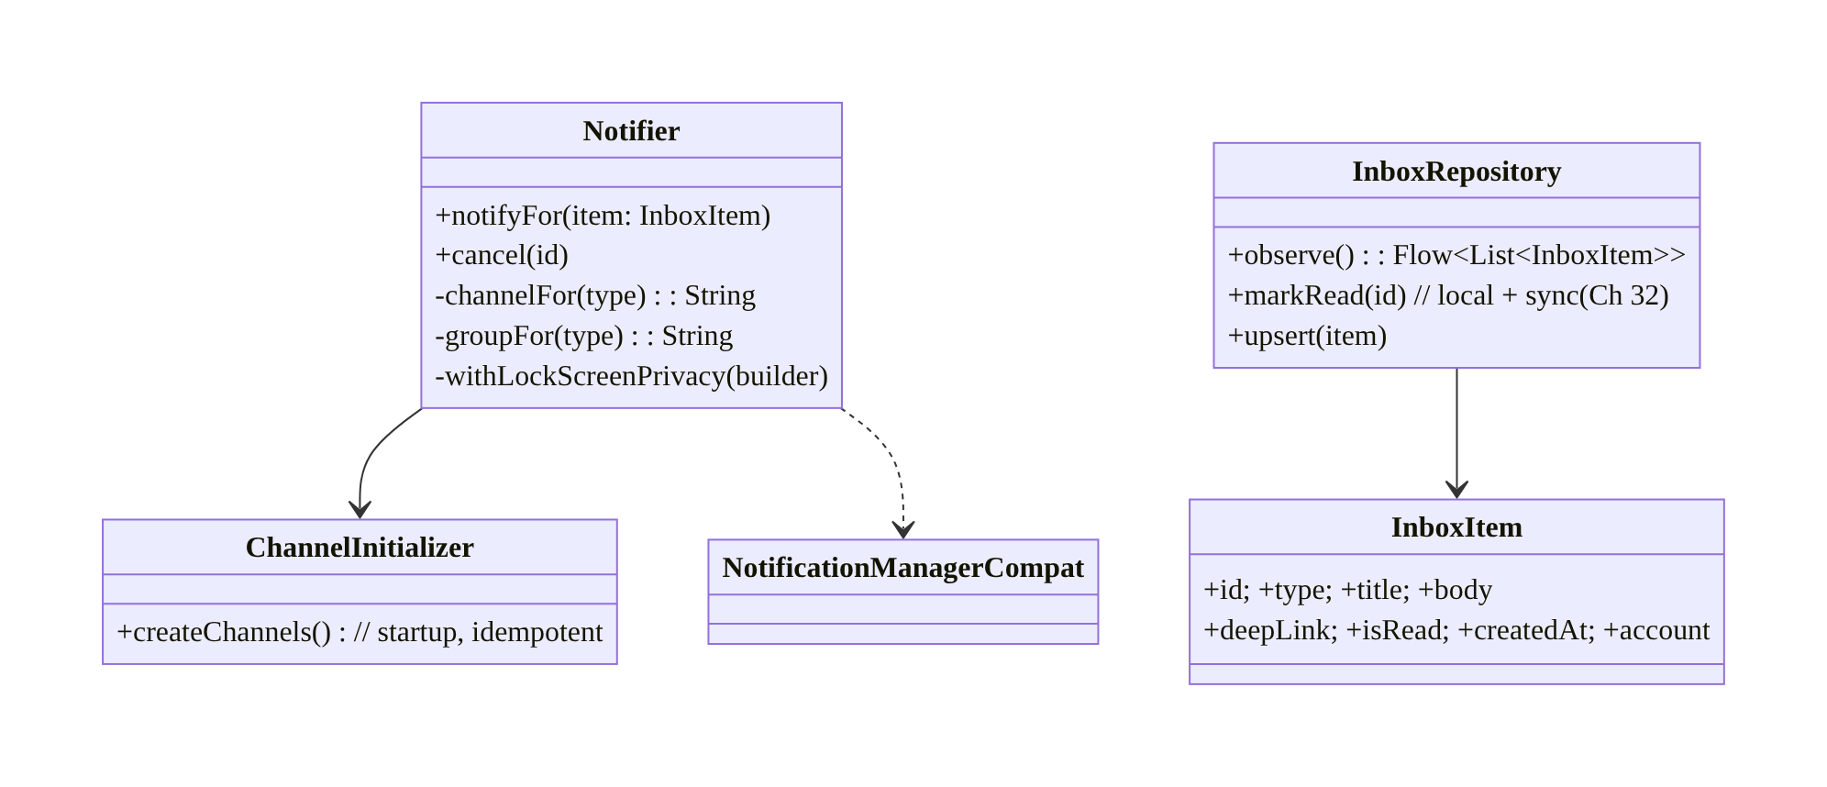
50.5 Detailed Component Design
Component | Responsibility
Notifier | one place to build/post/cancel system notifications (channel/style/group/privacy/PendingIntent)
ChannelInitializer | create channels+groups at startup (idempotent)
InboxRepository | Room-backed inbox (SSOT) + read state + sync (Ch 3/32)
Inbox UI | observe + render + mark read (Ch 6)

50.6 End-to-End Data Flow

Push → inbox + system notification → tap
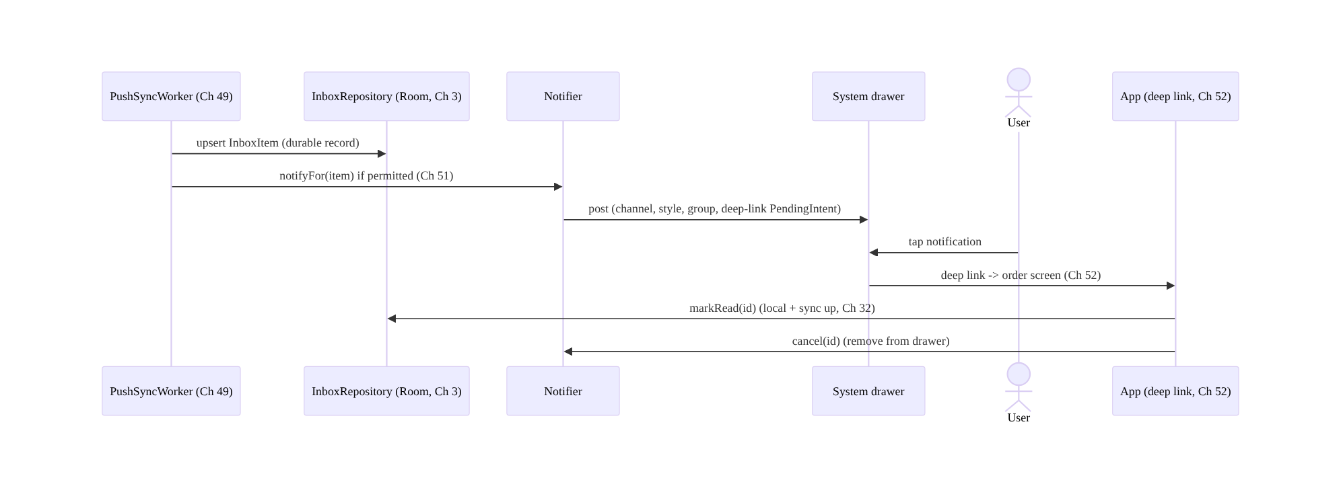
Push → inbox + system notification → tap

Grouping chat messages
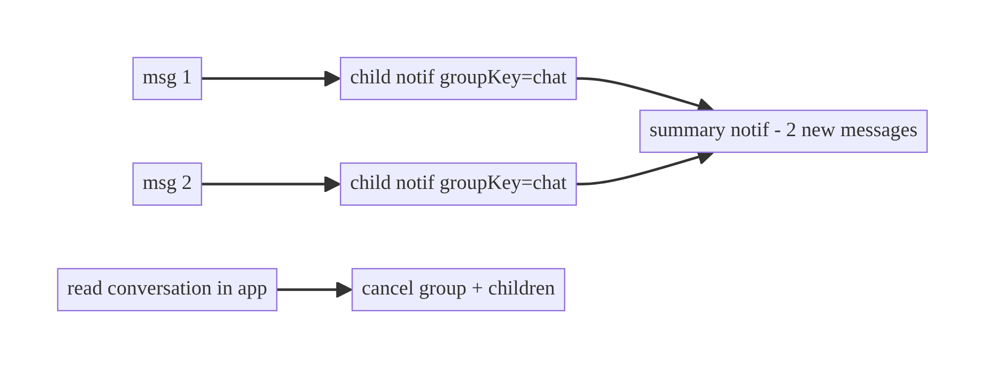
Grouping chat messages

50.7 Complete Kotlin Implementation
Package: com.streamcart.notifications.

50.7.1 Channels created at startup (idempotent)
@Singleton
class ChannelInitializer @Inject constructor(@ApplicationContext private val ctx: Context) {
fun createChannels() {
if (Build.VERSION.SDK_INT < Build.VERSION_CODES.O) return
val mgr = ctx.getSystemService(NotificationManager::class.java)
// Channel groups (e.g., per account, Ch 42) optional.
val channels = listOf(
channel(CH_TRANSACTIONAL, "Order & account", NotificationManager.IMPORTANCE_HIGH),
channel(CH_CHAT, "Messages", NotificationManager.IMPORTANCE_HIGH),
channel(CH_PROMOS, "Promotions", NotificationManager.IMPORTANCE_LOW), // user can mute separately
)
mgr.createNotificationChannels(channels) // idempotent; existing channels untouched (user owns importance)
}
private fun channel(id: String, name: String, importance: Int) =
NotificationChannel(id, name, importance).apply { lockscreenVisibility = Notification.VISIBILITY_PRIVATE }
}
// Called from Application.onCreate / App Startup (Ch 45).

50.7.2 Central Notifier (channel/style/group/privacy/PendingIntent)
@Singleton
class Notifier @Inject constructor(
@ApplicationContext private val ctx: Context,
private val deepLinks: DeepLinkFactory, // Ch 52
) {
private val nm = NotificationManagerCompat.from(ctx)
fun notifyFor(item: InboxItem) {
if (!nm.areNotificationsEnabled()) return // permission off (Ch 51) -> inbox still has it
val channel = channelFor(item.type)
val contentPI = deepLinks.pendingIntent(item.deepLink, item.id) // FLAG_IMMUTABLE, explicit (Ch 52)
val builder = NotificationCompat.Builder(ctx, channel)
.setSmallIcon(R.drawable.ic_notification)
.setContentTitle(item.title)
.setContentText(item.body)
.setStyle(NotificationCompat.BigTextStyle().bigText(item.body))
.setContentIntent(contentPI)
.setAutoCancel(true) // tap dismisses
.setVisibility(NotificationCompat.VISIBILITY_PRIVATE)
.setPublicVersion(publicVersion(item)) // lock-screen privacy (Ch 28)
.setGroup(groupFor(item.type)) // grouping
.addAction(markReadAction(item.id)) // action button
nm.notify(item.id.hashCode(), builder.build())
postGroupSummaryIfNeeded(groupFor(item.type), channel)
}
fun cancel(id: String) = nm.cancel(id.hashCode())
private fun channelFor(type: String) = when (type) {
"chat_message" -> CH_CHAT; "price_drop" -> CH_PROMOS; else -> CH_TRANSACTIONAL
}
private fun groupFor(type: String) = "group_$type"
}

50.7.3 Inbox as offline-first (Room SSOT + read sync)
@Entity(tableName = "inbox")
data class InboxItem(
@PrimaryKey val id: String, val type: String, val title: String, val body: String,
val deepLink: String, val isRead: Boolean, val createdAt: Long, val account: String,
)
@Dao interface InboxDao {
@Query("SELECT * FROM inbox WHERE account = :acct ORDER BY createdAt DESC")
fun observe(acct: String): Flow<List<InboxItem>>
@Query("UPDATE inbox SET isRead = 1 WHERE id = :id") suspend fun markRead(id: String)
@Upsert suspend fun upsert(item: InboxItem)
}
@Singleton
class InboxRepository @Inject constructor(
private val dao: InboxDao, private val syncRepo: SyncRepository, // Ch 32
private val activeAccount: ActiveAccountProvider, // Ch 42
) {
fun observe() = dao.observe(activeAccount.require().id)
suspend fun upsert(item: InboxItem) = dao.upsert(item)
suspend fun markRead(id: String) {
dao.markRead(id) // SSOT update -> UI reflects immediately (Ch 3)
syncRepo.pushReadState(id) // sync read across devices (Ch 32, outbox Ch 31)
}
}

50.7.4 Linking: deep-link tap marks read + cancels
// In the destination (Ch 52 routes here with the inbox id):
@Composable
fun OrderScreen(orderId: String, inboxId: String?, vm: OrderViewModel = hiltViewModel()) {
LaunchedEffect(inboxId) {
inboxId?.let { vm.onOpenedFromNotification(it) } // markRead(it) + notifier.cancel(it)
}
// ... screen ...
}

50.7.5 Module structure
:core:notifications Notifier, ChannelInitializer, DeepLinkFactory binding (Ch 52)
:feature:inbox InboxItem, InboxDao, InboxRepository, InboxScreen/ViewModel (Ch 6)
:core:sync read-state sync (Ch 32/31)
# Channels created from :app at startup (Ch 45).

50.8 Concurrency and Race Conditions
Scenario | Risk | Handling
Duplicate push → duplicate notification | spam | dedupe by stable id (notify(id.hashCode()) overwrites) + idempotent inbox upsert (Ch 15/49)
Read in-app vs tap race | double mark / stale | idempotent markRead; cancel is idempotent
Read state sync conflict across devices | divergence | LWW/synced boolean (Ch 32/33)
Many notifications at once | drawer flood | grouping (summary + children)
Channel created after first notify | notification dropped | create channels at startup (before any notify)
Account switch mid-notify | cross-account inbox | filter inbox by active account (Ch 42); per-account channel group
- Stable ids make posting idempotent: using item.id.hashCode() as the notification id means a re-delivered push updates the same notification instead of stacking a duplicate (pairs with idempotent inbox upsert, Ch 15/49).
- Read is idempotent and synced: markRead is safe to call twice (tap + in-app), and read state syncs as a field (LWW is fine, Ch 32/33) so devices converge.
- Channels must exist before the first notify — create them at startup (Ch 45), not lazily, or the first notification on Android 8+ is dropped.

50.9 Failure Scenarios and Recovery
Failure | Detection | Response | Outcome
User dismisses, loses message | support report | inbox is the durable record (SSOT) | never lost
Notification spam → app muted | opt-out rate | group + correct importance; separate promo channel | retained
No permission (Android 13+) | areNotificationsEnabled false | inbox still works; request permission (Ch 51) | data intact
Read state diverges across devices | user report | sync read state (Ch 32) | converges
Notification dropped (no channel) | logs | create channels at startup | shown
Lock-screen leak | privacy review | VISIBILITY_PRIVATE/public version | safe
Stale system notification after read | user report | cancel on in-app read | consistent
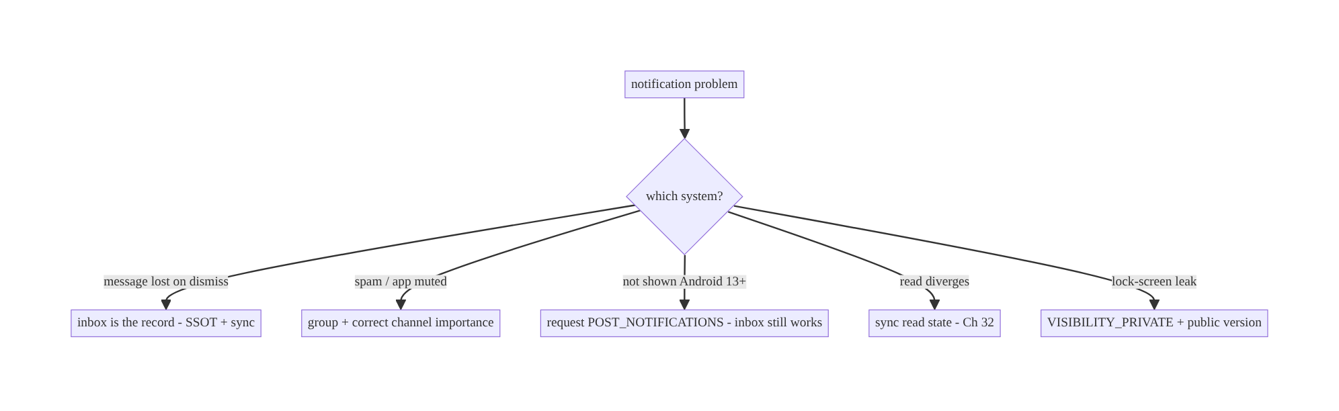
50.9 Failure Scenarios and Recovery
The durable record is the inbox, not the status-bar notification. Every “lost message” and “read state” problem dissolves once the inbox (SSOT + sync) is the source of truth and the system notification is just a transient, groupable, permission-gated alert that links back to it.

50.10 Scaling the Implementation
- Level 1. Central Notifier + channels at startup; basic inbox (Room) written on push.
- Level 2. Grouping + styles (Messaging for chat); deep-link tap → mark read + cancel; lock-screen privacy.
- Level 3 — production. Inbox sync (read state across devices, Ch 32); permission gating (Ch 51); per-channel user settings + settings deep-link; idempotent dedupe.
- Level 4 — large. Many categories/channels with channel groups (per-account, Ch 42); notification preference center; batching/digest notifications; rich actions (inline reply for chat); analytics (delivery/open/mute).
- Level 5 — enterprise. Notification governance (which teams own which channels), consent/compliance (Ch 28), cross-device inbox consistency SLOs, A/B of content/ timing, mute-rate dashboards and alerting.
Avoid overengineering: a few well-chosen channels + grouping + a Room-backed inbox with synced read state covers most needs. Don’t create a channel per notification or build a custom notification framework over NotificationCompat.

50.11 Alternative Approaches and Trade-offs
Dimension | Option A | Option B | When
Record of truth | In-app inbox (SSOT + sync) | the system notification | Inbox always (notification is ephemeral)
Channels | By category (few) | one channel / per-item | By category (user-tunable); never per-item
Many related notifs | Grouping (summary+children) | individual notifications | Grouping (avoid spam/muting)
Chat style | MessagingStyle | plain text | MessagingStyle (avatars/senders, system-optimized)
Read state | Synced field (Ch 32) | local only | Synced for multi-device; local-only diverges
Lock screen | VISIBILITY_PRIVATE + public version | PUBLIC always | Private for sensitive; public only for non-sensitive
Rendering | Central Notifier | scattered NotificationCompat | Central (consistency, ids, privacy)
Inbox vs system notification as the record: relying on the status-bar notification as the record loses the message on dismissal and can’t show history, read state, or sync across devices. A persisted, synced inbox (Ch 3/32) is a durable record that works even without notification permission and across reinstalls; the system notification becomes a transient alert that links into it. Build both; the inbox is authoritative.
Few category channels vs many channels: too few channels give users an all-or-nothing mute (they disable everything after one spammy promo); too many (per-feature or per-item) clutter settings and confuse users. A small set of category channels (Transactional, Chat, Promotions) with correct importance lets users mute marketing while keeping transactional alerts — the right balance.

50.12 Security & Privacy Considerations
- Lock-screen privacy: setVisibility(PRIVATE/SECRET) + setPublicVersion so sensitive content (messages, order details, amounts) isn’t shown on the lock screen; respect the channel’s lock-screen setting (Ch 28).
- No PII in notification logs/analytics (Ch 28) — log type/id, not content.
- PendingIntents FLAG_IMMUTABLE + explicit (Ch 49/52) so other apps can’t hijack the intent; validate deep-link targets (Ch 52).
- Per-account isolation (Ch 42): inbox filtered by active account; don’t render account A’s notifications/inbox under account B; per-account channel groups if needed.
- Respect consent/preferences (Ch 28): marketing channels honor opt-in; provide a clear settings deep-link (Settings.ACTION_CHANNEL_NOTIFICATION_SETTINGS).
- Don’t abuse importance/full-screen intents to force attention — Play/UX scrutinizes this, and users mute.
- Client vs backend: the backend provides inbox data + read-state sync (Ch 32) and must not include sensitive content in the push payload (fetch over authed API, Ch 49/19); the client enforces channels, privacy, grouping, and per-account rendering.

50.13 Performance and Resource Optimization
- Group and throttle notifications (summary + children; rate-limit notify()) to avoid drawer flood and battery from many posts.
- Reuse stable ids so re-delivery updates rather than stacks.
- Inbox paging (Ch 13) for long histories; observe with Flow (Ch 3/6) — don’t load all rows.
- Cheap channel creation at startup is idempotent and fast; don’t recreate on every notify.
- Load notification images off the main thread with size limits (BigPicture) to avoid jank/OOM.
- Profiling: notification post rate, mute/opt-out rate by channel, inbox query cost, read-sync latency.

50.14 Testing Strategy
System notifications test with Robolectric shadows / NotificationManagerCompat; inbox tests like any Room/sync feature (Ch 3/32).
@RunWith(AndroidJUnit4::class)
class NotifierTest {
@Test fun `posts on correct channel with deep-link intent`() {
val notifier = Notifier(ctx, FakeDeepLinks())
notifier.notifyFor(InboxItem(id="1", type="order_update", ...))
val shadow = shadowOf(ctx.getSystemService(NotificationManager::class.java))
val posted = shadow.allNotifications.single()
assertEquals(CH_TRANSACTIONAL, posted.channelId)
}
@Test fun `duplicate id updates instead of stacking`() { /* notify twice same id -> 1 notification */ }
@Test fun `does nothing when notifications disabled`() { /* areNotificationsEnabled=false -> no post */ }
}
class InboxRepositoryTest {
@Test fun `markRead updates SSOT and pushes read state`() = runTest {
repo.markRead("1"); assertTrue(dao.get("1").isRead); assertTrue(fakeSync.pushedRead.contains("1"))
}
@Test fun `inbox filtered by active account`() = runTest { /* Ch 42 */ }
}
What to test: channel creation (idempotent, at startup), Notifier channel/style/group/ privacy + stable-id dedupe + permission-off no-op; deep-link tap marks read + cancels; inbox upsert/observe/markRead + read-state sync; per-account filtering; lock-screen public version. Instrumentation on Android 13+ for permission-off inbox-still-works.

50.15 Production Observability
- Metrics: notification post / display / tap / dismiss rates by channel; mute/ opt-out rate per channel (the key UX health signal); inbox read rate; read-sync latency/conflicts (Ch 32); permission grant rate (Ch 51); per-account mis-render (0); spam complaints.
- Logs: notif{type, channel, grouped, shown, tapped} and inbox{action, synced} — no content/PII (Ch 28).
- Debugging: high mute rate → spam/wrong importance → group + separate channels; lost messages → inbox not persisting; read diverges → sync bug; not shown on 13+ → permission; cross-account render → account filter bug.
- Alerting: mute-rate spike on a channel; read-sync failure; any cross-account render.
- Dashboards: per-channel mute rate + tap rate; inbox consistency across devices.

50.16 System Design Interview Preparation
≥25 questions.
Fundamentals
- Two notification systems? System (status bar, transient) + in-app inbox (durable record).
- Which is the record? The inbox (SSOT + sync); the system notification is a transient alert.
- Channels (Android 8+)? Mandatory, user-controllable importance per category.
- Create channels when? At startup, idempotent, before any notify.
- Can you change importance later? No — user owns it; choose categories carefully.
Rendering
- Why a central Notifier? Consistency (channels/styles/ids/privacy); avoid scattered calls.
- Grouping? Summary + children by group key — avoid spam/muting.
- Chat style? MessagingStyle.
- Actions? Action buttons via PendingIntent (FLAG_IMMUTABLE).
- Lock-screen privacy? VISIBILITY_PRIVATE + setPublicVersion.
Inbox
- Inbox storage? Room SSOT (Ch 3), synced (Ch 32).
- Read/unread? Synced boolean field.
- Survives dismissal/reinstall? Yes (persisted/server-backed).
- UI? Observe Flow → Compose (Ch 6); paging for history (Ch 13).
Linking
- Tap behavior? Deep link (Ch 52) → screen + mark read + cancel.
- In-app read? Optionally cancel system notification; sync read state.
- Read across devices? Sync the read field (Ch 32).
Permission
- Android 13+ no permission? System suppressed; inbox still works.
- Request permission? Ch 51 (rationale, in-context).
- Settings deep-link? ACTION_CHANNEL_NOTIFICATION_SETTINGS.
Security/UX
- Lock-screen sensitive content? Private + public version.
- Per-account? Filter inbox by active account; per-account channel group (Ch 42).
- Avoid muting? Group, correct importance, separate promo channel.
Testing/Production
- Test notifications? Robolectric shadow NotificationManager.
- Dedupe duplicates? Stable notification id.
- Key UX metric? Per-channel mute/opt-out rate.
- Lost messages? Inbox not persisting (fix SSOT).

Design-change challenges
- Users lose messages when they dismiss notifications. Build the inbox as the durable record (SSOT + sync).
- App is getting muted from chat spam. Group with MessagingStyle summary+children; correct channel.
- Promos annoy users who still want order updates. Separate low-importance Promotions channel.
- Read state doesn’t sync across devices. Sync the read field (Ch 32).
- Sensitive content shows on the lock screen. VISIBILITY_PRIVATE + public version.

Mock walkthrough (abridged)
Clarify (what notification types, need history/read state, multi-device, sensitive?) → two systems (transient alert vs durable inbox) → channels by category at startup → central Notifier (styles/grouping/privacy/PendingIntent) → inbox as offline-first (Room + sync, read state) → link (deep link tap → mark read + cancel; in-app read → cancel + sync) → permission gating (inbox resilient) → privacy (lock screen) + per-account → observability (mute rate).

50.17 Practical Exercises
- Beginner. Create category channels at startup and post an order notification on the right channel via a central Notifier. Eval: correct channel; consistent style.
- Intermediate. Build a Room-backed inbox written on push; show read/unread; tapping a notification deep-links and marks read + cancels. Eval: durable; tap links + marks read.
- Advanced. Group chat notifications (MessagingStyle summary + children) and cancel the group when the conversation is read in-app; sync read state. Eval: grouped; read cancels + syncs.
- Production debugging. Fix a high mute rate (split promos into their own channel, add grouping) and a lock-screen leak (private + public version). Eval: mute rate drops; no leak.
- System design challenge. Make the inbox work with notifications permission off (Android 13+) and consistent across two devices (read-state sync). Eval: inbox functional without permission; devices converge.
(Solutions withheld unless requested.)

50.18 Chapter Summary & Reference Sheet
Key decisions: design two systems together — the system notification as a transient, groupable, permission-gated alert, and the in-app inbox (Room SSOT + sync, Ch 3/32) as the durable record with read/unread; render all system notifications through one central Notifier that owns channels by category (created at startup, correct importance — users own importance, so don’t over-split), consistent styles (MessagingStyle for chat), grouping (summary + children to avoid spam/muting), lock-screen privacy (VISIBILITY_PRIVATE + public version), and FLAG_IMMUTABLE deep-link PendingIntents (Ch 52) with stable ids (dedupe); link the two so a tap deep-links + marks read + cancels and in-app read cancels + syncs read state across devices; gate system display on POST_NOTIFICATIONS (Ch 51) while keeping the inbox fully functional without it; and enforce per-account isolation (Ch 42) and consent/preferences (Ch 28).
Concepts: system vs inbox, channels/groups/importance, styles, grouping (summary/ children), lock-screen visibility, central Notifier, offline-first inbox + synced read state, deep-link linking, permission gating, per-account isolation.
Common mistakes: treating the system notification as the record (lost messages); no/one/too-many channels; no grouping (spam → muting); scattered NotificationCompat; read state not synced (divergence); sensitive content on lock screen; channels created lazily (first notification dropped); no per-account filtering; inbox broken without permission.
Checklist:
- ☐ inbox = durable record (SSOT + sync)
- ☐ channels by category at startup
- ☐ central Notifier (style/group/privacy/ids)
- ☐ grouping (summary+children)
- ☐ MessagingStyle for chat
- ☐ lock-screen private + public version
- ☐ FLAG_IMMUTABLE deep-link PendingIntents
- ☐ stable ids (dedupe)
- ☐ tap → mark read + cancel
- ☐ synced read state
- ☐ permission-gated display; inbox resilient
- ☐ per-account isolation.
Key APIs: NotificationChannel/NotificationManager.createNotificationChannels, NotificationCompat.Builder/BigTextStyle/InboxStyle/MessagingStyle/ BigPictureStyle, setGroup/setGroupSummary, setVisibility/setPublicVersion, NotificationManagerCompat.notify/cancel/areNotificationsEnabled, PendingIntent (FLAG_IMMUTABLE), Room @Dao/Flow (Ch 3), Settings.ACTION_CHANNEL_NOTIFICATION_SETTINGS.
References:
- Notifications overview: https://developer.android.com/develop/ui/views/notifications
- Channels: https://developer.android.com/develop/ui/views/notifications/channels
- Groups/stacking: https://developer.android.com/develop/ui/views/notifications/group
- Notification runtime permission: https://developer.android.com/develop/ui/views/notifications/notification-permission
- (composes) Ch 49 Push/FCM, Ch 51 Permissions, Ch 3 SSOT, Ch 32 Sync, Ch 52 Deep Links, Ch 42 Multi-Account

Chapter 51 — Runtime Permissions Management
Part VI — Lifecycle, Background & Platform · Complexity: Standard (≥25 interview questions)
Prerequisites: Ch 44 (lifecycle), Ch 6 (UI state), Ch 49/50 (notifications), Ch 67 (location), Ch 25 (storage). Pairs with Ch 52 (deep links to settings), Ch 28 (privacy).
Reference surface in StreamCart: requesting and managing dangerous permissions — notifications (Android 13+), camera (scan a product/QR), location (nearby stores/ delivery), media/photos (upload a review image), microphone (voice search) — with correct rationale, graceful denial handling, and no feature breakage when denied.

51.1 Problem Definition and Real-World Context
Android gates access to sensitive capabilities (camera, location, contacts, mic, notifications, media) behind runtime permissions the user grants or denies in a system dialog. This is a consent and UX contract, and it’s easy to get wrong in ways that either break features or get the app rejected/uninstalled:
- Asking at the wrong time. Requesting camera/location at app launch (before the user understands why) → reflexive denial, and now the feature is dead. Permissions must be requested in context, when the user triggers the feature.
- No rationale. The system dialog is terse; without an app-provided rationale (especially after a first denial), users don’t understand the value and deny.
- Mishandling the denial states. There are several: not-yet-asked, granted, denied (can ask again), and permanently denied (“don’t ask again” / denied twice on modern Android — the system dialog won’t show again). Treating “denied” as one state, or trying to re-request when permanently denied (silently does nothing), breaks the flow.
- Not degrading gracefully. A denied permission should disable just that feature with a clear path to settings — not crash, not block the whole app, not nag.
- New permission models. Notifications became a runtime permission (Android 13+); location has foreground/background split + “approximate vs precise” + “only this time”; media moved to granular READ_MEDIA_IMAGES/VIDEO/AUDIO and the Photo Picker / “Selected photos” partial access (Android 13/14). Old patterns (request all storage) are wrong now.
- Permissions can be revoked anytime (settings, or auto-reset for unused apps, Android 11+) — so you must check at use, never cache “granted” forever.
The architecture: request in context (on feature trigger, not launch); show rationale (before, or after a denial, via shouldShowRequestPermissionRationale); use the Activity Result API (registerForActivityResult) — not the deprecated onRequestPermissionsResult; model the full state machine (not-asked / granted / denied-can-ask / permanently-denied) and route each correctly (request / proceed / rationale+request / deep-link to settings, Ch 52); check permission at use (it can be revoked); degrade gracefully (disable just the feature); and use the modern privacy-friendly APIs (Photo Picker, approximate location, “only this time”). This chapter is about getting consent respectfully and handling every outcome without breaking the app.

Three practical use cases
- Notifications (Android 13+). Request POST_NOTIFICATIONS after onboarding / when the user opts into alerts — with rationale — so pushes (Ch 49/50) can display; if denied, the inbox still works (Ch 50).
- Camera for QR/product scan (StreamCart). Request CAMERA when the user taps “Scan”; rationale if previously denied; on permanent denial, show a settings deep-link; feature disabled cleanly otherwise.
- Photos for a review image. Use the Photo Picker (no permission needed) by default; only request READ_MEDIA_IMAGES if full-gallery access is truly required, handling “Selected photos” partial grants.

Why this is architectural
Permission handling is a cross-cutting consent state machine touching lifecycle (Ch 44), UI state (Ch 6), many features (camera/location/media/notifications), privacy (Ch 28), and deep links to settings (Ch 52). The decisions — when to ask, how to explain, how to handle each outcome, how to degrade — determine grant rates, feature reliability, and user trust.

51.2 Requirements Engineering

Functional requirements
ID | Requirement
F1 | Request permissions in context (on feature trigger).
F2 | Show rationale before/after denial to explain value.
F3 | Model and route all states (not-asked/granted/denied/permanently-denied).
F4 | Check permission at use (revocation/auto-reset).
F5 | Degrade gracefully (disable just the feature; settings path).
F6 | Use modern privacy APIs (Photo Picker, approximate location, partial media).

Non-functional requirements
Attribute | Policy
UX / grant rate | In-context + rationale; never nag; clear value.
Correctness | Check at use; handle permanent denial (no silent re-request).
Resilience | No crash/whole-app block on denial.
Privacy | Least privilege; prefer no-permission APIs (Photo Picker); minimal scope.
Maintainability | Central permission helper + state machine, not ad hoc.

Scope
- In scope: runtime permission model, dangerous vs normal permissions, Activity Result API, rationale (shouldShowRequestPermissionRationale), state machine (not-asked/granted/denied/permanently-denied), check-at-use, graceful degradation, settings deep-link (Ch 52), notifications (13+), location (fg/bg, approximate/precise, one-time), media (granular + Photo Picker + partial), auto-reset, central helper.
- Out of scope: specific feature internals (camera/location — Ch 67), privacy policy (Ch 28), deep-link mechanics (Ch 52), notification rendering (Ch 50).

Assumptions & constraints
- minSdk 24, targetSdk current (13+ notifications, 14 partial media). AndroidX Activity Result API, Compose (rememberLauncherForActivityResult / Accompanist-style patterns). Permissions can be revoked anytime; permanent denial has no programmatic re-prompt (only settings).

51.3 System Design Fundamentals
- Normal vs dangerous permissions. Normal (e.g., INTERNET) are granted at install, declared in the manifest. Dangerous (camera, location, contacts, mic, notifications, media) require a runtime request and user consent. This chapter is about dangerous permissions.
- The permission state machine (model all of it):
  - Not requested → request (optionally with pre-rationale).
  - Granted → proceed.
  - Denied (can ask again) → shouldShowRequestPermissionRationale() returns true → show rationale, then re-request.
  - Permanently denied (“don’t ask again” / denied the required number of times) → shouldShowRequestPermissionRationale() returns false and not granted → the system dialog won’t show; you must deep-link to app settings (Ch 52) and explain. Re-requesting does nothing (returns denied immediately). Collapsing these into “granted/denied” is the #1 bug — you must distinguish “denied-can-ask” from “permanently-denied” to decide between rationale+request and a settings deep-link.
- Activity Result API (the correct mechanism). Use registerForActivityResult(RequestPermission()/RequestMultiplePermissions()) (Views) or rememberLauncherForActivityResult (Compose) — not the deprecated requestPermissions/onRequestPermissionsResult. It’s lifecycle-safe (Ch 44) and returns the grant result in a callback.
- Request in context, with rationale. Ask when the user triggers the feature (taps “Scan”, “Find nearby”, “Enable alerts”), not at launch. If a previous denial occurred (shouldShowRequestPermissionRationale true), show a rationale UI first explaining the value, then request. This maximizes grant rate and respects the user.
- Check at use, not once. Permissions can be revoked in settings or auto-reset for unused apps (Android 11+). Always ContextCompat. checkSelfPermission() at the point of use; never assume a past grant persists.
- Graceful degradation. A denied permission disables only that feature, with a clear message and (if permanently denied) a settings path — the rest of the app works. Never crash, never block the whole app, never nag repeatedly (one in-context ask + rationale; after that, a passive settings link).
- Modern per-permission specifics:
  - Notifications (POST_NOTIFICATIONS, Android 13+): runtime permission; request when the user opts into alerts / after onboarding. Denied → system notifications suppressed, but the inbox still works (Ch 50). Don’t request at first launch before value is shown.
  - Location: foreground (ACCESS_FINE_LOCATION/ACCESS_COARSE_LOCATION) vs background (ACCESS_BACKGROUND_LOCATION, must be requested separately/after foreground, and sparingly, Ch 67); approximate vs precise (Android 12+ — request coarse if precise isn’t needed); “only this time” grants (ephemeral). Request the least you need.
  - Media (Android 13+): granular READ_MEDIA_IMAGES/VIDEO/AUDIO replaced READ_EXTERNAL_STORAGE; Android 14 adds partial access (“Selected photos” → READ_MEDIA_VISUAL_USER_SELECTED). Prefer the Photo Picker (PickVisualMedia) which needs no permission at all — use it unless you truly need the whole library.
  - Camera/Mic: request on feature use; nothing special beyond the state machine.
- Manifest + policy: declare each permission; Play requires a declared, justified use for sensitive ones (location/camera/mic background) and may reject over-broad requests. Least privilege is both UX and policy.
Core insight: request dangerous permissions in context (on feature trigger) with a clear rationale, using the Activity Result API; model the full state machine — not-asked / granted / denied-can-ask (rationale + re-request) / permanently-denied (settings deep-link, no silent re-request) — distinguishing the last two via shouldShowRequestPermissionRationale; check the permission at the point of use (it can be revoked/auto-reset); degrade gracefully (disable just the feature, never crash/nag); and prefer the least-privilege, no-permission modern APIs (Photo Picker, approximate location, one-time grants).

51.4 High-Level Architecture
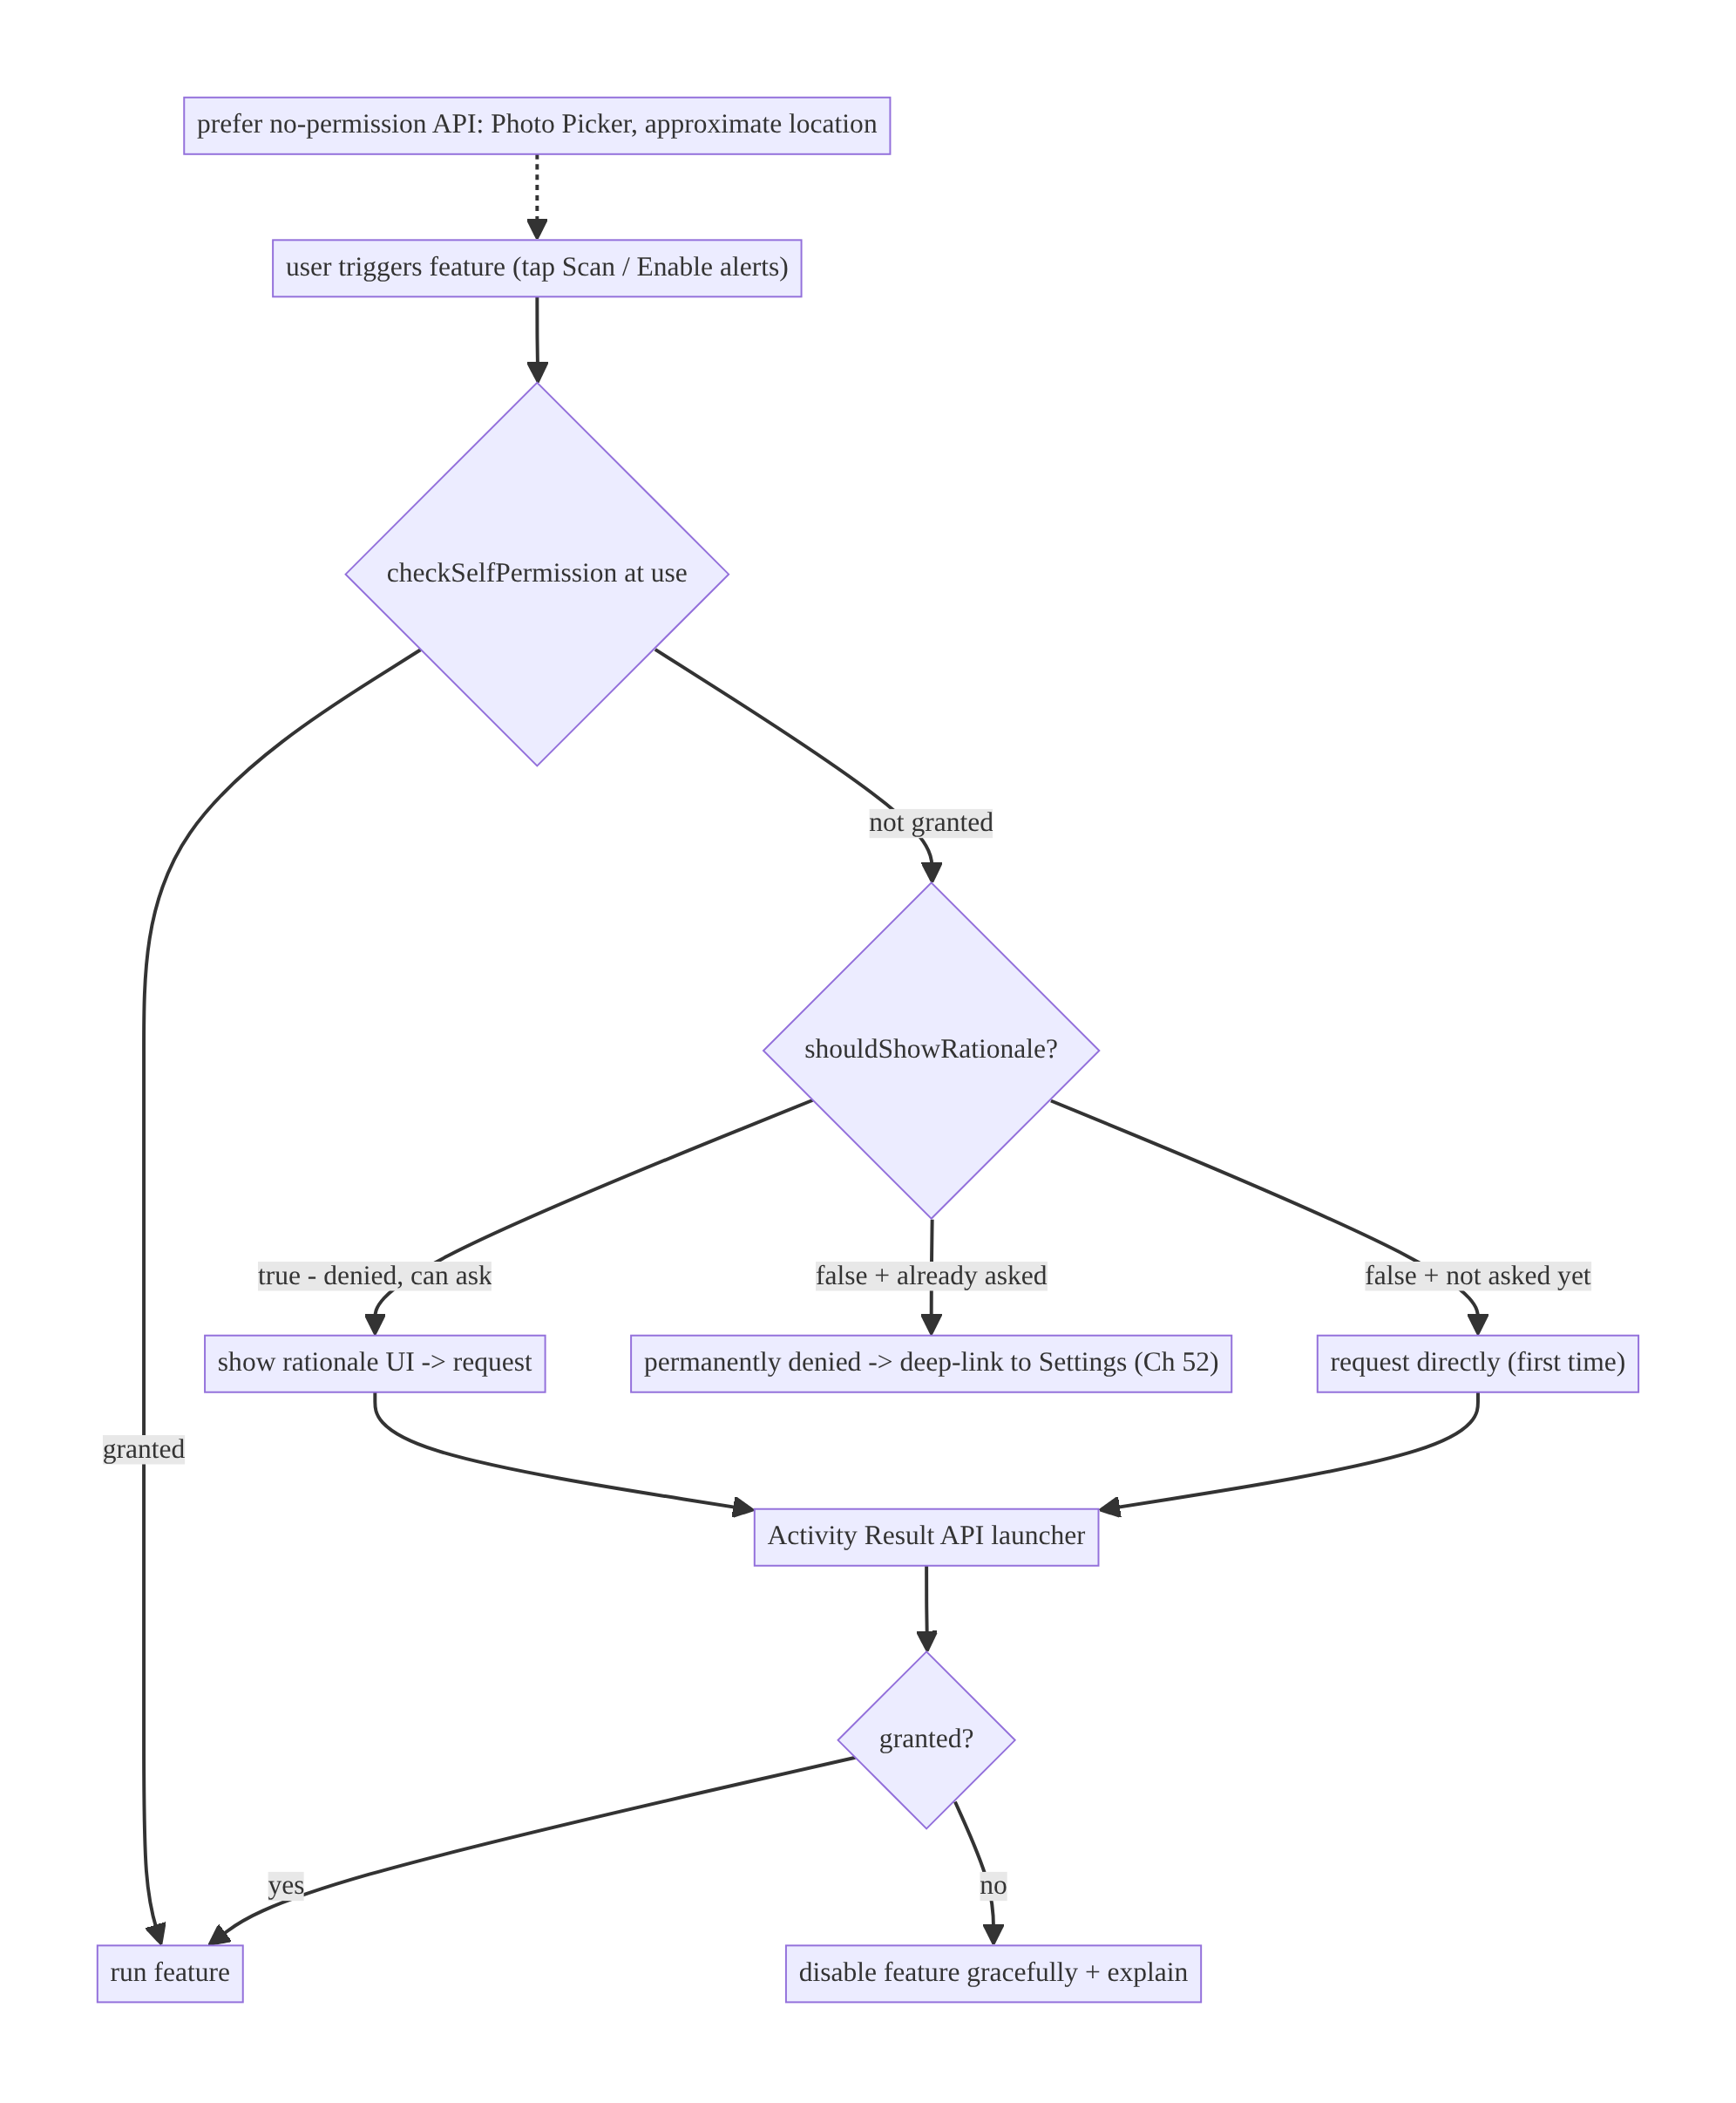
51.4 High-Level Architecture
Components & ownership
- Feature trigger initiates an in-context check.
- State machine routes to proceed / request / rationale+request / settings.
- Activity Result launcher performs the request lifecycle-safely.
- Graceful degradation disables just the feature on denial.
- No-permission APIs (Photo Picker) bypass the whole flow when possible.
Direction: trigger → check-at-use → state-routed request/rationale/settings → proceed or degrade.

51.5 Detailed Component Design
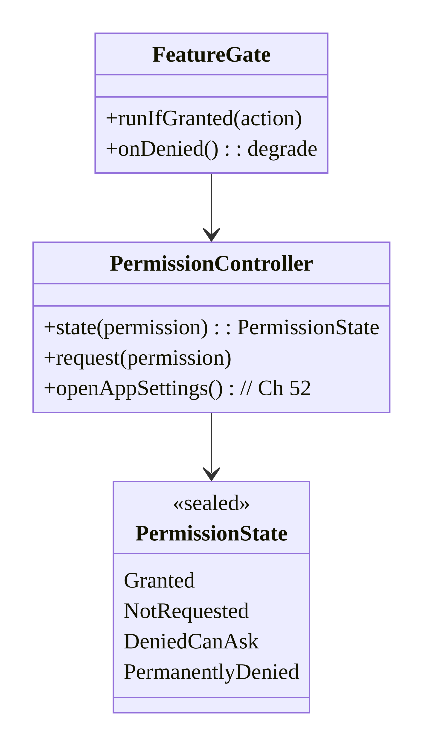
51.5 Detailed Component Design
Component | Responsibility
PermissionState | the 4-state model (the crux)
PermissionController | compute state, launch request, open settings (Ch 52)
FeatureGate | gate a feature on grant; degrade on denial
Rationale UI | explain value (before/after denial)

51.6 End-to-End Data Flow

In-context request with rationale and permanent-denial handling
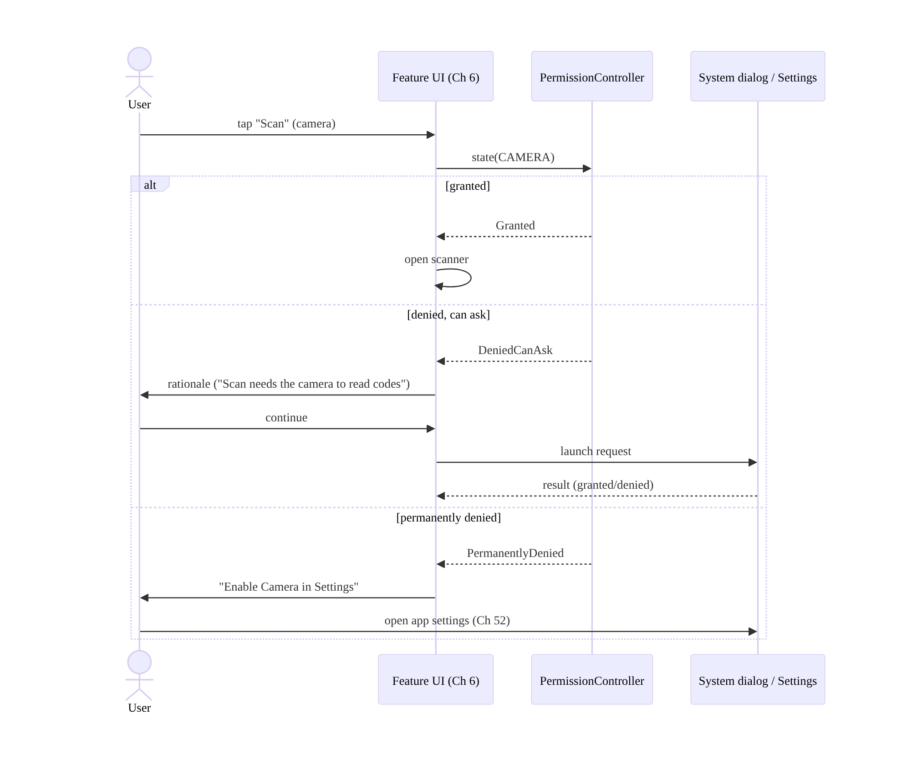
In-context request with rationale and permanent-denial handling

Media: prefer Photo Picker (no permission)
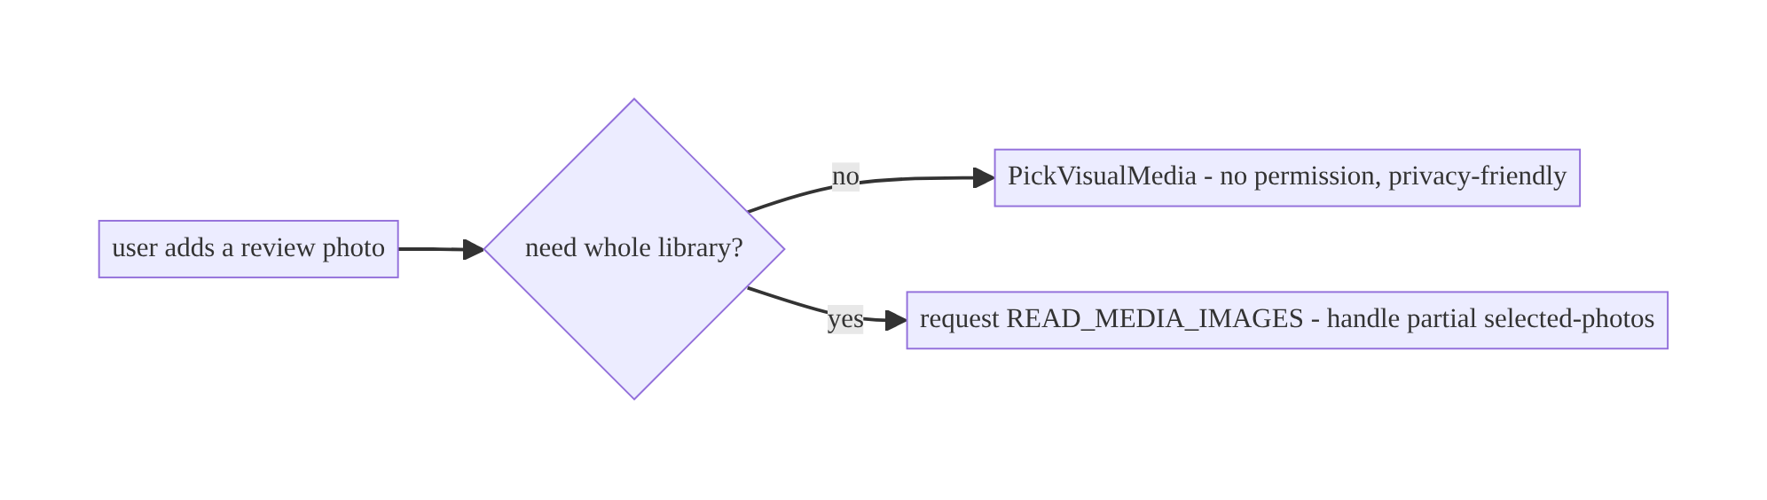
Media: prefer Photo Picker (no permission)

51.7 Complete Kotlin Implementation
Package: com.streamcart.permissions.

51.7.1 The state model + controller
sealed interface PermissionState {
data object Granted : PermissionState
data object NotRequested : PermissionState
data object DeniedCanAsk : PermissionState // shouldShowRationale == true
data object PermanentlyDenied : PermissionState // asked, not granted, rationale == false
}
class PermissionController(private val activity: ComponentActivity) {
fun state(permission: String, alreadyAsked: Boolean): PermissionState = when {
ContextCompat.checkSelfPermission(activity, permission) == PackageManager.PERMISSION_GRANTED ->
PermissionState.Granted
activity.shouldShowRequestPermissionRationale(permission) -> PermissionState.DeniedCanAsk
alreadyAsked -> PermissionState.PermanentlyDenied // asked before + no rationale + not granted
else -> PermissionState.NotRequested
}
fun openAppSettings() = activity.startActivity( // Ch 52
Intent(Settings.ACTION_APPLICATION_DETAILS_SETTINGS, Uri.parse("package:${activity.packageName}")))
}
// Persist "alreadyAsked" per permission (DataStore, Ch 4) since the system doesn't expose it directly.

51.7.2 Compose: in-context request, rationale, degrade
@Composable
fun ScanButton(viewModel: ScanViewModel = hiltViewModel()) {
val context = LocalContext.current
var showRationale by remember { mutableStateOf(false) }
var showSettings by remember { mutableStateOf(false) }
val launcher = rememberLauncherForActivityResult(ActivityResultContracts.RequestPermission()) { granted ->
viewModel.onCameraResult(granted) // granted -> open scanner; denied -> degrade
}
fun onScanClicked() {
when {
ContextCompat.checkSelfPermission(context, Manifest.permission.CAMERA) // CHECK AT USE
== PackageManager.PERMISSION_GRANTED -> viewModel.openScanner()
(context as Activity).shouldShowRequestPermissionRationale(Manifest.permission.CAMERA) ->
showRationale = true // DeniedCanAsk -> rationale first
viewModel.cameraAlreadyAsked() -> showSettings = true // PermanentlyDenied -> settings
else -> { viewModel.markCameraAsked(); launcher.launch(Manifest.permission.CAMERA) } // first ask
}
}
Button(onClick = ::onScanClicked) { Text("Scan") }
if (showRationale) RationaleDialog(
text = "Scanning uses your camera to read product and QR codes.",
onContinue = { showRationale = false; viewModel.markCameraAsked(); launcher.launch(Manifest.permission.CAMERA) },
onDismiss = { showRationale = false })
if (showSettings) SettingsDialog(
text = "Camera is turned off. Enable it in Settings to scan.",
onOpenSettings = { showSettings = false; PermissionController(context as ComponentActivity).openAppSettings() },
onDismiss = { showSettings = false })
}

51.7.3 Notifications permission (Android 13+)
@Composable
fun EnableAlerts(onResult: (Boolean) -> Unit) {
val launcher = rememberLauncherForActivityResult(ActivityResultContracts.RequestPermission(), onResult)
LaunchedEffect(Unit) {
if (Build.VERSION.SDK_INT >= 33) launcher.launch(Manifest.permission.POST_NOTIFICATIONS)
else onResult(true) // pre-13: granted by manifest
}
// Request after onboarding / when user opts into alerts — NOT at first launch.
// Denied -> inbox still works (Ch 50); don't block.
}

51.7.4 Media: Photo Picker (no permission) preferred
@Composable
fun AddReviewPhoto(onPicked: (Uri?) -> Unit) {
// Photo Picker needs NO permission and is privacy-friendly (Android 13+, backported via Play services).
val picker = rememberLauncherForActivityResult(
ActivityResultContracts.PickVisualMedia()) { uri -> onPicked(uri) }
Button(onClick = { picker.launch(PickVisualMediaRequest(ActivityResultContracts.PickVisualMedia.ImageOnly)) }) {
Text("Add photo")
}
// Only fall back to READ_MEDIA_IMAGES (handling READ_MEDIA_VISUAL_USER_SELECTED partial) if you
// genuinely need full-library access (e.g., a gallery browser).
}

51.7.5 Location: least privilege (approximate, foreground-first)
// Request COARSE if precise isn't needed; request BACKGROUND only separately/after foreground (Ch 67).
val locationLauncher = rememberLauncherForActivityResult(
ActivityResultContracts.RequestMultiplePermissions()) { grants ->
val coarse = grants[Manifest.permission.ACCESS_COARSE_LOCATION] == true
viewModel.onLocationResult(precise = grants[Manifest.permission.ACCESS_FINE_LOCATION] == true, coarse = coarse)
}
// locationLauncher.launch(arrayOf(ACCESS_FINE_LOCATION, ACCESS_COARSE_LOCATION)) // user may pick "Approximate"

51.7.6 Module structure
:core:permissions PermissionState, PermissionController, FeatureGate, rationale/settings UI
# "alreadyAsked" flags in DataStore (Ch 4). Settings deep-link -> Ch 52. Feature code per feature module.

51.8 Concurrency and Race Conditions
Scenario | Risk | Handling
Cached “granted” then revoked | crash/SecurityException at use | check at use (not cached)
Re-request when permanently denied | nothing happens (silent) | detect state → settings deep-link
Launcher registered after STARTED | crash | register at composition/onCreate (Activity Result API handles)
Config change mid-dialog | lost result | Activity Result API is lifecycle-safe (Ch 44)
Returning from settings | stale UI state | re-check permission on ON_RESUME (Ch 44)
Partial media grant treated as full | missing photos | handle READ_MEDIA_VISUAL_USER_SELECTED / use Photo Picker
- Check at use + re-check on resume: because permissions can be revoked (settings/ auto-reset) and the user may grant via settings then return, verify with checkSelfPermission at the point of use and re-evaluate on ON_RESUME (Ch 44) so the UI reflects a grant made in settings.
- Activity Result API is lifecycle-safe: it survives config changes and delivers the result correctly, unlike the deprecated onRequestPermissionsResult — register it at composition/onCreate, never conditionally.

51.9 Failure Scenarios and Recovery
Failure | Detection | Response | Outcome
Low grant rate | analytics | request in-context + rationale; don’t ask at launch | higher grants
Permanent denial, feature dead | user stuck | detect state → settings deep-link + explain | recoverable
Crash on revoked permission | SecurityException | check at use; try/catch | no crash
Whole app blocked on denial | user report | degrade just the feature | app usable
Nagging repeated prompts | opt-out/uninstall | one ask + rationale, then passive settings link | retained
Over-broad request rejected by Play | review | least privilege; Photo Picker; justify | approved
Partial media missing files | user report | handle partial / use Photo Picker | correct
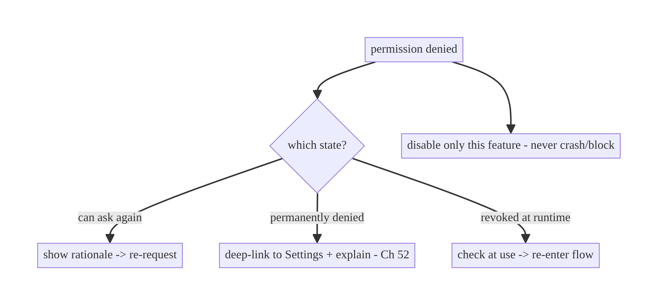
51.9 Failure Scenarios and Recovery
The two mistakes that define bad permission UX: asking out of context (low grants) and mishandling permanent denial (feature permanently dead with no path out). Fix both with in-context rationale and a settings deep-link, and always degrade just the one feature.

51.10 Scaling the Implementation
- Level 1. Activity Result API; in-context request; check at use.
- Level 2. Full 4-state machine with rationale + settings deep-link; graceful degradation per feature.
- Level 3 — production. Per-permission “alreadyAsked” persistence; re-check on resume; notifications (13+), least-privilege location, Photo Picker for media.
- Level 4 — large. Central PermissionController/FeatureGate reused across features; grant-rate analytics + rationale A/B; auto-reset handling; consistent rationale/settings UI.
- Level 5 — enterprise. Permission governance (which features may request what, Play justification), privacy review (Ch 28), grant-rate dashboards, consent center, per-market/regulatory variations.
Avoid overengineering: a small central helper + the 4-state machine covers nearly everything. Don’t wrap every permission in bespoke logic or request permissions you can avoid (use the Photo Picker and approximate location).

51.11 Alternative Approaches and Trade-offs
Dimension | Option A | Option B | When
When to ask | In context (feature trigger) | at launch | In context (far higher grant rate)
Mechanism | Activity Result API | deprecated onRequestPermissionsResult | Activity Result API (lifecycle-safe)
State model | 4-state machine | granted/denied | 4-state (must distinguish permanent denial)
Media access | Photo Picker (no permission) | READ_MEDIA_IMAGES | Photo Picker unless whole library needed
Location precision | Approximate (coarse) | precise (fine) | Approximate unless precise truly needed
Permission caching | Check at use | cache granted | Check at use (revocation/auto-reset)
Denial handling | Degrade just the feature | block/crash/nag | Degrade (app remains usable)
In-context vs launch-time requests: asking at launch, before the user sees the feature’s value, yields reflexive denials and often permanent denial — killing the feature. Requesting when the user actively triggers the feature (with a rationale when previously denied) dramatically improves grant rates and respects the user. Always ask in context.
Photo Picker vs media permissions: the Photo Picker (PickVisualMedia) lets the user pick specific images without any permission and is the privacy-friendly default (backported via Play services). Requesting READ_MEDIA_IMAGES gives full-library access but triggers a permission dialog, partial-access complexity (Android 14 “Selected photos”), and Play scrutiny. Use the Photo Picker unless you genuinely need to browse the whole library.
Approximate vs precise location: many features (nearby stores, city-level content) work fine with coarse location, which users grant more readily and which is more privacy-respecting. Request precise only when truly needed (turn-by-turn), and background location only separately and sparingly (Ch 67) — over-requesting hurts grant rates and Play approval.

51.12 Security & Privacy Considerations
- Least privilege: request the minimum permission that enables the feature (coarse over fine, Photo Picker over full media, no background location unless essential). This is both privacy and Play policy (Ch 28).
- Justify sensitive permissions: Play requires declared, justified use for location/camera/mic (especially background); over-broad or unjustified requests are rejected. Provide an in-app rationale and a privacy policy.
- Don’t abuse rationale/prompts to coerce; respect “no” (degrade, don’t nag).
- Handle “only this time” and partial grants honestly — don’t try to escalate an ephemeral/partial grant into persistent/full access.
- Auto-reset for unused apps (Android 11+) revokes permissions of unused apps; re-request in context when the feature is used again (don’t assume persistence).
- No sensitive data from a denied-then-revoked state: check at use to avoid SecurityException and avoid leaking that a capability is unavailable in a way that harms UX.
- Client vs backend: permissions are a client consent concern; the backend should never assume the client has a capability (e.g., don’t require location if denied — degrade server-side features too).

51.13 Performance and Resource Optimization
- Permission checks are cheap — do them at use; the cost is the user flow, not CPU.
- Avoid unnecessary permissions entirely (Photo Picker, approximate location, system share) — the best optimization is not needing the permission.
- Don’t block startup on permission requests (Ch 45) — request in context later.
- Re-check on resume cheaply (Ch 44) rather than polling.
- Batch multi-permission requests (RequestMultiplePermissions) when a feature needs several at once (e.g., fine+coarse location) to avoid sequential dialogs.
- Profiling: grant/denial/permanent-denial rates per permission; feature-usage drop after denial; settings-deep-link conversion.

51.14 Testing Strategy
Permissions test with Espresso + UiAutomator/GrantPermissionRule (instrumentation) and unit tests for the state machine.
class PermissionStateTest {
@Test fun `granted when checkSelfPermission granted`() { /* ... */ }
@Test fun `DeniedCanAsk when shouldShowRationale true`() { /* ... */ }
@Test fun `PermanentlyDenied when asked, not granted, no rationale`() { /* ... */ }
@Test fun `NotRequested when never asked`() { /* ... */ }
}
@RunWith(AndroidJUnit4::class)
class ScanPermissionFlowTest {
@get:Rule val grant = GrantPermissionRule.grant(Manifest.permission.CAMERA)
@Test fun `scanner opens when camera granted`() { /* launch, tap Scan, assert scanner */ }
// Denial/permanent-denial flows: use UiAutomator to deny in the system dialog and
// assert rationale / settings dialog appears; verify feature degrades (no crash).
}
What to test: the 4-state computation; in-context flow (granted → proceed; denied → rationale; permanent → settings); check-at-use (revoke → re-enter flow); degrade (denied → feature disabled, no crash); notifications 13+; Photo Picker needs no permission; re-check on resume after settings. UiAutomator for real system-dialog interaction.

51.15 Production Observability
- Metrics: per-permission grant / denied / permanently-denied rates; in-context request rate; rationale-shown → grant conversion; settings-deep-link conversion; feature-usage after denial; auto-reset re-request rate; notification-permission grant (Ch 49/50).
- Logs: permission{name, state, result, in_context} (no PII, Ch 28).
- Debugging: low grants → asking out of context / weak rationale; feature “broken” → permanent denial not routed to settings; crashes → not checking at use; Play rejection → over-broad/unjustified.
- Alerting: grant-rate drop after a release (changed flow) or OS update (new model); permanent-denial spike.
- Dashboards: grant funnel per permission; feature retention post-denial.

51.16 System Design Interview Preparation
≥25 questions.
Fundamentals
- Normal vs dangerous? Install-time (manifest) vs runtime consent.
- Mechanism? Activity Result API (registerForActivityResult/ rememberLauncherForActivityResult).
- Why not onRequestPermissionsResult? Deprecated, not lifecycle-safe.
- When to request? In context (feature trigger), not launch.
- Why rationale? Explain value → higher grant rate.
State machine
- The states? Not-asked / granted / denied-can-ask / permanently-denied.
- Distinguish denied vs permanent? shouldShowRequestPermissionRationale (true = can ask; false + asked + not granted = permanent).
- Permanent denial handling? Settings deep-link (Ch 52); re-request does nothing.
- Why persist “alreadyAsked”? System doesn’t expose not-asked vs permanent directly.
Check at use
- Cache granted? No — can be revoked / auto-reset.
- Auto-reset? Android 11+ revokes unused apps’ permissions.
- Re-check when? At use + on resume (after settings).
Degradation
- On denial? Disable just that feature; never crash/block/nag.
- Settings path? Deep-link to app settings with explanation.
Modern APIs
- Notifications? POST_NOTIFICATIONS runtime (13+); request on opt-in; inbox still works if denied (Ch 50).
- Media? Prefer Photo Picker (no permission); else granular READ_MEDIA_* + partial (14).
- Location? Fg/bg split, approximate vs precise, “only this time”; least privilege; background separate/after (Ch 67).
Security/UX
- Least privilege? Minimal permission (coarse, Photo Picker) — privacy + Play.
- Play justification? Declared/justified sensitive use or rejection.
- Respect “no”? Degrade, don’t coerce/nag.
Testing/Production
- Test the state machine? Unit test the 4 states.
- Test real dialogs? UiAutomator / GrantPermissionRule.
- Low grant rate cause? Out-of-context / weak rationale.
- Feature “broken”? Permanent denial not routed to settings.
- Crashes? Not checking at use.
- Key metric? Grant funnel + permanent-denial rate.

Design-change challenges
- Camera scan feature with respectful permission UX. In-context + rationale + settings on permanent denial + degrade.
- Enable notifications on Android 13+. POST_NOTIFICATIONS after onboarding; inbox resilient if denied.
- Add a review photo without full gallery access. Photo Picker (no permission).
- App crashes when a user revokes location in settings. Check at use; degrade.
- Feature permanently dead after “don’t ask again”. Detect permanent denial → settings deep-link.

Mock walkthrough (abridged)
Clarify (which permissions, can we avoid them, when triggered?) → prefer no-permission APIs (Photo Picker/approximate) → in-context request + rationale → 4-state machine (shouldShowRationale) → permanent denial → settings deep-link (Ch 52) → check at use + re-check on resume → degrade gracefully → least privilege + Play justification (Ch 28) → testing (UiAutomator) → grant-funnel observability.

51.17 Practical Exercises
- Beginner. Request CAMERA in context via the Activity Result API when the user taps “Scan”; open the scanner on grant. Eval: in-context; granted → scanner.
- Intermediate. Implement the 4-state machine: rationale on denied-can-ask, settings deep-link on permanent denial, degrade on denial. Eval: each state routed; feature recoverable; no crash.
- Advanced. Replace a READ_MEDIA_IMAGES flow with the Photo Picker (no permission) and request POST_NOTIFICATIONS after onboarding. Eval: no media permission; notifications requested in context; inbox works if denied.
- Production debugging. Fix a crash when location is revoked (check at use) and a “dead feature” after permanent denial (settings deep-link). Eval: no crash; recoverable.
- System design challenge. Build a reusable PermissionController/FeatureGate and a grant-funnel dashboard; A/B two rationales. Eval: reused across features; measurable grant rate.
(Solutions withheld unless requested.)

51.18 Chapter Summary & Reference Sheet
Key decisions: request dangerous permissions in context (on the feature trigger, never at launch) with a clear rationale, using the Activity Result API (registerForActivityResult / rememberLauncherForActivityResult, not the deprecated callback); model the full 4-state machine — not-asked / granted / denied-can-ask (rationale + re-request) / permanently-denied (settings deep-link, no silent re-request) — distinguishing the last two via shouldShowRequestPermissionRationale (persist an “alreadyAsked” flag to tell not-asked from permanent); check the permission at the point of use (it can be revoked or auto-reset) and re-check on resume; degrade gracefully (disable only that feature, never crash/block/nag); and prefer least-privilege, no-permission modern APIs — the Photo Picker for media, approximate location, “only this time”, and request background location only separately (Ch 67). Notifications are a runtime permission on Android 13+, but the inbox (Ch 50) must still work if denied.
Concepts: dangerous permissions, Activity Result API, 4-state machine, shouldShowRequestPermissionRationale, check-at-use, auto-reset, graceful degradation, settings deep-link, notifications (13+), location (fg/bg/approximate/one-time), media (granular/Photo Picker/partial), least privilege.
Common mistakes: asking at launch (low grants); treating denial as one state; re-requesting when permanently denied (silent no-op); caching “granted” (crash on revoke); blocking the whole app / nagging on denial; over-broad requests (full media, precise/background location) hurting grants and Play approval; using deprecated APIs.
Checklist:
- ☐ request in context
- ☐ Activity Result API
- ☐ 4-state machine via shouldShowRationale + persisted “alreadyAsked”
- ☐ rationale UI
- ☐ settings deep-link on permanent denial (Ch 52)
- ☐ check at use + re-check on resume
- ☐ degrade just the feature
- ☐ Photo Picker / approximate location (least privilege)
- ☐ notifications in context (inbox resilient)
- ☐ grant-funnel telemetry.
Key APIs: ContextCompat.checkSelfPermission, ActivityResultContracts. RequestPermission/RequestMultiplePermissions/PickVisualMedia, registerForActivityResult/rememberLauncherForActivityResult, Activity.shouldShowRequestPermissionRationale, Settings.ACTION_APPLICATION_DETAILS_SETTINGS (Ch 52), POST_NOTIFICATIONS, ACCESS_FINE/COARSE/BACKGROUND_LOCATION, READ_MEDIA_IMAGES/VIDEO/AUDIO/READ_MEDIA_VISUAL_USER_SELECTED.
References:
- Request runtime permissions: https://developer.android.com/training/permissions/requesting
- Permissions best practices: https://developer.android.com/training/permissions/usage-notes
- Notification permission: https://developer.android.com/develop/ui/views/notifications/notification-permission
- Photo Picker: https://developer.android.com/training/data-storage/shared/photopicker
- Location permissions: https://developer.android.com/develop/sensors-and-location/location/permissions
- (composes) Ch 44 Lifecycle, Ch 49/50 Notifications, Ch 52 Deep Links (settings), Ch 67 Location, Ch 28 Privacy

Chapter 52 — Deep Links & App Links Routing
Part VI — Lifecycle, Background & Platform · Complexity: Standard (≥25 interview questions)
Prerequisites: Ch 53 (navigation), Ch 49/50 (push/notifications), Ch 44 (lifecycle), Ch 19/21 (auth), Ch 42 (multi-account). Pairs with Ch 51 (settings deep-link), Ch 23 (security).
Reference surface in StreamCart: every link that opens a specific screen — a marketing URL https://streamcart.com/product/123, a notification tap (Ch 49/50), a referral, a share link, an streamcart:// scheme — resolved to the right destination, authenticated, and safe against malicious/forged links.

52.1 Problem Definition and Real-World Context
A deep link is a URI that opens a specific screen in the app rather than the home screen. They’re everywhere: push notifications (Ch 49/50), marketing emails/SMS, web pages, referrals, QR codes, shares, and the Play Store. Done right, a link drops the user exactly where intended with the right back stack and auth; done wrong, links open the wrong screen, a browser instead of the app, a crash on malformed input, or a security hole (a forged link that triggers a sensitive action or leaks data).
Concretely, teams hit:
- Scheme vs App Links confusion. A custom scheme (streamcart://) any app can claim (hijacking) and browsers won’t open it from a web context; Android App Links (verified https:// links via Digital Asset Links) open your app directly from the web without a chooser and can’t be hijacked — but require server-side verification setup. Choosing wrong means links open a browser or a chooser dialog, or get hijacked.
- Broken back stack. Tapping a product link should let Back go to a sensible place (home/category), not exit the app. A deep link must synthesize a proper back stack, not just slap one screen on top.
- Auth-gated destinations. A link to “My Orders” opened while logged out must route through login (Ch 21) and resume to the target afterward — not drop the user or show an empty screen.
- Unvalidated parameters = security risk. Link params are untrusted input (anyone can craft a URL). Blindly trusting ?userId= or opening an arbitrary url= param leads to IDOR, open-redirect, intent-injection, or data leaks (Ch 23).
- State-dependent routing. Cold start (process not alive) vs warm (app running) vs from a notification — the link must resolve correctly in all cases, including after process death (Ch 8/44).
- Multi-account. A link for account A tapped while account B is active must switch/ confirm, not show A’s data under B (Ch 42).
The architecture: define a URI scheme + App Links (verified https:// for web, a custom scheme for internal); centralize routing (one place maps a Uri → a typed destination, integrated with Navigation, Ch 53); synthesize a correct back stack; gate auth (route through login, resume to target, Ch 21); validate every parameter as untrusted and authorize server-side (Ch 23); handle all launch states (cold/warm/notification); and respect multi-account (Ch 42). This chapter is about resolving links to the right destination — correctly, with the right back stack and auth, and safely.

Three practical use cases
- Marketing App Link (StreamCart). https://streamcart.com/product/123 opens the app directly (verified App Link) to the product screen with Home in the back stack; falls back to the web if the app isn’t installed.
- Notification deep link. A push (Ch 49/50) taps into streamcart://order/456 → the order screen, marking the inbox item read; routes through login if the session expired (Ch 21).
- Referral/share link with params. https://streamcart.com/invite?code=ABC — the code is validated and redeemed server-side (never trusting it client-side); malformed/forged codes fail safely.

Why this is architectural
Deep linking is a routing + security + auth + navigation concern spanning the web↔app boundary, notifications (Ch 49/50), login (Ch 21), multi-account (Ch 42), and navigation (Ch 53). The decisions — App Links vs scheme, centralized routing, back-stack synthesis, auth gating, parameter validation — determine whether links work reliably and whether they’re an attack surface.

52.2 Requirements Engineering

Functional requirements
ID | Requirement
F1 | Resolve a URI to the correct in-app destination (web App Links + custom scheme).
F2 | Synthesize a sensible back stack for the destination.
F3 | Gate auth-required destinations through login and resume to target.
F4 | Handle all launch states (cold/warm/from notification/after process death).
F5 | Validate parameters as untrusted; authorize server-side.
F6 | Respect multi-account (switch/confirm, not cross-account rendering).

Non-functional requirements
Attribute | Policy
Correctness | Right destination + back stack in every launch state.
Security | Params untrusted; server-side authz; no open-redirect/IDOR/injection.
Reliability | Verified App Links (no chooser/hijack); graceful fallback.
UX | Resume after login; sensible Back; web fallback if not installed.
Maintainability | Central routing map; typed destinations (Ch 53).

Scope
- In scope: custom scheme vs Android App Links (Digital Asset Links verification), manifest intent filters, central Uri→destination routing, Navigation integration (Ch 53), back-stack synthesis, auth gating + resume (Ch 21), launch-state handling (cold/warm/notification/process death), parameter validation + server-side authz (Ch 23), multi-account (Ch 42), settings deep-links (Ch 51), deferred deep links (install-then-link).
- Out of scope: navigation architecture detail (Ch 53), auth internals (Ch 19/21), push detail (Ch 49), notification rendering (Ch 50), general security (Ch 23).

Assumptions & constraints
- minSdk 24, Jetpack Navigation (Compose or fragments), Hilt, verified App Links (hosting assetlinks.json). Link params are untrusted; App Links require server control; the backend is the authorization authority.

52.3 System Design Fundamentals
- Three link kinds:
  - Custom scheme (streamcart://product/123): simple, works for internal/ notification links, but any app can register the same scheme (hijack risk), and web browsers won’t launch it from a page context. Fine for internal, not for public web links.
  - Web deep link (http(s)://) without verification: opens a disambiguation chooser (browser vs app) — poor UX and hijackable.
  - Android App Links (https://, verified): you host a Digital Asset Links file (/.well-known/assetlinks.json) proving you own the domain; verified links open your app directly, no chooser, un-hijackable, and fall back to the web if the app isn’t installed. The correct choice for public web links.
- Intent filters (declaration). Destinations are reachable via <intent-filter> with VIEW/BROWSABLE/DEFAULT, a <data> scheme/host/path, and android:autoVerify="true" for App Links. Navigation (Ch 53) can also declare deep links per destination (<deepLink> / navDeepLink).
- Centralized routing (the key pattern). Don’t scatter Uri parsing across Activities. Have one router that maps a Uri → a typed destination (a sealed type / Navigation route, Ch 53), so all links (web, scheme, notification, settings) resolve consistently, with validation and auth in one place.
- Back-stack synthesis. A deep link shouldn’t land on a lone screen with nowhere to go Back. Build a sensible synthetic back stack (e.g., product → category → home) via Navigation (NavDeepLinkBuilder / nav graph deep links) so Back behaves naturally.
- Auth gating + resume. If the destination requires auth and the user is logged out/ session-expired (Ch 21/22), route to login, then resume to the original target (carry the pending deep link). Never drop the link or show an empty gated screen.
- Launch-state handling (Ch 44/8):
  - Cold start: process starts; the launch intent carries the Uri; route after minimal init (Ch 45).
  - Warm/running: route within the live app (onNewIntent for single-top activities).
  - From notification: the PendingIntent carries the deep link (Ch 49/50); additionally mark the inbox item read (Ch 50).
  - After process death: the pending deep link must survive (it’s in the intent; don’t lose it during restoration, Ch 8).
- Parameters are untrusted (security core, Ch 23). Treat every path/query param as attacker-controlled:
  - Validate/allowlist types and values; reject malformed.
  - Never open an arbitrary url= param (open-redirect / phishing / intent injection) — allowlist domains or don’t forward URLs.
  - Authorize server-side: a link to order/456 must be checked on the backend against the authed user (IDOR, Ch 23) — the client passing an id proves nothing.
  - Don’t perform sensitive actions directly from a link (e.g., streamcart://delete-account or confirm-payment) without an in-app confirmation + server authz; links can be forged/auto-opened.
- Multi-account (Ch 42): resolve the link’s target account vs the active account; if they differ, switch/confirm rather than rendering cross-account.
- Deferred deep links: for install-then-open (user clicks a link, installs, opens), a deferred-deep-link solution (e.g., Play Install Referrer / a link provider) carries the intended destination into the first launch — validate it like any other link.
Core insight: use verified Android App Links for public web URLs (direct, un-hijackable, web fallback) and a custom scheme for internal/notification links; route every URI through one central resolver to a typed destination (Navigation, Ch 53) that synthesizes a correct back stack, gates auth and resumes to the target after login (Ch 21), and works across cold/warm/notification/process-death launches; and treat all link parameters as untrusted — validate/allowlist them, authorize server-side (Ch 23), never open arbitrary URLs or perform sensitive actions straight from a link, and respect multi-account (Ch 42).

52.4 High-Level Architecture
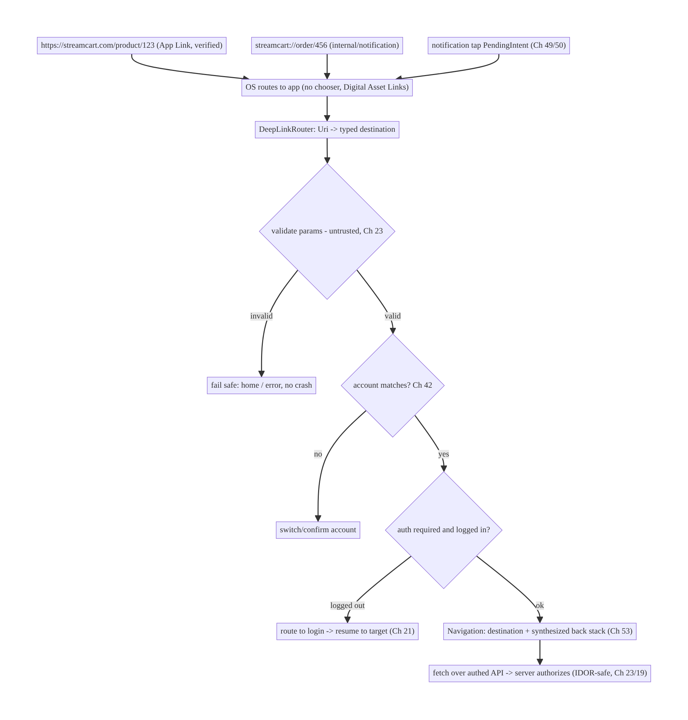
52.4 High-Level Architecture
Components & ownership
- App Links/scheme + intent filters get the URI into the app.
- DeepLinkRouter centrally maps URI → typed destination, validating params.
- Auth gate + account check route through login/switch and resume.
- Navigation (Ch 53) places the destination with a proper back stack.
- Server is the authorization authority (client ids are untrusted).
Direction: URI → OS → central router (validate) → account/auth gates → navigation + server authz.

52.5 Detailed Component Design
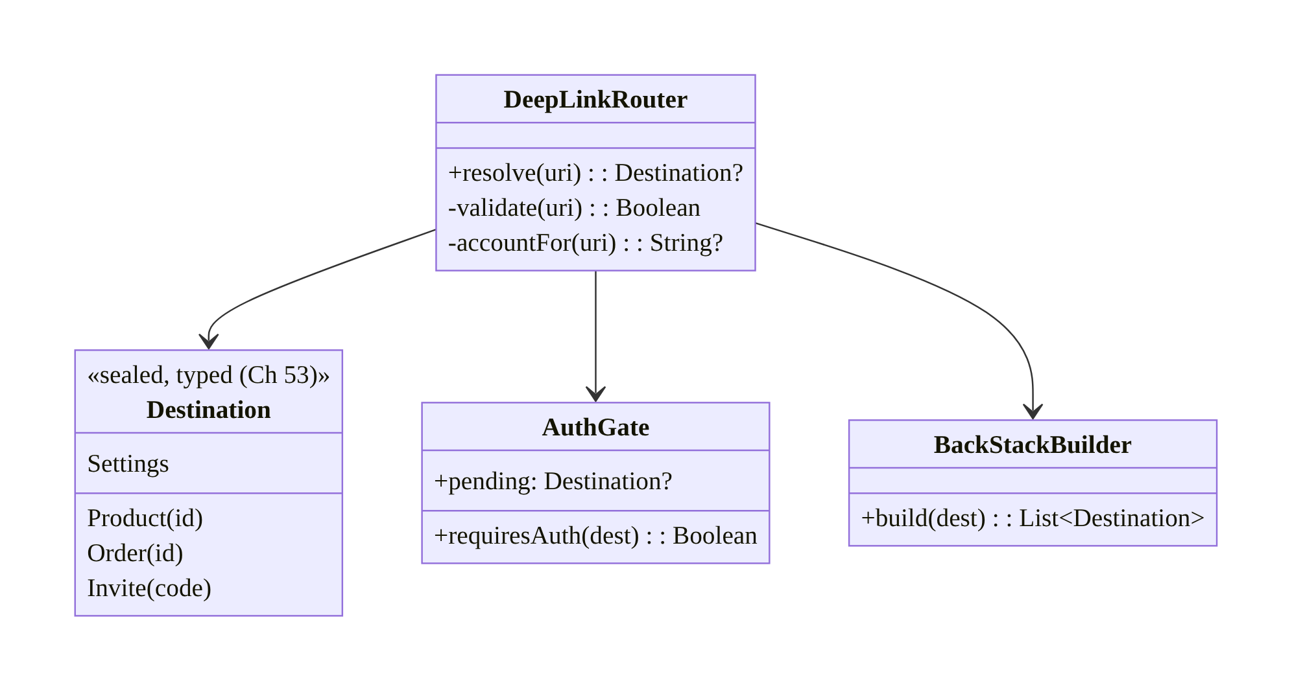
52.5 Detailed Component Design
Component | Responsibility
DeepLinkRouter | parse+validate URI → typed Destination (one place)
Destination | typed, exhaustive destinations (Navigation routes, Ch 53)
AuthGate | which destinations need auth; hold pending link for resume (Ch 21)
BackStackBuilder | synthesize a sensible back stack per destination

52.6 End-to-End Data Flow

Auth-gated deep link (cold start, logged out)
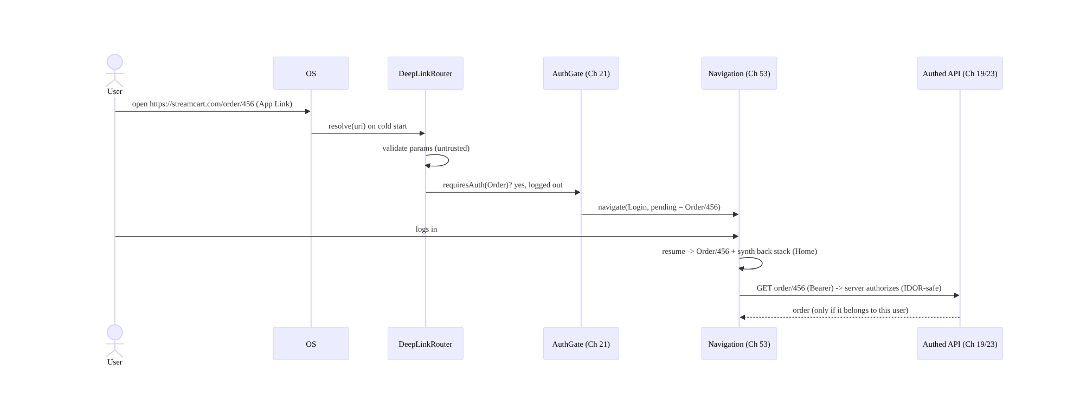
Auth-gated deep link (cold start, logged out)

Routing across launch states
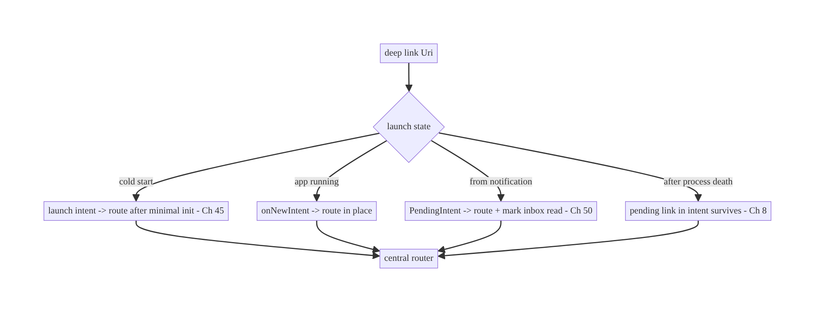
Routing across launch states

52.7 Complete Kotlin Implementation
Package: com.streamcart.deeplink.

52.7.1 Manifest: App Links (verified) + custom scheme
<activity android:name=".MainActivity" android:launchMode="singleTop" android:exported="true">
<!-- Verified App Links (https) -> open directly, no chooser, un-hijackable -->
<intent-filter android:autoVerify="true">
<action android:name="android.intent.action.VIEW" />
<category android:name="android.intent.category.DEFAULT" />
<category android:name="android.intent.category.BROWSABLE" />
<data android:scheme="https" android:host="streamcart.com" />
</intent-filter>
<!-- Custom scheme for internal/notification links -->
<intent-filter>
<action android:name="android.intent.action.VIEW" />
<category android:name="android.intent.category.DEFAULT" />
<category android:name="android.intent.category.BROWSABLE" />
<data android:scheme="streamcart" />
</intent-filter>
</activity>
<!-- Server hosts https://streamcart.com/.well-known/assetlinks.json (Digital Asset Links). -->

52.7.2 Typed destinations + central router (validate as untrusted)
sealed interface Destination { // typed (Navigation routes, Ch 53)
data class Product(val id: String) : Destination
data class Order(val id: String) : Destination
data class Invite(val code: String) : Destination
data object Settings : Destination
}
@Singleton
class DeepLinkRouter @Inject constructor() {
/** Parse + VALIDATE. Returns null for anything unrecognized/malformed -> caller fails safe. */
fun resolve(uri: Uri): Destination? {
val segments = uri.pathSegments
return when {
// /product/{id} -- validate id shape; never trust blindly
segments.size == 2 && segments[0] == "product" && segments[1].isValidId() ->
Destination.Product(segments[1])
segments.size == 2 && segments[0] == "order" && segments[1].isValidId() ->
Destination.Order(segments[1]) // server authorizes ownership (Ch 23)
segments.size == 1 && segments[0] == "invite" ->
uri.getQueryParameter("code")?.takeIf { it.isValidCode() }?.let { Destination.Invite(it) }
segments.firstOrNull() == "settings" -> Destination.Settings
else -> null // unknown -> fail safe, NOT a crash
}
}
// NEVER: open an arbitrary uri.getQueryParameter("url"); never act on a sensitive verb from a link.
private fun String.isValidId() = matches(Regex("^[a-zA-Z0-9_-]{1,64}$"))
private fun String.isValidCode() = matches(Regex("^[A-Z0-9]{4,16}$"))
}

52.7.3 Activity: handle all launch states → central routing
@AndroidEntryPoint
class MainActivity : ComponentActivity() {
@Inject lateinit var router: DeepLinkRouter
override fun onCreate(savedInstanceState: Bundle?) {
super.onCreate(savedInstanceState)
setContent { AppNav(onReady = { nav -> handleIntent(intent, nav) }) } // cold start
}
override fun onNewIntent(intent: Intent) { // app already running (singleTop)
super.onNewIntent(intent); setIntent(intent)
navController?.let { handleIntent(intent, it) }
}
private fun handleIntent(intent: Intent?, nav: NavController) {
val uri = intent?.data ?: intent?.getStringExtra(EXTRA_DEEP_LINK)?.let(Uri::parse) ?: return
val dest = router.resolve(uri) ?: run { nav.navigate(Routes.Home); return } // fail safe
navigateWithAuthAndBackStack(dest, nav) // auth gate + back-stack synthesis
}
}

52.7.4 Auth gating + resume + back-stack synthesis (Navigation, Ch 53)
fun navigateWithAuthAndBackStack(dest: Destination, nav: NavController) {
val account = ActiveAccountHolder.current() // Ch 42
if (dest.targetAccount != null && dest.targetAccount != account?.id) {
nav.navigate(Routes.ConfirmAccountSwitch(dest)); return // don't render cross-account
}
if (dest.requiresAuth && !SessionHolder.isLoggedIn()) { // Ch 21/22
PendingDeepLink.set(dest) // remember to resume
nav.navigate(Routes.Login); return
}
// Synthesize a sensible back stack, then land on the destination:
when (dest) {
is Destination.Product -> nav.navigate(Routes.Product(dest.id)) {
// e.g., ensure Home/Category is beneath so Back is natural
popUpTo(Routes.Home) { saveState = true }; launchSingleTop = true
}
is Destination.Order -> nav.navigate(Routes.Order(dest.id))
is Destination.Invite -> nav.navigate(Routes.Invite(dest.code)) // redeemed server-side (Ch 23)
Destination.Settings -> nav.navigate(Routes.Settings)
}
}
// After successful login, resume:
fun onLoginSuccess(nav: NavController) {
PendingDeepLink.consume()?.let { navigateWithAuthAndBackStack(it, nav) } ?: nav.navigate(Routes.Home)
}

52.7.5 Building a deep-link PendingIntent for notifications (Ch 49/50)
class DeepLinkFactory @Inject constructor(@ApplicationContext private val ctx: Context) {
fun pendingIntent(deepLink: String, inboxId: String): PendingIntent {
val intent = Intent(Intent.ACTION_VIEW, Uri.parse(deepLink), ctx, MainActivity::class.java)
.putExtra(EXTRA_INBOX_ID, inboxId)
return PendingIntent.getActivity(ctx, deepLink.hashCode(), intent,
PendingIntent.FLAG_UPDATE_CURRENT or PendingIntent.FLAG_IMMUTABLE) // immutable (Ch 49)
}
}

52.7.6 Module structure
:core:deeplink DeepLinkRouter, Destination, DeepLinkFactory, AuthGate, back-stack logic
:core:navigation Navigation routes + graph (Ch 53)
# assetlinks.json hosted by backend. Auth -> Ch 21/22; accounts -> Ch 42.

52.8 Concurrency and Race Conditions
Scenario | Risk | Handling
Deep link during cold start before nav ready | lost/crash | route after NavController ready (callback); minimal init (Ch 45)
Multiple rapid links | duplicate/stacked screens | launchSingleTop; dedupe
Pending link lost on process death | link dropped | it’s in the launch intent (survives, Ch 8); persist pending if needed
Login resume vs user navigating away | wrong resume | consume pending once; clear on manual nav
Account switch mid-route | cross-account render | resolve account before navigating (Ch 42)
onNewIntent not handled (not singleTop) | new Activity instance | launchMode="singleTop" + handle onNewIntent
- Route only when Navigation is ready: on cold start the NavController may not exist when the intent arrives; resolve first, then navigate once the graph is set (callback), so the link isn’t dropped or crashes.
- singleTop + onNewIntent: without it, a link while the app runs spawns a new Activity instance; declare singleTop and handle onNewIntent to route in place.
- Consume the pending deep link exactly once after login, and clear it if the user navigates elsewhere, to avoid a surprising late jump.

52.9 Failure Scenarios and Recovery
Failure | Detection | Response | Outcome
App Link opens browser/chooser | QA / reports | fix assetlinks.json + autoVerify; re-verify | opens app directly
Malformed link crash | crash | validate → return null → fail safe (home) | no crash
Gated screen while logged out | empty/blocked | route to login + resume (Ch 21) | lands correctly
Wrong user’s data (IDOR) | security audit | server-side authz; validate params (Ch 23) | blocked
Open-redirect via url= param | security audit | never open arbitrary URLs; allowlist | safe
Link lost on cold start | QA | route after nav ready; pending survives | resolved
Cross-account render | user report | account check before nav (Ch 42) | isolated
Not installed | user | App Link falls back to web | graceful
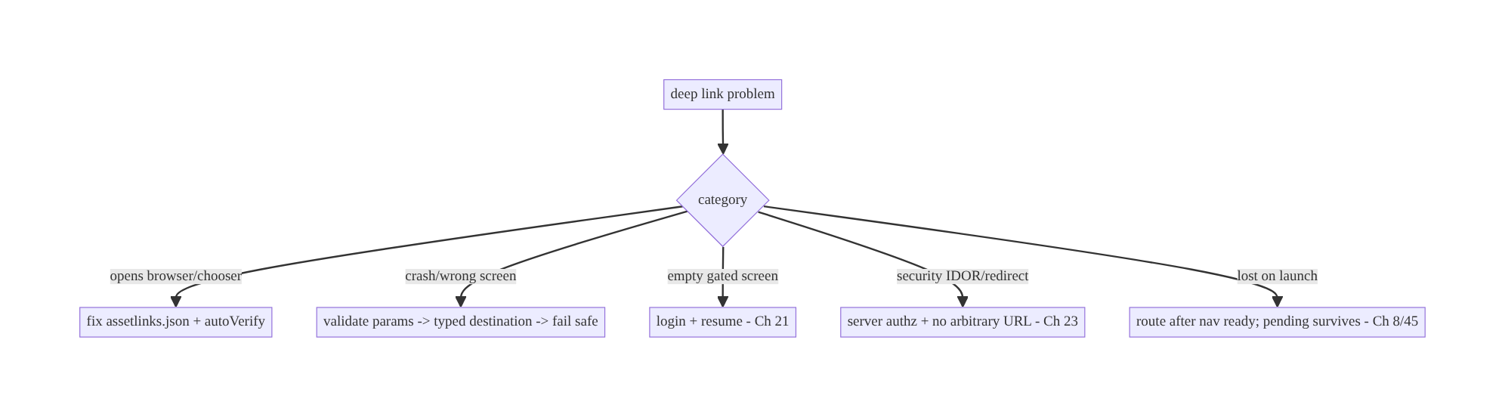
52.9 Failure Scenarios and Recovery
Two axes of deep-link failure: routing (wrong screen, chooser, lost link, bad back stack) and security (unvalidated params, IDOR, open-redirect, sensitive actions from forged links). Centralized routing with typed destinations fixes the first; untrusted-param validation + server-side authz fixes the second.

52.10 Scaling the Implementation
- Level 1. Custom scheme + intent filter; central router → typed destination; fail-safe on unknown.
- Level 2. Verified App Links (assetlinks.json + autoVerify) for web; Navigation deep links + back-stack synthesis (Ch 53).
- Level 3 — production. Auth gating + resume (Ch 21); all launch states (cold/warm/notification/process death); parameter validation + server-side authz (Ch 23); multi-account (Ch 42).
- Level 4 — large. Deferred deep links (install referrer); link analytics (open/attribution); dynamic link catalog; per-destination back-stack rules; settings deep-links (Ch 51).
- Level 5 — enterprise. Centralized link registry/governance (one source of truth for all routes), security review of every linkable action, A/B of link destinations, link-open funnel dashboards, universal/dynamic link provider integration.
Avoid overengineering: most apps need App Links + a scheme + one central router with typed destinations + auth gating. Don’t scatter parsing, and don’t build a dynamic link DSL before you have many links.

52.11 Alternative Approaches and Trade-offs
Dimension | Option A | Option B | When
Public web links | Verified App Links | custom scheme / unverified https | App Links (direct, un-hijackable, web fallback)
Internal/notification | Custom scheme | App Links | Scheme is fine (no web context, no hijack concern)
Routing | Central router → typed destinations | per-Activity Uri parsing | Central (consistency, one place for validation/auth)
Back stack | Synthesized (NavDeepLink) | single screen on top | Synthesized (natural Back)
Auth | Gate + resume to target | drop/show empty | Gate + resume (Ch 21)
Param trust | Validate + server authz | trust client params | Validate + server (security, Ch 23)
Sensitive action | In-app confirm + server authz | act directly from link | Confirm + server (links are forgeable)
App Links vs custom scheme: a custom scheme is trivial but hijackable (any app can claim streamcart://) and won’t launch from a web page, so it’s unsuitable for public web links — use it for internal/notification links only. Android App Links require hosting a Digital Asset Links file and server coordination, but open your app directly from the web with no chooser, can’t be hijacked, and fall back to the web when the app isn’t installed. Use App Links for all public https:// links.
Centralized routing vs per-Activity parsing: parsing Uris in each Activity scatters validation and auth logic, causing inconsistent behavior and security gaps. A single router mapping Uri → typed destination puts validation, auth gating, account checks, and back-stack rules in one audited place and integrates cleanly with Navigation (Ch 53). Centralize.
Trusting link params vs server-side authz: a link carries whatever the sender put in it — treating order/456 or ?userId= as authoritative enables IDOR and data leaks. The client must validate shape and the backend must authorize the action against the authenticated user (Ch 23/19). Never perform a sensitive action (delete, pay) straight from a link without in-app confirmation and server authorization.

52.12 Security Considerations
- All parameters are untrusted input. Validate/allowlist path and query params; reject malformed; fail safe (home/error), never crash or proceed on garbage.
- Server-side authorization (IDOR). The client passing an id (order/456) proves nothing — the backend authorizes against the authed user (Ch 23/19). This is the single most important deep-link security rule.
- No open-redirect / intent injection. Never open an arbitrary url= param or forward a link to startActivity with attacker-controlled components; allowlist domains/targets (Ch 23).
- No sensitive actions straight from a link. delete-account, confirm-payment, change-email must require in-app confirmation + server authz — links can be auto-opened, forged, or embedded maliciously.
- App Links verification (assetlinks.json) prevents hijacking of your https:// links by other apps; custom schemes can’t be verified, so keep them internal.
- exported + singleTop correctly; validate the intent’s data; don’t leak via a PendingIntent that’s mutable (use FLAG_IMMUTABLE, Ch 49).
- Multi-account isolation (Ch 42): resolve the link’s account and confirm/switch; never render account A’s resource under account B.
- Deferred deep links from install referrers are also untrusted — validate before acting.
- Client vs backend: the client validates shape and routes; the backend authorizes and resolves the resource against the session (the authority). Links are an attack surface — treat them like any untrusted external input (Ch 23).

52.13 Performance and Resource Optimization
- Route fast on cold start: keep Application.onCreate light (Ch 45) so a link resolves quickly; show a skeleton while fetching the destination’s data (Ch 45).
- Avoid redundant fetches: the destination loads from SSOT/cache first (Ch 3/12), fetches fresh in background — a link shouldn’t block on the network.
- launchSingleTop prevents duplicate destinations/back-stack bloat.
- Lazy-load feature modules (Ch 96) the link targets if using dynamic features.
- Cheap validation (regex/allowlist) before any navigation or fetch.
- Profiling: link-open latency (tap → rendered), cold-start-from-link time, open→destination funnel.

52.14 Testing Strategy
Deep links test with Navigation testing, adb to fire intents, and App Links verification checks.
# Fire a deep link via adb (test routing without a real web click):
adb shell am start -W -a android.intent.action.VIEW -d "https://streamcart.com/product/123" com.streamcart
adb shell am start -W -a android.intent.action.VIEW -d "streamcart://order/456" com.streamcart
# Verify App Links association (Digital Asset Links):
adb shell pm verify-app-links --re-verify com.streamcart
adb shell pm get-app-links com.streamcart # should show "verified" for streamcart.com
class DeepLinkRouterTest {
private val router = DeepLinkRouter()
@Test fun `resolves product link`() =
assertEquals(Destination.Product("123"), router.resolve(Uri.parse("https://streamcart.com/product/123")))
@Test fun `rejects malformed id - fail safe`() =
assertNull(router.resolve(Uri.parse("https://streamcart.com/product/<script>")))
@Test fun `never resolves arbitrary url param`() =
assertNull(router.resolve(Uri.parse("https://streamcart.com/redirect?url=http://evil.com")))
@Test fun `unknown path returns null`() = assertNull(router.resolve(Uri.parse("https://streamcart.com/???")))
}
@RunWith(AndroidJUnit4::class)
class DeepLinkNavTest {
@Test fun `gated link routes to login then resumes`() { /* logged out -> Login -> login -> Order */ }
@Test fun `product link synthesizes back stack to home`() { /* Back from product -> Home */ }
}
What to test: router resolution + rejection of malformed/arbitrary-URL params (fail safe); back-stack synthesis; auth gate + resume; launch states (adb cold/warm/ notification); App Links verification (pm get-app-links); multi-account switch; server-authz is enforced (integration — wrong user gets 403). Fuzz the router with hostile URIs.

52.15 Production Observability
- Metrics: link open → destination funnel (opened / resolved / rendered); App Links verification status + chooser-shown rate; unknown/malformed-link rate; gated- link resume success; link-open latency; cross-account-switch rate; security rejects (malformed/arbitrary-URL) count.
- Logs: deeplink{scheme, host, path_template, resolved, auth_gated, account_ok} — no raw params/PII (Ch 28).
- Debugging: chooser shown → App Links not verified (assetlinks.json); crashes → unvalidated params; empty gated screen → missing resume; wrong user data → server authz gap (IDOR); lost on launch → routing before nav ready.
- Alerting: App Links verification failure after a deploy (broke assetlinks.json); spike in malformed/arbitrary-URL links (attack); any IDOR indicator.
- Dashboards: open funnel by link source (web/notification/referral); verification health.

52.16 System Design Interview Preparation
≥25 questions.
Fundamentals
- Deep link? A URI that opens a specific screen.
- Custom scheme vs App Link? Hijackable, no web launch vs verified https, direct, un-hijackable, web fallback.
- Digital Asset Links? assetlinks.json proving domain ownership → verified App Links.
- autoVerify? Triggers App Link verification for the intent filter.
- When scheme vs App Link? Scheme for internal/notification; App Links for public web.
Routing
- Why centralize routing? Consistency + one place for validation/auth; avoid scattered parsing.
- Typed destinations? Map Uri → sealed/Navigation route (Ch 53).
- Back stack? Synthesize a sensible one (NavDeepLink), not a lone screen.
- Unknown link? Fail safe (home/error), never crash.
Auth/accounts
- Gated destination, logged out? Route to login, resume to target (Ch 21).
- Carry the pending link? Yes — consume once after login.
- Multi-account link? Resolve account; switch/confirm (Ch 42).
Launch states
- Cold start? Launch intent → route after minimal init (Ch 45).
- App running? singleTop + onNewIntent.
- From notification? PendingIntent carries the link; mark inbox read (Ch 50).
- Process death? Link in the intent survives (Ch 8).
Security
- Params trust? Untrusted — validate/allowlist; fail safe.
- IDOR? Authorize server-side against the authed user (Ch 23) — client id proves nothing.
- Open-redirect? Never open arbitrary url=; allowlist.
- Sensitive action from a link? In-app confirm + server authz; never direct.
- Hijacking? App Links verification prevents it; schemes can’t be verified.
Testing/Production
- Test links? adb am start -d; pm get-app-links; router unit tests.
- Chooser shown? App Links not verified.
- Verify App Links? pm verify-app-links / Play Console.
- Lost link on launch? Routed before nav ready.
- Key metric? Open→destination funnel + verification health.

Design-change challenges
- Marketing URLs should open the app directly. Verified App Links + assetlinks.json + autoVerify.
- A link to “My Orders” opened logged out. Auth gate → login → resume (Ch 21).
- Security review flags ?url= redirects. Never open arbitrary URLs; allowlist; server authz.
- Deep link crashes on malformed input. Validate → typed destination → fail safe.
- Links show the wrong account’s data after switching. Account check before nav (Ch 42).

Mock walkthrough (abridged)
Clarify (web or internal links, auth-gated, multi-account, which destinations?) → App Links (verified) + scheme → central router → typed destinations + validation (untrusted) → back-stack synthesis (Ch 53) → auth gate + resume (Ch 21) → launch states (cold/warm/ notification/death) → security (server authz, no arbitrary URL, no direct sensitive action, Ch 23) → multi-account (Ch 42) → testing (adb, pm get-app-links) → observability (open funnel, verification).

52.17 Practical Exercises
- Beginner. Add a central DeepLinkRouter that resolves product/{id} to a typed destination and fails safe on unknown links. Eval: correct destination; no crash on garbage.
- Intermediate. Set up verified App Links (assetlinks.json + autoVerify) so a web URL opens the app directly; synthesize a back stack to Home. Eval: no chooser; Back goes Home.
- Advanced. Gate an order link through login and resume to it; handle cold-start, running, and notification launches. Eval: resumes after login; works in all states.
- Production debugging / security. Fix an open-redirect (?url=) and an IDOR (trust of order/{id} client-side). Eval: arbitrary URLs rejected; server authorizes ownership.
- System design challenge. Build a link registry + open-funnel dashboard + App Links verification monitoring; add multi-account confirmation. Eval: centralized routes; observable; account-isolated.
(Solutions withheld unless requested.)

52.18 Chapter Summary & Reference Sheet
Key decisions: use verified Android App Links (assetlinks.json + autoVerify) for public https:// URLs — they open the app directly, with no chooser, can’t be hijacked, and fall back to the web — and a custom scheme only for internal/notification links; route every URI through one central DeepLinkRouter to a typed destination (Navigation, Ch 53) that validates all parameters as untrusted (allowlist, fail safe on unknown — never crash), synthesizes a sensible back stack, gates auth (route to login and resume to the target, Ch 21), handles all launch states (cold/warm/onNewIntent/notification/process death), and respects multi-account (switch/confirm, Ch 42); and enforce security: authorize server-side (IDOR — the client id proves nothing, Ch 23/19), never open arbitrary url= params (open-redirect/injection), and never perform sensitive actions straight from a link (in-app confirm + server authz).
Concepts: custom scheme vs App Links, Digital Asset Links/autoVerify, intent filters, central routing → typed destinations, back-stack synthesis, auth gating + resume, launch-state handling, untrusted parameters, server-side authorization, multi-account, deferred deep links.
Common mistakes: custom scheme for public web links (hijack/chooser); scattered per-Activity parsing; no back-stack synthesis; dropping/empty gated links; trusting link params (IDOR); opening arbitrary url= (open-redirect); sensitive actions straight from a link; not handling onNewIntent/cold start; cross-account rendering; crashing on malformed input.
Checklist:
- ☐ verified App Links for web + scheme for internal
- ☐ assetlinks.json + autoVerify
- ☐ central router → typed destinations
- ☐ validate params (allowlist, fail safe)
- ☐ synthesize back stack
- ☐ auth gate + resume (Ch 21)
- ☐ handle cold/warm/notification/process-death
- ☐ server-side authz (IDOR, Ch 23)
- ☐ no arbitrary URL / no direct sensitive action
- ☐ multi-account switch/confirm (Ch 42)
- ☐ FLAG_IMMUTABLE PendingIntents
- ☐ open-funnel + verification telemetry.
Key APIs: <intent-filter> VIEW/BROWSABLE/DEFAULT + <data> + android:autoVerify, /.well-known/assetlinks.json, Activity.onNewIntent + launchMode="singleTop", Intent.data/Uri.pathSegments/getQueryParameter, Navigation navDeepLink/NavDeepLinkBuilder (Ch 53), PendingIntent.getActivity (FLAG_IMMUTABLE), Settings.ACTION_APPLICATION_DETAILS_SETTINGS (Ch 51), adb am start -d / pm get-app-links.
References:
- Deep links & App Links: https://developer.android.com/training/app-links
- Verify Android App Links: https://developer.android.com/training/app-links/verify-android-applinks
- Navigation deep links: https://developer.android.com/guide/navigation/navigation-deep-link
- App Links security: https://developer.android.com/privacy-and-security/risks/unsafe-use-of-deeplinks
- (composes) Ch 53 Navigation, Ch 49/50 Push/Notifications, Ch 21 Auth, Ch 42 Multi-Account, Ch 23 Security, Ch 8 Process Death

Chapter 53 — Navigation Architecture (Multi-Module)
Part VI — Lifecycle, Background & Platform · Complexity: Standard (≥25 interview questions)
Prerequisites: Ch 52 (deep links), Ch 6 (UI state), Ch 5 (Hilt/modules), Ch 8 (process death), Ch 44 (lifecycle), Ch 42 (multi-account). Pairs with Ch 96 (dynamic features), Ch 40 (shared ViewModel scoping).
Reference surface in StreamCart: how the app moves between screens — feed, product, cart, checkout, orders, profile — across many feature modules, with type-safe routes, a correct back stack, deep-link integration (Ch 52), and no feature module depending on another.

53.1 Problem Definition and Real-World Context
Navigation is how users move through the app, and in a multi-module codebase it’s also an architecture boundary problem: feature modules must navigate to each other without depending on each other, or the module graph collapses into a tangled monolith. A navigation design that works for a 3-screen sample breaks badly at scale:
- Module coupling. If :feature:cart calls CheckoutActivity directly, it must depend on :feature:checkout — and soon every feature depends on every other, killing build times, reuse, and team autonomy. Features must navigate via an abstraction, not concrete screens.
- Back-stack correctness. Deep links (Ch 52), bottom-nav tab switching, nested graphs, “up vs back,” and conditional flows (login, onboarding) all shape the back stack. Getting it wrong strands users or exits the app unexpectedly.
- Type safety. String-route navigation (navigate("product/$id")) is error-prone — typos, missing/mis-typed args, no compile-time checks. Modern Navigation offers type-safe routes (Kotlin Serialization) that catch these at compile time.
- State & lifecycle across navigation. ViewModels scoped to the right nav entry (Ch 40), arguments surviving process death (Ch 8), and not leaking state between screens.
- Deep-link integration. Links (Ch 52) must map to the same destinations/graph as in-app navigation — one routing model, not two.
- Single-Activity vs multi-Activity, Compose vs Fragments. Choosing the navigation host and how it interacts with lifecycle (Ch 44) and config changes.
- Conditional/nested flows. Auth gates (Ch 21), onboarding, nested feature graphs, and bottom-nav with per-tab back stacks.
The architecture: adopt a single-Activity + Navigation model (Compose Navigation or Jetpack Navigation) with a nav graph composed of per-feature sub-graphs; keep feature modules decoupled via a navigation abstraction (a :core:navigation contract of routes/APIs that features depend on, while an :app-level graph wires them together — the api/impl or navigator interface pattern); use type-safe routes (Kotlin Serialization); synthesize and manage the back stack correctly (deep links, tabs, conditional flows); scope ViewModels to nav entries (Ch 40) and survive process death (Ch 8); and unify deep links (Ch 52) with in-app routes. This chapter is about scalable, decoupled, type-safe navigation across many modules.

Three practical use cases
- StreamCart cross-feature nav. :feature:cart navigates to checkout without depending on :feature:checkout — via a route/contract in :core:navigation, wired in :app.
- Bottom-nav with per-tab back stacks. Feed / Search / Cart / Profile tabs each keep their own back stack; switching tabs preserves state.
- Deep-link + auth flow. A product deep link (Ch 52) lands on the product screen with Home beneath; an orders link routes through login and resumes (Ch 21), using the same graph.

Why this is architectural
Navigation defines module boundaries (decoupling), the back-stack model (correctness/UX), type safety, state scoping (Ch 40), process-death survival (Ch 8), and the single routing model shared with deep links (Ch 52). These choices determine build scalability, team autonomy, and navigation correctness across the whole app.

53.2 Requirements Engineering

Functional requirements
ID | Requirement
F1 | Navigate between screens/features with a correct back stack.
F2 | Keep feature modules decoupled (no feature→feature dependency).
F3 | Type-safe routes with arguments; survive process death.
F4 | Integrate deep links (Ch 52) with the same destination graph.
F5 | Support nested graphs, bottom-nav per-tab back stacks, conditional flows (auth).
F6 | Scope ViewModels/state to the right nav entry (Ch 40).

Non-functional requirements
Attribute | Policy
Modularity | Features depend on a navigation contract, not each other.
Correctness | Back stack / up-vs-back / tabs behave predictably.
Type safety | Compile-time-checked routes + args.
Resilience | Args + back stack survive config change + process death (Ch 8).
Build scalability | Decoupling keeps module graph flat; fast builds.
Consistency | One routing model shared with deep links (Ch 52).

Scope
- In scope: single-Activity + Navigation (Compose/Jetpack), nav graph + per-feature sub-graphs, module-decoupling patterns (navigation contract / api-impl / navigator interface), type-safe routes (Serialization), back-stack management (deep links, tabs, conditional flows), nested graphs, bottom-nav per-tab back stacks, nav-entry ViewModel scoping (Ch 40), process-death survival (Ch 8), deep-link integration (Ch 52), up vs back.
- Out of scope: deep-link routing/security (Ch 52), UI state (Ch 6), ViewModel scoping detail (Ch 40), DI (Ch 5), dynamic feature modules (Ch 96), process-death mechanics (Ch 8).

Assumptions & constraints
- Jetpack Navigation (Compose Navigation or Navigation component), Kotlin Serialization type-safe routes, Hilt, multi-module Gradle, single-Activity. minSdk 24. Feature modules must not depend on each other; :app owns the top-level graph wiring.

53.3 System Design Fundamentals
- Single-Activity + Navigation (the modern default). One Activity hosts a NavHost; screens are destinations (composables or fragments) in a nav graph. This centralizes the back stack, lifecycle (Ch 44), and deep-link handling (Ch 52), and avoids the complexity/Intent coupling of many Activities. Multi-Activity is reserved for special isolation (e.g., a separate task).
- Nav graph composed of per-feature sub-graphs. The top-level graph (in :app) includes a nested sub-graph per feature (feedGraph, cartGraph, checkoutGraph). Each feature module contributes its own sub-graph (an extension function registering its destinations), and :app assembles them — so features are self-contained and :app is the only place that knows about all of them.
- Module decoupling (the crux). Three common patterns:
  - Navigation contract in :core:navigation: define routes (type-safe route classes) and/or a Navigator/feature-API interface in a shared low-level module that all features depend on. :feature:cart navigates to a route (CheckoutRoute(cartId)) it knows from :core:navigation, not to :feature:checkout. :app (or an :impl module) provides the destination.
  - api/impl split: :feature:checkout:api exposes a navigation entry (route/interface); :feature:checkout:impl implements the screens. Others depend only on :api.
  - Navigator interface (DI-provided): a Navigator abstraction injected (Ch 5); features call navigator.navigateToCheckout(cartId); the implementation (in :app) performs the real navigation. The invariant: no feature module depends on another feature module’s implementation.
- Type-safe routes. Modern Navigation supports Kotlin Serialization-based routes: define @Serializable data class ProductRoute(val id: String) and navigate with the object — compile-time-checked destinations and arguments, no string typos, no manual arg bundling. Arguments are serialized into the back stack (survive process death, Ch 8).
- Back-stack management:
  - popUpTo / launchSingleTop / inclusive control what the back stack looks like after navigation (e.g., after login, pop the login off; after a tab switch, don’t stack duplicates).
  - Deep links (Ch 52) synthesize a back stack via the graph (navDeepLink / start-destination hierarchy) so Back is natural.
  - Bottom-nav per-tab back stacks: each tab maintains its own back stack (saveState/restoreState when switching), so leaving and returning to a tab preserves where you were.
  - Up vs Back: Up navigates within the app’s hierarchy (parent screen); Back pops the temporal back stack — handle both (navigateUp() vs system back).
- Conditional/nested flows. Auth gates (Ch 21), onboarding, and feature flows are nested graphs or conditional start destinations; route through them and popUpTo to clean up (e.g., remove onboarding/login from the stack after completion).
- State scoping (Ch 40). ViewModels can be scoped to a nav entry or a nav graph (hiltViewModel() with the nav back-stack entry / graph scope) so a shared flow (e.g., checkout steps) shares a ViewModel across its sub-graph, while per-screen state is per-destination. This is how you share state across a multi-step flow without a global singleton (Ch 39/40).
- Process death (Ch 8). The nav back stack + serialized route args are restored by the system; SavedStateHandle (Ch 6/8) in nav-entry ViewModels restores screen state. Type-safe routes make args restoration automatic.
- Deep-link unification (Ch 52). Deep links map to the same destinations/graph as in-app navigation (navDeepLink), so there’s one routing model — no parallel deep-link navigation stack.
Core insight: use a single-Activity NavHost with a nav graph composed of per-feature sub-graphs, and keep feature modules decoupled by navigating through a shared navigation contract (routes/Navigator interface in :core:navigation, assembled in :app) so no feature depends on another; use type-safe (Serialization) routes whose arguments survive process death; manage the back stack deliberately (popUpTo/singleTop, per-tab stacks, synthesized deep-link stacks, up-vs-back); scope ViewModels to nav entries/graphs for multi-step flows (Ch 40); and unify deep links (Ch 52) onto the same graph as one routing model.

53.4 High-Level Architecture
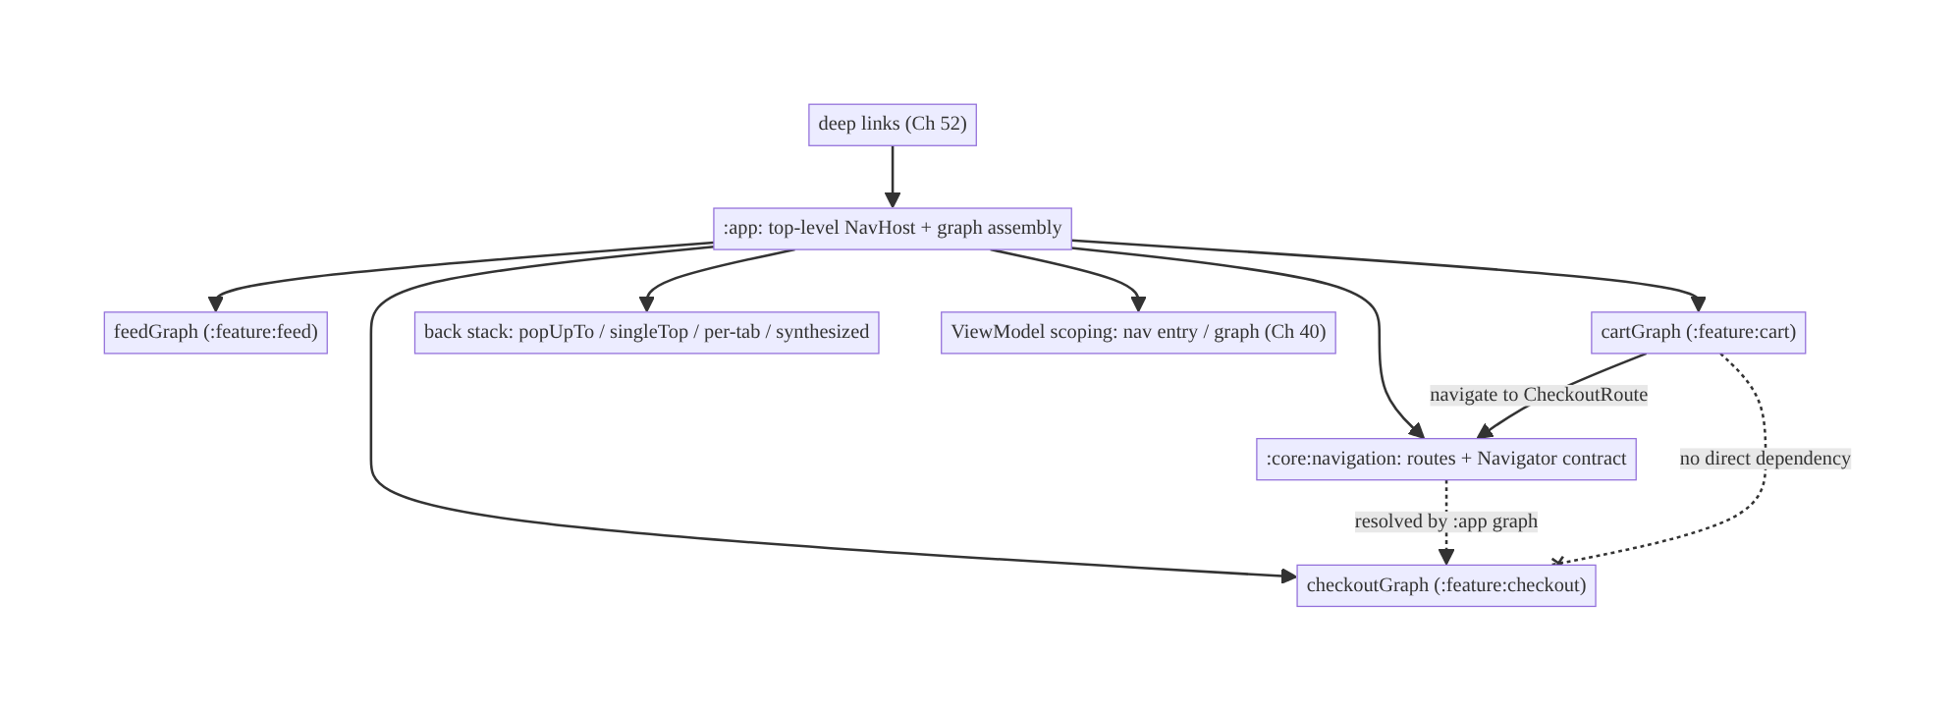
53.4 High-Level Architecture
Components & ownership
- :core:navigation owns the contract (routes/Navigator) every feature depends on.
- Feature modules contribute sub-graphs and navigate via the contract — never to each other.
- :app assembles the full graph (the only place that knows all features) and hosts the single NavHost.
- Deep links (Ch 52) and state scoping (Ch 40) attach to the same graph.
Direction: features → contract (routes) → :app assembles graph → single NavHost; back stack + scoping + deep links on one model.

53.5 Detailed Component Design
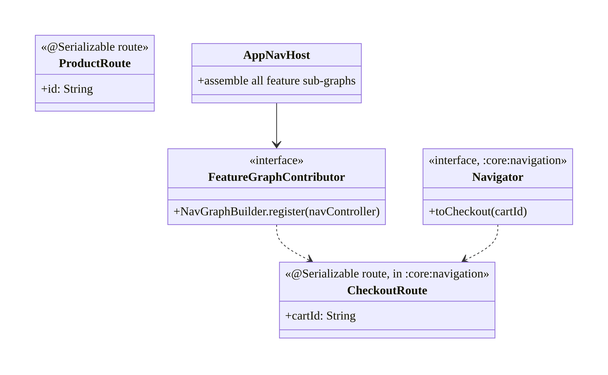
53.5 Detailed Component Design
Component | Module | Responsibility
Route types (ProductRoute, CheckoutRoute) | :core:navigation | type-safe destinations shared across features
Navigator interface | :core:navigation | abstraction features call (optional alt to routes)
Feature sub-graph | :feature:* | registers its own destinations
AppNavHost | :app | assembles all sub-graphs; single host

53.6 End-to-End Data Flow

Decoupled cross-feature navigation
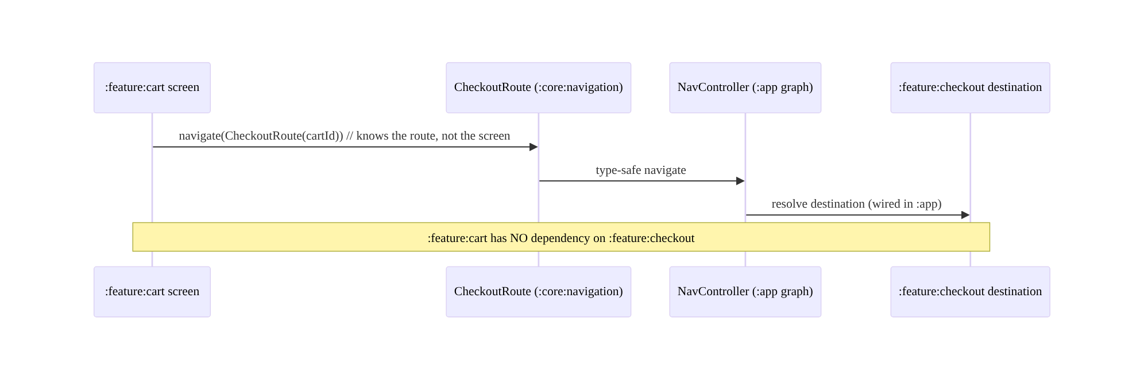
Decoupled cross-feature navigation

Login gate + resume with back-stack cleanup
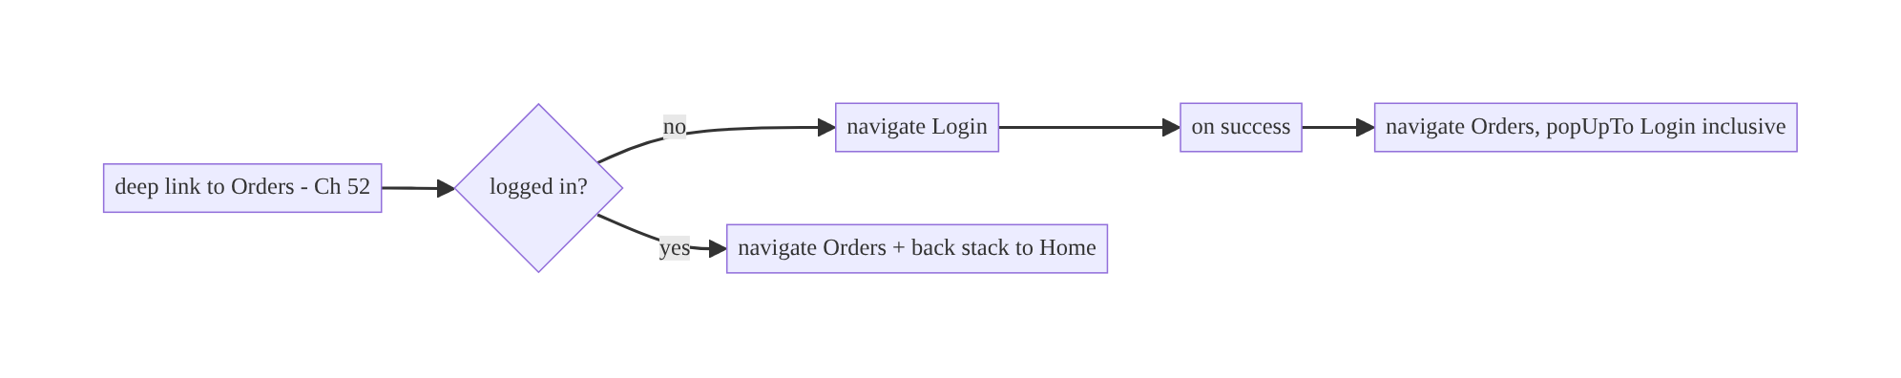
Login gate + resume with back-stack cleanup

53.7 Complete Kotlin Implementation
Package: com.streamcart.navigation (contract) + per-feature.

53.7.1 :core:navigation — type-safe routes + Navigator contract
// Shared routes every feature can navigate to WITHOUT depending on the target feature module.
@Serializable data class ProductRoute(val id: String)
@Serializable data class CheckoutRoute(val cartId: String)
@Serializable data object HomeRoute
@Serializable data object LoginRoute
// Optional alternative/complement: a Navigator abstraction (DI-provided, Ch 5).
interface Navigator {
fun toProduct(id: String)
fun toCheckout(cartId: String)
fun up(): Boolean
}

53.7.2 Feature module contributes its own sub-graph (no cross-feature dep)
// :feature:checkout — registers its destinations; knows its OWN route from :core:navigation.
fun NavGraphBuilder.checkoutGraph(navController: NavController) {
composable<CheckoutRoute> { entry ->
val route = entry.toRoute<CheckoutRoute>() // type-safe args (survive process death)
CheckoutScreen(cartId = route.cartId, onDone = { navController.navigate(HomeRoute) { popUpTo(HomeRoute) } })
}
}
// :feature:cart — navigates to CheckoutRoute, NOT to :feature:checkout.
@Composable
fun CartScreen(navController: NavController) {
Button(onClick = { navController.navigate(CheckoutRoute(cartId = "cart-1")) }) { Text("Checkout") }
// :feature:cart depends only on :core:navigation (for CheckoutRoute), never :feature:checkout.
}

53.7.3 :app — single NavHost assembling all sub-graphs
@Composable
fun AppNavHost(navController: NavHostController = rememberNavController()) {
NavHost(navController, startDestination = HomeRoute) {
// :app is the ONLY module that depends on all features and wires them together.
feedGraph(navController)
cartGraph(navController)
checkoutGraph(navController) // from :feature:checkout
composable<LoginRoute> { LoginScreen(onSuccess = { resumePendingOrHome(navController) }) }
composable<ProductRoute> { entry -> ProductScreen(entry.toRoute<ProductRoute>().id) }
// Deep links (Ch 52) attach to these same destinations via navDeepLink -> ONE routing model.
}
}

53.7.4 Back-stack control (login resume, tabs)
// After login, resume to the pending destination and remove Login from the stack:
fun resumePendingOrHome(nav: NavController) {
val pending = PendingDeepLink.consume() // Ch 52
if (pending != null) nav.navigate(pending) { popUpTo(LoginRoute) { inclusive = true } }
else nav.navigate(HomeRoute) { popUpTo(LoginRoute) { inclusive = true } }
}
// Bottom-nav: per-tab back stacks (save/restore so each tab keeps its place):
fun NavController.switchTab(tab: Any) = navigate(tab) {
popUpTo(graph.findStartDestination().id) { saveState = true }
launchSingleTop = true
restoreState = true
}

53.7.5 Nav-entry / graph-scoped ViewModel for a multi-step flow (Ch 40)
// Share a ViewModel across the checkout sub-graph (steps share state) without a global singleton.
@Composable
fun CheckoutStepScreen(navController: NavController) {
val parentEntry = remember(navController) { navController.getBackStackEntry<CheckoutRoute>() }
val sharedVm: CheckoutViewModel = hiltViewModel(parentEntry) // scoped to the checkout nav entry (Ch 40)
// ... step UI reads/writes sharedVm; SavedStateHandle survives process death (Ch 6/8) ...
}

53.7.6 Module structure
:core:navigation routes (@Serializable), Navigator interface, NavGraphBuilder extension signatures
:feature:feed feedGraph(...) + screens (depends on :core:navigation only)
:feature:cart cartGraph(...) + screens (depends on :core:navigation only)
:feature:checkout checkoutGraph(...) + screens
:app AppNavHost assembling all sub-graphs (depends on all features + :core:navigation)
# Invariant: no :feature:X depends on :feature:Y. Deep links (Ch 52) map to these routes.

53.8 Concurrency and Race Conditions
Scenario | Risk | Handling
Double navigation (rapid taps) | duplicate destinations | launchSingleTop; debounce clicks
Navigate before NavHost ready | crash/no-op | navigate from composition/after host set (Ch 52)
Process death mid-flow | lost args/state | type-safe routes serialize args; SavedStateHandle (Ch 8)
Config change | state loss | nav-entry ViewModel survives (Ch 40/6)
Tab switch loses state | poor UX | per-tab saveState/restoreState
Shared flow VM leaks after flow | memory | scope to nav graph entry (cleared when popped)
- Type-safe routes serialize arguments into the back stack, so process death (Ch 8) restores both the destination and its args automatically — a major reliability win over manual bundles.
- Nav-entry scoping bounds shared-flow ViewModels: a CheckoutViewModel scoped to the checkout entry is cleared when that sub-graph is popped (Ch 40), avoiding leaks and stale state across unrelated flows.
- launchSingleTop + nav-ready checks prevent duplicate destinations from rapid taps or navigating before the host exists.

53.9 Failure Scenarios and Recovery
Failure | Detection | Response | Outcome
Feature→feature coupling | module graph / build time | navigate via contract/routes in :core:navigation | decoupled
Back exits app unexpectedly | user report | synthesize back stack; correct popUpTo | natural Back
Args lost on process death | crash/empty screen | type-safe routes + SavedStateHandle (Ch 8) | restored
Tab loses state on switch | user report | per-tab save/restore | preserved
Duplicate screens | user report | launchSingleTop | single
Deep link uses a separate stack | inconsistency | unify on the same graph (Ch 52) | one model
Shared-flow state bleeds across flows | bug | nav-entry/graph scoping (Ch 40) | isolated
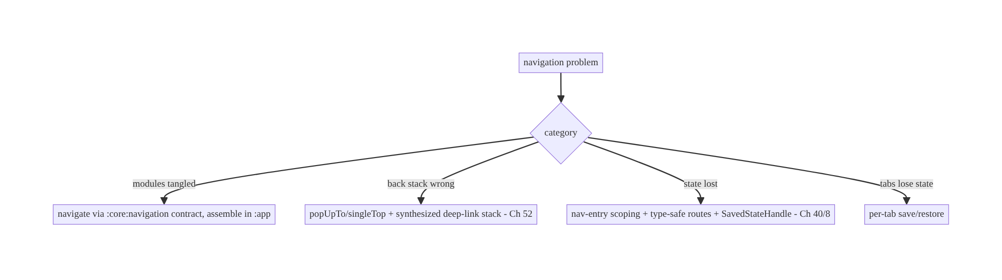
53.9 Failure Scenarios and Recovery
The defining multi-module navigation failure is coupling: the moment a feature navigates to another feature’s screen instead of a shared route/contract, the module graph tangles and builds slow down. Keep features depending only on :core:navigation, assemble in :app, and the rest (back stack, scoping, deep links) is standard Navigation.

53.10 Scaling the Implementation
- Level 1. Single-Activity + Compose NavHost; type-safe routes; basic back stack.
- Level 2. Per-feature sub-graphs; module decoupling via :core:navigation routes/Navigator; deep-link integration (Ch 52).
- Level 3 — production. Back-stack discipline (login resume, per-tab stacks); nav-entry/graph ViewModel scoping (Ch 40); process-death survival (Ch 8); up-vs-back.
- Level 4 — large. api/impl feature splits; nested conditional flows (onboarding/ auth); many teams owning sub-graphs independently; shared navigation contract governance.
- Level 5 — enterprise. Dynamic feature modules (Ch 96) with on-demand graphs; navigation analytics (screen funnels); centralized route registry; cross-app (universal) navigation; module-boundary enforcement in CI (no feature→feature deps).
Avoid overengineering: for a small app, a single graph with type-safe routes is enough. Introduce sub-graphs + the navigation contract when you have multiple feature modules; add api/impl splits only when build/ownership pressure demands.

53.11 Alternative Approaches and Trade-offs
Dimension | Option A | Option B | When
Host | Single-Activity + NavHost | multi-Activity | Single-Activity default; multi for isolation/separate task
UI toolkit | Compose Navigation | Fragment Navigation | Compose for new apps; Fragments for existing/interop
Routes | Type-safe (Serialization) | string routes | Type-safe (compile-checked, arg safety)
Decoupling | Routes in :core:navigation | Navigator interface (DI) | Routes simplest; Navigator for complex/testable nav; both valid
Feature exposure | api/impl split | single module | api/impl at scale (ownership/build); single when small
Shared flow state | Nav-graph-scoped ViewModel | global singleton | Graph-scoped (bounded lifetime, Ch 40); singleton leaks/over-shares
Deep links | Unified on nav graph | separate deep-link routing | Unified (one model, Ch 52)
Routes-in-core vs Navigator interface for decoupling: both avoid feature→feature dependencies. Shared route types in :core:navigation are the simplest — a feature navigates to CheckoutRoute(cartId) it imports from core, and :app wires the destination; type-safe and minimal. A Navigator interface (DI-provided) adds indirection but is more testable (mock the navigator) and better when navigation has logic/side effects or when features shouldn’t even know route shapes. Many apps use both: routes for simple cases, a Navigator for complex flows. Either way, the invariant holds — no feature depends on another feature’s implementation.
Single-Activity vs multi-Activity: single-Activity + Navigation centralizes the back stack, lifecycle (Ch 44), deep links (Ch 52), and transitions, and is the modern default. Multi-Activity scatters navigation across Intents, complicates the back stack and deep links, and couples modules via concrete Activity classes — reserve it for genuine isolation needs (a separate task, a third-party flow). Prefer single-Activity.
Type-safe vs string routes: string routes ("product/$id") are quick but fragile — typos compile fine and crash at runtime, args are manually bundled/parsed, and refactors miss call sites. Type-safe routes (Serialization) give compile-time destination and argument checking, automatic arg serialization (process-death-safe, Ch 8), and refactor-safety. Use type-safe routes.

53.12 Security Considerations
- Deep-link destinations are an attack surface (Ch 52): navigation makes any navDeepLink-exposed destination reachable from outside — validate args and authorize server-side (IDOR, Ch 23); don’t expose sensitive destinations to arbitrary external links without auth gating.
- Auth gating in the graph (Ch 21): gate protected destinations (conditional start / nested auth graph) so a route can’t bypass login; popUpTo to prevent Back into a gated screen after logout.
- Multi-account isolation (Ch 42): route resolution must respect the active account; don’t navigate to a destination rendering another account’s data.
- Don’t leak sensitive args in logs/analytics (Ch 28) — log route templates, not argument values (which may contain ids/PII).
- Back-stack after logout: on logout, clear the back stack (popUpTo(start) { inclusive }) so protected screens aren’t reachable via Back (Ch 22).
- Client vs backend: navigation is client routing; the backend remains the authority for what data a destination may show (authz, Ch 23/19) — reaching a screen is not authorization.

53.13 Performance and Resource Optimization
- Build performance is the main win of decoupling: a flat module graph (features → core, not features → features) parallelizes builds and limits rebuild scope.
- Lazy destination content: destinations load state from SSOT/cache first (Ch 3/12), fetch fresh in background — navigation itself is cheap; the screen’s data load is where cost is.
- launchSingleTop avoids back-stack bloat/duplicate ViewModels.
- Scope ViewModels correctly (Ch 40) so they’re created/cleared with their nav entry, not leaked across the whole app.
- Dynamic feature modules (Ch 96) defer loading rarely-used features’ code.
- Profiling: navigation latency (tap → rendered), back-stack depth, ViewModel create/clear counts, module build times (decoupling health).

53.14 Testing Strategy
Navigation tests with TestNavHostController / Compose navigation testing; module decoupling enforced by build checks.
@RunWith(AndroidJUnit4::class)
class AppNavTest {
@Test fun `cart navigates to checkout route`() {
composeRule.setContent {
navController = TestNavHostController(LocalContext.current).apply {
navigatorProvider.addNavigator(ComposeNavigator())
}
AppNavHost(navController)
}
composeRule.onNodeWithText("Checkout").performClick()
assertEquals("CheckoutRoute", navController.currentBackStackEntry?.destination?.route?.substringBefore("/"))
}
@Test fun `login resume pops login off back stack`() { /* gated nav -> login -> success -> target, no Login */ }
@Test fun `type-safe args survive recreation`() { /* recreate -> route args intact (Ch 8) */ }
}
// Module boundary enforcement (Gradle/CI): assert :feature:cart has NO dependency on :feature:checkout.
// e.g., a dependency-analysis / custom Gradle check that fails the build on feature->feature deps.
What to test: cross-feature nav via routes (no direct dep), back-stack outcomes (popUpTo/singleTop, login resume, per-tab save/restore), type-safe arg survival across recreation (Ch 8), nav-entry ViewModel scoping (shared across sub-graph, cleared on pop, Ch 40), deep-link → same destination (Ch 52), and a CI check enforcing no feature→ feature dependencies (the architectural invariant).

53.15 Production Observability
- Metrics: screen-view funnel (navigation analytics), navigation latency (tap → rendered), back-stack depth distribution, crash rate on navigation (missing destination/args), deep-link vs in-app nav consistency (Ch 52), module build times (decoupling health).
- Logs: nav{route_template, source(in_app/deep_link), auth_gated} — route templates only, no arg values/PII (Ch 28).
- Debugging: feature→feature coupling → slow/ cyclic builds (fix via contract); unexpected Back/exit → back-stack/popUpTo bug; lost args after death → non-type-safe routes / missing SavedState (Ch 8); tab state loss → missing save/restore; duplicate screens → no singleTop.
- Alerting: navigation crash spike after a release; a new feature→feature dependency introduced (CI boundary check).
- Dashboards: screen funnels; navigation crash rate; module dependency graph health.

53.16 System Design Interview Preparation
≥25 questions.
Fundamentals
- Single-Activity + Navigation? One Activity hosts a NavHost; screens are destinations in a graph — centralizes back stack/lifecycle/deep links.
- Why single-Activity? Simpler back stack, deep links (Ch 52), transitions vs Intent-coupled multi-Activity.
- Nav graph structure? Top-level graph composed of per-feature sub-graphs.
- Who assembles the graph? :app (only module that knows all features).
- Type-safe routes? Serialization-based routes — compile-checked destinations/args.
Module decoupling (the crux)
- Core problem in multi-module nav? Feature→feature coupling.
- How decouple? Navigate via a contract (routes/Navigator) in :core:navigation; assemble in :app.
- Routes-in-core vs Navigator interface? Simplest shared types vs DI’d testable abstraction; both avoid coupling.
- api/impl split? :feature:x:api exposes nav entry; others depend only on api.
- The invariant? No feature depends on another feature’s implementation.
- Who knows all features? Only :app.
Back stack
- popUpTo/launchSingleTop/inclusive? Shape the stack (e.g., pop login after success; avoid duplicates).
- Deep-link back stack? Synthesized via graph (Ch 52).
- Per-tab back stacks? Each tab saves/restores its own stack.
- Up vs Back? Hierarchical parent vs temporal pop.
- After logout? Clear back stack (popUpTo start inclusive, Ch 22).
State/lifecycle
- Share state across a multi-step flow? Nav-graph/entry-scoped ViewModel (Ch 40).
- Process death? Type-safe routes serialize args; SavedStateHandle (Ch 8).
- Config change? Nav-entry ViewModel survives (Ch 6).
Deep links
- Integrate deep links? Same destinations/graph (navDeepLink) — one routing model (Ch 52).
Security
- Destination as attack surface? Validate args + server authz (Ch 23); gate auth.
- Logging args? Templates only, no PII (Ch 28).
Testing/Production
- Test navigation? TestNavHostController / Compose nav testing.
- Enforce decoupling? CI check: no feature→feature deps.
- Unexpected Back/exit? Back-stack/popUpTo bug.
- Lost args after death? Non-type-safe routes / missing SavedState.

Design-change challenges
- :feature:cart must open checkout without depending on :feature:checkout. Navigate to CheckoutRoute in :core:navigation; assemble in :app.
- Bottom-nav tabs lose state on switch. Per-tab saveState/restoreState.
- A deep link uses a separate navigation path. Unify on the nav graph (navDeepLink, Ch 52).
- Checkout steps need shared state without a singleton. Nav-graph-scoped ViewModel (Ch 40).
- Builds are slow from a tangled module graph. Enforce feature→core-only deps via a navigation contract + CI check.

Mock walkthrough (abridged)
Clarify (how many feature modules, Compose/Fragments, bottom-nav, deep links, shared flows?) → single-Activity NavHost + per-feature sub-graphs → decouple via :core:navigation contract, assemble in :app → type-safe routes → back-stack management (popUpTo/singleTop/per-tab/synthesized) → nav-entry scoping for flows (Ch 40) → process-death survival (Ch 8) → unify deep links (Ch 52) → security (authz, logout clears stack) → CI enforcement of decoupling → observability (funnels, build health).

53.17 Practical Exercises
- Beginner. Set up a single-Activity Compose NavHost with type-safe routes for Home/Product; navigate with args that survive recreation. Eval: type-safe; args restored.
- Intermediate. Make :feature:cart navigate to checkout via a CheckoutRoute in :core:navigation, assembled in :app, with no cart→checkout dependency. Eval: decoupled; a CI check would pass.
- Advanced. Add bottom-nav with per-tab back stacks and a login gate that resumes to the target and pops Login. Eval: tabs preserve state; login resume + clean stack.
- Production debugging. Fix a feature→feature dependency (introduce a route contract) and unexpected app-exit on Back (back-stack synthesis). Eval: flat module graph; natural Back.
- System design challenge. Scope a CheckoutViewModel to the checkout sub-graph (shared across steps, cleared on pop) and add navigation analytics. Eval: shared bounded state; screen funnel visible.
(Solutions withheld unless requested.)

53.18 Chapter Summary & Reference Sheet
Key decisions: adopt single-Activity + Navigation with a nav graph composed of per-feature sub-graphs; keep feature modules decoupled by navigating through a shared navigation contract — type-safe routes and/or a Navigator interface in :core:navigation that all features depend on, with :app the only module that assembles the full graph (the invariant: no feature depends on another feature’s implementation); use type-safe (Serialization) routes whose arguments survive process death (Ch 8); manage the back stack deliberately (popUpTo/launchSingleTop, login-resume cleanup, per-tab save/restore, synthesized deep-link stacks, up-vs- back); scope ViewModels to nav entries/graphs for multi-step flows (Ch 40, no global singleton); and unify deep links (Ch 52) onto the same graph as one routing model. Enforce the decoupling invariant with a CI module-boundary check.
Concepts: single-Activity NavHost, per-feature sub-graphs, navigation contract (routes/Navigator/api-impl), type-safe routes, back-stack management (popUpTo/singleTop/ per-tab/synthesized), nav-entry/graph ViewModel scoping, process-death survival, deep-link unification, up vs back.
Common mistakes: feature→feature dependencies (tangled graph, slow builds); multi- Activity sprawl; string routes (runtime crashes); no back-stack synthesis (Back exits app); tabs losing state; global singletons for flow state; separate deep-link stack; logging arg values (PII); not surviving process death.
Checklist:
- ☐ single-Activity + NavHost
- ☐ per-feature sub-graphs
- ☐ decouple via :core:navigation routes/Navigator; assemble in :app
- ☐ no feature→feature deps (CI check)
- ☐ type-safe routes (args survive death)
- ☐ back stack: popUpTo/singleTop/per-tab/synthesized
- ☐ login gate + resume + clear-on-logout
- ☐ nav-entry/graph ViewModel scoping (Ch 40)
- ☐ unify deep links (Ch 52)
- ☐ authz at destination (Ch 23)
- ☐ log route templates only.
Key APIs: NavHost/NavController/rememberNavController, composable<Route>() + @Serializable routes + entry.toRoute<T>(), NavGraphBuilder extensions (per-feature sub-graphs), navigate(route) { popUpTo(...) { inclusive }; launchSingleTop; saveState/restoreState }, getBackStackEntry<Route>() + hiltViewModel(entry) (Ch 40), navDeepLink (Ch 52), SavedStateHandle (Ch 6/8), TestNavHostController.
References:
- Navigation overview: https://developer.android.com/guide/navigation
- Type-safe navigation: https://developer.android.com/guide/navigation/design/type-safety
- Multi-module navigation: https://developer.android.com/guide/navigation/design/encapsulate
- Nested graphs & scoping: https://developer.android.com/guide/navigation/design/nested-graphs
- (composes) Ch 52 Deep Links, Ch 40 Shared ViewModel Scoping, Ch 5 DI/Modules, Ch 8 Process Death, Ch 42 Multi-Account, Ch 96 Dynamic Features

Chapter 54 — App Update & Forced-Upgrade Flow
Part VI — Lifecycle, Background & Platform · Complexity: Standard (≥25 interview questions)
Prerequisites: Ch 16 (API schema evolution), Ch 41 (remote config/feature flags), Ch 19 (auth), Ch 44/45 (lifecycle/startup), Ch 52 (deep links). Pairs with Ch 26 (integrity), Ch 28 (privacy).
Reference surface in StreamCart: keeping users on a supported app version — nudging optional updates in-app, forcing an upgrade when an old client is incompatible or insecure, and doing it without locking users out or breaking the store-review contract.

54.1 Problem Definition and Real-World Context
Users don’t update apps promptly. Weeks after you ship a release, a long tail of users run old versions — and some of those versions are incompatible (a breaking API change, Ch 16), insecure (a patched vulnerability, Ch 23), or broken (a server-side change the old client can’t handle). You need a way to encourage updates (soft nudge) and, when necessary, require them (hard gate) — while respecting Play policy and never stranding a user with a dead app they can’t fix.
Concretely, teams hit:
- No update strategy. The app silently breaks for old-version users after a backend change (Ch 16) with no way to tell them to update — support floods, churn.
- Forced upgrade done wrong. A hard gate with no store link, or one that triggers for too many versions, or one driven by a hardcoded client constant (can’t change without another release) — the thing you can’t fix is a forced-upgrade bug itself.
- In-App Updates misunderstood. Google’s In-App Updates API offers flexible (background download, user keeps using the app) and immediate (full-screen blocking update) flows — but these only work for apps installed from Play, require handling the update lifecycle, and are not a substitute for a server-driven minimum-version policy.
- Version policy on the client vs server. The decision “is this version still allowed?” must be server-driven (remote config / an endpoint, Ch 41) so you can change the floor without shipping a new build — a hardcoded min-version is useless for the very users who won’t update.
- Graceful degradation & escape hatches. A forced upgrade must always give a working path (open Play), handle “update not available yet” (staged rollout), the no-network case, and never trap the user in a loop.
The architecture: define a server-driven version policy (minimum supported + “nudge above” thresholds, delivered via remote config / an endpoint, Ch 41) checked at startup/resume and on key API calls (a 426 Upgrade Required-style signal, Ch 16); map it to three states — up-to-date, soft update (dismissible nudge), forced upgrade (blocking gate); drive updates with the Play In-App Updates API (flexible for soft, immediate for forced) with a fallback to opening the store listing; handle the lifecycle (download/resume/failure, staged rollout, not-from-Play installs); and degrade gracefully (always an escape to Play, offline tolerance, no loops). This chapter is about steering users onto supported versions, forcibly when needed, without breaking them.

Three practical use cases
- Soft nudge (StreamCart). A new version is available with nice-to-have features → a dismissible in-app banner + Play flexible update (download in background, install when ready). The user can defer.
- Forced upgrade. The server raises the minimum supported version (a breaking API change or security fix, Ch 16/23) → old clients get a blocking screen with an Update button (Play immediate update / store link) and cannot proceed until updated.
- Server signals incompatibility mid-session. An API returns 426 Upgrade Required → the client surfaces the forced-upgrade gate even without a fresh config fetch.

Why this is architectural
Update policy is a server-driven control plane touching API compatibility (Ch 16), remote config (Ch 41), security (Ch 23/26), startup/lifecycle (Ch 44/45), and store policy. The decisions — where the version floor lives (server), soft vs forced, how updates are delivered (In-App Updates vs store link), and how to never trap a user — determine whether you can safely evolve the backend and retire old clients.

54.2 Requirements Engineering

Functional requirements
ID | Requirement
F1 | Determine update state (up-to-date / soft / forced) from a server-driven policy.
F2 | Nudge soft updates (dismissible); block on forced upgrade.
F3 | Drive the update (Play In-App Updates: flexible/immediate) with a store-link fallback.
F4 | Handle a mid-session incompatibility signal (e.g., 426, Ch 16).
F5 | Degrade gracefully (offline, staged rollout, not-from-Play) — never trap the user.
F6 | Change the version floor without shipping a new build (remote, Ch 41).

Non-functional requirements
Attribute | Policy
Controllability | Version floor is server-driven; changeable instantly (Ch 41).
Resilience | Always an escape to Play; offline tolerant; no loops.
Compliance | Play policy for forced updates / In-App Updates.
Security | Forced upgrade can be used for security fixes (Ch 23).
UX | Soft nudges are respectful (dismiss/snooze); forced is clear + actionable.

Scope
- In scope: server-driven version policy (min supported + nudge thresholds via remote config/endpoint, Ch 41), the 3 update states, soft vs forced gating, Play In-App Updates (flexible/immediate) lifecycle, store-link fallback, mid-session 426 handling (Ch 16), staged-rollout/not-from-Play/offline handling, no-loop/escape-hatch design, startup/resume checks.
- Out of scope: API compatibility detail (Ch 16), remote config internals (Ch 41), integrity/anti-tamper (Ch 26), security vuln handling (Ch 23), startup optimization (Ch 45).

Assumptions & constraints
- Play-distributed app (In-App Updates requires Play); remote config/endpoint available (Ch 41); versionCode monotonic; backend can emit 426/compat signals (Ch 16). minSdk 24. Some installs aren’t from Play (sideload/other stores) → store-link fallback needed.

54.3 System Design Fundamentals
- The version floor must be server-driven (the core principle). The decision “is version X still supported?” lives on the server (remote config, Ch 41, or a /version-policy endpoint), not a client constant. Why: the users you most need to force off an old version are exactly the ones who won’t take a new build — a hardcoded min-version can’t reach them. A server-driven floor lets you raise the minimum instantly, for a security fix or breaking change, without a release.
- Three update states:
  - Up-to-date: installedVersion >= nudgeFloor → nothing.
  - Soft update (optional): recommendedFloor <= installed < latest → a dismissible nudge (banner/dialog) + flexible update; user may defer/snooze.
  - Forced upgrade (required): installed < minSupported → a blocking screen; the app is unusable until updated (used for incompatibility/security). Thresholds (minSupported, recommendedFloor, latest) all come from the server-driven policy.
- Two trigger paths:
  - Proactive check at startup/resume (Ch 44/45): fetch policy (cached, Ch 41), compare to versionCode, set state.
  - Reactive signal mid-session: an API returns 426 Upgrade Required (or a compat error, Ch 16) → immediately enter forced state even if the cached policy was stale. This catches users whose session predates a floor change.
- Play In-App Updates API (the delivery mechanism):
  - Flexible flow: downloads the update in the background while the user keeps using the app; you then prompt to install (a restart). Use for soft updates.
  - Immediate flow: a full-screen, blocking Google-provided UI that updates before the user can continue. Use for forced upgrades.
  - Requires the app to be installed from Play; you check availability (AppUpdateManager.appUpdateInfo), confirm the flow is allowed, start it, and handle the result/lifecycle (download progress, failure, user cancel).
- Store-link fallback. When In-App Updates isn’t available (not from Play, staged rollout hasn’t reached the device, API error), fall back to opening the Play Store listing (market://details?id=... → https://play.google.com/...). The forced gate must always offer a working action.
- Staged rollout reality. A new version may not be downloadable yet for a given device (staged rollout / regional). A forced gate must handle “update not available right now” gracefully — show the store link, allow retry, and don’t claim an update exists that the device can’t get.
- Never trap the user. The forced screen must: always have an Update action; not loop (don’t re-gate immediately after a successful update because of a stale cached policy — re-read versionCode); tolerate offline (explain, allow retry, don’t crash); and ideally allow limited read-only/offline use if the incompatibility is partial (design choice).
- Security use (Ch 23/26). A forced upgrade is a security control: when a vulnerability is patched, raise the floor to retire exploitable clients. (It is not itself anti-tamper — a modified client can ignore the gate, so the server must also reject unsupported versions, Ch 16/23 — the client gate is UX, the server check is enforcement.)
Core insight: keep the version floor on the server (remote config/endpoint, Ch 41) so you can retire old clients instantly; derive three states (up-to-date / soft dismissible nudge / forced blocking gate) from it, checked proactively at startup/resume and reactively on a 426/compat signal (Ch 16); deliver updates via Play In-App Updates (flexible for soft, immediate for forced) with an always-available store-link fallback; handle staged rollout, offline, and not-from-Play so the user is never trapped in a loop; and enforce the floor on the server too, since the client gate is UX, not security.

54.4 High-Level Architecture
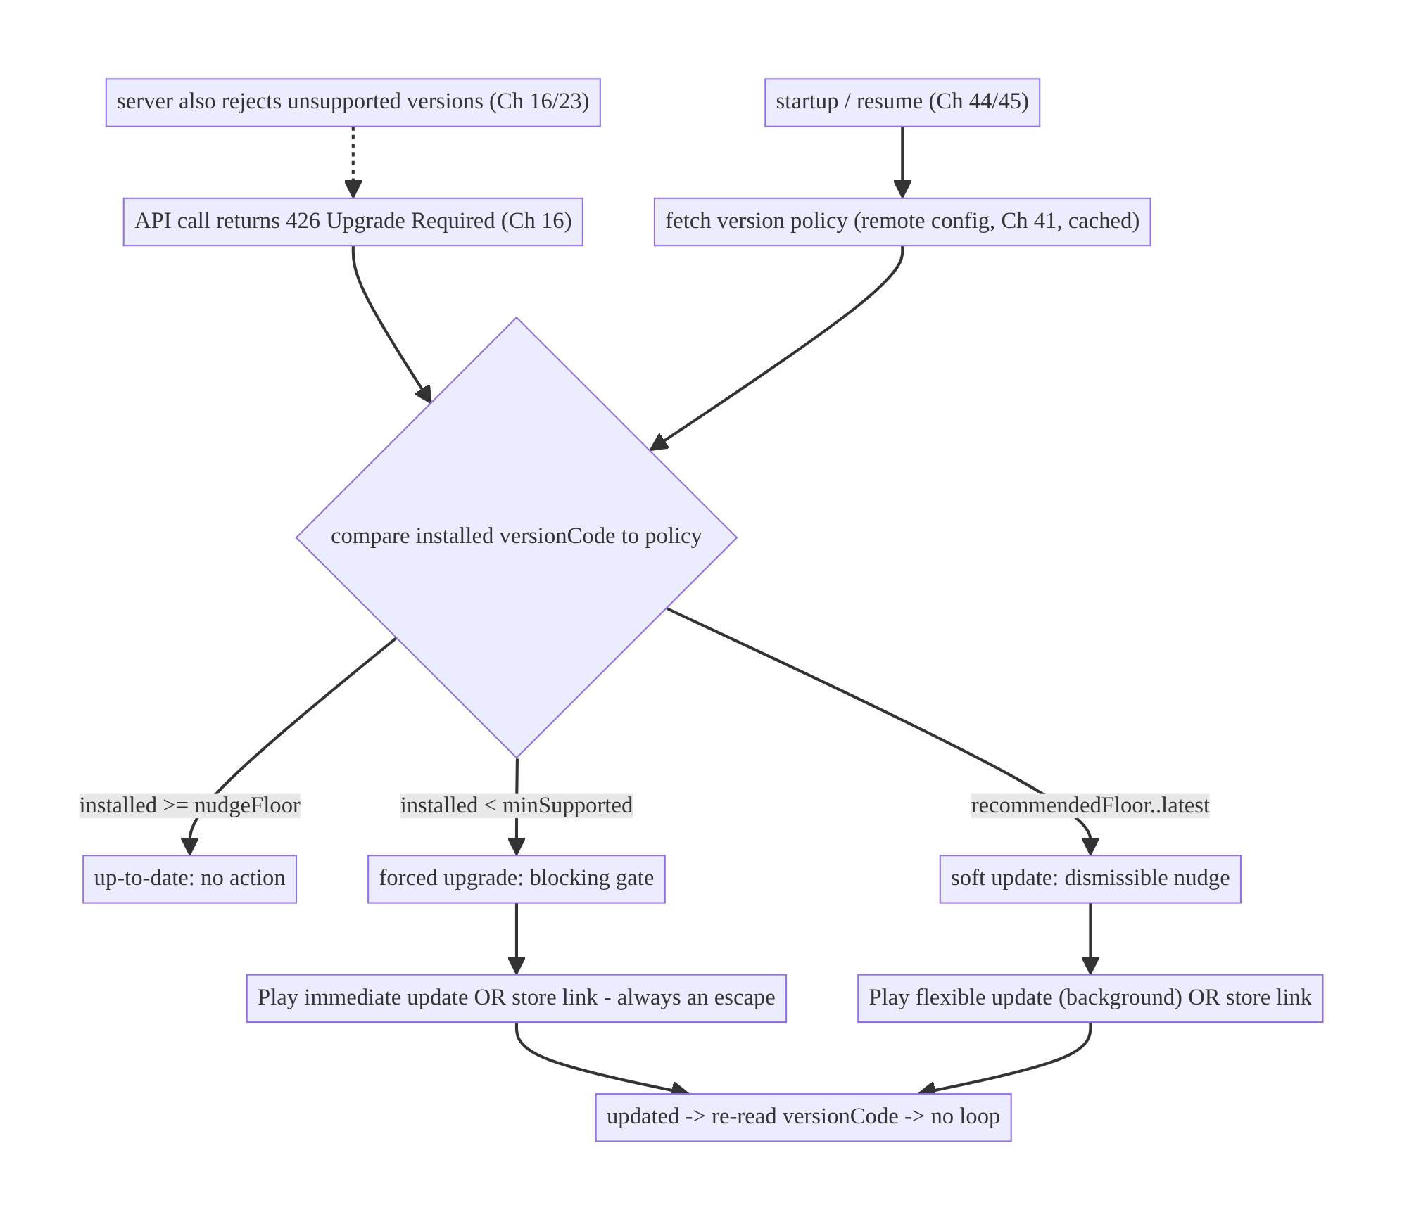
54.4 High-Level Architecture
Components & ownership
- Server policy (remote config/endpoint, Ch 41) owns the floor; server also enforces it (426).
- UpdateManager fetches policy, computes state, and drives the Play flow / store-link fallback.
- Gate UI renders soft nudge or forced screen.
- No-loop/escape logic ensures the user always has a working path.
Direction: server policy + 426 → state → soft/forced → Play update or store link → updated (re-checked, no loop).

54.5 Detailed Component Design
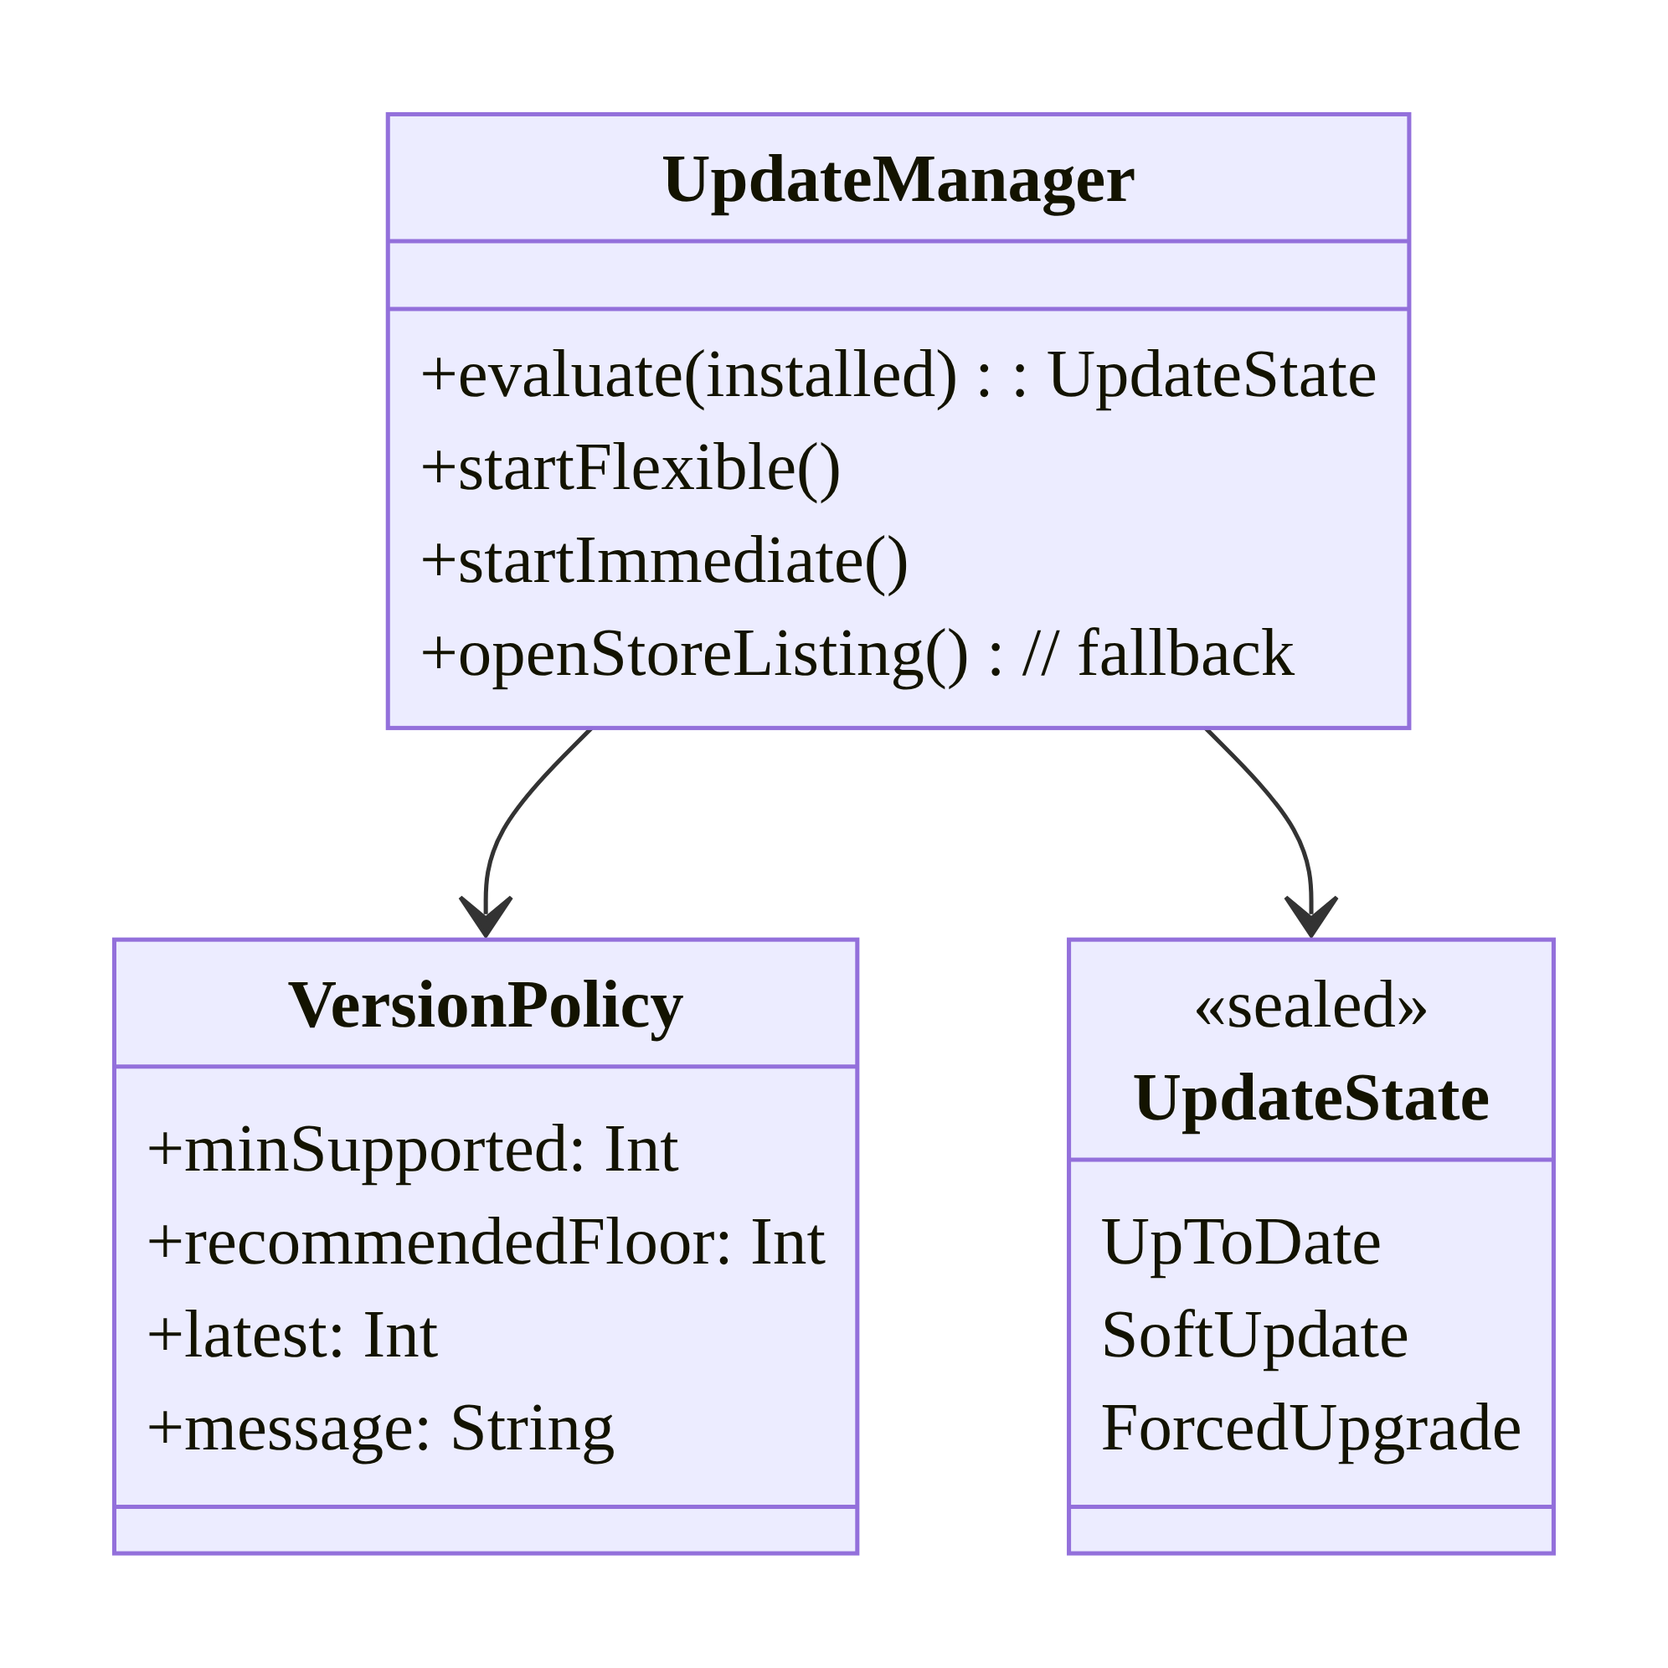
54.5 Detailed Component Design
Component | Responsibility
VersionPolicy | server-driven thresholds + message (Ch 41)
UpdateManager | evaluate state; start Play flow; store-link fallback; no-loop
UpdateState | up-to-date / soft / forced
Gate UI | dismissible nudge vs blocking screen

54.6 End-to-End Data Flow

Startup check → forced upgrade
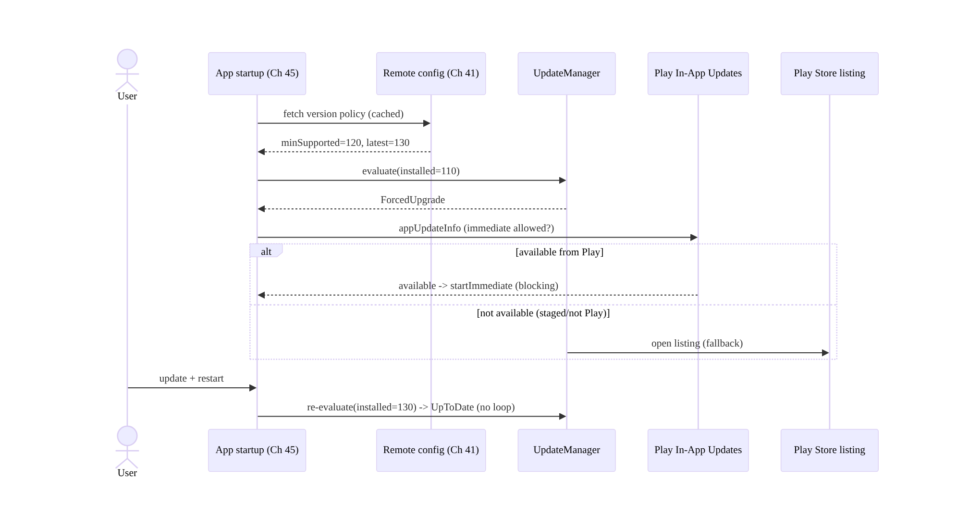
Startup check → forced upgrade

Reactive 426 mid-session
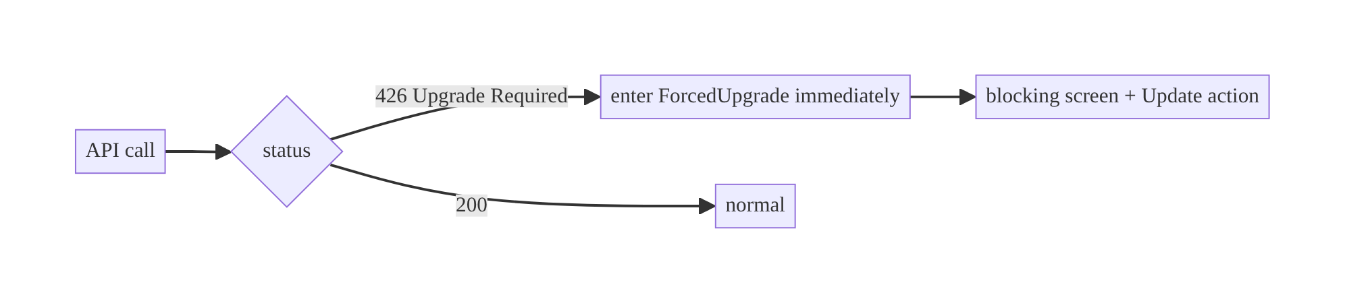
Reactive 426 mid-session

54.7 Complete Kotlin Implementation
Package: com.streamcart.appupdate.

54.7.1 Version policy + state evaluation (server-driven)
data class VersionPolicy( // from remote config / endpoint (Ch 41)
val minSupported: Int, val recommendedFloor: Int, val latest: Int, val message: String,
)
sealed interface UpdateState {
data object UpToDate : UpdateState
data class SoftUpdate(val policy: VersionPolicy) : UpdateState
data class ForcedUpgrade(val policy: VersionPolicy) : UpdateState
}
@Singleton
class UpdatePolicyEvaluator @Inject constructor(private val buildInfo: BuildInfo) {
fun evaluate(policy: VersionPolicy): UpdateState = when {
buildInfo.versionCode < policy.minSupported -> UpdateState.ForcedUpgrade(policy) // blocking
buildInfo.versionCode < policy.recommendedFloor -> UpdateState.SoftUpdate(policy) // dismissible
else -> UpdateState.UpToDate
}
}

54.7.2 UpdateManager: Play In-App Updates + store fallback
@Singleton
class UpdateManager @Inject constructor(
@ApplicationContext private val ctx: Context,
private val appUpdateManager: AppUpdateManager, // Play core
private val evaluator: UpdatePolicyEvaluator,
private val configRepo: RemoteConfigRepository, // Ch 41
) {
suspend fun currentState(): UpdateState =
evaluator.evaluate(configRepo.versionPolicy()) // cached; refreshed in background
/** Soft: flexible (background download, install when ready). */
fun startFlexible(activity: Activity, info: AppUpdateInfo, launcher: ActivityResultLauncher<IntentSenderRequest>) {
if (info.isUpdateTypeAllowed(AppUpdateType.FLEXIBLE))
appUpdateManager.startUpdateFlowForResult(info, launcher,
AppUpdateOptions.newBuilder(AppUpdateType.FLEXIBLE).build())
else openStoreListing() // fallback
}
/** Forced: immediate (full-screen blocking Play UI). */
fun startImmediate(activity: Activity, info: AppUpdateInfo, launcher: ActivityResultLauncher<IntentSenderRequest>) {
if (info.isUpdateTypeAllowed(AppUpdateType.IMMEDIATE))
appUpdateManager.startUpdateFlowForResult(info, launcher,
AppUpdateOptions.newBuilder(AppUpdateType.IMMEDIATE).build())
else openStoreListing() // staged rollout / not from Play -> always an escape
}
fun openStoreListing() {
val market = Intent(Intent.ACTION_VIEW, Uri.parse("market://details?id=${ctx.packageName}"))
val web = Intent(Intent.ACTION_VIEW, Uri.parse("https://play.google.com/store/apps/details?id=${ctx.packageName}"))
runCatching { ctx.startActivity(market.addFlags(Intent.FLAG_ACTIVITY_NEW_TASK)) }
.onFailure { ctx.startActivity(web.addFlags(Intent.FLAG_ACTIVITY_NEW_TASK)) }
}
}

54.7.3 Reactive 426 interceptor (Ch 16/2) → forced state
class UpgradeRequiredInterceptor @Inject constructor(
private val updateState: MutableStateFlow<UpdateState>, // app-global (Ch 39)
private val configRepo: RemoteConfigRepository,
) : Interceptor {
override fun intercept(chain: Interceptor.Chain): Response {
val response = chain.proceed(chain.request())
if (response.code == 426) { // Upgrade Required (server enforcement, Ch 23)
updateState.value = UpdateState.ForcedUpgrade(runBlocking { configRepo.versionPolicy() })
}
return response
}
}

54.7.4 Gate UI: forced (blocking) vs soft (dismissible), no loop
@Composable
fun UpdateGate(content: @Composable () -> Unit, vm: UpdateViewModel = hiltViewModel()) {
val state by vm.state.collectAsStateWithLifecycle()
when (val s = state) {
is UpdateState.ForcedUpgrade -> ForcedUpgradeScreen( // BLOCKS the whole app
message = s.policy.message,
onUpdate = { vm.startImmediateOrStore() }, // always a working action
// No dismiss. Offline -> show retry, never crash. After update, re-eval -> no loop.
)
is UpdateState.SoftUpdate -> {
content() // app usable
SoftUpdateBanner(onUpdate = { vm.startFlexibleOrStore() }, onDismiss = { vm.snooze() })
}
UpdateState.UpToDate -> content()
}
}

54.7.5 Resume handling (install downloaded flexible update; avoid stuck state)
// On resume, if a flexible update finished downloading, prompt to complete; if an immediate
// update was interrupted, resume it (Play requires handling this).
override fun onResume() {
super.onResume()
appUpdateManager.appUpdateInfo.addOnSuccessListener { info ->
if (info.installStatus() == InstallStatus.DOWNLOADED) promptInstall() // flexible finished
if (info.updateAvailability() == UpdateAvailability.DEVELOPER_TRIGGERED_UPDATE_IN_PROGRESS)
updateManager.startImmediate(this, info, launcher) // resume interrupted immediate
}
}

54.7.6 Module structure
:core:appupdate VersionPolicy, UpdatePolicyEvaluator, UpdateManager, UpgradeRequiredInterceptor, UpdateGate
:core:config RemoteConfigRepository (Ch 41) // version policy source
# 426 handling wired into the OkHttp stack (Ch 1/16). Server also enforces floor (Ch 23).

54.8 Concurrency and Race Conditions
Scenario | Risk | Handling
Stale cached policy re-gates after update | infinite loop | re-read live versionCode; evaluate against fresh policy on resume
426 during many parallel calls | repeated gate triggers | set forced state once (idempotent MutableStateFlow)
Flexible download completes in background | stuck “downloaded” | check installStatus on resume → prompt install
Immediate update interrupted | stuck mid-update | resume IN_PROGRESS on resume (Play requirement)
Config fetch fails at startup | wrong state | use last cached policy (Ch 41); fail open (don’t force on no data)
Offline on forced screen | trapped/crash | show retry + store link; tolerate offline
- No-loop is the subtle bug: after a successful update the app restarts with a new versionCode; if you evaluate against a stale cached policy or don’t re-read the version, you can re-gate immediately. Always compare the live versionCode to a freshly evaluated policy on resume.
- Reactive 426 must be idempotent: many in-flight requests can each see 426; set the forced state on a single app-global StateFlow (Ch 39) so the gate appears once.
- Fail open on missing policy: if the policy can’t be fetched (offline, backend down) and there’s no cached value, don’t force-gate on absence of data — that would trap users during a config outage; the server still enforces via 426 when it matters.

54.9 Failure Scenarios and Recovery
Failure | Detection | Response | Outcome
Old client breaks after backend change | support/426 | server-driven forced upgrade (Ch 16) | steered to update
Forced gate loops after update | user stuck | re-read live versionCode; fresh policy | no loop
Update not downloadable (staged) | Play API | store-link fallback + retry | recoverable
Not installed from Play | In-App API fails | store-link fallback | works
Offline on forced screen | no network | retry + explain; never crash | tolerated
Config outage force-gates everyone | spike | fail open on missing policy | no mass lockout
Modified client ignores gate | server logs | server rejects unsupported version (Ch 23) | enforced
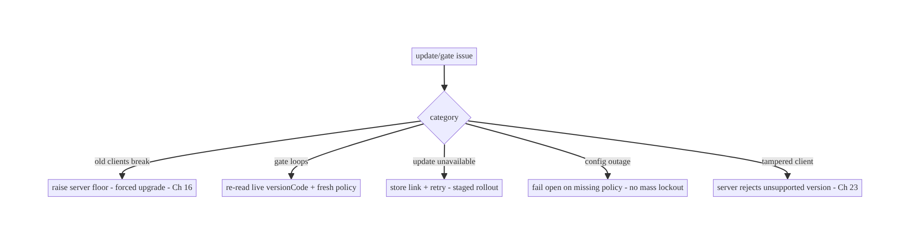
54.9 Failure Scenarios and Recovery
Two failure modes to fear most: trapping users (loops, offline crashes, config- outage mass-gating) and failing to actually enforce (client gate ignored by a modified app). Fix the first with always-an-escape + fail-open + no-loop; fix the second by enforcing the floor on the server — the client gate is UX, not security.

54.10 Scaling the Implementation
- Level 1. Server-driven policy (remote config, Ch 41); 3 states; store-link update.
- Level 2. Play In-App Updates (flexible soft, immediate forced); resume handling; no-loop.
- Level 3 — production. Reactive 426 (Ch 16); staged-rollout/offline/not-from-Play fallbacks; fail-open; server-side enforcement.
- Level 4 — large. Per-platform/region policies; phased floors (nudge → force over time); A/B of nudge copy; update-adoption analytics; security-driven emergency floors.
- Level 5 — enterprise. Version-support lifecycle governance (deprecation calendar tied to Ch 16 API versions), automated floor bumps on security fixes, adoption-curve dashboards, multi-store support (not just Play).
Avoid overengineering: most apps need a server-driven floor + soft/forced states + Play In-App Updates + store fallback. Don’t hardcode min-versions, and don’t build a custom updater when In-App Updates + store link suffice.

54.11 Alternative Approaches and Trade-offs
Dimension | Option A | Option B | When
Version floor | Server-driven (remote config/endpoint) | client constant | Server-driven always (reach non-updaters)
Update delivery | Play In-App Updates | store link only | In-App Updates (smooth) + store-link fallback
Forced flow | Immediate (Play blocking) | custom blocking screen + store link | Immediate where available; custom+link fallback
Soft flow | Flexible (background) | just a banner → store | Flexible (seamless); banner for non-Play
Enforcement | Server rejects old versions (426) | client gate only | Server (client gate is UX, bypassable)
Missing policy | Fail open | fail closed (force) | Fail open (avoid outage lockout)
Server-driven floor vs client constant: a hardcoded MIN_VERSION in the app can only be changed by shipping a new app — but the users who need to be forced off an old version are precisely those who won’t install the new one, so the constant never reaches them. A server-driven floor (remote config/endpoint, Ch 41) is changeable instantly and reaches every running client. Always server-drive the policy.
Play In-App Updates vs store link: In-App Updates give a seamless, Google-managed flow (background download for flexible, blocking UI for immediate) and higher update rates — but only for Play installs and subject to staged-rollout availability. A plain store link always works as a fallback (including non-Play installs). Use In-App Updates as the primary path and the store link as the always-available escape; never ship a forced gate that can only use In-App Updates.
Client gate vs server enforcement: the client gate is a UX mechanism — a modified or old client can ignore it. Real enforcement (for breaking changes/security) must be on the server (reject unsupported versions with 426, Ch 16/23). Do both: the gate gives users a good experience; the server guarantees incompatible/insecure clients can’t transact.

54.12 Security Considerations
- Forced upgrade as a security control (Ch 23): when a client vulnerability is patched, raise the server floor to retire exploitable versions — but enforce on the server (reject old versions), since a tampered client ignores the gate.
- Don’t leak why in the message: the forced-upgrade message shown to users shouldn’t detail the vulnerability (Ch 28) — “please update to continue” suffices.
- Validate the policy source: the version policy comes over authed/trusted config (Ch 41/19) — a MITM that could force a downgrade or spoof a policy is a concern; fetch over TLS/pinning (Ch 23) and don’t act on unauthenticated policy.
- Store-link integrity: open the official Play listing by package name; don’t follow an arbitrary URL from config (open-redirect, Ch 52).
- No bypass via deep links (Ch 52): a deep link must not route past a forced gate; evaluate the gate before honoring deep-link navigation.
- Client vs backend: the backend enforces supported versions and emits 426; the client provides the UX gate and update flow. Enforcement is server-side; convenience is client-side.

54.13 Performance and Resource Optimization
- Cheap startup check: use the cached policy (Ch 41) at startup (don’t block the first frame on a network fetch, Ch 45); refresh in the background.
- Flexible update downloads in the background — doesn’t interrupt the user; install on a natural restart.
- Don’t re-fetch policy excessively: remote config caching (Ch 41) + background refresh; evaluate on resume, not continuously.
- Lightweight gate check (integer compare) — negligible cost.
- Avoid over-gating: too-aggressive soft nudges annoy; rate-limit/snooze.
- Profiling: update-adoption rate per version, forced-gate display rate, store-link vs In-App-Update conversion, time-on-old-version distribution.

54.14 Testing Strategy
Policy evaluation is pure logic (easy unit tests); Play flow via its test tracks / fakes.
class UpdatePolicyEvaluatorTest {
private fun eval(installed: Int, min: Int, rec: Int, latest: Int) =
UpdatePolicyEvaluator(BuildInfo(versionCode = installed)).evaluate(VersionPolicy(min, rec, latest, ""))
@Test fun `forced when below minSupported`() =
assertTrue(eval(110, min = 120, rec = 125, latest = 130) is UpdateState.ForcedUpgrade)
@Test fun `soft when between recommended and latest`() =
assertTrue(eval(122, min = 120, rec = 125, latest = 130) is UpdateState.SoftUpdate)
@Test fun `up to date when at or above recommended`() =
assertEquals(UpdateState.UpToDate, eval(130, min = 120, rec = 125, latest = 130))
@Test fun `no loop - fresh version evaluates up to date`() =
assertEquals(UpdateState.UpToDate, eval(130, 120, 125, 130)) // post-update
}
class UpgradeInterceptorTest {
@Test fun `426 sets forced state once`() { /* two parallel 426 -> single ForcedUpgrade */ }
}
// Play In-App Updates: use FakeAppUpdateManager (play core testing) to simulate
// available/immediate/flexible, download complete, staged-unavailable -> assert store fallback.
What to test: evaluator for all boundaries (forced/soft/up-to-date + no-loop post-update); 426 → forced (idempotent); flexible/immediate start + store fallback when not allowed; resume install-complete + resume-interrupted; fail-open on missing policy; offline on forced screen (retry, no crash). FakeAppUpdateManager for Play flows.

54.15 Production Observability
- Metrics: version-adoption distribution; forced-gate display + completion rate; soft-nudge show/accept/snooze; store-link vs In-App-Update conversion; 426 rate (old clients hitting the server); update-failure/cancel rate; time-to-adopt after a floor bump.
- Logs: update{state, installed, min, latest, flow, outcome} (no PII, Ch 28).
- Debugging: users stuck → loop (stale policy) / offline / staged-unavailable; low adoption → nudge ineffective / In-App Updates unavailable; mass lockout → failed fail-open; old clients still transacting → server not enforcing 426.
- Alerting: forced-gate spike after a floor change (expected) vs unexpected (config bug); 426 from versions you didn’t intend to gate; adoption stall.
- Dashboards: version adoption curve per release; floor-bump impact.

54.16 System Design Interview Preparation
≥25 questions.
Fundamentals
- Why an update strategy? Old-version users break/are insecure; you must steer/force updates.
- Where does the version floor live? On the server (remote config/endpoint, Ch 41) — never a client constant.
- Why not a client constant? Non-updaters never get the build that changes it.
- Three states? Up-to-date / soft (dismissible) / forced (blocking).
- Who enforces incompatibility? The server (426, Ch 16); the client gate is UX.
Triggers
- Proactive check? At startup/resume, compare versionCode to cached policy.
- Reactive signal? 426 Upgrade Required mid-session → forced.
- Why reactive matters? Catches sessions predating a floor change.
Delivery
- Play In-App Updates flows? Flexible (background) and immediate (blocking).
- Flexible for? Soft updates.
- Immediate for? Forced upgrades.
- Requirement? Installed from Play.
- Fallback? Open the Play Store listing (always available).
Resilience
- No-loop? Re-read live versionCode + fresh policy after update.
- Staged rollout unavailable? Store link + retry; don’t claim unavailable update.
- Offline on forced screen? Retry + explain; never crash/trap.
- Config outage? Fail open (don’t mass-gate on missing policy).
- Interrupted immediate update? Resume on next launch (Play requirement).
Security
- Forced upgrade for security? Yes — retire vulnerable clients; enforce server-side.
- Message content? Don’t leak the vuln (Ch 28).
- Policy source trust? Authed/TLS-pinned config (Ch 23); don’t act on spoofable policy.
- Deep-link bypass? Evaluate gate before honoring deep links (Ch 52).
Testing/Production
- Test policy? Pure unit tests at all boundaries + no-loop.
- Test Play flows? FakeAppUpdateManager.
- Users stuck? Loop / offline / staged-unavailable.
- Old clients still transacting? Server not enforcing 426.

Design-change challenges
- A backend change breaks clients below v120. Raise server floor → forced upgrade (Ch 16); server rejects < v120 with 426.
- Forced gate loops after users update. Re-read live versionCode + fresh policy.
- Some users aren’t on Play. Store-link fallback.
- A security fix must retire old clients fast. Emergency server floor bump + server enforcement.
- A config outage locked everyone out. Fail open on missing policy.

Mock walkthrough (abridged)
Clarify (soft vs forced, security-driven?, Play-only?) → server-driven policy (Ch 41) + server enforcement (426, Ch 16) → 3 states → proactive (startup/resume) + reactive (426) triggers → Play In-App Updates (flexible/immediate) + store-link fallback → resilience (no-loop, offline, staged, fail-open) → security (server enforcement, message, policy trust) → observability (adoption, 426).

54.17 Practical Exercises
- Beginner. Implement UpdatePolicyEvaluator from a server-driven policy and render up-to-date/soft/forced states. Eval: correct boundaries; forced blocks.
- Intermediate. Add Play In-App Updates (flexible for soft, immediate for forced) with a Play Store-link fallback. Eval: flows start; fallback when unavailable.
- Advanced. Add a 426 interceptor that forces the gate mid-session (idempotent) and no-loop logic after update. Eval: 426 → forced once; no loop post-update.
- Production debugging. Fix a forced-gate loop (stale cached policy) and an offline crash on the forced screen. Eval: no loop; offline tolerated.
- System design challenge. Add fail-open on config outage and server-side version enforcement; build an adoption-curve dashboard. Eval: no mass lockout; server rejects old versions; adoption visible.
(Solutions withheld unless requested.)

54.18 Chapter Summary & Reference Sheet
Key decisions: keep the version floor server-driven (remote config/endpoint, Ch 41) so you can retire old clients instantly (a client constant never reaches non-updaters); derive three states — up-to-date / soft (dismissible nudge) / forced (blocking gate) — checked proactively at startup/resume and reactively on a 426 Upgrade Required signal (Ch 16); deliver updates with Play In-App Updates (flexible for soft background downloads, immediate for forced blocking) with an always-available Play Store-link fallback (for staged-rollout/not-from-Play); make it resilient — no loop (re-read live versionCode + fresh policy after update), offline-tolerant (retry, never crash/trap), and fail open on missing policy (no outage lockout); and enforce the floor on the server (426, Ch 16/23) because the client gate is UX, not security (a tampered client ignores it). Use forced upgrades as a security control to retire vulnerable clients.
Concepts: server-driven version policy, three update states, proactive/reactive triggers, 426 Upgrade Required, Play In-App Updates (flexible/immediate), store-link fallback, staged rollout, no-loop, fail-open, server-side enforcement.
Common mistakes: hardcoded min-version (can’t reach non-updaters); client-only enforcement (bypassable); forced gate with no escape (In-App-Updates-only); loop after update (stale policy); offline crash on gate; mass lockout on config outage (fail-closed); leaking the vuln in the message; deep-link bypass.
Checklist:
- ☐ server-driven policy (Ch 41)
- ☐ 3 states (up-to-date/soft/forced)
- ☐ startup/resume + 426 triggers
- ☐ Play In-App Updates (flexible/immediate)
- ☐ store-link fallback (always an escape)
- ☐ no-loop (live versionCode + fresh policy)
- ☐ offline tolerant
- ☐ fail open on missing policy
- ☐ server enforces floor (426, Ch 16/23)
- ☐ non-leaky message
- ☐ no deep-link bypass.
Key APIs: AppUpdateManager/appUpdateInfo/startUpdateFlowForResult, AppUpdateType.FLEXIBLE/IMMEDIATE, AppUpdateOptions, InstallStatus/ UpdateAvailability, FakeAppUpdateManager (test), market://details?id= / https://play.google.com/store/apps/details?id=, OkHttp Interceptor (426, Ch 1/16), remote config (Ch 41).
References:
- In-App Updates: https://developer.android.com/guide/playcore/in-app-updates
- Support in-app updates (Kotlin): https://developer.android.com/guide/playcore/in-app-updates/kotlin-java
- Test in-app updates: https://developer.android.com/guide/playcore/in-app-updates/test
- (composes) Ch 16 API Schema Evolution, Ch 41 Remote Config, Ch 23 Security, Ch 45 Startup, Ch 52 Deep Links

Chapter 55 — Widgets & App Shortcuts
Part VI — Lifecycle, Background & Platform · Complexity: Standard (≥25 interview questions)
Prerequisites: Ch 30 (WorkManager), Ch 3 (SSOT/Room), Ch 32 (sync), Ch 52 (deep links), Ch 47 (background limits), Ch 44 (lifecycle). Pairs with Ch 50 (notifications), Ch 42 (multi-account).
Reference surface in StreamCart: surfaces outside the app — home-screen widgets (order status, cart total, continue-watching) built with Glance, and app shortcuts (static/dynamic/pinned long-press actions like “Search”, “My Orders”, “Resume last show”) that deep-link into the app.
Note: this chapter completes Part VI — Lifecycle, Background & Platform (Ch 44–55).

55.1 Problem Definition and Real-World Context
Not everything happens inside your Activity. The home screen and launcher are app surfaces too: widgets show glanceable, periodically-updated content on the home screen, and app shortcuts give long-press quick actions on the launcher icon. Done well, they drive re-engagement and fast task access; done poorly, they show stale/wrong data, drain battery with over-frequent updates, leak content, or crash on the restricted execution model these surfaces run under.
Concretely, teams hit:
- The widget execution model is restrictive. A widget runs in the launcher’s process via RemoteViews — you cannot run arbitrary UI code or hold a long-lived process; updates are pushed to it, subject to background limits (Ch 47). Treating a widget like an in-app screen fails. Glance (Compose-style widget API) still compiles down to RemoteViews with these constraints.
- Stale or wrong data. Widgets must reflect the SSOT (Ch 3) and update on data change / periodically (WorkManager, Ch 30) — not hold their own copy. Over-frequent updates waste battery and hit update-rate limits; under-updating shows stale info.
- App shortcut types confused. Static (manifest, fixed), dynamic (runtime-pushed, e.g., recent items), and pinned (user places on home screen) have different lifecycles and limits (typically ~4–5 visible). Using the wrong type, or not updating dynamic shortcuts, gives stale/empty menus.
- Deep-link integration. Both widgets and shortcuts must deep-link (Ch 52) into the right screen with the right back stack, auth gating, and account (Ch 42) — they’re entry points like notifications (Ch 50).
- Multi-account & privacy. A widget on a shared/home screen can leak another account’s or sensitive data; account switching (Ch 42) must update widgets; sensitive content needs care on an always-visible surface.
- Lifecycle & updates under limits. Scheduling widget refresh respecting Doze/App Standby (Ch 47), handling the widget being added/removed, and surviving process death.
The architecture: build widgets with Glance backed by the SSOT (Ch 3), updated by WorkManager (periodic + on-data-change, respecting Ch 47) and rendered as RemoteViews under the restricted model; define app shortcuts (static for fixed actions, dynamic for contextual/recent, pinned on user request) that deep-link (Ch 52) into the app; integrate deep links for both surfaces (right destination, back stack, auth, account); and handle multi-account/privacy (update on switch, don’t leak) and lifecycle (add/remove, update under background limits). This chapter is about first-class app surfaces beyond the Activity, built within their constraints.

Three practical use cases
- Order-status widget (StreamCart). A home-screen widget shows the latest order’s status from the SSOT (Ch 3), refreshed by WorkManager on sync (Ch 32) and periodically; tapping deep-links to the order (Ch 52).
- Continue-watching widget / shortcut. A widget tile + a dynamic shortcut “Resume last show” that deep-links into the player at the saved position (Ch 58/59).
- Dynamic shortcuts for recent searches. Long-pressing the icon shows recent searches/categories (dynamic shortcuts), updated as the user browses, each deep-linking to results.

Why this is architectural
Widgets/shortcuts are out-of-process entry points bound to the SSOT (Ch 3), background scheduling (Ch 30/47), deep linking (Ch 52), and multi-account/privacy (Ch 42/28). The decisions — SSOT-backed updates, update cadence under limits, shortcut types, deep-link integration, leak prevention — determine whether these surfaces are fresh, efficient, safe, and correct.

55.2 Requirements Engineering

Functional requirements
ID | Requirement
F1 | Render glanceable widget content from the SSOT (Ch 3).
F2 | Update widgets on data change + periodically, respecting background limits (Ch 47).
F3 | Provide app shortcuts (static/dynamic/pinned) that deep-link into the app.
F4 | Deep-link widget/shortcut taps to the right destination + back stack + auth (Ch 52).
F5 | Handle multi-account (update on switch) and privacy (no leak) (Ch 42/28).
F6 | Handle widget/shortcut lifecycle (add/remove/limits) and process death.

Non-functional requirements
Attribute | Policy
Freshness | Reflects SSOT; timely updates without staleness.
Battery | Update cadence respects Doze/App Standby (Ch 47); no over-refresh.
Correctness | Right data, right deep-link; works under the RemoteViews model.
Privacy | No sensitive/cross-account leak on an always-visible surface.
Resilience | Survives process death; handles add/remove gracefully.

Scope
- In scope: widgets (Glance + RemoteViews model, AppWidgetProvider), SSOT-backed content, WorkManager-driven updates (periodic + on-change) under Ch 47, app shortcuts (static/dynamic/pinned, limits), deep-link integration (Ch 52), multi-account/privacy (Ch 42/28), lifecycle (add/remove/update/process death).
- Out of scope: deep-link routing/security detail (Ch 52), WorkManager internals (Ch 30), Doze detail (Ch 47), SSOT internals (Ch 3), notifications (Ch 50), Compose UI (Ch 6 — Glance is similar but separate).

Assumptions & constraints
- Jetpack Glance for widgets (compiles to RemoteViews), ShortcutManager/ ShortcutManagerCompat for shortcuts, WorkManager, Room, Hilt. minSdk 24 (dynamic/ pinned shortcuts 25+; Glance has its own min). Widgets run out-of-process under background limits; shortcut counts are capped.

55.3 System Design Fundamentals
- Widgets run out-of-process via RemoteViews (the key constraint). A home-screen widget is hosted in the launcher’s process; you don’t get a live Activity. You build a limited view tree (RemoteViews) and push updates to it via AppWidgetManager. You cannot run arbitrary code continuously, hold state, or use normal Compose. Glance gives a Compose-like authoring API but compiles to RemoteViews, so the same limits apply (limited components, no arbitrary logic in the view, updates pushed from your process).
- Widget data must come from the SSOT (Ch 3). The widget renders a snapshot of app state. Keep the source of truth in Room/DataStore (Ch 3/4); when it changes (sync, Ch 32, or user action), trigger a widget update that reads the SSOT and pushes new RemoteViews. The widget never holds its own authoritative copy.
- Updates are scheduled, under background limits (Ch 47):
  - Periodic: android:updatePeriodMillis has a 30-minute minimum and is unreliable under Doze — for anything finer/more reliable use WorkManager (Ch 30) with constraints (Ch 47) to refresh.
  - On-change: when the SSOT changes, enqueue a (possibly expedited) WorkManager update so the widget reflects it promptly.
  - Respect limits: don’t over-update (battery + rate limits); batch; update only when data actually changed.
  - Glance offers GlanceAppWidget.update(context, id) and state via updateAppWidgetState to push new content.
- App shortcuts (three types):
  - Static: declared in XML (manifest <meta-data>), fixed at build time (e.g., “Search”, “My Orders”). Always present.
  - Dynamic: pushed at runtime via ShortcutManagerCompat.pushDynamicShortcut (e.g., recent items, continue-watching). Update as context changes; capped (typically ~4–5 visible including static).
  - Pinned: the user places a shortcut on the home screen (requestPinShortcut); it persists until removed. Request only on user action.
  - All are long-press launcher actions that fire an Intent (a deep link, Ch 52).
- Deep-link integration (Ch 52). Widget taps and shortcut launches carry an Intent/deep link into the app → route through the central router (Ch 52) to the right destination with a synthesized back stack, auth gating (Ch 21), and account check (Ch 42). Treat the carried data as untrusted (Ch 52) and build PendingIntents with FLAG_IMMUTABLE.
- Multi-account & privacy (Ch 42/28). A widget sits on a potentially shared surface:
  - No sensitive leak: avoid showing sensitive content (balances, private messages) on an always-visible widget unless the user opts in; consider a tap-to-reveal.
  - Account correctness: on account switch (Ch 42), update/clear widgets so they reflect the active account; don’t show account A’s order on account B.
- Lifecycle (Ch 44/8): handle widget added (onEnabled/onUpdate), removed (onDisabled/onDeleted — cancel its update work), resize/reconfigure, and process death (widget state is re-derived from the SSOT on next update, so nothing to restore — this is a benefit of SSOT-backing). Shortcuts persist across process death (managed by the system).
Core insight: widgets run out-of-process via RemoteViews (Glance compiles to them), so render a glanceable snapshot of the SSOT (Ch 3) and push updates via WorkManager — periodic + on-change, respecting Doze/App Standby (Ch 47) and never over-refreshing; provide app shortcuts (static for fixed actions, dynamic for contextual/recent within the ~4–5 cap, pinned on user request) that, like widgets, deep-link (Ch 52) into the right destination with auth and account checks; and treat these as shared, always-visible surfaces — update them on account switch and keep sensitive data off them (Ch 42/28).

55.4 High-Level Architecture
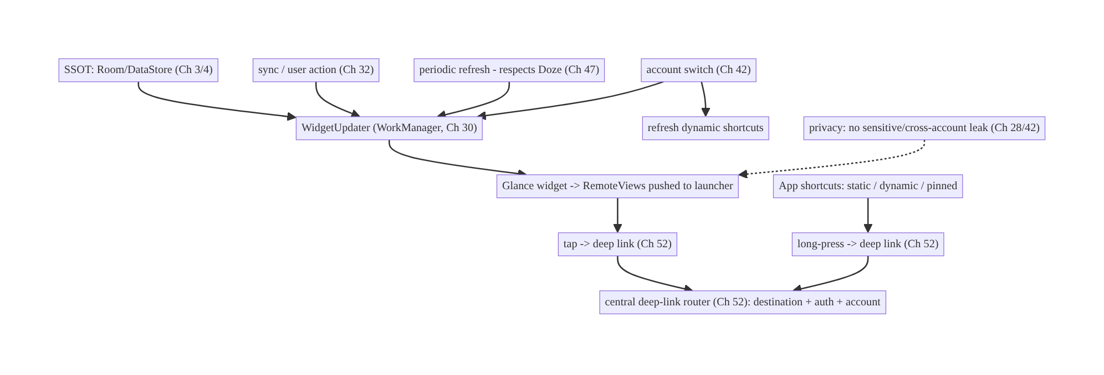
55.4 High-Level Architecture
Components & ownership
- SSOT is the single data source; WidgetUpdater (WorkManager) pushes snapshots to Glance/RemoteViews.
- Shortcuts (static/dynamic/pinned) are launcher entry points.
- Both deep-link through the central router (Ch 52) with auth/account checks.
- Account/privacy logic keeps surfaces correct and safe.
Direction: SSOT + triggers → WorkManager update → widget snapshot; widgets/shortcuts → deep link → router → destination.

55.5 Detailed Component Design
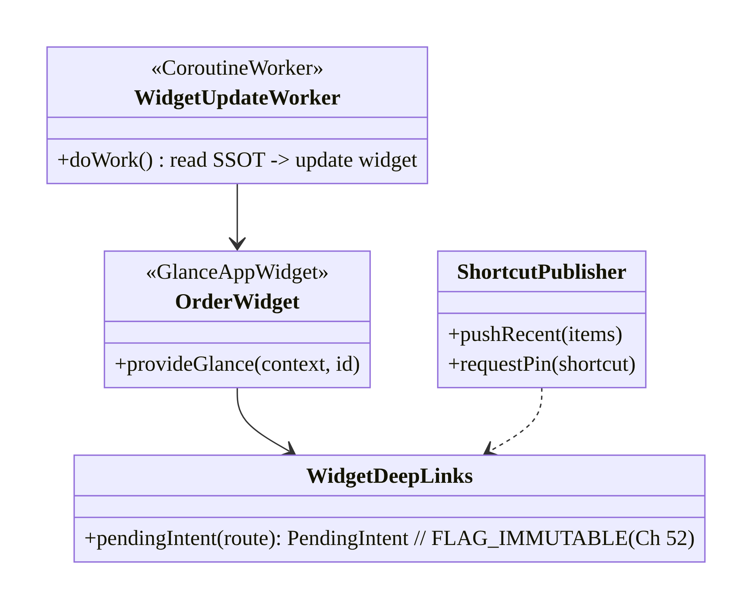
55.5 Detailed Component Design
Component | Responsibility
OrderWidget (Glance) | render SSOT snapshot as RemoteViews
WidgetUpdateWorker | read SSOT, push widget update (periodic + on-change, Ch 30/47)
ShortcutPublisher | manage dynamic/pinned shortcuts (cap-aware)
WidgetDeepLinks | build FLAG_IMMUTABLE deep-link PendingIntents (Ch 52)

55.6 End-to-End Data Flow

SSOT change → widget update
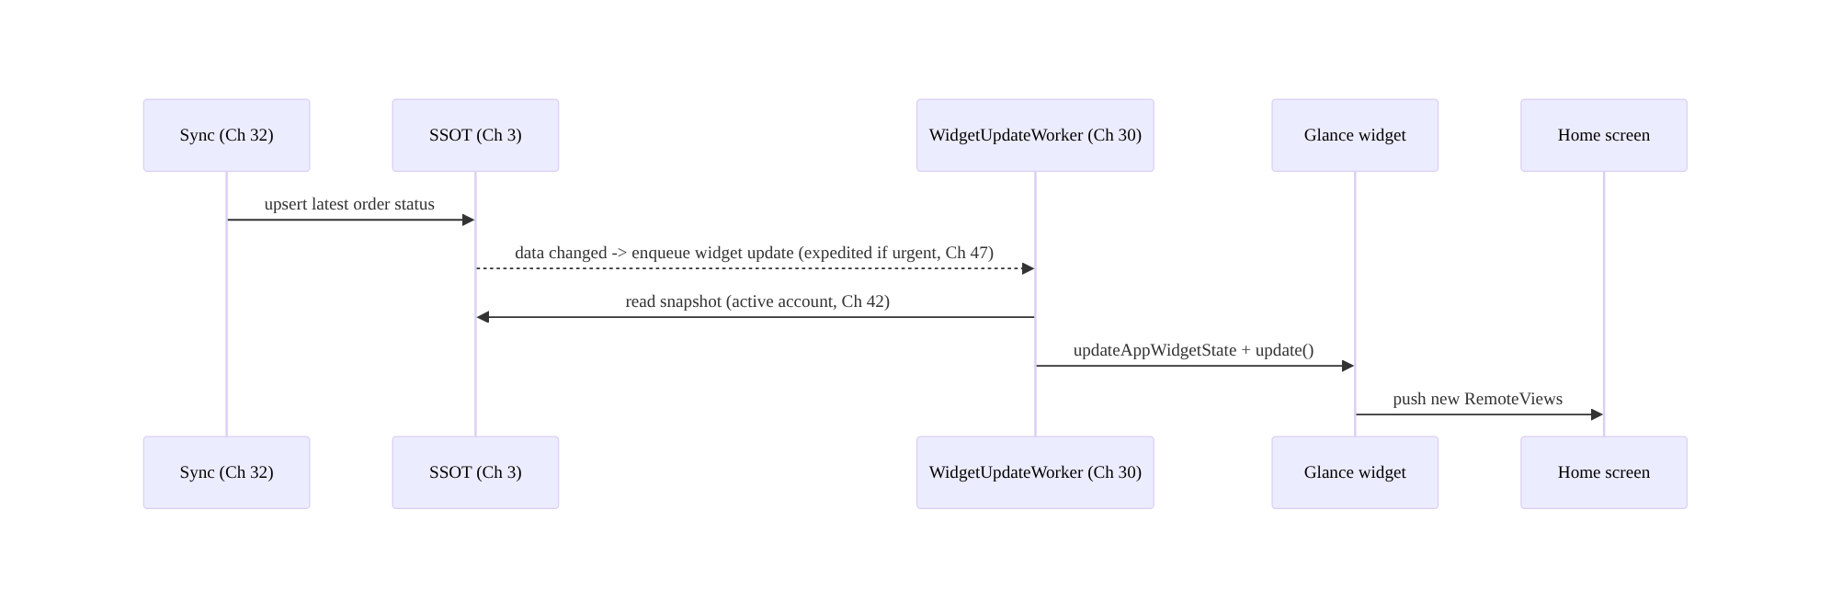
SSOT change → widget update

Widget/shortcut tap → deep link
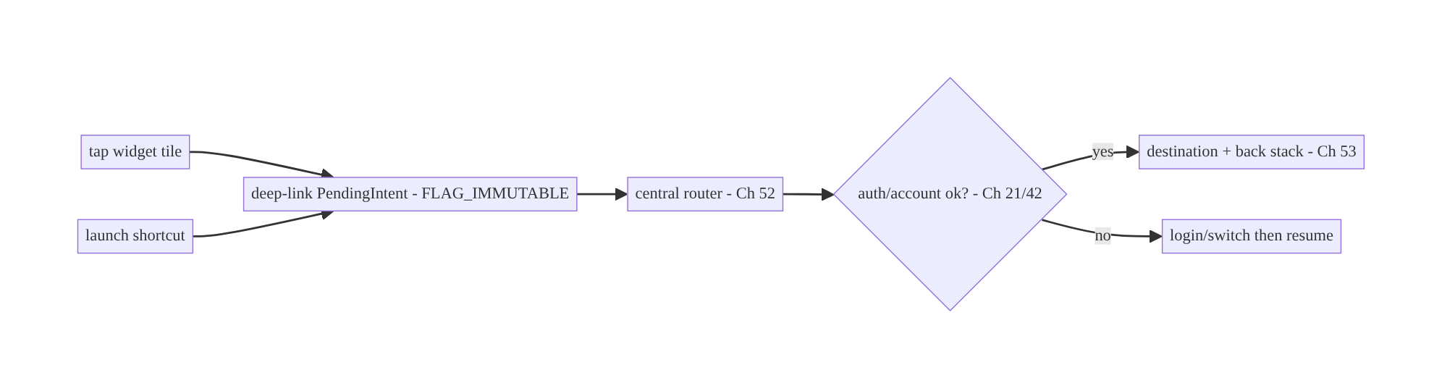
Widget/shortcut tap → deep link

55.7 Complete Kotlin Implementation
Package: com.streamcart.widgets.

55.7.1 Glance widget rendering an SSOT snapshot
class OrderWidget : GlanceAppWidget() {
override suspend fun provideGlance(context: Context, id: GlanceId) {
// Read a SNAPSHOT from the SSOT (Ch 3) for the ACTIVE account (Ch 42). No long-lived logic.
val entryPoint = EntryPointAccessors.fromApplication(context, WidgetEntryPoint::class.java)
val order = entryPoint.orderRepository().latestOrderSnapshot() // suspend, from Room
provideContent {
Column(GlanceModifier.fillMaxSize().clickable( // tap -> deep link (Ch 52)
actionStartActivity(entryPoint.deepLinks().intent("streamcart://order/${order?.id}")))) {
Text(order?.status ?: "No recent orders") // glanceable, non-sensitive
Text(order?.etaText ?: "")
}
}
}
}
class OrderWidgetReceiver : GlanceAppWidgetReceiver() { override val glanceAppWidget = OrderWidget() }

55.7.2 WorkManager-driven updates (periodic + on-change, Ch 47)
@HiltWorker
class WidgetUpdateWorker @AssistedInject constructor(
@Assisted ctx: Context, @Assisted p: WorkerParameters,
) : CoroutineWorker(ctx, p) {
override suspend fun doWork(): Result = runCatching {
OrderWidget().updateAll(applicationContext) // re-reads SSOT snapshot, pushes RemoteViews
}.fold({ Result.success() }, { Result.retry() })
}
@Singleton
class WidgetUpdater @Inject constructor(private val wm: WorkManager) {
fun schedulePeriodic() = wm.enqueueUniquePeriodicWork( // respects Doze (Ch 47)
"widget-refresh", ExistingPeriodicWorkPolicy.KEEP,
PeriodicWorkRequestBuilder<WidgetUpdateWorker>(30, TimeUnit.MINUTES)
.setConstraints(Constraints.Builder().setRequiredNetworkType(NetworkType.CONNECTED).build()).build())
fun updateNow() = wm.enqueue(OneTimeWorkRequestBuilder<WidgetUpdateWorker>()
.setExpedited(OutOfQuotaPolicy.RUN_AS_NON_EXPEDITED_WORK_REQUEST).build()) // on data change (Ch 47)
fun cancel() = wm.cancelUniqueWork("widget-refresh") // when last widget removed (onDisabled)
}

55.7.3 App shortcuts: static (XML) + dynamic + pinned
<!-- Static shortcuts: res/xml/shortcuts.xml, referenced from the launcher activity meta-data -->
<shortcuts xmlns:android="http://schemas.android.com/apk/res/android">
<shortcut android:shortcutId="search" android:shortcutShortLabel="@string/sc_search"
android:icon="@drawable/ic_search">
<intent android:action="android.intent.action.VIEW"
android:data="streamcart://search" android:targetPackage="com.streamcart"
android:targetClass="com.streamcart.MainActivity" />
</shortcut>
<!-- "My Orders" similar -->
</shortcuts>
@Singleton
class ShortcutPublisher @Inject constructor(@ApplicationContext private val ctx: Context) {
/** Dynamic: recent/contextual; capped (~4-5 incl. static). Update as context changes. */
fun pushRecentSearches(terms: List<String>) {
val max = ShortcutManagerCompat.getMaxShortcutCountPerActivity(ctx)
terms.take((max - STATIC_COUNT).coerceAtLeast(0)).forEach { term ->
val sc = ShortcutInfoCompat.Builder(ctx, "recent_$term")
.setShortLabel(term)
.setIntent(Intent(Intent.ACTION_VIEW, Uri.parse("streamcart://search?q=$term"), ctx, MainActivity::class.java))
.build()
ShortcutManagerCompat.pushDynamicShortcut(ctx, sc)
}
}
/** Pinned: only on explicit user action. */
fun requestPin(id: String, label: String, deepLink: String) {
if (!ShortcutManagerCompat.isRequestPinShortcutSupported(ctx)) return
val sc = ShortcutInfoCompat.Builder(ctx, id).setShortLabel(label)
.setIntent(Intent(Intent.ACTION_VIEW, Uri.parse(deepLink), ctx, MainActivity::class.java)).build()
ShortcutManagerCompat.requestPinShortcut(ctx, sc, null)
}
fun clearDynamic() = ShortcutManagerCompat.removeAllDynamicShortcuts(ctx) // on logout (Ch 42)
}

55.7.4 Account switch + privacy
// On account switch (Ch 42): refresh widgets + dynamic shortcuts so they reflect the active account.
suspend fun onAccountSwitched() {
OrderWidget().updateAll(ctx) // re-reads SSOT for the new active account
shortcutPublisher.clearDynamic() // clear previous account's contextual shortcuts
// Privacy (Ch 28): widget shows non-sensitive summary; sensitive detail only inside the app.
}

55.7.5 Module structure
:feature:widgets OrderWidget (Glance), OrderWidgetReceiver, WidgetUpdateWorker, WidgetUpdater
:feature:shortcuts ShortcutPublisher (+ res/xml/shortcuts.xml)
:core:deeplink WidgetDeepLinks / central router (Ch 52)
:core:data SSOT repositories (Ch 3) via Hilt EntryPoint for the out-of-process widget

55.8 Concurrency and Race Conditions
Scenario | Risk | Handling
Over-frequent updates | battery + rate limit | WorkManager cadence; update only on real change (Ch 47)
Update after widget removed | wasted work/crash | cancel work in onDisabled/onDeleted
SSOT read in launcher process | cross-process access | Hilt EntryPoint + Room (safe, read snapshot)
Account switch mid-update | stale/cross-account content | re-read active account (Ch 42); clear dynamic shortcuts
Dynamic shortcut cap exceeded | pushes dropped | respect getMaxShortcutCountPerActivity
Process death during update | partial | WorkManager retries; next update re-derives from SSOT
- Update only when data changed: enqueue a widget update on actual SSOT change (Ch 32) + a coarse periodic refresh — not on every event — to respect battery and update-rate limits (Ch 47).
- Cancel update work when the last widget is removed (onDisabled) so you don’t keep refreshing a non-existent widget.
- SSOT re-derivation makes widgets process-death-safe: since the widget renders a snapshot read on each update, there’s no widget state to restore — a benefit of SSOT-backing (Ch 3).

55.9 Failure Scenarios and Recovery
Failure | Detection | Response | Outcome
Widget shows stale data | user report | update on SSOT change + periodic (Ch 30/47) | fresh
Battery drain from updates | vitals (Ch 47) | reduce cadence; update-on-change only | battery ok
Widget blank after reboot/death | logs | re-derive from SSOT on next update | recovers
Dynamic shortcuts empty/stale | user report | push/update as context changes; respect cap | current
Cross-account leak on widget | privacy review | update on switch; non-sensitive content | isolated
Tap opens wrong screen | QA | route via central deep-link router (Ch 52) | correct
Pinned shortcut deep link broken | QA | validate route; FLAG_IMMUTABLE PendingIntent | works
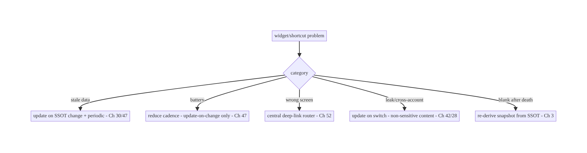
55.9 Failure Scenarios and Recovery
Widgets live or die by the SSOT + update cadence: back them with the single source of truth (Ch 3) and update them on real changes plus a battery-respecting periodic job (Ch 30/47). Everything else — freshness, process-death resilience, account correctness — follows from rendering a snapshot of the SSOT rather than holding widget-local state.

55.10 Scaling the Implementation
- Level 1. A Glance widget rendering an SSOT snapshot; static shortcuts; deep-link taps.
- Level 2. WorkManager updates (periodic + on-change, Ch 47); dynamic shortcuts (contextual/recent); central deep-link routing (Ch 52).
- Level 3 — production. Multi-account updates (Ch 42) + privacy; cancel-on-remove lifecycle; pinned shortcuts on user action; battery-respecting cadence.
- Level 4 — large. Multiple widget types + sizes (responsive Glance); shortcut analytics (usage); per-account widget content; configurable widgets.
- Level 5 — enterprise. Widget/shortcut governance, engagement analytics (widget-driven opens), A/B of content, server-informed contextual shortcuts, consistent deep-link registry (Ch 52/53).
Avoid overengineering: most apps need one or two SSOT-backed widgets + a few static/ dynamic shortcuts + deep links. Don’t build many rarely-used widgets or over-refresh them.

55.11 Alternative Approaches and Trade-offs
Dimension | Option A | Option B | When
Widget API | Glance (Compose-style) | classic RemoteViews/AppWidgetProvider | Glance for new (nicer API, same limits); classic for legacy
Widget data | SSOT-backed snapshot | widget-local state | SSOT always (fresh, process-death-safe)
Update cadence | WorkManager (on-change + periodic) | updatePeriodMillis only | WorkManager (reliable, finer, respects Doze); updatePeriodMillis is 30-min min + unreliable
Shortcut type | Static + dynamic (+ pinned on request) | all static | Mix: static for fixed, dynamic for contextual
Entry routing | Central deep-link router (Ch 52) | per-surface intent handling | Central (consistency, auth, account)
Sensitive content | Summary + tap into app | full detail on widget | Summary (privacy on shared surface)
Glance vs classic RemoteViews: Glance offers a Compose-style authoring experience and is the modern recommendation, but it compiles to RemoteViews and inherits all the out-of-process limits (limited components, pushed updates, no arbitrary logic). It doesn’t remove the constraints — it just makes authoring pleasanter. Use Glance for new widgets; the execution model and SSOT/update requirements are identical to classic.
SSOT-backed vs widget-local data: holding data inside the widget leads to staleness, divergence from the app, and loss on process death. Rendering a snapshot of the SSOT (Ch 3) on each update keeps the widget consistent with the app, makes it process-death-safe (re-derived), and centralizes freshness in the sync layer (Ch 32). Always back widgets with the SSOT.
WorkManager updates vs updatePeriodMillis: the manifest updatePeriodMillis has a 30-minute minimum and is deferred/unreliable under Doze — inadequate for timely updates. WorkManager (Ch 30) with constraints (Ch 47) gives reliable, finer, battery- respecting updates and lets you push an on-change update promptly (expedited). Use WorkManager; treat updatePeriodMillis as a coarse backstop at most.

55.12 Security & Privacy Considerations
- Widgets are an always-visible, potentially shared surface: don’t show sensitive content (balances, private messages, health) by default — show a non-sensitive summary and require opening the app (or an opt-in / tap-to-reveal) for detail (Ch 28).
- Multi-account isolation (Ch 42): update/clear widgets and dynamic shortcuts on account switch; never show account A’s data under account B.
- Deep-link safety (Ch 52): widget/shortcut intents carry deep links — route through the central router that validates params and authorizes server-side (IDOR); build PendingIntents with FLAG_IMMUTABLE; don’t perform sensitive actions directly from a shortcut without in-app confirmation.
- Exported receivers: the AppWidgetProvider/GlanceAppWidgetReceiver is invoked by the system; validate inputs and keep logic minimal.
- Shortcut data is visible: dynamic shortcut labels (e.g., recent searches) appear on the launcher — don’t put sensitive text there (Ch 28).
- Client vs backend: widgets/shortcuts render client-side SSOT data and deep-link in; the backend authorizes the destination like any entry point (Ch 52/23).

55.13 Performance and Resource Optimization
- Update-on-change + coarse periodic (Ch 47) is the main battery lever — don’t poll or over-refresh.
- Only update when data actually changed (diff against last-pushed snapshot) to skip redundant RemoteViews pushes.
- Keep widget content light: small images (sized for the widget), minimal view tree — RemoteViews are serialized across processes.
- Cancel work when no widgets remain (onDisabled).
- Respect the shortcut cap (getMaxShortcutCountPerActivity) — extra pushes are dropped.
- Profiling: widget-update frequency + battery attribution (Battery Historian), widget/shortcut-driven app opens, update latency after SSOT change.

55.14 Testing Strategy
Glance has test utilities; shortcuts/WorkManager test with their APIs; deep links via Ch 52 patterns.
// Glance widget content (GlanceAppWidgetUnitTest / runGlanceAppWidgetUnitTest):
class OrderWidgetTest {
@Test fun `renders latest order status from SSOT`() = runGlanceAppWidgetUnitTest {
// provide a fake OrderRepository snapshot; assert the Text shows the status + deep-link action
}
}
class WidgetUpdateWorkerTest {
@Test fun `updates widget from SSOT`() = runTest {
val worker = TestListenableWorkerBuilder<WidgetUpdateWorker>(context).build()
assertEquals(Result.success(), worker.doWork()) // (fake widget update)
}
}
class ShortcutPublisherTest {
@Test fun `respects max shortcut count`() { /* push N > cap -> only cap pushed */ }
@Test fun `clearDynamic removes all on logout`() { /* Ch 42 */ }
}
What to test: widget renders correct SSOT snapshot + deep-link action; update worker pushes update; on-change + periodic scheduling (WM TestDriver); shortcut cap respected; dynamic shortcuts cleared on logout; account switch updates widget/shortcuts; deep-link tap routes correctly (Ch 52); no update after onDisabled. Instrumentation for real widget add/remove.

55.15 Production Observability
- Metrics: widget-update frequency + battery attribution (Ch 47); widget/shortcut- driven app-open rate (engagement); update latency after SSOT change; dynamic-shortcut usage; pinned-shortcut acceptance; stale-data reports; cross-account leak (0).
- Logs: widget{type, trigger, updated, account} / shortcut{type, id, launched} — no sensitive content/PII (Ch 28).
- Debugging: stale widget → update not triggered on SSOT change / Doze deferral; battery → over-refresh; blank → process death + no re-derive; wrong screen → deep-link routing (Ch 52); empty shortcuts → not pushed / cap exceeded.
- Alerting: widget-update battery spike; cross-account leak; deep-link failure from these surfaces.
- Dashboards: widget/shortcut engagement (opens driven); update cost vs freshness.

55.16 System Design Interview Preparation
≥25 questions.
Fundamentals
- How does a widget run? Out-of-process in the launcher via RemoteViews; updates pushed from your process.
- Glance? Compose-style widget API that compiles to RemoteViews — same limits.
- Can a widget run arbitrary code? No — limited view tree, pushed updates.
- Where does widget data come from? The SSOT (Ch 3) — render a snapshot.
- Process death? Widget re-derives from SSOT on next update (no state to restore).
Updates
- How to update a widget? WorkManager (periodic + on-change) pushing new RemoteViews.
- updatePeriodMillis limits? 30-min minimum, unreliable under Doze.
- Respect background limits? Yes — cadence per Doze/App Standby (Ch 47); update-on- change.
- Over-update cost? Battery + rate limits.
Shortcuts
- Three types? Static (manifest, fixed), dynamic (runtime, contextual), pinned (user- placed).
- Cap? ~4–5 visible (getMaxShortcutCountPerActivity).
- Dynamic use? Recent/contextual; update as context changes.
- Pinned? Request only on user action.
- What do they fire? An Intent / deep link (Ch 52).
Deep links
- Routing? Central router (Ch 52): destination + back stack + auth + account.
- PendingIntent? FLAG_IMMUTABLE.
- Untrusted? Yes — validate + server authz (Ch 52/23).
Multi-account/privacy
- Account switch? Update/clear widgets + dynamic shortcuts (Ch 42).
- Sensitive content on widget? Avoid — summary only; detail in-app (Ch 28).
- Shortcut labels? No sensitive text (visible on launcher).
Lifecycle
- Widget removed? onDisabled/onDeleted → cancel update work.
- SSOT access from widget? Hilt EntryPoint + Room snapshot.
Testing/Production
- Test widget content? Glance unit test utilities.
- Test shortcuts? Cap + clear-on-logout.
- Stale widget cause? Update not triggered / Doze deferral.
- Battery? Over-refresh — reduce cadence.

Design-change challenges
- Order-status widget that stays fresh. SSOT-backed + WorkManager on-change + periodic (Ch 30/47).
- Long-press quick actions (Search, My Orders, recent). Static + dynamic shortcuts → deep links.
- Widget drains battery. Update-on-change only + coarse periodic; respect Doze.
- Widget shows the wrong account after switching. Update on switch; non-sensitive content (Ch 42/28).
- Resume last show from the launcher. Dynamic shortcut + widget tile deep-linking to the player (Ch 58).

Mock walkthrough (abridged)
Clarify (what content, how fresh, which actions, shared surface/sensitive?) → widget = RemoteViews/Glance snapshot of SSOT (Ch 3) → updates via WorkManager (on-change + periodic, Ch 47) → shortcuts (static/dynamic/pinned, cap) → deep-link both via central router (Ch 52, auth/account) → multi-account + privacy (Ch 42/28) → lifecycle (cancel on remove) → testing/observability (engagement, battery).

55.17 Practical Exercises
- Beginner. Build a Glance widget showing the latest order status from the SSOT, with a deep-link tap. Eval: renders snapshot; tap opens the order.
- Intermediate. Update the widget on SSOT change and on a periodic WorkManager job respecting Doze; cancel work when the last widget is removed. Eval: fresh; battery- respecting; cancels.
- Advanced. Add static shortcuts (Search, My Orders) and dynamic recent-search shortcuts (cap-aware) that deep-link; clear dynamic on logout. Eval: correct types; cap respected; cleared.
- Production debugging. Fix a stale widget (update not triggered on sync) and battery drain (over-refresh). Eval: updates on change; cadence reduced.
- System design challenge. Make widgets + dynamic shortcuts account-aware (update on switch, no leak) and add engagement analytics. Eval: account-isolated; opens tracked.
(Solutions withheld unless requested.)

55.18 Chapter Summary & Reference Sheet
Key decisions: build widgets with Glance (which compiles to RemoteViews and runs out-of-process in the launcher, so no arbitrary logic — updates are pushed), rendering a snapshot of the SSOT (Ch 3) so they’re fresh and process-death-safe; update via WorkManager (on-change + a coarse periodic job, respecting Doze/App Standby, Ch 30/47) rather than the unreliable 30-minute updatePeriodMillis, and only when data actually changed; provide app shortcuts — static (fixed, manifest), dynamic (contextual/recent, within the ~4–5 cap), pinned (on user request) — that deep-link (Ch 52) into the app; route all widget/shortcut taps through the central deep-link router (destination + back stack + auth + account, with FLAG_IMMUTABLE PendingIntents); and treat these as shared, always-visible surfaces — update/clear on account switch (Ch 42) and keep sensitive content off them (summary in the widget, detail in the app, Ch 28).
Concepts: RemoteViews/out-of-process widgets, Glance, SSOT-backed snapshots, WorkManager updates (on-change + periodic) under Ch 47, app shortcuts (static/dynamic/ pinned + cap), deep-link integration, multi-account/privacy, widget lifecycle.
Common mistakes: treating a widget like an Activity (arbitrary logic); widget-local data (stale/lost); updatePeriodMillis-only updates (unreliable/coarse); over-refreshing (battery); wrong shortcut type / ignoring the cap; not updating on account switch (leak/ wrong data); sensitive content on the widget; not routing taps through the central deep- link router; not cancelling work when widgets are removed.
Checklist:
- ☐ Glance/RemoteViews snapshot of SSOT (Ch 3)
- ☐ WorkManager updates (on-change + periodic, Ch 47)
- ☐ update only on real change
- ☐ static/dynamic/pinned shortcuts (respect cap)
- ☐ deep-link via central router (Ch 52) + FLAG_IMMUTABLE
- ☐ auth/account checks
- ☐ update/clear on account switch (Ch 42)
- ☐ no sensitive content on widget (Ch 28)
- ☐ cancel work on onDisabled
- ☐ engagement/battery telemetry.
Key APIs: GlanceAppWidget/GlanceAppWidgetReceiver/provideContent/updateAll/ updateAppWidgetState, AppWidgetProvider/AppWidgetManager/RemoteViews, ShortcutManagerCompat (pushDynamicShortcut/requestPinShortcut/ getMaxShortcutCountPerActivity/removeAllDynamicShortcuts), ShortcutInfoCompat, static shortcuts XML, CoroutineWorker/WorkManager (Ch 30), Hilt EntryPoint, PendingIntent/actionStartActivity (FLAG_IMMUTABLE, Ch 52).
References:
- App widgets / Glance: https://developer.android.com/develop/ui/compose/glance
- Create a widget (RemoteViews): https://developer.android.com/develop/ui/views/appwidgets/overview
- App shortcuts: https://developer.android.com/develop/ui/views/launch/shortcuts
- Update widgets with WorkManager: https://developer.android.com/develop/ui/compose/glance/glance-app-widget
- (composes) Ch 3 SSOT, Ch 30 WorkManager, Ch 47 Doze/Limits, Ch 52 Deep Links, Ch 42 Multi-Account, Ch 28 Privacy

Part VII — Media & Files
Media and storage: image loading and thumbnails, Media3/ExoPlayer playback, offline OTT and DRM, camera, large-file streaming, and the Storage Access Framework.

Chapter 56 — Image Loading & Caching (Coil)
Part VII — Media & Files · Complexity: Standard (≥25 interview questions)
Prerequisites: Ch 12 (caching), Ch 1 (networking/OkHttp), Ch 6 (UI state), Ch 13 (paging), Ch 44 (lifecycle), Ch 45 (startup/perf). Pairs with Ch 57 (thumbnails), Ch 60 (camera), Ch 86 (performance).
Reference surface in StreamCart: every image — product photos, thumbnails, avatars, banner carousels, stream posters — loaded fast, cached in memory and on disk, correctly sized, and without jank, OOM, or recycled-view flicker.
Note: this chapter opens Part VII — Media & Files (Ch 56–62).

56.1 Problem Definition and Real-World Context
Images dominate a modern app’s bandwidth, memory, and visual quality. A commerce/ streaming app shows thousands of images across feeds, grids, and carousels. Loading them naively — decoding full-resolution bitmaps on the main thread, no caching, no size targeting — causes OOM crashes, jank, wasted bandwidth, and flicker in recycled lists. Image loading is deceptively deep: it spans networking, decoding, two cache tiers, lifecycle, and view recycling.
Concretely, teams hit:
- OOM from full-size bitmaps. A 4000×3000 photo decoded at full resolution into a 200dp ImageView wastes ~48MB and risks OOM. Images must be downsampled to the target size.
- Main-thread decoding → jank. Decoding/resizing on the UI thread drops frames; it must be off the main thread (Coil does this).
- No caching → repeated downloads. Without a memory cache (fast, in-RAM) and a disk cache (persistent, across sessions) every scroll re-downloads — slow, costly, battery-draining. Two tiers are needed (Ch 12).
- Recycled-view flicker / wrong image. In RecyclerView/LazyColumn, an async load completing after the view is recycled shows the wrong image unless the request is tied to the view/lifecycle and cancelled on recycle.
- Reinventing it. Hand-rolling decode/cache/cancel is a classic mistake — mature libraries (Coil for Kotlin/Compose, Glide/Fresco historically) solve it correctly. The job is to use Coil well, not rebuild it.
- Formats, transformations, placeholders. Modern formats (WebP/AVIF), transformations (crop/rounded/blur), placeholders/error images, crossfade, and (Ch 57) thumbnails all need coherent handling.
The architecture: use Coil (OkHttp-backed, coroutine-native, Compose-first) as the image pipeline; configure a two-tier cache (memory + disk, Ch 12) sharing the app’s OkHttp client (Ch 1); target the display size (downsample so you never decode more than needed); tie each request to the lifecycle/composition (auto-cancel on recycle/ leave, Ch 44) to avoid flicker/leaks; set placeholders/error/crossfade; apply transformations efficiently; prefer modern formats and request appropriately- sized images from the backend/CDN (Ch 57); and tune memory (cache size by device) to avoid OOM. This chapter is about fast, correct, memory-safe image loading at scale with Coil.

Three practical use cases
- Product grid (StreamCart). A LazyVerticalGrid of product images — Coil loads each sized to the cell, memory+disk cached, request scoped to composition so scrolling never shows the wrong image or OOMs.
- Avatar with transformation. A circular avatar with a placeholder and crossfade, cached, decoded off-main.
- Banner carousel + thumbnails. A hero banner (large) and thumbnail strip (small) request different sizes (Ch 57) from the CDN, each cached appropriately.

Why this is architectural
Image loading touches networking (Ch 1), caching (Ch 12), memory/OOM, main-thread/jank, lifecycle (Ch 44), and list recycling at once. The decisions — library choice, two-tier cache, size targeting, lifecycle scoping, memory tuning — determine visual quality, performance, crash rate, and bandwidth across the whole app.

56.2 Requirements Engineering

Functional requirements
ID | Requirement
F1 | Load remote/local images into Compose/Views asynchronously, off the main thread.
F2 | Cache in memory and on disk (two tiers), sharing OkHttp (Ch 1).
F3 | Downsample to the target display size (no over-decoding).
F4 | Tie requests to lifecycle/composition (cancel on recycle/leave) — no flicker/leak.
F5 | Placeholders, error images, crossfade, transformations.
F6 | Tune memory to avoid OOM; prefer modern formats + right-sized source (Ch 57).

Non-functional requirements
Attribute | Target/Policy
Memory | No OOM; downsample to target; bounded memory cache by device.
Performance | Off-main decode; no jank; fast cache hits.
Bandwidth | Disk cache + right-sized requests; no re-download.
Correctness | No wrong/flickering images in recycled lists.
Quality | Placeholders/crossfade; sharp images at display size.

Scope
- In scope: Coil pipeline (ImageLoader, AsyncImage/rememberAsyncImagePainter), two-tier cache (memory + disk) + OkHttp sharing (Ch 1/12), size targeting/downsampling, lifecycle/composition scoping + cancellation, placeholders/error/crossfade, transformations, formats, memory tuning, right-sized CDN requests (Ch 57), preloading.
- Out of scope: thumbnail generation (Ch 57), camera capture (Ch 60), general caching theory (Ch 12), networking internals (Ch 1), Compose perf detail (Ch 60/86).

Assumptions & constraints
- Coil 2.x/3.x (coroutine-native, Compose-first, OkHttp-backed), shared OkHttp client (Ch 1), Compose primary (Views supported). minSdk 24. Bitmaps are heap-heavy; main- thread decode causes jank; recycled views need request cancellation.

56.3 System Design Fundamentals
- Use a mature library (Coil). Coil is Kotlin-first, coroutine-native, Compose-first, and OkHttp-backed — it handles off-main decoding, two-tier caching, downsampling, lifecycle cancellation, transformations, and formats correctly. Don’t hand-roll; the architecture is configuring Coil well. (Glide/Fresco are the mature Java-era equivalents; Coil is the modern Kotlin choice.)
- Two-tier cache (Ch 12):
  - Memory cache: decoded Bitmaps in RAM — fastest, bounded (by % of app memory). Hit = instant redraw (e.g., scrolling back).
  - Disk cache: encoded bytes on disk — persistent across sessions, avoids re-download. Coil’s disk cache (or the shared OkHttp cache, Ch 1/12) stores the HTTP responses.
  - Flow: memory hit → use; else disk hit → decode → populate memory; else network (OkHttp) → disk + memory. Share the app’s OkHttp client so HTTP caching, auth (Ch 19), and pinning (Ch 23) apply uniformly.
- Size targeting / downsampling (the OOM lever). A Bitmap’s memory is width × height × bytesPerPixel — independent of file size. Decoding a huge image into a small view wastes memory and risks OOM. Coil measures the target (the ImageView/ composable bounds) and downsamples during decode so it only ever holds a bitmap near the display size. Always let Coil size to the target (don’t force Size.ORIGINAL unless needed).
- Off-main decoding → no jank. Decoding/resizing happens on a background dispatcher; the main thread just draws the result. This (plus caching) is what keeps scrolling smooth.
- Lifecycle & recycling (the correctness lever):
  - In Compose, AsyncImage/rememberAsyncImagePainter tie the request to the composition — recomposition/leaving cancels/replaces it, so no wrong image.
  - In Views, Coil ties the request to the ImageView and cancels on recycle (via the view’s lifecycle), preventing a late load from showing in a reused row.
  - Requests are also tied to a LifecycleOwner (Ch 44) so they pause/cancel appropriately.
- Placeholders, error, crossfade: show a placeholder while loading, an error image on failure, and a crossfade for a smooth appearance — basic quality that also avoids layout jumps (set a fixed size / aspect ratio).
- Transformations: crop, rounded corners, circle, blur applied in the pipeline (cached as part of the key). Keep them cheap; heavy transforms belong off-main (Coil handles) and should be cache-keyed so they’re not recomputed.
- Formats & right-sizing (Ch 57): prefer WebP/AVIF (smaller) from the backend; request CDN-resized images per use (thumbnail vs full, Ch 57) rather than downloading a huge original and shrinking client-side — saves bandwidth and memory. The URL carries the size (?w=200) in a well-designed image API.
- Memory tuning: size the memory cache as a percentage of available heap (Coil default is sensible); on low-memory devices use less; respond to onTrimMemory/ lifecycle to release. Avoid caching giant originals in memory.
- Preloading: for predictable needs (next carousel page, Ch 13), preload into the cache so the image is ready when shown — but don’t over-preload (bandwidth/memory).
Core insight: use Coil (OkHttp-backed, coroutine-native, Compose-first) rather than hand-rolling; configure a two-tier cache (memory for decoded bitmaps + disk/OkHttp for encoded bytes, sharing the app’s OkHttp client, Ch 1/12); always downsample to the target display size (the main OOM/jank lever) with off-main decoding; tie every request to the composition/view lifecycle so recycled lists never flicker or show the wrong image (Ch 44); add placeholders/error/crossfade/transformations; and request right-sized, modern-format images from the CDN (Ch 57) while tuning the memory cache to the device.

56.4 High-Level Architecture
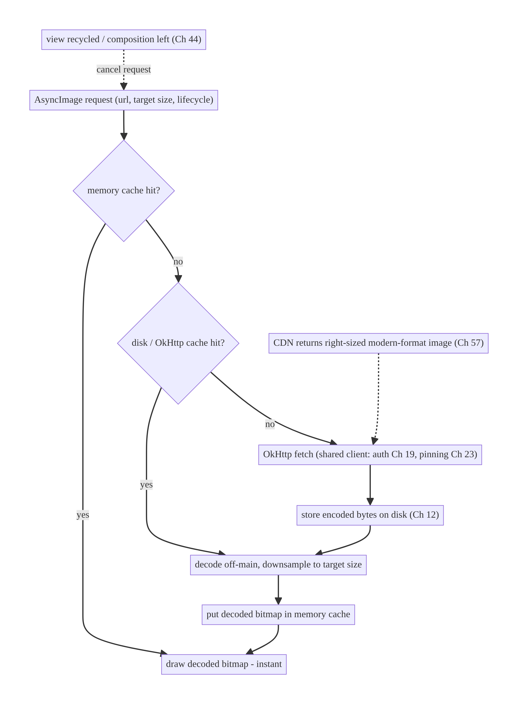
56.4 High-Level Architecture
Components & ownership
- Coil ImageLoader orchestrates: memory → disk/OkHttp → network, off-main decode + downsample.
- Two-tier cache (memory decoded, disk encoded) sharing OkHttp (Ch 1/12).
- Lifecycle binding cancels on recycle/leave.
- CDN supplies right-sized/modern-format sources (Ch 57).
Direction: request → memory → disk → network → decode/downsample off-main → draw; cancelled on recycle.

56.5 Detailed Component Design
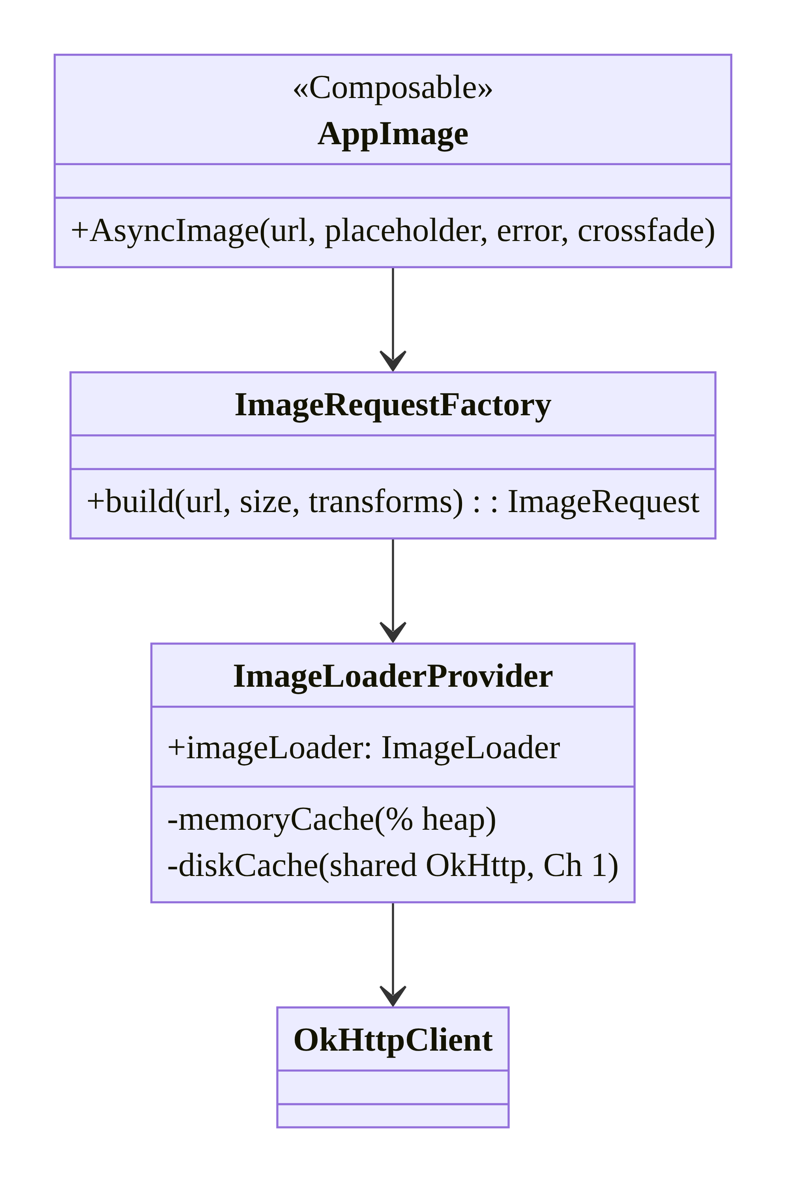
56.5 Detailed Component Design
Component | Responsibility
ImageLoaderProvider | single configured ImageLoader (memory %, disk, shared OkHttp)
ImageRequestFactory | build requests (size target, transforms, placeholders)
AppImage | Compose wrapper (AsyncImage) with app defaults
CDN URL helper (Ch 57) | append size params for right-sizing

56.6 End-to-End Data Flow

Loading a product image in a grid
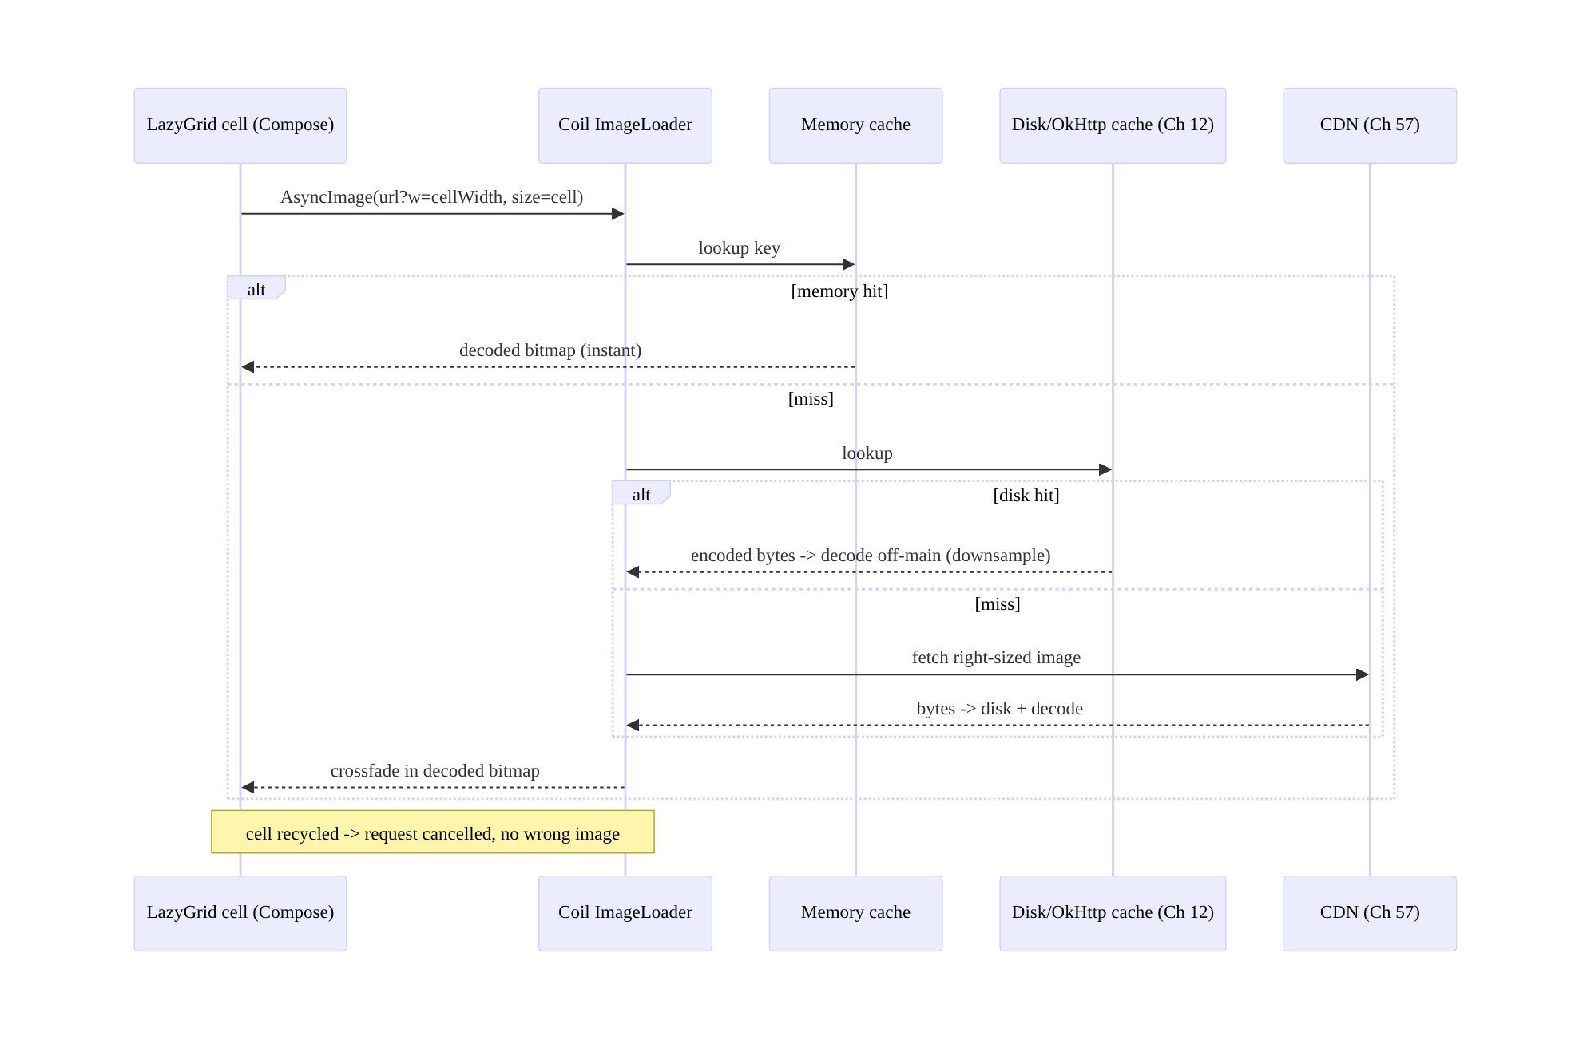
Loading a product image in a grid

Size targeting prevents OOM
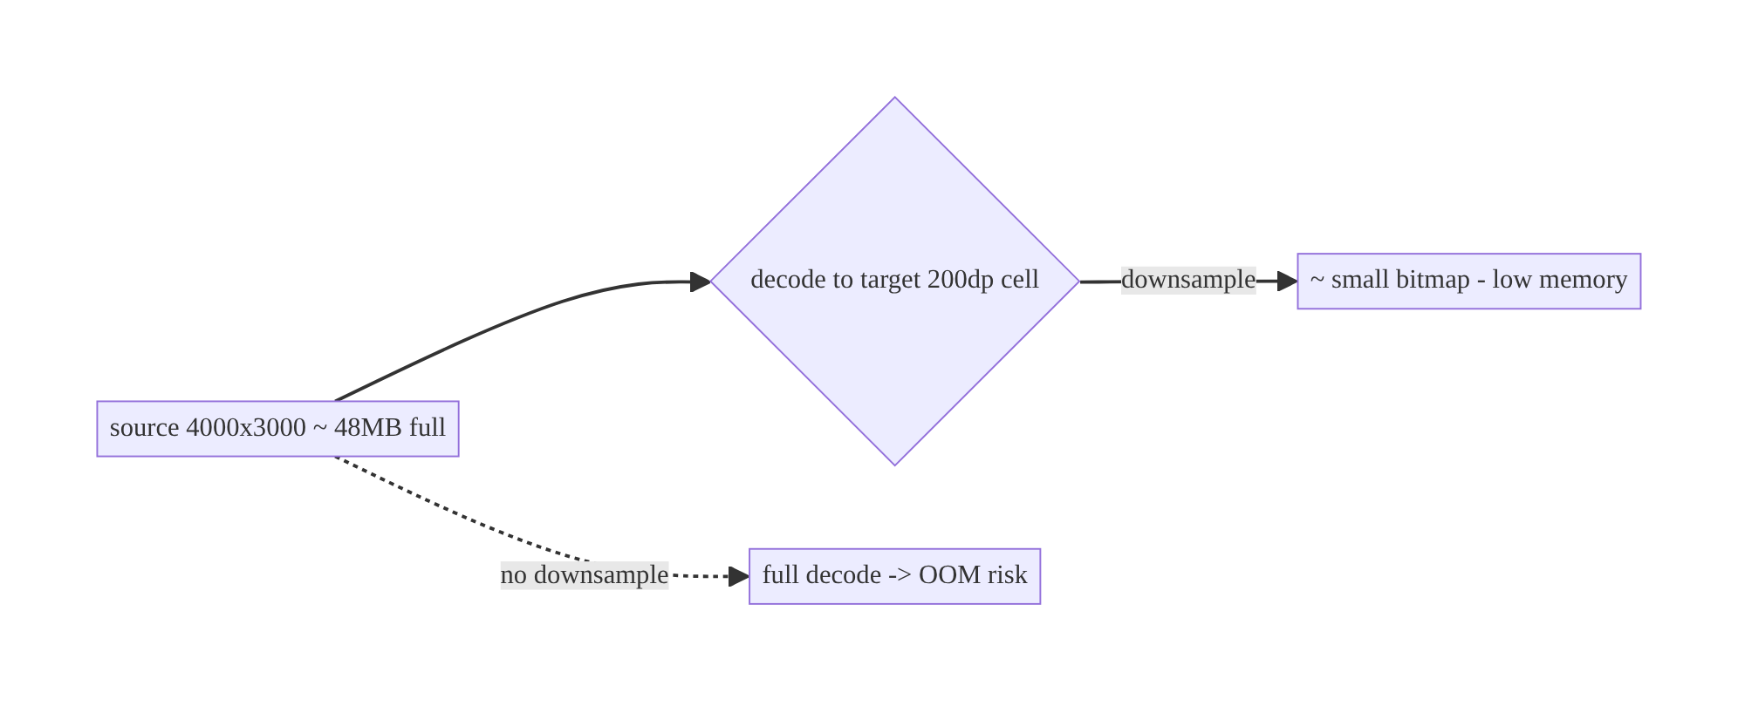
Size targeting prevents OOM

56.7 Complete Kotlin Implementation
Package: com.streamcart.images.

56.7.1 Single configured ImageLoader (shared OkHttp, two-tier cache)
@Module @InstallIn(SingletonComponent::class)
object ImageModule {
@Provides @Singleton
fun imageLoader(@ApplicationContext ctx: Context, okHttp: OkHttpClient): ImageLoader =
ImageLoader.Builder(ctx)
.okHttpClient(okHttp) // SHARE app OkHttp: auth (Ch 19), pinning (Ch 23), HTTP cache (Ch 12)
.memoryCache { MemoryCache.Builder(ctx).maxSizePercent(0.25).build() } // % of heap (tune by device)
.diskCache { DiskCache.Builder().directory(ctx.cacheDir.resolve("image_cache")).maxSizeBytes(250L*1024*1024).build() }
.crossfade(true) // smooth appearance
.respectCacheHeaders(true) // honor server cache-control (Ch 12)
.build()
}

56.7.2 Compose: AsyncImage with app defaults (size-targeted, placeholder/error)
@Composable
fun AppImage(url: String?, contentDescription: String?, modifier: Modifier = Modifier,
contentScale: ContentScale = ContentScale.Crop) {
AsyncImage(
model = ImageRequest.Builder(LocalContext.current)
.data(url?.sized(/* target handled automatically by the composable bounds */)) // right-size via CDN (Ch 57)
.crossfade(true)
.build(),
contentDescription = contentDescription, // a11y
modifier = modifier, // bounds define decode target -> downsample
contentScale = contentScale,
placeholder = painterResource(R.drawable.ph_image),
error = painterResource(R.drawable.ph_image_error),
)
// Coil measures `modifier` bounds -> decodes to that size (no OOM); request tied to composition (auto-cancel).
}

56.7.3 Right-sizing the CDN URL (Ch 57)
/** A well-designed image API carries size in the URL; request only what you display. */
fun String.sized(width: Int? = null, height: Int? = null, format: String = "webp"): String =
buildString {
append(this@sized)
append(if (contains("?")) "&" else "?")
width?.let { append("w=$it&") }
height?.let { append("h=$it&") }
append("fm=$format") // prefer modern format (WebP/AVIF)
}
// Grid cell: imageUrl.sized(width = cellWidthPx). Hero: imageUrl.sized(width = screenWidthPx).

56.7.4 Transformations + avatar
@Composable
fun Avatar(url: String?, size: Dp) {
AsyncImage(
model = ImageRequest.Builder(LocalContext.current)
.data(url?.sized(width = with(LocalDensity.current) { size.roundToPx() }))
.transformations(CircleCropTransformation()) // cached as part of the key
.crossfade(true)
.build(),
contentDescription = "avatar",
modifier = Modifier.size(size).clip(CircleShape),
placeholder = painterResource(R.drawable.ph_avatar),
)
}

56.7.5 Preloading (predictable next content, Ch 13)
class ImagePreloader @Inject constructor(private val imageLoader: ImageLoader, @ApplicationContext private val ctx: Context) {
fun preload(urls: List<String>) = urls.forEach { url ->
imageLoader.enqueue(ImageRequest.Builder(ctx).data(url).build()) // warm memory/disk cache
}
// Preload next page of a carousel/grid; don't over-preload (bandwidth/memory).
}

56.7.6 Memory pressure + module structure
// Coil responds to onTrimMemory via its MemoryCache; optionally clear on severe pressure:
// imageLoader.memoryCache?.clear() // on TRIM_MEMORY_COMPLETE if needed
:core:images ImageModule (ImageLoader), AppImage, Avatar, ImageRequestFactory, ImagePreloader, String.sized
# Shares :core:network OkHttp (Ch 1). CDN right-sizing contract (Ch 57).

56.8 Concurrency and Race Conditions
Scenario | Risk | Handling
Load completes after view recycled | wrong image in reused row | Coil ties request to view/composition → cancels on recycle
Many parallel loads on fast scroll | thrash/OOM | Coil dispatches off-main + bounded; downsample; cancel off-screen
Same URL requested concurrently | duplicate downloads | Coil de-dupes in-flight requests (single-flight, Ch 11)
Main-thread decode | jank | off-main decode (Coil)
Full-size decode into small view | OOM | size-target/downsample
Transformation recomputed each bind | CPU | cache-keyed transforms
- Lifecycle/view binding is the anti-flicker mechanism: because Coil ties a request to the composable/ImageView and cancels it when recycled, a slow load for an off-screen item never lands in a reused view — the classic RecyclerView wrong-image bug is handled for you (don’t bypass it with manual loads).
- In-flight de-duplication means the same URL requested by many cells downloads once (single-flight, Ch 11) — no manual coordination needed.
- Downsampling + off-main decode together are what keep fast scrolling smooth and OOM-free.

56.9 Failure Scenarios and Recovery
Failure | Detection | Response | Outcome
OOM on large images | crash/low-memory | downsample to target; bound memory cache | no OOM
Jank on scroll | frame metrics | off-main decode (Coil); right-size; preload modestly | smooth
Wrong image in recycled view | QA | lifecycle-bound request (Coil default) | correct
Repeated downloads | bandwidth | disk cache + share OkHttp; respect cache headers | cached
Broken image URL | load failure | error placeholder; retry policy | graceful
Layout jump on load | visual | fixed size/aspect + placeholder | stable
Huge original from backend | bandwidth/memory | request CDN right-sized/modern format (Ch 57) | efficient
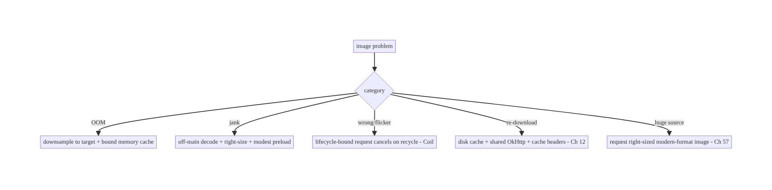
56.9 Failure Scenarios and Recovery
The two image killers are OOM and jank, and both come from decoding more than you display. Size-targeting/downsampling plus off-main decode (both Coil defaults when you let it size to the view) eliminate them; two-tier caching kills re-downloads; and lifecycle-bound requests kill recycled-view flicker. Don’t fight Coil’s defaults.

56.10 Scaling the Implementation
- Level 1. Coil AsyncImage with a shared OkHttp client; placeholders/crossfade.
- Level 2. Two-tier cache tuned (memory %, disk size); size-targeting; transformations.
- Level 3 — production. CDN right-sizing + modern formats (Ch 57); preloading for predictable content; error handling; memory-pressure response.
- Level 4 — large. Per-surface request policies (grid vs hero vs avatar); image analytics (cache hit rate, decode time); device-tiered cache sizing; blur-hash/ low-quality-image-placeholder (LQIP) for perceived speed.
- Level 5 — enterprise. Image CDN governance, format negotiation (AVIF/WebP by support), bandwidth/quality SLOs, offline image availability (Ch 59), consistent image API contract across teams.
Avoid overengineering: Coil with a shared OkHttp client, size-targeting, and a tuned two-tier cache covers the vast majority. Don’t hand-roll caching/decoding or over-preload.

56.11 Alternative Approaches and Trade-offs
Dimension | Option A | Option B | When
Library | Coil | Glide / Fresco | Coil for Kotlin/Compose; Glide/Fresco for legacy/Views-heavy
Build vs buy | Use a library | hand-roll | Always use a library (decode/cache/cancel are hard)
Cache | Memory + disk (two-tier) | memory only / none | Two-tier (Ch 12) — persistence + speed
Sizing | Target display size (downsample) | full original | Target size (OOM/jank/bandwidth)
Source size | CDN right-sized (Ch 57) | download original, shrink | CDN right-sized (bandwidth/memory)
OkHttp | Share app client | separate client | Share (auth/pinning/cache uniform, Ch 1/19/23)
Perceived speed | Placeholder/crossfade/LQIP | blank → pop-in | Placeholder/crossfade (quality)
Coil vs Glide/Fresco: all are mature and solve the hard parts (off-main decode, two-tier cache, lifecycle cancellation, downsampling). Coil is Kotlin-first, coroutine- native, and Compose-first with a small footprint and OkHttp integration — the natural choice for modern Kotlin/Compose apps. Glide is battle-tested and feature-rich for Views/Java; Fresco excels at very memory-constrained scenarios (ashmem). Pick Coil for new Compose apps; the architectural principles (two-tier cache, size-targeting, lifecycle scoping) are identical across all three.
CDN right-sizing vs client-side shrink: downloading a full-resolution original and downsampling on-device still wastes bandwidth (you downloaded megabytes to show a thumbnail) even if memory is fine. Requesting a CDN-resized image (?w=200, Ch 57) transfers only what’s displayed and in a modern format (WebP/AVIF). Right-size at the source; let Coil size-target as a second safety net.
Build vs buy: hand-rolling image loading (decode, two-tier cache, in-flight dedupe, lifecycle cancellation, downsampling, format support) is a large, bug-prone effort that libraries have refined over years. Always use Coil/Glide/Fresco; spend effort on configuring and right-sizing, not reimplementing.

56.12 Security & Privacy Considerations
- Share the authenticated OkHttp client (Ch 1/19/23): image requests to protected URLs carry auth and go through certificate pinning — don’t use a separate, unpinned/unauthenticated client for images (a bypass of your network security).
- Don’t cache sensitive images insecurely: private images (ID photos, documents) shouldn’t sit in a world-readable cache; use app-internal cache dirs (default) and consider not disk-caching highly sensitive media (Ch 25/28).
- Validate image sources: load only from trusted hosts/CDN; an attacker-supplied URL (from a deep link, Ch 52, or user content) could point anywhere — allowlist domains for sensitive contexts and beware decompression bombs (very large dimensions → OOM; cap decode size).
- Strip EXIF/metadata where privacy matters (location in photos, Ch 28/60) before upload/caching.
- Per-account isolation (Ch 42): don’t serve a cached image from one account’s session in another where it implies private content; key sensitive caches per account or clear on logout.
- Client vs backend: the backend/CDN serves right-sized images and enforces access (signed URLs/auth for private media, Ch 19/23); the client caches within app-internal storage and uses the secure network stack.

56.13 Performance and Resource Optimization
- Size-target/downsample (the #1 memory + bandwidth lever) — never decode larger than displayed.
- Two-tier cache (memory for instant redraw, disk for cross-session) + respect cache headers (Ch 12).
- CDN right-sizing + modern formats (WebP/AVIF, Ch 57) cut bytes dramatically.
- Off-main decode (Coil default) prevents jank.
- Modest preloading of predictable next content (Ch 13) — balance vs bandwidth.
- LQIP/blur-hash placeholders for perceived speed.
- Tune memory cache by device heap; release on memory pressure (onTrimMemory).
- Avoid heavy per-bind transformations; cache-key them.
- Profiling: cache hit rate (memory/disk), decode time, bitmap memory, jank frames during scroll, image bandwidth.

56.14 Testing Strategy
Image loading tests with Coil’s test support (fake ImageLoader/engine) and instrumentation for scroll/memory.
class AppImageTest {
@Test fun `uses shared OkHttp and targets size`() {
// Provide a fake ImageLoader; assert requests carry the right-sized URL and size target.
}
}
// Coil test: set a test ImageLoader that returns a fake image synchronously.
@Test fun `shows placeholder then image`() = runComposeTest {
val fakeLoader = ImageLoader.Builder(context).components { /* fake engine */ }.build()
setContent { CompositionLocalProvider(LocalImageLoader provides fakeLoader) { AppImage(url = "https://x/p.webp") } }
// assert placeholder shown, then image
}
class UrlSizingTest {
@Test fun `appends width and format`() =
assertEquals("https://cdn/x.jpg?w=200&fm=webp", "https://cdn/x.jpg".sized(width = 200))
}
What to test: URL right-sizing helper; AppImage uses the shared loader + size target + placeholder/error; cache config (memory %, disk size); transformation applied; (integration) no OOM scrolling a large grid, no wrong-image on fast recycle, cache hit on scroll-back. Use Coil’s fake engine for deterministic unit tests; instrumentation for memory/jank.

56.15 Production Observability
- Metrics: memory/disk cache hit rate; average decode time; bitmap memory footprint; image bandwidth; OOM/low-memory rate attributable to images; scroll jank frames; load failure rate; preload waste (preloaded-not-shown).
- Logs: image{host, size_requested, cache(memory/disk/network), decode_ms} — no sensitive URLs/PII (Ch 28).
- Debugging: OOM → not downsampling / caching originals; jank → main-thread work / over-large decode / over-preload; re-downloads → disk cache misconfigured / cache headers ignored; wrong image → bypassed lifecycle binding; high bandwidth → not CDN right-sizing (Ch 57).
- Alerting: image-OOM rate; cache-hit-rate drop (CDN/caching regression).
- Dashboards: cache hit rate + bandwidth + decode time by surface; image OOM trend.

56.16 System Design Interview Preparation
≥25 questions.
Fundamentals
- Why a library (Coil)? Off-main decode, two-tier cache, lifecycle cancel, downsample — all hard to hand-roll.
- Coil vs Glide/Fresco? Kotlin/Compose-native vs legacy/Views vs memory-constrained; same principles.
- Two-tier cache? Memory (decoded bitmaps, fast) + disk (encoded bytes, persistent, Ch 12).
- Share OkHttp? Yes — uniform auth (Ch 19), pinning (Ch 23), HTTP cache (Ch 12).
- Why off-main decode? Avoid jank.
Memory/OOM
- Bitmap memory? w × h × bytesPerPixel (not file size).
- OOM cause/fix? Full-size decode into small view → downsample to target.
- Memory cache sizing? % of heap; tune by device; release on pressure.
- Decompression bomb? Cap decode dimensions; validate sources.
Correctness
- Recycled-view wrong image? Request tied to view/composition, cancelled on recycle.
- In-flight dedupe? Same URL downloads once (single-flight, Ch 11).
- Layout jump? Fixed size/aspect + placeholder.
Quality/perf
- Placeholders/crossfade? Perceived speed + no pop-in.
- Transformations? Pipeline, cache-keyed.
- Modern formats? WebP/AVIF (smaller).
- CDN right-sizing? Request ?w= sized image (Ch 57) — bandwidth + memory.
- Preloading? Warm cache for predictable content; don’t over-preload.
Caching
- Cache flow? Memory → disk → network.
- Respect cache headers? Yes (Ch 12).
- Cross-session persistence? Disk cache.
Security
- Sensitive images? App-internal cache; maybe no disk cache; per-account (Ch 42/28).
- Untrusted URLs? Allowlist; cap decode size (Ch 52).
- EXIF? Strip for privacy (Ch 60/28).
Testing/Production
- Test images? Coil fake engine; instrumentation for OOM/jank.
- Key metrics? Cache hit rate, decode time, bitmap memory, bandwidth.
- OOM in prod? Not downsampling / caching originals.

Design-change challenges
- Product grid OOMs on scroll. Size-target/downsample + bound memory cache + CDN right-size.
- Wrong images flash in a recycled list. Lifecycle-bound requests (Coil default) — don’t bypass.
- Images re-download every session. Disk cache + shared OkHttp + respect cache headers.
- High image bandwidth. CDN right-sizing + WebP/AVIF (Ch 57).
- Avatars need circular crop with a placeholder. CircleCropTransformation + placeholder + crossfade.

Mock walkthrough (abridged)
Clarify (how many images, sizes, offline?, sensitive?) → use Coil (shared OkHttp) → two-tier cache (memory %, disk) → size-target/downsample (OOM/jank) + off-main → lifecycle- bound requests (recycle correctness) → placeholders/crossfade/transforms → CDN right- sizing + modern formats (Ch 57) → memory tuning → security (auth/pinning, sensitive cache, untrusted URLs) → observability (cache hit, decode, bandwidth).

56.17 Practical Exercises
- Beginner. Load a product grid with Coil AsyncImage using the shared OkHttp client, with placeholders and crossfade. Eval: images load off-main; cached.
- Intermediate. Configure the two-tier cache (memory %, disk size) and right-size CDN URLs per surface (grid vs hero). Eval: cache hits on scroll-back; bandwidth matches display size.
- Advanced. Add a circular avatar transformation and preload the next carousel page; verify no OOM on a large grid. Eval: transform cached; preloaded; no OOM.
- Production debugging. Fix OOM (decoding originals) and recycled-view flicker (bypassed lifecycle binding). Eval: downsampled; correct images.
- System design challenge. Add per-account sensitive-image handling (no shared disk cache / clear on logout) and a cache-hit-rate dashboard. Eval: isolated; measurable.
(Solutions withheld unless requested.)

56.18 Chapter Summary & Reference Sheet
Key decisions: use Coil (coroutine-native, Compose-first, OkHttp-backed) rather than hand-rolling; configure a two-tier cache — memory for decoded bitmaps (bounded by % heap) and disk/OkHttp for encoded bytes — and share the app’s OkHttp client so auth (Ch 19), pinning (Ch 23), and HTTP caching (Ch 12) apply uniformly; always downsample to the target display size with off-main decoding (the #1 lever against OOM and jank — bitmap memory is w×h×bpp, not file size); tie every request to the composition/view lifecycle (Ch 44) so recycled lists never flicker or show the wrong image (Coil also de-dupes in-flight loads, Ch 11); add placeholders/error/crossfade and cache-keyed transformations; request right-sized, modern-format (WebP/AVIF) images from the CDN (Ch 57) to cut bandwidth; and tune the memory cache by device, releasing on pressure. Keep sensitive images in app-internal storage, per-account (Ch 42/ 28), and validate untrusted URLs.
Concepts: Coil pipeline, two-tier cache (memory/disk) + OkHttp sharing, size-targeting/ downsampling, off-main decode, lifecycle/composition binding + cancellation, in-flight dedupe, placeholders/crossfade/transformations, CDN right-sizing + modern formats, memory tuning, preloading.
Common mistakes: hand-rolling image loading; no/one-tier cache (re-downloads); decoding full-size into small views (OOM); main-thread decode (jank); bypassing lifecycle binding (wrong image in recycled views); separate unpinned client for images; downloading originals instead of CDN right-sizing; over-preloading; caching sensitive images insecurely.
Checklist:
- ☐ use Coil + shared OkHttp (Ch 1/19/23)
- ☐ two-tier cache (memory %, disk)
- ☐ size-target/downsample to display
- ☐ off-main decode
- ☐ lifecycle/composition-bound requests
- ☐ placeholders/error/crossfade
- ☐ cache-keyed transformations
- ☐ CDN right-sizing + WebP/AVIF (Ch 57)
- ☐ tune memory cache by device + release on pressure
- ☐ sensitive images app-internal, per-account (Ch 42/28)
- ☐ validate untrusted URLs + cap decode size.
Key APIs: ImageLoader.Builder (.okHttpClient/.memoryCache/.diskCache/ .crossfade/.respectCacheHeaders), AsyncImage/rememberAsyncImagePainter, ImageRequest.Builder (.data/.size/.transformations/.placeholder/.error), MemoryCache/DiskCache, CircleCropTransformation/RoundedCornersTransformation, ImageLoader.enqueue (preload), LocalImageLoader (test).
References:
- Coil: https://coil-kt.github.io/coil/
- Coil image requests / caching: https://coil-kt.github.io/coil/image_requests/
- Handling bitmaps / memory: https://developer.android.com/topic/performance/graphics
- (composes) Ch 1 Networking, Ch 12 Caching, Ch 57 Thumbnails, Ch 19 Auth, Ch 23 Pinning, Ch 42 Multi-Account

Chapter 57 — Thumbnail Generation & Caching
Part VII — Media & Files · Complexity: Standard (≥25 interview questions)
Prerequisites: Ch 56 (Coil/image loading), Ch 12 (caching), Ch 30 (WorkManager), Ch 3 (SSOT), Ch 25 (secure file storage), Ch 60 (camera). Pairs with Ch 58/59 (media), Ch 61 (large files).
Reference surface in StreamCart: small preview images derived from larger sources — grid thumbnails for products, video poster frames, PDF/receipt previews, user-uploaded photo previews — generated once, cached, and reused, so the app never re-downloads or re-decodes a full asset to show a tiny preview.

57.1 Problem Definition and Real-World Context
A thumbnail is a small preview derived from a larger asset: a resized image, a video frame, a PDF-page render, a document icon. Thumbnails are everywhere (grids, lists, carousels, pickers) and the wrong approach is costly: downloading or decoding the full-resolution source just to show a 100dp tile wastes bandwidth, memory (Ch 56), CPU, and battery, and is slow. The engineering question is who generates the thumbnail, where, and how it’s cached — and it differs by source type (remote image, local photo, video, document).
Concretely, teams hit:
- Downloading/decoding originals for previews. Fetching a 5MB photo to show a tiny grid cell (should request a CDN-resized thumbnail, Ch 56) or decoding a 4K frame to preview a video.
- Generating thumbnails on the main thread. Video-frame extraction, PDF rendering, and large-image decode are expensive and must be off-main (WorkManager/coroutine, Ch 30), or they jank/ANR.
- No thumbnail cache / regeneration every time. Re-extracting a video frame or re-rendering a PDF page on every bind is wasteful; generated thumbnails must be cached (memory + disk, Ch 12/56) keyed by source + size.
- Server vs client generation. For remote assets, the server/CDN should generate thumbnails (on-the-fly resize, ?w=200, Ch 56) — cheap, cached at the edge, no client cost. For local assets (camera photos, downloaded videos, user files) the client must generate (no server involved). Choosing wrong does expensive work in the wrong place.
- Source-type specifics. Images (downsample decode), video (MediaMetadata Retriever/ThumbnailUtils/Media3 frame extraction), PDF (PdfRenderer), content URIs (ContentResolver.loadThumbnail, Android 10+) each need the right API.
- Staleness & invalidation. A thumbnail must track its source (if the source changes/ is deleted, invalidate the thumbnail, Ch 34).
The architecture: prefer server/CDN-generated thumbnails for remote assets (request a right-sized URL via Coil, Ch 56) — the client does nothing special; for local assets, generate on the client off-main (WorkManager/coroutine, Ch 30) using the right API per source type (image downsample, MediaMetadataRetriever for video, PdfRenderer for PDF, ContentResolver.loadThumbnail for content URIs); cache generated thumbnails (memory + disk, Ch 12/56) keyed by source + size, stored in app-internal storage (Ch 25); invalidate when the source changes (Ch 34); and track thumbnail references in the SSOT (Ch 3) where needed. This chapter is about cheap, cached previews generated in the right place with the right API.

Three practical use cases
- Product grid (StreamCart). Remote product images → request CDN thumbnails (?w=cellWidth, Ch 56); the client just loads them with Coil — no client generation.
- Uploaded-photo preview. A user picks/captures a photo (Ch 60) → the client generates a downsized thumbnail off-main for instant grid preview while the full image uploads (Ch 17).
- Downloaded-video poster (OTT). An offline video (Ch 59) → the client extracts a frame (MediaMetadataRetriever) off-main, caches it, and shows it as the poster.

Why this is architectural
Thumbnailing is a where-to-do-the-work decision (server/CDN vs client) crossing networking (Ch 56), caching (Ch 12), background work (Ch 30), per-source-type APIs, storage (Ch 25), and invalidation (Ch 34). Getting it right keeps previews fast and cheap; getting it wrong wastes bandwidth/CPU/memory and janks.

57.2 Requirements Engineering

Functional requirements
ID | Requirement
F1 | Produce small previews from images, video, PDFs, and content URIs.
F2 | Prefer server/CDN thumbnails for remote assets; generate client-side for local assets.
F3 | Generate off the main thread (WorkManager/coroutine, Ch 30).
F4 | Cache generated thumbnails (memory + disk) keyed by source + size (Ch 12/56).
F5 | Invalidate thumbnails when the source changes/is deleted (Ch 34).
F6 | Store thumbnails in app-internal storage; handle sensitive media (Ch 25/28).

Non-functional requirements
Attribute | Policy
Efficiency | Never fetch/decode full source for a preview; right-sized.
Performance | Off-main generation; cached reuse; no jank/ANR.
Bandwidth | Server/CDN thumbnails for remote; no original downloads.
Correctness | Right API per source; cache keyed by source+size; invalidated.
Privacy | App-internal cache; sensitive thumbnails handled (Ch 25/28).

Scope
- In scope: server/CDN vs client generation decision, per-source-type generation (image downsample, video frame via MediaMetadataRetriever/ThumbnailUtils/Media3, PDF via PdfRenderer, content URI via ContentResolver.loadThumbnail), off-main generation (Ch 30), thumbnail cache (memory+disk, keyed by source+size, Ch 12/56), invalidation (Ch 34), app-internal storage (Ch 25), integration with Coil (Ch 56).
- Out of scope: image loading pipeline (Ch 56), camera capture (Ch 60), media playback (Ch 58), offline downloads (Ch 59), upload (Ch 17), caching theory (Ch 12).

Assumptions & constraints
- Coil (Ch 56), WorkManager (Ch 30), Room/DataStore (Ch 3), app-internal storage (Ch 25). minSdk 24 (ContentResolver.loadThumbnail is 29+; PdfRenderer 21+; MediaMetadataRetriever broadly available). Remote assets go through a CDN that can resize (Ch 56); local assets have no server.

57.3 System Design Fundamentals
- The core decision: server/CDN vs client generation.
  - Remote assets → server/CDN generates. A well-designed image/media API resizes on-the-fly (?w=200&fm=webp, Ch 56): the CDN produces and edge-caches the thumbnail; the client simply requests the small URL via Coil (Ch 56) and does no generation. This is cheapest (no client CPU, minimal bandwidth, edge-cached).
  - Local assets → client generates. Camera photos (Ch 60), downloaded videos (Ch 59), picked files, generated PDFs have no server to ask — the client must generate the thumbnail locally. Deciding per asset is the architecture: don’t generate client-side what the CDN can do, and don’t try to server-generate what’s local.
- Per-source-type generation APIs (for local):
  - Image: decode downsampled to the target (BitmapFactory with inSampleSize, or Coil with a size target, Ch 56) — never full-size.
  - Video: extract a frame — MediaMetadataRetriever.getFrameAtTime() (specific timestamp) or ThumbnailUtils.createVideoThumbnail() / Media3 — expensive, off-main.
  - PDF/document: PdfRenderer renders a page to a bitmap (off-main); other docs may need a type-specific renderer or a generic icon.
  - Content URI (gallery/SAF): ContentResolver.loadThumbnail(uri, size, signal) (Android 10+) asks the provider for a thumbnail — often already cached by the system.
- Generate off-main (Ch 30). Video frame extraction, PDF rendering, and large-image decode are CPU/IO-heavy → run on a background dispatcher or WorkManager (for batch/deferred generation, e.g., generating posters for many downloaded videos). Never on the main thread (jank/ANR).
- Cache generated thumbnails (Ch 12/56). A generated thumbnail is expensive to recompute, so cache it:
  - Memory (Coil’s memory cache, Ch 56) for instant redraw.
  - Disk (app-internal, Ch 25) keyed by sourceId + size (+ source version/mtime) so it persists and is reused — and so a changed source produces a different key.
  - Integrate with Coil (Ch 56) by exposing the local thumbnail as a model/File Coil can load and cache, or use a custom Coil Fetcher/Keyer for generated thumbnails.
- Invalidation (Ch 34). When the source changes or is deleted, the thumbnail must be invalidated: key the cache by a source version/mtime/hash so a new source yields a new key (old entry ages out), and delete thumbnails when the source is deleted. Stale thumbnails are a classic bug.
- SSOT tracking (Ch 3). Where thumbnails belong to entities (a downloaded video’s poster path), store the thumbnail file path/ref in the SSOT (Room) so the UI (Ch 6) observes it; the file lives in app-internal storage (Ch 25).
- Right-sizing both ends. Generate the thumbnail at (or slightly above) the display size; combined with Coil size-targeting (Ch 56), you never hold or transfer more than needed.
Core insight: decide per asset where the thumbnail is generated — the CDN/server for remote assets (request a right-sized URL via Coil, zero client cost, edge-cached, Ch 56) and the client only for local assets (no server to ask); for local generation, use the right API per source type (downsample images, MediaMetadataRetriever for video, PdfRenderer for PDF, ContentResolver.loadThumbnail for content URIs), run it off-main (WorkManager/coroutine, Ch 30), and cache the result (memory + app-internal disk, Ch 12/ 25/56) keyed by source + size + version so it’s reused and correctly invalidated when the source changes (Ch 34).

57.4 High-Level Architecture
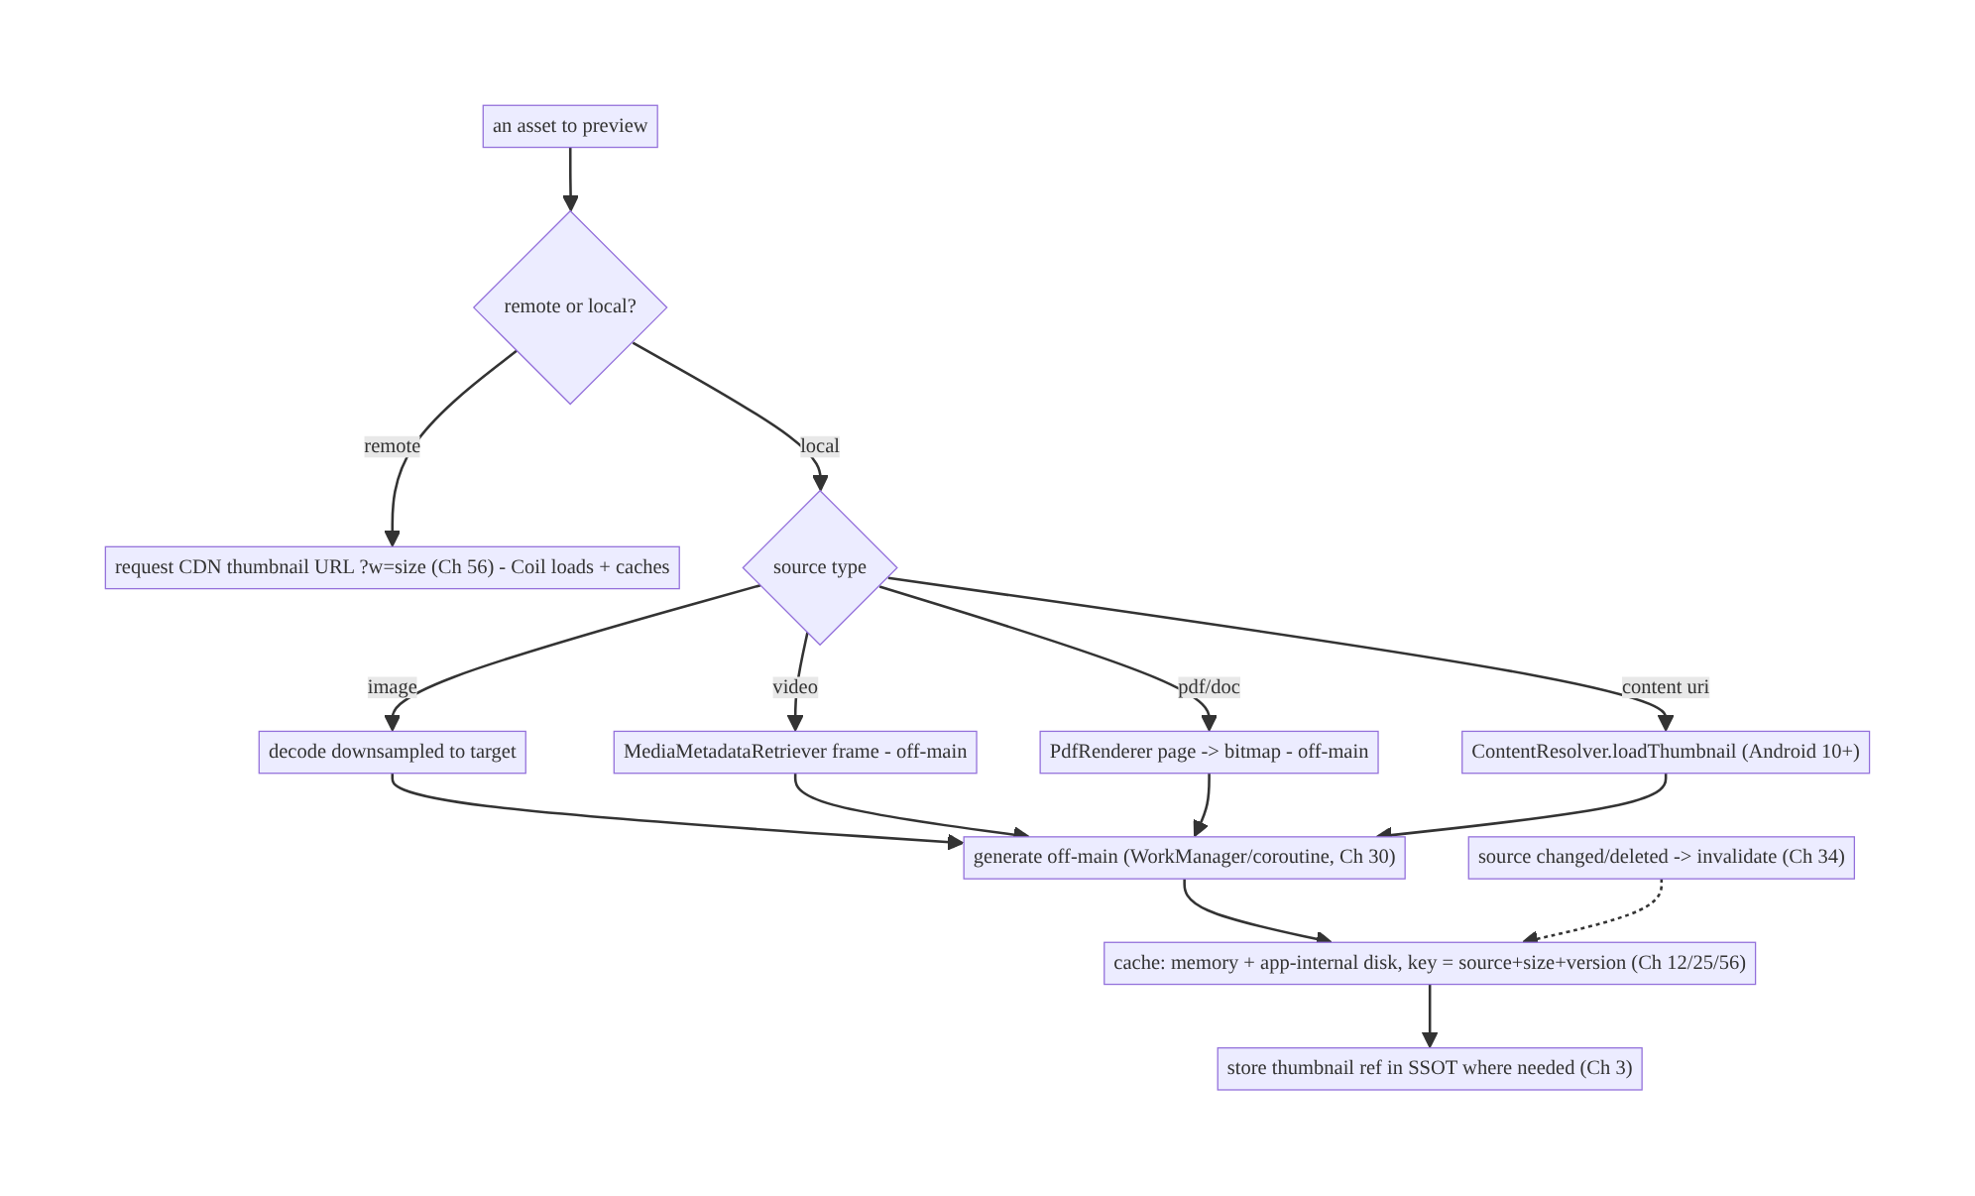
57.4 High-Level Architecture
Components & ownership
- Decision gate: remote → CDN (Coil); local → client generation.
- Per-type generators produce the preview using the correct API, off-main.
- Thumbnail cache (memory + app-internal disk, keyed by source+size+version) reuses and invalidates.
- SSOT tracks thumbnail refs for entities (Ch 3).
Direction: asset → remote(CDN)/local(generate off-main) → cache(keyed) → display; invalidate on source change.

57.5 Detailed Component Design
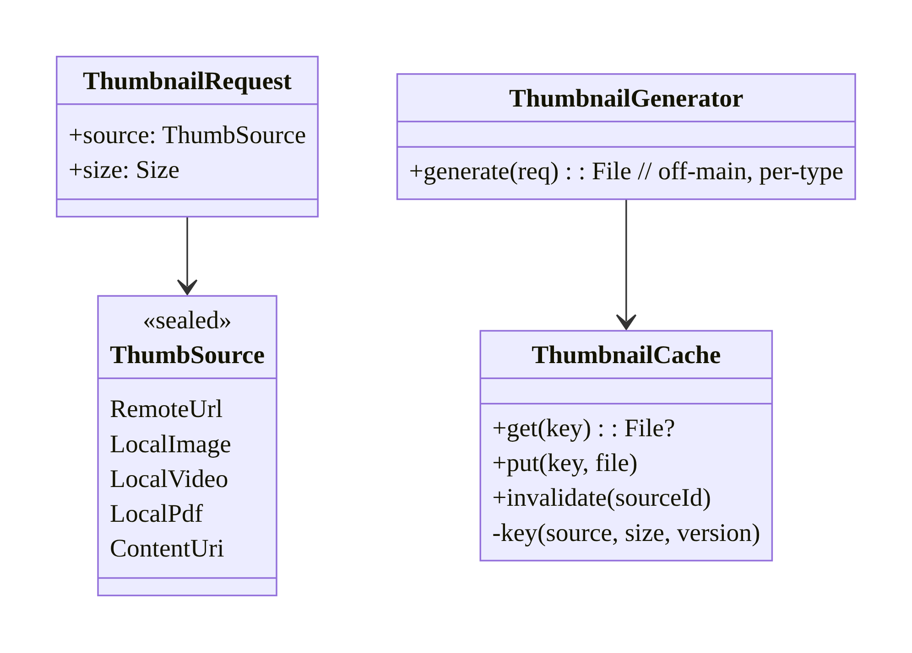
57.5 Detailed Component Design
Component | Responsibility
ThumbSource | typed source (remote vs local kinds)
ThumbnailGenerator | generate per type, off-main (image/video/pdf/content-uri)
ThumbnailCache | memory+disk, key = source+size+version; invalidation (Ch 34)
Coil integration (Ch 56) | load remote CDN thumbs + cached local thumb files

57.6 End-to-End Data Flow

Remote (CDN) vs local (client) generation
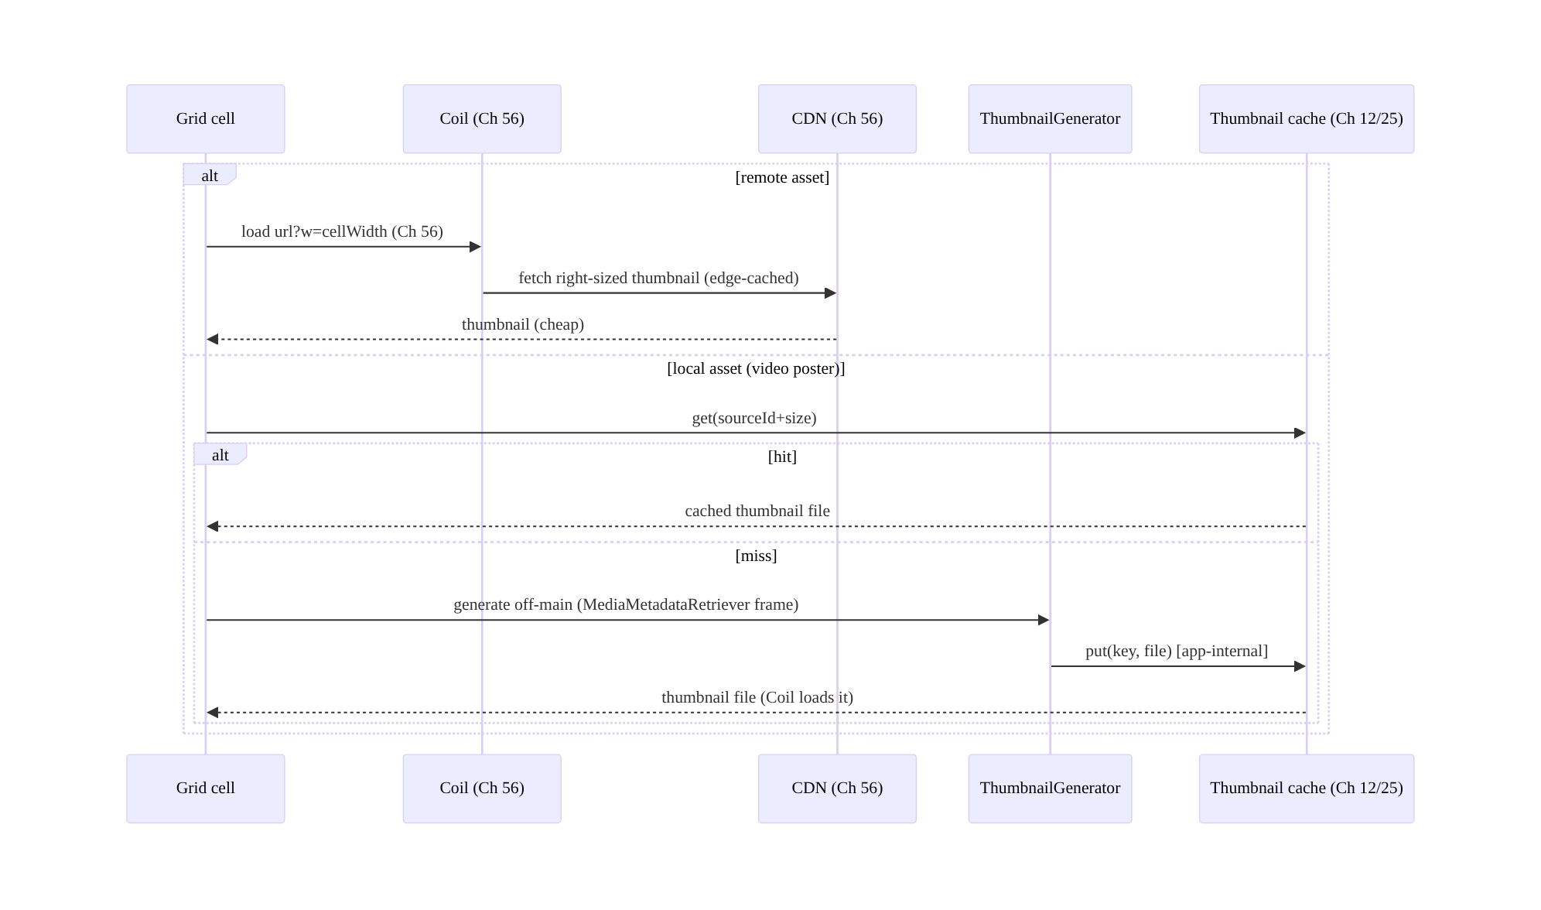
Remote (CDN) vs local (client) generation

Invalidation on source change
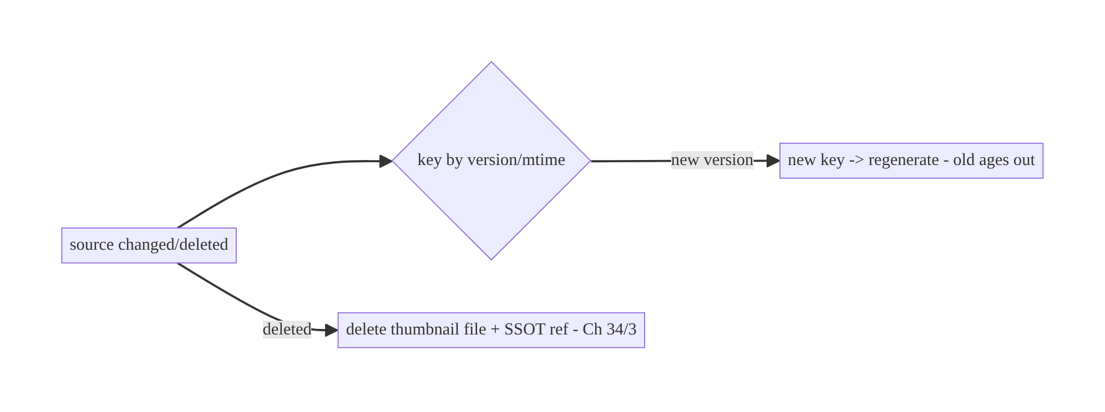
Invalidation on source change

57.7 Complete Kotlin Implementation
Package: com.streamcart.thumbnails.

57.7.1 Typed source + the decision
sealed interface ThumbSource {
data class RemoteUrl(val url: String) : ThumbSource // CDN generates (Ch 56)
data class LocalImage(val file: File, val version: Long) : ThumbSource // client generates
data class LocalVideo(val file: File, val atMs: Long, val version: Long) : ThumbSource
data class LocalPdf(val file: File, val page: Int, val version: Long) : ThumbSource
data class ContentUri(val uri: Uri) : ThumbSource // provider thumbnail
}
// Remote -> just load url.sized(width) with Coil (Ch 56). Local -> ThumbnailGenerator.
fun ThumbSource.isRemote() = this is ThumbSource.RemoteUrl

57.7.2 ThumbnailGenerator (off-main, per-type)
@Singleton
class ThumbnailGenerator @Inject constructor(
@ApplicationContext private val ctx: Context,
private val dispatchers: DispatcherProvider, // Ch 1
private val cache: ThumbnailCache,
) {
suspend fun generate(source: ThumbSource, size: Size): File = withContext(dispatchers.io) { // OFF-MAIN
val key = cache.keyFor(source, size)
cache.get(key)?.let { return@withContext it } // cache hit
val bitmap: Bitmap = when (source) {
is ThumbSource.LocalImage -> decodeDownsampled(source.file, size) // inSampleSize
is ThumbSource.LocalVideo -> MediaMetadataRetriever().use { mmr -> // video frame
mmr.setDataSource(source.file.absolutePath)
mmr.getFrameAtTime(source.atMs * 1000, MediaMetadataRetriever.OPTION_CLOSEST_SYNC)!!
.scaleTo(size)
}
is ThumbSource.LocalPdf -> renderPdfPage(source.file, source.page, size) // PdfRenderer
is ThumbSource.ContentUri -> ctx.contentResolver.loadThumbnail( // Android 10+
source.uri, android.util.Size(size.width, size.height), null)
is ThumbSource.RemoteUrl -> error("remote thumbnails are served by the CDN (Ch 56)")
}
cache.put(key, bitmap) // write to app-internal disk (Ch 25) + memory
}
private fun decodeDownsampled(file: File, size: Size): Bitmap {
val bounds = BitmapFactory.Options().apply { inJustDecodeBounds = true }
BitmapFactory.decodeFile(file.absolutePath, bounds)
val opts = BitmapFactory.Options().apply { inSampleSize = calcInSampleSize(bounds, size) } // downsample
return BitmapFactory.decodeFile(file.absolutePath, opts)!!
}
private fun renderPdfPage(file: File, page: Int, size: Size): Bitmap { /* PdfRenderer -> bitmap */ ... }
}

57.7.3 ThumbnailCache (memory + app-internal disk, keyed, invalidation)
@Singleton
class ThumbnailCache @Inject constructor(@ApplicationContext private val ctx: Context) {
private val dir = File(ctx.cacheDir, "thumbs").apply { mkdirs() } // app-internal (Ch 25)
/** Key includes source identity + size + VERSION so a changed source -> new key (Ch 34). */
fun keyFor(source: ThumbSource, size: Size): String = when (source) {
is ThumbSource.LocalImage -> "img_${source.file.name}_${source.version}_${size.width}x${size.height}"
is ThumbSource.LocalVideo -> "vid_${source.file.name}_${source.atMs}_${source.version}_${size.width}x${size.height}"
is ThumbSource.LocalPdf -> "pdf_${source.file.name}_${source.page}_${source.version}_${size.width}x${size.height}"
is ThumbSource.ContentUri -> "uri_${source.uri.hashCode()}_${size.width}x${size.height}"
is ThumbSource.RemoteUrl -> error("remote cached by Coil/CDN (Ch 56)")
}
fun get(key: String): File? = File(dir, "$key.webp").takeIf { it.exists() }
fun put(key: String, bitmap: Bitmap): File = File(dir, "$key.webp").apply {
outputStream().use { bitmap.compress(Bitmap.CompressFormat.WEBP_LOSSY, 80, it) } // compact modern format
}
/** Invalidate when the source is deleted (Ch 34). */
fun invalidate(sourcePrefix: String) = dir.listFiles { f -> f.name.startsWith(sourcePrefix) }?.forEach { it.delete() }
}

57.7.4 Batch generation via WorkManager (e.g., posters for downloaded videos)
@HiltWorker
class ThumbnailWorker @AssistedInject constructor(
@Assisted ctx: Context, @Assisted p: WorkerParameters,
private val generator: ThumbnailGenerator, private val repo: DownloadRepository, // Ch 59
) : CoroutineWorker(ctx, p) {
override suspend fun doWork(): Result = runCatching {
repo.downloadsNeedingPosters().forEach { d ->
val file = generator.generate(ThumbSource.LocalVideo(d.file, atMs = 5000, version = d.version), POSTER_SIZE)
repo.setPosterPath(d.id, file.absolutePath) // store ref in SSOT (Ch 3)
}
}.fold({ Result.success() }, { Result.retry() }) // off-main, deferrable (Ch 30)
}

57.7.5 Displaying (Coil loads CDN remote or local thumbnail file, Ch 56)
@Composable
fun Thumbnail(source: ThumbSource, size: Dp, vm: ThumbnailViewModel = hiltViewModel()) {
when (source) {
is ThumbSource.RemoteUrl -> AppImage(url = source.url.sized(width = size.px()), contentDescription = null) // Ch 56
else -> {
val file by vm.localThumb(source, size).collectAsStateWithLifecycle() // generated off-main + cached
AppImage(url = file?.toString(), contentDescription = null, modifier = Modifier.size(size))
}
}
}

57.7.6 Module structure
:core:thumbnails ThumbSource, ThumbnailGenerator (per-type, off-main), ThumbnailCache, ThumbnailWorker
:core:images Coil AppImage (Ch 56) loads CDN remote thumbs + local thumb files
:core:data SSOT refs to thumbnail paths (Ch 3); app-internal storage (Ch 25)

57.8 Concurrency and Race Conditions
Scenario | Risk | Handling
Generate on main thread | ANR/jank | withContext(io) / WorkManager (Ch 30)
Same thumbnail requested concurrently | duplicate work | single-flight by key (Ch 11); cache check first
MediaMetadataRetriever not released | leak | use {} / release in finally
Source changes mid-generation | stale thumbnail | key by version/mtime; regenerate on new version
Cache write partial (crash) | corrupt file | write temp + atomic rename (Ch 25)
Many video extractions at once | CPU/memory spike | bound concurrency; batch via WorkManager
- Off-main is mandatory for video/PDF/large-image generation — these are heavy enough to ANR; use a background dispatcher or WorkManager (Ch 30) for batches.
- Single-flight by key (Ch 11): concurrent requests for the same thumbnail should share one generation, not each decode — check cache, then coalesce in-flight.
- Version in the key makes invalidation race-free: a changed source yields a new key, so an in-flight generation of the old version can’t overwrite the new.

57.9 Failure Scenarios and Recovery
Failure | Detection | Response | Outcome
Full source fetched for preview | bandwidth | CDN right-sized thumbnail (Ch 56) | cheap
Jank/ANR generating | ANR | off-main (Ch 30) | smooth
Regenerated every bind | CPU | cache by source+size (Ch 12/25) | reused
Stale thumbnail after source change | user report | version-keyed cache; invalidate (Ch 34) | fresh
Thumbnail orphaned after source delete | disk bloat | delete on source delete (Ch 34) | clean
Corrupt thumbnail file | decode error | atomic write; regenerate on failure | recovers
Sensitive thumbnail leaks | privacy review | app-internal storage; per-account (Ch 25/42) | safe
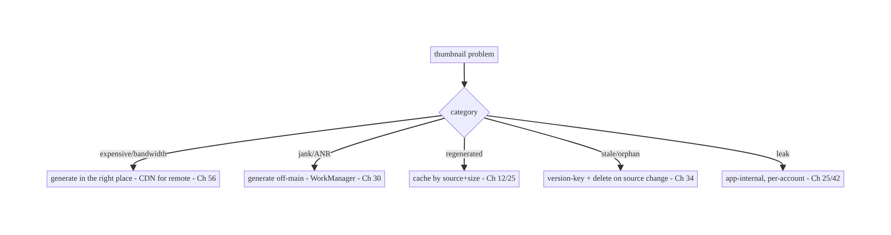
57.9 Failure Scenarios and Recovery
The defining question is “where does the thumbnail come from?” For remote assets the answer is almost always the CDN (right-sized URL, edge-cached, zero client cost, Ch 56) — generating client-side is the waste. For local assets the client must generate, but off-main and cached by source+size+version — never on the main thread, never twice, never stale.

57.10 Scaling the Implementation
- Level 1. CDN thumbnails for remote (Coil, Ch 56); simple client downsample for local images.
- Level 2. Per-type local generation (video/PDF/content-uri) off-main; cache by source+size (Ch 12/25).
- Level 3 — production. Version-keyed invalidation (Ch 34); SSOT thumbnail refs (Ch 3); batch generation via WorkManager (Ch 30); single-flight.
- Level 4 — large. Concurrency-bounded generation; blur-hash/LQIP placeholders (Ch 56); precompute popular thumbnails; per-account sensitive handling (Ch 42).
- Level 5 — enterprise. Server thumbnail service governance (sizes/formats), on-device generation budgets, cache eviction policy tuning, offline thumbnail availability (Ch 59), observability of generation cost + hit rate.
Avoid overengineering: for remote assets, just request CDN-sized URLs (Ch 56) — most apps need no client generation at all. Add client generation only for genuinely local assets.

57.11 Alternative Approaches and Trade-offs
Dimension | Option A | Option B | When
Where (remote) | CDN/server generates | client downloads original + shrinks | CDN always (bandwidth/CPU/edge-cache, Ch 56)
Where (local) | Client generates | — (no server) | Client is the only option for local assets
Generation thread | Off-main (WorkManager/coroutine) | main thread | Off-main always (ANR/jank)
Video frame | MediaMetadataRetriever/Media3 | decode whole video | Frame extraction (cheap) vs full decode
Cache key | source + size + version | source + size | Include version for invalidation (Ch 34)
Storage | App-internal | shared/external | App-internal (privacy, Ch 25)
Format | WebP/AVIF | PNG/JPEG | WebP/AVIF (compact)
CDN vs client generation for remote assets: downloading a full-resolution original to shrink it on-device wastes bandwidth (you transferred the whole asset) and CPU/ memory (decode) for a tiny preview — and every client repeats the work. A CDN/server thumbnail (?w=200, Ch 56) transfers only the preview, is generated once and edge-cached for all clients, and costs the client nothing beyond a normal Coil load. For remote assets, always use CDN thumbnails; client generation for remote is an anti-pattern.
Client generation for local assets (no alternative): camera photos, downloaded videos, and user-picked files have no server to produce a thumbnail — the client must generate them. The trade-off is how: off-main with the right per-type API, cached by source+size+ version, in app-internal storage. The mistake isn’t generating locally (it’s required); it’s doing it on the main thread, not caching, or not invalidating.
Version-keyed vs plain cache keys: a cache key of just source+size can serve a stale thumbnail after the source changes (same path, new content). Including a version/mtime/hash in the key means a changed source produces a new key (fresh generation; old entry ages out) and makes invalidation automatic — essential for mutable local sources (Ch 34).

57.12 Security & Privacy Considerations
- Store thumbnails in app-internal storage (Ch 25): generated previews of sensitive media (ID photos, documents, private images) must not land in shared/external storage where other apps can read them; use cacheDir/filesDir (default here).
- Per-account isolation (Ch 42): don’t serve one account’s cached thumbnail in another; key sensitive thumbnails per account or clear on logout.
- Strip/avoid leaking metadata: a thumbnail of a photo shouldn’t carry the original’s EXIF/location (Ch 60/28); generate a clean bitmap.
- Signed URLs for remote private thumbnails: CDN thumbnails of private media must be access-controlled (signed URLs/auth, Ch 19/23) — not public.
- Bound decode dimensions: a malicious source (huge dimensions) can OOM during generation (decompression bomb, Ch 56) — cap decode size and validate sources.
- Clean up on delete: when the source is deleted, delete its thumbnails (Ch 34) so previews of deleted sensitive content don’t linger.
- Client vs backend: the backend/CDN generates and access-controls remote thumbnails; the client generates local ones into app-internal, per-account storage and strips metadata.

57.13 Performance and Resource Optimization
- Generate in the right place: CDN for remote (zero client cost); only local on-device.
- Off-main + batch (WorkManager, Ch 30) for many local thumbnails; bound concurrency to avoid CPU/memory spikes (video extraction is heavy).
- Cache aggressively (memory + disk, keyed) — generation is expensive; reuse always.
- Downsample during generation (inSampleSize / target size) — never hold full bitmaps.
- Compact format (WebP/AVIF) for stored thumbnails — smaller disk + faster load.
- Right-size to display (combine with Coil size-targeting, Ch 56).
- Precompute predictable thumbnails (e.g., poster for each download, Ch 59) in the background.
- Profiling: generation time per type, thumbnail cache hit rate, generation CPU/battery, disk used by thumbnails, bandwidth saved vs originals.

57.14 Testing Strategy
Generation is pure-ish (bitmap in/out) given a dispatcher; cache/invalidation are file-based.
class ThumbnailCacheTest {
@Test fun `key includes version so changed source misses`() {
val cache = ThumbnailCache(ctx)
val k1 = cache.keyFor(ThumbSource.LocalImage(file, version = 1), SIZE)
val k2 = cache.keyFor(ThumbSource.LocalImage(file, version = 2), SIZE)
assertNotEquals(k1, k2) // invalidation via version (Ch 34)
}
@Test fun `invalidate deletes source thumbnails`() { /* put 2, invalidate prefix, assert gone */ }
}
class ThumbnailGeneratorTest {
@Test fun `generates off-main and caches`() = runTest(testDispatcher) {
val gen = ThumbnailGenerator(ctx, TestDispatchers(testDispatcher), cache)
val file = gen.generate(ThumbSource.LocalImage(sampleImage, version = 1), SIZE)
assertTrue(file.exists()); assertTrue(cache.get(cache.keyFor(...)) != null)
}
@Test fun `second call hits cache - no regeneration`() { /* spy: generate once */ }
}
What to test: remote → CDN URL (no client generation); local per-type generation (image/ video/pdf/content-uri) off-main; cache hit on repeat; version-keyed invalidation + delete; single-flight (concurrent → one generation); app-internal storage; downsampling (bounded bitmap). Instrumentation for real MediaMetadataRetriever/PdfRenderer.

57.15 Production Observability
- Metrics: thumbnail cache hit rate; generation time by source type; generation CPU/battery; bandwidth saved (CDN thumbnails vs originals); disk used by thumbnails; stale-thumbnail reports; generation failure rate.
- Logs: thumb{type, source=remote/local, generated, cache, gen_ms} — no sensitive paths/PII (Ch 28).
- Debugging: high bandwidth → downloading originals instead of CDN (Ch 56); jank/ANR → main-thread generation; regeneration → cache miss (keying/storage); stale → missing version in key (Ch 34); disk bloat → not deleting orphans; leak → external storage / cross-account.
- Alerting: generation-cost or failure spike; thumbnail disk bloat.
- Dashboards: hit rate + generation cost by type; bandwidth saved.

57.16 System Design Interview Preparation
≥25 questions.
Fundamentals
- What’s a thumbnail? A small preview derived from a larger source.
- Core decision? Where to generate — CDN/server (remote) vs client (local).
- Remote assets? CDN right-sized URL (Ch 56), edge-cached, zero client cost.
- Local assets? Client must generate (no server).
- Why not download originals for previews? Wastes bandwidth/CPU/memory.
Local generation
- Image? Downsample decode (inSampleSize/Coil size target).
- Video? MediaMetadataRetriever.getFrameAtTime / ThumbnailUtils / Media3.
- PDF? PdfRenderer.
- Content URI? ContentResolver.loadThumbnail (Android 10+).
- Thread? Off-main (WorkManager/coroutine) — heavy, ANR risk.
Caching/invalidation
- Cache tiers? Memory + disk (app-internal), keyed by source+size (+version).
- Why cache? Generation is expensive; reuse.
- Invalidation? Version/mtime/hash in key; delete on source delete (Ch 34).
- Integrate with Coil? Load CDN remote thumbs + local thumb files (Ch 56).
- Storage? App-internal (Ch 25).
Concurrency
- Concurrent same thumbnail? Single-flight by key (Ch 11).
- Retriever leak? use/release.
- Batch generation? WorkManager, bounded concurrency (Ch 30).
Security/privacy
- Sensitive thumbnails? App-internal, per-account (Ch 25/42).
- Metadata? Strip EXIF/location (Ch 60/28).
- Remote private thumbnails? Signed URLs/auth (Ch 19/23).
- Decompression bomb? Cap decode dimensions (Ch 56).
Testing/Production
- Test invalidation? Version in key → changed source misses.
- Key metrics? Cache hit rate, generation time, bandwidth saved.
- High bandwidth? Downloading originals instead of CDN.
- Stale previews? Missing version in cache key.

Design-change challenges
- Product grid shows tiny previews. CDN right-sized thumbnails (Ch 56) — no client generation.
- Poster frames for downloaded videos (OTT). Client MediaMetadataRetriever off-main, cached, SSOT ref (Ch 59/3).
- Instant preview of a just-captured photo. Client downsample off-main while full uploads (Ch 60/17).
- Thumbnails go stale after the source is edited. Version-keyed cache (Ch 34).
- PDF receipt previews. PdfRenderer off-main, cached.

Mock walkthrough (abridged)
Clarify (remote or local assets, source types, offline, sensitive?) → decide CDN (remote, Ch 56) vs client (local) → per-type generation off-main (Ch 30) → cache memory+disk keyed by source+size+version (Ch 12/25) → invalidation (Ch 34) → SSOT refs (Ch 3) → security (app-internal, per-account, metadata, signed URLs) → observability (hit rate, generation cost, bandwidth saved).

57.17 Practical Exercises
- Beginner. Show remote product thumbnails via CDN-sized URLs with Coil (no client generation). Eval: bandwidth matches preview size; edge-cached.
- Intermediate. Generate video poster thumbnails client-side off-main (MediaMetadataRetriever), cache them, and store refs in the SSOT. Eval: off-main; cached; reused.
- Advanced. Add version-keyed caching + invalidation so edited/deleted sources update/ clean up thumbnails. Eval: changed source regenerates; deleted source cleans up.
- Production debugging. Fix main-thread PDF rendering (ANR) and stale thumbnails (missing version in key). Eval: off-main; fresh.
- System design challenge. Batch-generate posters for all downloads via WorkManager with bounded concurrency + per-account sensitive handling. Eval: no CPU spike; isolated; observable.
(Solutions withheld unless requested.)

57.18 Chapter Summary & Reference Sheet
Key decisions: decide per asset where the thumbnail comes from — for remote assets, request a CDN/server-generated right-sized URL via Coil (edge-cached, zero client cost, Ch 56), never download the original to shrink it; for local assets (camera, downloaded video, picked files, generated PDFs) the client must generate, using the right API per source type (downsample images via inSampleSize/Coil, MediaMetadataRetriever for video frames, PdfRenderer for PDFs, ContentResolver.loadThumbnail for content URIs), off the main thread (WorkManager/ coroutine, Ch 30), with single-flight (Ch 11); cache generated thumbnails in memory + app-internal disk (Ch 12/25/56) keyed by source + size + version so they’re reused and invalidated when the source changes or is deleted (Ch 34); track thumbnail refs in the SSOT (Ch 3) where they belong to entities; store a compact format (WebP/AVIF); and keep sensitive thumbnails app-internal and per-account (Ch 42/28) with metadata stripped.
Concepts: server/CDN vs client generation, per-source-type APIs (image/video/PDF/ content-uri), off-main generation, thumbnail cache (memory+disk) keyed by source+size+ version, invalidation (Ch 34), SSOT refs, Coil integration, right-sizing/compact formats.
Common mistakes: downloading/decoding originals for remote previews (should be CDN, Ch 56); generating on the main thread (ANR); no cache (regeneration); keys without a version (stale); not deleting orphaned thumbnails; storing sensitive thumbnails in shared storage; leaking EXIF; not bounding decode size (OOM); unbounded concurrent video extraction.
Checklist:
- ☐ remote → CDN right-sized URL (Ch 56)
- ☐ local → client generate off-main (Ch 30)
- ☐ right API per source type
- ☐ cache memory+disk keyed by source+size+version
- ☐ invalidate on source change/delete (Ch 34)
- ☐ app-internal storage (Ch 25), per-account (Ch 42)
- ☐ WebP/AVIF compact
- ☐ single-flight (Ch 11)
- ☐ strip metadata / signed URLs for private
- ☐ cache-hit + generation-cost telemetry.
Key APIs: BitmapFactory/inSampleSize/inJustDecodeBounds, MediaMetadataRetriever.getFrameAtTime/ThumbnailUtils.createVideoThumbnail, PdfRenderer, ContentResolver.loadThumbnail (API 29+), Bitmap.compress(WEBP_LOSSY), Coil AsyncImage/custom Fetcher/Keyer (Ch 56), WorkManager CoroutineWorker (Ch 30), app-internal cacheDir/filesDir (Ch 25).
References:
- Create thumbnails / loadThumbnail: https://developer.android.com/reference/android/content/ContentResolver#loadThumbnail(android.net.Uri,%20android.util.Size,%20android.os.CancellationSignal)
- MediaMetadataRetriever: https://developer.android.com/reference/android/media/MediaMetadataRetriever
- PdfRenderer: https://developer.android.com/reference/android/graphics/pdf/PdfRenderer
- Loading large bitmaps efficiently: https://developer.android.com/topic/performance/graphics/load-bitmap
- (composes) Ch 56 Image Loading (Coil), Ch 12 Caching, Ch 30 WorkManager, Ch 25 Secure Storage, Ch 34 Cache Invalidation, Ch 60 Camera

Chapter 58 — Media Playback State (Media3/ExoPlayer)
Part VII — Media & Files · Complexity: Complex (≥40 interview questions)
Prerequisites: Ch 46 (foreground services/MediaSessionService), Ch 44 (lifecycle), Ch 6 (UI state), Ch 3 (SSOT), Ch 8 (process death), Ch 32 (sync). Pairs with Ch 59 (offline downloads), Ch 57 (thumbnails), Ch 67 (background).
Reference surface in StreamCart: the streaming half of the super-app — playing audio/video (adaptive HLS/DASH), keeping playback state consistent across the UI, notification, background, lock screen, Bluetooth/Auto, and process death, and resuming where the user left off.

58.1 Problem Definition and Real-World Context
Media playback is one of the hardest state-management problems on Android because playback state lives in many places at once and must stay consistent: the player engine, the on-screen UI, the media notification (Ch 46/50), the lock screen, Bluetooth headsets / Android Auto / Wear, and across background and process death. A naive implementation (an ExoPlayer created in a Fragment) breaks the moment the user backgrounds the app, rotates the screen, plugs in headphones, or the OS kills the process mid-stream.
Concretely, teams hit:
- Player tied to the UI lifecycle. An ExoPlayer owned by an Activity/Composable is destroyed on config change (Ch 44) and can’t play in the background — playback should outlive the UI, in a MediaSessionService (Ch 46).
- State scattered and inconsistent. The notification shows “playing” while the UI shows “paused”; the lock-screen controls do nothing; Bluetooth next/previous is ignored. There must be one source of truth for playback state (the MediaSession/Player) that every surface observes and controls.
- No system integration. Audio focus (another app starts playing → you must duck/ pause), becoming-noisy (headphones unplugged → pause), media buttons, Android Auto/ Wear/Assistant — all require a MediaSession; hand-rolling misses them.
- Adaptive streaming complexity. HLS/DASH with multiple bitrates, ABR (adaptive bitrate), buffering, seeking, track selection (audio/subtitle), and DRM (Ch 59) — this is what ExoPlayer/Media3 handles; reinventing it is futile.
- Resume & progress. Saving and restoring playback position across process death (Ch 8) and app restarts, and syncing “continue watching” position across devices (Ch 32).
- Lifecycle correctness. Pause/resume on app background (Ch 44/67), release the player when truly done (resources/battery), handle interruptions (calls, other media).
The architecture: use Media3 (the modern ExoPlayer) as the player engine inside a MediaSessionService (Ch 46) so playback outlives the UI and runs in the background with a system-managed media notification; expose a MediaSession as the single source of playback state that the UI connects to via a MediaController (observe state, send commands) and that the system (notification, lock screen, Bluetooth, Auto, Assistant) controls uniformly; handle audio focus, becoming-noisy, and interruptions; support adaptive streaming (HLS/DASH, ABR, track selection) and hooks for DRM/offline (Ch 59); persist and restore playback position (SSOT + process death, Ch 3/8) and sync continue-watching (Ch 32); and manage lifecycle (background pause/continue per content type, release when done). This chapter is about consistent, system-integrated, resilient media playback state.

Three practical use cases
- Video playback (StreamCart). An HLS stream plays in a Media3 player inside a MediaSessionService; the UI is a thin MediaController view; backgrounding keeps audio playing with a notification; rotation doesn’t interrupt; position persists.
- Audio/podcast with background + controls. Plays in the background with notification/lock-screen/Bluetooth controls; pauses on headphone unplug and on a phone call (audio focus); resumes after.
- Continue watching across devices. Playback position is saved to the SSOT and synced (Ch 32); the user resumes on another device where they left off.

Why this is architectural
Playback state is a multi-surface consistency problem (UI, notification, lock screen, Bluetooth, Auto) layered on background execution (Ch 46/67), lifecycle (Ch 44), process death (Ch 8), sync (Ch 32), and adaptive streaming/DRM (Ch 59). The decisions — service-hosted player, MediaSession as the single source of truth, controller-based UI, audio-focus/interruption handling, position persistence/sync — determine whether playback is consistent, controllable everywhere, and resilient.

58.2 Requirements Engineering

Functional requirements
ID | Requirement
F1 | Play audio/video (adaptive HLS/DASH), including in the background.
F2 | Single source of playback state controllable from UI, notification, lock screen, Bluetooth/Auto.
F3 | Handle audio focus, becoming-noisy, and interruptions (calls/other media).
F4 | Persist/restore playback position across process death; sync continue-watching (Ch 8/32).
F5 | Support track selection (audio/subtitle), seeking, playlist/queue.
F6 | Manage lifecycle (background pause/continue by content, release when done).

Non-functional requirements
Attribute | Policy
Consistency | All surfaces reflect/control one state (no drift).
Resilience | Survives config change, background, process death.
Battery/Resources | Release player when done; background only when intended (Ch 46).
Quality | Smooth ABR, fast start, correct seeking/buffering.
Integration | Works with notification, lock screen, Bluetooth, Auto, Assistant.

Scope
- In scope: Media3/ExoPlayer, MediaSessionService (Ch 46), MediaSession as single source of truth, MediaController UI, audio focus / becoming-noisy / interruptions, adaptive streaming (HLS/DASH/ABR) + track selection, playlists/queue, position persist/ restore (Ch 8) + continue-watching sync (Ch 32), lifecycle (background/release), notification integration (Ch 46/50), DRM/offline hooks (Ch 59).
- Out of scope: offline downloads/DRM detail (Ch 59), foreground-service mechanics (Ch 46), notifications UI (Ch 50), thumbnails/posters (Ch 57), sync algorithm (Ch 32), background limits detail (Ch 67/47).

Assumptions & constraints
- Media3 (androidx.media3, the current ExoPlayer), MediaSessionService/ MediaSession/MediaController, Hilt, Room/DataStore (Ch 3/4), WorkManager (Ch 30). minSdk 24. Playback must run in the background (FGS, Ch 46) and survive process death (Ch 8); the system expects a MediaSession for integration.

58.3 System Design Fundamentals
- Media3 is the engine; don’t reinvent it. Media3 (the evolution of ExoPlayer) handles adaptive streaming (HLS/DASH/SmoothStreaming), ABR (adaptive bitrate), buffering, seeking, track selection (audio/video/subtitle), DRM (Widevine, Ch 59), caching, and extensible MediaSource/DataSource pipelines. You configure and observe it — you don’t build a player.
- The player must outlive the UI → MediaSessionService (Ch 46). Create the ExoPlayer/MediaSession inside a MediaSessionService (a foreground service, Ch 46, type mediaPlayback) so playback continues in the background, survives config changes, and is owned independently of any Activity. The UI is a client, not the owner.
- MediaSession = the single source of playback state (the crux). The MediaSession (wrapping the Player) exposes the authoritative playback state (playing/paused, position, duration, queue, metadata) and accepts commands (play/pause/seek/skip). Every surface — your UI, the system media notification (Ch 46/50), the lock screen, Bluetooth headsets, Android Auto, Wear, Assistant — observes and controls the same session. This is why there’s no drift: there’s one state, many controllers.
- UI connects via MediaController. The UI (Compose/Views) creates a MediaController that connects to the MediaSession (even across process), observes state (Player.Listener), and sends commands. The UI holds no player state of its own — it renders the session’s state (UDF, Ch 6). On config change the UI is recreated and re-attaches to the still-running session (no interruption).
- System integration via the session:
  - Audio focus: request focus; when another app takes it, pause or duck (Media3’s AudioAttributes + setHandleAudioBecomingNoisy + focus handling do much automatically). On regaining focus, resume if appropriate.
  - Becoming noisy: headphones unplugged → pause (expected UX; setHandleAudioBecomingNoisy(true)).
  - Media buttons / Bluetooth / Auto / Assistant: routed to the session’s command handlers automatically.
- Adaptive streaming & track selection. Provide an HLS/DASH MediaItem; Media3’s DefaultTrackSelector + ABR pick bitrate by bandwidth; expose track selection (quality, audio language, subtitles) through the selector. Buffering/seeking are handled; you surface state (buffering spinner) from the player’s state.
- Playlists / queue. Media3 supports a playlist (setMediaItems, queue navigation seekToNext/Previous); the session exposes queue metadata to all surfaces.
- Position persistence & resume (Ch 8/3/32):
  - Process death: save the current mediaId + position periodically and on pause/stop to the SSOT (Ch 3) / SavedState so you can restore on relaunch (Media3 also supports state restoration).
  - Continue watching: persist position to the SSOT and sync it (Ch 32) so other devices resume where the user left off (position is synced state).
- Lifecycle (Ch 44/67). For audio (podcast/music), continue in background (FGS, Ch 46). For video, you may pause on background (unless PiP/audio-only) to save resources/battery, per content type. Release the player/session when playback is truly done (onDestroy of the service / no controllers + stopped) to free codecs/ battery. Handle interruptions (incoming call → pause via focus; resume after).
- DRM / offline hooks (Ch 59). Protected content uses a DRM session (Widevine); offline playback uses downloaded media + offline license (Ch 59) — Media3 integrates both through its MediaSource/DrmSessionManager/download modules.
Core insight: host the Media3 player in a MediaSessionService (Ch 46) so playback outlives the UI and runs in the background, and make the MediaSession the single source of playback state that the UI (via a MediaController, UDF, Ch 6) and the whole system (notification, lock screen, Bluetooth, Auto, Assistant) observe and control — eliminating state drift; let Media3 handle adaptive streaming/ABR/track-selection/DRM; handle audio focus, becoming-noisy, and interruptions; persist and restore playback position across process death (Ch 8) and sync continue-watching across devices (Ch 32); and manage lifecycle per content type (background-continue audio, pause video; release when done).

58.4 High-Level Architecture
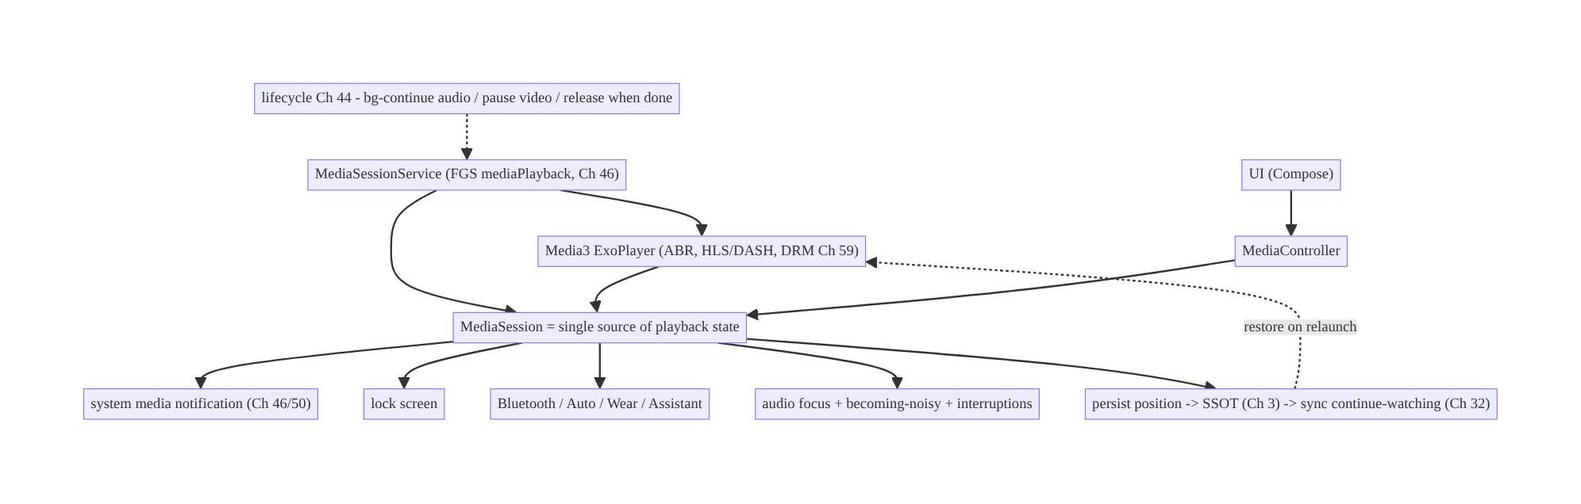
58.4 High-Level Architecture
Components & ownership
- MediaSessionService owns the Media3 player and the MediaSession — playback runs here, background-capable (Ch 46).
- MediaSession is the single source of playback state; all surfaces (notification, lock screen, Bluetooth, Auto) and the UI (MediaController) observe/ control it.
- Persistence/sync saves position to the SSOT and syncs continue-watching (Ch 3/32).
Direction: service-hosted player → session (single truth) → all surfaces + UI controller; position persisted/synced; lifecycle managed.

58.5 Detailed Component Design
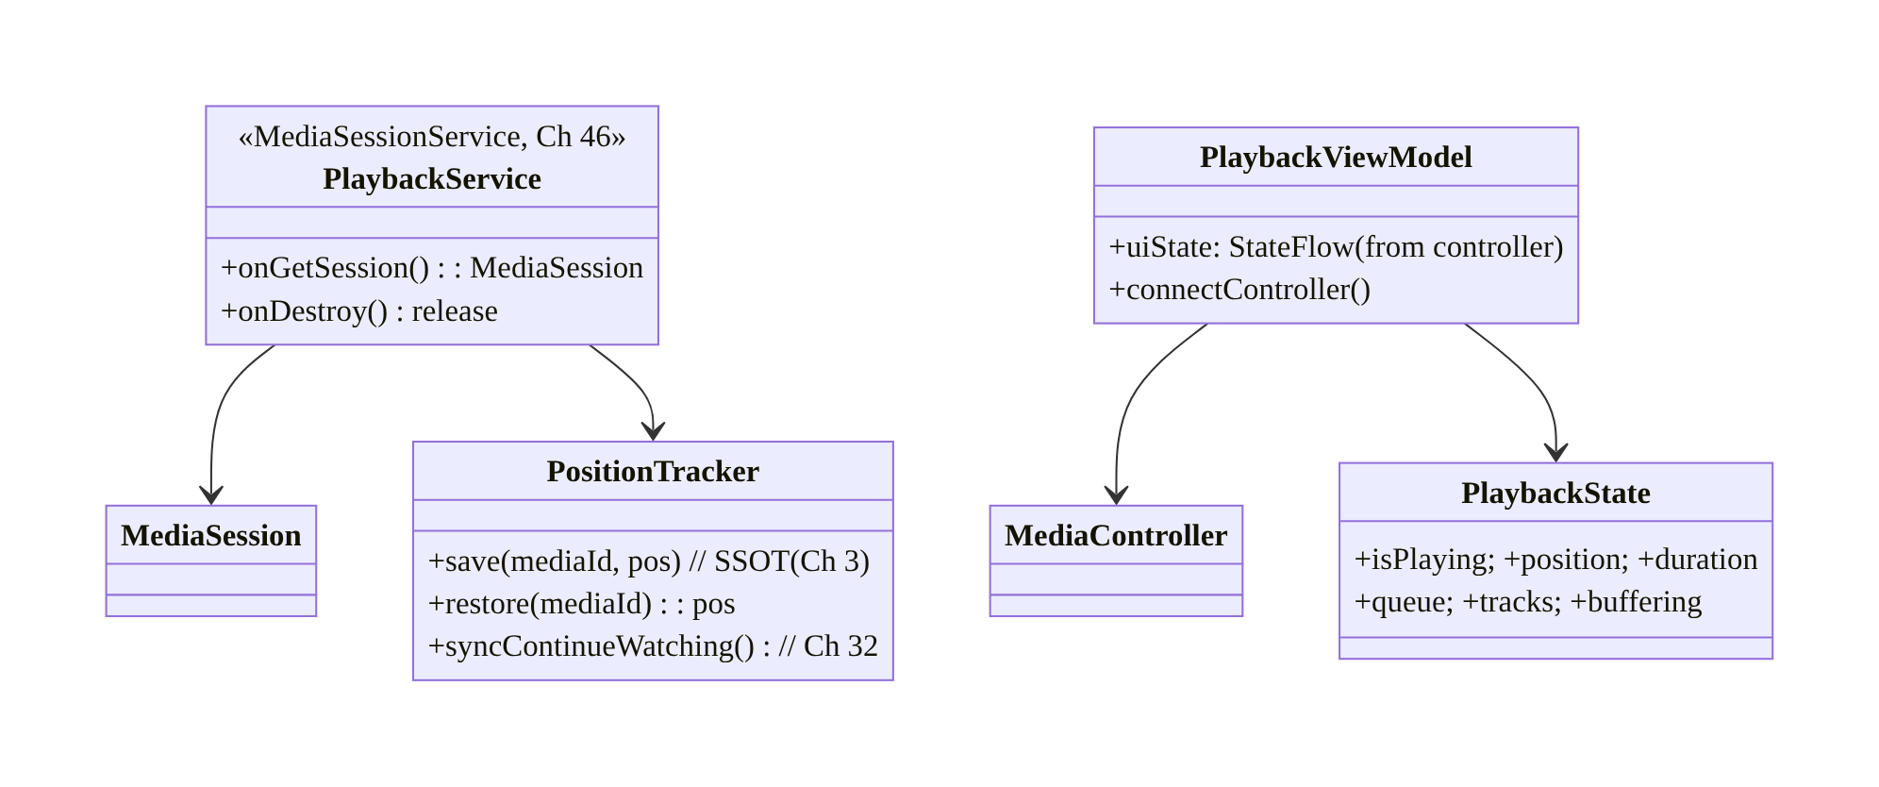
58.5 Detailed Component Design
Component | Responsibility
PlaybackService | own Media3 player + MediaSession; background; release
MediaSession | single source of playback state + command target
MediaController (in UI/VM) | observe state + send commands (UDF, Ch 6)
PositionTracker | persist position (SSOT, Ch 3/8) + sync continue-watching (Ch 32)

58.6 End-to-End Data Flow

UI, notification, and Bluetooth all control one session
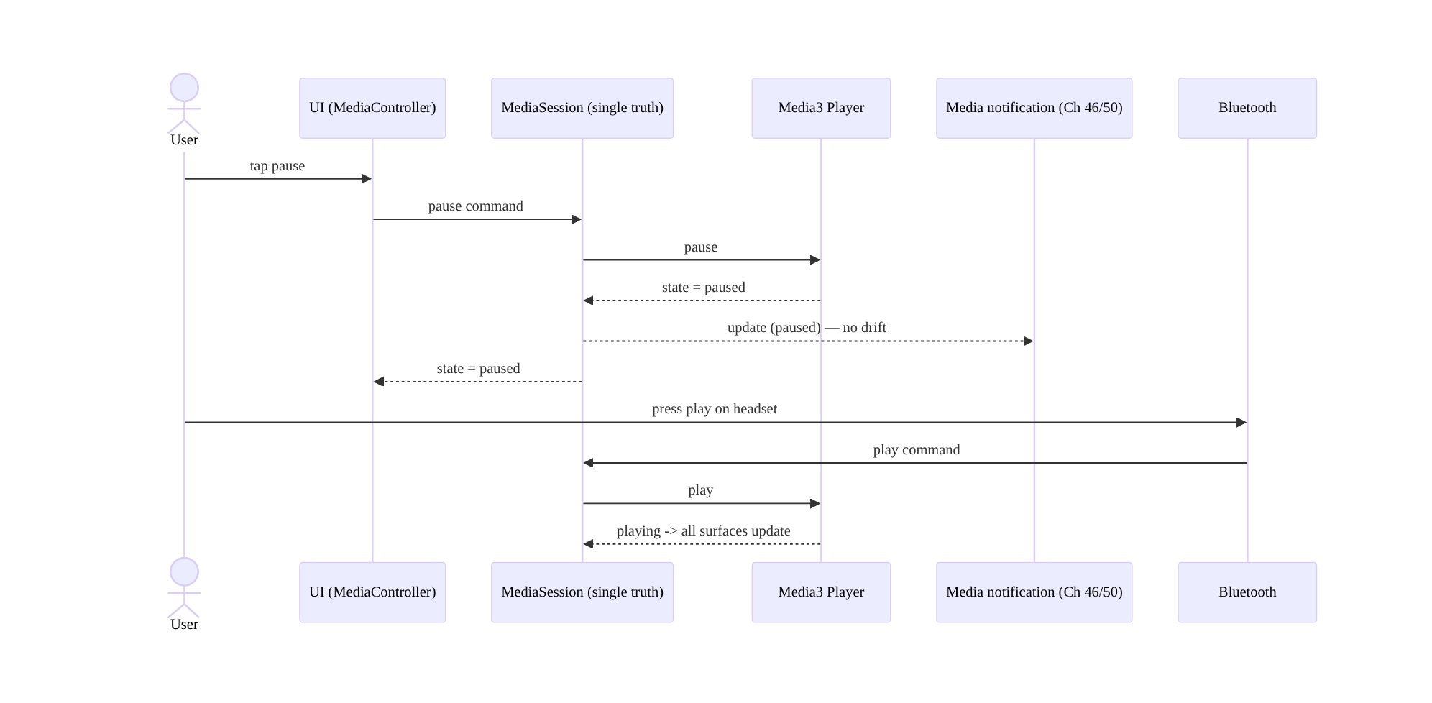
UI, notification, and Bluetooth all control one session

Resume across process death + continue-watching sync
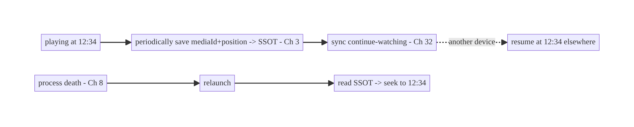
Resume across process death + continue-watching sync

58.7 Complete Kotlin Implementation
Package: com.streamcart.playback.

58.7.1 MediaSessionService hosting the Media3 player (Ch 46)
@AndroidEntryPoint
class PlaybackService : MediaSessionService() { // FGS type mediaPlayback (Ch 46)
@Inject lateinit var positionTracker: PositionTracker
private lateinit var player: ExoPlayer
private lateinit var session: MediaSession
override fun onCreate() {
super.onCreate()
player = ExoPlayer.Builder(this)
.setAudioAttributes(AudioAttributes.DEFAULT, /* handleAudioFocus = */ true) // audio focus
.setHandleAudioBecomingNoisy(true) // pause on unplug
.build()
.also { it.addListener(positionListener()) }
session = MediaSession.Builder(this, player).build() // the SINGLE source of playback state
}
override fun onGetSession(controllerInfo: MediaSession.ControllerInfo) = session
private fun positionListener() = object : Player.Listener {
override fun onIsPlayingChanged(isPlaying: Boolean) {
if (!isPlaying) positionTracker.save(player.currentMediaItem?.mediaId, player.currentPosition) // Ch 3
}
override fun onMediaItemTransition(item: MediaItem?, reason: Int) { /* save on track change */ }
}
override fun onDestroy() { // release when done (resources/battery)
positionTracker.save(player.currentMediaItem?.mediaId, player.currentPosition)
session.release(); player.release(); super.onDestroy()
}
}

58.7.2 UI connects via MediaController (observes the single state, UDF Ch 6)
@HiltViewModel
class PlaybackViewModel @Inject constructor(
@ApplicationContext private val ctx: Context,
) : ViewModel() {
private var controller: MediaController? = null
private val _state = MutableStateFlow(PlaybackUiState())
val state: StateFlow<PlaybackUiState> = _state.asStateFlow()
fun connect() {
val token = SessionToken(ctx, ComponentName(ctx, PlaybackService::class.java))
val future = MediaController.Builder(ctx, token).buildAsync()
future.addListener({
controller = future.get().also { c ->
c.addListener(object : Player.Listener { // render the SESSION's state (no local truth)
override fun onEvents(player: Player, events: Player.Events) {
_state.value = PlaybackUiState(
isPlaying = player.isPlaying, position = player.currentPosition,
duration = player.duration, buffering = player.playbackState == Player.STATE_BUFFERING)
}
})
}
}, MoreExecutors.directExecutor())
}
fun playPause() { controller?.let { if (it.isPlaying) it.pause() else it.play() } } // commands -> session
fun seekTo(ms: Long) { controller?.seekTo(ms) }
override fun onCleared() { controller?.release() } // release controller, NOT the session/player
}

58.7.3 Playing adaptive content + resume to saved position
fun PlaybackViewModel.play(mediaId: String, hlsUrl: String) {
val resumeAt = positionTracker.restore(mediaId) // continue-watching (Ch 3/32)
val item = MediaItem.Builder().setMediaId(mediaId).setUri(hlsUrl)
.setMimeType(MimeTypes.APPLICATION_M3U8) // HLS; Media3 handles ABR
.build()
controller?.apply { setMediaItem(item, resumeAt); prepare(); play() } // seek to saved position
}

58.7.4 Position persistence + continue-watching sync (Ch 3/32)
@Singleton
class PositionTracker @Inject constructor(
private val dao: PlaybackPositionDao, // Room SSOT (Ch 3)
private val syncRepo: SyncRepository, // Ch 32
private val scope: CoroutineScope, // app scope (Ch 5)
) {
fun save(mediaId: String?, positionMs: Long) {
mediaId ?: return
scope.launch {
dao.upsert(PlaybackPosition(mediaId, positionMs, System.currentTimeMillis())) // survive process death (Ch 8)
syncRepo.pushContinueWatching(mediaId, positionMs) // sync across devices (Ch 32, debounced/outbox Ch 31)
}
}
suspend fun restore(mediaId: String): Long = dao.get(mediaId)?.positionMs ?: 0L
}

58.7.5 Track selection (quality / subtitles)
// Expose Media3 track selection to the UI (quality, audio language, subtitles).
fun PlaybackViewModel.selectSubtitle(languageTag: String) {
controller?.trackSelectionParameters = controller!!.trackSelectionParameters.buildUpon()
.setPreferredTextLanguage(languageTag).build()
}
fun PlaybackViewModel.capQuality(maxHeight: Int) {
controller?.trackSelectionParameters = controller!!.trackSelectionParameters.buildUpon()
.setMaxVideoSize(Int.MAX_VALUE, maxHeight).build() // ABR within cap
}

58.7.6 Module structure
:feature:player PlaybackService (MediaSessionService), PlaybackViewModel (MediaController), player UI
:core:playback PositionTracker, PlaybackPositionDao (Room SSOT, Ch 3), continue-watching sync (Ch 32)
# FGS/notification -> Ch 46/50; offline/DRM -> Ch 59; background limits -> Ch 67.

58.8 Concurrency and Race Conditions
Scenario | Risk | Handling
UI owns player state | drift with notification/BT | session is single truth; UI observes via controller
Config change recreates UI | playback interrupted | player in service; UI re-attaches controller
Multiple controllers (UI + Auto) | conflicting commands | session serializes commands; single player
Position save races with transition | wrong position saved | save on pause/stop/transition from player state
Audio focus loss during command | double pause/resume | let Media3 handle focus; idempotent commands
Process death mid-playback | lost position | periodic + on-pause save to SSOT (Ch 8); restore on relaunch
Controller released but service running | leaks/wrong lifetime | release controller in UI onCleared, not the session
- The MediaSession serializes state and commands, so multiple controllers (your UI, Android Auto, a Bluetooth remote) can’t drive conflicting states — there’s one player, one state, commands applied in order. This is the whole reason drift disappears.
- Separate the controller’s lifecycle from the session’s: the UI MediaController is released on UI teardown, but the session/player live in the service and keep playing — never release the player when the UI goes away (only when playback is truly done).
- Persist position from the player’s authoritative state (on pause/stop/transition + periodically) so saves reflect true position, surviving process death (Ch 8).

58.9 Failure Scenarios and Recovery
Failure | Detection | Response | Outcome
Notification/UI/BT state drift | user report | single session as truth; all observe it | consistent
Playback stops on background | user report | MediaSessionService FGS (Ch 46) | continues (audio)
Playback lost on rotation | user report | player in service; UI re-attaches | uninterrupted
Position lost on process death | user report | periodic + on-pause SSOT save; restore (Ch 8) | resumes
Doesn’t pause on headphone unplug | user report | setHandleAudioBecomingNoisy(true) | pauses
Keeps playing over a phone call | user report | audio focus handling | pauses/ducks
Player never released | battery/resources | release in service onDestroy/when done | freed
Continue-watching not synced | user report | persist + sync position (Ch 32) | cross-device
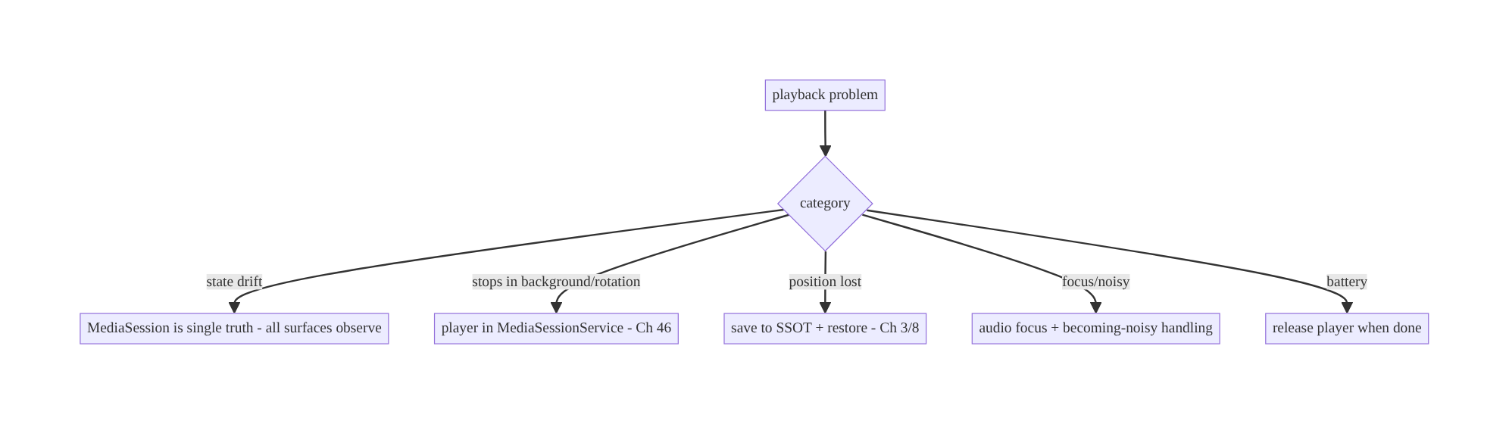
58.9 Failure Scenarios and Recovery
One principle resolves most playback bugs: the MediaSession (in a service) is the single source of playback state. Drift (UI vs notification vs Bluetooth), background survival, and config-change resilience all follow from putting the player in a MediaSessionService and having every surface — including your UI — observe and control that one session rather than holding its own state.

58.10 Scaling the Implementation
- Level 1. Media3 player in a MediaSessionService; UI via MediaController; HLS/DASH playback.
- Level 2. Audio focus / becoming-noisy / interruptions; media notification + lock screen + Bluetooth (free via session); position persist + resume (Ch 8).
- Level 3 — production. Continue-watching sync (Ch 32); track selection (quality/ subtitles); playlist/queue; lifecycle (bg-audio/pause-video, release when done).
- Level 4 — large. Android Auto/Wear/Assistant integration; ABR tuning; DRM + offline (Ch 59); PiP for video; casting (Cast); analytics (QoE: start time, rebuffering).
- Level 5 — enterprise. Playback QoE SLOs (startup latency, rebuffer ratio), adaptive- bitrate policy, multi-DRM, cross-device resume governance, A/B of player behavior.
Avoid overengineering: use Media3 + MediaSessionService + MediaController; the session gives you notification/lock-screen/Bluetooth/Auto nearly for free. Don’t hand-roll the player, the notification, or a second state store.

58.11 Alternative Approaches and Trade-offs
Dimension | Option A | Option B | When
Player engine | Media3/ExoPlayer | MediaPlayer / custom | Media3 (ABR/HLS/DASH/DRM); MediaPlayer only for trivial cases
Player host | MediaSessionService (FGS) | in Activity/Fragment | Service (background, outlives UI); in-UI breaks on bg/rotation
State source | MediaSession (single truth) | UI-held state | Session (no drift, system integration)
UI link | MediaController | direct player reference | Controller (cross-process, lifecycle-safe)
Background video | Pause (unless PiP/audio) | keep rendering | Pause (battery) unless PiP/audio-only
Position | SSOT persist + sync (Ch 3/32) | in-memory only | Persist+sync (process death + cross-device)
Audio focus | Media3-managed | manual | Media3-managed (handles duck/pause/resume)
Media3/ExoPlayer vs MediaPlayer: MediaPlayer is a thin wrapper suitable only for trivial single-file playback — it lacks robust adaptive streaming (HLS/DASH), ABR, track selection, DRM, and a modern state model. Media3/ExoPlayer is the production standard: adaptive streaming, extensible pipelines, DRM, offline (Ch 59), and MediaSession integration. Use Media3 for any real media app.
MediaSession as single truth vs UI-held state: holding playback state in the UI guarantees drift — the notification, lock screen, and Bluetooth can’t see or control it, and config changes/background break it. Making the MediaSession the single authoritative state (in a service) means every surface, including your UI via a MediaController, observes and controls the same state — the system handles notification/ lock-screen/Bluetooth/Auto automatically. This is the central design decision.
Service-hosted vs UI-hosted player: an ExoPlayer created in an Activity/Composable is destroyed on config change and can’t play in the background. Hosting it in a MediaSessionService (Ch 46) lets playback outlive the UI, run in the background, and survive rotation — the UI becomes a reconnectable client. Always host the player in a service for real playback.

58.12 Security & DRM Considerations
- DRM for protected content (Ch 59): premium video uses Widevine via Media3’s DrmSessionManager; keys are handled by the platform DRM stack, never exposed to app code; offline playback uses offline licenses (Ch 59). Don’t attempt to decrypt in app code.
- Secure output / screen capture: DRM content may require FLAG_SECURE and secure surfaces to block screenshots/recording of protected video (Ch 44).
- Authenticated manifests/segments: HLS/DASH URLs and license requests go over the authenticated, pinned network stack (Ch 19/23); use signed/expiring URLs for content; don’t leak content URLs.
- Don’t log media URLs/keys/PII (Ch 28); playback analytics use content ids, not signed URLs.
- Per-account entitlements (Ch 42): verify the user is entitled to the content server-side (Ch 23); the client player trusts the server’s authorization.
- Client vs backend: the backend issues entitlements, signed URLs, and DRM licenses; the client plays within those and uses secure surfaces — it never holds decryption keys or bypasses entitlement.

58.13 Performance and Resource Optimization
- Release the player when done (no controllers + stopped / service destroyed) — the top battery/memory lever (codecs/buffers are heavy).
- Pause video on background (unless PiP/audio-only) to stop decoding/rendering.
- ABR tuning: let Media3 adapt bitrate to bandwidth; cap quality on cellular/low battery (track selection) to save data.
- Buffering policy: tune load control (buffer sizes) for fast start vs memory; prefetch next item modestly.
- Reuse one player/session (don’t create per screen); the service owns it.
- Efficient position saves: debounce/periodic + on-pause, not every frame (Ch 31/32).
- Profiling: QoE — startup latency (time to first frame), rebuffer ratio, bitrate distribution, dropped frames, battery during playback, player create/release counts.

58.14 Testing Strategy
Media3 provides test utilities (TestExoPlayerBuilder, FakeMediaSource, RobolectricUtil); state/persistence test in isolation.
@RunWith(AndroidJUnit4::class)
class PlaybackStateTest {
@Test fun `controller reflects session state - no local truth`() {
val player = TestExoPlayerBuilder(context).build()
// attach a controller; assert UI state mirrors player.isPlaying/position
}
@Test fun `pause saves position to SSOT`() = runTest {
val tracker = PositionTracker(fakeDao, fakeSync, testScope)
tracker.save("m1", 12_340); assertEquals(12_340, fakeDao.get("m1")?.positionMs)
}
@Test fun `restore seeks to saved position`() = runTest { /* restore -> setMediaItem(item, pos) */ }
}
class PositionSyncTest {
@Test fun `continue-watching position synced`() = runTest { /* assert syncRepo.pushContinueWatching */ }
}
// Audio focus / becoming-noisy / background: instrumentation on device (unplug, call, background).
What to test: UI state mirrors the session (no local truth); position persist on pause/ transition + restore (Ch 8); continue-watching sync (Ch 32); command routing (play/pause/ seek) via controller; track selection; lifecycle (player survives config change, released when done). Instrumentation for audio focus, becoming-noisy, background continuation, notification/Bluetooth control.

58.15 Production Observability
- Metrics (QoE): startup latency (play → first frame), rebuffer ratio/ frequency, bitrate distribution, dropped frames, playback-error rate, continue- watching resume success, cross-device resume accuracy; state-drift incidents (0); player create/release balance; background-playback battery.
- Logs: playback{mediaId, state, position, bitrate, event} — no signed URLs/keys/PII (Ch 28).
- Debugging: drift → UI holding state (not observing session); stops in background → not in a service (Ch 46); position lost → not persisted (Ch 8); rebuffering → ABR/buffer policy/network; no Bluetooth control → session misconfigured; battery → player not released.
- Alerting: rebuffer-ratio or startup-latency regression; playback-error spike (CDN/ DRM); state-drift reports.
- Dashboards: QoE (startup latency, rebuffer ratio) by network/device; resume success.

58.16 System Design Interview Preparation
≥40 questions.
Fundamentals
- Why is playback state hard? It lives across UI, notification, lock screen, Bluetooth, Auto, background, process death.
- Engine? Media3/ExoPlayer (ABR, HLS/DASH, DRM, track selection).
- Why not MediaPlayer? No robust adaptive streaming/DRM/state model.
- Where does the player live? In a MediaSessionService (Ch 46) — outlives UI, background.
- Single source of playback state? The MediaSession.
Session/controller
- What does MediaSession expose? Authoritative state + command target.
- Who controls it? UI (MediaController), notification, lock screen, Bluetooth, Auto, Assistant.
- How does the UI connect? MediaController (cross-process), observes + commands.
- UI-held state? No — render the session’s state (UDF, Ch 6).
- Config change? UI recreated, re-attaches to the running session.
- Multiple controllers conflict? Session serializes; one player.
System integration
- Audio focus? Request; pause/duck on loss; resume on regain (Media3-managed).
- Becoming noisy? Pause on headphone unplug (setHandleAudioBecomingNoisy).
- Media buttons/Bluetooth/Auto? Routed to the session automatically.
- Notification? System media notification via the service (Ch 46/50).
Streaming
- Adaptive streaming? HLS/DASH + ABR (Media3).
- Track selection? Quality/audio/subtitle via TrackSelectionParameters.
- Buffering/seeking? Handled; surface state from the player.
- Playlist/queue? setMediaItems, seekToNext/Previous.
Persistence/resume
- Process death? Save mediaId+position to SSOT; restore on relaunch (Ch 8).
- When to save? Periodically + on pause/stop/transition.
- Continue watching cross-device? Persist + sync position (Ch 32).
Lifecycle
- Background audio? Continue (FGS, Ch 46).
- Background video? Pause (unless PiP/audio-only) for battery.
- When to release? When done (no controllers + stopped / service destroyed).
- Interruptions (call)? Pause via audio focus; resume after.
DRM/security
- Protected content? Widevine via DrmSessionManager (Ch 59); platform-held keys.
- Block screen capture? FLAG_SECURE/secure surface.
- URLs/manifests? Authed, pinned, signed/expiring (Ch 19/23).
- Entitlement? Server-side per account (Ch 42/23).
- Logging? No URLs/keys/PII (Ch 28).
Perf/QoE
- Top battery lever? Release the player when done.
- ABR on cellular? Cap quality (track selection).
- QoE metrics? Startup latency, rebuffer ratio, bitrate, dropped frames.
- Buffer policy? Tune load control (start vs memory).
Testing/Production
- Test playback? TestExoPlayerBuilder/FakeMediaSource; state in isolation.
- Test persistence? Save/restore position.
- Drift in prod? UI holding state, not observing session.
- Stops in background? Not in a service.
- Rebuffering? ABR/buffer/network.
- Key reliability signal? QoE (startup latency + rebuffer ratio) + zero drift.

Design-change challenges
- Audio must keep playing in the background with controls. MediaSessionService + session-driven notification/lock-screen/Bluetooth (Ch 46).
- Notification and UI show different play/pause states. Single MediaSession as truth; UI observes it.
- Resume where the user left off, across devices. Persist position to SSOT + sync (Ch 3/32).
- Playback dies on rotation. Host the player in the service; UI re-attaches.
- Protected 4K must block screenshots. DRM (Widevine) + FLAG_SECURE (Ch 59).

Mock walkthrough (abridged)
Clarify (audio/video, background, DRM, continue-watching, Auto?) → Media3 in a MediaSessionService (Ch 46) → MediaSession as single truth → UI via MediaController (UDF, Ch 6) → audio focus/becoming-noisy/interruptions → adaptive streaming + track selection → position persist (Ch 8) + continue-watching sync (Ch 32) → lifecycle (bg-audio/pause-video, release) → DRM/security (Ch 59/23) → QoE observability.

58.17 Practical Exercises
- Beginner. Play an HLS stream with Media3 inside a MediaSessionService; drive it from a Compose UI via a MediaController. Eval: plays; UI reflects session; survives rotation.
- Intermediate. Add background audio with notification/lock-screen/Bluetooth controls, audio focus, and becoming-noisy pause. Eval: consistent across surfaces; pauses on unplug/call.
- Advanced. Persist playback position across process death and sync continue-watching across devices. Eval: resumes after kill; resumes on another device.
- Production debugging. Fix notification/UI state drift (UI held its own state) and playback dying on background (player in the Activity). Eval: single session truth; survives background.
- System design challenge. Add track selection (quality/subtitles), cap bitrate on cellular, and a QoE dashboard (startup latency, rebuffer ratio). Eval: selectable; capped; measurable.
(Solutions withheld unless requested.)

58.18 Chapter Summary & Reference Sheet
Key decisions: host the Media3/ExoPlayer engine in a MediaSessionService (Ch 46) so playback outlives the UI and runs in the background, and make the MediaSession the single source of playback state that your UI (via a MediaController, UDF, Ch 6) and the entire system (media notification, lock screen, Bluetooth, Android Auto, Wear, Assistant) observe and control — which eliminates state drift and gives system integration nearly for free; let Media3 handle adaptive streaming (HLS/DASH), ABR, track selection, and DRM (Ch 59); handle audio focus, becoming-noisy (pause on unplug), and interruptions (calls); persist playback position to the SSOT and restore across process death (Ch 3/8), and sync continue-watching across devices (Ch 32); manage lifecycle per content type (continue audio in the background, pause video for battery, release the player when done); and secure protected content with Widevine + FLAG_SECURE + authed/signed URLs + server-side entitlement (Ch 59/23/42).
Concepts: Media3/ExoPlayer, MediaSessionService (Ch 46), MediaSession as single truth, MediaController UI (UDF), audio focus/becoming-noisy/interruptions, adaptive streaming/ABR/track selection, position persist (Ch 8) + continue-watching sync (Ch 32), lifecycle/release, DRM/secure output.
Common mistakes: player in the Activity/Composable (dies on bg/rotation); UI-held playback state (drift with notification/Bluetooth); hand-rolling the player/MediaPlayer (no ABR/DRM); no audio focus/becoming-noisy handling; position not persisted (lost on death) or not synced (no cross-device resume); never releasing the player (battery); leaving video rendering in the background; no DRM/secure output for protected content.
Checklist:
- ☐ Media3 player in MediaSessionService (Ch 46)
- ☐ MediaSession = single truth
- ☐ UI via MediaController (no local state, UDF)
- ☐ audio focus + becoming-noisy + interruptions
- ☐ adaptive streaming + track selection
- ☐ persist position (SSOT/process death, Ch 3/8)
- ☐ continue-watching sync (Ch 32)
- ☐ bg-continue audio / pause video / release when done
- ☐ DRM + FLAG_SECURE + authed/signed URLs + entitlement (Ch 59/23/42)
- ☐ QoE telemetry (startup latency, rebuffer ratio).
Key APIs: ExoPlayer.Builder (setAudioAttributes(handleAudioFocus)/ setHandleAudioBecomingNoisy), MediaSessionService/MediaSession.Builder/onGetSession, MediaController.Builder/SessionToken, Player.Listener/onEvents, MediaItem (HLS/DASH mime), TrackSelectionParameters (quality/subtitle), DefaultTrackSelector, DrmSessionManager (Ch 59), FLAG_SECURE, TestExoPlayerBuilder (test), Room SSOT (Ch 3), sync (Ch 32).
References:
- Media3 / ExoPlayer: https://developer.android.com/media/media3/exoplayer
- MediaSession: https://developer.android.com/media/media3/session/control-playback
- Background playback (MediaSessionService): https://developer.android.com/media/media3/session/background-playback
- Audio focus: https://developer.android.com/media/optimize/audio-focus
- Track selection: https://developer.android.com/media/media3/exoplayer/track-selection
- (composes) Ch 46 Foreground Services, Ch 59 Offline/DRM, Ch 44 Lifecycle, Ch 8 Process Death, Ch 32 Sync, Ch 6 UI State

Chapter 59 — Offline Media Downloads (OTT)
Part VII — Media & Files · Complexity: Complex (≥40 interview questions)
Prerequisites: Ch 58 (Media3 playback), Ch 18 (download manager), Ch 30 (WorkManager), Ch 46 (foreground services), Ch 3 (SSOT), Ch 25 (secure storage), Ch 19 (auth). Pairs with Ch 57 (posters), Ch 61 (large files), Ch 32 (sync).
Reference surface in StreamCart: the “Download for offline” feature of the streaming side — letting users download movies/shows/podcasts (adaptive, DRM-protected) to watch without a network, with correct licensing, storage management, and playback that seamlessly switches online↔offline.

59.1 Problem Definition and Real-World Context
“Download to watch offline” (OTT: over-the-top video) is far harder than downloading a file (Ch 18). Streaming content is adaptive (HLS/DASH — many segments, multiple bitrates), usually DRM-protected (Widevine), large (gigabytes), licensed (time-limited, device-bound, concurrency-limited by the rights holder), and must play back through the same player (Media3, Ch 58) whether online or offline. A naive “save the video file” approach fails on every axis.
Concretely, teams hit:
- Adaptive streams aren’t a single file. An HLS/DASH title is hundreds of segments across several bitrates. You must download a chosen track/quality (not all), store the segments, and let the player read them offline — Media3’s download modules (DownloadManager, DownloadService) handle this; hand-rolling segment download is a nightmare.
- DRM & offline licenses. Protected content needs an offline Widevine license acquired at download time, stored securely, with an expiry and renewal — and the license (not just the bytes) governs playback. Deleting the download must release the license; an expired license must block playback and prompt renewal.
- Huge storage, user choice, cleanup. Downloads are gigabytes; users pick quality (storage vs fidelity), downloads must be pausable/resumable (Ch 18), survive reboot/process death, and be cleaned up (auto-delete watched, expiry, storage pressure). External/SD-card storage choices (Ch 25/62) matter.
- Background, long-running, constrained. Multi-GB downloads run in the background via a foreground service / WorkManager (Ch 46/30), respecting Wi-Fi-only/charging constraints (Ch 47) and resuming after interruptions.
- Online↔offline playback switch. The player (Ch 58) must transparently use the downloaded copy when offline (or to save data) and the stream otherwise — one playback experience.
- Licensing policy enforcement. Download limits (how many titles, how many devices), geo/entitlement rules, and expiry are server-governed (Ch 19/23); the client enforces the UX but the server authorizes.
The architecture: use Media3’s download stack (DownloadManager + a DownloadService, a foreground service, Ch 46) to download a selected track of an adaptive stream with pause/resume/constraints (Ch 18/30/47); acquire and store an offline DRM license (Widevine) at download time, track its expiry/renewal, and release it on delete; model downloads in the SSOT (Room, Ch 3) with state (queued/downloading/paused/completed/failed/expired) and progress, stored in app-internal or user-chosen storage (Ch 25/62); run downloads in the background (FGS/WorkManager, Ch 46/30) under constraints; make the player (Ch 58) transparently prefer the offline copy; enforce licensing (server-authorized limits/expiry, Ch 19/ 23); and manage storage (quality choice, cleanup, pressure). This chapter is about licensed, DRM-protected, adaptive offline media done correctly.

Three practical use cases
- Download a movie (StreamCart). User taps Download, picks quality → Media3 downloads the selected track in the background (FGS, Wi-Fi-only), acquires an offline Widevine license, tracks progress in the SSOT, generates a poster (Ch 57); plays offline later.
- Expiry & renewal. A downloaded title’s license expires in 48h after first play → the UI shows the countdown; on expiry, playback is blocked and renewal is offered (server-authorized, Ch 19).
- Storage management. Auto-delete watched downloads, honor a storage cap, let the user choose SD-card storage (Ch 62), and clean up on storage pressure.

Why this is architectural
Offline OTT combines adaptive streaming + DRM licensing + huge background downloads + secure storage + player integration + server-enforced rights — a system where the license, not just the bytes, is the asset, and correctness spans download, storage, expiry, playback, and entitlement. The decisions determine whether offline playback is legal, reliable, and storage-sane.

59.2 Requirements Engineering

Functional requirements
ID | Requirement
F1 | Download a selected quality/track of an adaptive (HLS/DASH) title for offline playback.
F2 | Acquire/store/renew/release an offline DRM (Widevine) license with expiry.
F3 | Pause/resume/retry downloads; survive reboot/process death; background + constraints.
F4 | Model downloads in the SSOT (state + progress); store securely (Ch 25/62).
F5 | Play offline transparently via the same player (Ch 58); online↔offline switch.
F6 | Enforce licensing policy (limits/expiry/entitlement) with server authorization (Ch 19/23).

Non-functional requirements
Attribute | Policy
Legality | DRM licenses respected; server-authorized limits/expiry/entitlement.
Reliability | Resumable; survives reboot/death; retries; completes multi-GB.
Storage | User-chosen quality/location; cleanup; pressure handling.
Battery/Data | Wi-Fi-only/charging constraints (Ch 47); background (Ch 46).
Security | Licenses + content stored securely (Ch 25); keys platform-held.
UX | Transparent offline playback; clear state/expiry/renewal.

Scope
- In scope: Media3 download stack (DownloadManager/DownloadService FGS, Ch 46), track/quality selection for download, offline DRM (Widevine) license acquire/store/ renew/release + expiry, pause/resume/retry + reboot/death survival + constraints (Ch 18/30/47), SSOT download model (Ch 3), secure/user-chosen storage (Ch 25/62), transparent offline playback via Media3 (Ch 58), server-enforced licensing (Ch 19/23), storage management/cleanup, poster generation (Ch 57).
- Out of scope: playback state detail (Ch 58), generic downloads (Ch 18), WorkManager/ Doze internals (Ch 30/47), storage APIs detail (Ch 62), sync (Ch 32), thumbnail generation (Ch 57).

Assumptions & constraints
- Media3 download modules + DrmSessionManager (Widevine), DownloadService (FGS, Ch 46), Room/DataStore (Ch 3/4), WorkManager (Ch 30). minSdk 24. Content is adaptive + DRM-protected + licensed; the license governs playback (bytes alone are useless); the server authorizes downloads/renewals/limits.

59.3 System Design Fundamentals
- The license is the asset, not the bytes. For DRM content, downloading the (encrypted) media segments is necessary but useless without a valid offline license. The license is acquired at download time (from the license server, authed, Ch 19), stored securely, has an expiry (and possibly a “playback window” that starts on first play), can be renewed, and must be released when the download is deleted (so the rights holder’s device/concurrency accounting is correct). Playback is gated by the license, not file presence.
- Use Media3’s download stack (don’t hand-roll). Media3 provides:
  - DownloadManager: manages a queue of downloads, pause/resume, retries, progress, persistence (it has its own index), and constraint handling — purpose-built for adaptive media.
  - DownloadService: a foreground service (Ch 46, type dataSync) that runs the downloads in the background with a notification and survives app death/reboot.
  - DownloadHelper: selects which tracks/qualities to download from an adaptive manifest (so you download one bitrate + chosen audio/subtitle, not everything).
  - Offline DRM: OfflineLicenseHelper/DefaultDrmSessionManager acquire and persist the offline license; playback uses it. Hand-rolling segment download + DRM is a massive, error-prone effort — use the stack.
- Track/quality selection (storage vs fidelity). From the adaptive manifest, let the user (or a policy) choose a bitrate/resolution and which audio/subtitle tracks to download — this determines the storage footprint. You download a single rendition (plus chosen extra tracks), not all bitrates.
- Background, long-running, constrained (Ch 46/30/47). Multi-GB downloads run in the DownloadService (FGS) with constraints (Wi-Fi-only, charging, battery-not-low, Ch 47), pause/resume (user or constraint-driven), retry with backoff (Ch 2), and survival across reboot/process death (DownloadManager persists its index; a BOOT_COMPLETED/service restart resumes).
- SSOT model (Ch 3). Mirror download state into Room for the UI (Ch 6): Download{id, title, quality, state, progress, bytesDownloaded, totalBytes, licenseExpiry, storagePath, account} with states queued / downloading / paused / completed / failed / expired. Media3’s DownloadManager is the engine; the SSOT is what the app/UI observes and what survives.
- Secure, user-chosen storage (Ch 25/62). Store downloaded (encrypted) media in app-specific storage (internal or app-specific external/SD — large content often goes to SD, Ch 62), not shared storage. The content is DRM-encrypted anyway; keep licenses in secure storage (Ch 25). Honor the user’s storage location choice and a storage cap.
- Transparent offline playback (Ch 58). The same Media3 player plays the downloaded copy: when offline (or configured to prefer downloads), the player’s MediaSource reads from the download cache and uses the offline license; when online and not downloaded, it streams. The user sees one playback experience; the app chooses the source based on availability/preference.
- Expiry, renewal, release:
  - Expiry: the offline license has a hard expiry and/or a playback window; the UI surfaces the countdown; on expiry, block playback and offer renewal (re-acquire from the server, authed, if still entitled).
  - Release: deleting a download must release the offline license (so the rights holder’s accounting is correct) and remove the media + SSOT row.
- Server-enforced licensing (Ch 19/23). Download limits (titles/devices), entitlement (is the user allowed to download this?), geo, and expiry are decided server-side; the license server issues/renews offline licenses only to entitled, within-limit requests. The client enforces the UX (show limits, disable download) but the server authorizes — a modified client can’t grant itself an offline license without the server.
- Cleanup & storage pressure. Auto-delete watched downloads (policy), delete on expiry, honor the cap, and react to storage pressure (stop/prompt). Orphaned media/licenses must be reclaimable.
Core insight: offline OTT is about the license as much as the bytes — use Media3’s download stack (DownloadManager + a DownloadService foreground service + DownloadHelper for track selection) to download a chosen rendition of an adaptive stream in the background under constraints (Ch 46/30/47), acquire/store/renew/release an offline Widevine license (expiry-governed, server-authorized, Ch 19/23), model downloads in the SSOT (Ch 3) in secure/user-chosen storage (Ch 25/62), and let the same Media3 player (Ch 58) play the downloaded copy transparently offline — with the server enforcing entitlement, limits, and expiry because the license, not file presence, authorizes playback.

59.4 High-Level Architecture
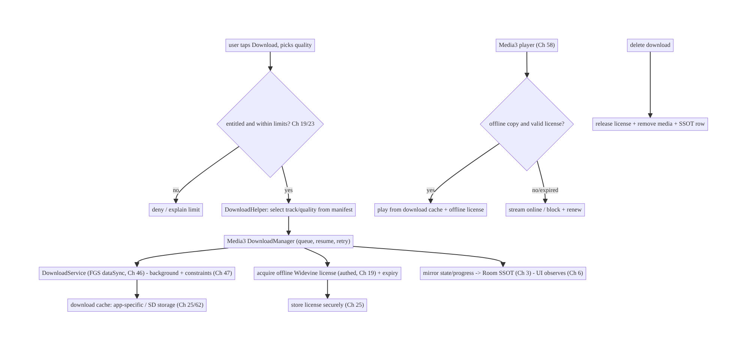
59.4 High-Level Architecture
Components & ownership
- Server authorizes entitlement/limits and issues/renews offline licenses (Ch 19/23).
- Media3 download stack (DownloadHelper → DownloadManager → DownloadService FGS) downloads a chosen rendition in the background.
- Offline license (Widevine) is acquired, stored securely, expiry-tracked, released on delete.
- SSOT mirrors state/progress; the player (Ch 58) plays the offline copy transparently.
Direction: entitlement → track select → background download + license acquire → SSOT/storage → transparent offline playback; delete releases license.

59.5 Detailed Component Design
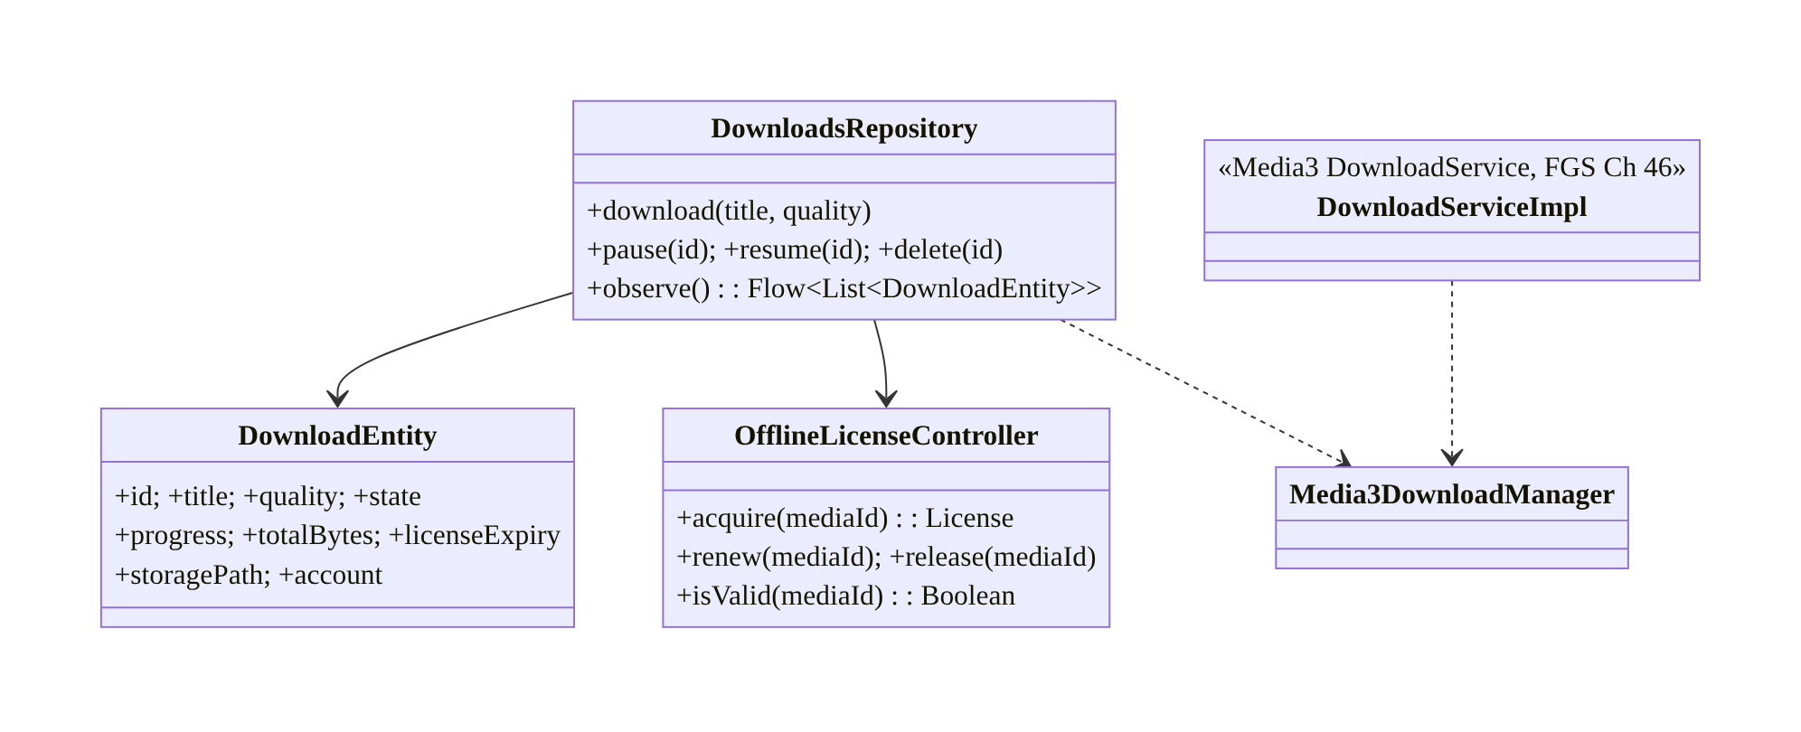
59.5 Detailed Component Design
Component | Responsibility
DownloadsRepository | app-facing API; mirror Media3 DownloadManager into SSOT (Ch 3)
DownloadEntity | SSOT row (state/progress/expiry/path/account)
OfflineLicenseController | acquire/renew/release/validate offline Widevine license
DownloadServiceImpl | Media3 DownloadService (FGS, background, Ch 46)

59.6 End-to-End Data Flow

Downloading a DRM title
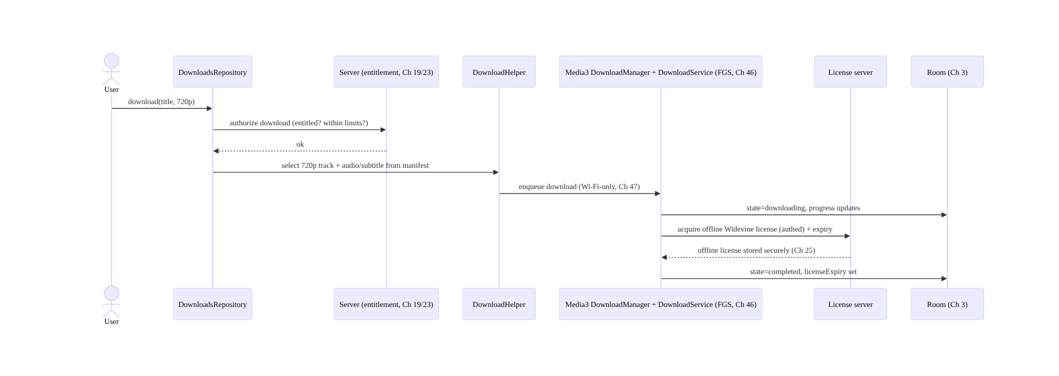
Downloading a DRM title

Transparent offline playback + expiry
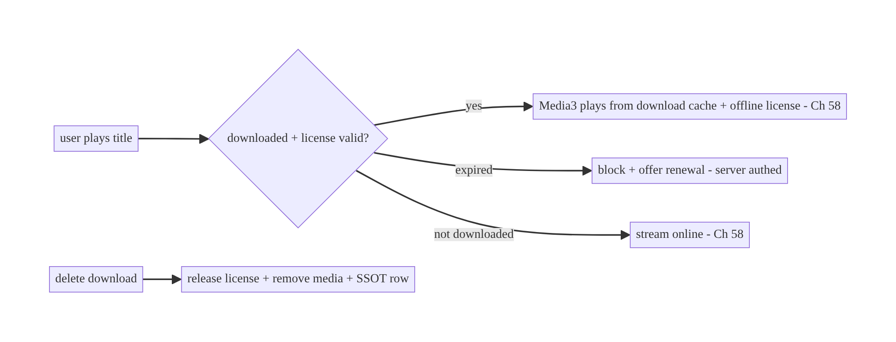
Transparent offline playback + expiry

59.7 Complete Kotlin Implementation
Package: com.streamcart.offline.

59.7.1 Media3 DownloadService (FGS, Ch 46) + DownloadManager
@AndroidEntryPoint
class StreamCartDownloadService : DownloadService(
FOREGROUND_NOTIFICATION_ID, DEFAULT_FOREGROUND_NOTIFICATION_UPDATE_INTERVAL,
DOWNLOAD_CHANNEL_ID, R.string.downloads_channel, 0, // notification (Ch 50)
) {
@Inject lateinit var downloadManager: DownloadManager // Media3, provided singleton
override fun getDownloadManager() = downloadManager
override fun getScheduler() = WorkManagerScheduler(this, "downloads") // resume via WorkManager (Ch 30)
override fun getForegroundNotification(downloads: List<Download>, notMetRequirements: Int) =
downloadNotificationHelper.buildProgressNotification(this, R.drawable.ic_download, null,
/* message */ null, downloads, notMetRequirements) // progress (Ch 46/50)
}
// DownloadManager provided with constraints (Wi-Fi-only etc., Ch 47) + cache in chosen storage (Ch 25/62).
@Provides @Singleton
fun downloadManager(@ApplicationContext ctx: Context, db: StandaloneDatabaseProvider,
cache: Cache, dataSourceFactory: HttpDataSource.Factory): DownloadManager =
DownloadManager(ctx, db, cache, dataSourceFactory, Executors.newFixedThreadPool(4)).apply {
requirements = Requirements(Requirements.NETWORK_UNMETERED) // Wi-Fi-only (Ch 47)
maxParallelDownloads = 2
}

59.7.2 Track/quality selection via DownloadHelper
suspend fun buildDownloadRequest(mediaItem: MediaItem, maxHeight: Int): DownloadRequest {
val helper = DownloadHelper.forMediaItem(context, mediaItem, renderersFactory, dataSourceFactory)
helper.prepare(object : DownloadHelper.Callback {
override fun onPrepared(h: DownloadHelper) {
// Select ONE rendition (chosen quality) + desired audio/subtitle -> not all bitrates
val params = DefaultTrackSelector.Parameters.Builder(context).setMaxVideoSize(Int.MAX_VALUE, maxHeight).build()
for (period in 0 until h.periodCount) {
h.clearTrackSelections(period); h.addTrackSelection(period, params)
}
}
override fun onPrepareError(h: DownloadHelper, e: IOException) { /* surface error */ }
})
return helper.getDownloadRequest(/* id */ mediaItem.mediaId, /* data */ null)
}
// DownloadService.sendAddDownload(context, StreamCartDownloadService::class.java, request, /*foreground*/ false)

59.7.3 Offline DRM license: acquire, renew, release (Widevine)
@Singleton
class OfflineLicenseController @Inject constructor(
private val httpFactory: HttpDataSource.Factory, // authed (Ch 19), pinned (Ch 23)
private val licenseStore: SecureLicenseStore, // Ch 25
) {
private fun helper() = OfflineLicenseHelper.newWidevineInstance(LICENSE_URL, httpFactory, DrmSessionEventListener.EventDispatcher())
/** At download time: server authorizes, then acquire + store the offline key set. */
suspend fun acquire(mediaId: String, drmInitData: DrmInitData): ByteArray = withContext(Dispatchers.IO) {
val keySetId = helper().downloadLicense(drmInitData) // offline Widevine license
licenseStore.put(mediaId, keySetId) // store securely (Ch 25)
keySetId
}
suspend fun renew(mediaId: String, drmInitData: DrmInitData) = acquire(mediaId, drmInitData) // re-acquire if entitled
suspend fun release(mediaId: String) = withContext(Dispatchers.IO) {
licenseStore.get(mediaId)?.let { helper().releaseLicense(it) } // release at rights server
licenseStore.remove(mediaId) // delete local
}
fun remainingMs(mediaId: String): Long =
licenseStore.get(mediaId)?.let { helper().getLicenseDurationRemainingSec(it).first * 1000L } ?: 0L
}

59.7.4 SSOT model + repository (mirror Media3 into Room, Ch 3)
@Entity(tableName = "downloads")
data class DownloadEntity(
@PrimaryKey val id: String, val title: String, val quality: String, val state: String, // queued/downloading/paused/completed/failed/expired
val progress: Float, val bytesDownloaded: Long, val totalBytes: Long,
val licenseExpiryMs: Long, val storagePath: String, val account: String,
)
@Singleton
class DownloadsRepository @Inject constructor(
private val dao: DownloadDao, private val license: OfflineLicenseController,
@ApplicationContext private val ctx: Context, private val activeAccount: ActiveAccountProvider, // Ch 42
) {
fun observe() = dao.observe(activeAccount.require().id) // UI observes SSOT (Ch 6)
suspend fun delete(id: String) {
DownloadService.sendRemoveDownload(ctx, StreamCartDownloadService::class.java, id, false) // remove media
license.release(id) // RELEASE the license (rights accounting)
dao.delete(id)
}
// A DownloadManager.Listener updates the SSOT rows as Media3 progresses/completes/fails.
fun bindListener(dm: DownloadManager) = dm.addListener(object : DownloadManager.Listener {
override fun onDownloadChanged(dm: DownloadManager, d: Download, e: Exception?) {
scope.launch { dao.upsert(d.toEntity(license.remainingMs(d.request.id), activeAccount.require().id)) }
}
})
}

59.7.5 Transparent offline playback (Media3, Ch 58)
// The player prefers the downloaded copy + offline license when available/valid; else streams.
fun buildMediaSource(mediaId: String, streamUri: Uri, cache: Cache): MediaSource {
val offlineKeySetId = licenseStore.get(mediaId)
val dataSourceFactory = CacheDataSource.Factory().setCache(cache) // reads the download cache if present
.setUpstreamDataSourceFactory(httpFactory) // else network (Ch 58)
val drmConfig = MediaItem.DrmConfiguration.Builder(C.WIDEVINE_UUID)
.setKeySetId(offlineKeySetId) // use OFFLINE license if present
.build()
val item = MediaItem.Builder().setMediaId(mediaId).setUri(streamUri).setDrmConfiguration(drmConfig).build()
return DefaultMediaSourceFactory(dataSourceFactory).createMediaSource(item)
}
// On play: if license expired -> block + offer renewal (server authed).

59.7.6 Module structure
:feature:downloads StreamCartDownloadService (FGS, Ch 46), DownloadsRepository, DownloadEntity/Dao (Ch 3)
:core:drm OfflineLicenseController, SecureLicenseStore (Ch 25)
:core:playback offline-aware MediaSource for the player (Ch 58)
:core:storage download cache location (app-specific/SD, Ch 62) + storage policy
# Entitlement/limits/license server -> backend (Ch 19/23). Posters -> Ch 57.

59.8 Concurrency and Race Conditions
Scenario | Risk | Handling
Download + play same title | partial-file playback | play only when state=completed; Media3 cache handles partial for progressive, gate for DRM
License acquire fails mid-download | unplayable download | mark failed; retry license; don’t mark completed without license
Delete during download | orphaned bytes/license | cancel download, release license, remove media atomically
Reboot/process death mid-download | stuck download | DownloadManager persists index; Scheduler/BOOT resumes (Ch 30)
Concurrent downloads exceed storage | failures | maxParallelDownloads + storage check before enqueue
Expiry during playback | illegal continued play | check license validity at play start + periodically; block on expiry
Account switch | cross-account downloads shown | filter SSOT by active account (Ch 42)
- Completion means bytes AND license: never mark a download “completed/playable” until both the media is fully downloaded and a valid offline license is stored — otherwise the user sees a download that won’t play (common bug).
- Delete must be atomic across three things: cancel/remove the media, release the license (rights accounting), and delete the SSOT row — a partial delete leaves orphans or over-counts the user’s device/title limit.
- DownloadManager persistence + a Scheduler make downloads survive reboot/process death: the index is persisted and a WorkManagerScheduler/BOOT_COMPLETED resumes under constraints (Ch 30/47).

59.9 Failure Scenarios and Recovery
Failure | Detection | Response | Outcome
Downloaded but won’t play | playback error | ensure license acquired before “completed”; renew | plays
License expired | validity check | block + offer renewal (server authed, Ch 19) | legal
Download interrupted | state | resume (DownloadManager + Scheduler, Ch 30) | completes
Reboot loses downloads | missing | persisted index + BOOT resume | survives
Storage full | enqueue/write fail | check before enqueue; cleanup; prompt (Ch 62) | handled
Delete leaves orphans | storage audit | atomic delete (media+license+row) | clean
Over device/title limit | server deny | enforce server-side; show limit UX | legal
Content plays after unsubscribe | entitlement | license expiry + server renewal check | enforced
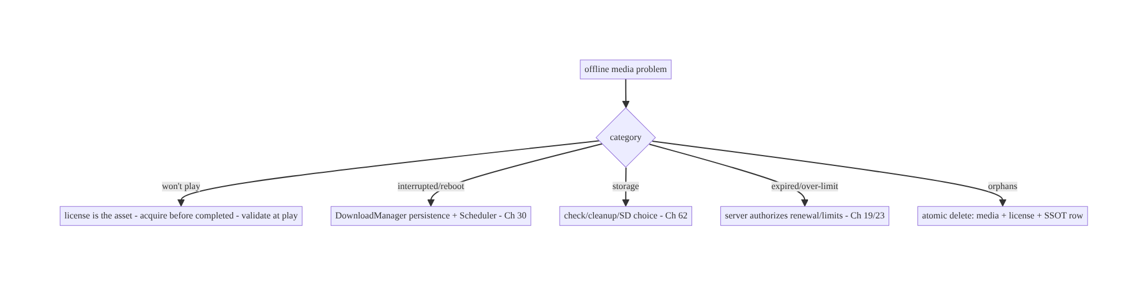
59.9 Failure Scenarios and Recovery
The license governs everything. Bytes on disk are worthless without a valid offline license, so “downloaded” means media + license, playback is gated by license validity, delete must release the license, and limits/expiry/entitlement are server-authorized. Treat the license as the real asset and most offline-OTT bugs (won’t-play, illegal-play, over-limit, orphans) disappear.

59.10 Scaling the Implementation
- Level 1. Media3 DownloadManager + DownloadService (FGS) downloading a chosen track; SSOT model; basic playback from cache.
- Level 2. Offline Widevine license acquire/validate/release; expiry UI; pause/resume/ constraints (Ch 47); reboot/death resume (Ch 30).
- Level 3 — production. Server-enforced entitlement/limits/renewal (Ch 19/23); transparent online↔offline playback (Ch 58); storage choice (SD, Ch 62) + cleanup; posters (Ch 57); per-account (Ch 42).
- Level 4 — large. Quality/track selection UX + storage estimates; auto-delete-watched policies; download queue management; smart downloads (auto-download next episode); analytics (completion, expiry churn).
- Level 5 — enterprise. Rights-management governance (device/title/geo limits), multi- DRM, offline-license renewal SLAs, storage SLOs, cross-device download accounting, download-QoE dashboards.
Avoid overengineering: use Media3’s download stack + offline license helper + SSOT; don’t hand-roll segment download or DRM. Add quality UX/cleanup policies as needed.

59.11 Alternative Approaches and Trade-offs
Dimension | Option A | Option B | When
Download engine | Media3 download stack | custom segment downloader (Ch 18) | Media3 for adaptive+DRM; custom only for non-adaptive files
Playback auth | Offline license (gated) | file presence | License-gated always (DRM legality)
Track scope | Selected rendition | all bitrates | Selected (storage) — download one quality
Background | DownloadService (FGS) | WorkManager raw | DownloadService (purpose-built, resumable, Ch 46)
Storage | App-specific / SD (Ch 62) | shared storage | App-specific/SD (security + size); not shared
Limits/expiry | Server-authorized | client-only | Server (bypassable client)
Delete | Atomic media+license+row | remove bytes only | Atomic (release license/accounting)
Media3 download stack vs custom downloader (Ch 18): a generic resumable downloader (Ch 18) handles a single file, but adaptive + DRM media needs manifest parsing, track selection, multi-segment download, a persistent index, and offline-license acquisition — which Media3’s DownloadManager/DownloadService/DownloadHelper/OfflineLicenseHelper provide and integrate with the player (Ch 58). Hand-rolling this is a huge, fragile effort; use Media3’s stack for OTT, and reserve the Ch 18 downloader for plain files.
License-gated vs file-presence playback: treating “the file is on disk” as permission to play ignores DRM — the content is encrypted and legally governed. Playback must be gated by a valid offline license (acquired at download, expiry-bound, server- authorized). This is both a legal requirement and the mechanism for expiry/limits; file presence alone must never authorize playback.
Selected rendition vs all bitrates: downloading every bitrate of an adaptive title wastes gigabytes. Download a single chosen rendition (quality the user picked) plus desired audio/subtitle tracks via DownloadHelper — the whole point of offline is a bounded, user-chosen footprint, not a full mirror of the stream.

59.12 Security & DRM Considerations
- Offline license handling is the core security concern: keys are managed by the platform DRM stack (never exposed to app code); the offline key set id is stored securely (Ch 25); the license has expiry and must be released on delete (rights accounting). Don’t attempt to extract/persist raw keys.
- Server authorizes entitlement/limits/renewal (Ch 19/23): the license server issues/ renews offline licenses only to entitled, within-limit, correct-geo requests — a modified client can’t self-grant. License + manifest requests go over the authed, pinned stack (Ch 19/23).
- Secure output for protected playback (Ch 58): FLAG_SECURE/secure surfaces for protected video to block capture.
- Store content in app-specific storage (Ch 25/62): downloaded (encrypted) media in app-specific internal/external dirs, not shared storage; licenses in secure storage.
- Per-account isolation (Ch 42): downloads and licenses are per-account; switching/ logout must not expose another account’s downloads; release/clear appropriately.
- No PII/keys/signed URLs in logs (Ch 28).
- Client vs backend: the backend owns entitlement, device/title limits, license issuance/renewal/expiry, and geo; the client downloads within those, stores securely, gates playback on the license, and uses secure surfaces — it never bypasses DRM or self-authorizes.

59.13 Performance and Resource Optimization
- Download one rendition (chosen quality) — the main storage/bandwidth lever.
- Constraints (Wi-Fi-only, charging, Ch 47) avoid cellular/battery cost; schedule in good conditions.
- Parallelism bounded (maxParallelDownloads) to avoid IO/CPU thrash.
- Resume, don’t restart (DownloadManager persistence) — never re-download on interruption.
- Storage management: quality-based size estimates, auto-delete-watched, cap, SD-card option (Ch 62), react to pressure.
- Poster/metadata generated once (Ch 57), cached.
- Efficient SSOT updates: debounce progress writes (Ch 31) — don’t write every percent.
- Profiling: download completion rate/time, resume rate, storage used, license-acquire latency/failure, expiry-driven churn, playback-from-download success.

59.14 Testing Strategy
Media3 download components test with fakes; license/SSOT logic in isolation; instrumentation for real DRM/background.
class DownloadsRepositoryTest {
@Test fun `completed requires media and license`() = runTest {
// simulate media complete but license missing -> state != completed (or flagged)
}
@Test fun `delete releases license and removes row`() = runTest {
repo.delete("m1")
assertTrue(fakeLicense.released.contains("m1")); assertNull(fakeDao.get("m1")) // atomic
}
@Test fun `downloads filtered by active account`() = runTest { /* Ch 42 */ }
}
class OfflineLicenseControllerTest {
@Test fun `expired license blocks playback`() { /* remainingMs <= 0 -> blocked */ }
@Test fun `renew re-acquires when entitled`() { /* server ok -> new keySetId */ }
}
// Instrumentation: real DownloadService background download + reboot resume + offline playback (test DRM/content).
What to test: completion requires media + license; delete is atomic (media + license + row); expiry blocks playback + renewal re-acquires; track selection downloads one rendition; resume after interruption/reboot (DownloadManager + Scheduler); constraints honored; per-account filtering; transparent offline playback picks the cache + offline license. Instrumentation with test DRM content for end-to-end.

59.15 Production Observability
- Metrics: download completion rate/time, resume rate, failure reasons; license- acquire latency/failure; expiry-driven churn (titles expiring unwatched); storage used per user; playback-from-download success; over-limit denials; orphaned media/ license count (0).
- Logs: download{id, state, quality, bytes, license_expiry, account} — no signed URLs/keys/PII (Ch 28).
- Debugging: downloaded-but-won’t-play → license not acquired before “completed” / expired; stuck downloads → Scheduler/constraints/storage; orphans → non-atomic delete; illegal play → license not validated at play; over-limit → server not enforcing.
- Alerting: license-acquire failure spike (license server); completion-rate drop; storage-pressure failures.
- Dashboards: completion/resume/license-acquire funnel; expiry churn; storage usage.

59.16 System Design Interview Preparation
≥40 questions.
Fundamentals
- Why is offline OTT hard? Adaptive + DRM + huge + licensed + player-integrated.
- The real asset? The offline license, not the bytes.
- Download engine? Media3 download stack (DownloadManager/DownloadService/ DownloadHelper).
- Why not a generic downloader (Ch 18)? Adaptive + DRM need manifest/track/segment/ license handling.
- Where does the download run? DownloadService (FGS, Ch 46), background, resumable.
DRM/license
- Offline license? Widevine license acquired at download, stored securely, expiry-bound.
- What gates playback? A valid offline license (not file presence).
- Expiry? Hard expiry / playback window; block + renew on expiry.
- Renewal? Re-acquire from server if still entitled (Ch 19).
- Delete? Release the license (rights accounting) + remove media + SSOT row (atomic).
- Keys in app code? No — platform DRM stack holds them.
Download mechanics
- Track selection? DownloadHelper — download one rendition + chosen audio/subtitle.
- Why one rendition? Storage (not all bitrates).
- Constraints? Wi-Fi-only/charging (Ch 47).
- Pause/resume? DownloadManager supports; survives reboot/death via Scheduler (Ch 30).
- Parallelism? maxParallelDownloads.
SSOT/storage
- State model? Room SSOT: queued/downloading/paused/completed/failed/expired + progress (Ch 3).
- Storage location? App-specific internal/external/SD (Ch 62), not shared.
- Cleanup? Auto-delete watched, expiry, cap, storage pressure.
- Per-account? Filter + isolate downloads/licenses (Ch 42).
Playback
- Offline playback? Same Media3 player reads the download cache + offline license (Ch 58).
- Online↔offline switch? Player picks source by availability/preference (transparent).
- Completion meaning? Media fully downloaded AND license stored.
Licensing policy
- Limits (titles/devices)? Server-authorized (Ch 19/23).
- Entitlement/geo? Server-enforced; client UX only.
- Can a modified client self-grant? No — server issues the license.
Security
- Protected playback capture? FLAG_SECURE/secure surface (Ch 58).
- Network for license/manifest? Authed + pinned (Ch 19/23).
- Logging? No keys/signed URLs/PII (Ch 28).
Testing/Production
- Test completion? Requires media + license.
- Test delete? Atomic (media+license+row).
- Test expiry? Blocks playback; renewal re-acquires.
- Test resume? After interruption/reboot.
- Won’t-play in prod? License not acquired/expired.
- Stuck downloads? Scheduler/constraints/storage.
- Orphans? Non-atomic delete.
- Illegal continued play? License not validated at play.
- Over-limit? Server not enforcing.
- Key metrics? Completion, license-acquire, expiry churn, storage.
- Expiry churn? Titles expiring unwatched — product signal.
- What survives reboot? DownloadManager index + Scheduler resume.

Design-change challenges
- Download a DRM movie for offline viewing. Media3 download stack + offline Widevine license + SSOT + FGS (Ch 46).
- A downloaded title must expire after 48h of first play. Offline license playback window; block + renew (Ch 19).
- Deleting a download must free the user’s device slot. Release the license on delete (atomic).
- Users on cellular shouldn’t auto-download. Wi-Fi-only constraints (Ch 47).
- Play downloads offline, stream otherwise, seamlessly. CacheDataSource + offline license; player picks source (Ch 58).

Mock walkthrough (abridged)
Clarify (DRM?, adaptive?, limits/expiry, storage/SD, cross-device?) → license is the asset → Media3 download stack (DownloadHelper track select → DownloadManager → DownloadService FGS, Ch 46) under constraints (Ch 47) → offline Widevine license acquire/ store/expiry/renew/release (Ch 19/25) → SSOT model + secure/SD storage (Ch 3/25/62) → transparent offline playback (Ch 58) → server-enforced entitlement/limits (Ch 19/23) → cleanup/pressure → observability (completion, license, expiry churn).

59.17 Practical Exercises
- Beginner. Download a chosen-quality track of an adaptive title via Media3 DownloadService (FGS) with Wi-Fi-only constraints; model it in the SSOT. Eval: downloads in background; state/progress in Room.
- Intermediate. Acquire an offline Widevine license at download time, gate playback on its validity, and release it on delete. Eval: plays only with a valid license; delete releases.
- Advanced. Add expiry (playback window) with countdown UI and server-authorized renewal; make deletion atomic (media + license + row). Eval: expires/renews; no orphans.
- Production debugging. Fix “downloaded but won’t play” (completed before license) and stuck downloads after reboot (no Scheduler). Eval: completion requires license; resumes.
- System design challenge. Add storage management (quality estimates, SD choice, auto-delete-watched) and per-account isolation; build a completion/expiry dashboard. Eval: storage-sane; isolated; measurable.
(Solutions withheld unless requested.)

59.18 Chapter Summary & Reference Sheet
Key decisions: treat the offline license as the real asset (bytes without a valid license are worthless and illegal to play); use Media3’s download stack — DownloadHelper to select a single chosen rendition (+ desired audio/subtitle) of an adaptive stream, DownloadManager for the resumable queue (persistent index, pause/resume/retry), and a DownloadService (foreground service, Ch 46) to run it in the background under constraints (Wi-Fi-only/charging, Ch 47), surviving reboot/ process death via a Scheduler (Ch 30); acquire/store/renew/release an offline Widevine license (expiry-bound, keys platform-held, stored securely, Ch 25) where playback is gated by license validity and delete releases the license atomically with the media and SSOT row; model downloads in the SSOT (Ch 3) in app-specific/SD storage (Ch 62); play the downloaded copy transparently via the same Media3 player (CacheDataSource + offline license, Ch 58); and enforce entitlement, device/title limits, geo, and expiry on the server (Ch 19/23) since a modified client cannot self-grant a license. Downloads/licenses are per-account (Ch 42), and storage is actively managed (quality estimates, cleanup, pressure).
Concepts: offline license (acquire/store/expiry/renew/release), Media3 download stack (DownloadManager/DownloadService/DownloadHelper), track/quality selection, FGS background + constraints, SSOT download model, secure/SD storage, transparent offline playback, server-enforced licensing, storage management.
Common mistakes: downloading all bitrates (storage); treating file presence as play permission (DRM/legality); marking “completed” before the license is acquired (won’t-play); not releasing the license on delete (over-limit/orphans); not validating license at play (illegal continued play); client-only limit enforcement (bypassable); hand-rolling adaptive+DRM download; no resume/Scheduler (lost on reboot); shared storage; cross-account leakage.
Checklist:
- ☐ Media3 download stack (DownloadHelper/DownloadManager/DownloadService FGS, Ch 46)
- ☐ download one chosen rendition
- ☐ Wi-Fi-only/charging constraints (Ch 47)
- ☐ resume via Scheduler, survive reboot/death (Ch 30)
- ☐ offline Widevine license acquire/store/expiry/renew (Ch 25)
- ☐ playback gated by license validity
- ☐ atomic delete (media + license + SSOT row)
- ☐ SSOT model (Ch 3), app-specific/SD storage (Ch 62)
- ☐ transparent offline playback (Ch 58)
- ☐ server-enforced entitlement/limits/geo/expiry (Ch 19/23)
- ☐ per-account (Ch 42)
- ☐ FLAG_SECURE for protected playback
- ☐ storage cleanup/pressure.
Key APIs: Media3 DownloadManager/DownloadService/DownloadHelper/DownloadRequest/ Download, DownloadNotificationHelper, WorkManagerScheduler/Requirements (Ch 30/47), OfflineLicenseHelper (downloadLicense/releaseLicense/getLicenseDurationRemainingSec), MediaItem.DrmConfiguration/setKeySetId, CacheDataSource/Cache, C.WIDEVINE_UUID, FLAG_SECURE, Room SSOT (Ch 3), secure storage (Ch 25).
References:
- Media3 downloading: https://developer.android.com/media/media3/exoplayer/downloading-media
- Offline DRM / downloading protected content: https://developer.android.com/media/media3/exoplayer/drm#offline
- DownloadService: https://developer.android.com/reference/androidx/media3/exoplayer/offline/DownloadService
- Store data (app-specific/SD): https://developer.android.com/training/data-storage
- (composes) Ch 58 Media Playback, Ch 18 Downloads, Ch 46 FGS, Ch 30 WorkManager, Ch 47 Constraints, Ch 25 Secure Storage, Ch 62 SAF/Storage, Ch 19/23 Auth/Security

Chapter 60 — Camera Capture Pipeline (CameraX)
Part VII — Media & Files · Complexity: Standard (≥25 interview questions)
Prerequisites: Ch 51 (runtime permissions), Ch 44 (lifecycle), Ch 25 (secure storage), Ch 17 (uploads), Ch 57 (thumbnails), Ch 28 (privacy). Pairs with Ch 61 (large files), Ch 62 (SAF), Ch 6 (UI state).
Reference surface in StreamCart: in-app camera features — scanning a product/QR code, capturing a photo for a review or profile, recording a short video, document capture — built on CameraX with correct lifecycle, permissions, output handling, and privacy.

60.1 Problem Definition and Real-World Context
The camera is one of the most fragmented, lifecycle-sensitive, and privacy-laden subsystems on Android. The legacy Camera2 API is powerful but extremely complex (manual session/surface/threading management, device quirks). CameraX (Jetpack) is the modern, lifecycle-aware, use-case-based abstraction that handles most of the complexity and device compatibility — but you still must get permissions (Ch 51), lifecycle binding (Ch 44), output + storage (Ch 25), threading, and privacy (Ch 28) right.
Concretely, teams hit:
- Camera2 complexity. Managing CameraDevice/CaptureSession/surfaces/threads manually across device quirks is error-prone — most apps should use CameraX, which provides Preview, ImageCapture, VideoCapture, and ImageAnalysis use cases bound to a lifecycle.
- Lifecycle leaks / crashes. The camera is a scarce, exclusive resource; not releasing it on background/destroy leaks it (other apps can’t use it) and crashes; binding to the wrong lifecycle breaks preview. CameraX binds use cases to a LifecycleOwner so it opens/closes automatically (Ch 44).
- Permissions (Ch 51). CAMERA (and audio for video, location only if geotagging) are runtime permissions needing in-context request + graceful denial. Modern alternatives (the system camera intent, Photo Picker, Ch 51) avoid the permission entirely for simple capture.
- Output & storage (Ch 25/62). Where captured photos/videos go (app-internal vs shared/MediaStore), orientation/EXIF handling, and privacy (EXIF location leaks, Ch 28) matter.
- Threading & performance. Analysis (ML/QR) must run off the main thread with backpressure; preview must be smooth; capture must not block the UI.
- Privacy & indicators. Camera use shows a system indicator; apps must use the camera only while the user expects it, release promptly, and handle sensitive capture (ID docs) carefully.
The architecture: use CameraX with the right use cases — Preview, ImageCapture, VideoCapture, ImageAnalysis — bound to a LifecycleOwner so the camera opens/closes with the lifecycle (Ch 44); gate on the CAMERA permission (Ch 51) with in-context request and graceful denial, preferring no-permission alternatives (system camera intent / Photo Picker) for simple capture; handle output to app-internal or MediaStore storage (Ch 25/62) with correct orientation/EXIF and privacy (strip location, Ch 28); run analysis off-main with backpressure; and manage resources/privacy (release promptly, use only when expected). This chapter is about a correct, lifecycle-safe, privacy-respecting camera pipeline with CameraX.

Three practical use cases
- QR/product scan (StreamCart). CameraX Preview + ImageAnalysis running ML Kit barcode scanning off-main; releases the camera when the scanner closes.
- Review/profile photo. For simple capture, prefer the system camera intent (ACTION_IMAGE_CAPTURE, no CAMERA permission); for an in-app custom UI, CameraX ImageCapture → app-internal file → thumbnail (Ch 57) → upload (Ch 17), EXIF location stripped (Ch 28).
- Short video. CameraX VideoCapture with audio permission, bound to lifecycle, output to app-specific storage, size-limited.

Why this is architectural
Camera work ties permissions (Ch 51), lifecycle (Ch 44) (exclusive resource), storage/output (Ch 25/62), threading/perf, and privacy (Ch 28) together. The decisions — CameraX use cases, lifecycle binding, permission strategy (including avoiding it), output/EXIF handling, off-main analysis — determine reliability, resource safety, and user trust.

60.2 Requirements Engineering

Functional requirements
ID | Requirement
F1 | Show a camera preview and capture photos/videos (or analyze frames).
F2 | Bind the camera to a lifecycle so it opens/closes automatically (Ch 44).
F3 | Gate on the CAMERA (and audio) permission with in-context request + graceful denial (Ch 51).
F4 | Handle output + storage (app-internal/MediaStore), orientation, EXIF (Ch 25/62).
F5 | Run frame analysis off the main thread with backpressure.
F6 | Respect privacy (strip location EXIF, release promptly, sensitive capture) (Ch 28).

Non-functional requirements
Attribute | Policy
Resource safety | Camera released on background/destroy (exclusive resource).
Compatibility | CameraX across device fragmentation; graceful fallback.
Performance | Smooth preview; off-main analysis with backpressure; non-blocking capture.
Privacy | Least privilege; strip location EXIF; use only when expected (Ch 28).
UX | In-context permission; prefer no-permission alternatives where possible.

Scope
- In scope: CameraX use cases (Preview/ImageCapture/VideoCapture/ImageAnalysis), lifecycle binding (Ch 44), CAMERA/audio permission (Ch 51) + no-permission alternatives (system camera intent, Photo Picker), output/storage (app-internal vs MediaStore, Ch 25/ 62), orientation/EXIF + privacy (Ch 28), off-main analysis + backpressure, resource release, Compose integration.
- Out of scope: permission state machine detail (Ch 51), upload (Ch 17), thumbnail generation (Ch 57), storage APIs (Ch 62), ML model detail, Camera2 low-level APIs.

Assumptions & constraints
- CameraX (androidx.camera), Compose (PreviewView/CameraController), Hilt, ML Kit for analysis (barcode). minSdk 24. Camera is an exclusive, scarce resource; needs runtime permission; privacy indicators apply; device fragmentation is real (CameraX mitigates).

60.3 System Design Fundamentals
- Use CameraX, not Camera2 (for most apps). CameraX abstracts the brutal complexity of Camera2 (session/surface/thread management, device quirks) into lifecycle-aware use cases with consistent behavior across devices. You use Camera2 directly only for advanced needs (manual exposure/RAW/custom sessions). Default to CameraX.
- The four use cases (compose what you need):
  - Preview: the live viewfinder (to a PreviewView/surface).
  - ImageCapture: take a still photo (to a file/MediaStore/in-memory).
  - VideoCapture: record video (with audio).
  - ImageAnalysis: a stream of frames for analysis (ML Kit barcode/face/text) — off-main with backpressure. Bind a subset (e.g., Preview + ImageAnalysis for a scanner; Preview + ImageCapture for a photo).
- Lifecycle binding = automatic open/close (the key). CameraX binds use cases to a LifecycleOwner (Ch 44): the camera opens when the lifecycle is STARTED and closes/releases when STOPPED/destroyed — automatically. This is what prevents the classic “camera not released” leak (other apps blocked) and crashes on rotation/ background. You never manually open/close; you bind.
- Permissions (Ch 51) and avoiding them:
  - CameraX requires CAMERA (and RECORD_AUDIO for video); request in context (when the user opens the camera feature) with a rationale and graceful denial (Ch 51).
  - Prefer no-permission alternatives for simple cases: the system camera intent (ACTION_IMAGE_CAPTURE / ACTION_VIDEO_CAPTURE) launches the device camera app and returns the result without your app holding CAMERA — ideal for one-off capture; the Photo Picker (Ch 51) for choosing existing media. Use CameraX only when you need an in-app custom camera UI (scanner, custom controls, real-time analysis).
- Output & storage (Ch 25/62):
  - App-internal (private) for images the app owns/uploads (Ch 17) — default for sensitive/transient capture.
  - MediaStore (shared gallery) when the user should keep the photo in their gallery (scoped storage, Ch 62).
  - Handle orientation (CameraX provides target rotation) and EXIF — and strip location/sensitive EXIF before storing/uploading unless the user intends geotagging (Ch 28).
- Off-main analysis + backpressure. ImageAnalysis delivers frames to a background Executor; use STRATEGY_KEEP_ONLY_LATEST backpressure so a slow analyzer (ML) drops stale frames instead of queueing/lagging. Close each ImageProxy promptly (or frames stall). Never analyze on the main thread.
- Resource management & privacy (Ch 28). The camera is exclusive — release it (unbind / lifecycle stop) the moment the feature closes or the app backgrounds; the system shows a privacy indicator while active, so using it when the user doesn’t expect it is a trust violation. For sensitive capture (ID docs), consider FLAG_SECURE and app-internal storage, and don’t retain longer than needed.
- Compose integration. PreviewView via AndroidView, or the newer CameraController + Compose viewfinder; bind to the composition’s LifecycleOwner.
Core insight: use CameraX’s lifecycle-aware use cases (Preview/ImageCapture/ VideoCapture/ImageAnalysis) bound to a LifecycleOwner so the exclusive camera resource opens and releases automatically (Ch 44) — never manually; gate on the CAMERA/audio permission in context (Ch 51) but prefer no-permission alternatives (system camera intent, Photo Picker) for simple capture; handle output to app-internal or MediaStore storage with correct orientation and privacy-stripped EXIF (Ch 25/62/28); run frame analysis off the main thread with keep-only-latest backpressure; and release the camera promptly, using it only when the user expects it.

60.4 High-Level Architecture
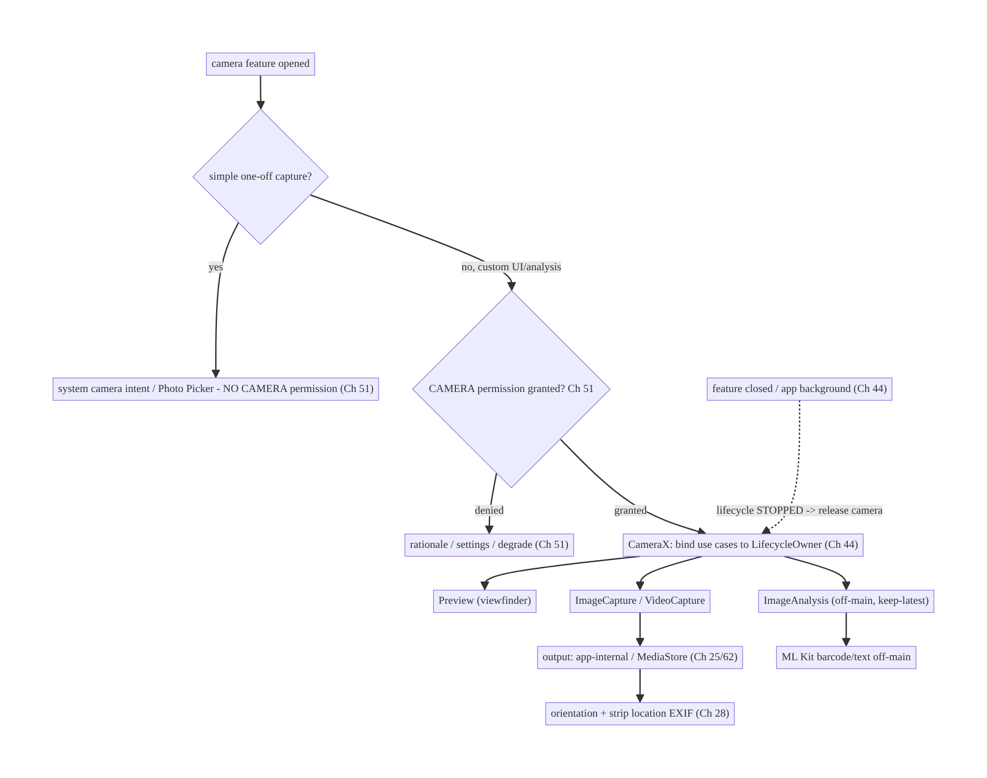
60.4 High-Level Architecture
Components & ownership
- Decision gate: simple capture → system intent/Photo Picker (no permission); custom → CameraX.
- CameraX binds use cases to the lifecycle (auto open/close).
- Output goes to app-internal/MediaStore with EXIF/orientation + privacy handling.
- Analysis runs off-main with backpressure.
Direction: feature → (intent vs CameraX) → permission → lifecycle-bound use cases → capture/analyze → output (privacy-handled); camera released on lifecycle stop.

60.5 Detailed Component Design
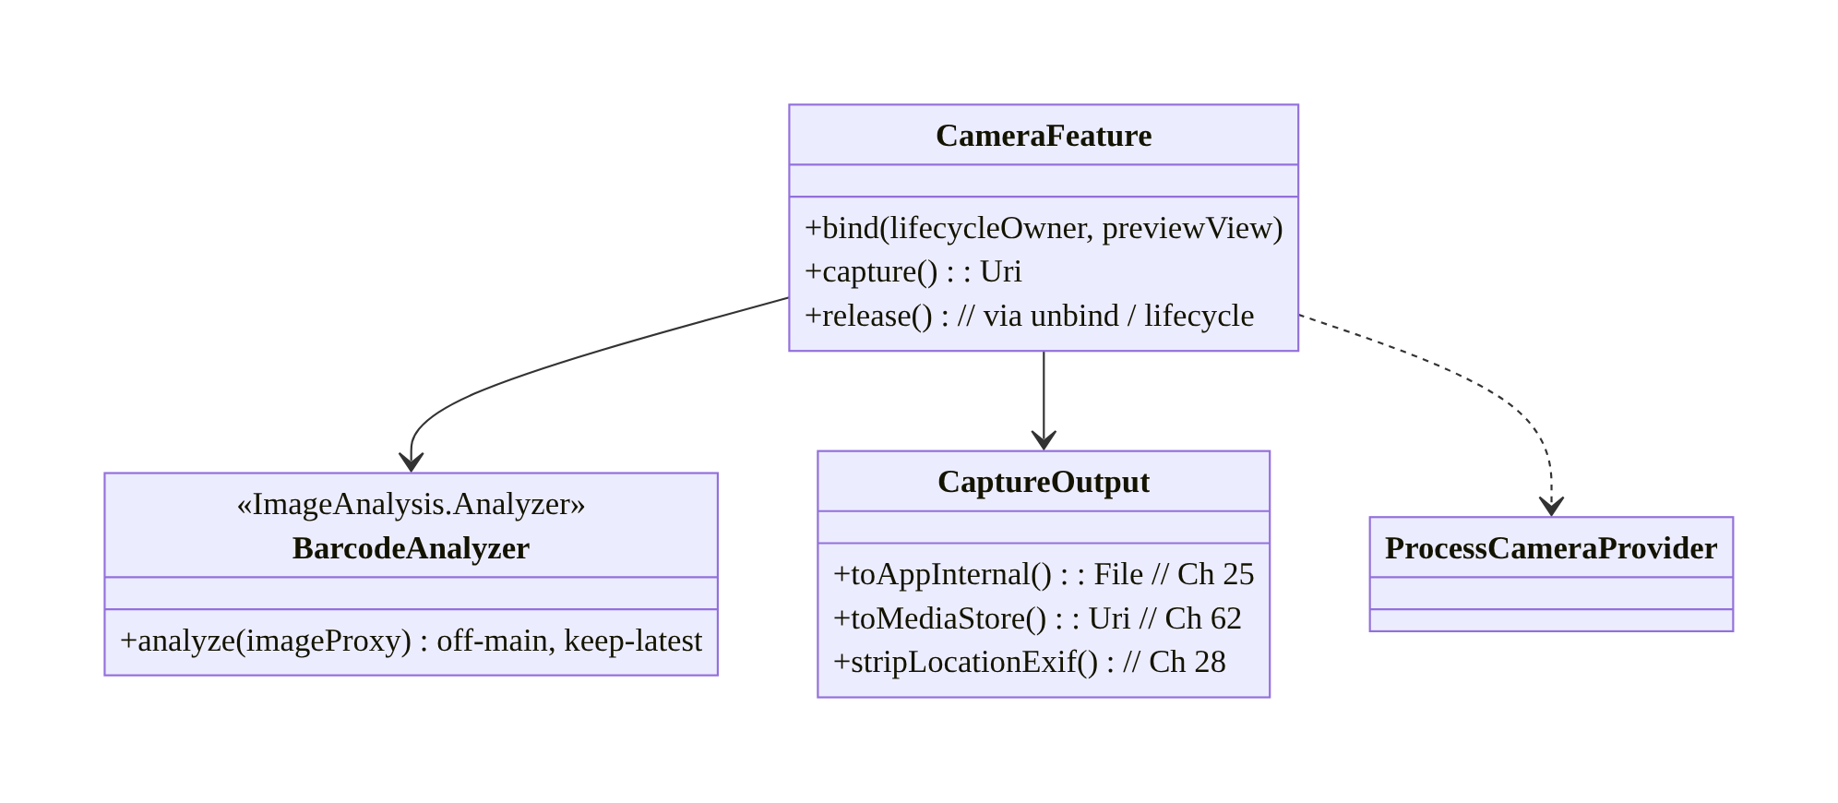
60.5 Detailed Component Design
Component | Responsibility
CameraFeature | bind use cases to lifecycle; capture; release (CameraX)
BarcodeAnalyzer | off-main frame analysis (keep-latest, close proxies)
CaptureOutput | write to app-internal/MediaStore; orientation; strip EXIF (Ch 25/62/28)
Permission gate (Ch 51) | in-context CAMERA request / alternatives

60.6 End-to-End Data Flow

Scanner (Preview + ImageAnalysis)
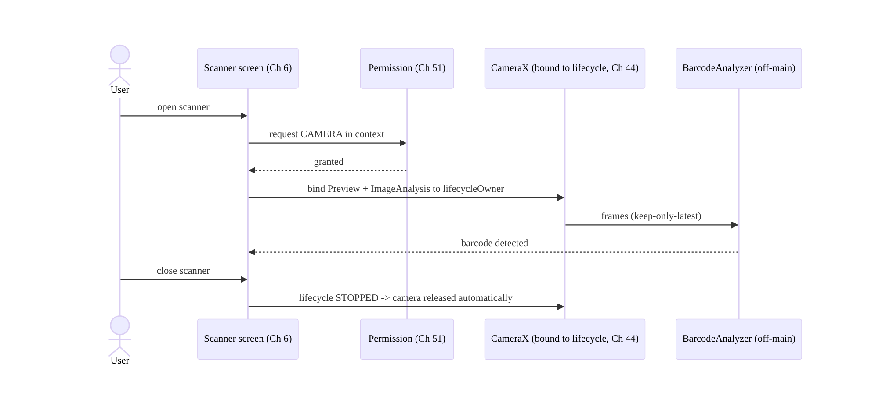
Scanner (Preview + ImageAnalysis)

Photo capture + privacy

Photo capture + privacy

60.7 Complete Kotlin Implementation
Package: com.streamcart.camera.

60.7.1 No-permission alternative first (system camera intent)
// For simple one-off capture, avoid the CAMERA permission entirely (Ch 51).
@Composable
fun CaptureReviewPhoto(onCaptured: (Uri) -> Unit) {
val context = LocalContext.current
val outputUri = remember { context.appInternalImageUri() } // app-provided file URI (FileProvider, Ch 62)
val launcher = rememberLauncherForActivityResult(ActivityResultContracts.TakePicture()) { success ->
if (success) onCaptured(outputUri) // device camera app handled capture; no CAMERA perm
}
Button(onClick = { launcher.launch(outputUri) }) { Text("Take photo") }
}

60.7.2 CameraX scanner (Preview + ImageAnalysis), lifecycle-bound
@Composable
fun ScannerScreen(onBarcode: (String) -> Unit, vm: ScannerViewModel = hiltViewModel()) {
val lifecycleOwner = LocalLifecycleOwner.current
val context = LocalContext.current
// (CAMERA permission already granted in-context, Ch 51)
AndroidView(factory = { ctx ->
PreviewView(ctx).also { previewView ->
val cameraProviderFuture = ProcessCameraProvider.getInstance(ctx)
cameraProviderFuture.addListener({
val provider = cameraProviderFuture.get()
val preview = Preview.Builder().build().also { it.setSurfaceProvider(previewView.surfaceProvider) }
val analysis = ImageAnalysis.Builder()
.setBackpressureStrategy(ImageAnalysis.STRATEGY_KEEP_ONLY_LATEST) // drop stale frames
.build().also { it.setAnalyzer(vm.analysisExecutor, BarcodeAnalyzer(onBarcode)) } // OFF-MAIN
provider.unbindAll()
provider.bindToLifecycle(lifecycleOwner, CameraSelector.DEFAULT_BACK_CAMERA, preview, analysis)
// bound to lifecycle -> camera opens now, RELEASES automatically on STOP/destroy (Ch 44)
}, ContextCompat.getMainExecutor(ctx))
}
})
}

60.7.3 Off-main analyzer (keep-latest, close proxies)
class BarcodeAnalyzer(private val onBarcode: (String) -> Unit) : ImageAnalysis.Analyzer {
private val scanner = BarcodeScanning.getClient()
@OptIn(ExperimentalGetImage::class)
override fun analyze(imageProxy: ImageProxy) {
val media = imageProxy.image ?: run { imageProxy.close(); return }
val input = InputImage.fromMediaImage(media, imageProxy.imageInfo.rotationDegrees)
scanner.process(input)
.addOnSuccessListener { it.firstOrNull()?.rawValue?.let(onBarcode) }
.addOnCompleteListener { imageProxy.close() } // MUST close or frames stall (backpressure)
}
}

60.7.4 Photo capture → app-internal + strip location EXIF (Ch 25/28)
fun ImageCapture.capture(context: Context, onSaved: (File) -> Unit) {
val file = File(context.filesDir, "capture_${System.currentTimeMillis()}.jpg") // app-internal (Ch 25)
val options = ImageCapture.OutputFileOptions.Builder(file).build()
takePicture(options, ContextCompat.getMainExecutor(context), object : ImageCapture.OnImageSavedCallback {
override fun onImageSaved(output: ImageCapture.OutputFileResults) {
stripLocationExif(file) // PRIVACY: remove GPS tags (Ch 28) unless user intends geotag
onSaved(file) // -> thumbnail (Ch 57), upload (Ch 17)
}
override fun onError(e: ImageCaptureException) { /* surface error */ }
})
}
private fun stripLocationExif(file: File) {
ExifInterface(file.absolutePath).apply {
setAttribute(ExifInterface.TAG_GPS_LATITUDE, null); setAttribute(ExifInterface.TAG_GPS_LONGITUDE, null)
setAttribute(ExifInterface.TAG_GPS_LATITUDE_REF, null); setAttribute(ExifInterface.TAG_GPS_LONGITUDE_REF, null)
saveAttributes()
}
}

60.7.5 Module structure
:feature:camera ScannerScreen, CameraFeature (CameraX bind), BarcodeAnalyzer, capture + EXIF strip
:core:permissions in-context CAMERA request (Ch 51)
:core:storage app-internal / MediaStore output + FileProvider (Ch 25/62)
# Thumbnails -> Ch 57; upload -> Ch 17; privacy -> Ch 28.

60.8 Concurrency and Race Conditions
Scenario | Risk | Handling
Camera not released | resource leak / other apps blocked | lifecycle binding auto-releases (Ch 44); unbind on close
Analysis on main thread | jank/ANR | dedicated Executor; off-main
ImageProxy not closed | frame pipeline stalls | close in onComplete; keep-only-latest
Rotation during capture | wrong orientation/crash | CameraX target rotation; lifecycle rebind
Rapid open/close | camera-in-use errors | unbindAll() before rebind; serialize provider access
Capture on background | crash / privacy | bound to lifecycle (won’t run when stopped)
- Lifecycle binding is the resource-safety mechanism: because use cases are bound to a LifecycleOwner, the exclusive camera opens on STARTED and releases on STOPPED/ destroyed automatically — eliminating the classic leak where the camera stays open (blocking other apps) after the user leaves. Never manually open/close.
- Close every ImageProxy in ImageAnalysis (and use keep-only-latest) or the frame pipeline backs up and the preview/analysis stalls.
- unbindAll() before rebinding avoids “camera in use” races on rapid open/close/ rotation.

60.9 Failure Scenarios and Recovery
Failure | Detection | Response | Outcome
Camera leaked / unavailable | other apps fail / logs | lifecycle binding; unbind on close | released
Permission denied | Ch 51 | rationale → settings; prefer system intent | recoverable
Jank on preview/scan | frames | off-main analysis; keep-latest; close proxies | smooth
Wrong photo orientation | visual | CameraX target rotation / EXIF orientation | correct
Location leaked in EXIF | privacy review | strip GPS EXIF (Ch 28) | private
Device quirk / use-case unsupported | bind error | CameraX fallback; reduce use cases | works
Crash capturing on background | crash | lifecycle-bound (won’t capture when stopped) | stable
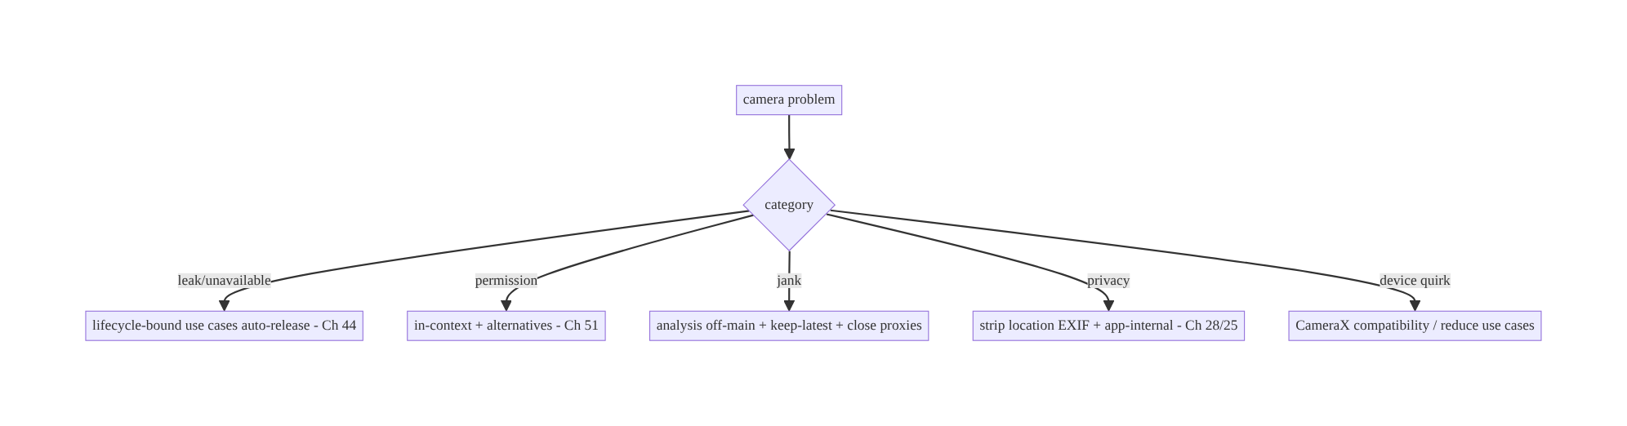
60.9 Failure Scenarios and Recovery
CameraX’s lifecycle binding solves the two hardest camera bugs for free: the resource leak (camera not released) and the crash-on-background — the camera opens and closes with the lifecycle. The remaining work is permissions (prefer avoiding them), off-main analysis, and privacy (strip EXIF) — not manual session/thread management.

60.10 Scaling the Implementation
- Level 1. Prefer system camera intent / Photo Picker (no permission) for simple capture.
- Level 2. CameraX Preview + ImageCapture (custom UI) bound to lifecycle; in-context permission (Ch 51); app-internal output + EXIF strip (Ch 25/28).
- Level 3 — production. ImageAnalysis off-main (ML Kit) with keep-latest; VideoCapture with audio; orientation; thumbnails (Ch 57) + upload (Ch 17).
- Level 4 — large. Multiple cameras/lenses, zoom/flash/torch controls, image quality tuning, MediaStore integration (Ch 62), document-capture flows (edge detection).
- Level 5 — enterprise. Camera governance (which features may use it), privacy review (Ch 28), capture-QoE analytics, Camera2 interop for advanced needs, accessibility.
Avoid overengineering: for simple capture, the system intent needs no permission and no CameraX. Use CameraX when you need a custom in-app camera; use Camera2 only for advanced control.

60.11 Alternative Approaches and Trade-offs
Dimension | Option A | Option B | When
API | CameraX | Camera2 | CameraX (most apps); Camera2 for manual exposure/RAW/custom sessions
Simple capture | System camera intent (no permission) | in-app CameraX | Intent for one-off; CameraX for custom UI/analysis
Lifecycle | CameraX bindToLifecycle | manual open/close | CameraX (auto release, no leak)
Analysis backpressure | Keep-only-latest | queue all frames | Keep-latest (real-time, no lag)
Output | App-internal (Ch 25) | MediaStore (Ch 62) | App-internal for app-owned/sensitive; MediaStore for user gallery
EXIF location | Strip (default) | keep (geotag) | Strip unless user intends geotagging (Ch 28)
CameraX vs Camera2: Camera2 offers full manual control (exposure, RAW, custom capture sessions) but at enormous complexity and device-fragmentation cost — manual session/surface/ thread management is a notorious source of bugs. CameraX provides lifecycle-aware use cases with consistent cross-device behavior and solves open/close/threading for you. Use CameraX unless you specifically need Camera2’s manual controls; CameraX even offers Camera2 interop for targeted advanced needs.
System camera intent vs in-app CameraX: for a one-off photo/video, launching the system camera app (ACTION_IMAGE_CAPTURE) returns a result without your app holding the CAMERA permission — simpler, safer, and privacy-friendly. Use CameraX only when you need an in-app custom camera (real-time scanning/analysis, custom controls, branded UI). Don’t take on the camera permission and pipeline for simple capture.
Keep-only-latest vs queueing frames: for real-time analysis (scanning), a slow analyzer (ML inference) must not build a backlog — keep-only-latest drops stale frames so detection stays current and the preview doesn’t lag. Queueing all frames causes growing latency and memory. Use keep-only-latest for analysis.

60.12 Security & Privacy Considerations
- Least privilege (Ch 51): prefer the system camera intent / Photo Picker (no CAMERA permission); request CAMERA/RECORD_AUDIO only for custom in-app camera, in context.
- Strip location/sensitive EXIF (Ch 28): captured photos carry GPS and device metadata — strip it before storing/uploading unless the user explicitly wants geotagging.
- App-internal storage for sensitive capture (Ch 25): ID documents, private photos go to app-internal storage, not shared/MediaStore where other apps can read them; consider FLAG_SECURE for sensitive capture screens.
- Release the camera promptly: it’s exclusive and shows a privacy indicator — use it only while the user expects it; unbind on close/background (lifecycle does this).
- Don’t capture/retain more than needed: no silent/background capture; delete transient captures after upload (Ch 17).
- Validate output URIs (Ch 62): when writing to a provided URI (system intent / MediaStore), use a proper FileProvider/scoped storage; don’t expose internal paths.
- Per-account (Ch 42): captured media tied to the active account; clear on logout.
- Client vs backend: capture and EXIF-stripping are client concerns; the backend receives the uploaded (stripped) media over authed channels (Ch 17/19) and must not assume client-side privacy handling (strip server-side too if needed).

60.13 Performance and Resource Optimization
- Release the camera when done (lifecycle unbind) — exclusive resource + battery.
- Off-main analysis + keep-only-latest — smooth preview, current detection, no backlog.
- Right-size capture/analysis resolution — analyze at a lower resolution than capture (scanning doesn’t need full res); set ImageAnalysis target resolution.
- Close ImageProxy promptly — avoid pipeline stalls.
- Bind only needed use cases — fewer surfaces = less overhead; don’t bind ImageAnalysis if not analyzing.
- Downsample/compress captured photos before upload (Ch 17/57).
- Profiling: preview FPS, analysis latency/throughput, camera open/close balance, capture time, memory from frames.

60.14 Testing Strategy
Camera is hard to unit-test (hardware); test logic (EXIF strip, output, analyzer) in isolation and the pipeline with instrumentation / CameraX test utilities.
class ExifStripTest {
@Test fun `strips GPS tags`() {
val file = sampleJpegWithGps()
stripLocationExif(file)
val exif = ExifInterface(file.absolutePath)
assertNull(exif.getAttribute(ExifInterface.TAG_GPS_LATITUDE)) // privacy (Ch 28)
}
}
class BarcodeAnalyzerTest {
@Test fun `closes image proxy after analysis`() {
val proxy = mockImageProxy()
BarcodeAnalyzer {}.analyze(proxy)
verify(proxy).close() // or frames stall
}
}
@RunWith(AndroidJUnit4::class)
class CameraLifecycleTest {
@get:Rule val grant = GrantPermissionRule.grant(Manifest.permission.CAMERA)
@Test fun `camera released when lifecycle stops`() { /* bind, move lifecycle to STOPPED, assert unbound */ }
}
What to test: EXIF stripping (privacy); analyzer closes proxies + keep-latest; output to app-internal; permission gate (Ch 51) + system-intent alternative; camera released on lifecycle stop (instrumentation); orientation. Use CameraX’s FakeCamera/test APIs and instrumentation for real hardware behavior.

60.15 Production Observability
- Metrics: camera open/close balance (leak detection); permission grant rate (Ch 51); capture success/error rate; analysis latency/FPS; capture time; EXIF-strip coverage; system-intent vs CameraX usage; crashes by device/OEM (fragmentation).
- Logs: camera{use_cases, result, device, error} — no image content/PII (Ch 28).
- Debugging: camera unavailable → not released (lifecycle) / other app; jank → on-main analysis / no keep-latest / proxies not closed; wrong orientation → target rotation; location leak → EXIF not stripped; device crash → quirk (CameraX fallback / reduce use cases).
- Alerting: camera-open leak (open without close); capture-failure spike on an OEM; EXIF-strip failures (privacy).
- Dashboards: camera reliability by device/OEM; capture success; permission funnel.

60.16 System Design Interview Preparation
≥25 questions.
Fundamentals
- CameraX vs Camera2? Lifecycle-aware use cases + compatibility vs manual low-level control.
- Four use cases? Preview, ImageCapture, VideoCapture, ImageAnalysis.
- Lifecycle binding? bindToLifecycle → camera opens/closes automatically (Ch 44).
- Why binding matters? Camera is exclusive — auto-release prevents leaks/crashes.
- When Camera2? Manual exposure/RAW/custom sessions.
Permissions
- What permission? CAMERA (+ RECORD_AUDIO for video) — runtime (Ch 51).
- Avoid it? System camera intent / Photo Picker (no permission).
- When CameraX over intent? Custom in-app camera / real-time analysis.
- Denied? In-context rationale → settings; degrade (Ch 51).
Analysis
- ImageAnalysis thread? Off-main (Executor).
- Backpressure? Keep-only-latest (drop stale frames).
- ImageProxy? Must close or pipeline stalls.
- Resolution? Analyze at lower res than capture.
Output/privacy
- Output storage? App-internal (sensitive) vs MediaStore (user gallery) (Ch 25/62).
- EXIF location? Strip unless geotagging intended (Ch 28).
- Orientation? CameraX target rotation / EXIF.
- Sensitive capture? App-internal + FLAG_SECURE.
Resource/lifecycle
- Release camera? Unbind / lifecycle stop — promptly.
- Privacy indicator? Use only when expected.
- Rotation? Rebind; target rotation.
Testing/Production
- Test EXIF strip? Assert GPS tags removed.
- Test analyzer? Closes proxies.
- Camera unavailable in prod? Not released (lifecycle).
- Jank? On-main analysis / no keep-latest.
- Device crashes? Quirks — CameraX fallback.
- Key metric? Open/close balance (leaks) + capture success by OEM.

Design-change challenges
- QR scanner feature. CameraX Preview + ImageAnalysis (ML Kit) off-main, keep-latest, lifecycle-bound.
- Simple profile photo without the camera permission. System camera intent / Photo Picker (Ch 51).
- Photos leak GPS location. Strip EXIF before store/upload (Ch 28).
- Camera stays locked after leaving the screen. Lifecycle binding / unbind (Ch 44).
- Scanner lags on a slow device. Keep-only-latest + lower analysis resolution + close proxies.

Mock walkthrough (abridged)
Clarify (capture vs scan vs video, simple or custom UI, sensitive?) → prefer no-permission (system intent/Photo Picker, Ch 51) → else CameraX use cases bound to lifecycle (Ch 44) → in-context CAMERA permission → off-main analysis + keep-latest → output app-internal/ MediaStore + orientation + strip EXIF (Ch 25/62/28) → release promptly → testing (instrumentation) → observability (open/close balance).

60.17 Practical Exercises
- Beginner. Capture a profile photo via the system camera intent (no CAMERA permission) into an app-internal file. Eval: no permission needed; file saved.
- Intermediate. Build a CameraX scanner (Preview + ImageAnalysis, ML Kit barcode) off-main with keep-only-latest, bound to the lifecycle. Eval: scans; releases camera on close.
- Advanced. Add in-app photo capture (ImageCapture) to app-internal storage, strip location EXIF, generate a thumbnail (Ch 57), and upload (Ch 17). Eval: no GPS leak; thumbnail + upload.
- Production debugging. Fix a camera leak (not released on leave) and scanner lag (proxies not closed / on-main). Eval: released via lifecycle; smooth.
- System design challenge. Add per-account capture handling + FLAG_SECURE for document capture and an open/close-balance leak dashboard. Eval: secure; isolated; leaks detected.
(Solutions withheld unless requested.)

60.18 Chapter Summary & Reference Sheet
Key decisions: use CameraX (not Camera2, except for advanced manual control) with the right use cases — Preview, ImageCapture, VideoCapture, ImageAnalysis — bound to a LifecycleOwner so the exclusive camera opens and releases automatically (Ch 44), eliminating the classic leak and background-crash; prefer no-permission alternatives (the system camera intent, Photo Picker, Ch 51) for simple one-off capture, and use CameraX only for a custom in-app camera / real-time analysis, gating on the CAMERA/RECORD_AUDIO permission in context with graceful denial; run ImageAnalysis off the main thread with keep-only-latest backpressure (and close every ImageProxy); handle output to app-internal (sensitive/app-owned) or MediaStore (user gallery) storage with correct orientation and privacy-stripped EXIF (strip GPS unless geotagging is intended, Ch 25/62/28); and release the camera promptly, using it only while the user expects it (privacy indicator). Sensitive capture uses app-internal storage + FLAG_SECURE, per-account (Ch 42).
Concepts: CameraX use cases, lifecycle binding (auto open/close), permission strategy + no-permission alternatives, off-main ImageAnalysis + keep-only-latest + proxy close, output/storage (app-internal/MediaStore), orientation + EXIF privacy, resource release.
Common mistakes: using Camera2 when CameraX suffices (complexity); manual open/close (leaks, crashes); taking the CAMERA permission for simple capture (should use the system intent); analysis on the main thread / not closing ImageProxy (stall/jank); queueing frames instead of keep-latest; leaking GPS EXIF; sensitive capture in shared storage; not releasing the camera on background.
Checklist:
- ☐ prefer system intent / Photo Picker (no permission, Ch 51)
- ☐ CameraX use cases bound to lifecycle (auto release, Ch 44)
- ☐ in-context CAMERA/audio permission + graceful denial
- ☐ ImageAnalysis off-main + keep-only-latest + close proxies
- ☐ output app-internal/MediaStore + orientation (Ch 25/62)
- ☐ strip location EXIF (Ch 28)
- ☐ release camera promptly
- ☐ FLAG_SECURE + app-internal for sensitive capture
- ☐ per-account (Ch 42)
- ☐ open/close-balance + capture-success telemetry.
Key APIs: ProcessCameraProvider/bindToLifecycle/unbindAll, Preview/ ImageCapture/VideoCapture/ImageAnalysis (STRATEGY_KEEP_ONLY_LATEST/setAnalyzer), PreviewView/CameraController, ImageProxy.close, CameraSelector, ImageCapture.OutputFileOptions/takePicture, ExifInterface (strip GPS), ActivityResultContracts.TakePicture/TakeVideo (system intent), FileProvider/ MediaStore (Ch 62), GrantPermissionRule/CameraX test APIs.
References:
- CameraX overview: https://developer.android.com/media/camera/camerax
- CameraX use cases / architecture: https://developer.android.com/media/camera/camerax/architecture
- Take a photo (intent): https://developer.android.com/media/camera/camera-intents
- ImageAnalysis: https://developer.android.com/media/camera/camerax/analyze
- (composes) Ch 51 Permissions, Ch 44 Lifecycle, Ch 25 Secure Storage, Ch 62 SAF/Storage, Ch 28 Privacy, Ch 57 Thumbnails, Ch 17 Uploads

Chapter 61 — Large File & Streaming Handling
Part VII — Media & Files · Complexity: Standard (≥25 interview questions)
Prerequisites: Ch 17 (uploads), Ch 18 (download manager), Ch 25 (secure storage), Ch 62 (SAF/storage), Ch 1 (networking), Ch 30 (WorkManager). Pairs with Ch 59 (offline media), Ch 60 (camera), Ch 57 (thumbnails).
Reference surface in StreamCart: anything too big to hold in memory — exporting a large order history, processing a captured video, hashing a multi-GB file for an upload (Ch 17), reading/transforming a large CSV, or piping a download (Ch 18) to disk — done with streaming so the app never loads the whole thing into RAM.

61.1 Problem Definition and Real-World Context
The cardinal sin of file handling is loading the whole file into memory. A 2GB video, a 500MB export, or even a 50MB image read as a single ByteArray/String causes OOM on most devices. The correct discipline is streaming: process data in bounded chunks through InputStream/OutputStream/okio sources and sinks, never holding more than a small buffer at once. This applies to reading, writing, copying, hashing, transforming, compressing, encrypting, uploading (Ch 17), and downloading (Ch 18) large files.
Concretely, teams hit:
- OOM from whole-file reads. file.readBytes() / readText() / bitmap of full image on a large file → crash. Must stream.
- Blocking the main thread. Large file IO on the UI thread → ANR. Must be off-main (coroutines/Dispatchers.IO, Ch 1) with cancellation.
- No progress / cancellation. Long operations need progress and cancellation (Ch 17/18) — streaming makes both natural (count bytes, check cancellation per chunk).
- Resource leaks. Streams not closed (use use {}), temp files not cleaned up, file descriptors exhausted.
- Storage location & limits. Where large temp/output files go (app-specific vs SAF/ MediaStore, Ch 62), running out of space, and cleaning up.
- Transform pipelines. Hashing (integrity, Ch 17), compressing (zip/gzip), encrypting (Ch 25), and chunking for upload — all should be streamed and composable (read → transform → write) without buffering the whole file.
- Random access / partial reads. Range requests (resumable download, Ch 18), seeking in a file, reading a slice — without reading everything.
The architecture: always stream large data in bounded chunks (never whole-file into memory) using InputStream/OutputStream or okio Source/Sink/Buffer; run IO off the main thread with coroutines + cancellation (Ch 1); emit progress and support cancellation/resume (Ch 17/18); compose transforms (hash, compress, encrypt, chunk) as streaming stages without full buffering; manage storage/temp files (app-specific/SAF, cleanup, space checks, Ch 62/25); and use range/partial reads for seeking and resumption. This chapter is about handling arbitrarily large files with bounded memory.

Three practical use cases
- Hash a file for upload (StreamCart). Compute a SHA-256 of a multi-GB video by streaming it through a digest (bounded memory) to produce an integrity hash / dedup key (Ch 17) — never loading the file.
- Export large data. Stream a large order-history export to a file (or SAF URI, Ch 62) chunk by chunk with progress, off-main, cancellable.
- Copy/transform with compression + encryption. Stream a captured video (Ch 60) through gzip + encryption (Ch 25) to app-specific storage, bounded memory, with progress.

Why this is architectural
Large-file handling is a memory-and-streaming discipline crossing IO, coroutines (Ch 1), storage (Ch 25/62), uploads/downloads (Ch 17/18), and integrity (hashing). The decisions — stream vs buffer, chunk size, off-main + cancellation, composable transforms, temp/storage management — determine whether the app survives large files or OOMs/ANRs.

61.2 Requirements Engineering

Functional requirements
ID | Requirement
F1 | Read/write/copy/transform large files in bounded memory (streaming).
F2 | Run file IO off the main thread with cancellation (Ch 1).
F3 | Emit progress; support cancellation and resume where applicable (Ch 17/18).
F4 | Compose transforms (hash/compress/encrypt/chunk) as streaming stages.
F5 | Manage storage/temp files (app-specific/SAF), space checks, cleanup (Ch 62/25).
F6 | Support partial/range reads for seeking and resumption.

Non-functional requirements
Attribute | Policy
Memory | Bounded (small buffer) regardless of file size — no OOM.
Responsiveness | Off-main; no ANR; cancellable.
Reliability | Streams closed; temp cleaned; space checked; resumable.
Composability | Streaming transform stages (read→transform→write).
Security | Encrypt sensitive data streamed to storage (Ch 25).

Scope
- In scope: streaming read/write/copy with bounded buffers (InputStream/ OutputStream/okio), off-main + cancellation (Ch 1), progress/cancel/resume (Ch 17/18), streaming transforms (hash/compress/encrypt/chunk), temp/output storage (app-specific/ SAF, Ch 62/25), space checks + cleanup, range/partial reads, backpressure.
- Out of scope: upload protocol (Ch 17), download manager (Ch 18), storage APIs detail (Ch 62), encryption primitives (Ch 25), media playback streaming (Ch 58/59), networking (Ch 1).

Assumptions & constraints
- Kotlin coroutines (Dispatchers.IO, Ch 1), okio (preferred for streaming) or java.io streams, app-specific/SAF storage (Ch 62), MessageDigest/Cipher (Ch 25), GZIPOutputStream/ZipOutputStream. minSdk 24. Files can exceed available RAM; main- thread IO ANRs; FDs/temp are finite.

61.3 System Design Fundamentals
- Stream, never buffer the whole file (the core rule). Process data in bounded chunks (e.g., 8–64KB buffer) via InputStream.read(buffer) → OutputStream.write (or okio source.read(sink, chunk)), so memory is constant regardless of file size. readBytes()/readText()/decoding a full image are only for small, known-bounded data — never for user files/media.
- okio is the modern streaming toolkit. Source/Sink/Buffer/BufferedSource/ BufferedSink give ergonomic, efficient, composable streaming (OkHttp uses okio, Ch 1). It handles buffering, makes transforms composable (gzip, hashing via HashingSink), and integrates with coroutines. java.io streams work too but okio is cleaner.
- Off-main + cancellation (Ch 1). All large-file IO runs on Dispatchers.IO inside a coroutine; check ensureActive()/isActive per chunk so the operation cancels promptly (user cancels, scope cleared) — streaming’s per-chunk loop is the natural cancellation point. Never do large IO on the main thread (ANR).
- Progress & resume. Count bytes copied per chunk → emit progress (a Flow, Ch 6). For resumable transfers (Ch 17/18), use offsets/ranges (RandomAccessFile/ range requests) to continue from where you left off rather than restarting.
- Composable streaming transforms. Build pipelines where each stage streams: read → hash → compress → encrypt → write, each operating on chunks. okio makes this elegant (HashingSink, GzipSink, a CipherSink); with java.io you nest streams (DigestInputStream, GZIPOutputStream, CipherOutputStream). The key: no stage buffers the whole file — data flows through.
  - Hashing (integrity/dedup, Ch 17): stream through MessageDigest/HashingSink.
  - Compression: gzip/zip streaming.
  - Encryption (Ch 25): CipherOutputStream/CipherSink streaming to storage.
  - Chunking (upload, Ch 17): read fixed-size parts for multipart/resumable upload.
- Resource management. Always use {} (Kotlin) / try-with-resources so streams and file descriptors are closed (leaks exhaust FDs / lock files). Clean up temp files (process in a temp, rename on success; delete on failure) and react to storage pressure.
- Storage & space (Ch 62/25). Large temp/output files go to app-specific storage (internal cacheDir/filesDir or app-specific external) or a SAF/MediaStore URI the user chose (Ch 62). Check free space before large writes (StatFs/ getAllocatableBytes); handle ENOSPC/IOException gracefully; don’t fill the disk.
- Partial / random access. For seeking or resuming, use RandomAccessFile or HTTP range requests (Ch 18) to read/write a slice without touching the whole file. FileChannel/mmap for advanced random access (careful with large maps).
- Backpressure. When piping between a slow producer and consumer (network ↔ disk), the bounded buffer + suspending reads naturally apply backpressure (don’t read faster than you can write).
Core insight: never load a large file into memory — stream it in bounded chunks through InputStream/OutputStream or okio Source/Sink so memory stays constant regardless of size; run all large-file IO off the main thread with per-chunk cancellation (Ch 1), emitting progress and supporting resume via offsets/ranges (Ch 17/18); compose transforms (hash, compress, encrypt, chunk) as streaming stages that never buffer the whole file (Ch 25/17); always close streams (use {}) and clean up temp files; and manage storage location and free space (app-specific/SAF, Ch 62/25) so large files are handled safely and responsively.

61.4 High-Level Architecture
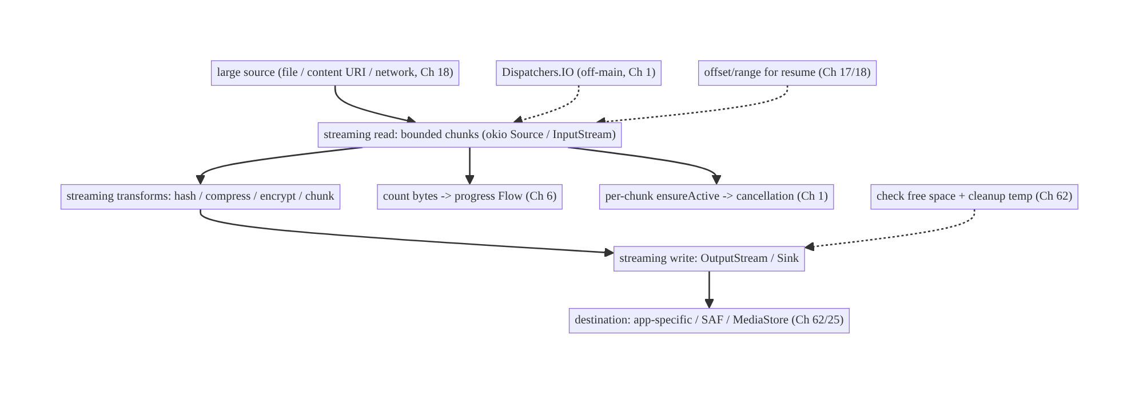
61.4 High-Level Architecture
Components & ownership
- Streaming read/write in bounded chunks (okio/java.io) — constant memory.
- Transform stages (hash/compress/encrypt/chunk) stream, never buffer whole.
- Off-main + per-chunk cancellation + progress (Ch 1/6).
- Storage (app-specific/SAF) with space checks, temp cleanup, resume offsets.
Direction: source → streaming read → streaming transforms → streaming write → dest; off-main, cancellable, progress-emitting, space-checked.

61.5 Detailed Component Design
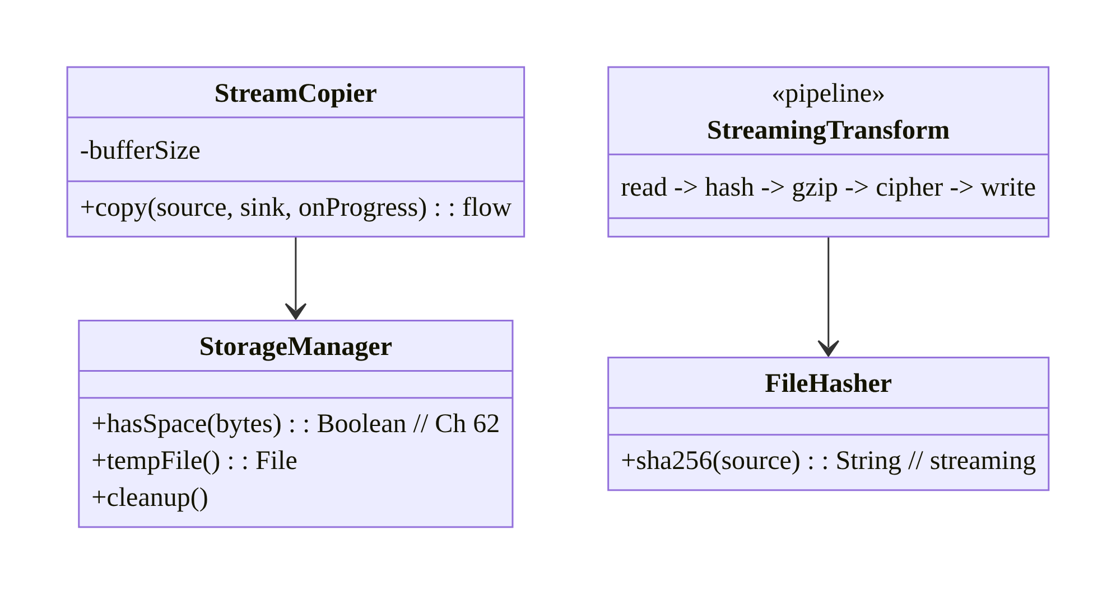
61.5 Detailed Component Design
Component | Responsibility
StreamCopier | bounded-chunk copy with progress + cancellation (okio/java.io)
FileHasher | streaming hash (integrity/dedup, Ch 17)
StreamingTransform | composable pipeline (hash→compress→encrypt→write)
StorageManager | space checks, temp files, cleanup (Ch 62/25)

61.6 End-to-End Data Flow

Streaming copy with transform + progress
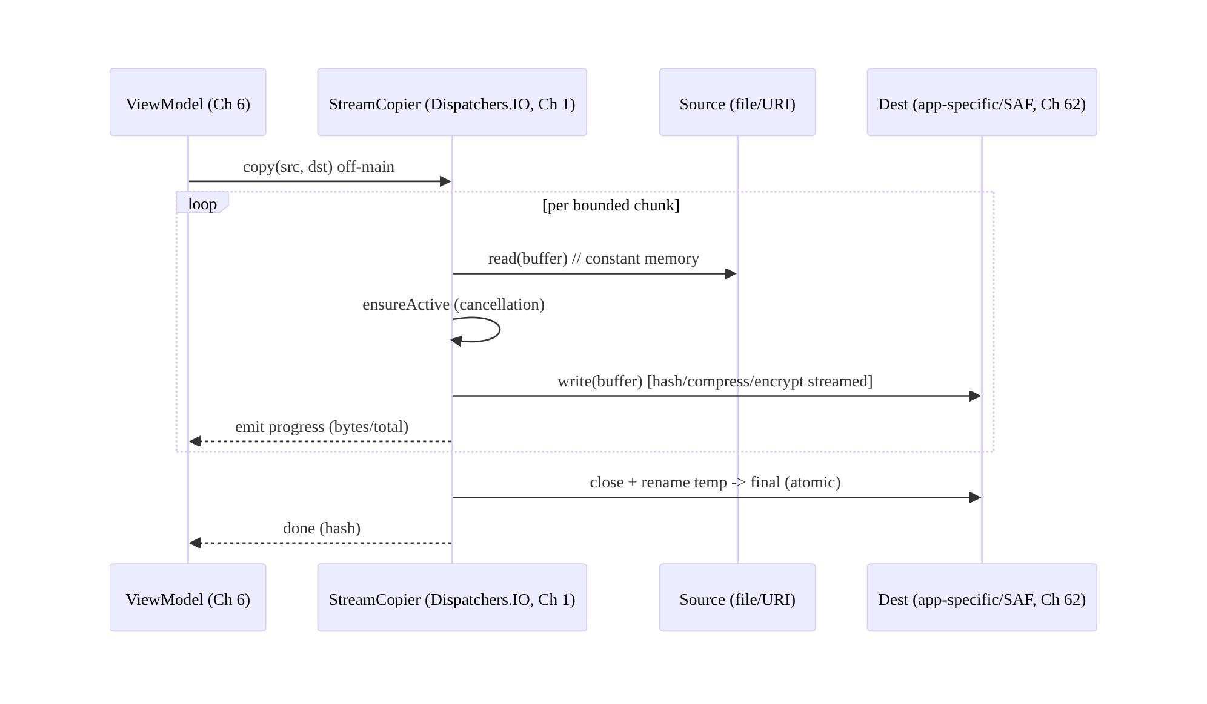
Streaming copy with transform + progress

Memory: streaming vs whole-file
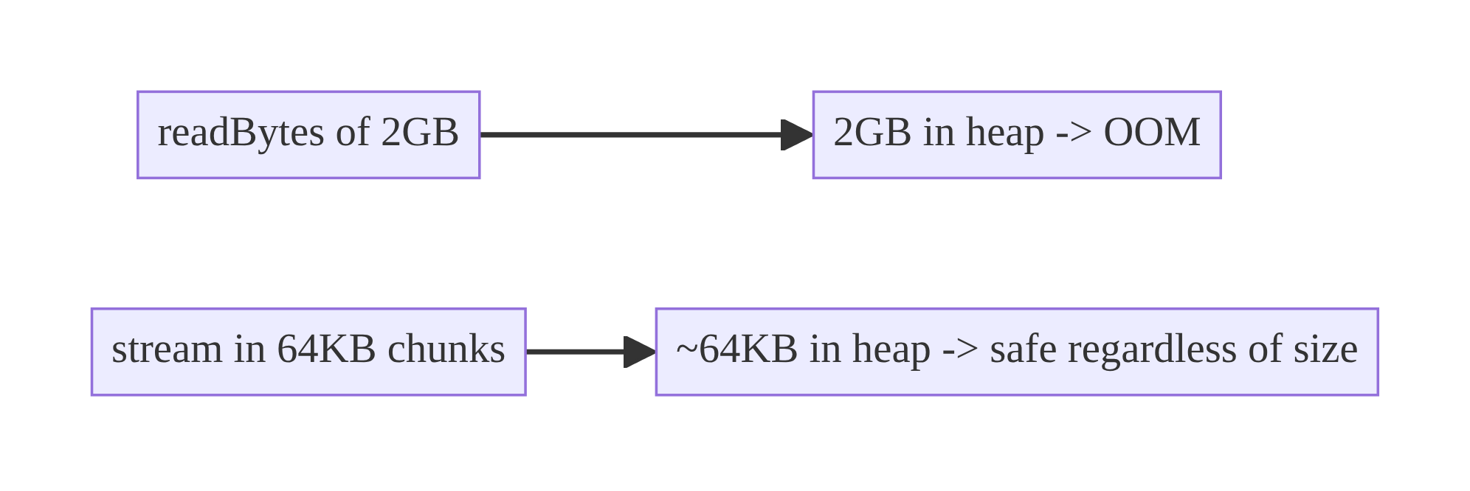
Memory: streaming vs whole-file

61.7 Complete Kotlin Implementation
Package: com.streamcart.files.

61.7.1 Streaming copy with progress + cancellation (okio)
class StreamCopier @Inject constructor(private val dispatchers: DispatcherProvider) { // Ch 1
/** Copy source -> sink in bounded chunks; emit progress; cancellable; constant memory. */
fun copy(source: Source, sink: Sink, totalBytes: Long): Flow<Float> = flow {
source.buffer().use { src ->
sink.buffer().use { dst ->
val buffer = Buffer()
var copied = 0L
while (true) {
currentCoroutineContext().ensureActive() // per-chunk cancellation (Ch 1)
val read = src.read(buffer, CHUNK) // bounded read (e.g., 64 KB)
if (read == -1L) break
dst.write(buffer, read)
copied += read
if (totalBytes > 0) emit(copied.toFloat() / totalBytes) // progress (Ch 6)
}
dst.flush()
}
}
}.flowOn(dispatchers.io) // OFF-MAIN
companion object { const val CHUNK = 64L * 1024 }
}

61.7.2 Streaming hash (integrity/dedup, Ch 17) — never loads the file
class FileHasher @Inject constructor(private val dispatchers: DispatcherProvider) {
suspend fun sha256(source: Source): String = withContext(dispatchers.io) {
val hashingSink = HashingSink.sha256(blackholeSink()) // okio: hash as data flows
source.buffer().use { src -> src.readAll(hashingSink) } // streams through, constant memory
hashingSink.hash.hex()
}
// java.io equivalent: DigestInputStream over an 8-64KB read loop.
}

61.7.3 Composable streaming transform pipeline (hash → gzip → encrypt → write, Ch 25)
suspend fun exportEncryptedCompressed(
input: Source, outFile: File, cipher: Cipher, // Ch 25
dispatchers: DispatcherProvider,
): String = withContext(dispatchers.io) {
val hashingSink = HashingSink.sha256(
// write -> encrypt -> gzip -> file, all STREAMING (no stage buffers the whole file)
outFile.sink().cipherSink(cipher).gzip().buffer() // okio composable sinks
)
input.buffer().use { src -> hashingSink.buffer().use { it.writeAll(src) } }
hashingSink.hash.hex() // integrity of the stream
}
// Each byte flows: source -> (hash) -> gzip -> cipher -> file. Memory stays ~a buffer.

61.7.4 Space check + temp-then-rename (atomic, cleanup)
class StorageManager @Inject constructor(@ApplicationContext private val ctx: Context) {
fun hasSpace(bytes: Long): Boolean { // check BEFORE large write (Ch 62)
val stat = StatFs(ctx.filesDir.path)
return stat.availableBytes > bytes + MARGIN
}
fun tempFile(): File = File.createTempFile("op_", ".tmp", ctx.cacheDir) // app-internal (Ch 25)
/** Write to temp, then atomic rename on success; delete temp on failure. */
suspend fun <T> writeAtomic(target: File, block: suspend (File) -> T): T {
val temp = tempFile()
return try {
val result = block(temp)
if (!temp.renameTo(target)) throw IOException("rename failed") // atomic
result
} catch (e: Exception) { temp.delete(); throw e } // cleanup on failure
}
}

61.7.5 Range / partial read (seek / resume, Ch 18)
/** Read a slice without touching the whole file (resume upload / seek). */
fun readRange(file: File, offset: Long, length: Long): ByteArray =
RandomAccessFile(file, "r").use { raf ->
raf.seek(offset)
val buf = ByteArray(length.toInt()); raf.readFully(buf); buf // for a BOUNDED length only
}
// For upload resume (Ch 17): stream chunks from `offset` onward; for download resume (Ch 18): HTTP Range.

61.7.6 Module structure
:core:files StreamCopier, FileHasher, StreamingTransform, StorageManager, range helpers
# Uploads -> Ch 17; downloads -> Ch 18; encryption -> Ch 25; SAF/MediaStore -> Ch 62.

61.8 Concurrency and Race Conditions
Scenario | Risk | Handling
Whole-file read | OOM | stream in bounded chunks always
Main-thread IO | ANR | Dispatchers.IO + flowOn (Ch 1)
Cancellation ignored | wasted work/leak | ensureActive() per chunk
Streams not closed | FD exhaustion / locks | use {} always
Temp not cleaned on failure | disk bloat | delete temp in catch; temp-then-rename
Concurrent writers to a file | corruption | single writer / lock; temp-then-rename atomic
Partial write on crash | corrupt output | write temp, atomic rename on success
- Per-chunk cancellation makes large operations responsive to cancel/scope-clear — the streaming loop is the natural checkpoint; without ensureActive() a cancelled export keeps running.
- Temp-then-atomic-rename guarantees the destination is never a half-written file: a crash mid-write leaves the temp (cleaned up), not a corrupt target.
- use {} everywhere prevents FD leaks — a top cause of “too many open files” in file-heavy apps.

61.9 Failure Scenarios and Recovery
Failure | Detection | Response | Outcome
OOM on large file | crash | stream (bounded chunks) | safe
ANR on IO | ANR | off-main (Ch 1) | responsive
Out of space | IOException/ENOSPC | check before; cleanup; prompt (Ch 62) | handled
Corrupt output on crash | integrity check | temp-then-atomic-rename | not corrupt
FD exhaustion | “too many open files” | use {} close | fixed
Cancelled op keeps running | wasted battery | per-chunk ensureActive | stops
Resume restarts from 0 | slow/data | offset/range resume (Ch 17/18) | resumes
Temp files accumulate | disk bloat | cleanup on success/failure/startup | clean
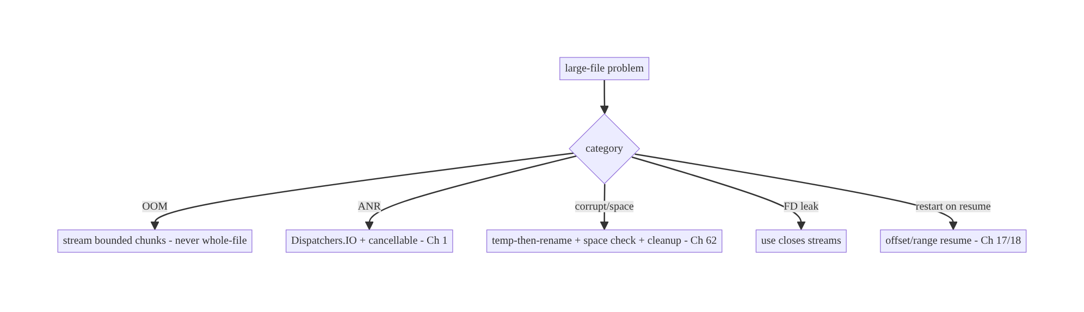
61.9 Failure Scenarios and Recovery
One rule prevents the catastrophic failures: never hold a whole large file in memory. Streaming in bounded chunks makes memory constant (no OOM), gives natural cancellation and progress points, and composes transforms without buffering. Add off-main execution, use {}, and temp-then-rename, and large files become routine.

61.10 Scaling the Implementation
- Level 1. Streaming copy/read/write in bounded chunks, off-main (Ch 1).
- Level 2. Progress + cancellation; use {}; temp-then-rename; space checks (Ch 62).
- Level 3 — production. Streaming transforms (hash/compress/encrypt, Ch 25/17); range/ resume (Ch 17/18); cleanup policies; backpressure.
- Level 4 — large. Composable pipeline abstraction; parallel chunk processing where safe; SAF/MediaStore integration (Ch 62); storage-pressure strategies.
- Level 5 — enterprise. File-operation governance (size limits, formats), observability of IO cost/failures, resumable large transfers at scale (Ch 17/18), encryption-at-rest everywhere (Ch 25).
Avoid overengineering: bounded-chunk streaming + off-main + use {} + temp-then-rename covers nearly everything. Don’t build a complex pipeline framework for simple copies; don’t parallelize chunking without a real need.

61.11 Alternative Approaches and Trade-offs
Dimension | Option A | Option B | When
Read strategy | Stream (bounded chunks) | whole-file (readBytes) | Stream for large/unknown; whole-file only for small bounded data
Toolkit | okio (Source/Sink) | java.io streams | okio (composable, efficient, OkHttp-aligned); java.io fine too
Thread | Off-main (Dispatchers.IO) | main thread | Off-main always for large IO
Transform | Streaming stages | buffer-then-transform | Streaming (constant memory)
Output safety | Temp-then-atomic-rename | write in place | Temp-then-rename (crash-safe)
Resume | Offset/range | restart | Offset/range for large transfers (Ch 17/18)
Random access | RandomAccessFile/range | read whole + slice | Range/RAF (don’t read whole)
Streaming vs whole-file reads: readBytes()/readText() are convenient but load the entire file into heap — fine for a small config, fatal for user media/exports (OOM). Streaming in bounded chunks keeps memory constant regardless of file size and is the only safe approach for large or unknown-size data. Reserve whole-file reads for small, known-bounded content.
okio vs java.io: both stream; okio (Source/Sink/Buffer) is more ergonomic and composable (chained gzip()/cipherSink()/HashingSink), efficient, and aligned with OkHttp (Ch 1) — the modern choice. java.io (InputStream/OutputStream with nested DigestInputStream/GZIPOutputStream/CipherOutputStream) works and is universal. Prefer okio for new code; the streaming discipline is identical.
Temp-then-rename vs write-in-place: writing directly to the destination means a crash or error mid-write leaves a corrupt file. Writing to a temp then atomically renaming on success guarantees the destination is either the old file or the complete new one — never partial. Always use temp-then-rename for important outputs.

61.12 Security Considerations
- Encrypt sensitive data streamed to storage (Ch 25): pipe sensitive exports/captures through a CipherSink/CipherOutputStream to encrypted app-internal storage — never write plaintext sensitive data to disk.
- App-internal / scoped storage (Ch 62/25): large temp/output files go to app-specific or user-chosen SAF locations, not world-readable shared storage; clean up temps (they may contain sensitive data).
- Validate sizes/sources: cap maximum sizes you’ll process; a hostile source could try to exhaust disk/memory (zip bombs — bound decompression output, decompression ratio).
- Integrity via streaming hash (Ch 17): verify large downloads/uploads with a streamed hash; don’t trust size alone.
- Don’t leak paths/content in logs (Ch 28); redact.
- Clean up on failure/logout: delete temp and sensitive output files; per-account isolation (Ch 42).
- Client vs backend: streaming/encryption/integrity are client-side handling; the backend validates uploaded integrity (hash, Ch 17) and enforces size limits server-side too.

61.13 Performance and Resource Optimization
- Bounded buffer (8–64KB typical) — constant memory; tune chunk size for throughput vs memory.
- Off-main (Dispatchers.IO) — no ANR.
- Streaming transforms — no double-buffering; one pass where possible (hash while copying).
- Avoid redundant passes: compute hash during copy, not in a separate read.
- FileChannel/transferTo for fast file-to-file copies where applicable.
- Space checks avoid failed large writes; cleanup prevents disk bloat.
- Backpressure (bounded buffer + suspending) matches producer/consumer speeds.
- Profiling: memory during large ops (should be flat), throughput (MB/s), IO time, temp disk usage, FD counts.

61.14 Testing Strategy
Streaming logic tests with in-memory/temp sources; assert bounded memory and correctness.
class StreamCopierTest {
@Test fun `copies large source in bounded memory`() = runTest {
val src = largeFakeSource(sizeBytes = 500L * 1024 * 1024) // 500MB fake
val sink = Buffer()
copier.copy(src, sink, totalBytes = 500L*1024*1024).collect { /* progress */ }
// assert bytes copied; (instrument) heap stays bounded, not ~500MB
}
@Test fun `cancellation stops mid-copy`() = runTest {
val job = launch { copier.copy(src, sink, total).collect() }
job.cancel(); /* assert stopped, streams closed */
}
}
class FileHasherTest {
@Test fun `hashes without loading the file`() = runTest {
assertEquals(knownSha256, hasher.sha256(sampleSource)) // streamed digest
}
}
class StorageManagerTest {
@Test fun `writeAtomic renames on success and deletes temp on failure`() = runTest { /* ... */ }
@Test fun `hasSpace false when insufficient`() { /* ... */ }
}
What to test: streaming copy correctness + bounded memory (instrumentation heap check) + progress + cancellation; streaming hash matches known digest; transform pipeline output correctness; temp-then-rename (success rename, failure cleanup); space check; range read. Use large fake sources; verify memory stays flat under profiling.

61.15 Production Observability
- Metrics: large-op memory (should be flat), throughput (MB/s), IO duration, OOM rate on file ops (→ 0 with streaming), ANR rate on IO (→ 0), out-of-space failures, temp disk usage, FD exhaustion incidents, resume rate.
- Logs: fileop{type, bytes, duration, result} — no paths/content/PII (Ch 28).
- Debugging: OOM → whole-file read somewhere (find readBytes/full decode); ANR → on-main IO; “too many open files” → unclosed streams (use {}); corrupt output → not temp-then-rename; out-of-space → no pre-check / no cleanup; slow → chunk size/double passes.
- Alerting: file-op OOM/ANR spike; out-of-space failures; FD exhaustion.
- Dashboards: file-op throughput + memory + failure reasons.

61.16 System Design Interview Preparation
≥25 questions.
Fundamentals
- Cardinal sin? Loading a whole large file into memory (OOM).
- Correct approach? Stream in bounded chunks (constant memory).
- Chunk size? 8–64KB typical; tune throughput vs memory.
- When is whole-file read ok? Small, known-bounded data only.
- Toolkit? okio (Source/Sink/Buffer) or java.io streams.
Threading/cancellation
- Where does IO run? Off-main (Dispatchers.IO, Ch 1).
- Why? ANR otherwise.
- Cancellation? ensureActive() per chunk — natural checkpoint.
- Progress? Count bytes per chunk → Flow (Ch 6).
Transforms
- Compose transforms? Streaming stages (hash→compress→encrypt→write), no full buffer.
- Hashing large file? Stream through MessageDigest/HashingSink (Ch 17).
- Encrypt to disk? CipherSink/CipherOutputStream streaming (Ch 25).
- Chunking for upload? Fixed-size parts (Ch 17).
Resources/storage
- Close streams? use {} always (FD leaks).
- Corrupt-safe output? Temp-then-atomic-rename.
- Space? Check before large write; cleanup; handle ENOSPC (Ch 62).
- Where do temp/output go? App-specific/SAF (Ch 62/25).
Partial/resume
- Seek/slice? RandomAccessFile / range — don’t read whole.
- Resume transfer? Offset/range (Ch 17/18).
- Backpressure? Bounded buffer + suspending reads.
Security
- Sensitive data to disk? Encrypt streaming (Ch 25).
- Zip bomb? Bound decompression output/ratio.
- Integrity? Streamed hash (Ch 17).
Testing/Production
- Test bounded memory? Large fake source + heap profiling (flat).
- OOM in prod? A whole-file read somewhere.
- “Too many open files”? Unclosed streams.

Design-change challenges
- Hash a multi-GB file for dedup/integrity. Stream through a digest (Ch 17) — never load it.
- Export large data without OOM. Stream to file/SAF in chunks, off-main, with progress (Ch 62).
- Encrypt a captured video to disk. CipherSink streaming to app-internal (Ch 25/60).
- Output file is corrupt after a crash. Temp-then-atomic-rename.
- Resume a large upload after interruption. Offset/range chunking (Ch 17).

Mock walkthrough (abridged)
Clarify (file sizes, transform needed, resume, sensitive?) → stream in bounded chunks (never whole-file) → off-main + per-chunk cancellation + progress (Ch 1/6) → composable streaming transforms (hash/compress/encrypt, Ch 17/25) → temp-then-rename + space check + cleanup (Ch 62) → range/resume (Ch 17/18) → security (encrypt, bound sizes) → observability (flat memory, throughput).

61.17 Practical Exercises
- Beginner. Copy a large file in 64KB chunks off-main with a progress Flow; verify memory stays flat. Eval: no OOM; progress emitted.
- Intermediate. Compute a streaming SHA-256 of a large file for an upload dedup key (Ch 17) without loading it. Eval: correct hash; bounded memory.
- Advanced. Build a streaming pipeline that hashes, gzips, and encrypts (Ch 25) a file to app-internal storage in one pass. Eval: one pass; constant memory; decryptable.
- Production debugging. Fix an OOM (a readBytes on user media) and an ANR (on-main IO) and an FD leak (unclosed streams). Eval: streamed; off-main; use {}.
- System design challenge. Add temp-then-atomic-rename, free-space checks, and range-based resume for a large export/upload. Eval: crash-safe; space-aware; resumable.
(Solutions withheld unless requested.)

61.18 Chapter Summary & Reference Sheet
Key decisions: never load a large file into memory — stream it in bounded chunks (8–64KB) through InputStream/OutputStream or okio Source/Sink/Buffer so memory stays constant regardless of file size (the whole-file readBytes()/readText() /full-decode path is only for small bounded data); run all large-file IO off the main thread (Dispatchers.IO, Ch 1) with per-chunk cancellation (ensureActive()), emitting progress and supporting resume via offsets/ranges (Ch 17/18); compose transforms (hash, compress, encrypt, chunk) as streaming stages that never buffer the whole file (okio HashingSink/GzipSink/CipherSink or nested java.io streams, Ch 17/ 25); always close streams (use {}), write outputs temp-then-atomic-rename (crash- safe), check free space and clean up temps (Ch 62); use RandomAccessFile/range requests for seeking/resume; and encrypt sensitive data streamed to app-specific storage (Ch 25/62), bounding sizes/decompression against abuse.
Concepts: streaming (bounded chunks), okio vs java.io, off-main + per-chunk cancellation, progress/resume, composable streaming transforms (hash/compress/encrypt/ chunk), use {}, temp-then-atomic-rename, space checks/cleanup, range/random access, backpressure.
Common mistakes: whole-file reads (OOM); on-main IO (ANR); ignoring cancellation; unclosed streams (FD exhaustion); buffering a whole file to transform; write-in-place (corrupt on crash); no space check / no temp cleanup; restarting instead of resuming; plaintext sensitive data to shared storage.
Checklist:
- ☐ stream in bounded chunks (never whole-file)
- ☐ off-main (Dispatchers.IO)
- ☐ per-chunk ensureActive() cancellation
- ☐ progress Flow
- ☐ streaming transforms (hash/compress/encrypt, Ch 17/25)
- ☐ use {} close
- ☐ temp-then-atomic-rename
- ☐ space check + temp cleanup (Ch 62)
- ☐ range/offset resume (Ch 17/18)
- ☐ encrypt sensitive to app-specific (Ch 25)
- ☐ bound sizes/decompression
- ☐ flat-memory + throughput telemetry.
Key APIs: okio Source/Sink/Buffer/BufferedSource/BufferedSink/HashingSink/ GzipSink/cipherSink/readAll/writeAll, InputStream/OutputStream/ DigestInputStream/GZIPOutputStream/CipherOutputStream, use {}, RandomAccessFile/ FileChannel/transferTo, StatFs/getAllocatableBytes (space), File.createTempFile/ renameTo, MessageDigest/Cipher (Ch 25), Dispatchers.IO/ensureActive (Ch 1).
References:
- okio: https://square.github.io/okio/
- Save files / app-specific storage: https://developer.android.com/training/data-storage/app-specific
- Coroutines IO + cancellation: https://developer.android.com/kotlin/coroutines/coroutines-best-practices
- (composes) Ch 17 Uploads, Ch 18 Downloads, Ch 25 Secure Storage, Ch 62 SAF/Storage, Ch 1 Networking, Ch 30 WorkManager

Chapter 62 — File Sharing & Content Providers (Storage Access Framework)
Part VII — Media & Files · Complexity: Standard (≥25 interview questions)
Prerequisites: Ch 25 (secure file storage), Ch 61 (large files/streaming), Ch 60 (camera), Ch 17 (uploads), Ch 51 (permissions), Ch 23 (security). Pairs with Ch 52 (deep links), Ch 28 (privacy).
Reference surface in StreamCart: moving files across the app boundary — sharing a receipt/invoice to another app, letting the user pick a file to upload (Ch 17), saving an export to the user’s chosen location, exposing an app file to a viewer — all under scoped storage, via FileProvider, Storage Access Framework (SAF), and content URIs, without the legacy file:// permissions mess.

62.1 Problem Definition and Real-World Context
Android storage changed fundamentally with scoped storage (Android 10+): apps can no longer freely read/write the shared filesystem with broad permissions, and sharing a raw file:// path to another app throws FileUriExposedException and is a security hole. The modern model is content URIs (content://) brokered by content providers: your app exposes its files via a FileProvider with temporary, granular permissions, and reads others’ files (or lets users pick/save) via the Storage Access Framework (SAF) and the system document/photo pickers. Getting this wrong means crashes, security holes, denied access, or a poor UX.
Concretely, teams hit:
- file:// exposure crash/hole. Sharing or passing a file:// URI to another app crashes (FileUriExposedException) and, if it worked, would leak a path with no access control. Must use a content:// URI via FileProvider with grant flags.
- Scoped storage confusion. Legacy “request WRITE_EXTERNAL_STORAGE and read anywhere” is gone (Android 10+). App files live in app-specific storage (no permission); user-visible/shared files go through MediaStore (media) or SAF (documents) — and MANAGE_EXTERNAL_STORAGE is restricted to niche apps (Play-reviewed).
- Picking/saving files. To let the user pick a file (upload, Ch 17) or save an export to their chosen location, use SAF (ACTION_OPEN_DOCUMENT/CREATE_DOCUMENT/ OPEN_DOCUMENT_TREE) — which returns a content URI you access without broad permissions, and can persist access across restarts.
- Permission grants on URIs. Content URIs carry temporary read/write grants (FLAG_GRANT_READ/WRITE_URI_PERMISSION); forgetting them → SecurityException in the receiving app. Persisted SAF URIs need takePersistableUriPermission.
- Exposing app files to others (a provider). When another app must read your file (share a receipt), expose it via FileProvider (or a custom ContentProvider) — never a path.
- Security of your provider. An exported/misconfigured provider can leak files or allow path traversal; grants must be minimal and validated (Ch 23).
The architecture: keep app files in app-specific storage (no permission, Ch 25); share app files to other apps via a FileProvider that returns a content:// URI with temporary grant flags (never file://); let users pick/save/browse files via SAF (ACTION_OPEN_DOCUMENT/CREATE_DOCUMENT/OPEN_DOCUMENT_TREE, persisting access when needed), reading/writing the returned content URI with streaming (Ch 61); use MediaStore for shared media; and secure providers (not over-exported, minimal grants, validated, Ch 23). This chapter is about moving files across the app boundary correctly under scoped storage.

Three practical use cases
- Share a receipt (StreamCart). Export a PDF to app-specific storage, expose it via FileProvider, and ACTION_SEND a content URI with read grant to the user’s chosen app (email/drive).
- Pick a file to upload. ACTION_OPEN_DOCUMENT (or Photo Picker, Ch 51) → a content URI → stream it (Ch 61) to the upload (Ch 17) — no storage permission.
- Save an export to the user’s location. ACTION_CREATE_DOCUMENT → a content URI in the user’s chosen folder → stream the export to it (Ch 61).

Why this is architectural
File sharing under scoped storage is a cross-app boundary + security + permission-model problem spanning storage (Ch 25), streaming (Ch 61), uploads/camera (Ch 17/60), permissions (Ch 51), and provider security (Ch 23). The decisions — content URIs vs paths, FileProvider/SAF/MediaStore, grant flags, persisted access, provider hardening — determine whether file flows work, are secure, and respect the user’s storage.

62.2 Requirements Engineering

Functional requirements
ID | Requirement
F1 | Share app files to other apps via content URIs with temporary grants (not file://).
F2 | Let users pick/save/browse files via SAF; persist access when needed.
F3 | Read/write content URIs via streaming (Ch 61); no broad storage permissions.
F4 | Use MediaStore for shared media; app-specific storage for app files (Ch 25).
F5 | Secure providers (minimal export, minimal grants, validated) (Ch 23).
F6 | Handle scoped-storage rules across Android versions.

Non-functional requirements
Attribute | Policy
Security | Content URIs + minimal temporary grants; no path exposure; hardened provider.
Correctness | Works under scoped storage; grants present; persisted when needed.
Least privilege | No broad storage permissions; SAF/MediaStore/FileProvider.
UX | Native pickers; user chooses location; smooth share.
Resilience | Streaming (Ch 61); handle revoked/invalid URIs.

Scope
- In scope: scoped storage model, app-specific storage (Ch 25), FileProvider (expose app files + grant flags + ACTION_SEND), SAF (ACTION_OPEN_DOCUMENT/ CREATE_DOCUMENT/OPEN_DOCUMENT_TREE + persistable permissions), MediaStore (shared media), reading/writing content URIs via streaming (Ch 61), custom ContentProvider basics, provider security (Ch 23), version differences.
- Out of scope: streaming internals (Ch 61), secure storage/encryption (Ch 25), upload (Ch 17), camera (Ch 60), permissions UX (Ch 51), deep-link security (Ch 52).

Assumptions & constraints
- minSdk 24, targetSdk current (scoped storage enforced). AndroidX FileProvider, Activity Result API for SAF, ContentResolver, okio/streams (Ch 61). file:// exposure is blocked; broad storage permissions are deprecated/restricted; content URIs carry grants.

62.3 System Design Fundamentals
- Scoped storage (the model since Android 10+). An app has unrestricted access to its app-specific storage (internal filesDir/cacheDir, app-specific external) with no permission (Ch 25). It does not have free access to the shared filesystem; user-visible/shared content goes through MediaStore (images/video/audio) or SAF (any document). Broad READ/WRITE_EXTERNAL_STORAGE is deprecated; MANAGE_EXTERNAL_STORAGE is restricted to niche, Play-reviewed apps (file managers).
- Content URIs, not file paths (the cardinal rule). Across the app boundary you pass content:// URIs, never file:// (which throws FileUriExposedException and has no access control). A content URI is brokered by a content provider and carries granular, revocable permissions.
- FileProvider — expose your app’s files. To share an app file (receipt, export) with another app, wrap it in a FileProvider (a built-in ContentProvider): declare it in the manifest with a file_paths XML mapping, call FileProvider.getUriForFile(...) to get a content:// URI, and attach grant flags (FLAG_GRANT_READ_URI_PERMISSION) when sending (ACTION_SEND/ACTION_VIEW). The receiving app gets temporary access to that file only — no path leak, no broad permission.
- Storage Access Framework (SAF) — the user picks/saves. SAF lets the user choose files/folders via system UI, returning a content URI your app can access without storage permissions:
  - ACTION_OPEN_DOCUMENT: pick a file to read (e.g., choose a file to upload, Ch 17).
  - ACTION_CREATE_DOCUMENT: create/save a file at a user-chosen location (export).
  - ACTION_OPEN_DOCUMENT_TREE: grant access to a whole folder (for apps managing many files there).
  - Persisted access: by default the grant is for the session; call takePersistableUriPermission (with the persistable flag) to keep access across restarts (store the URI). Use the Activity Result API (OpenDocument/CreateDocument/OpenDocumentTree contracts).
- MediaStore — shared media. To add/read media in the user’s shared collections (photos/video/audio, e.g., save a photo to the gallery, Ch 60), use MediaStore (MediaStore.Images, etc.) — scoped-storage-friendly, no broad permission for your own inserts; the Photo Picker (Ch 51) reads media without permission.
- Reading/writing content URIs = streaming (Ch 61). You don’t get a file path from a content URI — you open a stream via ContentResolver.openInputStream(uri) / openOutputStream(uri) (or openFileDescriptor) and stream (Ch 61) to/from it (upload, copy, export). Treat it like any stream; don’t assume a path.
- Custom ContentProvider (when needed). For structured cross-app data sharing (beyond files) or exposing queryable data, implement a ContentProvider — but most file sharing needs only FileProvider. A custom provider must be secured (below).
- Provider security (Ch 23). A content provider is an attack surface:
  - Don’t over-export: FileProvider is exported="false" + grantUriPermissions="true" (access only via explicit grants). A custom provider exposed to other apps needs careful permission/path checks.
  - Minimal grants: grant read-only when read suffices; grant per-URI, temporary (don’t persist unless needed); revoke when done.
  - Validate paths: file_paths mapping restricts what can be shared; prevent path traversal (don’t let a URI escape the allowed subtree).
  - Treat incoming URIs as untrusted (Ch 23/52): a URI from another app or a deep link could point anywhere — validate and open via ContentResolver (which enforces grants), don’t assume it’s yours.
Core insight: under scoped storage, keep app files in app-specific storage (no permission, Ch 25) and move files across the app boundary as content:// URIs — never file://: expose your files to other apps via a FileProvider with minimal temporary grant flags, and let the user pick/save/browse via the Storage Access Framework (ACTION_OPEN_DOCUMENT/CREATE_DOCUMENT/OPEN_DOCUMENT_TREE, persisting access only when needed), reading/writing the returned content URI by streaming through ContentResolver (Ch 61); use MediaStore/Photo Picker for shared media; and harden providers (not over-exported, read-only minimal grants, path-validated, untrusted incoming URIs, Ch 23).

62.4 High-Level Architecture
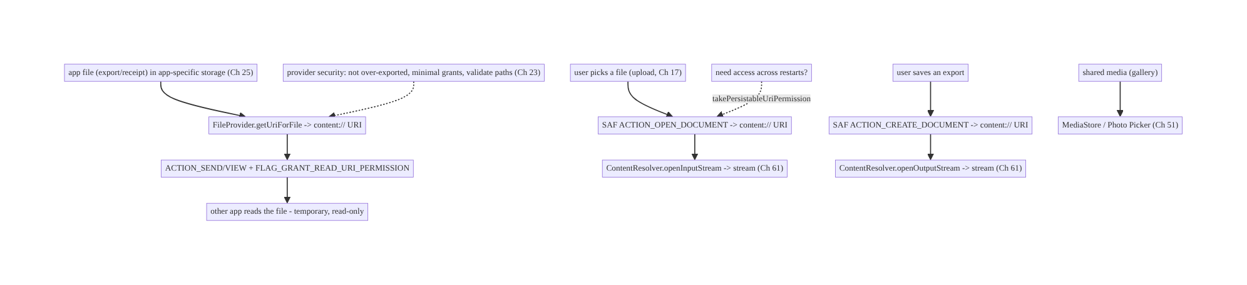
62.4 High-Level Architecture
Components & ownership
- App-specific storage holds app files (no permission, Ch 25).
- FileProvider exposes app files as content URIs with temporary grants.
- SAF lets the user pick/save/browse → content URIs streamed via ContentResolver (Ch 61).
- MediaStore/Photo Picker for shared media.
- Provider security keeps it all hardened (Ch 23).
Direction: app files ↔ content URIs (FileProvider for sharing out, SAF for user pick/ save) ↔ streamed via ContentResolver; media via MediaStore; secured.

62.5 Detailed Component Design
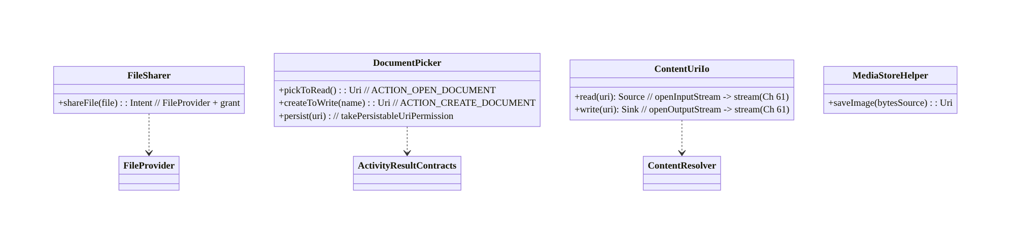
62.5 Detailed Component Design
Component | Responsibility
FileSharer | expose app file via FileProvider + grant flags; build share intent
DocumentPicker | SAF open/create/tree + persist access
ContentUriIo | stream read/write a content URI via ContentResolver (Ch 61)
MediaStoreHelper | insert/read shared media

62.6 End-to-End Data Flow

Sharing an app file (FileProvider)
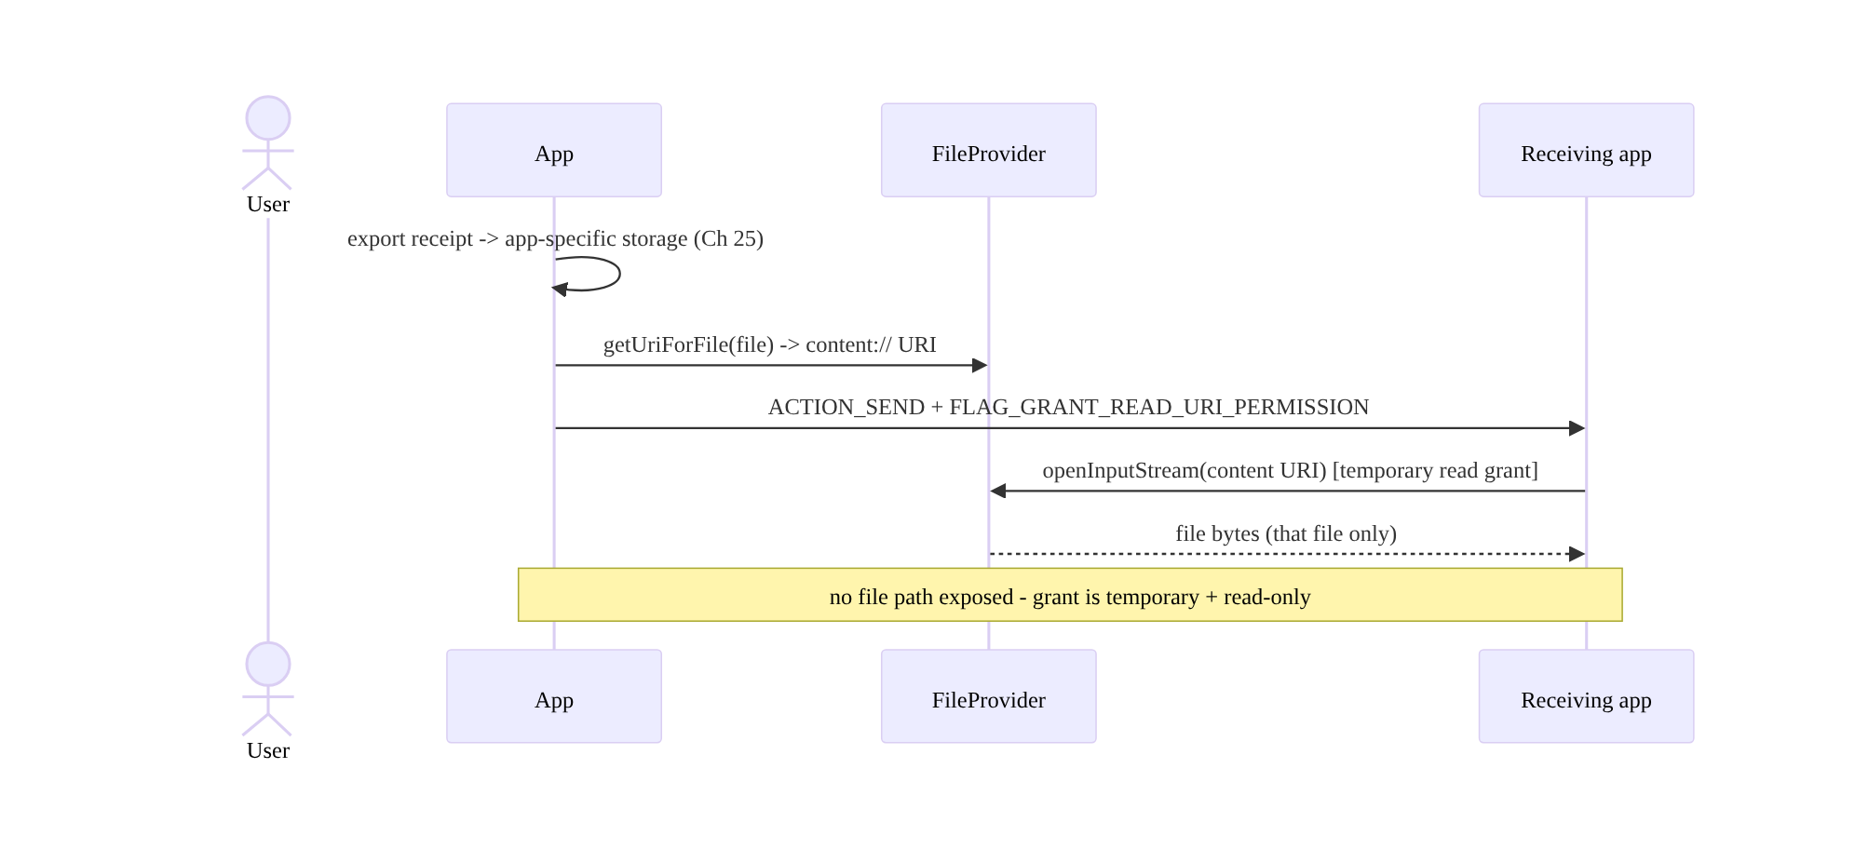
Sharing an app file (FileProvider)

Picking a file to upload (SAF) + streaming
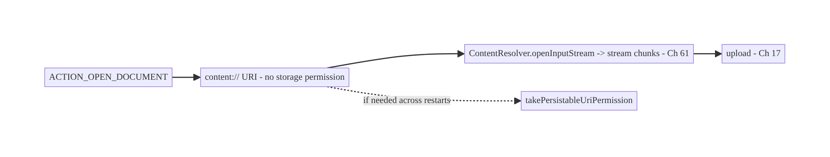
Picking a file to upload (SAF) + streaming

62.7 Complete Kotlin Implementation
Package: com.streamcart.sharing.

62.7.1 FileProvider: manifest + sharing an app file
<provider
android:name="androidx.core.content.FileProvider"
android:authorities="${applicationId}.fileprovider"
android:exported="false"
android:grantUriPermissions="true"> <!-- access only via explicit grants -->
<meta-data android:name="android.support.FILE_PROVIDER_PATHS" android:resource="@xml/file_paths" />
</provider>
<!-- res/xml/file_paths.xml: restricts WHAT can be shared (prevents traversal, Ch 23) -->
<paths>
<cache-path name="shared" path="shared/" /> <!-- only files under cacheDir/shared/ -->
<files-path name="exports" path="exports/" />
</paths>
class FileSharer @Inject constructor(@ApplicationContext private val ctx: Context) {
fun shareIntent(file: File, mime: String): Intent {
val uri = FileProvider.getUriForFile(ctx, "${ctx.packageName}.fileprovider", file) // content:// URI
return Intent(Intent.ACTION_SEND).apply {
type = mime
putExtra(Intent.EXTRA_STREAM, uri)
addFlags(Intent.FLAG_GRANT_READ_URI_PERMISSION) // TEMPORARY, read-only grant (minimal)
}.let { Intent.createChooser(it, "Share") }
// NEVER: Uri.fromFile(file) / file:// -> FileUriExposedException + security hole
}
}

62.7.2 SAF: pick a file to read, create a file to write (Activity Result API)
@Composable
fun PickFileToUpload(onPicked: (Uri) -> Unit) {
val launcher = rememberLauncherForActivityResult(ActivityResultContracts.OpenDocument()) { uri ->
uri?.let { onPicked(it) } // content:// URI; NO storage permission
}
Button(onClick = { launcher.launch(arrayOf("application/pdf", "image/*")) }) { Text("Choose file") }
}
@Composable
fun SaveExport(fileName: String, onLocation: (Uri) -> Unit) {
val launcher = rememberLauncherForActivityResult(
ActivityResultContracts.CreateDocument("text/csv")) { uri -> uri?.let(onLocation) }
Button(onClick = { launcher.launch(fileName) }) { Text("Export to...") } // user picks the location
}

62.7.3 Persist access across restarts (folder/tree)
class DocumentPicker @Inject constructor(@ApplicationContext private val ctx: Context) {
/** Keep access to a user-granted URI across app restarts. */
fun persist(uri: Uri, writable: Boolean) {
val flags = Intent.FLAG_GRANT_READ_URI_PERMISSION or
(if (writable) Intent.FLAG_GRANT_WRITE_URI_PERMISSION else 0)
ctx.contentResolver.takePersistableUriPermission(uri, flags) // store `uri` (DataStore, Ch 4) to reuse
}
// OPEN_DOCUMENT_TREE for a whole folder: ActivityResultContracts.OpenDocumentTree().
}

62.7.4 Read/write a content URI by STREAMING (Ch 61)
class ContentUriIo @Inject constructor(
@ApplicationContext private val ctx: Context, private val dispatchers: DispatcherProvider,
) {
/** Stream a picked URI to an upload/copy (Ch 61/17) — no path, no whole-file load. */
suspend fun streamIn(uri: Uri, sink: Sink) = withContext(dispatchers.io) {
ctx.contentResolver.openInputStream(uri)?.use { input -> // grant enforced by resolver
input.source().buffer().use { src -> sink.buffer().use { it.writeAll(src) } } // stream (Ch 61)
} ?: throw IOException("cannot open $uri")
}
/** Stream an export to a user-chosen location. */
suspend fun streamOut(uri: Uri, source: Source) = withContext(dispatchers.io) {
ctx.contentResolver.openOutputStream(uri)?.use { output ->
source.buffer().use { src -> output.sink().buffer().use { it.writeAll(src) } } // stream (Ch 61)
} ?: throw IOException("cannot open $uri")
}
}

62.7.5 MediaStore: save a photo to the gallery (Ch 60)
suspend fun saveToGallery(ctx: Context, source: Source, displayName: String): Uri = withContext(Dispatchers.IO) {
val values = ContentValues().apply {
put(MediaStore.Images.Media.DISPLAY_NAME, displayName)
put(MediaStore.Images.Media.MIME_TYPE, "image/jpeg")
put(MediaStore.Images.Media.RELATIVE_PATH, "Pictures/StreamCart") // scoped storage
}
val uri = ctx.contentResolver.insert(MediaStore.Images.Media.EXTERNAL_CONTENT_URI, values)!!
ctx.contentResolver.openOutputStream(uri)!!.use { out ->
source.buffer().use { src -> out.sink().buffer().use { it.writeAll(src) } } // stream (Ch 61)
}
uri // no WRITE_EXTERNAL_STORAGE needed for your own insert
}

62.7.6 Module structure
:core:sharing FileSharer (FileProvider), DocumentPicker (SAF), ContentUriIo (stream, Ch 61), MediaStoreHelper
# file_paths.xml restricts shareable paths (Ch 23). Streaming -> Ch 61; app storage -> Ch 25.

62.8 Concurrency and Race Conditions
Scenario | Risk | Handling
file:// passed to another app | crash/hole | always FileProvider content URI + grant
Missing grant flag | SecurityException in receiver | FLAG_GRANT_READ_URI_PERMISSION on send
SAF URI used after restart w/o persist | access denied | takePersistableUriPermission + store URI
Reading content URI off a path | wrong (no path) | stream via ContentResolver (Ch 61)
Large content URI read | OOM/ANR | stream in chunks off-main (Ch 61)
Revoked/invalid URI | exception | handle gracefully; re-prompt via SAF
Over-broad grant persisted | security | read-only, minimal, persist only if needed
- Content URIs have no file path — always open a stream via ContentResolver (Ch 61); code that calls uri.path and opens a File is wrong and will fail under scoped storage.
- Grants are required and minimal: forgetting FLAG_GRANT_READ_URI_PERMISSION denies the receiver; persisting write access you don’t need is a security risk — grant read-only, temporary by default.
- Persisted SAF access must be taken and stored: without takePersistableUriPermission a URI stops working after restart; store the URI (Ch 4) and handle revocation by re-prompting.

62.9 Failure Scenarios and Recovery
Failure | Detection | Response | Outcome
FileUriExposedException | crash | FileProvider content URI + grant | works
Receiver SecurityException | crash in other app | add grant flags | access granted
SAF access lost after restart | denied | persist + store URI; re-prompt | restored
OOM/ANR reading a big URI | crash | stream off-main (Ch 61) | safe
Provider leaks files (traversal) | security audit | restrict file_paths; validate (Ch 23) | contained
Broad storage permission denied | can’t access | use SAF/MediaStore (no permission) | works
Incoming URI points elsewhere | security | treat untrusted; resolver enforces grant (Ch 23) | safe
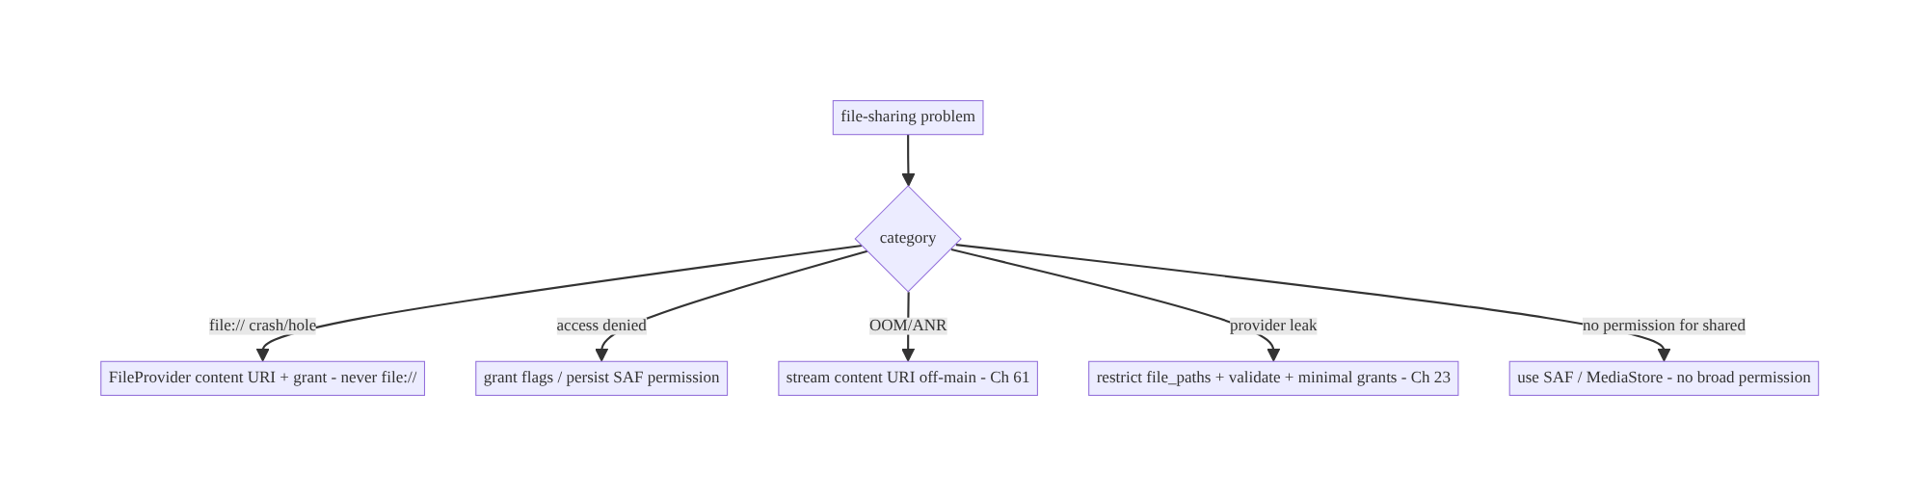
62.9 Failure Scenarios and Recovery
Scoped storage reduces to two rules: keep your files in app-specific storage (no permission) and cross the app boundary only as content URIs — FileProvider (with minimal grants) to share out, SAF/MediaStore to let the user pick/save. file:// and broad storage permissions are gone; content URIs + streaming (Ch 61) are the model.

62.10 Scaling the Implementation
- Level 1. App-specific storage (Ch 25); FileProvider to share app files with grants.
- Level 2. SAF open/create for pick/save; stream content URIs (Ch 61); MediaStore for media.
- Level 3 — production. Persisted SAF access (folders); Photo Picker (Ch 51); provider hardening (file_paths, minimal grants, Ch 23); version handling.
- Level 4 — large. Document-tree management (user folder of app files); custom ContentProvider for structured sharing; batch share/export; MIME negotiation.
- Level 5 — enterprise. Storage/sharing governance, DLP (what may leave the app), provider security review, cross-app integration contracts, enterprise managed-storage.
Avoid overengineering: FileProvider + SAF + MediaStore cover almost all needs; a custom ContentProvider is rarely necessary for files. Don’t request broad storage permissions.

62.11 Alternative Approaches and Trade-offs
Dimension | Option A | Option B | When
Cross-app file | content:// via FileProvider | file:// path | Always content URI (file:// crashes + insecure)
User pick/save | SAF (OPEN/CREATE_DOCUMENT) | request storage permission | SAF (no permission, user chooses)
Shared media | MediaStore / Photo Picker | SAF / broad permission | MediaStore/Picker for media (scoped-friendly)
App’s own files | App-specific storage (no perm) | shared storage | App-specific (no permission, private, Ch 25)
Read content URI | Stream via ContentResolver (Ch 61) | get a path + File | Stream (no path exists under scoped storage)
Persisted access | takePersistableUriPermission | re-prompt each time | Persist for recurring folder access
Broad access | SAF tree | MANAGE_EXTERNAL_STORAGE | SAF tree; MANAGE only for file managers (Play-restricted)
Content URIs vs file paths: passing a file:// path across the app boundary throws FileUriExposedException (since Android 7) and, historically, leaked a path with no access control. Content URIs brokered by a provider carry granular, temporary, revocable permissions and expose only the intended file. Always share via content:// (FileProvider); never file://.
SAF vs storage permissions: requesting READ/WRITE_EXTERNAL_STORAGE to access user files is deprecated and over-broad; SAF lets the user pick exactly what to share and returns a content URI your app accesses with no permission — better security and UX. Use SAF (and MediaStore/Photo Picker for media); reserve broad permissions for nothing (and MANAGE_EXTERNAL_STORAGE only for genuine file-manager apps that pass Play review).
FileProvider vs custom ContentProvider: for sharing files, FileProvider is a ready-made, secure provider needing only a file_paths mapping — use it. A custom ContentProvider is for exposing structured/queryable data across apps (or complex file logic) and must be carefully secured; don’t build one when FileProvider suffices.

62.12 Security Considerations
- Never expose file:// — it crashes and leaks a path; always a content:// URI with minimal grants (read-only, temporary; persist write only if truly needed).
- Restrict file_paths so the provider can only share files under intended subtrees — prevents path traversal/exfiltration of arbitrary app files (Ch 23).
- FileProvider is exported="false" + grantUriPermissions="true": access only via explicit grants; a custom provider exposed to other apps needs permission checks and path validation.
- Treat incoming URIs as untrusted (Ch 23/52): a URI from another app or a deep link could point anywhere — open via ContentResolver (which enforces the grant), validate MIME/size, and don’t assume it’s safe or yours.
- Minimal/temporary grants, revoke when done: don’t persist access you don’t need; revokeUriPermission when finished; persisted grants are a standing capability.
- Sensitive files (Ch 25/28): keep sensitive app files in app-internal storage; think before sharing (DLP) — a shared receipt may contain PII; strip/limit what leaves.
- Per-account (Ch 42): don’t share one account’s file under another; clear persisted URIs on logout if account-scoped.
- Client vs backend: file sharing is a client/OS boundary concern; when files go to the backend (upload, Ch 17) normal auth/TLS/pinning apply (Ch 19/23).

62.13 Performance and Resource Optimization
- Stream content URIs (Ch 61) — never load a picked/shared file wholly into memory (OOM); off-main (ANR).
- MediaStore/SAF inserts stream too (open the output stream, write in chunks).
- Minimal grants reduce security surface and bookkeeping.
- Persist only needed access; revoke stale persisted URIs (they count against a limit).
- Avoid copying when you can share a URI: if another app just needs to read, grant a URI instead of copying the file.
- Right MIME + size hints for faster handling by receivers.
- Profiling: share/pick success rate, content-URI read throughput/memory (flat, Ch 61), persisted-grant count, provider errors.

62.14 Testing Strategy
Provider/SAF logic tests with ContentResolver/Robolectric; integration via intents.
class FileSharerTest {
@Test fun `builds content uri with read grant - not file`() {
val intent = FileSharer(ctx).shareIntent(File(ctx.cacheDir, "shared/receipt.pdf"), "application/pdf")
val uri = intent.getParcelableExtra<Uri>(Intent.EXTRA_STREAM)!!
assertEquals("content", uri.scheme) // not "file"
assertTrue(intent.flags and Intent.FLAG_GRANT_READ_URI_PERMISSION != 0)
}
}
class ContentUriIoTest {
@Test fun `streams a content uri without loading whole file`() = runTest {
// provide a fake ContentResolver returning a large stream; assert streamed (Ch 61), bounded memory
}
}
// SAF: instrumentation with UiAutomator to drive the system picker; or fake the Activity Result.
What to test: share intent uses a content:// URI + read grant (not file://); content URI read/write streams (bounded memory, Ch 61); SAF persist (takePersistableUriPermission); MediaStore insert; provider only shares allowed paths (file_paths); untrusted incoming URI handled. Instrumentation/UiAutomator for the real system pickers.

62.15 Production Observability
- Metrics: share success rate; FileUriExposedException/SecurityException rate (→ 0); content-URI read throughput/memory (flat, Ch 61); SAF pick/create success; persisted-grant count; provider errors; broad-permission usage (should be none).
- Logs: fileshare{action, scheme, mime, result} — no URIs with PII/paths (Ch 28).
- Debugging: FileUriExposedException → a file:// somewhere (use FileProvider); receiver SecurityException → missing grant; SAF denied after restart → not persisted; OOM/ANR → not streaming (Ch 61); provider leak → file_paths too broad (Ch 23).
- Alerting: FileUriExposedException or provider-security errors after a release.
- Dashboards: share/pick success; scoped-storage error trends.

62.16 System Design Interview Preparation
≥25 questions.
Fundamentals
- Scoped storage? App-specific storage free (no permission); shared via MediaStore/SAF; no broad filesystem access.
- Cross-app file rule? Pass content:// URIs, never file://.
- FileUriExposedException? Thrown when sharing a file:// URI — use FileProvider.
- What’s a content URI? Provider-brokered URI with granular, revocable permissions.
- App’s own files? App-specific storage, no permission (Ch 25).
FileProvider
- Purpose? Expose app files as content URIs to other apps.
- Grant flags? FLAG_GRANT_READ_URI_PERMISSION (temporary, minimal).
- file_paths? Restricts what can be shared (prevents traversal).
- Exported? false + grantUriPermissions=true (access via grants only).
SAF
- What is SAF? System UI for the user to pick/save/browse → content URI, no permission.
- OPEN vs CREATE vs TREE? Pick file / save file / grant a folder.
- Persist access? takePersistableUriPermission + store the URI.
- Read/write the URI? Stream via ContentResolver (Ch 61) — no path.
MediaStore
- Shared media? MediaStore (insert your own without broad permission).
- Read media without permission? Photo Picker (Ch 51).
Security
- Why not file://? Crash + no access control.
- Grant minimality? Read-only, temporary; revoke; persist only if needed.
- Provider over-export? Attack surface — restrict + validate (Ch 23).
- Incoming URIs? Untrusted — resolver enforces grant; validate (Ch 52).
- Path traversal? Restrict file_paths.
Streaming/perf
- Big content URI? Stream off-main (Ch 61) — no path, no whole-file.
- Avoid copying? Grant a URI instead of copying when read-only.
Testing/Production
- Test share? Assert content URI + read grant (not file://).
- FileUriExposedException in prod? A file:// somewhere.
- SAF lost after restart? Not persisted.
- Broad permission denied? Use SAF/MediaStore instead.

Design-change challenges
- Share a generated PDF receipt to another app. FileProvider content URI + read grant (ACTION_SEND).
- Let the user pick a file to upload without storage permission. SAF ACTION_OPEN_DOCUMENT → stream (Ch 61/17).
- Save an export to the user’s chosen folder. SAF ACTION_CREATE_DOCUMENT → stream out.
- App crashes with FileUriExposedException. Replace file:// with FileProvider content URI.
- Keep access to a user folder across restarts. OPEN_DOCUMENT_TREE + takePersistableUriPermission.

Mock walkthrough (abridged)
Clarify (sharing out, picking in, saving, media?) → scoped-storage model → app files in app-specific storage (Ch 25) → share out via FileProvider content URI + minimal grant → user pick/save via SAF (persist if needed) → media via MediaStore/Photo Picker → stream content URIs via ContentResolver (Ch 61) → provider security (file_paths, minimal grants, untrusted URIs, Ch 23) → observability (exposure/security errors).

62.17 Practical Exercises
- Beginner. Share an app-internal PDF to another app via FileProvider with a read-only grant (no file://). Eval: content URI; receiver can read.
- Intermediate. Let the user pick a file with SAF ACTION_OPEN_DOCUMENT and stream it to an upload (Ch 61/17) with no storage permission. Eval: no permission; streamed.
- Advanced. Save an export via ACTION_CREATE_DOCUMENT and grant persistent access to a folder via OPEN_DOCUMENT_TREE + takePersistableUriPermission. Eval: saved; access survives restart.
- Production debugging. Fix a FileUriExposedException (a file:// share) and a receiver SecurityException (missing grant). Eval: content URI + grant.
- System design challenge. Harden the provider (file_paths subtree, read-only minimal grants, untrusted-URI validation) and add scoped-storage error telemetry. Eval: no traversal; minimal grants; observable.
(Solutions withheld unless requested.)

62.18 Chapter Summary & Reference Sheet
Key decisions: work within scoped storage — keep app files in app-specific storage (no permission, Ch 25) and cross the app boundary only as content:// URIs, never file:// (which throws FileUriExposedException and leaks a path): share your files out via a FileProvider (declared exported=false/grantUriPermissions=true, with a restrictive file_paths mapping) returning a content URI with minimal, temporary, read-only grant flags; let the user pick/save/browse via the Storage Access Framework (ACTION_OPEN_DOCUMENT/CREATE_DOCUMENT/OPEN_DOCUMENT_TREE, persisting access with takePersistableUriPermission only when needed) — no storage permission required; use MediaStore / Photo Picker for shared media; and read/write content URIs by streaming through ContentResolver.openInputStream/openOutputStream (Ch 61) since there is no file path. Harden providers (not over-exported, minimal grants, validated file_paths, untrusted incoming URIs, Ch 23/52), keep sensitive files app-internal and per-account (Ch 25/42), and avoid broad storage permissions entirely.
Concepts: scoped storage, content URIs vs file paths, FileProvider + grant flags + file_paths, SAF (open/create/tree + persistable permissions), MediaStore/Photo Picker, streaming content URIs via ContentResolver (Ch 61), custom ContentProvider, provider security.
Common mistakes: sharing file:// (FileUriExposedException/leak); requesting broad storage permissions (deprecated/denied); missing grant flags (SecurityException); not persisting SAF access (lost after restart); treating a content URI as a path (fails); loading a content URI wholly into memory (OOM — stream it); over-broad file_paths (traversal); trusting incoming URIs.
Checklist:
- ☐ app files in app-specific storage (Ch 25)
- ☐ share out via FileProvider content URI + minimal read grant (never file://)
- ☐ restrictive file_paths
- ☐ SAF for pick/save/tree; persist only if needed
- ☐ MediaStore/Photo Picker for media
- ☐ stream content URIs via ContentResolver (Ch 61)
- ☐ provider not over-exported + validated (Ch 23)
- ☐ untrusted incoming URIs
- ☐ sensitive files app-internal, per-account (Ch 25/42)
- ☐ no broad storage permissions
- ☐ exposure/security-error telemetry.
Key APIs: FileProvider.getUriForFile/file_paths.xml/grantUriPermissions, Intent.FLAG_GRANT_READ/WRITE_URI_PERMISSION/ACTION_SEND, ActivityResultContracts. OpenDocument/CreateDocument/OpenDocumentTree, ContentResolver.takePersistableUriPermission/ openInputStream/openOutputStream/openFileDescriptor/insert, MediaStore, ContentValues/RELATIVE_PATH, custom ContentProvider, revokeUriPermission.
References:
- Sharing files (FileProvider): https://developer.android.com/training/secure-file-sharing
- Storage Access Framework: https://developer.android.com/guide/topics/providers/document-provider
- Scoped storage / data storage: https://developer.android.com/training/data-storage
- MediaStore: https://developer.android.com/training/data-storage/shared/media
- (composes) Ch 25 Secure Storage, Ch 61 Large Files/Streaming, Ch 60 Camera, Ch 17 Uploads, Ch 51 Permissions, Ch 23 Security

Glossary & Index of Key Terms
A quick reference to the core terms introduced in this volume, with the chapters where each is treated. (Chapter numbers outside this volume’s range point to other volumes of the series.)
Lifecycle-aware component — A component that observes the lifecycle and starts/stops work at the right time. Ch 44.
Cold start — Launching when the process does not exist — the slowest, first-impression path. Ch 45; optimized in Ch 88.
Foreground service — A user-visible, long-running service for ongoing work (playback, navigation). Ch 46.
Doze / App Standby — Battery-saving modes that defer background work and network to maintenance windows. Ch 47.
Exact alarm — A precisely-timed alarm (setExactAndAllowWhileIdle) for genuinely time-critical work. Ch 48.
Push notification (FCM) — Server-initiated messages delivered over Firebase Cloud Messaging. Ch 49.
Notification inbox — An in-app center that mirrors and manages delivered notifications. Ch 50.
Runtime permission — A dangerous permission requested at runtime with a clear rationale. Ch 51.
Deep link / App Link — A URL that routes directly into app content; App Links are verified. Ch 52.
Navigation architecture — Structured, multi-module navigation between destinations. Ch 53.
In-app update — Prompting or forcing an app upgrade via Play In-App Updates. Ch 54.
Widget / shortcut — Home-screen widgets and app shortcuts for glanceable access. Ch 55.
Coil / image loading — Asynchronous image loading with memory/disk caching and downsampling. Ch 56.
Thumbnail generation — Producing and caching small preview images efficiently. Ch 57.
Media3 / ExoPlayer — The media playback stack: adaptive streaming, media session, transport. Ch 58.
DRM / offline OTT — Protected playback (Widevine) and downloading premium content for offline viewing. Ch 59.
CameraX — The Jetpack camera API for a robust capture pipeline. Ch 60.
Storage Access Framework (SAF) — System document UI and content providers for sharing files safely. Ch 62.

Acknowledgements
This book exists because of the Android engineering community — the library authors, the writers of official documentation and release notes, the conference speakers, and the countless engineers who have shared hard-won lessons in blog posts, talks, and code reviews. The patterns in this series are not invented in isolation; they are the distilled, composed practice of that community, organized into one coherent curriculum.
Special thanks to the maintainers of the open-source libraries this book builds on — including Kotlin and Coroutines, Jetpack (Compose, Room, WorkManager, Paging, Lifecycle), OkHttp and Retrofit, Hilt/Dagger, and Media3 — whose work makes modern Android development what it is.
And thank you, the reader, for investing in the craft of building software that lasts.

About the Author
Prakash Sharma is a Senior Software Engineer at Deutsche Telekom with a decade of experience building Android applications across mobile, television (TV), and set-top-box (STB) platforms. Over those years he has shipped and maintained large, long-lived Android codebases — the kind where architecture, offline behavior, security, performance, and multi-team maintainability are not optional extras but the whole job.
He writes about Android architecture and engineering on Medium, and is the author of technical books on modern Android development. He wrote Designing Android at Scale to close the gap he kept seeing — and interviewing for — between knowing Android APIs and designing systems that survive real-world scale, constraints, and teams.
Follow Prakash on Medium for articles, updates, and corrections to this series: {{MEDIUM PROFILE URL}}

Also in This Series
If this volume was useful, the series continues:
- Volume 1 — Foundations: Networking & Local Data (Chapters 1–18) — the networking core, persistence and the single source of truth, threading, dependency injection, and the networking patterns layered on top — search, pagination, caching, and reliability.
- Volume 2 — Security, Offline-First & State (Chapters 19–43) — authentication and token management, cryptography and the Keystore, secure storage and PII handling, offline-first architecture, the outbox pattern, delta sync and conflict resolution, and shared/global state.
- Volume 4 — Real-Time & Feature Architectures (Chapters 63–81) — WebSocket and SSE, presence and typing, live location, BLE and nearby connections, and the commerce feature stack — feeds, recommendations, cart, checkout, payments, order tracking, reviews, and onboarding.
- Volume 5 — Performance, Scale & Platform Breadth (Chapters 82–100) — analytics, crash reporting, distributed tracing, performance and memory, rendering and jank, battery, baseline profiles, modularization, localization, accessibility, theming, Android TV and Wear OS, and the end-to-end StreamCart capstone.
All five volumes build on the StreamCart reference application and the foundations introduced in Volume 1.
Reviews help other engineers find the series. If this book helped you, please consider leaving a rating or review.

