Designing Android at Scale
Volume 4 — Real-Time & Feature Architectures
Prakash Sharma
First Edition · 2026

Table of Contents
- Copyright
- Preface
- How to Read This Book
- The Series at a Glance
- Part VIII — Real-Time & Connectivity
  - Chapter 63 — Real-Time Communication over WebSocket
  - Chapter 64 — Chat / Messaging Architecture
  - Chapter 65 — Presence & Typing Indicators
  - Chapter 66 — Server-Sent Events & Long Polling
  - Chapter 67 — Live Location Tracking
  - Chapter 68 — Network State Monitoring (Wi-Fi / Cellular / Metered)
  - Chapter 69 — Bluetooth Low Energy (BLE) Connectivity
  - Chapter 70 — Peer-to-Peer / Nearby Connections
- Part IX — Feature Architectures
  - Chapter 71 — Infinite Scrolling Feed (Social)
  - Chapter 72 — Optimistic Updates (Likes / Comments)
  - Chapter 73 — Recommendations Feed
  - Chapter 74 — Wishlist
  - Chapter 75 — Checkout Flow (Fintech-Grade)
  - Chapter 76 — In-App Purchases / Play Billing
  - Chapter 77 — Wallet & Payments
  - Chapter 78 — Order Tracking & Live Status
  - Chapter 79 — Reviews & Ratings
  - Chapter 80 — Onboarding & Feature Discovery
  - Chapter 81 — In-App Feedback & Diagnostics
- Glossary & Index of Key Terms
- Acknowledgements
- About the Author
- Also in This Series

Copyright
Designing Android at Scale Volume 4 — Real-Time & Feature Architectures
Copyright © 2026 Prakash Sharma. All rights reserved.
No part of this publication may be reproduced, stored in a retrieval system, or transmitted in any form or by any means — electronic, mechanical, photocopying, recording, or otherwise — without the prior written permission of the author, except for brief quotations in reviews.
This book is an independent work. All product names, trademarks, and registered trademarks — including Android, Kotlin, and any third-party libraries, services, or platforms referenced — are the property of their respective owners and are used for identification and educational purposes only. Their use does not imply any affiliation with or endorsement by the trademark holders, nor by the author’s employer.
The code, patterns, and architectures in this book are provided for educational purposes “as is,” without warranty of any kind. The author assumes no responsibility for errors or omissions, or for damages resulting from the use of the information herein. Always validate designs against your own requirements, security review, and the current official platform documentation.
StreamCart is a fictional application used throughout this series as a running example. Any resemblance to real products or companies is coincidental.
First Edition · 2026

Preface
Most Android books teach you APIs. This series teaches you to design systems.
There is a large gap between knowing what OkHttp, Room, or WorkManager are and knowing how to compose them into an application that works offline, survives process death, syncs reliably, stays secure, performs on a budget phone, and can be maintained by a large team for years. Closing that gap — moving from API user to system designer — is the goal of Designing Android at Scale.
The complete work spans 100 chapters across eleven parts, published as a five-volume series. Every chapter follows the same rigorous 18-section structure — from problem definition and requirements, through architecture, a complete Kotlin implementation, concurrency and failure analysis, scaling, security, performance, testing, and observability, to a full set of system-design interview questions and exercises. Every chapter is anchored to one running reference application — StreamCart, a fictional e-commerce and streaming app — so the patterns compose into a coherent system rather than floating as isolated recipes.
This is Volume 4 — Real-Time & Feature Architectures. It covers Part VIII and Part IX:
- Part VIII — Real-Time & Connectivity (Chapters 63–70): real-time communication over WebSocket, chat, presence and typing, SSE and long-polling, live location, network-state monitoring, BLE, and peer-to-peer nearby connections.
- Part IX — Feature Architectures (Chapters 71–81): domain-rich product features composed from the earlier parts — infinite feeds, optimistic updates, recommendations, wishlist, fintech-grade checkout, billing and payments, order tracking, reviews, onboarding, and in-app feedback.
You do not need to read the volumes strictly in order, but each builds on the vocabulary, the layering, and the StreamCart reference application established across the series — most of all on Volume 1 — Foundations, which introduces them.

Who this book is for
This series is written for intermediate-to-senior Android engineers who are comfortable with Kotlin and Jetpack and want to level up to architecture and system design — and for anyone preparing for a senior Android system-design interview, where exactly this skill (composing subsystems with explicit trade-offs under real requirements) is what’s assessed. Chapter 100, the capstone, models that interview end to end.
Let’s design.

How to Read This Book
The 18-section chapter structure. Every chapter is deliberately uniform, so you always know where to find things: Problem Definition → Requirements → System Design Fundamentals → High-Level Architecture → Detailed Component Design → End-to-End Data Flow → Complete Kotlin Implementation → Concurrency & Race Conditions → Failure Scenarios → Scaling → Alternatives & Trade-offs → Security → Performance → Testing → Observability → Interview Preparation → Exercises → Summary & Reference Sheet. Read a chapter top-to-bottom the first time; afterwards, the Summary & Reference Sheet at the end is your quick refresher, and the Interview Preparation section is your drill.
Code. Implementations are in Kotlin, using current Jetpack libraries and idioms (Compose, Coroutines/Flow, Hilt, Room). Snippets are focused on the design point rather than being copy-paste-complete apps; package names and some glue are elided for clarity. Treat the code as a precise description of the design, not a finished module.
Diagrams. Architecture, data-flow, and failure diagrams appear throughout. They are the fast path to the mental model — study them before the prose.
The StreamCart reference app. Every pattern is applied to StreamCart, a fictional e-commerce + streaming application (catalog, cart, checkout, payments, order tracking, streaming, real-time updates, across phone/TV/watch). Reusing one app lets the patterns compose.
Cross-references between volumes. Because the complete work is one 100-chapter book split across five volumes, chapters reference each other by number (for example, “Ch 29” or “Ch 75”). References outside this volume’s chapter range point to other volumes of the series — see The Series at a Glance, next. Each reference is a pointer to where a topic is treated in depth, not a prerequisite you must read first.
Conventions. monospace denotes code, types, APIs, and file paths. Bold marks key terms on first use. Chapter numbers in parentheses — “(Ch 5)” — are cross-references.

The Series at a Glance
Designing Android at Scale is published in five volumes. Each is self-contained, but together they form one continuous 100-chapter system-design curriculum built on the StreamCart reference application.
- Volume 1 — Foundations: Networking & Local Data · Parts I–II · Chapters 1–18 — the networking core, persistence and the single source of truth, threading, dependency injection, and the networking patterns layered on top — search, pagination, caching, and reliability.
- Volume 2 — Security, Offline-First & State · Parts III–V · Chapters 19–43 — authentication and token management, cryptography and the Keystore, secure storage and PII handling, offline-first architecture, the outbox pattern, delta sync and conflict resolution, and shared/global state.
- Volume 3 — Lifecycle, Background & Media · Parts VI–VII · Chapters 44–62 — the Android lifecycle and startup, foreground and background work, WorkManager, Doze and background limits, notifications, deep links and navigation, plus media playback with Media3/ExoPlayer, DRM, the camera, and file handling.
- Volume 4 — Real-Time & Feature Architectures · Parts VIII–IX · Chapters 63–81 (this volume) — WebSocket and SSE, presence and typing, live location, BLE and nearby connections, and the commerce feature stack — feeds, recommendations, cart, checkout, payments, order tracking, reviews, and onboarding.
- Volume 5 — Performance, Scale & Platform Breadth · Parts X–XI · Chapters 82–100 — analytics, crash reporting, distributed tracing, performance and memory, rendering and jank, battery, baseline profiles, modularization, localization, accessibility, theming, Android TV and Wear OS, and the end-to-end StreamCart capstone.
Turn the page to begin.

Part VIII — Real-Time & Connectivity
Live and connected experiences: WebSocket and chat, presence and typing, SSE and long-polling, live location, network-state monitoring, BLE, and nearby connections.

Chapter 63 — Real-Time Communication over WebSocket
Part VIII — Real-Time & Connectivity · Complexity: Complex (≥40 interview questions)
Prerequisites: Ch 1 (networking/OkHttp), Ch 2 (retries/backoff), Ch 44 (lifecycle), Ch 49 (FCM), Ch 3 (SSOT), Ch 19 (auth), Ch 68 (network state). Pairs with Ch 64 (chat), Ch 65 (presence), Ch 66 (SSE/long-polling).
Reference surface in StreamCart: live, bidirectional features while the app is foreground/active — chat (Ch 64), live-stream reactions/viewer counts, order-status ticks, live auctions — delivered over a persistent WebSocket with reconnection, heartbeats, auth, and a clean handoff to FCM (Ch 49) when backgrounded.

63.1 Problem Definition and Real-World Context
Some features need low-latency, bidirectional, server-initiated updates: a chat where messages arrive instantly, a live stream showing reactions and viewer counts, an auction with live bids. HTTP request/response (Ch 1) can’t push; polling is laggy and wasteful (Ch 66); and FCM (Ch 49) is for background wake-ups, not a live foreground stream. The tool is a WebSocket — a single persistent, full-duplex TCP connection over which both sides send messages anytime. But a WebSocket on mobile is a stateful, fragile resource that must be managed carefully.
Concretely, teams hit:
- Connection fragility. Mobile networks drop, switch (Wi-Fi↔cellular, Ch 68), and idle-timeout constantly. A naive socket silently dies; you need reconnection with backoff (Ch 2), heartbeats/ping-pong to detect dead connections, and resume (catch up missed messages).
- Lifecycle & battery (Ch 44/47). A WebSocket must live only while it’s useful — typically foreground/active; holding it open in the background drains battery and is killed by Doze (Ch 47). Connect on foreground, disconnect on background, and hand off to FCM (Ch 49) for background events.
- State & consistency. The socket delivers a stream of events that must update the SSOT (Ch 3) idempotently; a dropped/duplicated message must not corrupt state, and truth must be reconcilable via REST/sync (Ch 32) — the socket is a fast path, not the only path.
- Auth & security. The connection must be authenticated (token in the handshake, Ch 19), use WSS (TLS) with pinning (Ch 23), handle token refresh/expiry mid- connection, and treat inbound messages as untrusted (Ch 23).
- Backpressure & ordering. High-rate events (live reactions) can flood the client; you need backpressure/coalescing; message ordering and delivery semantics (at-least-once + idempotency, Ch 15) must be defined.
- Reconnect storms & scaling. Mass reconnects (server blip) can stampede; jittered backoff (Ch 2) and server-side scaling matter.
The architecture: open a single authenticated WSS connection (token in handshake, TLS+pinning, Ch 19/23) scoped to foreground/active lifecycle (Ch 44), with heartbeat ping-pong to detect death, reconnection with jittered exponential backoff (Ch 2) and resume (catch up via a cursor/REST, Ch 32); expose incoming events as a Flow that updates the SSOT idempotently (Ch 3/15) with backpressure/coalescing; hand off to FCM (Ch 49) when backgrounded; refresh auth mid-connection; and treat messages as untrusted (Ch 23). This chapter is about a robust, lifecycle-aware, secure real-time WebSocket layer.

Three practical use cases
- Live chat (StreamCart, Ch 64). A WSS connection while the chat is open streams messages/typing (Ch 65); on background, disconnect and rely on FCM (Ch 49); on return, reconnect + catch up (Ch 32).
- Live-stream reactions / viewer count. High-rate events coalesced (viewer count debounced; reactions sampled) to avoid flooding the UI; connection lives only while watching.
- Order/auction live ticks. Server-pushed status/bid updates over WSS while the screen is open; reconciled via REST so a missed tick self-heals.

Why this is architectural
Real-time over WebSocket is a stateful connection-management + lifecycle + consistency + security problem crossing networking (Ch 1/2), lifecycle (Ch 44), background limits/FCM (Ch 47/49), SSOT/sync (Ch 3/32), auth/security (Ch 19/23), and connectivity (Ch 68). The decisions — WSS vs alternatives, lifecycle scoping, heartbeat/reconnect/resume, SSOT reconciliation, auth, backpressure — determine whether real-time is reliable, battery- sane, consistent, and secure.

63.2 Requirements Engineering

Functional requirements
ID | Requirement
F1 | Maintain an authenticated, full-duplex WSS connection for live events while active.
F2 | Detect dead connections (heartbeat) and reconnect with backoff + resume (Ch 2/32).
F3 | Scope the connection to foreground/active lifecycle; hand off to FCM on background (Ch 44/49).
F4 | Deliver events as a Flow; update the SSOT idempotently (Ch 3/15); reconcile via REST (Ch 32).
F5 | Handle auth (handshake token, refresh/expiry mid-connection) + security (WSS/pinning, untrusted) (Ch 19/23).
F6 | Apply backpressure/coalescing; define ordering + delivery semantics.

Non-functional requirements
Attribute | Policy
Reliability | Auto-reconnect + resume; missed messages self-heal via sync.
Battery | Connection only while active; disconnect on background; FCM for bg.
Latency | Low-latency push while connected.
Consistency | Idempotent SSOT updates; REST as source of truth.
Security | WSS+pinning, authed handshake, token refresh, untrusted messages.
Scalability | Jittered backoff (no reconnect storms); backpressure.

Scope
- In scope: WebSocket (OkHttp) connection management, authenticated WSS handshake + token refresh (Ch 19/23), lifecycle scoping (foreground/active) + FCM handoff (Ch 44/ 49), heartbeat/ping-pong, reconnection (jittered exponential backoff, Ch 2) + resume (cursor/REST, Ch 32), event Flow → idempotent SSOT (Ch 3/15), backpressure/coalescing, ordering/delivery semantics, network-change handling (Ch 68), WebSocket vs SSE/ long-polling/FCM.
- Out of scope: chat app design (Ch 64), presence/typing (Ch 65), SSE/long-polling (Ch 66), network monitoring detail (Ch 68), FCM detail (Ch 49), sync algorithm (Ch 32), retries/backoff theory (Ch 2).

Assumptions & constraints
- OkHttp WebSocket (ws/wss), Kotlin coroutines/Flow (Ch 1), Room SSOT (Ch 3), FCM (Ch 49). minSdk 24. The socket lives only foreground/active (Doze kills it, Ch 47); delivery is best-effort (reconcile via REST); messages are untrusted.

63.3 System Design Fundamentals
- WebSocket = one persistent full-duplex connection. After an HTTP upgrade handshake, the connection stays open and both sides send messages (text/binary) anytime — low-latency, server-initiated push without polling. It’s a stateful, long-lived resource you must manage (unlike stateless REST, Ch 1).
- When WebSocket vs alternatives:
Need | Mechanism
Low-latency bidirectional live (chat, auctions) while foreground | WebSocket
Server→client one-way stream (notifications feed) while foreground | SSE (Ch 66) — simpler, HTTP
Occasional server→client with simple infra | Long polling (Ch 66)
Background/killed wake-ups | FCM (Ch 49) — not a live socket
- WebSocket is for foreground bidirectional low-latency; it is not a background transport (use FCM).
- Lifecycle scoping (the battery crux, Ch 44/47). A WebSocket should live only while it’s useful — typically foreground/active (the relevant screen is visible). Connect on foreground/screen-open, disconnect on background (Ch 44) — holding it open in the background wastes battery and gets killed by Doze (Ch 47). For events that must reach a backgrounded user, hand off to FCM (Ch 49): the server sends a push; on return, the client reconnects and catches up (Ch 32).
- Heartbeat / ping-pong (detect death). Mobile connections die silently (NAT timeout, network drop). Send periodic pings (or app-level heartbeats) and expect pongs; if a pong is missed within a timeout, treat the connection as dead and reconnect. Don’t rely on the OS to tell you promptly.
- Reconnection with jittered backoff + resume (Ch 2/32). On drop/error, reconnect with exponential backoff + jitter (Ch 2) to avoid reconnect storms after a server blip. On reconnect, resume: send the last-seen cursor/sequence so the server replays missed events, or catch up via REST/sync (Ch 32) — because events may have been missed while disconnected.
- Events → Flow → idempotent SSOT (Ch 3/15). Expose incoming messages as a Flow (Ch 1/6); each event updates the SSOT (Room) idempotently (dedupe by id/sequence, Ch 15) so a duplicate (at-least-once delivery / resume replay) or out-of-order message doesn’t corrupt state. The UI observes the SSOT (UDF, Ch 6), not the socket directly.
- The socket is a fast path, not the truth (reconcile via REST, Ch 32). Because delivery is best-effort (drops, missed-while-disconnected), never treat the socket as the sole source of truth. The REST/sync layer (Ch 32) is authoritative; the socket is a low-latency accelerator. A missed message self-heals on the next sync/reconnect-catch-up. (Same principle as push-as-trigger, Ch 49.)
- Auth & security (Ch 19/23). Authenticate at the handshake (token in a header/ query/subprotocol); use WSS (TLS) + certificate pinning (Ch 23); handle token expiry mid-connection (refresh and reconnect, or an app-level re-auth message, Ch 19); and treat every inbound message as untrusted (validate/allowlist types, authorize server-side, Ch 23) — a connected client can receive crafted messages.
- Backpressure, ordering, delivery semantics. For high-rate streams (reactions, viewer counts), coalesce/sample/debounce so the UI isn’t flooded (conflate a viewer count; batch reactions). Define ordering (per-channel sequence) and delivery semantics (typically at-least-once + idempotency, Ch 15); for sends, use ack + retry with idempotency keys (Ch 15) so a dropped send isn’t lost or duplicated.
- Network changes (Ch 68). On Wi-Fi↔cellular switch or connectivity loss, the socket breaks; observe network state (Ch 68) to reconnect promptly on recovery (and not thrash while offline).
Core insight: use a single authenticated WSS connection (token-in-handshake, TLS+ pinning, Ch 19/23) scoped to the foreground/active lifecycle (connect on foreground, disconnect on background, hand off to FCM for background events, Ch 44/49); keep it alive with heartbeat ping-pong and reconnect with jittered exponential backoff + resume (Ch 2/32) because mobile connections die silently; expose events as a Flow that updates the SSOT idempotently (Ch 3/15) with backpressure/coalescing; and treat the socket as a low-latency fast path over an authoritative REST/sync layer (Ch 32) — so dropped, duplicated, or out-of-order messages self-heal — while validating all inbound messages as untrusted (Ch 23).

63.4 High-Level Architecture
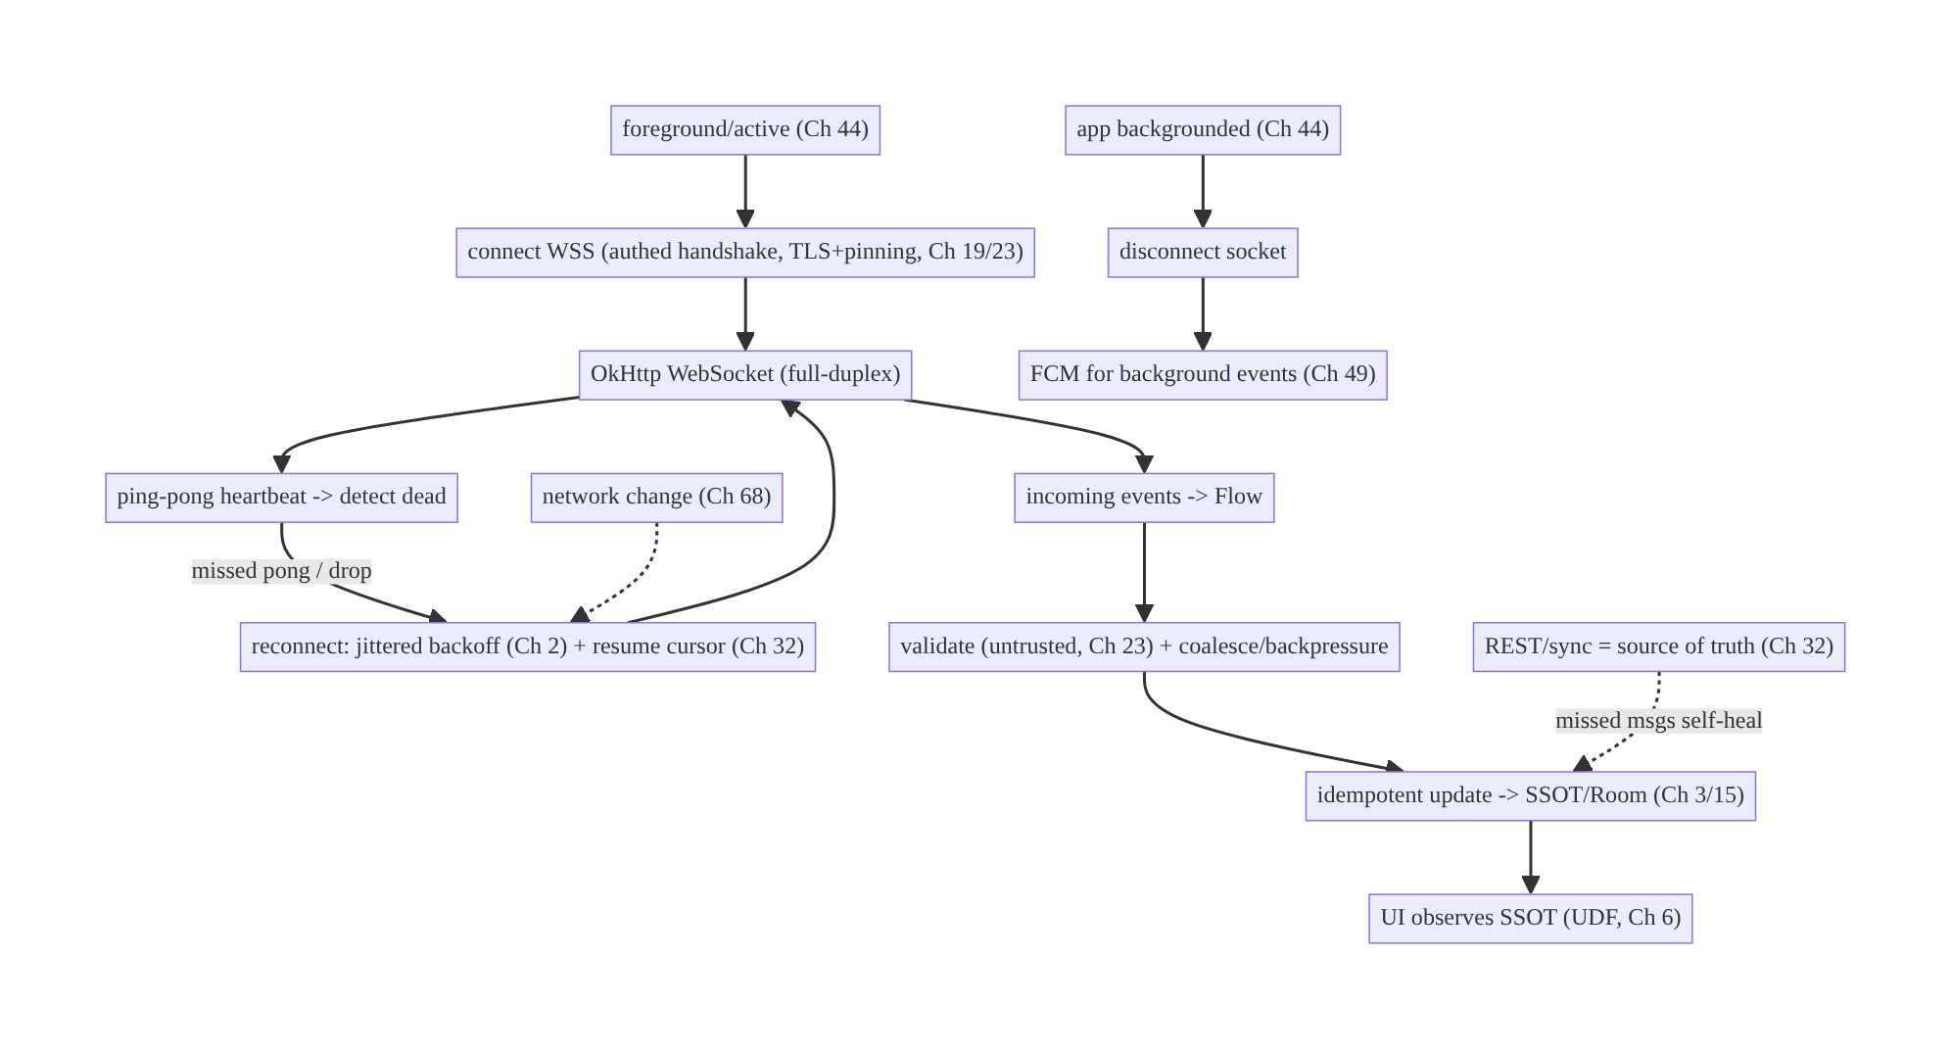
63.4 High-Level Architecture
Components & ownership
- Connection manager opens/closes the WSS scoped to lifecycle, with heartbeat + reconnect + resume.
- Events flow through validation/coalescing into the SSOT idempotently; the UI observes the SSOT.
- REST/sync is the authoritative backstop; FCM handles background.
Direction: foreground → authed WSS → heartbeat/reconnect/resume → events → validate/ coalesce → idempotent SSOT → UI; background → disconnect + FCM; REST reconciles.

63.5 Detailed Component Design
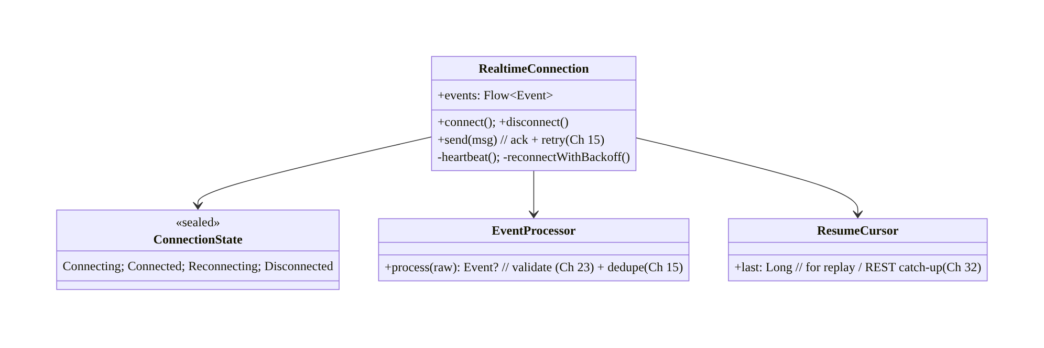
63.5 Detailed Component Design
Component | Responsibility
RealtimeConnection | lifecycle-scoped WSS: connect/disconnect, heartbeat, reconnect+resume, send(ack)
ConnectionState | observable connection status (for UI/retry)
EventProcessor | validate (untrusted, Ch 23) + dedupe (Ch 15) → typed events
ResumeCursor | last-seen sequence for replay / REST catch-up (Ch 32)

63.6 End-to-End Data Flow

Connect, stream, reconnect+resume
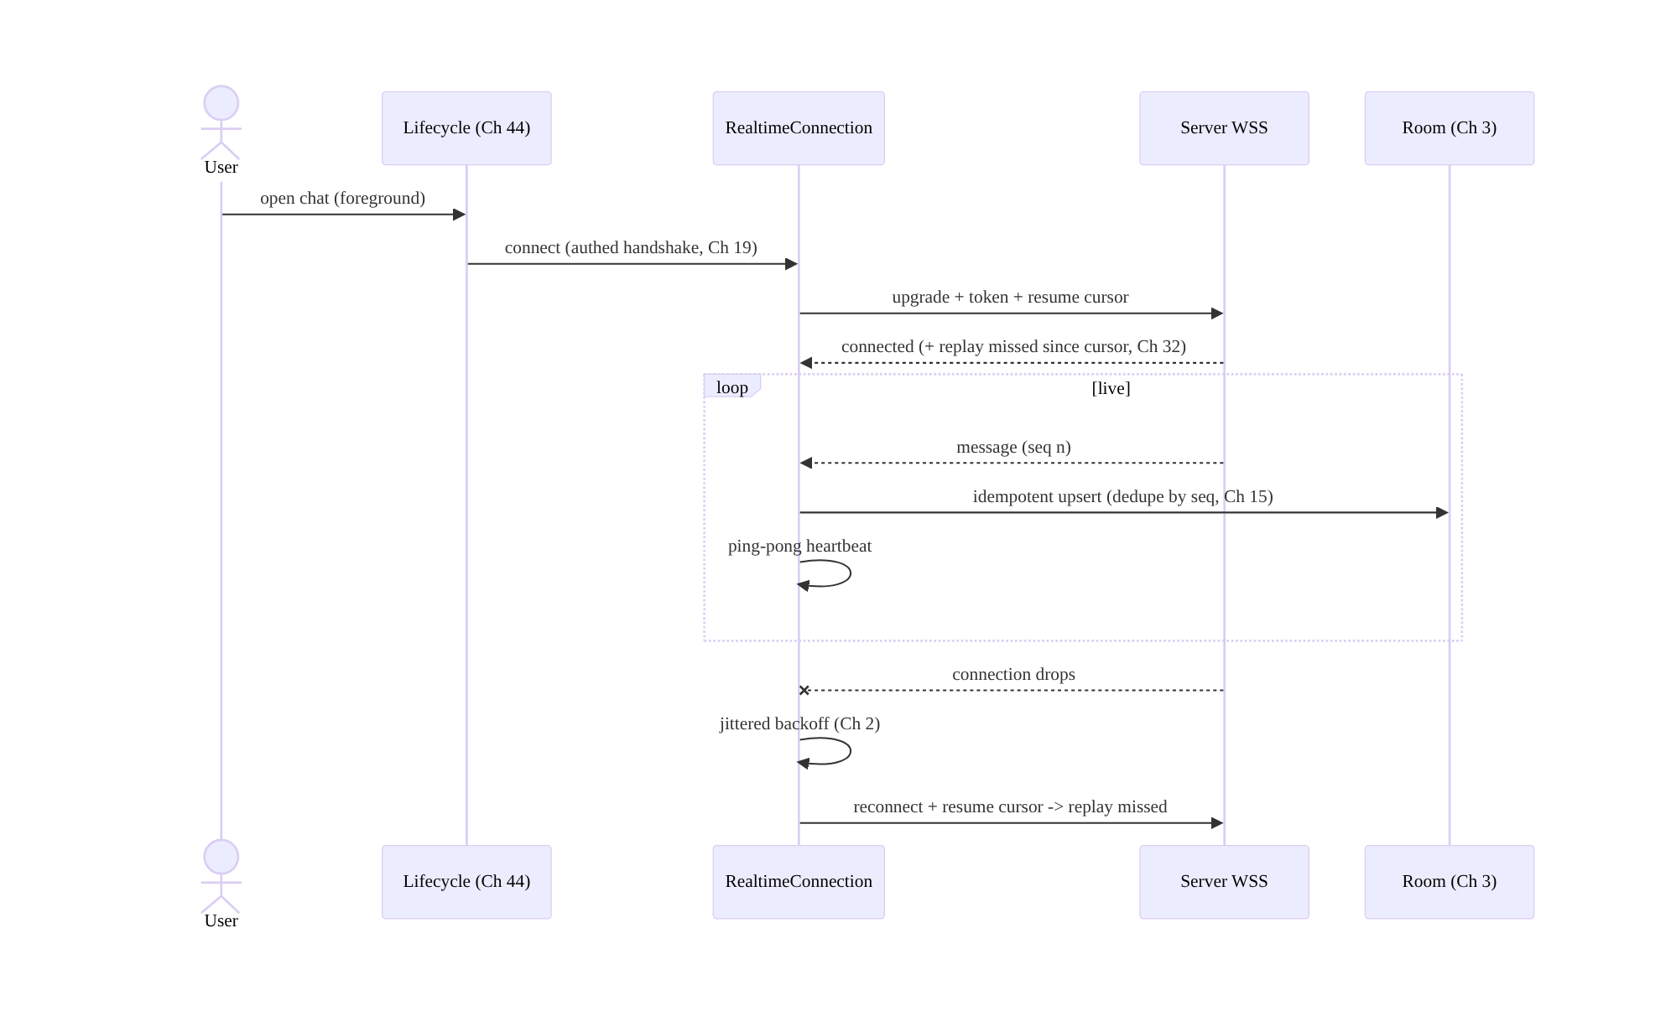
Connect, stream, reconnect+resume

Background handoff to FCM
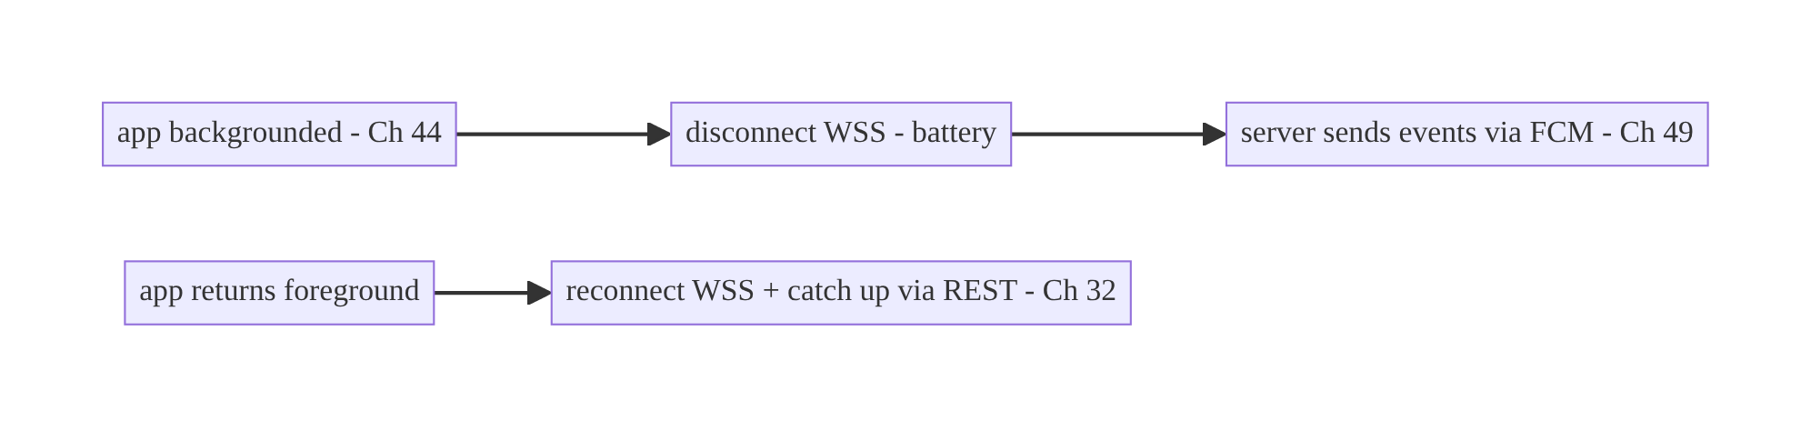
Background handoff to FCM

63.7 Complete Kotlin Implementation
Package: com.streamcart.realtime.

63.7.1 Lifecycle-scoped connection with heartbeat + reconnect + resume
sealed interface ConnectionState { object Connecting: ConnectionState; object Connected: ConnectionState
object Reconnecting: ConnectionState; object Disconnected: ConnectionState }
@Singleton
class RealtimeConnection @Inject constructor(
private val okHttp: OkHttpClient, // WSS + pinning (Ch 1/23)
private val auth: TokenProvider, // Ch 19
private val processor: EventProcessor,
private val cursorStore: ResumeCursorStore, // Ch 3/32
private val scope: CoroutineScope, // app scope (Ch 5)
) {
private val _events = MutableSharedFlow<Event>(extraBufferCapacity = 256, onBufferOverflow = BufferOverflow.DROP_OLDEST) // backpressure
val events: SharedFlow<Event> = _events.asSharedFlow()
val state = MutableStateFlow<ConnectionState>(ConnectionState.Disconnected)
private var webSocket: WebSocket? = null
private var attempt = 0
fun connect() {
state.value = ConnectionState.Connecting
val request = Request.Builder()
.url("wss://rt.streamcart.com/stream?cursor=${cursorStore.last()}") // resume cursor (Ch 32)
.header("Authorization", "Bearer ${auth.current()}") // authed handshake (Ch 19)
.build()
webSocket = okHttp.newWebSocket(request, listener())
}
fun disconnect() { webSocket?.close(1000, "lifecycle"); webSocket = null; state.value = ConnectionState.Disconnected }
private fun listener() = object : WebSocketListener() {
override fun onOpen(ws: WebSocket, response: Response) { attempt = 0; state.value = ConnectionState.Connected; startHeartbeat(ws) }
override fun onMessage(ws: WebSocket, text: String) {
processor.process(text)?.let { ev -> // validate (Ch 23) + dedupe (Ch 15)
cursorStore.advance(ev.seq); _events.tryEmit(ev) // update resume cursor
}
}
override fun onFailure(ws: WebSocket, t: Throwable, r: Response?) { scheduleReconnect() }
override fun onClosed(ws: WebSocket, code: Int, reason: String) { if (code != 1000) scheduleReconnect() }
}
private fun startHeartbeat(ws: WebSocket) = scope.launch {
while (isActive) {
delay(HEARTBEAT_MS); ws.send("""{"type":"ping"}""") // expect pong; miss -> reconnect (via timeout watchdog)
}
}
private fun scheduleReconnect() {
if (state.value == ConnectionState.Disconnected) return // intentional disconnect (background) -> stop
state.value = ConnectionState.Reconnecting
scope.launch {
val backoff = minOf(MAX_MS, BASE_MS * (1L shl attempt.coerceAtMost(6))) + Random.nextLong(JITTER_MS) // jittered (Ch 2)
attempt++; delay(backoff); connect() // reconnect + resume cursor
}
}
}

63.7.2 Event processing: validate (untrusted) + dedupe (idempotent)
@Singleton
class EventProcessor @Inject constructor(private val json: Json, private val seen: SeenSequences) {
fun process(raw: String): Event? {
val msg = runCatching { json.decodeFromString<WireMessage>(raw) }.getOrNull() ?: return null // untrusted (Ch 23)
if (msg.type !in KNOWN_TYPES) return null // allowlist
if (!seen.firstTime(msg.seq)) return null // dedupe (idempotent, Ch 15)
return msg.toEvent()
}
companion object { val KNOWN_TYPES = setOf("chat_message", "reaction", "viewer_count", "order_tick") }
}

63.7.3 Lifecycle scoping + FCM handoff (Ch 44/49)
// App-wide: connect on foreground, disconnect on background; FCM handles background (Ch 44/49).
@Singleton
class RealtimeLifecycleBinder @Inject constructor(
private val connection: RealtimeConnection, private val activeScreens: ActiveScreenTracker,
) : DefaultLifecycleObserver {
override fun onStart(owner: LifecycleOwner) { if (activeScreens.needsRealtime()) connection.connect() } // foreground
override fun onStop(owner: LifecycleOwner) { connection.disconnect() } // background -> rely on FCM (Ch 49)
// ProcessLifecycleOwner.get().lifecycle.addObserver(this) (Ch 44)
}

63.7.4 Events → idempotent SSOT; REST reconciles (Ch 3/32)
class ChatRepository @Inject constructor(
private val connection: RealtimeConnection, private val dao: MessageDao, // SSOT (Ch 3)
private val api: ChatApi, private val scope: CoroutineScope,
) {
init {
scope.launch {
connection.events.filterIsInstance<Event.ChatMessage>().collect { ev ->
dao.upsert(ev.toEntity()) // idempotent upsert (dedupe by id, Ch 15) -> UI observes (Ch 6)
}
}
}
/** On reconnect/open: REST catch-up = source of truth (Ch 32) — missed socket msgs self-heal. */
suspend fun catchUp(channelId: String) = dao.upsertAll(api.messagesSince(channelId, dao.lastSeq(channelId)))
/** Send with ack + retry + idempotency key (Ch 15) so a dropped send isn't lost/duplicated. */
suspend fun send(text: String) { /* optimistic SSOT insert (outbox, Ch 31) -> socket send -> await ack -> confirm */ }
}

63.7.5 High-rate coalescing (viewer count / reactions)
// Conflate a rapidly-changing viewer count so the UI isn't flooded (backpressure).
val viewerCount: Flow<Int> = connection.events
.filterIsInstance<Event.ViewerCount>().map { it.count }
.conflate() // keep only the latest
.sample(500.milliseconds) // at most ~2 updates/sec
// Reactions: buffer + batch render.

63.7.6 Module structure
:core:realtime RealtimeConnection, ConnectionState, EventProcessor, ResumeCursorStore, RealtimeLifecycleBinder
:feature:chat ChatRepository (events -> SSOT, REST catch-up, send+ack) [Ch 64]
# WSS client/pinning -> Ch 1/23; FCM -> Ch 49; network state -> Ch 68; sync -> Ch 32.

63.8 Concurrency and Race Conditions
Scenario | Risk | Handling
Connection dies silently | stale/no updates | heartbeat ping-pong + watchdog → reconnect
Reconnect storm (server blip) | stampede | jittered exponential backoff (Ch 2)
Duplicate/replayed messages | corrupted state | idempotent SSOT + dedupe by seq/id (Ch 15)
Out-of-order messages | wrong state | sequence-ordered apply; SSOT is last-writer/merge (Ch 33)
Missed while disconnected | data loss | resume cursor replay + REST catch-up (Ch 32)
High-rate flood | UI jank/OOM | conflate/sample/buffer (backpressure)
Token expires mid-connection | silent auth failure | refresh + reconnect (Ch 19)
Background holds socket | battery/Doze kill | disconnect on background; FCM (Ch 44/47/49)
Dropped send | lost message | optimistic + ack + retry + idempotency key (Ch 15/31)
- Idempotency makes the fragile socket safe: at-least-once delivery + resume replay + reconnect catch-up all produce duplicates; deduping by sequence/id (Ch 15) and upserting into the SSOT means duplicates and out-of-order arrivals never corrupt state.
- Jittered backoff prevents reconnect storms: when a server hiccups and thousands of clients drop, synchronized reconnects stampede it; exponential backoff + jitter (Ch 2) spreads them out.
- Resume cursor + REST catch-up cover the gap: anything missed while disconnected is replayed from the cursor or fetched authoritatively via REST (Ch 32) — the socket never has to be perfectly reliable.

63.9 Failure Scenarios and Recovery
Failure | Detection | Response | Outcome
Socket silently dead | missed pong | heartbeat → reconnect | restored
Frequent drops (bad network) | onFailure | backoff + resume; network-aware (Ch 68) | recovers
Reconnect storm | server load | jittered backoff (Ch 2) | spread out
Missed messages while disconnected | gap in seq | resume cursor + REST catch-up (Ch 32) | self-heals
Duplicates | repeated seq | idempotent dedupe (Ch 15) | single
Battery drain | socket in background | disconnect on background; FCM (Ch 49) | battery ok
Token expired | auth error frame | refresh + reconnect (Ch 19) | re-authed
UI flooded | jank | coalesce/sample (backpressure) | smooth
Malicious message | validation | untrusted validation + server authz (Ch 23) | safe
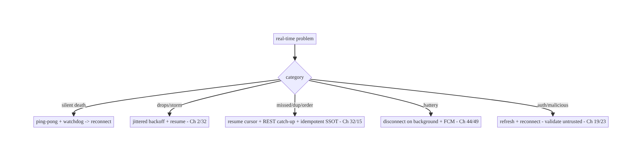
63.9 Failure Scenarios and Recovery
A WebSocket is a fast accelerator over an authoritative REST/sync layer, not a reliable pipe. Assume it dies silently (heartbeat), drops (backoff+resume), duplicates and reorders (idempotent SSOT), and is useless in the background (FCM) — build those in, and real-time becomes robust. Treating the socket as the source of truth is the root of most real-time bugs.

63.10 Scaling the Implementation
- Level 1. OkHttp WSS connection, events → Flow → SSOT; connect foreground/disconnect background (Ch 44).
- Level 2. Heartbeat + jittered-backoff reconnect (Ch 2) + resume cursor; idempotent dedupe (Ch 15); REST catch-up (Ch 32).
- Level 3 — production. FCM handoff for background (Ch 49); authed handshake + token refresh + WSS pinning (Ch 19/23); backpressure/coalescing; network-aware reconnect (Ch 68); untrusted-message validation.
- Level 4 — large. Multiplexed channels over one socket; send ack+retry+idempotency (Ch 15/31); per-feature coalescing policies; connection-quality metrics; graceful degradation to SSE/polling (Ch 66).
- Level 5 — enterprise. Real-time QoS SLOs (latency, reconnect rate), server-side scaling (sticky sessions/pub-sub), multi-region, protocol governance, fallback matrix (WS→SSE→polling→FCM).
Avoid overengineering: one lifecycle-scoped WSS with heartbeat, backoff, resume, idempotent SSOT, and FCM handoff covers most real-time needs. Don’t keep sockets open in the background, and don’t treat the socket as the source of truth.

63.11 Alternative Approaches and Trade-offs
Dimension | Option A | Option B | When
Transport | WebSocket | SSE (Ch 66) | WS for bidirectional low-latency; SSE for one-way server→client
Transport | WebSocket | long polling (Ch 66) | WS for frequent/low-latency; long-poll for occasional/simple infra
Foreground vs background | WebSocket (foreground) | FCM (background, Ch 49) | WS while active; FCM for background — use both
Source of truth | REST/sync (Ch 32) | the socket | REST authoritative; socket is a fast path
Reconnect | Jittered exponential backoff (Ch 2) | fixed/immediate | Jittered (avoid storms)
Missed messages | Resume cursor + REST catch-up | hope nothing dropped | Resume+catch-up (self-heal)
High-rate | Coalesce/sample (backpressure) | render every event | Coalesce (UI/battery)
Delivery | At-least-once + idempotency (Ch 15) | exactly-once (hard) | At-least-once + idempotent (practical)
WebSocket vs SSE vs long polling (Ch 66): WebSocket is full-duplex and lowest- latency — the choice for bidirectional real-time (chat, auctions). SSE is a simpler HTTP one-way server→client stream (good for feeds/notifications, auto-reconnect built in). Long polling works with basic infra for occasional updates but is laggy/wasteful at high rates. Pick WebSocket when you need to send and receive with low latency; SSE/ long-poll when one-way or simplicity matters (Ch 66 compares them directly).
WebSocket vs FCM (Ch 49): they solve different halves. A WebSocket is a live foreground connection (low-latency, bidirectional) that dies in the background (Doze). FCM wakes a backgrounded/killed app battery-efficiently but isn’t a live stream. Real apps use both: WebSocket while the user is active, FCM for background events, with REST/sync (Ch 32) reconciling behind both.
Socket as fast path vs source of truth: treating the socket as authoritative makes a dropped message a permanent loss and a duplicate a corruption. Treating it as a low- latency accelerator over an authoritative REST/sync layer (Ch 32) — with idempotent SSOT updates (Ch 15) and reconnect catch-up — makes real-time self-healing. This is the central design decision (mirroring push-as-trigger, Ch 49).

63.12 Security Considerations
- WSS (TLS) + certificate pinning (Ch 23): always wss://, never ws://; pin as with REST (Ch 23) to prevent MITM on the persistent connection.
- Authenticated handshake + token refresh (Ch 19): authenticate at connect (token in header/subprotocol — avoid long-lived tokens in the URL where they can be logged); handle token expiry mid-connection (server sends an auth-expiry frame → client refreshes and reconnects); re-auth on reconnect.
- Every inbound message is untrusted (Ch 23): validate/allowlist message types and schema; authorize server-side (a connected client must only receive events it’s entitled to — the server enforces channel membership); never act on a message that implies privilege without server authorization; beware injection via message content (Ch 52).
- Authorization per channel: subscribing to a channel (chat room, stream) must be server-authorized (Ch 23) — don’t let a client subscribe to arbitrary channels.
- Per-account isolation (Ch 42): events are scoped to the authenticated user; on logout/switch, close and reconnect with the new identity; never deliver account A’s events to account B.
- Rate limiting / abuse: the server rate-limits sends; the client shouldn’t be trusted to self-limit for security.
- No sensitive data beyond need; no PII in logs (Ch 28).
- Client vs backend: the backend authenticates the handshake, authorizes channels, enforces delivery/rate limits, and is the source of truth (REST); the client manages the connection, validates inbound messages, and reconciles — it never self-authorizes.

63.13 Performance and Resource Optimization
- Lifecycle scoping is the top battery lever: connect only while active; disconnect on background (Ch 44); FCM for background (Ch 49). A background socket drains battery and is killed anyway (Ch 47).
- Heartbeat interval tuning: frequent enough to detect death, infrequent enough to save battery/radio (align with keep-alive).
- Backpressure/coalescing: conflate/sample high-rate streams (viewer count, reactions) — don’t render every event; batch UI updates (Ch 6).
- One connection, multiplexed channels: avoid N sockets; multiplex logical channels over one WSS.
- Jittered backoff avoids self-inflicted load and radio churn on reconnect.
- Binary/compact framing for high-throughput; avoid chatty tiny messages (batch).
- Profiling: connection uptime, reconnect rate, message latency, battery/radio during connection, dropped/coalesced events, send-ack latency.

63.14 Testing Strategy
WebSocket logic tests with a fake/mock WebSocket (OkHttp MockWebServer supports WS); state machine + idempotency in isolation.
class EventProcessorTest {
@Test fun `dedupes replayed sequence`() {
val p = EventProcessor(json, InMemorySeen())
assertNotNull(p.process(msg(seq = 5))); assertNull(p.process(msg(seq = 5))) // idempotent (Ch 15)
}
@Test fun `rejects unknown/malformed message`() { assertNull(p.process("""{"type":"evil"}""")) } // untrusted (Ch 23)
}
class ReconnectTest {
@Test fun `uses jittered exponential backoff`() = runTest { /* assert increasing delays with jitter (Ch 2) */ }
@Test fun `intentional disconnect does not reconnect`() { /* background disconnect -> no reconnect loop */ }
}
@Test fun `reconnect resumes from cursor and REST catch-up fills gap`() = runTest {
// MockWebServer WS: drop, reconnect with cursor -> replay; assert SSOT has no gaps/dupes (Ch 32/15)
}
What to test: event validation (untrusted) + dedupe (idempotent); jittered backoff + no-reconnect-on-intentional-disconnect; resume cursor + REST catch-up fills gaps; lifecycle connect/disconnect + FCM handoff; heartbeat triggers reconnect on missed pong; coalescing/backpressure; token-refresh-on-expiry. MockWebServer WebSocket for integration; instrumentation for real network changes (Ch 68).

63.15 Production Observability
- Metrics: connection uptime / reconnect rate / reconnect latency; message delivery latency; dropped/coalesced event counts; resume-replay + REST-catch-up volume; send-ack latency/failure; battery/radio attributed to the socket; auth-refresh- mid-connection count; per-account mis-delivery (0).
- Logs: realtime{state, reconnects, latency, channel} — no message content/PII (Ch 28).
- Debugging: no updates → dead socket (heartbeat) / not reconnecting; storms → non-jittered backoff; missing/duplicate state → no resume/idempotency (Ch 32/15); battery → socket in background (Ch 44); flood → no coalescing; wrong-user events → channel authz/ account isolation (Ch 23/42).
- Alerting: reconnect-rate or latency spike (server/network); reconnect storm; auth- failure spike; any cross-account delivery (security).
- Dashboards: connection health (uptime/reconnect/latency) by network type (Ch 68); delivery funnel; battery impact.

63.16 System Design Interview Preparation
≥40 questions.
Fundamentals
- What is a WebSocket? A persistent full-duplex connection after an HTTP upgrade; both sides push anytime.
- WS vs REST? Stateful persistent bidirectional push vs stateless request/response.
- When WebSocket? Foreground low-latency bidirectional (chat, auctions).
- WS vs SSE vs long polling (Ch 66)? Full-duplex vs one-way HTTP stream vs occasional polling.
- WS vs FCM (Ch 49)? Live foreground vs background wake-up — use both.
Lifecycle/battery
- When to connect/disconnect? Connect foreground/active; disconnect on background (Ch 44).
- Why not keep it open in background? Battery + Doze kills it (Ch 47).
- Background events? FCM (Ch 49); reconnect + catch up on return.
Reliability
- Detect dead connection? Heartbeat ping-pong + watchdog.
- Why heartbeat? Connections die silently (NAT/network).
- Reconnect strategy? Jittered exponential backoff (Ch 2).
- Why jitter? Avoid reconnect storms.
- Missed messages? Resume cursor replay + REST catch-up (Ch 32).
- Duplicates/out-of-order? Idempotent SSOT + dedupe by seq (Ch 15).
Consistency
- Source of truth? REST/sync (Ch 32) — socket is a fast path.
- Why not socket-as-truth? Drops = permanent loss; dup = corruption.
- Events → UI? Flow → idempotent SSOT → UI observes (UDF, Ch 3/6).
- Delivery semantics? At-least-once + idempotency (Ch 15).
- Send reliability? Optimistic + ack + retry + idempotency key (Ch 15/31).
Auth/security
- Handshake auth? Token in header/subprotocol (not long-lived in URL).
- Transport? WSS (TLS) + pinning (Ch 23).
- Token expiry mid-connection? Refresh + reconnect (Ch 19).
- Inbound messages? Untrusted — validate/allowlist; server authorizes (Ch 23).
- Channel subscription? Server-authorized (Ch 23).
- Per-account? Reconnect with new identity on switch; no cross-account (Ch 42).
Backpressure/scale
- High-rate events? Coalesce/sample/debounce (backpressure).
- Many channels? Multiplex over one socket.
- Reconnect storms? Jittered backoff + server scaling.
- Network change (Ch 68)? Reconnect on recovery; don’t thrash offline.
Testing/Production
- Test WS? MockWebServer WS; dedupe/backoff/resume in isolation.
- Test idempotency? Replay seq → one effect.
- No updates in prod? Dead socket / not reconnecting.
- Storms? Non-jittered backoff.
- Missing/dup state? No resume/idempotency.
- Battery? Socket in background.
- Wrong-user events? Channel authz/account isolation.
- Key metrics? Uptime, reconnect rate, latency, battery.
- Graceful degradation? Fall back to SSE/polling/FCM (Ch 66/49).
- Ordering? Per-channel sequence; SSOT merge (Ch 33).
- One connection or many? One, multiplexed.
- What makes it robust? Treat as fast path over REST truth + idempotent SSOT + FCM background.

Design-change challenges
- Live chat. Foreground WSS → events → idempotent SSOT; FCM background; reconnect + catch-up; send ack (Ch 64).
- Battery drain from a background socket. Disconnect on background; FCM (Ch 44/49).
- Messages lost/duplicated after a drop. Resume cursor + REST catch-up + idempotent SSOT (Ch 32/15).
- Reconnect storm takes down the server. Jittered exponential backoff (Ch 2).
- Live viewer count floods the UI. Conflate + sample (backpressure).

Mock walkthrough (abridged)
Clarify (bidirectional?, rate, foreground-only?, consistency needs?) → WebSocket (vs SSE/ polling/FCM) → authed WSS + pinning (Ch 19/23) → lifecycle-scoped connect/disconnect + FCM handoff (Ch 44/49) → heartbeat + jittered reconnect + resume (Ch 2/32) → events → idempotent SSOT, REST as truth (Ch 3/15/32) → backpressure/coalescing → untrusted validation + channel authz (Ch 23) → observability (uptime/reconnect/latency).

63.17 Practical Exercises
- Beginner. Open an authenticated WSS with OkHttp, expose events as a Flow, and update the SSOT (Room); connect on foreground, disconnect on background. Eval: live updates; no background socket.
- Intermediate. Add heartbeat ping-pong and jittered exponential-backoff reconnect; do not reconnect on intentional disconnect. Eval: detects death; backs off; no loop on background.
- Advanced. Add a resume cursor + REST catch-up and idempotent dedupe so drops/ duplicates self-heal; hand off to FCM when backgrounded. Eval: no gaps/dupes; FCM for background.
- Production debugging. Fix a reconnect storm (no jitter) and UI flooding (no coalescing). Eval: spread reconnects; conflated stream.
- System design challenge. Add authed handshake + mid-connection token refresh + per-channel server authz + per-account isolation, and a connection-health dashboard. Eval: secure; isolated; observable.
(Solutions withheld unless requested.)

63.18 Chapter Summary & Reference Sheet
Key decisions: use a single authenticated WSS connection (token-in-handshake, TLS + certificate pinning, Ch 19/23) scoped to the foreground/active lifecycle — connect on foreground, disconnect on background (a background socket drains battery and is killed by Doze, Ch 44/47), and hand off to FCM (Ch 49) for background events; keep it alive with heartbeat ping-pong (connections die silently) and reconnect with jittered exponential backoff (Ch 2, to avoid storms) plus resume (last-seen cursor replay + REST catch-up, Ch 32); expose incoming messages as a Flow that updates the SSOT idempotently (dedupe by sequence/id, Ch 15) with backpressure/coalescing for high-rate streams, and let the UI observe the SSOT (UDF, Ch 6); treat the socket as a low-latency fast path over an authoritative REST/sync layer (Ch 32) so dropped, duplicated, and out-of-order messages self-heal; and secure it — validate every inbound message as untrusted, authorize channels/sends server-side (Ch 23), refresh tokens mid-connection (Ch 19), and isolate per account (Ch 42). For sends, use optimistic + ack + retry + idempotency key (Ch 15/31).
Concepts: WebSocket (full-duplex, stateful), WS vs SSE/long-polling/FCM, lifecycle scoping + FCM handoff, heartbeat, jittered-backoff reconnect + resume cursor, events → Flow → idempotent SSOT, REST as source of truth, backpressure/coalescing, authed handshake + token refresh + WSS pinning, untrusted-message validation + channel authz, delivery semantics (at-least-once + idempotency).
Common mistakes: treating the socket as the source of truth (drops = loss, dups = corruption); holding the socket open in the background (battery/Doze); no heartbeat (silent death); fixed/immediate reconnect (storms); no resume/catch-up (gaps); no idempotency (duplicate corruption); no backpressure (UI flood); ws:// or unpinned; not refreshing tokens; trusting inbound messages / client-side channel subscription; cross-account delivery.
Checklist:
- ☐ authed WSS + TLS pinning (Ch 19/23)
- ☐ connect foreground / disconnect background + FCM handoff (Ch 44/49)
- ☐ heartbeat ping-pong
- ☐ jittered exponential-backoff reconnect (Ch 2)
- ☐ resume cursor + REST catch-up (Ch 32)
- ☐ events → Flow → idempotent SSOT (Ch 3/15)
- ☐ REST = source of truth
- ☐ backpressure/coalescing
- ☐ token refresh mid-connection
- ☐ untrusted-message validation + server channel authz (Ch 23)
- ☐ per-account isolation (Ch 42)
- ☐ send optimistic+ack+retry+idempotency (Ch 15/31)
- ☐ uptime/reconnect/latency telemetry.
Key APIs: OkHttp newWebSocket/WebSocketListener (onOpen/onMessage/onFailure/ onClosed)/WebSocket.send/close, wss://, MutableSharedFlow(BufferOverflow/ extraBufferCapacity)/conflate/sample/buffer (backpressure), ProcessLifecycleOwner (Ch 44), FCM (Ch 49), Room SSOT (Ch 3), MockWebServer WebSocket (test), network callbacks (Ch 68).
References:
- OkHttp WebSocket: https://square.github.io/okhttp/5.x/okhttp/okhttp3/-web-socket/
- WebSocket protocol (RFC 6455): https://datatracker.ietf.org/doc/html/rfc6455
- Coroutines Flow backpressure: https://kotlinlang.org/docs/flow.html#buffering
- (composes) Ch 1 Networking, Ch 2 Retries/Backoff, Ch 44 Lifecycle, Ch 49 FCM, Ch 32 Sync, Ch 3 SSOT, Ch 15 Idempotency, Ch 19/23 Auth/Security, Ch 66 SSE/Long-Polling, Ch 68 Network State

Chapter 64 — Chat / Messaging Architecture
Part VIII — Real-Time & Connectivity · Complexity: Complex (≥40 interview questions)
Prerequisites: Ch 63 (WebSocket), Ch 49 (FCM), Ch 31 (outbox), Ch 32 (delta sync), Ch 15 (idempotency), Ch 3 (SSOT), Ch 13 (paging), Ch 44 (lifecycle). Pairs with Ch 65 (presence/typing), Ch 66 (SSE/long-poll), Ch 72 (optimistic updates).
Reference surface in StreamCart: buyer↔seller chat, support chat, and group conversations — messages that send reliably offline, arrive in real time, show correct delivery/read status, survive reconnects and process death, and stay consistent across devices.

64.1 Problem Definition and Real-World Context
Chat is the canonical “hard” mobile feature because it combines every distributed- systems problem into one UI: reliable sending (offline, retries), real-time receiving (WebSocket, Ch 63), background delivery (FCM, Ch 49), ordering, deduplication, delivery/read receipts, optimistic UI (Ch 72), pagination of history (Ch 13), multi-device consistency (Ch 32), and process-death survival (Ch 3/8). A naive chat (“POST a message, append to a list”) fails the moment the network blips, the app backgrounds, two devices are used, or messages race.
Concretely, teams hit:
- Unreliable sending. A message sent while offline/flaky is lost, or double-sent on retry. Must use an outbox (Ch 31) with idempotency keys (Ch 15) and optimistic insert (Ch 72).
- Ordering & dedup. Messages arrive out of order (retries, multi-path WebSocket+FCM), or duplicated. Need a server-assigned sequence/clock and dedup by client-id + server-seq (Ch 15/63).
- Real-time + background split. Live delivery over WebSocket (Ch 63) while foreground; FCM (Ch 49) to notify/sync when backgrounded — one coherent pipeline, not two inconsistent ones.
- Delivery & read receipts. Sent → delivered → read status per message, synced both ways, is its own state machine and consistency problem.
- History & sync. Paginate history (Ch 13), catch up missed messages on reconnect via a cursor (Ch 32), and reconcile across devices — the socket is a fast path, the SSOT + server are truth (Ch 3/63).
- Multi-device & groups. The same conversation on phone + tablet must converge; group chats fan out to many participants (server concern) with per-user state.
- Process death / offline-first. Draft messages, unsent outbox, and history must survive process death and work offline (Ch 3/8/29).
The architecture: model chat as an offline-first, SSOT-backed feature (Room, Ch 3) — optimistically insert a message with a client-generated id into the local store and an outbox (Ch 31/72), send with idempotency (Ch 15) over the current transport, and confirm with the server’s assigned sequence; receive live via WebSocket (Ch 63) while foreground and via FCM (Ch 49) when backgrounded, both funneling into the same idempotent SSOT merge (dedup by client-id/server-seq, ordered by server sequence); catch up missed messages on reconnect/open via a cursor (Ch 32); maintain delivery/read receipts as synced per-message state; paginate history (Ch 13); and keep it consistent across devices with the server as truth. This chapter is the end-to-end architecture of a reliable, real-time, offline-first chat.

Three practical use cases
- Buyer↔seller chat (StreamCart). Send works offline (outbox, optimistic), delivers live via WebSocket, notifies via FCM when backgrounded, shows sent/delivered/read, and survives reconnect with catch-up.
- Support chat with history. Paginated history (Ch 13), catch-up on reopen, read receipts, consistent across the user’s devices.
- Group conversation. Fan-out delivery (server), per-user read state, ordering by server sequence, dedup across WebSocket+FCM paths.

Why this is architectural
Chat composes the whole book: networking (Ch 1), WebSocket (Ch 63), FCM (Ch 49), outbox (Ch 31), idempotency (Ch 15), delta sync (Ch 32), SSOT (Ch 3), optimistic UI (Ch 72), paging (Ch 13), lifecycle (Ch 44). Its decisions — client-id + server-seq, unified real-time pipeline, receipts state machine, catch-up cursor, device convergence — are a masterclass in mobile distributed consistency.

64.2 Requirements Engineering

Functional requirements
ID | Requirement
F1 | Send messages reliably: offline-capable, retried, idempotent, optimistic (Ch 31/15/72).
F2 | Receive in real time (WebSocket) foreground + via FCM background — one pipeline (Ch 63/49).
F3 | Order and dedup messages (client-id + server sequence) (Ch 15).
F4 | Delivery/read receipts per message, synced both ways.
F5 | Paginate history; catch up missed messages on reconnect/open (Ch 13/32).
F6 | Consistent across devices; survive process death; offline-first (Ch 3/8/29).

Non-functional requirements
Attribute | Policy
Reliability | No lost/duplicated messages; send survives offline/death.
Latency | Real-time delivery while connected; prompt FCM when bg.
Consistency | Server-ordered; SSOT truth; devices converge (Ch 32).
Offline | Compose/read/queue offline; sync on reconnect (Ch 29).
Security | Authed transport, per-conversation authz, (optional) E2E (Ch 19/23).

Scope
- In scope: message model (client-id + server-seq), send path (outbox + idempotency + optimistic, Ch 31/15/72), unified receive (WebSocket foreground + FCM background → idempotent SSOT merge, Ch 63/49/3), ordering/dedup, delivery/read receipts, history paging + catch-up cursor (Ch 13/32), multi-device convergence, offline-first + process death (Ch 29/8), conversation list, (overview) groups + E2E.
- Out of scope: WebSocket internals (Ch 63), FCM internals (Ch 49), presence/typing (Ch 65), SSE/long-poll (Ch 66), outbox/sync/idempotency mechanics (Ch 31/32/15), optimistic-UI detail (Ch 72), E2E crypto depth, server fan-out implementation.

Assumptions & constraints
- WebSocket (Ch 63) + FCM (Ch 49), Room SSOT (Ch 3), outbox (Ch 31), WorkManager (Ch 30), Paging 3 (Ch 13). minSdk 24. Server assigns a monotonic per-conversation sequence and is the source of truth; transports are best-effort; messages carry a client-generated id for idempotency.

64.3 System Design Fundamentals
- SSOT-backed, offline-first (Ch 3/29). The Room database is the source of truth the UI renders (UDF, Ch 6). Sending and receiving both mutate the SSOT; the network (WebSocket/FCM/REST) feeds the SSOT, never the UI directly. This makes chat work offline, survive process death (Ch 8), and stay consistent.
- Dual id scheme: client-id + server-seq (the backbone). Every message has:
  - a client-generated id (UUID) created at compose time — used as the idempotency key (Ch 15) so retries/duplicates collapse, and to match the optimistic message to the server’s confirmation.
  - a server-assigned sequence (monotonic per conversation) — the ordering key and the catch-up cursor (Ch 32). The client orders by server-seq; before confirmation, an optimistic message sorts by its local timestamp at the tail. Dedup = “seen this client-id or server-seq before? ignore.” Ordering = “sort by server-seq.” This pair solves the two hardest chat problems.
- Send path (reliable, optimistic, Ch 31/15/72):
  - Optimistically insert the message into the SSOT with its client-id and a status = Sending → UI shows it instantly (Ch 72).
  - Enqueue in the outbox (Ch 31) so it survives process death and offline.
  - Send over the current transport (WebSocket if connected, else REST) with the client-id as idempotency key (Ch 15) → server dedups retries.
  - Confirm: server returns the assigned sequence + timestamp → update the SSOT message status = Sent, set server-seq (re-sort). The ack flows back via WebSocket or the REST response. Offline/flaky: the outbox retries with backoff (Ch 2); idempotency makes retries safe.
- Unified receive pipeline (WebSocket + FCM → one SSOT merge, Ch 63/49):
  - Foreground: messages stream over WebSocket (Ch 63) → idempotent upsert into the SSOT (dedup by client-id/server-seq).
  - Background: a high-priority FCM (Ch 49) wakes the app → fetch new messages via REST catch-up (Ch 32) → same idempotent SSOT merge → notification (Ch 50).
  - Crucially both paths converge on the same SSOT merge, so a message delivered twice (WebSocket + FCM, or WebSocket + catch-up) is deduped, and the UI is consistent regardless of path.
- Catch-up on reconnect/open (Ch 32). Because transports drop, on reconnect/foreground the client sends its last server-seq per conversation and the server replays missed messages (or the client does a REST delta, Ch 32). This heals gaps from disconnection — the socket need not be perfectly reliable (Ch 63).
- Delivery & read receipts (a mini state machine). Each message tracks Sending → Sent → Delivered → Read (and Failed). Outgoing: the server reports delivered/read when recipients ack; the client updates status. Incoming: when the user sees a message, the client sends a read receipt (batched, Ch 14) that syncs to the sender. Receipts are synced per-message state (Ch 32), not ephemeral — and privacy-configurable (Ch 65/28).
- History paging + conversation list (Ch 13). History is paged (Paging 3 from the SSOT, backed by a REST history endpoint for older pages, Ch 13). The conversation list shows last message + unread count per conversation, all from the SSOT.
- Multi-device convergence (Ch 32). The server’s per-conversation sequence + read state are synced to every device; each device catches up from its own cursor. The server is truth; devices converge (same as sync, Ch 32) — including read state (reading on one device marks read on others).
- Groups & E2E (overview). Group chat is server fan-out (one send → many recipients) with per-user delivery/read state; the client model is the same (messages with sender, server-seq). End-to-end encryption (optional) adds client-side crypto (e.g., Signal protocol) where the server can’t read content — a large addition layered on this architecture (keys, device verification), out of scope to build here.
- Security (Ch 19/23). Authed transport (WebSocket handshake/REST bearer, Ch 19/63); server authorizes conversation membership (you only receive/join conversations you’re in, Ch 23); treat message content as untrusted on render (Ch 52); per-account isolation (Ch 42).
Core insight: build chat as an offline-first, SSOT-backed feature where every message carries a client-generated id (idempotency key + optimistic match, Ch 15) and a server-assigned per-conversation sequence (ordering + catch-up cursor, Ch 32); send via an optimistic insert + outbox + idempotent send + server-seq confirmation (Ch 31/72); receive through a unified pipeline where WebSocket (foreground, Ch 63) and FCM-triggered REST catch-up (background, Ch 49/32) both converge on the same idempotent SSOT merge (so duplicates dedup and order is server-defined); catch up missed messages on reconnect via the sequence cursor; maintain delivery/read receipts as synced per-message state; page history (Ch 13); and converge devices with the server as truth — the socket is a fast path, the SSOT and server are the truth.

64.4 High-Level Architecture
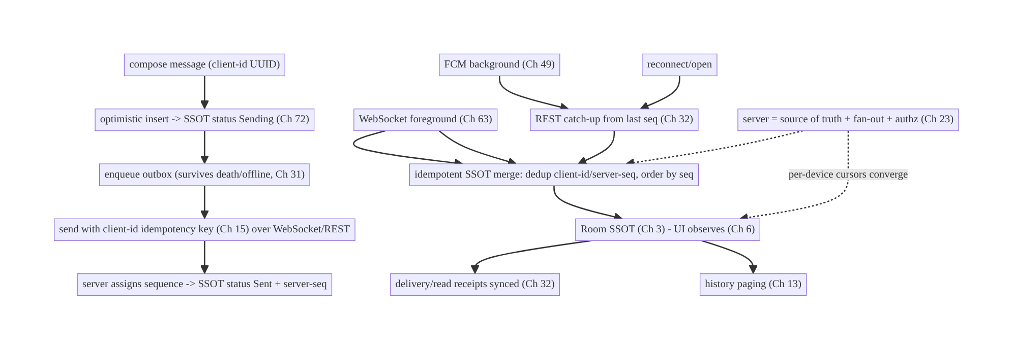
64.4 High-Level Architecture
Components & ownership
- Send: optimistic insert → outbox → idempotent send → server-seq confirm.
- Receive: WebSocket (fg) + FCM→catch-up (bg) both → one idempotent SSOT merge.
- SSOT is truth the UI renders; receipts and paging read it.
- Server assigns sequence, fans out, authorizes, and is the convergence truth.
Direction: compose → optimistic/outbox/idempotent send → confirm; WebSocket/FCM/ catch-up → idempotent merge → SSOT → UI; server orders and reconciles.

64.5 Detailed Component Design
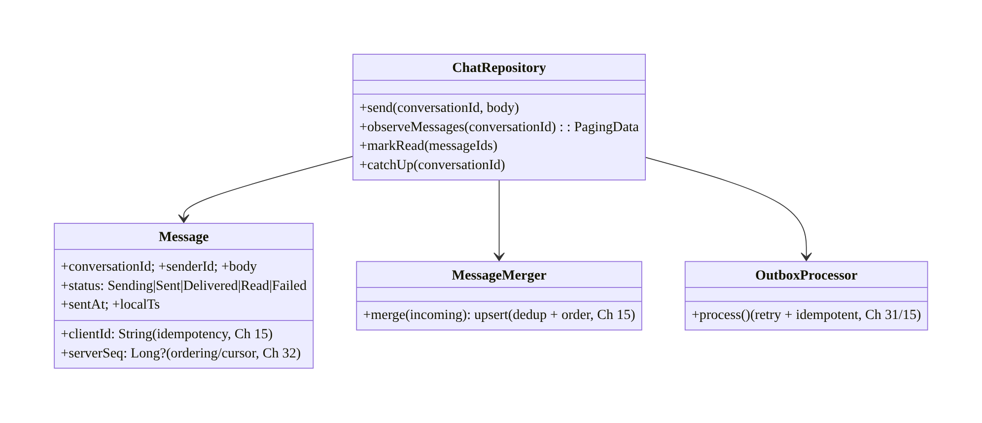
64.5 Detailed Component Design
Component | Responsibility
Message | SSOT row: client-id + server-seq + status + body (Ch 3)
ChatRepository | send/receive/paging/receipts over SSOT (Ch 3/13)
MessageMerger | idempotent upsert of incoming (WebSocket/FCM/catch-up), dedup+order (Ch 15)
OutboxProcessor | reliable send with retry + idempotency (Ch 31/15)

64.6 End-to-End Data Flow

Send (optimistic + outbox + idempotent + confirm)
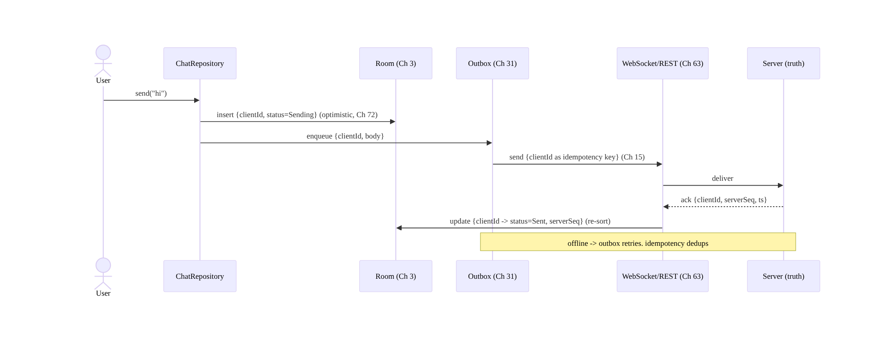
Send (optimistic + outbox + idempotent + confirm)

Unified receive + dedup
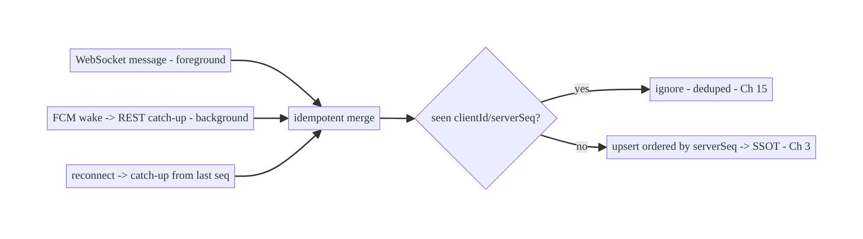
Unified receive + dedup

64.7 Complete Kotlin Implementation
Package: com.streamcart.chat.

64.7.1 Message model (client-id + server-seq + status)
@Entity(tableName = "messages", indices = [Index("conversationId", "serverSeq"), Index(value = ["clientId"], unique = true)])
data class Message(
@PrimaryKey val clientId: String, // UUID at compose; idempotency key (Ch 15) + optimistic match
val serverSeq: Long?, // server-assigned ordering/cursor (Ch 32); null until confirmed
val conversationId: String, val senderId: String, val body: String,
val status: Status, val sentAt: Long?, val localTs: Long,
) { enum class Status { Sending, Sent, Delivered, Read, Failed } }
// Order: serverSeq when present, else localTs at the tail (optimistic).

64.7.2 Send: optimistic insert + outbox + idempotent + confirm
@Singleton
class ChatRepository @Inject constructor(
private val dao: MessageDao, private val outbox: Outbox, // Ch 31
private val transport: ChatTransport, private val session: SessionManager, // WebSocket/REST (Ch 63/19)
private val scope: CoroutineScope,
) {
suspend fun send(conversationId: String, body: String) {
val msg = Message(clientId = UUID.randomUUID().toString(), serverSeq = null,
conversationId = conversationId, senderId = session.userId, body = body,
status = Status.Sending, sentAt = null, localTs = System.currentTimeMillis())
dao.upsert(msg) // 1) optimistic -> UI instant (Ch 72)
outbox.enqueue(OutboxOp.SendMessage(msg.clientId, conversationId, body)) // 2) survives death/offline (Ch 31)
}
// OutboxProcessor calls this; idempotent on the server via clientId (Ch 15).
suspend fun deliver(op: OutboxOp.SendMessage): Result<Unit> = runCatching {
val ack = transport.sendMessage(op.clientId, op.conversationId, op.body) // clientId = idempotency key
dao.confirm(op.clientId, serverSeq = ack.seq, sentAt = ack.ts, status = Status.Sent) // 3) confirm + re-sort
}.onFailure { dao.markStatus(op.clientId, Status.Failed) } // retry via outbox (Ch 31/2)
}

64.7.3 Unified merge: WebSocket + FCM + catch-up → idempotent SSOT
@Singleton
class MessageMerger @Inject constructor(private val dao: MessageDao) {
/** All inbound paths (WebSocket Ch 63, FCM catch-up Ch 49/32) funnel here. */
@Transaction
suspend fun merge(incoming: List<WireMessage>) {
for (m in incoming) {
// Dedup: if we already have this clientId (our own echo) or serverSeq, upsert (idempotent, Ch 15).
dao.upsertByClientIdOrSeq(
Message(clientId = m.clientId, serverSeq = m.seq, conversationId = m.conversationId,
senderId = m.senderId, body = m.body, status = statusFrom(m), sentAt = m.ts, localTs = m.ts))
}
}
}
// WebSocket (foreground): connection.events.filterIsInstance<ChatEvent>().collect { merger.merge(listOf(it.toWire())) }
// FCM (background, Ch 49): PushSyncWorker -> catchUp(conversationId) -> merger.merge(restMessages)

64.7.4 Catch-up on reconnect/open (sequence cursor, Ch 32)
suspend fun ChatRepository.catchUp(conversationId: String) {
val lastSeq = dao.maxSeq(conversationId) ?: 0L // resume cursor (Ch 32/63)
val missed = transport.messagesSince(conversationId, lastSeq) // REST delta
merger.merge(missed) // same idempotent merge -> heals gaps
}
// Called on WebSocket reconnect (Ch 63) and on opening a conversation / app foreground (Ch 44).

64.7.5 Read receipts (batched, synced, Ch 14/32)
suspend fun ChatRepository.markRead(conversationId: String, upToSeq: Long) {
dao.markReadLocally(conversationId, upToSeq) // SSOT -> UI unread count updates
outbox.enqueue(OutboxOp.ReadReceipt(conversationId, upToSeq)) // batched, idempotent sync (Ch 31/14)
// Server propagates read state to the sender + the user's other devices (Ch 32).
}
// Incoming receipts (delivered/read for our sent messages) arrive via WebSocket/catch-up -> update status.

64.7.6 History paging + conversation list (Ch 13)
fun ChatRepository.messages(conversationId: String): Flow<PagingData<Message>> =
Pager(PagingConfig(pageSize = 50), remoteMediator = ChatRemoteMediator(conversationId, transport, dao)) {
dao.pagingSource(conversationId) // ordered by serverSeq (Ch 13), from SSOT
}.flow
// Conversation list: dao.conversationsWithLastMessageAndUnreadCount() (all from SSOT, Ch 3).

64.7.7 Module structure
:feature:chat ChatRepository, MessageMerger, Message/Dao, ChatRemoteMediator, chat + list UI (Ch 6/13)
:core:realtime WebSocket transport (Ch 63); :feature:push FCM -> catch-up (Ch 49)
:core:outbox Outbox + OutboxProcessor (Ch 31); :core:sync catch-up/receipts (Ch 32)
# Server: sequence assignment, fan-out, membership authz (Ch 23).

64.8 Concurrency and Race Conditions
Scenario | Risk | Handling
Retry re-sends message | duplicate | client-id idempotency key (Ch 15); server dedups
Same message via WebSocket + FCM | duplicate in UI | unified merge dedups by client-id/server-seq
Out-of-order arrival | wrong order | order by server-seq; optimistic at tail by localTs
Our own message echoed back | duplicate of optimistic | merge matches by client-id → updates, not inserts
Concurrent sends | seq gaps | server assigns seq; client re-sorts on confirm
Read receipt races | flicker/over-count | mark up-to-seq (monotonic); idempotent (Ch 15)
Process death with unsent | lost message | outbox persisted (Ch 31); resumes
Multi-device read | divergent unread | server syncs read state; converge (Ch 32)
- client-id + server-seq is the race-killer: the client-id makes sends and inbound merges idempotent (retries, WebSocket+FCM double-delivery, and our own echoed message all collapse), and the server-seq gives a total order independent of arrival time. Every chat race reduces to “dedup by id, order by seq.”
- Our own echo matches by client-id: when the server broadcasts our message back (so other devices get it), the merge finds the existing optimistic row by client-id and updates it (sets server-seq) rather than inserting a duplicate.
- Outbox + idempotency makes send death-proof: the message is persisted before sending; a crash mid-send resumes from the outbox, and the idempotency key prevents a double-send.

64.9 Failure Scenarios and Recovery
Failure | Detection | Response | Outcome
Send while offline | no network | optimistic + outbox; send on reconnect (Ch 31/29) | not lost
Duplicate send on retry | — | client-id idempotency (Ch 15) | single
Missed messages (disconnect) | seq gap | catch-up from cursor (Ch 32/63) | healed
Dup across WebSocket+FCM | — | unified merge dedup | single
Out-of-order | — | order by server-seq | correct
Process death with drafts/outbox | restart | persisted SSOT/outbox (Ch 3/8/31) | survives
Devices show different unread | — | server-synced read state (Ch 32) | converge
Background delivery | app closed | FCM → catch-up → notification (Ch 49/50) | delivered
Send permanently fails | retries exhausted | status=Failed + manual retry (Ch 72) | visible
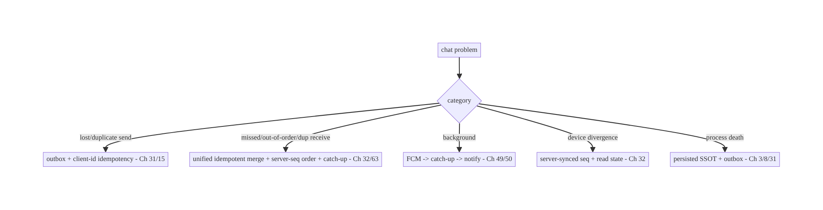
64.9 Failure Scenarios and Recovery
Every chat reliability problem collapses to two primitives: client-id (idempotency) and server-seq (ordering + cursor). Sends go through an outbox keyed by client-id; all inbound paths (WebSocket, FCM, catch-up) funnel through one idempotent merge ordered by server-seq. The socket is a fast path; the SSOT and server are the truth — so offline, retries, double-delivery, reordering, and process death all resolve cleanly.

64.10 Scaling the Implementation
- Level 1. SSOT messages (client-id + server-seq); optimistic send + outbox (Ch 31/72); WebSocket receive → idempotent merge (Ch 63).
- Level 2. FCM background → catch-up (Ch 49/32); reconnect catch-up cursor; delivery/ read receipts; history paging (Ch 13).
- Level 3 — production. Multi-device convergence (Ch 32); conversation list + unread; failed-send retry UX (Ch 72); per-conversation authz (Ch 23); offline-first (Ch 29).
- Level 4 — large. Group chat (fan-out, per-user state); media messages (Ch 17/59); message search (Ch 35); receipts privacy (Ch 65/28); backpressure for busy chats (Ch 63).
- Level 5 — enterprise. End-to-end encryption (Signal-style, device keys); message reactions/edits/deletes (tombstones, Ch 33); huge-group scaling; cross-platform consistency; chat QoE SLOs (send success, delivery latency).
Avoid overengineering: the client-id + server-seq + outbox + unified-merge + catch-up core is what every reliable chat needs. Don’t build E2E or huge-group handling until the core is solid; don’t treat the socket as truth.

64.11 Alternative Approaches and Trade-offs
Dimension | Option A | Option B | When
Truth | SSOT + server (socket is fast path) | the WebSocket stream | SSOT+server always (reliability)
Send | Optimistic + outbox + idempotent (Ch 31/15/72) | POST-and-wait | Optimistic+outbox (offline, instant UX)
Ordering | Server-assigned sequence | client timestamps | Server-seq (clocks skew; total order)
Dedup | client-id idempotency key (Ch 15) | server-id only | client-id (works pre-confirmation, across paths)
Receive | Unified WebSocket+FCM→merge | separate pipelines | Unified (dedup, consistency)
Background | FCM → catch-up (Ch 49/32) | keep socket open | FCM (battery/Doze, Ch 47)
History | Paging from SSOT + RemoteMediator (Ch 13) | load all | Paging (scale)
Multi-device | Server-synced seq + read state (Ch 32) | last-writer per device | Server-synced (converge)
SSOT+server as truth vs the socket stream as truth: treating the live WebSocket as the source of truth means a dropped/duplicated/reordered frame corrupts the chat. Making the SSOT the rendered truth and the server the ordering/convergence authority — with the socket as a fast path over catch-up (Ch 32) — makes chat self-healing: anything missed is caught up, anything duplicated is deduped, order is server-defined. This is the central decision (mirrors Ch 49/63).
client-id + server-seq vs server-id alone: relying only on a server-assigned id means you can’t dedup or match your optimistic message until the server responds — and you can’t dedup across WebSocket+FCM before confirmation. A client-generated id gives idempotency from compose time (retries, echoes, multi-path), while the server sequence gives total ordering and the catch-up cursor. Both are needed; neither alone suffices.
Unified receive vs separate WebSocket/FCM pipelines: handling WebSocket and FCM messages in separate code paths leads to duplicates (both deliver the same message) and inconsistency (different merge logic). Funneling both (plus reconnect catch-up) through one idempotent SSOT merge guarantees dedup and a single consistent state regardless of how a message arrived.

64.12 Security & Privacy Considerations
- Authenticated transport + membership authz (Ch 19/23): WebSocket handshake / REST bearer authenticates the user; the server authorizes conversation membership — you can only send to, receive from, and catch up on conversations you belong to (a client can’t subscribe to arbitrary conversations, Ch 63/23).
- Message content is untrusted on render (Ch 52): sanitize/escape message bodies (links, markup) to prevent injection; validate media URLs; don’t auto-execute content.
- Per-account isolation (Ch 42): messages/receipts scoped to the active account; on logout/switch, close the socket and clear/scope the SSOT.
- Read-receipt privacy (Ch 65/28): receipts reveal behavior (when you read) — make them configurable (send/receive receipts off) and respect the setting both ways.
- End-to-end encryption (optional): for private messaging, content is encrypted client-side so the server stores ciphertext (Signal-style); adds device key management, verification, and changes search/backup — a major addition, layered on this architecture.
- Media messages (Ch 17/59): upload/download over authed channels; access-controlled (signed URLs); scan/limit sizes.
- Abuse/rate limiting: server-side (spam, flooding); client can’t be trusted to self-limit for security.
- No sensitive content/PII in logs (Ch 28).
- Client vs backend: the server assigns sequence, fans out, authorizes membership, enforces rate limits, and is the truth; the client sends idempotently, merges idempotently, renders untrusted content safely, and (for E2E) holds keys.

64.13 Performance and Resource Optimization
- Paging (Ch 13) — never load a whole conversation; page from SSOT + RemoteMediator.
- Batch receipts (Ch 14) — don’t send a read receipt per message; batch up-to-seq.
- Lifecycle-scoped socket (Ch 63/44) — WebSocket only while active; FCM background.
- Unified merge in a transaction (Ch 3) — batch upserts; single DB write for a batch.
- Backpressure on busy chats (Ch 63) — coalesce rapid updates to the UI.
- Efficient diffing in the list (stable client-id keys) — smooth scrolling (Ch 6).
- Media thumbnails (Ch 57) and lazy media load (Ch 56).
- Profiling: send success rate/latency, delivery latency, catch-up volume, DB write rate, socket uptime (Ch 63), notification→open funnel.

64.14 Testing Strategy
Chat logic is highly testable in isolation (SSOT merge, outbox, ordering, receipts); transports faked.
class MessageMergerTest {
@Test fun `dedups our own echoed message by clientId`() = runTest {
repo.send("c1", "hi") // optimistic, clientId X
merger.merge(listOf(wire(clientId = "X", seq = 10))) // server echoes it back
assertEquals(1, dao.count("c1")) // updated, not duplicated (Ch 15)
assertEquals(Status.Sent, dao.byClientId("X").status)
}
@Test fun `dedups across WebSocket and FCM paths`() = runTest {
merger.merge(listOf(wire(seq = 11))); merger.merge(listOf(wire(seq = 11)))
assertEquals(1, dao.bySeq("c1", 11).let { 1 }) // single
}
@Test fun `orders by serverSeq`() = runTest { /* insert seq 12 then 11 -> list shows 11,12 */ }
}
class SendPathTest {
@Test fun `send survives offline and retries idempotently`() = runTest {
transport.offline = true; repo.send("c1", "hi") // outbox holds it
assertEquals(Status.Sending, dao.last("c1").status)
transport.offline = false; outboxProcessor.process() // retries -> Sent, idempotent
assertEquals(Status.Sent, dao.last("c1").status)
}
@Test fun `catch-up heals missed messages from cursor`() = runTest { /* lastSeq=10, server has 11-13 -> merged */ }
}
class ReadReceiptTest {
@Test fun `markRead is monotonic up-to-seq and idempotent`() { /* ... */ }
}
What to test: merge dedup (own echo, cross-path, by seq) + ordering; send optimistic + outbox + idempotent retry + confirm; catch-up heals gaps; receipts monotonic/idempotent; multi-device read convergence (fake server); process-death resume (outbox persisted); per-conversation authz (integration — can’t fetch others’). Fake WebSocket/FCM/REST; use Room in-memory.

64.15 Production Observability
- Metrics: send success rate + send latency (compose→Sent); delivery latency (sent→delivered); read-receipt latency; catch-up message volume + gap frequency; duplicate-merge rate (should dedup); failed-send rate; notification→open (Ch 49); socket uptime (Ch 63); per-device divergence incidents (0).
- Logs: chat{event, conversationId, status, seq, path(ws/fcm/catchup)} — no message content/PII (Ch 28).
- Debugging: lost messages → outbox not retrying / catch-up gap (Ch 31/32); duplicates → merge not deduping (client-id/seq); out-of-order → not ordering by seq; bg not delivered → FCM/catch-up (Ch 49); device divergence → read-state sync (Ch 32); wrong conversation → membership authz (Ch 23).
- Alerting: send-success drop; delivery-latency spike; duplicate-rate spike; any cross-conversation leakage.
- Dashboards: send/delivery funnel + latency; catch-up/gap rate; socket vs FCM delivery split.

64.16 System Design Interview Preparation
≥40 questions.
Fundamentals
- Why is chat hard? Combines reliable send, real-time receive, background, ordering, dedup, receipts, offline, multi-device.
- Source of truth? SSOT (rendered) + server (ordering/convergence); socket is a fast path.
- Two id scheme? client-id (idempotency + optimistic match) + server-seq (order + cursor).
- Why client-id? Dedup/idempotency from compose time (retries, echo, multi-path).
- Why server-seq? Total order (clocks skew) + catch-up cursor.
Send
- Send path? Optimistic insert → outbox → idempotent send → server-seq confirm (Ch 72/31/15).
- Offline send? Outbox persists; retries on reconnect (Ch 31/29).
- Duplicate on retry? client-id idempotency key (Ch 15).
- Status states? Sending→Sent→Delivered→Read (+Failed).
- Failed send? status=Failed + manual retry.
Receive
- Foreground delivery? WebSocket (Ch 63).
- Background delivery? FCM wake → REST catch-up → notification (Ch 49/50).
- Why unified pipeline? Dedup + consistency across WebSocket/FCM.
- Our own echo? Matched by client-id → update optimistic row, not duplicate.
- Dedup across paths? Same idempotent merge by client-id/server-seq.
Ordering/catch-up
- Ordering? By server-seq; optimistic at tail by localTs.
- Missed messages? Catch-up from last seq cursor (Ch 32/63).
- Out-of-order? Re-sort by server-seq on merge.
Receipts
- Receipt states? Delivered/read, synced per-message.
- Batching? Up-to-seq, batched (Ch 14).
- Incoming receipts? Update our sent messages’ status.
- Privacy? Configurable receipts (Ch 65/28).
Multi-device/history
- Device convergence? Server-synced seq + read state; per-device cursors (Ch 32).
- Read on one device? Syncs read state to others.
- History? Paging from SSOT + RemoteMediator (Ch 13).
- Conversation list? Last message + unread from SSOT.
Groups/E2E
- Group chat? Server fan-out; per-user state; same client model.
- E2E? Client-side crypto (Signal-style); server stores ciphertext; key management.
Security
- Transport auth? WebSocket handshake / REST bearer (Ch 19/63).
- Membership authz? Server authorizes conversations (Ch 23).
- Content safety? Untrusted render; sanitize (Ch 52).
- Per-account? Isolate; close socket + scope SSOT on switch (Ch 42).
Process death/offline
- Unsent on death? Outbox persisted (Ch 31/8).
- Offline compose/read? SSOT offline-first (Ch 29).
Testing/Production
- Test merge? Dedup (echo/cross-path/seq) + ordering.
- Test send? Offline + idempotent retry + confirm.
- Test catch-up? Heals gaps from cursor.
- Lost in prod? Outbox/catch-up gap.
- Duplicates? Merge not deduping.
- Device divergence? Read-state sync.
- Key metrics? Send success/latency, delivery latency, dup rate, catch-up/gap.

Design-change challenges
- Messages must send offline and never duplicate. Optimistic + outbox + client-id idempotency (Ch 31/15/72).
- A message arrives via both WebSocket and FCM. Unified idempotent merge dedups.
- Reopening shows missing messages. Catch-up from seq cursor (Ch 32).
- Read count differs across phone and tablet. Server-synced read state (Ch 32).
- Add delivery/read receipts. Per-message synced status + batched read receipts.

Mock walkthrough (abridged)
Clarify (1:1 or groups, offline, multi-device, receipts, E2E?) → SSOT + server as truth (socket fast path) → message model (client-id + server-seq) → send (optimistic + outbox + idempotent + confirm, Ch 72/31/15) → unified receive (WebSocket + FCM→catch-up → idempotent merge, Ch 63/49/32) → ordering/dedup → receipts (synced, batched) → paging + device convergence (Ch 13/32) → security (authz, untrusted content) → observability (send/delivery funnel).

64.17 Practical Exercises
- Beginner. Model messages with client-id + server-seq + status; render from the SSOT ordered by seq with optimistic tail. Eval: correct order; optimistic shows instantly.
- Intermediate. Implement the send path (optimistic + outbox + idempotent + confirm) so sending works offline and never duplicates on retry. Eval: offline-capable; idempotent.
- Advanced. Build the unified receive merge (WebSocket + FCM catch-up) with dedup and reconnect catch-up from the seq cursor. Eval: no dupes across paths; gaps heal.
- Production debugging. Fix duplicate messages (own echo not matched by client-id) and divergent unread counts across devices (no read-state sync). Eval: single; converge.
- System design challenge. Add delivery/read receipts (synced, batched, privacy- configurable) and a send/delivery-latency dashboard. Eval: receipts correct; measurable.
(Solutions withheld unless requested.)

64.18 Chapter Summary & Reference Sheet
Key decisions: build chat as an offline-first, SSOT-backed feature (Room is the rendered truth, the server is the ordering/convergence authority, the socket is a fast path, Ch 3/63); give every message a client-generated id (idempotency key + optimistic match, Ch 15) and a server-assigned per-conversation sequence (total ordering + catch-up cursor, Ch 32); send via optimistic insert → outbox → idempotent send → server-seq confirmation (Ch 72/31/15) so sending works offline, survives process death, and never duplicates; receive through a unified pipeline where WebSocket (foreground, Ch 63) and FCM-triggered REST catch-up (background, Ch 49/32) — plus reconnect catch-up from the sequence cursor — all converge on the same idempotent SSOT merge (dedup by client-id/server-seq, order by server-seq), so double-delivery dedups and gaps heal; maintain delivery/read receipts as synced, batched per-message state (Ch 14/32, privacy-configurable, Ch 65/28); page history (Ch 13); converge devices via server-synced sequence + read state (Ch 32); and secure it with authed transport + server-side membership authorization (Ch 19/23), untrusted- content rendering (Ch 52), and per-account isolation (Ch 42).
Concepts: SSOT+server truth, client-id + server-seq, optimistic+outbox+idempotent send, unified WebSocket+FCM+catch-up receive → idempotent merge, ordering/dedup, delivery/read receipts, history paging, multi-device convergence, offline-first, groups/E2E overview.
Common mistakes: treating the socket as truth (drops/dupes corrupt); POST-and-wait sends (no offline/instant UX); server-id-only (can’t dedup optimistic/cross-path); separate WebSocket/FCM pipelines (dupes/inconsistency); client-timestamp ordering (skew); no catch-up (gaps); unbatched receipts (spam); loading whole history (no paging); no membership authz; rendering untrusted content unsafely.
Checklist:
- ☐ SSOT+server truth, socket = fast path
- ☐ client-id (idempotency) + server-seq (order/cursor)
- ☐ send: optimistic + outbox + idempotent + confirm (Ch 72/31/15)
- ☐ unified receive: WebSocket + FCM + catch-up → one idempotent merge (Ch 63/49/32)
- ☐ order by server-seq, dedup by id
- ☐ catch-up on reconnect/open
- ☐ delivery/read receipts synced + batched (Ch 14/32)
- ☐ history paging (Ch 13)
- ☐ device convergence (Ch 32)
- ☐ membership authz + untrusted content + per-account (Ch 23/52/42)
- ☐ send/delivery-latency telemetry.
Key APIs: Room @Entity/@Dao/@Transaction (unique client-id index, seq index, Ch 3), UUID.randomUUID (client-id), Outbox (Ch 31), WebSocket transport (Ch 63), FCM + PushSyncWorker (Ch 49), Paging 3 Pager/RemoteMediator (Ch 13), delta catch-up (Ch 32), batched receipts (Ch 14), optimistic UI (Ch 72).
References:
- Offline-first / sync: https://developer.android.com/topic/architecture/data-layer/offline-first
- Paging 3: https://developer.android.com/topic/libraries/architecture/paging/v3-overview
- (composes) Ch 63 WebSocket, Ch 49 FCM, Ch 31 Outbox, Ch 32 Delta Sync, Ch 15 Idempotency, Ch 3 SSOT, Ch 13 Paging, Ch 72 Optimistic Updates, Ch 65 Presence/Typing

Chapter 65 — Presence & Typing Indicators
Part VIII — Real-Time & Connectivity · Complexity: Standard (≥25 interview questions)
Prerequisites: Ch 63 (WebSocket), Ch 64 (chat), Ch 44 (lifecycle), Ch 9 (debounce), Ch 3 (SSOT), Ch 28 (privacy). Pairs with Ch 49 (FCM), Ch 68 (network state).
Reference surface in StreamCart: the “live” cues around chat (Ch 64) — “online / last seen”, “typing…”, and “viewers watching” on a live stream — delivered over the WebSocket (Ch 63) as ephemeral, high-churn, best-effort signals that must not be confused with durable state.

65.1 Problem Definition and Real-World Context
Presence (“online/away/last seen”), typing indicators (“Alice is typing…”), and live counts (viewers, active users) are ephemeral real-time signals: they change constantly, are only meaningful right now, and are not durable data. Treating them like messages (Ch 64) — persisting every change, delivering reliably, showing stale values — wastes battery/bandwidth, floods the UI, and misleads users. The engineering is about cheap, debounced, auto-expiring, best-effort signals with the right privacy controls.
Concretely, teams hit:
- Treating presence as durable state. Persisting “online” and showing it after the connection dropped → stale “online” ghosts. Presence must auto-expire (heartbeat
  - TTL) and be treated as transient (not SSOT like messages, Ch 64).
- Typing-event spam. Sending a “typing” event per keystroke floods the socket; must be debounced/throttled (Ch 9) with a start/stop + timeout model (auto-clear if no update).
- Stale indicators. A “typing…” that never clears (sender dropped) or an “online” that lingers → must expire client-side on a timeout even without an explicit “stopped” event.
- Battery/bandwidth. High-churn signals over a mobile radio are costly; coalesce counts (sample/debounce), don’t over-send, and scope to active lifecycle (Ch 44).
- Privacy. Presence and read/typing receipts reveal behavior; must be opt-out/ configurable and reciprocal (if you hide yours, you don’t see others’ — a common product rule), per privacy settings (Ch 28).
- Scale (fan-out). “Viewers watching” or presence in a large group is a fan-out problem (server) — the client subscribes to a presence channel and renders coalesced updates; it never computes global presence itself.
The architecture: model presence/typing/counts as ephemeral, best-effort signals over the WebSocket (Ch 63), not durable SSOT (contrast Ch 64): heartbeat + TTL for presence (auto-expire “online”), debounced start/stop + client-side timeout for typing (Ch 9), coalesced/sampled counts (backpressure, Ch 63); scope signals to active lifecycle (Ch 44) and stop sending when backgrounded; render transient UI state that expires locally if updates stop; and gate on privacy settings (opt-out, reciprocal, Ch 28). This chapter is about doing lightweight real-time cues correctly — the opposite discipline from durable messaging.

Three practical use cases
- Typing indicator (StreamCart chat, Ch 64). Debounced “typing” start on first keystroke, auto-“stopped” after a pause or send, with a client-side timeout so a dropped sender’s “typing…” clears.
- Online / last seen. Presence via heartbeat + TTL: a user is “online” only while heartbeats arrive; otherwise show “last seen” (coarsened for privacy, Ch 28), respecting opt-out.
- Live viewer count. A coalesced/sampled count on a live stream — the client renders a smoothed number, never every tick (backpressure, Ch 63).

Why this is architectural
Presence/typing/counts are the ephemeral counterpart to durable messaging (Ch 64) over the same transport (Ch 63). The decisions — transient-not-durable, heartbeat/TTL, debounce + client-side expiry, coalescing, lifecycle scoping, privacy — define a reusable discipline for all “live cue” features and prevent the classic ghosts/spam/battery bugs.

65.2 Requirements Engineering

Functional requirements
ID | Requirement
F1 | Show presence (online/away/last seen) via heartbeat + TTL (auto-expire).
F2 | Show typing indicators (debounced start/stop + client-side timeout).
F3 | Show live counts (viewers/active) coalesced/sampled.
F4 | Treat all as ephemeral/best-effort (not durable SSOT); expire locally.
F5 | Scope signals to active lifecycle; stop when backgrounded (Ch 44).
F6 | Respect privacy settings (opt-out, reciprocal) (Ch 28).

Non-functional requirements
Attribute | Policy
Freshness | Reflects now; auto-expires stale (no ghosts).
Efficiency | Debounced/coalesced; low bandwidth/battery; active-only.
Best-effort | Loss is acceptable (unlike messages, Ch 64).
Privacy | Configurable + reciprocal; coarsened last-seen (Ch 28).
Scale | Server fan-out; client renders coalesced updates.

Scope
- In scope: presence (heartbeat + TTL, online/away/last-seen), typing (debounce + start/stop + client-side timeout, Ch 9), live counts (coalesce/sample, Ch 63), ephemeral transient state (not SSOT), lifecycle scoping (Ch 44), privacy (opt-out, reciprocal, coarsened, Ch 28), presence channels / fan-out (client side).
- Out of scope: WebSocket transport (Ch 63), chat/messages (Ch 64), FCM (Ch 49), debounce mechanics (Ch 9), network state (Ch 68), privacy framework (Ch 28), server fan-out implementation.

Assumptions & constraints
- WebSocket (Ch 63) as transport; signals are ephemeral (lost signals are fine); server does presence fan-out and may compute aggregate presence/counts; minSdk 24. Presence/typing are not persisted as durable truth (contrast Ch 64); last-seen may be persisted coarsely server-side.

65.3 System Design Fundamentals
- Ephemeral, best-effort — the opposite of messages (Ch 64). Presence/typing/counts are only meaningful now; a lost update is fine (the next one corrects it). So — unlike chat (Ch 64) — no outbox, no idempotency-for-durability, no persistent SSOT of truth, no catch-up. They live as transient UI state that expires if updates stop. Conflating these with durable messaging is the root mistake.
- Presence = heartbeat + TTL (auto-expire). A client that’s online sends periodic heartbeats (or the WebSocket’s liveness, Ch 63, serves as one); the server marks the user online and sets a TTL. If no heartbeat arrives within the TTL (app closed, network dropped), the user auto-expires to offline — no explicit “I went offline” needed (which often never arrives). The client shows “online” only within a fresh TTL; otherwise “last seen” (coarsened, Ch 28). This prevents stale “online” ghosts.
- Typing = debounced start/stop + client-side timeout (Ch 9):
  - Start: on the first keystroke, send a “typing start” (then debounce — don’t send again for a few seconds, Ch 9).
  - Stop: send “typing stop” on send, on clearing the field, or after an idle timeout (e.g., 3–5s of no typing).
  - Client-side expiry (critical): the receiver also runs a timeout — if no further “typing” within N seconds, clear the indicator anyway. This guarantees a “typing…” clears even if the “stop” event is lost or the sender dropped (best-effort). So typing is two throttled events + a receiver-side auto-clear, not a stream.
- Live counts = coalesce/sample (backpressure, Ch 63). A rapidly-changing count (viewers) should be conflated/sampled so the UI updates at most a few times/second (Ch 63 backpressure) — render the latest, not every tick. The server typically sends aggregate counts (it does the fan-out/counting); the client just smooths rendering.
- Transient UI state that expires locally. Presence/typing/counts are held in in-memory UI state (a StateFlow, Ch 6), not persisted as truth. Each has an expiry: presence TTL, typing timeout, count staleness. On expiry (or disconnect), the UI falls back (presence→last-seen/unknown, typing→cleared, count→last-known or hidden). On reconnect (Ch 63), fresh signals repopulate.
- Lifecycle scoping (Ch 44). Send presence/typing only while the relevant screen is active; stop when backgrounded (the socket disconnects anyway, Ch 63) — the server’s TTL then expires the user to offline. Don’t send typing for a backgrounded chat. This is the main battery/bandwidth lever.
- Privacy (opt-out + reciprocal, Ch 28). Presence and typing/read receipts (Ch 64) reveal behavior. Make them configurable: a user can hide their online status/ last-seen/typing; a common rule is reciprocity — if you hide yours, you don’t see others’ (symmetry). Coarsen “last seen” (e.g., “today”, “this week”) for privacy. Respect the setting both ways and server-enforce it (Ch 28).
- Scale / fan-out (server). In a large group or stream, presence/counts are a fan-out problem solved server-side (presence service, pub/sub). The client subscribes to a presence/count channel (authorized, Ch 63/23) and renders coalesced updates — it never computes global presence itself.
Core insight: presence, typing, and live counts are ephemeral, best-effort real-time signals — the opposite discipline from durable messaging (Ch 64): no persistence/outbox/ idempotency-for-truth, just transient UI state that auto-expires. Use heartbeat + TTL so presence auto-expires to offline (no ghosts), debounced start/stop plus a receiver-side timeout so typing clears even when the stop event is lost, and coalescing/sampling for high-churn counts (Ch 63); scope sending to the active lifecycle (stop when backgrounded, Ch 44) as the main battery lever; and gate everything on privacy settings (opt-out, reciprocal, coarsened last-seen, Ch 28), with the server doing fan-out.

65.4 High-Level Architecture
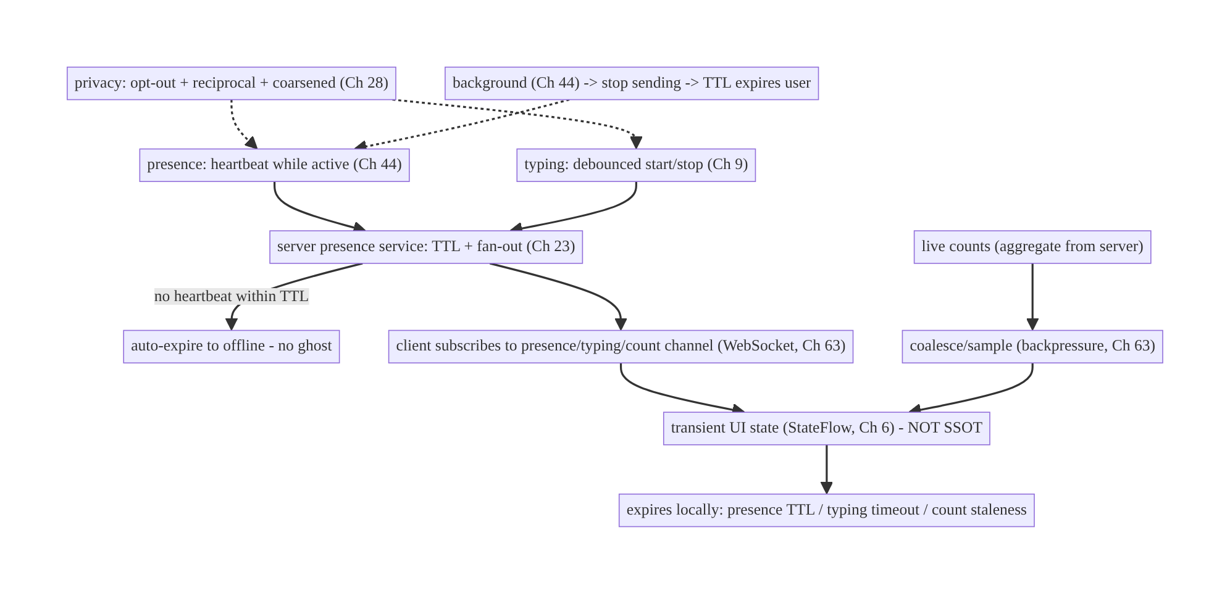
65.4 High-Level Architecture
Components & ownership
- Presence: heartbeat (active) → server TTL → auto-expire; client subscribes.
- Typing: debounced start/stop → server fan-out → receiver auto-clears on timeout.
- Counts: server aggregate → client coalesces/samples.
- All → transient UI state that expires locally; privacy gates send/receive; lifecycle stops sending in background.
Direction: active signals → server (TTL/fan-out) → subscribe → coalesced transient UI state → local expiry; privacy + lifecycle gate it.

65.5 Detailed Component Design
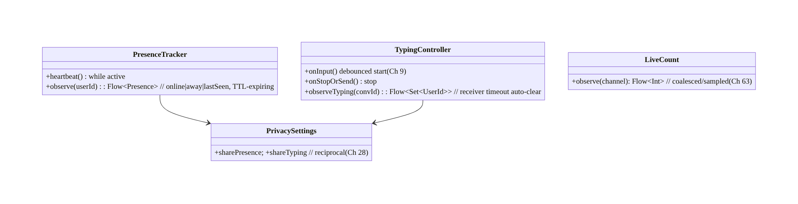
65.5 Detailed Component Design
Component | Responsibility
PresenceTracker | heartbeat (active); observe TTL-expiring presence
TypingController | debounced start/stop; receiver-side timeout auto-clear (Ch 9)
LiveCount | coalesced/sampled aggregate count (Ch 63)
PrivacySettings | opt-out + reciprocal gating (Ch 28)

65.6 End-to-End Data Flow

Typing: debounce + receiver timeout
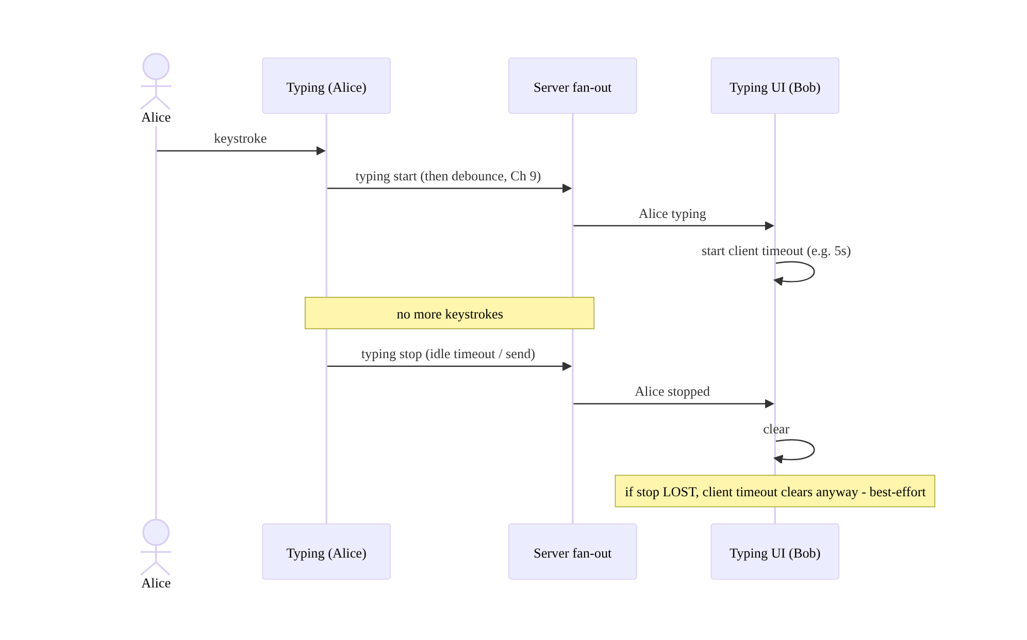
Typing: debounce + receiver timeout

Presence: heartbeat + TTL auto-expire
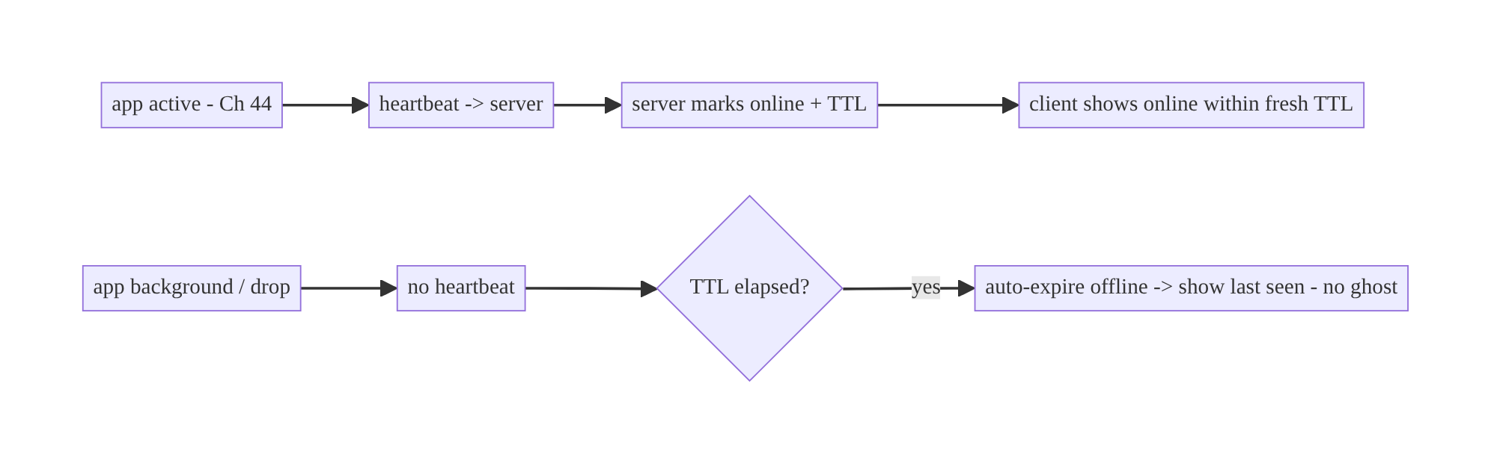
Presence: heartbeat + TTL auto-expire

65.7 Complete Kotlin Implementation
Package: com.streamcart.presence.

65.7.1 Presence: heartbeat (active) + TTL-expiring observation
@Singleton
class PresenceTracker @Inject constructor(
private val transport: RealtimeTransport, // WebSocket (Ch 63)
private val privacy: PrivacySettings, private val scope: CoroutineScope,
) {
private var heartbeatJob: Job? = null
/** Send heartbeats only while active (Ch 44); server TTL auto-expires us when we stop. */
fun startHeartbeat() {
if (!privacy.sharePresence()) return // opt-out (Ch 28)
heartbeatJob = scope.launch {
while (isActive) { transport.send(Presence.Heartbeat); delay(HEARTBEAT_MS) }
}
}
fun stopHeartbeat() { heartbeatJob?.cancel() } // background -> stop -> server TTL expires us
/** Observe another user's presence; render online only within a fresh TTL, else last-seen. */
fun observe(userId: String): Flow<Presence> = transport.presenceUpdates(userId)
.filter { privacy.canSeePresence() } // reciprocal (Ch 28)
.map { update -> if (update.ageMs < TTL_MS) Presence.Online else Presence.LastSeen(update.lastSeenCoarse) }
}

65.7.2 Typing: debounced start/stop (Ch 9)
class TypingController @Inject constructor(
private val transport: RealtimeTransport, private val privacy: PrivacySettings,
) {
private val input = MutableSharedFlow<Unit>(extraBufferCapacity = 64)
fun bind(conversationId: String, scope: CoroutineScope) {
if (!privacy.shareTyping()) return
scope.launch {
input
.onEach { transport.send(Typing.Start(conversationId)) } // start on first input
.debounce(TYPING_DEBOUNCE_MS) // throttle (Ch 9) - don't spam per keystroke
.collect { } // (start already sent; debounce gates frequency)
}
scope.launch {
input.debounce(TYPING_IDLE_MS) // idle -> stop (Ch 9)
.collect { transport.send(Typing.Stop(conversationId)) }
}
}
fun onInput() { input.tryEmit(Unit) }
fun onSendOrClear(conversationId: String) { transport.send(Typing.Stop(conversationId)) } // explicit stop
}

65.7.3 Receiver-side typing with client timeout (auto-clear)
class TypingReceiver @Inject constructor(private val transport: RealtimeTransport) {
/** Clear a user's "typing" if no update within the timeout — even if "stop" was lost. */
fun observeTyping(conversationId: String): Flow<Set<String>> = channelFlow {
val typing = mutableMapOf<String, Job>()
val state = MutableStateFlow<Set<String>>(emptySet())
launch { state.collect { send(it) } }
transport.typingUpdates(conversationId).collect { ev ->
when (ev) {
is Typing.Start -> {
typing[ev.userId]?.cancel()
typing[ev.userId] = launch { // client-side expiry (best-effort)
delay(TYPING_RECEIVER_TIMEOUT_MS); state.update { it - ev.userId } // auto-clear
}
state.update { it + ev.userId }
}
is Typing.Stop -> { typing.remove(ev.userId)?.cancel(); state.update { it - ev.userId } }
}
}
}
}

65.7.4 Live count: coalesce/sample (backpressure, Ch 63)
fun RealtimeTransport.viewerCount(channel: String): Flow<Int> =
countUpdates(channel) // server sends aggregate
.conflate() // keep latest only
.sample(500.milliseconds) // at most ~2 updates/sec (Ch 63 backpressure)
// Transient: on disconnect, show last-known or hide; repopulates on reconnect.

65.7.5 Lifecycle scoping + transient UI state (not SSOT)
// Presence/typing are transient StateFlow (Ch 6), NOT persisted as truth (contrast Ch 64).
@Composable
fun ChatHeader(userId: String, vm: ChatViewModel = hiltViewModel()) {
val presence by vm.presence(userId).collectAsStateWithLifecycle(Presence.Unknown) // expires to LastSeen/Unknown
val typing by vm.typing.collectAsStateWithLifecycle(emptySet()) // auto-clears on timeout
// Start/stop heartbeat with lifecycle (Ch 44): onStart -> startHeartbeat(); onStop -> stopHeartbeat()
Text(when (presence) { Presence.Online -> "Online"; is Presence.LastSeen -> "Last seen ${presence.text}"; else -> "" })
if (typing.isNotEmpty()) Text("typing…")
}

65.7.6 Module structure
:core:presence PresenceTracker, TypingController, TypingReceiver, LiveCount, PrivacySettings
# Transport -> :core:realtime WebSocket (Ch 63). Lifecycle -> Ch 44. Privacy -> Ch 28.
# NOT persisted as SSOT (contrast chat messages, Ch 64).

65.8 Concurrency and Race Conditions
Scenario | Risk | Handling
Presence “online” ghost after drop | stale UI | heartbeat + TTL auto-expire (server + client age check)
Typing “…” never clears | stuck UI | receiver-side timeout auto-clear (best-effort)
Typing-event spam | flood/battery | debounce start + idle-stop (Ch 9)
Count flood | UI jank | conflate + sample (Ch 63)
Lost stop/heartbeat | stale | local expiry handles it (don’t rely on explicit stop)
Sending while backgrounded | battery | stop on background; socket disconnects (Ch 44/63)
Privacy mismatch | leak | reciprocal gate both ways; server-enforced (Ch 28)
- Local expiry is the key safety net: because signals are best-effort, the receiver (not just the sender) enforces expiry — presence ages out via TTL, typing clears on a timer. This means a lost “stop”/heartbeat never leaves a stuck indicator (the classic ghost/stuck-typing bug).
- Debounce prevents spam without losing meaning: a “typing start” + idle “stop” (Ch 9) conveys the state in 2 events instead of one-per-keystroke, saving radio/battery.
- Conflation handles high-churn counts: render the latest sampled value; dropping intermediate counts is correct for an ephemeral signal.

65.9 Failure Scenarios and Recovery
Failure | Detection | Response | Outcome
Stale “online” | user report | heartbeat + TTL (no explicit offline needed) | accurate
Stuck “typing…” | user report | receiver timeout auto-clear | clears
Event spam/battery | metrics | debounce/throttle (Ch 9) | efficient
Count flicker/flood | jank | conflate + sample (Ch 63) | smooth
Signals sent in background | battery | lifecycle-scoped; stop (Ch 44) | battery ok
Presence leaks despite opt-out | privacy audit | reciprocal + server-enforced (Ch 28) | private
Disconnect clears cues | UX | show last-known/last-seen; repopulate on reconnect | graceful
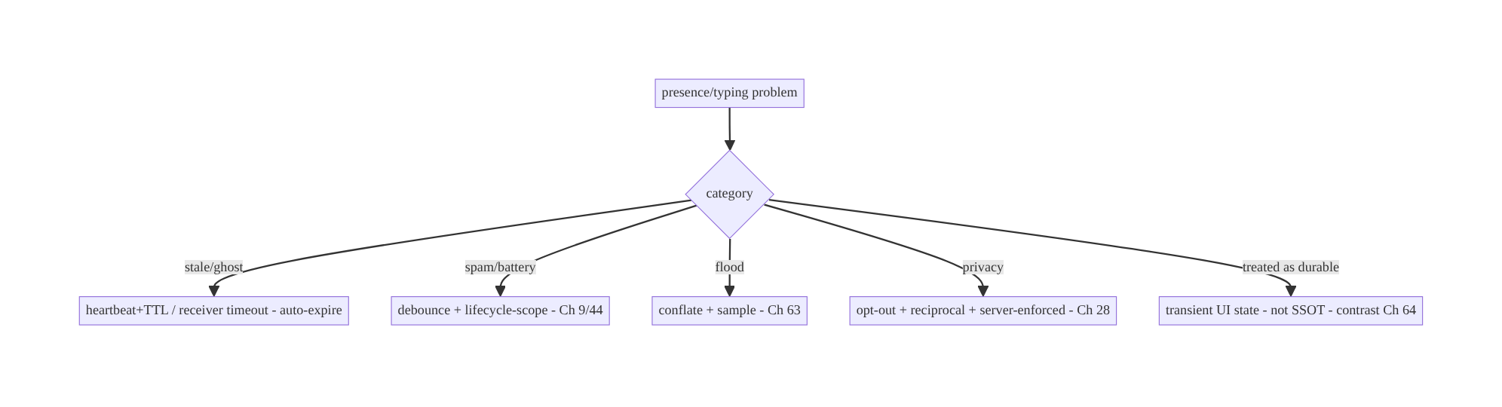
65.9 Failure Scenarios and Recovery
The whole discipline is “ephemeral, auto-expiring, best-effort” — the inverse of chat (Ch 64). No persistence, no delivery guarantees; instead heartbeat+TTL (presence), debounce + receiver-timeout (typing), and conflate+sample (counts), all scoped to the active lifecycle and gated by privacy. Get expiry right and ghosts/stuck-indicators/spam all disappear.

65.10 Scaling the Implementation
- Level 1. Typing: debounced start/stop + receiver timeout; presence: online/offline via WebSocket liveness.
- Level 2. Presence heartbeat + TTL + coarsened last-seen; live counts coalesced (Ch 63); lifecycle scoping (Ch 44).
- Level 3 — production. Privacy (opt-out + reciprocal, Ch 28); transient UI state with local expiry; presence channels (authorized subscribe, Ch 63/23).
- Level 4 — large. Server-side presence fan-out/pub-sub at scale; group presence (member lists); aggregate counts; per-feature coalescing policies.
- Level 5 — enterprise. Presence-service SLOs, privacy governance (regulatory), cross-platform consistency, presence analytics (engagement), abuse protection.
Avoid overengineering: typing (debounce + timeout) and presence (heartbeat + TTL) are small; don’t persist them or build delivery guarantees. Reuse the same transient/expiry pattern for all live cues.

65.11 Alternative Approaches and Trade-offs
Dimension | Option A | Option B | When
Model | Ephemeral transient (expire locally) | durable SSOT like messages (Ch 64) | Ephemeral always (presence/typing/counts)
Presence | Heartbeat + TTL (auto-expire) | explicit online/offline events | Heartbeat+TTL (offline event often lost)
Typing | Debounce start/stop + receiver timeout | per-keystroke stream | Debounce+timeout (spam/battery)
Counts | Coalesce + sample (Ch 63) | render every tick | Coalesce (UI/battery)
Expiry | Receiver-side timeout | trust explicit stop | Receiver timeout (best-effort; stop can be lost)
Sending | Active lifecycle only | always | Active-only (battery, Ch 44)
Privacy | Opt-out + reciprocal (Ch 28) | always share | Opt-out+reciprocal (trust)
Ephemeral vs durable modeling: the biggest mistake is treating presence/typing like messages (Ch 64) — persisting them, guaranteeing delivery, showing last value. They’re ephemeral: meaningful only now, cheap to lose, must auto-expire. Modeling them as transient UI state with local expiry (not SSOT, no outbox/idempotency-for-truth) is simpler, cheaper, and correct; durable modeling causes ghosts, spam, and wasted storage.
Heartbeat+TTL vs explicit online/offline events: sending an explicit “I’m offline” when the app closes is unreliable — the app may be killed, the network dropped, before it can send. Heartbeat + server TTL needs no reliable offline event: absence of heartbeats expires the user. Always use heartbeat+TTL for presence; never depend on a graceful offline signal.
Receiver-side timeout vs trusting “stop”: if a “typing stop” (or a user drop) is lost, trusting the explicit stop leaves a stuck “typing…”. A receiver-side timeout that clears after N seconds of silence guarantees the indicator clears regardless — the standard best-effort pattern for all ephemeral cues.

65.12 Security & Privacy Considerations
- Presence/typing/read receipts reveal behavior (Ch 28): when you’re online, when you read/typed. Make them opt-out and respect the setting; server-enforce it (a client can’t be trusted to hide another user’s view).
- Reciprocity: a common, user-trusted rule — if you hide your presence/receipts, you don’t see others’ (symmetry). Implement both directions.
- Coarsen last-seen (Ch 28): show “today”/“this week” rather than an exact timestamp to reduce behavioral tracking; let users hide it entirely.
- Authorized channels (Ch 63/23): subscribing to a presence/typing channel for a conversation/stream must be server-authorized (membership, Ch 64/23) — you can’t watch arbitrary users’ presence.
- Per-account isolation (Ch 42): presence/typing scoped to the active account; stop on switch/logout.
- No presence/behavior data in logs (Ch 28); aggregate counts only.
- Client vs backend: the server enforces privacy settings, authorizes channels, does fan-out, and computes aggregate presence/counts; the client gates send/display by settings and renders transient, expiring state — it never computes or exposes others’ presence against their settings.

65.13 Performance and Resource Optimization
- Lifecycle scoping (Ch 44) — send presence/typing only while active; stop on background (the top battery lever; the socket disconnects anyway, Ch 63).
- Debounce/throttle typing (Ch 9) — 2 events, not one-per-keystroke.
- Heartbeat interval tuned — frequent enough for accurate presence, infrequent enough to save radio (align with socket keep-alive, Ch 63).
- Coalesce/sample counts (Ch 63) — render latest; drop intermediate ticks.
- No persistence — transient in-memory state; no DB writes for high-churn signals.
- Batch presence for lists — one subscription per conversation list, aggregate render.
- Profiling: presence/typing event rate, battery/radio from signals, count update frequency, ghost/stuck-indicator incidents (→ 0), subscription count.

65.14 Testing Strategy
Expiry/debounce logic is very testable with virtual time; transport faked.
class TypingReceiverTest {
@Test fun `clears typing after timeout even if stop is lost`() = runTest {
val flow = receiver.observeTyping("c1")
transport.emit(Typing.Start("alice"))
advanceTimeBy(TYPING_RECEIVER_TIMEOUT_MS + 1) // no stop sent
assertEquals(emptySet<String>(), flow.first { it.isEmpty() }) // auto-cleared (best-effort)
}
@Test fun `debounces typing to start + idle-stop, not per keystroke`() = runTest {
repeat(10) { controller.onInput(); advanceTimeBy(100) } // rapid typing
assertEquals(1, transport.sent.count { it is Typing.Start }) // one start (Ch 9)
advanceTimeBy(TYPING_IDLE_MS); assertTrue(transport.sent.any { it is Typing.Stop }) // idle stop
}
}
class PresenceTest {
@Test fun `shows last-seen when heartbeat older than TTL`() = runTest {
val p = tracker.observe("bob").first() // update age > TTL
assertTrue(p is Presence.LastSeen) // no ghost
}
@Test fun `respects presence opt-out and reciprocity`() { /* sharePresence=false -> no heartbeat, canSee=false */ }
}
class LiveCountTest { @Test fun `samples rapid counts`() = runTest { /* 100 ticks -> few emissions */ } }
What to test: typing debounce (start + idle-stop, Ch 9) + receiver timeout auto-clear (lost-stop case); presence TTL → last-seen (no ghost); privacy opt-out + reciprocity; count conflate/sample; lifecycle stop on background (no sends). Use runTest virtual time; fake transport.

65.15 Production Observability
- Metrics: presence/typing event rate (and battery/radio attributed); ghost- presence + stuck-typing incidents (→ 0); count update frequency; privacy opt-out rate; subscription count; background-send incidents (should be 0, Ch 44).
- Logs: presence{event, expired} / typing{event, source} — no per-user behavior/ PII (Ch 28); aggregates only.
- Debugging: stale “online” → TTL/heartbeat (server or client age check); stuck “typing” → receiver timeout missing; spam/battery → no debounce / not lifecycle-scoped; count jank → no coalescing; privacy leak → reciprocity/server enforcement (Ch 28).
- Alerting: signal-event-rate spike (spam regression); battery attributed to presence; any privacy-setting bypass.
- Dashboards: signal rate + battery; ghost/stuck incident trend.

65.16 System Design Interview Preparation
≥25 questions.
Fundamentals
- Presence/typing/counts vs messages (Ch 64)? Ephemeral/best-effort vs durable.
- Persist them? No — transient UI state that expires.
- Why best-effort? Only meaningful now; loss is fine (next update corrects).
- Transport? WebSocket (Ch 63).
- Biggest mistake? Treating them as durable (ghosts/spam).
Presence
- Model? Heartbeat + TTL (auto-expire).
- Why not explicit offline event? Often lost (app killed/network drop).
- Show online when? Within a fresh TTL; else last-seen.
- Last-seen privacy? Coarsen (today/this week); hideable (Ch 28).
Typing
- Model? Debounced start + idle/explicit stop + receiver timeout.
- Why debounce? Per-keystroke floods the socket (Ch 9).
- Why receiver timeout? Stop event / sender can be lost → clear anyway.
- When stop? Send, clear field, idle timeout.
Counts
- High-churn counts? Coalesce + sample (Ch 63).
- Who computes them? Server aggregate; client smooths.
Lifecycle/efficiency
- When to send? Active only; stop on background (Ch 44).
- Main battery lever? Lifecycle scoping + debounce.
- Heartbeat interval? Tuned vs accuracy/battery.
Privacy
- Why privacy-sensitive? Reveals behavior.
- Opt-out? Yes, both ways; server-enforced (Ch 28).
- Reciprocity? Hide yours → don’t see others’.
- Channel authz? Server-authorized subscription (Ch 23).
Testing/Production
- Test expiry? Virtual time: lost-stop clears; TTL → last-seen.
- Ghost “online”? TTL/heartbeat bug.
- Stuck “typing”? Missing receiver timeout.
- Spam/battery? No debounce / not lifecycle-scoped.

Design-change challenges
- “Online” lingers after users leave. Heartbeat + TTL auto-expire.
- “Typing…” gets stuck. Receiver-side timeout auto-clear.
- Typing floods the socket. Debounce start + idle-stop (Ch 9).
- Viewer count flickers. Conflate + sample (Ch 63).
- Let users hide online status. Opt-out + reciprocal, server-enforced (Ch 28).

Mock walkthrough (abridged)
Clarify (presence/typing/counts, scale, privacy?) → ephemeral/best-effort (not SSOT, contrast Ch 64) → presence heartbeat+TTL → typing debounce start/stop + receiver timeout (Ch 9) → counts coalesce/sample (Ch 63) → transient UI state with local expiry → lifecycle scoping (Ch 44) → privacy opt-out+reciprocal (Ch 28) → server fan-out → observability (event rate, ghosts).

65.17 Practical Exercises
- Beginner. Add a typing indicator: debounced start, idle/explicit stop, and a receiver-side timeout that clears even if “stop” is lost. Eval: no spam; never stuck.
- Intermediate. Implement presence via heartbeat + TTL showing online within a fresh TTL, else coarsened last-seen. Eval: no ghost; privacy-coarsened.
- Advanced. Add a coalesced/sampled live viewer count and scope all signals to the active lifecycle (stop on background). Eval: smooth count; no background sends.
- Production debugging. Fix a stuck “typing…” (no receiver timeout) and a stale “online” (no TTL). Eval: both auto-expire.
- System design challenge. Add opt-out + reciprocal privacy (server-enforced) for presence/typing. Eval: hidden both ways; can’t see others’ when hidden.
(Solutions withheld unless requested.)

65.18 Chapter Summary & Reference Sheet
Key decisions: treat presence, typing, and live counts as ephemeral, best-effort real-time signals over the WebSocket (Ch 63) — the opposite discipline from durable messaging (Ch 64): no persistence, no outbox, no idempotency-for-truth, no catch-up, just transient UI state that auto-expires. Do presence with **heartbeat
- server TTL** so a user auto-expires to offline (no stale “online” ghosts — never depend on an explicit offline event); do typing with a debounced start + idle/ explicit stop (Ch 9) plus a receiver-side timeout that clears the indicator even when the “stop” is lost; do live counts with coalescing/sampling (Ch 63 backpressure, rendering the server’s aggregate). Scope sending to the active lifecycle and stop on background (Ch 44) as the main battery lever; render transient state with local expiry (presence→last-seen, typing→cleared, count→last-known); and gate everything on privacy — opt-out, reciprocal (hide yours → don’t see others’), coarsened last-seen, server-enforced (Ch 28) — with the server doing fan-out and the client subscribing to authorized channels (Ch 23).
Concepts: ephemeral vs durable (contrast Ch 64), heartbeat + TTL presence, debounced typing + receiver timeout, coalesced counts, transient UI state with local expiry, lifecycle scoping, privacy (opt-out/reciprocal/coarsened), server fan-out.
Common mistakes: modeling presence/typing as durable (ghosts, spam, wasted storage); relying on explicit offline/stop events (lost → stuck); per-keystroke typing (flood); rendering every count tick (jank); sending while backgrounded (battery); no local expiry (stuck indicators); ignoring privacy/reciprocity; computing global presence client-side.
Checklist:
- ☐ ephemeral/transient (not SSOT)
- ☐ presence: heartbeat + TTL auto-expire
- ☐ typing: debounce start/stop (Ch 9) + receiver timeout auto-clear
- ☐ counts: conflate + sample (Ch 63)
- ☐ local expiry (presence/typing/count)
- ☐ lifecycle-scoped send; stop on background (Ch 44)
- ☐ privacy opt-out + reciprocal + coarsened + server-enforced (Ch 28)
- ☐ authorized channels (Ch 23)
- ☐ per-account (Ch 42)
- ☐ no persistence/PII logging
- ☐ event-rate + ghost/stuck telemetry.
Key APIs: WebSocket transport (Ch 63), Flow.debounce/sample/conflate (Ch 9/63), MutableStateFlow/channelFlow (transient state, Ch 6), coroutine timeouts (delay/ cancel for receiver expiry), ProcessLifecycleOwner/lifecycle (Ch 44), privacy settings (Ch 28), collectAsStateWithLifecycle.
References:
- Flow operators (debounce/sample/conflate): https://kotlinlang.org/api/kotlinx.coroutines/kotlinx-coroutines-core/kotlinx.coroutines.flow/
- (composes) Ch 63 WebSocket, Ch 64 Chat, Ch 9 Debounce, Ch 44 Lifecycle, Ch 28 Privacy, Ch 6 UI State

Chapter 66 — Server-Sent Events & Long Polling
Part VIII — Real-Time & Connectivity · Complexity: Standard (≥25 interview questions)
Prerequisites: Ch 63 (WebSocket), Ch 1 (networking/OkHttp), Ch 2 (retries/backoff), Ch 49 (FCM), Ch 3 (SSOT), Ch 44 (lifecycle). Pairs with Ch 64 (chat), Ch 32 (sync), Ch 68 (network state).
Reference surface in StreamCart: the one-way, server→client real-time cases — an order-status feed, a live scoreboard/price ticker, notifications stream — where a full WebSocket (Ch 63) is more than needed, and where SSE or long polling are the simpler, HTTP-native fit.

66.1 Problem Definition and Real-World Context
Not every real-time feature needs the full bidirectional WebSocket (Ch 63). Many are one-way: the server pushes updates, the client only listens (order status, live scores, a price ticker, a notifications feed). For these, two HTTP-native mechanisms are often simpler and more robust than a WebSocket: Server-Sent Events (SSE) — a long-lived HTTP response streaming text/event-stream events, with built-in auto-reconnect and event ids — and long polling — the client makes a request the server holds open until there’s data (or a timeout), then immediately re-requests. Picking the wrong transport (WebSocket where SSE suffices, or naive short polling where nothing scales) costs complexity, battery, or server load.
Concretely, teams hit:
- Over-using WebSocket. A WebSocket is bidirectional, stateful, and needs its own heartbeat/reconnect/backpressure machinery (Ch 63). For server→client-only feeds, SSE gives you streaming + auto-reconnect + resume (Last-Event-ID) over plain HTTP with far less code.
- Naive short polling. Polling every few seconds is laggy, wasteful, and scales terribly. Long polling (hold the request open) gives near-real-time with simple infra; short polling is a fallback only for infrequent, non-urgent data.
- Reconnection & resume. A dropped stream must reconnect (backoff, Ch 2) and resume from the last event so nothing is missed. SSE standardizes this (id: + Last-Event- ID header); long polling uses a cursor; both must reconcile via the SSOT/REST (Ch 3/32).
- Lifecycle & background (Ch 44/47). Like WebSocket, these are foreground transports — hold them only while active; FCM (Ch 49) handles background.
- Choosing among WS / SSE / long poll / FCM. The decision depends on directionality, frequency, infra, and app state — getting it right is the core skill.
The architecture: for one-way server→client streams, prefer SSE (streaming HTTP + built-in reconnect + Last-Event-ID resume) and use long polling when SSE isn’t available or events are infrequent; manage them like any real-time transport — reconnect with backoff (Ch 2), resume from the last event id/cursor (Ch 32), feed a Flow that updates the SSOT idempotently (Ch 3/15), scope to the active lifecycle and hand off to FCM (Ch 49) in the background (Ch 44); and choose WS vs SSE vs long poll vs FCM by directionality/frequency/app-state. This chapter is about the simpler one-way real-time transports and when to use each.

Three practical use cases
- Order-status feed (StreamCart). SSE stream of order updates while the order screen is open — auto-reconnects, resumes via Last-Event-ID, updates the SSOT; FCM when backgrounded (Ch 49).
- Live scoreboard / price ticker. SSE one-way stream of frequent updates, coalesced for the UI (Ch 63 backpressure) — simpler than a WebSocket for a read-only ticker.
- Long-poll fallback. Where SSE/WebSocket are blocked (restrictive proxy) or events are rare, long polling with a cursor delivers near-real-time with basic HTTP infra.

Why this is architectural
Transport choice (WS vs SSE vs long poll vs FCM) is a cross-cutting real-time decision spanning directionality, frequency, infra, battery, and app state (Ch 63/49/44). SSE and long polling are the simpler one-way options; knowing when each beats a WebSocket — and reusing the same reconnect/resume/SSOT discipline (Ch 2/32/3) — is essential real-time design.

66.2 Requirements Engineering

Functional requirements
ID | Requirement
F1 | Receive one-way server→client updates in near real time (SSE or long polling).
F2 | Reconnect with backoff; resume from last event id / cursor (no missed events) (Ch 2/32).
F3 | Feed updates into the SSOT idempotently; reconcile via REST (Ch 3/15/32).
F4 | Scope to active lifecycle; hand off to FCM in background (Ch 44/49).
F5 | Choose the right transport (WS / SSE / long poll / FCM) per need.
F6 | Authenticated + secure stream (Ch 19/23); untrusted events.

Non-functional requirements
Attribute | Policy
Simplicity | SSE/long-poll over HTTP; less machinery than WebSocket for one-way.
Reliability | Reconnect + resume; missed events self-heal via SSOT/REST.
Battery | Foreground only; FCM for background (Ch 47/49).
Latency | Near-real-time (SSE streaming / long-poll hold).
Robustness | Works through proxies better than WS in some networks.

Scope
- In scope: SSE (text/event-stream, event ids, Last-Event-ID resume, auto- reconnect), long polling (hold-open request + cursor + immediate re-request), short polling (fallback), reconnect/backoff (Ch 2), resume/cursor (Ch 32), events→idempotent SSOT (Ch 3/15), lifecycle scoping + FCM handoff (Ch 44/49), transport selection (WS/SSE/ long poll/FCM), auth/security (Ch 19/23).
- Out of scope: WebSocket internals (Ch 63), FCM internals (Ch 49), sync algorithm (Ch 32), backoff theory (Ch 2), networking stack (Ch 1), chat (Ch 64).

Assumptions & constraints
- OkHttp (Ch 1) for SSE (streaming response / okhttp-sse) and long polling; Kotlin coroutines/Flow; Room SSOT (Ch 3); FCM (Ch 49). minSdk 24. These are foreground, one-way transports; delivery is best-effort (reconcile via SSOT/REST); events are untrusted.

66.3 System Design Fundamentals
- Server-Sent Events (SSE). A single long-lived HTTP GET whose response is Content-Type: text/event-stream; the server streams events (data: lines, optional event: type and id:) and keeps the connection open. Key built-ins:
  - One-way (server→client only) — simpler than WebSocket’s full duplex.
  - Auto-reconnect: the SSE client reconnects automatically on drop (with a server- suggestable retry: interval).
  - Resume via Last-Event-ID: the client remembers the last event id: and sends it as the Last-Event-ID header on reconnect; the server replays from there — missed events self-heal (standardized catch-up, Ch 32).
  - HTTP-native: works over normal HTTP/1.1 and HTTP/2, through most proxies/CDNs, with existing auth (Ch 19) — often more robust than WebSocket in restrictive networks.
- Long polling. The client sends a request; the server holds it open until there’s data (or a timeout), then responds; the client immediately re-requests (with an updated cursor). Near-real-time with basic HTTP infra (no streaming/WebSocket support needed). Costs: a request per event batch, careful timeout/cursor handling. Short polling (fixed interval, respond immediately even if empty) is the laggy, wasteful fallback — only for infrequent, non-urgent data.
- The decision matrix (the core skill):
Need | Transport
Bidirectional, low-latency, foreground (chat, auctions) | WebSocket (Ch 63)
One-way server→client stream, foreground (status, ticker, feed) | SSE
One-way, SSE/WS unavailable or events rare, basic infra | Long polling
Infrequent, non-urgent | Short polling (simplest)
Background/killed wake-ups | FCM (Ch 49)
- Default to SSE for one-way; WebSocket only when you need to send too; FCM for background.
- Same real-time discipline as WebSocket (Ch 63). SSE/long-poll are managed like any real-time transport:
  - Reconnect with backoff + jitter (Ch 2) — SSE does basic reconnect; add jittered backoff for storms.
  - Resume — SSE via Last-Event-ID; long poll via a cursor in each request.
  - Events → Flow → idempotent SSOT (Ch 3/15) — dedup by event id, order by sequence; the UI observes the SSOT (UDF, Ch 6).
  - SSOT/REST is truth (Ch 32) — the stream is a fast path; missed events are caught up via resume or a REST delta, so drops self-heal.
- Lifecycle & background (Ch 44/47/49). SSE/long-poll are foreground transports (a held-open HTTP connection drains battery and is killed by Doze, Ch 47). Connect on foreground, disconnect on background (Ch 44); hand off to FCM (Ch 49) for background events; reconnect + catch up on return.
- Backpressure for high-rate SSE (Ch 63): coalesce/sample frequent events (ticker, scoreboard) so the UI isn’t flooded.
- Auth & security (Ch 19/23). SSE is a normal authed HTTPS GET (bearer, cookies) over TLS + pinning (Ch 23) — reuses the REST auth stack (an advantage over WebSocket’s custom handshake). Long polling likewise. Treat every event as untrusted (validate/ allowlist, Ch 23/52); the server authorizes which stream you may subscribe to.
Core insight: for one-way server→client real-time, prefer SSE — a long-lived HTTP text/event-stream with built-in auto-reconnect and Last-Event-ID resume that reuses the REST auth stack and traverses proxies well — and use long polling (hold-open request + cursor) when SSE/WebSocket are unavailable or events are rare (short polling only for infrequent data); manage them with the same discipline as WebSocket (jittered-backoff reconnect, resume via event-id/cursor, events→idempotent SSOT with SSOT/REST as truth so drops self-heal, Ch 2/32/3/15), scope them to the foreground lifecycle and hand off to FCM in the background (Ch 44/49); and choose WS vs SSE vs long-poll vs FCM by directionality, frequency, infra, and app state — reserving WebSocket for when the client must also send.

66.4 High-Level Architecture
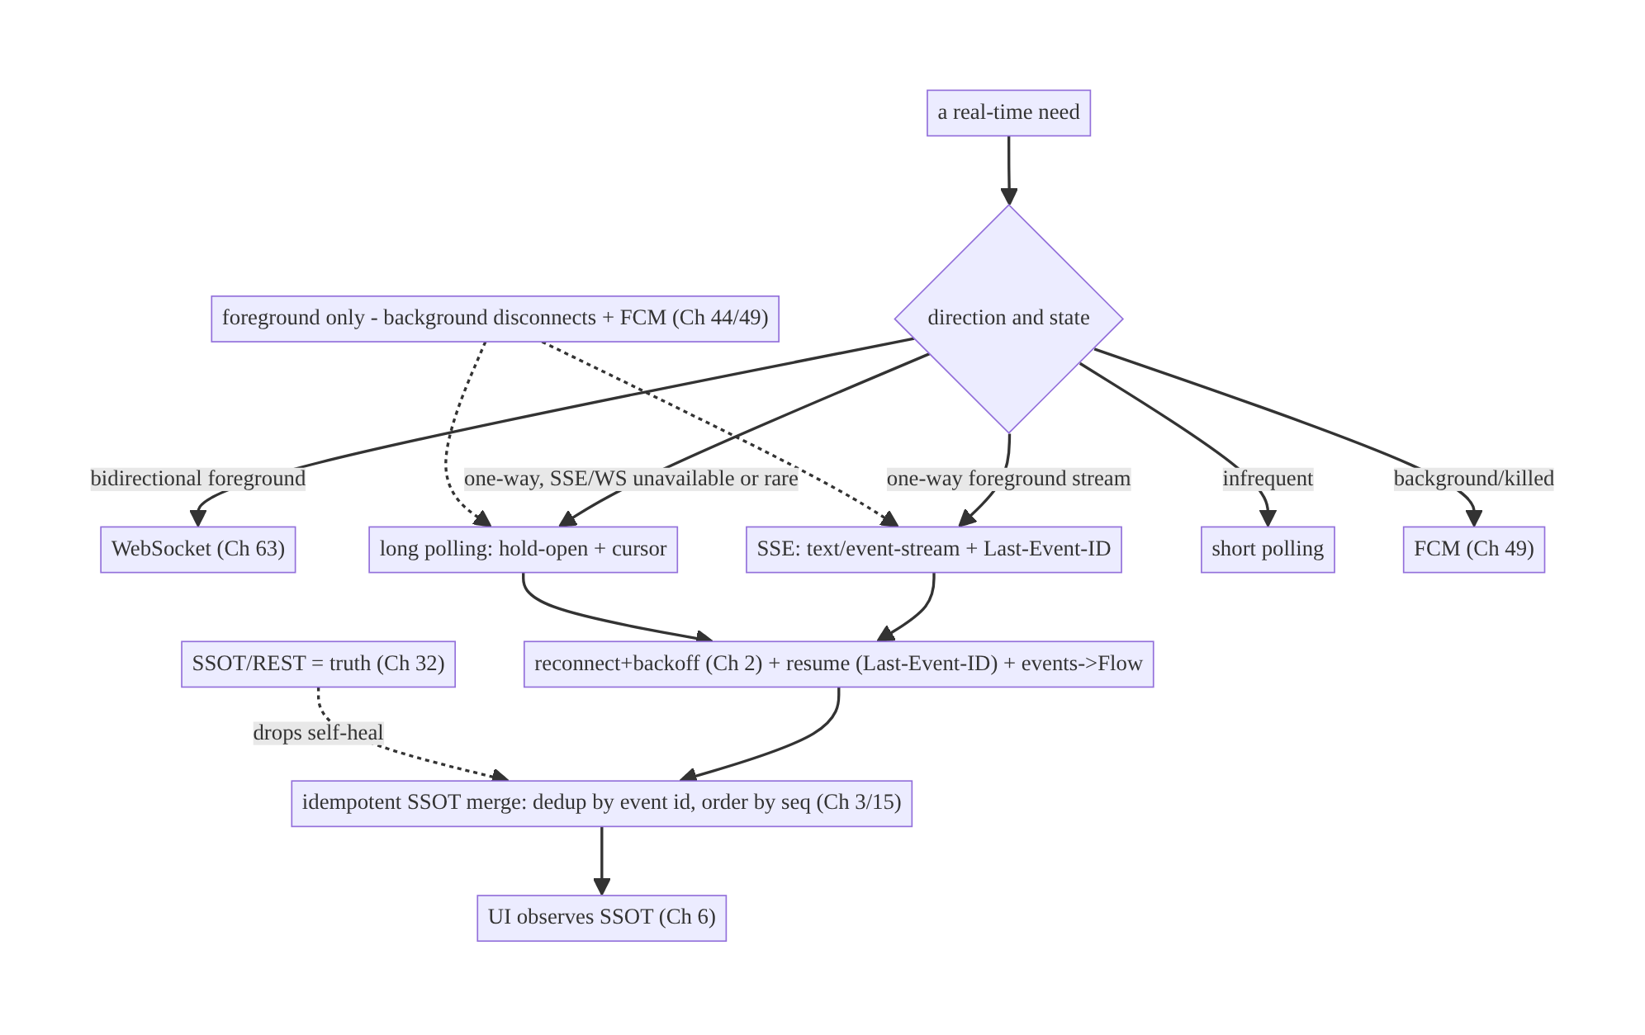
66.4 High-Level Architecture
Components & ownership
- Transport selector picks WS/SSE/long-poll/short-poll/FCM by direction/frequency/ state.
- SSE / long-poll stream events, reconnect with backoff, resume via Last-Event-ID/ cursor.
- Events → idempotent SSOT merge (dedup/order); the UI observes the SSOT.
- SSOT/REST is truth; FCM handles background; lifecycle scopes it.
Direction: need → transport choice → managed stream (reconnect/resume) → idempotent SSOT → UI; foreground-scoped with FCM background.

66.5 Detailed Component Design
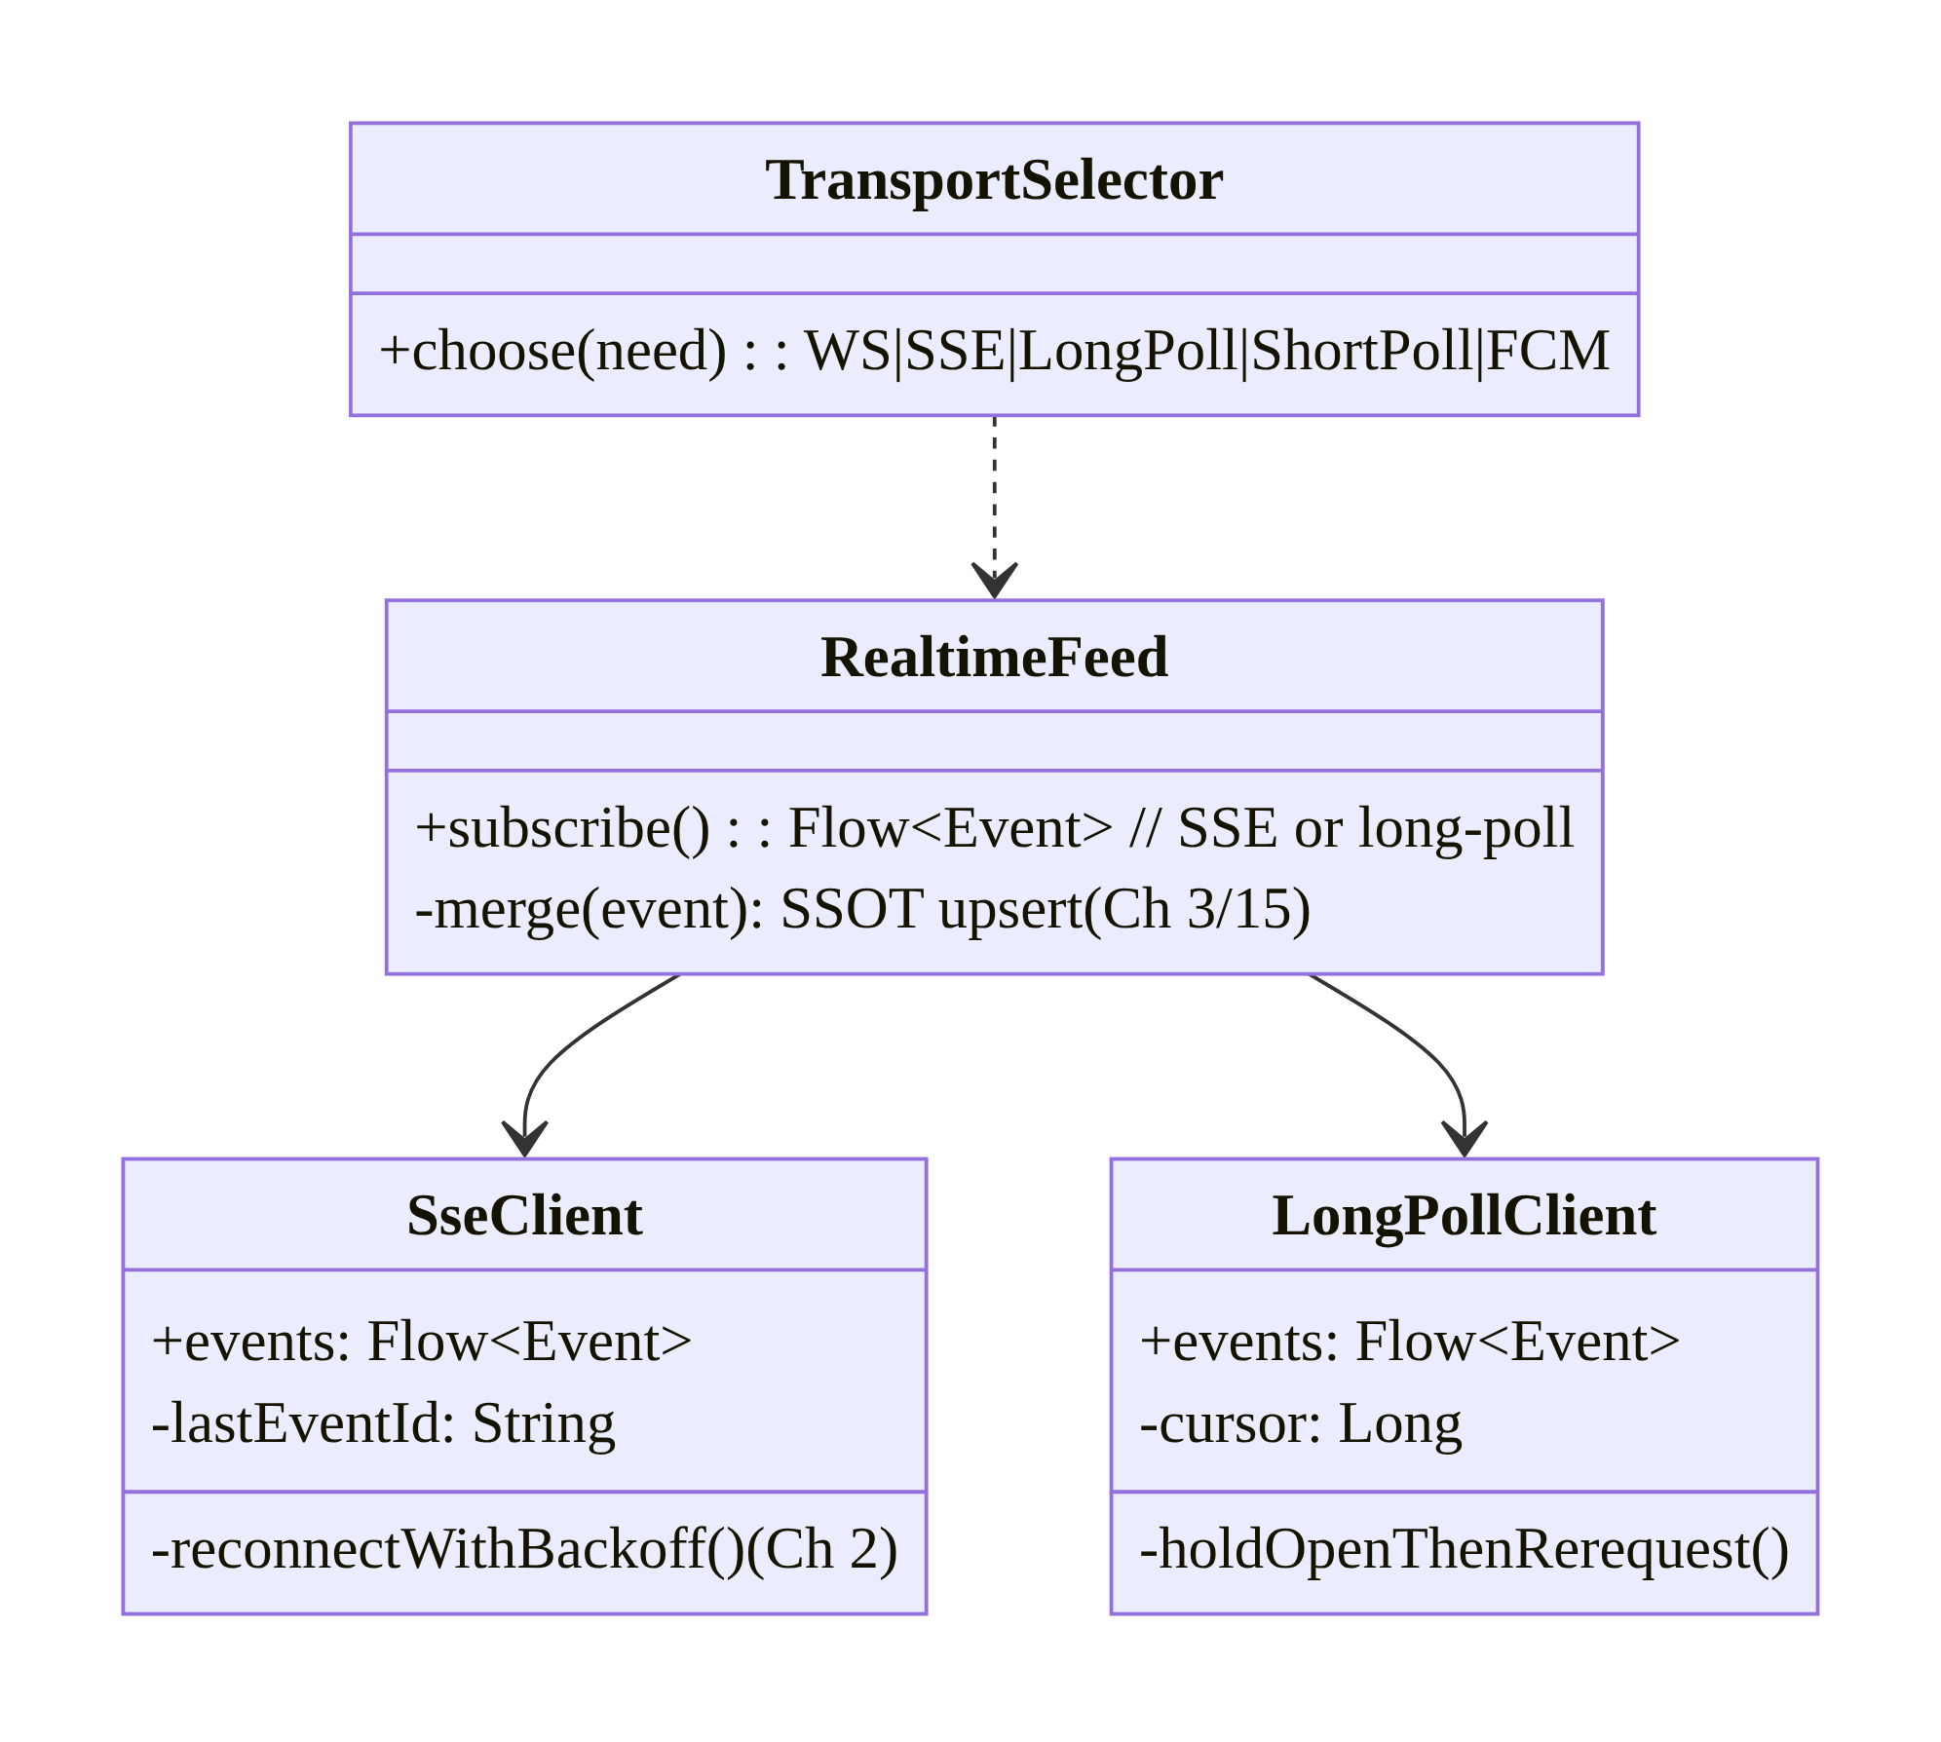
66.5 Detailed Component Design
Component | Responsibility
SseClient | stream text/event-stream; Last-Event-ID resume; backoff reconnect
LongPollClient | hold-open request + cursor + immediate re-request
RealtimeFeed | expose events as Flow → idempotent SSOT merge (Ch 3/15)
TransportSelector | choose WS/SSE/long-poll/short-poll/FCM (decision matrix)

66.6 End-to-End Data Flow

SSE: stream + resume
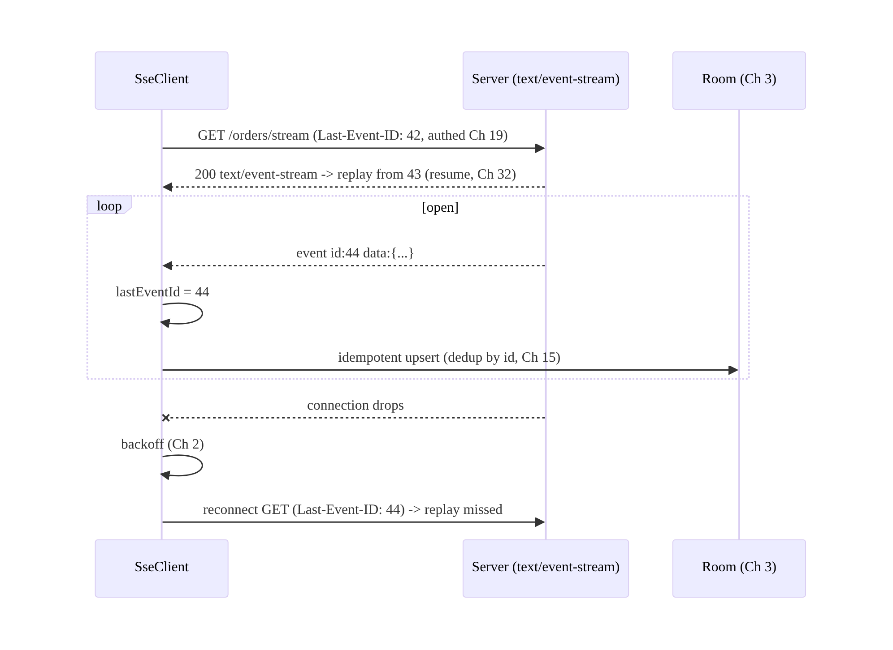
SSE: stream + resume

Long polling
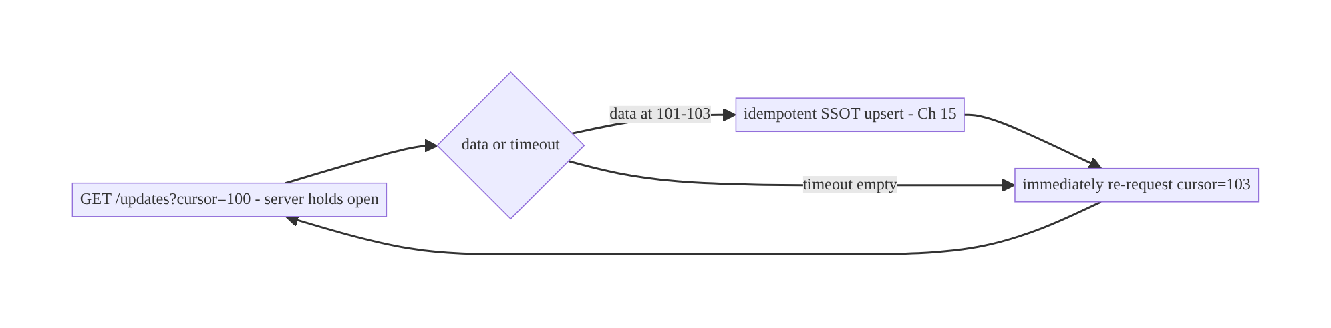
Long polling

66.7 Complete Kotlin Implementation
Package: com.streamcart.feed.

66.7.1 SSE client (OkHttp), resume via Last-Event-ID + backoff
@Singleton
class SseClient @Inject constructor(
private val okHttp: OkHttpClient, // TLS + pinning + auth (Ch 1/19/23)
private val cursorStore: LastEventIdStore, // persist last id (Ch 3/32)
) {
fun stream(url: String): Flow<SseEvent> = callbackFlow {
var attempt = 0
fun connect() {
val req = Request.Builder().url(url)
.header("Accept", "text/event-stream")
.apply { cursorStore.last()?.let { header("Last-Event-ID", it) } } // resume (Ch 32)
.build()
val es = EventSources.createFactory(okHttp).newEventSource(req, object : EventSourceListener() {
override fun onOpen(es: EventSource, r: Response) { attempt = 0 }
override fun onEvent(es: EventSource, id: String?, type: String?, data: String) {
id?.let { cursorStore.save(it) } // remember last id
trySend(SseEvent(id, type, data))
}
override fun onFailure(es: EventSource, t: Throwable?, r: Response?) {
// jittered backoff reconnect (Ch 2) -> resume from Last-Event-ID
launch { delay(backoff(attempt++)); connect() }
}
})
awaitClose { es.cancel() }
}
connect()
}
private fun backoff(a: Int) = minOf(30_000L, 500L * (1L shl a.coerceAtMost(6))) + Random.nextLong(500) // (Ch 2)
}

66.7.2 Long-poll client (hold-open + cursor + re-request)
@Singleton
class LongPollClient @Inject constructor(private val api: FeedApi, private val cursorStore: CursorStore) {
fun stream(channel: String): Flow<Event> = flow {
while (currentCoroutineContext().isActive) {
val resp = runCatching { api.longPoll(channel, cursor = cursorStore.get(channel), timeoutSec = 30) } // server holds open
.getOrElse { delay(backoff()); continue } // error -> backoff (Ch 2), retry
resp.events.forEach { emit(it); cursorStore.set(channel, it.seq) } // advance cursor
// loop immediately re-requests with the new cursor (near-real-time)
}
}.flowOn(Dispatchers.IO)
}

66.7.3 Feed: events → idempotent SSOT merge (Ch 3/15); REST reconciles
@Singleton
class OrderFeed @Inject constructor(
private val sse: SseClient, private val dao: OrderDao, // SSOT (Ch 3)
private val api: OrderApi, private val scope: CoroutineScope,
) {
fun start() = scope.launch {
sse.stream("https://api.streamcart.com/orders/stream").collect { ev ->
val update = parseOrder(ev.data) ?: return@collect // untrusted (Ch 23)
dao.upsertIfNewer(update) // idempotent: dedup by id/seq (Ch 15)
}
}
/** On (re)connect/open: REST catch-up = truth (Ch 32) — drops self-heal. */
suspend fun catchUp() = dao.upsertAll(api.ordersSince(dao.maxSeq()))
}
// UI observes dao.observeOrders() (Ch 6). SSE is a fast path; SSOT/REST is truth.

66.7.4 Transport selection (the decision)
object TransportSelector {
fun choose(need: RealtimeNeed): Transport = when {
need.bidirectional && need.foreground -> Transport.WebSocket // must send too (Ch 63)
need.oneWay && need.foreground && need.sseSupported -> Transport.Sse // DEFAULT one-way
need.oneWay && need.foreground -> Transport.LongPoll // SSE/WS unavailable
need.infrequent -> Transport.ShortPoll
need.background -> Transport.Fcm // Ch 49
else -> Transport.Sse
}
}

66.7.5 Lifecycle scoping + FCM handoff (Ch 44/49)
// Foreground-only (held-open HTTP drains battery + Doze-killed, Ch 47). FCM for background (Ch 49).
class FeedLifecycleBinder @Inject constructor(private val feed: OrderFeed) : DefaultLifecycleObserver {
private var job: Job? = null
override fun onStart(owner: LifecycleOwner) { job = feed.start() } // connect SSE
override fun onStop(owner: LifecycleOwner) { job?.cancel() } // disconnect -> FCM handles bg
}

66.7.6 Module structure
:core:feed SseClient, LongPollClient, OrderFeed, TransportSelector, cursor/LastEventId stores
# OkHttp/SSE -> Ch 1; backoff -> Ch 2; SSOT -> Ch 3; catch-up -> Ch 32; FCM -> Ch 49; lifecycle -> Ch 44.

66.8 Concurrency and Race Conditions
Scenario | Risk | Handling
Reconnect loses events | gaps | Last-Event-ID/cursor resume (Ch 32)
Duplicate on resume replay | dup state | idempotent SSOT upsert (dedup by id, Ch 15)
Reconnect storm | server load | jittered backoff (Ch 2)
Long-poll overlapping requests | double work | single in-flight per channel; advance cursor
High-rate SSE floods UI | jank | coalesce/sample (Ch 63)
Held connection in background | battery/Doze | foreground-only; disconnect (Ch 44/47)
Stale cursor after reinstall | re-replay | server tolerates; idempotent merge dedups
- Resume + idempotency mirror WebSocket (Ch 63): SSE’s Last-Event-ID (or the long-poll cursor) replays missed events on reconnect, and the idempotent SSOT merge (dedup by id, Ch 15) makes the inevitable replayed duplicates harmless — so drops self-heal without corruption.
- Single in-flight long-poll per channel: the loop must not launch overlapping requests; one request at a time, advancing the cursor from each response.
- Jittered backoff prevents reconnect storms just as for WebSocket (Ch 2/63).

66.9 Failure Scenarios and Recovery
Failure | Detection | Response | Outcome
Stream drops | onFailure | backoff reconnect + resume (Ch 2/32) | heals
Missed events | gap in id/seq | Last-Event-ID/cursor replay + REST catch-up | self-heals
Duplicates on replay | repeated id | idempotent SSOT (Ch 15) | single
WebSocket blocked by proxy | connect fail | SSE/long-poll (HTTP-native) fallback | works
High-rate flood | jank | coalesce/sample (Ch 63) | smooth
Battery drain | held connection bg | foreground-only + FCM (Ch 44/49) | battery ok
Short-poll too laggy | user report | switch to SSE/long-poll | near-real-time
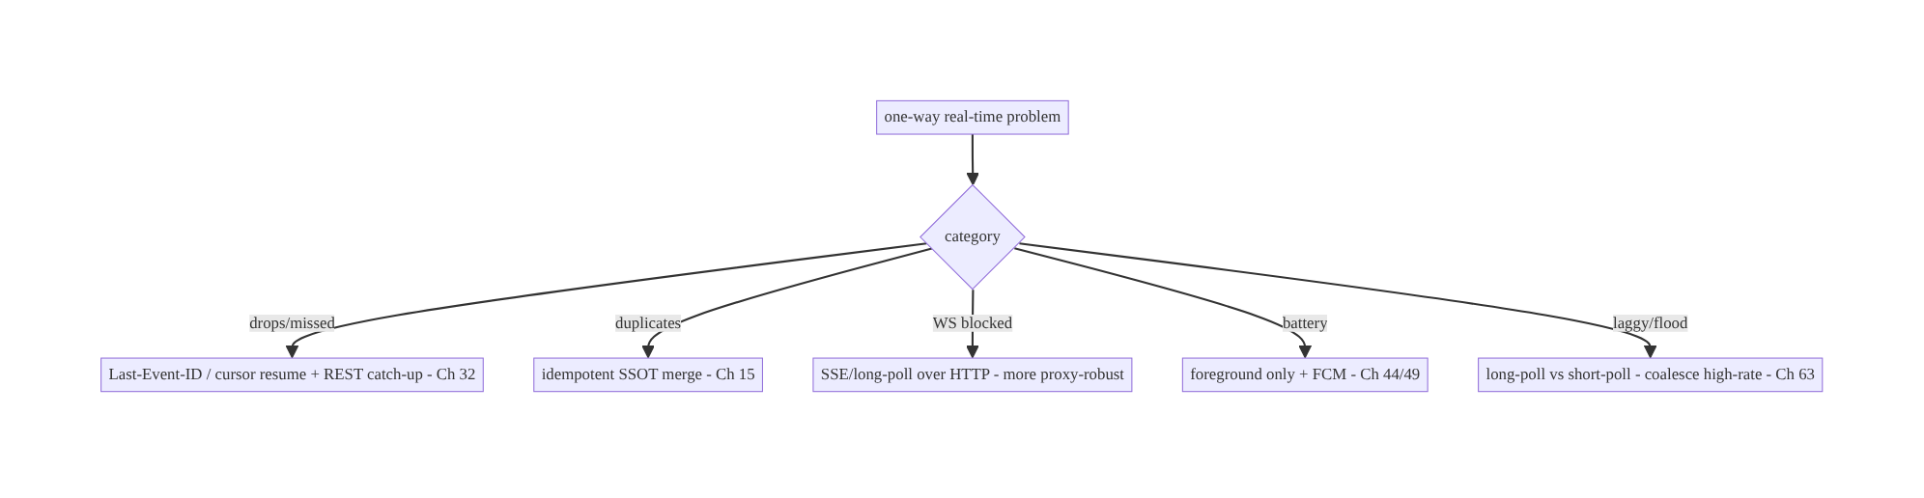
66.9 Failure Scenarios and Recovery
SSE and long polling reuse the same real-time principles as WebSocket (Ch 63) — reconnect, resume, idempotent-SSOT, SSOT/REST-as-truth, foreground-scope + FCM — but over plain HTTP and one-way, so they’re simpler and more proxy-robust. The real skill is choosing the right transport: SSE for one-way streams, WebSocket only when the client must send, long-poll as the HTTP fallback, FCM for background.

66.10 Scaling the Implementation
- Level 1. SSE for a one-way feed → idempotent SSOT; auto-reconnect.
- Level 2. Last-Event-ID/cursor resume + jittered backoff (Ch 2/32); REST catch-up; lifecycle scoping + FCM background (Ch 44/49).
- Level 3 — production. Transport selection (WS/SSE/long-poll/FCM); backpressure for high-rate (Ch 63); long-poll fallback where SSE/WS blocked; auth/pinning (Ch 19/23).
- Level 4 — large. Multiplexed SSE channels; adaptive transport (fall back WS→SSE→ long-poll); per-feed coalescing; connection-quality metrics.
- Level 5 — enterprise. Real-time transport governance + fallback matrix, QoS SLOs, server-side streaming scale (SSE fan-out), multi-region, HTTP/2 multiplexing tuning.
Avoid overengineering: for a read-only feed, SSE + idempotent SSOT + FCM background is the whole story — don’t reach for a WebSocket. Don’t short-poll frequent data; don’t hold connections in the background.

66.11 Alternative Approaches and Trade-offs
Dimension | Option A | Option B | When
One-way stream | SSE | WebSocket (Ch 63) | SSE (simpler, HTTP-native, auto-reconnect/resume); WS only if bidirectional
No SSE/WS infra | Long polling | short polling | Long poll (near-real-time); short poll only infrequent
Resume | Last-Event-ID (SSE) / cursor (long-poll) | none | Always resume (Ch 32)
Reconnect | Jittered backoff (Ch 2) | immediate/fixed | Jittered (avoid storms)
Truth | SSOT/REST (fast path) | the stream | SSOT/REST (self-heal)
Background | FCM (Ch 49) | hold connection | FCM (battery/Doze, Ch 47)
Proxy-restrictive nets | SSE/long-poll (HTTP) | WebSocket | SSE/long-poll (traverse proxies better)
SSE vs WebSocket (Ch 63): a WebSocket is bidirectional and stateful, needing custom handshake, heartbeat, and reconnect machinery. SSE is one-way over plain HTTP with built-in auto-reconnect and Last-Event-ID resume, reuses the REST auth stack (Ch 19), and traverses proxies/CDNs more reliably. For server→client-only feeds (status, ticker, notifications), SSE is simpler and often more robust; use a WebSocket only when the client must also send (chat, auctions). Many apps use SSE for feeds and WS only where duplex is genuinely needed.
Long polling vs short polling vs SSE: short polling (fixed interval) is laggy and wasteful — fine only for infrequent, non-urgent data. Long polling (server holds the request open) gives near-real-time with basic HTTP infra and is the fallback when SSE/WS aren’t available or events are rare. SSE is better than both for a true stream (one connection, many events, standardized resume). Prefer SSE; long-poll as fallback; short-poll only for rare updates.
Stream-as-truth vs SSOT/REST-as-truth: as with WebSocket (Ch 63), treating the SSE/ long-poll stream as authoritative makes a dropped event a permanent loss. Treating it as a fast path over an authoritative SSOT/REST (Ch 32) — with resume + idempotent merge — makes it self-healing. Same principle across all real-time transports.

66.12 Security Considerations
- Authed HTTPS + pinning (Ch 19/23): SSE/long-poll are normal authenticated HTTPS requests over TLS + certificate pinning (Ch 23) — they reuse the REST auth stack (bearer/cookies), an advantage over WebSocket’s custom handshake. Never plain HTTP.
- Stream authorization (Ch 23): the server authorizes which feed/channel you may subscribe to (your orders, a stream you’re watching) — a client can’t request arbitrary streams.
- Events are untrusted (Ch 23/52): validate/allowlist event types and schema; don’t act on an event implying privilege without server authorization; sanitize content; beware injection.
- Per-account isolation (Ch 42): feeds scoped to the active account; on logout/switch, disconnect + scope.
- Last-Event-ID/cursor are not secrets but shouldn’t leak another user’s position; they’re validated server-side against the authed user.
- No sensitive data/PII in event logs (Ch 28).
- Client vs backend: the server authenticates, authorizes the stream, assigns event ids/cursors, and is the truth (REST catch-up); the client manages reconnect/resume, validates untrusted events, and reconciles into the SSOT.

66.13 Performance and Resource Optimization
- SSE over WebSocket for one-way — less machinery, HTTP/2 multiplexing, proxy-friendly.
- Foreground-only (Ch 44) — don’t hold SSE/long-poll in the background (battery/Doze, Ch 47); FCM for background (Ch 49).
- Jittered backoff (Ch 2) — avoid reconnect storms + radio churn.
- Coalesce/sample high-rate streams (Ch 63) — ticker/scoreboard.
- Resume, don’t refetch all — Last-Event-ID/cursor replays only missed events.
- Long-poll timeout tuning — balance latency vs request overhead; single in-flight.
- HTTP/2 — multiplex multiple SSE streams over one connection.
- Profiling: stream uptime, reconnect rate, event latency, battery/radio, catch-up volume, request count (long-poll).

66.14 Testing Strategy
SSE/long-poll test with MockWebServer (stream responses / held requests); resume + merge in isolation.
class SseResumeTest {
@Test fun `sends Last-Event-ID on reconnect and dedups replay`() = runTest {
// MockWebServer: stream events 1-3 then drop; assert reconnect carries Last-Event-ID=3,
// server replays 3-5, SSOT has 1-5 once (idempotent, Ch 15)
}
}
class LongPollTest {
@Test fun `advances cursor and re-requests`() = runTest {
// held response returns seq 101-102 -> next request carries cursor=102
}
@Test fun `backs off on error then retries`() = runTest { /* error -> delay -> retry (Ch 2) */ }
}
class TransportSelectorTest {
@Test fun `one-way foreground picks SSE`() =
assertEquals(Transport.Sse, TransportSelector.choose(RealtimeNeed(oneWay = true, foreground = true, sseSupported = true)))
@Test fun `bidirectional picks WebSocket`() = assertEquals(Transport.WebSocket, /* ... */ )
@Test fun `background picks FCM`() = assertEquals(Transport.Fcm, /* ... */ )
}
What to test: SSE resume (Last-Event-ID) + idempotent dedup of replay; long-poll cursor advance + backoff; transport selection matrix; REST catch-up heals gaps; lifecycle connect/disconnect (no background hold); untrusted-event rejection. MockWebServer for streaming/held responses.

66.15 Production Observability
- Metrics: stream uptime / reconnect rate / reconnect latency; event delivery latency; catch-up/replay volume + gap frequency; long-poll request rate; duplicate- merge rate (deduped); battery/radio attributed; transport mix (SSE/long-poll/WS/FCM).
- Logs: feed{transport, state, reconnects, lastEventId} — no event content/PII (Ch 28).
- Debugging: missed events → resume not sent / cursor bug (Ch 32); duplicates → merge not idempotent (Ch 15); storms → non-jittered backoff; WS-blocked network → fall back to SSE/long-poll; battery → held connection in background (Ch 44); laggy → short-poll where long-poll/SSE needed.
- Alerting: reconnect-rate/latency spike; SSE failure spike (server/proxy); transport- fallback surge (infra issue).
- Dashboards: stream health (uptime/reconnect/latency) by transport; delivery funnel.

66.16 System Design Interview Preparation
≥25 questions.
Fundamentals
- SSE? A long-lived HTTP text/event-stream; server streams events one-way.
- SSE built-ins? Auto-reconnect + Last-Event-ID resume + HTTP-native.
- Long polling? Client request the server holds open until data/timeout, then re-request.
- Short polling? Fixed-interval polling — laggy/wasteful; infrequent data only.
- Direction of SSE? One-way (server→client).
Choosing
- SSE vs WebSocket (Ch 63)? One-way HTTP+resume vs bidirectional stateful.
- When WebSocket? Client must also send (chat/auctions).
- When long poll? SSE/WS unavailable or events rare; basic infra.
- When FCM? Background (Ch 49).
- Default for a read-only feed? SSE.
Reliability
- Resume (SSE)? Last-Event-ID header → server replays from there.
- Resume (long-poll)? Cursor in each request.
- Reconnect? Jittered backoff (Ch 2).
- Duplicates on replay? Idempotent SSOT merge (Ch 15).
- Truth? SSOT/REST (Ch 32); stream is a fast path.
- Missed events? Resume + REST catch-up self-heal.
Lifecycle/efficiency
- Foreground only? Yes — held connection drains battery, Doze-killed (Ch 47).
- Background? FCM handoff (Ch 49).
- High-rate? Coalesce/sample (Ch 63).
- Proxy-restrictive nets? SSE/long-poll traverse better than WS.
Security
- Auth? Normal authed HTTPS + pinning (Ch 19/23); reuses REST stack.
- Stream authz? Server authorizes which feed (Ch 23).
- Events trust? Untrusted — validate (Ch 52).
Testing/Production
- Test SSE? MockWebServer stream + resume/dedup.
- Test selection? Matrix (one-way→SSE, bidir→WS, bg→FCM).
- WS blocked in prod? Fall back to SSE/long-poll.

Design-change challenges
- One-way order-status feed. SSE + idempotent SSOT + Last-Event-ID resume; FCM background.
- WebSocket blocked by a corporate proxy. SSE or long-poll (HTTP-native).
- Rare updates, simple backend. Long polling with a cursor (or short poll if very rare).
- Live ticker floods the UI. SSE + coalesce/sample (Ch 63).
- Feed misses events after a drop. Last-Event-ID/cursor resume + REST catch-up (Ch 32).

Mock walkthrough (abridged)
Clarify (one-way or bidirectional, frequency, infra, app state?) → transport matrix (SSE for one-way, WS for bidirectional, long-poll fallback, FCM background) → manage like real-time (reconnect+backoff, resume via Last-Event-ID/cursor, events→idempotent SSOT, SSOT/REST truth, Ch 2/32/3/15) → foreground scope + FCM (Ch 44/49) → backpressure for high-rate → auth/pinning + untrusted events (Ch 19/23) → observability.

66.17 Practical Exercises
- Beginner. Consume an SSE order-status feed with OkHttp, updating the SSOT; render from the SSOT. Eval: streams; UI updates.
- Intermediate. Add Last-Event-ID resume + jittered-backoff reconnect so drops heal and replays dedup idempotently. Eval: no gaps/dupes.
- Advanced. Implement a long-poll fallback (hold-open + cursor) and a TransportSelector choosing WS/SSE/long-poll/FCM. Eval: correct choice; near-real-time long-poll.
- Production debugging. Fix missed events (resume not sent) and a reconnect storm (no jitter). Eval: resumes; spread reconnects.
- System design challenge. Scope the feed to foreground with FCM background, add coalescing for a high-rate ticker, and a stream-health dashboard. Eval: battery-sane; smooth; observable.
(Solutions withheld unless requested.)

66.18 Chapter Summary & Reference Sheet
Key decisions: for one-way server→client real-time, prefer SSE — a long-lived HTTP text/event-stream with built-in auto-reconnect and Last-Event-ID resume that reuses the REST auth stack (Ch 19) and traverses proxies/CDNs better than a WebSocket — and use long polling (server holds the request open + a cursor + immediate re-request) when SSE/WebSocket are unavailable or events are rare (short polling only for infrequent data); manage these with the same discipline as WebSocket (Ch 63) — jittered-backoff reconnect (Ch 2), resume via Last-Event-ID/cursor (Ch 32), events → idempotent SSOT merge (dedup by id, Ch 3/15) with SSOT/REST as the truth so drops self-heal, foreground-scoped with FCM for background (Ch 44/49) — and choose the transport by directionality, frequency, infra, and app state (SSE one-way, WebSocket only when the client must also send, long-poll fallback, FCM background); secure with authed HTTPS + pinning + server stream authorization + untrusted-event validation (Ch 19/23/52).
Concepts: SSE (text/event-stream, event ids, Last-Event-ID, auto-reconnect), long polling (hold-open + cursor), short polling, transport selection matrix, reconnect/backoff
- resume, events→idempotent SSOT, SSOT/REST truth, foreground scope + FCM, backpressure.
Common mistakes: using a WebSocket for a one-way feed (needless complexity); short- polling frequent data (laggy/wasteful); no resume (gaps); no idempotent merge (duplicates on replay); treating the stream as truth; holding SSE/long-poll in the background (battery/ Doze); plain HTTP / no stream authz; non-jittered reconnect (storms).
Checklist:
- ☐ pick transport by matrix (SSE one-way / WS bidirectional / long-poll fallback / FCM background)
- ☐ SSE with Last-Event-ID resume + auto-reconnect
- ☐ long-poll hold-open + cursor (single in-flight)
- ☐ jittered backoff (Ch 2)
- ☐ events → idempotent SSOT merge (Ch 3/15)
- ☐ SSOT/REST = truth; catch-up (Ch 32)
- ☐ foreground-scoped + FCM background (Ch 44/49)
- ☐ coalesce high-rate (Ch 63)
- ☐ authed HTTPS + pinning + stream authz + untrusted events (Ch 19/23/52)
- ☐ stream-health telemetry.
Key APIs: OkHttp EventSources/EventSource/EventSourceListener (onEvent/onFailure)
- Accept: text/event-stream + Last-Event-ID header, OkHttp long-poll (held GET + cursor), callbackFlow/flow (Ch 1), jittered backoff (Ch 2), Room idempotent upsert (Ch 3/15), REST catch-up (Ch 32), ProcessLifecycleOwner (Ch 44), FCM (Ch 49), MockWebServer (test).
References:
- Server-Sent Events (WHATWG/MDN): https://developer.mozilla.org/en-US/docs/Web/API/Server-sent_events
- OkHttp SSE (okhttp-sse): https://square.github.io/okhttp/features/events/
- (composes) Ch 63 WebSocket, Ch 1 Networking, Ch 2 Retries/Backoff, Ch 49 FCM, Ch 32 Sync, Ch 3 SSOT, Ch 44 Lifecycle, Ch 68 Network State

Chapter 67 — Live Location Tracking
Part VIII — Real-Time & Connectivity · Complexity: Standard (≥25 interview questions)
Prerequisites: Ch 46 (foreground services), Ch 51 (permissions), Ch 47 (Doze/ background limits), Ch 63 (WebSocket), Ch 31 (outbox), Ch 44 (lifecycle), Ch 28 (privacy). Pairs with Ch 68 (network state), Ch 30 (WorkManager).
Reference surface in StreamCart: delivery/driver tracking and “share my live location” — acquiring the device’s location efficiently, streaming it to the backend during an active trip, and doing so within Android’s strict location permission and background-execution rules, with privacy front and center.

67.1 Problem Definition and Real-World Context
Live location is Android’s most permission-, battery-, and privacy-sensitive feature. Tracking a delivery driver or sharing a user’s location in real time means continuously acquiring GPS (expensive), running during an active trip even when backgrounded (a foreground service, Ch 46), streaming updates to the server (Ch 63/31), and navigating the foreground/background location permission split, approximate-vs-precise, and Doze/background-location limits (Ch 51/47) — all while treating location as highly sensitive data (Ch 28). Get it wrong and you drain the battery, get killed by the OS, leak location, or get rejected by Play.
Concretely, teams hit:
- Battery drain from naive GPS. Requesting high-accuracy location at max frequency continuously destroys the battery. You must use the Fused Location Provider with the right priority and interval for the use case, and stop when not needed.
- Permission complexity (Ch 51). Foreground location (ACCESS_FINE/COARSE_LOCATION) vs background location (ACCESS_BACKGROUND_LOCATION, requested separately/after, heavily scrutinized by Play), approximate vs precise (Android 12+), and “only this time” grants — all with in-context requests and graceful denial.
- Background execution (Ch 46/47). Tracking during an active trip while the app is backgrounded requires a foreground service (type location, Ch 46) with a visible notification — you cannot silently track in the background; Doze/limits (Ch 47) kill unprivileged background location.
- Streaming reliably (Ch 63/31). Location updates stream to the backend over a WebSocket (Ch 63) while connected, buffered in an outbox (Ch 31) when offline so the trip’s track isn’t lost, reconciled on reconnect.
- Privacy & trust (Ch 28). Location is deeply personal. Track only during an active, user-understood session, show a clear indicator, stop promptly, minimize precision/ retention, and honor consent — misuse is both a Play violation and a trust breach.
- Accuracy/consistency. Noisy GPS needs filtering/smoothing; updates need timestamps and ordering; a trip’s path must be coherent.
The architecture: acquire location via the Fused Location Provider with a priority/ interval matched to the use case (balanced vs high accuracy), only during an active session; run active-trip tracking in a foreground service (type location, Ch 46) with a visible notification; gate on the foreground then background location permissions (Ch 51), preferring least precision; stream updates over a WebSocket (Ch 63) with an outbox buffer (Ch 31) and reconnect/catch-up; stop promptly when the session ends; and treat location as sensitive — minimal precision/ retention, clear indicator, consent (Ch 28). This chapter is about efficient, compliant, privacy-respecting live location.

Three practical use cases
- Delivery driver tracking (StreamCart). During an active delivery, a location foreground service (Ch 46) streams the driver’s position (balanced priority) to the backend over a WebSocket (Ch 63); stops when the delivery completes.
- “Share my live location.” A user shares location for a bounded time/trip; precise, foreground-service-backed, with a clear stop control and auto-expiry.
- Nearby stores (foreground, one-shot). A single coarse location fix (getCurrentLocation) to show nearby stores — no background, no continuous tracking, least precision.

Why this is architectural
Live location composes permissions (Ch 51), foreground services (Ch 46), background limits (Ch 47), real-time streaming (Ch 63/31), lifecycle (Ch 44), and privacy (Ch 28) — with the strictest OS and Play constraints of any feature. The decisions — provider/priority/interval, foreground-service-for-active-trips, permission strategy, streaming+buffering, stop-promptly, least-precision — determine battery, legality, reliability, and user trust.

67.2 Requirements Engineering

Functional requirements
ID | Requirement
F1 | Acquire location efficiently (Fused provider, priority/interval per use case).
F2 | Track during an active trip even when backgrounded, via a location foreground service (Ch 46).
F3 | Gate on foreground + background location permissions; least precision (Ch 51).
F4 | Stream updates to the backend reliably (WebSocket + outbox buffer) (Ch 63/31).
F5 | Stop promptly when the session ends; auto-expire shares.
F6 | Treat location as sensitive: minimal precision/retention, indicator, consent (Ch 28).

Non-functional requirements
Attribute | Policy
Battery | Right priority/interval; stop when idle; the top constraint.
Compliance | location FGS for background; Play-justified permissions (Ch 46/51).
Reliability | Trip track not lost (outbox); reconnect/catch-up (Ch 31/63).
Privacy | Active-session-only; least precision; clear indicator; consent (Ch 28).
Accuracy | Filtered/smoothed; timestamped/ordered updates.

Scope
- In scope: Fused Location Provider (priority/interval, one-shot vs continuous), location foreground service for active trips (Ch 46), foreground/background + approximate/ precise permissions (Ch 51), streaming via WebSocket + outbox buffering + reconnect (Ch 63/31), lifecycle/stop-promptly (Ch 44), accuracy filtering, privacy (precision/ retention/indicator/consent, Ch 28), geofencing (overview).
- Out of scope: FGS mechanics (Ch 46), permission state machine (Ch 51), Doze detail (Ch 47), WebSocket internals (Ch 63), outbox (Ch 31), maps rendering, privacy framework (Ch 28).

Assumptions & constraints
- Fused Location Provider (Play services) / LocationManager, location FGS (Ch 46), WebSocket (Ch 63), outbox (Ch 31). minSdk 24, targetSdk current (background-location separate request, approximate/precise). Continuous background tracking requires a foreground service; location is sensitive (Ch 28); Play scrutinizes location use.

67.3 System Design Fundamentals
- Fused Location Provider + right priority/interval (the battery lever). Use FusedLocationProviderClient (fuses GPS/Wi-Fi/cell/sensors) with a Priority and interval matched to the use case:
  - PRIORITY_HIGH_ACCURACY (GPS) for navigation/active-trip precise tracking — battery-heavy.
  - PRIORITY_BALANCED_POWER_ACCURACY (~city-block, Wi-Fi/cell) for most tracking — good enough, far cheaper.
  - PRIORITY_LOW_POWER / PRIORITY_PASSIVE for coarse/opportunistic. Set the interval (and minUpdateInterval, maxUpdateDelay for batching) to the slowest that meets the need. One-shot (getCurrentLocation) for a single fix (nearby stores) — don’t start continuous tracking for a one-time need. Match priority/interval to the use case is the dominant battery decision.
- Active-trip tracking = foreground service (Ch 46). Continuous location while the app is backgrounded requires a foreground service of type location (Ch 46) with a visible, persistent notification (“Tracking your delivery”). You cannot track continuously in the background without it (Doze/background-location limits kill it, Ch 47), and Play forbids silent background tracking. Start the FGS when the trip starts, stop it when the trip ends (battery + trust).
- Permissions (Ch 51), least precision:
  - Foreground: ACCESS_FINE_LOCATION (precise) or ACCESS_COARSE_LOCATION (approximate) — request coarse unless you truly need precise.
  - Background: ACCESS_BACKGROUND_LOCATION must be requested separately and after foreground (Android 10+), with a strong rationale; Play heavily scrutinizes it — only request it if the feature genuinely tracks in the background (active trips do; nearby- stores doesn’t).
  - Approximate vs precise (Android 12+): the user may grant only approximate; handle both.
  - “Only this time”: an ephemeral grant; handle revocation on next use (Ch 51). Request in context with graceful denial (Ch 51); the FGS notification itself signals tracking.
- Streaming reliably (Ch 63/31). Location updates are a real-time stream to the server: send over a WebSocket (Ch 63) while connected; buffer in an outbox (Ch 31) when offline so the trip’s track isn’t lost (a delivery path must be complete); on reconnect, flush the buffer in order. This mirrors chat’s reliable-send (Ch 64/31). Updates carry timestamps for ordering.
- Accuracy filtering. GPS is noisy: filter out low-accuracy fixes (large accuracy radius), smooth the path (e.g., discard physically-impossible jumps), and dedup near-identical points. Timestamp and order updates for a coherent track.
- Stop promptly + auto-expire (battery + privacy). The #1 battery and trust lever: stop location requests and the FGS the moment the session ends (delivery complete, share stopped). Time-bounded shares auto-expire. Never leave tracking running.
- Privacy & trust (Ch 28). Location is deeply sensitive:
  - Active-session-only: track only during a user-understood session with a clear indicator (the FGS notification + system location indicator).
  - Least precision/retention: collect the coarsest precision that works; retain the minimum; coarsen/aggregate where possible.
  - Consent: explicit, revocable; honor “stop sharing”.
  - Secure transmission/storage: authed WebSocket/REST (Ch 19/23), access-controlled server-side.
- Geofencing (overview). For “notify when near X” (geofences), use the Geofencing API (OS-managed, battery-efficient, triggers a broadcast) rather than continuous tracking — a related but distinct mechanism.
Core insight: acquire location with the Fused provider at the lowest priority/interval (and coarsest precision) that meets the use case, and only during an active session; run continuous active-trip tracking in a location foreground service with a visible notification (Ch 46) — never silently in the background (Doze/Play forbid it, Ch 47) — gated by foreground-then-background location permissions requested in context (Ch 51); stream updates over a WebSocket buffered by an outbox so the trip track survives offline and reconnect (Ch 63/31); filter noisy GPS; stop the FGS and requests the moment the session ends (the top battery and privacy lever); and treat location as highly sensitive — least precision/retention, clear indicator, revocable consent (Ch 28).

67.4 High-Level Architecture
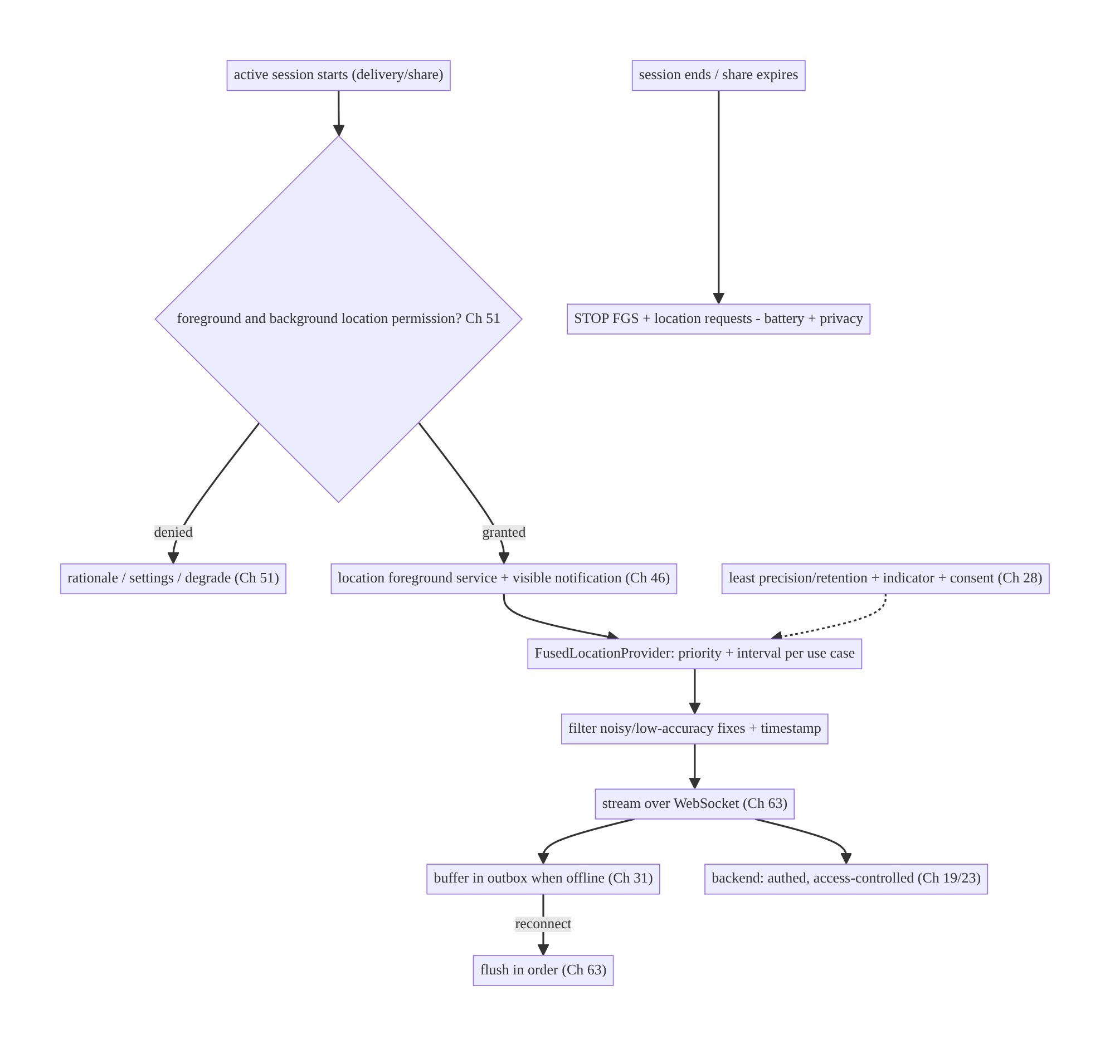
67.4 High-Level Architecture
Components & ownership
- Permission gate (Ch 51) → location FGS (Ch 46) runs active-trip tracking with a visible notification.
- Fused provider acquires at the right priority/interval; filter cleans fixes.
- Stream (WebSocket) + outbox (Ch 31) deliver reliably; backend is authed/ access-controlled.
- Stop-promptly + privacy (least precision/consent) govern everything.
Direction: session → permission → FGS + Fused provider → filter → stream (+outbox) → backend; stop on session end; privacy throughout.

67.5 Detailed Component Design
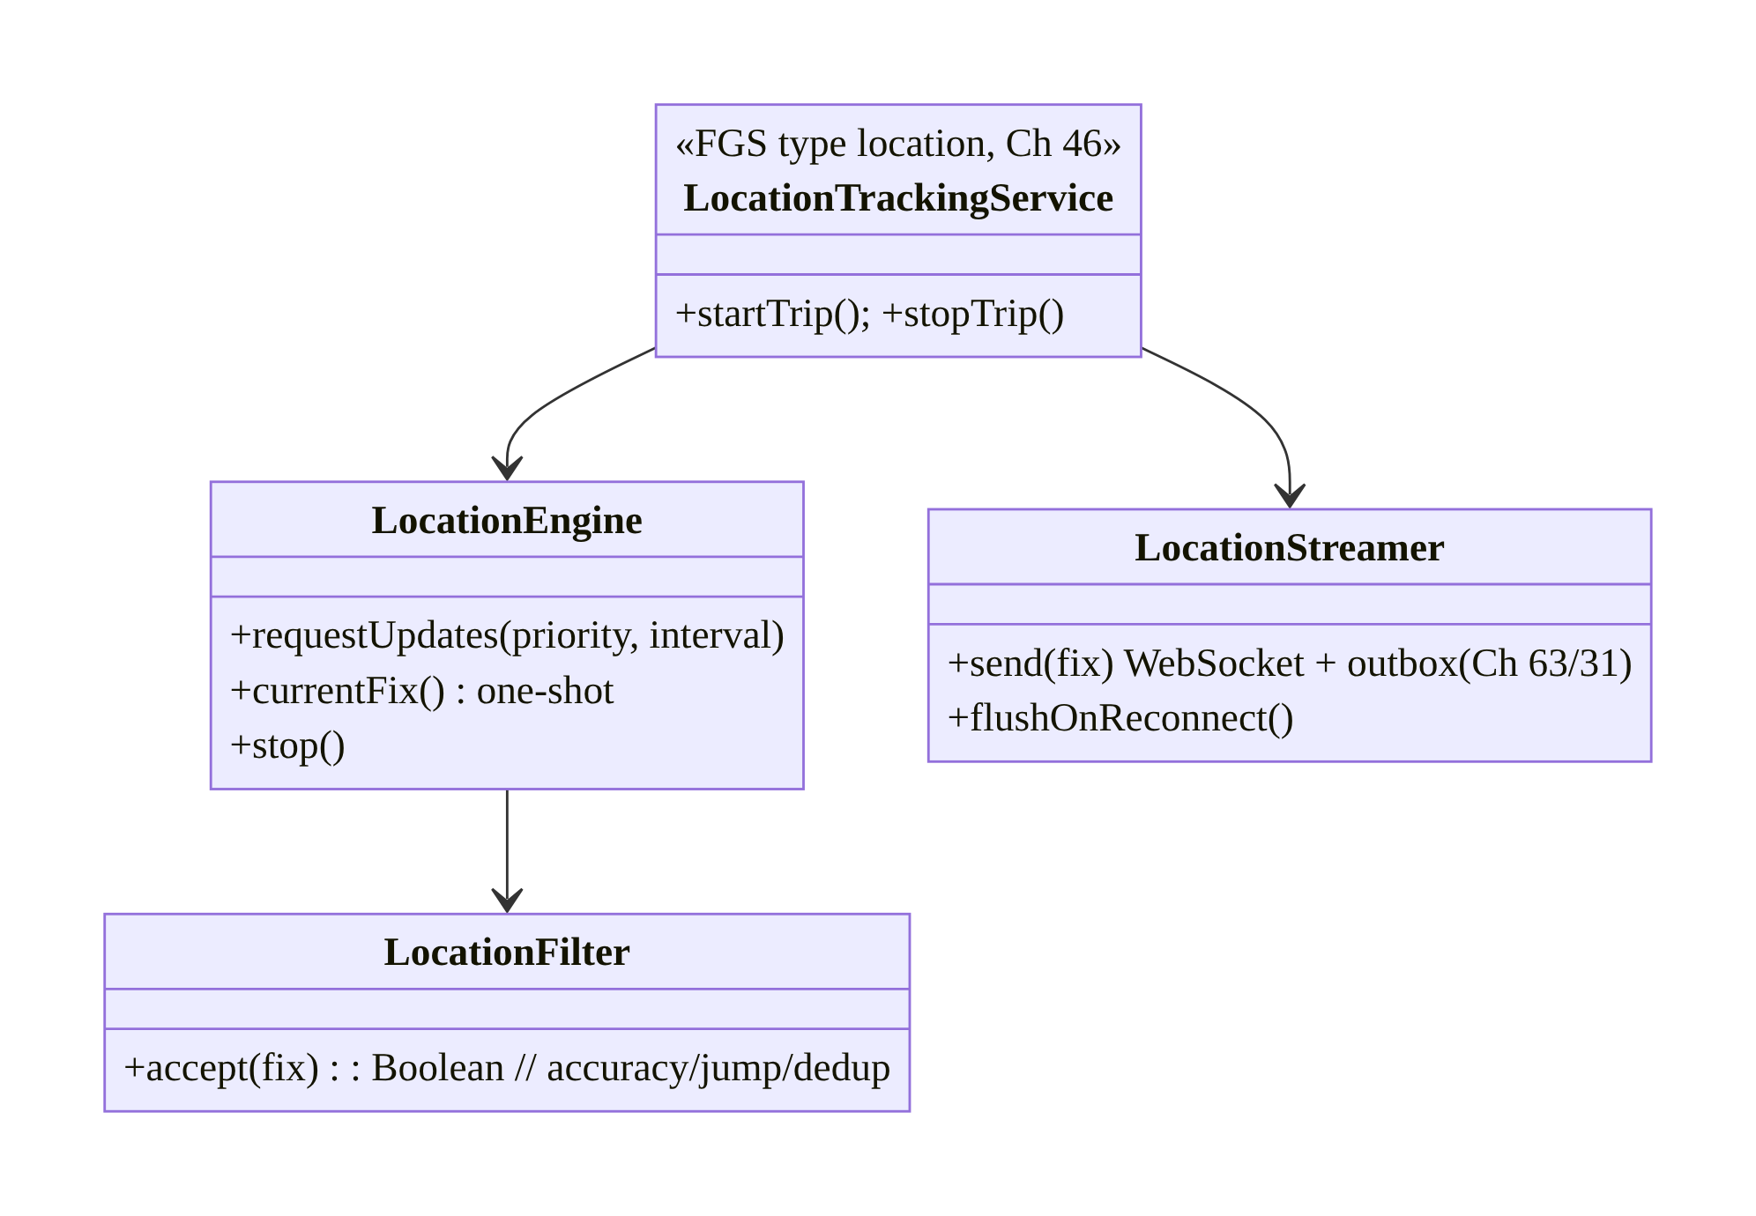
67.5 Detailed Component Design
Component | Responsibility
LocationTrackingService | location FGS: run/stop active-trip tracking (Ch 46)
LocationEngine | Fused provider: updates (priority/interval) + one-shot + stop
LocationFilter | drop low-accuracy/impossible/duplicate fixes
LocationStreamer | stream over WebSocket + outbox buffer + flush (Ch 63/31)

67.6 End-to-End Data Flow

Active-trip tracking
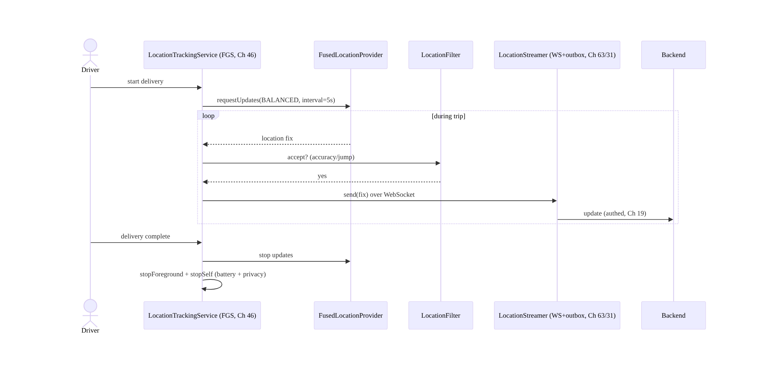
Active-trip tracking

Offline buffering + flush
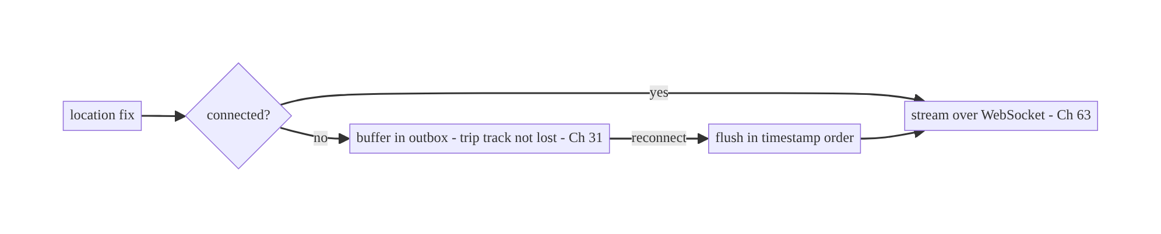
Offline buffering + flush

67.7 Complete Kotlin Implementation
Package: com.streamcart.location.

67.7.1 location foreground service (Ch 46)
<uses-permission android:name="android.permission.ACCESS_FINE_LOCATION" />
<uses-permission android:name="android.permission.ACCESS_COARSE_LOCATION" />
<uses-permission android:name="android.permission.ACCESS_BACKGROUND_LOCATION" /> <!-- requested separately (Ch 51) -->
<uses-permission android:name="android.permission.FOREGROUND_SERVICE" />
<uses-permission android:name="android.permission.FOREGROUND_SERVICE_LOCATION" />
<service android:name=".location.LocationTrackingService" android:foregroundServiceType="location" android:exported="false" />
@AndroidEntryPoint
class LocationTrackingService : Service() {
@Inject lateinit var engine: LocationEngine
@Inject lateinit var streamer: LocationStreamer // WebSocket + outbox (Ch 63/31)
@Inject lateinit var filter: LocationFilter
override fun onStartCommand(intent: Intent?, flags: Int, startId: Int): Int {
startForeground(NOTIF_ID, trackingNotification(), ServiceInfo.FOREGROUND_SERVICE_TYPE_LOCATION) // visible (Ch 46)
engine.requestUpdates(Priority.PRIORITY_BALANCED_POWER_ACCURACY, intervalMs = 5_000) { fix ->
if (filter.accept(fix)) streamer.send(fix.toUpdate()) // filter + stream
}
return START_STICKY // resume tracking if killed mid-trip (Ch 8)
}
override fun onDestroy() { engine.stop(); super.onDestroy() } // STOP requests (battery/privacy)
override fun onBind(intent: Intent?): IBinder? = null
// stopTrip(): stopForeground(true); stopSelf()
}

67.7.2 LocationEngine: Fused provider, priority/interval, one-shot
@Singleton
class LocationEngine @Inject constructor(@ApplicationContext private val ctx: Context) {
private val client = LocationServices.getFusedLocationProviderClient(ctx)
private var callback: LocationCallback? = null
@SuppressLint("MissingPermission") // permission checked before start (Ch 51)
fun requestUpdates(priority: Int, intervalMs: Long, onFix: (Location) -> Unit) {
val request = LocationRequest.Builder(priority, intervalMs)
.setMinUpdateIntervalMillis(intervalMs / 2)
.setMaxUpdateDelayMillis(intervalMs * 2) // allow batching (battery, Ch 47)
.build()
callback = object : LocationCallback() {
override fun onLocationResult(result: LocationResult) { result.lastLocation?.let(onFix) }
}
client.requestLocationUpdates(request, callback!!, Looper.getMainLooper())
}
fun stop() { callback?.let { client.removeLocationUpdates(it) }; callback = null } // STOP promptly
/** One-shot fix (nearby stores) — no continuous tracking. */
@SuppressLint("MissingPermission")
suspend fun currentFix(): Location? =
client.getCurrentLocation(Priority.PRIORITY_BALANCED_POWER_ACCURACY, null).await()
}

67.7.3 Filter noisy GPS
@Singleton
class LocationFilter @Inject constructor() {
private var last: Location? = null
fun accept(fix: Location): Boolean {
if (fix.accuracy > MAX_ACCURACY_M) return false // drop low-accuracy
last?.let {
val dt = (fix.time - it.time).coerceAtLeast(1)
val speed = fix.distanceTo(it) / (dt / 1000.0) // m/s
if (speed > MAX_PLAUSIBLE_SPEED) return false // discard impossible jump
if (fix.distanceTo(it) < MIN_MOVE_M) return false // dedup near-identical
}
last = fix; return true
}
}

67.7.4 Streamer: WebSocket + outbox buffer (Ch 63/31)
@Singleton
class LocationStreamer @Inject constructor(
private val connection: RealtimeConnection, // WebSocket (Ch 63)
private val outbox: LocationOutbox, // buffer (Ch 31)
private val scope: CoroutineScope,
) {
fun send(update: LocationUpdate) {
if (connection.isConnected()) connection.send(update) // stream live (Ch 63)
else outbox.buffer(update) // offline -> trip track not lost (Ch 31)
}
fun flushOnReconnect() = scope.launch {
outbox.drainInOrder { update -> connection.send(update) } // flush by timestamp on reconnect
}
// Backend stores the ordered track, authed + access-controlled (Ch 19/23).
}

67.7.5 Permission gating (Ch 51) — foreground then background
// 1) Request foreground (fine/coarse) in context; prefer coarse if precise not needed (Ch 51).
// 2) ONLY if the feature tracks in the background, request ACCESS_BACKGROUND_LOCATION
// separately/after, with a strong rationale; handle "approximate" and "only this time".
fun startTrackingIfPermitted(activity: Activity) {
when {
hasForeground(activity) && hasBackground(activity) -> startService() // active-trip tracking
hasForeground(activity) -> requestBackgroundRationaleThenPermission() // separate step (Ch 51)
else -> requestForegroundInContext()
}
}

67.7.6 Module structure
:feature:tracking LocationTrackingService (FGS location), start/stop trip, permission flow (Ch 51)
:core:location LocationEngine (Fused), LocationFilter, LocationStreamer, LocationOutbox (Ch 31)
# WebSocket -> Ch 63; FGS -> Ch 46; privacy -> Ch 28; geofencing -> Geofencing API.

67.8 Concurrency and Race Conditions
Scenario | Risk | Handling
Tracking not stopped | battery drain + privacy | stop FGS + removeUpdates on session end/destroy
Service killed mid-trip | gap in track | START_STICKY resume (Ch 8); outbox buffers
Offline fixes lost | incomplete path | outbox buffer + flush on reconnect (Ch 31)
Out-of-order after flush | wrong path | timestamp + order on flush/server
Noisy/impossible fix | bad track | filter (accuracy/jump/dedup)
Permission revoked mid-trip | SecurityException | check at use; stop + re-request (Ch 51)
Duplicate FGS starts | double tracking | single service instance / idempotent start
- Stop-promptly is both correctness and battery: on session end or onDestroy, remove location updates and stop the FGS — a lingering tracker is the top battery drain and a privacy/trust violation (and a Play risk).
- Outbox + ordering makes the track complete: offline fixes buffer (Ch 31) and flush in timestamp order on reconnect so a delivery path has no gaps and no reordering (mirrors chat send, Ch 64/31).
- Check permission at use + START_STICKY: a revoked permission mid-trip must stop gracefully (Ch 51); a killed service resumes tracking (Ch 8) so the trip isn’t dropped.

67.9 Failure Scenarios and Recovery
Failure | Detection | Response | Outcome
Battery drain | vitals | right priority/interval; stop when idle; batch (Ch 47) | battery ok
Can’t track in background | updates stop | location FGS + notification (Ch 46) | tracks
Trip track has gaps | server audit | outbox buffer + flush (Ch 31); START_STICKY | complete
Noisy/jumpy path | bad UX | filter accuracy/jumps | smooth
Permission denied/revoked | Ch 51 | rationale → settings; degrade; stop | recoverable
Play rejection | review | justify + location FGS + background separate (Ch 46/51) | approved
Location leaked | privacy audit | least precision/retention; authed transport (Ch 28/19) | safe
Share never stops | user report | auto-expire + explicit stop | bounded
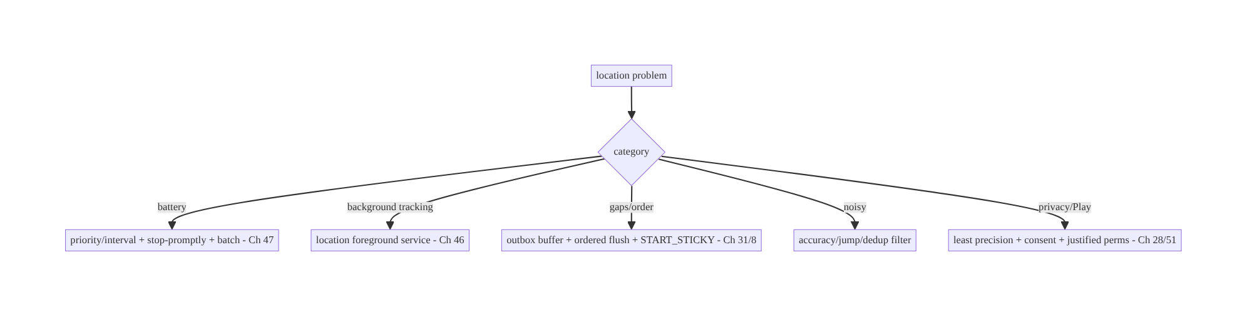
67.9 Failure Scenarios and Recovery
Two non-negotiables dominate live location: run background tracking only in a location foreground service (Ch 46), and stop the moment the session ends (Ch 47/28). The first keeps you alive and compliant; the second protects battery and trust. Around them, tune priority/interval, buffer with an outbox, filter noise, and minimize precision.

67.10 Scaling the Implementation
- Level 1. Fused one-shot fix (nearby); foreground tracking with right priority/ interval; stop promptly.
- Level 2. location FGS for active-trip background tracking (Ch 46); foreground+ background permission flow (Ch 51); filter.
- Level 3 — production. Stream over WebSocket + outbox buffering + reconnect flush (Ch 63/31); privacy (least precision/consent/indicator, Ch 28); auto-expire shares; START_STICKY resume.
- Level 4 — large. Adaptive priority/interval (speed/battery-aware); batching in Doze windows (Ch 47); geofencing for proximity; multi-trip; map ETA.
- Level 5 — enterprise. Fleet tracking scale, location-data governance/retention (regulatory, Ch 28), privacy SLOs, on-device trip summarization, cross-platform parity.
Avoid overengineering: for a one-time location (nearby stores), a single coarse fix needs no FGS, no background permission, no streaming. Reserve the full FGS+stream+outbox stack for genuine active-trip tracking.

67.11 Alternative Approaches and Trade-offs
Dimension | Option A | Option B | When
Provider | Fused Location Provider | raw LocationManager/GPS | Fused (fuses sensors, battery-smart); raw for no-Play-services
Precision | Balanced / coarse | high-accuracy GPS | Lowest that works (battery/privacy); high only for navigation
Background tracking | location FGS (Ch 46) | background job / silent | FGS (required + compliant); silent is killed/forbidden
One-time location | One-shot getCurrentLocation | continuous updates | One-shot (nearby stores) — don’t track continuously
Streaming | WebSocket + outbox (Ch 63/31) | periodic REST batch | WS+outbox for live; REST batch for non-live trails
Proximity | Geofencing API | continuous tracking | Geofencing (OS-managed, cheap) for “near X”
Permission | Foreground; background only if needed | background always | Least (Play scrutiny, Ch 51)
Fused provider vs raw GPS: the Fused Location Provider intelligently combines GPS, Wi-Fi, cell, and sensors and picks the cheapest source meeting your accuracy need — far more battery-efficient and simpler than driving raw LocationManager/GPS. Use Fused (Play services); reserve raw providers for devices without Play services.
location FGS vs silent background tracking: continuous background location is only allowed via a location foreground service with a visible notification (Ch 46) — the OS (Doze/background-location limits, Ch 47) and Play forbid silent background tracking. Trying to track in a plain background job fails and risks rejection. Use the FGS for active trips; for one-time needs, a foreground one-shot fix suffices.
One-shot vs continuous: a single getCurrentLocation for “nearby stores” needs no continuous updates, FGS, or background permission — starting continuous tracking for a one-time need wastes battery and over-asks permissions. Match the mechanism to the need: one-shot for a fix, continuous (FGS) only for an active trip.

67.12 Security & Privacy Considerations
- Location is highly sensitive (Ch 28) — minimize everything: collect the coarsest precision that works (approximate over precise), track only during an active, user- understood session, retain the minimum, and coarsen/aggregate where possible.
- Clear indicator + consent: the location FGS notification + the system location indicator make tracking visible; obtain explicit, revocable consent; honor “stop sharing” immediately; auto-expire time-bounded shares.
- Least-privilege permissions (Ch 51): request background location only if genuinely needed (active trips), separately/after foreground, with a strong Play-justified rationale; handle approximate/“only this time”.
- Secure transmission + access control (Ch 19/23): stream over authed WebSocket/REST with TLS + pinning (Ch 23); the backend access-controls who can see a location (only the customer tracking their delivery, per authz) — never a public endpoint.
- Per-account isolation (Ch 42): location scoped to the active account/trip; stop on logout/switch.
- No location in logs/analytics (Ch 28); aggregate/coarsen if needed.
- Play policy: location use must be disclosed, justified, and necessary; background location is heavily reviewed — misuse → rejection.
- Client vs backend: the client minimizes/consents/streams securely; the backend access-controls, retains minimally per policy, and never exposes raw location without authorization.

67.13 Performance and Resource Optimization
- Priority/interval matched to use case — the dominant battery lever (balanced over high-accuracy; slowest interval that works).
- Stop promptly — remove updates + stop FGS the instant the session ends.
- Batch updates (maxUpdateDelay) so the OS coalesces fixes (Ch 47) in Doze windows.
- One-shot for one-time needs — never continuous for a single fix.
- Filter/dedup — fewer streamed points, less bandwidth/CPU.
- Adaptive tracking — lower frequency when stationary/low battery.
- Outbox batching — flush buffered fixes in batches, not one-by-one.
- Profiling: battery/location attribution (Battery Historian), fix frequency, stream bandwidth, FGS runtime, track completeness.

67.14 Testing Strategy
Location logic (filter, streamer, outbox) tests in isolation with faked providers; FGS/permissions via instrumentation.
class LocationFilterTest {
@Test fun `drops low-accuracy fix`() { assertFalse(filter.accept(loc(accuracy = 200f))) }
@Test fun `discards impossible jump`() {
filter.accept(loc(lat = 0.0, lon = 0.0, t = 0))
assertFalse(filter.accept(loc(lat = 1.0, lon = 1.0, t = 1000))) // ~157km in 1s
}
@Test fun `dedups near-identical`() { /* within MIN_MOVE_M -> false */ }
}
class LocationStreamerTest {
@Test fun `buffers offline and flushes in order on reconnect`() = runTest {
connection.connected = false; streamer.send(u(t=1)); streamer.send(u(t=2))
assertEquals(2, outbox.size()) // trip not lost (Ch 31)
connection.connected = true; streamer.flushOnReconnect()
assertEquals(listOf(1L, 2L), connection.sent.map { it.t }) // ordered
}
}
// Instrumentation: FGS starts/stops, permission flow (fore then back), stop-on-complete.
What to test: filter (accuracy/jump/dedup); streamer buffer+ordered flush (outbox, Ch 31); one-shot vs continuous; FGS start/stop + stop-on-session-end (battery/privacy); foreground-then-background permission flow + check-at-use (Ch 51); START_STICKY resume. Use fake Fused provider emitting scripted fixes; instrumentation for real FGS/permissions.

67.15 Production Observability
- Metrics: battery/location attribution; fix frequency; FGS runtime per trip; stream bandwidth; track completeness (gaps); outbox buffer/flush volume; permission grant rates (fore/back, Ch 51); stop-on-complete success (no lingering trackers); Play-policy flags.
- Logs: tracking{trip, priority, interval, fixes, stopped} — no coordinates/PII (Ch 28).
- Debugging: battery → wrong priority/interval / not stopped (Ch 47); background stops → no location FGS (Ch 46); track gaps → outbox/START_STICKY (Ch 31/8); jumpy path → filter; privacy leak → precision/retention/transport (Ch 28/23); Play rejection → background-permission justification (Ch 51).
- Alerting: lingering-tracker (FGS running without an active trip); battery spike; track-completeness drop.
- Dashboards: FGS runtime + battery per trip; track completeness; permission funnel.

67.16 System Design Interview Preparation
≥25 questions.
Fundamentals
- Provider? Fused Location Provider (fuses GPS/Wi-Fi/cell/sensors, battery-smart).
- Battery lever? Priority + interval matched to use case (balanced over high-accuracy).
- Priorities? HIGH_ACCURACY / BALANCED / LOW_POWER / PASSIVE.
- One-shot vs continuous? getCurrentLocation for a single fix; continuous only for a trip.
- Biggest non-negotiable? Background tracking only via a location FGS.
Background/FGS
- Background continuous tracking? location foreground service + visible notification (Ch 46).
- Why not a background job? Doze/background-location limits kill it; Play forbids silent (Ch 47).
- Stop when? Session end/onDestroy — the top battery+privacy lever.
- Killed mid-trip? START_STICKY resume (Ch 8).
Permissions (Ch 51)
- Foreground perms? ACCESS_FINE/COARSE_LOCATION; prefer coarse.
- Background perm? ACCESS_BACKGROUND_LOCATION, separate/after, Play-scrutinized.
- Approximate vs precise? Android 12+; handle both; least precision.
- “Only this time”? Ephemeral; handle revocation (Ch 51).
Streaming
- Stream to backend? WebSocket (Ch 63).
- Offline? Outbox buffer; flush ordered on reconnect (Ch 31).
- Ordering? Timestamps; order on flush/server.
- Trip track not lost? Outbox + START_STICKY.
Accuracy
- Noisy GPS? Filter accuracy/impossible jumps; dedup.
- Smoothing? Discard low-accuracy/implausible; coherent track.
Privacy (Ch 28)
- Sensitivity? Highly sensitive — least precision/retention, active-session-only.
- Indicator/consent? FGS notification + system indicator; explicit, revocable; auto- expire.
- Secure transport? Authed WS/REST + pinning (Ch 19/23); server access-controlled.
- Play compliance? Disclosed, justified, necessary; background heavily reviewed.
Testing/Production
- Test filter/streamer? Faked provider; accuracy/jump/dedup + outbox flush order.
- Battery in prod? Wrong priority/interval / not stopped.
- Lingering tracker? FGS running without an active trip (alert).

Design-change challenges
- Track a delivery driver in the background. location FGS (Ch 46) + Fused (balanced) + stream (Ch 63); stop on complete.
- Nearby stores without continuous tracking. One-shot coarse getCurrentLocation; no background perm.
- Trip path has gaps when offline. Outbox buffer + ordered flush + START_STICKY (Ch 31/8).
- Battery complaints. Lower priority/interval; stop promptly; batch (Ch 47).
- “Stop sharing my location” must work instantly. Stop FGS + removeUpdates; auto-expire; consent (Ch 28).

Mock walkthrough (abridged)
Clarify (one-time or active-trip, background needed, precision, who sees it?) → Fused provider priority/interval per use case → one-shot vs continuous → location FGS for background trips (Ch 46) → foreground-then-background permissions, least precision (Ch 51) → stream over WebSocket + outbox buffer + reconnect flush (Ch 63/31) → filter noise → stop promptly → privacy (least precision/consent/indicator/secure transport, Ch 28/19/23) → observability (battery, track completeness).

67.17 Practical Exercises
- Beginner. Get a single coarse location fix for “nearby stores” with the Fused provider — no FGS, no background permission. Eval: one-shot; least precision.
- Intermediate. Build a location FGS (Ch 46) that tracks at balanced priority during an active trip and stops on completion. Eval: tracks backgrounded; stops promptly.
- Advanced. Stream fixes over a WebSocket with an outbox buffer that flushes in order on reconnect, and filter noisy fixes. Eval: no gaps; ordered; smooth.
- Production debugging. Fix battery drain (high-accuracy + never stopped) and gaps in an offline trip (no outbox). Eval: battery-sane; complete track.
- System design challenge. Add foreground-then-background permission flow (least precision), consent + auto-expiry, and a lingering-tracker alert. Eval: compliant; private; no lingering FGS.
(Solutions withheld unless requested.)

67.18 Chapter Summary & Reference Sheet
Key decisions: acquire location with the Fused Location Provider at the lowest priority/interval and coarsest precision that meets the use case (balanced over high-accuracy; getCurrentLocation one-shot for single fixes), and only during an active session; run continuous active-trip tracking in a location foreground service with a visible notification (Ch 46) — never silently in the background (Doze/Play forbid it, Ch 47) — gated by foreground-then-background location permissions requested in context with least precision (Ch 51); stream updates over a WebSocket buffered by an outbox so the trip track survives offline and flushes in order on reconnect (Ch 63/31), with START_STICKY resume (Ch 8); filter noisy/implausible/duplicate fixes; stop the FGS and location requests the moment the session ends (the top battery and privacy lever); and treat location as highly sensitive — least precision/retention, clear indicator + revocable consent + auto-expiry, authed+pinned transport, server access control, per-account isolation, no coordinates in logs (Ch 28/19/23/42).
Concepts: Fused provider (priority/interval, one-shot vs continuous), location FGS (Ch 46), foreground/background + approximate/precise permissions (Ch 51), streaming + outbox + reconnect flush (Ch 63/31), accuracy filtering, stop-promptly, privacy (least precision/consent/indicator), geofencing (overview).
Common mistakes: high-accuracy at max frequency (battery); never stopping tracking (battery/privacy/Play); silent background tracking (killed/forbidden — needs location FGS); continuous tracking for a one-time fix; losing offline fixes (no outbox); unfiltered noisy path; over-requesting precise/background permission; leaking location (precision/ retention/insecure transport); no consent/indicator/auto-expiry.
Checklist:
- ☐ Fused provider, priority/interval per use case
- ☐ one-shot for single fix / continuous only for trips
- ☐ location FGS + visible notification for background (Ch 46)
- ☐ foreground-then-background perms, least precision (Ch 51)
- ☐ stream over WebSocket + outbox buffer + ordered reconnect flush (Ch 63/31)
- ☐ START_STICKY resume (Ch 8)
- ☐ filter accuracy/jump/dedup
- ☐ stop FGS + removeUpdates on session end
- ☐ least precision/retention + indicator + revocable consent + auto-expiry (Ch 28)
- ☐ authed+pinned transport + server access control (Ch 19/23)
- ☐ per-account (Ch 42)
- ☐ no coordinates in logs
- ☐ battery + track- completeness telemetry.
Key APIs: FusedLocationProviderClient/LocationServices, LocationRequest.Builder (Priority.PRIORITY_*, interval/minUpdateInterval/maxUpdateDelay), LocationCallback/ requestLocationUpdates/removeLocationUpdates, getCurrentLocation (one-shot), Service
- foregroundServiceType="location" + FOREGROUND_SERVICE_LOCATION (Ch 46), ACCESS_FINE/COARSE/BACKGROUND_LOCATION (Ch 51), WebSocket (Ch 63) + outbox (Ch 31), Geofencing API, START_STICKY (Ch 8).
References:
- Request location updates: https://developer.android.com/develop/sensors-and-location/location/request-updates
- Background location limits: https://developer.android.com/develop/sensors-and-location/location/permissions#background
- Foreground service location type: https://developer.android.com/develop/background-work/services/foreground-services
- Location privacy best practices: https://developer.android.com/develop/sensors-and-location/location/privacy
- (composes) Ch 46 Foreground Services, Ch 51 Permissions, Ch 47 Doze/Limits, Ch 63 WebSocket, Ch 31 Outbox, Ch 28 Privacy

Chapter 68 — Network State Monitoring (Wi-Fi / Cellular / Metered)
Part VIII — Real-Time & Connectivity · Complexity: Standard (≥25 interview questions)
Prerequisites: Ch 1 (networking), Ch 2 (retries), Ch 29 (offline-first), Ch 30 (WorkManager), Ch 63 (WebSocket), Ch 44 (lifecycle), Ch 6 (UI state). Pairs with Ch 17/18 (uploads/downloads), Ch 32 (sync), Ch 56 (images).
Reference surface in StreamCart: knowing the network’s real state — connected or not, Wi-Fi vs cellular, metered or unmetered, validated (actually has internet) — so the app reconnects promptly, defers heavy transfers to Wi-Fi, shows an offline banner, and reacts to Wi-Fi↔cellular switches, via one ConnectivityManager abstraction.

68.1 Problem Definition and Real-World Context
Apps constantly need to know the network state and react to changes: reconnect a WebSocket when connectivity returns (Ch 63), defer a large download to Wi-Fi (Ch 18), avoid auto-playing video on metered cellular (Ch 58), show an offline banner, retry a failed request when the network recovers (Ch 2). But network state on Android is subtle: “connected” doesn’t mean “has internet” (captive portals), the network transport (Wi-Fi/ cellular/ethernet) and capabilities (metered, validated, bandwidth) matter, and networks switch constantly (Wi-Fi↔cellular hand-off). Getting this wrong means stale offline banners, data-plan burn, failed-but-not-retried requests, or dead real-time connections.
Concretely, teams hit:
- “Connected” ≠ “has internet”. A device on Wi-Fi behind a captive portal or a dead router is “connected” but has no real internet. You must check NET_CAPABILITY_ VALIDATED, not just connectivity.
- Deprecated/polling APIs. Old ConnectivityManager.activeNetworkInfo and broadcast CONNECTIVITY_ACTION are deprecated/unreliable; the modern approach is a NetworkCallback observing the active network’s capabilities as a Flow.
- Ignoring metered. Streaming video, large downloads (Ch 18), prefetch (Ch 56), and sync (Ch 32) on a metered cellular connection burn the user’s data plan — respect NET_CAPABILITY_NOT_METERED and let WorkManager constrain to unmetered (Ch 30/47).
- Not reacting to changes. On Wi-Fi↔cellular switch or recovery, a WebSocket (Ch 63) dies and a failed request (Ch 2) should retry — the app must observe transitions and react, not assume a static network.
- Per-screen ad-hoc checks. Scattered connectivity checks drift and misbehave; one observable abstraction feeding UI state (Ch 6) and background decisions is needed.
- Don’t gate on connectivity for correctness. Offline-first (Ch 29) means the app works offline from the SSOT (Ch 3); network state informs UX and scheduling, not whether a feature functions.
The architecture: expose network state as a Flow via a single ConnectivityManager.NetworkCallback abstraction reporting connected + transport (Wi-Fi/cellular) + metered + validated; react to changes — reconnect real-time (Ch 63), retry failed requests (Ch 2), defer heavy transfers to unmetered (WorkManager constraints, Ch 30/47), adjust quality (Ch 58/56), show an offline banner (Ch 6); treat the state as advisory for UX/scheduling, not a correctness gate (offline-first, Ch 29); and feed it to the UI and background layers from one source. This chapter is about a correct, reactive, single-source network-state abstraction.

Three practical use cases
- Offline banner + auto-reconnect (StreamCart). An observable network state drives an offline banner (Ch 6) and triggers WebSocket reconnect (Ch 63) + failed-request retry (Ch 2) on recovery.
- Defer heavy transfer to Wi-Fi. Large downloads (Ch 18/59) and backups wait for unmetered via WorkManager constraints (Ch 30/47); the UI explains “will download on Wi-Fi”.
- Metered-aware quality. On metered cellular, lower video bitrate (Ch 58), skip image prefetch (Ch 56), and pause non-essential sync (Ch 32).

Why this is architectural
Network state is a cross-cutting signal every connectivity feature consumes — real-time (Ch 63), transfers (Ch 17/18), sync (Ch 32), media (Ch 58/56), UI (Ch 6), background scheduling (Ch 30/47). The decisions — modern NetworkCallback Flow, validated/ metered/transport awareness, react-to-changes, advisory-not-gating, single source — determine data-plan respect, reconnection correctness, and UX accuracy.

68.2 Requirements Engineering

Functional requirements
ID | Requirement
F1 | Expose network state (connected, transport, metered, validated) as an observable Flow.
F2 | React to changes: reconnect real-time (Ch 63), retry failed requests (Ch 2).
F3 | Defer heavy transfers to unmetered (WorkManager constraints) (Ch 30/47).
F4 | Adjust behavior by metered/transport (quality, prefetch, sync) (Ch 58/56/32).
F5 | Drive UI (offline banner) from one source (Ch 6).
F6 | Treat state as advisory for UX/scheduling, not a correctness gate (offline-first, Ch 29).

Non-functional requirements
Attribute | Policy
Correctness | Validated (real internet), not just connected; metered respected.
Reactivity | Observe changes (callback), not poll; react promptly.
Data respect | Defer heavy work on metered; user data plan honored.
Consistency | Single source feeding UI + background.
Resilience | Offline-first; network state never blocks core features (Ch 29).

Scope
- In scope: ConnectivityManager.NetworkCallback as a Flow, capabilities (transport Wi-Fi/cellular/ethernet, NOT_METERED, VALIDATED, bandwidth), reacting (reconnect, retry, defer, quality), WorkManager network constraints (Ch 30/47), offline banner (Ch 6), advisory-not-gating (Ch 29), captive-portal/validated handling, single abstraction.
- Out of scope: networking stack (Ch 1), retry/backoff (Ch 2), offline-first (Ch 29), WorkManager internals (Ch 30), WebSocket (Ch 63), media quality (Ch 58/56), sync (Ch 32).

Assumptions & constraints
- ConnectivityManager + NetworkCallback (registerDefaultNetworkCallback), Kotlin Flow (callbackFlow), WorkManager (Ch 30). minSdk 24. Deprecated activeNetworkInfo/ CONNECTIVITY_ACTION avoided. “Connected” ≠ validated; networks switch; metered matters.

68.3 System Design Fundamentals
- Observe, don’t poll — NetworkCallback as a Flow. The modern API is ConnectivityManager.registerDefaultNetworkCallback (or registerNetworkCallback with a NetworkRequest), which pushes onAvailable/onLost/onCapabilitiesChanged callbacks. Wrap it in a callbackFlow to expose a Flow<NetworkState> the whole app observes (Ch 6). The deprecated activeNetworkInfo polling and CONNECTIVITY_ACTION broadcast are unreliable — don’t use them.
- “Connected” ≠ “has internet” — check VALIDATED. onAvailable means a network exists, not that it reaches the internet (captive portals, dead routers). Check NetworkCapabilities.NET_CAPABILITY_VALIDATED (the OS verified real connectivity). Treat “connected but not validated” as effectively offline for UX, and let the OS’s captive-portal flow handle sign-in. This is the most-missed subtlety.
- Capabilities that matter:
  - Transport: TRANSPORT_WIFI, TRANSPORT_CELLULAR, TRANSPORT_ETHERNET — what kind of network.
  - Metered: NET_CAPABILITY_NOT_METERED — whether the user pays per byte (cellular usually metered; some Wi-Fi is metered too — use the capability, not “is Wi-Fi”). The key signal for deferring heavy transfers.
  - Validated: real internet (above).
  - Bandwidth: linkDownstreamBandwidthKbps (rough) for adaptive decisions. Derive a clean NetworkState (Offline / Online(transport, metered, validated, bandwidth)) from these.
- React to changes (the point):
  - Reconnect real-time (Ch 63): on recovery, reconnect the WebSocket/SSE promptly (don’t thrash while offline).
  - Retry failed requests (Ch 2): a request that failed for connectivity should retry on recovery (WorkManager/backoff).
  - Defer heavy transfers to unmetered (Ch 30/47): large downloads (Ch 18/59), backups, prefetch wait for NOT_METERED — ideally via WorkManager network constraints (NetworkType.UNMETERED), which the OS enforces, rather than manual checks.
  - Adjust quality (Ch 58/56): lower bitrate / skip prefetch on metered; full quality on unmetered.
  - UI (Ch 6): offline banner / “will sync on Wi-Fi” messaging.
- Advisory, not a correctness gate (offline-first, Ch 29). Network state informs UX and scheduling, it does not decide whether a feature works — the app functions offline from the SSOT (Ch 3/29), queues mutations in the outbox (Ch 31), and syncs when online (Ch 32). Don’t block reads/composing on connectivity; don’t show a blocking “no internet” wall for features that work offline. (Many apps over-gate on connectivity — avoid it.)
- Prefer WorkManager constraints over manual checks for background work (Ch 30/47). For deferrable transfers, declare a NetworkType.UNMETERED/CONNECTED constraint and let WorkManager schedule it — it handles connectivity waiting, Doze, and retries (Ch 47). Use the live Flow for foreground UX (banner, reconnect, quality) and immediate decisions.
- Single source of truth for network state. One ConnectivityObserver emitting the Flow — injected everywhere (UI, real-time, transfers). Scattered per-screen connectivity checks drift and misbehave; centralize.
- Lifecycle (Ch 44). Observe the callback app-wide (it’s cheap and app-global); the UI collects the Flow lifecycle-aware (Ch 6); unregister the callback when truly done (usually app-scoped for the lifetime).
Core insight: expose network state as a single observable Flow built on ConnectivityManager.NetworkCallback (not deprecated polling), reporting connected + transport + metered + validated — and critically check VALIDATED because “connected” ≠ “has internet”; react to changes by reconnecting real-time (Ch 63), retrying failed requests (Ch 2), deferring heavy transfers to unmetered (preferably via WorkManager constraints, Ch 30/47), and adjusting quality/UI; and treat network state as advisory for UX and scheduling, never as a correctness gate — the app works offline from the SSOT (Ch 29) and syncs when connectivity (validated, suitable) returns.

68.4 High-Level Architecture
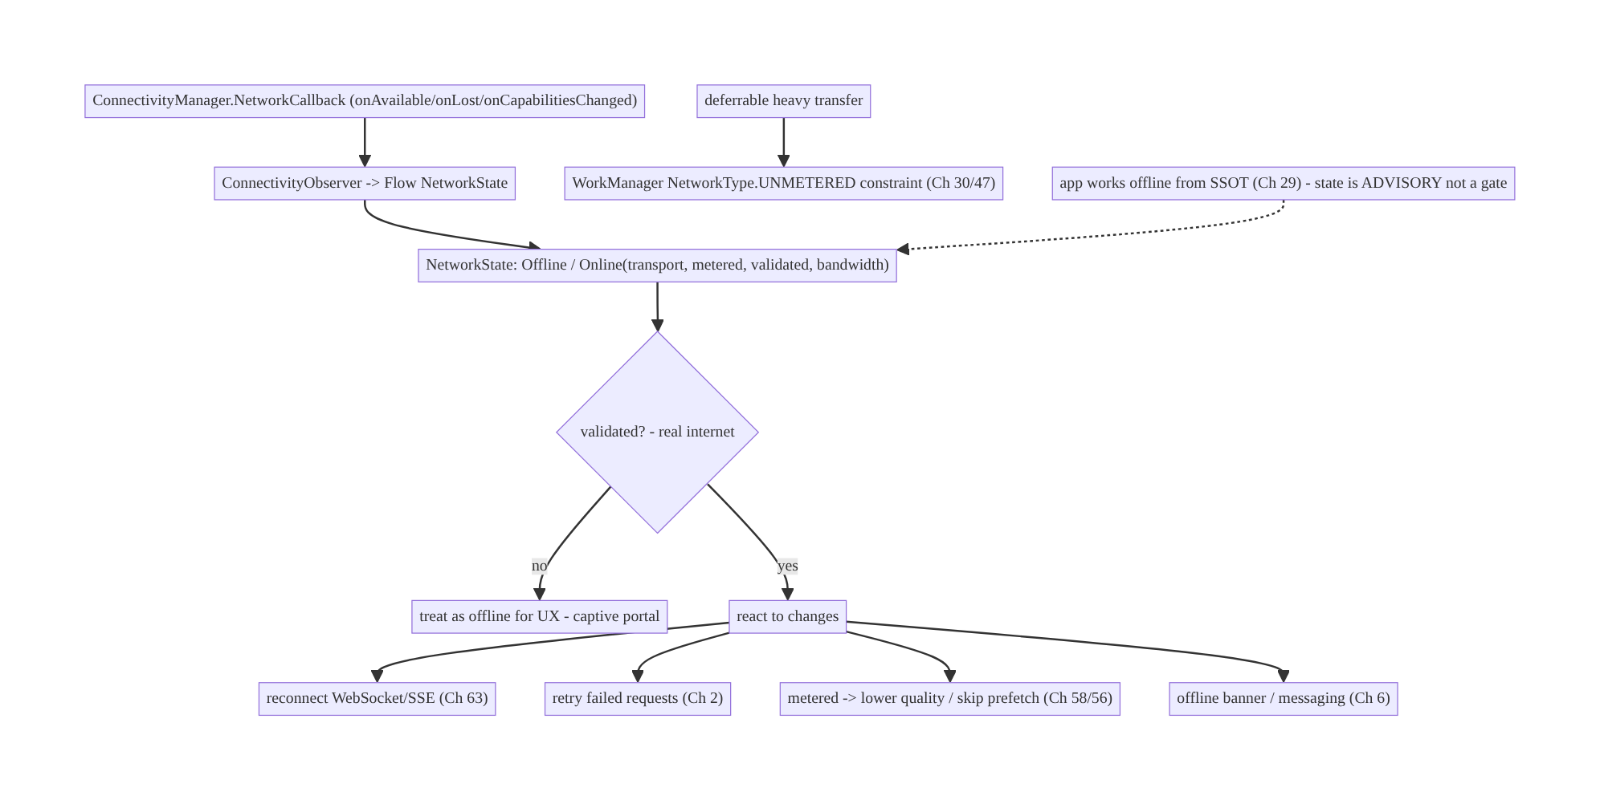
68.4 High-Level Architecture
Components & ownership
- ConnectivityObserver wraps NetworkCallback into one Flow<NetworkState> (single source).
- NetworkState carries connected + transport + metered + validated + bandwidth.
- Consumers react: real-time reconnect (Ch 63), retry (Ch 2), quality (Ch 58/56), UI (Ch 6); heavy transfers use WorkManager constraints (Ch 30/47).
- Advisory, not gating — offline-first (Ch 29) underlies it.
Direction: NetworkCallback → one Flow → validated/metered-aware state → consumers react (reconnect/retry/quality/UI); heavy work via WorkManager constraints; advisory only.

68.5 Detailed Component Design
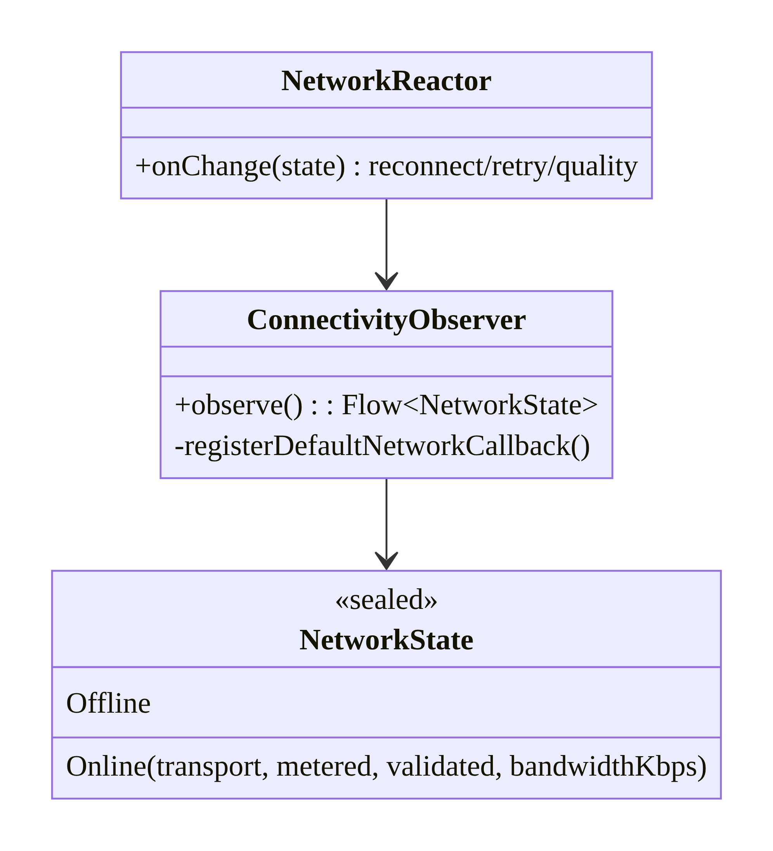
68.5 Detailed Component Design
Component | Responsibility
ConnectivityObserver | single Flow<NetworkState> from NetworkCallback
NetworkState | connected + transport + metered + validated + bandwidth
NetworkReactor | react: reconnect (Ch 63), retry (Ch 2), quality (Ch 58/56)
WorkManager constraints | defer heavy transfers to unmetered (Ch 30/47)

68.6 End-to-End Data Flow

Observe + react to recovery
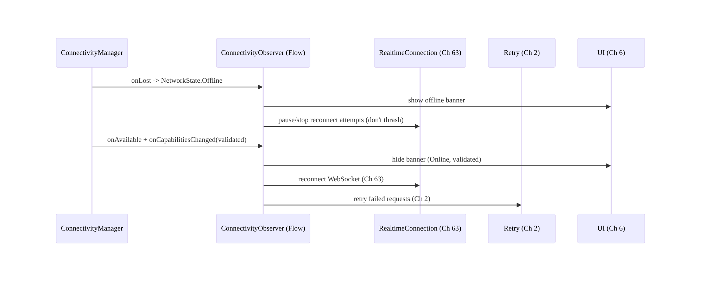
Observe + react to recovery

Metered-aware decision
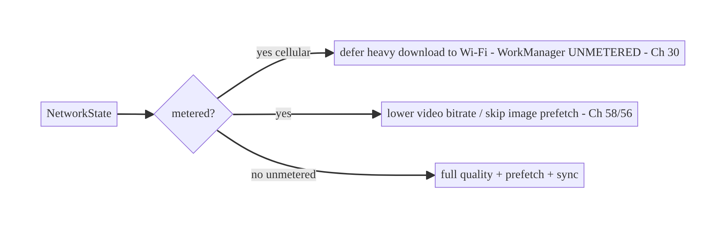
Metered-aware decision

68.7 Complete Kotlin Implementation
Package: com.streamcart.connectivity.

68.7.1 ConnectivityObserver: NetworkCallback → Flow (validated + metered + transport)
sealed interface NetworkState {
data object Offline : NetworkState
data class Online(val transport: Transport, val metered: Boolean, val validated: Boolean, val bandwidthKbps: Int) : NetworkState
enum class Transport { WIFI, CELLULAR, ETHERNET, OTHER }
}
@Singleton
class ConnectivityObserver @Inject constructor(@ApplicationContext private val ctx: Context) {
private val cm = ctx.getSystemService(ConnectivityManager::class.java)
fun observe(): Flow<NetworkState> = callbackFlow {
fun emitState() {
val caps = cm.activeNetwork?.let { cm.getNetworkCapabilities(it) }
trySend(caps?.toState() ?: NetworkState.Offline)
}
val callback = object : ConnectivityManager.NetworkCallback() {
override fun onAvailable(network: Network) = emitState()
override fun onLost(network: Network) = emitState()
override fun onCapabilitiesChanged(n: Network, c: NetworkCapabilities) = trySend(c.toState()).let {}
override fun onUnavailable() { trySend(NetworkState.Offline) }
}
cm.registerDefaultNetworkCallback(callback) // modern API (not deprecated polling/broadcast)
emitState() // initial
awaitClose { cm.unregisterNetworkCallback(callback) }
}.distinctUntilChanged().conflate() // de-dup transitions
private fun NetworkCapabilities.toState(): NetworkState {
val hasInternet = hasCapability(NetworkCapabilities.NET_CAPABILITY_INTERNET)
if (!hasInternet) return NetworkState.Offline
return NetworkState.Online(
transport = when {
hasTransport(NetworkCapabilities.TRANSPORT_WIFI) -> NetworkState.Transport.WIFI
hasTransport(NetworkCapabilities.TRANSPORT_CELLULAR) -> NetworkState.Transport.CELLULAR
hasTransport(NetworkCapabilities.TRANSPORT_ETHERNET) -> NetworkState.Transport.ETHERNET
else -> NetworkState.Transport.OTHER
},
metered = !hasCapability(NetworkCapabilities.NET_CAPABILITY_NOT_METERED), // KEY signal
validated = hasCapability(NetworkCapabilities.NET_CAPABILITY_VALIDATED), // real internet, not captive
bandwidthKbps = linkDownstreamBandwidthKbps,
)
}
}

68.7.2 React: reconnect + retry + offline banner (Ch 63/2/6)
@Singleton
class NetworkReactor @Inject constructor(
private val observer: ConnectivityObserver, private val realtime: RealtimeConnection, // Ch 63
private val retryScheduler: RetryScheduler, private val scope: CoroutineScope, // Ch 2
) {
fun start() = scope.launch {
observer.observe().collect { state ->
when (state) {
is NetworkState.Online -> if (state.validated) { // "connected" is not enough
realtime.reconnect() // reconnect WebSocket (Ch 63)
retryScheduler.retryPending() // retry failed requests (Ch 2)
} // not validated -> treat as offline for UX (captive portal)
NetworkState.Offline -> realtime.pause() // don't thrash reconnect while offline
}
}
}
}
// UI (Ch 6): val net by observer.observe().collectAsStateWithLifecycle(NetworkState.Offline)
// if (net !is Online || !net.validated) OfflineBanner()

68.7.3 Metered-aware behavior (quality/prefetch, Ch 58/56)
fun videoBitrateCap(state: NetworkState): Int = when {
state is NetworkState.Online && !state.metered -> Int.MAX_VALUE // unmetered -> full (Ch 58)
state is NetworkState.Online && state.metered -> 720 // metered -> cap (data respect)
else -> 0 // offline -> downloaded only (Ch 59)
}
fun shouldPrefetchImages(state: NetworkState): Boolean =
state is NetworkState.Online && !state.metered // skip prefetch on metered (Ch 56)

68.7.4 Defer heavy transfers to unmetered — WorkManager constraints (Ch 30/47)
// PREFER OS-enforced constraints over manual checks for deferrable background transfers.
fun scheduleBackup(workManager: WorkManager) = workManager.enqueue(
OneTimeWorkRequestBuilder<BackupWorker>()
.setConstraints(Constraints.Builder()
.setRequiredNetworkType(NetworkType.UNMETERED) // waits for Wi-Fi (Ch 30/47)
.setRequiresBatteryNotLow(true).build())
.build())
// Live Flow is for FOREGROUND/immediate decisions (banner, reconnect, quality);
// WorkManager constraints are for deferrable background work.

68.7.5 Advisory, not a gate (offline-first, Ch 29)
// WRONG: if (!online) { showNoInternetWall(); return } // over-gating
// RIGHT: feature works offline from SSOT (Ch 3/29); network state only informs UX/scheduling.
@Composable
fun FeedScreen(vm: FeedViewModel = hiltViewModel()) {
val feed by vm.feed.collectAsStateWithLifecycle() // from SSOT (Ch 3) - works offline
val net by vm.network.collectAsStateWithLifecycle(NetworkState.Offline)
Column {
if (net is NetworkState.Offline) OfflineBanner() // advisory only
FeedList(feed) // renders regardless of connectivity
}
}

68.7.6 Module structure
:core:connectivity ConnectivityObserver (Flow), NetworkState, NetworkReactor
# Consumers: real-time (Ch 63), retry (Ch 2), media quality (Ch 58/56), UI (Ch 6),
# WorkManager constraints (Ch 30/47). Offline-first underlies it (Ch 29).

68.8 Concurrency and Race Conditions
Scenario | Risk | Handling
Rapid Wi-Fi↔cellular flaps | thrash (reconnect storms) | distinctUntilChanged + debounce; jittered reconnect (Ch 2/63)
“Connected” but captive portal | fake online | check VALIDATED; treat non-validated as offline
Poll-based stale state | wrong decisions | callback-driven Flow (not polling)
Multiple observers register | leak/duplicate callbacks | single shared Flow (shareIn)
Reconnect while offline | wasted attempts | pause reconnect on Offline; resume on validated Online
Metered mis-detected as Wi-Fi | data burn | use NOT_METERED capability, not “is Wi-Fi”
Callback not unregistered | leak | awaitClose unregister; app-scoped
- VALIDATED prevents the captive-portal false-online: acting on onAvailable alone reconnects/retries against a network with no real internet; gating reactions on NET_CAPABILITY_VALIDATED avoids wasted attempts and wrong “online” UI.
- Debounce flaps + jittered reconnect: Wi-Fi↔cellular hand-offs flap quickly; distinctUntilChanged/conflate the state and use jittered reconnect (Ch 2/63) so you don’t thrash connections.
- One shared Flow: multiple independent callback registrations leak and duplicate; share a single Flow (shareIn/singleton) across all consumers.

68.9 Failure Scenarios and Recovery
Failure | Detection | Response | Outcome
Fake “online” (captive portal) | validated=false | treat as offline for UX | correct
Stale offline banner | polling/no callback | callback-driven Flow | accurate
Data-plan burn | metered ignored | respect NOT_METERED; defer/lower (Ch 30/58) | data saved
WebSocket stays dead after recovery | no reaction | reconnect on validated Online (Ch 63) | reconnects
Failed request never retried | no reaction | retry on recovery (Ch 2) | completes
Reconnect storm on flaps | thrash | debounce + jittered reconnect | stable
Feature blocked offline | over-gating | advisory-only; offline-first SSOT (Ch 29) | works
Callback leak | memory | unregister in awaitClose | no leak
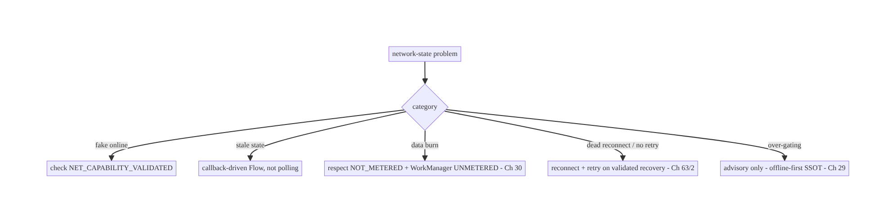
68.9 Failure Scenarios and Recovery
Two rules fix most network-state bugs: check VALIDATED (connected ≠ internet) and treat state as advisory, not a gate (offline-first, Ch 29). Build one callback-driven Flow, react to validated transitions (reconnect/retry/quality), respect metered (prefer WorkManager constraints for deferrable work), and never block an offline-capable feature on connectivity.

68.10 Scaling the Implementation
- Level 1. ConnectivityObserver Flow (connected/offline); offline banner (Ch 6).
- Level 2. Validated + metered + transport awareness; react (reconnect Ch 63, retry Ch 2); metered-aware quality (Ch 58/56).
- Level 3 — production. WorkManager constraints for deferrable transfers (Ch 30/47); debounced flaps + jittered reconnect; single shared Flow; advisory-not-gating (Ch 29).
- Level 4 — large. Bandwidth-adaptive behavior; per-feature network policies; captive- portal handling; data-saver mode respect.
- Level 5 — enterprise. Connectivity analytics (transport mix, validated rate, metered usage), network-policy governance, adaptive sync/transfer strategies, cross-platform parity.
Avoid overengineering: one observable NetworkState + validated/metered checks + WorkManager constraints covers most needs. Don’t poll, don’t gate offline-capable features, don’t scatter checks.

68.11 Alternative Approaches and Trade-offs
Dimension | Option A | Option B | When
Observe | NetworkCallback Flow | activeNetworkInfo polling / broadcast | Callback (modern, reactive); polling deprecated/stale
Online check | VALIDATED capability | connected only | Validated (connected ≠ internet)
Metered | NOT_METERED capability | “is Wi-Fi?” | Capability (some Wi-Fi metered, some cellular not)
Deferrable transfers | WorkManager constraints (Ch 30) | manual Flow checks | WorkManager (OS-enforced, Doze-aware, Ch 47)
Immediate decisions | Live Flow (reconnect/quality/UI) | WorkManager | Flow for foreground/immediate
Role | Advisory (UX/scheduling) | correctness gate | Advisory (offline-first, Ch 29)
Source | Single shared observer | per-screen checks | Single (consistency)
Callback Flow vs polling/broadcast: the deprecated activeNetworkInfo polling and CONNECTIVITY_ACTION broadcast are unreliable and stale — they miss transitions and capability details. A NetworkCallback wrapped in a callbackFlow pushes accurate, capability-rich state (transport/metered/validated) reactively. Always use the callback Flow.
Validated/metered capabilities vs naive checks: checking “connected” misses captive portals (fake online); checking “is Wi-Fi?” misses metered Wi-Fi and unmetered cellular. The OS capabilities (VALIDATED, NOT_METERED) are the correct signals — use them, not transport-type heuristics.
WorkManager constraints vs manual Flow checks for background transfers: for a deferrable transfer, declaring a NetworkType.UNMETERED constraint lets the OS wait for Wi-Fi, handle Doze, and retry (Ch 30/47) — far more robust than manually observing the Flow and launching work. Use WorkManager constraints for deferrable background work; reserve the live Flow for immediate foreground decisions (banner, reconnect, quality).

68.12 Security Considerations
- Don’t trust the network type for security: being on “Wi-Fi” or “a trusted network” is not a security boundary — always use TLS + certificate pinning (Ch 23) regardless of transport; a hostile Wi-Fi is a MITM risk.
- Captive portals (VALIDATED): a captive portal can intercept traffic; treat non-validated networks as untrusted/offline and rely on the OS captive-portal flow — don’t send sensitive requests assuming a clean path.
- Metered awareness is a user-cost concern, not security, but respect it (data plans).
- No sensitive data in connectivity logs (Ch 28); network state itself (transport/ metered) is low-sensitivity but don’t log identifiers.
- Data-saver mode: respect the user’s Data Saver setting (ConnectivityManager.getRestrictBackgroundStatus) — don’t do background data when the user restricted it.
- Client vs backend: network state is a client concern for UX/scheduling; the backend enforces auth/TLS regardless of the client’s transport (Ch 19/23) — never assume a “trusted network”.

68.13 Performance and Resource Optimization
- Callback over polling — no wasted periodic checks; react only on change.
- Single shared Flow (shareIn) — one callback for the whole app, not many.
- Debounce flaps (distinctUntilChanged/conflate) — avoid reconnect storms on hand-off (Ch 63).
- WorkManager constraints — OS schedules transfers in good conditions (unmetered/ charging, Ch 30/47) instead of the app spinning.
- Metered-aware — defer/lower on metered saves the user’s data and battery (radio).
- Bandwidth-adaptive — scale quality/prefetch to bandwidthKbps where useful.
- Profiling: reconnect frequency, metered-vs-unmetered data usage, validated rate, callback overhead (negligible), transfer deferral effectiveness.

68.14 Testing Strategy
ConnectivityObserver tests with a fake ConnectivityManager/shadow; reactions in isolation.
class ConnectivityObserverTest {
@Test fun `emits offline when no internet capability`() = runTest {
shadowCm.setNoNetwork()
assertEquals(NetworkState.Offline, observer.observe().first())
}
@Test fun `online but not validated is treated as offline for UX`() = runTest {
shadowCm.setCapabilities(internet = true, validated = false)
val s = observer.observe().first()
assertTrue(s is NetworkState.Online && !(s).validated) // consumer treats as offline
}
@Test fun `detects metered cellular`() = runTest {
shadowCm.setCapabilities(internet = true, validated = true, transport = CELLULAR, notMetered = false)
assertTrue((observer.observe().first() as NetworkState.Online).metered)
}
}
class NetworkReactorTest {
@Test fun `reconnects and retries on validated recovery`() = runTest {
emit(NetworkState.Offline); emit(online(validated = true))
assertTrue(realtime.reconnected && retry.retried)
}
@Test fun `does not reconnect when not validated`() = runTest { /* captive portal -> no reconnect */ }
}
class MeteredPolicyTest { @Test fun `skips prefetch and caps bitrate on metered`() { /* ... */ } }
What to test: observer maps capabilities → state (offline/validated/metered/transport); reactor reconnects+retries only on validated recovery (not captive portal); metered- aware quality/prefetch; WorkManager UNMETERED constraint on deferrable work; advisory-not- gating (feature renders offline); flap debounce. Use Robolectric shadow ConnectivityManager; instrumentation for real transitions.

68.15 Production Observability
- Metrics: validated rate (captive-portal frequency); metered vs unmetered data usage; reconnect frequency (flaps); transport mix (Wi-Fi/cellular); failed-request retry-on-recovery success; transfer-deferral effectiveness (how much heavy work ran on Wi-Fi); offline-banner accuracy.
- Logs: net{transport, metered, validated, event} — no identifiers/PII (Ch 28).
- Debugging: fake online → not checking VALIDATED; stale banner → polling / not callback-driven; data burn → metered ignored / not using WorkManager constraints; dead reconnect → not reacting to recovery (Ch 63); over-gating → blocking offline-capable features (Ch 29); reconnect storm → no flap debounce.
- Alerting: reconnect-storm spike; metered-data-usage spike (deferral regression); low validated rate (connectivity issues).
- Dashboards: transport mix + validated rate; metered data usage; reconnect frequency.

68.16 System Design Interview Preparation
≥25 questions.
Fundamentals
- Modern API? ConnectivityManager.NetworkCallback (wrap in a Flow); not deprecated polling/broadcast.
- Why not polling? Stale, misses transitions/capabilities.
- “Connected” vs “has internet”? Check NET_CAPABILITY_VALIDATED (captive portals).
- Capabilities that matter? Transport, NOT_METERED, VALIDATED, bandwidth.
- Derive what? A clean NetworkState (Offline / Online(transport, metered, validated, bandwidth)).
Metered/transport
- Metered signal? NET_CAPABILITY_NOT_METERED — not “is Wi-Fi”.
- Why not “is Wi-Fi”? Some Wi-Fi is metered; some cellular isn’t.
- On metered? Defer heavy transfers; lower quality; skip prefetch (Ch 30/58/56).
Reacting
- On recovery? Reconnect real-time (Ch 63) + retry failed requests (Ch 2) — if validated.
- While offline? Pause reconnect (don’t thrash); show banner.
- Deferrable transfers? WorkManager NetworkType.UNMETERED constraint (Ch 30/47).
- Flow vs WorkManager? Flow for immediate/foreground; constraints for deferrable background.
Advisory
- Is network state a correctness gate? No — advisory for UX/scheduling (offline-first, Ch 29).
- Over-gating? Blocking offline-capable features on connectivity — avoid.
- Offline features work how? From the SSOT (Ch 3); sync when online (Ch 32).
Correctness
- Captive portal? Non-validated → treat as offline for UX.
- Flaps? Debounce (distinctUntilChanged) + jittered reconnect.
- Single source? One shared observer Flow.
Security
- Trust the network type? No — TLS + pinning regardless (Ch 23).
- Data Saver? Respect getRestrictBackgroundStatus.
Testing/Production
- Test observer? Shadow ConnectivityManager → capabilities → state.
- Test reactor? Reconnect/retry only on validated.
- Fake online in prod? Not checking validated.
- Data burn? Metered ignored / no WorkManager constraint.
- Stale banner? Polling not callback.
- Key metrics? Validated rate, metered data usage, reconnect frequency.

Design-change challenges
- Offline banner + auto-reconnect. Observer Flow → banner (Ch 6) + reconnect on validated recovery (Ch 63).
- Don’t burn data on cellular. Respect NOT_METERED; defer downloads (WorkManager UNMETERED), cap bitrate (Ch 30/58).
- App shows “online” on a captive-portal Wi-Fi. Check VALIDATED.
- Failed requests don’t retry when Wi-Fi returns. React to recovery → retry (Ch 2).
- Feature blocked with a “no internet” wall though it works offline. Make state advisory; offline-first SSOT (Ch 29).

Mock walkthrough (abridged)
Clarify (what reacts to network, metered-sensitive, offline-capable?) → one ConnectivityObserver Flow from NetworkCallback → NetworkState (transport/metered/ validated) → react (reconnect Ch 63, retry Ch 2, quality Ch 58/56, banner Ch 6) → defer heavy work via WorkManager constraints (Ch 30/47) → advisory-not-gating (offline-first, Ch 29) → security (TLS regardless, Data Saver) → observability (validated rate, metered usage).

68.17 Practical Exercises
- Beginner. Build a ConnectivityObserver Flow from registerDefaultNetworkCallback emitting Offline/Online, and drive an offline banner (Ch 6). Eval: reactive; accurate.
- Intermediate. Extend NetworkState with transport + metered + validated; treat non-validated (captive portal) as offline for UX. Eval: correct online detection.
- Advanced. React to validated recovery by reconnecting the WebSocket (Ch 63) and retrying failed requests (Ch 2); debounce flaps. Eval: reconnects; no storm.
- Production debugging. Fix data-plan burn (metered ignored → add WorkManager UNMETERED
  - bitrate cap) and a “no internet” wall on an offline-capable feature. Eval: data saved; feature works offline.
- System design challenge. Make one shared observer feed UI + real-time + transfers, add bandwidth-adaptive quality, and a validated-rate/metered-usage dashboard. Eval: single source; adaptive; observable.
(Solutions withheld unless requested.)

68.18 Chapter Summary & Reference Sheet
Key decisions: expose network state as a single observable Flow built on ConnectivityManager.NetworkCallback (registerDefaultNetworkCallback, wrapped in a callbackFlow and shared) — never the deprecated activeNetworkInfo polling or CONNECTIVITY_ACTION broadcast — reporting connected + transport (Wi-Fi/cellular) + metered + validated + bandwidth, and critically check NET_CAPABILITY_VALIDATED because “connected” ≠ “has internet” (captive portals) and use NET_CAPABILITY_NOT_ METERED (not “is Wi-Fi”) for the metered signal; react to validated transitions — reconnect real-time (Ch 63), retry failed requests (Ch 2), adjust quality/prefetch on metered (Ch 58/56), show an offline banner (Ch 6) — while deferring heavy background transfers to unmetered via WorkManager constraints (NetworkType.UNMETERED, OS-enforced, Ch 30/47) rather than manual checks; debounce flaps and use jittered reconnect to avoid storms (Ch 2/63); and treat network state as advisory for UX and scheduling, never a correctness gate — the app works offline from the SSOT (Ch 29) and syncs when suitable connectivity returns. Never trust the network type as a security boundary — TLS + pinning regardless (Ch 23) — and respect Data Saver.
Concepts: NetworkCallback Flow, capabilities (transport/NOT_METERED/VALIDATED/ bandwidth), validated (connected ≠ internet), metered-aware behavior, react (reconnect/ retry/quality/UI), WorkManager constraints for deferrable work, advisory-not-gating (offline-first), single source, flap debounce.
Common mistakes: polling/deprecated APIs (stale); treating “connected” as online (captive portal — missing VALIDATED); using “is Wi-Fi” for metered (missing NOT_METERED); not reacting to recovery (dead reconnect/no retry); manual checks instead of WorkManager constraints for background transfers; gating offline-capable features on connectivity (over-gating); scattered per-screen checks; no flap debounce (reconnect storms); trusting the network type for security.
Checklist:
- ☐ NetworkCallback Flow (single shared source), not polling
- ☐ check VALIDATED (connected ≠ internet)
- ☐ use NOT_METERED capability (not “is Wi-Fi”)
- ☐ react to validated recovery: reconnect (Ch 63) + retry (Ch 2)
- ☐ metered-aware quality/prefetch (Ch 58/56)
- ☐ defer heavy transfers via WorkManager UNMETERED (Ch 30/47)
- ☐ debounce flaps + jittered reconnect
- ☐ advisory, not a gate — offline-first SSOT (Ch 29)
- ☐ TLS+pinning regardless of transport (Ch 23)
- ☐ respect Data Saver
- ☐ validated-rate + metered-usage telemetry.
Key APIs: ConnectivityManager.registerDefaultNetworkCallback/registerNetworkCallback/ unregisterNetworkCallback, NetworkCallback (onAvailable/onLost/ onCapabilitiesChanged/onUnavailable), NetworkCapabilities (NET_CAPABILITY_VALIDATED/ NET_CAPABILITY_NOT_METERED/NET_CAPABILITY_INTERNET/TRANSPORT_*/ linkDownstreamBandwidthKbps), callbackFlow/distinctUntilChanged/shareIn, WorkManager Constraints/NetworkType.UNMETERED (Ch 30), getRestrictBackgroundStatus (Data Saver).
References:
- Monitor connectivity: https://developer.android.com/training/monitoring-device-state/connectivity-status-type
- NetworkCapabilities: https://developer.android.com/reference/android/net/NetworkCapabilities
- WorkManager constraints: https://developer.android.com/develop/background-work/background-tasks/persistent/getting-started/define-work#work-constraints
- (composes) Ch 1 Networking, Ch 2 Retries, Ch 29 Offline-First, Ch 30 WorkManager, Ch 63 WebSocket, Ch 58/56 Media, Ch 23 Security

Chapter 69 — Bluetooth Low Energy (BLE) Connectivity
Part VIII — Real-Time & Connectivity · Complexity: Complex (≥40 interview questions)
Prerequisites: Ch 51 (runtime permissions), Ch 46 (foreground services), Ch 44 (lifecycle), Ch 2 (retries/backoff), Ch 3 (SSOT), Ch 1 (coroutines), Ch 28 (privacy). Pairs with Ch 70 (Nearby/P2P), Ch 67 (location), Ch 68 (network state).
Reference surface in StreamCart: connecting to BLE peripherals — a delivery scanner, a smart lock for pickup lockers, a fitness/wearable accessory, a beacon for in-store proximity — through Android’s notoriously complex, callback-heavy, permission- and lifecycle-sensitive BLE stack, wrapped into a reliable coroutine/Flow API.

69.1 Problem Definition and Real-World Context
Bluetooth Low Energy is one of the hardest, most device-fragmented, most callback- driven APIs on Android. The platform BluetoothGatt API is a maze of asynchronous callbacks, strict operation serialization (you must do one GATT operation at a time), permission changes across OS versions (Ch 51), location coupling (scanning historically needed location, Ch 67), aggressive OEM/radio quirks, and fragile connection lifecycles. A naive BLE integration (scan, connect, read) works on the developer’s phone and fails everywhere else — dropped connections, 133 errors, out-of-order operations, permission denials, and battery drain.
Concretely, teams hit:
- Callback hell + operation serialization. BluetoothGatt requires every operation (connect, discover services, read/write characteristic, enable notifications, request MTU) to be issued one at a time, each completing via a callback before the next — issuing two concurrently silently fails. You must queue and serialize GATT operations.
- Permission churn (Ch 51). Pre-Android-12 scanning needed location permission (Ch 67); Android 12+ introduced BLUETOOTH_SCAN/BLUETOOTH_CONNECT/ BLUETOOTH_ADVERTISE runtime permissions (with a neverForLocation scan flag to decouple from location). Getting the per-version matrix wrong → denied scans/connections.
- Fragile connections + the dreaded 133. BLE connections drop constantly (range, interference, device sleep); GATT_ERROR (status 133) is a catch-all. You need retry with backoff (Ch 2), connection state management, and reconnection.
- Lifecycle & background (Ch 44/46). Scanning/connections drain battery; background BLE is restricted. Scope to active sessions; use a foreground service (Ch 46, connectedDevice) for ongoing connections (e.g., a live scanner session).
- Device fragmentation. OEM Bluetooth stacks differ wildly (connection params, MTU, caching bugs, bonding quirks) — you must be defensive (retries, timeouts, refresh hacks) and test on a device matrix.
- GATT concepts. Central vs peripheral, services/characteristics/descriptors, read/write/notify/indicate, MTU, bonding/pairing — the domain model to get right.
The architecture: wrap the callback-heavy BluetoothGatt in a coroutine/Flow API with a serialized GATT operation queue (one op at a time) and timeouts; manage the permission matrix (Ch 51, BLUETOOTH_SCAN/CONNECT, neverForLocation, legacy location); model the connection as a state machine with retry/backoff (Ch 2) and reconnection; scope to active lifecycle and use a connectedDevice foreground service (Ch 46) for ongoing sessions; handle GATT operations (discover, read/write, notify, MTU, bonding) correctly; be defensive about device fragmentation; and treat device data/identity as sensitive (Ch 28). This chapter is about taming BLE into a reliable, coroutine-friendly connectivity layer.

Three practical use cases
- Delivery/pickup smart lock (StreamCart). Scan for the locker’s BLE peripheral, connect (serialized GATT), authenticate, write an “unlock” characteristic — with retry/backoff and a connectedDevice FGS during the session.
- Wearable/accessory. Connect to a fitness band, subscribe to notifications (heart-rate characteristic), stream readings into the SSOT (Ch 3), reconnect on drop.
- Beacon proximity (scan-only). Passive scan for in-store beacons (with neverForLocation where appropriate) to show contextual offers — scan-only, no GATT connection.

Why this is architectural
BLE composes permissions (Ch 51), foreground services (Ch 46), lifecycle (Ch 44), retries (Ch 2), SSOT (Ch 3), and coroutines (Ch 1), against the most fragmented, callback-driven, quirk-ridden API in the platform. The decisions — coroutine-wrapped serialized GATT queue, permission matrix, connection state machine + retry, lifecycle/FGS scoping, defensive fragmentation handling — determine whether BLE is reliable at all across real devices.

69.2 Requirements Engineering

Functional requirements
ID | Requirement
F1 | Scan for peripherals (filtered), connect, discover services (serialized GATT).
F2 | Read/write characteristics, subscribe to notifications, negotiate MTU, bond.
F3 | Serialize all GATT operations (one at a time) with timeouts; expose as coroutines/Flow.
F4 | Handle the permission matrix (BLUETOOTH_SCAN/CONNECT, neverForLocation, legacy location) (Ch 51).
F5 | Manage connection state + retry/backoff + reconnection (Ch 2); scope to lifecycle/FGS (Ch 44/46).
F6 | Be defensive about device fragmentation; treat device data as sensitive (Ch 28).

Non-functional requirements
Attribute | Policy
Reliability | Serialized ops; retry 133/drops; reconnection; works across OEMs.
Battery | Scan/connect only when needed; FGS for sessions; stop promptly (Ch 46/44).
Correctness | One GATT op at a time; timeouts; state machine.
Compatibility | Defensive against device/OEM quirks; device-matrix tested.
Security/Privacy | Permission-gated; bonding/auth; device identity sensitive (Ch 28).

Scope
- In scope: BLE domain (central/peripheral, GATT services/characteristics/descriptors, read/write/notify/indicate, MTU, bonding), scanning (filters, neverForLocation), serialized GATT operation queue + coroutine/Flow wrapper + timeouts, connection state machine + retry/backoff (Ch 2) + reconnection, permission matrix (Ch 51), lifecycle + connectedDevice FGS (Ch 44/46), fragmentation defensiveness, SSOT for device data (Ch 3), privacy (Ch 28).
- Out of scope: Classic Bluetooth (BR/EDR), BLE peripheral/advertiser role detail, Nearby/P2P (Ch 70), permission state machine (Ch 51), FGS mechanics (Ch 46), backoff theory (Ch 2), specific GATT profiles.

Assumptions & constraints
- Android BluetoothGatt/BluetoothLeScanner, Kotlin coroutines/Flow (Ch 1), minSdk 24, targetSdk current (Android 12+ Bluetooth permissions). The device is central (phone) connecting to peripherals. GATT requires strict serialization; BLE is fragile and fragmented; location coupling varies by version.

69.3 System Design Fundamentals
- BLE domain model (central/peripheral/GATT).
  - Roles: the phone is usually the central (initiates); the accessory is the peripheral (advertises, exposes data). (Android can also be a peripheral/advertiser — out of scope here.)
  - GATT: a peripheral exposes services, each with characteristics (the data values), each with optional descriptors (metadata, notably the CCCD to enable notifications). You read/write characteristics, subscribe to notify/ indicate (peripheral pushes changes), and may negotiate MTU (larger packets) and bond (pair for security).
- GATT operations MUST be serialized (the #1 correctness rule). BluetoothGatt allows one outstanding operation at a time — issue readCharacteristic, wait for onCharacteristicRead, then the next. Issuing two concurrently (e.g., read + write, or two reads) silently fails (the second is dropped). So you must maintain a serialized operation queue: enqueue each op, run it, wait for its callback (with a timeout for the ones that never call back — common on buggy stacks), then dequeue the next. This is the core of any usable BLE wrapper.
- Wrap callbacks in coroutines/Flow (Ch 1). The raw API is a BluetoothGattCallback with ~15 callbacks. Wrap each operation as a suspendCancellableCoroutine (resumes on its callback) behind the serialized queue, and expose notifications as a Flow (callbackFlow). This turns callback hell into sequential, cancellable coroutine code: connect() → discoverServices() → read(...) → subscribe(...).collect { }.
- Connection state machine + retry (Ch 2). Model connection as Disconnected → Connecting → Connected → (Disconnecting), driven by onConnectionStateChange. BLE connections drop constantly and throw GATT_ERROR (status 133) — a catch-all for “something went wrong.” Handle it with retry + exponential backoff (Ch 2), bounded attempts, and reconnection when a session should persist. Always close() the BluetoothGatt on disconnect (leaking GATT clients is a classic bug that exhausts the stack).
- Permission matrix (Ch 51) — version-dependent:
  - Android 12+ (API 31+): BLUETOOTH_SCAN, BLUETOOTH_CONNECT (and BLUETOOTH_ADVERTISE for peripheral) are runtime permissions (Ch 51). Add android:usesPermissionFlags="neverForLocation" to BLUETOOTH_SCAN if you don’t derive location from BLE — this decouples scanning from location permission.
  - Pre-Android-12: scanning required ACCESS_FINE_LOCATION (Ch 67) plus BLUETOOTH/BLUETOOTH_ADMIN.
  - Request in context with graceful denial (Ch 51); the matrix is a frequent source of “scan returns nothing” bugs.
- Scanning efficiently. Use ScanFilter (by service UUID/name/address) to only wake for relevant devices, and ScanSettings balancing latency vs power (SCAN_MODE_LOW_POWER/BALANCED/LOW_LATENCY). Stop scanning once you find/connect (scanning is battery-heavy). Avoid continuous background scanning.
- Lifecycle & background (Ch 44/46). BLE scanning/connections drain battery and are background-restricted. Scope to active sessions (Ch 44): scan when the user initiates, stop when done. For an ongoing connected session (streaming from a wearable, holding a lock connection), use a connectedDevice foreground service (Ch 46) with a notification — don’t hold BLE silently in the background.
- Device fragmentation (be defensive). OEM stacks vary enormously: connection parameters, MTU support, GATT caching bugs (sometimes needing a hidden refresh()), bonding quirks, autoConnect behavior, and timing. Be defensive: timeouts on every op, retries (Ch 2), bounded assumptions, connect on the main thread (a known requirement on some devices), and device-matrix testing — BLE that works on a Pixel often fails on specific OEMs.
- Data into the SSOT (Ch 3). Readings/state from the peripheral flow into the SSOT (Room, Ch 3); the UI observes it (UDF, Ch 6). Device connection state is transient UI state.
- Security/bonding (Ch 28). For sensitive peripherals (locks, medical), use bonding/ pairing (encrypted link) and authenticate at the app layer (don’t trust proximity alone); device identity/data is sensitive (Ch 28) — minimize, secure, don’t log.
Core insight: tame BLE by wrapping the callback-heavy BluetoothGatt in a coroutine/Flow API built on a strictly serialized GATT operation queue (one operation at a time, each awaited via suspendCancellableCoroutine with a timeout — concurrent ops silently fail); model the connection as a state machine with retry + exponential backoff for the inevitable drops and status-133 errors (Ch 2), always closing the GATT client; navigate the version-dependent permission matrix (BLUETOOTH_SCAN/CONNECT + neverForLocation on Android 12+, legacy location before, Ch 51); scan with filters and stop promptly; scope to the active lifecycle and use a connectedDevice foreground service for ongoing sessions (Ch 44/46); be defensive about severe device/OEM fragmentation (timeouts, retries, matrix testing); and treat device identity/data as sensitive with bonding + app-layer auth (Ch 28).

69.4 High-Level Architecture
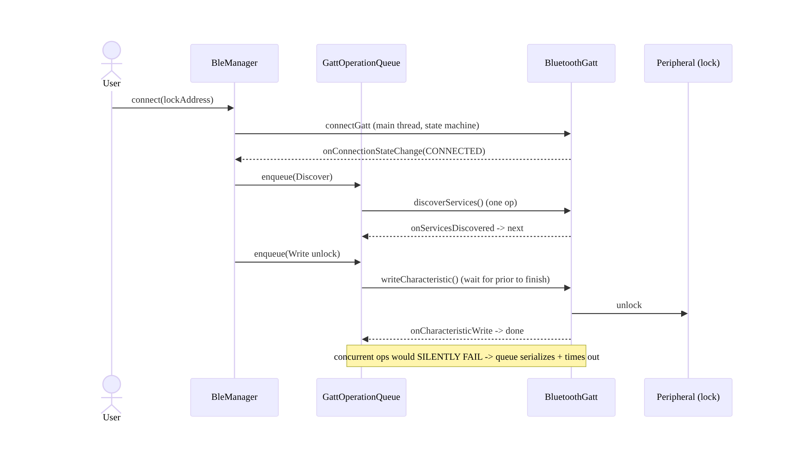
69.4 High-Level Architecture
Components & ownership
- Permission gate (Ch 51) → scan (filtered, stop promptly) → connect (state machine + retry 133, Ch 2).
- Serialized GATT queue runs one op at a time (discover/read/write/notify/MTU/bond), each coroutine-awaited with a timeout.
- Notifications → Flow → SSOT (Ch 3); connectedDevice FGS for ongoing sessions (Ch 46); lifecycle scopes it.
Direction: session → permission → scan → connect (state machine + retry) → serialized GATT ops (coroutine/Flow) → SSOT; FGS for sessions; defensive + lifecycle-scoped.

69.5 Detailed Component Design
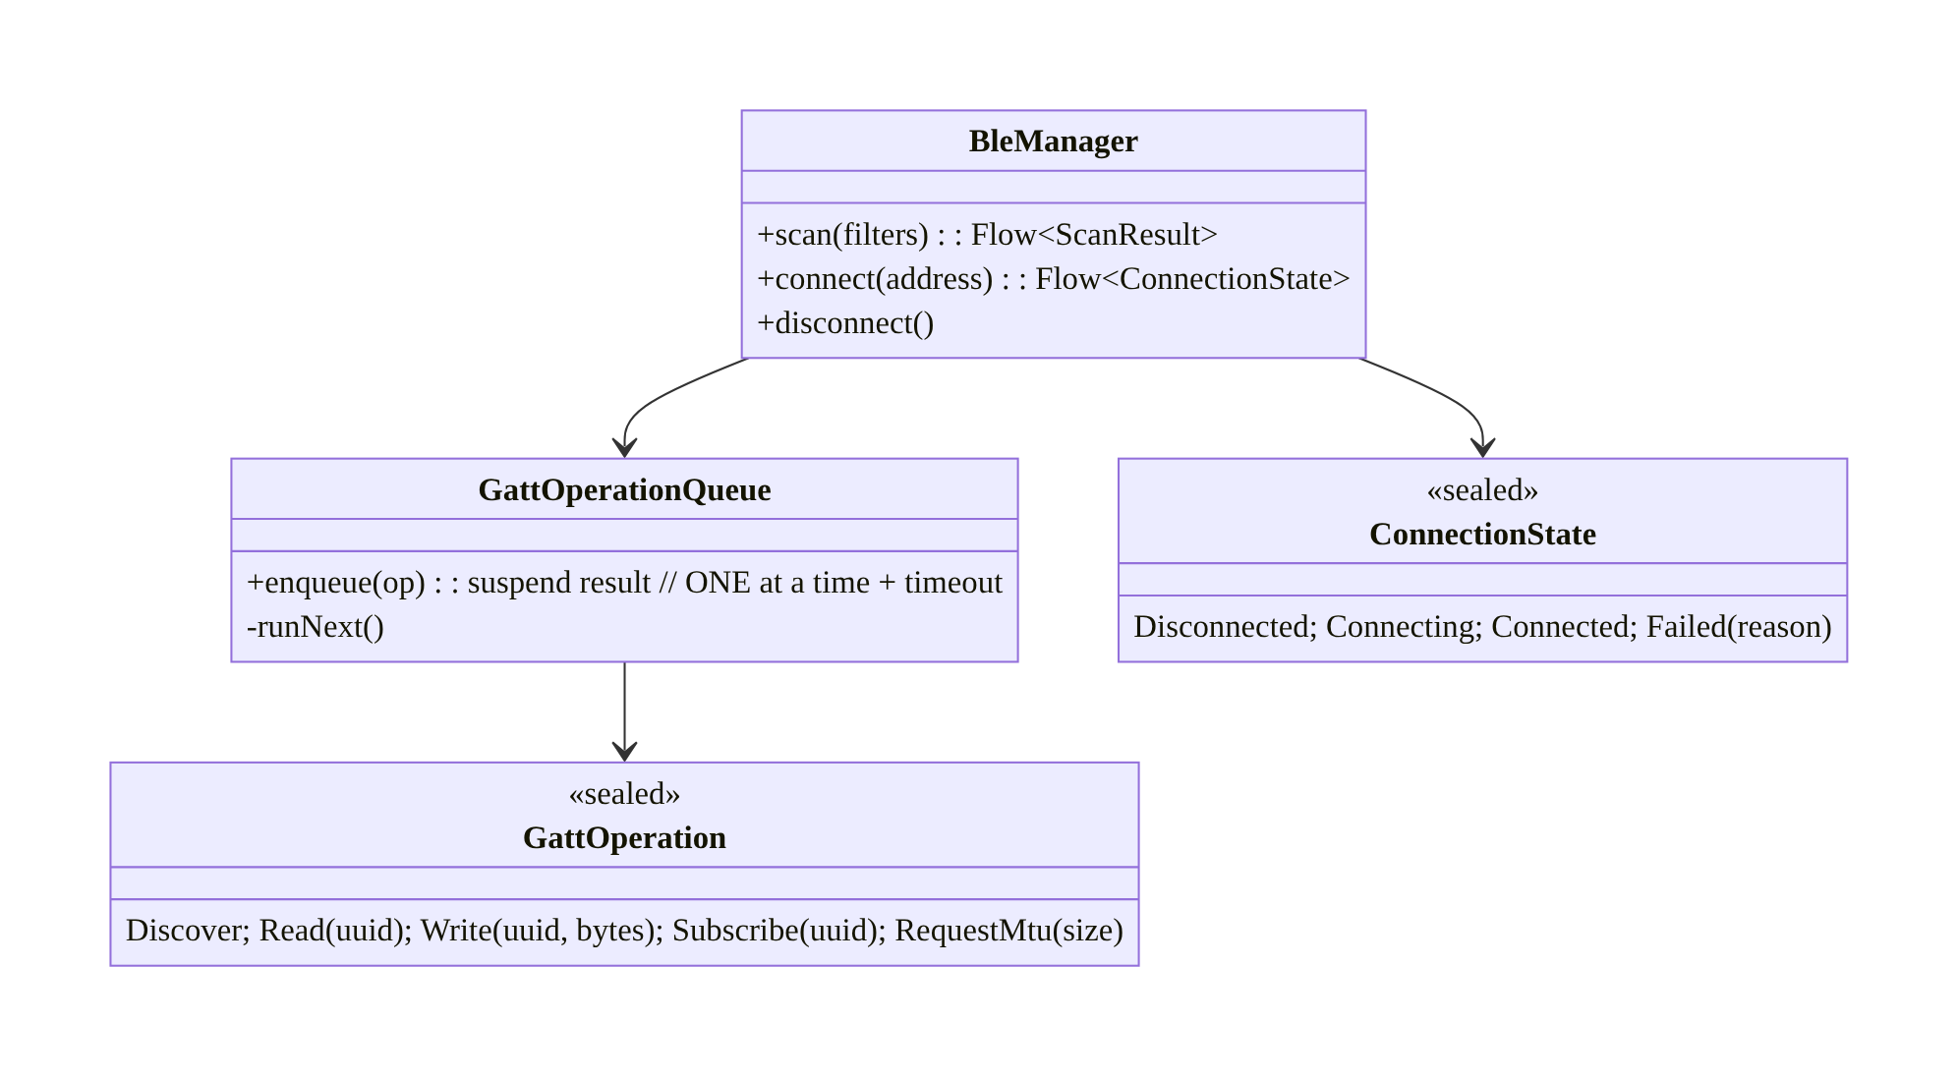
69.5 Detailed Component Design
Component | Responsibility
BleManager | scan/connect/disconnect; expose coroutine/Flow API
GattOperationQueue | serialize GATT ops (one at a time) + timeouts (the crux)
ConnectionState | state machine driven by onConnectionStateChange + retry (Ch 2)
GattOperation | typed ops (discover/read/write/subscribe/MTU/bond)

69.6 End-to-End Data Flow

Connect + serialized operations
Connect + serialized operations

Drop + retry (133)
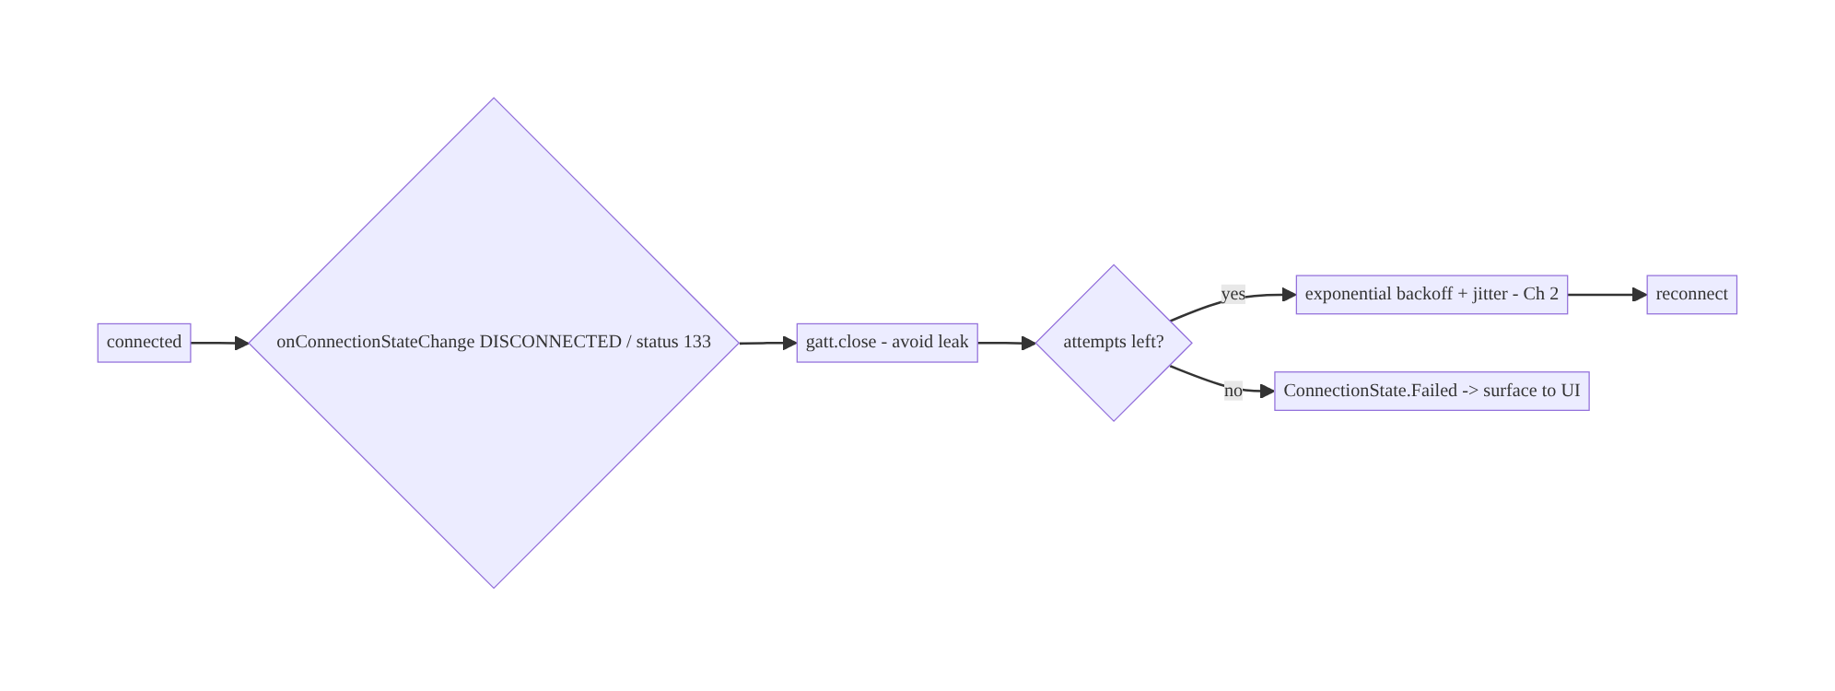
Drop + retry (133)

69.7 Complete Kotlin Implementation
Package: com.streamcart.ble.

69.7.1 Permissions (Android 12+ matrix, Ch 51)
<!-- Android 12+ (API 31+): runtime permissions -->
<uses-permission android:name="android.permission.BLUETOOTH_SCAN"
android:usesPermissionFlags="neverForLocation" /> <!-- decouple scan from location (Ch 67) -->
<uses-permission android:name="android.permission.BLUETOOTH_CONNECT" />
<!-- Pre-12: legacy -->
<uses-permission android:name="android.permission.BLUETOOTH" android:maxSdkVersion="30" />
<uses-permission android:name="android.permission.BLUETOOTH_ADMIN" android:maxSdkVersion="30" />
<uses-permission android:name="android.permission.ACCESS_FINE_LOCATION" android:maxSdkVersion="30" /> <!-- legacy scan (Ch 67) -->
<uses-permission android:name="android.permission.FOREGROUND_SERVICE_CONNECTED_DEVICE" /> <!-- Ch 46 -->

69.7.2 Serialized GATT operation queue (the crux)
sealed interface GattOp {
data object Discover : GattOp
data class Read(val uuid: UUID) : GattOp
data class Write(val uuid: UUID, val bytes: ByteArray) : GattOp
data class Subscribe(val uuid: UUID) : GattOp
data class RequestMtu(val size: Int) : GattOp
}
class GattOperationQueue(private val gatt: BluetoothGatt) {
private val mutex = Mutex()
private var pending: CancellableContinuation<ByteArray?>? = null
/** Run ONE operation at a time; await its callback with a timeout (buggy stacks never call back). */
suspend fun execute(op: GattOp): ByteArray? = mutex.withLock { // serialize
withTimeout(OP_TIMEOUT_MS) { // defensive timeout
suspendCancellableCoroutine { cont ->
pending = cont
val issued = when (op) {
is GattOp.Discover -> gatt.discoverServices()
is GattOp.Read -> gatt.readCharacteristic(gatt.characteristic(op.uuid))
is GattOp.Write -> gatt.writeCharacteristic(gatt.characteristic(op.uuid).apply { value = op.bytes })
is GattOp.Subscribe -> enableNotifications(op.uuid) // setCharacteristicNotification + CCCD write
is GattOp.RequestMtu -> gatt.requestMtu(op.size)
}
if (!issued) cont.resumeWithException(BleException("op not issued")) // stack rejected it
cont.invokeOnCancellation { pending = null }
}
}
}
// Called from BluetoothGattCallback (onServicesDiscovered/onCharacteristicRead/Write/onMtuChanged):
fun onResult(value: ByteArray?) { pending?.resume(value); pending = null }
fun onError(status: Int) { pending?.resumeWithException(BleException("status $status")); pending = null }
}

69.7.3 BleManager: connect (state machine + retry 133), coroutine/Flow API
@Singleton
class BleManager @Inject constructor(@ApplicationContext private val ctx: Context) {
private val adapter = ctx.getSystemService(BluetoothManager::class.java).adapter
@SuppressLint("MissingPermission") // BLUETOOTH_CONNECT checked first (Ch 51)
fun connect(address: String): Flow<ConnectionState> = callbackFlow {
var attempt = 0
var gatt: BluetoothGatt? = null
lateinit var queue: GattOperationQueue
val callback = object : BluetoothGattCallback() {
override fun onConnectionStateChange(g: BluetoothGatt, status: Int, newState: Int) {
when {
status != BluetoothGatt.GATT_SUCCESS -> { // status 133 etc.
g.close() // ALWAYS close (avoid leak)
if (attempt++ < MAX_RETRIES) launch { delay(backoff(attempt)); gatt = reconnect() } // retry (Ch 2)
else trySend(ConnectionState.Failed("status $status"))
}
newState == BluetoothProfile.STATE_CONNECTED -> { attempt = 0; trySend(ConnectionState.Connected(queue)) }
newState == BluetoothProfile.STATE_DISCONNECTED -> { g.close(); trySend(ConnectionState.Disconnected) }
}
}
override fun onServicesDiscovered(g: BluetoothGatt, status: Int) = routeResult(status, null)
override fun onCharacteristicRead(g: BluetoothGatt, c: BluetoothGattCharacteristic, status: Int) = routeResult(status, c.value)
override fun onCharacteristicWrite(g: BluetoothGatt, c: BluetoothGattCharacteristic, status: Int) = routeResult(status, null)
override fun onMtuChanged(g: BluetoothGatt, mtu: Int, status: Int) = routeResult(status, null)
override fun onCharacteristicChanged(g: BluetoothGatt, c: BluetoothGattCharacteristic) {
trySend(ConnectionState.Notification(c.uuid, c.value)) // notifications -> Flow
}
private fun routeResult(status: Int, value: ByteArray?) =
if (status == BluetoothGatt.GATT_SUCCESS) queue.onResult(value) else queue.onError(status)
}
trySend(ConnectionState.Connecting)
gatt = adapter.getRemoteDevice(address).connectGatt(ctx, /*autoConnect*/ false, callback, BluetoothDevice.TRANSPORT_LE)
queue = GattOperationQueue(gatt!!)
awaitClose { gatt?.close() } // close on cancel (lifecycle, Ch 44)
}
}

69.7.4 Using it: sequential coroutine flow (unlock a lock)
suspend fun unlockLocker(ble: BleManager, address: String, token: ByteArray) {
ble.connect(address).collect { state ->
when (state) {
is ConnectionState.Connected -> {
val q = state.queue
q.execute(GattOp.Discover) // 1) discover (awaited)
q.execute(GattOp.RequestMtu(185)) // 2) bigger MTU (awaited)
q.execute(GattOp.Write(UNLOCK_CHAR, token)) // 3) authenticate + unlock (awaited)
// Each awaits the prior's callback (serialized) — no silent failures.
}
is ConnectionState.Failed -> { /* surface error (Ch 2 exhausted) */ }
else -> {}
}
}
}

69.7.5 Scanning (filtered, stop promptly) + connectedDevice FGS (Ch 46)
@SuppressLint("MissingPermission") // BLUETOOTH_SCAN checked (Ch 51)
fun BleManager.scan(serviceUuid: UUID): Flow<ScanResult> = callbackFlow {
val scanner = adapter.bluetoothLeScanner
val filters = listOf(ScanFilter.Builder().setServiceUuid(ParcelUuid(serviceUuid)).build()) // only relevant devices
val settings = ScanSettings.Builder().setScanMode(ScanSettings.SCAN_MODE_BALANCED).build() // battery
val cb = object : ScanCallback() { override fun onScanResult(type: Int, r: ScanResult) { trySend(r) } }
scanner.startScan(filters, settings, cb)
awaitClose { scanner.stopScan(cb) } // STOP scanning when done/found (battery)
}
// Ongoing connected session -> run inside a connectedDevice foreground service (Ch 46) with a notification.

69.7.6 Module structure
:core:ble BleManager, GattOperationQueue, ConnectionState, GattOp, scan
:feature:lock connectedDevice FGS session (Ch 46), unlock flow
# Permissions -> Ch 51; retries -> Ch 2; device data -> SSOT (Ch 3); lifecycle -> Ch 44.

69.8 Concurrency and Race Conditions
Scenario | Risk | Handling
Concurrent GATT ops | silent failure (second dropped) | serialized queue (Mutex) — one at a time
Op never calls back (buggy stack) | queue stalls forever | per-op timeout (withTimeout)
GATT not closed on disconnect | stack exhaustion / can’t reconnect | always gatt.close()
Status 133 / random drop | connection fails | retry + backoff (Ch 2); bounded
Notifications before CCCD enabled | no data | enable notifications (setCharacteristicNotification + CCCD write) serialized
Connect off main thread (some OEMs) | fails | connect on main thread
Scan never stopped | battery drain | stop on found/done; lifecycle-scoped (Ch 44)
Double connect to same device | undefined | single GATT client per device; close before reconnect
- Serialization is the whole game: BluetoothGatt processes one operation at a time; a second concurrent op is silently dropped. The Mutex-guarded queue (each op awaited via suspendCancellableCoroutine) guarantees ordering. Without it, BLE is flaky and “works sometimes.”
- Timeouts are mandatory (fragmentation): buggy OEM stacks sometimes never fire the callback; a per-op withTimeout fails the op (and lets you retry/reset) instead of deadlocking the queue forever.
- Always close() the GATT: leaking BluetoothGatt clients exhausts the Android Bluetooth stack (a hard limit on concurrent clients) and causes “can’t connect anymore” until the Bluetooth is toggled — close on disconnect, failure, and cancellation.

69.9 Failure Scenarios and Recovery
Failure | Detection | Response | Outcome
Status 133 / connection fails | callback status | retry + backoff; close + reconnect (Ch 2) | connects
Concurrent-op silent failure | missing result | serialized queue | reliable
Op hangs (no callback) | timeout | withTimeout fail + retry | no deadlock
GATT leak → can’t connect | repeated failures | always close() | recovers
Scan returns nothing | no results | fix permission matrix (Ch 51); correct filters | scans
Works on Pixel, fails on OEM | device-matrix | defensive timeouts/retries/refresh; test matrix | compatible
Battery drain | vitals | stop scan/disconnect promptly; FGS only for sessions (Ch 44/46) | battery ok
Permission denied | Ch 51 | rationale → settings; degrade | recoverable
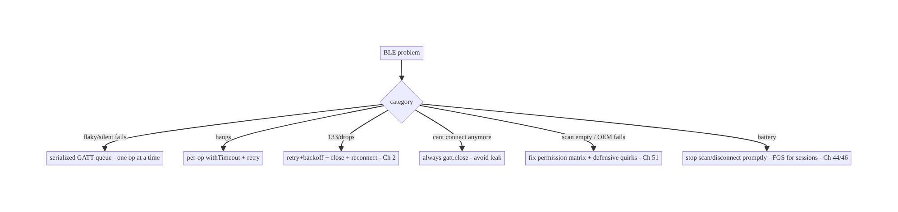
69.9 Failure Scenarios and Recovery
BLE reliability rests on three mechanics: serialize every GATT operation (concurrent ops silently fail), time out each operation (buggy stacks never call back), and always close the GATT client (leaks exhaust the stack) — all wrapped in retry+backoff for the inevitable status-133 drops. Get those right, be defensive about OEM fragmentation, and gate on the correct permission matrix, and BLE becomes usable.

69.10 Scaling the Implementation
- Level 1. Scan (filtered) + connect + serialized GATT queue + coroutine/Flow wrapper; read/write.
- Level 2. Connection state machine + retry/backoff for 133/drops (Ch 2); notifications as Flow → SSOT (Ch 3); MTU/bonding; always-close.
- Level 3 — production. Permission matrix (Ch 51); lifecycle scoping + connectedDevice FGS for sessions (Ch 44/46); stop-scan-promptly; defensive timeouts; device-matrix testing.
- Level 4 — large. Multiple peripherals; reconnection policies; firmware (OTA) over BLE; bonding management; fragmentation workarounds (refresh hack) behind feature flags.
- Level 5 — enterprise. BLE QoS/reliability SLOs by OEM; fleet device management; secure provisioning; cross-platform (iOS parity); BLE analytics (connect success by device).
Avoid overengineering: the serialized-queue + state-machine + retry + always-close core is what makes BLE work; use a battle-tested wrapper library (e.g., Nordic’s) if you can rather than hand-rolling all of it. Don’t scan continuously in the background.

69.11 Alternative Approaches and Trade-offs
Dimension | Option A | Option B | When
API | Coroutine/Flow wrapper over GATT | raw BluetoothGattCallback | Wrapper always (callback hell); consider a library (Nordic)
GATT ops | Serialized queue (one at a time) | fire concurrently | Serialized always (concurrent silently fail)
Op safety | Per-op timeout | wait indefinitely | Timeout (buggy stacks never call back)
Connection | State machine + retry/backoff (Ch 2) | connect once | Retry (133/drops inevitable)
autoConnect | false + manual reconnect | true | false (predictable); true is slow/quirky
Scan→location | neverForLocation (Android 12+) | FINE_LOCATION | neverForLocation if not deriving location (Ch 67)
Background session | connectedDevice FGS (Ch 46) | silent background | FGS (restricted + compliant)
Build vs library | Nordic BLE library | hand-roll | Library for complex needs (handles quirks)
Coroutine/Flow wrapper (or a library) vs raw GATT: the raw BluetoothGattCallback API is callback-heavy, requires manual serialization, and is riddled with device quirks. Wrapping it in coroutines/Flow with a serialized queue turns it into sequential, cancellable code — or use a mature library (e.g., Nordic’s Android-BLE-Library, Kable) that already handles serialization, timeouts, and quirks. Hand-rolling the full quirk matrix is a large effort; a wrapper or library is strongly preferred over raw GATT.
Serialized queue vs concurrent ops: BluetoothGatt executes one operation at a time and silently drops a concurrent second — the single biggest cause of “flaky BLE.” A serialized queue (await each callback before the next) is non-negotiable; there is no valid “fire multiple GATT ops at once” approach.
autoConnect false vs true: autoConnect=true lets the stack reconnect opportunistically but is slow and behaves inconsistently across OEMs; autoConnect=false with explicit retry+backoff (Ch 2) gives predictable, faster, controllable connection behavior. Prefer false + manual reconnection for most apps.

69.12 Security & Privacy Considerations
- Bonding/pairing for sensitive peripherals (Ch 28): locks, medical, payment accessories must use bonding (encrypted, authenticated link) — don’t send sensitive commands over an unencrypted BLE link.
- App-layer authentication: proximity/connection is not authorization — a lock must verify an app-layer auth token/challenge (Ch 19) before acting (an attacker in range must not unlock by connecting). Don’t trust “connected” as “authorized.”
- Device identity is sensitive (Ch 28): BLE MAC addresses (and the neverForLocation concern) can track users; Android randomizes scan addresses, but treat device identifiers as PII — minimize, don’t log (Ch 28), scope per account (Ch 42).
- neverForLocation (Ch 67): declare it on BLUETOOTH_SCAN if you don’t derive location from beacons — reduces permission scope and privacy risk; if you do use BLE for location/proximity, the location-permission implications apply.
- Least permission (Ch 51): request BLUETOOTH_SCAN/CONNECT in context; don’t request ADVERTISE or location unless needed.
- Validate peripheral data as untrusted: a peripheral (or a spoofed one) can send malformed/malicious data — validate characteristic payloads (Ch 23); don’t trust a device claiming to be your lock without authentication.
- MITM/relay attacks: for high-security use (locks), consider challenge-response and distance bounding; BLE relay attacks are real.
- Client vs backend: BLE is a client↔peripheral link; the backend issues/verifies auth tokens for actions (unlock, Ch 19) and the client authenticates the peripheral at the app layer — proximity is never authorization.

69.13 Performance and Resource Optimization
- Stop scanning promptly — scanning is the top BLE battery cost; filter + stop on found; use SCAN_MODE_LOW_POWER/BALANCED unless you need LOW_LATENCY.
- Scope connections to sessions (Ch 44) — disconnect + close when done; connectedDevice FGS only for genuine ongoing sessions (Ch 46).
- Negotiate MTU for bulk transfers (fewer round-trips) where supported.
- Serialized queue avoids retries from silent failures — ironically faster than “concurrent” ops that drop and need redoing.
- Tune connection parameters (interval/latency) for the use case where the peripheral allows.
- Avoid continuous background scanning (battery + restrictions).
- Profiling: connect success rate by OEM, connection time, scan battery, GATT op latency/timeout rate, reconnect frequency, GATT-client leak count (→ 0).

69.14 Testing Strategy
BLE is hard to unit-test (hardware); test the queue/state machine/retry logic in isolation with a fake GATT, and do device-matrix instrumentation.
class GattOperationQueueTest {
@Test fun `serializes operations - second waits for first`() = runTest {
val q = GattOperationQueue(fakeGatt)
val first = launch { q.execute(GattOp.Read(UUID_A)) }
val second = launch { q.execute(GattOp.Read(UUID_B)) }
advanceUntilIdle()
assertEquals(listOf(UUID_A, UUID_B), fakeGatt.issuedOrder) // not concurrent
}
@Test fun `times out when callback never arrives`() = runTest {
fakeGatt.silent = true
assertFailsWith<TimeoutCancellationException> { q.execute(GattOp.Discover) } // defensive
}
}
class ConnectionRetryTest {
@Test fun `retries on status 133 with backoff then fails`() = runTest {
fakeGatt.failWith133(times = MAX_RETRIES + 1)
val states = ble.connect("AA:BB").toList()
assertTrue(states.last() is ConnectionState.Failed) // bounded retry (Ch 2)
}
@Test fun `always closes gatt on disconnect`() = runTest { /* assert fakeGatt.closed */ }
}
What to test: queue serialization (ops run in order, not concurrent); per-op timeout; retry on 133 + bounded + backoff (Ch 2); always-close on disconnect/cancel; notification Flow; permission-gated scan (Ch 51). Use a fake BluetoothGatt; run instrumentation on a device matrix (multiple OEMs) for real behavior — unit tests can’t catch stack quirks.

69.15 Production Observability
- Metrics: connect success rate by device/OEM (the key fragmentation signal); connection time; status-133 / retry rate; GATT op latency + timeout rate; reconnect frequency; scan battery; GATT-client leak count (should be 0); permission grant rate (Ch 51).
- Logs: ble{event, device_model, status, op, latency} — no MAC/device identity/PII (Ch 28).
- Debugging: flaky/missing results → concurrent ops (serialize); hangs → missing timeout; “can’t connect anymore” → GATT leak (not closing); scan empty → permission matrix (Ch 51) / filters; fails on one OEM → fragmentation (defensive + matrix); battery → scan not stopped / background (Ch 44).
- Alerting: connect-success drop on an OEM/OS update; 133/timeout spike; GATT-leak detection.
- Dashboards: connect success + 133 rate by OEM/OS (the fragmentation matrix); op-timeout rate; scan battery.

69.16 System Design Interview Preparation
≥40 questions.
Fundamentals
- BLE roles? Central (phone, initiates) vs peripheral (advertises/exposes data).
- GATT? Services → characteristics → descriptors; read/write/notify/indicate.
- Enable notifications? setCharacteristicNotification + write the CCCD descriptor.
- MTU? Negotiated max packet size (larger = fewer round-trips).
- Bonding? Pairing → encrypted/authenticated link.
Serialization (the crux)
- Can you fire concurrent GATT ops? No — one at a time; a second is silently dropped.
- Solution? A serialized operation queue (await each callback).
- Why a timeout per op? Buggy stacks sometimes never call back → avoid deadlock.
- Wrapper? Coroutines/Flow over BluetoothGattCallback (or a library).
Connection
- State machine? Disconnected/Connecting/Connected via onConnectionStateChange.
- Status 133? GATT_ERROR catch-all — retry + backoff (Ch 2).
- Always do what on disconnect? gatt.close() (avoid stack exhaustion).
- autoConnect? Prefer false + manual retry (predictable, faster).
- GATT leak symptom? “Can’t connect anymore” until Bluetooth toggled.
Permissions (Ch 51)
- Android 12+? BLUETOOTH_SCAN/BLUETOOTH_CONNECT runtime permissions.
- neverForLocation? Scan flag decoupling scanning from location (Ch 67).
- Pre-12 scanning? Needed ACCESS_FINE_LOCATION.
- Scan empty bug? Usually the permission matrix.
Scanning
- Efficient scan? ScanFilter + ScanSettings (power mode); stop on found.
- Battery? Scanning is heavy — stop promptly; no continuous background scan.
Lifecycle/background
- Scope? Active sessions (Ch 44); disconnect when done.
- Ongoing connected session? connectedDevice FGS (Ch 46).
- Connect thread? Main thread (some OEMs require it).
Fragmentation
- Why so hard? OEM stack quirks (params, MTU, caching, bonding, timing).
- Defensive measures? Timeouts, retries, always-close, refresh hack, matrix testing.
- Testing? Device matrix instrumentation (unit tests miss quirks).
Security (Ch 28)
- Sensitive peripheral? Bonding (encrypted) + app-layer auth.
- Is proximity authorization? No — verify an auth token/challenge (Ch 19).
- Device identity? MAC = PII; minimize, don’t log; neverForLocation (Ch 28/67).
- Untrusted data? Validate peripheral payloads (Ch 23).
- Relay attacks? Challenge-response for high-security (locks).
Data/SSOT
- Device readings? Into the SSOT (Ch 3); UI observes (Ch 6).
- Connection state? Transient UI state.
Testing/Production
- Test the queue? Fake GATT; assert serialization + timeout.
- Test retry? 133 → bounded backoff → Failed.
- Flaky in prod? Concurrent ops (serialize).
- Hangs? Missing timeout.
- Can’t connect? GATT leak.
- One OEM fails? Fragmentation.
- Key metric? Connect success by OEM + 133/timeout rate.
- Build or library? Prefer a mature BLE library (handles quirks).

Design-change challenges
- Unlock a smart locker over BLE. Scan → connect (state machine + retry) → serialized GATT write + app-layer auth; connectedDevice FGS (Ch 46/19).
- BLE works on Pixel, fails on Samsung. Defensive timeouts/retries/refresh; device- matrix test; always-close.
- “Can’t connect anymore” after a while. GATT-client leak — always gatt.close().
- Scan returns nothing on Android 12+. Fix BLUETOOTH_SCAN permission + filters (Ch 51).
- Stream heart-rate from a wearable. Subscribe (CCCD) → notifications Flow → SSOT; reconnect on drop (Ch 3/2).

Mock walkthrough (abridged)
Clarify (peripheral type, scan-only or connect, ongoing session, security?) → BLE domain (central/GATT) → coroutine/Flow wrapper over a serialized GATT queue with timeouts → connection state machine + retry 133 + always-close (Ch 2) → permission matrix (BLUETOOTH_SCAN/CONNECT, neverForLocation, legacy location, Ch 51) → scan filters + stop promptly → lifecycle scope + connectedDevice FGS (Ch 44/46) → defensive fragmentation handling + matrix testing → security (bonding + app-layer auth, untrusted data, Ch 28/19/23) → data→SSOT (Ch 3) → observability (connect success by OEM).

69.17 Practical Exercises
- Beginner. Scan with a ScanFilter for a service UUID and stop on first match; gate on BLUETOOTH_SCAN (Ch 51). Eval: finds device; stops; permission-correct.
- Intermediate. Build a serialized GATT operation queue (one op at a time, per-op timeout) and connect → discover → read via coroutines. Eval: ops serialized; timeouts fire.
- Advanced. Add a connection state machine with status-133 retry+backoff and always-close, plus notifications as a Flow into the SSOT. Eval: reconnects; no leak; streams.
- Production debugging. Fix “works on Pixel, fails on OEM” (add timeouts/retries/ always-close) and a GATT leak (“can’t connect anymore”). Eval: compatible; recovers.
- System design challenge. Secure a smart-lock unlock (bonding + app-layer challenge- response, not proximity) and add a connect-success-by-OEM dashboard. Eval: can’t unlock by proximity alone; fragmentation visible.
(Solutions withheld unless requested.)

69.18 Chapter Summary & Reference Sheet
Key decisions: tame BLE by wrapping the callback-heavy BluetoothGatt in a coroutine/Flow API (or use a mature library like Nordic’s) built on a strictly serialized GATT operation queue — one operation at a time, each awaited via suspendCancellableCoroutine with a per-op timeout (concurrent ops silently fail; buggy stacks never call back); model the connection as a state machine with retry + exponential backoff for the inevitable drops and status-133 errors (Ch 2), and always gatt.close() on disconnect/failure/cancel (leaked GATT clients exhaust the stack → “can’t connect anymore”); navigate the version-dependent permission matrix (BLUETOOTH_SCAN/BLUETOOTH_CONNECT + neverForLocation on Android 12+, legacy ACCESS_FINE_LOCATION before, Ch 51/67); scan with filters and stop promptly (battery); scope to the active lifecycle and use a connectedDevice foreground service for ongoing sessions (Ch 44/46); be defensive about severe device/OEM fragmentation (timeouts, retries, refresh hacks, main-thread connect, device-matrix testing); route device data into the SSOT (Ch 3); and secure sensitive peripherals with bonding + app-layer authentication (proximity is never authorization), treating device identity/data as PII (Ch 28/19/23).
Concepts: BLE domain (central/peripheral/GATT/characteristics/notify/MTU/bonding), serialized GATT operation queue + coroutine/Flow wrapper + timeouts, connection state machine + retry (133) + always-close, permission matrix (BLUETOOTH_SCAN/CONNECT/ neverForLocation/legacy location), scanning (filters/power/stop), lifecycle + connectedDevice FGS, device fragmentation defensiveness, bonding + app-layer auth.
Common mistakes: firing concurrent GATT ops (silent failure); no per-op timeout (deadlock on buggy stacks); not closing the GATT (stack exhaustion); no retry for 133/drops; wrong permission matrix (empty scans); autoConnect=true (slow/quirky); continuous background scanning (battery/restrictions); trusting proximity as authorization; not device-matrix testing; logging device identity.
Checklist:
- ☐ coroutine/Flow wrapper (or library) over GATT
- ☐ serialized op queue (one at a time) + per-op timeout
- ☐ connection state machine + retry 133 + backoff (Ch 2)
- ☐ always gatt.close()
- ☐ permission matrix (BLUETOOTH_SCAN/CONNECT + neverForLocation / legacy location, Ch 51)
- ☐ scan filters + stop promptly
- ☐ lifecycle scope + connectedDevice FGS for sessions (Ch 44/46)
- ☐ defensive timeouts/retries + device-matrix testing
- ☐ data → SSOT (Ch 3)
- ☐ bonding + app-layer auth (proximity ≠ authorization, Ch 19)
- ☐ device identity as PII (Ch 28)
- ☐ connect-success-by-OEM telemetry.
Key APIs: BluetoothManager/BluetoothAdapter, BluetoothDevice.connectGatt (autoConnect=false, TRANSPORT_LE), BluetoothGatt (discoverServices/readCharacteristic/ writeCharacteristic/setCharacteristicNotification/CCCD write/requestMtu/close), BluetoothGattCallback (onConnectionStateChange/onServicesDiscovered/onCharacteristicRead/ Write/Changed/onMtuChanged), BluetoothLeScanner/ScanFilter/ScanSettings/ScanCallback, suspendCancellableCoroutine/withTimeout/Mutex/callbackFlow (Ch 1), BLUETOOTH_SCAN(neverForLocation)/BLUETOOTH_CONNECT (Ch 51), connectedDevice FGS (Ch 46).
References:
- BLE overview: https://developer.android.com/develop/connectivity/bluetooth/ble/ble-overview
- Connect to a GATT server: https://developer.android.com/develop/connectivity/bluetooth/ble/connect-gatt-server
- Bluetooth permissions (Android 12+): https://developer.android.com/develop/connectivity/bluetooth/bt-permissions
- Nordic Android-BLE-Library: https://github.com/NordicSemiconductor/Android-BLE-Library
- (composes) Ch 51 Permissions, Ch 46 Foreground Services, Ch 44 Lifecycle, Ch 2 Retries, Ch 3 SSOT, Ch 67 Location, Ch 28 Privacy

Chapter 70 — Peer-to-Peer / Nearby Connections
Part VIII — Real-Time & Connectivity · Complexity: Standard (≥25 interview questions)
Prerequisites: Ch 69 (BLE), Ch 51 (permissions), Ch 46 (foreground services), Ch 61 (large files/streaming), Ch 2 (retries), Ch 44 (lifecycle), Ch 28 (privacy). Pairs with Ch 68 (network state), Ch 17 (uploads).
Reference surface in StreamCart: offline, device-to-device features — sharing a product/receipt or a large media file directly between two nearby phones, a cashier handoff, a “nearby” multiplayer or group action — using Nearby Connections (or Wi-Fi Direct) so data moves peer-to-peer without the internet.
Note: this chapter completes Part VIII — Real-Time & Connectivity (Ch 63–70).

70.1 Problem Definition and Real-World Context
Sometimes two devices need to exchange data directly, nearby, without a server or the internet: sharing a large file at a trade show with no Wi-Fi, a cashier handing off a cart to a customer’s phone, a quick “send to the person next to me,” or local multiplayer. Routing this through the backend is wasteful (or impossible offline) and slow for big payloads. The platform answer is peer-to-peer (P2P) connectivity — primarily Google’s Nearby Connections API (which transparently uses Bluetooth, BLE, and Wi-Fi under the hood), or lower-level Wi-Fi Direct (Wi-Fi P2P) — to discover, connect, and transfer between nearby devices directly.
Concretely, teams hit:
- Choosing the mechanism. Nearby Connections (high-level, auto-selects radios, handles discovery/connection/transfer) vs Wi-Fi Direct (lower-level, more control, more work) vs just BLE (Ch 69, tiny payloads). Picking wrong means reinventing what Nearby gives you, or using a heavyweight API for a trivial need.
- Discovery + connection model. Advertise/discover, request/accept a connection with a mutual authentication token (both sides verify the same code), then exchange payloads — a specific handshake to get right.
- Payload types & large transfers. Nearby supports BYTES (small), FILE, and STREAM payloads; large files must be streamed (Ch 61) with progress and resume, not loaded into memory.
- Permissions (Ch 51). Nearby needs a combination of Bluetooth (BLUETOOTH_SCAN/ ADVERTISE/CONNECT, Ch 69), Wi-Fi/NEARBY_WIFI_DEVICES (Android 13+), and historically location — a matrix much like BLE (Ch 69).
- Topology & reliability. Point-to-point vs star vs cluster strategies; connections drop (range/interference) and need retry (Ch 2); transfers must survive and resume.
- Security & trust. No server mediates, so authenticate the peer (the mutual token), treat received data as untrusted (Ch 23), and get user consent — P2P is a physical-proximity trust model.
- Lifecycle/battery (Ch 44/46). Discovery/advertising and active transfers drain battery; scope to the session and use a foreground service (Ch 46) for ongoing transfers.
The architecture: prefer Nearby Connections for P2P (it auto-selects Bluetooth/BLE/ Wi-Fi and handles discovery/connection/transfer) over hand-rolling Wi-Fi Direct; implement the advertise/discover → authenticated connect (mutual token) → payload exchange handshake; stream large payloads (FILE/STREAM) with progress/resume (Ch 61); manage the permission matrix (Bluetooth + Wi-Fi/nearby + legacy location, Ch 51/69); choose a strategy/topology (P2P_POINT_TO_POINT/STAR/CLUSTER); handle drops with retry (Ch 2) and scope to lifecycle/FGS (Ch 44/46); and secure it — authenticate the peer, untrusted data, consent (Ch 23/28). This chapter is about direct device-to-device data transfer without the internet.

Three practical use cases
- Share a large media file (StreamCart). Two nearby phones transfer a big video offline via a Nearby FILE payload, streamed with progress (Ch 61) — no server, no data plan.
- Cashier → customer cart handoff. A store device advertises; the customer’s phone discovers and connects (authenticated token shown on both), receives the cart as a BYTES payload.
- Nearby group action / local multiplayer. A STAR topology where one host connects to several nearby devices for a shared local session.

Why this is architectural
P2P/Nearby composes radio selection (BLE/Wi-Fi, Ch 69/68), permissions (Ch 51), foreground services (Ch 46), streaming (Ch 61), retries (Ch 2), and a proximity trust model (Ch 23/28) — a distinct connectivity paradigm (no server). The decisions — Nearby vs Wi-Fi Direct vs BLE, authenticated handshake, payload streaming, permission matrix, topology, security — determine whether offline device-to-device transfer is reliable and safe.

70.2 Requirements Engineering

Functional requirements
ID | Requirement
F1 | Discover and connect to nearby devices directly (no internet).
F2 | Authenticate the connection (mutual token both sides verify).
F3 | Exchange payloads: small (BYTES) and large (FILE/STREAM, streamed + progress/resume) (Ch 61).
F4 | Handle the permission matrix (Bluetooth + Wi-Fi/nearby + legacy location) (Ch 51/69).
F5 | Choose topology/strategy; handle drops with retry; scope to lifecycle/FGS (Ch 2/44/46).
F6 | Secure: authenticate peer, untrusted data, user consent (Ch 23/28).

Non-functional requirements
Attribute | Policy
Offline | Works with no internet (direct radios).
Throughput | Large files stream efficiently (Wi-Fi radio); progress/resume (Ch 61).
Reliability | Retry drops; resume transfers (Ch 2).
Battery | Discovery/advertising/transfer scoped to session; FGS for ongoing (Ch 44/46).
Security | Peer authenticated; data untrusted; consent (proximity trust, Ch 23/28).

Scope
- In scope: Nearby Connections (strategies/topologies, advertise/discover, authenticated connect, payload types BYTES/FILE/STREAM, streaming large + progress), Wi-Fi Direct (overview/when), BLE for tiny payloads (contrast Ch 69), permission matrix (Ch 51/69), retry/reconnect (Ch 2), lifecycle + FGS (Ch 44/46), security (peer auth, untrusted data, consent, Ch 23/28).
- Out of scope: BLE GATT detail (Ch 69), streaming internals (Ch 61), permission state machine (Ch 51), FGS mechanics (Ch 46), network state (Ch 68), server-mediated transfer (Ch 17).

Assumptions & constraints
- Nearby Connections API (Google Play services) as primary; Wi-Fi Direct/BLE as alternatives; minSdk 24, targetSdk current (Android 13+ NEARBY_WIFI_DEVICES). P2P is physical-proximity trust with no server; large payloads need streaming (Ch 61); radios drop.

70.3 System Design Fundamentals
- Prefer Nearby Connections (high-level) over raw Wi-Fi Direct/BLE. Google’s Nearby Connections API abstracts P2P: it auto-selects the best radio (Bluetooth, BLE for discovery, Wi-Fi for high-throughput transfer), and handles discovery, connection, authentication, and payload transfer with a clean callback API. Hand-rolling Wi-Fi Direct (Wi-Fi P2P) gives more control (and works without Play services) but is far more work (group formation, sockets, IP). Use BLE (Ch 69) only for tiny payloads. Default to Nearby Connections.
- Strategies / topology. Nearby offers strategies:
  - P2P_POINT_TO_POINT: one-to-one, highest bandwidth (large file transfer).
  - P2P_STAR: one host ↔ many clients (group/host session).
  - P2P_CLUSTER: many-to-many mesh (flexible, lower bandwidth). Choose by use case (file share → point-to-point; local multiplayer → star/cluster).
- The handshake: advertise/discover → authenticate → connect → transfer.
  - One device advertises (startAdvertising), the other discovers (startDiscovery) by a shared service id.
  - On finding, one requests a connection; both sides receive an authentication token and must verify it matches (shown to users / auto-verified) — this establishes mutual trust (anti-MITM for the pairing).
  - On both accepting, the connection is established; then payloads flow.
- Payload types (small vs large):
  - BYTES: small (≤ a few KB) — a cart, a message, metadata.
  - FILE: a file — Nearby transfers it efficiently (over Wi-Fi), with progress callbacks.
  - STREAM: a continuous stream (e.g., audio/sensor). Large files must be handled as FILE/STREAM streamed (Ch 61) — never loaded wholly into memory — with progress and ideally resume on reconnect (Ch 2/61).
- Permission matrix (Ch 51/69). Nearby needs a combination:
  - Bluetooth: BLUETOOTH_SCAN/BLUETOOTH_ADVERTISE/BLUETOOTH_CONNECT (Android 12+, Ch 69).
  - Wi-Fi: NEARBY_WIFI_DEVICES (Android 13+, with neverForLocation if not deriving location), else historically ACCESS_FINE_LOCATION (Ch 67). Much like BLE’s matrix (Ch 69); request in context with graceful denial (Ch 51).
- Reliability: drops + retry + resume (Ch 2). P2P links drop (range, interference, device sleep). Handle disconnection (onDisconnected), retry connection with backoff (Ch 2), and resume large transfers (track bytes transferred; re-send the remainder, Ch 61) so a dropped multi-GB transfer doesn’t restart from zero.
- Lifecycle & battery (Ch 44/46). Discovery/advertising and active transfers are battery-heavy and should be scoped to the session (Ch 44): advertise/discover only while the share UI is open; stop promptly. For a long transfer, use a foreground service (Ch 46, connectedDevice/dataSync) with progress so it survives backgrounding.
- Security: proximity trust + authenticate + untrusted (Ch 23/28). There’s no server mediating, so:
  - Authenticate the peer: verify the mutual authentication token (users confirm the same code, or app-layer verification) — don’t accept connections blindly.
  - Treat received data as untrusted (Ch 23): validate payloads; a nearby device could be malicious (sending malware, spoofing).
  - User consent: both users explicitly accept the connection/transfer; show what’s being shared.
  - Device identity/proximity is sensitive (Ch 28) — minimize, don’t log.
Core insight: for offline device-to-device transfer, prefer the Nearby Connections API — it auto-selects Bluetooth/BLE/Wi-Fi and handles discovery, authenticated connection, and payload transfer — over hand-rolling Wi-Fi Direct (more control, more work) or using BLE (Ch 69, tiny payloads only); run the advertise/discover → mutual-token-authenticated connect → payload-exchange handshake, choosing a strategy (point-to-point for big files, star/cluster for groups); stream large FILE/STREAM payloads with progress and resume (Ch 61); navigate the Bluetooth + Wi-Fi(NEARBY_WIFI_DEVICES)/legacy-location permission matrix (Ch 51/69); handle drops with retry/backoff and resume (Ch 2), scoped to the active lifecycle with a foreground service for long transfers (Ch 44/46); and secure it as a physical-proximity trust model — authenticate the peer, treat received data as untrusted, require explicit consent (Ch 23/28).

70.4 High-Level Architecture
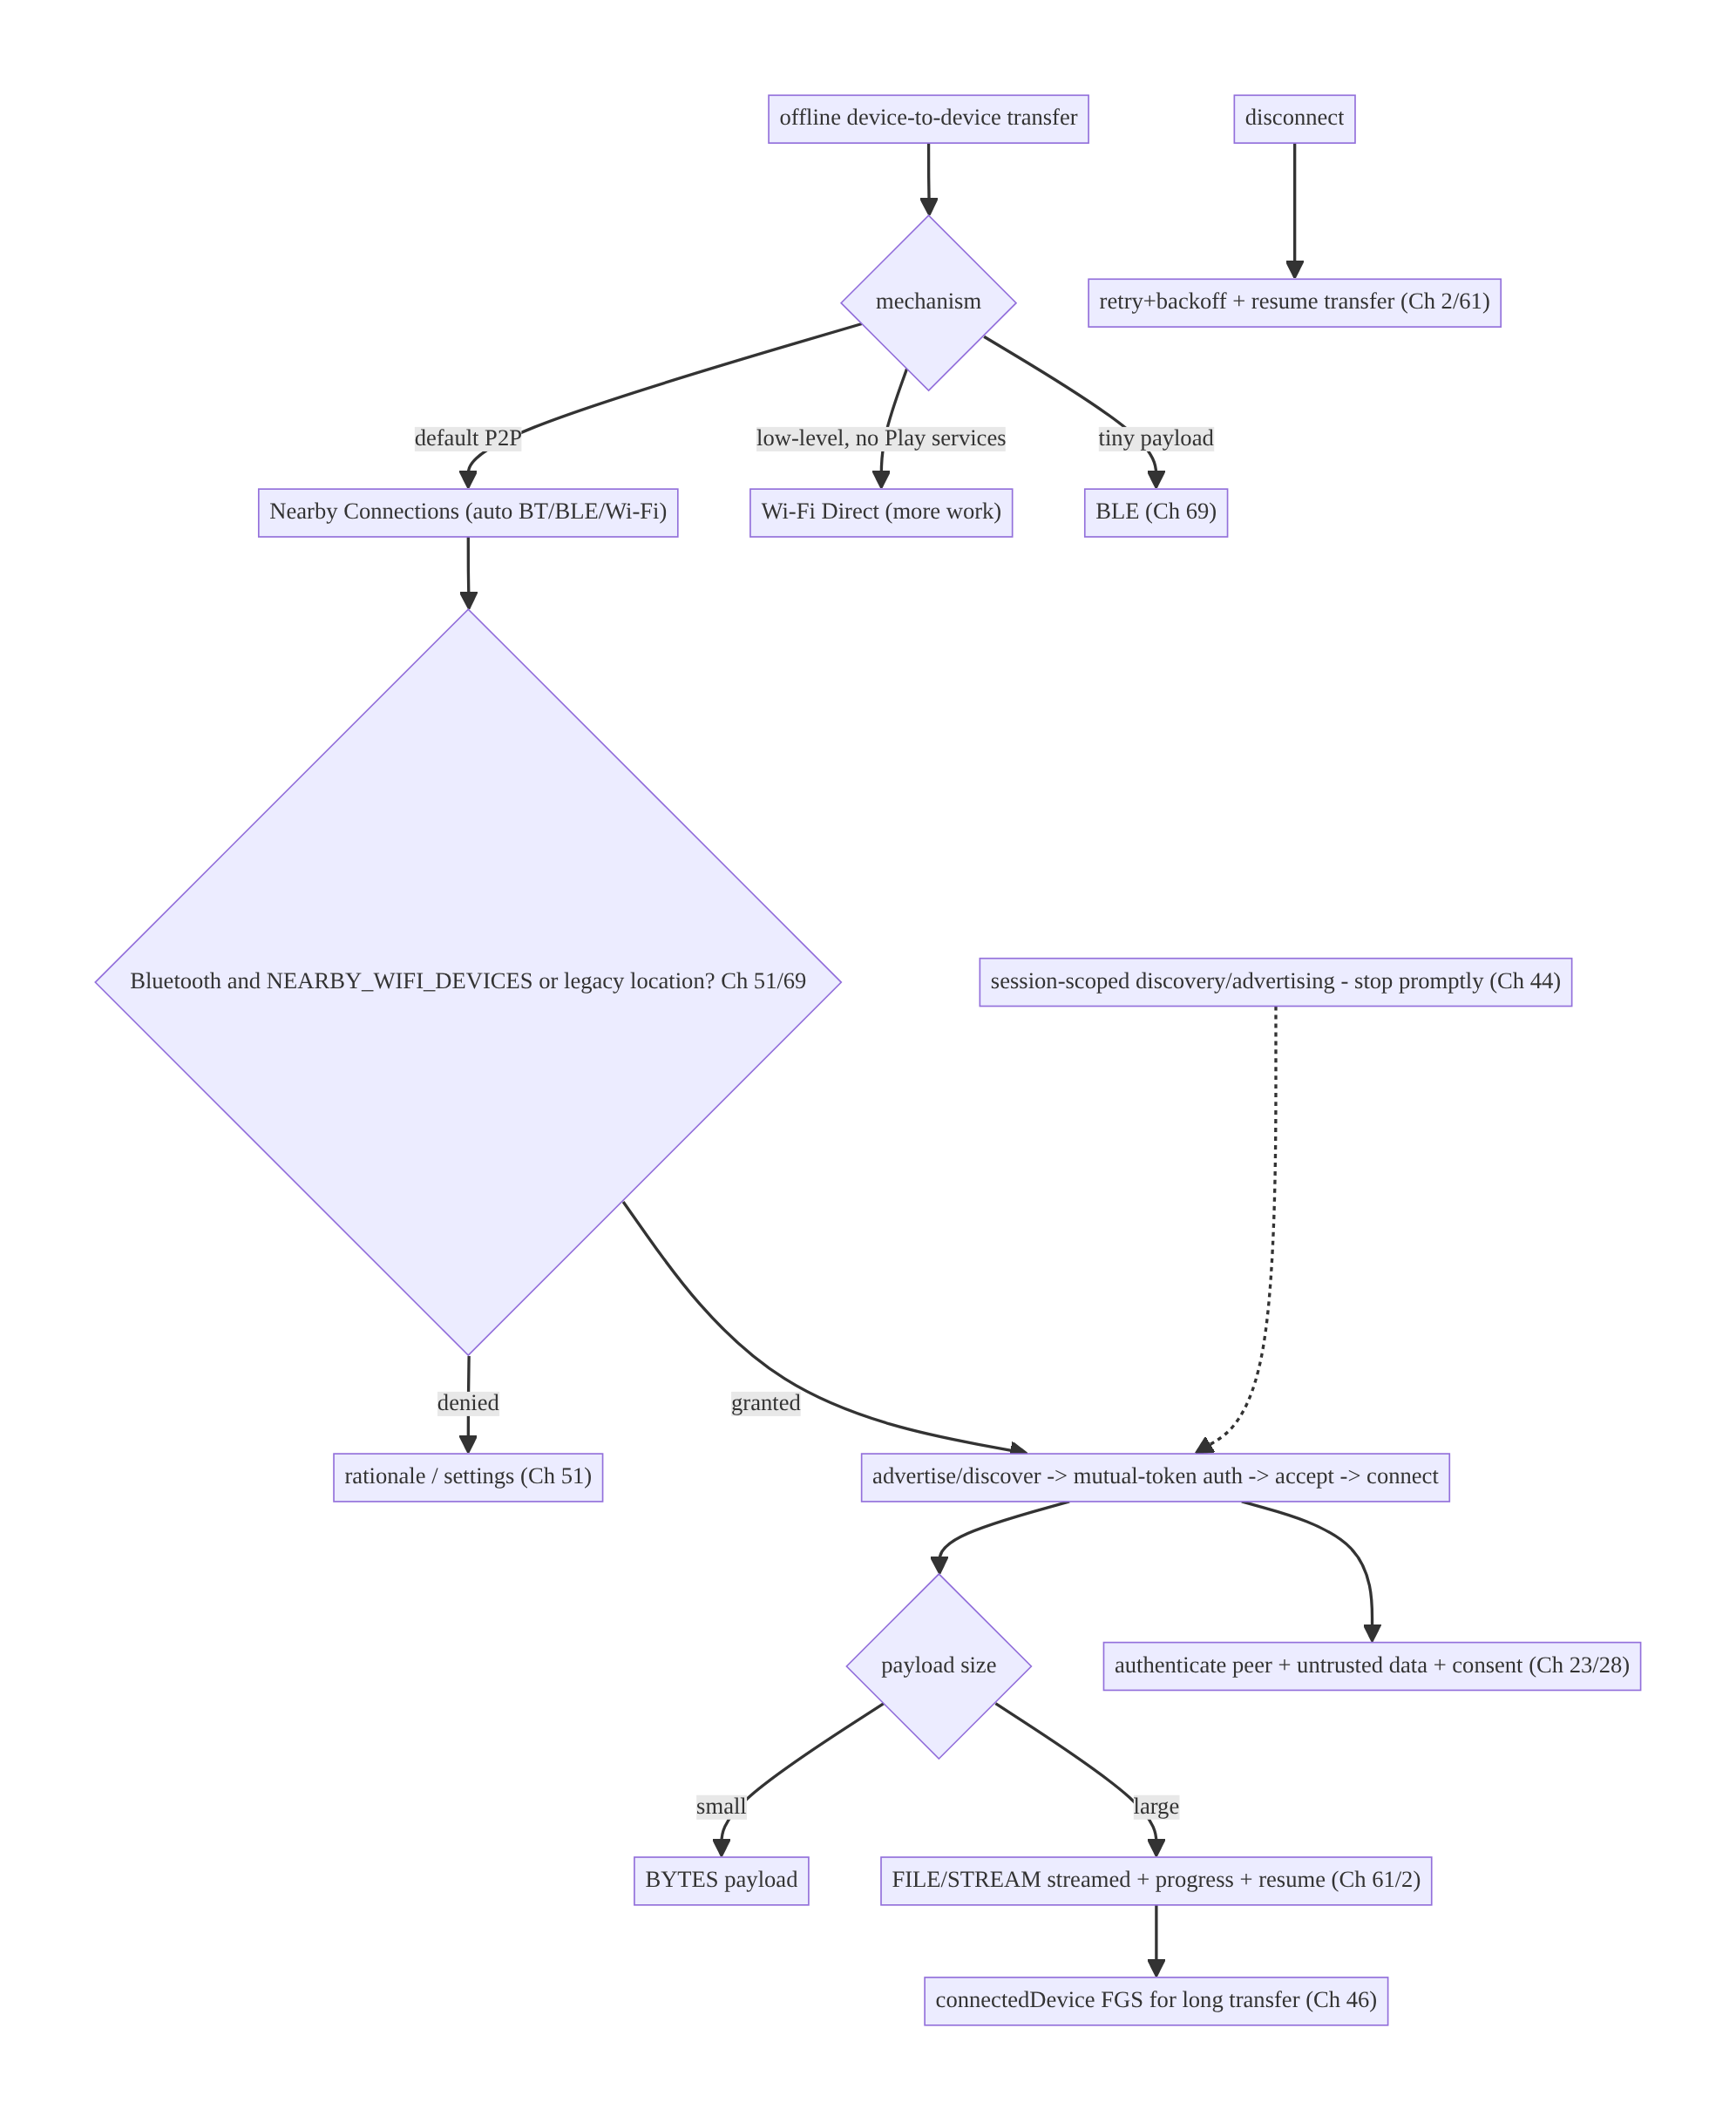
70.4 High-Level Architecture
Components & ownership
- Mechanism choice: Nearby (default) vs Wi-Fi Direct vs BLE.
- Permission gate (Ch 51/69) → authenticated handshake (mutual token) → payload exchange (BYTES small / FILE-STREAM streamed, Ch 61).
- FGS for long transfers (Ch 46); retry/resume on drop (Ch 2/61); lifecycle scopes discovery; security (peer auth, untrusted, consent).
Direction: need → Nearby → permissions → authenticated connect → payload (stream large) → FGS/retry/resume; session-scoped; secured by proximity trust.

70.5 Detailed Component Design
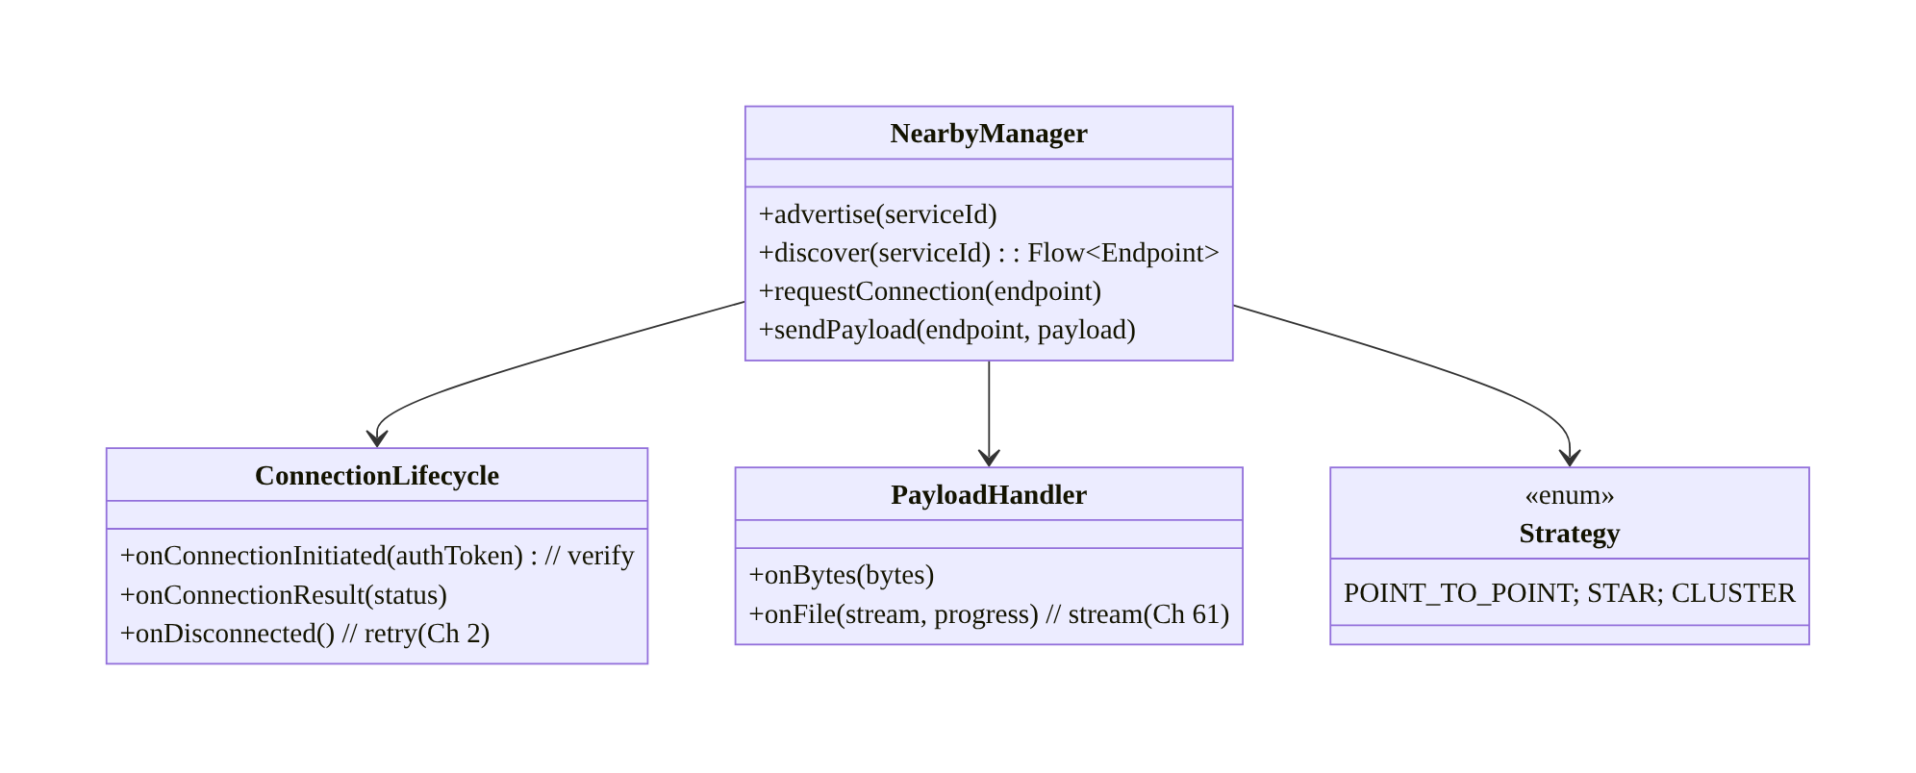
70.5 Detailed Component Design
Component | Responsibility
NearbyManager | advertise/discover/connect/send via Nearby Connections
ConnectionLifecycle | authenticate (token), handle result/disconnect + retry (Ch 2)
PayloadHandler | BYTES (small) + FILE/STREAM (streamed + progress, Ch 61)
Strategy | point-to-point / star / cluster topology

70.6 End-to-End Data Flow

Authenticated connect + file transfer
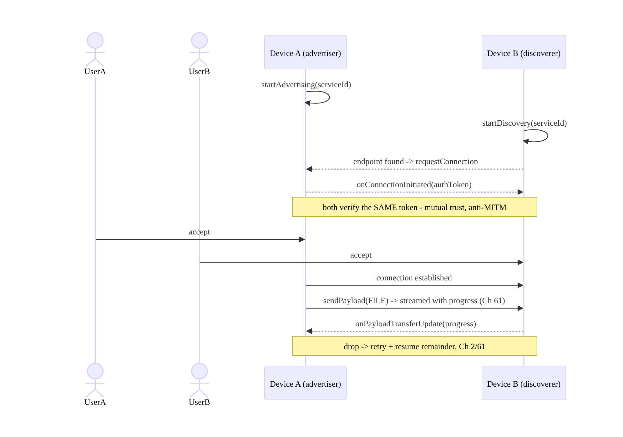
Authenticated connect + file transfer

Mechanism choice
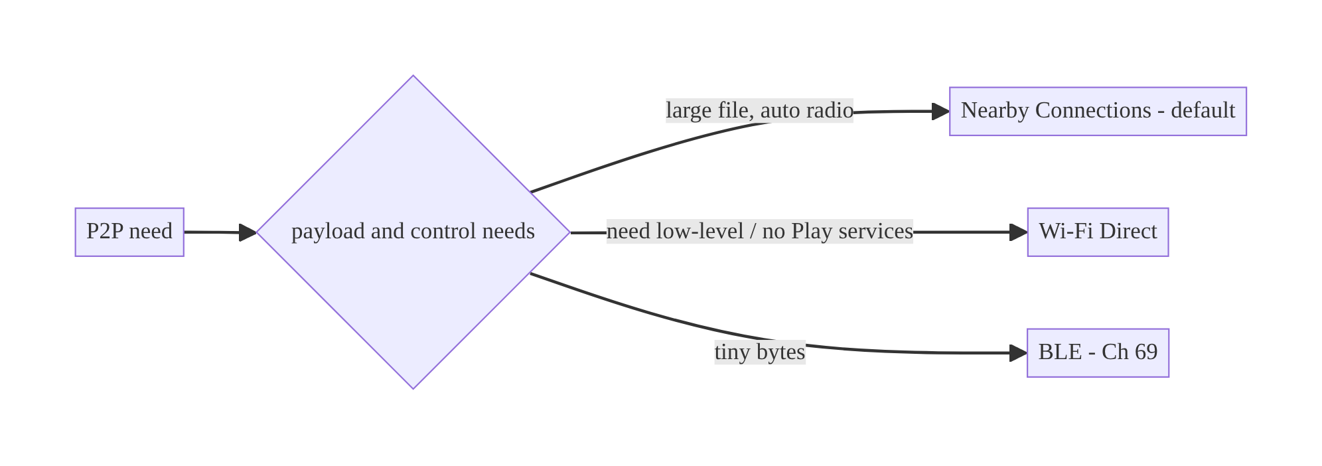
Mechanism choice

70.7 Complete Kotlin Implementation
Package: com.streamcart.nearby.

70.7.1 Permissions (Nearby matrix, Ch 51/69)
<!-- Bluetooth (Ch 69) -->
<uses-permission android:name="android.permission.BLUETOOTH_SCAN" android:usesPermissionFlags="neverForLocation" />
<uses-permission android:name="android.permission.BLUETOOTH_ADVERTISE" />
<uses-permission android:name="android.permission.BLUETOOTH_CONNECT" />
<!-- Wi-Fi (Android 13+) -->
<uses-permission android:name="android.permission.NEARBY_WIFI_DEVICES" android:usesPermissionFlags="neverForLocation" />
<!-- Legacy (pre-13) Wi-Fi scan needed location (Ch 67) -->
<uses-permission android:name="android.permission.ACCESS_FINE_LOCATION" android:maxSdkVersion="32" />
<uses-permission android:name="android.permission.FOREGROUND_SERVICE_CONNECTED_DEVICE" /> <!-- Ch 46 -->

70.7.2 NearbyManager: advertise/discover + authenticated connect
@Singleton
class NearbyManager @Inject constructor(@ApplicationContext private val ctx: Context) {
private val client = Nearby.getConnectionsClient(ctx)
private val strategy = Strategy.P2P_POINT_TO_POINT // highest bandwidth for file share
fun advertise(name: String) = client.startAdvertising(
name, SERVICE_ID, connectionLifecycle, AdvertisingOptions.Builder().setStrategy(strategy).build())
fun discover(): Flow<DiscoveredEndpoint> = callbackFlow {
val cb = object : EndpointDiscoveryCallback() {
override fun onEndpointFound(id: String, info: DiscoveredEndpointInfo) =
trySend(DiscoveredEndpoint(id, info.endpointName)).let {}
override fun onEndpointLost(id: String) {}
}
client.startDiscovery(SERVICE_ID, cb, DiscoveryOptions.Builder().setStrategy(strategy).build())
awaitClose { client.stopDiscovery() } // stop promptly (battery, Ch 44)
}
fun requestConnection(name: String, endpointId: String) =
client.requestConnection(name, endpointId, connectionLifecycle)
private val connectionLifecycle = object : ConnectionLifecycleCallback() {
override fun onConnectionInitiated(endpointId: String, info: ConnectionInfo) {
// AUTHENTICATE: verify the SAME token on both sides (show to user / app-layer) — anti-MITM.
val token = info.authenticationDigits // both devices see the same digits
// ... present token for user confirmation, then:
client.acceptConnection(endpointId, payloadCallback) // only after mutual verification/consent
}
override fun onConnectionResult(endpointId: String, result: ConnectionResolution) {
if (result.status.statusCode == ConnectionsStatusCodes.STATUS_OK) { /* connected */ }
}
override fun onDisconnected(endpointId: String) { /* retry + resume (Ch 2/61) */ }
}
}

70.7.3 Payloads: BYTES (small) + FILE streamed with progress (Ch 61)
private val payloadCallback = object : PayloadCallback() {
override fun onPayloadReceived(endpointId: String, payload: Payload) {
when (payload.type) {
Payload.Type.BYTES -> handleBytes(payload.asBytes()!!) // small (untrusted! Ch 23)
Payload.Type.FILE -> {
val uri = payload.asFile()?.asUri() // large -> stream, don't load (Ch 61)
// copy/stream from uri to app storage via ContentResolver (Ch 61/62)
}
Payload.Type.STREAM -> handleStream(payload.asStream()) // continuous
}
}
override fun onPayloadTransferUpdate(endpointId: String, update: PayloadTransferUpdate) {
val progress = update.bytesTransferred.toFloat() / update.totalBytes // progress (Ch 61)
// update UI; on FAILURE -> retry + resume remainder (Ch 2/61)
}
}
// Send a large file as a FILE payload (Nearby streams it over Wi-Fi):
fun sendFile(endpointId: String, file: File) =
client.sendPayload(endpointId, Payload.fromFile(file)) // streamed; progress via onPayloadTransferUpdate

70.7.4 Long transfer in a foreground service (Ch 46)
// A multi-GB transfer runs inside a connectedDevice/dataSync FGS (Ch 46) with a progress notification,
// so it survives backgrounding; stop the FGS + stopAll endpoints when the transfer completes.
@AndroidEntryPoint
class NearbyTransferService : Service() {
@Inject lateinit var nearby: NearbyManager
override fun onStartCommand(intent: Intent?, flags: Int, startId: Int): Int {
startForeground(NOTIF_ID, transferNotification(0), ServiceInfo.FOREGROUND_SERVICE_TYPE_CONNECTED_DEVICE)
// run transfer; update notification from onPayloadTransferUpdate; stopSelf on complete
return START_NOT_STICKY
}
override fun onBind(i: Intent?): IBinder? = null
}

70.7.5 Lifecycle + stop promptly
// Scope discovery/advertising to the share session (Ch 44); stop when done (battery).
fun stopSession() {
client.stopAdvertising(); client.stopDiscovery(); client.stopAllEndpoints() // release radios
}

70.7.6 Module structure
:feature:nearby NearbyManager, ConnectionLifecycle, PayloadHandler, NearbyTransferService (FGS, Ch 46)
# Permissions -> Ch 51/69; streaming large payloads -> Ch 61/62; retries -> Ch 2; lifecycle -> Ch 44.

70.8 Concurrency and Race Conditions
Scenario | Risk | Handling
Accept before token verified | MITM/unauthorized | verify mutual token + consent before acceptConnection
Large payload loaded into memory | OOM | FILE/STREAM streamed (Ch 61), not BYTES
Transfer drops mid-file | restart from 0 | track bytes; retry + resume remainder (Ch 2/61)
Discovery/advertising left on | battery drain | stop promptly; session-scoped (Ch 44)
Multiple simultaneous connections | contention | choose strategy (point-to-point limits to one)
Received data trusted | malware/spoof | validate untrusted payloads (Ch 23)
Permission missing | discovery/connect fails | permission matrix (Ch 51/69)
- Authenticate before accepting: acceptConnection must come after both sides verify the same authentication token and the users consent — accepting blindly allows a MITM or unwanted peer (the proximity trust model’s core safeguard).
- Stream large payloads, don’t BYTES them: a big file as a BYTES payload OOMs; use FILE/STREAM which Nearby transfers efficiently (over Wi-Fi) and stream it to storage (Ch 61/62).
- Resume, don’t restart: track bytesTransferred and on a drop resume the remainder (Ch 2/61) so a large transfer survives interruptions.

70.9 Failure Scenarios and Recovery
Failure | Detection | Response | Outcome
Connection drops mid-transfer | onDisconnected/FAILURE | retry + resume remainder (Ch 2/61) | completes
OOM on large payload | crash | FILE/STREAM streamed (Ch 61) | safe
MITM / wrong peer | token mismatch | verify mutual token + consent before accept | blocked
Discovery finds nothing | no endpoints | fix permission matrix (Ch 51/69); same service id | connects
Battery drain | radios left on | stop advertising/discovery/endpoints promptly (Ch 44) | battery ok
No Play services | Nearby unavailable | Wi-Fi Direct fallback | works
Malicious data | validation | treat received payloads as untrusted (Ch 23) | safe
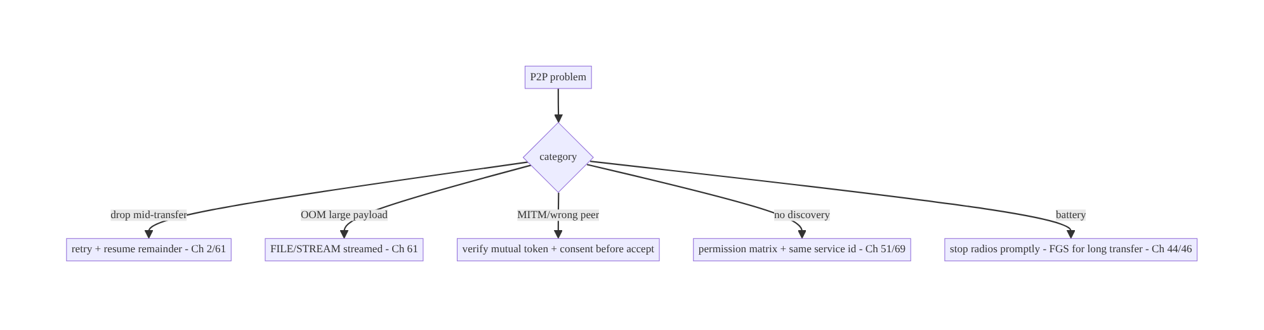
70.9 Failure Scenarios and Recovery
Nearby does the hard radio work; your job is the handshake, streaming, and trust. Authenticate the peer with the mutual token before accepting, stream large payloads (FILE/STREAM) with progress and resume, get the permission matrix right, scope radios to the session (FGS for long transfers), and validate received data as untrusted — then offline device-to-device transfer is reliable and safe.

70.10 Scaling the Implementation
- Level 1. Nearby advertise/discover + authenticated connect (verify token) + BYTES payload.
- Level 2. FILE/STREAM payloads streamed with progress (Ch 61); permission matrix (Ch 51/69); stop radios promptly.
- Level 3 — production. Retry/backoff + resume on drop (Ch 2/61); connectedDevice FGS for long transfers (Ch 46); strategy selection; consent + peer auth (Ch 23).
- Level 4 — large. STAR/CLUSTER group sessions; multi-file transfers; Wi-Fi Direct fallback (no Play services); transfer analytics.
- Level 5 — enterprise. P2P governance, offline-mesh scenarios, secure provisioning, cross-platform (iOS via a common protocol), throughput SLOs.
Avoid overengineering: for most “share nearby” needs, Nearby Connections + authenticated connect + FILE payload streamed is enough. Don’t hand-roll Wi-Fi Direct unless you lack Play services or need low-level control; don’t use BYTES for large files.

70.11 Alternative Approaches and Trade-offs
Dimension | Option A | Option B | When
Mechanism | Nearby Connections | Wi-Fi Direct | Nearby (auto-radio, handles handshake/transfer); Wi-Fi Direct for low-level / no Play services
Mechanism | Nearby Connections | BLE (Ch 69) | Nearby for real transfers; BLE for tiny payloads only
Payload (large) | FILE/STREAM streamed (Ch 61) | BYTES | FILE/STREAM (BYTES OOMs for large)
Strategy | Point-to-point (file) / star (group) | one for all | Match to use case
Transfer | Via P2P (offline, fast local) | via backend (Ch 17) | P2P when offline/local/large; backend when server needs it
Drop handling | Retry + resume (Ch 2/61) | restart | Resume (large transfers)
Trust | Authenticated token + consent | accept blindly | Authenticate (proximity trust, Ch 23)
Nearby Connections vs Wi-Fi Direct: Nearby auto-selects the best radio (BLE for discovery, Wi-Fi for throughput), handles discovery/authentication/transfer with a clean API, and “just works” — but needs Play services. Wi-Fi Direct (Wi-Fi P2P) is lower-level (you manage group formation, sockets, IP), more work, but available without Play services and offers more control. Default to Nearby; use Wi-Fi Direct only when you lack Play services or need that control.
P2P vs backend transfer (Ch 17): routing a large nearby transfer through the backend (upload then download, Ch 17) requires internet, burns data, and is slow for big files between co-located devices. P2P moves it directly (offline, over the local Wi-Fi radio) — ideal when devices are nearby and especially when offline. Use P2P for local/ offline/large transfers; the backend when the server must see/process the data.
FILE/STREAM vs BYTES for large payloads: a BYTES payload holds everything in memory (OOM for large files); FILE/STREAM payloads let Nearby transfer efficiently over Wi-Fi with progress and let you stream to storage (Ch 61). Use BYTES only for small metadata; FILE/STREAM for anything large.

70.12 Security & Privacy Considerations
- Proximity trust + authenticate the peer (Ch 23): no server mediates, so verify the mutual authentication token (both devices show the same digits; users confirm, or app-layer verification) before accepting — this is the anti-MITM safeguard. Never accept connections blindly.
- Treat all received data as untrusted (Ch 23): a nearby device could send malware, spoofed content, or malformed payloads — validate/sanitize everything received; don’t auto-execute or trust a received file.
- Explicit consent (Ch 28): both users explicitly accept the connection and the transfer; show what is being shared and with whom — surprise P2P transfers are a trust/abuse risk.
- Least permission (Ch 51/69): request Bluetooth + NEARBY_WIFI_DEVICES (with neverForLocation if not deriving location) in context; avoid legacy location where possible.
- Device identity is sensitive (Ch 28): endpoint names/ids can identify users — minimize, don’t log; use non-identifying advertise names.
- Encrypt sensitive payloads: Nearby encrypts the link, but for highly sensitive data, add app-layer encryption (Ch 25) and authenticate at the app layer.
- Stop radios promptly: leaving advertising/discovery on is a discoverability/privacy concern as well as battery.
- Client vs backend: P2P is serverless; there’s no backend to authorize the transfer, so the peer authentication + user consent + untrusted-data handling carry the entire trust burden — design them carefully.

70.13 Performance and Resource Optimization
- Nearby uses Wi-Fi for throughput automatically — large files transfer fast locally (far faster than cellular upload/download).
- Stop advertising/discovery/endpoints promptly (Ch 44) — the top battery lever; radios on = drain.
- Stream large payloads (FILE/STREAM, Ch 61) — no OOM; progress-driven.
- Resume, don’t restart (Ch 2/61) — don’t re-transfer gigabytes on a drop.
- Choose strategy by need — point-to-point maximizes a single transfer’s bandwidth.
- FGS for long transfers (Ch 46) so they complete backgrounded without the user holding the screen.
- Profiling: transfer throughput, connect success rate, drop/resume rate, radio battery, discovery time.

70.14 Testing Strategy
Nearby is hard to unit-test (needs two real devices + Play services); test the handshake/ payload/resume logic in isolation with a fake client, and do two-device instrumentation.
class ConnectionAuthTest {
@Test fun `does not accept before token verified`() {
lifecycle.onConnectionInitiated("E1", connectionInfo(token = "1234"))
assertFalse(fakeClient.accepted("E1")) // waits for verification/consent
lifecycle.userConfirmsToken("E1", "1234")
assertTrue(fakeClient.accepted("E1"))
}
@Test fun `rejects on token mismatch`() { /* user sees different digits -> reject */ }
}
class PayloadTest {
@Test fun `large file sent as FILE streamed, not BYTES`() { /* assert Payload.Type.FILE */ }
@Test fun `resumes remainder after drop`() = runTest { /* bytesTransferred tracked -> resume (Ch 61) */ }
@Test fun `received payload validated as untrusted`() { /* malformed -> rejected (Ch 23) */ }
}
What to test: authenticated connect (accept only after token verify + consent; reject on mismatch); large payload uses FILE/STREAM (not BYTES); resume after drop (Ch 2/61); untrusted-payload validation (Ch 23); permission-gated discovery (Ch 51/69); stop-radios. Fake the Nearby client for logic; two real devices with Play services for end-to-end.

70.15 Production Observability
- Metrics: connect success rate; transfer throughput + completion rate; drop/resume rate; discovery time; radio battery; permission grant rate (Ch 51/69); rejected-connection (token-mismatch) count; Play-services-unavailable rate (→ Wi-Fi Direct fallback).
- Logs: nearby{event, strategy, payload_type, bytes, result} — no endpoint names/ device identity/PII (Ch 28).
- Debugging: no discovery → permission matrix (Ch 51/69) / mismatched service id; OOM → BYTES for large (use FILE, Ch 61); transfer restarts → no resume (Ch 2/61); battery → radios not stopped (Ch 44); MITM concern → accepting before token verify; Play-services missing → fallback.
- Alerting: connect-success drop; transfer-completion drop; rejected-connection spike (possible abuse).
- Dashboards: connect/transfer success + throughput; drop/resume rate; permission funnel.

70.16 System Design Interview Preparation
≥25 questions.
Fundamentals
- What is P2P/Nearby for? Offline, direct device-to-device transfer (no server/internet).
- Primary API? Nearby Connections (auto-selects BT/BLE/Wi-Fi).
- Nearby vs Wi-Fi Direct? High-level auto-radio vs low-level control / no Play services.
- Nearby vs BLE (Ch 69)? Real transfers vs tiny payloads.
- Radios used? BLE for discovery, Wi-Fi for throughput (Nearby picks).
Handshake
- Steps? Advertise/discover → request connection → verify mutual token → accept → transfer.
- Authentication? Both sides verify the same token (anti-MITM) + consent.
- Service id? Shared id both sides advertise/discover on.
Payloads
- Types? BYTES (small), FILE (file), STREAM (continuous).
- Large files? FILE/STREAM streamed (Ch 61) — never BYTES (OOM).
- Progress? onPayloadTransferUpdate.
- Drop mid-file? Resume remainder (Ch 2/61).
Strategy
- Strategies? P2P_POINT_TO_POINT / STAR / CLUSTER.
- File share? Point-to-point (bandwidth).
- Group/multiplayer? Star/cluster.
Permissions (Ch 51/69)
- Matrix? Bluetooth (SCAN/ADVERTISE/CONNECT) + NEARBY_WIFI_DEVICES (13+) / legacy location.
- neverForLocation? If not deriving location (Ch 67).
Lifecycle/battery
- Scope? Session; stop advertising/discovery/endpoints promptly (Ch 44).
- Long transfer? connectedDevice FGS (Ch 46).
Security (Ch 23/28)
- Trust model? Physical proximity + authenticate peer + consent (no server).
- Received data? Untrusted — validate.
- Device identity? Sensitive — minimize/don’t log.
- Sensitive payloads? App-layer encryption (Ch 25).
Testing/Production
- Test end-to-end? Two real devices + Play services.
- No discovery? Permission matrix / service id.
- OOM? BYTES for large (use FILE).

Design-change challenges
- Share a large video between two phones offline. Nearby point-to-point + FILE payload streamed + progress (Ch 61).
- Prevent connecting to the wrong/malicious device. Verify mutual token + consent before accept (Ch 23).
- Transfer restarts from 0 on a drop. Track bytes; resume remainder (Ch 2/61).
- No discovery on Android 13. Add NEARBY_WIFI_DEVICES (Ch 51).
- No Play services on the device. Wi-Fi Direct fallback.

Mock walkthrough (abridged)
Clarify (offline?, payload size, group or 1:1, security?) → Nearby Connections (vs Wi-Fi Direct/BLE) → strategy (point-to-point/star) → permission matrix (Ch 51/69) → handshake (advertise/discover → verify token → accept) → payloads (BYTES small / FILE-STREAM streamed
- progress + resume, Ch 61/2) → FGS for long transfer + stop radios (Ch 46/44) → security (authenticate peer, untrusted data, consent, Ch 23/28) → observability.

70.17 Practical Exercises
- Beginner. Advertise/discover with Nearby on a shared service id and exchange a small BYTES payload after verifying the mutual token. Eval: connects; token-verified.
- Intermediate. Send a large file as a FILE payload, streamed with a progress bar (not BYTES); handle the permission matrix (Ch 51/69). Eval: no OOM; progress; permission- correct.
- Advanced. Add retry + resume on disconnect (resume the remaining bytes) and run the transfer in a connectedDevice FGS (Ch 46). Eval: survives drops/background.
- Production debugging. Fix “no discovery on Android 13” (missing NEARBY_WIFI_DEVICES) and an OOM (BYTES for a large file → FILE). Eval: discovers; streams.
- System design challenge. Secure the pairing (mutual token + consent + untrusted-data validation) and add a Wi-Fi Direct fallback for no-Play-services devices. Eval: no blind accept; works without Play services.
(Solutions withheld unless requested.)

70.18 Chapter Summary & Reference Sheet
Key decisions: for offline, direct device-to-device transfer, prefer the Nearby Connections API — it auto-selects Bluetooth/BLE/Wi-Fi and handles discovery, authenticated connection, and payload transfer — over hand-rolling Wi-Fi Direct (more control, more work, but no Play services needed) or using BLE (Ch 69, tiny payloads only); run the advertise/discover → mutual-token-authenticated connect (verify the same token + consent before acceptConnection) → payload exchange handshake, choosing a strategy (point-to-point for big files, star/cluster for groups); send small data as BYTES and large files as FILE/STREAM payloads streamed with progress and resume (never BYTES — OOM; Ch 61/2); navigate the Bluetooth + NEARBY_WIFI_DEVICES(13+)/legacy- location permission matrix (Ch 51/69); handle drops with retry/backoff and resume the remainder (Ch 2/61); scope radios to the active session and stop promptly, using a connectedDevice foreground service for long transfers (Ch 44/46); and secure it as a physical-proximity trust model with no server — authenticate the peer, treat received data as untrusted, require explicit consent, and minimize device identity (Ch 23/28).
Concepts: Nearby Connections (strategies/topologies, auto-radio), advertise/discover → authenticated connect (mutual token) → payload (BYTES/FILE/STREAM), streaming large payloads
- progress + resume, Wi-Fi Direct/BLE alternatives, permission matrix, lifecycle + FGS, proximity trust (authenticate/untrusted/consent).
Common mistakes: hand-rolling Wi-Fi Direct when Nearby suffices; BYTES for large files (OOM); accepting connections without verifying the mutual token (MITM); no resume (restart on drop); wrong permission matrix (no discovery); leaving radios on (battery); trusting received data; no consent; logging device identity.
Checklist:
- ☐ Nearby Connections (default) vs Wi-Fi Direct / BLE
- ☐ strategy per use case (point-to-point/star/cluster)
- ☐ advertise/discover → verify mutual token + consent → accept
- ☐ BYTES small / FILE-STREAM streamed + progress + resume (Ch 61/2)
- ☐ permission matrix (Bluetooth + NEARBY_WIFI_DEVICES/legacy location, Ch 51/69)
- ☐ retry + resume on drop (Ch 2/61)
- ☐ session-scoped radios + stop promptly + FGS for long transfer (Ch 44/46)
- ☐ authenticate peer + untrusted data + consent (Ch 23/28)
- ☐ device identity minimized/not logged
- ☐ Wi-Fi Direct fallback (no Play services)
- ☐ connect/transfer telemetry.
Key APIs: Nearby.getConnectionsClient, startAdvertising/startDiscovery/ stopAdvertising/stopDiscovery/stopAllEndpoints, requestConnection/acceptConnection, ConnectionLifecycleCallback (onConnectionInitiated/onConnectionResult/onDisconnected), ConnectionInfo.authenticationDigits, Payload.fromFile/fromBytes/fromStream/ Payload.Type, PayloadCallback (onPayloadReceived/onPayloadTransferUpdate), Strategy (P2P_POINT_TO_POINT/STAR/CLUSTER), NEARBY_WIFI_DEVICES/Bluetooth perms (Ch 51/69), connectedDevice FGS (Ch 46), Wi-Fi Direct (WifiP2pManager).
References:
- Nearby Connections: https://developers.google.com/nearby/connections/overview
- Nearby Connections strategies: https://developers.google.com/nearby/connections/strategies
- Wi-Fi Direct (Wi-Fi P2P): https://developer.android.com/develop/connectivity/wifi/wifi-direct
- NEARBY_WIFI_DEVICES: https://developer.android.com/develop/connectivity/wifi/wifi-permissions
- (composes) Ch 69 BLE, Ch 51 Permissions, Ch 46 Foreground Services, Ch 61 Large Files, Ch 2 Retries, Ch 44 Lifecycle, Ch 23/28 Security/Privacy

Part IX — Feature Architectures
Domain-rich product features composed from the earlier parts: infinite feeds, optimistic updates, recommendations, wishlist, checkout, payments and billing, order tracking, reviews, onboarding, and in-app feedback.

Chapter 71 — Infinite Scrolling Feed (Social)
Part IX — Feature Architectures · Complexity: Complex (≥40 interview questions)
Prerequisites: Ch 13 (Paging 3), Ch 3 (SSOT/Room), Ch 32 (delta sync), Ch 12 (caching), Ch 56 (images), Ch 6 (UI state), Ch 72 (optimistic updates), Ch 60/86 (perf). Pairs with Ch 73 (recommendations), Ch 49 (push).
Reference surface in StreamCart: the social/home feed — an endless, mixed-content stream (products, posts, videos, ads) that loads page by page, caches for offline, stays fresh, scrolls at 60fps, preserves position, and handles likes/comments optimistically.

71.1 Problem Definition and Real-World Context
An infinite feed looks simple (“load more at the bottom”) but is one of the most composite, performance-critical features in a consumer app. It must: paginate endlessly (Ch 13) without loading everything; cache pages so the feed works offline and survives process death (Ch 3/12); stay fresh (new items at top, deletions, updates) without jarring the user; scroll at 60fps with heterogeneous item types and images (Ch 56/60); preserve scroll position across config change, process death, and tab switches; handle optimistic interactions (like/comment, Ch 72); and deal with pagination correctness (offset drift, duplicates, gaps) as the underlying data changes. Done naively it OOMs, janks, loses position, shows duplicates, or re-fetches constantly.
Concretely, teams hit:
- Loading everything / offset pagination drift. Loading all items OOMs; naive offset pagination (?page=N) drifts when items are inserted/deleted between page loads (duplicates/skips). Keyset/cursor pagination is stable; Paging 3 (Ch 13) manages windows and prefetch.
- No cache / network-coupled. A feed that only works online and reloads from scratch on every open is slow and offline-broken. The feed should be SSOT-backed (Room, Ch 3) via Paging’s RemoteMediator (network + DB) so it’s cached, offline-capable, and survives process death.
- Freshness vs stability. New content must appear and stale content update, but not by yanking the user’s scroll position. Need refresh strategies (pull-to- refresh, “new posts” pill, background delta, Ch 32) that respect position.
- Jank at 60fps. Heterogeneous item types, images (Ch 56), video autoplay (Ch 58/60), and heavy binds drop frames. Need efficient diffing (stable keys), item-type view recycling, image right-sizing (Ch 56), and lazy/off-screen work (Ch 86).
- Scroll position preservation. Rotation, process death (Ch 8), and tab switches must restore scroll position — losing it is a top UX complaint.
- Interactions + consistency. Likes/comments must update optimistically (Ch 72) and reconcile; the same item on multiple screens must stay consistent (SSOT, Ch 3).
- Mixed content & ranking. Feeds mix content types and are server-ranked (Ch 73); the client renders what the server orders, with dedup and insert/remove handling.
The architecture: build the feed on Paging 3 (Ch 13) with a RemoteMediator backing it with the SSOT (Room) so it paginates, caches, works offline, and survives process death; use cursor/keyset pagination (not offset) for stability; apply refresh strategies that preserve scroll position (pull-to-refresh, “new content” pill, background delta sync, Ch 32); optimize for 60fps (stable keys, item-type recycling, image right-sizing Ch 56, lazy off-screen work Ch 86); preserve scroll position across config/ process death (Ch 8); handle optimistic interactions via the SSOT (Ch 72); and render server-ranked mixed content (Ch 73) with dedup. This chapter is the end-to-end architecture of a fast, cached, fresh, position-stable infinite feed.

Three practical use cases
- Home feed (StreamCart). Endless mixed feed (products/posts/video/ads), Paging 3 + RemoteMediator + Room, cursor pagination, offline from cache, “new posts” pill on refresh, 60fps.
- Offline + process death. User scrolls, backgrounds; process dies; on return the feed restores from the SSOT at the same scroll position with cached content, then refreshes in the background.
- Optimistic like/comment. Liking an item updates instantly (Ch 72) in the SSOT, reflected everywhere the item appears; reconciled with the server.

Why this is architectural
The feed composes Paging (Ch 13), SSOT (Ch 3), sync (Ch 32), caching (Ch 12), images (Ch 56), optimistic UI (Ch 72), process death (Ch 8), and performance (Ch 86) into one demanding surface. The decisions — Paging+RemoteMediator+SSOT, cursor pagination, position- preserving refresh, 60fps optimization, scroll restoration — are a capstone of mobile data + UI engineering.

71.2 Requirements Engineering

Functional requirements
ID | Requirement
F1 | Paginate endlessly (load more at the edge) without loading everything (Ch 13).
F2 | Cache pages in the SSOT; work offline; survive process death (Ch 3/12/8).
F3 | Stay fresh (new/updated/removed) without disrupting scroll position (Ch 32).
F4 | Scroll at 60fps with mixed item types + images/video (Ch 56/58/86).
F5 | Preserve scroll position across config change / process death / tab switch (Ch 8).
F6 | Optimistic interactions (like/comment) via the SSOT; consistent everywhere (Ch 72/3).

Non-functional requirements
Attribute | Policy
Performance | 60fps scroll; fast first content (cache-first, Ch 45).
Memory | Windowed paging (no load-all); bounded images (Ch 56).
Offline | Cache-backed; works offline (Ch 29).
Resilience | Survives process death; restores position (Ch 8).
Correctness | Stable pagination (cursor); dedup; consistent items (Ch 3).
Freshness | Timely updates; position-preserving refresh.

Scope
- In scope: Paging 3 + RemoteMediator + Room SSOT (Ch 13/3), cursor/keyset pagination, prefetch/placeholders, refresh strategies (pull-to-refresh, new-content pill, background delta, Ch 32) preserving position, 60fps optimization (stable keys, item-type recycling, image right-sizing Ch 56, lazy off-screen Ch 86), scroll restoration (config/process death, Ch 8), optimistic interactions (Ch 72), mixed content + server ranking (Ch 73), dedup/insert/remove.
- Out of scope: Paging internals (Ch 13), SSOT internals (Ch 3), sync algorithm (Ch 32), image pipeline (Ch 56), optimistic-UI mechanics (Ch 72), ranking/recommendations (Ch 73), perf profiling (Ch 86).

Assumptions & constraints
- Paging 3 (PagingSource/RemoteMediator), Room SSOT (Ch 3), Compose LazyColumn/ Paging compose, Coil (Ch 56). minSdk 24. Server supports cursor pagination and ranks the feed (Ch 73); content is heterogeneous; the feed must work offline and survive process death.

71.3 System Design Fundamentals
- Paging 3 + RemoteMediator + SSOT (the backbone, Ch 13/3). The feed is not a list you hold in memory — it’s a paged, cached stream:
  - Room is the SSOT (Ch 3); the UI pages from the database (PagingSource over Room).
  - A RemoteMediator (Ch 13) fetches pages from the network and writes them into Room; Paging then pages from Room. This gives caching, offline, and process-death survival for free — the feed renders from the DB whether online or not.
  - Paging handles windowing (only a window of items in memory), prefetch (load ahead of the scroll edge), and placeholders. This “network → DB → UI” (single source of truth) is the correct feed architecture; a network-only PagingSource loses offline/caching.
- Cursor/keyset pagination, not offset (stability). Offset pagination (?offset=40) drifts when items are inserted/removed between loads → duplicates or skipped items. Cursor/keyset pagination (?after=<lastItemCursor>) is stable under insertion/deletion — the server returns “items after this cursor.” Store the cursor (RemoteMediator keys) per page. Always prefer cursor pagination for feeds.
- Freshness without disrupting position (the UX crux).
  - Pull-to-refresh / RemoteMediator REFRESH: reload from the top (Ch 13).
  - “New content” pill: detect new items (via a background delta/push, Ch 32/49) and show a “N new posts” pill the user taps to jump up — don’t auto-scroll or reorder under them.
  - Background delta sync (Ch 32): update changed/removed items in the SSOT; Paging diffs and updates the list in place (stable keys) without moving position.
  - In-place updates: because items live in the SSOT, a like-count change or edit updates the row and the UI reflects it where the item is, no reload. The rule: never yank the user’s scroll position; surface freshness via a pill/ in-place updates.
- 60fps optimization (Ch 86/56).
  - Stable keys: give each item a stable id (key) so diffing/recycling is correct and minimal (no full rebinds).
  - Item-type recycling: heterogeneous types (product/post/video/ad) each bind efficiently; avoid heavy work in bind.
  - Image right-sizing (Ch 56): load CDN-sized images, downsample, placeholder/ crossfade — the top feed-jank cause.
  - Lazy / off-screen: defer expensive work (video autoplay only for the visible item, Ch 58; don’t compute off-screen).
  - Avoid nested scroll/overdraw; flatten layouts; measure with the jank profiler (Ch 86).
- Scroll position preservation (Ch 8). Rotation and process death must restore position: Compose LazyColumn + Paging restore scroll via rememberLazyListState (config change) and Paging’s state restoration; for process death, the paged SSOT means content is still there and the saved scroll key/position restores (Ch 8). Tab switches use saved state (Ch 53). Losing position is a top complaint — design for restoration.
- Optimistic interactions (Ch 72). Likes/comments update the SSOT optimistically (Ch 72) → the item updates instantly everywhere it appears (feed, detail) because it’s one SSOT row (Ch 3); reconcile with the server (outbox, Ch 31). The feed doesn’t special- case interactions — they’re SSOT mutations.
- Mixed content + server ranking (Ch 73). The feed mixes content types and is ranked by the server (Ch 73) — the client renders the server’s order, dedups (by id), and handles inserts/removes. The client doesn’t rank; it presents and interacts. Ads/sponsored items are inserted by the server at ranked positions.
Core insight: build the infinite feed as a paged, SSOT-backed stream — Paging 3 with a RemoteMediator that writes network pages into Room, so the UI pages from the database and gets caching, offline, and process-death survival for free (Ch 13/3); use cursor/keyset pagination (not offset) for stability under inserts/deletes; keep it fresh without ever yanking scroll position (pull-to-refresh, a “new content” pill, and in-place SSOT updates from background delta sync, Ch 32); optimize hard for 60fps (stable keys, item-type recycling, image right-sizing Ch 56, lazy off-screen work Ch 86); preserve and restore scroll position across config change, process death, and tab switches (Ch 8); apply interactions as optimistic SSOT mutations so they reflect everywhere (Ch 72/3); and render server-ranked mixed content (Ch 73) with dedup — the client presents and interacts, the server ranks.

71.4 High-Level Architecture
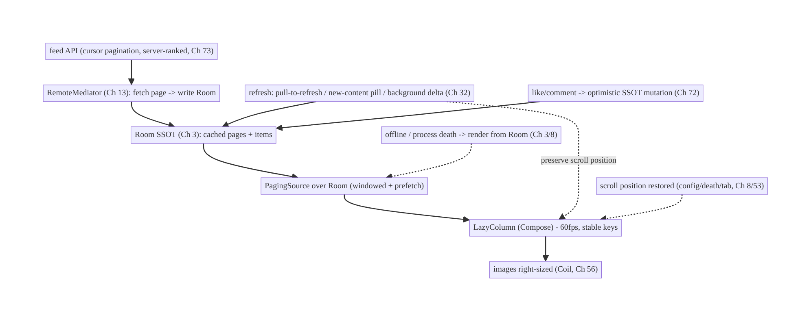
71.4 High-Level Architecture
Components & ownership
- RemoteMediator fetches cursor pages → Room SSOT; PagingSource pages from Room (windowed) → LazyColumn (60fps).
- Refresh (pull/pill/delta) and interactions (optimistic) mutate the SSOT; position is preserved/restored.
- Server ranks mixed content (Ch 73); client presents + dedups.
Direction: cursor API → RemoteMediator → Room (cache/offline/death) → PagingSource → LazyColumn (60fps); refresh + interactions via SSOT, position-preserving.

71.5 Detailed Component Design
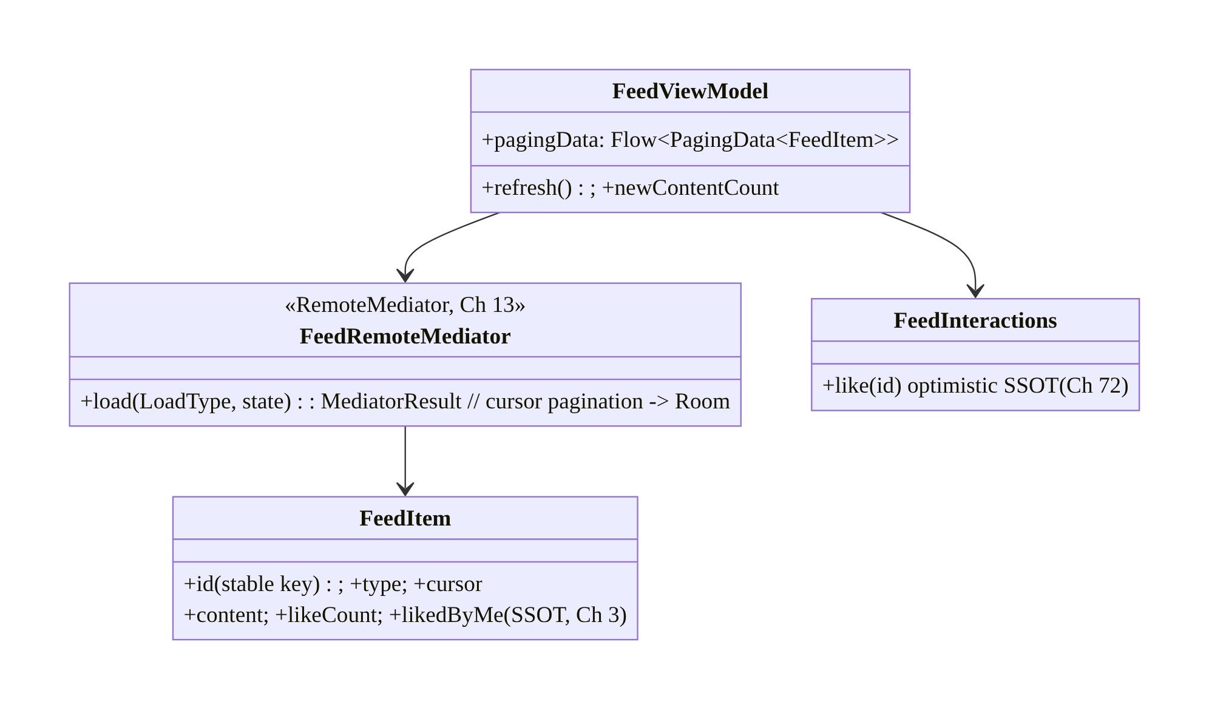
71.5 Detailed Component Design
Component | Responsibility
FeedRemoteMediator | fetch cursor pages → write Room; manage remote keys (Ch 13)
FeedItem | SSOT row: stable id + type + cursor + content + interaction state (Ch 3)
FeedViewModel | expose PagingData from Room; refresh; new-content count
FeedInteractions | optimistic like/comment via SSOT (Ch 72)

71.6 End-to-End Data Flow

Paged load (network → Room → UI)
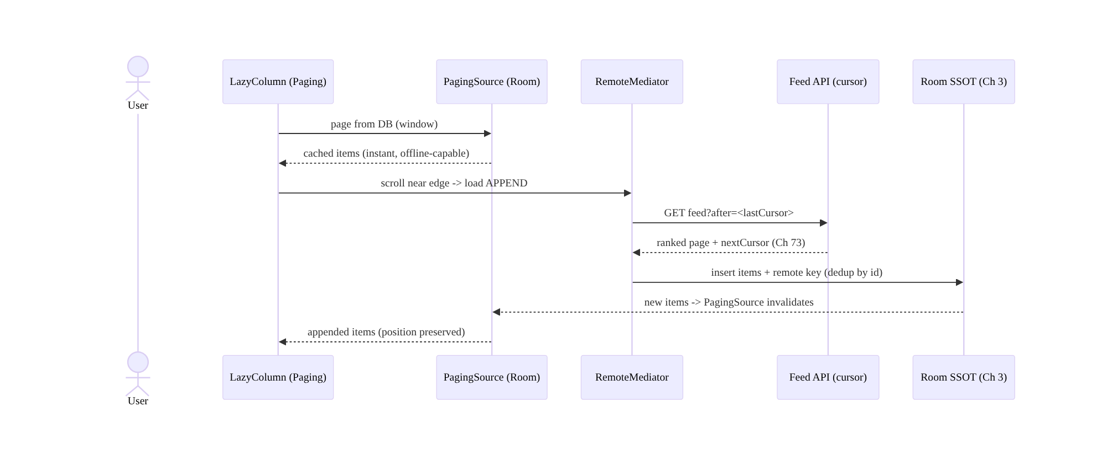
Paged load (network → Room → UI)

Freshness without yanking position
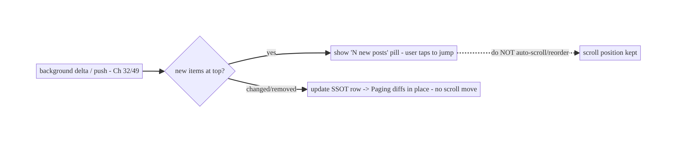
Freshness without yanking position

71.7 Complete Kotlin Implementation
Package: com.streamcart.feed.

71.7.1 FeedItem (SSOT, stable key + cursor)
@Entity(tableName = "feed_items", indices = [Index("position")])
data class FeedItem(
@PrimaryKey val id: String, // stable key (diffing/recycling + dedup)
val position: Int, // server rank order (Ch 73)
val type: String, // product/post/video/ad
val cursor: String, // keyset cursor for pagination
val contentJson: String,
val likeCount: Int, val likedByMe: Boolean, // interaction state (optimistic, Ch 72)
)
@Entity(tableName = "feed_remote_keys")
data class RemoteKey(@PrimaryKey val id: String, val prevCursor: String?, val nextCursor: String?)

71.7.2 RemoteMediator: cursor pagination → Room (Ch 13)
@OptIn(ExperimentalPagingApi::class)
class FeedRemoteMediator @Inject constructor(
private val api: FeedApi, private val db: FeedDatabase, // SSOT (Ch 3)
) : RemoteMediator<Int, FeedItem>() {
override suspend fun load(loadType: LoadType, state: PagingState<Int, FeedItem>): MediatorResult {
val cursor = when (loadType) {
LoadType.REFRESH -> null // from top
LoadType.PREPEND -> return MediatorResult.Success(endOfPaginationReached = true)
LoadType.APPEND -> db.remoteKeys().last()?.nextCursor
?: return MediatorResult.Success(endOfPaginationReached = true)
}
return runCatching {
val page = api.feed(after = cursor, limit = PAGE_SIZE) // CURSOR pagination (stable)
db.withTransaction {
if (loadType == LoadType.REFRESH) { db.feed().clear(); db.remoteKeys().clear() }
db.feed().upsertAll(page.items.map { it.toEntity() }) // dedup by id (stable key)
db.remoteKeys().upsertAll(page.items.map { RemoteKey(it.id, cursor, page.nextCursor) })
}
MediatorResult.Success(endOfPaginationReached = page.nextCursor == null)
}.getOrElse { MediatorResult.Error(it) } // offline -> Paging serves cached Room items (Ch 3)
}
}

71.7.3 ViewModel: PagingData from Room (cache-first, offline, death-safe)
@HiltViewModel
class FeedViewModel @Inject constructor(
private val db: FeedDatabase, private val mediator: FeedRemoteMediator,
private val freshness: FeedFreshness, // new-content detection (Ch 32/49)
) : ViewModel() {
@OptIn(ExperimentalPagingApi::class)
val pagingData: Flow<PagingData<FeedItem>> = Pager(
config = PagingConfig(pageSize = PAGE_SIZE, prefetchDistance = 10, enablePlaceholders = false),
remoteMediator = mediator, // network -> Room
) { db.feed().pagingSource() } // page from Room (Ch 3/13)
.flow.cachedIn(viewModelScope) // survive config change
val newContentCount: StateFlow<Int> = freshness.newCountAtTop() // drives the "N new posts" pill
}

71.7.4 60fps LazyColumn (stable keys, item types, right-sized images, position restore)
@Composable
fun FeedScreen(vm: FeedViewModel = hiltViewModel()) {
val items = vm.pagingData.collectAsLazyPagingItems()
val listState = rememberLazyListState() // restores position on config change
val newCount by vm.newContentCount.collectAsStateWithLifecycle()
Box {
LazyColumn(state = listState) {
items(count = items.itemCount, key = items.itemKey { it.id }) { index -> // STABLE keys
when (val item = items[index]) {
is FeedItem -> when (item.type) { // item-type recycling
"product" -> ProductCard(item) // right-sized images (Ch 56)
"post" -> PostCard(item)
"video" -> VideoCard(item, autoplay = /* only if visible */ false) // lazy (Ch 58/86)
"ad" -> AdCard(item)
else -> {}
}
null -> PlaceholderCard()
}
}
}
if (newCount > 0) NewContentPill(count = newCount, onClick = { // freshness WITHOUT yanking position
vm.refresh(); scope.launch { listState.animateScrollToItem(0) } // only on user tap
})
}
// Process death: paged SSOT (Ch 3) + saved scroll key restore content + position (Ch 8).
}

71.7.5 Optimistic interaction (like) via SSOT (Ch 72/3)
class FeedInteractions @Inject constructor(private val db: FeedDatabase, private val outbox: Outbox) { // Ch 31
suspend fun like(id: String) {
db.feed().updateLike(id, liked = true, delta = +1) // optimistic SSOT -> reflects EVERYWHERE (Ch 3/72)
outbox.enqueue(OutboxOp.Like(id)) // reconcile with server; rollback on failure (Ch 72/31)
}
// Because the item is one SSOT row, feed + detail + profile all show the new like instantly.
}

71.7.6 Module structure
:feature:feed FeedRemoteMediator, FeedItem/RemoteKey/Dao, FeedViewModel, FeedScreen, FeedInteractions, FeedFreshness
:core:data Room SSOT (Ch 3); :core:images Coil (Ch 56); :core:outbox (Ch 31)
# Pagination -> Ch 13; delta/freshness -> Ch 32/49; optimistic -> Ch 72; ranking -> server (Ch 73).

71.8 Concurrency and Race Conditions
Scenario | Risk | Handling
Offset drift on insert/delete | duplicates/skips | cursor/keyset pagination (stable)
Refresh yanks scroll position | jarring UX | pill + in-place updates; don’t auto-scroll/reorder
Duplicate items across pages | repeated rows | dedup by stable id (upsert)
Interaction vs incoming update race | stale like count | SSOT single-row; optimistic + reconcile (Ch 72)
Process death mid-scroll | lost content/position | paged SSOT + saved scroll key (Ch 3/8)
Heavy bind on fast scroll | jank | stable keys + item-type recycling + lazy work (Ch 86)
Large images decoded | OOM/jank | right-size/downsample (Ch 56)
Concurrent RemoteMediator loads | double fetch | Paging serializes load types; transactional DB write
- Cursor pagination + stable-id dedup kills the two classic feed bugs (offset drift → duplicates/skips; repeated items) — the server returns “after cursor,” and upserting by stable id dedups.
- The SSOT single-row model makes interactions and updates consistent: a like or an incoming edit mutates one row, so the item is identical everywhere it appears (feed/ detail), and optimistic+reconcile (Ch 72) handles the interaction race.
- Position preservation = paged SSOT + saved scroll key: content survives process death (it’s in Room, Ch 3) and the scroll position restores from a saved key (Ch 8) — never rebuild the feed from scratch and jump to top.

71.9 Failure Scenarios and Recovery
Failure | Detection | Response | Outcome
Duplicates/skips | QA | cursor pagination + stable-id dedup | correct
OOM on scroll | crash | windowed paging + right-sized images (Ch 13/56) | safe
Jank | frame metrics | stable keys, recycling, lazy off-screen (Ch 86) | 60fps
Lost scroll position | user report | paged SSOT + saved scroll key (Ch 3/8) | restored
Feed empty offline | no network | RemoteMediator serves cached Room items (Ch 3) | works offline
Refresh jumps user to top | complaint | pill + in-place updates (not auto-scroll) | position kept
Stale like count | user report | optimistic SSOT + reconcile (Ch 72) | consistent
Slow first content | vitals | cache-first from Room (Ch 45); background refresh | fast
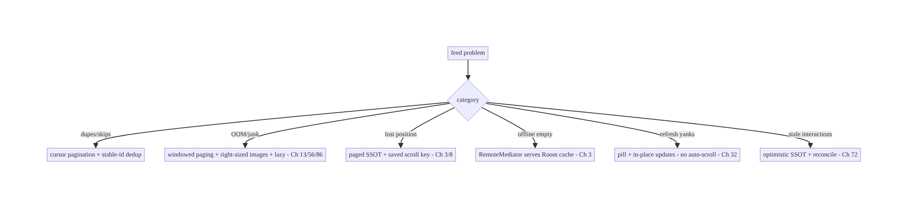
71.9 Failure Scenarios and Recovery
The feed’s correctness and resilience come from one architecture: Paging 3 + RemoteMediator + Room SSOT, with cursor pagination. That single decision delivers windowed memory, offline/cache, process-death survival, stable pagination, in-place freshness, and consistent interactions. Performance (60fps) layers on image right-sizing and lazy work; UX layers on position-preserving refresh.

71.10 Scaling the Implementation
- Level 1. Paging 3 + RemoteMediator + Room SSOT; cursor pagination; LazyColumn with stable keys.
- Level 2. Image right-sizing (Ch 56); item-type recycling; pull-to-refresh; offline from cache; scroll restoration (Ch 8).
- Level 3 — production. “New content” pill + background delta (Ch 32/49); optimistic interactions (Ch 72); in-place updates; jank profiling (Ch 86).
- Level 4 — large. Mixed content + server ranking (Ch 73); video autoplay (visible-only, Ch 58); ads insertion; prefetch tuning; LQIP/blur-hash placeholders (Ch 56).
- Level 5 — enterprise. Feed ranking experiments (Ch 73), engagement analytics, per-content-type QoE, feed-freshness SLOs, personalization (Ch 43), A/B of refresh UX.
Avoid overengineering: Paging 3 + RemoteMediator + Room + cursor pagination + stable keys + right-sized images covers the vast majority. Don’t hand-roll paging/caching; don’t auto-scroll on refresh.

71.11 Alternative Approaches and Trade-offs
Dimension | Option A | Option B | When
Architecture | Paging 3 + RemoteMediator + Room SSOT | network-only PagingSource / manual list | SSOT always (offline/cache/death); network-only loses them
Pagination | Cursor/keyset | offset (?page=N) | Cursor always (offset drifts on insert/delete)
Freshness | Pill + in-place updates | auto-scroll/reorder on refresh | Pill/in-place (never yank position)
Memory | Windowed paging | load all | Windowed (no OOM)
Images | Right-sized/downsampled (Ch 56) | full-res | Right-sized (jank/OOM)
Interactions | Optimistic SSOT (Ch 72) | wait for server | Optimistic (instant, consistent)
Ranking | Server-ranked (Ch 73) | client-ranked | Server (data/scale); client presents
Paging+RemoteMediator+SSOT vs network-only paging: a network-only PagingSource paginates but has no cache — the feed is empty offline, reloads from scratch on every open, and loses everything on process death. Backing paging with a RemoteMediator writing to Room (the SSOT) makes the feed cached, offline-capable, and process-death-survivable, and lets interactions/updates mutate items in place. The SSOT-backed approach is the correct feed architecture.
Cursor vs offset pagination: offset pagination (?offset=40) assumes a stable list, but feeds constantly gain/lose items — so between loading page 2 and page 3, offsets drift, causing duplicate or skipped items. Cursor/keyset pagination (“items after this cursor”) is stable under inserts/deletes. Always use cursor pagination for a feed.
Pill/in-place vs auto-scroll on refresh: auto-scrolling to new content (or reordering) when the user is mid-scroll is jarring and loses their place — a top complaint. Surface freshness with a “N new posts” pill (user taps to jump) and in-place updates (changed items update where they are, stable keys). Never yank the scroll position.

71.12 Security & Privacy Considerations
- Server-side authorization for feed content (Ch 23/19): the feed only contains items the user is allowed to see — the server enforces visibility/privacy (blocked users, private posts); the client renders what the authed API returns, doesn’t filter for security.
- Content rendered as untrusted (Ch 52): feed items (user posts, links, media) are untrusted — sanitize text/links, validate media URLs, don’t auto-execute; guard against injection in rich content.
- Interaction authorization (Ch 72/23): likes/comments are server-authorized; optimistic UI is client convenience, the server validates the action (can this user comment here?).
- Per-account isolation (Ch 42): the feed cache is per-account; clear/scope on logout/ switch (don’t show account A’s cached feed to B).
- Privacy of engagement (Ch 28): what the user views/likes is sensitive; log/analyze per policy and consent; don’t leak.
- Ad/sponsored transparency: sponsored items should be labeled (policy/trust).
- Client vs backend: the server authorizes visibility, ranks (Ch 73), and validates interactions; the client paginates/caches/renders untrusted content safely and applies optimistic interactions pending server confirmation.

71.13 Performance and Resource Optimization
- Windowed paging (Ch 13) — only a window in memory; never load-all.
- Image right-sizing + downsampling (Ch 56) — the #1 feed jank/OOM lever; CDN-sized, placeholder/crossfade.
- Stable keys + item-type recycling — minimal, correct diffing; avoid full rebinds.
- Lazy off-screen work (Ch 86) — autoplay only the visible video (Ch 58); no off-screen computation.
- Cache-first first content (Ch 45/3) — render from Room instantly; refresh in background.
- Prefetch distance tuned — load ahead of the edge without over-fetching.
- Flatten layouts / reduce overdraw (Ch 86).
- LQIP/blur-hash placeholders for perceived speed (Ch 56).
- Profiling: scroll jank (frozen/dropped frames, Ch 86), image decode time + cache hit (Ch 56), paging load latency, memory, first-content time.

71.14 Testing Strategy
Feed logic (RemoteMediator, dedup, cursor keys, interactions) tests in isolation; UI/jank via Paging test + Macrobenchmark (Ch 86).
class FeedRemoteMediatorTest {
@Test fun `APPEND uses next cursor and dedups by id`() = runTest {
val result = mediator.load(LoadType.APPEND, pagingState(lastCursor = "c1"))
assertTrue(result is RemoteMediator.MediatorResult.Success)
assertEquals(expectedIds.distinct().size, db.feed().count()) // no duplicates (stable id)
}
@Test fun `REFRESH clears and reloads from top`() = runTest { /* ... */ }
@Test fun `offline error serves cached Room items`() = runTest { /* Error -> Paging shows cache (Ch 3) */ }
}
class FeedInteractionsTest {
@Test fun `like updates SSOT optimistically and enqueues outbox`() = runTest {
interactions.like("p1")
assertTrue(db.feed().byId("p1").likedByMe) // instant (Ch 72)
assertTrue(outbox.contains(OutboxOp.Like("p1")))
}
}
// UI: Paging test (snapshot), scroll restoration (recreate -> position kept), Macrobenchmark jank (Ch 86).
What to test: RemoteMediator cursor paging + dedup + REFRESH clear + offline-serves-cache; interactions optimistic SSOT + outbox (Ch 72); scroll restoration across recreation (Ch 8); no-auto-scroll on refresh (pill); item-type rendering. Macrobenchmark for scroll jank (Ch 86); Paging snapshot tests.

71.15 Production Observability
- Metrics: scroll jank (frozen/dropped frame rate, Ch 86); first-content time (cache-first); paging load latency + error rate; image cache hit + decode time (Ch 56); offline-render rate; scroll-restoration success; interaction optimistic-vs-confirmed + rollback rate (Ch 72); duplicate/skip incidents (→ 0); feed freshness (staleness).
- Logs: feed{event, load_type, cursor, items, cache} — no content/PII (Ch 28).
- Debugging: jank → images/heavy bind/off-screen work (Ch 56/86); OOM → not windowed/ full-res images; dupes/skips → offset pagination (use cursor); lost position → not restoring scroll key (Ch 8); empty offline → network-only PagingSource (use RemoteMediator); refresh-yank → auto-scroll (use pill).
- Alerting: jank regression; paging error spike; duplicate/skip detection.
- Dashboards: scroll jank + first-content time; paging latency; interaction rollback; offline-render rate.

71.16 System Design Interview Preparation
≥40 questions.
Fundamentals
- Feed architecture? Paging 3 + RemoteMediator + Room SSOT (network→DB→UI).
- Why SSOT-backed? Caching, offline, process-death survival, in-place updates.
- Network-only paging drawback? No cache/offline; reloads; loses state.
- Why Paging 3? Windowing, prefetch, placeholders, RemoteMediator.
- Memory? Windowed — only a window in memory, never load-all.
Pagination
- Cursor vs offset? Cursor stable; offset drifts (dupes/skips) on insert/delete.
- Why offset drifts? Items change between page loads → offsets shift.
- Dedup? Stable id upsert.
- RemoteMediator keys? Store cursors (remote keys table).
- REFRESH? Clear + reload from top (transactional).
Freshness
- How fresh without yanking position? Pill + in-place updates (not auto-scroll).
- “New content” pill? Detect new top items (delta/push); user taps to jump.
- In-place updates? SSOT row changes → Paging diffs in place (stable keys).
- Background delta? Update changed/removed in SSOT (Ch 32).
Performance (Ch 86/56)
- 60fps levers? Stable keys, item-type recycling, image right-sizing, lazy off-screen.
- Top jank cause? Images — right-size/downsample (Ch 56).
- Video autoplay? Visible item only (Ch 58).
- First content fast? Cache-first from Room (Ch 45).
- Measure jank? Macrobenchmark / frame metrics (Ch 86).
Scroll position
- Restore across config? rememberLazyListState + Paging state.
- Process death? Paged SSOT + saved scroll key (Ch 8).
- Tab switch? Saved state (Ch 53).
Interactions
- Like/comment? Optimistic SSOT mutation (Ch 72) → everywhere.
- Consistency across screens? One SSOT row (Ch 3).
- Reconcile? Outbox + server; rollback on failure (Ch 72/31).
Content/ranking
- Mixed content? Item types; server-ranked (Ch 73); client presents + dedups.
- Who ranks? The server (Ch 73).
- Ads? Server inserts at ranked positions; label.
Offline
- Offline feed? RemoteMediator serves cached Room items (Ch 3).
- Error on load? Serve cache; show error affordance.
Security
- Content visibility? Server-authorized (Ch 23); client doesn’t filter for security.
- Untrusted content? Sanitize/validate (Ch 52).
- Per-account cache? Isolate; clear on switch (Ch 42).
Testing/Production
- Test RemoteMediator? Cursor paging + dedup + REFRESH + offline-cache.
- Test restoration? Recreate → position kept.
- Jank in prod? Images/bind/off-screen.
- Dupes/skips? Offset pagination.
- Lost position? Not restoring scroll key.
- Empty offline? Network-only paging.
- Refresh yanks? Auto-scroll (use pill).
- Key metrics? Scroll jank, first-content time, dupes, restoration success.

Design-change challenges
- Endless feed that works offline and survives process death. Paging 3 + RemoteMediator
  - Room SSOT (Ch 13/3).
- Feed shows duplicate/skipped posts. Cursor pagination + stable-id dedup.
- Refresh jumps the user to the top. “New posts” pill + in-place updates (no auto-scroll).
- Scroll janks with images. Right-size/downsample images + stable keys + lazy (Ch 56/ 86).
- Like count differs between feed and detail. One SSOT row + optimistic (Ch 3/72).

Mock walkthrough (abridged)
Clarify (offline?, mixed content?, interactions?, freshness UX?) → Paging 3 + RemoteMediator
- Room SSOT (network→DB→UI, Ch 13/3) → cursor pagination + stable-id dedup → freshness via pill + in-place updates (no yank, Ch 32) → 60fps (stable keys, image right-sizing Ch 56, lazy off-screen Ch 86) → scroll restoration (config/death/tab, Ch 8/53) → optimistic interactions via SSOT (Ch 72) → server-ranked mixed content (Ch 73) → security (authorized visibility, untrusted content) → observability (jank, first-content).

71.17 Practical Exercises
- Beginner. Build the feed with Paging 3 + RemoteMediator + Room SSOT using cursor pagination; render a LazyColumn with stable keys. Eval: paginates; cached; offline- capable.
- Intermediate. Add image right-sizing (Ch 56), item-type recycling, and scroll- position restoration across config change and process death. Eval: 60fps; position restored.
- Advanced. Add a “N new posts” pill (background delta) and in-place updates that never yank scroll position; optimistic like via the SSOT (Ch 32/72). Eval: fresh without jumping; like reflects everywhere.
- Production debugging. Fix duplicates/skips (offset → cursor) and scroll jank (full-res images → right-sized + lazy). Eval: no dupes; 60fps.
- System design challenge. Render server-ranked mixed content (products/posts/video/ ads) with dedup and a jank dashboard (Macrobenchmark, Ch 86). Eval: mixed + ranked; measured.
(Solutions withheld unless requested.)

71.18 Chapter Summary & Reference Sheet
Key decisions: build the infinite feed as a paged, SSOT-backed stream — Paging 3 with a RemoteMediator that writes network pages into Room, so the UI pages from the database and gains caching, offline, and process-death survival for free (network→DB→UI, Ch 13/3); use cursor/keyset pagination (never offset) with stable-id dedup for stability under inserts/deletes; keep it fresh without ever yanking scroll position — pull-to-refresh, a “N new posts” pill, and in-place SSOT updates from background delta sync (Ch 32); optimize hard for 60fps (stable keys, item-type recycling, image right-sizing/downsampling Ch 56, lazy off-screen work incl. visible-only video autoplay Ch 58/86); preserve and restore scroll position across config change, process death, and tab switches (Ch 8/53); apply interactions as optimistic SSOT mutations so a like/comment reflects everywhere the item appears and reconciles via the outbox (Ch 72/31/3); and render server-ranked mixed content (Ch 73) with dedup — the client presents and interacts, the server ranks and authorizes (Ch 23). Content is rendered as untrusted (Ch 52) and the cache is per-account (Ch 42).
Concepts: Paging 3 + RemoteMediator + Room SSOT, cursor/keyset pagination + dedup, position-preserving freshness (pill/in-place/delta), 60fps (stable keys/recycling/image right-sizing/lazy), scroll restoration (config/death/tab), optimistic interactions via SSOT, server-ranked mixed content, offline-from-cache.
Common mistakes: network-only paging (no cache/offline/death survival); offset pagination (dupes/skips); auto-scrolling/reordering on refresh (yanks position); loading all items (OOM); full-res images (jank/OOM); losing scroll position; treating interactions specially instead of SSOT mutations; client-side ranking; rendering untrusted content unsafely; shared cache across accounts.
Checklist:
- ☐ Paging 3 + RemoteMediator + Room SSOT (network→DB→UI, Ch 13/3)
- ☐ cursor pagination + stable-id dedup
- ☐ offline from Room cache; survives process death (Ch 8)
- ☐ freshness via pill + in-place updates (no auto-scroll, Ch 32)
- ☐ 60fps: stable keys + item-type recycling + image right-sizing (Ch 56) + lazy off-screen (Ch 86)
- ☐ scroll restoration (config/death/tab, Ch 8/53)
- ☐ optimistic interactions via SSOT (Ch 72)
- ☐ server-ranked mixed content + dedup (Ch 73)
- ☐ authorized visibility + untrusted content (Ch 23/52)
- ☐ per-account cache (Ch 42)
- ☐ jank + first-content telemetry (Ch 86).
Key APIs: Paging 3 Pager/PagingConfig/RemoteMediator/PagingSource/LoadType/ MediatorResult/cachedIn (Ch 13), Room @Dao pagingSource()/@Transaction/upsert (Ch 3), Compose collectAsLazyPagingItems/LazyColumn/items(key = ...)/ rememberLazyListState (Ch 6), Coil right-sized images (Ch 56), Outbox (Ch 31), optimistic updates (Ch 72), Macrobenchmark (Ch 86).
References:
- Paging 3 + network & database (RemoteMediator): https://developer.android.com/topic/libraries/architecture/paging/v3-network-db
- Paging in Compose: https://developer.android.com/develop/ui/compose/lists#paging
- App startup / scroll performance: https://developer.android.com/topic/performance/vitals/render
- (composes) Ch 13 Paging, Ch 3 SSOT, Ch 32 Delta Sync, Ch 56 Images, Ch 72 Optimistic Updates, Ch 8 Process Death, Ch 73 Recommendations, Ch 86 Performance

Chapter 72 — Optimistic Updates (Likes / Comments)
Part IX — Feature Architectures · Complexity: Complex (≥40 interview questions)
Prerequisites: Ch 3 (SSOT/Room), Ch 31 (outbox), Ch 15 (idempotency), Ch 2 (retries), Ch 6 (UI state/UDF), Ch 32 (sync), Ch 29 (offline-first). Pairs with Ch 71 (feed), Ch 64 (chat), Ch 33 (conflict resolution).
Reference surface in StreamCart: instant-feeling interactions — like/unlike, favorite, follow, add-to-cart, post a comment, rate — that update the UI immediately, persist and retry reliably, reconcile with the server, and roll back cleanly on failure, all while staying consistent across every screen the item appears on.

72.1 Problem Definition and Real-World Context
An optimistic update applies a user action to the UI immediately, assuming it will succeed, then confirms (or rolls back) once the server responds. It’s what makes likes, follows, and comments feel instant instead of showing a spinner on every tap. But doing it correctly is deceptively hard: the update must persist (survive process death and work offline), retry reliably, be idempotent (double-taps, retries), reconcile with the server’s authoritative value, roll back cleanly on genuine failure, stay consistent across every screen the item appears on, and handle concurrent actions (rapid like/unlike) and conflicts (server state diverged). Naive optimistic UI (“flip a boolean in memory, fire a POST”) loses updates on death, double-counts on double-tap, shows the wrong state after failure, and diverges across screens.
Concretely, teams hit:
- In-memory only → lost on death/offline. Flipping a UI flag without persisting means a like is lost on process death or if offline. The optimistic change must go into the SSOT (Room, Ch 3) and an outbox (Ch 31), not just memory.
- Double-count / non-idempotent. Rapid double-taps or retries fire multiple requests; without idempotency (Ch 15) the like counts twice or the comment posts twice.
- No reconciliation. The optimistic value is a guess; the server’s response is authoritative (the real like count may differ due to others’ actions). You must reconcile to the server value, not keep the guess.
- Bad rollback. On genuine failure, the UI must revert to the pre-action state (and ideally tell the user) — but only for real failures, not transient retries.
- Inconsistency across screens. The same item appears in the feed (Ch 71), detail, profile; an optimistic like must update all of them — only possible if it’s one SSOT row (Ch 3), not per-screen state.
- Concurrency / conflicts. Rapid like→unlike→like, or the server state changing underneath, needs ordering, idempotency (Ch 15), and conflict handling (Ch 33).
- Which actions to optimize. Likes/follows (cheap, reversible) are great candidates; payments/irreversible actions should not be optimistic (show real state).
The architecture: apply the action optimistically to the SSOT (Room, Ch 3) so the UI updates instantly everywhere the item appears (UDF, Ch 6); record the intent in an outbox (Ch 31) with an idempotency key (Ch 15) so it persists, retries, and dedups; reconcile with the server’s authoritative response (don’t keep the guess); roll back the SSOT to the pre-action value on genuine failure (with user feedback); handle concurrency (rapid toggles) and conflicts (Ch 33); and don’t apply optimism to irreversible/high-stakes actions. This chapter is the end-to-end pattern for reliable, consistent, reversible optimistic interactions.

Three practical use cases
- Like/unlike (StreamCart feed, Ch 71). Tap like → SSOT updates instantly (count+1, likedByMe=true) across feed/detail; outbox syncs with idempotency; reconcile to server count; roll back on failure.
- Post a comment. Comment appears immediately (status “sending”) in the SSOT; outbox posts it idempotently; on success it’s confirmed (server id/timestamp), on failure marked “failed” with retry.
- Follow / add-to-cart. Instant toggle; offline-capable; reconciled; rolled back if the server rejects (e.g., blocked, out of stock).

Why this is architectural
Optimistic updates compose SSOT (Ch 3), outbox (Ch 31), idempotency (Ch 15), retries (Ch 2), sync/reconciliation (Ch 32), conflict resolution (Ch 33), and UDF (Ch 6) into a reusable interaction pattern used across the whole app (feed Ch 71, chat Ch 64, cart Ch 38). The decisions — SSOT-not-memory, outbox+idempotency, reconcile-don’t-keep-guess, clean rollback, consistency-via-one-row, don’t-optimize-irreversible — determine whether interactions feel instant and stay correct.

72.2 Requirements Engineering

Functional requirements
ID | Requirement
F1 | Apply the action to the UI instantly (optimistic), via the SSOT (Ch 3/6).
F2 | Persist the intent (outbox) so it survives process death and works offline (Ch 31/29).
F3 | Send idempotently with retry; dedup double-taps/retries (Ch 15/2).
F4 | Reconcile with the server’s authoritative value (don’t keep the guess).
F5 | Roll back to pre-action state on genuine failure, with user feedback.
F6 | Stay consistent across all screens (one SSOT row); handle concurrency/conflicts (Ch 3/33).

Non-functional requirements
Attribute | Policy
Instant UX | UI updates immediately; no spinner for reversible actions.
Reliability | Persists (death/offline); retries; never lost (Ch 31/29).
Correctness | Idempotent; reconciled to server truth; clean rollback (Ch 15).
Consistency | One SSOT row → all screens consistent (Ch 3).
Safety | Not applied to irreversible/high-stakes actions.

Scope
- In scope: the optimistic pattern (SSOT apply → outbox → idempotent send → reconcile / rollback), consistency via one SSOT row (Ch 3/6), outbox + idempotency + retry (Ch 31/15/ 2), reconciliation to server truth, rollback UX, concurrency (rapid toggles), conflicts (Ch 33), offline (Ch 29), when-not-to-optimize (irreversible), count vs boolean vs create (like/comment) shapes.
- Out of scope: SSOT internals (Ch 3), outbox/sync/idempotency mechanics (Ch 31/32/15), conflict resolution depth (Ch 33), feed (Ch 71), chat send (Ch 64), UDF (Ch 6).

Assumptions & constraints
- Room SSOT (Ch 3), outbox (Ch 31), WorkManager (Ch 30), UDF/StateFlow (Ch 6). minSdk 24. The server is authoritative for the real value (like counts, comment ids); actions have idempotency keys; optimistic UI is for reversible actions.

72.3 System Design Fundamentals
- Optimistic = apply now, confirm/revert later. On the user action, immediately apply the expected result to local state, show it, and send the request in the background; when the server responds, confirm (replace the guess with the real value) or roll back (revert) on failure. This removes the per-tap spinner and makes the app feel instant.
- Apply to the SSOT, not memory (the consistency key, Ch 3/6). The optimistic change must mutate the SSOT (Room row) — not a screen-local variable. Because the item is one row rendered by every screen (feed Ch 71, detail, profile) via UDF (Ch 6), a single SSOT mutation makes the like appear everywhere at once and stay consistent. In-memory optimism diverges across screens and is lost on death.
- Persist the intent in an outbox (Ch 31). Record the action (like X, comment Y) in an outbox so it survives process death and offline and is retried reliably (Ch 2). The outbox op carries an idempotency key (Ch 15). (Same reliable-send pattern as chat, Ch 64, and cart mutations, Ch 38.)
- Idempotency (Ch 15) — mandatory. Rapid double-taps, retries, and the outbox re-sending must not double-apply. Use an idempotency key (per action) so the server dedups: a like is “set liked=true” (idempotent) not “increment” (not idempotent); a comment carries a client-generated id so a retry doesn’t post twice (Ch 15/64). Model actions idempotently.
- Reconcile with the server’s authoritative value (don’t keep the guess). The optimistic value is an estimate — the real like count depends on everyone’s actions, so the server’s response is truth. On confirmation, replace the local guess with the server value (e.g., the real count), not just “mark confirmed.” This corrects drift (your +1 guess vs the actual count). Background sync (Ch 32) also reconciles.
- Rollback on genuine failure (not transient). Distinguish:
  - Transient failure (network, 5xx): keep the optimistic state and retry (outbox/backoff, Ch 2/31) — don’t roll back on a blip.
  - Genuine failure (4xx: forbidden, blocked, out-of-stock, validation): roll back the SSOT to the pre-action value and tell the user (toast/snackbar). Store the pre-action value so rollback is exact. Rolling back on every transient error causes flicker; never rolling back leaves wrong state — distinguish by response.
- Consistency across screens = one SSOT row (Ch 3). Don’t special-case the feed’s like vs the detail’s like — they read the same row. Optimistic mutation + reconciliation happen on that row; every observer updates. This is why SSOT-backing (not per-screen state) is non-negotiable.
- Concurrency & conflicts (Ch 33). Rapid like→unlike→like must end in the correct final state: model as idempotent set-state (last intent wins) with the outbox coalescing/ordering (Ch 31), not racing increments. Server-state conflicts (someone else changed it; your offline action conflicts) reconcile via the server value / conflict policy (Ch 33) — typically the server’s count wins for counts, last-writer for booleans, with the user’s own action honored.
- Action shapes:
  - Boolean toggle (like/follow/favorite): optimistic liked=true/false; reconcile the count to server; idempotent set-state.
  - Create (comment/review): optimistic insert with status Sending → Sent/Failed and a client id (Ch 64); reconcile to the server-assigned id/timestamp.
  - Counter: never optimistic-increment blindly; set-state + reconcile to server count.
- When NOT to be optimistic (safety). Irreversible or high-stakes actions — payments, placing an order, deleting data, money transfer — should not be optimistic; show the real state (confirmed by the server) because a rollback after the user believed it succeeded is unacceptable. Optimism is for cheap, reversible actions (likes, follows, comments, cart toggles).
Core insight: apply the user’s reversible action optimistically to the SSOT (one Room row, Ch 3) so the UI updates instantly and consistently across every screen (UDF, Ch 6); persist the intent in an outbox with an idempotency key (Ch 31/15) so it survives process death and offline, retries reliably, and dedups double-taps/retries; reconcile with the server’s authoritative value (replace the guess — the real count depends on everyone, Ch 32); distinguish transient failures (keep + retry) from genuine ones (roll back to the stored pre-action value + tell the user); model actions as idempotent set-state and resolve concurrency/conflicts via the server value (Ch 33); and never apply optimism to irreversible or high-stakes actions (payments/orders/deletes) — show real state there.

72.4 High-Level Architecture
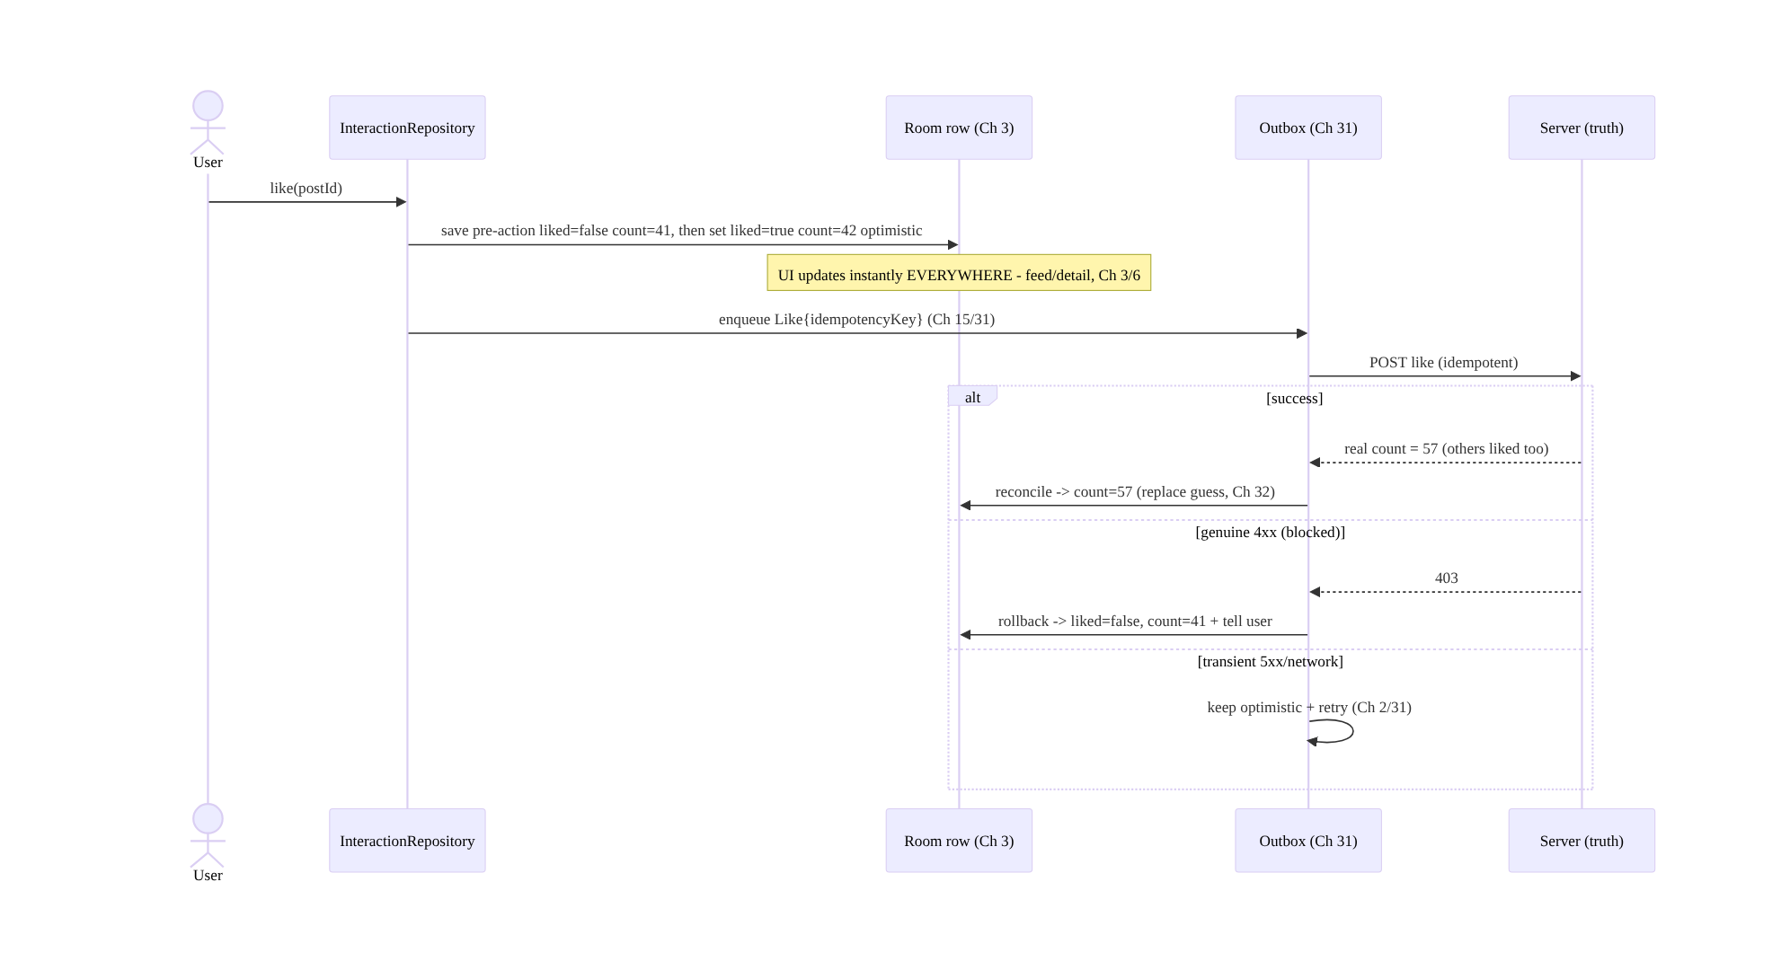
72.4 High-Level Architecture
Components & ownership
- Optimistic apply mutates the SSOT row (storing the pre-action value) → UI instant
  - consistent.
- Outbox + idempotency persist/retry/dedup the intent (Ch 31/15).
- Reconcile replaces the guess with server truth; rollback reverts on genuine failure; conflict policy (Ch 33) resolves divergence.
- Irreversible actions bypass optimism.
Direction: tap → optimistic SSOT apply (+pre-value) → instant UI + outbox(idempotent) → server → reconcile / keep-retry / rollback → SSOT truth; conflicts via policy; irreversible excluded.

72.5 Detailed Component Design
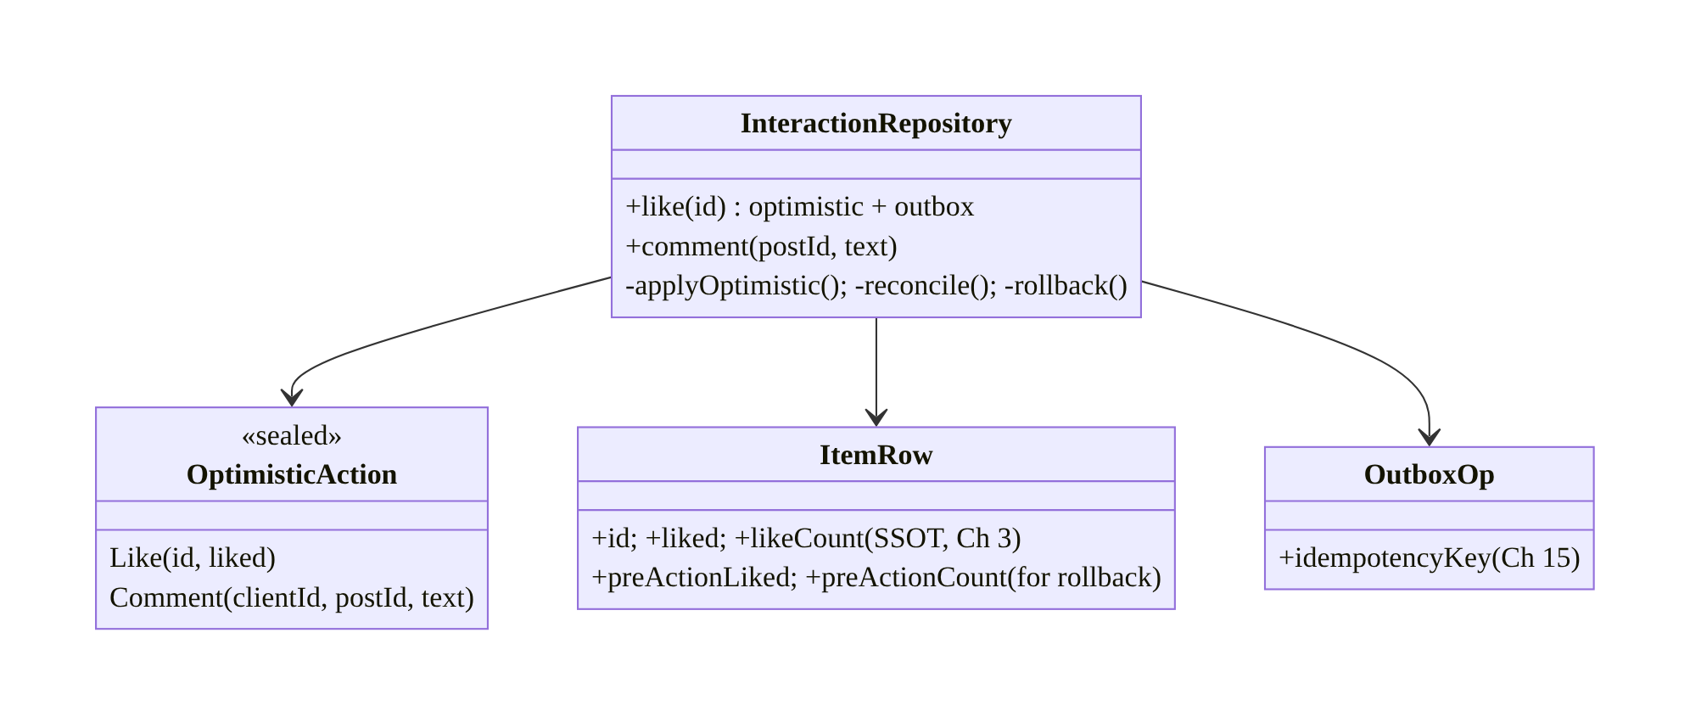
72.5 Detailed Component Design
Component | Responsibility
InteractionRepository | optimistic apply → outbox → reconcile/rollback over SSOT
ItemRow | SSOT row with current + pre-action values (rollback)
OptimisticAction | typed actions (toggle / create)
OutboxOp | persisted intent + idempotency key (Ch 31/15)

72.6 End-to-End Data Flow

Like: optimistic → reconcile / rollback
Like: optimistic → reconcile / rollback

Rapid toggle (idempotent set-state)
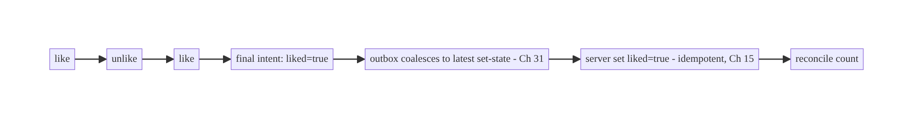
Rapid toggle (idempotent set-state)

72.7 Complete Kotlin Implementation
Package: com.streamcart.interactions.

72.7.1 SSOT row with pre-action values (for rollback)
@Entity(tableName = "posts")
data class PostRow(
@PrimaryKey val id: String, val likeCount: Int, val likedByMe: Boolean,
// pre-action snapshot for exact rollback (or store in the outbox op):
val pendingLike: Boolean = false,
)

72.7.2 Optimistic like: apply to SSOT → outbox (idempotent)
@Singleton
class InteractionRepository @Inject constructor(
private val dao: PostDao, private val outbox: Outbox, private val api: InteractionApi, // Ch 31
) {
suspend fun like(postId: String, like: Boolean) {
val current = dao.byId(postId) ?: return
val preLiked = current.likedByMe; val preCount = current.likeCount
// 1) Optimistic SSOT mutation -> UI instant EVERYWHERE (Ch 3/6). Idempotent SET-STATE (not increment).
dao.setLike(postId, liked = like, count = preCount + if (like && !preLiked) 1 else if (!like && preLiked) -1 else 0)
// 2) Persist intent with idempotency key; survives death/offline; retried (Ch 31/15/2).
outbox.enqueue(OutboxOp.SetLike(postId, like, idempotencyKey = "$postId:like:$like", preLiked, preCount))
}
// OutboxProcessor calls this.
suspend fun syncSetLike(op: OutboxOp.SetLike): OutboxResult = runCatching {
val serverCount = api.setLike(op.postId, op.like, op.idempotencyKey) // idempotent set-state (Ch 15)
dao.reconcileCount(op.postId, serverCount) // 3) RECONCILE to server truth (Ch 32)
OutboxResult.Done
}.getOrElse { e ->
when {
e.isTransient() -> OutboxResult.Retry // 5xx/network: keep + retry (Ch 2)
else -> { dao.setLike(op.postId, op.preLiked, op.preCount); OutboxResult.Failed(e) } // 4) ROLLBACK (4xx) + user feedback
}
}
}

72.7.3 Optimistic create (comment): Sending → Sent/Failed (Ch 64 pattern)
suspend fun InteractionRepository.comment(postId: String, text: String) {
val clientId = UUID.randomUUID().toString() // idempotency + optimistic match (Ch 15/64)
dao.insertComment(Comment(clientId, postId, text, status = Status.Sending, serverId = null)) // optimistic insert
outbox.enqueue(OutboxOp.PostComment(clientId, postId, text))
}
suspend fun InteractionRepository.syncComment(op: OutboxOp.PostComment): OutboxResult = runCatching {
val posted = api.postComment(op.postId, op.text, idempotencyKey = op.clientId) // idempotent (Ch 15)
dao.confirmComment(op.clientId, serverId = posted.id, status = Status.Sent) // reconcile to server id
OutboxResult.Done
}.getOrElse { e ->
if (e.isTransient()) OutboxResult.Retry
else { dao.markComment(op.clientId, Status.Failed); OutboxResult.Failed(e) } // show "failed" + manual retry
}

72.7.4 UI: render SSOT (instant + consistent), failure feedback (Ch 6)
@Composable
fun LikeButton(post: PostRow, vm: PostViewModel = hiltViewModel()) {
// Reads the SSOT row -> same state in feed/detail/profile (Ch 3). Tap updates instantly.
IconToggleButton(checked = post.likedByMe, onCheckedChange = { vm.like(post.id, it) }) {
Icon(if (post.likedByMe) Icons.Filled.Favorite else Icons.Outlined.FavoriteBorder, null)
}
Text("${post.likeCount}") // reconciled to server truth after sync (Ch 32)
// Genuine-failure rollback surfaces a snackbar ("Couldn't like — try again") via a one-time event (Ch 7).
}

72.7.5 When NOT to be optimistic (irreversible)
// Payments/orders/deletes: show REAL state (server-confirmed), not optimistic.
suspend fun placeOrder(cart: Cart): Outcome<Order> {
// NO optimistic "order placed". Show "Placing…" -> await server -> show confirmed/failed.
return api.placeOrder(cart) // real state only; a rollback after "order placed" is unacceptable
}

72.7.6 Module structure
:core:interactions InteractionRepository, OptimisticAction, OutboxOp (idempotency), reconcile/rollback
:core:data SSOT rows (Ch 3); :core:outbox Outbox + processor (Ch 31)
# Idempotency -> Ch 15; retries -> Ch 2; reconcile/sync -> Ch 32; conflicts -> Ch 33. Used by feed (Ch 71), chat (Ch 64), cart (Ch 38).

72.8 Concurrency and Race Conditions
Scenario | Risk | Handling
Double-tap / retry | double-count/post | idempotency key + set-state (not increment) (Ch 15)
Rapid like→unlike→like | wrong final state | idempotent set-state (latest intent); outbox coalesces (Ch 31)
Server count diverges | stale guess | reconcile to server value (Ch 32)
Process death mid-action | lost action | outbox persisted (Ch 31)
Transient failure | false rollback/flicker | keep + retry; roll back only on genuine 4xx (Ch 2)
Same item on many screens | divergent state | one SSOT row (Ch 3)
Offline action then conflict | divergence | queue; reconcile/conflict policy on sync (Ch 29/33)
- Idempotent set-state beats increments: modeling a like as “set liked=true” (not “increment count”) makes double-taps, retries, and re-sends idempotent (Ch 15); the count is then reconciled to the server’s authoritative value (which reflects everyone). Increment-based optimism double-counts and can’t reconcile cleanly.
- Latest-intent wins for rapid toggles: like→unlike→like should send the final set-state; the outbox coalesces rapid toggles to the latest (Ch 31) rather than racing N requests, and idempotency makes any that do go out safe.
- One SSOT row = inherent cross-screen consistency: because feed/detail/profile read the same row (Ch 3), there’s no multi-screen sync problem — the optimistic mutation and reconciliation happen once.

72.9 Failure Scenarios and Recovery
Failure | Detection | Response | Outcome
Lost on process death | action gone | outbox persisted (Ch 31) | survives
Double-count on double-tap | wrong count | idempotent set-state (Ch 15) | single
Stale count vs server | drift | reconcile to server value (Ch 32) | correct
Genuine failure (blocked/4xx) | response | roll back to pre-action + tell user | reverted
Transient failure | 5xx/network | keep optimistic + retry (Ch 2/31) | eventually sent
Divergent across screens | inconsistency | one SSOT row (Ch 3) | consistent
Offline conflict | server diverged | conflict policy / server value (Ch 33) | resolved
Optimistic on a payment | wrong “success” | don’t optimize irreversible; show real state | safe
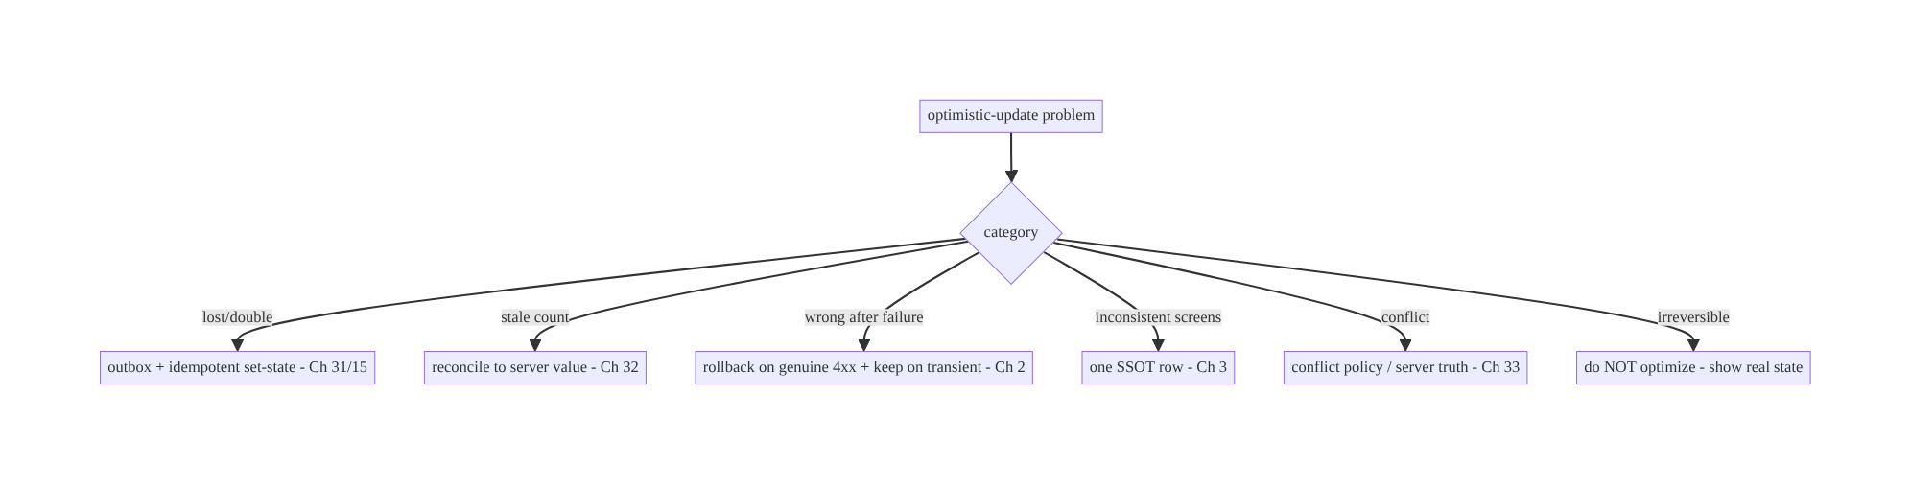
72.9 Failure Scenarios and Recovery
Optimistic updates are “guess, persist, reconcile, revert” — not “flip a boolean.” Apply to the SSOT (one row → consistent + death-safe), persist in an outbox with an idempotency key (reliable + dedup), reconcile to the server’s authoritative value (not your guess), and roll back only on genuine failure. Model actions as idempotent set-state, and never optimize irreversible actions.

72.10 Scaling the Implementation
- Level 1. Optimistic SSOT mutation + instant UI (one row); basic send.
- Level 2. Outbox + idempotency key + retry (Ch 31/15/2); reconcile to server value; rollback on genuine failure.
- Level 3 — production. Transient-vs-genuine failure distinction + user feedback; comment create (Sending/Sent/Failed); rapid-toggle coalescing; offline (Ch 29).
- Level 4 — large. Conflict resolution (Ch 33); cross-device consistency (Ch 32); per-action-type policies; analytics (optimistic success/rollback rate); reusable optimistic framework across features (feed Ch 71, chat Ch 64, cart Ch 38).
- Level 5 — enterprise. Interaction QoE SLOs, A/B of optimistic behavior, abuse/rate- limit handling, consistency guarantees, irreversible-action governance.
Avoid overengineering: SSOT apply + outbox + idempotency + reconcile + rollback is the reusable core. Don’t build optimism for irreversible actions; don’t hand-roll per-feature — reuse one pattern.

72.11 Alternative Approaches and Trade-offs
Dimension | Option A | Option B | When
State location | SSOT row (Ch 3) | screen-local memory | SSOT (consistent, death-safe); memory diverges/loses
Persistence | Outbox (Ch 31) | fire-and-forget POST | Outbox (survives death/offline, retries)
Action model | Idempotent set-state (Ch 15) | increment / non-idempotent | Set-state (double-tap/retry safe)
Server value | Reconcile (replace guess) | keep optimistic value | Reconcile (count reflects everyone, Ch 32)
Failure | Roll back on genuine, keep on transient | roll back on any error | Distinguish (avoid flicker vs wrong state)
Candidates | Reversible (like/follow/comment) | everything incl. payments | Reversible only; never irreversible
Create | Status Sending/Sent/Failed + client id (Ch 64) | optimistic with no status | Status + client id (reconcile, retry)
SSOT vs in-memory optimistic state: flipping a screen-local boolean is the common naive approach — it diverges across screens (feed vs detail show different like states), is lost on process death, and can’t reconcile. Applying to the SSOT row (Ch 3) makes the change consistent everywhere (one row, UDF Ch 6), death-safe, and reconcilable. Always optimize the SSOT, never memory.
Reconcile vs keep-the-guess: the optimistic “+1” is a guess — the real like count changes as others act, so keeping your guess drifts from reality. Reconciling to the server’s authoritative value on confirmation (and via background sync, Ch 32) keeps counts correct. Model booleans as your-own-state (honored) but counts as server truth.
Idempotent set-state vs increment: “increment the like count” is not idempotent — double-taps and retries double-count. “Set liked=true/false” is idempotent (Ch 15): applying it twice is the same as once, and the server dedups via the idempotency key. Model toggles as set-state and reconcile the derived count.
Optimistic vs real-state for irreversible actions: optimism is great for cheap, reversible actions, but for payments, orders, deletes, transfers a rollback after the user believed it succeeded is unacceptable (they think they paid/ordered). Show the real, server-confirmed state for irreversible/high-stakes actions; reserve optimism for likes/follows/comments/cart-toggles.

72.12 Security Considerations
- Server authorizes the action (Ch 23/19): optimistic UI is client convenience; the server validates and authorizes (can this user like/comment/follow? blocked? rate- limited?). A genuine 4xx (forbidden) triggers rollback — never treat the optimistic state as authorization.
- Idempotency key integrity (Ch 15): the key dedups retries; the server enforces idempotency so a replayed request can’t double-apply (also prevents some abuse).
- Untrusted content (Ch 52): optimistically-inserted comments are user content — sanitize on render; the server validates/moderates (don’t trust client text).
- Rate limiting / abuse: rapid toggles and spam are server-rate-limited; the client’s optimism must handle server rejections (rollback) gracefully — don’t let optimism mask abuse controls.
- Per-account isolation (Ch 42): interaction state (likedByMe) is per-account; clear/ scope on logout.
- Don’t optimize security-relevant or irreversible actions: permission changes, payments, deletes show real state (above).
- Client vs backend: the server is authoritative (validates, authorizes, dedups, ranks counts), the client applies optimistically and reconciles/rolls back to the server’s verdict — optimism never overrides server authority.

72.13 Performance and Resource Optimization
- Instant UI is the whole point — no network round-trip blocking the tap (SSOT mutation is local/fast).
- Coalesce rapid toggles (Ch 31) — send the final set-state, not N requests (battery/ server load).
- Batch reconciliations where possible (e.g., sync counts for visible items, Ch 32).
- Idempotent set-state avoids wasted re-work from retries/duplicates.
- Outbox efficiency — debounce/dedupe ops (Ch 31); don’t spam.
- Reconcile visible items (don’t fetch counts for off-screen).
- Profiling: optimistic→confirmed latency, rollback rate, double-send rate (→ 0), outbox depth, reconcile frequency.

72.14 Testing Strategy
Highly unit-testable (SSOT apply, idempotency, reconcile, rollback) with fakes.
class OptimisticLikeTest {
@Test fun `applies optimistically and enqueues idempotent outbox op`() = runTest {
repo.like("p1", true)
assertTrue(dao.byId("p1").likedByMe) // instant (Ch 3)
assertEquals("p1:like:true", outbox.last().idempotencyKey) // idempotent (Ch 15)
}
@Test fun `reconciles count to server value`() = runTest {
api.nextCount = 57; repo.syncSetLike(opLike("p1"))
assertEquals(57, dao.byId("p1").likeCount) // replace guess (Ch 32)
}
@Test fun `rolls back on genuine 4xx, keeps on transient`() = runTest {
api.failWith(403); repo.syncSetLike(opLike("p1", preCount = 41))
assertEquals(41, dao.byId("p1").likeCount) // rolled back
api.failWith(503); val r = repo.syncSetLike(opLike("p2"))
assertTrue(r is OutboxResult.Retry) // kept + retry (Ch 2)
}
@Test fun `double-tap does not double-count`() = runTest {
repo.like("p1", true); repo.like("p1", true) // idempotent set-state
assertEquals(1, dao.byId("p1").likeCount - baseCount)
}
}
class OptimisticCommentTest {
@Test fun `comment shows Sending then Sent with server id`() = runTest { /* reconcile to server id (Ch 64) */ }
@Test fun `comment marks Failed on genuine error`() = runTest { /* ... */ }
}
What to test: optimistic SSOT apply (instant) + idempotent outbox op; reconcile to server value; rollback on genuine 4xx vs keep+retry on transient; double-tap/rapid-toggle idempotency; comment Sending→Sent/Failed; cross-screen consistency (same row); process-death resume (outbox). Fake API/outbox; Room in-memory.

72.15 Production Observability
- Metrics: optimistic→confirmed latency; rollback rate (by reason: 4xx/validation); double-send/double-count rate (→ 0); reconcile corrections (guess vs server delta); outbox depth + retry rate; offline-queued actions; per-action-type success.
- Logs: interaction{type, action, result(confirmed/rolledback/retry)} — no content/PII (Ch 28).
- Debugging: lost actions → not using outbox (Ch 31); double-count → non-idempotent (increment vs set-state, Ch 15); wrong count → not reconciling (Ch 32); flicker → rolling back on transient; inconsistent screens → not SSOT-backed (Ch 3); “success” then gone → optimistic on an irreversible action.
- Alerting: rollback-rate spike (server rejecting — bug/abuse); double-count detection; reconcile-correction spike (guess drift).
- Dashboards: rollback rate by reason; optimistic latency; outbox depth.

72.16 System Design Interview Preparation
≥40 questions.
Fundamentals
- Optimistic update? Apply the action to the UI immediately, confirm/revert on server response.
- Why? Instant feel; no per-tap spinner.
- Apply where? The SSOT row (Ch 3), not memory.
- Why SSOT not memory? Consistent across screens + death-safe + reconcilable.
- Persist how? Outbox (Ch 31) with an idempotency key (Ch 15).
Idempotency/model
- Why idempotency? Double-tap/retry must not double-apply (Ch 15).
- Set-state vs increment? Set-state is idempotent; increment double-counts.
- Comment idempotency? Client-generated id (Ch 64).
- Rapid like→unlike→like? Latest set-state wins; outbox coalesces (Ch 31).
Reconciliation
- Is the optimistic value truth? No — a guess; server is authoritative.
- Reconcile? Replace guess with server value (real count, Ch 32).
- Why counts differ? Others act too; server reflects everyone.
- Boolean vs count? Your boolean honored; count reconciled to server.
Rollback
- When roll back? Genuine failure (4xx: forbidden/blocked/validation).
- When keep? Transient (5xx/network) → retry (Ch 2).
- Why distinguish? Rolling back on transient causes flicker; never rolling back leaves wrong state.
- Rollback to what? The stored pre-action value.
- User feedback? Snackbar/toast on rollback.
Consistency/concurrency
- Same item many screens? One SSOT row → all consistent (Ch 3).
- Process death? Outbox persisted (Ch 31).
- Offline? Queue; reconcile/conflict on sync (Ch 29/33).
- Conflicts? Server value / conflict policy (Ch 33).
Create (comment)
- Comment states? Sending → Sent/Failed; client id; reconcile to server id.
- Failed comment? Mark failed + manual retry.
Safety
- Don’t optimize what? Irreversible/high-stakes (payments/orders/deletes).
- Why? Rollback after perceived success is unacceptable.
- Server role? Authorize/validate/dedup (Ch 23); optimism is client convenience.
Testing/Production
- Test optimistic? Instant SSOT apply + idempotent op.
- Test reconcile? Count → server value.
- Test rollback? Genuine 4xx reverts; transient retries.
- Test double-tap? No double-count.
- Lost in prod? Not using outbox.
- Double-count? Non-idempotent.
- Wrong count? Not reconciling.
- Flicker? Rollback on transient.
- Inconsistent screens? Not SSOT-backed.
- Key metrics? Rollback rate, optimistic latency, double-count.
Composition
- Used by? Feed (Ch 71), chat send (Ch 64), cart (Ch 38).
- Reuse? One pattern (SSOT+outbox+idempotency+reconcile+rollback).
- Cross-device? Reconcile via sync (Ch 32).
- Abuse? Server rate-limits; client handles rejection (rollback).

Design-change challenges
- Make likes feel instant but correct. Optimistic SSOT set-state + outbox idempotency + reconcile count + rollback (Ch 3/31/15/32).
- Double-tap double-counts. Idempotent set-state + idempotency key (Ch 15).
- Like count wrong vs server. Reconcile to server value (Ch 32).
- UI flickers on flaky network. Keep on transient, roll back only on genuine 4xx (Ch 2).
- Optimistic “order placed” then it failed. Don’t optimize irreversible; show real state.

Mock walkthrough (abridged)
Clarify (which actions, reversible?, offline?, multi-screen?) → optimistic SSOT apply (one row, store pre-value, Ch 3) → outbox + idempotency key (persist/retry/dedup, Ch 31/15) → idempotent set-state model → reconcile to server value (Ch 32) → rollback on genuine 4xx vs keep+retry on transient (Ch 2) → consistency via one row + conflicts (Ch 3/33) → exclude irreversible actions → security (server authorizes) → observability (rollback rate).

72.17 Practical Exercises
- Beginner. Make like/unlike optimistic via an SSOT set-state mutation so it updates instantly in both the feed and detail (one row). Eval: instant; consistent.
- Intermediate. Add an outbox op with an idempotency key, retry, and reconcile the count to the server value. Eval: survives death/offline; count correct; double-tap safe.
- Advanced. Implement rollback on genuine 4xx (revert to pre-action + snackbar) vs keep+retry on transient; handle rapid like→unlike→like via coalescing. Eval: no flicker; correct final state.
- Production debugging. Fix double-counting (increment → idempotent set-state) and a count that drifts from the server (add reconciliation). Eval: single count; reconciled.
- System design challenge. Add optimistic comment create (Sending/Sent/Failed + client id) and ensure a payment is not optimistic (real state). Eval: comments reconcile; payment shows confirmed-only.
(Solutions withheld unless requested.)

72.18 Chapter Summary & Reference Sheet
Key decisions: apply the user’s reversible action optimistically to the SSOT (one Room row, Ch 3) so the UI updates instantly and consistently across every screen (UDF, Ch 6) and survives process death; persist the intent in an outbox with an idempotency key (Ch 31/15) so it works offline, retries reliably (Ch 2), and dedups double-taps/retries — modeling actions as idempotent set-state (not increments); reconcile with the server’s authoritative value (replace the guess — the real count reflects everyone, Ch 32); distinguish transient failures (keep the optimistic state + retry) from genuine failures (4xx → roll back to the stored pre-action value + tell the user), avoiding both flicker and wrong state; resolve concurrency (rapid toggles → latest set-state, coalesced) and conflicts via the server value / policy (Ch 33); and never apply optimism to irreversible or high-stakes actions (payments, orders, deletes) — show real, server-confirmed state there. The server is authoritative (validates/authorizes/dedups, Ch 23); optimism is client convenience.
Concepts: optimistic apply to SSOT (one row), outbox + idempotency (persist/retry/ dedup), idempotent set-state, reconcile-to-server-truth, transient-vs-genuine rollback, cross-screen consistency, concurrency/conflict (Ch 33), create (Sending/Sent/Failed), irreversible-exclusion.
Common mistakes: in-memory optimism (diverges across screens, lost on death); fire-and- forget (lost offline/on death); increment instead of set-state (double-count); keeping the guess (count drifts); rolling back on transient errors (flicker); never rolling back (wrong state); not reconciling; optimizing irreversible actions (unacceptable rollback); per-screen state instead of SSOT; ignoring server authorization.
Checklist:
- ☐ optimistic apply to the SSOT row (store pre-action value, Ch 3)
- ☐ instant + consistent across screens (one row, UDF Ch 6)
- ☐ outbox + idempotency key (Ch 31/15)
- ☐ idempotent set-state (not increment)
- ☐ reconcile count/id to server value (Ch 32)
- ☐ roll back on genuine 4xx (+ user feedback); keep+retry on transient (Ch 2)
- ☐ rapid-toggle coalescing (Ch 31)
- ☐ conflicts via server/policy (Ch 33)
- ☐ offline-capable (Ch 29)
- ☐ NOT optimistic for irreversible/high-stakes actions
- ☐ server authorizes (Ch 23)
- ☐ rollback-rate + double-count telemetry.
Key APIs: Room @Dao set-state mutation + reconcile (Ch 3), Outbox + OutboxOp + idempotency key (Ch 31/15), WorkManager retry (Ch 30/2), UUID.randomUUID (comment client id, Ch 64), UDF StateFlow (Ch 6), one-time events for failure feedback (Ch 7), sync reconcile (Ch 32), conflict policy (Ch 33).
References:
- Offline-first mutations: https://developer.android.com/topic/architecture/data-layer/offline-first#create-update-delete
- (composes) Ch 3 SSOT, Ch 31 Outbox, Ch 15 Idempotency, Ch 2 Retries, Ch 32 Delta Sync, Ch 33 Conflict Resolution, Ch 6 UI State, Ch 71 Feed, Ch 64 Chat, Ch 38 Cart

Chapter 73 — Recommendations Feed
Part IX — Feature Architectures · Complexity: Standard (≥25 interview questions)
Prerequisites: Ch 71 (infinite feed), Ch 13 (paging), Ch 3 (SSOT), Ch 41 (remote config), Ch 14 (analytics/events), Ch 43 (personalization), Ch 28 (privacy). Pairs with Ch 72 (interactions), Ch 87 (A/B & experiments).
Reference surface in StreamCart: the “Recommended for you” / “You might like” surfaces — a personalized, server-ranked feed of products/content, where the client’s job is to render, log signals, and experiment, and the server (and ML) does the ranking — with graceful cold-start, freshness, and privacy.

73.1 Problem Definition and Real-World Context
A recommendations feed (“Recommended for you”, “Because you watched…”, “You might like”) is a personalized, ranked surface. The crucial architectural truth is a division of labor: the server (and its ML models) does the ranking and personalization; the client renders the ranked results, logs the behavioral signals that feed the models, and runs experiments. Teams that try to rank on the client, or that fail to log the right signals, or that mishandle cold-start/freshness/privacy, end up with poor, stale, or creepy recommendations and no ability to improve them.
Concretely, teams hit:
- Trying to rank on the client. Recommendation ranking needs global data (everyone’s behavior, catalog, ML models) the client doesn’t have. The server ranks; the client must not reorder/re-rank (beyond trivial client-side filters) — it renders the server’s order (like the feed, Ch 71).
- Not logging the right signals. Models improve from behavioral signals — impressions (what was shown), clicks, dwell time, add-to-cart, purchases, likes (Ch 72), dismissals (“not interested”). If the client doesn’t log these reliably (Ch 14), the models can’t learn. Signal logging is a first-class client responsibility.
- Cold-start. A new user (or new item) has no history → recommendations are empty/bad. Need fallbacks: popular/trending, onboarding preferences (Ch 43), contextual (category) until personalization kicks in.
- Freshness & caching. Recommendations go stale (user’s interests change, new items); the client caches for offline/instant (Ch 3/71) but must refresh appropriately and not show day-old recs as fresh.
- Experimentation (A/B). Recommendation strategies are A/B tested (Ch 87) via remote config (Ch 41); the client renders the assigned variant and logs outcomes so the server measures which ranking wins.
- Privacy & transparency (Ch 28). Personalization uses behavioral data — handle with consent, allow opt-out/“not interested”, and be transparent (“Recommended because you viewed X”); regulatory constraints apply.
- Diversity & feedback loops. Over-optimizing engagement creates filter bubbles/ repetition; the server manages diversity, but the client surfaces controls (dismiss, “show less”).
The architecture: treat recommendations as a server-ranked feed (built on the Ch 71 infra — Paging + SSOT) where the client renders the server’s ranking and does not re-rank; log behavioral signals reliably (impressions, clicks, dwell, conversions, dismissals) via the analytics/event pipeline (Ch 14) to feed the models; handle cold-start with fallbacks (popular/onboarding/contextual, Ch 43); cache + refresh appropriately (Ch 3/71); render the A/B-assigned variant (remote config, Ch 41/87) and log outcomes; and respect privacy (consent, opt-out, transparency, Ch 28). This chapter is about the client side of recommendations: render, log, experiment — the server ranks.

Three practical use cases
- “Recommended for you” (StreamCart). A server-ranked product feed rendered via the Ch 71 infra; the client logs impressions/clicks/add-to-cart; handles cold-start with trending; refreshes periodically.
- “Because you watched…” row. A contextual rec row on a detail screen; client renders the server’s ranked items + the explanation; logs dwell/clicks; “not interested” dismissal.
- A/B of ranking strategies. Remote config assigns a ranking variant (Ch 41/87); the client renders it and logs conversions so the server picks the winner.

Why this is architectural
Recommendations define a client/server division of labor (server ranks, client renders/ logs/experiments) built on the feed infra (Ch 71), the analytics pipeline (Ch 14), personalization (Ch 43), remote config/experiments (Ch 41/87), and privacy (Ch 28). The decisions — don’t-rank-on-client, reliable-signal-logging, cold-start fallbacks, cache/ refresh, A/B rendering, privacy/transparency — determine whether recommendations are good, improvable, and trustworthy.

73.2 Requirements Engineering

Functional requirements
ID | Requirement
F1 | Render a server-ranked, personalized feed (reuse Ch 71 infra); don’t re-rank on client.
F2 | Log behavioral signals reliably (impressions, clicks, dwell, conversions, dismissals) (Ch 14).
F3 | Handle cold-start with fallbacks (popular/onboarding/contextual) (Ch 43).
F4 | Cache for offline/instant; refresh appropriately (not stale-as-fresh) (Ch 3/71).
F5 | Render the A/B-assigned variant; log outcomes (Ch 41/87).
F6 | Respect privacy (consent, opt-out/“not interested”, transparency) (Ch 28).

Non-functional requirements
Attribute | Policy
Division of labor | Server ranks; client renders/logs/experiments.
Signal fidelity | Reliable, accurate signals (impressions counted correctly).
Freshness | Timely refresh; cached for instant/offline; not stale.
Experimentation | Correct variant rendering + outcome logging (Ch 87).
Privacy | Consent, opt-out, transparency; regulatory (Ch 28).

Scope
- In scope: server-ranked rec feed on Ch 71 infra (render, don’t re-rank), signal logging (impression/click/dwell/conversion/dismiss via Ch 14), cold-start fallbacks (popular/onboarding/contextual, Ch 43), cache/refresh (Ch 3/71), A/B variant rendering + outcome logging (Ch 41/87), privacy (consent/opt-out/transparency, Ch 28), diversity controls (dismiss/“show less”), explanations.
- Out of scope: ML/ranking algorithms (server-side), feed infra detail (Ch 71), paging (Ch 13), analytics pipeline internals (Ch 14), personalization sync (Ch 43), experimentation platform (Ch 87), privacy framework (Ch 28).

Assumptions & constraints
- Built on the Ch 71 feed (Paging + SSOT); server/ML ranks and returns ordered, personalized items; the analytics/event pipeline (Ch 14) carries signals; remote config (Ch 41) assigns experiments. minSdk 24. The client does not rank; signals drive server-side learning; personalization uses consented behavioral data.

73.3 System Design Fundamentals
- Division of labor: server ranks, client renders/logs/experiments (the core truth). Recommendation ranking/personalization requires global data (all users’ behavior, the full catalog, trained ML models) that lives server-side. So:
  - Server: ranks and personalizes, returns an ordered list of items (+ optional explanations), runs the models, assigns experiments.
  - Client: renders the server’s order (reusing the feed infra, Ch 71), logs behavioral signals that feed the models, renders the assigned A/B variant, and surfaces controls (dismiss/“not interested”). The client must not re-rank (it lacks the data/model); client-side reordering breaks the experiment and the personalization. (Trivial client filters — hide already-purchased — are fine if the server allows.)
- Built on the feed infra (Ch 71). A recommendations feed is a feed: Paging 3 + RemoteMediator + SSOT (Ch 71/13/3) for caching, offline, process-death survival, 60fps, and position. The difference is the content is server-ranked/personalized and the client logs signals. Reuse Ch 71; don’t reinvent.
- Signal logging is a first-class responsibility (Ch 14). Models learn from what users do, so the client must reliably log:
  - Impressions: which items were actually shown (viewport-visible, not just loaded) — critical and easy to get wrong (log on visible, dedup per session).
  - Engagement: clicks/taps, dwell time (how long viewed), scroll-past.
  - Conversions: add-to-cart, purchase, like (Ch 72), save, watch.
  - Negative signals: dismiss, “not interested”, hide — strong model inputs. These go through the analytics/event pipeline (Ch 14: batched, reliable, offline- queued). Bad signal logging = bad recommendations (garbage in). Impressions especially must be accurate (count only truly-visible items).
- Cold-start (new user/item). With no history, personalization is empty/weak. Fallbacks:
  - Popular/trending (global or category) — a safe default.
  - Onboarding preferences (Ch 43) — ask interests up front.
  - Contextual — based on the current item/category (“because you’re viewing X”) or coarse signals (location/time). The server decides the fallback strategy; the client renders it and keeps logging so personalization warms up.
- Cache + refresh (Ch 3/71). Cache the ranked feed (SSOT) for instant/offline render (Ch 71), but recommendations go stale (interests change, new items, model updates). Refresh on a sensible cadence (app open, pull-to-refresh, after significant actions) and don’t present day-old recs as live — the server controls recency; the client refreshes and shows fresh content without yanking position (Ch 71).
- Experimentation / A/B (Ch 41/87). Recommendation strategies are A/B tested: the server/remote config (Ch 41) assigns the user a variant (ranking model/UX); the client renders the assigned variant and logs outcomes (engagement/conversion) so the platform (Ch 87) measures which ranking wins. The client must render the assigned variant faithfully and log consistently — a client that ignores the assignment or logs inconsistently invalidates the experiment.
- Privacy & transparency (Ch 28). Personalization uses behavioral data → consent (especially for cross-context/tracking), opt-out (turn off personalization), “not interested”/dismiss controls, and transparency (“Recommended because you viewed X”). Respect regulatory constraints (GDPR/CCPA: the user can opt out, see why, delete data). Signals are sensitive (Ch 28) — minimize, consent, don’t leak.
- Diversity / feedback loops (server-managed, client controls). Pure engagement optimization causes filter bubbles/repetition; the server manages diversity/ exploration, but the client surfaces controls (dismiss, “show less of this”) whose signals feed back. The client doesn’t fix diversity itself (no ranking) but provides the feedback mechanism.
Core insight: a recommendations feed is a server-ranked, personalized feed built on the Ch 71 feed infra (Paging + SSOT) — the server (and its ML models) does the ranking and personalization with global data the client lacks, and the client’s job is to render the server’s order (never re-rank), reliably log the behavioral signals that train the models (impressions on true visibility, clicks, dwell, conversions, and negative signals via the Ch 14 pipeline), handle cold-start with server-chosen fallbacks (popular/onboarding/ contextual, Ch 43), cache and refresh for instant/offline-yet-fresh content (Ch 3/71), faithfully render the A/B-assigned variant and log outcomes (Ch 41/87), and respect privacy with consent, opt-out, dismiss controls, and transparency (Ch 28).

73.4 High-Level Architecture
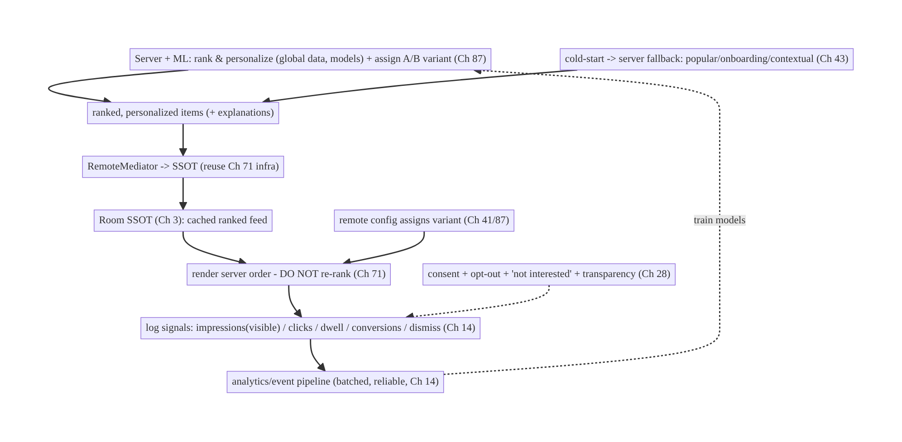
73.4 High-Level Architecture
Components & ownership
- Server + ML ranks/personalizes, assigns experiments, chooses cold-start fallbacks — with global data the client lacks.
- Client renders the server order (reusing Ch 71), logs signals (Ch 14) that train the models, renders the assigned variant (Ch 41/87), and surfaces privacy/diversity controls (Ch 28).
Direction: server ranks → client renders (no re-rank) + logs signals → pipeline trains models → better ranks; cold-start/experiment/privacy layered on.

73.5 Detailed Component Design
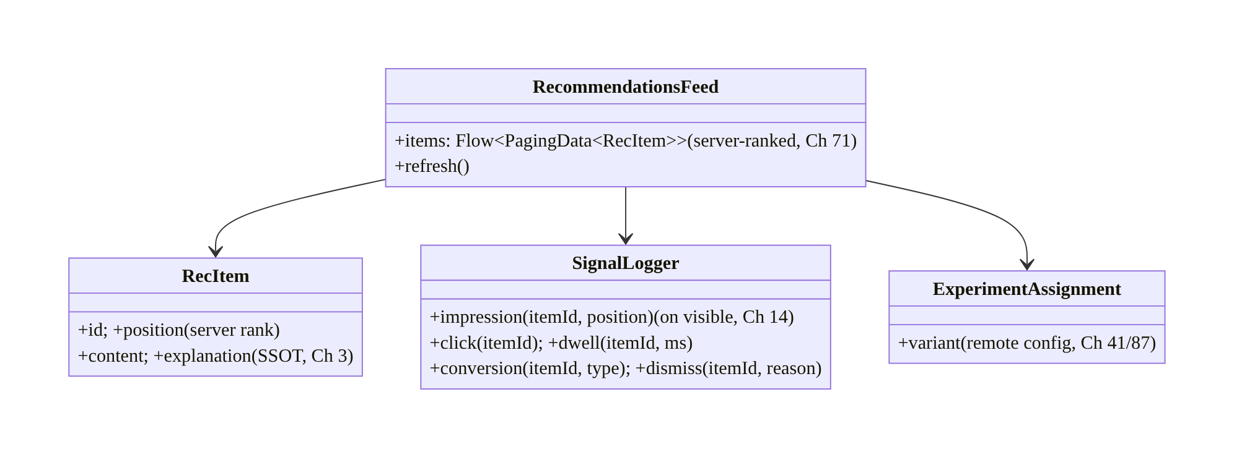
73.5 Detailed Component Design
Component | Responsibility
RecommendationsFeed | render server-ranked feed (Ch 71 infra); refresh; no re-rank
SignalLogger | log impressions(visible)/clicks/dwell/conversions/dismissals (Ch 14)
RecItem | SSOT row: server rank position + content + explanation (Ch 3)
ExperimentAssignment | the assigned A/B variant to render (Ch 41/87)

73.6 End-to-End Data Flow

Render + signal logging → model training
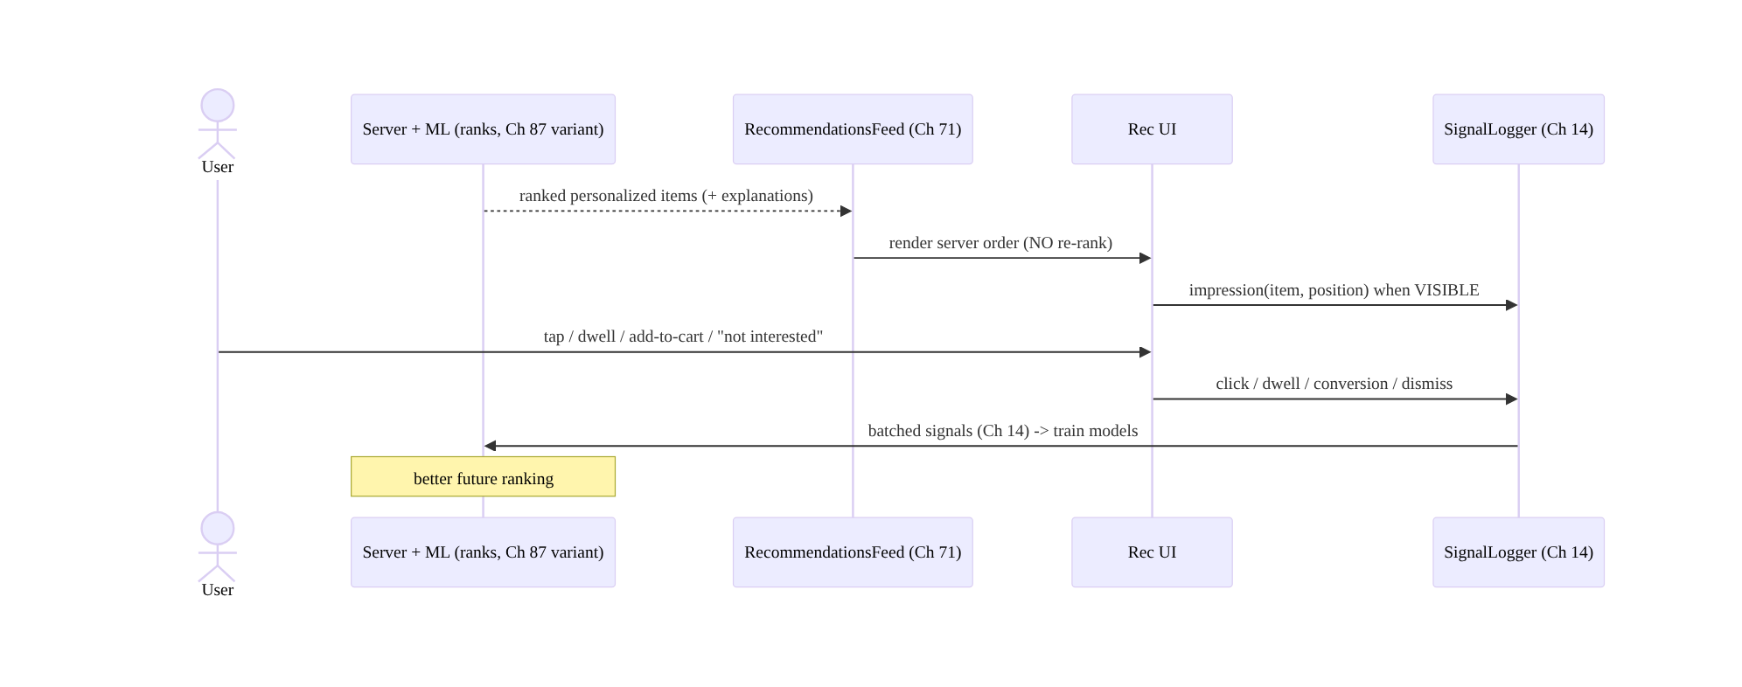
Render + signal logging → model training

Cold-start fallback
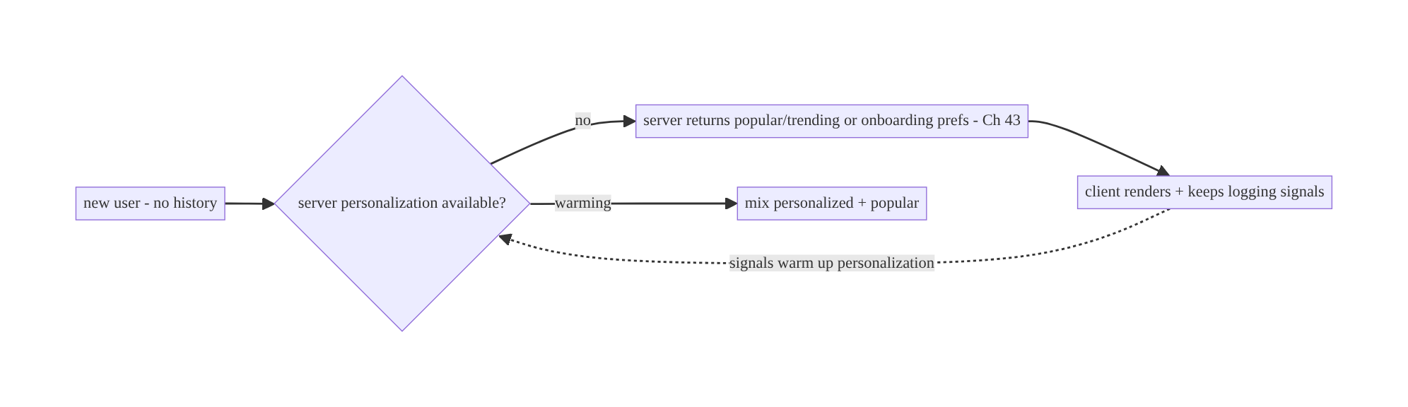
Cold-start fallback

73.7 Complete Kotlin Implementation
Package: com.streamcart.recommendations.

73.7.1 Rec feed on the Ch 71 infra (server-ranked, no re-rank)
@Entity(tableName = "recommendations")
data class RecItem(
@PrimaryKey val id: String, val position: Int, // SERVER rank order (Ch 3) - client renders as-is
val contentJson: String, val explanation: String?, // "Because you viewed X" (transparency, Ch 28)
val requestId: String, // ties impressions/clicks to this rec request
)
@HiltViewModel
class RecommendationsViewModel @Inject constructor(
private val db: RecDatabase, private val mediator: RecRemoteMediator, // reuse Ch 71 infra
private val experiments: ExperimentConfig, // Ch 41/87
) : ViewModel() {
val variant = experiments.recommendationVariant() // render the ASSIGNED variant (Ch 87)
@OptIn(ExperimentalPagingApi::class)
val items: Flow<PagingData<RecItem>> = Pager(
PagingConfig(pageSize = 20), remoteMediator = mediator,
) { db.recs().pagingSource() }.flow.cachedIn(viewModelScope) // ordered by server `position` - NO client re-rank
}

73.7.2 Signal logging — impressions on true visibility (Ch 14)
@Singleton
class SignalLogger @Inject constructor(private val analytics: AnalyticsBatcher) { // Ch 14
private val impressed = mutableSetOf<String>() // dedup per session
fun impression(item: RecItem) {
if (impressed.add(item.id)) // log once when truly visible
analytics.log("rec_impression", mapOf("id" to item.id, "pos" to item.position, "req" to item.requestId))
}
fun click(item: RecItem) = analytics.log("rec_click", mapOf("id" to item.id, "pos" to item.position, "req" to item.requestId))
fun dwell(item: RecItem, ms: Long) = analytics.log("rec_dwell", mapOf("id" to item.id, "ms" to ms))
fun conversion(item: RecItem, type: String) = analytics.log("rec_conversion", mapOf("id" to item.id, "type" to type))
fun dismiss(item: RecItem, reason: String) = analytics.log("rec_dismiss", mapOf("id" to item.id, "reason" to reason)) // negative signal
}

73.7.3 Log impression only when actually visible (viewport)
@Composable
fun RecCard(item: RecItem, logger: SignalLogger, onClick: () -> Unit) {
// Log an impression when the card is actually ON SCREEN (not merely composed/loaded).
val visible by rememberIsVisible() // viewport visibility helper
LaunchedEffect(visible) { if (visible) logger.impression(item) } // accurate impressions (Ch 14)
Column(Modifier.clickable { logger.click(item); onClick() }) {
// content...
item.explanation?.let { Text(it, style = MaterialTheme.typography.labelSmall) } // transparency (Ch 28)
DismissButton(onClick = { logger.dismiss(item, "not_interested") }) // negative signal + control
}
}

73.7.4 Cold-start + refresh (server-driven)
// The SERVER returns the cold-start fallback (popular/onboarding/contextual, Ch 43) — the client
// just renders whatever the feed API returns and keeps logging signals.
class RecRemoteMediator @Inject constructor(private val api: RecApi, private val db: RecDatabase, private val prefs: UserPrefs) {
suspend fun load(/* ... */): MediatorResult {
val recs = api.recommendations(
context = currentContextOrNull(), // e.g., viewing category X (contextual)
onboardingPrefs = prefs.interests(), // cold-start hint (Ch 43)
variant = experiments.recommendationVariant(), // A/B (Ch 87)
)
db.recs().replaceAll(recs) // server order; refreshable (Ch 71)
return MediatorResult.Success(endOfPaginationReached = recs.isEmpty())
}
}
// Refresh on app open / pull-to-refresh / after significant actions (don't show day-old as fresh).

73.7.5 Privacy: opt-out + transparency (Ch 28)
class RecommendationSettings @Inject constructor(private val prefs: UserPrefs, private val api: RecApi) {
suspend fun setPersonalization(enabled: Boolean) {
prefs.setPersonalization(enabled)
api.setPersonalization(enabled) // server stops personalizing -> popular/non-personalized (Ch 28)
}
// "Not interested" dismiss -> negative signal (SignalLogger) -> server adjusts.
// Explanations ("Because you viewed X") render from RecItem.explanation (transparency).
}

73.7.6 Module structure
:feature:recommendations RecommendationsViewModel, RecItem/Dao, RecRemoteMediator, SignalLogger, RecommendationSettings
:core:feed reuse Paging + SSOT infra (Ch 71/13/3)
:core:analytics event pipeline (Ch 14); :core:config remote config/experiments (Ch 41/87)
# Ranking/personalization/cold-start/diversity -> SERVER. Privacy -> Ch 28; prefs -> Ch 43.

73.8 Concurrency and Race Conditions
Scenario | Risk | Handling
Impression logged when not visible | garbage signals | log on true viewport visibility; dedup per session
Duplicate impressions | inflated signals | dedup set per request/session
Client re-ranks | breaks experiment/personalization | render server order only; no client sort
Stale cache shown as fresh | bad recs | refresh cadence; server recency
Variant changes mid-session | inconsistent experiment | pin variant per session (Ch 87)
Signals lost offline | missing training data | analytics pipeline queues offline (Ch 14)
Opt-out not honored | privacy violation | server + client stop personalizing (Ch 28)
- Impression accuracy is the signal-quality crux: logging an impression when an item is merely loaded/composed (but off-screen) floods the models with false “shown” signals. Log only when the item is actually visible in the viewport, deduped per request/session — accurate impressions are what make click-through and ranking meaningful.
- Never re-rank on the client: the client lacks the data/model and would break the A/B experiment and personalization. Render the server’s position order; client-side reordering is the cardinal recommendations mistake.
- Signals must survive offline (Ch 14): queue them in the analytics pipeline so training data isn’t lost — missing signals = worse recommendations.

73.9 Failure Scenarios and Recovery
Failure | Detection | Response | Outcome
Bad/empty recs (cold-start) | new user | server fallback (popular/onboarding/contextual, Ch 43) | useful
Models not improving | flat metrics | fix signal logging (impressions/clicks/conversions, Ch 14) | learns
Inflated/garbage signals | metric anomalies | log impressions on true visibility + dedup | accurate
Client re-ranks | broken experiment | render server order only | valid
Stale recs | user report | refresh cadence; server recency | fresh
Experiment invalid | skewed results | pin variant; consistent logging (Ch 87) | measurable
Privacy complaint | opt-out ignored | honor opt-out + transparency + dismiss (Ch 28) | compliant
Signals lost offline | gaps | pipeline offline queue (Ch 14) | retained
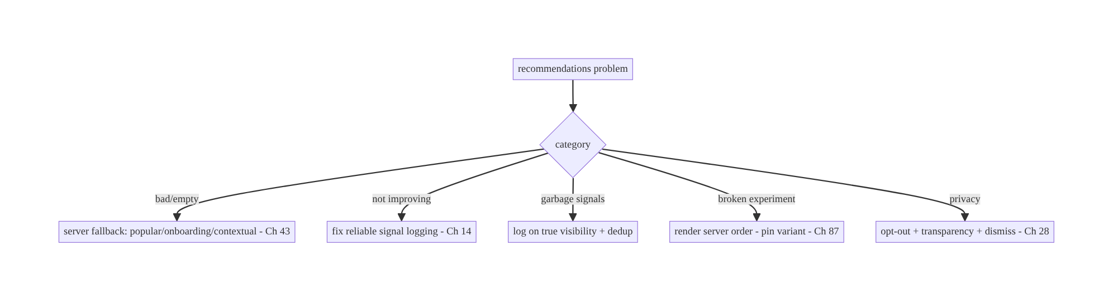
73.9 Failure Scenarios and Recovery
The client’s leverage over recommendation quality is signal logging, not ranking. Render the server’s order (never re-rank), log accurate behavioral signals (impressions on true visibility, clicks, dwell, conversions, dismissals) that train the models, handle cold-start via server fallbacks, faithfully render the assigned experiment variant, and respect privacy. Good signals → good recommendations; the server does the ML.

73.10 Scaling the Implementation
- Level 1. Render server-ranked recs on the Ch 71 feed infra (no re-rank); basic click logging.
- Level 2. Full signal logging (impressions-on-visible/dwell/conversions/dismissals, Ch 14); cold-start fallback render; cache/refresh (Ch 71).
- Level 3 — production. A/B variant rendering + outcome logging (Ch 41/87); privacy (opt-out/transparency/dismiss, Ch 28); explanations; negative-signal controls.
- Level 4 — large. Multiple rec surfaces (home/detail/category); contextual recs; personalization signals (Ch 43); on-device lightweight re-ranking only if the server provides it (rare); diversity controls.
- Level 5 — enterprise. Rec-quality metrics (CTR, conversion, diversity), experiment platform integration (Ch 87), privacy governance (consent/regulatory), real-time signal streaming, fairness/diversity monitoring.
Avoid overengineering: render + log + cold-start + experiment + privacy is the client’s whole job. Don’t build ranking/ML on the client; don’t re-rank; don’t skimp on signal accuracy.

73.11 Alternative Approaches and Trade-offs
Dimension | Option A | Option B | When
Ranking | Server/ML ranks | client ranks | Server always (global data/models; client can’t)
Client role | Render + log + experiment | re-rank/personalize | Render/log only (don’t re-rank)
Signals | Reliable pipeline (Ch 14) | ad-hoc/none | Reliable pipeline (models need signals)
Impressions | On true visibility | on load/compose | On visible (accurate)
Cold-start | Server fallback (popular/onboarding/contextual) | empty | Fallback (Ch 43)
Freshness | Cache + refresh (Ch 71) | always-live / always-stale | Cache + refresh (instant yet fresh)
Experiment | Render assigned variant + log (Ch 87) | ignore assignment | Faithful render + log
Privacy | Consent/opt-out/transparency (Ch 28) | silent tracking | Consent/opt-out (trust/regulatory)
Server ranks vs client ranks: recommendation quality depends on global data (all users’ behavior, full catalog, trained models) that only the server has. A client can’t meaningfully rank (it sees one user, a page of items) and client re-ranking breaks experiments and personalization. The server ranks; the client renders and logs. (Rare exception: the server may ship a tiny on-device model for a specific signal — but the client still doesn’t invent ranking.)
Signal logging quality is the client’s real contribution: models are only as good as the signals they train on, so accurate, reliable signal logging (impressions on true visibility, clicks, dwell, conversions, negative signals) via the Ch 14 pipeline is the client’s highest-leverage responsibility. Sloppy signals (false impressions, lost events) directly degrade recommendations — far more than any client UI tweak.
Cache + refresh vs always-live/always-stale: recommendations should render instantly (cached SSOT, offline-capable, Ch 71) but not be stale (interests change, new items). Always-live (fetch every time) is slow/offline-broken; always-stale (never refresh) shows day-old recs. Cache for instant render + refresh on sensible triggers (open, pull, significant action) is the balance; the server controls recency.

73.12 Security & Privacy Considerations
- Consent for personalization (Ch 28): personalization uses behavioral data; obtain consent (especially for cross-context tracking), honor opt-out (server + client stop personalizing → non-personalized/popular), and respect regulatory rights (GDPR/CCPA: opt out, see why, delete).
- Transparency: show why (“Recommended because you viewed X”) and provide controls (“not interested”/“show less”) — builds trust and feeds negative signals.
- Signals are sensitive (Ch 28): behavioral data (what you view/buy) is PII-adjacent — minimize, log per consent, secure the pipeline (Ch 14/19), don’t leak; don’t log raw sensitive content.
- Server authorizes content (Ch 23): recommended items the user is allowed to see; server-side visibility (like the feed, Ch 71).
- Per-account isolation (Ch 42): recs + signals per account; clear/scope on logout.
- No manipulation/dark patterns: don’t fabricate signals or mislead; sponsored recs labeled.
- Client vs backend: the server ranks, personalizes, decides cold-start/diversity, and enforces consent/authorization; the client logs signals (per consent), renders faithfully (incl. experiments), and surfaces privacy/diversity controls.

73.13 Performance and Resource Optimization
- Reuse the feed infra (Ch 71) — paging, cache-first instant render, 60fps, offline all come free.
- Batch signals (Ch 14) — don’t fire a request per impression; batch + offline-queue.
- Accurate, cheap impression tracking — viewport visibility without jank (debounce).
- Cache + refresh — instant render from SSOT; refresh in background (Ch 71/45).
- Right-sized images (Ch 56) for rec cards.
- Don’t over-log — log meaningful signals, not every micro-event (cost/noise).
- Profiling: signal-logging overhead, impression accuracy, rec render/first-content time, CTR/conversion (product metrics), cache hit.

73.14 Testing Strategy
Client logic (rendering server order, signal logging, cold-start render, variant) is testable; ranking/ML is server-side (out of scope).
class SignalLoggerTest {
@Test fun `logs impression once when visible, deduped`() {
logger.impression(rec("r1")); logger.impression(rec("r1"))
assertEquals(1, analytics.events("rec_impression").size) // dedup (accurate signals)
}
@Test fun `logs click, conversion, dismiss`() { /* ... */ }
}
class RecFeedTest {
@Test fun `renders server order - does not re-rank`() = runTest {
db.recs().replaceAll(listOf(rec("a", pos=0), rec("b", pos=1)))
val items = vm.items.first().collectToList()
assertEquals(listOf("a", "b"), items.map { it.id }) // server order preserved
}
@Test fun `renders assigned A-B variant`() = runTest { assertEquals("variantB", vm.variant) } // Ch 87
@Test fun `cold-start renders server fallback`() = runTest { /* popular items rendered */ }
}
class PrivacyTest { @Test fun `opt-out stops personalization (server + client)`() = runTest { /* ... */ } }
What to test: impression logged once on visibility (deduped); click/conversion/dismiss logged; feed renders server order (no re-rank); assigned variant rendered (Ch 87); cold-start fallback rendered; opt-out honored (Ch 28); offline signals queued (Ch 14). Fake analytics/API; reuse Ch 71 test infra.

73.15 Production Observability
- Metrics (product + client): CTR (click/impression), conversion rate, dwell, dismiss rate, cold-start coverage; signal-logging reliability (impression accuracy, event delivery rate, offline-queue drain); experiment variant exposure + outcomes (Ch 87); rec render/first-content time; opt-out rate; diversity (repetition).
- Logs: rec{event, variant, position} — signals go through the analytics pipeline; no raw sensitive content/PII (Ch 28).
- Debugging: models not improving → signal gaps/inaccuracy (impressions, Ch 14); garbage CTR → impressions logged off-screen; broken experiment → client re-ranking / inconsistent logging (Ch 87); stale recs → refresh cadence; privacy complaint → opt-out/transparency (Ch 28).
- Alerting: signal-delivery drop (training data loss); impression-accuracy anomaly; experiment-exposure imbalance; opt-out spike.
- Dashboards: CTR/conversion by variant (Ch 87); signal reliability; cold-start coverage.

73.16 System Design Interview Preparation
≥25 questions.
Fundamentals
- Division of labor? Server/ML ranks + personalizes; client renders + logs + experiments.
- Why not rank on client? Needs global data/models the client lacks; breaks experiments.
- Built on? The feed infra (Paging + SSOT, Ch 71) — recs are a server-ranked feed.
- Client’s highest-leverage job? Reliable signal logging (Ch 14).
- Can the client re-order? No (beyond trivial allowed filters) — render server order.
Signals
- What signals? Impressions, clicks, dwell, conversions (add-to-cart/purchase/like), dismissals.
- Impression accuracy? Log on true visibility (viewport), deduped — not on load.
- Negative signals? Dismiss/“not interested” — strong inputs.
- Pipeline? Analytics/event pipeline (batched, offline-queued, Ch 14).
- Bad signals →? Bad recommendations (garbage in).
Cold-start
- New user? Server fallback: popular/trending, onboarding prefs (Ch 43), contextual.
- Who decides fallback? The server; client renders + logs.
- Warming up? Signals personalize over time.
Freshness
- Cache? SSOT for instant/offline (Ch 71).
- Refresh? On open/pull/significant action; don’t show stale as fresh.
- Who controls recency? Server.
Experiments
- A/B? Remote config assigns variant (Ch 41/87); client renders it + logs outcomes.
- Client must? Render assigned variant faithfully; log consistently.
- Breaking an experiment? Client re-ranking / ignoring assignment / inconsistent logging.
Privacy (Ch 28)
- Consent? For behavioral personalization; honor opt-out.
- Transparency? “Because you viewed X” + controls.
- Signals sensitivity? PII-adjacent — minimize, consent, secure.
- Regulatory? GDPR/CCPA opt-out/see-why/delete.
Testing/Production
- Test logging? Impression once-on-visible deduped; click/conversion/dismiss.
- Test rendering? Server order preserved; assigned variant.
- Models not improving? Signal gaps/inaccuracy.

Design-change challenges
- Build “Recommended for you”. Server-ranked feed on Ch 71 infra; client renders + logs signals (Ch 14).
- Recommendations aren’t improving. Fix signal logging (accurate impressions, Ch 14).
- New users see nothing. Server cold-start fallback (popular/onboarding, Ch 43).
- A/B of ranking. Remote-config variant (Ch 41/87); render + log outcomes; no client re-rank.
- Let users opt out / say “not interested”. Opt-out (server+client) + dismiss negative signal + transparency (Ch 28).

Mock walkthrough (abridged)
Clarify (surface, personalized?, cold-start, experiments, privacy?) → division of labor (server ranks, client renders/logs/experiments) → build on Ch 71 feed infra → render server order (no re-rank) → reliable signal logging (impressions-on-visible/clicks/dwell/conversions/ dismiss via Ch 14) → cold-start server fallback (Ch 43) → cache + refresh (Ch 71) → A/B variant render + outcome logging (Ch 41/87) → privacy (consent/opt-out/transparency, Ch 28) → observability (CTR/conversion, signal reliability).

73.17 Practical Exercises
- Beginner. Render a server-ranked “Recommended for you” feed on the Ch 71 infra, preserving the server’s order (no client re-rank). Eval: order preserved; cached.
- Intermediate. Add signal logging: impressions on true visibility (deduped), clicks, and conversions via the analytics pipeline (Ch 14). Eval: accurate impressions; events delivered/offline-queued.
- Advanced. Render an A/B-assigned variant (remote config, Ch 41/87), add “not interested” dismissal (negative signal), and explanations. Eval: variant faithful; dismiss logged; transparent.
- Production debugging. Fix garbage CTR (impressions logged off-screen) and recs not improving (missing conversion signals). Eval: impressions accurate; signals complete.
- System design challenge. Add personalization opt-out (server + client) + cold-start fallback + a CTR/conversion-by-variant dashboard. Eval: opt-out honored; cold-start useful; measurable.
(Solutions withheld unless requested.)

73.18 Chapter Summary & Reference Sheet
Key decisions: treat a recommendations feed as a server-ranked, personalized feed built on the Ch 71 feed infra (Paging + SSOT for caching/offline/60fps/position) with a clear division of labor — the server (and its ML models) ranks and personalizes using global data the client lacks, assigns experiments, and chooses cold-start fallbacks, while the client renders the server’s order (never re-ranks), reliably logs the behavioral signals that train the models, renders the assigned A/B variant, and surfaces privacy/ diversity controls; the client’s highest-leverage job is accurate signal logging — impressions on true viewport visibility (deduped), clicks, dwell, conversions (add-to- cart/purchase/like, Ch 72), and negative signals (dismiss/“not interested”) — through the batched, offline-queued analytics pipeline (Ch 14), because good signals → good recommendations; handle cold-start with server fallbacks (popular/onboarding/ contextual, Ch 43); cache + refresh for instant-yet-fresh content (Ch 3/71); faithfully render the A/B-assigned variant and log outcomes (Ch 41/87) so experiments are valid; and respect privacy — consent, opt-out, transparency (“because you viewed X”), and dismiss controls (Ch 28), with signals treated as sensitive and content server-authorized (Ch 23/42).
Concepts: division of labor (server ranks / client renders-logs-experiments), feed infra reuse (Ch 71), reliable signal logging (impressions-on-visibility/clicks/dwell/conversions/ negative, Ch 14), cold-start fallbacks, cache + refresh, A/B variant rendering + outcome logging (Ch 41/87), privacy (consent/opt-out/transparency), diversity controls.
Common mistakes: re-ranking/personalizing on the client (breaks experiments, lacks data); logging impressions on load instead of visibility (garbage signals); missing/lost signals (models can’t learn); no cold-start fallback (empty for new users); showing stale recs as fresh; ignoring the experiment assignment or inconsistent logging (invalid A/B); no consent/opt-out/transparency (trust/regulatory); treating ranking as a client problem.
Checklist:
- ☐ server ranks; client renders server order (no re-rank)
- ☐ built on Ch 71 feed infra (Paging + SSOT)
- ☐ reliable signal logging via Ch 14 (impressions-on-visible deduped, clicks, dwell, conversions, dismiss)
- ☐ cold-start server fallback (popular/onboarding/contextual, Ch 43)
- ☐ cache + refresh (instant yet fresh, Ch 71)
- ☐ render assigned A/B variant + log outcomes (Ch 41/87)
- ☐ privacy: consent + opt-out + transparency + “not interested” (Ch 28)
- ☐ server-authorized content + per-account (Ch 23/42)
- ☐ CTR/conversion + signal-reliability telemetry.
Key APIs: reuse Paging 3 + RemoteMediator + Room SSOT (Ch 71/13/3), analytics/event pipeline (Ch 14) for signals, viewport-visibility impression tracking (Compose LaunchedEffect on visibility), remote config / experiment assignment (Ch 41/87), user preferences/opt-out (Ch 43/28), right-sized images (Ch 56).
References:
- Recommendations (concepts, Play/general): https://developers.google.com/machine-learning/recommendation
- Logging & analytics events: https://developer.android.com/topic/architecture (data layer) + Ch 14
- (composes) Ch 71 Infinite Feed, Ch 13 Paging, Ch 3 SSOT, Ch 14 Analytics/Events, Ch 43 Personalization, Ch 41 Remote Config, Ch 87 A/B & Experiments, Ch 28 Privacy, Ch 72 Interactions

Chapter 74 — Wishlist
Part IX — Feature Architectures · Complexity: Standard (≥25 interview questions)
Prerequisites: Ch 3 (SSOT/Room), Ch 72 (optimistic updates), Ch 31 (outbox), Ch 32 (delta sync), Ch 29 (offline-first), Ch 42 (multi-account), Ch 15 (idempotency). Pairs with Ch 38 (cart), Ch 71 (feed), Ch 43 (personalization).
Reference surface in StreamCart: the “Save for later” / wishlist / favorites — a per-user collection of products (and watchlist content) that toggles instantly, works offline, syncs across devices, and stays consistent everywhere the item appears.

74.1 Problem Definition and Real-World Context
A wishlist looks trivial (“a list of saved items”) but is a clean, recurring synced- collection feature that composes the book’s offline/sync/optimistic machinery. It must: toggle instantly (optimistic, Ch 72) from anywhere the product appears (feed Ch 71, detail, search); work offline (Ch 29); sync across devices (save on the phone → appears on the tablet, Ch 32); stay consistent everywhere the item shows a saved/unsaved state (Ch 3); be per-account (Ch 42); and reconcile with the server (idempotent, Ch 15). Done naively (an in-memory set, a fire-and-forget POST) it loses saves offline/on death, diverges across screens and devices, and double-toggles.
Concretely, teams hit:
- In-memory / network-coupled. A wishlist held in memory or requiring the network to toggle loses saves offline and on process death, and can’t render instantly. It must be SSOT-backed (Room, Ch 3) and offline-first (Ch 29).
- Inconsistent toggle state. The same product’s heart icon shows “saved” in the feed but “unsaved” on detail because each screen holds its own state — only fixable with a single SSOT (Ch 3) and optimistic toggle (Ch 72).
- No cross-device sync. Saving on one device doesn’t appear on another; removing on one leaves it on another. Wishlist membership is synced state (Ch 32) with conflict handling (Ch 33) for concurrent add/remove.
- Double-toggle / lost toggle. Rapid taps or retries add/remove twice; offline saves are lost. Needs idempotent set-membership (Ch 15) + outbox (Ch 31).
- Per-account leakage. One account’s wishlist shows under another; switching accounts must swap wishlists (Ch 42).
- Scale & presentation. A large wishlist needs paging (Ch 13); items need current price/availability (they may change after saving); “move to cart” ties to Ch 38.
The architecture: model the wishlist as a per-account, SSOT-backed, offline-first synced collection — toggle membership optimistically (Ch 72) in the SSOT (Room, Ch 3) so the UI updates instantly everywhere the item appears (UDF, Ch 6); persist the toggle in an outbox with an idempotent set-membership key (Ch 31/15) so it survives offline/ death, retries, and dedups; sync membership across devices (Ch 32) with conflict resolution (add/remove, Ch 33); scope per-account (Ch 42); page a large list (Ch 13); and refresh item price/availability (they drift after saving). This chapter is a focused application of the offline/optimistic/sync stack to a saved collection.

Three practical use cases
- Toggle save from anywhere (StreamCart). Tapping the heart in the feed/detail/search toggles the SSOT instantly and consistently everywhere; syncs across devices; works offline.
- Offline save → sync. Save items in airplane mode; they persist (SSOT + outbox) and sync when back online (Ch 29/31/32); a concurrent remove on another device reconciles (Ch 33).
- Wishlist screen + move to cart. A paged wishlist (Ch 13) showing current price/ availability; “move to cart” integrates with Ch 38.

Why this is architectural
The wishlist is a compact composition of SSOT (Ch 3), optimistic updates (Ch 72), outbox + idempotency (Ch 31/15), delta sync + conflict resolution (Ch 32/33), offline-first (Ch 29), multi-account (Ch 42), and paging (Ch 13). It demonstrates the synced-collection pattern reused for favorites, follows, saved searches, and watchlists — the decisions (SSOT toggle, idempotent set-membership, cross-device sync, per-account) recur across the app.

74.2 Requirements Engineering

Functional requirements
ID | Requirement
F1 | Toggle wishlist membership instantly (optimistic) from any surface, via the SSOT (Ch 72/3).
F2 | Work offline; persist and retry toggles (outbox + idempotency) (Ch 29/31/15).
F3 | Sync membership across devices; resolve concurrent add/remove conflicts (Ch 32/33).
F4 | Stay consistent everywhere the item appears (one SSOT row) (Ch 3).
F5 | Scope per-account; swap on account switch (Ch 42).
F6 | Show current price/availability; page a large list; move-to-cart (Ch 13/38).

Non-functional requirements
Attribute | Policy
Instant UX | Toggle updates immediately (optimistic).
Offline | Save/remove offline; works from cache (Ch 29).
Consistency | One SSOT row → consistent everywhere + cross-device (Ch 3/32).
Correctness | Idempotent set-membership; conflict-resolved; no double-toggle.
Isolation | Per-account (Ch 42).

Scope
- In scope: wishlist as a per-account SSOT-backed offline-first synced collection, optimistic toggle (Ch 72), outbox + idempotent set-membership (Ch 31/15), delta sync + add/remove conflict resolution (Ch 32/33), consistency via one SSOT row (Ch 3), per- account (Ch 42), paging a large list (Ch 13), price/availability refresh, move-to-cart (Ch 38).
- Out of scope: optimistic-update mechanics (Ch 72), outbox/sync/conflict internals (Ch 31/32/33), SSOT internals (Ch 3), cart (Ch 38), paging internals (Ch 13), feed (Ch 71).

Assumptions & constraints
- Room SSOT (Ch 3), outbox (Ch 31), WorkManager (Ch 30), Paging 3 (Ch 13). minSdk 24. Wishlist membership is synced (server-backed, cross-device); toggles are idempotent set-membership; the server is authoritative for membership on conflict.

74.3 System Design Fundamentals
- Wishlist = a per-account, SSOT-backed, offline-first synced set of item ids. Model membership in Room (the SSOT, Ch 3): a wishlist_items table keyed by (accountId, productId). The UI (heart icon everywhere the product appears) observes the SSOT (UDF, Ch 6), so saved/unsaved state is consistent across all screens and survives process death and offline (Ch 29). In-memory sets and network-coupled toggles are the anti-patterns.
- Optimistic toggle (Ch 72). Tapping save/unsave immediately mutates the SSOT membership → the heart flips instantly everywhere (one row, Ch 3). Then the toggle is persisted and synced; on genuine failure it rolls back (Ch 72). This is a direct application of the optimistic-update pattern (Ch 72) to set membership.
- Idempotent set-membership + outbox (Ch 15/31). Model the toggle as set-membership (add / remove), not a counter or a non-idempotent op, so rapid taps and retries are idempotent (Ch 15): “add product X” applied twice = once. Persist the intent in an outbox (Ch 31) so an offline save survives process death and is retried — the same reliable-send pattern as cart (Ch 38) and interactions (Ch 72). Use the latest intent for rapid add→remove→add (coalesced, Ch 31).
- Cross-device sync + conflict resolution (Ch 32/33). Wishlist membership is synced state: a delta sync (Ch 32) reconciles the local SSOT with the server so a save on one device appears on another. Conflicts (add on device A, remove on device B, or an offline toggle vs server) resolve by policy (Ch 33) — a wishlist is a set, so typically last-writer-wins per item (the latest add/remove timestamp wins), or add-wins (a product-chosen bias toward keeping saves). The server is authoritative for the reconciled membership.
- Per-account (Ch 42). The wishlist is per account: keyed by accountId, the UI observes the active account’s wishlist, and account switch swaps to the other account’s list (clear/scope, Ch 42). Never show account A’s saves under B.
- Price/availability drift. Items saved days ago may have changed price, gone out of stock, or been removed. The wishlist stores membership (ids); product details (price/availability) are refreshed from the catalog (SSOT/cache, Ch 12/3) when rendering the wishlist screen — show current state, flag unavailable/removed items, handle “price dropped” (a common wishlist notification, Ch 49).
- Paging a large wishlist (Ch 13). A long wishlist pages from the SSOT (Paging 3, Ch 13) rather than loading all — same infra as the feed (Ch 71).
- Move to cart (Ch 38). “Move to cart” / “add to cart” from the wishlist integrates with the cart (Ch 38) — optionally removing from the wishlist on add.
Core insight: a wishlist is a per-account, SSOT-backed, offline-first synced set — toggle membership optimistically in the SSOT (one Room row per item, Ch 72/3) so the heart flips instantly and consistently everywhere the product appears, persist the toggle as an idempotent set-membership op in an outbox (survives offline/death, retries, dedups, Ch 31/ 15), sync membership across devices with add/remove conflict resolution (last-writer or add-wins, server authoritative, Ch 32/33), scope strictly per-account (Ch 42), refresh item price/availability on render (membership is ids; details drift), and page a large list (Ch 13) — it is the reusable synced-collection pattern (favorites, follows, watchlist).

74.4 High-Level Architecture
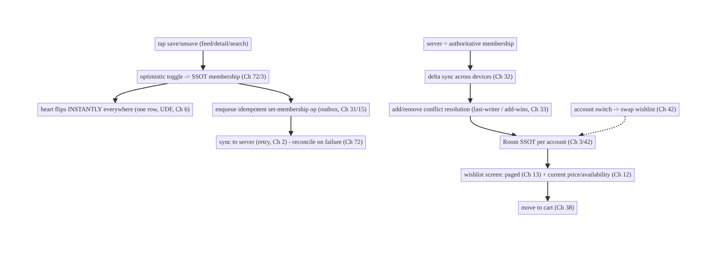
74.4 High-Level Architecture
Components & ownership
- Optimistic toggle mutates the per-account SSOT membership → instant + consistent (Ch 72/3/42).
- Outbox + idempotent set-membership persist/retry/dedup (Ch 31/15); delta sync + conflict resolution converge devices (Ch 32/33).
- Wishlist screen pages (Ch 13) and refreshes price/availability (Ch 12); move-to- cart → Ch 38.
Direction: tap → optimistic SSOT toggle → instant UI + outbox(idempotent) → server; delta sync + conflict → converged per-account SSOT → paged screen with fresh details.

74.5 Detailed Component Design
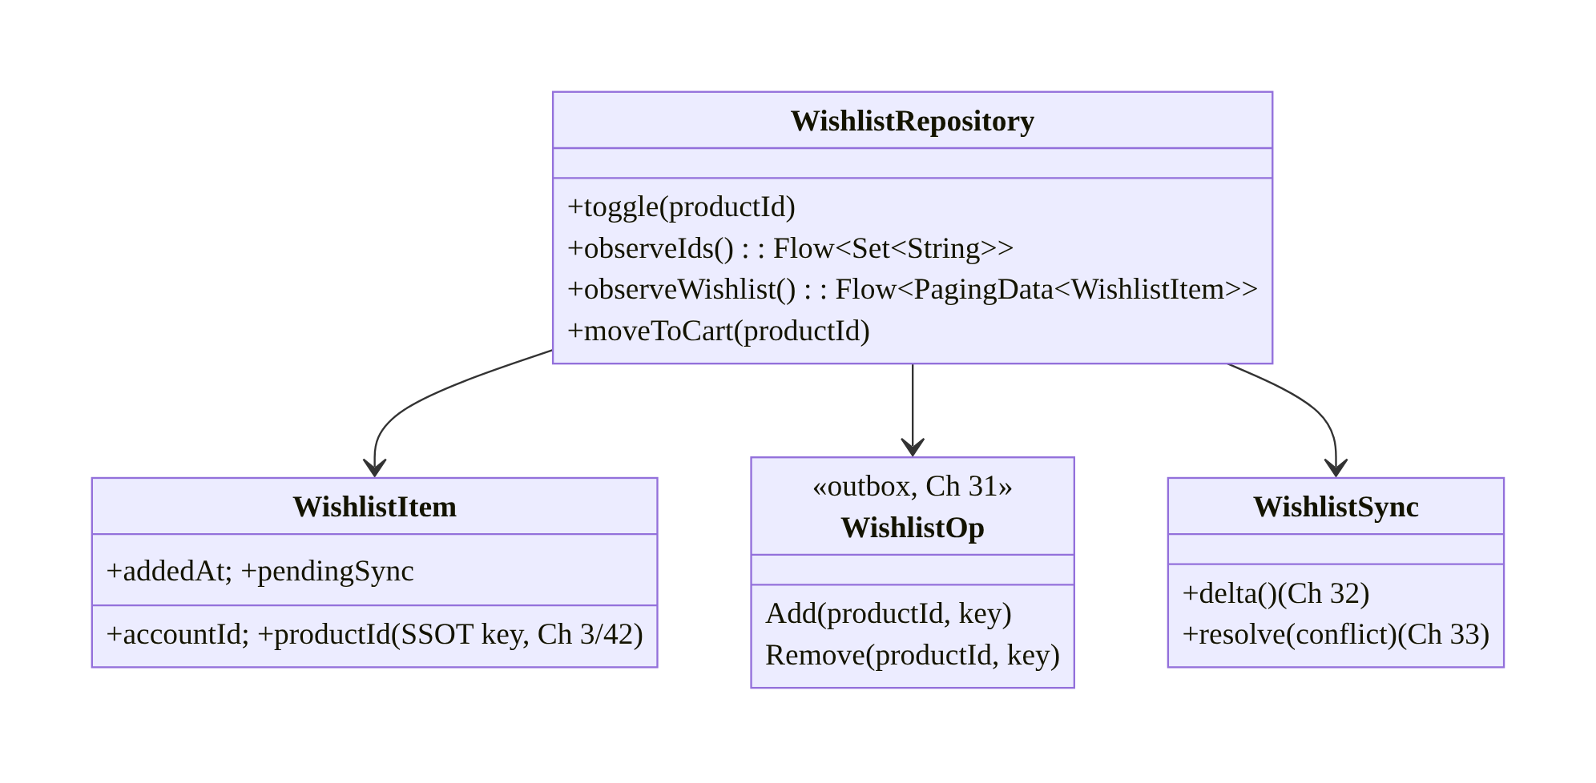
74.5 Detailed Component Design
Component | Responsibility
WishlistRepository | optimistic toggle; observe ids/list; move-to-cart over SSOT
WishlistItem | per-account SSOT row (accountId, productId) (Ch 3/42)
WishlistOp | outbox idempotent set-membership op (Ch 31/15)
WishlistSync | delta sync + add/remove conflict resolution (Ch 32/33)

74.6 End-to-End Data Flow

Optimistic toggle (offline-capable)
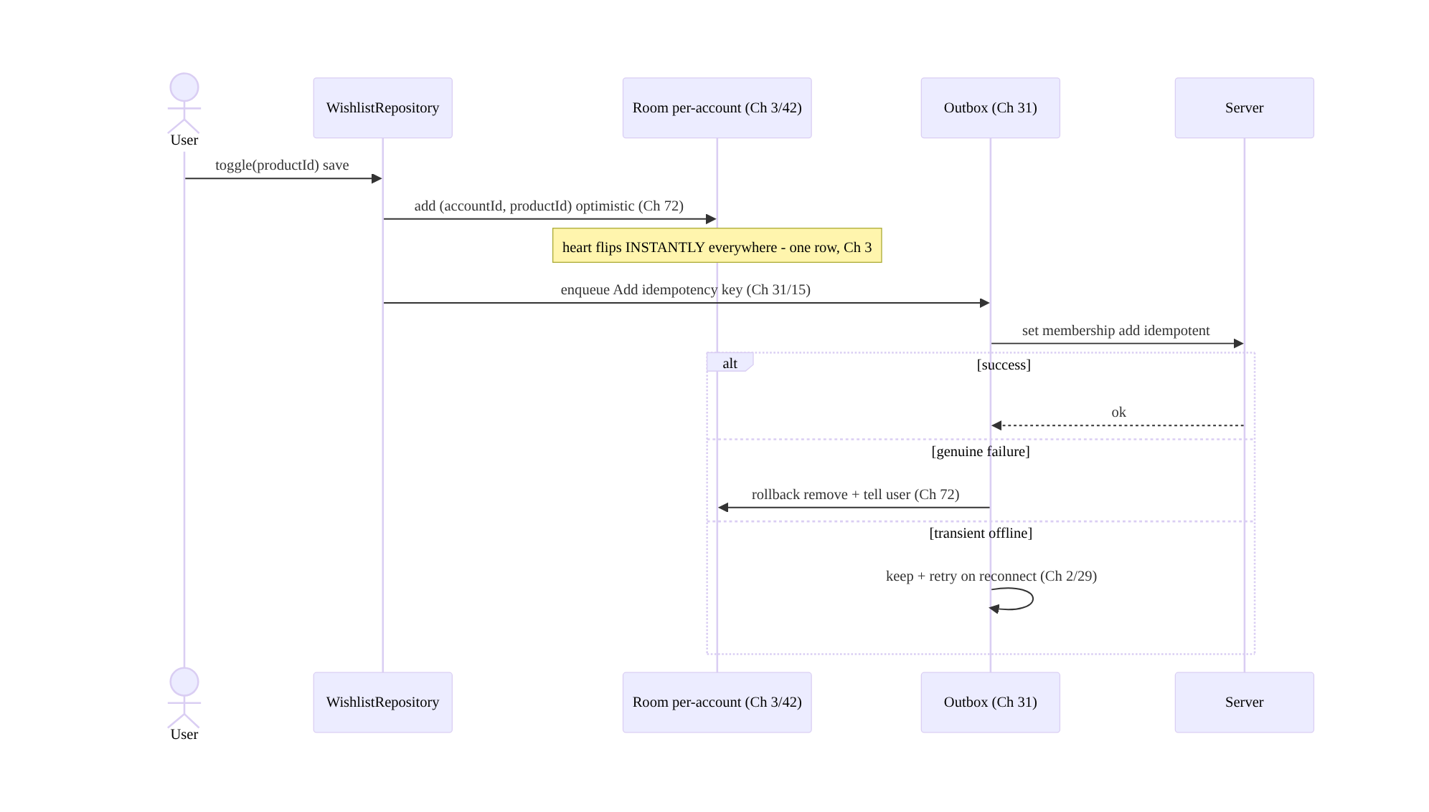
Optimistic toggle (offline-capable)

Cross-device sync + conflict
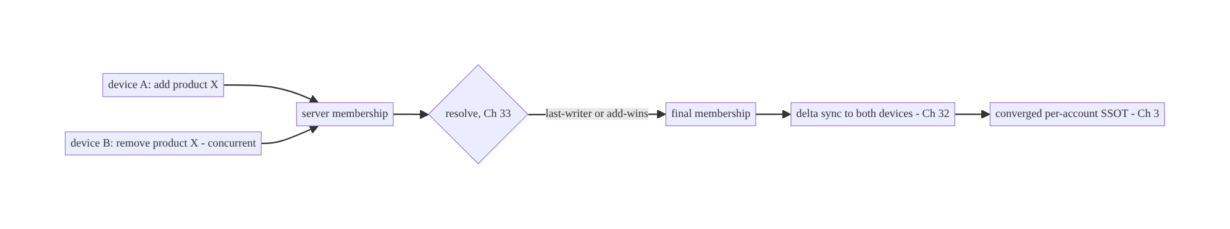
Cross-device sync + conflict

74.7 Complete Kotlin Implementation
Package: com.streamcart.wishlist.

74.7.1 Per-account SSOT membership (Ch 3/42)
@Entity(tableName = "wishlist_items", primaryKeys = ["accountId", "productId"])
data class WishlistItem(
val accountId: String, val productId: String, // per-account key (Ch 42)
val addedAt: Long, val pendingSync: Boolean = false,
)
@Dao interface WishlistDao {
@Query("SELECT productId FROM wishlist_items WHERE accountId = :acct")
fun observeIds(acct: String): Flow<List<String>> // UI observes -> consistent everywhere (Ch 3)
@Query("SELECT EXISTS(SELECT 1 FROM wishlist_items WHERE accountId=:acct AND productId=:id)")
fun isSaved(acct: String, id: String): Flow<Boolean>
@Upsert suspend fun add(item: WishlistItem)
@Query("DELETE FROM wishlist_items WHERE accountId=:acct AND productId=:id") suspend fun remove(acct: String, id: String)
@Query("SELECT * FROM wishlist_items WHERE accountId=:acct ORDER BY addedAt DESC") fun pagingSource(acct: String): PagingSource<Int, WishlistItem>
}

74.7.2 Optimistic toggle → outbox (idempotent set-membership, Ch 72/31/15)
@Singleton
class WishlistRepository @Inject constructor(
private val dao: WishlistDao, private val outbox: Outbox, // Ch 31
private val activeAccount: ActiveAccountProvider, // Ch 42
) {
fun isSaved(productId: String): Flow<Boolean> = dao.isSaved(activeAccount.require().id, productId)
suspend fun toggle(productId: String) {
val acct = activeAccount.require().id
val saved = dao.isSaved(acct, productId).first()
if (saved) {
dao.remove(acct, productId) // optimistic (Ch 72) -> instant everywhere (Ch 3)
outbox.enqueue(WishlistOp.Remove(productId, key = "$acct:wl:$productId:remove")) // idempotent set-membership (Ch 15)
} else {
dao.add(WishlistItem(acct, productId, addedAt = System.currentTimeMillis(), pendingSync = true))
outbox.enqueue(WishlistOp.Add(productId, key = "$acct:wl:$productId:add"))
}
}
// OutboxProcessor -> server; idempotent; rollback on genuine failure (Ch 72).
suspend fun sync(op: WishlistOp): OutboxResult = runCatching {
when (op) { is WishlistOp.Add -> api.addToWishlist(op.productId, op.key)
is WishlistOp.Remove -> api.removeFromWishlist(op.productId, op.key) }
OutboxResult.Done
}.getOrElse { e ->
if (e.isTransient()) OutboxResult.Retry // offline/5xx -> keep + retry (Ch 2/29)
else { rollback(op); OutboxResult.Failed(e) } // genuine -> revert SSOT (Ch 72)
}
}

74.7.3 UI: heart observes SSOT (instant + consistent, Ch 6)
@Composable
fun SaveButton(productId: String, vm: WishlistViewModel = hiltViewModel()) {
val saved by vm.isSaved(productId).collectAsStateWithLifecycle(false) // same SSOT row in feed/detail/search (Ch 3)
IconToggleButton(checked = saved, onCheckedChange = { vm.toggle(productId) }) {
Icon(if (saved) Icons.Filled.Favorite else Icons.Outlined.FavoriteBorder, contentDescription = "Wishlist")
}
// Toggling anywhere flips the heart EVERYWHERE instantly (optimistic SSOT, Ch 72/3).
}

74.7.4 Sync + conflict resolution (Ch 32/33)
@Singleton
class WishlistSync @Inject constructor(private val dao: WishlistDao, private val api: WishlistApi, private val activeAccount: ActiveAccountProvider) {
/** Delta sync membership; server authoritative; add/remove conflict policy (Ch 32/33). */
suspend fun sync() {
val acct = activeAccount.require().id
val server = api.wishlistSince(dao.lastSyncCursor(acct)) // delta (Ch 32)
db.withTransaction {
server.added.forEach { dao.add(WishlistItem(acct, it.productId, it.addedAt)) } // last-writer / add-wins (Ch 33)
server.removed.forEach { dao.remove(acct, it.productId) }
// local pendingSync items not yet on server are pushed via outbox (Ch 31); server reconciles.
}
}
}

74.7.5 Wishlist screen: paged + current price/availability (Ch 13/12)
fun WishlistRepository.observeWishlist(): Flow<PagingData<WishlistEntry>> =
Pager(PagingConfig(pageSize = 30)) { dao.pagingSource(activeAccount.require().id) }.flow
.map { paging -> paging.map { item ->
val product = catalog.current(item.productId) // refresh price/availability (Ch 12/3)
WishlistEntry(item, product, available = product?.inStock == true, priceDropped = product?.priceDropped == true)
} }
suspend fun WishlistRepository.moveToCart(productId: String) {
cart.add(productId) // Ch 38
toggle(productId) // optionally remove from wishlist
}

74.7.6 Module structure
:feature:wishlist WishlistRepository, WishlistItem/Dao, WishlistOp, WishlistSync, SaveButton, wishlist screen
:core:data SSOT (Ch 3); :core:outbox (Ch 31); :core:sync (Ch 32/33); :feature:cart (Ch 38); catalog (Ch 12)
# Optimistic -> Ch 72; idempotency -> Ch 15; per-account -> Ch 42; paging -> Ch 13.

74.8 Concurrency and Race Conditions
Scenario | Risk | Handling
Rapid toggle (save→unsave→save) | wrong final state | idempotent set-membership + latest-intent coalesce (Ch 15/31)
Double-tap | double add | idempotent add (set-membership) (Ch 15)
Offline toggle then death | lost save | outbox persisted (Ch 31)
Add on A, remove on B | divergence | conflict resolution (last-writer/add-wins, server authoritative, Ch 33)
Same product many screens | inconsistent heart | one SSOT row (Ch 3)
Account switch mid-toggle | cross-account | key by accountId; observe active (Ch 42)
Stale price shown | wrong info | refresh price/availability on render (Ch 12)
- Idempotent set-membership + one SSOT row kill the two classic wishlist bugs: rapid toggles/double-taps dedup to the latest membership (Ch 15/31), and the heart is consistent on every screen because they all read the same row (Ch 3).
- Conflict resolution for concurrent devices (Ch 33): a set tolerates last-writer or add-wins cleanly; the server is authoritative for the reconciled membership, and local pending ops push via the outbox.
- Per-account keying prevents cross-account leakage; observing the active account’s rows means switching accounts swaps the wishlist automatically.

74.9 Failure Scenarios and Recovery
Failure | Detection | Response | Outcome
Save lost offline/on death | missing | outbox persisted + retry (Ch 31/29) | not lost
Double add on double-tap | duplicate | idempotent set-membership (Ch 15) | single
Inconsistent heart across screens | UX | one SSOT row (Ch 3) | consistent
Devices diverge | user report | delta sync + conflict (Ch 32/33) | converge
Genuine toggle failure | server reject | rollback + tell user (Ch 72) | reverted
Saved item out of stock/removed | render | refresh + flag unavailable (Ch 12) | accurate
Cross-account wishlist | privacy | per-account key + active scope (Ch 42) | isolated
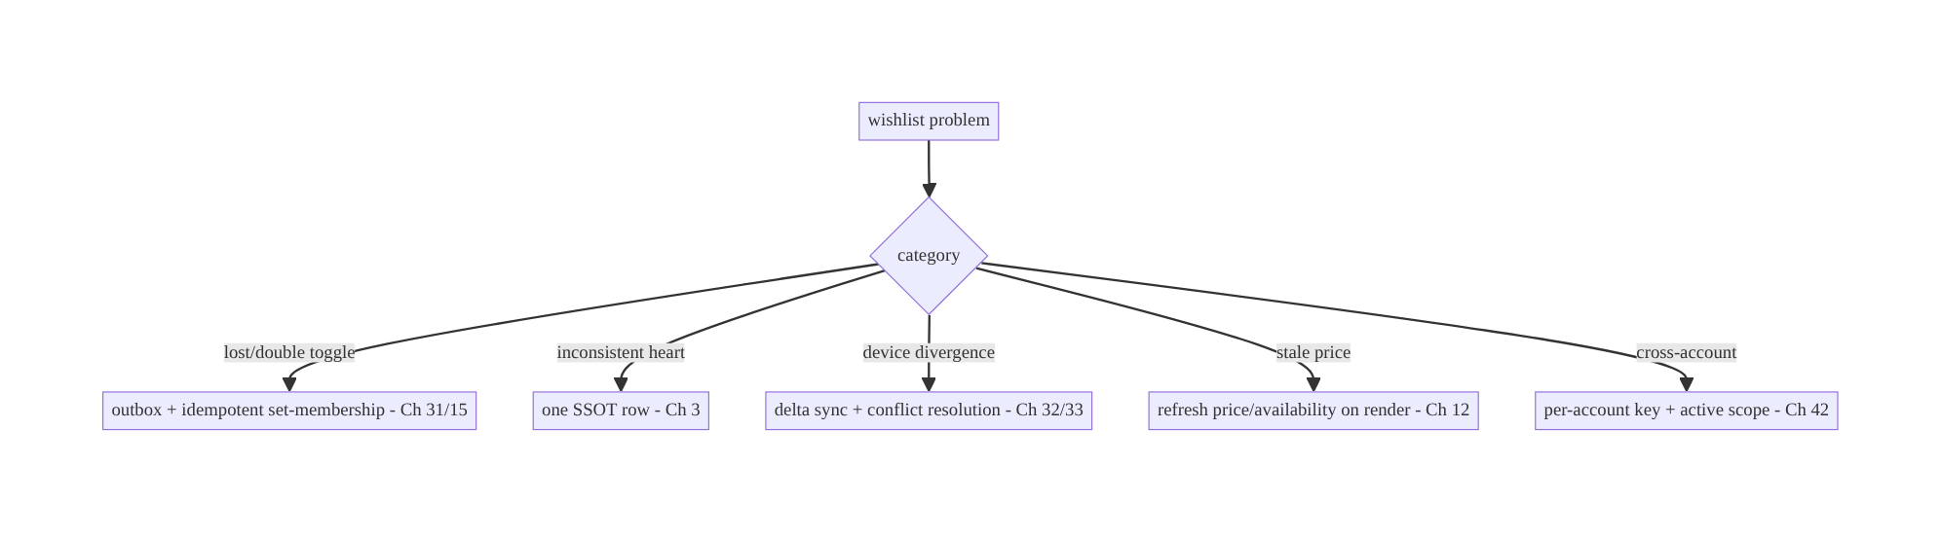
74.9 Failure Scenarios and Recovery
A wishlist is the synced-collection pattern: optimistic SSOT toggle + idempotent set-membership outbox + cross-device delta sync, all per-account. Every wishlist bug (lost/double toggle, inconsistent heart, device divergence) resolves through that stack — the same one powering cart (Ch 38), favorites, and follows.

74.10 Scaling the Implementation
- Level 1. Per-account SSOT membership; optimistic toggle (Ch 72); heart observes SSOT (consistent).
- Level 2. Outbox + idempotent set-membership + offline (Ch 31/15/29); wishlist screen (paged, Ch 13) with current price/availability (Ch 12).
- Level 3 — production. Cross-device delta sync + conflict resolution (Ch 32/33); per-account swap (Ch 42); move-to-cart (Ch 38); rollback on genuine failure (Ch 72).
- Level 4 — large. Price-drop notifications (Ch 49); wishlist sharing; multiple named lists; stock alerts; recommendations from wishlist (Ch 73).
- Level 5 — enterprise. Wishlist analytics, cross-platform consistency, large-list performance, personalization signals (Ch 43/73), gifting/registry features.
Avoid overengineering: the optimistic-SSOT + idempotent-outbox + delta-sync core is a small, reusable pattern. Don’t hold wishlists in memory; don’t re-invent sync — reuse the Ch 31/32 stack.

74.11 Alternative Approaches and Trade-offs
Dimension | Option A | Option B | When
Storage | SSOT (Room, per-account) | in-memory / network-only | SSOT always (offline/consistent/death-safe)
Toggle | Optimistic (Ch 72) | wait-for-server | Optimistic (instant); server-wait feels laggy
Op model | Idempotent set-membership (Ch 15) | non-idempotent add/remove | Set-membership (double-tap/retry safe)
Cross-device | Delta sync + conflict (Ch 32/33) | local only | Sync (users expect cross-device)
Conflict | Last-writer / add-wins (Ch 33) | manual merge | Last-writer/add-wins (a set tolerates it)
Details | Refresh price/availability (Ch 12) | store snapshot at save | Refresh (prices drift)
Large list | Paging (Ch 13) | load all | Paging
SSOT vs in-memory/network-only: an in-memory wishlist loses saves on death and can’t work offline; a network-only toggle is laggy and offline-broken. A per-account SSOT (Room, Ch 3) makes the wishlist instant, offline-capable, consistent across screens, and death- safe, and syncs (Ch 32). Always SSOT-back it.
Idempotent set-membership vs non-idempotent toggle: a non-idempotent “toggle” or a counter double-applies on rapid taps/retries. Set-membership (add/remove with an idempotency key) is idempotent (Ch 15) — applying twice equals once — and reconciles cleanly as a set on sync (Ch 33). Model membership, not toggles.
Refresh details vs snapshot at save: storing the price at save time shows stale prices later (and misses out-of-stock/removed). The wishlist stores ids (membership); current price/availability is refreshed from the catalog on render (Ch 12/3) — enabling “price dropped” and out-of-stock flags. Store membership, refresh details.

74.12 Security & Privacy Considerations
- Per-account authorization (Ch 42/23): the wishlist is per user; the server authorizes that a user can only read/modify their own wishlist; the client scopes by active account and never shows one account’s saves under another.
- A wishlist is personal data (Ch 28): what a user saves reveals intent/interests — treat as private (consent for sharing/recommendations use, Ch 73), don’t leak, log ids not content.
- Idempotency key integrity (Ch 15): prevents double-apply and some abuse; the server enforces idempotency.
- Validate on move-to-cart (Ch 38): price/availability are re-checked server-side at cart/checkout (Ch 75) — the wishlist price is informational, not authoritative.
- Per-account isolation on switch/logout (Ch 42): swap/clear the active wishlist; don’t retain another account’s.
- Client vs backend: the server owns authoritative membership, authorizes per-user access, and reconciles conflicts; the client toggles optimistically, syncs, and scopes per-account.

74.13 Performance and Resource Optimization
- Instant optimistic toggle (local SSOT write, no network block).
- Observe membership as a set/boolean Flow (Ch 6) — cheap isSaved per product; don’t query the whole list for a heart.
- Page the wishlist (Ch 13); refresh details for visible items only (Ch 12).
- Coalesce rapid toggles (Ch 31) — send the final set-membership, not N ops.
- Batch sync (Ch 32) — delta, not full-list fetch.
- Cache product details (Ch 12) for wishlist rendering.
- Profiling: toggle latency (instant), sync frequency/conflict rate, outbox depth, wishlist render time.

74.14 Testing Strategy
Wishlist logic (toggle, idempotency, sync, conflict, per-account) is highly unit-testable.
class WishlistToggleTest {
@Test fun `toggle adds optimistically and enqueues idempotent op`() = runTest {
repo.toggle("p1")
assertTrue(dao.isSaved(acct, "p1").first()) // instant (Ch 72/3)
assertEquals("$acct:wl:p1:add", outbox.last().key) // idempotent (Ch 15)
}
@Test fun `double-tap does not double-add`() = runTest {
repo.toggle("p1"); repo.toggle("p1") // save then unsave (set-membership)
assertFalse(dao.isSaved(acct, "p1").first())
}
@Test fun `rollback on genuine failure`() = runTest {
api.failWith(403); repo.toggle("p1"); repo.sync(WishlistOp.Add("p1", key))
assertFalse(dao.isSaved(acct, "p1").first()) // reverted (Ch 72)
}
}
class WishlistSyncTest {
@Test fun `delta sync converges membership`() = runTest { /* server added/removed -> SSOT matches */ }
@Test fun `add-remove conflict resolves by policy`() = runTest { /* Ch 33 */ }
@Test fun `wishlist scoped per account`() = runTest { /* acct A vs B isolated (Ch 42) */ }
}
What to test: optimistic toggle + idempotent op; double-tap/rapid-toggle idempotency; rollback on genuine failure (Ch 72); delta sync convergence + conflict (Ch 32/33); per- account isolation (Ch 42); consistency across screens (same row); offline persistence (outbox). Fake API/outbox; Room in-memory.

74.15 Production Observability
- Metrics: toggle rate + optimistic→confirmed latency; rollback rate; double-toggle rate (→ 0); sync frequency + conflict rate; outbox depth; cross-device convergence; per-account mis-scope (0); out-of-stock/removed wishlist items; move-to-cart conversion.
- Logs: wishlist{action, result, account} — ids not content; no PII (Ch 28).
- Debugging: lost saves → outbox/offline (Ch 31); double → non-idempotent (Ch 15); inconsistent heart → not SSOT-backed (Ch 3); device divergence → sync/conflict (Ch 32/33); stale price → not refreshing (Ch 12); cross-account → per-account scope (Ch 42).
- Alerting: rollback/double-toggle spike; sync-conflict spike; cross-account leak.
- Dashboards: toggle latency + rollback; convergence; move-to-cart conversion.

74.16 System Design Interview Preparation
≥25 questions.
Fundamentals
- Wishlist model? Per-account, SSOT-backed, offline-first synced set of product ids.
- Storage? Room SSOT keyed by (accountId, productId) (Ch 3/42).
- Why SSOT? Instant, offline, consistent across screens, death-safe, syncable.
- Toggle? Optimistic SSOT mutation (Ch 72) → instant everywhere.
- Consistency across screens? One SSOT row (Ch 3).
Reliability
- Offline toggle? Outbox persists + retries (Ch 31/29).
- Double-tap/rapid toggle? Idempotent set-membership (Ch 15) + coalesce (Ch 31).
- Op model? add/remove set-membership (idempotent), not a counter.
- Genuine failure? Rollback + tell user (Ch 72).
Cross-device
- Sync? Delta sync membership (Ch 32); server authoritative.
- Conflict (add A / remove B)? Last-writer or add-wins (set tolerates, Ch 33).
- Offline toggle vs server? Reconcile on sync (Ch 32/33).
Per-account
- Isolation? Key by accountId; observe active; swap on switch (Ch 42).
- Leakage? Never show A’s saves under B.
Details
- Price/availability? Refresh on render (Ch 12) — membership is ids; prices drift.
- Out-of-stock/removed? Flag on render.
- Price drop? Notify (Ch 49).
Scale/integration
- Large list? Paging (Ch 13).
- Move to cart? Integrate with cart (Ch 38).
- Reuse pattern? Favorites/follows/watchlist (same synced-collection).
Security
- Authorization? Server, per-user (Ch 23/42).
- Privacy? Wishlist is personal data (Ch 28).
Testing/Production
- Test toggle? Optimistic + idempotent op; double-tap safe.
- Test sync? Convergence + conflict.
- Lost saves in prod? Outbox/offline.
- Inconsistent heart? Not SSOT-backed.

Design-change challenges
- Save works offline and syncs across devices. SSOT + outbox + delta sync (Ch 3/31/32).
- Heart inconsistent between feed and detail. One SSOT row (Ch 3).
- Double-tap saves twice. Idempotent set-membership (Ch 15).
- Saved item now out of stock. Refresh price/availability on render (Ch 12).
- Add on phone / remove on tablet. Conflict resolution (last-writer/add-wins, Ch 33).

Mock walkthrough (abridged)
Clarify (offline?, cross-device?, per-account?, large list?) → per-account SSOT membership (Ch 3/42) → optimistic toggle (Ch 72) → idempotent set-membership outbox (Ch 31/15) → delta sync + conflict (Ch 32/33) → consistency via one row + page large list (Ch 3/13) → refresh price/availability (Ch 12) → move-to-cart (Ch 38) → security (per-user authz, privacy) → observability.

74.17 Practical Exercises
- Beginner. Model a per-account wishlist in Room and make the heart observe the SSOT so it’s consistent in feed and detail. Eval: consistent; per-account.
- Intermediate. Add optimistic toggle + idempotent set-membership outbox so saving works offline and double-tap is safe. Eval: instant; offline; no double-add.
- Advanced. Add cross-device delta sync with add/remove conflict resolution and rollback on genuine failure. Eval: converges; conflict-resolved; reverts on reject.
- Production debugging. Fix lost offline saves (no outbox) and stale wishlist prices (no refresh). Eval: persisted; current prices.
- System design challenge. Add a paged wishlist screen, move-to-cart (Ch 38), and price-drop detection; ensure per-account swap. Eval: paged; integrated; isolated.
(Solutions withheld unless requested.)

74.18 Chapter Summary & Reference Sheet
Key decisions: model the wishlist as a per-account, SSOT-backed, offline-first synced set of product ids — toggle membership optimistically in the SSOT (one Room row per (accountId, productId), Ch 72/3) so the heart flips instantly and consistently everywhere the product appears (UDF, Ch 6); persist each toggle as an idempotent set-membership op in an outbox (Ch 31/15) so it survives offline/process death, retries, and dedups double-taps/rapid toggles (latest-intent coalesced); sync membership across devices via delta sync with add/remove conflict resolution (last-writer or add-wins, server authoritative, Ch 32/33); scope strictly per-account (swap on switch, Ch 42); refresh item price/availability on render (membership is ids; details drift — enabling out-of-stock/price-drop flags, Ch 12/49); page a large list (Ch 13); and roll back on genuine failure (Ch 72). It is the reusable synced-collection pattern (favorites, follows, watchlist) and composes the same stack as cart (Ch 38).
Concepts: per-account SSOT membership, optimistic toggle, idempotent set-membership + outbox, delta sync + add/remove conflict resolution, consistency via one row, per-account isolation, price/availability refresh, paging, move-to-cart.
Common mistakes: in-memory/network-only wishlist (lost offline/on death, laggy); per-screen state (inconsistent heart); non-idempotent toggle (double-add); no outbox (lost offline saves); no cross-device sync/conflict (divergence); snapshotting price at save (stale); cross-account leakage; loading the whole list (no paging).
Checklist:
- ☐ per-account SSOT membership (accountId, productId) (Ch 3/42)
- ☐ optimistic toggle (Ch 72)
- ☐ heart observes SSOT (consistent everywhere)
- ☐ idempotent set-membership outbox op (Ch 31/15)
- ☐ offline-capable + rollback on genuine failure (Ch 29/72)
- ☐ cross-device delta sync + conflict (last-writer/add-wins, Ch 32/33)
- ☐ per-account swap (Ch 42)
- ☐ refresh price/availability on render (Ch 12)
- ☐ page large list (Ch 13)
- ☐ move-to-cart (Ch 38)
- ☐ per-user authz + privacy (Ch 23/28)
- ☐ toggle-latency + convergence telemetry.
Key APIs: Room @Entity composite key (accountId, productId) + @Dao (isSaved Flow / observeIds / pagingSource, Ch 3/13), Outbox + idempotency key (Ch 31/15), optimistic update + rollback (Ch 72), delta sync + conflict policy (Ch 32/33), ActiveAccountProvider (Ch 42), catalog refresh (Ch 12), cart integration (Ch 38).
References:
- Offline-first data layer: https://developer.android.com/topic/architecture/data-layer/offline-first
- (composes) Ch 3 SSOT, Ch 72 Optimistic Updates, Ch 31 Outbox, Ch 15 Idempotency, Ch 32 Delta Sync, Ch 33 Conflict Resolution, Ch 42 Multi-Account, Ch 13 Paging, Ch 38 Cart, Ch 12 Caching

Chapter 75 — Checkout Flow (Fintech-Grade)
Part IX — Feature Architectures · Complexity: Complex (≥40 interview questions)
Prerequisites: Ch 15 (idempotency), Ch 38 (cart), Ch 3 (SSOT), Ch 31 (outbox), Ch 2 (retries), Ch 53 (navigation), Ch 8 (process death), Ch 19/23 (auth/security), Ch 72 (optimistic — and when NOT to). Pairs with Ch 76/77 (billing/wallet), Ch 78 (order tracking).
Reference surface in StreamCart: placing an order — a money-moving, irreversible, multi-step flow (cart → address → shipping → payment → review → place) that must be exactly-once (never double-charge), survive interruptions, handle payment failures precisely, and be auditable — the opposite discipline from optimistic UI (Ch 72).

75.1 Problem Definition and Real-World Context
Checkout is where the app moves money and creates an irreversible commitment (an order, a charge). It is the highest-stakes flow in the app and demands a different discipline from the rest of the book: not optimistic (Ch 72), exactly-once (idempotency, Ch 15), server-authoritative at every step, resilient to interruption (process death mid-payment, Ch 8), and auditable. The cardinal sin is a double-charge (or a double-order) from a retry, a double-tap, a reconnect, or a process restart — a bug that directly costs users money and trust.
Concretely, teams hit:
- Double-charge / double-order. A “Place order” tap that retries (network blip, reconnect, process restart) without an idempotency key charges twice. Every money- moving request must carry an idempotency key (Ch 15) the server dedups on.
- Optimistic checkout (wrong). Showing “Order placed!” before the server confirms — then it failed — is unacceptable (the user believes they paid). Checkout shows real, server-confirmed state only (contrast Ch 72).
- Interruption mid-flow. The process dies after the charge but before the client sees the response → the client must recover (query order status by idempotency key, not blindly re-submit) to avoid double-charging and to show the true outcome (Ch 8).
- Multi-step state. Cart → address → shipping → payment method → review → place: server-validated at each step (price/stock/tax/shipping change), navigable (back/edit, Ch 53), resumable, and the final place-order is the only money-moving, idempotent step.
- Payment complexity. Payment goes through a PSP/SDK (Stripe/Adyen/Play Billing Ch 76), often with 3-D Secure / SCA challenges, async confirmation, and precise failure states (declined vs network vs insufficient funds) — each handled differently.
- Price/stock/total integrity. Totals, taxes, shipping, discounts, and stock are computed and validated server-side at place time (never trust client totals) — prices/stock can change between cart and checkout.
- Auditability & security. Orders/payments need an audit trail, strict auth (Ch 19), no card data on the device (PCI — use PSP tokenization, Ch 23), and fraud/ risk checks (server).
The architecture: treat place-order as an idempotent, server-authoritative, exactly-once transaction — generate an idempotency key for the attempt (Ch 15) and reuse it across retries/restarts so the server dedups; show only real, server-confirmed state (not optimistic, contrast Ch 72); validate every step server-side (price/stock/tax/ shipping) and compute the authoritative total at place time; integrate the PSP/SDK for tokenized payment + SCA/3-DS + async confirmation with precise failure handling; recover from interruption by querying order status via the idempotency key (never blind re-submit, Ch 8); keep card data off the device (PCI tokenization, Ch 23) and the flow authed and auditable (Ch 19). This chapter is the fintech-grade, exactly-once checkout — the book’s strictest correctness bar.

Three practical use cases
- Place an order (StreamCart). Multi-step checkout; the final “Place order” carries an idempotency key; the server validates totals/stock, charges via the PSP (with SCA if needed), and returns a confirmed order — exactly once, even on retry/restart.
- Process dies mid-payment. The app is killed after the charge; on relaunch it recovers by querying the order/payment status (by idempotency key) and shows the true outcome — no double-charge (Ch 8).
- Payment declined / SCA required. The PSP returns “requires authentication” (3-DS) or “declined” — the client handles the challenge or shows a precise, actionable error, with no partial order.

Why this is architectural
Checkout is the book’s exactly-once, irreversible, server-authoritative capstone, composing idempotency (Ch 15), SSOT (Ch 3), outbox (Ch 31), retries (Ch 2), process death (Ch 8), navigation (Ch 53), auth/security/PCI (Ch 19/23), and the deliberate non-use of optimistic UI (Ch 72). The decisions — idempotency-key reuse, server-authoritative totals, interruption recovery, precise payment failure handling, no-card-on-device — determine whether money moves correctly exactly once.

75.2 Requirements Engineering

Functional requirements
ID | Requirement
F1 | Multi-step checkout (cart → address → shipping → payment → review → place), server-validated each step.
F2 | Place order exactly-once via an idempotency key reused across retries/restarts (Ch 15).
F3 | Show only real, server-confirmed state (not optimistic) (contrast Ch 72).
F4 | Integrate PSP/SDK for tokenized payment + SCA/3-DS + async confirmation; precise failure handling.
F5 | Recover from interruption by querying status (never blind re-submit) (Ch 8).
F6 | Server-authoritative totals/stock; no card data on device (PCI); authed + auditable (Ch 19/23).

Non-functional requirements
Attribute | Policy
Exactly-once | Never double-charge/double-order; idempotent (Ch 15).
Integrity | Server-authoritative totals/stock/tax; no trusted client totals.
Resilience | Survives process death mid-payment; recovers true outcome (Ch 8).
Security/PCI | No PAN on device; PSP tokenization; authed; auditable (Ch 23/19).
UX | Real state only; precise, actionable failures; resumable.

Scope
- In scope: multi-step checkout + per-step server validation + navigation (Ch 53), idempotent exactly-once place-order (key reuse across retry/restart, Ch 15), real-state- not-optimistic (contrast Ch 72), PSP/SDK integration (tokenization, SCA/3-DS, async confirmation, precise failures), interruption recovery via status query (Ch 8), server-authoritative totals/stock (Ch 23), PCI (no card on device), auth/audit (Ch 19/23), SSOT for order/checkout state (Ch 3).
- Out of scope: Play Billing / IAP specifics (Ch 76), wallet/payment methods (Ch 77), order tracking (Ch 78), cart internals (Ch 38), idempotency mechanics (Ch 15), process- death detail (Ch 8).

Assumptions & constraints
- A PSP/payment SDK (Stripe/Adyen or Play Billing Ch 76) handles card tokenization + SCA; the server owns totals/charging/orders and dedups on an idempotency key (Ch 15); no raw card data touches the app (PCI, Ch 23). minSdk 24. Place-order is irreversible → not optimistic.

75.3 System Design Fundamentals
- Checkout is NOT optimistic (the opposite of Ch 72). For likes/cart (Ch 72/38), optimism is right; for placing an order / charging, it is wrong — never show “Order placed!” before the server confirms, because a rollback after the user believes they paid is unacceptable. Checkout shows “Placing…” then the real, server-confirmed outcome (confirmed / declined / needs-auth). Real state only.
- Exactly-once via an idempotency key (the core, Ch 15). The money-moving place-order request carries an idempotency key generated once per checkout attempt and reused on every retry and after a process restart. The server dedups on this key: a retried/replayed request returns the same result (the already-created order/charge), never a second charge. This is the single most important checkout mechanic — generate the key at the start of the place-order attempt, persist it (SSOT, Ch 3/8), and reuse it.
- Server-authoritative everything (Ch 23). The server computes and validates: price, tax, shipping, discounts, the total, and stock — at place time, not from client-sent totals (which can be stale or tampered). The client displays what the server returns; the place-order sends the cart + chosen options + idempotency key, and the server authoritatively prices, checks stock, and charges. Never trust client totals (price tampering, Ch 23).
- Multi-step flow, per-step validation (Ch 53). Cart → address → shipping method → payment method → review → place. Each step is server-validated (address serviceable? shipping options + cost? price/stock still valid?) and navigable (back/edit, Ch 53). Only place moves money. The flow is resumable (persist checkout state in the SSOT so a return/restart resumes, Ch 8). Prices/stock may change mid-flow → re-validate and surface changes before place.
- PSP/SDK: tokenization + SCA/3-DS + async confirmation + precise failures.
  - Tokenization (PCI): the PSP SDK collects card details and returns a token; the raw card number never touches your app or server (PCI scope minimization, Ch 23).
  - SCA / 3-D Secure: regulations (PSD2) may require a challenge (the SDK presents it); payment is async — “requires action” → challenge → confirm.
  - Confirmation: the charge is confirmed by the PSP + your server (often via a webhook to your server); the client polls/receives the final order state.
  - Precise failure states: declined, insufficient funds, network, requires-authentication, fraud-hold — each handled distinctly (retry vs re-enter card vs challenge vs show error). Don’t collapse to “payment failed.”
- Interruption recovery (Ch 8) — never blind re-submit. If the process dies after the charge but before the client sees the response, the client must not re-submit blindly (risking a double-charge if the key weren’t reused). Because the idempotency key is persisted (Ch 3/8), recovery re-submits with the same key (server dedups → returns the existing order) or queries order/payment status by the key/order id to learn the true outcome. Design recovery as “ask the server what happened,” not “try again.”
- SSOT + audit (Ch 3/19). Checkout/order state lives in the SSOT (Ch 3) so it survives process death and the UI reflects truth; orders/payments are audited server-side (immutable record, Ch 19) for support/disputes. The client keeps an authed session throughout (re-auth for sensitive steps if needed, Ch 21).
- Outbox nuance (Ch 31). Unlike cart/wishlist, place-order is not fire-and-forget from an outbox while offline — you cannot place an order offline (the server must authorize/charge). Checkout requires connectivity; if offline, block place with a clear message. (Non-money steps can be prepared offline, but place requires the server.) The idempotency key makes online retries safe, not offline queuing of charges.
Core insight: checkout is an exactly-once, server-authoritative, irreversible transaction — the opposite of optimistic UI: show only real server-confirmed state, and make the money- moving place-order idempotent by generating one idempotency key per attempt, persisting it (Ch 3/8), and reusing it across every retry and process restart so the server dedups and never double-charges; validate every step and compute the authoritative total/stock server-side (never trust client totals, Ch 23); integrate the PSP SDK for tokenized payment (no card data on device, PCI), SCA/3-DS challenges, async confirmation, and precise failure handling; recover from interruption by asking the server what happened (re-submit with the same key or query status) rather than blindly re-submitting (Ch 8); and keep the flow authed and auditable (Ch 19/23). Checkout requires connectivity — you cannot charge offline.

75.4 High-Level Architecture
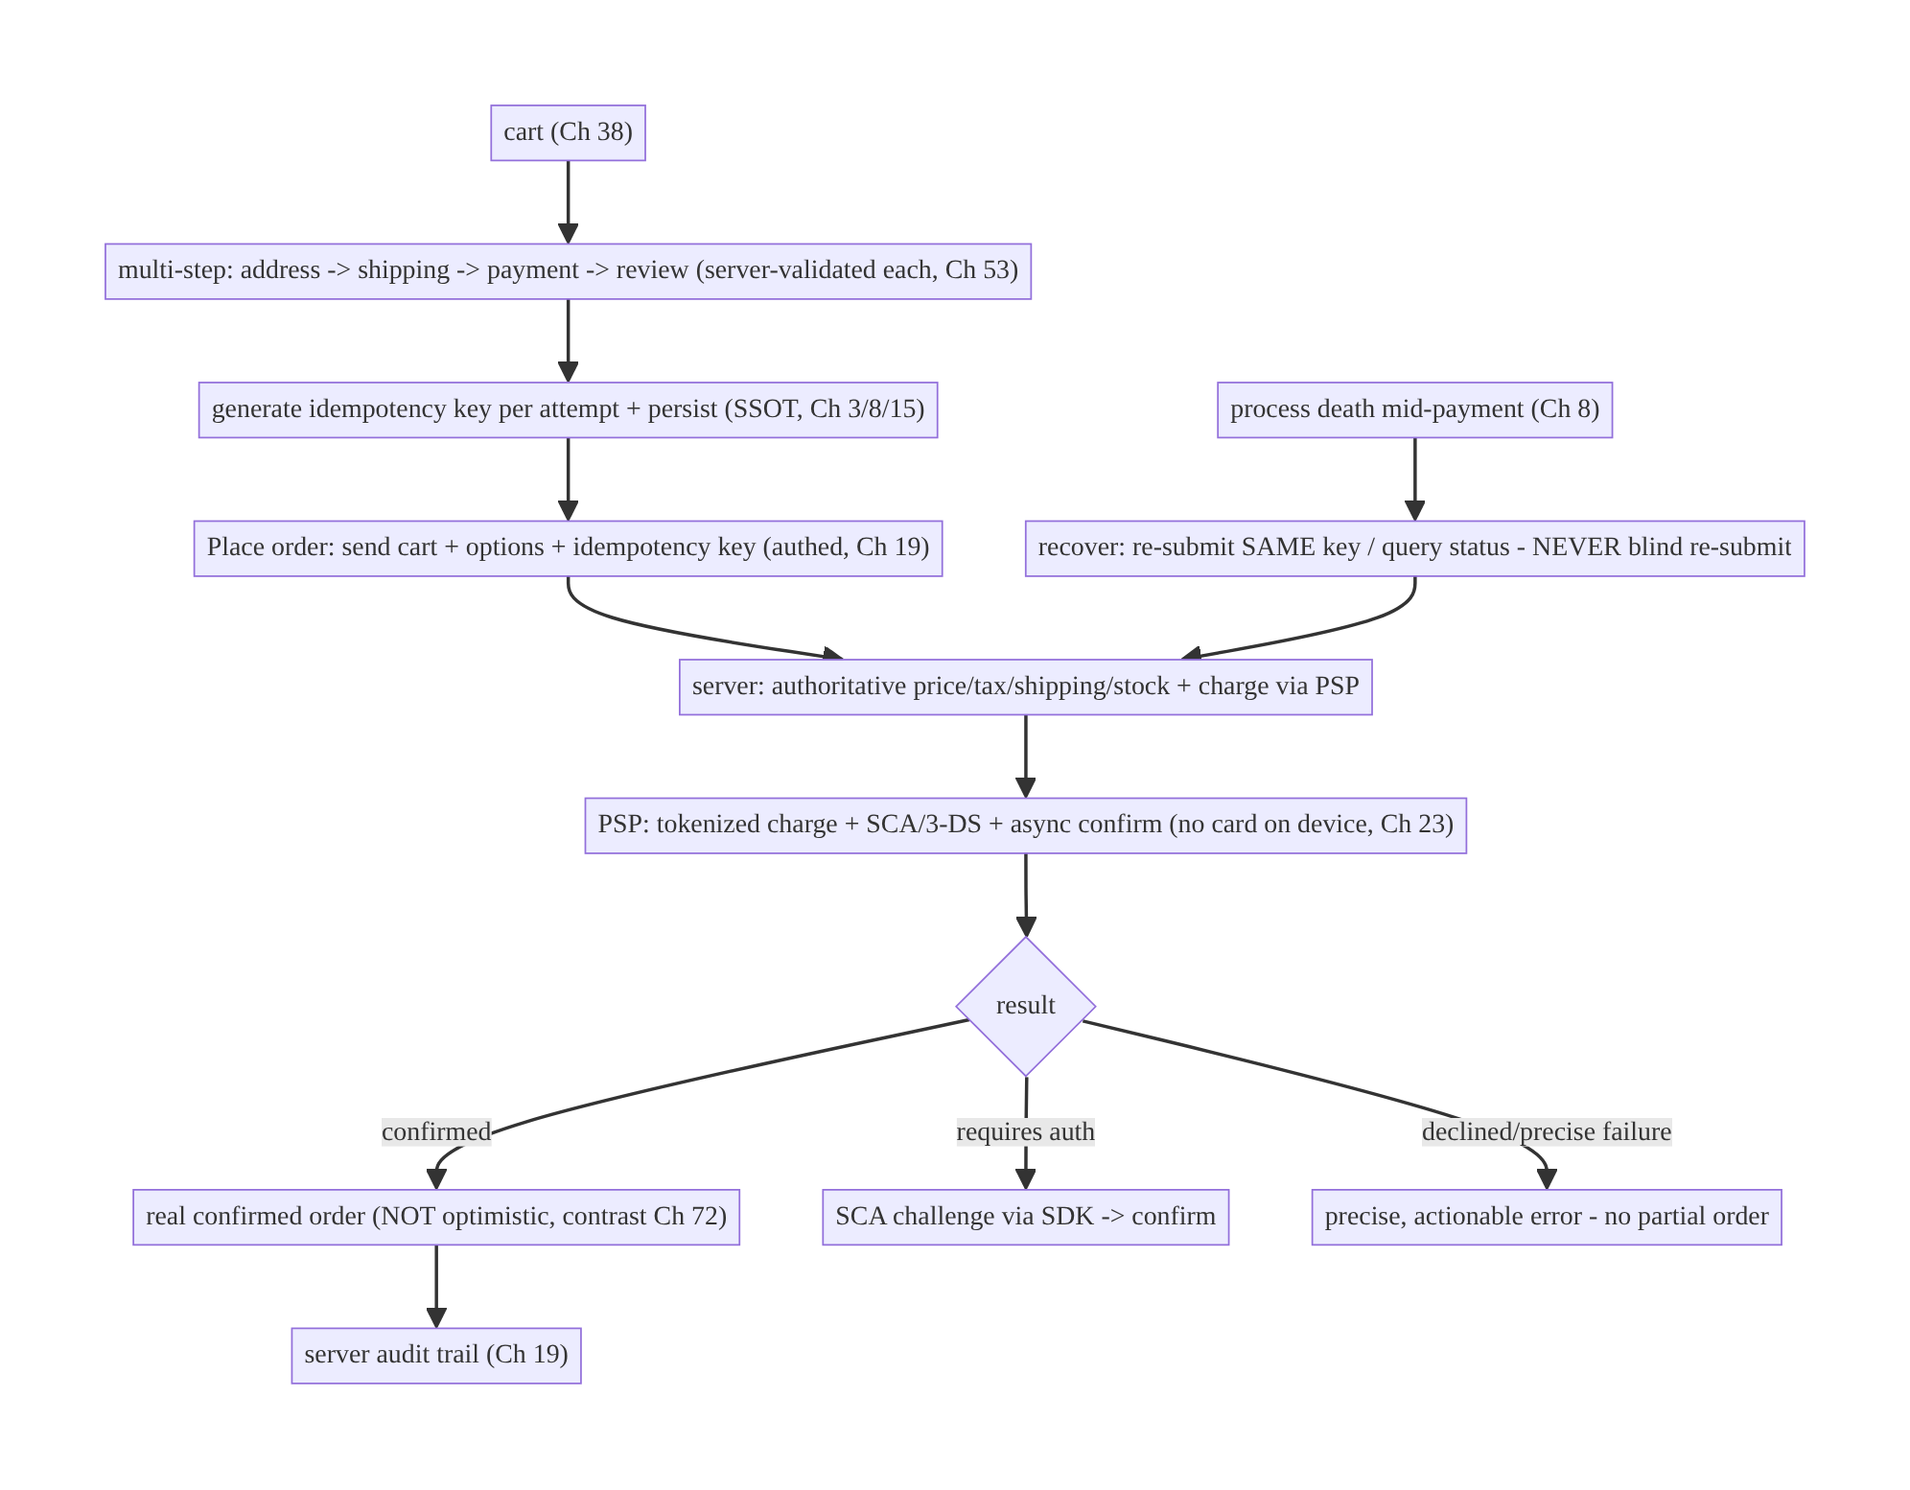
75.4 High-Level Architecture
Components & ownership
- Multi-step flow (Ch 53), each server-validated; an idempotency key generated once per attempt and persisted (Ch 3/8/15).
- Place-order sends cart + options + key; the server authoritatively prices/checks stock/charges via the PSP (tokenized, SCA, async, no card on device).
- Outcome is real (confirmed/needs-auth/declined — not optimistic); recovery asks the server; audit server-side.
Direction: cart → validated steps → idempotency key → authed place-order → server authoritative + PSP → real outcome; interruption recovers by asking the server.

75.5 Detailed Component Design
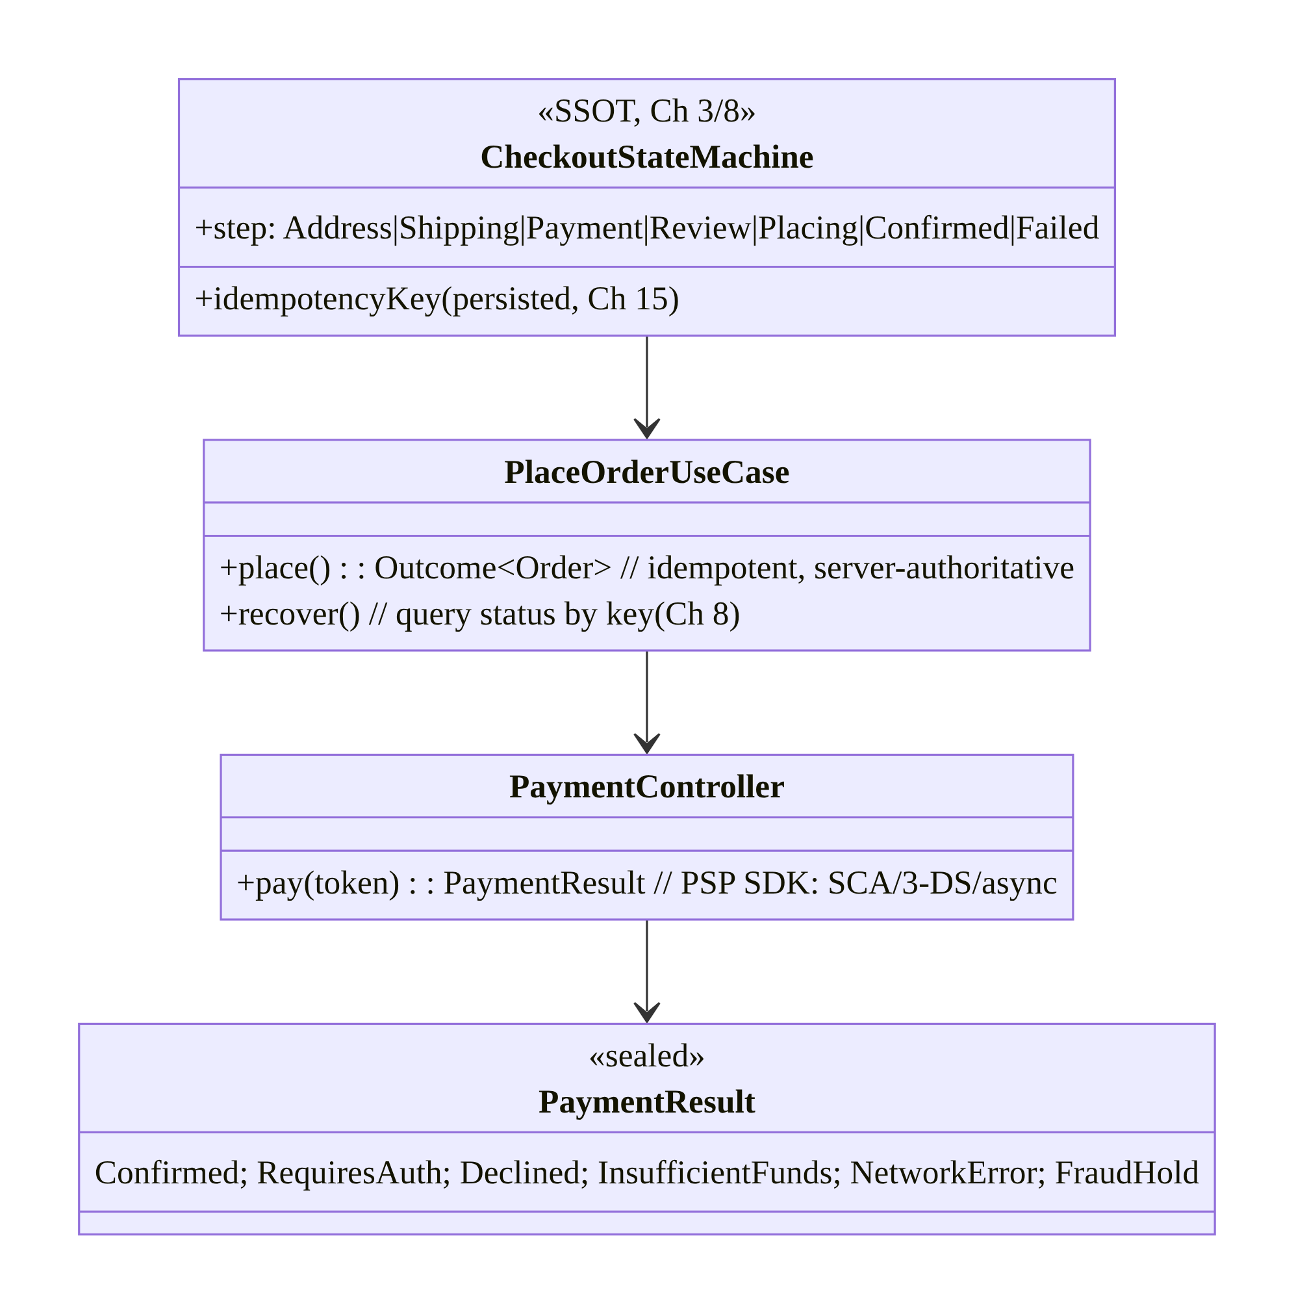
75.5 Detailed Component Design
Component | Responsibility
CheckoutStateMachine | SSOT checkout step + persisted idempotency key (Ch 3/8/15)
PlaceOrderUseCase | idempotent place + interruption recovery (query by key, Ch 8)
PaymentController | PSP SDK: tokenized charge, SCA/3-DS, async confirm
PaymentResult | precise outcomes (confirmed/requires-auth/declined/…)

75.6 End-to-End Data Flow

Place order exactly-once (with SCA)
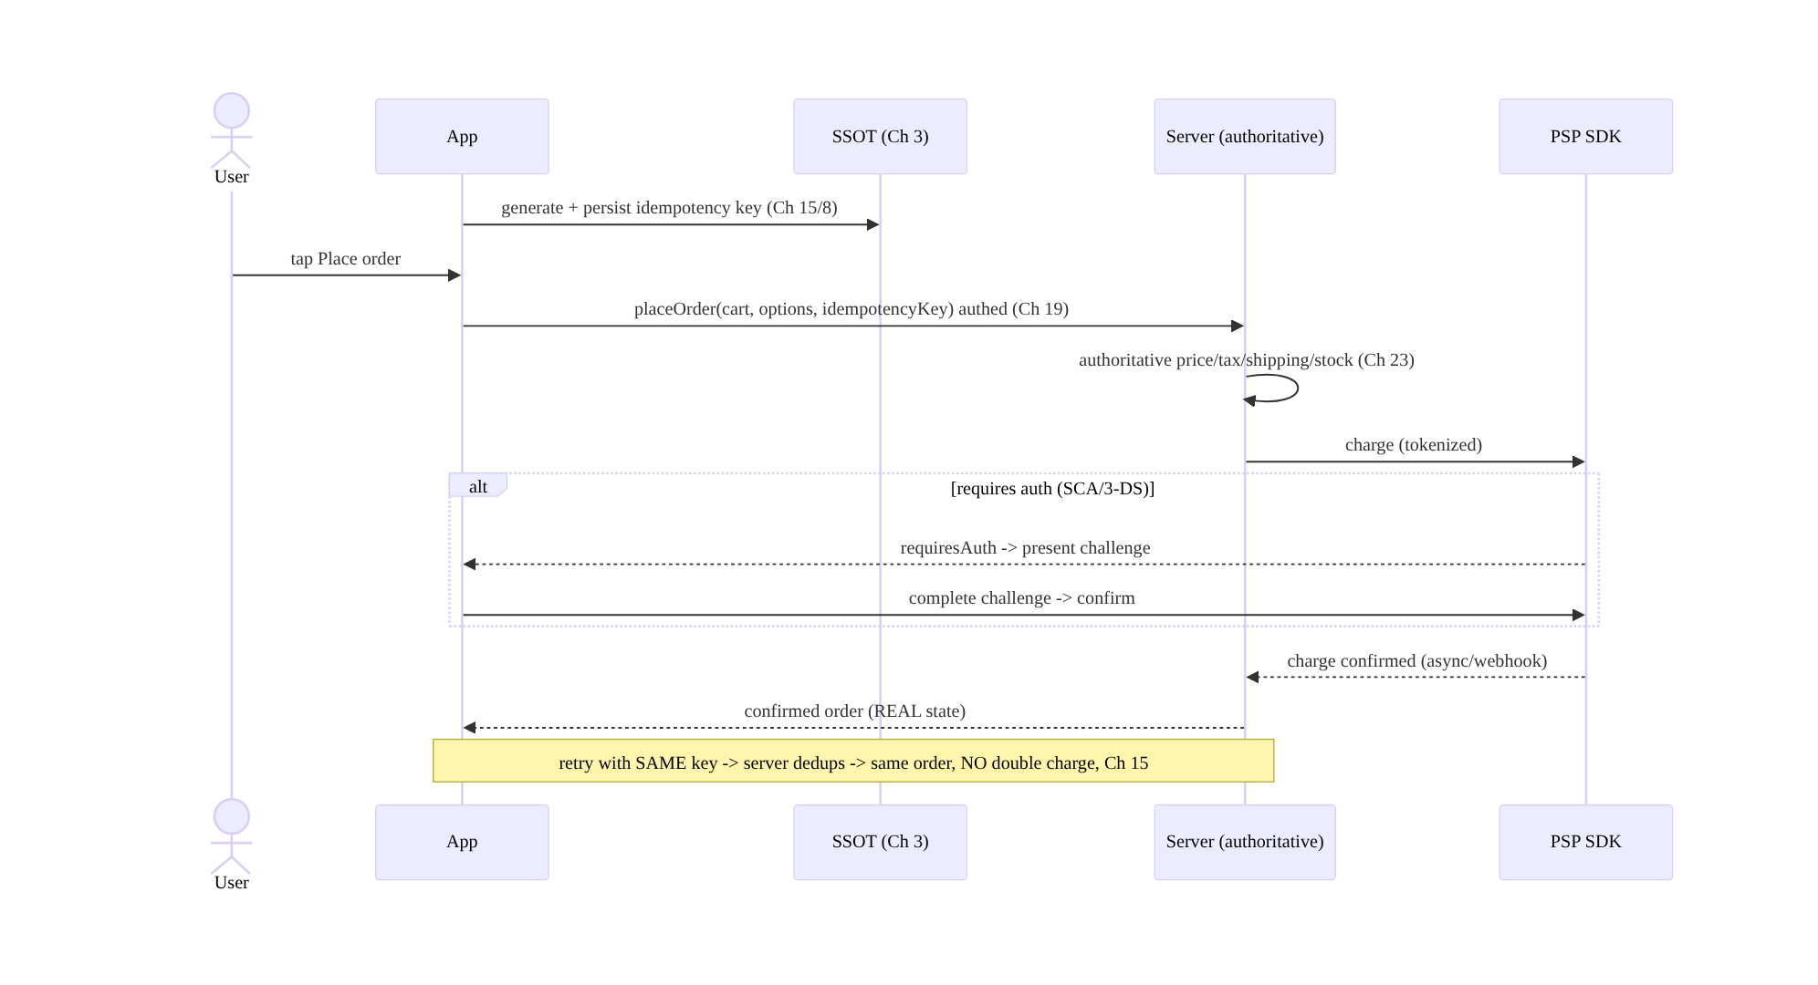
Place order exactly-once (with SCA)

Interruption recovery (never blind re-submit)
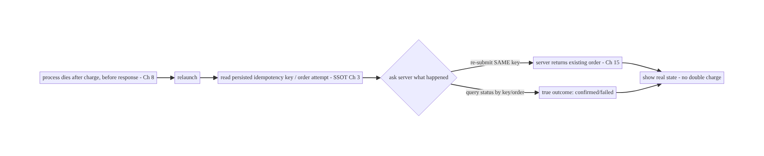
Interruption recovery (never blind re-submit)

75.7 Complete Kotlin Implementation
Package: com.streamcart.checkout.

75.7.1 Checkout state machine + persisted idempotency key (SSOT, Ch 3/8/15)
sealed interface CheckoutStep {
data object Address : CheckoutStep; data object Shipping : CheckoutStep
data object Payment : CheckoutStep; data object Review : CheckoutStep
data object Placing : CheckoutStep // "Placing…" - real state, NOT "placed"
data class Confirmed(val order: Order) : CheckoutStep
data class Failed(val reason: PaymentResult) : CheckoutStep // precise failure
}
@Entity(tableName = "checkout_session") // SSOT -> survives process death (Ch 3/8)
data class CheckoutSession(
@PrimaryKey val id: String, val step: String,
val idempotencyKey: String, // generated once per attempt, REUSED across retry/restart (Ch 15)
val cartSnapshot: String, val options: String,
)

75.7.2 PlaceOrderUseCase: idempotent place + recovery (Ch 15/8)
@Singleton
class PlaceOrderUseCase @Inject constructor(
private val api: CheckoutApi, private val dao: CheckoutDao, private val payment: PaymentController,
) {
suspend fun place(session: CheckoutSession): CheckoutStep {
dao.setStep(session.id, "Placing") // show "Placing…" (real state, NOT optimistic, Ch 72)
return runCatching {
// Server is authoritative: it prices, checks stock, charges; dedups on idempotencyKey (Ch 15/23).
val result = api.placeOrder(session.cartSnapshot, session.options, session.idempotencyKey)
when (result) {
is PlaceResult.Confirmed -> CheckoutStep.Confirmed(result.order)
is PlaceResult.RequiresAuth -> { // SCA/3-DS
val after = payment.completeChallenge(result.clientSecret) // PSP SDK
confirmAfterChallenge(session, after)
}
is PlaceResult.Failed -> CheckoutStep.Failed(result.reason) // precise failure
}
}.getOrElse { e ->
// Network error AFTER sending: DO NOT blindly re-charge. Recover by asking the server (Ch 8).
if (e.isTransient()) recover(session) else CheckoutStep.Failed(PaymentResult.NetworkError)
}.also { dao.setStep(session.id, it.name()) }
}
/** Interruption recovery: ask the server what happened using the SAME idempotency key (Ch 8/15). */
suspend fun recover(session: CheckoutSession): CheckoutStep {
val status = api.orderStatusByIdempotencyKey(session.idempotencyKey) // query, not blind re-submit
return when (status) {
is OrderStatus.Placed -> CheckoutStep.Confirmed(status.order) // it DID succeed -> show real
is OrderStatus.NotPlaced -> // safe to re-submit with the SAME key (server dedups if it later landed)
place(session)
is OrderStatus.Failed -> CheckoutStep.Failed(status.reason)
}
}
}

75.7.3 Idempotency key: generate once, persist, reuse (Ch 15/8)
suspend fun startCheckoutAttempt(cart: Cart, options: CheckoutOptions, dao: CheckoutDao): CheckoutSession {
val session = CheckoutSession(
id = UUID.randomUUID().toString(),
step = "Review",
idempotencyKey = UUID.randomUUID().toString(), // ONE key per attempt (Ch 15)
cartSnapshot = cart.toJson(), options = options.toJson(),
)
dao.upsert(session) // PERSIST so retry/restart reuse the SAME key (Ch 8)
return session
}
// NEVER regenerate the key on retry — reuse it so the server dedups (the anti-double-charge guarantee).

75.7.4 PaymentController: PSP SDK (tokenize, SCA/3-DS, precise failures, no card on device)
sealed interface PaymentResult {
data object Confirmed : PaymentResult; data class RequiresAuth(val clientSecret: String) : PaymentResult
data object Declined : PaymentResult; data object InsufficientFunds : PaymentResult
data object NetworkError : PaymentResult; data object FraudHold : PaymentResult
}
class PaymentController @Inject constructor(private val psp: PspSdk) { // Stripe/Adyen (or Play Billing, Ch 76)
// Card details collected by the PSP SDK -> TOKEN; raw PAN never touches app/server (PCI, Ch 23).
suspend fun completeChallenge(clientSecret: String): PaymentResult =
psp.handleNextAction(clientSecret) // presents 3-DS/SCA; returns precise result
// Map PSP error codes to PRECISE states (declined vs insufficient vs network vs fraud) — not "failed".
}

75.7.5 UI: real state only (not optimistic), precise failures, resumable (Ch 53/8)
@Composable
fun CheckoutScreen(vm: CheckoutViewModel = hiltViewModel()) {
val step by vm.step.collectAsStateWithLifecycle()
when (val s = step) {
is CheckoutStep.Placing -> PlacingSpinner("Placing your order…") // REAL state, not "Order placed!"
is CheckoutStep.Confirmed -> OrderConfirmed(s.order) // only AFTER server confirms
is CheckoutStep.Failed -> PreciseError(s.reason, onRetry = { vm.retrySameKey() }) // reuse key (Ch 15)
else -> CheckoutSteps(step = s, onNext = vm::next, onBack = vm::back) // multi-step (Ch 53), server-validated
}
// On launch after death: vm.recover() queries status by key (Ch 8) -> shows true outcome.
}

75.7.6 Module structure
:feature:checkout CheckoutStateMachine/Session (SSOT, Ch 3), PlaceOrderUseCase (idempotent + recover),
PaymentController (PSP SDK), multi-step UI (Ch 53)
:core:payments PSP SDK integration (tokenize/SCA); Play Billing -> Ch 76; wallet -> Ch 77
# Server: authoritative totals/stock/charge + idempotency dedup + audit (Ch 15/23/19). Order tracking -> Ch 78.

75.8 Concurrency and Race Conditions
Scenario | Risk | Handling
Double-tap “Place order” | double-charge | disable button + same idempotency key (server dedups, Ch 15)
Retry after network blip | double-charge | reuse SAME key (never regenerate)
Process death after charge | double-charge / wrong state | persisted key; recover by querying status (Ch 8) — never blind re-submit
Optimistic “placed” then fail | user thinks paid | real state only (not optimistic, Ch 72)
Stale client total | price tampering/mismatch | server-authoritative total at place time (Ch 23)
Concurrent stock | oversell | server stock check at place time
SCA challenge interrupted | stuck payment | resume/recover via status; re-present challenge
- Idempotency-key reuse is the double-charge guarantee (Ch 15): generate the key once per attempt, persist it (Ch 8), and reuse it on every retry/restart — the server dedups, so a double-tap, a retried blip, or a process restart yields the same single order/charge, never two. Regenerating the key on retry is the catastrophic bug.
- Recover by asking, not re-submitting (Ch 8): after an interruption where the outcome is unknown, query order status by the key (or re-submit with the same key, which dedups) — blindly re-submitting with a new key double-charges.
- Server-authoritative totals prevent client price tampering and stale-total mismatches (Ch 23) — the client never computes the charged amount.

75.9 Failure Scenarios and Recovery
Failure | Detection | Response | Outcome
Double-charge from retry/tap | billing | idempotency-key reuse (server dedups, Ch 15) | single charge
Process death mid-payment | relaunch | recover by status query (Ch 8); same key | true outcome, no dup
Payment declined | PSP result | precise error + re-enter/retry | no partial order
SCA required | PSP “requires action” | present challenge → confirm | authenticated
Price/stock changed mid-flow | server validation | re-validate + surface before place | correct total
Client total tampered/stale | server mismatch | server-authoritative total (Ch 23) | server wins
Offline at place | no network | block place + clear message (can’t charge offline) | no silent fail
Optimistic “placed” | wrong state | real state only (Ch 72) | honest
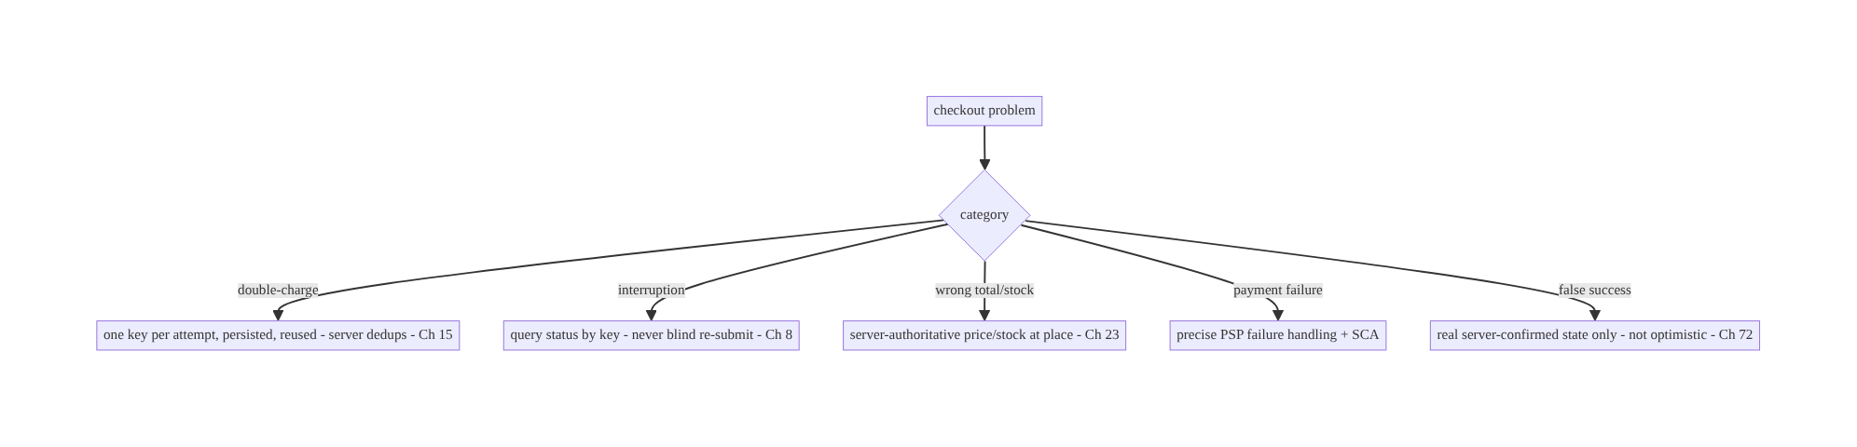
75.9 Failure Scenarios and Recovery
The one rule that defines fintech-grade checkout: exactly-once via a persisted, reused idempotency key, with real server-confirmed state only. Generate the key once, persist it, reuse it on every retry/restart so the server dedups (no double-charge); recover from interruption by asking the server, not re-submitting; keep totals/stock server-authoritative; and never show “placed” before the server confirms.

75.10 Scaling the Implementation
- Level 1. Multi-step flow (Ch 53); server-authoritative totals; place-order with an idempotency key (Ch 15); real-state-only UI.
- Level 2. Persist the key + checkout state (SSOT, Ch 3/8); interruption recovery via status query; precise PSP failure states.
- Level 3 — production. Full PSP integration (tokenization/SCA/3-DS/async + webhook confirmation); per-step re-validation; audit trail (Ch 19); no-card-on-device (Ch 23).
- Level 4 — large. Multiple payment methods (Ch 77) + Play Billing (Ch 76); saved payment tokens; fraud/risk integration; promo/discount validation; address/tax services; partial captures/refunds.
- Level 5 — enterprise. Checkout funnel analytics + conversion, A/B of flow (Ch 87), multi-currency, regulatory (SCA/PSD2, tax), dispute/chargeback handling, exactly-once SLOs.
Avoid overengineering: the idempotency-key + server-authoritative + real-state core is non-negotiable; build it first. Don’t add optimism to checkout; don’t trust client totals; don’t handle card data yourself.

75.11 Alternative Approaches and Trade-offs
Dimension | Option A | Option B | When
UI state | Real server-confirmed only | optimistic (“placed”) | Real only (irreversible; contrast Ch 72)
Exactly-once | Idempotency key reused (Ch 15) | no key / new key per retry | Reused key always (anti-double-charge)
Totals | Server-authoritative (Ch 23) | client-computed | Server (tampering/stale)
Interruption | Query status by key (Ch 8) | blind re-submit | Query (blind re-submit double-charges)
Card data | PSP tokenization (no PAN on device) | handle card in app | Tokenization (PCI, Ch 23)
Payment result | Precise states | “payment failed” | Precise (retry vs re-enter vs challenge)
Offline | Block place (needs server) | queue charge offline | Block (can’t charge offline)
Real-state vs optimistic for checkout: optimistic UI (Ch 72) is correct for reversible actions but catastrophic for checkout — showing “Order placed!” before confirmation, then failing, makes the user believe they paid when they didn’t (or vice-versa). Checkout shows “Placing…” and then the real, server-confirmed outcome. This is the deliberate inverse of Ch 72: optimism everywhere except money/irreversible actions.
Idempotency-key reuse vs new-key/no-key: without an idempotency key (or with a new key on each retry), a retried/replayed/double-tapped place-order double-charges. A single key per attempt, persisted and reused across retries and restarts lets the server dedup — the same request yields the same order. This is the defining checkout mechanic (Ch 15); everything else supports it.
Server-authoritative vs client-computed totals: trusting the client’s total invites price tampering (a modified client charging $0) and stale totals (price changed since cart). The server computes and validates price/tax/shipping/discount/stock at place time and charges the authoritative amount; the client only displays it. Never charge a client-sent amount (Ch 23).

75.12 Security & PCI Considerations
- No card data on the device (PCI, Ch 23): use the PSP SDK’s tokenization — card details go directly to the PSP, which returns a token; your app and server never handle the raw PAN, minimizing PCI scope. Never log/store card numbers.
- Server-authoritative + authenticated (Ch 19/23): place-order is authed (bearer, re-auth for sensitive steps if needed, Ch 21); the server authorizes the user, prices authoritatively, and charges — the client cannot set the amount or bypass validation.
- Idempotency prevents replay/double-charge (Ch 15): the server enforces idempotency (same key → same result), which also mitigates replay attacks on the charge endpoint.
- SCA/3-DS (PSD2): handle strong customer authentication challenges via the SDK where required — a regulatory + fraud control.
- Audit trail (Ch 19): orders/payments are an immutable server-side audit record for support, disputes, and compliance; the client doesn’t own the record of truth.
- Fraud/risk (server): risk checks, velocity limits, and holds are server-side; the client surfaces outcomes (e.g., fraud-hold).
- No sensitive data in logs (Ch 28): no PAN, CVV, tokens, or amounts tied to identity.
- Per-account (Ch 42): checkout/orders scoped to the authenticated user.
- Client vs backend: the server is the authority for pricing, charging, idempotency, audit, and fraud; the PSP handles card data; the client drives the flow, tokenizes via the SDK, shows real state, and recovers — it never holds card data or authoritative totals.

75.13 Performance and Resource Optimization
- Fast step validation — validate each step server-side promptly; cache serviceable addresses/shipping options where safe.
- Persist minimal checkout state (SSOT, Ch 3) for resume/recovery — not the whole UI.
- Disable “Place order” immediately on tap (prevent double-tap) while the single idempotent request is in flight.
- Efficient recovery — one status query by key (Ch 8), not a heavy reload.
- Async confirmation — don’t block the UI on webhook confirmation; poll/subscribe for the final state (show “Placing…”).
- Prefetch payment methods/addresses while earlier steps complete.
- Profiling: place-order latency, recovery frequency, double-charge rate (→ 0, the key KPI), step drop-off (funnel), SCA/decline rates.

75.14 Testing Strategy
Exactly-once and recovery are the critical tests; PSP faked.
class ExactlyOnceTest {
@Test fun `retry reuses same key - server dedups - single order`() = runTest {
val session = startAttempt()
placeUseCase.place(session); placeUseCase.place(session) // retry
assertEquals(1, fakeApi.ordersCreatedWith(session.idempotencyKey)) // ONE order (Ch 15)
}
@Test fun `double-tap does not double-charge`() = runTest { /* same key -> dedup */ }
@Test fun `key persisted and reused across restart`() = runTest { /* reload session -> same key */ }
}
class RecoveryTest {
@Test fun `after interruption, queries status by key - no blind re-submit`() = runTest {
fakeApi.orderPlaced(session.idempotencyKey) // it DID land
val step = placeUseCase.recover(session)
assertTrue(step is CheckoutStep.Confirmed) // shows real outcome, no second charge (Ch 8)
}
}
class CheckoutStateTest {
@Test fun `shows Placing then real Confirmed - never optimistic placed`() = runTest { /* ... */ }
@Test fun `maps PSP results to precise failures`() = runTest { /* declined/insufficient/network/sca */ }
@Test fun `blocks place when offline`() = runTest { /* no network -> blocked message */ }
}
What to test: exactly-once (retry/double-tap/restart → one order via reused key, Ch 15); recovery (query status by key, no blind re-submit, Ch 8); real-state-only (Placing → Confirmed, never premature “placed”); precise failure mapping (declined/insufficient/ network/SCA); server-authoritative total (reject client total mismatch); offline blocks place. Fake PSP + server with idempotency dedup.

75.15 Production Observability
- Metrics: double-charge rate (→ 0, the critical KPI); place-order success/latency; recovery frequency (interruptions); decline/SCA/fraud-hold rates; checkout funnel conversion + step drop-off; total-mismatch rejections (tampering/stale); offline-blocked places.
- Logs: checkout{step, result, idempotency_key_hash} — no card/PAN/CVV/token/amount- with-identity (PCI, Ch 28); audit on the server.
- Debugging: double-charge → key not reused/persisted (Ch 15/8); wrong state after interruption → blind re-submit instead of status query (Ch 8); false “placed” → optimistic UI (should be real); total mismatch → trusting client total (Ch 23); stuck payment → SCA not handled.
- Alerting: any double-charge (page immediately); place-order error/decline spike; recovery-rate anomaly.
- Dashboards: double-charge rate (must be 0), funnel conversion, decline/SCA rates, recovery rate.

75.16 System Design Interview Preparation
≥40 questions.
Fundamentals
- Is checkout optimistic? No — real server-confirmed state only (opposite of Ch 72).
- The cardinal sin? Double-charge / double-order.
- Exactly-once mechanism? Idempotency key, generated once, persisted, reused (Ch 15).
- Who owns totals/stock? The server (authoritative at place time, Ch 23).
- Card data on device? No — PSP tokenization (PCI, Ch 23).
Idempotency (Ch 15)
- Generate the key when? Once per checkout attempt.
- Reuse when? Every retry and after process restart.
- Persist why? So a restart reuses the same key (Ch 8).
- Regenerate on retry? Never (double-charges).
- Server behavior? Dedups — same key → same order.
Interruption (Ch 8)
- Process dies after charge? Recover by querying status by key — not blind re-submit.
- Safe re-submit? Only with the SAME key (server dedups).
- Why not blind re-submit? New/unknown state → double-charge.
Totals/validation
- Trust client total? Never — server computes authoritative total (Ch 23).
- Per-step validation? Address/shipping/price/stock server-validated (Ch 53).
- Price/stock changed mid-flow? Re-validate + surface before place.
Payment/PSP
- Tokenization? PSP SDK → token; no PAN on app/server (PCI).
- SCA/3-DS? Present challenge via SDK; async confirm.
- Async confirmation? PSP + server (webhook); client polls/receives final state.
- Precise failures? Declined/insufficient/network/requires-auth/fraud — handled distinctly.
- Collapse to “failed”? No — precise, actionable.
UI/state
- Show “placed” when? Only after server confirms (real state).
- During? “Placing…”.
- Resumable? Persist checkout state (SSOT, Ch 3/8).
Offline
- Place offline? Can’t — block (server must charge); clear message.
- Outbox for charges? No — not fire-and-forget; needs connectivity.
Security/PCI
- PCI scope? Minimized via tokenization (no PAN).
- Auth? Authed place; re-auth sensitive (Ch 21).
- Audit? Server-side immutable record (Ch 19).
- Fraud? Server-side risk/holds.
- Logging? No card/token/amount-with-identity (Ch 28).
Testing/Production
- Test exactly-once? Retry/double-tap/restart → one order.
- Test recovery? Query by key, no blind re-submit.
- Test real-state? Placing → Confirmed, never premature.
- Double-charge in prod? Key not reused/persisted.
- Wrong state after death? Blind re-submit.
- Key KPI? Double-charge rate (0).
- Funnel? Conversion + step drop-off.
- Total mismatch? Trusting client total.
- Stuck payment? SCA not handled.
- Alert priority? Any double-charge pages immediately.

Design-change challenges
- Ensure placing an order never double-charges. Idempotency key: once per attempt, persisted, reused; server dedups (Ch 15).
- App killed mid-payment. Recover by querying status by key (Ch 8) — no blind re-submit.
- Don’t show “placed” before it’s confirmed. Real state only (Placing → Confirmed, contrast Ch 72).
- Client could tamper with the total. Server-authoritative total at place time (Ch 23).
- Handle a declined card vs SCA-required. Precise PSP failure states; present challenge for SCA.

Mock walkthrough (abridged)
Clarify (steps, payment provider, SCA, offline?) → checkout is exactly-once + server- authoritative + real-state (not optimistic, Ch 72) → multi-step server-validated flow (Ch 53) → idempotency key once/persisted/reused (Ch 15/8) → place-order: server prices/ checks stock/charges via PSP (tokenized, SCA, async; no card on device, Ch 23) → precise failure handling → interruption recovery by status query (Ch 8) → auth/audit/PCI (Ch 19/23) → offline blocks place → observability (double-charge rate = 0).

75.17 Practical Exercises
- Beginner. Build a multi-step checkout (address→shipping→payment→review→place), server-validated, with real-state-only UI (“Placing…” then “Confirmed”). Eval: server-validated; never premature “placed”.
- Intermediate. Add an idempotency key generated once per attempt, persisted, and reused on retry/double-tap so the server dedups. Eval: retry/double-tap → one order.
- Advanced. Add interruption recovery: on relaunch, query order status by the key (no blind re-submit) and show the true outcome. Eval: process-death → correct state, no double-charge.
- Production debugging. Fix a double-charge (key regenerated on retry) and a false “placed” (optimistic UI). Eval: single charge; real state.
- System design challenge. Integrate PSP tokenization + SCA/3-DS + precise failure states (declined/insufficient/network), and block place when offline. Eval: no card on device; precise errors; offline-safe.
(Solutions withheld unless requested.)

75.18 Chapter Summary & Reference Sheet
Key decisions: treat place-order as an exactly-once, server-authoritative, irreversible transaction — the opposite of optimistic UI (Ch 72): show only real, server-confirmed state (“Placing…” → “Confirmed”, never a premature “placed”); guarantee exactly-once by generating one idempotency key per attempt, persisting it (SSOT, Ch 3/8), and reusing it on every retry and after a process restart so the server dedups and never double-charges (Ch 15) — the defining mechanic; validate every step and compute the authoritative total/stock server-side (never trust client totals — price tampering/stale, Ch 23); integrate the PSP SDK for tokenized payment (no card data on the device — PCI), SCA/3-DS challenges, async confirmation, and precise failure handling (declined/insufficient/network/requires-auth/fraud — not “failed”); recover from interruption (process death mid-payment, Ch 8) by asking the server what happened (query status by key, or re-submit with the same key) — never blindly re-submit; keep the flow authed and auditable (Ch 19/23), per-account (Ch 42), and block place when offline (you cannot charge offline — it is not an outbox/fire-and-forget operation). The critical KPI is a double-charge rate of zero.
Concepts: exactly-once idempotency (key once/persisted/reused), server-authoritative totals/stock, real-state-not-optimistic, multi-step server-validated flow, PSP tokenization
- SCA/3-DS + async + precise failures, interruption recovery (query by key), PCI (no card on device), audit/auth, connectivity-required.
Common mistakes: optimistic “placed” (false success); no idempotency key / new key per retry (double-charge); not persisting the key (restart double-charges); blind re-submit on interruption (double-charge); trusting client totals (tampering/stale); handling card data in the app (PCI violation); collapsing payment failures to “failed”; queuing charges offline.
Checklist:
- ☐ real server-confirmed state only (not optimistic, Ch 72)
- ☐ one idempotency key per attempt, persisted, reused on retry/restart (Ch 15/8)
- ☐ server dedups → zero double-charge
- ☐ server-authoritative totals/stock at place time (Ch 23)
- ☐ multi-step server-validated flow (Ch 53)
- ☐ PSP tokenization (no card on device, PCI) + SCA/3-DS + async confirm
- ☐ precise failure states (declined/insufficient/network/requires-auth/fraud)
- ☐ interruption recovery via status query (never blind re-submit, Ch 8)
- ☐ authed + auditable (Ch 19)
- ☐ block place when offline
- ☐ per-account (Ch 42)
- ☐ double-charge-rate alert (page on any).
Key APIs: idempotency key (UUID, persisted in SSOT, Ch 15/3/8), CheckoutApi.placeOrder(…, idempotencyKey) / orderStatusByIdempotencyKey (recovery, Ch 8), PSP SDK (tokenize / handleNextAction for SCA/3-DS), sealed PaymentResult (precise states), checkout state machine (SSOT, Ch 3), Navigation (Ch 53), authed session (Ch 19/21), Play Billing (Ch 76) / wallet (Ch 77) for payment methods.
References:
- Idempotency for payments (general PSP docs, e.g., Stripe): https://stripe.com/docs/api/idempotent_requests
- Strong Customer Authentication (SCA/3-DS): https://stripe.com/docs/strong-customer-authentication
- Android security / data safety (PCI context): https://developer.android.com/privacy-and-security/security-tips
- (composes) Ch 15 Idempotency, Ch 38 Cart, Ch 3 SSOT, Ch 8 Process Death, Ch 53 Navigation, Ch 19/23 Auth/Security, Ch 72 Optimistic (contrast), Ch 76 Play Billing, Ch 77 Wallet, Ch 78 Order Tracking

Chapter 76 — In-App Purchases / Play Billing
Part IX — Feature Architectures · Complexity: Complex (≥40 interview questions)
Prerequisites: Ch 15 (idempotency), Ch 75 (checkout), Ch 19/23 (auth/security), Ch 3 (SSOT), Ch 2 (retries), Ch 8 (process death), Ch 49 (push/RTDN). Pairs with Ch 77 (wallet), Ch 41 (entitlements/config).
Reference surface in StreamCart: digital goods and subscriptions — StreamCart Premium (ad-free streaming), coins/credits, unlock-a-show — sold through Google Play Billing, where Google (not your PSP, Ch 75) processes payment, and the engineering is about acknowledging, verifying, entitling, and restoring purchases correctly.

76.1 Problem Definition and Real-World Context
In-app purchases of digital goods and subscriptions on Android must go through Google Play Billing (Play policy, with narrow exceptions) — you cannot use a regular PSP (Ch 75) for digital content. This is a fundamentally different flow: Google processes the payment and owns the purchase record; your app’s job is to launch the billing flow, acknowledge/consume purchases, verify them server-side, grant entitlements, and restore them across devices and reinstalls. The failure modes are distinct and costly: an unacknowledged purchase is auto-refunded (the user paid but you took the money back), a purchase not verified server-side is spoofable (fraud/piracy), and lost entitlements on reinstall/new device anger paying customers.
Concretely, teams hit:
- PSP vs Play Billing confusion. Digital goods/subscriptions → Play Billing (mandatory); physical goods/services → your PSP checkout (Ch 75). Using the wrong one violates policy or law.
- Not acknowledging → auto-refund. Play requires acknowledging a purchase (consume for consumables, acknowledge for non-consumables/subs) within a window (~3 days) — an unacknowledged purchase is automatically refunded and revoked. This is the #1 Play Billing bug: user pays, gets nothing, and you lose the sale.
- Client-side entitlement (spoofable). Granting Premium because the client says “purchased” is insecure — purchases must be verified server-side (Google Play Developer API / Real-time Developer Notifications, RTDN) and the entitlement granted by your backend (Ch 23). Client-only entitlement is trivially pirated.
- Lost entitlements / no restore. A user reinstalls or switches devices and loses their subscription/purchase because the app doesn’t query existing purchases (queryPurchases) and restore entitlements. Purchases are tied to the Google account and must be restorable.
- Subscription lifecycle. Subs have renewals, cancellations, grace periods, account holds, upgrades/downgrades, pauses, refunds — a lifecycle your backend must track (via RTDN) and reflect as entitlement state.
- Pending/deferred purchases. Some payments are pending (e.g., cash/slow methods) — the purchase isn’t complete until it clears; granting early is wrong.
- Exactly-once + interruption. Like checkout (Ch 75), purchase flows must be idempotent and survive interruption (process death mid-purchase) — Play’s purchase record + queryPurchases provide the recovery mechanism.
The architecture: use Play Billing for digital goods/subscriptions; launch the billing flow, then on a purchase verify server-side (Developer API/RTDN) and grant the entitlement from your backend (never client-only, Ch 23); acknowledge (or consume consumables) promptly to avoid auto-refund; restore entitlements by querying existing purchases on launch/login and across devices; have the backend track the subscription lifecycle via RTDN (renewals/cancellations/holds, Ch 49) and expose entitlement state the app reads (SSOT, Ch 3); handle pending purchases; and make it idempotent/interruption-safe (Ch 15/8). This chapter is about selling digital goods through Play correctly — acknowledge, verify, entitle, restore.

Three practical use cases
- StreamCart Premium (subscription). User subscribes via Play Billing → backend verifies (Developer API) → grants the Premium entitlement → app reads entitlement from the backend (SSOT); renewals/cancellations tracked via RTDN; restored on reinstall.
- Coins (consumable). Buy 500 coins → consume the purchase (so it can be bought again) → backend credits coins after verification → idempotent (no double-credit).
- Unlock a show (non-consumable). One-time unlock → acknowledge → backend grants permanent entitlement → restored via queryPurchases on a new device.

Why this is architectural
Play Billing is a distinct, policy-mandated purchase system with its own correctness model (acknowledge-or-refund, server-verify-or-spoofable, restore-or-lose-entitlements, subscription lifecycle via RTDN) composing idempotency (Ch 15), server-side verification/ auth (Ch 23/19), SSOT entitlements (Ch 3), push (RTDN, Ch 49), and interruption recovery (Ch 8). Getting it wrong auto-refunds paying users, enables piracy, or loses subscriptions.

76.2 Requirements Engineering

Functional requirements
ID | Requirement
F1 | Sell digital goods/subscriptions via Play Billing (not a PSP).
F2 | Verify purchases server-side (Developer API/RTDN); grant entitlements from the backend (Ch 23).
F3 | Acknowledge non-consumables/subs and consume consumables promptly (avoid auto-refund).
F4 | Restore entitlements across reinstall/devices via queryPurchases (tied to Google account).
F5 | Track subscription lifecycle (renew/cancel/grace/hold) via RTDN; expose entitlement state (Ch 3/49).
F6 | Handle pending purchases; be idempotent and interruption-safe (Ch 15/8).

Non-functional requirements
Attribute | Policy
No auto-refund | Acknowledge/consume within the window (always).
Anti-fraud | Server-side verification; backend-granted entitlement (never client-only).
Restorability | Entitlements survive reinstall/device switch (query purchases).
Exactly-once | No double-credit/double-grant; idempotent (Ch 15).
Lifecycle | Subscription state accurate (RTDN-driven).

Scope
- In scope: Play Billing flow (BillingClient, products/offers, launch flow, purchase updates), acknowledge/consume (avoid auto-refund), server-side verification (Developer API) + RTDN (lifecycle, Ch 49), backend-granted entitlements + SSOT (Ch 3/23), restore (queryPurchases), pending purchases, subscription lifecycle (renew/cancel/grace/hold/upgrade), idempotency + interruption recovery (Ch 15/8), PSP-vs- Play decision.
- Out of scope: PSP checkout for physical goods (Ch 75), wallet/payment methods (Ch 77), idempotency mechanics (Ch 15), push/RTDN transport detail (Ch 49), entitlement config (Ch 41).

Assumptions & constraints
- Google Play Billing Library (client), Google Play Developer API + RTDN (server verification/lifecycle), a backend that verifies, grants entitlements, and is the source of truth for entitlement state. minSdk 24. Digital goods/subs must use Play Billing (policy); unacknowledged purchases auto-refund; purchases tie to the Google account.

76.3 System Design Fundamentals
- Play Billing is mandatory for digital goods/subscriptions (and different from a PSP, Ch 75). Play policy requires Google Play Billing for in-app digital content and subscriptions; your PSP checkout (Ch 75) is for physical goods/services. Google processes the payment and owns the purchase record — your app doesn’t handle card data or charge; it launches Google’s flow and then processes the resulting purchase.
- Product types: consumable / non-consumable / subscription.
  - Consumable (coins, credits): can be bought repeatedly → you consume it after granting, so Play lets it be purchased again.
  - Non-consumable (unlock a show, remove ads one-time): bought once, permanent → you acknowledge it.
  - Subscription (Premium): recurring → you acknowledge it; the lifecycle (renew/cancel/grace/hold) is tracked via RTDN.
- Acknowledge/consume promptly or it auto-refunds (the #1 rule). Play requires you to acknowledge (acknowledgePurchase for non-consumables/subs) or consume (consumeAsync for consumables) a purchase within ~3 days, or Google automatically refunds and revokes it. So: purchase → verify server-side → grant entitlement → acknowledge/consume. Acknowledge after granting (so you don’t acknowledge a purchase you failed to honor), but within the window. Missing this means the user paid and got nothing (auto-refunded).
- Server-side verification + backend-granted entitlement (anti-fraud, Ch 23). A client claiming “purchased” is spoofable (rooted device, patched app). The backend must verify the purchase with the Google Play Developer API (validate the purchase token) and grant the entitlement itself — the app then reads the backend’s entitlement state (SSOT, Ch 3), not the local purchase. Client-only entitlement is trivially pirated. The purchase token flows: client → your backend → Google (verify) → backend grants → app reads entitlement.
- Entitlement = backend state, not a purchase (the key abstraction). Model an entitlement (“has Premium”, “owns show X”, “coin balance”) as backend-owned state (Ch 3/41) derived from verified purchases + lifecycle. The app reads entitlements (does the user have Premium right now?), decoupled from the raw purchase. This makes cross-device, restore, subscription lifecycle, and server authority clean.
- Restore across reinstall/devices (queryPurchases). Purchases tie to the Google account, not the install. On launch/login, call queryPurchases to find existing (active) purchases and restore entitlements (verify + grant server-side if not already). A reinstall or new device must recover the user’s subscription/unlocks — not asking is the “lost my subscription” bug. Also expose an explicit “Restore purchases” action.
- Subscription lifecycle via RTDN (Ch 49). Subscriptions renew, cancel, enter grace periods, go on account hold, pause, upgrade/downgrade, refund — events the client rarely sees directly. Real-time Developer Notifications (RTDN) push these to your backend (Pub/Sub), which updates entitlement state; the app reads current entitlement (active/grace/expired). Don’t infer sub state from the client alone.
- Pending purchases. Some payments are PENDING (slow/cash methods) — the purchase isn’t complete. Do not grant the entitlement until it’s PURCHASED; handle the pending state (show “pending”) and grant when it clears (via queryPurchases/RTDN).
- Idempotent + interruption-safe (Ch 15/8). Like checkout (Ch 75), grant/consume must be idempotent (verify by purchase token; grant once — no double-credit) and interruption-safe: Play’s purchase record + queryPurchases are the recovery mechanism — on relaunch, re-query and reconcile (grant/acknowledge anything outstanding). Handle the PurchasesUpdatedListener and also queryPurchases (purchases can arrive when the app wasn’t listening).
Core insight: sell digital goods/subscriptions through Google Play Billing (not a PSP) — Google processes payment and owns the purchase record; your app launches the flow and then must verify the purchase server-side (Developer API) and grant the entitlement from the backend (never client-only — spoofable), acknowledge non-consumables/subs or consume consumables promptly (or Google auto-refunds within ~3 days), and restore entitlements across reinstall/devices via queryPurchases (purchases tie to the Google account); model entitlement as backend-owned state (SSOT, Ch 3) driven by verified purchases plus the subscription lifecycle tracked via RTDN (Ch 49), handle pending purchases, and make grant/consume idempotent and interruption-safe using the purchase token and queryPurchases (Ch 15/8).

76.4 High-Level Architecture
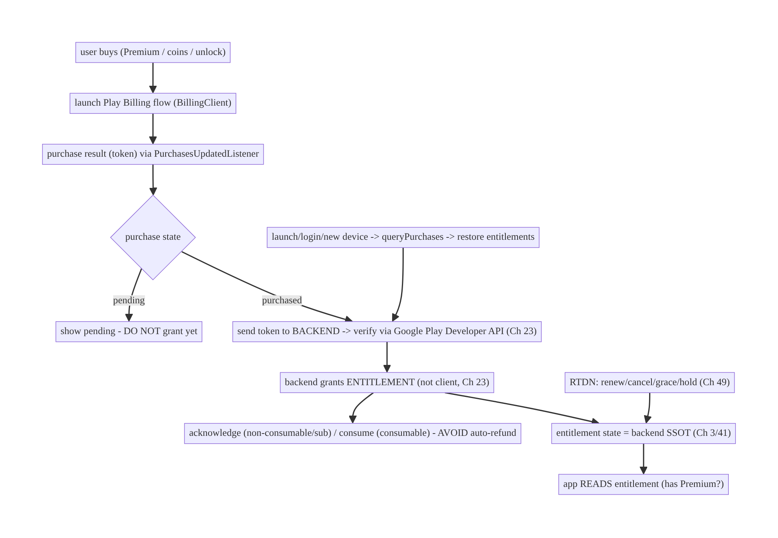
76.4 High-Level Architecture
Components & ownership
- Client launches the Play flow and receives the purchase token; it does not grant entitlement.
- Backend verifies (Developer API), grants the entitlement, tracks the subscription lifecycle via RTDN, and is the entitlement SSOT (Ch 3/41).
- Acknowledge/consume promptly (auto-refund avoidance); queryPurchases restores; the app reads entitlement state.
Direction: buy → Play flow → token → backend verify → backend grant entitlement → acknowledge/consume → app reads entitlement; RTDN drives lifecycle; queryPurchases restores.

76.5 Detailed Component Design
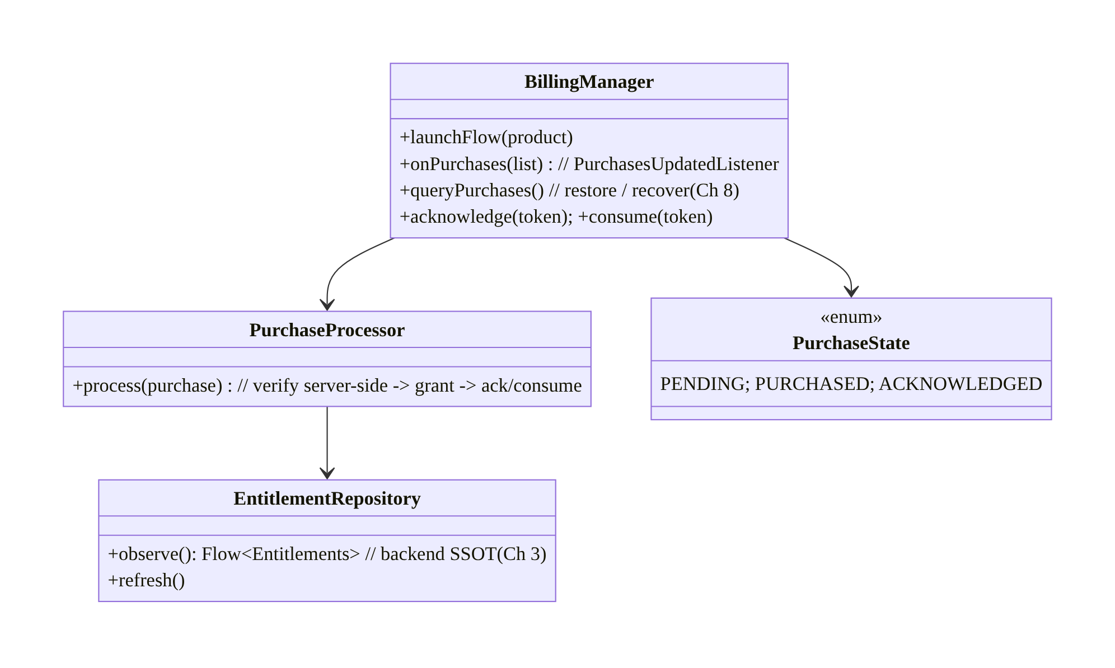
76.5 Detailed Component Design
Component | Responsibility
BillingManager | BillingClient: launch flow, receive purchases, query, acknowledge/consume
PurchaseProcessor | verify server-side → grant (backend) → acknowledge/consume (idempotent, Ch 15)
EntitlementRepository | read backend-owned entitlement state (SSOT, Ch 3), RTDN-driven
PurchaseState | pending vs purchased vs acknowledged

76.6 End-to-End Data Flow

Purchase → verify → grant → acknowledge
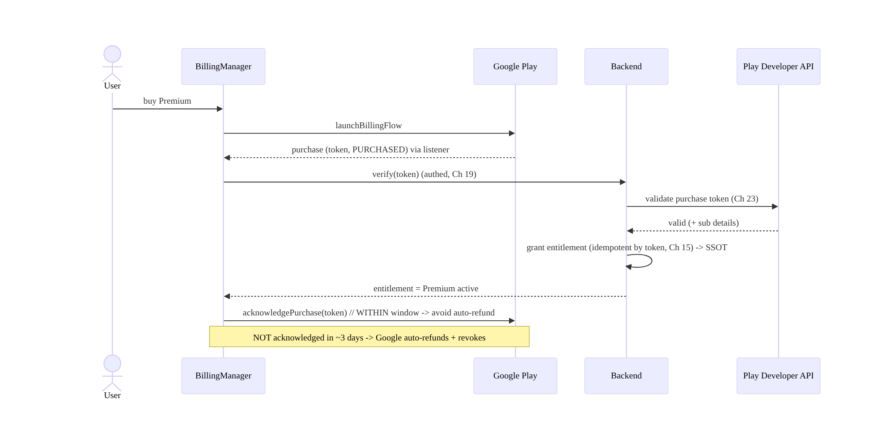
Purchase → verify → grant → acknowledge

Restore + RTDN lifecycle
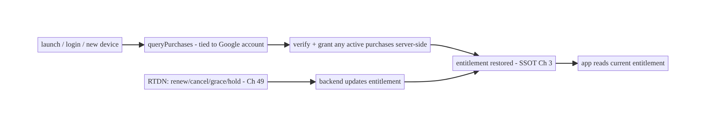
Restore + RTDN lifecycle

76.7 Complete Kotlin Implementation
Package: com.streamcart.billing.

76.7.1 BillingManager: flow + purchases + query + acknowledge/consume
@Singleton
class BillingManager @Inject constructor(
@ApplicationContext ctx: Context, private val processor: PurchaseProcessor,
) : PurchasesUpdatedListener {
private val client = BillingClient.newBuilder(ctx)
.setListener(this).enablePendingPurchases().build() // handle PENDING purchases
fun launchFlow(activity: Activity, productDetails: ProductDetails, offerToken: String) {
val params = BillingFlowParams.newBuilder().setProductDetailsParamsList(listOf(
BillingFlowParams.ProductDetailsParams.newBuilder()
.setProductDetails(productDetails).setOfferToken(offerToken).build())).build()
client.launchBillingFlow(activity, params)
}
override fun onPurchasesUpdated(result: BillingResult, purchases: List<Purchase>?) {
if (result.responseCode == BillingClient.BillingResponseCode.OK)
purchases?.forEach { scope.launch { processor.process(it) } } // verify -> grant -> ack/consume
}
/** Restore / recover: purchases can arrive when not listening, and on reinstall/new device (Ch 8). */
suspend fun restore() {
val subs = client.queryPurchasesAsync(QueryPurchasesParams.newBuilder().setProductType(ProductType.SUBS).build())
val inapp = client.queryPurchasesAsync(QueryPurchasesParams.newBuilder().setProductType(ProductType.INAPP).build())
(subs.purchasesList + inapp.purchasesList).forEach { processor.process(it) } // reconcile outstanding
}
suspend fun acknowledge(token: String) = client.acknowledgePurchase(
AcknowledgePurchaseParams.newBuilder().setPurchaseToken(token).build())
suspend fun consume(token: String) = client.consumePurchase(
ConsumeParams.newBuilder().setPurchaseToken(token).build())
}

76.7.2 PurchaseProcessor: verify server-side → grant → acknowledge/consume (idempotent)
@Singleton
class PurchaseProcessor @Inject constructor(
private val billing: BillingManager, private val backend: BillingApi, private val entitlements: EntitlementRepository,
) {
suspend fun process(purchase: Purchase) {
if (purchase.purchaseState == Purchase.PurchaseState.PENDING) { // DO NOT grant pending
entitlements.markPending(purchase); return
}
if (purchase.purchaseState != Purchase.PurchaseState.PURCHASED) return
// 1) SERVER-SIDE verification + grant (never client-only, Ch 23). Idempotent by purchase token (Ch 15).
val grant = backend.verifyAndGrant(purchase.purchaseToken, purchase.products) // backend -> Google Developer API
if (!grant.ok) return // verification failed -> do NOT grant/acknowledge
entitlements.refresh() // app reads backend entitlement SSOT (Ch 3)
// 2) Acknowledge/consume WITHIN the window to avoid auto-refund.
if (grant.consumable) billing.consume(purchase.purchaseToken) // consumable (coins) -> buy again
else if (!purchase.isAcknowledged) billing.acknowledge(purchase.purchaseToken) // non-consumable/sub
}
}

76.7.3 EntitlementRepository: backend-owned entitlement state (SSOT, Ch 3)
@Singleton
class EntitlementRepository @Inject constructor(private val backend: BillingApi, private val dao: EntitlementDao) {
/** App reads ENTITLEMENT (not raw purchase). Backend is the source of truth, RTDN-driven. */
fun observe(): Flow<Entitlements> = dao.observe() // e.g., { premium: active|grace|expired, coins: 500, unlockedShows: [...] }
suspend fun refresh() = dao.upsert(backend.entitlements()) // pull current entitlement state
suspend fun markPending(p: Purchase) { /* reflect "pending" in UI; grant only when PURCHASED */ }
}
// Gate features on entitlement: if (entitlements.premium.isActive()) showAdFree() else showAds()

76.7.4 Restore on launch/login + explicit action (Ch 8)
// On app start / login / "Restore purchases" button: reconcile with Play + backend.
class RestoreUseCase @Inject constructor(private val billing: BillingManager, private val entitlements: EntitlementRepository) {
suspend operator fun invoke() {
entitlements.refresh() // backend entitlement state (covers RTDN-driven sub lifecycle)
billing.restore() // queryPurchases -> verify+grant any active purchases (reinstall/new device)
}
}

76.7.5 PSP vs Play decision
// Digital goods/subscriptions -> Play Billing (this chapter). Physical goods/services -> PSP checkout (Ch 75).
fun purchaseRoute(item: Item): Route = when (item.kind) {
ItemKind.DigitalOrSubscription -> Route.PlayBilling // Premium, coins, unlock (policy-mandated)
ItemKind.PhysicalOrService -> Route.PspCheckout // products, shipping (Ch 75)
}

76.7.6 Module structure
:feature:billing BillingManager (BillingClient), PurchaseProcessor, EntitlementRepository, RestoreUseCase
:core:data entitlement SSOT (Ch 3)
# Backend: verify via Google Play Developer API + grant + RTDN lifecycle (Ch 23/49). PSP checkout -> Ch 75.

76.8 Concurrency and Race Conditions
Scenario | Risk | Handling
Not acknowledged in window | auto-refund (user paid, got nothing) | acknowledge/consume promptly after grant
Client-only entitlement | piracy/spoof | verify server-side; backend grants (Ch 23)
Purchase arrives when not listening | missed grant | queryPurchases on launch/resume (Ch 8)
Double-grant (retry/replay) | double-credit | idempotent by purchase token (Ch 15)
Pending granted early | wrong entitlement | grant only on PURCHASED
Reinstall/new device | lost entitlement | queryPurchases + backend entitlement restore
Sub state stale on client | wrong gating | RTDN-driven backend entitlement (Ch 49)
- Acknowledge/consume within the window is non-negotiable: an unacknowledged purchase is auto-refunded by Google — the user paid and lost it. Always: verify → grant → acknowledge/consume (idempotently). This is the single most common and costly Play Billing bug.
- queryPurchases is both restore and recovery: purchases can land when the app isn’t listening (killed mid-purchase, Ch 8), on another device, or after reinstall — always reconcile via queryPurchases (plus the listener), not just the listener.
- Idempotent-by-token grant (Ch 15) prevents double-credit when the same purchase is processed via both the listener and queryPurchases, or on retry.

76.9 Failure Scenarios and Recovery
Failure | Detection | Response | Outcome
Auto-refund | revenue loss / revoked | acknowledge/consume within window | retained
Spoofed entitlement | fraud/piracy | server-side verification + backend grant (Ch 23) | blocked
Lost sub on reinstall | user report | queryPurchases + restore entitlement | restored
Missed purchase (not listening) | user paid, no grant | queryPurchases on launch (Ch 8) | granted
Double-credit | billing | idempotent by token (Ch 15) | single
Pending granted | wrong access | grant only PURCHASED | correct
Stale sub state | wrong gating | RTDN backend entitlement (Ch 49) | accurate
Process death mid-purchase | unknown state | queryPurchases reconcile (Ch 8) | recovered
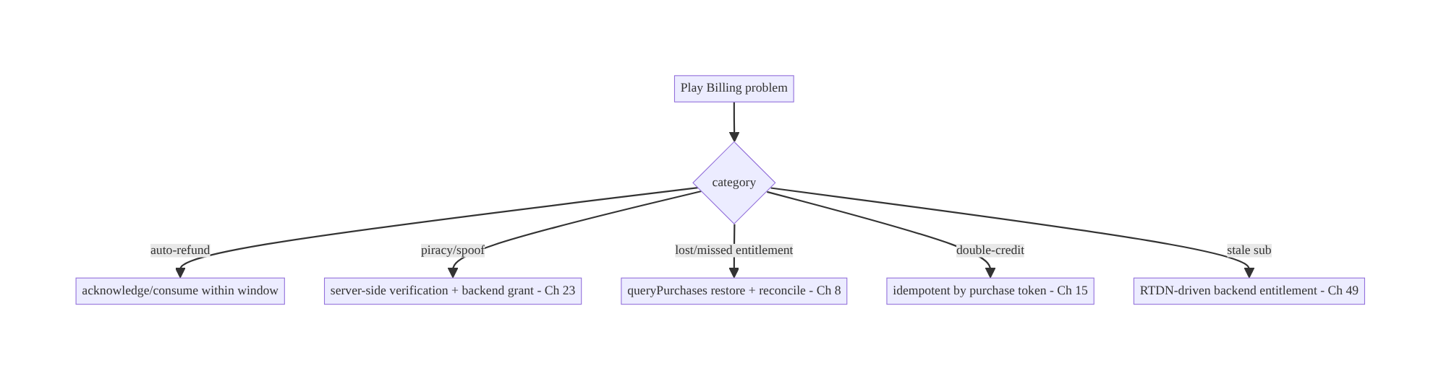
76.9 Failure Scenarios and Recovery
Four rules define correct Play Billing: acknowledge-or-auto-refund, verify-server-side- or-be-spoofed, queryPurchases-or-lose-entitlements, and entitlement-is-backend-state. Google owns payment and the purchase record; your app launches the flow, then verifies, grants (server-side), acknowledges, and restores — reading entitlement from the backend, never trusting the client.

76.10 Scaling the Implementation
- Level 1. Launch Play flow; on purchase, verify server-side + grant entitlement; acknowledge/consume promptly.
- Level 2. queryPurchases restore on launch/login + explicit “Restore”; pending handling; idempotent-by-token grant (Ch 15/8).
- Level 3 — production. RTDN subscription lifecycle → backend entitlement (Ch 49); entitlement SSOT the app reads (Ch 3); PSP-vs-Play routing (Ch 75).
- Level 4 — large. Upgrades/downgrades/proration, grace/hold/pause handling, offers/ promos, multiple SKUs/base-plans, server-side entitlement across platforms (iOS/web parity).
- Level 5 — enterprise. Subscription analytics (churn, LTV), entitlement governance, refund/dispute handling, price changes, regional pricing, fraud monitoring, exactly-once SLOs.
Avoid overengineering: the verify→grant→acknowledge→restore core + backend entitlement is mandatory; build it first. Don’t grant client-side; don’t skip acknowledge; don’t infer sub state on the client.

76.11 Alternative Approaches and Trade-offs
Dimension | Option A | Option B | When
Payment system | Play Billing (digital/subs) | PSP (Ch 75) | Play for digital/subs (policy); PSP for physical
Entitlement | Backend-granted (verified) | client-side | Backend always (anti-piracy, Ch 23)
Acknowledge | Promptly after grant | skip/late | Promptly (else auto-refund)
Restore | queryPurchases + backend | none | Always (reinstall/device)
Sub lifecycle | RTDN → backend (Ch 49) | client polling / inference | RTDN (accurate, timely)
Consumable | consume after grant | acknowledge | consume (re-purchasable)
Purchase detection | listener + queryPurchases | listener only | Both (purchases arrive off-listener)
Play Billing vs PSP (Ch 75): Play policy mandates Google Play Billing for digital goods and subscriptions — you cannot route them through your PSP; conversely, physical goods/services must use your PSP checkout (Ch 75), not Play Billing. The systems differ fundamentally: with Play, Google processes payment and owns the record, so your work is verify/grant/acknowledge/restore, not charging. Route by item kind.
Backend-granted vs client-side entitlement: granting access because the client reports a purchase is trivially pirated (patched app, replayed token). The backend must verify the purchase token with Google’s Developer API and grant the entitlement itself, which the app then reads (Ch 3/23). Client-side entitlement is the classic Play Billing security hole.
Acknowledge vs skip: Play auto-refunds any purchase not acknowledged/consumed within ~3 days — a skipped or delayed acknowledgement means the user paid and lost the purchase (and you lost revenue). Always acknowledge non-consumables/subs and consume consumables, after granting, within the window.
Listener + queryPurchases vs listener only: relying only on PurchasesUpdatedListener misses purchases that complete when the app isn’t listening (killed mid-flow, Ch 8), on other devices, or after reinstall. queryPurchases on launch/login reconciles and restores — use both the listener (live) and queryPurchases (reconcile/restore).

76.12 Security Considerations
- Server-side verification is the anti-piracy core (Ch 23): verify every purchase token with the Google Play Developer API on the backend and grant entitlement server-side — never trust the client’s claim of ownership. This defeats patched apps and replayed/spoofed purchases.
- Entitlement is backend state (Ch 3): gate premium features on the backend’s entitlement, not a local flag, so a modified client can’t unlock Premium.
- Idempotency by purchase token (Ch 15): the backend grants once per token — replaying a token can’t double-credit or re-grant.
- RTDN authenticity (Ch 49): validate RTDN messages (from Google Pub/Sub) server-side; don’t trust unverified lifecycle events.
- No sensitive purchase data in logs (Ch 28); the app never handles card data (Google does).
- Account binding (Ch 42): entitlements tie to the user account (and the Google account for restore); handle account switches and the Google-account-vs-app-account mapping carefully (a shared device, family sharing).
- Refund/revocation: honor refunds/chargebacks (RTDN) by revoking entitlement server-side — a refunded sub must lose access.
- Client vs backend: the backend verifies, grants, tracks lifecycle (RTDN), and owns entitlement truth; the client launches the flow, acknowledges/consumes, restores via queryPurchases, and reads entitlement — it never grants or trusts local purchase state for access.

76.13 Performance and Resource Optimization
- Acknowledge/consume promptly — not a perf issue but a revenue one (auto-refund).
- Cache entitlement state (SSOT, Ch 3) so feature-gating is instant/offline (re-verify/ refresh periodically + on RTDN).
- Query purchases on launch (cheap) to reconcile; don’t poll continuously.
- Lazy-load product details (queryProductDetails) when the store screen is shown.
- Backend does verification (not the client) — keeps the client light and secure.
- RTDN push (Ch 49) avoids client polling for sub state.
- Profiling: purchase success/latency, auto-refund rate (→ 0), restore success, entitlement-refresh cost, RTDN processing lag.

76.14 Testing Strategy
Play Billing tests use license testers / test tracks and faked BillingClient; backend verification + idempotency unit-tested.
class PurchaseProcessorTest {
@Test fun `grants then acknowledges a verified non-consumable`() = runTest {
backend.verifyResult = Grant(ok = true, consumable = false)
processor.process(purchase(PURCHASED, acknowledged = false))
assertTrue(backend.granted); assertTrue(billing.acknowledged) // avoid auto-refund
}
@Test fun `does not grant pending`() = runTest {
processor.process(purchase(PENDING)); assertFalse(backend.granted)
}
@Test fun `does not acknowledge if verification fails`() = runTest {
backend.verifyResult = Grant(ok = false); processor.process(purchase(PURCHASED))
assertFalse(billing.acknowledged) // don't ack an unhonored purchase
}
@Test fun `grant is idempotent by token`() = runTest {
processor.process(p); processor.process(p) // listener + queryPurchases
assertEquals(1, backend.grantsFor(p.purchaseToken)) // single (Ch 15)
}
}
class RestoreTest {
@Test fun `queryPurchases restores entitlement on reinstall`() = runTest { /* active sub -> entitlement granted */ }
}
What to test: verify→grant→acknowledge (non-consumable/sub) and consume (consumable); don’t grant pending; don’t acknowledge on failed verification; idempotent-by-token grant (listener + queryPurchases); restore via queryPurchases; entitlement read from backend (not client). Use license testers / Play test tracks for end-to-end; fake backend with idempotency.

76.15 Production Observability
- Metrics: auto-refund rate (→ 0, critical); purchase success/latency; server-side verification success/failure; restore success; entitlement-grant idempotency (double- grant → 0); subscription state distribution (active/grace/hold/expired); RTDN processing lag; pending→purchased conversion.
- Logs: billing{product, state, verified, acknowledged, granted} — no sensitive purchase data (Ch 28); backend holds the record.
- Debugging: auto-refunds → not acknowledging in window; piracy/spoof → client-side entitlement (verify server-side); lost subs → no queryPurchases restore; double-credit → non-idempotent grant; stale sub → not RTDN-driven; missed purchase → listener-only (add queryPurchases).
- Alerting: auto-refund spike (acknowledge bug — revenue loss); verification-failure spike (fraud or integration); RTDN lag.
- Dashboards: auto-refund rate (must be ~0), verification success, restore success, subscription funnel/churn.

76.16 System Design Interview Preparation
≥40 questions.
Fundamentals
- Play Billing vs PSP (Ch 75)? Digital goods/subs via Play (policy); physical via PSP.
- Who processes payment? Google (owns the purchase record) — not your app/PSP.
- App’s job? Launch flow, verify server-side, grant entitlement, acknowledge/consume, restore.
- Product types? Consumable (consume), non-consumable (acknowledge), subscription (acknowledge + lifecycle).
- Entitlement? Backend-owned state the app reads (Ch 3), not the raw purchase.
Acknowledge/consume
- Acknowledge rule? Must acknowledge/consume within ~3 days or Google auto-refunds.
- Consumable? consumeAsync (re-purchasable).
- Non-consumable/sub? acknowledgePurchase.
- Order? Verify → grant → acknowledge (don’t ack an unhonored purchase).
- #1 bug? Not acknowledging → auto-refund.
Verification/entitlement
- Why server-side verify? Client is spoofable (piracy) — verify token via Developer API (Ch 23).
- Who grants? The backend (not the client).
- Gate features on? Backend entitlement state (Ch 3).
- Client-only entitlement? Trivially pirated.
Restore
- Reinstall/new device? queryPurchases → verify+grant → restore (tied to Google account).
- Listener only? No — also queryPurchases (purchases arrive off-listener).
- Explicit restore? Provide a “Restore purchases” action.
Subscriptions
- Lifecycle events? Renew/cancel/grace/hold/pause/upgrade/refund.
- How tracked? RTDN → backend → entitlement (Ch 49).
- Client infer sub state? No — read backend entitlement.
- Grace/hold? Entitlement states the backend reflects.
Pending/idempotency
- Pending purchase? Don’t grant until PURCHASED.
- Idempotency? Grant once per purchase token (Ch 15).
- Interruption (Ch 8)? queryPurchases reconcile on launch.
- Double-grant source? Listener + queryPurchases both processing → idempotent-by-token.
Security
- Anti-piracy? Server-side verification + backend grant (Ch 23).
- RTDN authenticity? Validate server-side.
- Refund? Revoke entitlement (RTDN).
- Account binding? Entitlement per app user + Google account (Ch 42).
- Card data? App never handles it (Google does).
Testing/Production
- Test purchases? License testers / test tracks.
- Test acknowledge? Granted then acknowledged; not on failed verify.
- Test restore? queryPurchases grants entitlement.
- Auto-refunds in prod? Not acknowledging.
- Piracy? Client-side entitlement.
- Lost subs? No restore.
- Double-credit? Non-idempotent grant.
- Key KPI? Auto-refund rate (0).
- Stale sub? Not RTDN-driven.
- Missed purchase? Listener-only.
- Alert priority? Auto-refund spike (revenue).

Design-change challenges
- Sell a Premium subscription. Play Billing + server verify + backend entitlement + RTDN lifecycle + restore.
- Users lose Premium on reinstall. queryPurchases + backend entitlement restore.
- A rooted device unlocks Premium free. Server-side verification + backend-granted entitlement (Ch 23).
- Users paid but got auto-refunded. Acknowledge/consume within the window.
- Buy coins (consumable) without double-crediting. Consume + idempotent-by-token grant (Ch 15).

Mock walkthrough (abridged)
Clarify (digital or physical, consumable/sub, cross-device?) → Play Billing for digital/subs (policy; PSP for physical, Ch 75) → launch flow → on purchase verify server-side + grant entitlement (backend, Ch 23) → acknowledge/consume within window (auto-refund) → entitlement = backend SSOT the app reads (Ch 3) → restore via queryPurchases (reinstall/device) → RTDN subscription lifecycle (Ch 49) → pending handling + idempotent- by-token + interruption recovery (Ch 15/8) → security (anti-piracy, refunds) → observability (auto-refund rate 0).

76.17 Practical Exercises
- Beginner. Launch a Play Billing flow for Premium and, on purchase, acknowledge it — verifying the acknowledge happens within the window. Eval: purchase acknowledged (no auto-refund).
- Intermediate. Verify the purchase server-side and grant the entitlement from the backend; gate Premium on the backend entitlement (not the client). Eval: a spoofed client can’t unlock Premium.
- Advanced. Restore entitlements via queryPurchases on launch/reinstall and make the grant idempotent by purchase token. Eval: reinstall restores; no double-grant.
- Production debugging. Fix auto-refunds (missing acknowledge) and lost subscriptions on new devices (no restore). Eval: retained; restored.
- System design challenge. Add RTDN-driven subscription lifecycle (renew/cancel/grace) to backend entitlement + handle pending purchases + consumable coins. Eval: sub state accurate; pending not granted; coins idempotent.
(Solutions withheld unless requested.)

76.18 Chapter Summary & Reference Sheet
Key decisions: sell digital goods and subscriptions through Google Play Billing (Play policy mandates it; your PSP checkout (Ch 75) is for physical goods) — Google processes payment and owns the purchase record, so the app launches the flow and then must: verify the purchase token server-side (Google Play Developer API) and grant the entitlement from the backend (never client-side — spoofable/pirated, Ch 23); acknowledge non-consumables/subscriptions or consume consumables promptly (verify → grant → acknowledge, within ~3 days, or Google auto-refunds and revokes); restore entitlements across reinstall/devices via queryPurchases (purchases tie to the Google account — plus an explicit “Restore”); model entitlement as backend-owned SSOT state the app reads (Ch 3), driven by verified purchases plus the subscription lifecycle tracked via RTDN (renew/cancel/grace/hold, Ch 49); don’t grant PENDING purchases; and make grant/consume idempotent by purchase token and interruption-safe (reconcile via queryPurchases on launch, Ch 15/8). The critical KPI is an auto-refund rate of zero.
Concepts: Play Billing (BillingClient, product types), acknowledge/consume (auto-refund avoidance), server-side verification (Developer API) + backend-granted entitlement (anti- piracy), entitlement-as-backend-SSOT, restore via queryPurchases, RTDN subscription lifecycle, pending purchases, idempotency-by-token + interruption recovery, Play-vs-PSP.
Common mistakes: using a PSP for digital goods (policy violation); client-side entitlement (piracy); not acknowledging/consuming (auto-refund — paid-but-got-nothing); listener-only (missed purchases); no queryPurchases restore (lost subs on reinstall); granting PENDING; non-idempotent grant (double-credit); inferring subscription state on the client instead of RTDN-driven backend entitlement.
Checklist:
- ☐ Play Billing for digital/subs (PSP for physical, Ch 75)
- ☐ verify purchase token server-side + grant entitlement on backend (Ch 23)
- ☐ acknowledge (non-consumable/sub) / consume (consumable) within window
- ☐ entitlement = backend SSOT the app reads (Ch 3)
- ☐ restore via queryPurchases on launch/login/new device + explicit action
- ☐ RTDN → backend subscription lifecycle (Ch 49)
- ☐ don’t grant PENDING
- ☐ idempotent grant by purchase token (Ch 15)
- ☐ interruption recovery via queryPurchases (Ch 8)
- ☐ per-account/Google-account binding (Ch 42)
- ☐ revoke on refund
- ☐ auto-refund-rate alert (→ 0).
Key APIs: Play Billing BillingClient/enablePendingPurchases/launchBillingFlow/ PurchasesUpdatedListener/queryPurchasesAsync/queryProductDetailsAsync/ acknowledgePurchase/consumePurchase, Purchase.PurchaseState (PENDING/PURCHASED), Google Play Developer API (server verify), RTDN / Pub/Sub (Ch 49), entitlement SSOT (Ch 3), idempotency by purchase token (Ch 15).
References:
- Play Billing overview: https://developer.android.com/google/play/billing/integrate
- Process purchases (acknowledge/consume): https://developer.android.com/google/play/billing/integrate#process
- Verify purchases server-side: https://developer.android.com/google/play/billing/security
- Real-time developer notifications: https://developer.android.com/google/play/billing/rtdn-reference
- (composes) Ch 75 Checkout, Ch 15 Idempotency, Ch 23 Security, Ch 3 SSOT, Ch 49 Push/RTDN, Ch 8 Process Death, Ch 42 Multi-Account, Ch 41 Entitlements/Config, Ch 77 Wallet

Chapter 77 — Wallet & Payments
Part IX — Feature Architectures · Complexity: Standard (≥25 interview questions)
Prerequisites: Ch 75 (checkout), Ch 76 (Play Billing), Ch 15 (idempotency), Ch 3 (SSOT), Ch 19/23 (auth/security), Ch 20 (Keystore), Ch 21 (biometric). Pairs with Ch 32 (sync), Ch 78 (order tracking).
Reference surface in StreamCart: the user’s payment methods and in-app wallet — saved cards (tokenized), a stored-value balance (StreamCart Cash), Google Pay, and transaction history — managed so that no card data touches the device, balances are server-authoritative, and sensitive actions are authenticated.

77.1 Problem Definition and Real-World Context
A wallet feature manages the user’s payment methods (saved cards, Google Pay, bank accounts) and an in-app stored-value balance (wallet/credits/cash), plus transaction history. The non-negotiable truths: no raw card data (PAN) ever lives on the device (PCI — only PSP tokens, Ch 23); the balance is server-authoritative (the client never computes or trusts a local balance — double-spend/fraud risk); payment-method and balance mutations are idempotent (Ch 15); and sensitive actions (adding a card, spending, viewing full history) are authenticated (Ch 19/21). Done wrong, it leaks card data, allows double-spend or negative balances, or exposes one user’s wallet to another.
Concretely, teams hit:
- Card data on device. Storing or handling the PAN/CVV locally is a PCI violation and breach risk. Only PSP tokens (Ch 75) or Google Pay tokens may be referenced; the real card details live with the PSP/network.
- Client-trusted balance. Showing/trusting a locally computed balance invites double-spend (spend the same balance twice offline), negative balances, and tampering. The server is authoritative for the balance; the client displays it and requests debits/credits the server validates.
- Non-idempotent money ops. Adding funds, spending, or saving a card without an idempotency key double-applies on retry/double-tap (double-charge top-up, double- spend) — same discipline as checkout (Ch 75).
- Weak auth on sensitive actions. Adding a payment method, spending wallet balance, or viewing full card/transaction details must be authenticated (session + often biometric/re-auth, Ch 21) — not freely accessible.
- Google Pay integration. Google Pay returns a payment token (not card data) to charge via your PSP — a distinct, tokenized flow to integrate correctly.
- Consistency & history. Balance and transactions must be consistent across devices (server-synced, Ch 32), with an auditable transaction history (server-owned).
The architecture: keep no card data on the device — reference PSP/Google Pay tokens only (Ch 23/75); make the balance server-authoritative (display it, request server- validated debits/credits — never spend a local balance); make all money mutations idempotent (Ch 15); authenticate sensitive actions (session + biometric/re-auth, Ch 19/21); integrate Google Pay (tokenized) and the PSP (Ch 75) for payment methods; keep transaction history server-owned and auditable, synced to the client (Ch 32/3); and store any references securely (Keystore, Ch 20). This chapter is about a secure, server-authoritative wallet with tokenized payment methods.

Three practical use cases
- Saved cards (StreamCart). Add a card via the PSP SDK → a token is stored server-side; the app shows “Visa ••1234” from the token metadata (no PAN); charging uses the token (Ch 75); adding/removing requires auth (Ch 21).
- StreamCart Cash (stored value). A server-authoritative balance; top-up (idempotent charge, Ch 15) credits it; spending at checkout (Ch 75) debits server-side (never a local balance); history is auditable.
- Google Pay. One-tap payment returning a payment token charged via the PSP — no card details on the device.

Why this is architectural
The wallet is a security- and correctness-critical feature: no-card-on-device (PCI, Ch 23), server-authoritative balance (anti-double-spend), idempotent money ops (Ch 15), authenticated sensitive actions (Ch 19/21), tokenized PSP/Google Pay (Ch 75), and auditable server-owned history (Ch 3/32). The decisions determine whether money and card data are handled safely and exactly-once.

77.2 Requirements Engineering

Functional requirements
ID | Requirement
F1 | Manage payment methods as PSP/Google Pay tokens; no card data on device (Ch 23/75).
F2 | Show a server-authoritative balance; debit/credit server-side (no local-balance spend).
F3 | Make money mutations (top-up, spend, save/remove card) idempotent (Ch 15).
F4 | Authenticate sensitive actions (session + biometric/re-auth) (Ch 19/21).
F5 | Integrate Google Pay (tokenized) + PSP for charging (Ch 75).
F6 | Keep transaction history server-owned, auditable, synced to the client (Ch 3/32).

Non-functional requirements
Attribute | Policy
PCI / security | No PAN/CVV on device; tokens only; secure references (Ch 20/23).
Integrity | Server-authoritative balance; no double-spend/negative.
Exactly-once | Idempotent money ops (Ch 15).
Auth | Sensitive actions authenticated (biometric/re-auth, Ch 21).
Consistency | Balance/history server-synced + auditable (Ch 32/3).

Scope
- In scope: payment methods as tokens (PSP/Google Pay, no card on device), server- authoritative balance (display + server-validated debit/credit), idempotent money ops (Ch 15), auth for sensitive actions (Ch 19/21), Google Pay integration, transaction history (server-owned, synced, Ch 3/32), secure reference storage (Ch 20), PCI considerations.
- Out of scope: checkout flow (Ch 75), Play Billing (Ch 76), idempotency mechanics (Ch 15), auth/biometric internals (Ch 19/21), Keystore internals (Ch 20), sync (Ch 32).

Assumptions & constraints
- A PSP (Stripe/Adyen) tokenizes cards; Google Pay API returns payment tokens; the backend owns the wallet balance, payment-method tokens, and transaction history and is authoritative. minSdk 24. No raw card data on the device (PCI, Ch 23); money ops are idempotent and authenticated.

77.3 System Design Fundamentals
- No card data on the device — tokens only (PCI, Ch 23/75). The app never stores or handles the PAN or CVV. Adding a card goes through the PSP SDK, which tokenizes it; the token (and display metadata like brand + last4) is stored server-side. The app shows “Visa ••1234” from metadata and charges by token (Ch 75). This minimizes PCI scope and breach impact — a compromised device has no card numbers. Any token reference kept locally is non-sensitive display data; secrets go in Keystore (Ch 20).
- Server-authoritative balance (anti-double-spend, the core). The wallet balance is owned and computed by the server. The client displays the balance (synced, Ch 32) but never spends a local balance — spending requests a server-side debit that the server validates (sufficient funds? idempotent?) and applies atomically. A client-trusted balance enables double-spend (spend offline twice), negative balances, and tampering. The server is the ledger; the client is a view + request initiator.
- Idempotent money operations (Ch 15). Every money mutation — top-up (charge → credit), spend (debit), save/remove card — carries an idempotency key so a retry/double-tap/reconnect doesn’t double-charge the top-up, double-debit, or duplicate a card. Same exactly-once discipline as checkout (Ch 75): generate the key once per operation, persist it, reuse on retry; the server dedups.
- Authenticate sensitive actions (Ch 19/21). Wallet actions are sensitive: adding/removing a payment method, spending balance, topping up, and viewing full card/transaction details require authentication — a valid session (Ch 19) and often a biometric/re-auth step (Ch 21) for the sensitive action itself (even within an authed session). Don’t let a borrowed-unlocked phone spend the wallet freely.
- Google Pay (tokenized). The Google Pay API presents the user’s Google-stored payment methods and returns a payment token (a tokenized representation), which your PSP charges (Ch 75) — the app never sees card data. It’s a fast, tokenized path to pay or add a method.
- Transaction history: server-owned, auditable, synced (Ch 3/32). The ledger (top-ups, spends, refunds, adjustments) is server-owned and auditable (immutable record for disputes/support, Ch 19). The client syncs and displays history (SSOT, Ch 3; delta sync, Ch 32) but is not the record of truth. Balance = derived from the server ledger.
- Consistency across devices (Ch 32). Balance, payment methods, and history are server-synced so all the user’s devices show the same wallet; a spend on one device reflects on another (the server is authoritative, so convergence is straightforward).
- Refunds/adjustments. Handled server-side (credit the balance / reverse a charge), reflected as new ledger entries the client syncs — the client doesn’t mutate the ledger.
Core insight: a wallet keeps no card data on the device (PSP/Google Pay tokens only, PCI, Ch 23/75) and treats the balance and transaction ledger as server-authoritative — the client displays the balance (synced, Ch 32) but never spends a local balance; it requests server-validated, idempotent debits/credits (Ch 15) so top-ups never double-charge and spends never double-debit or go negative; sensitive actions (add/remove card, spend, top-up, view details) are authenticated with the session plus a biometric/re-auth step (Ch 19/21); payment methods are tokenized via the PSP and Google Pay and charged by token (Ch 75); and the auditable transaction history is server-owned and synced to the client (Ch 3/32), with any local references secured in the Keystore (Ch 20).

77.4 High-Level Architecture
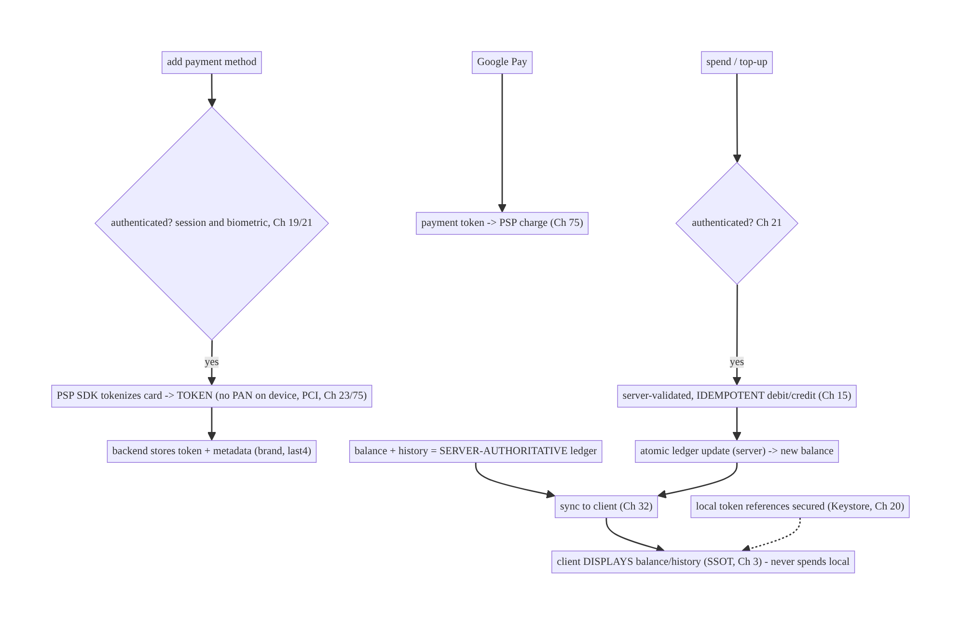
77.4 High-Level Architecture
Components & ownership
- Payment methods are tokens (PSP/Google Pay); the backend stores tokens + display metadata — no card data on device (Ch 23/75).
- Balance + history are a server-authoritative ledger; the client displays (synced, Ch 32) and requests idempotent debits/credits the server validates (Ch 15).
- Sensitive actions authenticated (session + biometric, Ch 19/21); references secured in Keystore (Ch 20).
Direction: add card → auth → PSP token (no PAN) → backend; balance/history server- authoritative → synced display; spend/top-up → auth → idempotent server-validated ledger op.

77.5 Detailed Component Design
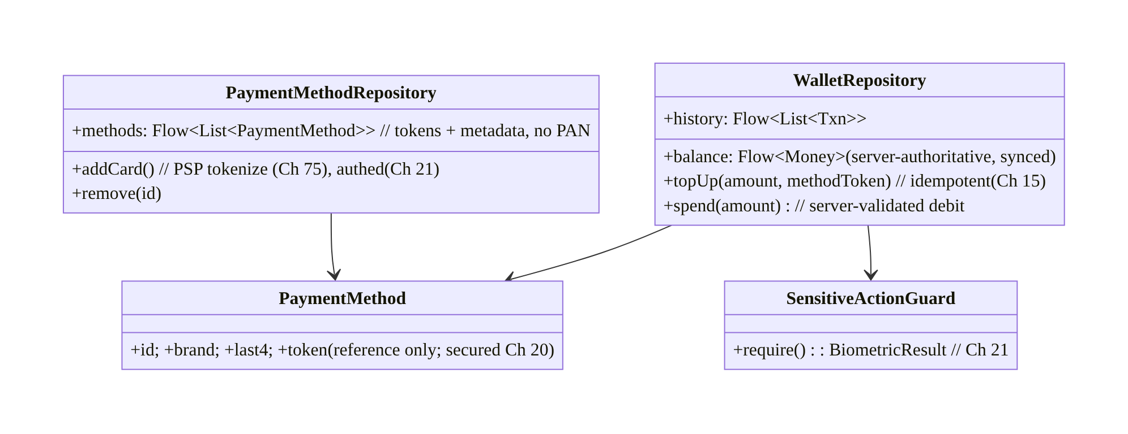
77.5 Detailed Component Design
Component | Responsibility
WalletRepository | display server-authoritative balance/history; idempotent server-validated top-up/spend
PaymentMethodRepository | tokenized payment methods (PSP/Google Pay); add/remove (authed)
PaymentMethod | token + display metadata (brand/last4) — no PAN (Ch 20/23)
SensitiveActionGuard | biometric/re-auth for sensitive actions (Ch 21)

77.6 End-to-End Data Flow

Add a card (tokenized, authed) + spend (server-validated, idempotent)
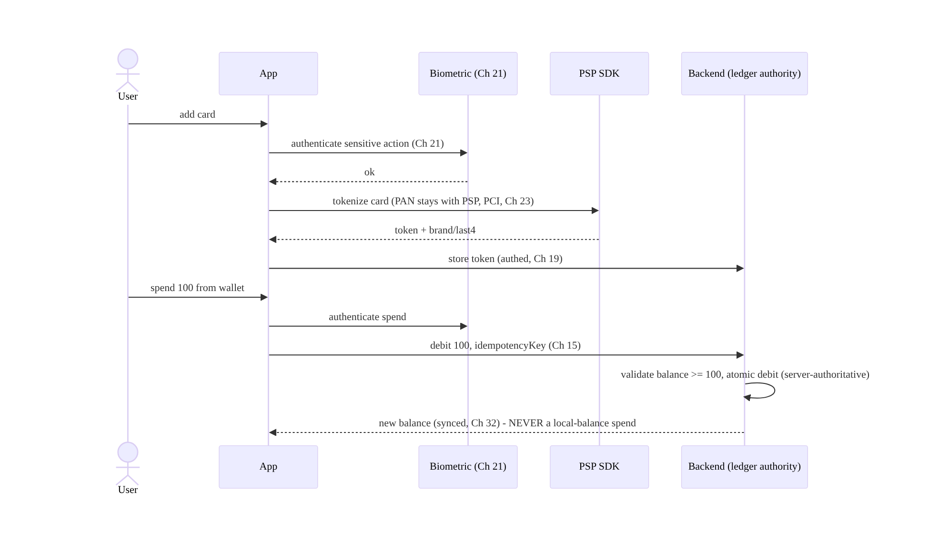
Add a card (tokenized, authed) + spend (server-validated, idempotent)

Server-authoritative balance (anti-double-spend)
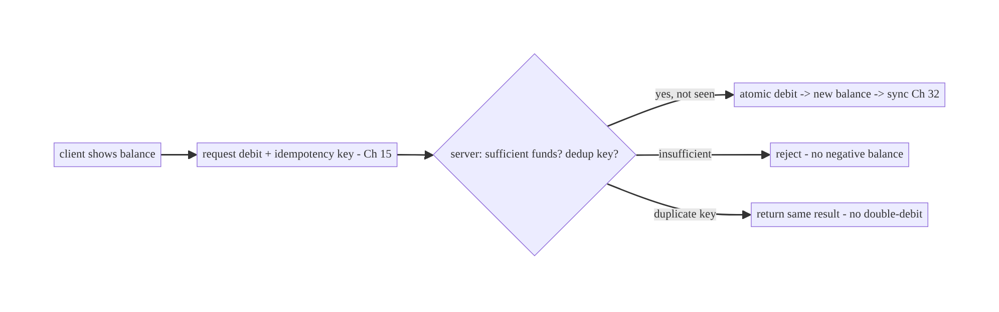
Server-authoritative balance (anti-double-spend)

77.7 Complete Kotlin Implementation
Package: com.streamcart.wallet.

77.7.1 Payment methods as tokens (no card data on device, Ch 23/75)
data class PaymentMethod(
val id: String, val brand: String, val last4: String, // DISPLAY metadata only
// NO PAN/CVV. The actual card lives with the PSP; we reference a token server-side.
)
@Singleton
class PaymentMethodRepository @Inject constructor(
private val psp: PspSdk, private val api: WalletApi, private val guard: SensitiveActionGuard, // Ch 21
) {
val methods: Flow<List<PaymentMethod>> = api.paymentMethodsFlow() // from backend (tokens + metadata)
suspend fun addCard(activity: Activity): Outcome<PaymentMethod> {
if (!guard.require(activity)) return Outcome.Failure(AppError.Unauthorized) // biometric (Ch 21)
val token = psp.tokenizeCard(activity) // PSP SDK; PAN never touches app/server (PCI, Ch 23)
return api.savePaymentMethod(token) // backend stores token; returns brand/last4
}
suspend fun remove(id: String, activity: Activity) {
if (!guard.require(activity)) return
api.removePaymentMethod(id)
}
}

77.7.2 WalletRepository: server-authoritative balance + idempotent ops (Ch 15)
@Singleton
class WalletRepository @Inject constructor(
private val api: WalletApi, private val dao: WalletDao, // SSOT cache of server state (Ch 3)
private val guard: SensitiveActionGuard, // Ch 21
) {
/** Balance is SERVER-AUTHORITATIVE; the client only DISPLAYS it (synced, Ch 32). */
val balance: Flow<Money> = dao.balanceFlow()
val history: Flow<List<Txn>> = dao.historyFlow()
suspend fun refresh() { dao.put(api.wallet()) } // pull authoritative balance + history
/** Top-up: idempotent charge -> credit. NEVER credit locally. */
suspend fun topUp(amount: Money, methodId: String, activity: Activity): Outcome<Money> {
if (!guard.require(activity)) return Outcome.Failure(AppError.Unauthorized) // authed (Ch 21)
return api.topUp(amount, methodId, idempotencyKey = "topup:${UUID.randomUUID()}") // idempotent (Ch 15)
.onSuccess { dao.put(it) } // server returns new authoritative balance/history
}
/** Spend: request a SERVER-VALIDATED debit; server checks funds + dedups. NO local-balance spend. */
suspend fun spend(amount: Money, idempotencyKey: String, activity: Activity): Outcome<Money> {
if (!guard.require(activity)) return Outcome.Failure(AppError.Unauthorized)
return api.debit(amount, idempotencyKey) // server: balance>=amount? atomic debit; dedup key (Ch 15)
.onSuccess { dao.put(it) } // new balance from server (authoritative)
}
// There is NO client method that mutates the balance directly — only server-validated requests.
}

77.7.3 Google Pay (tokenized → PSP charge, Ch 75)
class GooglePayController @Inject constructor(private val paymentsClient: PaymentsClient) {
fun requestPayment(activity: Activity, amount: Money) {
val request = PaymentDataRequest.fromJson(buildGooglePayRequest(amount)) // tokenized spec
AutoResolveHelper.resolveTask(paymentsClient.loadPaymentData(request), activity, GPAY_REQ)
}
// onActivityResult -> PaymentData.token -> send to backend -> PSP charge (Ch 75). No card data on device.
}

77.7.4 Sensitive-action guard (biometric/re-auth, Ch 21)
class SensitiveActionGuard @Inject constructor() {
/** Require biometric/re-auth for sensitive wallet actions even within an authed session (Ch 21). */
suspend fun require(activity: FragmentActivity): Boolean =
BiometricAuthenticator.authenticate(activity, "Confirm it's you") // Ch 21 (CryptoObject if gating a key)
// Applied to: add/remove card, spend, top-up, view full details.
}

77.7.5 UI: display server balance; never compute locally (Ch 3)
@Composable
fun WalletScreen(vm: WalletViewModel = hiltViewModel()) {
val balance by vm.balance.collectAsStateWithLifecycle(Money.ZERO) // from server (synced, Ch 32)
val methods by vm.methods.collectAsStateWithLifecycle(emptyList())
Column {
Text("Balance: ${balance.formatted()}") // DISPLAY only - not a source of truth
methods.forEach { PaymentMethodRow(it) } // "Visa ••${it.last4}" - no PAN
Button(onClick = { vm.topUp(/* amount, method */) }) { Text("Add funds") } // -> authed, idempotent
}
// Spending at checkout (Ch 75) calls WalletRepository.spend -> server validates/debits.
}

77.7.6 Module structure
:feature:wallet WalletRepository (server-authoritative balance + idempotent ops), PaymentMethodRepository (tokens),
GooglePayController, SensitiveActionGuard (Ch 21), wallet UI
:core:security Keystore for local token references (Ch 20); PSP SDK (tokenize)
# Backend: ledger authority + idempotency + audit (Ch 15/19/23). Charging/checkout -> Ch 75; Play Billing -> Ch 76.

77.8 Concurrency and Race Conditions
Scenario | Risk | Handling
Spend same balance twice (offline/double-tap) | double-spend / negative | server-authoritative debit + idempotency key (Ch 15)
Top-up retried | double-charge | idempotent top-up (Ch 15)
Card saved twice | duplicate method | idempotent save (Ch 15)
Local balance trusted | tampering/double-spend | never spend local; server validates
Concurrent spends (two devices) | overspend | server atomic debit (authoritative)
Sensitive action without auth | fraud on unlocked phone | biometric/re-auth guard (Ch 21)
Card data stored locally | PCI breach | tokens only; no PAN (Ch 23)
- Server-authoritative + idempotent debit is the anti-double-spend guarantee: the client requests a debit with an idempotency key; the server checks funds, applies the debit atomically, and dedups — so double-taps, retries, and concurrent spends on two devices can’t overspend or go negative (Ch 15). The client never holds the authority.
- No card data on device (Ch 23) means a compromised/rooted device leaks tokens (useless without your authenticated backend + PSP), not card numbers.
- Biometric-guard sensitive actions (Ch 21) so a borrowed-unlocked phone can’t add a card or drain the wallet within an already-authed session.

77.9 Failure Scenarios and Recovery
Failure | Detection | Response | Outcome
Double-spend | balance/ledger | server-authoritative + idempotent debit (Ch 15) | single
Double top-up charge | billing | idempotent top-up (Ch 15) | single
Negative balance | ledger | server rejects insufficient funds | prevented
Card data exposed | security audit | tokens only; no PAN (Ch 23) | safe
Unauthorized wallet action | fraud report | biometric/re-auth guard (Ch 21) | blocked
Stale balance | user report | server-synced authoritative balance (Ch 32) | accurate
Device divergence | user report | server authority + sync (Ch 32) | converge
Lost payment method on reinstall | user report | server-stored tokens, synced | restored
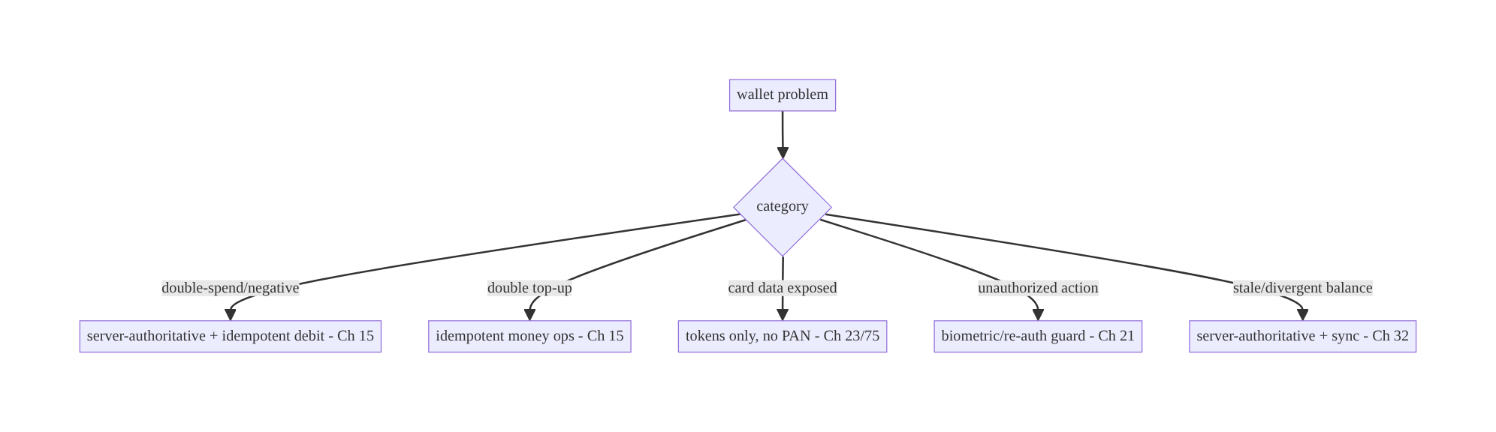
77.9 Failure Scenarios and Recovery
A wallet’s correctness and security reduce to: no card data on the device (tokens only), a server-authoritative balance (never spend local), idempotent money ops, and authenticated sensitive actions. The client displays and requests; the server is the ledger, the authority, and the record — so double-spend, negative balances, card leaks, and unauthorized spends are all prevented by design.

77.10 Scaling the Implementation
- Level 1. Tokenized payment methods (PSP, no card on device); display server- authoritative balance.
- Level 2. Idempotent top-up/spend (server-validated, Ch 15); biometric-guarded sensitive actions (Ch 21); transaction history (synced, Ch 3/32).
- Level 3 — production. Google Pay; multiple payment methods; refunds/adjustments (server ledger); cross-device consistency (Ch 32); secure token references (Ch 20).
- Level 4 — large. Multiple currencies, promotions/credits, split payments, auto-reload, wallet-to-wallet transfers, dispute handling.
- Level 5 — enterprise. Ledger-grade auditing/reconciliation, fraud/risk integration, regulatory (PCI-DSS, PSD2, KYC/AML), financial SLOs, multi-region.
Avoid overengineering: no-card-on-device + server-authoritative balance + idempotent ops
- authed sensitive actions is the mandatory core. Don’t store card data; don’t trust a local balance; don’t skip auth or idempotency.

77.11 Alternative Approaches and Trade-offs
Dimension | Option A | Option B | When
Card data | PSP token (no PAN on device) | handle card in app | Token always (PCI, Ch 23)
Balance | Server-authoritative | client-computed | Server always (anti-double-spend)
Money ops | Idempotent (Ch 15) | non-idempotent | Idempotent always
Sensitive actions | Biometric/re-auth (Ch 21) | session only | Biometric for spend/add-card
Payment method | PSP + Google Pay (tokenized) | manual card entry only | Tokenized (PCI, UX)
History/ledger | Server-owned + synced (Ch 3/32) | client-maintained | Server-owned (auditable)
Balance display | Synced server value | optimistic local | Synced (never optimistic for money)
Server-authoritative vs client-computed balance: a client-computed/trusted balance is a double-spend and tampering hazard — spend the same balance twice offline, or patch the client to show funds it doesn’t have. The server owns the ledger, validates every debit (sufficient funds, atomic), and dedups via idempotency (Ch 15); the client displays the synced balance and requests operations. Money is never optimistic (contrast Ch 72) and never client-authoritative.
Tokens vs card data on device: storing/handling the PAN/CVV locally is a PCI violation and a severe breach risk. Using PSP/Google Pay tokens (the real card stays with the PSP/network) means a compromised device exposes no card numbers, minimizes PCI scope, and still enables charging by token (Ch 75). Always tokenize; never hold card data.
Biometric-guarded vs session-only sensitive actions: a valid session (Ch 19) authorizes general use, but spending money, adding a card, or viewing full card/transaction details warrant a biometric/re-auth step (Ch 21) so a borrowed-unlocked phone can’t drain the wallet. Guard sensitive wallet actions explicitly, even within an authed session.

77.12 Security & PCI Considerations
- No PAN/CVV on the device (PCI, Ch 23): tokenize via the PSP/Google Pay; the app holds only tokens + display metadata (brand/last4). Never log/store card numbers. Secure any local token references in the Keystore (Ch 20).
- Server-authoritative ledger (Ch 23): the backend owns the balance and validates every debit/credit (funds, idempotency, atomicity) — the client cannot set the balance or overspend.
- Authenticate sensitive actions (Ch 19/21): session auth + biometric/re-auth for add/remove card, spend, top-up, view details; re-auth on sensitive flows even within a session.
- Idempotency (Ch 15): prevents double-charge/double-spend and mitigates replay on money endpoints.
- Per-account isolation (Ch 42): wallet/methods/history scoped to the authenticated user; never expose one user’s wallet to another.
- Audit trail (Ch 19): the transaction ledger is an immutable server record for disputes/compliance; the client doesn’t own it.
- Fraud/risk + KYC/AML (server): velocity limits, risk checks, and regulatory controls are server-side; the client surfaces outcomes.
- No sensitive data in logs (Ch 28): no card data, tokens, or balances tied to identity.
- Client vs backend: the backend is the ledger authority, validates/dedups money ops, owns tokens + audit, and enforces fraud/KYC; the client tokenizes via the SDK, displays synced state, authenticates sensitive actions, and requests server-validated operations — it never holds card data or authoritative balance.

77.13 Performance and Resource Optimization
- Display cached balance/history (SSOT, Ch 3) for instant/offline viewing (not spending); refresh from the server (Ch 32).
- Idempotent server ops avoid wasted re-work on retry.
- Tokenization is a one-time SDK flow per card; reuse the stored token for charges (Ch 75).
- Google Pay is a fast one-tap tokenized path (fewer steps).
- Batch history sync (delta, Ch 32); page long histories (Ch 13).
- Biometric guard adds a step only to sensitive actions, not general viewing.
- Profiling: money-op latency, double-spend rate (→ 0), top-up success, balance-sync freshness, biometric success rate.

77.14 Testing Strategy
Wallet logic (idempotency, server-authoritative behavior, auth gating) is unit-testable; card data handling verified absent.
class WalletSpendTest {
@Test fun `spend requests server-validated debit with idempotency key - no local mutation`() = runTest {
api.balance = Money(500)
wallet.spend(Money(100), key = "k1", activity)
assertEquals("k1", api.lastDebit.idempotencyKey) // idempotent (Ch 15)
// the client did NOT compute/mutate the balance locally
}
@Test fun `duplicate spend key does not double-debit`() = runTest {
wallet.spend(Money(100), key = "k1", activity); wallet.spend(Money(100), key = "k1", activity)
assertEquals(1, api.debitsWith("k1")) // server dedups (Ch 15)
}
@Test fun `insufficient funds rejected by server`() = runTest { /* balance 50, spend 100 -> rejected, no negative */ }
@Test fun `sensitive action requires biometric`() = runTest {
guard.willSucceed = false
assertTrue(wallet.spend(Money(10), "k2", activity) is Outcome.Failure) // auth gate (Ch 21)
}
}
class PaymentMethodTest {
@Test fun `add card stores token not PAN`() = runTest { /* assert no PAN stored; token saved server-side */ }
}
What to test: spend requests a server-validated debit (no local balance mutation) + idempotency; duplicate key → single debit; insufficient funds rejected (no negative); sensitive actions require biometric (Ch 21); add-card stores token not PAN (Ch 23); balance is displayed from synced server state. Fake PSP/backend with a ledger + idempotency; assert no card data anywhere local.

77.15 Production Observability
- Metrics: double-spend rate (→ 0) and double-top-up rate; money-op success/latency; insufficient-funds rejects; biometric success/decline on sensitive actions; balance-sync freshness; payment-method add/remove success; Google Pay usage.
- Logs: wallet{action, result, idempotency_key_hash} — no card data/tokens/balances- with-identity (PCI, Ch 28); ledger on the server.
- Debugging: double-spend → client trusting local balance / non-idempotent (server- authoritative + Ch 15); card leak → handling card data (tokenize); unauthorized action → missing biometric guard (Ch 21); stale balance → not syncing (Ch 32); negative balance → server not validating funds.
- Alerting: any double-spend/double-charge (page); unauthorized-action spike; balance discrepancy (client vs server).
- Dashboards: double-spend rate (must be 0), money-op success, biometric rates, balance sync.

77.16 System Design Interview Preparation
≥25 questions.
Fundamentals
- Card data on device? Never — PSP/Google Pay tokens only (PCI, Ch 23/75).
- Who owns the balance? The server (authoritative ledger).
- Client’s role? Display synced balance/history; request server-validated ops.
- Money ops? Idempotent (Ch 15) — top-up/spend/save-card.
- Sensitive actions? Authenticated (session + biometric/re-auth, Ch 21).
Balance/double-spend
- Why server-authoritative? Prevents double-spend, negative balance, tampering.
- Spend? Request a server-validated, idempotent debit — never spend local.
- Concurrent spends two devices? Server atomic debit (authoritative).
- Insufficient funds? Server rejects; no negative.
Tokens/cards
- Add a card? PSP SDK tokenizes; backend stores token + brand/last4.
- Display? “Visa ••1234” from metadata (no PAN).
- Charge? By token via PSP (Ch 75).
- Compromised device? Leaks tokens (useless without authed backend), not PAN.
Google Pay
- Google Pay returns? A payment token → PSP charge; no card data on device.
Auth
- Which actions need biometric? Add/remove card, spend, top-up, view details.
- Why within a session? Borrowed-unlocked phone shouldn’t drain the wallet (Ch 21).
History/consistency
- History? Server-owned, auditable ledger; client syncs/displays (Ch 3/32).
- Cross-device? Server-authoritative + sync (Ch 32).
- Refunds? Server ledger entries the client syncs.
Security/PCI
- PCI scope? Minimized via tokenization (no PAN).
- Local token references? Keystore (Ch 20).
- Per-account? Wallet scoped to the user (Ch 42).
- Logging? No card data/tokens/balances-with-identity (Ch 28).
Testing/Production
- Test spend? Server-validated + idempotent; no local mutation; biometric gate.
- Double-spend in prod? Client-trusted balance / non-idempotent.
- Key KPI? Double-spend rate (0).

Design-change challenges
- Save a card without PCI exposure. PSP tokenization; store token not PAN (Ch 23/75).
- Prevent double-spend of wallet balance. Server-authoritative + idempotent debit (Ch 15).
- Require confirmation to spend. Biometric/re-auth guard (Ch 21).
- Add Google Pay. Tokenized payment → PSP charge.
- Keep balance consistent across devices. Server-authoritative + sync (Ch 32).

Mock walkthrough (abridged)
Clarify (saved cards, stored-value balance, Google Pay?) → no card on device (tokens, PCI, Ch 23/75) → server-authoritative balance + ledger (display + request, never spend local) → idempotent money ops (Ch 15) → biometric-guard sensitive actions (Ch 19/21) → Google Pay/PSP tokenized charging (Ch 75) → server-owned auditable history + sync (Ch 3/32) → Keystore for local references (Ch 20) → observability (double-spend rate 0).

77.17 Practical Exercises
- Beginner. Add a card via the PSP SDK storing only a token + brand/last4 (no PAN); display “Visa ••1234”. Eval: no card data local; charges by token.
- Intermediate. Show a server-authoritative balance and implement spend as a server- validated, idempotent debit (never a local mutation). Eval: no double-spend; no negative.
- Advanced. Guard add-card/spend/top-up with biometric re-auth (Ch 21) and sync balance/ history across devices (Ch 32). Eval: sensitive actions authed; consistent.
- Production debugging. Fix a double-spend (client trusted a local balance) and card data stored locally (tokenize instead). Eval: server-authoritative; no PAN.
- System design challenge. Add Google Pay (tokenized) + refunds (server ledger) + a double-spend-rate dashboard. Eval: tokenized pay; refunds reflected; rate = 0.
(Solutions withheld unless requested.)

77.18 Chapter Summary & Reference Sheet
Key decisions: keep no card data on the device — reference PSP/Google Pay tokens only (the real card stays with the PSP/network; store token + brand/last4 server-side, PCI, Ch 23/75) and secure any local references in the Keystore (Ch 20); treat the balance and transaction ledger as server-authoritative — the client displays the synced balance/history (Ch 3/32) but never spends a local balance, instead requesting server-validated debits/credits that the server checks for sufficient funds, applies atomically, and dedups via an idempotency key (Ch 15) so top-ups never double-charge and spends never double-debit or go negative (even across devices); authenticate sensitive actions (add/remove card, spend, top-up, view full details) with the session plus a biometric/re-auth step (Ch 19/21); integrate Google Pay and the PSP (tokenized charging, Ch 75); and keep the transaction history server-owned and auditable (Ch 19), per-account (Ch 42). Money is never optimistic (contrast Ch 72) and never client-authoritative; the critical KPI is a double-spend rate of zero.
Concepts: tokenized payment methods (no PAN on device), server-authoritative balance/ ledger (anti-double-spend), idempotent money ops, biometric-guarded sensitive actions, Google Pay/PSP tokenized charging, server-owned auditable history + sync, Keystore references.
Common mistakes: handling/storing card data on device (PCI breach); client-computed/ trusted balance (double-spend, negative, tampering); non-idempotent money ops (double-charge/ double-spend); session-only sensitive actions (borrowed-phone fraud); optimistic money UI; client-owned ledger; per-account leakage; logging card data/balances.
Checklist:
- ☐ no card data on device — PSP/Google Pay tokens only (PCI, Ch 23/75)
- ☐ server-authoritative balance; never spend local
- ☐ server-validated + idempotent debit/credit (Ch 15)
- ☐ biometric/re-auth on sensitive actions (Ch 19/21)
- ☐ Google Pay/PSP tokenized charging (Ch 75)
- ☐ server-owned auditable history + sync (Ch 3/32)
- ☐ Keystore for local token references (Ch 20)
- ☐ per-account isolation (Ch 42)
- ☐ no card data/tokens/balances in logs (Ch 28)
- ☐ double-spend-rate alert (→ 0).
Key APIs: PSP SDK (tokenize card → token), Google Pay API (PaymentsClient/ loadPaymentData → payment token), idempotency key (Ch 15), WalletApi (server-authoritative balance/debit/credit), BiometricAuthenticator/CryptoObject (Ch 21), Keystore (Ch 20), SSOT + delta sync (Ch 3/32), charging via checkout (Ch 75).
References:
- Google Pay for Android: https://developers.google.com/pay/api/android/overview
- PCI tokenization (general PSP docs): https://stripe.com/docs/security/guide
- Android security tips (payments): https://developer.android.com/privacy-and-security/security-tips
- (composes) Ch 75 Checkout, Ch 76 Play Billing, Ch 15 Idempotency, Ch 23 Security, Ch 20 Keystore, Ch 21 Biometric, Ch 3 SSOT, Ch 32 Sync, Ch 19 Auth

Chapter 78 — Order Tracking & Live Status
Part IX — Feature Architectures · Complexity: Standard (≥25 interview questions)
Prerequisites: Ch 49 (FCM/push), Ch 63 (WebSocket), Ch 32 (sync), Ch 3 (SSOT), Ch 67 (live location), Ch 50 (notifications), Ch 44 (lifecycle). Pairs with Ch 75 (checkout), Ch 66 (SSE).
Reference surface in StreamCart: after checkout (Ch 75) — the order-status screen and live delivery tracking (“Confirmed → Packed → Shipped → Out for delivery → Delivered”, plus a moving driver on a map) — a server-driven status machine kept fresh via push, sync, and (while watching) a live channel, with notifications.

78.1 Problem Definition and Real-World Context
After an order is placed (Ch 75), the user wants to watch its progress: a status timeline (confirmed, packed, shipped, out-for-delivery, delivered) and, for delivery, a live driver location on a map. The architecture is a composition of the book’s real-time and sync layers applied to a server-owned status state machine: the status is authoritative on the server; the client reflects it, kept fresh by the right delivery mechanism per app state — push/FCM (Ch 49) for background updates + notifications, sync (Ch 32) as the reliable backstop, and a live channel (WebSocket Ch 63 / SSE Ch 66) only while the user is actively watching for low-latency updates and the moving driver (Ch 67).
Concretely, teams hit:
- Polling for status. Polling the order endpoint is laggy and wasteful; status updates should push (FCM, Ch 49) and the client should sync (Ch 32), with a live channel only while watching.
- Client-invented status. Inferring/advancing status on the client is wrong — status is a server-owned state machine (valid transitions, timestamps); the client renders it, never invents it.
- Wrong mechanism per state. Holding a WebSocket open in the background drains battery (Ch 63/47); not using a live channel while watching makes the driver map laggy. Match the mechanism to app state: live channel (foreground/watching) + FCM (background) + sync (reconcile).
- Missed/stale updates. A dropped push or missed live event must self-heal via sync (Ch 32) — the order SSOT (Ch 3) is reconciled against the server; status is never lost.
- Notifications. Status changes drive notifications (Ch 50) — “Your order shipped” — that must be consistent with the in-app status (one source), and work when backgrounded (FCM, Ch 49).
- Live location (delivery). The moving driver is live location (Ch 67) streamed server→client only during active delivery while watching, with smoothing and a map.
- Consistency & history. The order status + ETA + history must be consistent (SSOT), survive process death, and show accurately across devices.
The architecture: model order status as a server-owned state machine reflected in the SSOT (Ch 3); keep it fresh with the right mechanism per app state — a live channel (WebSocket Ch 63 / SSE Ch 66) only while actively watching (low-latency status + driver map, Ch 67), FCM (Ch 49) for background status changes + notifications (Ch 50), and sync (Ch 32) as the reliable backstop so dropped updates self-heal; render the status timeline + ETA + live map; and keep it consistent, death-safe, and notification-driven. This chapter composes the real-time and sync stack onto a server-driven order lifecycle.

Three practical use cases
- Order status timeline (StreamCart). Confirmed → Packed → Shipped → Out-for-delivery → Delivered, server-owned, reflected in the SSOT; FCM + notification on each change; sync reconciles.
- Live delivery map. While the user watches the “out for delivery” screen, a live channel (Ch 63/66) streams the driver’s smoothed location (Ch 67) and ETA; closes when they leave.
- Background + reopen. The app is closed when the order ships; FCM delivers the status + notification (Ch 49/50); on reopen, sync shows the current state (Ch 32).

Why this is architectural
Order tracking is a clean composition of a server-owned status machine (Ch 3) with the real-time/sync mechanism-selection discipline: FCM (Ch 49) + live channel (Ch 63/66) + sync (Ch 32) + live location (Ch 67) + notifications (Ch 50), each used per app state. The decisions — server-owned status, mechanism-per-state, sync-as-backstop, watching-scoped live channel — determine freshness, battery, and correctness.

78.2 Requirements Engineering

Functional requirements
ID | Requirement
F1 | Reflect a server-owned order status state machine in the SSOT; never invent status (Ch 3).
F2 | Keep status fresh per app state: live channel (watching) + FCM (background) + sync (backstop) (Ch 63/49/32).
F3 | Drive notifications on status changes, consistent with in-app status (Ch 49/50).
F4 | Stream live driver location + ETA while actively watching (Ch 67).
F5 | Self-heal missed/dropped updates via sync; survive process death (Ch 32/8).
F6 | Consistent across devices; accurate timeline/ETA/history.

Non-functional requirements
Attribute | Policy
Freshness | Low-latency while watching; prompt when backgrounded (push).
Battery | Live channel only while watching; FCM for background (Ch 63/47/49).
Correctness | Server-owned status; sync backstop; no lost updates.
Consistency | One SSOT; notification matches in-app; cross-device (Ch 3/32).
Resilience | Survives process death; dropped updates self-heal.

Scope
- In scope: server-owned order status state machine reflected in SSOT (Ch 3), mechanism-per-state (live channel Ch 63/66 while watching + FCM Ch 49 background + sync Ch 32 backstop), status-change notifications (Ch 50), live driver location + ETA (Ch 67, watching-scoped), self-healing via sync (Ch 32), process death (Ch 8), cross-device consistency, timeline/history rendering.
- Out of scope: WebSocket/SSE internals (Ch 63/66), FCM internals (Ch 49), sync algorithm (Ch 32), live-location mechanics (Ch 67), notifications detail (Ch 50), checkout (Ch 75).

Assumptions & constraints
- The server owns order status (state machine + timestamps) and emits changes via FCM (Ch 49) + a live channel (Ch 63/66); the client reflects it in the SSOT (Ch 3). Live channel + driver location only while watching (Ch 44/67). minSdk 24.

78.3 System Design Fundamentals
- Order status is a server-owned state machine (the client reflects it, Ch 3). The order moves through defined states (Placed → Confirmed → Packed → Shipped → Out-for-delivery → Delivered, plus Cancelled/Returned) with valid transitions and timestamps, all authoritative on the server. The client renders the current state + timeline from the SSOT (Room, Ch 3); it never advances or infers status itself (that’s the server’s job). This mirrors push-as-trigger (Ch 49) and socket-as-fast-path (Ch 63): the server is truth.
- Mechanism per app state (the core decision, Ch 49/63/32):
  - Live channel (WebSocket Ch 63 / SSE Ch 66) — only while actively watching. When the user is on the tracking screen, open a live channel for low-latency status updates and the moving driver (Ch 67); close it when they leave (battery, Ch 44/ 47). SSE (Ch 66) suffices for one-way status; WebSocket if bidirectional.
  - FCM (Ch 49) — background status changes + notifications. When the app is backgrounded/closed, status changes arrive via high-priority FCM (Ch 49), updating the SSOT (via a sync) and posting a notification (Ch 50) — “Your order shipped.”
  - Sync (Ch 32) — the reliable backstop. On app open/foreground and periodically, sync the order from the server into the SSOT so any missed push or live event self-heals. The order status is never lost because sync reconciles against the authoritative server state. This is the same mechanism-selection discipline as Ch 63/66 applied to orders: live channel (watching) + FCM (background) + sync (backstop).
- Self-healing (Ch 32). Because FCM and live channels are best-effort, a dropped status update self-heals: the next sync (on open/periodic) pulls the authoritative status into the SSOT. Push/live are accelerators; sync is the guarantee (the order SSOT always converges to server truth). (Same principle as Ch 49/63.)
- Notifications consistent with in-app status (Ch 50/49). Status-change notifications are driven by the same server status and the same SSOT — tapping a “shipped” notification deep-links (Ch 52) to the tracking screen showing the matching status. One source of status → notification and screen never disagree. Notifications work backgrounded (FCM, Ch 49).
- Live driver location + ETA (Ch 67), watching-scoped. For active delivery, the driver’s live location (Ch 67) streams server→client over the live channel only while the user watches the map; it’s smoothed (Ch 67) and paired with a server-computed ETA. Closing the screen closes the stream (battery). The driver side is a location FGS (Ch 67); the customer side is a watching-scoped subscriber.
- SSOT, process death, cross-device (Ch 3/8/32). Order status + timeline + ETA live in the SSOT (Ch 3) so the screen renders instantly, survives process death (Ch 8), and is consistent across devices (server-authoritative + sync, Ch 32). The timeline (with timestamps) is history the server owns and the client displays.
- Lifecycle (Ch 44). Open the live channel on the tracking screen’s onStart, close on onStop; rely on FCM when backgrounded; sync on foreground. Never hold the live channel or driver stream in the background.
Core insight: order tracking reflects a server-owned status state machine in the SSOT (Ch 3) and keeps it fresh with the right mechanism per app state — a live channel (WebSocket Ch 63 / SSE Ch 66) only while the user is actively watching (low-latency status + the smoothed driver location and ETA, Ch 67), high-priority FCM (Ch 49) for background status changes plus notifications (Ch 50), and periodic/on-open sync (Ch 32) as the reliable backstop so any dropped push or live event self-heals — with the server as truth (the client never invents status), the notification and screen sharing one SSOT, and the whole thing surviving process death and consistent across devices (Ch 8/3/32).

78.4 High-Level Architecture
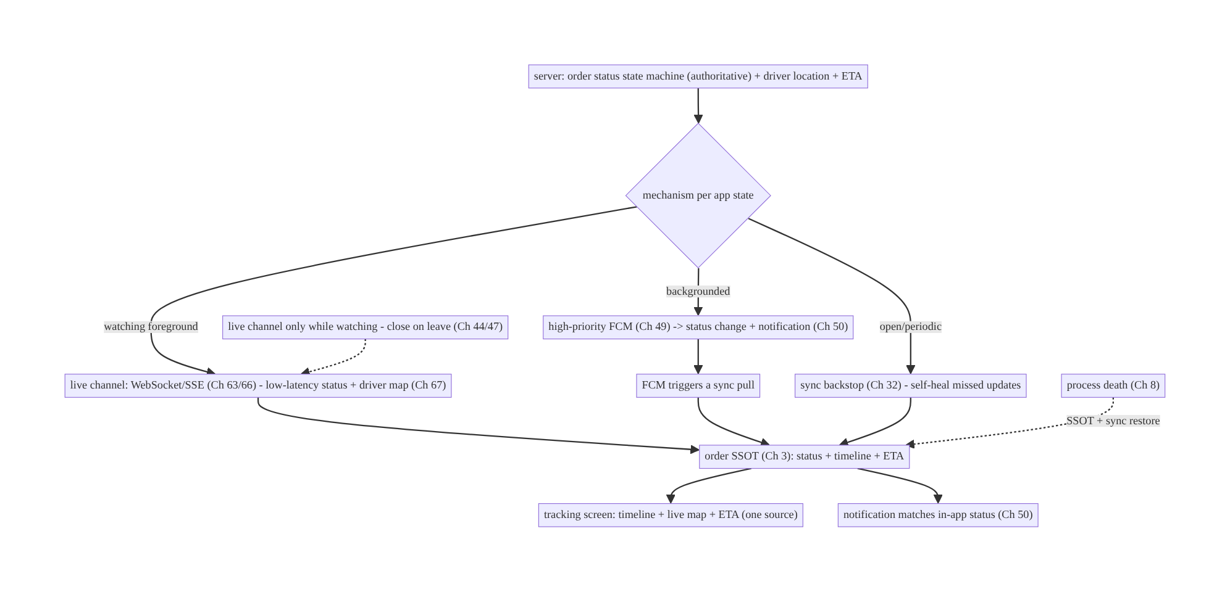
78.4 High-Level Architecture
Components & ownership
- Server owns the status state machine + driver location + ETA (authoritative).
- Mechanism per app state: live channel (watching, Ch 63/66 + driver Ch 67) + FCM (background + notification, Ch 49/50) + sync (backstop, Ch 32) — all into the order SSOT (Ch 3).
- UI + notification share one SSOT; lifecycle closes the live channel off-screen.
Direction: server status → (live channel watching / FCM background / sync backstop) → order SSOT → timeline + map + ETA + consistent notification; self-healing + death-safe.

78.5 Detailed Component Design
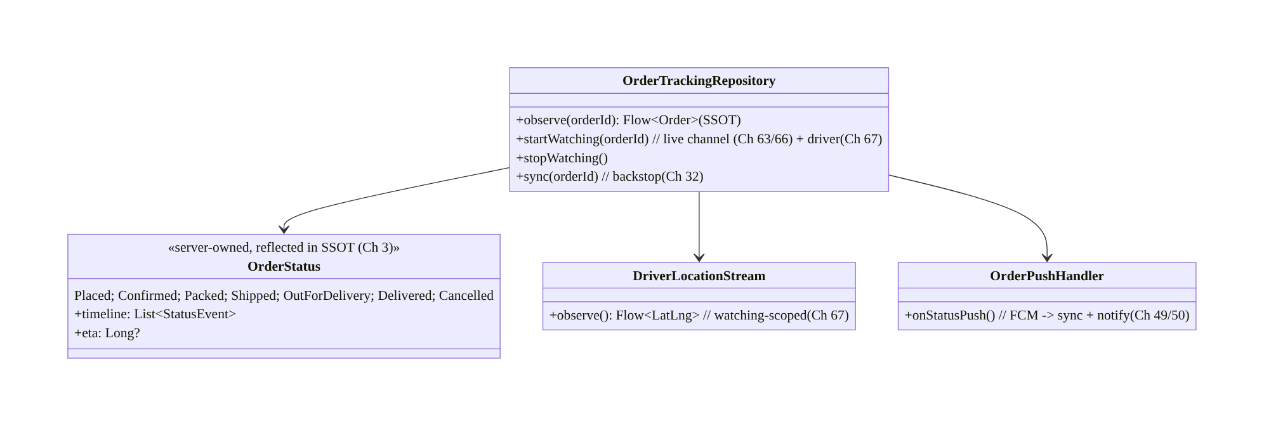
78.5 Detailed Component Design
Component | Responsibility
OrderStatus | server-owned state machine + timeline + ETA, reflected in SSOT (Ch 3)
OrderTrackingRepository | observe SSOT; start/stop live channel (watching); sync backstop
DriverLocationStream | watching-scoped smoothed driver location (Ch 67)
OrderPushHandler | FCM status change → sync + notification (Ch 49/50)

78.6 End-to-End Data Flow

Status fresh across app states
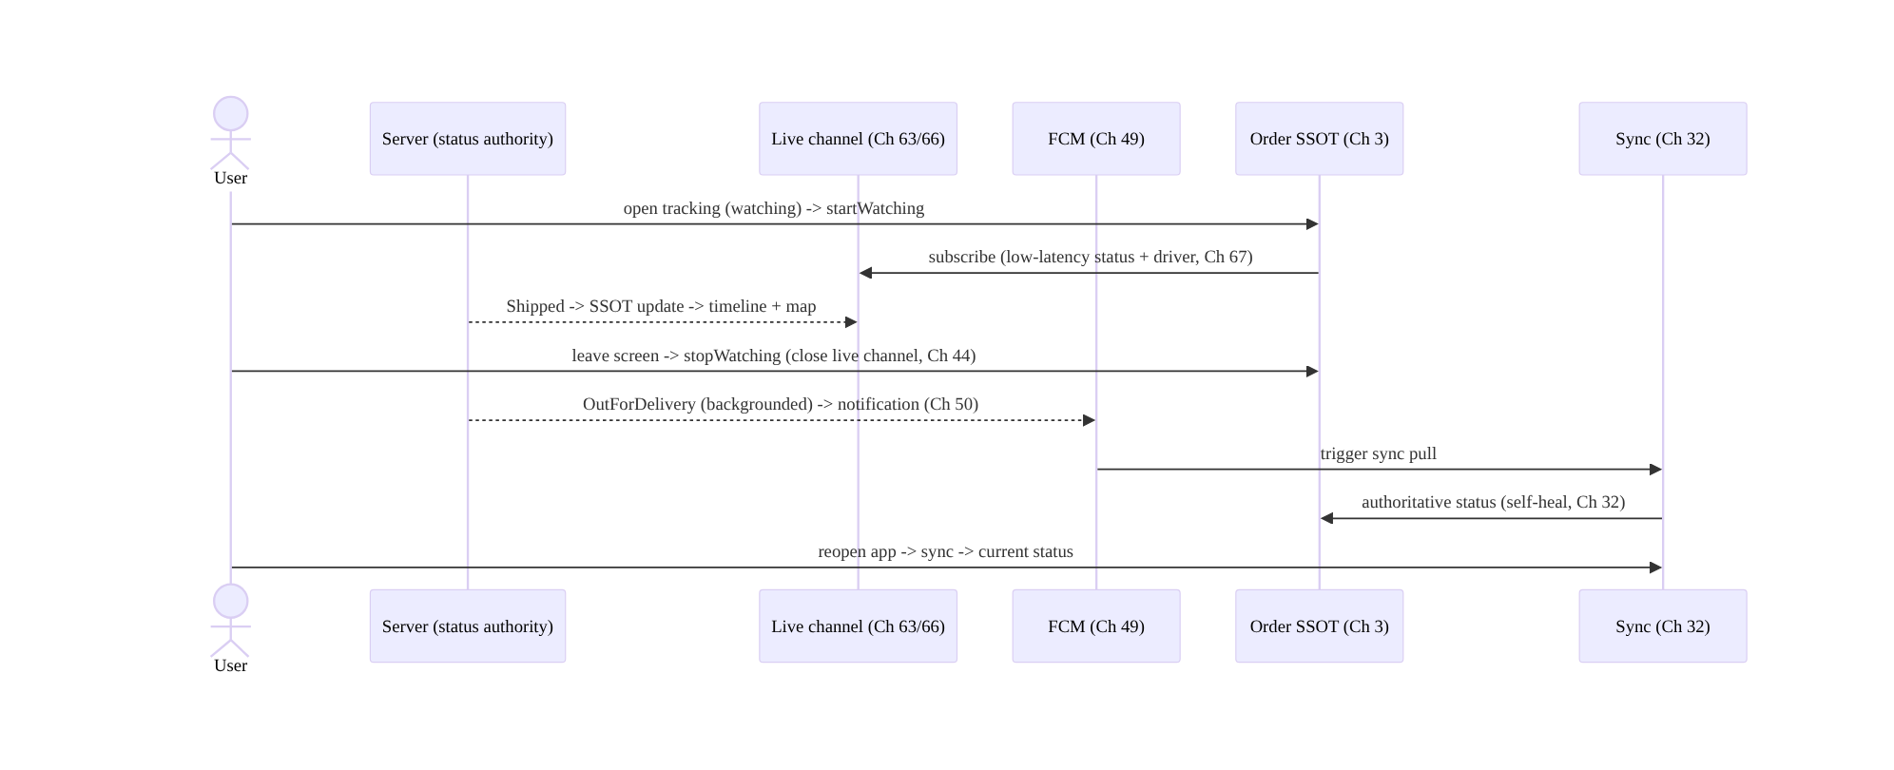
Status fresh across app states

Self-healing missed update
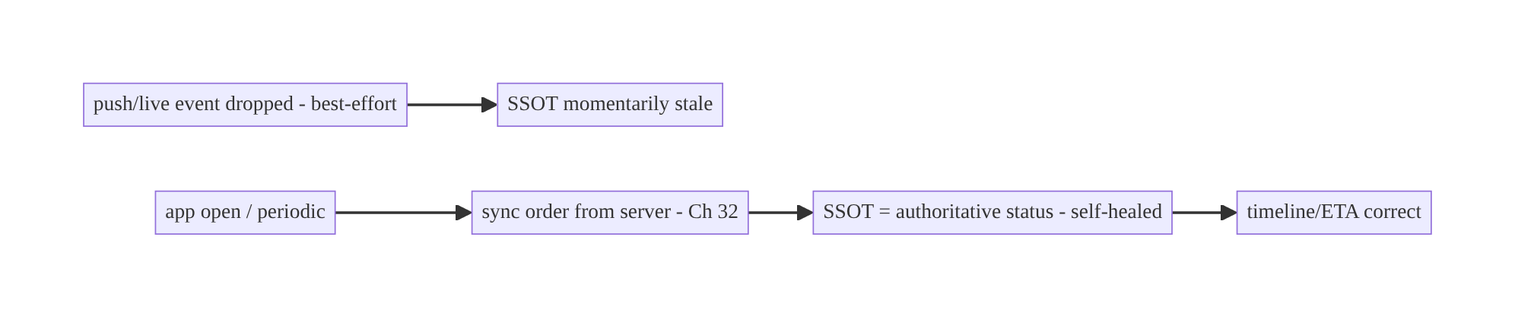
Self-healing missed update

78.7 Complete Kotlin Implementation
Package: com.streamcart.ordertracking.

78.7.1 Server-owned status reflected in the SSOT (Ch 3)
@Entity(tableName = "orders")
data class Order(
@PrimaryKey val id: String,
val status: OrderStatus, // server-owned; client NEVER advances it
val timelineJson: String, // status events + timestamps (server history)
val etaMillis: Long?, val driverId: String?, val updatedAt: Long,
)
enum class OrderStatus { Placed, Confirmed, Packed, Shipped, OutForDelivery, Delivered, Cancelled }

78.7.2 Repository: observe SSOT + watching-scoped live channel + sync backstop
@Singleton
class OrderTrackingRepository @Inject constructor(
private val dao: OrderDao, private val api: OrderApi, // sync (Ch 32)
private val live: LiveChannel, // WebSocket/SSE (Ch 63/66)
private val scope: CoroutineScope,
) {
fun observe(orderId: String): Flow<Order> = dao.observe(orderId) // SSOT (Ch 3) -> UI
private var watchJob: Job? = null
/** While the user WATCHES: low-latency live channel (Ch 63/66) + driver location (Ch 67). */
fun startWatching(orderId: String) {
watchJob = scope.launch {
live.subscribeOrder(orderId).collect { update -> dao.applyServerStatus(orderId, update) } // server-owned; reflect only
}
}
fun stopWatching() { watchJob?.cancel(); live.unsubscribe() } // close on leave (battery, Ch 44/47)
/** Backstop: pull authoritative status -> self-heal missed push/live (Ch 32). */
suspend fun sync(orderId: String) = dao.applyServerStatus(orderId, api.order(orderId).toUpdate())
}

78.7.3 FCM status push → sync + notification (Ch 49/50)
// High-priority FCM delivers background status changes; trigger a sync + post a notification (Ch 49/50).
class OrderPushHandler @Inject constructor(
private val repo: OrderTrackingRepository, private val notifier: Notifier, // Ch 50
) {
suspend fun onStatusPush(orderId: String) {
repo.sync(orderId) // pull authoritative status (self-heal, Ch 32)
val order = repo.observe(orderId).first()
notifier.notifyFor(orderStatusNotification(order)) // notification matches in-app status (one SSOT)
}
// Tapping the notification deep-links (Ch 52) to the tracking screen showing the SAME status.
}

78.7.4 Live driver location (watching-scoped, smoothed, Ch 67)
class DriverLocationStream @Inject constructor(private val live: LiveChannel) {
/** Driver location streams ONLY while watching (Ch 44/67); smoothed; paired with server ETA. */
fun observe(orderId: String): Flow<DriverPosition> = live.subscribeDriver(orderId)
.map { it.smoothed() } // filter/smooth (Ch 67)
// Closing the tracking screen closes this stream (battery). Driver side = location FGS (Ch 67).
}

78.7.5 UI: timeline + map + ETA (one SSOT), lifecycle-scoped live channel (Ch 44)
@Composable
fun OrderTrackingScreen(orderId: String, vm: OrderTrackingViewModel = hiltViewModel()) {
val order by vm.order(orderId).collectAsStateWithLifecycle(initialValue = null) // SSOT (Ch 3)
val lifecycleOwner = LocalLifecycleOwner.current
DisposableEffect(lifecycleOwner) { // live channel only while watching
vm.startWatching(orderId); vm.syncOnOpen(orderId) // + sync backstop (Ch 32)
onDispose { vm.stopWatching() } // close on leave (Ch 44/47)
}
order?.let { o ->
StatusTimeline(o.timeline, current = o.status) // server-owned timeline; client renders, never invents
if (o.status == OrderStatus.OutForDelivery) DriverMap(vm.driverLocation(orderId), eta = o.etaMillis) // Ch 67
}
// Process death: SSOT (Ch 3/8) restores the screen; sync reconciles (Ch 32).
}

78.7.6 Module structure
:feature:ordertracking Order/OrderStatus/Dao (SSOT, Ch 3), OrderTrackingRepository (live + sync), DriverLocationStream, OrderPushHandler
:core:realtime live channel (WebSocket/SSE, Ch 63/66); :feature:push FCM (Ch 49); :core:sync (Ch 32); :core:notifications (Ch 50)
# Server owns status state machine + driver location + ETA. Checkout -> Ch 75; live location -> Ch 67.

78.8 Concurrency and Race Conditions
Scenario | Risk | Handling
Client advances status | wrong/invalid state | server-owned; client reflects only (Ch 3)
Dropped push/live event | stale status | sync backstop self-heals (Ch 32)
Out-of-order status events | regress status | apply by server timestamp/sequence; server authoritative
Live channel held in background | battery | close on leave; FCM for background (Ch 44/47/49)
Notification vs screen mismatch | confusion | one SSOT drives both (Ch 3/50)
Process death on tracking screen | lost state | SSOT + sync restore (Ch 3/8/32)
Driver stream off-screen | battery | watching-scoped (Ch 67)
- Server-owned status + sync backstop make tracking correct and self-healing: the client never invents status (invalid/regressed states), applies updates by server timestamp/sequence, and any missed push/live event is reconciled by sync (Ch 32) — the SSOT always converges to server truth.
- Mechanism-per-state keeps it battery-sane and fresh: the live channel/driver stream run only while watching (Ch 44/47), FCM handles background, sync backstops.
- One SSOT guarantees the notification and the screen agree (Ch 3/50).

78.9 Failure Scenarios and Recovery
Failure | Detection | Response | Outcome
Status stale/missed | gap | sync backstop (Ch 32) | self-heals
Client-invented status | wrong UI | reflect server-owned only (Ch 3) | correct
Battery drain | live channel in bg | close on leave; FCM background (Ch 44/49) | battery ok
Notification mismatches screen | confusion | one SSOT drives both (Ch 3/50) | consistent
Process death | lost screen | SSOT + sync restore (Ch 8/32) | restored
Driver map laggy | not live while watching | live channel + smoothing while watching (Ch 63/67) | smooth
Background status missed | user unaware | FCM + notification (Ch 49/50) | delivered
Device divergence | user report | server-authoritative + sync (Ch 32) | converge
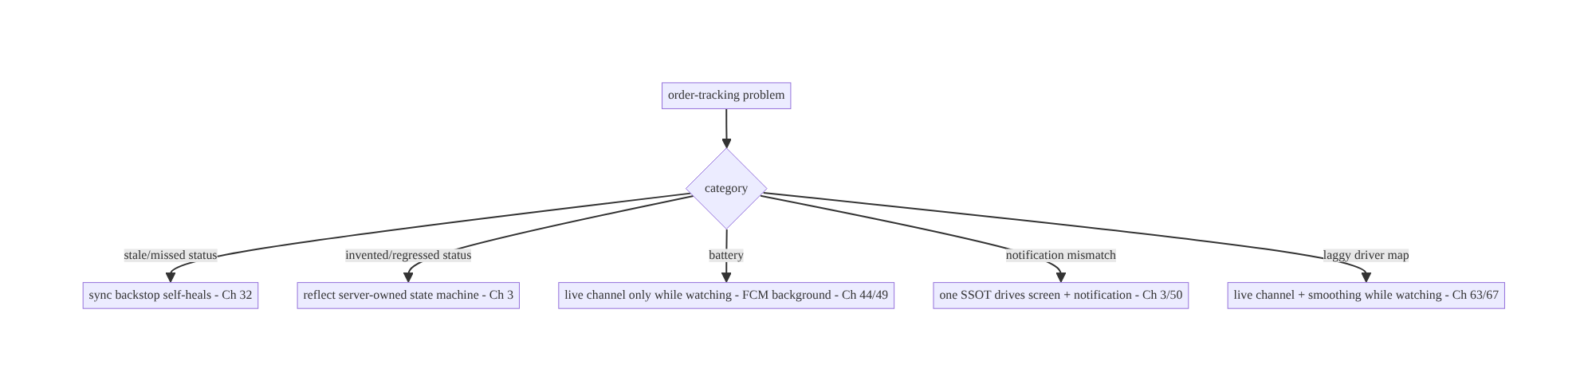
78.9 Failure Scenarios and Recovery
Order tracking is mechanism-selection over a server-owned status machine: live channel while watching, FCM when backgrounded, sync as the backstop — all into one SSOT. The client reflects the server’s status (never invents it), the live channel/driver stream run only while watching (battery), and sync guarantees no update is ever lost.

78.10 Scaling the Implementation
- Level 1. Server-owned status in the SSOT (Ch 3); sync on open (Ch 32); status timeline.
- Level 2. FCM status changes + notifications (Ch 49/50); live channel (Ch 63/66) while watching; sync backstop self-heals.
- Level 3 — production. Live driver location + ETA while watching (Ch 67); lifecycle- scoped channel (Ch 44); notification/screen consistency; process-death survival (Ch 8).
- Level 4 — large. Multi-order tracking; ETA refinement; map clustering; proactive alerts (delays); cross-device consistency (Ch 32).
- Level 5 — enterprise. Tracking SLOs (freshness/latency), delivery analytics, carrier integrations, real-time fleet scale, proactive issue detection.
Avoid overengineering: server-owned status + FCM + sync + a watching-scoped live channel is the core. Don’t poll; don’t invent status; don’t hold the live channel in the background.

78.11 Alternative Approaches and Trade-offs
Dimension | Option A | Option B | When
Status source | Server-owned (client reflects) | client-inferred | Server always (authoritative state machine)
Freshness | Mechanism per state (live/FCM/sync) | polling | Per-state (fresh + battery-sane)
Live updates | Channel only while watching (Ch 63/66) | always-on socket | While-watching (battery, Ch 44/47)
Background | FCM (Ch 49) | keep socket open | FCM (battery/Doze)
Reliability | Sync backstop (Ch 32) | trust push/live | Sync backstop (self-heal)
Driver map | Live location while watching (Ch 67) | poll location | Live + smoothing while watching
Notification | One SSOT (Ch 3/50) | separate status | One SSOT (consistent)
Server-owned status vs client-inferred: an order’s status is a server-owned state machine (valid transitions, authoritative timestamps) — the client cannot correctly infer or advance it (it lacks fulfillment/logistics data). The client reflects the server’s status in the SSOT (Ch 3) and renders it; inventing status produces wrong or regressed states.
Mechanism per state vs polling vs always-on socket: polling is laggy/wasteful; an always-on WebSocket drains battery and is killed in the background (Ch 47). The right design uses the mechanism per app state (as in Ch 63/66): a live channel while watching (low-latency + driver map), FCM for background (+ notifications), and sync as the backstop. This maximizes freshness while respecting battery.
Sync backstop vs trusting push/live: FCM and live channels are best-effort — a dropped update would leave the status stale forever if trusted blindly. Sync (Ch 32) on open/periodic reconciles the SSOT against the authoritative server status, so every missed update self-heals. Push/live accelerate; sync guarantees.

78.12 Security & Privacy Considerations
- Server-authorized order access (Ch 23/19): a user can only track their own orders; the server authorizes access to status, timeline, and driver location — never a public endpoint. The live channel/FCM topic for an order is authorized (Ch 63/49).
- Driver location privacy (Ch 67/28): the driver’s live location is sensitive — shared only during active delivery, only with the authorized customer, and stops on delivery; coarsen/limit as policy requires; don’t log coordinates.
- Notification content (Ch 50/28): status notifications shouldn’t leak sensitive details on the lock screen (public/private versions); don’t include PII.
- Per-account isolation (Ch 42): orders/tracking scoped to the authenticated user; clear on logout.
- Untrusted payloads (Ch 49/63/23): push/live status messages are untrusted triggers — validate and reconcile via authed sync (the server status is truth), don’t act on a payload’s claimed status blindly.
- Client vs backend: the server owns status, authorizes access, computes ETA, and shares driver location under authorization; the client reflects, subscribes (authorized), and renders — it never owns status or exposes location beyond the authorized customer.

78.13 Performance and Resource Optimization
- Live channel only while watching (Ch 44/47) — the top battery lever; FCM for background.
- Sync on open + sparingly periodic (Ch 32) — not continuous polling.
- Smooth + sample driver location (Ch 67) — don’t render every tick; coalesce (Ch 63).
- Cache status/timeline (SSOT, Ch 3) for instant render + offline view; refresh via sync.
- FCM for background avoids a held connection (Ch 49/47).
- Efficient map rendering — update the marker, don’t rebuild the map.
- Profiling: status freshness/latency, live-channel uptime (while watching), battery, sync frequency, notification delivery, ETA accuracy.

78.14 Testing Strategy
Status reflection, mechanism-per-state, and self-healing are testable with fakes.
class OrderTrackingTest {
@Test fun `reflects server status - never advances locally`() = runTest {
repo.sync("o1") // server says Shipped
assertEquals(OrderStatus.Shipped, dao.observe("o1").first().status)
// no client API advances status
}
@Test fun `sync self-heals a missed update`() = runTest {
// live/FCM dropped Shipped; open -> sync -> SSOT = Shipped (Ch 32)
repo.sync("o1"); assertEquals(OrderStatus.Shipped, dao.observe("o1").first().status)
}
@Test fun `live channel only while watching`() = runTest {
repo.startWatching("o1"); assertTrue(live.subscribed)
repo.stopWatching(); assertFalse(live.subscribed) // closed on leave (Ch 44)
}
@Test fun `out-of-order status does not regress`() = runTest { /* apply by server timestamp */ }
}
class OrderPushTest {
@Test fun `FCM status push syncs then notifies consistently`() = runTest {
pushHandler.onStatusPush("o1")
assertTrue(notifier.shown.any { it.orderId == "o1" }) // notification matches SSOT status (Ch 3/50)
}
}
What to test: status reflected from server (never client-advanced); sync self-heals missed updates (Ch 32); live channel start/stop with watching (Ch 44); out-of-order non-regression; FCM push → sync + consistent notification (Ch 49/50); driver stream watching-scoped (Ch 67); process-death restore (Ch 8). Fake live channel/FCM/sync.

78.15 Production Observability
- Metrics: status freshness/latency (server change → client reflects) by mechanism; live-channel uptime (while watching) + battery; sync frequency + self-heal rate (how often sync corrects a missed update); FCM status delivery + notification open; ETA accuracy; driver-location smoothness.
- Logs: ordertracking{orderId, status, mechanism, synced} — no coordinates/PII (Ch 28).
- Debugging: stale status → sync backstop not running / mechanism gap (Ch 32); invented status → client advancing (reflect server); battery → live channel in background (Ch 44/ 49); notification mismatch → not one-SSOT (Ch 3/50); laggy map → not live while watching (Ch 63/67); missed background update → FCM (Ch 49).
- Alerting: status-freshness regression; live-channel battery spike; FCM delivery drop.
- Dashboards: status freshness by mechanism; self-heal rate; ETA accuracy.

78.16 System Design Interview Preparation
≥25 questions.
Fundamentals
- Who owns order status? The server (state machine) — the client reflects it (Ch 3).
- Client invent status? No — renders server-owned status.
- Freshness mechanism? Per app state: live channel (watching) + FCM (background) + sync (backstop).
- Why not poll? Laggy, wasteful.
- Source of status truth? Server; SSOT reflects it.
Mechanism per state
- While watching? Live channel (WebSocket Ch 63 / SSE Ch 66) — low-latency + driver map.
- Backgrounded? FCM (Ch 49) + notification (Ch 50).
- Backstop? Sync (Ch 32) on open/periodic.
- Why close live channel on leave? Battery/Doze (Ch 44/47).
- WebSocket vs SSE here? SSE fine for one-way status; WebSocket if bidirectional.
Reliability
- Dropped push/live event? Sync self-heals (Ch 32).
- Out-of-order? Apply by server timestamp/sequence (no regress).
- Process death? SSOT + sync restore (Ch 8/32).
- Cross-device? Server-authoritative + sync (Ch 32).
Notifications
- Status notifications? FCM-driven (Ch 49/50), consistent with in-app (one SSOT).
- Tap behavior? Deep-link to tracking screen (Ch 52), same status.
Live location
- Driver map? Live location (Ch 67) while watching; smoothed; server ETA.
- When streamed? Only during active delivery while watching.
- Driver side? location FGS (Ch 67).
Security
- Access? Server-authorized (own orders only, Ch 23).
- Driver location privacy? Sensitive — authorized customer only, during delivery (Ch 67/28).
- Payloads? Untrusted triggers; reconcile via authed sync (Ch 49/63/23).
Testing/Production
- Test self-heal? Dropped update → sync corrects (Ch 32).
- Test lifecycle? Live channel start/stop with watching.
- Stale status in prod? Sync backstop/mechanism gap.
- Key metric? Status freshness/latency + self-heal rate.

Design-change challenges
- Live order status without polling. Server-owned status + FCM + live channel (watching)
  - sync backstop.
- Driver on a map. Live location (Ch 67) while watching; smoothed; server ETA.
- Status missed while app closed. FCM + notification; sync self-heals on reopen (Ch 49/32).
- Battery drain from tracking. Live channel only while watching; FCM background (Ch 44/ 49).
- Notification says shipped but screen says packed. One SSOT drives both (Ch 3/50).

Mock walkthrough (abridged)
Clarify (status timeline, live map, background?) → server-owned status state machine in SSOT (Ch 3) → mechanism per app state: live channel while watching (Ch 63/66 + driver Ch 67) + FCM background + notification (Ch 49/50) + sync backstop (Ch 32) → self-healing + process death (Ch 8) → notification/screen one SSOT → lifecycle closes live channel (Ch 44/47) → security (authorized access, driver-location privacy) → observability (freshness, self-heal rate).

78.17 Practical Exercises
- Beginner. Reflect a server-owned order status in the SSOT and render a timeline; sync on open. Eval: client never advances status; timeline correct.
- Intermediate. Add FCM status changes + notifications (consistent with in-app) and a sync backstop that self-heals missed updates. Eval: background updates + notification; dropped update heals.
- Advanced. Open a live channel (Ch 63/66) + smoothed driver location (Ch 67) only while watching; close on leave. Eval: low-latency map while watching; no background channel.
- Production debugging. Fix stale status (no sync backstop) and battery drain (live channel held in background). Eval: fresh via sync; channel scoped to watching.
- System design challenge. Ensure authorized order access + driver-location privacy and a status-freshness dashboard. Eval: own-orders-only; location authorized/time-boxed; freshness measured.
(Solutions withheld unless requested.)

78.18 Chapter Summary & Reference Sheet
Key decisions: model order status as a server-owned state machine (valid transitions
- authoritative timestamps) reflected in the SSOT (Ch 3) — the client renders, never invents status; keep it fresh with the right mechanism per app state — a live channel (WebSocket Ch 63 / SSE Ch 66) only while the user is actively watching (low-latency status + the smoothed driver location and server ETA, Ch 67, closed on leave for battery, Ch 44/47), high-priority FCM (Ch 49) for background status changes plus notifications (Ch 50), and periodic/on-open sync (Ch 32) as the reliable backstop so any dropped push or live event self-heals; drive notifications from the same SSOT so the notification and screen always agree (and deep-link to tracking, Ch 52); survive process death and stay consistent across devices (Ch 8/3/32); and authorize order access and protect driver-location privacy (own orders only, delivery-time-boxed, Ch 23/67/28). Push/live are accelerators; sync is the guarantee; the server is truth.
Concepts: server-owned status state machine reflected in SSOT, mechanism per app state (live channel watching + FCM background + sync backstop), self-healing via sync, notification/screen consistency (one SSOT), live driver location + ETA (watching-scoped), process death, cross-device consistency, authorized access + location privacy.
Common mistakes: client-invented/advanced status; polling for status; always-on WebSocket in the background (battery/Doze); trusting push/live without a sync backstop (stale on drop); notification inconsistent with in-app status (two sources); holding the driver stream off-screen; unauthorized order/location access.
Checklist:
- ☐ server-owned status reflected in SSOT (never invent, Ch 3)
- ☐ live channel (Ch 63/66) only while watching + driver location + ETA (Ch 67)
- ☐ FCM background status + notification (Ch 49/50)
- ☐ sync backstop self-heals missed updates (Ch 32)
- ☐ one SSOT drives screen + notification
- ☐ close live channel on leave (Ch 44/47)
- ☐ process-death survival + cross-device (Ch 8/32)
- ☐ authorized order access + driver-location privacy (Ch 23/67/28)
- ☐ untrusted payloads reconciled via authed sync
- ☐ status-freshness + self-heal telemetry.
Key APIs: Order SSOT (Room @Entity/@Dao, Ch 3), live channel (WebSocket/SSE, Ch 63/66) watching-scoped via DisposableEffect/lifecycle (Ch 44), FCM high-priority (Ch 49) + Notifier (Ch 50) + deep links (Ch 52), delta sync backstop (Ch 32), live driver location (Ch 67, smoothed), server-computed ETA, authorized access (Ch 23).
References:
- Offline-first / sync: https://developer.android.com/topic/architecture/data-layer/offline-first
- (composes) Ch 49 FCM, Ch 63 WebSocket, Ch 66 SSE, Ch 32 Sync, Ch 3 SSOT, Ch 67 Live Location, Ch 50 Notifications, Ch 44 Lifecycle, Ch 75 Checkout

Chapter 79 — Reviews & Ratings
Part IX — Feature Architectures · Complexity: Standard (≥25 interview questions)
Prerequisites: Ch 72 (optimistic updates), Ch 31 (outbox), Ch 15 (idempotency), Ch 3 (SSOT), Ch 13 (paging), Ch 17 (uploads), Ch 73 (recommendations/ranking), Ch 23 (security). Pairs with Ch 71 (feed), Ch 32 (sync).
Reference surface in StreamCart: product/content reviews and star ratings — writing a review (text + photos + stars) reliably, displaying a server-ranked list of reviews with aggregates (average, distribution), handling moderation and abuse, and keeping the user’s own review consistent.

79.1 Problem Definition and Real-World Context
Reviews and ratings combine several book patterns onto a user-generated-content (UGC) feature: submitting a review reliably (text + optional photos + a star rating, offline-capable, idempotent); displaying a server-ranked, paginated list of reviews plus server-computed aggregates (average rating, star distribution, count); moderation (UGC is untrusted and may be abusive/spam); and keeping the user’s own review consistent (edit/delete). The composition touches optimistic submit (Ch 72), outbox + idempotency (Ch 31/15), media upload (Ch 17), paging + ranking (Ch 13/73), SSOT (Ch 3), and UGC security/moderation (Ch 23).
Concretely, teams hit:
- Unreliable submit. A review submitted offline/flaky is lost or double-posted. It needs an outbox (Ch 31) + idempotency key (Ch 15) and optimistic display (Ch 72) with a “pending/posted/failed” status (like a comment, Ch 64).
- Client-computed aggregates. Computing the average rating / distribution on the client is wrong — aggregates span all reviews (which the client doesn’t have) and must be server-computed (Ch 73). The client displays server aggregates.
- Client-ranked reviews. Review ordering (“most helpful”, “recent”, “critical”) is a server ranking (helpfulness, recency, verified-purchase, Ch 73); the client renders the server’s order + logs signals (helpful votes), it doesn’t rank.
- UGC is untrusted + needs moderation. Reviews are user content → render safely (sanitize, Ch 52), moderate (spam/abuse/profanity — server-side), and handle report/flag. Photos need upload + moderation (Ch 17).
- The user’s own review consistency. The author’s review (edit/delete, pending state) must be consistent in the SSOT (Ch 3) and reflected in the list; “you already reviewed this” logic.
- Media in reviews. Review photos upload reliably (Ch 17) with progress; the review posts referencing uploaded media.
- Verified purchase / eligibility. Often only purchasers can review (server- enforced, Ch 23); “verified purchase” badges come from the server.
The architecture: submit a review optimistically via an outbox + idempotency key (Ch 72/31/15) with media upload (Ch 17) and a pending/posted/failed status; display a server-ranked, paginated review list (Ch 13/73) with server-computed aggregates (average/distribution/count); moderate UGC server-side and render untrusted content safely (Ch 52/23); keep the user’s own review consistent in the SSOT (edit/delete, Ch 3); and enforce eligibility (verified purchase) server-side. This chapter composes the UGC-submit + ranked-list + aggregates + moderation stack.

Three practical use cases
- Write a review (StreamCart). Stars + text + photos → optimistic “posting…” → outbox + idempotent submit (Ch 31/15) + photo upload (Ch 17) → “posted” (or “failed” + retry); eligibility (verified purchase) enforced server-side.
- Review list + aggregates. A product’s reviews, server-ranked (“most helpful”), paginated (Ch 13), with the server-computed average (4.3★), distribution, and count; “helpful” votes are optimistic signals (Ch 72/73).
- Moderation & reporting. Submitted reviews pass server moderation; users can report abusive reviews; rendered content is sanitized (Ch 52).

Why this is architectural
Reviews compose optimistic UGC submit (Ch 72/31/15/17), server-ranked paginated lists + server aggregates (Ch 13/73), SSOT (Ch 3), and UGC security/moderation (Ch 23/52). The decisions — reliable idempotent submit, server-computed aggregates, server-ranked list, moderation + safe rendering, verified-purchase eligibility — recur for comments, Q&A, and any UGC feature.

79.2 Requirements Engineering

Functional requirements
ID | Requirement
F1 | Submit a review (stars + text + photos) reliably: optimistic + outbox + idempotent (Ch 72/31/15).
F2 | Upload review photos reliably with progress (Ch 17); review references uploaded media.
F3 | Display a server-ranked, paginated review list + server-computed aggregates (Ch 13/73).
F4 | Moderate UGC server-side; render untrusted content safely; report/flag (Ch 23/52).
F5 | Keep the user’s own review consistent (edit/delete, pending state) in the SSOT (Ch 3).
F6 | Enforce eligibility (verified purchase) server-side; “helpful” votes as signals (Ch 23/73).

Non-functional requirements
Attribute | Policy
Reliability | Submit survives offline/death; idempotent; media uploaded.
Correctness | Server-computed aggregates; server-ranked list; no client math/ranking.
Safety | UGC moderated + sanitized; eligibility + abuse handled (Ch 23).
Consistency | User’s own review consistent (SSOT); list reflects it (Ch 3).
Scale | Paged list; aggregates efficient (server).

Scope
- In scope: review submit (optimistic + outbox + idempotency + media upload, Ch 72/31/ 15/17), server-ranked paginated list (Ch 13/73), server-computed aggregates (average/ distribution/count), moderation (server) + safe rendering (Ch 52) + report/flag, user’s own review consistency (edit/delete/pending, Ch 3), eligibility (verified purchase, Ch 23), “helpful” votes (optimistic signals, Ch 72/73).
- Out of scope: optimistic-update mechanics (Ch 72), outbox/idempotency (Ch 31/15), upload (Ch 17), paging/ranking internals (Ch 13/73), SSOT (Ch 3), moderation ML/backend.

Assumptions & constraints
- Room SSOT (Ch 3), outbox (Ch 31), upload (Ch 17), Paging 3 (Ch 13). The server ranks reviews, computes aggregates, moderates, and enforces eligibility (Ch 73/23). minSdk 24. UGC is untrusted; aggregates/ranking are server-owned.

79.3 System Design Fundamentals
- Submit = reliable optimistic UGC create (Ch 72/31/15/17). Writing a review is a create with media:
  - Optimistic insert into the SSOT with a client-generated id and status Posting (Ch 72/64) → the user sees their review immediately.
  - Upload photos reliably (Ch 17) with progress; the review references the uploaded media ids.
  - Submit via the outbox (Ch 31) with the client id as the idempotency key (Ch 15) so offline/death-safe, retried, and not double-posted.
  - On success → Posted (reconcile to the server id/timestamp); on genuine failure → Failed + retry (Ch 72). Same pattern as a comment (Ch 64).
- Aggregates are server-computed (not client, Ch 73). The average rating, star distribution (how many 5★/4★/…), and count are over all reviews — the client doesn’t have them all, so it cannot compute aggregates correctly. The server computes aggregates; the client displays them (and updates optimistically with caution, then reconciles — a single new review barely moves a 10k-review average, so show the server value). Client-computed averages are wrong and drift.
- Reviews are a server-ranked, paginated list (Ch 13/73). Review ordering — “most helpful”, “most recent”, “critical”, “verified” — is a server ranking (helpfulness votes, recency, verified-purchase, length, Ch 73). The client renders the server’s order, pages it (Paging 3 + SSOT, Ch 13/71), and logs signals (helpful votes) — it does not rank. This reuses the feed infra (Ch 71) and the recommendations division of labor (Ch 73).
- “Helpful” votes = optimistic signals (Ch 72/73). Voting a review helpful is an optimistic toggle (Ch 72) that also feeds the server’s ranking signal (Ch 73) — like a like (Ch 72). The displayed helpful count is server-reconciled.
- UGC is untrusted → moderate + render safely (Ch 23/52).
  - Moderation (server-side): reviews pass server moderation (spam/abuse/profanity/ policy — often ML + human), which may hold a review as pending moderation before it appears publicly. The author sees their own pending review; others don’t until approved.
  - Safe rendering (Ch 52): review text/links are untrusted — sanitize (no injection, safe links), handle media safely; never auto-execute content.
  - Report/flag: users can report a review; reports go to server-side moderation.
- The user’s own review is consistent (Ch 3). The author’s review lives in the SSOT (one row) with its status (pending/posted/failed/moderation); edit/delete are idempotent mutations (Ch 15) via the outbox (Ch 31); the list shows “your review” and “you already reviewed this” from the SSOT. Editing updates the row everywhere.
- Eligibility: verified purchase (server-enforced, Ch 23). Often only purchasers may review; the server enforces eligibility (checks the order history) — the client shows/hides the review CTA based on a server-provided flag, but the server authorizes the submit (a client can’t bypass). “Verified purchase” badges come from the server.
- Media moderation + upload (Ch 17). Review photos upload reliably (Ch 17, resumable + progress) and are moderated server-side (inappropriate images) before appearing.
Core insight: reviews are a user-generated-content feature composing reliable optimistic submit (optimistic SSOT insert + photo upload + outbox with an idempotency key so it’s offline/death-safe and not double-posted, Ch 72/31/15/17) with a server-ranked, paginated review list and server-computed aggregates (average/distribution/count — the client displays, never computes or ranks, Ch 13/73), server-side moderation and safe rendering of untrusted content (Ch 23/52) with report/flag, the user’s own review kept consistent in the SSOT (edit/delete, pending/posted/failed status, Ch 3), server-enforced eligibility (verified purchase, Ch 23), and “helpful” votes as optimistic ranking signals (Ch 72/73) — the server ranks/aggregates/moderates/authorizes, the client submits/displays/signals.

79.4 High-Level Architecture
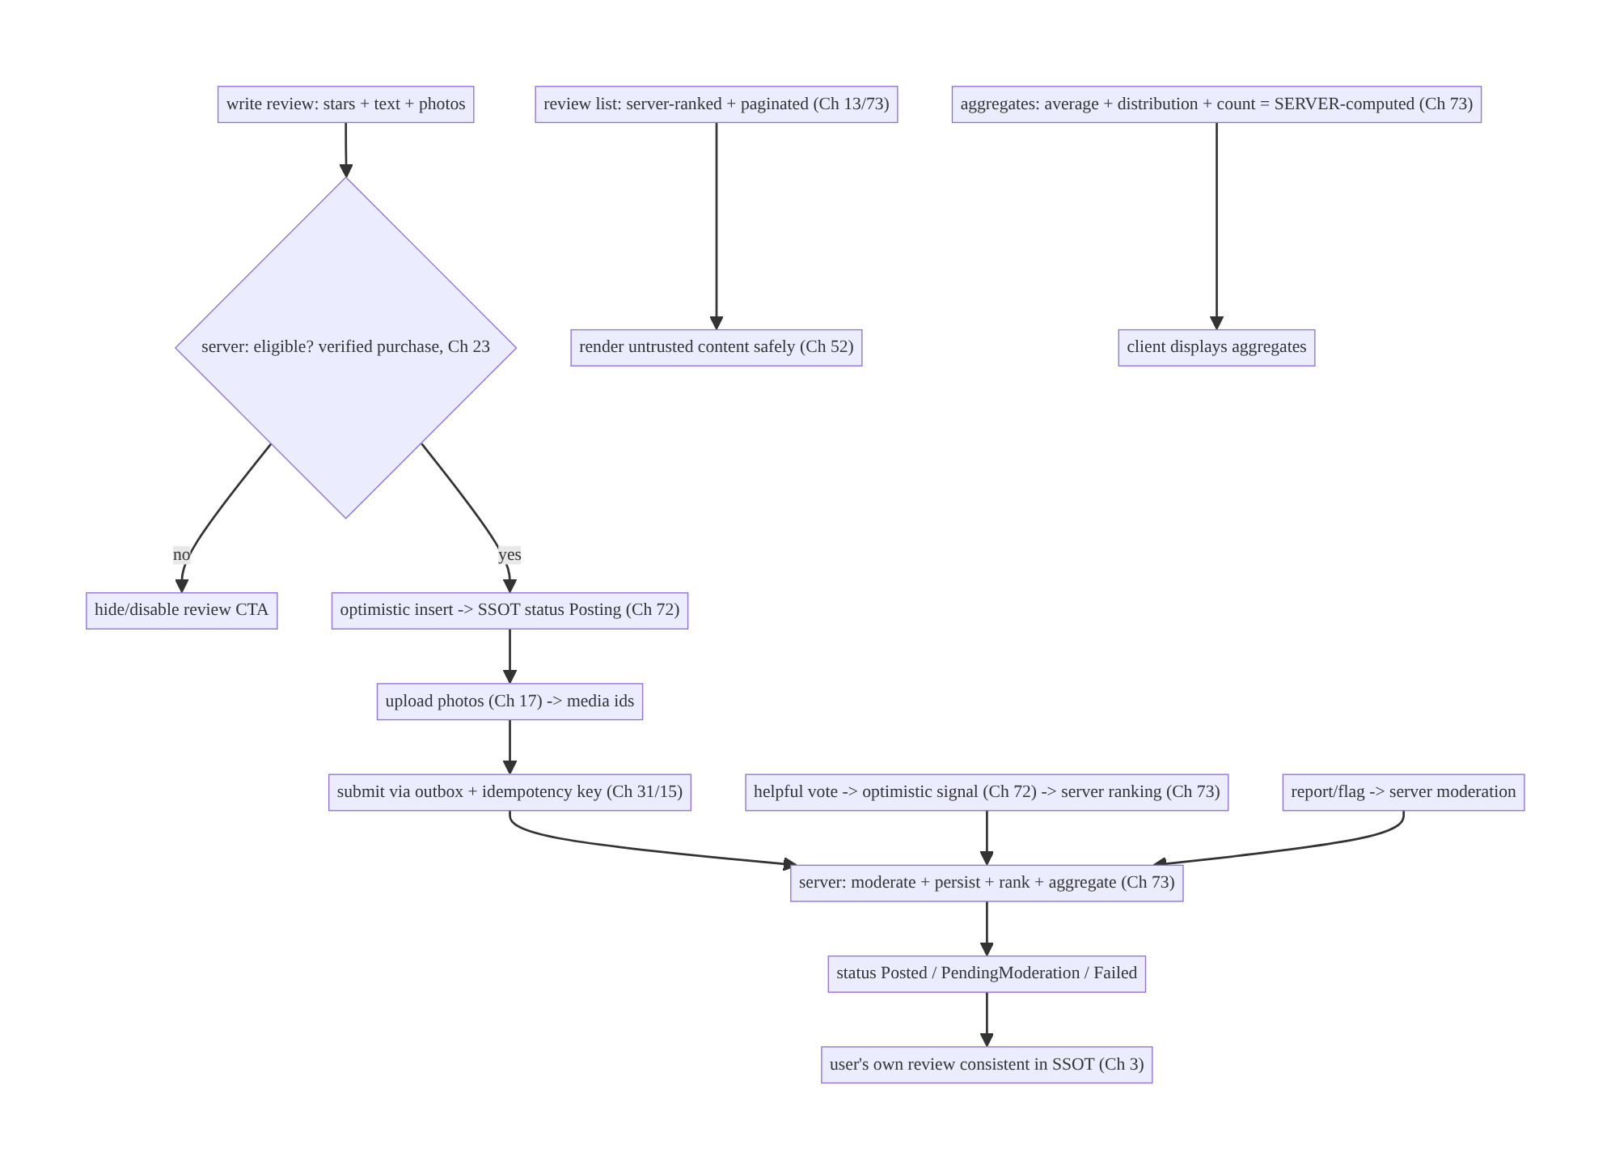
79.4 High-Level Architecture
Components & ownership
- Submit: eligibility (server) → optimistic SSOT insert → photo upload → outbox (idempotent) → server moderates/persists/ranks/aggregates.
- Display: server-ranked paginated list + server-computed aggregates; untrusted content rendered safely.
- Server owns ranking, aggregates, moderation, eligibility; client submits/displays/ signals; user’s own review consistent in the SSOT.
Direction: write → eligibility → optimistic + upload + outbox(idempotent) → server (moderate/rank/aggregate) → status/SSOT; display server-ranked list + server aggregates safely.

79.5 Detailed Component Design
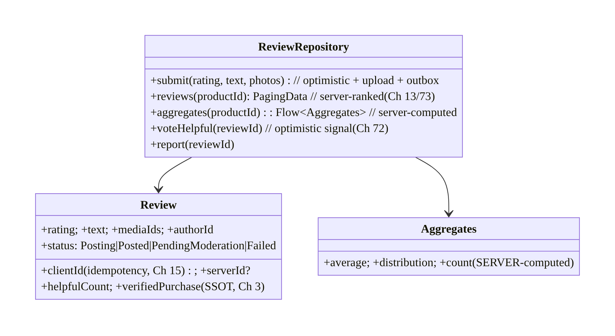
79.5 Detailed Component Design
Component | Responsibility
Review | SSOT row: client/server id + rating/text/media + status + helpful + verified (Ch 3)
ReviewRepository | submit (optimistic+upload+outbox), ranked list, aggregates, vote, report
Aggregates | server-computed average/distribution/count (client displays)

79.6 End-to-End Data Flow

Submit a review (optimistic + upload + idempotent)
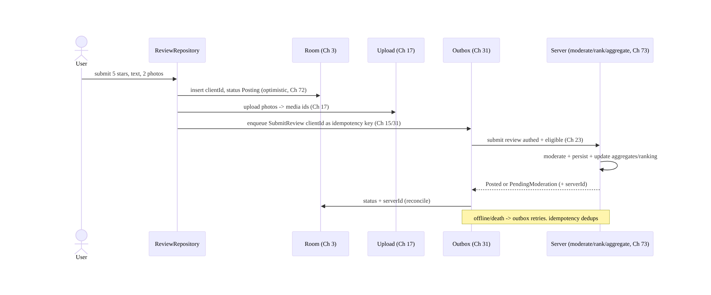
Submit a review (optimistic + upload + idempotent)

Display: server-ranked list + server aggregates
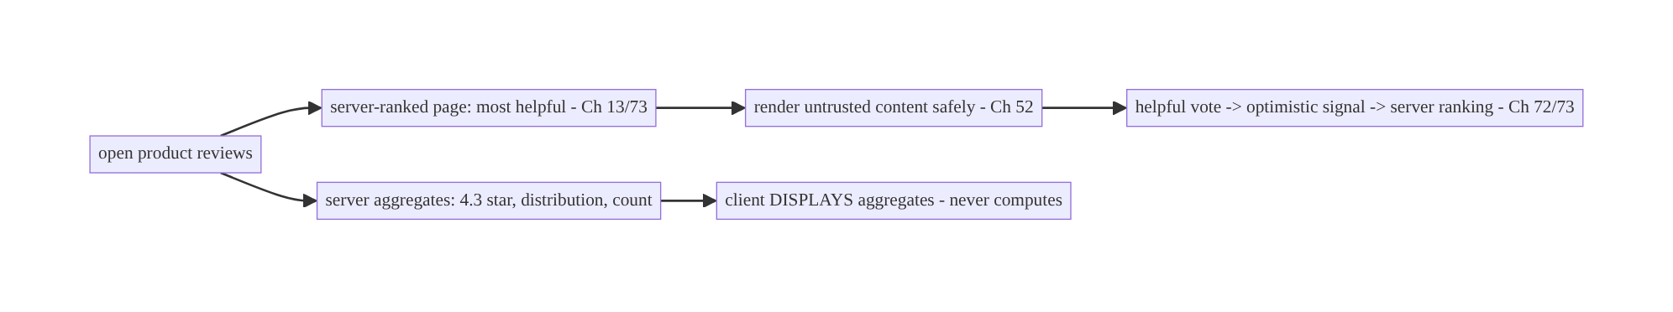
Display: server-ranked list + server aggregates

79.7 Complete Kotlin Implementation
Package: com.streamcart.reviews.

79.7.1 Review SSOT (client/server id + status, Ch 3/15)
@Entity(tableName = "reviews")
data class Review(
@PrimaryKey val clientId: String, // idempotency key + optimistic match (Ch 15/64)
val serverId: String?, val productId: String, val authorId: String,
val rating: Int, val text: String, val mediaIds: List<String>,
val status: Status, val helpfulCount: Int, val verifiedPurchase: Boolean, val createdAt: Long,
) { enum class Status { Posting, Posted, PendingModeration, Failed } }

79.7.2 Submit: optimistic + upload + outbox (idempotent, Ch 72/17/31/15)
@Singleton
class ReviewRepository @Inject constructor(
private val dao: ReviewDao, private val uploader: MediaUploader, // Ch 17
private val outbox: Outbox, private val session: SessionManager, // Ch 31/19
) {
suspend fun submit(productId: String, rating: Int, text: String, photos: List<Uri>) {
val clientId = UUID.randomUUID().toString()
dao.upsert(Review(clientId, serverId = null, productId, session.userId, rating, text,
mediaIds = emptyList(), status = Status.Posting, helpfulCount = 0,
verifiedPurchase = false, createdAt = System.currentTimeMillis())) // optimistic (Ch 72)
val mediaIds = photos.map { uploader.upload(it) } // reliable upload + progress (Ch 17)
dao.setMedia(clientId, mediaIds)
outbox.enqueue(OutboxOp.SubmitReview(clientId, productId, rating, text, mediaIds)) // idempotent (Ch 15/31)
}
suspend fun sync(op: OutboxOp.SubmitReview): OutboxResult = runCatching {
val result = api.submitReview(op.clientId, op.productId, op.rating, op.text, op.mediaIds) // authed + eligible (Ch 23)
dao.confirm(op.clientId, serverId = result.id, status = result.statusForClient()) // Posted / PendingModeration
OutboxResult.Done
}.getOrElse { e ->
if (e.isTransient()) OutboxResult.Retry // offline/5xx -> retry (Ch 2/29)
else { dao.setStatus(op.clientId, Status.Failed); OutboxResult.Failed(e) } // genuine -> Failed + retry UX (Ch 72)
}
}

79.7.3 Server-ranked, paginated list (Ch 13/73) + safe rendering (Ch 52)
fun ReviewRepository.reviews(productId: String, sort: ReviewSort): Flow<PagingData<Review>> =
Pager(PagingConfig(pageSize = 20), remoteMediator = ReviewRemoteMediator(productId, sort, api, db)) {
db.reviews().pagingSource(productId) // server-RANKED order (Ch 73); client renders (Ch 13/71)
}.flow
// RemoteMediator fetches server-ranked pages (sort = Helpful/Recent/Critical) -> Room. Client does NOT rank.
@Composable
fun ReviewText(text: String) {
Text(sanitizeUgc(text)) // UNTRUSTED content -> sanitize (Ch 52); safe links; no injection
}

79.7.4 Aggregates: server-computed, client displays (Ch 73)
data class Aggregates(val average: Double, val distribution: Map<Int, Int>, val count: Int) // SERVER-computed
fun ReviewRepository.aggregates(productId: String): Flow<Aggregates> =
db.aggregates().observe(productId) // client DISPLAYS server aggregates (Ch 3)
// Refreshed from the server (api.reviewAggregates(productId)); NEVER computed client-side (needs all reviews).
@Composable
fun RatingSummary(agg: Aggregates) {
Text("${agg.average} ★ (${agg.count})") // display server values
agg.distribution.forEach { (stars, n) -> StarBar(stars, n) }
}

79.7.5 Helpful vote (optimistic signal) + report (Ch 72/73)
suspend fun ReviewRepository.voteHelpful(reviewId: String) {
dao.incrementHelpfulOptimistic(reviewId) // optimistic (Ch 72) -> instant
outbox.enqueue(OutboxOp.HelpfulVote(reviewId, idempotencyKey = "$reviewId:helpful")) // idempotent (Ch 15); server ranking signal (Ch 73)
}
suspend fun ReviewRepository.report(reviewId: String, reason: String) =
api.reportReview(reviewId, reason) // -> server moderation

79.7.6 Eligibility (server-enforced, Ch 23)
// Client shows/hides the CTA from a server flag; the SERVER authorizes the submit (verified purchase).
fun ReviewRepository.canReview(productId: String): Flow<Boolean> = db.eligibility().observe(productId)
// Server checks order history -> eligible; a client can't bypass (submit is authorized server-side, Ch 23).

79.7.6 Module structure
:feature:reviews Review/Dao, ReviewRepository (submit/list/aggregates/vote/report), ReviewRemoteMediator
:core:upload MediaUploader (Ch 17); :core:outbox (Ch 31); :core:data SSOT (Ch 3)
# Server: ranking + aggregates + moderation + eligibility (Ch 73/23). Optimistic -> Ch 72; paging -> Ch 13; sanitize -> Ch 52.

79.8 Concurrency and Race Conditions
Scenario | Risk | Handling
Submit offline/double-tap | lost/double review | outbox + idempotency key (Ch 31/15)
Client computes average | wrong aggregate | server-computed; client displays (Ch 73)
Client ranks reviews | wrong order | server-ranked; client renders (Ch 73)
Edit own review | inconsistent | SSOT one row + idempotent edit (Ch 3/15)
Helpful double-vote | inflated | idempotent vote (Ch 15)
Untrusted content | injection | sanitize render (Ch 52)
Pending moderation shown to others | policy | server gates visibility; author sees own
- Server owns aggregates and ranking (Ch 73): the client cannot correctly compute an average over all reviews or rank by helpfulness — it displays server values and renders the server order, logging helpful votes as signals. Client-side math/ranking is wrong and drifts.
- Reliable optimistic submit (Ch 72/31/15/17): optimistic insert + photo upload + outbox with an idempotency key make submit offline/death-safe and dedup double-taps (same as comments, Ch 64).
- UGC untrusted (Ch 52): sanitize all rendered review text/links; moderation gates visibility server-side (author sees their own pending review; others don’t).

79.9 Failure Scenarios and Recovery
Failure | Detection | Response | Outcome
Review lost offline/on death | missing | outbox persisted + retry (Ch 31/29) | not lost
Double-post on retry | duplicate | idempotency key (Ch 15) | single
Wrong average | mismatch | server-computed aggregates (Ch 73) | correct
Wrong review order | UX | server-ranked (Ch 73) | correct
Abusive/spam review | report/moderation | server moderation + report/flag (Ch 23) | handled
Injection via content | security | sanitize render (Ch 52) | safe
Ineligible submit | server reject | server-enforced eligibility (Ch 23) | blocked
Photo upload fails | incomplete review | resumable upload + retry (Ch 17) | completes
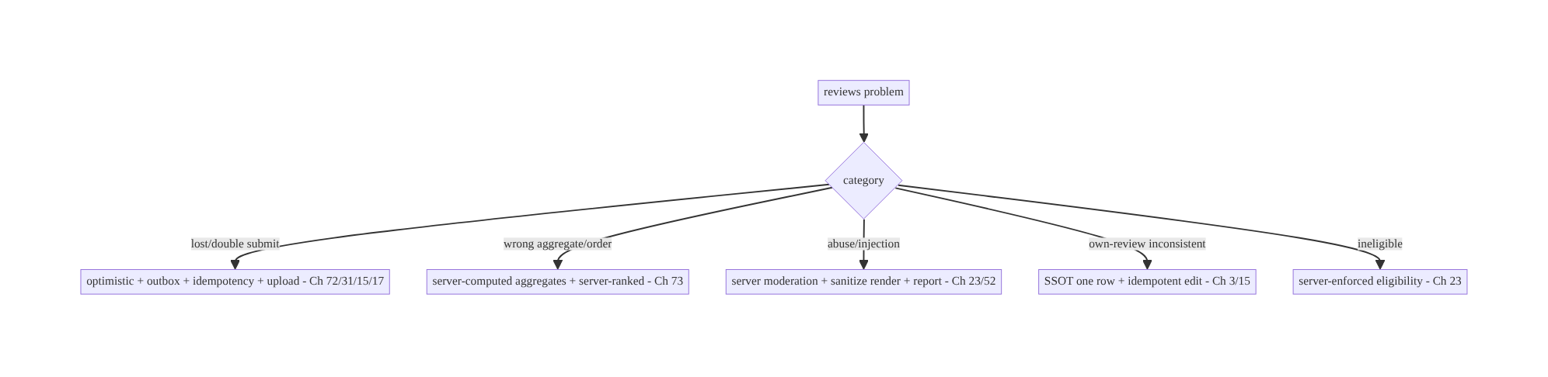
79.9 Failure Scenarios and Recovery
Reviews = reliable optimistic UGC submit + server-owned aggregates/ranking/moderation. The client submits (optimistic + upload + outbox + idempotency), displays (server aggregates, server-ranked list, safely rendered), and signals (helpful votes) — the server ranks, aggregates, moderates, and authorizes. Client-computed averages/rankings and unreliable submits are the recurring bugs.

79.10 Scaling the Implementation
- Level 1. Submit (optimistic + outbox + idempotency, Ch 72/31/15); display server- ranked paginated list (Ch 13/73) + server aggregates.
- Level 2. Photo upload (Ch 17); helpful votes (optimistic signals, Ch 72/73); sanitize rendering (Ch 52); user’s own review consistency (edit/delete, Ch 3).
- Level 3 — production. Server moderation + pending state; report/flag; verified- purchase eligibility (Ch 23); media moderation.
- Level 4 — large. Rich sorting/filtering (server-ranked), review search, author profiles, “was this helpful” ML signals (Ch 73), translation, incentivized-review controls.
- Level 5 — enterprise. Moderation pipeline governance, abuse/fraud detection (fake reviews), review analytics, aggregate-consistency SLOs, regulatory (disclosure).
Avoid overengineering: reliable submit + server aggregates/ranking + moderation + safe rendering is the core. Don’t compute aggregates or rank on the client; don’t fire-and-forget submits.

79.11 Alternative Approaches and Trade-offs
Dimension | Option A | Option B | When
Submit | Optimistic + outbox + idempotent (Ch 72/31/15) | POST-and-wait | Optimistic+outbox (offline/instant/no-dup)
Aggregates | Server-computed (Ch 73) | client-computed | Server (needs all reviews; client drifts)
Ranking | Server-ranked (Ch 73) | client-sorted | Server (helpfulness/verified signals)
Content | Sanitize + server-moderate (Ch 52/23) | trust UGC | Moderate+sanitize (untrusted)
Eligibility | Server-enforced (verified purchase) | client-only check | Server (bypassable client)
Own review | SSOT one row (Ch 3) | per-screen | SSOT (consistent edit/status)
Helpful vote | Optimistic signal (Ch 72/73) | wait-for-server | Optimistic (instant) + server signal
Server-computed aggregates vs client-computed: the average rating and distribution span all reviews, which the client doesn’t have — computing them client-side is wrong and drifts as new reviews arrive. The server computes aggregates (over the full set); the client displays them (a single optimistic review barely moves a large average, so show the server value). Never compute review aggregates on the client.
Server-ranked vs client-sorted reviews: review ordering (“most helpful”, “verified”, “recent”) depends on global signals (helpfulness votes across users, verified-purchase, recency) the client lacks — like recommendations (Ch 73), the server ranks and the client renders + logs signals (helpful votes). Client sorting by local data gives a poor, inconsistent order.
Optimistic+outbox vs POST-and-wait submit: a POST-and-wait submit shows a spinner, loses the review offline, and risks double-post on retry. Optimistic insert + outbox + idempotency (Ch 72/31/15) makes submit feel instant, work offline, survive death, and never double-post — the same reliable-create pattern as comments (Ch 64).

79.12 Security & Privacy Considerations
- UGC is untrusted (Ch 52/23): sanitize review text/links on render (no injection, safe links); validate/limit media (Ch 17); never auto-execute content.
- Server-side moderation (Ch 23): reviews pass server moderation (spam/abuse/profanity/ policy) — the client can’t be the moderation authority; hold pending reviews from public view until approved (author sees their own).
- Eligibility + authorization (Ch 23): the server enforces who can review (verified purchase) and authorizes submit/edit/delete — a client flag only shows/hides the CTA; the server is the gate.
- Report/flag → moderation: provide reporting; route to server-side moderation; handle abuse/retaliation.
- Author identity/privacy (Ch 28): show the author per policy (name/handle/anonymous); don’t leak PII; the user’s own review is editable/deletable.
- Fake-review/abuse detection (server): velocity, device, and pattern checks are server-side; the client can’t prevent fake reviews.
- Per-account (Ch 42): the user’s own review state is per-account.
- Client vs backend: the server moderates, ranks, aggregates, enforces eligibility, and detects abuse; the client submits reliably, renders untrusted content safely, displays server aggregates/order, and logs signals.

79.13 Performance and Resource Optimization
- Page the review list (Ch 13/71) — never load all; server-ranked pages.
- Display server aggregates (cheap) — no client computation over large sets.
- Reliable media upload (Ch 17) — resumable, progress, right-sized images (Ch 56/57).
- Optimistic submit/vote — instant UX; reconcile in background.
- Sanitize efficiently — cache sanitized content where safe.
- Right-sized review photos (Ch 56/57) in the list.
- Profiling: submit success/latency, upload success, list render/jank (Ch 71), aggregate freshness, moderation hold rate.

79.14 Testing Strategy
Submit reliability, server-owned aggregates/ranking, and safe rendering are testable.
class ReviewSubmitTest {
@Test fun `submit is optimistic, uploads media, enqueues idempotent op`() = runTest {
repo.submit("p1", 5, "great", listOf(uri))
assertEquals(Status.Posting, dao.last().status) // optimistic (Ch 72)
assertTrue(uploader.uploaded.isNotEmpty()) // media (Ch 17)
assertEquals(dao.last().clientId, outbox.last().idempotencyKey) // idempotent (Ch 15)
}
@Test fun `offline submit retries, no double-post`() = runTest { /* outbox retry; dedup (Ch 31/15) */ }
@Test fun `genuine failure -> Failed with retry`() = runTest { /* 4xx -> Failed (Ch 72) */ }
}
class ReviewDisplayTest {
@Test fun `aggregates come from server, not computed`() = runTest {
api.aggregates = Aggregates(4.3, mapOf(5 to 100), 123)
assertEquals(4.3, repo.aggregates("p1").first().average, 0.0) // displayed, not computed (Ch 73)
}
@Test fun `list renders server order`() = runTest { /* server-ranked preserved (Ch 73) */ }
@Test fun `review text is sanitized`() { assertFalse(sanitizeUgc("<script>").contains("<script>")) } // Ch 52
}
What to test: submit optimistic + upload + idempotent outbox + offline retry (no double-post)
- genuine-failure Failed; aggregates displayed from server (not computed); list renders server order; untrusted content sanitized (Ch 52); helpful vote optimistic + idempotent; eligibility gate (server). Fake API/uploader/outbox; Room in-memory.

79.15 Production Observability
- Metrics: submit success/latency + offline-queued; double-post rate (→ 0); media upload success; list render/jank (Ch 71); aggregate freshness; moderation hold/approval rate; report rate; helpful-vote reconcile; eligibility gate accuracy.
- Logs: review{action, status, productId} — no PII/content (Ch 28).
- Debugging: lost/double submit → outbox/idempotency (Ch 31/15); wrong average → client computing (server-compute, Ch 73); wrong order → client ranking; injection → not sanitizing (Ch 52); abusive content → moderation; ineligible submit allowed → server not enforcing (Ch 23).
- Alerting: double-post spike; moderation-queue backlog; abuse/report spike.
- Dashboards: submit funnel + success; moderation rates; aggregate freshness.

79.16 System Design Interview Preparation
≥25 questions.
Fundamentals
- Review submit? Optimistic SSOT insert + photo upload + outbox with idempotency key (Ch 72/17/31/15).
- Offline submit? Outbox persists + retries; no double-post (Ch 31/15).
- Status model? Posting → Posted/PendingModeration/Failed.
- Who computes aggregates? The server (average/distribution/count) — client displays (Ch 73).
- Why not client aggregates? Needs all reviews; client drifts.
Display/ranking
- Review list? Server-ranked, paginated (Ch 13/73); client renders + logs signals.
- Who ranks? The server (helpfulness/verified/recency).
- Helpful vote? Optimistic signal (Ch 72) feeding server ranking (Ch 73).
- Sort options? Server-ranked variants (helpful/recent/critical).
UGC safety
- Content trust? Untrusted — sanitize render (Ch 52).
- Moderation? Server-side; pending reviews gated from public view.
- Report/flag? To server moderation.
- Author sees pending? Yes (own); others don’t until approved.
Eligibility/consistency
- Who can review? Server-enforced (verified purchase, Ch 23).
- Client flag? Shows/hides CTA; server authorizes submit.
- Own review consistency? SSOT one row + idempotent edit/delete (Ch 3/15).
Media
- Review photos? Reliable upload (Ch 17); server media moderation.
- Verified-purchase badge? Server-provided.
Security
- Fake reviews? Server-side abuse detection.
- Injection? Sanitize (Ch 52).
- Author privacy? Per policy (Ch 28).
Testing/Production
- Test submit? Optimistic + upload + idempotent + offline retry.
- Test aggregates? Displayed from server (not computed).
- Lost/double submit? Outbox/idempotency.
- Wrong average? Client computing.
- Abuse? Moderation + report.

Design-change challenges
- Submit a review with photos offline. Optimistic + upload + outbox + idempotency (Ch 72/17/31/15).
- Show average rating + distribution. Server-computed aggregates; client displays (Ch 73).
- Order reviews by “most helpful”. Server-ranked + helpful-vote signals (Ch 73).
- Handle abusive reviews. Server moderation + report/flag + sanitize (Ch 23/52).
- Only purchasers can review. Server-enforced eligibility (Ch 23).

Mock walkthrough (abridged)
Clarify (text/photos/stars, who can review, moderation?) → submit: optimistic + upload + outbox + idempotency (Ch 72/17/31/15) → display: server-ranked paginated list + server aggregates (Ch 13/73) → moderation + safe rendering + report (Ch 23/52) → own-review consistency (SSOT, Ch 3) → eligibility (server, Ch 23) → helpful votes (optimistic signals, Ch 72/73) → observability (submit funnel, moderation).

79.17 Practical Exercises
- Beginner. Submit a star+text review optimistically via an outbox with an idempotency key; show Posting → Posted. Eval: offline-safe; no double-post.
- Intermediate. Add photo upload (Ch 17) and display a server-ranked, paginated review list with server-computed aggregates. Eval: media uploaded; server order + aggregates.
- Advanced. Add helpful votes (optimistic signals), report/flag, sanitized rendering, and pending-moderation state. Eval: votes instant + server signal; content safe; pending gated.
- Production debugging. Fix a wrong average (client-computed) and a double-posted review (no idempotency). Eval: server aggregates; single review.
- System design challenge. Enforce verified-purchase eligibility server-side and keep the user’s own review consistent (edit/delete). Eval: ineligible blocked; own review consistent.
(Solutions withheld unless requested.)

79.18 Chapter Summary & Reference Sheet
Key decisions: treat reviews as a user-generated-content feature that submits reliably (optimistic SSOT insert + reliable photo upload + outbox with a client-id idempotency key so it’s offline/death-safe and never double-posted, with Posting → Posted/PendingModeration/Failed status, Ch 72/31/15/17/64), displays a server-ranked, paginated review list (Ch 13/73) with server-computed aggregates (average/distribution/count — the client displays, never computes or ranks, Ch 73), moderates UGC server-side and renders untrusted content safely (sanitize, Ch 52) with report/flag, keeps the user’s own review consistent in the SSOT (idempotent edit/delete, Ch 3), enforces eligibility (verified purchase) server-side (Ch 23), and treats “helpful” votes as optimistic ranking signals (Ch 72/73). The division of labor: the server ranks/aggregates/moderates/authorizes/detects-abuse; the client submits, displays, renders safely, and signals.
Concepts: reliable optimistic UGC submit (optimistic + upload + outbox + idempotency), server-ranked paginated list + server-computed aggregates, server moderation + safe rendering + report, user’s own review consistency (SSOT), server-enforced eligibility, helpful votes as signals.
Common mistakes: fire-and-forget submit (lost offline, double-post); client-computed aggregates (wrong/drift); client-ranked reviews (wrong order); trusting/not sanitizing UGC (injection); no moderation/pending gating; client-only eligibility (bypassable); own review inconsistent (not SSOT); unreliable photo upload.
Checklist:
- ☐ submit optimistic + photo upload (Ch 17) + outbox + idempotency key (Ch 72/31/15)
- ☐ status Posting/Posted/PendingModeration/Failed
- ☐ server-ranked paginated list (Ch 13/73)
- ☐ server-computed aggregates (display only)
- ☐ sanitize untrusted content + server moderation + report (Ch 52/23)
- ☐ user’s own review consistent in SSOT (edit/delete, Ch 3/15)
- ☐ server-enforced eligibility (verified purchase, Ch 23)
- ☐ helpful votes optimistic + server signal (Ch 72/73)
- ☐ per-account (Ch 42)
- ☐ submit-funnel + moderation telemetry.
Key APIs: Review SSOT (Room @Entity/@Dao, client/server id, Ch 3), Outbox + idempotency key (Ch 31/15), MediaUploader (Ch 17), Paging 3 + RemoteMediator (server-ranked, Ch 13/73), server aggregates endpoint (display), optimistic vote (Ch 72), sanitizeUgc (Ch 52), eligibility flag (server, Ch 23).
References:
- Offline-first mutations: https://developer.android.com/topic/architecture/data-layer/offline-first
- (composes) Ch 72 Optimistic Updates, Ch 31 Outbox, Ch 15 Idempotency, Ch 17 Uploads, Ch 13 Paging, Ch 73 Recommendations/Ranking, Ch 3 SSOT, Ch 52 Deep Links/Sanitize, Ch 23 Security, Ch 64 Chat

Chapter 80 — Onboarding & Feature Discovery
Part IX — Feature Architectures · Complexity: Standard (≥25 interview questions)
Prerequisites: Ch 41 (remote config/experiments), Ch 4 (DataStore), Ch 51 (permissions), Ch 53 (navigation), Ch 14 (analytics), Ch 45 (startup), Ch 87 (A/B). Pairs with Ch 43 (personalization), Ch 73 (recommendations cold-start).
Reference surface in StreamCart: first-run onboarding (intro, sign-in/up, interest selection, permission priming) and ongoing feature discovery (tooltips, coach marks, “what’s new”, badges) — a server-/config-driven, experiment-friendly, state-tracked system that shows the right guidance once, respects the user, and measures completion.

80.1 Problem Definition and Real-World Context
Onboarding (the first-run experience) and feature discovery (ongoing in-context guidance) share one engineering problem: showing the right guidance, to the right user, at the right time, exactly once, and measuring it — without annoying users or hardcoding flows. A good system is config-/server-driven (change onboarding without an app release, Ch 41), experiment-friendly (A/B onboarding variants, Ch 87), state-tracked (don’t re-show completed steps — persisted across reinstall ideally), permission-priming-aware (explain before the system prompt, Ch 51), and measured (completion funnel, Ch 14).
Concretely, teams hit:
- Hardcoded onboarding. A flow baked into the app can’t change without a release and can’t be A/B tested — it should be remote-config-/server-driven (steps, copy, order, Ch 41/87).
- Re-showing completed guidance. A tooltip or intro that reappears after completion is the top annoyance. State must be tracked (per step/feature, persisted via DataStore Ch 4, ideally server-synced so it survives reinstall) so each is shown once.
- Permission priming done wrong. Firing the system permission prompt cold (Ch 51) tanks grant rates; onboarding should prime (explain value) before the in-context request — but not request at first launch for features not yet used.
- Blocking/over-long onboarding. A long mandatory flow before any value causes drop-off; onboarding should be skippable/progressive, show value fast, and defer optional steps.
- No measurement. Without a completion funnel (Ch 14), you can’t see where users drop or whether a variant wins (Ch 87).
- Feature discovery spam. Showing every tooltip at once overwhelms; discovery should be contextual, throttled, and dismissible, shown when the feature is relevant.
- Cold-start personalization. Interest selection in onboarding seeds personalization/ recommendations (Ch 43/73) for new users.
The architecture: drive onboarding and discovery from remote config/server (steps, copy, order, targeting — changeable without release, A/B-tested, Ch 41/87); track state per step/feature (persisted, DataStore Ch 4, ideally server-synced) so each shows once; prime permissions before the in-context request (Ch 51); keep onboarding skippable/ progressive (value fast, defer optional); measure a completion funnel (Ch 14); make feature discovery contextual, throttled, dismissible; and seed cold-start personalization (Ch 43/73). This chapter composes config-driven flows + state tracking + experiments + analytics for guidance.

Three practical use cases
- First-run onboarding (StreamCart). Remote-config-driven steps (intro → sign-up → interests → notification priming), skippable, A/B-tested (Ch 87), with a completion funnel (Ch 14); interests seed recommendations (Ch 73).
- Feature discovery. A coach mark for a new “Scan” feature shown once, in context, dismissible; “what’s new” after an update; a badge on an unexplored tab.
- Permission priming. Before requesting notifications (Ch 51), an onboarding screen explains the value; the system prompt follows — higher grant rate.

Why this is architectural
Onboarding/discovery is a config-driven, experiment-friendly, state-tracked, measured system composing remote config/experiments (Ch 41/87), persisted state (Ch 4), permission priming (Ch 51), navigation (Ch 53), analytics (Ch 14), and cold-start personalization (Ch 43/73). The decisions — server-driven flows, show-once state, priming, measurement — determine activation, retention, and the ability to iterate without releases.

80.2 Requirements Engineering

Functional requirements
ID | Requirement
F1 | Drive onboarding/discovery flows from remote config/server (steps/copy/order/targeting), A/B-testable (Ch 41/87).
F2 | Track per-step/feature state so each is shown exactly once; persist (ideally server-synced) (Ch 4).
F3 | Prime permissions before the in-context request (Ch 51).
F4 | Keep onboarding skippable/progressive; show value fast; defer optional steps.
F5 | Measure a completion funnel (per step, drop-off, variant) (Ch 14).
F6 | Feature discovery contextual, throttled, dismissible; seed cold-start personalization (Ch 43/73).

Non-functional requirements
Attribute | Policy
Iterability | Change flows without a release (remote-driven); A/B (Ch 41/87).
Respect | Show once; skippable; not spammy; dismissible.
Measurement | Completion funnel + variant outcomes (Ch 14/87).
Activation | Value fast; higher permission grant via priming.
Resilience | State persists (reinstall-safe if synced); startup-light (Ch 45).

Scope
- In scope: remote-config-/server-driven flows (steps/copy/order/targeting, Ch 41) + A/B (Ch 87), show-once state tracking (persisted, DataStore Ch 4, server-synced option), permission priming (Ch 51), skippable/progressive onboarding, completion-funnel analytics (Ch 14), feature discovery (contextual/throttled/dismissible coach marks/tooltips/what’s- new/badges), cold-start personalization seeding (Ch 43/73), startup impact (Ch 45).
- Out of scope: remote-config internals (Ch 41), DataStore internals (Ch 4), permission mechanics (Ch 51), navigation (Ch 53), analytics pipeline (Ch 14), experiment platform (Ch 87), recommendations (Ch 73).

Assumptions & constraints
- Remote config/experiments (Ch 41/87), DataStore (Ch 4), analytics (Ch 14). minSdk 24. Flows are server-/config-driven and A/B-tested; state is persisted (ideally server-synced for reinstall); onboarding must be light at startup (Ch 45).

80.3 System Design Fundamentals
- Config-/server-driven flows (not hardcoded, Ch 41/87). Onboarding steps and discovery prompts — their presence, order, copy, media, and targeting — come from remote config / a server endpoint (Ch 41), so you can change the flow without an app release and A/B test variants (Ch 87). The client renders a declarative flow definition (a list of steps/prompts) and handles each step type; it doesn’t bake the sequence into code. New steps/experiments ship via config.
- Show-once state tracking (the core UX correctness, Ch 4). Each onboarding step and each discovery prompt has a completion/seen flag, persisted (DataStore, Ch 4) so it’s never re-shown after completion/dismissal. Ideally the state is server-synced (tied to the account) so it survives reinstall / new device (Ch 32) — a user who onboarded shouldn’t re-onboard on a new phone. Track per step/feature (not a single “onboarded” bit) so individual discovery prompts and new steps are handled independently.
- Permission priming before the request (Ch 51). Firing a system permission prompt cold tanks grant rates; onboarding/discovery should prime — an app screen explaining the value (“Get notified when your order ships”) — before the in-context system request (Ch 51). Prime only for permissions the user will actually use soon; don’t request everything at first launch. The priming screen is a config-driven onboarding step; the actual request follows the Ch 51 flow.
- Skippable, progressive, value-fast. Onboarding should show value quickly and be skippable — a long mandatory flow before any value causes drop-off. Prefer progressive onboarding (teach features when first used, via discovery) over a big upfront flow; defer optional steps (interests, permissions) and let users skip. Keep the critical path (e.g., sign-in if required) short.
- Measure the completion funnel (Ch 14/87). Log each step shown/completed/skipped and drop-off through the analytics pipeline (Ch 14) so you can see where users fall out and which variant wins (Ch 87). Discovery prompts log shown/engaged/dismissed. Measurement is what makes onboarding iterable (config changes + A/B + funnel).
- Feature discovery: contextual, throttled, dismissible. Ongoing guidance (coach marks, tooltips, “what’s new”, badges) should appear in context (when the feature is relevant/visible), throttled (not many at once — a queue/priority so you don’t overwhelm), dismissible, and shown once (tracked, Ch 4). “What’s new” shows after an update (version-gated); badges mark unexplored features and clear on use.
- Cold-start personalization seeding (Ch 43/73). Onboarding often collects interests/ preferences that seed personalization (Ch 43) and recommendations cold-start (Ch 73) for a new user with no history — a direct input to those systems.
- Startup-light (Ch 45). Onboarding/discovery must not bloat cold start (Ch 45): fetch the flow config lazily/cached (Ch 41), decide what to show quickly, and don’t block the first frame.
Core insight: drive onboarding and feature discovery from remote config/server (steps, copy, order, targeting — changeable without release and A/B-tested, Ch 41/87) rendered from a declarative flow definition; track per-step/feature show-once state persisted in DataStore and ideally server-synced so nothing is re-shown and onboarding survives reinstall (Ch 4/32); prime permissions before the in-context request (Ch 51); keep onboarding skippable and progressive (value fast, teach features when first used, defer optional steps); measure a completion funnel through the analytics pipeline so flows are iterable and variants comparable (Ch 14/87); make discovery contextual, throttled, and dismissible; and seed cold-start personalization from collected interests (Ch 43/73) — all kept light at startup (Ch 45).

80.4 High-Level Architecture
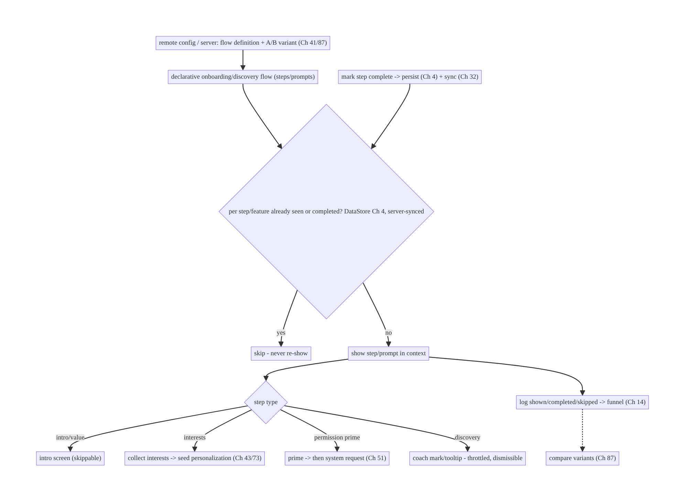
80.4 High-Level Architecture
Components & ownership
- Remote config/server defines the flow + variant (changeable without release, A/B); the client renders it.
- Show-once state (persisted, server-synced) gates each step/prompt; analytics logs the funnel.
- Step types: intro, interests (→ personalization), permission priming (→ Ch 51), discovery (throttled/dismissible).
Direction: config flow + variant → per-step show-once check → render in context → log funnel → mark complete (persist + sync); discovery contextual/throttled.

80.5 Detailed Component Design
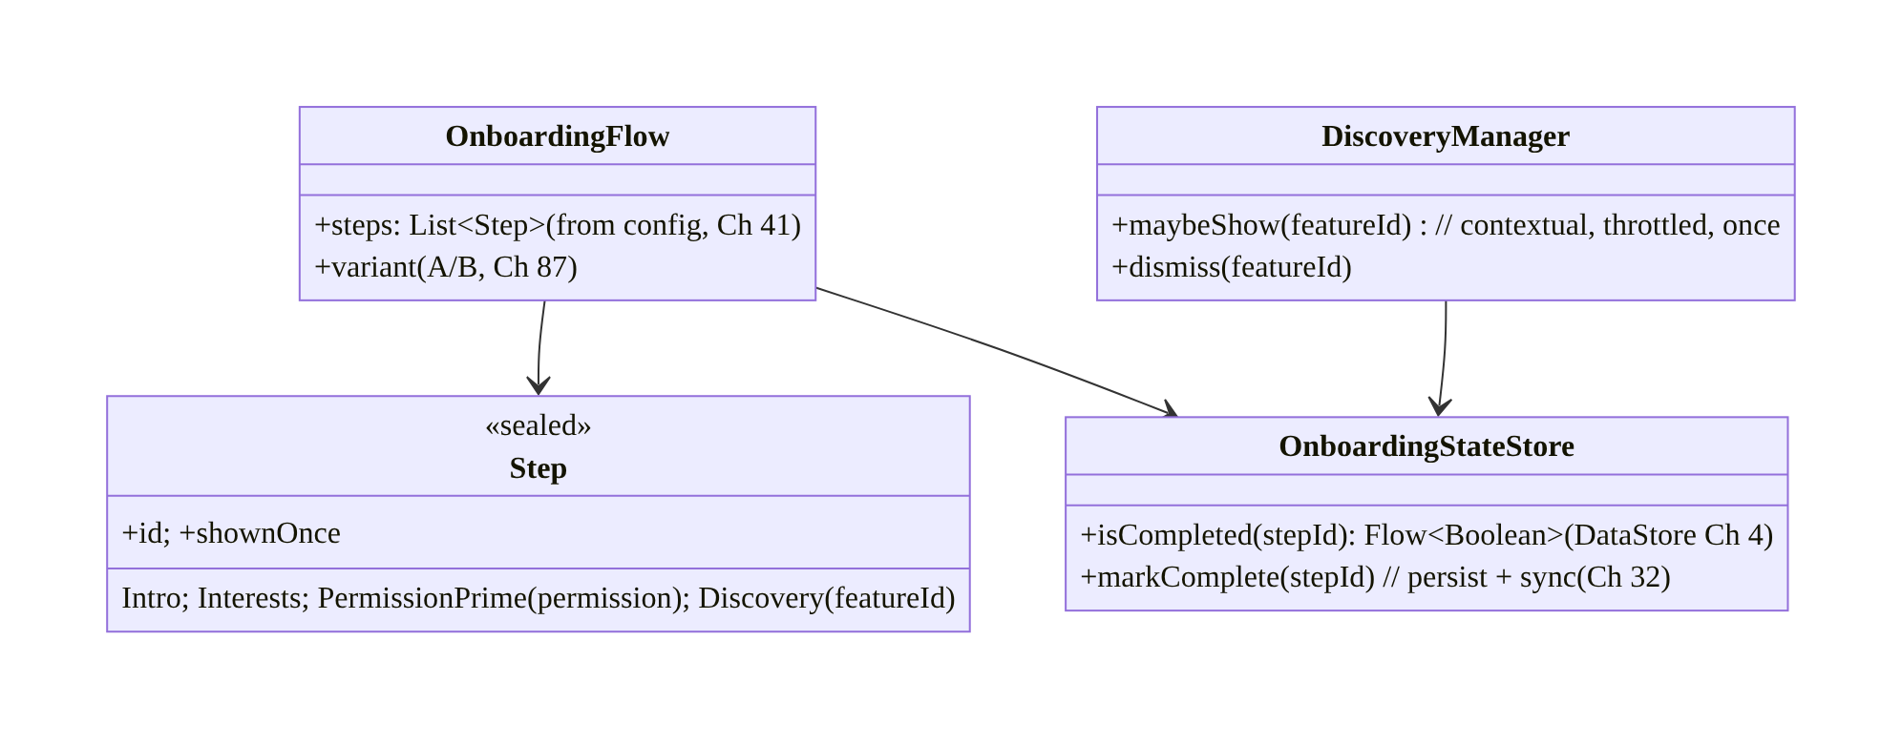
80.5 Detailed Component Design
Component | Responsibility
OnboardingFlow | declarative steps + A/B variant from config (Ch 41/87)
Step | typed step (intro/interests/permission-prime/discovery)
OnboardingStateStore | show-once state (DataStore + server sync, Ch 4/32)
DiscoveryManager | contextual, throttled, once-only discovery prompts

80.6 End-to-End Data Flow

First-run onboarding (config-driven, measured)
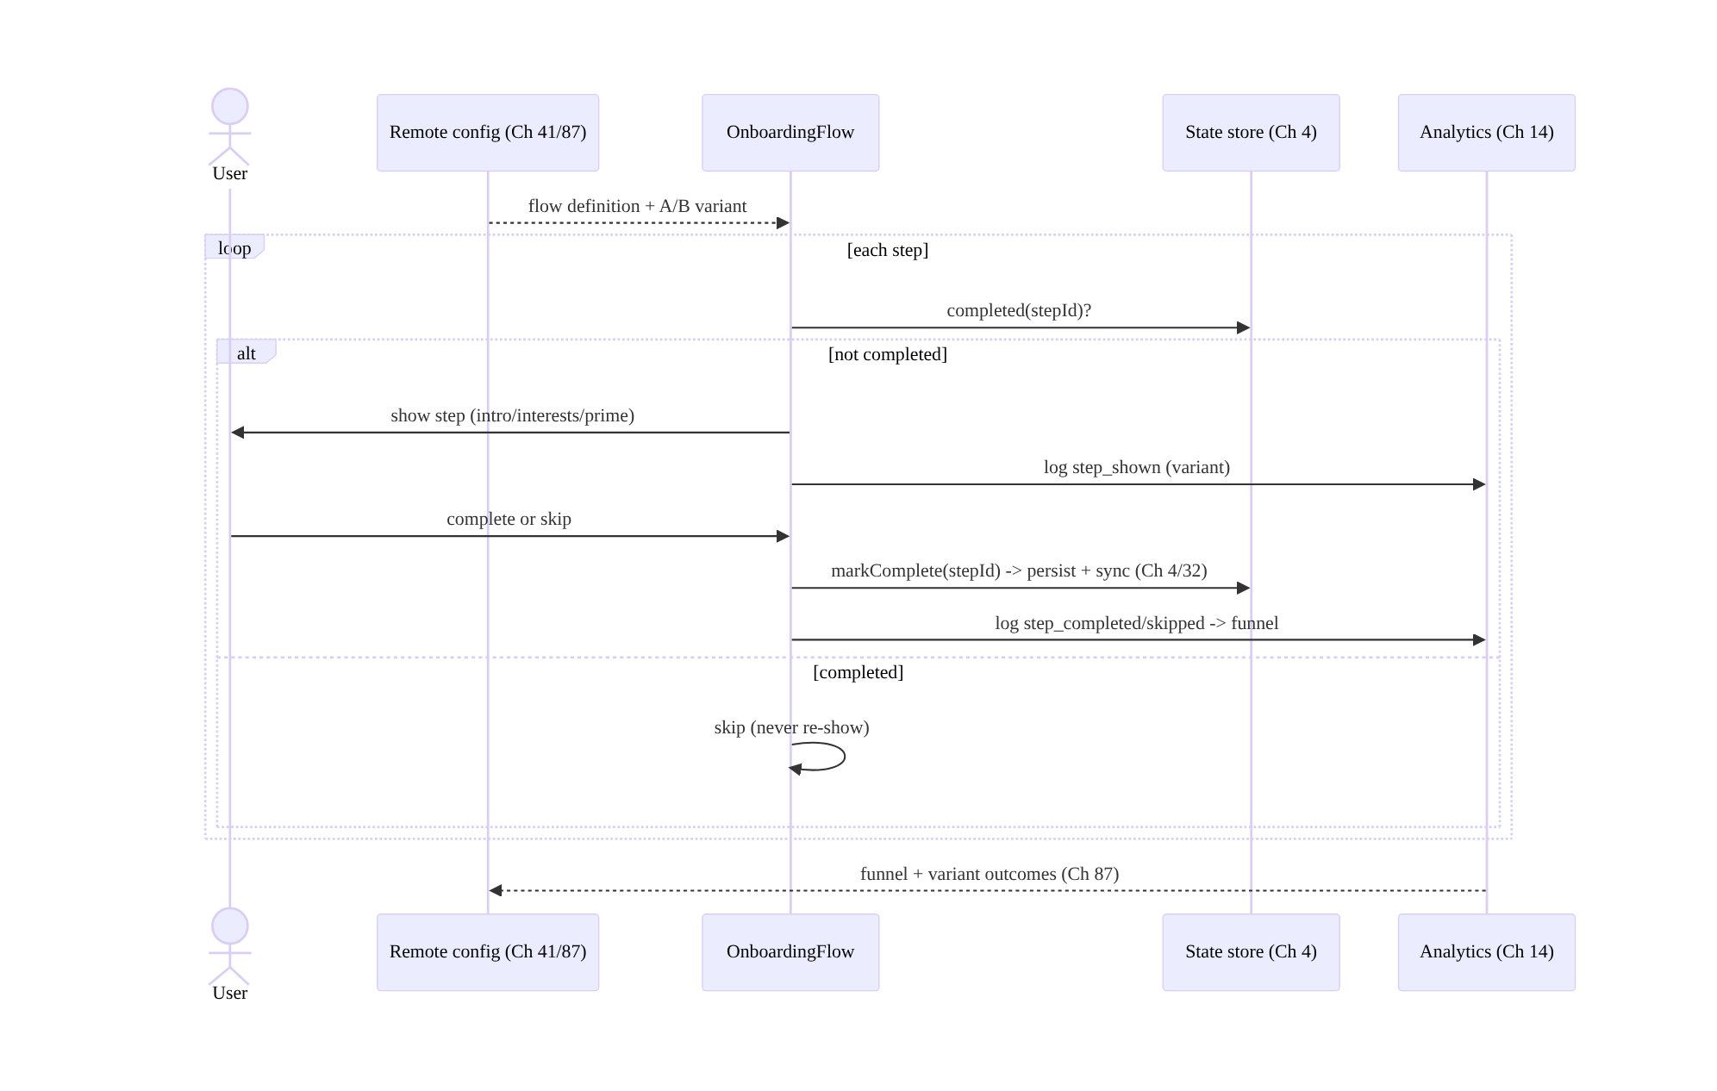
First-run onboarding (config-driven, measured)

Feature discovery (contextual, throttled, once)
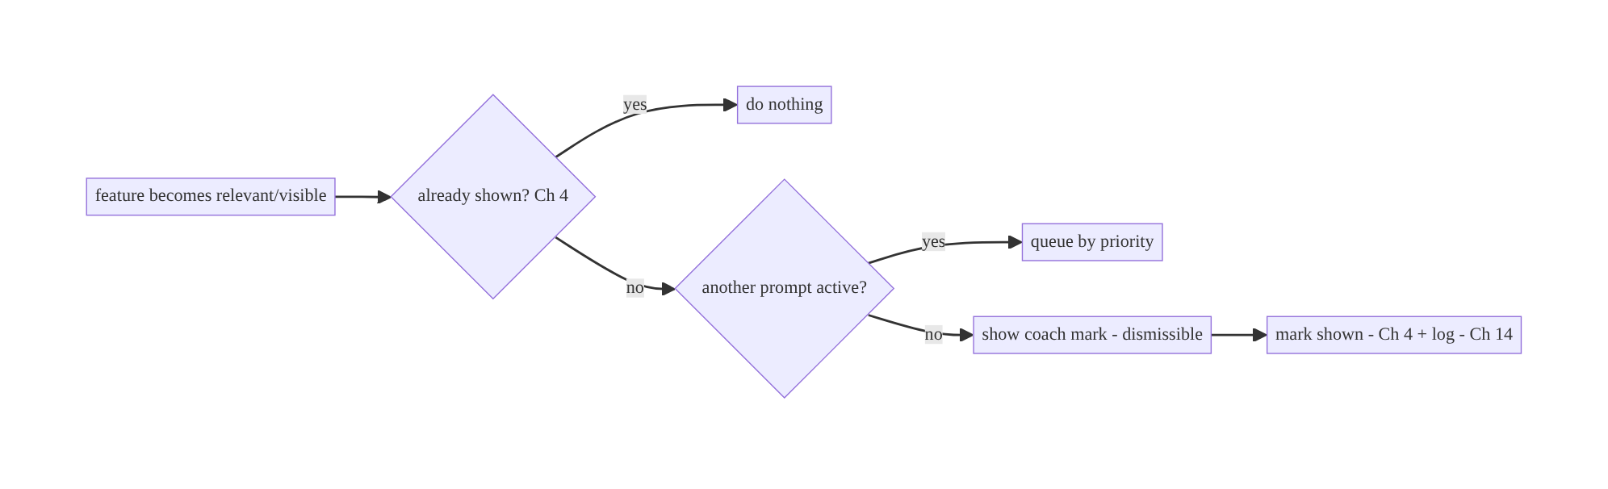
Feature discovery (contextual, throttled, once)

80.7 Complete Kotlin Implementation
Package: com.streamcart.onboarding.

80.7.1 Declarative flow from remote config (Ch 41/87)
sealed interface Step {
val id: String
data class Intro(override val id: String, val title: String, val body: String, val imageUrl: String) : Step
data class Interests(override val id: String, val options: List<String>) : Step // seeds personalization (Ch 43/73)
data class PermissionPrime(override val id: String, val permission: String, val rationale: String) : Step // Ch 51
data class Discovery(override val id: String, val featureId: String, val text: String) : Step
}
@Singleton
class OnboardingFlowProvider @Inject constructor(private val config: RemoteConfigRepository) { // Ch 41
/** Flow definition + copy + order + A/B variant come from config -> changeable without release (Ch 41/87). */
suspend fun flow(): List<Step> = config.onboardingFlow() // server/remote-config-driven
fun variant(): String = config.experiment("onboarding") // A/B (Ch 87)
}

80.7.2 Show-once state (DataStore + server sync, Ch 4/32)
@Singleton
class OnboardingStateStore @Inject constructor(
private val dataStore: DataStore<Preferences>, // Ch 4
private val sync: OnboardingSync, // server-sync so it survives reinstall (Ch 32)
) {
fun isCompleted(stepId: String): Flow<Boolean> =
dataStore.data.map { it[booleanPreferencesKey("ob_$stepId")] ?: false }
suspend fun markComplete(stepId: String) {
dataStore.edit { it[booleanPreferencesKey("ob_$stepId")] = true } // persist locally (Ch 4)
sync.push(stepId) // sync to account (reinstall-safe, Ch 32)
}
// On login/new device: pull server onboarding state so completed steps aren't re-shown.
suspend fun restore() = sync.pull().forEach { stepId -> dataStore.edit { it[booleanPreferencesKey("ob_$stepId")] = true } }
}

80.7.3 Onboarding host: render config flow, skip completed, measure (Ch 14)
@HiltViewModel
class OnboardingViewModel @Inject constructor(
private val flowProvider: OnboardingFlowProvider, private val state: OnboardingStateStore,
private val analytics: AnalyticsBatcher, // Ch 14
) : ViewModel() {
private val variant = flowProvider.variant()
val steps = flow { emit(flowProvider.flow().filterNot { state.isCompleted(it.id).first() }) } // skip completed
fun onStepShown(step: Step) = analytics.log("onboarding_step_shown", mapOf("id" to step.id, "variant" to variant))
fun onComplete(step: Step) = viewModelScope.launch {
state.markComplete(step.id) // persist + sync (never re-show, Ch 4/32)
analytics.log("onboarding_step_completed", mapOf("id" to step.id, "variant" to variant)) // funnel (Ch 14)
}
fun onSkip(step: Step) = analytics.log("onboarding_step_skipped", mapOf("id" to step.id))
}

80.7.4 Permission priming before the request (Ch 51)
@Composable
fun PermissionPrimeStep(step: Step.PermissionPrime, onDone: () -> Unit) {
// PRIME first (explain value), THEN the system request (Ch 51) -> higher grant rate.
val launcher = rememberLauncherForActivityResult(ActivityResultContracts.RequestPermission()) { onDone() }
Column {
Text(step.rationale) // value explanation (priming)
Button(onClick = { launcher.launch(step.permission) }) { Text("Enable") } // in-context request (Ch 51)
TextButton(onClick = onDone) { Text("Not now") } // skippable
}
// Do NOT fire the system prompt cold / at first launch for unused features (Ch 51).
}

80.7.5 Feature discovery: contextual, throttled, once (Ch 4/14)
@Singleton
class DiscoveryManager @Inject constructor(private val state: OnboardingStateStore, private val analytics: AnalyticsBatcher) {
private val activePrompt = MutableStateFlow<String?>(null) // throttle: one at a time
/** Show a coach mark ONCE, in context, only if nothing else is showing (throttled). */
suspend fun maybeShow(featureId: String): Boolean {
if (state.isCompleted("disc_$featureId").first()) return false // show once (Ch 4)
if (activePrompt.value != null) return false // throttle (don't overwhelm)
activePrompt.value = featureId
analytics.log("discovery_shown", mapOf("feature" to featureId)) // Ch 14
return true
}
suspend fun dismiss(featureId: String) {
state.markComplete("disc_$featureId"); activePrompt.value = null // never re-show
analytics.log("discovery_dismissed", mapOf("feature" to featureId))
}
}
// Interests step -> seed personalization: personalizationRepo.setInterests(selected) (Ch 43/73)

80.7.6 Module structure
:feature:onboarding OnboardingFlowProvider (config), OnboardingStateStore (DataStore+sync), OnboardingViewModel, step UI, DiscoveryManager
:core:config remote config/experiments (Ch 41/87); :core:analytics funnel (Ch 14)
# Permissions -> Ch 51; navigation -> Ch 53; personalization seeding -> Ch 43/73; startup-light -> Ch 45.

80.8 Concurrency and Race Conditions
Scenario | Risk | Handling
Re-show completed step/prompt | annoyance | persisted show-once state (Ch 4); check before show
Reinstall re-onboards | poor UX | server-synced state (Ch 32); restore on login
Multiple discovery prompts at once | overwhelm | throttle (one active); queue by priority
Permission prompt cold | low grants | prime first, then request (Ch 51)
Config fetch slow at startup | delayed/blank onboarding | cached config (Ch 41); startup-light (Ch 45)
Variant inconsistent | invalid A/B | pin variant per user (Ch 87)
Step completed but not logged | funnel gaps | log on complete; offline-queue analytics (Ch 14)
- Persisted + server-synced show-once state is the correctness crux: check completion before showing (DataStore, Ch 4), and sync it (Ch 32) so a reinstall/new device doesn’t re-onboard — tracking per step/feature, not one global bit.
- Throttle discovery (one prompt active, queue the rest) so the user isn’t overwhelmed; mark shown on dismiss (never re-show).
- Prime before the system request (Ch 51) and pin the A/B variant (Ch 87) for consistent experience + valid measurement.

80.9 Failure Scenarios and Recovery
Failure | Detection | Response | Outcome
Completed guidance reappears | user annoyance | persisted show-once check (Ch 4) | shown once
Reinstall re-onboards | user report | server-synced state (Ch 32) | preserved
Can’t change flow without release | slow iteration | remote-config-driven (Ch 41) | changeable
Low permission grants | analytics | prime before request (Ch 51) | higher grants
Onboarding drop-off | funnel (Ch 14) | shorten/skippable/progressive; A/B (Ch 87) | improved
Discovery spam | opt-out/complaints | throttle + dismissible (one at a time) | respectful
Slow/blank first run | startup trace (Ch 45) | cached config; startup-light | fast
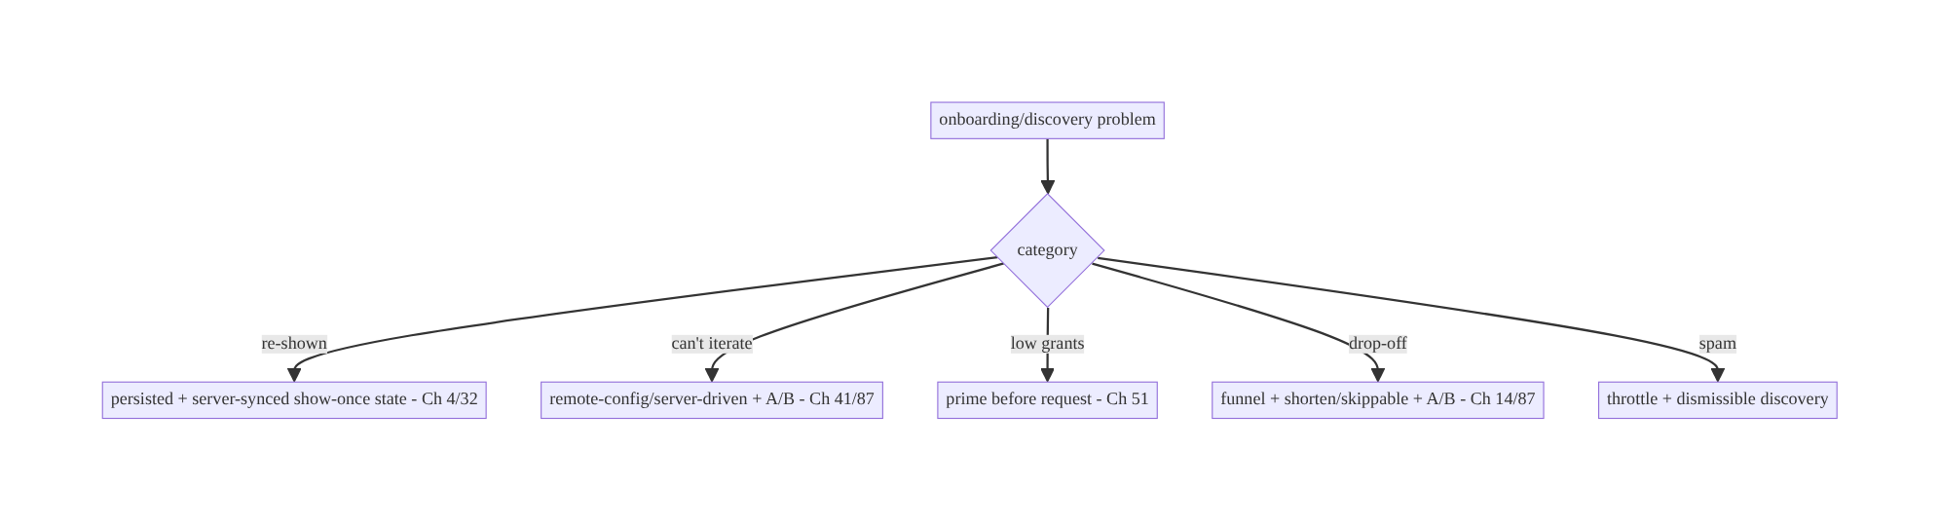
80.9 Failure Scenarios and Recovery
Onboarding/discovery is config-driven flows + show-once state + measurement. Drive it from remote config (change/A-B without release, Ch 41/87), track per-step/feature show-once state (persisted + server-synced so nothing re-shows and reinstall is safe, Ch 4/32), prime permissions (Ch 51), keep it skippable/progressive, throttle discovery, and measure the funnel (Ch 14) — so you can iterate to higher activation.

80.10 Scaling the Implementation
- Level 1. Config-driven onboarding steps; persisted show-once state (Ch 4); skippable.
- Level 2. Permission priming (Ch 51); completion-funnel analytics (Ch 14); interest seeding for personalization (Ch 43/73).
- Level 3 — production. A/B variants (Ch 41/87); server-synced state (reinstall-safe, Ch 32); throttled/dismissible feature discovery; “what’s new” (version-gated).
- Level 4 — large. Targeted onboarding (segment/locale/config), progressive onboarding (teach-on-use), discovery priority queue, re-engagement flows.
- Level 5 — enterprise. Onboarding experimentation platform (Ch 87), activation-funnel governance, personalization-driven onboarding (Ch 43), localization, accessibility.
Avoid overengineering: config-driven flow + show-once state + funnel + priming is the core. Don’t hardcode flows; don’t re-show completed guidance; don’t spam discovery.

80.11 Alternative Approaches and Trade-offs
Dimension | Option A | Option B | When
Flow source | Remote config/server (Ch 41) | hardcoded | Config-driven (iterate/A-B without release)
State | Persisted + server-synced (Ch 4/32) | in-memory / local-only | Persisted+synced (show-once, reinstall-safe)
Granularity | Per step/feature | single “onboarded” bit | Per step/feature (independent prompts/new steps)
Permissions | Prime then request (Ch 51) | cold system prompt | Prime (higher grants)
Length | Skippable/progressive | long mandatory | Skippable/progressive (less drop-off)
Discovery | Contextual/throttled/once | all tooltips at once | Contextual/throttled (not spammy)
Measurement | Funnel + A/B (Ch 14/87) | none | Always measure (iterate)
Config-driven vs hardcoded flows: a hardcoded onboarding can’t change without an app release and can’t be A/B tested, so you can’t iterate toward better activation. A remote-config/server-driven flow (steps, copy, order, targeting, Ch 41) lets you change it and experiment (Ch 87) without releases — the client renders a declarative flow definition. Always config-drive onboarding/discovery.
Per-step/feature state vs a single “onboarded” bit: a single flag can’t handle new onboarding steps (added via config) or individual discovery prompts — it either re-shows everything or nothing. Per-step/feature show-once state (persisted + synced, Ch 4/32) shows each exactly once, independently, and survives reinstall. Track granularly.
Prime-then-request vs cold permission prompt: firing the system permission dialog cold (Ch 51) yields reflexive denials and permanent denial. Priming (an app screen explaining the value) before the in-context request markedly improves grant rates. Onboarding is the natural place to prime notifications/location — but only for features the user will use soon.

80.12 Security & Privacy Considerations
- Permission priming is persuasion, not coercion (Ch 51/28): explain genuine value; respect “not now”; don’t dark-pattern users into permissions; prime only for permissions actually needed soon.
- Interest/preference data is personal (Ch 28): interests collected in onboarding feed personalization (Ch 43/73) — handle with consent, allow changing/clearing, don’t leak.
- Server-synced onboarding state (Ch 32/42): tie to the account (per-account, Ch 42); don’t expose one user’s onboarding/interests to another.
- Config as untrusted-ish (Ch 41/23): remote flow config drives UI — fetch over authed/ TLS config (Ch 41/23); don’t let config inject unsafe content (sanitize rendered copy/ links, Ch 52) or trigger unexpected actions.
- Analytics privacy (Ch 14/28): funnel events shouldn’t carry PII; respect consent.
- No sensitive data in onboarding logs (Ch 28).
- Client vs backend: the server/config defines flows, assigns experiments, and stores synced state + interests; the client renders safely, primes permissions respectfully, and logs the funnel — it doesn’t coerce or leak.

80.13 Performance and Resource Optimization
- Startup-light (Ch 45): cache the flow config (Ch 41); decide what to show quickly; don’t block the first frame on a config fetch.
- Lazy step content: load images/media per step (Ch 56), not all upfront.
- Cheap show-once checks: DataStore reads (Ch 4) are fast; gate before rendering.
- Throttled discovery: one prompt at a time avoids layout/animation overhead and overwhelm.
- Batch analytics (Ch 14): funnel events batched/offline-queued.
- Profiling: onboarding start impact on cold start (Ch 45), step render time, funnel completion, discovery engagement, config fetch latency.

80.14 Testing Strategy
Flow rendering, show-once state, priming, and funnel logging are testable.
class OnboardingStateTest {
@Test fun `completed step is not re-shown`() = runTest {
state.markComplete("intro")
assertTrue(state.isCompleted("intro").first()) // show-once (Ch 4)
}
@Test fun `server-synced state restored on new device`() = runTest {
sync.serverState = setOf("intro", "interests"); state.restore()
assertTrue(state.isCompleted("interests").first()) // reinstall-safe (Ch 32)
}
}
class OnboardingFlowTest {
@Test fun `renders config-driven steps and skips completed`() = runTest {
config.flow = listOf(Step.Intro("intro", ...), Step.Interests("interests", ...))
state.markComplete("intro")
assertEquals(listOf("interests"), vm.steps.first().map { it.id }) // config-driven + skip (Ch 41)
}
@Test fun `logs step funnel events`() = runTest { /* shown/completed/skipped (Ch 14) */ }
@Test fun `applies A-B variant`() = runTest { assertEquals("variantB", vm.variant) } // Ch 87
}
class DiscoveryTest {
@Test fun `shows once and throttles concurrent prompts`() = runTest { /* one active; second queued */ }
}
What to test: show-once state (persisted + restored from server); config-driven flow + skip-completed; A/B variant applied; funnel events logged (Ch 14); permission priming → request order (Ch 51); discovery once + throttled; interests seed personalization (Ch 43). Fake config/analytics/sync; DataStore test.

80.15 Production Observability
- Metrics: onboarding completion funnel (per step shown/completed/skipped, drop-off); variant outcomes (Ch 87); permission grant rate after priming (Ch 51); discovery shown/engaged/dismissed; time-to-value; reinstall re-onboard rate (→ 0 with sync); onboarding cold-start impact (Ch 45).
- Logs: onboarding{step, event, variant} / discovery{feature, event} — no PII (Ch 28).
- Debugging: re-shown guidance → state not persisted/checked (Ch 4); reinstall re-onboard → state not synced (Ch 32); low grants → no priming (Ch 51); high drop-off → too long/ mandatory (shorten, A/B); discovery spam → not throttled; slow first run → config fetch on critical path (Ch 45).
- Alerting: funnel-completion regression after a config change (Ch 41/87); grant-rate drop; discovery-dismiss spike.
- Dashboards: completion funnel by variant; grant rate; discovery engagement; time-to- value.

80.16 System Design Interview Preparation
≥25 questions.
Fundamentals
- Onboarding + discovery shared problem? Show the right guidance once, measured, iterably.
- Flow source? Remote config/server (Ch 41) — changeable without release, A/B (Ch 87).
- Why not hardcode? Can’t iterate/experiment without releases.
- Show-once state? Persisted per step/feature (DataStore, Ch 4), ideally server-synced (Ch 32).
- Why per-step not one bit? New steps + individual prompts handled independently.
State
- Persist where? DataStore (Ch 4).
- Reinstall-safe? Server-synced to the account (Ch 32).
- Check when? Before showing each step/prompt.
Permissions
- Priming? Explain value before the system request (Ch 51) → higher grants.
- Cold prompt? Bad — reflexive denial.
- Prime everything at launch? No — only soon-needed permissions.
UX
- Length? Skippable, progressive, value-fast.
- Progressive onboarding? Teach features when first used (discovery).
- Defer? Optional steps (interests, permissions).
Discovery
- Discovery prompts? Contextual, throttled, dismissible, once.
- Throttle? One active; queue by priority.
- “What’s new”? Version-gated after update.
- Badges? Mark unexplored; clear on use.
Measurement/experiments
- Funnel? Log step shown/completed/skipped + drop-off (Ch 14).
- A/B? Variant from config (Ch 87); pin per user; compare outcomes.
- Why measure? Iterate to activation.
Personalization
- Interests? Seed personalization/recommendations cold-start (Ch 43/73).
Security/startup
- Priming ethics? Persuade, not coerce (Ch 28).
- Startup impact? Startup-light; cache config (Ch 45/41).
Testing/Production
- Re-shown in prod? State not persisted/checked.
- Key metric? Completion funnel + grant rate.

Design-change challenges
- Change onboarding without a release. Remote-config-/server-driven flow (Ch 41).
- A tooltip keeps reappearing. Persisted per-feature show-once state (Ch 4).
- Reinstall re-onboards users. Server-synced state (Ch 32).
- Low notification opt-in. Prime before the request (Ch 51).
- A/B two onboarding flows. Config variant + funnel measurement (Ch 41/87/14).

Mock walkthrough (abridged)
Clarify (first-run vs discovery, A/B, reinstall-safe?) → remote-config/server-driven flow + variant (Ch 41/87) → per-step/feature show-once state (DataStore + server sync, Ch 4/32) → skippable/progressive, value-fast → permission priming before request (Ch 51) → completion- funnel analytics (Ch 14) → discovery contextual/throttled/dismissible → interests seed personalization (Ch 43/73) → startup-light (Ch 45) → observability (funnel, grants).

80.17 Practical Exercises
- Beginner. Render a remote-config-driven onboarding flow and skip steps the user has completed (persisted show-once state). Eval: config-driven; never re-shows completed.
- Intermediate. Add permission priming before the system request (Ch 51) and log a completion funnel (Ch 14). Eval: primes then requests; funnel events logged.
- Advanced. Server-sync onboarding state (reinstall-safe) and add throttled, once-only feature discovery coach marks. Eval: reinstall doesn’t re-onboard; discovery not spammy.
- Production debugging. Fix a reappearing tooltip (state not persisted) and a cold permission prompt (add priming). Eval: shown once; higher grants.
- System design challenge. A/B two onboarding variants (config, Ch 87) with a funnel dashboard and interest-seeded personalization (Ch 43/73). Eval: variant comparison; personalization seeded.
(Solutions withheld unless requested.)

80.18 Chapter Summary & Reference Sheet
Key decisions: drive onboarding and feature discovery from remote config/server — steps, copy, order, targeting, rendered from a declarative flow definition — so you can change flows without an app release and A/B test variants (Ch 41/87); track per-step/feature show-once state persisted in DataStore and ideally server-synced so nothing is re-shown and onboarding survives reinstall/new device (Ch 4/32); prime permissions before the in-context system request (Ch 51) and only for soon-needed ones; keep onboarding skippable and progressive (value fast, teach features when first used, defer optional steps); measure a completion funnel through the analytics pipeline so flows are iterable and variants comparable (Ch 14/87); make feature discovery contextual, throttled (one at a time), and dismissible; seed cold-start personalization from collected interests (Ch 43/73); and keep it light at cold start (cached config, Ch 45/41). Prime respectfully (persuade, not coerce) and treat interests/analytics as personal data (Ch 28).
Concepts: config-/server-driven declarative flows + A/B (Ch 41/87), per-step/feature show-once state (persisted + synced, Ch 4/32), permission priming (Ch 51), skippable/ progressive onboarding, completion-funnel measurement (Ch 14), contextual/throttled/ dismissible discovery, cold-start personalization seeding (Ch 43/73), startup-light (Ch 45).
Common mistakes: hardcoded flows (can’t iterate/A-B); single “onboarded” bit (re-shows or mishandles new steps); state not persisted/synced (re-shown, reinstall re-onboards); cold permission prompts (low grants); long mandatory onboarding (drop-off); discovery spam (all at once); no funnel measurement; blocking cold start on config.
Checklist:
- ☐ remote-config/server-driven flow + A/B variant (Ch 41/87)
- ☐ per-step/feature show-once state in DataStore (Ch 4), server-synced (Ch 32)
- ☐ check completion before showing
- ☐ prime permissions before request (Ch 51), only soon-needed
- ☐ skippable/progressive, value-fast
- ☐ completion-funnel analytics (Ch 14)
- ☐ discovery contextual/throttled/dismissible/once
- ☐ seed personalization from interests (Ch 43/73)
- ☐ startup-light (cached config, Ch 45/41)
- ☐ per-account + consent + sanitized config copy (Ch 42/28/52)
- ☐ funnel + grant-rate telemetry.
Key APIs: remote config/experiments (Ch 41/87), DataStore Preferences (show-once state, Ch 4), delta sync for state (Ch 32), ActivityResultContracts.RequestPermission after priming (Ch 51), analytics funnel events (Ch 14), Navigation (Ch 53), personalization seeding (Ch 43/ 73), AsyncImage for step media (Ch 56).
References:
- Remote config (flow-driven UI): Ch 41 + https://firebase.google.com/docs/remote-config
- Request permissions (priming): https://developer.android.com/training/permissions/requesting
- (composes) Ch 41 Remote Config, Ch 87 A/B & Experiments, Ch 4 DataStore, Ch 32 Sync, Ch 51 Permissions, Ch 14 Analytics, Ch 53 Navigation, Ch 43 Personalization, Ch 73 Recommendations, Ch 45 Startup

Chapter 81 — In-App Feedback & Diagnostics
Part IX — Feature Architectures · Complexity: Standard (≥25 interview questions)
Prerequisites: Ch 28 (PII redaction/privacy), Ch 17 (uploads), Ch 31 (outbox), Ch 83 (crash/ANR — forward ref), Ch 89 (logging), Ch 23 (security), Ch 3 (SSOT). Pairs with Ch 82 (analytics), Ch 41 (remote config).
Reference surface in StreamCart: the “Report a problem / Send feedback” flow and the diagnostic bundle it attaches — recent logs, device/app info, a screenshot, a breadcrumb trail — collected and uploaded with user consent and PII redaction so support/engineering can debug, and in-app surveys/ratings prompts done respectfully.
Note: this chapter completes Part IX — Feature Architectures (Ch 71–81).

81.1 Problem Definition and Real-World Context
When something goes wrong, users want to report it and engineers need enough context to debug — but collecting that context (logs, screenshots, device state) is a privacy and consent minefield. In-app feedback/diagnostics is the system that lets a user send feedback or a bug report with an attached diagnostic bundle (recent redacted logs, device/app metadata, optional screenshot, breadcrumbs), uploaded reliably and only with explicit consent and PII redaction (Ch 28). It also covers respectful in-app surveys and rating prompts (ask at the right time, not spammily). Done wrong, it leaks PII, nags users into bad store reviews, or gives support useless reports with no context.
Concretely, teams hit:
- Useless reports (no context). “App is broken” with no logs/device info is undebuggable. Attach a diagnostic bundle (recent logs, app/device info, breadcrumbs, optional screenshot) so engineers can reproduce.
- PII leakage in diagnostics (Ch 28). Logs/screenshots can contain PII (names, emails, tokens, messages, card data). Diagnostics must be redacted (Ch 28) and collected only with consent — a diagnostic upload is a privacy event.
- Consent missing. Silently uploading logs/screenshots is a trust and legal violation. The user must explicitly consent and ideally see/control what’s attached.
- Unreliable upload. A feedback submission (with a potentially large bundle) must be reliable (outbox + retry + resumable upload, Ch 31/17) so it isn’t lost offline.
- Rating-prompt spam / policy. Prompting for a Play rating at the wrong time (or with a custom dialog, violating policy) annoys users and backfires; use the in-app review API at a good moment, rate-limited.
- Survey fatigue. In-app surveys shown too often/at bad times hurt UX; they should be targeted, throttled, and dismissible (like discovery, Ch 80).
- Breadcrumbs & correlation. Linking a report to crash/analytics data (Ch 82/83) and a correlation id helps engineers find the session — without logging PII.
The architecture: a feedback/bug-report flow that assembles a diagnostic bundle (recent redacted logs, app/device info, breadcrumbs, optional screenshot) only with explicit consent, redacts PII (Ch 28), and uploads it reliably (outbox + resumable upload, Ch 31/17) with a correlation id linking to crash/analytics (Ch 82/83); plus respectful prompts — the Play in-app review API at a good, rate-limited moment, and targeted, throttled surveys. This chapter is about getting debuggable, privacy-safe feedback and asking for input respectfully.

Three practical use cases
- Report a problem (StreamCart). User taps “Report a problem” → consents to attaching diagnostics → a redacted bundle (logs, device info, screenshot, breadcrumbs) uploads reliably with a correlation id → support can debug.
- Shake-to-report (internal/beta). A shake gesture captures a screenshot + recent logs for a quick bug report (common in beta builds), consent-gated and redacted.
- In-app review prompt. After a positive moment (completed a few orders), show the Play in-app review prompt once, rate-limited — not a custom dialog, not after a crash.

Why this is architectural
Feedback/diagnostics is a privacy-critical collection + reliable upload + respectful prompting system composing PII redaction/privacy (Ch 28), reliable upload (Ch 31/17), logging/breadcrumbs (Ch 89), crash correlation (Ch 82/83), and consent. The decisions — consent-gated, redacted, reliable, correlated diagnostics + policy-compliant respectful prompts — determine debuggability, user trust, and legal compliance.

81.2 Requirements Engineering

Functional requirements
ID | Requirement
F1 | Let the user send feedback/bug reports with an attached diagnostic bundle.
F2 | Assemble a bundle (recent logs, app/device info, breadcrumbs, optional screenshot).
F3 | Collect only with explicit consent; redact PII; let the user see/control attachments (Ch 28).
F4 | Upload reliably (outbox + resumable upload) with a correlation id to crash/analytics (Ch 31/17/82/83).
F5 | Prompt for ratings via the Play in-app review API at a good, rate-limited moment.
F6 | Show targeted, throttled, dismissible in-app surveys.

Non-functional requirements
Attribute | Policy
Privacy | Consent-gated; PII-redacted; user-controlled attachments (Ch 28).
Debuggability | Enough context (logs/device/breadcrumbs/correlation) to reproduce.
Reliability | Report + bundle survive offline/death; retried (Ch 31/17).
Respect | Rating prompts policy-compliant + rate-limited; surveys throttled.
Security | Redaction thorough (tokens/PII); authed upload (Ch 23/19).

Scope
- In scope: feedback/bug-report flow, diagnostic bundle assembly (redacted logs/device info/breadcrumbs/screenshot), consent + PII redaction (Ch 28), reliable upload (outbox
  - resumable, Ch 31/17) + correlation id (Ch 82/83), Play in-app review API (rate-limited), targeted/throttled surveys, shake-to-report (beta), breadcrumbs/logging (Ch 89).
- Out of scope: crash/ANR capture (Ch 83), analytics pipeline (Ch 82), logging internals (Ch 89), redaction framework (Ch 28), upload internals (Ch 17), outbox (Ch 31).

Assumptions & constraints
- A redaction layer (Ch 28), reliable upload (Ch 17) + outbox (Ch 31), a breadcrumb/log buffer (Ch 89), and crash/analytics with a correlation id (Ch 82/ 83). Play in-app review API for ratings. minSdk 24. Diagnostics are a privacy event (consent + redaction mandatory).

81.3 System Design Fundamentals
- A feedback report = user message + consent-gated, redacted diagnostic bundle. The user’s text (and category/severity) plus an optional diagnostic bundle — recent logs, app/device info (version, OS, device model, locale), breadcrumbs (recent user actions/screens, Ch 89), and an optional screenshot. The bundle is what makes a report debuggable (vs “it’s broken”).
- Consent + PII redaction are mandatory (the privacy core, Ch 28). Collecting logs/ screenshots is a privacy event:
  - Explicit consent: the user must opt in to attaching diagnostics; ideally they can see/edit what’s attached (preview the screenshot, toggle log inclusion).
  - PII redaction (Ch 28): logs and screenshots can contain names, emails, tokens, messages, card data — redact before upload (the logging layer already redacts, Ch 28/89; also redact screenshots where sensitive, or let the user blur). Never upload raw secrets/tokens. A diagnostic upload without consent/redaction is a trust and legal violation — treat it with the same rigor as any PII handling (Ch 28).
- Breadcrumbs for context (Ch 89). A rolling buffer of recent actions/screens/events (redacted) gives engineers the sequence that led to the problem — far more useful than a single log line. Breadcrumbs are kept in a bounded in-memory/ring buffer (Ch 89) and attached to reports (and crashes, Ch 83).
- Correlation id to crash/analytics (Ch 82/83). Attach a correlation/session id so the report links to the user’s crash reports (Ch 83) and analytics events (Ch 82) for that session — engineers can find the full picture without PII (the id is an opaque identifier, not personal data).
- Reliable upload (Ch 31/17). A report (with a possibly large bundle: logs + screenshot) must survive offline/process death and retry — enqueue in the outbox (Ch 31) and upload the bundle resumably (Ch 17) with progress. Don’t lose a report because the network blipped.
- Rating prompts: Play in-app review API, respectful (policy). To ask for a store rating, use the Play In-App Review API (shows Google’s rating card in-app) at a good moment (after a positive action, not after a crash/error), rate-limited (Google quotas + your own throttle), and never a custom “rate us” dialog that funnels/pre-filters (policy violation, and it backfires). Don’t beg; ask once at the right time.
- Surveys: targeted, throttled, dismissible (like discovery, Ch 80). In-app surveys (NPS, feature feedback) should be targeted (segment/trigger, via remote config, Ch 41), throttled (not often; respect fatigue), dismissible, and shown once per campaign (tracked like onboarding show-once, Ch 80/4). Measure response (Ch 82) but don’t nag.
- Shake-to-report (beta/internal). A shake gesture (or a debug menu) captures a screenshot + recent logs for quick bug reports — common in beta builds; still consent/redaction-aware, often gated to internal/beta.
Core insight: in-app feedback assembles a diagnostic bundle (recent redacted logs, app/device info, breadcrumbs, optional screenshot) that makes reports debuggable — but only with explicit user consent and thorough PII redaction (a diagnostic upload is a privacy event, Ch 28), uploaded reliably via the outbox + resumable upload (Ch 31/17) with a correlation id that links to crash/analytics data without PII (Ch 82/83); and it asks for input respectfully — the Play in-app review API at a good, rate-limited moment (never a policy-violating custom dialog) and targeted, throttled, dismissible surveys (Ch 80/41) — so engineers get context, users keep trust, and you stay compliant.

81.4 High-Level Architecture
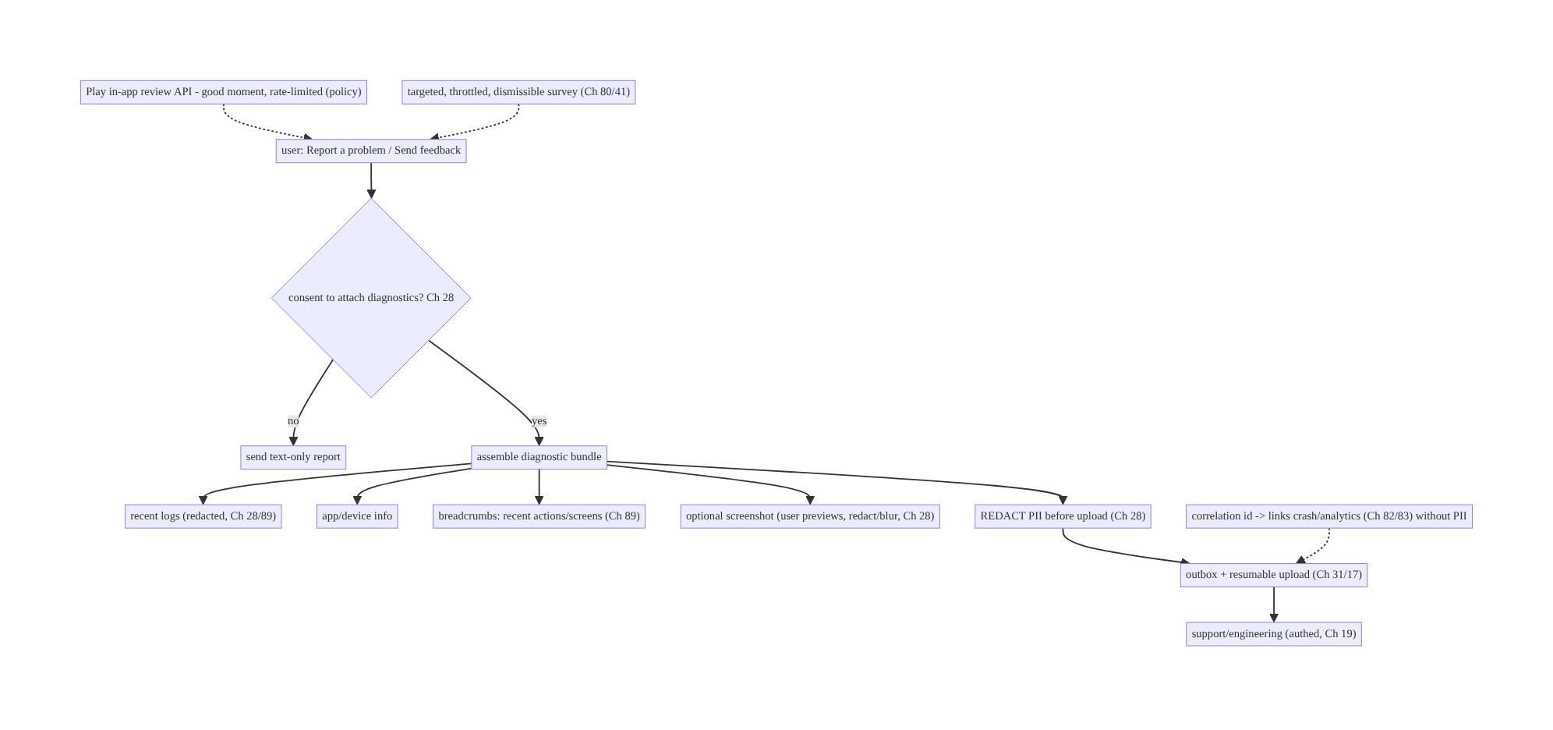
81.4 High-Level Architecture
Components & ownership
- Report flow gathers text + (consent-gated) diagnostic bundle (redacted logs/ info/breadcrumbs/screenshot).
- Redaction (Ch 28) runs before upload; outbox + resumable upload (Ch 31/17) deliver reliably with a correlation id (Ch 82/83).
- Respectful prompts: Play in-app review (rate-limited) + throttled surveys.
Direction: report → consent → assemble bundle → redact (Ch 28) → outbox + resumable upload (+ correlation id) → support; ratings/surveys asked respectfully.

81.5 Detailed Component Design
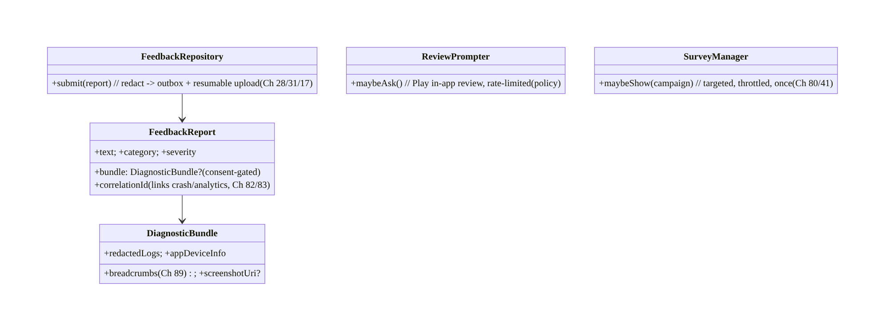
81.5 Detailed Component Design
Component | Responsibility
FeedbackReport | user message + consent-gated bundle + correlation id
DiagnosticBundle | redacted logs + device info + breadcrumbs + optional screenshot
FeedbackRepository | redact → outbox + resumable upload (Ch 28/31/17)
ReviewPrompter | Play in-app review at a good, rate-limited moment
SurveyManager | targeted/throttled/dismissible surveys (Ch 80/41)

81.6 End-to-End Data Flow

Report with consent-gated, redacted diagnostics
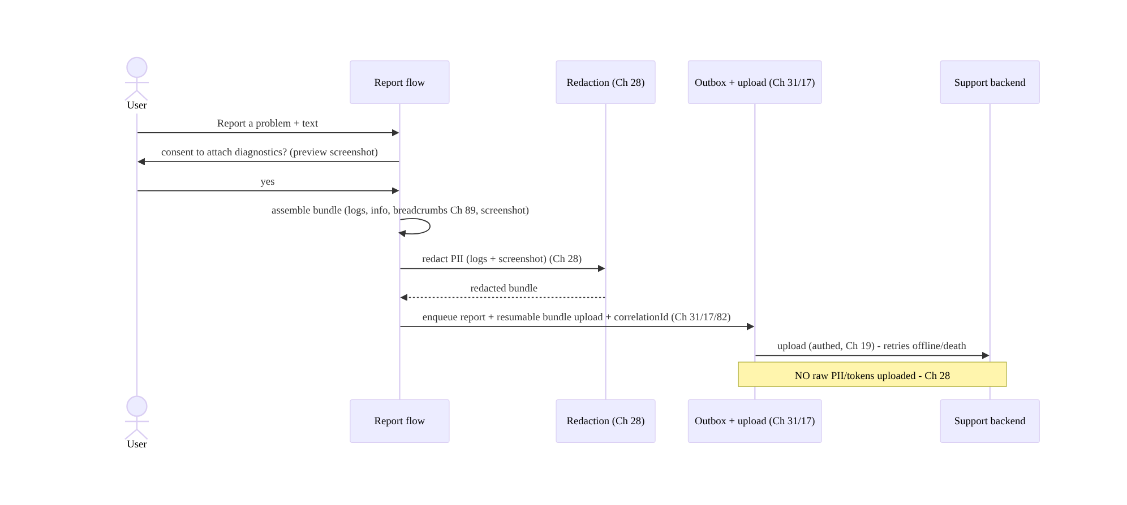
Report with consent-gated, redacted diagnostics

Respectful rating prompt
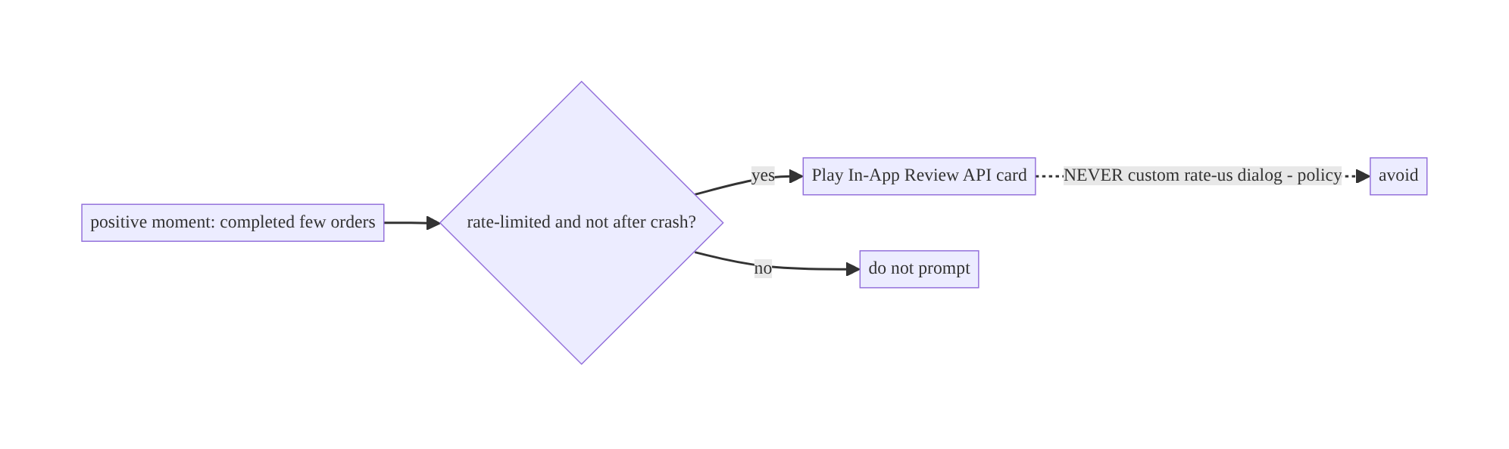
Respectful rating prompt

81.7 Complete Kotlin Implementation
Package: com.streamcart.feedback.

81.7.1 Report + bundle model (consent-gated, correlation id)
data class FeedbackReport(
val text: String, val category: String, val severity: String,
val bundle: DiagnosticBundle?, // null if user declined diagnostics (consent, Ch 28)
val correlationId: String, // opaque id linking crash/analytics (Ch 82/83) - NOT PII
)
data class DiagnosticBundle(
val redactedLogs: String, // redacted (Ch 28/89)
val appDeviceInfo: Map<String, String>, // version, OS, model, locale (non-PII)
val breadcrumbs: List<String>, // recent actions/screens, redacted (Ch 89)
val screenshotUri: Uri?, // optional, user-previewed, redactable (Ch 28)
)

81.7.2 FeedbackRepository: redact → outbox + resumable upload (Ch 28/31/17)
@Singleton
class FeedbackRepository @Inject constructor(
private val redactor: PiiRedactor, // Ch 28
private val uploader: ResumableUploader, // Ch 17
private val outbox: Outbox, // Ch 31
private val breadcrumbs: BreadcrumbBuffer, // Ch 89
) {
suspend fun submit(text: String, category: String, severity: String, attachDiagnostics: Boolean, screenshot: Uri?) {
val bundle = if (attachDiagnostics) assembleBundle(screenshot) else null // CONSENT-gated (Ch 28)
val report = FeedbackReport(text, category, severity, bundle, correlationId = Correlation.current())
// Enqueue for reliable, death-safe, offline-capable submission (Ch 31); bundle uploads resumably (Ch 17).
outbox.enqueue(OutboxOp.Feedback(report))
}
private suspend fun assembleBundle(screenshot: Uri?): DiagnosticBundle = DiagnosticBundle(
redactedLogs = redactor.redact(LogBuffer.recent()), // REDACT logs (Ch 28/89) - no tokens/PII
appDeviceInfo = DeviceInfo.nonPii(), // version/OS/model/locale only
breadcrumbs = breadcrumbs.recent().map { redactor.redact(it) }, // redacted (Ch 89)
screenshotUri = screenshot?.let { redactor.redactScreenshot(it) }, // blur/redact sensitive regions (Ch 28)
)
suspend fun upload(op: OutboxOp.Feedback): OutboxResult = runCatching {
op.report.bundle?.screenshotUri?.let { uploader.upload(it) } // resumable (Ch 17)
api.submitFeedback(op.report) // authed (Ch 19); NO raw PII (Ch 28)
OutboxResult.Done
}.getOrElse { if (it.isTransient()) OutboxResult.Retry else OutboxResult.Failed(it) } // offline-safe (Ch 2/31)
}

81.7.3 Consent + preview UI (user controls attachments, Ch 28)
@Composable
fun ReportProblemScreen(vm: FeedbackViewModel = hiltViewModel()) {
var text by remember { mutableStateOf("") }
var attachDiagnostics by remember { mutableStateOf(true) } // user controls
var screenshot by remember { mutableStateOf<Uri?>(vm.captureScreenshot()) }
Column {
TextField(text, { text = it }, label = { Text("Describe the problem") })
// CONSENT: explicit toggle + what's attached (transparency, Ch 28)
Row { Checkbox(attachDiagnostics, { attachDiagnostics = it }); Text("Attach diagnostics (logs, device info, screenshot)") }
if (attachDiagnostics) {
screenshot?.let { ScreenshotPreview(it, onBlur = { screenshot = vm.blurRegion(it) }) } // user can redact (Ch 28)
Text("We remove personal info before sending.", style = MaterialTheme.typography.labelSmall)
}
Button(onClick = { vm.submit(text, attachDiagnostics, screenshot) }) { Text("Send") }
}
}

81.7.4 Breadcrumbs (Ch 89)
@Singleton
class BreadcrumbBuffer @Inject constructor() {
private val buffer = ArrayDeque<String>(MAX) // bounded ring buffer (Ch 89)
fun log(action: String) { if (buffer.size >= MAX) buffer.removeFirst(); buffer.addLast("${now()} $action") }
fun recent(): List<String> = buffer.toList() // attached to reports + crashes (Ch 83), redacted on use
}
// Log screen views, taps, key events (NO PII) -> the sequence that led to the problem.

81.7.5 Respectful rating prompt (Play in-app review API)
class ReviewPrompter @Inject constructor(@ApplicationContext private val ctx: Context, private val prefs: ReviewPrefs) {
private val manager = ReviewManagerFactory.create(ctx)
/** Ask at a GOOD moment (positive action), rate-limited; NEVER a custom dialog (policy). */
suspend fun maybeAsk(activity: Activity) {
if (!prefs.eligibleNow() /* rate-limited + not after crash/error */) return
val info = manager.requestReviewFlow().await()
manager.launchReviewFlow(activity, info).await() // Google's in-app review card
prefs.markAsked() // throttle future prompts
}
}

81.7.6 Module structure
:feature:feedback FeedbackReport/DiagnosticBundle, FeedbackRepository (redact+outbox+upload), ReportProblemScreen, ReviewPrompter, SurveyManager
:core:privacy PiiRedactor (Ch 28); :core:logging BreadcrumbBuffer + LogBuffer (Ch 89)
:core:upload ResumableUploader (Ch 17); :core:outbox (Ch 31)
# Correlation id -> crash/analytics (Ch 82/83). Surveys -> remote config/throttle (Ch 41/80).

81.8 Concurrency and Race Conditions
Scenario | Risk | Handling
Diagnostics uploaded without consent | privacy/legal violation | consent-gate; null bundle if declined (Ch 28)
PII/tokens in logs/screenshot | leak | redact before upload (Ch 28); blur screenshot
Report lost offline/on death | lost bug report | outbox + resumable upload (Ch 31/17)
Large bundle upload interrupted | restart | resumable upload (Ch 17)
Rating prompt after a crash | backfire/bad review | rate-limit + not-after-error gate
Survey spam | fatigue | throttle + once + dismissible (Ch 80)
Correlation id contains PII | leak | opaque id only (not email/user data)
- Consent + redaction are the non-negotiables: never assemble/upload a bundle without explicit consent, and always redact PII (logs + screenshot) before upload (Ch 28) — a diagnostic upload is a privacy event, handled with the same rigor as any PII flow. Let the user see/control what’s attached (preview/blur).
- Reliable + resumable (Ch 31/17): a report with a large bundle survives offline/death and resumes a cut-off upload — bug reports shouldn’t vanish on a blip.
- Respectful prompting: rate-limit the review prompt (and never after a crash/error), throttle surveys — asking at the wrong time or too often backfires.

81.9 Failure Scenarios and Recovery
Failure | Detection | Response | Outcome
Undebuggable report | support | attach diagnostic bundle (logs/breadcrumbs/info) | debuggable
PII leaked | privacy audit | redact logs + screenshot before upload (Ch 28) | safe
No consent | legal/trust | consent-gate diagnostics | compliant
Report lost | user follow-up | outbox + resumable upload (Ch 31/17) | delivered
Bad store reviews from prompt | ratings drop | prompt at good moment, rate-limited, Play API | respectful
Survey fatigue | opt-out | throttle + once + dismissible (Ch 80) | respectful
Can’t find session | support | correlation id links crash/analytics (Ch 82/83) | found
Policy strike (custom rate dialog) | Play | use in-app review API | compliant
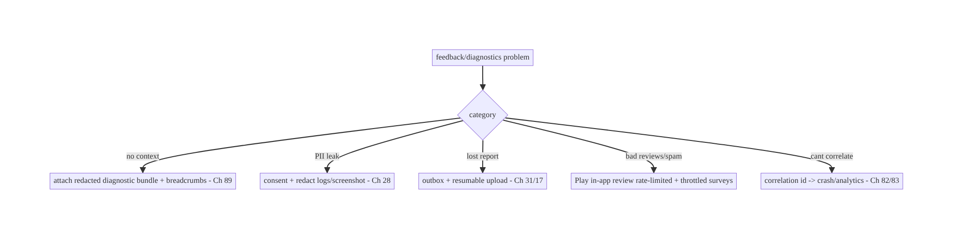
81.9 Failure Scenarios and Recovery
Diagnostics make reports debuggable; consent + redaction keep them trustworthy; outbox + resumable upload make them reliable; and respectful, policy-compliant prompting keeps users on side. Attach a redacted bundle + breadcrumbs + correlation id (with consent), deliver it reliably, and ask for ratings/surveys at the right time — never leak PII, never nag.

81.10 Scaling the Implementation
- Level 1. Feedback form + text; app/device info; reliable submit (outbox, Ch 31).
- Level 2. Diagnostic bundle (redacted logs + breadcrumbs + optional screenshot) with consent + redaction (Ch 28/89); resumable upload (Ch 17); correlation id (Ch 82/83).
- Level 3 — production. Play in-app review (rate-limited); targeted/throttled surveys (Ch 80/41); user preview/control of attachments.
- Level 4 — large. Shake-to-report (beta); categorized/triaged reports; attach session replay (privacy-reviewed); auto-diagnostics on detected errors (consented).
- Level 5 — enterprise. Feedback analytics/triage pipeline, privacy governance for diagnostics (Ch 28), support-tool integration, sentiment/NPS tracking, regulatory compliance.
Avoid overengineering: consent-gated redacted bundle + reliable upload + Play review API
- throttled surveys is the core. Don’t upload raw logs/screenshots; don’t nag; don’t use custom rate dialogs.

81.11 Alternative Approaches and Trade-offs
Dimension | Option A | Option B | When
Report context | Diagnostic bundle (logs/breadcrumbs/info) | text only | Bundle (debuggable) — consent-gated
Privacy | Consent + redaction (Ch 28) | silent raw upload | Consent+redact always (privacy/legal)
Upload | Outbox + resumable (Ch 31/17) | fire-and-forget | Reliable (don’t lose reports)
Rating prompt | Play in-app review API | custom “rate us” dialog | In-app review API (policy + effective)
Prompt timing | Good moment, rate-limited | anytime / after crash | Good moment (not after errors)
Surveys | Targeted/throttled/once (Ch 80) | frequent | Throttled (fatigue)
Correlation | Opaque id → crash/analytics | include user data | Opaque id (no PII, Ch 82/83)
Diagnostic bundle vs text-only (with consent/redaction): a text-only report (“it’s broken”) is usually undebuggable; a diagnostic bundle (redacted logs, breadcrumbs, device info, optional screenshot) gives engineers the context to reproduce. But it’s a privacy event — so it’s consent-gated and PII-redacted (Ch 28), with the user able to see/control attachments. Attach context, but always with consent + redaction.
Play in-app review API vs custom rate dialog: a custom “rate us” dialog that pre-filters happy users or nags violates Play policy and backfires (bad reviews, distrust). The Play In-App Review API shows Google’s standardized card in-app, must be used at a good moment and rate-limited — ask once, at the right time (after a positive action, never after a crash). Use the API, respectfully.
Reliable (outbox + resumable) vs fire-and-forget upload: a bug report with a large bundle can fail on a network blip or process death — losing the report. Outbox + resumable upload (Ch 31/17) make it survive offline/death and resume a cut-off upload, so reports aren’t lost. Reliability matters for support.

81.12 Security & Privacy Considerations
- Consent + redaction are mandatory (Ch 28): a diagnostic upload is a privacy event — explicit consent, PII redaction of logs and screenshots (names, emails, tokens, messages, card data), and user control/preview of attachments. Never upload raw secrets/PII.
- Redaction thoroughness (Ch 28/89): the logging layer should already redact (Ch 28); re-redact at bundle assembly; blur sensitive screenshot regions; strip auth headers/tokens from logs.
- Correlation id is opaque, not PII (Ch 82/83): link to crash/analytics via an opaque session id, not email/user identifiers — engineers correlate without personal data.
- Authed, secure upload (Ch 19/23): diagnostics upload over authed, TLS-pinned channels; access-controlled server-side (support staff only).
- Per-account (Ch 42): reports tied to the user with consent; honor deletion requests (diagnostics are personal data).
- Screenshot sensitivity: screenshots can capture other users’ data, messages, or payment screens — redact/blur or exclude sensitive screens (FLAG_SECURE screens shouldn’t be captured).
- No dark patterns: rating prompts/surveys must not manipulate (policy + trust).
- Client vs backend: the client collects with consent, redacts, and uploads reliably; the backend access-controls diagnostics, correlates via opaque ids, and honors retention/deletion — neither stores raw PII/secrets.

81.13 Performance and Resource Optimization
- Bounded breadcrumb/log buffers (Ch 89) — ring buffers; don’t grow unbounded.
- Assemble bundle lazily (only on consent) — don’t collect diagnostics proactively.
- Resumable + compressed upload (Ch 17/61) — large bundles stream/compress; don’t load wholly in memory.
- Right-size screenshots (Ch 56/57) before upload.
- Redaction cost — redact efficiently (streamed, Ch 28); cache patterns.
- Throttle prompts/surveys — minimal overhead, respect fatigue.
- Profiling: report submit success/latency, bundle size, upload success/resume, redaction time, review-prompt acceptance, survey response rate.

81.14 Testing Strategy
Redaction, consent-gating, reliable submit, and respectful prompting are testable.
class FeedbackRedactionTest {
@Test fun `bundle redacts PII and tokens before upload`() = runTest {
LogBuffer.add("user token=secret email=a@b.com")
val bundle = repo.assembleBundle(screenshot = null)
assertFalse(bundle.redactedLogs.contains("secret")) // redacted (Ch 28)
assertFalse(bundle.redactedLogs.contains("a@b.com"))
}
@Test fun `no bundle attached when consent declined`() = runTest {
repo.submit("bug", "ui", "low", attachDiagnostics = false, screenshot = null)
assertNull(outbox.last<OutboxOp.Feedback>().report.bundle) // consent-gated (Ch 28)
}
@Test fun `correlation id is opaque not PII`() { assertFalse(Correlation.current().contains("@")) }
}
class FeedbackSubmitTest {
@Test fun `submit survives offline and retries`() = runTest { /* outbox + resumable (Ch 31/17) */ }
}
class ReviewPromptTest {
@Test fun `does not prompt after a crash or when rate-limited`() = runTest { /* gate */ }
@Test fun `uses Play in-app review API, not a custom dialog`() = runTest { /* manager.requestReviewFlow */ }
}
What to test: bundle redacts PII/tokens (logs + screenshot) (Ch 28); consent-gating (no bundle when declined); correlation id opaque (no PII); reliable submit (offline retry, resumable, Ch 31/17); review prompt gated (rate-limited, not after crash, Play API); survey throttle/once (Ch 80). Fake redactor/uploader/outbox/review-manager.

81.15 Production Observability
- Metrics: report submit success/latency + offline-queued; bundle attach rate (consent); upload success/resume; redaction coverage (no PII slipped — audited); review-prompt acceptance; survey response/dismiss; correlation-link success (report ↔ crash/analytics, Ch 82/83).
- Logs: feedback{category, hasBundle, correlationId, result} — no report content/ PII (Ch 28).
- Debugging: undebuggable reports → no bundle/breadcrumbs (Ch 89); PII leak → redaction gap (Ch 28); lost report → outbox/upload (Ch 31/17); bad reviews → prompt timing/custom dialog; survey fatigue → not throttled; can’t correlate → correlation id missing (Ch 82/83).
- Alerting: any PII detected in uploaded diagnostics (privacy incident); report-upload failure spike; review-prompt policy flag.
- Dashboards: report funnel + bundle rate; redaction coverage; review/survey engagement.

81.16 System Design Interview Preparation
≥25 questions.
Fundamentals
- What’s in a bug report? User text + consent-gated diagnostic bundle (logs/device info/ breadcrumbs/screenshot).
- Why a bundle? Text-only is undebuggable; context enables reproduction.
- Privacy requirements? Explicit consent + PII redaction (Ch 28) — a privacy event.
- Breadcrumbs? Recent actions/screens (redacted) → the sequence that led to the problem (Ch 89).
- Correlation id? Opaque id linking crash/analytics without PII (Ch 82/83).
Privacy/consent
- Upload logs silently? No — consent-gated.
- What to redact? Names, emails, tokens, messages, card data (logs + screenshot) (Ch 28).
- User control? Preview/toggle/blur attachments.
- Screenshot risk? Can capture others’ data/payment screens — redact/blur/exclude.
Reliability
- Lost report? Outbox + resumable upload (Ch 31/17).
- Large bundle interrupted? Resumable upload (Ch 17).
- Offline? Queue + retry.
Rating prompts
- How to ask for a rating? Play In-App Review API.
- Custom “rate us” dialog? Policy violation + backfires.
- When? Good moment (positive action), rate-limited, not after a crash.
Surveys
- Survey UX? Targeted, throttled, dismissible, once (Ch 80/41).
- Fatigue? Throttle; measure response (Ch 82).
Correlation/breadcrumbs
- Link report to crash? Correlation id (Ch 82/83).
- Breadcrumb buffer? Bounded ring buffer (Ch 89).
Security
- Upload channel? Authed + TLS-pinned (Ch 19/23).
- Correlation id PII? No — opaque.
- Retention/deletion? Diagnostics are personal data (Ch 28/42).
Testing/Production
- Test redaction? Assert PII/tokens removed.
- Test consent? No bundle when declined.
- PII leaked in prod? Redaction gap (alert).
- Bad reviews? Prompt timing/custom dialog.

Design-change challenges
- Make bug reports debuggable. Attach a redacted diagnostic bundle + breadcrumbs + correlation id (consent, Ch 28/89/82).
- Logs contain emails/tokens. Redact before upload (Ch 28).
- Reports lost offline. Outbox + resumable upload (Ch 31/17).
- Rating prompt gives bad reviews. Play in-app review API at a good moment, rate-limited.
- Users annoyed by surveys. Targeted, throttled, dismissible, once (Ch 80).

Mock walkthrough (abridged)
Clarify (what context, consent model, prompts?) → report = text + consent-gated diagnostic bundle (logs/info/breadcrumbs/screenshot) → consent + PII redaction (Ch 28) + user control → reliable outbox + resumable upload + correlation id (Ch 31/17/82/83) → Play in-app review at a good moment, rate-limited (policy) → targeted/throttled surveys (Ch 80/41) → security (authed upload, opaque id, retention) → observability (report funnel, redaction coverage).

81.17 Practical Exercises
- Beginner. Build a “Report a problem” form that submits text + app/device info reliably via an outbox (Ch 31). Eval: offline-safe submit.
- Intermediate. Add a consent-gated diagnostic bundle (redacted logs + breadcrumbs + optional screenshot) with PII redaction and user preview (Ch 28/89). Eval: consent- gated; no PII; user controls.
- Advanced. Add a correlation id linking to crash/analytics and resumable bundle upload (Ch 82/83/17). Eval: correlates without PII; large bundle resumes.
- Production debugging. Fix PII in uploaded logs (redaction gap) and lost reports (no outbox). Eval: redacted; delivered.
- System design challenge. Add a Play in-app review prompt (good moment, rate-limited) and a throttled survey; ensure no custom rate dialog. Eval: respectful; policy-compliant.
(Solutions withheld unless requested.)

81.18 Chapter Summary & Reference Sheet
Key decisions: build in-app feedback as a report (user text) plus a consent-gated, PII-redacted diagnostic bundle — recent redacted logs, app/device info, breadcrumbs (the action sequence, Ch 89), and an optional user-previewed/redactable screenshot — that makes reports debuggable, treating any diagnostic upload as a privacy event requiring explicit consent and thorough PII redaction (names/emails/tokens/messages/card data, Ch 28) with the user able to see/control attachments; upload reliably via the outbox + resumable upload (survives offline/death, retries, Ch 31/17) with an opaque correlation id linking to crash/analytics data without PII (Ch 82/83); and ask for input respectfully — the Play In-App Review API at a good, rate-limited moment (never a policy-violating custom “rate us” dialog, never after a crash) and targeted, throttled, dismissible surveys (Ch 80/41). Upload over authed, TLS-pinned channels (Ch 19/23), per-account with retention/deletion honored (Ch 42/28). The critical invariant: no raw PII/secrets ever leave the device, and never collect without consent.
Concepts: diagnostic bundle (redacted logs/info/breadcrumbs/screenshot), consent + PII redaction (privacy event, Ch 28), breadcrumbs (Ch 89), correlation id to crash/analytics (opaque, Ch 82/83), reliable outbox + resumable upload (Ch 31/17), Play in-app review (rate-limited, policy), targeted/throttled surveys (Ch 80), shake-to-report (beta).
Common mistakes: text-only (undebuggable) OR silent raw-log/screenshot upload (PII leak); no consent; incomplete redaction (tokens/PII slip); fire-and-forget upload (lost reports); custom “rate us” dialog / prompting after a crash (policy/backfire); survey fatigue; correlation id containing PII; capturing sensitive screens.
Checklist:
- ☐ report = text + consent-gated diagnostic bundle
- ☐ bundle: redacted logs + device info + breadcrumbs (Ch 89) + optional screenshot
- ☐ explicit consent + PII redaction + user preview/control (Ch 28)
- ☐ reliable outbox + resumable upload (Ch 31/17)
- ☐ opaque correlation id → crash/analytics (Ch 82/83)
- ☐ authed + TLS-pinned upload (Ch 19/23)
- ☐ Play in-app review at a good moment, rate-limited (no custom dialog)
- ☐ targeted/throttled/dismissible surveys (Ch 80/41)
- ☐ per-account + retention/deletion (Ch 42/28)
- ☐ no raw PII/secrets uploaded
- ☐ redaction-coverage + report-funnel telemetry.
Key APIs: PiiRedactor (Ch 28), BreadcrumbBuffer/LogBuffer ring buffers (Ch 89), Outbox + ResumableUploader (Ch 31/17), correlation id (Ch 82/83), Play In-App Review (ReviewManagerFactory/requestReviewFlow/launchReviewFlow), survey throttle/show-once (Ch 80/4), authed upload (Ch 19/23), FLAG_SECURE-aware screenshot capture.
References:
- Play In-App Review API: https://developer.android.com/guide/playcore/in-app-review
- Data safety / privacy (diagnostics): https://developer.android.com/privacy-and-security
- (composes) Ch 28 PII Redaction/Privacy, Ch 17 Uploads, Ch 31 Outbox, Ch 89 Logging/Breadcrumbs, Ch 82 Analytics, Ch 83 Crash/ANR, Ch 23 Security, Ch 80 Surveys/Throttle

Glossary & Index of Key Terms
A quick reference to the core terms introduced in this volume, with the chapters where each is treated. (Chapter numbers outside this volume’s range point to other volumes of the series.)
WebSocket — A persistent, bidirectional connection for real-time messaging. Ch 63.
Chat / messaging architecture — Ordered, delivered, synced messages with offline support. Ch 64.
Presence / typing — Showing who is online and who is typing, efficiently. Ch 65.
SSE / long-polling — Server-push alternatives to WebSocket for one-way updates. Ch 66.
Live location — Streaming and displaying moving location updates. Ch 67.
Metered network — A connection where the user pays per byte (cellular); gates heavy transfers. Ch 68.
Bluetooth Low Energy (BLE) — Low-power device connectivity for peripherals. Ch 69.
Nearby Connections — Peer-to-peer device-to-device communication. Ch 70.
Infinite feed — An endlessly scrolling, paged list (Paging 3). Ch 71; list performance in Ch 93.
Optimistic update — Updating the UI immediately and reconciling with the server on confirm. Ch 72.
Recommendations — A personalized, ranked content feed. Ch 73.
Wishlist — A synced list of saved items. Ch 74.
Exactly-once checkout — Placing an order at most once using idempotency keys plus the outbox. Ch 75.
Play Billing — In-app purchases and subscriptions via Google Play. Ch 76.
Tokenization / PCI — Replacing card data with a token so the app never handles raw card numbers. Ch 77.
Order tracking — Real-time order status, updated via push and sync. Ch 78.
Reviews & ratings — User-generated ratings and reviews with moderation. Ch 79.
Onboarding — First-run flows and feature discovery. Ch 80.
In-app feedback / diagnostics — Capturing user feedback with privacy-safe diagnostics. Ch 81.

Acknowledgements
This book exists because of the Android engineering community — the library authors, the writers of official documentation and release notes, the conference speakers, and the countless engineers who have shared hard-won lessons in blog posts, talks, and code reviews. The patterns in this series are not invented in isolation; they are the distilled, composed practice of that community, organized into one coherent curriculum.
Special thanks to the maintainers of the open-source libraries this book builds on — including Kotlin and Coroutines, Jetpack (Compose, Room, WorkManager, Paging, Lifecycle), OkHttp and Retrofit, Hilt/Dagger, and Media3 — whose work makes modern Android development what it is.
And thank you, the reader, for investing in the craft of building software that lasts.

About the Author
Prakash Sharma is a Senior Software Engineer at Deutsche Telekom with a decade of experience building Android applications across mobile, television (TV), and set-top-box (STB) platforms. Over those years he has shipped and maintained large, long-lived Android codebases — the kind where architecture, offline behavior, security, performance, and multi-team maintainability are not optional extras but the whole job.
He writes about Android architecture and engineering on Medium, and is the author of technical books on modern Android development. He wrote Designing Android at Scale to close the gap he kept seeing — and interviewing for — between knowing Android APIs and designing systems that survive real-world scale, constraints, and teams.
Follow Prakash on Medium for articles, updates, and corrections to this series: {{MEDIUM PROFILE URL}}

Also in This Series
If this volume was useful, the series continues:
- Volume 1 — Foundations: Networking & Local Data (Chapters 1–18) — the networking core, persistence and the single source of truth, threading, dependency injection, and the networking patterns layered on top — search, pagination, caching, and reliability.
- Volume 2 — Security, Offline-First & State (Chapters 19–43) — authentication and token management, cryptography and the Keystore, secure storage and PII handling, offline-first architecture, the outbox pattern, delta sync and conflict resolution, and shared/global state.
- Volume 3 — Lifecycle, Background & Media (Chapters 44–62) — the Android lifecycle and startup, foreground and background work, WorkManager, Doze and background limits, notifications, deep links and navigation, plus media playback with Media3/ExoPlayer, DRM, the camera, and file handling.
- Volume 5 — Performance, Scale & Platform Breadth (Chapters 82–100) — analytics, crash reporting, distributed tracing, performance and memory, rendering and jank, battery, baseline profiles, modularization, localization, accessibility, theming, Android TV and Wear OS, and the end-to-end StreamCart capstone.
All five volumes build on the StreamCart reference application and the foundations introduced in Volume 1.
Reviews help other engineers find the series. If this book helped you, please consider leaving a rating or review.

