Designing Android at Scale
Volume 5 — Performance, Scale & Platform Breadth
Prakash Sharma
First Edition · 2026
Table of Contents

Copyright
Designing Android at Scale Volume 5 — Performance, Scale & Platform Breadth
Copyright © 2026 Prakash Sharma. All rights reserved.
No part of this publication may be reproduced, stored in a retrieval system, or transmitted in any form or by any means — electronic, mechanical, photocopying, recording, or otherwise — without the prior written permission of the author, except for brief quotations in reviews.
This book is an independent work. All product names, trademarks, and registered trademarks — including Android, Kotlin, and any third-party libraries, services, or platforms referenced — are the property of their respective owners and are used for identification and educational purposes only. Their use does not imply any affiliation with or endorsement by the trademark holders, nor by the author’s employer.
The code, patterns, and architectures in this book are provided for educational purposes “as is,” without warranty of any kind. The author assumes no responsibility for errors or omissions, or for damages resulting from the use of the information herein. Always validate designs against your own requirements, security review, and the current official platform documentation.
StreamCart is a fictional application used throughout this series as a running example. Any resemblance to real products or companies is coincidental.
First Edition · 2026

Preface
Most Android books teach you APIs. This series teaches you to design systems.
There is a large gap between knowing what OkHttp, Room, or WorkManager are and knowing how to compose them into an application that works offline, survives process death, syncs reliably, stays secure, performs on a budget phone, and can be maintained by a large team for years. Closing that gap — moving from API user to system designer — is the goal of Designing Android at Scale.
The complete work spans 100 chapters across eleven parts, published as a five-volume series. Every chapter follows the same rigorous 18-section structure — from problem definition and requirements, through architecture, a complete Kotlin implementation, concurrency and failure analysis, scaling, security, performance, testing, and observability, to a full set of system-design interview questions and exercises. Every chapter is anchored to one running reference application — StreamCart, a fictional e-commerce and streaming app — so the patterns compose into a coherent system rather than floating as isolated recipes.
This is Volume 5 — Performance, Scale & Platform Breadth. It covers Part X and Part XI:
- Part X — Performance, Observability & Quality (Chapters 82–93): analytics, crash and ANR reporting, distributed tracing, performance monitoring, A/B testing, the error pipeline, cold start, memory, rendering and jank, battery, baseline profiles, and large-list performance.
- Part XI — Reach, Scale & Platform Breadth (Chapters 94–100): multi-module architecture at enterprise scale, localization and RTL, accessibility, theming, Android TV / STB / Fire TV, Wear OS, and the end-to-end StreamCart capstone.
You do not need to read the volumes strictly in order, but each builds on the vocabulary, the layering, and the StreamCart reference application established across the series — most of all on Volume 1 — Foundations, which introduces them.

Who this book is for
This series is written for intermediate-to-senior Android engineers who are comfortable with Kotlin and Jetpack and want to level up to architecture and system design — and for anyone preparing for a senior Android system-design interview, where exactly this skill (composing subsystems with explicit trade-offs under real requirements) is what’s assessed. Chapter 100, the capstone, models that interview end to end.
Let’s design.

How to Read This Book
The 18-section chapter structure. Every chapter is deliberately uniform, so you always know where to find things: Problem Definition → Requirements → System Design Fundamentals → High-Level Architecture → Detailed Component Design → End-to-End Data Flow → Complete Kotlin Implementation → Concurrency & Race Conditions → Failure Scenarios → Scaling → Alternatives & Trade-offs → Security → Performance → Testing → Observability → Interview Preparation → Exercises → Summary & Reference Sheet. Read a chapter top-to-bottom the first time; afterwards, the Summary & Reference Sheet at the end is your quick refresher, and the Interview Preparation section is your drill.
Code. Implementations are in Kotlin, using current Jetpack libraries and idioms (Compose, Coroutines/Flow, Hilt, Room). Snippets are focused on the design point rather than being copy-paste-complete apps; package names and some glue are elided for clarity. Treat the code as a precise description of the design, not a finished module.
Diagrams. Architecture, data-flow, and failure diagrams appear throughout. They are the fast path to the mental model — study them before the prose.
The StreamCart reference app. Every pattern is applied to StreamCart, a fictional e-commerce + streaming application (catalog, cart, checkout, payments, order tracking, streaming, real-time updates, across phone/TV/watch). Reusing one app lets the patterns compose.
Cross-references between volumes. Because the complete work is one 100-chapter book split across five volumes, chapters reference each other by number (for example, “Ch 29” or “Ch 75”). References outside this volume’s chapter range point to other volumes of the series — see The Series at a Glance, next. Each reference is a pointer to where a topic is treated in depth, not a prerequisite you must read first.
Conventions. monospace denotes code, types, APIs, and file paths. Bold marks key terms on first use. Chapter numbers in parentheses — “(Ch 5)” — are cross-references.

The Series at a Glance
Designing Android at Scale is published in five volumes. Each is self-contained, but together they form one continuous 100-chapter system-design curriculum built on the StreamCart reference application.
- Volume 1 — Foundations: Networking & Local Data · Parts I–II · Chapters 1–18 — the networking core, persistence and the single source of truth, threading, dependency injection, and the networking patterns layered on top — search, pagination, caching, and reliability.
- Volume 2 — Security, Offline-First & State · Parts III–V · Chapters 19–43 — authentication and token management, cryptography and the Keystore, secure storage and PII handling, offline-first architecture, the outbox pattern, delta sync and conflict resolution, and shared/global state.
- Volume 3 — Lifecycle, Background & Media · Parts VI–VII · Chapters 44–62 — the Android lifecycle and startup, foreground and background work, WorkManager, Doze and background limits, notifications, deep links and navigation, plus media playback with Media3/ExoPlayer, DRM, the camera, and file handling.
- Volume 4 — Real-Time & Feature Architectures · Parts VIII–IX · Chapters 63–81 — WebSocket and SSE, presence and typing, live location, BLE and nearby connections, and the commerce feature stack — feeds, recommendations, cart, checkout, payments, order tracking, reviews, and onboarding.
- Volume 5 — Performance, Scale & Platform Breadth · Parts X–XI · Chapters 82–100 (this volume) — analytics, crash reporting, distributed tracing, performance and memory, rendering and jank, battery, baseline profiles, modularization, localization, accessibility, theming, Android TV and Wear OS, and the end-to-end StreamCart capstone.
Turn the page to begin.

Part X — Performance, Observability & Quality
Measuring and operating the app: analytics, crash and ANR reporting, distributed tracing, performance monitoring, A/B testing, error pipelines, cold start, memory, rendering and jank, battery, baseline profiles, and large-list performance.

Chapter 82 — Centralized Logging & Analytics
Part X — Performance, Observability & Quality · Complexity: Complex (≥40 interview questions)
Prerequisites: Ch 14 (batching/queueing), Ch 28 (PII redaction), Ch 31 (outbox), Ch 3 (SSOT/Room), Ch 47 (background limits), Ch 44 (lifecycle), Ch 87 (A/B). Pairs with Ch 83 (crash/ANR), Ch 89 (logging), Ch 73 (rec signals).
Reference surface in StreamCart: one pipeline for analytics events (screen views, taps, purchases, rec signals Ch 73) and operational logs/telemetry — a single, reliable, offline-buffered, batched, consented, PII-safe client SDK feeding the backend, decoupled from any vendor.
Note: this chapter opens Part X — Performance, Observability & Quality (Ch 82–93).

82.1 Problem Definition and Real-World Context
Every product decision, ranking model (Ch 73), funnel (Ch 80), and operational dashboard depends on analytics events and telemetry flowing reliably from the app. But a naive analytics integration (call the vendor SDK directly everywhere, fire events synchronously, send PII, lose events offline) is a mess: it couples the whole codebase to a vendor, drops events, drains battery/data, and leaks personal data. A centralized logging & analytics pipeline is the client-side system that captures events through one internal API, buffers them durably (offline-safe), batches uploads efficiently (Ch 14/47), redacts PII and enforces consent (Ch 28), and is decoupled from the vendor behind an abstraction — so events are reliable, cheap, private, and portable.
Concretely, teams hit:
- Vendor lock-in / scattered calls. Calling FirebaseAnalytics/Mixpanel/… directly across the codebase couples everything to one vendor and makes schema/consent/redaction impossible to enforce centrally. Need one internal analytics API behind an abstraction.
- Lost events (offline/death). Firing events over the network synchronously loses them offline or on process death. Events must be durably buffered (a persistent queue/ outbox, Ch 31/3) and sent later.
- Battery/data from chatty sends. Sending each event immediately drains the radio (Ch 47). Events must be batched and flushed on sensible triggers (size/time/ background/network, Ch 14/47).
- PII + consent violations (Ch 28). Events can carry PII (emails, names, content) and must respect consent (GDPR/CCPA opt-out, regional). The pipeline must redact PII and gate on consent centrally (Ch 28) — not per call site.
- No schema / bad data. Free-form event names/params produce unusable data. A typed event schema (names, params, versioning) keeps analytics meaningful.
- Ordering/dedup/identity. Events need stable ordering, dedup (retries), and a consistent user/session/device identity (reset on logout, Ch 42) — without over- identifying (privacy).
- Operational logs vs analytics. The same pipeline (or a sibling) carries operational telemetry (performance, errors, breadcrumbs Ch 89) distinct from product analytics, both PII-safe.
The architecture: a single internal analytics/telemetry API (track(event)) behind a vendor-agnostic abstraction; a typed event schema; durable buffering (persistent queue, Ch 31/3) so events survive offline/death; batched, trigger-based upload respecting background limits (Ch 14/47); central consent gating + PII redaction (Ch 28); consistent identity/session management (reset on logout, Ch 42); dedup/ordering; and clean separation of product analytics vs operational telemetry (with crash Ch 83 and logging Ch 89 as siblings). This chapter is the reliable, private, vendor-decoupled observability pipeline.

Three practical use cases
- Product analytics (StreamCart). Screen views, taps, add-to-cart, purchase, rec signals (Ch 73) captured via track(...), buffered, batched, consented, PII-redacted, uploaded — feeding funnels (Ch 80) and models (Ch 73).
- Operational telemetry. Performance timings, non-fatal errors, network metrics, and breadcrumbs (Ch 89) through the same reliable pipeline, PII-safe, for dashboards/alerting.
- Vendor swap / multi-sink. Change analytics vendor (or fan out to several sinks) without touching call sites — the abstraction isolates the vendor.

Why this is architectural
Centralized analytics is a cross-cutting pipeline every feature feeds and that underpins product decisions, ranking (Ch 73), funnels (Ch 80), and ops — composing batching (Ch 14), durable buffering (Ch 31/3), PII redaction + consent (Ch 28), background limits (Ch 47), identity (Ch 42), and vendor abstraction. The decisions — one API, typed schema, durable + batched + consented + redacted + vendor-agnostic — determine data quality, reliability, privacy, cost, and portability.

82.2 Requirements Engineering

Functional requirements
ID | Requirement
F1 | Capture analytics/telemetry via one internal, vendor-agnostic API with a typed schema.
F2 | Durably buffer events (survive offline/process death); don’t lose events (Ch 31/3).
F3 | Batch uploads on sensible triggers (size/time/background/network), respecting limits (Ch 14/47).
F4 | Centrally gate on consent and redact PII (GDPR/CCPA) (Ch 28).
F5 | Manage identity/session consistently; reset on logout; dedup/order events (Ch 42/15).
F6 | Separate product analytics from operational telemetry; decouple from vendor (swap/fan-out).

Non-functional requirements
Attribute | Policy
Reliability | No lost events (durable buffer + retry); at-least-once + dedup.
Battery/data | Batched, trigger-based, background-friendly (Ch 14/47).
Privacy | Central consent + PII redaction; regional compliance (Ch 28).
Data quality | Typed schema; versioned; consistent identity.
Portability | Vendor-agnostic abstraction; multi-sink.

Scope
- In scope: single internal track API + vendor abstraction, typed event schema + versioning, durable buffering (persistent queue/outbox, Ch 31/3), batching + flush triggers (Ch 14/47), central consent gating + PII redaction (Ch 28), identity/session (reset on logout, Ch 42), dedup/ordering (Ch 15), product-vs-operational separation, offline/death survival, sampling.
- Out of scope: batching mechanics (Ch 14), redaction framework (Ch 28), outbox (Ch 31), crash/ANR (Ch 83), logging/breadcrumbs (Ch 89), A/B platform (Ch 87), backend analytics stack.

Assumptions & constraints
- A vendor SDK (Firebase/Amplitude/self-hosted) sits behind an abstraction; durable buffering via Room/outbox (Ch 31/3); batching + background flush via WorkManager (Ch 14/ 30/47); central consent + PII redaction (Ch 28). minSdk 24. Delivery is at-least-once (dedup server-side); events are PII-safe and consented.

82.3 System Design Fundamentals
- One internal API behind a vendor-agnostic abstraction (the decoupling core). All event capture goes through a single internal interface — analytics.track(event) — not direct vendor SDK calls scattered across the app. Behind it, an AnalyticsSink abstraction wraps the vendor(s). This lets you enforce schema, consent, and redaction centrally, swap vendors or fan out to multiple sinks without touching call sites, and test the pipeline. Scattered vendor calls are the anti-pattern.
- Typed event schema (data quality). Events are typed (sealed hierarchy or a schema) with defined names and params, not free-form strings — so data is consistent, queryable, and refactor-safe. Version the schema (events evolve, Ch 16-style). A typed schema prevents the “1000 inconsistent event names” problem.
- Durable buffering — don’t lose events (Ch 31/3). Events are written to a persistent queue (Room/outbox, Ch 31/3) immediately (fast, local), not sent synchronously. This makes capture non-blocking, offline-safe, and process-death-safe — events wait in the durable buffer and upload later. Losing events because they were fired over the network inline is the classic reliability bug.
- Batched, trigger-based upload (Ch 14/47). The buffer is flushed in batches on sensible triggers: size (N events), time (every few minutes), app background (flush on ON_STOP, Ch 44), and network (prefer unmetered/WorkManager, Ch 47). This respects battery/data (Ch 14) and Doze/background limits (Ch 47) — never a request per event. WorkManager (Ch 30) handles reliable background flush.
- Central consent + PII redaction (Ch 28) — the privacy core. Before any event leaves the device:
  - Consent gating: if the user hasn’t consented (or opted out — GDPR/CCPA, regional), don’t collect/send analytics (or collect only essential/anonymized per policy). The pipeline checks consent centrally.
  - PII redaction: events are redacted (Ch 28) — no raw emails/names/content/tokens; param allowlists; hashed/anonymized ids where needed. Enforced in the pipeline, not per call site (so no event can accidentally carry PII). This central enforcement is only possible because of the single API/abstraction.
- Identity, session, dedup, ordering (Ch 42/15). Events carry a user id (consented/ anonymized), a session id, a device id, and a sequence/timestamp. On logout/ account switch (Ch 42), reset identity (new anonymous id; don’t leak across users). Delivery is at-least-once, so events have a stable event id for server-side dedup (Ch 15), and ordering uses sequence/timestamp. Avoid over-identifying (privacy).
- Sampling (cost/volume). High-volume events (e.g., scroll, impressions Ch 73) may be sampled (send a fraction) to control cost/volume while preserving statistical validity; critical events (purchase) are never sampled. Sampling is a pipeline policy.
- Product analytics vs operational telemetry. Keep product analytics (user behavior: funnels, ranking signals) and operational telemetry (performance, non-fatal errors, breadcrumbs Ch 89) conceptually separate (different schemas/sinks/retention), though they can share the pipeline. Crash/ANR (Ch 83) and logging (Ch 89) are siblings feeding observability. Both must be PII-safe.
Core insight: route all analytics and telemetry through one internal, vendor-agnostic track API with a typed, versioned schema, so you can enforce schema, consent, and PII redaction centrally and swap or fan out vendors without touching call sites; capture events by writing them to a durable persistent buffer immediately (non-blocking, offline- and death-safe, Ch 31/3) rather than sending synchronously, then upload in batches on sensible triggers (size/time/background/network) that respect battery and background limits (Ch 14/ 47); gate on consent and redact PII in the pipeline (GDPR/CCPA, Ch 28) before anything leaves the device; manage consistent identity/session with logout reset (Ch 42) and at-least-once delivery with stable event ids for server-side dedup (Ch 15); sample high-volume events; and keep product analytics distinct from operational telemetry (with crash Ch 83 and logging Ch 89 as siblings) — all PII-safe.

82.4 High-Level Architecture
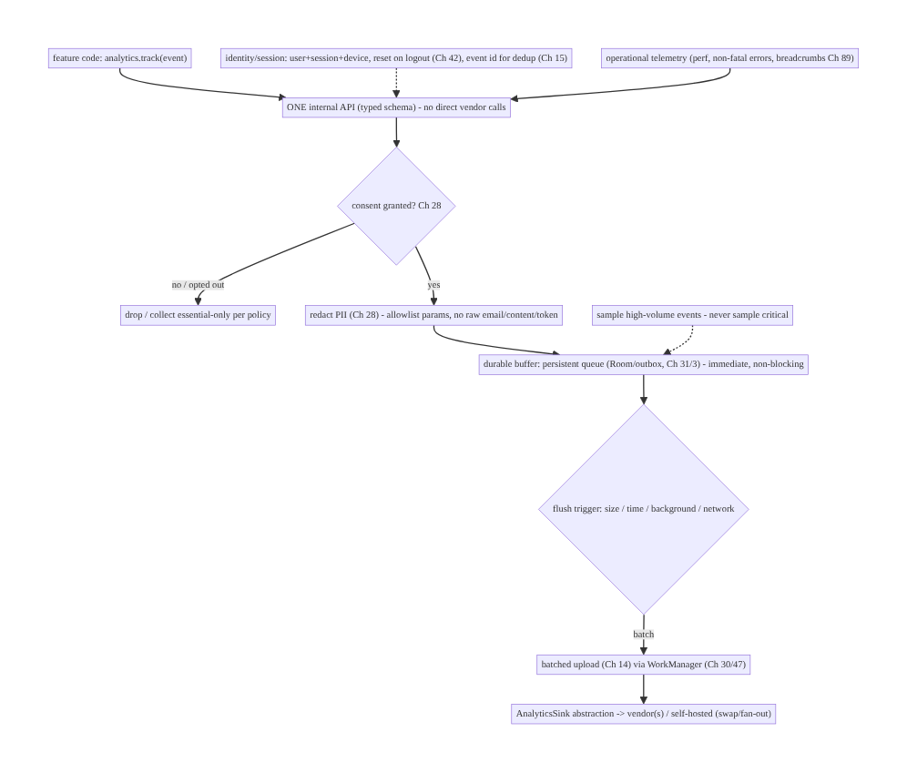
82.4 High-Level Architecture
Components & ownership
- One internal track API (typed schema) → central consent gate + PII redaction (Ch 28) → durable buffer (Ch 31/3) → batched trigger-based upload (Ch 14/30/47) → vendor-agnostic sink(s).
- Identity/session (reset on logout, dedup ids) and sampling are pipeline policies.
- Product analytics + operational telemetry both flow through it, PII-safe.
Direction: track → consent → redact → durable buffer → batched upload → vendor sink; identity/sampling/dedup as policies; vendor-decoupled.

82.5 Detailed Component Design
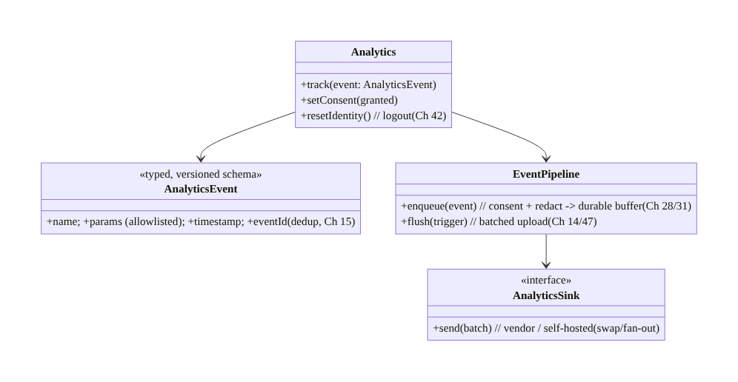
82.5 Detailed Component Design
Component | Responsibility
Analytics | the one internal API: track, consent, identity reset
AnalyticsEvent | typed, versioned event + stable event id (dedup, Ch 15)
EventPipeline | consent + redact (Ch 28) → durable buffer (Ch 31/3) → batched flush (Ch 14/47)
AnalyticsSink | vendor-agnostic sink abstraction (swap/fan-out)

82.6 End-to-End Data Flow

Capture → buffer → batched upload (consented, redacted)
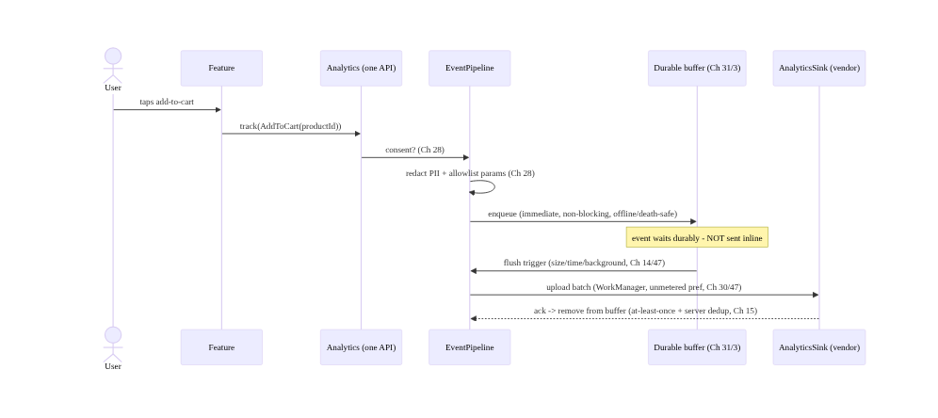
Capture → buffer → batched upload (consented, redacted)

Consent + logout reset
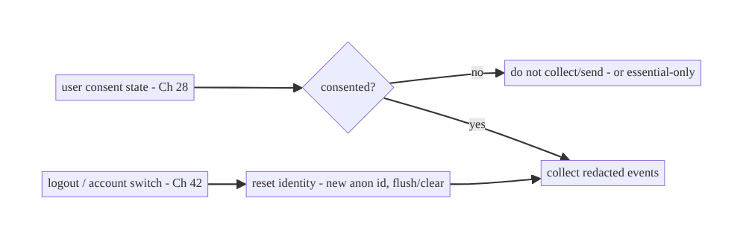
Consent + logout reset

82.7 Complete Kotlin Implementation
Package: com.streamcart.analytics.

82.7.1 One internal API + typed event schema
sealed interface AnalyticsEvent { // TYPED, versioned schema - not free-form strings
val name: String; val params: Map<String, Any?>
data class ScreenView(val screen: String) : AnalyticsEvent {
override val name = "screen_view"; override val params = mapOf("screen" to screen)
}
data class AddToCart(val productId: String, val price: Long) : AnalyticsEvent {
override val name = "add_to_cart"; override val params = mapOf("product_id" to productId, "price" to price)
}
data class Purchase(val orderId: String, val total: Long) : AnalyticsEvent { /* never sampled */ ... }
// Operational: data class PerfTiming(...), data class NonFatal(...) (Ch 89)
}
interface Analytics { // THE ONE API - all call sites use this (no vendor SDK directly)
fun track(event: AnalyticsEvent)
fun setConsent(granted: Boolean)
fun resetIdentity() // logout (Ch 42)
}

82.7.2 Pipeline: consent + redact → durable buffer (Ch 28/31/3)
@Singleton
class EventPipeline @Inject constructor(
private val consent: ConsentManager, // Ch 28
private val redactor: PiiRedactor, // Ch 28
private val dao: EventDao, // durable buffer (Room, Ch 3/31)
private val identity: IdentityProvider, // user/session/device (Ch 42)
private val sampler: Sampler,
private val scope: CoroutineScope,
) : Analytics {
override fun track(event: AnalyticsEvent) {
if (!consent.analyticsGranted()) return // CENTRAL consent gate (Ch 28)
if (!sampler.keep(event)) return // sample high-volume (never critical)
val redacted = redactor.redactParams(event.params) // CENTRAL PII redaction (Ch 28) - allowlist
val record = EventRecord(
eventId = UUID.randomUUID().toString(), // stable id -> server dedup (Ch 15)
name = event.name, params = redacted,
userId = identity.userId, sessionId = identity.sessionId, deviceId = identity.deviceId,
timestamp = System.currentTimeMillis(), schemaVersion = SCHEMA_VERSION,
)
scope.launch { dao.insert(record) } // DURABLE buffer, immediate, non-blocking (Ch 31/3)
}
override fun setConsent(granted: Boolean) = consent.set(granted) // if revoked -> stop + optionally purge buffer
override fun resetIdentity() { identity.reset(); /* flush then clear user scope on logout (Ch 42) */ }
}

82.7.3 Batched, trigger-based upload (Ch 14/30/47)
@Singleton
class EventUploader @Inject constructor(private val dao: EventDao, private val sink: AnalyticsSink, private val wm: WorkManager) {
/** Flush on triggers: size, time, app background (Ch 44), network. WorkManager for reliable background (Ch 30/47). */
fun scheduleBatchFlush() = wm.enqueueUniquePeriodicWork("analytics-flush", KEEP,
PeriodicWorkRequestBuilder<FlushWorker>(15, TimeUnit.MINUTES)
.setConstraints(Constraints.Builder().setRequiredNetworkType(NetworkType.CONNECTED).build()).build()) // Ch 47
suspend fun flush(): Result {
val batch = dao.nextBatch(limit = 200) // batch (Ch 14)
if (batch.isEmpty()) return Result.success()
return runCatching { sink.send(batch) } // vendor-agnostic sink
.fold({ dao.deleteAll(batch.map { it.eventId }); Result.success() }, // remove on ack
{ Result.retry() }) // keep + retry (at-least-once, Ch 2/31)
}
// Flush on ON_STOP (background) too: appScope flush (Ch 44) so events aren't stranded.
}

82.7.4 Vendor-agnostic sink (swap / fan-out)
interface AnalyticsSink { suspend fun send(batch: List<EventRecord>) } // the abstraction
class FirebaseSink @Inject constructor(...) : AnalyticsSink { override suspend fun send(batch: List<EventRecord>) { /* vendor */ } }
class SelfHostedSink @Inject constructor(private val api: TelemetryApi) : AnalyticsSink { override suspend fun send(batch) = api.ingest(batch) }
class FanOutSink(private val sinks: List<AnalyticsSink>) : AnalyticsSink { // send to several (multi-sink)
override suspend fun send(batch: List<EventRecord>) = sinks.forEach { it.send(batch) }
}
// Swapping the vendor = swapping the bound AnalyticsSink in DI (Ch 5). Call sites never change.

82.7.5 Identity + logout reset (Ch 42) + consent revoke
@Singleton
class IdentityProvider @Inject constructor(private val prefs: DataStore<Preferences>) {
var userId: String? = null; var deviceId: String = deviceId(); var sessionId: String = newSession()
fun reset() { // logout/account switch (Ch 42)
userId = null; sessionId = newSession() // new anonymous session; don't leak across users
}
}
// Consent revoke: pipeline stops collecting; optionally PURGE the durable buffer (Ch 28) per policy.

82.7.6 Module structure
:core:analytics Analytics (API), AnalyticsEvent (typed schema), EventPipeline (consent+redact+buffer),
EventUploader (batch+WorkManager), AnalyticsSink (+ vendor/self-hosted/fan-out), IdentityProvider, Sampler
:core:privacy ConsentManager + PiiRedactor (Ch 28); :core:data EventDao (durable buffer, Ch 3/31)
# Crash/ANR -> Ch 83; logging/breadcrumbs -> Ch 89 (siblings). Batching -> Ch 14; background -> Ch 30/47.

82.8 Concurrency and Race Conditions
Scenario | Risk | Handling
Event fired over network inline | lost offline/on death; jank | enqueue to durable buffer immediately (Ch 31/3)
Flush retried after partial send | duplicate events | at-least-once + stable event id → server dedup (Ch 15)
Consent revoked mid-session | collecting without consent | central consent gate; stop + optional purge (Ch 28)
Logout leaks events across users | wrong attribution/privacy | reset identity (new anon id) on logout (Ch 42)
High-volume floods buffer | storage/cost | sample high-volume (never critical); bounded buffer
Chatty uploads | battery/data | batch + trigger-based + unmetered (Ch 14/47)
Vendor change | code churn | vendor-agnostic sink abstraction (swap/fan-out)
- Durable buffer + at-least-once + dedup is the reliability model: capture writes to a persistent queue immediately (non-blocking, offline/death-safe, Ch 31/3); upload is at-least-once (retry on failure) so a partial send may duplicate, resolved by a stable event id the server dedups (Ch 15). Never send inline.
- Central consent + redaction (Ch 28) are enforced in the pipeline (possible only because of the single API) — no call site can bypass them; consent revoke stops collection (and may purge the buffer).
- Logout identity reset (Ch 42) prevents events being attributed across users (privacy + correctness).

82.9 Failure Scenarios and Recovery
Failure | Detection | Response | Outcome
Lost events (offline/death) | gaps | durable buffer + retry (Ch 31/3) | retained
Duplicate events | inflated metrics | stable event id + server dedup (Ch 15) | correct
PII in events | privacy audit | central redaction (Ch 28) | safe
Collecting without consent | legal | central consent gate (Ch 28) | compliant
Battery/data complaints | vitals | batch + trigger-based + unmetered (Ch 14/47) | efficient
Vendor lock-in | migration pain | vendor-agnostic sink (swap/fan-out) | portable
Inconsistent event data | unusable | typed, versioned schema | queryable
Cross-user attribution | privacy/accuracy | identity reset on logout (Ch 42) | isolated
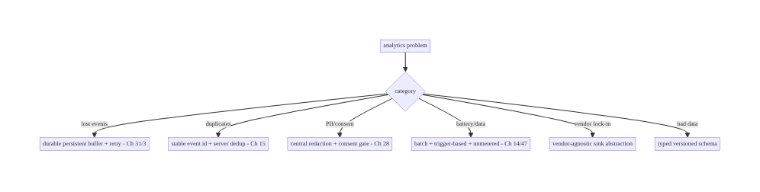
82.9 Failure Scenarios and Recovery
A good analytics pipeline is one API, durably buffered, batched, consented, redacted, and vendor-decoupled. The single track API makes central consent + PII redaction + schema enforceable; the durable buffer + at-least-once + dedup make it reliable; batching + triggers make it cheap; and the sink abstraction makes it portable. Direct scattered vendor calls fail all of these at once.

82.10 Scaling the Implementation
- Level 1. One track API + typed schema + vendor sink; events sent via the vendor SDK.
- Level 2. Durable buffer (Ch 31/3) + batched trigger-based upload (Ch 14/47) — offline/ death-safe, efficient.
- Level 3 — production. Central consent gate + PII redaction (Ch 28); identity/session + logout reset (Ch 42); stable event id + server dedup (Ch 15); vendor-agnostic sink.
- Level 4 — large. Sampling policies; multi-sink/fan-out; schema versioning + validation; operational telemetry sink (perf/errors, Ch 89); regional consent/compliance; A/B exposure logging (Ch 87).
- Level 5 — enterprise. Self-hosted analytics, data governance (retention/PII policies), real-time streaming, data-quality monitoring, consent management platform, cross-platform schema parity.
Avoid overengineering: one API + durable buffer + batched upload + consent/redaction + sink abstraction is the core. Don’t call vendor SDKs directly; don’t send inline; don’t skip consent/redaction.

82.11 Alternative Approaches and Trade-offs
Dimension | Option A | Option B | When
Capture API | One internal API + abstraction | direct vendor SDK calls | One API (central consent/redaction/schema/swap)
Send | Durable buffer + batched (Ch 31/14) | inline/synchronous | Buffer+batch (reliable, efficient)
Schema | Typed + versioned | free-form strings | Typed (data quality)
Privacy | Central consent + redaction (Ch 28) | per-call-site | Central (no bypass)
Delivery | At-least-once + dedup (Ch 15) | fire-and-forget / exactly-once | At-least-once + dedup (practical)
Vendor | Agnostic sink (swap/fan-out) | coupled | Agnostic (portability)
Volume | Sample high-volume | send everything | Sample (cost) — never critical events
One API + abstraction vs direct vendor calls: calling the vendor SDK directly across the codebase makes consent, redaction, and schema impossible to enforce centrally, couples everything to one vendor, and can’t be tested. A single internal track API behind a sink abstraction lets you enforce privacy/schema in one place, swap or fan out vendors without touching call sites, and test the pipeline. This single decision enables everything else.
Durable buffer + batched vs inline send: sending each event synchronously over the network loses events offline/on death, janks the UI, and drains battery/data. Writing events to a durable buffer immediately (non-blocking) and uploading in batches on triggers (Ch 14/47) makes capture reliable, offline/death-safe, and efficient. Never send inline.
Central consent + redaction vs per-call-site: enforcing privacy at each call site is error-prone — one forgotten redaction leaks PII, one missed consent check violates law. The pipeline enforces consent gating and PII redaction centrally (Ch 28), so no event can bypass them. This is only possible with the single API/abstraction.

82.12 Security & Privacy Considerations
- Consent gating (Ch 28): collect/send analytics only with consent (GDPR/CCPA, regional opt-out); on revoke, stop and optionally purge the buffer. Essential/ anonymized-only modes per policy. Enforced centrally.
- PII redaction (Ch 28): no raw PII in events — param allowlists, redact/hash emails/names/content/ids, never tokens/secrets. Enforced in the pipeline so no event carries PII. Operational telemetry (Ch 89) is PII-safe too.
- Identity minimization (Ch 28/42): use anonymized/consented ids; don’t over-identify; reset identity on logout so events aren’t linked across users.
- Secure, authed upload (Ch 19/23): events upload over TLS-pinned, authed channels; access-controlled server-side.
- Data governance: retention limits, deletion on request (right to erasure), regional data residency — pipeline + backend policies (Ch 28).
- No sensitive events: don’t log security-sensitive actions in a way that leaks (e.g., full card data, auth tokens) — ever.
- Client vs backend: the client enforces consent + redaction + identity + reliable batched upload; the backend dedups, applies retention/governance, and controls access — neither stores raw PII in analytics.

82.13 Performance and Resource Optimization
- Non-blocking capture — track writes to the buffer async; never blocks the caller/UI.
- Batching + triggers (Ch 14/47) — the main battery/data lever; flush on size/time/ background/unmetered, not per event.
- Sampling high-volume events (scroll/impressions, Ch 73) — control volume/cost; never sample critical (purchase).
- Bounded durable buffer — cap size; drop lowest-priority on overflow (never critical).
- Efficient redaction (Ch 28) — allowlist params (cheap) rather than scanning free-form.
- WorkManager background flush (Ch 30/47) — reliable, Doze-aware, unmetered.
- Profiling: event capture overhead (µs), buffer size, upload batch size/frequency/ success, battery/data from analytics, event delivery rate, dedup rate.

82.14 Testing Strategy
The pipeline (consent, redaction, buffering, batching, dedup, vendor abstraction) is highly unit-testable with a fake sink.
class EventPipelineTest {
@Test fun `drops events without consent`() = runTest {
consent.granted = false; pipeline.track(ScreenView("home"))
assertEquals(0, dao.count()) // central consent gate (Ch 28)
}
@Test fun `redacts PII from params`() = runTest {
pipeline.track(event(params = mapOf("email" to "a@b.com")))
assertFalse(dao.last().params.toString().contains("a@b.com")) // central redaction (Ch 28)
}
@Test fun `buffers immediately - does not send inline`() = runTest {
pipeline.track(ScreenView("home")); assertEquals(1, dao.count()); assertTrue(sink.sent.isEmpty()) // durable (Ch 31)
}
@Test fun `resets identity on logout`() = runTest { val s = identity.sessionId; identity.reset(); assertNotEquals(s, identity.sessionId) } // Ch 42
}
class EventUploaderTest {
@Test fun `uploads in batches and removes on ack`() = runTest { /* nextBatch -> send -> delete (Ch 14) */ }
@Test fun `keeps events on failure for retry`() = runTest { sink.fail = true; uploader.flush(); assertTrue(dao.count() > 0) } // at-least-once (Ch 2/31)
}
class VendorSwapTest { @Test fun `swapping sink does not change call sites`() { /* bind SelfHostedSink; track still works */ } }
What to test: consent gate (no consent → no collect); central PII redaction; buffer-not- inline capture; batched upload + remove-on-ack + keep-on-failure (at-least-once, Ch 14/31); stable event id (dedup, Ch 15); identity reset on logout (Ch 42); sampling; vendor swap via the sink. Fake sink/consent/redactor; Room in-memory.

82.15 Production Observability
- Metrics: event delivery rate (captured vs uploaded); buffer size/overflow; upload batch size/frequency/success; dedup rate (server); consent-gated drop rate; PII-leak incidents (→ 0, audited); battery/data from analytics; capture overhead; sampling rates.
- Logs: pipeline health only — never event content/PII (Ch 28).
- Debugging: lost events → not buffered/not flushing (Ch 31/14); duplicates → no event-id dedup (Ch 15); PII leak → redaction gap (Ch 28); collecting without consent → gate bypass; battery → inline/too-frequent sends; vendor migration pain → not using the sink abstraction; bad data → free-form schema.
- Alerting: any PII in uploaded events (privacy incident); delivery-rate drop (events lost); buffer overflow; consent-compliance regression.
- Dashboards: event delivery/dedup rates; buffer health; consent/redaction coverage; analytics battery/data cost.

82.16 System Design Interview Preparation
≥40 questions.
Fundamentals
- Why centralize? Enforce schema/consent/redaction centrally; decouple vendor; reliable pipeline.
- One API? analytics.track(event) behind a vendor-agnostic sink — no direct vendor calls.
- Typed schema? Defined names/params, versioned — data quality.
- Capture model? Write to a durable buffer immediately (non-blocking), not inline.
- Why not send inline? Lost offline/on death; jank; battery.
Reliability
- Durable buffer? Persistent queue (Room/outbox, Ch 31/3) — offline/death-safe.
- Upload? Batched on triggers (size/time/background/network, Ch 14/47).
- Delivery semantics? At-least-once + stable event id → server dedup (Ch 15).
- Partial send? Keep + retry; dedup handles duplicates.
- Background flush? WorkManager (Ch 30), unmetered pref (Ch 47); flush on ON_STOP.
Privacy
- Consent? Central gate; collect only with consent (GDPR/CCPA, Ch 28); revoke stops + optional purge.
- PII? Central redaction (allowlist params; no raw email/content/token, Ch 28).
- Why central? No call site can bypass; only possible with one API.
- Identity? Consented/anonymized; reset on logout (Ch 42); don’t over-identify.
Schema/identity
- Event id? Stable → dedup (Ch 15).
- Session/user/device? Carried on events; reset identity on logout.
- Schema versioning? Events evolve; version them.
Efficiency
- Batching? The battery/data lever (Ch 14).
- Flush triggers? Size/time/background/network.
- Sampling? High-volume events; never critical.
- Bounded buffer? Cap; drop lowest-priority on overflow.
Vendor
- Vendor abstraction? AnalyticsSink — swap/fan-out without touching call sites.
- Multi-sink? Fan-out sink.
- Self-hosted? Just another sink.
Product vs ops
- Separation? Product analytics (behavior) vs operational telemetry (perf/errors, Ch 89).
- Crash/ANR + logging? Siblings (Ch 83/89); PII-safe.
- Rec signals (Ch 73)? Product analytics through the same pipeline.
Security
- Upload channel? Authed + TLS-pinned (Ch 19/23).
- Governance? Retention/deletion/residency (Ch 28).
- Sensitive events? Never leak card/tokens.
Testing/Production
- Test consent? No consent → no collect.
- Test redaction? PII removed.
- Test buffer? Not inline; batched; remove-on-ack; keep-on-failure.
- Test vendor swap? Rebind sink; call sites unchanged.
- Lost events in prod? Not buffered/flushing.
- Duplicates? No event-id dedup.
- PII leak? Redaction gap (alert).
- Battery? Inline/too-frequent.
- Bad data? Free-form schema.
- Key metrics? Delivery rate, dedup rate, PII incidents, battery cost.
- Vendor migration? Sink abstraction.

Design-change challenges
- Decouple from the analytics vendor. One track API + AnalyticsSink abstraction.
- Events lost offline. Durable buffer + batched upload (Ch 31/14).
- PII in analytics / GDPR. Central consent gate + PII redaction (Ch 28).
- Analytics drains battery. Batch + trigger-based + unmetered (Ch 14/47).
- Inconsistent event data. Typed, versioned schema.

Mock walkthrough (abridged)
Clarify (product + ops, vendor, consent/regions, volume?) → one internal track API + typed schema behind a vendor-agnostic sink → central consent gate + PII redaction (Ch 28) → durable buffer (Ch 31/3, non-blocking) → batched trigger-based upload (Ch 14/47 via WorkManager) → identity/session + logout reset (Ch 42) + at-least-once + event-id dedup (Ch 15) → sampling → product vs operational separation (crash Ch 83, logging Ch 89 siblings) → security (authed upload, governance) → observability (delivery/dedup, PII incidents).

82.17 Practical Exercises
- Beginner. Build one track(event) API with a typed event schema behind an AnalyticsSink abstraction (no direct vendor calls). Eval: central API; vendor-agnostic.
- Intermediate. Add a durable buffer (Room/outbox) and batched, trigger-based upload (size/time/background) via WorkManager (Ch 31/14/47). Eval: offline/death-safe; batched.
- Advanced. Add central consent gating + PII redaction (Ch 28), identity with logout reset (Ch 42), and stable event ids for dedup (Ch 15). Eval: no PII/unconsented; reset on logout; dedupable.
- Production debugging. Fix lost events (inline send → buffer) and PII in events (redaction gap). Eval: retained; redacted.
- System design challenge. Add sampling, a fan-out sink (two vendors), and swap the vendor without touching call sites; add a delivery-rate dashboard. Eval: sampled; multi-sink; swappable; measured.
(Solutions withheld unless requested.)

82.18 Chapter Summary & Reference Sheet
Key decisions: route all analytics and operational telemetry through one internal, vendor-agnostic track API with a typed, versioned event schema — never direct vendor SDK calls — so that consent gating, PII redaction, and schema are enforced centrally and the vendor can be swapped or fanned out (via an AnalyticsSink abstraction) without touching call sites; capture events by writing them to a durable persistent buffer immediately (non-blocking, offline- and process-death-safe, Ch 31/3) rather than sending synchronously, then upload in batches on sensible triggers (size/time/background/network) that respect battery and background limits (Ch 14/47, via WorkManager); gate on consent and redact PII in the pipeline (GDPR/CCPA, allowlisted params, no raw emails/content/tokens, Ch 28) before anything leaves the device; manage consistent identity/session with logout reset (Ch 42) and at-least-once delivery with stable event ids for server-side dedup (Ch 15); sample high-volume events (never critical ones); and keep product analytics distinct from operational telemetry (with crash/ANR Ch 83 and logging/ breadcrumbs Ch 89 as PII-safe siblings). Upload over authed, TLS-pinned channels with retention/deletion governance (Ch 19/23/28).
Concepts: one track API + vendor-agnostic sink (swap/fan-out), typed versioned schema, durable buffering (persistent queue), batched trigger-based upload (Ch 14/47), central consent + PII redaction (Ch 28), identity/session + logout reset (Ch 42), at-least-once + event-id dedup (Ch 15), sampling, product-vs-operational separation.
Common mistakes: direct scattered vendor calls (can’t enforce consent/redaction/schema, lock-in); inline/synchronous send (lost offline/on death, jank, battery); no durable buffer; no batching (battery/data); PII in events / no consent gate (legal); free-form schema (bad data); no event-id dedup (inflated metrics); not resetting identity on logout (cross-user attribution); vendor-coupled (no portability).
Checklist:
- ☐ one track API + typed versioned schema behind AnalyticsSink (no direct vendor calls)
- ☐ durable persistent buffer, immediate non-blocking capture (Ch 31/3)
- ☐ batched, trigger-based upload (size/time/background/unmetered, Ch 14/47 via WorkManager)
- ☐ central consent gate + PII redaction (Ch 28)
- ☐ identity/session + reset on logout (Ch 42)
- ☐ at-least-once + stable event id → server dedup (Ch 15)
- ☐ sampling (never critical)
- ☐ product vs operational separation (crash Ch 83, logging Ch 89)
- ☐ authed + TLS-pinned upload + governance (Ch 19/23/28)
- ☐ delivery-rate + PII-incident telemetry.
Key APIs: Analytics.track/setConsent/resetIdentity (one API), sealed AnalyticsEvent (typed schema), EventPipeline (consent+redact+buffer), Room EventDao (durable buffer, Ch 3/31), EventUploader + WorkManager (batched flush, Ch 14/30/47), AnalyticsSink (vendor/self-hosted/fan-out), ConsentManager/PiiRedactor (Ch 28), IdentityProvider (Ch 42), Sampler, stable event id (Ch 15).
References: - Analytics best practices (events/params): https://developer.android.com/topic/architecture (data layer) + vendor docs - Data safety / consent: https://developer.android.com/privacy-and-security - WorkManager (background flush): https://developer.android.com/develop/background-work/background-tasks/persistent - (composes) Ch 14 Batching/Queueing, Ch 28 PII Redaction/Consent, Ch 31 Outbox, Ch 3 SSOT, Ch 47 Background Limits, Ch 42 Multi-Account, Ch 15 Idempotency/Dedup, Ch 83 Crash/ANR, Ch 89 Logging, Ch 73 Rec Signals, Ch 87 A/B

Chapter 83 — Crash & ANR Reporting
Part X — Performance, Observability & Quality · Complexity: Standard (≥25 interview questions)
Prerequisites: Ch 82 (analytics pipeline), Ch 28 (PII redaction), Ch 89 (logging/ breadcrumbs), Ch 27 (R8/deobfuscation), Ch 81 (feedback/correlation), Ch 44 (lifecycle). Pairs with Ch 45/86 (startup/perf), Ch 41 (release/vitals).
Reference surface in StreamCart: catching crashes (fatal exceptions, native crashes) and ANRs (main-thread blocks), attaching breadcrumbs/device state, symbolicating R8-obfuscated stacks, reporting them PII-safely, and watching Android vitals so the app’s crash-free rate stays high.

83.1 Problem Definition and Real-World Context
Crashes and ANRs (Application Not Responding — the main thread blocked too long) are the top drivers of bad reviews, uninstalls, and reduced Play Store visibility (Android vitals ranks apps on crash/ANR rates). You need to detect them (JVM exceptions, native crashes, ANRs), capture context (stack trace, breadcrumbs Ch 89, device/app state, the session’s logs), symbolicate R8/NDK-obfuscated stacks (Ch 27) so they’re readable, report PII-safely (Ch 28), and monitor aggregate crash-free rate / ANR rate (Android vitals) — all without the reporting itself leaking PII or causing problems. A crash you can’t see, can’t read (obfuscated), or that leaks PII is a failure of observability.
Concretely, teams hit:
- No/incomplete crash capture. JVM exceptions are easy; native (NDK) crashes and ANRs need special handling. A reporter (Crashlytics/Sentry/custom) must capture all three, with the stack + context, and send it on the next launch (a crash can’t reliably send during the crash).
- Unreadable obfuscated stacks (Ch 27). R8 minifies/obfuscates release builds, so stack traces are gibberish without the mapping file; native crashes need symbols. You must upload mapping/symbols and deobfuscate/symbolicate reports (Ch 27).
- ANRs are hard. An ANR is the main thread blocked >5s (input) — detection needs the system’s ANR signal + the main-thread stack; the cause is often main-thread I/O, lock contention, or a slow Binder call. Capturing the main-thread stack at ANR is key.
- Missing context. A bare stack trace is often not enough; breadcrumbs (Ch 89), device/app state, memory, the session’s logs, and a correlation id (Ch 81/82) make it debuggable.
- PII in crash reports (Ch 28). Exception messages, logs, and custom keys can carry PII — crash reports must be redacted (Ch 28); never log card data/tokens into exceptions.
- Monitoring the wrong thing. You must watch crash-free users/sessions and ANR rate (Android vitals) — aggregate, release-over-release, by device/OS — not just individual stacks; and alert on regressions.
- Reporting reliability. Reports must be buffered and sent on next launch (the crashing process can’t finish an upload); de-duplicated; and not themselves crash the app.
The architecture: integrate a crash/ANR reporter that captures JVM + native crashes + ANRs with stack + breadcrumbs + device/app state + session logs + correlation id (Ch 89/81/82); upload mapping files/symbols and symbolicate reports (Ch 27); redact PII (Ch 28); buffer and send on next launch reliably; and monitor crash-free rate / ANR rate via Android vitals with release-gated alerting. This chapter is about seeing, reading, and acting on crashes and ANRs — privacy-safely.

Three practical use cases
- JVM crash (StreamCart). An uncaught exception is captured with its stack + breadcrumbs + device state (redacted), buffered, sent on next launch, deobfuscated via the mapping file (Ch 27), and grouped — engineers fix it; crash-free rate recovers.
- ANR. A main-thread block (slow I/O) triggers an ANR; the reporter captures the main-thread stack + context, so the blocking call is identified and moved off-main (Ch 1); ANR rate drops.
- Native (NDK) crash. A native library crash is captured and symbolicated with uploaded symbols.

Why this is architectural
Crash/ANR reporting is the core quality-observability system, composing crash/ANR detection, context capture (breadcrumbs Ch 89, correlation Ch 81/82), deobfuscation (Ch 27), PII redaction (Ch 28), reliable next-launch reporting, and Android-vitals monitoring/alerting. The decisions — capture-all-three, symbolicate, redact, send-on-next-launch, monitor crash-free/ANR rate — determine whether you can keep the app stable and store-ranked.

83.2 Requirements Engineering

Functional requirements
ID | Requirement
F1 | Capture JVM exceptions, native crashes, and ANRs with stack + context.
F2 | Attach breadcrumbs, device/app state, session logs, and a correlation id (Ch 89/81/82).
F3 | Upload mapping files/symbols; symbolicate/deobfuscate reports (Ch 27).
F4 | Redact PII from reports; never report secrets (Ch 28).
F5 | Buffer reports and send reliably on next launch; dedup/group.
F6 | Monitor crash-free rate / ANR rate (Android vitals); alert on regressions by release/device.

Non-functional requirements
Attribute | Policy
Coverage | JVM + native + ANR captured; high capture rate.
Readability | Deobfuscated/symbolicated stacks (Ch 27).
Privacy | PII-redacted; no secrets (Ch 28).
Reliability | Buffered + sent on next launch; reporter never crashes the app.
Actionability | Crash-free/ANR rate monitored; alert on regressions.

Scope
- In scope: crash/ANR detection (JVM via UncaughtExceptionHandler/reporter SDK, native/NDK, ANR via system signal/ApplicationExitInfo), context (breadcrumbs Ch 89, device/app state, logs, correlation id Ch 81/82), mapping/symbol upload + deobfuscation (Ch 27), PII redaction (Ch 28), reliable next-launch reporting + dedup/grouping, Android vitals (crash-free/ANR rate) + alerting, custom keys/non-fatals.
- Out of scope: analytics pipeline (Ch 82), logging/breadcrumbs internals (Ch 89), R8 internals (Ch 27), redaction framework (Ch 28), feedback (Ch 81), perf profiling (Ch 86).

Assumptions & constraints
- A crash reporter (Crashlytics/Sentry/custom) captures JVM/native/ANR; R8 obfuscates release builds (mapping upload needed, Ch 27); Android vitals (Play Console) tracks crash-free/ANR rates. minSdk 24 (ApplicationExitInfo for exit reasons is API 30+). Reports are PII-safe and sent on next launch.

83.3 System Design Fundamentals
- Capture all three: JVM, native, ANR.
  - JVM exceptions: a global Thread.UncaughtExceptionHandler (the reporter SDK installs one) captures uncaught exceptions with the stack trace. You can also report non-fatal exceptions (caught but notable) with context.
  - Native (NDK) crashes: signals (SIGSEGV, etc.) captured by a native handler (the reporter’s), producing a native stack needing symbols to read.
  - ANRs: the main thread blocked too long (input dispatch >5s). Detected via the system’s ANR mechanism and, on API 30+, ApplicationExitInfo (REASON_ANR with the traces) read on next launch; reporters also use a watchdog on the main thread. The key artifact is the main-thread stack at the block.
- A crash can’t reliably report itself → buffer + send on next launch. During a crash the process is dying; a network upload may not finish. The reporter persists the report locally and uploads it on the next app launch (Ch 44) — reliable delivery despite the crash. (ANRs via ApplicationExitInfo are inherently read next launch.)
- Context makes crashes debuggable (Ch 89/81/82). A bare stack is often insufficient. Attach:
  - Breadcrumbs (Ch 89): the recent action/screen sequence leading to the crash.
  - Device/app state: app version, OS, device model, memory, free disk, orientation, custom keys (feature flags, screen).
  - Session logs (redacted, Ch 89) and a correlation id (Ch 81/82) linking to analytics/feedback. Breadcrumbs + state are what turn “NPE in X” into “NPE in X after the user did A→B→C on a low-memory device.”
- Deobfuscation/symbolication (Ch 27) — readability. R8 minifies/obfuscates release builds, so stacks are unreadable without the mapping file; native crashes need symbols. Upload the mapping file/symbols (at build/release time) to the reporter; it deobfuscates/symbolicates incoming reports into readable stacks. Without this, release crashes are gibberish — a common oversight.
- PII redaction (Ch 28). Exception messages, logs, breadcrumbs, and custom keys can carry PII (emails, user content, tokens). The reporter data must be redacted (Ch 28) — never put card data/tokens/PII into exception messages or custom keys. Crash reports are a privacy surface like any telemetry (Ch 82).
- Grouping & dedup. Reporters group identical crashes (by stack signature) into issues with counts/trends, and dedup repeated instances — so you triage issues (ranked by impact), not millions of individual stacks.
- Monitor crash-free rate / ANR rate (Android vitals). The product KPIs are crash-free users and crash-free sessions, and the ANR rate — tracked in Android vitals (Play Console) and the reporter, release-over-release, by device/ OS. Watch these; alert on regressions (a new release spiking crashes/ANRs); Play demotes apps exceeding bad-behavior thresholds. Velocity (crashes in a new release) drives rollback decisions (Ch 41).
- The reporter must be robust. Reporting must never crash the app itself, be low-overhead, respect consent (Ch 28/82), and handle its own failures gracefully.
Core insight: capture all three failure types — JVM exceptions, native crashes, and ANRs (main-thread blocks, via the system signal/ApplicationExitInfo on API 30+) — with the stack plus rich context (breadcrumbs Ch 89, device/app state, redacted session logs, a correlation id Ch 81/82); because a crashing process can’t reliably upload, persist the report and send it on the next launch; upload R8 mapping files / native symbols and deobfuscate/symbolicate so release stacks are readable (Ch 27); redact PII so reports are privacy-safe (Ch 28); group/dedup into triageable issues; and monitor crash-free rate and ANR rate in Android vitals release-over-release with alerting (and rollback on velocity) — with the reporter itself low-overhead and never crashing the app.

83.4 High-Level Architecture
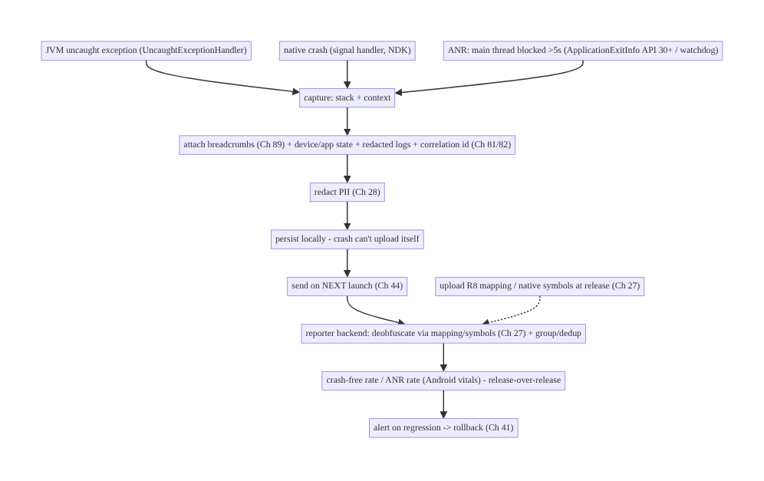
83.4 High-Level Architecture
Components & ownership
- Capture JVM + native + ANR with stack + context (breadcrumbs, state, logs, correlation id, Ch 89/81/82), redacted (Ch 28), persisted and sent on next launch.
- Reporter backend deobfuscates (mapping/symbols, Ch 27), groups/dedups into issues.
- Android vitals monitors crash-free/ANR rate; alerting + rollback on regression (Ch 41).
Direction: crash/ANR → capture + context + redact → persist → next-launch upload → deobfuscate/group → crash-free/ANR rate monitoring + alert/rollback.

83.5 Detailed Component Design
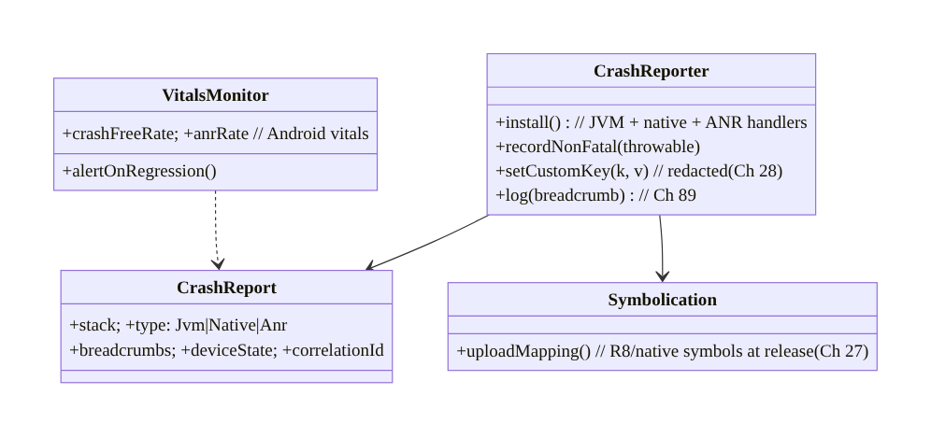
83.5 Detailed Component Design
Component | Responsibility
CrashReporter | install JVM/native/ANR handlers; non-fatals; custom keys; breadcrumbs (Ch 89)
CrashReport | stack + type + context (breadcrumbs/state/correlation), redacted (Ch 28)
Symbolication | upload mapping/symbols → deobfuscate (Ch 27)
VitalsMonitor | crash-free/ANR rate (Android vitals) + alerting/rollback (Ch 41)

83.6 End-to-End Data Flow

Crash → next-launch report → deobfuscate → vitals
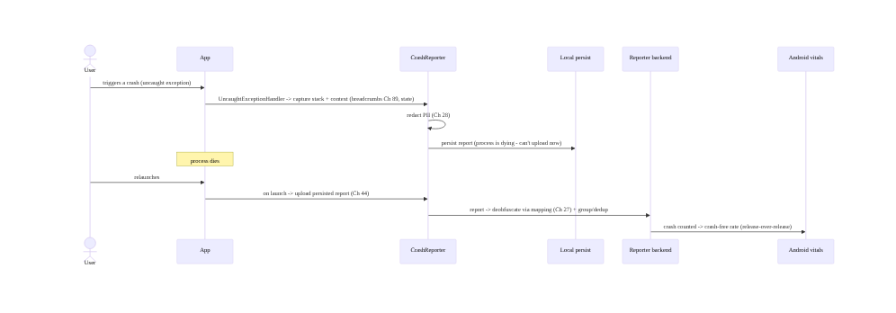
Crash → next-launch report → deobfuscate → vitals

ANR capture (ApplicationExitInfo, API 30+)
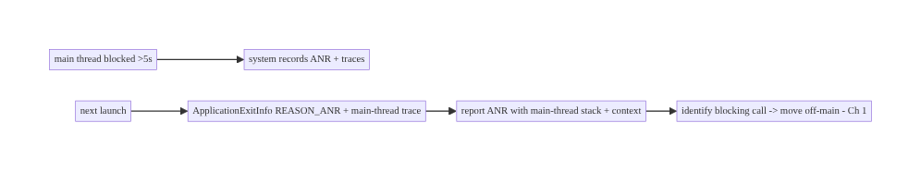
ANR capture (ApplicationExitInfo, API 30+)

83.7 Complete Kotlin Implementation
Package: com.streamcart.crash.

83.7.1 Install reporter (JVM + native + ANR) with context (Ch 89/28)
@Singleton
class CrashReporter @Inject constructor(
private val breadcrumbs: BreadcrumbBuffer, // Ch 89
private val redactor: PiiRedactor, // Ch 28
private val consent: ConsentManager, // Ch 28/82
) {
fun install() {
if (!consent.crashReportingGranted()) return // consent (Ch 28)
// Reporter SDK installs JVM UncaughtExceptionHandler + native signal handler + ANR detection.
Firebase.crashlytics.setCrashlyticsCollectionEnabled(true) // (or Sentry/custom)
// Attach custom keys/breadcrumbs (REDACTED, Ch 28/89). ApplicationExitInfo read on next launch for ANR.
}
fun log(breadcrumb: String) = Firebase.crashlytics.log(redactor.redact(breadcrumb)) // Ch 89, redacted (Ch 28)
fun setCustomKey(key: String, value: String) = Firebase.crashlytics.setCustomKey(key, redactor.redact(value)) // no PII
fun recordNonFatal(t: Throwable) = Firebase.crashlytics.recordException(t) // caught-but-notable
fun setCorrelationId(id: String) = Firebase.crashlytics.setCustomKey("correlation_id", id) // link analytics/feedback (Ch 81/82)
}

83.7.2 Read ANRs via ApplicationExitInfo on next launch (API 30+)
class ExitInfoReader @Inject constructor(@ApplicationContext private val ctx: Context, private val reporter: CrashReporter) {
/** On launch, inspect why the previous process exited - capture ANRs (and native crashes) with their traces. */
fun reportPreviousExits() {
if (Build.VERSION.SDK_INT < 30) return
val am = ctx.getSystemService(ActivityManager::class.java)
am.getHistoricalProcessExitReasons(ctx.packageName, 0, 5).forEach { info ->
when (info.reason) {
ApplicationExitInfo.REASON_ANR -> reporter.reportAnr(info.traceInputStream?.readBytes()) // main-thread trace
ApplicationExitInfo.REASON_CRASH_NATIVE -> reporter.reportNativeExit(info)
ApplicationExitInfo.REASON_LOW_MEMORY -> reporter.setCustomKey("prev_exit", "low_memory")
else -> {}
}
}
}
}
// Call reportPreviousExits() early on launch (Ch 44/45) - lightweight.

83.7.3 Breadcrumbs + device state (context, Ch 89)
// Breadcrumbs: log screen views, key taps, events (NO PII, Ch 89) -> attached to the crash.
fun trackScreen(screen: String, reporter: CrashReporter) = reporter.log("screen:$screen")
// Device/app state as custom keys (non-PII): version, flags, memory, screen.
fun attachState(reporter: CrashReporter, featureFlags: Map<String, Boolean>) {
reporter.setCustomKey("low_memory", isLowMemory().toString())
featureFlags.forEach { (k, v) -> reporter.setCustomKey("ff_$k", v.toString()) } // Ch 41
}

83.7.4 Mapping/symbol upload for deobfuscation (Ch 27, build config)
// build.gradle(.kts): enable R8 + mapping upload so release stacks are READABLE (Ch 27).
android {
buildTypes { release { isMinifyEnabled = true } } // R8 (Ch 27)
}
// Crashlytics Gradle plugin uploads the mapping file automatically; NDK symbols uploaded for native (Ch 27).
// Without the mapping/symbols, release crash stacks are gibberish.

83.7.5 Non-fatal reporting with context
// Report a caught-but-notable error (e.g., a recoverable failure) with context, redacted (Ch 28).
fun reportHandled(reporter: CrashReporter, e: Exception, context: String) {
reporter.setCustomKey("handled_context", context) // redacted (no PII)
reporter.recordNonFatal(e) // grouped as a non-fatal issue
}

83.7.6 Module structure
:core:crash CrashReporter (JVM+native+ANR), ExitInfoReader (ApplicationExitInfo), context/custom-keys
:core:logging BreadcrumbBuffer (Ch 89); :core:privacy PiiRedactor + ConsentManager (Ch 28)
# Mapping/symbol upload -> R8/build (Ch 27). Vitals -> Play Console + reporter dashboards. Correlation -> Ch 81/82.

83.8 Concurrency and Race Conditions
Scenario | Risk | Handling
Upload during crash | report lost | persist + send on next launch (not during crash)
ANR trace missed | undetected ANR | ApplicationExitInfo (API 30+) + watchdog
Obfuscated stack | unreadable | upload mapping/symbols; deobfuscate (Ch 27)
PII in exception/logs | leak | redact messages/breadcrumbs/custom keys (Ch 28)
Reporter crashes the app | worse than the bug | robust reporter; low-overhead; guard its own errors
Duplicate reports | noise | group/dedup by stack signature
Reporting without consent | privacy | consent gate (Ch 28/82)
- Send on next launch, not during the crash: the crashing process is dying and can’t finish an upload — persist the report and upload on the next launch (ANRs via ApplicationExitInfo are inherently next-launch). This is the reliability crux.
- Deobfuscation is mandatory for release (Ch 27): without the mapping file/symbols, release stacks are gibberish and un-triage-able — upload them at build/release time.
- Redact everything in the report (Ch 28): messages, breadcrumbs, custom keys, logs — no PII/secrets; crash reports are a privacy surface.

83.9 Failure Scenarios and Recovery
Failure | Detection | Response | Outcome
Crashes invisible | low crash-free with no reports | install reporter (JVM/native/ANR); send next launch | visible
Unreadable stacks | gibberish | upload mapping/symbols; deobfuscate (Ch 27) | readable
ANRs undetected | ANR rate up, no detail | ApplicationExitInfo/watchdog capture main-thread stack | diagnosed
PII in reports | privacy audit | redact (Ch 28) | safe
Missing context | hard to repro | breadcrumbs + state + correlation (Ch 89/81/82) | debuggable
New release spikes crashes | vitals alert | alert + rollback (Ch 41) | mitigated
Reporter crashes app | worse crashes | robust/guarded reporter | stable
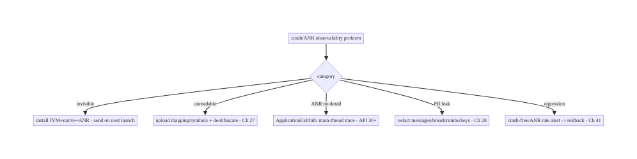
83.9 Failure Scenarios and Recovery
Crash/ANR reporting is: capture all three, add context, send on next launch, deobfuscate, redact, and monitor crash-free/ANR rate. A crash you can’t see (not captured), can’t read (obfuscated), can’t reproduce (no context), or that leaks PII is a broken observability chain — and the crash-free/ANR rate in Android vitals is the KPI that gates releases and store ranking.

83.10 Scaling the Implementation
- Level 1. Reporter capturing JVM exceptions + stacks; mapping upload for deobfuscation (Ch 27); crash-free rate in vitals.
- Level 2. Native crashes + ANRs (ApplicationExitInfo, Ch 44/45); breadcrumbs + device state + custom keys (Ch 89); PII redaction + consent (Ch 28).
- Level 3 — production. Correlation id to analytics/feedback (Ch 81/82); non-fatals; grouping/dedup; release-over-release vitals + alerting + rollback (Ch 41).
- Level 4 — large. Per-device/OS crash analysis; velocity-based rollback; regression gating in CI; crash budgets/SLOs; native symbol pipelines.
- Level 5 — enterprise. Crash-free SLOs with error budgets, automated triage/assignment, trend forecasting, cross-platform parity, privacy governance for reports.
Avoid overengineering: a mature reporter (Crashlytics/Sentry) + mapping upload + redaction + breadcrumbs + vitals monitoring covers almost everything. Don’t hand-roll crash capture; don’t skip deobfuscation or redaction.

83.11 Alternative Approaches and Trade-offs
Dimension | Option A | Option B | When
Reporter | Mature SDK (Crashlytics/Sentry) | hand-rolled | SDK (handles native/ANR/grouping); hand-roll rarely
Delivery | Send on next launch | upload during crash | Next launch (process is dying)
Stacks | Deobfuscate via mapping (Ch 27) | ship un-obfuscated | Deobfuscate (keep R8; upload mapping)
ANR | ApplicationExitInfo + watchdog | ignore ANRs | Capture (ANR rate is a vitals KPI)
Context | Breadcrumbs + state + correlation | bare stack | Rich context (debuggable)
Privacy | Redact + consent (Ch 28) | raw reports | Redact (privacy surface)
Monitoring | Crash-free/ANR rate + alerting (vitals) | individual stacks only | Aggregate + alert (gate releases)
Mature reporter vs hand-rolled: capturing native crashes and ANRs correctly, grouping by signature, and deobfuscating is a large effort that Crashlytics/Sentry have solved. A hand-rolled UncaughtExceptionHandler catches JVM exceptions but misses native/ ANR/grouping/symbolication. Use a mature reporter; spend effort on context, redaction, and monitoring, not reimplementing capture.
Send-on-next-launch vs upload-during-crash: the crashing process is terminating, so a network upload started during the crash often doesn’t finish (lost report). Persisting the report and uploading on the next launch (Ch 44) is reliable — and ANRs/native crashes read via ApplicationExitInfo are inherently next-launch. Always send on next launch.
Deobfuscate (keep R8) vs ship un-obfuscated: disabling R8 to get readable stacks loses R8’s size/security benefits (Ch 27). The right approach is to keep R8 and upload the mapping file so the reporter deobfuscates server-side — readable stacks and an optimized/obfuscated release. Always deobfuscate via mapping, never disable R8.

83.12 Security & Privacy Considerations
- Crash reports are a privacy surface (Ch 28): exception messages, logs, breadcrumbs, and custom keys can carry PII/secrets — redact them and never put card data/tokens/PII into exceptions or keys. Treat reports like any telemetry (Ch 82).
- Consent (Ch 28/82): crash reporting respects consent (some regions/users opt out); gate collection centrally.
- Correlation id is opaque (Ch 81/82): link to analytics/feedback via an opaque id, not personal data.
- Mapping file security (Ch 27): the mapping file deobfuscates your app — keep it secure (not shipped in the APK); upload it to the reporter at build time.
- Secure, authed upload (Ch 19/23): reports upload over TLS-pinned, authed channels; access-controlled server-side.
- Per-account (Ch 42): associate reports with the user only per consent, via opaque ids; honor deletion.
- No sensitive screens in attached screenshots (if any, Ch 81) — redact.
- Client vs backend: the client captures + redacts + sends; the reporter backend deobfuscates, groups, and access-controls; Android vitals aggregates — none store raw PII.

83.13 Performance and Resource Optimization
- Low-overhead capture: breadcrumbs/custom keys are cheap in-memory ops (Ch 89); the reporter must add minimal runtime cost.
- Send on next launch (not during crash) — no impact on the crashing path; upload lightly on launch (don’t bloat cold start, Ch 45).
- Bounded breadcrumb buffer (Ch 89) — ring buffer; don’t grow unbounded.
- ANR detection via ApplicationExitInfo is free (system-provided, read next launch) — prefer it over a heavy main-thread watchdog where possible.
- Deobfuscation is server-side — no client cost.
- Profiling: crash-free rate, ANR rate, report upload success, capture overhead, cold- start impact of next-launch upload (Ch 45).

83.14 Testing Strategy
Crash capture is validated with forced crashes/ANRs; context/redaction unit-tested; vitals via staged rollouts.
// Forced crash (debug) to verify capture + context + deobfuscation pipeline:
fun forceCrash() { throw RuntimeException("test crash") } // verify it appears deobfuscated with breadcrumbs
class RedactionTest {
@Test fun `custom keys and breadcrumbs are redacted`() {
reporter.setCustomKey("email", "a@b.com"); // via redactor
// assert stored value is redacted (Ch 28)
}
@Test fun `no PII in exception context`() { /* ... */ }
}
class ExitInfoTest {
@Test fun `reports previous ANR from ApplicationExitInfo`() { /* fake ActivityManager -> REASON_ANR -> report */ }
}
// Manual/staged: force an ANR (sleep on main thread), verify it's captured with the main-thread stack;
// verify mapping upload -> deobfuscated stack in the reporter; monitor crash-free rate in a staged rollout.
What to test: forced JVM crash captured + deobfuscated (mapping, Ch 27) + breadcrumbs/state attached; ANR captured via ApplicationExitInfo with main-thread stack; redaction of custom keys/breadcrumbs/messages (Ch 28); next-launch upload; consent gate; correlation id opaque. Staged rollout to watch crash-free/ANR rate before full release (Ch 41).

83.15 Production Observability
- Metrics (the KPIs): crash-free users + crash-free sessions; ANR rate; release-over-release trends; crash/ANR by device/OS/version; top issues by impact; report upload success; non-fatal rates; capture rate.
- Dashboards: Android vitals (Play Console) + reporter (Crashlytics/Sentry) — crash-free/ ANR rate by release/device; issue triage ranked by impact.
- Debugging: invisible crashes → reporter not capturing (JVM/native/ANR) or not sending next launch; gibberish stacks → mapping not uploaded (Ch 27); ANRs without detail → ApplicationExitInfo not read; PII in reports → redaction gap (Ch 28); new-release spike → a regression (rollback, Ch 41).
- Alerting: crash-free rate / ANR rate regression on a new release (gate/rollback, Ch 41); velocity (fast-growing new crash); any PII in reports (privacy incident).
- Release gating: Play’s bad-behavior thresholds + your SLOs gate rollout; halt/roll back a release that regresses vitals (Ch 41).

83.16 System Design Interview Preparation
≥25 questions.
Fundamentals
- What to capture? JVM exceptions, native (NDK) crashes, and ANRs.
- ANR? Main thread blocked too long (input >5s).
- Why not upload during the crash? Process is dying — persist + send on next launch.
- ANR capture? ApplicationExitInfo (API 30+) main-thread trace + watchdog.
- Reporter? Mature SDK (Crashlytics/Sentry) — handles native/ANR/grouping.
Readability
- Why gibberish stacks? R8 obfuscation (Ch 27).
- Fix? Upload mapping file/symbols → deobfuscate/symbolicate.
- Disable R8 instead? No — lose size/security; deobfuscate via mapping.
Context
- Beyond the stack? Breadcrumbs (Ch 89) + device/app state + logs + correlation id.
- Breadcrumbs? Recent action/screen sequence → repro.
- Correlation id? Opaque link to analytics/feedback (Ch 81/82).
- Custom keys? Flags/screen/memory — redacted (Ch 28).
Privacy
- PII in reports? Redact messages/breadcrumbs/keys; never secrets (Ch 28).
- Consent? Crash reporting respects consent (Ch 28/82).
- Mapping file security? Keep secure; not in the APK.
Monitoring
- KPIs? Crash-free users/sessions + ANR rate (Android vitals).
- Granularity? By release/device/OS; trends.
- Grouping? By stack signature into issues (triage by impact).
- Regression? Alert + rollback (Ch 41); velocity.
- Why vitals matter? Play ranks/demotes on crash/ANR behavior.
Reliability/robustness
- Reporter crashes app? Must be robust/low-overhead.
- Duplicate reports? Group/dedup.
- Delivery? Persist + next launch.
Testing/Production
- Test capture? Force a crash → verify deobfuscated + context.
- Test ANR? ApplicationExitInfo / block main thread.
- Invisible crashes? Not capturing / not sending next launch.

Design-change challenges
- Release crash stacks are unreadable. Keep R8; upload mapping; deobfuscate (Ch 27).
- ANRs are high but undiagnosable. Capture via ApplicationExitInfo (main-thread trace) → move blocking call off-main (Ch 1).
- Crashes carry user emails. Redact exception messages/keys/breadcrumbs (Ch 28).
- A new release spikes crashes. Vitals alert → rollback (Ch 41).
- Crashes aren’t being reported. Reporter not installed / not sending on next launch; fix + send persisted reports.

Mock walkthrough (abridged)
Clarify (JVM/native/ANR, release build, privacy?) → capture all three (reporter SDK + ApplicationExitInfo for ANR) → attach context (breadcrumbs Ch 89, state, correlation Ch 81/ 82) → redact PII (Ch 28) → persist + send on next launch → upload mapping/symbols + deobfuscate (Ch 27) → group/dedup → monitor crash-free/ANR rate in Android vitals release- over-release → alert + rollback (Ch 41) → reporter robust/low-overhead.

83.17 Practical Exercises
- Beginner. Integrate a crash reporter capturing JVM exceptions with stacks, and upload the R8 mapping file so stacks deobfuscate (Ch 27). Eval: crashes visible + readable.
- Intermediate. Attach breadcrumbs (Ch 89) + device state + an opaque correlation id (Ch 81/82); redact PII from custom keys/messages (Ch 28). Eval: debuggable; no PII.
- Advanced. Capture ANRs via ApplicationExitInfo (main-thread trace) and native crashes with symbols; send persisted reports on next launch. Eval: ANR/native captured next launch.
- Production debugging. Fix unreadable release stacks (missing mapping) and PII leaking into reports (redaction gap). Eval: readable; safe.
- System design challenge. Monitor crash-free/ANR rate release-over-release with alerting and a velocity-based rollback (Ch 41). Eval: regression alert; rollback triggers.
(Solutions withheld unless requested.)

83.18 Chapter Summary & Reference Sheet
Key decisions: capture all three failure types — JVM exceptions, native (NDK) crashes, and ANRs (main-thread blocks >5s, via the system signal and ApplicationExitInfo on API 30+ for the main-thread trace) — with the stack plus rich context (breadcrumbs Ch 89, device/app state, redacted session logs, an opaque correlation id linking analytics/feedback Ch 81/82); because a crashing process can’t reliably upload, persist the report and send it on the next launch (Ch 44); keep R8 and upload the mapping file / native symbols so the reporter deobfuscates/ symbolicates release stacks into readable form (never disable R8, Ch 27); redact PII from messages/breadcrumbs/custom keys/logs (crash reports are a privacy surface, consent- gated, Ch 28/82); group/dedup into triageable issues; and monitor crash-free users/ sessions and ANR rate in Android vitals release-over-release, by device/OS, with alerting and velocity-based rollback (Ch 41) — using a mature reporter (Crashlytics/Sentry) that is low-overhead and never crashes the app. A crash you can’t see, can’t read, can’t reproduce, or that leaks PII is a broken observability chain; crash- free/ANR rate is the KPI that gates releases and store ranking.
Concepts: JVM/native/ANR capture, ApplicationExitInfo, send-on-next-launch, context (breadcrumbs/state/correlation), deobfuscation/symbolication (mapping/symbols, Ch 27), PII redaction + consent (Ch 28), grouping/dedup, crash-free/ANR rate (Android vitals) + alerting/rollback (Ch 41), non-fatals, robust low-overhead reporter.
Common mistakes: capturing only JVM (missing native/ANR); uploading during the crash (lost report); shipping without mapping upload (unreadable stacks) or disabling R8; ignoring ANRs; bare stacks with no context; PII in exception messages/keys/logs; no consent; not monitoring crash-free/ANR rate or not alerting/rolling back on regressions; a reporter that adds overhead or crashes the app.
Checklist:
- ☐ capture JVM + native + ANR (ApplicationExitInfo API 30+)
- ☐ send on next launch (persist; don’t upload during crash)
- ☐ attach breadcrumbs (Ch 89) + device state + correlation id (Ch 81/82)
- ☐ keep R8 + upload mapping/symbols → deobfuscate (Ch 27)
- ☐ redact PII + consent (Ch 28/82)
- ☐ group/dedup into issues
- ☐ non-fatals with context
- ☐ monitor crash-free/ANR rate in Android vitals by release/device
- ☐ alert + velocity rollback (Ch 41)
- ☐ mature, low-overhead reporter that never crashes the app
- ☐ secure authed upload + mapping security (Ch 19/23/27).
Key APIs: crash reporter SDK (Crashlytics/Sentry — recordException/log/setCustomKey), Thread.setDefaultUncaughtExceptionHandler, ActivityManager.getHistoricalProcessExitReasons/ ApplicationExitInfo (REASON_ANR/REASON_CRASH_NATIVE, API 30+), R8 isMinifyEnabled + mapping/symbol upload (Ch 27), BreadcrumbBuffer (Ch 89), PiiRedactor/ConsentManager (Ch 28), Android vitals (Play Console), rollback (Ch 41).
References: - Android vitals (crashes/ANRs): https://developer.android.com/topic/performance/vitals - Diagnose ANRs: https://developer.android.com/topic/performance/vitals/anr - ApplicationExitInfo: https://developer.android.com/reference/android/app/ApplicationExitInfo - Crashlytics / NDK symbols / deobfuscation: https://firebase.google.com/docs/crashlytics - (composes) Ch 82 Analytics Pipeline, Ch 28 PII Redaction/Consent, Ch 89 Logging/Breadcrumbs, Ch 27 R8/Deobfuscation, Ch 81 Feedback/Correlation, Ch 44/45 Lifecycle/Startup, Ch 41 Release/Rollback

Chapter 84 — Distributed Tracing & Correlation IDs
Part X — Performance, Observability & Quality · Complexity: Standard (≥25 interview questions)
Prerequisites: Ch 1 (networking/OkHttp), Ch 82 (analytics pipeline), Ch 83 (crash reporting), Ch 81 (feedback/correlation), Ch 2 (retries), Ch 28 (privacy). Pairs with Ch 85 (perf monitoring), Ch 87 (error telemetry).
Reference surface in StreamCart: the thread that ties a user action on the device to the backend work it triggers — a trace/correlation id propagated from the app through every request so a slow checkout, a failed order, or a crash can be followed end-to-end across client and server logs, traces, analytics (Ch 82), and crash reports (Ch 83).

84.1 Problem Definition and Real-World Context
When something goes wrong — a checkout fails, a screen is slow, an order never arrives — engineers need to follow one user’s one action across many systems: the client code, the network request, the backend services it fans out to, the database, and back. Without a shared identifier threaded through all of it, client logs and server logs are disconnected islands; you can’t tell which backend trace corresponds to this user’s failed tap. Distributed tracing (trace + span ids propagated across service boundaries) and correlation ids (a stable id linking a client session/action to its backend work and to analytics/crash data) solve this — they make the whole system observable end-to-end.
Concretely, teams hit:
- Disconnected client/server logs. A user reports a failed order; support has a client log and the backend has thousands of traces — with no way to link them. A correlation id sent on the request and logged on both sides joins them.
- No trace propagation. The backend uses distributed tracing (OpenTelemetry/Jaeger), but the client doesn’t start or propagate a trace, so backend traces don’t include the client-originated context (which screen/action started this). The client should inject trace context (W3C traceparent) into outgoing requests.
- Can’t correlate across observability pillars. Analytics events (Ch 82), crash reports (Ch 83), feedback (Ch 81), and backend traces are separate — a shared correlation id (per session/action) lets you jump between them.
- Per-request vs per-session ids. You need both: a per-request id (trace a single call) and a session/correlation id (tie all of a session’s activity together) — consistently generated and propagated.
- Retries and id reuse. A retried request (Ch 2) should keep its trace semantics correct (new span, same trace); an idempotency key (Ch 15) is distinct from a trace id.
- Privacy. Trace/correlation ids must be opaque (not PII, Ch 28) — they identify a flow, not a person.
- Sampling & overhead. Tracing everything is costly; sample traces while keeping correlation ids cheap and always-on.
The architecture: generate a correlation/session id (opaque) on the client and a per-request trace context (W3C Trace Context traceparent), propagate them on every outgoing request via an OkHttp interceptor (Ch 1); log the correlation id on the client (analytics Ch 82, crash Ch 83, feedback Ch 81) and have the server log/trace it too, so one id joins client logs, backend traces, analytics, and crashes; manage per-request vs per-session ids and retry semantics (Ch 2); keep ids opaque/ non-PII (Ch 28); and sample traces. This chapter is about threading one id through everything so the system is traceable end-to-end.

Three practical use cases
- Debug a failed checkout (StreamCart). The checkout flow carries a correlation id; the failed placeOrder (Ch 75) request’s traceparent links to the backend trace showing which service failed — joined to the client’s analytics/crash via the correlation id.
- Trace a slow screen. A screen’s load fans out to several API calls, all sharing the session correlation id and each with its own trace; the end-to-end latency breakdown is visible across client and server.
- Support ties a report to a session. A user’s feedback (Ch 81) carries the correlation id; support finds the exact backend traces, client logs, and crashes for that session.

Why this is architectural
Distributed tracing/correlation is the connective tissue of observability, tying networking (Ch 1), analytics (Ch 82), crash reporting (Ch 83), feedback (Ch 81), and backend tracing into one followable thread. The decisions — correlation + trace ids, W3C propagation via an interceptor, cross-pillar logging, opaque/non-PII, sampling — determine whether you can actually debug production end-to-end.

84.2 Requirements Engineering

Functional requirements
ID | Requirement
F1 | Generate an opaque correlation/session id and per-request trace context (W3C traceparent).
F2 | Propagate them on every outgoing request via an OkHttp interceptor (Ch 1).
F3 | Log the correlation id on the client across analytics, crash, and feedback (Ch 82/83/81).
F4 | Enable the server to log/trace the same id, joining client and backend.
F5 | Handle per-request vs per-session ids and retry semantics (new span, same trace) (Ch 2).
F6 | Keep ids opaque/non-PII; sample traces for cost (Ch 28).

Non-functional requirements
Attribute | Policy
Traceability | One id joins client logs/analytics/crashes + backend traces.
Standards | W3C Trace Context propagation; OpenTelemetry-compatible.
Privacy | Opaque ids, not PII (Ch 28).
Overhead | Correlation always-on + cheap; traces sampled.
Consistency | Ids generated/propagated uniformly (interceptor).

Scope
- In scope: correlation/session id + per-request trace context (W3C traceparent), propagation via OkHttp interceptor (Ch 1), cross-pillar correlation (analytics Ch 82, crash Ch 83, feedback Ch 81), per-request vs per-session ids, retry/span semantics (Ch 2), opaque/non-PII ids (Ch 28), sampling, OpenTelemetry-on-mobile overview.
- Out of scope: analytics pipeline (Ch 82), crash reporting (Ch 83), feedback (Ch 81), networking internals (Ch 1), backend tracing infra, perf monitoring (Ch 85).

Assumptions & constraints
- OkHttp (Ch 1) for propagation; the backend uses distributed tracing (OpenTelemetry/ W3C Trace Context) and logs correlation ids; analytics/crash/feedback pipelines accept a correlation id (Ch 82/83/81). minSdk 24. Ids are opaque (non-PII, Ch 28); traces are sampled.

84.3 System Design Fundamentals
- Two kinds of id: trace context (per request) + correlation/session id (per session/ flow).
  - Trace context (W3C Trace Context): a traceparent header carrying a trace id (the whole distributed operation) and a span id (this hop), plus flags (sampled). The client starts or continues a trace and injects traceparent into each outgoing request; the backend continues the same trace across its services — producing one end-to-end distributed trace. This is the standard (W3C Trace Context, OpenTelemetry).
  - Correlation/session id: a stable, opaque id for a session (or a logical user action/flow) that ties together all of a session’s client activity — analytics events (Ch 82), crash reports (Ch 83), feedback (Ch 81) — and is sent to the backend so server logs carry it. Where a trace follows one request, the correlation id joins everything in a session/flow. Both are needed: the trace gives you the per-request latency/error breakdown across services; the correlation id gives you the “all activity for this session” join across observability pillars.
- Propagate via one interceptor (Ch 1). An OkHttp interceptor injects the traceparent (and a correlation-id header, e.g., X-Correlation-Id) into every outgoing request — uniformly, in one place (like auth, Ch 19). This guarantees consistency and means feature code doesn’t manage headers. The interceptor also creates the per-request span.
- Log the correlation id across all client pillars (Ch 82/83/81). Set the correlation id as a:
  - Analytics super-property (Ch 82) so every event carries it,
  - Crash reporter custom key (Ch 83) so crashes carry it,
  - Feedback attachment (Ch 81) so reports carry it,
  - Client log field. Then one id lets you jump from a crash → the session’s analytics → the backend traces → the feedback. This cross-pillar join is the whole point.
- Server logs/traces the same id. The backend, on receiving traceparent + X-Correlation-Id, continues the trace and logs the correlation id on every log line/span for that request — so client-sent ids appear in server logs and traces, completing the join. (This is a backend requirement the client enables by sending the ids.)
- Per-request vs per-session + retries (Ch 2). Each request gets a new span (and usually a new traceparent span id) under the trace; a retry (Ch 2) is a new span (it’s a new attempt) but can share the trace/correlation context so the retry is visible in the same trace. The correlation/session id persists across requests within a session. (Note: a trace id is not an idempotency key, Ch 15 — different purpose: tracing vs dedup.)
- Opaque, non-PII ids (Ch 28). Trace/correlation ids are random opaque identifiers (UUID/128-bit) — they identify a flow/session, not a person. Never embed PII (email, user id in the clear) in them. This keeps tracing privacy-safe (Ch 28/82/83).
- Sampling (cost). Full distributed tracing is expensive (storage/overhead), so traces are sampled (a fraction, with the sampled flag in traceparent so the backend agrees) — while the correlation id is always-on and cheap (just a header + a logged field). Sample traces; always correlate.
- OpenTelemetry on mobile. OpenTelemetry (OTel) provides SDKs and the W3C Trace Context standard; on mobile it’s emerging — you can use OTel or a lighter custom correlation layer, but standard propagation (W3C traceparent) is what makes client traces continue into the backend’s tracing system.
Core insight: thread two opaque, non-PII identifiers through the system — a W3C Trace Context (traceparent: trace id + per-hop span id) that the client starts and injects into every request so the backend continues one end-to-end distributed trace, and a stable correlation/session id that joins all of a session’s client activity (analytics Ch 82, crash Ch 83, feedback Ch 81) and is sent so server logs carry it — propagated uniformly by a single OkHttp interceptor (Ch 1), logged across every client observability pillar and the server, with new spans per request/retry (Ch 2) under a persistent session correlation, opaque/non-PII ids (Ch 28), and sampled traces (correlation always-on) — so one user’s one action can be followed end-to-end across client and server.

84.4 High-Level Architecture
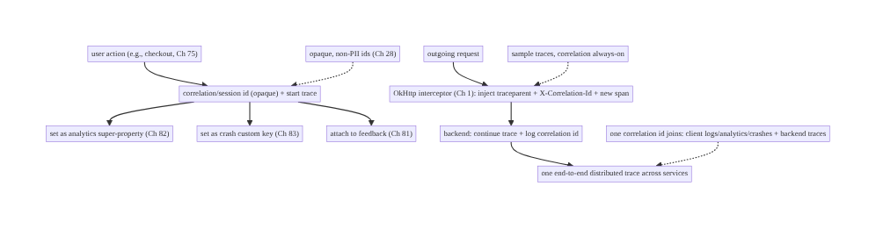
84.4 High-Level Architecture
Components & ownership
- Correlation/session id + trace started per action; set across analytics/crash/ feedback (Ch 82/83/81).
- OkHttp interceptor injects traceparent + correlation id on every request and creates the per-request span (Ch 1).
- Backend continues the trace and logs the correlation id → one id joins all pillars.
- Sampling for traces; opaque/non-PII ids (Ch 28).
Direction: action → correlation id + trace → set across pillars → interceptor injects on requests → backend continues trace + logs id → end-to-end join.

84.5 Detailed Component Design
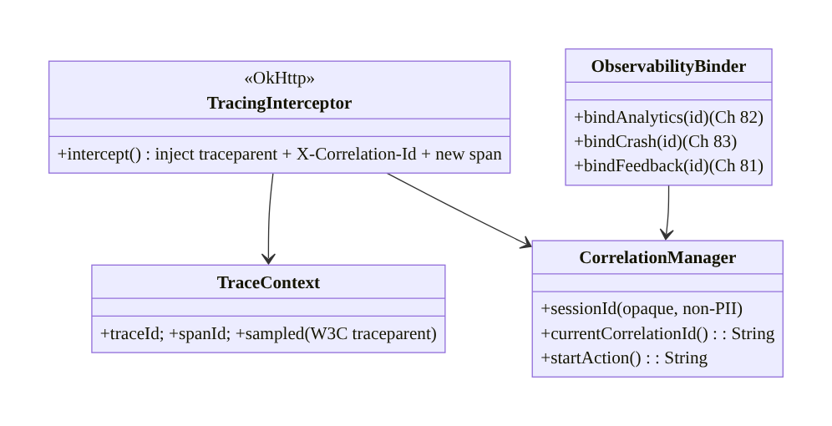
84.5 Detailed Component Design
Component | Responsibility
TraceContext | W3C trace id + span id + sampled flag (traceparent)
CorrelationManager | opaque session/action correlation id
TracingInterceptor | inject traceparent + correlation id + new span per request (Ch 1)
ObservabilityBinder | set correlation id on analytics/crash/feedback (Ch 82/83/81)

84.6 End-to-End Data Flow

One action, end-to-end
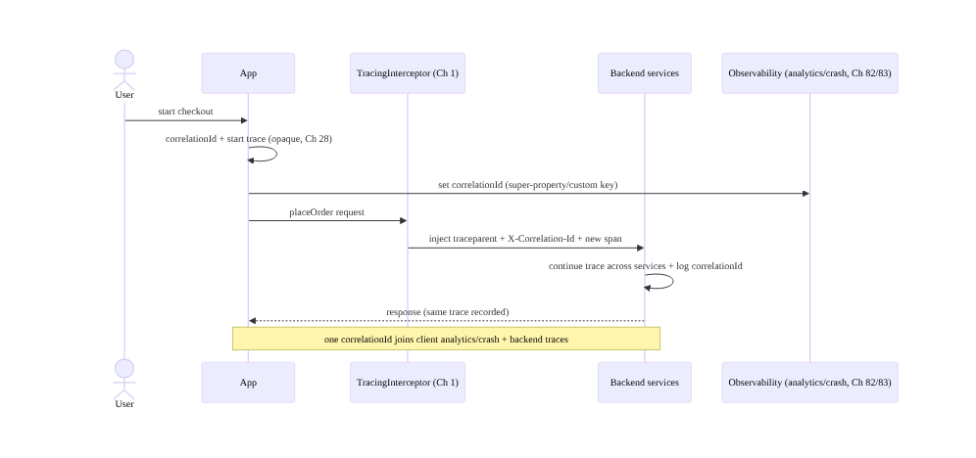
One action, end-to-end

Retry keeps trace, new span
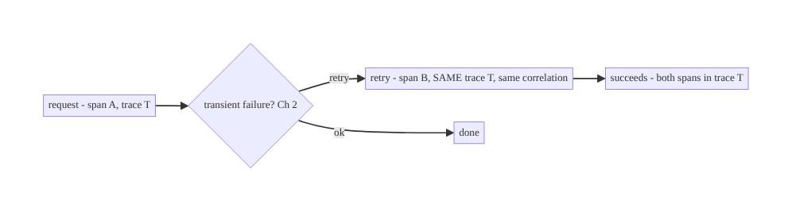
Retry keeps trace, new span

84.7 Complete Kotlin Implementation
Package: com.streamcart.tracing.

84.7.1 Correlation id + trace context (opaque, non-PII, Ch 28)
@Singleton
class CorrelationManager @Inject constructor() {
val sessionId: String = UUID.randomUUID().toString() // opaque, per session; NOT PII (Ch 28)
private var currentAction: String? = null
fun startAction(): String { currentAction = UUID.randomUUID().toString(); return currentAction!! }
fun currentCorrelationId(): String = currentAction ?: sessionId // action id if in a flow, else session
}
data class TraceContext(val traceId: String, val spanId: String, val sampled: Boolean) {
// W3C traceparent: version-traceId-spanId-flags
fun toTraceparent() = "00-$traceId-$spanId-%02x".format(if (sampled) 1 else 0)
companion object {
fun start(sampledRate: Double): TraceContext = TraceContext(
traceId = randomHex(32), spanId = randomHex(16), sampled = Random.nextDouble() < sampledRate) // sample (cost)
fun childSpan(parent: TraceContext) = parent.copy(spanId = randomHex(16)) // new span, same trace (retry/next request)
}
}

84.7.2 OkHttp interceptor: inject traceparent + correlation id (Ch 1)
class TracingInterceptor @Inject constructor(private val correlation: CorrelationManager) : Interceptor {
override fun intercept(chain: Interceptor.Chain): Response {
val trace = TraceContext.start(sampledRate = 0.1) // per-request trace/span (sampled)
val request = chain.request().newBuilder()
.header("traceparent", trace.toTraceparent()) // W3C Trace Context -> backend continues trace
.header("X-Correlation-Id", correlation.currentCorrelationId()) // joins client+server (always-on)
.build()
// (A full OTel SDK would create a real span with timing here.)
return chain.proceed(request) // retry (Ch 2) -> a new interceptor pass -> new span, same correlation
}
}
// Added to the OkHttp stack alongside auth/logging interceptors (Ch 1/19).

84.7.3 Bind correlation id across observability pillars (Ch 82/83/81)
@Singleton
class ObservabilityBinder @Inject constructor(
private val analytics: Analytics, // Ch 82
private val crash: CrashReporter, // Ch 83
private val correlation: CorrelationManager,
) {
/** One correlation id on EVERY pillar -> jump between crash <-> analytics <-> backend traces <-> feedback. */
fun bind() {
val id = correlation.currentCorrelationId()
analytics.setSuperProperty("correlation_id", id) // every event carries it (Ch 82)
crash.setCustomKey("correlation_id", id) // every crash carries it (Ch 83)
// feedback attaches it too (Ch 81); client logs include it.
}
}

84.7.4 Start a traced action (e.g., checkout, Ch 75)
fun startTracedCheckout(correlation: CorrelationManager, binder: ObservabilityBinder) {
correlation.startAction() // new correlation id for this flow (ties its requests + events + any crash)
binder.bind() // propagate to analytics/crash/feedback
// subsequent requests carry traceparent + X-Correlation-Id via the interceptor -> backend joins them.
}

84.7.5 Server-side expectation (what the client enables)
// The BACKEND must: read `traceparent` -> continue the W3C trace (OpenTelemetry);
// read `X-Correlation-Id` -> log it on every log line/span for the request.
// Then a single id joins client observability (Ch 82/83/81) and backend traces/logs.
// (Client enables this by sending the headers; backend owns continuation + logging.)

84.7.6 Module structure
:core:tracing CorrelationManager, TraceContext (W3C), TracingInterceptor (Ch 1), ObservabilityBinder
# Analytics -> Ch 82; crash -> Ch 83; feedback -> Ch 81. OpenTelemetry SDK optional. Backend continues trace + logs id.

84.8 Concurrency and Race Conditions
Scenario | Risk | Handling
Id not propagated on some requests | broken trace/join | inject in one interceptor (all requests, Ch 1)
Retry reuses span id | wrong trace graph | new span per attempt, same trace/correlation (Ch 2)
Correlation id missing on crash | can’t join | set as crash custom key on bind (Ch 83)
PII in id | privacy leak | opaque random ids only (Ch 28)
Trace not sampled but logged | inconsistent | sampled flag in traceparent; backend honors it
Concurrent actions share id | ambiguous | per-action correlation id for distinct flows
Backend ignores headers | no join | backend must continue trace + log id (requirement)
- One interceptor guarantees propagation: injecting traceparent + correlation id in a single OkHttp interceptor (Ch 1) means every request carries them — scattered manual headers inevitably miss some, breaking the trace/join.
- New span per request/retry, persistent correlation: each attempt is a new span under the same trace (Ch 2), and the correlation/session id persists across the flow — so retries and fan-out appear correctly in one trace and one session join.
- Opaque ids keep it private: random 128-bit ids identify a flow, not a person (Ch 28) — never encode PII.

84.9 Failure Scenarios and Recovery
Failure | Detection | Response | Outcome
Client/server logs disconnected | support can’t trace | correlation id sent + server-logged | joined
Backend trace lacks client context | incomplete trace | client injects traceparent (continue trace) | end-to-end
Can’t jump crash → backend | debugging gap | correlation id on crash (Ch 83) + server | linked
PII in ids | privacy audit | opaque ids (Ch 28) | safe
Tracing too costly | cost | sample traces (correlation always-on) | affordable
Missing on some requests | gaps | single interceptor (Ch 1) | consistent
Retry confuses trace | wrong graph | new span, same trace (Ch 2) | correct
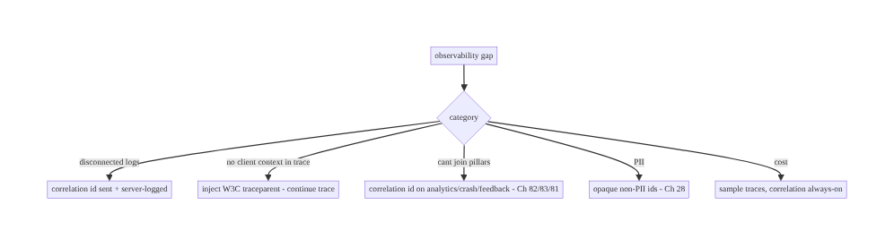
84.9 Failure Scenarios and Recovery
One opaque id, propagated by one interceptor and logged on every pillar and the server, makes the whole system followable. The W3C traceparent continues the backend’s distributed trace with client context; the correlation id joins the client’s analytics, crashes, and feedback to those traces. Sample the expensive traces; keep the cheap correlation always-on.

84.10 Scaling the Implementation
- Level 1. Correlation/session id + X-Correlation-Id header via an OkHttp interceptor (Ch 1); log it on the client.
- Level 2. W3C traceparent propagation (continue backend trace); set correlation id on analytics/crash/feedback (Ch 82/83/81).
- Level 3 — production. Per-request spans + retry semantics (Ch 2); sampling; opaque non-PII ids (Ch 28); server-side continuation + logging.
- Level 4 — large. OpenTelemetry SDK with real client spans (screen load, request timing); trace-based perf (Ch 85); cross-service dashboards; adaptive sampling.
- Level 5 — enterprise. Full client-to-backend distributed tracing, SLO/trace-based alerting, trace governance, PII/consent review, multi-platform correlation parity.
Avoid overengineering: a correlation id + W3C traceparent via one interceptor + binding to the pillars covers most debugging needs. Don’t hand-roll a tracing system; use W3C/OTel standards. Don’t trace everything — sample.

84.11 Alternative Approaches and Trade-offs
Dimension | Option A | Option B | When
Standard | W3C Trace Context / OpenTelemetry | custom headers | W3C/OTel (backend continuation, interop)
Ids | Trace (per request) + correlation (per session) | one id | Both (per-request latency + session join)
Propagation | One interceptor (Ch 1) | per-call headers | Interceptor (consistency)
Cross-pillar | Correlation id on analytics/crash/feedback | separate | Correlation id (join, Ch 82/83/81)
Ids | Opaque, non-PII (Ch 28) | embed user id | Opaque (privacy)
Cost | Sample traces, correlation always-on | trace everything | Sample (cost)
Trace id vs idempotency | Distinct (Ch 15) | reuse | Distinct (tracing ≠ dedup)
W3C/OpenTelemetry vs custom tracing: a custom header scheme can carry an id, but it won’t continue the backend’s distributed trace unless it follows the W3C Trace Context standard the backend tracing system (OTel/Jaeger/Zipkin) understands. Using W3C traceparent means client-originated context flows into the backend trace and tools interoperate. Use the standard; don’t invent a propagation format.
Trace + correlation vs a single id: a trace id follows one request across services (latency/error breakdown); a correlation/session id joins all of a session’s client activity (analytics, crashes, feedback) and server logs. They answer different questions — “what did this request do across services?” vs “show me everything for this session.” Use both.
One interceptor vs per-call propagation: adding trace headers per call site inevitably misses requests (breaking traces/joins) and duplicates logic. A single OkHttp interceptor (Ch 1) injects them on every request uniformly — like auth (Ch 19). Centralize propagation.

84.12 Security & Privacy Considerations
- Opaque, non-PII ids (Ch 28): trace and correlation ids are random identifiers of a flow/session, never PII — don’t embed email/clear user id. This keeps tracing privacy-safe across analytics/crash/feedback (Ch 82/83/81).
- Consent (Ch 28/82): correlation/tracing follows the same consent regime as analytics — if the user opted out, don’t collect/correlate beyond what’s essential.
- Don’t leak sensitive data in traces: spans/logs tied to the trace must not carry request bodies with PII/secrets, tokens, or card data (Ch 28) — redact as everywhere.
- Server-side access control: traces/logs with correlation ids are internal observability data — access-controlled (support/engineering), retention-limited (Ch 28).
- Id spoofing: a client-sent traceparent/correlation id is not a security credential — the backend uses it for correlation only, never authorization (auth is Ch 19); treat incoming ids as untrusted labels.
- Per-account (Ch 42): reset correlation/session on logout so a session’s trace isn’t attributed across users (and ids stay opaque).
- Client vs backend: the client generates opaque ids, propagates via the interceptor, and binds to pillars; the backend continues traces, logs ids, and access-controls/retains the observability data — neither stores PII in ids.

84.13 Performance and Resource Optimization
- Correlation id is cheap (a header + a logged field) — always-on; negligible overhead.
- Sample traces — full span timing/export is costly; sample a fraction (sampled flag in traceparent), keep correlation always-on.
- One interceptor — minimal per-request cost (header injection); no per-call-site logic.
- Lazy span creation — only create detailed spans for sampled traces.
- Bounded trace export — batch/async export (don’t block requests) if using an OTel SDK.
- Profiling: propagation overhead (µs), trace sampling rate, correlation-join success (can we link a report to a trace?), export cost.

84.14 Testing Strategy
Propagation, correlation binding, and retry/span semantics are testable with a fake chain.
class TracingInterceptorTest {
@Test fun `injects traceparent and correlation id on every request`() {
val req = runInterceptor(TracingInterceptor(FakeCorrelation("corr-1")))
assertTrue(req.header("traceparent")!!.matches(Regex("00-[0-9a-f]{32}-[0-9a-f]{16}-[0-9a-f]{2}"))) // W3C
assertEquals("corr-1", req.header("X-Correlation-Id"))
}
@Test fun `correlation id is opaque, not PII`() { assertFalse(CorrelationManager().sessionId.contains("@")) } // Ch 28
}
class CorrelationBindTest {
@Test fun `binds correlation id to analytics and crash`() {
binder.bind()
assertEquals("corr-1", fakeAnalytics.superProps["correlation_id"]) // Ch 82
assertEquals("corr-1", fakeCrash.customKeys["correlation_id"]) // Ch 83
}
}
class SpanSemanticsTest {
@Test fun `retry creates a new span under the same trace`() {
val t = TraceContext.start(1.0); val child = TraceContext.childSpan(t)
assertEquals(t.traceId, child.traceId); assertNotEquals(t.spanId, child.spanId) // same trace, new span (Ch 2)
}
}
What to test: interceptor injects valid W3C traceparent + correlation id on every request; ids opaque/non-PII (Ch 28); correlation id bound to analytics/crash/feedback (Ch 82/83/81); retry → new span, same trace (Ch 2); sampling flag set; per-action correlation for distinct flows. Fake OkHttp chain + observability pillars; (integration) verify server logs the id.

84.15 Production Observability
- Metrics: correlation-join success (can a report/crash be linked to a backend trace?); trace sampling rate; propagation coverage (% requests with traceparent/correlation id → should be ~100%); end-to-end trace latency breakdown (client vs server); orphaned client/server logs (→ 0).
- Logs: every client log/analytics/crash carries correlation_id; requests carry traceparent — no PII in ids (Ch 28).
- Debugging: disconnected logs → id not sent/server not logging it; incomplete backend trace → traceparent not injected/continued; can’t join crash↔trace → correlation id not on crash (Ch 83); PII in id → not opaque; tracing cost → increase sampling.
- Alerting: propagation-coverage drop (interceptor regression); correlation-join failure spike.
- Dashboards: end-to-end traces (client→backend) with latency breakdown; correlation-join rate; sampling.

84.16 System Design Interview Preparation
≥25 questions.
Fundamentals
- Distributed tracing? Trace + span ids propagated across service boundaries → one end-to-end trace.
- Correlation id? Stable opaque id joining a session’s client activity + server logs.
- Both needed? Trace = per-request cross-service; correlation = per-session cross-pillar join.
- Standard? W3C Trace Context (traceparent) / OpenTelemetry.
- traceparent? trace id + span id + sampled flag.
Propagation
- How propagate? One OkHttp interceptor injects headers on every request (Ch 1).
- Why interceptor? Consistency — never miss a request.
- Backend role? Continue the trace + log the correlation id.
Cross-pillar
- Join crash↔analytics↔trace? Correlation id on all pillars (Ch 82/83/81).
- Analytics? Super-property; crash? custom key; feedback? attachment.
- Why one id? Jump between observability pillars.
Semantics
- Per-request vs per-session? New span per request; correlation persists per session.
- Retry? New span, same trace/correlation (Ch 2).
- Trace id vs idempotency key? Distinct (tracing ≠ dedup, Ch 15).
Privacy
- Ids and PII? Opaque, non-PII (Ch 28) — identify a flow, not a person.
- Consent? Same regime as analytics (Ch 28/82).
- Sensitive data in traces? Redact; no PII/secrets in spans/logs.
Cost
- Tracing cost? Sample traces.
- Correlation cost? Cheap — always-on.
- Sampled flag? In traceparent; backend agrees.
Mobile/standards
- OpenTelemetry on mobile? Emerging; use W3C propagation for backend continuation.
- Custom vs standard? Standard (interop + continuation).
Testing/Production
- Test propagation? Interceptor injects valid headers on every request.
- Test join? Correlation id on all pillars.
- Disconnected logs in prod? Id not sent / server not logging.
- Key metric? Propagation coverage + correlation-join success.

Design-change challenges
- Follow a failed checkout across client and backend. Correlation id + traceparent propagated; server logs/continues (Ch 75).
- Jump from a crash to the backend trace. Correlation id on the crash report (Ch 83) + server logs.
- Backend traces lack client context. Inject W3C traceparent to continue the trace.
- Tracing is too expensive. Sample traces; keep correlation always-on.
- Ids might leak PII. Opaque random ids only (Ch 28).

Mock walkthrough (abridged)
Clarify (what to trace, backend tracing stack, privacy?) → two ids: W3C traceparent (per request) + correlation/session id (per session) → one OkHttp interceptor injects on every request (Ch 1) → bind correlation id to analytics/crash/feedback (Ch 82/83/81) → backend continues trace + logs id → per-request spans + retry semantics (Ch 2) → opaque/ non-PII + consent (Ch 28) → sample traces → observability (propagation coverage, join success).

84.17 Practical Exercises
- Beginner. Add an OkHttp interceptor that injects an X-Correlation-Id (opaque) on every request and log it on the client (Ch 1/28). Eval: every request carries it; non-PII.
- Intermediate. Add W3C traceparent propagation (trace id + span id + sampled) so the backend can continue the trace. Eval: valid traceparent; sampled flag.
- Advanced. Bind the correlation id to analytics (super-property), crash (custom key), and feedback (Ch 82/83/81) so one id joins all pillars. Eval: crash and analytics carry the same id.
- Production debugging. Fix disconnected client/server logs (send + server-log the id) and an incomplete backend trace (inject traceparent). Eval: end-to-end joined.
- System design challenge. Add per-request spans with retry semantics (new span, same trace) and trace sampling; measure propagation coverage. Eval: correct trace graph; sampled; ~100% coverage.
(Solutions withheld unless requested.)

84.18 Chapter Summary & Reference Sheet
Key decisions: thread two opaque, non-PII identifiers through the system — a W3C Trace Context (traceparent: a trace id for the whole operation + a per-hop span id + a sampled flag) that the client starts and injects into every outgoing request so the backend continues one end-to-end distributed trace (OpenTelemetry-compatible), and a stable correlation/session id that joins all of a session’s client activity — analytics (Ch 82), crash reports (Ch 83), feedback (Ch 81) — and is sent so server logs carry it; propagate both uniformly via a single OkHttp interceptor (Ch 1) that also creates the per-request span (a retry is a new span under the same trace, Ch 2; a trace id is not an idempotency key, Ch 15); bind the correlation id across every client pillar (analytics super-property, crash custom key, feedback attachment, log field) so one id lets you jump between crash ↔ analytics ↔ backend traces ↔ feedback; keep ids opaque/non-PII under the same consent regime as analytics (Ch 28/82); and sample the expensive traces while keeping the cheap correlation always-on — so one user’s one action is followable end-to-end across client and server.
Concepts: W3C Trace Context (traceparent), distributed tracing (trace/span), correlation/session id, single-interceptor propagation (Ch 1), cross-pillar binding (analytics/crash/feedback, Ch 82/83/81), per-request vs per-session + retry span semantics (Ch 2), opaque/non-PII ids (Ch 28), sampling, OpenTelemetry on mobile.
Common mistakes: disconnected client/server logs (no shared id); not injecting traceparent (backend trace lacks client context); per-call-site headers (missed requests); not binding the correlation id to crash/analytics (can’t join pillars); PII in ids; tracing everything (cost — sample); reusing span ids across retries (wrong trace graph); custom non-standard propagation (backend can’t continue).
Checklist:
- ☐ opaque correlation/session id + W3C traceparent (non-PII, Ch 28)
- ☐ single OkHttp interceptor injects both on every request (Ch 1)
- ☐ backend continues trace + logs correlation id
- ☐ bind correlation id to analytics/crash/feedback (Ch 82/83/81)
- ☐ new span per request/retry, same trace (Ch 2)
- ☐ sample traces, correlation always-on
- ☐ consent regime (Ch 28)
- ☐ no PII/secrets in spans/logs
- ☐ reset on logout (Ch 42)
- ☐ propagation-coverage + correlation-join telemetry.
Key APIs: W3C Trace Context traceparent header, OkHttp Interceptor (Ch 1), UUID/128-bit random ids (opaque), analytics super-property (Ch 82), crash setCustomKey (Ch 83), feedback correlation (Ch 81), OpenTelemetry SDK (optional), sampling.
References: - W3C Trace Context: https://www.w3.org/TR/trace-context/ - OpenTelemetry (Android/mobile): https://opentelemetry.io/docs/instrumentation/android/ - (composes) Ch 1 Networking, Ch 82 Analytics, Ch 83 Crash Reporting, Ch 81 Feedback, Ch 2 Retries, Ch 28 Privacy, Ch 85 Perf Monitoring

Chapter 85 — Performance Monitoring (Startup, Frames, Custom Metrics)
Part X — Performance, Observability & Quality · Complexity: Standard (≥25 interview questions)
Prerequisites: Ch 45 (startup), Ch 82 (analytics pipeline), Ch 84 (tracing), Ch 28 (privacy), Ch 44 (lifecycle). Pairs with Ch 88 (cold start), Ch 90 (jank), Ch 86 (A/B), Ch 83 (crash/vitals).
Reference surface in StreamCart: the field performance signals — cold-start time, frame rendering (jank/frozen frames), screen-load latency, and custom timings (checkout duration, search latency) — captured from real users, reported through the analytics pipeline (Ch 82), and watched as percentile metrics in Android vitals and dashboards so regressions are caught.

85.1 Problem Definition and Real-World Context
You cannot improve what you don’t measure, and lab measurements (Macrobenchmark on your dev phone, Ch 88) don’t reflect what real users on real devices/networks experience. Performance monitoring is the system that captures field performance — startup time, frame rendering (jank/frozen frames), screen-load latency, and custom timings (checkout, search) — from production, reports them through the analytics pipeline (Ch 82), and surfaces them as percentile (p50/p90/p95/p99) metrics (not averages) in Android vitals and dashboards, so you can detect regressions release-over-release and by device/OS. Without it, you ship perf regressions blind and only hear about them via bad reviews.
Concretely, teams hit:
- Lab-only measurement. Macrobenchmark (Ch 88) is great for CI gates but measures one device; the field is a long tail of slow/old devices and bad networks. You need real-user monitoring (RUM).
- Averages hide pain. A “good average” startup hides a terrible p95; perf must be tracked as percentiles (p50/p90/p95/p99) — the tail is where users suffer and where Android vitals thresholds bite.
- Not measuring the right things. The key field signals: cold/warm start time (Ch 45/88), frame metrics (jank = slow frames, frozen frames >700ms), screen- load/TTID/TTFMC (Ch 45), and custom business timings (checkout, search, feed load).
- No frame monitoring. Jank (dropped frames) is the top perceived-performance problem (Ch 90); you must capture frame timing in the field (FrameMetrics/JankStats).
- Overhead/privacy of monitoring. The monitoring itself must be low-overhead and PII-safe (Ch 28/82) — don’t slow the app to measure it, don’t log PII.
- No regression detection/alerting. Metrics are useless without release-over-release comparison and alerting on regressions (and gating/rollback, Ch 83/41).
- Android vitals vs custom. Android vitals (Play Console) gives startup/frame/ANR (Ch 83) from the field for free; custom metrics (Firebase Performance / your pipeline, Ch 82) add screen loads and business timings.
The architecture: capture field performance — startup (Ch 45), frame metrics (JankStats/FrameMetrics), screen-load latency (TTID/TTFMC, Ch 45), and custom timings (traces/spans, Ch 84) — from real users; report them through the analytics pipeline (Ch 82) and Android vitals / a perf-monitoring SDK; aggregate as percentiles (p50/p90/p95/p99) by device/OS/release; keep monitoring low-overhead and PII-safe (Ch 28); and detect regressions with alerting and release gating (Ch 83/ 41). This chapter is about seeing real-user performance and catching regressions.

Three practical use cases
- Startup monitoring (StreamCart). Cold/warm start time from the field, p95 by device class, tracked release-over-release in Android vitals; a regression triggers an alert (Ch 88/83).
- Frame/jank monitoring. JankStats captures janky/frozen frames per screen in production; the scroll-heavy feed (Ch 71) shows its jank rate so you know where to optimize (Ch 90).
- Custom timing. A checkout_duration trace (Ch 84) measures how long place-order takes for real users (Ch 75), p90 by network, so slow checkouts are visible.

Why this is architectural
Performance monitoring is the field-observability layer for quality, composing startup (Ch 45), frame metrics, custom tracing (Ch 84), the analytics pipeline (Ch 82), privacy (Ch 28), and Android vitals/alerting (Ch 83). The decisions — measure the right field signals as percentiles, low-overhead + PII-safe capture, regression detection + gating — determine whether you can keep the app fast for real users.

85.2 Requirements Engineering

Functional requirements
ID | Requirement
F1 | Capture field startup time (cold/warm), frame metrics (jank/frozen), screen-load latency (Ch 45).
F2 | Capture custom business timings (checkout, search, feed) as traces/spans (Ch 84).
F3 | Report via the analytics pipeline + perf SDK + Android vitals (Ch 82).
F4 | Aggregate as percentiles (p50/p90/p95/p99) by device/OS/release — not averages.
F5 | Keep monitoring low-overhead and PII-safe (Ch 28).
F6 | Detect regressions release-over-release; alert and gate/rollback (Ch 83/41).

Non-functional requirements
Attribute | Policy
Fidelity | Real-user (field), not lab; percentiles capture the tail.
Overhead | Low-overhead capture; doesn’t slow the app.
Privacy | PII-safe; consent regime (Ch 28/82).
Actionability | By device/OS/release; regression alerting (Ch 83/41).
Coverage | Startup + frames + screen loads + custom timings.

Scope
- In scope: field startup (Ch 45/88), frame metrics (JankStats/FrameMetrics, jank/ frozen), screen-load latency (TTID/TTFMC, reportFullyDrawn), custom timings (traces/spans, Ch 84), reporting via analytics (Ch 82) + perf SDK + Android vitals, percentile aggregation by device/OS/release, low-overhead + PII-safe (Ch 28), regression detection/alerting/gating (Ch 83/41), RUM vs lab (Ch 88).
- Out of scope: startup optimization (Ch 45/88), jank fixing (Ch 90), analytics pipeline (Ch 82), tracing (Ch 84), crash/ANR (Ch 83), Macrobenchmark detail (Ch 88).

Assumptions & constraints
- Analytics pipeline (Ch 82) + a perf-monitoring SDK (Firebase Performance / custom) + Android vitals (Play Console). JankStats/FrameMetrics for frames; reportFullyDrawn/ traces for screen loads (Ch 45). minSdk 24. Monitoring is low-overhead and PII- safe; metrics are percentiles by device/OS/release.

85.3 System Design Fundamentals
- Field (RUM) vs lab (Ch 88). Lab tools (Macrobenchmark, Ch 88) measure one controlled device — essential for CI gates and reproducibility, but they don’t see the field’s long tail (old/slow devices, bad networks, memory pressure). Field / Real-User Monitoring (RUM) captures what real users experience. You need both: lab for gating, field for truth. This chapter is field monitoring.
- Measure in percentiles, not averages (the key statistical point). An average hides the tail — a 1s mean startup can hide a 5s p95. Track p50/p90/p95/p99 (and max): the tail (p95/p99) is where users suffer, where bad reviews come from, and where Android vitals thresholds apply. Always report and alert on percentiles segmented by device class/OS/release.
- The field signals to capture:
  - Startup time (Ch 45/88): cold (process start → first frame/fully-drawn) and warm; TTID (time to initial display) and TTFMC (reportFullyDrawn). Android vitals reports field startup; a perf SDK can too.
  - Frame metrics (jank): janky frames (slow frames missing the frame deadline) and frozen frames (>700ms) — the top perceived-perf signal (Ch 90). Capture via JankStats (Jetpack) or Window.addOnFrameMetricsAvailableListener — per screen, in the field.
  - Screen-load latency: TTID/TTFMC per screen (Ch 45) — how long until a screen is usable; custom traces around navigation.
  - Custom business timings: checkout duration (Ch 75), search latency (Ch 9), feed load (Ch 71) — measured as traces/spans (Ch 84) so you track what matters to the product, not just system metrics.
- Report via the analytics pipeline + perf SDK + Android vitals (Ch 82). Performance metrics flow through the same reliable, batched, consented, PII-safe pipeline as analytics (Ch 82) — durably buffered, batched, redacted. Android vitals (Play Console) gives startup/frames/ANR (Ch 83) for free from the field; a perf SDK (Firebase Performance) or your pipeline adds custom screen loads and business timings. Correlate with tracing (Ch 84) where a specific trace is slow.
- Low-overhead, PII-safe capture (Ch 28). The monitoring must not slow the app — frame-metrics listeners are cheap, custom traces are lightweight, and everything is batched (Ch 82). Metrics are PII-safe: they measure timing, not personal data; log device/OS/screen, not user content (Ch 28). Respect consent (Ch 82).
- Regression detection + alerting + gating (Ch 83/41). Metrics are only useful if you compare release-over-release (did this release make startup/jank worse?), by device/ OS, and alert on regressions — then gate/roll back a bad release (Ch 41) like crashes (Ch 83). Android vitals flags bad behavior that affects store ranking. Set perf budgets/SLOs (e.g., p95 cold start < X) and alert on breach.
- Sampling (cost). High-volume per-frame data is sampled/aggregated (don’t export every frame); startup/custom timings may be sampled too — balance fidelity vs cost (Ch 82).
- Correlate perf with context. Attach device class, network type (Ch 68), app version, and a correlation id (Ch 84) so a slow timing can be investigated (which trace, which device). Perf without context isn’t actionable.
Core insight: monitor real-user (field) performance — not just lab (Ch 88) — capturing the signals that matter: cold/warm startup (Ch 45), frame metrics (janky and >700ms frozen frames via JankStats), screen-load latency (TTID/TTFMC), and custom business timings (checkout, search, feed) as traces/spans (Ch 84); report them through the same reliable, batched, consented, PII-safe pipeline as analytics plus Android vitals (Ch 82), aggregated as percentiles (p50/p90/p95/p99 — never averages, because the tail is where users suffer) segmented by device/OS/release; keep capture low-overhead and PII-safe (Ch 28); and detect regressions release-over-release with alerting, SLOs/budgets, and gating/rollback (Ch 83/41) — correlating slow metrics with trace/device context (Ch 84) so they’re actionable.

85.4 High-Level Architecture
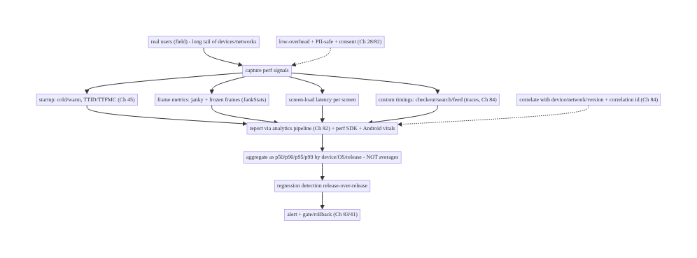
85.4 High-Level Architecture
Components & ownership
- Capture field startup/frames/screen-loads/custom-timings (low-overhead, Ch 45/84).
- Report via the analytics pipeline + perf SDK + Android vitals (Ch 82).
- Aggregate as percentiles by device/OS/release; detect regressions → alert/gate (Ch 83/41).
- Correlate with context (Ch 84); PII-safe + consented (Ch 28).
Direction: field capture → pipeline (Ch 82) + vitals → percentile aggregation by device/release → regression alerting/gating; correlated + PII-safe.

85.5 Detailed Component Design
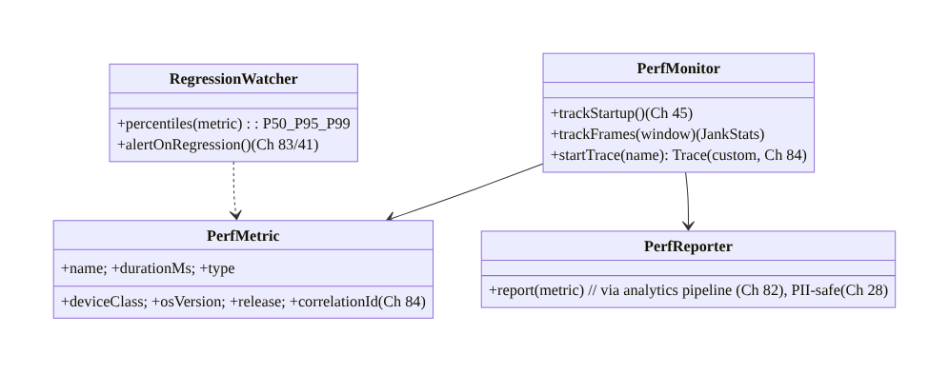
85.5 Detailed Component Design
Component | Responsibility
PerfMonitor | capture startup/frames/custom timings (low-overhead, Ch 45/84)
PerfMetric | a timing + context (device/OS/release/correlation, Ch 84)
PerfReporter | report via the analytics pipeline, PII-safe (Ch 82/28)
RegressionWatcher | percentile aggregation + regression alerting (Ch 83/41)

85.6 End-to-End Data Flow

Capture → report → percentiles → regression
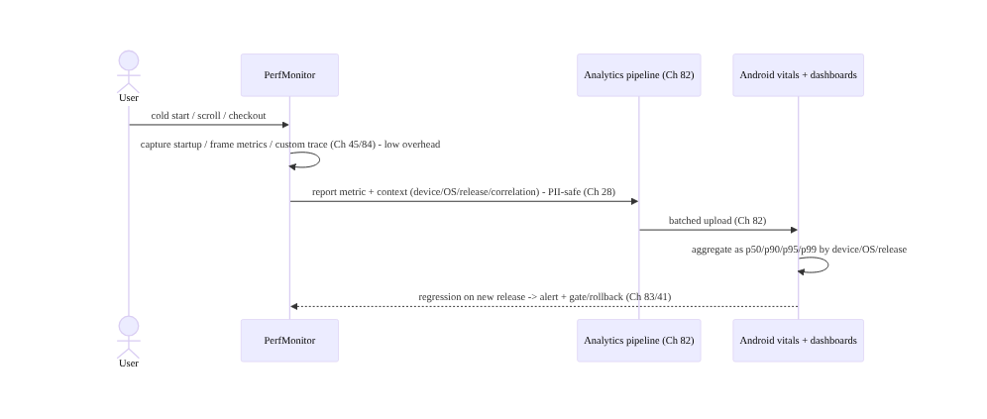
Capture → report → percentiles → regression

Percentiles vs average
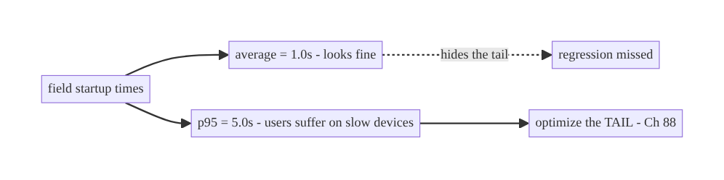
Percentiles vs average

85.7 Complete Kotlin Implementation
Package: com.streamcart.perf.

85.7.1 Frame metrics via JankStats (jank/frozen frames)
@Composable
fun MonitoredScreen(screen: String, content: @Composable () -> Unit) {
val window = (LocalContext.current as Activity).window
DisposableEffect(window) {
val jankStats = JankStats.createAndTrack(window) { frameData -> // JankStats (Jetpack)
if (frameData.isJank) perfReporter.report(PerfMetric(
name = "frame_jank", durationMs = frameData.frameDurationUiNanos / 1_000_000,
type = if (frameData.frameDurationUiNanos > 700_000_000) "frozen" else "janky", // >700ms = frozen
screen = screen, /* + device/OS/release context */))
}
onDispose { jankStats.isTrackingEnabled = false } // low-overhead; scoped to screen (Ch 44)
}
content()
}

85.7.2 Startup monitoring (field, Ch 45)
// Android vitals reports field startup for free. For custom: reportFullyDrawn marks TTFMC (Ch 45).
class StartupMonitor @Inject constructor(private val reporter: PerfReporter) {
fun onFullyDrawn(activity: ComponentActivity, startNanos: Long) {
activity.reportFullyDrawn() // marks TTFMC for vitals/traces (Ch 45)
reporter.report(PerfMetric(name = "cold_start_ttfmc",
durationMs = (System.nanoTime() - startNanos) / 1_000_000, type = "startup")) // custom field metric
}
// Perf SDK (Firebase Performance) auto-captures _app_start trace; add custom for screen loads.
}

85.7.3 Custom business timings as traces (Ch 84)
@Singleton
class PerfMonitor @Inject constructor(private val reporter: PerfReporter, private val correlation: CorrelationManager) { // Ch 84
/** Measure a business operation (checkout/search/feed) end-to-end. */
suspend fun <T> trace(name: String, block: suspend () -> T): T {
val start = System.nanoTime()
return try { block() } finally {
reporter.report(PerfMetric(name = name, durationMs = (System.nanoTime() - start) / 1_000_000,
type = "custom", correlationId = correlation.currentCorrelationId())) // correlate (Ch 84)
}
}
}
// Usage: perfMonitor.trace("checkout_duration") { placeOrderUseCase.place(session) } (Ch 75)
// perfMonitor.trace("search_latency") { searchRepo.search(query) } (Ch 9)

85.7.4 PII-safe reporting via the analytics pipeline (Ch 82/28)
@Singleton
class PerfReporter @Inject constructor(private val analytics: Analytics, private val device: DeviceContext) { // Ch 82
fun report(metric: PerfMetric) {
analytics.track(AnalyticsEvent.Perf( // same reliable, batched, consented pipeline (Ch 82)
name = metric.name, durationMs = metric.durationMs,
params = mapOf( // CONTEXT - no PII (Ch 28)
"type" to metric.type, "device_class" to device.deviceClass, "os" to device.osVersion,
"release" to device.appVersion, "network" to device.networkType, // Ch 68
"correlation_id" to metric.correlationId, "screen" to metric.screen)))
}
// No user content/PII; timing + device/OS/release/screen context only.
}

85.7.5 Percentiles + regression watch (dashboard/backend side)
// Aggregation is backend/dashboard-side (Android vitals / Firebase / your pipeline):
// - compute p50/p90/p95/p99 by device_class x os x release (NOT averages)
// - compare release-over-release -> regression -> alert + gate/rollback (Ch 83/41)
// - SLOs/budgets: e.g., p95 cold_start < 2s on mid-tier; p95 frame jank rate < X%

85.7.6 Module structure
:core:perf PerfMonitor (frames/startup/custom), PerfMetric, PerfReporter (via analytics, Ch 82)
# Startup -> Ch 45; frames -> JankStats; custom -> traces (Ch 84); vitals -> Play Console.
# Aggregation/regression/alerting -> backend/vitals (Ch 83/41). PII-safe -> Ch 28.

85.8 Concurrency and Race Conditions
Scenario | Risk | Handling
Monitoring slows the app | perf paradox | low-overhead capture (JankStats/listeners); batch (Ch 82)
Averages reported | tail hidden | percentiles (p50/p90/p95/p99)
No device segmentation | misleading | segment by device class/OS/release
Lab-only | field tail missed | RUM (field) + lab (Ch 88)
Per-frame flood | cost | sample/aggregate frames (Ch 82)
PII in metrics | leak | timing + context only, no content (Ch 28)
Regression unnoticed | shipped slow | release-over-release + alerting (Ch 83/41)
- Low-overhead is essential (the monitoring must not degrade what it measures): frame listeners/JankStats are cheap, custom traces are lightweight, and reporting is batched through the analytics pipeline (Ch 82) — never block the UI or spam the network to measure.
- Percentiles by segment are the only honest view: an average or an un-segmented number hides the tail and the slow-device population where perf actually hurts.
- Field + lab together: RUM shows the real distribution; Macrobenchmark (Ch 88) gives a reproducible CI gate — neither alone suffices.

85.9 Failure Scenarios and Recovery
Failure | Detection | Response | Outcome
Perf regression shipped | p95 spike | release-over-release alerting + rollback (Ch 83/41) | caught
“Average is fine” but users complain | reviews | track percentiles (tail) | visible
Jank unmeasured | user reports | JankStats frame metrics | measured
Lab passed, field slow | field data | RUM captures the tail (Ch 88) | surfaced
Monitoring slows app | own metrics | low-overhead + batched (Ch 82) | negligible
PII in perf data | privacy audit | context-only, PII-safe (Ch 28) | safe
Not actionable | can’t fix | correlate device/network/trace (Ch 84/68) | actionable
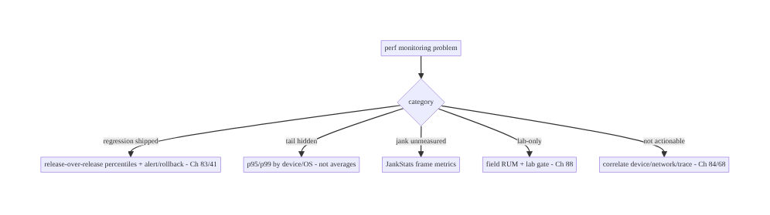
85.9 Failure Scenarios and Recovery
Monitor real users in percentiles, by device/release, and alert on regressions. The field’s tail (p95/p99 on slow devices/networks) is where performance actually hurts and where Android vitals thresholds bite — averages and lab-only measurement miss it. Capture startup/frames/screen-loads/custom-timings low-overhead through the analytics pipeline, and gate releases on perf like you do on crashes (Ch 83).

85.10 Scaling the Implementation
- Level 1. Android vitals (startup/frames/ANR) from the field; percentile awareness.
- Level 2. JankStats frame monitoring per screen; custom timings (traces, Ch 84) via the analytics pipeline (Ch 82); PII-safe + consent (Ch 28).
- Level 3 — production. Percentile dashboards by device/OS/release; regression alerting + gating/rollback (Ch 83/41); SLOs/budgets; context correlation (Ch 84/68).
- Level 4 — large. Per-screen/flow perf budgets; adaptive sampling; perf experiments (Ch 86); device-tiered targets; trace-based deep investigation (Ch 84).
- Level 5 — enterprise. Perf SLOs with error budgets, automated regression gating in CI (lab, Ch 88) + field alerting, perf governance, cross-platform parity, long-tail device programs.
Avoid overengineering: Android vitals + JankStats + a few custom timings through the analytics pipeline, tracked as percentiles with regression alerting, covers most needs. Don’t measure averages; don’t add heavy monitoring; don’t rely on lab alone.

85.11 Alternative Approaches and Trade-offs
Dimension | Option A | Option B | When
Where | Field (RUM) | lab (Macrobenchmark, Ch 88) | Both: field for truth, lab for CI gate
Stat | Percentiles (p50/p90/p95/p99) | averages | Percentiles always (tail)
Segmentation | By device/OS/release | aggregate | Segment (slow-device tail)
Frames | JankStats/FrameMetrics | none | JankStats (jank is top signal)
Custom timings | Traces/spans (Ch 84) | nothing | Traces (business metrics)
Reporting | Analytics pipeline + vitals (Ch 82) | ad-hoc | Pipeline (reliable, consented, PII-safe)
Action | Regression alert + gate (Ch 83/41) | dashboards only | Alert+gate (catch regressions)
Field (RUM) vs lab (Macrobenchmark, Ch 88): lab measures one controlled device reproducibly — ideal for CI gating — but can’t see the field’s long tail (old devices, bad networks, memory pressure). Field RUM captures the real distribution users experience. Use both: Macrobenchmark to gate regressions in CI (Ch 88), RUM to see truth and alert on field regressions.
Percentiles vs averages: an average collapses the distribution and hides the tail — a good mean can mask a terrible p95 that drives bad reviews and trips Android vitals thresholds. Percentiles (p95/p99) segmented by device/OS/release show where users actually suffer. Always measure and alert on percentiles, never averages.
Analytics pipeline vs ad-hoc reporting: sending perf metrics ad-hoc (inline, unbatched, unconsented) repeats the analytics mistakes (Ch 82) — lost/expensive/PII-risky. Routing perf through the same reliable, batched, consented, PII-safe pipeline (Ch 82) gives durable, efficient, compliant reporting. Reuse the pipeline.

85.12 Security & Privacy Considerations
- PII-safe metrics (Ch 28): performance data is timing + device/OS/screen context, not personal data — never attach user content, PII, or secrets. Screen names should be non-sensitive labels (Ch 28).
- Consent (Ch 28/82): perf monitoring follows the same consent regime as analytics; if the user opted out, limit to essential/anonymous.
- Correlation ids opaque (Ch 84): link slow metrics to traces via opaque ids, not PII.
- No sensitive screens in traces: a custom trace around a payment screen (Ch 75) measures timing, not content — never capture screen content.
- Secure, access-controlled dashboards: perf data is internal; access-controlled, retention-limited (Ch 28).
- Client vs backend: the client captures low-overhead PII-safe timings and reports via the pipeline; the backend/vitals aggregates percentiles, detects regressions, and access-controls — neither stores PII in perf data.

85.13 Performance and Resource Optimization
- Low-overhead capture — JankStats/frame listeners are cheap; custom traces are lightweight; batch reporting (Ch 82). Monitoring must not degrade perf.
- Sample high-volume — per-frame data sampled/aggregated; startup/custom timings sampled as needed (Ch 82).
- Scope frame tracking to visible screens (Ch 44) — don’t track off-screen.
- Report via the batched pipeline (Ch 82) — no inline/synchronous sends.
- Minimal context — device/OS/release/screen (cheap), not heavy payloads.
- Profiling: monitoring overhead (should be negligible), report volume, percentile computation cost (backend), sampling rate.

85.14 Testing Strategy
Capture logic and PII-safety are testable; percentiles/regression validated with field data + staged rollouts.
class PerfReporterTest {
@Test fun `reports timing with context, no PII`() {
reporter.report(PerfMetric("checkout_duration", 1200, "custom", correlationId = "c1"))
val e = analytics.lastPerfEvent()
assertEquals(1200, e.durationMs); assertTrue(e.params.containsKey("device_class"))
assertFalse(e.params.values.any { it.toString().contains("@") }) // no PII (Ch 28)
}
}
class PerfMonitorTest {
@Test fun `trace measures duration and correlates`() = runTest {
perfMonitor.trace("search_latency") { delay(100) }
assertTrue(analytics.lastPerfEvent().durationMs >= 100)
assertEquals("c1", analytics.lastPerfEvent().params["correlation_id"]) // Ch 84
}
}
class JankTest {
@Test fun `classifies frozen vs janky frames`() { /* >700ms -> frozen */ }
}
// Macrobenchmark (Ch 88) for lab gating; staged rollout to watch field percentiles before full release.
What to test: custom-trace timing + correlation (Ch 84); PII-safe reporting (context only, Ch 28); frame classification (janky/frozen); startup metric (reportFullyDrawn); reporting via the pipeline (batched, Ch 82). Lab gating via Macrobenchmark (Ch 88); field percentiles via staged rollouts.

85.15 Production Observability
- Metrics (the point): cold/warm startup p50/p90/p95/p99 by device class/OS/release (Android vitals + custom); frame jank rate + frozen-frame rate per screen; screen- load latency (TTID/TTFMC); custom business timings (checkout/search/feed) percentiles; monitoring overhead (negligible); report delivery (Ch 82).
- Logs: perf metrics are events in the pipeline (Ch 82) — no PII (Ch 28).
- Debugging: regression → release-over-release percentile spike (which device/OS); jank → frame metrics per screen (Ch 90); slow startup → cold-start trace (Ch 88); slow checkout → custom trace + correlation (Ch 84/75); “average fine but complaints” → look at p95/p99.
- Alerting: perf regression on a new release (p95 breach → gate/rollback, Ch 83/41); SLO/budget breach (e.g., p95 cold start); jank-rate spike.
- Dashboards: startup/jank/screen-load/custom-timing percentiles by device/OS/release; release-over-release trends; the tail.

85.16 System Design Interview Preparation
≥25 questions.
Fundamentals
- Field vs lab? RUM (real users) vs Macrobenchmark (one device, CI gate, Ch 88) — use both.
- Why field? The long tail (slow devices/networks) isn’t in the lab.
- Percentiles vs averages? Averages hide the tail; track p50/p90/p95/p99.
- Why the tail matters? p95/p99 is where users suffer + vitals thresholds apply.
- Segment by? Device class, OS, release.
Signals
- Startup? Cold/warm, TTID/TTFMC (Ch 45); Android vitals + custom.
- Frames? Janky + frozen (>700ms) via JankStats/FrameMetrics.
- Screen load? TTID/TTFMC per screen.
- Custom timings? Business ops (checkout/search/feed) as traces (Ch 84).
- Why custom? Track what matters to the product.
Reporting
- How report? Analytics pipeline (Ch 82) + perf SDK + Android vitals.
- Why the pipeline? Reliable, batched, consented, PII-safe (Ch 82).
- Android vitals? Field startup/frames/ANR for free.
- Correlate? Device/network/version + correlation id (Ch 84).
Overhead/privacy
- Overhead? Low — cheap listeners + batched; must not slow the app.
- Sampling? High-volume (frames) sampled/aggregated.
- PII? Timing + context only (Ch 28); consent (Ch 82).
Regression
- Detect? Release-over-release percentiles by device/OS.
- Act? Alert + gate/rollback (Ch 83/41); SLOs/budgets.
- Vitals ranking? Bad perf affects store visibility.
Lab/field
- CI gate? Macrobenchmark (Ch 88).
- Field truth? RUM.
Testing/Production
- Test capture? Trace timing + PII-safe reporting.
- “Average fine” complaints? Look at p95/p99.
- Jank in prod? Frame metrics per screen.
- Key metric? Startup/jank percentiles by device/release.

Design-change challenges
- Measure real-user startup. Android vitals + custom cold-start metric, p95 by device (Ch 45/88).
- Find janky screens. JankStats frame metrics per screen (Ch 90).
- Average looks fine but users complain. Track percentiles (p95/p99) by device.
- Catch a perf regression before full rollout. Staged rollout + release-over-release alerting (Ch 83/41).
- Measure checkout latency for real users. Custom trace + correlation (Ch 84/75).

Mock walkthrough (abridged)
Clarify (what to measure, device targets, regression gating?) → field RUM + lab gate (Ch 88) → capture startup (Ch 45) + frames (JankStats) + screen loads + custom timings (traces, Ch 84) → report via analytics pipeline + vitals (Ch 82), PII-safe (Ch 28) → aggregate percentiles by device/OS/release (not averages) → correlate context (Ch 84/68) → regression alerting + SLOs + gate/rollback (Ch 83/41) → low-overhead → observability (tail percentiles).

85.17 Practical Exercises
- Beginner. Capture frame metrics per screen with JankStats and report janky/frozen frames via the analytics pipeline (Ch 82). Eval: jank measured; PII-safe.
- Intermediate. Add a custom checkout_duration trace (Ch 84/75) and a cold-start metric (reportFullyDrawn, Ch 45), reported with device/OS/release context. Eval: timings captured + correlated.
- Advanced. Aggregate as percentiles by device class and add release-over-release regression alerting (Ch 83/41). Eval: p95 by device; regression alerts.
- Production debugging. Investigate “average startup fine but complaints” by looking at p95/p99 on slow devices; find a janky screen. Eval: tail surfaced; screen identified.
- System design challenge. Combine Macrobenchmark CI gating (Ch 88) with field RUM alerting and perf SLOs/budgets. Eval: lab gate + field truth; budget alerts.
(Solutions withheld unless requested.)

85.18 Chapter Summary & Reference Sheet
Key decisions: monitor real-user (field) performance — not just lab (Macrobenchmark, Ch 88) — capturing the signals that matter: cold/warm startup (TTID/TTFMC, Ch 45), frame metrics (janky and >700ms frozen frames via JankStats/FrameMetrics), screen- load latency per screen, and custom business timings (checkout, search, feed) as traces/spans (Ch 84); report them through the same reliable, batched, consented, PII-safe analytics pipeline as events plus Android vitals (Ch 82); aggregate as percentiles (p50/p90/p95/p99 — never averages, because the tail on slow devices/networks is where users suffer and where vitals thresholds apply) segmented by device class/OS/release; keep capture low-overhead and PII-safe (timing + context only, consented, Ch 28); correlate slow metrics with device/network (Ch 68) and trace/correlation ids (Ch 84) so they’re actionable; and detect regressions release-over-release with alerting, SLOs/budgets, and gating/rollback (Ch 83/41) — using both field RUM (truth) and lab Macrobenchmark (CI gate, Ch 88).
Concepts: field RUM vs lab (Ch 88), percentiles (p95/p99) vs averages, startup (Ch 45), frame metrics (jank/frozen, JankStats), screen-load latency, custom timings (traces, Ch 84), reporting via the analytics pipeline + Android vitals (Ch 82), device/OS/release segmentation, low-overhead + PII-safe (Ch 28), regression alerting/gating (Ch 83/41).
Common mistakes: lab-only (missing the field tail); tracking averages (hiding p95/p99); no segmentation (slow-device population hidden); not measuring frames/jank; heavy monitoring that slows the app; PII in perf data; ad-hoc reporting (not the pipeline); no regression detection/ alerting (shipping slow blind).
Checklist:
- ☐ field RUM + lab gate (Ch 88)
- ☐ capture startup (Ch 45) + frames (JankStats, janky/frozen) + screen loads + custom timings (traces, Ch 84)
- ☐ report via analytics pipeline + Android vitals (Ch 82)
- ☐ percentiles (p50/p90/p95/p99), not averages
- ☐ segment by device/OS/release
- ☐ low-overhead + PII-safe + consent (Ch 28)
- ☐ correlate device/network/trace (Ch 84/68)
- ☐ regression alerting + SLOs/budgets + gate/rollback (Ch 83/41)
- ☐ sample high-volume frames
- ☐ tail (p95/p99) dashboards.
Key APIs: JankStats (Jetpack frame metrics) / Window.addOnFrameMetricsAvailableListener, ComponentActivity.reportFullyDrawn (TTFMC, Ch 45), Firebase Performance / custom traces (Ch 84), analytics pipeline (Ch 82), Android vitals (Play Console), Macrobenchmark (lab gate, Ch 88), percentile aggregation (backend/vitals), regression alerting (Ch 83/41).
References: - Android vitals: https://developer.android.com/topic/performance/vitals - JankStats: https://developer.android.com/topic/performance/jankstats - Firebase Performance Monitoring: https://firebase.google.com/docs/perf-mon - Measure app startup (field): https://developer.android.com/topic/performance/vitals/launch-time - (composes) Ch 45 Startup, Ch 82 Analytics, Ch 84 Tracing, Ch 88 Cold Start/Macrobenchmark, Ch 90 Jank, Ch 83 Crash/Vitals, Ch 41 Release/Rollback, Ch 28 Privacy

Chapter 86 — A/B Testing & Experimentation
Part X — Performance, Observability & Quality · Complexity: Standard (≥25 interview questions)
Prerequisites: Ch 40 (feature flags/remote config), Ch 82 (analytics pipeline), Ch 84 (correlation), Ch 28 (privacy), Ch 41 (staged rollout). Pairs with Ch 85 (perf), Ch 83 (crash/guardrails), Ch 72 (recommendations).
Reference surface in StreamCart: running controlled experiments — assigning users to variants (control vs treatment), exposing a change to a fraction of traffic, measuring the effect on metrics (conversion, retention, latency, Ch 85), and deciding whether to ship or kill — built on the same remote config / feature-flag plumbing (Ch 40) and analytics pipeline (Ch 82), with consistent assignment, guardrail metrics, and privacy (Ch 28).

86.1 Problem Definition and Real-World Context
“Will this change actually help?” is usually unknowable by opinion — a new checkout button, a reordered feed, a different onboarding (Ch 80) may help or hurt, and only a controlled experiment tells you. A/B testing assigns users to variants (A = control / existing, B = treatment / new), exposes the change to a fraction of traffic, measures the effect on target metrics (conversion, retention, revenue, engagement) and guardrail metrics (crash rate Ch 83, latency Ch 85, uninstalls), and lets you decide with data whether to roll out or roll back. It’s built on the feature-flag/remote-config system (Ch 40) (which variant to show) and the analytics pipeline (Ch 82) (measuring the outcome), with consistent, random assignment, statistical significance, and privacy (Ch 28).
Concretely, teams hit:
- Shipping on opinion/HiPPO. Without experiments you ship the highest-paid person’s opinion and never know if it helped — or if it hurt a metric you didn’t watch.
- Inconsistent assignment. A user flickering between variants (seeing A then B) ruins the experiment and the UX. Assignment must be deterministic/sticky per user (hash of a stable id, Ch 40) so a user stays in one variant.
- No guardrails. A treatment that lifts clicks but triples crashes (Ch 83) or doubles latency (Ch 85) is a loss; experiments need guardrail metrics that stop a harmful variant (tie into staged rollout/kill switch, Ch 41/40).
- Measuring the wrong thing / p-hacking. Picking the metric after seeing results, peeking and stopping early, or ignoring significance leads to false wins. Need a pre-registered primary metric, adequate sample size/power, and significance.
- Exposure vs assignment. You must log when a user was actually exposed to the variant (saw the change), not just assigned, to measure effect correctly.
- Built on flags, not a separate system. Experiments reuse remote config/feature flags (Ch 40) for assignment+delivery and the analytics pipeline (Ch 82) for measurement — not a bespoke stack.
- Privacy. Assignment keys and exposure logs must be PII-safe and consented (Ch 28/82).
The architecture: assign users to variants deterministically (hash of a stable id, via remote config/flags, Ch 40) so assignment is sticky; expose the treatment to a fraction of traffic (ramp like staged rollout, Ch 41); log exposure + outcomes through the analytics pipeline (Ch 82); measure the effect on a pre-registered primary metric with significance/power, plus guardrail metrics (crash Ch 83, latency Ch 85) that can auto-stop a harmful variant (Ch 40/41); keep assignment/exposure PII-safe + consented (Ch 28); and decide ship/kill with data. This chapter is about learning whether a change helps, safely.

Three practical use cases
- Checkout button experiment (StreamCart). 50/50 split on a redesigned place-order button (Ch 75); primary metric = checkout conversion; guardrails = crash rate (Ch 83) + checkout latency (Ch 85); sticky per-user; ship if significant lift and guardrails hold.
- Feed ranking experiment. A new recommendation model (Ch 72) vs control, 10% ramp; primary = engagement/retention; guardrail = feed load latency (Ch 85) + reports.
- Onboarding experiment. Two onboarding flows (Ch 80); primary = activation; sticky so a user never sees both; measured via the analytics funnel (Ch 82).

Why this is architectural
Experimentation composes feature flags/remote config (Ch 40), the analytics pipeline (Ch 82), staged rollout/kill switch (Ch 41), guardrails (crash Ch 83, perf Ch 85), and privacy (Ch 28). The decisions — deterministic sticky assignment, fractional exposure, pre-registered metric + significance, guardrails that auto-stop — determine whether experiments produce trustworthy decisions rather than noise or harm.

86.2 Requirements Engineering

Functional requirements
ID | Requirement
F1 | Assign users to variants deterministically/sticky (hash of stable id, via flags, Ch 40).
F2 | Expose treatment to a configurable fraction; ramp like staged rollout (Ch 41).
F3 | Log exposure + outcome metrics through the analytics pipeline (Ch 82).
F4 | Measure effect on a pre-registered primary metric with significance/power.
F5 | Watch guardrail metrics (crash Ch 83, latency Ch 85); auto-stop harmful variants (Ch 40/41).
F6 | Keep assignment/exposure PII-safe + consented (Ch 28).

Non-functional requirements
Attribute | Policy
Consistency | Sticky per-user assignment; no flickering.
Trustworthiness | Pre-registered metric; significance; no p-hacking.
Safety | Guardrails + kill switch (Ch 40/41/83).
Privacy | PII-safe keys; consent (Ch 28/82).
Reuse | Built on flags (Ch 40) + analytics (Ch 82), not bespoke.

Scope
- In scope: variant assignment (deterministic/sticky hash, via remote config/flags, Ch 40), fractional exposure + ramp (Ch 41), exposure logging, outcome metrics via analytics (Ch 82), primary + guardrail metrics, significance/power/sample-size basics, auto-stop (Ch 40/41/83), PII-safe + consent (Ch 28), ship/kill decision.
- Out of scope: flag plumbing (Ch 40), analytics pipeline internals (Ch 82), rollout mechanics (Ch 41), deep statistics (reference only), recommendation models (Ch 72).

Assumptions & constraints
- Remote config/feature-flag system (Ch 40) for assignment+delivery; analytics pipeline (Ch 82) for measurement; staged-rollout/kill-switch (Ch 41/40) for safety. Assignment is deterministic (hash of a stable, PII-safe id). Primary metric pre-registered; guardrails watched. Consent respected (Ch 28). minSdk 24.

86.3 System Design Fundamentals
- Experiment = controlled comparison. Split users into control (A) and treatment (B) (or multiple variants), change one thing for treatment, measure the difference in a metric. Random assignment makes the groups comparable so the difference is caused by the change (causal inference), not correlation.
- Deterministic, sticky assignment (the key client property, Ch 40). A user must get the same variant every time — hash a stable id (an opaque experiment/user id, PII-safe, Ch 28) with the experiment id into a bucket; bucket < fraction → treatment. This is stateless (no stored assignment needed), consistent across launches/devices, and delivered via remote config/flags (Ch 40). Flickering between variants ruins both data and UX — stickiness is non-negotiable.
- Fractional exposure + ramp (Ch 41). Start the treatment at a small fraction (1%, 5%) and ramp like a staged rollout (Ch 41) — this limits blast radius and lets guardrails catch harm before full exposure. The fraction is a remote-config value (Ch 40) you can change server-side.
- Exposure logging vs assignment (subtle but important). Log when a user is actually exposed (rendered/experienced the variant), not merely assigned — a user assigned to treatment who never reaches the screen shouldn’t dilute the measurement. Analyze on exposed users (or intention-to-treat consistently); exposure is an analytics event (Ch 82).
- Primary metric + guardrails (pre-registered). Decide before the experiment: a primary metric (the thing you’re trying to move — conversion, retention, revenue) and guardrail metrics (things that must not get worse — crash rate Ch 83, latency Ch 85, uninstalls, errors). You ship only if the primary improves significantly and guardrails hold; a guardrail breach auto-stops/kills the variant (Ch 40/41).
- Statistical significance, power, sample size (avoid false wins). A difference could be noise; you need significance (the effect is unlikely by chance, e.g., p < 0.05 or a confidence interval excluding zero) and enough sample size/power to detect the effect. Don’t p-hack: don’t pick the metric after the fact, don’t peek-and-stop early (inflates false positives — use sequential tests or a fixed horizon), don’t run many metrics and cherry-pick. Pre-register; decide on the primary.
- Built on flags + analytics (reuse, Ch 40/82). Experiments aren’t a new system: assignment/delivery = remote config/feature flags (Ch 40); measurement = the analytics pipeline (Ch 82); safety = staged rollout/kill switch (Ch 41/40). The experiment layer adds buckets, exposure logs, and analysis.
- Privacy (Ch 28/82). The assignment key is an opaque, PII-safe id (Ch 28); exposure/outcome events follow the consent regime (Ch 82). Don’t key experiments on PII; don’t leak which variant implies sensitive info.
- Interaction & isolation. Running many experiments at once can interact; use layers/mutually-exclusive buckets for conflicting experiments, or accept orthogonal randomization for independent ones.
Core insight: assign users to variants deterministically and stickily by hashing a stable, PII-safe id with the experiment id (via remote config/feature flags, Ch 40 — so a user never flickers between A and B), expose the treatment to a configurable fraction and ramp it like a staged rollout (Ch 41) to bound blast radius; log actual exposure (not just assignment) and outcomes through the analytics pipeline (Ch 82); decide ship/kill on a pre-registered primary metric with real statistical significance and adequate power (no p-hacking, no peek-and-stop) while guardrail metrics — crash rate (Ch 83), latency (Ch 85), uninstalls — must not regress and auto-stop a harmful variant (Ch 40/41); and keep assignment keys and exposure logs PII-safe and consented (Ch 28) — reusing the flag and analytics infrastructure rather than building a bespoke stack.

86.4 High-Level Architecture
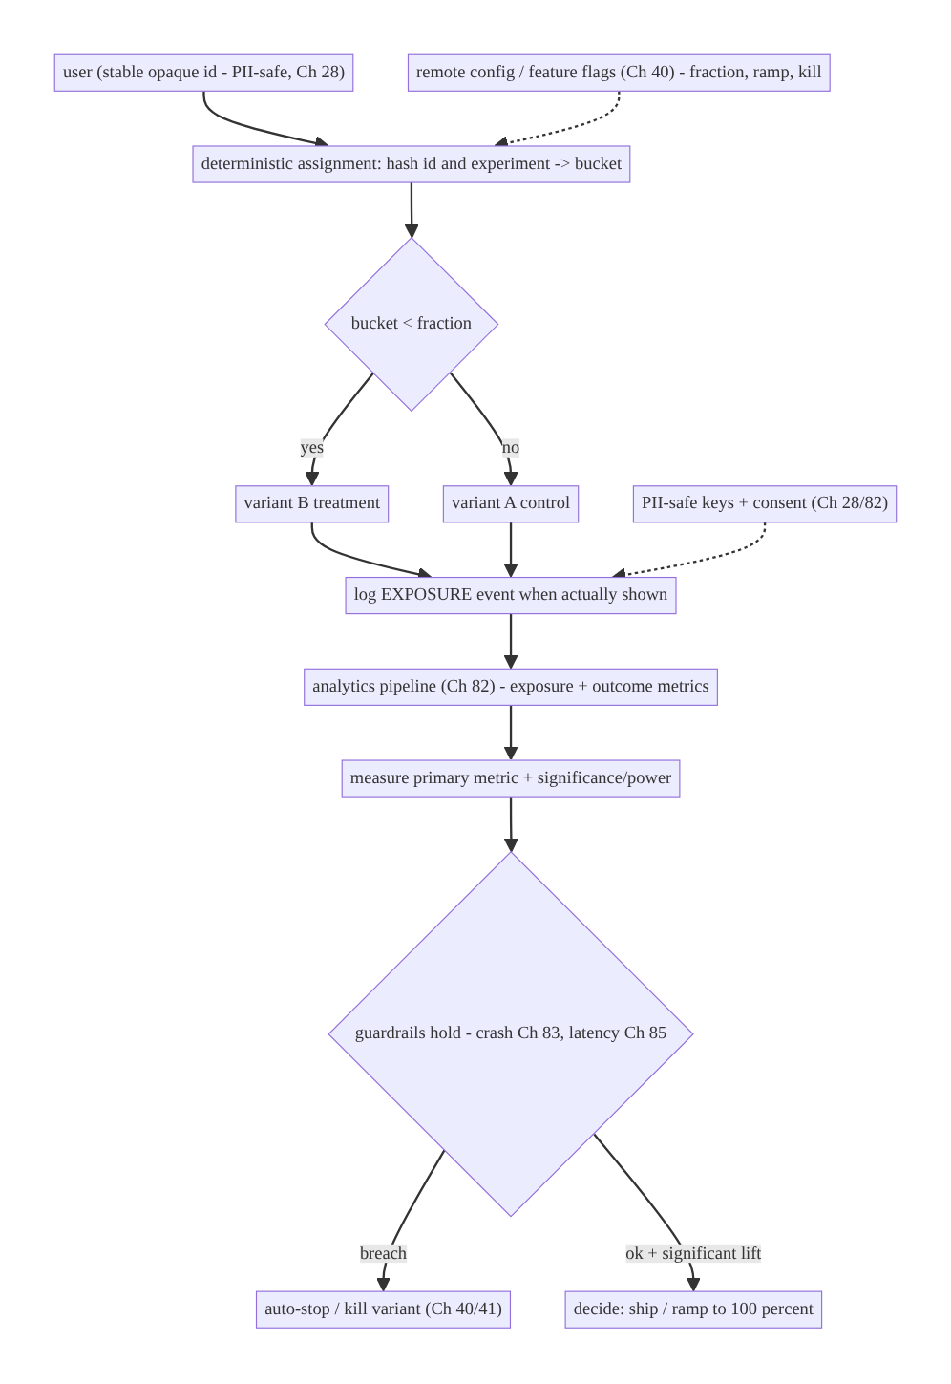
86.4 High-Level Architecture
Components & ownership
- Assigner hashes a stable id → variant (deterministic/sticky), gated by remote config (Ch 40).
- Exposure logger records actual exposure via analytics (Ch 82).
- Analyzer (backend) measures primary metric + significance; watches guardrails (Ch 83/85) → auto-stop (Ch 40/41).
- Decision: ship/kill. Privacy: PII-safe keys + consent (Ch 28).
Direction: stable id → deterministic bucket (flags, Ch 40) → variant → exposure/outcome via analytics (Ch 82) → significance + guardrails → ship/kill.

86.5 Detailed Component Design
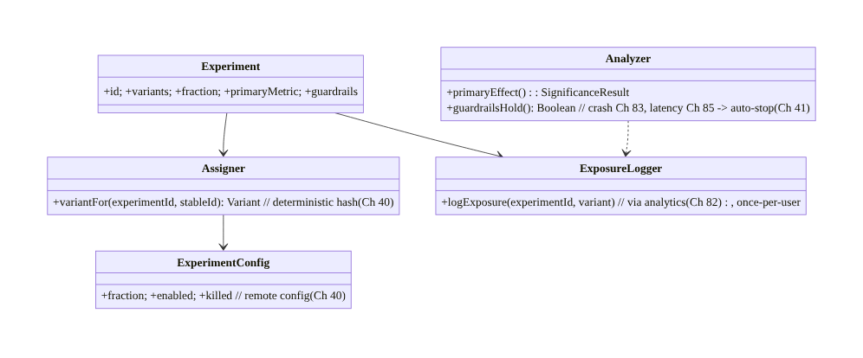
86.5 Detailed Component Design
Component | Responsibility
Experiment | definition: variants, fraction, primary + guardrail metrics
Assigner | deterministic sticky variant from a stable id (Ch 40)
ExposureLogger | log actual exposure via analytics, once per user (Ch 82)
ExperimentConfig | remote fraction/enabled/killed (Ch 40)
Analyzer | significance on primary + guardrail watch → auto-stop (backend, Ch 83/85/41)

86.6 End-to-End Data Flow

Assign → expose → measure → decide
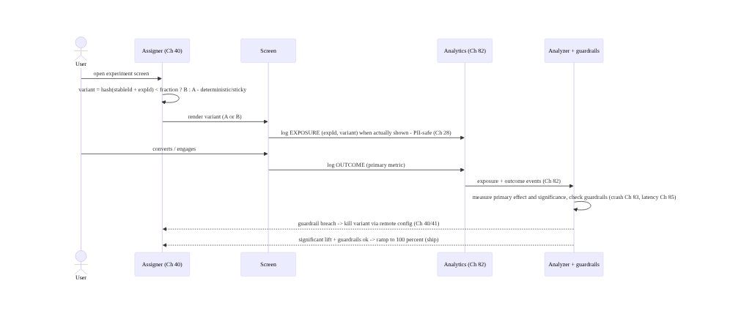
Assign → expose → measure → decide

Sticky assignment (no flicker)
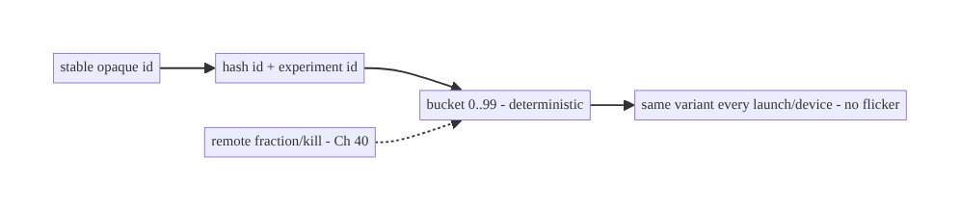
Sticky assignment (no flicker)

86.7 Complete Kotlin Implementation
Package: com.streamcart.experiments.

86.7.1 Deterministic, sticky assignment (built on flags, Ch 40)
enum class Variant { CONTROL, TREATMENT }
@Singleton
class Assigner @Inject constructor(
private val config: ExperimentConfig, // remote config (Ch 40)
private val ids: StableIdProvider, // opaque, PII-safe id (Ch 28)
) {
/** Deterministic + sticky: same user -> same variant every time, no stored state. */
fun variantFor(experimentId: String): Variant {
if (config.isKilled(experimentId)) return Variant.CONTROL // kill switch (Ch 40/41)
val fraction = config.fraction(experimentId) // remote ramp (Ch 41)
val bucket = bucketOf(ids.stableId(), experimentId) // 0..9999
return if (bucket < (fraction * 10000).toInt()) Variant.TREATMENT else Variant.CONTROL
}
private fun bucketOf(stableId: String, experimentId: String): Int {
val digest = MessageDigest.getInstance("SHA-256").digest("$experimentId:$stableId".toByteArray())
val v = ((digest[0].toInt() and 0xFF) shl 8) or (digest[1].toInt() and 0xFF) // stable hash
return v % 10000
}
}

86.7.2 Exposure logging (via analytics, once per user, Ch 82)
@Singleton
class ExposureLogger @Inject constructor(private val analytics: Analytics) { // Ch 82
private val logged = Collections.synchronizedSet(mutableSetOf<String>()) // once per (exp,variant) per session
/** Log ONLY when the variant is actually shown - exposure, not just assignment. */
fun logExposure(experimentId: String, variant: Variant) {
if (logged.add("$experimentId:$variant")) {
analytics.track(AnalyticsEvent.Exposure( // PII-safe (Ch 28)
experimentId = experimentId, variant = variant.name)) // opaque; via pipeline (Ch 82)
}
}
}

86.7.3 Using an experiment in UI
@Composable
fun CheckoutButton(assigner: Assigner, exposure: ExposureLogger, onPlace: () -> Unit) {
val variant = remember { assigner.variantFor("checkout_button_v2") } // sticky (Ch 40)
LaunchedEffect(variant) { exposure.logExposure("checkout_button_v2", variant) } // exposure (Ch 82)
when (variant) {
Variant.TREATMENT -> NewPlaceOrderButton(onPlace) // B: new design
Variant.CONTROL -> ClassicPlaceOrderButton(onPlace) // A: existing
}
// Outcome (conversion) logged by the checkout flow (Ch 75) via analytics (Ch 82).
}

86.7.4 Remote config: fraction, ramp, kill (Ch 40)
@Singleton
class ExperimentConfig @Inject constructor(private val remoteConfig: RemoteConfig) { // Ch 40
fun fraction(expId: String): Double = remoteConfig.getDouble("exp_${expId}_fraction", 0.0) // ramp (Ch 41)
fun isKilled(expId: String): Boolean = remoteConfig.getBoolean("exp_${expId}_killed", false) // kill (Ch 40)
// Backend ramps fraction 0.01 -> 0.05 -> 0.5 -> 1.0 while guardrails hold (Ch 41);
// sets killed=true if a guardrail breaches (crash Ch 83, latency Ch 85).
}

86.7.5 Analysis (backend-side, documented)
// Analysis is backend (on the analytics warehouse, Ch 82):
// - PRIMARY: effect = metric(treatment_exposed) - metric(control_exposed); significance (CI excludes 0 / p<0.05)
// - POWER/SAMPLE SIZE: ensure enough exposed users to detect the expected effect (pre-registered)
// - GUARDRAILS: crash rate (Ch 83), latency p95 (Ch 85), uninstalls MUST NOT regress -> else auto-kill (Ch 41)
// - NO p-hacking: pre-registered primary metric; fixed horizon or sequential test (no naive peeking)
// - DECISION: ship (ramp to 100%) if significant lift + guardrails hold; else kill (Ch 40)

86.7.6 Module structure
:core:experiments Assigner (deterministic, Ch 40), ExposureLogger (Ch 82), ExperimentConfig (Ch 40)
# Delivery/assignment reuse flags (Ch 40); measurement reuses analytics (Ch 82);
# safety reuses staged rollout/kill (Ch 41); guardrails -> crash (Ch 83) + perf (Ch 85).
# Analysis/significance -> backend warehouse. PII-safe keys -> Ch 28.

86.8 Concurrency and Race Conditions
Scenario | Risk | Handling
User flickers A↔B | ruined data + UX | deterministic sticky hash (Ch 40)
Exposure logged many times | inflated counts | once-per-user/session dedupe
Assignment on PII | privacy leak | opaque stable id (Ch 28)
Peeking/early stop | false wins | pre-registered horizon / sequential test
Guardrail breach unnoticed | user harm | guardrails + auto-kill (Ch 83/85/41)
Many experiments interact | confounded | layers / mutual exclusion
Fraction change mid-flight | re-bucket | deterministic hash keeps assignment stable
- Deterministic hashing gives stickiness without stored state and is stable across devices (same stable id, Ch 40) — raising the fraction only adds users to treatment, never moves existing ones out (monotonic bucketing).
- Exposure dedupe ensures you count users, not impressions, consistently.
- Guardrails + auto-kill make experiments safe — a harmful treatment is stopped via remote config (Ch 40/41) before wide exposure.

86.9 Failure Scenarios and Recovery
Failure | Detection | Response | Outcome
Treatment harms a metric | guardrail breach | auto-kill via remote config (Ch 40/41) | contained
User sees both variants | flicker reports | deterministic sticky assignment (Ch 40) | consistent
False win (noise) | low power/peeking | significance + power + pre-registration | trustworthy
Exposure double-counted | inflated metric | once-per-user dedupe | accurate
PII in assignment key | privacy audit | opaque id (Ch 28) | safe
Experiments interact | confounded results | layers / mutual exclusion | isolated
Shipped a loser | post-hoc metrics | guardrails + decision gate | prevented
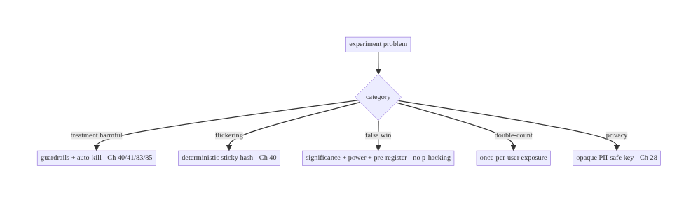
86.9 Failure Scenarios and Recovery
Make assignment sticky, measure a pre-registered metric with real significance, and let guardrails auto-kill harm. The failure modes of experimentation are flickering (sticky hashing fixes it), false wins (significance + power + pre-registration fix it), and shipping a harmful treatment (guardrails + kill switch fix it). Reuse flags (Ch 40) and analytics (Ch 82) rather than building bespoke, and keep keys PII-safe (Ch 28).

86.10 Scaling the Implementation
- Level 1. A single flag-gated A/B via remote config (Ch 40); outcome via analytics (Ch 82); eyeball the result.
- Level 2. Deterministic sticky assignment; exposure logging; pre-registered primary + guardrails (Ch 83/85); fractional ramp (Ch 41).
- Level 3 — production. Significance/power analysis (backend); auto-kill on guardrail breach (Ch 40/41); PII-safe keys + consent (Ch 28).
- Level 4 — platform. Experimentation platform: many concurrent experiments with layers/mutual exclusion, metric libraries, automated analysis dashboards, sequential testing, holdbacks.
- Level 5 — enterprise. Org-wide experimentation culture: metric governance, CUPED/ variance reduction, interleaving (Ch 72), long-term holdouts, guardrail SLOs, experiment review boards.
Avoid overengineering: a flag-gated, deterministic A/B with a pre-registered primary metric, guardrails, and a significance check covers most needs. Don’t build a platform for one test; don’t ship on opinion; don’t skip guardrails or stickiness.

86.11 Alternative Approaches and Trade-offs
Dimension | Option A | Option B | When
Assignment | Deterministic hash (sticky, Ch 40) | stored/random per-call | Hash (sticky, stateless)
Delivery | Remote config/flags (Ch 40) | bespoke system | Reuse flags
Measurement | Analytics pipeline (Ch 82) | custom logging | Reuse analytics
Analysis | Significance + power | eyeball/averages | Significance (trustworthy)
Safety | Guardrails + auto-kill (Ch 40/41) | none | Guardrails always
Exposure | Log actual exposure | assignment-only | Exposure (correct effect)
Stopping | Pre-registered/sequential | peek-and-stop | Pre-registered (no p-hacking)
Deterministic hash vs stored assignment: hashing a stable id gives sticky, stateless, cross-device assignment (same user → same variant, raising the fraction never re-buckets existing users) — no storage, no sync. Stored assignment needs persistence/sync and can drift. Prefer deterministic hashing (Ch 40).
Experiment vs ship-on-opinion: shipping without an experiment means you never know if the change helped — or if it hurt an unwatched metric (crashes, latency). A controlled experiment with a pre-registered primary metric, significance, and guardrails gives a trustworthy, safe decision. Experiment for anything that matters.
Reuse (flags + analytics) vs bespoke: building a separate experimentation stack duplicates assignment (flags, Ch 40), measurement (analytics, Ch 82), and safety (rollout/kill, Ch 41). Reusing them means experiments inherit reliability, consent, and kill switches for free; the experiment layer only adds buckets, exposure, analysis.

86.12 Security & Privacy Considerations
- PII-safe assignment key (Ch 28): hash an opaque, stable id (not email/phone); the bucket reveals nothing personal. Don’t key experiments on PII.
- Consent (Ch 28/82): exposure/outcome events follow the same consent regime as analytics; opted-out users limited to essential/anonymous.
- No sensitive-variant leakage: don’t let “which variant” imply sensitive info (e.g., an experiment targeting a protected group) — avoid discriminatory targeting.
- Guardrails include safety: crash (Ch 83), ANR, security errors as guardrails — a variant that degrades safety is killed (Ch 40/41).
- Kill switch (Ch 40/41): a harmful or abused experiment is remotely killable without an app update.
- Client vs backend: the client assigns deterministically and logs PII-safe exposure; the backend analyzes significance, watches guardrails, and controls fraction/kill (Ch 40) — neither stores PII in experiment keys.

86.13 Performance and Resource Optimization
- Assignment is cheap — a single hash; no network (fraction comes from already-fetched remote config, Ch 40). Compute once per screen (remember).
- Exposure logging is batched via the analytics pipeline (Ch 82) — once per user/session, not per frame.
- No extra storage — deterministic hashing needs no stored assignment.
- Guardrails reuse existing metrics (crash Ch 83, perf Ch 85) — no new capture.
- Ramp bounds cost/risk — small fraction first (Ch 41).
- Profiling: assignment cost (negligible), exposure event volume, remote-config fetch (Ch 40), analysis cost (backend).

86.14 Testing Strategy
Assignment determinism, fraction gating, and exposure dedupe are unit-testable; significance is validated on real data.
class AssignerTest {
@Test fun `assignment is deterministic and sticky`() {
val v1 = assigner.variantFor("exp_checkout"); val v2 = assigner.variantFor("exp_checkout")
assertEquals(v1, v2) // same user -> same variant, every call (Ch 40)
}
@Test fun `fraction gates treatment`() {
config.setFraction("exp_checkout", 0.0); assertEquals(Variant.CONTROL, assigner.variantFor("exp_checkout"))
config.setFraction("exp_checkout", 1.0); assertEquals(Variant.TREATMENT, assigner.variantFor("exp_checkout"))
}
@Test fun `killed experiment forces control`() {
config.kill("exp_checkout"); assertEquals(Variant.CONTROL, assigner.variantFor("exp_checkout")) // Ch 40/41
}
}
class ExposureLoggerTest {
@Test fun `exposure logged once per user`() {
exposure.logExposure("exp", Variant.TREATMENT); exposure.logExposure("exp", Variant.TREATMENT)
assertEquals(1, analytics.exposureCount("exp")) // dedupe (Ch 82)
}
}
// Significance/power validated on the analytics warehouse with real exposed-user data (Ch 82).
What to test: deterministic sticky assignment (Ch 40); fraction/kill gating (Ch 40/41); exposure dedupe (once per user, Ch 82); PII-safe key; guardrail wiring (crash Ch 83, latency Ch 85). Significance/power validated on real data; ramp via staged rollout (Ch 41).

86.15 Production Observability
- Metrics: per-experiment exposure counts (treatment/control), primary metric by variant with significance/CI, guardrail metrics (crash rate Ch 83, latency p95 Ch 85, uninstalls) by variant, fraction/ramp state (Ch 40/41), kill events.
- Logs: exposure/outcome events in the analytics pipeline (Ch 82) — PII-safe (Ch 28).
- Debugging: flicker → check deterministic assignment (Ch 40); false win → check power/ significance/peeking; no effect → check exposure logging (did users actually see it?); guardrail breach → which metric, auto-kill fired? (Ch 40/41).
- Alerting: guardrail breach on any live experiment (crash/latency spike in treatment → auto-kill, Ch 40/41/83/85); experiment running underpowered/too long.
- Dashboards: per-experiment primary vs guardrail by variant; ramp state; significance; decision (ship/kill).

86.16 System Design Interview Preparation
≥25 questions.
Fundamentals
- What is A/B testing? Controlled comparison of control vs treatment on a metric.
- Why experiment? Causal evidence a change helps — not opinion.
- Assignment? Deterministic hash of a stable id → sticky variant (Ch 40).
- Why sticky? No flickering; consistent data + UX.
- Built on? Flags/remote config (Ch 40) + analytics (Ch 82).
Assignment
- Deterministic how? Hash(stableId + expId) → bucket < fraction.
- Stateless? Yes — no stored assignment; stable across devices.
- Raise fraction? Monotonic — adds users, doesn’t re-bucket.
- PII? Opaque stable id, not PII (Ch 28).
Exposure/metrics
- Exposure vs assignment? Log when actually shown, not just assigned.
- Primary metric? Pre-registered; the thing you move.
- Guardrails? Must-not-regress: crash (Ch 83), latency (Ch 85), uninstalls.
- Where measured? Analytics pipeline (Ch 82).
Statistics
- Significance? Effect unlikely by chance (p<0.05 / CI excludes 0).
- Power/sample size? Enough exposed users to detect the effect.
- p-hacking? Pre-register; no peek-and-stop; no metric cherry-picking.
- Peeking? Inflates false positives; fixed horizon or sequential test.
Safety
- Guardrail breach? Auto-kill via remote config (Ch 40/41).
- Ramp? Small fraction first (Ch 41), like staged rollout.
- Kill switch? Remote, no app update (Ch 40).
Edge cases
- Many experiments? Layers / mutual exclusion to avoid interaction.
- Flickering? Deterministic sticky hash (Ch 40).
- Privacy? Opaque keys + consent (Ch 28/82).
Testing/Production
- Test assignment? Determinism + fraction/kill gating.
- No effect seen? Check exposure logging + power.
- Ship decision? Significant lift + guardrails hold.

Design-change challenges
- Run a checkout button A/B. Deterministic 50/50, primary = conversion, guardrails = crash+latency (Ch 83/85), auto-kill.
- Prevent flickering. Deterministic sticky hash of a stable id (Ch 40).
- Avoid a false win. Pre-register primary, ensure power, no peeking.
- Safely ramp a risky model (Ch 72). Fractional ramp + guardrails + auto-kill (Ch 41).
- Run many experiments without interference. Layers / mutual exclusion.

Mock walkthrough (abridged)
Clarify (hypothesis, primary metric, guardrails, traffic?) → deterministic sticky assignment (hash stable id, Ch 40) → fractional exposure + ramp (Ch 41) → log exposure + outcome via analytics (Ch 82) → measure primary with significance + power (pre-registered, no p-hacking) → guardrails (crash Ch 83, latency Ch 85) auto-kill (Ch 40/41) → PII-safe + consent (Ch 28) → decide ship/kill → observability (per-variant metrics).

86.17 Practical Exercises
- Beginner. Flag-gate a UI change as a deterministic 50/50 A/B (Ch 40) and log exposure + an outcome via analytics (Ch 82). Eval: sticky assignment; exposure logged.
- Intermediate. Add a pre-registered primary metric and guardrails (crash Ch 83, latency Ch 85); ramp the fraction (Ch 41). Eval: guardrails wired; ramp works.
- Advanced. Implement auto-kill on guardrail breach via remote config (Ch 40/41) and document a significance/power plan. Eval: auto-kill fires; power considered.
- Production debugging. Investigate a “no effect” result — verify exposure logging and power; investigate flickering — verify deterministic assignment. Eval: root cause found.
- System design challenge. Design multi-experiment layers/mutual exclusion with per- experiment guardrails and automated analysis. Eval: isolation; trustworthy decisions.
(Solutions withheld unless requested.)

86.18 Chapter Summary & Reference Sheet
Key decisions: run controlled experiments by assigning users to variants deterministically and stickily — hash a stable, PII-safe id with the experiment id (via remote config/feature flags, Ch 40) so a user gets the same variant every time (no flickering), with no stored state and cross-device consistency; expose the treatment to a configurable fraction and ramp it like a staged rollout (Ch 41) to bound blast radius; log actual exposure (not just assignment) and outcomes through the analytics pipeline (Ch 82); decide ship/kill on a pre-registered primary metric with real statistical significance and adequate power (no p-hacking, no peek-and-stop), while guardrail metrics — crash rate (Ch 83), latency (Ch 85), uninstalls — must not regress and auto-stop/kill a harmful variant via remote config (Ch 40/41); and keep assignment keys and exposure logs PII-safe and consented (Ch 28) — reusing the flag (Ch 40) and analytics (Ch 82) infrastructure rather than building a bespoke stack.
Concepts: control vs treatment, deterministic sticky assignment (hash, Ch 40), fractional exposure + ramp (Ch 41), exposure vs assignment logging, primary + guardrail metrics, significance/power/sample-size, no p-hacking/peeking, auto-kill (Ch 40/41/83/85), reuse of flags + analytics (Ch 40/82), PII-safe keys + consent (Ch 28).
Common mistakes: shipping on opinion; non-sticky assignment (flickering); logging assignment instead of exposure; no guardrails (harmful treatment ships); p-hacking/peek-and- stop/underpowered (false wins); keying on PII; building a bespoke stack instead of reusing flags + analytics; no kill switch.
Checklist:
- ☐ deterministic sticky assignment (hash stable id, Ch 40)
- ☐ fractional exposure + ramp (Ch 41)
- ☐ log actual exposure + outcome via analytics (Ch 82)
- ☐ pre-registered primary metric
- ☐ significance + power (no p-hacking/peeking)
- ☐ guardrails (crash Ch 83, latency Ch 85) auto-kill (Ch 40/41)
- ☐ PII-safe keys + consent (Ch 28)
- ☐ reuse flags + analytics
- ☐ layers for many experiments
- ☐ ship/kill decision gate.
Key APIs/concepts: remote config / feature flags (assignment + fraction + kill, Ch 40), SHA-256 bucketing (deterministic sticky), analytics pipeline (exposure + outcomes, Ch 82), staged rollout (ramp, Ch 41), guardrail metrics (crash Ch 83, perf Ch 85), significance/power (backend analysis), consent/PII-safe keys (Ch 28).
References: - Firebase Remote Config + A/B Testing: https://firebase.google.com/docs/ab-testing - Trustworthy Online Controlled Experiments (Kohavi et al.) — the standard reference - Statistical significance / power — experimentation literature - (composes) Ch 40 Feature Flags/Remote Config, Ch 82 Analytics, Ch 41 Staged Rollout, Ch 83 Crash, Ch 85 Perf, Ch 28 Privacy, Ch 72 Recommendations

Chapter 87 — Error Classification & Telemetry Pipeline
Part X — Performance, Observability & Quality · Complexity: Standard (≥25 interview questions)
Prerequisites: Ch 82 (analytics/logging pipeline), Ch 83 (crash/ANR), Ch 84 (tracing), Ch 85 (perf), Ch 28 (privacy), Ch 23 (error handling/Result). Pairs with Ch 81 (feedback/ diagnostics), Ch 67 (network errors).
Reference surface in StreamCart: the unifying telemetry pipeline that ingests all signals — errors (handled + unhandled, Ch 83), logs, metrics (Ch 85), traces (Ch 84), analytics (Ch 82) — and the error classification scheme that turns raw failures into actionable, grouped, severity-ranked, PII-safe signal: fatal vs non-fatal, transient vs permanent, by domain/cause, fingerprinted/deduplicated, routed by severity.

87.1 Problem Definition and Real-World Context
Previous chapters built individual observability pillars — analytics (Ch 82), crash/ANR (Ch 83), tracing (Ch 84), performance (Ch 85). This chapter is the unifying layer: a telemetry pipeline that ingests all signals (errors, logs, metrics, traces, events) through one reliable, batched, consented, PII-safe path, and an error classification scheme that turns the flood of raw failures into actionable signal — grouped (fingerprinted/deduplicated so 10,000 occurrences of one bug are one issue), classified (fatal vs non-fatal, transient vs permanent, by domain), severity-ranked (what needs a page vs a dashboard), and routed accordingly. Without classification, telemetry is noise: you can’t tell a retryable network blip (Ch 67) from a data-corruption bug, or a one-off from a crash-looping release (Ch 83).
Concretely, teams hit:
- Signal silos. Analytics, crashes, traces, metrics in separate SDKs/pipelines with no correlation (Ch 84) — you can’t connect a slow trace to the crash it caused. Need a unified pipeline (or at least correlated via ids, Ch 84).
- Unclassified errors = noise. 50,000 errors/day with no grouping or severity is useless. Errors must be classified: fatal (crash, Ch 83) vs non-fatal (handled, Ch 23); transient (retryable network, Ch 67) vs permanent (bug/data); by domain (network/db/UI/payment). And fingerprinted so duplicates collapse.
- No deduplication/fingerprinting. The same bug reported 10,000 times should be one issue with a count — group by a stable fingerprint (stack signature, error type + location), not raw text (Ch 83).
- No severity routing. A fatal, high-volume, new-in-this-release error needs a page (Ch 83); a rare handled warning needs a dashboard. Severity drives routing/alerting.
- PII in telemetry. Errors/logs often carry PII (user data in a stack message, a URL with a token) — must be redacted (Ch 28) at the boundary.
- Reliability/cost of the pipeline. Telemetry must be durably buffered, batched, sampled (Ch 82) — not lose data on crash, not drain battery/data, not cost a fortune at volume.
- Transient vs permanent handling. A transient error (timeout, 503, Ch 67) is retryable and often expected (lower severity); a permanent one (400, parse failure, assertion) is a bug (higher severity). Classification drives handling (retry vs report, Ch 23/67) and severity.
The architecture: a unified telemetry pipeline ingesting errors/logs/metrics/traces/ events (Ch 82/83/84/85) through one reliable, batched, consented, PII-safe path; classify each error — fatal/non-fatal, transient/permanent, by domain — fingerprint and deduplicate (group by stable signature, Ch 83), rank by severity, and route (page/dashboard/sample); correlate across pillars via ids (Ch 84); redact PII at the boundary (Ch 28); and sample/buffer for reliability + cost (Ch 82). This chapter is about turning raw failure signal into actionable, deduplicated, severity-ranked, PII-safe telemetry.

Three practical use cases
- Classified, deduplicated errors (StreamCart). A null-deref in checkout (Ch 75) is fingerprinted (type + location) so its 8,000 occurrences are one issue with a count, fatal/permanent severity, routed to a page if new-in-release (Ch 83).
- Transient vs permanent network errors. A 503 (Ch 67) is transient/retryable, logged at low severity and sampled; a 400 with a malformed request is permanent, surfaced as a bug.
- Cross-pillar correlation. A slow trace (Ch 84/85) that ends in a handled error (Ch 23) is correlated by trace/correlation id so you see the full story (Ch 84).

Why this is architectural
This is the capstone of observability: it composes analytics (Ch 82), crash (Ch 83), tracing (Ch 84), performance (Ch 85), error handling (Ch 23/67), and privacy (Ch 28) into one classified, deduplicated, correlated, PII-safe telemetry system. The decisions — classification scheme, fingerprinting/dedup, severity routing, unified+correlated ingestion — determine whether you can operate the app from signal rather than drown in noise.

87.2 Requirements Engineering

Functional requirements
ID | Requirement
F1 | Ingest errors/logs/metrics/traces/events through one reliable, batched pipeline (Ch 82/83/84/85).
F2 | Classify errors: fatal/non-fatal, transient/permanent, by domain.
F3 | Fingerprint + deduplicate (group by stable signature, Ch 83).
F4 | Rank by severity; route (page/dashboard/sample) (Ch 83).
F5 | Correlate across pillars via ids (Ch 84).
F6 | Redact PII at the boundary; consent (Ch 28); buffer/sample for reliability+cost (Ch 82).

Non-functional requirements
Attribute | Policy
Actionability | Classified, grouped, severity-ranked — not noise.
Reliability | Durably buffered; survives crash (Ch 82/83).
Privacy | PII redacted; consent (Ch 28).
Cost | Batched + sampled by severity (Ch 82).
Correlation | Cross-pillar via ids (Ch 84).

Scope
- In scope: unified telemetry ingestion (errors/logs/metrics/traces/events, Ch 82/83/84/85), error classification (fatal/non-fatal, transient/permanent, domain), fingerprinting/dedup (Ch 83), severity ranking + routing (page/dashboard/sample), cross-pillar correlation (Ch 84), PII redaction + consent (Ch 28), buffering/sampling (Ch 82), transient-vs-permanent handling (Ch 23/67).
- Out of scope: analytics internals (Ch 82), crash capture mechanics (Ch 83), tracing propagation (Ch 84), perf metrics (Ch 85), error-handling patterns (Ch 23), network retry (Ch 67).

Assumptions & constraints
- A telemetry/observability backend (Crashlytics + analytics + tracing, or a unified APM) reached via the reliable pipeline (Ch 82). Errors classified + fingerprinted; severity drives routing; signals correlated by id (Ch 84); PII redacted (Ch 28); data buffered + sampled. minSdk 24.

87.3 System Design Fundamentals
- Telemetry pillars, unified (Ch 82/83/84/85). The signals: logs (discrete events), metrics (aggregated numbers, Ch 85), traces (causal spans, Ch 84), events (analytics, Ch 82), errors/crashes (Ch 83). A mature system ingests them through one reliable, batched, consented, PII-safe pipeline (Ch 82) and correlates them via shared ids (Ch 84) — so a slow trace, its metrics, and the error it produced tell one story.
- Error classification (the core taxonomy):
  - Fatal vs non-fatal: fatal = crash/ANR (process died, Ch 83); non-fatal = handled error the app recovered from (Ch 23) but is worth tracking. Different severity, different handling.
  - Transient vs permanent: transient = retryable, often expected (timeout, 503, offline, Ch 67/67) — lower severity, sampled; permanent = a bug or bad data (400, parse failure, IllegalStateException, assertion) — higher severity, surfaced. This drives handling (retry vs report, Ch 23) and severity.
  - By domain/cause: network (Ch 67), database (Ch 5), UI/render (Ch 90), payment (Ch 76), auth (Ch 20) — so you route to the right team and dashboard.
- Fingerprinting & deduplication (Ch 83). The same error happening 10,000 times is one issue, not 10,000 — compute a stable fingerprint (exception type + top app frame/ location, normalized message) and group by it, keeping a count + first/last seen + affected users + versions (Ch 83). Group by signature, not raw text (which varies by dynamic values). Good fingerprinting is what makes error tools usable.
- Severity ranking + routing. Rank by impact: fatal + high-volume + new-in-this- release + affecting many users = page (Ch 83); a rare handled warning = dashboard only; transient/expected = sampled/aggregated. Severity drives alerting (Ch 83) and sampling (keep all fatals, sample transients, Ch 82). Velocity (spiking) matters as much as volume.
- Correlation across pillars (Ch 84). Attach trace/correlation/session ids (Ch 84) to every signal so an error links to its trace (what led to it, Ch 84), its metrics (Ch 85), the session/release/device context — turning an isolated error into an investigable story (Ch 84/81).
- PII redaction at the boundary (Ch 28). Errors/logs are the biggest PII leak risk — a stack message with user data, a URL with a token, a log line with an email. Redact at the pipeline boundary (allowlist fields, scrub patterns, Ch 28) before upload. Respect consent (Ch 82).
- Reliability + cost (Ch 82). The pipeline is durably buffered (survives crash — the crash report itself must persist, Ch 83), batched, and sampled by severity (keep all fatals, sample high-volume transients) to bound battery/data/cost (Ch 82). Telemetry mustn’t lose the important signal or bankrupt you on the noise.
- Structured, not free-text. Signals are structured (type, severity, domain, fingerprint, context, ids) — queryable and groupable — not free-text logs. Structure is what enables classification, dedup, and correlation.
Core insight: unify the observability pillars — logs, metrics (Ch 85), traces (Ch 84), analytics events (Ch 82), errors/crashes (Ch 83) — into one reliable, batched, consented, PII-safe telemetry pipeline, and classify every error along three axes (fatal vs non-fatal, transient/retryable vs permanent/bug, and by domain) so classification drives both handling (retry vs report, Ch 23/67) and severity; fingerprint and deduplicate errors by a stable signature (type + location) so thousands of occurrences collapse into one counted, ranked issue (Ch 83); rank by severity and velocity and route accordingly (page the fatal, new-in-release, high-impact ones; dashboard the rest; sample the expected transients, Ch 82); correlate every signal across pillars by trace/correlation/session ids (Ch 84) so an error links to the trace, metrics, and context that explain it; and redact PII at the boundary with consent (Ch 28) while durably buffering and severity-sampling for reliability and cost (Ch 82) — turning a flood of raw failures into actionable, deduplicated, correlated, PII-safe signal.

87.4 High-Level Architecture
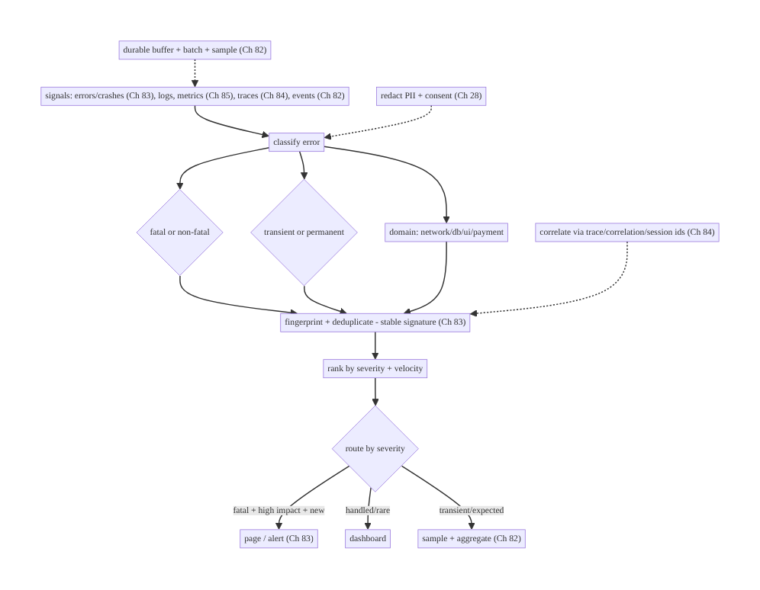
87.4 High-Level Architecture
Components & ownership
- Classifier tags each error (fatal/non-fatal, transient/permanent, domain).
- Fingerprinter groups/deduplicates by stable signature (Ch 83).
- Severity + router ranks and routes (page/dashboard/sample, Ch 83/82).
- Correlator attaches ids (Ch 84); Redactor scrubs PII (Ch 28); pipeline buffers/ batches/samples (Ch 82).
Direction: signals (Ch 82/83/84/85) → classify → fingerprint/dedup → severity → route; correlated (Ch 84), redacted (Ch 28), buffered (Ch 82).

87.5 Detailed Component Design
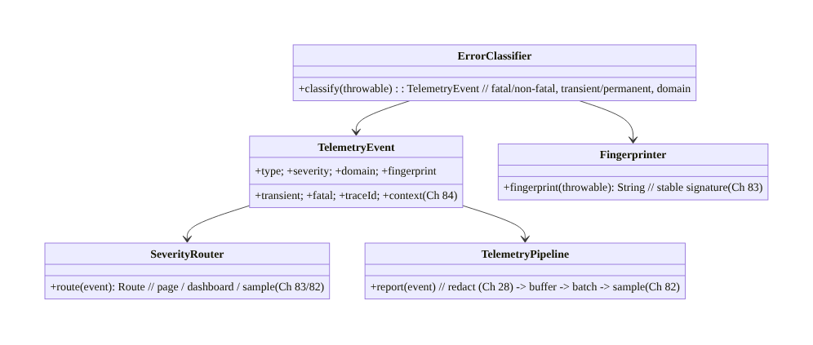
87.5 Detailed Component Design
Component | Responsibility
TelemetryEvent | structured signal: type/severity/domain/fingerprint/transient/ids (Ch 84)
ErrorClassifier | fatal/non-fatal, transient/permanent, domain
Fingerprinter | stable signature for grouping/dedup (Ch 83)
SeverityRouter | rank + route (page/dashboard/sample, Ch 83/82)
TelemetryPipeline | redact (Ch 28) + buffer + batch + sample (Ch 82)

87.6 End-to-End Data Flow

Error → classify → fingerprint → severity → route
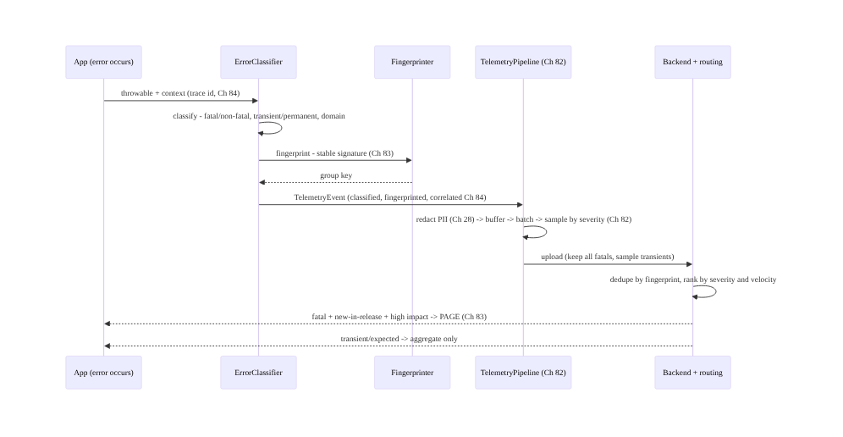
Error → classify → fingerprint → severity → route

Transient vs permanent → handling + severity
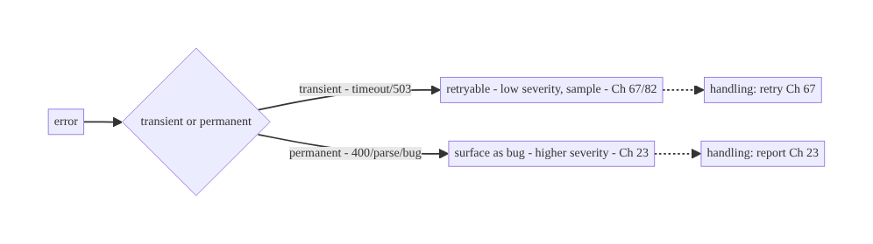
Transient vs permanent → handling + severity

87.7 Complete Kotlin Implementation
Package: com.streamcart.telemetry.

87.7.1 Classification (fatal/non-fatal, transient/permanent, domain)
data class TelemetryEvent(
val type: String, val severity: Severity, val domain: Domain,
val fingerprint: String, val transient: Boolean, val fatal: Boolean,
val traceId: String?, val context: Map<String, String>, // correlated (Ch 84), PII-safe (Ch 28)
)
enum class Severity { FATAL, ERROR, WARN, INFO }
enum class Domain { NETWORK, DATABASE, UI, PAYMENT, AUTH, UNKNOWN }
@Singleton
class ErrorClassifier @Inject constructor(private val fingerprinter: Fingerprinter, private val correlation: CorrelationManager) { // Ch 84
fun classify(t: Throwable, fatal: Boolean): TelemetryEvent {
val transient = isTransient(t) // retryable vs bug
return TelemetryEvent(
type = t::class.simpleName ?: "Unknown",
severity = when { fatal -> Severity.FATAL; transient -> Severity.WARN; else -> Severity.ERROR }, // transient -> lower
domain = domainOf(t), fingerprint = fingerprinter.fingerprint(t), // group/dedup (Ch 83)
transient = transient, fatal = fatal, traceId = correlation.currentTraceId(), // correlate (Ch 84)
context = mapOf("release" to BuildConfig.VERSION_NAME))
}
private fun isTransient(t: Throwable): Boolean = when (t) { // transient = retryable (Ch 67)
is SocketTimeoutException, is UnknownHostException, is IOException -> true
is HttpException -> t.code() in listOf(429, 500, 502, 503, 504) // 5xx/429 retryable
else -> false // 4xx (except 429), parse, state -> permanent (bug)
}
private fun domainOf(t: Throwable): Domain = when (t) {
is IOException, is HttpException -> Domain.NETWORK // Ch 67
is SQLException -> Domain.DATABASE // Ch 5
else -> Domain.UNKNOWN
}
}

87.7.2 Fingerprinting / deduplication (Ch 83)
@Singleton
class Fingerprinter @Inject constructor() {
/** Stable signature so thousands of occurrences group into ONE issue (Ch 83). */
fun fingerprint(t: Throwable): String {
val top = t.stackTrace.firstOrNull { it.className.startsWith("com.streamcart") } // top APP frame
val sig = "${t::class.qualifiedName}@${top?.className}.${top?.methodName}:${top?.lineNumber}"
return MessageDigest.getInstance("SHA-256").digest(sig.toByteArray()).joinToString("") { "%02x".format(it) }.take(16)
// Group by TYPE + LOCATION, not raw message (dynamic values vary) - stable across occurrences.
}
}

87.7.3 Severity routing (page/dashboard/sample)
@Singleton
class SeverityRouter @Inject constructor() {
enum class Route { PAGE, DASHBOARD, SAMPLE }
/** Route by severity (backend also factors volume/velocity/new-in-release, Ch 83). */
fun route(event: TelemetryEvent): Route = when {
event.fatal -> Route.PAGE // fatal -> page (Ch 83)
event.transient -> Route.SAMPLE // transient/expected -> sample+aggregate (Ch 82)
else -> Route.DASHBOARD // permanent non-fatal -> dashboard
}
// Backend escalates DASHBOARD -> PAGE if volume spikes / new-in-release / many users (Ch 83).
}

87.7.4 Pipeline: redact → buffer → batch → sample (Ch 82/28)
@Singleton
class TelemetryPipeline @Inject constructor(
private val redactor: PiiRedactor, // Ch 28
private val buffer: TelemetryBuffer, // durable (survives crash, Ch 83)
private val consent: ConsentManager, // Ch 82
) {
fun report(event: TelemetryEvent) {
if (!consent.telemetryAllowed()) return // consent (Ch 82)
val safe = redactor.redact(event) // scrub PII at boundary (Ch 28)
val keep = event.fatal || Random.nextFloat() < sampleRate(event) // keep ALL fatals; sample transients (Ch 82)
if (keep) buffer.enqueue(safe) // durable buffer -> batched upload (Ch 82)
}
private fun sampleRate(e: TelemetryEvent) = if (e.transient) 0.05f else 1.0f // sample expected transients
}
// PiiRedactor: allowlist context fields + scrub email/token/card patterns (Ch 28) BEFORE upload.

87.7.5 Hooking it up (fatal + non-fatal)
// Fatal (crash): uncaught handler (Ch 83) -> classify(fatal=true) -> pipeline (persist before death).
// Non-fatal (handled, Ch 23): in a catch, telemetry.report(classifier.classify(e, fatal = false)).
// Transient network (Ch 67): classified transient -> sampled, low severity (expected).
class CheckoutRepo(private val telemetry: Telemetry) {
suspend fun place(order: Order): Result<Receipt> = runCatching { api.place(order) } // Ch 23
.onFailure { telemetry.report(it, fatal = false) } // classified, fingerprinted, correlated (Ch 84)
}

87.7.6 Module structure
:core:telemetry TelemetryEvent, ErrorClassifier, Fingerprinter, SeverityRouter, TelemetryPipeline
# Ingests crash (Ch 83), traces (Ch 84), metrics (Ch 85), events (Ch 82); correlate -> Ch 84;
# redact -> Ch 28; buffer/batch/sample -> Ch 82; dedupe/rank/route -> backend. Handling -> Ch 23/67.

87.8 Concurrency and Race Conditions
Scenario | Risk | Handling
Error flood | noise + cost | fingerprint/dedup + severity sampling (Ch 83/82)
Transient treated as bug | false alarms | classify transient -> low severity/sample (Ch 67)
Unstable fingerprint | duplicate issues | type + location signature (not raw message, Ch 83)
PII in error | leak | redact at boundary (Ch 28)
Crash loses its own report | no signal | durable buffer, persist-before-death (Ch 83)
No correlation | un-investigable | attach trace/correlation ids (Ch 84)
Everything pages | alert fatigue | severity routing (page fatal only, Ch 83)
- Fingerprinting + severity sampling is what keeps the pipeline affordable and actionable under a flood — group duplicates, keep all fatals, sample expected transients (Ch 83/82).
- Classification drives handling (Ch 23/67): a transient error is retried and logged quietly; a permanent one is surfaced — so the taxonomy isn’t just reporting, it shapes behavior.
- Durable buffering ensures the crash’s own report survives the crash (Ch 83) — the most important signal is the one most at risk.

87.9 Failure Scenarios and Recovery
Failure | Detection | Response | Outcome
Error flood drowns signal | volume spike | fingerprint/dedup + severity sample (Ch 83/82) | actionable
Transient alarms as bug | false pages | classify transient (Ch 67) | quiet
Same bug = 10k issues | duplicate groups | stable fingerprint (Ch 83) | one issue
PII leaked in error | privacy audit | redact at boundary (Ch 28) | safe
Crash report lost | missing signal | durable buffer (Ch 83) | captured
Can’t investigate error | no context | correlate ids (Ch 84) | investigable
Alert fatigue | too many pages | severity routing (Ch 83) | focused
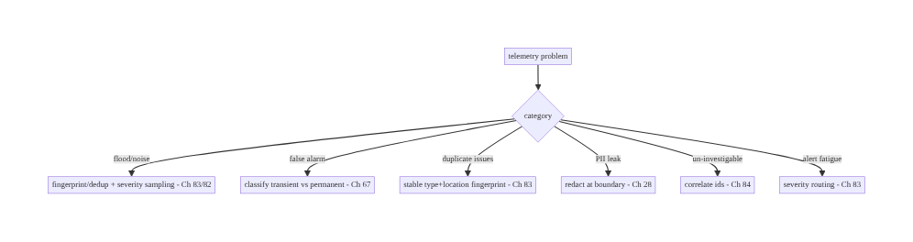
87.9 Failure Scenarios and Recovery
Classify, fingerprint, rank, route — and redact. The flood of raw errors becomes actionable only when you classify (fatal/transient/domain), group duplicates by a stable signature (Ch 83), rank by severity and velocity, and route (page the fatal, sample the transient, Ch 82). Correlate across pillars (Ch 84) to investigate, redact PII at the boundary (Ch 28), and durably buffer so the crash’s own report survives (Ch 83).

87.10 Scaling the Implementation
- Level 1. Crashlytics (fatal + non-fatal, Ch 83) with default fingerprinting; analytics (Ch 82) separate.
- Level 2. Explicit classification (transient/permanent/domain); custom fingerprinting; severity routing; PII redaction (Ch 28).
- Level 3 — production. Unified pipeline (Ch 82) with correlation ids (Ch 84); severity + velocity routing (page/dashboard/sample); durable buffering; consent (Ch 28).
- Level 4 — platform. One telemetry backend (APM) ingesting logs/metrics/traces/errors/ events with full correlation (Ch 84); SLO-based alerting; automated grouping/anomaly detection.
- Level 5 — enterprise. Observability platform: unified schema, tiered sampling, cost governance, cross-service correlation (Ch 84), error budgets, on-call routing by domain/ ownership.
Avoid overengineering: Crashlytics + analytics with explicit transient/permanent classification, stable fingerprinting, severity routing, and PII redaction covers most apps. Don’t page on transients; don’t skip fingerprinting; don’t leak PII; don’t silo the pillars without correlation.

87.11 Alternative Approaches and Trade-offs
Dimension | Option A | Option B | When
Pipeline | Unified + correlated (Ch 84) | siloed SDKs | Unified/correlated (one story)
Grouping | Fingerprint/dedup (Ch 83) | raw, ungrouped | Fingerprint (actionable)
Classification | Transient/permanent/domain | unclassified | Classify (drives handling+severity)
Routing | Severity + velocity (Ch 83) | all-or-nothing | Severity routing (focus)
Sampling | By severity (keep fatals, Ch 82) | uniform/none | Severity sampling (cost)
PII | Redact at boundary (Ch 28) | raw | Redact (privacy)
Fingerprint key | Type + location | raw message | Type+location (stable)
Unified/correlated vs siloed: separate SDKs for analytics, crashes, traces, metrics mean you can’t connect a slow trace to the error it caused (Ch 84). A unified (or id- correlated, Ch 84) pipeline tells one story — error ↔ trace ↔ metrics ↔ context. Prefer correlation (shared ids, Ch 84) even if backends differ.
Fingerprint by type+location vs raw message: grouping by raw message fails — dynamic values (ids, timestamps) make every occurrence look unique, so 10,000 instances become 10,000 issues. Grouping by exception type + top app frame/location is stable across occurrences → one counted issue (Ch 83). Always fingerprint by signature.
Severity sampling vs uniform: sampling everything uniformly either drops important fatals or keeps too much noise. Severity sampling — keep all fatals (Ch 83), sample expected transients (Ch 82) — keeps the signal while bounding cost. Sample by severity.

87.12 Security & Privacy Considerations
- Redact PII at the boundary (Ch 28): errors/logs are the top PII leak — stack messages with user data, URLs with tokens, logged payloads. Allowlist context fields, scrub email/token/card patterns before upload (Ch 28). Never ship raw error text with PII.
- Consent (Ch 82): telemetry follows the consent regime; opted-out users limited to essential crash signal (minimal, anonymized).
- Correlation ids opaque (Ch 84): link signals by opaque ids, not PII.
- No secrets in context: release/device/screen in context, never tokens/keys/card data (Ch 76).
- Access-controlled telemetry: error/trace data is internal, access-controlled, retention- limited (Ch 28).
- Client vs backend: the client classifies, fingerprints, redacts, and buffers PII-safely; the backend dedupes, ranks, routes, and access-controls — neither stores PII in telemetry.

87.13 Performance and Resource Optimization
- Classification/fingerprinting are cheap — type/stack inspection + one hash; done off the hot path (in the reporting path, Ch 82).
- Severity sampling bounds volume/cost — keep fatals, sample transients (Ch 82).
- Batched, buffered upload (Ch 82) — no per-error network; survives crash (Ch 83).
- Dedup reduces backend cost — one issue per fingerprint, not per occurrence (Ch 83).
- Redaction is bounded — allowlist + pattern scrub, not heavy parsing (Ch 28).
- Profiling: reporting-path overhead (should be negligible), event volume by severity, sampling rates, buffer size, upload batch efficiency (Ch 82).

87.14 Testing Strategy
Classification, fingerprinting, routing, and redaction are all unit-testable.
class ErrorClassifierTest {
@Test fun `timeout is transient and low severity`() {
val e = classifier.classify(SocketTimeoutException(), fatal = false)
assertTrue(e.transient); assertEquals(Severity.WARN, e.severity); assertEquals(Domain.NETWORK, e.domain) // Ch 67
}
@Test fun `parse error is permanent`() {
assertFalse(classifier.classify(JsonParseException("x"), fatal = false).transient) // bug, higher severity
}
}
class FingerprinterTest {
@Test fun `same type+location groups despite different messages`() {
val a = thrownAt("checkout", msg = "id=1"); val b = thrownAt("checkout", msg = "id=2")
assertEquals(fingerprinter.fingerprint(a), fingerprinter.fingerprint(b)) // one issue (Ch 83)
}
}
class RedactorTest {
@Test fun `scrubs PII from error context`() {
val safe = redactor.redact(eventWith("user@example.com"))
assertFalse(safe.context.values.any { it.contains("@") }) // Ch 28
}
}
class SeverityRouterTest {
@Test fun `fatal pages, transient samples`() {
assertEquals(Route.PAGE, router.route(fatalEvent())); assertEquals(Route.SAMPLE, router.route(transientEvent()))
}
}
What to test: classification (transient/permanent/domain/severity, Ch 67); stable fingerprinting (type+location groups, Ch 83); severity routing (page/dashboard/sample, Ch 83); PII redaction (Ch 28); consent + severity sampling (Ch 82); durable buffering survives crash (Ch 83).

87.15 Production Observability
- Metrics: error volume by severity/domain/fingerprint, top issues (by count/users/ velocity, Ch 83), crash-free rate (Ch 83), transient vs permanent ratio, new-in-release issues, pipeline health (buffer/upload/sampling, Ch 82).
- Logs: structured telemetry events — PII-redacted (Ch 28).
- Debugging: error flood → check fingerprinting/dedup (Ch 83); false pages → check transient classification (Ch 67); un-investigable error → check correlation ids (Ch 84); duplicate issues → check fingerprint stability (Ch 83); PII leak → check redaction (Ch 28).
- Alerting: fatal + new-in-release + high-impact (page, Ch 83); velocity spike on any fingerprint (regression); crash-free-rate drop (Ch 83); pipeline drop (Ch 82).
- Dashboards: top issues by severity/domain/velocity; crash-free trend (Ch 83); transient/ permanent split; correlation drill-down to trace (Ch 84).

87.16 System Design Interview Preparation
≥25 questions.
Fundamentals
- Telemetry pillars? Logs, metrics (Ch 85), traces (Ch 84), events (Ch 82), errors (Ch 83).
- Why unify? One correlated story across pillars (Ch 84).
- Why classify errors? Turn noise into actionable, routed signal.
- Classification axes? Fatal/non-fatal, transient/permanent, domain.
- Why fingerprint? Group duplicates into one counted issue (Ch 83).
Classification
- Fatal vs non-fatal? Crash (Ch 83) vs handled (Ch 23).
- Transient vs permanent? Retryable (timeout/503, Ch 67) vs bug (400/parse).
- Why it matters? Drives handling (retry vs report) + severity.
- Domain? Network/db/ui/payment — routing + ownership.
Fingerprinting
- How? Type + top app frame/location (not raw message).
- Why not message? Dynamic values make each unique → 10k issues.
- What’s kept? Count, first/last seen, users, versions (Ch 83).
Severity/routing
- Rank by? Impact: fatal + volume + velocity + new-in-release.
- Route? Page (fatal/high-impact), dashboard (rare), sample (transient).
- Sampling? Keep all fatals, sample transients (Ch 82).
- Velocity? Spiking matters as much as volume.
Correlation/privacy
- Correlate? Trace/correlation/session ids (Ch 84).
- Why? Link error to trace/metrics/context.
- PII? Redact at boundary — errors are the top leak (Ch 28).
- Consent? Follows the analytics regime (Ch 82).
Reliability
- Crash report survives? Durable buffer, persist-before-death (Ch 83).
- Cost? Batch + severity-sample (Ch 82).
Testing/Production
- Test classification? Transient/permanent/severity cases.
- Alert fatigue? Severity routing — page fatals only.
- Error flood? Fingerprint/dedup + sampling.
- Un-investigable? Correlation ids (Ch 84).

Design-change challenges
- Tame a 50k-errors/day flood. Fingerprint/dedup + severity routing + sampling (Ch 83/82).
- Stop paging on network blips. Classify transient → low severity/sample (Ch 67).
- Connect a slow trace to its error. Correlation ids (Ch 84).
- Prevent PII in error reports. Redact at the boundary (Ch 28).
- Group a bug reported 10k times. Stable type+location fingerprint (Ch 83).

Mock walkthrough (abridged)
Clarify (which signals, severity routing, PII?) → unified pipeline ingesting errors/logs/ metrics/traces/events (Ch 82/83/84/85) → classify (fatal/non-fatal, transient/permanent, domain) → fingerprint/dedup (Ch 83) → severity + velocity routing (page/dashboard/sample) → correlate ids (Ch 84) → redact PII + consent (Ch 28) → durable buffer + severity sample (Ch 82) → observability (top issues, crash-free, Ch 83).

87.17 Practical Exercises
- Beginner. Classify errors as transient vs permanent (Ch 67) and route severity (page fatal, sample transient). Eval: correct classification + routing.
- Intermediate. Implement stable fingerprinting (type + location) so duplicate errors group into one issue (Ch 83). Eval: same bug → one fingerprint.
- Advanced. Add PII redaction at the boundary (Ch 28), correlation ids (Ch 84), and severity sampling (keep fatals, Ch 82). Eval: PII-safe; correlated; cost-bounded.
- Production debugging. Investigate an error flood (fix dedup) and false pages (fix transient classification). Eval: flood tamed; pages focused.
- System design challenge. Design a unified telemetry pipeline correlating logs/metrics/ traces/errors/events (Ch 84) with severity routing and cost governance. Eval: one story; actionable; affordable.
(Solutions withheld unless requested.)

87.18 Chapter Summary & Reference Sheet
Key decisions: build a unified telemetry pipeline that ingests all observability pillars — logs, metrics (Ch 85), traces (Ch 84), analytics events (Ch 82), and errors/crashes (Ch 83) — through one reliable, batched, consented, PII-safe path, and classify every error along three axes: fatal vs non-fatal (crash, Ch 83, vs handled, Ch 23), transient/retryable vs permanent/bug (timeout/503, Ch 67, vs 400/parse), and by domain (network/db/ui/payment) — so classification drives both handling (retry vs report, Ch 23/67) and severity; fingerprint and deduplicate errors by a stable signature (exception type + top app frame/location, not raw message) so thousands of occurrences collapse into one counted, ranked issue (Ch 83); rank by severity and velocity and route accordingly (page the fatal, new-in-release, high-impact ones; dashboard the rest; sample expected transients, Ch 82); correlate every signal by trace/correlation/session ids (Ch 84) so an error links to the trace, metrics, and context that explain it; and redact PII at the boundary with consent (Ch 28) while durably buffering (so the crash’s own report survives, Ch 83) and severity-sampling for reliability and cost (Ch 82) — turning a flood of raw failures into actionable, deduplicated, correlated, PII-safe signal.
Concepts: telemetry pillars unified (Ch 82/83/84/85), error classification (fatal/non-fatal, transient/permanent, domain), fingerprinting/dedup (Ch 83), severity + velocity routing (page/ dashboard/sample), correlation ids (Ch 84), PII redaction + consent (Ch 28), durable buffering + severity sampling (Ch 82), classification-drives-handling (Ch 23/67).
Common mistakes: siloed pillars (no correlation); ungrouped errors (flood); fingerprinting by raw message (duplicate issues); paging on transients (alert fatigue); no severity sampling (cost/noise); PII in error text; losing the crash’s own report; unclassified errors (can’t route or handle).
Checklist:
- ☐ unified pipeline ingesting errors/logs/metrics/traces/events (Ch 82/83/84/85)
- ☐ classify fatal/non-fatal + transient/permanent + domain
- ☐ fingerprint/dedup by type+location (Ch 83)
- ☐ rank by severity + velocity
- ☐ route page/dashboard/sample
- ☐ correlate via ids (Ch 84)
- ☐ redact PII + consent (Ch 28)
- ☐ durable buffer (crash survives, Ch 83)
- ☐ severity sampling (keep fatals, Ch 82)
- ☐ classification drives handling (Ch 23/67).
Key APIs/concepts: Crashlytics fatal + non-fatal (recordException, Ch 83), custom keys/ fingerprints (Ch 83), structured telemetry events, SHA-256 signature fingerprinting, severity/ velocity routing (backend), correlation ids (Ch 84), PII redaction (Ch 28), reliable batched pipeline (Ch 82), transient classification (Ch 67).
References: - Observability pillars (logs/metrics/traces) — observability literature - Crashlytics issue grouping/fingerprinting: https://firebase.google.com/docs/crashlytics - OpenTelemetry (unified signals + correlation): https://opentelemetry.io - (composes) Ch 82 Analytics, Ch 83 Crash/ANR, Ch 84 Tracing, Ch 85 Perf, Ch 28 Privacy, Ch 23 Error Handling, Ch 67 Network Errors

Chapter 88 — Cold Start Optimization
Part X — Performance, Observability & Quality · Complexity: Complex (≥40 interview questions)
Prerequisites: Ch 45 (startup sequence), Ch 85 (perf monitoring), Ch 92 (baseline profiles/R8), Ch 44 (lifecycle), Ch 46 (DI/Hilt), Ch 3 (threading). Pairs with Ch 90 (jank), Ch 89 (memory), Ch 93 (lists).
Reference surface in StreamCart: making the app launch fast — minimizing cold start time (process create → first frame → fully drawn, Ch 45) by deferring/parallelizing Application.onCreate and library init, using App Startup, a well-designed splash (SplashScreen API), lazy dependency graphs (Ch 46), baseline profiles (Ch 92), and measuring with Macrobenchmark (lab) + field metrics (Ch 85) — because startup is the first impression and a slow one loses users.

88.1 Problem Definition and Real-World Context
Cold start — launching the app when its process doesn’t exist (killed/first launch, so Android must fork Zygote, create the Application, init libraries, build the first Activity, inflate/compose, and render the first frame, then reach fully drawn, Ch 45) — is the slowest launch path and the first impression users get. A slow cold start (blank screen, long splash) directly loses users and trips Android vitals thresholds (Ch 85). Cold start optimization is the discipline of making this path fast: deferring and parallelizing Application.onCreate and library initialization (App Startup), a correct SplashScreen, a lazy dependency graph (Ch 46), avoiding main-thread I/O, baseline profiles to pre- compile the hot path (Ch 92), and measuring rigorously with Macrobenchmark (lab) and field data (Ch 85). This is the Complex counterpart to Ch 45 (the sequence) and Ch 85 (monitoring) — focused on making it fast.
Concretely, teams hit:
- Bloated Application.onCreate. Every SDK’s init runs synchronously on the main thread before the first frame — analytics, crash (Ch 83), image loader (Ch 59), DI graph (Ch 46), feature flags (Ch 40) — adding hundreds of ms. The #1 cold-start cost.
- Synchronous library initialization. Each library initializing itself (often via a ContentProvider, which also costs) in series. App Startup (androidx.startup) consolidates/ orders them and lets you defer/parallelize/lazy-init.
- Main-thread I/O at startup. Reading SharedPreferences/DataStore (Ch 7), disk, or the DB (Ch 5) on the main thread before first frame blocks rendering. Must be off-main or deferred.
- Eager dependency graph (Ch 46). Building the entire Hilt/DI graph eagerly at startup constructs objects you don’t need yet. Use lazy injection (Lazy<T>/Provider<T>) and scope work.
- Wrong splash (pre-Android 12 patterns). A dedicated splash Activity adds a whole extra Activity launch; the correct approach is the SplashScreen API (Android 12+, compat library) — a themed window, no extra activity.
- No pre-compilation (JIT cold, Ch 92). On first runs, code is interpreted/JIT-compiled — slow. Baseline Profiles (Ch 92) pre-compile (AOT) the startup + critical-path code so it’s fast from the first launch. One of the biggest wins.
- TTID vs TTFD confusion (Ch 45). TTID (time to initial display — first frame) vs TTFD (time to full display — reportFullyDrawn, Ch 45). Optimize to show something fast (TTID) and be usable fast (TTFD); don’t block the first frame on full data.
- Measuring on a flagship only. Optimizing on a fast dev phone hides the low-end reality (Ch 85). Measure with Macrobenchmark (lab, reproducible, Ch 92) and field vitals (Ch 85), on representative devices, in percentiles.
The architecture: minimize the cold-start critical path (Ch 45) — defer and parallelize Application.onCreate/library init (App Startup, off-main, Ch 3); build a lazy dependency graph (Ch 46); use the SplashScreen API (no extra activity); show TTID fast and reach TTFD (reportFullyDrawn) quickly without blocking the first frame; pre-compile the hot path with Baseline Profiles + R8 (Ch 92); and measure with Macrobenchmark (lab) + field (Ch 85) on representative devices in percentiles. This chapter is about making the first impression fast.

Three practical use cases
- Trim Application.onCreate (StreamCart). Move analytics/image-loader/non-critical SDK init off the main-thread critical path (App Startup + background), defer feature-flag fetch (Ch 40); cold start drops from 1.8s → 0.9s on a mid-tier device (Ch 85).
- Baseline Profile for startup (Ch 92). Generate a baseline profile covering launch + home feed (Ch 71); AOT-compiled startup is ~20–30% faster from first launch, verified by Macrobenchmark.
- Lazy DI + deferred DB (Ch 46/5). Inject heavy repositories via Lazy<T>; don’t open the Room DB or read DataStore on the main thread before first frame — show the UI, then load.

Why this is architectural
Cold start composes the startup sequence (Ch 45), App Startup/library init, DI (Ch 46), threading (Ch 3), SplashScreen, baseline profiles/R8 (Ch 92), and measurement (Macrobenchmark + field, Ch 85). The decisions — defer/parallelize init, lazy graph, pre-compile, measure in percentiles on real devices — determine whether the first impression is fast, which drives retention and store ranking.

88.2 Requirements Engineering

Functional requirements
ID | Requirement
F1 | Minimize Application.onCreate + library init on the critical path (App Startup, Ch 3).
F2 | Build a lazy dependency graph; avoid eager construction (Ch 46).
F3 | Avoid main-thread I/O before first frame; defer/off-main (Ch 3/5/7).
F4 | Use the SplashScreen API (no extra activity); show TTID fast, reach TTFD quickly (Ch 45).
F5 | Pre-compile the hot path with Baseline Profiles + R8 (Ch 92).
F6 | Measure with Macrobenchmark (lab) + field vitals (Ch 85) in percentiles on representative devices.

Non-functional requirements
Attribute | Policy
Speed | Fast TTID + TTFD; p95 cold start within budget (Ch 85).
Correctness | Deferred init must not break features that need it.
Measured | Lab (reproducible) + field (truth), percentiles (Ch 85/92).
Device coverage | Low-end representative, not just flagship.
No regression | CI gate on startup (Macrobenchmark, Ch 92).

Scope
- In scope: cold-start critical path (Ch 45), Application.onCreate trimming, App Startup / library init ordering/deferral, off-main I/O (Ch 3), lazy DI graph (Ch 46), SplashScreen API, TTID/TTFD (reportFullyDrawn, Ch 45), baseline profiles + R8 (Ch 92), Macrobenchmark + field measurement (Ch 85), warm/hot start context.
- Out of scope: startup sequence detail (Ch 45), perf monitoring pipeline (Ch 85), baseline- profile/R8 mechanics (Ch 92), jank (Ch 90), memory (Ch 89), DI setup (Ch 46).

Assumptions & constraints
- Compose or Views; Hilt (Ch 46); Room/DataStore (Ch 5/7); App Startup available; SplashScreen compat; Baseline Profiles + R8 (Ch 92); Macrobenchmark for lab (Ch 92) + Android vitals for field (Ch 85). Measured in percentiles on representative devices. minSdk 24.

88.3 System Design Fundamentals
- The cold-start critical path (Ch 45). Process fork (Zygote) → Application.onCreate (+ all ContentProvider/library init) → first Activity onCreate/setContent → measure/ layout/inflate or compose → first frame drawn (TTID) → data loaded → fully drawn (TTFD, reportFullyDrawn). Everything on this path before the first frame delays the user seeing anything. The goal: shrink the pre-first-frame work and move the rest off the critical path.
- Application.onCreate is the hotspot. It runs synchronously on the main thread before anything is shown. Every SDK init here adds directly to cold start. Audit it: what must run before first frame (crash handler, Ch 83; DI graph essentials, Ch 46) vs what can be deferred (analytics flush, image preload, feature-flag fetch, Ch 40) or parallelized/ off-main (Ch 3).
- App Startup (androidx.startup). Libraries often auto-init via their own ContentProvider — each costs and they can’t be ordered. App Startup consolidates them under one provider with explicit dependency ordering, and lets you defer (lazy, manual) or parallelize initialization. Mark non-critical initializers lazy and trigger them after first frame.
- Off-main I/O + deferral (Ch 3/5/7). Never read disk/DB/DataStore/prefs on the main thread before first frame — it blocks rendering. Read off-main (Dispatchers.IO, Ch 3) or defer until after TTID. Show the UI with a lightweight state, then load data (TTFD).
- Lazy dependency graph (Ch 46). Building the whole Hilt graph eagerly constructs objects you don’t need at launch. Use Lazy<T>/Provider<T> so heavy dependencies (repositories, DB, network clients) are built on first use, not at startup. Scope construction to when it’s needed.
- SplashScreen API (not an extra activity). The old pattern — a dedicated splash Activity — adds a second activity launch to cold start. The SplashScreen API (Android 12+, androidx.core.splashscreen compat) shows a themed window during the normal cold start with no extra activity, and lets you keep it on-screen until content is ready (setKeepOnScreenCondition) — but don’t hold it too long (that’s just a slow start in disguise).
- TTID vs TTFD (Ch 45). TTID (first frame) — show something (skeleton/placeholder, Ch 93) fast; TTFD (reportFullyDrawn) — usable with real data. Don’t block the first frame on the network/DB — render a skeleton at TTID, fill at TTFD. Report both to vitals (Ch 85).
- Baseline Profiles + R8 (the AOT win, Ch 92). On fresh installs/updates, code runs interpreted then JIT — slow. A Baseline Profile lists the startup + critical-path methods so ART AOT-compiles them at install → fast from the first launch (often 20–30% faster startup). R8 (Ch 92) shrinks/optimizes code (less to load/init). These are among the biggest, lowest-effort wins — covered in depth in Ch 92.
- Measurement: Macrobenchmark (lab) + field (Ch 85/92). Macrobenchmark measures cold/ warm/hot start reproducibly in CI (StartupTimingMetric, CompilationMode) — the gate against regressions (Ch 92). Field vitals (Ch 85) show the real distribution (p95 on low-end). Measure both, in percentiles, on representative devices — never optimize by eyeballing a flagship.
- Warm/hot start context (Ch 45). Warm (process alive, activity recreated) and hot (activity in memory) are faster; cold is the worst case and the focus. Optimizations (lazy graph, deferred init) help all three. Also mind process death/restoration (Ch 44) — a warm start restoring state shouldn’t redo cold work.
Core insight: the cold-start critical path (Ch 45) is process-fork → Application.onCreate + library init → first Activity → first frame (TTID) → fully drawn (TTFD); make it fast by auditing and shrinking Application.onCreate (defer analytics/image/flag init, keep only the crash handler and DI essentials), consolidating and ordering library init under App Startup with non-critical initializers lazy/parallel/off-main (Ch 3), never doing main-thread disk/DB/ DataStore I/O before the first frame, building a lazy Hilt graph (Lazy/Provider) so heavy dependencies construct on first use not at launch (Ch 46), using the SplashScreen API (no extra activity, keep on screen only until ready), rendering a skeleton at TTID and filling real data by TTFD (reportFullyDrawn, Ch 45) so the first frame is never blocked on the network, and pre- compiling the startup + critical-path code with Baseline Profiles + R8 for a 20–30% AOT win from the first launch (Ch 92) — then measuring rigorously with Macrobenchmark (lab, CI-gated, Ch 92) and field vitals (Ch 85) in percentiles on representative low-end devices, because startup is the first impression and the tail is where it’s lost.

88.4 High-Level Architecture
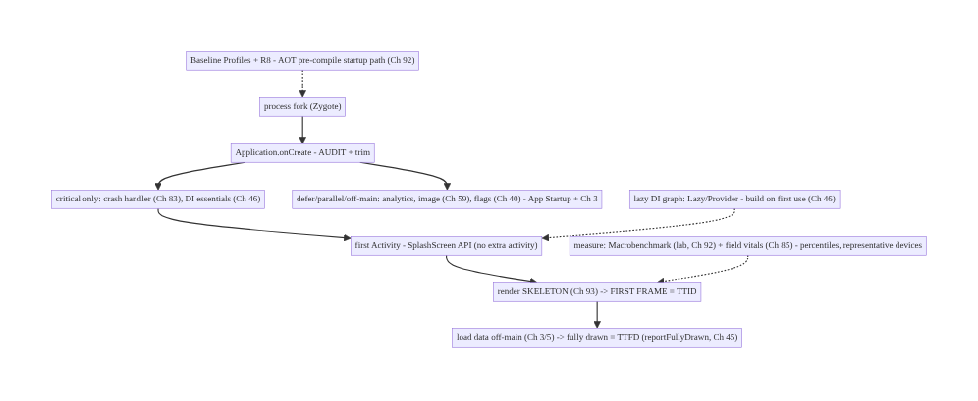
88.4 High-Level Architecture
Components & ownership
- Application.onCreate audited: critical init only; rest deferred/parallel/off-main (App Startup, Ch 3).
- SplashScreen API (no extra activity); skeleton at TTID, real data by TTFD (Ch 45).
- Lazy DI graph (Ch 46); Baseline Profiles + R8 pre-compile (Ch 92).
- Measurement: Macrobenchmark (lab, Ch 92) + field vitals (Ch 85), percentiles.
Direction: fork → trimmed onCreate (critical only; defer rest) → SplashScreen → skeleton (TTID) → off-main data (TTFD); lazy graph + AOT; measured in lab + field.

88.5 Detailed Component Design
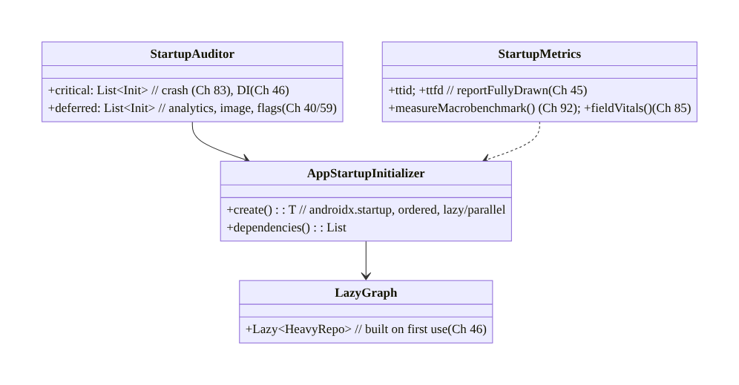
88.5 Detailed Component Design
Component | Responsibility
StartupAuditor | classify init: critical vs deferred
AppStartupInitializer | ordered, lazy/parallel library init (App Startup)
LazyGraph | lazy DI — heavy deps on first use (Ch 46)
StartupMetrics | TTID/TTFD (Ch 45); Macrobenchmark (Ch 92) + field (Ch 85)

88.6 End-to-End Data Flow

Cold-start critical path (optimized)
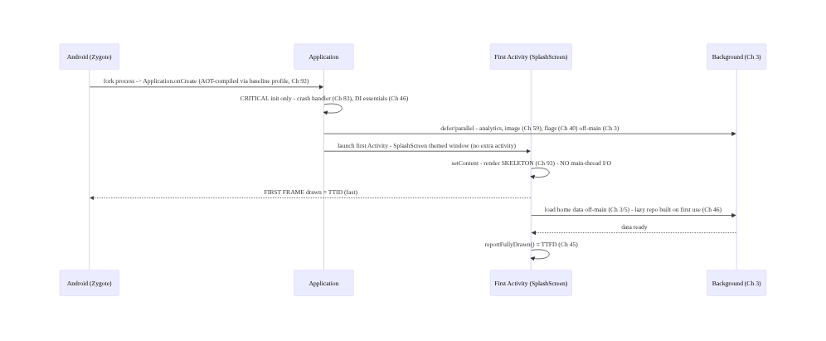
Cold-start critical path (optimized)

Audit: critical vs deferred
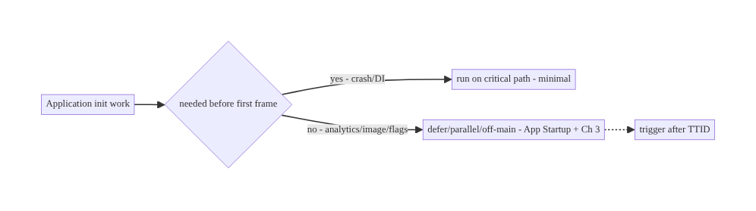
Audit: critical vs deferred

88.7 Complete Kotlin Implementation
Package: com.streamcart.startup.

88.7.1 Trimmed Application.onCreate (critical only; defer the rest)
@HiltAndroidApp
class StreamCartApp : Application() {
override fun onCreate() {
super.onCreate()
// CRITICAL ONLY - must run before first frame:
CrashReporter.install(this) // crash handler first (Ch 83)
// DI graph is Hilt - essentials only; heavy deps are Lazy (see 88.7.3, Ch 46).
// DEFER everything non-critical OFF the main-thread critical path (Ch 3):
appScope.launch(Dispatchers.Default) { // after onCreate returns; off-main
Analytics.init(this@StreamCartApp) // not needed for first frame (Ch 82)
ImageLoaderFactory.warm(this@StreamCartApp) // Coil (Ch 59)
FeatureFlags.prefetch() // Ch 40 - defer; use cached meanwhile
}
// NO SharedPreferences/DataStore/DB reads here on the main thread (Ch 5/7).
}
}

88.7.2 App Startup: ordered, lazy, non-critical init
// Replace each library's auto-init ContentProvider with App Startup (androidx.startup):
class AnalyticsInitializer : Initializer<Unit> { // consolidated under ONE provider
override fun create(context: Context) { /* lightweight register; heavy work deferred */ }
override fun dependencies(): List<Class<out Initializer<*>>> = emptyList() // explicit ordering
}
// In the manifest, disable libraries' own ContentProviders and mark non-critical initializers
// LAZY (manual) so they run AFTER first frame, triggered post-TTID - not on the critical path.

88.7.3 Lazy dependency graph (Ch 46)
@HiltViewModel
class HomeViewModel @Inject constructor(
private val feedRepo: dagger.Lazy<FeedRepository>, // built on FIRST USE, not at startup (Ch 46)
private val db: dagger.Lazy<AppDatabase>, // Room opened lazily, off-main (Ch 5)
) : ViewModel() {
fun load() = viewModelScope.launch(Dispatchers.IO) { // off-main (Ch 3)
val feed = feedRepo.get().home() // triggers construction here, after first frame
_state.value = HomeState.Ready(feed) // -> reportFullyDrawn (TTFD)
}
}

88.7.4 SplashScreen API + TTID/TTFD (Ch 45)
class MainActivity : ComponentActivity() {
override fun onCreate(savedInstanceState: Bundle?) {
val splash = installSplashScreen() // androidx.core.splashscreen - NO extra activity
super.onCreate(savedInstanceState)
val vm: HomeViewModel by viewModels()
// Keep splash only until essentials ready - do NOT hold on the network (that's a slow start):
splash.setKeepOnScreenCondition { vm.state.value is HomeState.Initializing } // brief
setContent {
val state by vm.state.collectAsStateWithLifecycle()
HomeScreen(state) // render SKELETON (Ch 93) at FIRST FRAME = TTID
LaunchedEffect(Unit) { vm.load() } // load data off-main -> TTFD
if (state is HomeState.Ready) {
LaunchedEffect(Unit) { reportFullyDrawn() } // TTFD marker for vitals (Ch 45/85)
}
}
}
}

88.7.5 Measurement: Macrobenchmark (lab, Ch 92) + field (Ch 85)
@RunWith(AndroidJUnit4::class)
class StartupBenchmark {
@get:Rule val rule = MacrobenchmarkRule()
@Test fun coldStartup() = rule.measureRepeated(
packageName = "com.streamcart", metrics = listOf(StartupTimingMetric()), // TTID/TTFD
compilationMode = CompilationMode.Partial(), // with baseline profile (Ch 92)
startupMode = StartupMode.COLD, iterations = 10,
) { pressHome(); startActivityAndWait() }
// CI GATE: fail if p-median cold start regresses (Ch 92). Field truth -> Android vitals (Ch 85).
}

88.7.6 Module structure
:app StreamCartApp (trimmed onCreate), MainActivity (SplashScreen)
:core:startup App Startup initializers (ordered/lazy), StartupMetrics
:benchmark Macrobenchmark StartupBenchmark (Ch 92)
# Lazy graph -> Hilt Lazy/Provider (Ch 46); off-main -> Ch 3; AOT -> Baseline Profiles + R8 (Ch 92);
# TTID/TTFD -> Ch 45; field -> vitals (Ch 85).

88.8 Concurrency and Race Conditions
Scenario | Risk | Handling
Deferred init raced by feature | NPE/uninit | gate feature on init-ready; use cached (Ch 40)
Main-thread I/O at startup | blocked frame | off-main (Dispatchers.IO, Ch 3) / defer
Eager graph construction | slow onCreate | Lazy/Provider (Ch 46)
Splash held on network | slow start | keep splash brief; skeleton + TTFD (Ch 45)
Parallel init ordering | dependency break | App Startup explicit dependencies()
Background init on main dispatcher | still blocks | Dispatchers.Default/IO (Ch 3)
Warm start redoes cold work | wasted | distinguish warm/hot; restore state (Ch 44)
- Deferring init introduces ordering hazards: a feature that needs a deferred library must wait for it (or use a cached value, Ch 40) — don’t let the first use race an uninitialized SDK. App Startup’s explicit dependencies() order parallel init safely.
- Off-main is non-negotiable before first frame (Ch 3): any main-thread disk/DB/DataStore read blocks the very frame you’re trying to show fast. Use Dispatchers.IO, and for CPU init Dispatchers.Default — never the main dispatcher for startup work.
- Keep the splash honest: holding the SplashScreen until data loads just hides a slow start; render a skeleton at TTID and reach TTFD fast (Ch 45/93).

88.9 Failure Scenarios and Recovery
Failure | Detection | Response | Outcome
Slow cold start | p95 vitals (Ch 85) | audit onCreate; defer/off-main; baseline profile (Ch 92) | fast
Blank/long splash | user reports | skeleton at TTID; brief splash (Ch 45/93) | responsive
Deferred-init crash | exception | gate feature on ready / cached (Ch 40) | robust
Main-thread jank at start | StrictMode/trace | off-main I/O (Ch 3) | smooth
Regression release-over-release | Macrobenchmark CI (Ch 92) | gate fails PR | prevented
Fast on flagship, slow on low-end | field p95 (Ch 85) | measure representative devices | honest
JIT-cold first launch | Macrobenchmark None vs Partial | baseline profile (Ch 92) | AOT fast
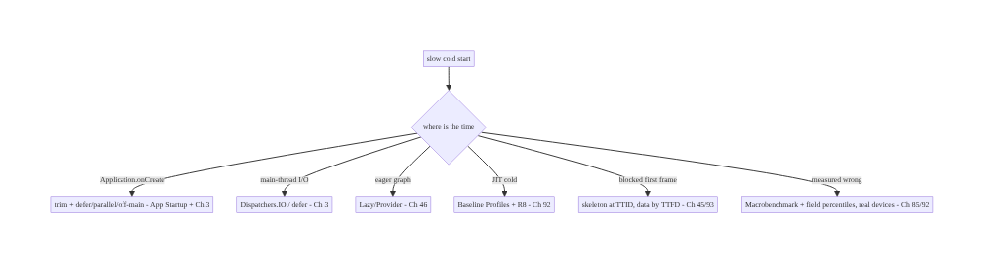
88.9 Failure Scenarios and Recovery
Shrink the critical path, defer the rest, pre-compile it, and measure it right. Cold start is lost in a bloated Application.onCreate, main-thread I/O, an eager graph, a JIT-cold first launch, and a first frame blocked on the network. Fix each: trim + defer (App Startup + off-main, Ch 3), lazy graph (Ch 46), Baseline Profiles + R8 (Ch 92), skeleton at TTID → TTFD (Ch 45) — then gate with Macrobenchmark (Ch 92) and watch field p95 (Ch 85) on real devices.

88.10 Scaling the Implementation
- Level 1. SplashScreen API; audit Application.onCreate; move obvious init off-main (Ch 3); reportFullyDrawn (Ch 45).
- Level 2. App Startup (consolidate/ order/defer); lazy DI graph (Ch 46); skeleton at TTID (Ch 93); field startup vitals (Ch 85).
- Level 3 — production. Baseline Profiles + R8 (Ch 92); Macrobenchmark CI gate; percentile startup budgets by device class (Ch 85); representative-device measurement.
- Level 4 — large. Per-flow baseline profiles (startup + top journeys); startup SLOs; module-level lazy loading; dependency-graph audits; automated regression gating (Ch 92).
- Level 5 — enterprise. Startup governance: budgets with error budgets, device-tier targets, long-tail device program, continuous profiling, cross-team startup ownership, AOT/ profile pipelines (Ch 92).
Avoid overengineering: SplashScreen + trimmed onCreate + App Startup deferral + lazy graph + Baseline Profiles + R8, measured by Macrobenchmark and field vitals, gets most of the win. Don’t micro-optimize before measuring; don’t hold the splash; don’t optimize only on a flagship.

88.11 Alternative Approaches and Trade-offs
Dimension | Option A | Option B | When
Init | Deferred/parallel (App Startup) | eager synchronous | Defer non-critical
Graph | Lazy (Lazy/Provider, Ch 46) | eager full graph | Lazy (build on use)
Splash | SplashScreen API | dedicated splash Activity | SplashScreen (no extra activity)
First frame | Skeleton at TTID (Ch 93) | block on data | Skeleton → TTFD
Compilation | Baseline Profiles + R8 (Ch 92) | JIT only | Baseline profiles (AOT win)
I/O | Off-main / deferred (Ch 3) | main-thread | Off-main always
Measure | Macrobenchmark + field (Ch 85/92) | eyeball flagship | Both, percentiles, real devices
SplashScreen API vs dedicated splash Activity: a splash Activity adds a whole extra activity launch to cold start (slower) and can flash. The SplashScreen API shows a themed window within the normal start — no extra activity — and keeps on screen only until ready. Always use the SplashScreen API.
Baseline Profiles vs JIT-only (Ch 92): without a profile, startup code is interpreted/ JIT-compiled on first launches — slow. A Baseline Profile AOT-compiles the startup + critical path → 20–30% faster from the first launch, a huge, low-effort win. Always ship one (Ch 92).
Skeleton at TTID vs blocking on data: blocking the first frame until data loads means a long blank/splash — bad first impression. Rendering a skeleton at TTID and filling real data by TTFD (reportFullyDrawn, Ch 45) shows something fast and feels responsive. Never block the first frame on the network/DB.

88.12 Security & Privacy Considerations
- Don’t defer security-critical init past its need: the crash handler (Ch 83) and any security/attestation (Ch 24) that must run before sensitive work should be on the critical path or gated — deferral is for non-critical init (analytics, image), not security.
- No secrets in startup logs/traces (Ch 28): startup profiling/metrics are timing, not content; keep PII out (Ch 85/28).
- Baseline profiles contain method names, not data (Ch 92): they’re compilation hints, not secrets.
- Deferred consent (Ch 28): analytics/telemetry deferral must still respect consent — don’t init tracking before consent is resolved (Ch 82/28).
- Gate features on secure init: a feature needing auth/crypto (Ch 20/24) must wait for that init, not race a deferred one.
- Client vs backend: cold-start optimization is client-side; the only cross-cutting concern is not deferring security/consent init incorrectly (Ch 24/28).

88.13 Performance and Resource Optimization
- This chapter is performance — the summary: trim onCreate, defer/parallelize/off- main init (App Startup, Ch 3), lazy graph (Ch 46), SplashScreen API, skeleton at TTID → TTFD (Ch 45/93), Baseline Profiles + R8 (Ch 92).
- Measure before optimizing — Macrobenchmark (lab, Ch 92) + system traces (Perfetto) show where the time goes; don’t guess.
- Representative devices + percentiles — optimize for the low-end p95 (Ch 85), not the flagship.
- AOT the hot path — Baseline Profiles are the biggest low-effort win (Ch 92).
- Don’t over-defer — deferring something the first screen needs just moves the delay to TTFD; balance.
- Profiling: TTID/TTFD (Ch 45), Application.onCreate duration, per-initializer cost, main- thread I/O (StrictMode), compilation mode comparison (None vs Partial, Ch 92).

88.14 Testing Strategy
Startup is measured (Macrobenchmark) and guarded (CI); correctness of deferral is unit/ integration-tested.
class StartupBenchmark { // lab gate (Ch 92)
@get:Rule val rule = MacrobenchmarkRule()
@Test fun coldStart_withBaselineProfile() = rule.measureRepeated(
packageName = "com.streamcart", metrics = listOf(StartupTimingMetric()),
compilationMode = CompilationMode.Partial(), // baseline profile (Ch 92)
startupMode = StartupMode.COLD, iterations = 10) { pressHome(); startActivityAndWait() }
@Test fun coldStart_noCompilation() = /* CompilationMode.None - shows the AOT delta (Ch 92) */ Unit
}
class DeferredInitTest {
@Test fun `feature waits for deferred init or uses cached`() { /* no race / NPE (Ch 40) */ }
@Test fun `no main-thread IO before first frame`() { /* StrictMode penaltyDeath in debug (Ch 3) */ }
}
// Field: Android vitals cold-start p95 by device class (Ch 85); staged rollout watches it (Ch 41).
What to test: Macrobenchmark cold start (lab gate, with/without baseline profile, Ch 92); deferred-init correctness (no race, cached fallback, Ch 40); StrictMode (no main-thread I/O, Ch 3); TTID/TTFD markers (reportFullyDrawn, Ch 45); field p95 by device (Ch 85).

88.15 Production Observability
- Metrics: cold/warm/hot start p50/p90/p95/p99 by device class/OS/release (field vitals, Ch 85); TTID vs TTFD (Ch 45); Application.onCreate duration; Macrobenchmark lab numbers (Ch 92); compilation-mode delta (baseline profile effect, Ch 92).
- Logs/traces: system traces (Perfetto) of the cold-start path — PII-safe (Ch 28/85).
- Debugging: slow start → trace onCreate/init (where’s the time?); low-end slow → field p95 by device (Ch 85); JIT-cold → compilation-mode comparison (Ch 92); blocked frame → StrictMode/main-thread I/O (Ch 3); regression → Macrobenchmark CI (Ch 92).
- Alerting: cold-start regression release-over-release (p95 breach → gate/rollback, Ch 85/41/92); startup budget/SLO breach by device class.
- Dashboards: startup percentiles by device/OS/release; TTID/TTFD; onCreate/init breakdown; baseline-profile effect; the low-end tail (Ch 85).

88.16 System Design Interview Preparation
≥40 questions (Complex).
Fundamentals
- Cold vs warm vs hot? No process / process alive / activity in memory (Ch 45).
- Cold-start path? Fork → onCreate+init → first Activity → first frame (TTID) → fully drawn (TTFD).
- Why optimize cold start? First impression; retention; vitals ranking (Ch 85).
- Biggest cost? Application.onCreate + synchronous library init.
- TTID vs TTFD? First frame vs usable (reportFullyDrawn, Ch 45).
Application.onCreate
- Why the hotspot? Runs synchronously on main before first frame.
- Audit how? Critical (crash/DI) vs deferrable (analytics/image/flags).
- Defer where? App Startup lazy / off-main (Ch 3).
- Crash handler? Critical — install first (Ch 83).
- Analytics init? Deferable (Ch 82).
App Startup
- What is it? androidx.startup — consolidate/order/defer library init.
- ContentProvider cost? Each library’s auto-init provider costs; consolidate.
- Ordering? Explicit dependencies().
- Lazy init? Non-critical initializers triggered after first frame.
Threading/I-O
- Main-thread I/O? Never before first frame — off-main (Ch 3).
- Which dispatcher? IO for disk/DB, Default for CPU init (Ch 3).
- DataStore/prefs? Off-main / deferred (Ch 7).
- DB open? Lazy, off-main (Ch 5).
DI graph
- Eager graph problem? Constructs unneeded objects at startup (Ch 46).
- Lazy how? Lazy<T>/Provider<T> — build on first use.
- Scope? Construct when needed, not at launch.
Splash
- SplashScreen API vs splash Activity? No extra activity vs a whole extra launch.
- Keep on screen? setKeepOnScreenCondition — briefly, not on network.
- Holding splash = ? Slow start in disguise.
Baseline profiles / R8
- JIT-cold problem? Interpreted/JIT on first launches — slow (Ch 92).
- Baseline Profile? AOT-compile startup path → 20–30% faster first launch (Ch 92).
- R8? Shrink/optimize — less to load/init (Ch 92).
- How measured? Macrobenchmark CompilationMode.None vs Partial (Ch 92).
Measurement
- Lab tool? Macrobenchmark (StartupTimingMetric) — CI gate (Ch 92).
- Field tool? Android vitals — real distribution (Ch 85).
- Why both? Lab reproducible gate + field truth.
- Percentiles? p95 on low-end — the tail (Ch 85).
- Device choice? Representative/low-end, not flagship.
Edge cases
- First frame blocked on data? Skeleton at TTID → TTFD (Ch 45/93).
- Deferred-init race? Gate feature / cached (Ch 40).
- Warm start redoing cold work? Distinguish; restore state (Ch 44).
- Process death restoration? Warm path, not full cold (Ch 44).
Production
- Regression gate? Macrobenchmark CI (Ch 92).
- Field regression? Vitals p95 → rollback (Ch 85/41).
- StrictMode? Catch main-thread I/O at startup (Ch 3).
- Trace tool? Perfetto/system trace for the path.
- Budget? p95 cold start by device class (Ch 85).

Design-change challenges
- Cut a 2s cold start in half. Audit+trim onCreate, defer/off-main (App Startup+Ch 3), lazy graph (Ch 46), Baseline Profiles+R8 (Ch 92), skeleton at TTID (Ch 93).
- Replace a splash Activity. SplashScreen API (no extra activity).
- Make first launch fast (JIT-cold). Baseline Profiles + R8 (Ch 92).
- Stop blocking the first frame. Skeleton at TTID, data by TTFD (Ch 45).
- Gate startup regressions in CI. Macrobenchmark + field vitals (Ch 92/85).

Mock walkthrough (abridged)
Clarify (target device/budget, measured how?) → map the critical path (Ch 45) → audit+trim onCreate (critical vs deferred) → App Startup consolidate/order/defer + off-main (Ch 3) → lazy DI graph (Ch 46) → SplashScreen API, skeleton at TTID → TTFD (reportFullyDrawn, Ch 45/93) → Baseline Profiles + R8 (Ch 92) → measure Macrobenchmark (lab, CI gate) + field vitals percentiles on representative devices (Ch 85/92) → don’t defer security/consent (Ch 24/28) → observability (startup tail by device).

88.17 Practical Exercises
- Beginner. Add the SplashScreen API, reportFullyDrawn (Ch 45), and move obvious SDK init off the main thread (Ch 3). Eval: no extra activity; TTFD marked; init off-main.
- Intermediate. Audit Application.onCreate, move non-critical init to App Startup (lazy) and a background scope; render a skeleton at TTID (Ch 93). Eval: trimmed onCreate; skeleton fast.
- Advanced. Add a Baseline Profile + R8 (Ch 92) and measure the cold-start delta with Macrobenchmark (None vs Partial). Eval: AOT win measured; CI gate added.
- Production debugging. Profile a slow cold start with Perfetto; find and fix main-thread I/O (Ch 3) and an eager graph (Ch 46); verify on a low-end device (Ch 85). Eval: time located and cut.
- System design challenge. Design a startup budget + regression-gating pipeline (Macrobenchmark CI + field vitals percentiles by device class) with per-flow baseline profiles. Eval: gated, measured, device-tiered.
(Solutions withheld unless requested.)

88.18 Chapter Summary & Reference Sheet
Key decisions: make cold start (process-fork → Application.onCreate + library init → first Activity → first frame/TTID → fully drawn/TTFD, Ch 45) fast because it’s the first impression and the tail (p95 on low-end) is where users are lost: audit and trim Application.onCreate to critical init only (crash handler Ch 83, DI essentials Ch 46) and defer/parallelize/off-main the rest (analytics, image Ch 59, feature flags Ch 40) via App Startup (androidx.startup — consolidate each library’s auto-init ContentProvider under one provider with explicit ordering and lazy initializers) and background dispatchers (Ch 3); never do main-thread disk/DB/DataStore I/O before the first frame (Ch 3/5/7); build a lazy Hilt graph (Lazy<T>/Provider<T>) so heavy dependencies construct on first use, not at launch (Ch 46); use the SplashScreen API (no extra activity; keep on screen only until essentials ready, never on the network); render a skeleton at TTID and fill real data by TTFD (reportFullyDrawn, Ch 45/93) so the first frame is never blocked; pre-compile the startup + critical path with Baseline Profiles + R8 for a 20–30% AOT win from the first launch (Ch 92); and measure rigorously with Macrobenchmark (lab, reproducible, CI- gated, Ch 92) and field vitals (Ch 85) in percentiles on representative low-end devices — not by eyeballing a flagship.
Concepts: cold/warm/hot start (Ch 45), critical path, Application.onCreate audit, App Startup (consolidate/order/defer), off-main I/O (Ch 3), lazy DI graph (Ch 46), SplashScreen API, TTID vs TTFD (reportFullyDrawn, Ch 45), skeleton (Ch 93), Baseline Profiles + R8 (Ch 92), Macrobenchmark (lab) + field vitals (Ch 85), percentiles + representative devices.
Common mistakes: bloated synchronous onCreate; main-thread I/O before first frame; eager DI graph; a dedicated splash Activity; holding the splash on the network; blocking the first frame on data (no skeleton); no Baseline Profile (JIT-cold); optimizing/measuring only on a flagship; no Macrobenchmark CI gate; deferring security/consent init incorrectly (Ch 24/28).
Checklist:
- ☐ audit + trim Application.onCreate (critical only)
- ☐ App Startup (consolidate/order/defer, lazy initializers)
- ☐ off-main / deferred I/O (no main-thread disk/DB, Ch 3)
- ☐ lazy DI graph (Lazy/Provider, Ch 46)
- ☐ SplashScreen API (no extra activity, brief)
- ☐ skeleton at TTID → reportFullyDrawn TTFD (Ch 45/93)
- ☐ Baseline Profiles + R8 (Ch 92)
- ☐ Macrobenchmark cold-start CI gate (None vs Partial)
- ☐ field vitals p95 by device class (Ch 85)
- ☐ representative low-end devices, percentiles
- ☐ don’t defer security/consent (Ch 24/28).
Key APIs: installSplashScreen / setKeepOnScreenCondition (androidx.core.splashscreen), androidx.startup.Initializer + dependencies(), ComponentActivity.reportFullyDrawn (TTFD, Ch 45), dagger.Lazy/Provider (lazy graph, Ch 46), Dispatchers.IO/Default (off-main, Ch 3), Baseline Profiles + CompilationMode.Partial + R8 (Ch 92), MacrobenchmarkRule + StartupTimingMetric (lab, Ch 92), Android vitals (field, Ch 85), StrictMode (main-thread I/O), Perfetto/system trace.
References: - App startup time: https://developer.android.com/topic/performance/vitals/launch-time - App Startup library: https://developer.android.com/topic/libraries/app-startup - SplashScreen API: https://developer.android.com/develop/ui/views/launch/splash-screen - Macrobenchmark & startup: https://developer.android.com/topic/performance/benchmarking/macrobenchmark-overview - (composes) Ch 45 Startup, Ch 85 Perf Monitoring, Ch 92 Baseline Profiles/R8, Ch 46 DI, Ch 3 Threading, Ch 93 Lists, Ch 44 Lifecycle

Chapter 89 — Memory Management & Leak Prevention
Part X — Performance, Observability & Quality · Complexity: Complex (≥40 interview questions)
Prerequisites: Ch 44 (lifecycle), Ch 3 (threading/coroutines), Ch 59 (image loading), Ch 46 (DI/scopes), Ch 85 (perf monitoring), Ch 83 (crash/OOM). Pairs with Ch 90 (jank), Ch 88 (cold start), Ch 93 (lists).
Reference surface in StreamCart: keeping the app’s memory healthy — understanding the managed heap + GC, avoiding leaks (holding Context/View/lifecycle objects past their life, Ch 44), preventing OutOfMemoryError (large bitmaps, Ch 59; unbounded caches), responding to memory pressure (onTrimMemory), and detecting leaks (LeakCanary) and footprint (Android Studio Memory Profiler, field, Ch 85) — because leaks and bloat cause jank (GC pauses, Ch 90), OOM crashes (Ch 83), and background kills.

89.1 Problem Definition and Real-World Context
Android apps run under a managed heap with garbage collection and a per-app memory limit; exceeding it causes OutOfMemoryError (a crash, Ch 83), and churning it causes GC pauses that drop frames (jank, Ch 90). The two dominant problems are memory leaks — objects that should be freed but are held by a longer-lived reference (the classic: an Activity/View/Context captured by a static field, a singleton, a running coroutine, a registered listener, or an inner class that outlives its host, Ch 44) — and memory bloat — holding too much at once (giant bitmaps, Ch 59; unbounded caches/lists). Memory management & leak prevention is the discipline of understanding the heap/GC, scoping references to lifecycles (Ch 44), bounding caches, responding to onTrimMemory pressure, and detecting leaks (LeakCanary) and footprint (Memory Profiler + field, Ch 85). Leaks and bloat make the app slow (GC), crash (OOM), and more likely to be killed in the background (Ch 44).
Concretely, teams hit:
- Context/View/Activity leaks (the #1 Android leak). A static field, a singleton (Ch 46), a companion object, a long-running coroutine/thread (Ch 3), a registered listener/callback/BroadcastReceiver (Ch 44), or a non-static inner class captures an Activity/Fragment/View/Context and outlives it — so the whole view hierarchy can’t be collected. Rotations make it worse (a new Activity each time).
- Coroutine/flow leaks (Ch 3). A coroutine launched in the wrong scope (GlobalScope, or a scope not tied to lifecycle) keeps running and captures the Activity/ViewModel. Must use lifecycle/viewModelScope (Ch 44) and collect with repeatOnLifecycle.
- Bitmap/image bloat → OOM (Ch 59). Bitmaps are the largest objects; loading full-res images into memory, not downsampling, or unbounded image caches causes OOM. Image loaders (Coil/Glide, Ch 59) manage this — but misuse (caching originals, huge ImageViews) still bloats.
- Unbounded caches/collections. An in-memory cache or list with no eviction grows until OOM. Caches must be bounded (LruCache, size/count limits) and respond to memory pressure.
- Ignoring memory pressure. The OS signals pressure via onTrimMemory/ComponentCallbacks2 (and the deprecated onLowMemory); an app that ignores it holds memory the OS needs → the app is killed sooner (Ch 44). Must release caches/non-critical memory on trim.
- GC churn → jank (Ch 90). Allocating heavily per frame (in onDraw/recompose, Ch 90) causes frequent GC → pauses → dropped frames. Avoid allocations on the hot path.
- Leaks found late / not at all. Without LeakCanary (debug) and Memory Profiler leaks ship to production and show up as OOM crashes (Ch 83) and background kills — hard to diagnose after the fact. Need detection in dev + field OOM monitoring (Ch 85).
- The WeakReference / lifecycle-scoping toolkit. The fixes: scope to lifecycle (Ch 44), unregister listeners, cancel coroutines, use WeakReference where a back-reference is unavoidable, don’t hold Context/View in long-lived objects (use applicationContext where appropriate), and bound caches.
The architecture: understand the managed heap + GC + per-app limit; scope every reference to a lifecycle (Ch 44) — cancel coroutines (viewModelScope/lifecycleScope, Ch 3), unregister listeners/receivers, never hold Activity/View/Context in singletons/statics (use applicationContext), use WeakReference for unavoidable back-refs; bound caches (LruCache) and image memory (Ch 59); respond to onTrimMemory by releasing non-critical memory (Ch 44); avoid per-frame allocations (GC churn → jank, Ch 90); and detect leaks (LeakCanary) + footprint (Memory Profiler) + field OOM (Ch 85/83). This chapter is about keeping memory healthy so the app doesn’t jank, OOM, or get killed.

Three practical use cases
- Fix an Activity leak (StreamCart). A singleton analytics helper (Ch 46) held an Activity Context; rotating leaked a view hierarchy each time. Fix: inject applicationContext, not the Activity; LeakCanary confirms the leak is gone.
- Bound an image cache → stop OOM (Ch 59). The product gallery cached full-res bitmaps unbounded → OOM on low-RAM devices. Fix: Coil’s bounded memory cache + downsampling to view size; respond to onTrimMemory by clearing it.
- Scope a coroutine (Ch 3). A GlobalScope.launch outlived its screen and captured the ViewModel. Fix: viewModelScope/repeatOnLifecycle so it cancels with the lifecycle (Ch 44).

Why this is architectural
Memory management composes lifecycle (Ch 44), threading/coroutine scopes (Ch 3), image loading (Ch 59), DI scopes (Ch 46), and monitoring (Memory Profiler + field OOM, Ch 85/83). The decisions — lifecycle-scoped references, bounded caches, memory-pressure response, allocation discipline, leak detection — determine whether the app stays fast (no GC jank, Ch 90), stable (no OOM, Ch 83), and resident (not killed, Ch 44).

89.2 Requirements Engineering

Functional requirements
ID | Requirement
F1 | Scope every reference to a lifecycle; cancel coroutines, unregister listeners (Ch 44/3).
F2 | Never hold Activity/View/Context in singletons/statics; use applicationContext / WeakReference (Ch 46).
F3 | Bound caches (LruCache) and image memory; downsample bitmaps (Ch 59).
F4 | Respond to onTrimMemory by releasing non-critical memory (Ch 44).
F5 | Avoid per-frame allocations (GC churn → jank, Ch 90).
F6 | Detect leaks (LeakCanary) + footprint (Memory Profiler) + field OOM (Ch 85/83).

Non-functional requirements
Attribute | Policy
Stability | No OOM (bounded memory, Ch 83).
Smoothness | No GC jank (allocation discipline, Ch 90).
Residency | Respond to trim → not killed early (Ch 44).
Detectability | LeakCanary (dev) + field OOM (Ch 85).
Correctness | Lifecycle-scoped; no leaks.

Scope
- In scope: managed heap + GC + per-app limit, leak taxonomy (Context/View/Activity, coroutine/flow, listener/receiver, static/singleton, inner class), lifecycle scoping (Ch 44/3), WeakReference/applicationContext, bounded caches (LruCache) + image memory (Ch 59), onTrimMemory/ComponentCallbacks2, per-frame allocation discipline (Ch 90), detection (LeakCanary, Memory Profiler, field OOM, Ch 85/83).
- Out of scope: lifecycle detail (Ch 44), coroutine internals (Ch 3), image-loader internals (Ch 59), jank/rendering (Ch 90), crash reporting mechanics (Ch 83), DI (Ch 46).

Assumptions & constraints
- ART managed heap with per-app limit (varies by device RAM); GC is automatic. LeakCanary in debug; Memory Profiler for footprint; field OOM via vitals/Crashlytics (Ch 85/83). References lifecycle-scoped (Ch 44); caches bounded; onTrimMemory honored. minSdk 24.

89.3 System Design Fundamentals
- Managed heap, GC, and the per-app limit. ART manages a heap and garbage-collects unreachable objects; the app has a per-process memory limit (device-dependent — tens to hundreds of MB). Exceed it → OutOfMemoryError (crash, Ch 83). Reachability is the key: an object is kept alive as long as a GC root (static field, live thread, stack) reaches it through references. A leak is an object still reachable that should be gone — the GC can’t collect it because something holds it.
- The Android leak taxonomy (what holds what):
  - Static/singleton holds Activity/View/Context (Ch 46): a static/companion/singleton field referencing an Activity, View, or non-application Context → the whole view hierarchy leaks. Fix: hold applicationContext (app-lived) or nothing; inject the right scope (Ch 46).
  - Listener/callback/receiver not unregistered (Ch 44): registering a listener/ BroadcastReceiver/observer that holds the Activity and not unregistering in the paired lifecycle callback → leak. Fix: unregister in onStop/onDestroy/onPause (Ch 44), or use lifecycle-aware components.
  - Coroutine/thread captures lifecycle (Ch 3): a coroutine in GlobalScope or a raw Thread/Handler captures the Activity/ViewModel and outlives it. Fix: viewModelScope/lifecycleScope; repeatOnLifecycle for collection; cancel on destroy (Ch 44).
  - Non-static inner class / anonymous class: holds an implicit reference to the outer (Activity). Fix: static nested class + WeakReference, or scope properly.
  - Handler/Runnable with delayed messages: a posted Runnable holds the Activity until it runs. Fix: remove callbacks on destroy; WeakReference.
- Bitmaps and OOM (Ch 59). Bitmaps are the biggest memory objects (width × height × 4 bytes for ARGB_8888). Loading full-res into memory, not downsampling to the view size, or caching originals causes OOM. Image loaders (Coil/Glide, Ch 59) handle downsampling, bounded memory/disk caches, and lifecycle cancellation — use them; don’t decode bitmaps by hand into unbounded caches.
- Bounded caches (LruCache). Any in-memory cache or collection must be bounded — by size (bytes, e.g., a fraction of maxMemory) or count — with LRU eviction (LruCache). Unbounded caches are a leak-by-design → OOM. Size caches relative to available memory.
- Memory pressure: onTrimMemory / ComponentCallbacks2 (Ch 44). The OS signals pressure with onTrimMemory(level) — e.g., TRIM_MEMORY_RUNNING_LOW, TRIM_MEMORY_UI_HIDDEN (app backgrounded), TRIM_MEMORY_COMPLETE (about to be killed). A well-behaved app releases non-critical memory (clear in-memory caches, free UI resources when hidden) on trim — this both avoids OOM and makes the app less likely to be killed (Ch 44). Honor it.
- Allocation discipline → avoid GC jank (Ch 90). Allocating heavily on the hot path — per frame in onDraw, per recomposition (Ch 90), in tight loops — causes frequent GC, whose pauses drop frames (jank). Avoid allocations in draw/recompose; reuse objects; be mindful of autoboxing, lambdas capturing, and temporary collections on the hot path (Ch 90).
- Detection: LeakCanary + Memory Profiler + field OOM (Ch 85/83). LeakCanary (debug-only) automatically detects retained Activity/Fragment/View/ViewModel after they should be gone and gives the reference chain (what’s holding it) — the single best leak tool. Android Studio Memory Profiler shows footprint, allocations, and lets you capture/ compare heap dumps. Field OOM (Ch 85/83) — OOM crashes and TRIM_MEMORY kills in production — tells you the real-device reality. Use LeakCanary in dev, profile footprint, watch field OOM.
- WeakReference / applicationContext (the escape hatches). When a back-reference is unavoidable (a callback that must reference its host), use a WeakReference so it doesn’t pin the host. When a long-lived object needs a Context, use applicationContext (app-lived, safe) — never an Activity/View Context. These, plus lifecycle scoping, are the toolkit.
Core insight: Android runs a managed heap with GC and a per-app limit, so a leak is any object still reachable from a GC root (a static field, a live thread/coroutine, a registered listener) that should have been freed — most often an Activity/View/Context captured by a singleton or static (Ch 46), a coroutine in the wrong scope (Ch 3), a non-static inner class, or an unregistered listener/receiver that outlives its lifecycle (Ch 44); prevent leaks by scoping every reference to a lifecycle (viewModelScope/lifecycleScope + repeatOnLifecycle, Ch 3/44), unregistering listeners and canceling coroutines, never holding Activity/View/Context in long- lived objects (use applicationContext, or a WeakReference for unavoidable back-refs), bounding every cache (LruCache by size/count) and image memory with downsampling (Ch 59), and responding to onTrimMemory by releasing non-critical memory so the app avoids OOM (Ch 83) and is killed less eagerly (Ch 44); avoid per-frame allocations that churn the GC into frame-dropping pauses (Ch 90); and detect problems with LeakCanary (dev, gives the reference chain), the Memory Profiler (footprint and heap dumps), and field OOM/trim monitoring (Ch 85/83) — because leaks and bloat manifest as jank, OOM crashes, and background kills.

89.4 High-Level Architecture
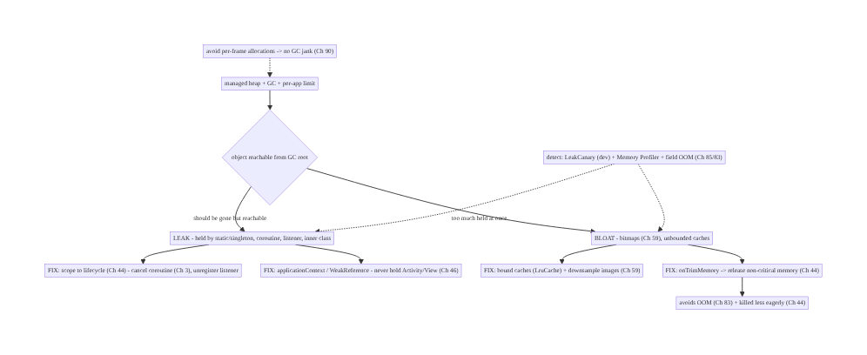
89.4 High-Level Architecture
Components & ownership
- Heap/GC keeps anything reachable from a GC root; a leak = wrongly reachable.
- Fix leaks: lifecycle scoping (Ch 44/3), applicationContext/WeakReference (Ch 46).
- Fix bloat: bounded caches + image downsampling (Ch 59); onTrimMemory response (Ch 44).
- Allocation discipline (no GC jank, Ch 90); detection (LeakCanary + Profiler + field, Ch 85/83).
Direction: reachable-but-should-be-gone = leak → scope/weak-ref; too-much = bloat → bound + trim; detect with LeakCanary + field OOM.

89.5 Detailed Component Design
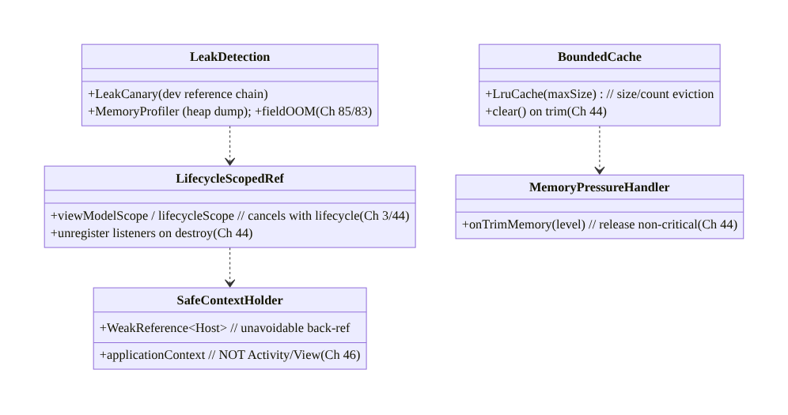
89.5 Detailed Component Design
Component | Responsibility
LifecycleScopedRef | coroutines/listeners scoped + canceled with lifecycle (Ch 3/44)
SafeContextHolder | applicationContext / WeakReference — never hold Activity/View (Ch 46)
BoundedCache | LruCache size/count eviction; clear on trim
MemoryPressureHandler | onTrimMemory → release non-critical (Ch 44)
LeakDetection | LeakCanary (dev), Memory Profiler, field OOM (Ch 85/83)

89.6 End-to-End Data Flow

Leak lifecycle (create → hold → detect → fix)
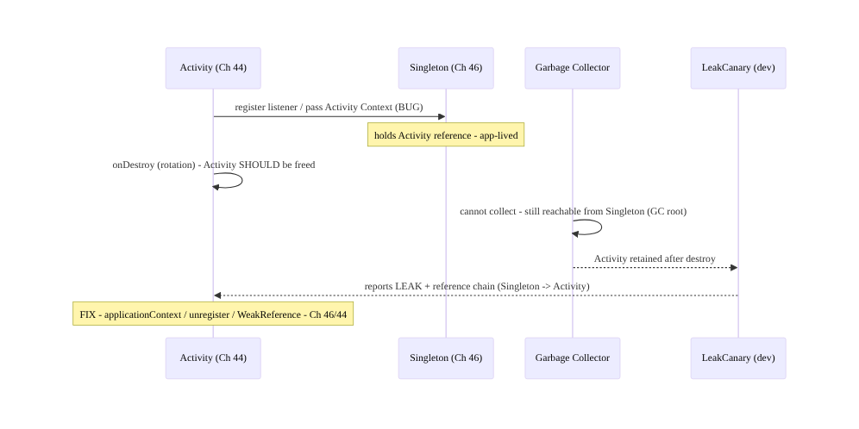
Leak lifecycle (create → hold → detect → fix)

Memory pressure response
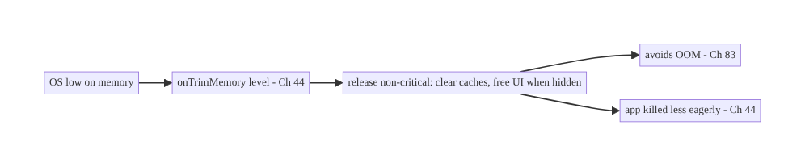
Memory pressure response

89.7 Complete Kotlin Implementation
Package: com.streamcart.memory.

89.7.1 Lifecycle-scoped coroutines + collection (no leak, Ch 3/44)
class FeedViewModel @Inject constructor(private val repo: FeedRepository) : ViewModel() {
// viewModelScope cancels on ViewModel clear - no leak, no outliving coroutine (Ch 3/44)
fun refresh() = viewModelScope.launch(Dispatchers.IO) { repo.refresh() }
}
@Composable
fun FeedScreen(vm: FeedViewModel) {
// collectAsStateWithLifecycle stops collecting when stopped - no leak (Ch 44)
val state by vm.state.collectAsStateWithLifecycle()
FeedList(state)
}
// NEVER: GlobalScope.launch { ... uses Activity/ViewModel ... } // outlives lifecycle -> leak

89.7.2 Safe Context: applicationContext, never Activity (Ch 46)
@Singleton
class AnalyticsHelper @Inject constructor(
@ApplicationContext private val appContext: Context, // app-lived - SAFE (Ch 46); NOT an Activity
) {
fun log(event: String) { /* uses appContext - never leaks an Activity */ }
}
// BUG (leak): class Helper(val activity: Activity) held by a singleton -> whole view tree leaks.
// If a back-ref to a short-lived host is unavoidable, hold a WeakReference (see 89.7.4).

89.7.3 Unregister listeners / receivers on lifecycle (Ch 44)
class LocationScreen : Fragment() {
private val callback = LocationCallback { /* ... */ }
override fun onStart() { super.onStart(); locationManager.register(callback) } // register
override fun onStop() { super.onStop(); locationManager.unregister(callback) } // UNREGISTER - no leak (Ch 44)
// A registered callback holds this Fragment; not unregistering leaks it. Pair register/unregister.
}

89.7.4 WeakReference for unavoidable back-ref + Handler cleanup
// Static nested class + WeakReference so a delayed Runnable doesn't pin the Activity:
class MainActivity : ComponentActivity() {
private val handler = Handler(Looper.getMainLooper())
private val task = WeakRunnable(this)
override fun onDestroy() { handler.removeCallbacks(task); super.onDestroy() } // remove - no leak
private class WeakRunnable(activity: MainActivity) : Runnable {
private val ref = WeakReference(activity) // weak - doesn't pin
override fun run() { ref.get()?.let { /* use if still alive */ } }
}
}

89.7.5 Bounded cache + trim response (Ch 44/59)
@Singleton
class ThumbnailCache @Inject constructor() : ComponentCallbacks2 {
private val maxKb = (Runtime.getRuntime().maxMemory() / 1024 / 8).toInt() // ~1/8 of heap
private val cache = object : LruCache<String, Bitmap>(maxKb) { // BOUNDED (Ch 59)
override fun sizeOf(key: String, v: Bitmap) = v.byteCount / 1024
}
fun get(k: String) = cache.get(k); fun put(k: String, b: Bitmap) = cache.put(k, b)
override fun onTrimMemory(level: Int) { // memory pressure (Ch 44)
when {
level >= ComponentCallbacks2.TRIM_MEMORY_RUNNING_LOW -> cache.evictAll() // release non-critical
level >= ComponentCallbacks2.TRIM_MEMORY_UI_HIDDEN -> cache.trimToSize(maxKb / 2)
}
}
override fun onConfigurationChanged(c: Configuration) {}
override fun onLowMemory() { cache.evictAll() }
}
// Prefer Coil/Glide's managed bounded memory cache (Ch 59) over hand-rolled bitmap caches.

89.7.6 Avoid per-frame allocations (GC jank, Ch 90)
// BAD: allocates every draw -> GC churn -> jank (Ch 90)
override fun onDraw(canvas: Canvas) {
val paint = Paint() // allocation PER FRAME - avoid
canvas.drawRect(RectF(0f,0f,w,h), paint)
}
// GOOD: hoist allocations out of the hot path
private val paint = Paint() // allocate ONCE
private val rect = RectF()
override fun onDraw(canvas: Canvas) { rect.set(0f,0f,w,h); canvas.drawRect(rect, paint) } // no per-frame alloc
// In Compose: hoist/remember objects; avoid allocating in the composition hot path (Ch 90).

89.7.7 Module structure
:core:memory BoundedCache (LruCache + trim), SafeContextHolder, LeakDetection hooks
# Lifecycle scoping -> Ch 44/3; images -> Coil bounded cache (Ch 59); trim -> ComponentCallbacks2 (Ch 44);
# detection -> LeakCanary (debug dep), Memory Profiler, field OOM (Ch 85/83). Allocation discipline -> Ch 90.

89.8 Concurrency and Race Conditions
Scenario | Risk | Handling
Coroutine outlives lifecycle | leak + crash on dead view | viewModelScope/lifecycleScope (Ch 3/44)
Listener not unregistered | Activity leak | pair register/unregister (Ch 44)
Static holds Context | view-tree leak | applicationContext / WeakReference (Ch 46)
Unbounded cache grows | OOM | LruCache size/count (Ch 59)
Per-frame allocation | GC jank | hoist allocations (Ch 90)
Ignoring trim | early kill / OOM | onTrimMemory release (Ch 44)
Bitmap not downsampled | OOM | decode to view size (Ch 59)
Rotation leaks accumulate | multiplying leaks | lifecycle-scoped; LeakCanary (Ch 44)
- Lifecycle scoping is the master fix (Ch 44/3): tying coroutines, listeners, and callbacks to viewModelScope/lifecycleScope/repeatOnLifecycle makes them cancel/unregister automatically when the owner dies — eliminating the most common leaks without manual cleanup.
- Rotations compound leaks: each config change creates a new Activity; a leak per rotation multiplies memory until OOM. LeakCanary catches retained activities after rotation.
- Bounded + trim-responsive caches keep footprint in check and make the app a good OS citizen — released memory on trim means surviving longer in the background (Ch 44).

89.9 Failure Scenarios and Recovery
Failure | Detection | Response | Outcome
Activity leak | LeakCanary chain | applicationContext / unregister / WeakReference (Ch 46/44) | freed
OOM crash | field OOM (Ch 83/85) | bound caches + downsample bitmaps (Ch 59) | stable
GC jank | Memory Profiler / frames (Ch 90) | hoist per-frame allocations | smooth
Killed early in bg | process-death metrics (Ch 44) | honor onTrimMemory | resident
Coroutine leak | LeakCanary / logs | lifecycle scope (Ch 3/44) | scoped
Cache grows unbounded | profiler footprint | LruCache eviction | bounded
Rotation leak pile-up | retained activities | lifecycle-scoped refs (Ch 44) | no accumulation
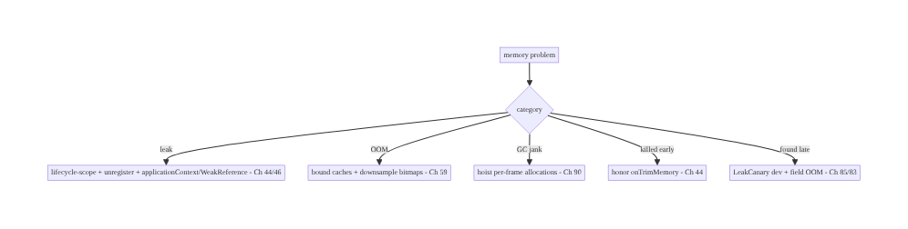
89.9 Failure Scenarios and Recovery
Scope to lifecycle, bound everything, honor trim — and detect with LeakCanary. The dominant Android memory failures are an Activity/View/Context leaked by a long-lived holder (lifecycle scoping + applicationContext/WeakReference fix it), OOM from bitmaps and unbounded caches (downsampling + LruCache fix it), and GC jank from per-frame allocations (hoisting fixes it). Respond to onTrimMemory to stay resident (Ch 44), and catch leaks in dev with LeakCanary + field OOM (Ch 85/83) before they crash production.

89.10 Scaling the Implementation
- Level 1. LeakCanary in debug; use viewModelScope/collectAsStateWithLifecycle (Ch 44); applicationContext in singletons (Ch 46).
- Level 2. Bounded caches (LruCache) + Coil-managed image memory (Ch 59); onTrimMemory response (Ch 44); unregister listeners.
- Level 3 — production. Field OOM monitoring (Ch 85/83); Memory Profiler in CI/manual audits; allocation discipline on hot paths (Ch 90); WeakReference where needed.
- Level 4 — large. Heap-dump analysis in CI (regression gates), memory budgets by device class, per-feature footprint tracking, large-object (bitmap) audits (Ch 59).
- Level 5 — enterprise. Memory SLOs, automated leak detection in CI (instrumented tests + LeakCanary), native-memory tracking, device-tiered memory policies, OOM-rate error budgets.
Avoid overengineering: lifecycle scoping + LeakCanary + bounded caches + onTrimMemory + Coil for images covers the vast majority. Don’t hand-roll bitmap caches; don’t hold Context in singletons; don’t ignore trim; don’t micro-optimize allocations without profiling.

89.11 Alternative Approaches and Trade-offs
Dimension | Option A | Option B | When
Reference scope | Lifecycle-scoped (Ch 44/3) | manual/unscoped | Lifecycle-scoped (auto cleanup)
Context in singleton | applicationContext (Ch 46) | Activity Context | applicationContext (no leak)
Back-ref | WeakReference | strong | Weak when unavoidable
Cache | Bounded LruCache (Ch 59) | unbounded | Bounded always
Images | Coil/Glide managed (Ch 59) | hand-decoded bitmaps | Managed loader
Pressure | Honor onTrimMemory (Ch 44) | ignore | Honor (residency + OOM)
Detection | LeakCanary + field (Ch 85) | none/late | LeakCanary + field
Lifecycle scoping vs manual cleanup: manual register/unregister and cancel is error- prone — one missed path leaks. Lifecycle scoping (viewModelScope, repeatOnLifecycle, lifecycle-aware components, Ch 44/3) makes cleanup automatic at the right time. Prefer scoping; use manual unregister only where no lifecycle-aware option exists.
applicationContext vs Activity Context in long-lived objects: holding an Activity Context in a singleton/static leaks the entire view hierarchy on every rotation. Holding applicationContext (app-lived) is safe for most needs (resources, system services). Use applicationContext in anything longer-lived than the Activity; use the Activity context only for UI tied to that activity (themed inflation, dialogs) and don’t retain it (Ch 46).
Managed image loader vs hand-rolled bitmap cache (Ch 59): hand-decoding bitmaps into a cache invites OOM (no downsampling, unbounded) and leaks (lifecycle). Coil/Glide downsample to view size, bound memory/disk caches, and cancel on lifecycle — far safer. Use a managed loader; don’t hand-roll bitmap memory.

89.12 Security & Privacy Considerations
- Clear sensitive data from memory (Ch 20/76): tokens, keys, card data (Ch 76) held in memory should be minimized and cleared when no longer needed (and not swapped into caches/ logs). Memory bloat that retains sensitive data widens exposure (Ch 28).
- Heap dumps may contain PII (Ch 28): a captured heap dump can contain user data — handle internally, don’t ship/share raw dumps; field OOM reports must be PII-safe (Ch 83/28).
- Don’t log memory contents: OOM diagnostics are footprint/metrics, not memory contents (Ch 28).
- Bounded caches reduce retention: bounding caches also limits how long data lives in memory (privacy + stability).
- No secrets in WeakReference-reachable singletons: the escape-hatch holders are for lifecycle safety, not for stashing secrets (Ch 24).
- Client-only concern mostly: memory is a client property; the cross-cutting privacy note is keeping sensitive data minimal and out of heap dumps/logs (Ch 28).

89.13 Performance and Resource Optimization
- Avoid allocations on the hot path (Ch 90) — per-frame/per-recomposition allocations churn the GC → pauses → jank. Hoist/reuse objects (Paint, RectF, buffers).
- Bound caches relative to maxMemory — size by available heap, not a fixed number; evict (LruCache).
- Downsample bitmaps to view size (Ch 59) — the single biggest footprint lever; use a managed loader.
- Release on trim (Ch 44) — free memory when hidden/low → avoid OOM + stay resident.
- Minimize retained scope — don’t keep large objects alive longer than needed; scope to lifecycle (Ch 44).
- Profiling: heap footprint (Memory Profiler), allocation rate on hot paths, GC frequency/ pauses (→ jank, Ch 90), retained set (LeakCanary), field OOM rate + trim kills (Ch 85/83).

89.14 Testing Strategy
Leaks are caught by LeakCanary (instrumented) and heap-dump assertions; bounds/trim are unit- testable.
class BoundedCacheTest {
@Test fun `cache evicts beyond max size`() {
repeat(1000) { cache.put("k$it", bitmap()) }
assertTrue(cache.size() <= cache.maxSize()) // bounded (Ch 59)
}
@Test fun `onTrimMemory releases memory`() {
cache.put("k", bitmap()); cache.onTrimMemory(TRIM_MEMORY_COMPLETE)
assertEquals(0, cache.size()) // released (Ch 44)
}
}
@RunWith(AndroidJUnit4::class)
class LeakTest { // LeakCanary / instrumented
@Test fun `screen does not retain activity after finish`() {
val scenario = launchActivity<MainActivity>()
scenario.recreate(); scenario.recreate() // rotations
scenario.close()
// LeakCanary fails the build on a retained Activity; or assert via heap dump (Ch 44)
}
}
// StrictMode (debug) flags leaked Closeables/activities; Memory Profiler for footprint audits.
What to test: cache bounds + eviction (Ch 59); onTrimMemory release (Ch 44); no retained Activity after rotation/finish (LeakCanary); lifecycle-scoped coroutines cancel (Ch 3/44); StrictMode leak/closeable detection; footprint audits (Memory Profiler). Field OOM via vitals (Ch 85/83).

89.15 Production Observability
- Metrics: OOM crash rate (Ch 83), memory footprint percentiles by device class (field, Ch 85), TRIM_MEMORY/low-memory kill rate (Ch 44), GC pause frequency (→ jank, Ch 90), retained-instance reports (LeakCanary in dev; some field leak tracking).
- Logs: OOM/trim events — PII-safe, footprint not contents (Ch 28/83).
- Debugging: OOM → heap dump / top retained objects (bitmaps? caches?); leak → LeakCanary reference chain (what holds it); GC jank → allocation profiler on the hot path (Ch 90); early kills → trim handling (Ch 44); low-end crashes → footprint by device class (Ch 85).
- Alerting: OOM-rate spike (release regression, Ch 83); footprint regression release-over- release (Ch 85); low-memory-kill-rate spike (Ch 44).
- Dashboards: OOM rate + footprint percentiles by device/release; trim-kill rate; GC/jank correlation (Ch 90); top memory consumers.

89.16 System Design Interview Preparation
≥40 questions (Complex).
Fundamentals
- Managed heap? ART heap + GC + per-app limit.
- What’s a leak? Reachable-from-GC-root object that should be freed.
- OOM cause? Exceeding the per-app limit (bitmaps, unbounded caches).
- GC jank? Per-frame allocations → GC pauses → dropped frames (Ch 90).
- Why memory matters? Jank, OOM crash, background kill.
Leak taxonomy
- #1 Android leak? Activity/View/Context held by static/singleton (Ch 46).
- Context fix? applicationContext, not Activity.
- Listener leak? Not unregistering; pair register/unregister (Ch 44).
- Coroutine leak? GlobalScope/wrong scope; use viewModelScope (Ch 3/44).
- Inner class leak? Implicit outer ref; static + WeakReference.
- Handler leak? Delayed Runnable pins Activity; removeCallbacks.
Fixes
- Master fix? Lifecycle scoping (Ch 44/3).
- WeakReference? Unavoidable back-ref — doesn’t pin host.
- repeatOnLifecycle? Collect only while started — no leak (Ch 44).
- Unregister where? Paired lifecycle callback (onStop/onDestroy).
Bitmaps/caches
- Why bitmaps? Largest objects (w×h×4).
- Avoid bitmap OOM? Downsample to view size; managed loader (Ch 59).
- Bounded cache? LruCache size/count eviction.
- Size cache by? Fraction of maxMemory.
- Image loader? Coil/Glide — bounded + lifecycle (Ch 59).
Memory pressure
- onTrimMemory? OS pressure signal; release non-critical (Ch 44).
- Trim levels? UI_HIDDEN, RUNNING_LOW, COMPLETE.
- Why respond? Avoid OOM + killed less eagerly (Ch 44).
- onLowMemory? Older callback; evict caches.
Allocation/GC
- Per-frame alloc? Hoist out of onDraw/recompose (Ch 90).
- Autoboxing? Avoid on hot path.
- GC types? ART generational; pauses drop frames.
Detection
- LeakCanary? Debug — detects retained objects + reference chain.
- Memory Profiler? Footprint, allocations, heap dumps.
- Field OOM? Vitals/Crashlytics (Ch 85/83).
- Heap dump? Snapshot of reachable objects; compare.
Edge cases
- Rotation leaks? New Activity each time → multiply; LeakCanary (Ch 44).
- ViewModel leak? Shouldn’t hold View/Activity; survives rotation (Ch 44).
- Static Context? Never; app-level if needed (Ch 46).
- Fragment view leak? Null out view binding in onDestroyView.
Production
- OOM spike? Release regression — bound/downsample (Ch 83).
- Footprint regression? Profiler + field percentiles (Ch 85).
- Early bg kill? Honor trim (Ch 44).
- Low-end crashes? Footprint by device class (Ch 85).
- Sensitive data? Minimize/clear; PII-safe dumps (Ch 28).
- Test leaks? LeakCanary instrumented + heap assertions.
- StrictMode? Flags leaked closeables/activities.

Design-change challenges
- Fix an Activity leak from a singleton. applicationContext / WeakReference / unregister (Ch 46/44).
- Stop OOM in an image gallery. Downsample + bounded Coil cache + trim (Ch 59/44).
- Eliminate GC jank in a custom view. Hoist per-frame allocations (Ch 90).
- Keep the app resident longer in background. Honor onTrimMemory (Ch 44).
- Catch leaks before they ship. LeakCanary in CI + field OOM monitoring (Ch 85/83).

Mock walkthrough (abridged)
Clarify (leak or bloat? device targets? detection?) → heap/GC/limit model → leak taxonomy (static/singleton/coroutine/listener/inner, Ch 46/3/44) → fix by lifecycle scoping + applicationContext/WeakReference + unregister (Ch 44/46) → bound caches + downsample bitmaps (LruCache, Coil, Ch 59) → honor onTrimMemory (Ch 44) → avoid per-frame allocations (Ch 90) → detect: LeakCanary (dev) + Memory Profiler + field OOM (Ch 85/83) → observability (OOM rate + footprint by device).

89.17 Practical Exercises
- Beginner. Add LeakCanary, reproduce an Activity leak (singleton holding Activity Context), and fix it with applicationContext (Ch 46). Eval: leak reported then gone.
- Intermediate. Replace an unbounded bitmap cache with a bounded LruCache + Coil downsampling (Ch 59) and add onTrimMemory release (Ch 44). Eval: bounded; releases on trim.
- Advanced. Scope a leaking GlobalScope coroutine to viewModelScope/repeatOnLifecycle (Ch 3/44) and null out a Fragment view binding in onDestroyView. Eval: no retained coroutine/view.
- Production debugging. Investigate an OOM spike with a heap dump (find the top retained objects); investigate GC jank with the allocation profiler (Ch 90). Eval: root cause found.
- System design challenge. Design memory budgets by device class + CI leak detection (instrumented LeakCanary) + field OOM monitoring (Ch 85/83). Eval: gated, device-tiered, observed.
(Solutions withheld unless requested.)

89.18 Chapter Summary & Reference Sheet
Key decisions: keep memory healthy under ART’s managed heap + GC + per-app limit by treating a leak as any object still reachable from a GC root (a static/singleton field, a live thread/coroutine, a registered listener) that should be freed — most often an Activity/View/Context captured by a singleton or static (Ch 46), a coroutine in the wrong scope (GlobalScope, Ch 3), a non-static inner class, a Handler/Runnable, or an unregistered listener/receiver that outlives its lifecycle (Ch 44); prevent leaks by scoping every reference to a lifecycle (viewModelScope/lifecycleScope + repeatOnLifecycle/collectAsStateWithLifecycle, Ch 3/44), unregistering listeners and canceling coroutines, never holding Activity/View/Context in long-lived objects (use applicationContext, or a WeakReference for unavoidable back-refs, Ch 46), bounding every cache (LruCache by size/count) and image memory with downsampling (Ch 59), and responding to onTrimMemory by releasing non-critical memory so the app avoids OOM (Ch 83) and is killed less eagerly in the background (Ch 44); avoid per-frame/per- recomposition allocations that churn the GC into frame-dropping pauses (Ch 90); and detect problems with LeakCanary (dev — gives the retaining reference chain), the Memory Profiler (footprint + heap dumps), and field OOM/trim monitoring (Ch 85/83) — because leaks and bloat surface as jank, OOM crashes, and background kills.
Concepts: managed heap + GC + per-app limit, reachability/GC roots, leak taxonomy (static/singleton/coroutine/listener/inner/Handler), lifecycle scoping (Ch 44/3), applicationContext/WeakReference (Ch 46), bounded caches (LruCache) + bitmap downsampling (Ch 59), onTrimMemory/ComponentCallbacks2 (Ch 44), allocation discipline → GC jank (Ch 90), LeakCanary + Memory Profiler + field OOM (Ch 85/83).
Common mistakes: holding Activity/View/Context in a singleton/static; GlobalScope coroutines capturing lifecycle objects; not unregistering listeners/receivers; unbounded caches; hand-decoded bitmaps without downsampling (OOM); ignoring onTrimMemory; per-frame allocations (GC jank); not nulling Fragment view bindings; finding leaks only in production (no LeakCanary).
Checklist:
- ☐ lifecycle-scoped coroutines/collection (viewModelScope, repeatOnLifecycle, Ch 3/44)
- ☐ unregister listeners/receivers in paired callback (Ch 44)
- ☐ applicationContext (not Activity) in long-lived objects; WeakReference for back-refs (Ch 46)
- ☐ bounded caches (LruCache) + downsampled bitmaps / Coil (Ch 59)
- ☐ honor onTrimMemory → release non-critical (Ch 44)
- ☐ no per-frame/recomposition allocations (Ch 90)
- ☐ null Fragment view bindings in onDestroyView
- ☐ LeakCanary in debug
- ☐ Memory Profiler footprint audits
- ☐ field OOM + trim monitoring (Ch 85/83).
Key APIs: viewModelScope/lifecycleScope/repeatOnLifecycle/collectAsStateWithLifecycle (Ch 3/44), @ApplicationContext / applicationContext (Ch 46), java.lang.ref.WeakReference, android.util.LruCache (sizeOf/trimToSize/evictAll), ComponentCallbacks2.onTrimMemory (Ch 44), Handler.removeCallbacks, Coil/Glide managed caches (Ch 59), LeakCanary (debug), Android Studio Memory Profiler + heap dumps, StrictMode, field OOM via vitals/Crashlytics (Ch 85/83).
References: - Manage your app’s memory: https://developer.android.com/topic/performance/memory - onTrimMemory / ComponentCallbacks2: https://developer.android.com/reference/android/content/ComponentCallbacks2 - LeakCanary: https://square.github.io/leakcanary/ - Memory Profiler: https://developer.android.com/studio/profile/memory-profiler - (composes) Ch 44 Lifecycle, Ch 3 Threading, Ch 59 Image Loading, Ch 46 DI, Ch 85 Perf, Ch 83 Crash/OOM, Ch 90 Jank

Chapter 90 — Rendering Performance & Jank in Compose
Part X — Performance, Observability & Quality · Complexity: Complex (≥40 interview questions)
Prerequisites: Ch 2 (Compose/UDF), Ch 85 (perf monitoring/JankStats), Ch 89 (memory/GC), Ch 93 (lists/LazyColumn), Ch 3 (threading), Ch 44 (lifecycle). Pairs with Ch 88 (cold start), Ch 92 (baseline profiles).
Reference surface in StreamCart: keeping the UI smooth — rendering every frame within the frame budget (≈16ms at 60Hz, ≈8–11ms at 90/120Hz) so there’s no jank (dropped/slow frames) or frozen frames (>700ms) — by understanding Compose’s recomposition model, making state stable and reads narrow, keeping work off the composition/UI thread (Ch 3), and measuring with the Layout Inspector recomposition counts, Compose compiler metrics, JankStats (field, Ch 85), and Macrobenchmark FrameTimingMetric (Ch 92).

90.1 Problem Definition and Real-World Context
Smoothness is perceived quality: the UI thread must produce each frame within the frame budget — ~16.7ms at 60Hz (less at 90/120Hz) — or the frame is dropped/late (jank), and a frame over 700ms is a frozen frame (Ch 85). In Jetpack Compose (Ch 2), the dominant cause of jank is recomposition problems: recomposing too much (unstable parameters, broad state reads, no remember), doing expensive work in composition (sorting/ allocating/IO on the composition thread), and janky lists (Ch 93). Rendering performance & jank is the discipline of keeping every frame within budget: understanding the compose phases (composition → layout → draw) and the recomposition model, making state stable and reads deferred/narrow, hoisting work out of composition and off the main thread (Ch 3), avoiding per-frame allocations (GC jank, Ch 89), and measuring recomposition and frame timing rigorously. Jank is the most visible perf problem — users feel stutter immediately.
Concretely, teams hit:
- Over-recomposition. A composable recomposes far more than needed because a parameter is unstable (an unstable type, a lambda recreated each time, a List instead of a stable/ immutable type) or it reads state too broadly — so the whole subtree recomposes on every change. The #1 Compose jank source.
- Unstable parameters / types. Compose can skip a composable if its parameters are stable and unchanged. A mutable or unknown-stability type (a plain class, a raw List, a lambda capturing unstable state) marks it unstable → it can’t skip → recomposes every time. Fix with stable/immutable types (@Immutable/@Stable, ImmutableList, stable collections) and remembered lambdas.
- Broad state reads. Reading a State/StateFlow high in the tree (and passing values down) recomposes the whole subtree; reading it low (at the leaf that needs it), or deferring the read (lambda/derivedStateOf), narrows recomposition. Read state as low and as late as possible.
- Expensive work in composition. Composition runs on a thread that blocks frames — sorting, filtering, allocating, formatting, or (worst) I/O in the composable body runs on every recomposition and blows the budget. Hoist it: compute in the ViewModel/off- main (Ch 3), remember the result, pass stable inputs.
- Missing remember / derivedStateOf. Recomputing a derived value every recomposition (instead of remember/derivedStateOf) wastes the budget; remember caches across recompositions, derivedStateOf recomputes only when inputs change.
- Janky lists (Ch 93). LazyColumn without stable keys, with unstable items, heavy item composables, or synchronous image decode (Ch 59) janks on scroll — covered in depth in Ch 93.
- Per-frame allocations → GC jank (Ch 89). Allocating in composition or onDraw churns the GC → pauses → dropped frames (Ch 89). Hoist allocations.
- The compose phases & where time goes. Composition (what to show — recomposition), layout (measure/place), draw. Jank can be in any phase; most Compose jank is excessive recomposition + expensive composition, but deep layout and overdraw matter too. Measure to know which.
- Measuring recomposition & frames. Layout Inspector shows recomposition/skip counts per composable; the Compose compiler metrics report stability (which params/types are unstable); JankStats (Ch 85) measures field jank; Macrobenchmark FrameTimingMetric (Ch 92) measures frame durations in the lab. Don’t guess — measure.
- First-run jank (JIT, Ch 92). On first runs, composition code is interpreted/JIT → slower → more first-scroll jank. Baseline Profiles (Ch 92) AOT-compile Compose + scroll paths → smoother from first launch.
The architecture: keep every frame within the frame budget by minimizing recomposition — make parameters/state stable/immutable (@Immutable/@Stable, immutable collections, remembered lambdas) so composables can skip; read state as low and late as possible (leaf reads, lambda deferral, derivedStateOf); hoist expensive work out of composition and off the main thread (ViewModel/Dispatchers.IO, Ch 3), remembering results; avoid per- frame allocations (GC jank, Ch 89); optimize lists with stable keys + light items (Ch 93); AOT-compile the render path (Baseline Profiles, Ch 92); and measure with Layout Inspector recomposition counts, compose compiler stability metrics, JankStats (field, Ch 85), and Macrobenchmark FrameTimingMetric (lab, Ch 92). This chapter is about keeping the UI smooth.

Three practical use cases
- Kill over-recomposition (StreamCart). The product card recomposed on every unrelated state change because it took a raw List and a fresh lambda; Layout Inspector showed thousands of recompositions. Fix: ImmutableList + remembered callback + @Immutable model → recompositions drop ~95%, scroll is smooth (Ch 93).
- Hoist expensive composition. A screen sorted/filtered a list in the composable body every recomposition. Fix: move to the ViewModel (off-main, Ch 3), expose stable state, remember derived values → frame budget restored.
- Smooth first scroll (Ch 92). First-scroll jank from JIT-cold Compose; a Baseline Profile covering the feed scroll (Ch 92) AOT-compiles it → smooth from first launch, verified by Macrobenchmark FrameTimingMetric.

Why this is architectural
Rendering performance composes Compose’s recomposition model (Ch 2), memory/GC (Ch 89), lists (Ch 93), threading (Ch 3), baseline profiles (Ch 92), and measurement (JankStats + Macrobenchmark, Ch 85/92). The decisions — stable state, narrow reads, hoisted work, allocation discipline, AOT-compiled render path, rigorous measurement — determine whether the UI is smooth, which is the most visible dimension of quality.

90.2 Requirements Engineering

Functional requirements
ID | Requirement
F1 | Render every frame within the frame budget (~16ms/60Hz, less at 90/120Hz); no jank/frozen frames.
F2 | Minimize recomposition: stable/immutable params + skippable composables.
F3 | Read state as low and late as possible (leaf reads, deferral, derivedStateOf).
F4 | Hoist expensive work out of composition and off the main thread (Ch 3).
F5 | Avoid per-frame allocations (GC jank, Ch 89); optimize lists (Ch 93).
F6 | Measure: Layout Inspector counts, compiler stability, JankStats (field), Macrobenchmark frames (Ch 85/92).

Non-functional requirements
Attribute | Policy
Smoothness | Within frame budget; low jank/frozen-frame rate (Ch 85).
Efficiency | Minimal recomposition; hoisted work.
Measured | Recomposition counts + field jank + lab frames (Ch 85/92).
Device coverage | Smooth on low-end (not just flagship, Ch 85).
No regression | Macrobenchmark frame gate (Ch 92).

Scope
- In scope: frame budget + jank/frozen frames (Ch 85), compose phases (composition/layout/ draw), recomposition model + skipping, stability (@Immutable/@Stable, immutable collections, remembered lambdas), narrow/deferred state reads (leaf, derivedStateOf), hoisting work off composition + off-main (Ch 3), remember/derivedStateOf, per-frame allocations (GC jank, Ch 89), list jank pointer (Ch 93), measurement (Layout Inspector, compiler metrics, JankStats, Macrobenchmark FrameTimingMetric, Ch 85/92), baseline profiles pointer (Ch 92).
- Out of scope: Compose basics/UDF (Ch 2), perf monitoring pipeline (Ch 85), memory detail (Ch 89), list detail (Ch 93), baseline-profile mechanics (Ch 92), threading detail (Ch 3).

Assumptions & constraints
- Jetpack Compose (Ch 2) with the Compose compiler; UDF with ViewModel + StateFlow (Ch 2). Measured with Layout Inspector (recomposition counts), compose compiler metrics (stability), JankStats (field, Ch 85), Macrobenchmark FrameTimingMetric (lab, Ch 92). Target smooth on representative devices. minSdk 24.

90.3 System Design Fundamentals
- The frame budget & jank (Ch 85). The display refreshes at 60/90/120Hz; each frame must be produced in 1/refresh seconds (~16.7ms at 60Hz, ~11ms at 90Hz, ~8ms at 120Hz). Miss it → the frame is late/dropped (jank — visible stutter); a frame >700ms is a frozen frame (Ch 85). The UI/composition thread does composition + layout + draw dispatch within this budget — any heavy work on it janks.
- The compose phases. Compose renders in three phases: composition (run composables to decide what to show — this is where recomposition happens), layout (measure + place), draw (issue draw commands). Recomposition re-runs (parts of) composition when state changes. Jank can be in any phase, but most Compose jank is excessive/expensive recomposition (plus deep layout and overdraw). Measure to locate it.
- Recomposition & skipping (the core model). When observed state changes, Compose recomposes the composables that read it. Compose can skip a composable (not re-run it) if all its parameters are stable and unchanged — this is the key to performance. Smart recomposition re-runs only what’s affected. The goal: maximize skipping by making parameters stable and reads narrow, so a change recomposes only the leaf that depends on it.
- Stability — why composables don’t skip. Compose marks a type stable if it’s immutable or its mutations are observable (@Immutable/@Stable, primitives, stable collections). An unstable parameter — a mutable class, a type of unknown stability (a class from a module without the Compose compiler), a raw List/Map/Set (interface — unknown stability), or a lambda recreated each recomposition — makes the composable unskippable → it recomposes every time the parent does. Fixes: @Immutable/@Stable on models, immutable collections (kotlinx.collections.immutable ImmutableList), remembered lambdas (or stable method refs), and keeping unstable types out of composable params. The Compose compiler stability metrics report exactly which params/types are unstable.
- Narrow & deferred state reads. Where you read state determines what recomposes. Reading state high and passing values down recomposes the whole subtree. Reading it low (at the leaf that uses it), or deferring the read behind a lambda (e.g., Modifier.offset { ... }, graphicsLayer { ... } — read in layout/draw, not composition) or derivedStateOf (recompute only when the derived value changes), narrows recomposition. Read state as low and as late as possible.
- Hoist expensive work out of composition + off-main (Ch 3). The composable body runs on every recomposition — so sorting, filtering, formatting, allocating, or I/O there is catastrophic. Hoist computation to the ViewModel / a background dispatcher (Ch 3), expose ready, stable state, and remember any per-composition derived value. Never do blocking/IO work in a composable (Ch 3).
- remember and derivedStateOf. remember caches a value across recompositions (compute once, reuse) — use it for any non-trivial derived/created object. derivedStateOf wraps a computation that reads state and recomputes only when its result changes (not on every input change) — use it when a frequently-changing state drives a rarely-changing derived value (e.g., isScrolled = derivedStateOf { listState.firstVisibleItemIndex > 0 }). Together they cut recomposition cost.
- Per-frame allocations → GC jank (Ch 89). Allocating in composition, onDraw, or a tight loop churns the GC, whose pauses drop frames (Ch 89). Hoist/remember allocations; avoid creating lambdas/collections/objects on the hot path.
- Lists (Ch 93). LazyColumn/LazyRow jank — missing stable keys, unstable items, heavy item content, sync image decode (Ch 59) — is the most common scroll-jank source, covered in depth in Ch 93. The same principles (stability, keys, light items, async images) apply.
- Baseline Profiles for the render path (Ch 92). First-run composition/scroll is JIT-cold → janky; a Baseline Profile covering launch + key scrolls (Ch 92) AOT-compiles the Compose runtime + your render path → smoother from the first launch. Pair with R8 (Ch 92).
- Measurement (don’t guess). Layout Inspector → recomposition + skip counts per composable (find the over-recomposing one). Compose compiler metrics → stability report (which params are unstable, why skipping fails). JankStats (Ch 85) → field jank/frozen rate per screen. Macrobenchmark FrameTimingMetric (Ch 92) → lab frame durations (CI gate). System trace (Perfetto) → where the frame time goes. Measure, then optimize the thing that’s actually slow.
Core insight: keep every frame within the budget (~16ms at 60Hz, less at 90/120Hz — a late frame is jank, a >700ms frame is frozen, Ch 85) by minimizing recomposition: make composables skippable by giving them stable/immutable parameters (@Immutable/@Stable models, immutable collections instead of raw List/Map, remembered lambdas instead of freshly-allocated ones — the Compose compiler stability metrics tell you exactly which params are unstable and why), read state as low and as late as possible (leaf reads, lambda/graphicsLayer deferral so the read happens in layout/draw not composition, and derivedStateOf so a frequently-changing state only recomposes when the derived result changes), hoist all expensive work — sorting, filtering, formatting, and above all I/O — out of the composable body (which re-runs on every recomposition) into the ViewModel and off the main thread (Ch 3), caching with remember; avoid per-frame allocations that churn the GC into frame-dropping pauses (Ch 89); apply the same stability + stable-key + light-item discipline to lists (Ch 93); AOT-compile the composition and scroll paths with Baseline Profiles + R8 so the first run isn’t JIT-janky (Ch 92); and measure with Layout Inspector recomposition counts, the compiler stability report, JankStats in the field (Ch 85), and Macrobenchmark FrameTimingMetric in the lab (Ch 92) rather than guessing — because jank is the most visible quality defect and the tail (low-end, first scroll) is where it’s felt.

90.4 High-Level Architecture
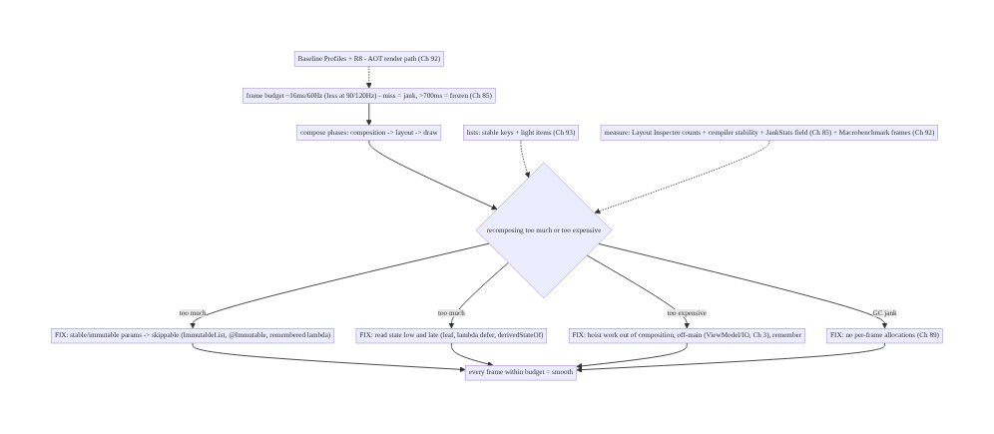
90.4 High-Level Architecture
Components & ownership
- Frame budget sets the deadline; compose phases (composition/layout/draw) do the work.
- Minimize recomposition: stable params (skippable), narrow/deferred reads, hoisted work (Ch 3), no per-frame allocation (Ch 89).
- Lists (Ch 93); AOT render path (Ch 92); measure (Layout Inspector + JankStats + Macrobenchmark, Ch 85/92).
Direction: frame budget → compose phases → minimize/cheapen recomposition (stable + narrow + hoisted + no-alloc) → smooth; measured by counts + field + lab.

90.5 Detailed Component Design
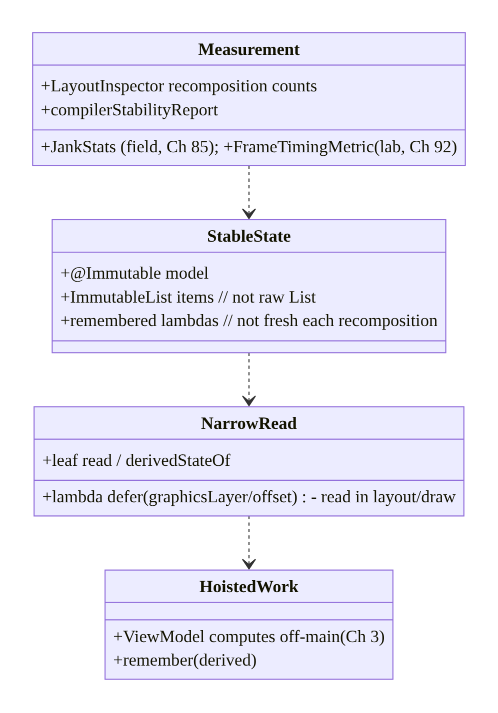
90.5 Detailed Component Design
Component | Responsibility
StableState | immutable models + collections + remembered lambdas → skippable
NarrowRead | leaf reads, derivedStateOf, lambda deferral → narrow recomposition
HoistedWork | compute off composition + off-main (Ch 3); remember results
Measurement | Layout Inspector counts, stability report, JankStats (Ch 85), FrameTiming (Ch 92)

90.6 End-to-End Data Flow

State change → recomposition (skip vs re-run)
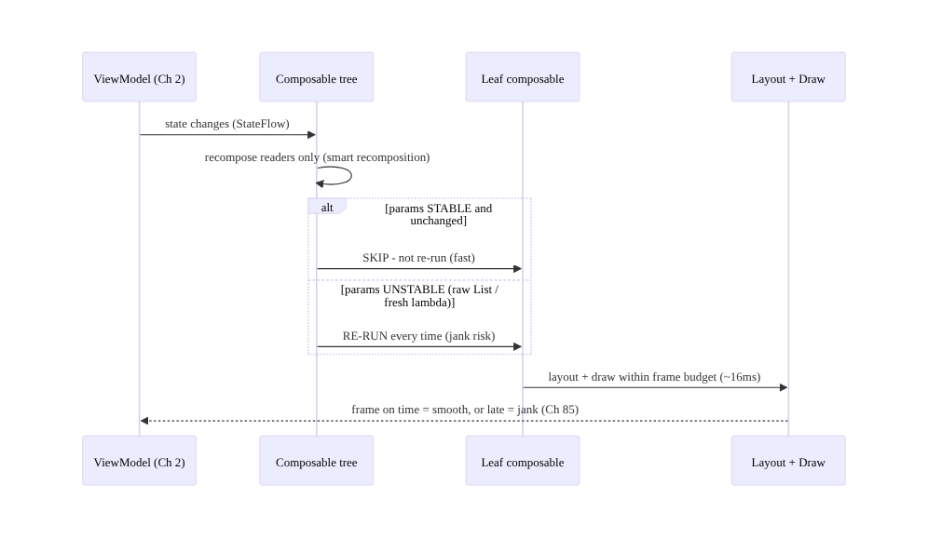
State change → recomposition (skip vs re-run)

Hoist expensive work out of composition
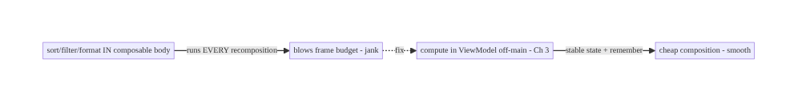
Hoist expensive work out of composition

90.7 Complete Kotlin Implementation
Package: com.streamcart.ui.

90.7.1 Stable params → skippable composable
@Immutable // stable -> enables skipping
data class ProductUi(val id: String, val title: String, val price: String, val imageUrl: String)
@Composable
fun ProductCard(
product: ProductUi, // @Immutable -> stable
onClick: (String) -> Unit, // pass a STABLE/remembered lambda (see caller)
) {
// Skippable: if `product` is unchanged and `onClick` is stable, Compose SKIPS this on recomposition.
Card(Modifier.clickable { onClick(product.id) }) { /* ... */ }
}
@Composable
fun Feed(items: ImmutableList<ProductUi>, onClick: (String) -> Unit) { // ImmutableList, NOT List (stable)
LazyColumn {
items(items, key = { it.id }) { product -> // stable keys (Ch 93)
ProductCard(product, onClick) // onClick is hoisted/stable -> cards skip
}
}
}

90.7.2 Narrow + deferred reads (derivedStateOf, lambda defer)
@Composable
fun FeedWithFab(listState: LazyListState) {
// derivedStateOf: recomposes the FAB ONLY when crossing the threshold, not every scroll pixel
val showFab by remember { derivedStateOf { listState.firstVisibleItemIndex > 3 } }
if (showFab) ScrollToTopFab()
// Lambda/graphicsLayer defer: read scroll offset in the DRAW phase, not composition -> no recomposition
Box(Modifier.graphicsLayer { translationY = listState.firstVisibleItemScrollOffset * 0.5f }) // parallax
}

90.7.3 Hoist expensive work off composition + off-main (Ch 3)
// BAD: sort/filter in the composable body - runs on EVERY recomposition, blocks the frame
@Composable fun BadList(all: List<ProductUi>, query: String) {
val filtered = all.filter { it.title.contains(query) }.sortedBy { it.price } // every recomposition!
LazyColumn { items(filtered) { ProductCard(it, {}) } }
}
// GOOD: compute in the ViewModel, off-main (Ch 3); expose ready, stable state
class FeedViewModel @Inject constructor(private val repo: FeedRepository) : ViewModel() {
val uiState: StateFlow<ImmutableList<ProductUi>> = combine(repo.products, query) { all, q ->
all.filter { it.title.contains(q) }.sortedBy { it.price }.toImmutableList()
}.flowOn(Dispatchers.Default) // off-main (Ch 3)
.stateIn(viewModelScope, SharingStarted.WhileSubscribed(5000), persistentListOf())
}
@Composable fun GoodList(vm: FeedViewModel) {
val items by vm.uiState.collectAsStateWithLifecycle() // ready state - cheap composition
Feed(items, remember { vm::onClick }) // remembered lambda - stable
}

90.7.4 remember to avoid recomputation/allocation (Ch 89)
@Composable
fun FormattedPrice(cents: Long) {
// remember: build the formatter ONCE, not every recomposition (avoids allocation -> GC jank, Ch 89)
val formatter = remember { NumberFormat.getCurrencyInstance() }
val text = remember(cents) { formatter.format(cents / 100.0) } // recompute only when cents change
Text(text)
}

90.7.5 Measurement: Macrobenchmark FrameTimingMetric (lab, Ch 92)
@RunWith(AndroidJUnit4::class)
class ScrollBenchmark {
@get:Rule val rule = MacrobenchmarkRule()
@Test fun feedScroll() = rule.measureRepeated(
packageName = "com.streamcart", metrics = listOf(FrameTimingMetric()), // frame durations (jank)
compilationMode = CompilationMode.Partial(), iterations = 10, // with baseline profile (Ch 92)
startupMode = null,
) { startActivityAndWait(); device.findObject(By.res("feed")).fling(Direction.DOWN) }
// CI GATE: fail if frameDurationCpuMs p95 regresses. Field jank -> JankStats/vitals (Ch 85).
}
// Dev: Layout Inspector recomposition counts; enable compose compiler metrics for the stability report.

90.7.6 Module structure
:feature:feed Feed/ProductCard (stable params), FeedViewModel (hoisted, off-main)
# Stability -> @Immutable + ImmutableList + remembered lambdas; narrow reads -> derivedStateOf/lambda defer;
# lists -> Ch 93; allocations -> Ch 89; AOT -> Baseline Profiles + R8 (Ch 92);
# measure -> Layout Inspector + compiler metrics + JankStats (Ch 85) + Macrobenchmark FrameTiming (Ch 92).

90.8 Concurrency and Race Conditions
Scenario | Risk | Handling
Work in composition thread | blocks frame | hoist to ViewModel off-main (Ch 3)
Unstable param | no skip, over-recompose | @Immutable / ImmutableList / remembered lambda
Broad state read | whole subtree recomposes | leaf read / derivedStateOf / defer
Per-frame allocation | GC jank | remember / hoist (Ch 89)
Fresh lambda each recomposition | unstable param | remember / stable method ref
Sync image decode in item | scroll jank | async loader (Coil, Ch 59/93)
IO in composable | frame stall + wrong thread | never — ViewModel/IO (Ch 3)
- Composition is on the frame-critical thread — any blocking/IO/heavy compute there directly causes jank. The UDF discipline (Ch 2) — compute in the ViewModel off-main (Ch 3), expose ready state — is also the performance discipline.
- Stability is a contract — an unstable param silently disables skipping, so a far-away state change recomposes composables that didn’t change. The compiler stability report makes this visible; immutable types + remembered lambdas restore skipping.
- derivedStateOf prevents recomposition storms — a rapidly-changing state (scroll offset) driving a rarely-changing derived value (is-scrolled) would otherwise recompose every frame; derivedStateOf gates it.

90.9 Failure Scenarios and Recovery
Failure | Detection | Response | Outcome
Over-recomposition | Layout Inspector counts | stable params + narrow reads | skips restored
Expensive composition | Perfetto/traces | hoist off-main (Ch 3) + remember | cheap composition
GC jank | allocation profiler (Ch 89) | hoist allocations | smooth
Scroll jank | JankStats (Ch 85) | stable keys + light items + async images (Ch 93/59) | smooth scroll
First-scroll jank | Macrobenchmark None vs Partial | Baseline Profile (Ch 92) | AOT smooth
Unstable param | compiler stability report | @Immutable / ImmutableList / remember | skippable
Low-end jank | field p95 (Ch 85) | optimize + measure on real devices | honest
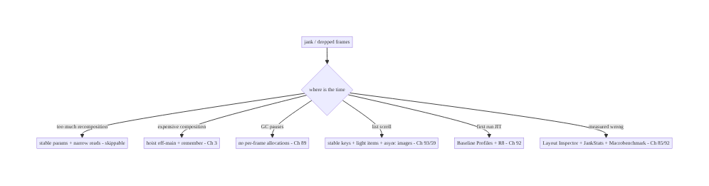
90.9 Failure Scenarios and Recovery
Make composables skippable, read state narrowly, hoist the work, and measure. Compose jank is over-recomposition (stable params + narrow reads fix it), expensive composition (hoist off-main + remember fix it), GC pauses (hoist allocations, Ch 89), and list/first-run jank (stable keys + baseline profiles, Ch 93/92). Don’t guess — use Layout Inspector recomposition counts, the compiler stability report, JankStats in the field (Ch 85), and Macrobenchmark FrameTimingMetric in the lab (Ch 92).

90.10 Scaling the Implementation
- Level 1. UDF with collectAsStateWithLifecycle (Ch 2); remember derived values; no IO in composables (Ch 3).
- Level 2. Stable params (@Immutable, ImmutableList, remembered lambdas); narrow reads + derivedStateOf; stable list keys (Ch 93).
- Level 3 — production. Compose compiler stability metrics in CI; Layout Inspector audits; JankStats field monitoring (Ch 85); Baseline Profiles + R8 (Ch 92).
- Level 4 — large. Macrobenchmark FrameTimingMetric CI gates per key screen; jank budgets by device class (Ch 85); strong-skipping mode; module-wide stability hygiene.
- Level 5 — enterprise. Jank SLOs with error budgets, automated frame-regression gating, per-flow baseline profiles (Ch 92), device-tiered rendering, continuous field jank dashboards (Ch 85).
Avoid overengineering: stable params + narrow reads + hoisted work + stable keys + baseline profiles, measured with Layout Inspector and JankStats, gets most of the smoothness. Don’t micro-optimize before measuring; don’t put work in composition; don’t use raw List/fresh lambdas in hot composables.

90.11 Alternative Approaches and Trade-offs
Dimension | Option A | Option B | When
Params | Stable/immutable (skippable) | raw List / fresh lambda | Stable (enable skipping)
State read | Narrow/deferred (derivedStateOf) | broad/high | Narrow (less recomposition)
Work | Hoisted off-main (Ch 3) | in composition | Hoisted (cheap composition)
Derived value | remember / derivedStateOf | recompute each time | remember (cache)
Allocations | Hoisted (Ch 89) | per-frame | Hoisted (no GC jank)
First run | Baseline Profile (Ch 92) | JIT | Baseline profile (smooth first)
Optimize by | Measurement (Ch 85/92) | guessing | Measure first
Stable/immutable params vs raw List/fresh lambdas: a raw List (interface — unknown stability) or a lambda recreated each recomposition marks a composable unskippable, so it recomposes on every parent recomposition — a silent, widespread jank source. Immutable collections + @Immutable/@Stable models + remembered lambdas make composables skippable. The compiler stability report shows which to fix. Always prefer stable params in hot composables.
Hoisting vs work-in-composition: computing in the composable body runs it on every recomposition on the frame-critical thread — catastrophic for sorting/filtering/IO. Hoisting to the ViewModel off-main (Ch 3), exposing ready state, and remembering derived values makes composition cheap. Never compute heavily (and never do IO) in composition.
Measurement vs guessing: optimizing by intuition wastes effort on the wrong thing. Layout Inspector (recomposition counts), compiler stability metrics (why skipping fails), JankStats (field, Ch 85), and Macrobenchmark FrameTimingMetric (lab, Ch 92) tell you what’s actually slow and where. Measure first, optimize the real bottleneck, verify.

90.12 Security & Privacy Considerations
- No sensitive data in recomposition logs/traces (Ch 28): recomposition counts and frame traces are structural/timing, not content — keep PII out of any custom perf logging (Ch 85/ 28).
- Screen content in overdraw/debug tools stays local: Layout Inspector/debug overlays are dev-only; don’t ship debug rendering that could expose content.
- Baseline profiles contain method names, not data (Ch 92): compilation hints, not secrets.
- Field jank metrics PII-safe (Ch 85): JankStats reports screen + timing, not user content (Ch 28).
- Sensitive screens render like any other: performance work doesn’t change the secure- surface handling (e.g., FLAG_SECURE on payment screens, Ch 76) — orthogonal concern.
- Client-only concern: rendering is client-side; the cross-cutting note is keeping perf logging/traces PII-safe (Ch 85/28).

90.13 Performance and Resource Optimization
- This chapter is rendering performance — summary: skippable composables (stable params), narrow/deferred reads (derivedStateOf, lambda defer), hoist work off composition + off-main (Ch 3), remember derived/allocated values, no per-frame allocations (Ch 89), stable list keys + light items (Ch 93), Baseline Profiles + R8 (Ch 92).
- Measure before optimizing — Layout Inspector counts, compiler stability, Perfetto traces, Macrobenchmark frames (Ch 92); don’t guess.
- Target low-end + high-refresh — the budget is tighter at 90/120Hz and work is slower on low-end; optimize for the p95 (Ch 85).
- Defer reads to layout/draw — graphicsLayer/offset { } lambdas read state without recomposing.
- Strong skipping / stability — keep hot composables’ params stable; use the stability report.
- Profiling: recomposition/skip counts, frame duration p95 (JankStats field, FrameTiming lab), GC pauses (Ch 89), composition vs layout vs draw time (Perfetto), stability report.

90.14 Testing Strategy
Frame timing is measured (Macrobenchmark); recomposition is inspected; stability is reported by the compiler.
class ScrollFrameBenchmark { // lab gate (Ch 92)
@get:Rule val rule = MacrobenchmarkRule()
@Test fun feedScroll_frames() = rule.measureRepeated(
packageName = "com.streamcart", metrics = listOf(FrameTimingMetric()),
compilationMode = CompilationMode.Partial(), iterations = 10, startupMode = null,
) { startActivityAndWait(); scrollFeed() } // assert frameDurationCpuMs p95 within budget
}
// Dev checks (not asserted in unit tests, but part of the workflow):
// - Layout Inspector: recomposition count on ProductCard should be ~1 per data change, not per unrelated change
// - Compose compiler metrics: enable -> stability report shows ProductUi @Immutable, params stable
// - StrictMode / no-IO-in-composition: ensure ViewModel does the work (Ch 3)
@Test fun `derivedStateOf gates recomposition`() { /* showFab flips only across the threshold */ }
What to test: Macrobenchmark FrameTimingMetric on key scrolls (lab gate, p95 within budget, Ch 92); recomposition counts (Layout Inspector — minimal, dev); compiler stability report (params stable); derivedStateOf/remember gating; no IO in composition (Ch 3); field jank via JankStats (Ch 85).

90.15 Production Observability
- Metrics: jank rate + frozen-frame rate per screen (JankStats, field, Ch 85), frame-duration percentiles (Macrobenchmark lab, Ch 92), recomposition counts (dev), GC pause correlation (Ch 89), first-scroll jank (baseline-profile effect, Ch 92).
- Logs/traces: Perfetto frame traces (dev), JankStats events (field) — PII-safe (Ch 28/ 85).
- Debugging: janky screen → JankStats (which screen, Ch 85) → Layout Inspector (over- recomposing composable?) → compiler stability (unstable param?) → Perfetto (composition/layout/ draw time?); GC jank → allocation profiler (Ch 89); first-scroll jank → None vs Partial (Ch 92); low-end → field p95 (Ch 85).
- Alerting: jank/frozen-frame-rate regression release-over-release (Ch 85/41); frame p95 budget breach (Macrobenchmark CI, Ch 92).
- Dashboards: jank/frozen rate by screen/device/release; frame percentiles; first-scroll jank; recomposition hotspots (dev).

90.16 System Design Interview Preparation
≥40 questions (Complex).
Fundamentals
- Frame budget? ~16.7ms@60Hz, ~11ms@90Hz, ~8ms@120Hz.
- Jank? A late/dropped frame; >700ms = frozen (Ch 85).
- Compose phases? Composition → layout → draw.
- Recomposition? Re-running composables that read changed state.
- #1 Compose jank? Excessive/expensive recomposition.
Recomposition/skipping
- Skipping? Compose skips a composable if params are stable + unchanged.
- Smart recomposition? Re-run only affected readers.
- Why not skip? Unstable parameter.
- Goal? Maximize skipping; recompose only the leaf.
Stability
- Stable type? Immutable or observably mutable (@Immutable/@Stable, primitives).
- Unstable examples? Mutable class, raw List/Map, fresh lambda, unknown-stability type.
- Fix collections? ImmutableList (kotlinx.collections.immutable).
- Fix lambdas? remember / stable method ref.
- Find instability? Compose compiler stability metrics.
- @Immutable vs @Stable? Immutable (never changes) vs stable (changes observable).
State reads
- Narrow read? Read at the leaf that uses it.
- Defer read? Lambda/graphicsLayer/offset { } — read in layout/draw.
- derivedStateOf? Recompute only when the derived result changes.
- Example? isScrolled = derivedStateOf { index > 0 }.
- Read high vs low? Low — narrows recomposition.
Work/hoisting
- Work in composition? Runs every recomposition — hoist it.
- Where? ViewModel, off-main (Ch 3).
- IO in composable? Never (Ch 3).
- remember? Cache across recompositions.
Allocations/GC
- Per-frame alloc? GC jank — hoist/remember (Ch 89).
- onDraw allocations? Hoist out (Ch 89).
Lists
- List jank? Stable keys + light items + async images (Ch 93).
- key? Stable identity so items aren’t recomposed/moved wrongly (Ch 93).
- Heavy item? Lighten / defer (Ch 93).
Baseline profiles
- First-scroll jank? JIT-cold — Baseline Profile (Ch 92).
- What it does? AOT-compile render path (Ch 92).
Measurement
- Recomposition counts? Layout Inspector.
- Stability? Compiler metrics.
- Field jank? JankStats (Ch 85).
- Lab frames? Macrobenchmark FrameTimingMetric (Ch 92).
- Where time goes? Perfetto/system trace.
Edge cases/production
- High-refresh? Tighter budget (8–11ms).
- Low-end jank? Field p95 (Ch 85).
- Regression gate? Macrobenchmark frames CI (Ch 92).
- Overdraw? Too many layers drawn — flatten.
- Deep layout? Flatten/SubcomposeLayout carefully.
- Measure first? Always — optimize the real bottleneck.

Design-change challenges
- Kill over-recomposition in a card. Stable params (@Immutable + ImmutableList + remembered lambda).
- Smooth a janky filtered list. Hoist filter/sort off-main (Ch 3) + stable keys (Ch 93).
- Stop a recomposition storm on scroll. derivedStateOf / lambda defer.
- Fix first-scroll jank. Baseline Profiles + R8 (Ch 92).
- Gate frame regressions in CI. Macrobenchmark FrameTimingMetric (Ch 92) + field JankStats (Ch 85).

Mock walkthrough (abridged)
Clarify (which screen janks? measured how? device targets?) → frame budget + phases (Ch 85) → measure (Layout Inspector counts, compiler stability, JankStats/Perfetto) → minimize recomposition: stable params (@Immutable, ImmutableList, remembered lambdas) + narrow/deferred reads (derivedStateOf, lambda defer) → hoist work off composition + off-main (Ch 3) + remember → no per-frame allocations (Ch 89) → lists (stable keys + light items + async images, Ch 93/59) → Baseline Profiles + R8 (Ch 92) → verify with Macrobenchmark frames (lab) + field JankStats (Ch 85/92) → observability (jank by screen/device).

90.17 Practical Exercises
- Beginner. Enable the Compose compiler stability metrics; find an unstable param on a hot composable and fix it (@Immutable + ImmutableList + remembered lambda). Eval: composable becomes skippable; recomposition count drops.
- Intermediate. Move a sort/filter out of a composable body into the ViewModel off-main (Ch 3) and add derivedStateOf for a scroll-driven flag. Eval: cheap composition; no recomposition storm.
- Advanced. Add a Baseline Profile covering feed scroll (Ch 92) and measure the frame delta with Macrobenchmark FrameTimingMetric (None vs Partial). Eval: first-scroll jank reduced; CI gate added.
- Production debugging. Use JankStats (Ch 85) to find the jankiest screen, then Layout Inspector + Perfetto to locate the cause (over-recomposition? allocation? Ch 89). Eval: root cause found and fixed.
- System design challenge. Design a jank budget + CI frame-gating pipeline (Macrobenchmark per screen) + field JankStats dashboards by device class (Ch 85/92). Eval: gated, measured, device-tiered.
(Solutions withheld unless requested.)

90.18 Chapter Summary & Reference Sheet
Key decisions: keep the UI smooth by rendering every frame within the frame budget (~16.7ms at 60Hz, ~11ms at 90Hz, ~8ms at 120Hz — a late frame is jank, a >700ms frame is frozen, Ch 85), which in Jetpack Compose (Ch 2) means minimizing recomposition: make composables skippable by giving them stable/immutable parameters (@Immutable/ @Stable models, immutable collections instead of raw List/Map, remembered lambdas instead of freshly-allocated ones — the Compose compiler stability metrics report exactly which params are unstable and why skipping fails); read state as low and as late as possible (leaf reads, lambda/graphicsLayer deferral so the read happens in layout/draw not composition, and derivedStateOf so a frequently-changing state only recomposes when the derived result changes); hoist all expensive work — sorting, filtering, formatting, and above all I/O — out of the composable body (which re-runs on every recomposition) into the ViewModel off the main thread (Ch 3), caching with remember; avoid per-frame allocations that churn the GC into frame-dropping pauses (Ch 89); apply the same stability + stable-key + light-item discipline to lists (Ch 93); AOT-compile the composition and scroll paths with Baseline Profiles + R8 so the first run isn’t JIT-janky (Ch 92); and measure with Layout Inspector recomposition counts, the compiler stability report, JankStats in the field (Ch 85), and Macrobenchmark FrameTimingMetric in the lab (Ch 92) — rather than guessing, because jank is the most visible quality defect and the tail (low-end, first scroll) is where it’s felt.
Concepts: frame budget + jank/frozen (Ch 85), compose phases (composition/layout/draw), recomposition + skipping, stability (@Immutable/@Stable, immutable collections, remembered lambdas, compiler metrics), narrow/deferred reads (leaf, lambda defer, derivedStateOf), hoisting off composition + off-main (Ch 3), remember/derivedStateOf, per-frame allocation → GC jank (Ch 89), lists (Ch 93), Baseline Profiles + R8 (Ch 92), measurement (Layout Inspector, JankStats, Macrobenchmark).
Common mistakes: raw List/fresh lambdas in hot composables (unskippable → over- recomposition); broad/high state reads; sorting/filtering/IO in composition; recomputing derived values without remember/derivedStateOf; per-frame allocations (GC jank); janky lists (no stable keys, heavy items, sync images, Ch 93/59); no Baseline Profile (first-scroll JIT jank); optimizing by guessing instead of measuring; testing only on a flagship.
Checklist:
- ☐ stable/immutable params (@Immutable, ImmutableList, remembered lambdas) → skippable
- ☐ compiler stability metrics enabled (find unstable params)
- ☐ narrow + deferred reads (leaf, derivedStateOf, lambda defer)
- ☐ hoist work off composition + off-main (Ch 3); never IO in composition
- ☐ remember derived/allocated values
- ☐ no per-frame allocations (Ch 89)
- ☐ stable list keys + light items + async images (Ch 93/59)
- ☐ Baseline Profiles + R8 (Ch 92)
- ☐ Layout Inspector recomposition audit
- ☐ JankStats field (Ch 85) + Macrobenchmark FrameTimingMetric lab gate (Ch 92).
Key APIs: @Immutable/@Stable, kotlinx.collections.immutable (ImmutableList/ persistentListOf), remember/remember(key), derivedStateOf, collectAsStateWithLifecycle (Ch 2), Modifier.graphicsLayer/offset { } (deferred read), LazyListState (firstVisibleItemIndex/ScrollOffset), Compose compiler metrics (stability report), Layout Inspector (recomposition counts), JankStats (field, Ch 85), MacrobenchmarkRule + FrameTimingMetric + CompilationMode.Partial (lab, Ch 92), Perfetto/system trace.
References: - Compose performance: https://developer.android.com/develop/ui/compose/performance - Stability & skipping: https://developer.android.com/develop/ui/compose/performance/stability - Compose compiler metrics: https://developer.android.com/develop/ui/compose/performance/stability/diagnose - JankStats: https://developer.android.com/topic/performance/jankstats - Macrobenchmark FrameTimingMetric: https://developer.android.com/topic/performance/benchmarking/macrobenchmark-overview - (composes) Ch 2 Compose/UDF, Ch 85 Perf/JankStats, Ch 89 Memory/GC, Ch 93 Lists, Ch 3 Threading, Ch 92 Baseline Profiles

Chapter 91 — Battery & Network Efficiency
Part X — Performance, Observability & Quality · Complexity: Standard (≥25 interview questions)
Prerequisites: Ch 47 (Doze/App Standby), Ch 48 (WorkManager), Ch 46/background work, Ch 68 (network state), Ch 82 (analytics batching), Ch 85 (perf monitoring). Pairs with Ch 29 (offline/sync), Ch 50 (FCM), Ch 59 (images).
Reference surface in StreamCart: keeping the app a good citizen of battery and data — minimizing wakelocks/wakeups, batching and deferring background work to efficient windows (WorkManager, Doze-aware, Ch 47/48), coalescing network requests, honoring metered/Data Saver and network type (Ch 68), and using efficient sync (delta, backoff, push-over-poll, Ch 29/50) — because battery drain and data overuse cause uninstalls, bad reviews, Android vitals “excessive background” flags, and OS throttling.

91.1 Problem Definition and Real-World Context
An app that drains battery or burns mobile data gets uninstalled, earns 1-star reviews, is flagged by Android vitals (“excessive wakeups / background Wi-Fi scans / partial wakelocks”), and is throttled by the OS (Doze/App Standby/background limits, Ch 47). Battery & network efficiency is the discipline of being a good citizen: minimizing wakeups and wakelocks, batching and deferring background work to efficient windows (WorkManager with constraints, Doze-aware maintenance windows, Ch 47/48), coalescing and minimizing network requests, respecting metered networks / Data Saver and network type (Ch 68), and using efficient data transfer (delta sync, compression, backoff, push over poll, Ch 29/50). The core principle: do less, less often, batched, at the right time, over the right network — and let the platform’s deferred-execution primitives (WorkManager, JobScheduler, Doze) schedule work efficiently instead of fighting them.
Concretely, teams hit:
- Frequent wakeups / polling (the #1 drain). Polling a server every minute, a short-interval alarm, or a tight background loop wakes the device/radio constantly — each radio wake costs energy for seconds (the radio tail). Fix: don’t poll — use push (FCM, Ch 50); batch; use deferrable work (WorkManager, Ch 48).
- Wakelocks held too long. A partial wakelock that isn’t released (or a WAKE_LOCK for work that should be deferrable) keeps the CPU awake → Android vitals “stuck partial wakelock”. Fix: avoid manual wakelocks; let WorkManager hold them minimally; always release.
- Fighting Doze/App Standby (Ch 47). Work scheduled to run “now, every N minutes” is deferred/batched by Doze anyway (Ch 47) — fighting it (exact alarms, foreground services for deferrable work) drains battery and may be restricted. Fix: use deferrable APIs that run in Doze maintenance windows; reserve exact alarms/FGS for truly time-critical user-facing work (Ch 47/49).
- Un-batched / chatty network. Many small requests, each waking the radio and paying the tail cost; no coalescing. Fix: batch uploads (analytics, Ch 82), coalesce syncs, piggyback requests, prefetch in one window.
- Ignoring metered / Data Saver / network type (Ch 68). Doing large transfers on metered cellular or when Data Saver is on burns the user’s data (and money). Fix: gate heavy work on unmetered (Wi-Fi) via WorkManager constraints; honor Data Saver (ConnectivityManager.restrictBackgroundStatus); adapt quality by network type (Ch 68/59).
- Inefficient data transfer. Full re-downloads instead of delta sync (Ch 29); no compression (gzip); no caching (re-fetching unchanged data, Ch 67); aggressive retry without backoff (Ch 29). Fix: delta sync, compression, HTTP caching, exponential backoff + jitter.
- Wasteful location / sensors (Ch 65). High-accuracy continuous location or sensor polling in the background is a top drain. Fix: lowest-adequate accuracy, batched location, stop when not needed (Ch 65).
- No measurement. Not knowing where battery/data goes. Fix: Battery Historian / Android vitals (excessive-background metrics, Ch 85), Network Inspector, JankStats-style field monitoring of background behavior.
The architecture: be a good battery/data citizen by minimizing wakeups/wakelocks (push over poll, Ch 50; no tight loops/short alarms), batching and deferring background work to efficient windows via WorkManager with constraints (unmetered, charging, idle) that cooperate with Doze/App Standby (Ch 47/48), coalescing and minimizing network requests (batch uploads, delta sync, compression, HTTP caching, backoff+jitter, Ch 29/82/67), honoring metered/Data Saver and network type (gate heavy work on Wi-Fi, adapt quality, Ch 68/59), and measuring with Battery Historian / Android vitals / Network Inspector (Ch 85). This chapter is about doing less, batched, at the right time, over the right network.

Three practical use cases
- Replace polling with push (StreamCart). The app polled for order updates every 2 min, draining battery and data. Fix: FCM push (Ch 50) for updates; a deferrable WorkManager reconcile when needed — wakeups drop drastically; Android vitals “excessive wakeups” clears.
- Gate media prefetch on Wi-Fi (Ch 68/59). Prefetching video thumbnails on metered cellular burned data. Fix: WorkManager NetworkType.UNMETERED constraint + honor Data Saver → heavy transfers only on Wi-Fi; adapt quality on cellular (Ch 59).
- Batch analytics + delta sync (Ch 82/29). Per-event network sends and full catalog re-downloads wasted battery/data. Fix: batch analytics (Ch 82), delta sync the catalog (Ch 29), gzip + HTTP caching → far fewer, smaller requests.

Why this is architectural
Battery/network efficiency composes Doze/App Standby (Ch 47), WorkManager (Ch 48), network state / metered / Data Saver (Ch 68), push (FCM, Ch 50), offline/delta sync (Ch 29), analytics batching (Ch 82), and measurement (Ch 85). The decisions — push over poll, batch + defer with constraints, respect metered/Doze, efficient transfer, measure — determine whether the app drains the device (uninstall, vitals flags, throttling) or coexists well.

91.2 Requirements Engineering

Functional requirements
ID | Requirement
F1 | Minimize wakeups/wakelocks: push over poll (Ch 50); no tight loops/short alarms.
F2 | Batch + defer background work to efficient windows (WorkManager + constraints, Doze-aware, Ch 47/48).
F3 | Coalesce + minimize network requests (batch uploads, delta sync, compression, caching, Ch 29/82/67).
F4 | Honor metered / Data Saver / network type; gate heavy work on unmetered (Ch 68).
F5 | Use efficient transfer: delta, gzip, HTTP cache, backoff+jitter (Ch 29/67).
F6 | Measure: Battery Historian, Android vitals excessive-background, Network Inspector (Ch 85).

Non-functional requirements
Attribute | Policy
Battery | Minimal wakeups/wakelocks; Doze-cooperative (Ch 47).
Data | Metered/Data-Saver aware; small, coalesced transfers (Ch 68).
Timeliness | Time-critical via push/exact; everything else deferrable (Ch 47/50).
Citizenship | No Android vitals excessive-background flags (Ch 85).
Measured | Battery Historian / vitals / Network Inspector (Ch 85).

Scope
- In scope: wakeups/wakelocks + radio tail, push-over-poll (Ch 50), deferrable/batched work (WorkManager constraints, Doze/App Standby cooperation, Ch 47/48), request coalescing + batching (Ch 82), metered/Data Saver/network-type awareness (Ch 68), efficient transfer (delta sync Ch 29, gzip, HTTP caching Ch 67, backoff+jitter), location/sensor efficiency pointer (Ch 65), measurement (Battery Historian, vitals, Network Inspector, Ch 85).
- Out of scope: Doze/Standby mechanics (Ch 47), WorkManager detail (Ch 48), network-state detail (Ch 68), FCM detail (Ch 50), sync detail (Ch 29), location detail (Ch 65), image adaptation (Ch 59).

Assumptions & constraints
- WorkManager for deferrable work (Ch 48) cooperating with Doze/App Standby (Ch 47); FCM for push (Ch 50); ConnectivityManager for metered/Data Saver/type (Ch 68). Heavy work gated on unmetered; transfers delta/compressed/cached; retries backoff+jitter. Measured via Battery Historian / vitals (Ch 85). minSdk 24.

91.3 System Design Fundamentals
- Why wakeups and the radio tail cost so much. Waking the CPU from idle and (especially) the cellular radio from low-power state costs energy; after a transfer the radio stays in a high-power state for seconds (the “tail”) before idling. So many small, spread-out requests are far worse than few batched ones — each pays the wake + tail. Batching requests into one window amortizes the tail. Frequent wakeups (alarms, polling) and partial wakelocks keep the device from sleeping — the top battery drains, and exactly what Android vitals flags.
- Push over poll (Ch 50). Polling (ask the server repeatedly “anything new?”) wakes the radio on every poll, mostly to hear “no” — hugely wasteful. Push (FCM, Ch 50) delivers updates only when there’s something, over a shared, OS-managed connection (no per-app radio wake). Always prefer push for server-driven updates; poll only as a fallback, with long intervals + backoff.
- Defer and batch with WorkManager + constraints (Ch 48). Most background work is not time-critical and should be deferrable — give it to WorkManager, which batches it with other work and runs it in efficient windows respecting constraints: NetworkType. UNMETERED (Wi-Fi), requiresCharging, requiresDeviceIdle, requiresBatteryNotLow. WorkManager cooperates with Doze/App Standby (Ch 47) — it runs your work in maintenance windows instead of waking the device. Don’t fight the scheduler; express constraints and let it choose the time.
- Cooperate with Doze / App Standby (Ch 47). Doze (device idle) and App Standby (unused app) defer background work, network, and alarms to batched maintenance windows. Work scheduled “every N minutes” is coalesced by Doze anyway. Cooperate: use deferrable APIs (WorkManager), reserve exact alarms (setExactAndAllowWhileIdle) and foreground services for genuinely time-critical, user-facing work (alarms, navigation, Ch 47/49) — misusing them to bypass Doze drains battery and risks restriction.
- Coalesce and minimize network (Ch 82). Batch outbound (analytics events, logs, Ch 82) into periodic flushes; coalesce multiple syncs into one; piggyback small requests; prefetch in a single window. Fewer, larger, batched requests beat many small ones (radio tail). Minimize payloads (only what’s needed).
- Honor metered / Data Saver / network type (Ch 68). Metered (cellular, or metered Wi-Fi) means the user pays per byte; Data Saver (restrictBackgroundStatus) means the user asked to limit background data. Gate heavy transfers on unmetered (Wi-Fi) via WorkManager constraints; honor Data Saver (skip/deferred background data); adapt (lower image/video quality on cellular, Ch 59/68). Respecting this saves the user money.
- Efficient data transfer (Ch 29/67). Transfer less: delta sync (only changes, not full re-download, Ch 29); compression (gzip/brotli); HTTP caching (ETags/Cache-Control — don’t re-fetch unchanged, Ch 67); pagination (don’t over-fetch); backoff + jitter on retries (don’t hammer, Ch 29). Less bytes + fewer requests = less battery + data.
- Location / sensors (Ch 65). Continuous high-accuracy location or sensor polling is a top background drain. Use the lowest adequate accuracy, batched location updates, geofencing over continuous tracking where possible, and stop when not needed (Ch 65).
- Foreground services are not free (Ch 49). A foreground service keeps the app alive and can bypass background limits, but drains battery and (Android 14+) requires a typed FGS for a user-visible ongoing task. Use it only for genuinely ongoing, user-aware work (playback, navigation, active upload) — not to run deferrable background work (Ch 49).
- Measurement (Ch 85). Battery Historian (bugreport analysis — wakelocks, wakeups, radio) and Android vitals (excessive wakeups, stuck partial wakelocks, excessive background Wi-Fi scans, excessive background network) show battery behavior in the field. Network Inspector / profiler shows request count/size/timing. Measure to find the drain, then fix the specific cause.
Core insight: be a good battery and data citizen by doing less, less often, batched, at the right time, over the right network — because every CPU wakeup and (especially) every cellular radio wake pays a multi-second tail cost, so many small spread-out requests drain far more than a few batched ones: prefer push (FCM, Ch 50) over polling so the radio wakes only when there’s real news; hand all non-time-critical work to WorkManager with constraints (UNMETERED, charging, idle, battery-not-low) so it batches into Doze maintenance windows instead of waking the device, and cooperate with Doze/App Standby rather than fighting them with exact alarms or foreground services (reserve those for genuinely time-critical, user-facing work, Ch 47/49); coalesce and batch network (analytics flushes Ch 82, combined syncs, piggybacked requests), minimize payloads, and transfer efficiently (delta sync Ch 29, gzip, ETag/HTTP caching Ch 67, pagination, backoff+jitter); honor metered networks and Data Saver by gating heavy transfers on Wi-Fi and adapting quality on cellular (Ch 68/59) to save the user money; use lowest-adequate-accuracy, batched location (Ch 65); and measure with Battery Historian, Android vitals excessive-background metrics, and the Network Inspector (Ch 85) — because battery drain and data overuse cause uninstalls, bad reviews, vitals flags that hurt ranking, and OS throttling.

91.4 High-Level Architecture
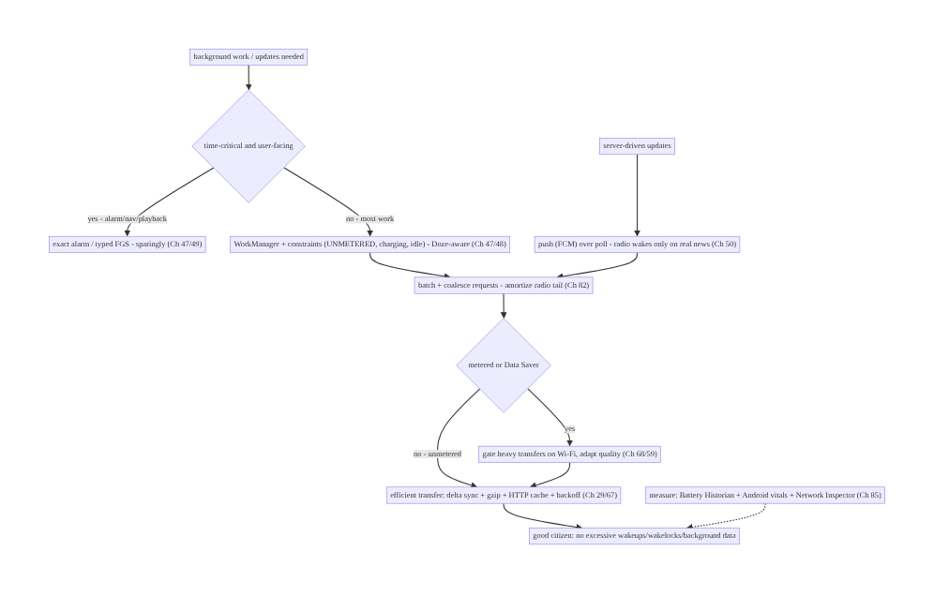
91.4 High-Level Architecture
Components & ownership
- Time-critical → exact alarm / typed FGS (sparingly, Ch 47/49); everything else → deferrable WorkManager + constraints (Doze-aware, Ch 47/48).
- Push (FCM) over poll (Ch 50); batch/coalesce (Ch 82); metered/Data-Saver gating (Ch 68).
- Efficient transfer (delta/gzip/cache/backoff, Ch 29/67); measured (Battery Historian/ vitals, Ch 85).
Direction: classify (time-critical vs deferrable) → push over poll + WorkManager constraints → batch/coalesce → metered-aware → efficient transfer → good citizen; measured.

91.5 Detailed Component Design
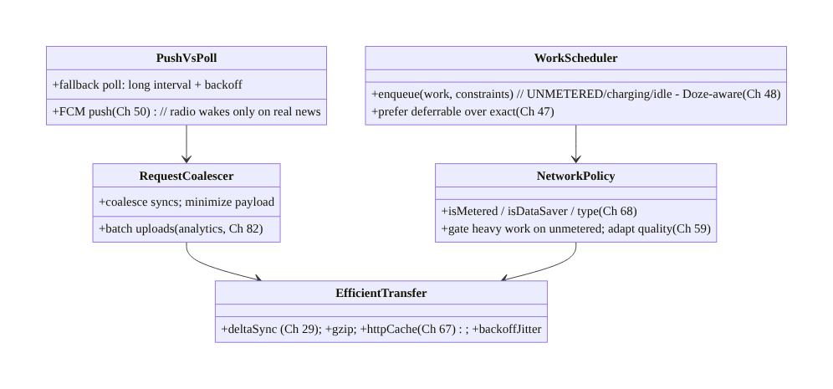
91.5 Detailed Component Design
Component | Responsibility
WorkScheduler | deferrable WorkManager work + constraints (Doze-aware, Ch 47/48)
PushVsPoll | FCM push over poll; long-interval backoff fallback (Ch 50)
RequestCoalescer | batch uploads + coalesce syncs + minimize payload (Ch 82)
NetworkPolicy | metered/Data-Saver/type gating + quality adaptation (Ch 68/59)
EfficientTransfer | delta sync + gzip + HTTP cache + backoff+jitter (Ch 29/67)

91.6 End-to-End Data Flow

Classify → schedule efficiently → transfer
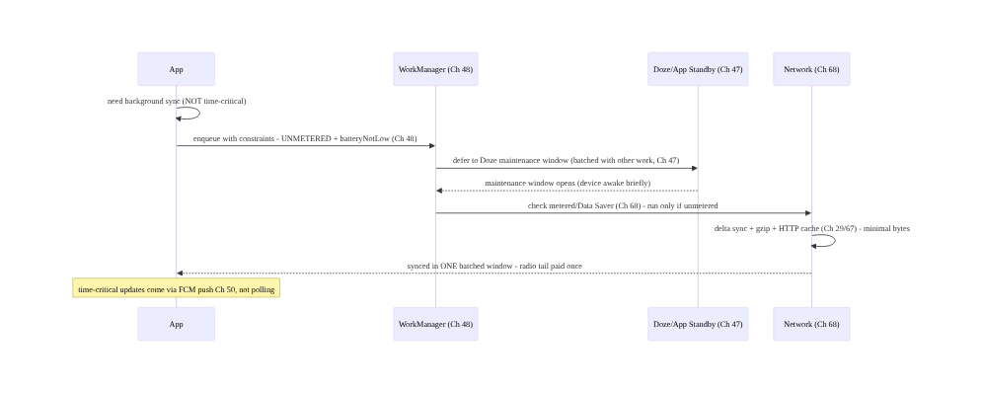
Classify → schedule efficiently → transfer

Radio tail: batched vs chatty
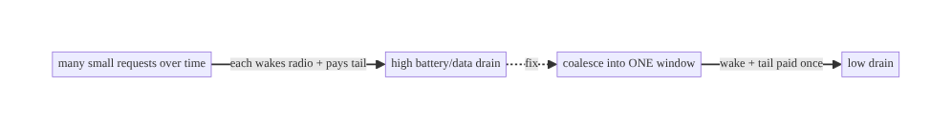
Radio tail: batched vs chatty

91.7 Complete Kotlin Implementation
Package: com.streamcart.efficiency.

91.7.1 Deferrable work with constraints (Doze-aware, Ch 48/47)
// Non-time-critical sync: let WorkManager batch it into efficient windows (Ch 48), honoring Doze (Ch 47)
val syncWork = PeriodicWorkRequestBuilder<CatalogSyncWorker>(6, TimeUnit.HOURS)
.setConstraints(Constraints.Builder()
.setRequiredNetworkType(NetworkType.UNMETERED) // Wi-Fi only - save data (Ch 68)
.setRequiresBatteryNotLow(true) // don't drain a low battery
.setRequiresCharging(false) // charging optional
.build())
.setBackoffCriteria(BackoffPolicy.EXPONENTIAL, 15, TimeUnit.MINUTES) // backoff on failure (Ch 29)
.build()
workManager.enqueueUniquePeriodicWork("catalog-sync", ExistingPeriodicWorkPolicy.KEEP, syncWork)
// NEVER: a 1-minute repeating alarm or a tight polling loop - that's what drains battery + trips vitals.

91.7.2 Push over poll (Ch 50)
// GOOD: server pushes order updates via FCM - radio wakes only when there IS an update (Ch 50)
class StreamCartMessagingService : FirebaseMessagingService() {
override fun onMessageReceived(msg: RemoteMessage) {
// handle update; optionally enqueue a deferrable reconcile (Ch 48) - no polling needed
orderRepository.onPushUpdate(msg.data)
}
}
// BAD: viewModelScope.launch { while (true) { delay(120_000); api.pollOrders() } } // wakes radio constantly

91.7.3 Metered / Data Saver awareness (Ch 68)
@Singleton
class NetworkPolicy @Inject constructor(private val cm: ConnectivityManager) { // Ch 68
fun isUnmetered(): Boolean {
val caps = cm.getNetworkCapabilities(cm.activeNetwork) ?: return false
return caps.hasCapability(NetworkCapabilities.NET_CAPABILITY_NOT_METERED) // Wi-Fi/unmetered
}
fun isDataSaverOn(): Boolean = // user asked to limit bg data
cm.restrictBackgroundStatus == ConnectivityManager.RESTRICT_BACKGROUND_STATUS_ENABLED
/** Gate heavy transfers; adapt quality on cellular (Ch 59). */
fun allowHeavyTransfer(): Boolean = isUnmetered() && !isDataSaverOn()
}
// Image/video quality adapts by network type (Ch 59/68): lower res on cellular, full on Wi-Fi.

91.7.4 Efficient transfer: delta + gzip + cache + backoff (Ch 29/67)
val client = OkHttpClient.Builder()
.addInterceptor { chain -> // request gzip (servers often honor)
chain.proceed(chain.request().newBuilder().header("Accept-Encoding", "gzip").build())
}
.cache(Cache(cacheDir, 20L * 1024 * 1024)) // HTTP cache - don't re-fetch unchanged (Ch 67)
.build()
// Delta sync: send last-sync cursor; server returns ONLY changes (Ch 29), not the full catalog.
suspend fun syncCatalog(sinceCursor: String): Delta =
api.catalogDelta(sinceCursor) // minimal bytes; ETag/If-None-Match -> 304 (Ch 67)
// Retries use exponential backoff + JITTER (Ch 29) - never a tight retry loop.

91.7.5 Batch outbound (coalesce, Ch 82)
// Analytics/logs are BATCHED, not sent per-event (Ch 82) - coalesces radio wakes into periodic flushes.
class BatchingUploader @Inject constructor(private val wm: WorkManager) {
fun enqueue(event: Event) {
buffer.add(event) // durable buffer (Ch 82)
// periodic/threshold flush via WorkManager (unmetered) - ONE batched upload (Ch 48/68)
}
}

91.7.6 Module structure
:core:efficiency WorkScheduler (constraints), NetworkPolicy (metered/Data Saver), EfficientTransfer
# Deferrable work -> WorkManager (Ch 48) + Doze (Ch 47); push -> FCM (Ch 50); batching -> Ch 82;
# metered/type -> Ch 68; delta/cache -> Ch 29/67; adapt quality -> Ch 59; measure -> Historian/vitals (Ch 85).

91.8 Concurrency and Race Conditions
Scenario | Risk | Handling
Polling loop | constant radio wakes | push (FCM, Ch 50); deferrable work (Ch 48)
Stuck partial wakelock | battery drain + vitals flag | avoid manual wakelocks; WorkManager (Ch 48)
Fighting Doze | drain + restriction | deferrable + constraints (Ch 47)
Chatty small requests | radio tail × N | batch/coalesce (Ch 82)
Heavy transfer on cellular | data cost | gate on unmetered (Ch 68)
Full re-download | wasted bytes | delta sync + HTTP cache (Ch 29/67)
Tight retry loop | hammering + drain | backoff + jitter (Ch 29)
Continuous high-accuracy location | top drain | lowest accuracy, batched, stop (Ch 65)
- The platform schedulers are allies, not obstacles (Ch 47/48): WorkManager + Doze already batch and defer efficiently — expressing constraints and using deferrable APIs gets efficiency for free; fighting them (exact alarms, FGS, wakelocks) causes the drain and the vitals flags.
- Batching amortizes the radio tail: the single highest-leverage move is turning many spread-out radio wakes into few batched ones (coalesced syncs, batched analytics Ch 82, prefetch in one window).
- Push eliminates poll waste entirely (Ch 50): FCM’s shared OS connection means zero per- app radio wakes until there’s real news — strictly better than polling for server-driven updates.

91.9 Failure Scenarios and Recovery
Failure | Detection | Response | Outcome
Excessive wakeups | Android vitals (Ch 85) | push over poll; deferrable work (Ch 50/48) | fewer wakes
Stuck partial wakelock | vitals / Historian | drop manual wakelocks → WorkManager (Ch 48) | released
High data usage | vitals / user reports | gate on unmetered; delta/compress (Ch 68/29) | less data
Battery drain complaints | reviews / Historian | batch + defer + push (Ch 48/50) | efficient
Doze fighting / restricted | background restriction | cooperate (deferrable, Ch 47) | compliant
Chatty network | Network Inspector | coalesce/batch (Ch 82) | fewer requests
Location drain | Historian | lowest accuracy, batched, stop (Ch 65) | minimal
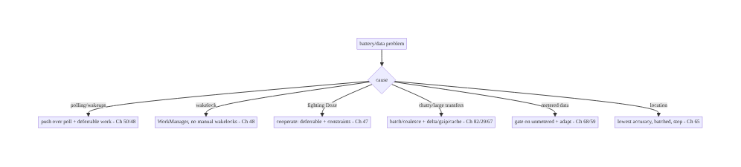
91.9 Failure Scenarios and Recovery
Do less, batched, at the right time, over the right network — and let the platform schedule it. Battery/data drain comes from polling and wakeups (push + deferrable work fix it), wakelocks and fighting Doze (WorkManager + cooperation fix it), chatty/large transfers (batch + delta + compress + cache fix it), and metered-oblivious transfers (gate on Wi-Fi fixes it). Measure with Battery Historian + Android vitals (Ch 85) and fix the specific drain.

91.10 Scaling the Implementation
- Level 1. WorkManager for background work with basic constraints (Ch 48); FCM push over polling (Ch 50); batch analytics (Ch 82).
- Level 2. Metered/Data-Saver gating (Ch 68); delta sync + gzip + HTTP caching (Ch 29/67); backoff+jitter; quality adaptation by network (Ch 59).
- Level 3 — production. Android vitals excessive-background monitoring (Ch 85); Battery Historian audits; location efficiency (Ch 65); coalesced syncs.
- Level 4 — large. Per-feature battery/data budgets; adaptive sync intervals by usage; network-aware prefetch policies; device-tiered behavior; vitals-gated releases (Ch 41/85).
- Level 5 — enterprise. Battery/data SLOs with error budgets, automated regression detection (field), energy governance, long-tail device/network programs, cross-team efficiency ownership.
Avoid overengineering: WorkManager + constraints + FCM push + batched analytics + delta/ cached transfers + metered gating covers most apps. Don’t poll; don’t hold wakelocks; don’t fight Doze; don’t do heavy transfers on cellular; measure before micro-optimizing.

91.11 Alternative Approaches and Trade-offs
Dimension | Option A | Option B | When
Updates | Push (FCM, Ch 50) | polling | Push (no wasted wakes)
Scheduling | Deferrable WorkManager (Ch 48) | exact alarm / FGS | Deferrable (Doze-cooperative)
Requests | Batched/coalesced (Ch 82) | chatty small | Batched (amortize tail)
Transfer | Delta + gzip + cache (Ch 29/67) | full re-download | Delta (fewer bytes)
Network | Metered/Data-Saver aware (Ch 68) | oblivious | Aware (save money)
Retry | Backoff + jitter (Ch 29) | tight loop | Backoff (no hammering)
Location | Lowest accuracy, batched (Ch 65) | continuous high-accuracy | Lowest adequate
Push vs poll (Ch 50): polling wakes the radio on a schedule mostly to hear “nothing new” — pure waste. Push (FCM) delivers over a shared OS connection only when there’s real news, with no per-app radio wake. For server-driven updates, push is strictly better; keep polling only as a long-interval, backed-off fallback.
Deferrable (WorkManager) vs exact/FGS (Ch 47/48/49): exact alarms and foreground services bypass Doze/batching — necessary for time-critical, user-facing work (alarms, navigation, playback) but expensive and (misused) restricted. Deferrable WorkManager work batches into Doze windows with constraints — far more efficient for the majority of work. Reserve exact/FGS for genuine time-criticality; default to deferrable.
Delta/cached transfer vs full re-download (Ch 29/67): re-downloading everything wastes battery and data. Delta sync (only changes, Ch 29) + HTTP caching (304s for unchanged, Ch 67) + compression transfer the minimum bytes. Always sync incrementally and cache.

91.12 Security & Privacy Considerations
- Data Saver is a user privacy/cost choice (Ch 68): honoring it respects the user’s explicit request to limit background data — don’t bypass it. Efficient apps save users money.
- Push payloads minimal + PII-safe (Ch 50/28): FCM pushes should carry minimal, non- sensitive data (an id to fetch, not sensitive content) — pushes transit Google’s infrastructure (Ch 50/28).
- Don’t leak via network timing: batching/coalescing also reduces fingerprintable per-action network signatures (minor privacy benefit).
- Location efficiency ≈ location privacy (Ch 65): using lowest-adequate accuracy and stopping when not needed is both efficient and privacy-respecting (Ch 65/28).
- Measurement data PII-safe (Ch 85): battery/network field metrics are behavioral/timing, not content (Ch 28).
- Client vs backend: the client schedules efficiently and respects metered/Data Saver; the backend supports delta sync (Ch 29) and push (Ch 50) and sets cache headers (Ch 67) — efficiency is a contract between both.

91.13 Performance and Resource Optimization
- This chapter is efficiency — summary: push over poll (Ch 50), deferrable + batched work with constraints (WorkManager + Doze, Ch 47/48), coalesce/minimize requests (Ch 82), metered/Data-Saver gating (Ch 68), delta + gzip + HTTP cache + backoff (Ch 29/ 67), location efficiency (Ch 65).
- Amortize the radio tail — batch into one window; the tail dominates small-request cost.
- Gate heavy work on unmetered + good battery — WorkManager constraints.
- Transfer the minimum — delta, compression, caching, pagination.
- Measure, then fix the specific drain — Battery Historian / vitals / Network Inspector (Ch 85).
- Profiling: wakeups/wakelocks (Historian), radio-active time, request count/size (Network Inspector), background data (vitals), battery per session, excessive-background flags (Ch 85).

91.14 Testing Strategy
Constraints, policy gating, and transfer efficiency are unit/integration-testable; battery behavior is validated with Historian/vitals.
class NetworkPolicyTest {
@Test fun `heavy transfer gated off on metered`() {
every { cm.isUnmetered() } returns false
assertFalse(policy.allowHeavyTransfer()) // cellular -> no heavy transfer (Ch 68)
}
@Test fun `data saver blocks heavy transfer`() {
every { cm.isDataSaverOn() } returns true
assertFalse(policy.allowHeavyTransfer()) // honor Data Saver (Ch 68)
}
}
class WorkConstraintsTest {
@Test fun `sync requires unmetered + battery not low`() {
val c = syncWork.workSpec.constraints
assertEquals(NetworkType.UNMETERED, c.requiredNetworkType) // Wi-Fi (Ch 48)
assertTrue(c.requiresBatteryNotLow())
}
}
class TransferTest {
@Test fun `delta sync sends cursor and applies only changes`() = runTest { /* minimal bytes (Ch 29) */ }
@Test fun `unchanged resource returns 304 from cache`() { /* HTTP cache (Ch 67) */ }
}
// Field: Battery Historian (wakelocks/wakeups), Android vitals excessive-background metrics (Ch 85).
What to test: metered/Data-Saver gating (Ch 68); WorkManager constraints (unmetered, battery, Ch 48); delta sync + HTTP cache (Ch 29/67); backoff+jitter; push handling (no polling, Ch 50); batched uploads (Ch 82). Field battery via Historian/vitals (Ch 85).

91.15 Production Observability
- Metrics (Android vitals, field, Ch 85): excessive wakeups, stuck partial wakelocks, excessive background Wi-Fi scans, excessive background network usage, background data volume; battery drain per session; wakeup/wakelock counts (Battery Historian); request count/ size (Network Inspector).
- Logs: background-work scheduling/outcomes (WorkManager, Ch 48) — PII-safe (Ch 28).
- Debugging: drain → Battery Historian (wakelocks? wakeups? radio?); data overuse → Network Inspector (chatty? large? metered?); vitals flag → the specific metric (wakeups → polling? wakelock → manual lock?); Doze issues → is work deferrable? (Ch 47).
- Alerting: Android vitals excessive-background flags (affect ranking, Ch 85); battery/ data regression release-over-release (Ch 85/41); wakeup/wakelock spike.
- Dashboards: excessive-background metrics by release/device; wakeups/wakelocks; background data; request efficiency; battery per session.

91.16 System Design Interview Preparation
≥25 questions.
Fundamentals
- Why battery/data matter? Uninstalls, reviews, vitals flags, OS throttling.
- Radio tail? Radio stays high-power for seconds after a transfer.
- Why batch? Amortize the wake + tail across many requests.
- Core principle? Do less, batched, right time, right network.
- Top drains? Wakeups, wakelocks, polling, continuous location.
Push/poll
- Push vs poll? Push wakes only on real news; poll wastes wakes.
- Push mechanism? FCM — shared OS connection (Ch 50).
- When poll? Fallback only — long interval + backoff.
Scheduling
- Deferrable work? WorkManager + constraints (Ch 48).
- Constraints? UNMETERED, charging, idle, battery-not-low.
- Doze/App Standby? Defer work to maintenance windows (Ch 47).
- Fight or cooperate? Cooperate — deferrable APIs.
- Exact alarm / FGS? Only time-critical, user-facing (Ch 47/49).
- Wakelock? Avoid manual; WorkManager holds minimally.
Network
- Coalesce? Batch uploads/syncs into one window (Ch 82).
- Metered? User pays per byte — gate heavy work on Wi-Fi (Ch 68).
- Data Saver? Honor restrictBackgroundStatus (Ch 68).
- Adapt quality? Lower on cellular (Ch 59/68).
Transfer
- Delta sync? Only changes, not full re-download (Ch 29).
- Compression? gzip/brotli.
- HTTP caching? ETag/304 — don’t re-fetch unchanged (Ch 67).
- Retry? Backoff + jitter (Ch 29).
Location/measure
- Location drain? Lowest accuracy, batched, stop (Ch 65).
- Measure battery? Battery Historian + Android vitals (Ch 85).
- Measure data? Network Inspector + vitals background data.
- Vitals flags? Excessive wakeups/wakelocks/bg data (affect ranking).

Design-change challenges
- Replace a 2-min poll. FCM push (Ch 50) + deferrable reconcile (Ch 48).
- Stop burning cellular data on prefetch. Gate on UNMETERED + Data Saver (Ch 68).
- Fix “excessive wakeups” vitals flag. Push + deferrable + batch (Ch 50/48/82).
- Cut sync data in half. Delta sync + gzip + HTTP caching (Ch 29/67).
- Stop a stuck wakelock. Drop manual wakelocks → WorkManager (Ch 48).

Mock walkthrough (abridged)
Clarify (what work, how time-critical, network/battery targets?) → classify time-critical (exact/FGS, Ch 47/49) vs deferrable (WorkManager + constraints, Ch 48) → push over poll (FCM, Ch 50) → batch/coalesce (Ch 82) → metered/Data-Saver gating + adapt (Ch 68/59) → efficient transfer (delta/gzip/cache/backoff, Ch 29/67) → location efficiency (Ch 65) → cooperate with Doze (Ch 47) → measure (Historian/vitals/Network Inspector, Ch 85) → observability (excessive- background metrics).

91.17 Practical Exercises
- Beginner. Replace a polling loop with FCM push (Ch 50) and a deferrable WorkManager reconcile (Ch 48). Eval: no polling; wakeups drop.
- Intermediate. Add metered/Data-Saver gating (Ch 68) so heavy prefetch runs only on Wi-Fi, and adapt image quality by network (Ch 59). Eval: no cellular heavy transfer.
- Advanced. Convert a full catalog download to delta sync + gzip + HTTP caching (Ch 29/67) with backoff+jitter. Eval: far fewer/smaller requests; 304s for unchanged.
- Production debugging. Use Battery Historian + Android vitals (Ch 85) to find a wakelock/ wakeup drain and fix it (WorkManager/push). Eval: flag cleared; drain reduced.
- System design challenge. Design battery/data budgets + vitals-gated releases (Ch 41/85) with adaptive sync intervals and network-aware prefetch. Eval: budgeted, gated, adaptive.
(Solutions withheld unless requested.)

91.18 Chapter Summary & Reference Sheet
Key decisions: be a good battery and data citizen by doing less, less often, batched, at the right time, over the right network — because every CPU wakeup and (especially) every cellular radio wake pays a multi-second tail, so many small spread-out requests drain far more than a few batched ones: prefer push (FCM, Ch 50) over polling so the radio wakes only when there’s real news; hand all non-time-critical work to WorkManager with constraints (UNMETERED, charging, idle, battery-not-low) so it batches into Doze maintenance windows instead of waking the device, and cooperate with Doze/App Standby (Ch 47) rather than fighting them with exact alarms or foreground services (reserve those for genuinely time-critical, user- facing work, Ch 47/49); coalesce and batch network (analytics flushes Ch 82, combined syncs, piggybacked requests), minimize payloads, and transfer efficiently (delta sync Ch 29, gzip, ETag/HTTP caching Ch 67, pagination, backoff+jitter); honor metered networks and Data Saver by gating heavy transfers on Wi-Fi and adapting quality on cellular (Ch 68/59) to save the user money; use lowest-adequate-accuracy, batched location (Ch 65); and measure with Battery Historian, Android vitals excessive-background metrics, and the Network Inspector (Ch 85) — because battery drain and data overuse cause uninstalls, bad reviews, vitals flags that hurt ranking, and OS throttling.
Concepts: radio tail + wakeups + wakelocks, push over poll (FCM, Ch 50), deferrable + batched work (WorkManager constraints, Doze/App Standby, Ch 47/48), coalescing + batching (Ch 82), metered/ Data-Saver/network-type awareness (Ch 68), efficient transfer (delta Ch 29, gzip, HTTP cache Ch 67, backoff+jitter), location efficiency (Ch 65), measurement (Battery Historian, Android vitals, Network Inspector, Ch 85).
Common mistakes: polling instead of push; frequent alarms / tight loops (wakeups); manual/ stuck wakelocks; fighting Doze with exact alarms/FGS for deferrable work; chatty small requests (radio tail); full re-downloads (no delta/cache); heavy transfers on metered/Data-Saver; continuous high-accuracy location; no measurement.
Checklist:
- ☐ push (FCM) over poll (Ch 50)
- ☐ deferrable work via WorkManager + constraints (UNMETERED, battery-not-low, Doze-aware, Ch 47/48)
- ☐ reserve exact alarm/FGS for time-critical (Ch 47/49)
- ☐ batch/coalesce requests + minimize payload (Ch 82)
- ☐ honor metered/Data Saver; gate heavy work on Wi-Fi; adapt quality (Ch 68/59)
- ☐ delta sync + gzip + HTTP cache + backoff+jitter (Ch 29/67)
- ☐ lowest-accuracy, batched location (Ch 65)
- ☐ no manual wakelocks
- ☐ measure (Battery Historian, vitals, Network Inspector, Ch 85)
- ☐ watch excessive-background vitals flags.
Key APIs: WorkManager + Constraints (setRequiredNetworkType(UNMETERED), setRequiresBatteryNotLow, setBackoffCriteria), ExistingPeriodicWorkPolicy (Ch 48), FirebaseMessagingService (push, Ch 50), ConnectivityManager (NET_CAPABILITY_NOT_METERED, restrictBackgroundStatus / Data Saver, Ch 68), OkHttp Cache + Accept-Encoding: gzip (Ch 67), ETag/If-None-Match (304), delta sync (Ch 29), setExactAndAllowWhileIdle (time- critical only, Ch 47), fused location lowest-accuracy/batched (Ch 65), Battery Historian + Android vitals + Network Inspector (Ch 85).
References: - Optimize for battery / background work: https://developer.android.com/topic/performance/power - Doze and App Standby: https://developer.android.com/training/monitoring-device-state/doze-standby - WorkManager: https://developer.android.com/topic/libraries/architecture/workmanager - Data Saver / metered networks: https://developer.android.com/training/basics/network-ops/data-saver - Battery Historian: https://developer.android.com/topic/performance/power/battery-historian - (composes) Ch 47 Doze/Standby, Ch 48 WorkManager, Ch 68 Network State, Ch 50 FCM, Ch 29 Sync, Ch 67 Network, Ch 65 Location, Ch 85 Perf

Chapter 92 — Baseline Profiles & R8 Optimization
Part X — Performance, Observability & Quality · Complexity: Standard (≥25 interview questions)
Prerequisites: Ch 88 (cold start), Ch 90 (jank), Ch 85 (perf monitoring/Macrobenchmark), Ch 45 (startup). Pairs with Ch 89 (memory), Ch 93 (lists), Ch 41 (release).
Reference surface in StreamCart: making the app fast from the first launch and smaller — Baseline Profiles (AOT-compile the startup + critical-path code so it isn’t interpreted/JIT-cold, improving cold start Ch 88 and first-scroll jank Ch 90) and R8 (shrink, optimize, obfuscate — smaller APK, faster load, dead-code removal) — verified with Macrobenchmark (CompilationMode.None vs Partial) and the field (Ch 85).

92.1 Problem Definition and Real-World Context
On a fresh install (or after an update/profile reset), Android runs app code interpreted, then JIT-compiles hot methods over time — so the first launches and first scrolls are slow/janky until the JIT warms up. Baseline Profiles fix this: a profile lists the startup + critical-path methods/classes, and ART AOT-compiles them at install → the app is fast from the very first launch (commonly 20–30% faster cold start, Ch 88, and smoother first-scroll, Ch 90). Separately, R8 (Android’s shrinker/optimizer/obfuscator) removes dead code, optimizes, and shrinks the APK/DEX → smaller download, faster load, less to compile/initialize. Together, Baseline Profiles + R8 are among the highest-impact, lowest-effort performance wins — and both are verified with Macrobenchmark (Ch 85) so you know the gain is real. This chapter is the deep-dive counterpart referenced by Ch 88 (cold start) and Ch 90 (jank).
Concretely, teams hit:
- JIT-cold first launches (the core problem). Without a baseline profile, the first few launches run interpreted → JIT, so they’re measurably slower than warmed-up runs. Users judge the app on the first impression (Ch 88). A Baseline Profile AOT-compiles the startup path so it’s fast immediately.
- First-scroll jank (Ch 90). The first scroll through a list/feed runs JIT-cold Compose/ scroll code → janky until warm. Including the scroll path in the baseline profile makes it smooth from the start (Ch 90).
- No profile / wrong profile. Shipping without a baseline profile leaves performance on the table; a profile that doesn’t cover the real critical journeys (only launch, not the key screens) under-delivers. The profile must cover launch + the most-used journeys.
- Profile not applied / verified. A baseline profile must be packaged correctly (via the Baseline Profile Gradle plugin / ProfileInstaller) and verified to actually apply — otherwise you think you have it but don’t. Macrobenchmark (CompilationMode.None vs Partial) measures the delta.
- R8 not enabled / misconfigured. Shipping debuggable/unshrunk release builds (R8 off) leaves the APK large and unoptimized; misconfigured keep rules either break the app (over-shrinking reflection-used code) or defeat shrinking (keeping everything). Need R8 on for release with correct -keep rules.
- Obfuscation vs debuggability (Ch 83). R8 obfuscates (renames) — great for size/IP, but stack traces become unreadable unless you retain + upload the mapping file for deobfuscation (Crashlytics, Ch 83). Forgetting the mapping file makes crashes undebuggable.
- Resource shrinking. Beyond code, shrinkResources removes unused resources — more size savings, must be paired with R8 code shrinking.
- Measuring the win. Claims of “faster” must be measured — Macrobenchmark StartupTimingMetric/FrameTimingMetric with CompilationMode.None (no profile) vs Partial (with profile) quantifies the baseline-profile gain; APK analyzer quantifies R8 size savings; field vitals confirm (Ch 85).
The architecture: ship a Baseline Profile covering launch + the critical journeys (feed scroll, key screens) — generated with the Baseline Profile Gradle plugin (Macrobenchmark- based generator) and packaged so ART AOT-compiles that code at install (fast first launch, Ch 88; smooth first scroll, Ch 90); enable R8 for release (shrink + optimize + obfuscate, smaller/faster), with correct -keep rules and shrinkResources, and retain + upload the mapping file for crash deobfuscation (Ch 83); and verify everything with Macrobenchmark (None vs Partial) and field metrics (Ch 85). This chapter is about fast-from-first-launch + smaller + verified.

Three practical use cases
- Baseline Profile for StreamCart launch + feed (Ch 88/90). Generate a profile covering app launch and the home-feed scroll (Ch 71); Macrobenchmark shows cold start ~25% faster (None vs Partial) and first-scroll jank cut — verified before shipping.
- R8 shrink + resource shrink. Enable R8 + shrinkResources for release; APK drops significantly (dead code/resources removed), with -keep rules for reflection-used (Gson/Hilt/serialization) classes; mapping file uploaded for Crashlytics (Ch 83).
- Verify the profile applied. Confirm via ProfileInstaller + Macrobenchmark that CompilationMode.Partial reflects the shipped profile — not silently missing.

Why this is architectural
Baseline Profiles + R8 compose cold start (Ch 88), jank (Ch 90), Macrobenchmark measurement (Ch 85), crash deobfuscation (Ch 83), and release (Ch 41). The decisions — profile the right journeys, enable R8 with correct keep rules, retain the mapping file, verify with Macrobenchmark — determine whether the app is fast from first launch and small, without breaking crash diagnosability.

92.2 Requirements Engineering

Functional requirements
ID | Requirement
F1 | Ship a Baseline Profile covering launch + critical journeys (feed scroll, key screens).
F2 | Generate it with the Baseline Profile Gradle plugin (Macrobenchmark generator).
F3 | Enable R8 for release: shrink + optimize + obfuscate; shrinkResources.
F4 | Correct -keep rules (reflection/serialization/DI) — don’t over- or under-shrink.
F5 | Retain + upload the mapping file for crash deobfuscation (Ch 83).
F6 | Verify with Macrobenchmark (None vs Partial) and field metrics (Ch 85).

Non-functional requirements
Attribute | Policy
First-launch speed | AOT startup path; fast from install (Ch 88).
First-scroll smoothness | Scroll path in profile (Ch 90).
Size | R8 + resource shrinking; smaller APK.
Debuggability | Mapping file retained/uploaded (Ch 83).
Verified | Macrobenchmark None vs Partial (Ch 85).

Scope
- In scope: AOT vs JIT vs interpreted, Baseline Profiles (generation via Gradle plugin/ Macrobenchmark, packaging, ProfileInstaller, coverage = launch + journeys), effect on cold start (Ch 88) + first-scroll jank (Ch 90), R8 (shrink/optimize/obfuscate), -keep rules, shrinkResources, mapping file + deobfuscation (Ch 83), Cloud/Startup profiles context, verification (Macrobenchmark None/Partial, Ch 85), APK size analysis.
- Out of scope: cold-start optimization detail (Ch 88), jank detail (Ch 90), Macrobenchmark setup detail (Ch 85), crash reporting (Ch 83), release mechanics (Ch 41).

Assumptions & constraints
- AGP with the Baseline Profile Gradle plugin + Macrobenchmark module (Ch 85); R8 enabled for release (minifyEnabled true, shrinkResources true); ProfileInstaller packaged. Profile covers launch + key journeys; mapping file retained + uploaded (Ch 83). Verified with CompilationMode.None vs Partial. minSdk 24 (ART; Baseline Profiles supported broadly via ProfileInstaller).

92.3 System Design Fundamentals
- Interpreted → JIT → AOT (why the first run is slow). ART runs DEX bytecode interpreted at first; it JIT-compiles frequently-run (“hot”) methods to native over time (and writes a profile of what was hot, used to AOT-compile later in the background). So fresh installs are slow until JIT/profile-guided compilation warms up. AOT (ahead-of-time) compilation before running avoids this. A Baseline Profile is a way to get AOT compilation of the code you choose, at install time — skipping the slow warm-up for the paths that matter.
- Baseline Profiles — what they are. A Baseline Profile is a list of classes/methods (in a human-readable rules format, compiled to a binary) that you ship with the app; at install (and app update), ART AOT-compiles exactly those → the startup + critical-path code is native from the first launch. Typical wins: ~20–30% faster cold start (Ch 88) and smoother first scroll (Ch 90). It’s additive to ART’s own profile-guided compilation (which still kicks in over time for the rest).
- Generating a Baseline Profile. Use the Baseline Profile Gradle plugin with a Macrobenchmark-based generator that exercises the critical journeys (launch, scroll the feed, open key screens) on a device/emulator; it records the methods/classes those journeys touch into the profile. Coverage matters: the generator must drive the real most-used journeys — a profile covering only launch under-delivers on scroll (Ch 90). Include launch + the top user journeys.
- Packaging & applying (ProfileInstaller). The profile is packaged into the app (AAB/APK) and applied at install (Play) or via ProfileInstaller (bundled library) on first run for sideloads/older setups. Verify it’s applied — a profile that isn’t packaged/ applied gives no benefit. Cloud Profiles / Startup Profiles are related mechanisms (Play-aggregated field profiles; profiles that also affect DEX layout) — the Baseline Profile plugin is the standard app-shipped approach.
- Effect on cold start (Ch 88) & jank (Ch 90). Baseline Profiles directly improve the two most visible perf dimensions: cold start (AOT startup path — faster first launch, Ch 88) and first-scroll jank (AOT Compose/scroll path — smoother first scroll, Ch 90). These chapters reference this one for the AOT mechanism.
- R8 — shrink, optimize, obfuscate. R8 (the default release compiler/shrinker) does: shrinking (remove unused classes/methods/fields — tree-shaking from entry points), optimization (inlining, dead-code elimination, class merging), and obfuscation (rename to short names — smaller + harder to reverse-engineer). Result: smaller DEX/APK, faster to load/verify, less to compile/init. Enable with minifyEnabled true for release; pair with shrinkResources true to drop unused resources.
- -keep rules (the correctness knob). R8 shrinks from reachable entry points; code reached only via reflection/serialization/JNI (Gson/Moshi models, Hilt/Dagger, Compose stability sometimes, Parcelable, enums used by name) may be wrongly removed/renamed → runtime crash. -keep rules (ProGuard/R8 rules) tell R8 to keep those. Too few → crashes; too many (-keep class ** { *; }) → defeats shrinking. Use library-provided consumer rules + minimal targeted keeps; test the release build.
- Obfuscation vs crash debuggability (Ch 83). Obfuscation renames everything, so stack traces are gibberish unless you retain the mapping.txt and upload it (to Crashlytics/ Play) for deobfuscation/symbolication (Ch 83). Always keep and upload the mapping file per release — otherwise production crashes are undebuggable.
- Verify with Macrobenchmark (Ch 85). Prove the wins: Macrobenchmark with CompilationMode.None (no AOT — simulates JIT-cold) vs CompilationMode.Partial (with baseline profile) quantifies the baseline-profile gain on startup (StartupTimingMetric, Ch 88) and frames (FrameTimingMetric, Ch 90). APK Analyzer quantifies R8 size savings. Field vitals (Ch 85) confirm in production. Measure — don’t assume.
Core insight: make the app fast from the very first launch and smaller by shipping a Baseline Profile and enabling R8: a Baseline Profile lists the startup + critical-journey classes/methods so ART AOT-compiles them at install time instead of leaving them interpreted/JIT-cold, which is why fresh installs are otherwise slow — generate it with the Baseline Profile Gradle plugin driving a Macrobenchmark that exercises the real most-used journeys (launch, feed scroll, key screens — coverage matters, a launch-only profile under-delivers on scroll), package it via ProfileInstaller, and it directly improves cold start (~20–30%, Ch 88) and first-scroll jank (Ch 90); R8 separately shrinks (tree-shakes dead code from entry points), optimizes (inlining/ dead-code elimination), and obfuscates (renames) the release build for a smaller, faster-loading APK, enabled with minifyEnabled + shrinkResources and correct -keep rules for reflection/ serialization/DI code (too few keeps crashes at runtime, too many defeats shrinking) — but obfuscation makes crash stack traces unreadable, so you must retain and upload the mapping.txt for deobfuscation (Ch 83); and you verify both wins with Macrobenchmark (CompilationMode.None vs Partial for the profile’s startup/frame delta) and the APK Analyzer and field vitals (Ch 85), because these are the highest-impact, lowest-effort perf wins only when actually applied and measured.

92.4 High-Level Architecture
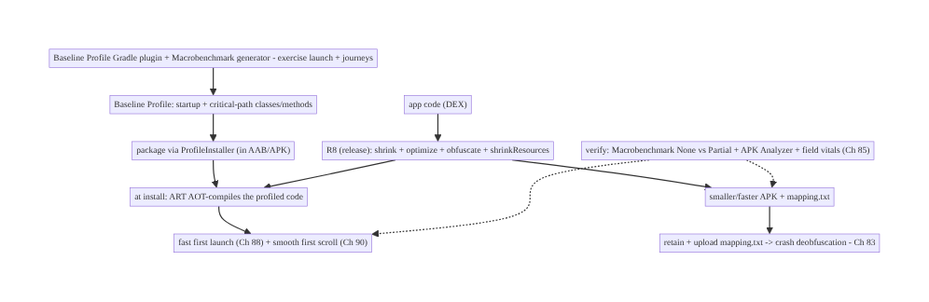
92.4 High-Level Architecture
Components & ownership
- R8 shrinks/optimizes/obfuscates release → smaller/faster + mapping.txt (upload for deobfuscation, Ch 83).
- Baseline Profile (generated via Gradle plugin + Macrobenchmark) → AOT startup + journeys at install → fast first launch (Ch 88) + smooth first scroll (Ch 90).
- Verify with Macrobenchmark (None vs Partial) + APK Analyzer + field (Ch 85).
Direction: code → R8 (smaller, +mapping) + Baseline Profile (AOT via ProfileInstaller) → fast-from-first-launch + small → verified.

92.5 Detailed Component Design
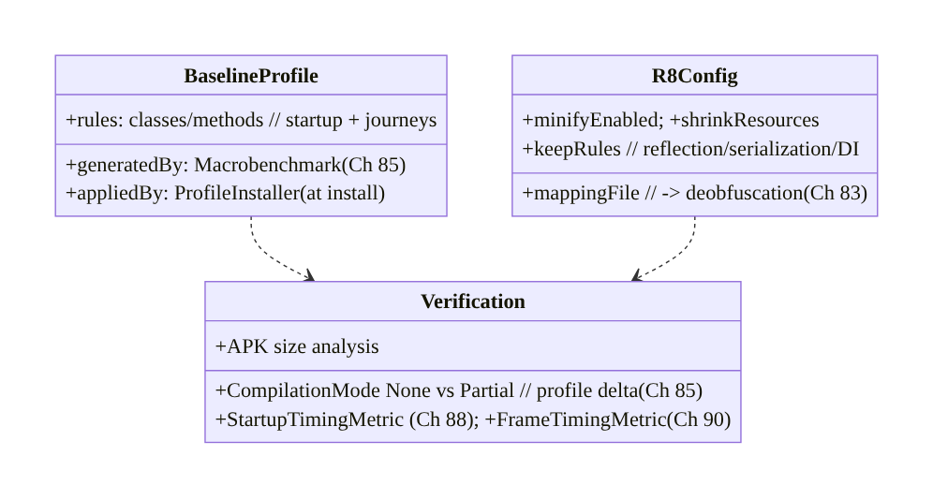
92.5 Detailed Component Design
Component | Responsibility
BaselineProfile | startup + journey rules; generated (Macrobenchmark), applied (ProfileInstaller)
R8Config | minifyEnabled/shrinkResources, keep rules, mapping file (Ch 83)
Verification | Macrobenchmark None vs Partial (Ch 88/90), APK size, field (Ch 85)

92.6 End-to-End Data Flow

Generate → package → AOT at install → fast
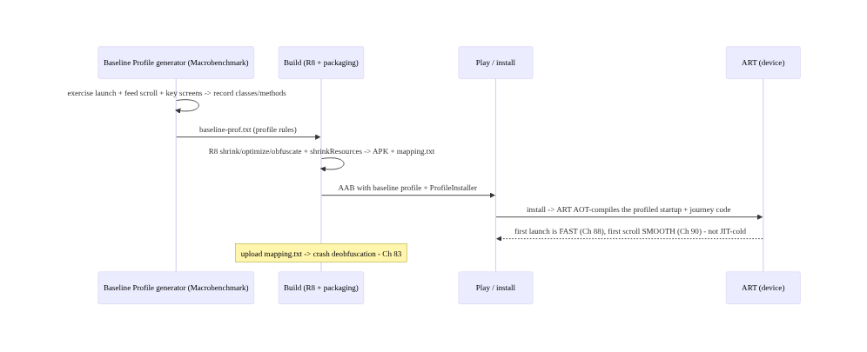
Generate → package → AOT at install → fast

Verify the gain (None vs Partial)
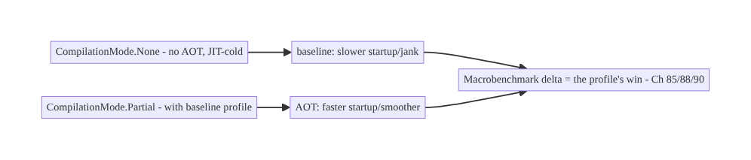
Verify the gain (None vs Partial)

92.7 Complete Kotlin / Gradle Implementation
Package/module: :baselineprofile, app build.gradle.

92.7.1 Baseline Profile generator (Macrobenchmark, Ch 85)
@RunWith(AndroidJUnit4::class)
class BaselineProfileGenerator {
@get:Rule val rule = BaselineProfileRule()
@Test fun generate() = rule.collect(packageName = "com.streamcart") {
pressHome(); startActivityAndWait() // LAUNCH path (Ch 88)
// exercise the REAL critical journeys so the profile covers them (coverage matters):
device.findObject(By.res("feed")).fling(Direction.DOWN) // FEED SCROLL path (Ch 90)
device.findObject(By.res("product_0")).click(); device.pressBack() // key screen
}
// Output: baseline-prof.txt (classes/methods) -> packaged; ART AOT-compiles them at install.
}

92.7.2 R8 + resource shrinking + mapping (app build.gradle)
android {
buildTypes {
release {
isMinifyEnabled = true // R8: shrink + optimize + obfuscate
isShrinkResources = true // drop unused resources (pair with R8)
proguardFiles(
getDefaultProguardFile("proguard-android-optimize.txt"),
"proguard-rules.pro", // our -keep rules
)
// mapping.txt is produced automatically -> upload for deobfuscation (Ch 83)
}
}
}
// Baseline Profile Gradle plugin wires the generated profile into the release build.

92.7.3 Keep rules (proguard-rules.pro) — correctness
# Keep reflection/serialization-used models (Gson/Moshi) - else R8 removes/renames -> runtime crash
-keep class com.streamcart.model.** { *; }
-keepclassmembers class com.streamcart.model.** { <fields>; }
# Hilt/Dagger, Parcelable, enums-by-name usually covered by library consumer rules; add targeted keeps only as needed.
# AVOID: -keep class ** { *; } // keeps everything -> defeats shrinking
# Keep source file + line numbers for readable (deobfuscated) stack traces (Ch 83):
-keepattributes SourceFile,LineNumberTable
-renamesourcefileattribute SourceFile

92.7.4 Verify with Macrobenchmark (None vs Partial, Ch 85/88/90)
@RunWith(AndroidJUnit4::class)
class ProfileVerificationBenchmark {
@get:Rule val rule = MacrobenchmarkRule()
private fun startup(mode: CompilationMode) = rule.measureRepeated(
packageName = "com.streamcart", metrics = listOf(StartupTimingMetric()), // Ch 88
compilationMode = mode, startupMode = StartupMode.COLD, iterations = 10,
) { pressHome(); startActivityAndWait() }
@Test fun noProfile() = startup(CompilationMode.None()) // JIT-cold baseline
@Test fun withProfile() = startup(CompilationMode.Partial()) // with baseline profile -> faster
// Delta (None - Partial) = the baseline-profile win. Also FrameTimingMetric for scroll (Ch 90).
}

92.7.5 Upload mapping for deobfuscation (Ch 83)
// Crashlytics Gradle plugin uploads mapping.txt automatically on release build;
// or upload to Play Console. Without it, obfuscated crash stack traces are unreadable (Ch 83).
// firebaseCrashlytics { mappingFileUploadEnabled = true } // per release

92.7.6 Module structure
:baselineprofile BaselineProfileGenerator (Macrobenchmark, Ch 85) -> baseline-prof.txt
:app R8 (minify + shrinkResources) + keep rules + baseline profile plugin + mapping upload (Ch 83)
:benchmark ProfileVerificationBenchmark (None vs Partial, Ch 88/90)
# Fast first launch -> Ch 88; smooth first scroll -> Ch 90; verify -> Macrobenchmark (Ch 85).

92.8 Concurrency and Race Conditions
Baseline Profiles & R8 are build/compilation-time concerns, so classic runtime races don’t apply. The analogous pitfalls are correctness/coverage issues:
Scenario | Risk | Handling
Profile covers only launch | under-delivers on scroll | exercise real journeys (Ch 90)
Profile not applied | no benefit | ProfileInstaller + verify (None vs Partial)
Over-shrinking (too few keeps) | runtime crash | keep reflection/serialization/DI classes
Under-shrinking (keep all) | no size win | minimal targeted keeps
Mapping file lost | undebuggable crashes | retain + upload mapping.txt (Ch 83)
Release untested (R8 on) | ships broken | test the release (minified) build
Assuming the win | unverified | Macrobenchmark None vs Partial (Ch 85)
- Coverage is the baseline-profile analog of correctness: a profile only helps the journeys it covers, so the generator must drive the real critical paths (launch and scroll and key screens). Verify with Macrobenchmark that Partial beats None for those journeys.
- Keep rules are the R8 correctness knob: R8’s static reachability can’t see reflection/ serialization, so missing keeps cause release-only crashes (invisible in debug). Always test the minified release build, and lean on library consumer rules plus minimal targeted keeps.
- The mapping file is non-negotiable for debuggability (Ch 83): obfuscation + no mapping = undebuggable production crashes — retain and upload it every release.

92.9 Failure Scenarios and Recovery
Failure | Detection | Response | Outcome
Slow first launch | Macrobenchmark None vs Partial (Ch 88) | ship Baseline Profile | fast first launch
First-scroll jank | FrameTimingMetric (Ch 90) | include scroll path in profile | smooth
Profile not applied | Partial == None | fix packaging/ProfileInstaller + verify | applied
Release crash (R8) | crash on reflection class | add targeted -keep rule | stable
Unreadable crashes | obfuscated stack trace (Ch 83) | retain + upload mapping.txt | deobfuscated
Large APK | APK Analyzer | R8 + shrinkResources + minimal keeps | smaller
Unverified win | no numbers | Macrobenchmark + APK Analyzer (Ch 85) | measured
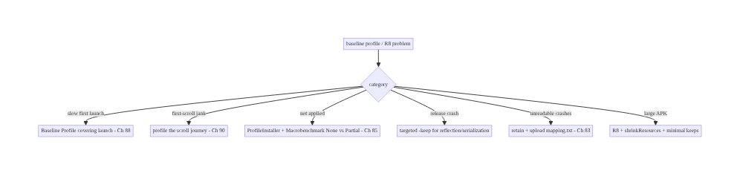
92.9 Failure Scenarios and Recovery
Ship the profile, enable R8, keep the mapping file — and verify. Baseline Profiles + R8 are the highest-impact, lowest-effort perf wins, but only when the profile covers the real journeys and is actually applied (verify None vs Partial, Ch 85), R8 has correct keep rules (test the release build), and the mapping file is uploaded so crashes stay debuggable (Ch 83). Measure the gain — don’t assume it.

92.10 Scaling the Implementation
- Level 1. Enable R8 (minifyEnabled) + shrinkResources for release; upload the mapping file (Ch 83); add library consumer keep rules.
- Level 2. Add a Baseline Profile (Gradle plugin) covering launch; verify cold start with Macrobenchmark None vs Partial (Ch 88).
- Level 3 — production. Expand the profile to key journeys (feed scroll, Ch 90); CI verification of the profile delta; APK-size tracking; field vitals confirmation (Ch 85).
- Level 4 — large. Per-flow profiles for all major journeys; automated profile regeneration in CI; size budgets; R8 optimization passes tuned; dynamic feature modules.
- Level 5 — enterprise. Profile + size governance, Cloud/Startup Profiles, per-module keep- rule hygiene, automated startup/size regression gates (Ch 41), cross-release AOT/size dashboards (Ch 85).
Avoid overengineering: R8 + shrinkResources + a Baseline Profile covering launch + the top journey, mapping file uploaded, verified with Macrobenchmark, captures most of the win. Don’t ship without a profile; don’t keep everything; don’t forget the mapping file; don’t claim wins you didn’t measure.

92.11 Alternative Approaches and Trade-offs
Dimension | Option A | Option B | When
First-run speed | Baseline Profile (AOT) | JIT-only | Baseline Profile (fast first launch)
Profile coverage | Launch + journeys | launch only | Journeys (smooth scroll too, Ch 90)
Release build | R8 on (shrink/optimize) | R8 off | R8 on (smaller/faster)
Keep rules | Minimal targeted | keep-all / none | Minimal targeted (shrink + correct)
Resources | shrinkResources | keep all | Shrink (size)
Debuggability | Upload mapping.txt (Ch 83) | no mapping | Upload (readable crashes)
Proof | Macrobenchmark (Ch 85) | assume | Measure
Baseline Profile vs JIT-only: without a profile, startup + scroll run interpreted/JIT on first launches — slow/janky until warm. A Baseline Profile AOT-compiles those paths at install → fast/smooth from the first launch (~20–30% startup, Ch 88/90). It’s additive to ART’s own profiling. Always ship one covering launch + top journeys.
R8 on vs off: shipping unshrunk release builds wastes size (dead code/resources) and load/compile time. R8 tree-shakes, optimizes, and obfuscates → smaller, faster. The cost is keep-rule maintenance and mapping-file management — both well-trodden. Always enable R8 for release with correct keeps + mapping upload.
Minimal targeted keeps vs keep-all: -keep class ** { *; } is “safe” but defeats shrinking (no size win). Too few keeps crashes on reflection/serialization. Minimal, targeted keeps (library consumer rules + specific models) shrink effectively while staying correct — verified by testing the release build. Prefer minimal targeted keeps.

92.12 Security & Privacy Considerations
- Obfuscation raises the reverse-engineering bar (not a security guarantee): R8 renaming makes the app harder to reverse-engineer (IP/tamper resistance), but it is not encryption — don’t rely on obfuscation to hide secrets (keys still shouldn’t be in the APK, Ch 24).
- Mapping file is sensitive (Ch 83): mapping.txt de-obfuscates your app — treat it as internal, upload it to your crash tooling securely (Ch 83), don’t ship/leak it publicly.
- Baseline profiles contain method/class names, not data: compilation hints — not secrets or PII (Ch 28).
- Shrinking can remove debug/log code: R8 can strip debug logging in release (good for leak- prevention), but ensure security-relevant code isn’t stripped by a wrong keep (Ch 24).
- Resource shrinking + size reduces attack surface marginally (less code) — not a primary security control.
- Build-time concern: these are build features; the security notes are mapping-file confidentiality (Ch 83) and not trusting obfuscation as secret-hiding (Ch 24).

92.13 Performance and Resource Optimization
- Baseline Profiles = first-launch + first-scroll speed (Ch 88/90) — AOT the startup + top journeys; the single biggest low-effort startup/jank win.
- R8 = size + load/compile speed — shrink + optimize + obfuscate; shrinkResources for assets.
- Coverage drives the profile win — profile the real journeys, not just launch (Ch 90).
- Minimal keeps maximize shrinking — keep only reflection/serialization/DI code.
- Verify, quantify — Macrobenchmark None vs Partial (startup/frames), APK Analyzer (size), field vitals (Ch 85).
- Profiling: cold start None vs Partial (Ch 88), frame timing None vs Partial (Ch 90), APK/DEX size before/after R8, resource count, field startup/jank (Ch 85).

92.14 Testing Strategy
The profile delta and release correctness are the things to test; size is measured.
class ProfileVerificationBenchmark { // quantify the baseline-profile win (Ch 85/88/90)
@get:Rule val rule = MacrobenchmarkRule()
@Test fun startup_none() = measure(CompilationMode.None()) // JIT-cold baseline
@Test fun startup_partial() = measure(CompilationMode.Partial()) // with profile -> assert faster
private fun measure(mode: CompilationMode) = rule.measureRepeated(
packageName = "com.streamcart", metrics = listOf(StartupTimingMetric()),
compilationMode = mode, startupMode = StartupMode.COLD, iterations = 10) { pressHome(); startActivityAndWait() }
}
// Release correctness (R8 keep rules):
// - Run instrumented/smoke tests on the MINIFIED release build - catch over-shrunk reflection classes.
// - Verify Gson/Moshi serialization, Hilt graph, Parcelable, enums-by-name still work post-R8.
// - Confirm mapping.txt produced + uploaded (Ch 83); deobfuscate a sample stack trace.
// Size: APK Analyzer before/after R8 + shrinkResources.
What to test: Macrobenchmark None vs Partial startup (Ch 88) + frames (Ch 90) — profile applied + faster; release (minified) build smoke/integration tests — keep rules correct (no reflection crash); mapping file produced/uploaded + sample deobfuscation (Ch 83); APK size delta (APK Analyzer). Field confirmation via vitals (Ch 85).

92.15 Production Observability
- Metrics: cold start p50/p95 (field vitals + Macrobenchmark None vs Partial, Ch 88/ 85), first-scroll jank (FrameTimingMetric None vs Partial, Ch 90), APK/DEX size per release, crash deobfuscation success (mapping uploaded?, Ch 83), profile-applied rate (ProfileInstaller).
- Logs: build-time R8/profile reports; ProfileInstaller status — no PII (Ch 28).
- Debugging: no startup win → profile applied? (None vs Partial equal → packaging issue); release crash → missing -keep (test minified build); unreadable crashes → mapping not uploaded (Ch 83); large APK → R8/shrinkResources off or keep-all; scroll still janky → profile missing the scroll journey (Ch 90).
- Alerting: cold-start/jank regression release-over-release (profile broke?, Ch 88/90/41); APK size regression; deobfuscation failures (missing mapping, Ch 83).
- Dashboards: cold start + first-scroll (profile effect) by release; APK size trend; profile- applied rate; crash deobfuscation health.

92.16 System Design Interview Preparation
≥25 questions.
Fundamentals
- Interpreted/JIT/AOT? Interpret first → JIT hot methods → AOT ahead-of-time.
- Why first launch slow? Code is interpreted/JIT-cold until warm.
- Baseline Profile? Ship class/method list → ART AOT-compiles at install.
- Typical win? ~20–30% faster cold start (Ch 88) + smoother first scroll (Ch 90).
- R8? Shrink + optimize + obfuscate the release build.
Baseline Profiles
- Generate how? Baseline Profile Gradle plugin + Macrobenchmark generator.
- Coverage? Launch + real critical journeys (not launch-only).
- Apply how? Packaged + ProfileInstaller (install time).
- Effect? Faster cold start (Ch 88), smoother first scroll (Ch 90).
- Cloud/Startup Profiles? Play-aggregated / DEX-layout variants.
R8
- Shrinking? Tree-shake dead code from entry points.
- Optimization? Inlining, dead-code elimination, class merging.
- Obfuscation? Rename to short names — smaller + harder to RE.
- Enable? minifyEnabled true (release).
- shrinkResources? Remove unused resources.
Keep rules
- Why needed? R8 can’t see reflection/serialization/JNI.
- Too few? Runtime crash (removed/renamed class).
- Too many? Defeats shrinking.
- Best practice? Library consumer rules + minimal targeted keeps.
- Test? On the minified release build.
Obfuscation/debuggability
- Crash stack traces? Obfuscated gibberish without mapping.
- Fix? Retain + upload mapping.txt (Ch 83).
- Mapping sensitive? Yes — internal only.
Verify
- Measure profile win? Macrobenchmark None vs Partial (Ch 85).
- Measure size? APK Analyzer.
- Confirm in field? Vitals cold start/jank (Ch 85).

Design-change challenges
- Make first launch faster. Baseline Profile covering launch; verify None vs Partial (Ch 88).
- Smooth first scroll. Include the scroll journey in the profile (Ch 90).
- Shrink the APK. R8 + shrinkResources + minimal keeps.
- Keep crashes debuggable. Retain + upload mapping.txt (Ch 83).
- Prove the win. Macrobenchmark None vs Partial + APK Analyzer (Ch 85).

Mock walkthrough (abridged)
Clarify (first-launch speed? size? journeys?) → AOT vs JIT (why first run slow) → Baseline Profile via Gradle plugin + Macrobenchmark generator covering launch + journeys (Ch 88/90) → package (ProfileInstaller) → R8 (minify + shrinkResources) + correct keep rules → retain + upload mapping.txt (Ch 83) → verify Macrobenchmark None vs Partial + APK Analyzer + field vitals (Ch 85) → observability (cold start/size/deobfuscation by release).

92.17 Practical Exercises
- Beginner. Enable R8 + shrinkResources for release, add library keep rules, and confirm the mapping file is uploaded for Crashlytics (Ch 83). Eval: smaller APK; readable crashes.
- Intermediate. Add a Baseline Profile (Gradle plugin) covering app launch and verify the cold-start delta with Macrobenchmark None vs Partial (Ch 88). Eval: measurable startup win.
- Advanced. Expand the profile to cover feed scroll (Ch 90) and verify the frame delta (FrameTimingMetric None vs Partial); tighten keep rules to maximize shrinking. Eval: smoother first scroll; smaller APK; no release crash.
- Production debugging. Diagnose “no startup win” (profile not applied — fix packaging) and a release-only reflection crash (add targeted -keep). Eval: profile applies; crash fixed.
- System design challenge. Design CI gates for cold-start (Ch 88), frame timing (Ch 90), and APK size, plus mapping-file upload verification (Ch 83). Eval: regressions gated; crashes debuggable.
(Solutions withheld unless requested.)

92.18 Chapter Summary & Reference Sheet
Key decisions: make the app fast from the very first launch and smaller by shipping a Baseline Profile and enabling R8: a Baseline Profile lists the startup + critical- journey classes/methods so ART AOT-compiles them at install instead of leaving them interpreted/JIT-cold (the reason fresh installs are otherwise slow) — generate it with the Baseline Profile Gradle plugin driving a Macrobenchmark that exercises the real most-used journeys (launch, feed scroll, key screens — coverage matters, a launch-only profile under- delivers on scroll), package it via ProfileInstaller, and it directly improves cold start (~20–30%, Ch 88) and first-scroll jank (Ch 90); R8 separately shrinks (tree-shakes dead code), optimizes (inlining/dead-code elimination), and obfuscates (renames) the release build for a smaller, faster-loading APK, enabled with minifyEnabled + shrinkResources and correct -keep rules for reflection/serialization/DI code (too few keeps crashes at runtime, too many defeats shrinking) — but obfuscation makes crash stack traces unreadable, so you must retain and upload the mapping.txt for deobfuscation (Ch 83); and you verify both wins with Macrobenchmark (CompilationMode.None vs Partial for the profile’s startup/frame delta), the APK Analyzer (size), and field vitals (Ch 85) — because these are the highest-impact, lowest- effort perf wins only when actually applied and measured.
Concepts: interpreted/JIT/AOT, Baseline Profiles (generation via Gradle plugin + Macrobenchmark, coverage, ProfileInstaller), effect on cold start (Ch 88) + first-scroll jank (Ch 90), R8 (shrink/optimize/obfuscate), -keep rules, shrinkResources, mapping.txt + deobfuscation (Ch 83), verification (None vs Partial, APK Analyzer, Ch 85).
Common mistakes: no Baseline Profile (JIT-cold first launch); profile covering only launch (no scroll win, Ch 90); profile not applied (unverified); R8 off (large/slow); too few keeps (release crash); keep-all (no shrink); forgetting the mapping file (undebuggable crashes, Ch 83); assuming the win without Macrobenchmark (Ch 85); not testing the minified release build.
Checklist:
- ☐ Baseline Profile covering launch + top journeys (feed scroll, Ch 90)
- ☐ generated via Gradle plugin + Macrobenchmark; applied via ProfileInstaller
- ☐ verify None vs Partial startup (Ch 88) + frames (Ch 90)
- ☐ R8 on (minifyEnabled) + shrinkResources
- ☐ minimal targeted -keep rules (reflection/serialization/DI)
- ☐ test the minified release build
- ☐ retain + upload mapping.txt for deobfuscation (Ch 83)
- ☐ APK Analyzer size delta
- ☐ field vitals confirm (Ch 85)
- ☐ CI gates for startup/frames/size (Ch 41).
Key APIs/Gradle: BaselineProfileRule (generator) + Baseline Profile Gradle plugin, ProfileInstaller, CompilationMode.None/Partial + StartupTimingMetric (Ch 88)/ FrameTimingMetric (Ch 90) via MacrobenchmarkRule (Ch 85), isMinifyEnabled/isShrinkResources (R8), proguard-rules.pro (-keep, -keepclassmembers, -keepattributes SourceFile,LineNumberTable), mapping.txt upload (Crashlytics/Play, Ch 83), APK Analyzer, field vitals (Ch 85).
References: - Baseline Profiles: https://developer.android.com/topic/performance/baselineprofiles/overview - Create a Baseline Profile: https://developer.android.com/topic/performance/baselineprofiles/create-baselineprofile - R8 / shrink, obfuscate, optimize: https://developer.android.com/build/shrink-code - Deobfuscate crash stack traces: https://developer.android.com/build/shrink-code#decode-stack-trace - (composes) Ch 88 Cold Start, Ch 90 Jank, Ch 85 Perf/Macrobenchmark, Ch 83 Crash/Deobfuscation, Ch 45 Startup, Ch 41 Release

Chapter 93 — Large List Performance
Part X — Performance, Observability & Quality · Complexity: Standard (≥25 interview questions)
Prerequisites: Ch 90 (jank/recomposition), Ch 71 (infinite feed/Paging 3), Ch 59 (image loading), Ch 89 (memory), Ch 85 (perf monitoring). Pairs with Ch 88 (cold start/first scroll), Ch 92 (baseline profiles), Ch 2 (Compose).
Reference surface in StreamCart: scrolling large lists/grids (product catalog, feed Ch 71, order history) smoothly — via LazyColumn/LazyRow/LazyVerticalGrid (view recycling) with stable keys, contentType, light/stable item composables (Ch 90), async image loading (Coil, Ch 59), and paging (Ch 71) — so even thousands of items scroll within the frame budget (Ch 90) without jank, excess memory (Ch 89), or over-fetching.

93.1 Problem Definition and Real-World Context
Lists are the most common and most scroll-performance-sensitive UI: a product catalog, a feed (Ch 71), order history, search results (Ch 9) — often thousands of items. Rendering them all is impossible (memory, Ch 89) and laying out off-screen items wastes work. Large list performance is the discipline of scrolling big lists smoothly (every frame within budget, Ch 90) by only composing/laying out visible items (lazy lists recycle/reuse), giving items stable keys and contentType (correct, efficient reuse), keeping each item composable light and stable (Ch 90 — no over-recomposition, no heavy work), loading images asynchronously (Coil, Ch 59 — never block the scroll on decode), and paging data (Ch 71 — don’t load everything). The classic failures are jank on scroll (heavy/unstable items, sync image decode), memory bloat (not recycling, full-res bitmaps, Ch 89/59), and over-fetching (loading all data instead of pages, Ch 71).
Concretely, teams hit:
- Rendering all items (memory + layout death). Putting thousands of items in a non-lazy container (Column with all items, or a ScrollView) composes/lays out everything → huge memory (Ch 89) and slow layout. Fix: lazy lists (LazyColumn/LazyRow/ LazyVerticalGrid) that only compose visible items (+ a small buffer) and recycle as you scroll.
- Missing / unstable keys (the #1 list bug). Without a stable key per item, Compose can’t track item identity across data changes — so inserts/removes/moves cause wrong reuse (state attached to the wrong item), unnecessary recomposition, and scroll-position jumps. Fix: items(list, key = { it.id }) with a stable, unique id.
- Heavy / unstable item composables (Ch 90). An item that does expensive work (formatting, allocation, sorting) in composition, or that over-recomposes (unstable params, Ch 90), janks on every scroll frame as items compose. Fix: light, skippable items (stable params, hoisted work, Ch 90).
- Synchronous image decode on scroll (Ch 59). Decoding a bitmap synchronously in the item (or on the main thread) blocks the frame → scroll stutter. Fix: async image loading (Coil AsyncImage, Ch 59) that decodes off-main, downsamples to view size (Ch 89), caches, and cancels on recycle.
- No contentType for mixed lists. A list with different item types (header, product, ad) reuses incompatible layouts inefficiently without contentType. Fix: provide contentType so Compose reuses the right item structure.
- Over-fetching / loading all data (Ch 71). Loading the entire dataset into memory to show a list wastes memory (Ch 89) and network (Ch 91). Fix: Paging 3 (Ch 71) — load pages as the user scrolls, with placeholders and prefetch distance.
- Expensive scroll work. Recomputing derived values, triggering side effects, or doing I/O per scroll janks. Fix: derivedStateOf for scroll-driven state (Ch 90), hoist work, no I/O in composition (Ch 90/3).
- First-scroll JIT jank (Ch 92). The first scroll runs JIT-cold → janky. Fix: a Baseline Profile covering the scroll path (Ch 92).
The architecture: scroll large lists smoothly with lazy lists (LazyColumn/LazyRow/ LazyVerticalGrid — compose only visible items, recycle) + stable keys (correct identity/ reuse, no position jumps) + contentType (efficient mixed-type reuse) + light, stable item composables (skippable, hoisted work, Ch 90) + async image loading (Coil off-main + downsample + cache + cancel, Ch 59/89) + paging (Paging 3, load pages not everything, Ch 71) + scroll-state discipline (derivedStateOf, no per-scroll work, Ch 90) + a Baseline Profile for the scroll path (Ch 92) — verified with JankStats/Macrobenchmark FrameTimingMetric (Ch 85/90). This chapter is about smooth scrolling of big lists.

Three practical use cases
- Smooth product catalog grid (StreamCart). 5,000 products in a LazyVerticalGrid with key = { it.id }, contentType, light @Immutable item cards (Ch 90), Coil AsyncImage (Ch 59), and Paging 3 (Ch 71) — scrolls within budget, bounded memory (Ch 89).
- Fix a janky feed (Ch 71). The feed janked from heavy item composables + sync image decode; fix: lighten items (hoist work, stable params, Ch 90) + Coil async images (Ch 59) + stable keys → smooth.
- Paged order history (Ch 71). Thousands of orders loaded via Paging 3 with placeholders and prefetch — no over-fetch, no memory blowup (Ch 89/91).

Why this is architectural
Large list performance composes recomposition/jank (Ch 90), paging/infinite feed (Ch 71), image loading (Ch 59), memory (Ch 89), baseline profiles (Ch 92), and measurement (Ch 85). The decisions — lazy recycling, stable keys + contentType, light stable items, async images, paging — determine whether the most common UI scrolls smoothly or janks and bloats.

93.2 Requirements Engineering

Functional requirements
ID | Requirement
F1 | Use lazy lists (compose only visible items, recycle) — never render all items.
F2 | Stable keys per item (correct identity/reuse; no position jumps).
F3 | contentType for mixed-type lists (efficient reuse).
F4 | Light, stable, skippable item composables; hoist work (Ch 90).
F5 | Async image loading (Coil: off-main, downsample, cache, cancel) (Ch 59/89).
F6 | Page data (Paging 3) instead of loading everything (Ch 71); verify with FrameTiming/JankStats (Ch 85/90).

Non-functional requirements
Attribute | Policy
Smoothness | Every scroll frame within budget; low jank (Ch 90/85).
Memory | Bounded (recycling + downsampled images + paging, Ch 89).
Efficiency | Paged fetch; no over-fetch (Ch 71/91).
Correctness | Stable keys → correct item state across changes.
Measured | FrameTiming (lab) + JankStats (field) (Ch 85/90).

Scope
- In scope: lazy lists (LazyColumn/LazyRow/LazyVerticalGrid) + recycling, stable keys (identity/reuse/position), contentType, light + stable + skippable items (Ch 90), async images (Coil, Ch 59) + downsampling (Ch 89), paging (Paging 3, Ch 71), scroll-state discipline (derivedStateOf, Ch 90), prefetch distance, baseline profile for scroll (Ch 92), measurement (FrameTiming/JankStats, Ch 85/90).
- Out of scope: jank/recomposition detail (Ch 90), paging detail (Ch 71), image-loader internals (Ch 59), memory detail (Ch 89), baseline-profile mechanics (Ch 92), Macrobenchmark setup (Ch 85).

Assumptions & constraints
- Jetpack Compose lazy lists (Ch 2/90); Coil for images (Ch 59); Paging 3 for data (Ch 71); items have stable unique ids. Measured with Macrobenchmark FrameTimingMetric (lab) + JankStats (field, Ch 85/90). Baseline Profile covers scroll (Ch 92). minSdk 24.

93.3 System Design Fundamentals
- Lazy lists & recycling (the foundation). LazyColumn/LazyRow/LazyVerticalGrid (Compose) — like RecyclerView (Views) — only compose and lay out the items currently visible (plus a small buffer), and reuse/recycle item slots as you scroll. This keeps memory bounded (Ch 89) and layout cheap regardless of dataset size. Never put a large dataset in a non-lazy Column/ScrollView (composes/lays out everything). Lazy is the baseline for any list that could be long.
- Stable keys — identity, reuse, and position (the #1 lever). By default a lazy list keys items by position/index; when the data changes (insert/remove/move), position-keying causes wrong reuse — item state (scroll position within item, animations, remembered values) sticks to the wrong item, items recompose unnecessarily, and the scroll position jumps. Providing a stable, unique key (items(list, key = { it.id })) lets Compose track each item’s identity → correct reuse, minimal recomposition, stable scroll position across data changes, and correct item animations. Always provide stable keys for dynamic lists.
- contentType — efficient reuse of mixed items. When a list has different item types (header vs product vs ad vs footer), Compose reuses item compositions more efficiently if you declare contentType per item — so it reuses a product slot for a product, not for a header. For single-type lists it’s optional; for mixed lists it improves reuse and reduces recomposition. Provide contentType for heterogeneous lists.
- Light, stable, skippable item composables (Ch 90). Each item composes as it scrolls into view, so item cost is paid repeatedly. An item that over-recomposes (unstable params, Ch 90) or does heavy work in composition (formatting, allocation, sorting, I/O) janks the scroll. Make items skippable (stable/@Immutable params, Ch 90), hoist work out of the item (precompute in the ViewModel/paging map, Ch 90/3), and keep item layout shallow (deep nesting costs layout). The item composable is the hot path — keep it light and stable.
- Async image loading (Ch 59/89). Images are the most common scroll-jank source and the biggest memory risk (Ch 89). Decode off the main thread (never synchronously in the item), downsample to the view size (Ch 89 — avoid full-res bitmaps → OOM), cache (memory/disk, Ch 59), and cancel the load when the item is recycled/scrolled away. Coil’s AsyncImage does all of this — use it; never decode bitmaps synchronously in a list item.
- Paging — don’t load everything (Ch 71). Loading the entire dataset to show a list wastes memory (Ch 89) and network/battery (Ch 91). Paging 3 (Ch 71) loads pages as the user scrolls (with a prefetch distance so the next page is ready before they hit the end), supports placeholders, and integrates with lazy lists (collectAsLazyPagingItems). For any potentially large/remote dataset, page it (Ch 71).
- Scroll-state discipline (Ch 90). Reading scroll state (LazyListState.firstVisibleItemIndex/ ScrollOffset) directly in composition recomposes every scroll frame; wrap scroll-driven derived state in derivedStateOf (recompute only when the derived value changes, Ch 90), and defer visual effects (parallax) to graphicsLayer lambdas (read in draw, not composition, Ch 90). Never do I/O or heavy work per scroll.
- Prefetch & smoothness tuning. Lazy lists prefetch upcoming items; Paging’s prefetch distance loads the next page ahead of time (Ch 71). Keep item composition cheap enough that prefetch stays ahead of the scroll. Avoid unbounded item heights that thrash layout.
- First-scroll JIT jank → Baseline Profile (Ch 92). The first scroll runs JIT-cold (interpreted/JIT Compose + scroll code) → janky until warm. A Baseline Profile covering the scroll journey (Ch 92) AOT-compiles it → smooth from the first scroll. Include lists in the profile.
- Measurement (Ch 85/90). Verify scroll smoothness with Macrobenchmark FrameTimingMetric (lab — fling the list, measure frame durations, Ch 90) and JankStats (field — per-screen jank, Ch 85). Use Layout Inspector to find over-recomposing items (Ch 90). Measure the scroll — don’t assume.
Core insight: scroll large lists smoothly by never rendering everything — use lazy lists (LazyColumn/LazyRow/LazyVerticalGrid, like RecyclerView) that compose and lay out only the visible items and recycle slots as you scroll, keeping memory bounded (Ch 89) and layout cheap regardless of dataset size; give every item a stable, unique key (items(list, key = { it.id })) so Compose tracks identity across inserts/removes/moves — otherwise position-keying causes wrong reuse (state on the wrong item), needless recomposition, and scroll-position jumps — and declare contentType for mixed-type lists so the right slot is reused; keep each item composable light, stable, and skippable (@Immutable params, hoisted work, shallow layout, Ch 90) because item cost is paid repeatedly as items scroll into view, and load images asynchronously with Coil (off-main decode, downsample to view size, cache, cancel on recycle, Ch 59/89) because synchronous bitmap decode is the top scroll-jank and OOM source; page the data with Paging 3 (load pages with a prefetch distance, not the whole dataset, Ch 71) to bound memory and network (Ch 89/91); keep scroll-driven state cheap with derivedStateOf and graphicsLayer deferral and never do I/O per scroll (Ch 90); ship a Baseline Profile covering the scroll path so the first scroll isn’t JIT-janky (Ch 92); and verify with Macrobenchmark FrameTimingMetric (lab) and JankStats (field, Ch 85/90) — because lists are the most common and most scroll-sensitive UI, and jank, memory bloat, and over-fetching all show up here.

93.4 High-Level Architecture
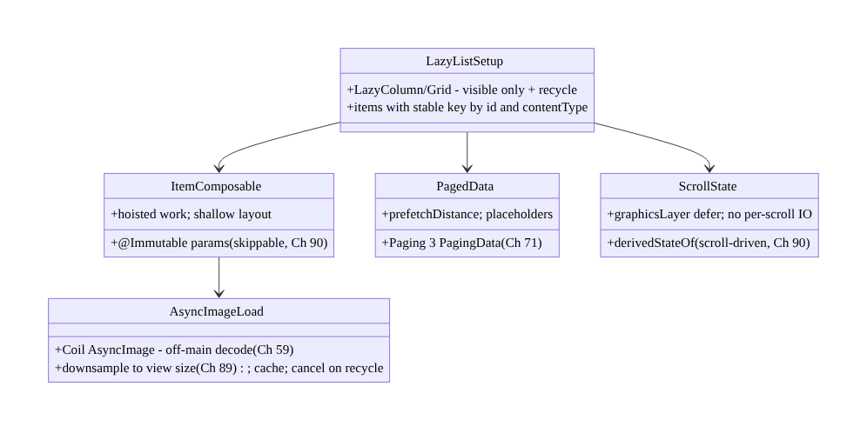
93.4 High-Level Architecture
Components & ownership
- Paging 3 loads pages + prefetch (not everything, Ch 71); lazy list composes only visible
  - recycles.
- Stable keys (identity/reuse) + contentType (mixed reuse); light stable items (Ch 90).
- Async images (Coil off-main/downsample/cache/cancel, Ch 59/89); scroll discipline (derivedStateOf, Ch 90).
- Baseline Profile for scroll (Ch 92); verified (FrameTiming/JankStats, Ch 85/90).
Direction: page → lazy + recycle → stable keys + contentType → light stable items → async images + scroll discipline → smooth; profiled + measured.

93.5 Detailed Component Design
93.5 Detailed Component Design
Component | Responsibility
LazyListSetup | lazy list + stable keys + contentType (visible-only + recycle)
ItemComposable | light, stable, skippable item; hoisted work (Ch 90)
AsyncImageLoad | Coil off-main decode + downsample + cache + cancel (Ch 59/89)
PagedData | Paging 3 pages + prefetch + placeholders (Ch 71)
ScrollState | derivedStateOf + graphicsLayer; no per-scroll work (Ch 90)

93.6 End-to-End Data Flow

Scroll → recycle → compose visible → async image
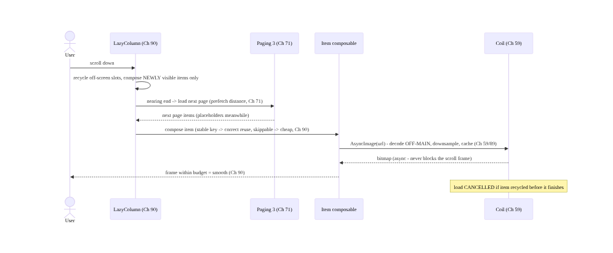
Scroll → recycle → compose visible → async image

Stable key vs position key (on data change)
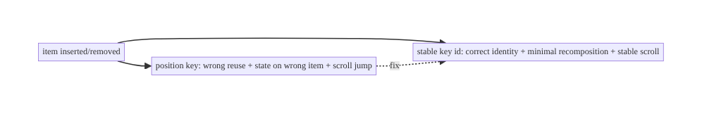
Stable key vs position key (on data change)

93.7 Complete Kotlin Implementation
Package: com.streamcart.ui.list.

93.7.1 Lazy list + stable keys + contentType
@Composable
fun ProductCatalog(items: LazyPagingItems<CatalogRow>) { // Paging 3 (Ch 71)
LazyVerticalGrid(columns = GridCells.Adaptive(160.dp)) {
items(
count = items.itemCount,
key = items.itemKey { it.id }, // STABLE key -> identity/reuse, no jumps
contentType = items.itemContentType { it.type }, // mixed types (product/header/ad) -> efficient reuse
) { index ->
when (val row = items[index]) {
is CatalogRow.Product -> ProductCard(row.product) // light, stable item (Ch 90)
is CatalogRow.Header -> SectionHeader(row.title)
null -> PlaceholderCard() // Paging placeholder (Ch 71)
}
}
}
}

93.7.2 Light, stable, skippable item + async image (Ch 90/59)
@Immutable // stable -> skippable (Ch 90)
data class ProductUi(val id: String, val title: String, val price: String, val imageUrl: String)
@Composable
fun ProductCard(product: ProductUi) {
// Skippable item (stable param). Shallow layout. NO heavy work / NO I/O in composition (Ch 90).
Card {
AsyncImage( // Coil: off-main decode, downsample, cache, cancel (Ch 59/89)
model = ImageRequest.Builder(LocalContext.current)
.data(product.imageUrl).size(Size.ORIGINAL).build(),
contentDescription = product.title,
modifier = Modifier.aspectRatio(1f), // bounded size -> downsample target (Ch 89)
contentScale = ContentScale.Crop,
)
Text(product.title); Text(product.price) // price pre-formatted in the ViewModel/paging map (Ch 90)
}
}
// Pre-format (price, dates) in the ViewModel/PagingData.map - NOT in the item composable (Ch 90).

93.7.3 Scroll-state discipline (derivedStateOf, Ch 90)
@Composable
fun CatalogWithScrollToTop(listState: LazyGridState, items: LazyPagingItems<CatalogRow>) {
// derivedStateOf: FAB recomposes only when crossing the threshold, NOT every scroll pixel (Ch 90)
val showScrollTop by remember { derivedStateOf { listState.firstVisibleItemIndex > 6 } }
Box {
LazyVerticalGrid(state = listState, columns = GridCells.Adaptive(160.dp)) { /* items as above */ }
if (showScrollTop) ScrollToTopFab(listState)
}
// NEVER read firstVisibleItemIndex directly in composition (recomposes every frame), and NO I/O per scroll.
}

93.7.4 Paging source (don’t load everything, Ch 71)
class CatalogViewModel @Inject constructor(repo: CatalogRepository) : ViewModel() {
// Paging 3: pages loaded on scroll with prefetch; not the whole dataset (Ch 71)
val catalog: Flow<PagingData<CatalogRow>> = Pager(
config = PagingConfig(pageSize = 30, prefetchDistance = 10, enablePlaceholders = true), // prefetch ahead
) { repo.catalogPagingSource() }
.flow.map { it.map { product -> product.toUi() } } // pre-format off the item (Ch 90/3)
.cachedIn(viewModelScope)
}

93.7.5 Verify scroll smoothness (Macrobenchmark FrameTiming, Ch 85/90)
@RunWith(AndroidJUnit4::class)
class CatalogScrollBenchmark {
@get:Rule val rule = MacrobenchmarkRule()
@Test fun scroll() = rule.measureRepeated(
packageName = "com.streamcart", metrics = listOf(FrameTimingMetric()), // frame durations (Ch 90)
compilationMode = CompilationMode.Partial(), iterations = 10, startupMode = null, // baseline profile (Ch 92)
) {
startActivityAndWait()
val grid = device.findObject(By.res("catalog"))
repeat(5) { grid.fling(Direction.DOWN) } // assert frame p95 within budget
}
// Field: JankStats per screen (Ch 85). Dev: Layout Inspector for over-recomposing items (Ch 90).
}

93.7.6 Module structure
:feature:catalog ProductCatalog (lazy + keys + contentType), ProductCard (light/stable, Ch 90), CatalogViewModel (Paging 3, Ch 71)
# Recycling -> lazy lists; images -> Coil (Ch 59/89); paging -> Ch 71; item stability -> Ch 90;
# scroll path AOT -> Baseline Profile (Ch 92); verify -> FrameTiming/JankStats (Ch 85/90).

93.8 Concurrency and Race Conditions
Scenario | Risk | Handling
Rendering all items | memory + layout death | lazy lists (visible-only + recycle)
Position keys on data change | wrong reuse + scroll jump | stable key = { it.id }
Sync image decode on scroll | frame block | Coil async off-main (Ch 59)
Heavy/unstable item | per-frame jank | light + skippable item (Ch 90)
Full-res bitmaps | OOM | downsample to view size (Ch 89)
Load-everything | memory/network bloat | Paging 3 (Ch 71)
Scroll-state read in composition | recompose every frame | derivedStateOf / graphicsLayer (Ch 90)
Image load after recycle | wasted/wrong image | cancel on recycle (Coil, Ch 59)
- Stable keys fix a whole class of correctness + perf bugs at once: identity-based reuse means item state stays with the right item, recomposition is minimal, scroll position is stable across data changes, and item animations are correct — missing keys break all four.
- Async image loading is the single biggest scroll-smoothness lever (Ch 59/89): sync decode blocks the frame and full-res bitmaps OOM; Coil’s off-main decode + downsample + cache + cancel- on-recycle solves both, and cancellation prevents wasted work on fast scroll.
- Paging bounds memory and network together (Ch 71/89/91): loading pages (not everything) keeps the in-memory list bounded and avoids over-fetching — essential for large/remote datasets.

93.9 Failure Scenarios and Recovery
Failure | Detection | Response | Outcome
Scroll jank | JankStats/FrameTiming (Ch 85/90) | light items + async images + stable keys (Ch 90/59) | smooth
Scroll-position jumps | visual/state bugs | stable key = { it.id } | stable
OOM on long list | field OOM (Ch 89/83) | downsample + recycle + paging (Ch 89/71) | bounded
Over-fetch / slow load | network/memory (Ch 91) | Paging 3 (Ch 71) | paged
Item over-recomposes | Layout Inspector (Ch 90) | stable params + hoist work (Ch 90) | skippable
First-scroll jank | Macrobenchmark None vs Partial | Baseline Profile scroll path (Ch 92) | AOT smooth
Wrong image on fast scroll | visual | cancel on recycle (Coil, Ch 59) | correct
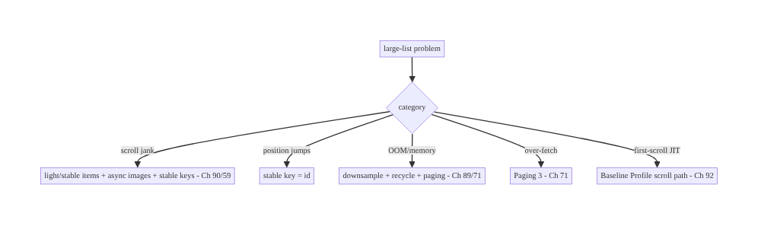
93.9 Failure Scenarios and Recovery
Lazy + stable keys + light items + async images + paging. Large-list jank comes from rendering too much (lazy + paging fix it), position-keyed reuse (stable keys fix it), heavy/ unstable items (light skippable items fix it, Ch 90), and sync image decode (Coil async fixes it, Ch 59). Bound memory with recycling + downsampling + paging (Ch 89/71), AOT the scroll path (Ch 92), and verify with FrameTiming/JankStats (Ch 85/90).

93.10 Scaling the Implementation
- Level 1. Lazy list (LazyColumn/grid) with stable keys; Coil AsyncImage (Ch 59).
- Level 2. contentType for mixed lists; light @Immutable items (Ch 90); derivedStateOf for scroll state; Paging 3 for large/remote data (Ch 71).
- Level 3 — production. Baseline Profile covering scroll (Ch 92); JankStats field monitoring (Ch 85); Macrobenchmark FrameTimingMetric CI gate (Ch 90); downsampled images (Ch 89).
- Level 4 — large. Prefetch tuning, placeholders/skeletons, item-type optimization, nested- scroll performance, sticky headers, per-screen jank budgets (Ch 85).
- Level 5 — enterprise. List-perf SLOs, automated frame-regression gates (Ch 92), device-tiered item complexity, continuous field jank dashboards by list screen (Ch 85).
Avoid overengineering: lazy list + stable keys + light items + Coil async images + Paging 3, verified with FrameTiming/JankStats, covers virtually every list. Don’t render all items; don’t position-key; don’t decode images synchronously; don’t load everything; don’t skip measurement.

93.11 Alternative Approaches and Trade-offs
Dimension | Option A | Option B | When
Container | Lazy list (recycle) | non-lazy Column/ScrollView | Lazy for any long list
Keys | Stable key = id | position/index | Stable (correct reuse + scroll)
Mixed items | contentType | none | contentType for heterogeneous
Item | Light/stable/skippable (Ch 90) | heavy/unstable | Light (per-frame cost)
Images | Coil async (Ch 59) | sync decode | Async (no frame block)
Data | Paging 3 (Ch 71) | load all | Page large/remote datasets
Scroll state | derivedStateOf (Ch 90) | direct read | derivedStateOf (no recompose storm)
Lazy vs non-lazy container: a non-lazy Column/ScrollView composes and lays out every item → memory + layout blow up on large lists. Lazy lists compose only visible items and recycle → bounded memory, cheap layout, any size. Always lazy for lists that could be long.
Stable keys vs position keys: position-keying breaks on data change — wrong reuse, state on the wrong item, scroll jumps, extra recomposition. Stable unique keys give identity-based reuse → correct, minimal, stable. Always provide stable keys for dynamic lists.
Async images vs sync decode (Ch 59): synchronous bitmap decode in an item blocks the scroll frame and risks OOM (full-res, Ch 89). Coil decodes off-main, downsamples, caches, and cancels on recycle → smooth + bounded. Never decode images synchronously in a list.
Paging vs load-all (Ch 71): loading the whole dataset wastes memory (Ch 89) and network/ battery (Ch 91). Paging 3 loads pages with prefetch → bounded + efficient. Page any large or remote dataset.

93.12 Security & Privacy Considerations
- Image URLs / content in lists (Ch 59/28): list items often show user/remote content — load images through the managed loader (Coil, Ch 59) with proper caching/headers; don’t leak auth in image URLs; respect content visibility (Ch 28).
- Paged data respects authorization (Ch 71/20): each page fetch is an authorized request (Ch 20); don’t cache another user’s paged data across accounts (per-account isolation, Ch 28).
- Placeholders don’t leak stale data: ensure placeholders/recycled slots don’t briefly show a previous item’s sensitive content (clear on reuse) — stable keys + correct reuse help here.
- No PII in scroll/jank telemetry (Ch 85/28): JankStats/FrameTiming report timing + screen, not item content (Ch 28).
- Sensitive lists (Ch 76): a list showing sensitive data (payment methods, Ch 76) renders under the same secure-surface rules — orthogonal to list perf.
- Client-mostly concern: list performance is client-side; the cross-cutting notes are authorized paging (Ch 20/71), per-account isolation (Ch 28), and no stale content on recycle.

93.13 Performance and Resource Optimization
- This chapter is list performance — summary: lazy (visible-only + recycle), stable keys, contentType, light/stable/skippable items (Ch 90), async images (Coil off- main + downsample + cache + cancel, Ch 59/89), paging (Ch 71), derivedStateOf scroll state (Ch 90), Baseline Profile scroll path (Ch 92).
- Keep item composition cheap — hoist formatting/work into the ViewModel/paging map (Ch 90); shallow layout.
- Downsample images to slot size — biggest memory lever (Ch 89).
- Page + prefetch — bounded memory/network; next page ready before the end (Ch 71).
- Verify the scroll — FrameTiming (lab, Ch 90) + JankStats (field, Ch 85); Layout Inspector for over-recomposing items (Ch 90).
- Profiling: frame p95 on scroll (FrameTiming/JankStats), item recomposition counts (Layout Inspector), list memory footprint (Ch 89), image cache hit rate (Ch 59), page-load timing (Ch 71).

93.14 Testing Strategy
Scroll smoothness is measured (Macrobenchmark); keys/paging/item stability are verified.
class CatalogScrollBenchmark { // lab gate (Ch 90/92)
@get:Rule val rule = MacrobenchmarkRule()
@Test fun scroll_frames() = rule.measureRepeated(
packageName = "com.streamcart", metrics = listOf(FrameTimingMetric()),
compilationMode = CompilationMode.Partial(), iterations = 10, startupMode = null,
) { startActivityAndWait(); repeat(5) { device.findObject(By.res("catalog")).fling(Direction.DOWN) } }
// assert frameDurationCpuMs p95 within budget
}
class PagingTest {
@Test fun `loads pages not everything`() = runTest { /* only pageSize+prefetch loaded initially (Ch 71) */ }
}
@Test fun `stable keys keep scroll position on insert`() { /* insert item -> position stable, no jump */ }
// Dev: Layout Inspector -> item recomposition ~1 per data change (Ch 90); compiler stability (item @Immutable).
// Field: JankStats per list screen (Ch 85).
What to test: Macrobenchmark FrameTimingMetric on fling (lab gate, p95 within budget, Ch 90/92); Paging loads pages not everything (Ch 71); stable keys keep scroll position across inserts; item recomposition minimal (Layout Inspector, Ch 90); item @Immutable/skippable (compiler stability, Ch 90); async image (no sync decode, Ch 59); field jank via JankStats (Ch 85).

93.15 Production Observability
- Metrics: scroll jank rate + frozen frames per list screen (JankStats, field, Ch 85), frame p95 on scroll (FrameTiming, lab, Ch 90), list memory footprint (Ch 89), image cache hit rate + decode time (Ch 59), page-load latency + prefetch effectiveness (Ch 71), first-scroll jank (baseline-profile effect, Ch 92).
- Logs/traces: scroll frame traces (Perfetto, dev); paging load events (Ch 71) — PII-safe (Ch 28).
- Debugging: scroll jank → JankStats (which list, Ch 85) → Layout Inspector (over-recomposing item? Ch 90) → is image sync-decoded? (Ch 59) → heavy item work? (Ch 90); position jumps → stable keys?; OOM → downsample/recycle/paging (Ch 89/71); over-fetch → Paging config (Ch 71); first- scroll jank → None vs Partial (Ch 92).
- Alerting: list-screen jank/frozen regression release-over-release (Ch 85/41); frame p95 budget breach (Macrobenchmark CI, Ch 90/92); list OOM (Ch 89/83).
- Dashboards: jank/frozen by list screen/device/release; scroll frame percentiles; list memory; image cache; page-load latency.

93.16 System Design Interview Preparation
≥25 questions.
Fundamentals
- Why not render all items? Memory + layout blow up; use lazy lists.
- Lazy list? Composes only visible items + recycles (like RecyclerView).
- Compose lazy APIs? LazyColumn/LazyRow/LazyVerticalGrid.
- Biggest list bug? Missing/unstable keys.
- Why keys? Identity → correct reuse, no scroll jumps, minimal recomposition.
Keys/contentType
- Default key? Position/index — breaks on data change.
- Stable key? items(list, key = { it.id }) — unique + stable.
- What breaks without keys? Wrong reuse, state on wrong item, scroll jump, extra recomposition.
- contentType? Efficient reuse for mixed item types.
- Single-type list? contentType optional.
Items
- Item cost? Paid repeatedly as items scroll in — keep light.
- Over-recomposing item? Stable/@Immutable params (Ch 90).
- Heavy work in item? Hoist to ViewModel/paging map (Ch 90).
- Shallow layout? Deep nesting costs layout.
Images
- Image jank? Sync decode blocks the frame.
- Fix? Coil async — off-main decode (Ch 59).
- Memory? Downsample to view size (Ch 89).
- Fast scroll? Cancel load on recycle (Ch 59).
Paging
- Load everything? No — Paging 3 (Ch 71).
- Prefetch distance? Load next page before the end.
- Placeholders? Show skeletons for not-yet-loaded (Ch 71).
- Why page? Bound memory + network (Ch 89/91).
Scroll/measure
- Scroll-state read? derivedStateOf — not direct (Ch 90).
- First-scroll jank? Baseline Profile scroll path (Ch 92).
- Measure? Macrobenchmark FrameTimingMetric (lab) + JankStats (field) (Ch 85/90).
- Find slow item? Layout Inspector recomposition counts (Ch 90).

Design-change challenges
- Smooth a 5,000-item grid. Lazy grid + stable keys + contentType + light items + Coil + Paging 3 (Ch 90/59/71).
- Fix scroll-position jumps. Stable key = { it.id }.
- Stop OOM on a long image list. Downsample + recycle + paging (Ch 89/71).
- Smooth the first scroll. Baseline Profile scroll path (Ch 92).
- Gate scroll-jank regressions. Macrobenchmark FrameTimingMetric (Ch 90) + field JankStats (Ch 85).

Mock walkthrough (abridged)
Clarify (dataset size, remote?, mixed types?, device targets?) → lazy list (visible-only + recycle) → stable keys + contentType → light/stable/skippable items (Ch 90) → async images (Coil off-main + downsample + cancel, Ch 59/89) → Paging 3 (pages + prefetch + placeholders, Ch 71) → scroll discipline (derivedStateOf, no per-scroll work, Ch 90) → Baseline Profile scroll path (Ch 92) → verify FrameTiming (lab) + JankStats (field) (Ch 85/90) → observability (jank by list screen).

93.17 Practical Exercises
- Beginner. Build a LazyColumn with stable keys (key = { it.id }) and Coil AsyncImage (Ch 59); confirm scroll position is stable on insert. Eval: keyed; async images; no jump.
- Intermediate. Add contentType for a mixed list (headers + products), make items @Immutable/skippable, and hoist price formatting out of the item (Ch 90). Eval: efficient reuse; minimal item recomposition.
- Advanced. Back the list with Paging 3 (prefetch + placeholders, Ch 71) and add a Baseline Profile covering the scroll (Ch 92); verify with Macrobenchmark FrameTimingMetric. Eval: paged; smooth first scroll.
- Production debugging. Use JankStats (Ch 85) to find a janky list, then Layout Inspector to find an over-recomposing item (Ch 90) and a sync-decoded image (Ch 59); fix both. Eval: root causes found and fixed.
- System design challenge. Design a list-perf budget + CI frame-gating (Macrobenchmark per list screen) + field JankStats dashboards by device class (Ch 85/92). Eval: gated, measured, device-tiered.
(Solutions withheld unless requested.)

93.18 Chapter Summary & Reference Sheet
Key decisions: scroll large lists smoothly by never rendering everything — use lazy lists (LazyColumn/LazyRow/LazyVerticalGrid, like RecyclerView) that compose and lay out only the visible items and recycle slots as you scroll, keeping memory bounded (Ch 89) and layout cheap regardless of dataset size; give every item a stable, unique key (items(list, key = { it.id })) so Compose tracks identity across inserts/removes/moves — otherwise position-keying causes wrong reuse (state on the wrong item), needless recomposition, and scroll-position jumps — and declare contentType for mixed-type lists so the right slot is reused; keep each item composable light, stable, and skippable (@Immutable params, hoisted work, shallow layout, Ch 90) because item cost is paid repeatedly as items scroll into view; load images asynchronously with Coil (off-main decode, downsample to view size, cache, cancel on recycle, Ch 59/89) because synchronous bitmap decode is the top scroll-jank and OOM source; page the data with Paging 3 (load pages with a prefetch distance, not the whole dataset, Ch 71) to bound memory and network (Ch 89/91); keep scroll-driven state cheap with derivedStateOf and graphicsLayer deferral and never do I/O per scroll (Ch 90); ship a Baseline Profile covering the scroll path so the first scroll isn’t JIT-janky (Ch 92); and verify with Macrobenchmark FrameTimingMetric (lab) and JankStats (field, Ch 85/90) — because lists are the most common and most scroll-sensitive UI, and jank, memory bloat, and over-fetching all show up here.
Concepts: lazy lists + recycling (LazyColumn/LazyRow/LazyVerticalGrid), stable keys (identity/reuse/position), contentType (mixed reuse), light/stable/skippable items (Ch 90), async images (Coil off-main/downsample/cache/cancel, Ch 59/89), Paging 3 (pages + prefetch + placeholders, Ch 71), scroll-state discipline (derivedStateOf/graphicsLayer, Ch 90), Baseline Profile scroll path (Ch 92), measurement (FrameTiming/JankStats, Ch 85/90).
Common mistakes: rendering all items (non-lazy container); missing/unstable keys (wrong reuse + scroll jumps); no contentType on mixed lists; heavy/unstable item composables (Ch 90); synchronous image decode (jank + OOM, Ch 59/89); loading everything instead of paging (Ch 71); reading scroll state directly in composition (recompose storm, Ch 90); I/O per scroll; no Baseline Profile (first- scroll JIT jank, Ch 92); not measuring the scroll.
Checklist:
- ☐ lazy list (visible-only + recycle)
- ☐ stable key = { it.id } (no position jumps)
- ☐ contentType for mixed lists
- ☐ light + stable + skippable items (@Immutable, hoisted work, Ch 90)
- ☐ Coil async images (off-main + downsample + cache + cancel, Ch 59/89)
- ☐ Paging 3 (pages + prefetch + placeholders, Ch 71)
- ☐ derivedStateOf/graphicsLayer scroll state; no per-scroll I/O (Ch 90)
- ☐ Baseline Profile covers scroll (Ch 92)
- ☐ Macrobenchmark FrameTimingMetric gate (Ch 90) + JankStats field (Ch 85)
- ☐ clear sensitive content on recycle (Ch 28).
Key APIs: LazyColumn/LazyRow/LazyVerticalGrid (+ items(..., key, contentType)), LazyPagingItems (itemKey/itemContentType/collectAsLazyPagingItems, Ch 71), Pager + PagingConfig (pageSize/prefetchDistance/enablePlaceholders, Ch 71), cachedIn, Coil AsyncImage/ImageRequest (Ch 59), @Immutable items (Ch 90), derivedStateOf + LazyListState/LazyGridState (Ch 90), Modifier.graphicsLayer (defer), MacrobenchmarkRule + FrameTimingMetric (Ch 90/92), JankStats (Ch 85), Layout Inspector.
References: - Lazy lists: https://developer.android.com/develop/ui/compose/lists - Compose list performance / keys: https://developer.android.com/develop/ui/compose/lists#item-keys - Paging 3: https://developer.android.com/topic/libraries/architecture/paging/v3-overview - Coil (async images): https://coil-kt.github.io/coil/compose/ - (composes) Ch 90 Jank/Recomposition, Ch 71 Infinite Feed/Paging, Ch 59 Image Loading, Ch 89 Memory, Ch 85 Perf, Ch 92 Baseline Profiles, Ch 2 Compose

Part XI — Reach, Scale & Platform Breadth
Reaching every user and device: multi-module architecture, localization and RTL, accessibility, theming, Android TV and set-top boxes, Wear OS, and the end-to-end StreamCart capstone.

Chapter 94 — Multi-Module Architecture at Enterprise Scale
Part XI — Reach, Scale & Platform Breadth · Complexity: Complex (≥40 interview questions)
Prerequisites: Ch 46 (DI/Hilt), Ch 1 (architecture/layers), Ch 88 (build/startup), Ch 92 (R8), Ch 41 (release). Pairs with Ch 97 (theming/design system), Ch 100 (capstone).
Reference surface in StreamCart: structuring the whole app as many Gradle modules — :app, per-feature modules (:feature:catalog, :feature:checkout), shared :core:* (network, database, design-system, common), and clean module boundaries enforced by API/implementation visibility and dependency direction — so a large team can build fast (parallel + incremental + cached builds), work in parallel without collisions, and keep the architecture enforced by the build graph itself (features can’t depend on each other; everything flows through contracts).

94.1 Problem Definition and Real-World Context
A real app at scale isn’t one module — it’s dozens to hundreds of Gradle modules. A single- module (monolith) app becomes unworkable past a certain size: every change recompiles everything (slow builds), everyone edits the same module (merge collisions), architecture isn’t enforced (any class can reach any other — layering erodes), and you can’t reuse code across apps. Multi-module architecture decomposes the app into well-bounded Gradle modules — an :app shell, feature modules (self-contained screens/flows), and core/shared modules (network, database, design system, common utilities) — with explicit dependencies and enforced boundaries (features depend on core, never on each other; dependencies flow one way; module internals are hidden behind api/implementation and public contracts). The payoff: faster builds (Gradle builds only changed modules + dependents, in parallel, with build caching), parallel teamwork (teams own modules), enforced architecture (the build graph forbids illegal dependencies), and reuse (core modules, even across apps).
Concretely, teams hit:
- Monolith build times. One module → any change recompiles the whole app; build times grow to minutes, killing iteration. Multi-module + Gradle’s incremental + parallel + build cache means a change rebuilds only the affected modules.
- Merge collisions / ownership. Everyone editing one module → constant conflicts, no clear ownership. Feature modules give teams isolated areas they own.
- Architecture erosion (no enforcement). In a monolith, any class can import any other — layering (Ch 1) and feature isolation erode over time. Module boundaries make illegal dependencies a compile error (the build graph enforces architecture).
- Feature coupling. Features importing each other’s internals → a tangle. Rule: features never depend on each other directly; they communicate through shared contracts (a :core API, a navigation contract, Ch 97) and the :app wires them.
- Dependency direction & cycles. Wrong direction (core depending on a feature) or cycles break the build. Dependencies must form a DAG flowing app → feature → core → common (one way).
- api vs implementation leakage. Exposing a dependency with api leaks it to consumers (recompile cascade + coupling); implementation hides it (faster builds, looser coupling). Overusing api destroys build performance and encapsulation.
- DI across modules (Ch 46). Hilt/Dagger wiring must span modules cleanly — core modules provide bindings, features consume them, :app aggregates — without a feature seeing another’s internals.
- :app as the composition root. The :app module is the only place that knows about all features — it wires them together (navigation, DI aggregation) so features stay decoupled. Features are leaves; :app is the root.
- Convention plugins / build logic. Hundreds of modules can’t each copy-paste build config. Convention plugins (build-logic) centralize shared Gradle setup (Kotlin, Compose, testing, Android config) so modules stay consistent and build.gradle files stay tiny.
- Module granularity. Too coarse (few big modules) → poor build parallelism/enforcement; too fine (hundreds of tiny modules) → Gradle overhead + navigation pain. Find the right granularity (often per-feature + layered core).
The architecture: decompose into :app (composition root — wires everything), :feature:* (self-contained flows — depend only on core, never each other), and :core:* (shared: network Ch 4, database Ch 5, design-system Ch 97, common, model) with enforced boundaries: one-way dependency DAG (app → feature → core → common, no cycles), api/implementation visibility to hide internals and limit recompile cascades, features communicating only through shared contracts (not each other’s internals), Hilt DI spanning modules (core provides, features consume, app aggregates, Ch 46), and convention plugins (build-logic) for consistent, minimal build config — so builds are fast (incremental + parallel + cached), teams work in parallel, and the build graph enforces the architecture. This chapter is about structuring a large app so it builds fast, scales to many teams, and enforces its own architecture.

Three practical use cases
- Decompose StreamCart’s monolith. Split into :app, :feature:catalog/checkout/orders/ account, :core:network/database/designsystem/common/model; a change to checkout rebuilds only :feature:checkout + :app, not the catalog — build time drops dramatically.
- Enforce feature isolation. :feature:checkout tries to import :feature:catalog’s internals → compile error (no dependency declared); they communicate via a :core contract + navigation (Ch 97). Architecture enforced by the build.
- Centralize build config. 40 modules each had 60-line build.gradle; a build-logic convention plugin reduces each to ~10 lines and makes Kotlin/Compose/test config consistent.

Why this is architectural
Multi-module architecture is the macro-architecture: it composes DI (Ch 46), layering (Ch 1), build/startup (Ch 88), R8 (Ch 92), the design system (Ch 97), and release (Ch 41). The decisions — module decomposition (app/feature/core), one-way dependency DAG, api/implementation visibility, feature isolation via contracts, cross-module DI, convention plugins, granularity — determine build speed, team scalability, and whether the architecture holds as the app grows.

94.2 Requirements Engineering

Functional requirements
ID | Requirement
F1 | Decompose into :app (composition root), :feature:*, :core:* modules.
F2 | Enforce a one-way dependency DAG (app → feature → core → common); no cycles.
F3 | Features never depend on each other; communicate via shared contracts (Ch 97).
F4 | Use api/implementation to hide internals and limit recompile cascades.
F5 | Hilt DI spans modules cleanly (core provides, features consume, app aggregates, Ch 46).
F6 | Convention plugins (build-logic) for consistent, minimal module build config.

Non-functional requirements
Attribute | Policy
Build speed | Incremental + parallel + build cache; rebuild only affected modules.
Scalability | Teams own modules; parallel work without collisions.
Enforcement | Build graph forbids illegal dependencies (compile errors).
Encapsulation | Module internals hidden behind contracts (implementation).
Consistency | Convention plugins; uniform config.

Scope
- In scope: module types (app/feature/core/common/model), dependency DAG + direction + cycle avoidance, api vs implementation visibility, feature isolation via contracts + navigation (Ch 97), cross-module Hilt DI (Ch 46), :app as composition root, convention plugins (build-logic), module granularity, build performance (incremental/parallel/cache), dynamic feature modules (brief).
- Out of scope: DI internals (Ch 46), layering within a module (Ch 1), build/startup detail (Ch 88), R8 (Ch 92), design system detail (Ch 97), release (Ch 41), navigation detail.

Assumptions & constraints
- Gradle with Kotlin DSL + version catalogs; Hilt (Ch 46); Compose. One-way dependency DAG (no cycles); features isolated; internals hidden (implementation); convention plugins for shared config. Gradle build cache + configuration cache + parallel enabled. minSdk 24.

94.3 System Design Fundamentals
- Why modularize (the four payoffs). (1) Build speed — Gradle rebuilds only changed modules + their dependents (incremental), builds independent modules in parallel, and caches outputs (local + remote build cache); a monolith rebuilds everything. (2) Parallel teamwork — teams own modules and work without stepping on each other. (3) Enforced architecture — the build graph makes illegal dependencies a compile error (you literally cannot import what you don’t depend on). (4) Reuse — core modules are reusable (even across apps). These are the reasons to pay modularization’s complexity cost.
- Module types (the standard decomposition).
  - :app — the composition root / shell: the only module that depends on all features; it wires them (navigation host, DI aggregation, Application). Thin — no business logic. Features are leaves; :app is the root.
  - :feature:* — self-contained flows/screens (catalog, checkout, orders, account), each its own UI + ViewModels + feature-scoped logic. Depend only on :core:*, never on each other. Owned by a team.
  - :core:* — shared capabilities: :core:network (Ch 4), :core:database (Ch 5), :core:designsystem (Ch 97), :core:common (utilities), :core:model (shared data types), :core:data (repositories). Depended on by features; depend on lower core/common only.
  - :core:model / :core:common — the lowest layer: pure data types + utilities, no Android/feature deps — depended on by everyone.
- Dependency direction & the DAG (the central rule). Dependencies must flow one way and form a Directed Acyclic Graph: :app → :feature:* → :core:* → :core:common/model. No cycles (Gradle fails on them), and no upward/sideways deps (core must not depend on a feature; features must not depend on each other). This direction is what enforces layering and feature isolation — the build graph is the architecture diagram.
- Feature isolation via contracts (not internals). Two features that need to interact (checkout → product detail) must not import each other’s internals. Instead: (a) share a contract in :core (a model/interface), (b) communicate through navigation (a route/ deep link, Ch 97) that :app wires, or (c) a feature-API module pattern (:feature:catalog: api with interfaces, :feature:catalog:impl with the implementation — others depend only on api). This keeps features swappable and independently buildable.
- api vs implementation (the build-performance + encapsulation knob). In a module’s dependencies: implementation dep → the dependency is internal (not exposed to consumers); changing it doesn’t recompile consumers, and consumers can’t use it → faster builds + encapsulation. api dep → the dependency is exposed in this module’s public API (consumers can use it, and recompile when it changes) → use sparingly (only when a type genuinely appears in your public API). Default to implementation; overusing api creates recompile cascades and coupling. This is one of the highest-leverage build-speed levers.
- Cross-module DI with Hilt (Ch 46). Hilt wiring spans modules: core modules provide bindings via @Module @InstallIn(SingletonComponent::class); features consume via @Inject/@HiltViewModel; :app hosts @HiltAndroidApp and aggregates all modules’ bindings into one graph at the composition root. A feature gets dependencies without seeing another feature’s internals — Hilt resolves across the module graph. Keep bindings in the module that owns the capability.
- :app as composition root. Only :app knows the full set of features — it builds the navigation graph (wiring feature routes), aggregates DI, and holds the Application. This is what keeps features decoupled: they don’t know about each other; :app composes them. (Analogous to the composition root in DI, Ch 46.)
- Convention plugins (build-logic). With many modules, duplicating build config is unmaintainable. Convention plugins (a build-logic included build with plugins like streamcart.android.feature, streamcart.android.library) centralize shared Gradle config (Kotlin/Compose/Android/test setup, common dependencies). Each module’s build.gradle becomes tiny (apply the convention plugin + its specific deps) and consistent. Version catalogs (libs.versions.toml) centralize dependency versions.
- Granularity (the trade-off). Too coarse (few big modules) → less build parallelism, weaker enforcement, more collisions. Too fine (hundreds of tiny modules) → Gradle configuration overhead, navigation/cognitive burden, over-engineering. A good default: per-feature modules + layered core modules; split further only when a module is large/ slow/shared enough to justify it. Measure build impact.
- Dynamic feature modules (brief). Dynamic feature modules (installed on demand via Play, not at install) reduce install size for rarely-used features — a delivery concern layered on modularization. Most apps use standard modules; dynamic features are for large, optional flows.
Core insight: decompose a large app into many Gradle modules — a thin :app composition root that is the only module aware of all features and wires them (navigation + DI aggregation + the Application), self-contained :feature:* modules that depend only on :core:* and never on each other, and shared :core:* modules (network, database, design system, common, model) in layers — with dependencies forced into a one-way Directed Acyclic Graph (app → feature → core → common, no cycles, no upward or sideways edges) so the build graph itself enforces layering and feature isolation as compile errors; features that must interact do so through shared contracts, a navigation route the app wires, or an api/impl split, never by importing each other’s internals; default every dependency to implementation (internal, no recompile cascade, encapsulated) and use api only for types genuinely in a module’s public surface, because that single choice is among the biggest build-speed and coupling levers; wire Hilt across modules (core provides bindings, features consume, app aggregates into one graph, Ch 46) so a feature gets what it needs without seeing another’s internals; centralize build config in convention plugins (build-logic) plus version catalogs so hundreds of modules stay consistent with tiny build.gradle files; and pick a granularity (per-feature + layered core) that maximizes incremental/parallel/cached build speed and team parallelism without drowning in tiny modules — because the payoff is fast builds (rebuild only affected modules), many teams working in parallel, architecture the build enforces, and reusable core.

94.4 High-Level Architecture
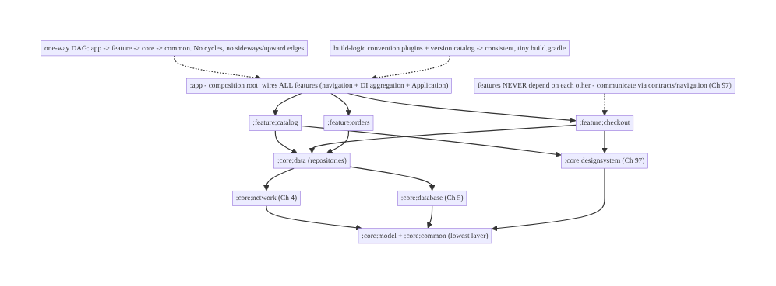
94.4 High-Level Architecture
Components & ownership
- :app composition root — wires all features (navigation + DI, Ch 46); thin.
- :feature:* — isolated flows; depend only on core; never each other.
- :core:* — shared (network/db/designsystem/data/common/model), layered; depend downward only.
- Boundaries enforced by the one-way DAG; config by convention plugins.
Direction: app → feature → core → common (one-way DAG); features isolated; internals hidden (implementation); DI spans modules; config centralized.

94.5 Detailed Component Design
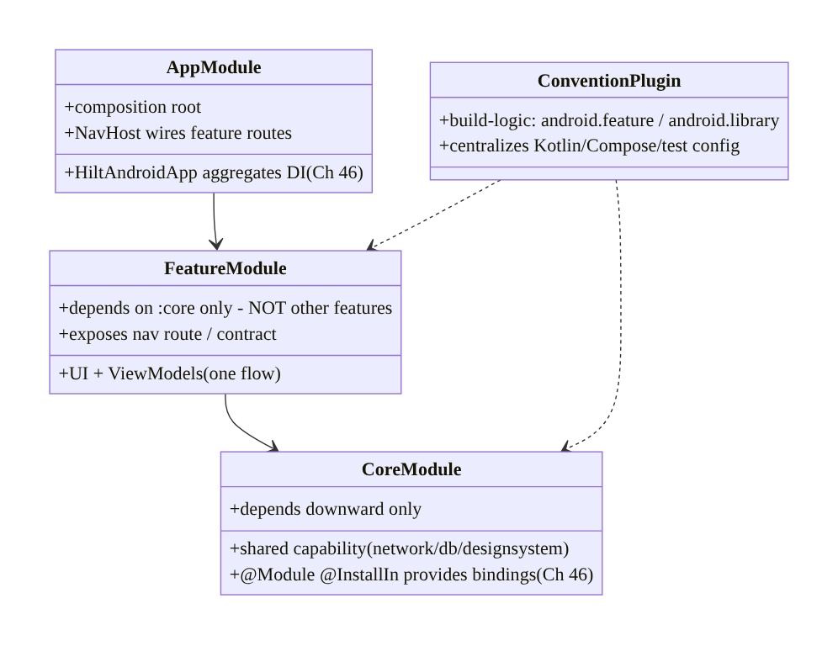
94.5 Detailed Component Design
Component | Responsibility
:app | composition root — wire features (nav + DI aggregation, Ch 46); thin shell
:feature:* | one flow (UI+VM); depend only on core; expose route/contract
:core:* | shared capability; provide DI bindings; depend downward only
build-logic | convention plugins — centralize Kotlin/Compose/Android/test config

94.6 End-to-End Data Flow

Build graph: a change rebuilds only affected modules
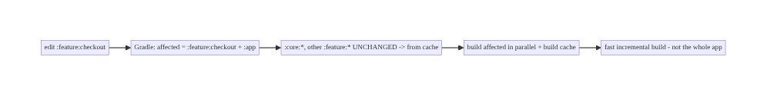
Build graph: a change rebuilds only affected modules

Cross-module interaction (via contract, not internals)
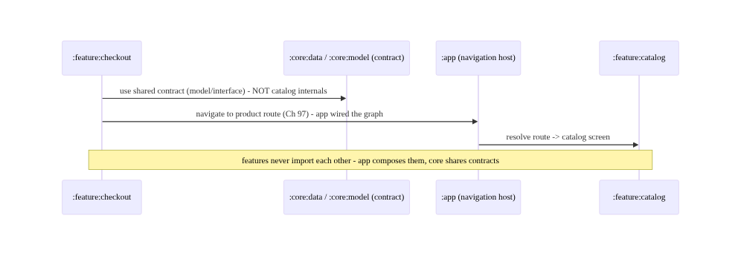
Cross-module interaction (via contract, not internals)

94.7 Implementation (Gradle + Kotlin)
Repo layout and build config.

94.7.1 Module layout + settings.gradle
// settings.gradle.kts
include(":app")
include(":feature:catalog", ":feature:checkout", ":feature:orders", ":feature:account")
include(":core:data", ":core:network", ":core:database", ":core:designsystem", ":core:common", ":core:model")
includeBuild("build-logic") // convention plugins
// Dependency DAG: :app -> :feature:* -> :core:data -> :core:network/:core:database -> :core:model/:core:common

94.7.2 Convention plugin (build-logic) — centralized config
// build-logic/convention/.../AndroidFeatureConventionPlugin.kt
class AndroidFeatureConventionPlugin : Plugin<Project> {
override fun apply(target: Project) = with(target) {
pluginManager.apply("streamcart.android.library") // base Android+Kotlin+Compose config
pluginManager.apply("dagger.hilt.android.plugin") // Hilt for every feature (Ch 46)
dependencies {
add("implementation", project(":core:data")) // features depend on core
add("implementation", project(":core:designsystem")) // Ch 97
add("implementation", project(":core:common"))
// NOTE: no feature depends on another feature - enforced here + by the graph
}
}
}

94.7.3 A feature module’s tiny build.gradle
// feature/checkout/build.gradle.kts - tiny, thanks to the convention plugin
plugins { id("streamcart.android.feature") } // all shared config applied
android { namespace = "com.streamcart.feature.checkout" }
dependencies {
implementation(libs.androidx.compose.ui) // feature-specific extras only
// NO implementation(project(":feature:catalog")) - features never depend on each other
}

94.7.4 api vs implementation (encapsulation + build speed)
// core/data/build.gradle.kts
dependencies {
api(project(":core:model")) // model types APPEAR in :core:data's public API -> expose (api)
implementation(project(":core:network")) // network is an INTERNAL detail -> hide (implementation)
implementation(project(":core:database")) // database internal -> hide
// Consumers of :core:data see :core:model, but NOT :core:network/:core:database.
// Changing :core:network does NOT recompile features (implementation) -> faster builds.
}

94.7.5 Cross-module Hilt DI (Ch 46)
// :core:network provides its bindings; features consume without seeing internals
@Module @InstallIn(SingletonComponent::class) // Ch 46 - installed into the app-wide graph
object NetworkModule {
@Provides @Singleton fun okHttp(): OkHttpClient = OkHttpClient.Builder().build() // Ch 4
@Provides @Singleton fun retrofit(client: OkHttpClient): Retrofit = /* ... */ TODO()
}
// :feature:checkout just @Injects a repository from :core:data - Hilt resolves across modules.
@HiltViewModel class CheckoutViewModel @Inject constructor(private val repo: OrderRepository) : ViewModel()
// :app hosts @HiltAndroidApp -> aggregates ALL modules' bindings into one graph (composition root).

94.7.6 Module structure
:app composition root: NavHost (wires feature routes), @HiltAndroidApp, Application
:feature:catalog/checkout/orders/account isolated flows (UI+VM), depend on :core only
:core:data repositories (api :core:model; implementation :core:network/:core:database)
:core:network (Ch 4), :core:database (Ch 5), :core:designsystem (Ch 97)
:core:common, :core:model lowest layer (utilities, data types) - everyone depends on these
build-logic convention plugins (android.feature/library) + version catalog

94.8 Concurrency and Race Conditions
Modularization is a build-time / structural concern; the analog of “races” are build-graph and boundary hazards:
Scenario | Risk | Handling
Dependency cycle | build fails | enforce one-way DAG (app→feature→core→common)
Feature depends on feature | coupling/tangle | forbid; use contracts/navigation (Ch 97)
Overusing api | recompile cascade + coupling | default implementation
Core depends on feature | inverted layering | core depends downward only
Inconsistent module config | drift/bugs | convention plugins (build-logic)
Too-fine granularity | Gradle overhead | right-size (per-feature + layered core)
DI binding in wrong module | leaks/duplication | bindings in the owning module (Ch 46)
- The build graph is the enforcement mechanism: unlike runtime architecture rules (which erode), a missing dependency edge makes an illegal import a compile error — the architecture is enforced mechanically, not by discipline.
- implementation is the default for a reason: it both encapsulates (consumers can’t reach internals) and speeds builds (no recompile when an internal dep changes). Reserve api for types that genuinely appear in the public surface.
- Parallel builds + build cache turn modularization’s structure into speed: independent modules build concurrently, and unchanged modules come from cache (local or remote, shared across the team/CI).

94.9 Failure Scenarios and Recovery
Failure | Detection | Response | Outcome
Slow monolith builds | build profiling | modularize; incremental/parallel/cache | fast
Dependency cycle | Gradle error | break cycle (move shared code to core) | DAG restored
Feature↔feature coupling | illegal import | contracts/navigation/api-impl (Ch 97) | isolated
Recompile cascade | build profiling | api→implementation | fast rebuilds
Config drift across modules | inconsistency | convention plugins (build-logic) | consistent
Merge collisions | git conflicts | feature-module ownership | parallel teams
Architecture erosion | review/graph audit | build-graph enforcement | enforced
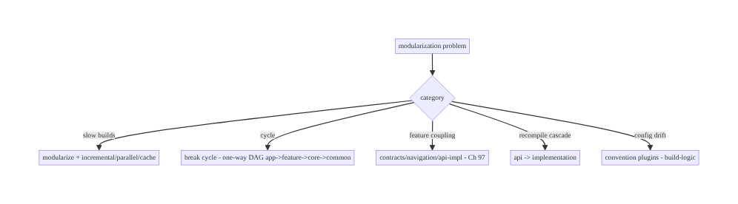
94.9 Failure Scenarios and Recovery
Let the build graph enforce the architecture. Modularize into app/feature/core with a one-way DAG so illegal dependencies become compile errors; keep features isolated (contracts/ navigation, Ch 97), default to implementation to encapsulate and speed builds, aggregate DI at the :app composition root (Ch 46), and centralize config in convention plugins. The payoff — fast incremental/parallel/cached builds, parallel teams, enforced architecture — is why large apps modularize.

94.10 Scaling the Implementation
- Level 1. Split :app + a few :core modules (network, database, common); enable Gradle parallel + build cache.
- Level 2. Per-feature modules; one-way DAG; api/implementation discipline; cross-module Hilt (Ch 46); design-system module (Ch 97).
- Level 3 — production. Convention plugins (build-logic) + version catalogs; feature api/impl split where needed; remote build cache (CI/team); module-ownership map.
- Level 4 — enterprise. Hundreds of modules; dependency-graph governance (lint rules forbidding bad edges); affected-module-only CI; dynamic feature modules for optional flows; build-scan-based optimization.
- Level 5 — org scale. Monorepo tooling, module-graph visualization + budgets, build-time SLOs, shared core libraries across apps, platform teams owning :core, automated architecture-fitness functions.
Avoid overengineering: per-feature + layered-core modules with a one-way DAG, convention plugins, and implementation-by-default covers most apps. Don’t over-split into hundreds of tiny modules; don’t let features depend on each other; don’t overuse api; don’t duplicate build config.

94.11 Alternative Approaches and Trade-offs
Dimension | Option A | Option B | When
Structure | Multi-module (app/feature/core) | monolith (single module) | Multi-module at scale
Dependencies | One-way DAG | tangled/cyclic | DAG always
Feature interaction | Contracts/navigation (Ch 97) | direct feature deps | Contracts (isolation)
Visibility | implementation default | api everywhere | implementation (speed+encap)
Feature structure | api/impl split | single feature module | api/impl for swappable/large
Config | Convention plugins | per-module copy-paste | Convention plugins
Delivery | Standard modules | dynamic feature modules | Dynamic for optional/large flows
Multi-module vs monolith: a monolith is simplest for small apps but at scale gives slow builds (recompile everything), merge collisions, and eroding architecture (any import allowed). Multi-module gives fast incremental/parallel/cached builds, parallel teams, and build-enforced architecture — at the cost of setup complexity (Gradle, DI across modules). Modularize when build time/team size/architecture erosion justify it.
implementation vs api: api exposes a dependency to consumers (they can use it and recompile when it changes) — convenient but creates coupling + recompile cascades. implementation hides it (encapsulation + no cascade). Default to implementation; use api only when a type genuinely appears in your public API. This is a top build-speed lever.
Feature api/impl split vs single feature module: a single :feature:x is simpler; an :feature:x:api (interfaces) + :feature:x:impl split lets other code depend only on the api (not the implementation) — enabling swappability, better build parallelism, and tighter isolation — at the cost of more modules. Use api/impl for large or cross-depended features; keep small ones single.

94.12 Security & Privacy Considerations
- Module boundaries limit blast radius (Ch 20/24): security-sensitive capabilities (auth Ch 20, crypto/keystore Ch 24, payments Ch 76) live in dedicated core modules with narrow public APIs (implementation-hidden internals) — a feature can’t reach into the keystore wiring, only the exposed contract. Modularization enforces least privilege structurally.
- Secrets stay in their module (Ch 24): keys/config live in the owning :core module (not spread across features); the module’s public API exposes operations, not secrets.
- Dynamic feature modules + integrity: on-demand modules are delivered by Play; ensure code integrity (signed, Play-delivered) — don’t load untrusted code (Ch 24).
- Build-logic is privileged code (supply chain): convention plugins run at build time with full access — treat build-logic as trusted, reviewed code; a compromised build plugin is a supply-chain risk (Ch 92/24).
- Per-module lint/rules for security: forbid, via graph rules, a feature depending directly on a sensitive internal module — enforce access through the vetted API.
- Build-time/structural concern: the security value is structural least privilege (boundaries limit what each module can reach) and supply-chain hygiene for build-logic (Ch 24).

94.13 Performance and Resource Optimization
- Build performance is the point — incremental (rebuild only affected modules), parallel (independent modules concurrently), build cache (local + remote; unchanged modules from cache), configuration cache (skip configuration phase). Modularization enables all four.
- implementation over api — the biggest recompile-cascade reducer (changing an internal dep doesn’t recompile consumers).
- Right-size modules — enough to parallelize/cache, not so fine that Gradle configuration overhead dominates.
- Convention plugins + version catalogs — fast, consistent configuration; configuration cache friendly.
- Affected-only CI — build/test only modules touched by a change (and dependents).
- Profiling: build scans (task timing, cache hit rate), configuration time, module graph (fan-in/out), incremental-build time per typical change, remote-cache effectiveness.

94.14 Testing Strategy
Each module tests independently (faster, parallel); the graph/boundaries are verified by the build + lint.
// Each module has its own tests, run independently and in parallel:
// :core:data -> repository unit tests (fakes for :core:network/:core:database)
// :feature:checkout -> ViewModel + UI tests (fakes for :core:data) - no other feature needed
// :core:designsystem-> component screenshot/behavior tests (Ch 97)
// Boundary enforcement (verified mechanically):
// - Dependency DAG: Gradle fails on cycles; a lint/graph rule forbids feature->feature edges.
// - api/implementation: changing an `implementation` dep does NOT recompile consumers (build check).
class CheckoutViewModelTest { // tests in isolation with a FAKE core:data repo
@Test fun `places order via core contract`() = runTest { /* fake OrderRepository (core contract) */ }
}
// Affected-module CI: a change to :feature:checkout runs only its tests + dependents, in parallel.
What to test: each module in isolation (fakes for its core deps) — faster + parallel; dependency DAG (no cycles — Gradle; no feature→feature — lint/graph rule); api/implementation encapsulation (consumers can’t see hidden deps); cross-module DI resolves (Ch 46). CI runs affected modules only, in parallel.

94.15 Production Observability
- Build metrics (the key “production” here is the build/CI): build time (clean + incremental) by change type, cache hit rate (local + remote), configuration time, affected-module count per change, module graph health (fan-in/out, cycles=0), CI build/test duration.
- Logs: Gradle build scans (task timing, cache, dependency resolution).
- Debugging: slow builds → build scan (which tasks? cache misses? api cascades?); cycle → Gradle error (break it); feature coupling → graph/lint violation; config drift → convention-plugin audit; recompile cascade → find the api dep to make implementation.
- Alerting: build-time regression (a change made builds slower — e.g., a new api cascade); cache-hit-rate drop; a new dependency cycle / illegal edge (CI fails).
- Dashboards: build-time trends, cache effectiveness, module-graph metrics, affected-module distribution, CI duration by module.

94.16 System Design Interview Preparation
≥40 questions (Complex).
Fundamentals
- Why modularize? Build speed, parallel teams, enforced architecture, reuse.
- Monolith problems? Slow builds, collisions, architecture erosion.
- Module types? :app, :feature:*, :core:*.
- :app role? Composition root — wires all features (nav + DI).
- Feature module? One self-contained flow; depends on core only.
Dependency graph
- Dependency direction? One-way: app → feature → core → common.
- Cycles? Forbidden — Gradle fails; it’s a DAG.
- Core depend on feature? Never — downward only.
- Features depend on each other? Never — contracts/navigation.
- What enforces architecture? The build graph (compile errors).
Feature isolation
- How do features interact? Shared contract (core), navigation (app-wired), api/impl.
- api/impl split? :feature:x:api (interfaces) + :impl — depend on api only.
- Why isolate? Swappable, independently buildable, no tangle.
api vs implementation
- implementation? Internal dep — hidden, no recompile cascade.
- api? Exposed dep — consumers use + recompile.
- Default? implementation.
- When api? Type appears in your public API.
- Why it matters? Build speed + encapsulation.
DI across modules
- Hilt across modules? Core provides, feature consumes, app aggregates (Ch 46).
- Bindings where? In the owning module.
- @HiltAndroidApp? In :app — aggregates the graph.
- Feature sees other’s internals? No — Hilt resolves across the graph.
Build config
- Convention plugins? build-logic — centralize shared Gradle config.
- Version catalogs? Centralize dependency versions.
- Why? Hundreds of modules stay consistent; tiny build.gradle.
Granularity/build
- Granularity? Per-feature + layered core; not too fine.
- Too fine? Gradle overhead + navigation pain.
- Build speed from? Incremental + parallel + build cache.
- Build cache? Reuse unchanged module outputs (local/remote).
- Configuration cache? Skip configuration phase.
Dynamic features
- Dynamic feature module? On-demand install (Play) — smaller install.
- When? Large/optional flows.
Edge cases/production
- Break a cycle? Move shared code to a lower core module.
- Recompile cascade? An api dep — make it implementation.
- Affected-only CI? Build/test only touched modules + dependents.
- Shared code across apps? Reusable core modules.
- Enforce no-bad-edges? Lint/graph rules in CI.
- Test a module? In isolation with fakes for core deps.
- Module ownership? Teams own feature/core modules.
- build-logic risk? Supply-chain — it’s privileged build code.
- Measure build? Build scans (timing, cache).
- :core:model/common? Lowest layer — pure types/utilities.

Design-change challenges
- Modularize a monolith. app/feature/core decomposition + one-way DAG.
- Speed up builds. api→implementation, parallel, build cache, affected-only CI.
- Stop feature coupling. Contracts/navigation/api-impl (Ch 97).
- Standardize 50 modules’ config. Convention plugins + version catalogs.
- Enforce architecture. Build-graph + lint rules forbidding illegal edges.

Mock walkthrough (abridged)
Clarify (app size, team count, build pain?) → decompose (:app composition root, :feature:*, :core:*) → one-way dependency DAG (app→feature→core→common, no cycles) → feature isolation (contracts/navigation/api-impl, Ch 97) → implementation default / api sparingly → cross-module Hilt (core provides, app aggregates, Ch 46) → convention plugins + version catalogs → granularity (per-feature + layered core) → build speed (incremental/parallel/cache) → observability (build metrics).

94.17 Practical Exercises
- Beginner. Extract :core:network (Ch 4) and :core:common from a monolith; enable Gradle parallel + build cache. Eval: modules build; faster incremental build.
- Intermediate. Create :feature:checkout depending only on :core:* (not other features), with cross-module Hilt (Ch 46) and a tiny build.gradle. Eval: isolated; DI resolves.
- Advanced. Add a build-logic convention plugin (android.feature) + version catalog, and convert api deps to implementation where possible. Eval: consistent config; recompile cascade reduced.
- Production debugging. Use a build scan to find a recompile cascade (an api dep) and a dependency cycle; fix both. Eval: faster builds; DAG restored.
- System design challenge. Design the module graph + enforcement (lint rules forbidding feature→feature and upward edges) + affected-only CI for a 100-module app. Eval: enforced, fast, scalable.
(Solutions withheld unless requested.)

94.18 Chapter Summary & Reference Sheet
Key decisions: decompose a large app into many Gradle modules — a thin :app composition root (the only module aware of all features; it wires them via navigation + DI aggregation + the Application, Ch 46), self-contained :feature:* modules that depend only on :core:* and never on each other, and shared layered :core:* modules (network Ch 4, database Ch 5, design system Ch 97, data, common, model) — with dependencies forced into a one-way Directed Acyclic Graph (app → feature → core → common, no cycles, no upward or sideways edges) so the build graph itself enforces layering and feature isolation as compile errors; features that must interact do so through shared contracts, a navigation route the app wires (Ch 97), or an api/impl split — never by importing each other’s internals; default every dependency to implementation (internal, no recompile cascade, encapsulated) and use api only for types genuinely in a module’s public surface, because that choice is among the biggest build-speed and coupling levers; wire Hilt across modules (core provides, features consume, :app aggregates into one graph, Ch 46); centralize build config in convention plugins (build-logic) plus version catalogs so hundreds of modules stay consistent with tiny build.gradle files; and pick a granularity (per-feature + layered core) that maximizes incremental/parallel/cached build speed and team parallelism without drowning in tiny modules — for the payoff of fast builds (rebuild only affected modules), many teams in parallel, build-enforced architecture, and reusable core.
Concepts: module types (app/feature/core/common/model), one-way dependency DAG + cycle avoidance, api vs implementation (encapsulation + recompile cascades), feature isolation via contracts/navigation/api-impl (Ch 97), cross-module Hilt DI (Ch 46), :app composition root, convention plugins + version catalogs (build-logic), granularity, build speed (incremental/parallel/ cache), dynamic feature modules.
Common mistakes: staying monolithic at scale (slow builds, erosion); feature→feature dependencies (tangle); dependency cycles / upward edges; overusing api (recompile cascades + coupling); duplicating build config across modules; over-splitting into hundreds of tiny modules; putting DI bindings in the wrong module; :app holding business logic (should be a thin shell).
Checklist:
- ☐ :app (thin composition root) + :feature:* + :core:* decomposition
- ☐ one-way DAG (app→feature→core→common); no cycles
- ☐ features never depend on each other (contracts/navigation/api-impl, Ch 97)
- ☐ implementation default; api only for public-surface types
- ☐ cross-module Hilt (core provides, app aggregates, Ch 46)
- ☐ convention plugins (build-logic) + version catalogs
- ☐ right-size granularity (per-feature + layered core)
- ☐ parallel + build cache + configuration cache
- ☐ affected-module-only CI
- ☐ lint/graph rules forbidding illegal edges.
Key Gradle/APIs: settings.gradle.kts include/includeBuild, project(":core:x") deps, api/implementation configurations, build-logic convention plugins (Plugin<Project>), version catalog (libs.versions.toml), Gradle --parallel / build cache / configuration cache, Hilt @Module @InstallIn(SingletonComponent::class) / @HiltAndroidApp (Ch 46), dynamic feature modules (com.android.dynamic-feature), build scans, module-graph/lint rules.
References: - Android modularization guide: https://developer.android.com/topic/modularization - Now in Android (modularization reference app): https://github.com/android/nowinandroid - Gradle build performance: https://docs.gradle.org/current/userguide/performance.html - api vs implementation: https://docs.gradle.org/current/userguide/java_library_plugin.html - (composes) Ch 46 DI/Hilt, Ch 1 Architecture, Ch 88 Build/Startup, Ch 92 R8, Ch 97 Design System, Ch 100 Capstone

Chapter 95 — Localization, RTL & Regionalization
Part XI — Reach, Scale & Platform Breadth · Complexity: Standard (≥25 interview questions)
Prerequisites: Ch 2 (Compose UI), Ch 97 (theming/config), Ch 44 (config changes), Ch 1 (architecture). Pairs with Ch 96 (accessibility), Ch 100 (capstone).
Reference surface in StreamCart: reaching a global audience — translating UI text (string resources, no hardcoded strings), supporting RTL languages (Arabic/Hebrew) via start/end layout, formatting numbers, dates, currencies, and plurals per locale (ICU), and regionalizing content/behavior (currency, tax, catalog, legal) — so the app is correct and natural in every market, not just an English app with swapped words.

95.1 Problem Definition and Real-World Context
Shipping globally means the app must be correct and natural in each user’s language, script direction, and region — not an English app with translated words. Localization (l10n) translates UI text; internationalization (i18n) is designing the app so it can be localized (no hardcoded strings, no assumptions about text direction/length/format); regionalization adapts content and behavior per region (currency, tax, catalog, legal, units). The core discipline: externalize all user-facing text into string resources (never hardcode), support RTL by using start/end (not left/right) throughout, format numbers/dates/currencies/plurals per locale with ICU (never concatenate or assume formats), and regionalize data/behavior. Get it wrong and the app shows untranslated strings, broken RTL layouts, wrong number/date/currency formats, broken plurals, and truncated/overflowing text — all of which make it feel foreign and broken in non-English markets.
Concretely, teams hit:
- Hardcoded strings (the #1 i18n bug). Text literals in code/XML can’t be translated. Every user-facing string must live in strings.xml (R.string.* / stringResource) so translators can localize it per language (values-es/, values-ar/, …).
- No RTL support. Using left/right (margins, gravity, drawables) breaks RTL languages (Arabic, Hebrew), where the layout should mirror. Use start/end everywhere, set supportsRtl="true", and the layout mirrors automatically; test RTL.
- Locale-wrong formatting. Formatting numbers (1,000.5 vs 1.000,5), dates (MM/DD vs DD/MM), times (12h vs 24h), and currencies by string concatenation or a fixed format is wrong per locale. Use ICU / locale-aware formatters (NumberFormat, DateTimeFormatter, java.text/android.icu).
- Broken plurals. "$count items" is wrong — plural rules vary by language (English: 1/ many; Arabic: zero/one/two/few/many/other; Polish: complex). Use plurals resources (getQuantityString) / ICU MessageFormat, never string concatenation.
- String concatenation / word order. Building sentences by concatenating fragments breaks in languages with different word order. Use parameterized strings with placeholders (%1$s) so translators reorder.
- Text expansion / truncation. Translations can be 30–200% longer (German, Finnish); fixed-width layouts truncate/overflow. Design flexible layouts; test with long translations/pseudolocales.
- Regionalization ≠ translation. The same language differs by region (en-US vs en-GB: spelling, date, currency; es-ES vs es-MX). And behavior differs: currency, tax, catalog availability, legal/consent (Ch 28), units (metric/imperial). Regionalize content + behavior, not just words.
- Per-app language (Android 13+). Users can set a per-app language (AppCompat/ LocaleManager) independent of the device — the app must honor it. Also handle locale change as a config change (Ch 44).
- Translation pipeline / untranslated fallback. Missing translations must fall back (to the default values/), and a pipeline (export strings → translate → import) keeps translations in sync as strings change. Pseudolocalization catches issues early.
The architecture: externalize all user-facing text into string resources (never hardcode; per-language values-xx/), support RTL with start/end everywhere (+ supportsRtl, mirror drawables), format numbers/dates/times/currencies with locale-aware ICU formatters (never concatenate or assume), handle plurals with plurals/ICU MessageFormat, use parameterized strings for correct word order, design flexible layouts for text expansion, and regionalize content + behavior (currency, tax, catalog, legal, units) per region — honoring per-app language (Android 13+) and locale config changes (Ch 44), with a translation pipeline and fallback. This chapter is about being correct and natural in every market.

Three practical use cases
- Translate + RTL StreamCart. All strings in strings.xml, translated to values-es/ar/de/ ja; start/end layout mirrors correctly for Arabic (RTL); tested with pseudolocales for expansion.
- Locale-correct price/date. Product prices formatted with currency + locale ($1,234.56 vs 1.234,56 €), order dates per locale (DD/MM/YYYY vs MM/DD/YYYY) — via ICU formatters, never concatenation.
- Regionalize checkout. Currency, tax rules, available catalog, and legal/consent (Ch 28) adapt by region — not just translated text.

Why this is architectural
Localization composes UI (Ch 2), theming/config (Ch 97), config changes (Ch 44), and architecture (Ch 1), and interacts with privacy/legal (Ch 28). The decisions — externalized strings, RTL via start/end, locale-aware formatting, plurals, flexible layouts, regionalized behavior — determine whether the app reaches global markets correctly or ships broken for most of the world.

95.2 Requirements Engineering

Functional requirements
ID | Requirement
F1 | Externalize all user-facing text into string resources (never hardcode); per-language values-xx/.
F2 | Support RTL: start/end everywhere, supportsRtl, mirror drawables; test RTL.
F3 | Format numbers/dates/times/currencies with locale-aware ICU formatters.
F4 | Handle plurals (plurals resources / ICU MessageFormat); parameterized strings for word order.
F5 | Design flexible layouts for text expansion; test with pseudolocales/long translations.
F6 | Regionalize content + behavior (currency, tax, catalog, legal, units); honor per-app language + locale changes (Ch 44).

Non-functional requirements
Attribute | Policy
Correctness | Natural in each locale (format, plurals, direction).
Reach | Every target market correct; fallback for missing.
Flexibility | Layouts survive text expansion + RTL.
Maintainability | Translation pipeline; no hardcoded strings.
Compliance | Regional legal/consent (Ch 28).

Scope
- In scope: string externalization (strings.xml, values-xx/), i18n vs l10n vs regionalization, RTL (start/end, supportsRtl, mirroring), locale-aware formatting (numbers/ dates/times/currencies, ICU), plurals (plurals/MessageFormat), parameterized strings/word order, text expansion/flexible layouts, pseudolocalization, per-app language (Android 13+), locale config changes (Ch 44), regionalization (currency/tax/catalog/legal/units), translation pipeline + fallback.
- Out of scope: Compose UI basics (Ch 2), theming (Ch 97), config-change detail (Ch 44), accessibility (Ch 96), privacy/consent detail (Ch 28).

Assumptions & constraints
- Compose/Views with strings.xml resources; supportsRtl="true"; ICU formatters (android.icu/ java.text); AppCompat/LocaleManager for per-app language (Android 13+). All user-facing text externalized; layouts use start/end; formatting locale-aware. minSdk 24.

95.3 System Design Fundamentals
- i18n vs l10n vs regionalization (the three concepts). Internationalization (i18n) is designing the app so it can be localized — no hardcoded strings, no left/right assumptions, no format assumptions, flexible layouts. Localization (l10n) is translating (and adapting formats) for a specific language/locale. Regionalization adapts content and behavior for a region (currency, tax, catalog, legal) — beyond language. You i18n once (architecturally), then l10n per language and regionalize per market.
- Externalize all strings (resources, the foundation). Every user-facing string lives in res/values/strings.xml (R.string.* / stringResource(R.string.x)), never hardcoded in code/layout. Translations go in values-<lang>/strings.xml (values-es/, values-ar/, values-de/, values-ja/, with region qualifiers like values-es-rMX/). Android selects the right file by the user’s locale, falling back to default values/ for missing translations. This separation lets translators work without touching code.
- RTL support (start/end, mirroring). For RTL languages (Arabic, Hebrew, Persian, Urdu), the UI should mirror — text right-aligned, layout flowing right-to-left, back arrows flipped. Achieve it by: (1) android:supportsRtl="true"; (2) using start/end instead of left/ right for all padding/margin/gravity/constraints (Compose uses start/end by default; it auto-mirrors); (3) auto-mirroring drawables (autoMirrored) for directional icons; (4) testing in RTL (force RTL in dev options / a pseudolocale). Hardcoded left/right is the main RTL bug.
- Locale-aware formatting (ICU, never concatenate). Numbers, dates, times, and currencies have locale-specific formats: decimal/grouping separators (1,234.56 en vs 1.234,56 de), date order (MM/DD/YYYY en-US vs DD/MM/YYYY en-GB vs YYYY/MM/DD ja), 12h/24h, currency symbol + placement ($1,234.56 vs 1 234,56 €). Always use locale-aware formatters — NumberFormat.getCurrencyInstance(locale), DateTimeFormatter.ofLocalizedDate(...), android.icu.* — never build formats by concatenation or assume a format. Currency needs both the currency (USD/EUR — a data/region concern) and the locale (formatting).
- Plurals (quantity strings / ICU MessageFormat). Plural rules vary drastically: English has 2 forms (one/other), Arabic has 6 (zero/one/two/few/many/other), Polish/ Russian have complex rules. "$count items" is wrong. Use plurals resources (<plurals> + getQuantityString(R.plurals.items, count, count)) or ICU MessageFormat, which encode the correct per-language rules. Never concatenate a count with a noun.
- Parameterized strings & word order. Languages differ in word order and grammar. Concatenating fragments ("Added " + name + " to cart") breaks when a language needs a different order. Use parameterized strings with positional placeholders ("Added %1$s to cart" → translators reorder as "%1$s a été ajouté…"). One string per sentence, placeholders for variables.
- Text expansion & flexible layouts. Translations vary in length — German/Finnish can be +30–200% vs English; some scripts are taller. Fixed-width/height layouts truncate or overflow. Design flexible (wrap, constraints, scrollable, avoid fixed sizes for text), and test with long translations and pseudolocalization (en-XA/ar-XB — expands text, adds accents, forces RTL) to catch issues before translation.
- Per-app language & locale changes (Android 13+, Ch 44). Android 13+ lets users set a per- app language (independent of device) via system settings / LocaleManager / AppCompatDelegate.setApplicationLocales. The app must honor it and persist it. A locale change is a configuration change (Ch 44) — the activity recreates and resources re-resolve; state must survive (Ch 44). Support locale lists (user’s ordered preferences).
- Regionalization (content + behavior). Beyond language: currency (what to charge), tax/VAT rules, catalog/availability (different products per market), legal/consent (GDPR in EU, Ch 28), units (metric/imperial), payment methods (Ch 76), address formats, phone formats, first day of week. Regionalization is a data + business-logic concern driven by the user’s region (not just language) — often server-driven.
- Translation pipeline & fallback. Keep translations in sync via a pipeline: export strings → translate (TMS/vendor) → import, with versioning and missing-translation fallback (to default). Mark non-translatable strings (translatable="false" for brand names, format patterns). Catch missing/overflowing translations in CI with pseudolocales.
Core insight: reach a global audience by internationalizing the app once (so it can be localized) and then localizing and regionalizing per market: externalize every user-facing string into resources (strings.xml, never hardcoded, with per-language values-xx/ files Android auto-selects and falls back from), support RTL by using start/end instead of left/right everywhere plus supportsRtl and auto-mirrored drawables so Arabic/Hebrew layouts mirror correctly, format all numbers/dates/times/currencies with locale-aware ICU formatters rather than concatenation or fixed patterns (because separators, date order, 12/24h, and currency placement all vary by locale), handle plurals with plurals resources or ICU MessageFormat (plural rules range from English’s 2 forms to Arabic’s 6, so count+noun concatenation is always wrong), use parameterized strings with positional placeholders so translators can reorder for each language’s word order, and design flexible layouts tested with pseudolocales because translations can be 30-200% longer and truncate fixed widths; then regionalize content and behavior — currency, tax, catalog, legal/consent (Ch 28), units, payment methods — by the user’s region, not just their language; honor the per-app language setting (Android 13+) and treat locale change as a config change (Ch 44); and maintain a translation pipeline with fallback — because a global app must be correct and natural in every market, not an English app with swapped words.

95.4 High-Level Architecture
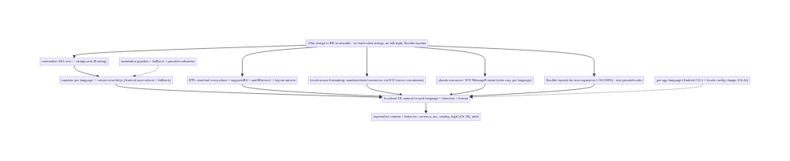
95.4 High-Level Architecture
Components & ownership
- i18n (externalize strings, start/end, flexible layouts, locale formatters) — the architectural foundation.
- l10n (translate per language, RTL, format, plurals) — per-language correctness.
- Regionalization (currency/tax/catalog/legal/units) — per-market behavior.
- Per-app language + config change (Ch 44); pipeline + fallback.
Direction: i18n once (externalize + start/end + ICU + flexible) → l10n per language (translate + RTL + format + plurals) → regionalize per market (content + behavior); per-app language + pipeline.

95.5 Detailed Component Design
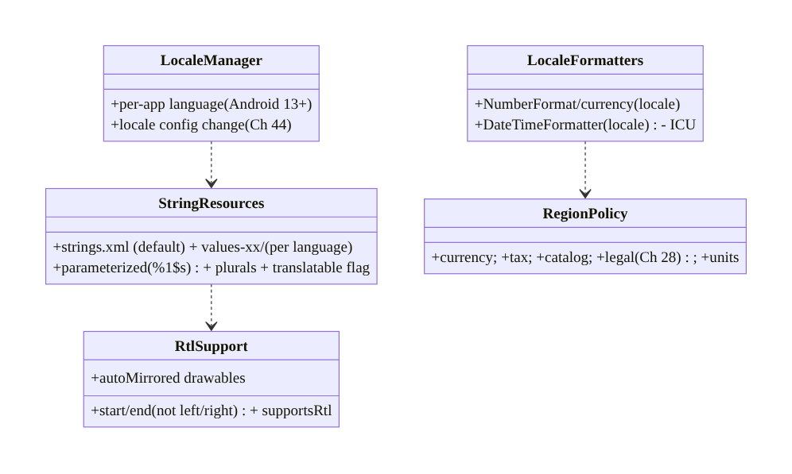
95.5 Detailed Component Design
Component | Responsibility
StringResources | externalized, parameterized, pluralized text per language
RtlSupport | start/end + supportsRtl + mirrored drawables
LocaleFormatters | locale-aware number/date/currency formatting (ICU)
RegionPolicy | regionalized currency/tax/catalog/legal/units (Ch 28)
LocaleManager | per-app language + locale config change (Ch 44)

95.6 End-to-End Data Flow

Locale selection → resources + formatting
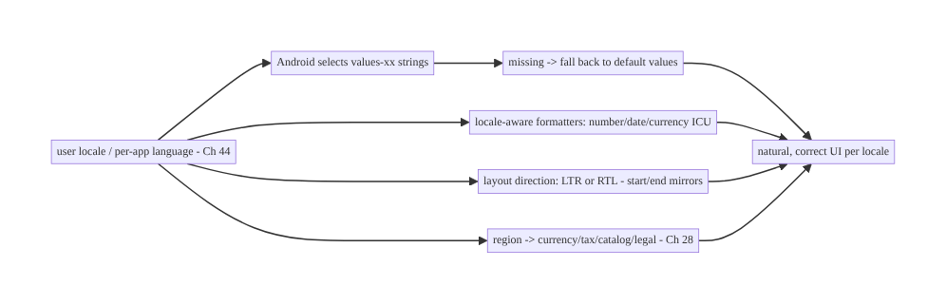
Locale selection → resources + formatting

RTL mirroring (start/end vs left/right)
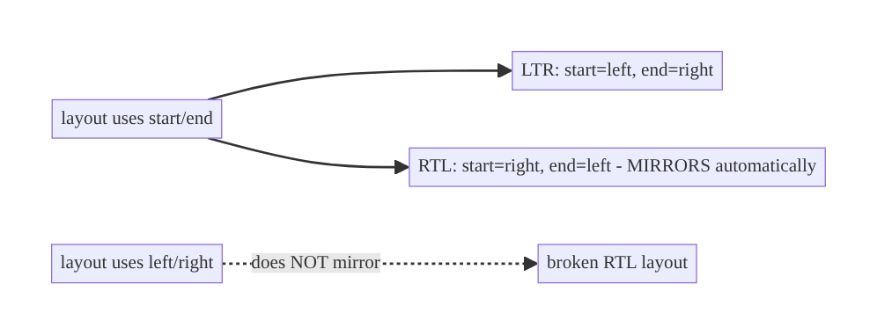
RTL mirroring (start/end vs left/right)

95.7 Implementation (Kotlin + resources)
Package: com.streamcart.i18n.

95.7.1 Externalized, parameterized, pluralized strings
<!-- res/values/strings.xml (default/English) -->
<resources>
<string name="add_to_cart">Add to cart</string>
<string name="added_item">Added %1$s to cart</string> <!-- parameterized -> translators reorder -->
<plurals name="items_in_cart"> <!-- plural rules per language -->
<item quantity="one">%1$d item</item>
<item quantity="other">%1$d items</item>
</plurals>
<string name="brand" translatable="false">StreamCart</string> <!-- don't translate brand -->
</resources>
<!-- res/values-ar/strings.xml (Arabic) provides translations; values-de/ German; etc. -->
// Usage - NEVER hardcode user-facing text:
Text(stringResource(R.string.add_to_cart)) // externalized
Text(stringResource(R.string.added_item, product.name)) // parameterized
Text(pluralStringResource(R.plurals.items_in_cart, count, count)) // correct plurals

95.7.2 RTL: start/end (not left/right)
// Compose uses start/end by default and auto-mirrors for RTL - DON'T hardcode left/right:
Row(Modifier.padding(start = 16.dp, end = 8.dp)) { // mirrors in RTL
Icon(Icons.AutoMirrored.Filled.ArrowBack, null) // AutoMirrored -> flips in RTL
Text(product.title, textAlign = TextAlign.Start) // Start, not Left
}
// Manifest: <application android:supportsRtl="true"> ; test with forced RTL / pseudolocale ar-XB.

95.7.3 Locale-aware formatting (ICU, never concatenate)
@Singleton
class LocaleFormatters @Inject constructor() {
/** Currency: needs the CURRENCY (data) + the user's LOCALE (formatting). */
fun price(amountMinor: Long, currency: String, locale: Locale = Locale.getDefault()): String {
val fmt = NumberFormat.getCurrencyInstance(locale) // locale-aware (symbol + placement)
fmt.currency = Currency.getInstance(currency) // USD/EUR from region data
return fmt.format(amountMinor / 100.0) // "$1,234.56" / "1.234,56 €"
}
fun date(instant: Instant, locale: Locale = Locale.getDefault()): String =
DateTimeFormatter.ofLocalizedDate(FormatStyle.MEDIUM).withLocale(locale) // locale date order
.format(instant.atZone(ZoneId.systemDefault()))
// NEVER: "$" + amount, or "${d}/${m}/${y}" - locale-wrong.
}

95.7.4 Per-app language (Android 13+) + locale change (Ch 44)
// Per-app language (Android 13+ via AppCompat) - independent of device locale:
fun setAppLanguage(tag: String) {
AppCompatDelegate.setApplicationLocales(LocaleListCompat.forLanguageTags(tag)) // e.g. "ar", "de"
// Triggers a config change (Ch 44) - activity recreates, resources re-resolve, state must survive.
}
// Locale change is a configuration change (Ch 44): keep state in ViewModel/rememberSaveable.

95.7.5 Regionalization (content + behavior)
// Region drives BEHAVIOR, not just language (often server-driven):
data class RegionPolicy(
val currency: String, // USD / EUR / INR
val taxRule: TaxRule, // VAT / sales tax per region
val catalogRegion: String, // available products differ by market
val legalConfig: LegalConfig, // GDPR consent in EU (Ch 28)
val units: Units, // metric / imperial
)
// StreamCart checkout (Ch 75) uses RegionPolicy: charge in local currency, apply local tax,
// show region-available catalog, enforce regional consent (Ch 28). Regionalization != translation.

95.7.6 Module structure
:core:designsystem / :core:common LocaleFormatters, locale utilities
res/values*/ strings.xml (default) + values-xx/ (per language) + plurals
:core:data RegionPolicy (region-driven behavior, often server-provided)
# i18n -> externalize + start/end + ICU + flexible layouts; l10n -> translate + RTL + format + plurals;
# per-app language -> LocaleManager/AppCompat (Android 13+); config change -> Ch 44; legal -> Ch 28.

95.8 Concurrency and Race Conditions
Localization is mostly a resource-resolution / formatting concern; the pitfalls are correctness ones:
Scenario | Risk | Handling
Hardcoded string | untranslatable | externalize to strings.xml
left/right used | broken RTL | start/end + supportsRtl
Concatenated format | locale-wrong | ICU locale-aware formatters
Count + noun concat | broken plurals | plurals/MessageFormat
Fragment concatenation | wrong word order | parameterized strings (%1$s)
Fixed-width text | truncation on expansion | flexible layouts + pseudolocale test
Locale change loses state | reset screen | survive config change (Ch 44)
Missing translation | blank/English | fallback to default values/
- Resource qualifiers do the selection automatically: Android picks values-<locale> by the user’s locale list, falling back to default values/ — so the discipline is having the resources (externalized, translated) and not hardcoding.
- start/end is the RTL correctness contract: using it everywhere makes mirroring automatic; a single hardcoded left/right (or Left icon) breaks RTL — audit for them.
- Locale change is a config change (Ch 44): switching language recreates the activity; state must live in ViewModel/rememberSaveable or the screen resets — the same discipline as rotation (Ch 44).

95.9 Failure Scenarios and Recovery
Failure | Detection | Response | Outcome
Untranslated text shown | QA / pseudolocale | externalize + translate (values-xx/) | localized
Broken RTL layout | RTL testing | start/end + supportsRtl + autoMirrored | mirrors
Wrong number/date/currency | locale QA | ICU locale-aware formatters | correct
Broken plurals | plural QA | plurals/MessageFormat | correct
Truncated translation | pseudolocale/long-text | flexible layouts | fits
Wrong word order | translation QA | parameterized strings | natural
State lost on locale switch | manual test | survive config change (Ch 44) | preserved
Wrong region behavior | market QA | RegionPolicy (currency/tax/legal, Ch 28) | regionalized
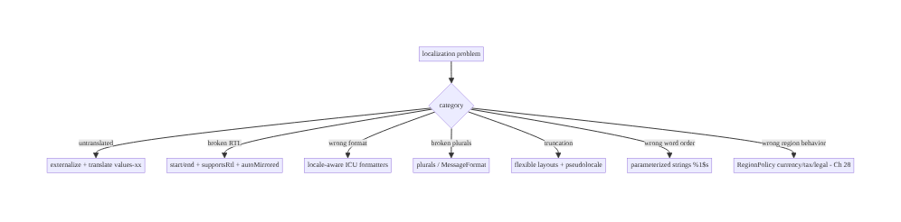
95.9 Failure Scenarios and Recovery
Externalize, use start/end, format with ICU, and regionalize behavior. Localization failures are hardcoded/untranslated strings (externalize), broken RTL (start/end + supportsRtl), locale-wrong formats (ICU formatters), broken plurals (plurals resources), truncation (flexible layouts + pseudolocales), and region-oblivious behavior (RegionPolicy for currency/tax/legal, Ch 28). Design i18n once; localize and regionalize per market; survive locale config changes (Ch 44).

95.10 Scaling the Implementation
- Level 1. Externalize all strings; supportsRtl + start/end; locale-aware formatters for price/date.
- Level 2. Translate target languages (values-xx/); plurals; parameterized strings; flexible layouts; pseudolocale testing.
- Level 3 — production. Translation pipeline (export/translate/import) + fallback; per-app language (Android 13+); locale-change handling (Ch 44); RTL QA.
- Level 4 — global. Regionalization (currency/tax/catalog/legal, Ch 28); region-driven server config; many locales; continuous pseudolocalization in CI; translation coverage metrics.
- Level 5 — enterprise. Full i18n/l10n governance: TMS integration, locale SLAs, per-market compliance (Ch 28), machine-translation + review pipelines, locale-specific A/B (Ch 86), market expansion playbooks.
Avoid overengineering: externalized strings + start/end + ICU formatters + plurals + flexible layouts + fallback covers the l10n basics for most apps; regionalize behavior as you enter markets. Don’t hardcode strings; don’t use left/right; don’t concatenate formats/plurals; don’t assume region == language.

95.11 Alternative Approaches and Trade-offs
Dimension | Option A | Option B | When
Text | String resources (externalized) | hardcoded | Resources always
Direction | start/end (+supportsRtl) | left/right | start/end (RTL)
Formatting | Locale-aware ICU | concatenation/fixed | ICU always
Plurals | plurals/MessageFormat | count+noun concat | plurals resources
Sentences | Parameterized (%1$s) | fragment concat | Parameterized (word order)
Layout | Flexible (expansion) | fixed width | Flexible + pseudolocale
Region | Regionalize behavior | translate only | Regionalize for markets
Resources vs hardcoded strings: hardcoded text cannot be translated — the #1 i18n failure. String resources (strings.xml + values-xx/) let Android auto-select the locale and let translators work without code. Externalize everything user-facing.
start/end vs left/right: left/right doesn’t mirror → broken RTL layouts. start/end (Compose default) auto-mirrors for RTL. Use start/end everywhere (+ supportsRtl, auto-mirrored drawables); audit for stray left/right.
ICU formatters vs concatenation: concatenating or assuming a format is locale-wrong (separators, date order, currency placement, plural rules all vary). Locale-aware ICU formatters produce correct output for each locale. Never concatenate numbers/dates/currencies or build plurals by hand.

95.12 Security & Privacy Considerations
- Regional legal/consent compliance (Ch 28): regionalization includes legal — GDPR consent in the EU, regional privacy laws, data-residency; the app must enforce the right regime per region (Ch 28). This is a compliance requirement, not cosmetic.
- Don’t leak locale-inferred sensitive info: a user’s locale/region can be sensitive (it can imply location/identity); handle it as data (Ch 28), don’t broadcast unnecessarily.
- Translated content integrity: translations (especially externally sourced) are content — validate they don’t inject markup/format-string exploits (%n, unexpected placeholders) that could crash or misbehave; keep translatable=false for format-sensitive strings.
- Locale-dependent security strings: security/legal notices (consent, Ch 28; terms) must be correctly translated — a mistranslated consent prompt is a compliance risk.
- Right-to-left + sensitive data display: ensure RTL layout doesn’t misorder sensitive data (account numbers, amounts) — test RTL with real data.
- Client + server + legal: client formats/mirrors/translates; server/region config drives regional behavior; legal/compliance drives per-region consent/data rules (Ch 28).

95.13 Performance and Resource Optimization
- Resource resolution is cheap — Android selects values-<locale> at load; no runtime cost beyond lookup.
- Cache formatters where hot — NumberFormat/DateTimeFormatter creation isn’t free; remember/ reuse per locale on hot paths (lists, Ch 93).
- Avoid per-item formatting in composition (Ch 90) — pre-format prices/dates in the ViewModel/ paging map, not in each list item (Ch 90/93).
- Bundle only needed locales — Play delivers per-locale resources; shrinkResources (Ch 92) + language splits reduce size.
- Pseudolocalization in CI — catches expansion/RTL issues cheaply before shipping.
- Profiling: formatter allocation on hot paths (Ch 90), resource size per locale, translation coverage, layout overflow in pseudolocale.

95.14 Testing Strategy
Formatting, plurals, and RTL are testable; translation coverage and layout via pseudolocales.
class LocaleFormattersTest {
@Test fun `currency formats per locale`() {
assertEquals("$1,234.56", formatters.price(123456, "USD", Locale.US))
assertEquals("1.234,56 €", formatters.price(123456, "EUR", Locale.GERMANY)) // locale-aware
}
@Test fun `date order per locale`() { /* MM/DD vs DD/MM */ }
}
class PluralsTest {
@Test fun `plural forms resolve per language`() { /* Arabic 6 forms, English 2 (Ch resources) */ }
}
@Test fun `no hardcoded user-facing strings`() { /* lint: HardcodedText - fail on literals in UI */ }
@Test fun `layout survives pseudolocale expansion`() { /* en-XA +200% text - no truncation */ }
@Test fun `RTL mirrors with start-end`() { /* force RTL - layout mirrors, no left/right */ }
// Locale change: switch language -> state survives (Ch 44). Regionalization: RegionPolicy per market.
What to test: locale-aware formatting (currency/date per locale); plurals (per-language forms); no hardcoded strings (lint HardcodedText); pseudolocale expansion (no truncation) + RTL mirror; locale-change state survival (Ch 44); regionalized behavior (RegionPolicy). CI runs pseudolocales.

95.15 Production Observability
- Metrics: per-locale usage (which languages/regions), translation coverage (% strings translated per language), locale-specific crash/error rates (Ch 83 — a format/RTL bug may crash one locale), layout-overflow reports, per-app-language adoption (Android 13+).
- Logs: locale/region in context (as data, PII-aware, Ch 28) for debugging locale-specific issues — PII-safe (Ch 28).
- Debugging: untranslated → missing values-xx (fallback showing); broken RTL → left/right in layout; wrong format → non-locale formatter; crash in one locale → format-string/plural bug (Ch 83); truncation → fixed layout + long translation.
- Alerting: locale-specific crash spike (Ch 83 — a locale regression); translation coverage drop; region-config error (wrong currency/tax).
- Dashboards: usage by locale/region, translation coverage, locale-specific crash/error rates, per-app-language adoption.

95.16 System Design Interview Preparation
≥25 questions.
Fundamentals
- i18n vs l10n? Design-to-be-localizable vs translating for a locale.
- Regionalization? Adapt content + behavior per region (beyond language).
- #1 i18n bug? Hardcoded strings.
- Externalize where? strings.xml → values-xx/.
- Locale selection? Android auto-selects by locale; falls back to default.
RTL
- RTL languages? Arabic, Hebrew, Persian, Urdu.
- How support? start/end + supportsRtl + autoMirrored.
- left/right problem? Doesn’t mirror → broken RTL.
- Compose default? start/end (auto-mirrors).
- Test RTL? Force RTL / pseudolocale ar-XB.
Formatting
- Why locale-aware format? Separators/date order/currency vary.
- Currency? NumberFormat.getCurrencyInstance(locale) + currency.
- Concatenation? Locale-wrong — never.
- Date? DateTimeFormatter.ofLocalizedDate (locale).
Plurals/strings
- Plurals? plurals resources / ICU MessageFormat.
- Why? Rules vary (Arabic 6 forms).
- count+noun concat? Always wrong.
- Word order? Parameterized strings (%1$s) — translators reorder.
Layout
- Text expansion? +30–200%; flexible layouts.
- Catch early? Pseudolocalization (en-XA).
- Fixed width? Truncates — avoid.
Locale/region
- Per-app language? Android 13+ (LocaleManager/AppCompat).
- Locale change? Config change — survive it (Ch 44).
- Regionalize what? Currency, tax, catalog, legal (Ch 28), units.
- Region == language? No — en-US vs en-GB; behavior differs.
- Fallback? Missing translation → default values/.

Design-change challenges
- Add Arabic (RTL). Translate + start/end + autoMirrored + RTL test.
- Fix wrong prices in Germany. Locale-aware currency formatter.
- Fix broken “1 items”. Plurals resource / MessageFormat.
- Support per-app language. LocaleManager (Android 13+) + config change (Ch 44).
- Regionalize checkout. RegionPolicy (currency/tax/legal, Ch 28/76).

Mock walkthrough (abridged)
Clarify (target markets, RTL?, regionalization needed?) → i18n (externalize strings, start/end, ICU formatters, flexible layouts) → l10n (translate values-xx/, RTL, plurals, parameterized, pseudolocale test) → per-app language + locale config change (Ch 44) → regionalize (currency/tax/ catalog/legal, Ch 28) → translation pipeline + fallback → observability (per-locale usage/crash).

95.17 Practical Exercises
- Beginner. Externalize all hardcoded strings to strings.xml, add values-es/ translations, and enforce with the HardcodedText lint. Eval: no hardcoded strings; Spanish works.
- Intermediate. Add RTL support (start/end + supportsRtl + autoMirrored) and locale-aware currency/date formatting (ICU); test with the ar-XB pseudolocale. Eval: mirrors; correct formats.
- Advanced. Add plurals + parameterized strings, make layouts survive the en-XA pseudolocale (+200%), and handle a per-app language change as a config change (Ch 44). Eval: correct plurals; no truncation; state survives.
- Production debugging. Investigate a crash that happens only in one locale (format-string/ plural bug, Ch 83) and a truncated German layout. Eval: root causes fixed.
- System design challenge. Design regionalization (RegionPolicy: currency/tax/catalog/legal, Ch 28) + a translation pipeline with fallback + CI pseudolocalization for 10 markets. Eval: correct + compliant per market.
(Solutions withheld unless requested.)

95.18 Chapter Summary & Reference Sheet
Key decisions: reach a global audience by internationalizing once (so the app can be localized) and localizing + regionalizing per market: externalize every user-facing string into resources (strings.xml, never hardcoded, with per-language values-xx/ files Android auto-selects and falls back from), support RTL by using start/end instead of left/right everywhere plus supportsRtl and auto-mirrored drawables so Arabic/Hebrew layouts mirror correctly, format all numbers/dates/times/currencies with locale-aware ICU formatters rather than concatenation or fixed patterns (separators, date order, 12/24h, currency placement all vary), handle plurals with plurals resources or ICU MessageFormat (rules range from English’s 2 forms to Arabic’s 6, so count+noun concatenation is always wrong), use parameterized strings with positional placeholders so translators reorder for each language’s word order, and design flexible layouts tested with pseudolocales (en-XA/ ar-XB) because translations can be 30–200% longer and truncate fixed widths; then regionalize content and behavior — currency, tax, catalog, legal/consent (Ch 28), units, payment methods — by the user’s region, not just language; honor the per-app language (Android 13+) and treat locale change as a config change (Ch 44); and maintain a translation pipeline with fallback — because a global app must be correct and natural in every market, not an English app with swapped words.
Concepts: i18n vs l10n vs regionalization, string externalization (strings.xml/values-xx// fallback), RTL (start/end, supportsRtl, mirroring), locale-aware formatting (ICU numbers/dates/ currencies), plurals (plurals/MessageFormat), parameterized strings/word order, text expansion/ flexible layouts/pseudolocalization, per-app language (Android 13+) + locale config change (Ch 44), regionalization (currency/tax/catalog/legal/units, Ch 28), translation pipeline.
Common mistakes: hardcoded strings; left/right (broken RTL); concatenated/assumed formats (locale-wrong); count+noun plurals; fragment concatenation (wrong word order); fixed-width layouts (truncation); assuming region == language; losing state on locale change (Ch 44); no fallback; no pseudolocale testing; mistranslated legal/consent (Ch 28).
Checklist:
- ☐ externalize all user-facing text (strings.xml + values-xx/)
- ☐ start/end + supportsRtl + autoMirrored (RTL)
- ☐ locale-aware ICU formatters (number/date/currency)
- ☐ plurals resources / MessageFormat
- ☐ parameterized strings (%1$s) for word order
- ☐ flexible layouts + pseudolocale (en-XA/ar-XB) testing
- ☐ per-app language (Android 13+) + locale config change (Ch 44)
- ☐ regionalize currency/tax/catalog/legal/units (Ch 28)
- ☐ translation pipeline + fallback + translatable=false
- ☐ HardcodedText lint; locale-specific crash monitoring (Ch 83).
Key APIs: stringResource/pluralStringResource/R.string/R.plurals, values-<lang>-r<REGION>/ qualifiers, android:supportsRtl + start/end + Icons.AutoMirrored, NumberFormat.getCurrencyInstance(locale) + Currency, DateTimeFormatter.ofLocalizedDate(...).withLocale, android.icu.* / ICU MessageFormat, AppCompatDelegate.setApplicationLocales / LocaleManager (per-app language, Android 13+), LocaleListCompat, pseudolocales (en-XA/ar-XB), HardcodedText lint, translatable="false".
References: - Localize your app: https://developer.android.com/guide/topics/resources/localization - RTL support: https://developer.android.com/training/basics/supporting-devices/rtl - Per-app language (Android 13): https://developer.android.com/guide/topics/resources/app-languages - Unicode CLDR / ICU (formatting + plurals): https://cldr.unicode.org - (composes) Ch 2 Compose UI, Ch 97 Theming/Config, Ch 44 Config Changes, Ch 96 Accessibility, Ch 28 Privacy/Legal, Ch 76 Payments

Chapter 96 — Accessibility Architecture
Part XI — Reach, Scale & Platform Breadth · Complexity: Standard (≥25 interview questions)
Prerequisites: Ch 2 (Compose UI/semantics), Ch 97 (theming), Ch 95 (localization), Ch 1 (architecture). Pairs with Ch 90 (rendering), Ch 100 (capstone).
Reference surface in StreamCart: making the app usable by everyone — including people using TalkBack (screen reader), large fonts / display scaling, switch access, high contrast, and limited motor control — by building a correct semantics tree (content descriptions, roles, state, headings), touch-target sizing, focus/traversal order, contrast, scalable text (sp), and captions — because accessibility is a requirement (legal + ethical + reach), not a nice-to-have, and it’s architected, not bolted on.

96.1 Problem Definition and Real-World Context
A significant fraction of users rely on accessibility services — TalkBack (screen reader for blind/low-vision users), large fonts / display scaling (low vision), Switch Access (motor impairments), high-contrast / color-correction (color vision), captions (deaf/hard- of-hearing), and reduced-motion settings. An app that ignores them is unusable for these users — and accessibility is increasingly a legal requirement (ADA, EN 301 549, Section 508) as well as an ethical one and a reach multiplier. Accessibility architecture is the discipline of building the app so assistive technologies work: a correct semantics tree (each element’s content description, role, state, headings, grouping) that screen readers consume, adequate touch-target sizes (≥48dp), correct focus/traversal order, sufficient color contrast, scalable text (sp, honoring font-size settings), captions for media (Ch 56), and respect for reduced motion. In Compose, much comes for free from standard components, but custom UI and nuance require explicit semantics — accessibility is designed in, not retrofitted.
Concretely, teams hit:
- Missing content descriptions (the #1 a11y bug). An icon button, image, or custom control with no content description is invisible/opaque to TalkBack (announces nothing or “button”). Every meaningful non-text element needs a content description; decorative ones must be explicitly null (so they’re skipped).
- Broken semantics on custom UI. Custom composables/views without roles/state/semantics are unusable by screen readers (TalkBack can’t announce “checkbox, checked” or “tab, selected”). Custom UI must declare semantics (role, state, actions).
- Tiny touch targets. Controls smaller than ~48dp are hard to hit for motor-impaired users (and everyone). Ensure minimum touch-target size even if the visual is smaller.
- Wrong focus/traversal order. TalkBack/Switch Access navigate in a traversal order; a wrong order (visual ≠ logical) confuses users. Group related content, set traversal order, mark headings for navigation.
- Insufficient contrast. Low text/background contrast fails low-vision users (and WCAG 4.5:1 for normal text). Design and test contrast; support high-contrast mode.
- Non-scalable text (dp instead of sp). Text sized in dp doesn’t scale with the user’s font-size setting; low-vision users can’t enlarge it. Use sp for text and test at large font scales (don’t break layouts).
- Color-only information. Conveying state by color alone (red = error) fails color-blind users. Pair color with text/icon/shape.
- No captions / media accessibility (Ch 56). Video/audio without captions excludes deaf/ hard-of-hearing users. Provide captions/subtitles (Media3, Ch 56).
- Motion / announcements. Excessive animation can harm (vestibular); honor reduced motion. Live region announcements (e.g., “added to cart”) must be announced to TalkBack.
- Not tested with assistive tech. Accessibility that isn’t tested with TalkBack/large fonts/Switch Access regresses silently. Use Accessibility Scanner, automated a11y tests, and manual TalkBack testing.
The architecture: build a correct semantics tree — content descriptions for meaningful elements (null for decorative), roles/state/actions on custom UI, headings and grouping for navigation, correct focus/traversal order — ensure ≥48dp touch targets, sufficient contrast (WCAG, + high-contrast mode), scalable text (sp, tested at large scales), non-color-only information, captions for media (Ch 56), and respect reduced motion and live-region announcements — then test with TalkBack, large fonts, Switch Access, and the Accessibility Scanner. This chapter is about making the app usable by everyone, by design.

Three practical use cases
- Make StreamCart’s catalog TalkBack-usable. Product images get content descriptions (name), decorative icons null, the add-to-cart icon button announces its action, cards are grouped so TalkBack reads a product as one item — navigable and announced correctly.
- Scalable, contrast-correct UI. Text in sp, layouts tested at 200% font scale (no truncation, Ch 95), contrast ≥4.5:1, error state shown by icon+text not color alone.
- Accessible custom rating control. A custom star-rating composable declares role = Slider/semantics, current value/state, and a content description so TalkBack announces “rating, 4 of 5 stars” and Switch Access can adjust it.

Why this is architectural
Accessibility composes UI/semantics (Ch 2), theming/contrast (Ch 97), text scaling/localization (Ch 95), and media captions (Ch 56). The decisions — semantics tree, touch targets, focus order, contrast, scalable text, captions, reduced motion — determine whether the app is usable by the many users relying on assistive technology (and legally compliant), and they must be designed in across the component system, not patched per-screen.

96.2 Requirements Engineering

Functional requirements
ID | Requirement
F1 | Correct semantics tree: content descriptions (null for decorative), roles, state, headings, grouping.
F2 | ≥48dp touch targets; correct focus/traversal order.
F3 | Sufficient contrast (WCAG 4.5:1); support high-contrast; non-color-only info.
F4 | Scalable text (sp), tested at large font scales (Ch 95).
F5 | Captions for media (Ch 56); respect reduced motion; live-region announcements.
F6 | Test with TalkBack, large fonts, Switch Access, Accessibility Scanner, automated a11y tests.

Non-functional requirements
Attribute | Policy
Usability | Fully operable via TalkBack/Switch Access.
Inclusivity | Low-vision, motor, color, hearing supported.
Compliance | WCAG / legal (ADA, EN 301 549).
Robustness | Survives large fonts (no truncation, Ch 95).
Tested | Assistive-tech + automated testing.

Scope
- In scope: semantics tree (content description, role, state, actions, headings, grouping, merge/clear), touch-target sizing (≥48dp), focus/traversal order, contrast (WCAG, high-contrast, non-color-only), scalable text (sp, large-scale testing, Ch 95), captions/media a11y (Ch 56), reduced motion, live-region announcements, testing (TalkBack, Switch Access, large fonts, Accessibility Scanner, automated).
- Out of scope: Compose UI basics (Ch 2), theming detail (Ch 97), localization detail (Ch 95), media playback (Ch 56), rendering (Ch 90).

Assumptions & constraints
- Compose (semantics modifiers) / Views (accessibility APIs); standard components give much a11y for free, custom UI needs explicit semantics. Text in sp; targets ≥48dp; contrast WCAG-compliant; media captioned (Ch 56). Tested with TalkBack + large fonts
  - Accessibility Scanner. minSdk 24.

96.3 System Design Fundamentals
- Assistive technologies to support. TalkBack (screen reader — announces elements, user navigates by swipe/explore-by-touch), large fonts / display size (system font-scale / display-density settings), Switch Access (navigate/activate via switches — needs focusable, ordered elements), high-contrast / color inversion / color correction, captions (deaf/HoH), reduced motion (vestibular), voice access. Each imposes requirements; the semantics tree serves most of them.
- The semantics tree (the core model). Beneath the visual UI, Android maintains an accessibility/semantics tree that assistive services (TalkBack) consume — each node has a content description/label (what to announce), a role (button, checkbox, tab, heading, image, slider…), state (checked, selected, disabled, expanded), actions (click, toggle, custom), and structure (headings, grouping/merging). In Compose, you shape this with semantics modifiers (contentDescription, role, stateDescription, heading(), semantics { }, mergeDescendants); in Views, with accessibility properties/delegates. Standard components populate it correctly for free; custom UI must do it explicitly.
- Content descriptions (meaningful vs decorative). Every meaningful non-text element (icon button, informative image) needs a content description (what it is/does: “Add to cart”, not “icon”). Decorative elements (a background flourish) must be explicitly null (contentDescription = null) so TalkBack skips them (not announce “unlabeled”). Text is announced automatically. Keep descriptions concise and meaningful (action/identity, not visual detail).
- Roles, state, and actions. TalkBack announces an element’s role (“button”, “checkbox”) and state (“checked”, “selected”, “disabled”) so users know what it is and its status. Custom controls must declare role and stateDescription/state, and expose actions (click/toggle/custom accessibility actions) so Switch Access/TalkBack can operate them. A custom toggle without role/state is just “button” with no indication of on/off.
- Headings, grouping, traversal order. Headings (semantics { heading() }) let TalkBack users jump between sections. Grouping/merging (mergeDescendants = true) makes a card announce as one item (name + price + rating together) instead of three separate swipes. Traversal order should match the logical reading order (usually visual); override it (traversalIndex/isTraversalGroup) when the visual and logical orders diverge. Good structure makes navigation efficient.
- Touch targets (≥48dp). Interactive elements need a minimum touch target of ~48dp (Material guidance) even if the visual is smaller — critical for motor-impaired users (and usability generally). Compose: Modifier.minimumInteractiveComponentSize() / size the touch area; don’t ship 24dp tap targets.
- Contrast & non-color-only (color vision). Text/background contrast must meet WCAG (4.5:1 normal text, 3:1 large) for low-vision/aging users; support high-contrast mode. And never convey information by color alone (red = error) — pair with text/icon/shape (an error icon + message), so color-blind users get the information. Design the component system for contrast + redundant cues.
- Scalable text (sp) + large-font resilience (Ch 95). Size text in sp (scales with the user’s font-size setting), not dp (fixed). Low-vision users may set large fonts; layouts must survive (no truncation/overlap) — the same flexible-layout discipline as localization expansion (Ch 95). Test at large font scales (up to 200%). Non-text sizes (icons, targets) use dp.
- Captions, reduced motion, live regions. Media needs captions/subtitles (Media3, Ch 56) for deaf/HoH users. Honor reduced motion (disable/soften non-essential animation for vestibular sensitivity). Use live regions (liveRegion semantics) for dynamic updates (“added to cart”, “error”) so TalkBack announces them without the user navigating there.
- Testing accessibility (don’t ship untested). Use the Accessibility Scanner (flags missing labels, small targets, low contrast), automated a11y tests (Compose assertContentDescriptionEquals, Espresso accessibility checks), and manual testing with TalkBack, large fonts, and Switch Access. Accessibility regresses silently without testing — bake checks into CI and QA.
Core insight: make the app usable by everyone by architecting the accessibility semantics tree that assistive technologies consume — give every meaningful non-text element a concise content description (what it is or does) and mark decorative ones explicitly null so TalkBack skips them, declare role, state, and actions on all custom controls (a custom toggle without them is just an unlabeled ‘button’) so screen readers announce ‘checkbox, checked’ and Switch Access can operate it, and structure the tree with headings, grouping/merging (so a product card reads as one item), and a logical traversal order; ensure interactive elements have at least ~48dp touch targets for motor-impaired users, meet WCAG contrast (4.5:1) with a high-contrast mode and never convey information by color alone (pair it with text/icon/shape for color-blind users), size text in sp so it scales with the font-size setting and test layouts at large scales without truncation (the same flexible-layout discipline as localization expansion, Ch 95), caption media (Ch 56), honor reduced motion, and announce dynamic changes via live regions; standard Compose/View components populate the semantics tree correctly for free, but custom UI must declare it explicitly — and because accessibility regresses silently, test it with TalkBack, large fonts, Switch Access, the Accessibility Scanner, and automated a11y checks in CI — since accessibility is a legal, ethical, and reach requirement designed in across the component system, not bolted on per screen.

96.4 High-Level Architecture
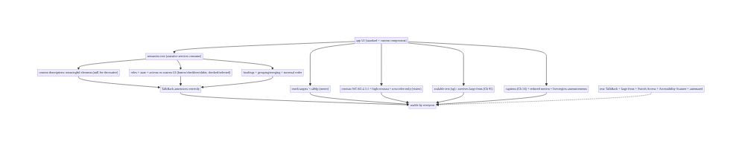
96.4 High-Level Architecture
Components & ownership
- Semantics tree (content descriptions, roles/state/actions, headings/grouping/order) — serves screen readers/Switch Access.
- Touch targets (≥48dp, motor), contrast + non-color-only (vision), scalable text (sp, Ch 95).
- Captions (Ch 56), reduced motion, live regions.
- Testing (TalkBack, large fonts, Switch Access, Scanner, automated).
Direction: UI → correct semantics tree (descriptions/roles/state/structure) + targets + contrast + scalable text + media a11y → usable by everyone; tested with assistive tech.

96.5 Detailed Component Design
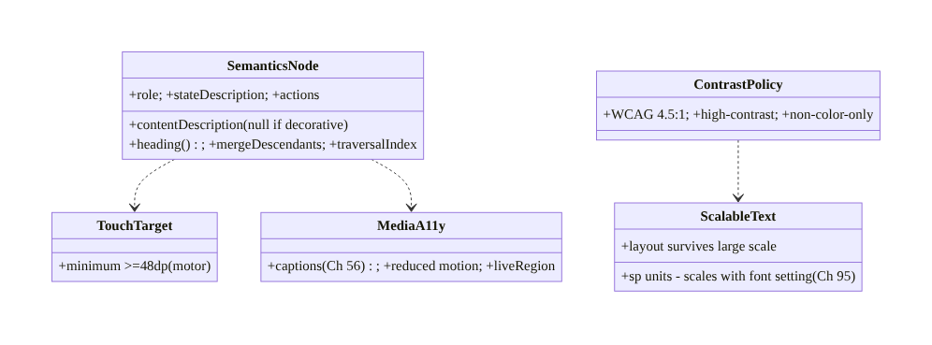
96.5 Detailed Component Design
Component | Responsibility
SemanticsNode | description/role/state/actions/headings/grouping/order (TalkBack/Switch)
TouchTarget | ≥48dp interactive targets (motor)
ContrastPolicy | WCAG contrast + high-contrast + non-color-only (vision)
ScalableText | sp text, large-scale-resilient layouts (Ch 95)
MediaA11y | captions (Ch 56), reduced motion, live-region announcements

96.6 End-to-End Data Flow

TalkBack reads the semantics tree
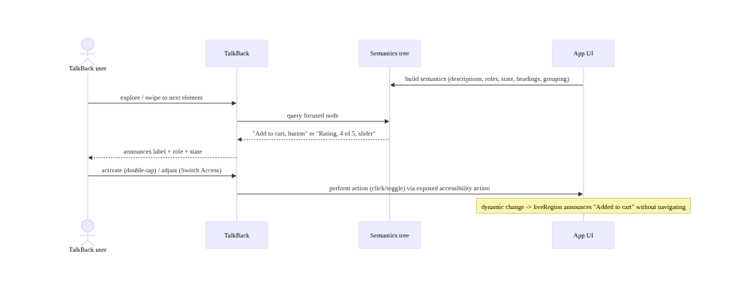
TalkBack reads the semantics tree

Decorative vs meaningful (content description)
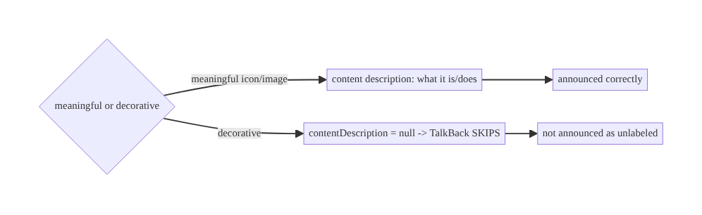
Decorative vs meaningful (content description)

96.7 Implementation (Compose + Kotlin)
Package: com.streamcart.a11y.

96.7.1 Content descriptions (meaningful vs decorative)
// Meaningful image/icon-button: describe what it IS / DOES
AsyncImage(model = product.imageUrl, contentDescription = product.name) // announced (Ch 59)
IconButton(onClick = onAddToCart) {
Icon(Icons.Default.AddShoppingCart, contentDescription = stringResource(R.string.add_to_cart)) // action
}
// Decorative element: explicitly NULL so TalkBack skips it (not "unlabeled image")
Icon(Icons.Default.Star, contentDescription = null, modifier = Modifier.background(...)) // decorative

96.7.2 Grouping + headings + traversal (navigation)
@Composable
fun ProductCard(product: ProductUi, onClick: () -> Unit) {
// Merge: TalkBack reads the whole card as ONE item (name + price + rating), not three swipes
Card(Modifier
.clickable(onClick = onClick)
.semantics(mergeDescendants = true) { /* contentDescription auto-composed from children */ }) {
Text(product.title)
Text(product.price)
Text("Rated ${product.rating} of 5")
}
}
// Section titles as headings so TalkBack users can jump between them:
Text("Recommended", modifier = Modifier.semantics { heading() })

96.7.3 Custom control: role + state + actions
@Composable
fun StarRating(rating: Int, max: Int = 5, onRate: (Int) -> Unit) {
Row(Modifier.semantics {
// Custom control MUST declare role + state + an action, else TalkBack can't announce/operate it
role = Role.Button
stateDescription = "$rating of $max stars" // announced state
contentDescription = "Rating"
// expose an action so Switch Access / TalkBack can adjust it
setProgress { target -> onRate(target.toInt().coerceIn(1, max)); true }
}) {
repeat(max) { i -> Icon(if (i < rating) Icons.Filled.Star else Icons.Outlined.Star,
contentDescription = null, Modifier.clickable { onRate(i + 1) }) } // children decorative (merged)
}
}

96.7.4 Touch targets, scalable text, non-color-only
// >=48dp touch target even if the visual icon is smaller (motor accessibility)
IconButton(onClick = onClose, modifier = Modifier.minimumInteractiveComponentSize()) { // ensures >=48dp
Icon(Icons.Default.Close, contentDescription = stringResource(R.string.close))
}
// Text in sp (scales with font setting, Ch 95); layout must survive large scale (no fixed height)
Text(product.title, fontSize = 16.sp) // sp, NOT dp
// Non-color-only: error shows ICON + TEXT, not just red
Row { Icon(Icons.Default.Error, contentDescription = null); Text(stringResource(R.string.payment_failed)) }

96.7.5 Live-region announcement + reduced motion
// Live region: announce dynamic change WITHOUT the user navigating to it
var cartMessage by remember { mutableStateOf("") }
Text(cartMessage, modifier = Modifier.semantics { liveRegion = LiveRegionMode.Polite }) // TalkBack announces
// on add-to-cart: cartMessage = "Added ${product.name} to cart" (Ch 95 parameterized)
// Reduced motion: soften/disable non-essential animation if the user requested it
val reduceMotion = LocalAccessibilityManager.current?.let { /* check setting */ } ?: false
val animSpec = if (reduceMotion) snap() else spring() // respect reduced motion

96.7.6 Module structure
:core:designsystem accessible components (targets >=48dp, contrast, roles/state baked in)
# Semantics -> Compose semantics modifiers; scalable text -> sp (Ch 95); captions -> Media3 (Ch 56);
# contrast/high-contrast -> theming (Ch 97); test -> Accessibility Scanner + TalkBack + automated.

96.8 Concurrency and Race Conditions
Accessibility is a UI-correctness concern; the pitfalls are semantics-correctness ones:
Scenario | Risk | Handling
Missing content description | element invisible to TalkBack | describe meaningful; null decorative
Custom control no role/state | unusable by screen reader | declare role + state + actions
Ungrouped card | 3 swipes per item | mergeDescendants
Small touch target | motor users can’t hit | ≥48dp
dp text | doesn’t scale | sp + large-scale test (Ch 95)
Color-only state | color-blind miss it | icon/text + color
Dynamic change silent | TalkBack unaware | liveRegion announcement
Untested a11y | silent regression | TalkBack + Scanner + automated CI
- Standard components give a11y for free; custom UI is where bugs live: a Button/Checkbox announces correctly out of the box, but a custom star-rating/toggle/chip needs explicit role/state/actions — audit custom composables specifically.
- Grouping is about navigation efficiency: without mergeDescendants, a TalkBack user swipes through every child; merging makes a card one stop — a large usability win on lists (Ch 93).
- Accessibility and localization share the flexible-layout discipline (Ch 95): large fonts (a11y) and long translations (l10n) both demand non-fixed layouts that don’t truncate — test both.

96.9 Failure Scenarios and Recovery
Failure | Detection | Response | Outcome
Icon button announces nothing | TalkBack / Scanner | add content description | announced
Custom control unusable | TalkBack | role + state + actions | operable
Card read as 3 items | TalkBack | mergeDescendants | one item
Small target unhittable | Scanner | ≥48dp | hittable
Text won’t enlarge | large-font test | sp + flexible layout (Ch 95) | scales
Color-blind miss error | contrast/color QA | icon+text (non-color-only) | perceivable
Dynamic update missed | TalkBack | liveRegion | announced
Low contrast | Scanner / contrast check | WCAG contrast + high-contrast | readable
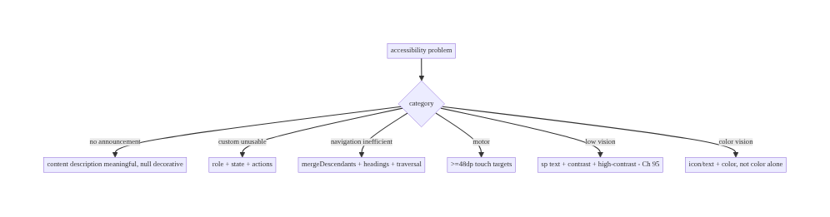
96.9 Failure Scenarios and Recovery
Build the semantics tree, size targets, meet contrast, scale text — and test with assistive tech. Accessibility failures are missing descriptions (describe meaningful, null decorative), custom controls without role/state (declare them), inefficient navigation (group + headings), small targets (≥48dp), non-scalable text (sp + flexible layouts, Ch 95), and color-only info (add icon/text). Standard components help; custom UI needs explicit semantics; test with TalkBack + Scanner + automated CI — accessibility regresses silently.

96.10 Scaling the Implementation
- Level 1. Content descriptions on all meaningful elements (null decorative); sp text; ≥48dp targets; Accessibility Scanner pass.
- Level 2. Roles/state/actions on custom controls; grouping + headings; contrast (WCAG) + non-color-only; TalkBack manual testing.
- Level 3 — production. Accessible design system (Ch 97 — targets/contrast/semantics baked into components); captions (Ch 56); live regions; reduced motion; large-font resilience (Ch 95).
- Level 4 — org. Automated a11y tests in CI; a11y acceptance criteria per feature; Switch Access
  - high-contrast coverage; a11y linting; periodic audits.
- Level 5 — enterprise. Accessibility SLOs/compliance (WCAG/EN 301 549/ADA), a11y champions per team, user testing with disabled users, VPAT/compliance reporting, continuous a11y regression gates.
Avoid overengineering: content descriptions + roles/state on custom UI + ≥48dp + contrast + sp + grouping, baked into the design system and tested with TalkBack/Scanner, covers most needs. Don’t skip custom-control semantics; don’t ship untested; don’t convey by color alone; don’t use dp for text.

96.11 Alternative Approaches and Trade-offs
Dimension | Option A | Option B | When
Semantics | Explicit on custom UI | rely on defaults | Explicit for custom controls
Decorative images | contentDescription = null | omit / describe | null (skip cleanly)
Grouping | mergeDescendants | per-child | Merge for cards/items
Text units | sp (scalable) | dp (fixed) | sp for text
State signal | Icon/text + color | color only | Non-color-only
Targets | ≥48dp | visual size | ≥48dp (motor)
Where | Design-system baked | per-screen patches | Design system
Design-system-baked a11y vs per-screen patches: patching accessibility per screen is error-prone and regresses. Baking touch targets, contrast, roles/state, and semantics into the design-system components (Ch 97) makes every screen accessible by default — the scalable approach. Architect accessibility into the component system.
Explicit semantics vs defaults: standard components (Button, Checkbox) are accessible by default — use them where possible. Custom UI needs explicit role/state/actions/ descriptions, because the framework can’t infer them. Prefer standard components; when custom, declare semantics explicitly.
sp vs dp for text: dp text ignores the user’s font-size setting — low-vision users can’t enlarge it. sp scales with the setting. Always use sp for text (and test at large scales, Ch 95); use dp for non-text dimensions.

96.12 Security & Privacy Considerations
- Accessibility services are powerful (user trust): TalkBack and other a11y services can read screen content — so sensitive screens (payments Ch 76, auth Ch 20) must still present content correctly to legitimate assistive tech while respecting FLAG_SECURE and not leaking secrets in content descriptions (don’t put a full card number in a label).
- Don’t put secrets in content descriptions (Ch 28): a content description is announced/ readable — never embed tokens, full card numbers, or PII beyond what the UI shows (Ch 76/28).
- Malicious accessibility services (threat model): Android warns that a11y services are powerful; apps can’t fully prevent a user-granted a11y service from reading the screen, but should minimize sensitive exposure and use secure surfaces where required (Ch 76).
- Captions/transcripts are content (Ch 56/28): media captions may contain sensitive content — handle per privacy (Ch 28).
- Accessible ≠ less secure: making UI accessible (labels, roles) must not weaken security (e.g., don’t disable FLAG_SECURE for a11y) — provide accessible and secure.
- Client concern mostly: the privacy note is no secrets in announced content; the security note is secure surfaces + a11y coexist (Ch 76/20).

96.13 Performance and Resource Optimization
- Semantics are cheap but not free — overly deep/complex semantics trees cost; merge decorative children, keep the tree meaningful (not one node per pixel).
- Don’t over-announce — excessive live regions/announcements overwhelm TalkBack users; announce meaningful changes only.
- Scalable text + flexible layouts (Ch 95) — the same discipline serves a11y (large fonts) and l10n (expansion); build it once.
- Reduced motion saves work too — honoring it can reduce animation cost.
- Accessibility Scanner / automated checks are cheap to run in CI — catch regressions early.
- Profiling: semantics-tree size/depth, announcement frequency, large-font layout performance (Ch 90/95), Scanner issue count, automated a11y-test coverage.

96.14 Testing Strategy
Accessibility is testable automatically (semantics assertions, Scanner) and manually (TalkBack, Switch Access, large fonts).
class AccessibilityTest {
@get:Rule val compose = createComposeRule()
@Test fun `add to cart button has content description`() {
compose.setContent { ProductCard(sampleProduct, onClick = {}) }
compose.onNodeWithContentDescription("Add to cart").assertExists() // announced
}
@Test fun `custom rating exposes role and state`() {
compose.setContent { StarRating(rating = 4) {} }
compose.onNode(hasStateDescription("4 of 5 stars")).assertExists() // role+state declared
}
@Test fun `decorative icon is not in a11y tree`() { /* contentDescription = null -> skipped */ }
}
// Automated: Espresso AccessibilityChecks / Compose semantics assertions in CI.
// Manual (required): TalkBack walkthrough, Switch Access, large font (200%, Ch 95), Accessibility Scanner.
// Contrast: automated contrast check / Scanner; non-color-only: manual/color-blind simulation.
What to test: content descriptions present (meaningful) / absent (decorative); custom controls expose role+state+actions; grouping/headings/traversal; ≥48dp targets; contrast (WCAG) + non-color-only; sp text + large-font layout (Ch 95); live-region announcements; captions (Ch 56). Automated (semantics assertions, AccessibilityChecks, Scanner in CI) + manual TalkBack/Switch Access/large-font.

96.15 Production Observability
- Metrics: Accessibility Scanner issue count (missing labels, small targets, contrast), automated a11y-test coverage/pass rate, a11y-service usage (how many users have TalkBack/large fonts enabled — where available), large-font-related layout issues, a11y-specific crash/error (Ch 83).
- Logs: a11y-related errors — PII-safe (no announced content with secrets, Ch 28).
- Debugging: element not announced → missing content description; custom control unusable → missing role/state; navigation inefficient → no grouping/headings; truncation at large font → fixed layout (Ch 95); color-blind complaint → color-only info.
- Alerting: a11y-test regression in CI (new Scanner issues, failed semantics assertions); large-font crash spike (Ch 83).
- Dashboards: Scanner issues per release, a11y-test coverage, a11y-service adoption, large-font issue trend.

96.16 System Design Interview Preparation
≥25 questions.
Fundamentals
- Why accessibility? Usable by all; legal + ethical + reach.
- Assistive tech? TalkBack, large fonts, Switch Access, high-contrast, captions.
- Semantics tree? What assistive services consume (label/role/state/structure).
- #1 a11y bug? Missing content descriptions.
- Standard vs custom? Standard free; custom needs explicit semantics.
Semantics
- Content description? What a meaningful element is/does.
- Decorative? contentDescription = null → skipped.
- Role/state? Announce “checkbox, checked” etc.
- Custom control? Declare role + state + actions.
- Headings? Let TalkBack jump between sections.
- Grouping? mergeDescendants → one item not many swipes.
- Traversal order? Match logical/visual order.
Perception/motor
- Touch target? ≥48dp (motor).
- Contrast? WCAG 4.5:1 + high-contrast.
- Color-only? Never — add icon/text.
- Scalable text? sp, test large fonts.
- dp text? Doesn’t scale — avoid.
Media/motion
- Captions? Media3 for deaf/HoH (Ch 56).
- Reduced motion? Honor the setting.
- Live region? Announce dynamic changes.
Testing
- Tools? Accessibility Scanner, TalkBack, Switch Access.
- Automated? Semantics assertions / AccessibilityChecks.
- Why test? Regresses silently.
Architecture/production
- Where to bake a11y? Design system (Ch 97).
- Sensitive content? No secrets in descriptions (Ch 28/76).
- Large font + l10n? Shared flexible-layout discipline (Ch 95).

Design-change challenges
- Make an icon-only toolbar TalkBack-usable. Content descriptions + ≥48dp.
- Make a custom toggle accessible. Role + state + action.
- Support large fonts. sp + flexible layouts (Ch 95).
- Fix color-only error states. Icon+text + contrast.
- Bake a11y into the design system. Accessible components (Ch 97) + CI a11y tests.

Mock walkthrough (abridged)
Clarify (which assistive tech, custom UI?, compliance target?) → semantics tree (descriptions/ roles/state/actions/headings/grouping/order) → touch targets ≥48dp → contrast WCAG + non-color-only → scalable text sp + large-font resilience (Ch 95) → captions (Ch 56) + reduced motion + live regions → bake into design system (Ch 97) → test (TalkBack + Switch Access + large fonts + Scanner + automated CI) → observability (Scanner issues/coverage).

96.17 Practical Exercises
- Beginner. Add content descriptions to all meaningful icons/images (null for decorative) and ensure ≥48dp touch targets; pass the Accessibility Scanner. Eval: TalkBack announces; no small targets.
- Intermediate. Make a custom control (star rating/toggle) accessible with role + state + actions, and group a product card with mergeDescendants + a heading. Eval: custom control operable; card is one item.
- Advanced. Convert text to sp and make layouts survive 200% font scale (Ch 95); add a live-region “added to cart” announcement and reduced-motion handling. Eval: scales; announced; motion respected.
- Production debugging. Use TalkBack + Scanner to find an unannounced custom control and a color-only error; fix both. Eval: operable; non-color-only.
- System design challenge. Design an accessible design system (Ch 97) with targets/contrast/ semantics baked in + automated a11y CI gates. Eval: accessible by default; regressions gated.
(Solutions withheld unless requested.)

96.18 Chapter Summary & Reference Sheet
Key decisions: make the app usable by everyone by architecting the accessibility semantics tree that assistive technologies consume — give every meaningful non-text element a concise content description (what it is/does) and mark decorative ones explicitly null so TalkBack skips them; declare role, state, and actions on all custom controls (a custom toggle without them is just an unlabeled “button”) so screen readers announce “checkbox, checked” and Switch Access can operate it; structure the tree with headings, grouping/merging (so a product card reads as one item), and a logical traversal order; ensure interactive elements have ≥48dp touch targets for motor-impaired users, meet WCAG contrast (4.5:1) with a high-contrast mode and never convey information by color alone (pair with text/icon/shape for color-blind users); size text in sp so it scales with the font-size setting and test layouts at large scales without truncation (the same flexible-layout discipline as localization expansion, Ch 95); caption media (Ch 56), honor reduced motion, and announce dynamic changes via live regions; standard components populate the semantics tree for free while custom UI must declare it explicitly; and because accessibility regresses silently, test with TalkBack, large fonts, Switch Access, the Accessibility Scanner, and automated a11y checks in CI — since accessibility is a legal, ethical, and reach requirement designed into the component system (Ch 97), not bolted on per screen.
Concepts: assistive technologies (TalkBack/large fonts/Switch Access/high-contrast/captions), semantics tree (content description, role, state, actions, headings, grouping/merge, traversal order), touch targets (≥48dp), contrast (WCAG, high-contrast, non-color-only), scalable text (sp, large-scale resilience, Ch 95), captions (Ch 56), reduced motion, live regions, testing (TalkBack/ Scanner/automated), design-system-baked a11y (Ch 97).
Common mistakes: missing content descriptions (or describing decorative elements); custom controls without role/state/actions; ungrouped cards (per-child swipes); small touch targets; dp text (doesn’t scale); color-only information; no captions (Ch 56); ignoring reduced motion; silent dynamic changes (no live region); shipping untested with assistive tech; patching per-screen instead of design-system.
Checklist:
- ☐ content descriptions (meaningful; null for decorative)
- ☐ role + state + actions on custom controls
- ☐ headings + grouping (mergeDescendants) + traversal order
- ☐ ≥48dp touch targets
- ☐ WCAG contrast + high-contrast + non-color-only
- ☐ sp text + large-font layout resilience (Ch 95)
- ☐ captions (Ch 56) + reduced motion + live regions
- ☐ a11y baked into design system (Ch 97)
- ☐ no secrets in content descriptions (Ch 28/76)
- ☐ test: TalkBack + Switch Access + large fonts + Scanner + automated CI.
Key APIs: Compose Modifier.semantics { } (contentDescription, role, stateDescription, heading(), liveRegion, custom actions like setProgress), mergeDescendants, traversalIndex/ isTraversalGroup, Modifier.minimumInteractiveComponentSize() (≥48dp), Icons.AutoMirrored (Ch 95), sp text units, LiveRegionMode, View contentDescription/AccessibilityDelegate, Media3 captions (Ch 56), Accessibility Scanner, Espresso AccessibilityChecks, Compose onNodeWithContentDescription/hasStateDescription.
References: - Accessibility overview: https://developer.android.com/guide/topics/ui/accessibility - Compose accessibility: https://developer.android.com/develop/ui/compose/accessibility - Material accessibility (touch targets/contrast): https://m3.material.io/foundations/accessible-design - WCAG / EN 301 549 (contrast, success criteria): https://www.w3.org/WAI/standards-guidelines/wcag/ - (composes) Ch 2 Compose/Semantics, Ch 97 Theming/Design System, Ch 95 Localization/Scaling, Ch 56 Media/Captions, Ch 76 Payments/Secure, Ch 28 Privacy

Chapter 97 — Theming & Dynamic Configuration
Part XI — Reach, Scale & Platform Breadth · Complexity: Standard (≥25 interview questions)
Prerequisites: Ch 2 (Compose UI), Ch 44 (config changes), Ch 96 (accessibility), Ch 95 (localization), Ch 40 (remote config). Pairs with Ch 94 (modularization), Ch 100 (capstone).
Reference surface in StreamCart: a coherent design system / theme — centralized color, typography, shape, spacing tokens (Material 3) that drive every component — with dark/light mode, dynamic color (Material You), contrast/accessibility (Ch 96), density/font-scale resilience (Ch 95/96/44), and runtime-configurable theming (brand/ seasonal/experiment-driven, Ch 40) — so the UI is consistent, adaptable, and themeable from one source of truth instead of hardcoded styles scattered per screen.

97.1 Problem Definition and Real-World Context
A large app’s UI must be consistent (every button, card, text looks right), adaptable (dark/light, dynamic color, large fonts, RTL, Ch 95/96), and themeable (brand variants, seasonal skins, A/B-tested styles, Ch 40/86) — and this is impossible if styles are hardcoded per screen (colors as hex literals, fixed text sizes, ad-hoc spacing). Theming & dynamic configuration is the discipline of a design system: a single source of truth of design tokens — color, typography, shape, spacing/elevation — exposed through a theme (Material 3 MaterialTheme) that every component reads, so changing a token updates the whole app consistently. On top of that: dark/light theming, dynamic color (Material You — theme from the wallpaper), accessibility integration (contrast, Ch 96; font scale, Ch 95/96), configuration resilience (density, orientation, locale — all config changes, Ch 44), and runtime theming (brand/experiment-driven via remote config, Ch 40). Without a design system, the UI is inconsistent, un-themeable, and hard to adapt.
Concretely, teams hit:
- Hardcoded styles (the #1 theming failure). Hex colors, fixed sp/dp sizes, and ad-hoc spacing scattered across screens → inconsistency, no dark mode, no re-theming. Fix: centralize into design tokens (a theme) that components reference (MaterialTheme.colorScheme. primary, not Color(0xFF...)).
- No dark mode / per-screen dark hacks. Bolting dark mode on per-screen (if/else colors) is unmaintainable. A theme with light + dark color schemes switches everything at once; components just read semantic colors (surface, onSurface).
- Semantic vs literal colors. Using literal colors (Red) instead of semantic/role colors (error, primary, onPrimary) breaks theming — the same literal can’t adapt to dark/ dynamic/brand. Use role-based tokens.
- Dynamic color (Material You). Android 12+ can theme the app from the user’s wallpaper (dynamic color). Supporting it requires reading the dynamic color scheme (with a static fallback for older/opted-out) — and ensuring contrast/branding still work (Ch 96).
- Config changes mishandled (Ch 44). Theme/mode/density/locale/orientation changes are configuration changes (Ch 44) — the activity recreates and the theme re-resolves. State must survive (Ch 44); theme must re-read correctly.
- Accessibility integration (Ch 96/95). The theme must support contrast (WCAG, Ch 96), high-contrast mode, and font scaling (sp, Ch 95/96) — layouts must survive large fonts and large display density. Theming and accessibility are intertwined.
- No runtime/brand theming. White-label apps, seasonal skins, or experiment-driven themes (Ch 86) need the theme to be configurable at runtime (from remote config, Ch 40) — not baked in. The token layer enables this.
- Inconsistent components. Without a shared component library built on the theme, teams rebuild buttons/cards with slightly different styles. A design-system module (Ch 94) with themed components ensures consistency.
The architecture: a design system with a single source of truth of design tokens — color (semantic/role-based: primary, surface, error, on*), typography (type scale), shape, spacing/elevation — exposed via a theme (MaterialTheme) that every component reads (no hardcoded styles), supporting light/dark schemes, dynamic color (Material You, with fallback), accessibility (contrast + font scale + high-contrast, Ch 95/96), config-change resilience (density/orientation/locale, Ch 44), and runtime theming (brand/seasonal/ experiment via remote config, Ch 40) — packaged as a :core:designsystem module (Ch 94) with themed components. This chapter is about a consistent, adaptable, themeable UI from one source of truth.

Three practical use cases
- StreamCart design system. All color/type/shape/spacing as tokens in :core:designsystem (Ch 94); every screen uses MaterialTheme.colorScheme/typography — changing the brand color re-themes the whole app; dark mode works everywhere automatically.
- Dynamic color + dark mode. On Android 12+, the app themes from the user’s wallpaper (Material You) with a branded static fallback; dark/light follows the system; contrast stays WCAG-compliant (Ch 96).
- Runtime brand/seasonal theme (Ch 40/86). A seasonal skin or an A/B-tested color scheme (Ch 86) is pushed via remote config (Ch 40) and applied at runtime — because theming is token-driven, not hardcoded.

Why this is architectural
Theming composes UI (Ch 2), config changes (Ch 44), accessibility (Ch 96), localization/scaling (Ch 95), modularization (:core:designsystem, Ch 94), and remote config (Ch 40/86). The decisions — centralized semantic tokens, theme-driven components, dark/dynamic color, accessibility + config resilience, runtime theming — determine whether the UI is consistent, adaptable, and themeable, or a scattered mess of hardcoded styles.

97.2 Requirements Engineering

Functional requirements
ID | Requirement
F1 | Single source of truth of design tokens (color/typography/shape/spacing) via a theme.
F2 | Every component reads semantic/role-based tokens; no hardcoded styles.
F3 | Light/dark schemes + dynamic color (Material You) with static fallback.
F4 | Integrate accessibility: contrast (WCAG), high-contrast, font scale (sp) (Ch 95/96).
F5 | Survive config changes (theme/density/orientation/locale) (Ch 44).
F6 | Runtime theming (brand/seasonal/experiment) via remote config (Ch 40/86); packaged as :core:designsystem (Ch 94).

Non-functional requirements
Attribute | Policy
Consistency | One token source drives all components.
Adaptability | Dark/dynamic/contrast/font-scale/RTL (Ch 95/96).
Themeability | Runtime-configurable (Ch 40).
Resilience | Survives config changes (Ch 44).
Reuse | Design-system module + themed components (Ch 94).

Scope
- In scope: design tokens (color/typography/shape/spacing/elevation), semantic/role-based color, theme (MaterialTheme) as single source of truth, light/dark, dynamic color (Material You + fallback), accessibility integration (contrast/high-contrast/font scale, Ch 95/96), config-change resilience (density/orientation/locale, Ch 44), runtime theming (remote config, Ch 40/86), design- system module + themed components (Ch 94).
- Out of scope: Compose UI basics (Ch 2), config-change mechanics (Ch 44), accessibility detail (Ch 96), localization detail (Ch 95), modularization detail (Ch 94), remote config detail (Ch 40).

Assumptions & constraints
- Compose + Material 3 (MaterialTheme, colorScheme, typography, shapes); design tokens centralized in :core:designsystem (Ch 94); semantic colors; dynamic color (Android 12+) with fallback; accessibility (contrast + sp, Ch 95/96); config changes handled (Ch 44); runtime theming via remote config (Ch 40). minSdk 24.

97.3 System Design Fundamentals
- Design tokens as a single source of truth. A design system centralizes design tokens — the named, semantic values for color, typography (type scale: display/headline/ title/body/label), shape (corner radii), spacing (a spacing scale), and elevation. Every component reads tokens (never hardcodes) — so changing a token (e.g., primary color) updates the whole app consistently. This is the foundation: tokens → theme → components.
- The theme (MaterialTheme) exposes tokens. In Compose Material 3, MaterialTheme provides colorScheme, typography, and shapes; components read MaterialTheme.colorScheme.primary, MaterialTheme.typography.bodyLarge, MaterialTheme.shapes.medium. Wrapping the app in one MaterialTheme (with your tokens) means a token change propagates everywhere. This is the injection point for dark mode, dynamic color, and runtime theming.
- Semantic / role-based color (not literal). Material 3 colors are roles, not literal hues: primary/onPrimary, surface/onSurface, error/onError, secondary, background, etc. Components use the role (error for errors), so the same component adapts across light/dark/dynamic/brand — because the role maps to different hues per scheme. Using a literal color (Color.Red) breaks this (it can’t adapt). Always use semantic roles.
- Light & dark schemes. Define two color schemes (light + dark) mapping the same roles to appropriate hues; the theme selects by the system setting (isSystemInDarkTheme()) or a user override. Components reading roles (surface, onSurface) switch automatically — no per-screen dark logic. Dark mode is a theme concern, not a component concern.
- Dynamic color (Material You, Android 12+). Android 12+ can generate a color scheme from the user’s wallpaper (dynamic color). Support it by reading dynamicLightColorScheme/dynamicDarkColorScheme when available, with a static branded fallback for older devices or when the user/brand opts out. Ensure contrast/branding still hold (a wallpaper-derived scheme must still be accessible, Ch 96). Dynamic color is a personalization win but must not break contrast or brand identity.
- Accessibility integration (Ch 95/96). The theme is where accessibility meets UI: contrast (color roles must meet WCAG 4.5:1, Ch 96), a high-contrast scheme option, and font scaling — typography in sp (Ch 95/96) scales with the user’s setting, and layouts must survive large fonts/large display density (config changes, Ch 44). Theming and accessibility are co-designed: tokens encode accessible contrast, typography is scalable.
- Configuration resilience (Ch 44). Theme mode, density (display size), orientation, locale, and dark/light are all configuration changes (Ch 44) — the activity recreates and the theme re-resolves from the new config. The app must: survive the recreation (state in ViewModel/rememberSaveable, Ch 44), re-read the theme correctly (Compose recomposes with the new MaterialTheme), and handle density/font-scale/locale resiliently (Ch 95/96). Theming must be config-change-correct.
- Runtime / dynamic theming (Ch 40/86). Because the theme is token-driven, you can change it at runtime: brand/white-label variants, seasonal skins, or experiment-driven themes (A/B, Ch 86) delivered via remote config (Ch 40). The app reads theme config (colors/ branding) at runtime and feeds it into MaterialTheme — re-theming without an app update. This is only possible because styles aren’t hardcoded.
- Design-system module + themed components (Ch 94). Package the tokens, theme, and a themed component library (buttons, cards, text styles, spacing) in a :core:designsystem module (Ch 94) that every feature depends on — ensuring consistency (everyone uses the same themed components) and enabling accessibility (Ch 96) baked into components. The design system is a shared core module, not per-feature styling.
Core insight: **build a design system with a single source of truth of design tokens — color (semantic/role-based: primary, surface, error, on*, not literal hues), typography (a scalable sp type scale), shape, and spacing/elevation — exposed through one MaterialTheme that every component reads (MaterialTheme.colorScheme/typography/shapes, never hardcoded hex or fixed sizes), so changing a token re-themes the whole app consistently; define light and dark color schemes mapping the same roles to appropriate hues so components switch automatically by reading roles (dark mode is a theme concern, not per-screen logic), support dynamic color (Material You) from the wallpaper on Android 12+ with a static branded fallback while keeping contrast accessible (Ch 96), integrate accessibility directly into the theme (WCAG-contrast color roles, a high-contrast option, sp typography that scales, layouts resilient to large fonts and density — all config changes, Ch 44), survive configuration changes (theme/density/orientation/locale recreate the activity and re-resolve the theme, so state must survive and the theme re-read correctly, Ch 44), enable runtime theming (brand/seasonal/experiment-driven schemes via remote config, Ch 40/86 — possible only because styles are tokens not hardcoded), and package tokens + theme + a themed component library in a shared :core:designsystem module (Ch 94) that every feature depends on for consistency — turning UI from scattered hardcoded styles into a consistent, adaptable, themeable system driven from one source of truth.**

97.4 High-Level Architecture
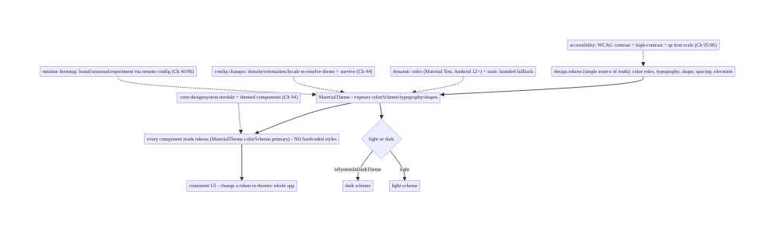
97.4 High-Level Architecture
Components & ownership
- Design tokens (semantic color/typography/shape/spacing) — single source of truth.
- MaterialTheme exposes tokens; components read roles (no hardcoding) → consistency.
- Light/dark + dynamic color (+ fallback); accessibility (contrast/scale, Ch 95/96); config resilience (Ch 44).
- Runtime theming (remote config, Ch 40); packaged as :core:designsystem (Ch 94).
Direction: tokens → theme → components (read roles) → consistent + adaptable UI; light/dark + dynamic + a11y + config-resilient + runtime-themeable.

97.5 Detailed Component Design
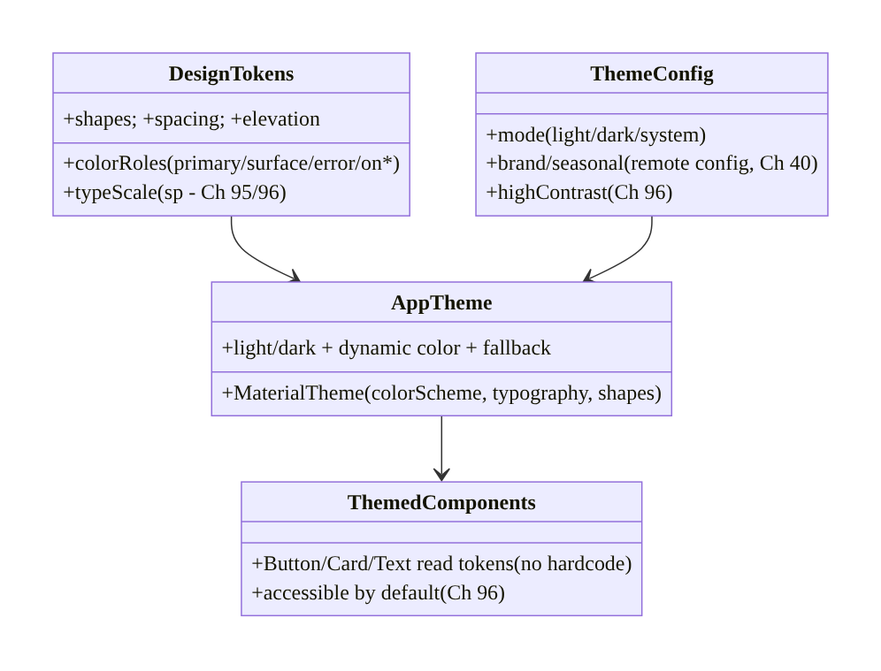
97.5 Detailed Component Design
Component | Responsibility
DesignTokens | semantic color/type/shape/spacing — single source of truth
AppTheme | MaterialTheme wiring: light/dark + dynamic color + fallback
ThemeConfig | mode + brand/seasonal (remote config, Ch 40) + high-contrast (Ch 96)
ThemedComponents | components reading tokens; accessible by default (Ch 96)

97.6 End-to-End Data Flow

Tokens → theme → component (and a token change)
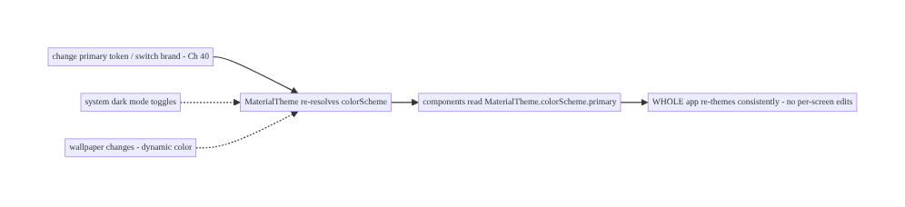
Tokens → theme → component (and a token change)

Config change re-resolves the theme (Ch 44)
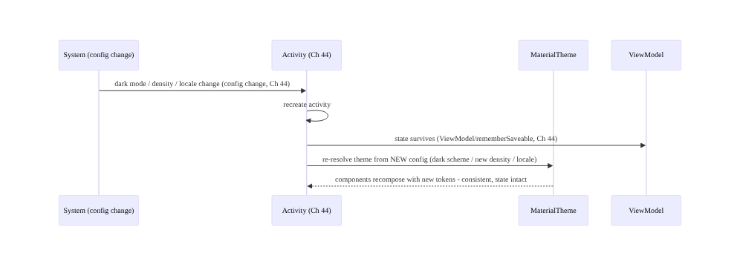
Config change re-resolves the theme (Ch 44)

97.7 Implementation (Compose + Kotlin)
Package: com.streamcart.designsystem (module :core:designsystem, Ch 94).

97.7.1 Design tokens (semantic color + type scale)
// Color ROLES (semantic), light + dark - NOT literal hues scattered in screens
private val LightColors = lightColorScheme(
primary = Brand700, onPrimary = White, surface = Gray50, onSurface = Gray900, error = Red600, /* ... */)
private val DarkColors = darkColorScheme(
primary = Brand300, onPrimary = Gray900, surface = Gray900, onSurface = Gray100, error = Red300, /* ... */)
// Typography in SP (scales with font setting, Ch 95/96)
private val AppTypography = Typography(
bodyLarge = TextStyle(fontSize = 16.sp, lineHeight = 24.sp), // sp, not dp
titleLarge = TextStyle(fontSize = 22.sp, fontWeight = FontWeight.SemiBold), /* ... */)
private val AppShapes = Shapes(medium = RoundedCornerShape(12.dp))

97.7.2 The theme: light/dark + dynamic color + fallback
@Composable
fun StreamCartTheme(
darkTheme: Boolean = isSystemInDarkTheme(), // config-driven (Ch 44)
dynamicColor: Boolean = true, // Material You
brandOverride: ColorScheme? = null, // runtime brand (Ch 40)
content: @Composable () -> Unit,
) {
val colorScheme = when {
brandOverride != null -> brandOverride // runtime theming (Ch 40/86)
dynamicColor && Build.VERSION.SDK_INT >= Build.VERSION_CODES.S -> { // dynamic color (Android 12+)
val ctx = LocalContext.current
if (darkTheme) dynamicDarkColorScheme(ctx) else dynamicLightColorScheme(ctx)
}
darkTheme -> DarkColors // static fallback (branded)
else -> LightColors
}
MaterialTheme(colorScheme = colorScheme, typography = AppTypography, shapes = AppShapes, content = content)
}

97.7.3 Components read tokens (no hardcoded styles)
@Composable
fun PrimaryButton(text: String, onClick: () -> Unit) {
Button(onClick = onClick,
colors = ButtonDefaults.buttonColors(
containerColor = MaterialTheme.colorScheme.primary, // ROLE, not Color(0xFF...)
contentColor = MaterialTheme.colorScheme.onPrimary)) {
Text(text, style = MaterialTheme.typography.labelLarge) // token typography (sp)
}
}
// NEVER: Button(colors = buttonColors(Color(0xFF6200EE))) ... Text(fontSize = 14.dp) - hardcoded, un-themeable.

97.7.4 Runtime brand/seasonal theming (Ch 40)
// Theme config from remote config (Ch 40) -> runtime re-theming without an app update
@Composable
fun ThemedApp(remoteTheme: RemoteThemeConfig, content: @Composable () -> Unit) { // Ch 40
val brandScheme = remoteTheme.toColorSchemeOrNull() // seasonal/brand/A-B (Ch 86)
StreamCartTheme(brandOverride = brandScheme, content = content) // applied at runtime
}
// RemoteThemeConfig { primaryHex, surfaceHex, ... } mapped to a ColorScheme - possible ONLY because tokens.

97.7.5 High-contrast + font-scale resilience (Ch 95/96)
// High-contrast scheme option (Ch 96) chosen by the user's accessibility setting:
val scheme = if (highContrastEnabled) HighContrastColors else colorScheme // WCAG contrast (Ch 96)
// Typography is sp -> scales with font setting; layouts must survive large scale (Ch 95/96):
Text(title, style = MaterialTheme.typography.titleLarge, // sp scales
maxLines = 2, overflow = TextOverflow.Ellipsis) // flexible, survives large fonts (Ch 95)

97.7.6 Module structure
:core:designsystem (Ch 94) DesignTokens (color roles/type/shape/spacing), StreamCartTheme, themed components
# Every :feature:* depends on :core:designsystem (Ch 94) -> consistency.
# Dark/dynamic -> MaterialTheme; a11y -> contrast + sp (Ch 95/96); config change -> Ch 44; runtime -> Ch 40.

97.8 Concurrency and Race Conditions
Theming is a UI-consistency / configuration concern; the pitfalls are consistency and config ones:
Scenario | Risk | Handling
Hardcoded color/size | un-themeable, inconsistent | tokens via MaterialTheme
Literal color (not role) | won’t adapt dark/dynamic | semantic roles
Per-screen dark logic | inconsistent dark mode | theme-level light/dark schemes
Dynamic color breaks contrast | inaccessible | contrast check + fallback (Ch 96)
Config change loses state | reset screen | survive config change (Ch 44)
dp typography | doesn’t scale | sp (Ch 95/96)
Divergent components | inconsistency | design-system module (Ch 94)
- The single-source-of-truth is the consistency guarantee: because components read roles from one theme, a token change (dark mode, brand, dynamic color) propagates everywhere automatically — there’s no per-screen state to keep in sync.
- Theming and config changes are intertwined (Ch 44): dark/light, density, locale, and orientation are config changes that recreate the activity and re-resolve the theme — state must survive and the theme must re-read, the same discipline as rotation (Ch 44).
- Theming and accessibility are co-designed (Ch 95/96): contrast lives in the color tokens, scalability in the typography (sp), high-contrast is a scheme — accessibility is built into the design system, not added later.

97.9 Failure Scenarios and Recovery
Failure | Detection | Response | Outcome
Inconsistent styles | design review | centralize tokens + themed components (Ch 94) | consistent
No/broken dark mode | dark-mode QA | theme-level light/dark schemes (roles) | works
Color won’t adapt | dark/dynamic test | semantic roles (not literal) | adapts
Dynamic color low contrast | contrast check (Ch 96) | fallback / enforce contrast | accessible
State lost on theme change | config-change test | survive config change (Ch 44) | preserved
Text won’t scale | large-font test | sp typography (Ch 95/96) | scales
Can’t re-brand | product request | runtime theming via remote config (Ch 40) | themeable
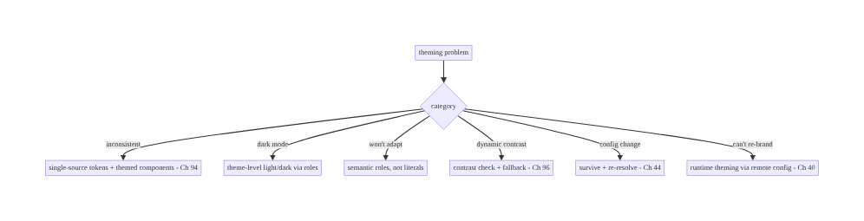
97.9 Failure Scenarios and Recovery
One source of truth: tokens → theme → components. Theming failures are hardcoded/literal styles (centralize into semantic tokens), per-screen dark logic (theme-level schemes), dynamic color breaking contrast (fallback + WCAG, Ch 96), lost state on config change (survive it, Ch 44), non-scalable text (sp, Ch 95/96), and un-themeable UI (runtime theming via remote config, Ch 40). Package it in a :core:designsystem module (Ch 94) so every feature is consistent by default.

97.10 Scaling the Implementation
- Level 1. MaterialTheme with semantic color roles + type scale; components read tokens; light/dark schemes.
- Level 2. Dynamic color (Material You) + static fallback; :core:designsystem module (Ch 94) with themed components; sp typography (Ch 95/96).
- Level 3 — production. Accessibility (WCAG contrast + high-contrast, Ch 96); config-change resilience (density/locale, Ch 44); design-token documentation; component library.
- Level 4 — large. Runtime/brand theming via remote config (Ch 40); white-label variants; experiment-driven themes (Ch 86); token tooling (design-to-code sync); theme regression tests.
- Level 5 — enterprise. Multi-brand design system, token pipelines (Figma→code), theme governance, cross-platform token sharing, accessibility-compliance-baked tokens, automated visual regression.
Avoid overengineering: MaterialTheme + semantic roles + light/dark + dynamic color + :core:designsystem module covers most apps. Don’t hardcode styles; don’t use literal colors; don’t do per-screen dark logic; don’t skip the design-system module.

97.11 Alternative Approaches and Trade-offs
Dimension | Option A | Option B | When
Styles | Design tokens (theme) | hardcoded per screen | Tokens always
Color | Semantic roles | literal hues | Roles (adapt)
Dark mode | Theme-level schemes | per-screen logic | Theme-level
Dynamic color | Material You + fallback | static only | Material You (personalization)
Typography | sp scale | dp fixed | sp (scales, Ch 95/96)
Packaging | :core:designsystem (Ch 94) | per-feature styles | Shared module
Theming | Runtime (remote config, Ch 40) | compile-time only | Runtime for brand/experiment
Design tokens vs hardcoded styles: hardcoded hex colors and fixed sizes scattered per screen → inconsistency, no dark mode, no re-theming. Design tokens via a theme give one source of truth that drives all components — consistent, adaptable, themeable. Always tokenize; never hardcode styles.
Semantic roles vs literal colors: a literal color (Color.Red) can’t adapt to dark/ dynamic/brand. Semantic roles (error, primary, onSurface) map to different hues per scheme, so the same component works across all themes. Use roles.
Theme-level dark mode vs per-screen logic: per-screen if/else dark logic is unmaintainable and inconsistent. A theme with light + dark schemes (components read roles) switches everything at once. Dark mode belongs in the theme, not components.

97.12 Security & Privacy Considerations
- Runtime theme config is content (Ch 40/28): theme config fetched via remote config (Ch 40) is data — validate it (don’t apply malformed/hostile values that break contrast or hide critical UI); a theme that makes security-critical text invisible (low contrast) is a risk. Enforce minimum contrast even on runtime themes (Ch 96).
- Don’t hide security cues via theme: a theme must not obscure security indicators (e.g., a lock icon, an error, a payment-confirmation, Ch 76) — maintain contrast/visibility of security-relevant UI regardless of brand/skin.
- Dynamic color from wallpaper is user data (Ch 28): the derived scheme reflects the user’s wallpaper — it stays on-device (Android generates it); don’t exfiltrate it.
- No secrets in theme/branding: theme tokens are UI values, not a place for secrets (Ch 24).
- Accessibility is a safety/compliance property (Ch 96): runtime themes must preserve contrast/accessibility — a brand skin that fails WCAG is both an a11y and (potentially) a compliance problem (Ch 96).
- Client concern mostly: the notes are validating runtime theme config (Ch 40) and preserving contrast/visibility of security-critical UI (Ch 76/96).

97.13 Performance and Resource Optimization
- Theme reads are cheap — MaterialTheme.colorScheme.* is a composition-local read; no cost concern. Avoid recreating the theme/schemes on every recomposition (hoist/remember, Ch 90).
- Dynamic color is cheap — the scheme is computed once per config; cache it.
- Config-change re-theme — recomposition with new tokens is normal Compose work (Ch 90); keep state in ViewModel so recreation is cheap (Ch 44).
- Runtime theme fetch — remote theme config comes through the normal remote-config path (Ch 40, cached); don’t block UI on it (apply fallback, then update).
- Large-font/density resilience — flexible layouts (Ch 95/96) avoid re-layout thrash at large scales.
- Profiling: recomposition on theme change (Ch 90), scheme computation cost, remote-theme fetch (Ch 40), layout at large font/density (Ch 95), contrast validation.

97.14 Testing Strategy
Token usage, dark/dynamic, contrast, and config resilience are testable (screenshot + unit + instrumented).
class ThemeTest {
@get:Rule val compose = createComposeRule()
@Test fun `button uses theme primary, not hardcoded`() {
// screenshot/semantics: PrimaryButton renders with MaterialTheme.colorScheme.primary in light + dark
}
@Test fun `dark scheme applied when system dark`() { /* isSystemInDarkTheme -> DarkColors */ }
@Test fun `runtime brand override applies`() { /* brandOverride -> that scheme (Ch 40) */ }
}
@Test fun `color roles meet WCAG contrast`() { /* onSurface vs surface >= 4.5:1 (Ch 96) */ }
@Test fun `layout survives large font scale`() { /* 200% fontScale - no truncation (Ch 95/96) */ }
@Test fun `theme re-resolves on config change`() { /* recreate -> dark scheme + state survives (Ch 44) */ }
// Screenshot tests across light/dark/dynamic catch visual regressions; contrast checks automated (Ch 96).
What to test: components use tokens (not hardcoded) — screenshot across light/dark/dynamic; dark scheme applied on system dark; runtime brand override (Ch 40); contrast of color roles (WCAG, Ch 96); large-font/density resilience (Ch 95/96); theme re-resolves + state survives on config change (Ch 44). Visual-regression (screenshot) tests across schemes.

97.15 Production Observability
- Metrics: dark-mode adoption, dynamic-color usage (Android 12+), runtime-theme (brand/ seasonal/experiment) application success (Ch 40), theme-related crash/layout issues (Ch 83), large-font/density issue rate (Ch 95/96), contrast-failure reports (Ch 96).
- Logs: theme config applied (mode/brand) — PII-safe (Ch 28).
- Debugging: inconsistent UI → hardcoded styles (not tokens); broken dark mode → literal colors / per-screen logic; low contrast → token contrast / dynamic color (Ch 96); state lost on theme change → config-change handling (Ch 44); re-brand not applying → remote theme fetch (Ch 40).
- Alerting: theme-related crash/layout regression (Ch 83); contrast failure after a runtime theme change (Ch 96); remote-theme application failure (Ch 40).
- Dashboards: dark/dynamic adoption, runtime-theme application, theme-related issues by release, contrast/large-font issue trends.

97.16 System Design Interview Preparation
≥25 questions.
Fundamentals
- Why a design system? Consistency, adaptability, themeability from one source.
- Design tokens? Named semantic values (color/type/shape/spacing).
- Single source of truth? Theme drives all components.
- #1 theming failure? Hardcoded styles per screen.
- MaterialTheme? Exposes colorScheme/typography/shapes.
Color
- Semantic vs literal? Roles (primary/error/onSurface) adapt; literals don’t.
- Why roles? Same component works across light/dark/dynamic/brand.
- Dark mode? Theme-level light + dark schemes (roles).
- Per-screen dark logic? Anti-pattern — use theme.
Dynamic color
- Material You? Theme from wallpaper (Android 12+).
- Fallback? Static branded scheme for older/opted-out.
- Risk? Contrast — must stay accessible (Ch 96).
Accessibility
- Theme + a11y? Contrast (tokens) + high-contrast + sp (Ch 95/96).
- Contrast? WCAG 4.5:1 in color roles.
- Typography units? sp (scales, Ch 95/96).
- Large fonts? Flexible layouts survive (Ch 95/96).
Config
- Config changes? Dark/density/locale/orientation (Ch 44).
- On change? Activity recreates, theme re-resolves, state survives (Ch 44).
Runtime/packaging
- Runtime theming? Brand/seasonal/experiment via remote config (Ch 40/86).
- Why possible? Token-driven, not hardcoded.
- Where packaged? :core:designsystem module (Ch 94).
- Themed components? Shared library reading tokens.
Edge/production
- Inconsistent components? Design-system module (Ch 94).
- Validate runtime theme? Enforce contrast; reject malformed (Ch 40/96).
- Test theming? Screenshot across schemes + contrast checks.
- Security UI + theme? Keep security cues visible/contrasted (Ch 76/96).

Design-change challenges
- Add dark mode. Theme-level light/dark schemes; components read roles.
- Support dynamic color. Material You + static fallback + contrast (Ch 96).
- Enable runtime re-branding. Token-driven theme via remote config (Ch 40).
- Make text scale. sp typography + flexible layouts (Ch 95/96).
- Ensure consistency. :core:designsystem module + themed components (Ch 94).

Mock walkthrough (abridged)
Clarify (dark/dynamic?, branding/white-label?, a11y target?) → design tokens (semantic color roles, sp type scale, shape, spacing) → MaterialTheme single source of truth → components read tokens (no hardcode) → light/dark + dynamic color + fallback → accessibility (contrast/high-contrast/sp, Ch 95/ 96) → config-change resilience (Ch 44) → runtime theming (remote config, Ch 40/86) → package as :core:designsystem (Ch 94) → test (screenshot across schemes + contrast) → observability.

97.17 Practical Exercises
- Beginner. Replace hardcoded colors/sizes with MaterialTheme semantic roles + sp typography; add light/dark schemes. Eval: no hardcoded styles; dark mode works.
- Intermediate. Add dynamic color (Material You) with a static branded fallback and verify contrast (Ch 96); package tokens + themed components in :core:designsystem (Ch 94). Eval: dynamic + accessible; shared module.
- Advanced. Add runtime brand/seasonal theming via remote config (Ch 40) and make the theme survive config changes (Ch 44) with state intact. Eval: re-themes at runtime; state survives.
- Production debugging. Investigate inconsistent dark-mode screens (literal colors / per-screen logic) and a low-contrast dynamic-color case (Ch 96). Eval: roles everywhere; contrast fixed.
- System design challenge. Design a multi-brand design system with token pipeline, runtime theming (Ch 40), accessibility-baked tokens (Ch 96), and screenshot regression tests. Eval: consistent, themeable, accessible, tested.
(Solutions withheld unless requested.)

97.18 Chapter Summary & Reference Sheet
Key decisions: build a design system with a single source of truth of design tokens — color (semantic/role-based: primary, surface, error, on*, not literal hues), typography (a scalable sp type scale), shape, and spacing/elevation — exposed through one MaterialTheme that every component reads (MaterialTheme.colorScheme/ typography/shapes, never hardcoded hex or fixed sizes), so changing a token re-themes the whole app consistently; define light and dark color schemes mapping the same roles to appropriate hues so components switch automatically by reading roles (dark mode is a theme concern, not per-screen logic); support dynamic color (Material You) from the wallpaper on Android 12+ with a static branded fallback while keeping contrast accessible (Ch 96); integrate accessibility into the theme (WCAG-contrast color roles, a high-contrast option, sp typography that scales, layouts resilient to large fonts/density — all config changes, Ch 44); survive configuration changes (theme/density/orientation/locale recreate the activity and re-resolve the theme, so state must survive and the theme re-read correctly, Ch 44); enable runtime theming (brand/seasonal/experiment-driven schemes via remote config, Ch 40/86 — possible only because styles are tokens, not hardcoded); and package tokens + theme + a themed component library in a shared :core:designsystem module (Ch 94) that every feature depends on — turning UI from scattered hardcoded styles into a consistent, adaptable, themeable system from one source of truth.
Concepts: design tokens (color/typography/shape/spacing), MaterialTheme single source of truth, semantic/role-based color, light/dark schemes, dynamic color (Material You + fallback), accessibility integration (contrast/high-contrast/sp, Ch 95/96), config-change resilience (Ch 44), runtime theming (remote config, Ch 40/86), :core:designsystem module + themed components (Ch 94).
Common mistakes: hardcoded hex/sizes per screen; literal colors (won’t adapt); per-screen dark logic; dynamic color breaking contrast (Ch 96); dp typography (doesn’t scale, Ch 95/96); losing state on config change (Ch 44); divergent components (no design-system module); theme config not validated (Ch 40); obscuring security-critical UI via theme (Ch 76).
Checklist:
- ☐ design tokens (semantic color roles, sp type scale, shape, spacing)
- ☐ MaterialTheme single source of truth; components read tokens (no hardcode)
- ☐ light/dark schemes via roles
- ☐ dynamic color (Material You) + static fallback
- ☐ WCAG contrast + high-contrast + sp (Ch 95/96)
- ☐ survive config changes (density/locale/orientation, Ch 44)
- ☐ runtime theming via remote config (Ch 40/86)
- ☐ package as :core:designsystem + themed components (Ch 94)
- ☐ validate runtime theme (contrast/visibility, Ch 96/76)
- ☐ screenshot + contrast tests across schemes.
Key APIs: MaterialTheme (colorScheme/typography/shapes), lightColorScheme/ darkColorScheme, dynamicLightColorScheme/dynamicDarkColorScheme (Android 12+), isSystemInDarkTheme(), color roles (primary/onPrimary/surface/onSurface/error), Typography/TextStyle in sp (Ch 95/96), Shapes, CompositionLocalProvider (custom tokens), remote-config-driven theme (Ch 40), :core:designsystem module (Ch 94), screenshot testing.
References: - Material 3 theming in Compose: https://developer.android.com/develop/ui/compose/designsystems/material3 - Dynamic color (Material You): https://developer.android.com/develop/ui/compose/designsystems/dynamic - Material Design 3 (tokens/color roles): https://m3.material.io - Custom design systems in Compose: https://developer.android.com/develop/ui/compose/designsystems/custom - (composes) Ch 2 Compose UI, Ch 44 Config Changes, Ch 96 Accessibility, Ch 95 Localization/Scaling, Ch 40 Remote Config, Ch 94 Modularization, Ch 86 A/B Testing

Chapter 98 — Android TV / STB / Fire TV State & Input Architecture
Part XI — Reach, Scale & Platform Breadth · Complexity: Complex (≥40 interview questions)
Prerequisites: Ch 56 (Media3/ExoPlayer), Ch 58 (offline OTT/DRM), Ch 2 (Compose), Ch 90 (jank), Ch 44 (lifecycle), Ch 89 (memory). Pairs with Ch 99 (Wear), Ch 100 (capstone).
Reference surface in StreamCart: the living-room form factor — Android TV, set- top boxes (STB), and Fire TV — where the interaction model is D-pad / remote (not touch), the UI is 10-foot (viewed from across the room), focus is explicit, playback is the core job (Ch 56/58), and devices are low-RAM / low-power with long sessions. This chapter is about D-pad focus-state architecture, 10-foot UI, leanback/TV navigation, media-centric state, and the constraints of TV/STB/Fire TV hardware.

98.1 Problem Definition and Real-World Context
The living room is a different platform: the user sits ~10 feet away and drives the UI with a D-pad remote (up/down/left/right + select, maybe a few media/voice keys) — no touch, no cursor. This inverts the mobile interaction model: focus becomes the central UI state (there is always exactly one focused element, and the user moves focus with the D-pad), navigation is spatial (which element is up/down/left/right of the current one), text entry is painful (an on-screen keyboard navigated by D-pad), and the UI must be 10-foot legible (large text, high contrast, generous focus highlight). The device is typically a low-RAM, low-power STB / TV / Fire TV dongle running long media sessions (Ch 56/58). TV state & input architecture is the discipline of building for this: an explicit, predictable focus-state model and D-pad navigation, a 10-foot UI (leanback/TV-Compose patterns — rows/cards/browse), media-centric state (the player is the core, Ch 56/58), and respecting TV/STB/Fire TV constraints (memory Ch 89, no touch, platform differences between Android TV and Amazon Fire TV).
Concretely, teams hit:
- Porting a touch app to TV (the #1 mistake). A phone UI with tap targets, scroll gestures, and small text is unusable on TV — there’s no touch, focus isn’t handled, text is illegible at 10 feet. TV needs a purpose-built focus/D-pad UI, not a resized phone app.
- Focus management (the core TV problem). On TV, focus is the UI state: exactly one element is focused, the user moves it with the D-pad, and every focusable element must be reachable and show a clear focus highlight. Broken focus (focus traps, lost focus, unreachable elements, wrong initial focus) makes the app unnavigable.
- Spatial/directional navigation. The D-pad moves focus spatially (up/down/left/right); the framework computes the next focusable in that direction, but complex layouts need explicit focus order (nextFocusUp/Down/Left/Right, Compose focus modifiers/FocusRequester). Grids/rows (the TV browse pattern) need correct 2D navigation.
- 10-foot UI. Text, targets, and focus highlights must be large and high-contrast for across-the-room viewing; dense phone layouts fail. Use leanback / TV Compose components (BrowseFragment/rows/cards, or androidx.tv Compose) designed for 10-foot.
- Media-centric state (Ch 56/58). TV’s core job is playback — the player (Media3/ ExoPlayer, Ch 56), DRM for premium OTT (Ch 58), playback controls via D-pad/media keys, resume, background audio, and leanback transport are central. TV state revolves around the player.
- Low-RAM / low-power constraints (Ch 89). Many STBs/Fire TV dongles have little RAM (512MB–2GB) and weak CPUs/GPUs — memory (Ch 89) and rendering (Ch 90) discipline is stricter than mobile; OOM and jank are easier to hit. Long sessions amplify leaks (Ch 89).
- Platform fragmentation (Android TV vs Fire TV vs STB). Fire TV is an Amazon fork (Amazon Appstore, Amazon’s services, different remote, no Google Play Services) — code must handle both (and operator STBs with custom launchers/remotes). Abstract platform differences.
- No/limited Google services on some devices. Fire TV and some STBs lack Google Play Services (no FCM via Google, no Play Billing) — need alternatives (Amazon services, Ch 50/ 77 analogs) behind an abstraction.
- D-pad text entry & deep linking. Text entry is slow (D-pad keyboard) — minimize it (voice, QR-to-phone, deep links). Deep links / voice (Assistant/Alexa) launch content directly.
The architecture: build a purpose-built 10-foot UI with an explicit focus-state model — exactly one focused element, D-pad spatial navigation with correct focus order and initial focus, clear focus highlights, no focus traps — using leanback / TV-Compose patterns (browse rows/cards), a media-centric state model (player core, Ch 56/58: playback/ DRM/transport/resume), strict memory + rendering discipline for low-RAM/low-power devices (Ch 89/90), and a platform abstraction over Android TV vs Fire TV vs STB differences (services, remotes, stores) — minimizing text entry (voice/deep-link). This chapter is about architecting for the D-pad-driven, media-centric, constrained living-room platform.

Three practical use cases
- StreamCart TV browse + focus. A leanback/TV-Compose browse screen (rows of content cards); D-pad moves focus with correct spatial order and initial focus, each card shows a clear focus highlight, and select opens detail/playback — fully navigable without touch.
- Media-centric playback (Ch 56/58). The player (Media3/ExoPlayer, Ch 56) with DRM for premium OTT (Ch 58), D-pad/media-key transport controls (play/pause/seek), resume, and leanback transport UI — the core TV experience.
- Fire TV + low-RAM support. The same app runs on Fire TV (Amazon services/remote behind an abstraction, no Google Play Services) and a low-RAM STB — with strict memory (Ch 89) and rendering (Ch 90) budgets so it doesn’t OOM or jank.

Why this is architectural
TV architecture composes media (Ch 56/58), Compose/leanback UI (Ch 2/90), lifecycle (Ch 44), memory (Ch 89), and platform abstraction. The decisions — explicit focus-state model, D-pad spatial navigation, 10-foot UI, media-centric state, low-RAM/low-power discipline, Android-TV/Fire-TV/STB abstraction — determine whether the app is navigable, legible, performant, and portable across the living-room ecosystem, which is a fundamentally different platform from mobile.

98.2 Requirements Engineering

Functional requirements
ID | Requirement
F1 | Explicit focus-state model: one focused element; D-pad spatial navigation; correct order + initial focus; clear highlight; no traps.
F2 | 10-foot UI (leanback / TV-Compose: browse rows/cards; large, high-contrast).
F3 | Media-centric state: player core (Media3/DRM/transport/resume) (Ch 56/58).
F4 | Strict memory + rendering discipline for low-RAM/low-power devices (Ch 89/90).
F5 | Platform abstraction over Android TV / Fire TV / STB (services, remotes, stores).
F6 | Minimize text entry (voice / deep links); handle D-pad/media keys.

Non-functional requirements
Attribute | Policy
Navigability | Every element D-pad-reachable; predictable focus.
Legibility | 10-foot (large text, high contrast, visible focus).
Performance | No OOM/jank on low-RAM/low-power (Ch 89/90).
Portability | Android TV + Fire TV + STB behind abstractions.
Media-first | Robust playback/DRM/transport (Ch 56/58).

Scope
- In scope: focus-state model + D-pad spatial navigation (order, initial focus, highlight, traps), 10-foot UI (leanback / androidx.tv Compose, browse rows/cards), media-centric state (player/DRM/transport/resume, Ch 56/58), low-RAM/low-power constraints (memory Ch 89, rendering Ch 90), platform abstraction (Android TV vs Fire TV vs STB: services, remotes, stores, no-GPS), text-entry minimization (voice/deep link), media/D-pad keys, leanback vs TV-Compose.
- Out of scope: Media3/ExoPlayer detail (Ch 56), DRM/offline OTT detail (Ch 58), Compose basics (Ch 2), jank detail (Ch 90), memory detail (Ch 89), lifecycle (Ch 44).

Assumptions & constraints
- Android TV / Fire TV / operator STB; D-pad remote (no touch); 10-foot viewing; Media3/ ExoPlayer (Ch 56) + DRM (Ch 58) for playback; low-RAM/low-power devices (strict Ch 89/ 90). Leanback or androidx.tv Compose for UI. Fire TV lacks Google Play Services (Amazon services behind abstraction). minSdk per TV (often 21+/22+; here aligned to the book’s 24).

98.3 System Design Fundamentals
- The living room is a different platform (the framing). TV/STB/Fire TV differ from mobile on every axis: input (D-pad remote, no touch/cursor), distance (10 feet — big UI), orientation (landscape only), primary job (media playback, Ch 56/58), hardware (low-RAM/low-power STBs/dongles), and ecosystem (Android TV + Amazon Fire TV + operator STBs, different stores/services). You design for TV, not port a phone app.
- Focus is the central UI state (the core model). With a D-pad, there is always exactly one focused element, and the user navigates by moving focus (not tapping a location). So focus state — which element is focused — is the TV app’s primary UI state. The architecture must guarantee: (1) every interactive element is focusable and reachable; (2) a clear focus highlight (the user must see what’s focused from 10 feet); (3) correct initial focus when a screen appears; (4) no focus traps (focus that can’t escape a region) or lost focus (focus going nowhere); (5) predictable spatial movement. Broken focus = an unnavigable app.
- D-pad spatial / directional navigation. The D-pad moves focus spatially: pressing right moves to the nearest focusable element to the right, etc. The framework computes this geometrically, but real layouts need explicit control: nextFocusLeft/Right/Up/Down (Views) or Compose focus modifiers / FocusRequester / Modifier.focusProperties to define the focus graph, and focusGroup for rows. Grids and rows (the TV browse pattern) need correct 2D navigation (move within a row with left/right, between rows with up/down). Handle wrap-around and edge behavior deliberately.
- 10-foot UI (leanback / TV-Compose). The UI must be legible and operable from across the room: large text, high contrast, generous spacing, prominent focus highlights (scale/ glow/border on the focused card), and landscape layouts. Android provides Leanback (androidx.leanback: BrowseSupportFragment, rows, cards, VerticalGridView/ HorizontalGridView) and, increasingly, TV Compose (androidx.tv.material3, androidx.tv.foundation: TvLazyRow/TvLazyColumn, focus-aware components) — designed for 10-foot + D-pad. Use these, not phone components.
- Media-centric state (Ch 56/58). The TV app’s core is playback: the player (Media3/ExoPlayer, Ch 56) drives the primary state (playing/paused/buffering/position), DRM (Widevine, Ch 58) gates premium OTT, transport controls (play/pause/seek/skip) are driven by D-pad + media keys, resume (continue watching) is expected, and a leanback playback / transport UI overlays the video. TV state architecture revolves around the player — more so than mobile. Handle background audio and media session (Ch 56) for system/voice controls.
- Low-RAM / low-power constraints (Ch 89/90). Many STBs and Fire TV dongles have 512MB– 2GB RAM and weak CPUs/GPUs — so memory discipline (bounded caches, downsampled images, no leaks, Ch 89) and rendering discipline (no jank, light lists, Ch 90/93) are stricter than on phones. OOM and jank are easy to hit; long media sessions amplify leaks (Ch 89). Budget memory/rendering tightly and test on real low-end devices.
- Platform fragmentation: Android TV vs Fire TV vs STB. Android TV / Google TV (Google ecosystem: Play Store, Play Services, Google Assistant). Amazon Fire TV is an Android fork with Amazon ecosystem (Amazon Appstore, no Google Play Services → no Google FCM/Play Billing, use Amazon equivalents, Alexa voice, Amazon’s remote). Operator STBs run customized Android TV with custom launchers/remotes/services. Architect a platform abstraction (interfaces for push, billing, voice, store, device-specific remote keys) with per-platform implementations — don’t hardcode Google services.
- No Google Play Services on Fire TV/some STBs (Ch 50/77). FCM-via-Google (Ch 50), Play Billing (Ch 77), Google sign-in, and Play In-App Updates are unavailable on Fire TV — use Amazon equivalents (ADM for push, Amazon IAP for billing) behind the abstraction. Detect the platform and bind the right implementation (Ch 46 DI).
- Text entry & deep linking/voice. D-pad text entry (on-screen keyboard) is slow and painful — minimize it: use voice (Google Assistant / Alexa), deep links (launch content directly from search/recommendations), sign-in via phone/QR (device-code flow), and recommendations/search integration so users rarely type. Media/voice keys and D-pad keys must be handled (onKeyEvent).
Core insight: **the living room is a different platform — D-pad remote instead of touch, 10-foot viewing instead of in-hand, landscape-only, media playback as the core job, and low-RAM/low-power STBs/dongles across a fragmented ecosystem (Android TV, Amazon Fire TV, operator STBs) — so you design for it rather than porting a phone app: make focus the central UI state (exactly one focused element the user moves with the D-pad, every interactive element focusable and reachable, a clear 10-foot focus highlight, correct initial focus, and no focus traps or lost focus — broken focus makes the app unnavigable), implement D-pad spatial/directional navigation with explicit focus order (nextFocus*/FocusRequester/focusGroup) and correct 2D grid/row movement, build a 10-foot UI with leanback or androidx.tv Compose (browse rows/cards, large high-contrast text, prominent focus highlights), center the state model on the player (Media3/ExoPlayer with Widevine DRM for premium OTT, D-pad/media-key transport, resume, media session, Ch 56/58), hold strict memory and rendering discipline because low-RAM/low-power devices OOM and jank far more easily than phones and long media sessions amplify leaks (Ch 89/90), abstract the fragmented ecosystem behind interfaces (push, billing, voice, store, remote keys) with per-platform implementations since Fire TV and some STBs lack Google Play Services and need Amazon/operator equivalents, and minimize painful D-pad text entry with voice, deep links, and phone/QR sign-in — because a navigable, legible, performant, portable living-room app is architected for the D-pad-driven, media-centric, constrained platform, not resized from mobile.**

98.4 High-Level Architecture
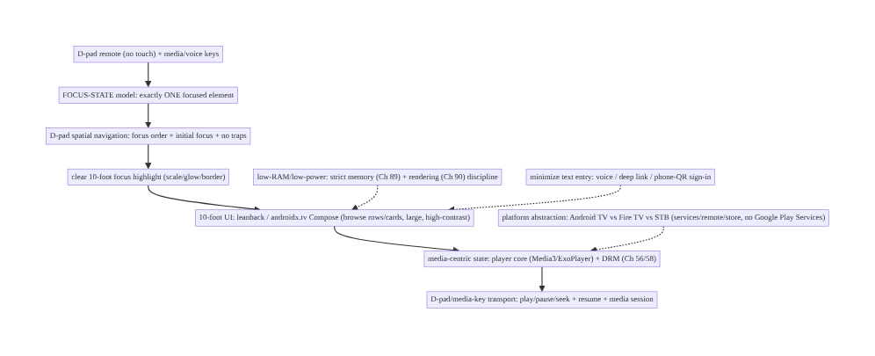
98.4 High-Level Architecture
Components & ownership
- Focus-state model (one focused element) + D-pad spatial navigation (order/initial/no traps) + 10-foot highlight — the TV UI core.
- 10-foot UI (leanback / TV-Compose rows/cards); media-centric state (player/DRM/transport, Ch 56/58).
- Low-RAM/low-power discipline (Ch 89/90); platform abstraction (Android TV/Fire TV/STB); minimal text entry.
Direction: D-pad input → focus-state + spatial navigation → 10-foot UI (leanback/TV-Compose) → media-centric state (player/DRM/transport); constrained + platform-abstracted + low-text-entry.

98.5 Detailed Component Design
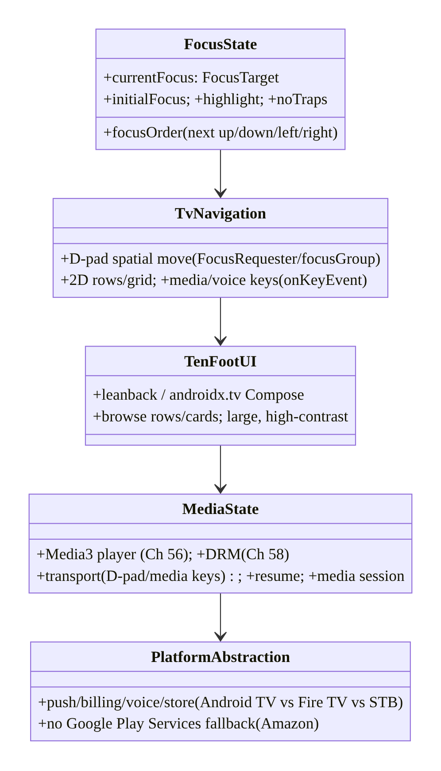
98.5 Detailed Component Design
Component | Responsibility
FocusState | one focused element; order; initial focus; highlight; no traps
TvNavigation | D-pad spatial move (FocusRequester/focusGroup); 2D rows; media keys
TenFootUI | leanback / TV-Compose browse rows/cards; 10-foot legibility
MediaState | player (Media3) + DRM + transport + resume + media session (Ch 56/58)
PlatformAbstraction | push/billing/voice/store per Android TV/Fire TV/STB (no-GPS fallback)

98.6 End-to-End Data Flow

D-pad navigation → focus → select → play
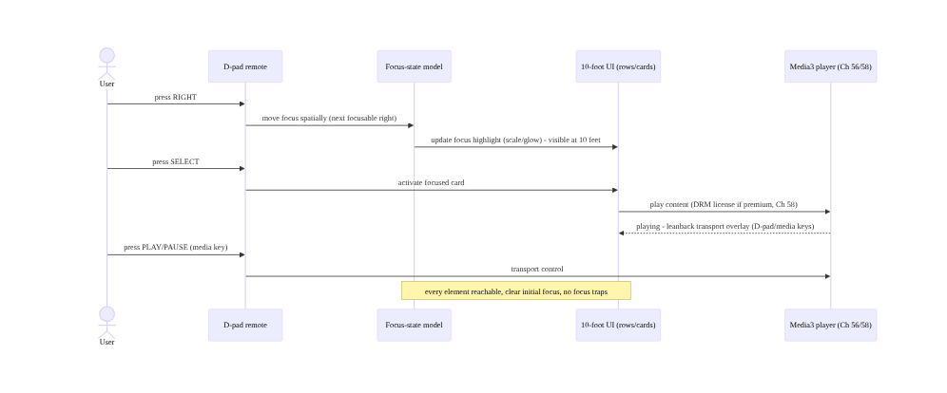
D-pad navigation → focus → select → play

Platform abstraction (Android TV vs Fire TV)
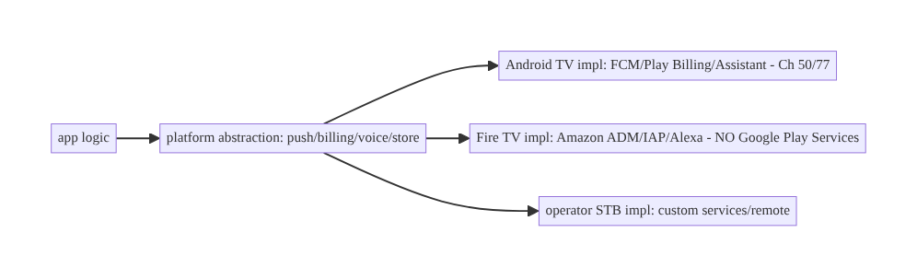
Platform abstraction (Android TV vs Fire TV)

98.7 Implementation (Compose TV + Kotlin)
Package: com.streamcart.tv.

98.7.1 Focus-state: initial focus + highlight + spatial order
@Composable
fun BrowseRow(title: String, items: List<ContentUi>, onSelect: (ContentUi) -> Unit) {
val firstCard = remember { FocusRequester() }
TvLazyRow(Modifier.focusGroup()) { // androidx.tv - row is a focus group
itemsIndexed(items, key = { _, it -> it.id }) { index, item ->
ContentCard(item, onSelect = onSelect,
modifier = if (index == 0) Modifier.focusRequester(firstCard) else Modifier) // initial focus target
}
}
LaunchedEffect(Unit) { firstCard.requestFocus() } // correct INITIAL focus when row appears
}
@Composable
fun ContentCard(item: ContentUi, onSelect: (ContentUi) -> Unit, modifier: Modifier = Modifier) {
var focused by remember { mutableStateOf(false) }
Card(
onClick = { onSelect(item) }, // D-pad SELECT activates
modifier = modifier
.onFocusChanged { focused = it.isFocused }
.scale(if (focused) 1.1f else 1.0f) // 10-foot focus HIGHLIGHT (scale/glow/border)
.border(if (focused) 3.dp else 0.dp, MaterialTheme.colorScheme.primary), // visible from 10 feet
) { /* large, high-contrast card content */ }
}

98.7.2 D-pad / media key handling
// Handle D-pad and MEDIA keys (play/pause/seek) - TV remotes send KeyEvents, not touch
Modifier.onKeyEvent { event ->
when (event.key) {
Key.MediaPlayPause -> { player.playWhenReady = !player.playWhenReady; true } // media key (Ch 56)
Key.MediaFastForward -> { player.seekForward(); true }
Key.DirectionCenter -> { onSelect(); true } // D-pad select
else -> false // let focus system handle arrows
}
}

98.7.3 Media-centric state (player core, Ch 56/58)
class TvPlayerViewModel @Inject constructor(
private val playerFactory: PlayerFactory, // Media3/ExoPlayer (Ch 56)
private val drm: DrmSessionManager, // Widevine for premium OTT (Ch 58)
private val resumeStore: ResumeStore, // continue-watching position
) : ViewModel() {
val player: ExoPlayer = playerFactory.create(drm) // DRM-enabled (Ch 58)
fun play(content: Content) {
val item = MediaItem.Builder().setUri(content.url)
.setDrmConfiguration(content.drm?.toMedia3()) // license (Ch 58)
.build()
player.setMediaItem(item, resumeStore.position(content.id)) // RESUME from saved position
player.prepare(); player.playWhenReady = true
// Media session (Ch 56) exposes transport to system/voice; leanback transport overlay for D-pad.
}
override fun onCleared() { resumeStore.save(player); player.release() } // save resume + release (Ch 89)
}

98.7.4 Platform abstraction (Android TV vs Fire TV vs STB)
// Abstract platform-specific services - Fire TV/STB may lack Google Play Services (Ch 50/77)
interface PlatformServices {
fun push(): PushProvider // FCM (Android TV) vs ADM (Fire TV) - Ch 50
fun billing(): BillingProvider // Play Billing vs Amazon IAP - Ch 77
fun voice(): VoiceProvider // Google Assistant vs Alexa
}
// DI binds the right impl per platform (Ch 46):
@Module @InstallIn(SingletonComponent::class)
object PlatformModule {
@Provides fun services(ctx: Context): PlatformServices =
if (isFireTv(ctx)) FireTvServices(ctx) // Amazon ADM/IAP/Alexa - no Google Play Services
else AndroidTvServices(ctx) // FCM/Play Billing/Assistant (Ch 50/77)
}

98.7.5 Low-RAM discipline (Ch 89/90)
// STBs/dongles have little RAM - stricter than mobile (Ch 89):
// - bounded image cache sized to the (smaller) heap; downsample card art to card size (Ch 89/59)
// - light TV card composables, stable keys, async images (Ch 90/93) - jank is easy on weak GPUs
// - release the player promptly (onCleared) - long sessions amplify leaks (Ch 89)
// - onTrimMemory -> evict caches (Ch 44/89); test on a real low-RAM Fire TV stick, not an emulator

98.7.6 Module structure
:feature:tv BrowseRow/ContentCard (focus+highlight), TvPlayerViewModel (player core)
:core:platform PlatformServices abstraction (Android TV / Fire TV / STB) - Ch 46 DI
# Focus/nav -> androidx.tv + FocusRequester/focusGroup; media -> Media3 (Ch 56) + DRM (Ch 58);
# low-RAM -> Ch 89/90; no-GPS fallback -> Amazon services. Leanback is the View-based alternative.

98.8 Concurrency and Race Conditions
Scenario | Risk | Handling
Lost / trapped focus | unnavigable | explicit focus order + initial focus + no traps
Unreachable element | can’t select | ensure focusable + in focus graph
Focus highlight invisible | user lost at 10 feet | prominent highlight (scale/glow/border)
Media key unhandled | no transport | onKeyEvent for media/D-pad keys
Player not released | leak on weak device | release in onCleared (Ch 89)
Low-RAM OOM | crash | bounded caches + downsample + test real device (Ch 89)
Google service on Fire TV | crash/no-op | platform abstraction (Amazon fallback)
Wrong initial focus | confusing | requestFocus on screen entry
- Focus is the state machine to get right: on TV, a lost or trapped focus leaves the user stuck with no touch escape — the architecture must guarantee initial focus, a reachable focus graph, and no traps; test every screen with only the D-pad.
- Memory/rendering discipline is stricter than mobile (Ch 89/90): low-RAM STBs/dongles OOM and jank where a phone wouldn’t; the player must be released promptly (long sessions, Ch 89), and caches/lists must be bounded/light (Ch 89/93) — test on real low-end hardware.
- Platform differences must be abstracted, not branched everywhere: Fire TV’s lack of Google Play Services means push/billing/voice differ — bind the right implementation via DI (Ch 46) behind an interface, not scattered if (fireTv) checks.

98.9 Failure Scenarios and Recovery
Failure | Detection | Response | Outcome
App unnavigable (focus) | D-pad-only testing | explicit focus order + initial + no traps | navigable
Can’t see what’s focused | 10-foot review | prominent highlight | legible
Phone UI ported | TV UX review | leanback / TV-Compose 10-foot UI | TV-native
OOM on Fire TV stick | real-device test (Ch 89) | bounded memory + downsample + release player | stable
Jank on weak GPU | FrameTiming (Ch 90) | light cards + stable keys + async art | smooth
Crash: no Google services | Fire TV test | platform abstraction (Amazon) | portable
No transport controls | remote test | handle media/D-pad keys | controllable
Lost resume position | playback test | save/restore resume (Ch 56) | continues
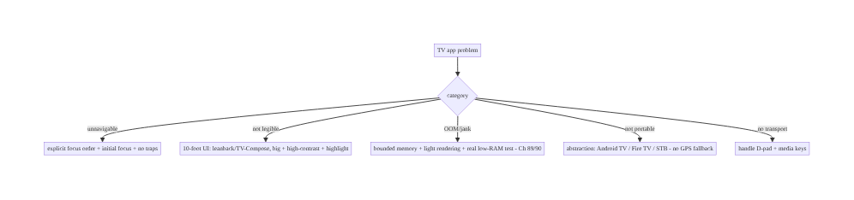
98.9 Failure Scenarios and Recovery
Make focus explicit, build 10-foot, center on the player, respect the hardware, abstract the platform. TV failures are broken focus (explicit order + initial focus + no traps + visible highlight), ported phone UIs (leanback/TV-Compose 10-foot), OOM/jank on weak devices (strict memory + light rendering, Ch 89/90 — test real hardware), missing transport (handle media/D-pad keys), and Google-service crashes on Fire TV (platform abstraction). The living room is a different platform — architect for it.

98.10 Scaling the Implementation
- Level 1. TV-Compose/leanback browse rows/cards; focusable cards with a visible highlight; D-pad select; a Media3 player (Ch 56).
- Level 2. Explicit focus order + initial focus (FocusRequester/focusGroup); media/D-pad key handling; DRM for premium (Ch 58); resume.
- Level 3 — production. Platform abstraction (Android TV / Fire TV, no-GPS fallback); strict memory/rendering budgets for low-RAM (Ch 89/90); media session + voice; deep links.
- Level 4 — multi-device. Operator STB support (custom remotes/launchers); recommendations/ channels integration; voice (Assistant/Alexa); device-tiered quality; A/B on TV (Ch 86).
- Level 5 — ecosystem. Full living-room platform: multi-store (Play + Amazon Appstore), per-operator builds, TV-specific performance SLOs, large device-matrix testing, living-room analytics (Ch 82).
Avoid overengineering: TV-Compose/leanback browse + correct focus + a Media3 player + platform abstraction + low-RAM discipline covers the core. Don’t port a phone UI; don’t neglect focus; don’t assume Google services; don’t skip real-low-RAM-device testing.

98.11 Alternative Approaches and Trade-offs
Dimension | Option A | Option B | When
UI toolkit | TV Compose (androidx.tv) | Leanback (Views) | TV-Compose (modern); leanback (legacy/rich browse)
App | Purpose-built TV | ported phone app | Purpose-built always
Focus | Explicit order + initial | rely on default geometry | Explicit for complex layouts
Services | Platform abstraction | hardcode Google | Abstraction (Fire TV/STB)
Player | Media3/ExoPlayer (Ch 56) | custom | Media3 (DRM/transport)
Text entry | Voice/deep-link/QR | D-pad keyboard | Minimize typing
Memory | Strict (low-RAM) | mobile budgets | Strict for STB/dongle (Ch 89)
TV Compose vs Leanback: Leanback (androidx.leanback, Views) is the established TV toolkit (rich BrowseSupportFragment, rows, cards) — mature but View-based. TV Compose (androidx.tv.material3/foundation) is the modern declarative approach (focus-aware TvLazyRow/components) — preferred for new apps, though some rich leanback patterns are still maturing. Choose TV Compose for new work; leanback for legacy or when you need its specific browse components.
Purpose-built vs ported phone app: a resized phone app is unusable on TV (no touch, illegible, no focus). A purpose-built TV UI (D-pad focus, 10-foot, leanback/TV-Compose) is the only acceptable approach. Share business logic / data (Ch 1/94) across phone and TV, but build TV-specific UI.
Platform abstraction vs hardcoding Google: hardcoding Google Play Services (FCM, Play Billing) crashes/no-ops on Fire TV (no GPS). A platform abstraction (push/billing/voice behind interfaces, Ch 46) with Amazon implementations keeps the app portable. Abstract platform services from the start.

98.12 Security & Privacy Considerations
- DRM for premium content (Ch 58): TV OTT playback of premium content requires Widevine DRM (often L1 hardware-backed on TVs) — the same secure-playback discipline as mobile (Ch 58); license handling and secure video path matter more on TV (big-screen piracy target).
- Shared-device / profiles (privacy, Ch 28): a TV is often shared (family device) — handle profiles and per-profile data isolation (Ch 28); don’t leak one user’s data/recommendations to another; sign-out/switch-profile must clear appropriately.
- Sign-in on a shared, typing-hostile device: prefer device-code / phone-QR sign-in (Ch 20) over typing credentials on a shared TV with a D-pad — more secure and far more usable; don’t display secrets on a big shared screen.
- No Google Play Services → different security surfaces (Fire TV): auth/attestation/integrity (Ch 24) that rely on Google services need alternatives on Fire TV — don’t silently drop security checks; use platform-appropriate equivalents.
- Payment on TV (Ch 76/77): billing uses the platform store (Play vs Amazon IAP) — don’t roll custom card entry on a shared TV (PCI + usability); defer to the store or phone.
- Client + platform: DRM/secure playback (Ch 58), profile isolation on shared devices (Ch 28), QR/device-code sign-in (Ch 20), and platform-appropriate integrity/billing (Ch 24/77).

98.13 Performance and Resource Optimization
- Memory is tighter than mobile (Ch 89) — low-RAM STBs/dongles: bounded caches sized to the smaller heap, downsample card art to card size (Ch 59/89), release the player promptly (long sessions, Ch 89), honor onTrimMemory.
- Rendering on weak GPUs (Ch 90/93) — light TV cards, stable keys, async art, no per-frame allocation; the TV browse grid is a large list (Ch 93) on a weak GPU — apply list discipline strictly.
- Baseline Profiles help here too (Ch 92) — AOT the browse/playback path for smoother first use on weak CPUs.
- Playback is the hot path (Ch 56/58) — efficient buffering, hardware decode, DRM L1; test on real devices.
- Test on real low-end hardware — emulators hide the OOM/jank reality of a cheap Fire TV stick.
- Profiling: memory footprint on low-RAM devices (Ch 89), browse/scroll frame timing on weak GPU (Ch 90/93), playback start time + rebuffer (Ch 56), focus-navigation responsiveness, startup (Ch 88/92).

98.14 Testing Strategy
Focus, D-pad navigation, and media are testable; low-RAM behavior needs real devices.
class TvFocusTest {
@get:Rule val compose = createComposeRule()
@Test fun `every card is D-pad reachable`() {
// simulate D-pad right/down across the browse grid - assert each card gains focus (no traps)
}
@Test fun `initial focus set on screen entry`() { /* firstCard.requestFocus() -> first card focused */ }
@Test fun `focused card shows highlight`() { /* onFocusChanged -> scale/border applied */ }
}
class TvKeyTest {
@Test fun `media play-pause key toggles player`() { /* Key.MediaPlayPause -> playWhenReady toggles (Ch 56) */ }
}
class PlatformAbstractionTest {
@Test fun `Fire TV binds Amazon services, not Google`() { /* isFireTv -> FireTvServices (no GPS) */ }
}
// Real-device (required): low-RAM Fire TV stick - memory/jank (Ch 89/90); D-pad-only navigation walkthrough;
// DRM playback on hardware (L1, Ch 58); resume; voice (Assistant/Alexa).
What to test: D-pad reachability (every element, no traps) + initial focus + highlight; media/D-pad key handling (Ch 56); platform abstraction (Fire TV → Amazon, no Google); player release/resume (Ch 89/56); DRM playback (Ch 58). Real low-RAM device testing for memory/jank (Ch 89/90) and D-pad-only navigation is mandatory — emulators miss it.

98.15 Production Observability
- Metrics: playback start time + rebuffer + errors (Ch 56), DRM license success (Ch 58), memory footprint / OOM on low-RAM devices (Ch 89), browse jank on weak GPU (Ch 90/93), focus/navigation issues, platform split (Android TV vs Fire TV vs STB usage), startup (Ch 88/92), by device model (huge TV/STB fragmentation).
- Logs: playback/focus/platform events — PII-safe (Ch 28; shared-device profile-aware).
- Debugging: unnavigable → focus graph (traps/initial focus); OOM → low-RAM device memory (Ch 89); jank → browse-grid rendering on weak GPU (Ch 90); crash on Fire TV → Google-service dependency (abstraction); playback failure → DRM/buffer (Ch 56/58); by device model.
- Alerting: playback-error/rebuffer spike (Ch 56); OOM-rate spike on a device model (Ch 89); Fire-TV-specific crash (platform); DRM license failures (Ch 58).
- Dashboards: playback QoE + DRM by device model, memory/OOM by device, browse jank, platform split, focus-issue reports.

98.16 System Design Interview Preparation
≥40 questions (Complex).
Fundamentals
- How is TV different? D-pad (no touch), 10-foot, landscape, media-centric, low-RAM, fragmented.
- #1 TV mistake? Porting a phone app.
- Central UI state? Focus (exactly one focused element).
- Why focus matters? No touch — the user navigates by moving focus.
- Input? D-pad + select + media/voice keys.
Focus
- Focus guarantees? Reachable, visible highlight, initial focus, no traps.
- Focus trap? Focus can’t escape a region — unnavigable.
- Spatial navigation? D-pad moves focus geometrically (next in direction).
- Explicit order? nextFocus*/FocusRequester/focusProperties.
- focusGroup? Group a row for navigation.
- Initial focus? requestFocus on screen entry.
- 2D navigation? Rows (left/right) + between rows (up/down).
10-foot UI
- 10-foot? Large text, high contrast, prominent focus highlight, landscape.
- Toolkits? Leanback (Views) / androidx.tv Compose.
- Browse pattern? Rows of cards (BrowseFragment / TvLazyRow).
- Highlight? Scale/glow/border on focused card.
Media
- Core job? Playback (Media3/ExoPlayer, Ch 56).
- DRM? Widevine (L1 on TV) for premium OTT (Ch 58).
- Transport? D-pad + media keys (play/pause/seek).
- Resume? Save/restore position (continue watching).
- Media session? System/voice transport control (Ch 56).
Constraints
- RAM? Low (512MB–2GB STB/dongle) — strict memory (Ch 89).
- GPU? Weak — strict rendering/jank (Ch 90/93).
- Long sessions? Amplify leaks — release player (Ch 89).
- Test? Real low-RAM device, not emulator.
Platform
- Android TV vs Fire TV? Google vs Amazon ecosystem (fork).
- Fire TV lacks? Google Play Services (no FCM/Play Billing).
- Fallback? Amazon ADM/IAP/Alexa behind abstraction.
- STB? Operator-customized (remotes/launchers/services).
- Abstract how? Interfaces + per-platform DI (Ch 46).
Text/voice
- Text entry? Painful (D-pad keyboard) — minimize.
- Alternatives? Voice, deep links, phone/QR sign-in.
- Deep links? Launch content directly (search/recs).
- Voice? Assistant (Android TV) / Alexa (Fire TV).
Edge/production
- Shared device? Profiles + per-profile isolation (Ch 28).
- Sign-in? Device-code/QR (not typing on shared TV, Ch 20).
- Payment? Platform store (Play/Amazon IAP), not custom (Ch 77).
- Observe by? Device model (fragmentation).
- Startup? Baseline Profiles help on weak CPU (Ch 92).
- Share with phone? Business logic/data (Ch 94), TV-specific UI.
- Leanback vs TV-Compose? Legacy/rich vs modern declarative.
- Key metric? Playback QoE + memory/jank by device model.

Design-change challenges
- Make a browse grid D-pad-navigable. Focus order + initial focus + highlight + no traps.
- Support Fire TV. Platform abstraction (Amazon services, no GPS).
- Stop OOM on a Fire TV stick. Strict memory + downsample + release player (Ch 89).
- Add D-pad transport controls. Handle media/D-pad keys + media session (Ch 56).
- Avoid typing credentials on TV. Device-code/QR sign-in (Ch 20).

Mock walkthrough (abridged)
Clarify (Android TV/Fire TV/STB? media-centric? device RAM?) → focus-state model (one focused, reachable, initial, highlight, no traps) → D-pad spatial navigation (FocusRequester/focusGroup, 2D rows) → 10-foot UI (leanback/TV-Compose rows/cards) → media-centric state (Media3 player + DRM + transport + resume, Ch 56/58) → low-RAM/low-power discipline (Ch 89/90) → platform abstraction (Android TV/Fire TV/STB, no-GPS fallback, Ch 46) → minimize text entry (voice/deep-link/QR) → test real low-RAM device + D-pad-only → observability (QoE/memory by device model).

98.17 Practical Exercises
- Beginner. Build a TV-Compose browse row of focusable cards with a visible focus highlight, correct initial focus, and D-pad select → play (Media3, Ch 56). Eval: D-pad-navigable; highlight visible.
- Intermediate. Add explicit focus order for a 2D grid (no traps) and handle media/D-pad keys (play/pause/seek) with resume (Ch 56). Eval: every card reachable; transport works; resumes.
- Advanced. Add a platform abstraction (Android TV vs Fire TV, no Google Play Services) with per-platform DI (Ch 46), and DRM playback (Ch 58). Eval: runs on both; premium plays.
- Production debugging. Diagnose OOM/jank on a real low-RAM Fire TV stick (Ch 89/90) and a focus trap on a screen. Eval: memory/jank fixed; navigable.
- System design challenge. Design a living-room app spanning Android TV + Fire TV + operator STB with shared business logic (Ch 94), TV-specific UI, platform abstraction, DRM (Ch 58), and device-model observability. Eval: navigable, performant, portable, media-robust.
(Solutions withheld unless requested.)

98.18 Chapter Summary & Reference Sheet
Key decisions: treat the living room as a different platform — D-pad remote instead of touch, 10-foot viewing, landscape-only, media playback as the core job, and low-RAM/ low-power STBs/dongles across a fragmented ecosystem (Android TV, Amazon Fire TV, operator STBs) — and design for it rather than porting a phone app: make focus the central UI state (exactly one focused element the user moves with the D-pad; every interactive element focusable and reachable; a clear 10-foot focus highlight; correct initial focus; no focus traps or lost focus — broken focus makes the app unnavigable); implement D-pad spatial/directional navigation with explicit focus order (nextFocus*/FocusRequester/ focusGroup) and correct 2D grid/row movement; build a 10-foot UI with leanback or androidx.tv Compose (browse rows/cards, large high-contrast text, prominent highlights); center the state model on the player (Media3/ExoPlayer with Widevine DRM for premium OTT, D-pad/media-key transport, resume, media session, Ch 56/58); hold strict memory and rendering discipline because low-RAM/low-power devices OOM and jank far more easily than phones and long media sessions amplify leaks (Ch 89/90); abstract the fragmented ecosystem behind interfaces (push, billing, voice, store, remote keys) with per-platform implementations since Fire TV and some STBs lack Google Play Services and need Amazon/operator equivalents; and minimize painful D-pad text entry with voice, deep links, and phone/QR sign-in — because a navigable, legible, performant, portable living-room app is architected for the D-pad- driven, media-centric, constrained platform, not resized from mobile.
Concepts: living-room platform differences, focus-state model (one focused, reachable, initial, highlight, no traps), D-pad spatial navigation (focus order, 2D rows/grid, media keys), 10-foot UI (leanback / androidx.tv Compose, browse rows/cards), media-centric state (Media3 player + DRM + transport + resume + media session, Ch 56/58), low-RAM/low-power discipline (memory Ch 89, rendering Ch 90/93), platform abstraction (Android TV vs Fire TV vs STB, no-GPS fallback), minimal text entry (voice/deep-link/QR).
Common mistakes: porting a phone UI; broken focus (traps, lost/wrong-initial, unreachable, invisible highlight); dense/small 10-foot UI; hardcoding Google Play Services (crashes on Fire TV); ignoring low-RAM/low-power (OOM/jank); not releasing the player (leaks, Ch 89); unhandled media/ D-pad keys; forcing D-pad text entry; testing only on emulators (missing real low-RAM reality).
Checklist:
- ☐ focus-state model (one focused, reachable, initial focus, visible highlight, no traps)
- ☐ D-pad spatial navigation (focus order, 2D rows/grid, FocusRequester/focusGroup)
- ☐ 10-foot UI (leanback / androidx.tv Compose, large, high-contrast)
- ☐ media-centric state (Media3 + DRM + transport + resume + media session, Ch 56/58)
- ☐ handle media/D-pad keys (onKeyEvent)
- ☐ strict memory + rendering for low-RAM/low-power (Ch 89/90) + release player
- ☐ platform abstraction (Android TV/Fire TV/STB; no-GPS fallback; DI, Ch 46)
- ☐ minimize text entry (voice/deep-link/QR sign-in)
- ☐ profiles/isolation on shared device (Ch 28)
- ☐ test real low-RAM device + D-pad-only.
Key APIs: androidx.tv.material3/androidx.tv.foundation (TvLazyRow/TvLazyColumn, TV Card), Modifier.focusGroup/focusRequester/onFocusChanged/focusProperties, FocusRequester.requestFocus, Modifier.onKeyEvent (Key.MediaPlayPause/DirectionCenter/media keys), Leanback (BrowseSupportFragment, VerticalGridView), Media3/ExoPlayer + MediaSession (Ch 56) + DrmConfiguration/Widevine (Ch 58), platform detection + DI (Ch 46), Amazon ADM/IAP (Fire TV), device-code sign-in (Ch 20), onTrimMemory (Ch 89).
References: - Build TV apps / Android TV: https://developer.android.com/training/tv - TV Compose (androidx.tv): https://developer.android.com/training/tv/playback/compose - Leanback: https://developer.android.com/training/tv/start/libraries - Amazon Fire TV development: https://developer.amazon.com/docs/fire-tv/ - (composes) Ch 56 Media3/ExoPlayer, Ch 58 DRM/Offline OTT, Ch 2 Compose, Ch 90 Jank, Ch 89 Memory, Ch 44 Lifecycle, Ch 94 Modularization

Chapter 99 — Wear OS Companion & Cross-Device State Sync
Part XI — Reach, Scale & Platform Breadth · Complexity: Standard (≥25 interview questions)
Prerequisites: Ch 29 (offline/sync), Ch 50 (FCM), Ch 48 (WorkManager), Ch 91 (battery), Ch 2 (Compose), Ch 44 (lifecycle). Pairs with Ch 98 (TV), Ch 100 (capstone).
Reference surface in StreamCart: the wrist form factor — a Wear OS companion app (tiny screen, tiny battery, often paired to a phone, sometimes standalone with LTE) that shows glanceable state (order status, notifications), offers quick actions, and syncs state with the phone (and backend) over the Data Layer — under severe battery/size/compute constraints (Ch 91), with tiles, complications, and notifications as first-class surfaces. This chapter is about cross-device state sync, the Wear Data Layer, glanceable UX, and wrist constraints.

99.1 Problem Definition and Real-World Context
A watch is a glance device: tiny screen, seconds of attention, minimal battery/compute, often paired to a phone (bridged connectivity) but sometimes standalone (Wi-Fi/LTE). A Wear OS companion must show glanceable state, offer one-tap actions, and stay in sync with the phone app and backend — without draining the watch or duplicating the phone’s complexity. Wear OS companion & cross-device state sync is the discipline of: a glanceable UX (tiles, complications, notifications, short in-app flows), cross-device state synchronization between watch ↔ phone ↔ backend (via the Wear Data Layer — DataClient/MessageClient/ CapabilityClient — and/or a shared backend, Ch 29), and operating under severe wrist constraints (Ch 91: battery, size, compute, tiny screen). The hard parts are sync (keeping watch and phone consistent, handling the watch being disconnected), constraints (battery/size), and glanceable UX (not a shrunk phone app).
Concretely, teams hit:
- Porting the phone app to the watch. A shrunk phone UI with long flows and dense screens is wrong for the wrist. Wear needs glanceable surfaces (tiles/complications/notifications) and very short in-app interactions — a purpose-built companion, not a port.
- Cross-device state sync (the core problem). Watch and phone (and backend) must show consistent state (order status, cart, auth). Syncing requires the Wear Data Layer (DataClient for synced data items, MessageClient for messages, CapabilityClient for discovering nodes/capabilities) and/or a shared backend (Ch 29) — plus handling the watch being disconnected (bridged vs standalone) and conflict/ordering (Ch 29).
- Paired vs standalone. Wear can be paired (connectivity bridged through the phone) or standalone (own Wi-Fi/LTE, talks to backend directly). The app must handle both — and the transition (phone out of range). Standalone needs its own auth/network (Ch 20/67); paired can lean on the phone.
- Notifications: bridged vs watch-specific (Ch 50). Phone notifications bridge to the watch automatically, but Wear benefits from watch-specific notification actions/layouts. Avoid duplicate notifications (phone + watch showing the same thing twice). Coordinate the notification strategy across devices.
- Tiles & complications (glanceable surfaces). Tiles (swipeable glanceable screens) and complications (data on the watch face) are first-class Wear surfaces for at-a-glance info (next order status, a quick action) — updated efficiently (they’re not always-running apps). Designing for tiles/complications is central to Wear UX.
- Severe battery/size/compute constraints (Ch 91). The watch has a tiny battery and weak compute; sync and background work must be extremely efficient (Ch 91 — batch, defer, push over poll), the app small, and compute minimal. Wear amplifies every battery/efficiency lesson (Ch 91).
- Tiny screen / glanceable UX. Interactions are seconds long; UI is round (often), small, scrollable (rotary input), with large touch targets and minimal text. Design for glance + one action, not deep navigation.
- Data Layer efficiency & consistency (Ch 29). Syncing DataItems must be efficient (not chatty — battery, Ch 91) and consistent (last-writer / versioned, conflict handling, Ch 29); large data shouldn’t go over the Data Layer (use the backend). Treat it like sync (Ch 29) with device-specific transport.
The architecture: build a purpose-built, glanceable Wear companion — tiles/complications/ notifications as first-class surfaces plus very short in-app flows — that syncs state cross-device (watch ↔ phone ↔ backend) via the Wear Data Layer (DataClient/MessageClient/ CapabilityClient) and/or a shared backend (Ch 29), handling paired vs standalone connectivity and conflict/disconnection (Ch 29), under severe battery/size/compute constraints (Ch 91: batch/defer/push-over-poll, minimal compute, small app), with a tiny-screen glanceable UX (rotary input, large targets, minimal text). This chapter is about a consistent, efficient, glanceable companion on the wrist.

Three practical use cases
- Glanceable order status (StreamCart). A tile + complication show the user’s next order status at a glance; the watch syncs order state from the phone/backend (Data Layer / shared backend, Ch 29) and updates efficiently (Ch 91) — no app launch needed.
- Cross-device sync. The user marks an order received on the phone; the watch reflects it (Data Layer sync); if the watch is disconnected (bridged, phone away), it reconciles when reconnected (Ch 29) — consistent state across devices.
- Standalone quick action. On a standalone LTE watch (phone absent), a watch notification offers “track order” — the watch talks to the backend directly (own auth/network, Ch 20/67), not via the phone.

Why this is architectural
Wear composes sync (Ch 29), notifications/push (Ch 50), background work (Ch 48), battery/efficiency (Ch 91), and UI (Ch 2) — with a device-to-device transport (Data Layer) and paired/standalone duality. The decisions — glanceable surfaces, cross-device sync + conflict/disconnection handling, paired-vs-standalone, severe efficiency — determine whether the companion is consistent, efficient, and glanceable, or a battery-draining shrunk phone app.

99.2 Requirements Engineering

Functional requirements
ID | Requirement
F1 | Glanceable surfaces: tiles, complications, notifications + very short in-app flows.
F2 | Cross-device state sync (watch ↔ phone ↔ backend) via Data Layer and/or shared backend (Ch 29).
F3 | Handle paired (bridged) vs standalone (Wi-Fi/LTE) connectivity + disconnection/reconnection.
F4 | Coordinate notifications (bridged vs watch-specific; avoid duplicates) (Ch 50).
F5 | Operate under severe battery/size/compute constraints (batch/defer/push-over-poll) (Ch 91).
F6 | Tiny-screen glanceable UX (rotary input, large targets, minimal text).

Non-functional requirements
Attribute | Policy
Consistency | Watch/phone/backend state consistent; conflict-handled (Ch 29).
Efficiency | Minimal battery/compute/size (Ch 91).
Glanceability | Seconds of attention; tiles/complications first.
Resilience | Works paired + standalone + disconnected.
Purpose-built | Not a shrunk phone app.

Scope
- In scope: glanceable surfaces (tiles, complications, notifications, short flows), cross-device sync (Wear Data Layer: DataClient/MessageClient/CapabilityClient; shared backend; conflict/ disconnection, Ch 29), paired vs standalone connectivity, notification coordination (bridged vs watch-specific, Ch 50), battery/size/compute constraints (Ch 91), tiny-screen/rotary glanceable UX, Data Layer efficiency/consistency.
- Out of scope: sync internals (Ch 29), FCM detail (Ch 50), WorkManager detail (Ch 48), battery detail (Ch 91), Compose basics (Ch 2), health/sensors (Wear-specific, beyond scope).

Assumptions & constraints
- Wear OS (Compose for Wear OS / androidx.wear); Wear Data Layer (DataClient/MessageClient/ CapabilityClient) and/or shared backend (Ch 29); paired (bridged) + standalone (Wi-Fi/ LTE); tiles/complications/notifications as glanceable surfaces. Severe battery/compute/size constraints (Ch 91). Sync is efficient + consistent (Ch 29). minSdk per Wear (often 30+; here aligned to the book’s conventions).

99.3 System Design Fundamentals
- The wrist is a glance device (the framing). A watch gets seconds of attention on a tiny (often round) screen with a tiny battery and weak compute, usually paired to a phone. So the companion is about glanceability (see state instantly), quick actions (one tap), and staying in sync — not replicating the phone app. The primary surfaces are tiles, complications, and notifications (which don’t require launching an app), with short in-app flows for the occasional deeper interaction.
- Glanceable surfaces (tiles, complications, notifications). Tiles — swipeable, glanceable screens (next to the watch face) showing at-a-glance info + a quick action; updated periodically/efficiently, not always running. Complications — small data snippets on the watch face itself (e.g., order count/status). Notifications — bridged from phone or watch-specific, with actions. These first-class surfaces deliver most of the value without opening the app. Design the companion around them.
- Cross-device state sync (the core technical problem). The watch, phone, and backend must show consistent state. Two mechanisms: (1) Wear Data Layer — DataClient syncs DataItems (small key-value/blob data) between nodes (watch ↔ phone) with automatic replication, MessageClient sends one-off messages (RPC-like, requires connectivity), CapabilityClient discovers which nodes have which capabilities (is the phone reachable? does it have the app?);
  - shared backend — both devices sync to the same backend (Ch 29), especially for standalone watches. In practice: small, device-local state via Data Layer; authoritative state via the backend (Ch 29). Treat it as sync (Ch 29): versioning, conflict resolution, offline reconciliation.
- Paired (bridged) vs standalone. Paired/bridged — the watch’s connectivity goes through the phone (Bluetooth/companion); it can lean on the phone for network/auth and use the Data Layer. Standalone — the watch has own Wi-Fi/LTE and talks to the backend directly (needs own auth Ch 20, network Ch 67). The app must handle both and the transition (phone goes out of range → fall back to standalone or degrade gracefully). Capability discovery (CapabilityClient) tells you if the phone/app is reachable.
- Disconnection & reconciliation (Ch 29). The watch is frequently disconnected (phone out of range, watch off-body, power saving). Sync must be offline-tolerant: DataItems replicate when reconnected; messages need connectivity (handle failure); backend sync reconciles on reconnect (Ch 29). State changes made offline on either device must merge (conflict resolution, Ch 29). Design for eventual consistency across devices (Ch 29).
- Notification coordination (Ch 50). Phone notifications bridge to the watch automatically — convenient, but you may want watch-specific actions/layouts, and must avoid duplicates (don’t post the same notification on both independently). Strategy: let the phone bridge general notifications, add watch-specific enhancements where valuable, and dismiss across devices (dismissing on one clears the other). Push (Ch 50) may target the phone (which bridges) or, for standalone, the watch.
- Severe battery/size/compute constraints (Ch 91). The watch battery is tiny — every sync, background task, and wake matters more than on a phone (Ch 91). Apply Ch 91 strictly: batch/coalesce Data Layer updates, defer work (WorkManager, Ch 48), push over poll, minimize compute, keep the app small (size matters on constrained storage), and let tiles/complications update efficiently (periodic, not continuous). Wear is where battery discipline is most critical.
- Tiny-screen, glanceable UX. Round screens, rotary input (crown/bezel), large touch targets, minimal text, short scrollable lists, glance + one action. Use Compose for Wear OS (androidx.wear.compose) components (ScalingLazyColumn, Chip, rotary support). No deep multi-screen flows — push complexity to the phone; the watch is for glance + quick action.
- What goes where (device responsibility split). Watch: glanceable state + quick actions + minimal local logic. Phone: the full app, the richer flows, often the sync hub for a bridged watch. Backend: the source of truth (Ch 29) both sync to. Keep heavy work and authoritative state off the watch.
Core insight: build a purpose-built, glanceable Wear companion rather than shrinking the phone app — center it on the surfaces that need no app launch (tiles for swipeable glanceable state, complications on the watch face, and notifications bridged or watch-specific) plus very short in-app flows, because the wrist gives seconds of attention on a tiny screen with a tiny battery; keep state consistent across watch, phone, and backend by treating it as sync (Ch 29) over the right transport — the Wear Data Layer for small device-to-device state (DataClient replicates DataItems between nodes automatically, MessageClient sends connectivity-dependent messages, CapabilityClient discovers whether the phone/app is reachable) and a shared backend for authoritative state, especially for standalone watches — while handling the two connectivity modes (paired/bridged, where the watch leans on the phone, versus standalone Wi-Fi/LTE, where it talks to the backend directly with its own auth) and the frequent disconnection they entail, reconciling offline changes with versioning and conflict resolution for eventual consistency (Ch 29); coordinate notifications so the phone bridges general ones, the watch adds specific actions, and duplicates and cross-device dismissals are handled (Ch 50); and apply battery/size/compute discipline even more strictly than on a phone (Ch 91 — batch and defer sync, push over poll, minimize compute, keep the app small, update tiles/complications efficiently) with a tiny-screen glanceable UX (rotary input, large targets, minimal text, glance + one action) — keeping heavy work and the source of truth off the watch (on the phone and backend) so the companion stays consistent, efficient, and glanceable.

99.4 High-Level Architecture
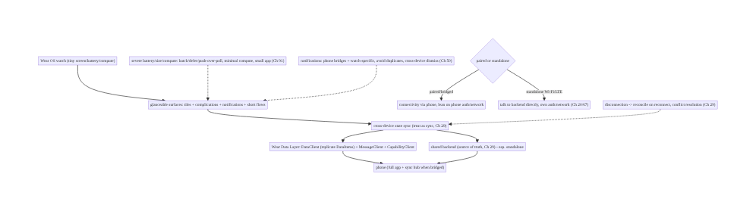
99.4 High-Level Architecture
Components & ownership
- Glanceable surfaces (tiles/complications/notifications + short flows) — the Wear UX core.
- Cross-device sync (Data Layer + shared backend, Ch 29) with conflict/disconnection handling.
- Paired vs standalone connectivity; notification coordination (Ch 50); severe efficiency (Ch 91).
Direction: watch glanceable surfaces → cross-device sync (Data Layer / backend, Ch 29) ↔ phone/ backend; paired-or-standalone, disconnection-reconciled, efficiency-constrained.

99.5 Detailed Component Design
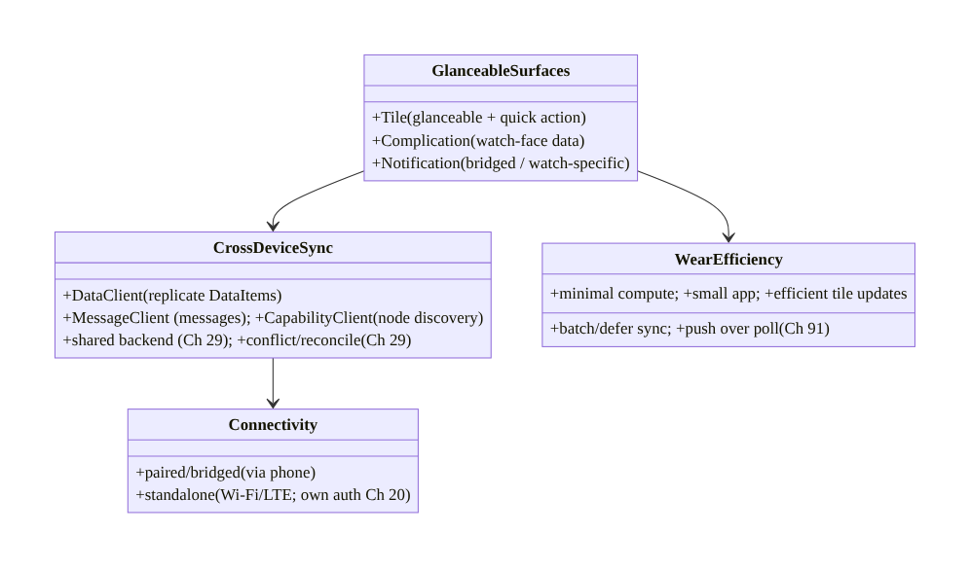
99.5 Detailed Component Design
Component | Responsibility
GlanceableSurfaces | tiles, complications, notifications, short flows
CrossDeviceSync | Data Layer (DataClient/MessageClient/CapabilityClient) + backend; conflict/reconcile (Ch 29)
Connectivity | paired/bridged vs standalone (own auth/network, Ch 20/67)
WearEfficiency | batch/defer/push-over-poll, minimal compute, small app, efficient tiles (Ch 91)

99.6 End-to-End Data Flow

Phone change → sync → watch glanceable update
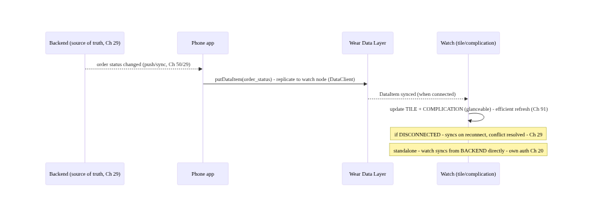
Phone change → sync → watch glanceable update

Paired vs standalone sync path
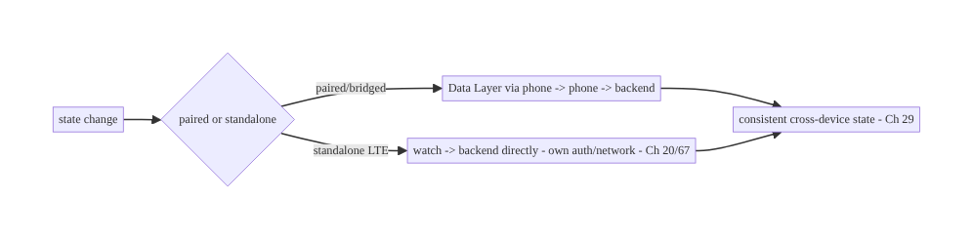
Paired vs standalone sync path

99.7 Implementation (Wear Compose + Kotlin)
Package: com.streamcart.wear.

99.7.1 Cross-device sync via Data Layer (DataClient)
// PHONE side: publish state to the watch node (replicated automatically by DataClient)
class PhoneSyncPublisher @Inject constructor(private val dataClient: DataClient) { // Wear Data Layer
suspend fun publishOrderStatus(order: OrderStatus) {
val req = PutDataMapRequest.create("/order_status").apply {
dataMap.putString("id", order.id)
dataMap.putString("status", order.status)
dataMap.putLong("version", order.version) // versioned -> conflict resolution (Ch 29)
}.asPutDataRequest().setUrgent()
dataClient.putDataItem(req).await() // replicated to watch when connected
}
}
// WATCH side: observe synced DataItems and update glanceable state
class WatchSyncListener : WearableListenerService() {
override fun onDataChanged(events: DataEventBuffer) {
events.filter { it.dataItem.uri.path == "/order_status" }.forEach { e ->
val map = DataMapItem.fromDataItem(e.dataItem).dataMap
orderStore.applyIfNewer(map.getString("id"), map.getString("status"), map.getLong("version")) // Ch 29
TileService.getUpdater(this).requestUpdate(OrderTileService::class.java) // refresh tile (glanceable)
}
}
}

99.7.2 Capability discovery (paired vs standalone)
class ConnectivityResolver @Inject constructor(private val capabilityClient: CapabilityClient) {
/** Is the phone (with our app) reachable? -> choose bridged vs standalone path. */
suspend fun phoneReachable(): Boolean {
val caps = capabilityClient.getCapability("streamcart_phone_app", CapabilityClient.FILTER_REACHABLE).await()
return caps.nodes.isNotEmpty() // phone node present -> bridged; else standalone
}
}
// Standalone: talk to backend directly with the watch's OWN auth (Ch 20) + network (Ch 67).

99.7.3 Glanceable tile (quick, efficient)
class OrderTileService : TileService() { // Tiles = glanceable, updated efficiently (NOT always running)
override fun onTileRequest(req: TileRequest): ListenableFuture<Tile> = /* build tile */ future {
val order = orderStore.latest() // synced state (Ch 29)
Tile.Builder().setResourcesVersion("1")
.setTileTimeline(singleGlanceableLayout( // "Order #123 - Out for delivery" + a quick action
status = order.status, action = "Track")) // glance + ONE action; minimal text, large target
.build()
}
// Complications similarly expose a small status snippet on the watch face.
}

99.7.4 Wear efficiency (Ch 91)
// Severe battery/compute constraints (Ch 91) - stricter than phone:
// - batch/coalesce Data Layer updates (setUrgent only when needed); don't sync chattily
// - push over poll (Ch 50/91); defer background work via WorkManager (Ch 48) with constraints
// - update tiles/complications PERIODICALLY/efficiently, not continuously
// - minimal compute on the watch; keep heavy work + source of truth on phone/backend
// - keep the app SMALL (constrained storage); test battery on a real watch

99.7.5 Glanceable Wear Compose UX
@Composable
fun OrderList(orders: List<OrderUi>) {
ScalingLazyColumn { // Wear Compose - rotary scroll, large targets
items(orders, key = { it.id }) { order ->
Chip(label = { Text(order.status, maxLines = 1) }, // minimal text, glanceable
onClick = { /* ONE quick action; deep flows -> phone */ },
modifier = Modifier.fillMaxWidth())
}
}
// Round screen, rotary input, large targets; glance + one action, not deep navigation.
}

99.7.6 Module structure
:wear:app OrderTileService (tile), OrderList (Wear Compose), WatchSyncListener (Data Layer)
:core:sync (shared, Ch 29) conflict resolution / versioning reused across phone + watch + backend
# Data Layer -> DataClient/MessageClient/CapabilityClient; backend sync -> Ch 29; notifications -> Ch 50;
# efficiency -> Ch 91; connectivity -> paired/standalone; heavy work/source-of-truth -> phone/backend.

99.8 Concurrency and Race Conditions
Scenario | Risk | Handling
Watch disconnected | stale state | DataItem replicates on reconnect; backend reconcile (Ch 29)
Concurrent watch+phone edit | conflict | versioning + conflict resolution (Ch 29)
Chatty Data Layer sync | battery drain | batch/coalesce; setUrgent sparingly (Ch 91)
Duplicate notifications | annoyance | bridge once; cross-device dismiss (Ch 50)
Standalone, phone assumed | no connectivity | CapabilityClient check; backend path (Ch 20/67)
Always-running tile/compute | battery | efficient periodic updates (Ch 91)
Large data over Data Layer | slow/battery | use backend for large; Data Layer for small
Heavy work on watch | drains/slow | push to phone/backend
- Cross-device sync is sync (Ch 29) with a device transport: the same versioning, conflict resolution, and offline reconciliation apply — the watch being frequently disconnected makes eventual consistency and reconcile-on-reconnect essential.
- Efficiency is stricter than any other form factor (Ch 91): the tiny battery means chatty sync, polling, always-running tiles, and heavy compute are worse here than anywhere — apply Ch 91 aggressively (batch, defer, push-over-poll, minimal compute, small app).
- Capability discovery drives the paired/standalone decision: CapabilityClient tells you if the phone/app is reachable, so the app chooses the bridged vs standalone sync path rather than assuming — essential for standalone (LTE) watches.

99.9 Failure Scenarios and Recovery
Failure | Detection | Response | Outcome
Watch state stale/diverged | sync audit | versioned Data Layer + backend reconcile (Ch 29) | consistent
Battery drain | battery metrics (Ch 91) | batch/defer sync, push-over-poll, efficient tiles | efficient
Duplicate notifications | UX report | bridge once + cross-device dismiss (Ch 50) | clean
Standalone no connectivity | CapabilityClient | backend path + own auth (Ch 20/67) | works
Conflict (watch+phone edit) | version mismatch | conflict resolution (Ch 29) | merged
Shrunk phone UI | Wear UX review | glanceable tiles/complications + short flows | glanceable
Tile always updating | battery | efficient periodic update (Ch 91) | bounded
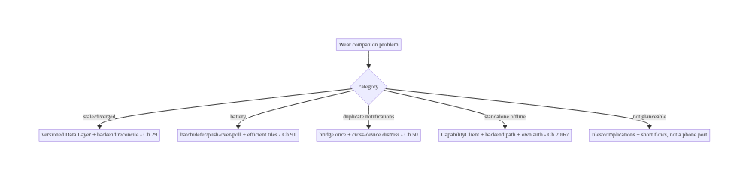
99.9 Failure Scenarios and Recovery
Sync as sync, stay efficient, and be glanceable. Wear failures are stale/diverged state (versioned Data Layer + backend reconcile, Ch 29), battery drain (batch/defer/push-over-poll, efficient tiles, Ch 91 — strictest here), duplicate notifications (bridge once + cross-device dismiss, Ch 50), standalone connectivity assumptions (CapabilityClient + backend path, Ch 20/67), and shrunk phone UIs (glanceable tiles/complications + short flows). Keep heavy work and the source of truth on the phone/backend.

99.10 Scaling the Implementation
- Level 1. Bridged notifications; a basic Wear Compose list; read-only state via Data Layer (DataClient).
- Level 2. Tiles + complications (glanceable); versioned cross-device sync + conflict handling (Ch 29); efficient updates (Ch 91).
- Level 3 — production. Standalone support (CapabilityClient + backend path + own auth, Ch 20/ 67); notification coordination (watch-specific + cross-device dismiss, Ch 50); strict battery discipline (Ch 91).
- Level 4 — rich. Richer tiles/complications, quick actions, voice, health/sensor integration (Wear-specific), offline-first watch (Ch 29); size optimization.
- Level 5 — ecosystem. Multi-device state (phone + watch + TV, Ch 98) consistency, cross-device handoff, Wear SLOs (battery/sync), broad watch-model testing, Wear analytics (Ch 82).
Avoid overengineering: glanceable tiles/complications + versioned Data Layer sync (Ch 29) + strict efficiency (Ch 91) + bridged notifications covers most companions. Don’t port the phone app; don’t sync chattily; don’t assume the phone is present; don’t put heavy work/source-of-truth on the watch.

99.11 Alternative Approaches and Trade-offs
Dimension | Option A | Option B | When
App | Glanceable companion | shrunk phone app | Glanceable always
Primary surface | Tiles/complications/notifications | in-app screens | Glanceable surfaces first
Sync transport | Data Layer (small) + backend (authoritative) | one only | Both (small vs authoritative)
Connectivity | Handle paired + standalone | assume paired | Handle both
Sync model | Versioned + reconcile (Ch 29) | last-write-wins naive | Versioned (conflicts)
Efficiency | Strict (Ch 91) | phone-level | Strict (tiny battery)
Heavy work | On phone/backend | on watch | Off the watch
Glanceable companion vs shrunk phone app: a shrunk phone app (long flows, dense screens) is wrong for the wrist — seconds of attention, tiny screen. A glanceable companion (tiles, complications, notifications + short flows) delivers value at a glance without app launch. Build purpose-built glanceable, push complexity to the phone.
Data Layer vs shared backend for sync: the Data Layer is ideal for small device-to-device state (phone ↔ watch, bridged) with automatic replication; a shared backend (Ch 29) is needed for authoritative state and standalone watches. Use Data Layer for small/local and the backend for authoritative/standalone — often both, treated as sync (Ch 29).
Handle standalone vs assume paired: assuming the phone is always present breaks on standalone (LTE) watches and when the phone is out of range. CapabilityClient detects reachability so the app chooses bridged vs backend-direct. Handle both connectivity modes.

99.12 Security & Privacy Considerations
- Standalone auth (Ch 20): a standalone watch talking to the backend directly needs its own authenticated session (Ch 20) — don’t assume the phone’s auth; handle token storage/refresh on the watch securely (Ch 24), and device-code/phone pairing for sign-in (typing on a watch is worse than TV, Ch 98).
- Data Layer data is synced across devices (Ch 28): DataItems replicate to the paired watch — don’t put sensitive data (full PII, tokens, payment, Ch 76) on the Data Layer unnecessarily; sync minimal, non-sensitive glanceable state; authoritative/sensitive data stays backend-side (Ch 29).
- Lost/stolen watch (Ch 28): a watch is easily lost — minimize sensitive data at rest on it; support remote sign-out; rely on device lock; don’t display secrets on a glanceable (often always-on) surface.
- Notifications on the wrist (Ch 50/28): bridged notifications show on the watch — ensure sensitive notification content respects privacy (lock-screen/visibility), since the watch is glanceable by anyone nearby (Ch 28).
- Minimal data on device: the efficiency pressure (Ch 91) and privacy pressure align — keep the watch’s local data small and non-sensitive.
- Client + backend: standalone auth (Ch 20), minimal/non-sensitive synced data (Ch 28/29), remote sign-out for lost devices, notification privacy (Ch 50/28).

99.13 Performance and Resource Optimization
- Battery is the dominant constraint (Ch 91, strictest here) — batch/coalesce Data Layer sync, push over poll, defer background work (WorkManager, Ch 48), update tiles/complications periodically (not continuously), minimal compute on-watch.
- Keep heavy work off the watch — do it on the phone/backend; the watch displays glanceable state and takes quick actions.
- Small app + small synced data — constrained storage; sync minimal state over the Data Layer; large data via backend.
- Efficient tiles/complications — they’re not always-running; refresh on meaningful change / efficient schedule.
- Rendering on weak compute (Ch 90) — light Wear Compose, minimal; short lists.
- Profiling: battery per sync/session (Ch 91), Data Layer message frequency/size, tile/ complication update frequency, watch compute/memory (Ch 89), connectivity (paired/standalone) time.

99.14 Testing Strategy
Sync, connectivity, and glanceable surfaces are testable; battery needs a real watch.
class CrossDeviceSyncTest {
@Test fun `applies newer version, ignores older`() { // conflict/versioning (Ch 29)
orderStore.applyIfNewer("o1", "shipped", version = 2)
orderStore.applyIfNewer("o1", "placed", version = 1) // older -> ignored
assertEquals("shipped", orderStore.status("o1"))
}
@Test fun `reconciles after reconnect`() = runTest { /* queued DataItem applied on reconnect (Ch 29) */ }
}
class ConnectivityTest {
@Test fun `standalone path when phone unreachable`() = runTest {
every { capabilityClient.phoneReachable() } returns false
assertTrue(resolver.shouldUseBackendDirectly()) // standalone -> backend (Ch 20/67)
}
}
class TileTest { @Test fun `tile shows latest synced status`() { /* glanceable state (Ch 29) */ } }
// Real-watch (required): battery over a day (Ch 91), bridged + standalone sync, tile/complication refresh,
// notification bridging/dismiss (Ch 50), disconnection/reconnection reconcile (Ch 29).
What to test: cross-device sync (versioning/conflict/reconcile, Ch 29); connectivity (paired vs standalone via CapabilityClient); glanceable surfaces (tile/complication show synced state); notification coordination (Ch 50). Real-watch testing for battery (Ch 91), bridged+standalone sync, and disconnection reconcile is mandatory.

99.15 Production Observability
- Metrics: battery per session/day on-watch (Ch 91 — the key metric), sync success/latency
  - conflict rate (Ch 29), Data Layer message frequency/size, tile/complication update frequency, paired vs standalone split, notification bridge/dismiss (Ch 50), watch memory (Ch 89), by watch model.
- Logs: sync/connectivity events — PII-safe, minimal (Ch 28; watch data minimal).
- Debugging: stale state → sync (version/reconcile, Ch 29); battery drain → chatty sync/polling/ always-on tile (Ch 91); standalone failure → CapabilityClient/auth (Ch 20); duplicate notifications → bridging (Ch 50); by watch model.
- Alerting: battery-drain spike on-watch (Ch 91); sync failure/conflict spike (Ch 29); standalone auth failures (Ch 20).
- Dashboards: watch battery, sync health (success/latency/conflict), paired/standalone split, tile/complication efficiency, by watch model.

99.16 System Design Interview Preparation
≥25 questions.
Fundamentals
- Wear UX principle? Glanceable (seconds) — not a shrunk phone app.
- Primary surfaces? Tiles, complications, notifications.
- Tile? Swipeable glanceable screen + quick action.
- Complication? Small data on the watch face.
- Core technical problem? Cross-device state sync.
Sync
- Sync mechanisms? Wear Data Layer + shared backend (Ch 29).
- DataClient? Replicates DataItems between nodes.
- MessageClient? One-off messages (needs connectivity).
- CapabilityClient? Discover reachable nodes/capabilities.
- Backend? Authoritative state, esp. standalone (Ch 29).
- Conflicts? Versioning + conflict resolution (Ch 29).
- Disconnection? Reconcile on reconnect (Ch 29).
Connectivity
- Paired/bridged? Connectivity via phone; lean on it.
- Standalone? Own Wi-Fi/LTE; backend directly; own auth (Ch 20).
- Choose path? CapabilityClient reachability.
- Transition? Handle phone going out of range.
Notifications
- Bridged? Phone notifications auto-appear on watch.
- Watch-specific? Custom actions/layouts.
- Duplicates? Bridge once; cross-device dismiss (Ch 50).
Constraints
- Battery? Tiny — strictest efficiency (Ch 91).
- Efficiency levers? Batch/defer/push-over-poll, efficient tiles (Ch 91).
- Heavy work? On phone/backend, not watch.
- App size? Small (constrained storage).
UX/production
- Glanceable UX? Rotary, large targets, minimal text, glance+action.
- What’s on the watch vs phone? Glance+quick action vs full app/source-of-truth.
- Key metric? Battery + sync health by watch model.

Design-change challenges
- Show order status at a glance. Tile + complication synced from phone/backend (Ch 29).
- Support a standalone LTE watch. CapabilityClient + backend path + own auth (Ch 20).
- Stop battery drain. Batch/defer sync, push-over-poll, efficient tiles (Ch 91).
- Keep watch/phone consistent. Versioned Data Layer + reconcile (Ch 29).
- Avoid duplicate notifications. Bridge once + cross-device dismiss (Ch 50).

Mock walkthrough (abridged)
Clarify (bridged/standalone? what state to sync? battery budget?) → glanceable surfaces (tiles/ complications/notifications + short flows) → cross-device sync as sync (Data Layer small + backend authoritative, versioned/reconciled, Ch 29) → paired vs standalone (CapabilityClient, own auth for standalone, Ch 20) → notification coordination (bridge once + dismiss, Ch 50) → severe efficiency (batch/defer/push-over-poll, efficient tiles, small app, Ch 91) → heavy work/source-of-truth off the watch → test real watch (battery/sync) → observability (battery/sync by model).

99.17 Practical Exercises
- Beginner. Build a Wear Compose glanceable order list + a tile showing order status synced from the phone via DataClient (Ch 29). Eval: glanceable; shows synced state.
- Intermediate. Add versioned cross-device sync with conflict resolution (Ch 29) and efficient tile updates (Ch 91); handle disconnection/reconnection. Eval: consistent; reconciles; efficient.
- Advanced. Add standalone support (CapabilityClient + backend-direct path + own auth, Ch 20/67) and notification coordination (bridge once + cross-device dismiss, Ch 50). Eval: works standalone; no duplicate notifications.
- Production debugging. Diagnose battery drain on a real watch (chatty sync / always-on tile, Ch 91) and a stale-state bug (versioning, Ch 29). Eval: battery fixed; state consistent.
- System design challenge. Design multi-device state consistency (phone + watch + TV, Ch 98) with the backend as source of truth (Ch 29), efficient per-device sync (Ch 91), and per-model observability. Eval: consistent, efficient, glanceable.
(Solutions withheld unless requested.)

99.18 Chapter Summary & Reference Sheet
Key decisions: build a purpose-built, glanceable Wear companion rather than shrinking the phone app — center it on surfaces that need no app launch (tiles for swipeable glanceable state, complications on the watch face, notifications bridged or watch-specific) plus very short in-app flows, because the wrist gives seconds of attention on a tiny screen with a tiny battery; keep state consistent across watch, phone, and backend by treating it as sync (Ch 29) over the right transport — the Wear Data Layer for small device-to-device state (DataClient replicates DataItems between nodes automatically, MessageClient sends connectivity-dependent messages, CapabilityClient discovers whether the phone/app is reachable) and a shared backend for authoritative state (especially standalone watches) — while handling the two connectivity modes (paired/bridged, where the watch leans on the phone, versus standalone Wi-Fi/LTE, where it talks to the backend directly with its own auth, Ch 20) and the frequent disconnection they entail, reconciling offline changes with versioning and conflict resolution for eventual consistency (Ch 29); coordinate notifications so the phone bridges general ones, the watch adds specific actions, and duplicates and cross-device dismissals are handled (Ch 50); and apply battery/size/compute discipline even more strictly than on a phone (Ch 91 — batch and defer sync, push over poll, minimize compute, keep the app small, update tiles/complications efficiently) with a tiny-screen glanceable UX (rotary input, large targets, minimal text, glance + one action) — keeping heavy work and the source of truth off the watch (on the phone and backend) so the companion stays consistent, efficient, and glanceable.
Concepts: glanceable surfaces (tiles/complications/notifications + short flows), cross-device sync (Wear Data Layer DataClient/MessageClient/CapabilityClient + shared backend, treated as sync Ch 29), paired/bridged vs standalone connectivity (own auth Ch 20), disconnection/reconciliation + conflict resolution (Ch 29), notification coordination (bridge/watch-specific/dismiss, Ch 50), severe battery/size/compute efficiency (Ch 91), tiny-screen glanceable UX (Wear Compose, rotary), device responsibility split (watch glance / phone full / backend source-of-truth).
Common mistakes: shrinking the phone app (not glanceable); chatty Data Layer sync (battery, Ch 91); assuming the phone is always present (breaks standalone); naive last-write-wins (conflicts, Ch 29); duplicate notifications; putting sensitive/large data on the Data Layer (Ch 28); heavy work/ source-of-truth on the watch; always-running tiles/compute; not testing battery on a real watch.
Checklist:
- ☐ glanceable surfaces (tiles/complications/notifications + short flows)
- ☐ cross-device sync as sync (Data Layer small + backend authoritative, versioned/reconciled, Ch 29)
- ☐ paired vs standalone (CapabilityClient; own auth for standalone, Ch 20)
- ☐ disconnection reconcile + conflict resolution (Ch 29)
- ☐ notification coordination (bridge once + cross-device dismiss, Ch 50)
- ☐ severe efficiency (batch/defer/push-over-poll, efficient tiles, small app, Ch 91)
- ☐ minimal/non-sensitive synced data (Ch 28)
- ☐ heavy work + source-of-truth off the watch
- ☐ glanceable UX (rotary, large targets, minimal text)
- ☐ test battery + sync on a real watch.
Key APIs: Wear Data Layer (DataClient.putDataItem/PutDataMapRequest, MessageClient, CapabilityClient.getCapability), WearableListenerService.onDataChanged, Tiles (TileService/ TileService.getUpdater), Complications (ComplicationDataSourceService), Wear Compose (androidx.wear.compose ScalingLazyColumn/Chip, rotary), notification bridging/BridgingConfig (Ch 50), WorkManager constraints (Ch 48/91), standalone auth (Ch 20), backend sync (Ch 29).
References: - Wear OS overview: https://developer.android.com/training/wearables - Data Layer API: https://developer.android.com/training/wearables/data/data-layer - Tiles: https://developer.android.com/training/wearables/tiles - Compose for Wear OS: https://developer.android.com/training/wearables/compose - Standalone vs bridged apps: https://developer.android.com/training/wearables/apps/standalone-apps - (composes) Ch 29 Sync/Offline, Ch 50 FCM/Notifications, Ch 48 WorkManager, Ch 91 Battery/Efficiency, Ch 20 Auth, Ch 98 TV, Ch 2 Compose

Chapter 100 — Capstone: StreamCart End-to-End System Design
Part XI — Reach, Scale & Platform Breadth · Complexity: Complex (≥40 interview questions)
Prerequisites: the whole book. This chapter synthesizes Ch 1–99 into one coherent, end-to-end Android system design, and is also the template for a full mock interview.
Reference surface: StreamCart itself — the fictional e-commerce + streaming app used throughout — designed end to end: architecture and layering, offline-first data, real-time features, media/OTT, feature flows (catalog → checkout → payments → orders), security, performance/observability, and platform breadth (phone/TV/Wear). This is the chapter that shows how the pieces compose into a system, and how to drive a senior Android system-design interview from requirements to trade-offs.

100.1 Problem Definition and Real-World Context
Every prior chapter solved one problem in depth. A real app — and a real senior system-design interview — requires composing them: making the architecture, data, real-time, media, feature, security, performance, and platform decisions fit together into a coherent whole, with the trade-offs that connect them made explicit. StreamCart is an e-commerce + streaming app: users browse a catalog, watch product videos / streamed content (OTT), add to cart, check out and pay, track orders, get real-time updates (order status, live events), and use it across phone, TV, and watch, online and offline, globally, accessibly, and at scale. This capstone designs StreamCart end to end, showing how the book’s chapters compose — and doubles as the structure of a full mock interview: clarify requirements → high-level architecture → data model → deep-dive the hard parts → cross-cutting concerns → trade-offs → scale → wrap-up.
The capstone answers the questions a senior interview (or a real tech-lead decision) demands:
- How do the layers fit (Ch 1)? UI (Compose, Ch 2) → ViewModel/UDF (Ch 2) → domain (use cases, Ch 1) → data (repositories, Ch 1) → sources (network Ch 4, DB Ch 5), wired by DI (Ch 46), across modules (Ch 94). One architecture spans every feature.
- How is data kept correct offline (Part IV)? Offline-first: Room as SSOT (Ch 5/29), sync with the backend (delta sync, Ch 29), the outbox pattern + idempotency for writes (Ch 29/75), conflict resolution (Ch 29), and optimistic updates (Ch 71). Data is the spine.
- How do real-time + media work (Parts VII–VIII)? WebSocket/SSE for live updates (Ch 63/ 65), FCM push (Ch 50), presence (Ch 66); Media3/ExoPlayer for playback (Ch 56), DRM for premium OTT (Ch 58). Streaming is a first-class capability.
- How does the money flow safely (Part IX)? Checkout with exactly-once semantics (idempotency keys, Ch 75), Play Billing / payments with PCI/tokenization (Ch 76/77), order tracking (Ch 78). Correctness + security where it matters most.
- How is it secure, fast, observable, and broad (Parts III, X, XI)? Auth (Ch 20), crypto/ keystore (Ch 24), privacy (Ch 28); startup/jank/memory performance (Ch 88/90/89), analytics/crash/tracing observability (Ch 82/83/84); modularization (Ch 94), localization/accessibility/theming (Ch 95/96/97), TV/Wear (Ch 98/99). The cross-cutting concerns.
This chapter integrates all of it, then models how to present it in an interview.

The StreamCart product (the system to design)
- Catalog & discovery: browse/search products (Ch 9), infinite feed (Ch 71), recommendations (Ch 72), images (Ch 59).
- Streaming/OTT: watch product videos and streamed content with Media3 (Ch 56), offline downloads + DRM (Ch 58).
- Commerce: cart + wishlist (Ch 73/74), checkout (Ch 75), payments/billing (Ch 76/77), order tracking (Ch 78), reviews (Ch 79).
- Real-time: order-status updates, live events, presence/notifications (Ch 50/63/66).
- Cross-cutting: offline-first (Ch 29), auth/security/privacy (Ch 20/24/28), performance/ observability (Part X), platform breadth — phone/TV/Wear (Ch 98/99), global reach (Ch 95/96/97).

Why this is architectural (and interview-critical)
Senior system design is not solving one problem — it’s composing solutions with coherent trade-offs under requirements and constraints. The capstone shows how StreamCart’s architecture (Ch 1/94), data (Ch 29), real-time (Ch 63), media (Ch 56/58), features (Part IX), security (Part III), performance/observability (Part X), and platform breadth (Part XI) fit together, and how to drive the interview that evaluates exactly this skill.

100.2 Requirements Engineering (the interview’s first move)
In a system-design interview, start here — clarify functional scope, non-functional targets, scale, and constraints before designing. Don’t jump to a solution.

Functional requirements (what StreamCart does)
ID | Requirement | Chapters
F1 | Browse/search catalog, infinite feed, recommendations | Ch 9, 71, 72
F2 | Stream product/OTT video; offline downloads + DRM | Ch 56, 58
F3 | Cart, wishlist, checkout (exactly-once), payments | Ch 73, 74, 75, 76, 77
F4 | Order tracking + real-time status; reviews | Ch 78, 79, 63
F5 | Auth + accounts; notifications | Ch 20, 50
F6 | Offline-first; works on phone, TV, watch; global | Ch 29, 98, 99, 95

Non-functional requirements (the targets)
Attribute | Target | Chapters
Offline | Fully usable offline; syncs/reconciles | Ch 29
Correctness | Exactly-once checkout/payment; consistent data | Ch 75, 76, 29
Performance | Fast cold start, smooth scroll, no OOM | Ch 88, 90, 89
Security/Privacy | Auth, encrypted secrets, PII-safe, PCI | Ch 20, 24, 28, 76
Observability | Analytics, crash, tracing, perf | Ch 82, 83, 84, 85
Reach | Localized, accessible, themeable, multi-device | Ch 95, 96, 97, 98, 99

Scale & constraints (clarify explicitly)
- Scale: millions of users, large catalog, high read (browse) vs lower write (checkout) ratio, global, device range from flagship to low-RAM STB/watch.
- Constraints: mobile network (flaky/offline, Ch 67/68), battery (Ch 91), device memory (Ch 89), Play policies, regional legal/PCI (Ch 28/76), multi-platform (Ch 98/99).
- What to clarify in the interview: which features are in scope (don’t design everything); offline requirements; consistency needs (exactly-once?); platform targets; scale numbers.

Scope (this capstone)
- In scope: end-to-end composition — architecture/layers/modules, offline-first data + sync, real-time + media, the checkout/payment critical path, cross-cutting security/performance/ observability, platform breadth, and the interview method.
- Out of scope: re-deriving each subsystem (covered in its chapter); backend internals (this is the Android system design, with backend contracts).

100.3 System Design Fundamentals (how the pieces compose)
- One layered architecture across every feature (Ch 1/2/46/94). Every StreamCart feature — catalog, checkout, orders — uses the same layering: UI (Compose, declarative, Ch 2) → ViewModel (UDF: state down, events up, StateFlow, Ch 2) → domain (use cases, business rules, Ch 1) → data (repositories = single source of truth, Ch 1) → sources (network, Ch 4; Room, Ch 5), wired by Hilt DI (Ch 46) and organized into Gradle modules (:app + :feature:* + :core:*, Ch 94). Consistency of architecture is what lets many teams build many features coherently. The architecture is the frame into which everything else fits.
- Offline-first data is the spine (Part IV: Ch 29–37). StreamCart is offline-first: Room is the single source of truth (Ch 5/29); the UI reads from the DB (Flow), and sync reconciles with the backend. Reads come from the local DB (instant, offline-capable); writes go through the outbox pattern (Ch 29) — write locally + enqueue, sync when online, with idempotency keys (Ch 29/75) so retries don’t duplicate, and conflict resolution (Ch 29) for concurrent edits. Delta sync (Ch 29) keeps it efficient (Ch 91). Optimistic updates (Ch 71) make the UI feel instant. This data architecture underpins every feature’s correctness and offline behavior.
- Real-time + push layer (Part VIII: Ch 63–70). Live features — order status, live events, presence — use WebSocket (Ch 63) or SSE/long-poll (Ch 65) for a live channel, FCM (Ch 50) for push when the app is backgrounded, with reconnection/backoff (Ch 63), network-state awareness (Ch 68), and battery discipline (push over poll, Ch 91). Real-time updates flow into the same SSOT (Ch 29) so the UI stays consistent.
- Media / OTT (Part VII: Ch 56–62). Streaming uses Media3/ExoPlayer (Ch 56) with adaptive streaming, a media session (background/lock-screen/voice), **offline downloads
  - DRM** (Widevine, Ch 58) for premium content, and efficient image loading (Coil, Ch 59) for catalog art. Media is a first-class subsystem, central on TV (Ch 98).
- The commerce critical path (Part IX: Ch 71–81) — correctness where it counts. Browse (infinite feed Ch 71 + recommendations Ch 72 + search Ch 9) → cart/wishlist (Ch 73/74) → checkout with exactly-once semantics (idempotency keys + outbox, Ch 75) → payment (Play Billing Ch 77 / card tokenization + PCI, Ch 76) → order tracking (Ch 78, real-time, Ch 63) → reviews (Ch 79). The money path demands the strongest correctness (exactly-once, idempotency) and security (PCI, tokenization) — this is where the architecture’s guarantees matter most.
- Cross-cutting security (Part III: Ch 19–28). Auth (token-based, refresh, Ch 20) gates the app; crypto/Keystore (Ch 24) protects secrets at rest; certificate pinning (Ch 22) secures transport; privacy (consent, PII minimization/redaction, per-account isolation, Ch 28) governs all data; payments add PCI/tokenization (Ch 76). Security is woven through every layer, not a feature.
- Cross-cutting performance & observability (Part X: Ch 82–93). Performance: fast cold start (App Startup + lazy graph + baseline profiles, Ch 88/92), smooth scrolling (lazy lists + stable keys + async images, Ch 90/93), no OOM/leaks (lifecycle scoping + bounded caches, Ch 89), battery efficiency (Ch 91). Observability: analytics (Ch 82), crash/ ANR (Ch 83), distributed tracing (Ch 84), field perf (Ch 85), error classification (Ch 87) — a unified, PII-safe, consented telemetry pipeline. You operate StreamCart from this signal.
- Cross-cutting reach & platform breadth (Part XI: Ch 94–99). Modularization (Ch 94) scales the codebase/teams; localization/RTL/regionalization (Ch 95), accessibility (Ch 96), and theming (Ch 97) make it correct for every user; TV/STB/Fire TV (Ch 98) and Wear (Ch 99) extend it across the device ecosystem — sharing business logic/data (Ch 1/94/29) while building platform-specific UI.
- How the trade-offs connect (the senior skill). The decisions interact: offline-first (Ch 29) enables optimistic UI (Ch 71) but demands conflict resolution (Ch 29) and idempotency (Ch 75); exactly-once checkout (Ch 75) requires the outbox + idempotency + backend contract (Ch 29); real-time (Ch 63) and battery (Ch 91) trade off (push vs poll, Ch 50); performance (Ch 88/90) and features trade off (defer non-critical, Ch 88); reach (Ch 95/96/97) is a cross-cutting tax paid by the design system (Ch 97/94). Senior system design is naming these trade-offs and choosing coherently under the requirements.
Core insight: a real Android app — and a senior system-design answer — is the coherent composition of the whole book: one consistent layered architecture (UI → ViewModel/UDF → domain → data → sources, DI-wired, modularized, Ch 1/2/46/94) into which every feature fits; an offline-first data spine where Room is the single source of truth and sync reconciles with the backend using the outbox pattern, idempotency keys, delta sync, and conflict resolution (Ch 5/29) so every feature is correct offline and optimistic online (Ch 71); a real-time layer (WebSocket/SSE + FCM, Ch 63/65/50) and a media/OTT subsystem (Media3 + DRM, Ch 56/58) as first-class capabilities feeding the same SSOT; a commerce critical path that demands the strongest correctness and security — exactly-once checkout via idempotency and the outbox (Ch 75), payments with PCI tokenization (Ch 76/77), real-time order tracking (Ch 78); security woven through every layer (auth, Keystore, pinning, privacy/consent/PII, Ch 20/24/22/28); performance and observability as cross-cutting disciplines (fast startup, smooth scroll, no OOM — Ch 88/90/89 — measured and operated via a unified PII-safe telemetry pipeline, Ch 82/83/84/85/87); and reach across the ecosystem (modularization for teams, localization/ accessibility/theming for every user, TV/Wear for every device — Ch 94/95/96/97/98/99, sharing business logic while building platform-specific UI) — with the senior skill being to name how these decisions interact and trade off (offline-first enables optimistic UI but demands conflict resolution and idempotency; real-time trades against battery; performance trades against features; reach is a design-system tax) and to choose coherently under explicit requirements, scale, and constraints — which is exactly what the system-design interview evaluates, structured as clarify → architecture → data → deep-dive the hard parts → cross-cutting concerns → trade-offs → scale.

100.4 High-Level Architecture (the whiteboard diagram)
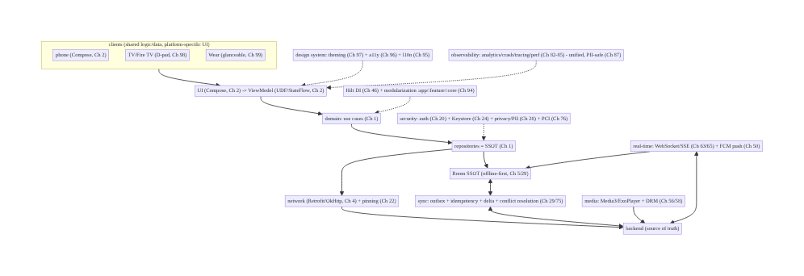
100.4 High-Level Architecture (the whiteboard diagram)
Components & ownership (the whole system)
- Clients (phone/TV/Wear, Ch 2/98/99) share domain + data (Ch 1/29), build platform UI.
- Layered core: UI → ViewModel (UDF) → domain → repositories (SSOT) → Room + network (Ch 1/2/ 4/5).
- Offline-first sync (outbox + idempotency + delta + conflict, Ch 29/75) ↔ backend; real-time (Ch 63/50) + media (Ch 56/58).
- Cross-cutting: security (Ch 20/24/28/76), observability (Ch 82–87), DI + modularization (Ch 46/94), design system (Ch 95/96/97).
Direction: platform UI → shared layered core (UDF → domain → SSOT repositories → Room + network) ↔ offline-first sync + real-time + media ↔ backend; security, observability, DI/modules, and design system woven through.

100.5 Detailed Component Design (the subsystems, integrated)
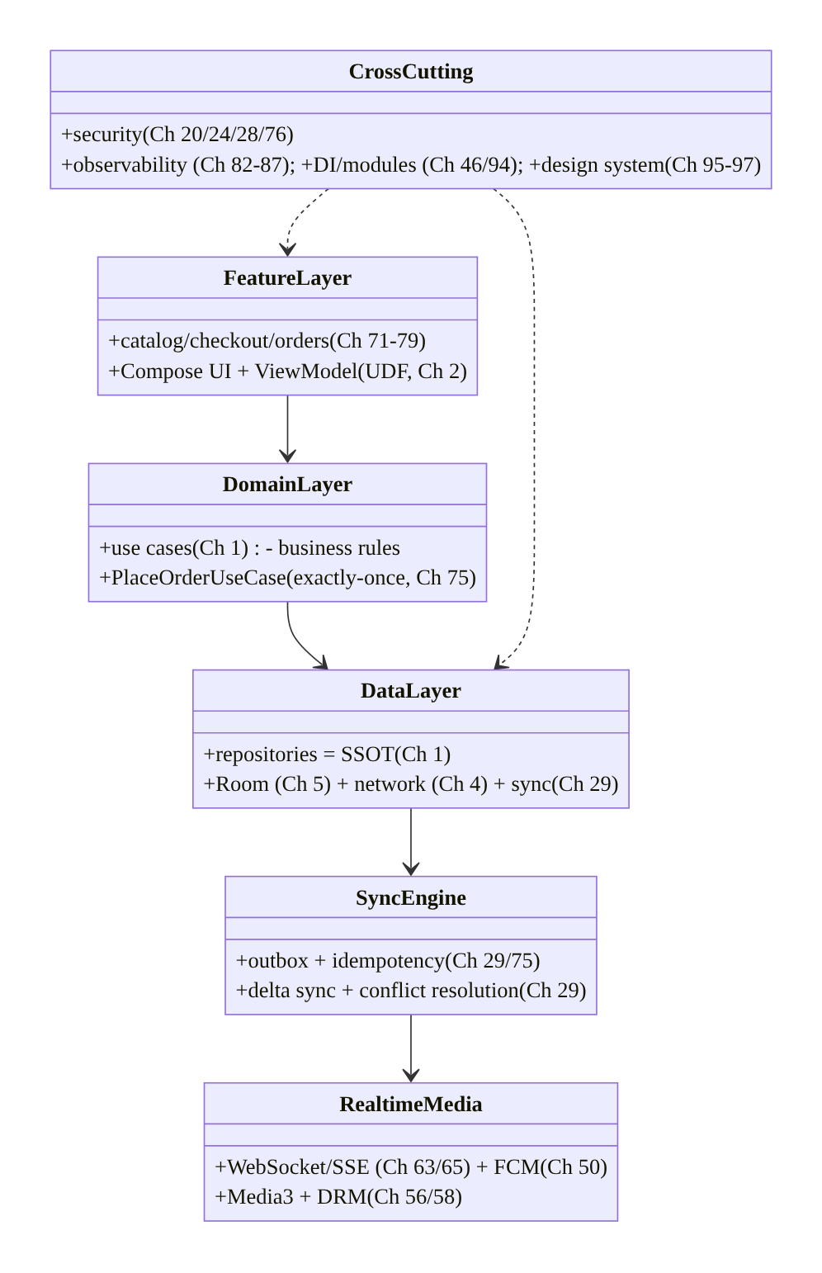
100.5 Detailed Component Design (the subsystems, integrated)
Subsystem | Responsibility | Chapters
Feature layer | per-feature UI + ViewModel (UDF) | Ch 2, 71–79, 94
Domain layer | use cases / business rules (exactly-once checkout) | Ch 1, 75
Data layer | repositories (SSOT) + Room + network | Ch 1, 4, 5
Sync engine | outbox + idempotency + delta + conflict | Ch 29, 75
Real-time/media | WebSocket/SSE + FCM; Media3 + DRM | Ch 63, 65, 50, 56, 58
Cross-cutting | security, observability, DI/modules, design system | Ch 20–28, 82–87, 46, 94–97

100.6 End-to-End Data Flow (a full user journey: browse → checkout)
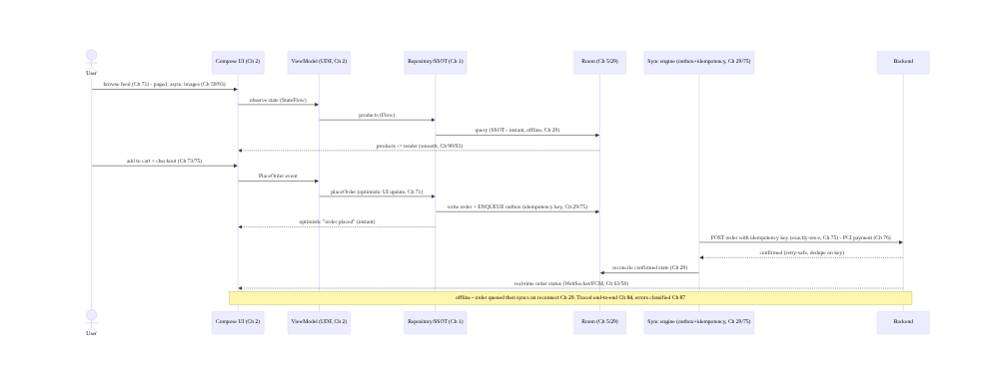
100.6 End-to-End Data Flow (a full user journey: browse → checkout)
This single flow composes: feed (Ch 71) + paging/images (Ch 93/59) + rendering (Ch 90), SSOT reads (Ch 29), optimistic UI (Ch 71), outbox + idempotency (Ch 29/75), exactly- once checkout (Ch 75), PCI payment (Ch 76), sync reconciliation (Ch 29), real-time status (Ch 63/50), offline tolerance (Ch 29), tracing (Ch 84), and error classification (Ch 87) — the whole book in one journey.

100.7 Implementation (the integration seams)
The capstone doesn’t re-implement subsystems (each chapter did). It shows the seams where they connect. Package: com.streamcart.

100.7.1 The layered seam: UI → ViewModel → use case → repository (Ch 1/2)
// UI (Ch 2) observes ViewModel state; ViewModel calls a use case; use case uses a repository (SSOT).
@HiltViewModel
class CheckoutViewModel @Inject constructor(private val placeOrder: PlaceOrderUseCase) : ViewModel() {
val state: StateFlow<CheckoutState> = /* ... */ MutableStateFlow(CheckoutState.Idle)
fun onPlaceOrder(cart: Cart) = viewModelScope.launch {
_state.value = CheckoutState.Placing // optimistic (Ch 71)
placeOrder(cart).fold( // use case (Ch 1) -> Result (Ch 23)
onSuccess = { _state.value = CheckoutState.Placed(it) },
onFailure = { _state.value = CheckoutState.Error(it) }) // classified downstream (Ch 87)
}
}

100.7.2 The correctness seam: exactly-once checkout (outbox + idempotency, Ch 29/75)
class PlaceOrderUseCase @Inject constructor(private val orders: OrderRepository) {
suspend operator fun invoke(cart: Cart): Result<Order> = runCatching {
val idempotencyKey = UUID.randomUUID().toString() // exactly-once key (Ch 75)
orders.placeLocallyAndEnqueue(cart, idempotencyKey) // write SSOT + outbox (Ch 29) - survives offline
// Sync engine POSTs with the key; backend dedupes -> exactly-once even on retry (Ch 75).
}
}

100.7.3 The sync seam: outbox drained by WorkManager, reconciled to SSOT (Ch 29/48)
class OutboxSyncWorker @Inject constructor(/* ... */) : CoroutineWorker(/* ... */) { // Ch 48
override suspend fun doWork(): Result {
outbox.pending().forEach { op ->
val resp = api.execute(op, idempotencyKey = op.key) // idempotent (Ch 75) - retry-safe
room.reconcile(resp) // SSOT reflects confirmed state (Ch 29)
outbox.markDone(op)
}
return Result.success() // retries with backoff on failure (Ch 29/91)
}
}

100.7.4 The cross-cutting seam: security + observability + DI (Ch 20/84/46)
// One OkHttp stack wires auth (Ch 20), pinning (Ch 22), tracing (Ch 84) - injected everywhere (Ch 46)
@Provides @Singleton
fun okHttp(auth: AuthInterceptor, pinner: CertificatePinner, tracing: TracingInterceptor): OkHttpClient =
OkHttpClient.Builder()
.addInterceptor(auth) // token auth + refresh (Ch 20)
.certificatePinner(pinner) // pinning (Ch 22)
.addInterceptor(tracing) // correlation/trace propagation (Ch 84)
.build()
// Analytics/crash/perf (Ch 82/83/85) flow through one PII-safe pipeline (Ch 87/28); DI aggregates at :app (Ch 94).

100.7.5 The platform seam: shared core, platform UI (Ch 94/98/99)
// :core:data, :core:domain, :core:sync are SHARED across phone/TV/Wear (Ch 94);
// only :feature:* UI differs per platform:
// phone -> Compose touch UI (Ch 2)
// tv -> D-pad focus UI (Ch 98)
// wear -> glanceable tiles/Compose (Ch 99)
// All three read the SAME repositories/SSOT + sync (Ch 1/29) -> consistent state across devices (Ch 99).

100.7.6 Module structure (the whole app)
:app (+ :tv:app, :wear:app) composition roots per platform (Ch 94/98/99)
:feature:catalog/checkout/orders/account/... per-feature UI+VM (Ch 71-79)
:core:domain (use cases, Ch 1), :core:data (repositories/SSOT, Ch 1), :core:sync (outbox/idempotency, Ch 29)
:core:network (Ch 4) + :core:database (Ch 5) + :core:designsystem (Ch 95/96/97)
:core:common/model, build-logic (Ch 94)
# Security (Ch 20/24/28/76), observability (Ch 82-87), real-time (Ch 63/50), media (Ch 56/58) as core modules.

100.8 Concurrency and Race Conditions (the system-level ones)
Scenario | Risk | Handling | Ch
Double checkout (retry/offline) | duplicate order/charge | idempotency key + outbox (exactly-once) | 75, 29
Concurrent edits (devices) | conflict | versioned sync + conflict resolution | 29, 99
Optimistic update diverges | wrong UI | reconcile to SSOT on sync | 29, 71
Real-time + sync race | inconsistent state | both write the single SSOT | 29, 63
Token refresh storm | thundering herd | single-flight refresh | 20
Background work on main | jank/ANR | off-main, WorkManager | 3, 48
Cross-device state | divergence | backend source of truth + sync | 29, 99
- The single source of truth (Ch 29) is the system-wide race-resolver: real-time updates (Ch 63), sync reconciliation (Ch 29), and optimistic writes (Ch 71) all funnel through the one SSOT (Room), so the UI is always consistent regardless of which path updated it.
- Idempotency is the money-path guarantee (Ch 75): the idempotency key + outbox make checkout exactly-once even across retries, offline queueing, and process death — the single most important correctness property, composed from sync (Ch 29) and checkout (Ch 75).
- Cross-device consistency (Ch 99) extends the same model: phone/TV/Wear all reconcile against the backend source of truth (Ch 29), so a change on one device propagates consistently.

100.9 Failure Scenarios and Recovery (system-level resilience)
Failure | Detection | Response | Ch
Offline during checkout | connectivity | outbox queues; syncs on reconnect; exactly-once | 29, 75
Payment retry | idempotency | key dedupes — no double charge | 75, 76
Sync conflict | version mismatch | conflict resolution; SSOT authoritative | 29
Crash/ANR | vitals (Ch 83) | crash pipeline + rollback (Ch 41) | 83, 41
Perf regression | field p95 (Ch 85) | gate/rollback; baseline profiles | 85, 88, 92
Real-time disconnect | heartbeat | reconnect/backoff; fall back to poll/FCM | 63, 50
Low-RAM OOM (TV/low-end) | field OOM (Ch 89) | bounded memory; device-tiered | 89, 98
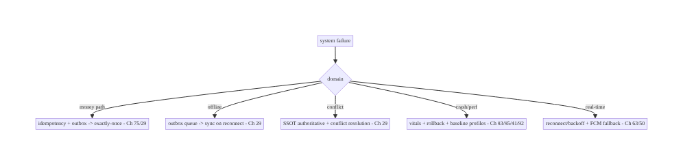
100.9 Failure Scenarios and Recovery (system-level resilience)
The system is resilient because its parts compose correctly. Offline-first + outbox + idempotency (Ch 29/75) make the money path exactly-once and offline-tolerant; the SSOT (Ch 29) resolves races across sync, real-time, and optimistic UI; observability + rollback (Ch 83/85/41) let you operate and recover; device-tiering (Ch 89/98/99) handles the hardware range. Senior design is ensuring the composition is resilient, not just each part.

100.10 Scaling the Implementation (how StreamCart grows)
- Level 1 (MVP). Core layered architecture (Ch 1/2), Room SSOT + basic sync (Ch 5/29), catalog + cart + checkout (Ch 71/73/75), auth (Ch 20), one platform (phone).
- Level 2 (product). Offline-first (outbox/idempotency/conflict, Ch 29/75), payments (Ch 76/77), real-time order status (Ch 63/50), media (Ch 56), analytics/crash (Ch 82/83).
- Level 3 (scale). Modularization (Ch 94), full observability (tracing/perf/error, Ch 84/85/87), performance (startup/jank/memory, Ch 88/90/89), DRM/OTT (Ch 58), recommendations (Ch 72).
- Level 4 (reach). Localization/accessibility/theming (Ch 95/96/97), TV + Wear (Ch 98/99), experimentation (Ch 86), baseline profiles (Ch 92), battery (Ch 91), staged rollout (Ch 41).
- Level 5 (enterprise). Multi-team modular platform, SLOs/error budgets (Ch 85/87), global regionalization/compliance (Ch 95/28), device-matrix testing, cross-device ecosystem (phone/TV/ Wear consistency, Ch 99), continuous experimentation + governance.
Avoid overengineering: build the architecture + SSOT + the critical path (checkout) correctly first; add real-time, media, platforms, and reach as the product demands. Don’t build for scale you don’t have; do get the money path’s correctness (Ch 75) and the data spine (Ch 29) right from the start — they’re the hardest to retrofit.

100.11 Alternative Approaches and Trade-offs (the senior conversation)
Decision | Option A | Option B | StreamCart choice & why
Data | Offline-first (SSOT, Ch 29) | network-driven | Offline-first — usable offline, resilient, optimistic UI (Ch 71)
Writes | Outbox + idempotency (Ch 29/75) | direct fire-and-forget | Outbox — exactly-once, offline-tolerant
Real-time | WebSocket + FCM (Ch 63/50) | poll | WebSocket + push — live + battery-efficient (Ch 91)
Architecture | Modular (Ch 94) | monolith | Modular — teams + build speed + enforcement
UI | Compose (Ch 2) | Views | Compose — declarative, UDF, multiplatform-ish
Consistency | SSOT + conflict resolution (Ch 29) | last-write-wins | SSOT + conflict — correctness
Platforms | Shared core + platform UI (Ch 94/98/99) | separate apps | Shared core — consistency + reuse
The trade-offs interact (the point of the capstone): - Offline-first (Ch 29) ⇄ complexity: it enables optimistic UI (Ch 71) and resilience but requires conflict resolution (Ch 29) and idempotency (Ch 75). StreamCart pays this cost because offline usability + correctness are core requirements. - Real-time (Ch 63) ⇄ battery (Ch 91): a live socket drains battery; push (FCM, Ch 50) + efficient reconnection balance freshness vs power. Choose per feature. - Performance (Ch 88/90) ⇄ features: every SDK/init costs startup (Ch 88); defer non- critical and baseline-profile the critical path (Ch 92). Features earn their startup cost. - Reach (Ch 95/96/97) ⇄ effort: localization/accessibility/theming are a cross-cutting tax paid efficiently by a design system (Ch 97) + modularization (Ch 94) — architect it in, don’t retrofit. - Exactly-once (Ch 75) ⇄ simplicity: idempotency + outbox + backend contract is more work than fire-and-forget, but the money path demands it. Correctness where it counts.
Senior system design is making these trade-offs explicit and choosing coherently under the stated requirements — not reaching for the most complex option everywhere.

100.12 Security & Privacy Considerations (woven through, summarized)
- Auth gates everything (Ch 20): token-based auth with refresh, secure token storage (Keystore, Ch 24), single-flight refresh; the money path requires a valid session (Ch 20).
- Secrets at rest (Ch 24): keys/tokens in the Android Keystore; no secrets in code/logs (Ch 28); R8 obfuscation raises the bar (Ch 92) but isn’t secret-hiding.
- Transport security (Ch 22): TLS + certificate pinning for sensitive endpoints (auth, payment); the single OkHttp stack enforces it everywhere (Ch 4).
- Payments = PCI (Ch 76/77): never handle raw card data — tokenize via the payment SDK/ Play Billing; the app orchestrates, the processor holds card data; idempotency prevents double charges (Ch 75).
- Privacy (Ch 28): consent gates analytics/telemetry (Ch 82/85); PII minimization + redaction in all telemetry (Ch 87); per-account isolation (clear on sign-out); regional compliance (GDPR, Ch 95/28); sensitive surfaces use FLAG_SECURE (Ch 76).
- Cross-device security (Ch 98/99): DRM for premium OTT (Ch 58), profile isolation on shared TVs (Ch 28/98), QR/device-code sign-in on TV/Wear (Ch 98/99), standalone-watch auth (Ch 20/99).
- Security is a cross-cutting layer, not a feature — it’s in the network stack, storage, the money path, telemetry, and every platform. Design it in from the start.

100.13 Performance and Resource Optimization (the cross-cutting discipline)
- Startup (Ch 88/92): trim Application.onCreate, App Startup + lazy DI graph (Ch 46), skeleton at TTID → TTFD, Baseline Profiles + R8 (Ch 92) — fast first launch across the device range.
- Scrolling (Ch 90/93): lazy lists + stable keys + light/skippable items + async images (Coil, Ch 59) + paging (Ch 71) — smooth catalog/feed on low-end + TV (Ch 98).
- Memory (Ch 89): lifecycle-scoped references, bounded caches, downsampled images, no leaks — critical on low-RAM TV/STB/Wear (Ch 98/99).
- Battery/network (Ch 91): push over poll (Ch 50), batch/defer (WorkManager, Ch 48), delta sync (Ch 29), metered-aware — strictest on Wear (Ch 99).
- Measured, operated, gated (Ch 85/92): field perf percentiles (Ch 85), Macrobenchmark CI gates (Ch 92), regression rollback (Ch 41) — performance is continuously defended.
- Device-tiered: flagship → low-RAM STB → watch — budgets and behavior adapt per tier (Ch 89/98/ 99).
- Profiling: the full toolkit — startup (Ch 88), frames (Ch 90), memory (Ch 89), battery (Ch 91), field vitals (Ch 85) — across the device matrix.

100.14 Testing Strategy (the whole pyramid)
StreamCart’s testing composes every chapter’s strategy into a coherent pyramid:
// UNIT (most): use cases (Ch 1), repositories (fakes), ViewModels (UDF, Ch 2), sync/idempotency (Ch 29/75),
// formatters/plurals (Ch 95), classification (Ch 87), focus logic (Ch 98) - fast, isolated, per-module (Ch 94).
class PlaceOrderUseCaseTest {
@Test fun `checkout is exactly-once on retry`() = runTest {
placeOrder(cart); placeOrder(cart) // same idempotency key path
assertEquals(1, backend.orderCount()) // exactly-once (Ch 75/29) - the critical test
}
}
// INTEGRATION: repository + Room + fake network (Ch 5/4); sync reconciliation (Ch 29); real-time -> SSOT (Ch 63).
// UI: Compose tests (Ch 2) + accessibility (semantics, Ch 96) + screenshot across themes (Ch 97) + pseudolocale (Ch 95).
// E2E/DEVICE: offline checkout -> reconnect -> exactly-once (Ch 29/75); DRM playback (Ch 58);
// real low-RAM TV (Ch 89/98) + real watch battery/sync (Ch 91/99); Macrobenchmark startup/frames CI gate (Ch 88/90/92).
What to test (system-level): exactly-once checkout (the critical correctness test, Ch 75/29); offline → reconnect reconciliation (Ch 29); sync conflict resolution (Ch 29); real-time → SSOT consistency (Ch 63); payment tokenization/PCI path (Ch 76); accessibility + localization + theming (Ch 95/96/97); performance gates (Macrobenchmark, Ch 88/90/92); cross-device sync (Ch 99); DRM (Ch 58). Unit-heavy pyramid, per-module (Ch 94), with real-device E2E for the hard parts.

100.15 Production Observability (operating StreamCart)
- The unified telemetry pipeline (Ch 82–87): analytics (funnels: browse→cart→checkout, Ch 82), crash/ANR (vitals, Ch 83), distributed tracing (end-to-end request correlation, Ch 84), field performance (startup/jank/memory percentiles, Ch 85), error classification (fingerprinted/severity-routed, Ch 87) — unified, correlated, PII-safe, consented (Ch 28).
- The business + health metrics: checkout conversion + exactly-once integrity (no double charges, Ch 75/76), sync success/conflict rate (Ch 29), real-time delivery (Ch 63), playback QoE (Ch 56/58), crash-free rate (Ch 83), startup/jank percentiles by device (Ch 85), battery (Ch 91), by platform (phone/TV/Wear, Ch 98/99).
- Debugging (end-to-end): a failed checkout → trace (Ch 84) → which service/step → error classification (Ch 87) → correlated crash (Ch 83) or perf (Ch 85) — the unified pipeline lets you follow one request across the system.
- Alerting + gating (Ch 41/83/85): crash/ANR regression, perf regression (p95), exactly-once violations, sync failures, playback errors → alert + staged-rollout gate/rollback (Ch 41).
- Dashboards: conversion funnel, sync/real-time health, playback QoE, crash-free + perf percentiles by device/platform/release, battery — operate the whole system from one place.

100.16 System Design Interview Preparation (the capstone method)
≥40 questions. This section is how to drive a senior Android system-design interview — the capstone’s dual purpose.
The interview structure (what to do, in order):
- Clarify requirements (§100.2) — don’t skip. Functional scope, non-functional targets, scale, constraints. Ask: offline? consistency (exactly-once)? platforms? scale numbers? Narrow scope.
- High-level architecture (§100.4). Draw the layered diagram (UI→VM→domain→data→sources, Ch 1), name offline-first SSOT (Ch 29), real-time/media, backend contract.
- Data model + flow (§100.5–6). SSOT (Room, Ch 29), sync (outbox/idempotency/conflict, Ch 29/ 75), a key flow (checkout).
- Deep-dive the hard part. Usually exactly-once checkout (Ch 75) or offline sync (Ch 29) or real-time (Ch 63) — go deep where the interviewer probes.
- Cross-cutting concerns. Security (Ch 20/24/28/76), performance (Ch 88/90/89), observability (Ch 82–87) — show you operate it.
- Trade-offs (§100.11). Name the interacting trade-offs; justify choices under requirements.
- Scale + wrap-up (§100.10). How it grows; what you’d do next.
Core Q&A (composing the book):
Architecture/data 1. Layers? UI→VM(UDF)→domain→data(SSOT)→sources; DI; modular (Ch 1/2/46/94). 2. Offline-first? Room SSOT; UI reads DB; sync reconciles (Ch 29). 3. Writes offline? Outbox + idempotency; sync on reconnect (Ch 29/75). 4. Exactly-once checkout? Idempotency key + outbox + backend dedupe (Ch 75). 5. Conflicts? Versioning + conflict resolution; SSOT authoritative (Ch 29). 6. Optimistic UI? Update SSOT optimistically; reconcile on sync (Ch 71/29).
Real-time/media 7. Live updates? WebSocket/SSE + FCM; into SSOT (Ch 63/50/29). 8. Real-time vs battery? Push over poll; efficient reconnect (Ch 50/91). 9. Streaming? Media3 + adaptive + media session (Ch 56). 10. Premium content? DRM (Widevine); offline downloads (Ch 58).
Commerce/security 11. Payment? Tokenize (PCI); Play Billing / processor SDK (Ch 76/77). 12. No double charge? Idempotency (Ch 75). 13. Auth? Token + refresh; Keystore storage (Ch 20/24). 14. Transport? TLS + pinning (Ch 22). 15. Privacy? Consent + PII redaction + per-account isolation (Ch 28).
Performance/observability 16. Fast startup? Trim onCreate + lazy graph + baseline profiles (Ch 88/92). 17. Smooth scroll? Lazy lists + stable keys + async images + paging (Ch 90/93/59/71). 18. No OOM? Lifecycle scoping + bounded caches (Ch 89). 19. Observe? Analytics + crash + tracing + perf, unified/PII-safe (Ch 82–87). 20. Operate/recover? Vitals + rollback + staged rollout (Ch 83/85/41).
Reach/platform 21. Scale the codebase? Modularization (Ch 94). 22. Global? Localization/RTL/regionalization (Ch 95). 23. Accessible? Semantics tree + targets + contrast (Ch 96). 24. Theming? Design tokens + Material 3 + dynamic color (Ch 97). 25. TV? D-pad focus + 10-foot + media-centric (Ch 98). 26. Watch? Glanceable + cross-device sync + efficiency (Ch 99). 27. Multi-device consistency? Shared SSOT + backend source of truth (Ch 29/99).
Trade-offs/method 28. Offline-first cost? Conflict resolution + idempotency complexity (Ch 29/75). 29. Real-time vs battery? Socket vs push trade-off (Ch 63/91). 30. Performance vs features? Defer non-critical init (Ch 88). 31. Reach cost? Design-system tax (Ch 97/94). 32. Where exactly-once? Money path only (Ch 75). 33. Monolith vs modular? Modular at scale (Ch 94). 34. Compose vs Views? Compose (declarative/UDF, Ch 2). 35. First interview move? Clarify requirements (§100.2). 36. Deep-dive what? The hard part (checkout/sync/real-time). 37. How to show seniority? Name interacting trade-offs; choose coherently. 38. Scale strategy? Levels 1–5 (§100.10). 39. What to get right first? Architecture + SSOT + money-path correctness. 40. Hardest to retrofit? The data spine (Ch 29) + exactly-once (Ch 75). 41. How to handle unknown scale? Ask; design for the stated scale, note where it’d change. 42. Wrap-up? Summary + what’s next + risks.

Design-change challenges (full mock prompts)
- Design StreamCart’s checkout end-to-end. Offline-first + outbox + idempotency + PCI payment + real-time status (Ch 29/75/76/63).
- Make StreamCart work fully offline. SSOT + sync + conflict resolution + optimistic UI (Ch 29/ 71).
- Extend StreamCart to TV + Wear. Shared core + platform-specific UI + cross-device sync (Ch 94/ 98/99).
- Make StreamCart fast on a low-RAM device. Startup + memory + rendering + baseline profiles (Ch 88/89/90/92).
- Operate StreamCart in production. Unified observability + gating + rollback (Ch 82–87/41).

Full mock walkthrough (the whole method)
Clarify requirements (scope/offline/consistency/platforms/scale, §100.2) → high-level layered architecture (UI→VM→domain→SSOT→sources, modular, Ch 1/94) → data model + offline-first sync (Room SSOT + outbox + idempotency + conflict, Ch 29/75) → key flow (browse→checkout, §100.6) → deep-dive the hard part (exactly-once checkout / sync / real-time) → real-time + media (Ch 63/56/58) → cross-cutting security (Ch 20/24/28/76) + performance (Ch 88/90/89) + observability (Ch 82–87) → platform breadth (Ch 94–99) → trade-offs (name interactions, §100.11) → scale (levels, §100.10) → wrap-up (summary, next, risks). This is the whole book, delivered as one coherent design.

100.17 Practical Exercises (capstone projects)
- Beginner. Build StreamCart’s core slice: layered architecture (Ch 1/2) + Room SSOT (Ch 5/29) + catalog browse (Ch 71) + cart (Ch 73), offline-capable. Eval: clean layers; reads offline.
- Intermediate. Add exactly-once checkout (outbox + idempotency, Ch 75/29) + payment tokenization (Ch 76) + real-time order status (Ch 63/50). Eval: no double orders; live status.
- Advanced. Add offline sync with conflict resolution (Ch 29), optimistic UI (Ch 71), observability (analytics/crash/tracing, Ch 82/83/84), and performance (startup/jank, Ch 88/90). Eval: consistent offline; operable; fast.
- Platform. Extend to TV (D-pad/media, Ch 98) + Wear (glanceable/sync, Ch 99) sharing the core (Ch 94); add localization + accessibility + theming (Ch 95/96/97). Eval: multi-device consistent; globally correct; accessible.
- Full capstone / mock interview. Design all of StreamCart end-to-end on a whiteboard in 45 minutes using §100.16’s method; then implement one vertical slice production-quality. Eval: coherent architecture; justified trade-offs; the money path correct; operable and reachable.
(Solutions withheld unless requested — but every subsystem’s chapter has the detailed design.)

100.18 Chapter Summary & Reference Sheet
Key decisions (the whole system): StreamCart composes the entire book into one coherent design — one consistent layered architecture (UI → ViewModel/UDF → domain use cases → repositories/SSOT → Room + network, DI-wired and modularized into :app/:feature:*/:core:*, Ch 1/2/46/94) into which every feature fits; an offline-first data spine where Room is the single source of truth and sync reconciles with the backend using the outbox pattern, idempotency keys, delta sync, and conflict resolution (Ch 5/29) so every feature is correct offline and optimistic online (Ch 71); a real-time layer (WebSocket/SSE + FCM, Ch 63/65/50) and a media/OTT subsystem (Media3 + DRM, Ch 56/58) as first-class capabilities feeding the same SSOT; a commerce critical path demanding the strongest correctness and security — exactly-once checkout via idempotency + outbox (Ch 75), payments with PCI tokenization (Ch 76/77), real-time order tracking (Ch 78); security woven through every layer (auth Ch 20, Keystore Ch 24, pinning Ch 22, privacy/consent/PII Ch 28, PCI Ch 76); performance and observability as cross-cutting disciplines (fast startup, smooth scroll, no OOM — Ch 88/90/89 — measured and operated via a unified, correlated, PII-safe telemetry pipeline, Ch 82/83/84/85/87, with gating/rollback, Ch 41); and reach across the ecosystem (modularization for teams Ch 94; localization/ accessibility/theming for every user Ch 95/96/97; TV/Wear for every device Ch 98/99 — sharing business logic/data while building platform-specific UI) — with the senior skill being to name how these decisions interact and trade off (offline-first enables optimistic UI but demands conflict resolution and idempotency; real-time trades against battery; performance trades against features; reach is a design-system tax) and to choose coherently under explicit requirements, scale, and constraints — delivered in an interview as clarify → architecture → data → deep-dive → cross-cutting → trade-offs → scale.
Concepts (the book, integrated): layered architecture + UDF + DI + modularization (Ch 1/2/46/94); offline-first SSOT + sync + outbox + idempotency + conflict + optimistic UI (Ch 29/71/75); real-time + push (Ch 63/65/50); media + DRM (Ch 56/58); commerce critical path (Ch 71–79); security (auth/Keystore/pinning/privacy/PCI, Ch 20/22/24/28/76); performance (startup/jank/memory/battery/ baseline profiles, Ch 88/89/90/91/92); observability (analytics/crash/tracing/perf/error, unified + PII-safe, Ch 82–87); reach (l10n/a11y/theming/TV/Wear, Ch 95–99); the interview method (clarify → architecture → data → deep-dive → cross-cutting → trade-offs → scale).
Common mistakes (system-level): jumping to a solution without clarifying requirements; network-driven (not offline-first) data; fire-and-forget writes (not exactly-once) on the money path; treating security/observability/reach as features instead of cross-cutting layers; building for unneeded scale while getting the data spine/money path wrong; separate apps per platform instead of shared core; not naming trade-offs; designing every subsystem at max complexity instead of per requirements.
Checklist (designing a full Android system):
- ☐ clarify requirements/scale/constraints first
- ☐ one layered architecture + UDF + DI + modules (Ch 1/2/46/94)
- ☐ offline-first SSOT + sync (outbox/idempotency/delta/conflict, Ch 29/75)
- ☐ optimistic UI reconciled to SSOT (Ch 71/29)
- ☐ real-time (WebSocket/FCM) + media (Media3/DRM) into SSOT (Ch 63/50/56/58)
- ☐ exactly-once money path + PCI tokenization (Ch 75/76/77)
- ☐ security woven through (auth/Keystore/pinning/privacy, Ch 20/22/24/28)
- ☐ performance (startup/jank/memory/battery/baseline profiles, Ch 88–92)
- ☐ unified PII-safe observability + gating/rollback (Ch 82–87/41)
- ☐ reach (l10n/a11y/theming/TV/Wear, Ch 95–99)
- ☐ name the interacting trade-offs and choose per requirements.
The book, in one sentence: a production Android app is the coherent composition of a consistent layered, modular architecture; an offline-first single-source-of-truth data spine with exactly-once writes; real-time and media subsystems; a correctness- and security-critical commerce path; security, performance, and observability woven through every layer; and reach across the device ecosystem — and senior system design is choosing how these compose and trade off under real requirements.
References: - Guide to app architecture: https://developer.android.com/topic/architecture - Now in Android (reference app composing these patterns): https://github.com/android/nowinandroid - Android app architecture samples: https://github.com/android/architecture-samples - (composes) the entire book, Ch 1–99 — this capstone is their synthesis.

Glossary & Index of Key Terms
A quick reference to the core terms introduced in this volume, with the chapters where each is treated. (Chapter numbers outside this volume’s range point to other volumes of the series.)
Analytics pipeline — A reliable, batched, consented, PII-safe path for events. Ch 82.
Crash / ANR reporting — Capturing fatal crashes and Application-Not-Responding errors from the field. Ch 83.
Distributed tracing — Correlating a request across client and services via trace/correlation IDs. Ch 84.
Percentiles (p95/p99) — Tail latency metrics; the tail, not the average, is where users suffer. Ch 85.
Real-user monitoring (RUM) — Measuring performance from real users in the field, not just the lab. Ch 85.
A/B testing — Comparing variants with sticky assignment, guardrails, and significance. Ch 86.
Error fingerprinting — Grouping identical errors by a stable signature so thousands collapse to one issue. Ch 87.
TTID / TTFD — Time to initial display and time to full display — key startup metrics. Ch 88.
Memory leak / LeakCanary — A reachable object that should be freed; detected with LeakCanary. Ch 89.
Recomposition / jank — Excess Compose recomposition and dropped frames that cause stutter. Ch 90.
Radio tail — The cellular radio staying in a high-power state for seconds after a transfer. Ch 91.
Baseline Profile — A list of startup/critical-path methods AOT-compiled at install for a fast first launch. Ch 92.
Lazy list — A recycling list (LazyColumn) that composes only visible items with stable keys. Ch 93.
Multi-module architecture — Splitting the app into app/feature/core Gradle modules with a one-way dependency graph. Ch 94.
Localization / RTL — Translating and mirroring the UI for every language and direction. Ch 95.
Accessibility / semantics — The semantics tree that screen readers consume; targets, contrast, scalable text. Ch 96.
Design tokens / theming — A single source of color/type/shape tokens driving the whole UI, with dark/dynamic color. Ch 97.
D-pad focus — The focus-state model that drives TV/STB navigation with a remote. Ch 98.
Wear Data Layer — The API that syncs small state between a phone and a Wear OS watch. Ch 99.
Capstone — The end-to-end StreamCart system design that composes the whole book. Ch 100.

Acknowledgements
This book exists because of the Android engineering community — the library authors, the writers of official documentation and release notes, the conference speakers, and the countless engineers who have shared hard-won lessons in blog posts, talks, and code reviews. The patterns in this series are not invented in isolation; they are the distilled, composed practice of that community, organized into one coherent curriculum.
Special thanks to the maintainers of the open-source libraries this book builds on — including Kotlin and Coroutines, Jetpack (Compose, Room, WorkManager, Paging, Lifecycle), OkHttp and Retrofit, Hilt/Dagger, and Media3 — whose work makes modern Android development what it is.
And thank you, the reader, for investing in the craft of building software that lasts.

About the Author
Prakash Sharma is a Senior Software Engineer at Deutsche Telekom with a decade of experience building Android applications across mobile, television (TV), and set-top-box (STB) platforms. Over those years he has shipped and maintained large, long-lived Android codebases — the kind where architecture, offline behavior, security, performance, and multi-team maintainability are not optional extras but the whole job.
He writes about Android architecture and engineering on Medium, and is the author of technical books on modern Android development. He wrote Designing Android at Scale to close the gap he kept seeing — and interviewing for — between knowing Android APIs and designing systems that survive real-world scale, constraints, and teams.
Follow Prakash on Medium for articles, updates, and corrections to this series: {{MEDIUM PROFILE URL}}

Also in This Series
If this volume was useful, the series continues:
- Volume 1 — Foundations: Networking & Local Data (Chapters 1–18) — the networking core, persistence and the single source of truth, threading, dependency injection, and the networking patterns layered on top — search, pagination, caching, and reliability.
- Volume 2 — Security, Offline-First & State (Chapters 19–43) — authentication and token management, cryptography and the Keystore, secure storage and PII handling, offline-first architecture, the outbox pattern, delta sync and conflict resolution, and shared/global state.
- Volume 3 — Lifecycle, Background & Media (Chapters 44–62) — the Android lifecycle and startup, foreground and background work, WorkManager, Doze and background limits, notifications, deep links and navigation, plus media playback with Media3/ExoPlayer, DRM, the camera, and file handling.
- Volume 4 — Real-Time & Feature Architectures (Chapters 63–81) — WebSocket and SSE, presence and typing, live location, BLE and nearby connections, and the commerce feature stack — feeds, recommendations, cart, checkout, payments, order tracking, reviews, and onboarding.
All five volumes build on the StreamCart reference application and the foundations introduced in Volume 1.
Reviews help other engineers find the series. If this book helped you, please consider leaving a rating or review.

