Performance Analysis and Comparison between Legacy-PSM and U-APSD
Adriano Vinhas∗, Vitor Bernardo∗, Marilia Curado∗, Torsten Braun†
∗Center for Informatics and Systems, University of Coimbra, Coimbra, Portugal
{avinhas,vmbern,marilia}@dei.uc.pt
†Institute for Computer Science and Applied Mathematics,
University of Bern, Bern, Switzerland braun@iam.unibe.ch
Abstract—This paper evaluates the performance of the most popular power saving mechanisms defined in the IEEE 802.11 standard, namely the Power Save Mode (Legacy-PSM) and the Unscheduled Automatic Power Save Delivery (U-APSD). The assessment comprises a detailed study concerning energy efficiency and capability to guarantee the required Quality of Service (QoS) for a certain application. The results, obtained in the OMNeT++ simulator, showed that U-APSD is more energy efficient than Legacy-PSM without compromising the end-toend delay. Both U-APSD and Legacy-PSM revealed capability to guarantee the application QoS requirements in all the studied scenarios. However, unlike U-APSD, when Legacy-PSM is used in the presence of QoS demanding applications, all the stations connected to the network through the same access point will consume noticeable additional energy.
Keywords—IEEE 802.11, Energy Efficiency, Power Save Mode,
U-APSD

I. INTRODUCTION
The usage of Wireless Local Area Networks (WLANs) has become more and more popular worldwide, since they have low maintenance and deployment costs while offering a good performance (e.g., throughput and coverage) to the end-users. The IEEE 802.11 [1] family is the most used WLAN technology. The actual IEEE 802.11 public and private infrastructure is well disseminated, leading mobile phone vendors’ to include this technology in almost all devices.
The IEEE 802.11 proliferation, together with the more developed cellular networks available, has contributed to the growth of traffic generated by mobile devices [2]. However, the increasing growth of this kind of traffic revealed that mobile phones with IEEE 802.11 capabilities require a higher device’s energy consumption [3], prooving that the use of WLAN capabilities in a mobile device has direct impact on its battery lifetime. This limitation is mainly due to the original design and goals of the IEEE 802.11 standard, where the energy constraints were not fully taken into account.
The usage of IEEE 802.11 in battery powered devices raises new challenges regarding energy consumption. Aiming at solving these issues, the IEEE 802.11 standard [1] specifies a Power Save Mode (referred as Legacy-PSM in this paper) which allows the device to commute between active and doze states. In the former, the device is able to send and receive data, while in the latter it can not communicate with the network. When operating in active state, the device consumes more energy than in sleep state. In fact, the values of energy consumption in sleep state are almost negligible [4].
The Legacy-PSM can perform well for non real-time applications, but several limitations were identified using realtime applications, namely Video Streaming and Voice over IP (VoIP), which are the most popular applications among mobile end-users [2]. The Legacy-PSM specified in IEEE 802.11 is not able to guarantee the Quality of Service (QoS) required by these applications. Later, with the introduction of QoS support in the standard (IEEE 802.11e [5]), a new mechanism that uses power saving techniques while guaranteeing the QoS requirements was proposed. This mechanism was named Unscheduled Automatic Power Save Delivery (U-APSD) and must be used within the QoS-aware IEEE 802.11 MAC layer, the Enhanced Distributed Channel Access (EDCA).
This work aims to study IEEE 802.11 power saving mechanisms performance by comparing the most popular power save schemes, namely Legacy-PSM and U-APSD. Additionally, this assessment takes also into consideration the application QoS requirements, evaluating the feasibility of employing power save mechanisms in scenarios where QoS guarantees are required. The studied power saving algorithms were implemented in the OMNeT++ simulator, and the performance comparison between them includes the study of Quality of Service related metrics (e.g., end-to-end delay) and energy consumption. The analysis includes scenarios with multiple parameters, ranging from the network level (e.g., distinct packet sizes) to algorithm specific parameters variation, such as wake up period.
The remaining of this paper is organized as follows. Section II describes the IEEE 802.11 power saving mechanisms in study, followed by the related work discussion in Section III. Section IV depicts the performance evaluation scenario and conditions, and discusses obtained results. Finally, Section V concludes the paper.

II. IEEE 802.11 POWER SAVING MECHANISMS
This section describes the IEEE 802.11 Legacy Power Save Mode (Legacy-PSM) and Unscheduled Automatic Power Save Delivery (U-APSD) power saving schemes.

A. IEEE 802.11 Legacy-PSM
This subsection describes the IEEE 802.11 Legacy Power Save Mode (Legacy-PSM) algorithm.
When communicating using the IEEE 802.11 standard, an Access Point (AP) periodically broadcasts Beacon Frames. Apart from other control related information, the Beacon Frames also contain specific information related with the power saving operations. In Legacy-PSM a Station (STA) can be in two main different states: Continuous Aware Mode (CAM) or Power Saving Mode (PSM), which is also known as sleep mode.
When a Station (STA) is in sleep mode, the AP handles the frames addressed to it by buffering them locally. All the STAs operating the Legacy-PSM must wake up regularly to receive the Beacon Frames. Therefore, the STA can recognize whether the AP has buffered frames addressed to it by analyzing the Traffic Indicator Map (TIM) field of the Beacon Frame.
Once a STA wakes up to receive the Beacon Frame, it might goes back into sleep mode if there are no queued frames in the AP to be received. The AP should always be informed about power saving mode changes. If the STA recognizes that there are frames buffered for it in the AP, it sends back a request to receive those frames by transmitting a PS-Poll frame to the AP. When the AP receives such frame, it must reply with an Acknowledgment (ACK) or directly with a queued data frame. If the AP has more than one frame to send for a certain STA, it sets the MoreData flag, forcing the STA to be awake to receive all the pending frames. If the frames stay buffered for too long, the AP might use an aging function to delete these frames. Due to this dependency with the Beacon Frame, a STA operating in Legacy-PSM is characterized as reactive.

B. IEEE 802.11 U-APSD
This subsection describes the U-APSD power saving mode. Unlike Legacy-PSM, the U-APSD does not relay on Beacon Frames to control the stations power management. When operating in U-APSD, a STA does not need to wake up periodically to receive the Beacon Frames. Instead, the STA has a proactive behavior, meaning that it can wake up whenever desired.
To inform the AP about its power state, the STA sends a trigger frame (QoS data or QoS Null messages) to it. These trigger frames can be sent to the AP anytime and do not need to be sent after receiving a Beacon Frame.
Upon receiving a trigger frame, if there are pending data to the STA, the AP allocates a Service Period (SP) to the STA. The transmission starts and the AP can send all the pending frames, limited by the maximum service period time length, following the Transmission Opportunity rules (TXOP).
When the service period is over, the AP informs the STA about the Service Period (EOSP) using the Power Management bits within the Frame Control field of transmitted frames. If the EOSP bit is not set, the station remains awake and waits for the other incoming frames. Once the EOSP bit is set, the station go back into sleep.
Concerning the Quality of Service support, the usage of the novel Enhanced Distributed Channel Access (EDCA) MAC layer (mandatory to use the U-APSD protocol), also introduces important changes in order to support the applications QoS demands. The EDCA defines four access categories which can be used to classify the traffic, as described in Table I.

TABLE I. EDCA ACCESS CATEGORIES
Name | Description | Example Apps
AC BK | Background Access Category | File transfer (e.g., FTP)
AC BE | Best Effort Access Category | Browsing (e.g., HTTP)
AC VI | Video Access Category | Video streaming
AC VO | Voice Access Category | VoIP applications
Each category has a different priority (the first category has the lowest priority and the last category has the highest priority) which allows the traffic to be treated in a different way according with the above categories.

III. RELATED WORK
This section describes the most relevant related work concerning the comparison between Legacy-PSM and U-APSD algorithms.
In spite of both algorithms having the same approach, they reach the same goal in different ways. Legacy-PSM takes advantage of Beacon Frames to inform associated stations about possible pendent information for them. In order to know if there are buffered frames for a STA, it must wake up in each Beacon Interval to receive the beacon frame. In U-APSD, since the STA has power to decide whether it should wake up, information about buffered data is only given when the STA makes a request and informs the AP about its active state.
Perez Costa et al. [6] have studied the main difference between both algorithms and proposed a new U-APSD paradigm, called Static U-APSD. Despite of the analysis of Legacy-PSM and U-APSD, they use only the energy metrics to study the impact of varying the number of stations associated to a single AP. Therefore, they do not study the impact of varying beacon interval in Legacy-PSM or wake up period in U-APSD in the total energy consumption and end-to-end delay.
The QoS requirements within power saving algorithms were studied by CampsMur et al. [7], where the authors’ analyze the performance of distinct QoS demanding applications. In this work, the authors have employed VoIP traffic, using G.711 codec, and evaluated the application performance regarding various QoS requirements. Nevertheless, the simulation results presented do not take into account the possibility of a STA running various applications at the same time, but consider only that a STA can just be receiving data belonging to a single Access Category.
Others in the literature [8][9][10] have proposed enhancements to standard Legacy-PSM, while suggesting some drawbacks of employing U-APSD due to unfairness or starvation problems. Nevertheless, those works do not perform a proper comparison between their power saving proposals against both Legacy-PSM and U-APSD standards.
The next section presents the results obtained from the performance evaluation of Legacy-PSM and U-APSD algorithms.

IV. PERFORMANCE EVALUATION
This section shows the performance evaluation of the power saving mechanisms in study. First, the simulation scenario and configuration parameters are described, followed by the experimental results analysis and discussion.

A. Simulation Scenario and Parameters
This subsection depicts the simulation scenario used and presents the relevant parameters configured. The study goal is to provide a comparison between Legacy-PSM and U-APSD using energy consumption and end-to-end delay as metrics.
The simulations were performed using OMNeT++ 4.3 simulator [11]. OMNeT++ is an open-source simulator that contains several frameworks such as INET [11][12], which implements several protocols and standards, including TPC/IP and wireless networks support. The choice of OMNeT++ as the simulator to carry on the tests was twofold. First, there is an implementation of Legacy-PSM which was previously validated and tested [13]. Second, a multimeter like model implementation is also available for INET framework version 2.1.0 [13]. The U-APSD was implemented also within the INET framework 2.1.0.
The simulation scenario used is illustrated in Figure 1.
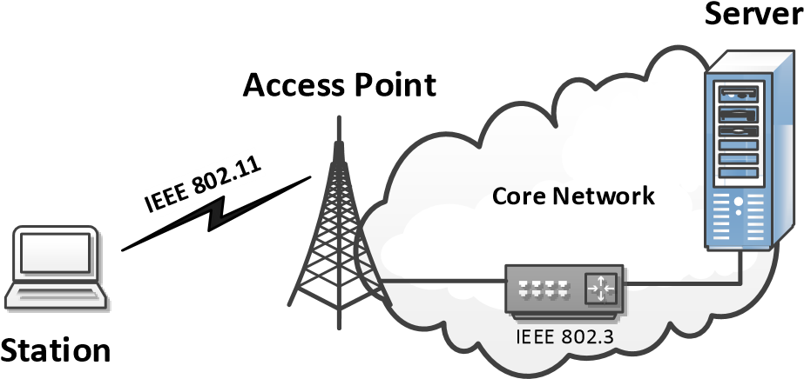
Fig. 1. OMNeT++ simulation scenario
Table II describes the simulation parameters used, such as power values used [14], IEEE 802.11 standard and Beacon Interval. Although some of the parameters are changed to provide a detailed study (e.g. Beacon Interval), when the parameters are not changed, a base value is used (the value showed in Table II) to guarantee a standard of values in order to provide a comparison between the different tests.
All the results depicted in the following sections include 15 runs using different random seed numbers with a confidence interval of 95%.

B. Regular wake up period
This subsection discusses the impact of regular wake up period in Legacy-PSM and U-APSD algorithms. For the LegacyPSM, the regular wake up period was studied defining distinct beacon intervals in the access point, since according to the protocol each station must wake up to listen to the beacons. It is possible that a STA does not wake up to receive all the beacons, but in this work we assume that a STA will always wake up to receive all the beacons. When using U-APSD,
TABLE II. OMNET++ SIMULATION PARAMETERS
Parameter | Value
OMNeT++ version | 4.3
INET version | 2.1.0
Simulation time | 300 seconds
Repetitions | 15
IEEE 802.11 standard | “g” and “e”
Default regular wake up interval | 100 ms
Power while transmitting | 2000 mW
Power while receiving | 1500 mW
Power while idle | 300 mW
Power while sleep | 20 mW
the regular wake up period is defined by the STA, as already discussed in Section II-B. Additionally, a scenario where power saving mechanism were not employed (i.e., No-PSM scenario) is also discussed.
The end-to-end delay (milliseconds) achieved for all the tested scenarios (No-PSM, Legacy-PSM and U-APSD) is depicted in Figure 2, where the x-axis shows the distinct regular wake up periods studied in milliseconds.
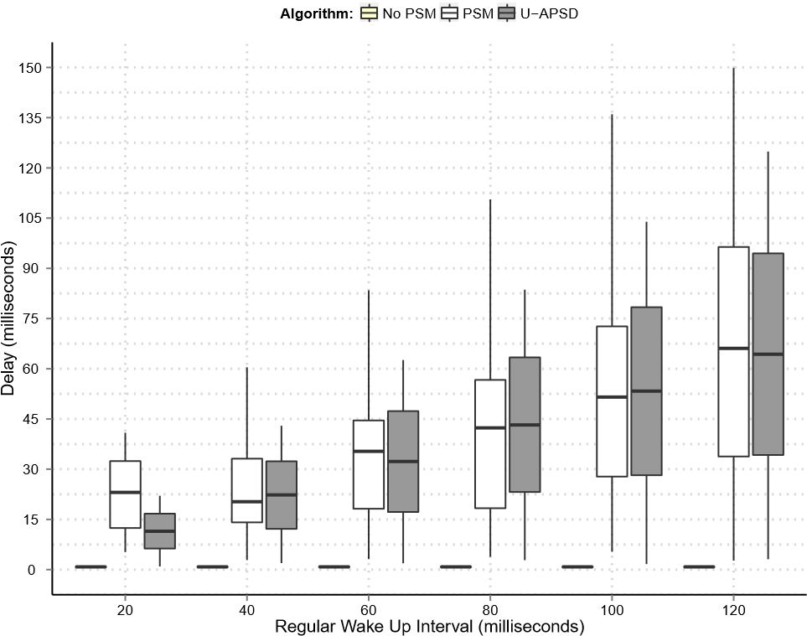
Fig. 2. End-to-end delay for distinct wake up periods
As expected, the No-PSM mechanism is not affected by the regular wake up period (i.e., different beacon interval in this scenario), since the STA is always awake and ready to receive or send information to the network. In Legacy-PSM and U-APSD scenarios, the end-to-end delay is influenced by the regular wake up period. When compared with U-APSD, the Legacy-PSM has a lower average end-to-end delay, but the maximum delay is always higher. This can be explained by the TXOP concept implemented in EDCA, which gives advantage to U-APSD when sending queued frames to the STA.
To keep the end-to-end delay within the acceptable bounds, the Legacy-PSM must change the AP beacon interval. This need represents an extra overhead for all the STAs connected to the AP, since they must wake up to receive more information. Moreover, it also increases the overall network collision probability, because the medium will be busy for longer periods. This behavior can be observed when the regular wake up period is defined with lower values (e.g., 20ms). In this case the Legacy-PSM performance is worst than with U-APSD, which is able to keep the end-to-end delay within the acceptable bounds.
The energy consumption for the already presented scenario is illustrated in Figure 3. The y-axis shows the total energy consumption in Joule, while the x-axis shows the different wake up periods tested.
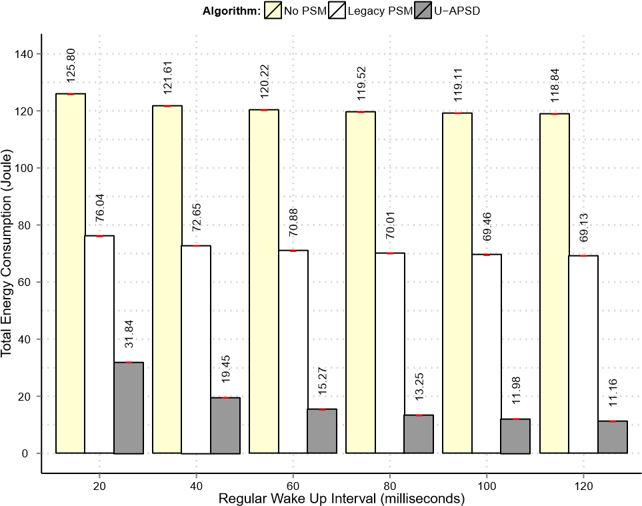
Fig. 3. Energy consumption for distinct wake up periods
The No-PSM scenario energy consumption is higher than both Legacy-PSM and U-APSD, showing the need to employ these mechanisms in order to save energy. By analyzing Legacy-PSM and U-APSD, it is possible to observe a lower energy consumption of the U-APSD algorithm in all the cases. The Legacy-PSM needs almost 4 times more energy for scenarios with wake up period ≥ 40ms and roughly 2.5 times more when the wake up period is lower (i.e. wake up period = 20ms).
In short, the U-ASPD outperforms the Legacy-PSM, since it is able to reach almost the same performance (i.e., delay) using less energy. The U-APSD has also benefits regarding the network congestion, since the beacon interval does not need to be changed. Moreover, unlike U-APSD, using the LegacyPSM all the STAs must have the same wake up period.

C. Study of Packet Size
This subsection studies the impact of varying the packet size for both Legacy-PSM and U-APSD power saving mechanisms. This study was made with distinct packet size values and a fixed sending interval of 40ms. An additional scenario with No-PSM mechanism was also studied, referred as No-PSM scenario.
The energy consumption results are presented in Figure 4. The y-axis depicts the total energy consumption in Joule and the x-axis shows the different packet sizes tested, in Bytes.
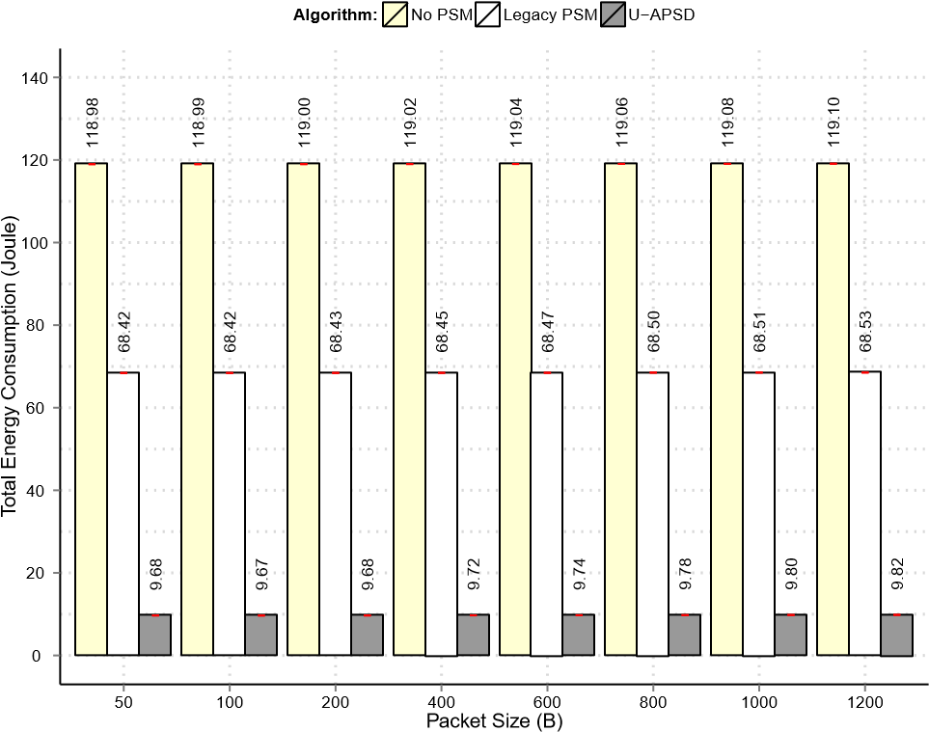
Fig. 4. Total energy consumption for distinct packet sizes
With the Legacy-PSM it is possible to see that energy consumption in No-PSM scenario is higher than both LegacyPSM and U-APSD, showing the need to employ the power saving mechanisms of the IEEE 802.11 technology. Regarding the Legacy-PSM and U-APSD power saving mechanisms, UAPSD saves more energy than Legacy-PSM for each one of the packet size values used. Legacy-PSM performs the tests needing approximately 4 times more energy than U-APSD.
By analysing these results, it is possible to observe that packet size has a minor impact on the STA overall energy consumption, following the results shown in a testbed analysis performed by Bernardo et al. [4].
Aiming to evaluate the energy cost of receiving information from the AP, the results of energy consumption per byte are illustrated in Figure 5. The y-axis shows the energy required to receive each byte in Joule, while the x-axis depicts the packet sizes variation.
The results also show that lower packet sizes require more energy per byte than higher packet sizes. This observation encourages the employment of aggregation techniques on the IEEE 802.11 technology, in order to reduce the energy consumption per byte. The usage of MAC layer aggregation techniques allows to transmit several frames in a single MAC frame. As the packet size only slightly influences the STA energy consumption, this technique allows to reduce the total energy consumption while contributing to reduce the medium overhead and collisions [15].

D. Study of QoS requirements guarantees
This subsection studies the QoS requirements guarantees for both Legacy-PSM and U-APSD by emulating the main characteristics of the G.711 voice codec [16]. Regarding the end-to-end delay metrics studied, this codec has a maximum
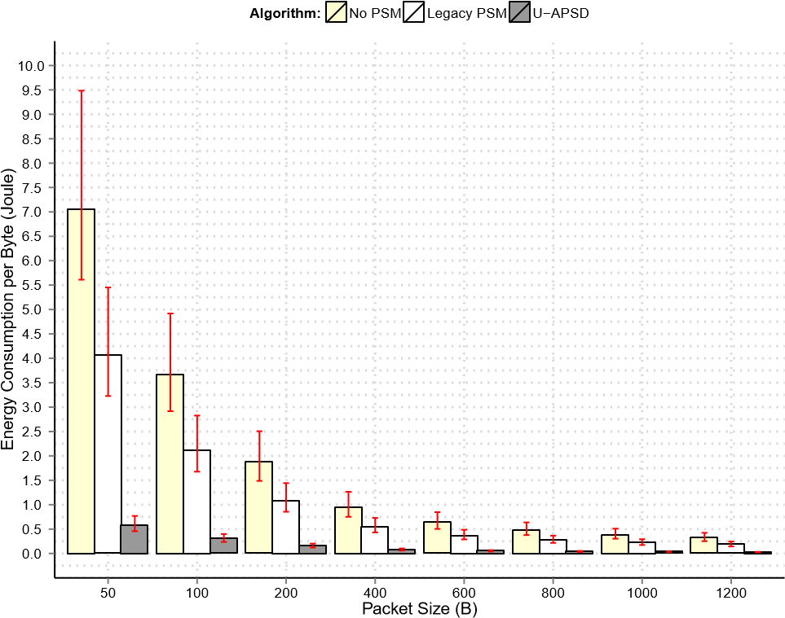
Fig. 5. Energy Consumption per byte for distinct packet sizes
acceptable end-to-end delay of 150ms defined by the ITU-T Y.1541 recommendation [17].
In order to emulate a more realistic scenario, three other applications were used to create background traffic. Each application was used in a distinct Access Category, different from the one to be used for the VoIP service. This scenario creates a more realistic network, since the Access Point must deal with different applications priorities.
The end-to-end delay (milliseconds) achieved for both Legacy-PSM and U-APSD is depicted in Figure 6. The x-axis shows the different access mechanisms used with the power saving mode referred in the graphic subtitle. As Legacy-PSM does not support traffic prioritization, it is only possible to classify traffic in a single class. In the U-APSD case, it does support traffic prioritization as it operates together with EDCA mechanism, explaining the reason why it appears the box plot related with access category used by the VoIP application in the Figure 6.
Three different scenarios were taken into account to make this study. The first one is the employment of Legacy-PSM with the default Beacon Interval indicated on Table II. The second one is also a Legacy-PSM scenario with a Beacon Interval value of 20ms. Lastly, an U-APSD scenario was analysed, with a regular wake up period of 20ms.
The Legacy-PSM scenario with beacon interval value of 100ms has higher delay values when compared within the other two scenarios, showing the need to change the beacon interval in order to keep end-to-end delay values within the acceptable bounds.
The other Legacy-PSM scenario is a consequence of this conclusion since the end-to-end delay is lower in this scenario. However, reducing the beacon interval introduces more overhead in the network since the STA is trying to listen for a number of beacons 5 times higher than the Legacy-PSM scenario with beacon interval value of 100ms.
The results show that all scenarios guarantee a good op-
0
10
20
30
40
50
60
70
80
90
100
110
120
130
140
150
PSM with
Wake Up interval = 20ms
PSM with
Wake Up interval = 100ms
U−APSD with
Wake Up interval = 20ms
Algorithm
Delay (miliseconds)
Fig. 6. QoS requirements guarantees on PSM and U-APSD end-to-end delay
eration of the VoIP application since the end-to-end delay does not reach the maximum end-to-end delay acceptable for applications which use the G.711 voice codec. However, the Legacy-PSM scenario with a beacon interval value of 100ms almost reaches this limit since it obtains higher end-to-end delay values when compared with the others.
The energy consumption for the scenarios described is illustrated on Figure 7. The y-axis shows the total energy consumption in Joule, while the x-axis indicates the different scenarios studied.
74
.76
73
.00
.13
22
0
5
10
15
20
25
30
35
40
45
50
55
60
65
70
75
80
PSM with
Wake Up interval = 20ms
PSM with
Wake Up interval = 100ms
U−APSD with
Wake Up interval = 20ms
Algorithm
Total Energy Consumption (Joule)
Fig. 7. Impact of running a VoIP application in PSM and U-APSD Energy Consumption
It is possible to see the consequence of sending more beacons. Besides introducing more overhead in the network, the Legacy-PSM scenario with a Beacon Interval value of 20ms also causes the STA to be in sleep mode for less time. That is why energy consumption values are lower for the Legacy-PSM scenario with Beacon Interval value of 100ms.
Concerning the U-APSD scenario, it presents the lowest energy consumption values as in all the previous studies.

V. CONCLUSIONS
The constant growth of traffic generated by mobile devices in the last years, together with the increasing number devices using IEEE 802.11 capabilities, created new challenges regarding the standard power saving protocols. Apart from avoid the devices’ batteries from running out in a short time, these protocols must also be able to guarantee certain Quality of Server for a range of applications, particularly for the realtime ones. This paper evaluates the performance of two power saving mechanisms defined in IEEE 802.11 standard (LegacyPSM and U-APSD) in order to fulfill those challenges.
The obtained results comparing Legacy-PSM and U-APSD showed that U-APSD is more energy efficient, while keeping better application performance. When analyzing the energy consumption, the results revealed that Legacy-PSM needs roughly 4 times more energy than U-APSD for scenarios with wake up period ≥ 40ms and roughly 2.5 times more when the wake up period is equal to 20ms.
Concerning the QoS requirements, U-APSD revealed the capability to guarantee Quality of Service for the studied realtime applications, as the obtained end-to-end delay is lower than the maximum acceptable end-to-end delay allowed in ITU-T Y.1541 recommendation.

ACKNOWLEDGMENTS
This work was partially supported by the COST framework, under Actions IC0804 and IC0906, as well as by the iCIS project (CENTRO-07-ST24-FEDER-002003), co-financed by QREN, in the scope of the Mais Centro Program and European Union’s FEDER, and by industrial partners (ISA, OneSource) and COMPETE program in the scope of SI I&DT sMeter project (“Integrated Platform for Energy Efficiency and Smart
Metering”, contract n. 21588, QREN FCOMP-01-02)
The second author was also supported by the Portuguese National Foundation for Science and Technology (FCT) through a Doctoral Grant (SFRH/BD/66181/2009).

REFERENCES
- “Ieee standard for information technology–telecommunications and information exchange between systems local and metropolitan area networks–specific requirements part 11: Wireless lan medium access control (mac) and physical layer (phy) specifications,” IEEE Std 802.112012 (Revision of IEEE Std 802.11-2007), pp. 1–2793, 2012.
- Cisco, “Cisco Visual Networking Index: Global Mobile Data Traffic Forecast Update, 2012–2017.” http://www.cisco.com/en/US/solutions/collateral/ns341/ns525/ns537/ns7 05/ns827/white paper c11-520862.html, February 2013.
- G. Li, Z. Xu, C. Xiong, C. Yang, S. Zhang, Y. Chen, and S. Xu,
“Energy-efficient wireless communications: tutorial, survey, and open issues,” Wireless Communications, IEEE, vol. 18, no. 6, pp. 28–35, 2011.
- V. Bernardo, M. Curado, T. Staub, and T. Braun, “Towards energy consumption measurement in a cloud computing wireless testbed,” in Network Cloud Computing and Applications (NCCA), 2011 First International Symposium on, pp. 91–98, 2011.
- “Ieee standard for information technology - telecommunications and information exchange between systems - local and metropolitan area networks - specific requirements part 11: Wireless lan medium access control (mac) and physical layer (phy) specifications amendment 8: Medium access control (mac) quality of service enhancements,” IEEE Std 802.11e-2005 (Amendment to IEEE Std 802.11, 1999 Edition (Reaff 2003), pp. 0 1–189, 2005.
- X. P. Costa, D. Camps-Mur, and A. Vidal, “On distributed power saving mechanisms of wireless lans 802.11e u-apsd vs 802.11 power save mode.,” Computer Networks, vol. 51, no. 9, pp. 2326–2344, 2007.
- X. Perez-Costa and D. Camps-Mur, “Ieee 802.11e qos and power saving features overview and analysis of combined performance [accepted from open call],” Wireless Communications, IEEE, vol. 17, no. 4, pp. 88–96, 2010.
- Y. He, R. Yuan, X. Ma, J. Li, and C. Wang, “Scheduled psm for minimizing energy in wireless lans,” in Network Protocols, 2007. ICNP 2007. IEEE International Conference on, pp. 154–163, 2007.
- E. Rozner, V. Navda, R. Ramjee, and S. Rayanchu, “Napman: networkassisted power management for wifi devices,” in Proceedings of the 8th international conference on Mobile systems, applications, and services, MobiSys ’10, (New York, NY, USA), pp. 91–106, ACM, 2010.
- A. J. Pyles, Z. Ren, G. Zhou, and X. Liu, “Sifi: exploiting voip silence for wifi energy savings insmart phones,” in Proceedings of the 13th international conference on Ubiquitous computing, UbiComp ’11, (New York, NY, USA), pp. 325–334, ACM, 2011.
- A. Varga and R. Hornig, “An overview of the omnet++ simulation environment,” in Proceedings of the 1st international conference on Simulation tools and techniques for communications, networks and systems & workshops, Simutools ’08, (ICST, Brussels, Belgium, Belgium), pp. 60:1–60:10, ICST (Institute for Computer Sciences, SocialInformatics and Telecommunications Engineering), 2008.
- “INET framework main page.” http://www.inet.omnetpp.org/.
- V. Bernardo, M. Curado, and T. Braun, “Enhancing ieee 802.11 energy efficiency for continuous media applications,” in EE-LSDS 2013, Energy Efficiency in Large Scale Distributed Systems conference, vol. 8046, (n/a), pp. 1–15, Lecture Notes in Computer Science, Vol. 8046, April 2013.
- D. Camps-Mur, M. D. Gomony, X. P. Costa, and S. S. Ribes, “Leveraging 802.11n frame aggregation to enhance qos and power consumption in wi-fi networks,” Computer Networks, vol. 56, no. 12, pp. 2896–2911, 2012.
- D. Skordoulis, Q. Ni, H.-H. Chen, A. Stephens, C. Liu, and A. Jamalipour, “IEEE 802.11n MAC frame aggregation mechanisms for nextgeneration high-throughput WLANs,” Wireless Communications, IEEE, vol. 15, pp. 40–47, Feb. 2008.
- I. T. Recommendation, “ITU-T recommendation G.711. Pulse code modulation (PCM) of voice frequencies,” Nov. 1988.
- I. T. Recommendation, “ITU-T recommendation Y.1541: Network Performance Objectives for IP-Based Services,” tech. rep., International Telecommunication Union, 2003.

