**Comment on CMF chapter 14, lines 25–26**

**Cathy Kessel, July 7, 2023**

Lines 25–26: “Algebra. The part of mathematics in which letters and other general symbols are used to represent numbers and quantities in formulae and equations.

It may be useful to consider Bill Barton’s remark:

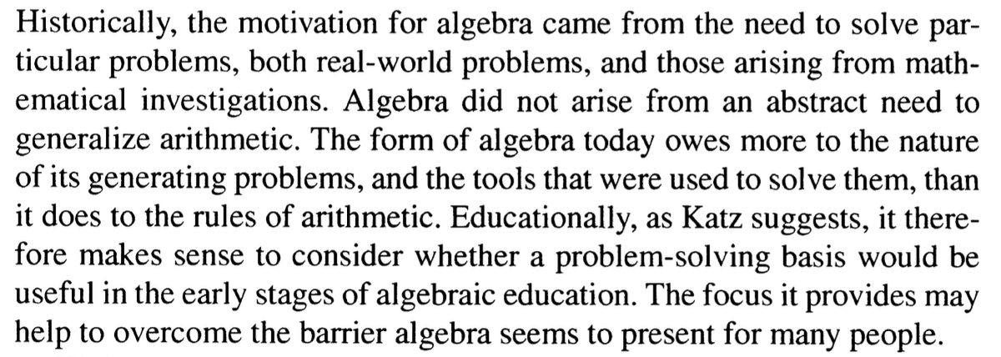

Source:

Katz, V. J., & Barton, B. (2007). Stages in the history of algebra with implications for teaching. *Educational Studies in Mathematics*, *66*, 185-201. <https://personal.psu.edu/ecb5/Courses/M475W/WeeklyReadings/Week%2010/StagesOfAlgebra>

Algebra has geometrical roots. The word “algebra” comes from the *al-Jabr* in the name of the 9th-century treatise *al-Kitāb al-Mukhtaṣar fī Ḥisāb al-Jabr wal-Muqābalah*. ([*The Compendious Book on Calculation by Completion and Balancing*](https://archive.org/details/algebraofmohamme00khuwrich)), written by Muḥammad ibn Mūsā al-Khwārizmī (whose name gave us the word “algorithm”). In this treatise, problems that involved finding an unknown number were given in words and solutions were obtained geometrically.