Corrections to Chapter 3

p. 4, line 62 – incomplete sentence.

“Similarly, chapter 4 describes how the Standards for Mathematical Practice can be instilled across grade levels, and chapter 5 describes progressions for.”

Suggestion: … chapter 5 describes progressions for the development of Data Science for all the grades, K-12.

p. 11, line 248-9 – redundancy.

“They select or invent sensible calculation strategies to make sense in a particular situation, developing as mathematical thinkers.”

Suggestion: … “They select or invent sensible calculation strategies to apply in a particular situation, developing as mathematical thinkers.

p. 20 lines 499-501 . The two diagrams’ labels are reversed!

Suggestion: Instead, the upper image should be labeled 3 + 4, and the lower image should indicate 4 + 3.

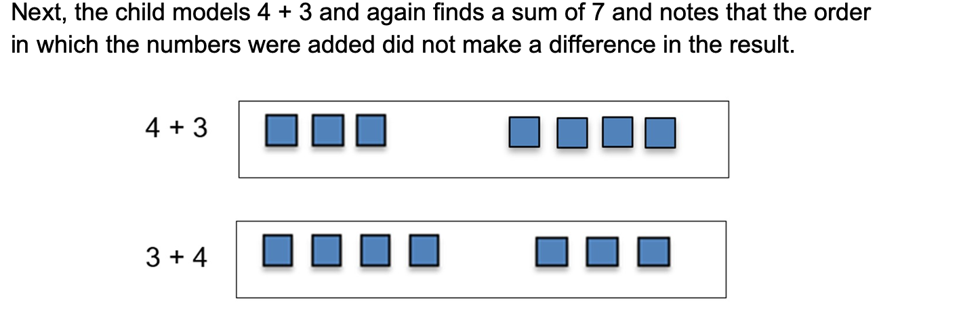

p. 24, line 602: needs an apostrophe. “students” should be “students’ “

#### The vignette also illustrates the value of number talk, in this instance to expand students understanding of taking things apart and refitting them back together.

p. 32, line 793: error in quantity described.

Another useful tool is a printed 10 x 10 grid. Students visualize the whole grid as representing the whole and can shade in various decimal values. For example, if two columns plus an additional five small squares are shaded on the grid, the student can visualize that value as 1.25 or 1-1/4 of the whole.

Suggestion: Please correct to read, “For example, if two columns plus an additional five small squares are shaded on the grid, the student can visualize that value as 0.25 or 1/4 of the whole.”

p. 35, line 861: rewording suggestion.

“It is essential that students have developed a robust understanding of the operations of multiplication and division as they approach the middle grades, where they will apply such reasoning to solve ratio and rate problems.”

Suggestion: “It is essential that students have developed a robust understanding of the operations of multiplication and division as they approach Grades 6-8, where they will apply such reasoning to solve ratio and rate problems.”