**6.3数据库模型层·ORM模型基类优化**

# 现状说明

1. 接口字段为小驼峰
2. 数据库字段为下划线
3. 模型对象不能直接转成JSON字段串，需要转成dict
4. 表单字段也需要转成模型对象
5. 一个个转换不方便

# 优化思路

1. 模型基类新增to_dict方法，可将属性对象转成字典对象
2. 提供key可为下划线或小驼峰的转换方式
3. 提供可根据表单数据对象构造成模型对象的构造方法

# 新增工具模块

mkdir tools

# 新增tools/__init__.py

def hump_to_underline(text):  
 """  
 驼峰转下划线  
 :param text:  
 :return:  
 """  
 res = []  
 for index, char in enumerate(text):  
 if char.isupper() and index != 0:  
 res.append("_")  
 res.append(char)  
 return ''.join(res).lower()  
  
  
def underline_to_hump(text):  
 """  
 下划线转大驼峰  
 :param text:  
 :return:  
 """  
 arr = text.lower().split('_')  
 res = []  
 for i in arr:  
 res.append(i[0].upper() + i[1:])  
 return ''.join(res)  
  
  
def underline_to_camel(text):  
 """  
 下划线转小驼峰  
 :param text:  
 :return:  
 """  
 s = underline_to_hump(text)  
 return s[0].lower() + s[1:]

# 修改models/__init__.py

from datetime import datetime  
  
from flask_sqlalchemy import SQLAlchemy  
  
from tools import underline_to_camel, hump_to_underline  
  
db = SQLAlchemy()  
  
  
class BaseModel(db.Model):  
 """  
 普通模型基类  
 """  
 __abstract__ = True  
 id = db.Column(db.BigInteger, primary_key=True, comment="主键")  
 create_time = db.Column(db.DateTime, name="create_time", default=datetime.now, comment="创建时间")  
 update_time = db.Column(db.DateTime, name="update_time", default=datetime.now, onupdate=datetime.now,  
 comment="更新时间")  
 is_deleted = db.Column(db.Boolean, name="is_deleted", default=False, comment="逻辑删除:0=未删除,1=删除")  
  
 def __init__(self, **kwargs):  
 """  
 构造函数，将dict=>obj  
 :param kwargs: 校验表单的**form.data  
 """  
 for (key, value) in kwargs.items():  
 underline_key = hump_to_underline(key)  
 if hasattr(self, underline_key):  
 self.__dict__.update({  
 underline_key: value  
 })  
  
 def to_dict(self, camel=True):  
 """  
 对象转成dict  
 :param camel: 是否转成小驼峰，默认True  
 :return:  
 """  
 m_dict = {}  
 if self is not None:  
 for c in self.__table__.columns:  
 key = c.name  
 if hasattr(self, key):  
 value = getattr(self, key)  
 if value is not None:  
 if camel:  
 m_dict[underline_to_camel(key)] = value  
 else:  
 m_dict[key] = value  
  
 return m_dict  
  
 @staticmethod  
 def to_page(page):  
 # print(page.page) # 当前页码-从1开始  
 # print(page.per_page) # 每页大小  
 # print(page.total) # 总记录数  
 # print(page.items) # 数据集  
 if page is None:  
 return None  
 rows = []  
 for u in page.items:  
 rows.append(u.to_dict(camel=True))  
 return {  
 "recordCount": page.total,  
 "totalPage": int((page.total - 1) / page.per_page) + 1,  
 "pageSize": page.per_page,  
 "pageNum": page.page,  
 "rows": rows  
 }  
  
  
class TreeModel(BaseModel):  
 """  
 树型表模型基类  
 """  
 __abstract__ = True  
 parent_id = db.Column(db.BigInteger, primary_key=True, default=0, comment="父ID")  
 name = db.Column(db.String(64), name="name", nullable=False, comment="名称")  
 sort = db.Column(db.BigInteger, name="sort", default=99, nullable=False,  
 comment="排序")

# 修改controllers/user_controller.py

from flask import Blueprint  
  
from controllers import R  
from models import db  
from models.user import User  
from validators import BasePageForm  
from validators.id_validator import IdForm, IdsForm  
from validators.user_validator import UserForm  
  
user = Blueprint('user', __name__, url_prefix="/user")  
  
  
@user.route("/get", methods=['POST'])  
def user_get():  
 """  
 通过id获取用户信息  
 :return:  
 """  
 form = IdForm()  
 form.validate_for_api()  
 # 可通过form.data获取所有提交参数  
 # 或者直接拿id值 id=form.id.data  
 # u = User.query.filter_by(id=form.id.data).first()  
 # 通过主键查询  
 u = User.query.get(form.id.data)  
 if u is not None:  
 return R.data(u.to_dict(camel=True))  
 else:  
 return R.fail("该记录不存在")  
  
  
@user.route("/list", methods=['POST'])  
def user_list():  
 """  
 分页查询用户列表  
 :return:  
 """  
 form = BasePageForm()  
 form.validate_for_api()  
 # 可通过form.data获取所有提交参数  
 # 可通过form.pageNum.data获取pageNum  
 # 可通过form.pageSize.data获取pageSize  
 page=User.query.filter().paginate(form.pageNum.data, form.pageSize.data,False)  
 return R.data(User.to_page(page))  
  
  
@user.route("/save", methods=['POST'])  
def user_save():  
 """  
 添加用户  
 :return:  
 """  
 form = UserForm()  
 form.validate_for_api()  
 # 可通过form.data获取所有提交参数  
 # print(form.data)  
 u = User(**form.data)  
 db.session.add(u)  
 db.session.commit()  
 return R.success("添加用户成功")  
  
  
@user.route("/update", methods=['POST'])  
def user_update():  
 """  
 修改用户  
 :return:  
 """  
 form = UserForm()  
 form.validate_for_api()  
 # 可通过form.data获取所有提交参数  
 # print(form.data)  
 u = User(**form.data)  
 User.query.filter_by(id=form.id.data).update(u.to_dict(camel=False))  
 db.session.commit()  
 return R.success("修改用户成功")  
  
  
@user.route("/delete", methods=['POST'])  
def user_delete():  
 """  
 删除用户  
 :return:  
 """  
 form = IdsForm()  
 form.validate_for_api()  
 # 可通过form.data获取所有提交参数  
 # print(form.data)  
 User.query.filter(User.id.in_(form.ids.data)).delete()  
 db.session.commit()  
 return R.success("删除用户成功")

# 运行Flask服务

flask run

# 测试前重新建表

drop table if exists t_user;  
CREATE TABLE `t_user` (  
 `id` bigint(20) NOT NULL AUTO_INCREMENT COMMENT '主键',  
 `user_name` varchar(32) NOT NULL COMMENT '用户名',  
 `real_name` varchar(32) NOT NULL COMMENT '姓名',  
 `password` varchar(64) NOT NULL COMMENT '密码',  
 `create_time` datetime DEFAULT NULL COMMENT '创建时间',  
 `update_time` datetime DEFAULT NULL COMMENT '更新时间',  
 `is_deleted` tinyint(1) DEFAULT NULL COMMENT '逻辑删除:0=未删除,1=删除',  
 PRIMARY KEY (`id`),  
 UNIQUE KEY `user_name` (`user_name`)  
) ENGINE=InnoDB DEFAULT CHARSET=utf8mb4 COMMENT='用户';

# 使用Postman接口测试工具访问

## 访问/user/save添加用户

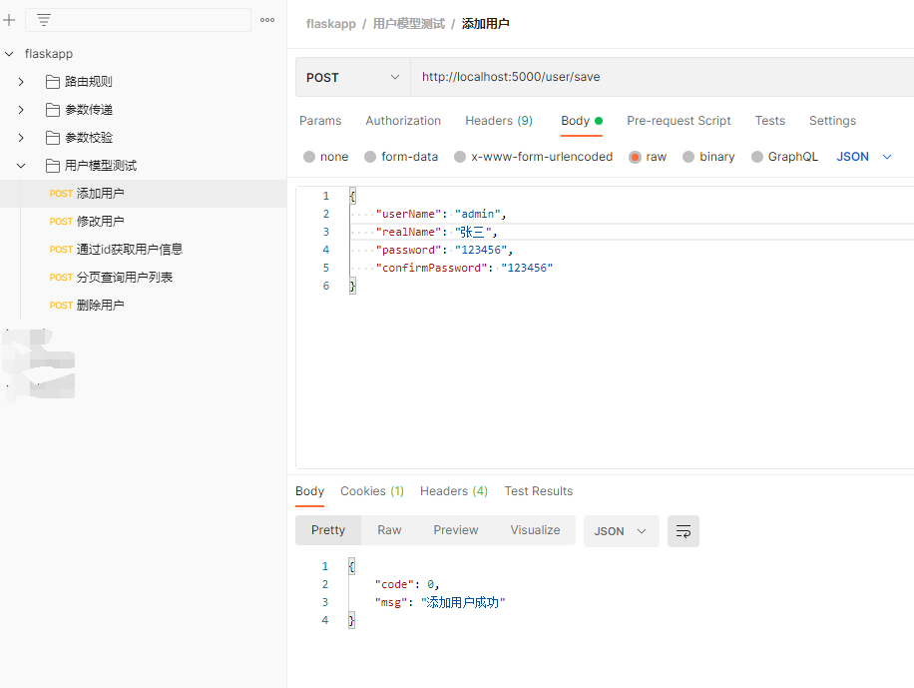

## 访问/user/update修改用户

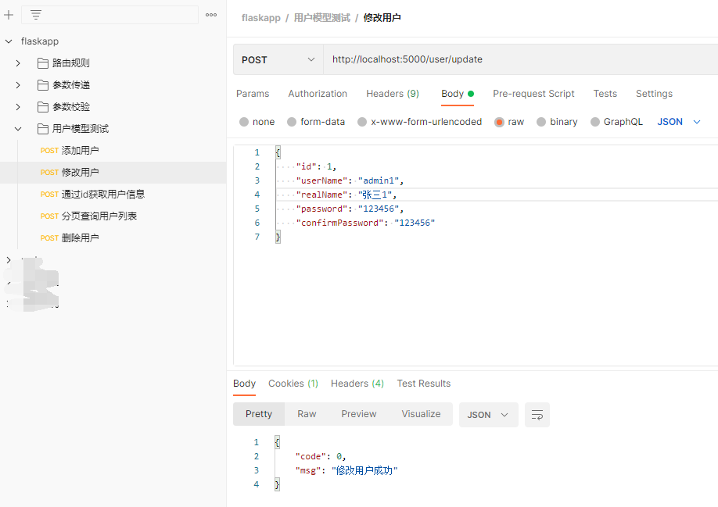

## 访问/user/get通过id获取用户信息

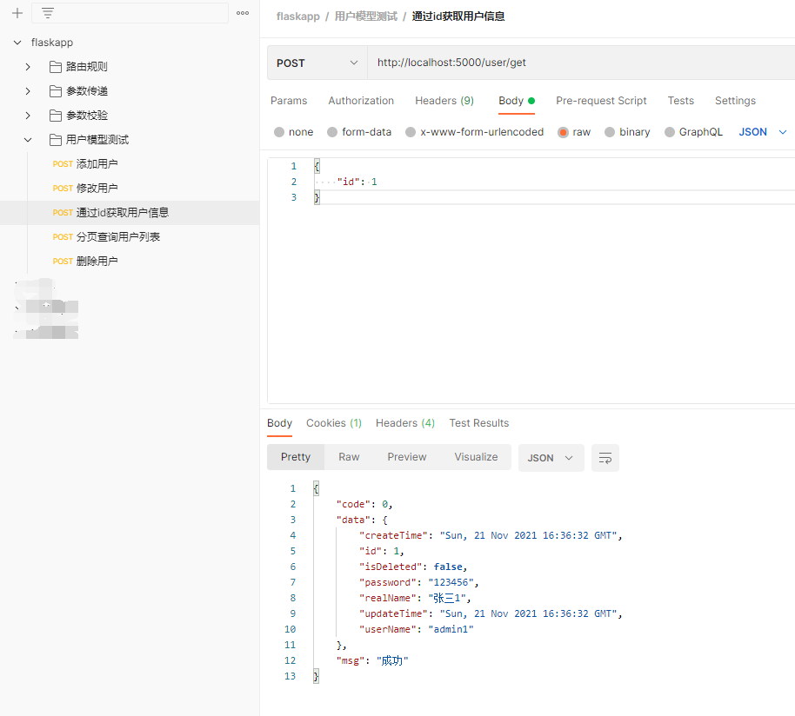

## 访问/user/list分页查询用户列表

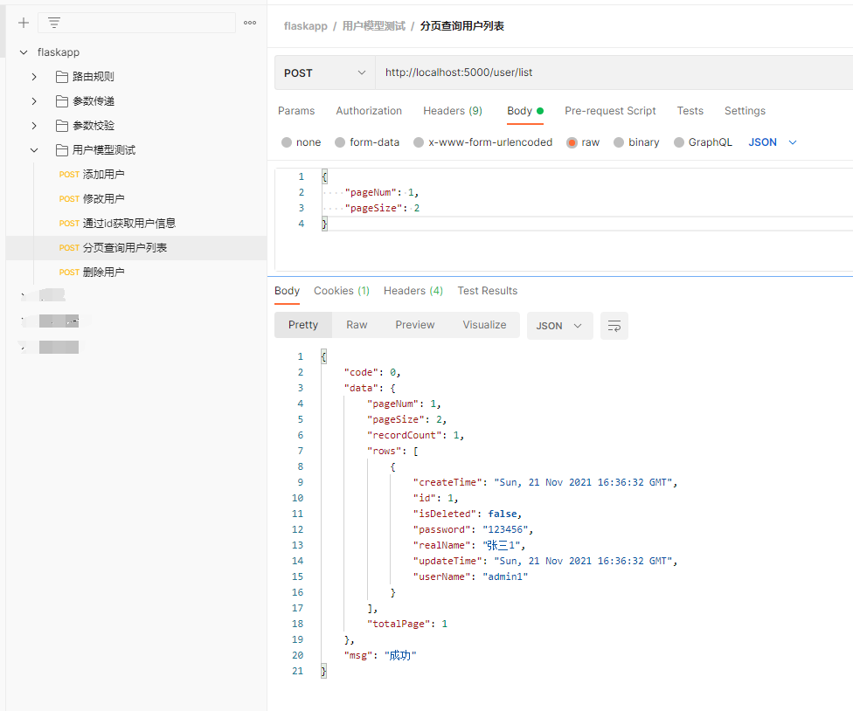

## 访问/user/delete删除用户

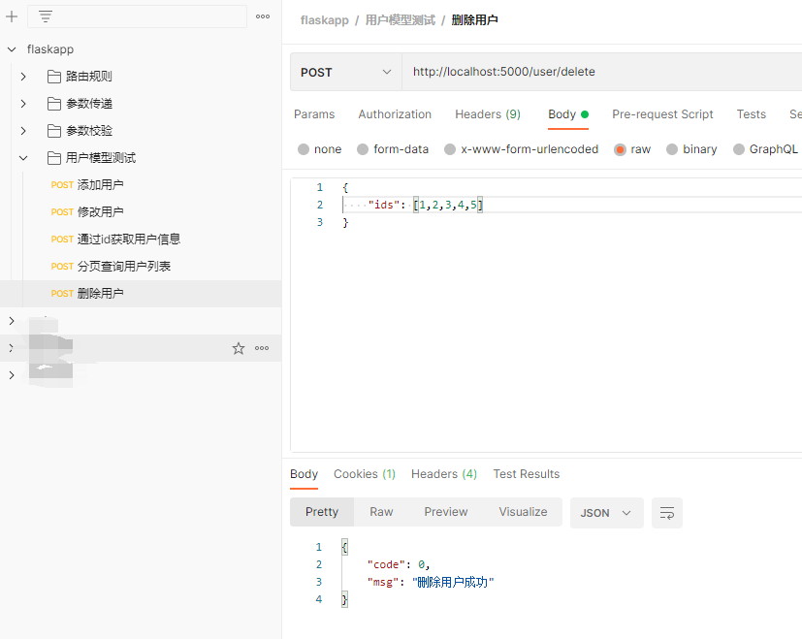

# postman导出文件

