**8.3权限拦截·Flask实现Token认证**

上文只是简单的实现了权限拦截的逻辑，但是就整个权限认证体系来说，还是不够的，我们缺少了权限认证的入口。权限认证，存储会话信息有多种方式，比如Flask自带的session。但是随着系统的发展，session是不太能满足需求了，本文采用的是Token认证的方式。整体流程为：

* 登录成功->返回认证token
* 访问需要认证的接口时携带认证的token
* 权限装饰器判断是否携带认证token来进行权限拦截

# 关于Token存储策略

当我们生成token凭证后，后端也是需要存储token信息的，这样客户端请求时携带token凭证,后端才能验证该凭证是否存在且是否在有效期内。在这里我们可以提供三种常用的存储方案。我们可以根据业务的需要，进行配置使用。

## CacheTokenStrategy

缓存存储策略,一般开发阶段常用的方案，服务重启后，token数据会丢失。

## MysqlTokenStrategy

Mysql存储策略，不想多安装一个redis中间件的的另一种token持久化方案

## RedisTokenStrategy

redis存储策略，建议使用的方案

# 安装依赖

## 安装缓存依赖库

# 安装最新版本  
pip3 install cacheout  
# 或指定安装版本  
pip3 install cacheout==0.13.1

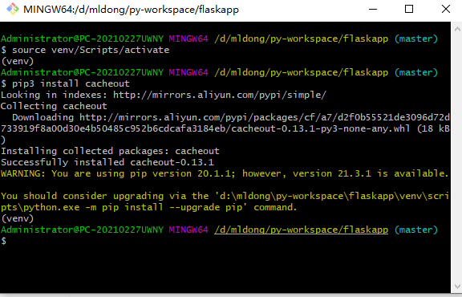

## 安装flask-redis依赖库

# 安装最新版本  
pip3 install flask-redis  
# 或指定安装版本  
pip3 install flask-redis==0.4.0

# 新增目录mauth/mtoken

mkdir -p mauth/mtoken

# 新增mauth/mtoken/__init__.py文件

三个token存储实现类

import datetime  
import json  
import uuid  
  
from flask import request, current_app, g  
from flask_redis import FlaskRedis  
  
from models import BaseModel, db  
  
redis_client = FlaskRedis()  
  
  
class AbstractTokenStrategy:  
 """  
 token存储策略抽象类  
 """  
 # token 过期时间- 单位是s # 2小时  
 TOKEN_EXPIRE_TIMEOUT = 60 * 60 * 2  
 # token-key  
 TOKEN_KEY = "token"  
 # token 前辍  
 TOKEN_KEY_PREFIX = "flaskapp:"  
 # 超级管理员id  
 SUPER_ADMIN_ID = 1  
  
 def __init__(self, app=None):  
 self.app = app  
 if app:  
 self.init_app(app)  
 else:  
 self.init_app(current_app)  
  
 def init_app(self, app):  
 if app.config.get('TOKEN_EXPIRE_TIMEOUT'):  
 self.TOKEN_EXPIRE_TIMEOUT = app.config.get('TOKEN_EXPIRE_TIMEOUT')  
 if app.config.get('TOKEN_KEY'):  
 self.TOKEN_KEY = app.config.get('TOKEN_KEY')  
 if app.config.get('TOKEN_KEY_PREFIX'):  
 self.TOKEN_KEY_PREFIX = app.config.get('TOKEN_KEY_PREFIX')  
 if app.config.get('SUPER_ADMIN_ID'):  
 self.SUPER_ADMIN_ID = app.config.get('SUPER_ADMIN_ID')  
  
 def __new__(cls, *args, **kwargs):  
 """  
 设置成单例模式  
 :param args:  
 :param kwargs:  
 """  
 if not hasattr(cls, '_instance'):  
 orig = super(AbstractTokenStrategy, cls)  
 cls._instance = orig.__new__(cls, *args, **kwargs)  
 return cls._instance  
  
 def set(self, data):  
 """  
 存储token  
 :param data:  
 :return:  
 """  
 pass  
  
 def get(self, token):  
 """  
 获取token  
 :param token:  
 :return:  
 """  
 pass  
  
 def remove(self, token):  
 """  
 删除token  
 :param token:  
 :return:  
 """  
 pass  
  
  
class TokenStrategyFactory:  
  
 @staticmethod  
 def get_instance():  
 token_strategy = current_app.config.get("TOKEN_STRATEGY", "cache")  
 if token_strategy == 'redis':  
 return RedisTokenStrategy()  
 elif token_strategy == 'mysql':  
 return MysqlTokenStrategy()  
 else:  
 return CacheTokenStrategy()  
  
 @staticmethod  
 def create_token(data=None):  
 uid = str(uuid.uuid4())  
 suid = ''.join(uid.split('-'))  
 return suid  
  
 """  
 校验token是否存在  
 """  
  
 @staticmethod  
 def check_token(access=None):  
 """  
 核实token-如果权限标识存在，则校验是否存在权限标识  
 :param access: 权限标识  
 :return:  
 """  
 token_strategy = TokenStrategyFactory.get_instance()  
 token = request.headers.get(token_strategy.TOKEN_KEY, "")  
 data = token_strategy.get(token)  
 if data is not None:  
 # 将当前用户信息注入到这一次请求中，方便全局使用  
 g.current_user = data  
 if data.get("userId") is not token_strategy.SUPER_ADMIN_ID and access is not None:  
 return access in data.get("perms", "").split(",")  
 return True  
 else:  
 return False  
  
  
class CacheTokenStrategy(AbstractTokenStrategy):  
 """  
 缓存Token存储策略  
 """  
 from cacheout import LFUCache # 最小频率使用机制  
 cache = LFUCache(maxsize=1000)  
  
 def set(self, data):  
 token = data.get("token", TokenStrategyFactory.create_token(data))  
 data['token'] = token  
 self.cache.set(token, json.dumps(data, ensure_ascii=False), ttl=self.TOKEN_EXPIRE_TIMEOUT)  
 return data  
  
 def get(self, token):  
 data = self.cache.get(token)  
 if data is None:  
 return None  
 # 重新设置，延长存活时间  
 self.cache.set(token, data, ttl=self.TOKEN_EXPIRE_TIMEOUT)  
 return json.loads(data)  
  
 def remove(self, token):  
 if token is None:  
 token = request.headers.get(self.TOKEN_KEY, "")  
 self.cache.delete(token)  
  
  
class AccessToken(BaseModel):  
 """  
 access_token存储表  
 """  
 __tablename__ = "t_access_token"  
 __table_args__ = ({"comment": "Token"})  
 id = db.Column(db.Integer, primary_key=True, comment="主键")  
 user_id = db.Column(db.Integer, name="user_id", unique=False, nullable=False, comment="用户id")  
 user_name = db.Column(db.String(32), name="user_name", unique=False, nullable=False, comment="用户名")  
 token = db.Column(db.String(40), name="token", unique=True, nullable=False, comment="token")  
 perms = db.Column(db.String(1000), name="perms", unique=False, nullable=True, comment="权限集合")  
  
  
class MysqlTokenStrategy(AbstractTokenStrategy):  
 """  
 mysql Token存储策略  
 """  
  
 def set(self, data):  
 accessToken = AccessToken()  
 accessToken.token = data.get("token", TokenStrategyFactory.create_token(data))  
 accessToken.user_id = data.get("userId", data.get("id"))  
 accessToken.user_name = data.get("userName", "")  
 accessToken.perms = data.get("perms", "")  
 db.session.add(accessToken)  
 db.session.commit()  
 data['token'] = accessToken.token  
 return data  
  
 def get(self, token):  
 now = datetime.datetime.now()  
 delta = datetime.timedelta(seconds=self.TOKEN_EXPIRE_TIMEOUT)  
 expireTime = now - delta  
 accessToken = AccessToken.query.filter_by(token=token).filter(AccessToken.update_time > expireTime).first()  
 if accessToken is None:  
 return None  
 else:  
 # 更新时间,基类已经做了自动更新更新时间，这里只修改一个字段触发更新操作即可  
 AccessToken.query.filter_by(id=accessToken.id).update({  
 AccessToken.is_deleted: accessToken.is_deleted  
 })  
 # 提交事务  
 db.session.commit()  
 return AccessToken.to_dict(accessToken)  
  
 def remove(self, token):  
 if token is None:  
 token = request.headers.get(self.TOKEN_KEY, "")  
 AccessToken.query.filter_by(token=token).delete()  
  
  
class RedisTokenStrategy(AbstractTokenStrategy):  
 """  
 Redis Token存储策略  
 """  
  
 def set(self, data):  
 token = data.get('token', TokenStrategyFactory.create_token(data))  
 data['token'] = token  
 token = self.TOKEN_KEY_PREFIX + token  
 p = redis_client.pipeline()  
 p.set(token, json.dumps(data, ensure_ascii=False))  
 p.expire(token, self.TOKEN_EXPIRE_TIMEOUT)  
 p.execute()  
 return data  
  
 def get(self, token):  
 data = redis_client.get(self.TOKEN_KEY_PREFIX + token)  
 if data is None:  
 return None  
 p = redis_client.pipeline()  
 p.expire(self.TOKEN_KEY_PREFIX + token, self.TOKEN_EXPIRE_TIMEOUT)  
 p.execute()  
 return json.loads(data.decode("utf-8"))  
  
 def remove(self, token):  
 if token is None:  
 token = request.headers.get(self.TOKEN_KEY, "")  
 p = redis_client.pipeline()  
 p.delete(self.TOKEN_KEY_PREFIX + token)  
 p.execute()

# 修改mauth/__init__.py

新增token与权限的判断

from functools import wraps  
from flask import abort  
  
from mauth.mtoken import TokenStrategyFactory  
  
  
class HasPerm(ｏｂｊｅｃｔ):  
 """  
 权限装饰器类  
 """  
  
 def __init__(self, access=None, name=None):  
 self.access = access  
 self.name = name  
  
 def __call__(self, func):  
 @wraps(func)  
 def wrapped_function(*args, **kwargs):  
 # 这里处理权限拦截的逻辑  
 if not TokenStrategyFactory.check_token(self.access):  
 abort(403)  
 else:  
 return func(*args, **kwargs)  
  
 return wrapped_function

# 修改controllers/user_controller.py

新增登录与退出处理逻辑

from flask import Blueprint, request  
  
from controllers import R  
from mauth import HasPerm, TokenStrategyFactory  
from models.user import User  
from services.user_service import UserService  
from validators import BasePageForm  
from validators.id_validator import IdForm, IdsForm  
from validators.user_validator import UserForm, LoginForm  
  
# 声明一个蓝图  
user = Blueprint('user', __name__, url_prefix="/user")  
  
# 声明一个用户业务服务  
user_service = UserService(model=User)  
  
  
@user.route("/get", methods=['POST'])  
@HasPerm(access="user:get", name="通过id获取用户信息")  
def user_get():  
 """  
 通过id获取用户信息  
 :return:  
 """  
 form = IdForm()  
 form.validate_for_api()  
 # 可通过form.data获取所有提交参数  
 # 或者直接拿id值 id=form.id.data  
 # u = User.query.filter_by(id=form.id.data).first()  
 # 通过主键查询  
 u = user_service.get(form)  
 if u is not None:  
 return R.data(u.to_dict(camel=True))  
 else:  
 return R.fail("该记录不存在")  
  
  
@user.route("/list", methods=['POST'])  
@HasPerm(access="user:list", name="分页查询用户列表")  
def user_list():  
 """  
 分页查询用户列表  
 :return:  
 """  
 form = BasePageForm()  
 form.validate_for_api()  
 return R.data(user_service.list(form))  
  
  
@user.route("/save", methods=['POST'])  
@HasPerm(access="user:save", name="添加用户")  
def user_save():  
 """  
 添加用户  
 :return:  
 """  
 form = UserForm()  
 form.validate_for_api()  
 # 可通过form.data获取所有提交参数  
 # print(form.data)  
 user_service.save(form)  
 return R.success("添加用户成功")  
  
  
@user.route("/update", methods=['POST'])  
@HasPerm(access="user:update", name="修改用户")  
def user_update():  
 """  
 修改用户  
 :return:  
 """  
 form = UserForm()  
 form.validate_for_api()  
 # 可通过form.data获取所有提交参数  
 # print(form.data)  
 user_service.update(form)  
 return R.success("修改用户成功")  
  
  
@user.route("/delete", methods=['POST'])  
@HasPerm(access="user:delete", name="删除用户")  
def user_delete():  
 """  
 删除用户  
 :return:  
 """  
 form = IdsForm()  
 form.validate_for_api()  
 # 可通过form.data获取所有提交参数  
 # print(form.data)  
 user_service.delete(form)  
 return R.success("删除用户成功")  
  
  
@user.route("/login", methods=['POST'])  
def user_login():  
 """  
 登录  
 :return:  
 """  
 form = LoginForm()  
 form.validate_for_api()  
 # 可通过form.data获取所有提交参数  
 # print(form.data)  
 res = user_service.login(form.userName.data, form.password.data)  
 token_strategy = TokenStrategyFactory.get_instance()  
 return R.data(token_strategy.set({  
 "userId": res.get("id"),  
 "userName": res.get("userName")  
 }))  
  
  
@user.route('/logout')  
def user_logout():  
 """  
 退出  
 :return:  
 """  
 token_strategy = TokenStrategyFactory.get_instance()  
 token_strategy.remove(None)  
 return R.success()  
  
  
@user.route("/saveBatch", methods=['GET', 'POST'])  
def user_save_batch():  
 """  
 批量插入用户-开启事务  
 :return:  
 """  
 # 复杂的表单校验-wtforms支持不是很好，这里先不校验  
 user_service.save_batch(request.get_json())  
 return R.success("添加成功")  
  
  
@user.route("/saveBatchNoTrans", methods=['POST'])  
def user_save_batch_no_trans():  
 """  
 批量插入用户-未开启事务  
 :return:  
 """  
 # 复杂的表单校验-wtforms支持不是很好，这里先不校验  
 user_service.save_batch_no_trans(request.get_json())  
 return R.success("添加成功")

# 修改config.py

新增redis与token相关配置

import os  
from urllib import parse  
  
  
class BaseConfig(ｏｂｊｅｃｔ):  
 """  
 基础配置  
 """  
 DEBUG = True # 调试模式  
 APP_AUTHOR = "mldong" # 作者  
 WHITE_LIST = ['/user/get', '/user/list', '/ex/test', '/ex/other', "/db/test", "/config/test"] # 权限白名单  
 DB_HOST = os.getenv("DB_HOST", "localhost") # 数据库ip  
 DB_PORT = os.getenv("DB_PORT", "3306") # 数据库端口  
 DB_NAME = os.getenv("DB_NAME", "flaskapp") # 数据库名称  
 DB_USER = os.getenv("DB_USER", "root") # 数据库用户  
 DB_PASSWORD = os.getenv("DB_PASSWORD", "root") # 数据库密码  
 # 数据库相关配置结束  
 # 防止密码中有特殊字符，需要使用parse.quote_plus进行转义  
 SQLALCHEMY_DATABASE_URI = f'mysql+pymysql://{DB_USER}:{parse.quote_plus(DB_PASSWORD)}@{DB_HOST}:{DB_PORT}/{DB_NAME}?charset=utf8mb4'  
 SQLALCHEMY_TRACK_MODIFICATIONS = True  
 SQLALCHEMY_RECORD_QUERIES = True  
 SQLALCHEMY_ENGINE_OPTIONS = {  
 'pool_size': 5,  
 'pool_timeout': 90,  
 'pool_recycle': 7200,  
 'max_overflow': 1024  
 }  
 # 数据库相关配置结束  
 JSON_AS_ASCII = False # 禁止中文转义  
 # ------redis相关配置------  
 # 环境变量中获取数据库REDIS_HOST  
 REDIS_HOST = os.getenv("REDIS_HOST", "localhost")  
 # 环境变量中获取数据库REDIS_PORT  
 REDIS_PORT = os.getenv("REDIS_PORT", "6379")  
 # 环境变量中获取数据库REDIS_PASSWORD  
 REDIS_PASSWORD = os.getenv("REDIS_PASSWORD", "")  
 # REDIS_URL = "redis://:password@localhost:6379/0" --->flask-redis需要该配置  
 REDIS_URL = f'redis://:{REDIS_PASSWORD}@{REDIS_HOST}:{REDIS_PORT}/0'  
 # ------redis相关配置------  
 # ------token相关配置------  
 # token 过期时间- 单位是s # 2小时  
 TOKEN_EXPIRE_TIMEOUT = int(os.getenv("TOKEN_EXPIRE_TIMEOUT", 60 * 60 * 2))  
 # token-key  
 TOKEN_KEY = os.getenv("TOKEN_KEY", "token")  
 # token 前辍  
 TOKEN_KEY_PREFIX = os.getenv("TOKEN_KEY", "flaskapp:")  
 # 超级管理员id  
 SUPER_ADMIN_ID = os.getenv("SUPER_ADMIN_ID", 1)  
 # Token存储策略  
 TOKEN_STRATEGY = os.getenv("TOKEN_STRATEGY", "redis")  
 # ------token相关配置------  
  
  
class Development(BaseConfig):  
 PORT = 5000  
 DEBUG = True  
 ENV = "dev"  
 TESTING = True  
 SQLALCHEMY_ECHO = True # 打印SQL  
  
  
class Test(BaseConfig):  
 PORT = 5000  
 DEBUG = True  
 ENV = "test"  
 TESTING = True  
  
  
class Production(BaseConfig):  
 PORT = 5000  
 DEBUG = False  
 ENV = "prod"  
 TESTING = False  
  
  
def getConfig():  
 # 从环境变量中加载ENV  
 env = os.getenv("ENV", "dev")  
 if env == "test":  
 return Test  
 elif env == "prod" or env == "production":  
 return Production  
 else:  
 return Development

# 修改app.py

注册flask_redis

from flask import Flask, request  
  
from config import getConfig  
from controllers import R  
from controllers.role_controller import role  
from controllers.user_controller import user  
from mauth.mtoken import redis_client  
from models import db  
  
app = Flask(__name__)  
  
# 注册用户模块  
app.register_blueprint(user)  
# 注册角色模块  
app.register_blueprint(role)  
# 从配置对象中加载  
app.config.from_ｏｂｊｅｃｔ(getConfig())  
  
# 初始化db  
db.init_app(app)  
# 初始化redis  
redis_client.init_app(app)  
  
  
# @app.before_request  
def auth():  
 """  
 权限拦截  
 :return:  
 """  
 # 简单处理一下，非白名单路由，提示登录  
 if request.path not in app.config['WHITE_LIST']:  
 return R.fail("请先登录")  
  
  
@app.route("/ex/test")  
def ex_test():  
 """  
 测试其他异常  
 :return:  
 """  
 a = 3 / 0  
 return a  
  
  
@app.route("/db/test")  
def db_test():  
 """  
 数据库连接测试  
 :return:  
 """  
 cursor = db.session.execute('select * from t_user')  
 result = cursor.fetchall()  
 if len(result) > 0:  
 u = result[0]  
 return R.data({  
 "id": u.id,  
 "userName": u.user_name  
 })  
 return R.fail("无记录")  
  
  
@app.route("/config/test")  
def config_test():  
 """  
 配置测试  
 :return:  
 """  
 return R.data({  
 'APP_AUTHOR': app.config['APP_AUTHOR'],  
 "ENV": app.config['ENV']  
 })  
  
  
@app.errorhandler(404)  
def error_404(e):  
 """  
 404异常处理  
 :param e:  
 :return:  
 """  
 return R.fail("请求地址不存在")  
  
  
@app.errorhandler(Exception)  
def error(e):  
 """  
 其他异常处理  
 :param e: 异常  
 :return:  
 """  
 return R.fail(str(e))  
  
  
if __name__ == '__main__':  
 app.run(host="0.0.0.0")

# 运行Flask服务

默认为CacheTokenStrategy存储策略

flask run

# 使用Postman接口测试工具访问

## 访问/user/get

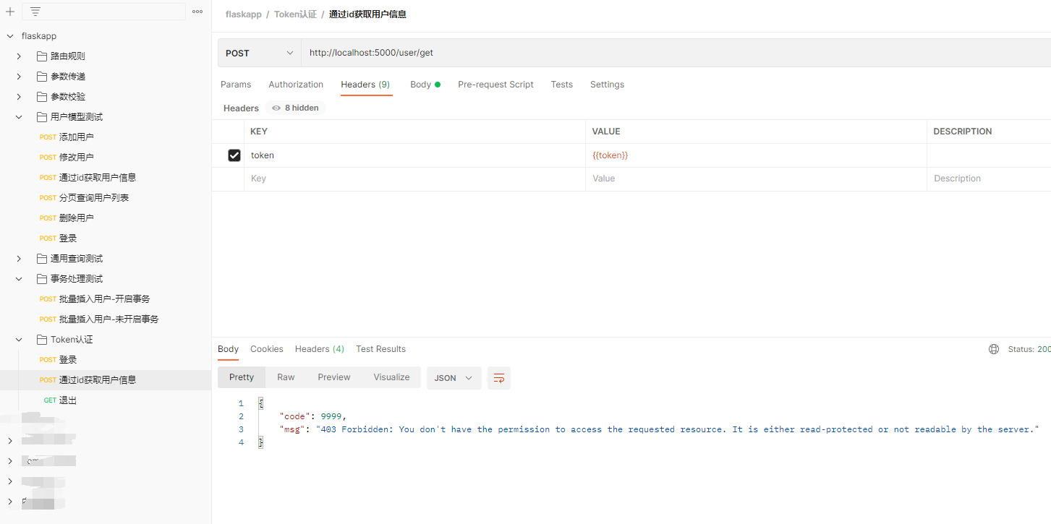

## 访问/user/login

登录后，使用tests设置全局token,方便下个接口使用。

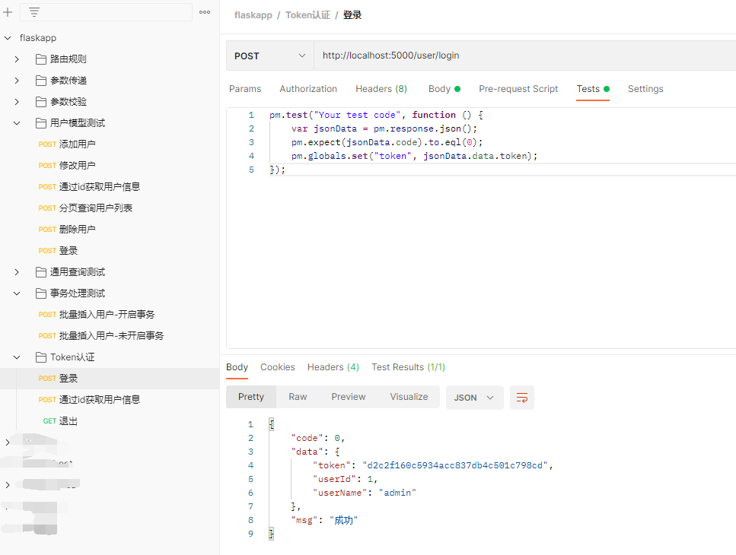

## 再次访问/user/get

使用上文登录的token

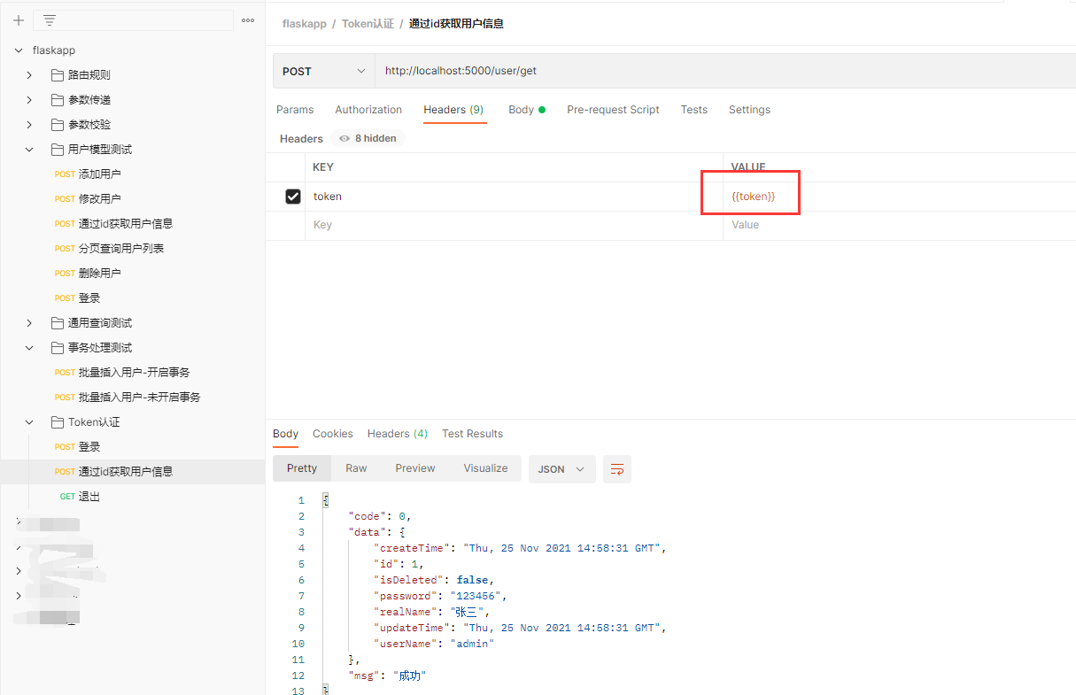

## 访问/user/logout

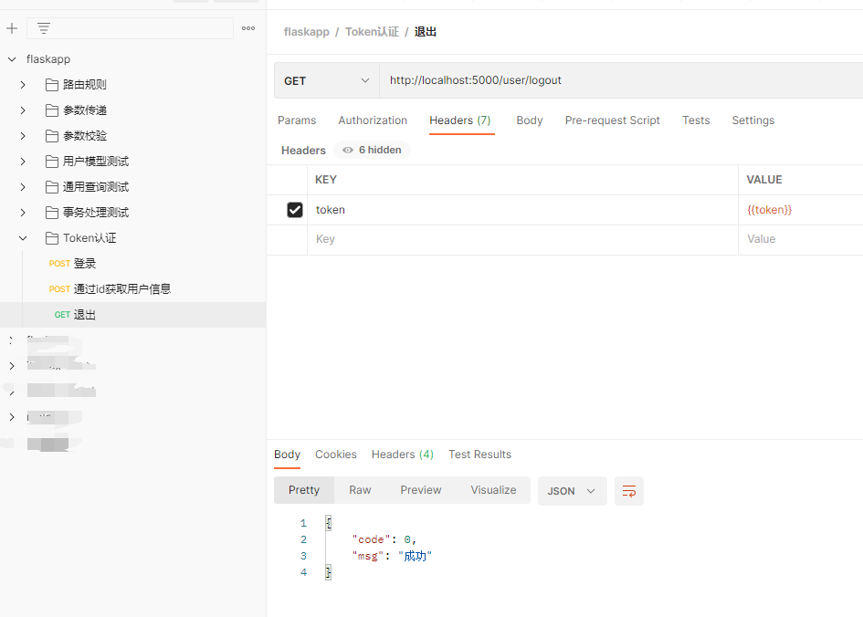

## 再次访问/user/get



# 更换MysqlTokenStrategy存储策略

要先创建表

再次测试-略

CREATE TABLE `t_access_token` (  
 `create_time` datetime(3) DEFAULT NULL COMMENT '创建时间',  
 `update_time` datetime(3) DEFAULT NULL COMMENT '更新时间',  
 `is_deleted` int(11) DEFAULT NULL COMMENT '逻辑删除:0=未删除,1=删除',  
 `id` int(11) NOT NULL AUTO_INCREMENT COMMENT '主键',  
 `user_id` int(11) NOT NULL COMMENT '用户id',  
 `token` varchar(40) NOT NULL COMMENT 'token',  
 `perms` varchar(1000) DEFAULT NULL COMMENT '权限集合',  
 PRIMARY KEY (`id`),  
 UNIQUE KEY `token` (`token`)  
) ENGINE=InnoDB AUTO_INCREMENT=15 DEFAULT CHARSET=utf8mb4;

export TOKEN_STRATEGY=mysql  
 flask run

登录成功，数据库会插入一条记录：

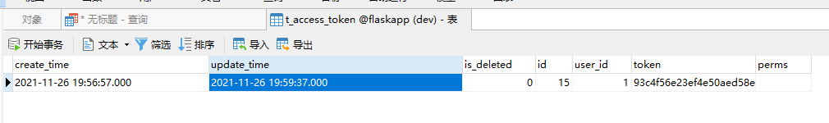

# 更换RedisTokenStrategy存储策略

需要安装redis

export TOKEN_STRATEGY=redis  
 flask run

再次测试-略

登录成功，效果如下：

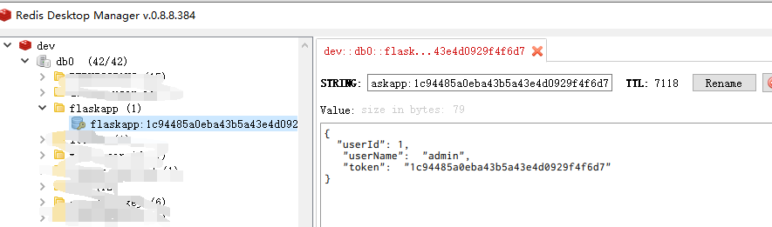

# 最后

目前只实现了登录权限的拦截，具体的接口权限拦截因为涉及到RBAC相关的权限分配等，这里先不展开，后续做到完整的权限管理的时候，再实现。

# postman导出文件

