Effective Coverage vs. Lives Saved: A Comparison

In this document, we will find the optimal set of nutritional interventions over space and time, first using each micronutrient’s effect on effective coverage separately, and then using all interventions together to see if they yield different optimal results, using a measure of the number of lives saved from each intervention.

## Summary of Results

Table 1 Optimally Chosen Interventions vs. BAU*

|  |  |  |  |
| --- | --- | --- | --- |
|  | BAU* | Optimal Intervention Chosen | Interventions Not Chosen |
| Zinc (Children Eff. Cov.) | *Zinc Flour (95 mg/kg)* | *Zinc Flour (95 mg/kg)* | Zinc Cube 600 mg/kg |
| VA (Children Eff. Cov.) | VA Oil 9 mg/kg +  *VAS-CHD (national)* | VA Oil 9 mg/kg +  *VAS-CHD (partial)* +  VA Cube (80 mg/kg) | VAS Routine |
| Folic Acid (WRA Eff. Cov.) | *Folic Acid Flour 1.65 mg/kg* | *Folic Acid Flour 1.65 mg/kg* | Folic Acid Cube 100 mg/kg  Folic Acid Flour 5 mg/kg |
| All (Lives Saved) | *VA Oil 9 mg/kg* +  VAS-CHD (national) +  *Zinc Flour 95 mg/kg* + Folic Acid Flour 1.65 mg/kg | *VA Oil 9 mg/kg* +    *Zinc Flour 95 mg/kg* + Folic Acid Flour 5 mg/kg +  Folic Acid Cube 100 mg/kg | Zinc Cube 600 mg/kg,  VAS Routine,  VA Oil 12 mg/kg,  VA Cube 80 mg/kg,  VAS Routine |
| All (Lives Saved, Alt.) | *VA Oil 9 mg/kg* +  *VAS-CHD (national)* +  *Zinc Flour 95 mg/kg* +  Folic Acid Flour 1.65 mg/kg | *VA Oil 9 mg/kg* +  *VAS-CHD* (partial) + *Zinc Flour 95 mg/kg*+  Folic Acid Cube (100 mg/kg) +  Folic Acid Flour (5 mg/kg) | Zinc Cube 600 mg/kg,  VAS Routine,  VA Oil 12 mg/kg  VA Cube 80 mg/kg,  VAS Routine |

*Note: Italic interventions represent interventions that are in both optimal and BAU* scenarios. VAS-CHD and VAS Routine assume 90% of 167 microgram retinol activity equivalent of Vitamin A. VA Oil standard is 12 mg/kg (9 mg/kg = 75% OF standard). VA cube standard is 80 mg/kg. Folic acid flour standard is 5 mg/kg (1.65 mg/kg = 33% of standard). Folic Acid cube standard is 100 mg/kg. Zinc flour standard is 95 mg/kg. Zinc cube is 600 mg/kg.*

shows the set of optimal interventions chosen for each micronutrient simulation as well as their Business as Usual Scenario (BAU*).

The BAU* was chosen for each simulation so that it would be consistent across effective coverage and lives saved simulations. In the case of the micronutrient effective coverage simulations, the optimal solution is the BAU* scenario for zinc and folic acid. For vitamin A, in contrast to the BAU* scenario, fortified boullion cube is also chosen.

When we consider all interventions together, however, the optimal choice becomes different than the BAU* (which is just a composite of the micronutrient scenarios’ BAU*).*[1] *In contrast to the BAU*, the optimally chosen set of interventions may not include VAS campaign, and may include an addition of folic acid fortified boullion cube.

Note that, although some of the interventions chosen optimally are the same as in the BAU*, the timing and spatial distribution of each intervention may not be the same. Since MINIMOD chooses the optimal set of interventions across space and time, it may be that the appearance of an intervention may happen earlier or later in time than others and may only occur in certain parts of the country.

The BAU* scenarios all assume a constant set of interventions across space and time.

We can also see the differences in how each region is affected after 10 years in terms of accumulated benefits and costs.

Table 2 Total Benefits and Costs Across Space

|  |  |  |  |  |  |  |
| --- | --- | --- | --- | --- | --- | --- |
|  |  |  | % North | % South | % Cities | National |
|  | Zinc (Children Eff. Cov.) | Total Benefits | 0.26 | 0.33 | 0.41 | 8,923,189.41 |
|  | Total Costs | 0.24 | 0.37 | 0.39 | 6,069,548.82 |
|  | VA (Children Eff. Cov.) | Total Benefits | 0.64 | 0.20 | 0.16 | 13,069,585.95 |
|  | Total Costs | 0.64 | 0.20 | 0.16 | 23,736,675.25 |
|  | Folic Acid (WRA Eff. Cov.) | Total Benefits | 0.18 | 0.33 | 0.49 | 17,096,476.30 |
|  | Total Costs | 0.24 | 0.37 | 0.39 | 1,550,946.68 |
|  | All (Lives Saved) | Total Benefits | 0.37 | 0.35 | 0.28 | 26,614.00 |
|  | Total Costs | 0.27 | 0.33 | 0.40 | 11,511,343.00 |
|  | All (Lives Saved Alt.) | Total Benefits | 0.31 | 0.38 | 0.31 | 26,270.00 |
|  | Total Costs | 0.22 | 0.36 | 0.43 | 10,713,326.00 |
|  |  |  |  |  |  |  |

shows the accumulated benefits and costs for each simulation across space. Note that the units of the benefits are dependent on the simulation.

We can also see how benefits accumulate over time, in 3.

Optimal Cumulative Benefits over Time

|  |  |  |  |  |  |
| --- | --- | --- | --- | --- | --- |
|  | Zinc (Children EC) | VA (Children EC) | Folic Acid (WRA EC) | All (LS) | All (LS, Alt.) |
| Time |  |  |  |  |  |
| 1 | 833,571 | 1,344,998 | 0 | 2,290 | 3,741 |
| 2 | 1,679,604 | 2,704,263 | 0 | 4,611 | 7,524 |
| 3 | 2,538,338 | 2,521,598 | 1,928,972 | 6,962 | 11,350 |
| 4 | 3,410,396 | 3,965,198 | 3,915,128 | 9,658 | 14,299 |
| 5 | 4,296,229 | 5,428,330 | 5,958,749 | 12,390 | 17,287 |
| 6 | 5,195,240 | 6,911,502 | 8,061,227 | 15,160 | 20,317 |
| 7 | 6,107,563 | 8,416,423 | 10,225,700 | 17,967 | 23,387 |
| 8 | 7,033,162 | 9,944,016 | 12,452,854 | 20,811 | 26,498 |
| 9 | 7,971,739 | 11,494,698 | 14,743,015 | 23,695 | 29,653 |
| 10 | 8,923,189 | 13,069,586 | 17,096,476 | 26,614 | 32,849 |

To illustrate how different these outcomes are to the BAU* scenarios, Figure 1 shows the difference in cost-per child on a bar graph for each simulation, side by side.

Figure 1 Cost per Benefit Comparison of BAU* vs. Optimal

In the following sections, we will look at relevant maps that will show us how accumulated benefits evolve through time. For these sections we will use shorthand for interventions, outlined in the following table:

|  |  |
| --- | --- |
| Interventions Chosen | Abbreviation |
| Zinc Flour (95 mg/kg) | zflour |
| VA Oil 9mg/kg | oil |
| VAS-CHD | vas |
| VA Cube (80 mg/kg) | cube |
| Folic Acid Cube (100 mg/kg) | fcube |
| Folic Acid Flour (5 mg/kg) | fflour |
| Folic Acid Flour (1.65 mg/kg) | fflour33 |
|  |  |
| Interventions Not Chosen |  |
| Zinc Cube 600 mg/kg | zcube |
| VAS Routine | clinic |
| VA Oil 12 mg/kg | maxoil |
|  |  |
|  |  |

## 

## Effective Coverage Simulations

### Vitamin A

For the Vitamin A simulations, we start with fortified oil (at 75% coverage), fortified cube and a VAS routine as can be seen in figure 2. By Period 4 (in figure 3), the south and cities stop VAS campaigns, but proceed with cube and oil interventions. This continues until the last period. If we compare this to the BAU* scenario, accumulated benefits have reached around the same levels in the South and cities, but with higher benefits in the North.

Figure 2 Vitamin A Accumulated Benefits, T=1

Figure 3 Vitamin A Accumulated Benefits, T=3

Figure 4 Vitamin A Accumulated Benefits, T=10

To illustrate the differences between benefits and costs between the optimal and BAU* scenarios, we compare the two in figure 5.

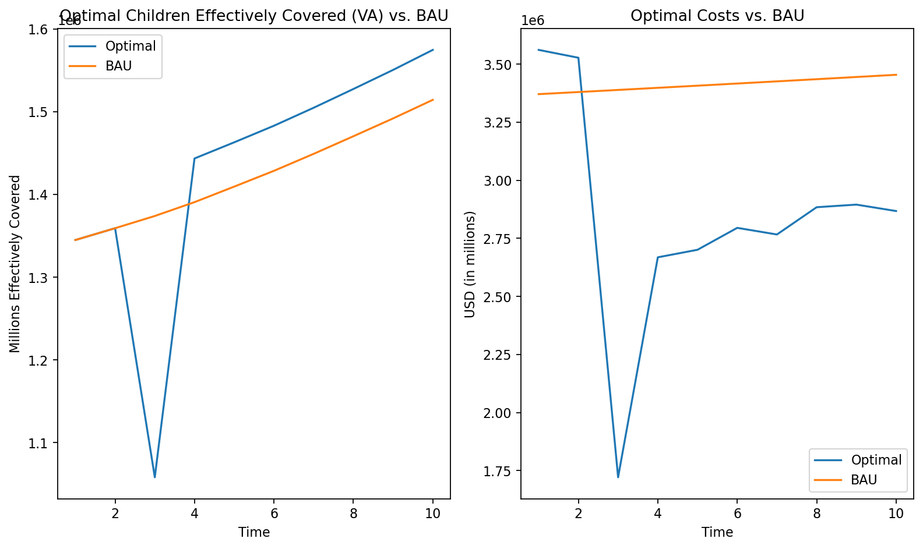

Figure 5 Vitamin A Per-year Benefits and Costs across Time

### Zinc

For zinc interventions, we see that zinc fortified flour is chosen, which is the same as the BAU* scenario. This leads to the highest benefits being in the cities, followed by the south and then the North.

Figure 6 Zinc Accumulated Benefits, T=10

### Folic Acid

Folic Acid is the same as the zinc interventions, in that the BAU* intervention is chosen as the optimal intervention. Cities are disproportionately affected, compared to the South and the North.

Figure 7 Folic Acid Accumulated Benefits, T=10

## Lives Saved

For Lives Saved, we find that the same intervention is chosen for all periods everywhere leading to accumulated benefits that are more proportionately distributed across the country, while the BAU* scenario has higher benefits in the North.

Figure 8 Lives Saved Accumulated Benefits, T=10

We also show the difference in per-year benefits and costs in figure 9.

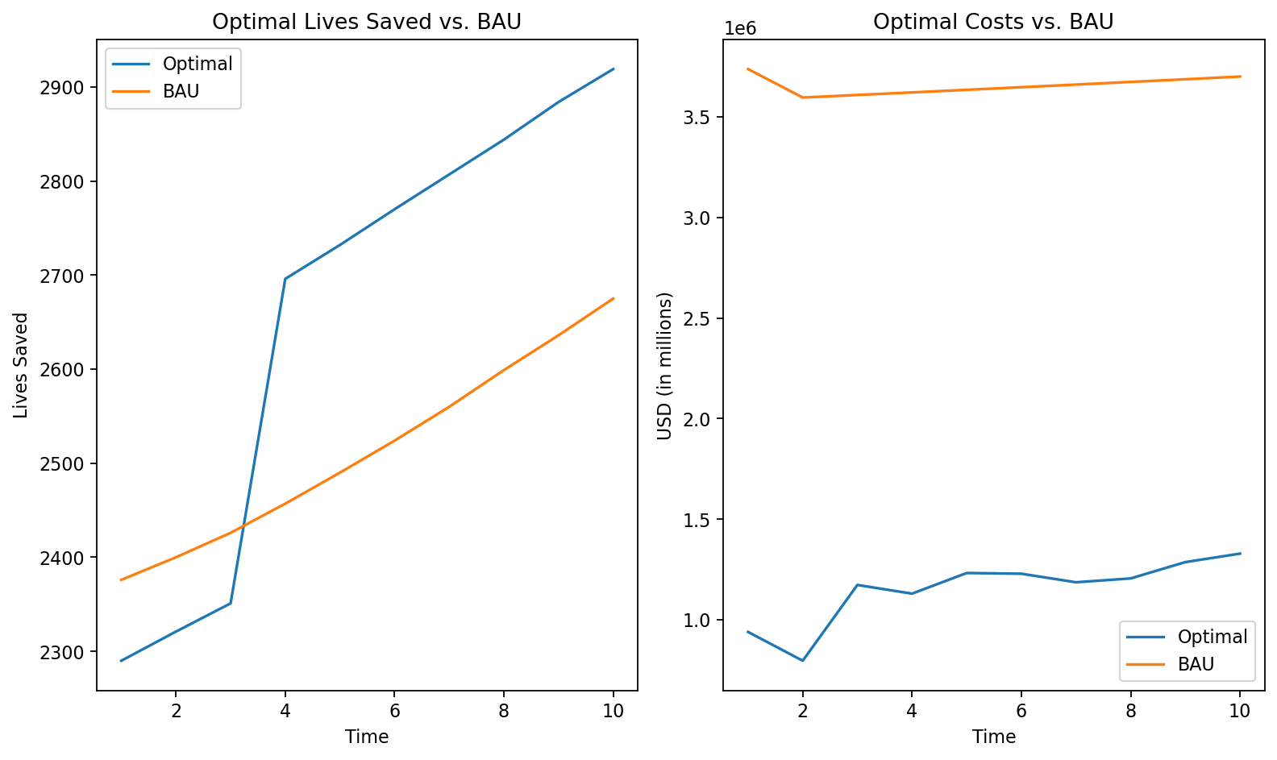

Figure 9 Lives Saved Per-Year Benefits and Costs

### Lives Saved Alternative Definition

For the alternative definition of lives saved, we find that the same interventions are chosen across the country, apart from VAS campaigns in the north in periods 1-3 (figure 10). By period 4, we find that VAS campaigns stop and for the rest of time, the same interventions are used for all of the country. This leads to a similar geographic distribution by the end (figure 12) as the other lives saved definition, but with relatively higher benefits for the North.

Figure 10 Lives Saved Alternative Specification Accumulated Benefits, T=1

Figure 11 Lives Saved Alternative Specification Accumulated Benefits, T=4

Figure 12 Lives Saved Alternative Specification Accumulated Benefits, T=10

We also show the difference in per-year benefits and costs in figure 13.

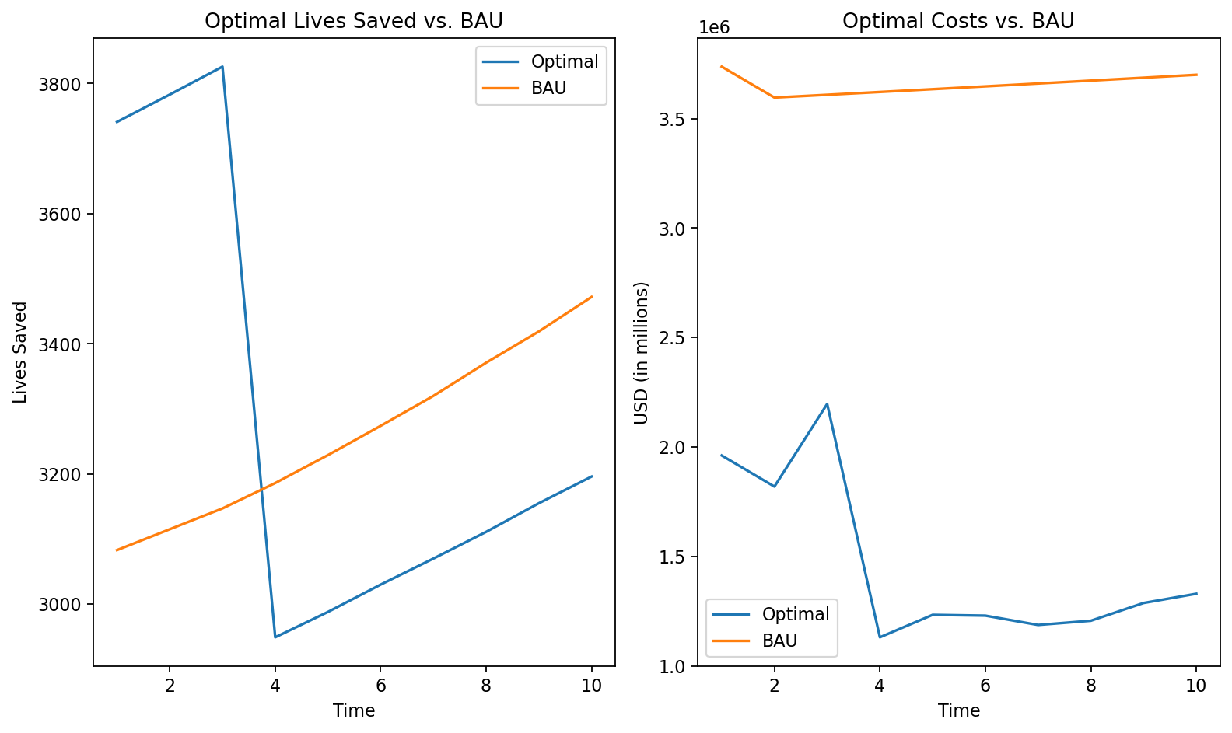

Figure 13 Lives Saved (Alt. Definition) Per-Year Benefits and Costs

1. Notice that there are two alternative definitions for the lives saved estimates of each nutritional intervention. The resulting optimally chosen interventions are similar, but the alternative specification includes VAS campaign as well.