Input of interface

1. Database (MySQL).
   1. Host: database host
   2. User Name: database user name
   3. Password: database password
2. Choose dataset file (.dat file).
3. Click “import” button.
4. Wait until finish.

Tables

**t_change**

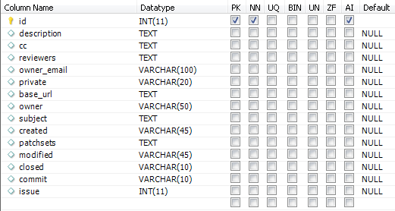

1. In .dat file, cc and patchsets and reviewers are stored as list. But here we simply store lists in one field (split with comma).

**t_messages**

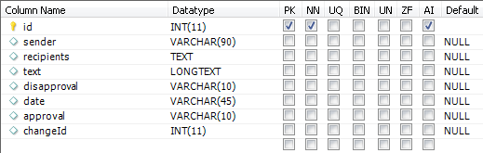

1. In .dat file, we store recipients as one field split with comma
2. changeId (It is a foreign key) references t_change.id.

Notice

1. MySQL version should be higher than 5.3.
2. After click the <Import> button, the application will run, please wait until the finish message appear.