Quick Digest
Curious about breaking into AI? The rapid growth of artificial intelligence has created unprecedented demand for skilled practitioners. This guide distills expert insights, practical steps and emerging trends to help you learn AI from scratch—then turn that knowledge into a fulfilling career. We’ll cover how long it really takes to learn AI, the foundational skills and must-have tools, a step-by-step roadmap tailored for 2025, and tips for building a standout portfolio. You’ll also discover why responsible AI matters, which future-proof skills are worth mastering, and how to land a job in a booming market. Throughout, you'll see how Clarifai’s unified AI platform can speed up your journey, from model training and inference to deployment.

1. How long does it take to learn AI?

Quick Summary: How long does it take to learn AI?
Most learners can build a solid foundation in 6 to 12 months by dedicating a few hours each week to Python, math, and basic machine learning. Specialising in areas like deep learning or generative AI may take another 6–12 months, depending on your background.

Timeline Overview
One leading AI learning guide proposes a phased roadmap: months 1–3 to master Python and mathematics; months 4–6 to learn classical machine learning; months 7–9 to tackle deep learning and specialisations; and months 10+ for advanced topics and continual learning. Another expert source notes that beginners can advance from novice to proficient in under two years with focused learning.
Learning time depends on:
- Prior experience: If you already know programming or have a math background, you’ll progress faster.
- Time commitment: A consistent schedule of 8–10 hours per week helps maintain momentum.
- Learning style: Combine structured courses with hands-on projects to solidify concepts.
- Support tools: Platforms like Clarifai offer pre-built models, data management and compute orchestration, enabling you to experiment without complex setups.

Expert Insights
- AI becomes accessible faster: The cost of running models comparable to GPT-3.5 has fallen more than 280-fold since late 2022, allowing learners to train and deploy models on modest hardware.
- Benchmark performance is soaring: New AI benchmarks such as MMMU, GPQA and SWE-bench have seen 18.8–67.3 percentage point improvements within one year. This rapid progress underscores the need for continuous learning.
- AI-assisted coding lowers barriers: AI pioneer Andrew Ng urges learners to use AI-powered tools rather than coding “the old way,” noting that such tools make people in all roles “much more productive”.
- Focus on consistent practice: A 2025 AI guide emphasises that regular hands-on work—not just watching tutorials—builds lasting proficiency.

2. Foundational Skills You Need to Get Started

Quick Summary: What skills do I need to start learning AI?
To succeed in AI, you need Python programming, strong math foundations, knowledge of data structures and algorithms, and an understanding of statistics and probability. These skills form the backbone of machine learning and deep learning.

Building Blocks

Python Programming
Python remains the go-to language for AI because of its extensive libraries and community support. Start by mastering basic syntax, data types and control structures. Then explore NumPy for array operations, pandas for data manipulation, and Matplotlib for visualisation. Creative example: write a Python script that counts word frequencies in a text file—this introduces the concept of tokenisation used in natural language processing.

Mathematics: Linear Algebra, Calculus & Probability
You don’t need a PhD, but understanding matrices, vectors, derivatives and integrals helps you grasp how algorithms learn from data. Probability and statistics teach you to measure uncertainty and evaluate models. Think of linear algebra as the language of images: a grayscale image can be represented as a matrix of pixel intensities.

Data Structures & Algorithms
Efficient data handling is key when working with large datasets. Familiarity with arrays, lists, stacks, queues and trees helps in implementing algorithms. Learn to evaluate algorithm complexity (Big O notation) and practise basic algorithms like sorting and searching.

Statistics & Probability
Statistical thinking underpins machine learning. Learn descriptive statistics (mean, median, variance), distributions (Gaussian, Bernoulli), hypothesis testing and confidence intervals. This enables you to interpret model outputs and understand data variability.

Basic Machine Learning Concepts
Once you have the above skills, explore fundamental ML concepts: supervised vs. unsupervised learning, feature engineering, training vs. testing, and model evaluation metrics (accuracy, precision, recall). Try building a simple linear regression model to predict housing prices—a classic beginner project.

Clarifai Integration
Clarifai’s unified AI platform provides a sandbox for experimentation. You can upload images, text or audio into the AI Lake, label them using automated data labelling, and explore pre-built models. This allows you to focus on learning core concepts without spending hours on setup.

Expert Insights
- Python is king: A 2025 learning guide emphasises that Python's rich ecosystem of libraries makes it indispensable for AI.
- Start with math basics: Leading online courses recommend mastering linear algebra, calculus and probability before diving into algorithms.
- Algorithms matter: Efficient code is crucial when working with large datasets. Understanding data structures helps optimise machine learning pipelines.
- Small models close the gap: Open-weight models are catching up with closed proprietary ones, meaning you can achieve impressive results without huge compute resources.
- Hands-on tools accelerate learning: Clarifai’s platform lets you train and deploy models quickly, so you spend more time learning and less time configuring environments.

3. Must-Have AI Tools and Packages (and Where Clarifai Fits)

Quick Summary: What tools and libraries should I learn?
Essential AI tools fall into several categories: data handling (pandas, NumPy), classical machine learning frameworks (scikit-learn, XGBoost), deep-learning frameworks (PyTorch, TensorFlow, Keras), generative AI and LLM libraries (Transformers, LangChain, LlamaIndex), and MLOps & deployment tools (MLflow, Weights & Biases, Docker, Kubernetes). Clarifai’s unified platform ties these together with data management, model training, inference, and compute orchestration.

Key Categories

Data Handling
- pandas: A library for data manipulation and analysis. Use it to clean, transform and explore datasets.
- NumPy: Provides multidimensional array objects and operations for efficient numerical computation.
- Matplotlib and Seaborn: Visualisation libraries for plotting charts and graphs.

Classical ML Frameworks
- scikit-learn: Implements classical ML algorithms like regression, classification and clustering.
- XGBoost/LightGBM: Gradient boosting libraries that excel at structured/tabular data.

Deep-Learning Frameworks
- PyTorch: A dynamic neural network library known for flexibility. Great for research and prototyping.
- TensorFlow/Keras: A powerful ecosystem for production-grade deep learning. Keras offers a high-level interface.
- Hugging Face Transformers: Houses hundreds of pre-trained models for natural language processing and computer vision.

Generative AI & LLM Tools
- LangChain: Helps orchestrate large language models into applications (e.g., chatbots, RAG systems).
- LlamaIndex: A toolkit for building information retrieval applications with LLMs.
- Vector databases (e.g., Milvus, Pinecone): Store embeddings for similarity search, crucial for RAG.

MLOps & Deployment
- MLflow and Weights & Biases: Tools for experiment tracking, model management and deployment.
- Docker & Kubernetes: Containerisation and orchestration platforms for scaling ML workloads.
- Clarifai’s Compute Orchestration: Manages resources across cloud, local and edge environments; allows you to run models where they make sense (e.g., on a local server or IoT device).

Clarifai’s Platform
Clarifai’s unified AI platform includes:
- Data management & search: Organise and query datasets in the AI Lake.
- Automated data labeling: Accelerate training by generating annotations.
- Model inference: Deploy pre-built models or your own via APIs with high throughput.
- Model training & workflows: Customise training pipelines without complex infrastructure.
- Governance & Control: Maintain compliance and track model lineage with the Control Center.

Expert Insights
- Open-source models thrive: A generative AI trends report highlights the rise of open-source models like Llama and Mistral, making advanced AI accessible to everyone.
- Multimodal AI is coming: Combining text, images and audio will require robust data handling and generative tools.
- MLOps matters: Enterprises focus on tools that evaluate and measure AI performance. Tools like MLflow and Clarifai’s governance features help achieve this.
- Edge computing & custom chips: Demand for AI reasoning is driving the development of custom chips and edge solutions. Clarifai’s local runners enable on-device deployment without sacrificing accuracy.
- Unified platforms simplify learning: Platforms like Clarifai unify data, models and deployment, letting learners focus on experimentation instead of infrastructure.
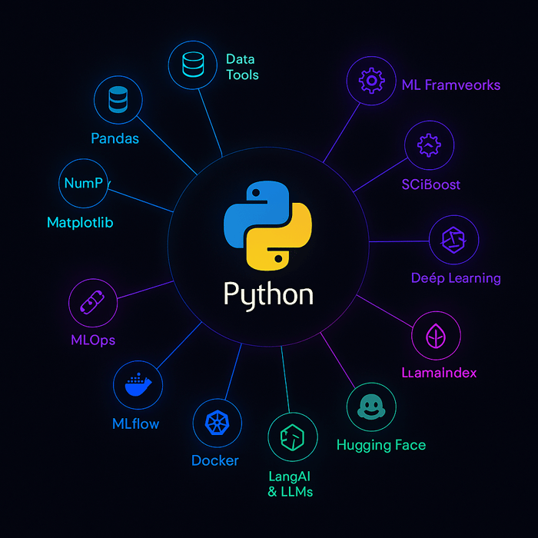

4. Step-by-Step Roadmap to Master AI

Quick Summary: What is a step-by-step roadmap to learning AI?
A proven roadmap involves five stages: build foundational knowledge (Python, math), learn classical machine learning, dive into deep learning and generative AI, master MLOps and deployment, and finally specialise and contribute to research.

Stage 1 – Foundations (Months 1–3)
- Learn Python & essential math: Complete a beginner-friendly Python course and revisit linear algebra, calculus and probability. Create simple scripts to explore data structures and matrix operations.
- First project: Analyse a public dataset (e.g., Titanic survival) using pandas and Matplotlib. Explore Clarifai’s API by uploading images and retrieving tags—this introduces computer vision concepts.

Stage 2 – Classical Machine Learning (Months 4–6)
- Study ML algorithms: Learn about supervised learning (regression, classification) and unsupervised learning (clustering, dimensionality reduction). Understand model evaluation (train/test split, cross-validation).
- Build models: Implement linear regression and logistic regression using scikit-learn. Practise on datasets like housing prices or customer churn.
- Hands-on with Clarifai: Use Clarifai’s model inference to experiment with pre-trained models on your data. For example, classify product images or detect objects in pictures.

Stage 3 – Deep Learning & Generative AI (Months 7–9)
- Study neural networks: Learn about feedforward networks, convolutional neural networks (CNNs) for images, recurrent neural networks (RNNs) for sequences, and Transformers for language.
- Build your first neural network: Use PyTorch or TensorFlow to build an image classifier on the CIFAR-10 dataset. Learn how to tune hyperparameters and evaluate results.
- Explore generative models: Experiment with variational autoencoders (VAEs), generative adversarial networks (GANs) and diffusion models. Learn about large language models (LLMs) and their applications (chatbots, summarisation).
- Try Clarifai’s generative AI features: Build a simple application that uses Clarifai’s generative AI endpoints to create images or summarise text. Use retrieval-augmented generation (RAG) by connecting to a vector database.

Stage 4 – MLOps & Deployment (Months 10–12)
- Learn MLOps tools: Gain proficiency with MLflow (experiment tracking), Docker (containerisation), Kubernetes (orchestration) and monitoring tools.
- Deploy your models: Package a model with Docker and deploy it on a cloud platform or use Clarifai’s compute orchestration to run it on a local runner. Understand model serving architectures (REST APIs, gRPC).
- Automate workflows: Use Clarifai’s platform to schedule training jobs, manage data pipelines and monitor inference performance. Learn about CI/CD for ML.

Stage 5 – Specialisation & Research (Months 12+)
- Choose a focus: Multimodal AI, reinforcement learning, generative AI, agentic AI or domain-specific AI (e.g., healthcare, finance).
- Read research papers: Follow conferences like NeurIPS, ICML and ACL. Explore the Stanford AI Index for trends and benchmarks.
- Contribute to open source: Implement algorithms or tools, join communities like Hugging Face or LangChain, and contribute code.
- Develop a portfolio project: Build an end-to-end application: e.g., a multimodal search engine using Clarifai’s AI Lake, vector database and RAG; or an agentic workflow that automates a series of tasks.
- Stay updated: Emerging topics like custom silicon, energy-efficient computing and quantum-safe cryptography may shape the future.

Expert Insights
- Phased learning works: A reputable AI guide suggests mastering basics in months 1–3, diving into ML and deep learning in months 4–9, and using the final months to specialise.
- Research is accelerating: Benchmarks like MMMU and GPQA show performance leaps of 18.8–48.9 percentage points within a year, meaning today’s cutting-edge quickly becomes standard.
- Small models lower barriers: Inference costs for models at GPT-3.5 level have plummeted, enabling experimentation on modest hardware.
- Use AI to build AI: Andrew Ng recommends using AI-assisted coding tools to reduce friction—this principle applies to using platforms like Clarifai to accelerate deployment.
- Experimentation breeds mastery: The most successful learners run experiments regularly, test hypotheses and embrace failure.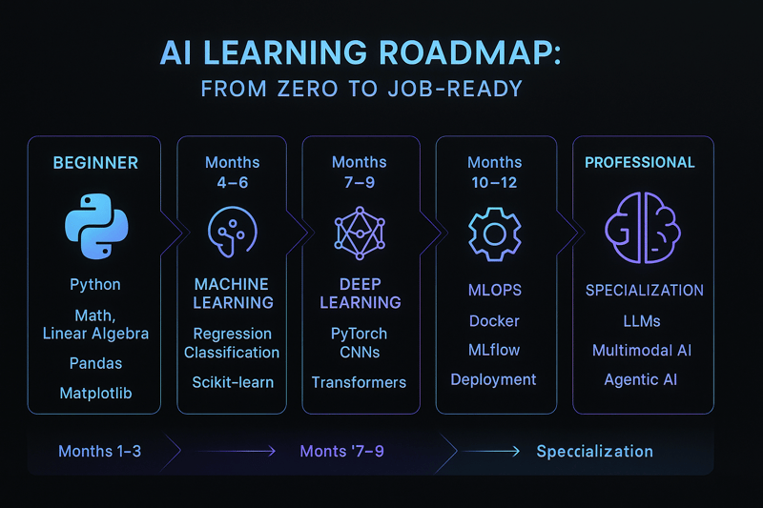

5. Best Ways to Learn AI: Courses, Projects, Community and More

Quick Summary: What are the best ways to learn AI?
Combine structured learning (courses and books) with hands-on projects, community engagement and open-source contributions. Learning in public and collaborating with others helps you deepen understanding and stay motivated.

Structured Learning
- Online courses: Free or low-cost courses from universities and tech companies cover fundamentals and advanced topics. Seek out beginner-friendly AI curricula, such as those that introduce neural networks, symbolic AI, computer vision and ethics.
- Books & tutorials: Books like “Deep Learning” by Goodfellow et al. or practical tutorials on GitHub complement courses. Reading research papers builds deeper understanding.
- Interactive learning platforms: Sites offering coding exercises, quizzes and projects provide immediate feedback.

Hands-On Projects
- Personal projects: Build an AI-powered chatbot using LLM APIs; create a movie recommendation system; or develop a classifier for identifying plant diseases. Use Clarifai’s API to quickly test image and text models.
- Competitions: Participating in data science competitions helps you practise under real constraints and learn from peers. Winning isn’t required; the key is learning new techniques and receiving feedback.
- Hackathons & hack nights: Short, intense coding sessions push you to build functional prototypes quickly. Many AI hackathons focus on solving social good challenges.

Community & Collaboration
- Forums & Discord: Join AI communities to ask questions, share insights and learn from others. Clarifai’s community and GitHub projects are valuable spaces for collaboration.
- Learning in public: Share your journey through blog posts, Twitter threads or YouTube videos. Documenting challenges and breakthroughs reinforces learning and builds a portfolio.
- Mentorship: Seek mentors through community programs or connect with professionals on LinkedIn. They can provide guidance, review your work and recommend resources.

Creative Example
Suppose you want to learn generative AI. You could follow a three-part plan: (1) complete a structured course on neural networks; (2) build a small text-to-image generator using a diffusion model; (3) share your project on social media and invite feedback. If you struggle with training, use Clarifai’s generative AI API to experiment with pre-trained models and focus on building a polished application.

Expert Insights
- Balance theory and practice: Experts stress that theoretical knowledge must be paired with hands-on projects to truly master AI.
- Learn in public: A 2024 learning roadmap championed “learning in public,” encouraging students to write blogs, join hackathons and ask questions openly.
- Soft skills matter: Business leaders emphasise soft skills like creativity, empathy and adaptability, which are crucial for cross-disciplinary AI work.
- Diverse resources help: Combining courses, projects, research papers and community discussions creates a rich learning experience.
- Use AI platforms: Clarifai’s tools can accelerate your learning by removing infrastructure barriers, letting you focus on experiments.

6. Responsible AI and Governance

Quick Summary: Why is responsible AI important and how do you practise it?
Responsible AI ensures that AI systems are fair, transparent, secure and trustworthy. It involves mitigating bias, protecting privacy, ensuring accountability and complying with regulations.

Why It Matters
AI systems influence decisions in healthcare, finance and hiring. Biased or unregulated models can lead to discrimination, privacy breaches and reputational harm. A comprehensive 2025 report warns that 71 % of office workers use AI tools without approval, leading to unauthorised “shadow AI”. Companies with high shadow AI levels face average breach costs of $670k.

Key Principles

Fairness & Bias Mitigation
Identify and reduce biases in training data. Evaluate models on diverse datasets and use fairness metrics (e.g., demographic parity). Regularly audit models for unintended outcomes.

Transparency & Explainability
Use techniques like SHAP (SHapley Additive exPlanations) to explain model predictions. Document data sources, features used and model design decisions.

Privacy & Security
Follow data protection laws (GDPR, CCPA). Use privacy-preserving methods like differential privacy or federated learning. Avoid shadow AI by approving AI tools through IT and using enterprise-grade platforms like Clarifai with robust security policies.

Accountability & Governance
Establish clear responsibilities for AI outcomes. Implement monitoring to detect model drift or degradation. Maintain documentation and version control to track changes.

Regulation Compliance
Stay informed about regulatory frameworks: EU AI Act, NIST AI Risk Management Framework, OECD principles. The AI Index notes that legislative mentions of AI grew over 21 % across 75 countries in 2024, signalling a tightening regulatory landscape.

Clarifai’s Role
Clarifai’s platform offers governance features such as the Control Center and AI Lake that track data lineage, model versions and access. Automated audit trails support compliance efforts. Clarifai’s compute orchestration and local runners ensure data remains on secure infrastructure, reducing shadow AI risks.

Expert Insights
- AI governance is crucial: Gartner’s 2025 tech trends emphasise robust governance frameworks to mitigate bias and ensure transparency.
- Shadow AI is costly: Reco’s report shows unauthorised AI tools lead to significant breaches and warns that OpenAI accounts for 53 % of shadow AI usage.
- New safety benchmarks: The AI Index highlights new benchmarks like HELM Safety and AIR-Bench for evaluating factuality and safety, pushing industry standards.
- Ethics meets regulation: Regulations are doubling yearly; failing to align with them can hinder product adoption.
- Enterprise-grade tools: Platforms like Clarifai provide built-in governance and security, helping organisations avoid shadow AI and maintain compliance.
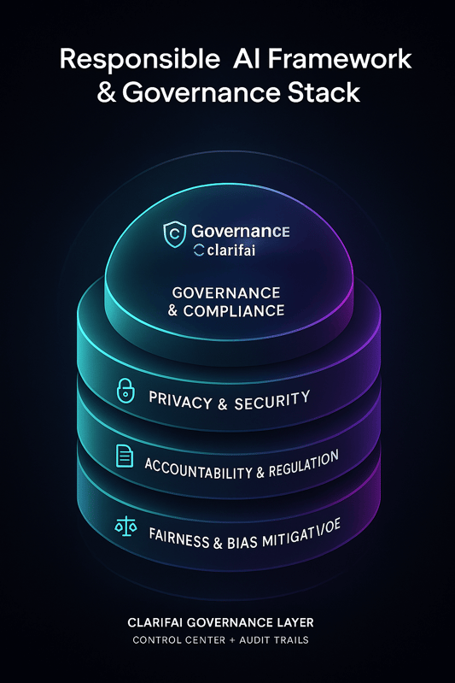

7. Emerging & Future-Proof AI Skills

Quick Summary: What emerging AI skills should I learn to stay ahead?
Focus on multimodal AI, vertical AI integration, agentic AI, AI reasoning & custom silicon, energy-efficient computing, and open-source small models. These trends will shape the next decade of AI.

Trending Skills

Multimodal AI
Models that process images, text, audio and video simultaneously are becoming mainstream. A 2025 AI trends report notes that startups invested heavily in multimodal AI in 2023, and products are expected to launch widely in 2025. Multimodal AI enhances accessibility (e.g., real-time transcription) and improves human-computer interaction.

Vertical AI Integration
Instead of one-size-fits-all models, companies are building AI tailored for sectors like healthcare, finance and retail. This trend, called vertical AI integration, enhances efficiency and creates new roles for data scientists who specialise in domain-specific models.

Agentic AI
Agentic AI refers to autonomous systems that plan, act and learn without human oversight. Gartner highlights agentic AI as the top tech trend of 2025, describing it as an evolution toward systems that execute complex tasks and adapt to new challenges. Agentic AI is already transforming healthcare by automating care coordination and monitoring.

AI Reasoning & Custom Silicon
Enterprise adoption requires AI systems that can reason and make decisions; this demands specialised hardware. Morgan Stanley points out that AI reasoning drives demand for custom chips and programmable infrastructure. Learning about AI hardware ecosystems (GPUs, TPUs, ASICs) helps engineers optimise performance.

Energy-Efficient & Hybrid Computing
The need for sustainable AI is driving energy-efficient designs and hybrid computing (combining CPUs, GPUs, FPGAs and quantum processors). Innovations like neuromorphic computing and post-quantum cryptography aim to secure data and reduce energy use.

Small Models & Open Source
The AI Index reports that the inference cost for GPT-3.5-level performance has dropped 280-fold. Meanwhile, open-weight models are closing the performance gap with proprietary ones. Learning to fine-tune and deploy small, efficient models such as Llama 2 or Mistral enables you to build powerful applications on limited resources.

Clarifai & Emerging Skills
Clarifai’s platform helps you explore these trends practically:
- Multimodal AI: Use Clarifai’s computer vision and generative APIs to integrate images and text.
- Vertical AI: Clarifai provides domain-specific solutions (e.g., visual inspection, content moderation).
- Agentic workflows: Use Clarifai’s compute orchestration to chain models and actions, building agentic workflows.
- Custom silicon: Clarifai’s local runners allow deployment on edge devices, benefiting from custom chips.

Expert Insights
- Open models democratise AI: Multimodal and open-source models will dominate new applications.
- Agentic AI is a game-changer: Gartner calls agentic AI a significant evolution towards autonomous systems.
- Enterprise priorities: Morgan Stanley lists AI reasoning, custom silicon and agentic AI as top enterprise trends.
- Future will be hybrid: Energy-efficient computing and hybrid architectures will define the next wave of innovation.
- Continuous learning is vital: Rapid benchmark improvements and new technologies require ongoing skill development.

8. Building Your AI Portfolio & Learning Plan

Quick Summary: How do I build an AI portfolio?
Create a structured learning plan and develop a portfolio of diverse projects. Document your progress publicly (GitHub, blog, LinkedIn), participate in competitions and hackathons, and use platforms like Clarifai to accelerate project development.

Crafting a Learning Plan
- Set clear goals: Decide what skills you want to master within specific time frames. For example, “complete a course on deep learning by month 3,” or “deploy an NLP model by month 6.”
- Schedule regular sessions: Allocate weekly hours to learning. Consistency beats cramming.
- Select resources: Choose courses, tutorials and books that align with your goals. Use Clarifai’s documentation to explore platform features.

Portfolio Building
- Start with simple projects: Create a data analysis notebook, train a classifier for handwritten digits, or build a sentiment analysis tool.
- Add complexity: Progress to more challenging tasks—such as a voice-controlled assistant, generative art or a time-series forecasting model.
- Show your work: Host code on GitHub and include clear README files explaining your approach. Use Jupyter notebooks to combine code and narrative.
- Leverage Clarifai: Build an application using Clarifai’s API—like an image moderation tool or a RAG system that answers questions using your custom dataset. Clarifai’s AI Lake helps you organise datasets and share them with collaborators.
- Contribute to open source: Join communities like Hugging Face or LangChain, fix issues, add features or write documentation.
- Write about your projects: Publish blog posts or LinkedIn articles describing what you learned. This demonstrates communication skills and deepens your understanding.

Plan Example
Suppose your goal is to specialise in computer vision. Your plan might look like:
- Month 1–2: Learn Python, NumPy and Matplotlib; build a basic image classifier.
- Month 3–4: Study CNNs; implement a convolutional autoencoder using PyTorch.
- Month 5: Participate in an image classification competition; refine your model.
- Month 6: Use Clarifai to deploy your model as an API and integrate it into a web app.
- Month 7: Write a blog post about your experience; share it in the Clarifai community.

Expert Insights
- Learning in public pays dividends: Sharing your journey builds credibility and invites feedback.
- Soft skills matter: Employers value communication, adaptability and teamwork.
- Industry contributions stand out: Nearly 90 % of notable AI models in 2024 originated from industry. Demonstrating real-world applications is key.
- Keep evolving: The AI field moves rapidly. Continuously refine your portfolio with new projects and emerging techniques.
- Use unified platforms: Clarifai’s AI Lake and compute orchestration make it easier to manage data and deploy models, giving your portfolio a professional edge.

9. AI Career Paths & Market Outlook

Quick Summary: What are the most promising AI careers?
Key AI roles include machine learning engineer, data scientist, AI research scientist, MLOps engineer, AI product manager, and AI ethicist. The market is booming, with roles growing 30 % annually and salaries often exceeding six figures.

Career Clusters

Research
Roles: AI research scientist, algorithm engineer, PhD student.
Skills: Advanced mathematics, deep learning, evaluation design, publishing papers.
Education: Often requires master’s or PhD degrees.

Applied Engineering
Roles: Machine learning engineer, AI software developer.
Skills: Implement and optimise models, build user-facing features (recommendation engines, chatbots).
Salary: Average ML engineer salary exceeds $160k.

Platforms & MLOps
Roles: MLOps engineer, platform engineer.
Skills: Manage model lifecycle, build data pipelines, deploy models at scale. Tools: Docker, Kubernetes, MLflow, Clarifai compute orchestration.

Insights & Data
Roles: Data scientist, data analyst, BI engineer.
Skills: Data exploration, hypothesis testing, predictive modeling.

Direction & Product
Roles: AI product manager, solutions architect.
Skills: Translate business needs into AI features, roadmap planning, cross-functional collaboration.

Safety & Ethics
Roles: AI ethicist, AI governance specialist.
Skills: Fairness auditing, policy compliance, risk mitigation.

Market Trends
- Demand surge: AI roles are growing faster than many other tech roles. A LinkedIn report notes that positions like AI data engineer and MLOps engineer are growing at 30 % annually.
- Industry leads: Most notable AI models (about 90 %) come from industry rather than academia.
- Emerging roles: As agentic AI and multimodal models mature, new roles like agentic system designer or multimodal specialist are emerging.
- Global opportunities: Regions outside the traditional tech hubs are producing high-impact models; countries in the Middle East, Latin America and Southeast Asia are contributing innovative models.
- Salaries vary by role: Research roles and MLOps engineers can command some of the highest salaries, while ethics and compliance roles are growing due to regulation.

Clarifai’s Niche
As a market leader, Clarifai is expanding into roles such as Solutions Architect, AI Applications Engineer, Community Manager and Developer Evangelist. Professionals with experience deploying models using Clarifai’s platform, managing data through the AI Lake, and orchestrating compute across edge devices have a competitive advantage.

Expert Insights
- AI roles pay well: Average salaries for ML engineers are around $161k.
- Research requires depth: Roles in research and algorithm design often need advanced degrees.
- Soft skills & ethics are in demand: Employers prioritise creativity, empathy and ethical judgement.
- Regional shifts: More models come from outside North America, reflecting global collaboration.
- Clarifai expertise opens doors: Familiarity with Clarifai’s products can lead to niche roles in platform integration and AI solutions.
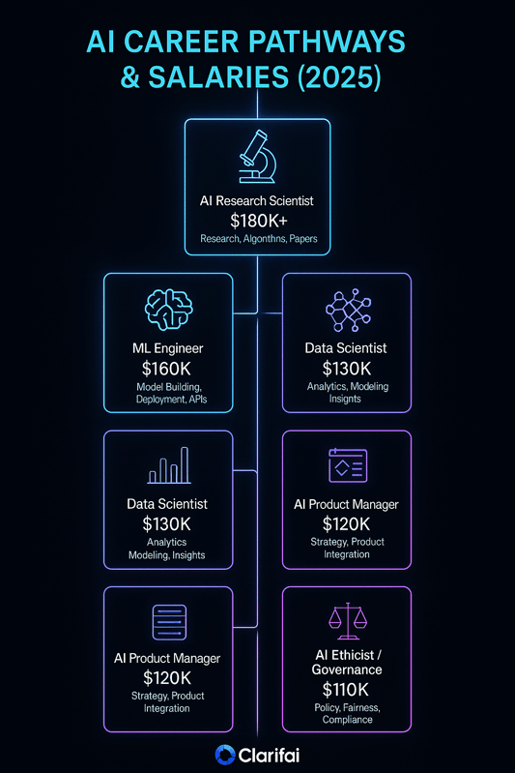

10. How to Land a Job in AI

Quick Summary: How do I land a job in AI?
Build a strong portfolio, tailor your resume, network effectively, contribute to open source and prepare rigorously for interviews. Showcasing real projects and soft skills increases your chances of success.

Step-by-Step Guide

1. Strengthen Your Foundation & Portfolio
Focus on building projects that highlight your ability to solve real problems. Demonstrate how you collected data, chose algorithms, evaluated performance and iterated. Use Clarifai’s API or AI Lake to showcase enterprise-grade workflows.

2. Tailor Your Resume
Highlight AI-related projects and relevant skills like Python, PyTorch, scikit-learn, MLflow, and Clarifai. Quantify your impact (e.g., improved accuracy by 10 %, reduced inference time). Mention contributions to open-source or research collaborations.

3. Network Strategically
- Join communities: Participate in forums, Discord servers and Slack groups related to AI.
- Attend conferences: Virtual or in-person events like NeurIPS, CVPR and Clarifai’s community meetups are great networking opportunities.
- LinkedIn: Connect with AI professionals; engage with their posts and share your projects.

4. Contribute to Open Source
Select a project that aligns with your interests. Fix bugs, write documentation or implement features. Contributing to Hugging Face Transformers, LangChain or Clarifai’s open-source projects builds credibility.

5. Secure Internships or Freelance Projects
Practical experience matters. Apply for internships at startups, research labs or companies using AI. Even short-term freelance projects (e.g., building a predictive model for a small business) demonstrate real-world impact.

6. Prepare for Interviews
- Technical prep: Practise coding problems (LeetCode, HackerRank), review ML algorithms and statistics, and practise system design for ML.
- Project discussion: Be ready to explain your portfolio projects in depth: why you chose a method, how you handled challenges, and what you’d improve.
- Ethics & biases: Employers may ask about fairness and responsible AI practices. Understand how to mitigate bias and ensure model transparency.
- Mock interviews: Practise with peers or mentors to build confidence.

7. Hone Soft Skills
Employers value communication, teamwork, creativity and resilience. Demonstrate these in your interactions, portfolio and interview responses.

Creative Example
During an interview, you might showcase a Clarifai-powered app you built. Imagine demonstrating a mobile app that uses Clarifai’s computer vision API to detect plant diseases in farmers’ fields and recommending treatment. This shows technical skill, user-centric design and real-world impact.

Expert Insights
- Four-step formula: A business guide recommends building AI skills, developing soft skills, contributing to open source, and pursuing formal education.
- Industry experience matters: Most notable AI models originate in industry, so internships and real projects carry weight.
- Job growth is booming: LinkedIn projects 97 million new AI-related roles worldwide by 2025.
- Soft skills are non-negotiable: Employers seek empathy, adaptability and creativity.
- Portfolios over degrees: A strong portfolio often outweighs a degree for applied roles.

11. Tips to Stay Motivated & Learn Continuously

Quick Summary: How can I stay motivated and keep learning AI?
Set clear goals, join communities, stay updated on research, use AI tools to accelerate learning, document your progress and maintain balance.

Practical Strategies

Set Realistic Goals & Routine
Define weekly learning objectives and track them. Use productivity tools or spreadsheets to schedule tasks and monitor progress. Short bursts of study (e.g., 1–2 hours daily) are more effective than sporadic 8-hour sessions.

Join Communities & Find Accountability
Active communities provide support and accountability. Clarifai’s Discord and forum allow you to discuss projects and get feedback. Study groups encourage regular progress and help you tackle roadblocks together.

Stay Up-to-Date
Subscribe to newsletters (e.g., AI Weekly, The Batch) and follow the Stanford AI Index for data-driven insights. Watch conference keynotes and webinars to learn about new models and tools.

Use AI Tools to Learn AI
Leverage AI assistants for code completion, debugging and brainstorming. Andrew Ng notes that AI-assisted coding tools reduce friction and boost productivity. Use Clarifai’s generative AI endpoints to iterate on ideas quickly.

Document & Share Your Journey
Keep a learning journal or blog. Reflecting on what you’ve learned deepens understanding. Sharing your progress on social media or in a newsletter builds community and may attract mentors.

Collaborate & Teach
Join a local AI club or online study group. Teaching a concept to someone else is one of the best ways to master it. Pair programming or code reviews accelerate growth.

Balance & Persistence
Avoid burnout by scheduling breaks and celebrating milestones. The AI field evolves rapidly, but pace yourself. Remember that mastery is a marathon, not a sprint.

Expert Insights
- AI advancements require continual learning: Benchmarks and models evolve quickly; staying current is essential.
- AI-assisted tools boost productivity: Andrew Ng emphasises using AI tools to make coding faster and more fun.
- Public accountability works: Many learners who document their journey publicly achieve faster progress and stronger networks.
- Feedback accelerates growth: Joining communities and asking for feedback improves your work and provides new perspectives.
- Balance fosters longevity: Long-term success requires mental health and sustained motivation.

Conclusion: The AI Journey Starts Now
Artificial intelligence is transforming every industry—from healthcare and finance to entertainment and education. Learning AI from scratch is not only achievable but also empowering. With a structured roadmap, mastery of foundational skills, and the right tools, you can transition from novice to practitioner within a year. The world needs responsible, ethical AI practitioners who understand the implications of their work. By keeping an eye on emerging trends like multimodal and agentic AI, and by honing both technical and soft skills, you will remain relevant as AI evolves.
Clarifai’s unified AI platform accelerates this journey, offering data management, model training, inference, and compute orchestration in one place. Whether you’re building your first computer vision model or deploying a complex agentic workflow, Clarifai provides the infrastructure to bring your ideas to life. Start exploring Clarifai’s free tier today, join the community, and continue learning. The next breakthrough could come from you.

FAQs
Q1: Do I need a degree to learn AI?**** A: No. While advanced roles (research scientist) may require graduate degrees, many applied AI roles value skills and portfolios over formal credentials. Use online courses, projects and Clarifai’s platform to build experience.
Q2: Which programming language should I start with?**** A: Python is the recommended language for AI due to its extensive libraries. You can also explore R or Julia for specific tasks, but Python is the best entry point.
Q3: How can I practise without access to large datasets?**** A: Use publicly available datasets from sources like Kaggle or UCI. Clarifai’s AI Lake lets you store and search your own datasets, and its automated labeling accelerates preparation.
Q4: What’s the difference between machine learning and deep learning?**** A: Machine learning encompasses algorithms that learn patterns from data (e.g., linear regression, decision trees). Deep learning is a subset of ML using multi-layered neural networks inspired by the brain, enabling complex tasks like image recognition and language modeling.
Q5: How do I build a portfolio if I’m short on time?**** A: Focus on quality over quantity. Build a couple of end-to-end projects that demonstrate your ability to collect data, choose algorithms, evaluate results and deploy a model. Use Clarifai’s pre-built models to accelerate the deployment phase.
Q6: What roles can I pursue with AI skills?**** A: Popular roles include machine learning engineer, data scientist, AI research scientist, MLOps engineer, product manager and AI ethicist. Choose roles based on your interests and strengths.
Q7: How can I ensure my AI models are ethical and fair?**** A: Use diverse datasets, evaluate for bias, apply fairness metrics, ensure transparency, and adhere to regulations. Platforms like Clarifai support governance and audit trails, helping you build responsible AI systems.
Q8: What are agentic AI systems?**** A: Agentic AI refers to systems that can plan, act and learn autonomously without human oversight. They perform complex tasks and adapt to new challenges. This emerging field will create new career opportunities.

