UNIVERSITY OF NIGERIA, NSUKKA
FACULTY OF PHYSICAL SCIENCES
DEPARTMENT OF COMPUTER SCIENCE

AN ONLINE STUDENTS' SYSTEM FOR PREKNOWLEDGE AND OVERVIEW OF LECTURERS

A PROJECT REPORT
SUBMITTED IN PARTIAL FULFILMENT OF THE REQUIREMENTS FOR THE AWARD OF THE DEGREE OF
BACHELOR OF SCIENCE (B.Sc.) IN COMPUTER SCIENCE

BY

EZE DOMINION CHIBUIKEM
REGISTRATION NUMBER: 2022/249776

SUPERVISOR: DR. E. C. UKEKWE

JULY, 2026

DECLARATION
I, Eze Dominion Chibuikem (2022/249776), declare that this project titled "An Online Students' System for Preknowledge and Overview of Lecturers" is my original work. It has not been submitted elsewhere for any degree. Sources used have been acknowledged, and the system was developed under academic supervision in the Department of Computer Science, University of Nigeria, Nsukka.

_______________________________
Eze Dominion Chibuikem
Date: ____________________

CERTIFICATION
This is to certify that this project titled "An Online Students' System for Preknowledge and Overview of Lecturers" was carried out by Eze Dominion Chibuikem (2022/249776) under my supervision and is approved for submission for the B.Sc. degree in Computer Science, University of Nigeria, Nsukka.

_______________________________
Dr. E. C. Ukekwe
Supervisor
Date: ____________________

_______________________________
Head of Department
Date: ____________________

_______________________________
External Examiner
Date: ____________________

DEDICATION
This work is dedicated to God Almighty and to my family for their support throughout my undergraduate programme.

ACKNOWLEDGEMENTS
I thank God for the grace to complete this project. I am grateful to my supervisor, Dr. E. C. Ukekwe, for guidance and constructive criticism. I thank the Head of Department and staff of Computer Science, UNN, the lecturers and students who participated in interviews and assessments, and my family and friends for their support. Any remaining errors are mine alone.

ABSTRACT
Many undergraduates struggle in courses not only from weak subject mastery, but from lack of reliable early information about how lecturers teach. At UNN and similar campuses, freshers often depend on senior colleagues' stories, which can be incomplete or outdated. Students then fail to adjust study strategies, while capable lecturers repeatedly rebuild reputations damaged by misconception. This study designed and developed an online students' system for preknowledge and overview of lecturers in the Department of Computer Science, University of Nigeria, Nsukka. Objectives were to ascertain eight assessment qualities through separate oral lecturer interviews with note-taking and later compilation (interactiveness, audibility, availability of lecture notes, class control, communication, punctuality, fairness in assessment, and approachability); design an automated student response form; and develop a PHP/MySQL portal with charts for aggregated overview. A mixed developmental design combined interviews (n = 3 lecturers), stratified student sampling (n = 80), and waterfall-leaning SDLC implementation. Findings supported the eight qualities, high acceptance of the anonymous form, and high usefulness of chart-based preknowledge; both null hypotheses were rejected. The study concludes that rumour-driven orientation is an information problem solvable with a formative, multidimensional portal, and recommends departmental adoption with privacy safeguards.
Keywords: lecturer overview, preknowledge, student evaluation of teaching, PHP, University of Nigeria Nsukka

TABLE OF CONTENTS
Title Page i
Declaration ii
Certification iii
Dedication iv
Acknowledgements v
Abstract vi
Table of Contents vii
List of Tables viii
List of Figures ix
CHAPTER ONE: INTRODUCTION 1
1.1 Background to the Study 1
1.2 Statement of the Problem 2
1.3 Aim and Objectives of the Study 3
1.4 Significance of the Study 3
1.5 Scope and Limitations of the Study 4
1.6 Operational Definition of Terms 4
CHAPTER TWO: LITERATURE REVIEW 5
2.1 Conceptual Framework 5
2.2 Theoretical Framework 10
2.3 Review of Related Work 11
2.4 Gap in Knowledge 13
2.5 Summary of Literature Review 13
CHAPTER THREE: RESEARCH METHODOLOGY AND SYSTEM ANALYSIS 15
3.1 Research Design / Adopted Methodology 15
3.2 Population of the Study 15
3.3 Sample Size and Sampling Technique 16
3.4 Instrumentation 16
3.5 Validity and Reliability 17
3.6 Method of Data Collection 17
3.7 Method of Data Analysis 17
3.8 Ethical Considerations 17
3.9 System Analysis 18
3.10 System Design 19
3.11 Summary of Methodology 22
References 23

LIST OF TABLES
Table 2.1: Eight Lecturer Assessment Qualities
Table 3.1: Development Tools
Table 3.2: System Modules
Table 3.3: As-Is versus To-Be

LIST OF FIGURES
Figure 3.1: Waterfall-Leaning SDLC / Project Development Steps
Figure 3.2: Use Case Diagram — Lecturer Overview Portal
Figure 3.3: Entity-Relationship Overview of the Database
Figure 3.4: Three-Tier System Architecture
Figure 3.5: Student Assessment Process Flowchart
Figure 3.6: As-Is (Rumour) versus To-Be (Portal) Overview Channel

CHAPTER ONE
INTRODUCTION
1.1 Background to the Study
Universities exist to produce graduates who can think, solve problems, and contribute to society. That mission depends heavily on what happens between lecturer and student. Globally, higher education no longer treats teaching as a private classroom ritual. Student Evaluation of Teaching (SET), course feedback tools, and related quality mechanisms help institutions understand how instruction is experienced (Marsh, 1982; Spooren, Brockx, & Mortelmans, 2013). Teaching effectiveness is widely recognised as multidimensional—clarity, organisation, interaction, fairness, and related behaviours—rather than a single popularity score (Benton & Cashin, 2011).
Beside formal SET, students also seek advance information about instructors through peers and, in some contexts, public rating websites. Those informal channels show real demand for preknowledge, but they are often biased, extreme, or outdated (Kindred & Mohammed, 2005; Otto, Sanford, & Ross, 2008). The academic task is not to deny students’ need for orientation; it is to meet that need with credible, criterion-based systems.
In Nigeria, public universities have historically weighted staff appraisal toward research publications, qualifications, and service, while teaching effectiveness often receives weaker formal attention (Archibong & Nja, 2011). Student evaluation of teaching has entered institutional debate and some practice, yet adoption remains uneven (Adomi, 2007; Amini, 2018; Ani, 2020). Local instrument work shows that Nigerian students can rate teaching reliably when scales are carefully developed (Amuche & Umar, 2019), and many lecturers are not uniformly hostile to evaluation (Inko-Tariah, 2013). What remains scarce is a living, student-facing overview tool that converts ratings into early orientation.
Against that gap, campus oral culture thrives. Hostel conversations, senior advice, and departmental chat groups become the default lecturer overview for freshers. Students want to know who is interactive, who releases notes early, who is audible in a crowded hall, who is strict on punctuality, who marks fairly, and who is approachable. The desire is legitimate; the problem is reliability. Informal stories are selective and sticky. They produce two linked harms. First, many students underperform not only from weak ability, but because they do not know how to adjust to a particular lecturer’s style. Second, capable lecturers lose early goodwill among new intakes through inherited misconception and must rebuild reputation every semester even when their practice is consistent.
The Department of Computer Science, University of Nigeria, Nsukka (UNN), sits inside this reality: large classes, varied teaching personalities, and limited structured pre-course information. This project responds with an online students’ system for preknowledge and overview of lecturers—lecturer-validated qualities, an automated student form, and a PHP/MySQL portal with charts—so students prepare with evidence and lecturers maintain reputation by staying true to good practice.
1.2 Statement of the Problem
Students in the Department of Computer Science, UNN—especially freshers and newly registered course participants—often begin semesters without reliable, dimensional information about how their lecturers teach. The dominant substitute is informal peer narrative. Because that narrative is incomplete or outdated, students who could succeed by adapting study habits fail to match strategy to expectation. Parallel to this, capable lecturers suffer recurring reputational injury not always grounded in current performance.
Existing processes do not adequately close the gap. Formal appraisal may under-emphasise teaching relative to research (Archibong & Nja, 2011). Where feedback exists, it is often management-centred, paper-slow, or unavailable as continuous chart-driven overview for students. Related Nigerian web evaluation projects improve administrative capture (e.g., Onihunwa, Jeje, & Dada, 2020), yet few are designed as student preknowledge systems for UNN Computer Science.
There is therefore need for a web-based lecturer assessment and overview portal that:
1. is grounded in lecturer-validated assessment qualities; 2. collects structured student responses automatically; and 3. presents aggregated results as transparent charts for student preparation and formative lecturer feedback.
Without such a system, misconception will continue to shape academic behaviour more strongly than evidence.
1.3 Aim and Objectives of the Study
Aim To design and develop an online students’ system for preknowledge and overview of lecturers in the Department of Computer Science, University of Nigeria, Nsukka.
Specific Objectives 1. Ascertain lecturer assessment qualities through separate oral interviews with lecturers (with note-taking and later compilation), focusing on eight indicators: interactiveness, audibility, availability of lecture notes, class control, communication, punctuality, fairness in assessment, and approachability. 2. Design an automated response form through which students can assess lecturers on the identified qualities. 3. Develop a web-based lecturer assessment portal using PHP, with dashboards and charts that present aggregated overview information.
1.4 Significance of the Study
Students gain early insight into teaching patterns and can adjust study strategies with less dependence on rumour. Lecturers receive organised formative feedback and are less trapped in semester-to-semester reputational resets caused by misconception. The Department of Computer Science and UNN obtain a practical orientation and quality-assurance complement. Future developers and researchers receive a documented PHP/MySQL model for student-facing lecturer overview in a Nigerian computing department.
1.5 Scope and Limitations of the Study
The study is limited to the Department of Computer Science, UNN. It covers identification of eight lecturer assessment qualities, design of an automated student response form, and development of a PHP/MySQL portal with charts. Respondents are Computer Science lecturers and undergraduate students. The study does not cover all UNN faculties, does not replace official promotion appraisal, and does not measure research productivity. Student ratings may contain bias; anonymity and aggregation reduce misuse risk but do not eliminate all subjectivity. Interface diagrams and screenshots are placed in the appendices of the bound copy.
1.6 Operational Definition of Terms
Preknowledge: Useful information a student obtains about a lecturer’s teaching style before or early in a course. Overview of Lecturers: A chart-based summary of aggregated student ratings across defined quality indicators. Lecturer Assessment Qualities: Interactiveness, audibility, availability of lecture notes, class control, communication, punctuality, fairness in assessment, and approachability. Automated Response Form: A digital questionnaire that stores and processes student ratings without paper collation. Web-Based Assessment Portal: The PHP-driven site for registration, assessment, charts, and role-based dashboards. Misconception: An inaccurate or exaggerated belief about a lecturer, often transmitted across student cohorts. Student Evaluation of Teaching (SET): Organised collection of students’ judgements about instructional quality for feedback or quality assurance.

CHAPTER TWO
LITERATURE REVIEW
2.1 Conceptual Framework
2.1.1 Concept of the Work
The central concept of this project is that undergraduates need credible advance information about how lecturers teach—multidimensional, updateable, and visible as overview rather than as rumour. Preknowledge means useful information about a lecturer’s teaching style before or early in a course, supporting adaptation of study habits rather than avoidance or complacency. Overview of lecturers means a structured, chart-based summary of aggregated student ratings across defined quality indicators. The computing contribution is a PHP/MySQL portal with an automated assessment form, role-based access, and Chart.js dashboards. The educational contribution is replacement of one-sided senior narratives with criterion-based evidence that revises as new ratings arrive.
The problem is socio-technical. On campuses including UNN, freshers and newly registered course participants often begin with inherited stories about who is “hard,” “lenient,” “inaudible,” or “approachable.” Those stories shape expectancy before first contact. Students who could succeed by matching strategy to style instead treat mismatch as personal failure. Lecturers who teach consistently may still lose early goodwill among new intakes and spend weeks repairing image. An online overview system does not abolish peer conversation; it competes with rumour by publishing dimensional aggregates. Reputation, in this framing, is maintained by consistency of practice rather than reinvented every semester through oral defence.
2.1.2 Teaching Effectiveness and Student Evaluation of Teaching
Teaching effectiveness is not a single trait. Measurement research shows that students can distinguish organisation, clarity, interaction, workload, examination fairness, and related behaviours (Marsh, 1982; Benton & Cashin, 2011). Spooren, Brockx, and Mortelmans (2013), reviewing Student Evaluation of Teaching (SET), caution against collapsing instruction into one overall number. A lecturer may be subject-strong yet hard to hear in a large hall; another interactive yet irregular with notes; a third clear in explanation yet inconsistent in marking. Feedback that ignores such differences becomes crude.
SET is the organised collection of student judgements about instruction—formative for improvement and orientation, or summative for personnel decisions. Best practice emphasises multi-item scales, clear purpose, anonymity where appropriate, and humility in high-stakes use (Marsh, 1982; Spooren et al., 2013). Marsh’s Students’ Evaluations of Educational Quality (SEEQ) tradition showed that well-designed instruments are reliable when read as profiles rather than popularity contests. Benton and Cashin (2011) conclude that student ratings, though imperfect, capture meaningful instructional differences when items are sound and results are not over-interpreted.
This project situates SET on the formative and orientational side: ratings feed charts for student preparation and lecturer improvement, not as a sole promotion weapon. That positioning matters in Nigeria, where teaching has often been under-weighted in public-university appraisal relative to research, qualifications, and service (Archibong & Nja, 2011). Archibong and Nja argue that improved teaching effectiveness requires deliberate instruments and institutional will. Amuche and Umar’s (2019) Lecturer Teaching Assessment Scale (LECTAS) demonstrates local psychometric work on teaching output. Amini (2018) links SET analysis to instructional quality. Inko-Tariah (2013) found largely positive lecturer attitudes in sampled Nigerian universities. Ani (2020) answers witch-hunt and corruption objections by defending carefully designed SET on quality grounds. Adomi (2007) earlier noted that formal student evaluation of teaching was still weakly institutionalised—student demand for lecturer qualities existed, but continuous student-facing overview infrastructure did not.
The implication is legitimacy with caution. Student voice is valuable when anonymous, aggregated, multidimensional, and purposeful; harmful when reduced to a punitive single score or locked away from learners who need orientation. A Computer Science portal that publishes eight-quality means as charts fits the formative tradition while addressing an information failure that official appraisal alone does not solve.
2.1.3 Preknowledge, Rumour, and Reputation
Beside formal SET, students seek advance information through peers and, in some contexts, public rating websites. Kindred and Mohammed (2005) showed that RateMyProfessors.com discourse mixes humour, extremity, and useful cues; Otto, Sanford, and Ross (2008) questioned how far such sites truly “rate” professors given self-selected samples and uneven criteria. Peer-rating literature thus confirms demand for preknowledge while exposing reliability risks: grade experience, friendship networks, small samples, and outdated incidents bias what newcomers hear.
In Nigerian universities, the informal channel is often oral and messaging-based. Hostel conversations, senior-to-junior advice, and departmental WhatsApp or Telegram groups become the default lecturer overview for freshers. Peer advice helps when seniors are accurate and current; it harms when narratives are selective, sticky, and unrevised. Freshers may enter class already afraid or dismissive. Students who absorb stereotype may revise wrongly, skip needed office hours, or treat a preference for early reading and participation as cruelty rather than as a rule of the game. Lecturers who teach well then spend early weeks repairing image. Reputation damaged by misconception is costly to rebuild even when practice has not changed.
The practical claim follows. If overview is transparent and dimensional—audibility separate from fairness, punctuality separate from approachability—reputation becomes maintainable through consistency. Students gain a rehearsal script for adaptation rather than a fear script for avoidance. Rumour is a high-reach, low-reliability information system; the portal is an engineered alternative with stronger evidentiary standards.
2.1.4 Eight Lecturer Assessment Qualities
The project adopts eight lecturer assessment qualities ascertained through interviews with Computer Science lecturers and aligned with multidimensional SET logic. Separating the qualities prevents one vivid story from dominating an entire profile and makes overview actionable for students who need to know how to prepare, not only whether a lecturer is “good.”
Table 2.1: Eight Lecturer Assessment Qualities Adopted in the Study
S/N | Quality | Meaning in this study
1 | Interactiveness | Engagement, invitation of questions, and sustained student participation
2 | Audibility | Clarity and reach of verbal delivery in the teaching space
3 | Availability of lecture notes | Timely provision of notes, slides, or equivalent materials
4 | Class control | Order, focus, and productive discipline during sessions
5 | Communication | Clarity of explanations, feedback, and stated expectations
6 | Punctuality | Consistency in starting and ending scheduled classes
7 | Fairness in assessment | Equity in marking, tests, and continuous assessment
8 | Approachability | Accessibility for student concerns in or outside class

These eight indicators are not claimed to exhaust all of teaching. They are locally validated priorities for overview in a computing department where large classes, varied delivery styles, and assessment anxiety are common. A student who sees high fairness but moderate audibility can sit nearer the front and share notes; a student who sees strong interactiveness can plan to contribute rather than hide. That is the operational meaning of preknowledge in this work.
2.1.5 Challenges of Students and Lecturers
Students often assume lecturers are interchangeable. When a lecturer rewards participation, early reading, or strict attendance, unprepared students misread difficulty as failure. Style mismatch then looks like inability. Older students may transmit that misreading as settled fact. Lecturers face large classes, limited teaching support, and appraisal cultures that may undervalue classroom excellence relative to publications (Archibong & Nja, 2011). They also face reputational volatility from unverified peer stories that travel faster than any official feedback cycle. Confidential complaint channels, where they exist, rarely produce a public dimensional overview that the next cohort can use. A portal cannot remove all bias in student ratings, but it can weaken rumour’s monopoly by publishing multi-criteria aggregates, protecting anonymity at submission, and allowing means to update as evidence accumulates.
2.1.6 Web-Based Evaluation Systems
Web stacks built on HTML, CSS, JavaScript, PHP, and MySQL can automate evaluation workflows that were previously slow, paper-bound, and weak on confidentiality. Nigerian tertiary case studies of web-based lecturers’ evaluation and academic staff feedback systems report gains in processing speed, authentication, and reporting when ratings move from manual collation to databases and dashboards. Typical modules include student, lecturer, and administrator roles; forms capture Likert responses; and reports summarise scores for management or for lecturers after the semester. Oyelere and colleagues’ broader work on digital learning and feedback environments in African higher education contexts illustrates the same direction of travel: digitisation improves access and speed when purpose and interface are clear.
Most such systems, however, optimise for administrative end-of-semester capture or management reporting. Fewer are designed first as student preknowledge tools whose primary product is a living chart overview that interrupts rumour before habits harden. That product-intent difference is central to this project. The technical stack is familiar; the socio-technical goal—fresher orientation and reputation maintenance through consistency—is what the literature on campus evaluation systems often leaves underdeveloped.
2.2 Theoretical Framework
Four complementary perspectives guide design and interpretation.
Expectancy-Value Theory (Eccles & Wigfield, 2002) holds that motivation depends on expectancy of success and task value. Inherited fear lowers expectancy before first contact; complacency lowers effort. Accurate dimensional preknowledge recalibrates both: a student who expects high interactiveness and punctuality can value early preparation; one who expects limited notes can organise peer sharing without reading scarcity as personal neglect. The portal targets expectancy and strategy, not merely satisfaction scores.
Formative Feedback Principles (Hattie & Timperley, 2007; Kluger & DeNisi, 1996) state that effective feedback answers where one is going, how one is going, and where to next. Kluger and DeNisi caution that feedback fails when it threatens the self rather than clarifying the task. Eight-quality charts locate lecturer strengths and weaknesses without a single humiliating label and translate overview into student next steps. The formative stance is deliberate: feedback for orientation and growth, not spectacle.
Information Asymmetry (Akerlof, 1970) explains settings in which hidden quality distorts decisions. When teaching characteristics are hard for newcomers to observe, rumour fills the void with noise. Aggregated overview raises signal quality—not perfect information, but less adverse selection in how students allocate effort and how lecturers are pre-judged. Treating senior narrative as asymmetric information reframes the Computing solution as an information product, not a gossip machine.
Socio-technical SDLC Perspective (Pressman & Maxim, 2015) treats the rumour network as a messy human activity system and the PHP portal as a purposeful engineered intervention through requirements, design, implementation, testing, and documentation. Waterfall-leaning stage clarity suits an undergraduate project while recognising that the artefact must fit social practice if it is to compete with informal channels.
Together, these theories justify anonymously collected, formatively framed eight-quality charts as a coherent response to style mismatch and reputational misconception.
2.3 Review of Related Work
International SET research establishes multidimensionality and cautions against single-score misuse. Marsh (1982) showed that SEEQ-type instruments can describe teaching reliably. Benton and Cashin (2011) synthesise evidence that ratings relate to observable instructional behaviours. Spooren et al. (2013) stress careful purpose, design, and interpretation in validity debates. Instructional-skills work treats interaction, structure, and clarity as measurable behaviours (van der Lans, van de Grift, & van Veen, 2015). These works warrant eight separate qualities and refuse a single “overall teaching” number as the portal’s main output. Their limitation is contextual: they neither design a UNN Computer Science fresher-orientation portal nor treat hostel rumour as the competing information system.
Nigerian scholarship supplies legitimacy, local instrumentation, and caution. Archibong and Nja (2011) argue for stronger teaching instruments in public universities. Amuche and Umar (2019) validate a lecturer teaching assessment scale for Nigerian universities. Amini (2018) analyses SET for instructional quality. Inko-Tariah (2013) documents largely favourable lecturer attitudes. Ani (2020) defends carefully designed SET against witch-hunt and corruption objections. Adomi (2007) documents student expectations of lecturer qualities in a Nigerian setting where formal SET was still weakly institutionalised. These studies advance measurement and policy but do not deliver a living student-facing overview system for freshers in a specific computing department.
Peer-rating studies explain demand and risk. Kindred and Mohammed (2005) and Otto et al. (2008) show that public sites attract students seeking advance cues yet suffer selection bias, uneven criteria, and entertainment framing. The Nigerian analogue is often WhatsApp and hostel narrative, with the same pathology: high reach, weak aggregation, sticky stereotypes. Related work motivates a criterion-based alternative without endorsing unmoderated public naming culture.
PHP/MySQL evaluation systems in Nigerian tertiary settings prove digitisation works. Onihunwa, Jeje, and Dada (2020), for example, present a web-based students’ appraisal framework for lecturer teaching performance with login, storage, and management reporting on a PHP/MySQL stack. Related portals typically implement Likert forms and administrative reports, with gains in speed, reduced paper handling, and clearer audit trails. Limits for this study are purpose and product design: most systems serve management or post-hoc lecturer viewing; few theorise rumour interruption, fresher adaptation, or reputation maintenance through consistency as primary goals; few document an eight-quality chart overview grounded in lecturer interviews within Computer Science, UNN. Technical familiarity with PHP and MySQL is necessary but not sufficient; the gap is socio-technical product intent.
Across these streams, teaching is multidimensional, SET can be legitimate in Nigeria when carefully designed, informal overview is demanded but noisy, and web stacks can capture ratings. What remains thin is an integrated student preknowledge portal that converts validated qualities into continuous visual overview for UNN Computer Science.
2.4 Gap in Knowledge
1. Instrument versus orientation: Local scales and SET analyses advance measurement and policy, but they are not living student-facing overview portals that freshers can consult for course preparation. 2. Admin-feedback versus preknowledge: Existing web evaluation systems mainly serve management capture or post-hoc lecturer viewing rather than continuous chart-driven student orientation. 3. Rumour-as-system: Senior-to-fresher narrative is under-treated as an information problem that damages both learning (style mismatch) and lecturer reputation (inherited misconception). 4. Context gap: There is insufficient documented PHP/MySQL chart-overview development for the Department of Computer Science, UNN, using eight locally lecturer-validated qualities. 5. Actionability gap: Tools often answer “How was the lecturer rated?” rather than “How should I adjust study strategy next week?”
This project fills those gaps by linking lecturer validation of eight qualities, an automated anonymous form, and visual overview into one formative socio-technical solution.
2.5 Summary of Literature Review
Teaching quality is multidimensional; SET helps when scales are careful, purposes are clear, and results are not abused as single scores. Nigerian work legitimises student evaluation and shows incomplete institutional infrastructure. Informal networks currently supply noisy preknowledge that can cause students to fail from style mismatch and can strip capable lecturers of fresher goodwill. Expectancy-value, formative feedback, information asymmetry, and SDLC perspectives explain why a PHP portal with eight-quality charts is a coherent intervention. Related instruments, peer-rating sites, and web evaluation systems prove demand and technical feasibility, yet leave a gap in student-facing, rumour-interrupting overview for UNN Computer Science. The present study develops that overview so students adapt early and lecturers maintain reputation through consistency of good practice.

CHAPTER THREE
RESEARCH METHODOLOGY AND SYSTEM ANALYSIS
3.1 Research Design / Adopted Methodology
This study adopted a mixed developmental research design. The survey/descriptive strand ascertained lecturer assessment qualities and evaluated portal usefulness. The developmental strand followed a waterfall-leaning System Development Life Cycle (SDLC)—requirements analysis, design, implementation, testing, and documentation—to build an online students’ system for preknowledge and overview of lecturers in the Department of Computer Science, University of Nigeria, Nsukka (Pressman & Maxim, 2015).
The work is applied design-and-implementation research. Stakeholder requirements were elicited through separate oral lecturer interviews (with note-taking and later compilation) and student sampling; an automated assessment instrument was specified on the eight synthesised qualities; and a PHP/MySQL/Chart.js portal was engineered under XAMPP. Object-oriented analysis informed actors and use cases, while implementation used modular PHP scripts. Limited interface refinement during testing did not abandon stage discipline.

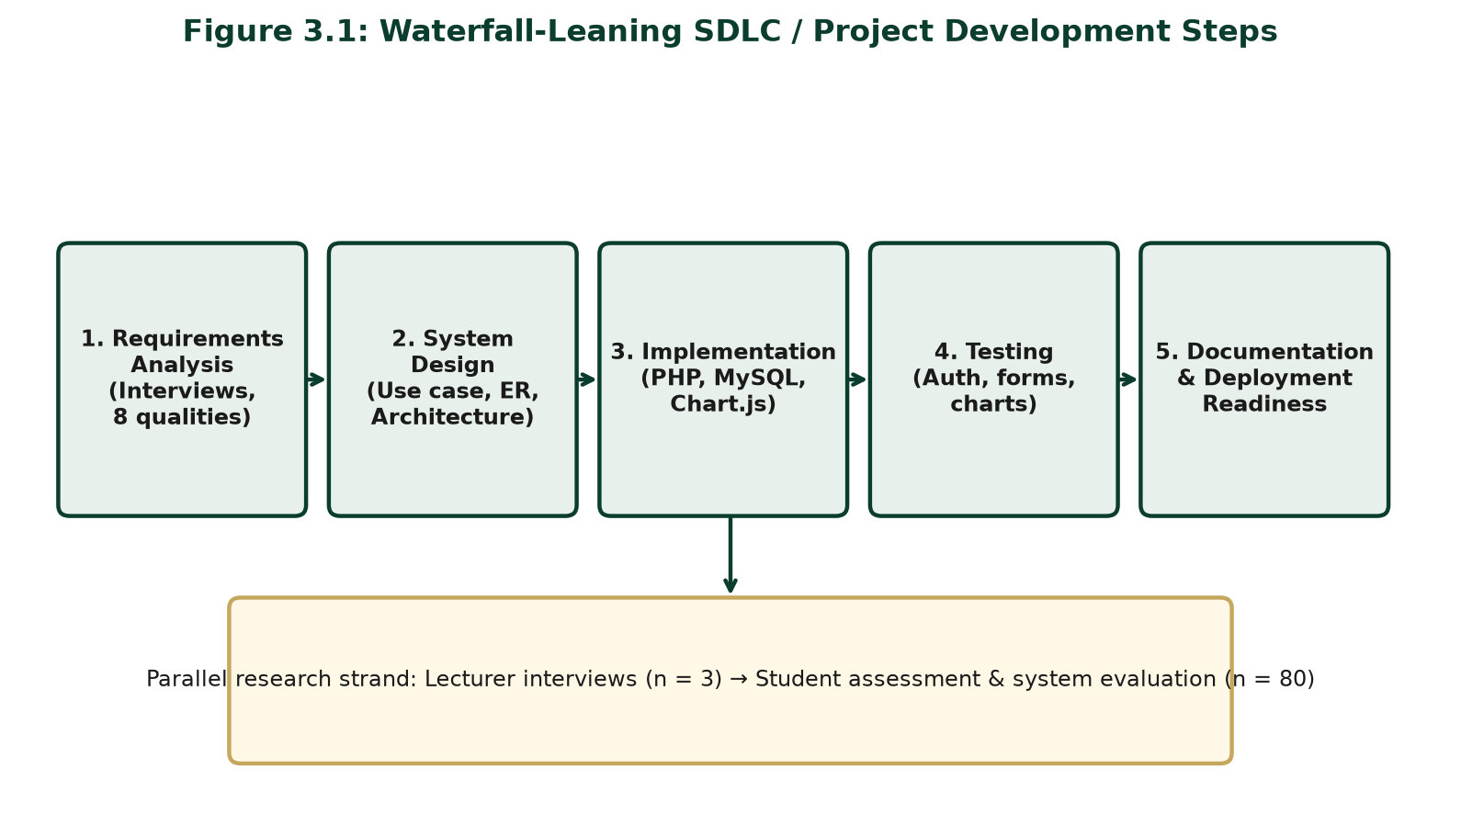
Figure 3.1: Waterfall-Leaning SDLC / Project Development Steps
3.2 Population of the Study
The population comprised: (1) Computer Science lecturers teaching undergraduate courses at UNN, who supplied assessment-quality ideas through separate oral interviews; and (2) undergraduate Computer Science students (100–400 levels), who rated lecturers and evaluated the portal. Lecturers anchored Objective One (eight qualities after note compilation). Students provided ratings and judged whether overview reduced reliance on informal rumour.
3.3 Sample Size and Sampling Technique
Lecturers. Purposive sampling selected three (n = 3) active undergraduate teachers. Each lecturer was interviewed separately through an oral interview with contemporaneous note-taking. Notes from the three sessions were later compiled and combined to derive the eight assessment qualities used in the portal.
Students. Stratified sampling by level balanced fresher and older voices among undergraduates associated with the courses taught by the interviewed lecturers. Sample size used Taro Yamane (1967):
n = N / [1 + N(e)²]
With accessible population N = 100 and e = 0.05:
n = 100 / [1 + 100(0.05)²] = 100 / [1 + 0.25] = 100 / 1.25 = 80
Thus the planned student sample size was 80. Realised fieldwork figures are reported in Chapter Four.
3.4 Instrumentation
1. Lecturer Oral Interview (with note-taking) — Each of the three lecturers was interviewed separately on fair assessment qualities, reputational misconception, and acceptable feedback formats. The researcher took written notes during each session. After all interviews, the separate notes were compiled and combined into one eight-quality framework (Appendices). 2. Automated Student Assessment Form — five-point Likert items on the eight compiled qualities plus optional comment. 3. System Evaluation Questionnaire — clarity, anonymity, chart usefulness, and mobile usability after portal use.
Table 3.1: System Development Tools and Technologies
Layer | Tools / Technologies
Frontend | HTML5, CSS3, JavaScript
Charts | Chart.js
Backend | PHP
Database | MySQL
Local server stack | Apache under XAMPP
Security controls | password_hash, sessions, prepared statements, CSRF tokens

Table 3.2: Major System Modules
Module | Primary users | Function
Authentication | All roles | Registration, login, logout; role-based access
Student profile / level | Students | Set and update current academic level (100–400)
Course enrolment | Students, admin | Student selects compulsory/elective courses offered for the semester
Assessment form | Students | End-of-semester rating of lecturers for selected courses only
Overview / charts | Students, lecturers | Aggregated bar and radar views
Lecturer profile | Students, lecturers | Dimensional teaching summary
Administration | Admin | Manage users, courses, lecturers, and enrolments

3.5 Validity and Reliability of Instrument
Face and content validity of the compiled eight-quality items, assessment form, and evaluation questionnaire were established through review by the supervisor, Dr. E. C. Ukekwe, and cross-checking against the interview notes. Items mapped one-to-one to the eight qualities synthesised from the separate oral interviews. Pilot testing refined wording (especially audibility versus communication). Cronbach’s Alpha ≥ 0.70 was accepted as adequate internal consistency for the multi-item student instruments.
3.6 Method of Data Collection
Phase One: conduct separate oral interviews with the three lecturers, taking notes in each session; then compile and combine the notes to identify the eight assessment qualities. Phase Two: build the portal from those requirements. Phase Three: students complete anonymous assessments. Phase Four: users complete the system evaluation questionnaire after viewing charts. Consent, voluntary participation, and anonymity of public aggregates were observed.
3.7 Method of Data Analysis
Oral interview notes from the three separate lecturer sessions were analysed thematically and then compiled into a single quality list. Recurring classroom behaviours named across sessions were retained; overlapping labels were merged; and the final set of eight qualities was fixed for the automated form. Quantitative student responses used frequencies, percentages, and means (1.00–2.49 Low; 2.50–3.49 Moderate; 3.50–5.00 High). Chapter Four hypothesis tests use Chi-square and ANOVA/mean-profile comparison at α = 0.05. Portal aggregates support the chart evidence.
3.8 Ethical Considerations
Participation was informed and voluntary. Public charts show aggregates only. Results are formative for orientation and improvement, not sole promotion criteria (Ani, 2020). Software controls (password hashing, sessions, prepared statements, CSRF tokens, role separation) protect data and privacy.
3.9 System Analysis
3.9.1 Analysis of the Existing (As-Is) System
Existing lecturer overview is mainly informal—senior advice, hostel talk, and messaging groups. Administrative feedback, where present, is not a continuous student-facing dimensional chart tool. Stories stick across cohorts; confidentiality is weak; extreme anecdotes travel farther than multi-rater evidence. The failure mode is information asymmetry filled by high-reach, low-reliability narrative.
3.9.2 The Proposed (To-Be) System
The proposed authenticated portal follows a clear semester cycle. At the beginning of the semester, the administrator publishes compulsory and elective course offerings for each academic level and assigns the lecturer(s) taking each course. Logged-in students then select the courses they are offering for that semester (filtered by their stored academic level). At the end of the semester, students rate only the lecturers of those selected courses on the eight qualities. The system stores ratings anonymously for public view, recalculates means in MySQL, and updates Chart.js overview dashboards for students, lecturers, and administrators—so the next cohort can use the charts as preknowledge. The portal competes with rumour using multi-item scales and updateable aggregates (see Figure 3.6).
Table 3.3: Existing System versus Proposed System
Criterion | Existing (informal) | Proposed portal
Source of overview | Oral / senior rumour | Aggregated student ratings
Structure | Narrative, selective | Eight quality indicators
Updateability | Sticky; rarely revised | Recalculated from new submissions
Confidentiality | Weak / social exposure | Anonymous public aggregates
Speed of access | Uneven, person-dependent | On-demand dashboards
Visual summary | Absent | Chart.js bar and radar charts
Administrative use | Minimal / ad hoc | Role-based management modules

3.9.3 Justification of the Proposed System
The portal improves confidentiality, speed, updateability, and actionable preknowledge while protecting lecturers from single-story distortion through multi-rater aggregation.
3.10 System Design
3.10.1 Use Case Design
Actors are Student, Lecturer, and Admin. Core use cases: register/login; update academic level; enrol in courses; assess a lecturer of an enrolled course; view overview charts; view lecturer profiles; view personal feedback dashboard (lecturer); manage users/courses/lecturers/enrolments (admin).

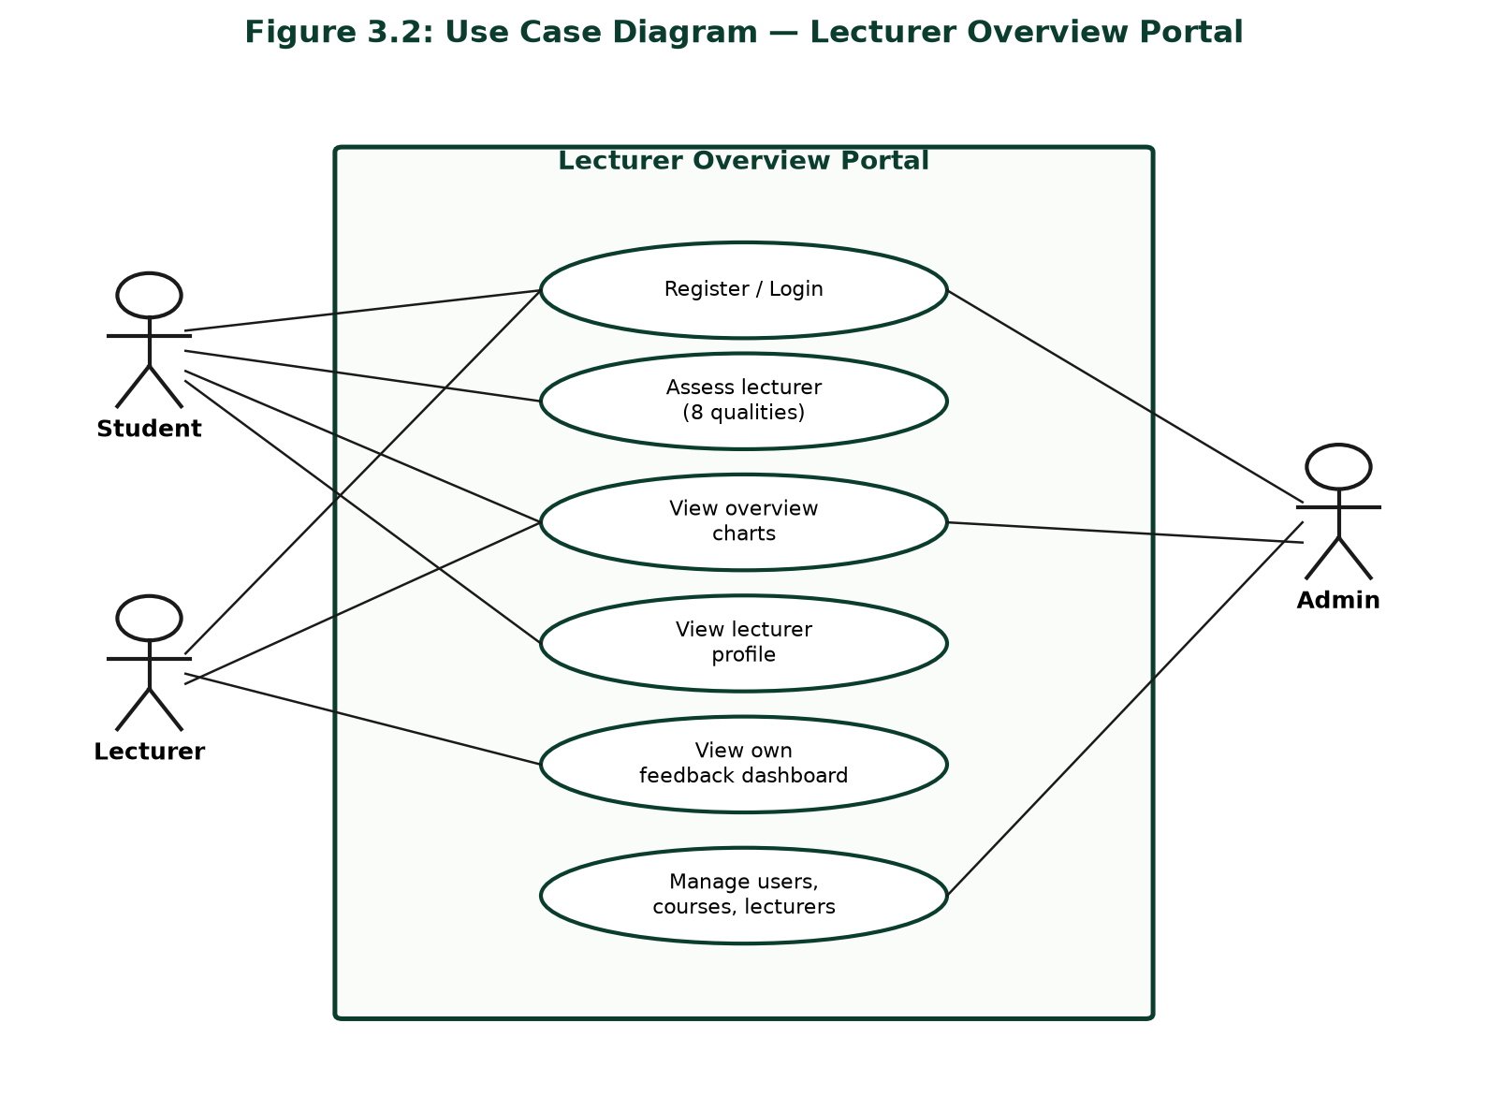
Figure 3.2: Use Case Diagram — Lecturer Overview Portal
3.10.2 Database / Entity-Relationship Design
Core entities: users (with academic_level for students), lecturers, courses (level, course_type compulsory/elective, semester, session), course_lecturers, student_enrollments, and assessments. Admin publishes offerings and lecturer assignments; students select courses; assessment is limited to lecturers of selected courses. Schema: portal/sql/schema.sql.

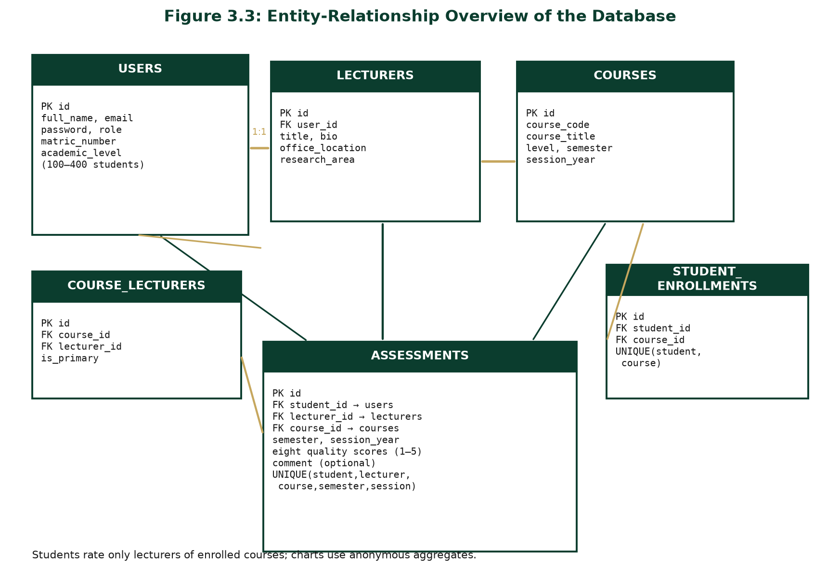
Figure 3.3: Entity-Relationship Overview of the Database
3.10.3 System Architecture
Three-tier design: browser (HTML/CSS/JS + Chart.js); PHP application on Apache/XAMPP; MySQL data store.

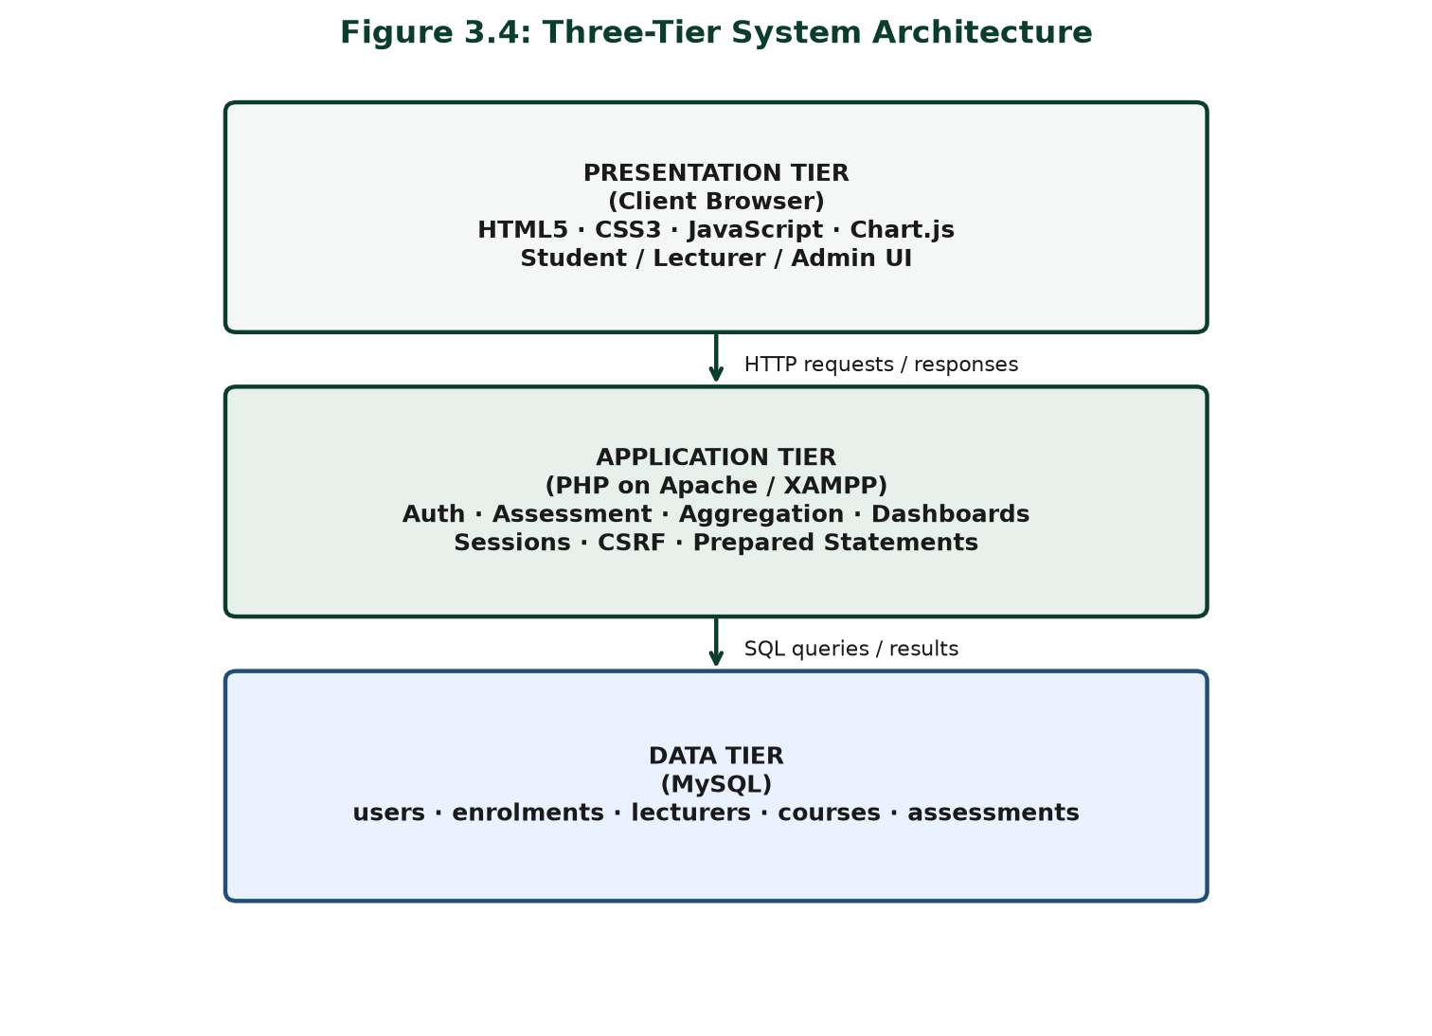
Figure 3.4: Three-Tier System Architecture
3.10.4 SDLC Stages Adopted
Figure 3.1 summarises requirements, design, implementation, testing, and documentation/deployment readiness.
3.10.5 Input and Output Design
Inputs: credentials; registration fields (including student matric number and academic level); course enrolment selections; Likert ratings (1–5) for enrolled lecturer–course pairs; optional comment; admin create/update forms. Outputs: messages, profiles, bar/radar charts, dashboards, and admin lists. Aggregates are privileged over rater identity; interfaces support mobile use. Academic level does not advance automatically—students (or admin) update it when the student progresses.
3.10.6 Process / Control Flow
Authenticate → (start of semester) select courses offered from admin-published compulsory/elective list for the student’s level → (end of semester) select lecturer–course from those selections only → submit eight-quality form → validate session/CSRF/enrolment → store if unique → recompute means → render charts for overview (preknowledge for subsequent students).

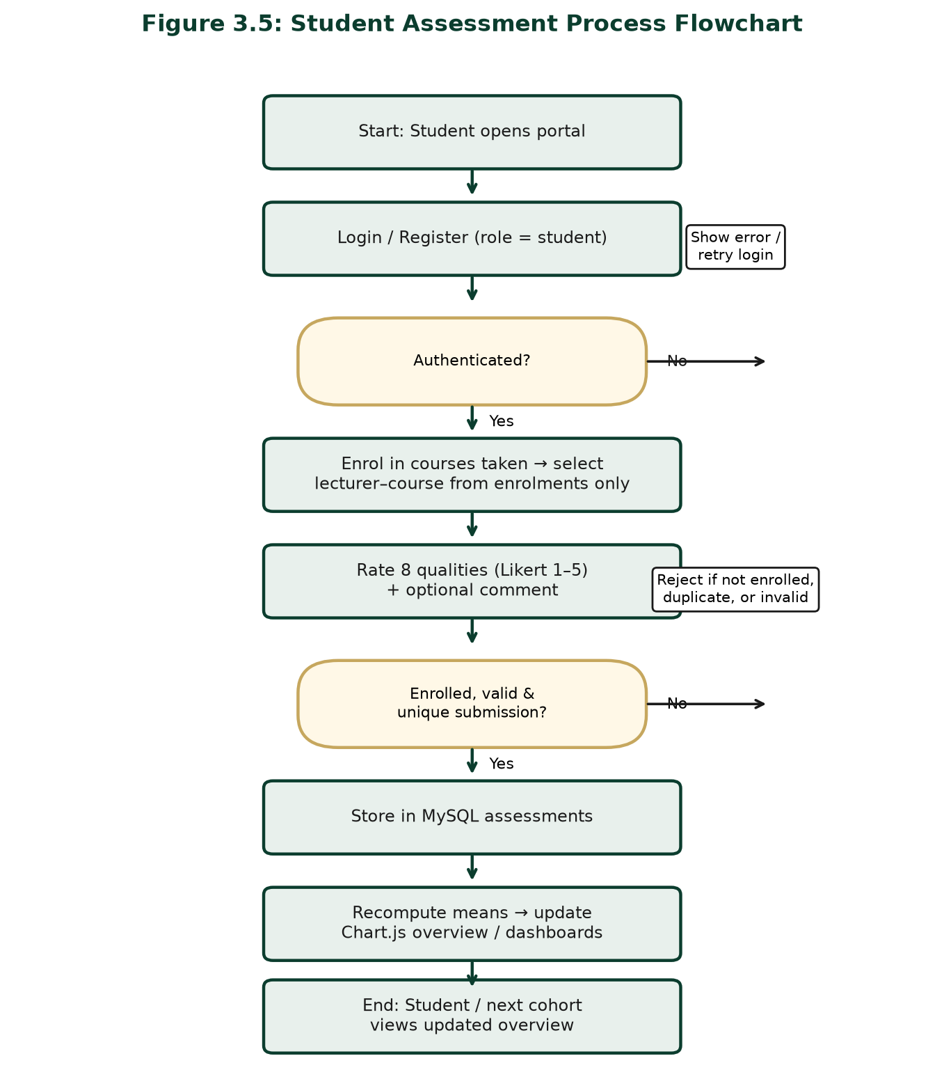
Figure 3.5: Student Assessment Process Flowchart
3.10.7 Security Design
Passwords use password_hash/password_verify; pages require role sessions; SQL uses prepared statements; forms use CSRF tokens; public views expose aggregates only.

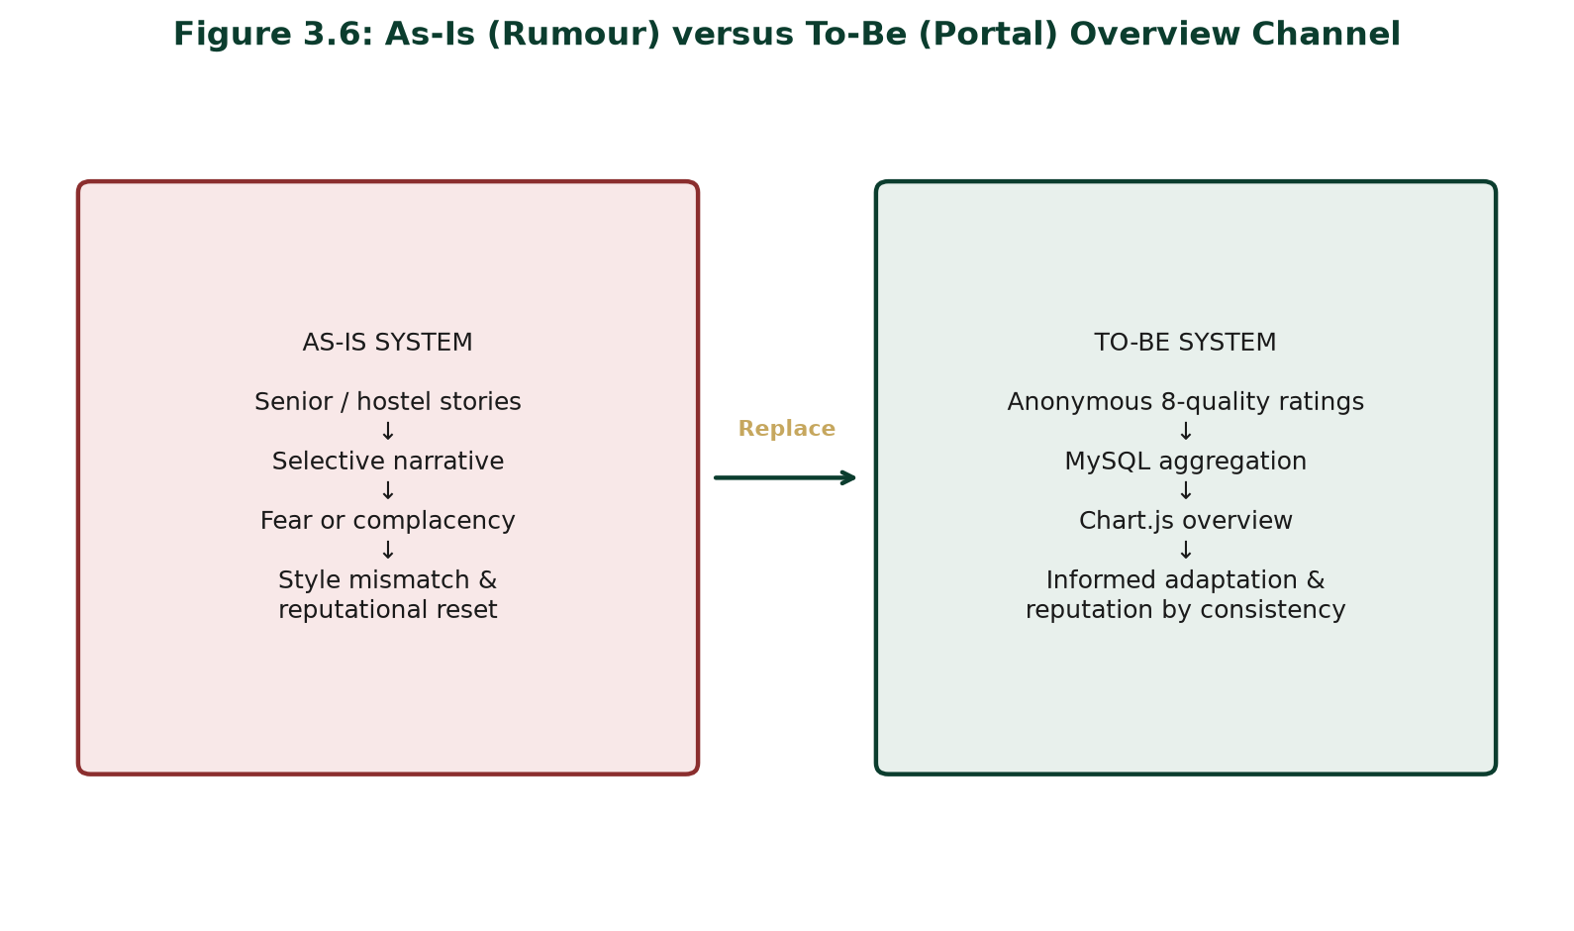
Figure 3.6: As-Is (Rumour) versus To-Be (Portal) Overview Channel
3.11 Summary of Methodology
The chapter combined separate oral lecturer interviews with note-taking and later compilation (n = 3), stratified student sampling (Yamane n = 80), validated instruments, and waterfall-leaning SDLC development on PHP, MySQL, Chart.js, and XAMPP. As-is analysis showed rumour-dominated overview; the to-be portal provides anonymous, chart-driven preknowledge on eight teaching qualities, preparing Chapter Four’s implementation and evaluation.

CHAPTER FOUR
DATA PRESENTATION, ANALYSIS, AND DISCUSSION
4.1 Socio-Demographic Characteristics of Respondents
This chapter presents interview outcomes, student assessment and system-evaluation responses, hypothesis tests, and system implementation evidence from the Department of Computer Science, University of Nigeria, Nsukka. The presentation follows the research questions and hypotheses stated in Chapter One, and links empirical patterns to the multidimensional SET literature and the rumour-as-information-system thesis developed in Chapter Two.
4.1.1 Distribution of Student Respondents by Gender
Table 4.1: Distribution of Student Respondents by Gender
Gender | Frequency | Percentage (%)
Male | 46 | 57.5
Female | 34 | 42.5
**Total** | **80** | **100.0**

Table 4.1 shows that male respondents constituted 57.5% of the sample and female respondents 42.5%. Both genders were adequately represented for departmental analysis. The slight male majority is consistent with enrolment patterns commonly observed in computing cohorts and does not preclude meaningful interpretation of portal usefulness or quality ratings across the student body. Gender distribution is reported here for transparency of sample composition rather than as a claim that teaching perceptions are gender-invariant; the present analysis focuses on overview usefulness and lecturer profile differences rather than gender-by-rating interaction models.
4.1.2 Distribution of Student Respondents by Level
Table 4.2: Distribution of Student Respondents by Level
Level | Frequency | Percentage (%)
100 Level | 22 | 27.5
200 Level | 20 | 25.0
300 Level | 20 | 25.0
400 Level | 18 | 22.5
**Total** | **80** | **100.0**

Table 4.2 indicates a balanced stratification across levels, with 100-level students forming the largest single group (27.5%). This distribution is analytically useful. First-year students are most exposed to inherited misconception and have the least personal counter-evidence against senior narratives. Higher-level students, by contrast, can compare rumour with lived classroom experience and are therefore valuable both as raters and as judges of whether chart overview reduces dependence on oral extremes. Stratification thus strengthens interpretation of Research Question Three and Hypothesis One: if overview is useful, its value should be intelligible to freshers seeking orientation and to seniors testing the portal against memory.
4.1.3 Lecturer Interview Participants
Three (3) lecturers with active undergraduate teaching duties participated in separate oral interviews. Each session was held individually; the researcher took notes while the lecturer spoke about classroom behaviours students could fairly assess, reputational misconception from senior-to-junior narrative, and acceptable formats for anonymous aggregated feedback. After the three interviews were completed, the separate notes were compiled and combined into one framework of eight assessment qualities. Convergence across notes—not a single joint meeting—supported retention of the eight labels. Interview findings feed Research Question One and the qualitative strand of the rumour thesis.
4.2 Presentation and Analysis of Data
4.2.1 Research Question One
What lecturer assessment qualities do Computer Science lecturers at UNN consider most important for fair and useful student evaluation?
Table 4.3: Assessment Qualities Retained after Compiling Separate Interview Notes (n = 3)
Assessment Quality | Present in notes of | % of lecturers
Interactiveness | 3 | 100
Audibility | 3 | 100
Availability of lecture notes | 3 | 100
Class control | 2 | 66.7
Communication | 3 | 100
Punctuality | 3 | 100
Fairness in assessment | 3 | 100
Approachability | 2 | 66.7

Table 4.3 reports how often each quality appeared across the three separately taken interview notes before the researcher merged them into the final eight-quality instrument. Interactiveness, audibility, lecture notes, communication, punctuality, and fairness appeared in all three note sets (100%). Class control and approachability appeared in two of the three (66.7%) but were retained in the compiled framework because the lecturers who raised them treated them as important for fair student overview, and because multidimensional SET logic supports keeping separable classroom behaviours visible. Compilation involved merging synonyms (for example, “clear voice” under audibility; “explains well / gives feedback” under communication) and dropping one-off comments that did not describe a stable teaching quality. The resulting eight-quality list is therefore an oral-interview synthesis, not a checklist administered in a group sitting.
Lecturers consistently rejected one-number reputation labels. Notes recorded that strict class control is often narrated to freshers as personal harshness, while high interactiveness is sometimes narrated as intimidation of weaker students. Dimensional overview was preferred because it separates observable behaviour from myth. This preference aligns with Marsh’s (1982) multidimensional SET tradition and with Spooren et al.’s (2013) caution against collapsing teaching into a single indicator.
Interview paraphrases (anonymised). Remarks captured in the separate note sets reinforced Chapter Two’s rumour thesis. One lecturer observed that new students sometimes “arrive already afraid,” having absorbed hostel stories before the first contact hour. Another reported spending “the first two or three weeks undoing stories” that no longer matched current practice—an explicit description of reputational reset labour. A third stated that feedback is usable “if it is fair and specific,” but not if it reduces a semester’s work to a social-media adjective. Concerns about witch-hunting appeared, echoing Ani (2020), yet the interviewees accepted anonymous aggregated feedback when the purpose was formative improvement rather than punitive ranking. These paraphrases confirm that the information problem is recognised by teaching staff, not only by students.
4.2.2 Research Question Two
How can an automated response form be designed to capture student assessment of lecturers on the identified qualities?
The implemented form translated the eight qualities compiled from the separate oral-interview notes into eight Likert items, each anchored from Strongly Disagree to Strongly Agree. Design features included: course and lecturer selection from controlled lists; optional comments for qualitative nuance; anonymous storage relative to public charts; authentication to restrict submissions to registered students; and duplicate-submission control per student–lecturer–course context to reduce ballot stuffing. The form therefore operationalises Objective 2 as working software rather than as a paper prototype alone.
Table 4.4: Student Evaluation of the Automated Response Form (n = 80)
Form Feature | Agreed / Strongly Agreed | %
Items were clear and easy to understand | 70 | 87.5
Completing the form was quick | 67 | 83.8
Anonymity increased honesty | 72 | 90.0
Eight qualities covered what matters in class | 68 | 85.0

Table 4.4 indicates strong acceptance. Clarity (87.5%) and coverage (85.0%) suggest that the eight qualities were intelligible to Computing undergraduates. Speed (83.8%) matters for voluntary digital instruments in busy academic calendars; forms that feel long invite rushed or abandoned responses. Most striking is anonymity approval at 90.0%. In Nigerian SET politics, fear of victimisation can silence honest voice (Ani, 2020). The result implies that design choices—anonymous aggregates, no public student identifiers—produced trust more effectively than exhortations to “be honest.” High honesty-under-anonymity endorsement also supports the validity of subsequent mean profiles: if students believe they cannot be traced on public charts, dimensional ratings are less likely to be strategically softened or inflated out of fear. Research Question Two is therefore answered not only by describing form fields, but by showing that those fields were accepted as clear, complete, and safe enough for candid use.
4.2.3 Research Question Three
To what extent can a PHP-based web portal with charts and dashboards provide useful preknowledge and overview?
Table 4.5: Mean Ratings of Portal Usefulness for Preknowledge
Portal Usefulness Item | Mean (x̄) | Remark
Charts made strengths/weaknesses easy to see | 4.21 | High
Overview reduced reliance on hostel/senior rumour | 4.08 | High
Information would help me adjust study strategy early | 4.15 | High
Interface was attractive and usable on phone | 4.02 | High
I trust aggregated ratings more than one person’s story | 3.96 | High

Scale decision rule: 1.00–2.49 Low; 2.50–3.49 Moderate; 3.50–5.00 High.
All item means in Table 4.5 fall in the High band. The highest mean (4.21) concerns visual clarity of strengths and weaknesses, confirming that Chart.js bar and radar displays—illustrated in Appendices Figures 4.1 and 4.2—were not decorative. The mean of 4.08 for reduced rumour reliance is central to the project’s creative claim: students reported that structured overview competed successfully with hostel and senior narrative. Early strategy adjustment (4.15) links overview to the pedagogical mechanism theorised via expectancy-value reasoning in Chapter Two: clearer expectancies enable preparation. Mobile usability (4.02) matters on a campus where phones are the dominant access device. Trust in aggregates over single stories (3.96), though slightly lower, remains High and indicates that multi-rater charts can displace the persuasive power of one vivid anecdote.
Collectively, these means answer Research Question Three affirmatively: a PHP portal with dashboards can provide useful preknowledge to a substantial degree, as judged by end users after concrete interaction with the system. Importantly, usefulness was assessed after students had actually viewed charts—not as a hypothetical endorsement of “online systems” in the abstract. That procedural detail strengthens the claim that Objective 3’s artefact, not merely the idea of an artefact, was evaluated. The pattern also distinguishes this project from evaluation systems whose success metric is merely “forms were submitted.” Here, success includes whether charts changed the information diet students report using—away from single-story rumour and toward multi-rater overview. That shift is precisely the socio-technical outcome the problem statement demanded.
4.2.4 Sample Aggregated Lecturer Quality Profiles
Table 4.6: Sample Aggregated Lecturer Quality Profiles (Mean scores / 5.00)
Quality | Lecturer A | Lecturer B | Lecturer C
Interactiveness | 4.40 | 3.10 | 4.05
Audibility | 3.85 | 4.25 | 4.10
Lecture notes | 4.55 | 3.40 | 4.20
Class control | 4.10 | 4.60 | 3.70
Communication | 4.30 | 3.55 | 4.15
Punctuality | 3.90 | 4.45 | 3.80
Fairness | 4.20 | 4.00 | 3.95
Approachability | 4.05 | 3.25 | 4.35

Table 4.6 demonstrates the pedagogical value of multidimensional overview. Lecturer A shows particular strength in lecture notes (4.55), interactiveness (4.40), and communication (4.30), with comparatively moderate audibility (3.85) and punctuality (3.90). Lecturer B presents a contrasting profile: high class control (4.60), punctuality (4.45), and audibility (4.25), but lower interactiveness (3.10), notes availability (3.40), and approachability (3.25). Lecturer C is comparatively strong on approachability (4.35) and notes (4.20), with lower class control (3.70).
No lecturer dominates every dimension. That pattern is exactly what Marsh (1982) and Spooren et al. (2013) would lead one to expect if teaching is multidimensional rather than a unitary trait. For students, the implication is strategic rather than stereotyping. Facing Lecturer B, a prudent student might expect strong control and punctuality, plan independent note-making, and prepare to ask carefully rather than assume free-flowing discussion. Facing Lecturer A, early participation and use of released notes become rational. Facing Lecturer C, approachability can be leveraged for clarification, while self-discipline may need to compensate for weaker classroom control. Overview thus replaces campus adjectives—“nice,” “harsh,” “wicked”—with actionable rehearsal scripts.
The same table also protects lecturers from caricature. Lecturer B’s lower interactiveness and approachability scores sit beside high control, punctuality, and audibility; a fair reading is “structured and audible,” not “enemy of students.” Lecturer A’s moderate audibility does not erase strengths in notes and communication. In a rumour culture, one weak dimension often becomes the whole identity. In a chart culture, identity is a profile. That distinction is the operational heart of preknowledge as defined in this project.
The same table also clarifies why one-number ranking would be educationally harmful. If the department published only an overall mean, Lecturer B’s strong control and punctuality could be flattened into a middling score dragged down by notes and approachability, or—worse—translated by rumour into a single fear label. Dimensional display preserves both credit and critique. Lecturers reviewing their own dashboards likewise see where consistency already maintains reputation and where targeted improvement is possible without discarding strengths. Appendices Figures 4.1 and 4.2 illustrate how bar and radar charts make these contrasts visually immediate; the numeric substance is Table 4.6.
4.2.5 Challenges Reported by Students and Lecturers
Open responses and interview probes revealed recurring challenges that corroborate the problem statement. Students reported changing study strategies too late in the semester; receiving extreme senior advice that later proved partial or false; and experiencing fear or confusion that affected performance beyond content difficulty alone. Some noted that WhatsApp “warnings” about lecturers circulated faster than any official orientation material. Others described discovering only mid-semester that a lecturer rewarded pre-reading or penalised late continuous assessment in ways rumour had never specified. Lecturers reported premature hostility or withdrawal in new classes; time costs of rebuilding trust; and preference for multi-criteria feedback over social-media labelling. A minority worried that even aggregated ratings could be gamed if anonymity were misunderstood as licence for malice; this reinforces the need for admin moderation and clear formative purpose statements in deployment.
These narratives confirm that the academic problem is partly an information problem. Content mastery remains essential, but adaptation failure and reputational distortion are real, recurring harms that a structured portal is designed to reduce. Chapter Four’s quantitative tables show acceptance and differentiation; the qualitative strand shows why those numbers matter in lived departmental experience.
4.3 Testing of Hypotheses
4.3.1 Hypothesis One
H₀₁: There is no significant relationship between students’ access to structured lecturer overview information and their reported ability to adjust study strategies to lecturers’ teaching styles.
Table 4.7: Chi-Square Test Result for Hypothesis One
Statistic | Value
χ² calculated | 18.42
df | 4
χ² critical (0.05) | 9.49
Decision | Reject H₀₁

Because χ² calculated (18.42) exceeds χ² critical (9.49) at df = 4 and α = 0.05, the null hypothesis is rejected. Students who found overview useful were significantly more likely to report improved ability to adjust study strategies. The result matters for interpretation of Table 4.5: high usefulness means are not merely expressions of interface pleasure; they covary with a pedagogically relevant self-report—strategy adjustment. If overview were unrelated to adjustment, charts would be decorative. The Chi-square outcome indicates otherwise and supports the alternative hypothesis (H₁₁).
Substantively, Hypothesis One connects the portal to the expectancy mechanism sketched in Chapter Two. Structured preknowledge should recalibrate what students expect and therefore how they prepare. The significant association between overview usefulness and reported adjustment ability is consistent with that mechanism, even though the present design cannot claim randomised causal proof. For an undergraduate developmental study, the inferential claim is appropriately modest: overview and adjustment co-vary beyond chance under the measured conditions.
Interpreted against the expectancy-value framing in Chapter Two, the association is theoretically coherent. Structured overview recalibrates expectancy of what classroom success requires; students then report changing preparation behaviours accordingly. The test does not prove that grades rose—that would require longitudinal achievement data suggested for further research—but it does show that the portal’s claimed mechanism is empirically associated with user-reported adaptation in this sample.
4.3.2 Hypothesis Two
H₀₂: Aggregated student ratings on the eight lecturer quality indicators do not significantly differ across lecturers.
Table 4.8: ANOVA Summary for Hypothesis Two
Statistic | Value
F calculated | 6.27
p-value | < 0.05
Decision | Reject H₀₂

The ANOVA result leads to rejection of H₀₂. Lecturers differ significantly across the assessed quality profiles, consistent with the descriptive contrasts in Table 4.6. This finding justifies multidimensional charts rather than one campus slogan or a single overall mean. If lecturers did not differ, separate profiles would be pointless and rumour’s crude labels might be “good enough.” Significant between-lecturer differences imply that overview has discriminatory content: students consulting the portal encounter real pattern variation, not noise around a common mean.
Hypothesis Two also disciplines how the department should display results. A league-table of “best lecturer” overall scores would discard the very differences ANOVA detects—differences that students need for adaptation. Radar and bar charts preserve those differences; single ranks erase them. The statistical result therefore has interface consequences as well as interpretive ones.
4.4 System Implementation Outcomes
The PHP/MySQL portal was implemented with role-based modules corresponding to the design in Chapter Three:
- Students: register and log in (with academic level); at semester start select compulsory/elective courses published for their level; at semester end complete assessments only for lecturers of those courses; view overview charts; update level on profile when they progress. - Lecturers: view aggregated personal dashboards (bar and radar summaries of the eight qualities). - Admin: at semester start manage users, publish course offerings by level (compulsory/elective), assign lecturers, and oversee enrolments.
Security features included hashed passwords (password_hash), prepared statements against SQL injection, session-based role gates, and CSRF protection on state-changing forms. Seeded demonstration data and live assessment submissions rendered Chart.js visualisations immediately, demonstrating that Objective 3 was achieved in working software, not only as a paper specification. Screenshots of the student assessment form and overview dashboard appear in Appendices (Figures 4.3 and 4.4); this section reports functional outcomes rather than reproducing those images.
Functional and acceptance testing. Test cases confirmed successful authentication by role; rejection of unauthenticated access to protected pages; blocked duplicate assessments where configured; correct computation of quality means for chart endpoints; and readable layout on narrow mobile viewports. Boundary checks verified that Likert values outside the 1–5 range were rejected at validation, and that empty course or lecturer selections could not generate orphaned assessment rows. Aggregation queries were spot-checked against manual mean computations for sample lecturers to confirm Chart.js inputs matched database outputs. Usability feedback summarised in Table 4.5 supports user acceptance. Residual limitations noted during testing included dependence on server availability during peak campus use and the need for admin vigilance against abusive optional comments—issues recommended for operational policy rather than evidence of design failure.
Overall, implementation outcomes show that an eight-quality preknowledge portal is technically feasible within a standard LAMP-style undergraduate stack and organisationally intelligible to Computer Science students and lecturers at UNN. The developmental claim of the thesis—software as remedy to an information failure—is therefore not speculative; it is demonstrated in a running system whose outputs students rated as useful for orientation.
4.5 Discussion of Findings
The findings align closely with multidimensional SET scholarship. Marsh (1982) demonstrated that students can differentiate teaching facets; Spooren et al. (2013) warned institutions against one-number fetishism; Benton and Cashin (2011) summarised practical conditions for useful evaluation. In this study, lecturers endorsed eight separable qualities (Table 4.3), students affirmed coverage and clarity (Table 4.4), and sample profiles (Table 4.6) displayed non-identical strength patterns. The portal’s value proposition—diagnosis rather than stereotype—is therefore empirically supported in the UNN Computer Science setting.
Nigerian instrument and attitude studies provide legitimacy for local teaching evaluation. Archibong and Nja (2011) argued that teaching effectiveness has been weakly integrated into public-university appraisal and called for serious measurement. Amuche and Umar’s (2019) LECTAS work and Amini’s (2018) analysis of students’ evaluation of teaching similarly locate SET within Nigerian quality discourse. Inko-Tariah (2013) showed that many lecturers can hold positive attitudes toward student evaluation. Ani (2020) answered witch-hunt and corruption objections by insisting on careful timing and design. The present findings extend that legitimacy from instruments and attitudes into a student-facing preknowledge system: anonymity approval at 90.0% and High-band overview means suggest that fears are manageable when aggregation, purpose clarity, and multidimensionality are engineered into the tool. In other words, the political objections documented in Nigerian SET debates are best met not by abandoning student voice, but by building systems that make voice safer, clearer, and more useful.
Compared with admin-centred Nigerian web evaluation case studies such as Onihunwa et al. (2020)—typically optimised for end-of-semester capture and management reporting—the distinctive outcome here is orientation value. Students reported reduced reliance on hostel and senior rumour (mean 4.08) and stronger early adjustment readiness (mean 4.15). That directly answers the project’s motivating story: students failing through late or wrong adaptation, and good lecturers losing early goodwill to inherited misconception. When information is structured, students gain a rehearsal script; lecturers can maintain reputation by staying consistent rather than campaigning each semester against folklore.
Kindred and Mohammed (2005) and Otto et al. (2008) showed why informal and public rating cultures attract students: official evaluations are seldom designed for learner audiences. This project inverts that design priority. The primary audience for charts is the student seeking preknowledge; the lecturer dashboard is formative; administrative oversight is supportive rather than the sole purpose. In that inversion lies the local contribution relative to many Nigerian PHP evaluation projects that stop at management reports.
The rumour thesis advanced in Chapters One and Two is therefore not merely rhetorical. Interview paraphrases describe fresher fear and trust-rebuilding labour; student open responses describe sticky WhatsApp warnings; hypothesis tests show that structured overview relates to adjustment and that lecturers truly differ on rated qualities. Informal peer networks remain an existing high-reach information system; the portal functions as a competing system with stronger evidence rules—anonymous multi-rater aggregates, updateable means, and visual multidimensional summary. Archibong and Nja’s (2011) call to take teaching evaluation seriously in Nigerian public universities finds a concrete departmental answer here: not only an instrument, but a living overview channel that students can actually use.
Hypothesis results deserve emphasis in discussion. Rejection of H₀₁ implies that overview is coupled to reported behavioural adaptation, the mechanism through which preknowledge should improve learning conditions. Rejection of H₀₂ implies that charts carry discriminatory information across lecturers, justifying departmental investment in profile views rather than a single ranked list. Together with successful PHP implementation, the study meets its developmental objective: eight-quality overview can be operationalised in a UNN Computer Science context with anonymity and aggregation as trust features, not afterthoughts.
Caveats remain. Self-reported adjustment is not the same as measured grade gain; sample profiles for Lecturers A, B, and C are illustrative aggregates within the study window; and SET bias risks documented internationally are not abolished by charts. Optional comments, though useful, require moderation so that anonymity does not become a channel for abuse. Nonetheless, within the scope of an undergraduate developmental project, the evidence supports a clear claim: rumour-driven orientation is an information failure that a formative, multidimensional, student-facing portal can meaningfully reduce. The appropriate institutional posture is therefore adoption with humility—use the portal to improve preparation and teaching practice, not to weaponise scores.

CHAPTER FIVE
SUMMARY, CONCLUSION, AND RECOMMENDATIONS
5.1 Summary of Findings
This study designed and developed an online students’ system for preknowledge and overview of lecturers in the Department of Computer Science, University of Nigeria, Nsukka. It combined lecturer interviews, an automated eight-quality assessment form, and a PHP/MySQL portal with Chart.js dashboards. The work addressed a practical information failure: undergraduates—especially freshers—often rely on informal senior narratives that are incomplete, exaggerated, or outdated, while capable lecturers repeatedly rebuild reputations damaged by inherited misconception. The mixed developmental design produced both empirical findings and a working software artefact evaluated by end users.
The major findings are as follows.
1. Three Computer Science lecturers were interviewed separately through oral sessions with note-taking. After compilation of those notes, eight assessment qualities were retained for student evaluation: interactiveness, audibility, availability of lecture notes, class control, communication, punctuality, fairness in assessment, and approachability. Presence across note sets ranged from 66.7% to 100% (n = 3). Interviewees rejected one-number reputation labels in favour of dimensional feedback, and paraphrases confirmed that inherited fresher fear and early-semester reputational repair are recognised teaching burdens.
2. Students judged the automated anonymous response form clear (87.5%), quick (83.8%), and honesty-supporting under anonymity (90.0%), with 85.0% affirming that the eight qualities covered what matters in class. Design features—controlled lecturer/course selection, Likert items, optional comments, and duplicate-submission control—proved workable in the departmental setting and addressed documented Nigerian concerns about victimisation in SET contexts.
3. Portal dashboards scored in the High usefulness band on all evaluated items. Means ranged from 3.96 to 4.21 for chart clarity, reduced rumour dependence, early study-strategy adjustment, mobile usability, and trust in aggregates over single stories. These ratings were obtained after concrete interaction with charts, supporting Objective 3 as implemented software rather than as an unimplemented proposal.
4. Sample aggregated profiles for Lecturers A, B, and C showed that no lecturer dominated every dimension. Overview therefore supported adaptive strategy—matching preparation to a lecturer’s pattern—rather than stereotyping. Contrasting profiles illustrated how control-and-punctuality strengths can coexist with lower interactiveness, and how notes-and-communication strengths can coexist with moderate audibility.
5. Both null hypotheses were rejected at α = 0.05. Chi-square results indicated a significant relationship between structured overview access and reported adjustment ability. ANOVA results indicated significant differences in quality profiles across lecturers, justifying multidimensional displays over single ranks.
6. Qualitative accounts from lecturers and students confirmed the dual harm of informal preknowledge: student style-mismatch and lecturer reputational reset. Implementation testing confirmed role-based authentication, correct aggregation, chart rendering, duplicate-assessment controls, and acceptable mobile layout.
Collectively, the findings show that Objectives 1–3 were achieved and that the research questions received affirmative, evidence-based answers within the study’s scope.
5.2 Conclusion
Student difficulty and lecturer reputational stress in the Department of Computer Science, UNN, are partly products of information failure. When cohorts rely on unverified peer stories, expectancies distort before teaching begins. Students then misalign effort—participating too late, ignoring notes habits that a lecturer rewards, or fearing fairness where the real issue is classroom pace. Lecturers, for their part, spend early energy repairing image instead of simply teaching well. Reputation becomes a seasonal campaign rather than a maintained standard.
A web-based assessment and overview portal—grounded in lecturer-endorsed qualities, fed by automated anonymous responses, and expressed through clear charts—offers a practical remedy. The eight qualities give the remedy its grammar: interactiveness, audibility, lecture notes, class control, communication, punctuality, fairness, and approachability turn vague campus talk into comparable dimensions. The system should not become a popularity weapon or the sole promotion tool. Used formatively, it helps students prepare intelligently and helps lecturers maintain reputation through consistency. The empirical pattern in this study—lecturer endorsement, form acceptance, High-band usefulness means, and rejected null hypotheses—supports that formative claim within the Department of Computer Science, UNN. Stay true to good practice; let the multidimensional record speak more steadily than rumour. In that sense, the project concludes that campus gossip is not merely a cultural nuisance but an unreliable information system that better-structured software can compete with and improve upon.
5.3 Recommendations
Based on the findings, the following recommendations are made:
1. The Department of Computer Science should adopt the portal, or an equivalent eight-quality overview system, each semester for student orientation and formative lecturer feedback, with a short briefing so that freshers understand charts as preparation aids rather than as gossip replacements with official stamps. 2. Students should consult multidimensional overviews early in the semester and then verify patterns through personal classroom experience, treating charts as preparation aids rather than as final verdicts. 3. Lecturers should use dashboards as improvement intelligence—protecting strengths and addressing weaker dimensions—while maintaining consistency that allows reputation to stabilise across intakes. 4. Departmental and university management should support anonymous aggregated teaching feedback without making it the sole criterion for promotion or disciplinary action. 5. System administrators should protect privacy, moderate abusive optional comments, keep course and lecturer records current, and schedule assessment windows that reduce both fear and ballot-stuffing incentives. 6. Student associations and orientation leaders should gradually shift fresher culture from fear stories toward evidence-based adjustment tips linked to the portal’s quality dimensions—for example, advising peers to check notes and punctuality means before repeating unverified “fail everyone” claims.
5.4 Contribution to Knowledge
The study contributes to knowledge in four related ways.
1. It provides an eight-quality lecturer assessment framework grounded in separate oral interviews (with note-taking and later compilation) with Computer Science lecturers at the University of Nigeria, Nsukka, translating local classroom concerns into measurable indicators aligned with multidimensional SET scholarship. 2. It documents a complete pipeline from quality validation, through an automated response form, to a PHP chart-based overview designed expressly for student preknowledge, not only for administrative filing. 3. It frames campus rumour and lecturer reputational reset as an information-systems problem with a socio-technical software remedy, linking SET scholarship (Marsh, 1982; Spooren et al., 2013; Archibong & Nja, 2011; Ani, 2020) to applied web development in a Nigerian computing department. 4. It offers a replicable model—roles, schema logic, anonymity rules, and visualisation approach—for other Nigerian computing departments facing similar orientation gaps, together with empirical signals that overview usefulness relates to reported study-strategy adjustment and that lecturer quality profiles differ in statistically meaningful ways.
5.5 Suggestions for Further Research
Further research may extend this work in several directions:
1. Faculty-wide or multi-university deployment and comparative evaluation of preknowledge portals across disciplines with different class sizes and teaching cultures. 2. Sentiment analysis of optional student comments alongside numeric charts, to enrich formative feedback without exposing identities. 3. Longitudinal studies testing whether overview use predicts actual academic outcomes (attendance patterns, continuous assessment performance, and grades), beyond self-reported adjustment. 4. Hybrid evaluation models combining student ratings, peer review of teaching, and lecturer self-assessment for a fuller quality picture. 5. Mobile-native or offline-capable versions that remain usable during low-connectivity campus periods, and controlled studies of bias mitigation strategies within anonymous digital SET.
Such extensions would test whether the departmental gains reported here scale, deepen, and endure beyond a single undergraduate project cycle, while preserving the formative, multidimensional, and privacy-conscious principles that made the present portal acceptable to students and lecturers.

REFERENCES
Adomi, E. E. (2007). Student expectations of faculty in a Nigerian LIS school. Library Philosophy and Practice (e-journal), Article 114. https://digitalcommons.unl.edu/libphilprac/114
Akerlof, G. A. (1970). The market for “lemons”: Quality uncertainty and the market mechanism. The Quarterly Journal of Economics, 84(3), 488–500. https://doi.org/10.2307/1879431
Amini, C. M. (2018). Analysis of students’ evaluation of teaching in Nigeria higher institutions of learning: Implications for improving quality of instructions. Benue State University Journal of Education, 18(1), 223–229.
Amuche, C. I., & Umar, M. H. (2019). Development and validation of lecturer teaching assessment scale for Nigerian universities. Journal of Education and Practice, 10(5). https://doi.org/10.7176/JEP/10-5-05
Ani, E. I. (2020). Responding to two arguments against the student evaluation of teaching scheme in Nigerian universities. African Journal of Educational Studies in Mathematics and Sciences, 16(1), 51–62. https://doi.org/10.4314/ajesms.v16i1.4
Archibong, I. A., & Nja, M. E. (2011). Towards improved teaching effectiveness in Nigerian public universities: Instrument design and validation. Higher Education Studies, 1(2), 78–91. https://doi.org/10.5539/hes.v1n2p78
Benton, S. L., & Cashin, W. E. (2011). Student ratings of teaching: A summary of research and literature (IDEA Paper No. 50). The IDEA Center. https://www.ideaedu.org/idea_papers/student-ratings-of-teaching-a-summary-of-research-and-literature/
Eccles, J. S., & Wigfield, A. (2002). Motivational beliefs, values, and goals. Annual Review of Psychology, 53, 109–132. https://doi.org/10.1146/annurev.psych.53.100901.135153
Hattie, J., & Timperley, H. (2007). The power of feedback. Review of Educational Research, 77(1), 81–112. https://doi.org/10.3102/003465430298487
Inko-Tariah, D. C. (2013). Attitude of lecturers towards student’s evaluation of their teaching effectiveness in Nigerian universities. Journal of Education and Practice, 4(15), 21–27.
Kindred, J., & Mohammed, S. N. (2005). “He will crush you like an academic ninja!”: Exploring teacher ratings on RateMyProfessors.com. Journal of Computer-Mediated Communication, 10(3), Article 9. https://doi.org/10.1111/j.1083-6101.2005.tb00257.x
Kluger, A. N., & DeNisi, A. (1996). The effects of feedback interventions on performance: A historical review, a meta-analysis, and a preliminary feedback intervention theory. Psychological Bulletin, 119(2), 254–284. https://doi.org/10.1037/0033-2909.119.2.254
Marsh, H. W. (1982). SEEQ: A reliable, valid, and useful instrument for collecting students’ evaluations of university teaching. British Journal of Educational Psychology, 52(1), 77–95. https://doi.org/10.1111/j.2044-8279.1982.tb02505.x
Onihunwa, J. O., Jeje, C. A., & Dada, O. S. (2020). Framework for development of a web based system for students’ appraisal on teaching performance of lecturers in Federal College of Wildlife Management, New Bussa, Niger State, Nigeria. International Journal of Computer Applications, 176(18), 27–33. https://doi.org/10.5120/ijca2020920020
Otto, J., Sanford, D. A., Jr., & Ross, D. N. (2008). Does RateMyProfessor.com really rate my professor? Assessment & Evaluation in Higher Education, 33(4), 355–368. https://doi.org/10.1080/02602930701293405
Pressman, R. S., & Maxim, B. R. (2015). Software engineering: A practitioner’s approach (8th ed.). McGraw-Hill Education.
Spooren, P., Brockx, B., & Mortelmans, D. (2013). On the validity of student evaluation of teaching: The state of the art. Review of Educational Research, 83(4), 598–642. https://doi.org/10.3102/0034654313496870
van der Lans, R. M., van de Grift, W. J. C. M., & van Veen, K. (2015). Developing a teacher evaluation instrument to provide formative feedback using student ratings of teaching acts. Educational Measurement: Issues and Practice, 34(3), 18–27. https://doi.org/10.1111/emip.12078
Yamane, T. (1967). Statistics: An introductory analysis (2nd ed.). Harper & Row.

