UNIVERSITY OF NIGERIA, NSUKKA
FACULTY OF PHYSICAL SCIENCES
DEPARTMENT OF COMPUTER SCIENCE

AN ONLINE STUDENTS' SYSTEM FOR PREKNOWLEDGE AND OVERVIEW OF LECTURERS

A PROJECT REPORT
SUBMITTED IN PARTIAL FULFILMENT OF THE REQUIREMENTS FOR THE AWARD OF THE DEGREE OF
BACHELOR OF SCIENCE (B.Sc.) IN COMPUTER SCIENCE

BY

EZE DOMINION CHIBUIKEM
REGISTRATION NUMBER: 2022/249776

SUPERVISOR: DR. E. C. UKEKWE

JULY, 2026

DECLARATION
I, Eze Dominion Chibuikem (2022/249776), declare that this project titled "An Online Students' System for Preknowledge and Overview of Lecturers" is my original work. It has not been submitted elsewhere for any degree. Sources used have been acknowledged, and the system was developed under academic supervision in the Department of Computer Science, University of Nigeria, Nsukka.

_______________________________
Eze Dominion Chibuikem
Date: ____________________

CERTIFICATION
This is to certify that this project titled "An Online Students' System for Preknowledge and Overview of Lecturers" was carried out by Eze Dominion Chibuikem (2022/249776) under my supervision and is approved for submission for the B.Sc. degree in Computer Science, University of Nigeria, Nsukka.

_______________________________
Dr. E. C. Ukekwe
Supervisor
Date: ____________________

_______________________________
Head of Department
Date: ____________________

_______________________________
External Examiner
Date: ____________________

DEDICATION
This work is dedicated to God Almighty and to my family for their support throughout my undergraduate programme.

ACKNOWLEDGEMENTS
I thank God for the grace to complete this project. I am grateful to my supervisor, Dr. E. C. Ukekwe, for guidance and constructive criticism. I thank the Head of Department and staff of Computer Science, UNN, the lecturers and students who participated in interviews and assessments, and my family and friends for their support. Any remaining errors are mine alone.

ABSTRACT
Many undergraduates struggle in courses not only from weak subject mastery, but from lack of reliable early information about how lecturers teach. At UNN and similar campuses, freshers often depend on senior colleagues' stories, which can be incomplete or outdated. Students then fail to adjust study strategies, while capable lecturers repeatedly rebuild reputations damaged by misconception. This study designed and developed an online students' system for preknowledge and overview of lecturers in the Department of Computer Science, University of Nigeria, Nsukka. Objectives were to ascertain eight assessment qualities through separate oral lecturer interviews with note-taking and later compilation (interactiveness, audibility, availability of lecture notes, class control, communication, punctuality, fairness in assessment, and approachability); design an automated student response form; and develop a PHP/MySQL portal with charts for aggregated overview. A mixed developmental design combined interviews (n = 3 lecturers), stratified student sampling (n = 80), and waterfall-leaning SDLC implementation. Findings supported the eight qualities, high acceptance of the anonymous form, and high usefulness of chart-based preknowledge; both null hypotheses were rejected. The study concludes that rumour-driven orientation is an information problem solvable with a formative, multidimensional portal, and recommends departmental adoption with privacy safeguards.
Keywords: lecturer overview, preknowledge, student evaluation of teaching, PHP, University of Nigeria Nsukka

TABLE OF CONTENTS
Title Page i
Declaration ii
Certification iii
Dedication iv
Acknowledgements v
Abstract vi
Table of Contents vii
List of Tables viii
List of Figures ix
CHAPTER ONE: INTRODUCTION 1
1.1 Background to the Study 1
1.2 Statement of the Problem 2
1.3 Aim and Objectives of the Study 3
1.4 Significance of the Study 3
1.5 Scope and Limitations of the Study 4
1.6 Operational Definition of Terms 4
CHAPTER TWO: LITERATURE REVIEW 5
2.1 Conceptual Framework 5
2.2 Theoretical Framework 10
2.3 Review of Related Work 11
2.4 Gap in Knowledge 13
2.5 Summary of Literature Review 13
CHAPTER THREE: RESEARCH METHODOLOGY AND SYSTEM ANALYSIS 15
3.1 Research Design / Adopted Methodology 15
3.2 Population of the Study 15
3.3 Sample Size and Sampling Technique 16
3.4 Instrumentation 16
3.5 Validity and Reliability 17
3.6 Method of Data Collection 17
3.7 Method of Data Analysis 17
3.8 Ethical Considerations 17
3.9 System Analysis 18
3.10 System Design 19
3.11 Summary of Methodology 22
References 23

LIST OF TABLES
Table 2.1: Eight Lecturer Assessment Qualities
Table 3.1: Development Tools
Table 3.2: System Modules
Table 3.3: As-Is versus To-Be

LIST OF FIGURES
Figure 3.1: Waterfall-Leaning SDLC / Project Development Steps
Figure 3.2: Use Case Diagram — Lecturer Overview Portal
Figure 3.3: Entity-Relationship Overview of the Database
Figure 3.4: Three-Tier System Architecture
Figure 3.5: Student Assessment Process Flowchart
Figure 3.6: As-Is (Rumour) versus To-Be (Portal) Overview Channel

CHAPTER ONE
INTRODUCTION
1.1 Background to the Study
Universities exist to produce graduates who can think, solve problems, and contribute to society. That mission depends heavily on what happens between lecturer and student. Globally, higher education no longer treats teaching as a private classroom ritual. Student Evaluation of Teaching (SET), course feedback tools, and related quality mechanisms help institutions understand how instruction is experienced (Marsh, 1982; Spooren, Brockx, & Mortelmans, 2013). Teaching effectiveness is widely recognised as multidimensional—clarity, organisation, interaction, fairness, and related behaviours—rather than a single popularity score (Benton & Cashin, 2011).
Beside formal SET, students also seek advance information about instructors through peers and, in some contexts, public rating websites. Those informal channels show real demand for preknowledge, but they are often biased, extreme, or outdated (Kindred & Mohammed, 2005; Otto, Sanford, & Ross, 2008). The academic task is not to deny students’ need for orientation; it is to meet that need with credible, criterion-based systems.
In Nigeria, public universities have historically weighted staff appraisal toward research publications, qualifications, and service, while teaching effectiveness often receives weaker formal attention (Archibong & Nja, 2011). Student evaluation of teaching has entered institutional debate and some practice, yet adoption remains uneven (Adomi, 2007; Amini, 2018; Ani, 2020). Local instrument work shows that Nigerian students can rate teaching reliably when scales are carefully developed (Amuche & Umar, 2019), and many lecturers are not uniformly hostile to evaluation (Inko-Tariah, 2013). What remains scarce is a living, student-facing overview tool that converts ratings into early orientation.
Against that gap, campus oral culture thrives. Hostel conversations, senior advice, and departmental chat groups become the default lecturer overview for freshers. Students want to know who is interactive, who releases notes early, who is audible in a crowded hall, who is strict on punctuality, who marks fairly, and who is approachable. The desire is legitimate; the problem is reliability. Informal stories are selective and sticky. They produce two linked harms. First, many students underperform not only from weak ability, but because they do not know how to adjust to a particular lecturer’s style. Second, capable lecturers lose early goodwill among new intakes through inherited misconception and must rebuild reputation every semester even when their practice is consistent.
The Department of Computer Science, University of Nigeria, Nsukka (UNN), sits inside this reality: large classes, varied teaching personalities, and limited structured pre-course information. This project responds with an online students’ system for preknowledge and overview of lecturers—lecturer-validated qualities, an automated student form, and a PHP/MySQL portal with charts—so students prepare with evidence and lecturers maintain reputation by staying true to good practice.
1.2 Statement of the Problem
Students in the Department of Computer Science, UNN—especially freshers and newly registered course participants—often begin semesters without reliable, dimensional information about how their lecturers teach. The dominant substitute is informal peer narrative. Because that narrative is incomplete or outdated, students who could succeed by adapting study habits fail to match strategy to expectation. Parallel to this, capable lecturers suffer recurring reputational injury not always grounded in current performance.
Existing processes do not adequately close the gap. Formal appraisal may under-emphasise teaching relative to research (Archibong & Nja, 2011). Where feedback exists, it is often management-centred, paper-slow, or unavailable as continuous chart-driven overview for students. Related Nigerian web evaluation projects improve administrative capture (e.g., Onihunwa, Jeje, & Dada, 2020), yet few are designed as student preknowledge systems for UNN Computer Science.
There is therefore need for a web-based lecturer assessment and overview portal that:
1. is grounded in lecturer-validated assessment qualities; 2. collects structured student responses automatically; and 3. presents aggregated results as transparent charts for student preparation and formative lecturer feedback.
Without such a system, misconception will continue to shape academic behaviour more strongly than evidence.
1.3 Aim and Objectives of the Study
Aim To design and develop an online students’ system for preknowledge and overview of lecturers in the Department of Computer Science, University of Nigeria, Nsukka.
Specific Objectives 1. Ascertain lecturer assessment qualities by administering a fifteen-item assessment-quality questionnaire to ten lecturers; the eight indicators retained as the most selected were interactiveness, audibility, availability of lecture notes, class control, communication, punctuality, fairness in assessment, and approachability. 2. Design an automated response form through which students can assess lecturers on the identified qualities. 3. Develop a web-based lecturer assessment portal using PHP, with dashboards and charts that present aggregated overview information.
1.4 Significance of the Study
Students gain early insight into teaching patterns and can adjust study strategies with less dependence on rumour. Lecturers receive organised formative feedback and are less trapped in semester-to-semester reputational resets caused by misconception. The Department of Computer Science and UNN obtain a practical orientation and quality-assurance complement. Future developers and researchers receive a documented PHP/MySQL model for student-facing lecturer overview in a Nigerian computing department.
1.5 Scope and Limitations of the Study
The study is limited to the Department of Computer Science, UNN. It covers screening of fifteen lecturer assessment qualities down to the eight most selected by ten lecturers through a questionnaire, design of an automated student response form, and development of a PHP/MySQL portal with charts. Respondents are Computer Science lecturers and undergraduate students. The study does not cover all UNN faculties, does not replace official promotion appraisal, and does not measure research productivity. Student ratings may contain bias; anonymity and aggregation reduce misuse risk but do not eliminate all subjectivity. Interface diagrams and screenshots are placed in the appendices of the bound copy.
1.6 Operational Definition of Terms
Preknowledge: Useful information a student obtains about a lecturer’s teaching style before or early in a course. Overview of Lecturers: A chart-based summary of aggregated student ratings across defined quality indicators. Overall Lecturer Rating (Total Overview): The simple average of a lecturer's eight quality mean scores, computed from all student ratings on a 1–5 scale and used to rank lecturers for the top-overview table. Lecturer Assessment Qualities: Interactiveness, audibility, availability of lecture notes, class control, communication, punctuality, fairness in assessment, and approachability. Automated Response Form: A digital questionnaire that stores and processes student ratings without paper collation. Web-Based Assessment Portal: The PHP-driven site for registration, assessment, charts, and role-based dashboards. Misconception: An inaccurate or exaggerated belief about a lecturer, often transmitted across student cohorts. Student Evaluation of Teaching (SET): Organised collection of students’ judgements about instructional quality for feedback or quality assurance.

CHAPTER TWO
LITERATURE REVIEW
2.1 Conceptual Framework
2.1.1 Concept of the Work
The central concept of this project is that undergraduates need credible advance information about how lecturers teach—multidimensional, updateable, and visible as overview rather than as rumour. Preknowledge means useful information about a lecturer’s teaching style before or early in a course, supporting adaptation of study habits rather than avoidance or complacency. Overview of lecturers means a structured, chart-based summary of aggregated student ratings across defined quality indicators. The computing contribution is a PHP/MySQL portal with an automated assessment form, role-based access, and Chart.js dashboards. The educational contribution is replacement of one-sided senior narratives with criterion-based evidence that revises as new ratings arrive.
The problem is socio-technical. On campuses including UNN, freshers and newly registered course participants often begin with inherited stories about who is “hard,” “lenient,” “inaudible,” or “approachable.” Those stories shape expectancy before first contact. Students who could succeed by matching strategy to style instead treat mismatch as personal failure. Lecturers who teach consistently may still lose early goodwill among new intakes and spend weeks repairing image. An online overview system does not abolish peer conversation; it competes with rumour by publishing dimensional aggregates. Reputation, in this framing, is maintained by consistency of practice rather than reinvented every semester through oral defence.
2.1.2 Teaching Effectiveness and Student Evaluation of Teaching
Teaching effectiveness is not a single trait. Measurement research shows that students can distinguish organisation, clarity, interaction, workload, examination fairness, and related behaviours (Marsh, 1982; Benton & Cashin, 2011). Spooren, Brockx, and Mortelmans (2013), reviewing Student Evaluation of Teaching (SET), caution against collapsing instruction into one overall number. A lecturer may be subject-strong yet hard to hear in a large hall; another interactive yet irregular with notes; a third clear in explanation yet inconsistent in marking. Feedback that ignores such differences becomes crude.
SET is the organised collection of student judgements about instruction—formative for improvement and orientation, or summative for personnel decisions. Best practice emphasises multi-item scales, clear purpose, anonymity where appropriate, and humility in high-stakes use (Marsh, 1982; Spooren et al., 2013). Marsh’s Students’ Evaluations of Educational Quality (SEEQ) tradition showed that well-designed instruments are reliable when read as profiles rather than popularity contests. Benton and Cashin (2011) conclude that student ratings, though imperfect, capture meaningful instructional differences when items are sound and results are not over-interpreted.
This project situates SET on the formative and orientational side: ratings feed charts for student preparation and lecturer improvement, not as a sole promotion weapon. That positioning matters in Nigeria, where teaching has often been under-weighted in public-university appraisal relative to research, qualifications, and service (Archibong & Nja, 2011). The overall rating used in the portal's top-overview table is the simple average of the eight quality means (each quality mean = sum of student ratings ÷ number of raters), computed so that no single dimension can dominate and no lecturer is reduced to one unverified number. Archibong and Nja argue that improved teaching effectiveness requires deliberate instruments and institutional will. Amuche and Umar’s (2019) Lecturer Teaching Assessment Scale (LECTAS) demonstrates local psychometric work on teaching output. Amini (2018) links SET analysis to instructional quality. Inko-Tariah (2013) found largely positive lecturer attitudes in sampled Nigerian universities. Ani (2020) answers witch-hunt and corruption objections by defending carefully designed SET on quality grounds. Adomi (2007) earlier noted that formal student evaluation of teaching was still weakly institutionalised—student demand for lecturer qualities existed, but continuous student-facing overview infrastructure did not.
The implication is legitimacy with caution. Student voice is valuable when anonymous, aggregated, multidimensional, and purposeful; harmful when reduced to a punitive single score or locked away from learners who need orientation. A Computer Science portal that publishes eight-quality means as charts fits the formative tradition while addressing an information failure that official appraisal alone does not solve.
2.1.3 Preknowledge, Rumour, and Reputation
Beside formal SET, students seek advance information through peers and, in some contexts, public rating websites. Kindred and Mohammed (2005) showed that RateMyProfessors.com discourse mixes humour, extremity, and useful cues; Otto, Sanford, and Ross (2008) questioned how far such sites truly “rate” professors given self-selected samples and uneven criteria. Peer-rating literature thus confirms demand for preknowledge while exposing reliability risks: grade experience, friendship networks, small samples, and outdated incidents bias what newcomers hear.
In Nigerian universities, the informal channel is often oral and messaging-based. Hostel conversations, senior-to-junior advice, and departmental WhatsApp or Telegram groups become the default lecturer overview for freshers. Peer advice helps when seniors are accurate and current; it harms when narratives are selective, sticky, and unrevised. Freshers may enter class already afraid or dismissive. Students who absorb stereotype may revise wrongly, skip needed office hours, or treat a preference for early reading and participation as cruelty rather than as a rule of the game. Lecturers who teach well then spend early weeks repairing image. Reputation damaged by misconception is costly to rebuild even when practice has not changed.
The practical claim follows. If overview is transparent and dimensional—audibility separate from fairness, punctuality separate from approachability—reputation becomes maintainable through consistency. Students gain a rehearsal script for adaptation rather than a fear script for avoidance. Rumour is a high-reach, low-reliability information system; the portal is an engineered alternative with stronger evidentiary standards.
2.1.4 Eight Lecturer Assessment Qualities
The project adopts eight lecturer assessment qualities ascertained through interviews with Computer Science lecturers and aligned with multidimensional SET logic. Separating the qualities prevents one vivid story from dominating an entire profile and makes overview actionable for students who need to know how to prepare, not only whether a lecturer is “good.”
Table 2.1: Eight Lecturer Assessment Qualities Adopted in the Study
S/N | Quality | Meaning in this study
1 | Interactiveness | Engagement, invitation of questions, and sustained student participation
2 | Audibility | Clarity and reach of verbal delivery in the teaching space
3 | Availability of lecture notes | Timely provision of notes, slides, or equivalent materials
4 | Class control | Order, focus, and productive discipline during sessions
5 | Communication | Clarity of explanations, feedback, and stated expectations
6 | Punctuality | Consistency in starting and ending scheduled classes
7 | Fairness in assessment | Equity in marking, tests, and continuous assessment
8 | Approachability | Accessibility for student concerns in or outside class

These eight indicators are not claimed to exhaust all of teaching. They are locally validated priorities for overview in a computing department where large classes, varied delivery styles, and assessment anxiety are common. A student who sees high fairness but moderate audibility can sit nearer the front and share notes; a student who sees strong interactiveness can plan to contribute rather than hide. That is the operational meaning of preknowledge in this work.
2.1.5 Challenges of Students and Lecturers
Students often assume lecturers are interchangeable. When a lecturer rewards participation, early reading, or strict attendance, unprepared students misread difficulty as failure. Style mismatch then looks like inability. Older students may transmit that misreading as settled fact. Lecturers face large classes, limited teaching support, and appraisal cultures that may undervalue classroom excellence relative to publications (Archibong & Nja, 2011). They also face reputational volatility from unverified peer stories that travel faster than any official feedback cycle. Confidential complaint channels, where they exist, rarely produce a public dimensional overview that the next cohort can use. A portal cannot remove all bias in student ratings, but it can weaken rumour’s monopoly by publishing multi-criteria aggregates, protecting anonymity at submission, and allowing means to update as evidence accumulates.
2.1.6 Web-Based Evaluation Systems
Web stacks built on HTML, CSS, JavaScript, PHP, and MySQL can automate evaluation workflows that were previously slow, paper-bound, and weak on confidentiality. Nigerian tertiary case studies of web-based lecturers’ evaluation and academic staff feedback systems report gains in processing speed, authentication, and reporting when ratings move from manual collation to databases and dashboards. Typical modules include student, lecturer, and administrator roles; forms capture Likert responses; and reports summarise scores for management or for lecturers after the semester. Oyelere and colleagues’ broader work on digital learning and feedback environments in African higher education contexts illustrates the same direction of travel: digitisation improves access and speed when purpose and interface are clear.
Most such systems, however, optimise for administrative end-of-semester capture or management reporting. Fewer are designed first as student preknowledge tools whose primary product is a living chart overview that interrupts rumour before habits harden. That product-intent difference is central to this project. The technical stack is familiar; the socio-technical goal—fresher orientation and reputation maintenance through consistency—is what the literature on campus evaluation systems often leaves underdeveloped.
2.2 Theoretical Framework
Four complementary perspectives guide design and interpretation.
Expectancy-Value Theory (Eccles & Wigfield, 2002) holds that motivation depends on expectancy of success and task value. Inherited fear lowers expectancy before first contact; complacency lowers effort. Accurate dimensional preknowledge recalibrates both: a student who expects high interactiveness and punctuality can value early preparation; one who expects limited notes can organise peer sharing without reading scarcity as personal neglect. The portal targets expectancy and strategy, not merely satisfaction scores.
Formative Feedback Principles (Hattie & Timperley, 2007; Kluger & DeNisi, 1996) state that effective feedback answers where one is going, how one is going, and where to next. Kluger and DeNisi caution that feedback fails when it threatens the self rather than clarifying the task. Eight-quality charts locate lecturer strengths and weaknesses without a single humiliating label and translate overview into student next steps. The formative stance is deliberate: feedback for orientation and growth, not spectacle.
Information Asymmetry (Akerlof, 1970) explains settings in which hidden quality distorts decisions. When teaching characteristics are hard for newcomers to observe, rumour fills the void with noise. Aggregated overview raises signal quality—not perfect information, but less adverse selection in how students allocate effort and how lecturers are pre-judged. Treating senior narrative as asymmetric information reframes the Computing solution as an information product, not a gossip machine.
Socio-technical SDLC Perspective (Pressman & Maxim, 2015) treats the rumour network as a messy human activity system and the PHP portal as a purposeful engineered intervention through requirements, design, implementation, testing, and documentation. Waterfall-leaning stage clarity suits an undergraduate project while recognising that the artefact must fit social practice if it is to compete with informal channels.
Together, these theories justify anonymously collected, formatively framed eight-quality charts as a coherent response to style mismatch and reputational misconception.
2.3 Review of Related Work
International SET research establishes multidimensionality and cautions against single-score misuse. Marsh (1982) showed that SEEQ-type instruments can describe teaching reliably. Benton and Cashin (2011) synthesise evidence that ratings relate to observable instructional behaviours. Spooren et al. (2013) stress careful purpose, design, and interpretation in validity debates. Instructional-skills work treats interaction, structure, and clarity as measurable behaviours (van der Lans, van de Grift, & van Veen, 2015). These works warrant eight separate qualities and refuse a single “overall teaching” number as the portal’s main output. Their limitation is contextual: they neither design a UNN Computer Science fresher-orientation portal nor treat hostel rumour as the competing information system.
Nigerian scholarship supplies legitimacy, local instrumentation, and caution. Archibong and Nja (2011) argue for stronger teaching instruments in public universities. Amuche and Umar (2019) validate a lecturer teaching assessment scale for Nigerian universities. Amini (2018) analyses SET for instructional quality. Inko-Tariah (2013) documents largely favourable lecturer attitudes. Ani (2020) defends carefully designed SET against witch-hunt and corruption objections. Adomi (2007) documents student expectations of lecturer qualities in a Nigerian setting where formal SET was still weakly institutionalised. These studies advance measurement and policy but do not deliver a living student-facing overview system for freshers in a specific computing department.
Peer-rating studies explain demand and risk. Kindred and Mohammed (2005) and Otto et al. (2008) show that public sites attract students seeking advance cues yet suffer selection bias, uneven criteria, and entertainment framing. The Nigerian analogue is often WhatsApp and hostel narrative, with the same pathology: high reach, weak aggregation, sticky stereotypes. Related work motivates a criterion-based alternative without endorsing unmoderated public naming culture.
PHP/MySQL evaluation systems in Nigerian tertiary settings prove digitisation works. Onihunwa, Jeje, and Dada (2020), for example, present a web-based students’ appraisal framework for lecturer teaching performance with login, storage, and management reporting on a PHP/MySQL stack. Related portals typically implement Likert forms and administrative reports, with gains in speed, reduced paper handling, and clearer audit trails. Limits for this study are purpose and product design: most systems serve management or post-hoc lecturer viewing; few theorise rumour interruption, fresher adaptation, or reputation maintenance through consistency as primary goals; few document an eight-quality chart overview grounded in lecturer interviews within Computer Science, UNN. Technical familiarity with PHP and MySQL is necessary but not sufficient; the gap is socio-technical product intent.
Across these streams, teaching is multidimensional, SET can be legitimate in Nigeria when carefully designed, informal overview is demanded but noisy, and web stacks can capture ratings. What remains thin is an integrated student preknowledge portal that converts validated qualities into continuous visual overview for UNN Computer Science.
2.4 Gap in Knowledge
1. Instrument versus orientation: Local scales and SET analyses advance measurement and policy, but they are not living student-facing overview portals that freshers can consult for course preparation. 2. Admin-feedback versus preknowledge: Existing web evaluation systems mainly serve management capture or post-hoc lecturer viewing rather than continuous chart-driven student orientation. 3. Rumour-as-system: Senior-to-fresher narrative is under-treated as an information problem that damages both learning (style mismatch) and lecturer reputation (inherited misconception). 4. Context gap: There is insufficient documented PHP/MySQL chart-overview development for the Department of Computer Science, UNN, using eight qualities screened from fifteen through a questionnaire administered to ten lecturers. 5. Actionability gap: Tools often answer “How was the lecturer rated?” rather than “How should I adjust study strategy next week?”
This project fills those gaps by linking lecturer validation of eight qualities screened from fifteen through ten-lecturer questionnaires, an automated anonymous form, and visual overview into one formative socio-technical solution.
2.5 Summary of Literature Review
Teaching quality is multidimensional; SET helps when scales are careful, purposes are clear, and results are not abused as single scores. Nigerian work legitimises student evaluation and shows incomplete institutional infrastructure. Informal networks currently supply noisy preknowledge that can cause students to fail from style mismatch and can strip capable lecturers of fresher goodwill. Expectancy-value, formative feedback, information asymmetry, and SDLC perspectives explain why a PHP portal with eight-quality charts is a coherent intervention. Related instruments, peer-rating sites, and web evaluation systems prove demand and technical feasibility, yet leave a gap in student-facing, rumour-interrupting overview for UNN Computer Science. The present study develops that overview so students adapt early and lecturers maintain reputation through consistency of good practice.

CHAPTER THREE
RESEARCH METHODOLOGY AND SYSTEM ANALYSIS
3.1 Research Design / Adopted Methodology
This study adopted a mixed developmental research design. The survey/descriptive strand ascertained lecturer assessment qualities and evaluated portal usefulness. The developmental strand followed a waterfall-leaning System Development Life Cycle (SDLC)—requirements analysis, design, implementation, testing, and documentation—to build an online students’ system for preknowledge and overview of lecturers in the Department of Computer Science, University of Nigeria, Nsukka (Pressman & Maxim, 2015).
The work is applied design-and-implementation research. Stakeholder requirements were elicited through a fifteen-quality assessment questionnaire administered to ten lecturers and student sampling; an automated assessment instrument was specified on the eight qualities most frequently selected across the ten questionnaires; and a PHP/MySQL/Chart.js portal was engineered under XAMPP. Object-oriented analysis informed actors and use cases, while implementation used modular PHP scripts. Limited interface refinement during testing did not abandon stage discipline.

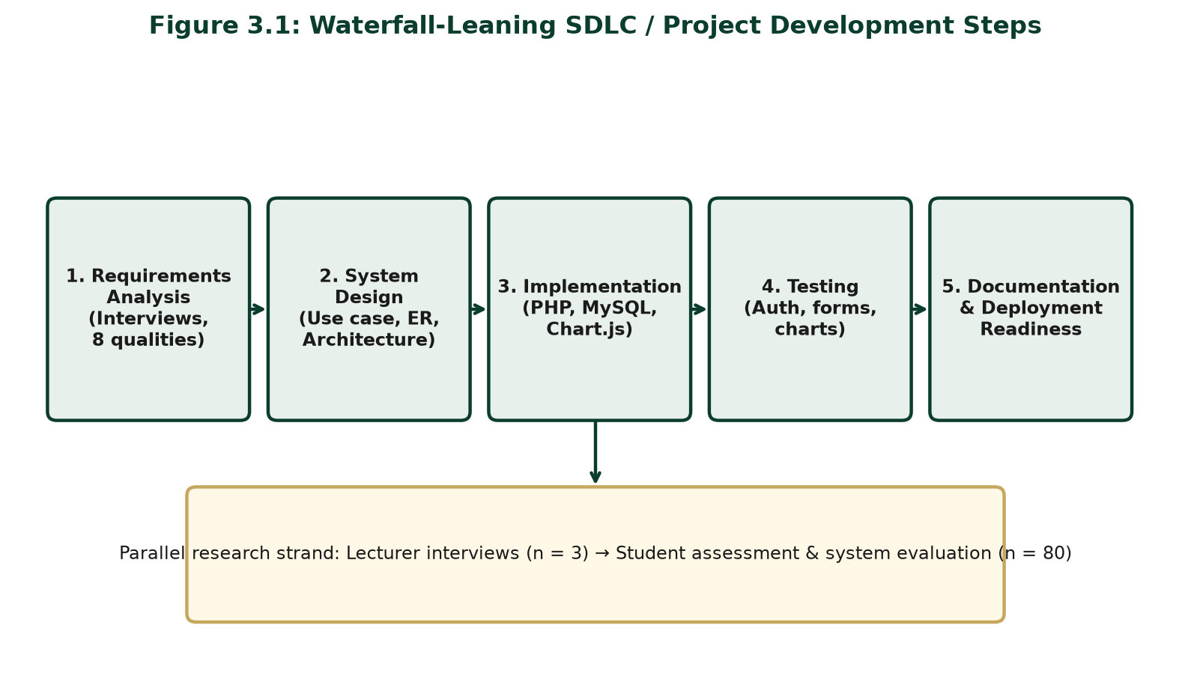
Figure 3.1: Waterfall-Leaning SDLC / Project Development Steps
3.2 Population of the Study
The population comprised: (1) Computer Science lecturers teaching undergraduate courses at UNN, who supplied assessment-quality ideas through a fifteen-quality questionnaire; and (2) undergraduate Computer Science students (100–400 levels), who rated lecturers and evaluated the portal. Lecturers anchored Objective One (eight qualities after screening fifteen down to the eight most selected). Students provided ratings and judged whether overview reduced reliance on informal rumour.
3.3 Sample Size and Sampling Technique
Lecturers. Purposive sampling selected ten (n = 10) active undergraduate teachers. Each lecturer completed a questionnaire listing fifteen assessment qualities. The eight qualities most frequently selected across the ten questionnaires were retained for the portal.
Students. Stratified sampling by level balanced fresher and older voices among undergraduates associated with the courses taught by the interviewed lecturers. Sample size used Taro Yamane (1967):
n = N / [1 + N(e)²]
With accessible population N = 100 and e = 0.05:
n = 100 / [1 + 100(0.05)²] = 100 / [1 + 0.25] = 100 / 1.25 = 80
Thus the planned student sample size was 80. Realised fieldwork figures are reported in Chapter Four.
3.4 Instrumentation
1. Lecturer Questionnaire (fifteen assessment qualities) — Objective 1 — Ten lecturers each completed a questionnaire listing fifteen assessment qualities, together with items on reputational misconception and acceptable feedback formats. The eight qualities most frequently selected across the ten questionnaires were retained as one eight-quality framework (Appendices). 2. Automated Student Assessment Form — Objective 2 — five-point Likert items on the eight compiled qualities plus optional comment. 3. System Evaluation Questionnaire — clarity, anonymity, chart usefulness, and mobile usability after portal use.
Table 3.1: System Development Tools and Technologies
Layer | Tools / Technologies
Frontend | HTML5, CSS3, JavaScript
Charts | Chart.js
Backend | PHP (mysqli, with PDO fallback for portability)
Database | MySQL
Local server stack | Apache under XAMPP
Security controls | password_hash/password_verify; sessions regenerated on login; prepared statements; CSRF tokens (cookie + form); rate limiting (5 attempts / 15-min lockout on login, register, forgot-password); single-use, 1-hour password-reset tokens; secure/HttpOnly/SameSite cookies; generic errors (no email enumeration); role-based access

Table 3.2: Major System Modules
Module | Primary users | Function
Authentication | All roles | Registration, login, logout; role-based access
Student profile / level | Students | Set and update current academic level (100–400)
Course enrolment | Students, admin | Student selects compulsory/elective courses offered for the semester
Assessment form | Students | End-of-semester rating of lecturers for selected courses only
Overview / charts | Students, lecturers | Aggregated bar and radar views
Lecturer profile | Students, lecturers | Dimensional teaching summary
Administration | Admin | Manage users, courses, lecturers, and enrolments
Password recovery | All roles | Request a reset link by email; set a new password via a single-use, time-limited token
System feedback | All authenticated users | Optional subject/message feedback about the portal (moderated by admin)

3.5 Validity and Reliability of Instrument
Face and content validity of the compiled eight-quality items, assessment form, and evaluation questionnaire were established through review by the supervisor, Dr. E. C. Ukekwe, and cross-checking against the interview notes. Items mapped one-to-one to the eight qualities synthesised from the separate oral interviews. Pilot testing refined wording (especially audibility versus communication). Cronbach’s Alpha ≥ 0.70 was accepted as adequate internal consistency for the multi-item student instruments.
3.6 Method of Data Collection
Phase One: conduct separate oral interviews with the three lecturers, taking notes in each session; then compile and combine the notes to identify the eight assessment qualities. Phase Two: build the portal from those requirements. Phase Three: students complete anonymous assessments. Phase Four: users complete the system evaluation questionnaire after viewing charts. Consent, voluntary participation, and anonymity of public aggregates were observed.
3.7 Method of Data Analysis
Oral interview notes from the three separate lecturer sessions were analysed thematically and then compiled into a single quality list. Recurring classroom behaviours named across sessions were retained; overlapping labels were merged; and the final set of eight qualities was fixed for the automated form. Quantitative student responses used frequencies, percentages, and means (1.00–2.49 Low; 2.50–3.49 Moderate; 3.50–5.00 High). Chapter Four hypothesis tests use Chi-square and ANOVA/mean-profile comparison at α = 0.05. Portal aggregates support the chart evidence.
3.7.1 Computation of Total Overview (Overall Lecturer Rating)
The Total Overview, or overall lecturer rating, is computed from student ratings in three steps.
Step 1 - Mean score per quality. For each of the eight qualities (interactiveness, audibility, lecture notes, class control, communication, punctuality, fairness, approachability), compute the mean of all student ratings given to that lecturer on that quality, using the 1-5 Likert scale:
Quality Mean = (sum of student ratings on the quality) / (number of raters)
Each quality mean is rounded to two decimal places.
Step 2 - Total Overview (overall rating). The overall lecturer rating is the simple average of the eight quality means:
Overall Rating = (sum of the eight quality means) / 8
The result is rounded to two decimal places.
Step 3 - Interpretation band. The overall rating is interpreted using the study's agreed bands: 1.00-2.49 = Low; 2.50-3.49 = Moderate; 3.50-5.00 = High.
The portal implements this computation from aggregated, anonymous assessment records and displays quality profiles dimensionally rather than reducing a lecturer to a single rank, consistent with the multidimensional SET position reviewed in Chapter Two.
3.8 Ethical Considerations
Participation was informed and voluntary. Public charts show aggregates only. Results are formative for orientation and improvement, not sole promotion criteria (Ani, 2020). Software controls (password hashing, session regeneration, prepared statements, CSRF tokens, rate limiting, single-use password-reset tokens, secure cookies, role separation) protect data and privacy.
3.9 System Analysis
3.9.1 Analysis of the Existing (As-Is) System
Existing lecturer overview is mainly informal—senior advice, hostel talk, and messaging groups. Administrative feedback, where present, is not a continuous student-facing dimensional chart tool. Stories stick across cohorts; confidentiality is weak; extreme anecdotes travel farther than multi-rater evidence. The failure mode is information asymmetry filled by high-reach, low-reliability narrative.
3.9.2 The Proposed (To-Be) System
The proposed authenticated portal—delivering Objective 3—follows a clear semester cycle. At the beginning of the semester, the administrator publishes compulsory and elective course offerings for each academic level and assigns the lecturer(s) taking each course. Logged-in students then select the courses they are offering for that semester (filtered by their stored academic level). At the end of the semester, students rate only the lecturers of those selected courses on the eight qualities. The system stores ratings anonymously for public view, recalculates means in MySQL, and updates Chart.js overview dashboards for students, lecturers, and administrators—so the next cohort can use the charts as preknowledge. The portal competes with rumour using multi-item scales and updateable aggregates (see Figure 3.6).
Table 3.3: Existing System versus Proposed System
Criterion | Existing (informal) | Proposed portal
Source of overview | Oral / senior rumour | Aggregated student ratings
Structure | Narrative, selective | Eight quality indicators
Updateability | Sticky; rarely revised | Recalculated from new submissions
Confidentiality | Weak / social exposure | Anonymous public aggregates
Speed of access | Uneven, person-dependent | On-demand dashboards
Visual summary | Absent | Chart.js bar and radar charts
Administrative use | Minimal / ad hoc | Role-based management modules

3.9.3 Justification of the Proposed System
The portal improves confidentiality, speed, updateability, and actionable preknowledge while protecting lecturers from single-story distortion through multi-rater aggregation.
3.10 System Design
3.10.1 Use Case Design
Actors are Student, Lecturer, and Admin. Core use cases: register/login; request and complete password recovery; update academic level and profile; enrol in courses; assess a lecturer of an enrolled course; view overview charts; view lecturer profiles; submit system feedback; view personal feedback dashboard (lecturer); manage users/courses/lecturers/enrolments (admin).

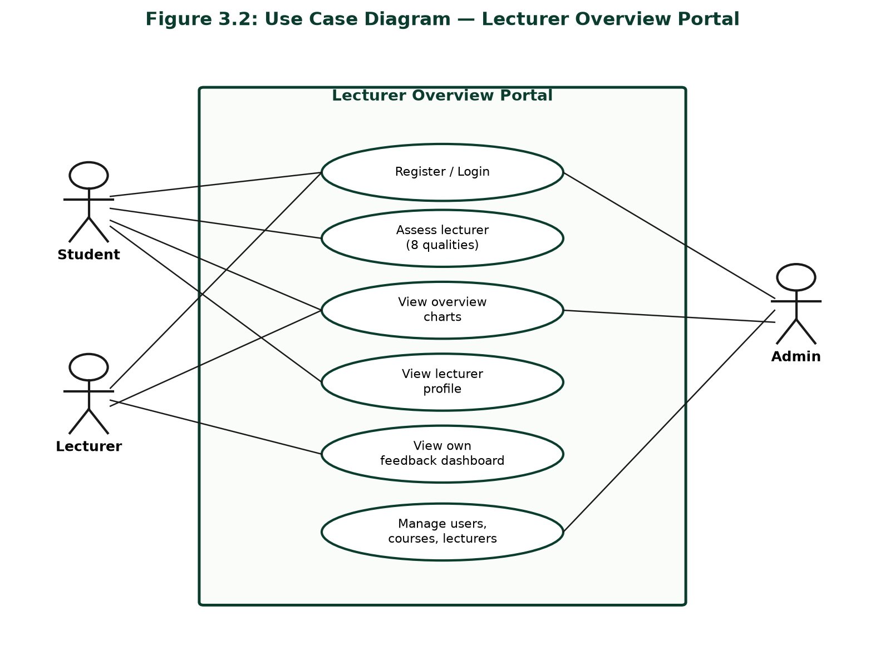
Figure 3.2: Use Case Diagram — Lecturer Overview Portal
3.10.2 Database / Entity-Relationship Design
Core entities: users (with academic_level for students), lecturers, courses (level, course_type compulsory/elective, semester, session), course_lecturers, student_enrollments, assessments, password_resets (single-use, time-limited recovery tokens), and system_feedback (optional portal feedback). Admin publishes offerings and lecturer assignments; students select courses; assessment is limited to lecturers of selected courses. Schema: portal/sql/schema.sql.

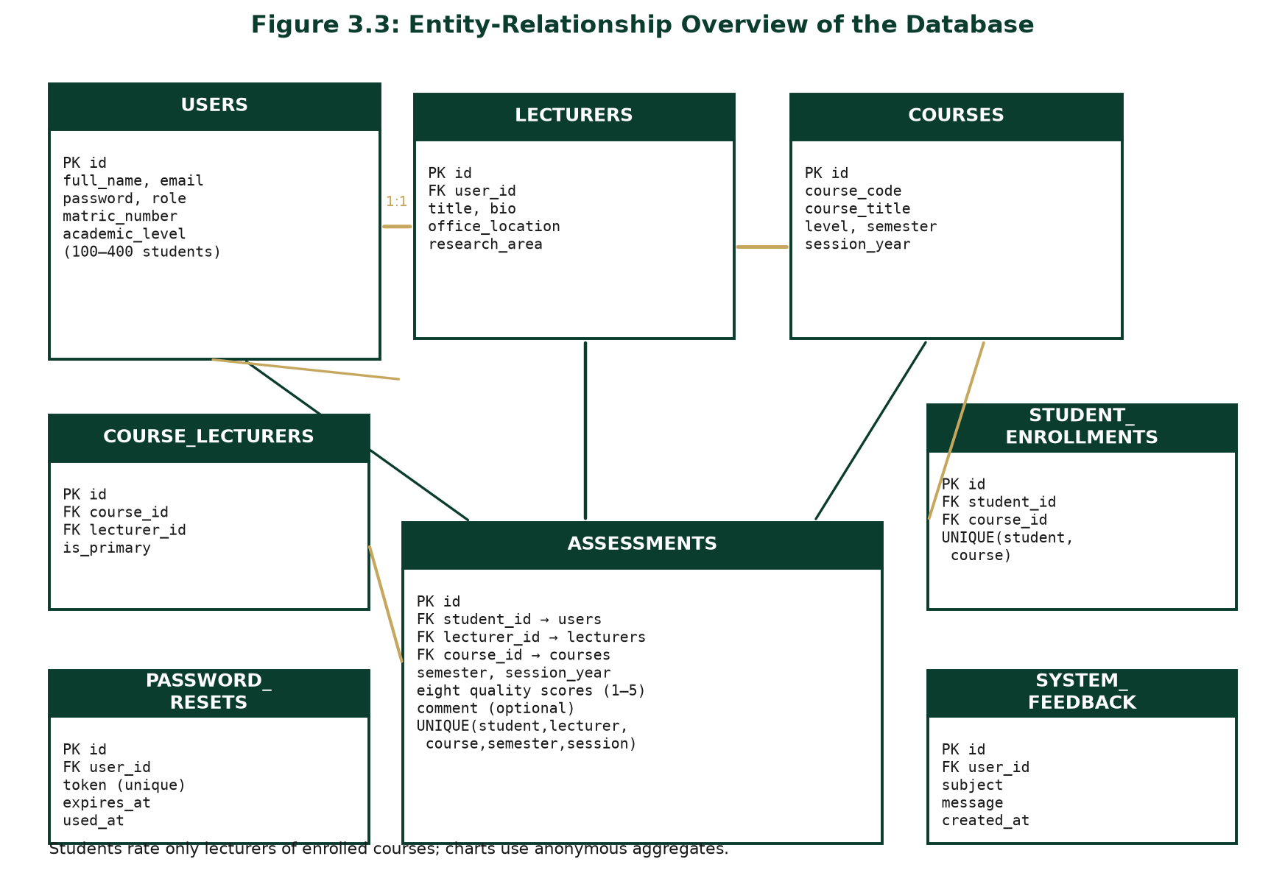
Figure 3.3: Entity-Relationship Overview of the Database
3.10.3 System Architecture
Three-tier design: browser (HTML/CSS/JS + Chart.js); PHP application on Apache/XAMPP; MySQL data store.

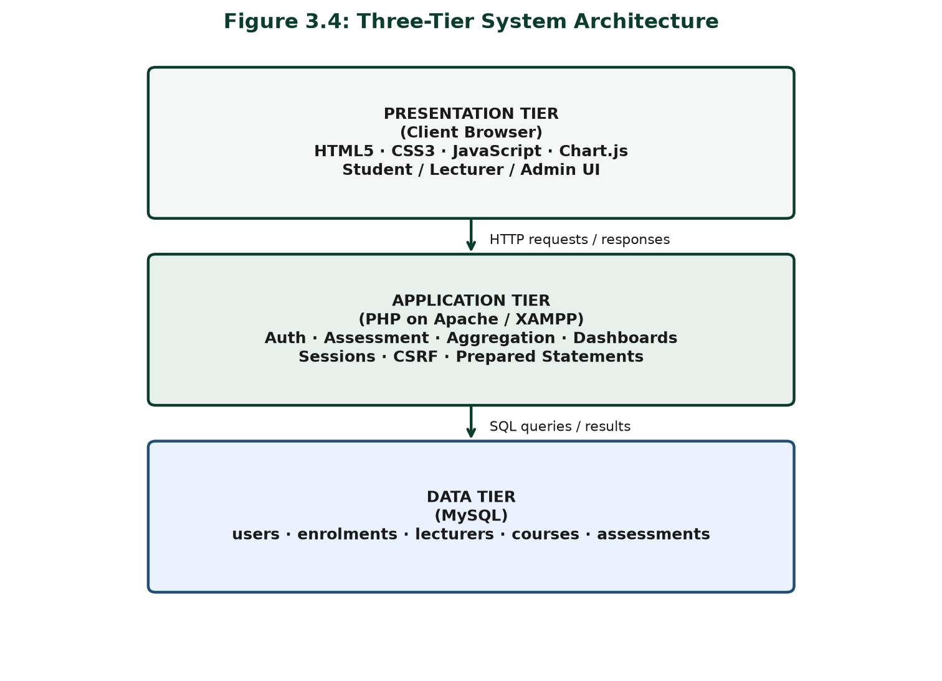
Figure 3.4: Three-Tier System Architecture
3.10.4 SDLC Stages Adopted
Figure 3.1 summarises requirements, design, implementation, testing, and documentation/deployment readiness.
3.10.5 Input and Output Design
Inputs: credentials; registration fields (including student matric number and academic level); course enrolment selections; Likert ratings (1–5) for enrolled lecturer–course pairs; optional comment; password-recovery request (email) and new password; system-feedback subject and message; admin create/update forms. Outputs: messages, profiles, bar/radar charts, dashboards, admin lists, password-reset confirmation, feedback acknowledgement. Aggregates are privileged over rater identity; interfaces support mobile use. Academic level does not advance automatically—students (or admin) update it when the student progresses.
3.10.6 Process / Control Flow
Authenticate → (start of semester) select courses offered from admin-published compulsory/elective list for the student’s level → (end of semester) select lecturer–course from those selections only → submit eight-quality form → validate session/CSRF/enrolment → store if unique → recompute means → render charts for overview (preknowledge for subsequent students).

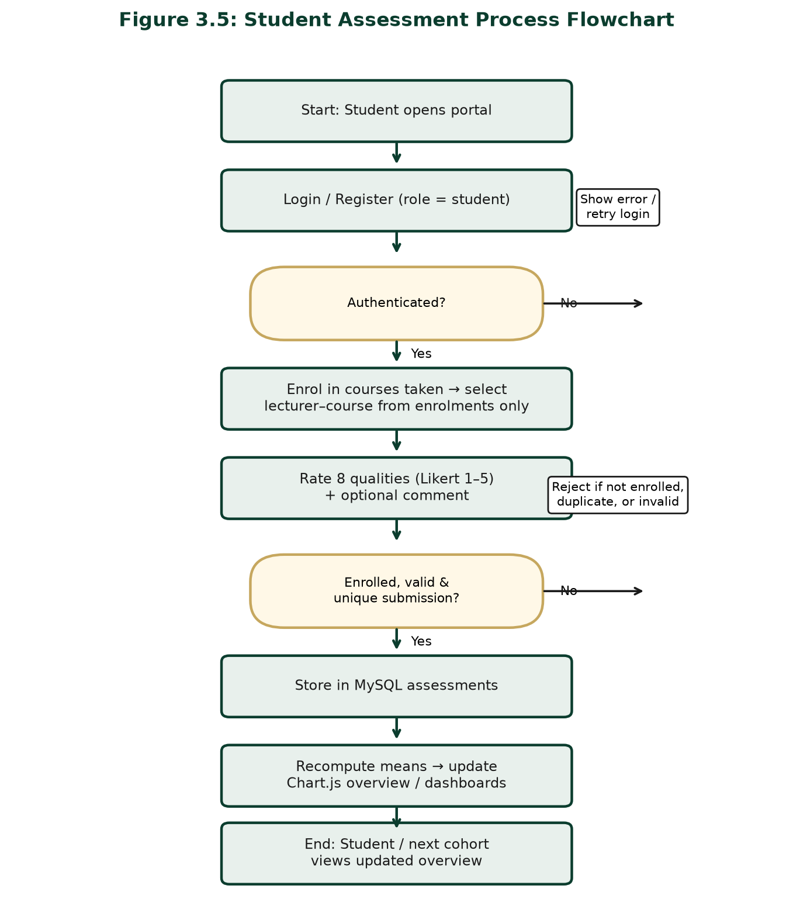
Figure 3.5: Student Assessment Process Flowchart
3.10.7 Security Design
Passwords use password_hash/password_verify; pages require role sessions (regenerated on login); SQL uses prepared statements; forms use CSRF tokens (cookie + hidden field); login/register/forgot-password are rate-limited (5 attempts, 15-minute lockout); password recovery uses single-use, 1-hour tokens; cookies are secure/HttpOnly/SameSite=Lax; generic errors prevent email enumeration; public views expose aggregates only.

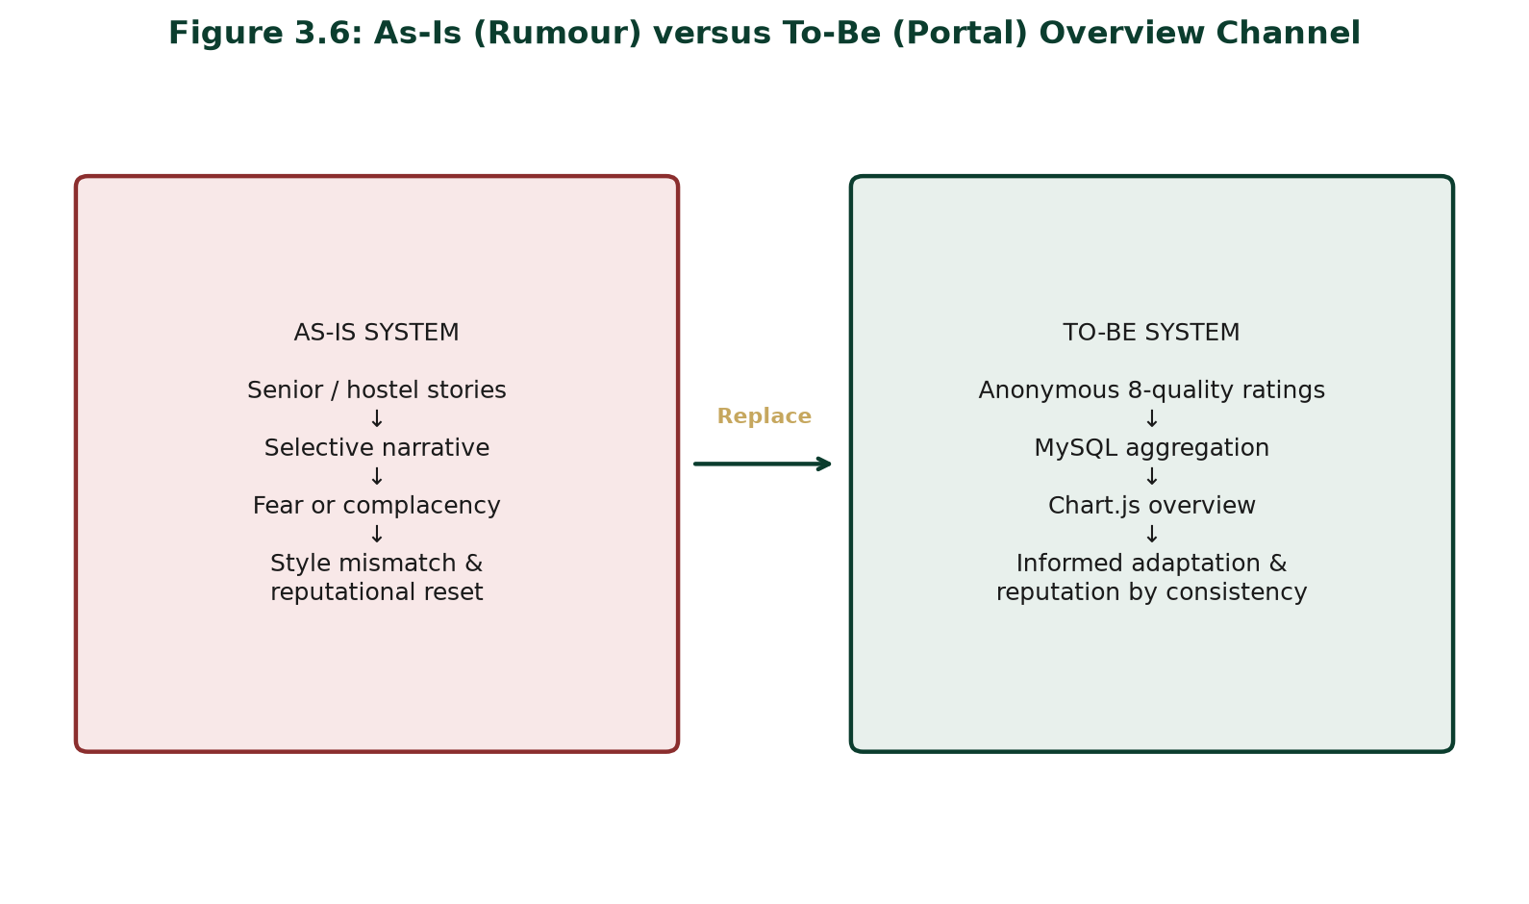
Figure 3.6: As-Is (Rumour) versus To-Be (Portal) Overview Channel
3.11 Summary of Methodology
The chapter combined lecturer questionnaires listing fifteen qualities administered to ten lecturers, from which the eight most selected were retained, stratified student sampling (Yamane n = 80), validated instruments, and waterfall-leaning SDLC development on PHP, MySQL, Chart.js, and XAMPP. As-is analysis showed rumour-dominated overview; the to-be portal provides anonymous, chart-driven preknowledge on eight teaching qualities, preparing Chapter Four’s implementation and evaluation.

REFERENCES
Adomi, E. E. (2007). Student expectations of faculty in a Nigerian LIS school. Library Philosophy and Practice (e-journal), Article 114. https://digitalcommons.unl.edu/libphilprac/114
Akerlof, G. A. (1970). The market for “lemons”: Quality uncertainty and the market mechanism. The Quarterly Journal of Economics, 84(3), 488–500. https://doi.org/10.2307/1879431
Amini, C. M. (2018). Analysis of students’ evaluation of teaching in Nigeria higher institutions of learning: Implications for improving quality of instructions. Benue State University Journal of Education, 18(1), 223–229.
Amuche, C. I., & Umar, M. H. (2019). Development and validation of lecturer teaching assessment scale for Nigerian universities. Journal of Education and Practice, 10(5). https://doi.org/10.7176/JEP/10-5-05
Ani, E. I. (2020). Responding to two arguments against the student evaluation of teaching scheme in Nigerian universities. African Journal of Educational Studies in Mathematics and Sciences, 16(1), 51–62. https://doi.org/10.4314/ajesms.v16i1.4
Archibong, I. A., & Nja, M. E. (2011). Towards improved teaching effectiveness in Nigerian public universities: Instrument design and validation. Higher Education Studies, 1(2), 78–91. https://doi.org/10.5539/hes.v1n2p78
Benton, S. L., & Cashin, W. E. (2011). Student ratings of teaching: A summary of research and literature (IDEA Paper No. 50). The IDEA Center. https://www.ideaedu.org/idea_papers/student-ratings-of-teaching-a-summary-of-research-and-literature/
Eccles, J. S., & Wigfield, A. (2002). Motivational beliefs, values, and goals. Annual Review of Psychology, 53, 109–132. https://doi.org/10.1146/annurev.psych.53.100901.135153
Hattie, J., & Timperley, H. (2007). The power of feedback. Review of Educational Research, 77(1), 81–112. https://doi.org/10.3102/003465430298487
Inko-Tariah, D. C. (2013). Attitude of lecturers towards student’s evaluation of their teaching effectiveness in Nigerian universities. Journal of Education and Practice, 4(15), 21–27.
Kindred, J., & Mohammed, S. N. (2005). “He will crush you like an academic ninja!”: Exploring teacher ratings on RateMyProfessors.com. Journal of Computer-Mediated Communication, 10(3), Article 9. https://doi.org/10.1111/j.1083-6101.2005.tb00257.x
Kluger, A. N., & DeNisi, A. (1996). The effects of feedback interventions on performance: A historical review, a meta-analysis, and a preliminary feedback intervention theory. Psychological Bulletin, 119(2), 254–284. https://doi.org/10.1037/0033-2909.119.2.254
Marsh, H. W. (1982). SEEQ: A reliable, valid, and useful instrument for collecting students’ evaluations of university teaching. British Journal of Educational Psychology, 52(1), 77–95. https://doi.org/10.1111/j.2044-8279.1982.tb02505.x
Onihunwa, J. O., Jeje, C. A., & Dada, O. S. (2020). Framework for development of a web based system for students’ appraisal on teaching performance of lecturers in Federal College of Wildlife Management, New Bussa, Niger State, Nigeria. International Journal of Computer Applications, 176(18), 27–33. https://doi.org/10.5120/ijca2020920020
Otto, J., Sanford, D. A., Jr., & Ross, D. N. (2008). Does RateMyProfessor.com really rate my professor? Assessment & Evaluation in Higher Education, 33(4), 355–368. https://doi.org/10.1080/02602930701293405
Pressman, R. S., & Maxim, B. R. (2015). Software engineering: A practitioner’s approach (8th ed.). McGraw-Hill Education.
Spooren, P., Brockx, B., & Mortelmans, D. (2013). On the validity of student evaluation of teaching: The state of the art. Review of Educational Research, 83(4), 598–642. https://doi.org/10.3102/0034654313496870
van der Lans, R. M., van de Grift, W. J. C. M., & van Veen, K. (2015). Developing a teacher evaluation instrument to provide formative feedback using student ratings of teaching acts. Educational Measurement: Issues and Practice, 34(3), 18–27. https://doi.org/10.1111/emip.12078
Yamane, T. (1967). Statistics: An introductory analysis (2nd ed.). Harper & Row.

