UNIT I
Introduction to Computer Networks: Need for Networking - Service Description –connectionless and Connection-Oriented Services – Circuit and Packet Switching – Access Networks and Physical Media – Wireless Links and Characteristics – Queuing Delay and Packet Loss – Internet Protocol stack – OSI Reference Model - Service Models – History of Computer Networking and the Internet.
COMPUTER NETWORK:

A computer network or data network is a telecommunications network which allows computers to exchange data. In computer networks, networked computing devices exchange data with each other along network links (data connections). The connections between nodes are established using either cable media or wireless media. The best-known computer network is the Internet.

NEED FOR NETWORKING:

- File sharing: A network makes it easy for everyone to access the same file and prevents people from accidentally creating different versions

- Printer sharing: With a network, several computers can share the same printer.

- Communication and collaboration: A network allows employees to share files, view other people's work, and exchange ideas more efficiently.

- Organization: A variety of scheduling software is available that makes it possible to arrange meetings without constantly checking everyone's schedules.

- Remote access: Having own network allows greater mobility while maintaining the same level of productivity.

- Data protection: A network makes it easier to back up all of our company's data on an offsite server, a set of tapes, CDs, or other backup systems.

Internet:

Internet is a global computer network providing a variety of information and communication facilities, consisting of interconnected networks using standardized communication protocols. It is also called as networks of networks.

ISO-OSI 7-LAYER NETWORK ARCHITECTURE

According to the ISO standards, networks have been divided into 7 layers depending on the complexity of the functionality each of these layers provide. The detailed description of each of these layers is given in the notes below. We will first list the layers as defined by the standard in the increasing order of function complexity:

Application Layer

Presentation Layer

Session Layer

Transport Layer

Network Layer

Data Link Layer

Physical Layer

Physical Layer

This layer is the lowest layer in the OSI model. It helps in the transmission of data between two machines that are communicating through a physical medium, which can be optical fibres, copper wire or wireless etc. The following are the main functions of the physical layer:

  - Hardware Specification: The details of the physical cables, network interface cards, wireless radios, etc are a part of this layer.

- Encoding and Signalling: How are the bits encoded in the medium is also decided by this layer. For example, on the coppar wire medium, we can use differnet voltage levels for a certain time interval to represent '0' and '1'. We may use +5mV for 1nsec to represent '1' and -5mV for 1nsec to represent '0'. All the issues of modulation is dealt with in this layer. eg, we may use Binary phase shift keying for the representation of '1' and '0' rather than using different volatage levels if we have to transfer in RF waves. For Example

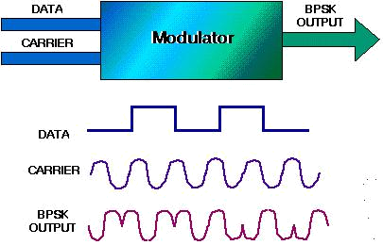

Binary Phase Shift Keying

- Data Transmission and Reception: The transfer of each bit of data is the responsibility of this layer. This layer assures the transmission of each bit with a high probability. The transmission of the bits is not completely reliable as there is no error correction in this layer.

- Topology and Network Design: The network design is the integral part of the physical layer. Which part of the network is the router going to be placed, where the switches will be used, where we will put the hubs, and how many machines is each switch going to handle, what server is going to be placed where, and many such concerns are to be taken care of by the physical layer.

Data Link Layer

This layer provides reliable transmission of a packet by using the services of the physical layer which transmits bits over the medium in an unreliable fashion. This layer is concerned with:

- Framing : Breaking input data into frames (typically a few hundred bytes) and caring about the frame boundaries and the size of each frame.

- Acknowledgment : Sent by the receiving end to inform the source that the frame was received without any error.

- Sequence Numbering : To acknowledge which frame was received.

- Error Detection : The frames may be damaged, lost or duplicated leading to errors. The error control is on link to link basis.

- Retransmission : The packet is retransmitted if the source fails to receive acknowledgment.

6. Flow Control : Necessary for a fast transmitter to keep pace with a slow receiver.
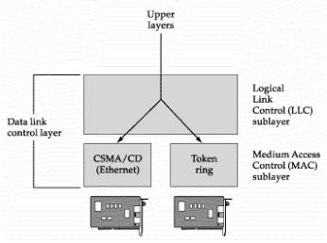

Data Link Layer

Network Layer

Its basic functions are routing and congestion control.

Routing: This deals with determining how packets will be routed (transferred) from source to destination. It can be of three types :

- Static : Routes are based on static tables that are "wired into" the network and are rarely changed.

- Dynamic : All packets of one application can follow different routes depending upon the topology of the network, the shortest path and the current network load.

- Semi-Dynamic : A route is chosen at the start of each conversation and then all the packets of the application follow the same route.

- Connection less service: Each packet of an application is treated as an independent entity. On each packet of the application the destination address is provided and the packet is routed.

- Connection oriented service: Here, first a connection is established and then all packets of the application follow the same route.

Congestion Control: A router can be connected to 4-5 networks. If all the networks send packet at the same time with maximum rate possible then the router may not be able to handle all the packets and may drop some/all packets. In this context the dropping of the packets should be minimized and the source whose packet was dropped should be informed. The control of such

congestion is also a function of the network layer. Other issues related with this layer are transmitting time, delays, jittering.

Internetworking: Internetworks are multiple networks that are connected in such a way that they act as one large network, connecting multiple office or department networks.

Internetworks are connected by networking hardware such as routers, switches, and bridges. Internetworking is a solution born of three networking problems: isolated LANs, duplication of resources, and the lack of a centralized network management system. With connected LANs, companies no longer have to duplicate programs or resources on each network. Network Layer does not guarantee that the packet will reach its intended destination. There are no reliability guarantees.

Transport Layer

Its functions are :

- Multiplexing / Demultiplexing : The transport layer may either create multiple network connections (to improve throughput) or it may multiplex several transport connections onto the same network connection (because creating and maintaining networks may be expensive). In the latter case, demultiplexing will be required at the receiving end. A point to note here is that communication is always carried out between two processes and not between two machines. This is also known as process-to-process communication.

- Fragmentation and Re-assembly: The data accepted by the transport layer from the session layer is split up into smaller units (fragmentation) if needed and then passed to the network layer. Correspondingly, the data provided by the network layer to the transport layer on the receiving side is re-assembled.

- Types of service : The transport layer also decides the type of service that should be provided to the session layer. The service may be perfectly reliable, or may be reliable within certain tolerances or may not be reliable at all. The message may or may not be received in the order in which it was sent.

- Error Control : If reliable service is provided then error detection and error recovery operations are also performed. It provides error control mechanism on end to end basis.

- Flow Control : A fast host cannot keep pace with a slow one. Hence, this is a mechanism to regulate the flow of information.

- Connection Establishment / Release : The transport layer also establishes and releases the connection across the network. This requires some sort of naming mechanism so that a process on one machine can indicate with whom it wants to communicate.

Session Layer

- It deals with the concept of Sessions i.e. when a user logins to a remote server he should be authenticated before getting access to the files and application programs.

- Another job of session layer is to establish and maintain sessions. If during the transfer of data between two machines the session breaks down, it is the session layer which re-establishes the connection.

- It also ensures that the data transfer starts from where it breaks keeping it transparent to the end user. e.g. In case of a session with a database server, this layer introduces check points at various places so that in case the connection is broken and reestablished, the transition running on the database is not lost even if the user has not committed. This activity is called Synchronization. Another function of this layer is Dialogue Control which determines whose turn is it to speak in a session. It is useful in video conferencing.

Presentation Layer

- This layer is concerned with the syntax and semantics of the information transmitted. In order to make it possible for computers with different data representations to communicate data structures to be exchanged can be defined in abstract way along with standard encoding.

- It also manages these abstract data structures and allows higher level of data structures to be defined an exchange. It encodes the data in standard agreed way (network format). This layer ensures that the data transmitted by one gets converted in the form compatible to other machine. Other functions include compression, encryption etc.

Application Layer

- The seventh layer contains the application protocols with which the user gains access to the network. The choice of which specific protocols and their associated functions are to be used at the application level is up to the individual user.

- Thus the boundary between the presentation layer and the application layer represents a separation of the protocols imposed by the network designers from those being selected and implemented by the network users. For example commonly used protocols are HTTP(for web browsing), FTP(for file transfer) etc.

INTERNET PROTOCOL STACK

The Internet stack consists of five layers: the physical, data link, network, transport, and application layers. Rather than use the cumbersome terminology n-PDU for each of the five layers, we instead give special names to the PDUs in four of the five layers: frame, datagram, segment, and message.

A protocol layer can be implemented in software, in hardware, or using a combination of the two. Application-layer protocols--such as HTTP and SMTP--are almost always implemented in software in the end systems; so are transport-layer protocols.

Because the physical layer and data link layers are responsible for handling communication over a specific link, they are typically implemented in a network interface card (for example,
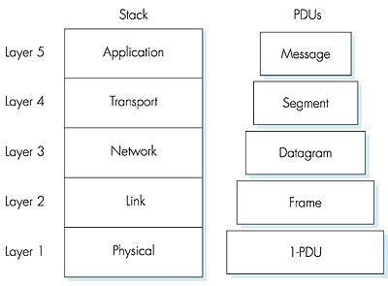

Fig: The Internet protocol stack, and protocol data units

Ethernet or ATM interface cards) associated with a given link. The network layer is often a mixed implementation of hardware and software. We now summarize the Internet layers and the services they provide:

Application Layer

The application layer is responsible for supporting network applications. The application layer includes many protocols, including HTTP to support the Web, SMTP to support electronic mail, and FTP to support file transfer.

Transport Layer

The transport layer provides the service of transporting application-layer messages between the client and server sides of an application. In the Internet there are two transport

protocols, TCP and UDP, either of which can transport application-layer messages. TCP provides a connection-oriented service to its applications. The UDP protocol provides its applications a connectionless service, which is very much a no-frills service.

Network Layer

The network layer is responsible for routing datagrams from one host to another. The Internet's network layer has two principle components. It has a protocol that defines the fields in the IP datagram as well as how the end systems and routers act on these fields. This protocol is the celebrated IP protocol.

Link Layer

The network layer routes a packet through a series of packet switches (called routers, in the Internet) between the source and destination. To move a packet from one node (host or packet switch) to the next node in the route, the network layer must rely on the services of the link layer.
Physical Layer

While the job of the link layer is to move entire frames from one network element to an adjacent network element, the job of the physical layer is to move the individual bits within the frame from one node to the next. The protocols in this layer are again link dependent, and further depend on the actual transmission medium of the link.

SERVICE DESCRIPTION

The Internet allows distributed applications running on its end systems to exchange data with each other. These applications include remote login, file transfer, electronic mail, audio and video streaming, real-time audio and video conferencing, distributed games and World Wide Web.

The internet provides two services to its distributed applications:

- Connection-oriented reliable service

- Connectionless unreliable service

Connection-oriented service guarantees that data transmitted from a sender to a receiver will eventually be delivered to the receiver in-order and in its entirety.

Connectionless service does not make any guarantees about eventual delivery. Typically, a distributed application makes use of one or the other of these two services and not both.

CONNECTION-ORIENTED SERVICES:

- The Internet's connection oriented service is also called as Transmission Control Protocol (TCP). It offers several other services, including reliable data transfer, flow control and congestion control.

- By reliable data transfer, we mean that an application can rely on the connection to deliver all of its data without error and in the proper order. Reliability in the Internet is achieved through the use of acknowledgments and retransmissions.

- Flow control makes sure that neither side of a connection overwhelms the other side by sending too many packets too fast.

- Congestion control service helps prevent the Internet from entering a state of grid lock. When a router becomes congested, its buffers can overflow and packet loss can occur. In such circumstances, if every pair of communicating end systems continues to pump packets into the network as fast as they can, gridlock sets in and few packets are delivered to their destinations.

Example:

The telephone system. When we pick up the phone, we have an open circuit, and the dial tone carrier signal allows us to connect to a destination of our choosing. Given valid input parameters, the service:

- Establishes the connection.

- Allow us to utilize the connection.

- Tears down the connection when we done using it.

CONNECTIONLESS SERVICES:

The internet connectionless service is also called as User Datagram Protocol (UDP). Here, there is no reliable data transfer, so a source never knows for sure which packets have arrived at the destination.

For Example, A good analogy for a connectionless service is the process of sending letters through the postal system. Each transmission (the "letter") contains the full destination address and is processed independent of related messages. As described above, the service has only to ensure that each reaches its host within certain time parameters. Unlike a connection-oriented service, the system has free reign on what happens enroute between the sender and receiver:
- A message can be delayed to ensure another arrives first.

- Widely different channels of communication can be used for transmitting messages.

- A message can be handed off to a trusted third party in the distribution network.

- A message can be intercepted by a third party, copied or logged, and passed on to the intended receiver.

Difference between Connection oriented and Connectionless:

Sl.no | Connection Oriented | Connection less
1. | Reliable data transmission | Not reliable data transmission
2. | All communications are take place on the same | All transmission are independently
 | transmission channel | routed and perhaps reassembled in some
 |  | order.
3. | Flow control is reduced | conjunction occurs
4. | It is cost effective when compared to | Less cost effective
 | connectionless
5. | Packet loss is little | More packet loss

CIRCUIT SWITCHING AND PACKET SWITCHING.

There are two fundamental approaches to building a network core:
- Circuit Switching and 2.Packet Switching.

CIRCUIT SWITCHING

In circuit-switched networks, the resources needed along a path (buffers, link bandwidth) to provide for communication between the end systems are reserved for the duration of the session. Example: public telephone network.

- In circuit switched networks, when one node wants to send information to another, it "calls" the other node. A circuit is then established between the two nodes. In traditional circuit switching, as with the telephone network, this circuit uses a fixed amount of bandwidth (digital or analog), regardless of whether data is being sent. This can be wasteful, but provides assurance that the entire bandwidth of the connection will be available at any time while it is open.

- Circuit switching has been around for a long time. The first telephone networks were circuit switched networks, even though human operators did the switching. As time marched on, mechanical, and then later, electronic machines did the switching.

- Modern circuit switching, such as with ATM, can vary the amount of bandwidth allocated to a circuit dynamically, so an idle circuit does not consume bandwidth. This provides the flexibility of circuit switching without the waste of bandwidth in idle circuits.

- Contrast packet switching, where there are no "connections", just individual packets with source and destination information that compete for available bandwidth.

Multiplexing in Circuit-Switched Networks

A circuit in a link is implemented with either Frequency division multiplexing (FDM) or

Time-division multiplexing (TDM).

- FDM
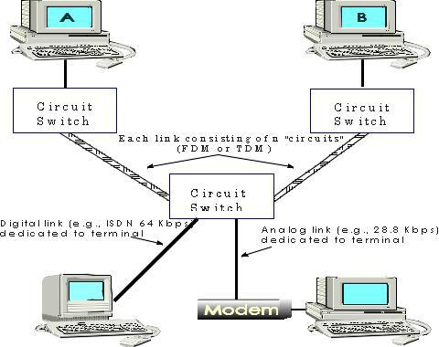

The frequency spectrum of a link is shared among the connections established across the link. For telephone network, the frequency band has a width of 4kHz. The width of the band is called bandwidth.FM radio stations also use FDM to share the frequency spectrum between 88MHz and 108 MHz.

2. TDM : The time is divided into frames of fixed duration and each frame is divided into a fixed number of time slots. Each circuit is assigned the same dedicated slot in the revolving TDM frames. Proponents of packet switching have always argued that circuit switching is wasteful because the dedicated circuits are idle during silent periods.

Figure 1.14 illustrates FDM and TDM for a specific network link supporting up to four circuits.

For FDM, the frequency domain is segmented into four bands, each of bandwidth 4 kHz.

For TDM, the time domain is segmented into frames, with four time slots in each frame; each circuit is assigned the same dedicated slot in the revolving TDM frames. For TDM, the transmission rate of a circuit is equal to the frame rate multiplied by the number of bits in a slot. For example, if the link transmits 8,000 frames per second and each slot consists of 8 bits, then the transmission rate of a circuit is 64 kbps.

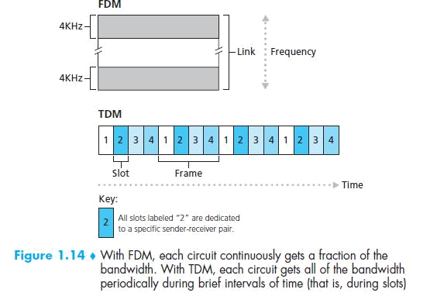

PACKET SWITCHING

Packet Switching is one of the most important technologies that led to the creation of the modern day internet. The resources are not reserved; a session’s messages use the resource on demand and as a consequence, may have to wait for access to a communication link.

Packet switching uses store-and-forward transmission. A packet is accumulated in a router's memory, then sent on to the next router. Datagram Switching is used for TCP/IP. Virtual Circuit Packet Switching is used for frame relays and X.25.

In a modern packet-switched network, the source host segments long messages into smaller packets and sends the smaller packets into the network; the receiver reassembles the packets back into the original message

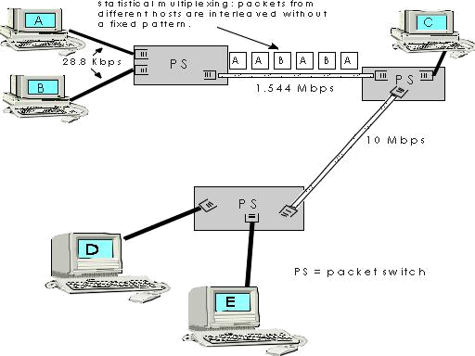

Internet makes best effect delivers the packet in a timely manner. They are two predominant types:

- Router

- Link layer switches

Packets are transmitted over each communication link at a rate equal to the full transmission rate of the link. Most packet switches use store-and-forward transmission at the inputs to the links. Store-and-forward transmission means that the packet switch must receive the entire packet before it can begin to transmit the first bit of the packet onto the outbound link.
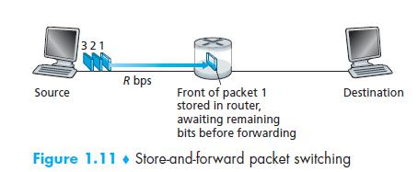

It suffers output buffer queuing delays.

Packet loss will occur- Either the arriving packet or One of the already-queued packets will be dropped.

COMPARISON WITH CIRCUIT AND PACKET SWITCHED NETWORKS

- Circuit switching requires that a circuit be set up end to end before communication begins. Packet switching does not require any advance setup. The first packet can just be sent as soon as it is available

- Packet switching is more fault tolerant than circuit switching

- Bandwidth is reserved in circuit switching, it can be sent out immediately over the reserved bandwidth. No bandwidth is reserved in packet, so packets may have to wait their turn to be forwarded.

- The bandwidth of that circuit is wasted. It cannot be used for other traffic. Packet switching does not waste bandwidth and thus is more efficient from a system-wide perspective.

- Packet switching uses store-and-forward transmission. With circuit switching, the bits just flow through the wire continuously.

- A final difference between circuit and packet switching is the charging algorithm. With circuit switching, charging has historically been based on distance and time. With packet switching, connect time is not an issue, but the volume of traffic sometimes is.
MESSAGE SWITCHING

In message switching, the message send into the network as a whole. Thus message switching is a specific kind of packet switching, whereby the packets traversing the network are themselves entire messages.

The below Figure illustrates message switching in a route consisting of two packet switches (PSs) and three links. With message switching, the message stays intact as it traverses the network. Because the switches are store-and-forward packet switches, a packet switch must receive the entire message before it can begin to forward the message on an outbound link
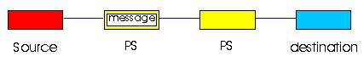

A simple message-switched network

Figure illustrates packet switching for the same network. In this example the original message has been divided into five distinct packets.

In Figure , the first packet has arrived at the destination, the second and third packets are in transit in the network, and the last two packets are still in the source. Again, because the switches are store-and-forward packet switches, a packet switch must receive an entire packet before it can begin to forward the packet on an outbound link.
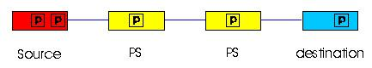

A simple packet-switched network

For example, One major advantage of packet switching (with segmented messages) is that it achieves end-to-end delays that are typically much smaller than the delays associated with message-switching. We illustrate this point with the following simple example. Consider a message that is 7.5 Mbits long. Suppose that between source and destination there are two packet switches and three links, and that each link has a transmission rate of 1.5Mbps. Assuming there is no congestion in the network, how much time is required to move the message from source to destination with message switching? It takes the source 5 seconds to move the message from the source to the first switch. Because the switches use store-and-forward, the first switch cannot begin to transmit any bits in the message onto the link until this first switch has received the entire message. Once the first switch has received the entire message, it takes 5 seconds to move the message from the first switch to the second switch. Thus it takes ten seconds to move the message from the source to the second switch. Following this logic we see that a total of 15 seconds is needed to move the message from source to destination. These delays are illustrated in Figure.

Figure : Timing of message transfer of a 7.5 Mbit message in a message-switched network
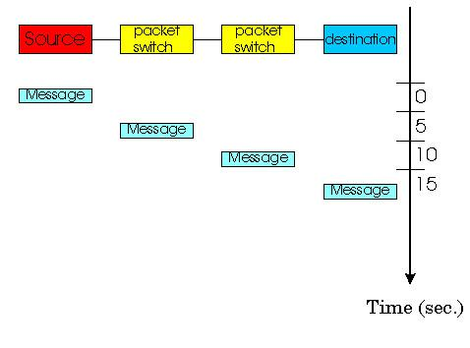

ACCESS NETWORKS AND PHYSICAL MEDIA

Cconsider the access network the physical links that connect an end system to its edge router, which the first router on a path from the end system to any other distant end system access networks. The access network technology is closely tied to physical media technology (fiber, coaxial pair, twisted pair telephone wire, radio spectrum).

Access Neetwork can be loosely classified into three categories:

- Residential access networks, connecting a home end system into the network;

- Institutional access networks, connecting an end system in a business or educational institution into the network;

3.Mobile access networks, connecting a mobile end system into the network
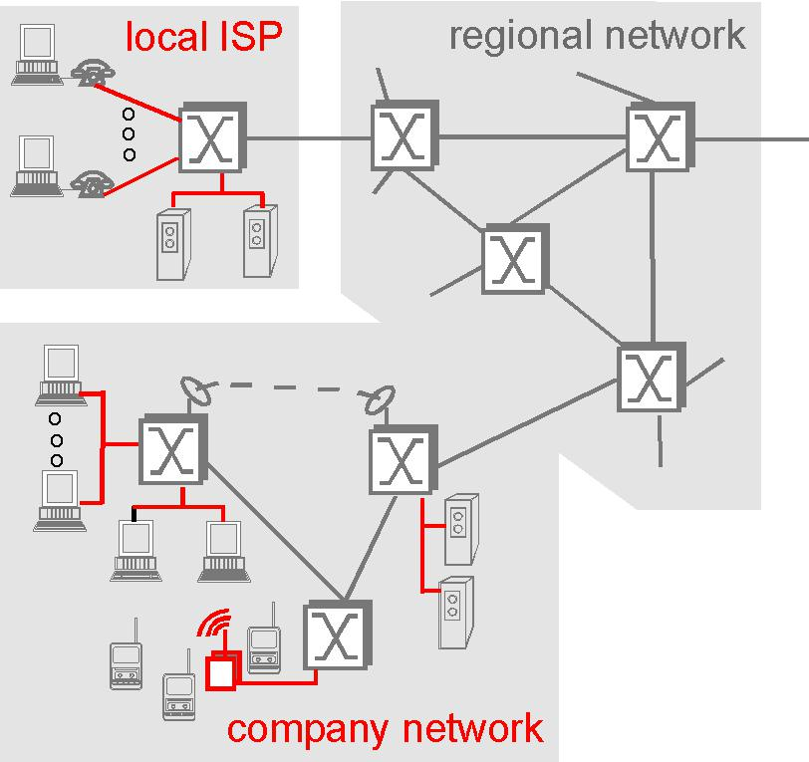

- Residential access

  - Connecting home end system into the network (PC,dial-up modem)

  - DSL is new modem technology running ovew existing twisted-pair telephone lines. This uses FDM It divides the communication link between the home and the ISP into three nonoverlapping frequency bands:

o High speed downstream channel, in the50KHz-1MHz band o Medium speed upstream channel in the 4kHz-50kHz band

  - Ordinary two-way telephone channel in the 0-4kHz band

- Dialup modems and narrowband ISDN are already widely deployed technologies. Two new technologies, Asymmetric Digital Subscriber Line (ADSL) and hybrid fiber coaxial cable (HFC) are currently being deployed.

- ADSL is conceptually similar to dialup modems: it is a new modem technology again running over existing twisted pair telephone lines, but can transmit at rates of up to about 8 Mbps from the ISP router to a home end system.

- One important characteristic of the HFC is that it is a shared broadcast medium. In particular, every packet sent by the headend travels downstream on every link to every home; and every packet sent by a home travels on the upstream channel to the headend
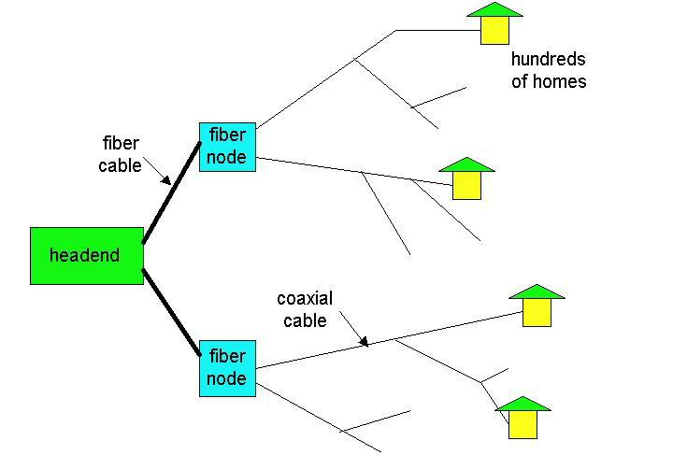

- Company Access or Enterprise Access Networks

Connecting end system in a business or educational institution into the network.Ethernet

operates at 10Mbps/100Mbps. It uses either twisted pair copper wire/ co-axial cable to connect a bumber of end system with other and with an edge router.

The edge router responsible for routing packets that have destinations outside of that LAN. Switched Ethernet uses multiple twisted-pair therent segments connected at a switch to allow the full transmission rate of an etherent to be deliverd to differenct users on the same

LAN simultaneously.

- Wireless Access or Mobile Access Networks

Mobile access networks use the radio spectrum to connect a mobile end system (e.g., a laptop PC or a PDA with a wireless modem) to a base station. This base station, in turn, is connected to an edge router of a data network.

There are two broad types of wireless internet access

- Wireless LAN(wireless transmit/receive packets to/from a base station withina few radius of a few tens of meters.)

- Wide area WLAN( the base statio is managed by a telecomunications provider nad serves user within a radius of tens of kilometers.)

PHYSICAL MEDIA

For each transmitter-receiver pair, the bit is sent by propagating electromagnetic waves across a physical medium. The physical medium can take many shapes and forms, and does not have to be of the same type for each transmitter-receiver pair along the path.

Twisted-pair copper wire, coaxial cable, multimode fiber optic cable, terrestrial radio spectrum and satellite radio spectrum are the example of physical medium.

Physical media fall into two categories:

- Guided media, the waves are guided along a solid medium, such as a fiber-optic cable, a twisted-pair cooper wire or a coaxial cable.

- Unguided media, the waves propagate in the atmosphere and in outer space, such as in a digital satellite channel or in a CDPD system.

Some Popular Physical Media : Twisted-Pair Copper Wire

- The least-expensive and most commonly-used transmission medium is twisted-pair copper wire. For over one-hundred years it has been used by telephone networks.

- In fact, more than 99% of the wired connections from the telephone handset to the local telephone switch use twisted-pair copper wire.

- Twisted pair consists of two insulated copper wires, each about 1 mm thick, arranged in a regular spiral pattern. The wires are twisted together to reduce the electrical interference from similar pairs close by.

- Typically, a number of pairs are bundled together in a cable by wrapping the pairs in a protective shield. A wire pair constitutes a single communication link.

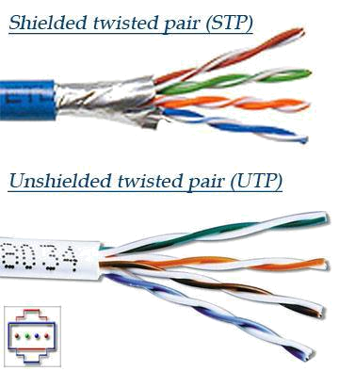

- Unshielded twisted pair (UTP) is commonly used for computer networks within a building, that is, for local area networks (LANs). Data rates for LANs using twisted pair today range from 10 Mbps to 100 Mbps.

- Two types of UTP are common in LANs

- Category 3 corresponds to voice-grade twisted pair, commonly found in office buildings. Office buildings are often prewired with two or more parallel pairs of category 3 twisted pair; one pair is used for telephone communication, and the additional pairs can be used for additional telephone lines or for LAN networking.

10 Mbps Ethernet, one of the most prevalent LAN types, can use category 3 UTP.

- Category 5, with its more twists per centimeter and Teflon insulation, can handle higher bit rates. 100 Mbps Ethernet running on category 5 UTP has become very popular in recent years. In recent years, category 5 UTP has become common for pre installation in new office buildings.

Coaxial-Cable

- Like twisted pair, coaxial cable consists of two copper conductors, but the two conductors are concentric rather than parallel. With this construction and a special insulation and shielding, coaxial cable can have higher bit rates than twisted pair.

- Coaxial cable comes in two varieties:

- Baseband coaxial cable, also called 50-ohm cable, is about a centimeter thick, lightweight, and easy to bend. It is commonly used in LANs;

- Broadband coaxial cable, also called 75-ohm cable, is quite a bit thicker, heavier, and stiffer than the baseband variety. Broadband cable, however, is quite common
in cable television systems.

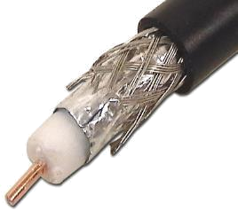

- Both baseband and broadband coaxial cable can be used as a guided shared medium. Specifically, a number of end systems can be connected directly to the cable, and all the end systems receive whatever any one of the computers transmits.

Fiber Optics

- An optical fiber is a thin, flexible medium that conducts pulses of light, with each pulse representing a bit.

- A single optical fiber can support tremendous bit rates, up to tens or even hundreds of gigabits per second. They are immune to electromagnetic interference, have very low signal attenuation up to 100 kilometers, and are very hard to tap.

- Fiber optics is also prevalent in the backbone of the Internet. However, the high cost of optical devices -- such as transmitters, receivers, and switches -- has hindered their deployment for short-haul transport, such as in a LAN or into the home in a residential access network. AT&T Labs provides an excellent site on fiber optics, including several nice animations.
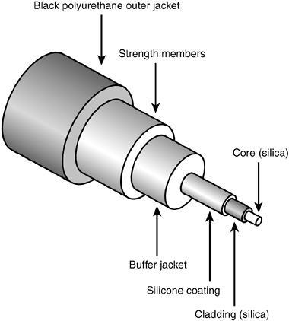

Terrestrial Radio Channels

- Radio channels carry signals in the electromagnetic spectrum. They are an attractive media because require no physical "wire" to be installed, can penetrate walls, provide connectivity to a mobile user, and can potentially carry a signal for long distances.

- The characteristics a radio channel depend significantly on the propagation environment and the distance over which a signal is to be carried.
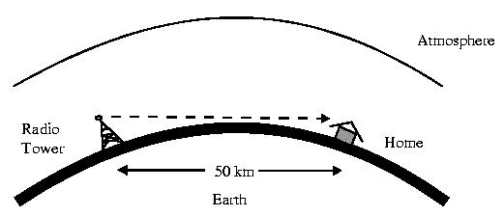

- Environmental considerations determine path loss and shadow fading (which decrease in signal strength as it travels over a distance and around/through obstructing objects), multipath fading (due to signal reflection off of interfering objects), and interference (due to other radio channels or electromagnetic signals).

- Terrestrial radio channels can be broadly classified into two groups: those that operate as local area networks (typically spanning 10's to a few hundred meters) and wide-area radio channels that are used for mobile data services (typically operating within a metropolitan region).

- A number of wireless LAN products are on the market, operating in the 1 to 10's of Mbps range. Mobile data services (such as the CDPD standard we touched on in section 1.3), typically provide channels that operate at 10's of Kbps.
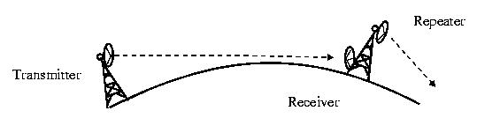

Satellite Radio Channels

- A communication satellite links two or more earth-based microwave transmitter/receivers, known as ground stations. The satellite receives transmissions on one frequency band, regenerates the signal using a repeater, and transmits the signal on another frequency. Satellites can provide bandwidths in the gigabit per second range.

Two types of satellites are used in communications:
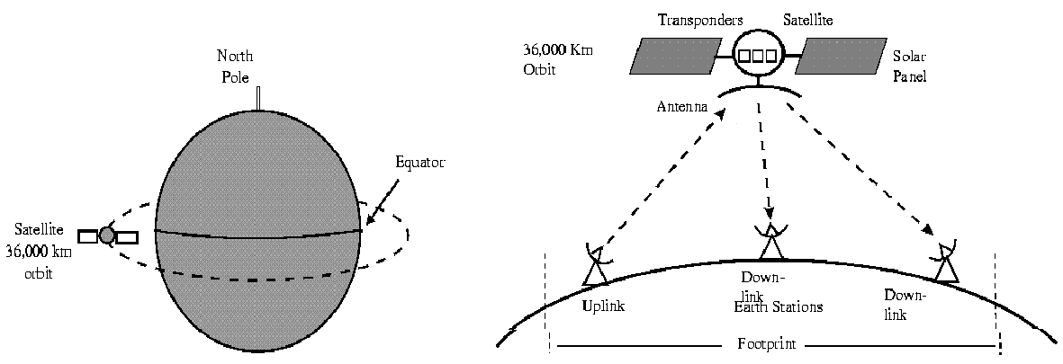

Geostationary satellites permanently remain above the same spot on the Earth. This stationary presence is achieved by placing the satellite in orbit at 36,000 kilometers above the Earth's surface. This huge distance between from ground station though satellite back to ground station introduces a substantial signal propagation delay of 250 milliseconds. Nevertheless, satellites links are often used in telephone networks and in the backbone of the Internet.

- Low-altitude satellites are placed much closer to the Earth and do not remain permanently above one spot on the Earth. They rotate around the Earth just as the Moon rotates around the Earth. To provide continuous coverage to an area, many satellites to be placed in orbit. The Iridium system, for example, consists of 66 low-altitude satellites. Lloyd's satellite constellations provides and collects information on Iridium as well as other satellite constellation systems. The low-altitude satellite technology may be used for Internet access sometime in the future.

Delay and Loss in Packet-Switched Networks:

As a packet travels from one node (host or router) to the subsequent node (host or router) along this path, the packet suffers from several different types of delays at each node along the path. The most important of these delays are the nodal processing delay, queuing delay, transmission delay and propagation delay; together, these delays accumulate to give a total nodal delay.
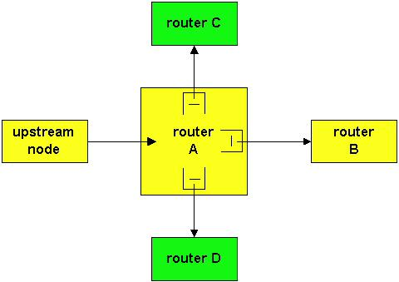

The delay through router A

Let us explore these delays in the context of above Figure. As part of its end-to-end route between source and destination, a packet is sent from the upstream node through router, A, to router B. Our goal is to characterize the nodal delay at router A. Note that router A has three outbound link , one leading to router B, another leading to router C, and yet another leading to router D. Each link is preceded a queue (also known as a buffer). When the packet arrives at router A (from the upstream node), router A examines the packet's header to determine the appropriate outbound link for the packet, and then directs the packet to the link. In this example, the outbound link for the packet is the one that leads to router B.

A packet can only be transmitted on a link if there is no other packet currently being transmitted on the link and if there are no other packets preceding it in the queue; if the link is currently busy

or if there are other packets already queued for the link, the newly arriving packet will then join the queue

TYPES OF DELAY

Nodal Processing Delay:

- The time required to examine the packet's header and determine where to direct the packet is part of the processing delay. The processing delay can also include other factors, such as the time needed to check for bit-level errors in the packet that occurred in transmitting the packet's bits from the upstream router to router A. After this nodal processing, the router directs the packet to the queue that precedes the link to router B.

Queuing Delay

- At the queue, the packet experiences a queuing delay as it waits to be transmitted onto the link. The queuing delay of a specific packet will depend on the number of other, earlier-arriving packets that are queued and waiting for transmission across the link; the delay of a given packet can vary significantly from packet to packet.

- If the queue is empty and no other packet is currently being transmitted, then our packet's queuing delay is zero. On the other hand, if the traffic is heavy and many other packets are also waiting to be transmitted, the queuing delay will be long.

Transmission Delay

- Assuming that packets are transmitted in first-come-first-serve manner, as is common in the Internet, our packet can be transmitted once all the packets that have arrived before it have been transmitted.

- Denote the length of the packet by L bits and denote the transmission rate of the link (from router A to router B) by R bits/sec. The rate R is determined by transmission rate of the link to router B. For example, for a 10 Mbps Ethernet link, the rate is R=10 Mbps; for a 100 Mbps Ethernet link, the rate is R=100 Mbps.

- The transmission delay (also called the store-and-forward delay) is L/R. This is the amount of time required to transmit all of the packet's bits into the link.

Propagation Delay

- Once a bit is pushed onto the link, it needs to propagate to router B. The time required to propagate from the beginning of the link to router B is the propagation delay. The bit propagates at the propagation speed of the link. The propagation speed

MVIT/IT DEPT/2016-17/III YEAR/VI SEM/COMPUTER NETWORKS/UNIT-1 –part-B -QA

depends on the physical medium of the link (i.e., multimode fiber,twisted-pair copper wire, etc.) and is in the range of equal to, or a little less than, the speed of light.
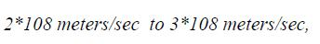

- The propagation delay is the distance between two routers divided by the propagation speed. That is, the propagation delay is d/s, where d is the distance between router A and router B and s is the propagation speed of the link.

- Once the last bit of the packet propagates to node B, it and all the preceding bits of the packet are stored in router B. The whole process then continues with router B now performing the forwarding.

An analogy might clarify the notions of transmission and propagation delay. Consider a highway which has a toll booth every 100 kilometers. You can think of the highway segments between toll booths as links and the toll booths as routers. Suppose that cars travel (i.e., propagate) on the highway at a rate of 100 km/hour (i.e., when a car leaves a toll booth it instantaneously accelerates to 100 km/hour and maintains that speed between toll booths). Suppose that there is a caravan of 10 cars that are traveling together, and that these ten cars follow each other in a fixed order. You can think of each car as a bit and the caravan as a packet. Also suppose that each toll booth services (i.e., transmits) a car at a rate of one car per 12 seconds, and that it is late at night so that the caravan's cars are only cars on the highway.

Finally, suppose that whenever the first car of the caravan arrives at a toll booth, it waits at the entrance until the nine other cars have arrived and lined up behind it. (Thus the entire caravan must be "stored" at the toll booth before it can begin to be "forwarded".) The time required for the toll booth to push the entire caravan onto the highway is 10/(5 cars/minute) = 2 minutes. This time is analogous to the transmission delay in a router. The time required for a car to travel from the exit of one toll booth to the next toll booth is 100 Km/(100 km/hour) = 1 hour. This time is analogous to propagation delay.

Therefore the time from when the caravan is "stored" in front of a toll booth until the caravan is "stored" in front of the next toll booth is the sum of "transmission delay" and "the propagation delay" - in this example, 62 minutes. Let's explore this analogy a bit more. What would happen if the toll-booth service time for a caravan were greater than the time for a car to travel between toll

booths? For example, suppose cars travel at rate 1000 km/hr and the toll booth services cars at rate one car per minute. Then the traveling delay between toll booths is 6 minutes and the time to serve a caravan is 10 minutes. In this case, the first few cars in the caravan will arrive at the second toll booth before the last cars in caravan leave the first toll booth. This situation also arises in packet-switched networks - the first bits in a packet can arrive at a router while many of the remaining bits in the packet are still waiting to be transmitted by the preceding router.

If we let dproc, dqueue, dtrans and dprop denote the processing, queuing, transmission and propagation delays, then the total nodal delay is given by

dnodal = dproc + dqueue + dtrans + dprop .

QUEUING DELAY

- In telecommunication and computer engineering, the queuing delay (or queueing delay) is the time a job waits in a queue until it can be executed. It is a key component of network delay. This term is most often used in reference to routers.

- The maximum queuing delay is proportional to buffer size. The longer the line of packets waiting to be transmitted, the longer the average waiting time is.

- During network congestion, queuing delays can be considered infinite when the packet is dropped. The retransmission of such packets causes significant overall delay because all forms of delay will be incurred more than once.

- If the network congestion continues, the packet may be dropped many times.

- When is the queuing delay big and when is it insignificant? The answer to this question depends largely on the rate at which traffic arrives to the queue, the transmission rate of the link, and the nature of the arriving traffic, i.e., whether the traffic arrives periodically or whether it arrives in bursts. To gain some insight here, let a denote the average rate at which packets arrive to the queue (a is units of packets/sec). Recall that R is the transmission rate, i.e., it is the rate (in bits/sec) at which bits are pushed out of the queue. Also suppose, for simplicity, that all packets consist of L bits. Then the average rate at which bits arrive to the queue is La bits/sec.

- If the queue is very big, so that it can hold essentially an infinite number of bits. The ratio La/R is called traffic intensity, often plays an important role in estimating the extent of queuing delay

- If La/R>1, then the average rate at which bits arrive at the queue exceeds the rate at which the bits can be transmitted from the queue.
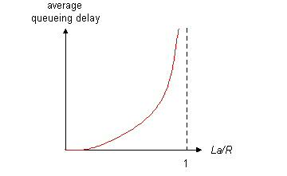

- In this unfortunate situation, the queue will tend to increase without bound and the queuing delay will approach infinity! Therefore, one of the golden rules in traffic engineering is: design your system so that the traffic intensity is no greater than one.

- Now consider the case La/R =< 1. Here, the nature of the arriving traffic impacts the queuing delay.

Packet Loss:

Packet loss occurs when one or more packets of data travelling across a computer network fail to reach their destination. Packet loss is distinguished as one of the three main error types encountered in digital communications; the other two being bit error and spurious packets caused due to noise.

End-to-End Delay

Delay occurs at a single router. If the network is uncongested(so that queuing are negligible),

- the processing delay at each router and at the source host is dproc,

- the transmission rate out of each router and out of the source host is R bits/sec,

- and the progation on each link is dprop

The nodal delays accumulate and give an end-to-end delay:

dend-end= N(dproc+dtrans+dproc)

WIRELESS LINKS AND CHARACTERISTICS

The following elements are identified in a wireless network:

- Wireless hosts. As in the case of wired networks, hosts are the end-system devices that run applications. A wireless host might be a laptop, palmtop, smartphone, or desktop computer. The hosts themselves may or may not be mobile.

Wireless links: A host connects to a base station (defined below) or to another wireless host through a wireless communication link. Different wireless link technologies have different transmission rates and can transmit over different distances.

Base station. The base station is a key part of the wireless network infrastructure. Unlike the wireless host and wireless link, a base station has no obvious counterpart in a wired network. Abase station is responsible for sending and receiving data (e.g., packets) to and from a wireless host that is associated with that base station.

In Figure 6.1, the base station is connected to the larger network (e.g., the Internet, corporate or home network, or telephone network), thus functioning as a link-layer relay between the wireless host and the rest of the world with which the host communicates.

Hosts associated with a base station are often referred to as operating in infrastructure mode, since all traditional network services (e.g., address assignment and routing) are provided by the network to which a host is connected via the base station.

In ad hoc networks, wireless hosts have no such infrastructure with which to connect. In the absence of such infrastructure, the hosts themselves must provide for services such as routing, address assignment, DNS-like name translation, and more.

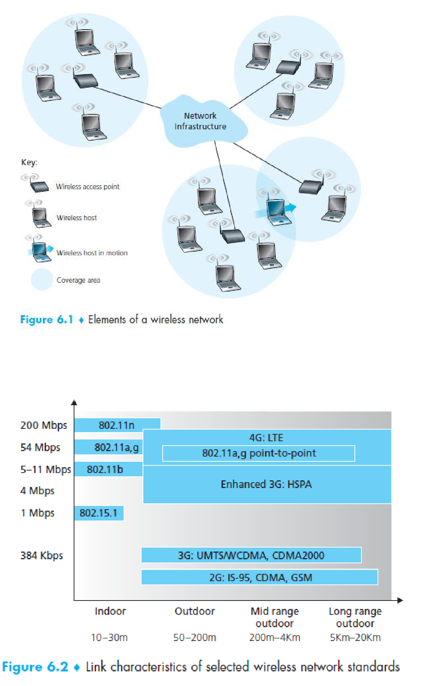

A number of important differences between a wired link and a wireless link:

Decreasing signal strength. Electromagnetic radiation attenuates as it passes through matter (e.g., a radio signal passing through a wall). Even in free space, the signal will disperse, resulting in decreased signal strength (sometimes referred to as path loss) as the distance between sender and receiver increases.

Interference from other sources. Radio sources transmitting in the same frequency band will interfere with each other. For example, 2.4 GHz wireless phones and 802.11b wireless LANs transmit in the same frequency band. Thus, the 802.11b wireless LAN user talking on a 2.4 GHz wireless phone can expect that neither the network nor the phone will perform particularly well. In addition to interference from transmitting sources, electromagnetic noise within the environment (e.g., a nearby motor, a microwave) can result in interference

Multipath propagation. Multipath propagation occurs when portions of the electromagnetic wave reflect off objects and the ground, taking paths of different lengths between a sender and receiver. This results in the blurring of the received signal at the receiver. Moving objects between the sender and receiver can cause multipath propagation to change over time.

For a detailed discussion of wireless channel characteristics, models, and measurements, the discussion above suggests that bit errors will be more common in wireless links than in wired links.

Having considered the impairments that can occur on a wireless channel, let’s next turn our attention to the host receiving the wireless signal. This host receives an electromagnetic signal that is a combination of a degraded form of the original signal transmitted by the sender (degraded due to the attenuation and multipath propagation effects that we discussed above, among others) and background noise in the environment.

The signal-to-noise ratio (SNR) is a relative measure of the strength of the received signal (i.e., the information being transmitted) and this noise. The SNR is typically measured in units of decibels (dB), a unit of measure that some think is used by electrical engineers primarily to confuse computer scientists.

Figure shows the bit error rate (BER)— roughly speaking, the probability that a transmitted bit is received in error at the receiver—versus the SNR for three different modulation techniques for encoding information for transmission on an idealized wireless channel.

Figure illustrates several physical-layer characteristics that are important in understanding higher-layer wireless communication protocols:

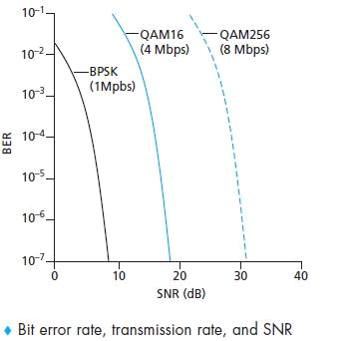

For a given modulation scheme, the higher the SNR, the lower the BER. Since a sender can increase the SNR by increasing its transmission power, a sender can decrease the probability that a frame is received in error by increasing its transmission power.

For a given SNR, a modulation technique with a higher bit transmission rate (whether in error or not) will have a higher BER.

Dynamic selection of the physical-layer modulation technique can be used to adapt the modulation technique to channel conditions

A higher and time-varying bit error rate is not the only difference between a wired and wireless link. Recall that in the case of wired broadcast links, all nodes receive the transmissions from all other nodes.

Hidden terminal problem:

In the first scenario that Station A is transmitting to Station B. Suppose also that Station C is transmitting to Station B. With the so called hidden terminal problem, physical obstructions in the environment (for example, a mountain or a building) may prevent A and C from hearing each other’s transmissions, even though A’s and C’s transmissions are indeed interfering at the destination, B. (Figure (a))

A second scenario that results in undetectable collisions at the receiver results from the fading of a signal’s strength as it propagates through the wireless medium. Figure (b) illustrates the case where A and C are placed such that their signals are not strong enough to detect each other’s transmissions, yet their signals are strong enough to interfere with each other at station B.

