UNIT-III

Transport Layer: Transport Layer Services – Multiplexing and Demultiplexing – UDP –

Reliable Data Transfer – Go-Back-N and Selective Repeat. Connection-Oriented Transport: TCP

– Segment Structure – RTT estimation – Flow Control – Connection Management – Congestion Control – TCP Delay Modeling – SSL and TLS. Integrated and Differentiated Services: Intserv –

Diffserv.

1. | Describe the selective repeat protocol. | Apr 2012
2. | Describe the major components of TCP congestion control algorithm. Apr 2012
3. | Explain sliding window protocol with example. | Nov 2011
4. | Explain the functions of Transport Layer. | Nov 2011
5. | Explain about TCP protocol. | Nov 2009
6. | Explain about UDP. | Nov 2009

- Explain about multiplexing and demultiplexing.

- Describe GO-BACK-N protocol.

- Explain the following connection-oriented transport

- TCP segment structure

- RTT estimation

- Flow control

- Describe in detail about TCP connection management and delay modeling.

- Explain in detail about SSL and TLS.

- Describe about Integrated and Differentiated Services.

TRANSPORT LAYER

The transport layer is in the core of the layered network architecture. It has the critical

role of providing communication services directly to the application processes running on

different hosts. Two distinct transport-layer protocols are available to the application layer.

One of these protocols is UDP (User Datagram Protocol), which provides an unreliable,

connectionless service to the invoking application.

The second of these protocols is TCP (Transmission Control Protocol), which provides a

reliable, connection-oriented service to the invoking application. When designing a network

application, the application developer must specify one of these two transport protocols.

Extending host-to-host delivery to process-to-process delivery is called application

multiplexing and demultiplexing.

TRANSPORT LAYER SERVICES

- A transport layer protocol provides for logical communication between application processes running on different hosts. Application processes use the logical communication provided by the transport layer to send messages to each other, free for the worry of the details of the physical infrastructure used to carry these messages.

- Transport layer protocols are implemented in the end systems but not in network routers.

- At the sending side, the transport layer converts the messages it receives from a sending application process into packets(segments). This is done by (possibly) breaking the application messages into smaller chunks and adding a transport-layer header to each chunk to create transport layer segment. The transport layer then passes the segment to the network layer, where each is encapsulated into a 3-PDU.

- At the receiving side, the transport layer receives the 4-PDUs from the network layer, removes the transport header from the 4-PDUs, reassembles the messages and passes them to a receiving application process.
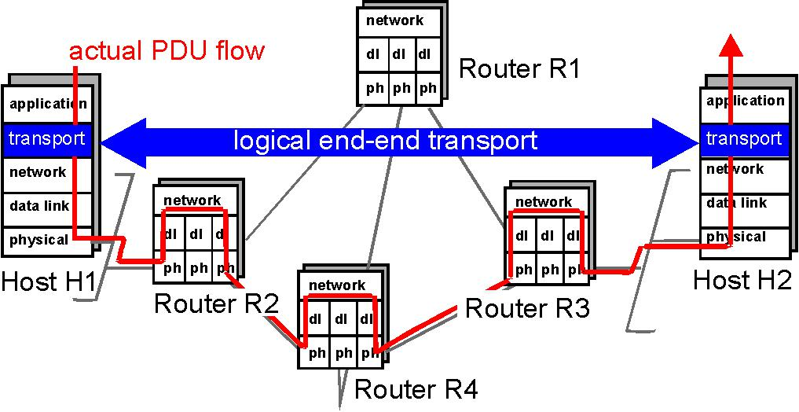

Figure 3.1-1: The transport layer provides logical rather than physical communication between applications.

TCP provides services:

Reliable data transfer: Using flow control, sequence numbers, acknowledgments and timers, TCP's guarantee of reliable data transfer ensures that data is delivered from sending process to receiving process, correctly and in order.

Congestion control: TCP congestion control prevents any one TCP connection from swamping the links and switches between communicating hosts with an excessive amount of traffic.

UDP provides:

Unreliable Data Transfer it does not guarantee data sent by one process will arrive in tact to the destination process.

MULTIPLEXING AND DEMULTIPLEXING

The transport layer has the responsibility of delivering the data in these segments to the appropriate application process running in the host.

A process can have one or more sockets, doors through which the data passes from the network to the process and from the process to the network.

The transport layer in the receiving host does not actually deliver the data directly to the process, but instead to an intermediary socket. Because there can be more than one socket in the receiving host, each socket has unique identifier.

Each transport-layer segment has a field that contains information that is used to determine the process to which the segment's data is to be delivered. At the receiving end, the transport layer can then examine this field to determine the receiving process, and then direct the segment to that process. This job of delivering the data in a transport-layer segment to the correct application process is called demultiplexing.

The job of gathering data at the source host from different application processes, enveloping the data with header information (which will later be used in demultiplexing) to create segments, and passing the segments to the network layer is called multiplexing.

The transport layer multiplexing requires: that socket have unique identifiers and that each segment have special fields that indicate the socket to which the segment is to deliver.

UDP and TCP perform the demultiplexing and multiplexing jobs by including two special fields in the segment headers: the source port number field and the destination port number field.

3

These two fields are illustrated in the below figure. When taken together, the fields uniquely identify an application process running on the destination host.
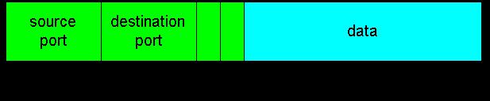
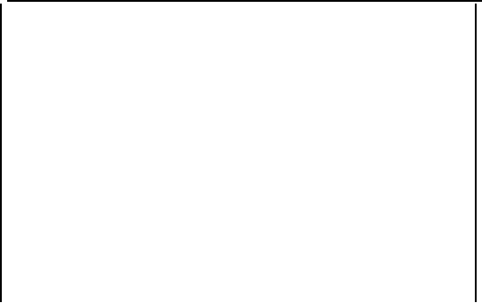

 | 32 bits
Source Port | Destination Port

Other header field

Application
Data

﴾message﴿

Source and destination port number fields in a transport layer segment

The port number is a 16-bit number, ranging from from 0 to 65535. The port numbers ranging from 0 - 1023 are called well-known port numbers. HTTP uses port number 80; FTP uses port number 21. Given that each type of application running on an end system has a unique port number.

Connectionless Multiplexing and Demultiplexing:

Java program in a host can create a UDP socket with the line:

DatagramSocket mySocket = new DatagramSocket ();

When a UDP socket created in this manner, the transport layer automatically assigns a port number to the socket. Port number in the range of 1024 to 65535.

DatagramSocket mySocket = new DatagramSocket (19157);

In this case, the application assigns a specific port number namely, 19157 to the UDP socket. The client side of the application, the transport layer automatically assign the port number, whereas the server side of the application assigns a specific port number.

 |  |  |  |  |  |  |  |  |  |  | Server B
 |  |  |  |  |  |  |  |  | 19157 |  |  | 46428
 |  |  | Appl
 |  |  | Trans
 | Host A
 |  |  | Network
 |  |  | Data Link
 |  |  | Phy
Client process
 |  |  |  |  |  |  |  |  |  | 46428 |  |  | 19157 |  |  |  | Socket
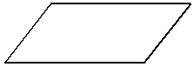
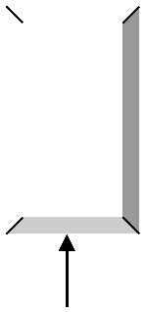
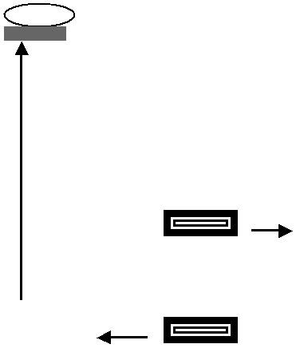
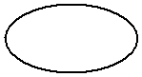


In the above figure, a process in host A, with UDP port number 19157, wants to send a chunk of application data to a process with UDP port 46428 in host B. the transport layer in host A creates a transport-layer segment that includes the application data, the source port number, the destination port number and other two values.

The transport layer then passes the resulting segment to the network layer. The network layer then encapsulates the segment in an IP datagram and makes best-effort attempt to deliver the segment to the receiving host.

If the segment arrives at the receiving host B, the receiving host examines the socket 46428 and delivers the segment to its socket identified by port 46428.

Connection-Oriented Multiplexing and Demultiplexing:

UDP socket has only two tuple ﴾source port number and destination port number ﴿ whereas TCP socket is identified by a four-tuple: ﴾source IP address, source port number, destination IP address, destination port number .﴿

When a TCP segment arrives from the network to a host, the host uses all four values to direct ﴾demultiplexing﴿ the segment to the appropriate socket. TC client/server programming,

- A TCP server application has a “welcome socket”, waits for connection establishment requests from TCP clients on port number 6789.

- The TCP client generates a connection-establishment segment with the line

Socket clientSocket = new Socket("hostname", 6789);

5

- The line above creates a TCP socket for the client process, through which data can enter and leave the client process.

- When the host running the server process receives the incoming connection request segment with the destination port 6789, it locates the server process that is waiting to accept a connection on port number 6789. The server process then creates a new connection:

Socket connectionSocket = welcomeSocket.accept();

- The server notes the four values and the newly created connection socket is identified by these four values; all subsequent arriving segments whose source IP, port, destination IP, port match these four values demultiplexed to this socket, with the TCP conection now in place, the client and server can now send data to each other.

Connectionless Transport: UDP

UDP, defined in [RFC 768], connectionless service. User Datagram Protocol or UDP is part of the Internet Protocol suite, using which, programs running on different computers on a network can send short messages known as Datagrams to one another.

UDP is a stateless protocol which is useful for servers engaged in answering short queries from a large number of clients. While TCP is mainly used for communication between a server and a single client, UDP is used for packet broadcast or multicasting whereby the data is sent to all the clients in the network. Frequent network applications that use UDP include: Trivial File Transfer Protocol (TFTP) , Voice over IP (VoIP), IPTV, Domain Name System (DNS), etc.

The network layer encapsulates the segment into an IP datagram and then makes a best-effort attempt to deliver the segment to the receiving host. If the segment arrives at the receiving host, UDP uses the port numbers and the IP source and destination addresses to deliver the data in the segment to the correct application process. Note that with UDP there is no handshaking between sending and receiving transport-layer entities before sending a segment. For this reason, UDP is said to be connectionless.

As many applications are better suited for UDP for the following reasons:

- Finer application-level control over what data is sent, and when. TCP has a congestion control mechanism that throttles the sender when one or more links between sender and receiver becomes excessively congested. On the other hand, the speed at which UDP sends data is only constrained by the rate at which the application generates data, the capabilities of the source (CPU, clock rate, etc.) and the access bandwidth to the

Internet. However, that the receiving host does not necessarily receive all the data - when the network is congested, a significant fraction of the UDP-transmitted data could be lost due to router buffer overflow.

- No connection establishment. TCP uses a three-way handshake before it starts to transfer data. UDP just blasts away without any formal preliminaries. Thus UDP does not introduce any delay to establish a connection. This is probably the principle reason why DNS runs over UDP rather than TCP -- DNS would be much slower if it ran over TCP. HTTP uses TCP rather than UDP, since reliability is critical for Web pages with text. The TCP connection establishment delay in HTTP is an important contributor to the "world wide wait".

- No connection state. TCP maintains connection state in the end systems. This connection state includes receive and send buffers, congestion control parameters, and sequence and acknowledgment number parameters. UDP, on the other hand, does not maintain connection state and does not track any of these parameters.

- Small segment header overhead. The TCP segment has 20 bytes of header overhead in every segment, whereas UDP only has 8 bytes of overhead.

UDP is used for RIP routing table updates, because the updates are sent periodically, so that lost updates are replaced by more up-to-date updates.

 | Application |  |  | Application-layer |  | Underlying | Transport
 | electronic mail |  |  | SMTP |  | TCP
 | remote | terminal |  | Telnet |  | TCP
 | Web |  |  | HTTP |  | TCP
 | file transfer |  |  | FTP |  | TCP
 | remote file server |  |  | NFS |  | typically UDP
 | streaming multimedia |  |  | proprietary |  | typically UDP
 | Internet telephony |  |  | proprietary |  | typically UDP
 | Network Management |  |  | SNMP |  | typically UDP
 | Routing Protocol |  |  | RIP |  | typically UDP
 | Name Translation |  |  | DNS |  | typically UDP

Popular Internet applications and their underlying transport protocols

UDP is also commonly used today with multimedia applications, such as Internet phone, real-time video conferencing, and streaming of stored audio and video. We just mention now that

7

all of these applications can tolerate a small fraction of packet loss, so that reliable data transfer is not absolutely critical for the success of the application. Furthermore, interactive real-time applications, such as Internet phone and video conferencing, react very poorly to TCP's congestion control. For these reasons, developers of multimedia applications often choose to run the applications over UDP instead of TCP. Finally, because TCP cannot be employed with multicast, multicast applications run over UDP.

Although commonly done today, running multimedia applications over UDP is controversial to say the least. As we mentioned above, UDP lacks any form of congestion control. But congestion control is needed to prevent the network from entering a congested state in which very little useful work is done. If everyone were to start streaming high bit-rate video without using any congestion control, there would be so much packet overflow at routers that no one would see anything. Thus, the lack of congestion control in UDP is a potentially serious problem. Many researchers have proposed new mechanisms to force all sources, including UDP sources, to perform adaptive congestion control.

The application data occupies the data field of the UDP datagram. For example, for DNS, the data field contains either a query message or a response message. For a streaming audio application, audio samples fill the data field. The UDP header has only four fields, each consisting of four bytes.

UDP Segment Structure

The UDP segment structure, shown in Figure 3.3-2, is defined in [RFC 768].
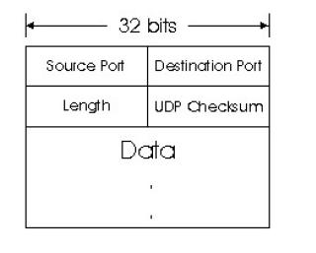

The application data occupies the data field of the UDP datagram. For example, for DNS, the data field contains either a query message or a response message. For a streaming audio application, audio samples fill the data field.

8

The UDP header has only four fields, each consisting of four bytes. The port numbers allow the destination host to pass the application data to the correct process running on that host (i.e., perform the demultiplexing function).

The checksum is used by the receiving host to check if errors have been introduced into the segment during the course of its transmission from source to destination.

UDP Checksum

The UDP checksum provides for error detection. UDP at the sender side performs the one's complement of the sum of all the 16-bit words in the segment. This result is put in the checksum field of the UDP segment. When the segment arrives at the receiving host, all 16-bit words are added together, including the checksum.

If this sum equals 1111111111111111, then the segment has no detected errors. If one of the bits is a zero, then we know that errors have been introduced into the segment.

Here we give a simple example of the checksum calculation. As an example, suppose that we have the following three 16-bit words:

0110011001100110

0101010101010101

0000111100001111

The sum of first of these 16-bit words is:

0110011001100110

0101010101010101

---------------------

1011101110111011

Adding the third word to the above sum gives

1011101110111011

0000111100001111

---------------------

1100101011001010

The 1's complement is obtained by converting all the 0s to 1s and converting all the 1s to 0s. Thus the 1's complement of the sum 1100101011001010 is 0011010100110101, which becomes the checksum. At the receiver, all four 16-bit words are added, including the checksum. If no errors are introduced into the segment, then clearly the sum at the receiver will be

9

1111111111111111. If one of the bits is a zero, then we know that errors have been introduced into the segment. Internet checksum is not foolproof -- even if the sum equals 111111111111111, it is still possible that there are undetected errors in the segment. For this reason, a number of protocols use more sophisticated error detection techniques than simple check summing.

PRINCIPLES OF RELIABLE DATA TRANSFER

Internet's network layer service (IP service) is unreliable. IP does not guarantee datagram delivery, does not guarantee in-order delivery of datagrams, and does not guarantee the integrity of the data in the datagrams.

With IP service, datagrams can overflow router buffers and never reach their destination, datagrams can arrive out of order, and bits in the datagram can get corrupted (flipped from 0 to 1 and vice versa). Because transport-layer segments are carried across the network by IP datagrams, transport-layer segments can also suffer from these problems as well.

TCP creates a reliable data transfer service on top of IP's unreliable best-effort service.

Many popular application protocols -- including FTP, SMTP, NNTP, HTTP and Telnet -- use

TCP rather than UDP primarily because TCP provides reliable data transfer service.

TCP's reliable data transfer service ensures that the data stream that a process reads out of its TCP receive buffer is uncorrupted, without gaps, without duplication, and in sequence, i.e., the byte stream is exactly the same byte stream that was sent by the end system on the other side of the connection.

In this subsection we provide an informal overview of how TCP provides reliable data transfer.

10

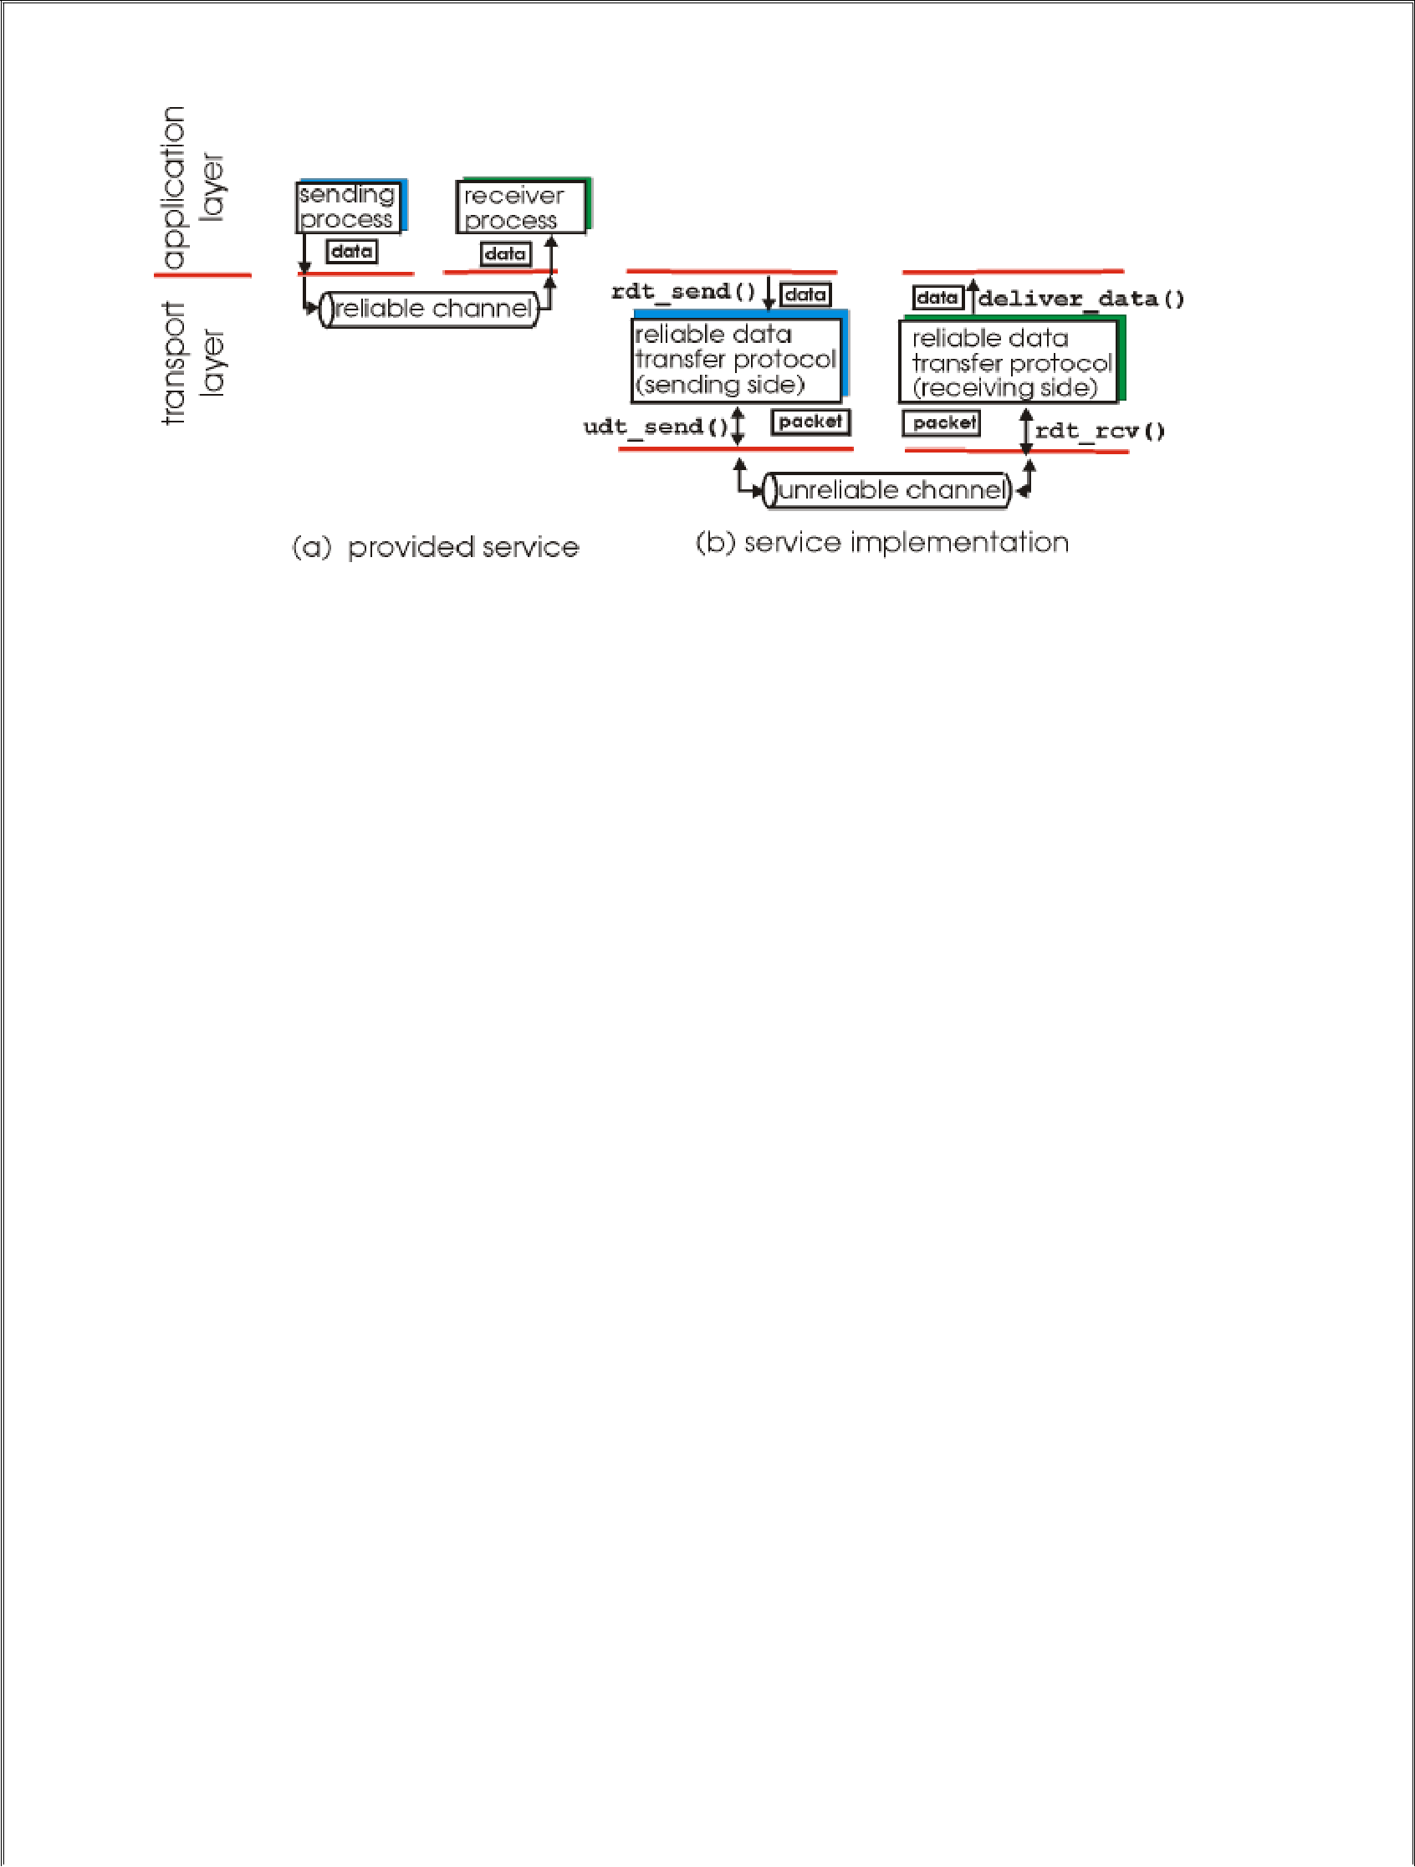

Reliable data transfer: service model and service implementation.

The sending side of the data transfer protocol will be invoked from above by a call to rdt_send(). It will be passed the data to be delivered to the upper-layer at the receiving side. (Here rdt stands for ``reliable data transfer'' protocol and _send indicates that the sending side of rdt is being called.) On the receiving side, rdt_rcv() will be called when a packet arrives from the receiving side of the channel. When the rdt protocol wants to deliver data to the upper-layer, it will do so by calling deliver_data().

Building a Reliable Data Transfer Protocol:

Reliable Data Transfer over a Perfectly Reliable Channel: rdt1.0

The finite state machine (FSM) definitions for the rdt1.0 sender and receiver are shown in the below fig. The sender and receiver FSMs in Figure each have just one state. The arrows in the FSM description indicate the transition of the protocol from one state to another.

The sending side of rdt simply accepts data from the upper-layer via the rdt_send(data)event, puts the data into a packet (via the action make_pkt(packet,data)) and sends the packet into the channel. In practice, the rdt_send(data)event would result from a procedure call (e.g., to rdt_send()) by the upper layer application.

On the receiving side, rdt receives a packet from the underlying channel via the rdt_rcv(packet) event, removes the data from the packet (via the action extract(packet,data)) and

11

passes the data up to the upper-layer. In practice, the rdt_rcv(packet)event would result from a procedure call (e.g., to rdt_rcv()) from the lower layer protocol.
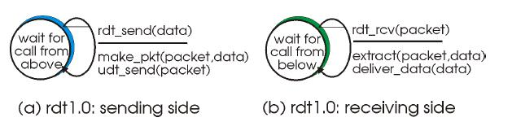

Reliable Data Transfer over a Channel with Bit Errors: rdt2.0

A more realistic model of the underlying channel is one in which bits in a packet may be corrupted. In a computer network setting, reliable data transfer protocols based on such retransmission are known ARQ (Automatic Repeat reQuest) protocols.

Fundamentally, two additional protocol capabilities are required in ARQ protocols to handle the presence of bit errors:

- Error detection. First, a mechanism is needed to allow the receiver to detect when bit errors have occurred.

- For error detection an extra bits (beyond the bits of original data to be transferred) be sent from the sender to receiver; these bits will be gathered into the packet checksum field of the rdt2.0 data packet.

- Receiver feedback. The positive (ACK) and negative acknowledgement (NAK) replies in the message dictation scenario are an example of such feedback. Our rdt2.0 protocol will similarly send ACK and NAK packets back from the receiver to the sender. In principle, these packets need only be one bit long, e.g., a zero value could indicate a NAK and a value of 1 could indicate an ACK.

2

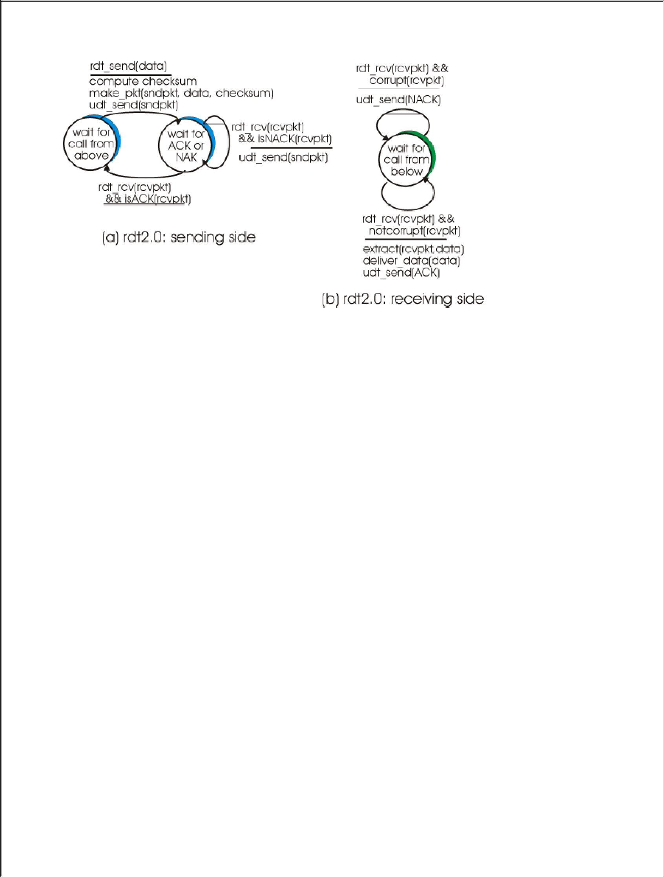

The above figure shows the FSM representation of rdt2.0, a data transfer protocol employing error detection, positive acknowledgements (ACKs), and negative acknowledgements (NAKs).

The send side of rdt2.0 has two states. In one state, the send-side protocol is waiting for data to be passed down from the upper layer. In the other state, the sender protocol is waiting for an ACK or a NAK packet from the receiver. If an ACK packet is received the sender knows the most recently transmitted packet has been received correctly and thus the protocol returns to the state of waiting for data from the upper layer.

If a NAK is received, the protocol retransmits the last packet and waits for an ACK or NAK to be returned by the receiver in response to the retransmitted data packet.

It is important to note that when the receiver is in the wait-for-ACK-or-NAK state, it can not get more data from the upper layer; that will only happen after the sender receives an ACK and leaves this state. Thus, the sender will not send a new piece of data until it is sure that the receiver has correctly received the current packet. Because of this behavior, protocols such as rdt2.0 are known as stop-and-wait protocols.

The receiver-side FSM for rdt2.0 still has a single state. On packet arrival, the receiver replies with either an ACK or a NAK, depending on whether or not the received packet is corrupted. In Figure the notation rdt_rcv(rcvpkt) && corrupt(rcvpkt) corresponds to the event where a packet is received and is found to be in error.

13

The difficulty in Protocol rdt2.0 is that if an ACK or NAK is corrupted, the sender has no way of knowing whether or not the receiver has correctly received the last piece of transmitted data.

A simple solution to this new problem is to add a new field to the data packet and have the sender number its data packets by putting a sequence number into this field. The receiver then need only check this sequence number to determine whether or not the received packet is a retransmission.

The below figures show the FSM description for rdt2.1, our fixed version of rdt2.0. The rdt2.1 sender and receiver FSM's each now have twice as many states as before. This is because the protocol state must now reflect whether the packet currently being sent (by the sender) or expected (at the receiver) should have a sequence number of 0 or 1.

Protocol rdt2.1 uses both positive and negative acknowledgements from the receiver to the sender. A negative acknowledgement is sent whenever a corrupted packet, or an out of order packet, is received.

14

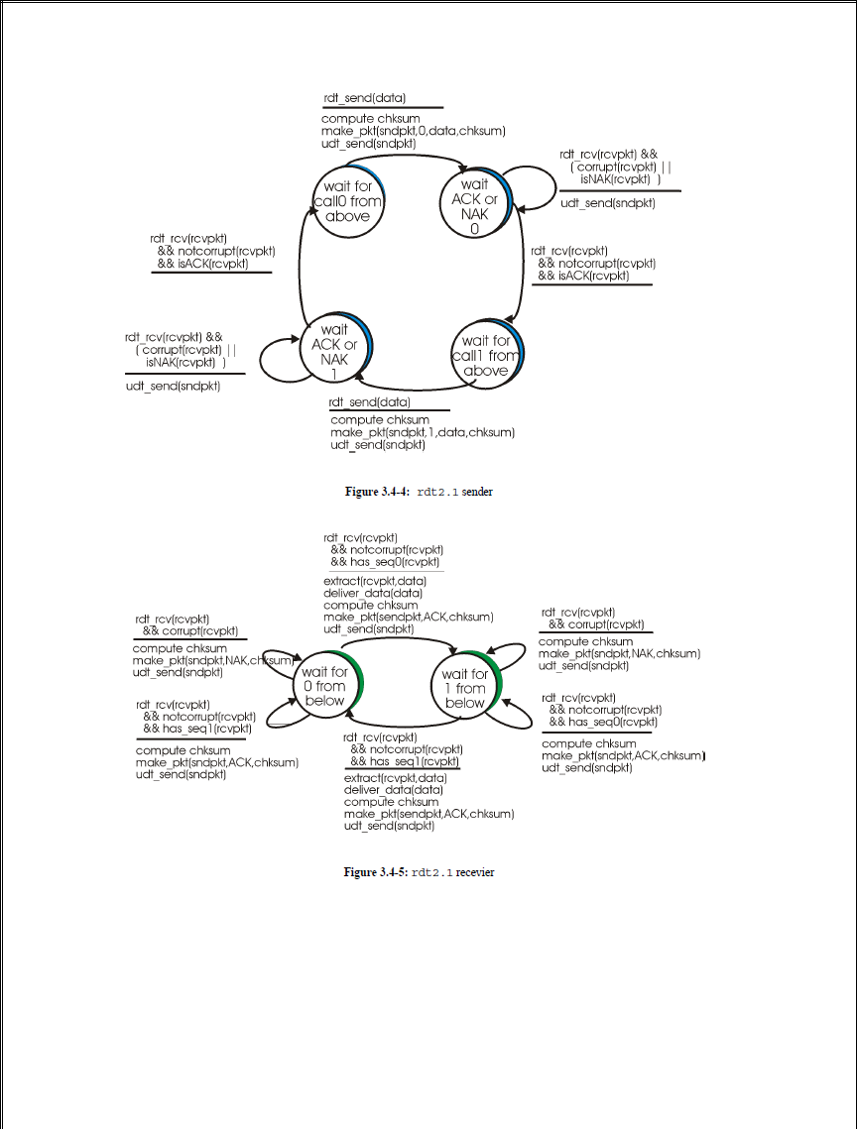

A sender that receives two ACKs for the same packet (i.e., receives duplicate ACKs) knows that the recevier did not correctly receive the packet following the packet that is being ACKed twice. Many TCP implementations use the receipt of so-called "triple duplicate ACKs" (three ACK packets all ACK'ing the same packet) to trigger a retransmission at the sender.

15

Our NAK-free reliable data transfer protocol for a channel with bit errors is rdt2.2, shown in below figure
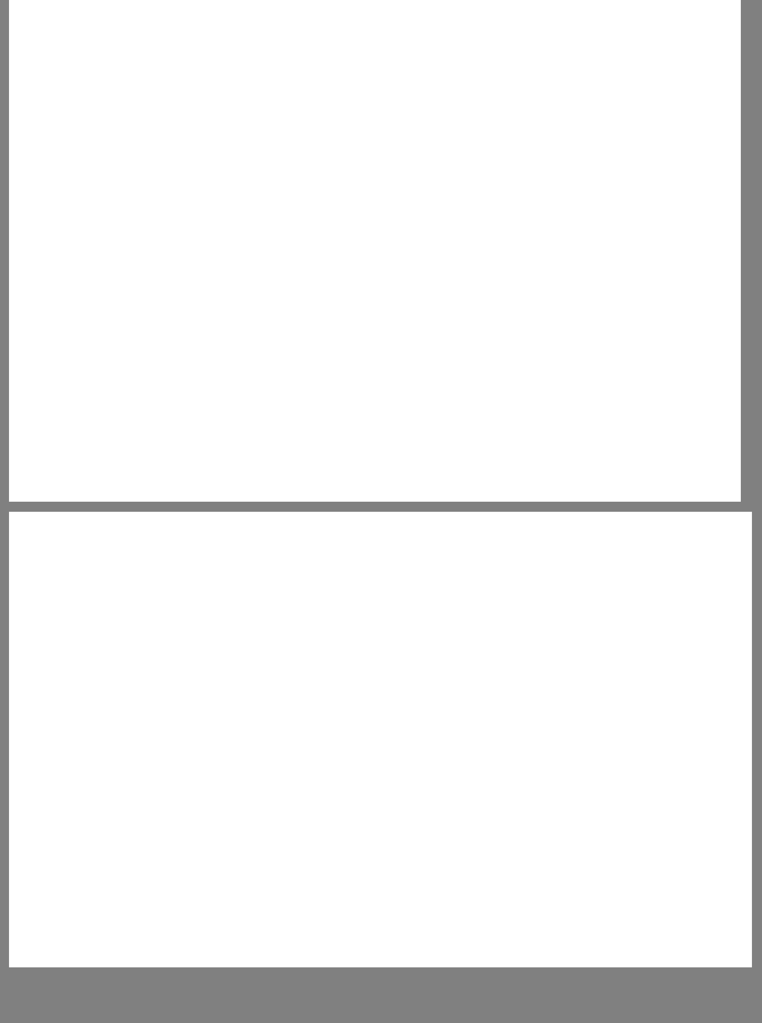
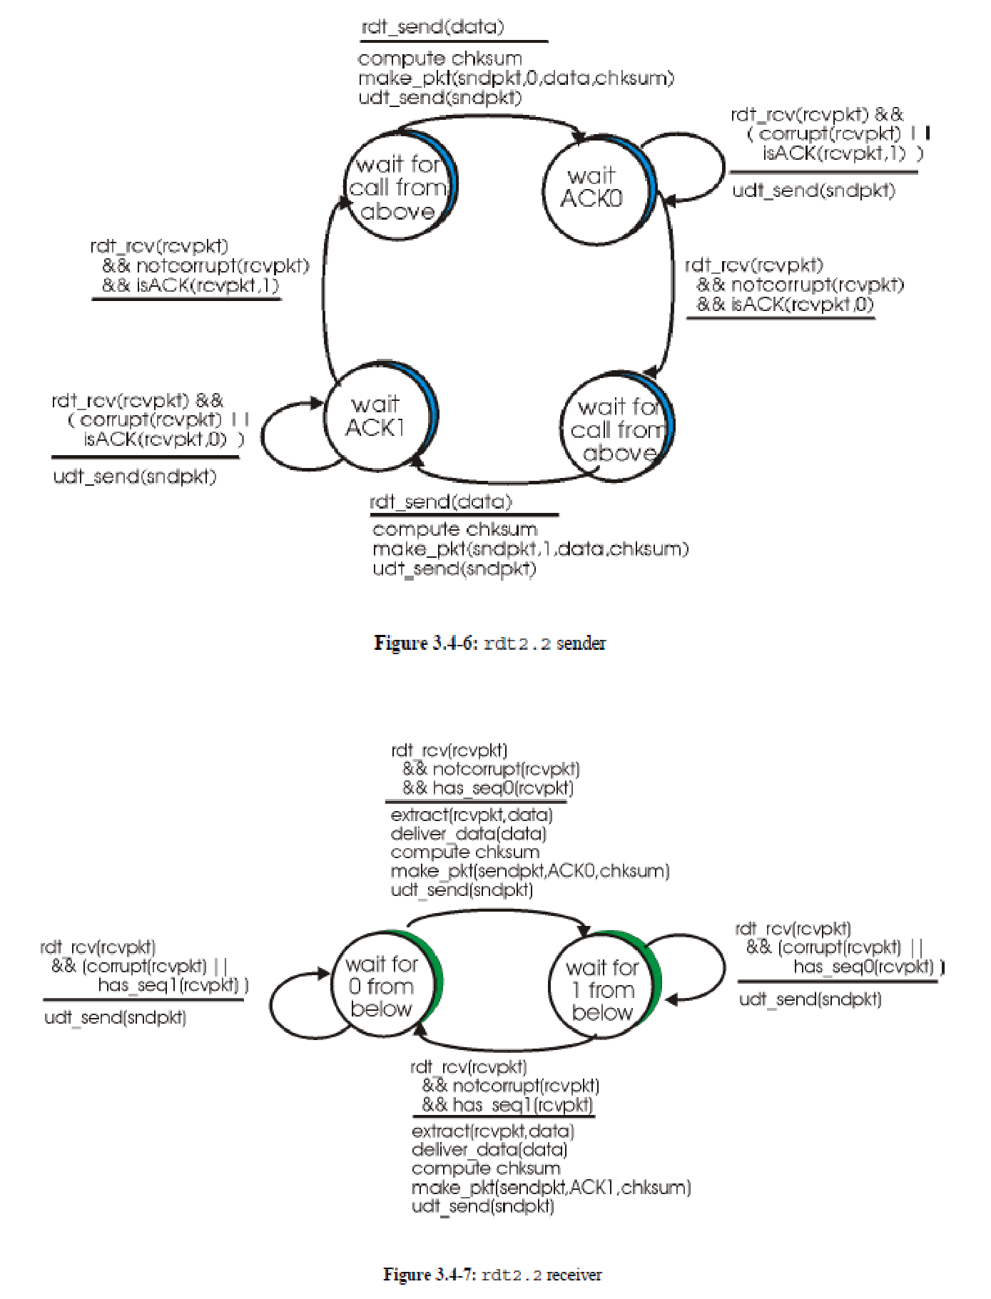

16

Reliable Data Transfer over a Lossy Channel with Bit Errors: rdt3.0

The sender does not know whether a data packet was lost, an ACK was lost, or if the packet or ACK was simply overly delayed. In all cases, the action is the same: retransmit. In order to implement a time-based retransmission mechanism, a countdown timer will be needed that can interrupt the sender after a given amount of timer has expired.

The sender will thus need to be able to (i) start the timer each time a packet (either a first time packet, or a retransmission) is sent, (ii) respond to a timer interrupt (taking appropriate actions), and (iii) stop the timer.

When the receiver generates an ACK, it will copy the sequence number of the data packet being ACK'ed into this acknowledgement field. By examining the contents of the acknowledgment field, the sender can determine the sequence number of the packet being positively acknowledged.
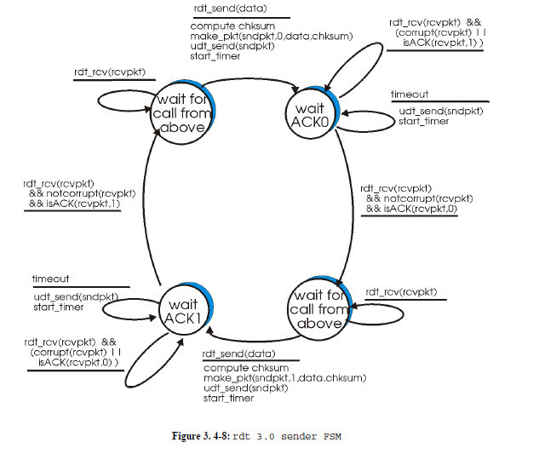
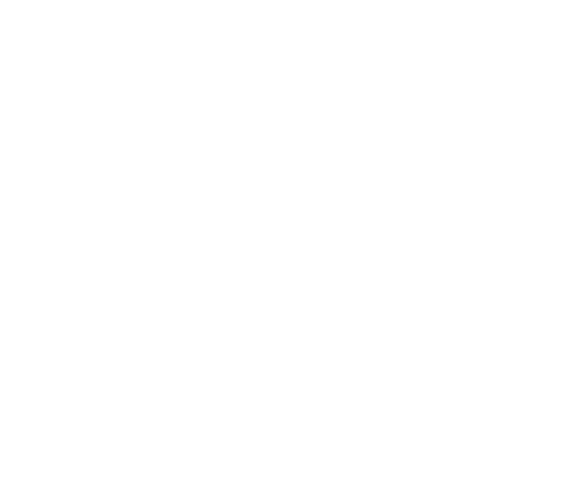

The above figure shows the sender FSM for rdt3.0, a protocol that reliably transfers data over a channel that can corrupt or lose packets.

The below figure shows how the protocol operates with no lost or delayed packets, and how it handles lost data packets. In the below Figure, time moves forward from the top of the diagram towards the bottom of the diagram; note that a receive time for a packet is neccessarily later than the send time for a packet as a result of transmisison and propagation delays.

In Figures 3.4-9(b)-(d), the send-side brackets indicate the times at which a timer is set and later times out. Several of the more subtle aspects of this protocol are explored in the exercises at the end of this chapter. Because packet sequence numbers alternate between 0 and 1, protocol rdt3.0 is sometimes known as the alternating bit protocol.

18

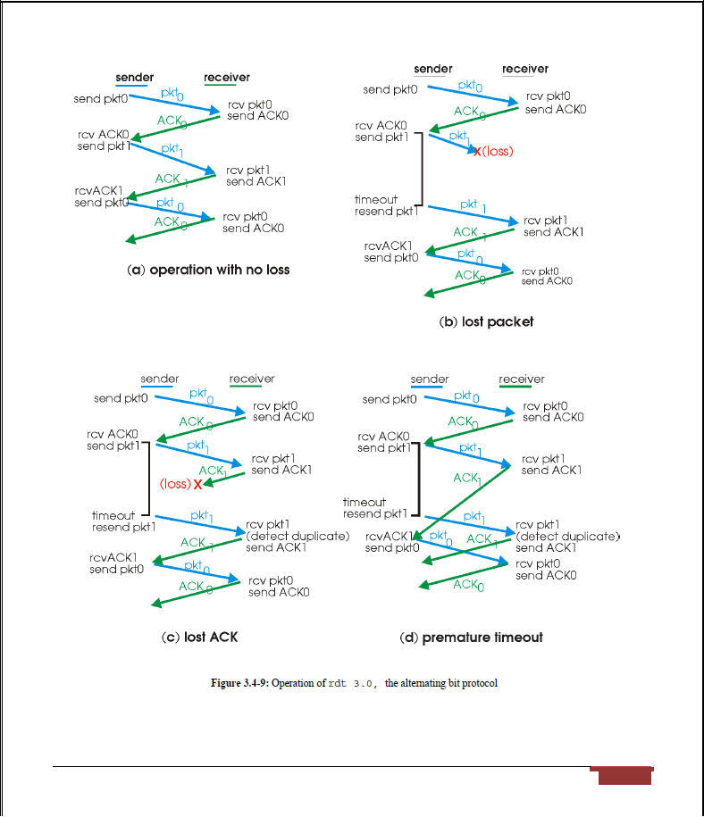

19

Go-Back-N (GBN)

In a Go-Back-N (GBN) protocol, the sender is allowed to transmit multiple packets (when available) without waiting for an acknowledgment, but is constrained to have no more than some maximum allowable number, N, of unacknowledged packets in the pipeline.
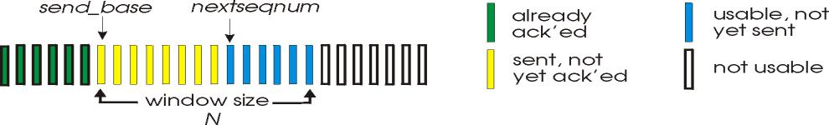

Sender's view of sequence numbers in Go-Back-N

The above figure shows the sender's view of the range of sequence numbers in a GBN protocol. If we define base to be the sequence number of the oldest unacknowledged packet and nextseqnum to be the smallest unused sequence number (i.e., the sequence number of the next packet to be sent), then four intervals in the range of sequence numbers can be identified.

Sequence numbers in the interval [0,base-1] correspond to packets that have already been transmitted and acknowledged.

The interval [base, nextseqnum-1] corresponds to packets that have been sent but not yet acknowledged. Sequence numbers in the interval [nextseqnum,base+N-1] can be used for packets that can be sent immediately, should data arrive from the upper layer. Finally, sequence numbers greater than or equal to base+N can not be used until an unacknowledged packet currently in the pipeline has been acknowledged.

The range of permissible sequence numbers for transmitted but not-yet-acknowledged packets can be viewed as a ``window'' of size N over the range of sequence numbers. N is often referred to as the window size and the GBN protocol itself as a sliding window protocol. The GBN sender must respond to three types of events:

- Invocation from above. When rdt_send() is called from above, the sender first checks to see if the window is full, i.e., whether there are N outstanding, unacknowledged packets. If the window is not full, a packet is created and sent, and variables are appropriately updated. If the window is full, the sender simply returns the data back to the upper layer, an implicit indication that the window is full.

20

- Receipt of an ACK. In our GBN protocol, an acknowledgement for packet with sequence number n will be taken to be a cumulative acknowledgement, indicating that all packets with a sequence number up to and including n have been correctly received at the receiver. We'll come back to this issue shortly when we examine the receiver side of GBN.

- A timeout event. The protocol's name, ``Go-Back-N,'' is derived from the sender's behavior in the presence of lost or overly delayed packets. As in the stop-and-wait protocol, a timer will again be used to recover from lost data or acknowledgement packets. If a timeout occurs, the sender resends all packets that have been previously sent but that have not yet been acknowledged. If an ACK is received but there are still additional transmitted-but-yet-to-be-acknowledged packets, the timer is restarted. If there are no outstanding unacknowledged packets, the timer is stopped.

The receiver's actions in GBN are also simple. If a packet with sequence number n is received correctly and is in-order (i.e., the data last delivered to the upper layer came from a packet with sequence number n-1), the receiver sends an ACK for packet n and delivers the data portion of the packet to the upper layer.

In all other cases, the receiver discards the packet and resends an ACK for the most recently received in-order packet. Note that since packets are delivered one-at-a-time to the upper layer, if packet k has been received and delivered, then all packets with a sequence number lower than k have also been delivered. Thus, the use of cumulative acknowledgements is a natural choice for GBN.

In our GBN protocol, the receiver discards out-of-order packets. While it may seem silly and wasteful to discard a correctly received (but out-of-order) packet, there is some justification for doing so. Recall that the receiver must deliver data, in-order, to the upper layer.

Suppose now that packet n is expected, but packet n+1 arrives. Since data must be delivered in order, the receiver could buffer (save) packet n+1 and then deliver this packet to the upper layer after it had later received and delivered packet n. However, if packet n is lost, both it and packet n+1 will eventually be retransmitted as a result of the GBN retransmission rule at the sender. Thus, the receiver can simply discard packet n+1.

The advantage of this approach is the simplicity of receiver buffering - the receiver need not buffer any out-of-order packets. Thus, while the sender must maintain the upper and lower

21

bounds of its window and the position of nextseqnum within this window, the only piece of information the receiver need maintain is the sequence number of the next in-order packet. Of course, the disadvantage of throwing away a correctly received packet is that the subsequent retransmission of that packet might be lost or garbled and thus even more retransmissions would be required.
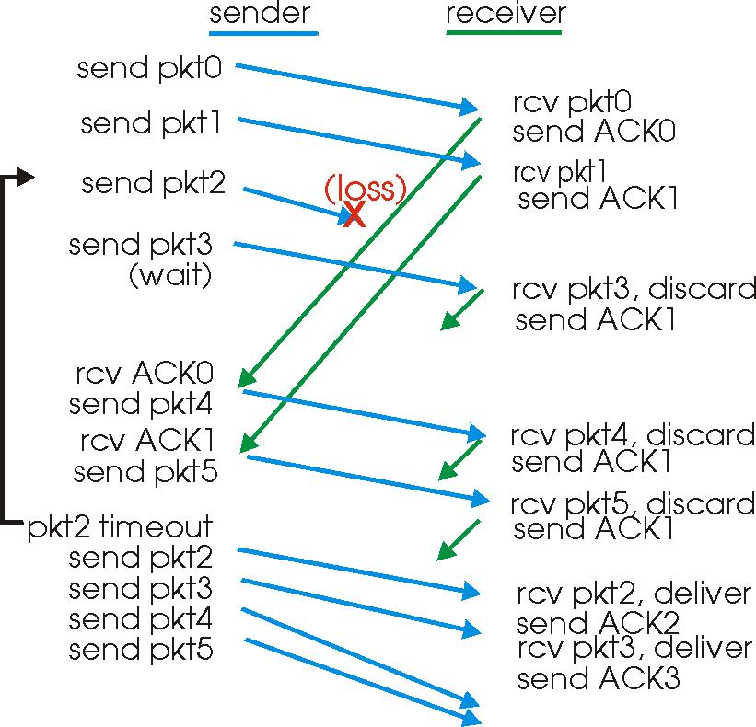

Go-Back-N in operation

In the above figure, shows the operation of the GBN protocol for the case of a window size of four packets. Because of this window size limitation, the sender sends packets 0 through 3 but then must wait for one or more of these packets to be acknowledged before proceeding. As each successive ACK (e.g., ACK0 and ACK1) is received, the window slides forwards and the sender can transmit one new packet (pkt4 and pkt5, respectively).

On the receiver side, packet 2 is lost and thus packets 3, 4, and 5 are found to be out-of-order and are discarded.

The implementation would also likely be in the form of various procedures that implement the actions to be taken in response to the various events that can occur. In such event-based programming, the various procedures are called (invoked) either by other procedures in the protocol stack, or as the result of an interrupt.

In the sender, these events would be (i) a call from the upper layer entity to invoke rdt_send(), (ii) a timer interrupt, and (iii) a call from the lower layer to invoke rdt_rcv() when a

22

packet arrives. The programming exercises at the end of this chapter will give you a chance to actually implement these routines in a simulated, but realistic, network setting.

Selective Repeat

Selective Repeat (SR) protocols avoid unnecessary retransmissions by having the sender retransmit only those packets that it suspects were received in error (i.e., were lost or corrupted) at the receiver. This individual, as-needed, retransmission will require that the receiver individually acknowledge correctly-received packets. A window size of N will again be used to limit the number of outstanding, unacknowledged packets in the pipeline.
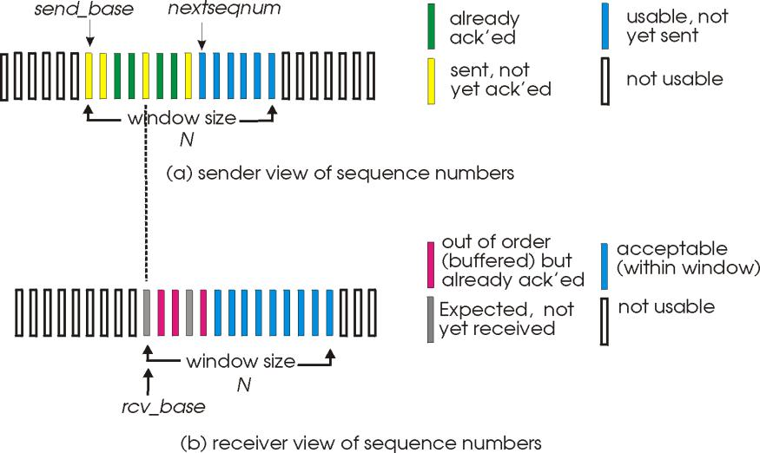

SR sender and receiver views of sequence number space

The SR receiver will acknowledge a correctly received packet whether or not it is in-order. Out-of-order packets are buffered until any missing packets (i.e., packets with lower sequence numbers) are received, at which point a batch of packets can be delivered in-order to the upper layer. Figure receiver itemizes the various actions taken by the SR receiver.

Selective Repeat sender actions

- Data received from above. When data is received from above, the SR sender checks the next available sequence number for the packet. If the sequence number is within the sender's window, the data is packetized and sent; otherwise it is either buffered or returned to the upper layer for later transmission, as in GBN.

- Timeout. Timers are again used to protect against lost packets. However, each packet must now have its own logical timer, since only a single packet will be transmitted on

23

timeout. A single hardware timer can be used to mimic the operation of multiple logical timers.

- ACK received. If an ACK is received, the SR sender marks that packet as having been received, provided it is in the window. If the packet's sequence number is equal to sendbase, the window base is moved forward to the unacknowledged packet with the smallest sequence number. If the window moves and there are untransmitted packets with sequence numbers that now fall within the window, these packets are transmitted.

Selective Repeat Receiver Actions

- Packet with sequence number in [rcvbase, rcvbase+N-1] is correctly received. In this case, the received packet falls within the receivers window and a selective ACK packet is returned to the sender. If the packet was not previously received, it is buffered. If this packet has a sequence number equal to the base of the receive window, then this packet, and any previously buffered and consecutively numbered (beginning with rcvbase) packets are delivered to the upper layer. The receive window is then moved forward by the number of packets delivered to the upper layer.

- Packet with sequence number in [rcvbase-N,rcvbase-1] is received. In this case, an ACK must be generated, even though this is a packet that the receiver has previously acknowledged.

- Otherwise. Ignore the packet.

The below figure shows an example of SR operation in the presence of lost packets. The receiver initially buffers packets 3 and 4, and delivers them together with packet 2 to the upper layer when packet 2 is finally received.

24

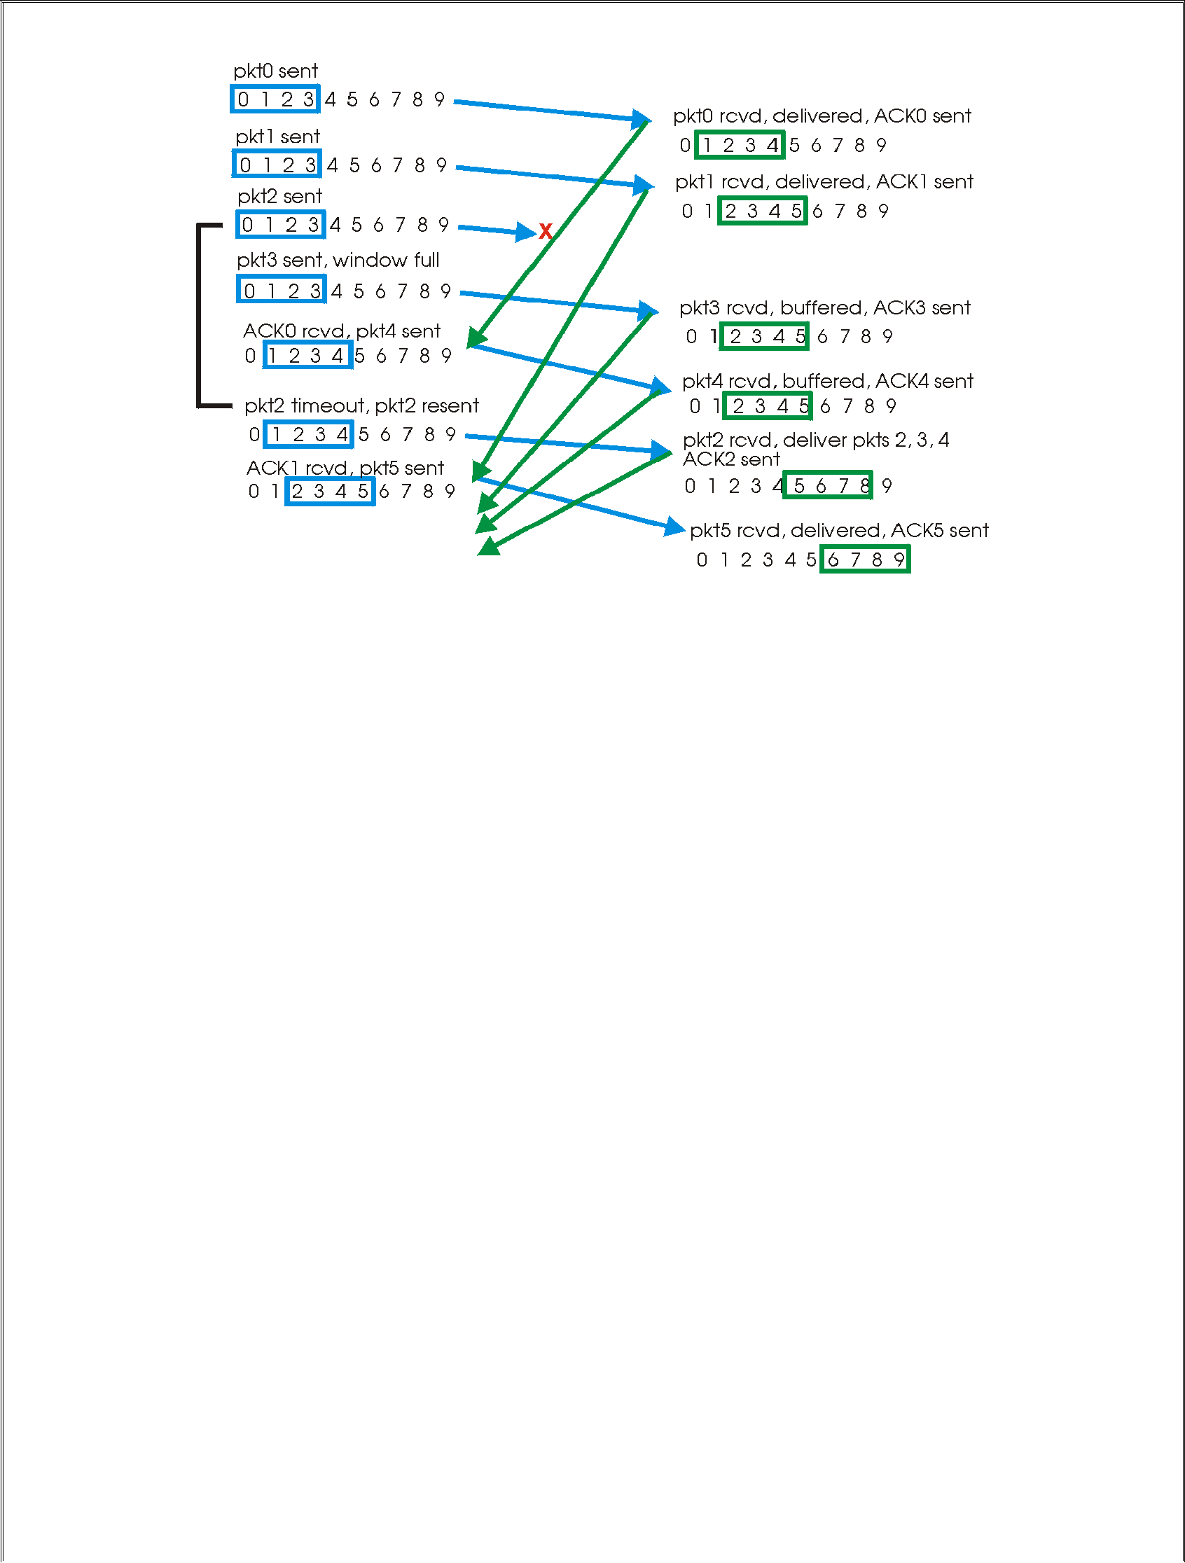

SR Operation
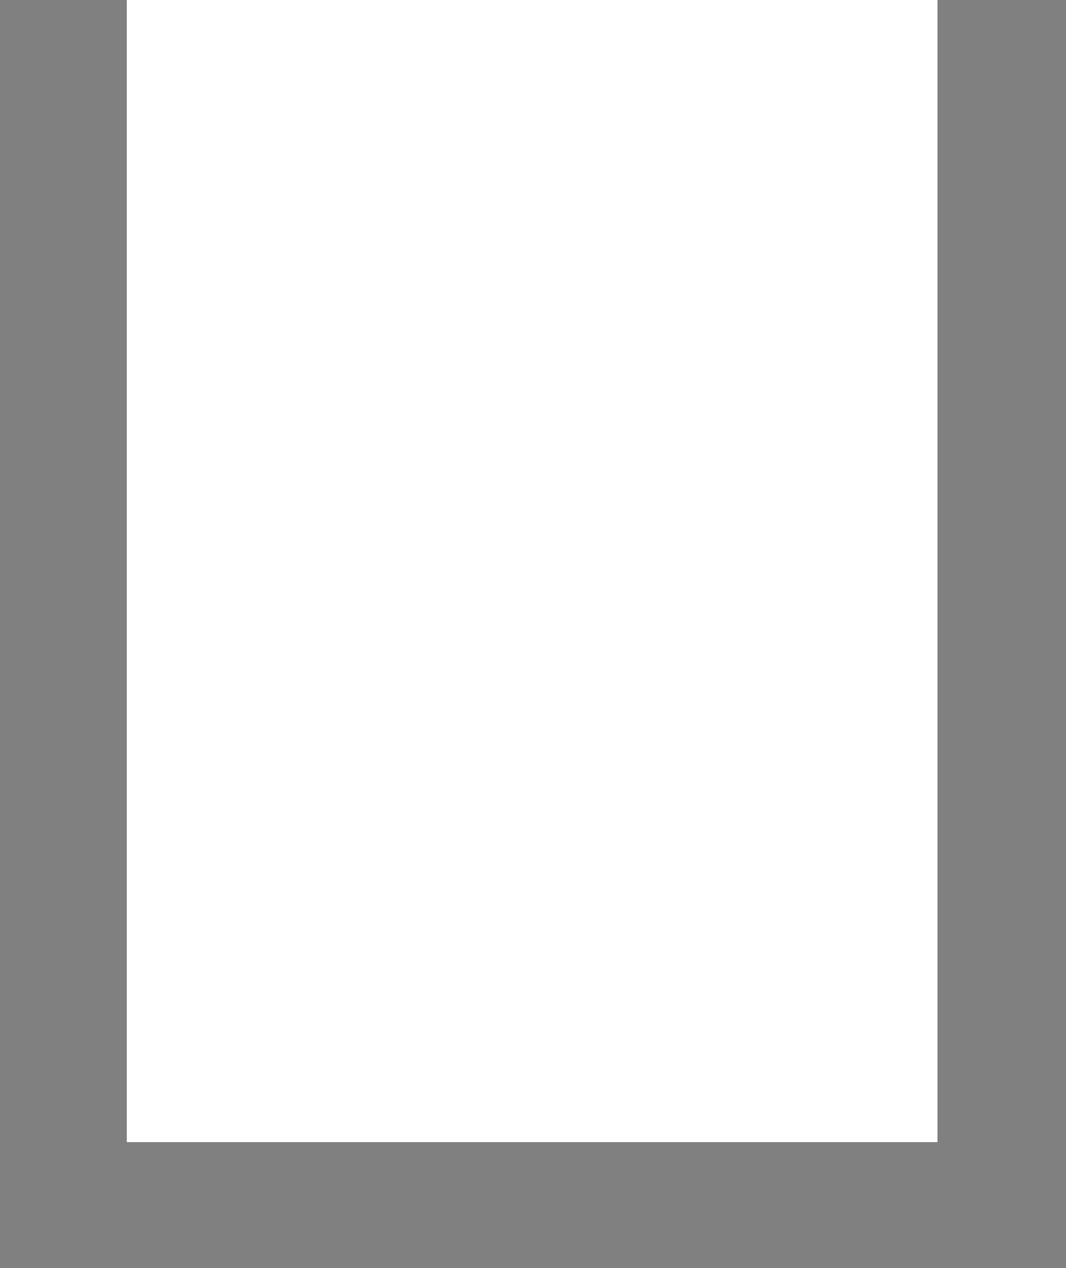
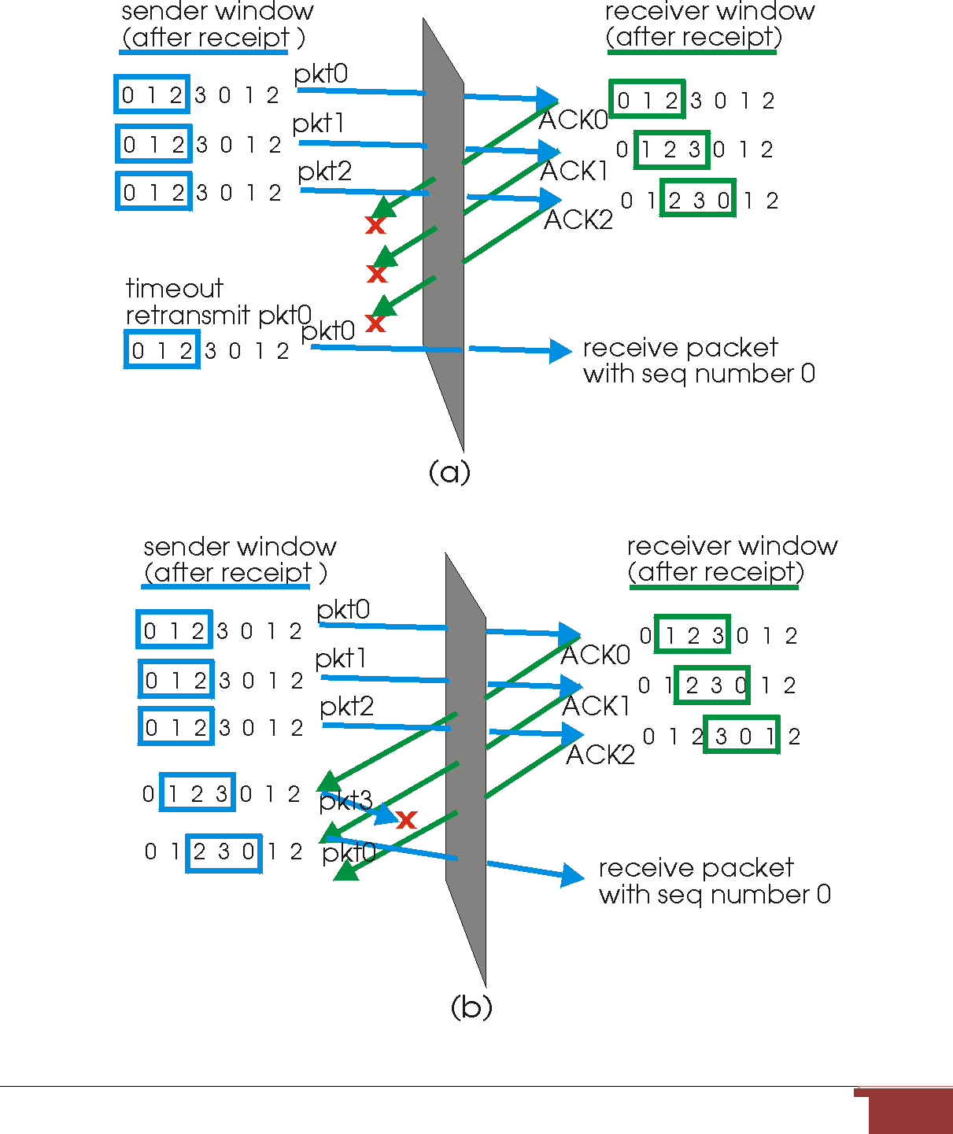

The lack of synchronization between sender and receiver windows has important consequences when we are faced with the reality of a finite range of sequence numbers.

Consider what could happen, for example, with a finite range of four packet sequence numbers, 0,1,2,3 and a window size of three. Suppose packets 0 through 2 are transmitted and correctly received and acknowledged at the receiver.

At this point, the receiver's window is over the fourth, fifth and sixth packets, which have sequence numbers 3, 0, and 1, respectively. Now consider two scenarios.

In the first scenario, shown in Figure (a), the ACKs for the first three packets are lost and the sender retransmits these packets. The receiver thus next receives a packet with sequence number 0 - a copy of the first packet sent.

In the second scenario, shown in Figure 3.4-19(b), the ACKs for the first three packets are all delivered correctly. The sender thus moves its window forward and sends the fourth, fifth and sixth packets, with sequence numbers 3, 0, 1, respectively. The packet with sequence number 3 is lost, but the packet with sequence number 0 arrives - a packet containing new data

Connection-Oriented Transport TCP

- TCP provides multiplexing, demultiplexing, and error detection. TCP is connection-oriented because before one application process can begin to send data to another, the two processes must first "handshake" with each other -- that is, they must send some preliminary segments to each other to establish the parameters of the ensuing data transfer.

- A TCP connection provides for full duplex data transfer. That is, application-level data can be transferred in both directions between two hosts - if there is a TCP connection between process A on one host and process B on another host, then application-level data can flow from A to B at the same time as application-level data flows from B to A.

26

- TCP connection is also always point-to-point, i.e., between a single sender and a single receiver. So called "multicasting" the transfer of data from one sender to many receivers in a single send operation -- is not possible with TCP.

TCP connection establishment

Suppose a process running in one host wants to initiate a connection with another process in another host. Recall that the host that is initiating the connection is called the client host, while the other host is called the server host.

The client application process first informs the client TCP that it wants to establish a connection to a process in the server. For example, a Java client program does this by issuing the command:

Socket clientSocket = new Socket("hostname", "port number");

The TCP in the client then proceeds to establish a TCP connection with the TCP in the server. The client first sends a special TCP segment; the server responds with a second special TCP segment; and finally the client responds again with a third special segment. The first two segments contain no "payload," i.e., no application-layer data; the third of these segments may carry a payload. Because three segments are sent between the two hosts, this connection establishment procedure is often referred to as a three-way handshake.
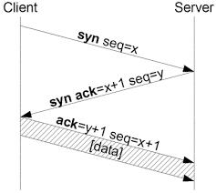

Once a TCP connection is established, the two application processes can send data to each other; because TCP is full-duplex they can send data at the same time.

27

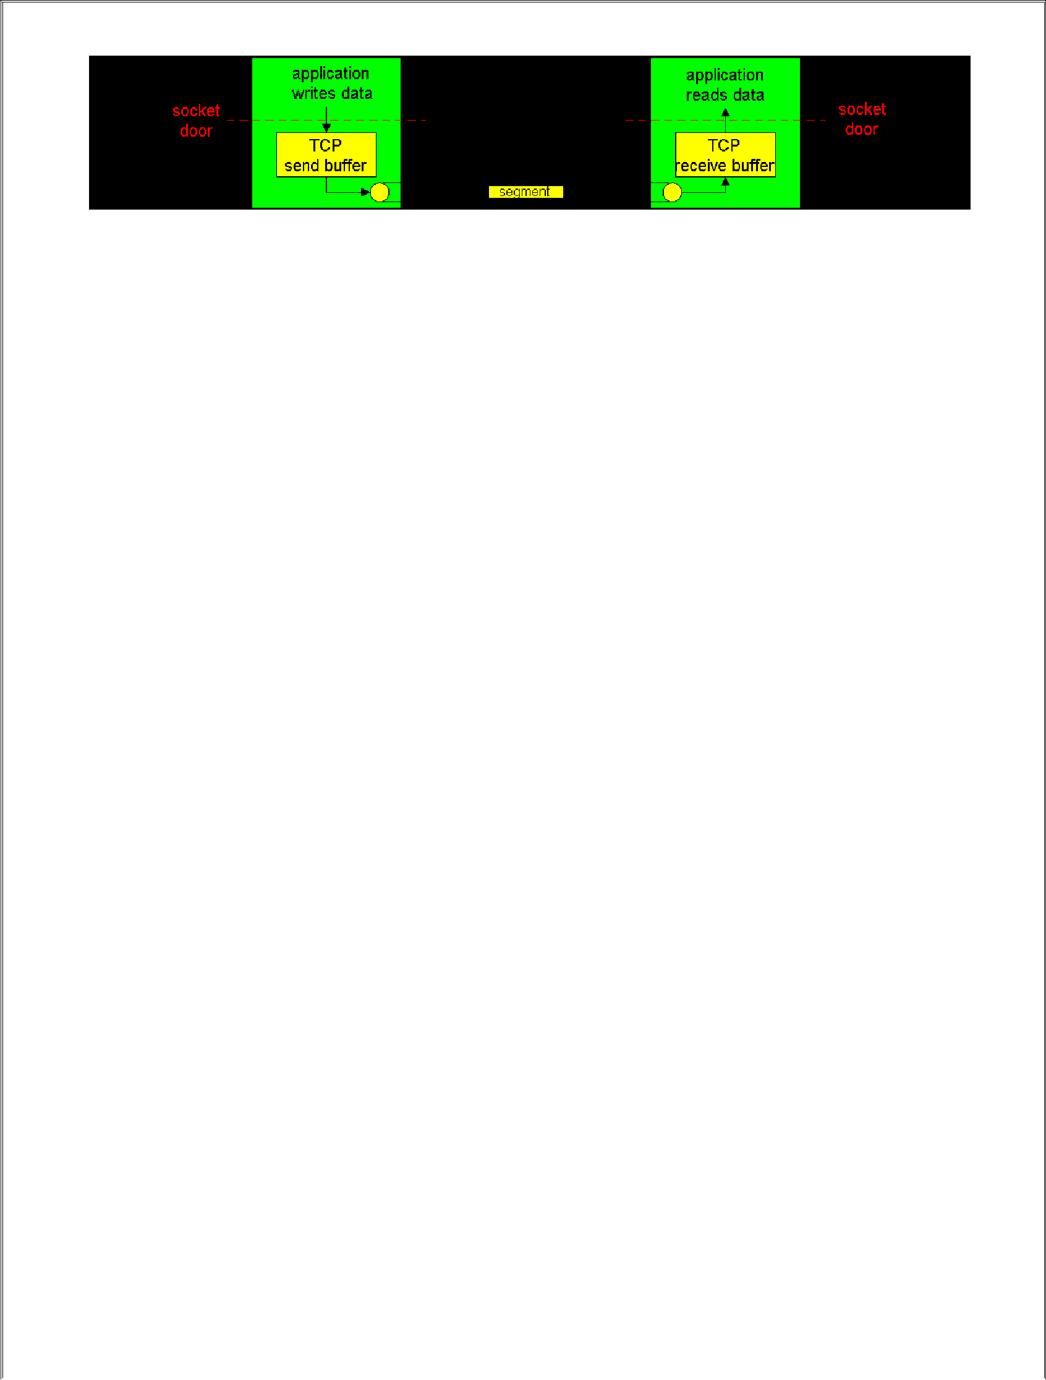

TCP send and receive buffers

TCP directs this data to the connection's send buffer, which is one of the buffers that is set aside during the initial three-way handshake. From time to time, TCP will "grab" chunks of data from the send buffer. The maximum amount of data that can be grabbed and placed in a segment is limited by the Maximum Segment Size (MSS). The MSS depends on the TCP implementation (determined by the operating system) and can often be configured; common values are 1,500 bytes, 536 bytes and 512 bytes.

TCP encapsulates each chunk of client data with TCP header, thereby forming TCP

segments. The segments are passed down to the network layer, where they are separately

encapsulated within network-layer IP datagrams. The IP datagrams are then sent into the

network. When TCP receives a segment at the other end, the segment's data is placed in the TCP

connection's receive buffer.

TCP Segment Structure

A TCP segment header also contains the following fields:

- The32-bit sequence number field, and the 32-bit acknowledgment number field are used by the TCP sender and receiver in implementing a reliable data transfer service.

- The 16-bit window size field is used for the purposes of flow control. We will see shortly that it is used to indicate the number of bytes that a receiver is willing to accept.

8

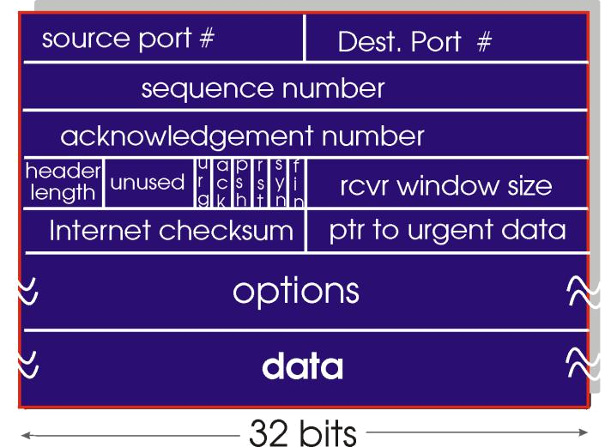

- The 4-bit length field specifies the length of the TCP header in 32-bit words. The TCP header can be of variable length due to the TCP options field.

- The optional and variable length options field is used when a sender and receiver negotiate the maximum segment size (MSS) or as a window scaling factor for use in high-speed networks. A timestamping option is also defined.
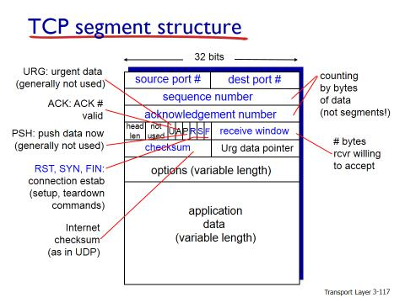

29

- The flag field contains 6 bits. The ACK bit is used to indicate that the value carried in the acknowledgment field is valid. The RST, SYN and FIN bits are used for connection setup and teardown, as we will discuss at the end of this section.

- When the PSH bit is set, this is an indication that the receiver should pass the data to the upper layer immediately. Finally, the URG bit is used to indicate there is data in this segment that the sending-side upper layer entity has marked as ``urgent.'' The location of the last byte of this urgent data is indicated by the 16-bit urgent data pointer. TCP must inform the receiving-side upper layer entity when urgent data exists and pass it a pointer to the end of the urgent data.

Round Trip Time Estimation and Timeout

Recall that when a host sends a segment into a TCP connection, it starts a timer. If the timer expires before the host receives an acknowledgment for the data in the segment, the host retransmits the segment. The time from when the timer is started until when it expires is called the timeout of the timer.

Clearly, the timeout should be larger than the connection's round-trip time, i.e., the time from when a segment is sent until it is acknowledged. Otherwise, unnecessary retransmissions would be sent. But the timeout should not be much larger than the round-trip time; otherwise, when a segment is lost, TCP would not quickly retransmit the segment, thereby introducing significant data transfer delays into the application. Before discussing the timeout interval in more detail, let us take a closer look at the round-trip time (RTT).

Estimating the Average Round-Trip Time

The sample RTT, denoted SampleRTT, for a segment is the time from when the segment is sent (i.e., passed to IP) until an acknowledgment for the segment is received. Each segment sent will have its own associated SampleRTT.

Obviously, the SampleRTT values will fluctuate from segment to segment due to congestion in the routers and to the varying load on the end systems. Because of this fluctuation, any given SampleRTT value may be atypical. In order to estimate a typical RTT, it is therefore natural to take some sort of average of the SampleRTT values.

30

TCP maintains an average, called EstimatedRTT, of the SampleRTT values. Upon receiving an acknowledgment and obtaining a new SampleRTT, TCP updates EstimatedRTT according to the following formula:

EstimatedRTT = (1-x) EstimatedRTT + x SampleRTT.

The above formula is written in the form of a programming language statement - the new value of EstimatedRTT is a weighted combination of the previous value of Estimated RTT and the new value for SampleRTT. A typical value of x is x = .1, in which case the above formula becomes:

EstimatedRTT = .9 EstimatedRTT + .1 SampleRTT.

Note that EstimatedRTT is a weighted average of the SampleRTT values. As we will see in the homework, this weighted average puts more weight on recent samples than on old samples, This is natural, as the more recent samples better reflect the current congestion in the network. In statistics, such an average is called an exponential weighted moving average (EWMA).

Setting the Timeout

The timeout should be set so that a timer expires early (i.e., before the delayed arrival of a segment's ACK) only on rare occasions. It is therefore natural to set the timeout equal to the EstimatedRTT plus some margin. The margin should be large when there is a lot of fluctuation in the SampleRTT values; it should be small when there is little fluctuation. TCP uses the following formula:

Timeout = EstimatedRTT + 4*Deviation,

where Deviation is an estimate of how much SampleRTT typically deviates from EstimatedRTT:

Deviation = (1-x) Deviation + x | SampleRTT - EstimatedRTT |

Note that Deviation is an EWMA of how much SampleRTT deviates from EstimatedRTT. If the SampleRTT values have little fluctuation, then Deviation is small and Timeout is hardly more than EstimatedRTT; on the other hand, if there is a lot of fluctuation, Deviation will be large and Timeout will be much larger than EstimatedRTT.

1

Reliable Data Transfer

Retransmissions

Retransmission of lost and corrupted data is crucial for providing reliable data transfer. TCP provides reliable data transfer by using positive acknowledgments and timers. TCP acknowledges data that has been received correctly, and retransmits segments when segments or their corresponding acknowledgements are thought to be lost or corrupted.
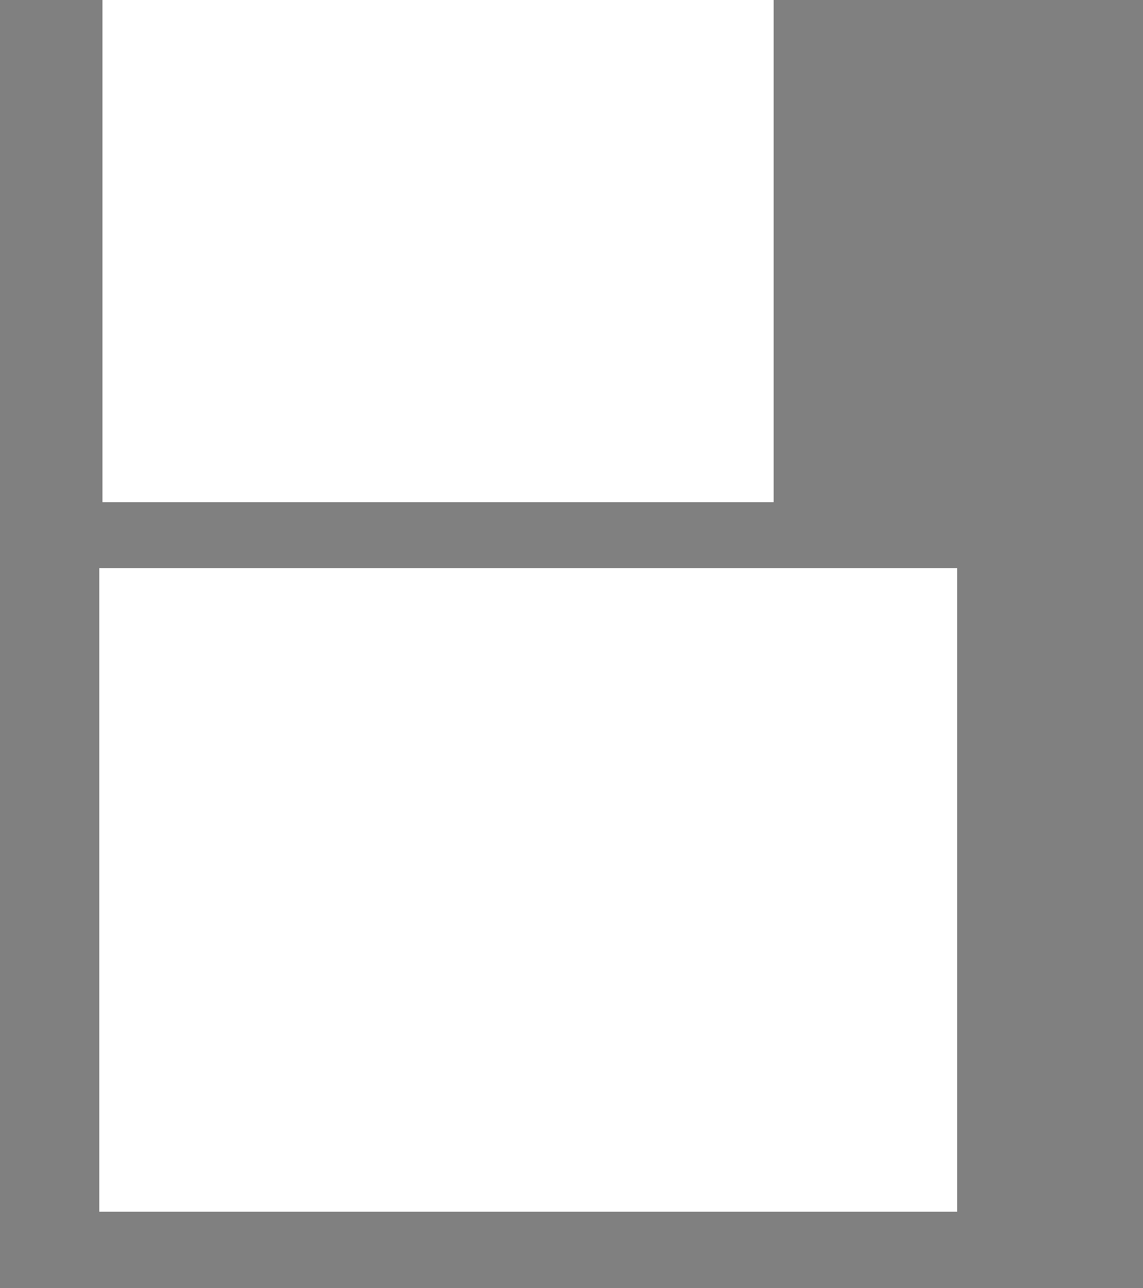
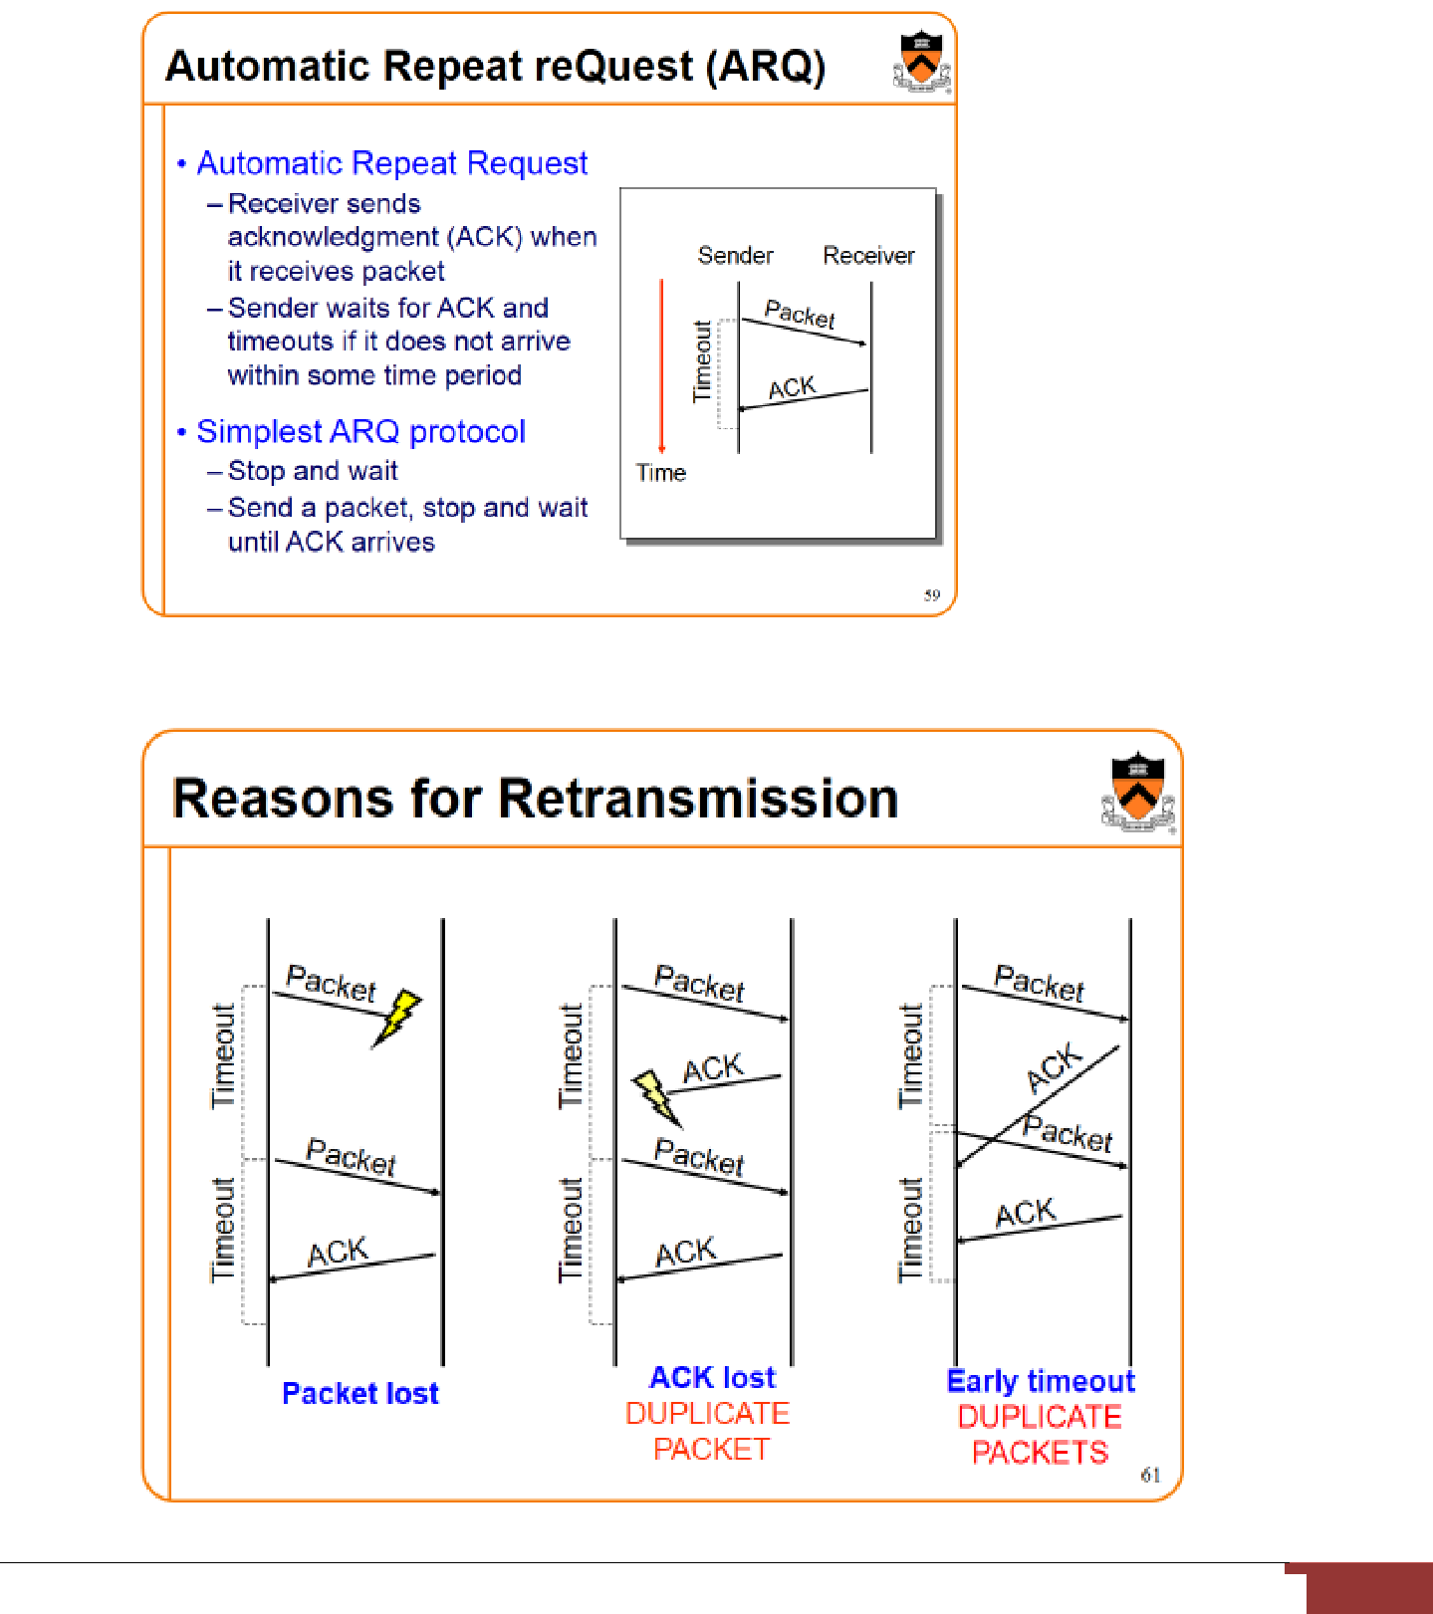

32

TCP also uses pipelining, allowing the sender to have multiple transmitted but yet-to-be-acknowledged segments outstanding at any given time.

/*

assume

sender

is

not

constrained

by

TCP

flow

or

congestion

control,

that

data

from

above

is

less

than

MSS

in

size,

and

that

data

transfer

is

in one direction only */

sendbase = initial_sequence number
nextseqnum=initial_sequencenumber

loop(forever){
switch(event)

event: data received from application above

create TCP segment with sequence number nextseqnum if ﴾timer currently not running﴿

start timer
pass segment to IP
nextseqnum = nextseqnum + length(data)
break;

event: timer timeout
retransmit not-yet-acknowledge segment with smallest sequence number
start timer
break;

event: ACK received, with ACK field value of y
if (y > sendbase)

{ /* cumulative ACK of all data up to y */cancel all timers for segments with sequencenumbers < y

sendbase = y

if ﴾there are currently any not-yet-acknowledged segments﴿ start timer

}
Break;
} /* end of loop forever */

Figure : simplified TCP sender

The above figure shows three major events related to data transmission/retransmission at

a simplified TCP sender.

Let us consider a TCP connection between host A and B and focus on the data stream

being sent from host A to host B. At the sending host (A), TCP is passed application-layer data,

which it frames into segments and then passes on to IP.

The passing of data from the application to TCP and the subsequent framing and transmission of a segment is the first important event that the TCP sender must handle. Each time TCP releases a segment to IP, it starts a timer for that segment. If this timer expires, an interrupt event is generated at host A. TCP responds to the timeout event, the second major type of event that the TCP sender must handle, by retransmitting the segment that caused the timeout.

The third major event that must be handled by the TCP sender is the arrival of an acknowledgement segment (ACK) from the receiver (more specifically, a segment containing a valid ACK field value). Here, the sender's TCP must determine whether the ACK is a first-time ACK for a segment that the sender has yet to receive an acknowledgement for, or a so-called duplicate ACK that re-acknowledges a segment for which the sender has already received an earlier acknowledgement. In the case of the arrival of a first-time ACK, the sender now knows that all data up to the byte being acknowledged has been received correctly at the receiver. The sender can thus update its TCP state variable that tracks the sequence number of the last byte that is known to have been received correctly and in-order at the receiver.

To understand the sender's response to a duplicate ACK, we must look at why the receiver sends a duplicate ACK in the first place.

The below table summarizes the TCP receiver's ACK generation policy.

When a TCP receiver receives a segment with a sequence number that is larger than the next, expected, in-order sequence number, it detects a gap in the data stream - i.e., a missing segment. Since TCP does not use negative acknowledgements, the receiver can not send an explicit negative acknowledgement back to the sender.

Instead, it simply re-acknowledges (i.e., generates a duplicate ACK for) the last in-order byte of data it has received. If the TCP sender receives three duplicate ACKs for the same data, it takes this as an indication that the segment following the segment that has been ACKed three times has been lost. In this case, TCP performs a fast retransmit, retransmitting the missing segment before that segment's timer expires.
 | Event |  |  |  |  |  | TCP receiver action
 | Arrival of in-order |  | segment | with | expected |  | Delayed ACK. Wait up to 500 ms for arrival
 | sequence | number. | All data | up | to up to |  | of another in-order segment. If next | in-order
 | expected |  |  |  |  |  | segment
 | sequence | number | already | acknowledged. |  |  | does not arrives in this interval, send an ACK

No gaps in the received data.

Arrival of in-order segment with expected sequence number. One other in-order segment waiting for ACK transmission. No gaps in the received data.

Immediately send single cumulative ACK, ACKing both in-order segments

Arrival of out-of-order segment with higher- |  | Immediately send duplicate ACK, indicating
than |  | sequence
expected sequence number. Gap detected. |  | number of next expected byte
Arrival of segment that partially or |  | Immediately send ACK, provided that segment
completely |  | starts
fills in gap in received data |  | at the lower end of gap.

Table: TCP ACK generation recommendations

Example Scenarios

The below figure depicts the scenario where host A sends one segment to host B. Suppose that this segment has sequence number 92 and contains 8 bytes of data. After sending this segment, host A waits for a segment from B with acknowledgment number 100. Although the segment from A is received at B, the acknowledgment from B to A gets lost.

In this case, the timer expires, and host A retransmits the same segment. Of course, when host B receives the retransmission, it will observe that the bytes in the segment duplicate bytes it has already deposited in its receive buffer. Thus TCP in host B will discard the bytes in the retransmitted segment.
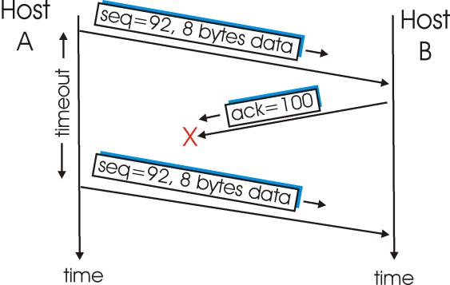

Figure: Retransmission due to a lost acknowledgment

In a second scenario, host A sends two segments back to back. The first segment has sequence number 92 and 8 bytes of data, and the second segment has sequence number 100 and 20 bytes of data. Suppose that both segments arrive intact at B, and B sends two separate
35

acknowledgements for each of these segments. The first of these acknowledgements has acknowledgment number 100; the second has acknowledgment number 120. Suppose now that neither of the acknowledgements arrive at host A before the timeout of the first segment. According to the rules described above, host A resends the segment only if the timer expires before the arrival of an acknowledgment with an acknowledgment number of 120 or greater. Thus, as shown in the below figure, if the second acknowledgment does not get lost and arrives before the timeout of the second segment, A does not resend the second segment.
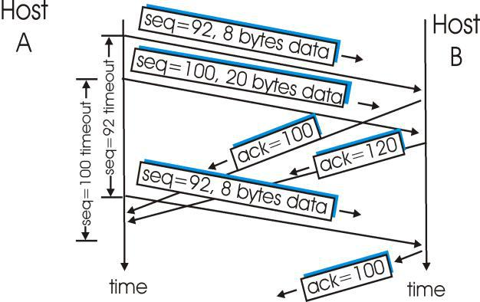

Figure: Segment is not retransmitted because its acknowledgment arrives before the timeout.

In a third and final scenario, suppose host A sends the two segments, exactly as in the second example. The acknowledgment of the first segment is lost in the network, but just before the timeout of the first segment, host A receives an acknowledgment with acknowledgment number 120. Host A therefore knows that host B has received everything up through byte 119; so host A does not resend either of the two segments. This scenario is illustrated in the below figure.
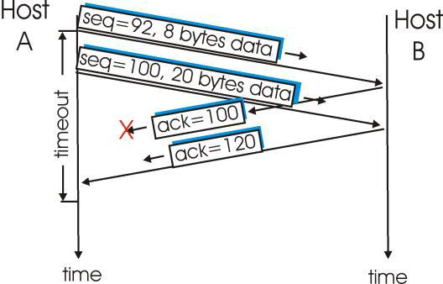

Figure: A cumulative acknowledgment avoids retransmission of first segment

Consequently, as shown in Figure, the TCP sender need only maintain the smallest sequence number of a transmitted but unacknowledged byte (sendbase) and the sequence number of the next byte to be sent (nextseqnum). But the reader should keep in mind that although the reliable-data-transfer component of TCP resembles Go-Back-N, it is by no means a pure
36

implementation of Go-Back-N. To see that there are some striking differences between TCP and Go-Back-N, consider what happens when the sender sends a sequence of segments 1, 2,..., N, and all of the segments arrive in order without error at the receiver. Further suppose that the acknowledgment for packet n < N gets lost, but the remaining N-1 acknowledgments arrive at the sender before their respective timeouts.

Doubling the timeout interval:

Whenever the timeout event occurs, TCP retransmits the not yet acknowledges segment with the smallest sequence number. But each time TCP retransmits, it sets the next timeout interval twice the previous value.

For example, suppose TimeoutInterval associated with the oldest not yet acknowledged segment is .75 sec when the timer expires. TCP will then retransmit this segment and set the new timer expiration to 1.5sec.

Fast Retransmit:

One of the problems with timeout triggered retransmission is that the timeout period can be relatively long. When a segment lost, the sender resending the lost packet, thereby increasing the end-end delay. Fortunately, the sender can often detect packet loss well before the timeout event occurs by nothing called duplicate ACKs.

A duplicate ACK is an ACK that reacknowledges a segment for which the sender has already received an earlier acknowledgement. If the sender receives three duplicate ACKs for the same data it takes this as an indication the segment that has been ACKed three times has been lost. In the case that three duplicate ACKs are received, the TCP sender performs a fast retransmit.
event: ACK received, with ACK field value of y

if (y > sendbase)

{ /* cumulative ACK of all data up to y */cancel all timers for segments with sequencenumbers < y

sendbase = y

if ﴾there are currently any not-yet-acknowledged segments﴿ start timer

}

7

else

{ /* a duplicate ACK for already ACKed segment */ increment number of duplicate ACKs received for y

if (number of duplicate ACKS received for y == 3)

{

/* TCP fast retransmit */

resend segment with sequence number y restart timer for segment y

}

Break;

Flow Control

- TCP thus provides a flow control service to its applications by eliminating the possibility of the sender overflowing the receiver's buffer. Flow control is thus a speed matching service - matching the rate at which the sender is sending to the rate at which the receiving application is reading.

- TCP provides flow control by having the sender maintain a variable called the receive window. Informally, the receive window is used to give the sender an idea about how much free buffer space is available at the receiver. In a full-duplex connection, the sender at each side of the connection maintains a distinct receive window. The receive window is dynamic, i.e., it changes throughout a connection's lifetime.

- Let's investigate the receive window in the context of a file transfer. Suppose that host A is sending a large file to host B over a TCP connection. Host B allocates a receive buffer to this connection; denote its size by RcvBuffer. From time to time, the application process in host B reads from the buffer. Define the following variables:

LastByteRead = the number of the last byte in the data stream read from the buffer by the application process in B.

LastByteRcvd = the number of the last byte in the data stream that has arrived from the

network and has been placed in the receive buffer at B.

Because TCP is not permitted to overflow the allocated buffer, we must have:

LastByteRcvd - LastByteRead <= RcvBuffer

The receive window, denoted RcvWindow, is set to the amount of spare room in the buffer:

RcvWindow = RcvBuffer - [ LastByteRcvd - LastByteRead]

Because the spare room changes with time, RcvWindow is dynamic. The variable RcvWindow is illustrated in the below figure.
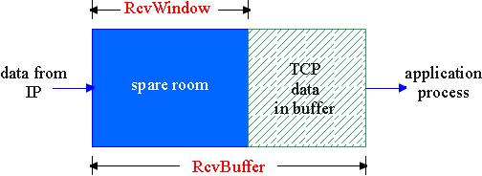

Figure: The receive window (RcvWindow) and the receive buffer (RcvBuffer)

Host B informs host A of how much spare room it has in the connection buffer by placing its current value of RcvWindow in the window field of every segment it sends to A. Initially host B sets RcvWindow = RcvBuffer. Note that to pull this off, host B must keep track of several connection-specific variables.

Host A in turn keeps track of two variables, LastByteSent and LastByteAcked, which have obvious meanings.

Note that the difference between these two variables, LastByteSent - LastByteAcked, is the amount of unacknowledged data that A has sent into the connection. By keeping the amount of unacknowledged data less than the value of RcvWindow, host A is assured that it is not overflowing the receive buffer at host B. Thus host A makes sure throughout the connection's life that

LastByteSent - LastByteAcked <= RcvWindow.

There is one minor technical problem with this scheme. To see this, suppose host B's receive buffer becomes full so that RcvWindow = 0. After advertising RcvWindow = 0 to host A, also suppose that B has nothing to send to A. As the application process at B empties the buffer, TCP does not send new segments with new RcvWindows to host A -- TCP will only send a segment to host A if it has data to send or if it has an acknowledgment to send. Therefore host A is never informed that some space has opened up in host B's receive buffer: host A is blocked

39

and can transmit no more data! To solve this problem, the TCP specification requires host A to continue to send segments with one data byte when B's receive window is zero. These segments will be acknowledged by the receiver. Eventually the buffer will begin to empty and the acknowledgements will contain non-zero RcvWindow.

TCP Connection Management

Suppose a process running in one host wants to initiate a connection with another process in another host. The host that is initiating the connection is called the client host whereas the other host is called the server host.

The client application process first informs the client TCP that it wants to establish a connection to a process in the server.

For example that a Java client program does this by issuing the command:

Socket clientSocket = new Socket("hostname", "port number");

The TCP in the client then proceeds to establish a TCP connection with the TCP in the server in the following manner:

- Step 1. The client-side TCP first sends a special TCP segment to the server-side TCP. This special segment contains no application-layer data. It does, however, have one of the flag bits in the segment's header, the so-called SYN bit, set to 1. For this reason, this special segment is referred to as a SYN segment. In addition, the client chooses an initial sequence number (client_isn) and puts this number in the sequence number field of the initial TCP SYN segment.This segment is encapsulated within an IP datagram and sent into the Internet.

- Step 2. Once the IP datagram containing the TCP SYN segment arrives at the server host, the server extracts the TCP SYN segment from the datagram, allocates the TCP buffers and variables to the connection, and sends a connection-granted segment to client TCP. This connection-granted segment also contains no application-layer data.

However, it does contain three important pieces of information in the segment header. First, the SYN bit is set to 1. Second, the acknowledgment field of the TCP segment header is set to isn+1. Finally, the server chooses its own initial sequence number (server_isn) and puts this value in the sequence number field of the TCP segment header. This connection granted segment is saying, in effect, "I received your SYN packet to start a connection with your initial sequence number, client_isn. I agree to

40

establish this connection. My own initial sequence number is server_isn." The connection-granted segment is sometimes referred to as a SYNACK segment.

- Step 3. Upon receiving the connection-granted segment, the client also allocates buffers and variables to the connection. The client host then sends the server yet another segment; this last segment acknowledges the server's connection-granted segment (the client does so by putting the value server_isn+1 in the acknowledgment field of the TCP segment header). The SYN bit is set to 0, since the connection is established.

Once the following three steps have been completed, the client and server hosts can send segments containing data to each other. In each of these future segments, the SYN bit will be set to zero. Note that in order to establish the connection, three packets are sent between the two hosts, as illustrated in Figure. For this reason, this connection establishment procedure is often referred to as a three-way handshake.
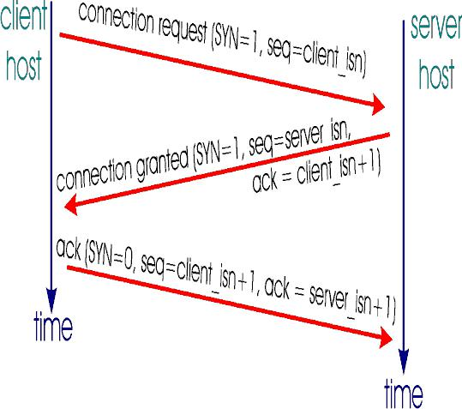

Figure: TCP three-way handshake: segment exchange

During the life of a TCP connection, the TCP protocol running in each host makes transitions through various TCP states.

1

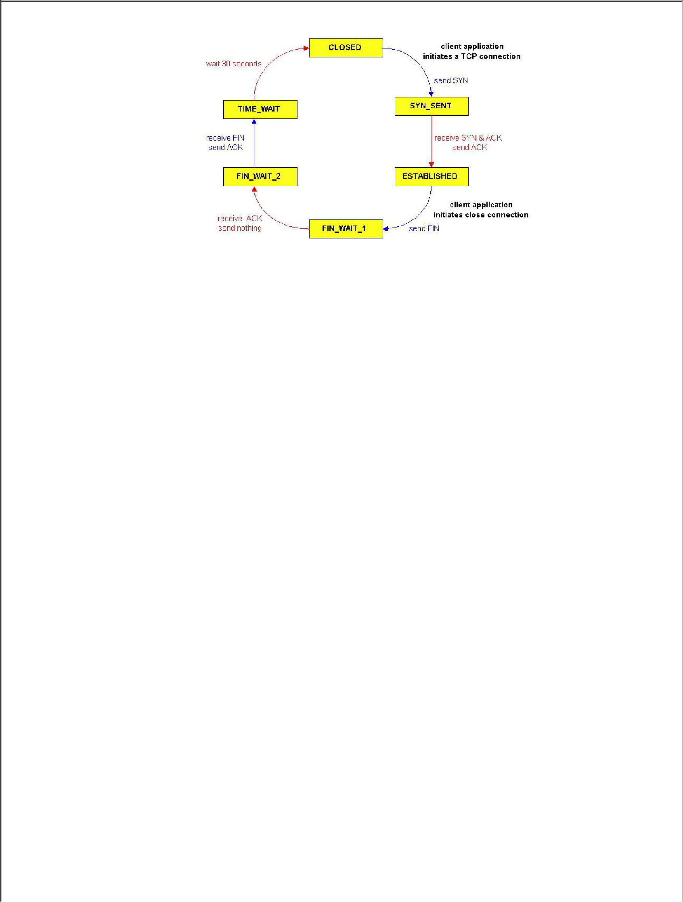

A typical sequence of TCP states visited by a client TCP

The above figure illustrates a typical sequence of TCP states that are visited by the client TCP. The client TCP begins in the closed state. The application on the client side initiates a new TCP connection (by creating a Socket object in our Java examples). This causes TCP in the client to send a SYN segment to TCP in the server.

After having sent the SYN segment, the client TCP enters the SYN_SENT sent. While in the SYN_STATE the client TCP waits for a segment from the server TCP that includes an acknowledgment for the client's previous segment as well as the SYN bit set to 1. Once having received such a segment, the client TCP enters the ESTABLISHED state. While in the ESTABLISHED state, the TCP client can send and receive TCP segments containing payload (i.e., application-generated) data.

Suppose that the client application decides it wants to close the connection. This causes the client TCP to send a TCP segment with the FIN bit set to 1 and to enter the FIN_WAIT_1 state. While in the FIN_WAIT state, the client TCP waits for a TCP segment from the server with an acknowledgment.

When it receives this segment, the client TCP enters the FIN_WAIT_2 state. While in the FIN_WAIT_2 state, the client waits for another segment from the server with the FIN bit set to 1; after receiving this segment, the client TCP acknowledges the server's segment and enters the TIME_WAIT state. The TIME_WAIT state lets the TCP client resend the final acknowledgment in the case the ACK is lost.

The time spent in the TIME-WAIT state is implementation dependent, but typical values are 30 seconds, 1 minute and 2 minutes. After the wait, the connection formally closes and all resources on the client side (including port numbers) are released.

42

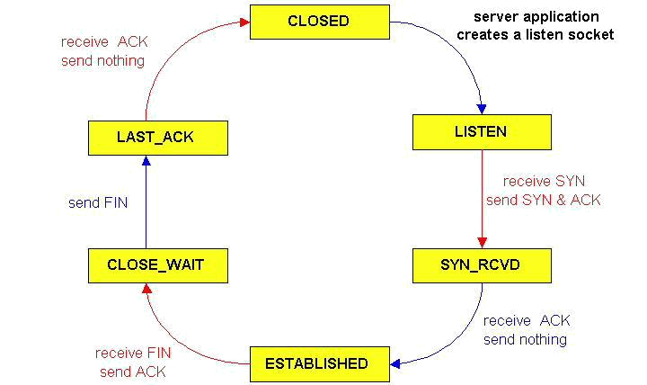

A typical sequence of TCP states visited by a server-side TCP

The above figure illustrates the series of states typically visited by the server-side TCP; the transitions are self-explanatory. In these two state transition diagrams, we have only shown how a TCP connection is normally established and shut down. We are not going to describe what happens in certain pathological scenarios, for example, when both sides of a connection want to shut down at the same time. If you are interested in learning about this and other advanced issues concerning TCP, you are encouraged to see Steven's comprehensive book.

CONGESTION CONTROL

- TCP uses a number of mechanisms to achieve high performance and avoid congestion collapse, where network performance can fall by several orders of magnitude. These mechanisms control the rate of data entering the network, keeping the data flow below a rate that would trigger collapse.

- A TCP connection controls its transmission rate by limiting its number of transmitted-but-yet-to-be-acknowledged segments. Let us denote this number of permissible unacknowledged segments as w, often referred to as the TCP window size.

- The TCP congestion control mechanism has each side of the connection keep track of two additional variables: the congestion window and the threshold.

43

- The congestion window, denoted CongWin, imposes an additional constraint on how much traffic a host can send into a connection. Specifically, the amount of unacknowledged data that a host can have within a TCP connection may not exceed the minimum of CongWin and RcvWin, i.e.,

- The sender’s send rate is roughly congwin/RTT bytes/sec. By adjusting the value of congwin, the sender can therefore adjust the rate at which it sends data into its connection.

- Sender uses TCP congestion control algorithm to regulate its sending rate. The algorithm has three main components: 1. Additive-increase, multiplicative decrease, 2.slow start, 3. Reaction to timeout events.

Additive-increase, multiplicative decrease,:

- TCP congestion control is for the sender to reduce its sending rate when a loss event occurs.

- TCP uses “multiplicative decrease” approach, if any loss event occurs. Thus if the value of a TCP sender’s congwin is currently 20Kbytes and loss is detected, congwin is cut in half to 10Kbytes.

- If another event occurs, congwin is further reduced to 5Kbytes. The value of congwin may continue to drop, but it is not allowed to drop below 1MSS.

- TCP sender increases its sending rate when it perceives no congestion, that is, when ACKs arrives previously yet-to-be-acknowledged data.

- TCP sender does this by incrementing congwin a little each time it receives an acknowledgement, 1MSS every round trip time.

- TCP congestion control is often referred to as an additive-increase, multiplicative decrease ﴾AIMD﴿ algorithm.

44

Slow Start:

- During this phase of the congestion control procedure, the congestion window increases exponentially fast, i.e., the congestion window is initialized to one MSS, after one RTT the window is increased to two segments, after two round-trip times the window is increased to four segments, after three round-trip times the window is increased to eight segments, etc. This phase of the algorithm is called slow start because it begins with a small congestion window equal to one MSS.

- The slow start phase ends when the window size exceed the value of threshold. Once the congestion window is larger than the current value of threshold, the congestion window grows linearly rather than exponentially.

- Specifically, if w is the current value of the congestion window, and w is larger than threshold, then after w acknowledgements have arrived, TCP replaces w with w + 1 . This has the effect of increasing the congestion window by one in each RTT for which an entire window's worth of acknowledgements arrives. This phase of the algorithm is called congestion avoidance.

Reaction to timeout Events:

- When a timeout occurs, the value of threshold is set to half the value of the current congestion window, and the congestion window is reset to one MSS. The sender then again grows the congestion window exponentially fast using the slow start procedure until the congestion window hits the threshold.

- When the congestion window is below the threshold, the congestion window grows exponentially.

- When the congestion window is above the threshold, the congestion window grows linearly.

- Whenever there is a timeout, the threshold is set to one half of the current congestion window and the congestion window is then set to one.

TCP DELAY MODELING

- Many TCP connections transport relatively small files from one host to another. When transporting a small file, TCP connection establishment and slow start may have a significant impact on the latency.

- For a given object, we define the latency as the time from when the client initiates a TCP connection until when the client receives the requested object in its entirety.
45

- The analysis presented here assumes that that the network is uncongested, i.e., the TCP connection transporting the object does not have to share link bandwidth with other TCP or UDP traffic.
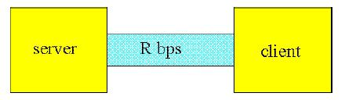

A simple one-link network connecting a client and a server

We also make the following simplifying assumptions:

- The amount of data that the sender can transmit is solely limited by the sender's congestion window. (Thus, the TCP receive buffers are large.)

- Packets are neither lost nor corrupted, so that there are no retransmission

- All protocol header overheads -- including TCP, IP and link-layer headers -- are negligible and ignored.

- The object (that is, file) to be transferred consists of an integer number of segments of size MSS (maximum segment size).

- The only packets that have non-negligible transmission times are packets that carry maximum-size TCP segments. Request packets, acknowledgements and TCP connection establishment packets are small and have negligible transmission times.

- The initial threshold in the TCP congestion control mechanism is a large value which is

never attained by the congestion window.

We also introduce the following notation:

- The size of the object to be transferred is O bits.

- The MSS (maximum size segment) is S bits (e.g., 536 bytes).

- The transmission rate of the link from the server to the client is R bps.

- The round-trip time is denoted by RTT.

  - One RTT is required to initiate the TCP connection. After one RTT the client sends a request for the object (which is piggybacked onto the third segment in the three-way TCP handshake). After a total of two RTTs the client begins to receive data from the server.

46

The client receives data from the server for a period of time O/R, the time for the server to transmit the entire object.

- Thus, in the case of no congestion window constraint, the total latency is 2 RTT + O/R.

Static Congestion Window

- Let W, a positive integer, denote a server receives the request from the back-to-back to the client.

fixed-size static congestion window. When the client, the server immediately sends W segments

- The server then sends one segment into the network for each acknowledgement it receives from the client. The server continues to send one segment for each acknowledgement until all of the segments of the object have been sent.

- There are two cases to consider:

- WS/R > RTT + S/R. In this case, the server receives an acknowledgement for the first segment in the first window before the server completes the transmission of the first window.

- WS/R < RTT + S/R. In this case, the server transmits the first window's worth of segments before the server receives an acknowledgement for the first segment in the window.

Let us first consider Case 1, which is illustrated in Figure. In this figure the window size is W = 4 segments.
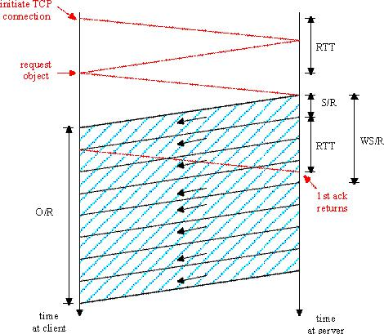

The case that WS/R > RTT + S/R

7

- One RTT is required to initiate the TCP connection. After one RTT the client sends a request for the object (which is piggybacked onto the third segment in the three-way TCP handshake). After a total of two RTTs the client begins to receive data from the server.

- Segments arrive periodically from the server every S/R seconds, and the client acknowledges every segment it receives from the server. Because the server receives the first acknowledgement before it completes sending a window's worth of segments, the server continues to transmit segments after having transmitted the first window's worth of segments.

- And because the acknowledgements arrive periodically at the server every S/R seconds from the time when the first acknowledgement arrives, the server transmits segments continuously until it has transmitted the entire object. Thus, once the server starts to transmit the object at rate R, it continues to transmit the object at rate R until the entire object is transmitted.

- The latency therefore is 2 RTT + O/R.

Now let us consider Case 2, which is illustrated in Figure. In this figure, the window size is W=2 segments.
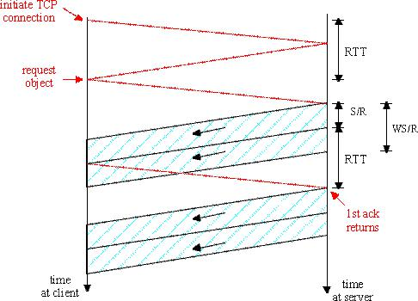

The case that WS/R < RTT + S/R

48

- Once again, after a total of two RTTs the client begins to receive segments from the server. These segments arrive peridodically every S/R seconds, and the client acknowledges every segment it receives from the server. But now the server completes the transmission of the first window before the first acknowledgment arrives from the client.

- When an acknowledgement finally arrives, the server sends a new segment to the client. Once the first acknowledgement arrives, a window's worth of acknowledgements arrive, with each successive acknowledgement spaced by S/R seconds.

- For each of these acknowledgements, the server sends exactly one segment. Thus, the server alternates between two states: a transmitting state, during which it transmits W segments; and a stalled state, during which it transmits nothing and waits for an acknowledgement.

- The latency is equal to 2 RTT plus the time required for the server to transmit the object, O/R, plus the amount of time that the server is in the stalled state.

- To determine the amount of time the server is in the stalled state, let K = O/WS; if O/WS is not an integer, then round K up to the nearest integer. Note that K is the number of windows of data there are in the object of size O.

- The server is in the stalled state between the transmission of each of the windows, that is, for K-1 periods of time, with each period lasting RTT- (W-1)S/R (see above diagram).

Thus, for Case 2, Latency = 2 RTT + O/R + (K-1)[S/R + RTT - W S/R] .

Combining the two cases, we obtain Latency = 2 RTT + O/R + (K-1) [S/R + RTT - W S/R]+ where [x]+ = max(x,0).

49

Dynamic Congestion Window

- The server first starts with a congestion window of one segment and sends one segment to the client. When it receives an acknowledgement for the segment, it increases its congestion window to two segments and sends two segments to the client

- As it receives the acknowledgements for the two segments, it increases the congestion window to four segments and sends four segments to the client (again spaced apart by S/R seconds). The process continues, with the congestion window doubling every RTT. A timing diagram for TCP is illustrated in Figure.
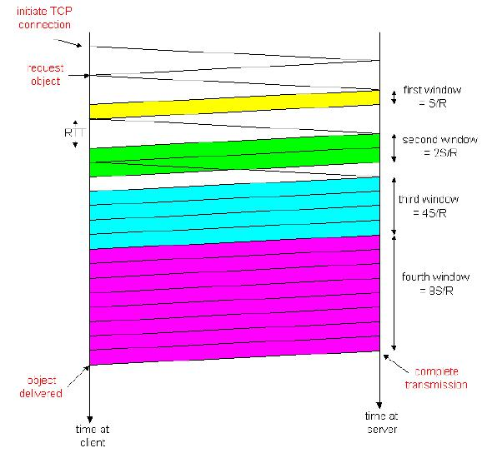

TCP timing during slow start

- Note that O/S is the number of segments in the object; in the above diagram, O/S =15. Consider the number of segments that are in each of the windows. The first window contains 1 segment; the second window contains 2 segments; the third window contains 4 segments. More generally, the kth window contains 2k-1 segments.

50

- Let K be the number of windows that cover the object; in the preceding diagram K=4. In general we can express K in terms of O/S as follows:
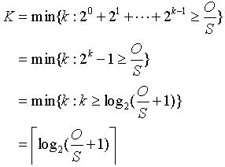

- After transmitting a window's worth of data, the server may stall (i.e., stop transmitting) while it waits for an acknowledgement.

- Let us now calculate the amount of stall time after transmitting the kth window. The time from when the server begins to transmit the kth window until when the server receives an acknowledgement for the first segment in the window is S/R + RTT. The transmission time of the kth window is (S/R) 2k-1. The stall time is the difference of these two quantities, that is,

- The server can potentially stall after the transmission of each of the first K-1 windows.. We can now calculate the latency for transferring the file.

- The latency has three components: 2RTT for setting up the TCP connection and requesting the file; O/R, the transmission time of the object; and the sum of all the stalled times. Thus,

- Compare the above equation for the latency equation for static congestion windows; all the terms are exactly the same except the term WS/R for static windows has been replaced by 2k-1S/R for dynamic windows.
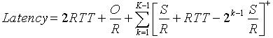

51

- To obtain a more compact expression for the latency, let Q be the number of times the server would stall if the object contained an infinite number of segments:
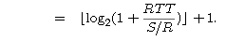

Q

- The actual number of times the server stalls is P = min{Q,K-1}. In the preceding diagram P=Q=2.

- Combining the above two equations gives the following closed-form expression for the latency:

- Thus to calculate the latency, we simple must calculate K and Q, set P = min{Q,K-1}, and plug P into the above formula.

- It is interesting to compare the TCP latency to the latency that would occur if there were no congestion control (that is, no congestion window constraint). Without congestion control, the latency is 2RTT + O/R, which we define to be the Minimum Latency.
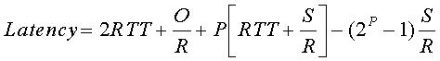

TLS/SSL

- One way of mitigating a potential attack during a user’s session would be to use a secure communication protocol to encrypt data in transit between the user and the server on which the sensitive information resides.

- Two of these communication protocols are: Secure Sockets Layer (SSL) and Transport Layer Security (TLS).

Secure Sockets Layer Protocol

- SSL is the secure communications protocol of choice for a large part of the Internet community. There are many applications of SSL in existence, since it is capable of securing any transmission over TCP.

- SSL Protocol, the point of the protocol “is to provide privacy and reliability between two communicating applications.”

52

- The protocol release further explains that three points combine to provide connection security. These points are:

o Privacy - connection through encryption

o Identity authentication – identification through certificates, and

- Reliability –dependable maintenance of a secure connection through

- message integrity checking

Transport Layer Security Protocol

Definition of TLS

- TLS was released in response to the Internet community’s demands for a standardized protocol. The IETF provided a venue for the new protocol to be openly discussed, and encouraged developers to provide their input to the protocol.

- The protocol "allows client/server applications to communicate in a way that is designed to prevent eavesdropping, tampering or message forgery."

- The goals of the TLS protocol are cryptographic security, interoperability, extensibility, and relative efficiency. These goals are achieved through implementation of the TLS protocol on two levels: the TLS Record protocol and the TLS Handshake protocol.

Difference between TLS/SSL:

- TLS 1.0 and SSL 3.0 are not interchangeable. TLS Enhancements to SSL

- The keyed-Hashing for Message Authentication Code (HMAC) algorithm replaces the SSL Message Authentication Code (MAC) algorithm.

- HMAC produces more secure hashes than the MAC algorithm. The HMAC produces an integrity check value as the MAC does, but with a hash function construction that makes the hash much harder to break.

Benefits of TLS/SSL

TLS/SSL provides numerous benefits to clients and servers over other methods of authentication, including:

- Strong authentication, message privacy, and integrity

- Interoperability

- Algorithm flexibility

- Ease of deployment

53

• Ease of use

- Strong authentication, message privacy, and integrity

TLS/SSL can help to secure transmitted data using encryption. TLS/SSL also authenticates servers and, optionally, authenticates clients to prove the identities of parties engaged in secure communication. It also provides data integrity through an integrity check value. In addition to protecting against data disclosure, the TLS/SSL security protocol can be used to help protect against masquerade attacks, man-in-the-middle or bucket brigade attacks, rollback attacks, and replay attacks.
- Interoperability

TLS/SSL works with most Web browsers, including Microsoft Internet Explorer and Netscape Navigator, and on most operating systems and Web servers, including the Microsoft Windows operating system, UNIX, Novell, Apache (version 1.3 and later), Netscape Enterprise Server, and Sun Solaris. It is often integrated in news readers, LDAP servers, and a variety of other applications.
- Algorithm flexibility

TLS/SSL provides options for the authentication mechanisms, encryption algorithms, and

hashing algorithms that are used during the secure session.

  - Data can be encrypted and decrypted, but you cannot reverse engineer a hash. Hashing is a one-way process. Running the process backward will not create the original data. This is why a new hash is computed and then compared to the sent hash.

- Ease of deployment

Many applications use TLS/SSL transparently on a Windows Server 2003 operating system. You can use TLS for more secure browsing when you are using Internet Explorer and Internet Information Services (IIS) and, if the server already has a server certificate installed, you only have to select the check box.

- Ease of use

Because you implement TLS/SSL beneath the application layer, most of its operations are completely invisible to the client. This allows the client to have little or no knowledge of the security of communications and still be protected from attackers.

Limitations of TLS/SSL

There are a few limitations to using TLS/SSL, including:

4

- Increased processor load

This is the most significant limitation to implementing TLS/SSL. Cryptography, specifically public key operations, is CPU-intensive. As a result, performance varies when you are using SSL. Unfortunately, there is no way to know how much performance you will lose. The performance varies, depending on how often connections are established and how long they last. TLS uses the greatest resources while it is setting up connections.

- Administrative overhead

A TLS/SSL environment is complex and requires maintenance; the system administrator must configure the system and manage certificates.

Common TLS/SSL Scenarios

Many people think of TLS and SSL as protocols that are used with Web browsers to browse the Internet more securely. However, they are also general purpose protocols that can be used whenever authentication and data protection are necessary. For example, you can use TLS/SSL for:

- SSL-secured transactions with an e-commerce Web site

- Authenticated client access to an SSL-secured Web site

- Remote access

- SQL access

- E-mail

SSL-secured transactions with an e-commerce Web site:

This situation is a typical use of SSL between a browser and a Web server. An example is an e-commerce shopping site where clients need to provide their credit card numbers. The protocol first confirms that the certificate of the Web site is valid, and then sends the client’s credit card information as cipher text. For this type of transaction, where the server’s certificate comes from a trusted source, authentication only occurs for the server. TLS/SSL must be enabled for the Web page, such as an order form, where the data transactions occur.

Authenticated client access to an SSL-secured Web site

Both the client and server need certificates from a mutually-trusted certification authority (CA). With Schannel, client certificates can be mapped on a one-to-one or many-to-one basis to their Windows Server 2003 user or computer accounts, and they can be managed by Active

55

Directory Users and Computers. Users can then be authenticated to a Web site without needing to supply a password.

Many-to-one mapping has several uses. For example, if you want to give several users access to confidential material, you can create a group, map the users’ certificates to the group, and give the group the necessary permissions to the material.

In one-to-one mapping, the server has a copy of the client’s certificate; whenever the client logs in; the server verifies that they are identical. This one-to-one mapping is typically used for private material, such as a banking Web site where only one individual has the right to view a personal account.

Remote access

In this situation, telecommuting is a common use for Schannel. You can use this technology to provide authentication and data protection when users remotely log in to Windows-based systems or networks. Users can more securely access their e-mail or enterprise applications from home or while traveling, reducing the risk of exposure of the information to anyone on the Internet.

SQL access

With Microsoft SQL Server, you can require authentication of the client when connecting to the server running SQL Server. Either the client or server can be configured to require encryption of the data that is transferred between them. Very sensitive information, such as financial or medical databases, can be protected to prevent unauthorized access and disclosure of information about the network.

E-mail

When using Exchange servers, you can use Schannel to help protect data as it moves from server to server on the intranet or Internet. Full end-to-end security might require the use of Secure/Multipurpose Internet Mail Extensions (S/MIME); however, helping to protect data in a server-to-server exchange allows companies to use the Internet to securely transfer e-mail among divisions within the same company, subsidiaries, and partners. This can be done regardless of whether S/MIME is used.

Integrated Services and Differentiated Services

- There are two architectures that have been proposed for providing quality of service in the internet: the integrated services (IntServ) and Differentiated Services (DiffServ).

Integrated services (IntServ)

- The IntServ architecture model (RFC 1633, June 1994) was motivated by the needs of real-time applications such as remote video, multimedia conferencing, visualization, and virtual reality.

- It provides a way to deliver the end-to-end Quality of Service (QoS) that real-time applications require by explicitly managing network resources to provide QoS to specific user packet streams (flows). It uses "resource reservation" and "admission control" mechanisms as key building blocks to establish and maintain QoS.

- IntServ uses Resource Reservation Protocol (RSVP) to explicitly signal the QoS needs of an application's traffic along the devices in the end-to-end path through the network

- Reserved Resources. A router is required to know what amounts of its resources (buffers, link bandwidth) are already reserved for on-going sessions.

- Call Setup. A session requiring QoS guarantees must first be able to reserve sufficient resources at each network router on its source-to-destination path to ensure that its end-to-end QoS requirement is met. This call setup (also known as call admission) process requires the participation of each router on the path.
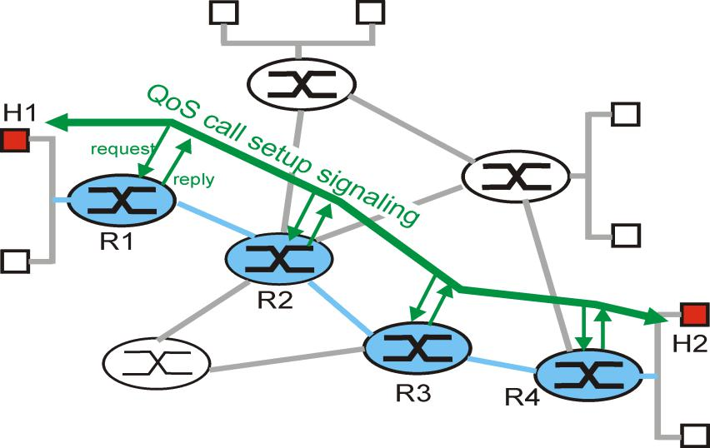

The call setup process

Let us now consider the steps involved in call admission in more detail:

- Traffic characterization and specification of the desired QoS. In the Intserv architecture, the so-called Rspec (R for reserved) defines the specific QoS being requested by a connection; the so-called Tspec (T for traffic) characterizes the traffic the sender will be sending into the network, or the receiver will be receiving from the network. The specific form of the Rspec and Tspec will vary, depending on the service requested. The Tspec and Rspec are defined in part in [RFC2210], [RFC 2215].

- Signaling for call setup. A session's Tspec and Rspec must be carried to the routers at which resources will be reserved for the session. [RFC 2210] describes the use of the RSVP resource reservation protocol with the Intserv architecture.

- Per-element call admission. Once a router receives the Tspec and Rspec for a session requesting a QoS guarantee, it can determine whether or not it can admit the call. This call admission decision will depend on the traffic specification, the requested type of service, and the existing resource commitments already made by the router to on-going sessions. Per-element call admission is shown in Figure
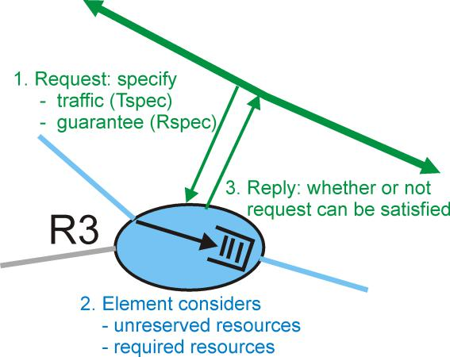

Per-element call behavior

The Intserv architecture defines two major classes of service: Guaranteed Service and Controlled-Load service.

Guaranteed Quality of Service

- The Guaranteed Service definition, defined in [RFC 2212] provides firm (mathematically provable) bounds on the queuing delays that a packet will experience in a router.
- To a first approximation, a source's traffic characterization is given by a leaky bucket with parameters (r,b) and the requested service is characterized by a transmission rate, R, at which packets will be transmitted.

- In essence, a session requesting Guaranteed Service is requiring that the bits in its packet be guaranteed a forwarding rate of R bits/sec. Given that traffic is specified using a leaky bucket characterization, and a guaranteed rate of R is being requested, it is also possible to bound the maximum queuing delay at the router.

- Recall that with a leaky bucket traffic characterization, the amount of traffic (in bits) generated over any interval of length t is bounded by rt+b

- When a leaky bucket source is fed into a queue which guarantees that queued traffic will be serviced at least at a rate of R bits per second, then the maximum queuing delay experienced by any packet will be bounded by b/R, as long as R is greater than r.

- The actual delay bound guaranteed under the Guaranteed Service definition is slightly more complicated, due to packetization effects (the simple b/R bound assumes that data is in the forms of a fluid-like flow rather than discrete packets), the fact that the traffic arrival process is subject to the peak rate limitation of the input link, and possible additional variations in a packet's transmission time.

Control Load Network Service

- A session receiving Controlled-Load service will receive "a quality of service closely approximating the QoS that same flow would receive from an unloaded network element." [RFC 2211].

- In other words, the session may assume that a "very high percentage" of its packets will successfully pass through the router without being dropped and will experience a queuing delay in the router that is close to zero.

- Interestingly, Control Load service makes no quantitative guarantees about performance - it does not specify what constitutes a "very high percentage" of packets nor what quality of service closely approximates that of an unloaded network element.

- The Controlled Load service targets real-time multimedia applications that have been developed for today's Internet. These applications perform quite well when the network is unloaded, but rapidly degrade in performance as the network becomes more loaded.

Differentiated Services (DiffServ)

- The ability to request and reserve per-flow resources, in turn, makes it possible for the intserv framework to provide quality of service guarantees to individual flows.

Difficulties associated with the Intserv model and per-flow reservation of resources:

- Scalability. The per-flow resource reservation implies the need for a router to process resource reservations and to maintain per-flow state for each flow passing though the router.

- Flexible service models. The Intserv framework provides for a small number of pre-specified service classes. This particular set of service classes does not allow for more qualitative or relative definitions of service distinctions (e.g., "Service class A will received preferred treatment over service class B.").

The differentiated services architecture is flexible in the sense that it does not define specific services or service classes. Instead, the differentiated services architecture provides the functional components, i.e., the "pieces" of a network architecture, with which such services can be built. Let us now examine these components in detail.

Differentiated Services: A Simple Scenario

To set the framework for defining the architectural components of the differentiated service model, let us begin with the simple network shown in Figure.
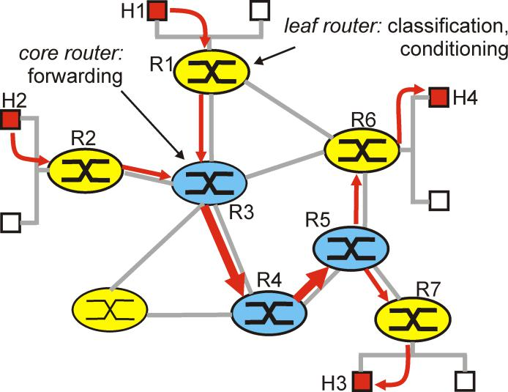

A simple diffserv network example.

The differentiated services architecture consists of two sets of functional elements:

- Edge functions: packet classification and traffic conditioning. At the incoming "edge" of the network, arriving packets are marked. More specifically, the Diffierentiated Service (DS) field of the packet header is set to some value.

- For example, in Figure, packets being sent from H1 to H3 might be marked at R1,

while packets being sent from H2 to H4 might be marked at R2. The mark that a packet receives identifies the class of traffic to which it belongs.

- Different classes of traffic will then receive different service within the core network. The RFC defining the differeniated service architecture [RFC 2475] uses the term "behavior aggregate" rather than "class of traffic." After being marked, a packet may then be immediately forwarded into the network, delayed for some time before being forwarded, or may be discarded.

  - We will see shortly that many factors can influence how a packet is to be marked, and whether it is to be forwarded immediately, delayed, or dropped.

- Core function: forwarding. When a DS-marked packet arrives at a DS-capable router, the packet is forwarded onto its next hop according to the so-called per-hop behavior associated with that packet's class.

  - The per-hop behavior influences how a router's buffers and link bandwidth are shared

among the competing classes of traffic.

- A crucial tenet of the DS architecture is that a router's per-hop behavior will be based only on packet markings, i.e., the class of traffic to which a packet belongs. Thus, if packets being sent from H1 to H3 in Figure receive the same marking as packets from H2 to H4, then the network routers treat these packets as a aggregate, without

distinguishing whether the packets originated at H1 or H2.

- For example, R3 would not distinguish between packets from H1 and H2 when forwarding these packets on to R4. Thus, the differentiated service architecture obviates the need to keep router state for individial source-destination pairs - an important consideration in meeting the scalability requirement discussed at the beginning of this section.

61

Diffsery Traffic Classification and Conditioning

- It provides a logical view of the classification and marking function within the edge router. Packets arriving to the edge router are first "classified."
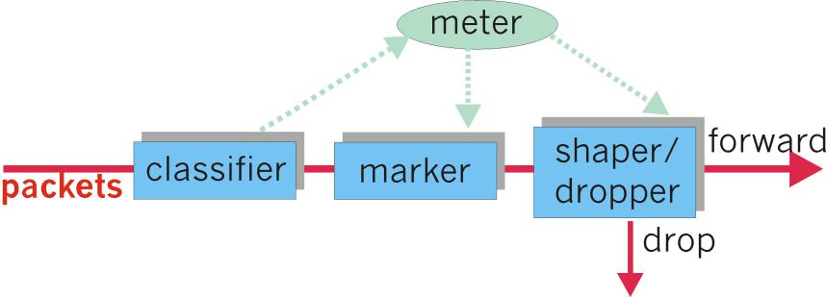

Logical view of packet classification and traffic conditioning at the edge router

- The classifier selects packets based the values of one or more packet header fields (e.g., source address, destination address, source port, destination port, protocol ID) and steers the packet to the appropriate marking function.

- The DS field value is then set accordingly at the marker. Once packets are marked, they are then forwarded along their route to the destination. At each subsequent DS-capable router, these marked packets then receive the service associated with the packets' marks. Even this simple marking scheme can be used to support different classes of service within the Internet.

- end user agrees that its packet sending rate would be within some declared traffic profile. The traffic profile might contain a limit on the peak rate, as well as the burstiness of the packet flow,

- As long as the user sends packets into the network in a way that conforms to the negotiated traffic profile, the packets receive their priority marking. On the other hand, if the traffic profile is violated, the out-of-profile packets might be marked differently, might be shaped (e.g. delayed so that a maximum rate constraint would be observed), or might be dropped at the network edge.

- The role of the metering function, shown in Figure 6.9-4, is to compare the incoming packet flow with the negotiated traffic profile and to determine whether a packet is within the

negotiated traffic profile. The actual decision about whether to immediately re-mark,

2

forward, delay, or drop a packet is not specified in the diffserv architecture. The diffserv architecture only provides the framework for performing packet marking and shaping/dropping; it does not mandate any specific policy for what marking and conditioning (shaping or dropping) is actually to be done.

Per-Hops Behavior

- The second key component of the DS architecture involves the per hop behavior (i.e., packet forwarding function) performed by DS-capable routers.

- The per-hop behavior (PHB) is rather cryptically, but carefully, defined as "a description of the externally observable forwarding behavior of a DS node applied to a particular DS

behavior aggregate."

Several important considerations:

- A PHB can result in different classes of traffic ( i.e., traffic with different DS field values) receiving different performance (i.e., different externally observable forwarding behavior).

- While a PHB defines differences in performance (behavior) among classes, it does not mandate any particular mechanism for achieving these behaviors. As long as the externally observable performance criteria are met, any implementation mechanism and any buffer/bandwidth allocation policy can be used.

- Differences in performance must be observable, and hence measurable.

Currently, two PHB's are have been defined: an Expedited Forwarding (EF) PHB [RFC 3246] and an Assured Forwarding (AF) PHB [RFC 2597]:

- The Expedited Forwarding PHB specifies that the departure rate of a class of traffic from a router must equal or exceed a configured rate. That is, during any interval of time, the class of traffic can be guaranteed to receive enough bandwidth so that the output rate of the traffic equals or exceeds this minimum configured rate.

- Thus, even if the other classes of traffic are overwhelming router and link resources, enough of those resources must still be made available to the class to

63

ensure that it receives its minimum rate guarantee. EF thus provides a class with the simple abstraction of a link with a minumum guaranteed link bandwidth.

- The Assured Forwarding PHB is more complex. AF divides traffic into four classes, where each AF class is guaranteed to be provided with some minimum amount of bandwidth and buffering.

o Within each class, packets are further partitioned into one of three "drop preference" categories.

o When congestion occurs within an AF class, a router can then discard (drop) packets based on their drop preference values. By varying the amount of resources allocated to each class, an ISP can provide different levels of performance to the different AF traffic classes.

64

