Proofs

Goldman Sachs Intern
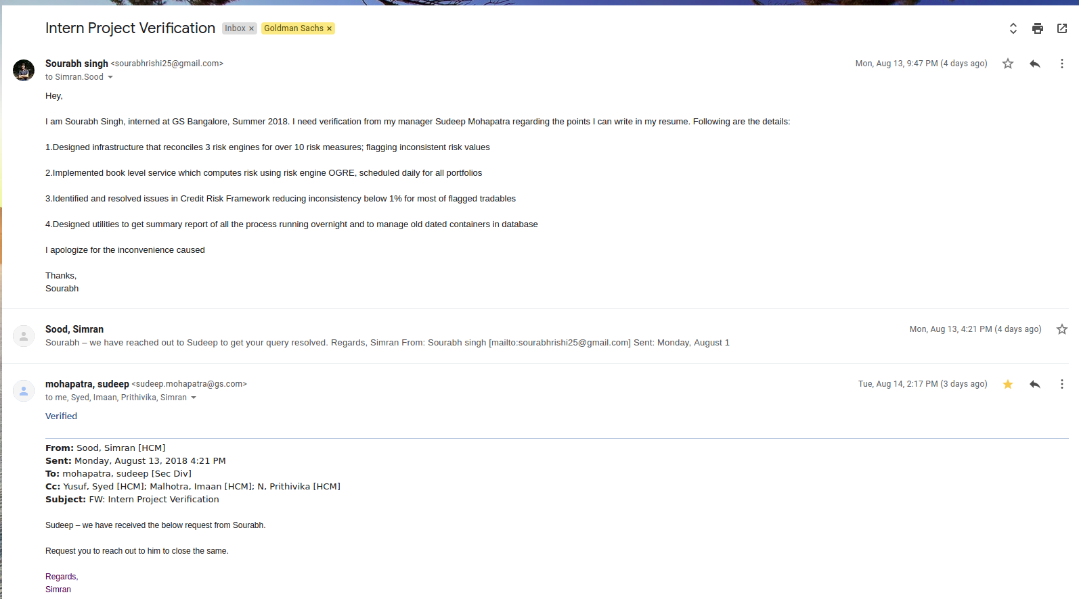

Ubisoft Intern
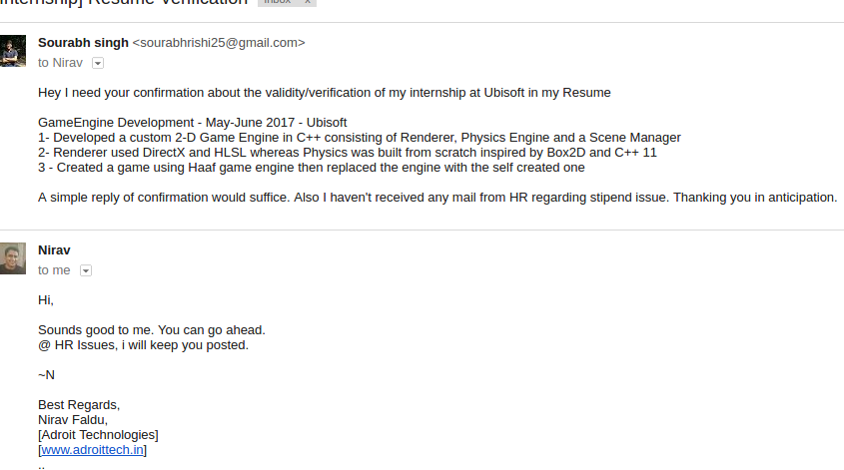

Wellthy Intern
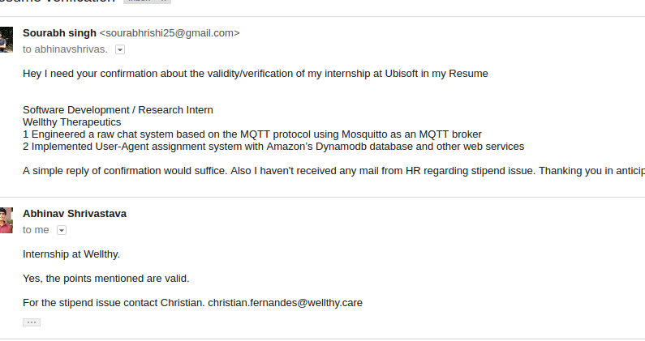

KVPY
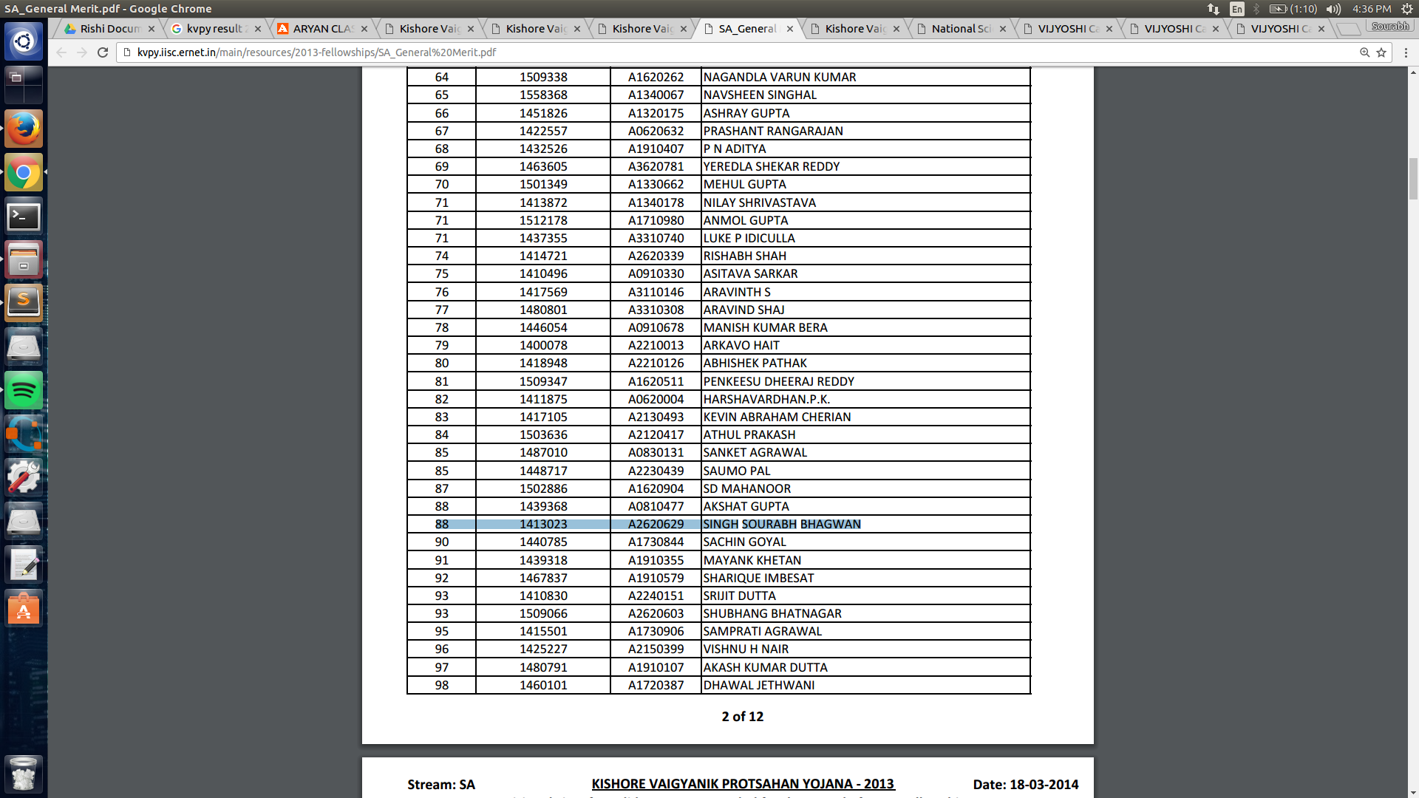

INMO

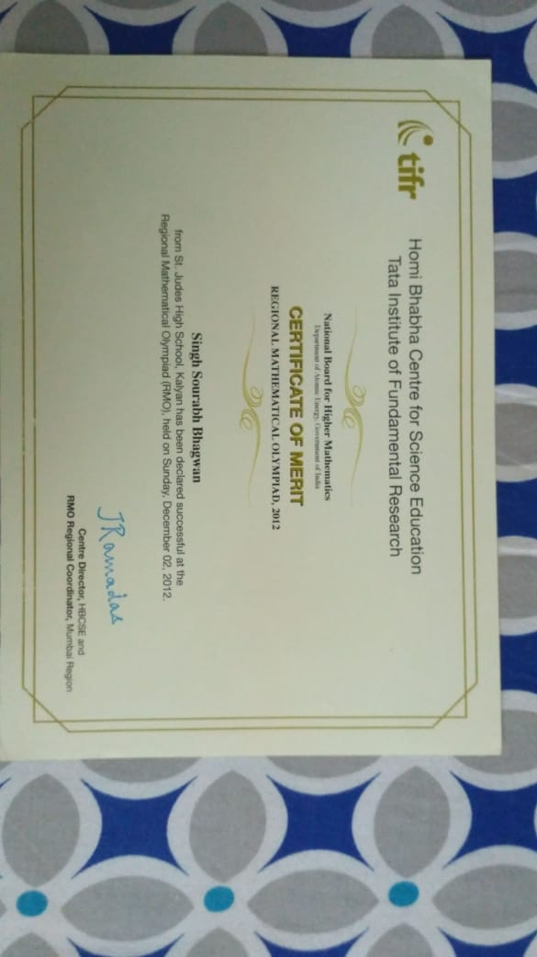
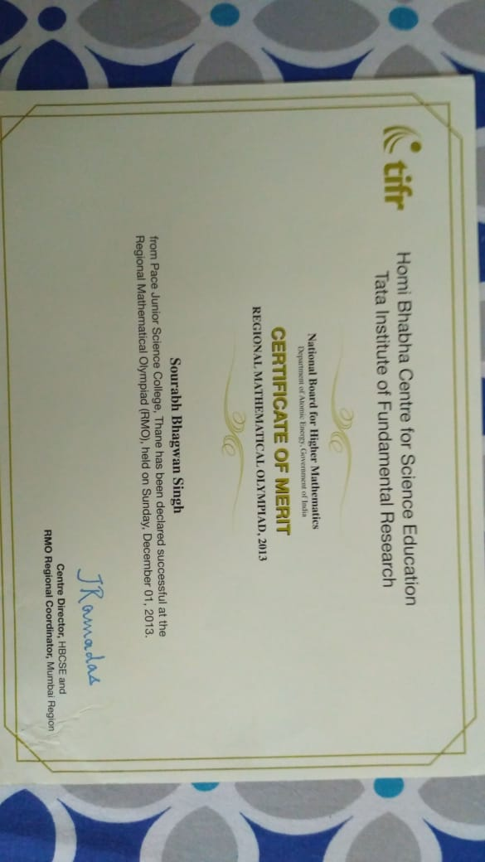

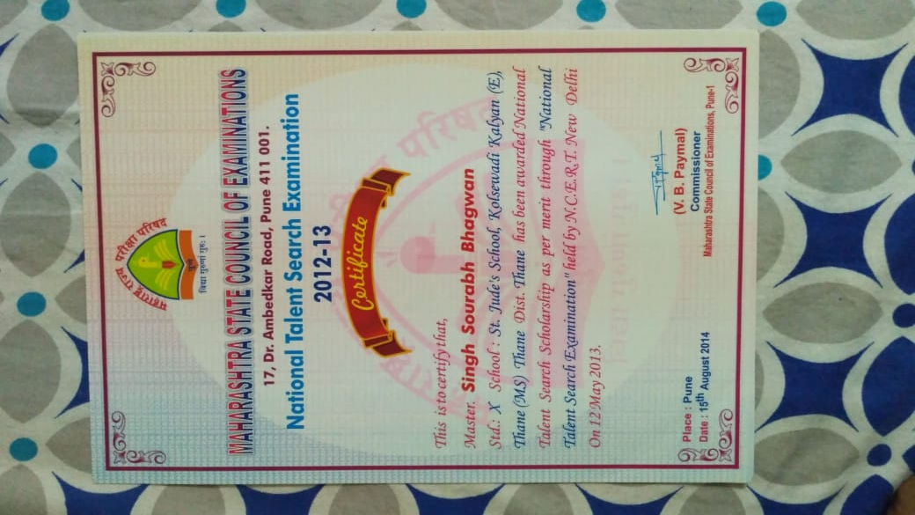
NTSE

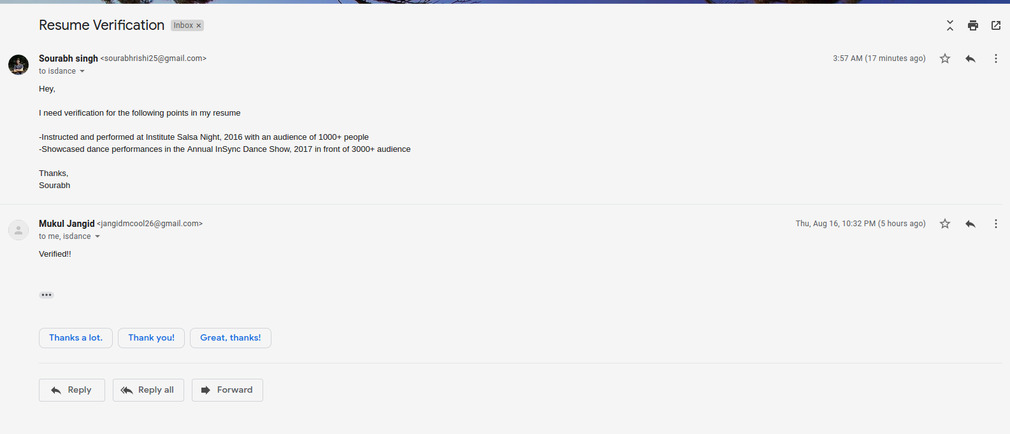
Dance

Swimming
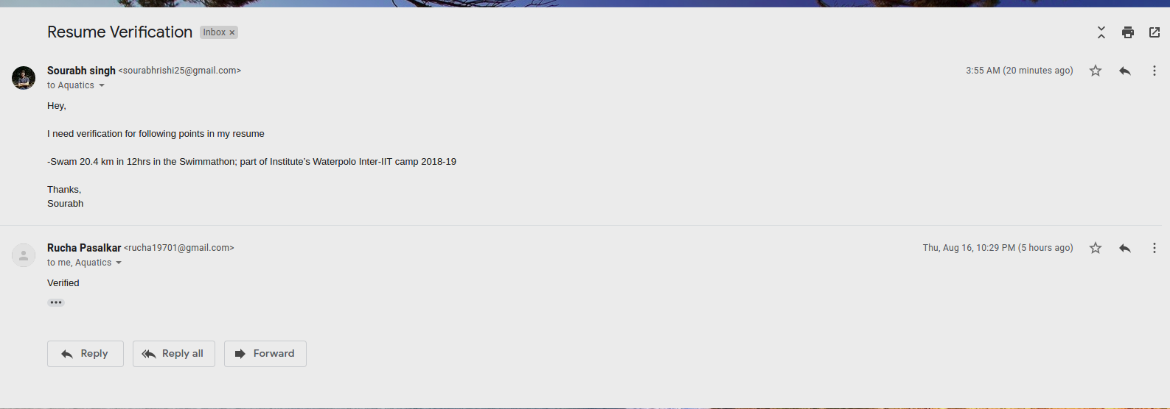

DAMP
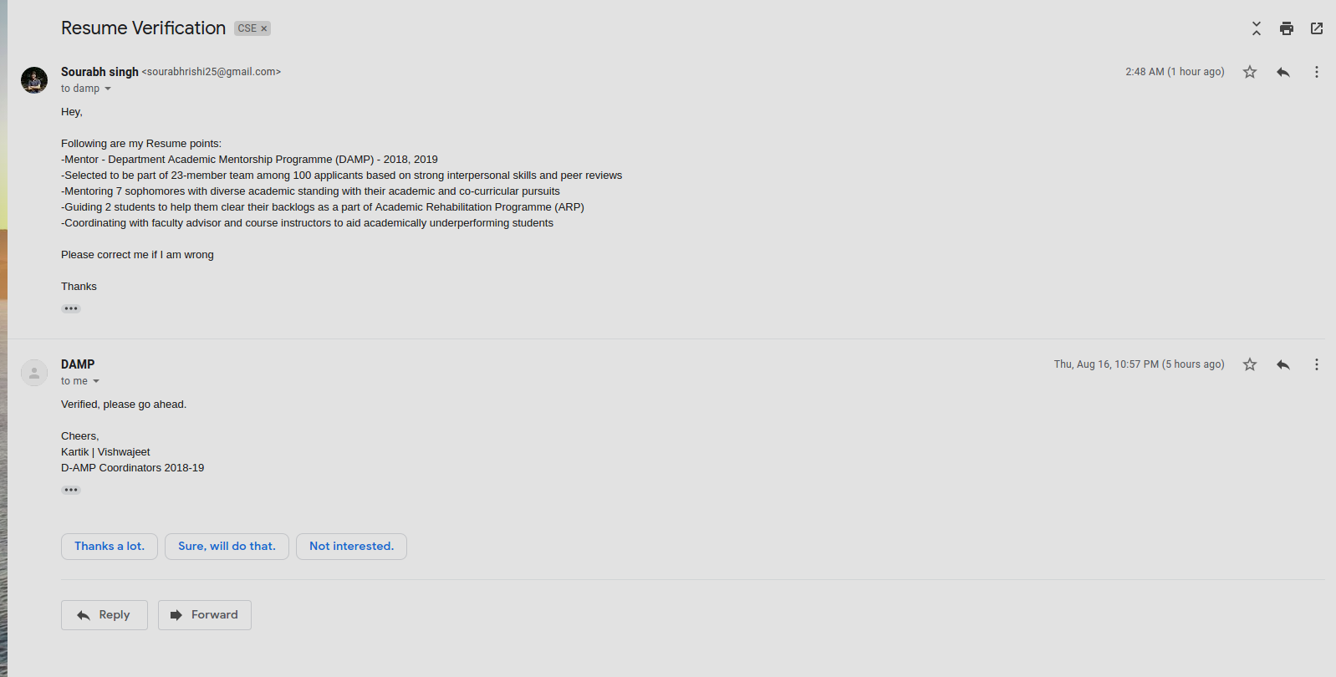
Line followers
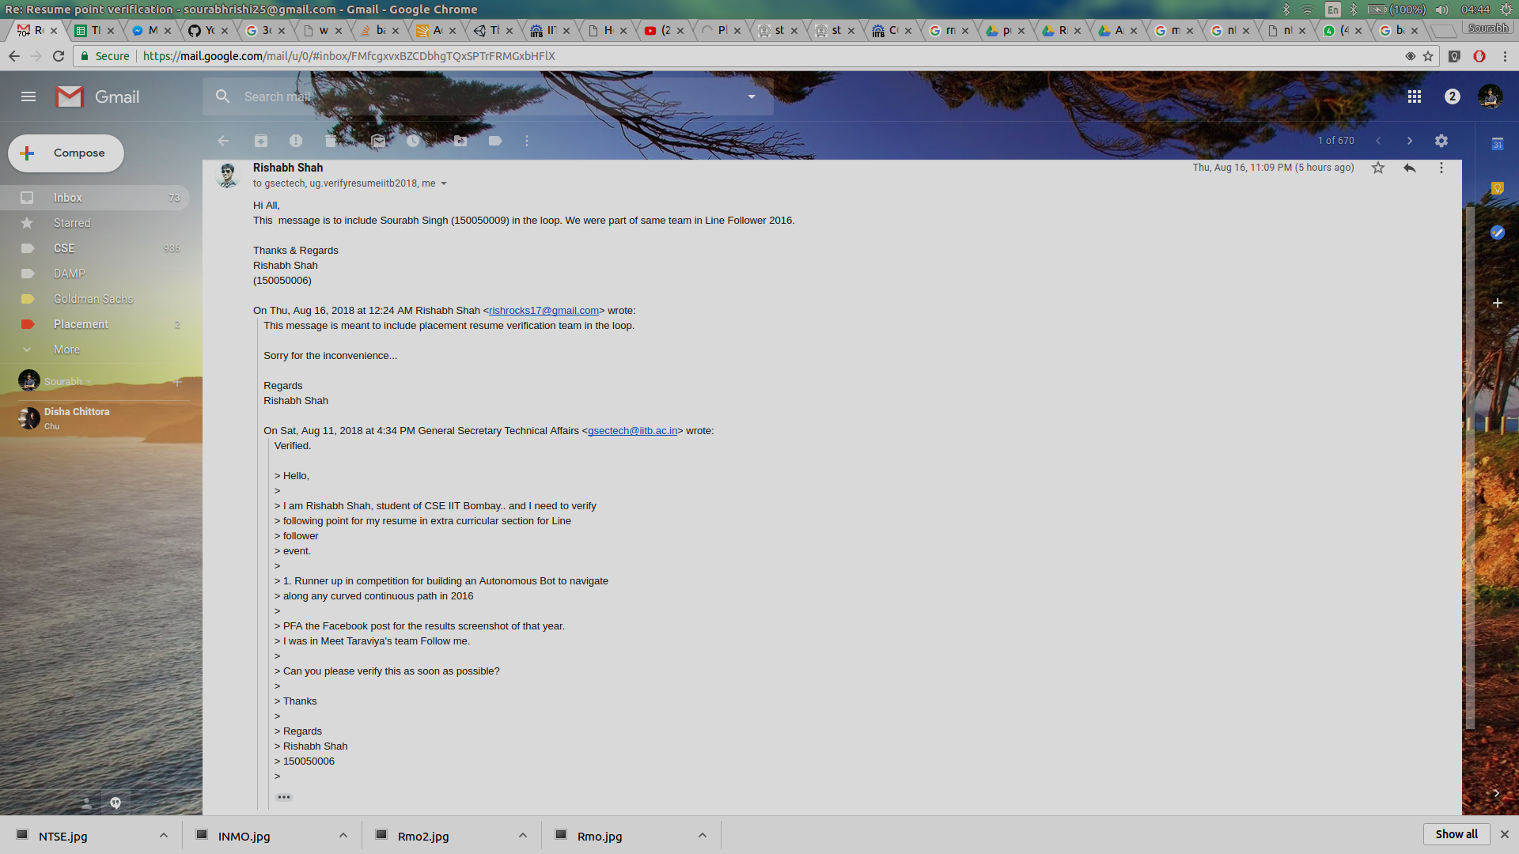

Proofs to all the projects are here uploaded to my gihub links here are the github links

https://github.com/ministark/GearEngine.git

https://github.com/ministark/Parallel-Sorting-Algorithms.git

https://github.com/ministark/Crafter.git

https://github.com/ministark/FirstPersonShooter.git

https://github.com/ministark/Aarohi.git

https://github.com/ministark/Echo.git

https://github.com/ministark/Feeder.git

10th and 12th percentage


