Clean Install on Empty vm

# Objectives

* + The objective of this exercise is to demonstrate the ability to install an operating system.

## Skills Reviewed

* + ipconfig command
  + Rename computer
  + Rename NIC

## New Skills

* + Setting startup type of a Windows service in PowerShell
  + Stopping a service in Windows with PowerShell
  + Clean install of Windows 10 with no previous OS installed.

# Initial Conditions

Your VM should be in this state prior to beginning this guided practice:

* + - Hyper-V installed on **VMHost** machine.
    - **CLIENT1** and **CLIENT2** VMs created by script in previous exercise.

# Final Conditions

At the end of this exercise, you will have:

* + Windows 10 installed on both **CLIENT1** and **CLIENT2** VM.

# Instructions

1. On your **VMHost**, open **Hyper-V Management**.
2. Add a DVD with **Windows 10 ISO** image to the **CLIENT2** VM.
   1. Right-click **CLIENT2** and select **Settings…** The **Settings for CLIENT2** page opens.
   2. This page is where the hardware for the **CLIENT2** VM is added or removed. How much RAM is configured for the VM? Which switch is the VM connected?

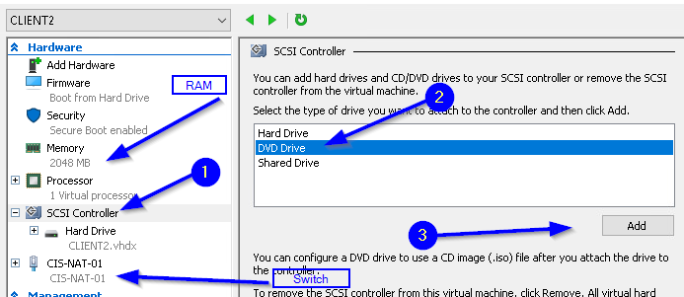

* 1. Add DVD by selecting **SCSI controller**, then selecting **DVD Drive** and then clicking **Add**.
  2. On the next screen, select the **Image file:** radio button and browse to **C:\ISO\Windows_10.iso** file click **Open** and then click **Apply**.

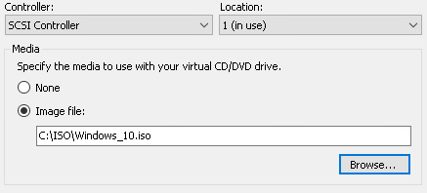

* 1. On physical hardware, you would need to access BIOS and change the boot order. In Hyper-V, the boot order is set in the **Firmware** section in **Hardware**. Click **Firmware**. You will see the boot order for the VM. Use the **Move Up** and **Move Down** buttons to move **DVD drive** to the top, followed by **Hard Drive** with **Network Adapter** at the bottom and then click **Apply**.

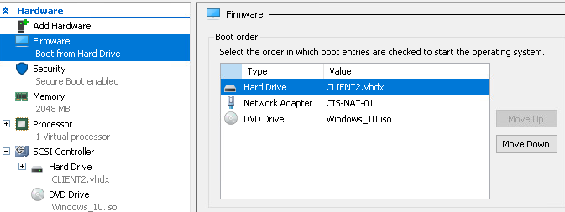

* 1. The hardware section should look like the mage below now, showing **Boot from DVD** **Drive** and that the **Windows_10.iso** is loaded in the DVD drive. After verifying these items, click **OK** to close the Properties page.

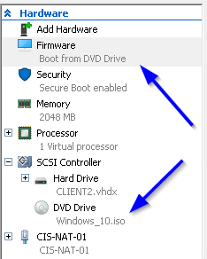

1. Double-click **CLIENT2** to connect to the VM. You should see a message indicating that **CLIENT2 is turned off**. Click **Start** and then click in the VM and **Press any key to boot from CD or DVD…**, click on the screen and press **Enter**. You need to be quick on these items.
   1. The VM should boot. If you were too slow, click **Turn Off** and then **Start** again. Repeat until the VM boots on DVD drive.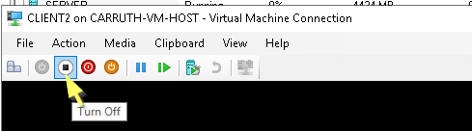
2. You will see that the system has booted with the Windows 10 ISO and the installation has started.

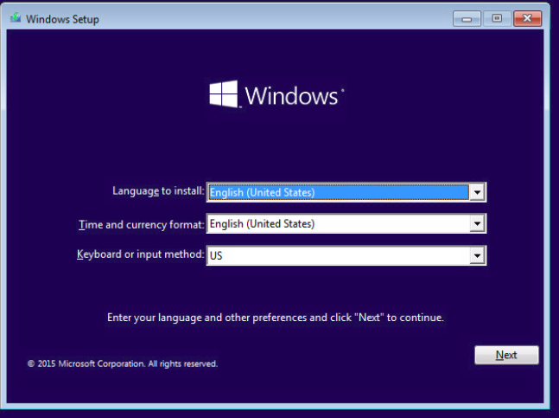

1. Click **Next** button.
2. Click **Install now** to start the installation.
3. On the **Select the operating system you want to install** page, select **Windows 10 Education**.
4. On the **Applicable notices and** **license terms** page, check the **I accept the license terms** check box and then click **Next**.
5. On the **Which type of installation do you want?** page, select **Custom: Install Windows only (advanced)**.
6. On the **Where do you want to install Windows?** page, accept **Drive 0 Unallocated Space** by clicking **Next**.
7. The **Installing Windows** page opens showing the installation progress.

**Note:** Now is a good time for a break or catching up on the reading assignment for the week as this phase of the installation will take a few minutes.

1. After the first pass of the installation completes, the VM restarts, and setup continues.
2. You will see a **Getting Ready** spinner. During this time device drivers are being installed. The screen may go black for a bit, then the VM restarts again to continue the startup.
3. On the **Let’s start with regions, Is this right?** screen, click **Yes**.
4. On the **Is this the right keyboard layout?** screen, click **Yes**.
5. On the **Want to add a second keyboard layout?** screen click **Skip**.
6. On the **Let’s connect you to a network** screen, click **I don’t have internet** link.
7. On the **There’s more to discover when you connect to the internet** page, click the **Continue with limited setup** link.
8. On the **Who’s going to use this PC?** screen, enter **ecpi** and then click **Next**.
9. On the **Create a super memorable password** screen, enter **Password1** and then click **Next**.
10. On the **Confirm your password** screen, enter **Password1** and then click **Next**.
11. On the **Create security questions for this account** page, select a security question and provide your answer, and then click **Next**. Repeat two times.
12. On the **Choose privacy settings for your device** screen, select **No** for all items and then click **Accept**.
13. On the **Do more across devices with active history** page, click **No**.
14. On the **Let Cortana help you get things done** page, select click **Not now**.
15. The logon process starts. It takes a few minutes to build the profile. You will see this series of screens each time you logon to a Windows 10 system for the first time with a new account.

**Note**: Installation is complete.

## disabling Windows update service

**Note**: The next portion of the process is setting Windows update service to manual. Do not disable Windows update on a production machine. The reason Windows update is set to manual on the lab computers is: 1) takes a LONG time to download and install the updates, 2) Microsoft changes the menu and app locations in some of the updates, and 3) the amount of bandwidth needed to update a whole classroom would cause adverse effects outside the classroom. There will be a lab exercise later in the course where updates are applied.

1. Log onto **CLIENT2** with the **ecpi** account.
2. Stop and set the **Windows Update** service startup type to **Manual**.
   1. Open elevated PowerShell window by right-clicking **Start** selecting **Windows PowerShell(Admin).**
   2. Enter the commands

Stop-Service -Name wuauserv

Set-Service -Name wuauserv -Startuptype Manual

1. Rename the network adapter to **LAN**.
2. Set the IP address for **CLIENT2** in the **Network Diagram** guided practice. Select **Yes** to allow your PC to be discoverable by other PCs and devices on this network. This network is the network run inside of Hyper-V.
3. Rename the system to the name planned for **CLIENT2** in the **Network Diagram** guided practice.
4. Join **CLIENT2** to the **KMK** domain. (**Hint**: Right-click **Start -> Settings -> System -> About -> System Info)**

Clean Install - Windows 10 From Windows 8

# Objectives

* + You will perform a clean installation of Windows 10 from Windows 8.

## Skills Reviewed

* + Stopping a Windows service from an elevated PowerShell prompt
  + Disabling a Windows service from an elevated PowerShell prompt
  + Adding DVD drive to VM
  + Link DVD drive to an ISO image.

## New Skills

* + Installing Windows 10 from Windows 8 using ISO image.

# Initial Conditions

Your virtual machine should be in this state prior to beginning this guided practice:

* + Windows 8 machine joined to the KMK domain.

# Final Conditions

At the end of this exercise:

* + Windows 10 will be installed with the Windows update service set to manual startup.

# Instructions

1. Log into **VMHost** and open **Hyper-V Manager**.
2. Add **DVD** to **CLIENT1** and attached the **Windows 10 ISO** as you did in **CLIENT2**.
3. Log in to the **CLIENT1**, with an **KMK\administrator** account.
4. In the **CD/DVD** drive with the Windows 10 ISO, double click on **setup.exe**.
5. On the **Install Windows 10** page, click the **Change how Windows setup downloads updates** link and then select the **Not right now** radio button and the click **Next**.
6. On the **Select Image** screen, select **Windows 10 Education** and then click **Next**.
7. On the **Applicable notices and** **license terms** page, click the **Accept** button.
8. On the **Ready to install** page, click the **Change what to keep** link and choose the **Nothing** radio button and then click **Next**. Verify that the **Install Windows 10 Education** and **Keep nothing** are displayed as below and then click **Install**.



**Note**: Now is a good time for a break or to work on your reading assignment. Files are being copied from the DVD to the hard drive.

1. On the **Let’s start with regions, Is this right?** screen, click **Yes**.
2. On the **Is this the right keyboard layout?** screen, click **Yes**.
3. On the **Want to add a second keyboard layout?** screen click **Skip**.
4. On the **Let’s connect you to a network** screen, click **I don’t have Internet**.
5. On the **There’s more to discover when you connect to the internet** page, click **Continue with limited setup**.
6. On the **Who’s going to use this PC?** screen, enter **ecpi** and then click **Next**.
7. On the **Create a super memorable password** screen, enter **Password1** and then click **Next**.
8. On the **Confirm your password** screen, enter **Password1** and then click **Next**.
9. On the **Create security questions for this account** page, select a security question and provide your answer, and then click **Next**. Repeat two times.
10. On the **Choose privacy settings for your device** screen, select **No** for all items and then click **Accept**.
11. On the **Do more across devices with active history** screen, select **No**.
12. On the **Make Cortona your personal assistant?** screen, select **Not now**.
13. The logon process starts. It takes a few minutes to build the profile. You will see this series of screens each time you logon to a Windows 10 system for the first time with a new account.

**Note**: Installation is complete.

1. Log in to **CLIENT1** as **ecpi**. Why can you no longer log in to the **KMK** domain?
2. Rename the NIC to **LAN**.
3. Set the **IP address** for **CLIENT1** in the **Network Diagram** guided practice. Select Yes to Do you want to allow your PC to be discoverable to other PCs and devices on the network?
4. Rename the computer to **CLIENT1** in the **Network Diagram** guided practice.
5. Join the computer to your **KMK** Active Directory domain.
6. How do you sign into **KMK** domain?
7. Stop and set the **Windows update** service to **StartupType** of **Manual**.
   1. Open **Windows PowerShell(Admin**) and enter the commands:

Stop-Service -Name wuauserv

Set-Service -Name wuauserv -Startuptype Manual

1. Activate **CLIENT1** and **CLIENT2**.
   1. Sign into **CLIENT1** as **Administrator** of **KMK** domain.
   2. Open **Windows** **PowerShell (Admin)** prompt.
   3. The KMS server is as **10.10.6.20**. Se the KMS server location

slmgr /skms 10.10.6.20

* 1. Activate the client.

slmgr /ato

* 1. Repeat for **CLIENT2**.

# Document your work

1. On your VMHost system. **Download** the **grading** **script** from the assignment page to the **C:\Scripts** folder.
2. Check your lab by running the following command:

Invoke-Pester -Path C:\Scripts\GP03-Install_andUpgrade. Test.ps1

**Note**: you will see a security warning when running the script. Ener **R** to run the script.

If you want to see more detail, add **-Output Detailed** to the command. This may assist you with troubleshooting

Invoke-Pester -Path C:\Scripts\GP03-Install_andUpgrade. Test.ps1 -Output Detailed

1. You should not see any red in the output. Red in the PowerShell way of telling you that an error condition exists. Most of the time, the output will tell you what is wrong. If it is not obvious, contact your teacher and ask for assistance. You will be learning PowerShell during this term. **Correct** any **errors** you may have and run the script until all the output has no red. You should see the output like the images below.

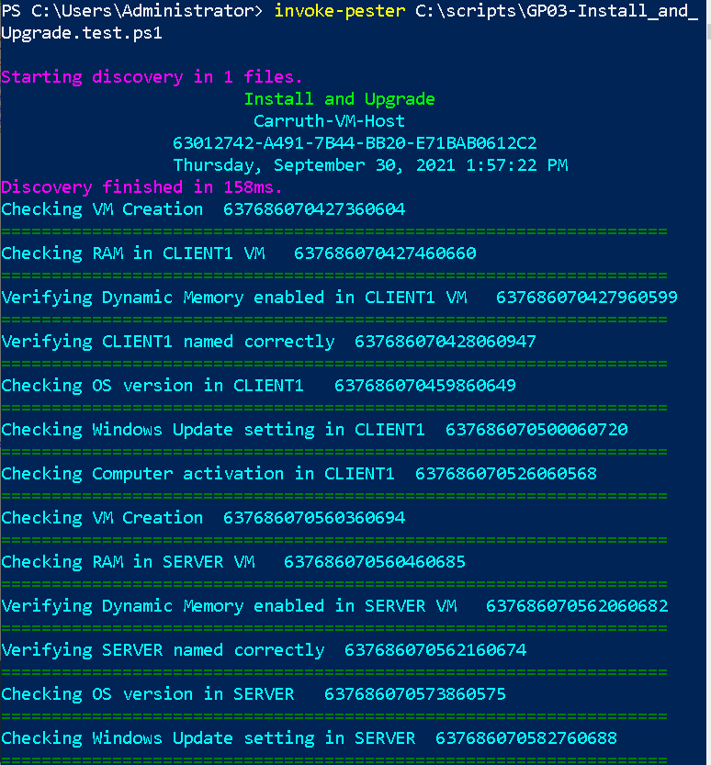

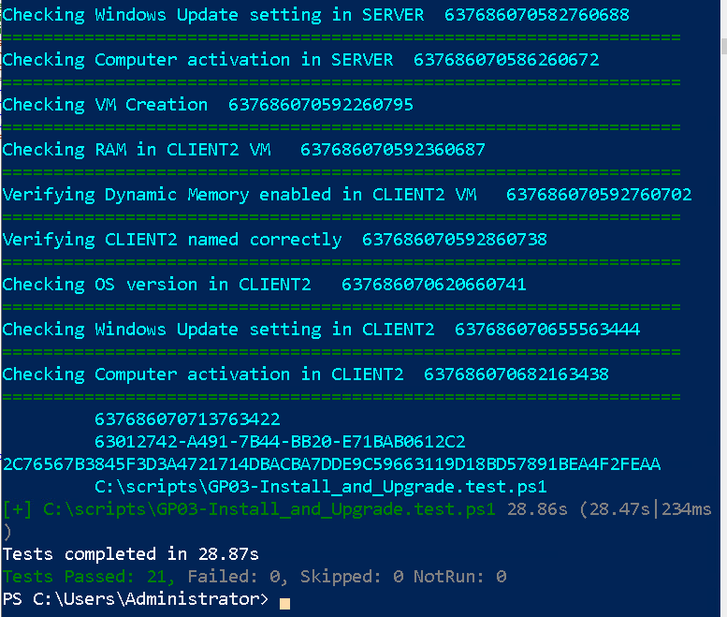

1. Capture a snippet that shows the PowerShell Command and all its output. If you must use more than one snippet to capture the output, you must have at least **one line of overlap** in the snippets. The text in the snippets **must be legible** when pasted into the Word document. Paste the snippet(s) into the **InstallandUpgrade_*Firstname*_*LastName.docx* (**where***Firstname***is your first name and***Lastname***is your last name**)**. The snippet should look like the image above.
2. **Upload** your **InstallandUpgrade_*Firstname*_*LastName.docx*** report in the submission area for the assignment.