system protection

# Objectives

* + Walk through the process of setting up system protection, configuring and testing restore points.

## Skills Reviewed

* + Download and restore applications.

## New Skills

* + Turn on system protection.
  + Create a restore point.
  + Validate a restore point.
  + Use a restore point to check for changes on a system.
  + Perform a system restore.

# Initial Conditions

Your virtual machine should be in this state prior to beginning this guided practice:

* + **Guided Practice: Install and Upgrade Windows 10** has been completed. The Windows 10 virtual machine is running.

# Final Conditions

At the end of this exercise, you will have:

* + System protection enabled and a restore point created.

# Instructions

1. Log in to **CLIENT1** using your administrative account.
2. Open **System Properties**. Right click **Start** > **System**. **System** page opens.
   * 1. Click **System Info** link. **System** opens.
3. Turn on **System Protection** as follows:
   * 1. On **System**, click **System Protection**.
     2. **System Properties** applet opens. On the **System Protection** tab, in the **Protection Settings** area, verify that **Local Disk (C:)** is selected, and then click **Configure**.
     3. Select **Turn on system protection.**
     4. Slide the **Disk Space Usage** slider to **10%** and then click **OK**.
     5. In **Protection settings,** verify **Protection** is set to **On** for **C:**
4. Create a **Restore point**.
   * 1. On **System Properties** applet, on the **System Properties** tab, click **Create**.
     2. In the **Create a restore point** dialog box, enter your ***studentID*** (where ***studentID*** is you assigned studentID) as the name for the restore point and then click create. After the restore point is created, click **Close**.
5. Validate the restore point.
   * 1. On **System Protection** tab of **System Properties**, click **System Restore…**
     2. **Restore system files and settings** screen, click **Next.**
     3. You will see the restore points created.
     4. Click **Cancel**.
6. Download and install **Notepad++**.
7. Check for changes in programs and drivers since the last restore point was created.
   * 1. On **System Protection** tab of **System Properties**, click **System Restore…**
     2. Click **Next** on **Restore system files and settings** screen.
     3. You may see one or more restore points. Select one of the restore points and then click **Scan for affected programs.** Systemrestore scans your system for changes and reports the changes in drivers and programs since the restore point creation. You will See **Notepad++** listed in the **Program and drivers that will be deleted:** box.

# Document Work

1. Capture a snippet of the System restore screen. Save the snippet as **RestorePoint_*studentID*.png** (where ***studentID*** is your studentID). The snippet should show:
   * 1. Description: (should be ***studentid***)
     2. Date:
     3. Program and drivers that will be deleted: (Notepad++ should be shown).

Shows Description :marca1234
Date: 12/812/2017 7:41:42 AM
Programs and drivers that will be deleted: Notepad++

* + 1. Click **Close** after capture of the snippet.

1. Test system restore in operation.
   * 1. On **System Protection** tab of **System Properties**, click **System Restore…**
     2. On **Restore system files and settings** screen, click **Next.**
     3. Select the most recent restore point and click **Next**.
     4. On **Confirm your restore point** screen, click **Finish**.
     5. Read the cautionary note and then click **Yes**. System restore starts. After restore completes, the computer will restart.
     6. Log in to **CLIENT1** using your administrative account.
        1. Was **Notepad++** installed? Why?

File history

# Objectives

* + You will configure and use **File History**.

## Skills Reviewed

* + Create text documents.

## New Skills

* + Turn on **File History**
  + Viewing previous version of files
  + Restoring previous version of files
  + Configure frequency for **File History**.

# Initial Conditions

Your virtual machine should be in this state prior to beginning this guided practice:

* + **CLEINT1** VM is running.
  + **J**:\ drive is added and is empty.
  + Verify that **Windows Search** service **Startup Type** is set to **Automatic (Delayed Startup)**.

# Final Conditions

At the end of this exercise, you will have:

* + File History configured.

# Instructions

1. Log out to **CLIENT1** using your administrative account.
2. Login to **CLIENT1** as **Jane King.**
3. Create a folder named **Video Documentation** in **C:\.** Add a text file with the name ***studentId*MyFirstVideo**, where ***studentID*** is our studentID (e.g**. marcar2685MyFirstVideo**), and then add a short sentence to the file.
4. Configure the **C:\Video Documentation** folder to be part of the **Documents** library by right clicking **C:\Video Documentation** and then selecting **Include in** **Library > Documents**.
5. Open **File History**.
   * 1. Right **Start -> Settings -> Update & Security -> Backup**. **Backup** page opens.
     2. Click **More options** link under **Back up using File History**.
     3. **Backup options** page opens, select **See advance settings**...
     4. **File History** opens. Click **Turn on**.

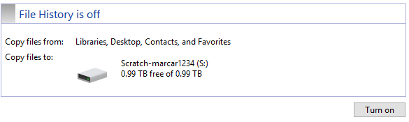

1. **File history** makes an initial copy of your files. You will see **File History is on.**
2. Edit the ***studentId*MyFirstVideo** file and add a new sentence, save, and close the file.
3. Right click ***studentId*MyFirstVideo** file and select **Restore Previous versions.**
   * 1. The ***studentId*MyFirstVideo.txt** **Properties** opens. Click the **Previous Versions** tab.
     2. You should see one previous version.

# Document work

* + - 1. Capture a snippet of ***studentId*MyFirstVideo.txt** **Properties** page with the **PreviousVersion** tab selected. The snippet should show the name and date modified for the file. Save the file as **FileHistory_*studentID*.png** (where ***studentID*** is your assigned studentID).

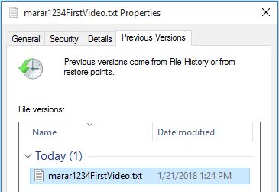

* + - 1. Click that version and then click **Open**. The previous version of the file opens, the version with a single sentence.
      2. Click **Restore.** The **Replace or Skip Files** page opens. Click **Replace the file in the destination**.
    1. Open **MyFirstVideo.txt** file. The file now has one sentence.
    2. Add a new sentence to the file.

1. Configure frequency to save files.
   * 1. Open **File History** and click **See** **Advanced settings**.
     2. On the **Advanced settings** tab, in the **Save copies of files**:, select **Every 10 minutes**. In the **Keep saved versions page:** select **Until space is needed** and then click **Save changes**.
     3. Wait a few minutes and check file history for ***studentId*MyFirstVideo** text file. You will see two entries now.